Cost recovery implementation statement: dairy exports 2020–21

© Commonwealth of Australia 2021
Ownership of intellectual property rights
Unless otherwise noted, copyright (and any other intellectual property rights) in this publication is owned by the Commonwealth of Australia (referred to as the Commonwealth).
Creative Commons licence
All material in this publication is licensed under a Creative Commons Attribution 4.0 International Licence except content supplied by third parties, logos and the Commonwealth Coat of Arms.
Inquiries about the licence and any use of this document should be emailed to copyright@agriculture.gov.au.

Cataloguing data
This publication (and any material sourced from it) should be attributed as: DAWE 2021, Cost recovery implementation statement: dairy exports 2020–21, Department of Agriculture, Water and the Environment, Canberra, January. CC BY 4.0.
ISBN 978-1-76003-369-9
This publication is available at haveyoursay.awe.gov.au/export-cost-recovery-implementation-statements.
Department of Agriculture, Water and the Environment
GPO Box 858 Canberra ACT 2601
Telephone 1800 900 090
Web awe.gov.au
The Australian Government acting through the Department of Agriculture, Water and the Environment has exercised due care and skill in preparing and compiling the information and data in this publication. Notwithstanding, the department, its employees and advisers disclaim all liability, including liability for negligence and for any loss, damage, injury, expense or cost incurred by any person as a result of accessing, using or relying on any of the information or data in this publication to the maximum extent permitted by law.

Contents
Summary v
Government decision – busting congestion for agricultural exporters v
CRIS consultation v
Reforms to improve the efficiency and effectiveness of export regulation v
1 Introduction 1
1.1 Purpose of this CRIS 1
1.2 Path to full cost recovery 1
2 CRIS updates 3
3 Reforms 4
3.1 Busting congestion for all agricultural exporters 4
3.2 Dairy deregulation 4
3.3 Dairy arrangement cost base following reforms 5
4 Policy and statutory authority to cost recover 7
4.1 Description of the regulatory activity 7
4.2 Why cost recovery is appropriate 7
4.3 Government policy approval to cost recover the regulatory activity 8
4.4 Statutory authority to charge 8
5 Cost recovery model 10
5.1 Outputs and business processes of the regulatory charging activity 10
5.2 Costs of regulatory charging activity 11
6 Stakeholder engagement 13
6.1 Industry engagement 13
7 Cost recovery arrangement for dairy exports 16
7.1 Design of cost-recovered charges 16
7.2 Cost base 16
7.3 New export control legislation 19
7.4 Financial estimates 19
7.5 Dairy exports fees and charges 20
8 Financial estimates 21
9 Financial and non-financial performance 22
9.1 Financial performance 22
10 Key dates and events 23
Appendix A: Description of cost model activities 24
Program management and administration activities 24
Assurance activities 25
Incident management activities 25
Intervention activities 25
Appendix B: Summary of dairy export stakeholder feedback from 2019–20 consultation 27
Glossary 29

Tables
Table 1 Dairy fees and charges for 2020–21 and illustrative prices for 2021–22 to 2023–24 2
Table 2 Dairy cost base with and without adjustments to expense and expected cost recovered revenue 5
Table 3 Cost base for dairy export cost recovery arrangement, 2020–21 17
Table 4 Cost type breakdown for dairy export cost recovery arrangement, 2020–21 17
Table 5 Changes to cost base for dairy exports, 2019–20 18
Table 6 Changes to cost base for dairy exports, 2020–21 19
Table 7 Fees, charges and volumes for dairy export cost recovery arrangement, 2020–21 20
Table 8 Financial estimates for dairy export cost recovery arrangement 21
Table 9 Financial performance for dairy export cost recovery arrangement, 2015–16 to 2019–20 22
Table 10 Key forward dates and events 23

Figures
Figure 1 Dairy revenues and expenses vi
Figure 2 Outputs and business processes of our regulatory charging activity 10
Figure 3 Categories of activities 12

Summary
This cost recovery implementation statement (CRIS) describes how the Department of Agriculture, Water and the Environment will:
- recover the costs of providing regulatory services to the dairy industry in 2020–21
- implement the government’s decision to freeze fees and charges in the 2020–21 financial year
- implement the government’s decision to return export cost recovery arrangements to full cost recovery by 2023–24.

Government decision – busting congestion for agricultural exporters
On 6 October 2020 the government announced its decision to freeze regulatory fees and charges in 2020–21 for exporters and then gradually return to full cost recovery by 2023–24. The announcement was part of the Busting Congestion for Agricultural Exporters package. This package also includes a series of reform projects and a significant IT investment measure.
In practical terms, the decision will result in fees and charges remaining at their current levels in 2020–21, with stepped increases from 2021–22 to 2023–24, to enable the dairy export cost recovery arrangement to fully recover the cost of delivering the regulatory activity.

CRIS consultation
The department had previously flagged a number of changes to the dairy export CRIS through an ongoing consultation process with impacted dairy export supply chain participants. As a result of this consultation and industry feedback, a number of changes to fees and charges, both in terms of charge points and charge amount, will be progressively made from 1 July 2021. We will consult with industry on these proposed changes during the first quarter of 2021.
This 2020-21 CRIS therefore describes the decision of government to freeze fees and charges. A separate 2021–22 CRIS, outlining proposed changes from 1 July 2021 will be released for public consultation in the first quarter of 2021.

Reforms to improve the efficiency and effectiveness of export regulation
On 6 October 2020, the Australian Government announced a $328 million investment to modernise Australia’s export systems over 4 years.
The centrepiece of the package is a $222.2 million plan to upgrade the ICT that underpins our export system. The package also includes a number of other measures that will streamline and simplify our business and make the essential export services that we provide more efficient and sustainable for the future. This marks a significant opportunity for our department to transform our business processes to become digitally preferred.
These investments, both in ICT and in improvements to our business processes are aimed at making the export dairy system more effective and efficient. The outcomes of this work are expected to reduce the overall cost of delivering regulatory services to the dairy export industry, in addition to providing regulated entities the opportunity to reduce their interaction costs incurred in dealing with the department on regulatory matters. Changes in the department's cost of delivering regulatory activities will be reflected in the cost recovery arrangement.
When the department commenced consultation on cost recovery in 2018–19, the projected total cost of all export cost recovered arrangements in 2023–24 was $163 million The direct impact of the reforms that are currently planned are estimated to reduce this future cost to $142 million across all export cost recovered arrangements. This equates to a $21 million reduction in costs.
Figure 1 shows the projected expense and portion of cost recovered revenue for the dairy cost recovery arrangement.
Figure 1 Dairy revenues and expenses
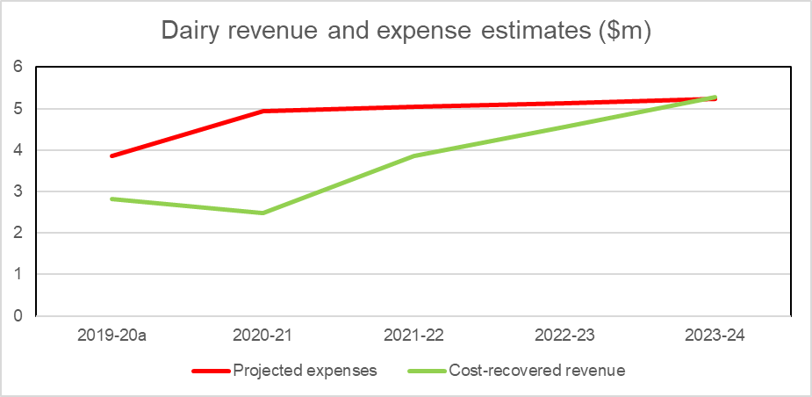
a Actuals.

Introduction

Purpose of this CRIS
This CRIS details the cost base and pricing structure for the dairy export cost recovery arrangement and incorporates the impacts of the Busting Congestion for Agricultural Exporters package and then More Efficient and Sustainable Export Regulation measure announced in the 2020–21 Federal Budget.
The government is investing in modernising and reforming export regulatory services which will impact the cost base over time for all export cost recovery arrangements. Agriculture and food exporters and producers will be assisted through the modernisation and reform process with a freeze in fees and charges in 2020–21, and gradual increases from 2021–22 to 2023–24. Government has committed $71.1 million to improve the financial sustainability of export certification services by returning to full cost recovery of these services over time. A stepped return to full recovery will enable reforms to be rolled out while maintaining existing systems.
The key purpose of this CRIS is to:
- Baseline the dairy export cost recovery arrangement expense for the regulatory activity against which progress of these reforms can be measured and changes transparently explained.
- Describe the freeze in fees and charges in 2020–21, and stepped increases from 2021–22 through to through 2023–24.
An updated CRIS will be released for consultation published in the first quarter of 2021 and updated annually. The annual CRIS will provide a summary of the previous year's financial performance, and description of deviations from forecast, provide an update of forward year cost base expectations and any consequential changes to charges required to ensure the arrangement remains financially balanced.
This CRIS describes the impact of government decisions on charges as they were outlined in the previous 2015 CRIS. The proposed charging options and cost allocation approaches discussed in previous consultation have not been included in this CRIS – but will be considered in the next CRIS update. A subsequent CRIS update in 2021–22 will also reprofile demand for services and reflect the impact of reforms (further detail on likely changes to charging are detailed in section 2).

Path to full cost recovery
The government is freezing fees and charges for 2020–21 at current prices. From 2021–22, prices will be gradually increased to return all arrangements to full cost recovery in 2023–24.
The government is investing $71.1 million over 3 years from 2020–21 to maintain essential export regulatory services across all export cost recovered arrangements while prices are gradually increased.
This is part of a $328 million investment over 4 years from 2020–21 that also includes reforms to deliver an estimated annual cost reduction of $21.4 million from 2023–24 across all export cost recovered arrangements.
The impact of these decisions on dairy export cost recovery from 2020–21 to 2023–24 is shown in Table 1. The fees and charges are notional only, illustrating the gradual increase of prices supported by the government decisions if no changes are made to the way the department charges for regulatory activity.
Changes to charging will from 1 July 2021 be described in a separate 2021–22 CRIS to be released for public consultation in the first quarter of 2021.
Table 1 Dairy fees and charges for 2020–21 and illustrative prices for 2021–22 to 2023–24
Charge | Unit | 2020–21 ($) | 2021–22 ($) | 2022–23 ($) | 2023–24 ($)
Charges
Corp/Co-op exporting >=2,000 tns | Annual | 7,729 | 12,021 | 14,212 | 16,299
Corp/Co-op exporting <2,000 tns | Annual | 4,275 | 6,649 | 7,861 | 9,016
Storage establishment – dairy | Annual | 1,820 | 2,831 | 3,347 | 3,838
Document – electronic | Per document | 15 | 24 | 28 | 32
Registration application | Per application | 600 | 934 | 1,104 | 1,266
Fee-for-service
Audit | Per quarter hour | 33 | 52 | 61 | 70
Inspection | Per quarter hour | 33 | 52 | 61 | 70
Electronic certificates | Per document | 6 | 10 | 12 | 13
Manual certificates | Per document | 100 | 156 | 184 | 211
Replacement certificate | Per document | 500 | 778 | 919 | 1,055
Organicsª
Organic certifying organisation | Annual (charged quarterly) | 7,500 | 11,665 | 13,791 | 15,816
a Organic certifiers support a small number of exporters in all of the export arrangements (excluding Live Animal Exports) and therefore the expense has been reflected in each CRIS.
Note: Forward year prices shown are for illustrative purposes only. The 2021–22 CRIS will describe the changes to fees and charges for 2021–22 to 2023–24.

CRIS updates
In accordance with the Australian Government Cost Recovery Guidelines (CRGs), the dairy exports CRIS will be updated annually to report on financial and non-financial performance and revised 4-year forecasts. This annual update will provide an opportunity to measure progress of the reforms as they become quantifiable and to account for any external factors, for example, projected demand for activity.
The department will also report in-year financial performance within the CRIS, periodically reporting performance against the CRIS and explaining any variances. This will provide transparency in reporting for all exporters.
There may be other significant developments warranting a broader review of the cost base or charges. These could include:
- Changes to the regulatory settings of the arrangement, for example through a government policy change or the introduction of new systems or infrastructure.
- Changes to demand for regulatory activity, for example, due to a large part of industry changing its business model or significant change in terms of trade.
Where a CRIS update reveals that the existing fee or charge structure no longer meets the financial or regulatory requirements of the arrangement, the department may propose revised fees and charges. In this circumstance, the CRIS update will be the first step in consultation on changes to prices, followed by opportunities for stakeholder engagement.
This CRIS describes the impact of the busting congestion package has on the dairy export cost recovery arrangement. It does not include the price changes proposed during the 2019–20 consultations.
Changes were proposed during previous industry are expected to feature again in an updated CRIS in the first quarter of 2021. These include:
- Charging a document fee for the assessment of requests to amend or resubmit documents. This charge point would allow us to recover the reasonable costs of exporters amending or re-submitting documents. By recovering these costs and ensuring that those causing this expense are appropriately charged for it, we aim to reduce re-work and incentivise exporters to submit suitably completed documents.
- Charging a single multicommodity standard audit rate across all export cost recovery arrangements to reflect the multiskilled workforce and simplify arrangements for industry.

Reforms

Busting congestion for all agricultural exporters
The Australian Government announced the Busting Congestion for Agricultural Exporters package in the 2020–21 Budget which includes reforms to slash unnecessary red tape to get products to export markets faster and support jobs in rural and remote Australia.
The package, worth over $328 million over 4 years from 2020–21, includes the following measures that are relevant to this CRIS.

Digital services to take farmers to markets
The centrepiece of the reform package is the Digital Services to Take Farmers to Markets measure, which will invest $222 million to modernise Australia’s agricultural export systems by slashing red tape and improving regulation and service delivery for our producers and exporters. This measure will transition our systems online and provide a single portal for transactions between exporters and government, streamlining processes for exporters and helping them experience faster and more cost-effective services.

Improving regulation post–COVID-19
The Improving Regulation Post–COVID-19 measure capitalise on new ways of working that were developed during the government's response to COVID-19.
The measure includes:
- Working with trading partners and international standard setting organisations to embed, where appropriate, alternative regulatory approaches such as technology supported auditing, and to promote wider utilisation of e-certification.
- Assignment of dedicated case managers to support new agriculture exporters, including seafood, grains, dairy and NPGs, to allow them to navigate and meet regulatory requirements to get on the front foot to enter markets. Support existing exporters to expand and diversify their market opportunities by assisting them to more easily navigate export regulatory processes for example registration process ($3.7 million over 2 years).
- Capacity to develop and implement a risk based, targeted, approach to the regulation of the live animal and seafood export industries that supports compliant exporters and focuses on non-compliant operators ($2.3 million over 2 years). The initiatives will consider increased use of new technologies including for on-vessel audit. Key to the successful deployment of technology will be the collaborative development of feasible options between the department, industry bodies and individual operators.

Dairy deregulation
The Dairy Export Assurance Program is an exciting opportunity for the government, state regulatory agencies and industry to co-design a more robust and inclusive regulatory framework for the dairy export industry. The program consists of 3 projects that focus on raising export awareness, reducing regulatory burden and streamlining audit arrangements in the dairy sector.
This funding is the first major investment into the export sector for over a decade. The government agreed to fund $12.740 million between 2019–24 with approval for additional $2.040 million in 2024–25.
The funding will allow the delivery of 3 projects:
- Working with stakeholders to identify regulatory hurdles for domestic dairy manufacturers to become exporters, building a better understanding of how regulators and industry can overcome these hurdles and providing improved clarity around ownership and responsibility within the export system.
- Seeking opportunities to create a more streamlined and aligned regulatory auditing system by working with industry to investigate commercial auditing outcomes and linkages to regulatory requirements.
- Focus on reducing regulatory intervention through the improved use of data and information to better inform risks, targeted audit interventions and regulatory oversight, providing greater focus on problem areas while also rewarding good performance. The project will also work closely with Dairy Food Safety Victoria’s RegTech 2022 project and other state regulators to explore the opportunities for using data in food safety assurance.
Cost impacts will be incorporated in updated CRIS as they are identified.

Dairy arrangement cost base following reforms
These reforms are an opportunity for government and industry to work in partnership to lower the cost base of export arrangements. While specific savings have not been identified for this arrangement, it is anticipated there will be benefits that may be quantified in the future. This will require an iterative approach to manage of the cost base over the forward estimates. We will work with industry to achieve these outcomes.
Table 2 shows the cost base with and without adjustments to expense and forecast revenue for the dairy arrangement and it describes:
- the cost base per the draft CRIS from the 2019–20 consultation
- adjustments to that cost base from the busting congestion package.
Table 2 Dairy cost base with and without adjustments to expense and expected cost recovered revenue
Expense base | Unit | 2020–21 | 2021–22 | 2022–23 | 2023–24
Expenses – no adjustment | $ | 4,944,407 | 5,035,255 | 5,127,669 | 5,227,726
Total cost reduction from adjustments | $ | n/a | tbd | tbd | tbd
Expected expenses after adjustments | $ | 4,944,407 | 5,035,255 | 5,127,669 | 5,227,726
Revenue from cost recovered regulatory services | $ | 2,479,029 | 3,855,568 | 4,558,346 | 5,277,870
Appropriation funding | $ | 2,465,378 | 1,179,687 | 569,323 | n/a
Total revenues | $ | 4,944,407 | 5,035,255 | 5,127,669 | 5,277,870
Expenses less revenues | $ | – | – | – | (50,144)
Appropriation funding as % of expenses | % | 50 | 23 | 11 | n/a
n/a Not applicable. tbd To be determined.

Policy and statutory authority to cost recover
Under the Australian Government charging framework (charging framework), cost recovery requires both policy approval and statutory authority. The following sections provide information on government approval of regulatory charging for export regulatory activities and the legislation that enables the department to collect fees and charges.

Description of the regulatory activity
Agriculture, food and fibre exports are regulated in accordance with Export Control Act 1982 and associated legislative framework (for more information see section 4.4).
To certify a product’s compliance with Australia’s export requirements and the importing country requirements, we undertake a range of activities, including:
- Developing, implementing and monitoring of operational policy and systems that ensure compliance with Australian export controls and any importing country requirements. These activities serve to maintain the eligibility of commodities for export from Australia and to protect and promote Australia’s reputation for premium agricultural goods, while maintaining existing and seeking increased market access opportunities.
- Providing inspection, auditing, and enforcement activities to ensure that the production, storage, handling and transportation of dairy products intended for export comply with the conditions of the Australian export controls and any additional requirements imposed by an importing country.
- Issuing permits, export certification and other documentation necessary to confirm compliance with the Australian export controls and any additional importing country requirements.
- Managing quota allocation and quota certification to enable exporters to access tariff rate concessions offered under trade agreements.
- Providing support through our overseas counsellors relating to detained consignments, government certification and other issues which result in goods being held at the border.
- Providing scientific and technical advice to improve, maintain or restore market access and to demonstrate adherence to export requirements.
- Enforcing regulation of certified organic goods exported from Australia.
For more information, see Export goods controlled by the department.

Why cost recovery is appropriate
Cost recovery (regulatory charging) falls within the Australian Government’s broader charging framework. Other charges in this framework include commercial charges and resource charges. The type of charge is determined by the characteristics of the activities as described in the charging framework. This provides the overarching framework under which government entities must design, implement and review cost recovery.
Under the charging framework regulatory charging is appropriate because export regulatory activity is provided to a clearly identifiable group – individuals and organisations that participate in the agriculture, food and fibre export supply chain.
There are additional benefits to funding export regulation through regulatory charging. When a business pays for the activities it receives, the government has an obligation to justify the prices it charges. Regulatory charging also raises awareness of regulated entities of how much a regulated activity costs.
For these reasons, the government has determined regulatory charging to be the most appropriate mechanism for funding export regulatory activity. We have reviewed regulatory charging of export regulatory activities, consistent with the charging framework.

Government policy approval to cost recover the regulatory activity
Policy authority for regulatory charging for export regulatory activities was reaffirmed in the 2020–21 Budget when the government announced the Busting Congestion for Agricultural Exporters package. The package sets out a period of partial cost recovery from 2020–21 to 2023–24 before a return to full cost recovery by 2023–24, while a series of reforms to improve efficiency and lower costs are implemented.

Statutory authority to charge
Fees and levies for export regulatory activities are recovered under separate statutory authority.

Cost recovery fees
Section 25 of the Export Control Act 1982 provides the power to impose fees in relation to a range of export activities and with administering certain quotas. The specific amounts are set out in the Export Control (Fees) Order 2015.
The Australian Meat and Live-stock Industry Act 1997 and subordinate legislation provides the power to impose fees in relation to an application for an export meat licence.
Amendments to, or new, subordinate legislation provide authority for the fees detailed in this CRIS to be established. These and other delegated instruments include descriptions of the charging points.

Cost recovery levies
Cost recovery levies as described in the Australian Government Cost Recovery Guidelines (CRGs) are implemented for export regulatory activity through charging legislation. The following Acts and subordinate legislation include descriptions of the charging points:
- Export Charges (Collections) Act 2015
- Export Charges (Imposition – Customs) Act 2015
- Export Charges (Imposition – Excise) Act 2015
- Export Charges (Imposition – General) Act 2015
- Export Charges (Imposition – General) Regulation 2015
- Export Charges (Imposition – Customs) Regulation 2015
- Export Control (Fees) Order 2015

New legislative framework
The Export Control Act 2020 commences 28 March 2021, consolidating export functions from the Export Control Act 1982 and Australian Meat and Live-stock Industry Act 1997 into a new legislative framework. The new legislative framework will be more relevant, responsive, and efficient for exporters, farmers and other primary producers. The export framework will continue to provide strong regulation, while removing duplication and ensuring consistency across commodities where possible. The new legislation supports existing policy, while providing flexibility for different approaches to the regulation of exports in the future.
No changes to the cost base have been identified at this time because of the implementation of the new legislative framework, but changes to our regulatory approach could affect cost recovery. Any impacts will be reviewed when or if changes are implemented and incorporated in an updated CRIS as appropriate.

Cost recovery model

Outputs and business processes of the regulatory charging activity
The key policy objectives for our cost recovery arrangements are to:
- safeguard Australia’s animal and plant health status to maintain overseas markets and protect the economy and environment from the impact of exotic pests and diseases, through risk assessment, inspection and certification, and the implementation of emergency response arrangements for Australian agricultural, food and fibre industries.
- Support more sustainable, productive, internationally competitive and profitable Australian agricultural, food and fibre industries through policies and initiatives that promote better resource management practices, innovation, self-reliance and improved market access.
Our cost recovery arrangements describe how we use resources (such as people, IT, property and equipment) to undertake business processes (regulatory activities), which enable us to provide outputs that meet our policy objectives (Figure 2).
Figure 2 Outputs and business processes of our regulatory charging activity
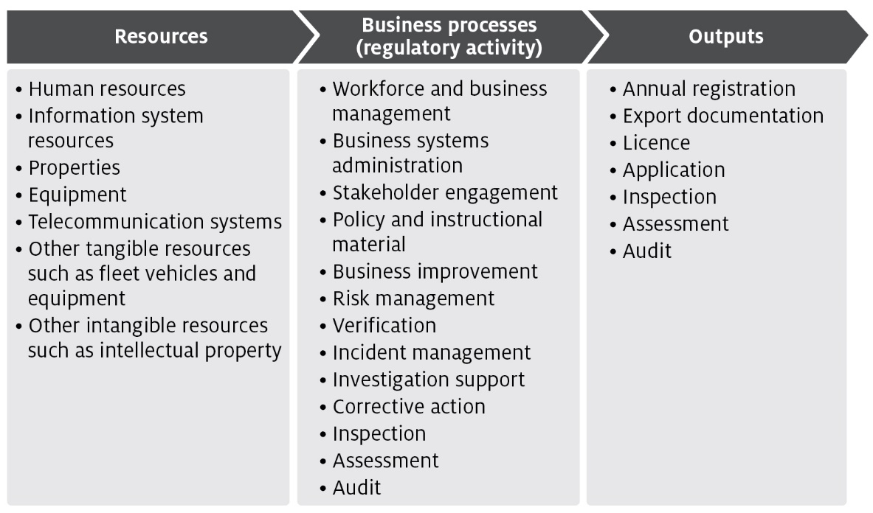
The processes listed in Figure 2 are described in Appendix A and are grouped into 4 categories of activities:
- Program management and administration – administrative activities that support and deliver our export regulatory activity commitments.
- Assurance – activities that mitigate risks to collective user groups by assessing departmental controls of systems and processes to ensure they operate in accordance with their intended design.
- Incident management – activities that respond to incidents concerning alleged breaches of Australian regulation or international import conditions.
- Intervention – activities provided directly to an individual, business or organisation to meet export regulatory activity requirements.

Costs of regulatory charging activity

Cost allocation process
To determine the cost of regulatory activities, we use an activity-based costing (ABC) system. The ABC cost allocation methodology reflects costs incurred through usage of regulatory activities, providing a transparent allocation of costs while also being efficient and effective to administer.
The 2 expense categories are:
- direct expenses – these can be directly attributed to the provision of an activity, for example, inspections. They comprise of staff salaries and supplier costs including direct capital expenses.
- indirect expenses – these are not directly linked to an activity provided by us. Indirect expenses include corporate employee salaries and overheads such as information technology, finance, human resources costs, and indirect capital expenses.
The cost allocation process apportions the costs of support functions (indirect expense) and direct expense to the processes/activities defined in Appendix A. We include indirect expenses in the cost base to reflect the systems and processes that exist to help with efficient administration, which the cost-recovered arrangements benefit from. This is the same methodology employed for allocation of indirect costs to appropriated activities, in line with our cost allocation policy.
The ABC system allocates costs in a staged approach:
- Indirect costs such as property, finance, information technology, human resources and divisional executives are allocated to direct cost centres using a cost driver which estimates the relative usage of each of the corporate services. Cost drivers for corporate services include:
  - Workpoints – distributes costs based on space occupied, with the workpoint count reflecting the space where a person may be able to work.
  - FTE – distributes costs based on each programme's full-time equivalent staff numbers.
  - PC count/IT assets – distributes costs based on the number of IT assets in a program.
  - Transactions – distributes costs based on the number of transactions incurred over a period. This driver is used to allocate expenses related to the functions of accounts receivable and accounts payable.
  - Headcount – allocates costs based on the number of staff that a program area has as a proportion of the number of staff that are on the department’s total staff.
  - Custom drivers – allocate costs to specific cost centres, primarily based on usage for shared program resources.
- Cost drivers are reviewed on an annual basis, or as required. Changes to cost drivers are substantiated through effort or other data.
- Direct costs (including the indirect costs allocated in step 1) are allocated to the activity and cost-recovered arrangements that best reflects the activity undertaken. Time recording systems allow the accurate allocation of effort to specific activities and arrangements, particularly to intervention activities.
- The primary variable used in the allocation of costs to activities is effort. As a result, cost estimates vary with changes in activity. If actual activity levels change during a financial year, the costs allocated to arrangements would require adjustment to align with that effort. We monitor this throughout the year and adjust where necessary.
- For example, food safety auditors undertake audits across multiple arrangements. We forecast the number of audits and average time for an audit for each arrangement. The associated costs are allocated to the arrangements and audit function based on total audit hours.
- Activity/arrangement costs (from step 2) are allocated to charge points which identifies the cost associated with that charge. We use a combination of cost recovery fees and charges. Figure 3 shows how we categorise cost-recovered levy and fee activities and outputs.
Figure 3 Categories of activities
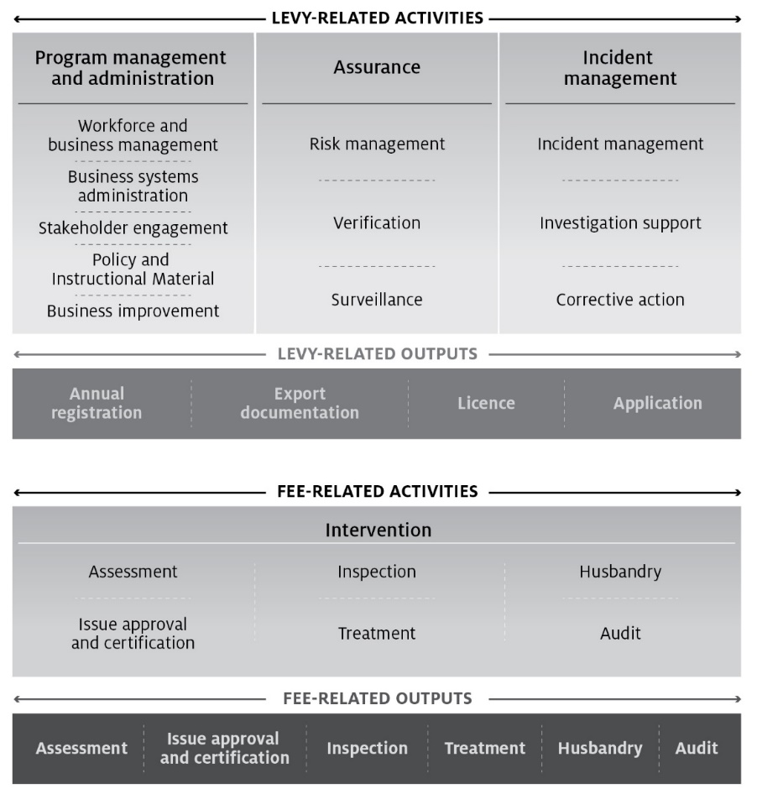

Stakeholder engagement
Stakeholder engagement plays an important role in the development and management of cost recovery arrangements. Our stakeholders have a unique insight into how our regulatory activities impact on their business and help us design efficient cost recovery frameworks for these activities.
This CRIS explains the decisions taken by government and financial outcomes of the measures in the busting congestion package. No changes to fees and charges apply in 2020–21. However, we note you may want to make comment in relation to this CRIS. If you are interested, we ask that you register your interest to participate in our upcoming consultation and in receiving further information and invites to future opportunities to engage.
You are also welcome to make comments on our Have Your Say page. Any comments you make will be addressed as part of the consultation process scheduled to take place in early 2021 on the proposed 2021–22 CRIS.
Stakeholder engagement on the development and implementation of reforms from 2021–22 through to 2023–24 will take place over the course of the annual CRIS update cycle, beginning in February 2021. For further information on the package see Busting Congestion for Agricultural Exporters.

Industry engagement
The department has been reviewing the CRIS since 2018–19 including public consultation on a draft in 2019–20. The department has established industry consultative committees to represent industry views in relation to food exports and we consult with these committees on a number of different activities. In developing this CRIS, we have consulted with the:
- Dairy Export Industry Consultative Committee through the Dairy Export Cost Recovery Charging Committee (DECRCC).
Throughout the development of this CRIS, consultative groups have been given detailed information on:
- the cost base
- the volume of activities
- the proposed fee and levy structure
- the proposed rates of the fees and charges.
The industry consultative committees have indicated a strong view that we must remain committed to continual improvement and the realisation of efficiencies from a number of reform activities we currently have underway.
We consulted widely on the development of a draft CRIS during 2019–20, including through engagement with key stakeholders, a public submission process and face-to-face meetings with stakeholders. For a detailed summary of dairy stakeholder feedback see Appendix B.

In addition to feedback from industry, the department also commissioned an independent review of the efficiency and effectiveness of the department’s delivery of export regulatory services. The independent review and the department’s response have now been finalised and are available at Independent review of the cost of export certification. The independent review was largely conducted as a survey of both internal and external stakeholders.
The independent review was delivered to the department in March 2020. The review found the department’s staff to be committed and passionate, working diligently to achieve positive outcomes for industry. It also found that external stakeholders were somewhat satisfied with the department’s services and that overarching export market and legislative objectives were often met. A range of recommendations were made to improve efficiency and effectiveness, with each requiring an investment of resources, effort, funding and time to fully implement.
Key messages from stakeholders and the review were:
- Industry wants the department to work to create efficiencies to lower costs.
- Antiquated systems were impeding efficient processing of export consignments.
- The department needed to focus on improvements while still delivering routine regulatory activities.
- Smaller exporters are finding it difficult to enter and compete on the global market without assistance from the government.
- Industry predict increases could cause significant hardships for producers and exporters who are recovering from a period of severe drought and natural disasters.
- If prices need to rise, they should do so in a stepped way, to prevent shocks to business.
Since release of the draft CRIS for public consultation in October 2019, the new Department of Agriculture, Water and the Environment was created in February 2020 through a machinery of government change. As part of this change the department undertook an internal ‘Future Department Review’ to identify how to maximise the capability of the new department and fully realise the opportunities it presents. A subsequent change process is now underway.

Dairy exports stakeholder engagement
Dairy industry members were primarily consulted through the DECRCC. Key topics covered through the consultation process included: past financial performance; cost base and pricing structure; and the cost recovery reserve and use of remissions. Key points discussed in this section.

Past financial performance
- We provided additional information requested by industry on the key drivers for the financial position of the dairy export cost recovery arrangement, including information on increased expenses and lower than forecast revenue leading to a deficit position.
- We provided a breakdown of the increases in the cost base since 2014–15. Key changes in the cost base related to the expanded cost base (2018–19 Budget measure) and additional workload for the inclusion of additional function and audit responsibility.

Cost base and pricing structure
- Industry noted that the cumulative impact of the cost base increases have resulted in the cost base doubling since 2014–15.
- Industry noted that the primary principle for pricing structure design should be ‘user-pays’, where those who incur the costs are those that pay.
- They also expressed objections and concerns around the expansion of the cost recovery base.

Cost recovery reserve and use of remissions
- Industry noted the shift from a historically positive balance to the current deficit position and sought further consideration of the cost recovery reserve balance policy and use of remissions to assist to manage the reserve balance to minimise the impact of price or volume shifts.

Cost recovery arrangement for dairy exports
This section describes the dairy export cost recovery arrangement cost base as well as additional financial information associated with inspection and certification activities.

Design of cost-recovered charges
There are no changes to the existing dairy cost recovery charging structure in this CRIS. We will consult on any adjustments to the charging structure in a revised CRIS prior to implementing updated fees and charges from 1 July 2021.
Dairy exports are forecast to be steady over the next 4 years.

Cost base
Table 3 shows the dairy arrangement cost base for 2020–21. Table 4 provides a breakdown of expenses of the dairy export cost recovery arrangement (2020–21).
A detailed description of cost activities is provided at Appendix A and the methodology for attributing costs to these activities is provided in section 5.

Cost base assumptions
The cost base has been modelled to reflect the full costs of the arrangements. Partial cost recovery levels are displayed in the tables dealing with financial performance and fees and charges. The 2018–19 budget has been used as the starting point for determining the cost base in this CRIS. To project the cost base over the next 4 years, we have applied adjustments to capture expected changes to the costs including:
- inflation of 1.65% per annum, in line with the Department of Finance’s inflation estimate
- increases in employee expenses of 2% per annum, reflecting reasonable estimates of wage increments in line with the Australian Public Service Workplace Bargaining Policy 2018
- additional depreciation from new assets anticipated to be recognised over the period
- adjustments for future fee-related activities to reflect expected changes in volume.

Projected cost base
The cost base from 2020–21 for the dairy export cost recovery arrangement is $4.944 million (Table 3), made up of:
- $4.253 million in levy-related activities
- $0.691 million in fee-related activities.
Table 3 Cost base for dairy export cost recovery arrangement, 2020–21
Charge type | Activity group | Activity | Expense ($) | Cost recovery charges
Levy | Program management and administration | Workforce and business administration | 4,253,120 | Annual registration, export documentation, throughput, application and organic certification
 |  | Business system administration
 |  | Stakeholder engagement
 |  | Policy and instructional material
 |  | Business improvement
 | Assurance | Risk management
 |  | Verification
 |  | Surveillance
 | Incident management | Incident management
 |  | Investigative support
 |  | Corrective action
Fee for service | Intervention | Assessment | 319,587 | Assessment
 |  | Issue approvals/certification | 20,982 | Issue approvals/certification
 |  | Inspection | 2,255 | Inspection
 |  | Audit | 348,464 | Audit
Total cost base |  |  | 4,944,407 | –
Table 4 provides a breakdown of expenses of the dairy export cost recovery arrangement (2020–21).
Table 4 Cost type breakdown for dairy export cost recovery arrangement, 2020–21
Expense | Forecast ($)
Direct | 3,521,529
Employee | 2,299,296
Operating | 1,056,806
Other | 165,427
Indirect | 1,422,878
Assurance and Legal | 91,841
Corporate Strategy and Governance | 169,930
Finance and Business Support | 260,169
Information Services | 545,488
Property | 355,449
Total | 4,944,407
For more information on how expenses are allocated see cost recovery methodology in section 5.

Changes to the cost base
Adjustments to the dairy export cost recovery arrangement include additional inflation and depreciation expenses, and the expanded cost recovery activities announced in the 2018–19 Budget that was implemented from 1 July 2019.
The new government policy provided authority to additional cost recovery regulatory activities including enforcement, scientific and technical advice, and support for detained consignments which increased the cost base by $0.444 million indexed annually from 1 July 2019.
Levy charges will recover:
- enforcement activities that are directly related to our regulatory function of ensuring industry compliance with international import conditions ($0.106 million indexed annually from 1 July 2019)
- scientific and technical advice related to supporting industry to improve, maintain or restore market access ($0.266 million indexed annually from 1 July 2019) the cost of our overseas counsellor network assisting industry to meet export requirements for detained consignments or during trade disruptions ($0.072 million indexed annually from 1 July 2019).
In line with the government’s CRGs and the department’s cost allocation policy, inflation and depreciation expenses have been adjusted in the cost base to reflect increased employee and supplier expenses in line with the Australian Public Service Workplace Bargaining Policy 2018 and government inflation estimates. Cost recovery of these activities is considered appropriate because industry directly benefits from having a system in place that allows the department to manage and respond to market access issues, including ensuring compliance with overseas country requirements.
Changes to the cost base between the 2019–20 budget and 2020–21 forecast are outlined in Table 5 and Table 6.
Table 5 Changes to cost base for dairy exports, 2019–20
Adjustment to cost base | Impact on cost base | Unit | Forecast
Total baseline expense | n/a | $ | $3,927,138
Enforcement | Increase | $ | $105,956
Scientific and technical advice | Increase | $ | $266,320
Detained consignments | Increase | $ | $72,261
Depreciation expenses | Increase | $ | $191,444
Inflation | Increase | $ | $22,753
Net impact of other changes | Increase | $ | $201,690
Total adjustments to cost base | Increase | $ | 860,424
Adjusted cost base | n/a | $ | 4,787,562
Change in expense | Increase | % | 21.9
n/a Not applicable.
Table 6 Changes to cost base for dairy exports, 2020–21
Adjustment to cost base | Impact on cost base | Unit | Forecast
Total baseline expense | n/a | $ | 4,787,562
Inflation and other changes | Increase | $ | 156,845
Total adjustments to cost base | Increase | $ | 156,845
Adjusted cost base | n/a | $ | 4,944,407
Change in expense | Increase | % | 3.3
n/a Not applicable.
As part of the charging review, the department has considered a number of additional reforms. These reforms have not been included in the cost base because their financial impact cannot be quantified at this point.

Cost impact from reform and efficiency program
Government investment through the busting congestion package and other reforms will lead to changes in expense and will be shown in future CRIS updates as they are identified.

New export control legislation
As noted at section 4.4.3, the Export Control Act 2020 commences 28 March 2021, consolidating export functions from the Export Control Act 1982 into a new legislative framework. No changes to the cost base have been identified at this time as a result of the implementation of the new legislative framework, but changes to our regulatory approach could affect cost recovery. Any impacts will be reviewed when/or if changes are implemented.

Financial estimates
A summary of the annual budgeted operating position for the dairy cost recovery arrangement is provided in section 10. All cost-recovered activities are subject to a detailed semi-annual review as part of departmental budgeting processes.
Contrary to the existing cost recovery reserves policy, the cumulative balance will remain below the target range of 0 to 5% of annual program expense.

Dairy exports fees and charges
The amount payable for 2020–21 is shown in Table 7. Forward year prices have not been included and will be provided in the 2021–22 CRIS.
Table 7 Fees, charges and volumes for dairy export cost recovery arrangement, 2020–21
Type of charge | Cost recovery charges | Unit | Price ($) | Estimated volume (units) | Estimated total revenue ($)
Levies | Corporation/Co-operative exporting ≥2,000 tons | Annual | 7,729 | 30 | 231,870
 | Corporation/Co-operative exporting <2,000 tns | Annual | 4,275 | 180 | 769,500
 | Storage establishment – dairy | Annual | 1,820 | 266 | 484,120
 | Electronic document | Per permit | 15 | 30,682 | 460,230
 | Registration application | Per application | 600 | 82 | 49,200
Fees-audit | Audit | Per quarter hour | 33 | 6,008 | 198,264
Fees-inspection | Inspection | Per quarter hour | 33 | 41 | 1,353
Fees-documentation | Electronic certificates | Per permit | 6 | 30,682 | 184,092
 | Manual certificates | Per document | 100 | 164 | 16,400
 | Replacement certificate | Per replacement | 500 | 153 | 76,500
Organicsª | Organic certifying organisation | Annual (charged quarterly) | 7,500 | 1 | 7,500
Total | 2,479,029
a Organic certifiers support a small number of exporters in all of the export arrangements (excluding Live Animal Exports) and therefore the expense has been reflected in each CRIS.
Note: Prices have been rounded. The annual charge will be rounded upwards to the nearest dollar, with the exception of throughput, which will be rounded upwards to the nearest cent.

Financial estimates
The financial performance of the dairy export cost recovery arrangement is provided at Table 8.
There will be no change to the cost recovery reserve for the duration of the busting congestion package. The reserve deficit will be carried forward until a government decision is taken to address it.
Table 8 Financial estimates for dairy export cost recovery arrangement
Finance element | 2020–21 ($) | 2021–22 ($) | 2022–23 ($) | 2023–24 ($)
Revenue = X | 2,479,029 | 3,855,568 | 4,558,346 | 5,277,870
Expenses = Y | 4,944,407 | 5,035,255 | 5,127,669 | 5,227,726
Balance = X – Y | (2,465,378) | (1,179,687) | (569,323) | 50,144
Appropriation funding | 2,465,378 | 1,179,687 | 569,323 | n/a
Balance after appropriation | 0 | 0 | 0 | 50,144
Forecast opening cost recovery reserve balance | (1,805,781) | (1,805,781) | (1,805,781) | (1,805,781)
Transfer | 0 | 0 | 0 | 50,144
Forecast closing cost recovery reserve balance | (1,805,781) | (1,805,781) | (1,805,781) | (1,755,637)
n/a Not applicable.

Financial and non-financial performance
Both the ANAO report and the independent review made recommendations about improving our performance reporting. The department is committed to consulting with industry stakeholders on performance indicators to assist in evaluating the performance of our regulatory arrangements. We will use the benchmarking framework provided by the independent review to engage with industry on development of financial and non-financial Key Performance Indicators (KPIs).

Financial performance
This section presents information on the financial and non-financial performance of the dairy export cost recovery arrangement. This is intended to provide an overview of our performance in recovering forecasted costs and meeting regulatory objectives. The financial performance for the dairy cost recovery arrangement is provided in Table 9.
Table 9 Financial performance for dairy export cost recovery arrangement, 2015–16 to 2019–20
Finance element | 2015–16 ($) | 2016–17 ($) | 2017–18 ($) | 2018–19 ($) | 2019–20 ($)
Revenue = X | 2,520,636 | 2,745,102 | 2,778,011 | 2,966,333 | 2,828,756
Expenses = Y | 2,322,730 | 2,711,117 | 3,770,738 | 3,856,692 | 3,849,129
Balance = X – Y | 197,906 | 33,985 | (992,727) | (890,359) | (1,020,373)
Remissions, rebates and adjustments = Z | (78,137) | (292,863) | 366,225 | (376) | 0
Net balance = balance + Z | 119,769 | (258,878) | (626,502) | (890,735) | (1,020,373)
Cost recovery reserve balance | 990,707 | 731,829 | 105,327 | (785,408) | (1,805,781)
Note: The major movements are due to the addition of the Australian Milk Residue Analysis (AMRA) function into the arrangement from 1 July 2019; the transfer of audit responsibility from South Australia and Western Australia to the department; and increases to various corporate costs including information services costs and depreciation from additional capital investments. These have contributed to the movements to the cost base since 2015–16. From 1 July 2019, $0.444 million for regulatory activities for enforcement, scientific and technical advice and detained consignments was added to the arrangement indexed and ongoing.

Key dates and events
We undertake regular reviews of our financial performance and conduct regular stakeholder engagement activities throughout the CRIS cycle. Key forward dates for regulatory charging for the dairy export regulatory activities are documented in Table 10.
Table 10 Key forward dates and events
Key forward events schedule | Next scheduled update
Annual CRIS update to forward estimates | February 2021
Updated fees and charges implemented | 1 July 2021
Annual CRIS updates to financial and non-financial performance for 2020–21 | October 2021
Annual CRIS update to forward estimates | February 2022
Updated fees and charges implemented | 1 July 2022
Annual CRIS updates to financial and non-financial performance for 2021–22 | October 2022
Portfolio charging review to be undertaken | 2023
Annual CRIS update to forward estimates | February 2023
Updated fees and charges implemented | 1 July 2023
Annual CRIS updates to financial and non-financial performance for 2022–23 | October 2023
Portfolio charging review outcomes to be brought forward in Budget | 2024–25

Appendix A: Description of cost model activities
The following provides details of the cost model activities undertaken in our cost recovery arrangements.

Program management and administration activities

Workforce and business management
This activity has 4 categories:
- Workforce management activities include staff supervision, allocating workforce resources, managing employee performance, leave, training and other conditions, managing Work, Health and Safety requirements, recruitment and termination.
- Business management activities include business planning and continuity; requesting legal advice; procurement and contracts; program and project administration, assurance, design and management; management of fixtures, facilities, equipment, supplies and logistics.
- Financial management activities include billing and accounting, budgeting, charges and payments, collections and receivables, debt management, financial accounts, reporting and policy development.
- Information management activities include data management, information and records management, and information sharing and collaboration.

Business systems administration
Includes developing, acquiring, testing, implementing and supporting applications and business systems. This includes technical support and maintenance of all business systems including information and communications technology.

Stakeholder engagement
Involves proactive engagement with any person, business, or organisation including any associated travel. This includes, engaging with peak industry bodies, secretariat support and attendance at industry consultative committee meetings, consultation on new standards and requirements, publishing website content and other information.

Policy and instructional material
Includes developing, maintaining and communicating our policy and instructional material, such as operational and corporate policies, scientific advice, departmental guidelines and work instructions, and associated training development and delivery. Examples include responding to changes in importing country requirements, developing or revising policy processes and instructional material.

Business improvement
Includes assessment, monitoring and management of business performance. Examples include adjustments to improve regulatory activity, against business performance reports against KPIs and similar activities.

Assurance activities

Risk management
Involves assessing and managing the risks posed to Australia’s ability to maintain market access. This includes communicating results of risk analysis, modelling and forecasting to operational areas and the collection, receipt and use of reliable compliance data to meet our compliance objectives. This work also includes any associated travel and regulated entity assistance work. For example, organising, involvement in and responding to overseas government’s systems-based audits.

Verification
Includes assurance activities to provide stakeholders and departmental executive with confidence that departmental controls of its systems and processes are operating in accordance with their intended design and associated documentation. For example, verification of certification activity internally and by state regulators.

Surveillance
Includes formal and informal monitoring to detect issues that may affect onshore production for export, such as changes in Australia’s pest or disease status or food safety concerns. Surveillance differs from an inspection because it is not done for a specific client.

Incident management activities

Incident management
The coordination and management of any incident including post border detection and export incidents. This includes all associated pre- and post-work, travel and regulated entity assistance in relation to an incident, government certification and other issues which result in goods being held at the border. For example, this includes managing and responding to food safety incidents where food may have been exported.

Investigation support
Involves providing support for enforcement activities relating to an alleged breach of portfolio legislation, including any related regulated entity assistance and travel. This also includes enforcement activities that ensure compliance with Australian regulation and international import conditions such as investigations and engagement with regulated entities about compliance.

Corrective action
Includes actions taken in response to non-compliance or contravention of legislation or procedures that are managed without a formal investigation by an enforcement officer. Corrective action activities includes all pre and post work, travel and regulated entity assistance in relation to the enforcement process.

Intervention activities

Assessments
Involves assessing information to determine if it meets ours and the importing country requirements. This includes all preparatory work (such as confirming importing country or export requirements) and post work (such as assessment report preparation) travel and regulated entity assistance in relation to the assessment. Examples include assessments of licenses, permits, registrations, accreditations, and exemptions.

Issue approvals/certification
Includes issuing of a decision in relation to an assessment for cargo, vessels, plants, animals, food, biological and genetic material. This includes the work from the end of the assessment period to the completion of the decision notification process to support issuance of appropriate export documentation.

Inspections
Involves the physical examination (and supervision of a physical examination) of export food commodities to determine compliance with export and importing country requirements.

Treatments
Includes the physical treatment of cargo, vessels, plants, animals, food, biological and genetic material, other conveyances or premises to prevent an adverse biosecurity outcome from occurring and to meet relevant importing country requirements.

Husbandry
Includes activities relating to the care of plants and animals that we are responsible for, including transport of plants and animals, housing, daily monitoring, feeding, cleaning of facilities, administering of medication, bookings and regulated entity assistance.

Audit
Includes the systematic and functionally independent examination to determine whether activities and related results comply with legislative or documented requirements. This includes all pre- and post-work, travel and regulated entity assistance in relation to the audit. Examples include audit to verify compliance with an export registered establishment’s approved arrangement.

Appendix B: Summary of dairy export stakeholder feedback from 2019–20 consultation
Consultation on the draft CRIS involved engagement with industry consultative committees and targeted discussions with industry stakeholders. A draft CRIS was released in October 2019 for public consultation and submissions closed in January 2020. During this period the department received 69 submissions across all export cost recovery arrangements and held 13 face to face or teleconference meetings.
Key theme | Department response
- Opposition to full cost recovery  The government has endorsed the goal of making agriculture a $100 billion industry by 2030. Survey respondents have the view that full cost recovery is a hindrance to achieving this goal, and that the CRIS is a strong disincentive to export and will have a significant negative effect on Australian international competitiveness. | The Australian Government’s policy on cost recovery is articulated in the Australian Government Cost Recovery Guidelines (CRGs).  The CRGs state that Australian Government entities should generally set charges to recover the full efficient cost of providing specific activities. Recovering the full costs means the full efficient costs which are defined as the minimum costs necessary to provide the activity while achieving the policy outcomes and legislative functions of the government. Further, the CRGs state that the full costs include the costs of all the activities that can be reasonably attributed to an individual/organisation or group of individuals/organisations receiving the service. Our fees and charges are designed to reflect as closely as possible the actual cost of delivering these important regulatory activities. The model seeks to recover costs from each participant on the basis of regulatory effort and consumption of departmental resources.  The Australian Bureau of Agricultural and Resource Economics and Sciences has shown that the cost of the department’s export certification is less than 1% of the value of meat exports.
- Negative impact on small exporters  Survey respondents have the view that the CRIS will have a negative impact on small exporters because certification costs are prohibitive to small exporters entering new markets. The government should consider a transition period of lower costs for small exporters while they establish and grow their business. This would complement the government’s extension of grant funding under the Package Assisting Small Exports (PASE) for projects that support market access for small exporters. There should be fewer audits per year of smaller casing and storage facilities. The fee structure needs to be amended, perhaps as a sliding scale for small exporters, and or a moratorium imposed for a few years to enable new businesses to establish the trade and then the fee structure should be based on volume exported rather than a flat fee. | Government policy requires full cost recovery of the cost of export certification. We have determined that the level of effort required to provide regulation activity to small and emerging exporters is the same as provided to others. Therefore, the cost to each entity should be the same.
- Benchmarking  A benchmarking of costs of audit delivery is necessary and would allow some comparison to be made on departmental efficiency. | To provide assurance on the efficiency and effectiveness of the department’s export regulatory activities, the department commissioned an independent review of food and plant export certification costs. Following recommendations of this review, benchmarks will be developed to help measure efficiency.

Glossary
Term | Definition
Activity | Any measurable work undertaken by the department to enable export of goods. This includes activities, business processes and outputs as described in the Australian Government Cost Recovery Guidelines (CRGs).
Charge | In the CRGs, charges are referred to as cost recovery levies. A charge is imposed when activities are provided to a group of individuals or organisations (for example, an industry sector) rather than to a specific individual or organisation. A charge is legally a taxation charge and needs to be imposed in a separate taxation Act to comply with constitutional requirements. A charge differs from general taxation, as it is earmarked to fund activities provided to the group being charged.
Cost recovery arrangement | Describes the management, delivery and the cost recovery of activities for a defined group of regulated entities.
Export document | Can refer to permits, certificates, or any other document issued or certified under the Export Control Act 1982 and may be issued in paper form or electronically.
Fee | A charge imposed when activities are provided directly to a specific individual or organisation. In the CRGs, fees are referred to as cost recovery fees.

