Cost recovery implementation statement: grain exports 2020–21

© Commonwealth of Australia 2021
Ownership of intellectual property rights
Unless otherwise noted, copyright (and any other intellectual property rights) in this publication is owned by the Commonwealth of Australia (referred to as the Commonwealth).
Creative Commons licence
All material in this publication is licensed under a Creative Commons Attribution 4.0 International Licence except content supplied by third parties, logos and the Commonwealth Coat of Arms.
Inquiries about the licence and any use of this document should be emailed to copyright@agriculture.gov.au.

Cataloguing data
This publication (and any material sourced from it) should be attributed as: DAWE 2021, Cost recovery implementation statement: grain exports 2020–21, Department of Agriculture, Water and the Environment, Canberra, January. CC BY 4.0.
ISBN 978-1-76003-371-2
This publication is available at haveyoursay.awe.gov.au/export-cost-recovery-implementation-statements.
Department of Agriculture, Water and the Environment
GPO Box 858 Canberra ACT 2601
Telephone 1800 900 090
Web awe.gov.au
The Australian Government acting through the Department of Agriculture, Water and the Environment has exercised due care and skill in preparing and compiling the information and data in this publication. Notwithstanding, the department, its employees and advisers disclaim all liability, including liability for negligence and for any loss, damage, injury, expense or cost incurred by any person as a result of accessing, using or relying on any of the information or data in this publication to the maximum extent permitted by law.

Contents
Summary v
Government decision – busting congestion for agricultural exporters v
CRIS consultation v
Reforms to improve the efficiency and effectiveness of export regulation v
1 Introduction 1
1.1 Purpose of this CRIS 1
1.2 Path to full cost recovery 1
2 CRIS updates 3
3 Reforms 4
3.1 Busting congestion for all agricultural exporters 4
3.2 Grain arrangement cost base following reforms 5
4 Policy and statutory authority to cost recover 6
4.1 Description of the regulatory activity 6
4.2 Why cost recovery is appropriate 7
4.3 Government policy approval to cost recover the regulatory activity 7
4.4 Statutory authority to charge 8
5 Cost recovery model 9
5.1 Outputs and business processes of the regulatory charging activity 9
5.2 Costs of regulatory charging activity 10
6 Stakeholder engagement 12
6.1 Industry engagement 12
7 Cost recovery arrangement for grain and seed exports 15
7.1 Design of cost-recovered charges 15
7.2 Cost base 15
7.3 New export control legislation 18
7.4 Financial estimates 18
7.5 Grain export fees and charges 18
8 Financial estimates 20
9 Financial and non-financial performance 21
9.1 Financial performance 21
10 Key dates and events 22
Appendix A: Description of cost model activities 23
Program management and administration activities 23
Assurance activities 24
Incident management activities 24
Intervention activities 24
Appendix B: Summary of grain and seed export stakeholder feedback from 2019–20 consultation 26
Glossary 27

Tables
Table 1 Grain fees and charges 2020–21 and illustrative prices for 2021–22 to 2023–24 2
Table 2 Grain cost base with and without adjustments to expense and expected cost recovered revenue 5
Table 3 Cost base for grain export cost recovery arrangement, 2020–21 16
Table 4 Cost type breakdown for grain export cost recovery arrangement, 2020–21 16
Table 5 Changes to cost base for grain exports, 2019–20 17
Table 6 Changes to cost base for grain exports, 2020–21 18
Table 7 Fees, charges and volumes for grain export cost recovery arrangement, 2020–21 18
Table 8 Financial estimates for grain export cost recovery arrangement 20
Table 9 Financial performance for grain export cost recovery arrangement, 2015–16 to 2020–21 21
Table 10 Key forward dates and events 22

Figures
Figure 1 Grain revenues and expenses vi
Figure 2 Outputs and business processes of our regulatory charging activity 9
Figure 3 Categories of activities 11

Summary
This cost recovery implementation statement (CRIS) describes how the Department of Agriculture, Water and the Environment will:
- recover the costs of providing regulatory services to the grain industry in 2020–21
- implement the government’s decision to freeze fees and charges in the 2020–21 financial year
- implement the government’s decision to return export cost recovery arrangements to full cost recovery by 2023–24.

Government decision – busting congestion for agricultural exporters
On 6 October 2020 the government announced its decision to freeze regulatory fees and charges in 2020–21 for exporters and then gradually return to full cost recovery by 2023–24. The announcement was part of the Busting Congestion for Agricultural Exporters package. This package also includes a series of reform projects and a significant IT investment measure.
In practical terms, the decision will result in fees and charges remaining at their current levels in 2020–21, with stepped increases from 2021–22 to 2023–24, to enable the grain export cost recovery arrangement to fully recover the cost of delivering the regulatory activity.

CRIS consultation
The department had previously flagged a number of changes to the grain export CRIS through an ongoing consultation process with impacted grain export supply chain participants. As a result of this consultation and industry feedback, a number of changes to fees and charges, both in terms of charge points and charge amount, will be progressively made from 1 July 2021. We will consult with industry on these proposed changes during the first quarter of 2021.
This 2020–21 CRIS therefore describes the decision of government to freeze fees and charges. A separate 2021–22 CRIS, outlining proposed changes from 1 July 2021 will be released for consultation in the first quarter of 2021.

Reforms to improve the efficiency and effectiveness of export regulation
On 6 October 2020, the Australian Government announced a $328 million investment to modernise Australia’s export systems over 4 years.
The centrepiece of the package is a $222.2 million plan to upgrade the ICT that underpins our export system. The package also includes a number of other measures that will streamline and simplify our business and make the essential export services that we provide more efficient and sustainable for the future. This marks a significant opportunity for our department to transform our business processes to become digitally preferred.
These investments, both in ICT and in improvements to our business processes are aimed at making the export grain system more effective and efficient. The outcomes of this work are expected to reduce the overall cost of delivering regulatory services to the grain export industry, in addition to providing regulated entities the opportunity to reduce their interaction costs incurred in dealing with the department on regulatory matters. Changes in the department's cost of delivering regulatory activities will be reflected in the cost recovery arrangement.
When the department commenced consultation on cost recovery in 2018–19, the projected total cost of all export cost recovered arrangements in 2023–24 was $163 million. The direct impact of the reforms that are currently planned are estimated to reduce this future cost to $142 million across all export cost recovered arrangements. This equates to a $21 million reduction in costs.
Figure 1 shows the expected savings from adjustments to expense for the grain export cost recovery arrangement. When the department commenced consultation on cost recovery in 2018–19, the projected total cost of the grain export cost recovery arrangement in 2023–24 was $17.1 million. The direct impact of the reforms that are currently planned are estimated to reduce this future cost by $1 million to $16.1 million by 2023–24.
Figure 1 Grain revenues and expenses
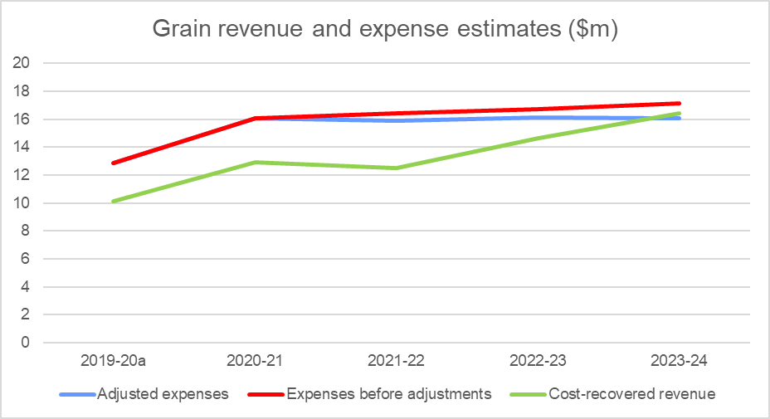
a Actuals.

Introduction

Purpose of this CRIS
This CRIS details the cost base and pricing structure for the grain export cost recovery arrangement and incorporates the impacts of the Busting Congestion for Agricultural Exporters package and the More Efficient and Sustainable Export Regulation measure announced in the 2020–21 Federal Budget.
The government is investing in modernising and reforming export regulatory services which will impact the cost base over time for all export cost recovery arrangements. Agriculture and food exporters and producers will be assisted through the modernisation and reform process with a freeze in fees and charges in 2020–21, and gradual increases from 2021–22 to 2023–24. Government has committed $71.1 million to improve the financial sustainability of export certification services by returning to full cost recovery of these services over time. A stepped return to full recovery will enable reforms to be rolled out while maintaining existing systems.
The key purpose of this CRIS is to:
- Baseline the grain export cost recovery arrangement expense for the regulatory activity against which progress of these reforms can be measured and changes transparently explained.
- Describe the freeze in fees and charges in 2020–21, and stepped increases from 2021–22 through to 2023–24.
An updated CRIS will be released for consultation in the first quarter of 2021 and updated annually. The annual CRIS will provide a summary of the previous year's financial performance, and description of deviations from forecast, provide an update of forward year cost base expectations and any consequential changes to charges required to ensure the arrangement remains financially balanced.
This methodology will provide a transparent description of the impact of the reforms and a record of changes to the cost base that will be able to be tracked over time.
This CRIS describes the impact of government decisions on charges as they were outlined in the previous 2015 CRIS. The proposed charging options and cost allocation approaches discussed in previous consultation have not been included in this CRIS – but will be considered in the next CRIS update. A subsequent CRIS update in 2021–22 will also reprofile demand for services and reflect the impact of reforms (further detail on likely changes to charging are detailed in section 2).

Path to full cost recovery
The government is freezing fees and charges for 2020–21 at current prices. From 2021–22, prices will be gradually increased to return all arrangements to full cost recovery in 2023–24.
The government is investing $71.1 million over 3 years from 2020–21 to maintain essential export regulatory services across all export cost recovered arrangements while prices are gradually increased.
This is part of a $328 million investment over 4 years from 2020–21 that also includes reforms to deliver an estimated annual cost reduction of $21.4 million from 2023–24 across all export cost recovered arrangements.
The impact of these decisions on grain export cost recovery from 2020–21 to 2023–24 is shown in Table 1. The fees and charges are notional only, illustrating the gradual increase of prices supported by the government decisions if no changes are made to the way the department charges for regulatory activity.
Changes to charging from 1 July 2021 will be described in a separate 2021–22 CRIS to be released for public consultation in the first quarter of 2021.
Table 1 Grain fees and charges 2020–21 and illustrative prices for 2021–22 to 2023–24
Charge | Unit | 2020–21 ($) | 2021–22 ($) | 2022–23 ($) | 2023–24 ($)
Charges
Establishment registration – simple | Annual | 3,000 | 2,917 | 3,426 | 3,778
Establishment registration – complex | Annual | 6,000 | 5,833 | 6,852 | 7,555
Authorised officer approval | Annual | 750 | 730 | 857 | 945
Export volume – grain and related products | Per tonne | 0.11 | 0.11 | 0.13 | 0.14
Phytosanitary certificate | Per certificate | 36 | 35 | 42 | 46
Establishment application (one-off) | Per application | 600 | 584 | 686 | 756
Fee-for-service
Core inspection | Per quarter hour | 36 | 35 | 42 | 46
Additional inspection | Per quarter hour | 75 | 59 | 69 | 76
Audit | Per quarter hour | 36 | 35 | 42 | 46
Document – electronic | Per document | 12 | 12 | 14 | 16
Document – manual | Per document | 100 | 98 | 115 | 126
Replacement certificate | Per replacement | 500 | 487 | 571 | 630
AAO application | Per application | 250 | 244 | 286 | 315
AAO approval | Per approval | 250 | 244 | 286 | 315
AAO learning and assessment | Per person delivered training | 1,750 | 1,702 | 1,999 | 2,204
Additional AAO learning and assessment | Per additional person delivered training | 2,000 | 1,562 | 1,835 | 2,023
Organicsª
Organic certifying organisation | Annual | 7,500 | 7,288 | 8,561 | 9,440
a Organic certifiers support a small number of exporters in all of the export arrangements (excluding Live Animal Exports) and therefore the expense has been reflected in each CRIS.
Note: Forward year prices shown are for illustrative purposes only. The 2021–22 CRIS will describe the changes to fees and charges for 2021–22 to 2023–24.

CRIS updates
In accordance with the Australian Government Cost Recovery Guidelines (CRGs), the grain exports CRIS will be updated annually to report on financial and non-financial performance and revised 4-year forecasts. This annual update will provide an opportunity to measure progress of the reforms as they become quantifiable and to account for any external factors, for example, projected demand for activity.
The department will also report in–year financial performance within the CRIS, periodically reporting performance against the CRIS and explaining any variances. This will provide transparency in reporting for all exporters.
There may be other significant developments warranting a broader review of the cost base or charges. These could include:
- Changes to the regulatory settings of the arrangement, for example through a government policy change or the introduction of new systems or infrastructure.
- Changes to demand for regulatory activity, for example, due to a large part of industry changing its business model or significant change in terms of trade.
Where a CRIS update reveals that the existing fee or charge structure no longer meets the financial or regulatory requirements of the arrangement, the department may propose revised fees and charges. In this circumstance, the CRIS update will be the first step in consultation on changes to prices, followed by opportunities for stakeholder engagement.
This CRIS describes the impact of the busting congestion package has on the grain export cost recovery arrangement. It does not include the price changes proposed during the 2019–20 consultations. Changes that were proposed during previous industry consultation are expected to feature again in an updated CRIS in the first quarter of 2021. These include:
- Charging a document fee for the assessment of requests to amend or resubmit documents. This charge point would allow us to recover the reasonable costs of exporters amending or re-submitting documents. By recovering these costs and ensuring that those causing this expense are appropriately charged for it, we aim to reduce re-work and incentivise exporters to submit suitably completed documents.
- Charging a single multicommodity standard audit rate across all export cost recovery arrangements to reflect the multiskilled workforce and simplify arrangements for industry.
- Introducing an export permit levy, tiered phytosanitary charge (with and without attestation) and a single export tonnage charge.
- The AO learning and assessment fee-for-service charge point currently provides access to training and assessment for up to 5 learning modules. We have considered making it payable per module of training requested by the AO. This would better recover the actual expenses from the recipient of each module of training. The additional learning and assessment charge point would be removed and the per module charge would be applied where additional learning and assessment is required.

Reforms

Busting congestion for all agricultural exporters
The Australian Government announced the Busting Congestion for Agricultural Exporters package in the 2020–21 Budget which includes reforms to slash unnecessary red tape to get products to export markets faster and support jobs in rural and remote Australia.
The package, worth over $328 million over 4 years from 2020–21, includes the following measures that are relevant to this CRIS.

Digital services to take farmers to markets
The centrepiece of the reform package is the Digital Services to Take Farmers to Markets measure, which will invest $222 million to modernise Australia’s agricultural export systems by slashing red-tape and improving regulation and service delivery for our producers and exporters. This measure will transition our systems online and provide a single portal for transactions between exporters and government, streamlining processes for exporters and helping them experience faster and more cost-effective services.

Improving regulation post-COVID-19
The Improving Regulation Post–COVID-19 measure will capitalise on new ways of working that were developed during the government's response to COVID-19.
The measure includes:
- Working with trading partners and international standard setting organisations to embed, where appropriate, alternative regulatory approaches such as technology supported auditing, and to promote wider utilisation of e-certification
- Assignment of dedicated case managers to support new agriculture exporters, including seafood, grains, dairy and NPGs, to allow them to navigate and meet regulatory requirements to get on the front foot to enter markets. Support existing exporters to expand and diversify their market opportunities by assisting them to more easily navigate export regulatory processes for example registration process ($3.7 million over 2 years).
- Capacity to develop and implement a risk based, targeted, approach to the regulation of the live animal and seafood export industries that supports compliant exporters and focuses on non-compliant operators ($2.3 million over 2 years). The initiatives will consider increased use of new technologies including for on-vessel audit. Key to the successful deployment of technology will be the collaborative development of feasible options between the department, industry bodies and individual operators.

Harmonised and streamlined plant export regulation
The measure Harmonised and streamlined plant export regulation will invest $10 million to simplify processes for plant product exports, making it easier, cheaper and quicker for plant exporters to get their produce into overseas markets. It will also harmonise regulation for plant industries and streamline plant export audit intervention, making the rules easier to navigate and more consistent. Projected cost reduction for both plant arrangements will amount to $2.6 million, over 3 years to 2023–24.

Grain arrangement cost base following reforms
These reforms are an opportunity for government and industry to work in partnership to lower the cost base of export arrangements. While possible efficiency measures have been identified, the cost reduction of these measures needs to be monitored as measures are implemented and will only be achieved with ongoing efforts from the department and industry. This will require an iterative approach to managing the cost base over the forward estimates. We will work with industry to achieve these outcomes.
Table 2 shows the cost base with and without adjustments to expense and forecast revenue for the grain arrangement and it describes:
- the cost base per the draft CRIS from the 2019–20 consultation
- adjustments to that cost base from the busting congestion package.
Table 2 Grain cost base with and without adjustments to expense and expected cost recovered revenue
Expense base | Unit | 2020–21 | 2021–22 | 2022–23 | 2023–24
Expenses – no adjustment | $ | 16,072,045 | 16,410,556 | 16,721,532 | 17,145,016
Total cost reduction from adjustments | $ | n/a | (544,223) | (583,987) | (1,090,281)
Expected expenses after adjustments | $ | 16,072,045 | 15,866,333 | 16,137,544 | 16,054,735
Revenue from cost recovered regulatory services | $ | 12,910,006 | 12,491,958 | 14,662,985 | 16,431,472
Appropriation funding | $ | 3,162,038 | 3,374,374 | 1,474,559 | n/a
Total revenues | $ | 16,072,045 | 15,866,333 | 16,137,544 | 16,431,472
Expenses less revenues | $ | – | – | – | (376,737)
Appropriation funding as % of expenses | % | 20 | 21 | 9 | n/a
n/a Not applicable.

Policy and statutory authority to cost recover
Under the Australian Government charging framework (charging framework), cost recovery requires both policy approval and statutory authority. The following sections provide information on government approval of regulatory charging for export regulatory activities and the legislation that enables the department to collect fees and charges.

Description of the regulatory activity
Plant export is regulated in accordance with the export legislative framework (see section 4.4). Plant export certification activities undertaken by the department involves inspection, audit and certification activities with respect to the export of grain and horticulture products. Grain and horticulture products specified in the legislation are:
- prescribed grain, including any seed or the following grains
  - barley, canola, chickpeas, dried field peas, fava beans, lentils, lupins, mung beans, oats, sorghum, soybeans, whole vetch, and wheat
- prescribed hay and straw
- fresh fruit and vegetables (including mushrooms and sprouts)
- other plants or plant products for which a phytosanitary certificate or any other official certificate is required by an importing country authority (e.g. timber products, nuts, nursery stock, tissue cultures, cotton and other grains and seeds not listed here).
The grain and horticulture export cost recovery arrangements are separate. Our Plant Export Operations branch undertakes export certification activities under both cost recovery arrangements.
Exporters of plants and plant products must obtain an export permit prior to the departure of prescribed goods from Australia. To certify a product’s compliance with Australia’s export requirements and the importing country requirements, we undertake a range of activities, including:
- Developing, implementing and monitoring of operational policy and systems that ensure compliance with Australian export controls and any importing country requirements. These activities serve to maintain the eligibility of commodities for export from Australia and to protect and promote Australia’s reputation for premium agricultural goods, while maintaining existing and seeking increased market access opportunities.
- Providing inspection, auditing, and enforcement activities to ensure that the production, storage, handling and transportation of grain and horticulture products intended for export comply with the conditions of the Australian export controls and any additional requirements imposed by an importing country.
- Issuing permits, phytosanitary certification, and other documentation necessary to confirm compliance with Australian export controls and any additional importing country requirements.
- Providing support through our overseas counsellors relating to detained consignments, government certification and other issues that result in goods being held at the border.
- Providing scientific and technical advice to improve, maintain or restore market access to demonstrate adherence to export requirements.
- Enforcing regulation of certified organic goods exported from Australia.
For more information, see Export goods controlled by the department.
Plant export certification occurs across both the grain and horticulture cost recovery arrangements.

Why cost recovery is appropriate
Cost recovery (regulatory charging) falls within the Australian Government’s broader charging framework. Other charges in this framework include commercial charges and resource charges. The type of charge is determined by the characteristics of the activities as described in the charging framework. This provides the overarching framework under which government entities must design, implement and review cost recovery.
Under the charging framework, regulatory charging is appropriate because plant export certification activity is provided to a clearly identifiable group – individuals and organisations that participate in the plant export supply chain.
There are additional benefits to funding export certification through regulatory charging. When a business pays for the activities it receives, the government has an obligation to justify the prices it charges. Regulatory charging also raises awareness of regulated entities of how much a regulated activity costs.
For these reasons, the government has determined regulatory charging to be the most appropriate mechanism for funding plant export certification. We have reviewed regulatory charging of plant export certification activities, consistent with the charging framework.

Government policy approval to cost recover the regulatory activity
Policy authority for regulatory charging for export certification activities was reaffirmed in the 2020–21 Budget when the government announced the Busting Congestion for Agricultural Exporters package. The package sets out a period of partial cost recovery from 2020–21 to 2023–24 before a return to full cost recovery by 2023–24, while a series of reforms to improve efficiency and lower costs are implemented.

Statutory authority to charge
Fees and levies for plant export certification are recovered under separate statutory authority.

Cost recovery fees
Section 25 of the Export Control Act 1982 provides the power to impose fees in relation to a range of export certification activities. The specific amounts are set out in the Export Control (Fees) Orders 2015.
Amendments to, or new subordinate legislation will provide for the fees detailed in this CRIS to be established. These and other delegated instruments will include descriptions of the charging points for plant export fees.

Cost recovery levies
Cost recovery levies as described in the CRGs are implemented for export certification regulatory activity through charging legislation. The following Acts, Regulations and delegated instruments will include descriptions of the charging points for plant export charges:
- Export Charges (Collection) Act 2015
- Export Charges (Imposition – Customs) Act 2015
- Export Charges (Imposition – Excise) Act 2015
- Export Charges (Imposition – General) Act 2015
- Export Charges (Imposition – Customs) Regulation 2015
- Export Charges (Imposition – General) Regulation 2015
- Export Control (Fees Order) 2015

New legislative framework
The Export Control Act 2020 commences 28 March 2021, consolidating export functions from the Export Control Act 1982 and Australian Meat and Live-stock Industry Act 1997 into a new legislative framework. The new legislative framework will be more relevant, responsive, and efficient for exporters, farmers and other primary producers. The export framework will continue to provide strong regulation, while removing duplication and ensuring consistency across commodities where possible. The new legislation supports existing policy, while providing flexibility for different approaches to the regulation of exports in the future.
No changes to the cost base have been identified at this time arising from the implementation of the new legislative framework, but changes to our regulatory approach could affect cost-recovery. Any impacts will be reviewed when or if changes are implemented.

Cost recovery model

Outputs and business processes of the regulatory charging activity
The key policy objectives for our cost recovery arrangements are to:
- safeguard Australia’s animal and plant health status, to maintain overseas markets and protect the economy and environment from the impact of exotic pests and diseases. This will be achieved through risk assessment, inspection and certification, and the implementation of emergency response arrangements for Australian agricultural, food and fibre industries.
- Support more sustainable, productive, internationally competitive, and profitable Australian agricultural, food and fibre industries through policies and initiatives that promote better resource management practices, innovation, self-reliance and improved market access.
Our cost recovery arrangements describe how we use resources (such as people, IT, property and equipment) to undertake business processes (regulatory activities), which enable us to provide the outputs that meet our policy objectives (Figure 2).
Figure 2 Outputs and business processes of our regulatory charging activity
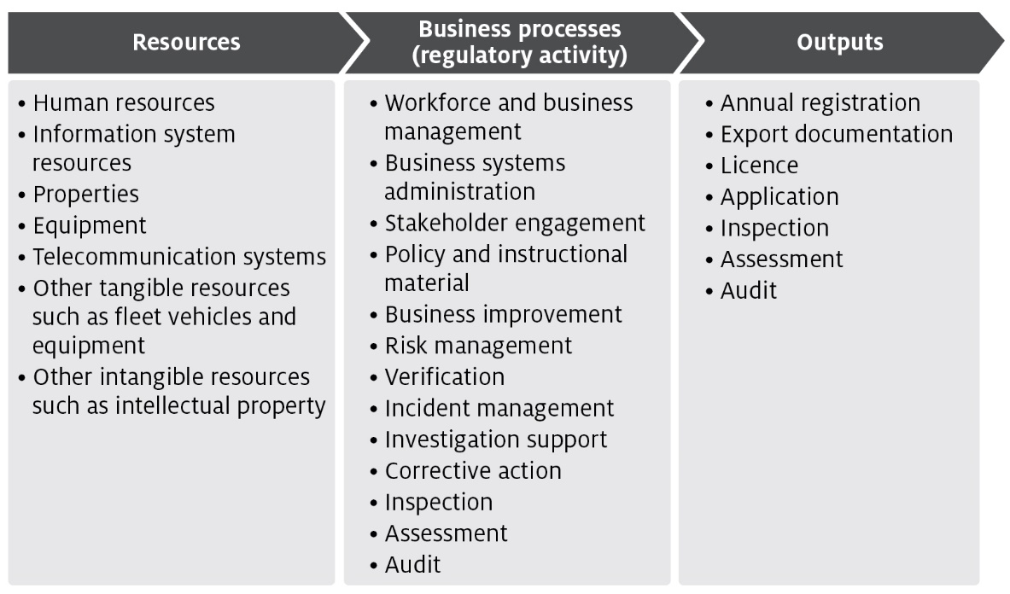
The processes listed in Figure 2 are described in Appendix A and are grouped into 4 categories of activities:
- Program management and administration – administrative activities that support and deliver our export certification commitments.
- Assurance – activities that mitigate risks to collective user groups by assessing departmental controls of systems and processes to ensure they operate in accordance with their intended design.
- Incident management – activities that respond to incidents concerning alleged breaches of Australian regulation or international import conditions.
- Intervention – activities provided directly to an individual, business or organisation to meet export certification requirements.

Costs of regulatory charging activity

Cost allocation process
To determine the cost of regulatory activities, we use an activity-based costing (ABC) system. The ABC cost allocation methodology reflects costs incurred through usage of regulatory activities. This provides a transparent allocation of costs that is also efficient and effective to administer.
The 2 expense categories are:
- Direct expenses – these can be directly attributed to the provision of an activity, for example, inspections. They comprise of staff salaries and supplier costs including direct capital expenses.
- Indirect expenses – these are not directly linked to an activity provided by us. Indirect expenses include corporate employee salaries and overheads such as information technology, finance, human resources costs, and indirect capital expenses.
The cost allocation process apportions the costs of support functions (indirect expense) and direct expense to the processes/activities defined in Appendix A. We include indirect expenses in the cost base to reflect the systems and processes that exist to help with efficient administration, which the cost-recovered arrangements benefit from. This is the same methodology employed for allocation of indirect costs to appropriated activities, in line with our cost allocation policy.
The ABC system allocates costs in a staged approach:
- Indirect costs such as property, finance, information technology, human resources and divisional executives are allocated to direct cost centres using a cost driver which estimates the relative usage of each of the corporate services. Cost drivers for corporate services include:
  - Workpoints – distributes costs based on space occupied, with the workpoint count reflecting the space where a person may be able to work.
  - FTE – distributes costs based on each programme's full-time equivalent staff numbers.
  - PC count/IT assets – distributes costs based on the number of IT assets in a program.
  - Transactions – distributes costs based on the number of transactions incurred over a period. This driver is used to allocate expenses related to the functions of accounts receivable and accounts payable.
  - Headcount – allocates costs based on the number of staff that a program area has as a proportion of the number of staff that are on the department’s total staff.
  - Custom drivers – allocate costs to specific cost centres, primarily based on usage for shared program resources.
- Cost drivers are reviewed on an annual basis, or as required. Changes to cost drivers are substantiated through effort or other data.
- Direct costs (including the indirect costs allocated in step 1) are allocated to the activity and cost-recovered arrangements that best reflects the activity undertaken. Time recording systems allow the accurate allocation of effort to specific activities and arrangements, particularly to intervention activities.
- The primary variable used in the allocation of costs to activities is effort. As a result, cost estimates vary with changes in activity. If actual activity levels change during a financial year, the costs allocated to arrangements would require adjustment to align with that effort. We monitor this throughout the year and adjust where necessary.
- For example, auditors undertake audits across multiple arrangements. We forecast the number of audits and average time for an audit for each arrangement. The associated costs are allocated to the arrangements and audit function based on total audit hours.
- Activity/arrangement costs (from step 2) are allocated to charge points which identify the cost associated with that charge. We use a combination of cost recovery fees and charges. Figure 2 shows how we categorise cost-recovered levy and fee activities and outputs.
Figure 3 Categories of activities
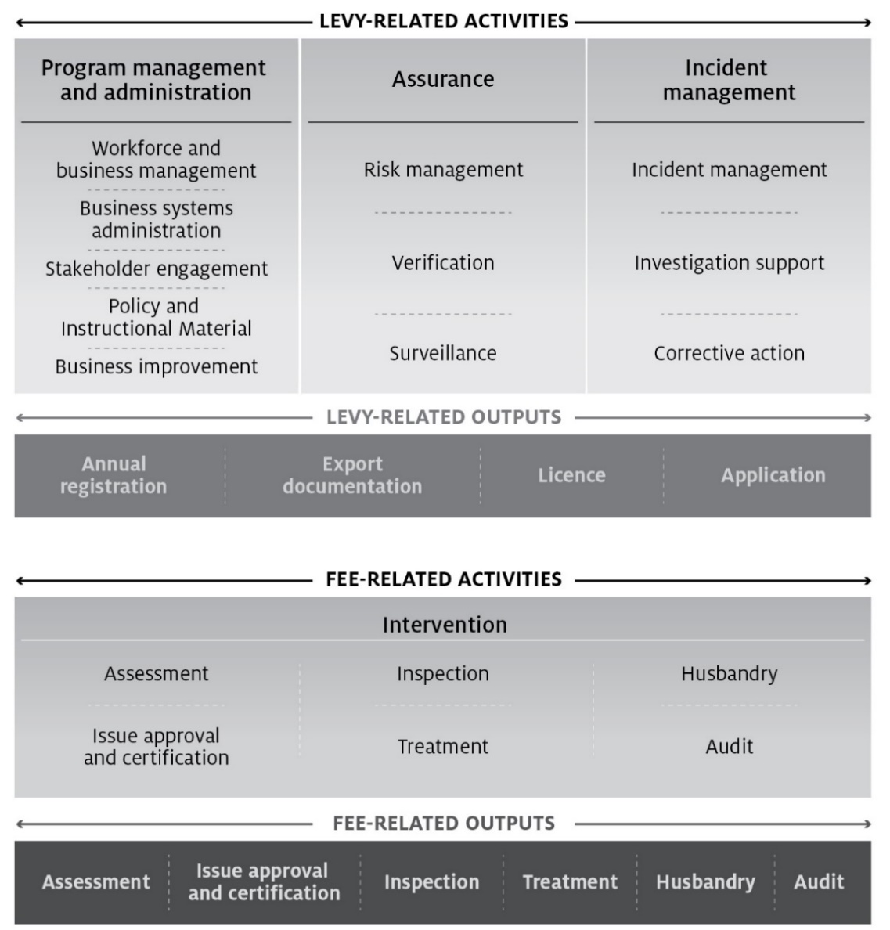

Stakeholder engagement
Stakeholder engagement plays an important role in the development and management of cost recovery arrangements. Our stakeholders have a unique insight into how our regulatory activities impact on their business and help us design efficient cost recovery frameworks for these activities.
This CRIS explains the decisions taken by government and financial outcomes of the measures in the busting congestion package. No changes to fees and charges apply in 2020–21. However, we note you may want to make comment in relation to this CRIS. If you are interested, we ask that you register your interest to participate in our upcoming consultation and in receiving further information and invites to future opportunities to engage.
You are also welcome to make comments on our Have Your Say page. Any comments you make will be addressed as part of the consultation process scheduled to take place in early 2021 on the proposed 2021–22 CRIS.
Stakeholder engagement on the development and implementation of reforms from 2021–22 to 2023–24 will take place over the course of the annual CRIS update cycle, beginning in February 2021. For further information on the package see Busting Congestion for Agricultural Exporters.

Industry engagement
The department has been reviewing the CRIS since 2018–19 including public consultation on a draft in 2019–20. The department has established industry consultative committees to represent industry views in relation to plant exports and we consult with these committees on a number of different activities. In developing this CRIS, we have consulted with the Grain and Plant Products Industry Consultative Committee (GPPEICC) through its subcommittee, the Grain Export Cost Recovery Charging Committee
Throughout the development of this CRIS, we have given the GPPEICC information about:
- the cost base
- the volume of activities
- the proposed fee and charge structure
- the proposed rates of the fees and charges.
We consulted widely on the development of a draft CRIS during 2019–20, including through engagement with key stakeholders, a public submission process and face-to-face meetings with stakeholders. For a detailed summary of Grain stakeholder feedback see Appendix B.
In addition to feedback from industry, the department also commissioned an independent review of the efficiency and effectiveness of the department’s delivery of export regulatory services. The independent review and the department’s response have now been finalised and are available at Independent review of the cost of export certification. The independent review was largely conducted as a survey of both internal and external stakeholders.
The independent review was delivered to the department in March 2020. The review found the department’s staff to be committed and passionate, working diligently to achieve positive outcomes for industry. It also found that external stakeholders were somewhat satisfied with the department’s services and that overarching export market and legislative objectives were often met. A range of recommendations were made to improve efficiency and effectiveness, with each requiring an investment of resources, effort, funding and time to fully implement.
Key messages from stakeholders and the review were:
- Industry wants the department to work to create efficiencies to lower costs.
- Antiquated systems were impeding efficient processing of export consignments.
- The department needed to focus on improvements while still delivering routine regulatory activities.
- Smaller exporters are finding it difficult to enter and compete on the global market without assistance from the government.
- Industry predict increases could cause significant hardships for producers and exporters who are recovering from a period of severe drought and natural disasters.
- If prices need to rise, they should do so in a stepped way, to prevent shocks to business.
Since release of the draft CRIS for public consultation in October 2019, the new Department of Agriculture, Water and the Environment was created in February 2020 through a machinery of government change. As part of this change the department undertook an internal ‘Future Department Review’ to identify how to maximise the capability of the new department and fully realise the opportunities it presents. A subsequent change process is now underway.

Grain and seed export stakeholder engagement
The grains industry consultation was undertaken through the GPPEICC and public consultation. Key topics covered through the consultation process included the arrangement’s past financial performance (including drivers of key variances), cost base, volumes, the proposed charging structures, pricing principles and price options.

Cost base and charging structure
In consultative meetings with the department, grains industry representatives proposed the view that efficiencies from capital projects underway such as the Plant Export Management System (PEMS) need to be included in the cost base. Industry encouraged the department to forecast efficiencies through a reduction in cost stating that it creates accountability for the department to realise and reflect efficiency gains in its cost recovery arrangements.
Many grains exporters did not support the proposed price increases because they are higher than anticipated, particularly in the levy cost pool. Industry representatives have indicated that this level of price increase would not be palatable to their members and would be looking to take further representations on this point to government.
Consultation with grain export industry members have raised concerns over the department’s rationale for charging per learning module for authorised officer (AO) learning and assessment which may act as a disincentive to some AOs who may be priced out of the program and lead to increased departmental inspection requirements.

Use of remissions
Grains members noted the approach to the charging structure but questioned how the remissions would be applied. We noted our obligations under the CRGs to align revenue with expense and that it could be providing remissions to the modelled price in each year. Industry asked the department to act quickly to apply remissions where over-recoveries occur, to maximise remissions being given to those who contributed to the over-recovery.

Cost recovery arrangement for grain and seed exports
This section describes the grain export cost recovery arrangement cost base as well as additional financial information associated with audit, inspection and certification activities for grain exports.

Design of cost-recovered charges
There are no changes to the existing grain cost recovery charging structure in this CRIS. We will consult on any adjustments to the charging structure in a revised CRIS prior to implementing updated fees and charges from 1 July 2021.

Cost base
Table 3 shows the grain arrangement cost base for 2020–21. See Table 4 for an overview by cost type for 2020–21.
For a detailed description of cost activities, see Appendix A. The methodology for attributing costs to these activities is provided in section 5.

Cost base assumptions
The cost base has been modelled to reflect the full costs of the arrangements. Partial cost recovery levels are displayed in the tables dealing with financial performance and fees and charges. The 2018–19 budget has been used as the starting point for determining the cost base in this CRIS. To project the cost base over the next 4 years, we have applied adjustments to capture expected changes to the costs including:
- inflation of 1.65% per annum, in line with the Department of Finance’s inflation estimate
- increases in employee expenses of 2% per annum, reflecting reasonable estimates of wage increments in line with the Australian Public Service Workplace Bargaining Policy 2018
- additional depreciation from new assets anticipated to be recognised over the period
- adjustments for future fee-related activities to reflect expected changes in volume.

Projected cost base
The cost base for 2020–21 for the grain export cost recovery arrangement is $16,072,045 (Table 3), made up of:
- $11.532 million in levy-related activities
- $4.540 million in fee-related activities.
Table 3 Cost base for grain export cost recovery arrangement, 2020–21
Charge type | Activity group | Activity | Expense ($) | Cost recovery charge
Levy | Program management and administration | Workforce and business administration | 11,532,396 | Annual registration, export documentation, throughput, application and organic certification
 |  | Business system administration
 |  | Stakeholder engagement
 |  | Policy and instructional material
 |  | Business improvement
 | Assurance | Risk management
 |  | Verification
 |  | Surveillance
 | Incident management | Incident management
 |  | Investigative support
 |  | Corrective action
Fee for service | Intervention | Assessment | 2,243,982 | Assessment
 |  | Inspection | 815,738 | Inspection
 |  | Audit | 1,479,928 | Audit
Total cost base |  |  | 16,072,045 | –
Table 4 provides a breakdown of direct and indirect costs for the grain export cost recovery arrangement in 2020–21.
Table 4 Cost type breakdown for grain export cost recovery arrangement, 2020–21
Expenses | Forecast ($)
Direct | 11,033,739
Employee | 9,311,479
Operating | 1,415,679
Other | 306,581
Indirect | 5,038,305
Assurance and Legal | 336,291
Corporate Strategy and Governance | 588,987
Finance & Business Support | 799,962
Information Services | 1,934,235
Property | 1,378,830
Total | 16,072,045
For more information on how expenses are allocated see section 5.

Changes to the cost base
Adjustments to the grain export cost recovery arrangement include additional inflation and depreciation expenses, and the expanded cost recovery activities announced in the 2018–19 Budget and implemented from 1 July 2019.
The new government policy provided authority to additional cost recovery regulatory activities including enforcement, scientific and technical advice, and support for detained consignments which increased the cost base by $1.032 million indexed annually from 1 July 2019.
We will apply Levy charges will recover:
- enforcement activities that are directly related to our regulatory function of ensuring industry compliance with international import conditions ($0.429 million indexed annually from 1 July 2019)
- scientific and technical advice related to supporting industry to improve, maintain or restore market access ($0.514 million indexed annually from 1 July 2019)
- the cost of our overseas counsellor network assisting industry to meet export requirements for detained consignments or during trade disruptions ($0.088 million indexed annually from 1 July 2019).
In line with the government’s CRGs and the department’s cost allocation policy, inflation and depreciation expenses have been adjusted in the cost base to reflect increased employee and supplier expenses in line with the Australian Public Service Workplace Bargaining Policy 2018 and government inflation estimates. Cost recovery of these activities is considered appropriate because industry directly benefits from having a system in place that allows the department to manage and respond to market access issues, including ensuring compliance with overseas country requirements.
A significant change in the cost base is a reduction of $1.8 million. This largely reflects decreased demand for departmental inspection activities associated with grain export certification because of industry uptake of the Authorised Officer Program.
Table 5 outlines the changes to the forecast cost base for 2019–20 and Table 6 for 2020–21.
Table 5 Changes to cost base for grain exports, 2019–20
Adjustment to cost base | Impact on cost base | Unit | Forecast
Total baseline expense | n/a | $ | 16,046,851
- Enforcement | Increase | $ | 429,122
- Scientific and technical advice | Increase | $ | 514,025
- Detained consignments | Increase | $ | 88,684
- Depreciation expenses | Increase | $ | 278,529
- Inflation | Increase | $ | 289,567
- Net Impact of other changes | Decrease | $ | (1,809,435)
Total adjustments to cost base | Decrease | $ | (209,508)
Adjusted cost base | n/a | $ | 15,837,343
Change in expense | Decrease | % | (1.3)
n/a Not applicable.
Table 6 Changes to cost base for grain exports, 2020–21
Adjustment to cost base | Impact on cost base | Unit | Forecast
Total baseline expense | n/a | $ | 15,837,343
Inflation and other changes | Increase | $ | 234,702
Adjusted cost base | n/a | $ | 16,072,045
Change in expense | Increase | % | 1.5
n/a Not applicable.
As part of the charging review, the department has considered a number of additional reforms. These reforms have not been included in the cost base because their financial impact cannot be quantified at this point.

New export control legislation
As noted at section 4.4.3, the Export Control Act 2020 commences 28 March 2021, consolidating export functions from the Export Control Act 1982 into a new legislative framework. No changes to the cost base have been identified at this time as a result of the implementation of the new legislative framework, but changes to our regulatory approach could affect cost recovery. Any impacts will be reviewed when /or if changes are implemented.

Financial estimates
A summary of the annual budgeted operating position for the grain export cost recovery arrangement is provided in section 9. All cost-recovered activities are subject to a detailed semi-annual review as part of departmental budgeting processes.

Grain export fees and charges
The amount payable for 2020–21 is shown in Table 7. Forward year prices have not been included and will be provided in the 2021–22 CRIS.
Table 7 Fees, charges and volumes for grain export cost recovery arrangement, 2020–21
Type of charge | Cost recovery charges | Unit | Price ($) | Estimated volume (units) | Estimated total revenue ($)
Levies | Establishment registration – simple | Annual | 3,000 | 544 | 1,632,000
 | Establishment registration – complex | Annual | 6,000 | 17 | 102,000
 | Authorised officer approval | Annual | 750 | 1,092 | 819,000
 | Export volume – grain and related products rate | Per tonne (or part thereof) | 0.11 | 44,582,873 | 4,904,116
 | Phytosanitary certificate | Per certificate | 36 | 60,464 | 2,176,704
 | Establishment application (one-off) | Per application | 600 | 26 | 15,600
Fees – audit and inspection | Inspection | Per quarter hour | 36 | 10,594 | 381,384
 | Additional inspection | Per quarter hour | 75 | – | –
 | Audit | Per quarter hour | 36 | 25,516 | 918,576
Fees – documentation | Document electronic | Per document | 12 | 109,523 | 1,314,276
 | Manual document | Per document | 100 | 1 | 100
 | Replacement certificate | Per replacement | 500 | 45 | 22,500
Fees – Authorised Officer (AO) | AO application fee | Per application | 250 | 219 | 54,750
 | AO approval | Per approval | 250 | 650 | 162,500
 | AO learning and assessment | Per person delivered training | 1,750 | 228 | 399,000
 | Additional AO learning and assessment | Per person delivered additional training | 2,000 | – | –
Organics | Organic certifying organisation | Annual | 7,500 | 1 | 7,500
Total | 12,910,006
a Organic certifiers support a small number of exporters in all of the export arrangements (excluding Live Animal Exports) and therefore the expense has been reflected in each CRIS.
Note: Note: Prices have been rounded. The annual charge will be rounded upwards to the nearest dollar, with the exception of throughput, which will be rounded upwards to the nearest cent.

Financial estimates
Table 8 shows the financial performance of the grain export cost recovery arrangement.
There will be no change to the cost recovery reserve for the duration of the busting congestion package. The reserve deficit will be carried forward until a government decision is taken to address it.
Table 8 Financial estimates for grain export cost recovery arrangement
Finance element | 2020–21 ($) | 2021–22 ($) | 2022–23 ($) | 2023–24 ($)
Revenue = X | 12,910,006 | 12,491,958 | 14,662,985 | 16,431,472
Expenses = Y | 16,072,045 | 15,866,333 | 16,137,544 | 16,054,735
Balance = X – Y | (3,162,038) | (3,374,374) | (1,474,559) | 376,737
Appropriation funding | 3,162,038 | 3,374,374 | 1,474,559 | n/a
Balance after appropriation | 0 | 0 | 0 | 376,737
Forecast opening cost recovery reserve balance | (1,214,549) | (1,214,549) | (1,214,549) | (1,214,549)
Transfer | 0 | 0 | 0 | 376,737
Forecast closing cost recovery reserve balance | (1,214,549) | (1,214,549) | (1,214,549) | (837,812)
n/a Not applicable.

Financial and non-financial performance
Both the ANAO report and the independent review made recommendations about improving our performance reporting. The department is committed to consulting with industry stakeholders on performance indicators to assist in evaluating the performance of our regulatory arrangements. We will use the benchmarking framework provided by the independent review to engage with industry on development of financial and non-financial Key Performance Indicators (KPIs).

Financial performance
This section presents information on the financial and non-financial performance of the grain export cost recovery arrangement. This is intended to provide stakeholders with an overview of our performance in recovering forecasted costs and meeting regulatory objectives.
The financial performance for the grain cost recovery arrangement is provided in Table 9.
Table 9 Financial performance for grain export cost recovery arrangement, 2015–16 to 2020–21
Finance element | 2015–16 ($) | 2016–17 ($) | 2017–18 ($) | 2018–19 ($) | 2019–20 ($) | 2020–21 ($)
Revenue = X | 16,223,705 | 24,305,568 | 15,128,807 | 11,641,099 | 10,110,020 | Update in 2021
Expenses = Y | 19,237,847 | 17,677,644 | 17,353,875 | 14,337,997 | 12,848,167 | Update in 2021
Balance = X – Y | (3,014,142) | 6,627,924 | (2,225,068) | (2,696,898) | (2,738,147) | Update in 2021
Remissions, Rebates & Adjustments = Z | 24,461 | (77,861) | (290,495 | n/a | n/a | Update in 2021
Net Balance = Balance + Z | (2,989,681) | 6,550,063 | (2,515,563) | (2,696,898) | (2,738,147) | Update in 2021
Cost Recovery Reserve Balance | 185,996 | 6,736,059 | 4,220,496 | 1,523,598 | (1,214,549) | Update in 2021
n/a Not applicable.
Note: Annual revenue has varied due to climate conditions, which resulted in favourable crop returns in 2016–17 and poor returns in 2018–19. Inspection revenue continues to reduce as industry increases their use of third-party authorised officer to undertake inspections under the Authorised Officer program. This has decreased the inspection capability and capacity required to be maintained in the department, which has reduced the cost of grain inspection allocated to the arrangement. This has been partly offset by increased spending in program management and administration, including information services costs associated with our service delivery modernisation program, corporate costs and property costs. From 1 July 2019, 1.032 million for regulatory activities for enforcement, scientific and technical advice and detained consignments was added to the arrangement indexed and ongoing.

Key dates and events
We undertake regular reviews of our financial performance and conducts regular stakeholder engagement activities throughout the CRIS cycle. Key forward dates for regulatory charging for grain export certification activities are documented in Table 10.
Table 10 Key forward dates and events
Key forward events schedule | Next scheduled update
Annual CRIS update to forward estimates | February 2021
Updated fees and charges implemented | 1 July 2021
Annual CRIS updates to financial and non-financial performance for 2020–21 | October 2021
Annual CRIS update to forward estimates | February 2022
Updated fees and charges implemented | 1 July 2022
Annual CRIS updates to financial and non-financial performance for 2021–22 | October 2022
Portfolio charging review to be undertaken | 2023
Annual CRIS update to forward estimates | February 2023
Updated fees and charges implemented | 1 July 2023
Annual CRIS updates to financial and non-financial performance for 2022–23 | October 2023
Portfolio charging review outcomes to be brought forward in Budget | 2024–25

Appendix A: Description of cost model activities
This section provides details of the cost model activities undertaken in the departments cost recovery arrangements.

Program management and administration activities

Workforce and business management
This activity comprises 4 categories:
- Workforce management activities include staff supervision, allocating workforce resources, managing employee performance, leave, training and other conditions, managing Work, Health and Safety requirements, recruitment and termination.
- Business management activities include business planning and continuity; requesting legal advice; procurement and contracts; program and project administration, assurance, design and management; management of fixtures, facilities, equipment, supplies and logistics.
- Financial management activities include billing and accounting, budgeting, charges and payments, collections and receivables, debt management, financial accounts, reporting and policy development.
- Information management activities include data management, information and records management, and information sharing and collaboration.

Business systems administration
Includes developing, acquiring, testing, implementing and supporting applications and business systems. It encompasses technical support and maintenance of all business systems including information and communications technology.

Stakeholder engagement
Involves proactive engagement with any person, business, or organisation including any associated travel. This includes, engaging with peak industry bodies, secretariat support and attendance at industry consultative committee meetings, consultation on new standards and requirements, publishing website content and other information.

Policy and instructional material
Includes developing, maintaining and communicating the department’s policy and instructional material, such as operational and corporate policies, scientific advice, departmental guidelines and work instructions, and associated training development and delivery. Examples include responding to changes in importing country requirements developing or revising policy processes and instructional material.

Business improvement
Includes assessment, monitoring and development of initiatives to improve performance. Examples include adjustments to improve program and service delivery, business performance reports against KPIs and similar activities.

Assurance activities

Risk management
Involves assessing and managing the risks posed to Australia’s ability to maintain market access. This includes communicating results of risk analysis, modelling and forecasting to operational areas and the collection, receipt and use of reliable compliance data to meet the department’s compliance objectives. This work also includes any associated travel and client assistance work.

Verification
Includes assurance activities to provide stakeholders and the departmental executive with confidence that departmental controls of its systems and processes are operating in accordance with their intended design and associated documentation. This includes assurance activities provided to trading partners.

Surveillance
Includes formal and informal monitoring to detect issues that may affect onshore production for export, such as changes in Australia’s pest or disease status or food safety concerns. Surveillance differs from an inspection because it is not done for a specific client.

Incident management activities

Incident management
The coordination and management of any incident, including post-border detection and export incidents. This includes all associated preparatory work and post work, travel and client assistance in relation to an incident.

Investigation Support
Involves providing support for enforcement activities relating to an alleged breach of portfolio legislation, including any related client assistance and travel. This also includes enforcement activities that ensure compliance with Australian regulation and international import conditions such as investigations and engagement with clients about compliance.

Corrective action
Includes actions taken in response to non-compliance or contravention of legislation that is not required to be reported to enforcement officers. Corrective action activities includes all preparatory work and post work, travel and client assistance in relation to the enforcement process.

Intervention activities

Assessment
Involves assessing information to determine if it meets Australian standards and legislation, international conventions and importing country conditions. This includes all preparatory work (such as confirming importing country or export requirements) and post work (such as assessment report preparation), travel and client assistance in relation to the assessment. Examples include assessments of licenses, permits, registrations or accreditations.

Issue approvals and certification
Includes issuing of a decision in relation to an assessment for cargo, vessels, plants, animals, food, biological and genetic material. This includes the work from the end of the assessment period to the completion of the decision notification process to support issuance of appropriate export documentation.

Inspection
Involves the physical examination and supervision of an export consignment of plants or plant products to determine compliance with Australian standards and legislation, international conventions and importing country conditions.

Treatments
Includes the physical treatment of cargo, vessels, plants, animals, food, biological and genetic material, other conveyances or premises to prevent an adverse biosecurity outcome from occurring and to meet relevant importing country requirements.

Husbandry
Includes activities relating to the care of plants and animals that the department is responsible for, including transport of plants and animals, housing, daily monitoring, feeding, cleaning of facilities, administering of medication, bookings and client assistance.

Audit
Includes the systematic and functionally independent examination of industry systems and processes to determine whether activities and related results comply with legislative or documented requirements. This includes all preparatory work and post work, travel and client assistance in relation to the audit.

Appendix B: Summary of grain and seed export stakeholder feedback from 2019–20 consultation
Consultation on the draft CRIS involved engagement with industry consultative committees and targeted discussions with industry stakeholders. A draft CRIS was released in October 2019 for public consultation and submissions closed in January 2020. During this period the department received 69 submissions across all export cost recovery arrangements and held 13 face to face or teleconference meetings.
Key theme | Department response
- Introduction of efficiency dividend to offset cost increase  Industry cannot continue to absorb increased costs without efficiency gains and/or improved services. | During consultation on developing revised charges, industry have requested the introduction of an efficiency dividend. Following this feedback, the department is assessing if and how a productivity measure could be included in this CRIS review. Further details will be discussed with the industry consultative committee after the department has finalised its assessment.
- Greater transparency and clarification requested  This CRIS does not address industry’s call for greater transparency and clarification especially in indirect costs. Improved performance metrics on the overall cost base and each key charge are necessary to justify increases. Benchmarking against other export programs and government departments would provide greater transparency of overall costs. | We will be making improvements to increase the transparency of the CRIS in the future based on stakeholder feedback as well as the independent review. This may include a benchmarking framework and cost object diagram.
- Impact of drought and maintaining AO workforce number  The fixed costs are difficult to wear when the products that we rely on for export are heavily impacted by drought. The arrangement of employing and providing AOs is inequitable and unsustainable in the current environment. Due to the drought, there is a need to maintain enough AOs to meet future demand. The department should explore options to provide incentives to maintain the AO workforce numbers. | The significance of our market access work can be seen by comparing our experience during this drought and the worst years of the Millennium Drought. When prices collapsed, producers rushed the saleyards and there was enormous commercial damage. This time, with greater access to markets, that has so far not eventuated. This is a great turnaround in a decade and an indication of the greater commercial strength and resilience of the sector.  The department notes the feedback and will engage with industry to discuss options to support the AO workforce during difficult circumstances.
- Negative impact on small exporters  The CRIS will have a negative impact on small exporters because certification costs are prohibitive to small exporters entering new markets. The government should consider a transition period of lower costs for small exporters while they establish and grow their business. | The busting congestion package will provide a transition full cost recovery for all exporters.  The base level of effort required to provide regulatory activity to small and emerging exporters is the same as provided to others and our registration charges reflect this. Tonnage charges are used to ensure that the additional regulatory effort associated with larger scale export operations is reflected.

Glossary
Term | Definition
Activity | Any measurable work undertaken by the department to enable export of goods. This includes activities, business processes and outputs as described in the Australian Government Cost Recovery Guidelines (CRGs).
Authorised officers | Specially trained individuals who are appointed to perform specific export inspection functions in accordance with Australian export legislation.
Charge | In the CRGs, charges are referred to as cost recovery levies. A charge is imposed when activities are provided to a group of individuals or organisations (e.g., an industry sector) rather than to a specific individual or organisation. A charge is legally a taxation charge and needs to be imposed in a separate taxation Act to comply with constitutional requirements. A charge differs from general taxation, as it is earmarked to fund activities provided to the group being charged.
Cost recovery arrangement | Describes the management, delivery and the cost recovery of activities for a defined group of clients.
Export document | Can refer to permits, certificates, or any other document issued or certified under the Export Control Act 1982 and may be issued in paper form or electronically.
Fee | A charge imposed when activities are provided directly to a specific individual or organisation. In the CRGs, fees are referred to as cost recovery fees.
Prescribed goods | Goods, or goods included in a class of goods, that are declared by the regulations to be prescribed goods for the purposes of the Export Control Act.  At time of drafting, the following are declared to be prescribed goods for the definition of prescribed goods in section 3 of the Act:  a) prescribed grain  b) hay and straw  c) fresh fruit  d) fresh vegetables  e) plants or plant products for which a phytosanitary certificate or any other official certificate is required by an importing country authority.

