Cost recovery implementation statement: horticulture exports 2020–21

© Commonwealth of Australia 2021
Ownership of intellectual property rights
Unless otherwise noted, copyright (and any other intellectual property rights) in this publication is owned by the Commonwealth of Australia (referred to as the Commonwealth).
Creative Commons licence
All material in this publication is licensed under a Creative Commons Attribution 4.0 International Licence except content supplied by third parties, logos and the Commonwealth Coat of Arms.
Inquiries about the licence and any use of this document should be emailed to copyright@agriculture.gov.au.

Cataloguing data
This publication (and any material sourced from it) should be attributed as: DAWE 2021, Cost recovery implementation statement: horticulture exports 2020–21, Department of Agriculture, Water and the Environment, Canberra, January. CC BY 4.0.
ISBN 978-1-76003-372-9
This publication is available at haveyoursay.agriculture.gov.au/export-cost-recovery-implementation-statements.
Department of Agriculture, Water and the Environment
GPO Box 858 Canberra ACT 2601
Telephone 1800 900 090
Web awe.gov.au
The Australian Government acting through the Department of Agriculture, Water and the Environment has exercised due care and skill in preparing and compiling the information and data in this publication. Notwithstanding, the department, its employees and advisers disclaim all liability, including liability for negligence and for any loss, damage, injury, expense or cost incurred by any person as a result of accessing, using or relying on any of the information or data in this publication to the maximum extent permitted by law.

Contents
Summary v
Government decision – busting congestion for agricultural exporters v
CRIS consultation v
Reforms to improve the efficiency and effectiveness of export regulation v
1 Introduction 1
1.1 Purpose of this CRIS 1
1.2 Path to full cost recovery 1
2 CRIS updates 4
3 Reforms 5
3.1 Busting congestion for all agricultural exporters 5
3.2 Horticulture arrangement cost base following reforms 6
4 Policy and statutory authority to cost recover 7
4.1 Description of the regulatory activity 7
4.2 Why cost recovery is appropriate 8
4.3 Government policy approval to cost recover the regulatory activity 8
4.4 Statutory authority to charge 8
5 Cost recovery model 10
5.1 Outputs and business processes of the regulatory charging activity 10
5.2 Costs of regulatory charging activity 11
6 Stakeholder engagement 13
6.1 Industry engagement 13
7 Cost recovery arrangement for horticulture exports 16
7.1 Design of cost-recovered charges 16
7.2 Cost base 16
7.3 New export control legislation 19
7.4 Financial estimates 19
7.5 Horticulture export fees and charges 19
8 Financial estimates 21
9 Financial and non-financial performance 22
9.1 Financial performance 22
10 Key dates and events 23
Appendix A: Description of cost model activities 24
Program management and administration activities 24
Assurance activities 25
Incident management activities 25
Intervention activities 25
Appendix B: Summary of horticulture export stakeholder feedback from 2019–20 consultation 27
Glossary 30

Tables
Table 1 Horticulture fees and charges for 2020–21 and illustrative prices for 2020-22 to 2023–24 2
Table 2 Horticulture cost base with and without adjustments to expense and expected cost recovered revenue 6
Table 3 Cost base for horticulture export cost recovery arrangement, 2020–21 17
Table 4 Cost type breakdown for horticulture export cost recovery arrangement, 2020–21 17
Table 5 Changes to cost base for horticulture exports, 2019–20 18
Table 6 Changes to cost base for horticulture exports, 2020–21 19
Table 7 Fees, charges and volumes for horticulture export cost recovery arrangement, 2020–21 19
Table 8 Financial estimates for horticulture export cost recovery arrangement 21
Table 9 Financial performance for horticulture export cost recovery arrangement, 2015–16 to 2020–21 22
Table 10 Key forward dates and events 23

Figures
Figure 1 Horticulture revenues and expenses vi
Figure 2 Outputs and business processes of our regulatory charging activity 10
Figure 3 Categories of activities 12

Summary
This cost recovery implementation statement (CRIS) describes how the Department of Agriculture, Water and the Environment will:
- recover the costs of providing regulatory services to the horticulture industry in 2020–21
- implement the government’s decision to freeze fees and charges in the 2020–21 financial year
- implement the government’s decision to return export cost recovery arrangements to full cost recovery by 2023–24.

Government decision – busting congestion for agricultural exporters
On 6 October 2020 the government announced its decision to freeze regulatory fees and charges in 2020–21 for exporters and then gradually return to full cost recovery by 2023–24. The announcement was part of the Busting Congestion for Agricultural Exporters package. This package also includes a series of reform projects and a significant IT investment measure.
In practical terms, the decision will result in fees and charges remaining at their current levels in 2020–21, with stepped increases from 2021–22 to 2023–24, to enable the horticulture export cost recovery arrangement to fully recover the cost of delivering the regulatory activity.

CRIS consultation
The department had previously flagged a number of changes to the horticulture export CRIS through an ongoing consultation process with impacted horticulture export supply chain participants. As a result of this consultation and industry feedback, a number of changes to fees and charges, both in terms of charge points and charge amount, will be progressively made from 1 July 2021. We will consult with industry on these proposed changes during the first quarter of 2021.
This 2020–21 CRIS therefore describes the decision of government to freeze fees and charges. A separate 2021-22 CRIS, outlining proposed changes from 1 July 2021 will be released for consultation in the first quarter of 2021.

Reforms to improve the efficiency and effectiveness of export regulation
On 6 October 2020, the Australian Government announced a $328 million investment to modernise Australia’s export systems over 4 years.
The centrepiece of the package is a $222.2 million plan to upgrade the ICT that underpins our export system. The package also includes a number of other measures that will streamline and simplify our business and make the essential export services that we provide more efficient and sustainable for the future. This marks a significant opportunity for our department to transform our business processes to become digitally preferred.
These investments, both in ICT and in improvements to our business processes are aimed at making the export horticulture system more effective and efficient. The outcomes of this work are expected to reduce the overall cost of delivering regulatory services to the horticulture export industry, in addition to providing regulated entities the opportunity to reduce their interaction costs incurred in dealing with the department on regulatory matters. Changes in the department's cost of delivering regulatory activities will be reflected in the cost recovery arrangement.
When the department commenced consultation on cost recovery in 2018–19, the projected total cost of all export cost recovered arrangements in 2023–24 was $163 million. The direct impact of the reforms that are currently planned are estimated to reduce this future cost to $142 million across all export cost recovered arrangements. This equates to a $21 million reduction in costs.
Figure 1 shows the expected savings from adjustments to expense for the horticulture export cost recovery arrangement. When the department commenced consultation on cost recovery in 2018–19, the projected total cost of the horticulture export cost recovery arrangement in 2023–24 was $13.7. The direct impact of the reforms that are currently planned are estimated to reduce this future cost by $1.3 million to $12.4 million by 2023–24.
Figure 1 Horticulture revenues and expenses
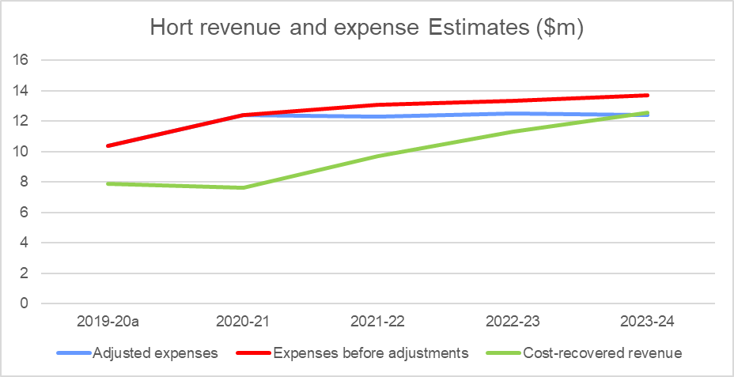
a Actuals.

Introduction

Purpose of this CRIS
This CRIS details the cost base and pricing structure for the horticulture export cost recovery arrangement and incorporates the impacts of the Busting Congestion for Agricultural Exporters package and the More Efficient and Sustainable Export Regulation measure announced in the 2020–21 Federal Budget.
The government is investing in modernising and reforming export regulatory services which will impact the cost base over time for all export cost recovery arrangements. Agriculture and food exporters and producers will be assisted through the modernisation and reform process with a freeze in fees and charges in 2020–21, and gradual increases from 2021–22 to 2023–24. The Australian Government has committed $71.1 million to improve the financial sustainability of export certification services by returning to full cost recovery of these services over time. A stepped return to full recovery will enable reforms to be rolled out while maintaining existing systems.
The key purpose of this CRIS is to:
- Baseline the horticulture export cost recovery arrangement expense for the regulatory activity against which progress of these reforms can be measured and changes transparently explained.
- Describe the freeze in fees and charges in 2020–21, and stepped increases from 2021–22 through to 2023–24.
An updated CRIS will be released for consultation in the first quarter of 2021 and updated annually. The annual CRIS will provide a summary of the previous year's financial performance, and description of deviations from forecast, provide an update of forward year cost base expectations and any consequential changes to charges required to ensure the arrangement remains financially balanced.
This methodology will provide a transparent description of the impact of the reforms and a record of changes to the cost base that will be able to be tracked over time.
This CRIS describes the impact of government decisions on charges as they were outlined in the previous 2015 CRIS. The proposed charging options and cost allocation approaches discussed in previous consultation have not been included in this CRIS – but will be considered in the next CRIS update. A subsequent CRIS update in 2021–22 will also reprofile demand for services and reflect the impact of reforms (further detail on likely changes to charging are detailed in section 2).

Path to full cost recovery
The government is freezing fees and charges for 2020–21 at current prices. From 2021–22, prices will be gradually increased to return all arrangements to full cost recovery in 2023–24.
The government is investing $71.1 million over 3 years from 2020–21 to maintain essential export regulatory services across all export cost recovered arrangements while prices are gradually increased.
This is part of a $328 million investment over 4 years from 2020–21 that also includes reforms to deliver an estimated annual cost reduction of $21.4 million from 2023–24 across all export cost recovered arrangements.
The impact of these decisions on horticulture export cost recovery from 2020–21 to 2023–24 is shown in Table 1. The fees and charges are notional only, illustrating the gradual increase of prices supported by the government decisions if no changes are made to the way the department charges for regulatory activity.
Changes to charging from 1 July 2021 will be described in a separate 2021–22 CRIS to be released for public consultation in the first quarter of 2021.
Table 1 Horticulture fees and charges for 2020–21 and illustrative prices for 2020-22 to 2023–24
Charge | Unit | 2020–21 ($) | 2021–22 ($) | 2022–23 ($) | 2023–24 ($)
Levy
Establishment registration – grower/exporter | Annual | 600 | 780 | 913 | 1,011
Establishment registration – simple | Annual | 3,000 | 3,899 | 4,561 | 5,052
Establishment registration – complex | Annual | 6,000 | 7,797 | 9,122 | 10,103
Authorised Officer Approval | Annual | 750 | 975 | 1,141 | 1,263
Establishment application (one-off) | Per application | 600 | 780 | 913 | 1,011
Phytosanitary certificate | Per document | 36 | 47 | 55 | 61
Export volume rate – non-protocol rate | Per tonne | 0.65 | 0.85 | 0.99 | 1.10
Export volume rate – protocol rate | Per tonne | 1.30 | 1.69 | 1.98 | 2.19
Fee-For-Service
Core inspection | Per quarter hour | 36 | 47 | 55 | 61
Additional inspection | Per quarter hour | 75 | 98 | 115 | 128
Audit | Per quarter hour | 36 | 47 | 55 | 61
Document – Electronic | Per document | 12 | 16 | 19 | 21
Document – Manual | Per document | 100 | 130 | 152 | 169
Replacement certificate | Per document | 500 | 650 | 761 | 842
AAO Application | Per application | 250 | 325 | 381 | 421
AAO Approval | Per approval | 250 | 325 | 381 | 421
AAO Learning and Assessment | Per person delivered training | 1,750 | 2,274 | 2,661 | 2,947
Additional AAO Learning and Assessment | Per additional person delivered training | 2,000 | 2,599 | 3,041 | 3,369
Organicsª
Organic Certifying Organisation | Annual | 7,500 | 9,746 | 11,402 | 12,629
a Organic certifiers support a small number of exporters in all of the export arrangements (excluding Live Animal Exports) and therefore the expense has been reflected in each CRIS.
Note: Forward year prices shown are for illustrative purposes only. The 2021–22 CRIS will describe the changes to fees and charges for 2021–22 to 2023–24.

CRIS updates
In accordance with the Australian Government Cost Recovery Guidelines (CRGs), the horticulture exports CRIS will be updated annually to report on financial and non-financial performance and revised 4-year forecasts. This annual update will provide an opportunity to measure progress of the reforms as they become quantifiable and to account for any external factors, for example, projected demand for activity.
The department will also report in–year financial performance within the CRIS, periodically reporting performance against the CRIS and explaining any variances. This will provide transparency in reporting for all exporters.
There may be other significant developments warranting a broader review of the cost base or charges. These could include:
- Changes to the regulatory settings of the arrangement, for example through a government policy change or the introduction of new systems or infrastructure.
- Changes to demand for regulatory activity, for example, due to a large part of industry changing its business model or significant change in terms of trade.
Where a CRIS update reveals that the existing fee or charge structure no longer meets the financial or regulatory requirements of the arrangement, the department may propose revised fees and charges. In this circumstance, the CRIS update will be the first step in consultation on changes to prices, followed by opportunities for stakeholder engagement.
This CRIS describes the impact of the busting congestion package has on the meat export cost recovery arrangement. It does not include the price changes proposed during the 2019-20 consultations. Changes that were proposed during previous industry consultation are expected to feature again in an updated CRIS in the first quarter of 2021. These include:
- Charging a document fee for the assessment of requests to amend or resubmit documents. This charge point would allow us to recover the reasonable costs of exporters amending or resubmitting documents. By recovering these costs and ensuring that those causing this expense are appropriately charged for it, we aim to reduce rework and incentivise exporters to submit suitably completed documents.
- Charging a single multicommodity standard audit rate across all export cost recovery arrangements to reflect the multiskilled workforce and simplify arrangements for industry.
- Introducing an export permit levy, tiered phytosanitary charge (with and without attestation) and a single export tonnage charge.
- The AO learning and assessment fee-for-service charge point currently provides access to training and assessment for up to 5 learning modules. We have considered making it payable per module of training requested by the AO. This would better recover the actual expenses from the recipient of each module of training. The additional learning and assessment charge point would be removed and the per module charge would be applied where additional learning and assessment is required.

Reforms

Busting congestion for all agricultural exporters
The Australian Government announced the Busting Congestion for Agricultural Exporters package in the 2020–21 Budget which includes reforms to slash unnecessary red tape to get products to export markets faster and support jobs in rural and remote Australia.
The package, worth over $328 million over 4 years from 2020–21, includes the following measures that are relevant to this CRIS.

Digital services to take farmers to markets
The centrepiece of the reform package is the Digital Services to Take Farmers to Markets measure, which will invest $222 million to modernise Australia’s agricultural export systems by slashing red tape and improving regulation and service delivery for our producers and exporters. This measure will transition our systems online and provide a single portal for transactions between exporters and government, streamlining processes for exporters and helping them experience faster and more cost-effective services.

Improving regulation post-COVID-19
The Improving Regulation Post-COVID-19 measure will capitalise on new ways of working that were developed during the government's response to COVID-19.
The measure includes:
- Working with trading partners and international standard setting organisations to embed, where appropriate, alternative regulatory approaches such as technology supported auditing, and to promote wider utilisation of e-certification.
- Assignment of dedicated case managers to support new for agriculture exporters, including seafood, grains, dairy and NPGs, to allow them to navigate and meet regulatory requirements to get on the front foot to enter markets. Support existing exporters to expand and diversify their market opportunities by assisting them to more easily navigate export regulatory processes for example registration processes ($3.7 million over 2 years).
- Capacity to develop and implement a risk based, targeted, approach to the regulation of the live animal and seafood export industries that supports compliant exporters and focuses on non-compliant operators ($2.3 million over 2 years). The initiatives will consider increased use of new technologies including for on-vessel. Key to the successful deployment of technology will be the collaborative development of feasible options between the department, industry bodies and individual operators.

Harmonised and streamlined plant export regulation
The Harmonised and Streamlined Plant Export Regulation measure will invest $10 million to simplify processes for plant product exports, making it easier, cheaper and quicker for plant exporters to get their produce into overseas markets. It will also harmonise regulation for plant industries and streamline plant export audit intervention, making the rules easier to navigate and more consistent. Projected cost reduction for both plant arrangements will amount to $2.6 million, over 3 years to 2023–24.

Horticulture arrangement cost base following reforms
These reforms are an opportunity for government and industry to work in partnership to lower the cost base of export arrangements. While possible efficiency measures have been identified, the cost reduction of these measures needs to be monitored as measures are implemented and will only be achieved with ongoing efforts from the department and industry. This will require an iterative approach to manage the cost base over the forward estimates. We will work with industry to achieve these outcomes.
Table 2 shows the cost base with and without adjustments to expense and forecast revenue for the horticulture arrangement and it describes:
- the cost base per the draft CRIS from the 2019-20 consultation
- adjustments to that cost base from the busting congestion package.
Table 2 Horticulture cost base with and without adjustments to expense and expected cost recovered revenue
Expense base | Unit | 2020–21 | 2021–22 | 2022–23 | 2023–24
Expenses – no adjustment | $ | 12,412,329 | 13,075,516 | 13,348,988 | 13,695,103
Total cost reductions from adjustments | $ | n/a | (757,277) | (847,038) | (1,314,162)
Expected expenses after adjustment | $ | 12,412,329 | 12,318,239 | 12,501,950 | 12,380,941
Revenue from cost recovered regulatory services | $ | 7,648,715 | 9,691,839 | 11,303,547 | 12,550,900
Appropriation funding | $ | 4,763,614 | 2,626,400 | 1,198,403 | n/a
Total revenues | $ | 12,412,329 | 12,318,239 | 12,501,950 | 12,550,900
Expenses less revenues | $ | – | – | – | (169,959)
Appropriation funding as % of expenses | % | 38 | 21 | 10 | n/a
n/a Not applicable.

Policy and statutory authority to cost recover
Under the Australian Government charging framework (charging framework), cost recovery requires both policy approval and statutory authority. The following sections provide information on government approval of regulatory charging for export regulatory activities and the legislation that enables the department to collect fees and charges.

Description of the regulatory activity
Plant export is regulated in accordance with the export legislative framework (see section 4.4). Plant export certification activities undertaken by the department involves inspection, audit and certification activities with respect to the export of grain and horticulture products. Grain and horticulture products specified in the legislation are:
- prescribed grain, including any seed or the following grains
- barley, canola, chickpeas, dried field peas, fava beans, lentils, lupins, mung beans, oats, sorghum, soybeans, whole vetch, and wheat
- prescribed hay and straw
- fresh fruit and vegetables (including mushrooms and sprouts)
- other plants or plant products for which a phytosanitary certificate or any other official certificate is required by an importing country authority (for example, timber products, nuts, nursery stock, tissue cultures, cotton and other grains and seeds not listed here).
The grain and horticulture export cost recovery arrangements are separate. Our Plant Export Operations branch undertakes export certification activities under both cost recovery arrangements.
Exporters of plants and plant products must obtain an export permit prior to the departure of prescribed goods from Australia. Overseas government authorities may require additional certification to verify that the exported products comply with their respective import conditions:
- Developing, implementing and monitoring of operational policy and systems that ensure compliance with Australian export controls and any importing country requirements. These activities serve to maintain the eligibility of commodities for export from Australia and to protect and promote Australia’s reputation for premium agricultural goods, while maintaining existing and seeking increased market access opportunities.
- Providing inspection, auditing, and enforcement activities to ensure that the production, storage, handling and transportation of grain and horticulture products intended for export comply with the conditions of the Australian export controls and any additional requirements imposed by an importing country.
- Issuing permits, phytosanitary certification, and other documentation necessary to confirm compliance with Australian export controls and any additional importing country requirements.
- Providing support through our overseas counsellors relating to detained consignments, government certification and other issues that result in goods being held at the border.
- Providing scientific and technical advice to improve, maintain or restore market access to demonstrate adherence to export requirements.
- Enforcing regulation of certified organic goods exported from Australia.
For more information, see Export goods controlled by the department.
Plant export certification occurs across both the grain and horticulture cost recovery arrangements.

Why cost recovery is appropriate
Cost recovery (regulatory charging) falls within the Australian Government’s broader charging framework. Other charges in this framework include commercial charges and resource charges. The type of charge is determined by the characteristics of the activities as described in the charging framework. This provides the overarching framework under which government entities must design, implement and review cost recovery.
Under the charging framework, regulatory charging is appropriate because plant export certification activity is provided to a clearly identifiable group – individuals and organisations that participate in the plant export supply chain.
There are additional benefits to funding export certification through regulatory charging. When a business pays for the activities it receives, the government has an obligation to justify the prices it charges. Regulatory charging also raises awareness of regulated entities of how much a regulated activity costs.
For these reasons, the government has determined regulatory charging to be the most appropriate mechanism for funding plant export certification. We have reviewed regulatory charging of plant export certification activities, consistent with the charging framework.

Government policy approval to cost recover the regulatory activity
Policy authority for regulatory charging for export certification activities was reaffirmed in the 2020–21 Budget when the government announced the Busting Congestion for Agricultural Exporters package. The package sets out a period of partial cost recovery from 2020–21 to 2023–24 before a return to full cost recovery by 2023–24, while a series of reforms to improve efficiency and lower costs are implemented.

Statutory authority to charge
Fees and levies for plant export certification are recovered under separate statutory authority.

Cost recovery fees
Section 25 of the Export Control Act 1982 provides the power to impose fees in relation to a range of export certification activities. The specific amounts are set out in the Export Control (Fees) Orders 2015.
Amendments to, or new subordinate legislation will provide for the fees detailed in this CRIS to be established. These and other delegated instruments will include descriptions of the charging points for plant export fees.

Cost recovery levies
Cost recovery levies as described in the CRGs are implemented for export certification regulatory activity through charging legislation. The following Acts, Regulations and delegated instruments will include descriptions of the charging points for plant export charges:
- Export Charges (Collection) Act 2015
- Export Charges (Imposition – Customs) Act 2015
- Export Charges (Imposition – Excise) Act 2015
- Export Charges (Imposition – General) Act 2015
- Export Charges (Imposition – Customs) Regulation 2015
- Export Charges (Imposition – General) Regulation 2015
- Export Control (Fees Order) 2015

New legislative framework
The Export Control Act 2020 commences 28 March 2021, consolidating export functions from the Export Control Act 1982 and Australian Meat and Live-stock Industry Act 1997 into a new legislative framework. The new legislative framework will be more relevant, responsive, and efficient for exporters, farmers and other primary producers. The export framework will continue to provide strong regulation, while removing duplication and ensuring consistency across commodities where possible. The new legislation supports existing policy, while providing flexibility for different approaches to the regulation of exports in the future.
No changes to the cost base have been identified at this time arising from the implementation of the new legislative framework, but changes to our regulatory approach could affect cost-recovery. Any impacts will be reviewed when or if changes are implemented.

Cost recovery model

Outputs and business processes of the regulatory charging activity
The key policy objectives for our cost recovery arrangements are to:
- safeguard Australia’s animal and plant health status, to maintain overseas markets and protect the economy and environment from the impact of exotic pests and diseases. This will be achieved through risk assessment, inspection and certification, and the implementation of emergency response arrangements for Australian agricultural, food and fibre industries.
- support more sustainable, productive, internationally competitive, and profitable Australian agricultural, food and fibre industries through policies and initiatives that promote better resource management practices, innovation, self-reliance and improved market access.
Our cost recovery arrangements describe how we use resources (such as people, IT, property and equipment) to undertake business processes (regulatory activities), which enable us to provide the outputs that meet our policy objectives (Figure 2).
Figure 2 Outputs and business processes of our regulatory charging activity
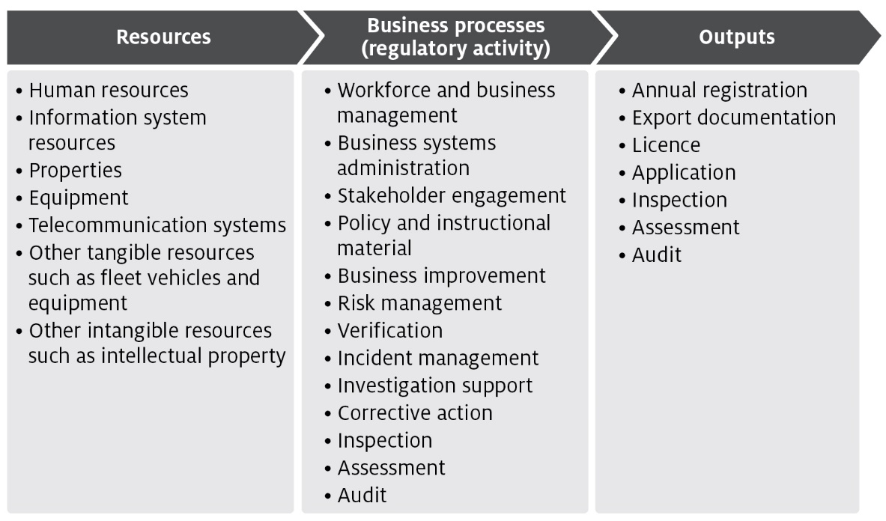
The processes listed in Figure 2 are described in Appendix A and are grouped into 4 categories of activities:
- Program management and administration – administrative activities that support and deliver our export certification commitments.
- Assurance – activities that mitigate risks to collective user groups by assessing departmental controls of systems and processes to ensure they operate in accordance with their intended design.
- Incident management – activities that respond to incidents concerning alleged breaches of Australian regulation or international import conditions.
- Intervention – activities provided directly to an individual, business or organisation to meet export certification requirements.

Costs of regulatory charging activity

Cost allocation process
To determine the cost of regulatory activities, we use an activity-based costing (ABC) system. The ABC cost allocation methodology reflects costs incurred through usage of regulatory activities. This provides a transparent allocation of costs that is also efficient and effective to administer.
The 2 expense categories are:
- direct expenses – these can be directly attributed to the provision of an activity, for example, inspections. They comprise of staff salaries and supplier costs including direct capital expenses.
- indirect expenses – these are not directly linked to an activity provided by us. Indirect expenses include corporate employee salaries and overheads such as information technology, finance, human resources costs, and indirect capital expenses.
The cost allocation process apportions the costs of support functions (indirect expense) and direct expense to the processes/activities defined in Appendix A. We include indirect expenses in the cost base to reflect the systems and processes that exist to help with efficient administration, which the cost-recovered arrangements benefit from. This is the same methodology employed for allocation of indirect costs to appropriated activities, in line with our cost allocation policy.
The ABC system allocates costs in a staged approach:
- Indirect costs such as property, finance, information technology, human resources and divisional executives are allocated to direct cost centres using a cost driver which estimates the relative usage of each of the corporate services. Cost drivers for corporate services include:
  - Workpoints – distributes costs based on space occupied, with the workpoint count reflecting the space where a person may be able to work.
  - FTE – distributes costs based on each programme's full-time equivalent staff numbers.
  - PC count/IT assets – distributes costs based on the number of IT assets in a program.
  - Transactions – distributes costs based on the number of transactions incurred over a period. This driver is used to allocate expenses related to the functions of accounts receivable and accounts payable.
  - Headcount – allocates costs based on the number of staff that a program area has as a proportion of the number of staff that are on the department’s total staff.
  - Custom drivers – allocate costs to specific cost centres, primarily based on usage for shared program resources.
Cost drivers are reviewed on an annual basis, or as required. Changes to cost drivers are substantiated through effort or other data.
- Direct costs (including the indirect costs allocated in step 1) are allocated to the activity and cost-recovered arrangements that best reflects the activity undertaken. Time recording systems allow the accurate allocation of effort to specific activities and arrangements, particularly to intervention activities.
- The primary variable used in the allocation of costs to activities is effort. As a result, cost estimates vary with changes in activity. If actual activity levels change during a financial year, the costs allocated to arrangements would require adjustment to align with that effort. We monitor this throughout the year and adjust where necessary.
- For example, auditors undertake audits across multiple arrangements. We forecast the number of audits and average time for an audit for each arrangement. The associated costs are allocated to the arrangements and audit function based on total audit hours.
- Activity/arrangement costs (from step 2) are allocated to charge points which identify the cost associated with that charge. We use a combination of cost recovery fees and charges. Figure 3 shows how we categorise cost-recovered levy and fee activities and outputs.
Figure 3 Categories of activities
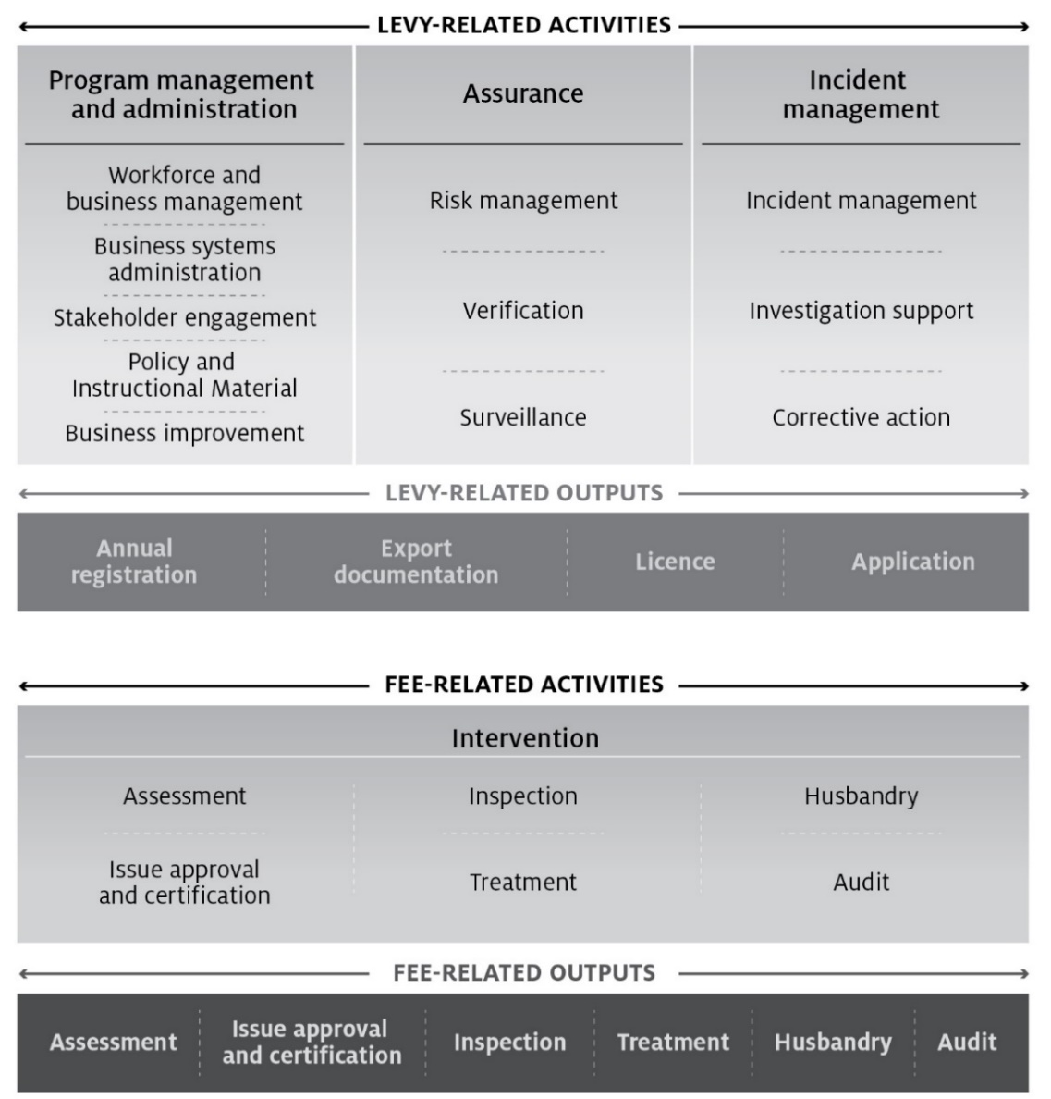

Stakeholder engagement
Stakeholder engagement plays an important role in the development and management of cost recovery arrangements. Our stakeholders have a unique insight into how our regulatory activities impact on their business and help us design efficient cost recovery frameworks for these activities.
This CRIS explains the decisions taken by government and financial outcomes of the measures in the Busting Congestion package. No changes to fees and charges apply in 2020–21. However, we note you may want to make comment in relation to this CRIS. If you are interested, we ask that you register your interest to participate in our upcoming consultation and in receiving further information and invites to future opportunities to engage.
You are also welcome to make comments on our Have Your Say page. Any comments you make will be addressed as part of the consultation process scheduled to take place in early 2021 on the proposed 202122 CRIS.
Stakeholder engagement on the development and implementation of reforms from 2021–22 through to 2023–24 will take place over the course of the annual CRIS update cycle, beginning in February 2021. For further information on the package see Busting Congestion for Agricultural Exporters.

Industry engagement
The department has been reviewing the CRIS since 2018–19 including public consultation on a draft in 2019–20during which the department has consulted with the Horticulture Export Industry Consultative Committee (HEICC) on development of the draft CRIS.
Throughout the development of this CRIS, we have given the HEICC information about:
- the cost base
- the volume of activities
- the proposed fee and charge structure
- the proposed rates of the fees and charges.
We consulted widely on the development of a draft CRIS during 2019–20, including through engagement with key stakeholders, a public submission process and face-to-face meetings with stakeholders. For a detailed summary of horticulture stakeholder feedback see Appendix B.
In addition to feedback from industry, the department also commissioned an independent review of the efficiency and effectiveness of the department’s delivery of export regulatory services. The independent review and the department’s response have now been finalised and are available at Independent review of the cost of export certification. The independent review was largely conducted as a survey of both internal and external stakeholders.
The independent review was delivered to the department in March 2020. The review found the department’s staff to be committed and passionate, working diligently to achieve positive outcomes for industry. It also found that external stakeholders were somewhat satisfied with the department’s services and that overarching export market and legislative objectives were often met. A range of recommendations were made to improve efficiency and effectiveness, with each requiring an investment of resources, effort, funding and time to fully implement.
Key messages from stakeholders and the review were:
- Industry wants the department to work to create efficiencies to lower costs.
- Antiquated systems were impeding efficient processing of export consignments.
- The department needed to focus on improvements while still delivering routine regulatory activities.
- Smaller exporters are finding it difficult to enter and compete on the global market without assistance from the government.
- Industry predict increases could cause significant hardships for producers and exporters who are recovering from a period of severe drought and natural disasters.
- If prices need to rise, they should do so in a stepped way, to prevent shocks to business.
Since release of the draft CRIS for public consultation in October 2019, the new Department of Agriculture, Water and the Environment was created in February 2020 through a machinery of government change. As part of this change the department undertook an internal ‘Future Department Review’ to identify how to maximise the capability of the new department and fully realise the opportunities it presents. A subsequent change process is now underway.

Horticulture export stakeholder engagement
The horticulture industry members were primarily consulted through HEICC. Key topics through the consultation included the arrangement’s past financial performance (including drivers of key variances), cost base, volumes, the proposed charging structures, pricing principles and price options.

Past financial performance
During a meeting on our pricing principles for the charging review, HEICC members requested historical information on the arrangement’s cost base. The department later provided a timeline of increases to the cost base since 2014–15, with detail on significant changes that affected the cost base.

Cost base and charging structure
Industry has clearly stated its opposition to the 2018–19 Budget measure to expand cost recovery to include scientific, technical and enforcement activities, and expressed concerns as to whether the department is applying sufficient downward pressure on expenses to reduce the cost base.
Industry representatives sought clarification on whether the CRIS charging model sought to recover historical under-recoveries, noting that the department had previously agreed that it would not do so because it would be inequitable to recover historical costs from current exporters and because it would have a significant financial impact on the industry. The department clarified that government has not taken a decision as to how the deficit for the arrangement would be treated. The department will seek a decision following public consultation on the CRIS. The cost base presented in this CRIS does not include historic deficits.
HEICC members have requested additional modelling and the department will continue to engage with industry representatives throughout the public consultation period. The department has continued engagement with the HEICC and while the pricing option proposed by HEICC is not viable at the time, the committee has supported the inclusion of option 2 in the draft CRIS.

Cost recovery reserve and use of remissions
Industry representatives expressed concern regarding the department’s proposal to set the legislated price at the highest modelled price over the 4-year outlook and then remit to align revenue with expense each year. The primary concern was that delays between over recoveries occurring and the remittance of over-recovered funds could result in remissions benefiting people who had not contributed to the surplus position in the reserve.
The department proposed setting remissions in advance annually based on forecast expense and revenue, rather than implementing remissions after the fact or retrospectively. The remission would be monitored and adjusted on an ongoing basis, reducing the likelihood of over-recoveries. HEICC representatives stated that they disagreed with this approach, noting that industry would be uncomfortable with the remissions being entirely at the department’s discretion.

Cost recovery arrangement for horticulture exports
This section describes the horticulture export cost recovery arrangement cost base as well as additional financial information associated with horticulture export inspection and certification activities.

Design of cost-recovered charges
There are no changes to the existing horticulture cost recovery charging structure in this CRIS. We will consult on any adjustments to the charging structure in a revised CRIS prior to implementing updated fees and charges from 1 July 2021.

Cost base
Table 3 shows the horticulture arrangement cost base for 2020–21. See Table 4 for an overview by cost type for 2020–21.
A detailed description of cost activities is provided at Appendix A. The methodology for attributing costs to these activities is provided in section 5.

Cost base assumption
The cost base has been modelled to reflect the full costs of the arrangements. Partial cost recovery levels are displayed in the tables dealing with financial performance and fees and charges. The 2018–19 budget has been used as the starting point for determining the cost base in this CRIS. To project the cost base over the next 4 years, we have applied adjustments to capture expected changes to the costs including:
- inflation of 1.65% per annum, in line with the Department of Finance’s inflation estimate
- increases in employee expenses of 2% per annum, reflecting reasonable estimates of wage increments in line with the Australian Public Service Workplace Bargaining Policy 2018
- additional depreciation from new assets anticipated to be recognised over the period
- adjustments for future fee-related activities to reflect expected changes in volume.

Projected cost base
The cost base for 2020–21 for the horticulture export cost recovery arrangement is $12,412,329 (Table 3), made up of:
- $9.564 million in levy-related activities
- $2.848 million in fee-related activities.
Table 3 Cost base for horticulture export cost recovery arrangement, 2020–21
Charge type | Activity group | Activity | Expense ($) | Cost recovery charge
Levy | Program management and administration | Workforce and business administration | 9,563,973 | Annual registration, export documentation, throughput, application and organic certification
 |  | Business system administration
 |  | Stakeholder engagement
 |  | Policy and instructional material
 |  | Business improvement
 | Assurance | Risk management
 |  | Verification
 |  | Surveillance
 | Incident management | Incident management
 |  | Investigative support
 |  | Corrective action
Fee for service | Intervention | Assessment | 887,687 | Assessment
 |  | Inspection | 612,227 | Inspection
 |  | Audit | 1,348,442 | Audit
Total cost base |  |  | 12,412,329 | –
Table 4 provides a breakdown of expenses of the horticulture export cost recovery arrangement in 2020–21.
Table 4 Cost type breakdown for horticulture export cost recovery arrangement, 2020–21
Expense | Forecast ($)
Direct | 8,409,888
Employee | 7,142,272
Operating | 1,136,899
Other | 130,716
Indirect | 4,002,441
Assurance and Legal | 264,139
Corporate Strategy and Governance | 473,522
Finance & Business Support | 710,113
Information Services | 1,474,977
Property | 1,079,690
Total | 12,412,329
For more information on how expenses are allocated see section 5.

Changes to the cost base
Adjustments to the horticulture export cost recovery arrangement include additional inflation and depreciation expenses, and the expanded cost recovery activities announced in the 2018–19 Budget that was implemented from 1 July 2019.
The new government policy provided authority to additional cost recovery regulatory activities including enforcement, scientific and technical advice, and support for detained consignments which increased the cost base by $1.533 million indexed annually from 1 July 2019.
Levy charges will recover:
- enforcement activities that are directly related to our regulatory function of ensuring industry compliance with international import conditions ($0.125 million indexed annually from 1 July 2019)
- scientific and technical advice related to supporting industry to improve, maintain or restore market access ($1.225 million indexed annually from 1 July 2019)
- the cost of our overseas counsellor network assisting industry to meet export requirements for detained consignments or during trade disruptions ($0.182 million indexed annually from 1 July 2019).
In line with the government’s CRGs and the department’s cost allocation policy, inflation and depreciation expenses have been adjusted in the cost base to reflect increased employee and supplier expenses in line with the Australian Public Service workplace bargaining policy 2018 and government inflation estimates. Cost recovery of these activities is considered appropriate because industry directly benefits from having a system in place that allows the department to manage and respond to market access issues, including ensuring compliance with overseas country requirements.
Table 5 outlines the changes to the forecast cost base for 2019–20 and
Table 6 for 2020–21.
Table 5 Changes to cost base for horticulture exports, 2019–20
Adjustment to cost base | Impact on cost base | Unit | Forecast ($)
Total baseline expense | n/a | $ | 10,178,500
- Enforcement | Increase | $ | 125,957
- Scientific and technical advice | Increase | $ | 1,225,199
- Detained consignments | Increase | $ | 182,335
- Depreciation expenses | Increase | $ | 202,277
- Inflation | Increase | $ | 127,888
- Net impact of other changes | Increase | $ | 59,250
Total adjustments to cost base | Increase | $ | 1,922,906
Adjusted cost base | n/a | $ | 12,101,406
Change in expense | Increase | % | 18.9
n/a Not applicable.
Table 6 Changes to cost base for horticulture exports, 2020–21
Adjustment to cost base | Impact on cost base | Unit | Forecast ($)
Total baseline expense | n/a | $ | 12,101,406
Inflation and other changes | Increase | $ | 310,923
Adjusted cost base | n/a | $ | 12,412,329
Change in expense | Increase | % | 2.6
n/a Not applicable.
As part of the charging review, the department has considered a number of additional reforms. These reforms have not been included in the cost base because their financial impact cannot be quantified at this point.

New export control legislation
As noted at section 4.4.3, the Export Control Act 2020 commences 28 March 2021, consolidating export functions from the Export Control Act 1982 into a new legislative framework. No changes to the cost base have been identified at this time as a result of the implementation of the new legislative framework, but changes to our regulatory approach could affect cost recovery. Any impacts will be reviewed when/or if changes are implemented.

Financial estimates
A summary of the annual budgeted operating position for the plant export cost recovery arrangements is provided in section 9. All cost-recovered activities are subject to a detailed semi-annual review as part of departmental budgeting processes.

Horticulture export fees and charges
The amount payable for 2020–21 is shown in Table 7. Forward year prices have not been included and will be provided in the 2021–22 CRIS.
Table 7 Fees, charges and volumes for horticulture export cost recovery arrangement, 2020–21
Category | Charge title | Unit | Price ($) | Estimated volume | Total revenue ($)
Levies | Establishment registration – grower or exporter | Annual | 600 | 92 | 55,200
 | Establishment registration– simple | Annual | 3,000 | 197 | 591,000
 | Establishment registration– complex | Annual | 6,000 | 189 | 1,134,000
 | Authorised officer approval | Annual | 750 | 267 | 200,250
 | Establishment application (one-off) | Per initial establishment application | 600 | 45 | 27,000
 | Phytosanitary certificate | Per document | 36 | 51,466 | 1,852,776
 | Export volume rate – non-protocol rate | Per tonne | 0.65 | 682,600 | 443,729
 | Export volume rate – protocol rate | Per tonne | 1.30 | 379,366 | 493,176
Fees – audit and inspection | Core inspection | Per Quarter Hour | 36 | 7,951 | 286,236
 | Additional inspection | Per Quarter Hour | 75 | - | -
 | Audit | Per Quarter Hour | 36 | 23,249 | 836,964
Fees – documentation | Document – Electronic | Per Document | 12 | 109,907 | 1,318,884
 | Document – Manual | Per Document | 100 | 2,700 | 270,000
 | Replacement certificate | Per Document | 500 | 10 | 5,000
Fees – authorised officer (AO) | AO application fee | Per Application | 250 | 45 | 11,250
 | AO approval | Per AO Approval | 250 | 148 | 37,000
 | AO Learning and Assessment | Per person delivered training | 1,750 | 45 | 78,750
 | Additional Learning and Assessment | Per additional person delivered training | 2,000 | – | –
Organics | Organic certifying organisation | Annual | 7,500 | 1 | 7,500
Total | 7,648,715
a Organic certifiers support a small number of exporters in all of the export arrangements (excluding Live Animal Exports) and therefore the expense has been reflected in each CRIS.
Note: Prices have been rounded. The annual charge will be rounded upwards to the nearest dollar, with the exception of throughput, which will be rounded upwards to the nearest cent.

Financial estimates
Table 8 shows the financial performance of the horticulture export cost recovery arrangement.
There will be no change to the cost recovery reserve for the duration of the busting congestion package. The reserve deficit will be carried forward until a government decision is taken to address it.
Table 8 Financial estimates for horticulture export cost recovery arrangement
Finance element | 2020–21 ($) | 2021–22 ($) | 2022–23 ($) | 2023–24 ($)
Revenue = X | 7,648,715 | 9,691,839 | 11,303,547 | 12,550,900
Expenses = Y | 12,412,329 | 12,318,239 | 12,501,950 | 12,380,941
Balance = X – Y | (4,763,614) | (2,626,400) | (1,198,403) | 169,959
Appropriation funding | 4,763,614 | 2,626,400 | 1,198,403 | n/a
Balance after appropriation | 0 | 0 | 0 | 169,959
Forecast opening cost recovery reserve balance | (8,766,095) | (8,766,095) | (8,766,095) | (8,766,095)
Transfer | 0 | 0 | 0 | 169,959
Forecast closing cost recovery reserve balance | (8,766,095) | (8,766,095) | (8,766,095) | (8,596,136)
n/a Not applicable.

Financial and non-financial performance
Both the ANAO report and the independent review made recommendations about improving our performance reporting. The department is committed to consulting with industry stakeholders on performance indicators to assist in evaluating the performance of our regulatory arrangements. We will use the benchmarking framework provided by the independent review to engage with industry on development of financial and non-financial Key Performance Indicators (KPIs).

Financial performance
This section presents information on the financial and non-financial performance of the horticulture export cost recovery arrangement. This is intended to provide an overview of our performance in recovering forecasted costs and meeting regulatory objectives. The financial performance for the horticulture cost recovery arrangement are provided in Table 9.
Table 9 Financial performance for horticulture export cost recovery arrangement, 2015–16 to 2020–21
Finance element | 2015–16 ($) | 2016–17 ($) | 2017–18 ($) | 2018–19 ($) | 2019–20 ($) | 2020–21
Revenue = X | 7,249,366 | 7,576,457 | 7,867,794 | 8,399,981 | 7,893,802 | Update in 2021
Expenses = Y | 8,243,565 | 7,054,949 | 9,383,098 | 9,896,460 | 10,361,950 | Update in 2021
Balance = X – Y | (994,199) | 521,508 | (1,515,304) | (1,496,479) | (2,468,148) | Update in 2021
Remissions, rebates and adjustments = Z | 4,551 | (34,829) | (11,374) | n/a | n/a | Update in 2021
Net balance = balance + Z | (989,648) | 486,679 | (1,526,678) | (1,496,479) | (2,468,148) | Update in 2021
Cost recovery reserve balance | (3,761,469) | (3,274,790) | (4,801,468) | (6,297,947) | (8,766,095) | Update in 2021
n/a Not applicable.
Note: Revenue has increased since 2015–16 due to steady annual growth in the horticulture export industry. Increased expenses have primarily been driven by increased program management and administration costs, including information services costs associated with our service delivery modernisation program, corporate costs and property costs. This has been partially offset by lower inspection costs being allocated to the arrangement resulting from higher industry use of third-party authorised officer to undertake inspections under the Authorised Officer program. This has decreased the inspection capability and capacity required to be maintained in the department, which has reduced the cost of horticulture inspection allocated to the arrangement. From 1 July 2019, 1.553 million for regulatory activities for enforcement, scientific and technical advice and detained consignments was added to the arrangement indexed and ongoing.

Key dates and events
We undertake regular reviews of our financial performance and conducts regular stakeholder engagement activities throughout the CRIS cycle. Key forward dates for regulatory charging for horticulture export certification activities are documented in Table 10.
Table 10 Key forward dates and events
Key forward events schedule | Next scheduled update
Annual CRIS update to forward estimates | February 2021
Updated fees and charges implemented | 1 July 2021
Annual CRIS updates to financial and non-financial performance for 2020–21 | October 2021
Annual CRIS update to forward estimates | February 2022
Updated fees and charges implemented | 1 July 2022
Annual CRIS updates to financial and non-financial performance for 2021–22 | October 2022
Portfolio charging review to be undertaken | 2023
Annual CRIS update to forward estimates | February 2023
Updated fees and charges implemented | 1 July 2023
Annual CRIS updates to financial and non-financial performance for 2022–23 | October 2023
Portfolio charging review outcomes to be brought forward in Budget | 2024–25

Appendix A: Description of cost model activities
This section provides details of the cost model activities undertaken in the departments cost recovery arrangements.

Program management and administration activities

Workforce and business management
This activity comprises 4 categories:
- Workforce management activities include staff supervision, allocating workforce resources, managing employee performance, leave, training and other conditions, managing Work, Health and Safety requirements, recruitment and termination.
- Business management activities include business planning and continuity; requesting legal advice; procurement and contracts; program and project administration, assurance, design and management; management of fixtures, facilities, equipment, supplies and logistics.
- Financial management activities include billing and accounting, budgeting, charges and payments, collections and receivables, debt management, financial accounts, reporting and policy development.
- Information management activities include data management, information and records management, and information sharing and collaboration.

Business systems administration
Includes developing, acquiring, testing, implementing and supporting applications and business systems. It encompasses technical support and maintenance of all business systems including information and communications technology.

Stakeholder engagement
Involves proactive engagement with any person, business, or organisation including any associated travel. This includes, engaging with peak industry bodies, secretariat support and attendance at industry consultative committee meetings, consultation on new standards and requirements, publishing website content and other information.

Policy and instructional material
Includes developing, maintaining and communicating the department’s policy and instructional material, such as operational and corporate policies, scientific advice, departmental guidelines and work instructions, and associated training development and delivery. Examples include responding to changes in importing country requirements developing or revising policy processes and instructional material.

Business improvement
Includes assessment, monitoring and development of initiatives to improve performance. Examples include adjustments to improve program and service delivery, business performance reports against KPIs and similar activities.

Assurance activities

Risk management
Involves assessing and managing the risks posed to Australia’s ability to maintain market access. This includes communicating results of risk analysis, modelling and forecasting to operational areas and the collection, receipt and use of reliable compliance data to meet the department’s compliance objectives. This work also includes any associated travel and client assistance work.

Verification
Includes assurance activities to provide stakeholders and the departmental executive with confidence that departmental controls of its systems and processes are operating in accordance with their intended design and associated documentation. This includes assurance activities provided to trading partners.

Surveillance
Includes formal and informal monitoring to detect issues that may affect onshore production for export, such as changes in Australia’s pest or disease status or food safety concerns. Surveillance differs from an inspection because it is not done for a specific client.

Incident management activities

Incident management
The coordination and management of any incident, including post-border detection and export incidents. This includes all associated preparatory work and post work, travel and client assistance in relation to an incident.

Investigation Support
Involves providing support for enforcement activities relating to an alleged breach of portfolio legislation, including any related client assistance and travel. This also includes enforcement activities that ensure compliance with Australian regulation and international import conditions such as investigations and engagement with clients about compliance.

Corrective action
Includes actions taken in response to non-compliance or contravention of legislation that is not required to be reported to enforcement officers. Corrective action activities includes all preparatory work and post work, travel and client assistance in relation to the enforcement process.

Intervention activities

Assessment
Involves assessing information to determine if it meets Australian standards and legislation, international conventions and importing country conditions. This includes all preparatory work (such as confirming importing country or export requirements) and post work (such as assessment report preparation), travel and client assistance in relation to the assessment. Examples include assessments of licenses, permits, registrations or accreditations.

Issue approvals and certification
Includes issuing of a decision in relation to an assessment for cargo, vessels, plants, animals, food, biological and genetic material. This includes the work from the end of the assessment period to the completion of the decision notification process to support issuance of appropriate export documentation.

Inspection
Involves the physical examination and supervision of an export consignment of plants or plant products to determine compliance with Australian standards and legislation, international conventions and importing country conditions.

Treatments
Includes the physical treatment of cargo, vessels, plants, animals, food, biological and genetic material, other conveyances or premises to prevent an adverse biosecurity outcome from occurring and to meet relevant importing country requirements.

Husbandry
Includes activities relating to the care of plants and animals that the department is responsible for, including transport of plants and animals, housing, daily monitoring, feeding, cleaning of facilities, administering of medication, bookings and client assistance.

Audit
Includes the systematic and functionally independent examination of industry systems and processes to determine whether activities and related results comply with legislative or documented requirements. This includes all preparatory work and post work, travel and client assistance in relation to the audit.

Appendix B: Summary of horticulture export stakeholder feedback from 2019–20 consultation
Consultation on the draft CRIS involved engagement with industry consultative committees and targeted discussions with industry stakeholders. A draft CRIS was released in October 2019 for public consultation and submissions closed in January 2020. During this period the department received 69 submissions across all export cost recovery arrangements and held 13 face to face or teleconference meetings.
During consultation on the horticulture export cost recovery arrangements multi options were discussed including:
- Option 1– increase the phytosanitary certificate, tonnage and establishment registration levies in proportion to the prices that were proposed in the 2017–18 draft CRIS that was previously released for public consultation. This approach sets prices at the level necessary to recover the cost of horticulture export certification while retaining a charging structure that industry is familiar.
- Option 2– introduction of a new charging structure through the introduction of an export permit levy, tiered phytosanitary charge (with and without attestation) and a single export tonnage charge.
Key theme | Department response
- Opposition to full cost recovery  The government has endorsed the goal of making agriculture a $100 billion industry by 2030. The CRIS, which promotes full cost recovery, will not help achieve this goal. The benefits of exports to the broader community need to be recognised by partially funding exports through appropriation and policy functions should be funded by government to remove the cost from industry. The CRIS is a strong disincentive to export and will have a significant negative effect on the international competitiveness of Australian exporters. With DAWE already recovering nearly half of its costs directly from exporters and producers, an increase to full cost recovery is not sustainable. Current exporters should not be penalised for the department under-recovering costs from previous periods. The rate of DAWE cost recovery is proportionally much higher than other Commonwealth departments and New Zealand counterparts, with Australian horticulture one of the least subsidised industries in the OECD. | The Australian Government’s policy on cost recovery is articulated in the Australian Government Cost Recovery Guidelines (CRGs).  The CRGs state that Australian Government entities should generally set charges to recover the full efficient cost of providing specific activities. Recovering the full costs means the full efficient costs which are defined as the minimum costs necessary to provide the activity while achieving the policy outcomes and legislative functions of the government. Further, the CRGs state that the full costs include the costs of all the activities that can be reasonably attributed to an individual/organisation or group of individuals/organisations receiving the service. Our fees and charges are designed to reflect as closely as possible the actual cost of delivering these important regulatory activities. The model seeks to recover costs from each participant based on regulatory effort and consumption of departmental resources.  The department’s cost recovery charges for export certification increase the cost of exporting, but the impact on competitiveness of agricultural exporters is limited. The ABARES investigation of other countries’ cost recovery arrangements suggests that differences, and impacts on competitiveness, are generally small. ABARES analysis suggests that the impact on value of exports is small – less than 1 % for each commodity considered.
- Greater transparency and clarification needed on increased costs  This CRIS does not address industry’s call for greater transparency and clarification. There is no evidence of harmonisation across arrangements when horticulture increases range between 45 and 277 %. As price takers, exporters and producers will need to absorb on-costs across differently regulated, subsidised, protocol and non-protocol markets which they cannot afford.  Increased on-costs are not explained or substantiated and are applied inefficiently. The socialisation of scientific research, technical advice and travel costs should not be cost-recovered from private enterprises. Activities that are of a broader national benefit such as enforcement should also not be cost-recovered from private enterprises. | We will be making improvements to increase the transparency of the CRIS in the future based on stakeholder feedback as well as the independent review. This may include a benchmarking framework and cost object diagram.  As part of the 2018–19 Budget, government decided to stop funding the regulatory activities through appropriation and recover the costs of those activities from the industries that create the need for those services. This decision is consistent with the CRGs.
- Stakeholder engagement process  This CRIS warrants extensive consultation which has not occurred. Greater notice of the specific details of engagement sessions was needed. Repeated changes to consultation timelines and insufficient communications with both industry representative bodies and affected businesses has led to extreme confusion regarding the submission process. Engagement sessions are not easily accessible for rural and regional communities. | The department notes this feedback and will be making improvements to the stakeholder engagement process in the future.
- Timeframe of the consultation and submission period  The findings of the Ernst and Young (EY) report should have been released to stakeholders prior to the call for submissions on the draft CRIS. The EY report should identify areas of the department where process improvements could lead to increases in both efficiency and effectiveness. The cost of the EY report cannot be justified without a commensurate revenue value-add. | The department continues to be committed to extensive engagement with stakeholders, through the consultative committees and public consultation. The department further notes extensive consultation has occurred to date on the expenditure, volumes and pricing models with the HEICC.  The public consultation was undertaken parallel to the independent review to avoid delays in implementing new fees and charges and restoring the financial sustainability of our export certification cost recovery arrangements.  The feedback from public consultation on the CRISs and recommendations of the independent review will be considered in the development of the final plant export certification CRIS document.
- Impact of CRIS on the Authorised Officer (AO) model  This CRIS threatens the viability of the Authorised Officer (AO) model. Audit requirements, cost apportion, and the duplication of federal and state government audit activities act as barriers to exporters and producers. The outsourcing of the audit process to a private competent third party will achieve greater efficiencies and cost savings. | The CRGs state that where a regulatory function is provided to an identifiable group that group, and not general taxpayers, should bear the associated costs. Export certification services are provided to a clearly identifiable group – individuals and organisations that participate in the plant export supply chain.  Certification rules and requirements are set based on what importing countries require. In setting requirements, many overseas governments will only accept Australian Government certification, rather than from non-government individuals and businesses. We try to negotiate the acceptance of third-party regulation, but ultimately it is a decision for importing countries as to what they will accept. certification, underpinned by assurance activity, ensures markets remain open and exporters can confidently plan their business models.
- Detained consignment cost  Consistent with other industry views, detained consignment costs should be recovered from the shipper where the shipper is found to be at fault. | Due to the highly reactive, uncertain and expensive nature of managing detained consignment, it is important that there is certainty for funding these activities while ensuring the most effective and efficient cost recovery arrangements are in place. The department recover costs of managing these incidents through levies imposed on users of the export certification system.  Cost recovery is considered appropriate as industry benefits by having a system in place that allows the department to manage detained cargo situations when they arise. Activities undertaken by the department in cases of detained cargo include: working with foreign governments and agricultural posts; identifying new markets for the detained cargo; and issuing certificates to meet new importing country requirements.
- Negative impact on small exporters  The CRIS will have a negative impact on small exporters because certification costs are prohibitive to small exporters entering new markets. The government should consider a transition period of lower costs for small exporters while they establish and grow their business. | The busting congestion package will provide a transition full cost recovery for all exporters.  The base level of effort required to provide regulatory activity to small and emerging exporters is the same as provided to others and our registration charges reflect this. Tonnage charges are used to ensure that the additional regulatory effort associated with larger scale export operations is reflected.
- Introduction of efficiency dividend as cost increased too high  Industry cannot continue to absorb increased costs without efficiency gains and/or improved services. | During consultation on developing revised charges, industry have requested the introduction of an efficiency dividend. Following this feedback, the department is assessing if and how a productivity measure could be included in this CRIS review. Further details will be discussed with the industry consultative committee after the department has finalised its assessment.
- No formal feedback on pricing models  Industry representative groups made the representation that no model would be acceptable where total cost recovery increases to the magnitude proposed. | In the absence of industry advice, the department prefers the second proposed pricing model as the introduction of a charge on permits will better capture the effort on all export consignments. This will better drive the costs of the regulatory service to each charge point. This has been reflected in the prices proposed in this CRIS.

Glossary
Term | Definition
Activity | Any measurable work undertaken by the department to enable export of goods. This includes activities, business processes and outputs as described in the Australian Government Cost Recovery Guidelines (CRGs).
Authorised officers | Specially trained individuals who are appointed to perform specific export inspection functions in accordance with Australian export legislation.
Charge | In the CRGs, charges are referred to as cost recovery levies. A charge is imposed when activities are provided to a group of individuals or organisations (for example, an industry sector) rather than to a specific individual or organisation. A charge is legally a taxation charge and needs to be imposed in a separate taxation Act to comply with constitutional requirements. A charge differs from general taxation, as it is earmarked to fund activities provided to the group being charged.
Cost recovery arrangement | Describes the management, delivery and the cost recovery of activities for a defined group of clients.
Export document | Can refer to permits, certificates, or any other document issued or certified under the Export Control Act 1982 and may be issued in paper form or electronically.
Fee | A charge imposed when activities are provided directly to a specific individual or organisation. In the CRGs, fees are referred to as cost recovery fees.
Prescribed goods | Goods, or goods included in a class of goods, that are declared by the regulations to be prescribed goods for the purposes of the Export Control Act.  At time of drafting, the following are declared to be prescribed goods for the definition of prescribed goods in section 3 of the Act:  a) prescribed grain  b) hay and straw  c) fresh fruit  d) fresh vegetables  e) plants or plant products for which a phytosanitary certificate or any other official certificate is required by an importing country authority.

