Cost recovery implementation statement: live animal exports 2020–21

© Commonwealth of Australia 2021
Ownership of intellectual property rights
Unless otherwise noted, copyright (and any other intellectual property rights) in this publication is owned by the Commonwealth of Australia (referred to as the Commonwealth).
Creative Commons licence
All material in this publication is licensed under a Creative Commons Attribution 4.0 International Licence except content supplied by third parties, logos and the Commonwealth Coat of Arms.
Inquiries about the licence and any use of this document should be emailed to copyright@agriculture.gov.au.

Cataloguing data
This publication (and any material sourced from it) should be attributed as: DAWE 2021, Cost recovery implementation statement: live animal exports 2020–21, Department of Agriculture, Water and the Environment, Canberra, January. CC BY 4.0.
ISBN 978-1-76003-373-6
This publication is available at haveyoursay.awe.gov.au/export-cost-recovery-implementation-statements.
Department of Agriculture, Water and the Environment
GPO Box 858 Canberra ACT 2601
Telephone 1800 900 090
Web awe.gov.au
The Australian Government acting through the Department of Agriculture, Water and the Environment has exercised due care and skill in preparing and compiling the information and data in this publication. Notwithstanding, the department, its employees and advisers disclaim all liability, including liability for negligence and for any loss, damage, injury, expense or cost incurred by any person as a result of accessing, using or relying on any of the information or data in this publication to the maximum extent permitted by law.

Contents
Summary v
Government decision - busting congestion for agricultural exporters v
CRIS consultation v
Reforms to improve the efficiency and effectiveness of export regulation v
1 Introduction 1
1.1 Purpose of this CRIS 1
1.2 Path to full cost recovery 1
2 CRIS updates 3
3 Reforms 4
3.1 Busting congestion for all agricultural exporters 4
3.2 LAE cost recovery arrangement cost base following reforms 4
3.3 Livestock exports regulatory reforms 5
4 Policy and statutory authority to cost recover 7
4.1 Description of the regulatory activity 7
4.2 Why cost recovery is appropriate 8
4.3 Government policy approval to cost recover the regulatory activity 8
4.4 Statutory authority to charge 8
5 Cost recovery model 10
5.1 Outputs and business processes of the regulatory charging activity 10
5.2 Costs of regulatory charging activity 11
6 Stakeholder engagement 13
6.1 Industry engagement 13
7 Cost recovery arrangement for live animal export 15
7.1 Design of cost-recovered charges 15
7.2 Cost base 15
7.3 Changes to the cost base 18
7.4 Reforms from 2020–21 20
7.5 Live animal export fees and charges 21
8 Financial estimates 22
9 Financial and non-financial performance 23
9.1 Financial performance 23
10 Key dates and events 24
Appendix A: Description of cost model activities 25
Program management and administration activities 25
Assurance activities 26
Incident management activities 26
Intervention activities 26
Glossary 28

Tables
Table 1 LAE fees and charges for 2020–21 and illustrative prices for 2021–22 to 2023–24 2
Table 2 LAE cost base with and without adjustments to expense and expected cost recovered revenue 5
Table 3 Cost base for live animal export cost recovery arrangement, 2020–21 17
Table 4 Cost type breakdown for live animal export cost recovery arrangement, 2020–21 17
Table 5 Changes to cost base for live animal export, 2020–21 18
Table 6 Changes to cost base for live animal export, 2021–22 18
Table 7 Fees, charges and volumes for live animal export cost recovery arrangement, 2020–21 21
Table 8 Financial estimates for live animal export cost recovery arrangement 22
Table 9 Financial performance for live animal export cost recovery arrangement, 2016–17 to 2019–20 23
Table 10 Key forward dates and events 24

Figures
Figure 1 LAE revenues and expenses vi
Figure 2 Outputs and business processes of our regulatory charging activity 10
Figure 3 Categories of activities 12
Figure 4 LAE cost base and recovery over time 16

Summary
This cost recovery implementation statement (CRIS) describes how the Department of Agriculture, Water and the Environment will:
- recover the costs of providing regulatory services to the live animal export (LAE) industry in 2020–21
- implement the government’s decision to freeze fees and charges in the 2020–21 financial year
- implement the government’s decision to return export cost recovery arrangements to full cost recovery by 2023–24.

Government decision - busting congestion for agricultural exporters
On 6 October 2020 the government announced its decision to freeze regulatory fees and charges in 2020–21 for exports cost recovery and then gradually return to full cost recovery by 2023–24. The announcement was part of the Busting Congestion for Agricultural Exporters package. This package also includes a series of reform projects and a significant IT investment measure.
In practical terms, the decision will result in fees and charges remaining at their current levels in 2020–21, with stepped increases from 2021–22 to 2023–24, to enable the LAE cost recovery arrangement to fully recover the cost of delivering the regulatory activity.

CRIS consultation
The department had previously identified a number of changes, both in terms of charge points and charge amount to the LAE CRIS through an ongoing CRIS review. We will consult with industry on these proposed changes during the first quarter of 2021.
This 2021–22 CRIS therefore describe the decision of government to freeze fees and charges. A separate 2021–22 CRIS, outlining proposed changes from 1 July 2021 will be released for consultation in the first quarter of 2021.

Reforms to improve the efficiency and effectiveness of export regulation
On 6 October 2020, the Australian Government announced a $328 million investment to modernise Australia’s export systems over 4 years.
The centrepiece of the package is a $222.2 million plan to upgrade the ICT that underpins our export system. The package also includes a number of other measures that will streamline and simplify our business and make the essential export services that we provide more efficient and sustainable for the future. This marks a significant opportunity for our department to transform our business processes to become digitally preferred.
These investments, both in ICT and in improvements to our business processes are aimed at making the Australia's agricultural export system more effective and efficient. The outcomes of this work are expected to reduce the overall cost of delivering regulatory services, including to the LAE industry, in addition to providing regulated entities the opportunity to reduce their interaction costs incurred in dealing with the department on regulatory matters. Changes in the department's cost of delivering regulatory activities will be reflected in the cost recovery arrangement.
When the department commenced consultation on cost recovery in 2018–19, the projected total cost of all export cost recovered arrangements in 2023–24 was $163 million. The direct impact of the reforms that are currently planned are estimated to reduce this future cost to $142 million across all export cost recovered arrangements. This equates to a $21 million reduction in costs.
Figure 1 shows the expected savings from adjustments to expense for the LAE cost recovery arrangement. The projected total cost of the LAE cost recovery arrangement in 2023–24 was $28.4 million when the department commenced a review of cost recovery in 2019–20. The direct impact of the reforms that are currently planned are estimated to reduce this future cost to by $4.7 million to $23.7 million by 2023–24.
Figure 1 LAE revenues and expenses
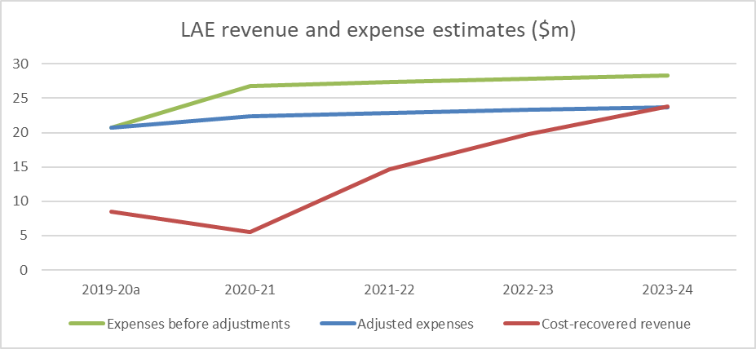
a Actuals.

Introduction

Purpose of this CRIS
This CRIS details the cost base and pricing structure for the LAE cost recovery arrangement and incorporates the impacts of the Busting Congestion for Agricultural Exporters package and the More Efficient and Sustainable Export Regulation measure announced in the 2020–21 Federal Budget.
The government is investing in modernising and reforming export regulatory services which will impact the cost base over time for all export cost recovery arrangements. Agriculture and food exporters and producers will be assisted through the modernisation and reform process with a freeze in fees and charges in 2020–21, and gradual increases from 2021–22 to 2023–24. Government has committed $71.1 million to improve the financial sustainability of export certification services by returning to full cost recovery of these services over time. A stepped return to full recovery will enable reforms to be rolled out while maintaining existing systems.
The key purpose of this CRIS is to:
- Baseline the LAE cost recovery arrangement expense for the regulatory activity against which progress of these reforms can be measured and changes transparently explained.
- Describe the freeze in fees and charges in 2020–21, and stepped increases from 2021–22 through to 2023–24.
An updated CRIS will be released for consultation in the first quarter of 2021 and updated annually. The annual CRIS will provide a summary of the previous year's financial performance, and description of deviations from forecast, provide an update of forward year cost base expectations and any consequential changes to charges required to ensure the arrangement remains financially balanced.
This methodology will provide a transparent description of the impact of the reforms and a record of changes to the cost base that will be able to be tracked over time.
This CRIS describes the impact of government decisions on current charges as they were outlined in the previous 2015 CRIS. A subsequent CRIS update in 2021–22 will implement the outcomes of a review on approaches to charging, in addition to reprofiling demand for services and reflecting the impact of reforms. reforms (further detail on likely changes to charging are detailed in section 2).

Path to full cost recovery
The government is freezing fees and charges for 2020–21 at current prices. From 2021–22 prices will be gradually increased to return all arrangements to full cost recovery in 2023–24.
The government is investing $71.1 million over 3 years from 2020–21 to maintain essential export regulatory services across all export cost recovered arrangements while prices are gradually increased.
This is part of a $328 million investment over 4 years from 2020–21 that also includes reforms to deliver an estimated annual cost reduction of $21.4 million from 2023–24 across all export cost recovered arrangements.
The impact of these decisions on LAE cost recovery from 2020–21 to 2023–24 is shown in
Table 1. The fees and charges are notional only, illustrating the gradual increase of prices supported by the government decisions if no changes are made to the way the department charges for regulatory activity.
Changes to charging from 1 July 2021 will be described in a separate 2021–22 CRIS to be released for public consultation in the first quarter of 2021.
Table 1 LAE fees and charges for 2020–21 and illustrative prices for 2021–22 to 2023–24
Cost recovery charges | Unit | 2020–21 ($) | 2021–22 ($) | 2022–23 ($) | 2023–24 ($)
Levy charges
Application | Per application | 600 | 1,584 | 2,134 | 2,558
Variation | Per variation | 300 | 792 | 1,067 | 1,279
Approved arrangement – air | Annual | 10,000 | 26,395 | 35,560 | 42,621
Approved arrangement – sea | Annual | 20,000 | 52,790 | 71,120 | 85,241
Establishment (premises) registration | Annual | 5,000 | 13,198 | 17,780 | 21,311
Export licence a | Annual | 25,000 | 65,988 | 88,900 | 106,551
Export licence – small and infrequent | Annual | 5,000 | 13,198 | 17,780 | 21,311
Throughput – full unit (Sheep/Goat) | Per animal | 0.31 | 0.82 | 1.11 | 1.33
Throughput – full unit (cattle/buffalo/camel) | Per animal | 1.21 | 3.20 | 4.31 | 5.16
Export permit – non-livestock | Per document | 130 | 344 | 463 | 555
Fee-for-service
Inspection | Per quarter hour | 55 | 146 | 196 | 235
Additional inspection | Per quarter hour | 71 | 188 | 253 | 303
Audit | Per quarter hour | 43 | 114 | 153 | 184
Specialist audit | Per quarter hour | 103 | 272 | 367 | 439
Document | Per document | 60 | 159 | 214 | 256
Replacement document | Per document | 500 | 1,320 | 1,778 | 2,132
Independent observer | Per quarter hour | 43 | 114 | 153 | 184
a For the purposes of this charge, export licence volumes have been set to zero in this CRIS as this charge does not apply to all livestock exporters who, since 1 January 2017, have been required to operate with an approved arrangement unless an exemption has been granted.
Note: Forward year prices shown are for illustrative purposes only. The 2021–22 CRIS will describe the changes to fees and charges for 2021–22 to 2023–24.

CRIS updates
In accordance with the Australian Government Cost Recovery Guidelines (CRGs), the LAE CRIS will be updated annually. It will report on financial and non-financial performance and revised 4-year forecasts. This annual update will provide an opportunity to measure progress of the reforms as they become quantifiable and to account for any external factors, for example, projected demand for activity.
The department will also report in-year financial performance within the CRIS, periodically reporting performance against the CRIS and explaining any variances. This will provide transparency in reporting for all exporters.
There may be other significant developments warranting a broader review of the cost base or charges. These could include:
- Changes to the regulatory settings of the arrangement, for example through a government policy change or the introduction of new systems or infrastructure.
- Changes to demand for regulatory activity, for example, due to a large part of industry changing its business model or significant change in terms of trade.
Where a CRIS update reveals that the existing fee or charge structure no longer meets the financial or regulatory requirements of the arrangement, the department may propose revised fees and charges. In this circumstance, the CRIS update will be the first step in consultation on changes to prices, followed by opportunities for stakeholder engagement.

Reforms

Busting congestion for all agricultural exporters
The Australian Government announced the Busting Congestion for Agricultural Exporters package in the 2020–21 Budget which includes reforms to slash unnecessary red tape to get products to export markets faster and support jobs in rural and remote Australia.
The package, worth over $328 million over 4 years from 2020–21, includes the following measures that are relevant to this CRIS.

Digital services to take farmers to markets
The centrepiece of the reform package is the Digital Services to Take Farmers to Markets measure, which will invest $222 million to modernise Australia’s agricultural export systems by slashing red-tape and improving regulation and service delivery for our producers and exporters. This measure will transition our systems online and provide a single portal for transactions between exporters and government, streamlining processes for exporters and helping them experience faster and more cost-effective services.

Improving regulation post–COVID-19 including targeted interventions for seafood and LAE
The Improving Regulation Post–COVID-19 measure will capitalise on new ways of working that were developed during the government's response to COVID-19.
The measure includes:
- Working with trading partners and international standard setting organisations to embed, where appropriate, alternative regulatory approaches such as technology supported auditing, and to promote wider utilisation of e-certification
- Assignment of dedicated case managers to support new exporters, including seafood, grains, dairy and NPGs, to allow them to navigate and meet regulatory requirements to get on the front foot to enter markets. Support existing exporters to expand and diversify their market opportunities by assisting them to more easily navigate export regulatory processes for example registration process ($3.7 million over 2 years).
- Capacity to develop and implement a risk based, targeted, approach to the regulation of the live animal and seafood export industries that supports compliant exporters and focuses on non-compliant operators ($2.3 million over 2 years). The initiatives will consider increased use of new technologies including for on-vessel. Key to the successful deployment of technology will be the collaborative development of feasible options between the department, industry bodies and individual operators.

LAE cost recovery arrangement cost base following reforms
These reforms are an opportunity for government and industry to work in partnership to lower the cost base of export arrangements. While possible efficiency measures have been identified, the cost reduction of these measures needs to be monitored as measures are implemented and will only be achieved with ongoing efforts from the department and industry. This will require an iterative approach to manage the cost base over the forward estimates. We will work with industry to achieve these outcomes.
Table 2 shows the cost base with and without adjustments to expense and forecast revenue for the LAE cost recovery arrangement and it describes:
- the cost base per the draft CRIS from the 2019–20 consultation
- adjustments to that cost base from the busting congestion package.
Table 2 LAE cost base with and without adjustments to expense and expected cost recovered revenue
Expense base | Unit | 2020–21 | 2021–22 | 2022–23 | 2023–24
Expenses – no adjustmentª | $ | 26,805,558 | 27,314,112 | 27,832,531 | 28,362,965
Total cost reductions from adjustments | $ | (4,370,766) | (4,458,181) | (4,547,345) | (4,638,292)
Expected expenses after adjustments | $ | 22,434,792 | 22,855,931 | 23,285,186 | 23,724,673
Revenue from cost recovered regulatory services | $ | 5,566,520 | 14,692,844 | 19,794,441 | 23,814,130
Appropriation funding | $ | 16,868,273 | 8,163,087 | 3,490,745 | n/a
Total revenues | $ | 22,434,792 | 22,855,931 | 23,285,186 | 23,814,130
Expenses less revenues | $ | – | – | – | (89,457)
Appropriation funding as % of expenses | % | 75 | 36 | 15 | n/a
a Expense estimates incorporating expansion of regulatory capacity post-2019–20 Budget.

Livestock exports regulatory reforms
The CRIS outlines the full cost of delivering regulatory services, addressing the Review of the Regulatory Capability and Culture of the Department of Agriculture and Water Resources in the Regulation of Live Animal Exports (Moss Review) recommendations, introduction of the independent observer program and the 2018–19 Budget Expanded Cost Recovery measure.
The arrangement has been under recovering ever since it was last revised in 2015 and the accumulated deficit for the arrangement was $30.4 million at the end of 2019–20. This deficit resulted from under-recoveries in both the livestock and other animal export areas of the arrangement. Updated fees and charges will ensure our ongoing financial sustainability and reflect the regulatory needs of the sector.
If changes to revenue are not made, regulation and reform in the live animal export (LAE) arrangement will not be able to continue at the same level as is currently being undertaken. The practical impacts of this include reductions in the responsiveness of regulatory services, an inability to maintain strong engagement with both the export and animal welfare sectors and reductions to the Animal Welfare Branch functions. There would be significant constraints on our ability to pursue complex regulatory actions and investigations, leaving the entire sector exposed to the risk of poor, non-compliant behaviour by bad actors.
Without effective regulation and ongoing reform, there is a likelihood that the sector will see further major incidents and reduction in public confidence and social licence. Trading partners may lose confidence in our ability to meet their importing country requirements. Further, reforms introduced in response to the Moss Review may not be able to be maintained or further developed. We would have limited capacity to respond to recommendations from the Inspector General of Live Animal Exports and there would be a risk of regulatory stagnation for the arrangement, further increasing risks to efficient and effective regulation.

Policy and statutory authority to cost recover
Under the Australian Government charging framework (charging framework), cost recovery requires both policy approval and statutory authority. The following sections provide information on government approval of regulatory charging for export regulatory activities and the legislation that enables the department to collect fees and charges.

Description of the regulatory activity
The export of live animals and reproductive material is regulated in accordance with the export legislative framework (see section 4.4).
To certify an export’s compliance with these regulations and the importing country requirements, the department undertakes a range of activities, including:
- The regulation and administration of the Australian Government accredited veterinarian program, livestock export licences, and registered and approved premises.
- The auditing of licenced livestock exporters, registered premises and accredited veterinarians to ensure compliance with the applicable regulations and standards.
- The assessment of approved arrangements (AAs) and notices of intention to export.
- The assessment of exporter supply chain assurance system applications for the export of livestock for feeder/slaughter purposes.
- The inspection of animals prior to export.
- The provision of export permits and health certification acceptable to Australia’s trading partners.
- The development, implementation and monitoring of operational policy and systems that ensure compliance with Australian export controls and any additional importing country requirements. These activities serve to maintain the eligibility of commodities for export from Australia and ensure that market access is maintained.
- Support provided by our overseas counsellors relating to detained consignments, government certification and other issues which result in goods being held at the border.
- The provision of scientific and technical advice to improve, maintain or restore market access and to demonstrate adherence to export requirements.
For more information on exporting, see Export goods controlled by the department.
For information about LAE regulatory services, such as the authority to cost recover and the cost recovery methodology, see section 5. Specific details, cost base, levies and fees for the LAE cost recovery arrangement can be found in Appendix A.

Why cost recovery is appropriate
Cost recovery (regulatory charging) falls within the Australian Government’s broader charging framework. Other charges in this framework include commercial charges and resource charges. The type of charge is determined by the characteristics of the activities as described in the charging framework. This provides the overarching framework under which government entities must design, implement and review cost recovery.
Under the charging framework, regulatory charging is appropriate because live animal export certification activity is provided to a clearly identifiable group-individuals and organisations that participate in the live animal export supply chain.
There are additional benefits to funding export certification through regulatory charging. When a business pays for the activities it receives, the government has an obligation to justify the prices it charges. Regulatory charging also raises awareness of regulated entities of how much a regulated activity costs.
For these reasons, the government has determined regulatory charging to be the most appropriate mechanism for funding live animal export regulation. We have reviewed regulatory charging of live animal export regulation activities, consistent with the charging framework.

Government policy approval to cost recover the regulatory activity
Policy authority for regulatory charging for export certification activities was reaffirmed in the 2020–21 Budget when the government announced the Busting Congestion for Agricultural Exporters package. The package sets out a period of partial cost recovery from 2020–21 to 2023–24 before a return to full cost recovery by 2023–24, while a series of reforms to improve efficiency and lower costs are implemented.

Statutory authority to charge
Fees and charges for live animal export certification are recovered under a separate statutory authority.

Cost recovery fees
Section 25 of the Export Control Act 1982 provides the power to impose fees in relation to a range of export activities and with administering certain quotas. The specific amounts are set out in the Export Control (Fees) Order 2015.
The Australian Meat and Live-stock Industry Act 1997 and subordinate legislation provides the power to impose fees in relation to an application for an export licence.
Amendments to, or new, subordinate legislation provide authority for the fees detailed in this CRIS to be established. These and other delegated instruments include descriptions of the charging points for live animal export fees.

Cost recovery levies
The following Acts and subordinate legislation include descriptions of the charging points for the live animal export levies:
- Export Control Act 1982
- Export Charges (Collection) Act 2015
- Export Charges (Imposition – Customs) Act 2015
- Export Charges (Imposition – Excise) Act 2015
- Export Charges (Imposition – General) Act 2015
- Export Charges (Collection) Regulation 2015
- Export Charges (Imposition – General) Regulation 2015
- Export Charges (Imposition – Customs) Regulation 2015
- Export Control (Fees) Order 2015
- Export Control Act 2020
- Export Charges (Imposition – General) Amendment Act 2020
- Export Charges (Imposition – Customs) Amendment Act 2020
- Export Charges (Imposition – Excise) Amendment Act 2020

New legislative framework
The Export Control Act 2020 commences 28 March 2021, consolidating export functions from the Export Control Act 1982 and Australian Meat and Live-stock Industry Act 1997 into a new legislative framework. The new legislation supports existing policy, while providing flexibility for different approaches to the regulation of exports in the future.
No changes to the expense base have been identified at this time because of the implementation of the new legislative framework, but changes to our regulatory approach could affect cost recovery. Any impacts will be reviewed when or if changes are implemented.

Cost recovery model

Outputs and business processes of the regulatory charging activity
The key policy objectives for our regulatory charging arrangements are to:
- safeguard Australia’s animal and plant health status to maintain overseas markets and protect the economy and environment from the impact of exotic pests and diseases, through risk assessment, inspection and certification, and the implementation of emergency response arrangements for Australian agricultural, food and fibre industries.
- support more sustainable, productive, internationally competitive and profitable Australian agricultural, food and fibre industries through policies and initiatives that promote better resource management practices, innovation, self-reliance and improved market access.
Our cost recovery arrangements describe how we use resources (such as people, IT, property and equipment) to undertake business processes (regulatory activities), which enable us to provide outputs that meet our policy objectives (Figure 2).
Figure 2 Outputs and business processes of our regulatory charging activity
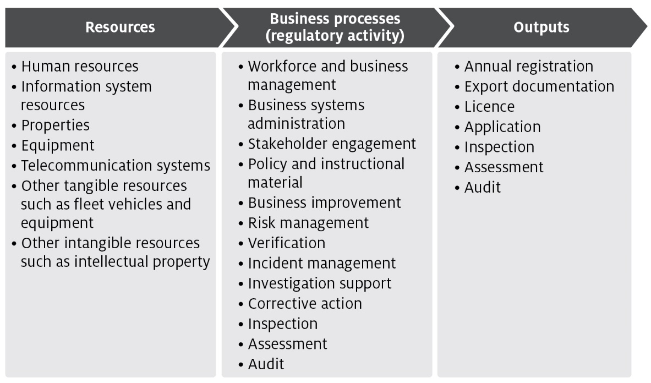
The processes listed in Figure 2 are described in Appendix A and are grouped into 4 categories of activities:
- Program management and administration – administrative activities that support us to deliver our export regulatory activities.
- Assurance – activities that mitigate risks to collective user groups by assessing departmental controls of systems and processes to ensure they operate in accordance with their intended design.
- Incident management – activities that respond to incidents concerning alleged breaches of Australian regulation or international import conditions.
- Intervention – activities provided directly to an individual, business or organisation to meet export requirements.

Costs of regulatory charging activity

Cost allocation process
To determine the cost of regulatory activities we use an activity-based costing (ABC) system. The ABC cost allocation methodology reflects costs incurred through usage of regulatory activities, providing a transparent allocation of costs while also being efficient and effective to administer.
The 2 expense categories are:
- Direct expenses – these can be directly attributed to the provision of an activity, for example, inspections. They comprise of staff salaries and supplier costs including direct capital expenses.
- Indirect expenses – these are not directly linked to an activity provided by us. Indirect expenses include corporate employee salaries and overheads such as information technology, finance, human resources costs, and indirect capital expenses.
The cost allocation process apportions the costs of support functions (indirect expense) and direct expense to the processes/activities defined in Appendix A. We include indirect expenses in the cost base to reflect the systems and processes that exist to help with efficient administration, which the cost-recovered arrangements benefit from. This is the same methodology employed for the allocation of indirect costs to appropriated activities, in line with our cost allocation policy.
The ABC system allocates costs in a staged approach:
- Indirect costs such as property, finance, information technology, human resources and divisional executives are allocated to direct cost centres using a cost driver which estimates the relative usage of each of the corporate services. Cost drivers for corporate services include:
  - Workpoints – distributes costs based on space occupied, with the workpoint count reflecting the space where a person may be able to work.
  - Full-time equivalent (FTE) – distributes costs based on each program's FTE staff numbers.
  - PC count/IT assets – distributes costs based on the number of IT assets in a program.
  - Transactions – distributes costs based on the number of transactions incurred over a period. This driver is used to allocate expenses related to the functions of accounts receivable and accounts payable.
  - Headcount – allocates costs based on the number of staff that a program area has as a proportion of the number of staff that are on the department’s total staff.
  - Custom drivers – allocate costs to specific cost centres, primarily based on usage for shared program resources.
- Cost drivers are reviewed on an annual basis, or as required. Changes to cost drivers are substantiated through effort or other data.
- Direct costs (including the indirect costs allocated in stage 1) are allocated to the activity and cost-recovered arrangements that best reflects the activity undertaken. Time recording systems allow the accurate allocation of effort to specific activities and arrangements, particularly to intervention activities.
- The primary variable used in the allocation of costs to activities is effort. As a result, cost estimates vary with changes in activity. If actual activity levels change during a financial year, the costs allocated to arrangements would require adjustment to align with that effort. This is monitored throughout the year and adjusted where necessary.
- For example, food safety auditors undertake audits across multiple arrangements. We forecast the number of audits and average time for an audit for each arrangement. The associated costs are allocated to the arrangements and audit function based on total audit hours.
- Activity/arrangement costs (from stage 2) are allocated to charge points which identifies the cost associated with that charge. We use a combination of cost recovery fees and levies. Figure 3 shows how we categorise cost–recovered levy and fee activities and outputs.
Figure 3 Categories of activities
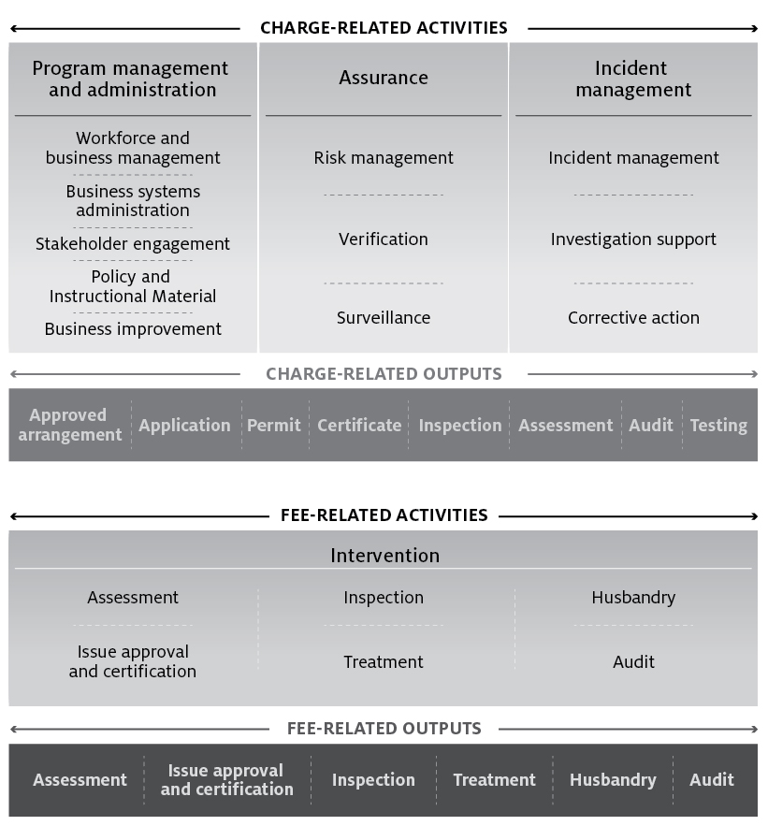

Stakeholder engagement
Stakeholder engagement plays an important role in the development and management of cost recovery arrangements. Our stakeholders have a unique insight into how our regulatory activities impact on their business and help us design efficient cost recovery frameworks for these activities.
This CRIS explains the decisions taken by government and financial outcomes of the measures in the busting congestion package. No changes to fees and charges apply in 2020–21. However, we note you may want to make comment in relation to this CRIS. If you are interested, we ask that you register your interest to participate in our upcoming consultation and in receiving further information and invites to future opportunities to engage.
You are also welcome to make comments on our Have Your Say page. Any comments you make will be addressed as part of the consultation process scheduled to take place in early 2021 on the proposed 2021–22 CRIS.
Stakeholder engagement on the development and implementation of reforms from 2021–22 through to 2023–24 will take place over the course of the annual CRIS update cycle, beginning in February 2021. For further information on the package see Busting Congestion for Agricultural Exporters.

Industry engagement
The department has established industry consultative committee (the Live Animal Export Cost Recovery Consultative Group) to represent industry views in relation to live animal export and we consult with this committee on a number of different activities. In February 2020, the consultative group was given detailed information on:
- the cost base
- the volume of activities
- the proposed fee and levy structure
- the proposed rates of the fees and levies.
The committee has indicated a strong view that we must remain committed to continual improvement and the realisation of efficiencies from a number of reform activities we currently have underway.
Feedback from the consultative group has maintained that we must continually improve the way we regulate. Specific concerns raised by the groups include:
- Changes to the live animal export cost recovery arrangements due to the expanded cost recovery measure announced in the 2018–19 Budget. They suggested the measure might contravene the CRGs.
- We have explained how this measure aligns with the government’s cost recovery policy. We will work with industry participants to make the implementation of this measure, and impact to the cost base, as transparent as possible.
- The increasing cost of the department’s activities, despite the planned realisation of efficiencies from reform activities. The committee has questioned how efficient we were in regulating their industries.
- The busting congestion budget measures, by investing in regulatory reform, provides industry with an opportunity to address these concerns.
- We have agreed to discuss additional performance indicators to assess and improve the realisation of efficiency in our export certification activities. This will include performance against reform targets.
- The difficulty understanding the impact of the drought and the effect that might have on export volumes.
- We have agreed to take a conservative approach to forecasting export volumes and did not adjust them for any potential impacts of the drought.

Cost recovery arrangement for live animal export
This section describes the live animal export cost recovery arrangement cost base, as well as additional financial information associated with audit, inspection and certification activities for live animal exports.

Design of cost-recovered charges
There are no changes to the existing LAE cost recovery charging structure in this CRIS. We will consult on any adjustments to the charging structure in a revised CRIS prior to implementing updated fees and charges from 1 July 2021.

Cost base
The airing of footage showing poor animal welfare conditions on board a livestock vessel in 2018 led to a number of reviews and changes to the regulatory environment for livestock exports in particular. These changes that include the introduction of independent observers, a Notice of Intention assessment point and increased scrutiny over the program, have resulted in increased costs. An Animal Welfare Branch has also been established to support live animal exports by reviewing and updating LAE standards and regulations in consideration of the latest available science and evidence, and in accordance with government policy.
The purpose of the review conducted by Mr Philip Moss AM, an independent reviewer appointed by the then Minister for Agriculture, was to assure government and the Australian public that exporters meet our high animal welfare standards and identify regulatory and investigative improvements we can make. The Moss Review made a series of recommendations which have since been implemented or are in the process of being implemented. These have implications for the cost base for LAE regulation and in turn the fees and charges required to be recovered from industry.
One of the significant regulatory reforms has been to introduce the independent observer program, which was forecast to cost $4.371 million in 2020–21 before being suspended due to COVID-19.
The implementation of these changes broadly aligns with the increasing cost base as depicted in Figure 4, including a comparison of costs with and without the independent observer program.
Figure 4 LAE cost base and recovery over time
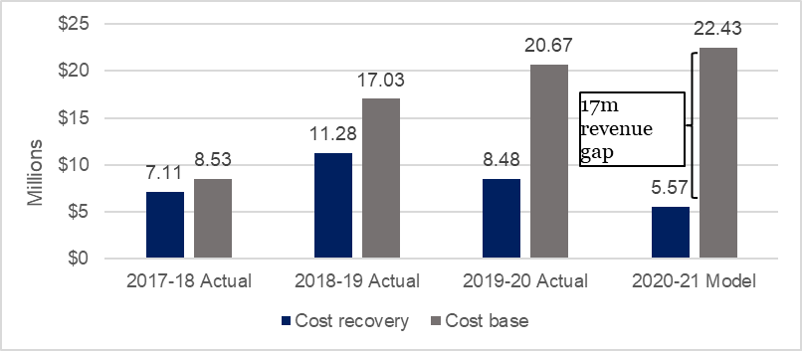
The level of under-recovery in 2017–18 was $1.4 million. This under-recovery increased in 2018–19 to $5.7 million and $12.2 million in 2019–20.
The department maintains a cost recovery reserve which allows over and under recoveries to be offset and avoid the need for rapid price fluctuations. In 2019–20 the balance of the reserve was a deficit of $30.4 million, reflecting years of accumulated under recovery. This amount is far in excess of the department’s policy of maintaining a cost recovery reserve balance of 0 to 5% (approximately $1.1 million) above program expense.
Cost recovery charges in this CRIS have been designed to establish a new baseline that addresses the modelled level of under-recovery. These charges do not however seek to recover any portion of the accumulated deficit that has occurred within the balance of the cost recovery reserve.
Live animal export volumes are forecasted to remain steady over the next 4 years.

Cost base assumptions
The cost base has been modelled to reflect the full costs of the arrangements. Partial cost recovery levels are displayed in the tables dealing with financial performance and fees and charges. The 2019–20 budget has been used as the starting point for determining the cost base in this CRIS. To project the cost base over the next 4 years, we have applied adjustments to capture expected changes to the costs including:
- inflation of 1.65% per annum, in line with the Department of Finance’s inflation estimate
- increases in employee expenses of 2% per annum, reflecting reasonable estimates of wage increments in line with the Australian Public Service Workplace Bargaining Policy 2018
- additional depreciation from new assets anticipated to be recognised over the period
- adjustments for future fee-related activities to reflect expected changes in volume.

Projected cost base
The cost base for 2020–21 for the live animal export cost recovery arrangement is $22.535 million (Table 3), made up of:
- $15.007 million in charge-related activities
- $7.529 million in fee-related activities
A detailed description of activities is provided at Appendix A and the methodology for attributing costs to these activities is provided in section 5.
Table 3 Cost base for live animal export cost recovery arrangement, 2020–21
Charge type | Activity group | Activity | Expense ($) | Cost recovery charge
Levy | Program management and administration | Workforce and business administration | 14,972,900 | Establishment (Premises) registration, export licence, export permit, approved arrangement - air/sea, throughput
 |  | Business system administration
 |  | Stakeholder engagement
 |  | Policy and instructional material
 |  | Business improvement
 | Assurance | Risk management
 |  | Verification
 |  | Surveillance
 | Incident management | Incident management
 |  | Investigative support
 |  | Corrective action
Fee for service | Intervention | Assessment | 6,678,088 | Standard and specialist assessment, document, replacement document
 |  | Inspection | 626,264 | Inspection
 |  | Audit | 157,540 | Audit
Total cost base |  |  | 22,434,792 | –
Table 4 provides a breakdown of expenses of the cost recovery arrangement (2020–21).
Table 4 Cost type breakdown for live animal export cost recovery arrangement, 2020–21
Expenses | Forecast ($)
Direct | 15,962,248
Employee | 14,925,055
Operating | 1,034,518
Other | 2,674
Indirect | 6,472,544
Assurance and Legal | 1,559,258
Corporate Strategy and Governance | 696,364
Finance & Business Support | 734,239
Information Services | 1,909,036
Property | 1,573,647
Total | 22,434,792
For more information on how expenses are allocated see section 5.

Changes to the cost base
Table 5 shows the adjustments to the cost base in 2020–21 and Table 6 shows the adjustments to the cost base in 2021–22.
Table 5 Changes to cost base for live animal export, 2020–21
Adjustment to cost base | Impact on cost base | Unit | Forecast
Total baseline expense (2019–20 Approved Budget) | n/a | $ | 20,776,401
- Increase regulatory capacity LAE program | Increase | $ | 3,616,218
- Increase inspection and assessment | Increase | $ | 1,269,163
- Indirect expense | Increase | $ | 587,880
- Inflation | Increase | $ | 555,896
- Independent observer program | Decrease | $ | (4,370,766)
Total adjustments to cost base | Increase | $ | 1,658,391
Adjusted cost base | n/a | $ | 22,434,792
Change in expense | Increase | % | 8.0
n/a Not applicable.
Table 6 Changes to cost base for live animal export, 2021–22
Adjustment to cost base | Impact on cost base | Unit | Forecast
Total baseline expense | n/a | $ | 22,434,792
Inflation | Increase | $ | 421,138
Adjusted cost base | n/a | $ | 22,855,931
Change in expense | Increase | % | 1.9
n/a Not applicable.

Increased regulatory capacity for live animal exports
The most significant change, to an already under recovering cost base, is the implementation of recommendations from the Moss Review of regulatory standards and animal welfare. Consideration of animal welfare has been put at the centre of our work.
To achieve this, the Animal Welfare Branch was established in October 2018 to provide effective standards development and an evidence-based approach to the consideration of welfare. The Animal Welfare Branch has since led the review and development of new arrangements for the Australian Standards for the Export of Livestock, the Heat Stress Risk Assessment review, interim arrangements for the 2019 Northern Hemisphere summer (NHS) and arrangements for NHS sheep exports from 2020. This has been achieved through stakeholder engagement as well as technical and analytic work.
Strengthening regulatory practice, improving transparency and delivering as a regulator with the necessary systems has also required an increase in capacity. We are working on a range of business improvement projects and policies. For example, work on operations projects is aimed at increasing efficiency, improving transparency, and providing clarity to exporters on performance expectations. There is an ongoing need for operations policy, including working with industry to respond to issues identified since the introduction of AAs and ensuring mechanisms are strengthened to respond to non-compliance in an effective way.
Other examples of how we are addressing Moss Review recommendations include:
- improved engagement with stakeholders, including by establishing the Live Export Animal Welfare Advisory Group (LEAWAG). This group includes representatives from industry (exporters and producers), animal welfare groups, academics and Australian, state and territory government agencies. It provides a forum for strategic consultation with stakeholders about live animal export animal welfare practices, standards and legislation.
- improving staff capability and culture, including by developing and implementing a regulatory training framework. This ensures staff are appropriately inducted and receive training in administrative law, defensible decision making and integrity.
- strengthening internal policies and procedures, including introducing a new Compliance Statement for the Export of Livestock; updating customer service standards; commencing work to deliver a program of random, unannounced audits and system verification and rolling out new decision-making templates to all officers involved in the regulation of live animal exports.
- increasing investigative capability and willingness to take effective regulatory action which reduces risk for the rest of the industry.
- The independent observer program was introduced to provide a level of assurance for the health and welfare of live animal exports while in transit by sea. IOs are placed on livestock vessels to observe, monitor, record and report to the department matters affecting animal health and welfare. This program has been suspended for 2020–21 during the COVID-19 pandemic and costs associated with department officers travelling aboard vessels have been removed.

Increased inspection and assessment activity
Veterinarians work across import and export activities-undertaking inspection, audit and assessment functions. Time spent on each function is recorded and whether it is import or export related. Surveys have shown that more time is spent on exports than is currently being allocated to the arrangement. The updated survey data has therefore led to a significant increase in the associated expense included in the 2020–21 forecast.

Indirect expense
Indirect expenditure has increased proportionally with the size of the LAE program. Examples of indirect expenses include:
- assurance and legal – providing legal advice, risk management strategies, managing insurance requirements and instructional material guidance under the Practice Statement Framework
- corporate strategy and governance – providing advice on workplace relations issues, interpreting and support for our enterprise agreement, managing a code of conduct and human resource services
- finance and business support – providing financial services including budgeting, cost recovery, financial accounting, payroll, procurement and treasury functions
- information services – providing application support for IT systems, managing web design, content and accessibility and ICT strategy
- property – costs associated with departmental property leases and management fees.

Inflation
In line with the government’s CRGs and our cost allocation policy, inflation and depreciation expenses have been adjusted in the cost base to reflect increased employee and supplier expenses. This is in line with the Australian Public Service workplace bargaining policy 2018 and government inflation estimates. Cost recovery of these activities is considered appropriate because industry directly benefits from having a system in place that allows us to manage and respond to market access issues, including ensuring compliance with overseas country requirements.
The inflationary adjustments in the cost base per year include:
- employee expenses – increasing by 2% and compounding annually to reflect reasonable estimates of wage increments in line with the Australian Public Service workplace bargaining policy 2018
- supplier expenses – increasing by 1.65% and compounding annually to reflect inflation in line with the Department of Finance inflation estimate.

Reforms from 2020–21

Cost reductions from reform and efficiency program
Government investment through the Busting Congestion for Agricultural Exporters and other budget measures may lead to reduced costs to this arrangement. These reductions will be reflected in future CRIS updates as they are identified.

Independent observers
The independent observer program was introduced to increase regulatory oversight of the livestock export trade in 2018. The key role of the independent observer program has been to monitor exporters’ arrangements to ensure the health and welfare of live animals on export vessels. The program has provided provide important insight into practices and conditions on board livestock export vessels.
While the program is suspended, the government is reviewing the independent observer model with a view to maintain the benefits of additional oversight while ensuring an efficient and effective regulatory framework. Once a new model has been designed and approved, the costs of any new approach will be added to the cost base.

Livestock Global Assurance Program (LGAP) reform
The Livestock Global Assurance Program (LGAP) is an industry led reform intended to improve the efficiency of live animal exporters. The reform is aimed at developing a global conformity assessment program that ensures that animals are treated in accordance with international animal welfare guidelines.

New export control legislation
No changes to the cost base have been identified at this time arising from the implementation of the new legislative framework, but changes to our regulatory approach could affect cost-recovery. Any impacts will be reviewed when or if changes are implemented.

Live animal export fees and charges
The amount payable for 2020–21 is shown in Table 7. Forward year prices will be provided in the 2021–22 CRIS.
Table 7 Fees, charges and volumes for live animal export cost recovery arrangement, 2020–21
Type of charge | Cost recovery charges | Unit | Price ($) | Estimated volume (units) | Estimated total revenue ($)
Levies | Application | Per application | 600 | 37 | 22,200
 | Variation | Per variation | 300 | 374 | 112,200
 | Approved arrangement – air | Annual | 10,000 | 10 | 100,000
 | Approved arrangement – sea | Annual | 20,000 | 26 | 520,000
 | Establishment (premises) registration | Annual | 5,000 | 74 | 370,000
 | Export licenceª | Annual | 25,000 | – | –
 | Export Licence – small and infrequent | Annual | 5,000 | 2 | 10,000
 | Throughput – full unit (sheep/goat) | Per animal | 0.31 | 1,044,365 | 323,753
 | Throughput – full unit (cattle/buffalo/camel) | Per animal | 1.21 | 978,219 | 1,183,645
 | Export permit non-livestock | Per document | 130 | 6,445 | 837,850
Fees-audit | Standard audit | Per quarter hr | 43 | 1,956 | 84,108
 | Specialist audit | Per quarter hr | 103 | 445 | 45,835
Fees-inspection | Inspection | Per quarter hr | 55 | 9,017 | 495,935
 | Additional inspection | Per quarter hour | 71 | – | –
 | Document | Per document | 60 | 23,800 | 1,428,000
 | Replacement document | Per document | 500 | 66 | 33,000
 | Independent observer | Per quarter hr | 43 | – | –
Total | 5,566,520
a For the purposes of this charge, export licence volumes have been set to zero in this CRIS as this charge does not apply to all livestock exporters who, since 1 January 2017, have been required to operate with an approved arrangement unless an exemption has been granted.
Note: Prices have been rounded. The annual charge will be rounded upwards to the nearest dollar, with the exception of throughput, which will be rounded upwards to the nearest cent.

Financial estimates
The financial performance of the live animal export cost recovery arrangement is provided at Table 8.
There will be no change to the cost recovery reserve for the duration of the busting congestion package. The reserve deficit will be carried forward until a government decision is taken to address it.
Table 8 Financial estimates for live animal export cost recovery arrangement
Finance element | 2020–21 ($) | 2021–22 ($) | 2022–23 ($) | 2023–24 ($)
Revenue = X | 5,566,520 | 14,692,844 | 19,794,441 | 23,814,130
Expenses = Y | 22,434,792 | 22,855,931 | 23,285,186 | 23,724,673
Balance = X – Y | (16,868,273) | (8,163,087) | (3,490,745) | 89,457
Appropriation funding | 16,868,273 | 8,163,087 | 3,490,745 | n/a
Balance after Appropriation | 0 | 0 | 0 | 89,457
Forecast opening cost recovery reserve balance | (30,375,437) | (30,375,437) | (30,375,437) | (30,375,437)
Transfer | 0 | 0 | 0 | 89,729
Forecast closing cost recovery reserve balance | (30,375,437) | (30,375,437) | (30,375,437) | (30,285,980)
n/a Not applicable.

Financial and non-financial performance
This section presents information on the financial and non-financial performance of the live animal export cost recovery arrangement. This is intended to provide an overview of our performance in recovering forecasted costs and meeting regulatory objectives.

Financial performance
We continue to consult with key industry stakeholders on financial performance indicators to assist in evaluating the performance of our cost recovery arrangements. This CRIS will be updated as performance indicators are refined and further developed. The financial performance for the live animal export cost recovery arrangement is provided in Table 9. This table will be updated each year, as financial results become available.
Table 9 Financial performance for live animal export cost recovery arrangement, 2016–17 to 2019–20
Finance element | 2016–17 ($) | 2017–18 ($) | 2018–19 ($) | 2019–20 ($)
Revenue = X | 6,608,200 | 7,110,948 | 11,281,861 | 8,480,976
Expenses = Y | 8,692,649 | 8,526,298 | 17,031,102 | 20,674,858
Balance = X – Y | (2,084,448) | (1,415,349) | (5,749,241) | (12,193,882)
Remissions, rebates & adjustments = Z | 28,265 | 2,858 | n/a | n/a
Net balance = balance + Z | (2,112,713) | (1,418,207) | (5,749,241) | (12,193,882)
Cost recovery reserve balance | (11,014,106) | (12,432,314) | (18,181,555) | (30,375,437)
n/a Not applicable. In accordance with the CRGs, the department will update the arrangements’ financial performance results annually.
Note: Annual revenue has varied due to trade conditions, which resulted in poor returns in 2016–18. Since the implementation of Expansion of Cost Recovery measures from 2018, Moss Review and the Independent Observers, the spending in workforce and management has increased significantly. This has been partly offset by increased revenue in independent observer charging.

Key dates and events
We undertake regular reviews of our financial performance and conduct regular stakeholder engagement activities throughout the CRIS. Key forward dates for regulatory charging for live animal export certification activities are documented in Table 10.
Table 10 Key forward dates and events
Key forward events schedule | Next scheduled update
Annual CRIS update to forward estimates | February 2021
Updated fees and charges implemented | 1 July 2021
Annual CRIS updates to financial and non-financial performance for 2020–21 | October 2021
Annual CRIS update to forward estimates | February 2022
Updated fees and charges implemented | 1 July 2022
Annual CRIS updates to financial and non-financial performance for 2021–22 | October 2022
Portfolio charging review to be undertaken | 2023
Annual CRIS update to forward estimates | February 2023
Updated fees and charges implemented | 1 July 2023
Annual CRIS updates to financial and non-financial performance for 2022–23 | October 2023
Portfolio charging review outcomes to be brought forward in Budget | 2024–25

Appendix A: Description of cost model activities
The following provides details of the cost model activities undertaken in our cost recovery arrangements.

Program management and administration activities

Workforce and business management
This activity has 4 categories:
- Workforce management activities include staff supervision, allocating workforce resources, managing employee performance, leave, training and other conditions, managing Work, Health and Safety requirements, recruitment and termination.
- Business management activities include business planning and continuity; requesting legal advice; procurement and contracts; program and project administration, assurance, design and management; management of fixtures, facilities, equipment, supplies and logistics.
- Financial management activities include billing and accounting, budgeting, charges and payments, collections and receivables, debt management, financial accounts, reporting and policy development.
- Information management activities include data management, information and records management, and information sharing and collaboration.

Business systems administration
Includes developing, acquiring, testing, implementing and supporting applications and business systems. This includes technical support and maintenance of all business systems including information and communications technology.

Stakeholder engagement
Involves proactive engagement with any person, business, or organisation including any associated travel. This includes, engaging with peak industry bodies, secretariat support and attendance at industry consultative committee meetings, consultation on new standards and requirements, publishing website content and other information.

Policy and instructional material
Includes developing, maintaining and communicating our policy and instructional material, such as operational and corporate policies, scientific advice, departmental guidelines and work instructions, and associated training development and delivery. Examples include responding to changes in importing country requirements, developing or revising policy processes and instructional material.

Business improvement
Includes assessment, monitoring and management of business performance. Examples include adjustments to improve regulatory activity, against business performance reports against key performance indicators and similar activities.

Assurance activities

Risk management
Involves assessing and managing the risks posed to Australia’s ability to maintain market access. This includes communicating results of risk analysis, modelling and forecasting to operational areas and the collection, receipt and use of reliable compliance data to meet our compliance objectives. This work also includes any associated travel and regulated entity assistance work. For example, organising, involvement in and responding to overseas government’s systems-based audits.

Verification
Includes assurance activities to provide stakeholders and departmental executive with confidence that departmental controls of its systems and processes are operating in accordance with their intended design and associated documentation. For example, verification of certification activity internally and by state regulators.

Surveillance
Includes formal and informal monitoring to detect issues that may affect onshore production for export, such as changes in Australia’s pest or disease status or food safety concerns. Surveillance differs from an inspection because it is not done for a specific client.

Incident management activities

Incident management
The coordination and management of any incident including post border detection and export incidents. This includes all associated pre- and post-work, travel and regulated entity assistance in relation to an incident, government certification and other issues which result in goods being held at the border. For example, this includes managing and responding to food safety incidents where food may have been exported.

Investigation support
Involves providing support for enforcement activities relating to an alleged breach of portfolio legislation, including any related regulated entity assistance and travel. This also includes enforcement activities that ensure compliance with Australian regulation and international import conditions such as investigations and engagement with regulated entities about compliance.

Corrective action
Includes actions taken in response to non-compliance or contravention of legislation or procedures that are managed without a formal investigation by an enforcement officer. Corrective action activities includes all pre- and post-work, travel and regulated entity assistance in relation to the enforcement process.

Intervention activities

Assessments
Involves assessing information to determine if it meets ours and the importing country requirements. This includes all preparatory work (such as confirming importing country or export requirements) and post work (such as assessment report preparation) travel and regulated entity assistance in relation to the assessment. Examples include assessments of licences, permits, registrations, accreditations, and exemptions.

Issue approvals/certification
Includes issuing of a decision in relation to an assessment for cargo, vessels, plants, animals, food, biological and genetic material. This includes the work from the end of the assessment period to the completion of the decision notification process to support issuance of appropriate export documentation.

Inspections
Involves the physical examination (and supervision of a physical examination) of export food commodities to determine compliance with export and importing country requirements.

Treatments
Includes the physical treatment of cargo, vessels, plants, animals, food, biological and genetic material, other conveyances or premises to prevent an adverse biosecurity outcome from occurring and to meet relevant importing country requirements.

Husbandry
Includes activities relating to the care of plants and animals that we are responsible for, including transport of plants and animals, housing, daily monitoring, feeding, cleaning of facilities, administering of medication, bookings and regulated entity assistance.

Audit
Includes the systematic and functionally independent examination to determine whether activities and related results comply with legislative or documented requirements. This includes all pre- and post-work, travel and regulated entity assistance in relation to the audit. Examples include audits to verify compliance with an export registered establishment’s AA.

Glossary
Term | Definition
Activity | Any measurable work undertaken by the department to enable export of goods. This includes activities, business processes and outputs as described in the Australian Government Cost Recovery Guidelines (CRGs).
Charge | A fee or a levy that the department imposes to recover costs. In the CRGs, charges are referred to as cost recovery charges.
Cost recovery arrangement | Describes the management, delivery and the cost recovery of activities for a defined group of regulated entities.
Export document | Can refer to permits, certificates, or any other document issued or certified under the Export Control Act 1982 and may be issued manually or electronically.
Fee | A charge imposed when activities are provided directly to a specific individual or organisation. In the CRGs, fees are referred to as cost recovery fees.
Levy | A charge imposed when activities are provided to a group of individuals or organisations (e.g. an industry sector) rather than to a specific individual or organisation. A levy is legally a taxation charge and needs to be imposed in a separate taxation Act to comply with constitutional requirements. A levy differs from general taxation, as it is earmarked to fund activities provided to the group being charged. In the CRGs, levies are referred to as cost recovery levies.

