Cost recovery implementation statement: Live animal exports 2025–26
© Commonwealth of Australia 2025
Ownership of intellectual property rights
Unless otherwise noted, copyright (and any other intellectual property rights) in this publication is owned by the Commonwealth of Australia (referred to as the Commonwealth).
Creative Commons licence
All material in this publication is licensed under a Creative Commons Attribution 4.0 International Licence except content supplied by third parties, logos and the Commonwealth Coat of Arms.

Cataloguing data
This publication (and any material sourced from it) should be attributed as: DAFF 2025, Cost recovery implementation statement: Live animal exports 2025-26, Department of Agriculture, Fisheries and Forestry, Canberra, July. CC BY 4.0.
This publication is available at agriculture.gov.au/ about/fees/cost-recovery-2025-26
Department of Agriculture, Fisheries and Forestry
GPO Box 858 Canberra ACT 2601
Telephone 1800 900 090
Web agriculture.gov.au
Disclaimer
The Australian Government acting through the Department of Agriculture, Fisheries and Forestry has exercised due care and skill in preparing and compiling the information and data in this publication. Notwithstanding, the Department of Agriculture, Fisheries and Forestry, its employees and advisers disclaim all liability, including liability for negligence and for any loss, damage, injury, expense or cost incurred by any person as a result of accessing, using or relying on any of the information or data in this publication to the maximum extent permitted by law.
Acknowledgement of Country
We acknowledge the continuous connection of First Nations Traditional Owners and Custodians to the lands, seas and waters of Australia. We recognise their care for and cultivation of Country. We pay respect to Elders past and present, and recognise their knowledge and contribution to the productivity, innovation and sustainability of Australia’s agriculture, fisheries and forestry industries.

Contents
Summary 1
1 Policy and statutory authority to cost recover 2
1.1 About the department 2
1.2 Government policy approval to cost recover 2
1.3 Statutory authority to apply fees and charges 4
1.4 Who pays for regulatory activities 4
2 Risk assessment 5
2.1 Accumulated results 6
3 Stakeholder consultation 7
3.1 Stakeholder engagement strategy 7
4 Cost recovery arrangement for live animal exports 10
4.1 Description of the regulatory activity 10
4.2 Cost-base assumptions 11
4.3 Modelled cost base 12
5 Design of regulatory charges 15
5.1 Live animal exports fees and charges 15
5.2 Revenue variability 16
6 Financial estimates 18
6.1 Financial estimates 18
7 Financial and non-financial performance 19
7.1 Financial performance 19
7.2 Summary financial performance 2023-24 19
7.3 Non-financial performance 19
8 CRIS approval and change register 22
Appendix A: Additional fees and charges that may apply 23
Tariff rate quota (TRQ) certificates 23
Outside ordinary hours (OOH) 23
Appendix B: Cost recovery model 25
Outputs and business processes of the regulatory charging activity 25
Costs of regulatory charging activity 26
Description of cost model activities 28
Assurance activities 29
Incident management activities 30
Intervention activities 30
Appendix C: Summary of stakeholder feedback 32

Tables
Table 1 Government decisions impacting regulatory charging for agricultural export activities 3
Table 2 Approach to stakeholder engagement for regulatory charging 8
Table 3 Cost base for live animal exports cost recovery arrangement, 2025-26 13
Table 4 Cost type breakdown for live animal exports cost recovery arrangement, 2025–26 14
Table 5 Fees, charges and volumes for live animal exports cost recovery arrangement, 2025–26 16
Table 6 Financial estimates for live animal exports cost recovery arrangement 18
Table 7 Financial performance for live animal exports cost recovery arrangement, 2020-21 to 2023-24 19
Table 8 Live animal export arrangement summary of financial position, 2023–24 19
Table 9 CRIS approval and change register 22
Table A1 TRQ certificate fees and charge 23
Table A2 Outside ordinary hours 23
Table C1 Stakeholder feedback for the 2025-26 CRIS 32

Figures
Figure 1 Engagement process 8
Figure 2 Example the process a regulated entity would experience for an intervention activity. 13
Figure B1 Outputs and business processes of the department’s regulatory charging activity 25
Figure B2 Categories of activities 28

Summary
This cost recovery implementation statement (CRIS) provides information on how the department implements cost recovery for the live animal export cost recovery arrangement.
The department performs a range of regulatory activities in support of our producers and exporters who take their high-quality products to global markets. The gross value of agricultural, fisheries and forestry production in 2024–25 is expected to be around $88.4 billion.
Cost Recovery is implemented when:
- Fees are charged when regulation is provided directly to an individual or organisation for the delivery of regulatory activities such as inspections of goods, audit of registered premises, or assessment of export certification.
- Cost recovery levies or charges are applied when regulation is imposed on an industry sector rather than directly to a specific individual or organisation. These charges recover the costs of maintaining regulatory infrastructure and integrity through program management and administration, assurance and incident management activities.
As part of the 2023-24 Mid-Year Economic and Fiscal Outlook (MYEFO), the Australian Government invested in the department under budget measure 'Securing the future of agricultural trade (PDF 306KB)' to ensure Australia’s export regulatory and trade system remains able to meet both the needs of our exporters and the expectations of our trading partners, while supporting industry to achieve its goals now and into the future.
This measure included $91.8 million over 2 years to sustain and underpin the delivery of the department’s key export regulatory and non-regulatory trade services, while work progressed to design and develop an ongoing sustainable export trade funding model into the future. While this model is under development cost recovery fees and charges will remain unchanged.
The department continues to work to design and develop this model. Therefore, the Australian Government has invested an additional $46.6 million as part of the 2024–25 MYEFO to continue to sustain the delivery of the departments export regulatory services through 2025–26. This funding supports significant lead time for consultation and engagement on the design and implementation of a fit for purpose sustainable funding model.

Policy and statutory authority to cost recover

About the department
Our vision is a more sustainable and prosperous Australia through biosecurity, agricultural production and trade.
We maintain and create agricultural export opportunities, to provide gains for Australian agriculture, fishing and forestry. We manage biosecurity risks to Australia to protect our multi-billion-dollar industries and our way of life. We engage with international counterparts to reinforce Australia’s role in shaping how the global agriculture and fibre sector addresses food security, productivity, trade, sustainability and the impacts of climate change.
As a regulator, we enforce laws relating to agricultural goods exported from Australia. We are also responsible for administration of export controls on agricultural, fisheries and forestry industries products.
By working together with industry and our state and territory partners, our objective is to safeguard and grow sustainable agriculture, fisheries and forestry for all Australians.

Government policy approval to cost recover
Under the Australian Government Charging Framework, cost recovery requires both policy approval and statutory authority. This chapter provides information on government approval of regulatory charging for export regulatory activities and the legislation that enables the department to collect fees and charges.
Cost recovery (regulatory charging) falls within the Australian Government’s Charging Framework. The type of charge is determined by the characteristics of the activities as described in the charging framework. This provides the overarching framework under which government entities must design, implement and review cost recovery.
Regulatory charging is appropriate because exports regulatory activity is provided to a clearly identifiable group, individuals and organisations that participate in the agriculture, food and fibre export supply chain. If it were not for the business activities of these groups, the regulatory activities would not be required.
There are additional benefits to funding exports regulation through regulatory charging. When a business pays for the activities it receives, the government has an obligation to justify the prices it charges. Regulatory charging also raises the awareness of regulated entities of how much a regulated activity costs.
For these reasons, the government has determined regulatory charging to be the most appropriate mechanism for funding exports regulatory activities. Regulatory charging of export regulatory activities is consistent with the charging framework. This has been reaffirmed in various measures as outlined below.
Table 1 describes the key government approvals for continued and expanded regulatory charging for agricultural exports since 2015.
Table 1 Government decisions impacting regulatory charging for agricultural export activities
Date | Government decision | Details
2024–25 | Enabling Agriculture Exports into the Future | The Australian Government has invested an additional $46.6 million as part of the 2024–25 MYEFO to continue to sustain the delivery of the department’s export regulatory services through 2025–26. This funding supports significant lead time for consultation and engagement on the design and implementation of a fit for purpose sustainable funding model.
2023–24 | Securing the future of agricultural trade | In the 2023–24 MYEFO, the Australian Government committed $91.8 million over 2 years to ensure Australia’s regulatory export and trade system remains able to meet the needs of both our exporters and the expectations of our trading partners, while supporting industry to achieve its goals now and into the future.  $3.7 million over 3 years was also provided for the development of an ongoing sustainable funding model to support the department’s export regulatory and trade activities.
2020–21 | Busting Congestion for Agricultural Exporters | Policy authority for export regulatory charging was reaffirmed in the 2020–21 Budget when the then government announced the Busting Congestion for Agricultural Exporters package.  The package consisted of reforms for the Australian agricultural sector as part of the Economic Recovery Plan to rebuild the economy and recover from the COVID-19 recession. This included $71.1 million to improve the financial sustainability of export certification services, supporting a stepped return to full cost recovery, and enabling reforms to be rolled out while maintaining existing systems.
2020 | Introduction of the Export Control Act 2020 | The Export Control Act 2020 and related rules and charging regulations for exported commodities, set out the overarching legislative framework for the regulation of exported goods, including food and agricultural products, from Australian territory. A fundamental aspect of this framework is the recovery of costs from exporters for regulatory activities carried out by the department.
2018–19 | Expanded Cost Recovery | In the May 2018 Budget, the government confirmed continuing cost recovery from industry through the Expanded Cost Recovery Measure, commencing 1 July 2019, and included:  Enforcement activities that ensure compliance with Australian regulation and international import conditions. Activities that will be cost recovered include investigations and engagement with clients about compliance but will not include the costs of infringement notice schemes or undertaking litigation.  Provision of scientific and technical advice to improve or maintain existing export markets. Examples include the provision of scientific or technical advice to re-open or maintain market access following a pest or disease incursion or change in import conditions; and improving existing market access by seeking to reduce import requirements or simplify certification processes.  Services provided by overseas counsellors relating to detained consignments, government certification and other issues which result in goods being held at the border.
2015 | Department of Agriculture and Water Resources – Comprehensive Review of Cost Recovery | Over the period 2014–15, the department redesigned its cost recovery arrangements as part of a funding strategy for its biosecurity and export certification activities. The review sought to streamline existing frameworks to address inequities, ensure all costs are recovered and reduce the complexity of the department’s fees and charges. Outcomes of the review were implemented 1 December 2015.

Policy authority for regulatory charging for export regulatory activities was reaffirmed in the 2020–21 Budget when the then government announced the Busting Congestion for Agricultural Exporters package. The package set out a period of partial cost recovery from 2020–21 to 2022–23 with a view to return to full cost recovery by 2023–24, while a series of reforms to improve efficiency and lower costs were implemented.
As described previously, work is progressing on the design and development of an ongoing sustainable export trade funding model. While this model is under development, cost recovery fees and charges will remain unchanged.

Statutory authority to apply fees and charges
The Export Control Act 2020 Section 399 Fees and other rules for fee-bearing activities, states the rules may prescribe fees that may be charged in relation to fee‑bearing activities carried out by, or on behalf of, the Commonwealth in the performance of functions or the exercise of powers under the Act. The specific fees and price points are set out in the Export Control (Fees and Payments) Rules 2021.
Cost recovery charges are imposed under the following legislation:
- Export Charges (Imposition – General) Act 2015
- Export Charges (Imposition – Customs) Act 2015
- Export Charges (Imposition – Excise) Act 2015.
Details of specific price points and charges payable are included in the following regulations:
- Export Charges (Imposition – General) Regulations 2021
- Export Charges (Imposition – Customs) Regulations 2021.

Who pays for regulatory activities
It is intended that the department recovers the full cost of regulatory activities from participants in the live animal export supply chain, including exporters, producers and regulated entities. In 2025–26, the government is supplementing a portion of the regulatory activities with appropriation while a sustainable funding model is developed.
Additional information on services provided and the entities are outlined in section 4.1.

Risk assessment
In accordance with the Australian Government Charging Policy, the department has undertaken a Charging Risk Assessment (CRA) involving the ongoing assessment and management of risk at each phase of the cost recovery process. The CRA for the live animal exports cost recovery arrangement is rated at low, which is based on an assessment of each component, including:
- a low-risk rating for the expected percentage change in total annual revenue (less than 10%)
- a low-risk rating for the expected change in total value of annual revenue (less than $10 million)
- a low-risk rating for the highest percentage increase in price a payer may experience (less than 5%)
- a low-risk rating as the changes proposed apply to both fees and levies
- a low-risk rating as the proposal relates to a change in the level of existing regulatory charges only
- a low-risk rating due to the level of change in legislative arrangements (no legislative changes required)
- a low-risk rating due to the level of impact of cost recovery on payers
- a low-risk rating due to the level of complexity in working with other government entities to deliver regulatory functions
- a low-risk rating due to previous consultation with stakeholders and no proposed changes for 2025-26 prices.
The department provided the Office of Impact Analysis (OIA) preliminary information to assist in determining whether a detailed impact analysis is required. The OIA advised that this was not required, based on an assessment of the following components:
- Regulatory prices for export cost recovery arrangements were developed in 2020–21 and stepped price increases were set over a 4-year period covering the 2021–22 to 2024–25 financial years.
- Consultation was undertaken in 2021–22, 2022–23 and 2024–25 on the prices, which were subsequently enacted in legislation.
- Legislated prices for 2025–26 are to be implemented on 1 July 2025.
The area not addressed in the CRA is the current misalignment of our current regulatory activities and the cost recovery revenue collected through fees and charges. The department will be engaging with industry and government on the design of an ongoing sustainable funding model to support regulatory trade functions into the future.
The department will also work alongside the Department of Finance to conduct a Portfolio Charging
Review (PCR) for Budget 2026–27. The PCR occurs every five years and will allow the department to
review charging across its portfolio including export arrangements.

Accumulated results
Accumulated results assist with managing the alignment of revenue, expenses and variations to forecast volumes and have been accumulated since the inception of the arrangement. Our policy requires that a balance of up to 5% of annual program expense be maintained. Additionally, any excess amounts collected are not used to subsidise shortfalls in other arrangements or the departments non-cost recovered functions.
Regulatory charging is set to recover reasonable costs however, several factors can affect the difference between revenue and expenses. These factors include volume variances and changes in expenses based on risk profiles. Demand for commodities, overseas economic factors, and climatic events can all impact regulatory effort, costs and volumes of activities.
Under-recoveries will result in the arrangement not recovering the costs of regulatory activities. This results in the arrangement operating at a loss and adversely impacts the accumulated balance for the arrangement at year’s end. Ongoing under recovery will lead to the need for further review of the regulatory charging arrangement to ensure its return to sustainable recovery for all regulatory costs. This excludes any accumulated deficits, which are not factored into future price setting, consistent with the Australian Government Cost Recovery Framework.
Once a fee or charge is paid by industry, it becomes government revenue. We will consult with industry on any under-recovery or over-recovery. Subject to agreement between the department and industry, over-recoveries may be managed through remittance or investment initiatives.

Stakeholder consultation
The department engages with live animal industry representatives on charging arrangements through the Live Animal Export Finance Industry Consultative Committee (LAEFICC). The 2021–22 CRIS explained the approach for gradually increasing prices and what those prices would be each year.
Consultation with stakeholders on the 2022–23 CRIS occurred in July and August 2022. Stakeholders were further consulted on the 2024–25 CRIS in April 2024. This feedback is detailed in Appendix C.

Stakeholder engagement strategy

Purpose
This stakeholder engagement strategy for the cost recovery of live animal exports regulatory activities outlines the engagement principles, method and approach. The purpose of the strategy is to work with industry to update the CRIS as needed and provide information on the performance of the cost recovery arrangement.
This strategy helps the department to plan, design, undertake and evaluate stakeholder engagement activities.
It has been designed to meet the requirements of the:
- Australian Government Charging Framework
- Australian Government Guide to Regulation
- Australian Public Service Framework for Engagement and Participation.

Principles
The department’s principles for engagement are to listen, be genuine and open. The department will achieve this by:
- engaging with a diverse group of stakeholders to ensure a clear explanation of the objectives and context
- communicating our objectives clearly with what is yet to be decided and what has already been decided
- providing sufficient time for stakeholders to engage in the consultation processes
- clearly communicating challenges and outcomes
- providing responses on how stakeholder feedback has been taken into consideration.

Method
The department, throughout the annual CRIS reviews plans to consult, implement, monitor, and review regulatory charging.
The department will also design revised fees and charges in the CRIS documents as needed.
Figure 1 Engagement process
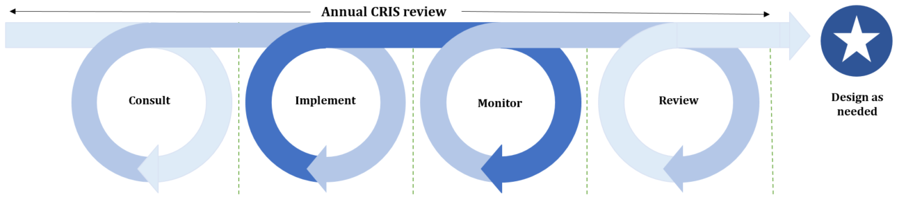
Throughout this process, the department used 2 different levels of engagement:
- share – when government needs to tell the public about an initiative
- consult – when government gathers feedback from specific industry groups about a problem or a solution.

Approach
The department’s engagement approach is outlined in Table 2.
Table 2 Approach to stakeholder engagement for regulatory charging
Category | Consult | Implement | Monitor | Review | Design as needed
Objective | Public consultation to seek feedback on annual updates to the proposed cost base, fees and charges in the draft CRIS. | Publish public information to prepare stakeholders for upcoming changes to regulatory charging. | Publish information on prior year financial and non-financial performance of regulatory charging. | Consultation to seek feedback on regulatory charging performance and stakeholder engagement. | Targeted consultation to seek advice and input on behalf of their industries to develop volume, expense and pricing models.
Level of engagement | Consult | Share | Share | Consult | Consult
Timing | Annually in first quarter of the year. | Annually in June. | Annually in October. | As needed for a potential Portfolio Charging Review in 2025. | As needed.
Stakeholders | - Industry consultative committees (ICCs).  - All industry participants.  - Peak industry bodies. | - All industry participants.  - Peak industry bodies. | - Industry consultative committees (ICCs).  - All industry participants.  - Peak industry bodies. | - Industry consultative committees (ICCs).  - All industry participants.  - Peak industry bodies. | - Industry consultative committees (ICCs).  - Peak industry bodies
Method | - Online – Have Your Say.  - Face-to face. | - Industry advice notices (IANs).  - Online – department website. | - Online – department website. | - Online – Have Your Say. | - Face-to-face.  - Teleconference.

Cost recovery arrangement for live animal exports
The Australian Government Cost Recovery Policy requires that regulators recover some or all of the efficient costs of the effort required to deliver their services, unless the government has decided to fund that activity.
The modelling of fees and charges in 2021–22 endeavoured to forecast Consumer Price Index (CPI) growth in costs and increased demand for regulatory activities for horticulture exports. Stepped increases were planned to return export cost recovery arrangements back to full cost recovery by 2023–24. Prices were legislated for these stepped increases from 2022–23 through to 2024–25 with prices for 2025-26 remaining the same as 2024–25 prices while a sustainable funding model is developed.
In recent years, the rate of change in Australia’s export trade landscape has accelerated. Our market access requirements are changing, and the global agricultural trade environment is becoming more complex. It has become clear that the modelling and assumptions used to form the prices in legislation are no longer fit for purpose given contemporary regulatory service and pressures.
The department is acting on these issues in 2 ways:
- Regulatory pricing for 2025–26 will continue at the rates set out in legislation to give certainty to industry and maintain the prices that have previously been consulted on, with government appropriation supplementing arrangements over the same period.
- Continuing the development of an ongoing sustainable funding model. This will enable the department to remain appropriately and accurately resourced to carry out its export regulatory functions into the future.
Industry will be engaged, through the development of a sustainable model, to gain views and feedback on more modern ways of providing an efficient and sustainable model of cost recovery for export regulatory activities.

Description of the regulatory activity
Live animal exports are regulated in accordance with Export Control Act 2020 and associated legislative framework (see section 1.3).
The department delivers a range of regulatory services to support the export of live animals and reproductive materials. These services are described using the categories in the department’s cost model activity framework (Appendix B).
Live animal export certification activity undertaken by the department involves registration, inspection, audit and certification activities.
Exporters of live animals must obtain an export permit prior to the departure of prescribed goods from Australia. Overseas government authorities may require additional certification to verify that the exported products comply with their respective import conditions. To certify compliance with Australia’s export requirements and the importing country requirements, the department undertakes a range of activities, including:
- developing, implementing and monitoring of operational policy and systems that ensure compliance with Australian export controls and any importing country requirements. These activities serve to maintain the eligibility of commodities for export from Australia and to protect and promote Australia’s reputation for premium agricultural goods, while maintaining existing, and seeking increased, market access opportunities
- providing registration, inspection, auditing, verifying, and enforcement activities to ensure that the production, storage, handling and transportation of live animals intended for export comply with the conditions of Australian export controls and any additional requirements imposed by an importing country
- appointing and managing live animal export authorised officers, through the development, maintenance and delivery of authorised officer training and assessment, and ongoing infield support
- issuing permits and other documentation necessary to confirm compliance with Australian export controls and any additional importing country requirements
- providing support through the department’s overseas counsellors relating to detained consignments, government certification and other issues that result in goods being held at the border
- providing scientific and technical advice to improve, maintain or restore market access to demonstrate adherence to export requirements
- providing assurance and transparency to the government, department, industry and the broader community regarding the health and welfare of live animals on export vessels. (see Independent observers).
The broad range of services are described in the description of cost model activities using the categories in the department’s cost model activity framework (Appendix B).
Learn more about Export goods controlled by the department.

Cost-base assumptions
The greater part of the department’s regulatory activity cost is employee related. External suppliers and operating support for our export IT systems makes up other major direct costs. The key cost driver for permit and assessment-based activities is complexity, which determines the amount of time and effort spent on a regulatory output.
The cost base was modelled to reflect the full costs to deliver regulatory services to support the live animal export industry. The 2021–22 CRIS model was used as the starting point for determining the cost base applied in this CRIS and advised to industry in previous versions of this document.
Assumptions made in the modelling were:
- inflation of 1.7% per annum, in line with the Department of Finance’s inflation estimate
- a decreased wage price index (WPI) applied to employee expenses from 2.0% to 1.7% per annum, reflecting reasonable estimates of wage increments in line with the Australian Public Service Workplace Bargaining Policy 2020
- additional depreciation from new assets anticipated to be recognised over the period
- adjustments for future fee-related activities to reflect expected changes in volume.
As described earlier, the rate of change in Australia’s export trade landscape has accelerated. Our market access requirements are changing, and the global agricultural trade environment is becoming more complex. The assumptions underlying the 2021–22 cost base increases are no longer accurate and extensive work is required to reset all cost recovery arrangements for export regulatory services, including for live animal exports.
Following the work being undertaken by the Trade Strategy Taskforce (the Taskforce) the department will continue to undertake annual reviews to evaluate regulatory effort, costs, and the charges based on those costs, to ensure pricing remains consistent with costs and sustainable to maintain regulatory activities.

Modelled cost base
The cost base used modelling from 2020 to establish current pricing as represented in tables 3, 4 and 5. This is in contrast to the tables reflecting our financial performance which uses current budgets and forecasts.
We allocate employee, supplier, system and corporate costs to each type of regulatory activity (see Appendix B).

Direct costs
Direct costs are primarily the costs of employees who provide regulatory activities. In addition to the costs of employees, it also includes supplier cost such as direct capital expenses. Direct costs are allocated to the regulatory activity that best reflects the activity undertaken.
Figure 2 provides an example of the connection between the activity of intervention and output of export documentation for an exported good
Figure 2 Example the process a regulated entity would experience for an intervention activity.
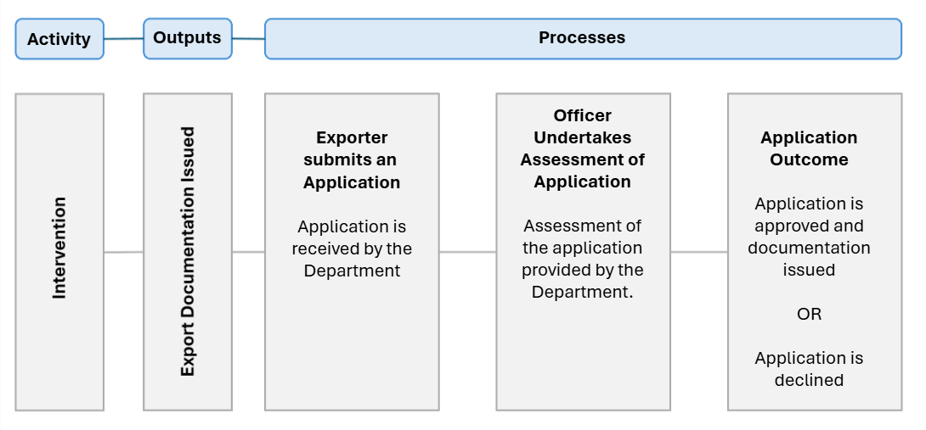

Indirect costs
Indirect costs are enabling costs that cannot be attributed to a specific activity or output. These include information and communications technology, maintenance, office accommodation, and finance and corporate services costs. The department includes indirect expenses in the cost base to reflect the systems and processes that exist to help with efficient administration, which the cost-recovered arrangements benefit from. Indirect costs are allocated to cost recovered and appropriated activities using cost drivers such as headcount and full-time equivalent (FTE), in line with the department’s cost allocation policy.

Capital costs
Capital costs included in the operating costs of business processes are depreciation of property, plant and equipment (including furniture, IT hardware and infrastructure), amortisation of IT systems and software, non-capital software development costs, and accommodation.
Table 3 shows the live animal export arrangement cost base for 2025–26.
The cost base of $22.5 million is made up of:
- $14.7 million in charge-related activities
- $7.9 million in fee-related activities.
A description of cost activities and the methodology for attributing costs to these activities is provided at Appendix B.
Table 3 Cost base for live animal exports cost recovery arrangement, 2025–26
Charge type | Activity | Expense ($) | Cost recovery charges
Charge | - Program management and administration  - Workforce and business administration  - Business system administration  - Stakeholder engagement  - Policy and instructional material  - Business improvement  - Assurance  - Risk management  - Verification  - Surveillance  - Incident management  - Incident management  - Investigative support  - Corrective action | 14,691,584 | Annual registration, export documentation, throughput, application and organic certification
Fee-for-service | Intervention – assessment | 3,819,422 | Assessment
 | Intervention – inspection | 351,400 | Inspection
 | Intervention – audit | 216,708 | Audit
 | Intervention – Independent Observers | 3,508,337 | Independent Observers
Total cost base | – | 22,587,450 | –
Figures in Table 4 are sourced from modelling which occurred in 2020. This modelling reflects the methodology used to determine 2024–25 prices which we are continuing unchanged in 2025–26. As a result, these figures are not expected to match those in Table 5.
Table 4 Cost type breakdown for live animal exports cost recovery arrangement, 2025–26
Category | Expense | Forecast ($)
Direct | Employee | 13,034,010
 | Operating | 2,804,795
 | Other | 97,792
 | Subtotal | 15,936,597
Indirect | Assurance and legal | 282,745
 | Corporate Strategy and Governance | 441,199
 | Export support | 180,349
 | Finance | 926,984
 | Information services | 1,981,056
 | People services | 854,772
 | Property | 1,983,747
 | Subtotal | 6,650,853
Total | – | 22,587,450
Note: Structural changes to the department from machinery of government decisions means that some indirect expenses in this table have been reclassified as direct expenses and there have been some changes in terminology. (eg. Export Support is now known as Digital Business Division)

Design of regulatory charges
This CRIS provides for a mix of fee-for-service and levy (charges) regulatory activities, implemented under the Export Control (Fees and Payments) Rules 2021 and the Export Charges (Imposition—General) Regulations 2021

Fees are charged when regulation is provided directly to an individual or organisation for the delivery of regulatory activities such as inspections of goods, audit of registered premises, or assessment of export certification (see Intervention activities).
Cost recovery levies or charges are applied when regulation is imposed on an industry sector rather than directly to a specific individual or organisation. These charges recover the costs of maintaining regulatory infrastructure and integrity through program management and administration, assurance and incident management activities, as described at Appendix B.

Live animal exports fees and charges
No changes to the types of fees and charges or charge points are proposed in this CRIS.
Figures in this table are sourced from modelling which occurred in 2020 and the methodology to set prices between the 2021–22 and 2024–25 financial years. This modelling has not been updated to reflect contemporary volumes or the increase in expenditure. As a result, these figures are not expected to match those in Table 6.

The fees and charges have been legislated in the Export Control (Fees and Payments) Rules 2021 and the Export Charges (Imposition—General) Regulations 2021.
The payable for 2025–26 is shown in Table 5.

Table 5 Fees, charges and volumes for live animal exports cost recovery arrangement, 2025–26
Type of charge | Cost recovery charges | Unit | Modelled Cost ($) |  | Modelled volume (units) |  | Price ($)
Charges | Throughput – full unit (sheep/goat) – sea | Per animal | 969,050 |  | 633,366 |  | 1.53
 | Throughput – full unit (cattle/buffalo/camel) – sea | Per animal | 4,648,800 |  | 780,000 |  | 5.96
 | Throughput – full unit (sheep/goat) – air | Per animal | 47,468 |  | 36,514 |  | 1.3
 | Throughput – full unit (cattle/buffalo/camel) – air | Per animal | 39,213 |  | 7,719 |  | 5.08
 | Approved arrangement – air | Annual | 248,680 |  | 10 |  | 24,868
 | Approved arrangement – sea | Annual | 1,293,136 |  | 26 |  | 49,736
 | Establishment (premises) registration | Annual | 920,116 |  | 74 |  | 12,434
 | Licence – livestock | Annual | 382,000 |  | 40 |  | 9,550
 | Export permit non – livestock | Per document | 2,287,500 |  | 7,500 |  | 305
 | Document – replacement | Per document | 36,366 |  | 66 |  | 551
Fees – audit and inspections | Standard audit | Per quarter hour | 93,504 |  | 1,461 |  | 64
 | Specialist audit | Per quarter hour | 48,505 |  | 445 |  | 109
 | Inspection | Per quarter hour | 264,375 |  | 3,525 |  | 75
Fees – documentation | Specialist assessment | Per quarter hour | 1,865,475 |  | 24,873 |  | 75
 | Standard assessment | Per quarter hour | 961,586 |  | 19,624 |  | 49
Fees – independent observer | International flight – passthrough | At cost | – |  | – |  | –
 | Independent observer | Per day | 1,691,483 |  | 916 |  | 1,847
Total | – | – | 15,797,256 |  | – |  | –
Note: Prices have been rounded. The annual charge will be rounded upwards to the nearest dollar.

Revenue variability
Complexity, materiality and sensitivity are considered in assessing the risk of variation in revenue from cost-recovered activities. Each of these factors applies to the export arrangements in varying degrees. For example, in relation to the department’s regulatory activity, the variability in demand and climatic events both contribute to the complexity of projecting revenue from fees and charges.
The demand for the department’s activities, and therefore our revenue stream, is sensitive to market fluctuations. The applications for new registrations and permits are initiated by industry and are beyond the department’s control. They can vary depending on government policy settings, demand for Australian products overseas and broader economic and climatic conditions.
The department provides industry representatives (livestock, non-livestock and reproductive material export industries) with an opportunity to provide anticipated volumes of exports to contribute to financial year forecasts. Where estimates are provided by industry representatives, the information is considered in light of published data projections, e.g. livestock exports projections published by Meat and Livestock Australia and the Australian Bureau of Agricultural and Resource Economics and Sciences (ABARES).

Financial estimates

Financial estimates
The financial estimates of the live animal exports cost recovery arrangement are provided in Table 6.
Table 6 Financial estimates for live animal exports cost recovery arrangement
Finance element | 2022–23 ($) ª | 2023–24 ($) ª | 2024–25 ($) | 2025–26 ($)
Revenue = X | 12,151,984 | 14,504,319 | 12,805,715 | 12,805,715
Expenses = Y | 19,902,029 | 21,258,658 | 25,935,214 | 25,935,214
Balance = X – Y | (7,750,045) | (6,754,339) | (13,129,498) | (13,129,498)
Appropriation funding^{b} | 4,303,364 | 6,754,339 | 13,129,498 | 13,129,498
Balance after appropriation | (3,446,681) | 0 | 0 | 0
Forecast opening balance | (30,375,436) | (33,822,117) | (33,822,117) | (33,822,117)
Transfer | (3,446,681) | 0 | 0 | 0
Forecast closing balance | (33,822,117) | (33,822,117) | (33,822,117) | (33,822,117)
Note: numbers in brackets are negative. a. Actual. b. Appropriation allocated in 2024-25 and 2025-26 is notional until financial results are finalised and published in the department’s annual report
Estimates in 2024–25 consist of December year-to-date actuals plus forecast up to June 2025. Noting work currently being undertaken by the Taskforce, 2024–25 estimates have been notionally carried forward for 2025–26. Deficits will be supplemented with appropriation from the Securing the future of agricultural trade budget measure, continued through 2025–26. Deficits will be supplemented with appropriation from the Securing the future of agricultural trade budget measure continued through 2025–26.
Notable movements between 2023–24 actuals and 2024–25 budget are as follows:
- The increase being seen in staffing levels throughout 2023–24 and into 2024–25 is enabling the Department to return to an optimal and efficient workforce. This has resulted in a 10% rise in staffing associated with the live animal export arrangement, translating to an approximate $2.2m increase compared to 2023–24.
- The staffing growth has been further influenced by the salary adjustments outlined in the Enterprise Agreement, which are reflected in the 2024–25 budget estimates. This includes a 3.8% salary increase as stipulated in the agreement.
- In corporate expenditure, we observe continued increases to our costs for digital services, at a rate greater than anticipated. Specifically, there are increased costs for:
  - Investments to meet mandated government cyber security standards
  - Software licensing and support costs
  - Operational expenses supporting our capital infrastructure.
  - Telephony – network and phones (including data costs)
- These costs have been partially offset by reduced property occupancy costs resulting from the subletting of the Agriculture House office in Canberra.

Financial and non-financial performance
This section presents information on the financial and non-financial performance of the live animal exports cost recovery arrangement. This is intended to provide an overview of the department’s performance in recovering forecast costs and meeting regulatory objectives.

Financial performance
The financial performance for the live animal export cost recovery arrangement is provided in Table 7.
Table 7 Financial performance for live animal exports cost recovery arrangement, 2020–21 to 2023–24
Finance element | 2020–21 ($) | 2021–22 ($) | 2022–23 ($) | 2023–24 ($)
Revenue = X | 5,767,529 | 7,741,005 | 12,151,984 | 14,504,319
Expenses = Y | 16,265,218 | 19,797,593 | 19,902,029 | 21,258,658
Balance = X – Y | (10,497,689) | (12,056,588) | (7,750,045) | (6,754,339)
Remissions, rebates and adjustments = Z | 10,497,689 | 12,056,588 | 4,303,364 | 6,754,339
Net balance = balance + Z | 0 | 0 | (3,446,681) | 0
Balance | (30,375,436) | (30,375,436) | (33,822,117) | (33,822,117)

Summary financial performance 2023–24
The live animal exports 2023–24 CRIS forecast a deficit of $6.3 million. Actual expenditure totalled $21.3 million with cost recovery from participants returning $14.5 million resulting in a deficit of $6.8 million (Table 8).
Table 8 Live animal export arrangement summary of financial position, 2023–24
Category | Actual ($) | CRIS ($) | Variance ($) | Variance (%)
Revenue | 14,504,319 | 15,507,198 | (1,002,879) | (6)
Expenses | 21,258,658 | 21,838,626 | (579,968) | (3)
Net surplus/(Deficit) | (6,754,339) | (6,331,428) | (422,911) | 7
Appropriation | 6,754,339 | N/A | N/A | N/A
Balance | (33,822,117) | N/A | N/A | N/A

Non-financial performance
Our Annual report 2023-24 provides comprehensive information on performance measures and performance results. It is not intended to duplicate this information in this document but rather to draw attention to the key objectives relevant to export cost recovery arrangements. Non-financial performance measures are given as high-level objectives and are not reported at a level specific to each cost recovery arrangement.

Objective 1 Industry growth
Support industry to grow towards a $100 billion agriculture, fisheries and forestry industry by 2030.
Key activity 1.1 Support industry productivity and growth through science, policy and partnerships.
Measure IG–01 | Greater growth in average agricultural productivity (adjusted for climate and weather effects) for the past 10 years, compared to average annual market sector productivity growth over the same period.
Measure type | Effectiveness.
Target | Greater than or equal to 0% difference over past 10 years.
Sources | Corporate Plan 2023-24  Portfolio Budget Statements 2023–24  Programs: 1.1, 1.3, 1.4, 1.5, 1.6, 1.7, 1.8, 1.9, 1.10, 1.11, 1.12.
Result | Achieved – agricultural productivity growth was 0.11 percentage points higher than the market sector growth rate.
Tolerances | Achieved: Average annual growth in the agricultural productivity (climate-adjusted) series exceeds average annual market sector productivity growth over the same period.  Partially achieved: Not applicable.  Not achieved: Average annual growth in the agricultural productivity (climate-adjusted) series is lower than average annual market sector productivity growth over the same period.
Measure IG–02 | Equal or reduced cost of levies administration compared with levies disbursed.
Measure type | Efficiency and regulatory
Target | Cost is less than or equal to 1.2% of levies disbursed.
Sources | Corporate Plan 2023-24  Portfolio Budget Statements 2023–24  Programs: 1.1, 1.3, 1.4, 1.5, 1.6, 1.7, 1.8, 1.9, 1.10, 1.11, 1.12.
Result | Achieved – cost was $4.65 million or 0.77% of levies disbursed
Tolerances | Achieved: Levies administration cost is less than 1.2% of levies disbursed.  Partially achieved: Not applicable.  Not achieved: Levies administration cost is more than 1.2% of levies disbursed.
Key activity 1.2 Maintain and expand international markets by certifying and regulating exports and negotiating new and improved market access.
Measure IG–05 | The department negotiates new and improved technical market access to international markets.
Measure type | Output
Target | Each year, at least one new and one improved trade protocol is implemented by the department and made available to Australia’s agriculture, fisheries and forestry exporters.
Source | Corporate Plan 2023-24
Result | Achieved – 10 new export opportunities opened, and 44 improvements to market access
Tolerances | Achieved: If at least one new and one improved market access protocol is made available.  Partially achieved: Not applicable.  Not achieved: If the department fails to deliver at least one new and one improved market access protocol.
Measure IG–06 | The department negotiates to maintain technical market access to international markets when trade is threatened and restores trade where it has been lost.
Measure type | Output
Target | Not applicable.
Source | Corporate Plan 2023-24
Result | There were 29 instances of maintained market access and 5 instances of restored market access. These actions protected markets worth a potential $4.6 billion
Tolerances | Not applicable.
Key activity 1.3 Streamline export regulations and compliance arrangements
Measure IG–07 | Increase in the number of electronic certificates for export issued (moving to paperless trade).
Measure type | Efficiency and regulatory.
Target | Plus 2.5% of the final 2022–23 eCert number (61,237).
Sources | Corporate Plan 2023-24  Portfolio Budget Statements 2023-24  Programs: 1.13
Result | Achieved – 21.9% increase in the number of electronic certificates issued for export (74,661 in 2023–24 compared with 61,237 in 2022–23).
Tolerances | Achieved: 100%.  Partially achieved: 50% to 99%.  Not achieved: 0% to 49%.
Note: For a complete picture of our performance, see Part 1: Annual performance statements – Our performance measures, of the Annual report 2023-24.

CRIS approval and change register
Table 9 tracks the changes to the CRIS as a result of changes to the regulatory charging activity.
Table 9 CRIS approval and change register
Date of CRIS Change | CRIS Change | Approver | Basis for change
06/06/2025 | Certification of the CRIS | Secretary, Department of Agriculture, Fisheries and Forestry | New regulatory charging activity and revalidation of cost model
23/06/2025 | Approval of CRIS | Minister of Agriculture, Fisheries and Forestry | Communication and distribution of the new regulatory charging activity and revalidation of cost model

Appendix A: Additional fees and charges that may apply

Tariff rate quota (TRQ) certificates
The prices for TRQ certificates for goods other than prescribed meat, prescribed meat products, prescribed milk and prescribed milk products are as indicated in Table A1.
Table A1 TRQ certificate fees and charge
Type of charge | Cost recovery charges | Unit | Price ($)
 |  |  | 2023–24 | 2024–25 | 2025-26
Charge | TRQ Certificate | Per document | 45 | 46 | 46
Fee | TRQ Certificate electronic | Per document | 17 | 17 | 17
 | TRQ Certificate, manual | Per document | 41 | 41 | 41
 | Replacement TRQ Certificate | Per document | 574 | 585 | 585

Outside ordinary hours (OOH)
The additional fees payable for fee-bearing activity for certain goods by Commonwealth authorised officers outside ordinary hours of duty are as indicated Table A2.
Table A2 Outside ordinary hours
Type of charge | Time of service | Unit | Price ($)
 |  |  | 2023–24 | 2024–25 | 2025–26
Fee – OOH | On a weekday, immediately before or after a fee-bearing activity  non-veterinarian | Per quarter hour | 15 | 15 | 15
 | On a weekday, in any other case  non-veterinarian | Any period up to 30 minutes | 30 | 30 | 30
 |  | Per quarter hour after first 30 minutes | 15 | 15 | 15
 | Saturday, Sunday or a departmental holiday  non-veterinarian | Any period up to 30 minutes | 40 | 40 | 40
 |  | Per quarter hour after first 30 minutes | 20 | 20 | 20
 | On a weekday, immediately before or after a fee-bearing activity  Veterinarian | Per quarter hour | 21 | 21 | 21
 | On a weekday, in any other case  Veterinarian | Any period up to 30 minutes | 42 | 42 | 42
 |  | Per quarter hour after first 30 minutes | 21 | 21 | 21
 | Saturday, Sunday or a departmental holiday  Veterinarian | Any period up to 30 minutes | 58 | 58 | 58
 |  | Per quarter hour after first 30 minutes | 29 | 29 | 29

Appendix B: Cost recovery model

Outputs and business processes of the regulatory charging activity
The key policy objectives for the department’s cost recovery arrangements are to:
safeguard Australia’s animal and plant health status to maintain overseas markets and protect the economy and environment from the impact of exotic pests and diseases, through risk assessment, inspection and certification, and the implementation of emergency response arrangements for Australian agricultural, food and fibre industries
support more sustainable, productive, internationally competitive and profitable Australian agricultural, food and fibre industries through policies and initiatives that promote better resource management practices, innovation, self-reliance and improved market access.
The department’s cost recovery arrangements describe how the department uses resources (such as people, IT, property and equipment) to undertake business processes (regulatory activities), which enable the department to provide outputs that meet the department’s policy objectives (Figure B1)
Figure B1 Outputs and business processes of the department’s regulatory charging activity
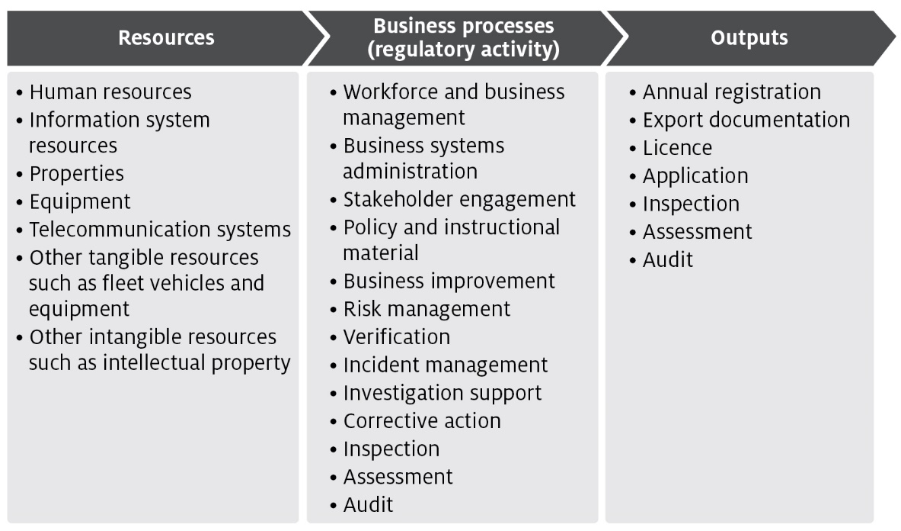
The processes listed in Figure B2 are grouped into 4 categories of activities:
- Program management and administration – administrative activities that support and deliver the department’s export regulatory activity commitments.
- Assurance – activities that mitigate risks to collective user groups by assessing departmental controls of systems and processes to ensure they operate in accordance with their intended design.
- Incident management – activities that respond to incidents concerning alleged breaches of Australian regulation or international import conditions.
- Intervention – activities provided directly to an individual, business or organisation to meet export regulatory activity requirements.

Costs of regulatory charging activity

Cost allocation process
To determine the cost of regulatory activities, the department uses an activity-based costing (ABC) system. The ABC system allows for complex cost allocation calculations while also being efficient and effective to administer.
The 2 expense categories are:
- Direct expenses – these can be directly attributed to the provision of an activity (e.g. inspections). They comprise of staff salaries and supplier costs including direct capital expenses.
- Indirect expenses – these are not directly linked to an activity provided by us. Indirect expenses include corporate employee salaries and overheads such as information technology, finance, human resources costs, and indirect capital expenses.
The cost allocation process apportions the costs of support functions (indirect expense) and direct expense to the processes/activities defined in Description of cost model activities. The department includes indirect expenses in the cost base to reflect the systems and processes that exist to help with efficient administration, which the cost-recovered arrangements benefit from. This is the same methodology employed for allocation of indirect costs to appropriated activities, in line with the department’s cost allocation policy.
The ABC system allocates costs in a staged approach.

Stage 1
Indirect costs such as property, finance, information technology, human resources and divisional executives are allocated to direct cost centres using a cost driver that estimates the relative usage of each of the corporate services. Cost drivers for corporate services include:
- Work points – distributes costs based on space occupied, with the work point count reflecting the space where a person may be able to work.
- FTE – distributes costs based on each programme’s full-time equivalent staff numbers.
- PC count/IT assets – distributes costs based on the number of IT assets in a program.
- Transactions – distributes costs based on the number of transactions incurred over a period. This driver is used to allocate expenses related to the functions of accounts receivable and accounts payable.
- Headcount – allocates costs based on the number of staff that a program area has as a proportion of the number of staff that are on the department’s total staff.
- Custom drivers – allocate costs to specific cost centres, primarily based on usage for shared program resources.
- Cost drivers are reviewed on an annual basis, or as required. Changes to cost drivers are substantiated through effort or other data.

Stage 2
Direct costs (including the indirect costs allocated in stage 1) are allocated to the activity and cost-recovered arrangements that best reflects the activity undertaken. Time recording systems allow the accurate allocation of effort to specific activities and arrangements, particularly to intervention activities.
The primary variable used in the allocation of costs to activities is effort. As a result, cost estimates vary with changes in activity. If actual activity levels change during a financial year, the costs allocated to arrangements would require adjustment to align with that effort. The department monitors this throughout the year and adjust where necessary.
For example, food safety auditors undertake audits across multiple arrangements. The department forecasts the number of audits and average time for an audit for each arrangement. The associated costs are allocated to the arrangements and audit function based on total audit hours.

Stage 3
Activity/arrangement costs (from stage 2) are allocated to charge points which identifies the cost associated with that charge. The department uses a combination of cost recovery fees and charges. Figure B2 shows how the department categorises cost-recovered charge and fee activities and outputs.
Figure B2 Categories of activities
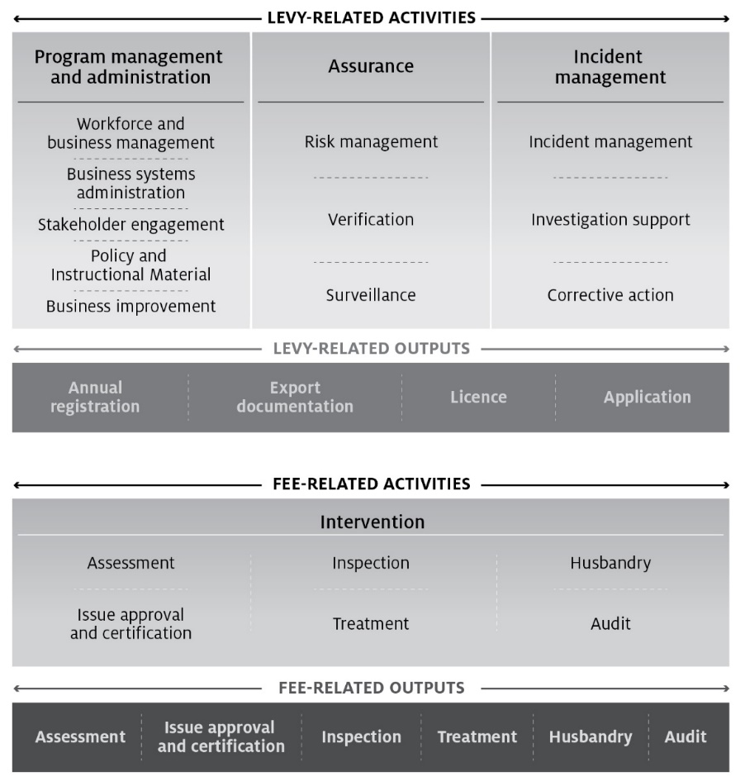

Description of cost model activities
The following provides details of the cost model activities undertaken in the department’s cost recovery arrangements.

Program management and administration activities

Workforce and business management
This activity has 4 categories:
- Workforce management activities include staff supervision, allocating workforce resources, managing employee performance, leave, training and other conditions, managing work, health and safety requirements, recruitment and termination.
- Business management activities include business planning and continuity; requesting legal advice; procurement and contracts; program and project administration, assurance, design and management; management of fixtures, facilities, equipment, supplies and logistics.
- Financial management activities include billing and accounting, budgeting, charges and payments, collections and receivables, debt management, financial accounts, reporting and policy development.
- Information management activities include data management, information and records management, and information sharing and collaboration.

Business systems administration
Includes developing, acquiring, testing, implementing and supporting applications and business systems. This includes technical support and maintenance of all business systems including information and communications technology.

Stakeholder engagement
Involves proactive engagement with any person, business, or organisation including any associated travel. This includes, engaging with peak industry bodies, secretariat support and attendance at industry consultative committee meetings, consultation on new standards and requirements, publishing website content and other information.

Policy and instructional material
Includes developing, maintaining and communicating the department’s policy and instructional material, such as operational and corporate policies, scientific advice, departmental guidelines and work instructions, and associated training development and delivery. Examples include responding to changes in importing country requirements, developing or revising policy processes and instructional material.

Business improvement
Includes assessment, monitoring and management of business performance. Examples include adjustments to improve regulatory activity, against business performance reports against Key Performance Indicators (KPI) and similar activities.

Assurance activities

Risk management
Involves assessing and managing the risks posed to Australia’s ability to maintain market access. This includes communicating results of risk analysis, modelling and forecasting to operational areas and the collection, receipt and use of reliable compliance data to meet the departments compliance objectives. This work also includes any associated travel and regulated entity assistance work. For example, organising, involvement in and responding to overseas government’s systems-based audits.

Verification
Includes assurance activities to provide stakeholders and departmental executive with confidence that departmental controls of its systems and processes are operating in accordance with their intended design and associated documentation. For example, verification of certification activity internally and by state regulators.

Surveillance
Includes formal and informal monitoring to detect issues that may affect onshore production for export, such as changes in Australia’s pest or disease status or food safety concerns. Surveillance differs from an inspection because it is not done for a specific client.

Incident management activities

Incident management
The coordination and management of any incident including post border detection and export incidents. This includes all associated pre-and post-work, travel and regulated entity assistance in relation to an incident, government certification and other issues which result in goods being held at the border. For example, this includes managing and responding to food safety incidents where food may have been exported.

Investigation support
Involves providing support for enforcement activities relating to an alleged breach of portfolio legislation, including any related regulated entity assistance and travel. This also includes enforcement activities that ensure compliance with Australian regulation and international import conditions such as investigations and engagement with regulated entities about compliance.

Corrective action
Includes actions taken in response to non-compliance or contravention of legislation or procedures that are managed without a formal investigation by an enforcement officer. Corrective action activities include all pre and post work, travel and regulated entity assistance in relation to the enforcement process.

Intervention activities

Assessments
Involves assessing information to determine if it meets the department and the importing country requirements. This includes all preparatory work (such as confirming importing country or export requirements) and post work (such as assessment report preparation) travel and regulated entity assistance in relation to the assessment. Examples include assessments of licences, permits, registrations, accreditations, and exemptions.

Issue approvals and certification
Includes issuing of a decision in relation to an assessment for cargo, vessels, plants, animals, food, biological and genetic material. This includes the work from the end of the assessment period to the completion of the decision notification process to support issuance of appropriate export documentation.

Inspections
Involves the physical examination (and supervision of a physical examination) of export food commodities to determine compliance with export and importing country requirements.

Treatments
Includes the physical treatment of cargo, vessels, plants, animals, food, biological and genetic material, other conveyances or premises to prevent an adverse biosecurity outcome from occurring and to meet relevant importing country requirements.

Husbandry
Includes activities relating to the care of plants and animals that the department is responsible for, including transport of plants and animals, housing, daily monitoring, feeding, cleaning of facilities, administering of medication, bookings and regulated entity assistance.

Audit
Includes the systematic and functionally independent examination to determine whether activities and related results comply with legislative or documented requirements. This includes all pre and post-work, travel and regulated entity assistance in relation to the audit. Examples include audit to verify compliance with an export registered establishment’s approved arrangement.

Appendix C: Summary of stakeholder feedback
Table C1 Stakeholder feedback for the 2025-26 CRIS
Key theme | Department response
- Industry raised concerns around high fixed costs calling for a more realistic and flexible cost model for small businesses. Specifically, registered quarantine facility audits, annual export permit fees, authorised officer accreditation and audit fees and the SHPRE tonnage threshold for bulky horticultural products. | This feedback will continue to be examined as part of the department’s work on a sustainable trade funding model.
- Industry is seeking modernised service level agreements, adaptable systems and processes, streamlined and transparent document approvals and improved departmental staff availability to reduce processing congestion. | This feedback will continue to be examined as part of the department’s work on a sustainable trade funding model.
- Industry is seeking a replacement to uniform flat fees with a scaled or tiered model that adjusts charges based on exporter size, throughput volume, and risk profile to ensure fairer cost distribution and better alignment with regulatory effort. | This feedback will continue to be examined as part of the department’s work on a sustainable trade funding model.
- Industry seeks improved efficiency and transparency in certification and audit processes. | This feedback will continue to be examined as part of the department’s work on a sustainable trade funding model.
- Industry seeks improvements to the current regulatory framework and cost recovery approach. Greater transparency and accountability from the regulator, in meeting service standards and reporting performance. Regulatory decisions based strictly on evidence and operational relevance, with clearer boundaries around third-party influence. A more collaborative, risk-based approach that rewards good compliance history and supports continuous improvement.  The Independent Observer program re-evaluated in favour of more efficient, technology-driven alternatives. | This feedback will continue to be examined as part of the department’s work on a sustainable trade funding model.

