Compliance Policy

We partner and regulate to enhance Australia’s agriculture, fisheries and forestry
© Commonwealth of Australia 2023
Ownership of intellectual property rights
Unless otherwise noted, copyright (and any other intellectual property rights) in this publication is owned by the Commonwealth of Australia (referred to as the Commonwealth).
Creative Commons licence
All material in this publication is licensed under a Creative Commons Attribution 4.0 International Licence except content supplied by third parties, logos and the Commonwealth Coat of Arms.

Cataloguing data
This publication (and any material sourced from it) should be attributed as: DAFF 2023, Compliance Policy, Department of Agriculture, Fisheries and Forestry, Canberra, CC BY 4.0.
This publication is available at agriculture.gov.au/about/commitment/compliance-policy.
Department of Agriculture, Fisheries and Forestry
GPO Box 858 Canberra ACT 2601
Telephone 1800 900 090
Web agriculture.gov.au
Disclaimer
The Australian Government acting through the Department of Agriculture, Fisheries and Forestry has exercised due care and skill in preparing and compiling the information and data in this publication. Notwithstanding, the Department of Agriculture, Fisheries and Forestry, its employees and advisers disclaim all liability, including liability for negligence and for any loss, damage, injury, expense or cost incurred by any person as a result of accessing, using or relying on any of the information or data in this publication to the maximum extent permitted by law.
Acknowledgement of Country
We acknowledge the Traditional Custodians of Australia and their continuing connection to land and sea, waters, environment and community. We pay our respects to the Traditional Custodians of the lands we live and work on, their culture, and their Elders past and present.

Contents
Introduction 5
About the department 5
Our regulatory context 5
Our compliance policy 5
Our approach to compliance 7
Our compliance model 7
Our compliance posture 8
Our compliance priorities 9
Our principles 10
Our regulatory workforce 10
How we regulate 10
How we engage 10
Managing compliance 11
Engagement and education 13
Monitoring, verification, collection and analysis 13
Administrative actions 14
Civil sanctions 14
Criminal sanctions 16
Information disclosure 17
Role of this policy 18
Reporting non-compliance 19

Introduction

About the department
The Department of Agriculture, Fisheries and Forestry uses a range of approaches to influence national outcomes, including policymaking, regulation, program delivery and scientific research. Compliance is an important element of our regulatory systems and helps to ensure our laws are achieving the outcomes they were designed to deliver. The department is responsible for:
- managing biosecurity risks
- ensuring that goods for export, including agricultural products and food, meet Australian export and importing country requirements
- prohibiting the importation of illegally logged timber and the processing of illegally logged domestic raw logs
- ensuring food imported into Australia complies with Australian food standards and public health and safety requirements
- administering primary industry levy and charge collection to improve efficiency and effectiveness.
These diverse responsibilities are safe guarded by regulatory systems helping to deliver a strong economy, healthy environment, and protect the health and wellbeing of all Australians.
For more information about the legislation we administer, see our legislation.

Our regulatory context
Our Regulatory Practice Statement sets out the principles that underpin our regulatory practice and the way we approach our regulatory responsibilities.
We use a range of activities to help regulated entities, including individuals and businesses operating in Australia, understand and comply with these laws. We provide relevant information to clearly communicate specific conditions and standards that have implications for regulated entities and our trading partners.
Our Regulatory Practice Statement outlines how we work with our stakeholders to deliver regulatory outcomes. We consider risks and respond accordingly. We continuously look for better ways to achieve our outcomes. We are clear about expectations and processes. We engage honestly, clearly and accurately.

Our compliance policy
Along with the Regulatory Practice Statement, this policy forms part of our regulatory practice framework. The policy aims to inform the community, particularly regulated entities and our staff, about our approaches to managing compliance. It aims to outline how our approach transitions from promoting compliance with our regulations to monitoring, assessing and verifying compliance through to detecting breaches to enforcement of penalties in response to non-compliance.
The policy outlines the principles we follow when carrying out our compliance activities. It also addresses:
- our regulatory context – the responsibility we have as a regulator to administer legislation to deliver regulatory outcomes
- our compliance objectives – set to ensure our regulatory systems align with our legislative frameworks and achieve government policy outcomes
- our approach to compliance – how we encourage, monitor, assess and verify compliance
- our approach to non-compliance – how we respond to non-compliance.
This policy operates within the context of the Australian Government’s law enforcement framework but does not apply to the regulatory or compliance activities undertaken by other Australian Government agencies, including those within our portfolio. However, we may partner with these agencies to achieve regulatory outcomes.

Our approach to compliance
We work with our stakeholders to improve compliance with a range of legislation. Our stakeholders in administering regulation include regulated entities, partners and co-regulators (for example, Australian Government agencies, state, territory and local governments, international trading partners and other organisations that operate as partners or as parallel regulators), influencers and the community. We use a range of compliance tools to support regulatory outcomes. Our compliance activities are risk-based and informed by intelligence.
To achieve the objectives of the legislation we administer we:
- develop policies and procedures
- set conditions and standards
- issue directions
- grant permits, approvals and licences
- approve co-regulatory arrangements
- gain assurance about the systems in place
- undertake communication, education and capacity-building activities
We utilise a range of powers provided in Commonwealth legislation to monitor and verify compliance and to identify and respond to suspected non-compliance.

Our compliance model
We operate a proportionate compliance response model (Figure 1). This model allows us to assess how a regulated entity engages with its regulatory obligations and tailor our response – by supporting compliant behaviour, or by taking proportionate regulatory actions in response to suspected or actual breaches. Our objective is to drive regulated entities compliance with the legislation, policies and procedures of the relevant regulatory system. We acknowledge that most regulated entities generally accept the obligations in the legislation and are prepared to comply voluntarily. We seek to recognise good compliance through a range of approaches that enable self-regulation such as approved arrangements and authorised officers.
To verify compliance, we monitor regulated systems and activities through document assessment, information and data analysis, programmed monitoring, inspections and audits, and intelligence assessments and through investigations and targeted operations. Where non-compliance is detected and it is relevant to do so, we share information and conduct joint investigations with other law enforcement agencies and regulators.
We assess non-compliance with our legislative requirements to determine an appropriate response. We consider a range of factors, including the risk of harm, the seriousness of the contravention, the apparent intent of the regulated entity (inadvertent, negligent, reckless or deliberate), their compliance history and the frequency of the issue occurring (Figure 1).

Figure 1 Our proportionate compliance response model

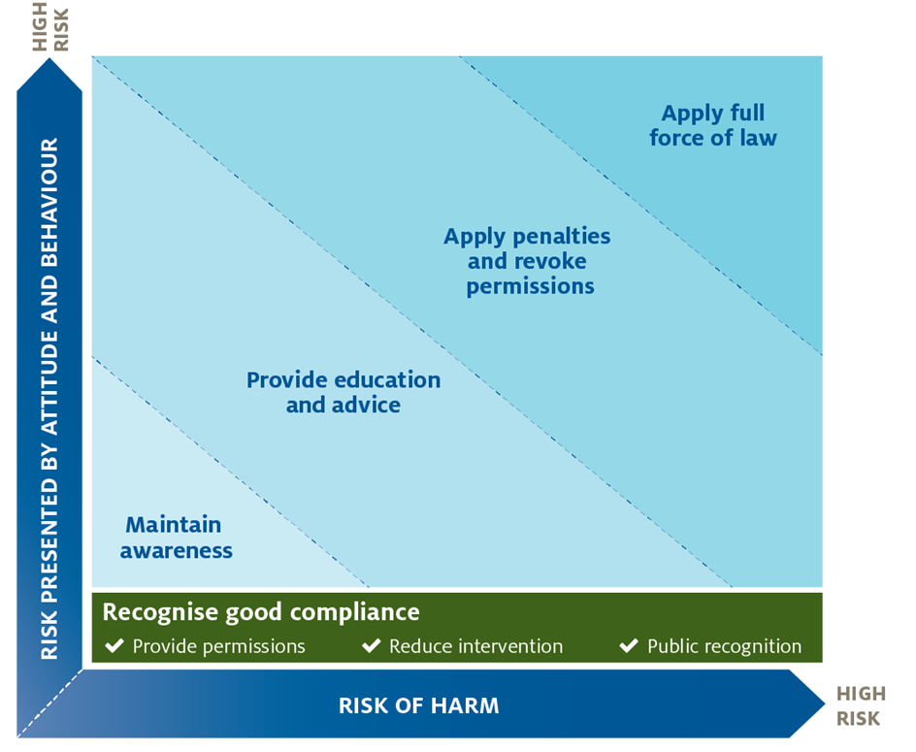

Our compliance posture
The regulatory systems we administer play a critical role in safeguarding Australia’s economy, human health and preserving Australia’s international standing. This means we need a strong focus on supporting voluntary compliance, balanced with proportionate action to deter non-compliant behaviour.
We view compliance with these regulatory systems as a responsibility we share with our regulated entities.
Our compliance posture focuses on working with regulated entities to promote a culture of compliance. We do this by:
- setting clear objectives for the desired regulatory outcomes
- setting conditions and standards to measure compliance
- engaging with regulated entities to establish shared understanding
- building capacity to strengthen compliance
- educating regulated entities on their obligations and deterring non-compliance
- where non-compliance is detected, applying a response that is proportionate to the risk.
Where suspected or actual non-compliance is detected, we determine whether a breach has occurred. We then consider whether it is in the public interest to bring proceedings to penalise the entity for the breach. In making this decision, we consider any relevant mitigating factors.

Our compliance priorities
We develop priorities to focus our compliance efforts for each regulatory system. Our priorities are informed by intelligence and risk assessments as well as engagement with our stakeholders. We review our compliance priorities periodically to ensure they are responsive to the latest risks and intelligence.
Individual regulators will publish annual or multi-year plans that communicate the compliance priorities for each regulatory system. These plans contain specific strategies and focus areas relevant to the regulatory objectives of the target system.

Our principles
Our compliance activities are guided by our regulatory practice principles as set out in our Regulatory Practice Statement.

Our regulatory workforce
- We invest in and support our staff to ensure our regulatory workforce is professional and capable.

How we regulate
- We make lawful, evidence-based, transparent and timely decisions
- We vary our approach based on the risks to our regulatory objectives for each regulatory system
- We use information, data analysis and intelligence to inform our understanding of regulatory risk
- We respond to non-compliance in a proportionate manner
- We regulate in a cost-effective way
- We measure, report and review our regulatory performance, make improvements to the way we regulate and ensure regulations are fit for purpose
- We seek to make it easier for regulated parties to comply.

How we engage
- We educate our stakeholders to help us achieve our regulatory objectives
- We work with our staff and stakeholders to design policies, standards and conditions. This ensures effective implementation and consistency with our regulatory objectives
- We ensure our guidance materials are current, easy to understand and readily accessible by our staff and stakeholders.

Managing compliance
Achieving successful regulatory outcomes is highly reliant on driving compliance. Our approach to managing compliance is therefore an important component of each regulatory system. Our regulators will conduct interactions with regulated entities that can range from providing information to discussing assessment activities through to actions being taken in response to non-compliance. These interactions involve a broad range of regulatory capabilities and tools that regulators rely on to align their actions with our regulatory practice principles.
We verify compliance through ongoing monitoring and assessment of regulated activities. We also work to detect, disrupt and deter non-compliant activity and behaviour by regulated entities across our regulatory systems. We recognise regulated entities attitudes towards compliance can vary from actively seeking to comply to deliberate non-compliance. We seek to bring all entities into compliance through:
- establishing a shared understanding of industry practices, current and emerging, in the context of the regulatory system
- aiming to understand and address threats and vulnerabilities, including organised and deliberate attempts to circumvent our regulation
- raising awareness across regulated entities about the potential impacts and consequences of non-compliance
- implementing compliance arrangements that recognise key drivers for inadvertent and intentional non-compliance
- taking appropriate action against specific cases of non-compliance, noting entities that deliberately seek to subvert the law present a high risk and may warrant the use of sanctions.
These activities contribute to maintaining or improving levels of general compliance and the effective functioning of our regulatory systems.
In conducting all compliance activities, we aim to make decisions that are lawful, evidence-based and transparent. We consider factors relevant to each case and the implications for other cases. Our approach seeks to balance appropriate fairness for regulated entities with achieving regulatory outcomes.
Our compliance activities operate across a continuum that travels from establishing compliance conditions and standards to responding to non-compliance. In practice, our approach to managing compliance is outlined in Figure 2.

Figure 2 Compliance management

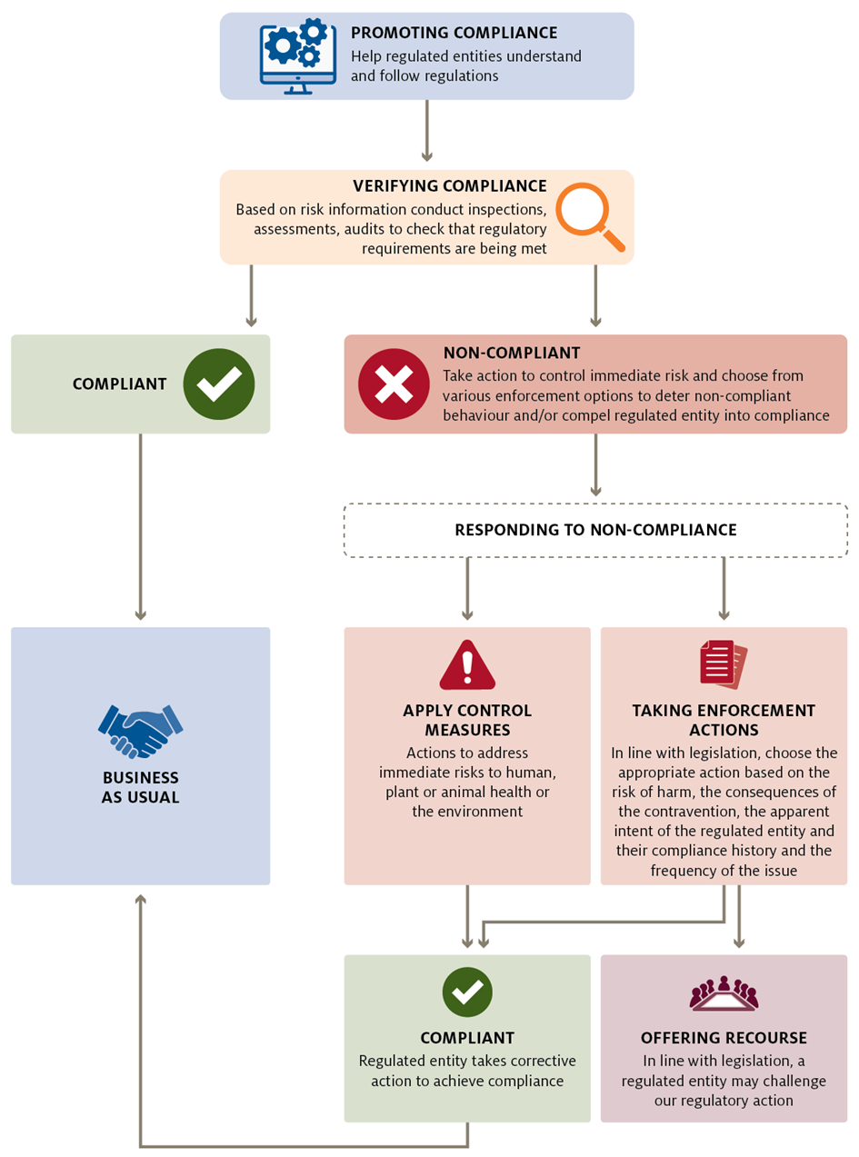

The tools we use to manage compliance across our regulatory systems include:
- engagement and education
- monitoring, verification, collection, and analysis
- administrative actions
- civil sanctions
- criminal sanctions.
The choice of tools to achieve a compliance outcome depends on the situation and legislation. For example, for serious non-compliance the department may commence civil or criminal proceedings against a regulated entity if such action is necessary to achieve the appropriate compliance outcome.

Engagement and education
We seek to assist regulated entities in meeting their regulatory obligations by providing information and advice to help them understand what is expected and ensure their actions are compliant. We do this through:
- information published on our website or on social media platforms
- policies and guidelines
- educational media campaigns
- responses to specific enquiries
- warning or advice letters to raise awareness of non-compliance
- industry advice notices
- training sessions
- consultative committees.

Monitoring, verification, collection and analysis
We routinely monitor and verify compliance across our regulatory systems. Information and data collection and analysis conducted in accordance with relevant legislation, can include:
- asking questions
- inspecting, authenticating, taking extracts from or making copies of documents
- requiring the production of records
- inspecting, examining, taking measurements or conducting tests
- taking images or making recordings
- examining or observing activity conducted on the premises
- accessing external information, intelligence and data sources – including commercial business data sets and specialist sources such as aerial or satellite imagery.
Where suspected non-compliance is identified, we undertake additional targeted collection and analysis to confirm or dismiss our concerns. Targeted collection can include:
- conducting additional compliance inspections or audits within existing departmental processes
- undertaking investigations to gather specific information that may not normally be collected
- conducting targeted operations such as multi-agency investigations, intelligence gathering, surveillance activities and a range of law enforcement actions
- utilising external information, intelligence and data sources – including data holdings from other law enforcement and regulatory agencies
- using specialist examination and detection technologies operated by other law enforcement and regulatory agencies
- searching premises under warrant.
We also undertake broad assurance activities to provide confidence that systems are managing the risk.

Administrative actions
Regulated entities may hold permissions such as permits, approvals, licences and approved arrangements to carry out activities regulated by law. Where a regulated entity engages in behaviour that is non-compliant with their legal obligations under the permission, or where emerging risks have been identified, we may vary, suspend or revoke the permission. This may result in the regulated entity being unable to continue to operate within the regulatory system.
Subject to the seriousness of the non-compliance, we may choose to immediately suspend, revoke or vary a permission or an approval held by a regulated entity.
Relevant legislation generally sets out grounds for variation, suspension or revocation of a permission. These can include a failure to perform administrative requirements or no longer meeting the relevant suitability criteria for the approval, such as being a ‘fit and proper person’.
We can take administrative action to achieve appropriate and timely outcomes that maintain the integrity of our regulatory systems. This does not prevent us from also using civil or criminal sanctions where necessary.
Under Commonwealth legislation, adverse administrative decisions may be taken into consideration in relation to continuing permissions and future applications for permissions.

Civil sanctions
We use a stronger compliance response when the regulated activity or the attitude or behaviour of a regulated entity creates a high risk of harm. This may occur when a regulated entity negligently, recklessly or deliberately engages in behaviour or activity that does not comply with their regulatory obligations.
Depending on the legislation, we may choose to use one or more civil sanctions when responding to non-compliance.

Policy for use of specific sanctions
Compliance Division and Legal Division have developed requirements for proceeding with enforceable undertakings, civil penalties, and injunctions. These policies guide how the department efficiently handles potential civil sanctions cases in line with legal practice and procedure for the most effective regulatory outcomes.
When potential compliance matters may warrant a civil response, regulators work with Legal Division to ensure the efficient management of civil action, as well as ensuring the department meets its obligations under the Legal Services Directions 2017. Please refer to these policies for the specific requirements in relation to using particular sanctions.

Infringement notices
We can issue an infringement notice to a regulated entity as a quick and straightforward method for dealing with certain behaviour that contravenes a civil penalty provision in our legislation. Payment of the infringement notice will typically discharge any liability for the alleged contravention.
Although payment of the penalty amount specified on the infringement notice is voluntary, and payment ordinarily discharges liability, if circumstances warrant, we may choose to withdraw the infringement notice, refund any monies paid and commence civil penalty proceedings regardless of whether the notice recipient chooses to pay the penalty amount or not.

Civil penalty proceedings
We can commence civil penalty proceedings against a regulated entity seeking an order requiring them to pay a financial penalty for breaching a civil penalty provision under our legislation. A civil penalty imposed by a court is a debt owed to the Commonwealth. The court has extensive powers available to ensure such debts are paid.
We can commence civil penalty proceedings either as a standalone action or following non-payment of a prior infringement notice. A civil penalty amount can substantially exceed an infringement notice amount for the same contravention.

Injunctions
We can seek an injunction requiring a regulated entity to do something or to refrain from doing something to ensure compliance with our legislation. We can also ask the court to grant an urgent interim injunction where there is a real or significant likelihood of serious or material harm occurring, or an interlocutory injunction while a matter is being resolved by the courts.

Enforceable undertakings
We can accept an enforceable undertaking that has been voluntarily offered by a regulated entity, under which they offer to take specified action to comply with a legislative provision and to refrain from taking specified non-compliant action to ensure future compliance. Enforceable undertakings can be used to minimise, reduce or eliminate the risk of harm occurring as a result of a regulated entity’s non-compliant behaviour. We will monitor undertakings to ensure the agreed action occurs. The undertaking is a legally binding agreement that can be enforced by a court.

Civil sanctions
Civil penalties and injunctions are generally sought and enforced through the Federal Court of Australia. Court decisions are usually published and are publicly accessible.
Under a range of Commonwealth legislation, court-imposed civil sanctions may be taken into consideration in relation to continuing permissions and future applications for permissions.

Criminal sanctions
Where criminal behaviour is suspected, we can refer a matter to the Commonwealth Director of Public Prosecutions to commence a criminal prosecution. This will be done on a case-by-case basis following a careful case selection process, taking into account the full circumstances of the contravention. Criminal prosecutions may result in a criminal penalty involving imprisonment or a financial penalty or both. These serious penalties mean that criminal sanctions should be used only in situations where such a response is appropriate, such as in the case of deliberate non-compliance, or when recklessness and high risk coincide. This is consistent with the compliance response approach outlined in the department’s Regulatory Practice Statement and the Prosecution Policy of the Commonwealth. Depending on the nature of an offence, prosecutions may be conducted against individuals, regulated entities, their directors and employees for committing offences under our legislation.
Under a range of Commonwealth legislation, adverse court-imposed criminal sanctions may be taken into consideration in relation to continuing permissions and future applications for permissions.

Information disclosure
Information received from the public about alleged non-compliance will be handled in a confidential manner. We may share this information with relevant internal areas and with other law enforcement and regulatory agencies as provided for under relevant legislation.
Where legislation permits or requires, we may release details of non-compliance or investigative activities where such a release would support the achievement of the department’s regulatory outcomes or is required by law. In other circumstances, the details of investigation activities may remain confidential once the investigation is complete.
We may choose to release information about entities that have breached or are alleged to have breached our legislation to support our regulatory outcomes. This will be done in accordance with our legal obligations, including the Privacy Act 1988. We will ensure that the released information does not prejudice a person’s right to a fair hearing or legal process, impinge upon the safety of others involved in the investigation (such as complainants, witnesses and suspects) or prejudice any of our past or future activities.
Request for information from the public, including regulated entities, may be made under the Freedom of Information Act 1982. For details about how to make a Freedom of Information (FOI) request, see Freedom of Information.
The media can greatly assist us by informing the regulated community of its obligations under our laws. This includes communicating the consequences of not complying with our laws. Media enquiries or requests for information should be directed to either our Agriculture Media or Environment Media.
Non-compliant entities that are subject to court decisions and enforcement actions can expect the outcomes of these matters to be published in accordance with our legal obligations. For information on our compliance outcomes see News and media.

Role of this policy
This policy is intended to assist the department, regulated entities and other parties that have duties, obligations and responsibilities under relevant legislation to understand the compliance tools available to the department to ensure legislative requirements are met.
This is an administrative document intended to provide an overview of the department’s compliance tools and general information about when it may use these tools. It does not reduce, extend or modify legislative obligations or powers contained in the legislation.
This policy assists but does not control the department’s compliance-related decisions. Each decision will consider all matters relevant to the circumstances.
In the event of any inconsistency between this policy and the legislation under which the department exercises a statutory function, power or discretion, the legislation will prevail.
This policy will be reviewed and updated to incorporate amendments to legislation, feedback from industry and changes required by the department.

Reporting non-compliance
If you come across something you think does not comply with our legislation, use these contact points to find out more information or to report your concern:
• Redline – report a biosecurity breach
• Report a pest or disease concern
• Live animal export compliance and investigations
• Illegal logging compliance and enforcement
• Farming, food, and drought levies
• Imported food consumer information.

