

Regulatory Practice
Statement

© Commonwealth of Australia 2023
Ownership of intellectual property rights
Unless otherwise noted, copyright (and any other intellectual property rights) in this publication is owned by the Commonwealth of Australia (referred to as the Commonwealth).
Creative Commons licence
All material in this publication is licensed under a Creative Commons Attribution 4.0 International Licence except content supplied by third parties, logos and the Commonwealth Coat of Arms.

Cataloguing data
This publication (and any material sourced from it) should be attributed as: DAFF 2023, Regulatory Practice Statement, Department of Agriculture, Fisheries and Forestry, Canberra, CC BY 4.0.
This publication is available at agriculture.gov.au/about/commitment/regulator-practice
Department of Agriculture, Fisheries and Forestry GPO Box 858 Canberra ACT 2601
Telephone 1800 900 090 Web agriculture.gov.au
Disclaimer
The Australian Government acting through the Department of Agriculture, Fisheries and Forestry has exercised due care and skill in preparing and compiling the information and data in this publication. Notwithstanding, the Department of Agriculture, Fisheries and Forestry, its employees and advisers disclaim all liability, including liability for negligence and for any loss, damage, injury, expense or cost incurred by any person as a result of accessing, using or relying on any of the information or data in this publication to the maximum extent permitted by law.
Acknowledgement of Country
We acknowledge the Traditional Custodians of Australia and their continuing connection to land and sea, waters, environment and community. We pay our respects to the Traditional Custodians of the lands we live and work on, their culture, and their Elders past and present.

Contents

Foreword 3

Introduction 5

Our regulatory systems 6

Regulatory practice principles 7
Our regulatory workforce 7
How we regulate 7
How we engage 8

Our stakeholders 9

Our regulatory model 11
Regulatory approach 12
Understand regulatory risks 13
Set requirements 13
Assess and monitor 13
Engagement, assurance and evaluation 13

Compliance 15

Introduction
Australian Government regulation underpins markets, protects the rights and safety of all Australians and helps ensure the efficient and equitable delivery of goods, services and resources. We deliver policies and programs for a strong economy and enhance our agricultural, fisheries, food and forestry industries.

We regulate to:

- meet Australia’s economic, agricultural and biodiversity objectives
- meet the objectives of the legislation we administer
- benefit the Australian community.
We continue to strongly support the Australian Government’s efforts to reduce unnecessary red tape and improve regulatory efficiencies through streamlining and digitally transforming processes.
However, this is not at the expense of maintaining strong and responsive regulatory outcomes.

We comply with the Australian Government’s cost-recovery policy, which requires that users of our regulatory services pay, and not general taxpayers. As a result, we are committed to continuous improvement of service delivery to ensure that regulated entities are receiving professional, timely and cost-efficient services. Regulated entities include the people and businesses that we service.

This document sets out our regulatory practice principles and the way we approach our regulatory responsibilities. These principles will help us achieve a more outcomes-based approach to regulation and deliver efficient services to our stakeholders and communities.

Our regulatory systems
The department is responsible for a range of regulatory systems in the agricultural, fisheries and forestry sectors. Effective regulation of these systems occurs through a thorough understanding of the risks and their management. We are responsible for matters relating to:

- managing biosecurity risks
- ensuring that goods for export, including agricultural products and food, meet Australian export and importing country requirements
- prohibiting the importation of illegally logged timber and the processing of illegally logged domestic raw logs
- ensuring food imported into Australia complies with Australian food standards and public health and safety requirements
- administering primary industry levy and charge collection to improve efficiency and effectiveness.

Regulatory practice principles
The way we administer regulation is underpinned by a set of regulatory practice principles, informed by the three principles described in the Australian Government Regulator Performance Resource Management Guide (formally known as the Regulator Performance Guide):

- continuous improvement and building trust
- risk based and data driven
- collaboration and engagement.
Our principles have been designed to transform and streamline the way we deliver regulation and improve our regulatory decision-making and processes.

The principles help to:

- outline our focus on supporting staff to deliver professional regulation
- keep us accountable to those we regulate and those we co-regulate with
- show how we engage with our stakeholders and regulated entities to achieve compliance
- promote a positive risk culture to guide innovation, harness opportunities and empower staff to make informed decisions.
Our regulatory practice principles are grouped thematically:

- our regulatory workforce
- how we regulate
- how we engage.

Our regulatory workforce
- we invest in and support our staff to ensure our regulatory workforce is professional and capable.
How we regulate
- we make lawful, evidence-based, transparent and timely decisions
- we vary our approach based on the risks to our regulatory objectives for each regulatory system
- we use information, data analysis and intelligence to inform our understanding of regulatory risk
- we respond to non-compliance in a proportionate manner
- we regulate in a cost-effective way

- we measure, report, and review our regulatory performance, make improvements to the way we regulate and ensure regulations are fit for purpose.
How we engage
- we engage with and educate our stakeholders to ensure we achieve our regulatory objectives
- we work with our staff and stakeholders to design policies, standards and conditions. This ensures effective implementation and consistency with our regulatory objectives
- we ensure our guidance materials are current, easy to understand and readily accessible to our staff and stakeholders.
These principles are designed to streamline the way we deliver regulation and improve our regulatory decision-making and processes.

Our stakeholders
We aim to be trusted, professional, accountable and predictable in our dealings with stakeholders. In return, we expect our stakeholders to:

- familiarise themselves, understand and comply with Australian Government requirements and relevant legislation
- draw our attention to any emerging risks of market failure
- be open and honest with us
- provide complete, accurate and timely information
- treat our staff with respect
- provide a safe working environment for department staff who attend their premises.
Our stakeholders are diverse. They include regulated entities, partners and co-regulators, industry and the Australian community (Figure 1).

We recognise that meaningful engagement with all our stakeholders helps inform and direct our regulatory work. We will seek to identify opportunities to collaborate, respond to emerging priorities and harness industry insights. This enables us to deliver better regulatory outcomes and implement them in practice.

Figure 2 Our stakeholders

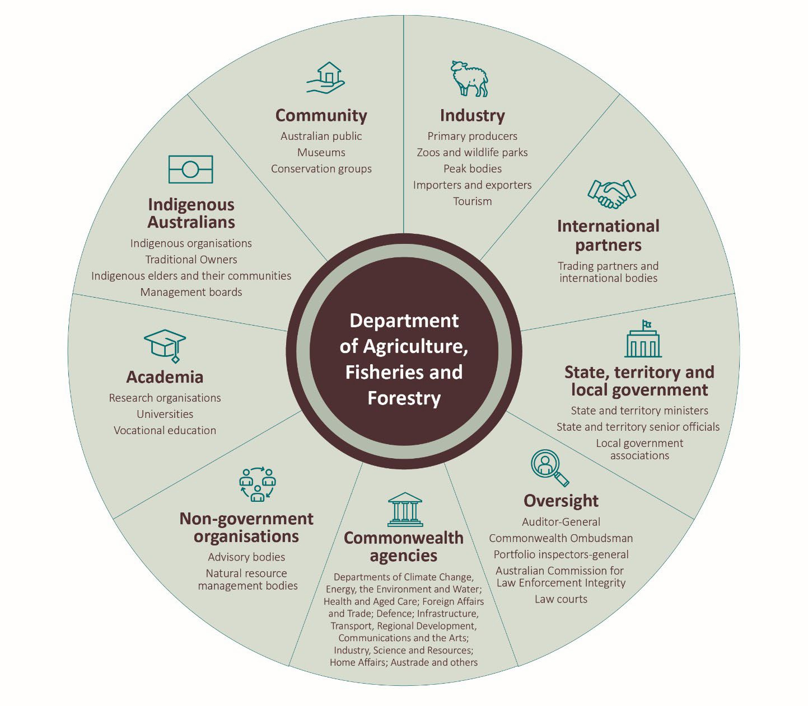

Note: This is an indicative list that may not include all stakeholders.

Our regulatory model
The Australian Government sets the national policies and establishes regulatory objectives and legislation. We advise the government on the design of and approach to regulation. Where practical, we develop regulation through consultation with the community, industry and our partners.

Our model (Figure 2) for administering each of our regulatory objectives and legislative authority shows:

- understanding the regulatory risks relating to our regulatory objectives and legislative authority
- designing a regulatory approach, including giving regulatory responsibility to partners and co- regulators where appropriate
- setting requirements that regulated entities need to comply with, including conditions and governance arrangements for approved permission holders
- assessing and monitoring to ensure requirements are being complied with and that industry participants (including those who perform activities on our behalf) are acting in accordance with their obligations
- recognising compliance and responding to non-compliance
- ensuring the system remains responsive to changes in the markets we regulate and in our regulatory capabilities by:
  - engaging with stakeholders
  - assuring our approach to regulation
  - evaluating our performance.

Figure 2 Our regulatory system model

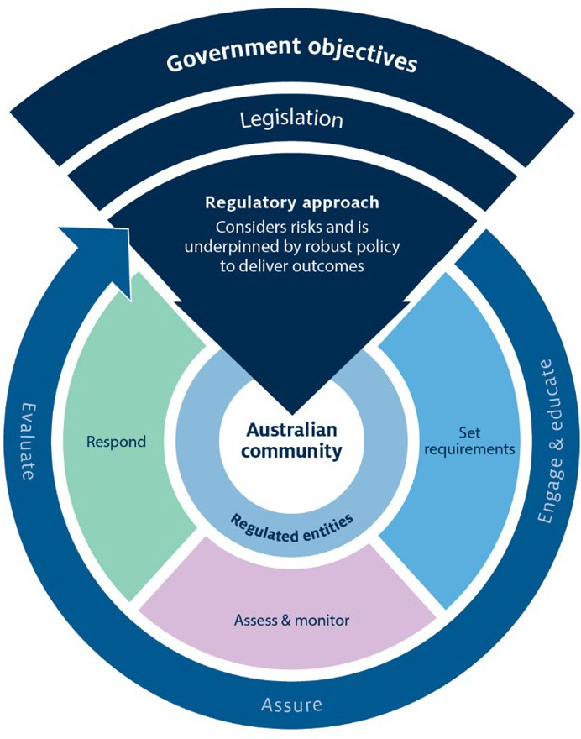

Regulatory approach
This is informed by government policy, regulatory objectives, legislative authority and an understanding of regulatory risks. Our approach identifies the tools that we will use in setting requirements, assessing and monitoring, and responding.

In designing and reviewing our regulatory approach we consider and engage on the

cost-effectiveness and efficiency of implementation for us as the regulator, for co-regulators and partners, and for regulated entities.

We use evidence-based research undertaken by our scientists and policy advisors to ensure we deliver better outcomes for our stakeholders and communities. We drive innovation across the department by bringing together stakeholder views to make improvements to our regulatory systems.

Understand regulatory risks
Our regulatory risks include:

- risk of harm identified in the purpose of the regulation
- risks posed by regulated entities and other stakeholders
- risks arising from changes in the operating environment and the global trading environment.

Regulated operating environment and global trading environment
We monitor and respond to changes in these operating environments to ensure that our approach continues to meet regulatory objectives.

We aim to understand the markets that regulated entities, influencers and stakeholders operate in. We also consider relevant social and economic incentives for compliance.

Set requirements
We review our requirements regularly in accordance with policy and regulatory objectives. We aim to ensure that requirements can be practically implemented, complied with, monitored and enforced. We provide educational material and undertake engagement activities to help regulated entities understand what is expected of them. Where appropriate, we can authorise third parties to help regulated entities meet requirements.

Assess and monitor
We access accurate, timely and reliable information about whether requirements are being complied with, who the regulated entities are and how they are behaving.

We identify and assess the risk of harm from non-compliance and target our monitoring resources proportionally. We communicate clearly on how we expect regulated entities to comply. We have well-established criteria for assessing compliance and conducting audit activities. Working closely with our stakeholders and regulated entities ensures that non-compliance is reported and responded to in a timely manner.
Where appropriate, we authorise third parties to undertake assessment or auditing activities provided they meet conditions and standards. In these cases, we establish governance arrangements to help ensure that industry participants operate within our requirements.

Engagement, assurance and evaluation
We engage with our stakeholders when:

- designing regulation
- reviewing and implementing regulation
- identifying risks and setting requirements.
This ensures that achieving compliance is as efficient and practical as possible. It means that our stakeholders have a clear understanding of our regulatory objectives and share the responsibility for achieving regulatory outcomes.

Our decisions are transparent. We communicate clearly with those we regulate to help them understand the reasons behind our decision-making. When decisions affect our stakeholders, we communicate what has changed and how to comply.

We evaluate our regulatory practice and report on our performance as a regulator annually, in accordance with the Australian Government Regulator Performance Resource Management Guide. Relevant performance metrics on the work we do are also released and includes information on compliance with legislation and other reporting requirements.

Compliance
Our Compliance Policy outlines our approach to recognising regulated entities that comply and responding to those that do not comply.

We aim to minimise the impact of regulation where appropriate – for example, by recognising regulated entities that consistently comply with regulatory requirements. Depending on the regulatory system, we recognise good compliance through tools that reduce the need for intervention.

Where the risk of non-compliance is low, we seek to educate and maintain awareness. When risk increases, we apply penalties and revoke permissions. Where risk is highest, we apply the full force of the law.

We approach non-compliance through the consistent application of rules, principles and evidence. When we assess the likely consequences of a regulated entity’s non-compliance, we consider the risk of harm and the attitude and behaviour of that entity.

