Inclusion Strategy 2021 to 2024

© Commonwealth of Australia 2021
Ownership of intellectual property rights
Unless otherwise noted, copyright (and any other intellectual property rights) in this publication is owned by the Commonwealth of Australia (referred to as the Commonwealth).
Creative Commons licence
All material in this publication is licensed under a Creative Commons Attribution 4.0 International Licence except content supplied by third parties, logos and the Commonwealth Coat of Arms
Inquiries about the licence and any use of this document should be emailed to copyright@awe.gov.au.

Cataloguing data
This publication (and any material sourced from it) should be attributed as: Inclusion Strategy 2021 to 2024, Department of Agriculture, Fisheries and Forestry, Canberra, CC BY 4.0.
ISBN: 978-1-76003-493-1
This publication is available at
https://www.awe.gov.au/about/jobs/inclusion-strategy
Department of Agriculture, Fisheries and Forestry
GPO Box 858 Canberra ACT 2601
Telephone 1800 900 090
Web awe.gov.au
Disclaimer
The Australian Government acting through the Department of Agriculture, Fisheries and Forestry has exercised due care and skill in preparing and compiling the information and data in this publication. Notwithstanding, the Department of Agriculture, Fisheries and Forestry, its employees and advisers disclaim all liability, including liability for negligence and for any loss, damage, injury, expense or cost incurred by any person as a result of accessing, using or relying on any of the information or data in this publication to the maximum extent permitted by law.
Acknowledgements
The authors thank the department’s inclusion networks, and interview and survey participants, for their input.

Contents
Message from the inclusion champions iv
1 Introduction 1
Purpose and vision 1
Diversity and inclusion 1
Our shared commitment 1
Our Core 4 Values 2
2 Roles and responsibilities 3
Executive Board 3
People and Culture Committee 3
Inclusion Council 3
SES officers 3
Staff-led networks 3
People Division 3
3 Our journey so far 4
Inclusion networks 4
Measuring success 5
4 Our diverse workforce 7
History 7
Our progress 7
Messages from staff 10
5 Partners 12
6 Monitoring success 13
7 Legislative responsibilities 14
8 Supporting documents 15

Figures
Figure 1 Department of Agriculture, Fisheries and Forestry inclusion champions iv
Figure 2 Core 4 values 2
Figure 3 Diversity groups within the department 8

Message from the inclusion champions
We are pleased to be your inclusion champions.
We as the inclusion champions hold a collective commitment to foster an environment where all differences are valued, practices are equitable, and everyone experiences a sense of belonging; where people are inspired to be part of a team and lead inclusively in their interactions every day. We are stronger and more successful when our workforce reflects the diversity of the communities we serve and when we harness this strength effectively.
We would like to take this opportunity to acknowledge the members of the inclusion networks for their role in shaping our culture and providing a sense of belonging for everyone. We look forward to supporting the networks and the department by continuing to raise awareness of the importance of an inclusive culture and encouraging all staff to be involved in shaping it.
Figure 1 Department of Agriculture, Fisheries and Forestry inclusion champions
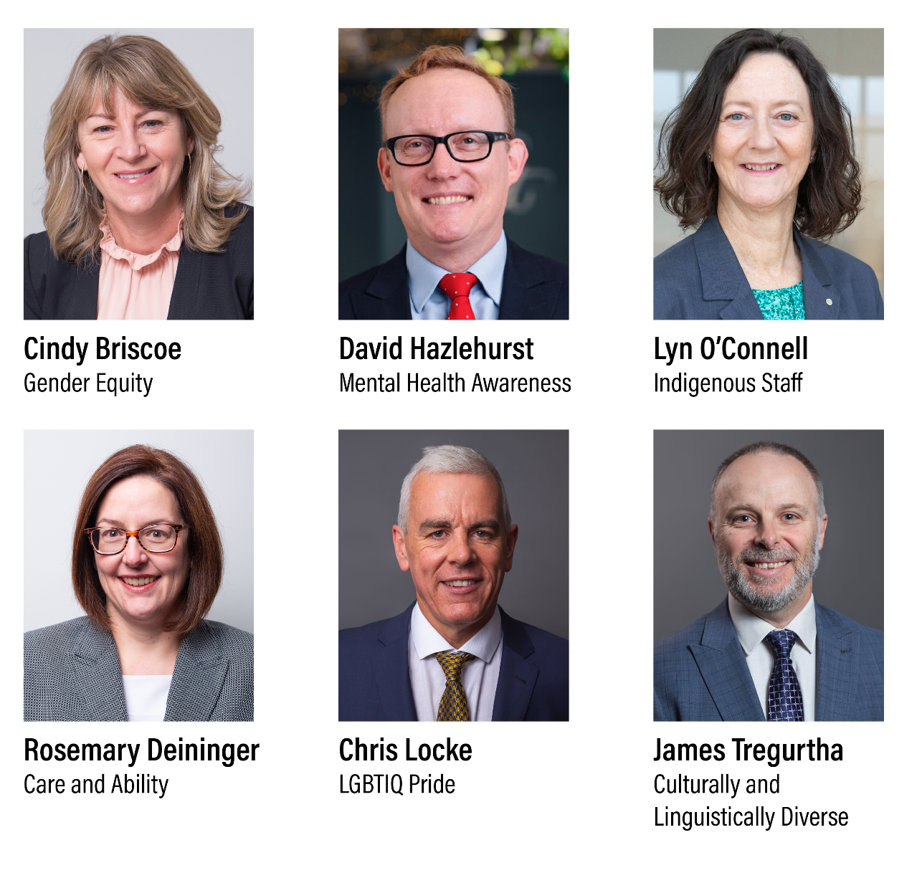

Introduction

Purpose and vision

Purpose
This inclusion strategy confirms our commitment to promoting diversity and inclusion in the department for the next 3 years. It supplies the foundation to achieve a truly inclusive and diverse workforce where all people feel valued and supported. We will embrace all the aspects of diversity that our workforce offers. We will use this to build an integrated, inclusive and high-performing culture, which is aligned with our strategic priorities, values and behaviours.

Vision
Our vision is to provide a safe and accepting work environment where all staff can bring their authentic selves to work.

Diversity and inclusion
Diversity and inclusion is the way we come together, value and celebrate our collective differences to realise the many benefits they provide to us and our stakeholders.
Diversity refers to a mix of different people and the way they identify in relation to their age, caring responsibilities, cultural background, disability, gender, sexual preferences and socio-economic background (social identity); and their professional, educational and work experiences and organisational role (professional identity).
Inclusion refers to creating an environment where people feel safe to bring their authentic selves to work. It means valuing our differences and developing a culture and a sense of community where everyone can participate and thrive. This means individuals are respected, supported and engaged; have a voice; and are provided with opportunities to contribute.
Only once we have embraced and accepted diversity can true inclusion occur.

Our shared commitment
Embedding inclusion within all areas of our department requires all employees to show a personal commitment. This will create a true sense of belonging for everyone. Without leadership at all levels, inclusive behaviours are unlikely to become part of our normal workplace practices.
Our shared commitment is more than words on a page. Over the next 3 years we need to reflect critically on the choices we make, the behaviours we demonstrate, and the interactions we have. We must hold one another to account for building an inclusive, safe, nurturing and community-minded department.
Inclusive leadership means listening to everyone and taking into account everyone’s perspectives before taking action. Inclusive leadership is essential for making sure diverse thinking is respected, managed, heard and applied. Prioritising inclusive leadership capabilities and rewarding leadership excellence will embed our inclusive culture and help make the department the best possible place to work.

Our Core 4 Values
- The launch of Our Core 4 Values reinforced our collective and shared belief that diversity and inclusion are integral to all of us and all we do (
Figure 2). The behaviours we use to achieve our priorities is just as important as achieving them, and diversity is paramount to our success.
People are our most important asset. We are committed to ensuring the mental and physical wellbeing of our people and acknowledge this by putting safety and integrity at the centre of everything we do.
Diversity is one of our Core 4 values. It sets the standard of behaviour our stakeholders should expect from us, and that we should expect from each other, in any interaction. Courage is another core values – the courage to call out unacceptable behaviour, make a safe workplace, and use our differences to innovate and take risks.
We demonstrate our values through our behaviours.

Core 4 Value: Diversity
- Create an environment where people feel safe to bring their authentic selves to work.
- Recognise the value of diversity and create an inclusive workplace by celebrating differences.
- Engage in authentic consultation processes with First Nations Australians and embrace and learn from their traditional knowledge.
- Listen to and draw on the expertise, knowledge and perspectives of others.
- Build relationships and champion diversity and inclusion.
- Act with care and diligence.
Figure 2 Core 4 values
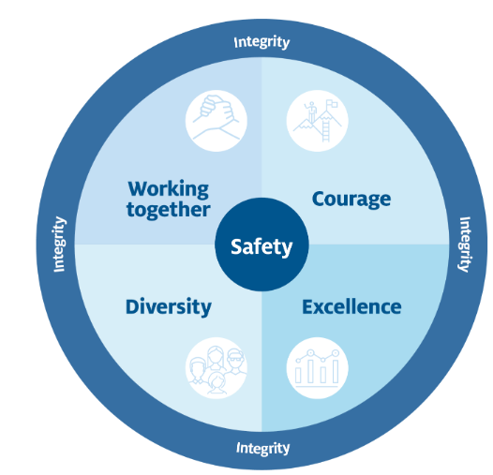

Roles and responsibilities
This section identifies the people in the department who have oversight of this strategy and are responsible for supporting and promoting the successful delivery of the action plans.

Executive Board
The members of the Executive Board are responsible for empowering leaders at all levels to contribute to our inclusive culture. They will be role models, signalling to the department that building an inclusive culture is an essential aspect of the way we work.

People and Culture Committee
The People and Culture Committee (PCC) will be responsible for supporting the Executive Board to implement appropriate personnel policies and practices to attract, develop and retain staff and to foster an inclusive and collaborative culture.

Inclusion Council
The Inclusion Council will be the department’s peak body for addressing the challenges and acting on the opportunities of building an inclusive and diverse culture. The council will provide a direct link between the staff-led networks and the department’s senior leadership. It will invest in and drive changes across the organisation that foster diversity and inclusion. The council will also regularly communicate with staff about new initiatives and share our successes.

SES officers
As a senior leader in the department, their role is to create an environment where people feel empowered to contribute and feel safe to bring their genuine and whole self to work. They have a role in leading an ongoing conversation about inclusion with their teams and implementing the inclusion model in a meaningful way at a branch and divisional level.

Staff-led networks
Staff-led networks continue to provide a safe, open and supportive forum for members to share views and experiences in our quest to build an inclusive environment. The networks have important roles in influencing the development, progress and execution of our diversity and inclusion action plans.

People Division
The role of the People Division is to enable and support our people to build an inclusive culture. The division has an important role to play by continuously reviewing our people policies and practices to ensure they promote diversity and inclusion.

Our journey so far
Since becoming a department, we have implemented several diversity and inclusion initiatives including establishing our seven inclusion networks and appointing Inclusion Champions and Network Leadership Groups.

Inclusion networks
Effective inclusion networks help us to increase employee engagement, enthusiasm and collaboration; help inform policy and processes related to our diversity groups; encourage innovation; and help improve the overall understanding of the diverse community the department serves.
Our networks’ role is to provide culturally safe places for our members to come together to discuss matters of interest, share experiences and provide support to colleagues. They work to increase awareness, and to create a workplace that openly values and supports everyone regardless of their age, background, sexual orientation, race, religious beliefs, qualifications, social status, and abilities. Allies play an equally important role to help build awareness, and actively participate in the networks.
The department captures statistical data on all its diversity groups, which is used to identify trends and help us develop fit-for-purpose programs. We collect 2 datasets for non-English-speaking people: the first is of people who migrated to Australia after 5 years of age; the second is of children of non-English-speaking immigrants.

Indigenous Staff Network
The Indigenous Staff Network (ISN) is for Indigenous staff only. It plays a pivotal role in providing a safe and culturally appropriate environment where Indigenous employees can receive personal support, mentoring, coaching and guidance on career development. The ISN also plays a consultancy role, where members provide feedback and comments on all departmental and broader Australian Public Service (APS) strategies, policies and guidelines that may affect our Aboriginal and Torres Strait Islander staff.

Aboriginal and Torres Strait Islander Employee and Ally Network
The Aboriginal and Torres Strait Islander Employee and Ally Network (ATSIEAN) is open to all employees. Its primary focus is to provide a means for Aboriginal and Torres Strait Islander employees from across the department to discuss matters of interest, share experiences and provide support to colleagues. The ATSIEAN assists the department in setting the direction for Aboriginal and Torres Strait Islander–related matters, including building cultural capability. The network provides feedback and comments on all departmental and APS strategies, policies and guidelines that may affect Aboriginal and Torres Strait Islander staff.

Culturally and Linguistically Diverse Network
The Culturally and Linguistically Diverse (CALD) Network provides a forum for employees to discuss issues relevant to their workplace experiences, share information, and build relationships to support employees from a CALD background. The CALD Network collaborates on improvements to support employees from a CALD background by providing input into departmental policies, strategies and programs to create awareness. It also helps break down barriers by promoting the benefits of a diverse workforce.

LGBTIQ Pride Network
The LGBTIQ Pride Network works to support lesbian, gay, bisexual, transgender, intersex, queer and asexual (LGBTQIA+) staff by building a genuinely inclusive workplace, where employees feel safe, valued and supported to bring their whole selves to work. The network aims to increase awareness and create a workplace that openly values and supports LGBTIQA+ employees by building relationships, sharing experiences, educating people and discussing relevant issues. A priority of the network is to increase the visibility of gender and sexuality issues and help build the capabilities of leaders to promote a diverse and inclusive culture in the workplace while supporting their LGBTQIA+ employees.

Gender Equity Network
The Gender Equity Network (GEN) helps facilitate initiatives that support gender equity and.
raise awareness of gender-based challenges. The network is an inclusive, staff-led group, which builds support for and awareness of equity issues that intersect with gender and gender identities. The GEN works to break down systemic barriers to gender inequality by influencing changes to internal policies that affect the workplace and ensure equality of access is integrated into external-facing policies.

Care and Ability Network
The Care and Ability Network (CAN) works to support staff with disability and/or caring responsibilities (such as caring for children, elderly or sick parents, and partners) by providing a forum to discuss issues, inform best practice, raise awareness, and contribute to a diverse and disability confident workplace. The network helps to create a culture where all staff feel empowered to speak openly about what adjustments can be made to enable them to work effectively, to share and listen to the views and concerns of people with disability and carers, and to promote awareness of key issues to senior management.

Mental Health Awareness Network
The Mental Health Awareness (MHA) Network seeks to reduce stigma and discrimination based on mental health status, to increase mental health awareness, to contribute to creating and sustaining mentally healthy workplaces throughout the department, and to improve the mental health and wellbeing of all staff. The network promotes a culture where all staff feel empowered to speak openly about their mental health and wellbeing, and to share information and resources about mental health, dealing with mental health issues, and supporting others with their mental health.

Measuring success
In 2021 we achieved Bronze Employer status for LGBTQ inclusion from the Australian Workplace Equality Index and delivered our Reconciliation Action Plan with Stretch status.
In addition to this inclusion strategy, the Diversity and Inclusion team, in conjunction with the inclusion networks, has developed action plans that demonstrate our department’s commitment to change and building an inclusive culture. These plans set targets and goals to ensure that we continue on our inclusion journey and provide actions to benefit employees across all diversity groups and the wider department.
The action plans are based on 3 themes: opportunities, inclusive culture and leadership. These themes are key to helping us identify areas where we can have the biggest impact and truly achieve inclusion across the department.
We will continue to develop tools and resources to build awareness and encourage people to share their personal stories and provide safe places for them to do so.

Our diverse workforce

History
Several significant events in our history have led us to where we are today, including:
- 1943 – the first woman was elected to the Senate and the House of Representatives
- 1966 – the marriage bar in the Commonwealth Public Service was lifted
- 1967 – Australians voted in a referendum to change the Constitution so that, like all other Australians, Aboriginal and Torres Strait Islander peoples would be counted as part of the population and the Commonwealth would be able to make laws for them
- 1981 – the Disabled Peoples International held its first World Assembly in Singapore in the the International Year of Disabled Persons (IYDP), which had been declared by the United Nations – this was a turning point in the history of the Australian and international disability rights movement
- 1986 – disability rights advocacy was recognised as a program area to be funded under the Disability Services Act 1986.
- 1999 – Harmony Day was launched to celebrate Australian multiculturalism and the successful integration of migrants into our community
- 2017 – marriage equality legislation was passed – a turning point for our LGBTIQ+ colleagues and friends.
All these events have had a huge impact on our culture and society. They have contributed to providing better support services and fit-for-purpose programs and building awareness and understanding among our Australian communities.

Our progress
We have a national and international workforce, with a wide variety of capable people performing policy, program and service delivery, and regulatory and research functions. We have a significant geographical footprint, encompassing officers posted overseas to advance Australia’s agricultural trade interests as well as people working in Antarctica.
Our workforce is mutigenerational, and many employees face their own challenges such as rapid technological change, ageism and health concerns. To support our multigenerational workforce, we have developed an action plan which articulates the activities we will take to better support them. We will provide an environment that appreciates their knowledge and experience and gives them opportunities to continue to participate in the workforce.
The Australian Public Service Commission has launched 3 diversity strategies: the Commonwealth Aboriginal and Torres Strait Islander Workforce Strategy 2020–24, the APS Disability Employment Strategy, and the APS Gender Equality Strategy. While these strategies have employment targets, our department’s focus is to build awareness and develop programs that are fit for purpose and work to remove stigmas associated with being from a diverse background. We need to have a workforce that reflects the society that we support, and to provide meaningful opportunities for all people to contribute and feel valued.
Across the department we have implemented programs and policies to support our diverse workforce. Examples include achieving Gold and Bronze Employer status, and striving to achieve Platinum status, in the Australian Workplace Equality Index; implementing affirmative measures in recruiting Aboriginal and Torres Strait Islander peoples and people with disability; and implementing the entry-level graduate employment program, the Indigenous Apprenticeship Program, and the Stepping Into Program internships for people with disability. Although these programs and initiatives have been successful, we still have a way to go to be fully inclusive.
In the last 50 years, the Australian Public Service has increased its representation of diversity groups:
- The number of people from non-English-speaking backgrounds has increased by 28%.
- The number of Aboriginal and Torres Strait Islander peoples has increased by 16%.
- The number of people with disability has increased by 10%.
- The number of females in the workplace has increased by 26%, compared with the number of males which increased by 2.6%.
Figure 3 demonstrates the representation of the diversity groups within the department.
Our diversity and inclusion programs aim to increase representation from all diversity groups – this inclusion strategy and associated action plans will set us on the right path to achieving this.
Figure 3 Diversity groups within the department
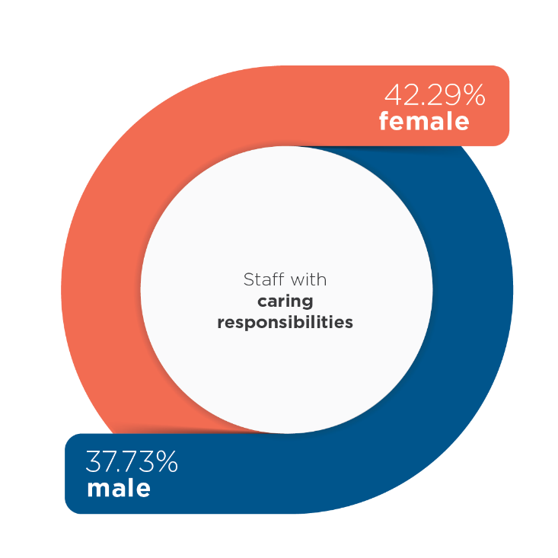
42.29% of staff with caring responsibilities are female, while 37.73% are male.
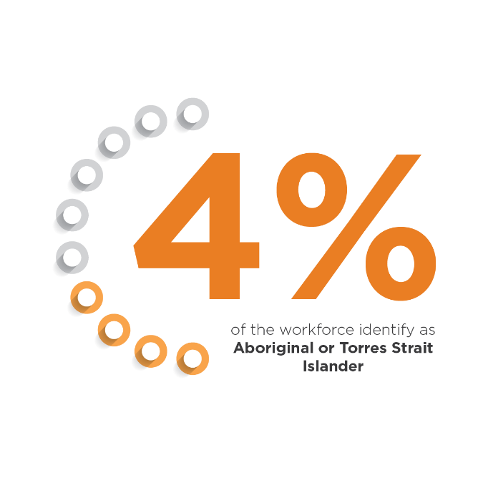
4 percent of the workforce identify as Aboriginal or Torres Strait Islander.
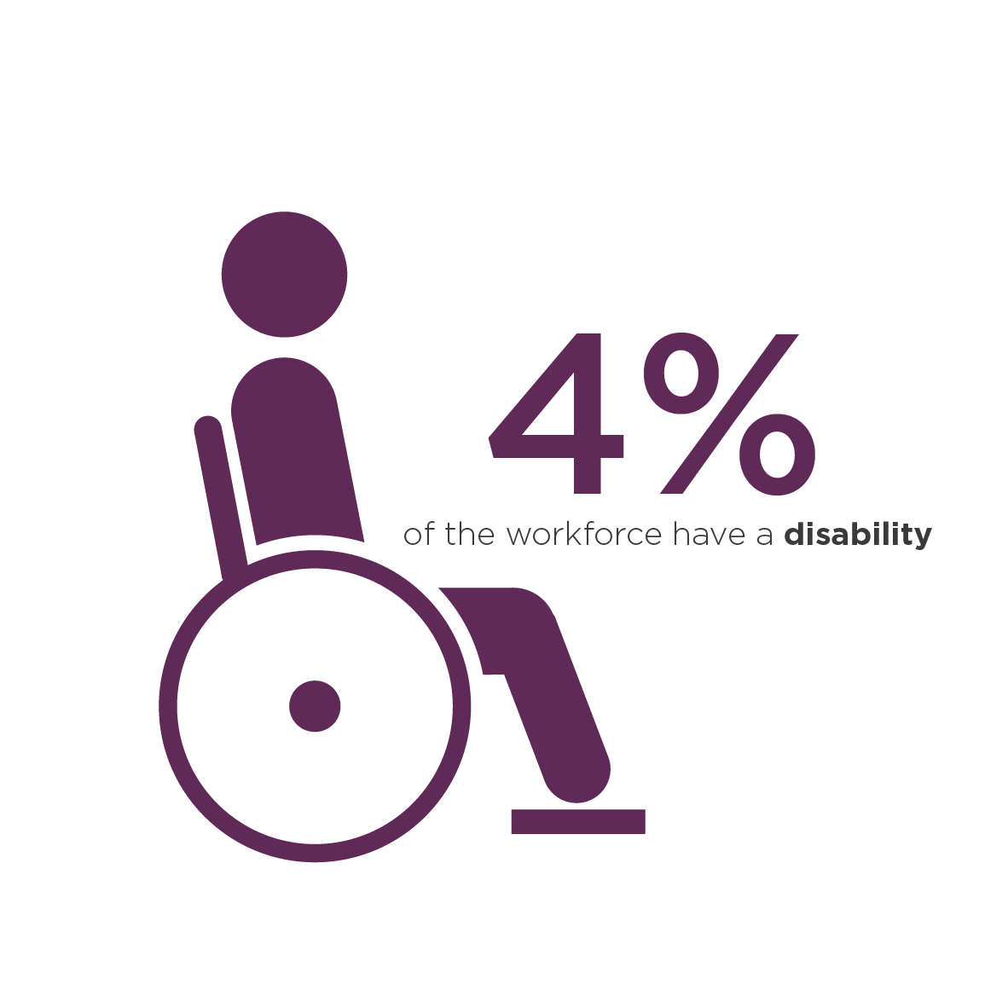
4% of the workforce have a disability.
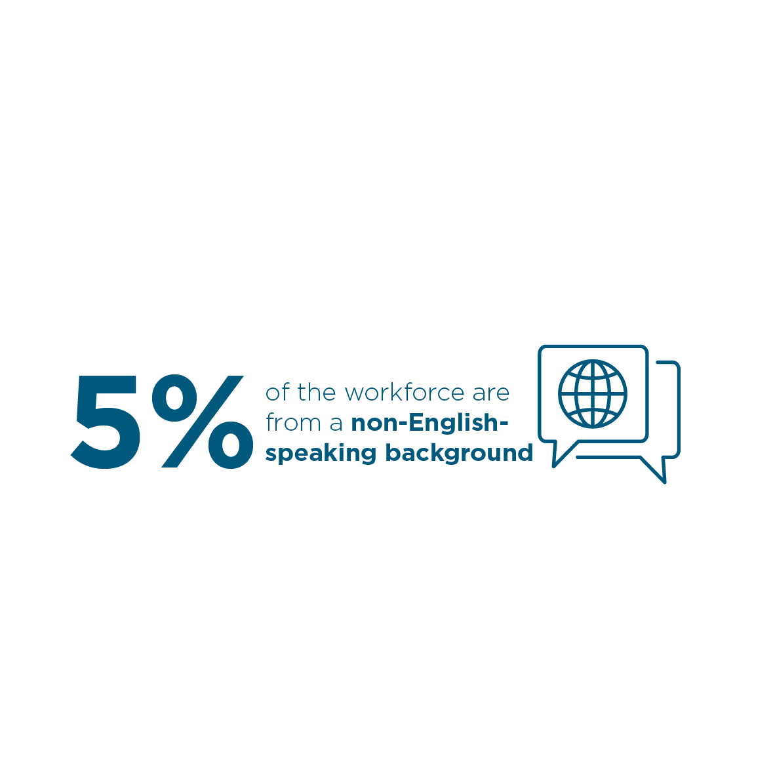
5% of the workforce are from a non-English-speaking background.
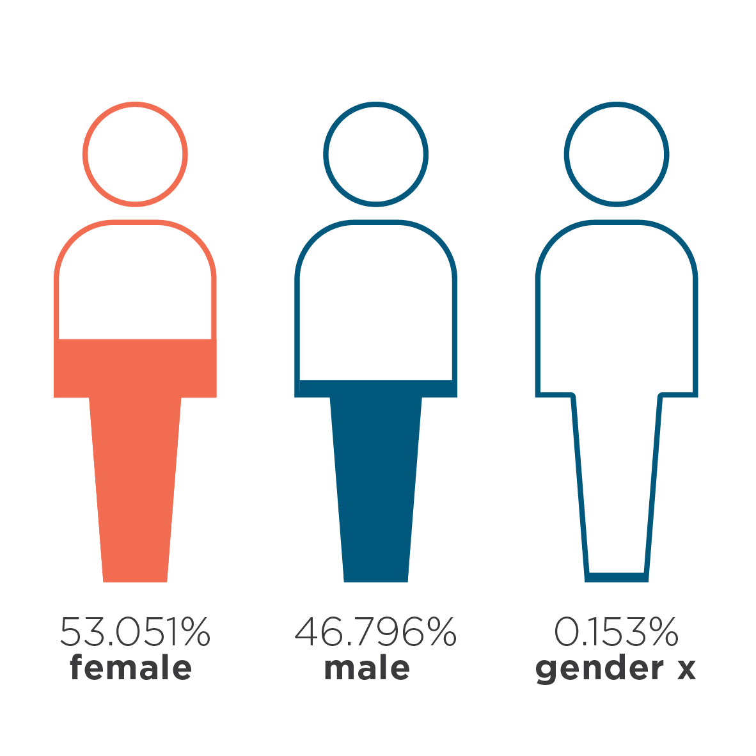
53.051% of staff identify as female, with 46.796% identifying as male and 0.153 identifying as gender x.

Messages from staff
‘I was born in Singapore and came to Australia when I was very young. I don’t fit in either the Chinese or English cultures but straddle both; this has given me an appreciation of the nuances in each. I am glad that my department is taking action to improve diversity and inclusion. I believe that a diverse APS workforce, that reflects the diverse public whom we serve, improves stakeholder engagement by offering perspectives from people from different minority groups. An inclusive workplace where everyone feels valued is also a more enjoyable one.’
Sharon, Biodiversity Conservation Division
‘I am a middle-aged woman who identifies as queer and has a disability. I am the daughter of an immigrant and the first person in my family with a university degree, having graduated in a STEM field at 45. While for many, I tick a lot of marginalised, diverse boxes, to me, this is my norm. Working in a place that appreciates my uniqueness and sees past the challenges to understand the strength of my inputs is vital to not just my existence but helps us grow in our policy delivery.’
Rhianna, Strategic Risk and Business Improvement
‘I grew up as an Emirati in Abu Dhabi and moved to Australia in 2007. It was a huge eye-opening experience for me to move to Melbourne when I was 16 by myself. I am now a proud queer Australian public servant and love talking to people and sharing my lived experience. The intersectionality of identity, ethnicity, culture, sexuality, religion, and disability are things that I live with every day. There is so much to learn about others and the most interesting things about us are the parts you don’t know!’
Mohamed, Enabling Services Group
‘I have been living with an anxiety disorder for most of my adult life. I have experienced negative (‘you shouldn’t be in this sort of job, it’s too stressful’) or dismissive (‘I couldn’t tell, so it mustn’t be serious’) reactions when sharing this with managers and colleagues in the past. It’s a relief to be part of a team that is open and supportive, with mental illness treated no differently than any other health or personal issue. I believe a culture of diversity and inclusion, supported by initiatives to increase awareness, and reduce stigma, can improve everyone’s experience in the workplaces.’
[name removed], Biosecurity and Compliance Group
‘Born in Australia, I am the child of first-generation migrants of Chinese heritage, with my dad having fled Vietnam as a refugee in the aftermath of the Vietnam War in the 1980s. Mandarin Chinese is my first language, having been raised by my monolingual grandparents up until I was exposed to English through school. In addition to being a member of an ethnic minority, I also suffer from mental health as a survivor of childhood trauma and abuse. The department is the first workplace where I have felt there is safe space to share my lived experiences, and where I have received the necessary support from colleagues when personal factors have impinged upon my ability to perform work to the best of my abilities. I believe this is a true testament to the department’s culture and the hard work of champions to destigmatise mental health and to create a workplace that embraces cultural and linguistic diversity at all levels.’
Cynthia, Bilateral Agreements Branch, Environment Protection Reform Division

Partners
We have established strong working relationships with several external organisations to help us achieve our inclusion objectives. These organisations provide support, guidance and best practices which inform our policies and procedures, events and opportunities. We are proud to be in partnership with Reconciliation Australia, Pride in Diversity and the Australian Network on Disability.
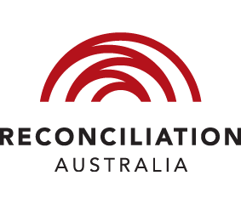
Reconciliation Australia (RA) promotes and facilitates respect, trust and positive relationships between the wider Australian community and Aboriginal and Torres Strait Islander peoples. We work with RA to develop our reconciliation action plan to ensure we are developing appropriate initiatives to support the national reconciliation movement.
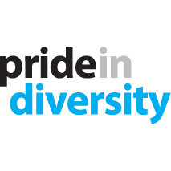
Pride in Diversity (PiD) is Australia’s first and only national not-for-profit employer support program for all aspects of LGBTIQ workplace inclusion. Our membership of PiD gives us access to research and training as well as the Australian Workplace Equality Index (AWEI). We have participated in the AWEI since 2018, when we achieved Bronze Employer status; and in 2020, we achieved Gold Employer status. The services we receive from PiD help us to develop policies and programs to support our LGBTIQ+ staff.

The Australian Network on Disability (AND) provides expert advice and services in relation to disability. Our membership with AND gives us access to employment and development programs for people with disability, as well as training, research and consultancy services which help us develop policies and programs to support our staff with disability.

Monitoring success
We will monitor our progress against our action plans and provide a progress report to the Executive Board in December each year. The action plans will be iteratively reviewed and adapted during the reporting period to ensure actions remain relevant and aligned with departmental priorities. We will regularly measure and monitor the diversity of our workforce, evaluate trends and identify areas for improvement. In addition, we will report to the Australian Public Service Commission on the progress of the Australian Government’s three diversity strategies:
- Australian Public Service Disability Employment Strategy 2020-2025
- Australian Public Service Gender Equality Strategy
- Commonwealth Aboriginal and Torres Strait Islander Workforce Strategy 2020-2024

Indicators of success include:
- an increase in employees self-identifying with the diversity groups in SAP/Aurion
- an improvement in the APS Employee Census results for all diversity groups
- an increase in employees identifying with diversity groups in the APS Employee Census
- increased participation, higher engagement and greater visibility of the inclusion networks
- increased instances of leaders displaying inclusion in their day-to-day duties
- a reduction in the number of employees from all diversity groups who report they have experienced discrimination, bullying or harassment.

Legislative responsibilities
As an APS agency, every employee is bound by the Public Service Act 1999, the APS Code of Conduct, APS Values and APS Employment Principles. A range of legislation governs our approach to diversity and outlines our legislative responsibilities:
- The Public Service Act 1999 and the Australian Public Service Commissioner’s Directions 2016 define the scope and application of the APS Values, the APS Code of Conduct and the requirement to establish diversity programs.
- The Australian Human Rights Commission Act 1986 outlines the rights of people alleging discrimination and provides an avenue for redress for those people.
- The Racial Discrimination Act 1975 makes it unlawful to discriminate on the grounds of race, colour, nationality or ethnic origin.
- The Sex Discrimination Act 1984 relating to discrimination on the ground of sex, sexual orientation, gender identity, intersex status, marital or relationship status, pregnancy, potential pregnancy, breastfeeding or family responsibilities, and relating to discrimination involving sexual harassment and discrimination involving harassment on the ground of sex.
- The Disability Discrimination Act 1992 makes it unlawful to discriminate against a person on the grounds of disability.
- The Age Discrimination Act 2004 makes it unlawful to discriminate on the basis of age.
- The Fair Work Act 2009 provides a safety net of minimum terms and conditions of employment.
- The Carer Recognition Act 2010 aims to increase recognition and awareness of the role carers play in providing daily care and support to people with disability, medical conditions or mental illness or those who are frail aged.
- The Work Health and Safety Act 2011 provides for a balanced and nationally consistent framework to secure the health and safety of workers and workplaces.
- The Workplace Gender Equality Act 2012 aims to promote and improve gender equality in employment in the workplace.

Supporting documents
This strategy is supported by the following action plans:
- Culturally and Linguistically Diverse Action Plan 2021-2024
- LGBTIQ+ Action Plan 2021-2024
- Gender Action Plan 2021-2024
- Disability Action Plan 2021-2024
- Aboriginal and Torres Strait Islander
- Mental Health Action Plan 2021-2024
- Multigenerational Workforce Action Plan 2021-2024
This inclusion strategy complements and supports a range of APS-wide strategies including:
- Commonwealth Aboriginal and Torres Strait Islander Workforce Strategy 2020–24
- Australian Public Service Disability Employment Strategy 2020–25
- Australian Public Service Gender Equality Strategy 2021–26
- Optimising our Multigenerational Workforce (APSC)
The inclusion strategy fits within our:
- Workforce Strategy and Action Plan 2021 to 2025
- Core 4 values and behaviours
- Mental Health and Wellbeing Strategy 2021 to 2024, and associated action plans.
This strategy is also supported by the following plans, strategies and guidelines:
- Stretch Reconciliation Action Plan, May 2021 to April 2024
- Staff-Led Inclusion Network Guidelines
- Gender Affirmation Guidelines.

