Portfolio Budget Statements 2022–23
Budget Related Paper No. 1.1

Agriculture, Fisheries and Forestry Portfolio

Budget Initiatives and Explanations of Appropriations
Specified by Outcomes and Programs by Entity

© Commonwealth of Australia 2022
ISSN: 2653-6250 (print) 2653-6269 (online)
This publication is available for your use under a Creative Commons BY Attribution 3.0 Australia licence, with the exception of the Commonwealth Coat of Arms, the Department of Agriculture, Fisheries and Forestry logo, photographs, images, signatures and where otherwise stated. The full licence terms are available from http://creativecommons.org /licenses/by/3.0/au/legalcode.


Use of Department of Agriculture, Fisheries and Forestry material under a Creative Commons BY Attribution 3.0 Australia licence requires you to attribute the work (but not in any way that suggests that the Department of Agriculture, Fisheries and Forestry endorses you or your use of the work).
Department of Agriculture, Fisheries and Forestry material used ‘as supplied’
Provided you have not modified or transformed Department of Agriculture, Fisheries and Forestry material in any way including, for example, by changing the department’s text; calculating percentage changes; graphing or charting data; or deriving new statistics from published Department of Agriculture, Fisheries and Forestry statistics, then the department prefers the following attribution:
Source: Australian Government Department of Agriculture, Fisheries and Forestry
Derivative material
If you have modified or transformed Department of Agriculture, Fisheries and Forestry material, or derived new material from those of the Department of Agriculture, Fisheries and Forestry in any way, then the department prefers the following attribution:
Based on Australian Government Department of Agriculture, Fisheries and Forestry data
Use of the Coat of Arms
The terms under which the Coat of Arms can be used are set out on the Department of the Prime Minister and Cabinet website (www.pmc.gov.au/government/commonwealth-coat-arms).
Other Uses
Enquiries regarding this licence and any other use of this document are welcome at:
External Budgets Section; Finance and Investment Division
Department of Agriculture, Fisheries and Forestry
GPO Box 858,
Canberra, ACT 2601
Email: externalbudgets@agriculture.gov.au

President of the Senate
Australian Senate
Parliament House
CANBERRA ACT 2600

Speaker
House of Representatives
Parliament House
CANBERRA ACT 2600

Dear Ms President
Dear Mr Speaker

I hereby submit October Portfolio Budget Statements in support of the 2022–23 October Budget for the Agriculture, Fisheries and Forestry portfolio.

These statements have been developed, and are submitted to the Parliament, as a statement on the outcomes for the portfolio.

I present these statements to provide accountability to the Parliament and, through it, the public.


Yours sincerely



MURRAY WATT

Senator the Hon Murray Watt

Abbreviations and conventions
The following notation may be used:
NEC/nec not elsewhere classified
- nil
.. not zero, but rounded to zero
na not applicable (unless otherwise specified)
nfp not for publication
$m $ million
$b $ billion
Figures in tables and in the text may be rounded. Figures in text are generally rounded to one decimal place, whereas figures in tables are generally rounded to the nearest thousand. Discrepancies in tables between totals and sums of components are due to rounding.

Enquiries
Should you have any enquiries regarding this publication please contact
Paul Pak Poy, Chief Finance Officer, Department of Agriculture, Fisheries and Forestry, on (02) 6272 5523.
Links to Portfolio Budget Statements (including Portfolio Additional Estimates Statements and Portfolio Supplementary Additional Statements) can be located on the Australian Government Budget website at: www.budget.gov.au.

User Guide
To The
Portfolio Budget Statements

User guide
The purpose of the October 2022–23 Portfolio Budget Statements (PBS) is to inform Senators and Members of Parliament of the proposed allocation of resources to government outcomes by entities within the portfolio. Entities receive resources from the annual appropriations acts, special appropriations (including standing appropriations and special accounts), and revenue from other sources.
The PBS facilitates understanding of proposed annual appropriations in Appropriation Bills (No. 1 and No. 2) 2022–23 (or Appropriation (Parliamentary Departments) Bill (No. 1) 2022–23 for the parliamentary departments). For this reason, the PBS is declared by the Appropriation Acts to be a ‘relevant documents’ to the interpretation of the Acts according to section 15AB of the Acts Interpretation Act 1901.
The PBS provides information, explanation and justification to enable Parliament to understand the purpose of each outcome proposed in the Bills.
As required under section 12 of the Charter of Budget Honesty Act 1998, only entities within the general government sector are included as part of the Commonwealth general government sector fiscal estimates and produce PBS where they receive funding (either directly or via portfolio departments) through the annual appropriation acts.
The Commonwealth Performance Framework
The following diagram outlines the key components of the Commonwealth performance framework. The diagram identifies the content of each of the publications and the relationship between them. Links to the publications for each entity within the portfolio can be found in the introduction to Section 2: Outcomes and planned performance.
Commonwealth Performance Framework
Key components of relevant publications

Portfolio Budget Statements
(October)
Portfolio based
Corporate Plan
(August)
Entity based
Supports Annual Appropriations. Informs Senators and Members of Parliament of the proposed allocation of other resources to government outcomes and programs.
Provides links to relevant programs
undertaken by other Commonwealth
entities.
Provides high level performance
information for current, ongoing programs, particularly a forecast of performance for the current year.
Provides detailed prospective
performance information for proposed new budget measures that require a new program or significantly change an existing program.

Primary planning document of a
Commonwealth entity.
Sets out the purposes of the entity, the activities it will undertake to achieve its purposes and the results it expects to achieve over a minimum four-year period.
Describes the environment in which the entity operates, the capability it requires to undertake activities and a discussion
of risk.
Explains how the entity’s performance will be measured and assessed.
Annual Performance Statement (October following year)
Entity based

Included in the Commonwealth entity’s Annual Report. Focuses on recent
performance.
Reports on the actual performance results for the year against the forecasts made in the corporate plan and Portfolio Budget Statements and provides other performance information relevant to the entity.
Provides an analysis of the factors that contributed to the entity’s
performance results.

Contents
User guide v
Agriculture, Fisheries and Forestry Portfolio Overview 3
Entities’ resources and planned performance 9
Department of Agriculture, Fisheries and Forestry 15
AgriFutures Australia 91
Australian Fisheries Management Authority 115
Australian Pesticides and Veterinary Medicines Authority 141
Cotton Research and Development Corporation 159
Fisheries Research and Development Corporation 181
Grains Research and Development Corporation 201
Regional Investment Corporation 223
Wine Australia 243

Portfolio Overview

Agriculture, Fisheries and Forestry
Portfolio overview
Since the March 2022–23 Portfolio Budget Statements (PBS) the following change has occurred:
- Senator the Hon Murray Watt was appointed Minister for Agriculture, Fisheries and Forestry.
As a result of the Administrative Arrangements Orders (AAO) made on 23 June 2022 and commencing on 1 July 2022, the following changes occurred:
- The Agriculture, Water and Environment portfolio was renamed the Agriculture, Fisheries and Forestry portfolio
- The Department of Agriculture, Water and the Environment was renamed the Department of Agriculture, Fisheries and Forestry (DAFF)
- Agriculture, Fisheries and Forestry functions and two outcomes were transferred to DAFF
- Environment and Water functions and three outcomes were transferred to the new Department of Climate Change, Energy, the Environment and Water (DCCEEW)
- AgriFutures Australia, Australian Fisheries Management Authority, Australian Pesticides and Veterinary Medicines Authority, Cotton Research and Development Corporation, Fisheries Research and Development Corporation, Grains Research and Development Corporation, Regional Investment Corporation and Wine Australia were transferred to the renamed Agriculture, Fisheries and Forestry portfolio
- Bureau of Meteorology, Director of National Parks, Great Barrier Reef Marine Park Authority, Murray-Darling Basin Authority and Sydney Harbour Federation Trust were transferred to the Climate Change, Energy, the Environment and Water portfolio
- The National Carp Control Plan was transferred to DAFF
- The National Soils Advocate program was transferred to DAFF
- The following programs were transferred from the Department of Agriculture, Water and the Environment (DAWE) to DCCEEW:
- Agriculture Stewardship Package
- Agriculture 2030 – Soil and Stewardship: Implement an Australian farm biodiversity certification scheme
- Agriculture 2030 – Soil and Stewardship: Pilot Stewardship program.

From 1 July 2022 the Agriculture, Fisheries and Forestry portfolio consists of DAFF (the department) and eight portfolio bodies. A revised portfolio structure reflecting these changes is presented at Figure 1.
The portfolio consists of:

- Department of Agriculture, Fisheries and Forestry
- AgriFutures Australia
- Australian Fisheries Management Authority
- Australian Pesticides and Veterinary Medicines Authority
- Cotton Research and Development Corporation
- Fisheries Research and Development Corporation
- Grains Research and Development Corporation
- Regional Investment Corporation
- Wine Australia.
Each entity within the portfolio has at least one outcome and program. Details are provided in each entity’s section of this document.
For information on resourcing across the portfolio, please refer to Part 1: Agency Financial Resourcing in October Budget Paper No. 4: Agency Resourcing.

Figure 1: Agriculture, Fisheries and Forestry portfolio structure and outcomes
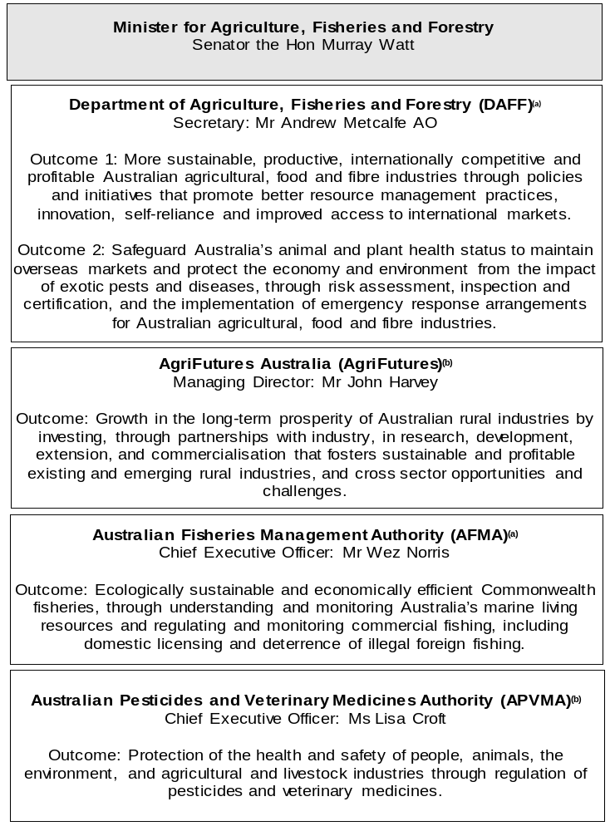

Figure 1: Agriculture, Fisheries and Forestry portfolio structure and outcomes (continued)
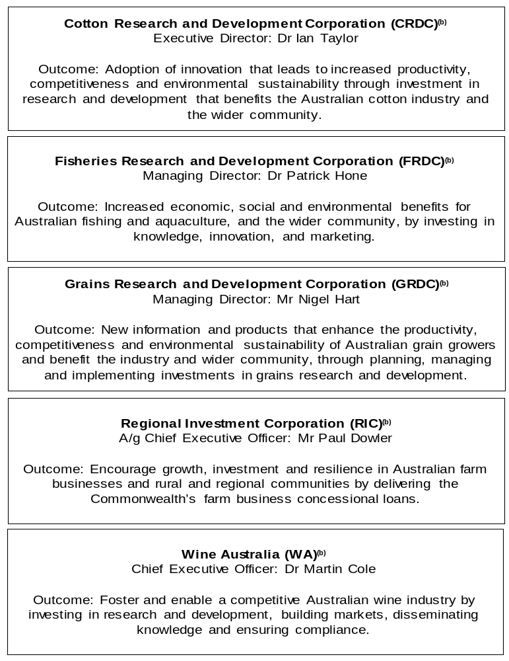
(a) ‘Non-corporate Commonwealth Entity’ (NCCE) as defined under the Public Governance, Performance and Accountability Act 2013 (PGPA Act).
(b) ‘Corporate Commonwealth Entity’ (CCE) as defined under the PGPA Act.

Other industry-owned and not-for-profit companies related to the portfolio
Australian industry-owned companies are independent corporate entities, established under specific legislation with expertise-based boards. The company members appoint the directors of the board. Companies are accountable to the Minister for Agriculture, Fisheries and Forestry through legislation and statutory funding agreements and are entitled to receive industry levies and matching Australian Government funding for eligible research and development (R&D) expenditure. These entities report outside the general government sector.
The following industry-owned companies provide R&D and marketing services:
- Australian Egg Corporation Limited
- Australian Livestock Export Corporation Limited
- Australian Meat Processor Corporation Limited
- Australian Pork Limited
- Australian Wool Innovation Limited
- Dairy Australia Limited
- Forest and Wood Products Australia Limited
- Horticulture Innovation Australia Limited
- Meat and Livestock Australia Limited
- Sugar Research Australia Limited.
Separately, the Australian Government provides funding to the following
not-for-profit, portfolio-related companies:
- Animal Health Australia
- Plant Health Australia Limited.

Entities’ resources and planned performance
Department of Agriculture, Fisheries and Forestry 15
AgriFutures Australia 91
Australian Fisheries Management Authority 115
Australian Pesticides and Veterinary Medicines Authority 141
Cotton Research and Development Corporation 159
Fisheries Research and Development Corporation 181
Grains Research and Development Corporation 201
Regional Investment Corporation 223
Wine Australia 243

Department of Agriculture, Fisheries and Forestry

Entity resources and planned performance

Department of Agriculture, Fisheries and Forestry
Section 1: Entity overview and resources 15
1.1 Strategic direction statement 15
1.2 Entity resource statement 17
1.3 Budget measures 23
Section 2: Outcomes and planned performance 29
2.1 Changes to Outcome and Program Structures since the last portfolio statement 30
2.2 Budgeted expenses and performance measures for DAFF Outcome 1 34
2.3 Budgeted expenses and performance measures for DAFF Outcome 2 52
2.4 Budgeted expenses for DAWE Outcome 1 62
2.5 Budgeted expenses for DAWE Outcome 2 68
2.6 Budgeted expenses for DAWE Outcome 5 70
Section 3: Budgeted financial statements 73
3.1 Budgeted financial statements 73
3.2 Budgeted financial statements tables 75

Department of Agriculture, Fisheries and Forestry

Section 1: Entity overview and resources

Strategic direction statement
The Department of Agriculture, Fisheries and Forestry supports Australia’s food and fibre industries to grow and thrive. We strengthen the nation’s agriculture, fisheries and forestry sectors by protecting our land, plants and animals from biosecurity threats, supporting our farmers and producers to get their produce into premium overseas markets and supporting productivity growth, including through more sustainable agriculture practices and natural resources management.
The department’s work is central to the lives of Australians, particularly those living in regional, rural and remote communities. We support economic prosperity and jobs, while helping our food and fibre industries to build their sustainability and premium credentials. Our diverse roles and functions include biosecurity operations and trade facilitation, world-class science and research, policy advice to government, program administration, client services and regulation.
We are supporting our agriculture, fisheries and forestry industries to meet their goal of becoming a $100 billion sector by 2030 amid changing global market conditions.
The backdrop of labour shortages, biosecurity threats in our region and the impact of climate change means that enacting policies now that build market access, support innovation and create jobs through the supply chain is critical to ensure that our food and fibre industries can face the future with confidence.
Australia’s world-class biosecurity system is essential to our export trade and the integrity and sustainability of our way of life and unique environment. Biosecurity is at the heart of how we prevent, respond to and recover from pest and disease incursions that threaten plant, animal and human health, regional communities, our economy and the natural environment. Through programs such as Indigenous Biosecurity Rangers we benefit from the knowledge of First Nations people in agricultural supply chains and our biosecurity responses to deliver rapid, effective and successful biosecurity outcomes.
Changes in global trade, climate change, and the spread of pests and diseases in our region continue to create new and complex biosecurity risk pathways, increasing pressure on Australia’s biosecurity system. The strength of our biosecurity system will be reinforced by improved diagnostics, emerging surveillance technologies, engagement with First Nations people, and working closely with industry partners and international neighbours.

We support Australia’s agriculture exporters to grow and diversify their markets through funding to develop a national approach to improve traceability in agricultural supply chains across all products and commodities, including by driving reform of Australia’s livestock traceability and strengthening on-farm biosecurity.
The department has embarked on a major export reform program to modernise and deliver world-leading regulatory systems and processes to help our farmers and producers get their produce into high-value overseas trade markets more quickly and efficiently. We also continue to play an active leadership role in strengthening the international institutions that underpin our trade by setting global standards for animal health, plant health and food safety.
Australian farmers have long been at the forefront of adapting to climate change, in the face of natural disasters such as drought, floods and fires, all of which present challenges to farm performance. Farmers and industry have led the way on climate adaptation and innovation, work that is increasingly critical to retaining and expanding international market access for our agricultural goods, demonstrating the premium credentials and provenance that our trading partners demand.
Through programs such as the National Landcare Program, we take a broad-based approach to sustainable agriculture and natural resources management, including improving farm productivity, pest and weed management, biodiversity stewardship and resilience to drought and natural disasters. The program will continue to support the food and fibre sector’s contribution to the Government’s climate agenda and the economy’s transition to net zero emissions.
Our partnerships with the agriculture, fisheries and forestry industries are crucial to ensuring we can achieve the best possible outcomes in agriculture, biosecurity, and driving down emissions. The department continues to work in partnership with primary producers, state and territory governments, First Nations people, not for profit organisations, the private sector, local communities and industry. These partnerships are central to our efforts to ensuring a competitive and sustainable sector.
We seek to achieve our mission through the department’s two outcomes.
Outcome 1: More sustainable, productive, internationally competitive and profitable Australian agricultural, food and fibre industries through policies and initiatives that promote better resource management practices, innovation, self-reliance and improved access to international markets.
Outcome 2: Safeguard Australia’s animal and plant health status to maintain overseas markets and protect the economy and environment from the impact of exotic pests and diseases, through risk assessment, inspection and certification, and the implementation of emergency response arrangements for Australian agricultural, food and fibre industries.

Entity resource statement
Table 1.1 shows the total funding from all sources available to the entity for its operations and to deliver programs and services on behalf of the Government.
The table summarises how resources will be applied by outcome (Government strategic policy objectives) and by administered (on behalf of the Government or the public) and departmental (for the entity’s operations) classification.
For more detailed information on special accounts and special appropriations, please refer to October Budget Paper No. 4: Agency Resourcing.
Information in this table is presented on a resourcing (i.e. appropriations/cash available) basis, whilst the ‘Budgeted expenses by Outcome’ tables in Section 2 and the financial statements in Section 3 are presented on an accrual basis.

Table 1.1: Department of Agriculture, Fisheries and Forestry – Resource Statement – Budget Estimates for 2022–23 as at October Budget 2022
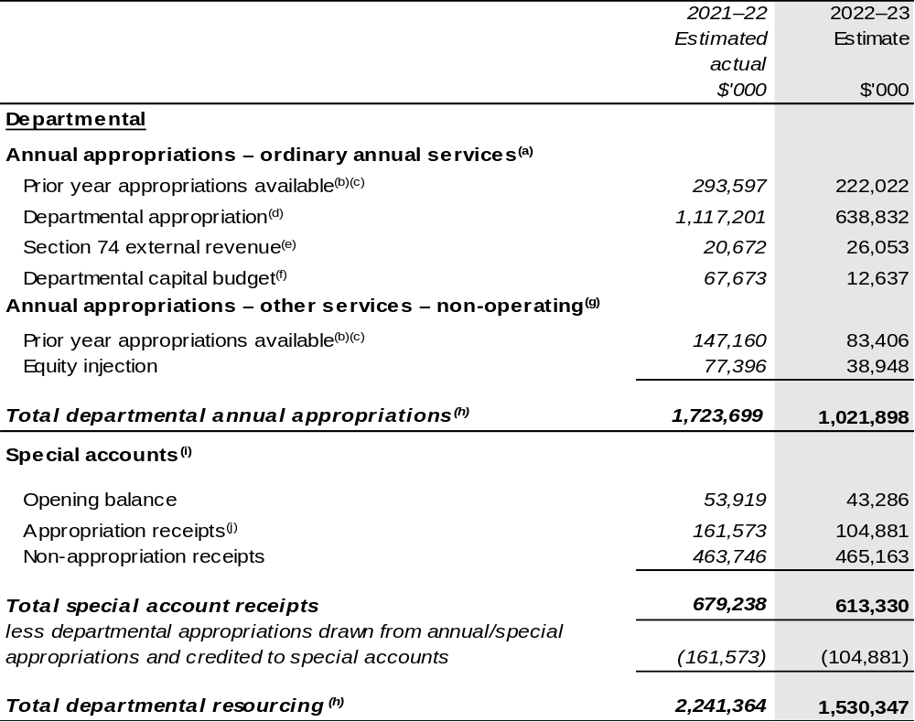
Continued on following pages
Table 1.1: Department of Agriculture, Fisheries and Forestry – Resource Statement – Budget Estimates for 2022–23 as at October Budget 2022 (continued)
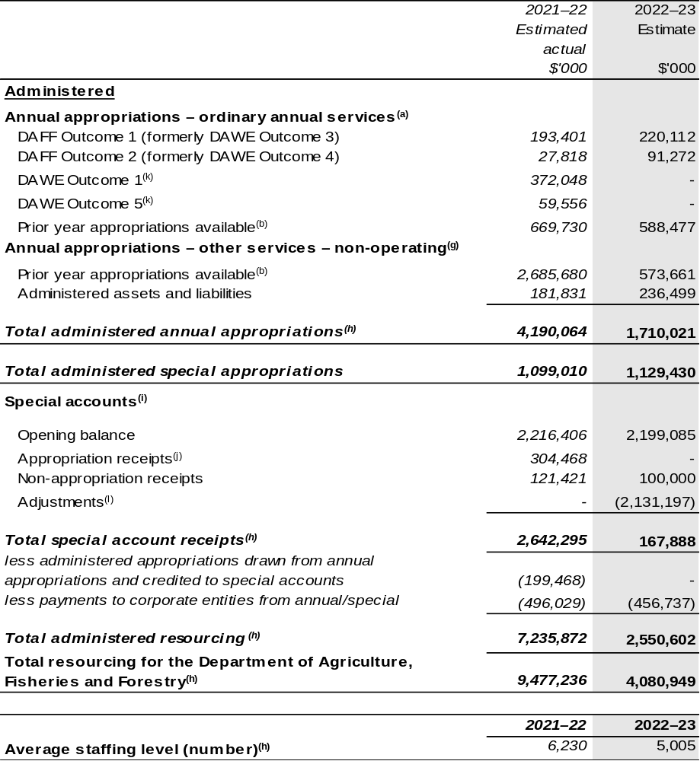
Continued on following pages

Table 1.1: Department of Agriculture, Fisheries and Forestry – Resource Statement – Budget Estimates for 2022–23 as at October Budget 2022 (continued)

- Appropriation Bill (No. 1) 2022–23, Supply Bill (No. 3) 2022–23 and Supply Act (No. 1) 2022–23.
- Excludes $1,097.175 million subject to administrative quarantine by Finance or withheld under section 51 of the PGPA Act.
- Prior year appropriations partly include resourcing related to outcomes that have transferred to DCCEEW, this will be transferred through a future Section 75 Determination under the PGPA Act.
- Excludes departmental capital budget (DCB).
- Estimated external revenue under section 74 of the PGPA Act.
- Departmental capital budgets are not separately identified in Appropriation Bill (No. 1) 2022–23 and form part of ordinary annual services items. Please refer to Table 3.5 for further details. For accounting purposes, this amount has been designated as a 'contribution by owner'.
- Appropriation Bill (No. 2) 2022–23, Supply Bill (No. 4) 2022–23 and Supply Act (No. 2) 2022–23.
- As a result of AAO made on 23 June 2022 and commencing on 1 July 2022, the 2021–22 resourcing reflects the structure of DAWE. The AAO changes have moved the water and environment functions to DCCEEW. Refer to Portfolio overview for further information. These changes have resulted in significant reductions against these items in Table 1.1 in 2022–23.
- Excludes trust moneys held in Services for Other Entities and Trust Moneys (SOETM) and other special accounts. For further information on special accounts, please refer to October Budget Paper No. 4 – Agency Resourcing. Please also see Table 2.1 for further information on outcome and program expenses broken down by various funding sources, e.g. annual appropriations, special appropriations and special accounts.
- Amounts credited to the special account(s) from the department’s annual appropriations.
- Responsibility for these outcomes and corporate entities were transferred to DCCEEW effective 1 July 2022 as a result of AAO changes published on 23 June 2022.
- Adjustments reflect the transfer of environment and water related special account balances to DCCEEW from 1 July 2022 as a result of AAO changes. For further information on special accounts, please refer to October Budget Paper No. 4 – Agency Resourcing.
- ‘Corporate entities’ are CCE and Commonwealth companies as defined under the PGPA Act.

All figures shown above are GST exclusive – these may not match figures in the cash flow statement.

Prepared on a resourcing (i.e. appropriations available) basis.

Continued on following pages

Table 1.1: Department of Agriculture, Fisheries and Forestry – Resource Statement – Budget Estimates for 2022–23 as at October Budget 2022 (continued)
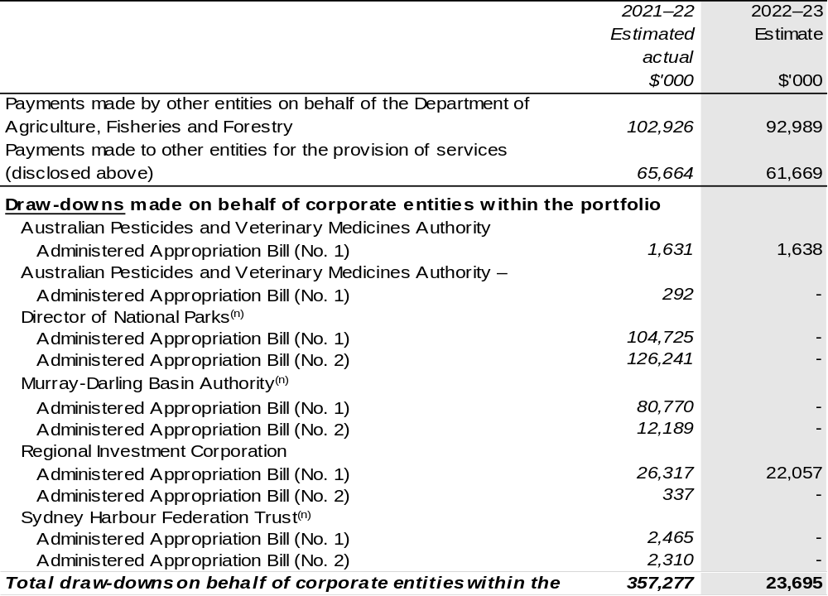
- Responsibility for these corporate entities were transferred to DCCEEW effective 1 July 2022 as a result of AAO changes published on 23 June 2022.

Continued on following page

Table 1.1: Department of Agriculture, Fisheries and Forestry – Resource Statement – Budget Estimates for 2022–23 as at October Budget 2022 (continued)
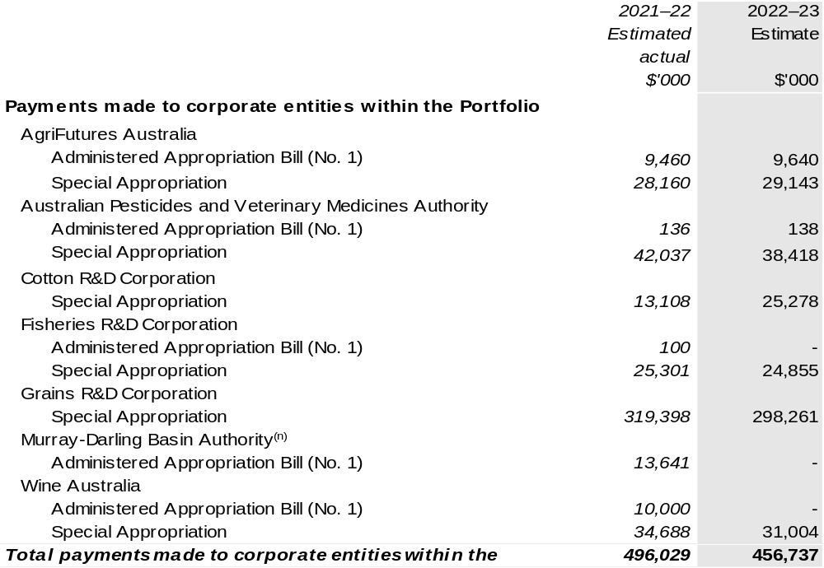
- Responsibility for these corporate entities were transferred to DCCEEW effective 1 July 2022 as a result
of AAO changes published on 23 June 2022.

1.3 Budget measures
Budget measures in Part 1 relating to Department of Agriculture, Fisheries and Forestry are detailed in October Budget Paper No. 2 and are summarised below.

Table 1.2: Department of Agriculture, Fisheries and Forestry – October 2022–23 Budget Measures

Part 1: Measures announced since the March 2022–23 Budget
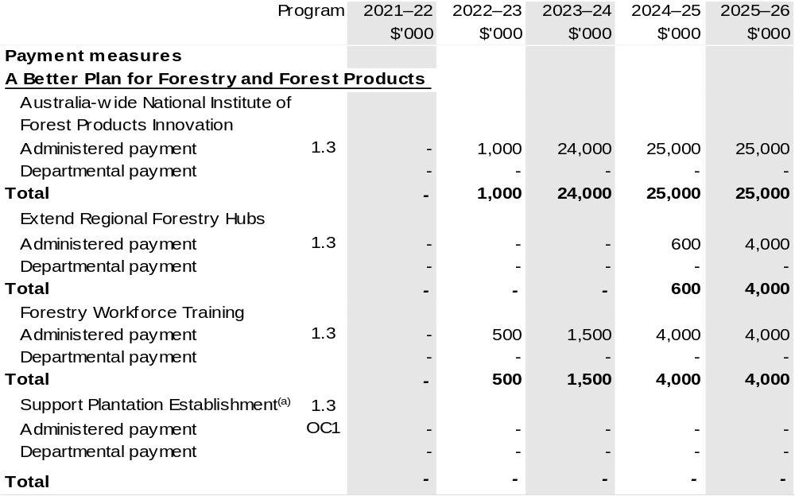
Continued on following pages
Part 1: Measures announced since the March 2022–23 Budget (continued)
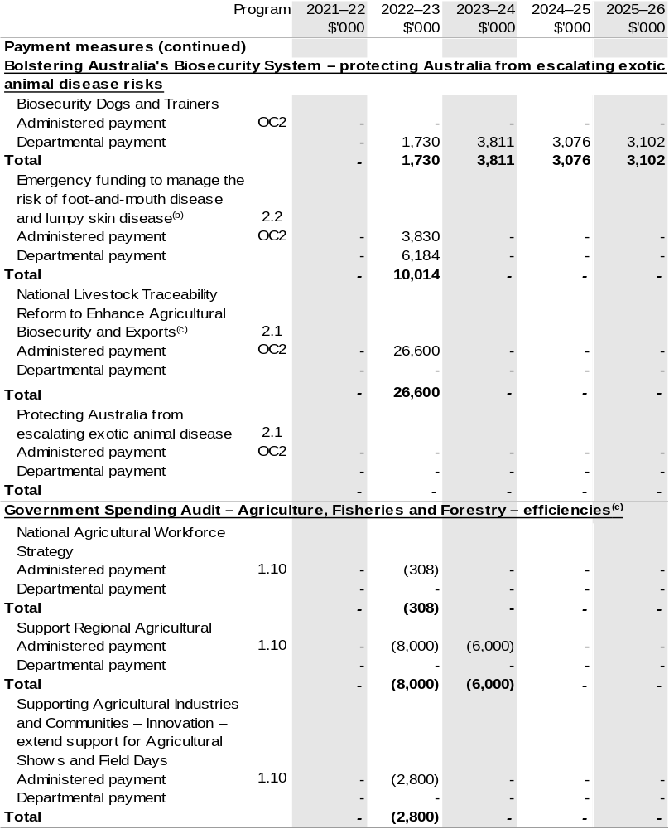
Continued on following pages
Part 1: Measures announced since the March 2022–23 Budget (continued)
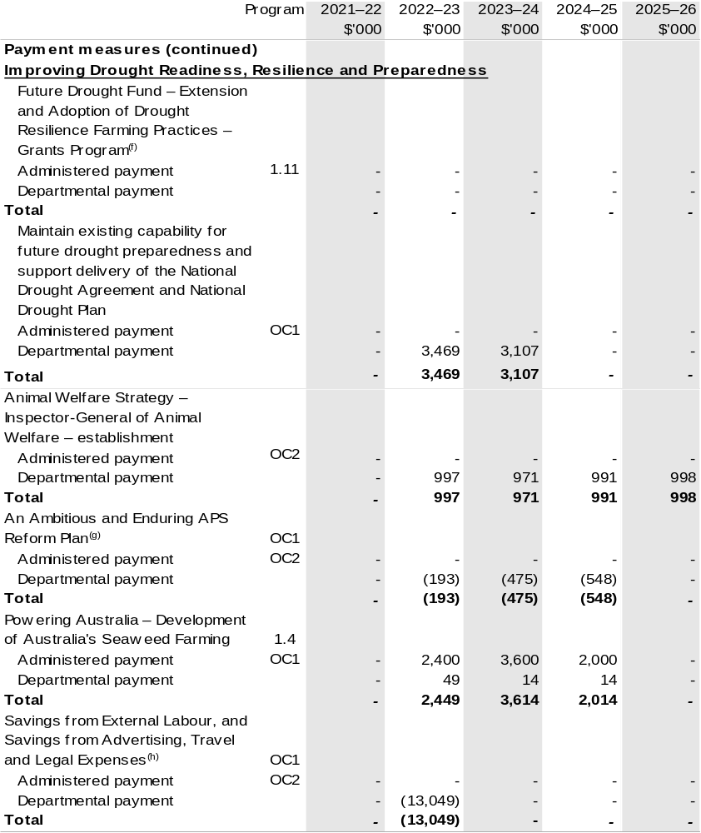
Continued on following pages

Part 1: Measures announced since the March 2022–23 Budget (continued)
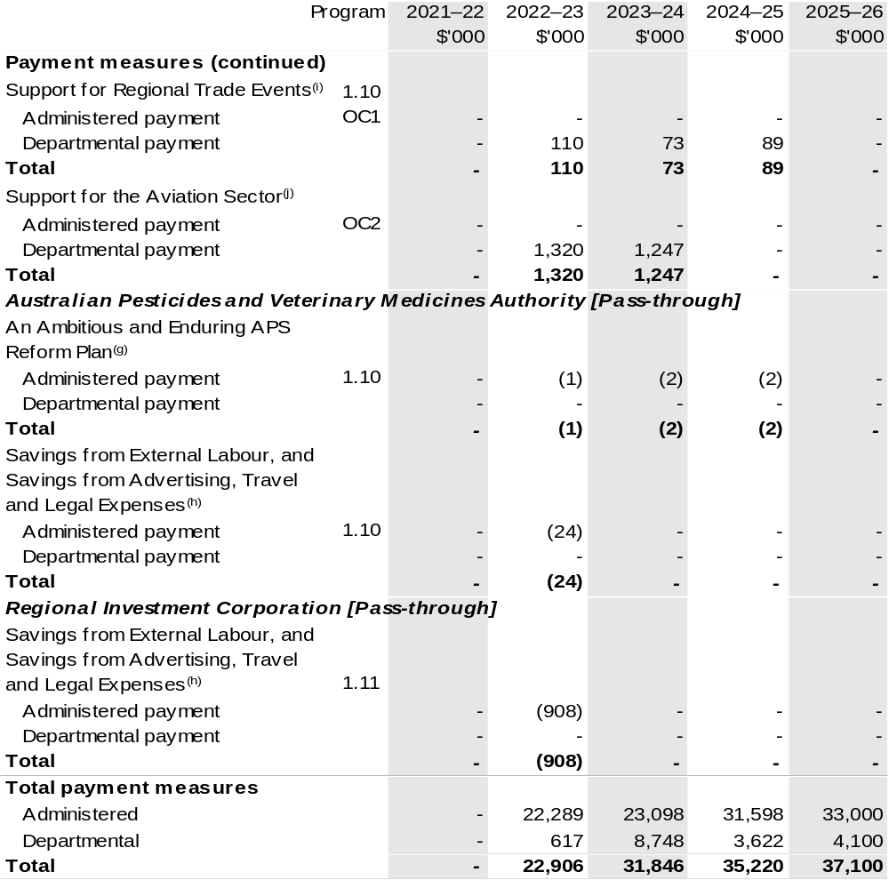
Continued on following page

Part 1: Measures announced since the March 2022–23 Budget (continued)

(a) The measure A Better Plan for Forestry and Forest Products – Support Plantation Establishment has been reframed, the total package is $86.209 million, with the following departmental impacts: 2022–23 $0.300 million; 2023–24 $3.242 million; 2024–25 $2.778 million; 2025–26 $2.797 million; 2026–27 $3.038 million and with the following administered impacts; 2023–24 $6.949 million; 2024–25 $22.426 million; 2025–26 $27.426 million; and 2026–27 $16.959 million. An additional $0.294 million is available in funding from the original measure. The measure description appears in October Budget Paper No. 2: Budget Measures 2022–23 under the DAFF portfolio.
(b) This measure was announced on 15 July 2022. Total package is $14.014 million in 2022–23, with $4.000 million coming from existing funding within DAFF.
(c) The measure Bolstering Australia's Biosecurity System – protecting Australia from escalating exotic animal disease risks – National Livestock Traceability Reform to Enhance Agricultural Biosecurity and Exports has been reframed, the total package is $46.732 million over three years with the following departmental impacts; 2022–23 $0.080 million, 2024–25 $0.052 million; and the following administered impact; 2022–23 $26.600 million. This measure includes $20.000 million funding to the National Partnership programs within the Department of the Treasury. Details appear in October Budget Paper No. 3: Federal Financial Relations.
(d) The measure Bolstering Australia's Biosecurity System – protecting Australia from escalating exotic animal disease risks has been reframed, the total package is $61.587 million over two years, with the following departmental impacts: 2022–23 $21.377 million; 2023–24 $29.387 million; and the following administered impacts: 2022–23 $1.213 million; 2023–24 $6.810 million. This measure includes $2.800 million funding to the National Partnership programs within the Department of the Treasury. Details appear in October Budget Paper No. 3: Federal Financial Relations.
(e) The measure Government Spending Audit – Agriculture, Fisheries and Forestry – efficiencies contains a savings measure National Centre for Digital Agriculture Innovation and Adoption Hubs, this belongs to Department of Infrastructure, Transport, Regional Development, Communications and the Arts.
The total savings is $30.017 million over four years. The measure description appears in October Budget Paper No. 2: Budget Measures 2022–23 under the DAFF portfolio.
(f) The measure Improving Drought Readiness, Resilience and Preparedness – Future Drought Fund – Extension and Adoption of Drought Resilience Farming Practices – Grants Program has been reframed; the total package is $14.265 million over two years.
(g) The measure description appears in October Budget Paper No. 2: Budget Measures 2022–23 under the Prime Minister and Cabinet Portfolio section.
(h) The measure description appears in October Budget Paper No. 2: Budget Measures 2022–23 under the Cross Portfolio section.
(i) The measure Support for Regional Trade Events has been reframed, the total package is $12.272 million over three years.
(j) The measure description appears in October Budget Paper No. 2: Budget Measures 2022–23 under the Infrastructure, Transport, Regional Development, Communications and the Arts Portfolio section.

Note: The Government has reviewed the remaining measures previously announced in the 2022–23 March Budget and has agreed to implement them as announced. These measures can be found in the March 2022–23 DAWE PBS for Outcome 3 and 4, under Table 1.2, 2.1 and also in National Partnership programs within the Department of the Treasury. Details also appear in March Budget Paper No. 2: Budget Measures 2022–23 and Budget Paper No. 3: Federal Financial Relations.

Part 2: Other measures not previously reported in a portfolio statement
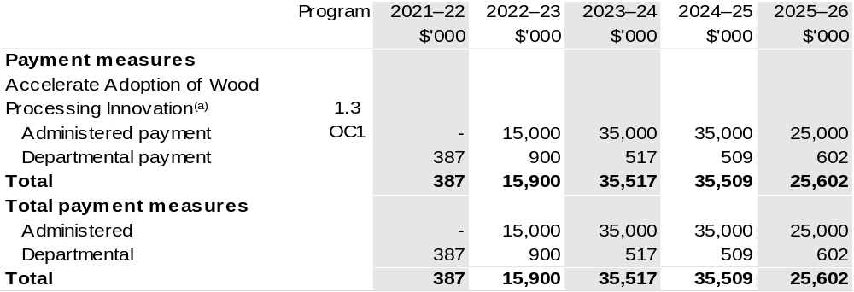

(a) This measure was published in the Pre-election Economic and Fiscal Outlook report (PEFO) 2022.
This measure commits funding of $112.938 million over six years from 2021–22. This measure was included as a ‘Decisions Taken But Not Yet Announced’ in the 2021–22 Mid-Year Economic and Fiscal Outlook (MYEFO) and 2021–22 Portfolio Additional Estimates Statements (PAES). The $0.387 million in 2021–22 will be appropriated in the Appropriation Bill (No. 1) 2022–23.

Prepared on a Government Finance Statistics (Underlying Cash) basis.

Figures displayed as a negative (-) represent a decrease in funds and a positive (+) represent an increase in funds.

Section 2: Outcomes and planned performance
Government Outcomes are the intended results, impacts or consequences of actions by the Government on the Australian community. Commonwealth programs are the primary vehicle by which government entities achieve the intended results of their Outcome Statements. Entities are required to identify the programs which contribute to Government outcomes over the Budget and forward years.
Each outcome is described below together with its related programs. The following provides detailed information on expenses for each Outcome and program, further broken down by funding source.
Note:
Performance reporting requirements in the Portfolio Budget Statements are part of the Commonwealth performance framework established by the Public Governance, Performance and Accountability Act 2013. It is anticipated that the performance criteria described in Portfolio Budget Statements will be read with broader information provided in an entity’s corporate plans and annual performance statements — included in Annual Reports — to provide a complete picture of an entity’s planned and actual performance.
Our most recent corporate plan can be found at agriculture.gov.au/about/reporting/corporate-plan.
The most recent annual performance statements can be found at: agriculture.gov.au/about/reporting/annual-report.

2.1 Changes to Outcome and Program Structures since the last portfolio statement
The newly named DAFF has resulted in two existing outcome statements reordered to Outcome 1 and 2. They supersede the previous DAWE Outcomes 3 and 4 that were reported in the 2022–23 PBS, published in March 2022.
The creation of a new department has resulted in three outcomes from the former DAWE combining with one new outcome from the former Department of Industry, Science, Energy and Resources (DISER) going to DCCEEW.
Figure 2 shows the changes to the order of DAFF’s two outcome statements and the reordering of the program numbers.
In Figure 3, reporting of the 2021–22 actuals for the former three DAWE outcomes will be reported as Outcome 1, 2 and 5. The forward estimates will be published in the DCCEEW October 2022–23 PBS.

Figure 2: Changes to Outcome and Program Structures for DAFF
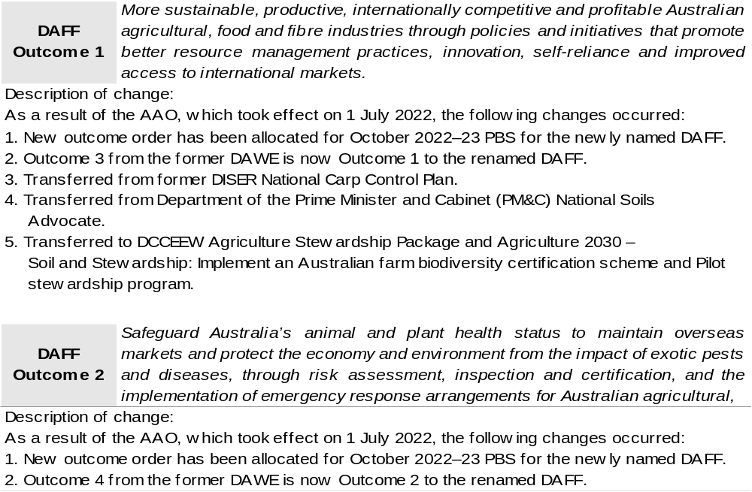
Continued on following pages

Figure 2: Changes to Outcome and Program Structures for DAFF (continued)
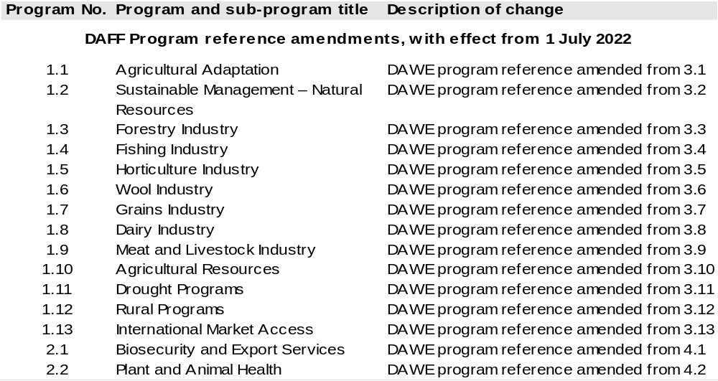
Continued on following pages

Figure 3: Changes to Outcome and Program Structures for DAWE to DCCEEW
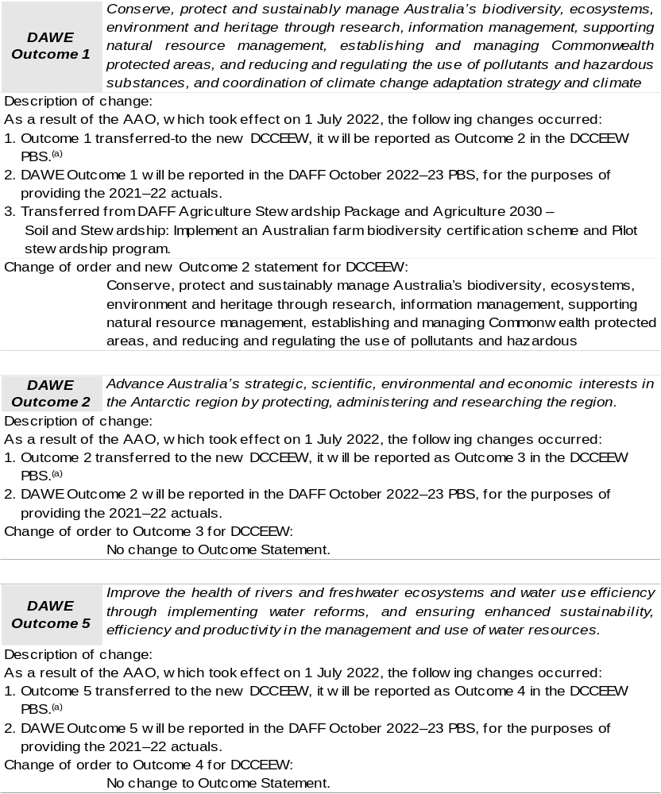
- Refer to DCCEEW October 2022–23 PBS.

Continued on following page

Figure 3: Changes to Outcome and Program Structures for DAWE to DCCEEW (continued)
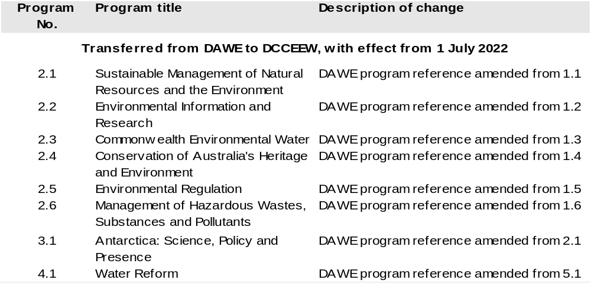

2.2 Budgeted expenses and performance measures for DAFF Outcome 1
Outcome 1: More sustainable, productive, internationally competitive and profitable Australian agricultural, food and fibre industries through policies and initiatives that promote better resource management practices, innovation, self-reliance and improved access to international markets.

2.2.1: Linked programs
Portfolio Agencies:
AgriFutures Australia
Australian Fisheries Management Authority
Australian Pesticides and Veterinary Medicines Authority
Cotton Research and Development Corporation
Fisheries Research and Development Corporation
Grains Research and Development Corporation
Regional Investment Corporation
Wine Australia
Program 1.1: Australian Fisheries Management Authority
Program 1.1: Australian Pesticides and Veterinary Medicines Authority
Program 1.1: Cotton Research and Development Corporation
Program 1.1: Fisheries Research and Development Corporation
Program 1.1: Grains Research and Development Corporation
Program 1.1: Rural Industries Research and Development Corporation
Program 1.1: Regional Investment Corporation
Program 1.1: Wine Australia
Contribution to Outcome 1 made by linked program:
DAFF works together with AgriFutures Australia, Australian Fisheries Management Authority, Australian Pesticides and Veterinary Medicines Authority, Cotton, Fisheries and Grains Research and Development Corporations, Regional Investment Corporation and Wine Australia to ensure sustainable, productive, and profitable agricultural industries.

Continued on following pages

2.2.1: Linked programs (continued)
Australian Trade and Investment Commission
Program 1.1: Promotion of Australia’s export and other international economic interests
Program 1.2: Programs to promote Australia’s export and other international economic
interests
Contribution to Outcome 1 made by linked program
DAFF and the Australian Trade and Investment Commission (Austrade) work together to achieve the best outcomes for Australian agricultural, fisheries and forestry exports, including through improved market access and addressing non-tariff measures. The agencies also work cooperatively to deliver whole-of-government programs such as the Agri-Business Expansion Initiative and the Non-Tariff Barrier Action Plan.
Bureau of Meteorology
Program 1.1: Bureau of Meteorology
Contribution to Outcome 1 made by linked program
The Bureau of Meteorology provides weather, climate and water modelling and information to DAFF.
Department of the Treasury
Program 1.9: National Partnership Payments to the States
Contribution to Outcome 1 made by linked program
The Department of the Treasury contributes to Outcome 1 by making payments through the Federation Funding Agreement Framework on behalf of DAFF, for the following funding agreements:
- Construction Softwood Transport Assistance (SPP880)
- Fishing and Camping Facilities Program (SPP815)
- Management of Established Pest and Weeds (SPP693)
- Support Plantation Establishment (SPP895)
Future Drought Fund
- Farm Business Resilience (SPP840)
- Regional Drought Resilience Planning (SPP838)

Continued on following page
2.2.1: Linked programs (continued)
National Indigenous Australians Agency
Program 1.1: Indigenous Advancement – Jobs, Land and the Economy
Contribution to Outcome 1 made by linked program:
DAFF and NIAA work together to provide opportunities for Indigenous communities and land managers to engage with the National Landcare Program.
Services Australia
Program 1.1: Strategy and Corporate Enabling
Program 1.2: Customer Service Delivery
Program 1.3: Technology and Transformation
Contribution to Outcome 1 made by linked program
Services Australia manages payments under the Farm Household Support Act 2014 on behalf of DAFF.

2.2.2: Budgeted expenses for Outcome 1
This table shows how much the entity intends to spend (on an accrual basis) on achieving the outcome, broken down by program, as well as by administered and departmental funding sources.

Table 2.1: Budgeted expenses for Outcome 1
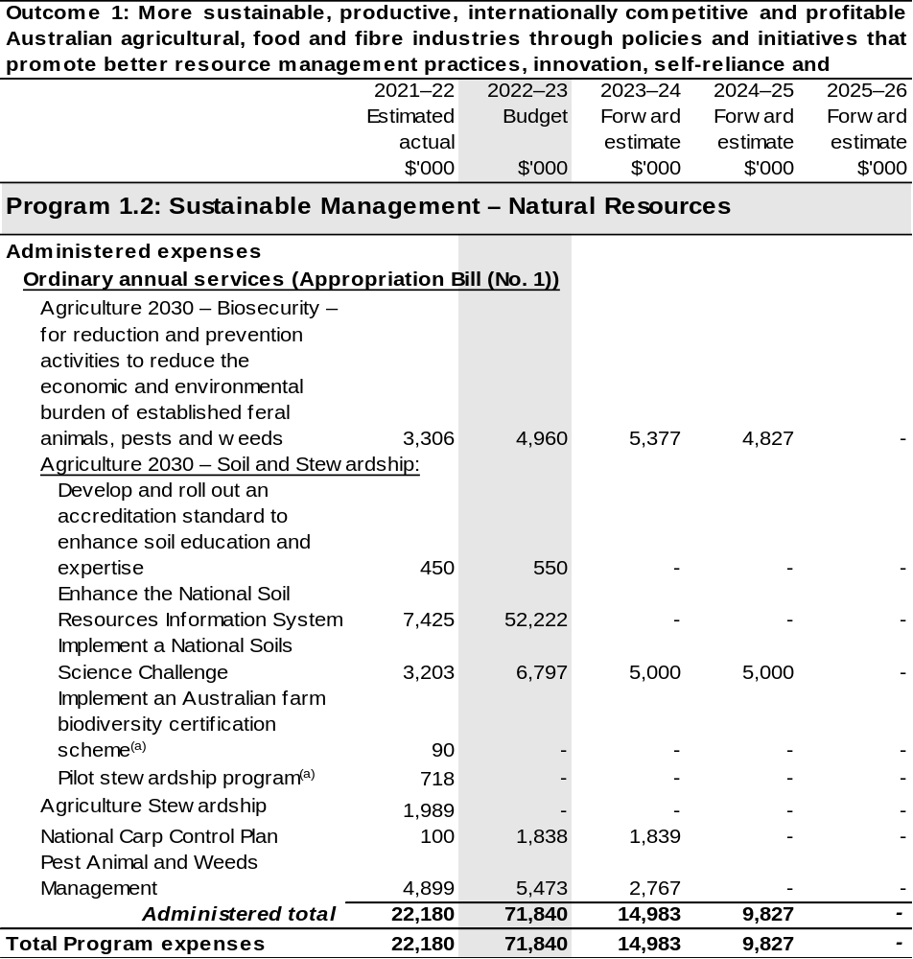

Continued on following pages
Table 2.1: Budgeted expenses for Outcome 1 (continued)
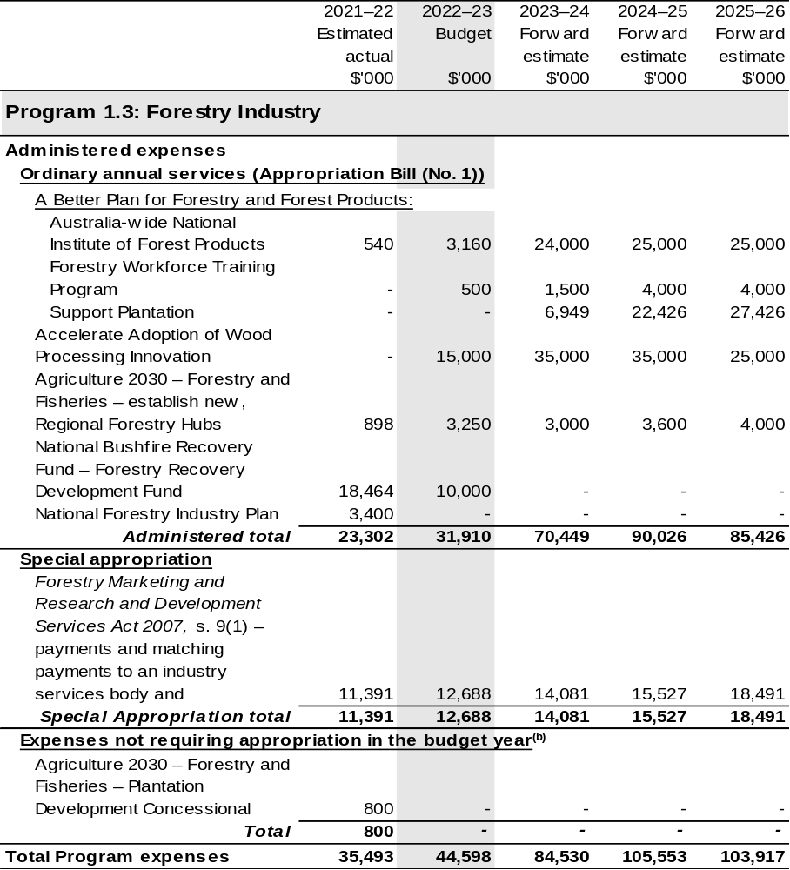

Continued on following pages
Table 2.1: Budgeted expenses for Outcome 1 (continued)
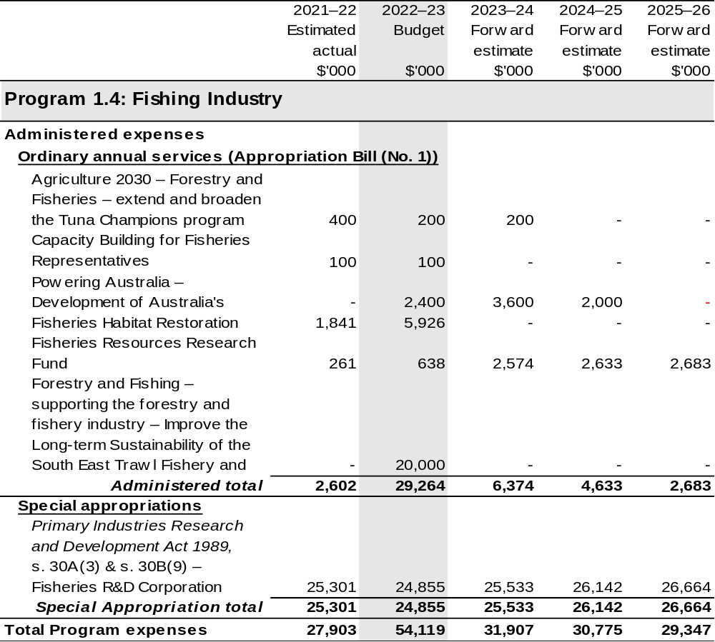

Continued on following pages
Table 2.1: Budgeted expenses for Outcome 1 (continued)
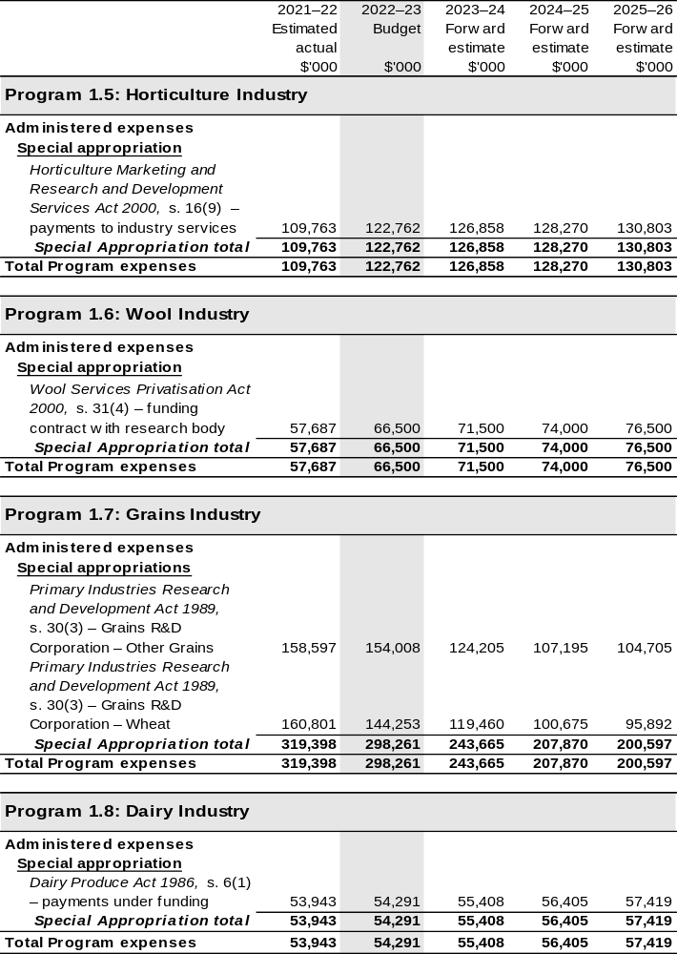

Continued on following pages
Table 2.1: Budgeted expenses for Outcome 1 (continued)
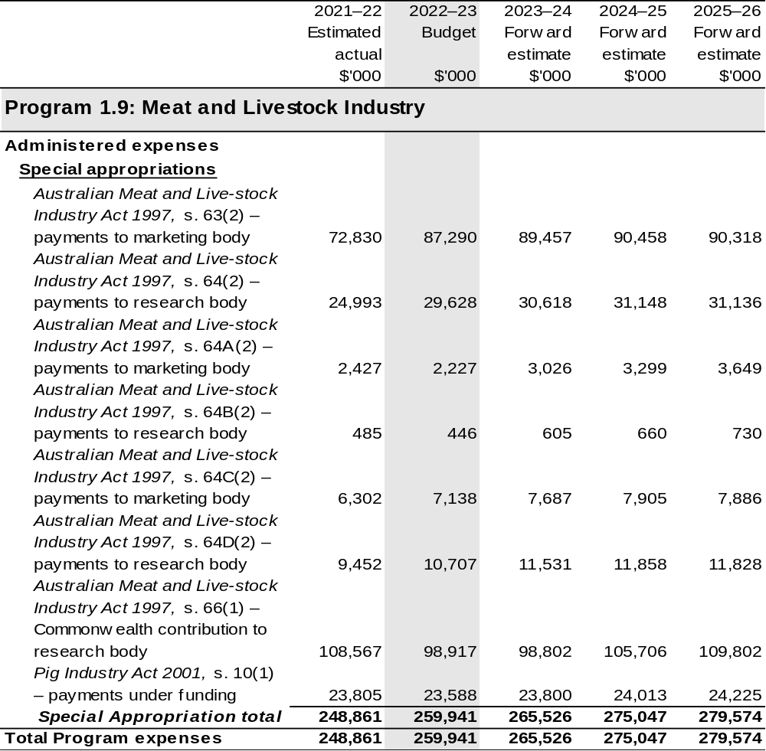

Continued on following pages

Table 2.1: Budgeted expenses for Outcome 1 (continued)
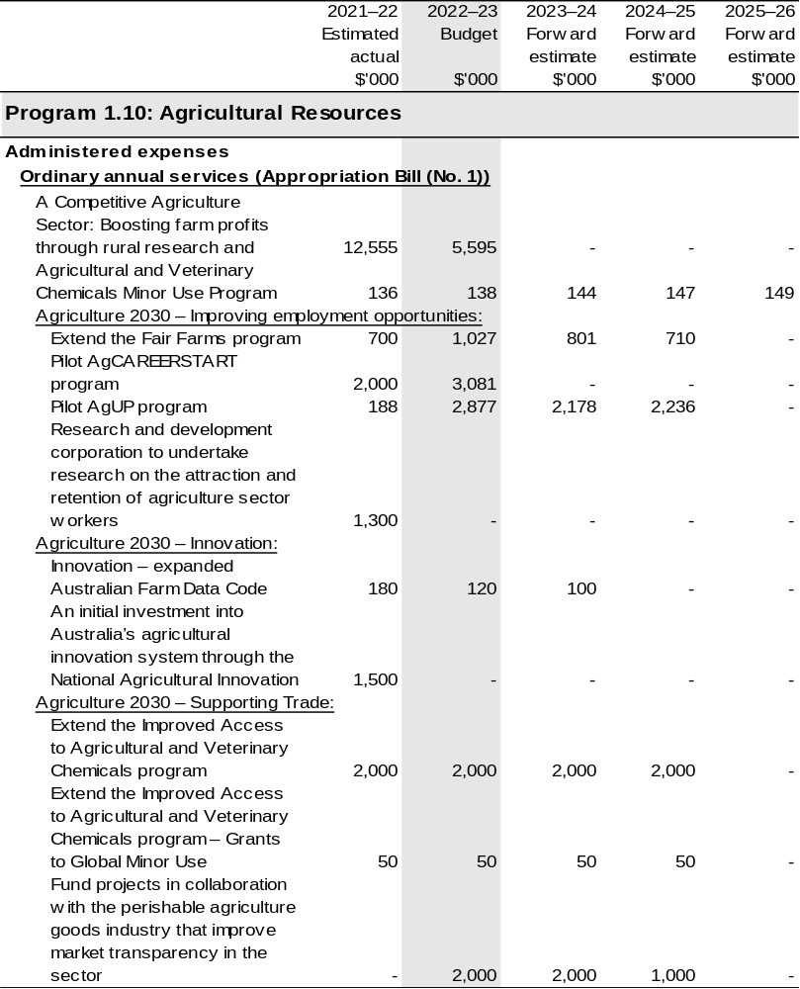

Continued on following pages

Table 2.1: Budgeted expenses for Outcome 1 (continued)
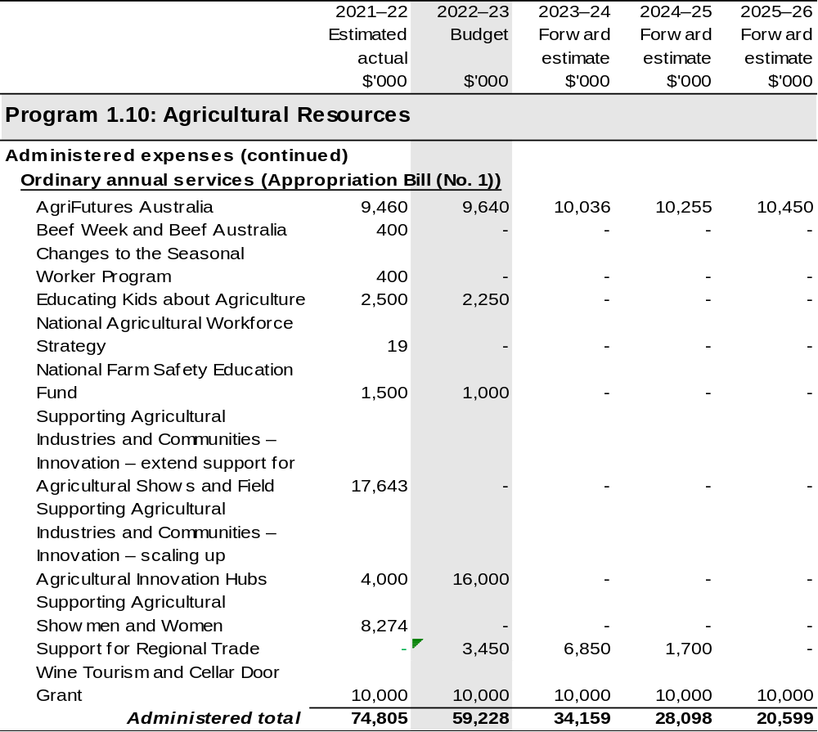

Continued on following pages

Table 2.1: Budgeted expenses for Outcome 1 (continued)
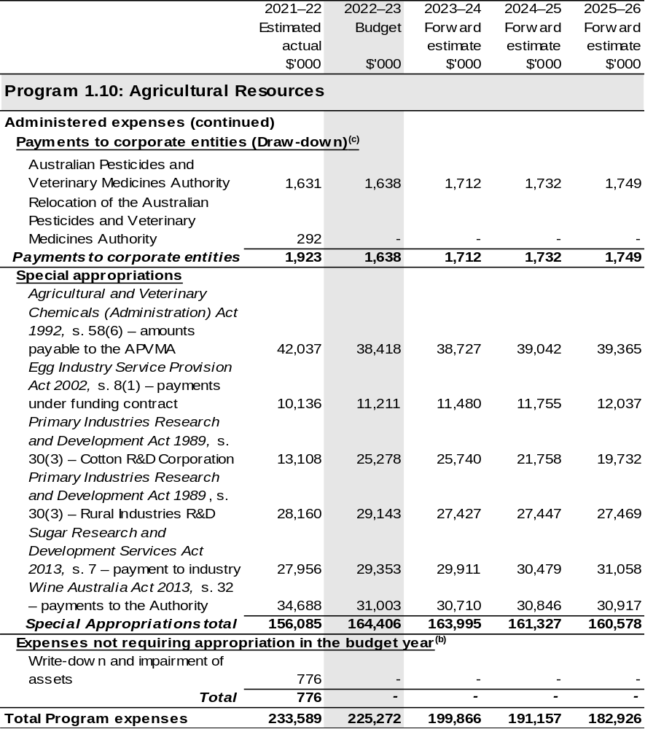

Continued on following pages

Table 2.1: Budgeted expenses for Outcome 1 (continued)
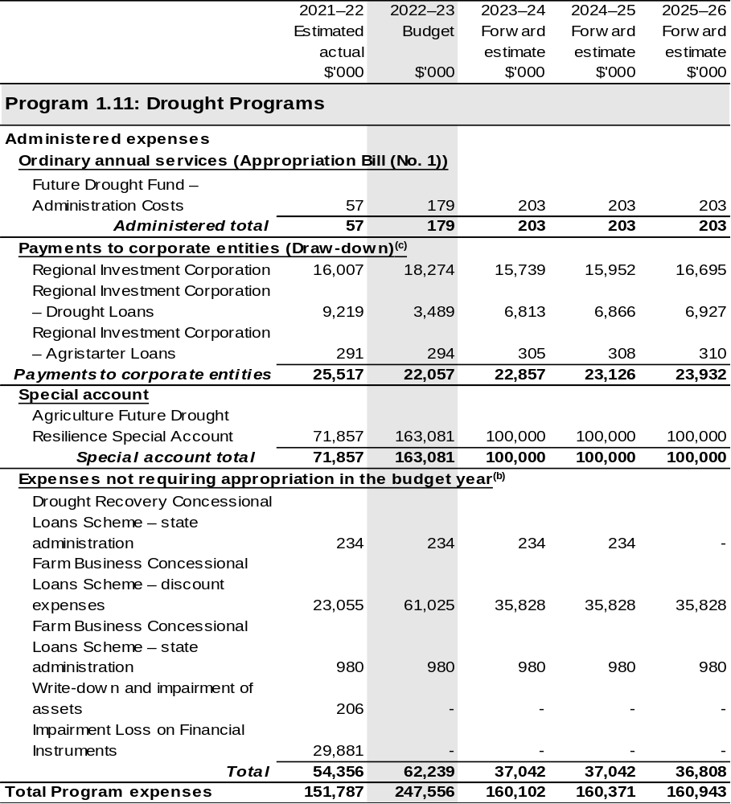

Continued on following pages
Table 2.1: Budgeted expenses for Outcome 1 (continued)
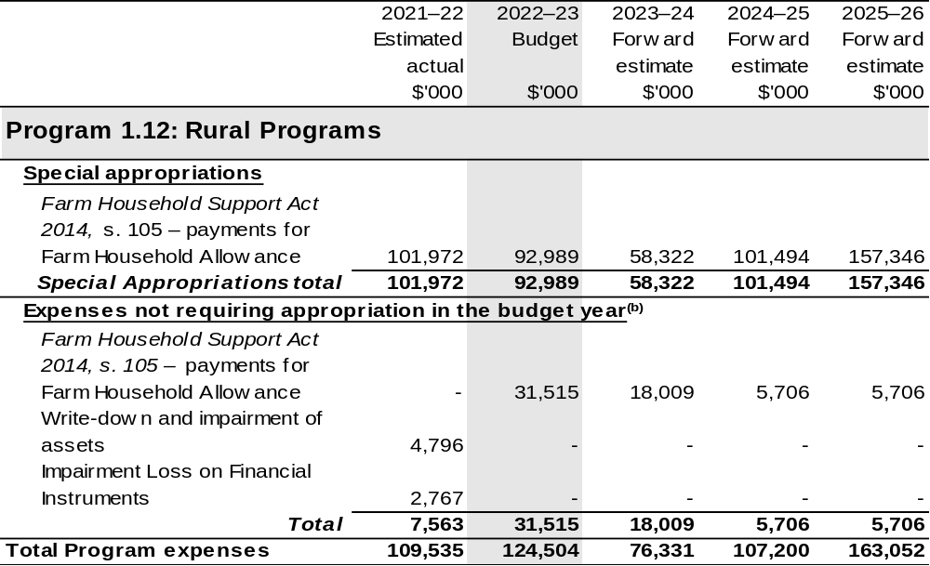

Continued on following pages

Table 2.1: Budgeted expenses for Outcome 1 (continued)
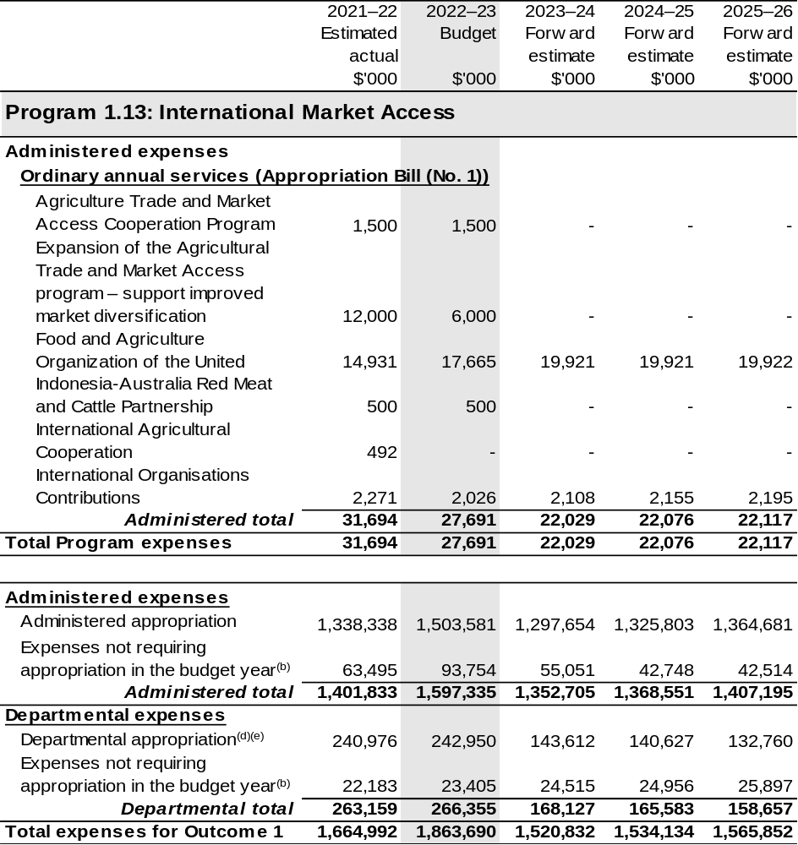

Continued on following pages

Table 2.1: Budgeted expenses for Outcome 1 (continued)
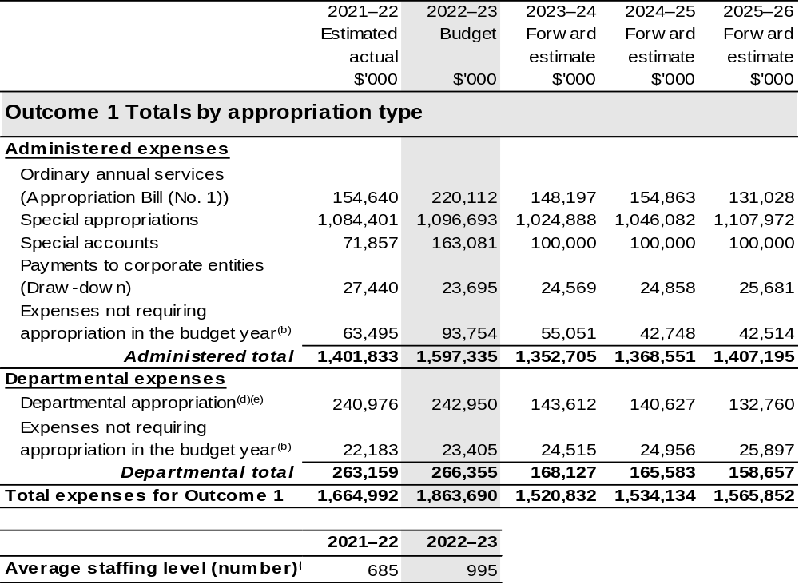

(a) The budget for 2022–23 and forward estimates for these programs has been transferred to DCCEEW.
(b) ‘Expenses not requiring appropriation in the budget year’ are made up of depreciation and amortisation expenses, resources received free of charge, concessional loan discount and balance sheet adjustments.
(c) APVMA and RIC are CCEs under the PGPA Act and do not receive direct appropriations. Instead, this funding passes through the department to these entities.
(d) Departmental appropriation allocations are notional and reflect the current structure of the department. Expenses are funded from both ‘ordinary annual services’ Appropriation Bill (No. 1) 2022–23,
Supply Bill (No. 3) 2022–23 and Supply Act (No. 1) 2022–23 and ‘revenue from independent sources’ (receipts retained under section 74 of the PGPA Act).
(e) The budgeted departmental appropriation and ASL for 2022–23 additionally reflects the part-year impact of costs attributable to former DAWE staff that were reported under Outcomes 1, 2 and 5, then transferred to DCCEEW on 29 September 2022, after the date of effect of the AAO on 1 July 2022.

Note: Departmental appropriation splits and totals are indicative estimates and may change in the course of the budget year as Government priorities change.

Continued on following page

Table 2.1: Budgeted expenses for Outcome 1 (continued)
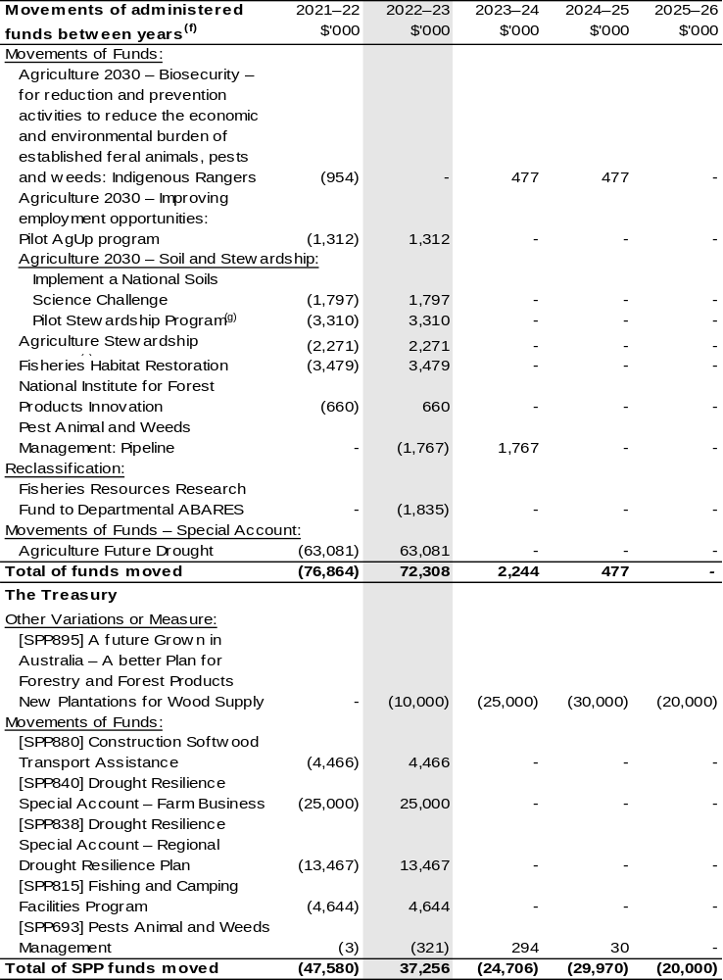

(f) Figures displayed as a negative (-) represent a decrease in funds and a positive (+) represent an increase in funds.
(g) These programs have been transferred to DCCEEW.

Table 2.2: Performance measure for Outcome 1
Table 2.2 details the key activities and programs associated with Outcome 1.
The PBS performance results for the prior year (2021–22) are detailed in the DAWE annual performance statements, which can be found in the DAWE Annual Report 2021–22.
DAFF is in the process of developing its 2022–23 Corporate Plan (due early 2023).
This will involve setting the purpose, key activities and performance measures for 2022–23 and beyond, to align with current government priorities and commitments. Performance measures for budget year 2022–23 and forward estimates will be set out in the DAFF 2022–23 Corporate Plan.
Outcome 1: More sustainable, productive, internationally competitive and profitable Australian agricultural, food and fibre industries through policies and initiatives that promote better resource management practices, innovation, self-reliance and improved access to international markets.
Program 1.1: Agricultural Adaptation
Program 1.2: Sustainable Management – Natural Resources
Program 1.3: Forestry Industry
Program 1.4: Fishing Industry
- Support food and fibre production by promoting the sustainable use and management of soils, water and vegetation.
Program 1.5: Horticulture Industry
Program 1.6: Wool Industry
Program 1.7: Grains Industry
Program 1.8: Dairy Industry
Program 1.9: Meat and Livestock Industry
Program 1.10: Agricultural Resources
Program 1.11: Drought Programs
Program 1.12: Rural Programs
- Improve farm gate returns for agriculture, fisheries, food and fibre industries.
- Provide targeted assistance to help primary producers, their families and communities manage adjustment pressures.
Program 1.13: International Market Access
Maximise returns to primary producers from selling into export markets.

Continued on following page
Table 2.2: Performance measure for Outcome 1 (continued)
Key Activities^{(a)} | - Regulate and support agricultural sector productivity and sustainability through policy and innovation.  - Maintain, expand and improve agricultural export markets.  - Streamline export regulations and compliance arrangements.  - Support Australian farmers.
Year | Performance measures | Expected Performance Results
Prior year  2021–22 | Performance measures from the  2021–22 DAWE PBS are listed in the DAWE Annual Report 2021–22. | As detailed in the DAWE Annual Report 2021–22.
Year | Performance measures | Planned Performance Results
Budget Year  2022–23 | Performance measures for budget year 2022–23 and forward estimates will be set out in the DAFF 2022–23 Corporate Plan. | Performance measures for budget year 2022–23 and forward estimates will be set out in the DAFF 2022–23 Corporate Plan.
Forward Estimates  2023–26 | As per 2022–23. | As per 2022–23.
Material changes to Programs 1.1 – 1.13 resulting from October 2022–23 Budget Measures: Nil

(a) Performance criteria from the DAWE 2021–22 Corporate Plan were renamed as key activities in the DAWE Annual Report 2021–22, to better align with PGPA Act requirements.

2.3 Budgeted expenses and performance measures for DAFF Outcome 2
Outcome 2: Safeguard Australia’s animal and plant health status to maintain overseas markets and protect the economy and environment from the impact of exotic pests and diseases, through risk assessment, inspection and certification, and the implementation of emergency response arrangements for Australian agricultural, food and fibre industries.

2.3.1: Linked programs
Australian Trade and Investment Commission
Program 1.1: Promotion of Australia’s export and other international economic interests
Contribution to Outcome 2 made by linked program:
DAFF and Austrade work together to achieve the best outcomes for Australian agricultural, fisheries and forestry exports.
Commonwealth Scientific and Industrial Research Organisation
Program 1: Scientific and Industrial Research and Infrastructure
Contribution to Outcome 2 made by linked program:
DAFF contributes to the operating costs of the CSIRO’s Australian Centre for Disease Preparedness (formerly the Australian Animal Health Laboratory) for animal disease diagnosis, prevention, and research.
Department of Health and Aged Care
Program 1.8: Health Protection, Emergency Response and Regulation
Contribution to Outcome 2 made by linked program:
DAFF provides the at-the-border services for the management of various human biosecurity risks on behalf of the Department of Health and Aged Care under the Biosecurity Act 2015 pursuant to a memorandum of understanding.

Continued on following pages

2.3.1: Linked programs (continued)
Department of Home Affairs
Program 3.4: Border Enforcement
Program 3.2: Border Management
Contribution to Outcome 2 made by linked programs:
DAFF and the Department of Home Affairs work collaboratively to undertake screening and surveillance for all people and goods entering Australia.
Department of Industry, Science and Resources
Program 1.1: Investing in Science, Technology and Commercialisation
Program 1.3: Supporting a Strong Resources Sector
Contribution to Outcome 2 made by linked programs:
DAFF works collaboratively with the Department of Industry, Science and Resources (DISR) through the National Measurement Institute. DAFF access analytical laboratory services and expertise to support the National Residue Survey and Imported Food Inspection Scheme.
Department of the Treasury
Program 1.9: National Partnership Payments to the States
Contribution to Outcome 2 made by linked program:
The Department of the Treasury contributes to Outcome 2 by making payments through the Federation Funding Agreement Framework on behalf of DAFF, for the following funding agreements:
- Bolstering Australia’s Biosecurity System – Protecting Australia from Escalating Exotic Animal Disease Risks (SPP900)
- Building Resilience to Manage Fruit Fly (SPP993)
- Ehrlichia Canis Pilot Program (SPP876)
- Horse Traceability (SPP875)
- National Plant Health Surveillance Program (SPP857)
- Pest and Disease Preparedness and Response Programs (SPP188)
- Reducing Regulatory Burden and Streamlining Audit Arrangements in the Dairy Sector (SPP859)
- Strengthen Australia’s Frontline Biosecurity Capability and Domestic Preparedness (SPP913)

Continued on following page

2.3.1: Linked programs (continued)
Food Standards Australia New Zealand
Program 1.1: Food Regulatory Activity and Services to the Minister and Parliament
Contribution to Outcome 2 made by linked program:
Food Standards Australia New Zealand provides advice on whether foods pose a medium to high risk to public health to help DAFF to manage the food safety risks associated with imported food for human consumption.
National Indigenous Australians Agency
Program 2.1: Indigenous Advancement – Jobs, Land and Economy
Contribution to Outcome 2 made by linked programs:
DAFF and NIAA partner with Aboriginal and Torres Strait Islander Ranger groups to deliver biosecurity work that protects Australian agriculture and the northern Australian environment.

2.3.2: Budgeted expenses for Outcome 2
This table shows how much the entity intends to spend (on an accrual basis) on achieving the outcome, broken down by program, as well as by administered and departmental funding sources.

Table 2.3: Budgeted expenses for Outcome 2
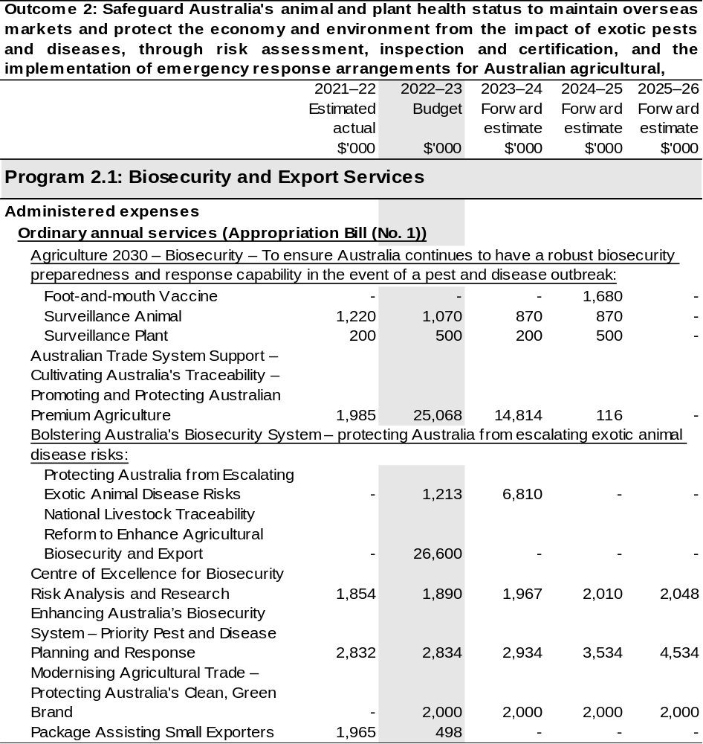
Continued on following pages

Table 2.3: Budgeted expenses for Outcome 2 (continued)
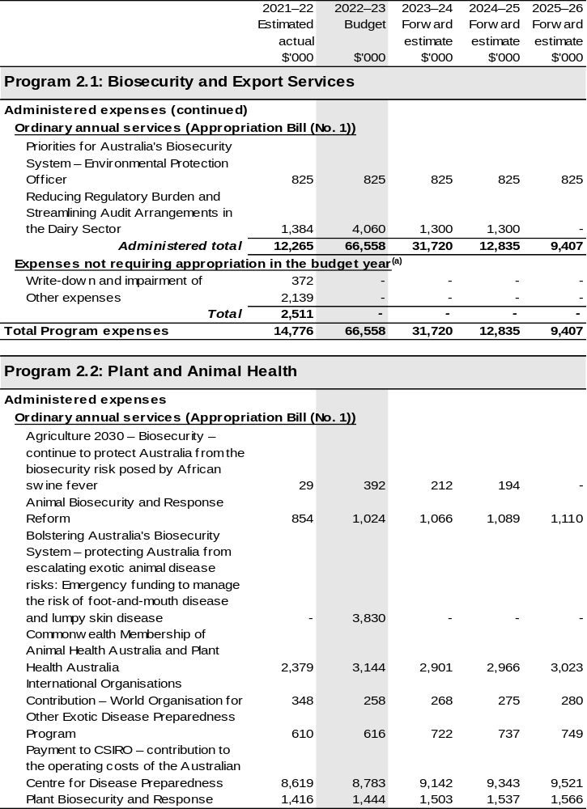
Continued on following pages
Table 2.3: Budgeted expenses for Outcome 2 (continued)
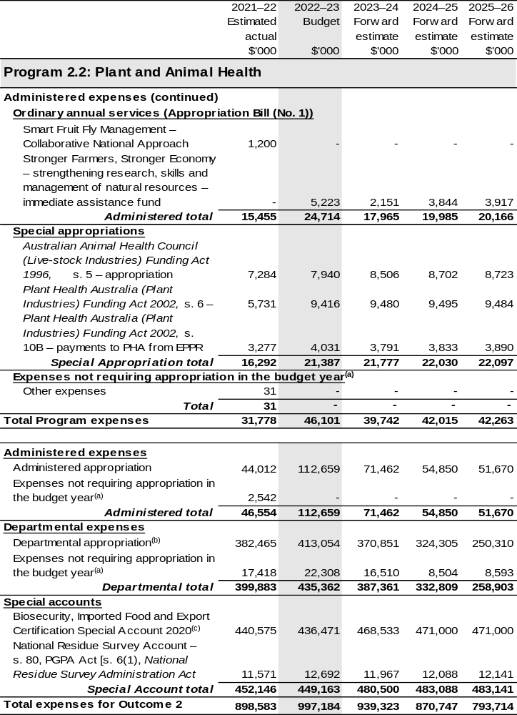
Continued on following pages
Table 2.3: Budgeted expenses for Outcome 2 (continued)
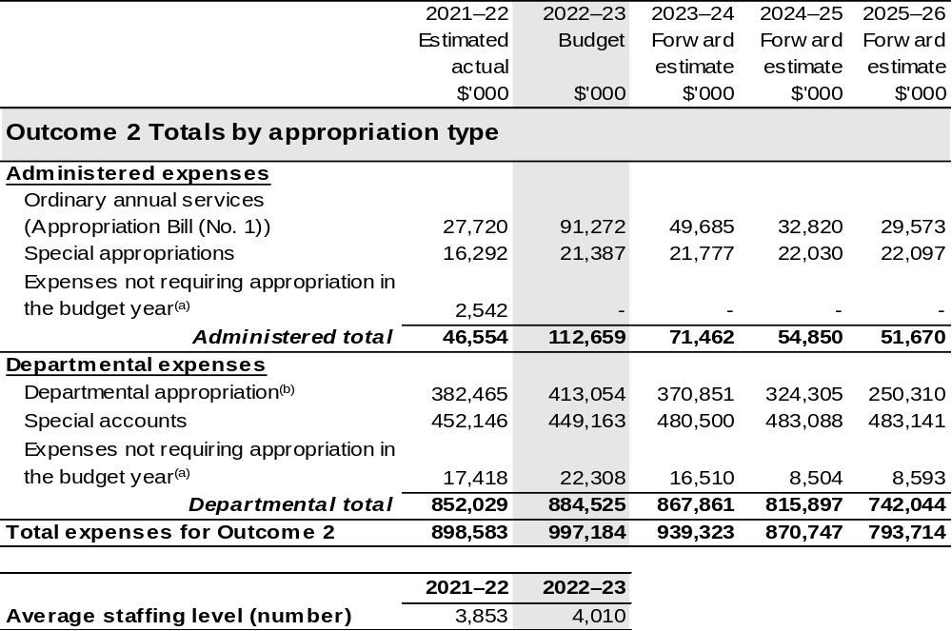
(a) ‘Expenses not requiring appropriation in the budget year’ are made up of depreciation and amortisation
expenses, resources received free of charge, balance sheet adjustments and an approved operating loss.
(b) Departmental appropriation allocations are notional and reflect the current structure of the department. Expenses are funded from both ‘ordinary annual services’ Appropriation Bill (No. 1) 2022–23,
Supply Bill (No. 3) 2022–23 and Supply Act (No. 1) 2022–23 and ‘revenue from independent sources’ (receipts retained under section 74 of the PGPA Act).
(c) The Biosecurity, Imported Food and Export Certification Special Account was formerly known as the Australian Quarantine and Inspection Service Special Account.

Note: Departmental appropriation splits and totals are indicative estimates and may change in the course of the budget year as Government priorities change.

Continued on following page

Table 2.3: Budgeted expenses for Outcome 2 (continued)
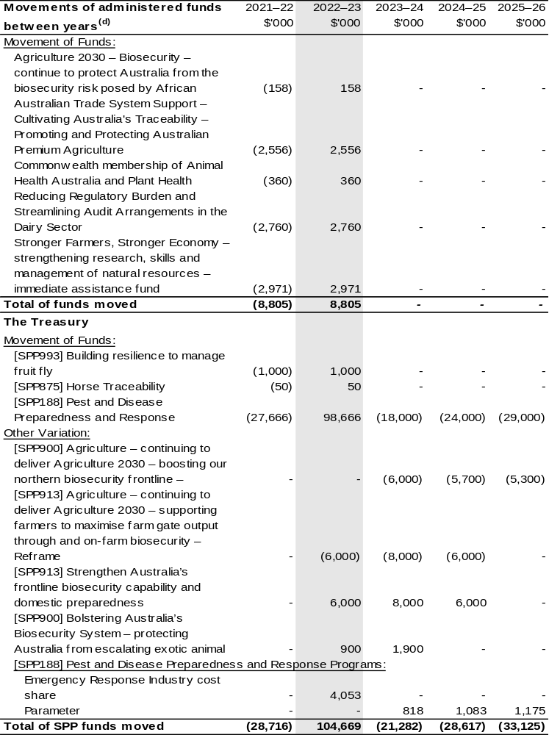
(d) Figures displayed as a negative (-) represent a decrease in funds and a positive (+) represent an increase in funds.

Table 2.4: Performance measure for Outcome 2
Table 2.4 details the key activities and programs associated with Outcome 2.
The PBS performance results for the prior year (2021–22) are detailed in the DAWE annual performance statements, which can be found in the DAWE Annual Report 2021–22.
DAFF is in the process of developing its 2022–23 Corporate Plan (due early 2023).
This will involve setting the purpose, key activities and performance measures for 2022–23 and beyond, to align with current government priorities and commitments. Performance measures for budget year 2022–23 and forward estimates will be set out in the DAFF 2022–23 Corporate Plan.
Outcome 2: Safeguard Australia’s animal and plant health status to maintain overseas markets and protect the economy and environment from the impact of exotic pests and diseases, through risk assessment, inspection and certification, and the implementation of emergency response arrangements for Australian agricultural, food and fibre industries.
Program 2.1: Biosecurity and Export Services
Program 2.2: Plant and Animal Health
- Use evidence-based risk management to ensure the safe movement into Australia of people, animals, plants, food and cargo.
- Coordinate emergency responses to pest and disease incursions.
Key Activities^{(a)} | - Reduce the likelihood of exotic pests and diseases entering and becoming established or spreading in Australia.  - Enhance awareness and understanding of biosecurity risks across business sectors and the Australian community.  - Regulate and collaborate to assure compliance with biosecurity requirements.  - Invest in partnerships, technology and innovation to advance the national biosecurity system.
Year | Performance measures | Expected Performance Results
Prior year 2021–22 | Performance measures from the 2021–22 DAWE PBS are listed in the DAWE Annual Report 2021–22. | As detailed in the DAWE Annual Report 2021–22.

Continued on following page
Table 2.4: Performance measure for Outcome 2 (continued)
Year | Performance measures | Planned Performance Results
Budget Year 2022–23 | Performance measures for budget year 2022–23 and forward estimates will be set out in the DAFF 2022–23 Corporate Plan. | Performance measures for budget year 2022–23 and forward estimates will be set out in the DAFF 2022–23 Corporate Plan.
Forward Estimates 2023–26 | As per 2022–23. | As per 2022–23.
Material changes to Programs 2.1 and 2.2 resulting from October 2022–23 Budget Measures: Nil

(a) Performance criteria from the DAWE 2021–22 Corporate Plan were renamed as key activities in the DAWE Annual Report 2021–22, to better align with PGPA Act requirements.

2.4 Budgeted expenses for DAWE Outcome 1
As a result of the AAO made on 23 June 2022 and commencing on 1 July 2022, the 2021–22 Estimated actuals are reported for DAWE.
DAWE Outcome 1: Conserve, protect and sustainably manage Australia’s biodiversity, ecosystems, environment and heritage through research, information management, supporting natural resource management, establishing and managing Commonwealth protected areas, and reducing and regulating the use of pollutants and hazardous substances, and coordination of climate change adaptation strategy and climate change science activities.

2.4.1: Linked programs
Please refer to the DCCEEW October 2022–23 PBS for changes to linked programs.

2.4.2: Budgeted expenses for DAWE Outcome 1
This table shows how much the entity intends to spend (on an accrual basis) on achieving the outcome, broken down by program, as well as by administered and departmental funding sources.
This table reflects the actuals for DAWE Outcome 1 for 2021–22. This outcome will be reported as Outcome 2 in DCCEEW, please refer to their October 2022–23 PBS for forward years estimates.

Table 2.5: Budgeted expenses for DAWE Outcome 1
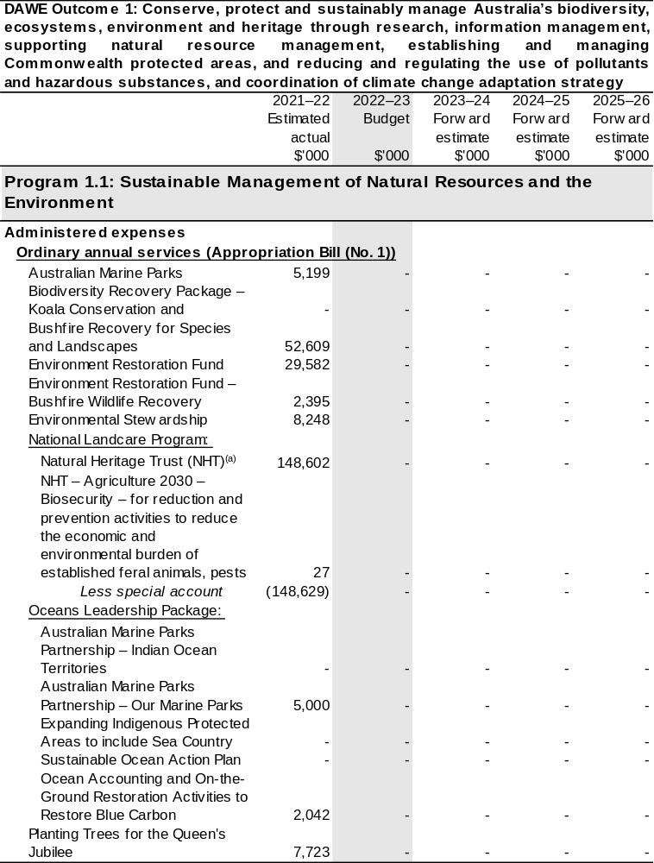
Continued on following pages
Table 2.5: Budgeted expenses for DAWE Outcome 1 (continued)
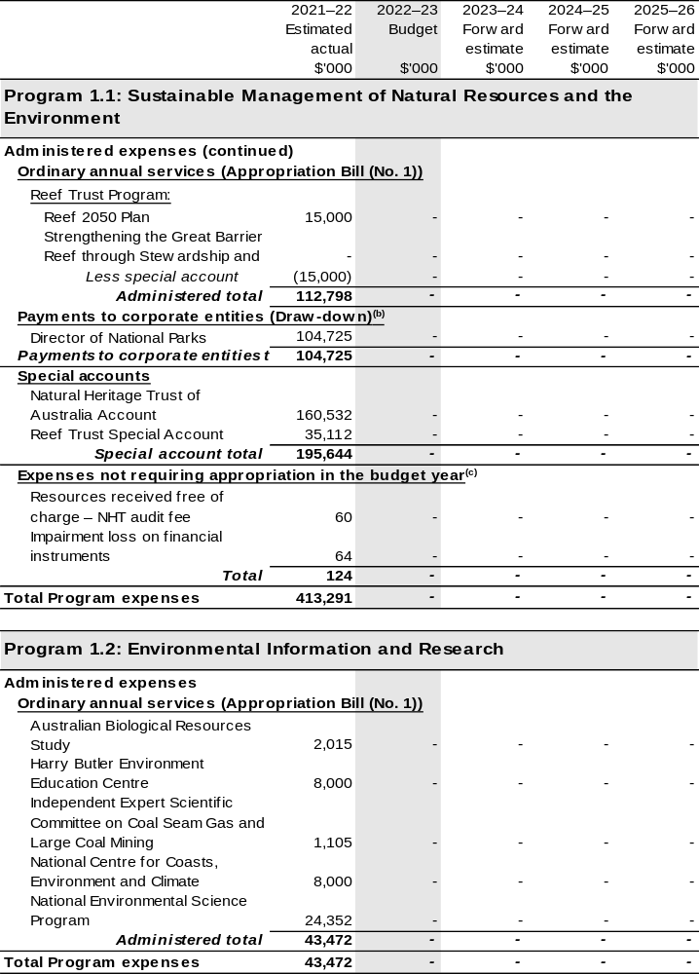

Continued on following pages
Table 2.5: Budgeted expenses for DAWE Outcome 1 (continued)
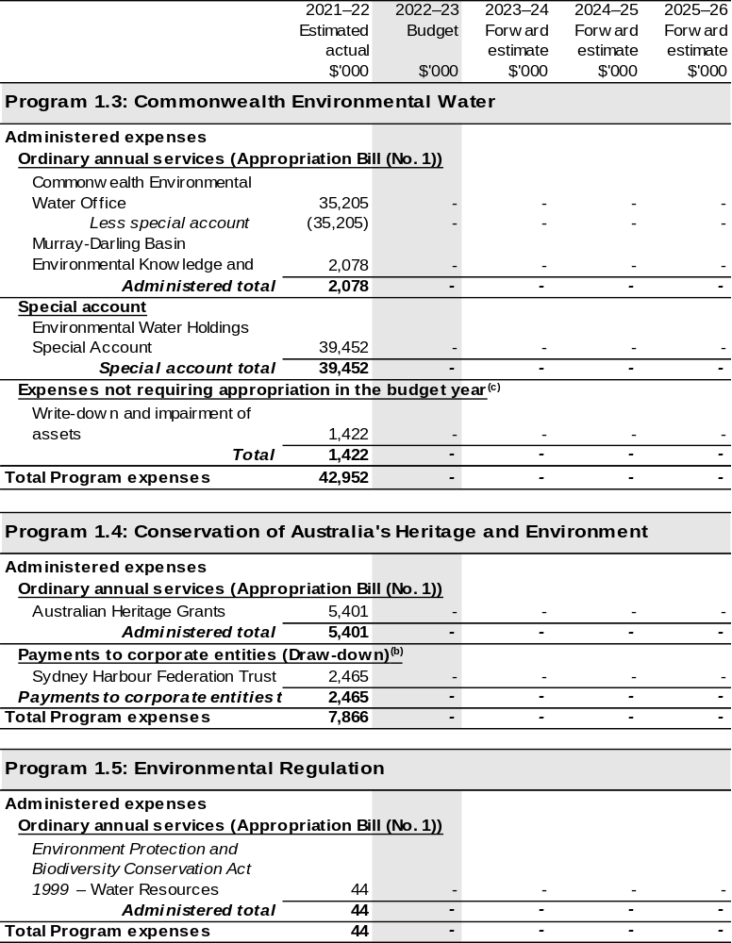

Continued on following pages
Table 2.5: Budgeted expenses for DAWE Outcome 1 (continued)
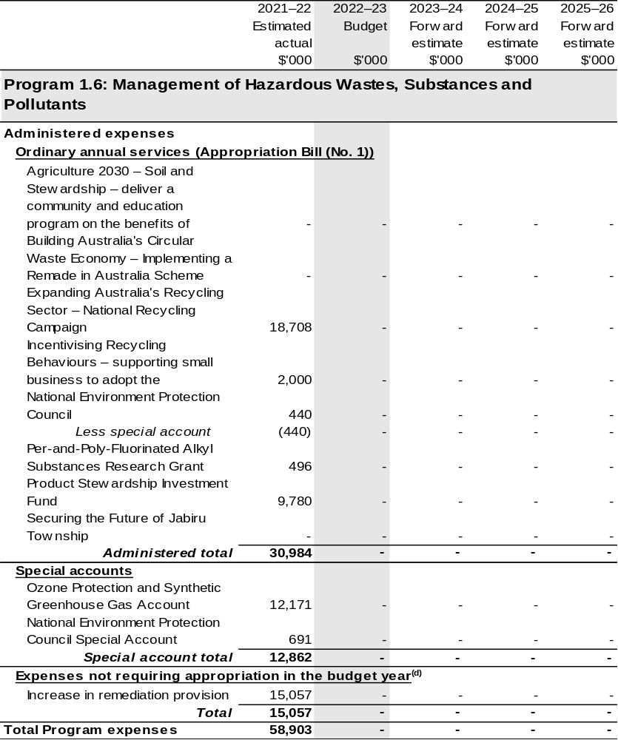

Continued on following page
Table 2.5 Budgeted expenses for DAWE Outcome 1 (continued)
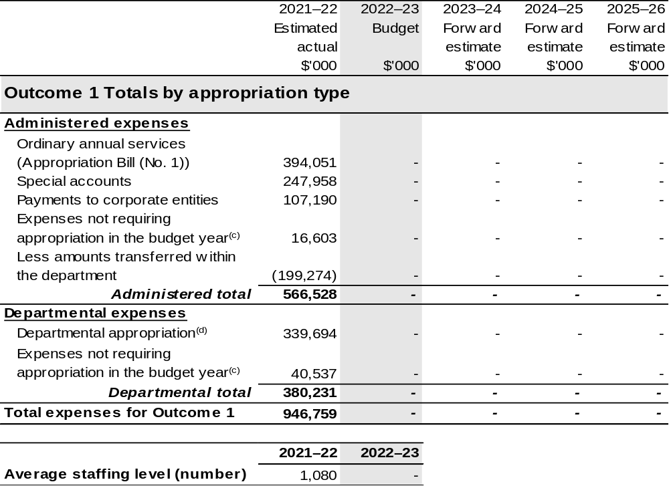

(a) Funding for components of the National Landcare Program are directly appropriated to the Department of the Treasury and the Department of the Prime Minister and Cabinet.
(b) The Director of National Parks and Sydney Harbour Federation Trust are CCEs under the PGPA Act and do not receive direct appropriations. Instead, their funding passes through the department and is drawn down on their behalf.
(c) ‘Expenses not requiring appropriation in the budget year’ are made up of depreciation and amortisation expenses, audit fees and an approved operating loss.
(d) Departmental appropriation allocations are notional and reflect the current structure of the department. Expenses are funded from both ‘Ordinary annual services (Appropriation Act (No. 1) and (No. 3)
2021–22)’ and ‘External Revenue’ under section 74 of the PGPA Act.

Note: Departmental appropriation splits and totals are indicative estimates and may change in the course of the budget year as Government priorities change.

Table 2.6: Performance measure for DAWE Outcome 1
DAWE Outcome 1, 2 and 5 2021–22 Expected Performance Results and 2022–23 budget year and forward estimates are found in the DCCEEW October 2022–23 PBS under the performance measures section within Outcome 2, 3 and 4.

2.5 Budgeted expenses for DAWE Outcome 2
As a result of the AAO made on 23 June 2022 and commencing on 1 July 2022, the 2021–22 Estimated actuals are reported for DAWE.
DAWE Outcome 2: Advance Australia’s strategic, scientific, environmental and economic interests in the Antarctic region by protecting, administering and researching the region.

2.5.1: Linked programs
Please refer to the DCCEEW October 2022–23 PBS for changes to linked programs.

2.5.2: Budgeted expenses for DAWE Outcome 2
This table shows how much the entity intends to spend (on an accrual basis) on achieving the outcome, broken down by program, as well as by administered and departmental funding sources.

This table reflects the actuals for DAWE Outcome 2 for 2021–22. This outcome will be reported as Outcome 3 in DCCEEW, please refer to their October 2022–23 PBS for forward years estimates.

Table 2.7: Budgeted expenses for DAWE Outcome 2
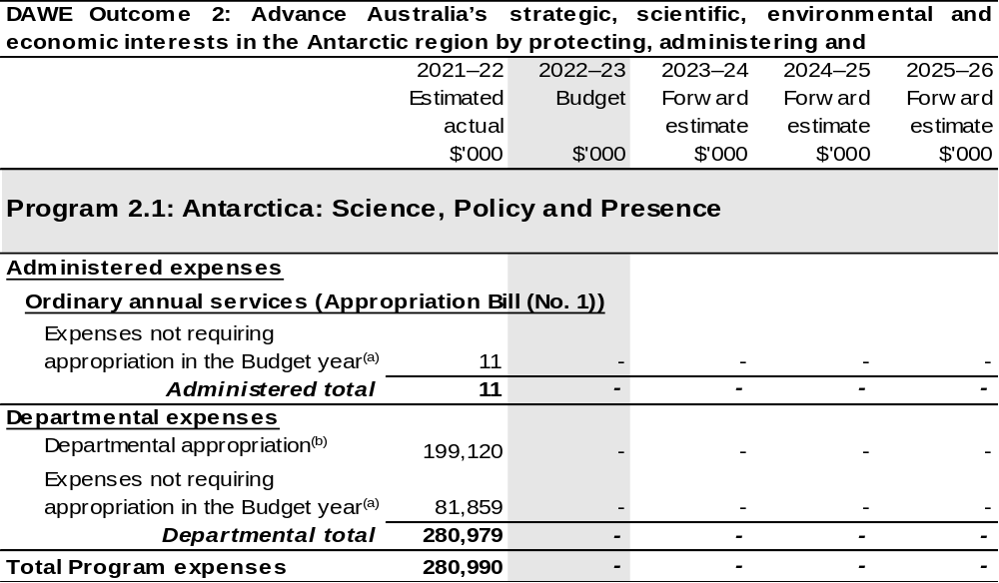

Continued on following page
Table 2.7: Budgeted expenses for DAWE Outcome 2 (continued)
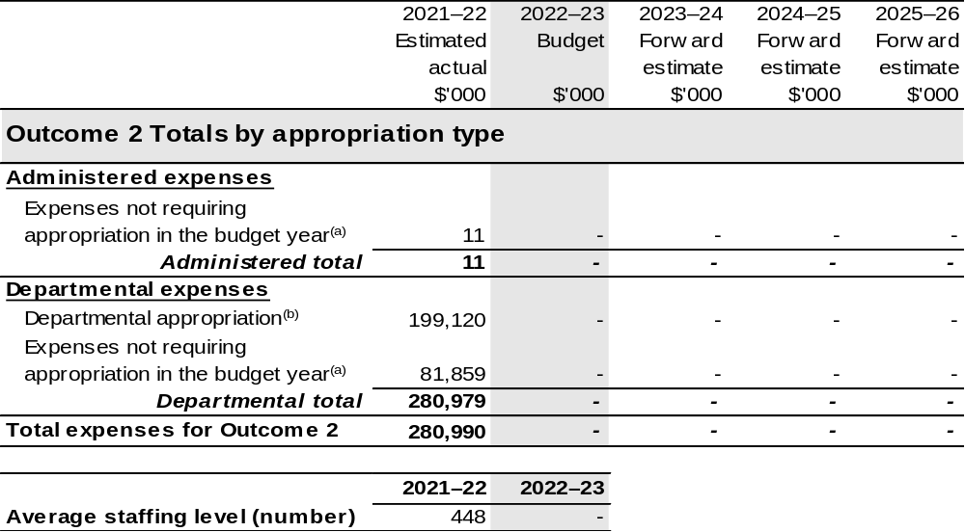

(a) ‘Expenses not requiring appropriation in the budget year’ are made up of depreciation and amortisation expenses, audit fees and an approved operating loss.
(b) Departmental appropriation allocations are notional and reflect the current structure of the department. Expenses are funded from both ‘Ordinary annual services (Appropriation Act (No. 1) and (No. 3)
2021–22)’ and ‘External Revenue’ under section 74 of the PGPA Act.

Note: Departmental appropriation splits and totals are indicative estimates and may change in the course of the budget year as Government priorities change.

Table 2.8: Performance measure for DAWE Outcome 2
DAWE Outcome 1, 2 and 5 2021–22 Expected Performance Results and 2022–23 budget year and forward estimates are found in the DCCEEW October 2022–23 PBS under the performance measures section within Outcome 2, 3 and 4.

2.6 Budgeted expenses for DAWE Outcome 5
As a result of the AAO made on 23 June 2022 and commencing on 1 July 2022, the 2021–22 Estimated actuals are reported for DAWE.
DAWE Outcome 5: Improve the health of rivers and freshwater ecosystems and water use efficiency through implementing water reforms, and ensuring enhanced sustainability, efficiency and productivity in the management and use of water resources.

2.6.1 Linked programs
Please refer to the DCCEEW October 2022–23 PBS for changes to linked programs.

2.6.2: Budgeted expenses for DAWE Outcome 5
This table shows how much the entity intends to spend (on an accrual basis) on achieving the outcome, broken down by program, as well as by administered and departmental funding sources.
This table reflects the actuals for DAWE Outcome 5 for 2021–22. This outcome will be reported as Outcome 4 in DCCEEW, please refer to their October 2022–23 PBS for forward years estimates.

Table 2.9: Budgeted expenses for DAWE Outcome 5
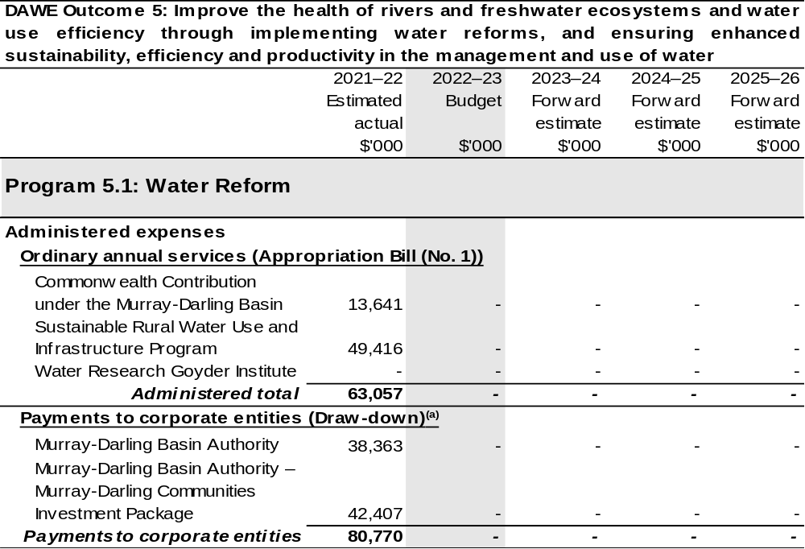
Continued on following pages
Table 2.9: Budgeted expenses for DAWE Outcome 5 (continued)
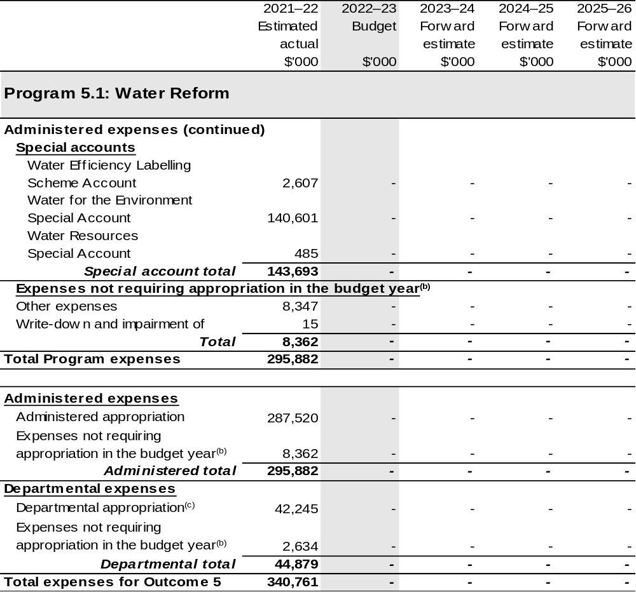
Continued on following page

Table 2.9: Budgeted expenses for DAWE Outcome 5 (continued)
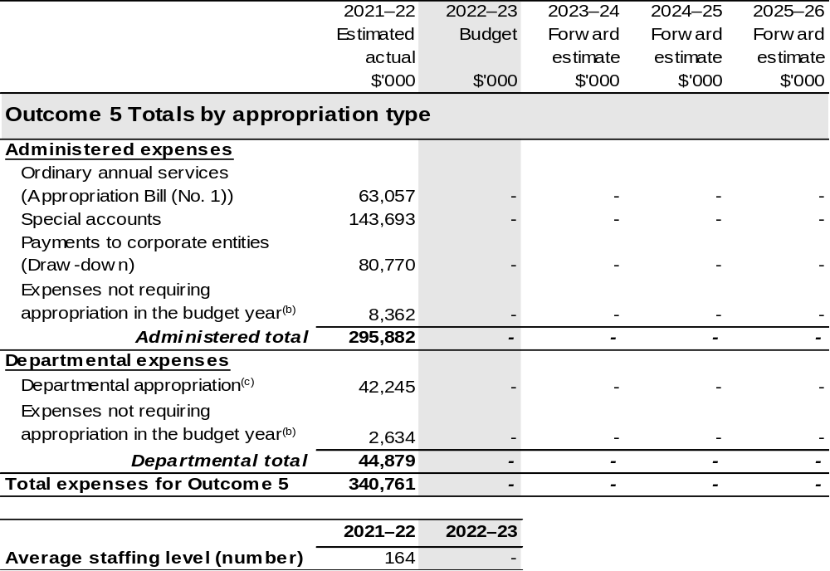
(a) The MDBA is a CCE under the PGPA Act and does not receive direct appropriations. Instead, this funding passes through the department to the MDBA.
(b) ‘Expenses not requiring appropriation in the budget year’ are made up of depreciation and amortisation
expenses, resources received free of charge and balance sheet adjustments.
(c) Departmental appropriation allocations are notional and reflect the current structure of the department. Expenses are funded from both ‘Ordinary annual services (Appropriation Act (No. 1) and (No. 3)
2021–22)’ and ‘External Revenue’ under section 74 of the PGPA Act.
Note: Departmental appropriation splits and totals are indicative estimates and may change in the course of the budget year as Government priorities change.

Table 2.10: Performance measure for DAWE Outcome 5
DAWE Outcome 1, 2 and 5 2021–22 Expected Performance Results and 2022–23 budget year and forward estimates are found in the DCCEEW October 2022–23 PBS under the performance measures section within Outcome 2, 3 and 4.

Section 3: Budgeted financial statements
Section 3 presents budgeted financial statements which provide a comprehensive snapshot of entity finances for the 2022–23 budget year, including the impact of budget measures and resourcing on financial statements.

3.1 Budgeted financial statements

3.1.1: Differences between entity resourcing and financial statements
An analysis of the primary causes of movements in the budgeted departmental financial statements and administered schedules is provided in the relevant sections. The March 2022–23 PBS is used as comparative figures in the analysis.

3.1.2: Budgeted comprehensive departmental income statement
The changes in departmental expense, income and revenue estimates are primarily attributable to the:
- Transfer of responsibility of functions between entities as a result of the Administrative Arrangements Order (AAO) changes, as outlined in Table 1.1 (implementation of the AAO changes in this context is referred to as a Machinery of Government [MoG] change)
- New measures as outlined in Table 1.2
- Estimate variations.

Since the March 2022–23 PBS, estimated revenue from Government in 2022–23 has decreased by $520.1 million. The decrease is due to MoG changes, which is partly offset by October 2022–23 Budget measures listed in Table 1.2.
The own source revenue estimate in 2022–23 has decreased by $30.8 million since the March 2022–23 PBS, driven by MoG changes and lower than anticipated external revenue receipts.
The expense estimate in 2022–23 has decreased by $638.8 million and is due to MoG changes and partly offset by decreased employee expenses.
The department is budgeting for a $14.0 million net operating loss in 2022–23.
The budgeted operating loss has decreased because the loss attributable to the Antarctica function has moved to DCCEEW arising from the AAO.

3.1.3: Budgeted departmental balance sheet
The budgeted departmental balance sheet has been updated for the impact of 2021–22 actuals which changes the opening balances for 2022–23 and includes the impact of transfer of functions between DAFF and DCCEEW arising from the AAO.
The value of departmental net assets as at 30 June 2023 is anticipated to be $613.6 million lower than the estimate published in the March 2022–23 PBS.
The reduced estimate is mainly as a result of the MoG changes.

3.1.4: Schedule of budgeted income and expenses administered on behalf of the Government
The revised schedule reflects the impact to administered expenses due to changes in entity responsibilities arising from the AAO.
It is estimated that the department will receive non-appropriation revenue on behalf of Government of $836.6 million in 2022–23, an increase of $20.1 million since the March 2022–23 Budget. The increase is largely due to higher levy revenue estimates and offset by other non-taxation revenue.
Administered expenses are estimated to be $1,710.0 million in 2022–23, a decrease of $1,692.3 million since the March 2022–23 Budget. The decrease largely relates to MoG changes and is partly offset by October 2022–23 Budget measures detailed in Table 1.2, movements of funds and reclassifications of funds detailed in Table 2.1 Budgeted expenses for each Outcome.

3.1.5: Schedule of budgeted assets and liabilities administered on behalf of the Government
The value of administered net assets as at 30 June 2023 is anticipated to be $6,704.8 million lower than the estimate published in the March 2022–23 PBS.
The decrease in net assets primarily consists of transferring $4,023.9 million in water assets, $959.8 million of investments in portfolio agencies, $908.6 million in special account balances and $537.0 million in other non-financial assets to DCCEEW as entity responsibilities have changed as a result of the AAO.

3.2 Budgeted financial statements tables

Table 3.1 Comprehensive income statement (showing net cost of services)
for the period ended 30 June
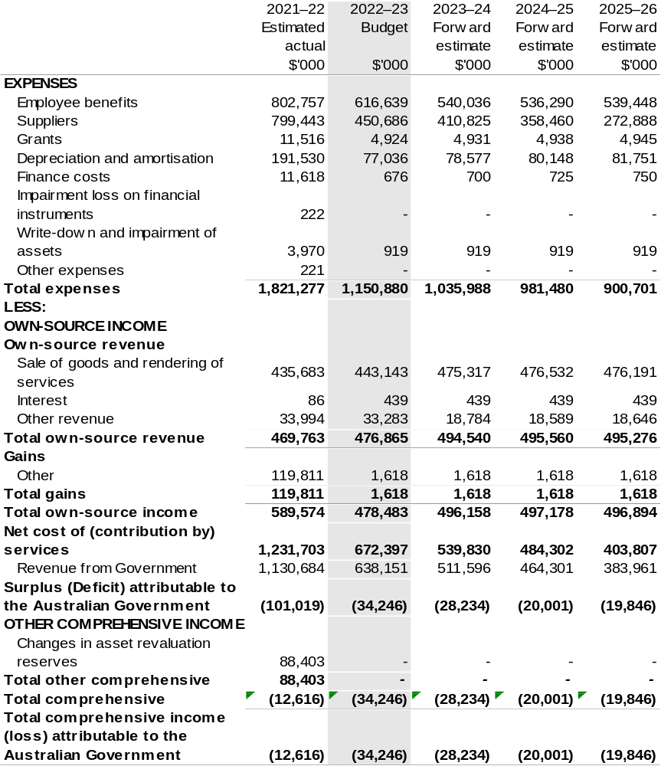

Continued on following page

Table 3.1 Comprehensive income statement (showing net cost of services) for the period ended 30 June (continued)
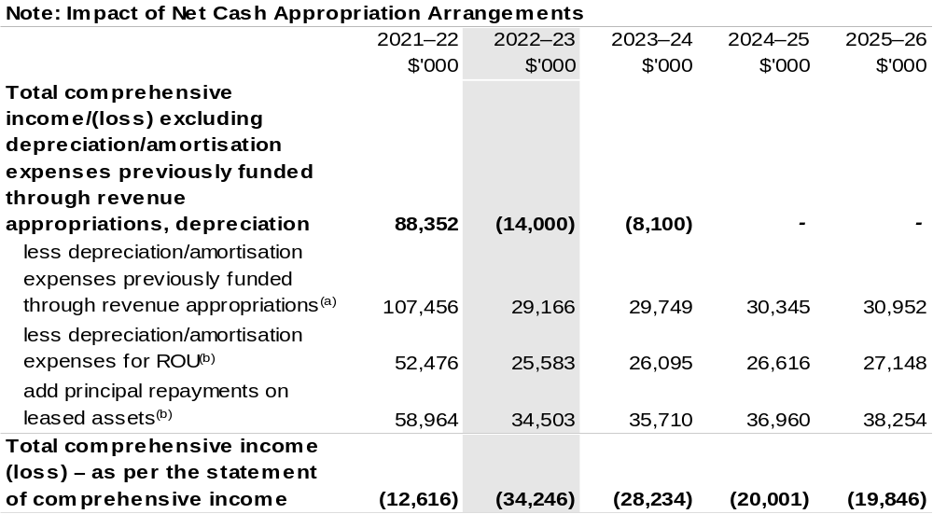
(a) From 2010–11, the Government introduced net cash appropriation arrangements where Appropriation Bill (No. 1) revenue appropriations for the depreciation/amortisation expenses of non-corporate Commonwealth entities (and select corporate Commonwealth entities) were replaced with a separate capital budget (the Departmental Capital Budget, or DCB) provided through Appropriation Bill (No. 1) equity appropriations. For information regarding DCBs, please refer to Table 3.5 Departmental Capital Budget Statement.
(b) Applies to leases under AASB 16 Leases. Right of Use (ROU).

Prepared on Australian Accounting Standards basis.

Table 3.2: Budgeted departmental balance sheet (as at 30 June)
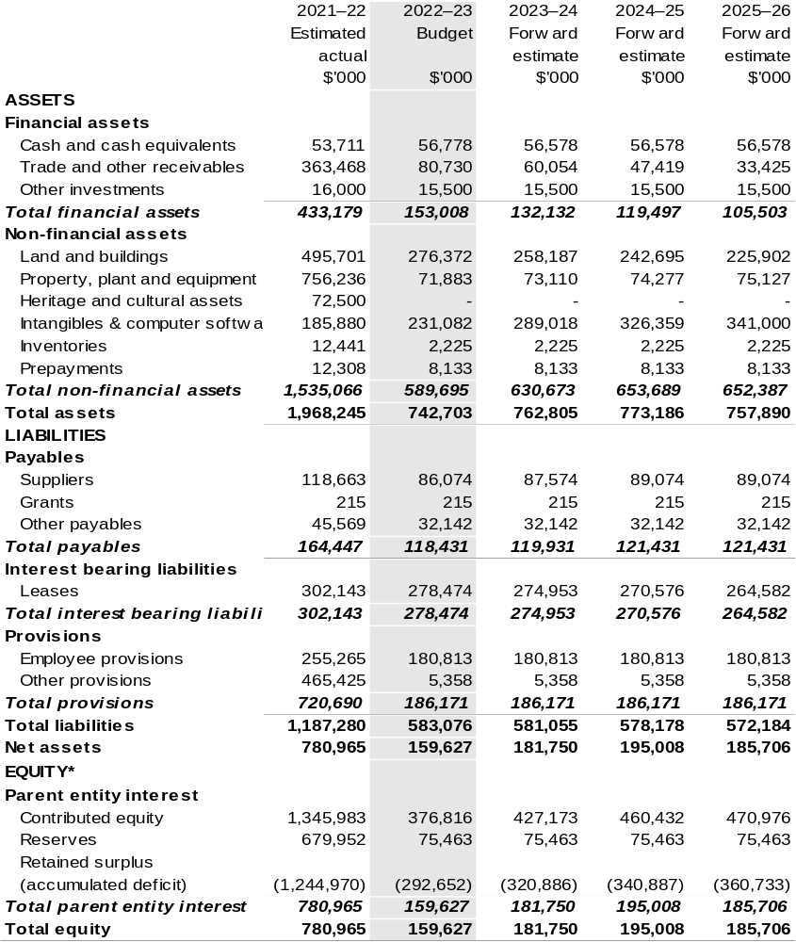
*‘Equity’ is the residual interest in assets after deduction of liabilities.

Prepared on Australian Accounting Standards basis.

Table 3.3: Departmental statement of changes in equity – summary of movement (Budget year 2022–23)
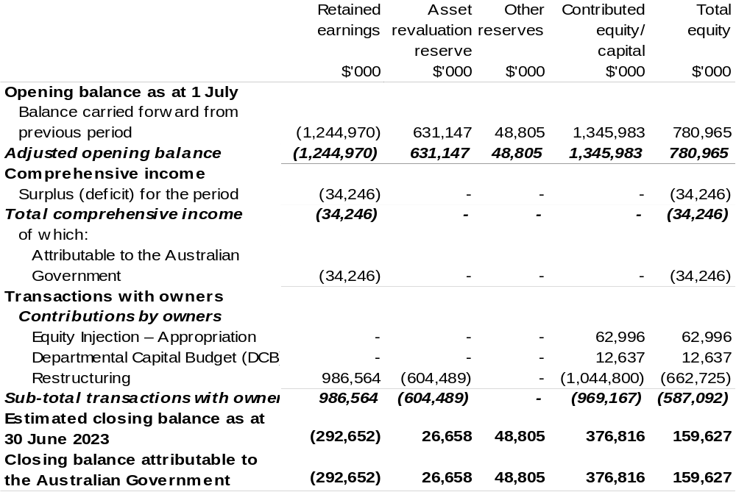
Prepared on Australian Accounting Standards basis.

Table 3.4: Budgeted departmental statement of cash flows (for the period ended 30 June)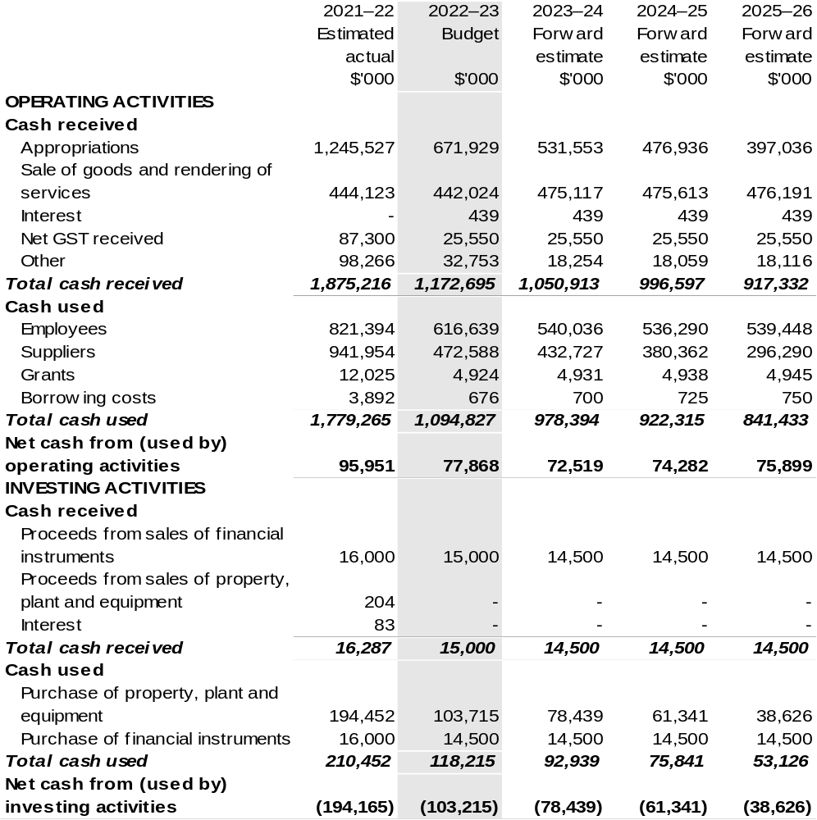
Continued on following page

Table 3.4: Budgeted departmental statement of cash flows (for the period ended 30 June) (continued)
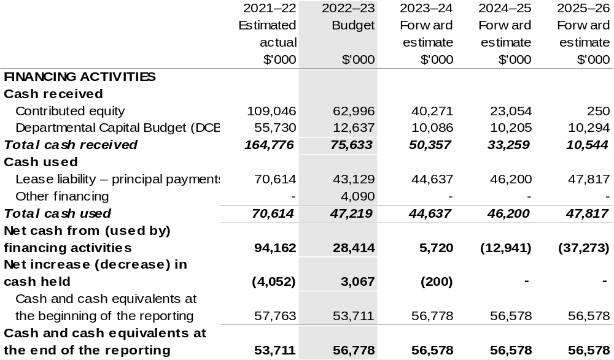
Prepared on Australian Accounting Standards basis.

Table 3.5: Departmental capital budget statement (for the period ended 30 June)
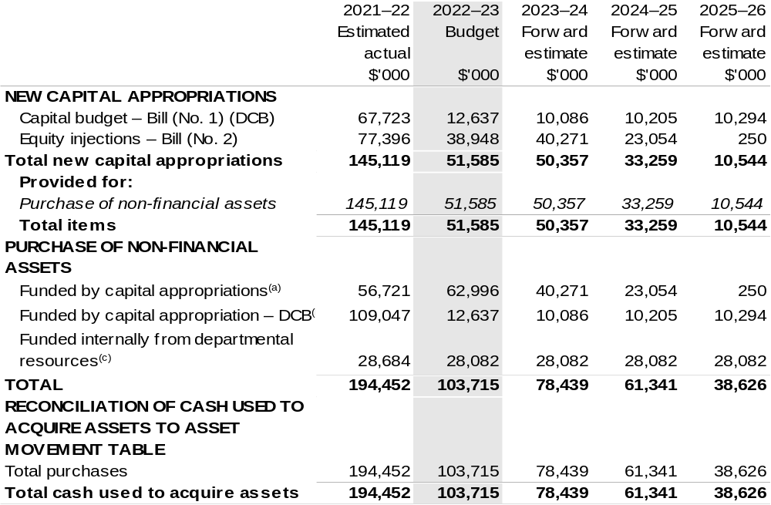
- Includes both current Bill (No. 2) and prior Act (No. 2/4/6) appropriations and special capital appropriations.
(b) Does not include annual finance lease costs. Includes purchases from current and previous years’ Departmental Capital Budgets (DCBs).
(c) Includes the following sources of funding:
- current Bill (No. 1) and prior year Act (No. 1/3/5) appropriations (excluding amounts from the DCB);
- internally developed assets;
- section 74 external revenue; and
- proceeds from the sale of assets.

Prepared on Australian Accounting Standards basis.

Table 3.6: Statement of departmental asset movements (Budget year 2022–23)
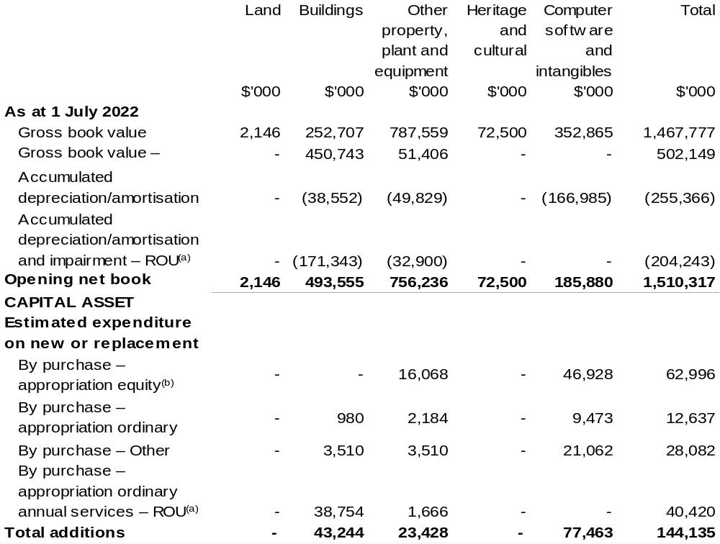

Continued on following page

Table 3.6: Statement of departmental asset movements (Budget year 2022–23) (continued)
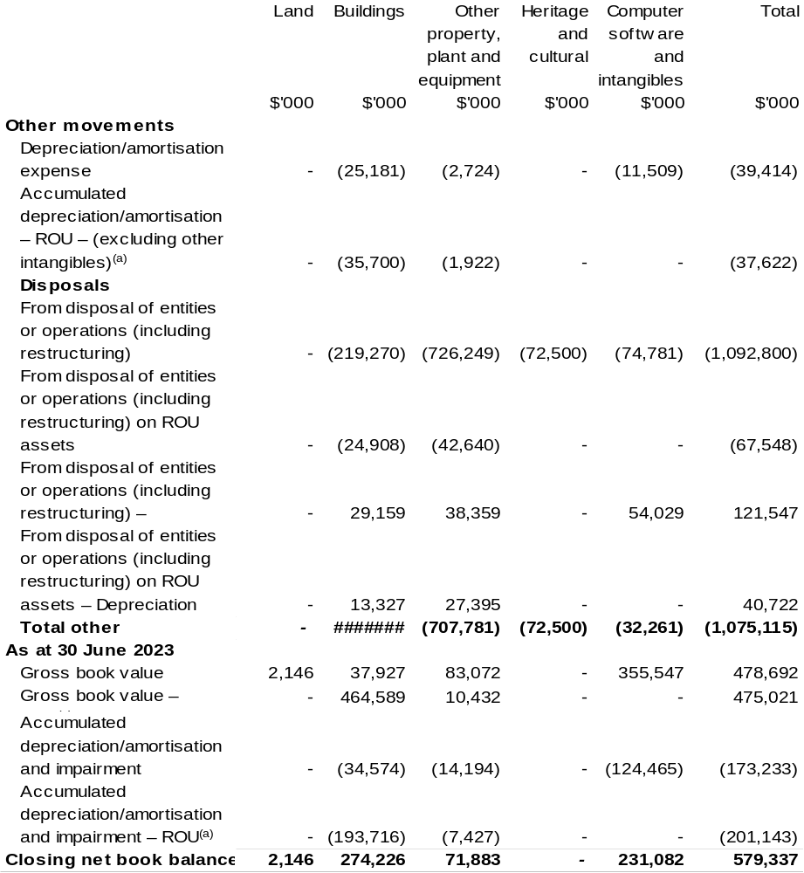

(a) Applies to leases under AASB 16 Leases. Right of Use (ROU).
(b) ‘Appropriation equity’ refers to equity injections, appropriations provided through Appropriation
Bill (No. 2) 2021–22.
(c) ‘Appropriation ordinary annual services’ refers to funding provided through Appropriation Bill (No. 1) 2021–22 for depreciation / amortisation expenses, DCBs or other operational expenses.

Prepared on Australian Accounting Standards basis.

Table 3.7: Schedule of budgeted income and expenses administered on behalf of Government (for the period ended 30 June)
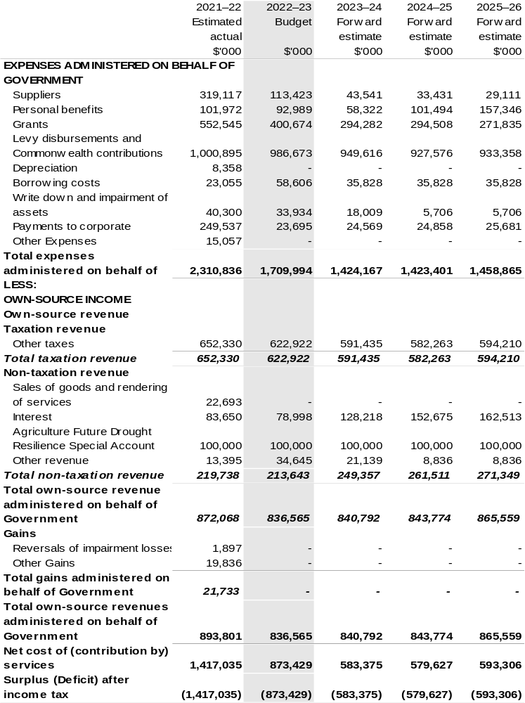
Continued on following page
Table 3.7: Schedule of budgeted income and expenses administered on behalf of Government (for the period ended 30 June) (continued)
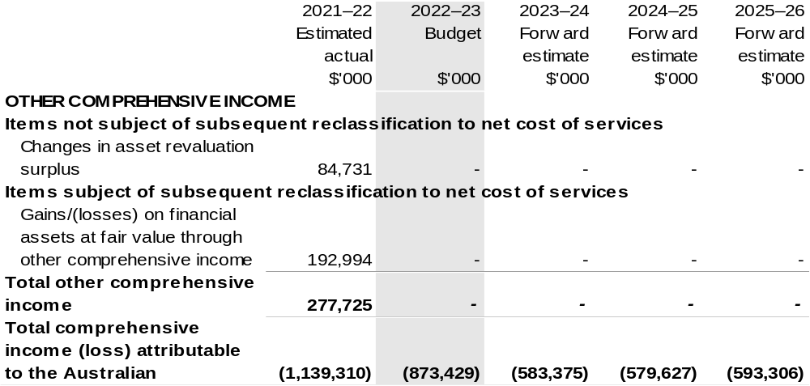
Prepared on Australian Accounting Standards basis.

Table 3.8: Schedule of budgeted assets and liabilities administered on behalf of Government (as at 30 June)
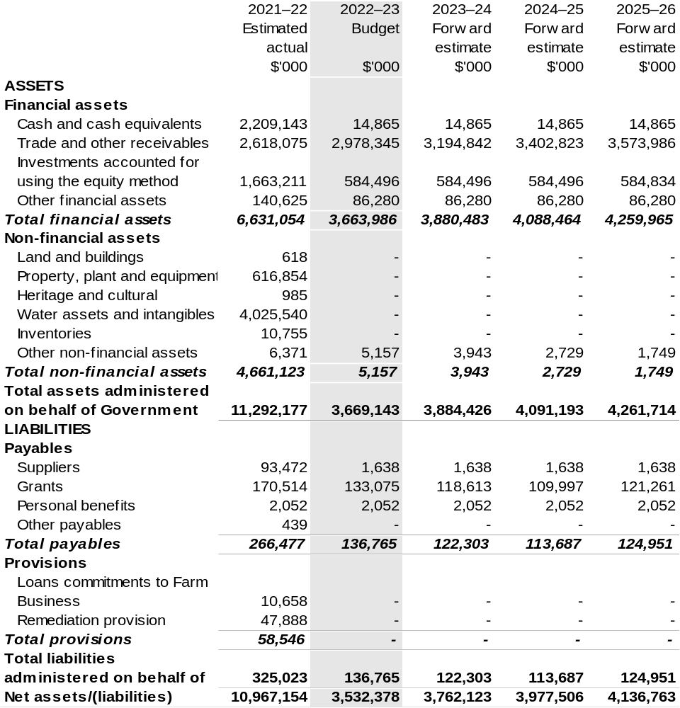

Prepared on Australian Accounting Standards basis.

Table 3.9: Schedule of budgeted administered cash flows (for the period ended 30 June)
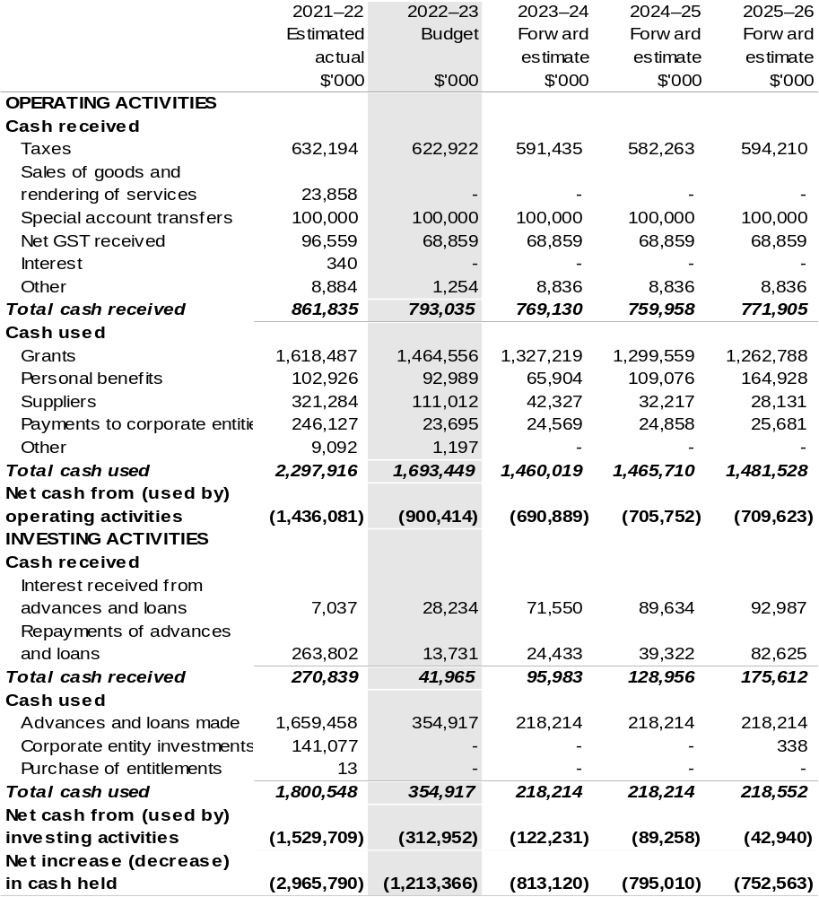
Continued on following page

Table 3.9: Schedule of budgeted administered cash flows (for the period ended 30 June) (continued)
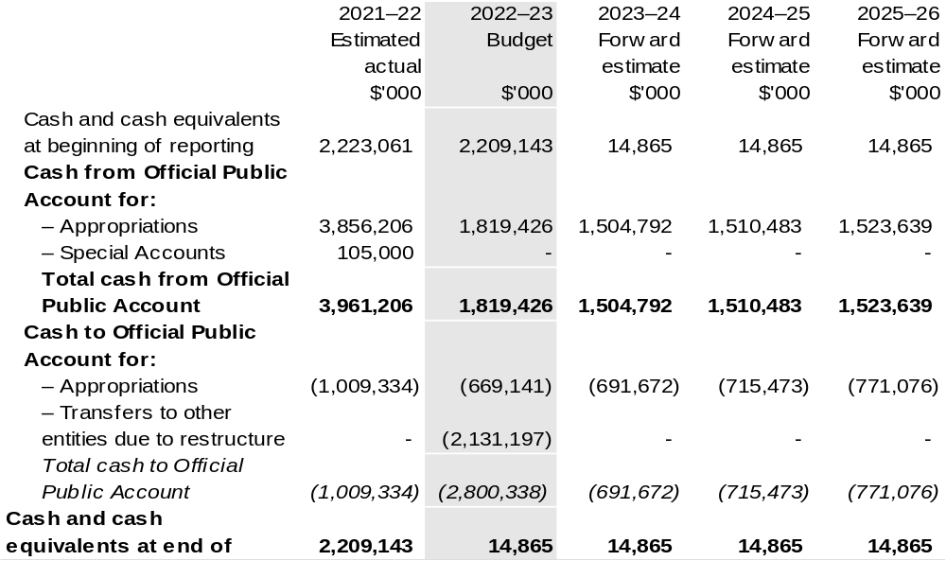
Prepared on Australian Accounting Standards basis.

Table 3.10: Administered capital budget statement (for the period ended 30 June)
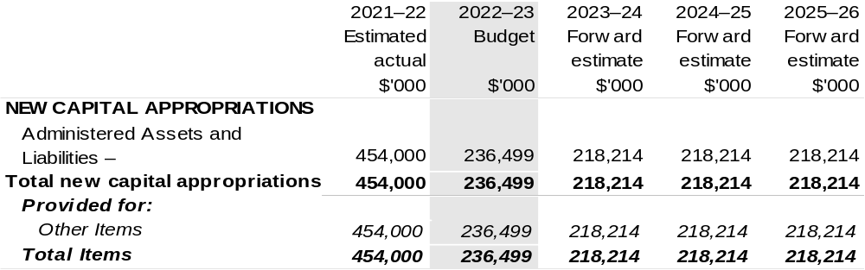
Prepared on Australian Accounting Standards basis.

Table 3.11: Statement of administered asset movements (Budget year 2022–23)
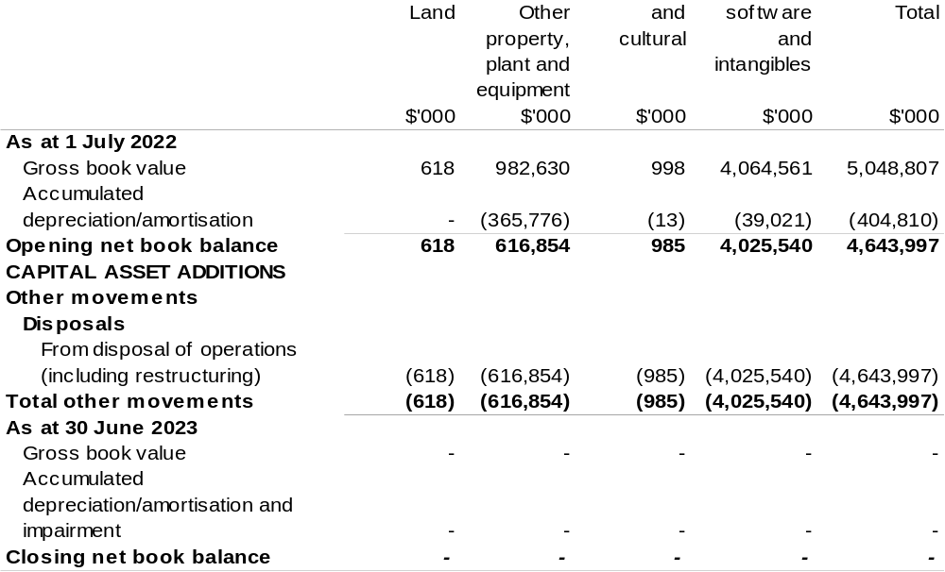
Prepared on Australian Accounting Standards basis.
AgriFutures Australia
Section 1: Entity overview and resources 93
1.1 Strategic direction statement 93
1.2 Entity resource statement 96
1.3 Budget measures 98
Section 2: Outcomes and planned performance 99
2.1 Budgeted expenses and performance for Outcome 1 100
Section 3: Budgeted financial statements 107
3.1 Budgeted financial statements 107
3.2 Budgeted financial statements tables 108

AgriFutures Australia

Section 1: Entity overview and resources

1.1 Strategic direction statement
AgriFutures Australia (AgriFutures) is the trading name for the Rural Industries Research and Development Corporation (RIRDC). AgriFutures plays a unique role in Australian agriculture by investing in research and development (R&D) to maintain and create profitable and sustainable rural industries. AgriFutures knows that the key to developing real and lasting solutions for rural industries is to take a shared approach to shared challenges. That is why AgriFutures works in collaboration with a range of stakeholders to develop and implement its initiatives.
AgriFutures’ vision is to grow the long-term prosperity of Australian rural industries. AgriFutures’ mission is to collaborate with its partners to create lasting value for its stakeholders, through investing in research, innovation and learning initiatives that enhance the prosperity, profitability, and sustainability of the agricultural, fisheries and forestry sectors. AgriFutures’ approach is guided by an ambition to be an organisation that places people, rural industries, and regional communities at the centre of all its activities.
AgriFutures supports rural industries that do not have their own research and development corporation (RDC) and invests in R&D to accelerate the establishment of new and emerging rural industries.
AgriFutures’ cross-sectoral mandate supports it to focus on national opportunities and challenges that affect multiple rural industries, not just the industries it traditionally serves. AgriFutures’ future orientation enables it to not only tackle the challenges and opportunities that rural industries face today, but to identify and unearth the challenges and opportunities of tomorrow. AgriFutures does this by listening and collaborating with the emerging leaders in agriculture, industries bodies, other RDCs and government.
As outlined in AgriFutures Australia Research and Innovation Strategic Plan
2022–2027 published on Monday, 23 August 2022, AgriFutures has designed the “AgriFutures’ 16:5:5 Roadmap” – a simple, decisive set of priorities, centred around two important audiences – our levied industries and Australian rural industries.
The plan sets out sixteen priorities within five focus areas over five years (2022–2027).
AgriFutures’ 16:5:5 Roadmap
Focus Area: Our Industries
In partnership with each of our industries, create value by:
- Maximising the return on investment for R&D levies.
- Listening to, engaging, collaborating, and consulting with our industries.
- Delivering research and innovation that addresses the specific needs of each of our industries.
- Supporting our industries to prepare for and thrive into the future.
- Identifying, linking, and testing new technologies, practices, and innovations with the potential for our industries to uptake and adopt.
- Assisting our industries to enhance their industry stewardship to build community and consumer confidence.
Focus Area: Emerging Industries
Grow the value and diversity of Australia’s rural economy by:
- Driving the growth of emerging, high-potential rural industries.
- Identifying new revenue streams.
Focus Area: Workforce and Leadership
Assist in the development of the agricultural workforce by:
- Understanding and responding to the future workforce needs of Australia’s rural industries.
- Attracting and retaining a workforce that will ensure Australia’s rural industries are future ready.
- Supporting people in Australia’s rural industries to build their motivation and skills to lead change.
- Responding to the specific workforce and leadership needs of our levied and emerging industries.
Focus Area: National Challenges and Opportunities
Future proof Australian rural industries by:
- Identifying, understanding, and responding to national challenges and opportunities impacting Australian rural industries.
- Facilitating collaboration across sectors and organisations including other RDCs and Agricultural Innovation Australia (AIA).
- Fostering responsible industry stewardship and building community trust.
Focus Area: Global Innovation Networks
Engage with the global agrifood innovation system by:
- Ensuring Australia is a leader in accessing and adopting, as well as developing and exporting agrifood technologies and innovation.

1.2 Entity resource statement
Table 1.1 shows the total funding from all sources available to the entity for its operations and to deliver programs and services on behalf of the Government.
The table summarises how resources will be applied by outcome (Government strategic policy objectives) and by administered (on behalf of the Government or the public) and departmental (for the entity’s operations) classification.
For more detailed information on special accounts and special appropriations, please refer to October Budget Paper No. 4: Agency Resourcing.
Information in this table is presented on a resourcing (i.e. appropriations/cash available) basis, whilst the ‘Budgeted expenses by Outcome’ tables in Section 2 and the financial statements in Section 3 are presented on an accrual basis.

Table 1.1: AgriFutures Australia – Resource Statement – Budget Estimates for 2022–23 as at October Budget 2022
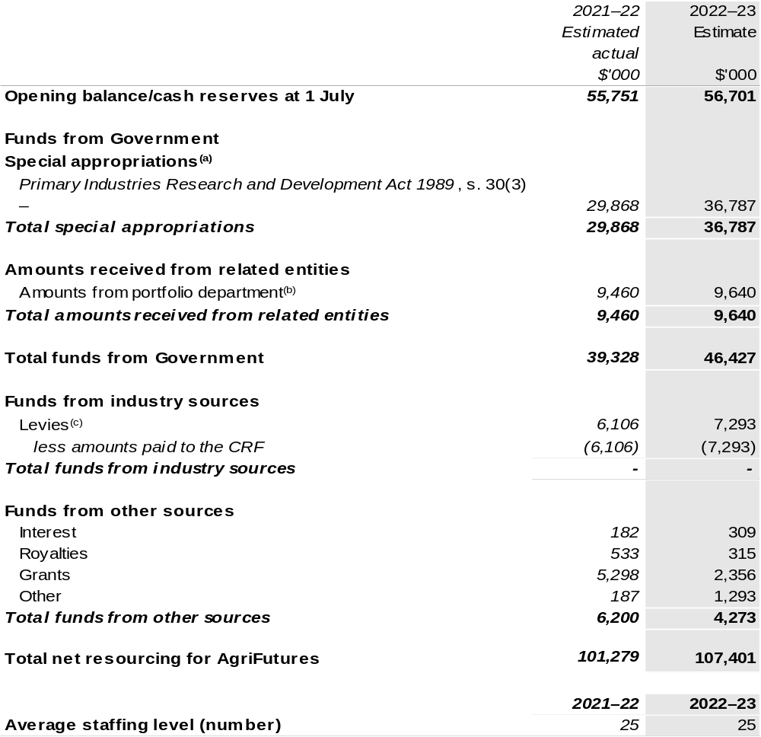

(a) AgriFutures' special appropriation is not directly appropriated as it is a corporate Commonwealth entity (CCE) under the Public Governance, Performance and Accountability Act 2013 (PGPA Act). Appropriations are made to Department of Agriculture, Fisheries and Forestry (DAFF) and are then paid to AgriFutures and are considered departmental for all purposes.
(b) Funding provided by the portfolio department that is not specified within the Annual Appropriation Bills as a payment to that CCE (for example, a grant awarded to a CCE from one of its portfolio department's administered programs).
(c) The levies are imposed by the Primary Industries (Excise) Levies Act 1999. The levies are collected by DAFF under the Primary Industries Levies and Charges Collection Act 1991 and transferred to the Consolidated Revenue Fund (CRF). These amounts are then drawn down by the department as a special appropriation and paid to AgriFutures under the Primary Industries Research and Development Act 1989 (PIRD Act) s. 30(3) – Rural Industries R&D Corporation.

Please note: All figures shown above are GST exclusive – these may not match figures in the cash flow statement.

Prepared on a resourcing (i.e. appropriations available) basis.

1.3 Budget measures
Budget measures in Part 1 relating to AgriFutures Australia are detailed in October Budget Paper No. 2 and are summarised below.

Table 1.2: AgriFutures Australia – October 2022–23 Budget Measures

Part 1: Measures announced since the March 2022–23 Budget

AgriFutures does not have any October 2022–23 Budget measures.

Section 2: Outcomes and planned performance
Government outcomes are the intended results, impacts or consequences of actions by the Government on the Australian community. Commonwealth programs are the primary vehicle by which government entities achieve the intended results of their outcome statements. Entities are required to identify the programs which contribute to Government outcomes over the Budget and forward years.
Each outcome is described below together with its related programs. The following provides detailed information on expenses for each outcome and program, further broken down by funding source.
Note:
Performance reporting requirements in the Portfolio Budget Statements are part of the Commonwealth performance framework established by the Public Governance, Performance and Accountability Act 2013. It is anticipated that the performance criteria described in Portfolio Budget Statements will be read with broader information provided in an entity’s corporate plans and annual performance statements – included in Annual Reports – to provide a complete picture of an entity’s planned and actual performance.
The most recent corporate plan and annual performance statement for AgriFutures can be found at:
http://www.agrifutures.com.au/about/corporate-documents/.

2.1 Budgeted expenses and performance for Outcome 1
Outcome 1: Growth in the long-term prosperity of Australian rural industries by investing, through partnerships with industry, in research, development, extension, and commercialisation that fosters sustainable and profitable existing and emerging rural industries, and cross sector opportunities and challenges.

2.1.1: Linked programs
Department of Agriculture, Fisheries and Forestry
Program 1.10: Agricultural Resources
Contribution to Outcome 1 made by linked program:
AgriFutures works together with DAFF to ensure sustainable, productive and profitable rural industries.

2.1.2: Budgeted expenses for Outcome 1
This table shows how much the entity intends to spend (on an accrual basis) on achieving the outcome, broken down by program, as well as by administered and departmental funding sources.

Table 2.1: Budgeted expenses for Outcome 1
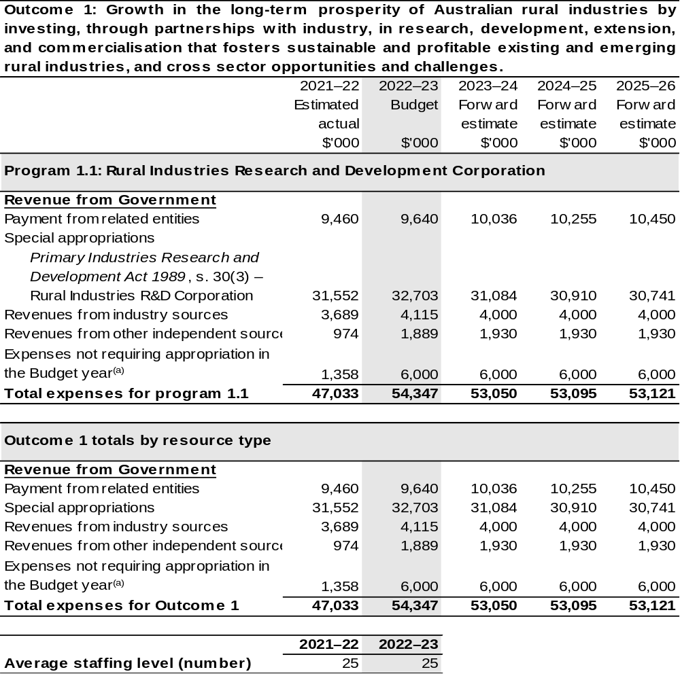

- Expenses not requiring appropriation in the budget year are made up of make good expenses, audit fees, and can include depreciation / amortisation expenses not requiring an appropriation.

Note: Departmental appropriation splits and totals are indicative estimates and may change in the course of the budget year as government priorities change.

Prepared on Australian Accounting Standards basis.

Table 2.2: Performance measure for Outcome 1
Table 2.2 details the performance measures for each program associated with Outcome 1. It also provides the related key activities as expressed in the current corporate plan where further detail is provided about the delivery of the activities related to the program, the context in which these activities are delivered and how the performance of these activities will be measured. Where relevant, the October 2022–23 Budget measures that have created new programs or materially changed existing programs are provided.
As an entity established under the Primary Industries Research and Development Act 1989 (PIRD Act), AgriFutures does not produce a corporate plan under the PGPA Act and is therefore exempt from the requirement to map purposes to outcomes.
Outcome 1: Growth in the long-term prosperity of Australian rural industries by investing, through partnerships with industry, in research, development, extension, and commercialisation that fosters sustainable and profitable existing and emerging rural industries, and cross sector opportunities and challenges.
Program 1.1: Rural Industries Research and Development Corporation
Objective | Through research and development create thriving rural industries and vibrant regional communities.
Key Activities | Focus Area: Our Industries  In partnership with each of our industries, create value by:  - Maximising the return on investment for R&D levies.  - Listening to, engaging, collaborating, and consulting with our industries.  - Delivering research and innovation that addresses the specific needs of each of our industries.  - Supporting our industries to prepare for and thrive into the future.  - Identifying, linking, and testing new technologies, practices, and innovations with the potential for our industries to uptake and adopt.  - Assisting our industries to enhance their industry stewardship to build community and consumer confidence.
Key Activities | Focus Area: Emerging Industries  Grow the value and diversity of Australia’s rural economy by:  - Driving the growth of emerging, high-potential rural industries.  - Identifying new revenue streams.

Continued on following pages
Table 2.2: Performance measure for Outcome 1 (continued)
Key Activities (continued) | Focus Area: Workforce and Leadership  Assist in the development of the agricultural workforce by:  - Understanding and responding to the future workforce needs of Australia’s rural industries.  - Attracting and retaining a workforce that will ensure Australia’s rural industries are future ready.  - Supporting people in Australia’s rural industries to build their motivation and skills to lead change.  - Responding to the specific workforce and leadership needs of our levied and emerging industries.
Key Activities (continued) | Focus Area: National Challenges and Opportunities  Future proof Australian rural industries by:  - Identifying, understanding, and responding to national challenges and opportunities impacting on Australian rural industries.  - Facilitating collaboration across sectors and organisations including other RDCs and AIA.  - Fostering responsible industry stewardship and building community trust.
Key Activities (continued) | Focus Area: Global Agrifood Innovation  Engage with the global agrifood innovation system by:  - Ensuring Australia is a leader in accessing and adopting, as well as, developing and exporting agrifood technologies and innovation.
Year | Performance measures | Expected Performance Results
Prior year  2021–22 | 1,800 graduates per annum of an agriculture or agriculture science course at Australian universities. | N/A*  *The official figures will not be released until mid-2023.
Prior year  2021–22 | Percentage of participants who feel their confidence as a leader has increased significantly or very significantly as a result of participation in an AgriFutures sponsored activity. | 83 per cent of surveyed participants.
Prior year  2021–22 | Impact of AgriFutures sponsored studies on debates of national significance to rural industries. | 17 studies published.

Continued on following pages
Table 2.2: Performance measure for Outcome 1 (continued)
Year | Performance measures | Expected Performance Results
Prior year  2021–22 (continued) | New technologies adapted for use in Australian rural industries. | One new technology adapted for use.
Prior year  2021–22 (continued) | Evidence of collaboration between RDCs in cross sector investment initiatives. | 18 collaborative initiatives involving other RDCs.
Prior year  2021–22 (continued) | Percentage of growers comfortable or very comfortable paying the R&D levy. | 62 per cent of surveyed participants.
Prior year  2021–22 (continued) | Degree to which the objectives of the industry-based R&D plans are being achieved. | 74 per cent.
Prior year  2021–22 (continued) | Stakeholders rate the value of AgriFutures’ information products and services as high or very high. | 53 per cent of surveyed participants.
Prior year  2021–22 (continued) | Number of new rural industries reaching or exceeding $10 million per annum threshold. | 15*  *Develop clear and prioritised  industry investment plans for Research, Development and Extension (RD&E) in rural industries with potential to grow and exceed a value of $10 million per annum (GVP).
Year | Performance measures | Planned Performance Results
Budget Year  2022–23 | Maximising the return of investment for our levy industries. | Benefit cost ratio of 4:1.
Budget Year  2022–23 | Percentage of industry representative bodies and our panel members that believe that AgriFutures’ engagement with our industries has been effective. | 70 per cent.
Budget Year  2022–23 | Degree to which the Key Performance Indicators (KPI) in each of the individual levied industries RD&E Plans are achieved. | 80 per cent of KPIs achieved in each of the levied industries.

Continued on following pages
Table 2.2: Performance measure for Outcome 1 (continued)
Year | Performance measures | Planned Performance Results
Budget Year  2022–23 (continued) | Percentage of our industry representative bodies and panel members that feel that AgriFutures’ engagement with industry has supported them to prepare for the future. | 70 per cent.
Budget Year  2022–23 (continued) | Number of new technologies or innovations trials per annum relevant to our levied industries. | Five new technologies or innovations tested.
Budget Year  2022–23 (continued) | Percentage of industry representative bodies and panel members that believe that AgriFutures’ has assisted their industry to build community and consumer confidence. | 70 per cent.
Budget Year  2022–23 (continued) | Deliver five investments across emerging industries that enables them to address the highest priorities identified in their RD&E Plans. | Five investments over five years.
Budget Year  2022–23 (continued) | Identify new potential revenue streams post farm-gate or ecosystem* market opportunities that have the potential to return additional revenue streams. | Five potential revenue streams identified over five years.
Budget Year  2022–23 (continued) | Deliver and extend to stakeholders the key findings of a study that addresses national workforce needs. | One study per annum.
Budget Year  2022–23 (continued) | Percentage of participants in AgriFutures leadership and capacity building programs that feel equipped and confident to contribute to the future of Australia’s rural industries. | 80 per cent.

Continued on following page

Table 2.2: Performance measure for Outcome 1 (continued)
Year | Performance measures | Planned Performance Results
Budget Year  2022–23 (continued) | Percentage of participants in AgriFutures leadership and capacity building programs that feel their motivation and skills to lead change have increased due to their participation. | 80 per cent.
Budget Year  2022–23 (continued) | Percentage of participants in levied and emerging industries capacity building programs that feel they are better equipped to address workforce needs within their industry. | 80 per cent.
Budget Year  2022–23 (continued) | Deliver and extend to stakeholders the key findings of studies addressing national challenges and opportunities impacting Australian rural industries. | Four studies per annum.
Budget Year  2022–23 (continued) | Deliver one Emerging National Rural Issues Forum per annum that results in national collaborative projects or programs. | Five or more collaborative projects/programs.
Budget Year  2022–23 (continued) | Deliver and extend to stakeholders the key findings of studies that address responsible industry stewardship and build community trust. | One study per annum.
Budget Year  2022–23 (continued) | Deliver events, networks and/or platforms that support the positioning of Australia as a global leader in agrifood tech. | Three events, networks or platforms.
Forward Estimates 2023–26 | As per 2022–23. | As per 2022–23.

Section 3: Budgeted financial statements
Section 3 presents budgeted financial statements which provide a comprehensive snapshot of entity finances for the 2022–23 budget year, including the impact of budget measures and resourcing on financial statements.

3.1 Budgeted financial statements

3.1.1: Differences between entity resourcing and financial statements
The financial statements are prepared on an accrual basis where revenues and expenses are recognised as and when the resources are received and used. The entity resourcing table recognises the cash resources available to be used during the period and includes amounts recognised as revenue in previous periods.

3.1.2: Explanatory notes and analysis of budgeted financial statements
AgriFutures is budgeting for a deficit of $6.0 million in 2022–23.
AgriFutures’ balance sheet remains strong with estimated total assets of $57.8 million in 2022–23. Of the total assets, approximately $51.8 million is represented by cash and investments.
Total liabilities of $7.7 million are mostly represented by payables to R&D providers and suppliers of $3.1 million and employee entitlements of $0.8 million over the same period.

3.2 Budgeted financial statements tables

Table 3.1: Comprehensive income statement (showing net cost of services) (for the period ended 30 June)
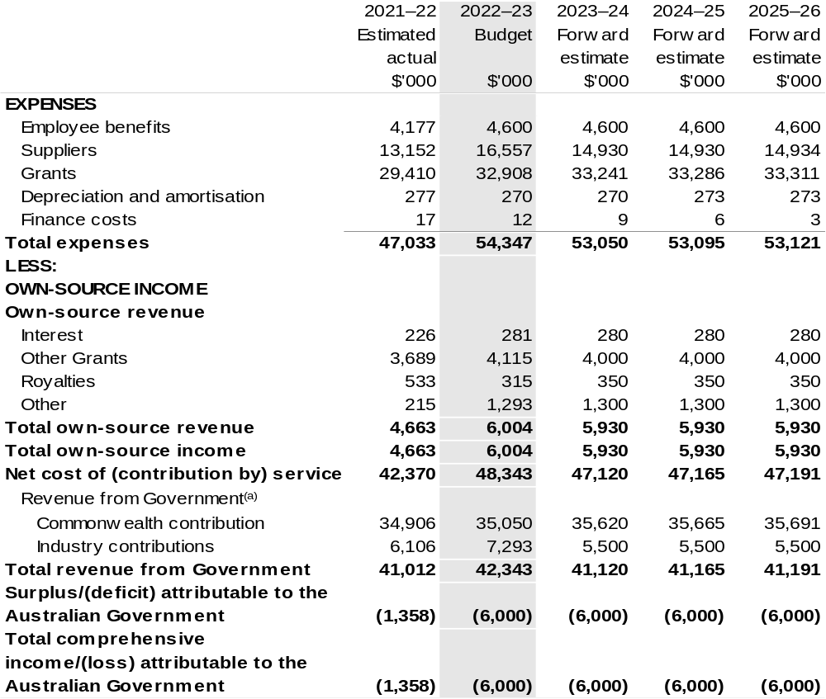

Continued on following page
Table 3.1: Comprehensive income statement (showing net cost of services) (for the period ended 30 June) (continued)
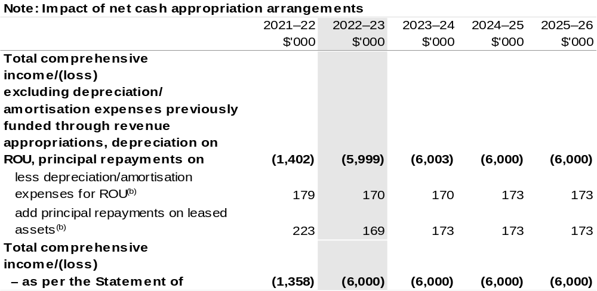
(a) Revenue from Government includes a Commonwealth contribution under the PIRD Act and levies collected from industry by DAFF for R&D activities.
(b) Applies to leases under AASB 16 Leases. Right of Use (ROU).

Prepared on Australian Accounting Standards basis.

Table 3.2: Budgeted departmental balance sheet (as at 30 June)
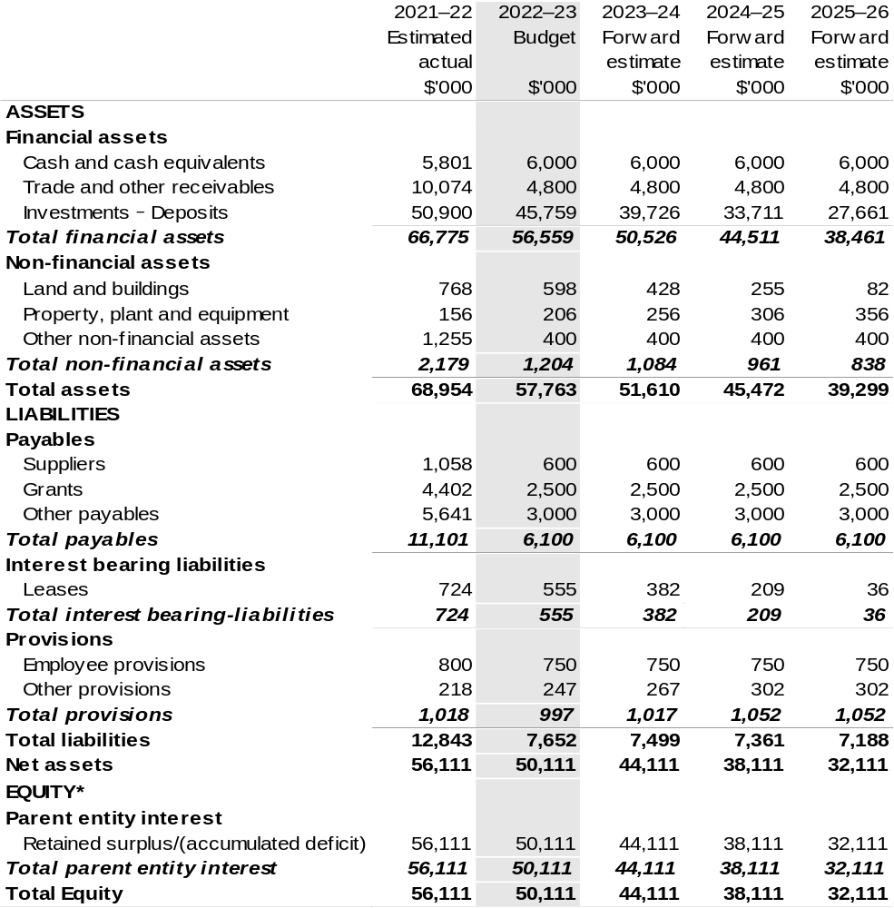

*'Equity' is the residual interest in assets after deduction of liabilities.

Prepared on Australian Accounting Standards basis.

Table 3.3: Departmental statement of changes in equity – summary of movement (Budget year 2022–23)
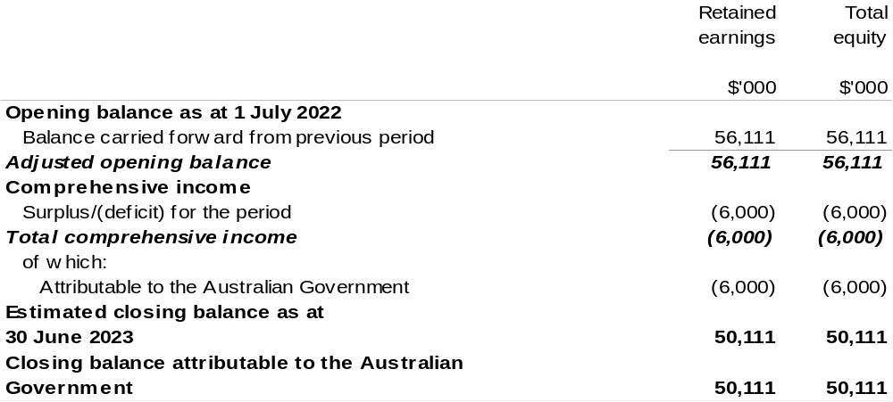

Prepared on Australian Accounting Standards basis.

Table 3.4: Budgeted departmental statement of cash flows (for the period
ended 30 June)
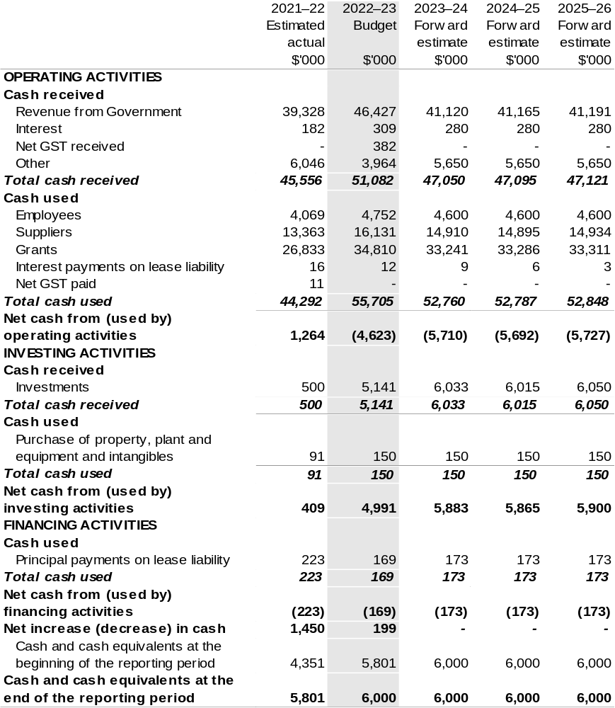

Prepared on Australian Accounting Standards basis.

Table 3.5: Departmental capital budget statement (for period ended 30 June)
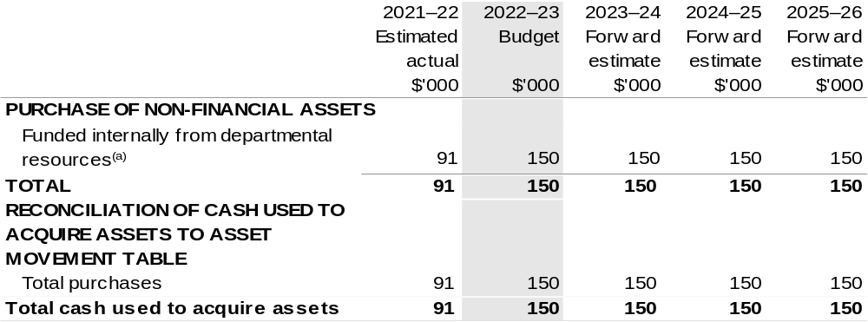

(a) Includes the following s74 external revenue:
– internally developed assets; and
– proceeds from the sale of assets.

Consistent with information contained in the Statement of Asset Movements and the Budgeted Statement of Cash Flows.

Prepared on Australian Accounting Standards basis.

Australian Fisheries Management Authority
Section 1: Entity overview and resources 117
1.1 Strategic direction statement 117
1.2 Entity resource statement 119
1.3 Budget measures 121
Section 2: Outcomes and planned performance 122
2.1 Budgeted expenses and performance for Outcome 1 123
Section 3: Budgeted financial statements 130
3.1 Budgeted financial statements 130
3.2 Budgeted financial statements tables 131

Australian Fisheries Management Authority

Section 1: Entity overview and resources

1.1 Strategic direction statement
The Australian Fisheries Management Authority (AFMA) was established under the Fisheries Administration Act 1991 (FAA) to manage Commonwealth fisheries on behalf of the Australian community in accordance with the Fisheries Management Act 1991 (FMA).
The AFMA Commission is responsible for exercising AFMA’s domestic fisheries management functions and powers under the FAA and FMA. The Chief Executive Officer (CEO) of AFMA is also a Commissioner and is responsible for assisting the Commission, including giving effect to its decisions. The CEO is also responsible for exercising AFMA’s foreign compliance functions, is the accountable authority under the Public Governance, Performance and Accountability Act 2013 (PGPA Act) and the agency head for the purposes of the Public Service Act 1999.
AFMA pursues four overarching goals, drawn from our legislated functions and objectives:
- Management of Commonwealth fisheries consistent with principles of ecologically sustainable development
- Maximise net economic returns to the Australian community from the management of Commonwealth fisheries
- Compliance with Commonwealth fisheries laws and policies and relevant international fishing obligations and standards
- Deliver effective, cost efficient and accountable management of Commonwealth fisheries resources.
We have regard to the impact of fishing on non-target species and on the long-term sustainability of the marine environment as well as taking into account the interests of commercial and recreational fishers. We are committed to better understanding Indigenous fishing interests as they relate to Commonwealth fisheries so that these too can be considered properly.
Climate change challenges our understanding of, and ability to, influence fish stocks and marine ecosystems. We continue to improve our understanding of and response to the impacts of climate change through a number of projects, which are progressing from research to implementation.
We commission and place high importance on scientific and economic research and ecological risk assessments to inform decision making. AFMA uses these tools and our own monitoring activities to identify Australian marine living resources potentially affected by Commonwealth managed commercial fishing and implement measures to pursue sustainable fishing.
Our risk-based domestic compliance programs, participation in the Australian Government’s civil maritime surveillance and response arrangements and engaging internationally are all integral activities to improve the management of fish stocks within and beyond the Australian Fishing Zone. Our activities include education, monitoring and enforcement to protect Commonwealth fisheries from illegal fishing and engaging internationally to provide specialist advice and delivering capacity building programs to deter illegal, unreported and unregulated (IUU) fishing beyond Australia’s borders.
AFMA also provides fisheries management, licensing and domestic compliance services for the Protected Zone Joint Authority (PZJA) under the Torres Strait Fisheries Act 1984. Decisions under this legislation are made by the PZJA, which comprises the Commonwealth Fisheries Minister as Chair, with the Torres Strait Regional Authority and the Queensland Government as other members. Management and policy reform is of growing importance to the PZJA to ensure that the objectives of sustainable fisheries, economic development, and employment opportunities for traditional inhabitants and protection of the traditional way of life and traditional fishing can be achieved.
AFMA works in partnership with stakeholders, including commercial fishing operators, prescribed peak industry bodies, sectoral industry associations, Indigenous Australian communities, recreational and charter fishing representatives, researchers, environment/conservation organisations, state and territory agencies and others with an interest in Commonwealth fisheries management. We engage with stakeholder groups through management advisory committees, resource assessment groups, scientific panels, working groups, liaison meetings, port visits, and electronic newsletters to concession holders in Commonwealth fisheries. We consult with the public using contemporary digital, web and social media communication channels.
AFMA applies the Australian Government’s cost recovery policy through its Cost Recovery Implementation Statement (CRIS). The commercial fishing industry operating in Commonwealth fisheries pay for activities directly attributed to it, while the Commonwealth pays for activities that benefit the broader community, including compliance and enforcement. Delivering on government and community expectations in a cost-efficient manner is a growing challenge in some Commonwealth fisheries.
We have a strong record of applying technological and other solutions to reduce and help minimise costs and improve efficiency in the delivery of our regulatory services to the Commonwealth managed commercial fishing industry.
Our purpose
The ecologically sustainable development of Commonwealth fisheries for the benefit of the Australian community.

1.2 Entity resource statement
Table 1.1 shows the total funding from all sources available to the entity for its operations and to deliver programs and services on behalf of the Government.
The table summarises how resources will be applied by outcome (Government strategic policy objectives) and by administered (on behalf of the Government or the public) and departmental (for the entity’s operations) classification.
For more detailed information on special accounts and special appropriations, please refer to October Budget Paper No. 4: Agency Resourcing.
Information in this table is presented on a resourcing (that is, appropriations/cash available) basis, whilst the ‘Budgeted expenses by Outcome’ table in Section 2 and the financial statements in Section 3 are presented on an accrual basis.

Table 1.1: Australian Fisheries Management Authority – Resource Statement – Budget Estimates for 2022–23 as at October Budget 2022
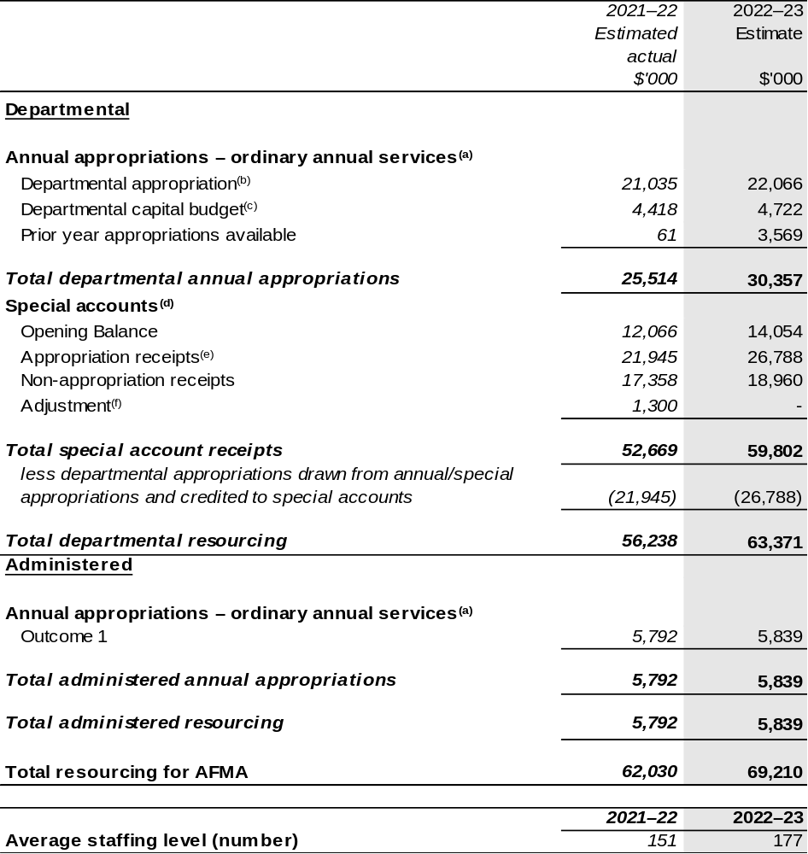

(a) Appropriation Bill (No. 1) 2022–23, Supply Bill (No. 3) 2022–23 and Supply Act (No. 1) 2022–23.
(b) Excludes departmental capital budget (DCB).
(c) Departmental capital budgets are not separately identified in Appropriation Bill (No.1) and form part of ordinary annual services items. Please refer to Table 3.5 for further details. For accounting purposes, this amount has been designated as a 'contribution by owner'.
(d) For further information on special appropriations and special accounts, please refer to October Budget Paper No. 4: Agency Resourcing 2022–23. Please also see Table 2.1 for further information on outcome and program expenses broken down by various funding sources, e.g, annual appropriations, special appropriations and special accounts.
(e) Amounts credited to the special account from the Authority’s annual appropriations.
(f) Adjustment reflects net GST receipts to the special account.

Please note: All figures shown above are GST exclusive – these may not match figures in the cash flow statement. Prepared on a resourcing (i.e. appropriations available) basis.
1.3 Budget measures
Budget measures in Part 1 relating to the Australian Fisheries Management Authority are detailed in October Budget Paper No. 2 and are summarised below.

Table 1.2: Australian Fisheries Management Authority – October 2022–23 Budget Measures

Part 1: Measures announced since the March 2022–23 Budget
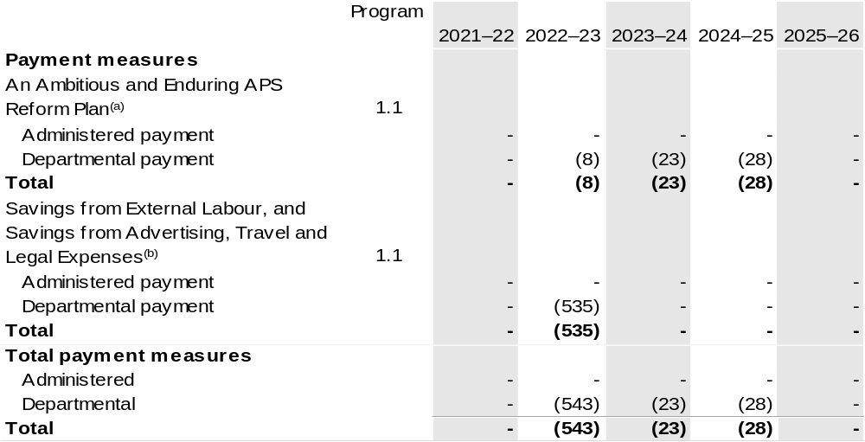

- The measure description appears in October Budget Paper No. 2: Budget Measures 2022–23 under the Prime Minister and Cabinet Portfolio section.
- The measure description appears in October Budget Paper No. 2: Budget Measures 2022–23 under the Cross Portfolio section.

Note: The measure Forestry and Fishing – supporting the forestry and fishery industry – Improve the long term sustainability of the South East Trawl Fishery and Support Fisheries will be implemented as announced and can be found in the March 2022–23 Department of Agriculture, Water and the Environment Portfolio Budget Statements within the AFMA chapter.

Prepared on a Government Finance Statistics (Underlying Cash) basis.

Figures displayed as a negative (-) represent a decrease in funds and a positive (+) represent an increase in funds.

Section 2: Outcomes and planned performance
Government outcomes are the intended results, impacts or consequences of actions by the Government on the Australian community. Commonwealth programs are the primary vehicle by which government entities achieve the intended results of their outcome statements. Entities are required to identify the programs which contribute to Government outcomes over the Budget and forward years.
Each outcome is described below together with its related programs. The following provides detailed information on expenses for each outcome and program, further broken down by funding source.
Note:
Performance reporting requirements in the Portfolio Budget Statements are part of the Commonwealth performance framework established by the PGPA Act. It is anticipated that the performance criteria described in Portfolio Budget Statements will be read with broader information provided in an entity’s corporate plans and annual performance statements – included in Annual Reports – to provide a complete picture of an entity’s planned and actual performance.
AFMA’s most recent corporate plan can be found at:
https://www.afma.gov.au/sites/default/files/afma_corporate_plan_2022–25.pdf.
AFMA’s most recent annual performance statement can be found at:
https://www.afma.gov.au/sites/default/files/afma_annual_report_2020–21_fa-tagged.pdf .

2.1 Budgeted expenses and performance for Outcome 1
Outcome 1: Ecologically sustainable and economically efficient Commonwealth fisheries, through understanding and monitoring Australia’s marine living resources and regulating and monitoring commercial fishing, including domestic licensing and deterrence of illegal foreign fishing.

2.1.1: Linked programs
Department of Agriculture, Fisheries and Forestry
Program 1.4: Fishing Industry
Program 2.1: Biosecurity and Export Services
Contribution to Outcome 1 made by linked program:
AFMA and DAFF engage on fisheries management to ensure a sustainable, productive and profitable fishing industry.
Department of Climate Change, Energy, the Environment and Water
Program 2.4: Conservation of Australia’s Heritage and Environment
Contribution to Outcome 1 made by linked program:
AFMA and DCCEEW engage on fisheries management to ensure a sustainable, productive and profitable fishing industry.
Department of Home Affairs
Program 3.4: Border Enforcement
Contribution to Outcome 1 made by linked program:
AFMA provides the fisheries focus within the Australian Government Civil Maritime Surveillance and Response Program and is responsible for the administration of legislation on illegal fishing in the Australian Fishing Zone. AFMA deters and prevents illegal foreign fishing by carrying out education programs, cooperative enforcement operations, prosecution of offenders, confiscation of boats and capacity building projects.

2.1.2: Budgeted expenses for Outcome 1
This table shows how much the entity intends to spend (on an accrual basis) on achieving the outcome, broken down by program, as well as by administered and departmental funding sources.

Table 2.1: Budgeted expenses for Outcome 1
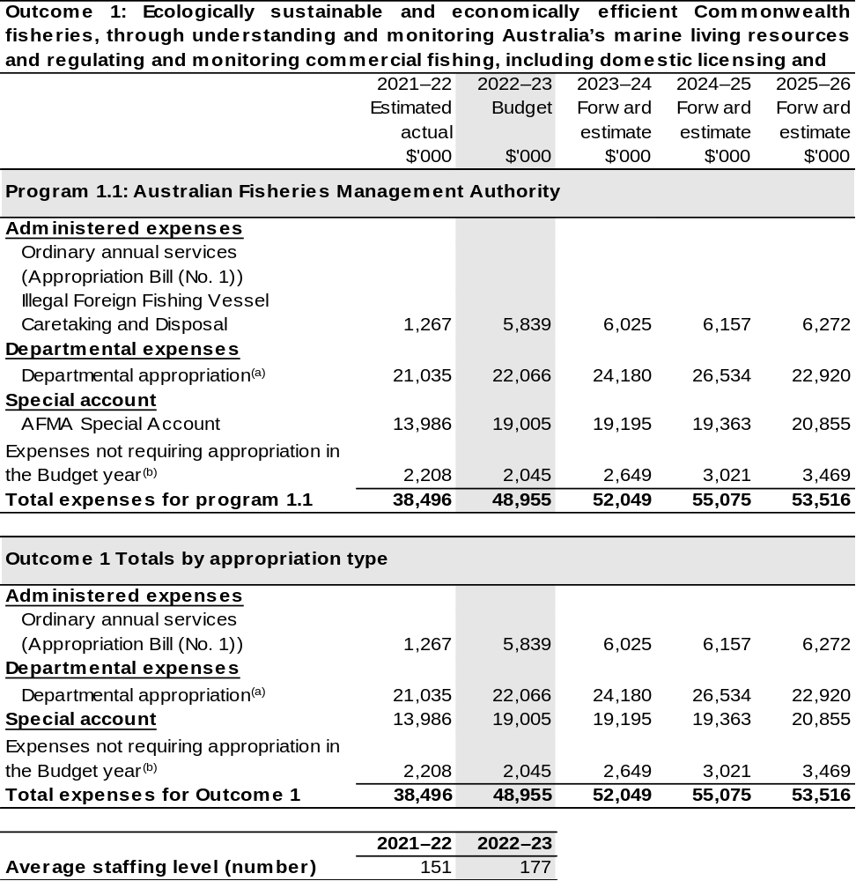

(a) Expenses are funded from both ‘ordinary annual services’ Appropriation Bill (No. 1) 2022–23, Supply Bill (No. 3) 2022–23 and Supply Act (No. 1) 2022–23 and ‘revenue from independent sources’ (receipts retained under section 74 of the PGPA Act).
(b) Expenses not requiring appropriation in the budget year are made up of make good expenses, audit fees, and can include depreciation / amortisation expenses not requiring an appropriation.
Note: Departmental appropriation splits and totals are indicative estimates and may change in the course of the budget year as Government priorities change.
Prepared on Australian Accounting Standards basis.

Table 2.2: Performance measure for Outcome 1
Table 2.2 details the performance measures for each program associated with Outcome 1. It also provides the related key activities as expressed in the current corporate plan where further detail is provided about the delivery of the activities related to the program, the context in which these activities are delivered and how the performance of these activities will be measured. Where relevant, the October 2022–23 Budget measures that have created new programs or materially changed existing programs are provided.
Outcome 1: Ecologically sustainable and economically efficient Commonwealth fisheries, through understanding and monitoring Australia’s marine living resources and regulating and monitoring commercial fishing, including domestic licensing and deterrence of illegal foreign fishing.
Program 1.1: Australian Fisheries Management Authority
Objective 1 | Management of Commonwealth fisheries consistent with principles of ecological sustainable development.
Key Activities^{(a)} | - Developing management arrangements that:  - Support the implementation of Commonwealth fisheries policies including the Harvest Strategy and Bycatch Policies  - Implement AFMA’s Ecological Risk Management Framework  - Recover overfished stocks and prevent overfishing  - Ensure commercial, recreational and Indigenous fishing information is used to the extent possible in decision making.  - Investing in and applying monitoring, scientific and economic research to decision making on fish stocks, sub-stocks, species (target and non-target species) and the impact of fishing on the marine environment.
Objective 2 | Maximise net economic returns to the Australian community from the management of Commonwealth fisheries.
Key Activities^{(a)} | - Reviewing management arrangements to take into account commercial, recreational and Indigenous fishing interests when maximising net economic returns from the commercial sector.  - Increasing catch levels within sustainable total allowable catches (TACs) by conducting and considering implementation of research focussed on under caught TACs.  - Managing exploratory fisheries (potentially underutilised fisheries).  - Understanding impacts of resource allocation between commercial, recreational, and Indigenous fishers.

Continued on following pages
Table 2.2: Performance measure for Outcome 1 (continued)
Objective 3 | Compliance with Commonwealth fisheries laws and policies and relevant international fishing obligations and standards.
Key Activities^{(a)} | - Operating an effective compliance and enforcement regime encompassing:  - Measures to maximise voluntary compliance  - Risk-based, intelligence driven, and targeted domestic operations  - Building and maintaining strategic links and relationships with relevant law enforcement agencies.  - Operating effective foreign fisheries compliance enforcement and capacity building by:  - Implementing strategies to deter and eliminate IUU foreign fishing in Australian waters and on the high seas where Australia has an interest  - Delivering capacity building programs internationally and providing technical input to support key regional and international fishing bodies.
Objective 4 | Deliver effective, cost efficient and accountable management of Commonwealth fisheries resources.
Key Activities^{(a)} | - Pursuing initiatives to improve regulation and administration generally in the Australian Government sector including:  - Exploring opportunities to streamline fisheries assessment and management processes  - Implementing new fisheries policies for harvest strategies and bycatch to improve fishery management performance.  - Reviewing business processes and systems, information flows and financial management arrangements through:  - Assessing and mitigating high financial and operating risks  - Implementing a digital first service delivery policy that provides electronic service delivery for all relevant programs (E-logs, Electronic Catch Disposal Records, licencing, data requests, etc.).^{(a)}  - Increasing AFMA accountability and stakeholder engagement through:  - Expanded membership of management advisory committees (MACs) and resource assessment groups (RAGs)  - Capability development for recreational and Indigenous stakeholders.

Continued on following pages
Table 2.2: Performance measure for Outcome 1 (continued)
Year | Performance measures | Expected Performance Results
Prior year  2021–22 | - The number of stocks for which management measures are based on species-appropriate scientific assessment. | Performance results of no change or an increase are on track.
Prior year  2021–22 | - The percentage of species assessed as “residual High Risk” under Ecological Risk Assessment. | Performance results of no change or an increase are on track.
Prior year  2021–22 | - The number of AFMA-only stocks assessed as “subject to overfishing” in the Australian Bureau of Agricultural and Resource Economics and Sciences (ABARES), Fishery Status Report. | Zero target is not on track.
Prior year  2021–22 | - AFMA advocates measures to address stocks shared with states and territories that are assessed as “overfished” or “subject to overfishing” in the ABARES Fishery Status Report in relevant negotiations. | Qualitative assessment is on track.
Prior year  2021–22 | - Status of Wildlife Trade Operations (WTOs) under the Environmental Protection and Biodiversity Conservation Act 1999. | All WTOs are maintained on track.
Prior year  2021–22 | - The number of stocks with target reference points based on Maximum Economic Yield, an agreed proxy thereof or a multi-stock harvest strategy. | Performance results of no change or an increase are on track.
Prior year  2021–22 | - Net Economic Return, as assessed in the ABARES Status of Fish Stocks Report. | Positive trend over 3-year window is on track.
Prior year  2021–22 | - Treatment of identified domestic compliance risks as outlined in the National Compliance and Enforcement Program (NCEP). | >90 per cent of NCEP performance targets met is not on track.
Prior year  2021–22 | - Incidence level of illegal foreign fishing vessels operating in the Australian Fishing Zone. | Lower than the previous 10-year average is not on track to be met.

Continued on following pages
Table 2.2: Performance measure for Outcome 1 (continued)
Year | Performance measures | Expected Performance Results
Prior year  2021–22 (continued) | - Compliance rate with international obligations as assessed in Regional Fisheries Management Organisation (implemented by AFMA). | >90 per cent is on track.
Prior year  2021–22 (continued) | - Cost recover budget. | At or below 2005–06 once adjusted for CPI is on track.
Prior year  2021–22 (continued) | - Corporate overheads compared to total budget. | <20 per cent is not on track.
Prior year  2021–22 (continued) | - Engagement with legislated peak body. | Commonwealth Fisheries Association is satisfied that meaningful opportunity is given to contribute to planning, delivery and reporting is on track.
Year | Performance measures | Planned Performance Results
Budget Year  2022–23 | - As per 2021–22. | No change or an increase.
Budget Year  2022–23 | - As per 2021–22. | No change or a decrease.
Budget Year  2022–23 | - As per 2021–22. | Zero.
Budget Year  2022–23 | - As per 2021–22. | Qualitative assessment.
Budget Year  2022–23 | - As per 2021–22. | All WTOs are maintained.
Budget Year  2022–23 | - As per 2021–22. | No change or an increase.
Budget Year  2022–23 | - As per 2021–22. | Positive trend over rolling 3-year average.
Budget Year  2022–23 | - As per 2021–22. | >90 per cent of NCEP performance targets met.
Budget Year  2022–23 | - As per 2021–22. | Lower than the previous 3-year average.
Budget Year  2022–23 | - As per 2021–22. | >90 per cent.
Budget Year  2022–23 | - As per 2021–22. | At or below 2005–06 once adjusted for CPI.
Budget Year  2022–23 | - As per 2021–22. | <25 per cent.

Continued on following page
Table 2.2: Performance measure for Outcome 1 (continued)
Year | Performance measures | Planned Performance Results
Budget Year  2022–23 (continued) | - As per 2021–22. | Commonwealth Fisheries Association is satisfied that meaningful opportunity is given to contribute to planning, delivery, and reporting.
Budget Year  2022–23 (continued) | - Number of services offered digitally.^{(b)} | Increased trend in the number of empirical data collection services offered electronically.
Forward Estimates  2023–26 | - As per 2022–23. | As per 2022–23.

- Refers to updated key activities that will be reflected in the 2022–23 Corporate Plan.
- New performance measures that reflect new or materially changed programs are shown in italics.

Section 3: Budgeted financial statements
Section 3 presents budgeted financial statements which provide a comprehensive snapshot of entity finances for the 2022–23 budget year, including the impact of budget measures and resourcing on financial statements.

3.1 Budgeted financial statements

3.1.1: Differences between entity resourcing and financial statements
The financial statements are prepared on an accrual basis where revenues and expenses are recognised as and when the resources are received and used. The entity resourcing table recognises cash resources available to be used during the period and includes amounts recognised as revenue in previous periods.

3.1.2: Explanatory notes and analysis of budgeted financial statements
AFMA expects to maintain a balanced budget position over the forward years, before depreciation and amortisation.
AFMA collects levies via regulations under the Fishing Levy Act 1991, in accordance with the Fisheries Management Act 1991, Fisheries Administration Act 1991, Australian Government cost recovery policy and AFMA’s Cost Recovery Implementation Statement.
Administered income reflects the fines imposed by AFMA for domestic and international illegal fishing activities and the receipt of administered revenue for expenditure incurred.
Administered expenditure reflects payments to the providers of illegal foreign fishing vessel caretaking and disposal services.

3.2 Budgeted financial statements tables

Table 3.1: Comprehensive income statement (showing net cost of services) (for the period ended 30 June)
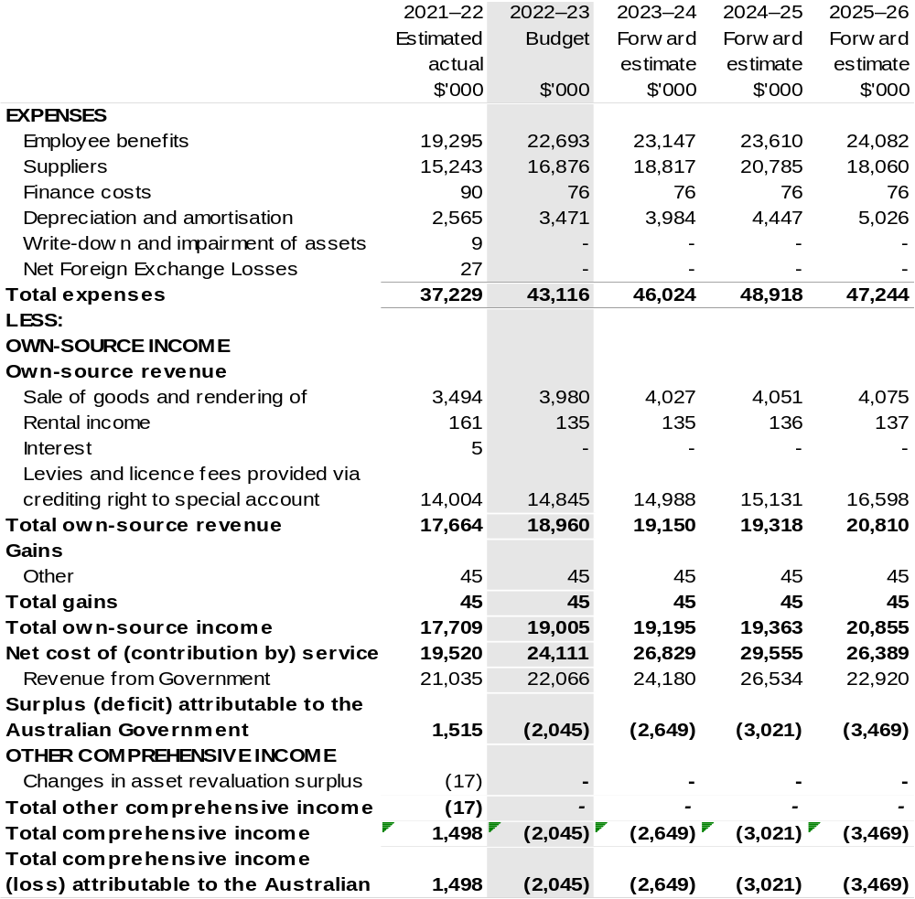

Continued on following page

Table 3.1: Comprehensive income statement (showing net cost of services) (for the period ended 30 June) (continued)
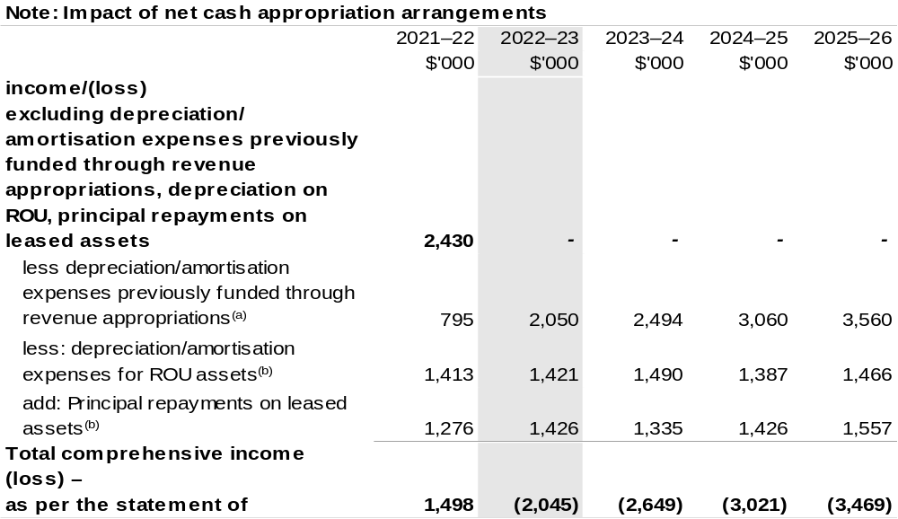

(a) From 2010–11, the Government introduced net cash appropriation arrangements where Appropriation
Bill (No. 1) revenue appropriations for the depreciation/amortisation expenses of non-corporate Commonwealth entities (and select corporate Commonwealth entities) were replaced with a separate capital budget (the Departmental Capital Budget, or DCB) provided through Appropriation Bill (No. 1) equity appropriations. For information regarding DCBs, please refer to Table 3.5 Departmental Capital Budget Statement.
- Applies to leases under AASB 16 Leases. Right of Use (ROU).

Prepared on Australian Accounting Standards basis.

Table 3.2: Budgeted departmental balance sheet (as at 30 June)
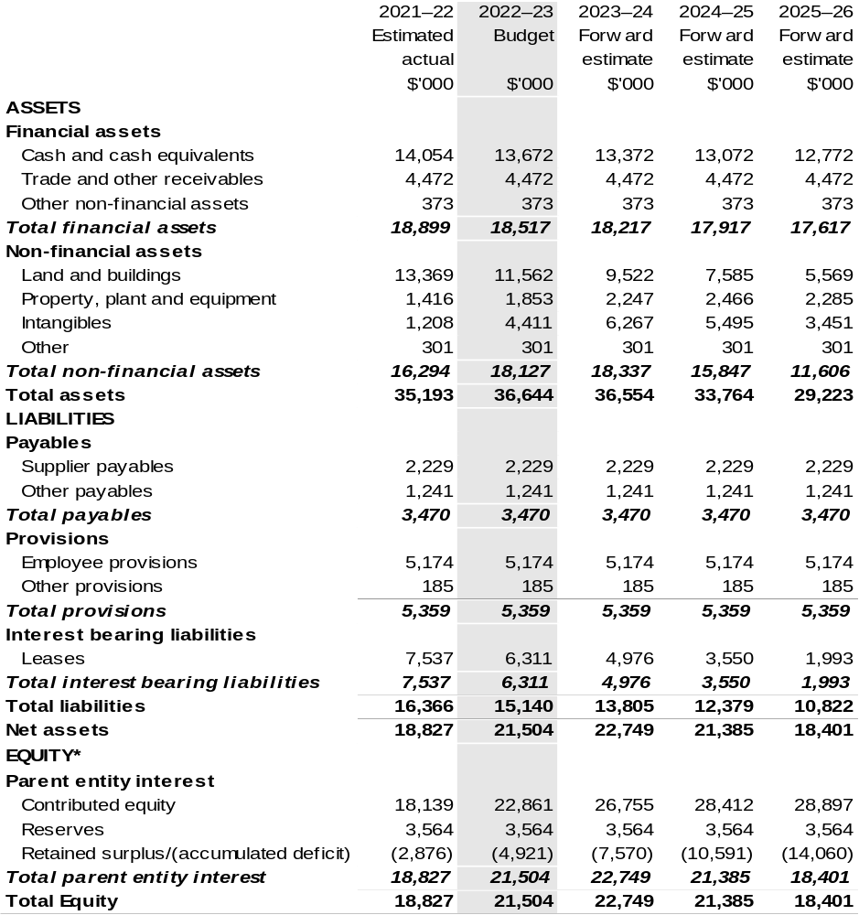

*’Equity’ is the residual interest in assets after deduction of liabilities.

Prepared on Australian Accounting Standards basis.

Table 3.3: Departmental statement of changes in equity — summary of movement (Budget year 2022–23)
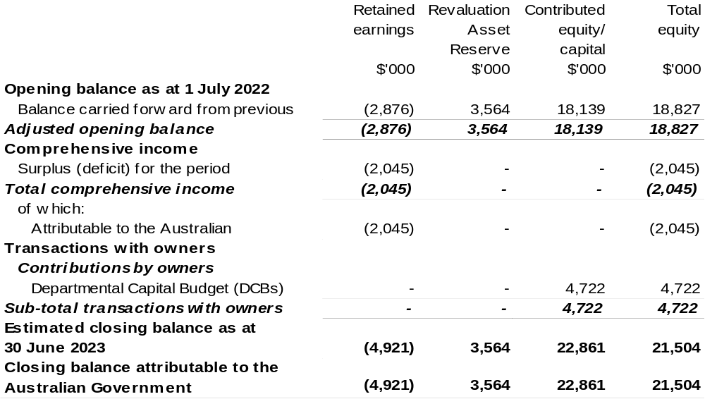

Prepared on Australian Accounting Standards basis.

Table 3.4: Budgeted departmental statement of cash flows (for the period
ended 30 June)
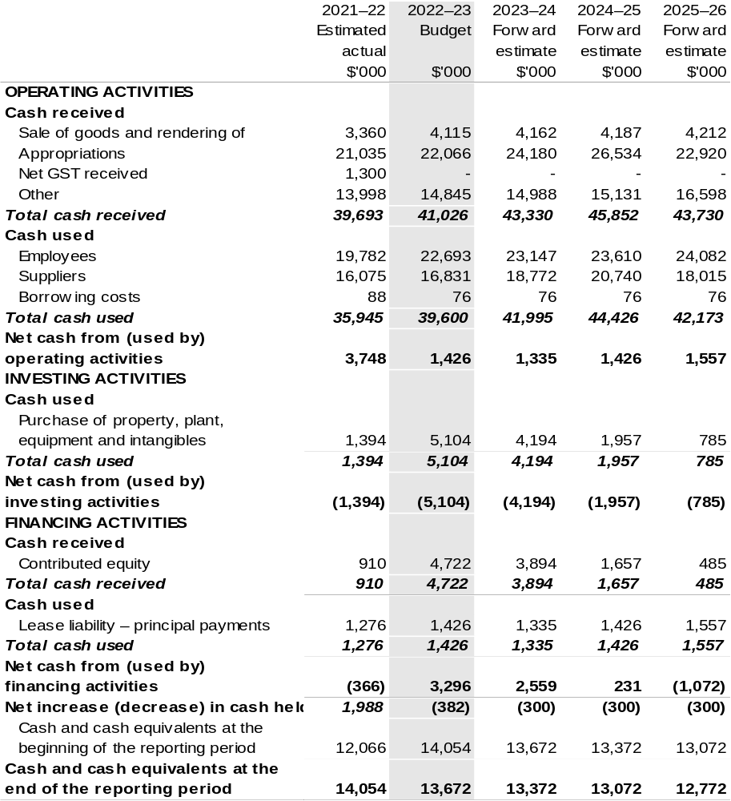

Prepared on Australian Accounting Standards basis.

Table 3.5: Departmental capital budget statement (for the period ended 30 June)
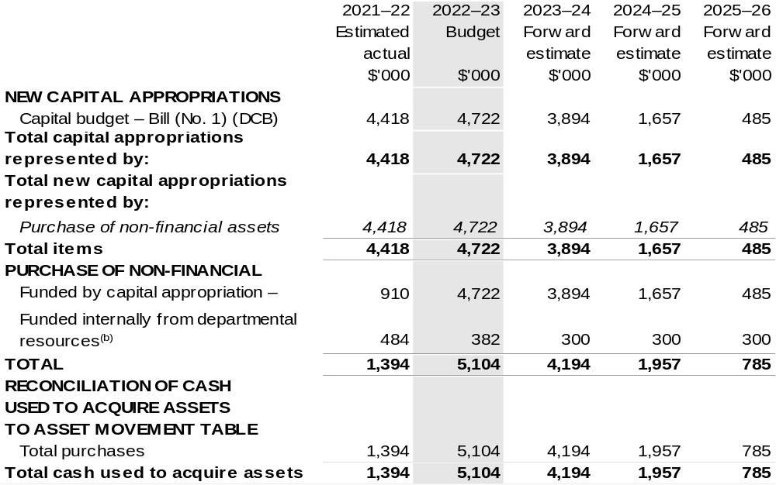

(a) Does not include annual finance lease costs. Include purchases from current and previous years Departmental Capital Budgets (DCBs).
(b) Includes the following s74 external revenue:
– current Bill (No. 1) and prior year Act/Bill (No. 1/3/5) appropriations (excluding amounts from the DCBs);
– sponsorship, subsidy, gifts or similar contribution;
– internally developed assets;
– proceeds from the sale of assets; and
– the AFMA Special Account under s 94B of the Fisheries Administration Act 1991.

Consistent with information contained in the Statement of Asset Movements and the Budgeted Statement of Cash Flows.

Prepared on Australian Accounting Standards basis.`

Table 3.6: Statement of departmental asset movements (Budget year 2022–23)
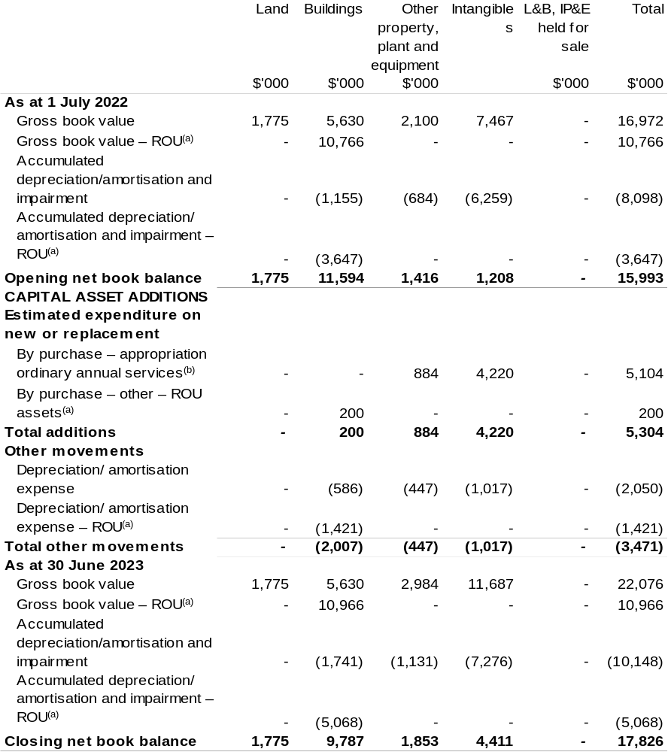

(a) Applies to leases under AASB 16 Leases. Right of Use (ROU).
(b) 'Appropriation ordinary annual services' refers to funding provided through Appropriation Bill (No.1)
2022 –23 for Departmental Capital Budget or other operational expenses.

Prepared on Australian Accounting Standards basis.

Table 3.7: Schedule of budgeted income and expenses administered on behalf of Government (for the period ended 30 June)
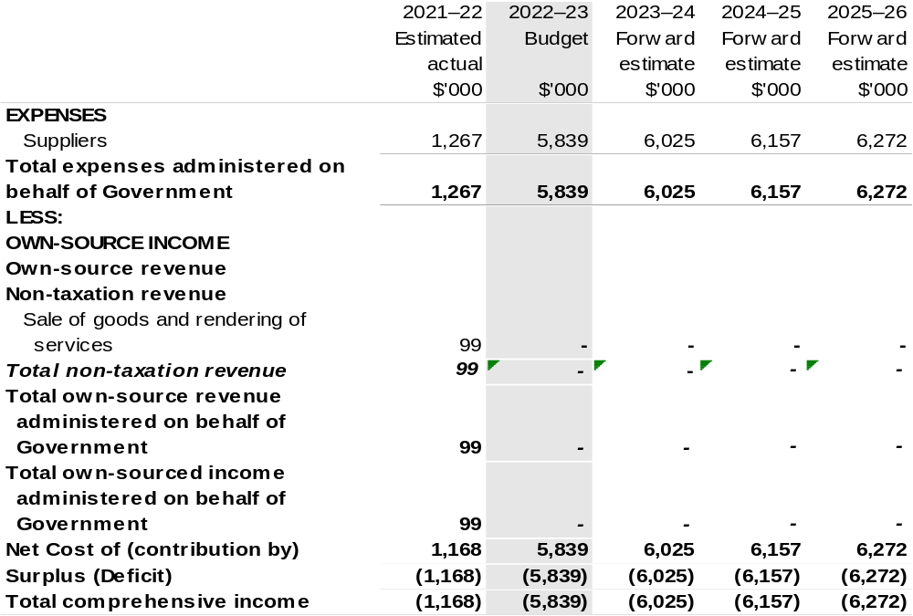

Prepared on Australian Accounting Standards basis.

Table 3.8: Schedule of budgeted assets and liabilities administered on behalf of Government (as at 30 June)
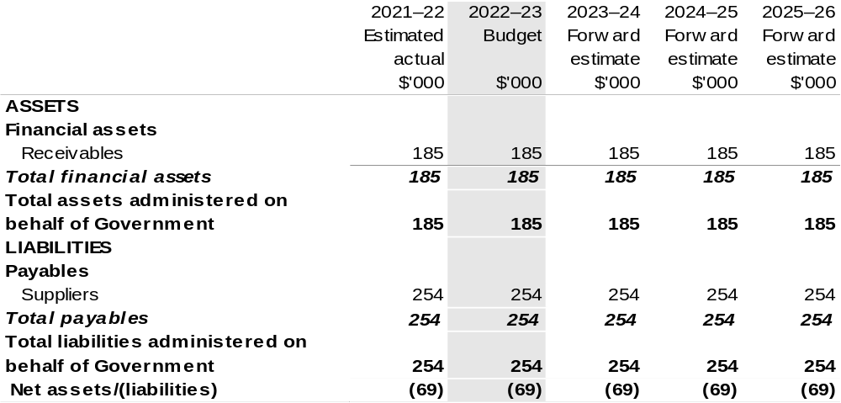

Prepared on Australian Accounting Standards basis.

Table 3.9: Schedule of budgeted administered cash flows (for the period
ended 30 June)
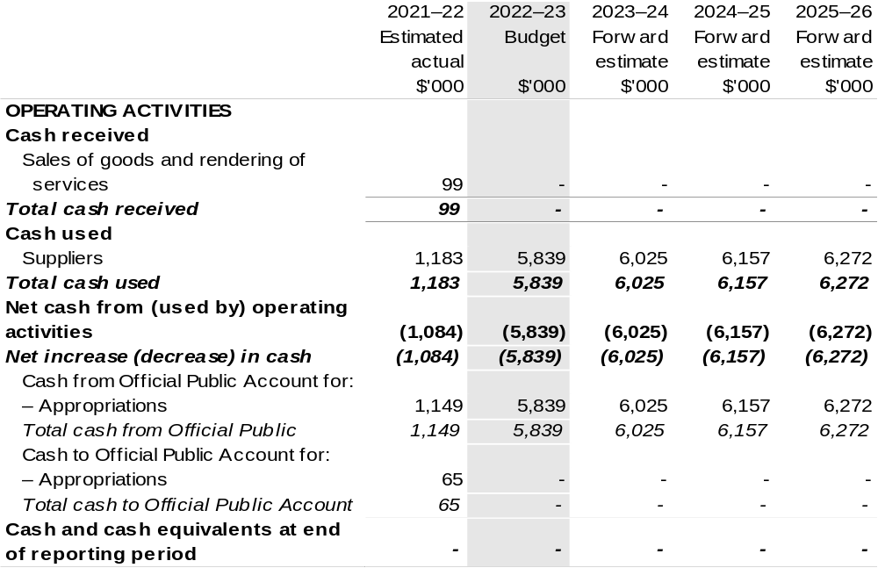

Prepared on Australian Accounting Standards basis.

Table 3.10: Statement of administered asset movements (Budget year 2022–23)

The schedule of administered asset movements on behalf of Government is nil.

Table 3.6: Statement of departmental asset movements (Budget year 2022–23)
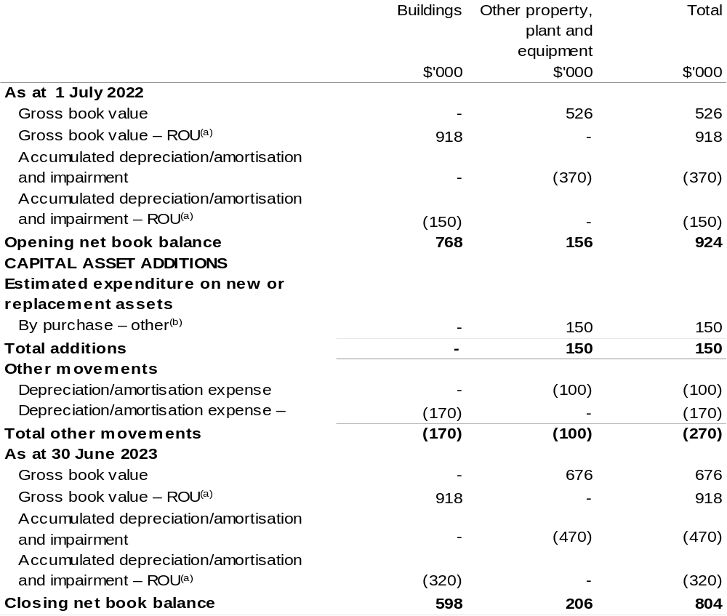

(a) Applies to leases under AASB 16 Leases. Right of Use (ROU).
(b) ‘By purchase – other’ refers to funding provided through other internal funding sources.

Prepared on Australian Accounting Standards basis.

Australian Pesticides and Veterinary Medicines Authority
Section 1: Entity overview and resources 143
1.1 Strategic direction statement 143
1.2 Entity resource statement 144
1.3 Budget measures 146
Section 2: Outcomes and planned performance 147
2.1 Budgeted expenses and performance for Outcome 1 148
Section 3: Budgeted financial statements 151
3.1 Budgeted financial statements 151
3.2 Budgeted financial statements tables 152

Australian Pesticides and Veterinary Medicines Authority

Section 1: Entity overview and resources

1.1 Strategic direction statement
The Australian Pesticides and Veterinary Medicines Authority (APVMA) is established under the Agricultural and Veterinary Chemicals (Administration) Act 1992 (Administration Act). The APVMA’s principal responsibilities are described in the Administration Act and the Agricultural and Veterinary Chemicals Code Act 1994.
APVMA regulates the supply of safe and effective agricultural and veterinary (agvet) chemicals in Australia. Robust risk assessment methods are used to scientifically evaluate new and existing pesticides and veterinary medicines. Through efficient and effective regulation, the APVMA ensures the registration of agvet chemical products, delivers appropriate protections for human health and safety, animals and the environment, and supports international trade.
APVMA’s regulatory responsibility extends from registration and manufacturing through to the point of sale. By agreement, the states and territories are then responsible for regulating and monitoring how agvet chemicals are used.
We will build on the adaptive and flexible response adopted during the COVID-19 pandemic and continue to deliver regulatory services through collaborative and innovative work practices.
We will work to minimise cost recovery charges, consistent with the Australian Government Cost Recovery Guidelines, through the efficient implementation of cost recovered activities.

1.2 Entity resource statement
Table 1.1 shows the total funding from all sources available to the entity for its operations and to deliver programs and services on behalf of the Government.
The table summarises how resources will be applied by outcome (Government strategic policy objectives) and by administered (on behalf of the Government or the public) and departmental (for the entity’s operations) classification.
For more detailed information on special accounts and special appropriations, please refer to October Budget Paper No. 4: Agency Resourcing.
Information in this table is presented on a resourcing (i.e. appropriations/cash available) basis, whilst the ‘Budgeted expenses by Outcome’ tables in Section 2 and the financial statements in Section 3 are presented on an accrual basis.

Table 1.1: Australian Pesticides and Veterinary Medicines Authority – Resource Statement – Budget Estimates for 2022–23 as at October Budget 2022
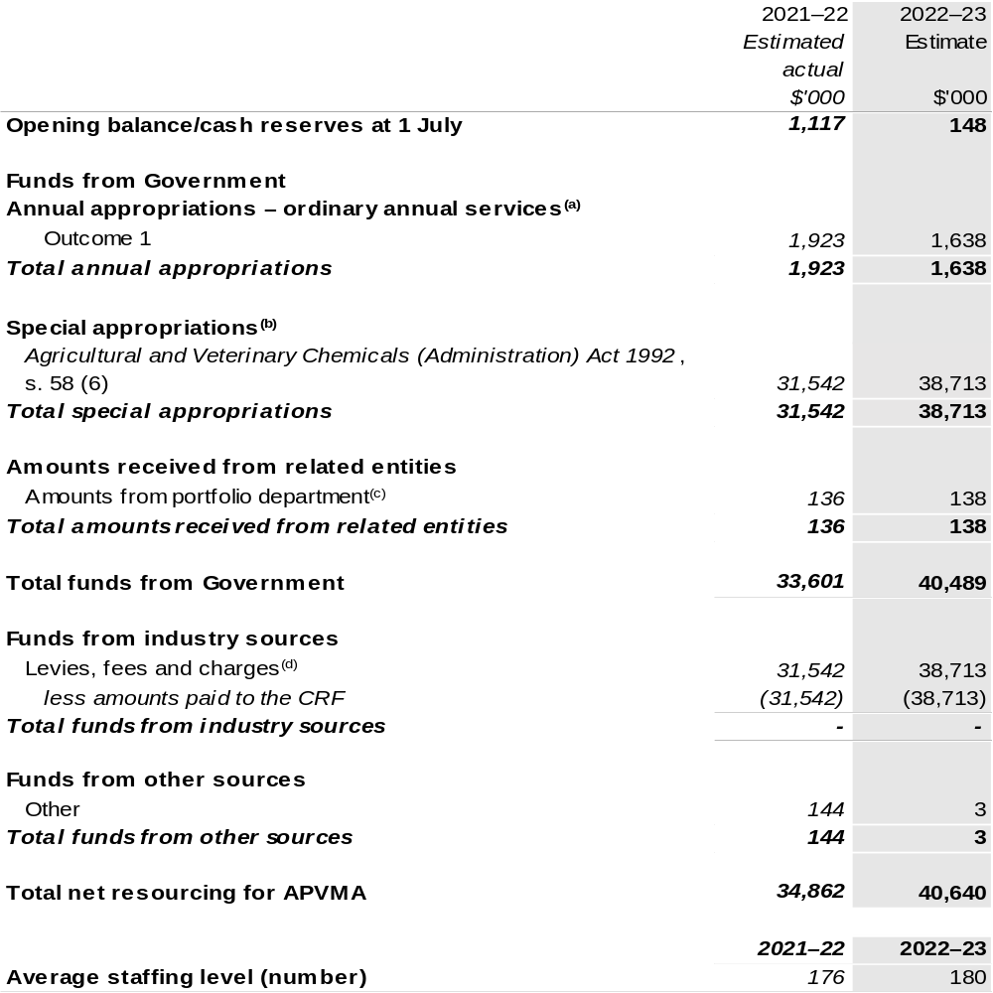
(a) Appropriation Bill (No. 1) 2022–23, Supply Bill (No. 3) 2022–23 and Supply Act (No. 1) 2022–23. Appropriation is provided through the Department of Agriculture, Fisheries and Forestry (DAFF) and is specified within the Annual Appropriation Bills as a payment to APVMA and is considered departmental for all purposes.
(b) APVMA’s special appropriation is not directly appropriated as it is a corporate Commonwealth entity (CCE) under the Public Governance, Performance and Accountability Act 2013 (PGPA Act). Appropriations are made to DAFF and are then paid to APVMA and are considered departmental for all purposes.
(c) Funding provided by the portfolio department that is not specified within the Annual Appropriation Bills as a payment to that CCE (for example, a grant awarded to a CCE from one of its portfolio department's administered programs).
(d) These charges are imposed by the Agricultural and Veterinary Chemicals Code Act 1994 and the Agricultural and Veterinary Chemical Products (Collection of Levy) Act 1994. They are collected by APVMA and transferred to the Consolidated Revenue Fund (CRF). These amounts are then drawn down by the department as a special appropriation under the Administration Act.
Please note: All figures shown above are GST exclusive – these may not match figures in the cash flow
statement.
Prepared on a resourcing (i.e. appropriations available) basis.

1.3 Budget measures
Budget measures in Part 1 relating to the Australian Pesticides and Veterinary Medicines Authority are detailed in October Budget Paper No. 2 and are summarised below.

Table 1.2: Australian Pesticides and Veterinary Medicines Authority – October 2022–23 Budget Measures

Part 1: Measures announced since the March 2022–23 Budget
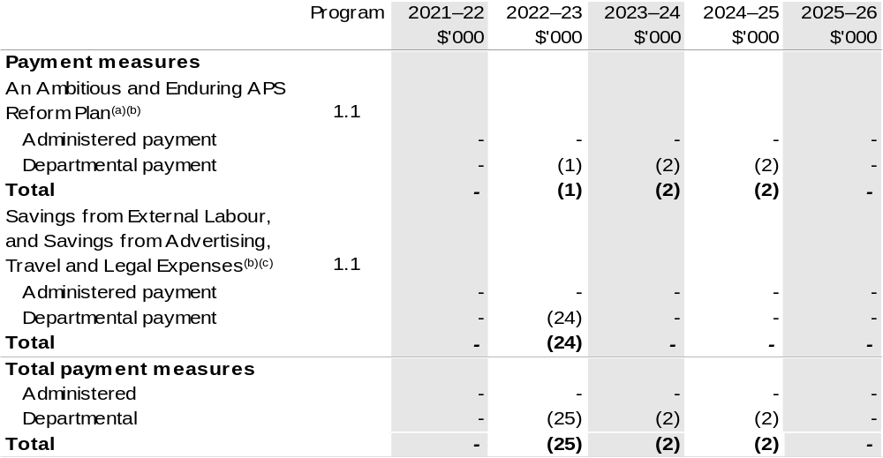

(a) The measure description appears in October Budget Paper No. 2: Budget Measures 2022–23 under the Prime Minister and Cabinet Portfolio section.
(b) Funding for this measure passes through DAFF to APVMA.
(c) The measure description appears in October Budget Paper No. 2: Budget Measures 2022–23 under the Cross Portfolio section.

Prepared on a Government Finance Statistics (Underlying Cash) basis.

Figures displayed as a negative (-) represent a decrease in funds and a positive (+) represent an increase in funds.

Section 2: Outcomes and planned performance
Government outcomes are the intended results, impacts or consequences of actions by the Government on the Australian community. Commonwealth programs are the primary vehicle by which government entities achieve the intended results of their outcome statements. Entities are required to identify the programs which contribute to Government outcomes over the Budget and forward years.
Each outcome is described below together with its related programs. The following provides detailed information on expenses for each outcome and program, further broken down by funding source.
Note:
Performance reporting requirements in the Portfolio Budget Statements are part of the Commonwealth performance framework established by the Public Governance, Performance and Accountability Act 2013. It is anticipated that the performance criteria described in Portfolio Budget Statements will be read with broader information provided in an entity’s corporate plans and annual performance statements – included in Annual Reports – to provide a complete picture of an entity’s planned and actual performance.
APVMA’s most recent corporate plan can be found at: https://apvma.gov.au/node/101686.
APVMA’s most recent annual performance statement can be found at:
https://apvma.gov.au/node/92371 in chapter 3.

2.1 Budgeted expenses and performance for Outcome 1
Outcome 1: Protection of the health and safety of people, animals, the environment, and agricultural and livestock industries through regulation of pesticides and veterinary medicines.

2.1.1: Linked programs
Department of Agriculture, Fisheries and Forestry
Program 1.10: Agricultural Resources
Contribution to Outcome 1 made by linked programs:
APVMA and DAFF work together to ensure the protection of the health and safety of humans, animals and the environment.

2.1.2: Budgeted expenses for Outcome 1
This table shows how much the entity intends to spend (on an accrual basis) on achieving the outcome, broken down by program, as well as by administered and departmental funding sources.

Table 2.1: Budgeted expenses for Outcome 1
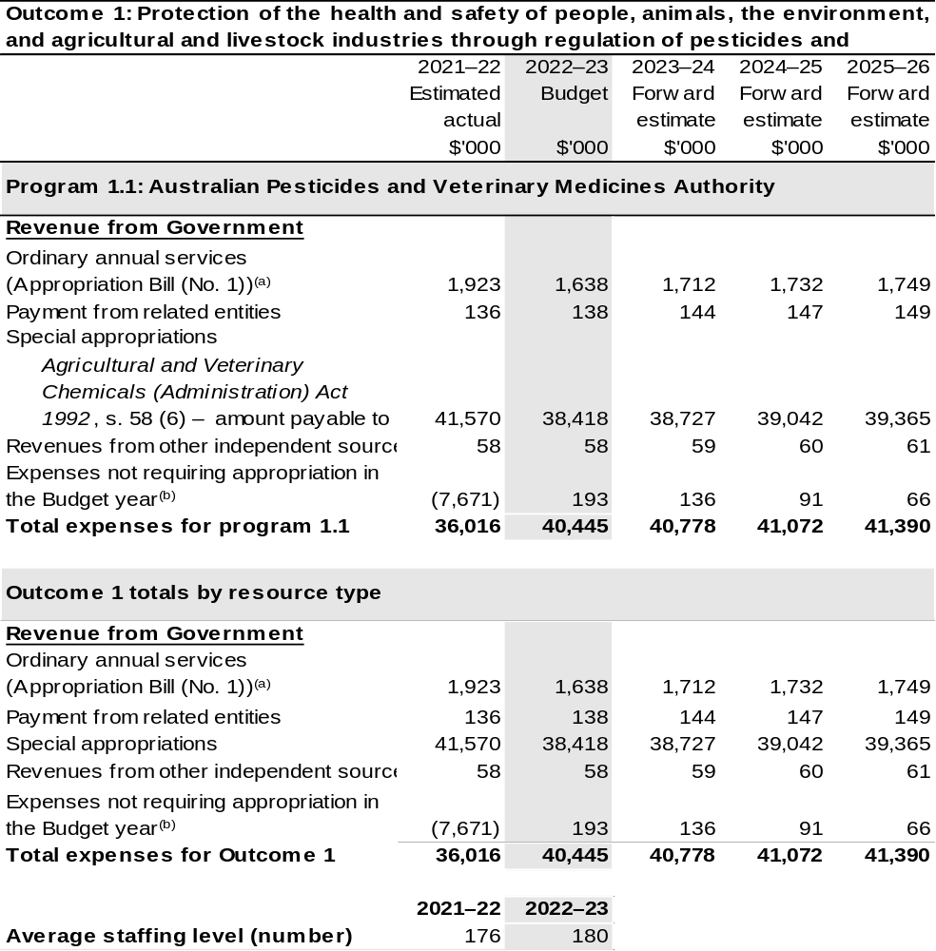

(a) Appropriation Bill (No. 1) 2022–23, Supply Bill (No. 3) 2022–23 and Supply Act (No. 1) 2022–23.
APVMA is CCE under the PGPA Act and does not receive direct appropriations. Appropriation is provided through DAFF and is specified with the Annual Appropriation Bills as payment to APVMA and is considered departmental for all purposes.
(b) Expenses not requiring appropriation in the budget year are made up of make good expenses, audit fees, and can include depreciation / amortisation expenses not requiring an appropriation.

Note: Departmental appropriation splits and totals are indicative estimates and may change in the course of the budget year as government priorities change.

Prepared on Australian Accounting Standards basis.

Table 2.2: Performance measure for Outcome 1
Table 2.2 details the performance measures for each program associated with Outcome 1. It also provides the related key activities as expressed in the current corporate plan where further detail is provided about the delivery of the activities related to the program, the context in which these activities are delivered and how the performance of these activities will be measured. Where relevant, the October 2022–23 Budget measures that have created new programs or materially changed existing programs are provided.
Outcome 1: Protection of the health and safety of people, animals, the environment, and agricultural and livestock industries through regulation of pesticides and veterinary medicines.
Program 1.1: Australian Pesticides and Veterinary Medicines Authority
Objective | APVMA regulates agricultural and veterinary chemicals to manage the risks of pests and diseases for the Australian community and to protect Australia’s trade and the health and safety of people, animals and the environment.
Key Activities | Regulation of agricultural and veterinary chemicals is delivered through  4 mechanisms:  Risk-based assessment and registration of pesticides and veterinary chemicals  - Identification and resolution of non-compliance up to and including the point of retail sale  - Licence and audit veterinary manufacturers  - Identification and review of the safety of existing chemicals of regulatory concern.
Year | Performance measures | Expected Performance Results
Prior year  2021–22 | Percentage of applications finalised within statutory timeframes. | 97 per cent.
Year | Performance measures | Planned Performance Results
Budget Year  2022–23 | As per 2021–22. | 100 per cent.
Forward Estimates  2023–26 | As per 2022–23. | 100 per cent.

Section 3: Budgeted financial statements
Section 3 presents budgeted financial statements which provide a comprehensive snapshot of entity finances for the 2022–23 budget year, including the impact of budget measures and resourcing on financial statements.

3.1 Budgeted financial statements

3.1.1: Differences between entity resourcing and financial statements
The resourcing statement is prepared on a cash basis. The financial statements are prepared on an accrual basis. Differences between the resourcing and financial statements represent timing differences between revenue recognition and cash received.

3.1.2: Explanatory notes and analysis of budgeted financial statements
No significant updates have been made to the budget or forward estimates since the March Budget. The following tables now present the final results for the 2021–22 financial year.

3.2 Budgeted financial statements tables

Table 3.1: Comprehensive income statement (showing net cost of services)
(for the period ended 30 June)
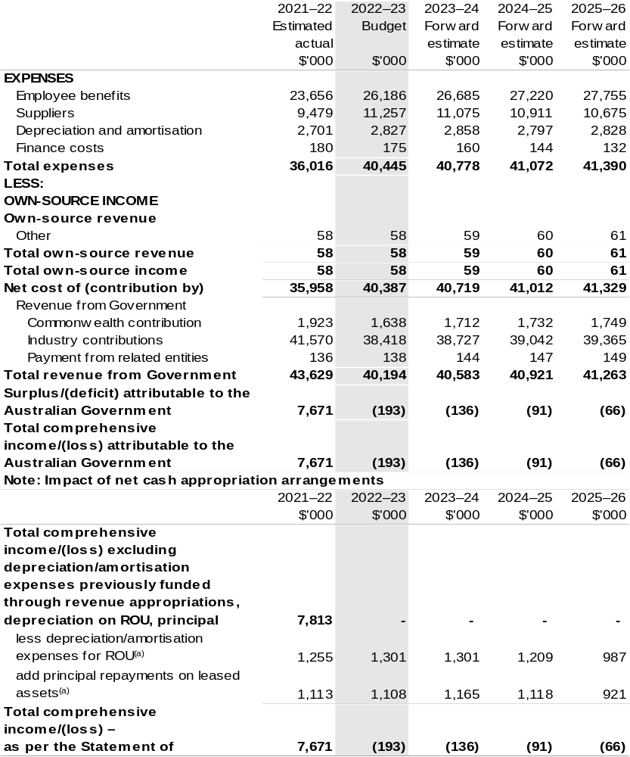

(a) Applies to leases under AASB 16 Leases. Right of Use (ROU).

Prepared on Australian Accounting Standards basis.

Table 3.2: Budgeted departmental balance sheet (as at 30 June)
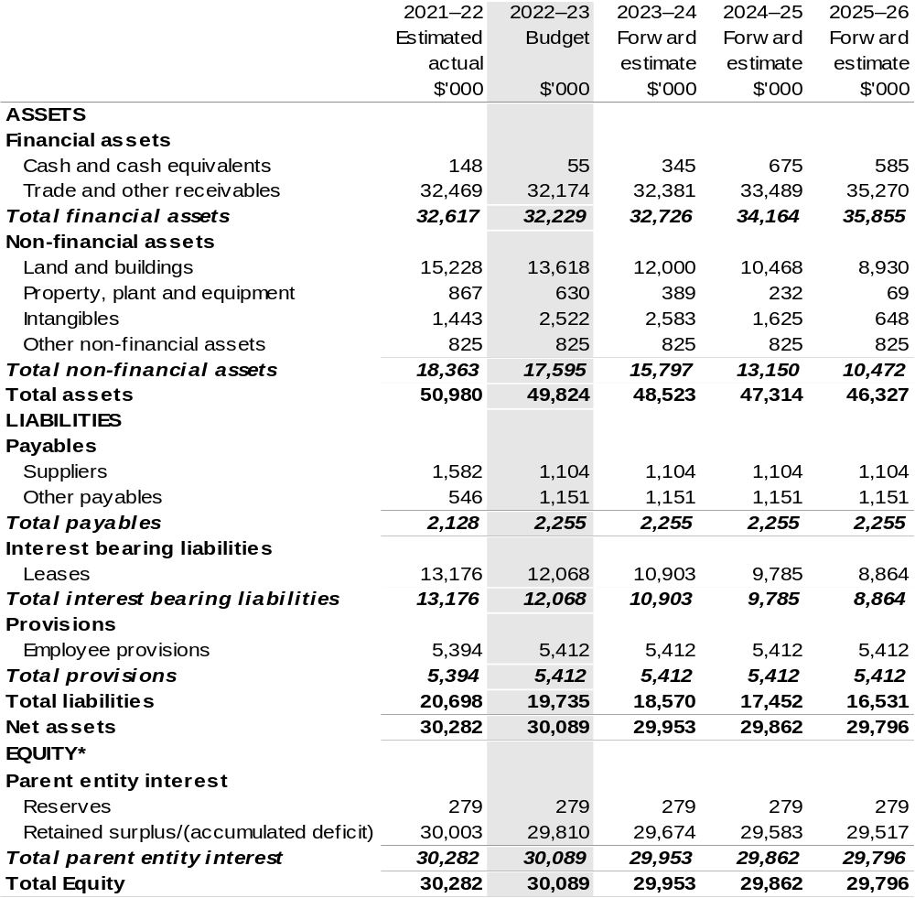

*’Equity’ is the residual interest in assets after deduction of liabilities.

Prepared on Australian Accounting Standards basis.

Table 3.3: Departmental statement of changes in equity — summary of movement (Budget year 2022–23)
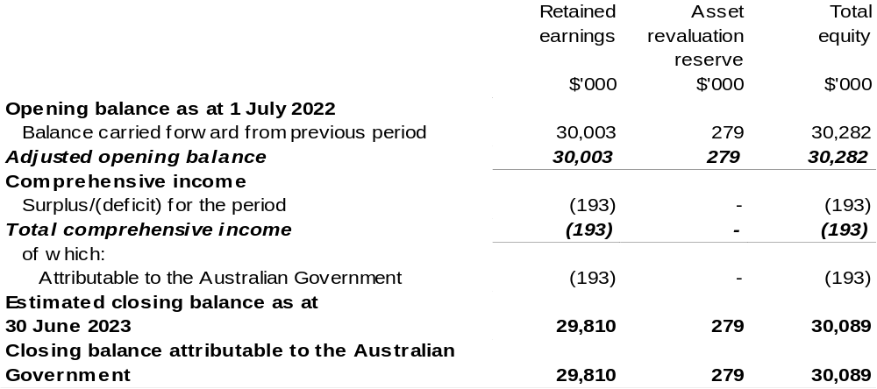

Prepared on Australian Accounting Standards basis.

Table 3.4: Budgeted departmental statement of cash flows (for the period
ended 30 June)
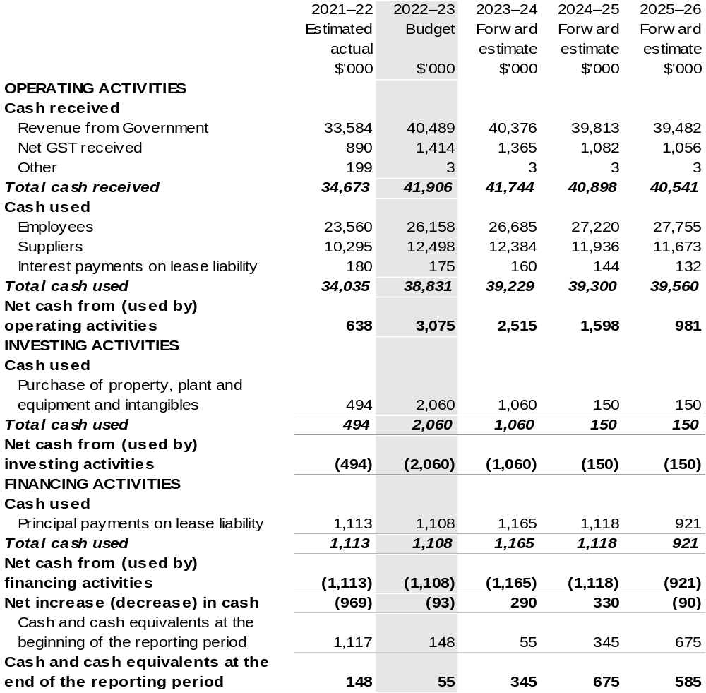

Prepared on Australian Accounting Standards basis.

Table 3.5: Departmental capital budget statement (for the period ended 30 June)
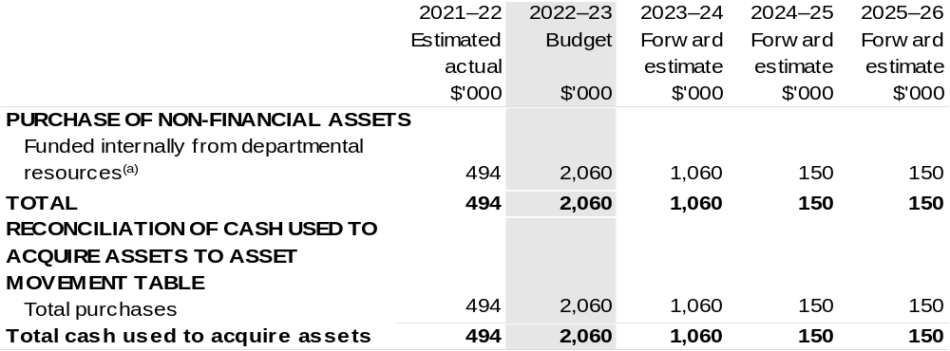

(a) Includes the following s74 external revenue:
– internally developed assets;
– proceeds from the sale of assets.

Consistent with information contained in the Statement of Asset Movements and the Budgeted Statement of Cash Flows.

Prepared on Australian Accounting Standards basis.

Table 3.6: Statement of departmental asset movements (Budget year 2022–23)
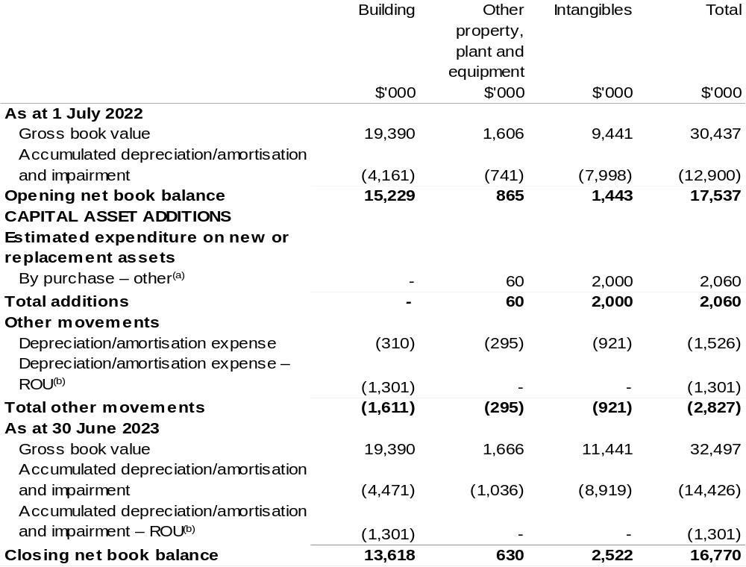

(a) 'By purchase – other' refers to funding provided through other internal funding sources.
(b) Applies to leases under AASB 16 Leases. Right of Use (ROU).

Prepared on Australian Accounting Standards basis.

Cotton Research and Development Corporation
Section 1: Entity overview and resources 161
1.1 Strategic direction statement 161
1.2 Entity resource statement 163
1.3 Budget measures 165
Section 2: Outcomes and planned performance 166
2.1 Budgeted expenses and performance for Outcome 1 167
Section 3: Budgeted financial statements 173
3.1 Budgeted financial statements 173
3.2 Budgeted financial statements tables 175

Cotton Research and Development Corporation

Section 1: Entity overview and resources

1.1 Strategic direction statement
The Cotton Research and Development Corporation (CRDC) delivers outcomes in cotton research, development and extension (RD&E) on behalf of Australia’s cotton growers and the Australian Government.
Established in October 1990 and operating under the Primary Industries Research and Development Act 1989 (PIRD Act), CRDC exists to power the success of Australian cotton through investment in, and delivery of, cotton RD&E. CRDC is based in Narrabri, New South Wales: the heart of one of Australia's major cotton-growing regions and home to the Australian Cotton Research Institute.
Cotton is a major contributor to the economic, environmental and social fabric of rural Australia. Predominately grown in New South Wales and Queensland, with expansion into northern Australia, cotton is a major employer and contributor to the local, state and national economy. The industry generates significant wealth and provides an economic foundation to these regions and their communities, employing some 10,000 people. Cotton is a valuable agricultural export commodity, generating an average of $2.3 billion in export revenue annually over the last five years.
CRDC’s role is to invest in RD&E on behalf of cotton growers and the Government, with the outcomes boosting the productivity and profitability of industry. RD&E, and its resulting innovations, are a key driving force behind the cotton industry’s continued success. CRDC’s ultimate aim is to deliver increased economic, social and environmental benefits for the Australian cotton industry, and the wider community, by investing in knowledge, innovation and its adoption.
CRDC’s investments are governed by a five-year strategic plan, with 2022–23 being the fifth year under CRDC’s 2018–23 Strategic Plan. The strategic plan provides an ambitious roadmap for CRDC’s investments.
CRDC’s aim through the plan is to contribute to creating $2 billion in additional gross value of cotton production for the benefit of Australian cotton growers and the wider community.
The plan has five key areas of focus:
- Increasing productivity and profitability on Australian cotton farms
- Improving cotton farming sustainability and value chain competitiveness
- Building the adaptive capacity of the Australian cotton industry
- Strengthening partnerships and adoption
- Driving RD&E impact.
To help achieve this, Australia cotton growers and the Australia Government will
co-invest $18.8 million into cotton RD&E during 2022–23, across these key focus areas.

1.2 Entity resource statement
Table 1.1 shows the total funding from all sources available to the entity for its operations and to deliver programs and services on behalf of the Government.
The table summarises how resources will be applied by outcome (Government strategic policy objectives) and by administered (on behalf of the Government or the public) and departmental (for the entity’s operations) classification.
For more detailed information on special accounts and special appropriations, please refer to October Budget Paper No. 4: Agency Resourcing.
Information in this table is presented on a resourcing (that is, appropriations/cash available) basis, whilst the ‘Budgeted expenses by Outcome’ table in Section 2 and the financial statements in Section 3 are presented on an accrual basis.

Table 1.1: Cotton Research and Development Corporation – Resource Statement – Budget Estimates for 2022–23 as at October Budget 2022
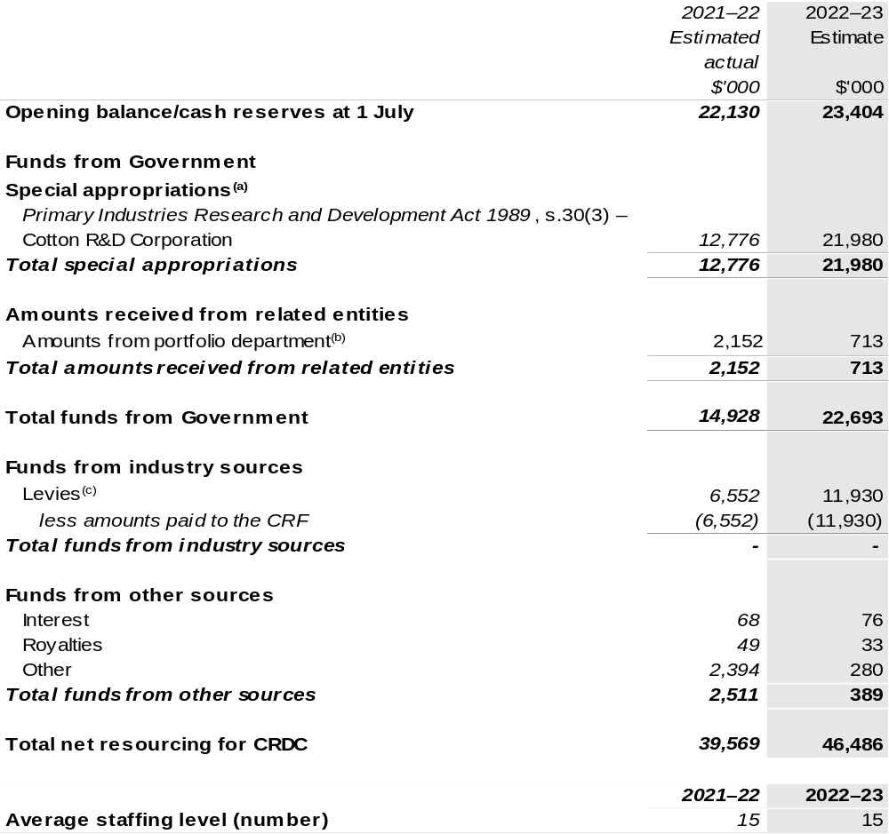
(a) CRDC's special appropriation is not directly appropriated as it is a corporate Commonwealth entity (CCE) under the Public Governance, Performance and Accountability Act 2013 (PGPA Act). Appropriations are made to the Department of Agriculture, Fisheries and Forestry (DAFF) and are then paid to CRDC and are considered departmental for all purposes.
(b) Funding provided by the portfolio department that is not specified within the Annual Appropriation Bills as a payment to that CCE (for example, a grant awarded to a CCE from one of its portfolio department's administered programs).
(c) The levies are imposed by the Primary Industries (Excise) Levies Act 1999. The levies are collected by DAFF under the Primary Industries Levies and Charges Collection Act 1991 and transferred to the Consolidated Revenue Fund (CRF). These amounts are then drawn down by the department as a special appropriation and paid to CRDC under the Primary Industries Research and Development Act 1989 (PIRD Act), s. 30(3) – Cotton R&D Corporation.

Please note: All figures shown above are GST exclusive – these may not match figures in the cash flow statement.

Prepared on a resourcing (i.e. appropriations available) basis.

1.3 Budget measures
Budget measures in Part 1 relating to the Cotton Research and Development Corporation are detailed in October Budget Paper No. 2 and are summarised below.

Table 1.2: Cotton Research and Development Corporation – October 2022–23 Budget Measures

Part 1: Measures announced since the March 2022–23 Budget

CRDC does not have any October 2022–23 Budget measures.

Section 2: Outcomes and planned performance
Government outcomes are the intended results, impacts or consequences of actions by the Government on the Australian community. Commonwealth programs are the primary vehicle by which government entities achieve the intended results of their outcome statements. Entities are required to identify the programs which contribute to Government outcomes over the Budget and forward years.
Each outcome is described below together with its related programs. The following provides detailed information on expenses for each outcome and program, further broken down by funding source.
Note:
Performance reporting requirements in the Portfolio Budget Statements are part of the Commonwealth performance framework established by the Public Governance, Performance and Accountability Act 2013. It is anticipated that the performance criteria described in Portfolio Budget Statements will be read with broader information provided in an entity’s corporate plans and annual performance statements – included in Annual Reports – to provide a complete picture of an entity’s planned and actual performance.
The most recent corporate plan for the Cotton Research and Development Corporation can be found at: www.crdc.com.au/publications/crdc-strategic-plan.
The most recent annual performance statement for the Cotton Research and Development Corporation can be found at:
www.crdc.com.au/publications/crdc-annual-report.

2.1 Budgeted expenses and performance for Outcome 1
Outcome 1: Adoption of innovation that leads to increased productivity, competitiveness and environmental sustainability through investment in research and development that benefits the Australian cotton industry and the wider community.

2.1.1: Linked programs
Department of Agriculture, Fisheries and Forestry
Program 1.10: Agricultural Resources
Contribution to Outcome 1 made by linked program:
CRDC works together with DAFF to ensure a sustainable, productive and profitable cotton industry.

2.1.2: Budgeted expenses for Outcome 1
This table shows how much the entity intends to spend (on an accrual basis) on achieving the outcome, broken down by program, as well as by administered and departmental funding sources.

Table 2.1: Budgeted expenses for Outcome 1
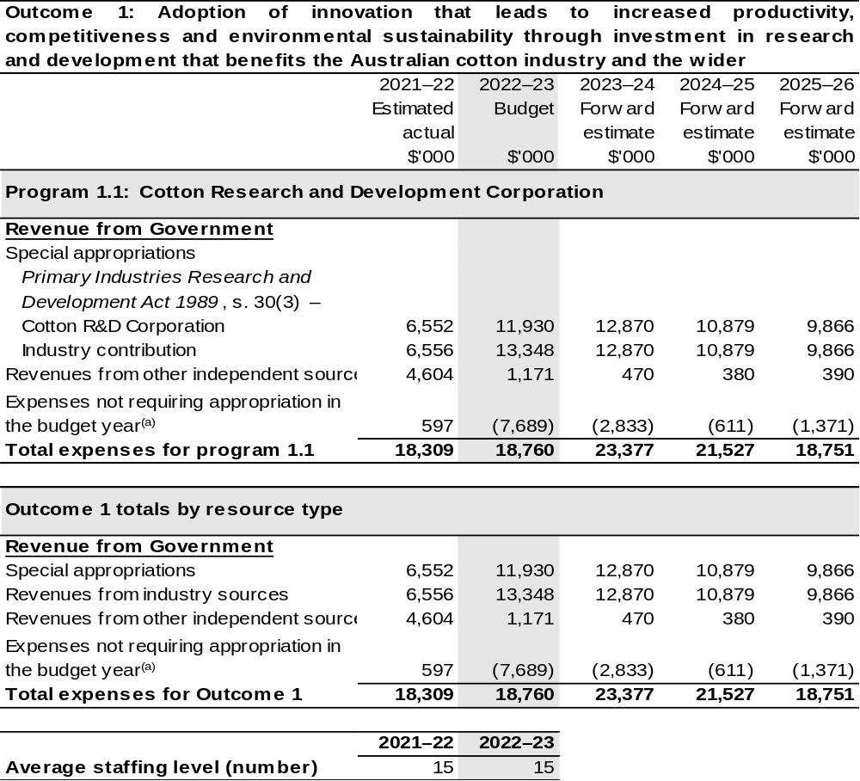
(a) Expenses not requiring appropriation in the budget year are made up of make good expenses, audit fees, and can include depreciation / amortisation expenses not requiring an appropriation.

Note: Departmental appropriation splits and totals are indicative estimates and may change in the course of the budget year as government priorities change.

Prepared on Australian Accounting Standards basis.

Table 2.2: Performance measure for Outcome 1
Table 2.2 details the performance measures for each program associated with Outcome 1. It also provides the related key activities as expressed in the current corporate plan where further detail is provided about the delivery of the activities related to the program, the context in which these activities are delivered and how the performance of these activities will be measured. Where relevant, the October 2022–23 Budget measures that have created new programs or materially changed existing programs are provided.
As an entity established under the PIRD Act, CRDC does not produce a Corporate Plan under the PGPA Act and is therefore exempt from the requirement to map purposes to outcomes.
Outcome 1: Adoption of innovation that leads to increased productivity, competitiveness and environmental sustainability through investment in research and development that benefits the Australian cotton industry and the wider community.
Program 1.1: Cotton Research and Development Corporation
Objective 1 | Increase productivity and profitability on cotton farms  Deliver RD&E for cotton producers to increase productivity, successfully protect crops from biotic threats and environmental stresses, adopt transformative technologies and innovate for improved profitability.
Key Activities 1 | Strategically prioritise investment in basic, applied and blue-sky research collaboratively with research and cross-sectoral partners to develop new knowledge, practices and adapt transformative technologies for on-farm application that also protect industry from biotic threats and environmental stresses.
Year | Performance measures | Expected Performance Results
Prior year  2021–22 | Improved yield and quality. | Annual increase of 0.35 bales per hectare for irrigated cotton and 0.14 bales per hectare for dryland cotton.  On target for irrigated cotton.  The rolling five-year target for dryland cotton is less than the target due to the influence of drought however the 2021–22 yield was above target.

Continued on following pages
Table 2.2: Performance measure for Outcome 1 (continued)
Objective 1 | (continued)
Year | Performance measures | Planned Performance Results
Budget Year 2022–23 | As per 2021–22. | As per 2021–22.
Forward Estimates  2023–26 | As per 2022–23. | As per 2022–23.

Objective 2 | Improve cotton farming sustainability and value chain competitiveness  Deliver RD&E and innovation to create higher value uses for cotton and assist the industry achieve its ambition to be the highest yielding, finest, cleanest and most responsibly produced cotton in the world.
Key Activities 2 | Strategically prioritise investment in basic, applied and blue-sky research collaboratively with research, industry and cross-sectoral partners to develop new knowledge, practices, processes, higher value products and innovative approaches to improve the sustainability of cotton farming and strengthen value chain competitiveness.
Year | Performance measures | Expected Performance Results
Prior year  2021–22 | CRDC collaborates in global leadership for sustainability initiatives. | Participates in six global initiatives.  On target.
Year | Performance measures | Planned Performance Results
Budget Year 2022–23 | As per 2021–22. | As per 2021–22.
Forward Estimates  2023–26 | As per 2022–23. | As per 2022–23.

Continued on following pages
Table 2.2: Performance measure for Outcome 1 (continued)
Objective 3 | Build adaptive capacity of the cotton industry  Deliver RD&E to develop science and innovation capacity as well as new knowledge to strengthen adaptive capacity.
Key Activities 3 | Strategically prioritise investment in RD&E collaboratively with research, industry and cross-sectoral partners to develop new knowledge, future thinking, science and innovation capability.
Year | Performance measures | Expected Performance Results
Prior year  2021–22 | Science and innovation capacity is strengthened and strategically fit for a digital future. | Eight honours, eight PhD and two Post-doctoral researchers were supported in 2021–22.  On target.
Year | Performance measures | Planned Performance Results
Budget Year 2022–23 | As per 2021–22. | As per 2021–22.
Forward Estimates  2023–26 | As per 2022–23. | As per 2022–23.

Objective 4 | Strengthening partnerships and adoption  Deliver RD&E and innovation through collaborative partnerships to ensure adoption of best practice, new knowledge, products and services.
Key Activities 4 | Strategically prioritise investment in the effective adoption of research by strengthening partnerships and collaboration, development of best practice and supporting innovation and commercialisation.
Year | Performance measures | Expected Performance Results
Prior year  2021–22 | Partnerships are strengthened to engage multi-disciplinary and multi-institutional resources. | 42 per cent of annual RD&E investments are through cross sectoral partnerships.  On target.
Year | Performance measures | Planned Performance Results
Budget Year 2022–23 | As per 2021–22. | As per 2021–22.
Forward Estimates  2023–26 | As per 2022–23. | As per 2022–23.

Table 2.2: Performance measure for Outcome 1 (continued)
Objective 5 | Driving RD&E impact  Deliver assessments of the impact of CRDC’s RD&E investments that inform future investment direction and continuous improvement.
Key Activities 5 | Strategically prioritise investment in research, data capture, analysis and reviews with stakeholders and partners to demonstrate that RD&E investments deliver impact.
Year | Performance measures | Expected Performance Results
Prior year  2021–22 | CRDC monitors and evaluates RD&E impact. | One RD&E impact report per annum.  On target.
Year | Performance measures | Planned Performance Results
Budget Year 2022–23 | As per 2021–22. | As per 2021–22.
Forward Estimates  2023–26 | As per 2022–23. | As per 2022–23.

Section 3: Budgeted financial statements
Section 3 presents budgeted financial statements which provide a comprehensive snapshot of entity finances for the 2022–23 budget year, including the impact of budget measures and resourcing on financial statements.

3.1 Budgeted financial statements

3.1.1: Differences between entity resourcing and financial statements
The resourcing statement is prepared on a cash basis. The financial statements are prepared on an accrual basis. Differences between the resourcing and financial statements represent timing differences between revenue recognition and cash received.

3.1.2: Explanatory notes and analysis of budgeted financial statements
Budgeted Comprehensive Income Statement
Variability in CRDC’s revenue and expenditure is a result of significant fluctuations in the production of Australian cotton each year. Cotton production has been as low as 0.6 million bales in 2008 and 2020, as high as 5.4 million bales in 2012 and is estimated to be 5.5 million bales in 2022–23.
Revenue from industry levies and matching contributions from the Australian Government are determined by the level of cotton production and represent more than 74 per cent of total revenue. Since 2008–09 CRDC’s revenue has fluctuated between $7.7 million and $31.4 million per annum.
The impact of a highly variable revenue stream on CRDC’s investment in RD&E is minimised by managing cash reserves. During periods of high revenue CRDC builds up reserves by operating in surplus. During periods of low revenue CRDC draws on reserves by operating under approved deficits. This financial strategy allows CRDC to maintain a more consistent level of RD&E expenditure each year.
Matching contributions from the Australian Government are determined by either the value of industry levies collected or 0.5 per cent of the cotton industry’s three-year average gross value of production. Which limit will apply depends on the price of cotton, timing of the harvest and ginning and the variability of the crop size. Royalties, interest on investments, external grant revenue and research project refunds make up the balance of the CRDC’s income.

To achieve the strategic priorities of the research and development (R&D) plan for the period 2018–23, CRDC planned to invest a total of $125.0 million for the five-year R&D plan. The 2019 to 2020 drought reduced cotton production in most of the major cotton growing regions and impacted CRDC’s revenues and ability to invest $125 million over the five-year R&D plan. The current forward estimate is for a total investment of $98.2 million.
CRDCs investments during drought have focused on supporting core research activities to support industry needs and building research and innovation skills that will provide the foundation for the future of the cotton industry.
In 2022–23 CRDC has budgeted for a surplus of $7.7 million based on revenues of $26.4 million and RD&E expenditure of $18.8 million.

Budgeted Balance Sheet
Reserves increased between 2010–11 and 2013–14 during years of high cotton production and decreased from 2014–15 to 2021–22 due to below average levels of cotton production. In 2022–23 CRDC estimates production will be approximately 5.5 million bales, returning to above-average production. Recent rainfall resulting in inflows to irrigation storages and above average world cotton prices have resulted in production of 5.6 million bales in 2021–22 and estimated 5.5 million bales in 2022–23.
CRDC plans to rebuild reserves while maintaining research expenditure at a consistent level in future years.

3.2 Budgeted financial statements tables

Table 3.1: Comprehensive income statement (showing net cost of services)
(for the period ended 30 June)
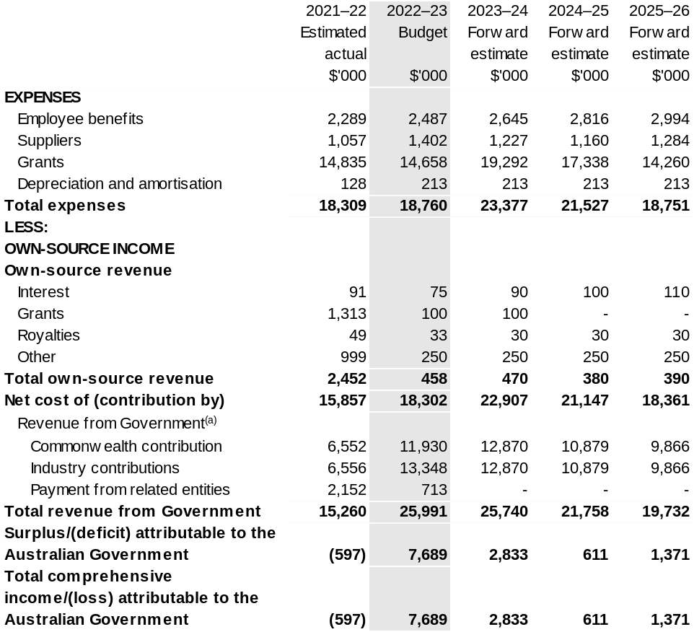
(a) Revenue from Government includes a Commonwealth contribution under the PIRD Act and levies collected from industry by DAFF for R&D activities.

Prepared on Australian Accounting Standards basis.

Table 3.2: Budgeted departmental balance sheet (as at 30 June)
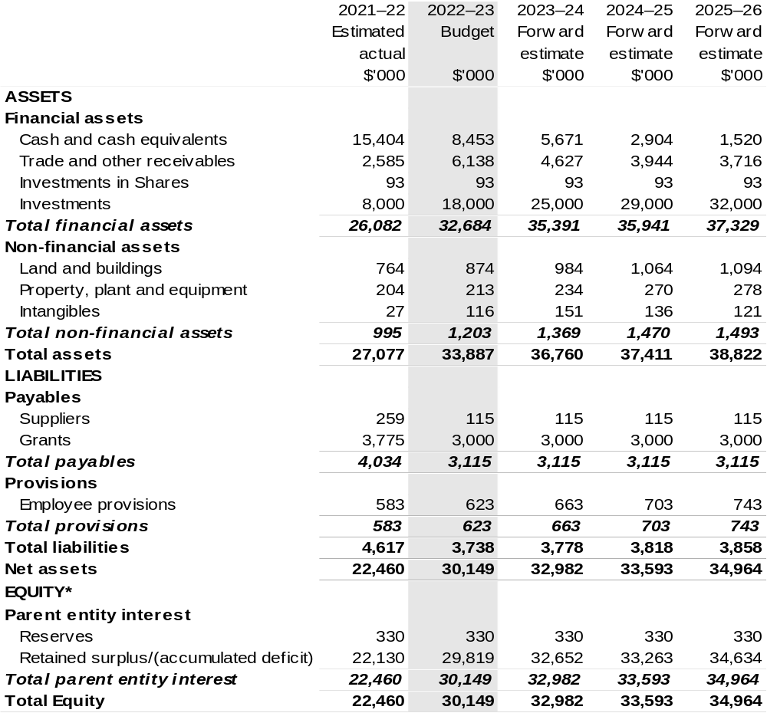
*’Equity’ is the residual interest in assets after deduction of liabilities.

Prepared on Australian Accounting Standards basis.

Table 3.3: Departmental statement of changes in equity – summary of movement (Budget year 2022–23)
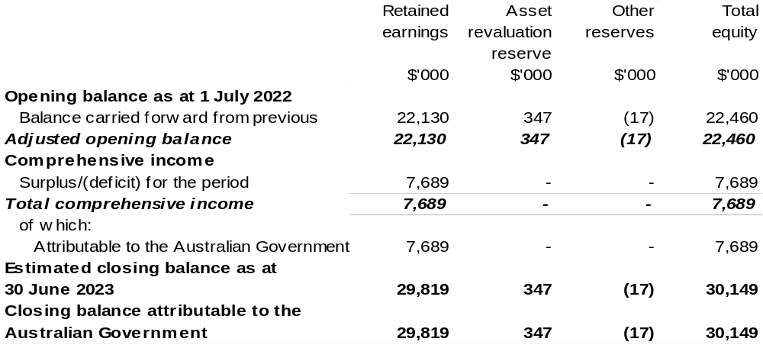
Prepared on Australian Accounting Standards basis.

Table 3.4: Budgeted departmental statement of cash flows (for the period
ended 30 June)
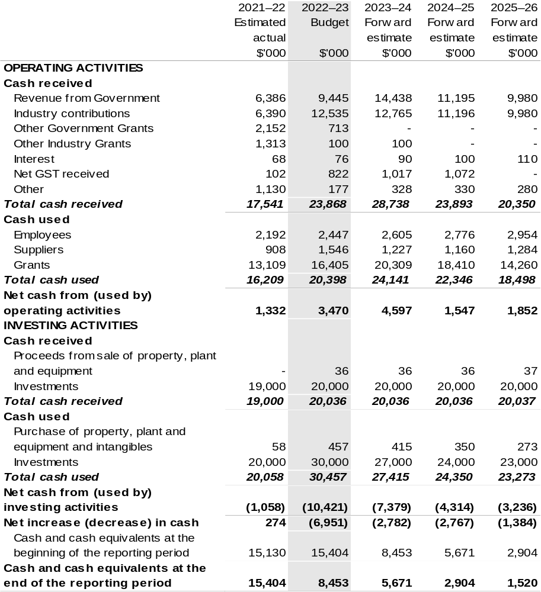
Prepared on Australian Accounting Standards basis.

Table 3.5: Departmental capital budget statement (for period ended 30 June)
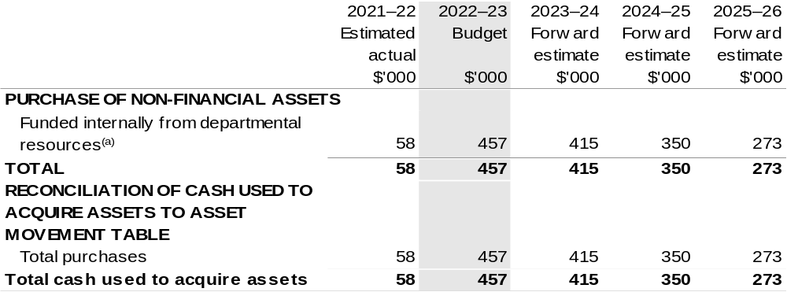
(a) Includes the following s74 external revenue:
– internally developed assets;
– proceeds from the sale of assets.

Consistent with information contained in the Statement of Asset Movements and the Budgeted Statement of Cash Flows.

Prepared on Australian Accounting Standards basis.

Table 3.6: Statement of departmental asset movements (Budget year 2022–23)
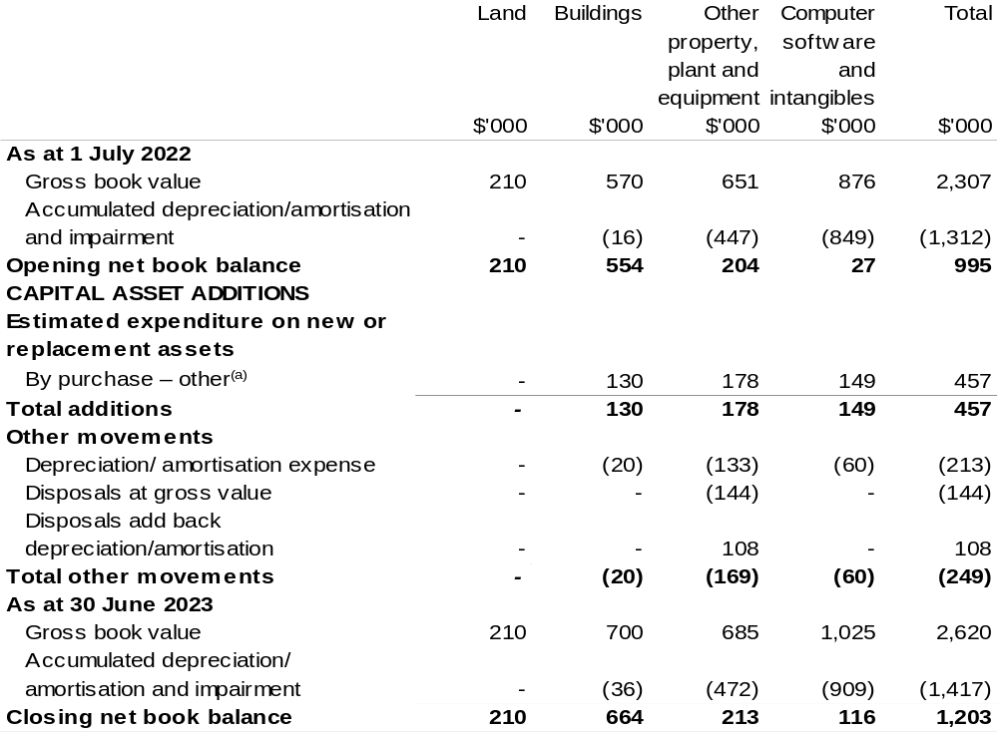
(a) ‘By purchase – other' refers to funding provided through other internal funding sources.

Prepared on Australian Accounting Standards basis.

Fisheries Research and Development Corporation
Section 1: Entity overview and resources 183
1.1 Strategic direction statement 183
1.2 Entity resource statement 184
1.3 Budget measures 186
Section 2: Outcomes and planned performance 187
2.1 Budgeted expenses and performance for Outcome 1 188
Section 3: Budgeted financial statements 192
3.1 Budgeted financial statements 192
3.2 Budgeted financial statements tables 193

Fisheries Research and Development Corporation

Section 1: Entity overview and resources

1.1 Strategic direction statement
The Fisheries Research and Development Corporation (FRDC) plans, invests in and manages research and development (R&D) activities for fishing, aquaculture and the wider community, and encourages the adoption of the resulting knowledge and innovation to achieve impact.
We work with diverse stakeholders from sectors including aquaculture, commercial wild harvest, Indigenous Australians, recreational fishing, post-harvest, fisheries management, research, consumers and the wider community. Our activities span environments from the northern tropics to temperate seas, from icy Antarctic waters to freshwater rivers and lakes, and from estuaries to land-based aquaculture around Australia.
Our investment policy balances the needs of our stakeholders to achieve specific, planned end-user-driven solutions to national, regional and sector-based priorities. Partnerships and previous research, development and extension (RD&E) are considered in our planning and investment processes to optimise the use of existing knowledge, maximise leverage and reduce duplication. We also contribute to the broader national strategic approach to fishing and aquaculture RD&E to build cohesion and establish common goals between sectors.
We lead investment in fisheries RD&E, partnering with organisations that have the capabilities to undertake the varied and specialised activities necessary to achieve the five outcomes in our R&D Plan 2020–25. Our R&D Plan outcomes are: growth for enduring prosperity; best practices and production systems; a culture that is inclusive and forward thinking; fair and secure access to aquatic resources; and community trust, respect and value. We will achieve these by driving digitisation and advanced analytics, strengthening adoption for transformative change, promoting innovation and entrepreneurship, building capability and capacity, and providing foundational information and support services.
We encourage adaptive and creative approaches to problem solving and focusing on continuous improvement.

1.2 Entity resource statement
Table 1.1 shows the total funding from all sources available to the entity for its operations and to deliver programs and services on behalf of the Government.
The table summarises how resources will be applied by outcome (Government strategic policy objectives) and by administered (on behalf of the Government or the public) and departmental (for the entity’s operations) classification.
For more detailed information on special accounts and special appropriations, please refer to October Budget Paper No. 4: Agency Resourcing.
Information in this table is presented on a resourcing (that is, appropriations/cash available) basis, whilst the ‘Budgeted expenses by Outcome’ table in Section 2 and the financial statements in Section 3 are presented on an accrual basis.

Table 1.1: Fisheries Research and Development Corporation –
Resource Statement – Budget Estimates for 2022–23 as at October Budget 2022
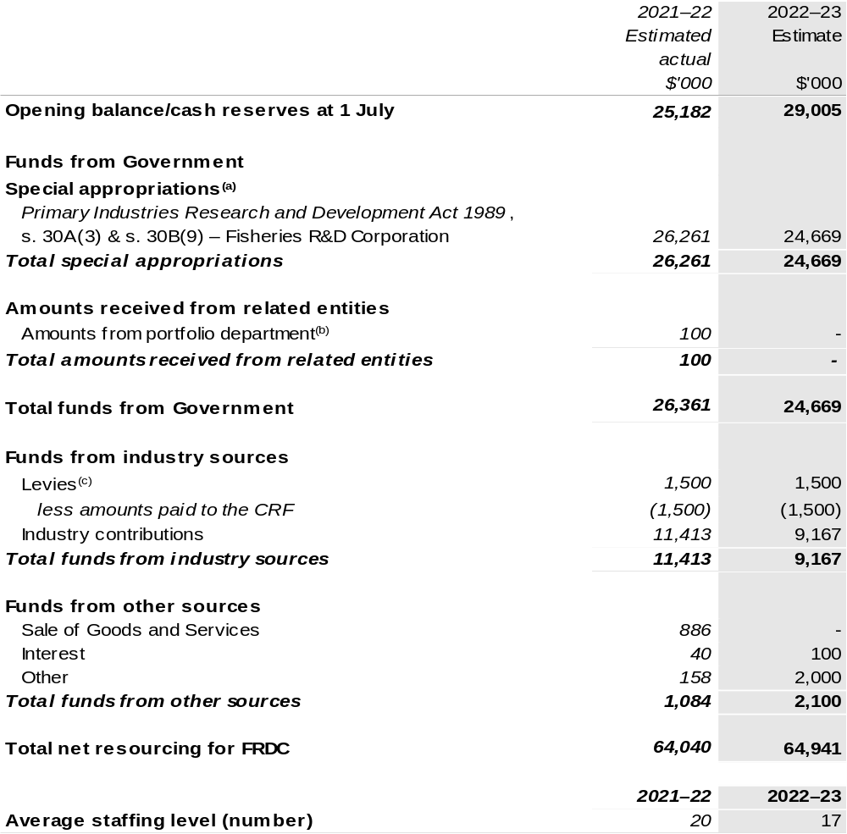
(a) FRDC's special appropriation is not directly appropriated as it is a corporate Commonwealth entity (CCE) under the Public Governance, Performance and Accountability Act 2013 (PGPA Act). Appropriations are made to the Department of Agriculture, Fisheries and Forestry (DAFF) and are then paid to FRDC and are considered departmental for all purposes.
(b) Funding provided by the portfolio department that is not specified within the Annual Appropriation Bills as a payment to that CCE (for example, a grant awarded to a CCE from one of its portfolio department's administered programs). FRDC receives this to develop the National Carp Control Plan.
(c) The levies are imposed by the Primary Industries (Excise) Levies Act 1999. The levies are collected by DAFF under the Primary Industries Research and Development Act 1989 (PIRD Act) and the Fishing Levy Regulations and are transferred to the Consolidated Revenue Fund (CRF). These amounts are then drawn down by the department as a special appropriation and paid to FRDC under the
PIRD Act, s. 30A(3) and s. 30B(9) – Fisheries R&D Corporation.

Please note: All figures shown above are GST exclusive – these may not match figures in the cash flow statement.

Prepared on a resourcing (i.e. appropriations available) basis.

1.3 Budget measures
Budget measures in Part 1 relating to the Fisheries Research and Development Corporation are detailed in October Budget Paper No. 2 and are summarised below.

Table 1.2: Fisheries Research and Development Corporation – October 2022–23 Budget Measures

Part 1: Measures announced since the March 2022–23 Budget

FRDC does not have any October 2022–23 Budget measures.

Section 2: Outcomes and planned performance
Government outcomes are the intended results, impacts or consequences of actions by the Government on the Australian community. Commonwealth programs are the primary vehicle by which government entities achieve the intended results of their outcome statements. Entities are required to identify the programs which contribute to Government outcomes over the Budget and forward years.
Each outcome is described below together with its related programs. The following provides detailed information on expenses for each outcome and program, further broken down by funding source.
Note:
Performance reporting requirements in the Portfolio Budget Statements are part of the Commonwealth performance framework established by the Public Governance, Performance and Accountability Act 2013. It is anticipated that the performance criteria described in Portfolio Budget Statements will be read with broader information provided in an entity’s corporate plans and annual performance statements – included in Annual Reports - to provide a complete picture of an entity’s planned and actual performance.
While the FRDC reports against an annual framework, as an organisation that invests in science, the benefit of those investments endures over a longer time period.
The most recent corporate plans (annual operating plan and research development and extension plan for the Fisheries Research and Development Corporation can be found at:
https://www.frdc.com.au/annual-operational-plans and
https://www.frdc.com.au/strategic-planning-and-priorities.

The most recent annual performance statement for the Fisheries Research and Development Corporation can be found at:
https://www.frdc.com.au/annual-reports.

2.1 Budgeted expenses and performance for Outcome 1
Outcome 1: Increased economic, social and environmental benefits for Australian fishing and aquaculture, and the wider community, by investing in knowledge, innovation, and marketing.

2.1.1: Linked programs
Department of Agriculture, Fisheries and Forestry
Program 1.4: Fishing Industry
Contribution to Outcome 1 made by linked program:
FRDC works together with DAFF to ensure fishing and aquaculture in Australia is sustainable, productive and profitable.

2.1.2: Budgeted expenses for Outcome 1
This table shows how much the entity intends to spend (on an accrual basis) on achieving the outcome, broken down by program, as well as by administered and departmental funding sources.

Table 2.1: Budgeted expenses for Outcome 1
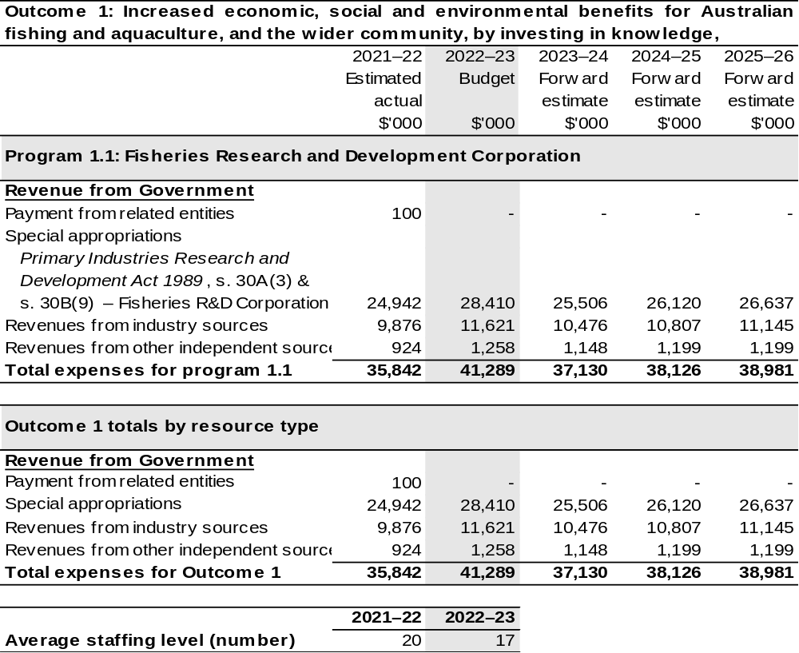
Note: Departmental appropriation splits and totals are indicative estimates and may change in the course
of the budget year as government priorities change.

Prepared on Australian Accounting Standards basis.

Table 2.2: Performance measure for Outcome 1
Table 2.2 details the performance measures for each program associated with Outcome 1. It also provides the related key activities as expressed in the current corporate plan where further detail is provided about the delivery of the activities related to the program, the context in which these activities are delivered and how the performance of these activities will be measured. Where relevant, the October 2022–23 Budget measures that have created new programs or materially changed existing programs are provided.
As an entity established under the PIRD Act, FRDC does not produce a corporate plan under the PGPA Act and is therefore exempt from the requirement to map purposes to outcomes.
Outcome 1: Increased economic, social and environmental benefits for Australian fishing and aquaculture, and the wider community, by investing in knowledge, innovation, and marketing.
Program 1.1: Fisheries Research and Development Corporation
Objective | Establish collaborative, vibrant fishing and aquaculture, creating diverse benefits from aquatic resources, and celebrated by the community.
Key Activities | - Drive digitisation and advanced analytics  - Strengthen the adoption of transformative change  - Promote innovation and entrepreneurship  - Build capability and capacity  - Provide foundational information and support services.
Year | Performance measures | Expected Performance Results
Prior year  2021–22 | Growth for enduring prosperity.  Enduring and balanced ecological, social and economic growth for the community benefit. | Achieved.  Projects align with strategic priorities set out in FRDC’s  2021–22 Annual Operational Plan (AOP) and partner plans.  Projects sampled for cost-benefit analysis show positive average return on investment.
Prior year  2021–22 | Best practices and production systems.  Diverse benefits from aquatic resources to be consistent with shared principles.

Continued on following page
Table 2.2: Performance measure for Outcome 1 (continued)
Year | Performance measures | Expected Performance Results
Prior year  2021–22 (continued) | A culture that is inclusive and forward thinking.  A fishing and aquaculture community that is cooperative, diverse and well equipped to enable growth and adaptability in a complex and uncertain world. | Achieved.  Projects align with strategic priorities set out in FRDC’s  2021–22 AOP and partner plans.
Prior year  2021–22 (continued) | Fair and secure access to aquatic resources.  Integrated management of Australia’s aquatic resources, providing certainty and confidence.
Prior year  2021–22 (continued) | Community trust, respect and value.  People feel good about using the products, services and experiences provided by fishing and aquaculture.
Year | Performance measures | Planned Performance Results
Budget Year  2022–23 | As per 2021–22. | As per 2021–22.
Forward Estimates  2023–26 | As per 2022–23. | As per 2022–23.

Section 3: Budgeted financial statements
Section 3 presents budgeted financial statements which provide a comprehensive snapshot of entity finances for the 2022–23 budget year, including the impact of budget measures and resourcing on financial statements.

3.1 Budgeted financial statements

3.1.1: Differences between entity resourcing and financial statements
The financial statements are prepared on an accrual basis where revenues and expenses are recognised as and when the resources are received and used. The entity resourcing table recognises the cash resources available to be used during the period and includes amounts recognised as revenue in previous periods.

3.1.2: Explanatory notes and analysis of budgeted financial statements
The FRDC’s RD&E expenditure is dependent on the gross value of production (GVP) of the Australian seafood industry. The indication for the GVP for the Australian seafood industry is positive, with growth expected in 2022–23. This is based primarily on aquaculture, which is anticipated to grow – prawns, barramundi, Atlantic salmon and yellowtail kingfish will be key drivers. Income contributions from the commercial sector are expected to maintain current levels.

3.2 Budgeted financial statements tables

Table 3.1: Comprehensive income statement (showing net cost of services)
(for the period ended 30 June)
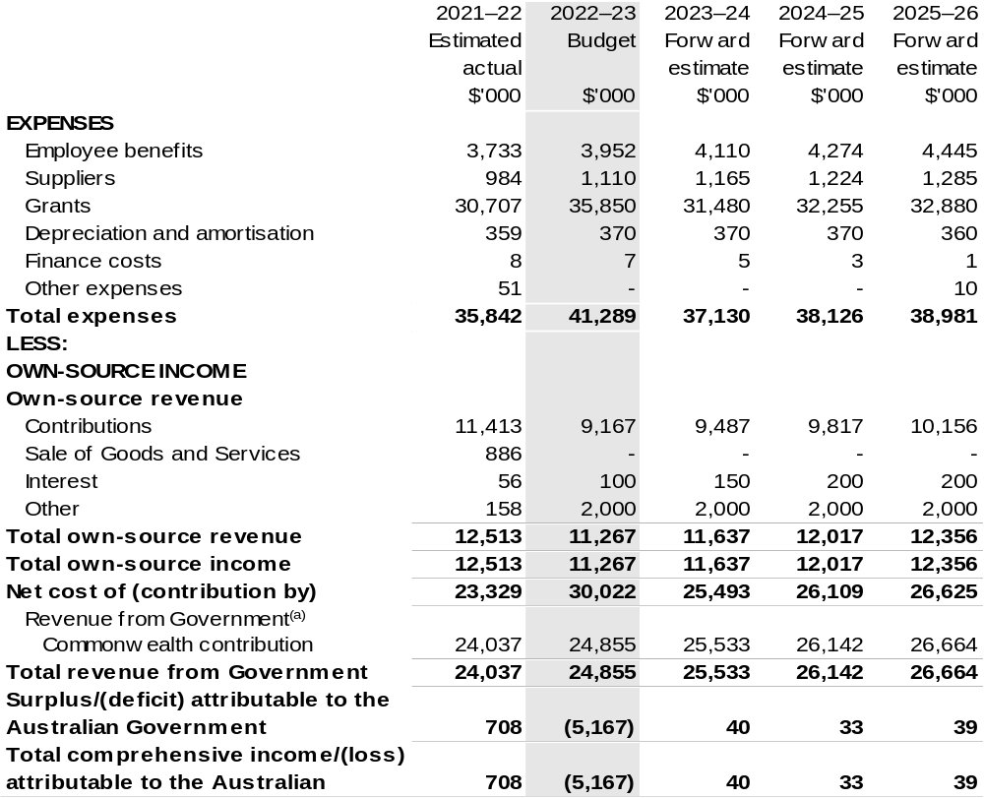
Continued on following page

Table 3.1: Comprehensive income statement (showing net cost of services)
(for the period ended 30 June) (continued)
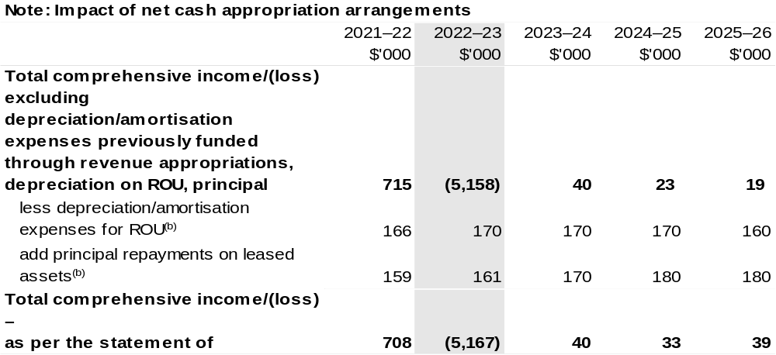
(a) Revenue from Government includes a Commonwealth contribution under the PIRD Act and levies collected from industry by DAFF for R&D activities.
(b) Applies to leases under AASB 16 Leases. Right of Use (ROU).

Prepared on Australian Accounting Standards basis

Table 3.2: Budgeted departmental balance sheet (as at 30 June)
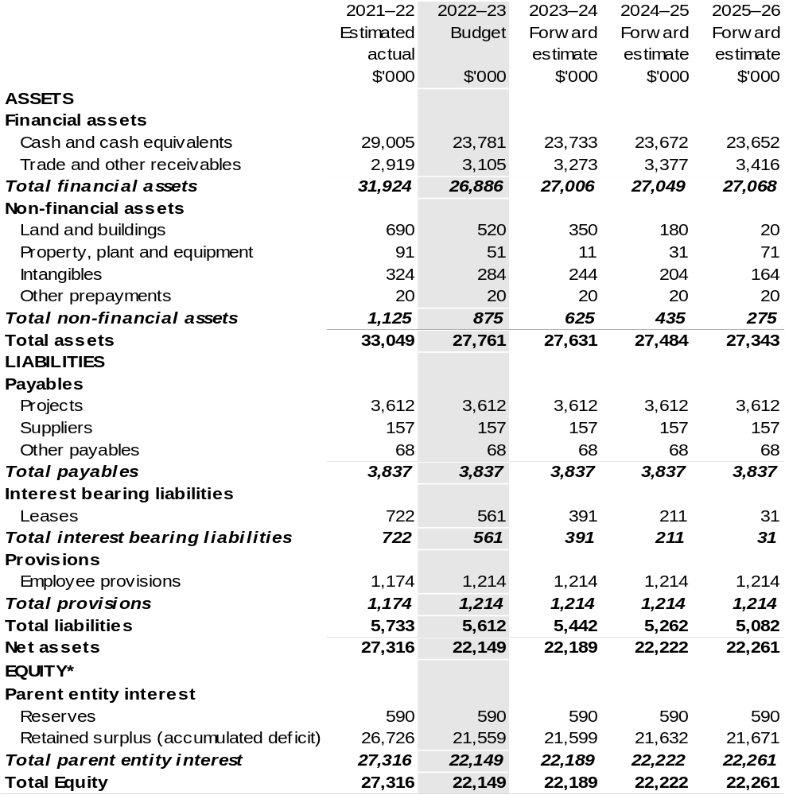
*'Equity' is the residual interest in assets after deduction of liabilities.

Prepared on Australian Accounting Standards basis.

Table 3.3: Departmental statement of changes in equity – summary of movement (Budget year 2022–23)
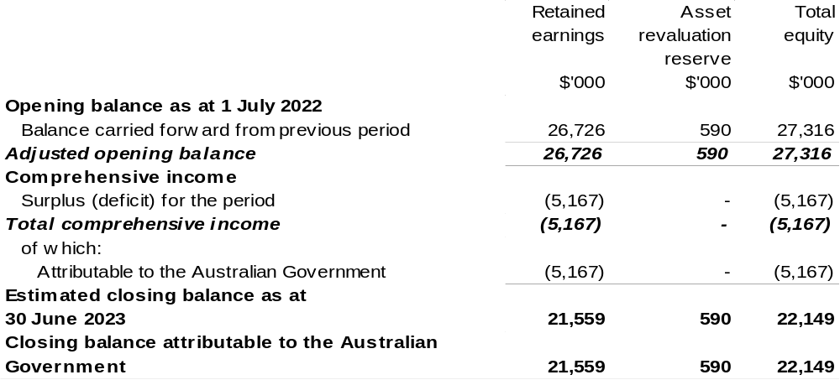

Prepared on Australian Accounting Standards basis.

Table 3.4: Budgeted departmental statement of cash flows (for the period
ended 30 June)
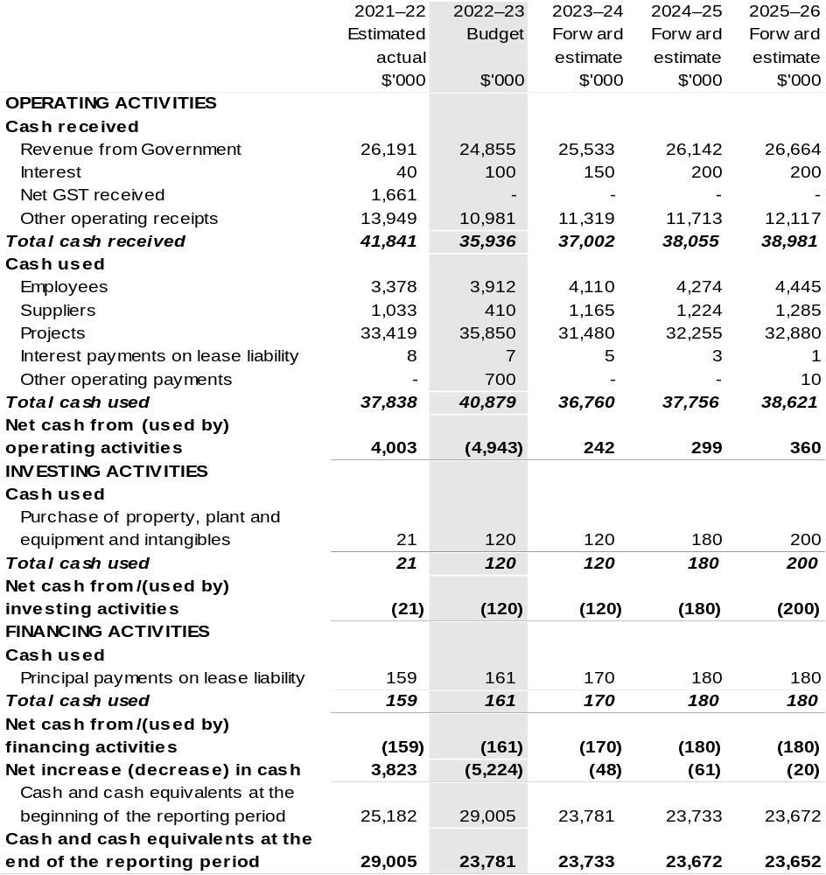

Prepared on Australian Accounting Standards basis.

Table 3.5: Departmental capital budget statement (for the period ended 30 June)
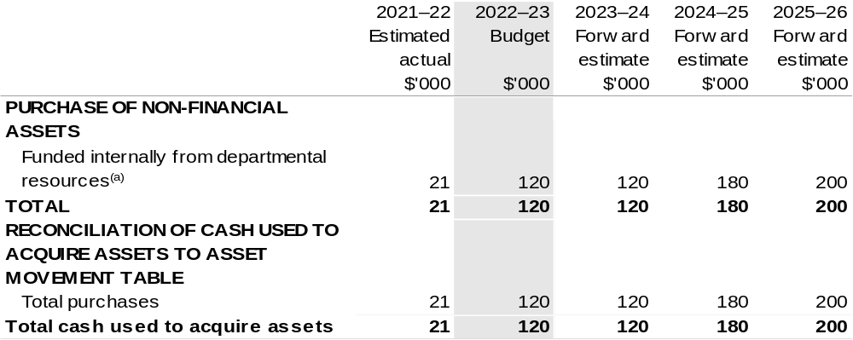

(a) Includes the following s74 external revenue:
– internally developed assets.

Consistent with information contained in the Statement of Asset Movements and the Budgeted Statement of Cash Flows.

Prepared on Australian Accounting Standards basis.

Table 3.6: Statement of departmental asset movements (Budget year 2022–23)
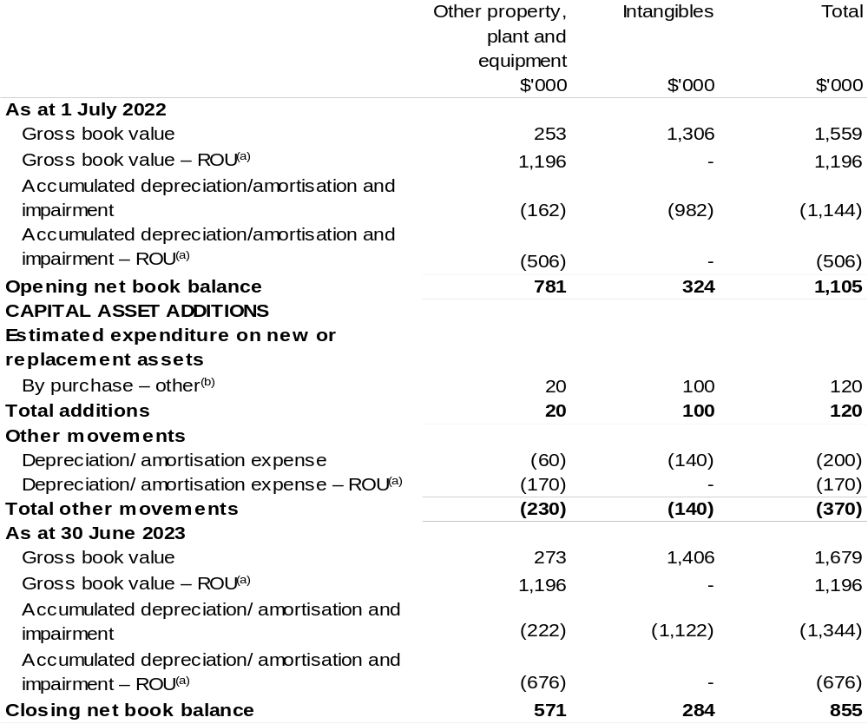

(a) Applies to leases under AASB 16 Leases. Right of Use (ROU).
(b) ‘By purchase – other’ refers to funding provided through other internal funding sources.

Prepared on Australian Accounting Standards basis.

Grains Research and Development Corporation
Section 1: Entity overview and resources 203
1.1 Strategic direction statement 203
1.2 Entity resource statement 205
1.3 Budget measures 207
Section 2: Outcomes and planned performance 208
2.1 Budgeted expenses and performance for Outcome 1 209
Section 3: Budgeted financial statements 214
3.1 Budgeted financial statements 214
3.2 Budgeted financial statements tables 215

Grains Research and Development Corporation

Section 1: Entity overview and resources

1.1 Strategic direction statement
The Grains Research and Development Corporation’s (GRDC) purpose is to invest in research, development and extension (RD&E) to create enduring profitability for Australian grain growers.
In supporting its purpose, GRDC invests in RD&E activities across a portfolio spanning temperate and tropical cereals (including coarse grains), pulses and oilseeds. This involves identifying and prioritising research for investment, monitoring, evaluating and reporting on research impacts, and facilitating the dissemination, adoption and commercialisation of research results.
GRDC also contributes to the development of strategic national approaches to grains industry RD&E, to reduce fragmentation and duplication and to help address industry-wide issues such as biosecurity, grains market access and sustainable resource management.
While its focus is on delivering benefits to Australian grain growers, GRDC also generates outcomes from investing in RD&E that benefit other participants in the Australian grains industry value chain and the wider Australian community, as well as the grains research community in Australia and overseas. GRDC investments support the capacity of the Australian research community through collaborative approaches that minimise duplication of effort and provide access to shared knowledge, infrastructure and facilities.
Effective partnerships with other Australian organisations enable GRDC to leverage resources and research capability, share market knowledge, technologies and intellectual property, and reduce the risk associated with transformational investments. GRDC also builds strong relationships with organisations overseas, both to broaden the resources available to the Australian grains industry and to access international RD&E efforts that offer potential benefits, such as food security, for Australia.
Because adoption by growers is critical to achieving benefits from research and development (R&D), GRDC undertakes activities to raise awareness of grains industry R&D and extend the results of GRDC-supported investments to grain growers and their advisers, other participants in rural industry and the wider community. Recognising different needs and preferences for receiving information, GRDC uses a range of products and channels, from phone apps to field days.

GRDC works closely with Australian grain growers and the Australian Government to ensure that their RD&E priorities are effectively addressed through GRDC investments. GRDC also maintains strong connections with its other stakeholders, particularly in the R&D and agribusiness sectors.
GRDC’s investment priorities are articulated in the RD&E Plan 2018–2023. The plan is firmly focused on delivering research and extension investments that increase the profitability of Australian grain growers. The plan considers the key drivers of profitability in terms of yield, price, costs (on-farm and post farm gate) as well as risk.
The RD&E Plan 2018–2023 has been informed by extensive consultation across a broad spectrum of grains industry participants, government, and research providers. The consultation identified 29 key investment targets, with relative priorities that will underpin the delivery of the GRDC’s purpose.
Detailed performance information across all the drivers of profitability through Key Investment Targets will be available in each of the GRDC Annual Operational Plans across the five-year period.

1.2 Entity resource statement
Table 1.1 shows the total funding from all sources available to the entity for its operations and to deliver programs and services on behalf of the Government.
The table summarises how resources will be applied by outcome (Government strategic policy objectives) and by administered (on behalf of the Government or the public) and departmental (for the entity’s operations) classification.
For more detailed information on special accounts and special appropriations, please refer to October Budget Paper No. 4: Agency Resourcing.
Information in this table is presented on a resourcing (i.e. appropriations/cash available) basis, whilst the ‘Budgeted expenses by Outcome 1’ tables in Section 2 and the financial statements in Section 3 are presented on an accrual basis.

Table 1.1: Grains Research and Development Corporation –
Resource Statement – Budget Estimates for 2022–23 as at October Budget 2022

(a) GRDC's special appropriation is not directly appropriated as it is a corporate Commonwealth entity under the Public Governance, Performance and Accountability Act 2013 (PGPA Act). Appropriations are made to the Department of Agriculture, Fisheries and Forestry (DAFF) and are then paid to GRDC and are considered departmental for all purposes.
(b) The levies are imposed by the Primary Industries (Excise) Levies Act 1999. The levies are collected by DAFF under the Primary Industries Levies and Charges Collection Act 1991 and transferred to the Consolidated Revenue Fund (CRF). These amounts are then drawn down by the department as a special appropriation and paid to GRDC under the Primary Industries Research and Development
Act 1989 (PIRD Act), s. 30(3) – Grains and Wheat R&D Corporation.

Prepared on a resourcing (i.e. appropriations available) basis.

Please note: All figures shown above are GST exclusive – these may not match figures in the cash flow statement.

1.3 Budget measures
Budget measures in Part 1 relating to the Grains Research and Development Corporation are detailed in October Budget Paper No. 2 and are summarised below.

Table 1.2: Grains Research and Development Corporation – October 2022–23 Budget Measures

Part 1: Measures announced since the March 2022–23 Budget

GRDC does not have any October 2022–23 Budget measures.

Section 2: Outcomes and planned performance
Government outcomes are the intended results, impacts or consequences of actions by the Government on the Australian community. Commonwealth programs are the primary vehicle by which government entities achieve the intended results of their outcome statements. Entities are required to identify the programs which contribute to Government outcomes over the Budget and forward years.
Each outcome is described below together with its related programs. The following provides detailed information on expenses for each outcome and program, further broken down by funding source.
Note:
Performance reporting requirements in the Portfolio Budget Statements are part of the Commonwealth performance framework established by the Public Governance, Performance and Accountability Act 2013. It is anticipated that the performance criteria described in Portfolio Budget Statements will be read with broader information provided in an entity’s corporate plans and annual performance statements – included in Annual Reports – to provide a complete picture of an entity’s planned and actual performance.
The most recent corporate plan for the Grains Research and Development Corporation can be found at:
https://rdeplan.grdc.com.au/ .
The most recent annual performance statement for the Grains Research and Development Corporation can be found at:
https://grdc.com.au/about/who-we-are/corporate-governance/annual-reportsnd-reporting.

2.1 Budgeted expenses and performance for Outcome 1
Outcome 1: New information and products that enhance the productivity, competitiveness and environmental sustainability of Australian grain growers and benefit the industry and wider community, through planning, managing and implementing investments in grains research and development.

2.1.1: Linked programs
Department of Agriculture, Fisheries and Forestry
Program 1.7: Grains Industry
Contribution to Outcome 1 made by linked program:
GRDC works together with DAFF to ensure sustainable, productive, and profitable grains industry.

2.1.2: Budgeted expenses for Outcome 1
This table shows how much the entity intends to spend (on an accrual basis) on achieving the outcome, broken down by program, as well as by administered and departmental funding sources.

Table 2.1: Budgeted expenses for Outcome 1
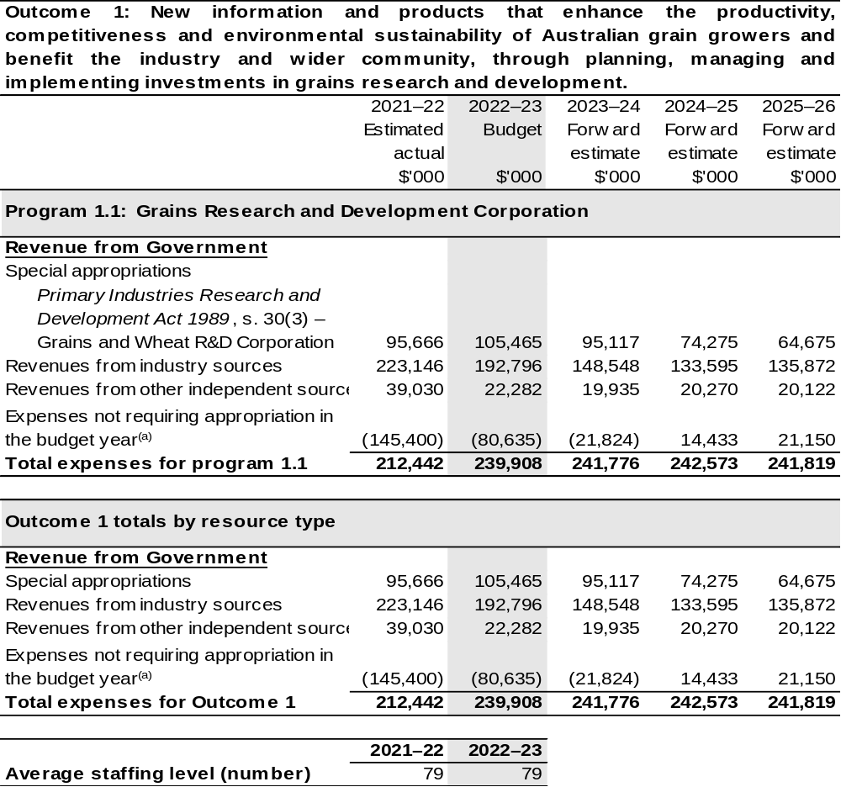
(a) Expenses not requiring appropriation in the Budget year are made up of make good expenses, audit fees, and can include depreciation / amortisation expenses not requiring an appropriation.

Note: Departmental appropriation splits and totals are indicative estimates and may change in the course of the budget year as government priorities change.

Prepared on Australian Accounting Standards basis.

Table 2.2: Performance measure for Outcome 1
Table 2.2 details the performance measures for each program associated with Outcome 1. It also provides the related key activities as expressed in the current corporate plan where further detail is provided about the delivery of the activities related to the program, the context in which these activities are delivered and how the performance of these activities will be measured. Where relevant, the October 2022–23 Budget measures that have created new programs or materially changed existing programs are provided.
As an entity established under the PIRD Act, GRDC does not produce a corporate plan under the PGPA Act and is therefore exempt from the requirement to map purposes to outcomes.
Outcome 1: New information and products that enhance the productivity, competitiveness and environmental sustainability of Australian grain growers and benefit the industry and wider community, through planning, managing and implementing investments in grains research and development.
Program 1.1: Grains Research and Development Corporation
Objective | Drive the discovery, development and delivery of world-class innovation to enhance the productivity, profitability and sustainability of Australian grain growers and benefit the industry and the wider community.
Key Activities^{(a)} | Continue to prioritise RD&E investments that support the enduring profitability of Australian grain growers. The target group is primarily Australian grain growers but the grains industry value chain also includes Governments, industry groups, rural and regional communities, research organisations and the wider community.
Year | Performance measures | Expected Performance Results
Prior year  2021–22 | Average farm business rates of return. | A minimum of 6 per cent by 2023.  In 2021–22 the Rate of Return was 5.7 per cent.
Prior year  2021–22 | Improvements in yield and yield stability. | Minimum yield increases equivalent to one per cent per annum for cereals, two per cent per annum for pulses and 1.5 per cent for oilseeds.  2021-22 results:  1.72 per cent increase on the  5–year average for wheat.  2.4 per cent increase on the  5–year average for pulses.  7.29 per cent increase on the  5–year average for oilseeds.

Table 2.2: Performance measure for Outcome 1 (continued)
Year | Performance measures | Expected Performance Results
Prior year  2021–22 (continued) | Yield stability. | By 2023 a minimum 20 per cent closure of the gap between potential yield and actual yield.  70 per cent of wheat, barley and canola crops showed no discernible yield gap (Paddock Survey 2019).  GRDC is continuing to develop reliable measures of yield gap, including through the continuation of the National Paddock Survey and exploring Water Use Efficiency as alternative measure.
Prior year  2021–22 (continued) | Maintaining and improving price. | 84 per cent of the 20 most commonly grown wheat varieties in 2020 utilise rust resistance genes or markers that were developed through GRDC investment.  85 per cent of tonnes of pulses produced over the past 5 years are varieties bred with the support of GRDC investment*  *Based on data from receivals.
Prior year  2021–22 (continued) | Optimising input costs. | Maintain increases in chemistry costs below the five-year trend (2018–2023) equivalent to $85.50 per hectare or a ratio of input to crop revenue of 0.166.  Ratio 0.142.  The result in 2021–22 is ratio of 0.129 or $100.50 per hectare.  Maintain increases in fertilizer costs below the five-year trend (2018–2023) equivalent to $84.30 per hectare or a ratio of input to crop revenue of 0.164.  Ratio 0.140.  The result in 2021–22 is a ratio of 0.136 or $95.33 per hectare.

Continued on following page
Table 2.2: Performance measure for Outcome 1
Year | Performance measures | Expected Performance Results
Prior year  2021–22 (continued) |  | Note:  - Not all input costs are captured in this target – all inputs costs as a share of cash receipts are captured in the calculation of Rates of Return.  - Reporting on a mean can be informative but is not the best indicator of impact due to variations across region, soil type, rainfall, and business characteristics of each farm. GRDC is working toward developing a more detailed regionalised dataset which will allow for impact measurement.
Year | Performance measures | Planned Performance Results
Budget Year  2022–23 | As per 2021–22. | As per 2021–22.
Forward Estimates  2023–26 | As per 2023–28 RD&E Plan. | As per 2023–28 RD&E Plan.

- Additional performance information that supports the achievement of the above performance criteria are available in the GRDC’s 2018–2023 Strategic RD&E plan.

Section 3: Budgeted financial statements
Section 3 presents budgeted financial statements which provide a comprehensive snapshot of entity finances for the 2022–23 budget year, including the impact of budget measures and resourcing on financial statements.

3.1 Budgeted financial statements

3.1.1: Differences between entity resourcing and financial statements
The financial statements are prepared on an accrual basis where revenues and expenses are recognised as and when the resources are received and used. The entities resourcing table recognises cash resources available to be used during the period and includes amounts recognised as revenue in previous periods.

3.1.2: Explanatory notes and analysis of budgeted financial statements
GRDC’s revenue is primarily from industry contributions in the form of levies paid on the farm gate value of grain sold and Australian Government contributions which are capped at 0.5 per cent of the three-year rolling average of gross value of production (GVP). GRDC’s revenue streams are therefore subject to the volatility of local and international grain commodity markets, farm gate costs, environmental conditions, and the marketing decisions of growers. This means the assumptions in developing financial forecasts have a high degree of uncertainty and change frequently.
In 2022–23, GRDC is budgeting for an operating surplus of $80.6 million which will significantly increase accumulated reserves. Industry contributions are expected to decrease from 2021-22 by $30.4 million and remain above the long-term average.
Australian Government contributions are expected to increase by $9.8 million after the higher-than-average gross volume of production across recent years. Own source income is expected to decrease by $16.7 million on current year estimates, of which interest is expected to increase by $5.4 million. In support of current higher values of R&D expenditure, supplier expenses, including those relating to contracted operational support services, are expected to remain consistent with prior periods.
The budgeted net asset position for 2022–23 is $502.9 million which is $80.6 million more than the 2021–22 estimated actual. This increase is largely due to the flow on impacts from record levels of industry contributions and Australian Government
co-contributions received in the past two years.

3.2 Budgeted financial statements tables

Table 3.1: Comprehensive income statement (showing net cost of services)
(for the period ended 30 June)
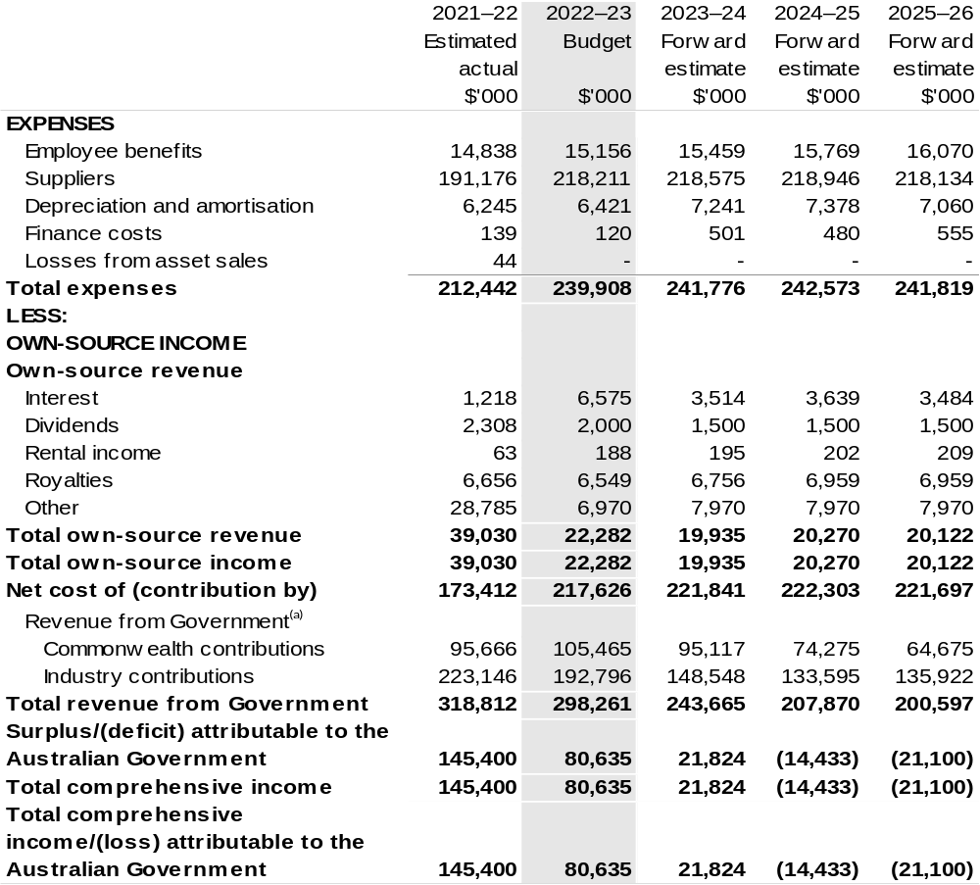
Continued on following page

Table 3.1: Comprehensive income statement (showing net cost of services) (for the period ended 30 June) (continued)
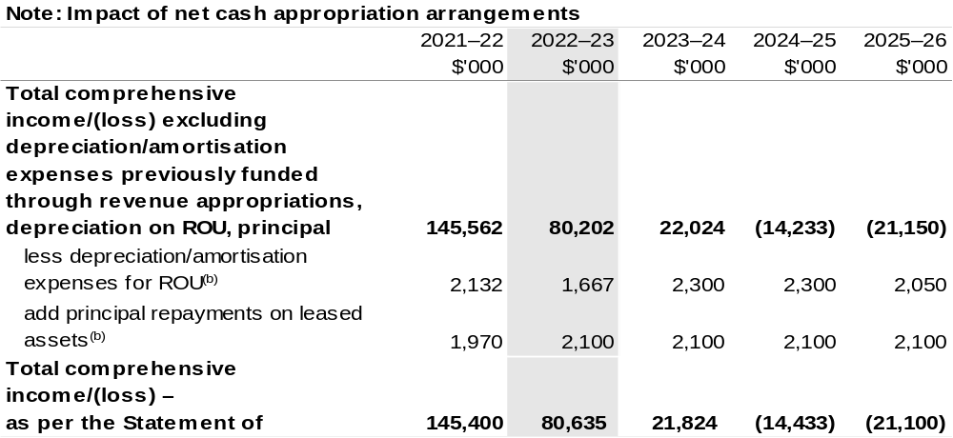
(a) Revenue from Government includes a Commonwealth contribution under the PIRD Act and levies collected from industry by DAFF for R&D activities.
(b) Applies to leases under AASB 16 Leases. Right of Use (ROU).

Prepared on Australian Accounting Standards basis.

Table 3.2: Budgeted departmental balance sheet (as at 30 June)
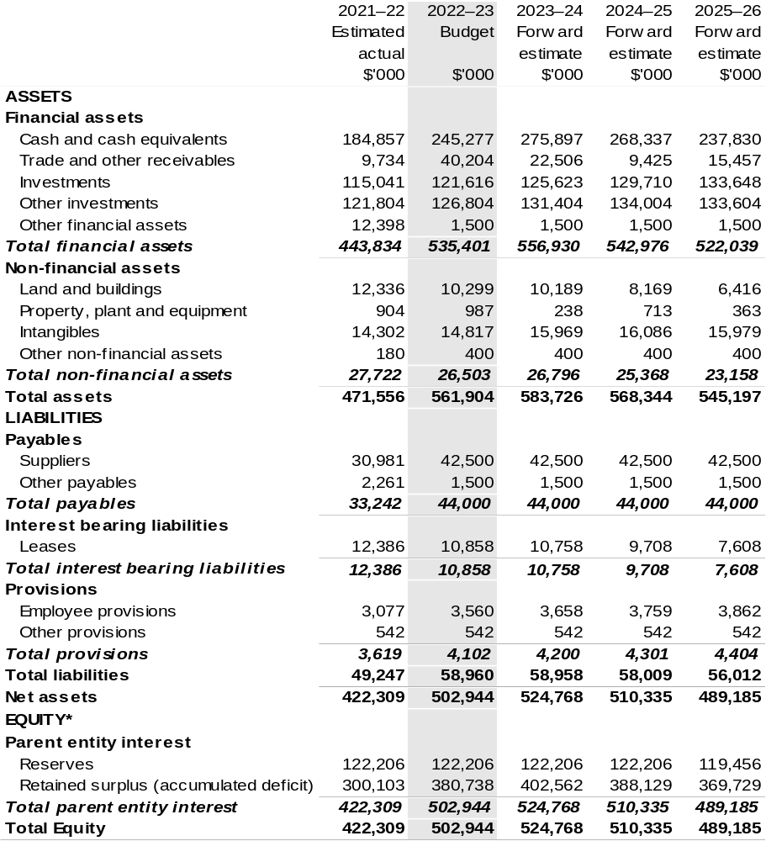
*'Equity' is the residual interest in assets after deduction of liabilities.

Prepared on an Australian Accounting Standards basis.

Table 3.3: Departmental statement of changes in equity – summary of movement (Budget year 2022–23)
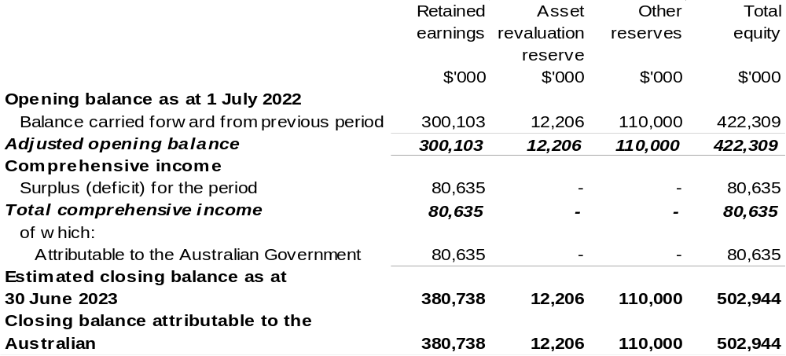

Prepared on Australian Accounting Standards basis.

Table 3.4: Budgeted departmental statement of cash flows (for the period
ended 30 June)
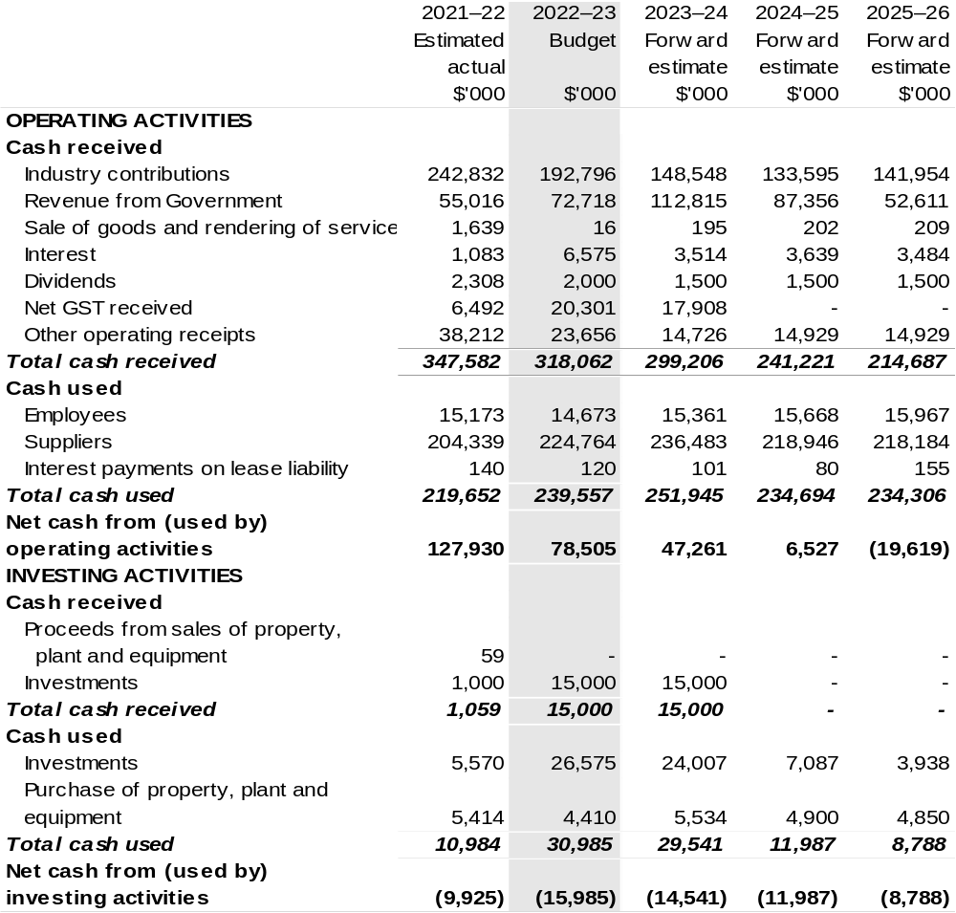

Continued on following page

Table 3.4: Budgeted departmental statement of cash flows (for the period
ended 30 June) (continued)
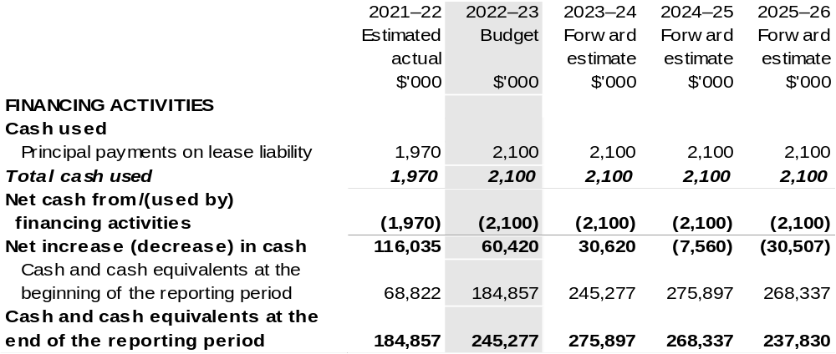

Prepared on Australian Accounting Standards basis.

Table 3.5: Departmental capital budget statement (for the period ended 30 June)
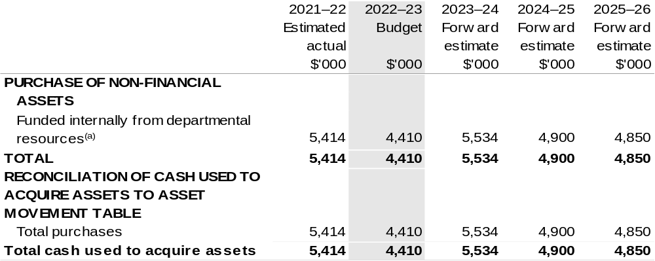
(a) Includes the following s74 external revenue:
– internally developed assets.

Consistent with information contained in the Statement of Asset Movements and the Budgeted Statement of Cash Flows.

Prepared on Australian Accounting Standards basis.

Table 3.6: Statement of departmental asset movements (Budget year 2022–23)
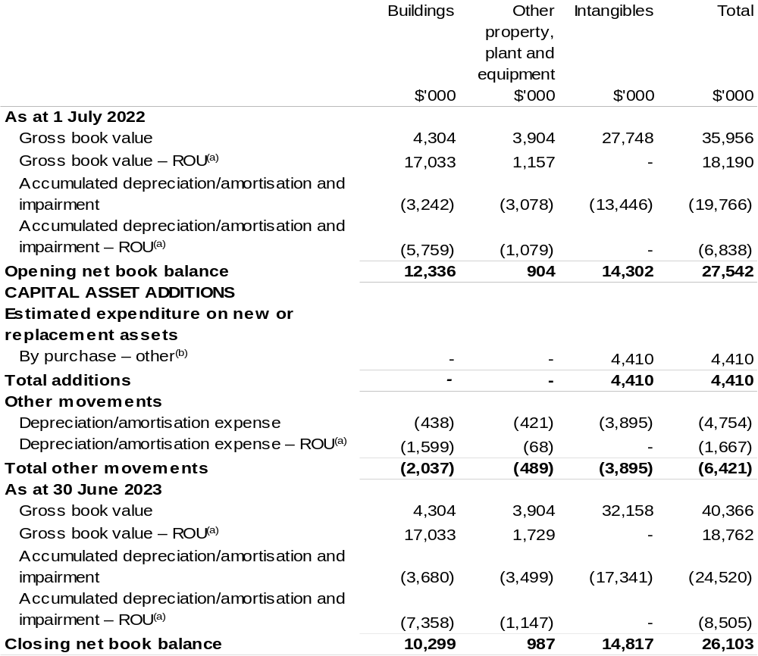
(a) Applies to leases under AASB 16 Leases. Right of Use (ROU).
(b) ‘By purchase – other’ refers to funding provided through other internal funding sources.

Prepared on Australian Accounting Standards basis.

Regional Investment Corporation
Section 1: Entity overview and resources 225
1.1 Strategic direction statement 225
1.2 Entity resource statement 226
1.3 Budget measures 227
Section 2: Outcomes and planned performance 228
2.1 Budgeted expenses and performance for Outcome 1 229
Section 3: Budgeted financial statements 234
3.1 Budgeted financial statements 234
3.2 Budgeted financial statements tables 235

Regional Investment Corporation

Section 1: Entity overview and resources

1.1 Strategic direction statement
The Regional Investment Corporation (RIC) is a corporate Commonwealth entity established by the Regional Investment Corporation Act 2018. An independent Board oversees RIC and is responsible for providing loans to eligible farm businesses, farm-related small businesses and forestry businesses.
RIC Board also provides independent advice to the Minister for Agriculture, Fisheries and Forestry on the making of individual grants or arrangements for projects and activities that build drought resilience to be funded by the Future Drought Fund.
RIC streamlines the administration of concessional loans by delivering loans that are assessed in a nationally consistent, prudent and timely manner. Loans are targeted at farm businesses and farm-related small businesses impacted by drought and those that are in financial need that mainly supply, or intend to mainly supply, products into supply chains that are interstate or overseas. Loans are also targeted at forestry businesses to encourage new plantation developments and the replanting of bushfire damaged plantation areas.
The concessional loan programs support the long-term strength, resilience and profitability of eligible farm businesses, farm-related small businesses and forestry businesses with $354.917 million in loan funding available for RIC in 2022–23.
This funding recognises the importance of RIC loans for farmers, foresters and small businesses in need of practical assistance and the demand for RIC loan products.
RIC achieves this through its outcome:
Outcome 1: Encourage growth, investment and resilience in Australian farm businesses and rural and regional communities by delivering the Commonwealth’s farm business concessional loans.

1.2 Entity resource statement
Table 1.1 shows the total funding from all sources available to the entity for its operations and to deliver programs and services on behalf of the Government.
The table summarises how resources will be applied by outcome (Government strategic policy objectives) and by administered (on behalf of the Government or the public) and departmental (for the entity’s operations) classification.
For more detailed information on special accounts and special appropriations, please refer to October Budget Paper No. 4: Agency Resourcing.
Information in this table is presented on a resourcing (i.e. appropriations/cash available) basis, whilst the ‘Budgeted expenses by Outcome 1’ tables in Section 2 and the financial statements in Section 3 are presented on an accrual basis.

Table 1.1: Regional Investment Corporation – Resource Statement – Budget Estimates for 2022–23 as at October Budget 2022
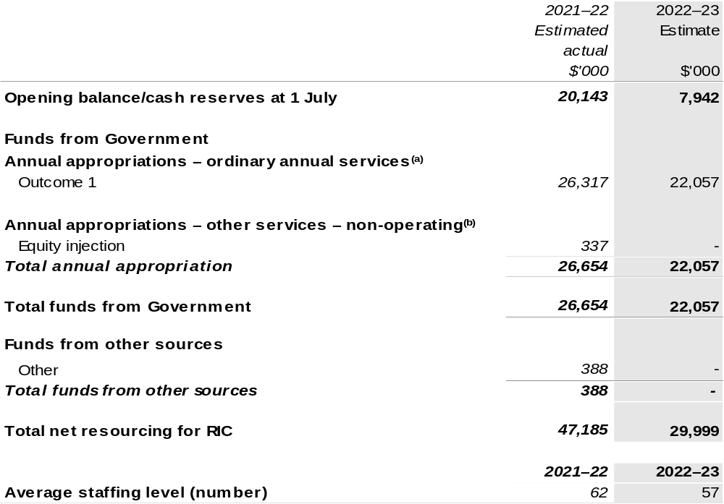
(a) Appropriation Bill (No. 1) 2022–23, Supply Bill (No. 3) 2022–23 and Supply Act (No. 1) 2022–23.
Appropriation is provided through the Department of Agriculture, Fisheries and Forestry (DAFF) and is
specified with the Annual Appropriation Bills as payment to RIC and is considered departmental for all
purposes.
(b) Appropriation Bill (No. 2) 2022–23, Supply Bill (No. 4) 2022–23 and Supply Act (No. 2) 2022–23. Appropriation is provided through the DAFF and is specified with the Annual Appropriation Bills as payment to RIC and is considered departmental for all purposes.
Please note: All figures shown above are GST exclusive – these may not match figures in the cash flow statement. Prepared on a resourcing (i.e. appropriations available) basis.

1.3 Budget measures
Budget measures in Part 1 relating to the Regional Investment Corporation are detailed in October Budget Paper No. 2 and are summarised below.

Table 1.2: Regional Investment Corporation – October 2022–23 Budget Measures

Part 1: Measures announced since the March 2022–23 Budget
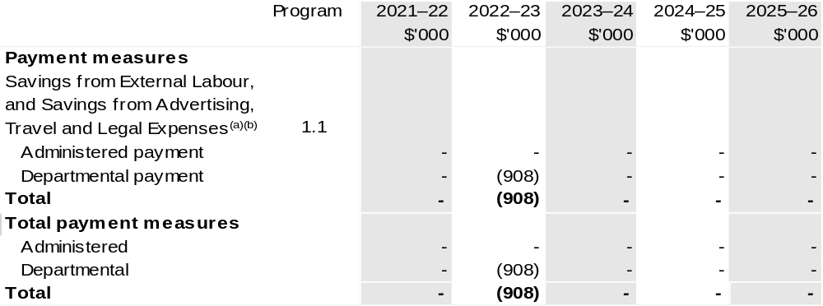
(a) The measure description appears in October Budget Paper No. 2: Budget Measures 2022–23 under the Cross Portfolio section.
(b) Funding for this measure passes through DAFF to RIC.

Prepared on a Government Finance Statistics (Underlying Cash) basis.

Figures displayed as a negative (-) represent a decrease in funds and a positive (+) represent an increase in funds.

Section 2: Outcomes and planned performance
Government outcomes are the intended results, impacts or consequences of actions by the Government on the Australian community. Commonwealth programs are the primary vehicle by which government entities achieve the intended results of their outcome statements. Entities are required to identify the programs which contribute to Government outcomes over the Budget and forward years.
Each outcome is described below together with its related programs. The following provides detailed information on expenses for each outcome and program, further broken down by funding source.
Note:
Performance reporting requirements in the Portfolio Budget Statements are part of the Commonwealth performance framework established by the Public Governance, Performance and Accountability Act 2013. It is anticipated that the performance criteria described in Portfolio Budget Statements will be read with broader information provided in an entity’s corporate plans and annual performance statements – included in Annual Reports – to provide a complete picture of an entity’s planned and actual performance.
The most recent corporate plan for the Regional Investment Corporation can be found at: www.ric.gov.au/about/corporate-plan.
The most recent annual report for the Regional Investment Corporation can be found at: http://www.ric.gov.au/about/reporting/annual-report.

2.1 Budgeted expenses and performance for Outcome 1
Outcome 1: Encourage growth, investment and resilience in Australian farm businesses and rural and regional communities by delivering the Commonwealth’s farm business concessional loans.

2.1.1: Linked programs
Department of Agriculture, Fisheries and Forestry
- Program 1.3: Forestry Industry
- Program 1.11: Drought Programs
Contribution to Outcome 1 made by linked program:
RIC works together with DAFF to ensure more sustainable, productive, internationally competitive and profitable Australian agricultural and forestry industries.

2.1.2: Budgeted expenses for Outcome 1
This table shows how much the entity intends to spend (on an accrual basis) on achieving the outcome, broken down by program, as well as by administered and departmental funding sources.

Table 2.1: Budgeted expenses for Outcome 1
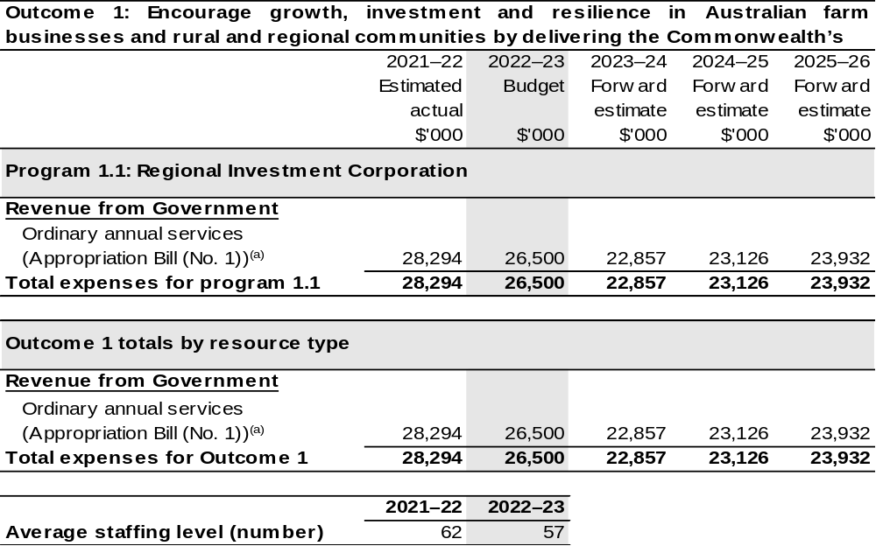
(a) Appropriation Bill (No. 1) 2022–23, Supply Bill (No. 3) 2022–23 and Supply Act (No. 1) 2022–23.
RIC is a corporate Commonwealth entity under the Public Governance, Performance and Accountability Act 2013 (PGPA Act) and does not receive direct appropriations. Appropriation is provided through DAFF and is specified with the Annual Appropriation Bills as payment to RIC and is considered departmental for all purposes.

Note: Departmental appropriation splits and totals are indicative estimates and may change in the course of the budget year as government priorities change.

Prepared on Australian Accounting Standards basis.

Table 2.2: Performance measure for Outcome 1
Table 2.2 details the performance measures for each program associated with Outcome 1. It also provides the related key activities as expressed in the current corporate plan where further detail is provided about the delivery of the activities related to the program, the context in which these activities are delivered and how the performance of these activities will be measured. Where relevant, the October 2022–23 Budget measures that have created new programs or materially changed existing programs are provided.
Outcome 1 – Encourage growth, investment and resilience in Australian farm businesses and rural and regional communities by delivering the Commonwealth’s farm business concessional loans.
Program 1.1: Regional Investment Corporation
Objectives | Provide practical support and investment to help rural and regional communities achieve economic growth, agricultural productivity, and resilience through the delivery of farm business loans, farm-related small business loans and plantation development loans.  RIC’s farm business loans and farm related small business loans provide low-cost finance to businesses that are in financial need of assistance, to recover from short-term hardship, but are assessed as financially viable over the long-term and able to repay the loan.  RIC also provides plantation development concessional loans to support new plantation developments and the replanting of bushfire-damaged plantations.
Key Activities | We will manage the risk and assurance in the loan portfolio, with a focus in 2022–23 on revising our risk appetite and framework, followed by ongoing review and alignment of the statement and framework to emerging risks in future years.  We will implement final stages of the transformation program, involving the deployment of new technology that insources loan management and origination, and realigns our workforce and capability to a new operating model.  We will deliver our loans in accordance with appropriations and timelines. In 2022–23 we will track our progress against a new loan processing timeframe target, ensuring customers receive a decision on their loan as quickly as possible to help them with their planning.  We will increase customer satisfaction, including by insourcing our services to enhance our customer service and experience.  We will deliver new products or product amendments as directed by the Australian Government.

Continued on following pages

Table 2.2: Performance measure for Outcome 1 (continued)
Year | Performance measures | Expected Performance Results
Prior year  2021–22 | - Support is provided within funding appropriation limits. | Fully achieved.
Prior year  2021–22 | - Plantation Development Loan is implemented. | Fully achieved.
Prior year  2021–22 | - 90 per cent of loan decisions are consistent with the loan appetite. | Fully achieved.
Prior year  2021–22 | - Financial risk management program is implemented. | Partially achieved.
Prior year  2021–22 | - 80 per cent farm business loans are processed within 65 RIC handling days. | Fully achieved.
Prior year  2021–22 | - Loan application management system is implemented. | Fully achieved.
Prior year  2021–22 | - Data capture and reporting arrangements are improved. | Fully achieved.
Prior year  2021–22 | - Information Governance and Records Management system is implemented. | Fully achieved.
Prior year  2021–22 | - Enterprise Resource Planning system is implemented. | Fully achieved.
Prior year  2021–22 | - Operating results are within approved budgets. | Fully achieved.
Prior year  2021–22 | - Increase in satisfaction rates and Net Promoter Score (NPS). | Partially achieved.
Year | Performance measures | Planned Performance Results
Budget Year  2022–23 | - Risk is managed within acceptable tolerances. | Ongoing portfolio management framework is finalised and operational by December 2022.  90 per cent of loan decisions are consistent with the risk appetite.
Budget Year  2022–23 | - Implement loan management system. | Loan management system implemented and functional by December 2023.
Table 2.2: Performance measure for Outcome 1 (continued)
Year | Performance measures | Planned Performance Results
Budget Year  2022–23 (continued) | - Workforce capability aligned to RIC operating model. | Workforce plan implemented and embedded by December 2023.
Budget Year  2022–23 (continued) | - Number and value of farm business loans provided. | Support provided within funding appropriation limits.
Budget Year  2022–23 (continued) | - Deliver services efficiently within approved funding. | Operate within approved operating budget.
Budget Year  2022–23 (continued) | - Improved customer satisfaction. | Increase in satisfaction rates compared with prior years.
Budget Year  2022–23 (continued) | - Loan processing timeframe. | 85 per cent of eligible loans decisioned in 30 RIC-handling days.
Budget Year  2022–23 (continued) | - Responsive and efficient delivery of new products and enhancements. | New products delivered on time and within funding appropriation limits.
Forward Estimates  2023–26 | As per 2022–23. | As per 2022–23.

Section 3: Budgeted financial statements
Section 3 presents budgeted financial statements which provide a comprehensive snapshot of entity finances for the 2022–23 budget year, including the impact of budget measures and resourcing on financial statements.

3.1 Budgeted financial statements

3.1.1: Explanatory notes and analysis of budgeted financial statements
In 2022–23, RIC will continue to support the provision of loans to eligible farm businesses, farm-related small businesses, and loans for eligible forestry businesses.
RIC is budgeting for an approved $4.4 million operating loss in 2022–23 with expenses (including employee and supplier expenses) budgeted at $26.5 million representing expenditure funded from appropriations received in prior years. RIC has sufficient cash reserves to fund the operating loss without impacting on the financial viability of RIC in the future.
The expense budget reflects the work programs for RIC in receiving and evaluating loan applications and managing approved loans to eligible farm businesses,
farm-related small businesses and eligible forestry businesses and providing independent advice to the Government.

3.2 Budgeted financial statements tables

Table 3.1: Comprehensive income statement (showing net cost of services)
(for the period ended 30 June)
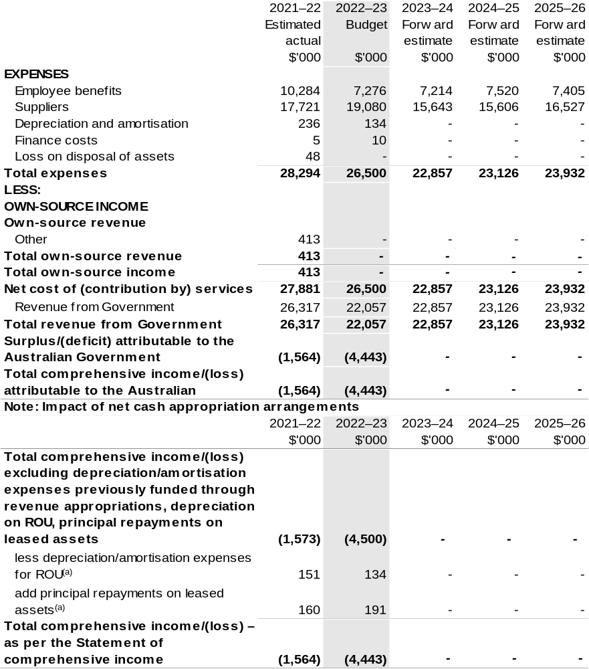
(a) Applies to leases under AASB 16 Leases. Right of Use (ROU).

Prepared on Australian Accounting Standards basis.

Table 3.2: Budgeted departmental balance sheet (as at 30 June)
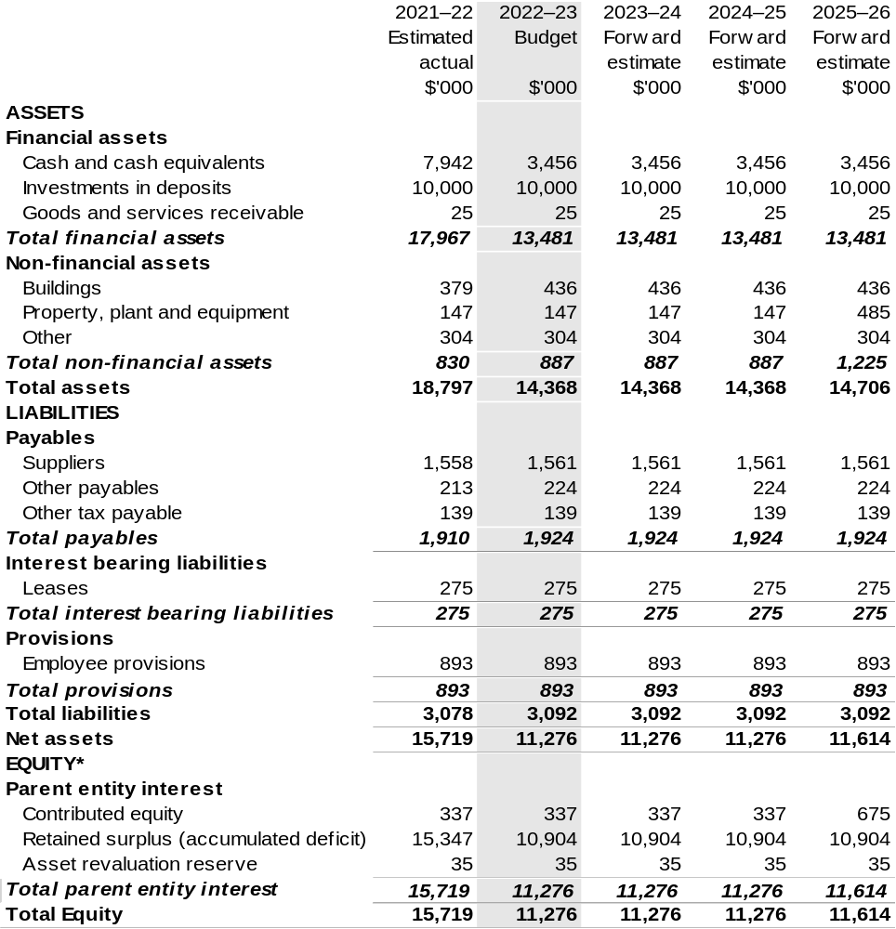
*’Equity’ is the residual interest in assets after deduction of liabilities.

Prepared on Australian Accounting Standards basis.

Table 3.3: Departmental statement of changes in equity—summary of movement (Budget year 2022–23)
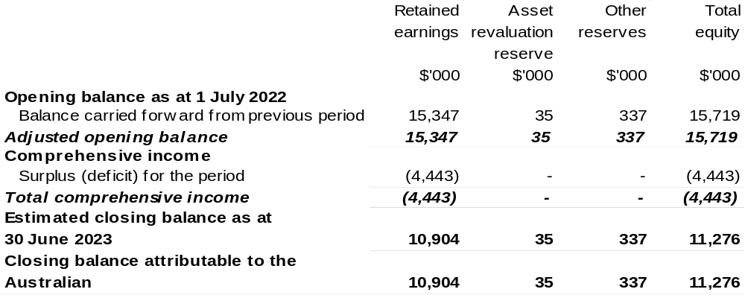

Prepared on Australian Accounting Standards basis.

Table 3.4: Budgeted departmental statement of cash flows (for the period
ended 30 June)
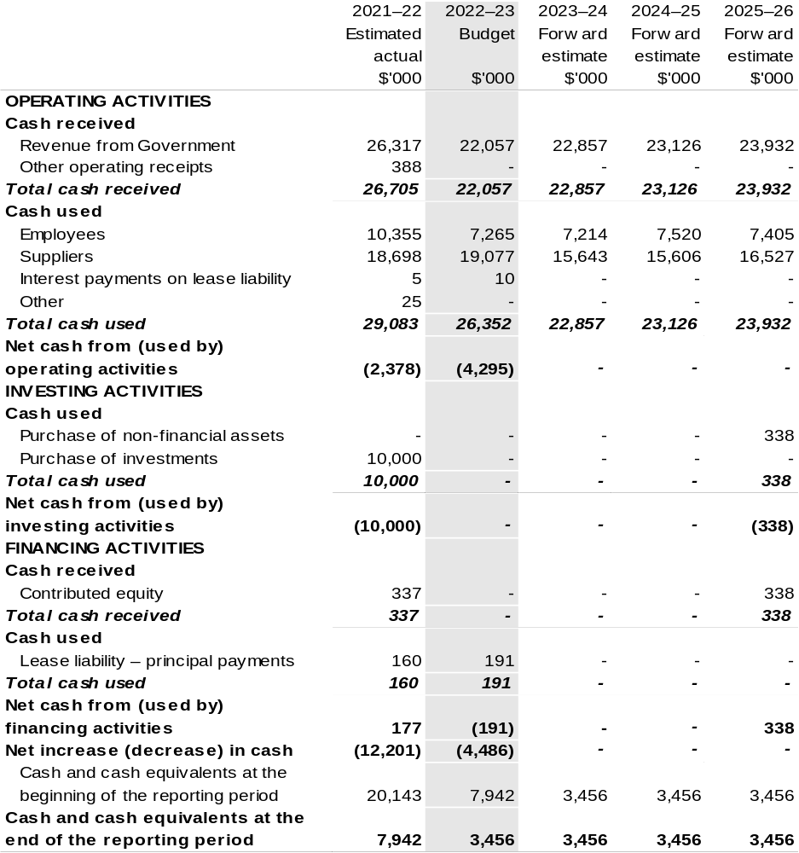
Prepared on Australian Accounting Standards basis.

Table 3.5: Departmental capital budget statement (for the period ended 30 June)
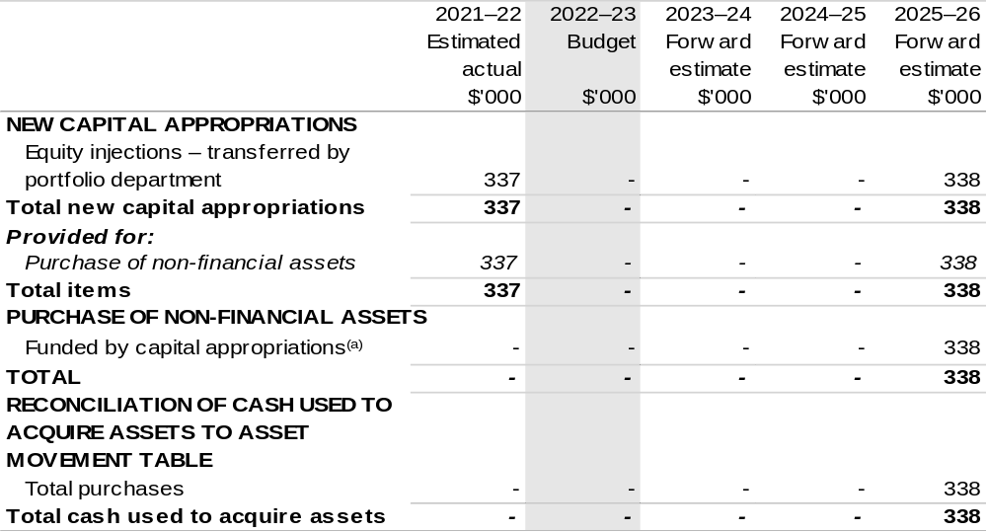
(a) Includes current Appropriation Bill (No. 2) and prior year Act (No. 2/4/6) appropriation.

Consistent with information contained in the Statement of Asset Movements and the Budgeted Statement of Cash Flows.

Prepared on Australian Accounting Standards basis.

Table 3.6: Statement of departmental asset movements (Budget year 2022–23)
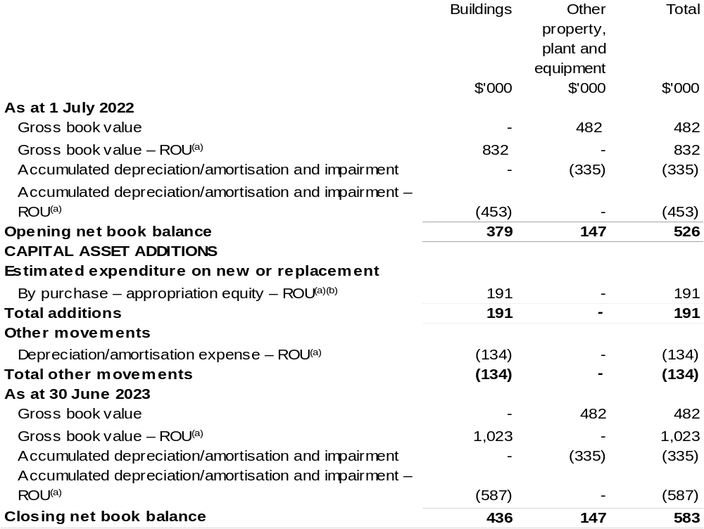
(a) Applies to leases under AASB 16 Leases. Right of Use (ROU).
(b) ‘By purchase – appropriation equity’ refers to equity injections appropriations provided through Appropriation Bill (No. 2) 2022–23 and other internal funding sources.

Prepared on Australian Accounting Standards basis.

Table 3.7: Schedule of budgeted income and expenses administered on behalf of Government (for the period ended 30 June)

The schedule of budgeted income and expenses administered on behalf of Government does not apply to RIC.

Table 3.8: Schedule of budgeted assets and liabilities administered on behalf of Government (as at 30 June)

The schedule of budgeted assets and liabilities administered on behalf of Government does not apply to RIC.

Table 3.9: Schedule of budgeted administered cash flows (for the period
ended 30 June)

The schedule of budgeted administered cash flows on behalf of Government does not apply to RIC.

Wine Australia
Section 1: Entity overview and resources 245
1.1 Strategic direction statement 245
1.2 Entity resource statement 248
1.3 Budget measures 250
Section 2: Outcomes and planned performance 251
2.1 Budgeted expenses and performance for Outcome 1 252
Section 3: Budgeted financial statements 260
3.1 Budgeted financial statements 260
3.2 Budgeted financial statements tables 261

Wine Australia

Section 1: Entity overview and resources

1.1 Strategic direction statement
Wine Australia seeks to foster and encourage profitable, resilient, and sustainable Australian winegrape and wine businesses by investing in research and development (R&D), building markets, disseminating market information and knowledge, encouraging adoption, and ensuring compliance through our regulatory functions.
We are governed by the Wine Australia Act 2013 (Wine Australia Act).

Wine Australia’s role under the Wine Australia Act is to:
- coordinate or fund grape and wine R&D and facilitate the dissemination, adoption, and commercialisation of the results
- control the export of wine from Australia
- promote the sale and consumption of wine, both in Australia and overseas.
Wine Australia is funded by grape growers, winemakers and exporters through levies and user-pays charges, and by the Australian Government, which provides matching funding for research, development, and adoption (RD&A) investments.

Australian wine is a unique, high-quality product crafted in 65 wine regions around the country. The Australian wine sector has approximately 6,000 grape growers, 146,244 hectares of vines, 2,156 wineries and produced 1.48 billion litres of wine in 2020–21.
In the year ended December 2021, Australian wine exports decreased by 30 per cent in value to $2.03 billion and 17 per cent in volume to 619 million litres (69 million 9-litre case equivalents). This resulted in a 15 per cent decline in average value to $3.27 per litre. The biggest driver of the decline was the reduction in exports to mainland China, following the imposition of tariffs on Australian packaged wine in November 2020. The 619 million litres shipped in total for the 2021 calendar year represents the lowest volume shipped in a 12-month period since the year ended September 2004. Aside from the decrease in shipments to mainland China, the significant decline in volume can also be attributed to low inventory at the start of the year after three small vintages and delays in getting the large 2021 vintage onto ships due to the ongoing global freight disruptions. There were 1,269 active exporters in 2021 and 19,247 products exported to 112 destinations.

Wine Australia’s goal is profitable, resilient, and sustainable winegrape and wine businesses, and how Wine Australia achieves its responsibilities under the Wine Australia Act is outlined in the five-year Strategic Plan 2020–25. In 2022–23, the third year of the strategic plan, Wine Australia will continue to invest in five strategies:
- Strategy 1: Promote Australian wine
- Strategy 2: Protect Australian wine
- Strategy 3: Build grape and wine excellence
- Strategy 4: Build sustainable environments
- Strategy 5: Build business sustainability, excellence, and leadership.
Since Wine Australia’s Strategic Plan 2020–25 was approved in June 2020, the environment within which it operates has been significantly impacted by COVID-19 restrictions, and the imposition of tariffs on Australian wine exported to China.
The operational impacts that will flow from the current market and financial challenges have been contemplated in developing this statement and will be reflected in future annual operational plans.
In the current operational environment, Wine Australia is seeking to intensify marketing efforts to gain greater market share in established markets of the United States of America (USA), Canada, and the United Kingdom (UK) and diversify into emerging markets. Wine Australia’s key marketing objectives are to:
- build the Australian wine category to drive positive sentiment and awareness among trade and consumers
- drive increased market entry into the USA, Canada, UK, Europe, and Asia Pacific
- build availability and reach of product across distributors, on premise and retail
- align investment and category building activities with exporters and federal, state, and regional bodies to target growth
- promote sustainability in key markets with activations for trade and consumers.
Wine Australia has partnered with Austrade through the Australian Government’s Agri-Business Expansion Initiative (ABEI) to unlock market diversification opportunities in the Asia Pacific Accreditation Cooperation (APAC) markets, such as Vietnam, Thailand, South Korea, Indonesia, Japan, and Taiwan. The partnership is also helping wine businesses develop capabilities to support diversification efforts.
Wine Australia’s regulatory services activities seek to protect the reputation and integrity of Australian wine in all markets, including the domestic market. It will ensure that the regulatory regime remains fit for purpose, explore new opportunities for traceability technologies, build relationships with counterpart regulators in export markets and enhance the Wine Australia Licensing and Approvals System (WALAS) and the Label Directory. Wine Australia will also support the Geographical Indications Committee that defines the wine grape producing regions of Australia.
In Strategy 3, Wine Australia’s R&D investments will continue to enhance grape and wine excellence by identifying enhanced grapevine varieties and clones and breeding new varieties and rootstocks that suit our environment and consumer tastes.
To maintain the supply of genetically diverse and high-health planting material, Wine Australia will continue to work towards the establishment of a national germplasm collection. To increase grape and wine production efficiency and sustainability, it will continue to develop, test, and commercialise new technologies and demonstrate them through agricultural technology demonstration sites to encourage adoption.
In Strategy 4, Wine Australia’s R&D investments will provide knowledge and tools to help growers and producers to be more environmentally sustainable, including information to manage the challenges of short-term climate cycles and long-term climate change. Wine Australia will determine baseline levels of carbon emissions and waste production in a grape and wine production setting so that the sector can develop benchmarks as a first step towards its goal of zero net carbon emissions and zero waste production by 2050.
Wine Australia will continue investing in research to allow more efficient and effective use of water in the vineyard, and focus on the value of soil remediation processes, lower chemical use in the vineyard, more sustainably managing endemic pests and diseases and being better prepared for exotic pests and diseases. It will actively support the sector’s Sustainable Winegrowing Australia program to help the sector demonstrate its sustainability credentials.
In Strategy 5, Wine Australia’s R&D adoption investments seek to accelerate the adoption of research outcomes and best practice. Wine Australia will implement our Extension and Adoption Strategy to build capacity and drive behaviour and practice change, including through our Regional Program. It will continue developing the leaders of tomorrow – and building the skills of the leaders of today – through regional governance and leadership programs and by supporting postgraduate students and early-career researchers.
Wine Australia also works closely with other rural research and development corporations (RDCs) in cross-sectoral collaborative research, including through Agricultural Innovation Investments Limited, to deliver RD&A benefits to the broader community.

1.2 Entity resource statement
Table 1.1 shows the total funding from all sources available to the entity for its operations and to deliver programs and services on behalf of the Government.
The table summarises how resources will be applied by outcome (Government strategic policy objectives) and by administered (on behalf of the Government or the public) and departmental (for the entity’s operations) classification.
For more detailed information on special accounts and special appropriations, please refer to October Budget Paper No. 4: Agency Resourcing.
Information in this table is presented on a resourcing (that is, appropriations/cash available) basis, whilst the ‘Budgeted expenses by Outcome’ table in Section 2 and the financial statements in Section 3 are presented on an accrual basis.

Table 1.1: Wine Australia – Resource Statement – Budget Estimates for 2022–23 as at October Budget 2022
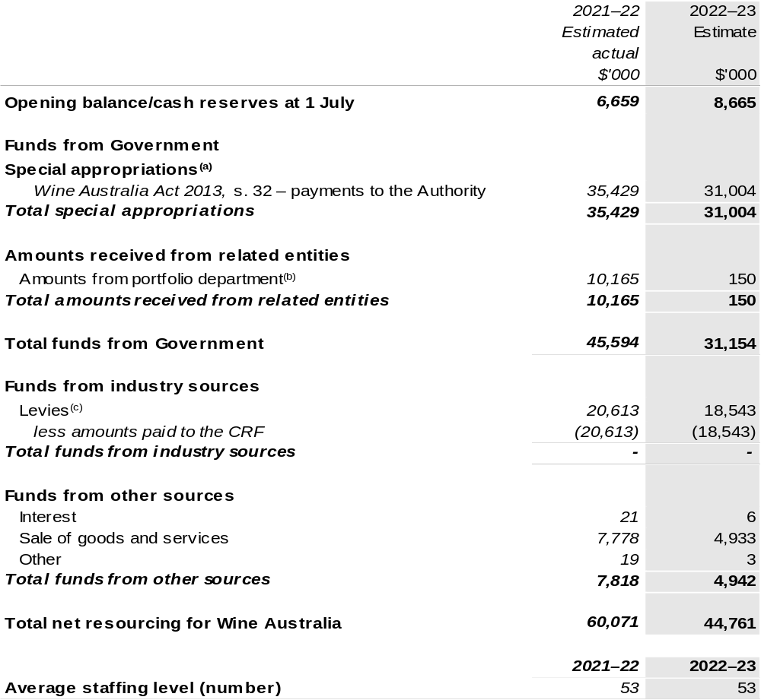
(a) Wine Australia's special appropriation is not directly appropriated as it is a corporate Commonwealth Entity (CCE) under the Public Governance, Performance and Accountability Act 2013 (PGPA Act). Appropriations are made to the Department of Agriculture, Fisheries and Forestry (DAFF) and are then paid to Wine Australia and are considered departmental for all purposes.
(b) Funding provided by the portfolio department that is not specified within the Annual Appropriation Bills as a payment to that CCE (for example, a grant awarded to a CCE from one of its portfolio department's administered programs).
(c) The levies are imposed by the Primary Industries (Excise) Levies Act 1999. Levies are collected by DAFF under the Primary Industries (Excise) Levies Act 1999 and Primary Industries (Customs) Charges Act 1999 and comprise of the Grape Research Levy and the Wine Grapes Levy and are transferred to the Consolidated Revenue Fund (CRF). These amounts are then drawn down by the department as a special appropriation and paid to Wine Australia under the Wine Australia Act 2013, s. 32.

Please note: All figures shown above are GST exclusive – these may not match figures in the cash flow statement.

Prepared on a resourcing (i.e. appropriations available) basis.

1.3 Budget measures
Budget measures in Part 1 relating to the Wine Australia are detailed in October Budget Paper No. 2 and are summarised below.

Table 1.2: Wine Australia – October 2022–23 Budget Measures

Part 1: Measures announced since the March 2022–23 Budget

Wine Australia does not have any October 2022–23 Budget measures.

Section 2: Outcomes and planned performance
Government outcomes are the intended results, impacts or consequences of actions by the Government on the Australian community. Commonwealth programs are the primary vehicle by which government entities achieve the intended results of their outcome statements. Entities are required to identify the programs which contribute to Government outcomes over the Budget and forward years.
Each outcome is described below together with its related programs. The following provides detailed information on expenses for each outcome and program, further broken down by funding source.
Note:
Performance reporting requirements in the Portfolio Budget Statements are part of the Commonwealth performance framework established by the Public Governance, Performance and Accountability Act 2013. It is anticipated that the performance criteria described in Portfolio Budget Statements will be read with broader information provided in an entity’s corporate plans and annual performance statements — included in Annual Reports — to provide a complete picture of an entity’s planned and actual performance.
The most recent corporate plan for Wine Australia can be found at: https://www.wineaustralia.com/WA_StrategicPlan_2020–25.
The most recent annual performance statement for Wine Australia can be found at:
https://www.wineaustralia.com/WA_AnnualReport_2020–21.

2.1 Budgeted expenses and performance for Outcome 1
Outcome 1: Foster and enable a competitive Australian wine industry by investing in research and development, building markets, disseminating knowledge and ensuring compliance.

2.1.1: Linked programs
Department of Agriculture, Fisheries and Forestry
Program 1.10: Agricultural Resources
Program 1.13: International Market Access
Contribution to Outcome 1 made by linked program:
Wine Australia and DAFF work together to ensure a sustainable, productive and profitable grape and wine sector.
Wine Australia will also administer the Wine Tourism and Cellar Door Grant program that commenced in 2019–20.

2.1.2: Budgeted expenses for Outcome 1
This table shows how much the entity intends to spend (on an accrual basis) on achieving the outcome, broken down by program, as well as by administered and departmental funding sources.

Table 2.1: Budgeted expenses for Outcome 1
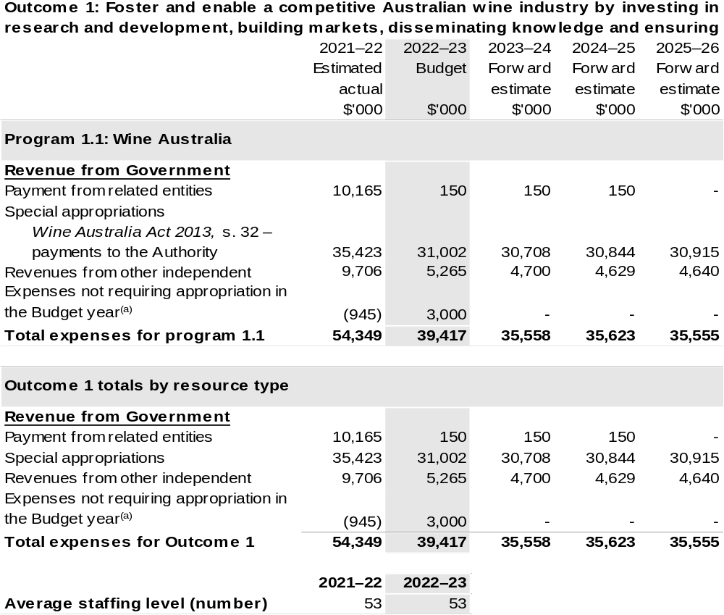
(a) Expenses not requiring appropriation in the Budget year are made up of make good expenses, audit fees, and can include depreciation / amortisation expenses not requiring an appropriation.

Note: Departmental appropriation splits and totals are indicative estimates and may change in the course of the budget year as government priorities change.

Prepared on Australian Accounting Standards basis.

Table 2.2: Performance measure for Outcome 1
Table 2.2 below details the performance measure for each program associated with Outcome 1. It also summarises how each program is delivered and where relevant, the October 2022–23 Budget measures have created new programs or materially changed existing programs are provided.
As an entity established under the Wine Australia Act, Wine Australia does not produce a corporate plan under the PGPA Act and is therefore exempt from the requirement to map purposes to outcomes.
Outcome 1: Foster and enable a competitive Australian wine industry by investing in research and development, building markets, disseminating knowledge and ensuring compliance.
Program 1.1: Wine Australia
Objective | Invest in R&D, building markets, disseminating knowledge and ensuring compliance to foster and enable a competitive Australian wine sector.
Key Activities | Wine Australia will:  - Invest in R&D in the five strategic areas outlined in its Strategic Plan 2020–2025 for the benefit of wine grape growers, winemakers, wine businesses and the wider community.  - Invest in RD&A to build grape and wine excellence, build sustainable environments, and build business sustainability, excellence and leadership.  - Invest in marketing to promote Australian wine and grow international markets.  - Invest in regulatory services to protect the reputation of Australian wine.  - Support grape and wine businesses with market insights that allow them to make effective and informed decisions.

Continued on following pages
Table 2.2: Performance measure for Outcome 1 (continued)
Year | Performance measures | Expected Performance Results
Prior year  2021–22 | Wine Australia
Prior year  2021–22 | Improve our stakeholder net promoter score from 2019 baseline. | Target Above +12.  In 2021–22, we focused instead on the creation of the above Stakeholder Engagement Plan (now referred to as the Customer Engagement Plan), the onboarding of the new CEO, and the strategic plan refresh. Now that this has been completed, we have commenced the design of our next Stakeholder Engagement Survey, to be completed before the end of 2022–23.
Prior year  2021–22 | RD&A
Prior year  2021–22 | Research contracts are actively managed through regular and ongoing monitoring of the research. | Target 100 per cent.
Prior year  2021–22 | Market Insights customers are satisfied or very satisfied with the services they receive. | Target >90 per cent.  During the year, 40 individual analyst sessions were booked by our levy-payers. The “Ask Analyst’ sessions were heavily promoted throughout the year to encourage usage.
Prior year  2021–22 | Levy payers who participate in  Wine Australia-supported extension and adoption programs consider them a ‘good’ or ‘very good’ use of levy funds. | Target 80 per cent.  Australian Grape and Wine (AGW) Research Advisory Committee continue to assist in identifying and prioritising extension and adoption priorities.  Monitoring and evaluation metrics across Wine Australia supported extension activities with the Australian Wine Research Institute and the Australian Society of Viticulture and Oenology indicate that events overall are delivering value – on average at least 75 per cent of attendees at workshops, seminars and

Continued on following pages
Table 2.2: Performance measure for Outcome 1 (continued)
Year | Performance measures | Expected Performance Results
Prior year  2021–22 (continued) | RD&A (continued)
Prior year  2021–22 (continued) |  | webinars rated these events ‘very good’ or ‘excellent’ and at least 80 per cent of attendees intend to make changes to current practices, reassess current practices, seek extra information or discuss with peers about making changes to their current practices.
Prior year  2021–22 (continued) | Marketing
Prior year  2021–22 (continued) | Tier A influencers actively engage with Wine Australia. | Target 85 per cent.  73 per cent of Tier A influencers actively engaged with Wine Australia through marketing activities.  Europe, Middle East, Africa: 87 per cent  Americas: 71 per cent  Asia-Pacific: 36 per cent  The COVID-19 pandemic impacted engagement particularly in Asia where borders remained closed and planned activity was moved to 2022–23.  1,205 business-to-business connections made via Australian Wine Connect and its associated campaigns and hybrid events.  Trade audience Net Promotor Score (NPS) rating:  - Australian Wine Discovered NPS 64, an ‘very good’ to ‘excellent’ score; and  - Australian Wine Connect NPS 26, a ‘good’ score.  Downloads of Australian Wine Discovered content decreased by 52 per cent due to ongoing reduction in engagement from China and reduced activity in markets due to the COVID-19 pandemic.  The tone in 94 per cent of media articles about Australian wine was positive or neutral. An increase of 5 per cent on the previous year.
Table 2.2: Performance measure for Outcome 1 (continued)
Year | Performance measures | Expected Performance Results
Prior year  2021–22 (continued) | Marketing (continued)
Prior year  2021–22 (continued) | The perception of Australian wine increases in Canada, the UK and the USA. | Target is to increase perception above 2019 baseline.  The annual Wine Intelligence survey showed the average consumer perception of Australian wine increased in each market from the previous year.  The stretch 8.6 key performance indicator was not achieved, due to the continued impacts of the COVID-19 pandemic and reduced activity in market.  - Canada increased from 8.20/8.07 to 8.36/8.33.  - UK increased from 8.22 to 8.39.  - USA increased from 8.29 to 8.30.  For paid social media, we achieved a 22 per cent engagement rate for Facebook and Instagram.
Prior year  2021–22 (continued) | Wineries and distributors who participate in Wine Australia events report that they are ‘satisfied’ or ‘very satisfied. | Target >90 per cent.  Average satisfaction rating across marketing campaigns was 87 per cent.  - 73 per cent of participants in the US Market Entry Program have commenced export to the USA or have an agreement to commence export.  - 19 participants in Explore Canada commenced export or have an agreement to commence export (two programs in 2021–22).  - Nine participants in Explore UK commenced export (one program held over to financial year 2023).  Additional wineries which have participated in the US Market Entry Program and Explore programs have indicated they anticipate commencing export in short to medium-term.

Continued on following pages
Table 2.2: Performance measure for Outcome 1 (continued)
Year | Performance measures | Expected Performance Results
Prior year  2021–22 (continued) | Regulatory services
Prior year  2021–22 (continued) | Achieve the six key performance indicators in the Regulatory Performance Framework. | Target to achieve.  Achieved.
Prior year  2021–22 (continued) | Through our Label Integrity Program, we inspect producers’ records, focusing on those relating to wine regions and varieties in particular demand. | Target is up to 300 inspections of records kept under the Label Integrity Program.  Following the abolishment of the Regulator Performance Framework in 2021–22, we worked with the department to develop a Statement of Intent in response to a Statement of Expectation issued in accordance with the Regulator Performance Guide published by the Department of Prime Minister and Cabinet.  We promoted and monitored compliance with the Label Integrity Program (LIP) by:  - Inspecting the records pertaining to more than 1300 labels prior to granting export approval to verify compliance with the record keeping requirements mandated under the LIP and the truthfulness of claims made about vintage, variety, and origin.  - Maintaining and promoting our WineWatch portal through which suspected incidences of non-compliance can be reported anonymously.  - Investigating all alleged breaches of the labelling and record keeping provisions set out in the Wine Australia Act 2013 and the Forest Stewardship Council (FSC).

Continued on following page

Table 2.2: Performance measure for Outcome 1 (continued)
Year | Performance measures | Expected Performance Results
Prior year  2021–22 (continued) | Regulatory services (continued)
Prior year  2021–22 (continued) |  | - Inspecting the LIP records kept by 174 Australian wine producers to verify whether records are being kept in accordance with the LIP.  - Maintaining WALAS to ensure that product composition and label descriptions are automatically reconciled to verify compliance with the FSC and the labelling laws set out in the Wine Australia Act 2013, and launching and maintaining Export Label Image Search System.
Year | Performance measures | Planned Performance Results
Budget Year  2022–23 | As per 2021–22. | As per 2021–22.
Forward Estimates  2023–26 | As per 2022–23. | As per 2022–23.

Section 3: Budgeted financial statements
Section 3 presents budgeted financial statements which provide a comprehensive snapshot of entity finances for the 2022–23 budget year, including the impact of budget measures and resourcing on financial statements.

3.1 Budgeted financial statements

3.1.1: Differences between entity resourcing and financial statements
There are no differences between the resource information presented in the Budget Papers and Portfolio Budget Statements.

3.1.2: Explanatory notes and analysis of budgeted financial statements
The Budget incorporates the contracted and committed research, development and extension activities, the anticipated marketing programs and statutory duties.

Wine Australia receives levies on the tonnage of fruit grown (Grape Research Levy), grape products used in the manufacture of wine (Wine Grapes Levy), and on the value of wine exported (Wine Export Charge). Revenue from these levies is expected to be approximately $18.5 million for the 2022–23 year, based on an expected 2022 vintage of 1.78 million tonnes.

Research, development, and extension expenditure attracts Commonwealth matching funding, which is calculated in accordance with the provisions of the Primary Industries Research and Development Act 1989 (PIRD Act).

Other major sources of revenue are export licences and associated fees and promotional user-pays events.

3.2 Budgeted financial statements tables

Table 3.1: Comprehensive income statement (showing net cost of services)
(for the period ended 30 June)
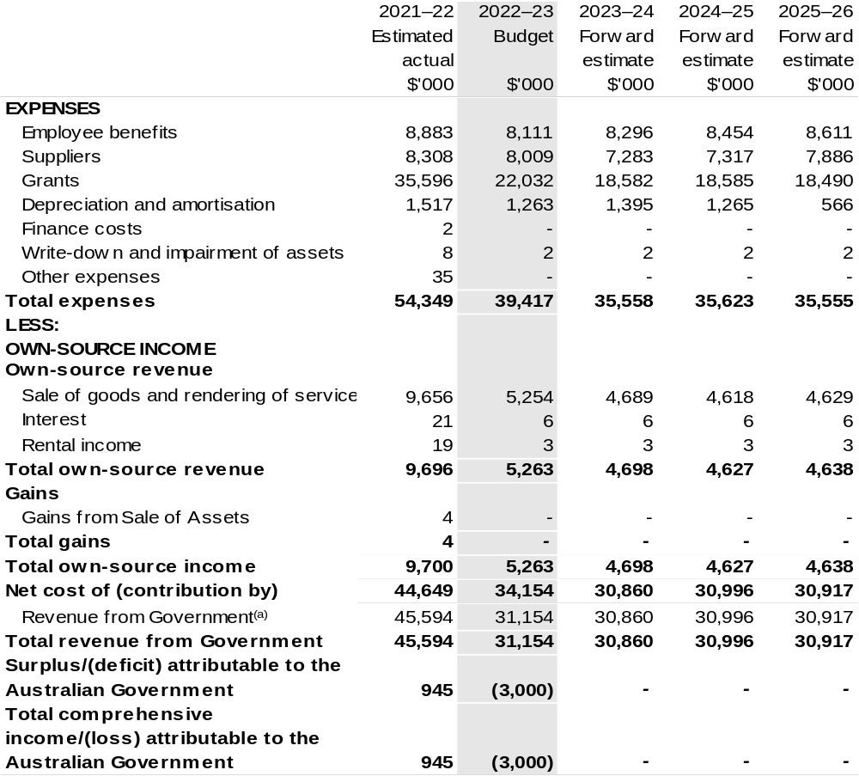
Continued on following page

Table 3.1: Comprehensive income statement (showing net cost of services)
(for the period ended 30 June) (continued)
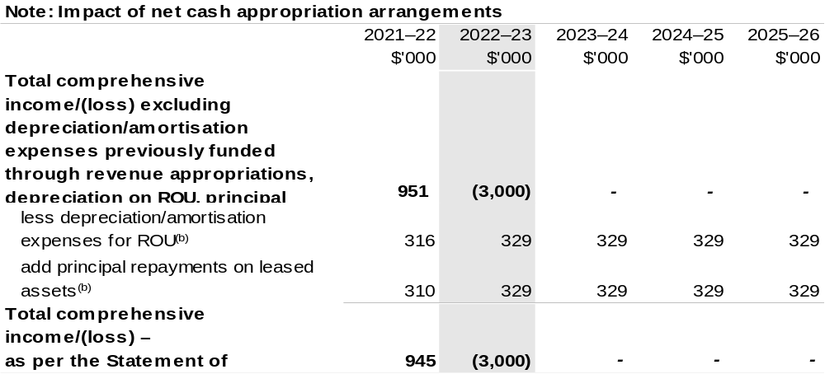
(a) Revenue from Government includes a Commonwealth contribution under the PIRD Act and levies collected from industry by DAFF for R&D and marketing activities.
(b) Applies to leases under AASB 16 Leases. Right of Use (ROU).

Prepared on Australian Accounting Standards basis.

Table 3.2: Budgeted departmental balance sheet (as at 30 June)
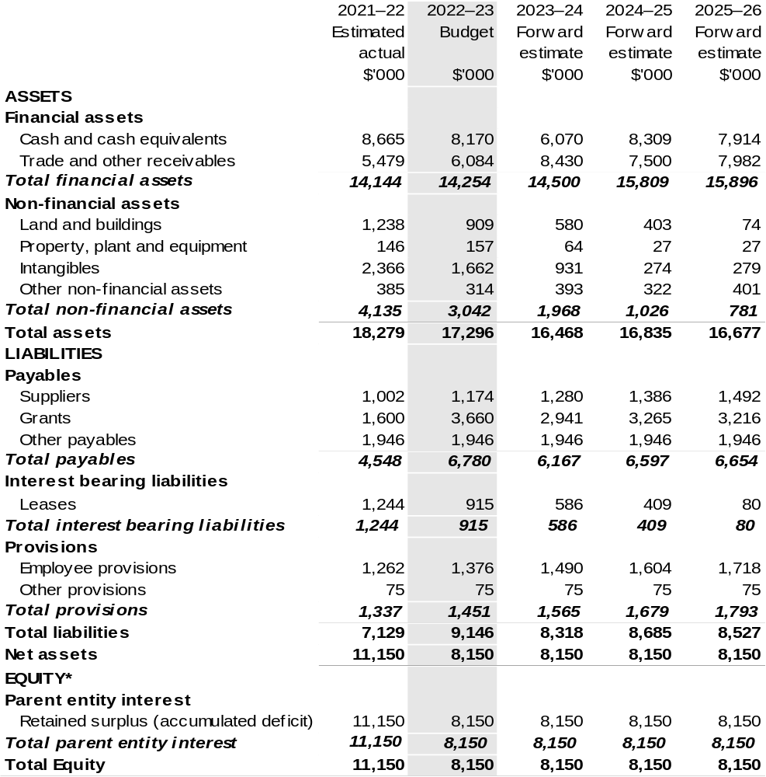
*’Equity’ is the residual interest in assets after deduction of liabilities.

Prepared on Australian Accounting Standards basis.

Table 3.3: Departmental statement of changes in equity – summary of movement (Budget year 2022–23)
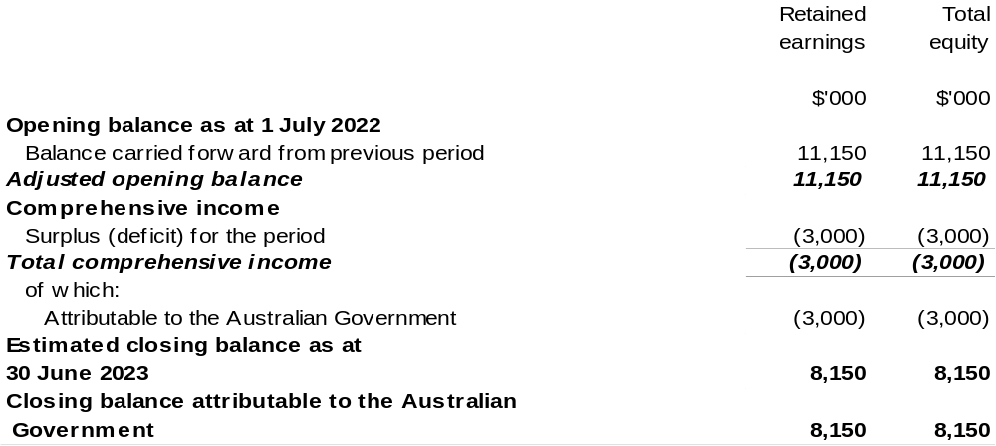
Prepared on Australian Accounting Standards basis.

Table 3.4: Budgeted departmental statement of cash flows (for the period
ended 30 June)
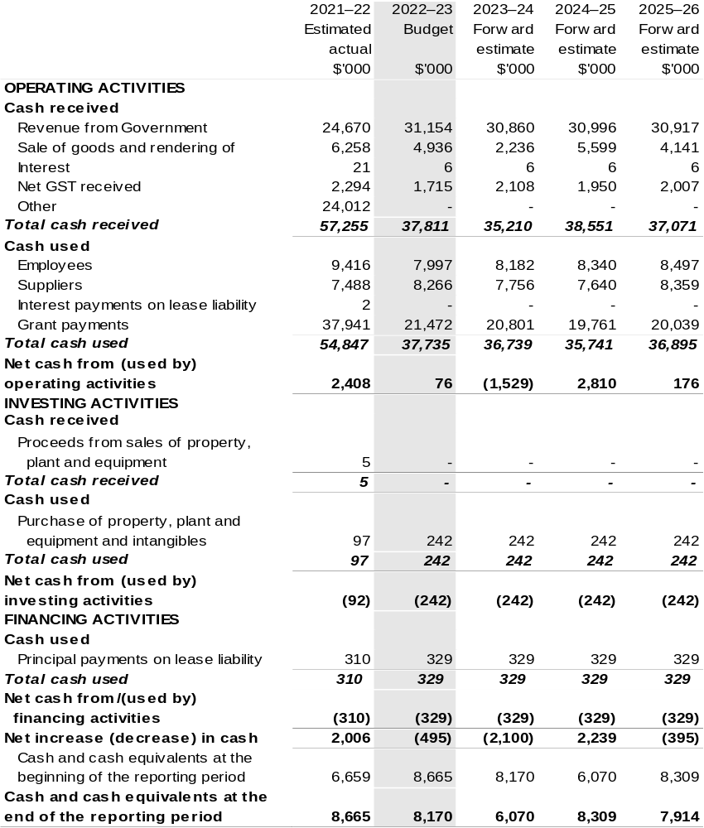

Prepared on Australian Accounting Standards basis.

Table 3.5: Departmental capital budget statement (for the period ended 30 June)
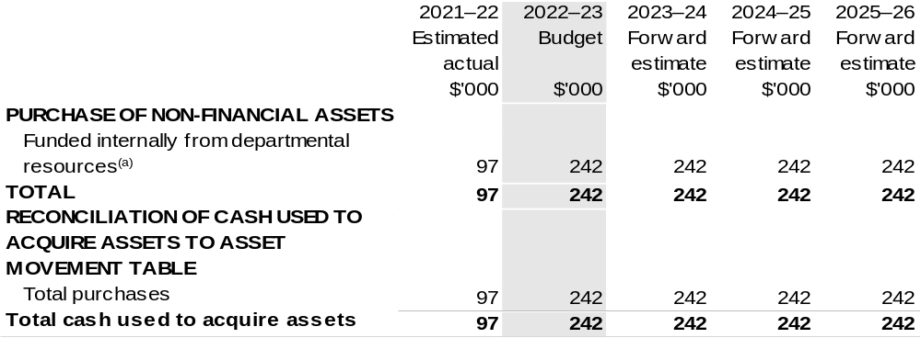
(a) Includes the following s74 external revenue:
– internally developed assets.

Consistent with information contained in the Statement of Asset Movements and the Budgeted Statement of Cash Flows.

Prepared on Australian Accounting Standards basis.

Table 3.6: Statement of departmental asset movements (Budget year 2022–23)
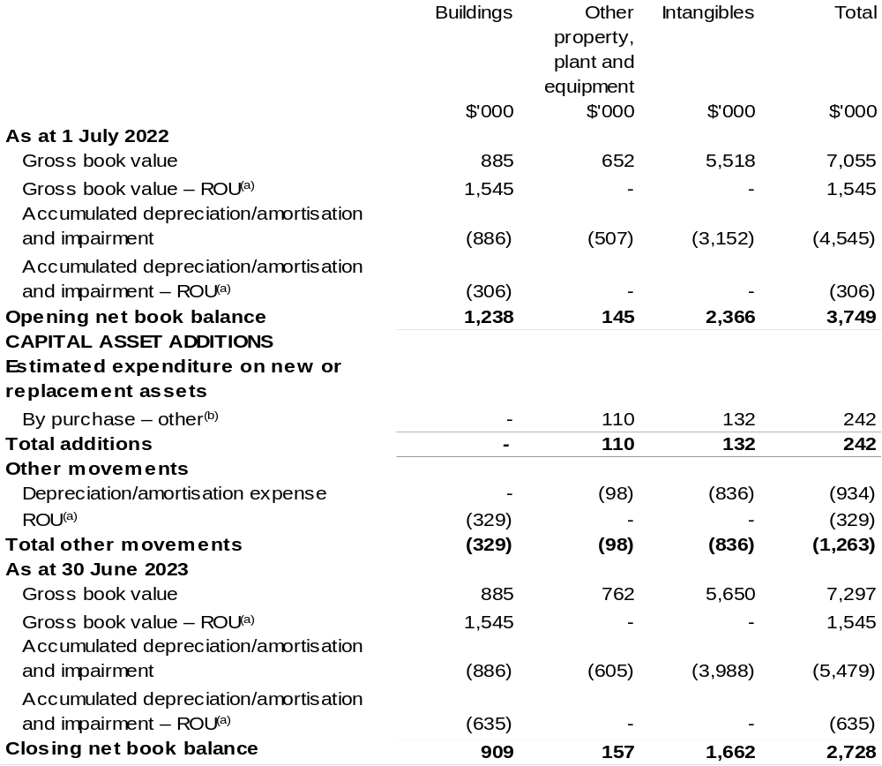

(a) Applies to leases under AASB 16 Leases. Right of Use (ROU).
(b) ‘By purchase – other’ refers to funding provided through other internal funding sources.

Prepared on Australian Accounting Standards basis.

