Portfolio Additional
Estimates Statements 2022–23

Appropriation Bill (NO. 3) 2022–2023
and
Appropriation Bill (No. 4) 2022–2023

Agriculture, Fisheries and Forestry Portfolio

Explanations of Additional Estimates 2022–23

© Commonwealth of Australia 2023
ISSN: 2653-8113 (print) 2653-8121 (online)
This publication is available for your use under a Creative Commons BY Attribution 3.0 Australia licence, with the exception of the Commonwealth Coat of Arms, the Department of Agriculture, Fisheries and Forestry logo, photographs, images, signatures and where otherwise stated. The full licence terms are available from http://creativecommons.org /licenses/by/3.0/au/legalcode.


Use of Department of Agriculture, Fisheries and Forestry material under a Creative Commons BY Attribution 3.0 Australia licence requires you to attribute the work (but not in any way that suggests that the Department of Agriculture, Fisheries and Forestry endorses you or your use of the work).
Department of Agriculture, Fisheries and Forestry material used ‘as supplied’.
Provided you have not modified or transformed Department of Agriculture, Fisheries and Forestry material in any way including, for example, by changing the department’s text; calculating percentage changes; graphing or charting data; or deriving new statistics from published Department of Agriculture, Fisheries and Forestry statistics, then the department prefers the following attribution:
Source: Australian Government Department of Agriculture, Fisheries and Forestry
Derivative material
If you have modified or transformed Department of Agriculture, Fisheries and Forestry material, or derived new material from those of the Department of Agriculture, Fisheries and Forestry in any way, then the department prefers the following attribution:
Based on Australian Government Department of Agriculture, Fisheries and Forestry data
Use of the Coat of Arms
The terms under which the Coat of Arms can be used are set out on the It’s an Honour website (see www.pmc.gov.au/honours-and-symbols/commonwealth-coat-arms)
Other Uses
Inquiries regarding this licence and any other use of this document are welcome at:
External Budgets Section; Finance and Investment Division
Department of Agriculture, Fisheries and Forestry GPO Box 858, Canberra, ACT 2601
Email: externalbudgets@agriculture.gov.au
Department of Agriculture, Fisheries and Forestry acknowledges the Traditional Custodians of country throughout Australia and their connections to land, sea and community. We pay our respects to their Elders past and present and extend that respect to all Aboriginal and Torres Strait Islander peoples today.

President of the Senate
Australian Senate
Parliament House
CANBERRA ACT 2600

Speaker
House of Representatives
Parliament House
CANBERRA ACT 2600

Dear Ms President
Dear Mr Speaker

I hereby submit these Portfolio Additional Estimates Statements in support of the additional appropriations sought for the Agriculture, Fisheries and Forestry portfolio, through Appropriation Bill (No. 3) 2022–2023 and Appropriation Bill (No.4) 2022–2023.
These statements have been developed, and are submitted to the Parliament, as a statement on the funding requirements being sought for the Portfolio.

I present these statements by virtue of my ministerial responsibility for accountability to the Parliament and, through it, the public.
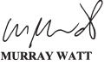
Yours sincerely

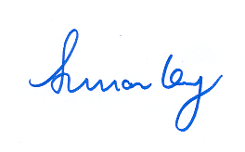

Abbreviations and conventions
The following notation may be used:
NEC/nec not elsewhere classified
- nil
.. not zero, but rounded to zero
na not applicable (unless otherwise specified)
nfp not for publication
$m $ million
$b $ billion
Figures in tables and in the text may be rounded. Figures in text are generally rounded to one decimal place, whereas figures in tables are generally rounded to the nearest thousand. Discrepancies in tables between totals and sums of components are due to rounding.
Enquiries
Should you have any enquiries regarding this publication please contact
Paul Pak Poy, Chief Finance Officer, Department of Agriculture, Fisheries and Forestry, on (02) 6272 5523.
A copy of this document can be located on the Australian Government Budget website at: www.budget.gov.au.

User Guide
to the
Portfolio Additional
Estimates Statements

User Guide
The purpose of the 2022–23 Portfolio Additional Estimates Statements (PAES) is to inform Senators, Members of Parliament and the public of the proposed allocation of additional resources to Government outcomes by entities within the portfolio.
The PAES facilitate understanding of the proposed appropriations in Appropriation Bill (No. 3) 2022–2023 and Appropriation Bill (No. 4) 2022–2023. In this sense the PAES is declared by the Appropriation Acts to be a ‘relevant document’ to the interpretation of the Acts according to section 15AB of the Acts Interpretation Act 1901.
Appropriation Bill (No. 3) 2022–2023, which follows on from Appropriation Act (No. 1) 2022–2023 tabled at Budget, will provide additional expenditure authority for the ordinary annual services of government in respect of the 2022–2023 financial year.
Appropriation Bill (No. 4) 2022–2023, which follows on from Appropriation Act (No. 2) 2022–2023 tabled at Budget, will provide additional expenditure authority in respect of the 2022–2023 financial year for capital works and services, payments to or for the states, territories and local government authorities, and new administered outcomes not authorised in specific legislation.

Contents
Department of Agriculture, Fisheries and Forestry xi
Australian Fisheries Management Authority 19

Entity Additional Estimates Statements

Department of Agriculture, Fisheries and Forestry
Overview of additional appropriations 13
Entity measures table 14
Additional estimates and variations 15
Breakdown of additional estimates by appropriation bill 18

Department of Agriculture, Fisheries and Forestry

Overview of additional appropriations
The Agriculture, Fisheries and Forestry portfolio consists of the Department of Agriculture, Fisheries and Forestry (the department) and eight portfolio entities.
The role and responsibilities of the department and the portfolio entities have not changed since the 2022–23 October Portfolio Budget Statements (PBS). An outline of the department’s Portfolio Overview can be found in the 2022–23 October PBS.
The department is receiving additional appropriations through Appropriation Bills (No. 3) 2022–23. The Australian Fisheries Management Authority will also be receiving additional appropriation through Appropriations Bills (No. 3) 2022–23.

Entity measures table
Table 1.1 summarises new Government measures taken since the 2022–23 October Budget that have financial implications in 2022–23. The table is split into receipt and payment measures, with the affected program identified.

Table 1.1: Department of Agriculture, Fisheries and Forestry – 2022–23 additional estimates measures
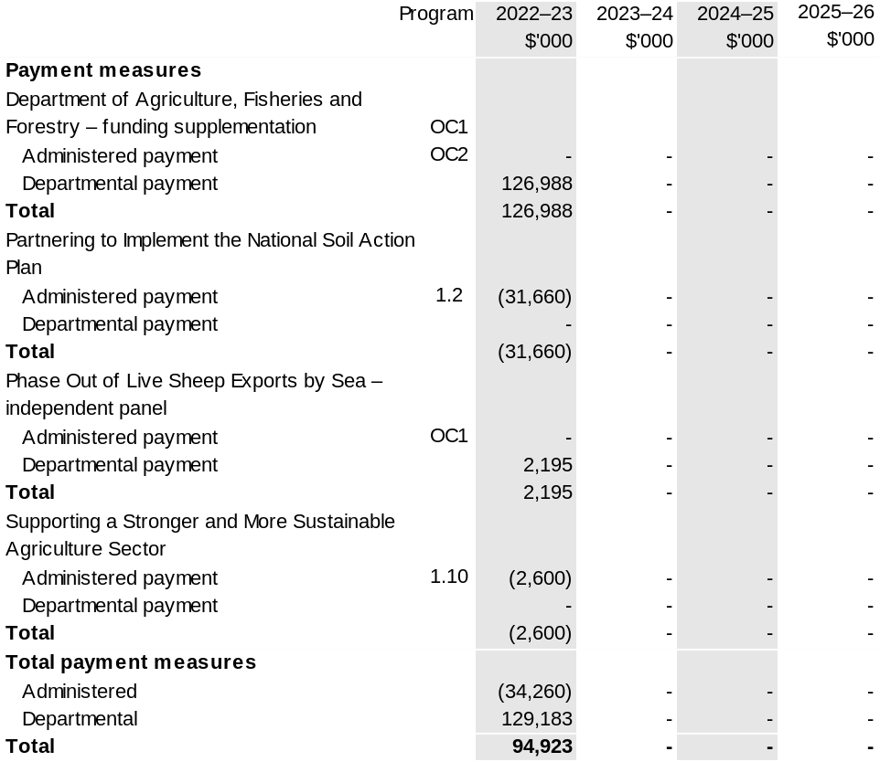
Note 1: The full measure description details appear in 2023–24 Budget Paper No. 2: Budget Measures under the Agriculture, Fisheries and Forestry portfolio.

Note 2: The full measure amounts will also appear in the department’s 2023–24 Portfolio Budget Statements (PBS), Section 1.3 Budget measures, Table 1.2: Department of Agriculture, Fisheries and Forestry – 2023–24 Budget Measures

Prepared on a Government Financial Statistics (Underlying Cash) basis.

Figures displayed as a negative (-) represent a decrease in funds and a positive (+) represent an increase in funds.

Additional estimates and variations
The following table details the changes to the resourcing for entity Department of Agriculture, Fisheries and Forestry at Additional Estimates, by outcome. The following table details the estimates and variations resulting from new measures and any other variations (if applicable) since the 2022–23 October Budget in Appropriation Bills
(No. 3) and (No. 4).

Table 1.2: Additional estimates and variations to outcomes from measures and other variations
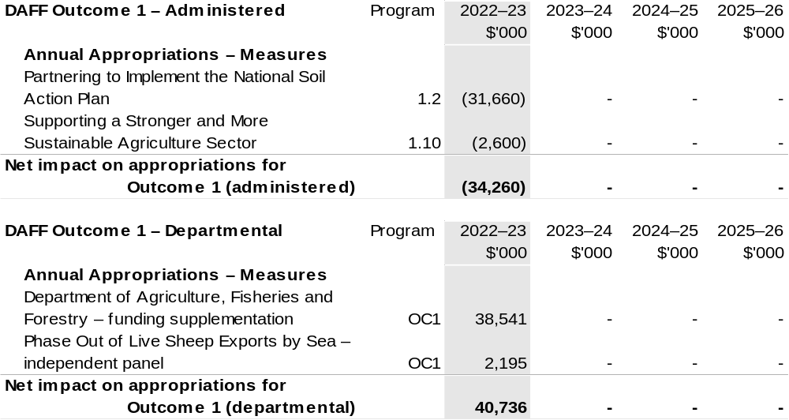
Continued on following pages
Table 1.2: Additional estimates and variations to outcomes from measures and other variations (continued)
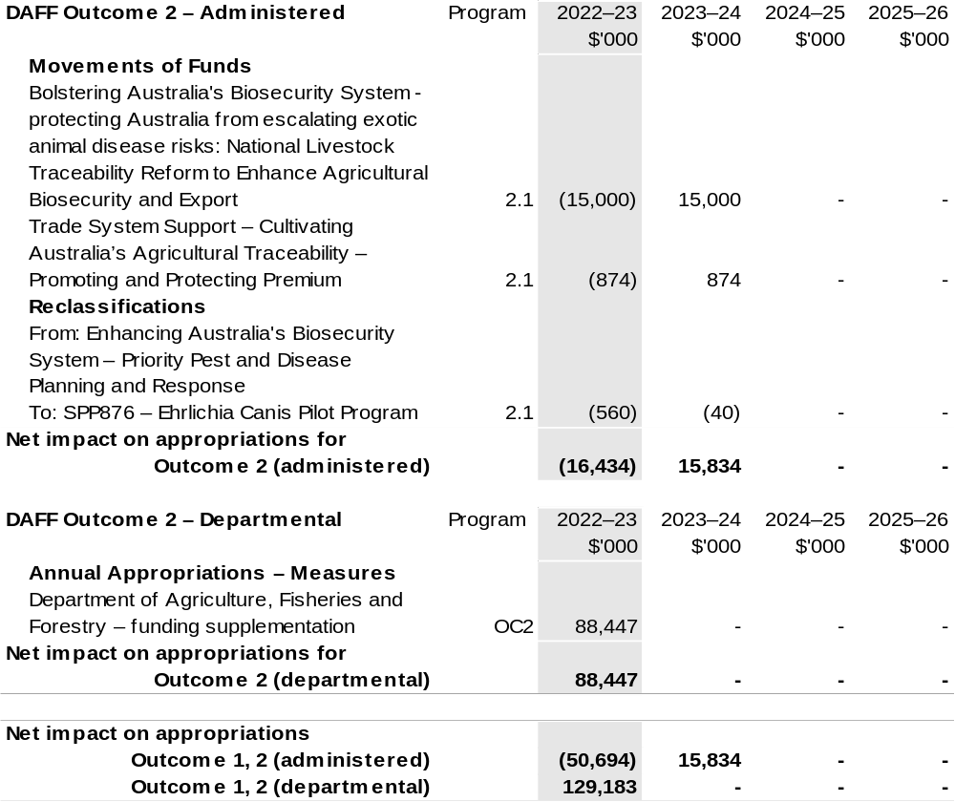
Continued on following page
Table 1.2: Additional estimates and variations to outcomes from measures and other variations (continued)
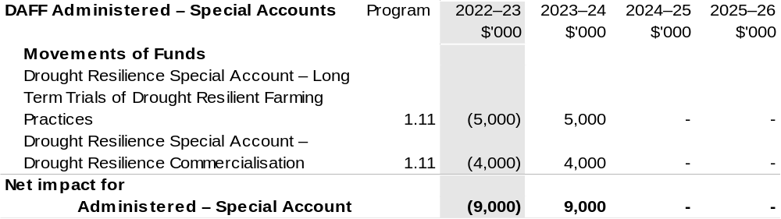
Note: Additional variations processed through the Department of the Treasury that impact the Department of Agriculture, Fisheries and Forestry.

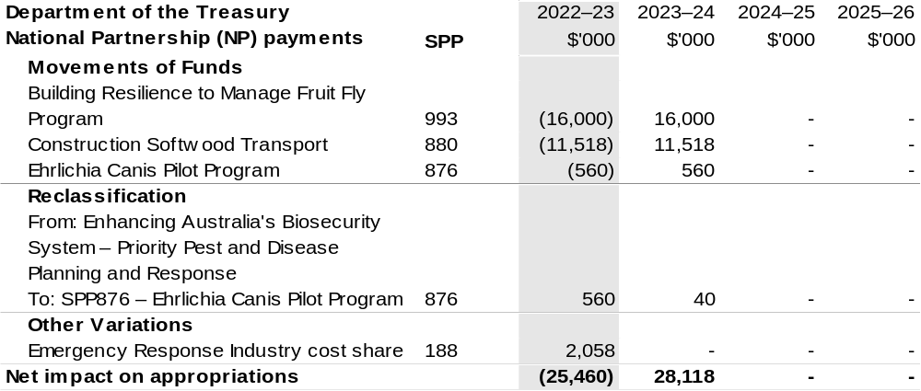

Breakdown of additional estimates by appropriation bill
The following tables detail the Additional Estimates sought for entity Department of Agriculture, Fisheries and Forestry through Appropriation Bills (No. 3) and (No. 4).

Table 1.3: Appropriation Bill (No. 3) 2022–23 – Departmental
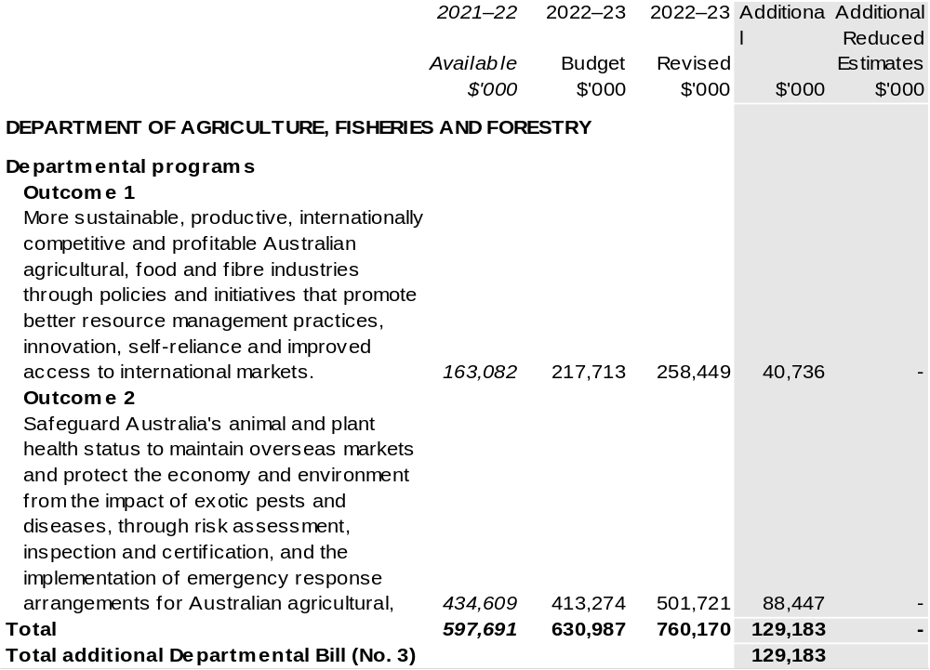
Note 1: 2021–22 available appropriation is included to allow a comparison of this year's appropriation with
what was made available for use in the previous year.
Australian Fisheries Management Authority
Overview of additional appropriations 21
Entity measure table 22
Additional estimates and variations 23
Breakdown of additional estimates by appropriation bill 24

Australian Fisheries Management Authority

Overview of additional appropriations
The purpose of the Australian Fisheries Management Authority (AFMA) is the ecologically sustainable development of Commonwealth fisheries for the benefit of the Australian community.
The role and responsibilities of AFMA have not changed since the 2022–23 October Portfolio Budget Statements (PBS).
The Australian Fisheries Management Authority will be receiving additional appropriation through Appropriations Bills (No. 3) 2022–23.

Entity measures table
Table 1.1 summarises new Government measures taken since the 2022–23 October Budget that have financial implications in 2022–23. The table is split into receipt and payment measures, with the affected program identified.

Table 1.1: Australian Fisheries Management Authority – 2022–23 additional estimates measures
AFMA does not have any measures in the 2022–23 PAES.

Additional estimates and variations
The following tables detail changes in resourcing for the Australian Fisheries Management Authority at Additional Estimates, by outcome. The following table details the estimates and variations resulting from new measures and any other variations (if applicable) since the 2022–23 October Budget in Appropriation Bills (No. 3) and (No. 4).

Table 1.2: Additional estimates and variations to outcomes from measures and other variations
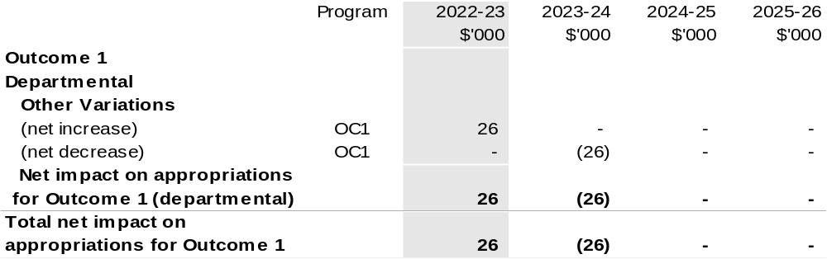

Breakdown of additional estimates by appropriation bill
The following tables detail the Additional Estimates sought for entity Australian Fisheries Management Authority through Appropriation Bills (No. 3) and (No. 4).

Table 1.3: Appropriation Bill (No. 3) 2022–23 – Departmental
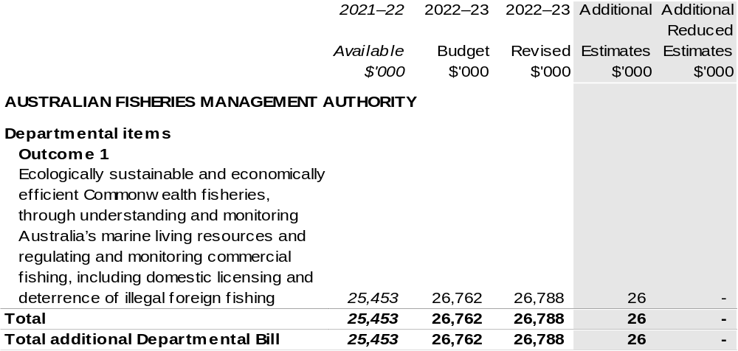

Note 1: 2021–22 available appropriation is included to allow a comparison of this year's appropriation with what was made available for use in the previous year.

