Portfolio Budget Statements 2023–24
Budget Related Paper No. 1.1

Agriculture, Fisheries and Forestry Portfolio

Budget Initiatives and Explanations of Appropriations
Specified by Outcomes and Programs by Entity

© Commonwealth of Australia 2023
ISSN: 2653-6250 (print) 2653-6269 (online)
This publication is available for your use under a Creative Commons BY Attribution 3.0 Australia licence, with the exception of the Commonwealth Coat of Arms, the Department of Agriculture, Fisheries and Forestry logo, photographs, images, signatures and where otherwise stated. The full licence terms are available from http://creativecommons.org /licenses/by/3.0/au/legalcode.


Use of Department of Agriculture, Fisheries and Forestry material under a Creative Commons BY Attribution 3.0 Australia licence requires you to attribute the work (but not in any way that suggests that the Department of Agriculture, Fisheries and Forestry endorses you or your use of the work).
Department of Agriculture, Fisheries and Forestry material used ‘as supplied’
Provided you have not modified or transformed Department of Agriculture, Fisheries and Forestry material in any way including, for example, by changing the department’s text; calculating percentage changes; graphing or charting data; or deriving new statistics from published Department of Agriculture, Fisheries and Forestry statistics, then the department prefers the following attribution:
Source: Australian Government Department of Agriculture, Fisheries and Forestry
Derivative material
If you have modified or transformed Department of Agriculture, Fisheries and Forestry material, or derived new material from those of the Department of Agriculture, Fisheries and Forestry in any way, then the department prefers the following attribution:
Based on Australian Government Department of Agriculture, Fisheries and Forestry data
Use of the Coat of Arms
The terms under which the Coat of Arms can be used are set out on the Department of the Prime Minister and Cabinet website (www.pmc.gov.au/government/commonwealth-coat-arms).
Other Uses
Enquiries regarding this licence and any other use of this document are welcome at:
External Budgets Section; Finance and Investment Division
Department of Agriculture, Fisheries and Forestry
GPO Box 858,
Canberra, ACT 2601
Email: externalbudgets@agriculture.gov.au

President of the Senate
Australian Senate
Parliament House
CANBERRA ACT 2600

Speaker
House of Representatives
Parliament House
CANBERRA ACT 2600

Dear Ms President
Dear Mr Speaker

I hereby submit Portfolio Budget Statements in support of the 2023–24 Budget for the
Agriculture, Fisheries and Forestry portfolio.

These statements have been developed, and are submitted to the Parliament, as a statement on the outcomes for the portfolio.

I present these statements to provide accountability to the Parliament and, through it, the
public.

Yours sincerely
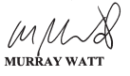



Abbreviations and conventions
The following notation may be used:
NEC/nec not elsewhere classified
- nil
.. not zero, but rounded to zero
na not applicable (unless otherwise specified)
nfp not for publication
$m $ million
$b $ billion
Figures in tables and in the text may be rounded. Figures in text are generally rounded to one decimal place, whereas figures in tables are generally rounded to the nearest thousand. Discrepancies in tables between totals and sums of components are due to rounding.

Enquiries
Should you have any enquiries regarding this publication please contact
Paul Pak Poy, Chief Finance Officer, Department of Agriculture, Fisheries and Forestry, on (02) 6272 5523.
Links to Portfolio Budget Statements (including Portfolio Additional Estimates Statements and Portfolio Supplementary Additional Statements) can be located on the Australian Government Budget website at: www.budget.gov.au.

User Guide
To The
Portfolio Budget Statements

User guide
The purpose of the 2023–24 Portfolio Budget Statements (PBS) is to inform Senators and Members of Parliament of the proposed allocation of resources to government outcomes by entities within the portfolio. Entities receive resources from the annual appropriations acts, special appropriations (including standing appropriations and special accounts), and revenue from other sources.
The PBS facilitates understanding of proposed annual appropriations in Appropriation Bills (No. 1 and No. 2) 2023–24 (or Appropriation (Parliamentary Departments) Bill (No. 1) 2023–24 for the parliamentary departments). For this reason, the PBS is declared by the Appropriation Acts to be ‘relevant documents’ for the interpretation of the Acts according to section 15AB of the Acts Interpretation Act 1901.
The PBS provides information, explanation and justification to enable Parliament to understand the purpose of each outcome proposed in the Bills.
As required under section 12 of the Charter of Budget Honesty Act 1998, only entities within the general government sector are included as part of the Commonwealth general government sector fiscal estimates and produce PBS where they receive funding (either directly or via portfolio departments) through the annual appropriation acts.
The Commonwealth Performance Framework
The following diagram outlines the key components of the Commonwealth performance framework. The diagram identifies the content of each of the publications and the relationship between them. Links to the publications for each entity within the portfolio can be found in the introduction to Section 2: Outcomes and planned performance.
Commonwealth Performance Framework
Key components of relevant publications

Portfolio Budget Statements (May)
Portfolio based

Corporate Plan
(August)
Entity based

Supports Annual Appropriations. Informs Senators and Members of Parliament of the proposed allocation of other resources to government outcomes and programs.
Provides links to relevant programs
undertaken by other Commonwealth
entities.
Provides high level performance
information for current, ongoing programs, particularly a forecast of performance for the current year.
Provides detailed prospective
performance information for proposed new budget measures that require a new program or significantly change an existing program.
Primary planning document of a
Commonwealth entity.
Sets out the purposes of the entity, the key activities it will undertake to achieve its purposes and the results it expects to achieve over a minimum four year period.
Describes the environment in which the entity operates, the capability it requires to undertake its activities, its risk oversight and management systems including key risks, and how it will cooperate with others, including any subsidiaries, to achieve its purposes.
Explains how the entity’s performance will be measured and assessed.
Annual Performance Statement (October following year)
Entity based

Included in the Commonwealth entity’s Annual Report. Focuses on recent
performance.
Reports on the actual performance results for the year against the forecasts made in the corporate plan and Portfolio Budget Statements, and provides other performance information relevant to the entity.
Provides an analysis of the factors that contributed to the entity’s
performance results.

Contents
User guide v
Agriculture, Fisheries and Forestry Portfolio Overview 3
Entities’ resources and planned performance 9
Department of Agriculture, Fisheries and Forestry 13
AgriFutures Australia 73
Australian Fisheries Management Authority 97
Australian Pesticides and Veterinary Medicines Authority 123
Cotton Research and Development Corporation 143
Fisheries Research and Development Corporation 165
Grains Research and Development Corporation 187
Regional Investment Corporation 211
Wine Australia 231

Portfolio Overview

Agriculture, Fisheries and Forestry
Portfolio overview
The Agriculture, Fisheries and Forestry portfolio is overseen by:
- The Minister for Agriculture, Fisheries and Forestry, Senator the Hon Murray Watt.
The portfolio consists of:

- Department of Agriculture, Fisheries and Forestry
- AgriFutures Australia
- Australian Fisheries Management Authority
- Australian Pesticides and Veterinary Medicines Authority
- Cotton Research and Development Corporation
- Fisheries Research and Development Corporation
- Grains Research and Development Corporation
- Regional Investment Corporation
- Wine Australia.
Each entity within the portfolio has at least one outcome and program. Details are provided in each entity’s section of this document.
On 24 April 2023, the Prime Minister agreed to transfer responsibility for administering the Rural Financial Counselling Service (RFCS) from the National Emergency Management Agency (NEMA) within Department of Home Affairs to the Department of Agriculture, Fisheries and Forestry from 1 July 2023.
For information on resourcing across the portfolio, please refer to Part 1: Agency Financial Resourcing in Budget Paper No. 4: Agency Resourcing.

Figure 1: Agriculture, Fisheries and Forestry portfolio structure and outcomes
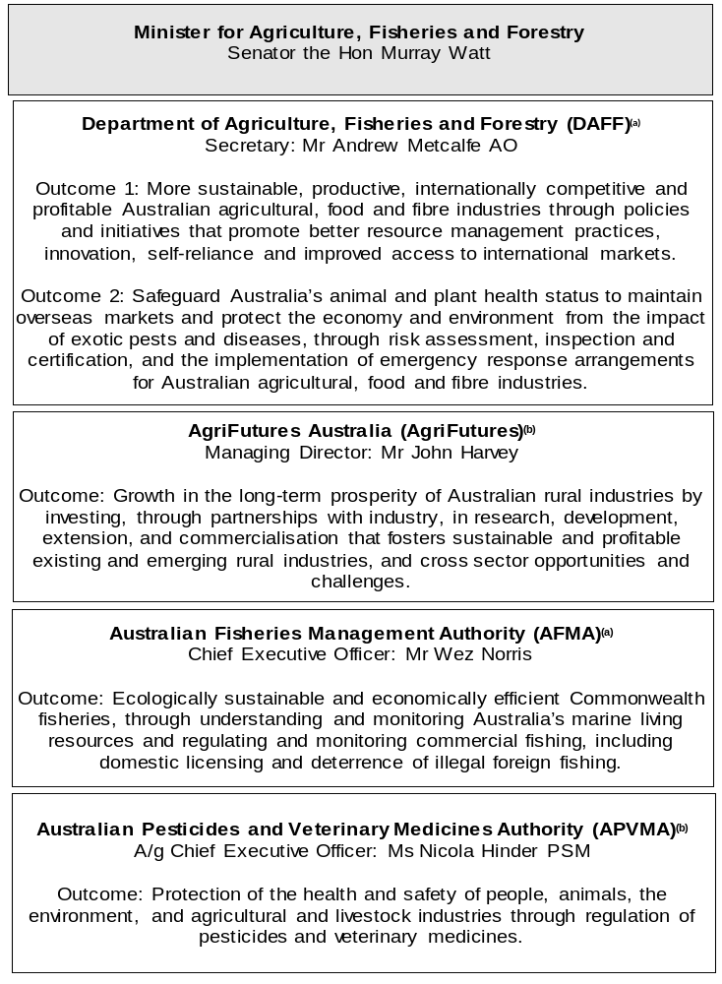

Figure 1: Agriculture, Fisheries and Forestry portfolio structure and outcomes (continued)
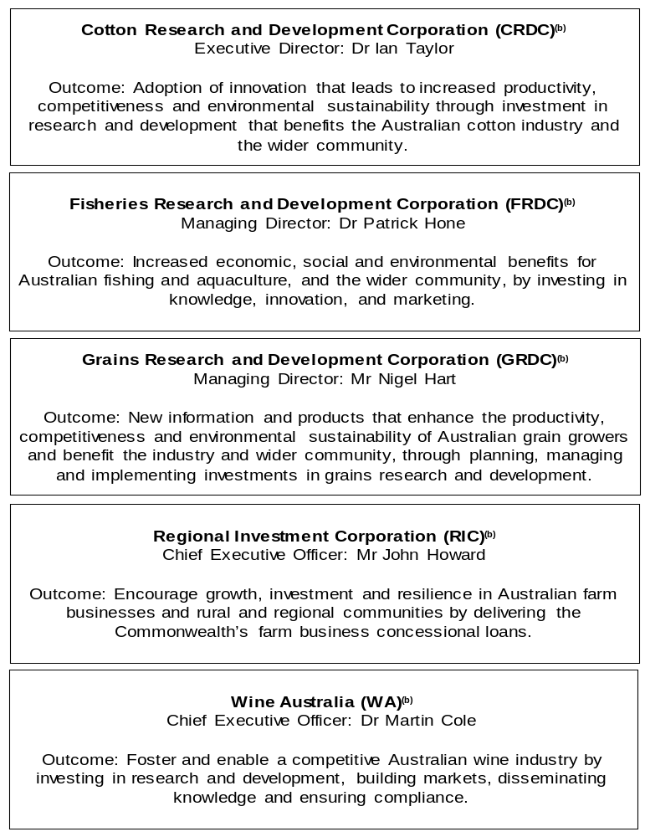
(a) ‘Non-corporate Commonwealth Entity’ (NCCE) as defined under the Public Governance, Performance and Accountability Act 2013 (PGPA Act).
(b) ‘Corporate Commonwealth Entity’ (CCE) as defined under the PGPA Act.

Other industry-owned and not-for-profit companies related to the portfolio
Australian industry-owned companies are independent corporate entities, established under specific legislation with expertise-based boards. The company members appoint the directors of the board. Companies are accountable to the Minister for Agriculture, Fisheries and Forestry through legislation and statutory funding agreements and are entitled to receive industry levies and matching Australian Government funding for eligible research and development (R&D) expenditure. These entities report outside the general government sector.
The following industry-owned companies provide R&D and marketing services.
- Australian Egg Corporation Limited
- Australian Livestock Export Corporation Limited
- Australian Meat Processor Corporation Limited
- Australian Pork Limited
- Australian Wool Innovation Limited
- Dairy Australia Limited
- Forest and Wood Products Australia Limited
- Horticulture Innovation Australia Limited
- Meat and Livestock Australia Limited
- Sugar Research Australia Limited.
Separately, the Australian Government provides funding to the following
not-for-profit, portfolio-related companies.
- Animal Health Australia
- Plant Health Australia Limited.

Entities’ resources and planned performance
Department of Agriculture, Fisheries and Forestry 11
AgriFutures Australia 73
Australian Fisheries Management Authority 97
Australian Pesticides and Veterinary Medicines Authority 123
Cotton Research and Development Corporation 143
Fisheries Research and Development Corporation 165
Grains Research and Development Corporation 187
Regional Investment Corporation 211
Wine Australia 231

Department of Agriculture, Fisheries and Forestry

Entity resources and planned performance

Department of Agriculture, Fisheries and Forestry
Section 1: Entity overview and resources 13
1.1 Strategic direction statement 13
1.2 Entity resource statement 16
1.3 Budget measures 21
Section 2: Outcomes and planned performance 26
2.1 Changes to program 27
2.2 Budgeted expenses and performance measures for Outcome 1 28
2.3 Budgeted expenses and performance measures for Outcome 2 46
Section 3: Budgeted financial statements 56
3.1 Budgeted financial statements 56
3.2 Budgeted financial statements tables 58

Department of Agriculture, Fisheries and Forestry

Section 1: Entity overview and resources

Strategic direction statement
The Department of Agriculture, Fisheries and Forestry bolsters the nation’s agriculture, fisheries and forestry sectors by protecting our land, plants and animals from biosecurity threats and supporting farmers, graziers, fishers, foresters, and other producers to strengthen trading partnerships and grow our exports. We work in collaboration with national and international governments to ensure the growth and prosperity of Australia’s food and fibre industries, and support of the sector’s transition to a profitable, climate-smart and sustainable future.
We are supporting our agriculture industries to reach a farm gate value of $100 billion by 2030 amid changing global market conditions. With a record year of production forecasted to reach over $90 billion in 2022–23, Australian agriculture is well placed to navigate future challenges, through a collaborative, forward thinking approach.
The department is playing a vital role to support the sector adapt and build resilience to a changing climate and global environment while increasing agricultural productivity, profitability, and food security. Increasingly, we are working in partnership with First Nations peoples to participate in and deliver sustainable agriculture outcomes. We are also delivering on agricultural workforce priorities by continuing and bolstering existing programs and supporting future agricultural workforce building initiatives.
Australia’s world-class biosecurity system is essential to our export industries, the integrity and sustainability of agricultural production, tourism, our unique environment and our everyday life. Changes in global trade, climate change, and the spread of pests and diseases in our region continue to create new and complex biosecurity risk pathways, increasing pressure on Australia’s biosecurity system. Increases in the volume of travellers, mail and cargo and changing environments demands a proactive and strong biosecurity preparedness and response system.
By working closely with industry partners and organisations, the government is delivering on its commitment to establish sustainable funding for a robust biosecurity system with the capacity to prevent, respond to and recover from significant outbreaks. This ensures the safe movement of people and goods while protecting us against disease incursions that would impact trade, jobs, regional Australia, health and the environment. A strong system will support better yields by minimising damage to produce and access to new markets through greater biosecurity assurance and reputation.
Australian agricultural producers have intensely felt the impacts of climate change, in the face of droughts and natural disasters such as floods and fires, all of which present challenges to farm performance and rural life. They have also been on the forefront of innovative practices, implementing sustainable soil practices and harnessing on-farm technologies to reduce water usage and fuel emissions. The government is investing in foundational regional data and sophisticated spatial analytics capability to inform evidence-based policy making, so industry and government can navigate our shared climate and sustainability agenda together. A climate-smart, sustainable agriculture sector will allow for more productive and profitable farming practices, stronger regional communities and a better-protected environment.
The Australian Government ensures Commonwealth fisheries are managed sustainably for the benefit of all Australians. The government is committed to the sustainable use of fisheries resources and the conservation of marine ecosystems and biodiversity. Through science-based management and a strong aquaculture industry, the sector has been able to continue to grow, reaching $3.6 billion of gross production value in 2021–22, whilst improving the status of stocks and reducing environmental impacts. The government supports aquaculture and fisheries to anticipate and respond to emerging consumer demands and trading partner requirements, such as sustainability, provenance, traceability, animal welfare and carbon footprint credentials.
The forest industry continues to face supply shortfalls whilst global demand keeps growing. The government is investing over $300 million to assist in expanding the plantation estate to shore up future timber supply and to enable wood processors to make better use of the available domestic resource. Investment is also focused on providing a step-change in forestry research and development to look at innovative products and processes for the future and the positive climate outcomes that our forestry sector can deliver.
The department also plays a key role in the sustainable management of natural resources and to protect our unique environment. The National Landcare Program invests in activities to protect Australia’s biodiversity through natural resource management and sustainable agriculture activities. The Natural Heritage Trust program in partnership with the Department of Climate Change, Energy, the Environment and Water, will address factors impacting the sustainability of the agriculture sector. Climate concerns, changing domestic and international market conditions and increasing pressure to produce more food and fibre from our arable lands needs addressing to support the profitability and sustainability of the sector.
The program will continue to support the food and fibre sector’s contribution to the government’s climate agenda and the economy’s transition to net zero emissions.
The department is making a generational investment to move away from inefficient, costly, and manual processes, including wet seals, physical certificates, fax and paper, to a digital by default agency. We are transforming into an agency that provides easier, faster, cheaper, and innovative ways for exporters to interact with us, and integrating further into the digital supply chains of export and import industries and trading partners.
We also play a leadership role in strengthening the international institutions that underpin our trade by setting global standards for animal health, plant health and food safety. The government is delivering on its commitment to animal welfare through the renewal of the Australian Animal Welfare Strategy to re-establish a national framework to demonstrate Australia’s commitment to modern, sustainable and science-based animal welfare practices.
We seek to achieve our mission through the department’s two outcomes.
Outcome 1: More sustainable, productive, internationally competitive and profitable Australian agricultural, food and fibre industries through policies and initiatives that promote better resource management practices, innovation, self-reliance and improved access to international markets.
Outcome 2: Safeguard Australia’s animal and plant health status to maintain overseas markets and protect the economy and environment from the impact of exotic pests and diseases, through risk assessment, inspection and certification, and the implementation of emergency response arrangements for Australian agricultural, food and fibre industries.

Entity resource statement
Table 1.1 shows the total funding from all sources available to the entity for its operations and to deliver programs and services on behalf of the Government.
The table summarises how resources will be applied by outcome (Government strategic policy objectives) and by administered (on behalf of the Government or the public) and departmental (for the entity’s operations) classification.
For more detailed information on special accounts and special appropriations, please refer to Budget Paper No. 4: Agency Resourcing.
Information in this table is presented on a resourcing (this is, appropriations/cash available) basis, whilst the ‘Budgeted expenses by Outcome’ tables in Section 2 and the financial statements in Section 3 are presented on an accrual basis.
Changes to indexation framework for various programs
The indexation framework for programs indexed by Wage Cost Indices, including for government supported services, has been updated to better align with wages and prices movements.
Increased funding has been provided to the following sub-programs:
Program 1.4: Fishing Industry – Fisheries Resources Research Fund
Program 1.10: Agricultural Resources – Agricultural and Veterinary Chemicals Minor Use Program, Agriculture 2030 – Improving employment opportunities, AgriFutures Australia
Program 1.12: Rural Programs – Rural Financial Counselling Service
Program 1.13: International Market Access – International Agricultural Cooperation, International Organisations Contributions
Program 2.1: Biosecurity and Export Services – Centre of Excellence for Biosecurity Risk Analysis and Research
Program 2.2: Plant and Animal Health – Agriculture 2030 – Biosecurity – continue to protect Australia from the biosecurity risk posed by African swine fever, Animal Biosecurity and Response Reform, Commonwealth Membership of Animal Health Australia and Plant Health Australia, Payment to CSIRO – contribution to the operating costs of the Australian Centre for Disease Preparedness, Plant Biosecurity and Response Reform, Stronger Farmers, Stronger Economy – strengthening research, skills and management of natural resources – immediate assistance fund.

Table 1.1: Department of Agriculture, Fisheries and Forestry – Resource Statement – Budget Estimates for 2023–24 as at May Budget 2023
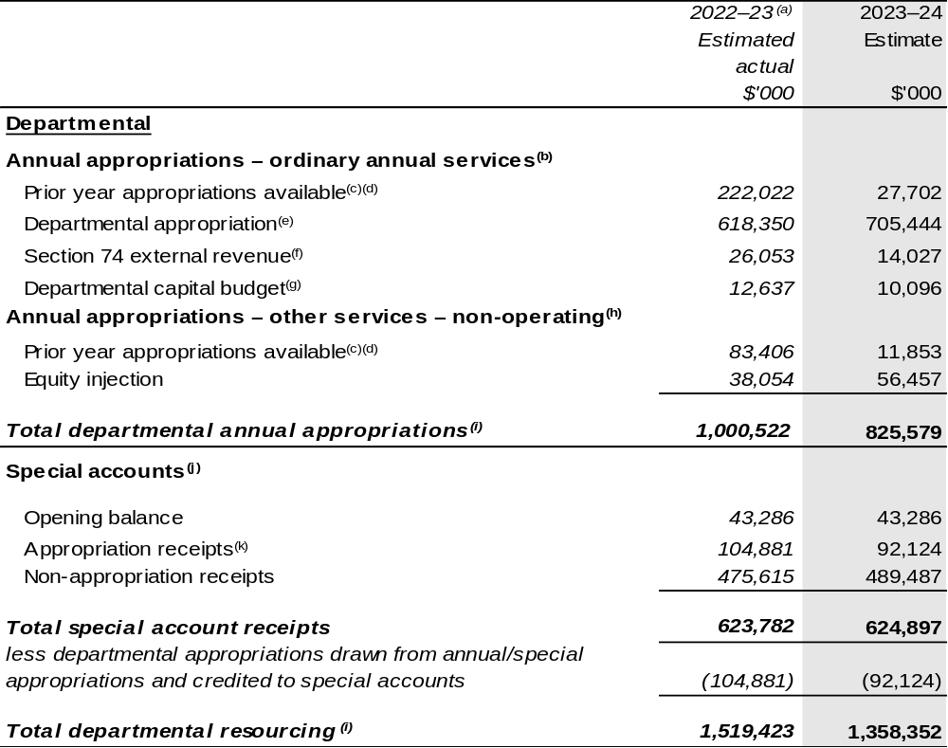
Continued on following pages
Table 1.1: Department of Agriculture, Fisheries and Forestry – Resource Statement – Budget Estimates for 2023–24 as at May Budget 2023 (continued)
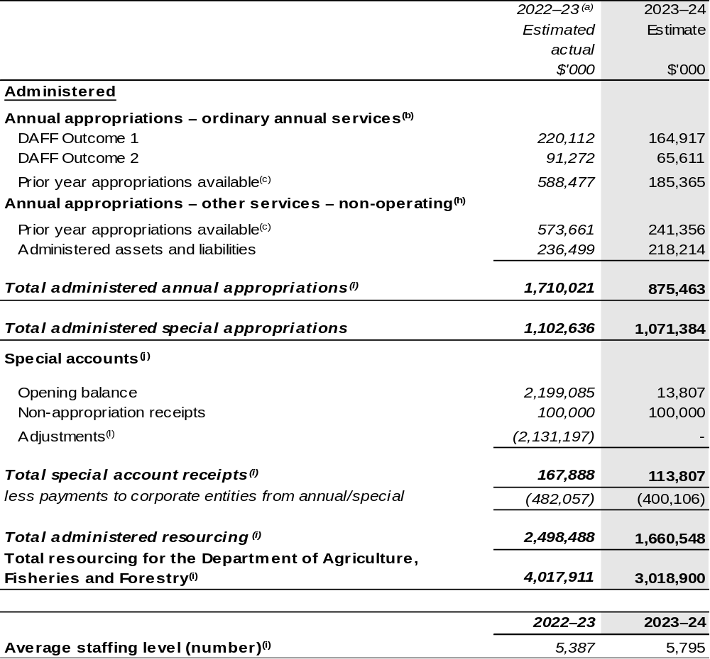
Continued on following pages

Table 1.1: Department of Agriculture, Fisheries and Forestry – Resource Statement – Budget Estimates for 2023–24 as at May Budget 2023 (continued)

- Annual appropriation amounts presented for 2022–23 do not include the Appropriation Bills (No. 3), as they had not been enacted at the time of publication. For the department, $129.183 million will be received through the 2022–23 Annual Appropriation Bill (No. 3). The annual appropriations received from this bill will be recognised in a future portfolio budget statement but only after the Bills have received Royal Assent.
- Appropriation Bill (No. 1) 2023–24.
- Excludes $754.930 million subject to administrative quarantine by Finance or withheld under section 51 of the PGPA Act.
- Prior year appropriations partly include resourcing related to outcomes that have transferred to Department of Climate Change, Energy, the Environment and Water (DCCEEW), this was transferred through Section 75 Determination under the PGPA Act.
- Excludes departmental capital budget (DCB).
- Estimated external revenue under section 74 of the PGPA Act.
- Departmental capital budgets are not separately identified in Appropriation Bill (No. 1) 2023–24 and form part of ordinary annual services items. Please refer to Table 3.5 for further details. For accounting purposes, this amount has been designated as a 'contribution by owner'.
- Appropriation Bill (No. 2) 2023–24.
- As a result of AAO made on 23 June 2022 and commencing on 1 July 2022, the 2021–22 resourcing reflects the structure of Department of Agriculture, Water and the Environment (DAWE). The AAO changes have moved the water and environment functions to DCCEEW. Refer to 2022–23 October DAFF PBS. These changes have resulted in significant reductions against these items in Table 1.1 in 2023–24.
- Excludes trust moneys held in Services for Other Entities and Trust Moneys (SOETM) and other special accounts. For further information on special accounts, please refer to Budget Paper No. 4 – Agency Resourcing. Please also see Table 2.1 for further information on outcome and program expenses broken down by various funding sources, e.g. annual appropriations, special appropriations and special accounts.
- Amounts credited to the special account(s) from the department’s annual appropriations.
- Adjustments reflect the transfer of environment and water related special account balances to DCCEEW from 1 July 2022 as a result of AAO changes. For further information on special accounts, please refer to Budget Paper No. 4 – Agency Resourcing.
- ‘Corporate entities’ are CCE and Commonwealth companies as defined under the PGPA Act.

All figures shown above are GST exclusive – these may not match figures in the cash flow statement.

Prepared on a resourcing (i.e. appropriations available) basis.

Continued on following pages

Table 1.1: Department of Agriculture, Fisheries and Forestry – Resource Statement – Budget Estimates for 2023–24 as at May Budget 2023 (continued)

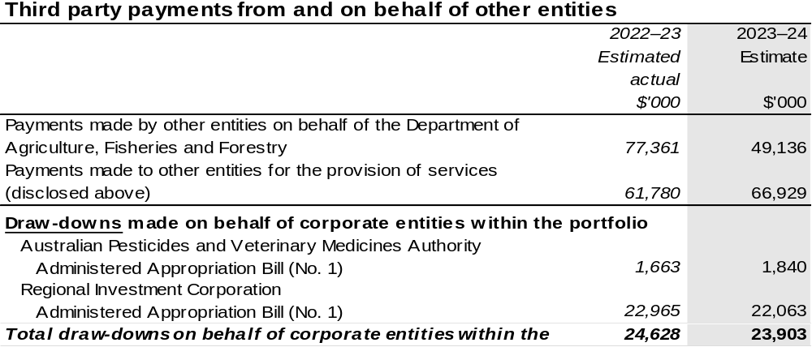
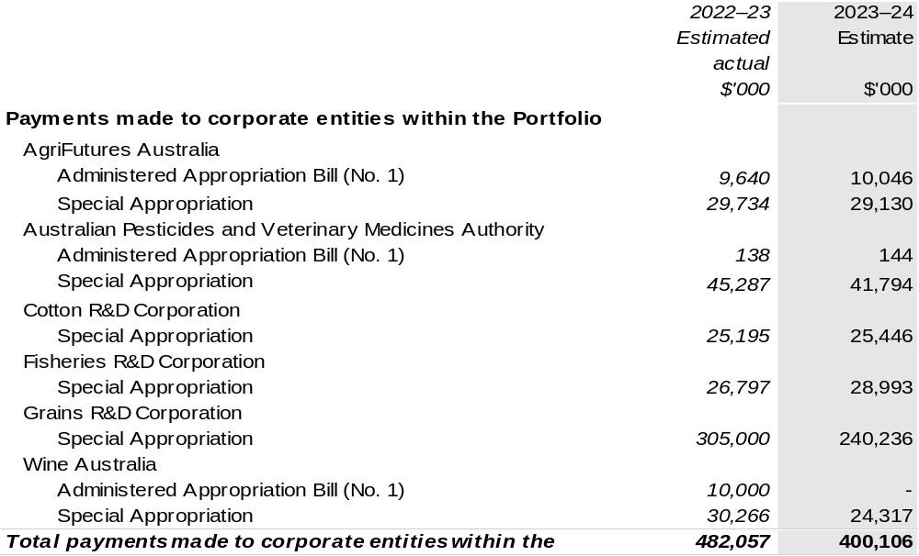

1.3 Budget measures
Budget measures in Part 1 relating to Department of Agriculture, Fisheries and Forestry are detailed in Budget Paper No. 2 and are summarised below.

Table 1.2: Department of Agriculture, Fisheries and Forestry – 2023–24 Budget Measures

Part 1: Measures announced since the 2022–23 October Budget
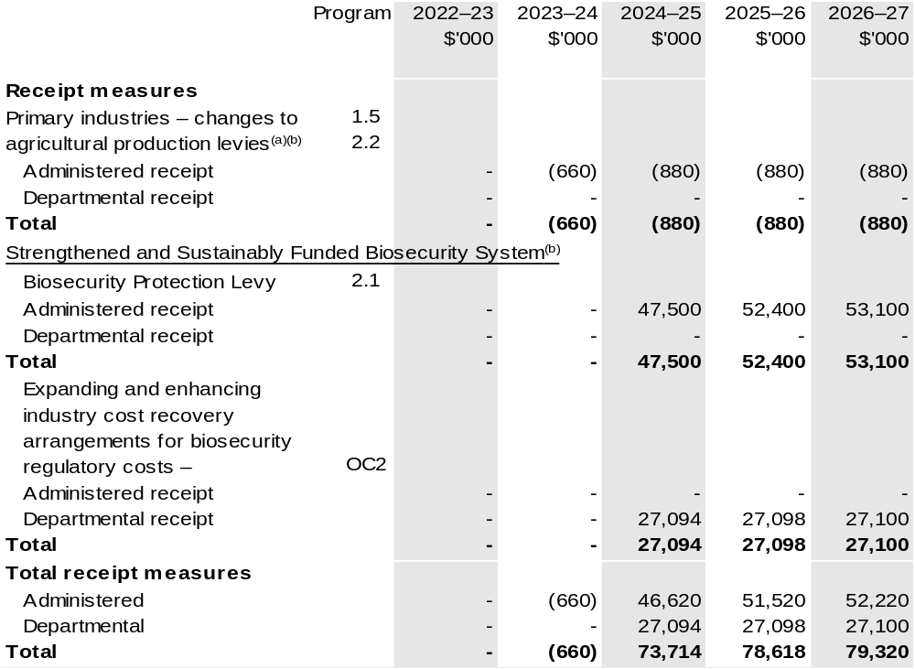

Continued on following pages
Part 1: Measures announced since the 2022–23 October Budget (continued)
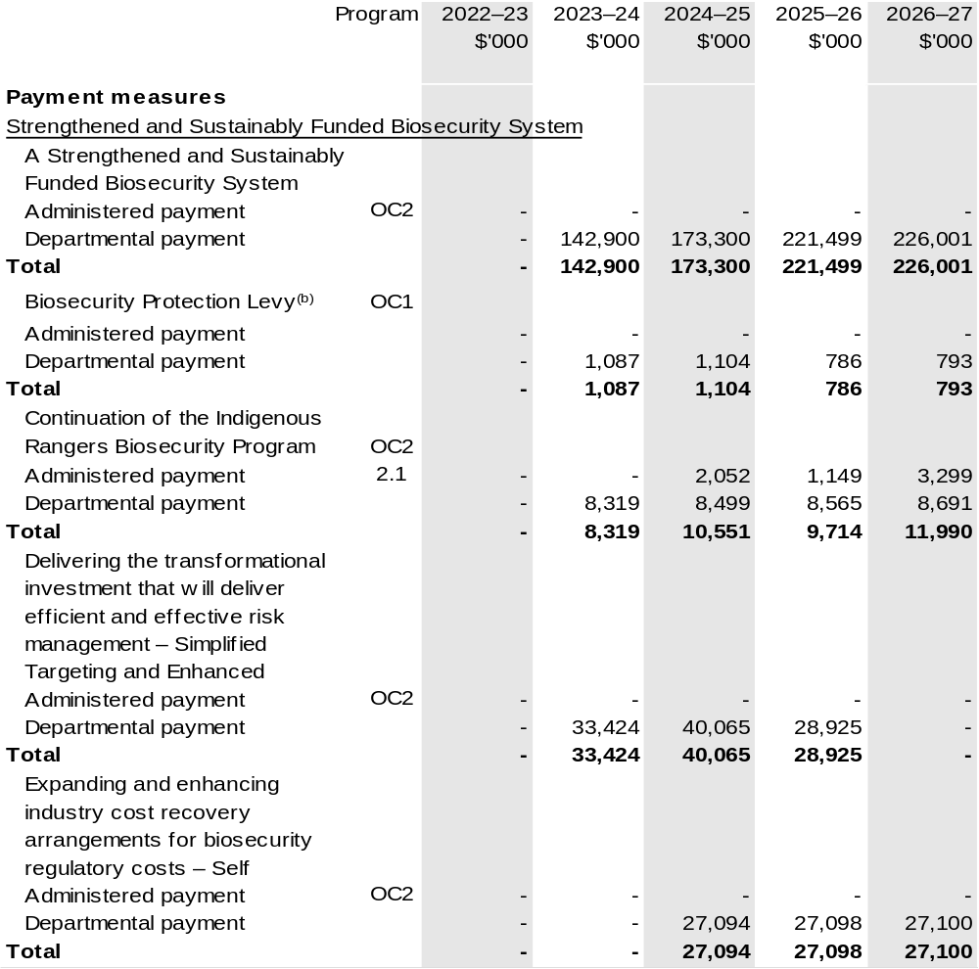

Continued on following pages
Part 1: Measures announced since the 2022–23 October Budget (continued)
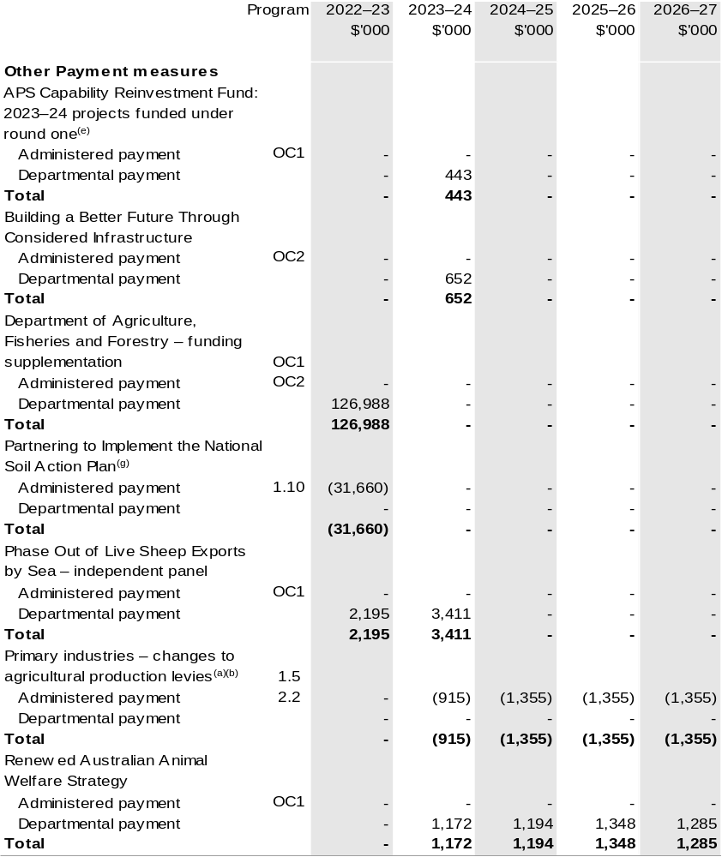

Continued on following pages

Part 1: Measures announced since the 2022–23 October Budget (continued)
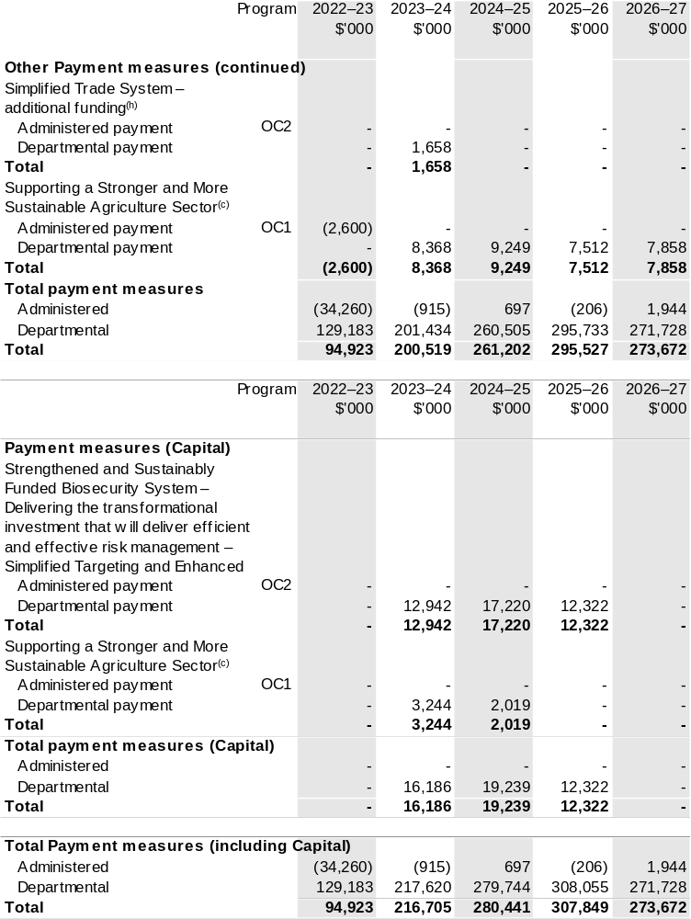

Continued on following page
Part 1: Measures announced since the 2022–23 October Budget (continued)

(a) The Government is making changes to the following agricultural levies at the request of industry to better reflect the current needs of the agricultural sector:
The measures comprise:
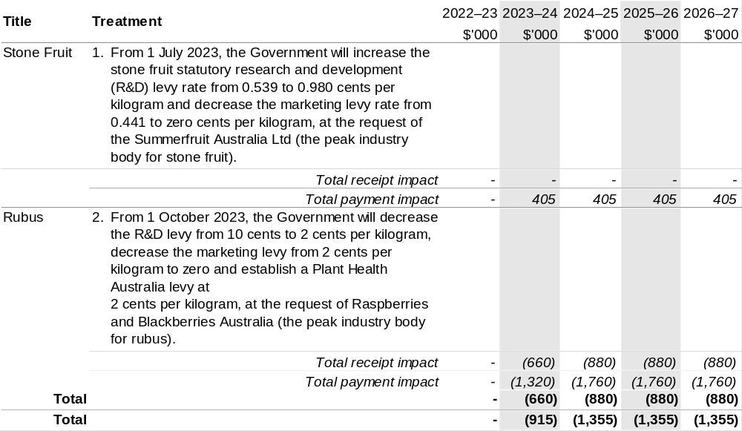(b) This measure appears under the receipts and payments measures heading.
(c) This measure can also be found in the capital and payment section of the 2023–24 DAFF PBS.
(d) The measure Strengthened and Sustainably Funded Biosecurity System – Delivering the transformational investment that will deliver efficient and effective risk management – Simplified Targeting and Enhanced Processing System, total package is $145.198 million over three years and includes $0.300 million going to Department of Finance. The measure description appears in
Budget Paper No. 2: Budget Measures 2023–24 under the Agriculture, Fisheries and Forestry Portfolio.
(e) The lead entity for this measure is the Department of the Prime Minister and Cabinet. The measure description appears in Budget Paper No. 2: Budget Measures 2023–24 under the Prime Minister and Cabinet Portfolio.
(f) The lead entity for this measure is the Department of Infrastructure, Transport, Regional Development, Communications and the Arts. The measure description appears in Budget Paper No. 2: Budget Measures 2023–24 under the Infrastructure, Transport, Regional Development, Communications and the Arts Portfolio.
(g) This measure includes $20.000 million funding to the National Partnership programs within the Department of the Treasury. Details appear in Budget Paper No. 3: Federal Financial Relations
2023–24.
(h) The lead entity for this measure is the Department of Foreign Affairs and Trade. The measure description appears in Budget Paper No. 2: Budget Measures 2023–24 under the Foreign Affairs and Trade Portfolio.

Note: The next phase of the of Natural Heritage Trust program has been appropriated to DCCEEW, with DAFF provided with $302.070 million over five years with the following administered impact;
2023–24 $53.501 million, 2024–25 $54.176 million, 2025–26 $53.272 million, 2026–27 $53.832 million and 2027–28 $56.296 million; and the following departmental impact; 2023–24 $6.761 million, 2024–25 $5.713 million, 2025–26 $6.240 million, 2026–27 $5.629 million and
2027–28 $6.650 million.

Prepared on a Government Finance Statistics (Underlying Cash) basis.

Figures displayed as a negative (-) represent a decrease in funds and a positive (+) represent an increase in funds.

Section 2: Outcomes and planned performance
Government Outcomes are the intended results, impacts or consequences of actions by the Government on the Australian community. Commonwealth programs are the primary vehicle by which government entities achieve the intended results of their Outcome Statements. Entities are required to identify the programs which contribute to Government outcomes over the Budget and forward years.
Each outcome is described below together with its related programs. The following provides detailed information on expenses for each Outcome and program, further broken down by funding source.
Note:
Performance reporting requirements in the Portfolio Budget Statements are part of the Commonwealth performance framework established by the Public Governance, Performance and Accountability Act 2013. It is anticipated that the performance criteria described in Portfolio Budget Statements will be read with broader information provided in an entity’s corporate plans and annual performance statements — included in Annual Reports — to provide a complete picture of an entity’s planned and actual performance.
Our most recent corporate plan can be found at agriculture.gov.au/about/reporting/corporate-plan.
The most recent annual performance statements can be found at: agriculture.gov.au/about/reporting/annual-report.

2.1 Changes to program

Table 2.1: Transfer to the department
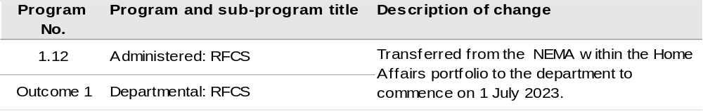
Note: The NEMA transferred the responsibility for administering the ongoing RFCS program to the department with administered funding of $18.549 million in 2023–24, $19.197 million in 2024–25, $19.639 million in 2025–26 and $19.854 million in 2026–27, along with departmental appropriation of $0.740 million in 2023–24, $0.741 million in 2024–25, $0.741 million in 2025–26 and $0.742 million in 2026–27.

2.2 Budgeted expenses and performance measures for Outcome 1
Outcome 1: More sustainable, productive, internationally competitive and profitable Australian agricultural, food and fibre industries through policies and initiatives that promote better resource management practices, innovation, self-reliance and improved access to international markets.

2.2.1: Linked programs
Portfolio Agencies:
AgriFutures Australia
Australian Fisheries Management Authority
Australian Pesticides and Veterinary Medicines Authority
Cotton Research and Development Corporation
Fisheries Research and Development Corporation
Grains Research and Development Corporation
Regional Investment Corporation
Wine Australia
Program 1.1: Australian Fisheries Management Authority
Program 1.1: Australian Pesticides and Veterinary Medicines Authority
Program 1.1: Cotton Research and Development Corporation
Program 1.1: Fisheries Research and Development Corporation
Program 1.1: Grains Research and Development Corporation
Program 1.1: Rural Industries Research and Development Corporation
Program 1.1: Regional Investment Corporation
Program 1.1: Wine Australia
Contribution to Outcome 1 made by linked program:
DAFF works together with AgriFutures Australia, Australian Fisheries Management Authority, Australian Pesticides and Veterinary Medicines Authority, Cotton, Fisheries and Grains Research and Development Corporations, Regional Investment Corporation and Wine Australia to ensure sustainable, productive, and profitable agricultural industries.

Continued on following pages

2.2.1: Linked programs (continued)
Australian Trade and Investment Commission
Program 1.1: Support Australian exporters to expand internationally, attract productive
international investment, and grow the visitor economy
Program 1.2: Programs to support Australian exporters to expand internationally, attract
productive international investment, and grow the visitor economy
Contribution to Outcome 1 made by linked program
DAFF, the Department of Foreign Affairs and Trade (DFAT) and the Australian Trade and Investment Commission (Austrade) work together to achieve the best outcomes for Australian agricultural, fisheries and forestry exporters, including through improved market access.
Bureau of Meteorology
Program 1.1: Bureau of Meteorology
Contribution to Outcome 1 made by linked program
The Bureau of Meteorology provides weather, climate and water modelling and information to DAFF.
Department of Climate Change, Energy, the Environment and Water
Program 2.1: Conserve, protect and sustainably manage Australia’s natural environment
through a nature positive approach
Contribution to Outcome 1 made by linked program
DAFF and DCCEEW work together to deliver the next phase of the Natural Heritage Trust.
Department of Industry, Science and Resources
Program 1.1: Growing Innovative and Competitive Businesses, Industries and Regions
Program 1.2: Investing in Science, Technology and Commercialisation
Program 1.3: Supporting a Strong Resources Sector
Contribution to Outcome 1 and 2 made by linked programs:
The Department of Industry, Science and Resources works collaboratively with DAFF to monitor and manage critical supply chain risks in the agricultural sector, while providing laboratory services and expertise to support the National Residue Survey, Imported Food Inspection Scheme, and other trade enabling activities through the National Measurement Institute.

Continued on following page
2.2.1: Linked programs (continued)
Department of the Treasury
Program 1.4: Commonwealth-State Financial Relations
Contribution to Outcome 1 made by linked program
The Department of the Treasury contributes to Outcome 1 by making payments through the Federation Funding Agreement Framework on behalf of DAFF, for the following funding agreements:
- Construction Softwood Transport Assistance (SPP880)
- Enhance the National Soil Resources Information System (SPP970)
- Fishing and Camping Facilities Program (SPP815)
- Management of Established Pests and Weeds (SPP693)
Future Drought Fund
- Farm Business Resilience (SPP840)
- Regional Drought Resilience Planning (SPP838)
National Indigenous Australians Agency
Program 1.1: Indigenous Advancement – Jobs, Land and the Economy
Contribution to Outcome 1 made by linked program:
DAFF, DCCEEW and NIAA work together to provide opportunities for Indigenous communities and land managers to engage with the National Landcare Program programs funded under the Natural Heritage Trust.
Services Australia
Program 1.1: Strategy and Corporate Enabling
Program 1.2: Customer Service Delivery
Program 1.3: Technology and Transformation
Contribution to Outcome 1 made by linked program
Services Australia manages payments under the Farm Household Support Act 2014 on behalf of DAFF.

2.2.2: Budgeted expenses for Outcome 1
This table shows how much the entity intends to spend (on an accrual basis) on achieving the outcome, broken down by program, as well as by administered and departmental funding sources.

Table 2.2: Budgeted expenses for Outcome 1
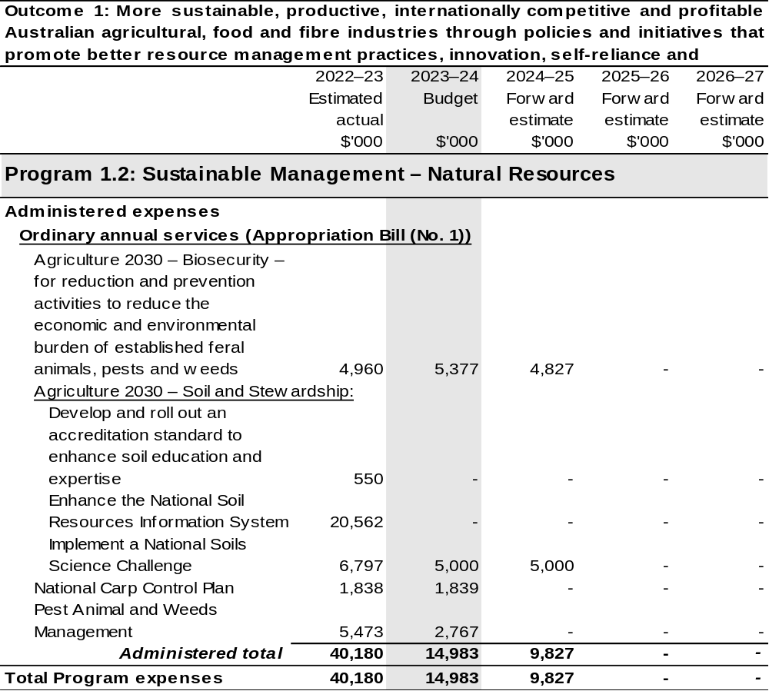

Continued on following pages
Table 2.2: Budgeted expenses for Outcome 1 (continued)
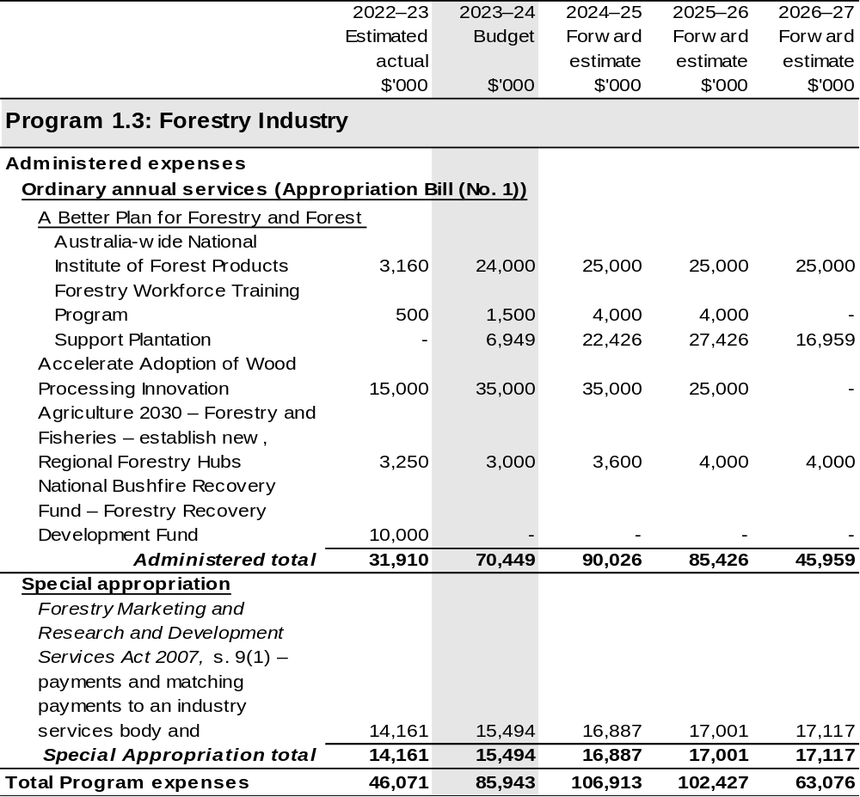

Continued on following pages
Table 2.2: Budgeted expenses for Outcome 1 (continued)
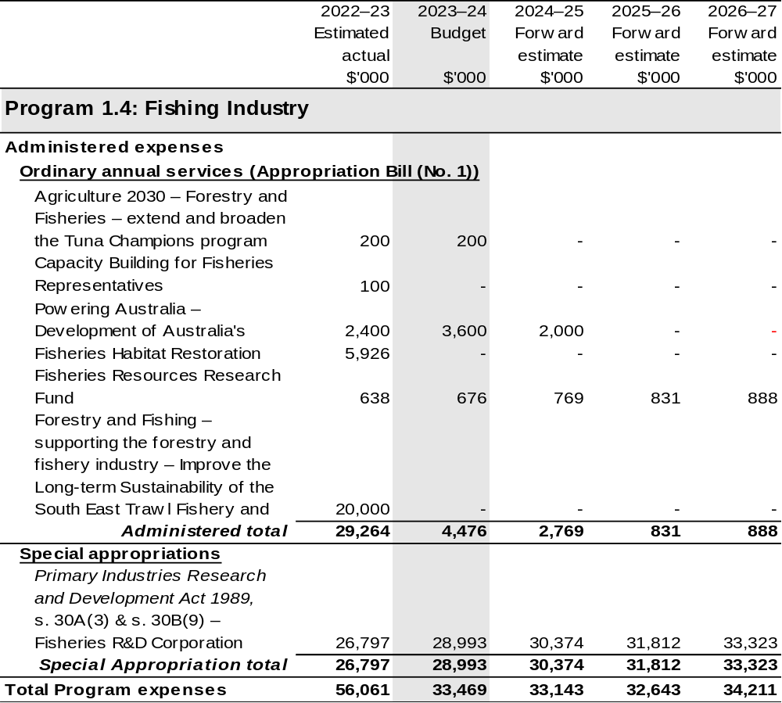

Continued on following pages
Table 2.2: Budgeted expenses for Outcome 1 (continued)
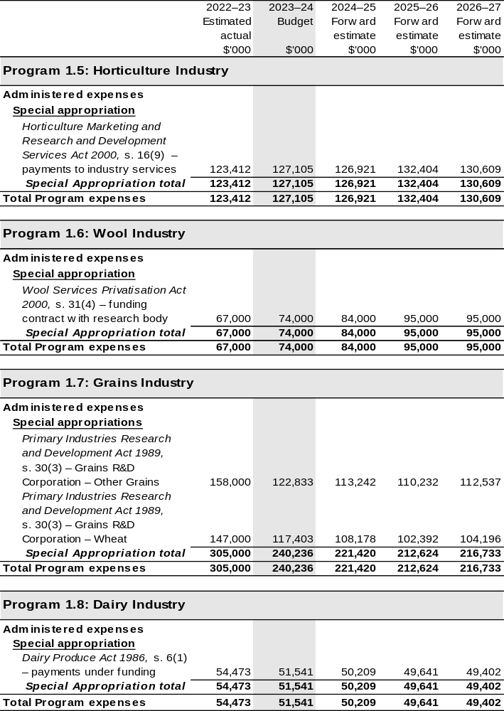

Continued on following pages
Table 2.2: Budgeted expenses for Outcome 1 (continued)
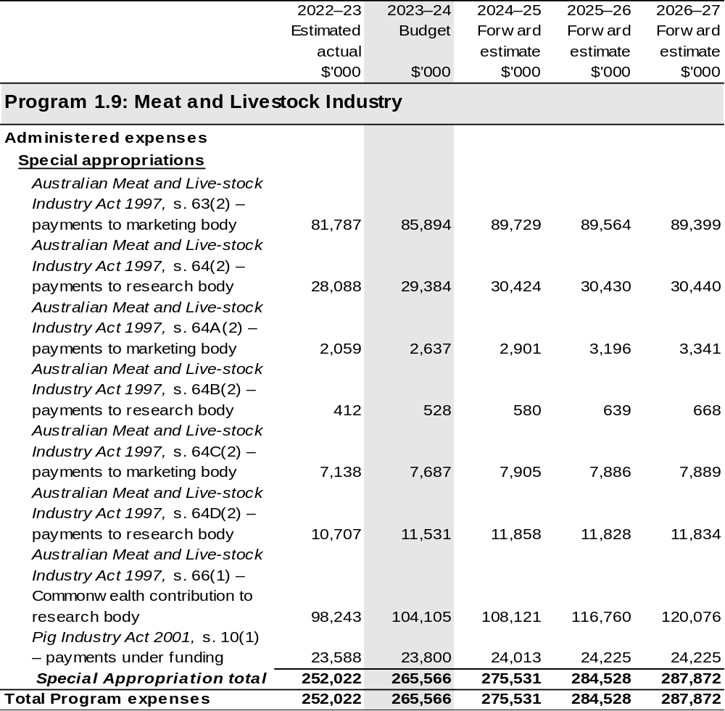

Continued on following pages

Table 2.2: Budgeted expenses for Outcome 1 (continued)
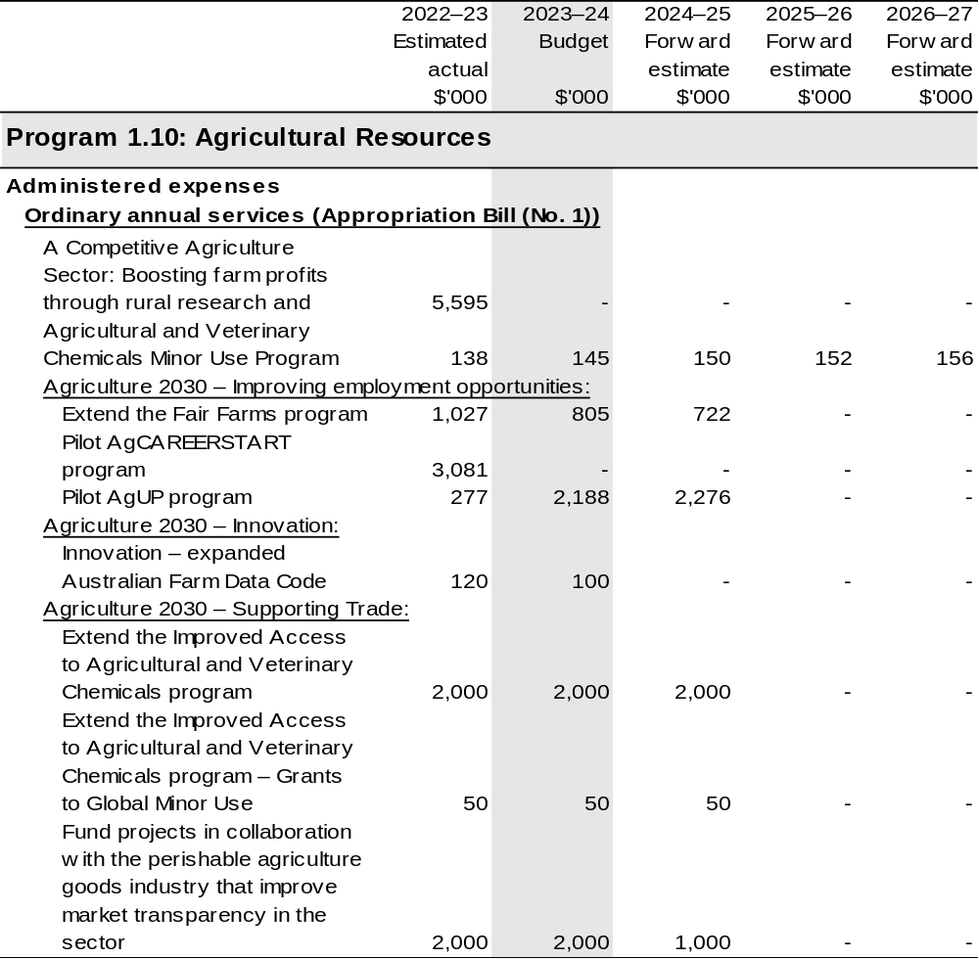

Continued on following pages

Table 2.2: Budgeted expenses for Outcome 1 (continued)
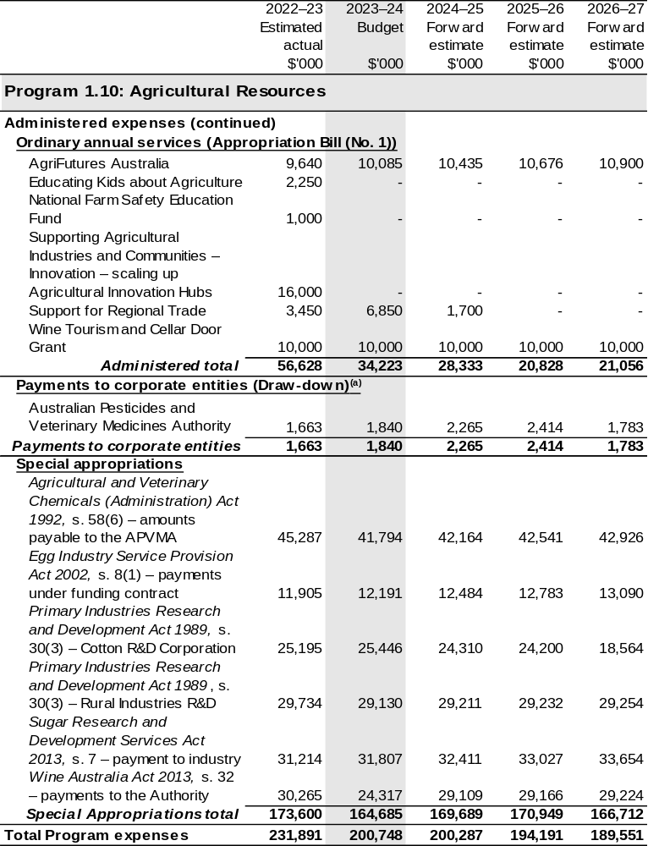

Continued on following pages

Table 2.2: Budgeted expenses for Outcome 1 (continued)
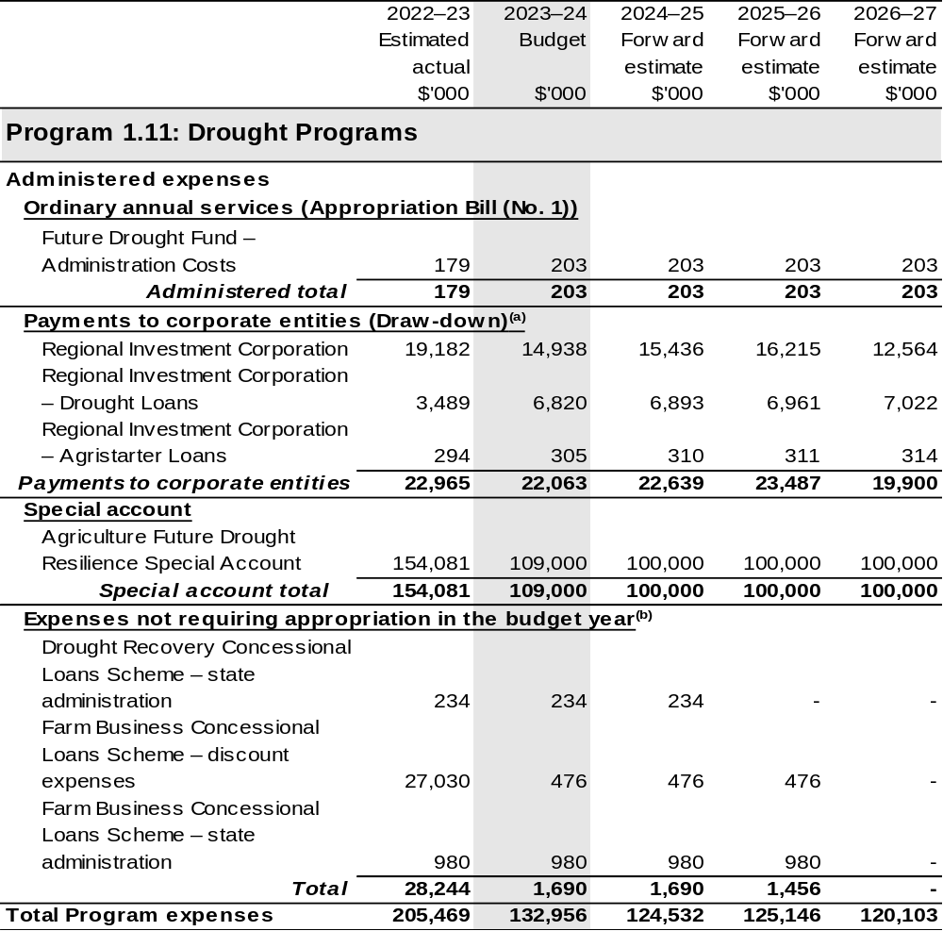

Continued on following pages

Table 2.2: Budgeted expenses for Outcome 1 (continued)
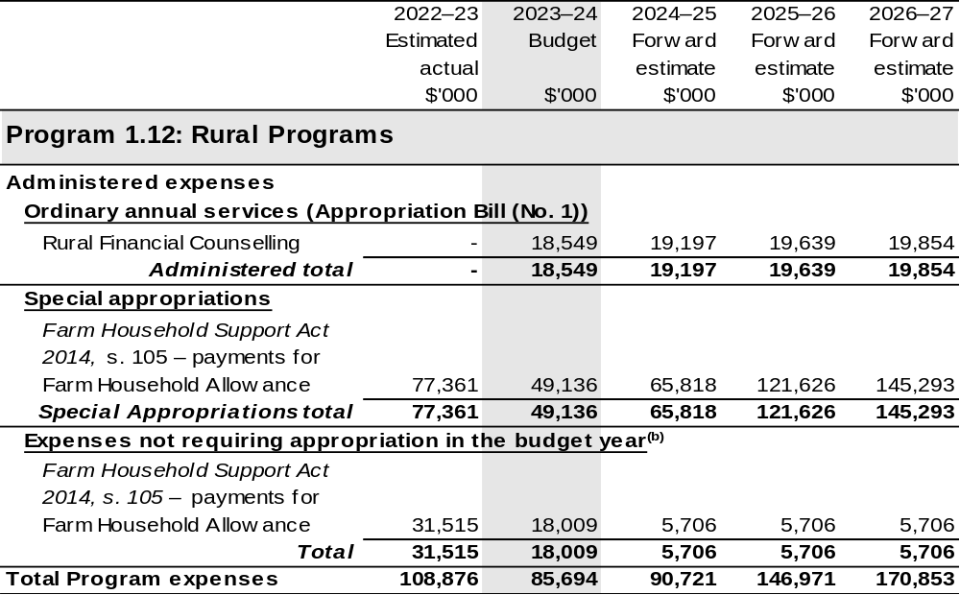

Continued on following pages
Table 2.2: Budgeted expenses for Outcome 1 (continued)
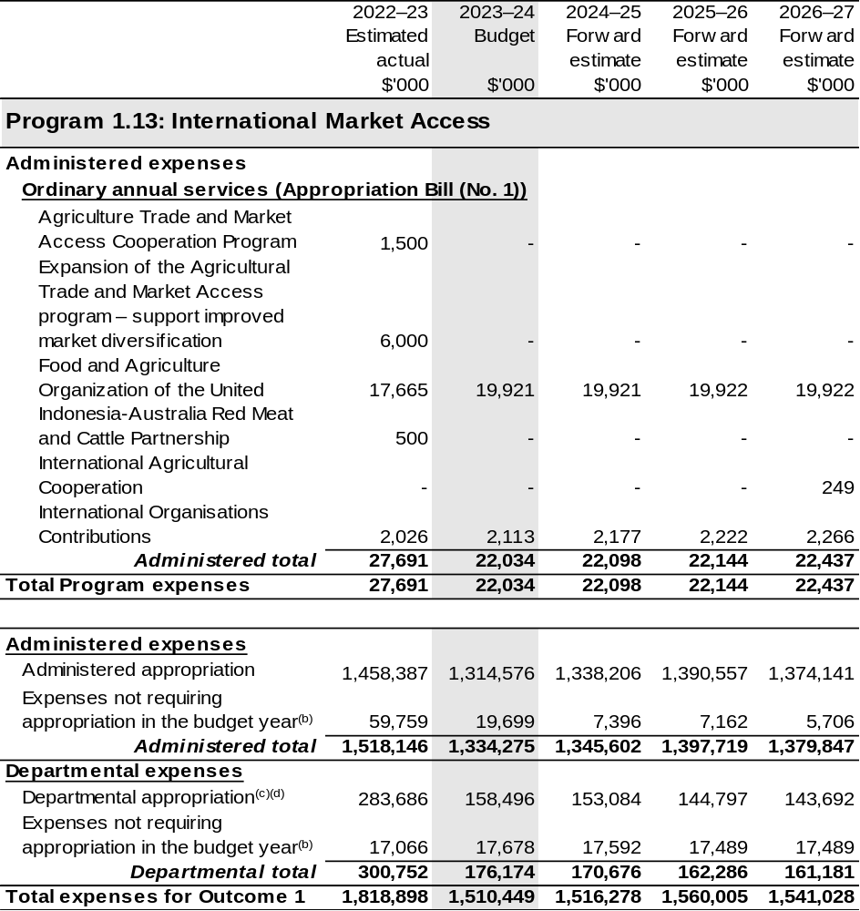

Continued on following pages

Table 2.2: Budgeted expenses for Outcome 1 (continued)
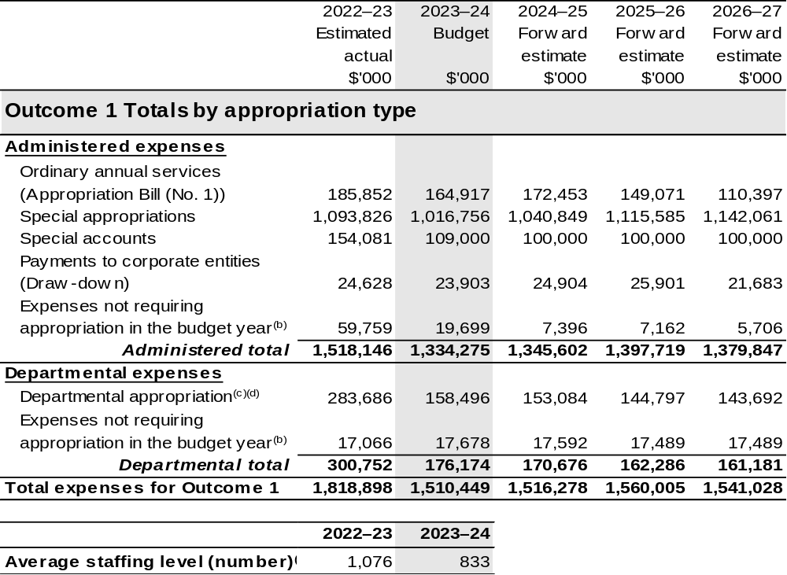

(a) The APVMA and the RIC are CCEs under the PGPA Act and do not receive direct appropriations. Instead, this funding passes through the department to these entities.
(b) ‘Expenses not requiring appropriation in the budget year’ are made up of depreciation and amortisation expenses, resources received free of charge, concessional loan discount and balance sheet adjustments.
(c) Departmental appropriation allocations are notional and reflect the current structure of the department.
Expenses are funded from both ‘ordinary annual services’ Appropriation Bill (No. 1) 2023–24 and
‘revenue from independent sources’ (receipts retained under section 74 of the PGPA Act).
(d) The estimates actual for departmental appropriation and ASL for 2022–23 reflects the part-year impact of costs attributable to former DAWE staff that were reported under Outcomes 1, 2 and 5, then transferred to DCCEEW on 29 September 2022, after the date of effect of the AAO on 1 July 2022.

Note: Departmental appropriation splits and totals are indicative estimates and may change in the course of the budget year as Government priorities change.

Table has been prepared inclusive of 2022–23 Additional Estimates figures.

Continued on following page
Table 2.2: Budgeted expenses for Outcome 1 (continued)
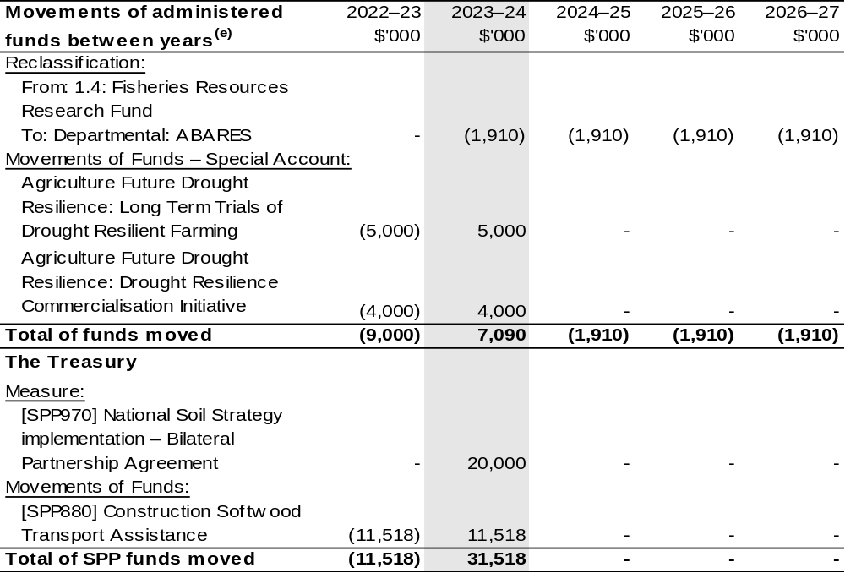

(e) Figures displayed as a negative (-) represent a decrease in funds and a positive (+) represent an increase in funds.

Table 2.3: Performance measure for Outcome 1
Performance measures for budget year 2022–23 and forward estimates have been published in the DAFF Corporate Plan 2022–23.
Outcome 1: More sustainable, productive, internationally competitive and profitable Australian agricultural, food and fibre industries through policies and initiatives that promote better resource management practices, innovation, self-reliance and improved access to international markets.
Program 1.1: Agricultural Adaptation
Program 1.3: Forestry Industry
Program 1.4: Fishing Industry
Program 1.5: Horticulture Industry
Program 1.6: Wool Industry
Program 1.7: Grains Industry
Program 1.8: Dairy Industry
Program 1.9: Meat and Livestock Industry
Program 1.10: Agricultural Resources
Program 1.11: Drought Programs
Program 1.12: Rural Programs
Key Activities | Support sector productivity, resilience and growth through science, policy and partnership.
Year | Performance measures | Expected Performance Results
Current year  2022–23 | Greater growth in average agricultural productivity (adjusted for climate and weather effects) for the past 10 years, compared to average annual market sector productivity growth over the same period. | Greater than or equal to 0 per cent difference over past 10 years.
Current year  2022–23 | Equal or reduced cost of levies administration compared with levies disbursed. | Cost is less than or equal to 1.2 per cent of levies disbursed.
Current year  2022–23 | Proportion of farm businesses making capital investments. | Increase in the percentage of farm businesses making new capital investments, compared to previous year (based on a 5-year moving average).

Continued on following pages
Table 2.3: Performance measure for Outcome 1 (continued)
Year | Performance measures | Planned Performance Results
Budget Year  2023–24 | As per 2022–23. | As per 2022–23.
Forward Estimates  2024–27 | As per 2023–24. | As per 2023–24.
Material changes to Programs 1.1, 1.3, 1.4, 1.5, 1.6, 1.7, 1.8, 1.9, 1.10, 1.11 and 1.12 resulting from 2023–24 Budget Measures: Nil.

Program 1.2: Sustainable Management – Natural Resources
Key Activities | Promote the sustainable management of Australian and regional fisheries and a sustainable fishing industry.  Increase the contribution that agriculture makes to a healthy, sustainable environment.
Year | Performance measures | Expected Performance Results
Current year  2022–23 | The number of Australian Government managed fish stocks assessed as ‘subject to overfishing’ or ‘uncertain’ in the ABARES Fishery status report. | Reduction in the 3-year average of the number of Australian Government managed fish stocks assessed as ‘subject to overfishing’ or ‘uncertain’ in the ABARES Fishery Status Report.
Current year  2022–23 | The percentage of farms using sustainable management practices. | The share of farms using sustainable management practices is maintained or increases by 2025.
Year | Performance measures | Planned Performance Results
Budget Year  2023–24 | As per 2022–23. | As per 2022–23.
Forward Estimates  2024–27 | As per 2023–24. | As per 2023–24.
Material changes to Program 1.2 resulting from 2023–24 Budget Measures: Nil.

Continued on following page
Table 2.3: Performance measure for Outcome 1 (continued)
Program 1.13: International Market Access
Key Activities | Maintain and expand exports and access to international markets.  Streamline export regulations and compliance arrangements.
Year | Performance measures | Expected Performance Results
Current year  2022–23 | Decrease in the number of point-of-entry failures of agricultural exports where the department’s actions have caused the failure. | Decrease from the previous year in the number of point-of-entry failures from agricultural exports.
Current year  2022–23 | Increase in the number of electronic certificates for export issued (moving to paperless trade). | Establish a baseline.
Year | Performance measures | Planned Performance Results
Budget Year  2023–24 | As per 2022–23. | As per 2022–23.
Budget Year  2023–24 | As per 2022–23. | To be developed.
Forward Estimates  2024–27 | As per 2023–24. | As per 2023–24.
Forward Estimates  2024–27 | As per 2023–24. | As per 2023–24.
Material changes to Program 1.13 resulting from 2023–24 Budget Measures: Nil.

2.3 Budgeted expenses and performance measures for Outcome 2
Outcome 2: Safeguard Australia’s animal and plant health status to maintain overseas markets and protect the economy and environment from the impact of exotic pests and diseases, through risk assessment, inspection and certification, and the implementation of emergency response arrangements for Australian agricultural, food and fibre industries.

2.3.1: Linked programs
Australian Trade and Investment Commission
Program 1.1: Support Australian exporters to expand internationally, attract productive
international investment, and grow the visitor economy
Contribution to Outcome 2 made by linked program:
DAFF, DFAT and Austrade work together to achieve the best outcomes for Australian agricultural, fisheries and forestry exporters.
Commonwealth Scientific and Industrial Research Organisation
Program 1.1: Scientific and Industrial Research and Infrastructure
Contribution to Outcome 2 made by linked program:
DAFF contributes to the operating costs of the CSIRO’s Australian Centre for Disease Preparedness (formerly the Australian Animal Health Laboratory) for animal disease diagnosis, prevention, and research.
Department of Health and Aged Care
Program 1.8: Health Protection, Emergency Response and Regulation
Contribution to Outcome 2 made by linked program:
DAFF provides the at-the-border services for the management of various human biosecurity risks on behalf of the Department of Health and Aged Care under the Biosecurity Act 2015 pursuant to a memorandum of understanding.

Continued on following pages

2.3.1: Linked programs (continued)
Department of Home Affairs
Program 3.4: Border Enforcement
Program 3.2: Border Management
Contribution to Outcome 2 made by linked programs:
DAFF and the Department of Home Affairs work collaboratively to undertake screening and surveillance for all people and goods entering Australia.
Department of Industry, Science and Resources
Program 1.1: Growing Innovative and Competitive Businesses, Industries and Regions
Program 1.2: Investing in Science, Technology and Commercialisation
Program 1.3: Supporting a Strong Resources Sector
Contribution to Outcome 1 and 2 made by linked programs:
The Department of Industry, Science and Resources works collaboratively with DAFF to monitor and manage critical supply chain risks in the agricultural sector, while providing laboratory services and expertise to support the National Residue Survey, Imported Food Inspection Scheme, and other trade enabling activities through the National Measurement Institute.
Department of the Treasury
Program 1.4: Commonwealth-State Financial Relations
Contribution to Outcome 2 made by linked program:
The Department of the Treasury contributes to Outcome 2 by making payments through the Federation Funding Agreement Framework on behalf of DAFF, for the following funding agreements:
- Bolstering Australia’s Biosecurity System – Protecting Australia from Escalating Exotic Animal Disease Risks (SPP900)
- Building Resilience to Manage Fruit Fly (SPP993)
- Ehrlichia Canis Pilot Program (SPP876)
- Horse Traceability (SPP875)
- National Plant Health Surveillance Program (SPP857)
- Pest and Disease Preparedness and Response Programs (SPP188)
- Reducing Regulatory Burden and Streamlining Audit Arrangements in the Dairy Sector (SPP859)
- Strengthen Australia’s Frontline Biosecurity Capability and Domestic Preparedness (SPP913)

Continued on following page

2.3.1: Linked programs (continued)
Food Standards Australia New Zealand
Program 1.1: Food Regulatory Activity and Services to the Minister and Parliament
Contribution to Outcome 2 made by linked program:
Food Standards Australia New Zealand provides advice on whether foods pose a medium to high risk to public health to help DAFF to manage the food safety risks associated with imported food for human consumption.
National Indigenous Australians Agency
Program 2.1: Indigenous Advancement – Jobs, Land and Economy
Contribution to Outcome 2 made by linked programs:
DAFF and NIAA partner with Aboriginal and Torres Strait Islander Ranger groups to deliver biosecurity work that protects Australian agriculture and the northern Australian environment.

2.3.2: Budgeted expenses for Outcome 2
This table shows how much the entity intends to spend (on an accrual basis) on achieving the outcome, broken down by program, as well as by administered and departmental funding sources.

Table 2.4: Budgeted expenses for Outcome 2
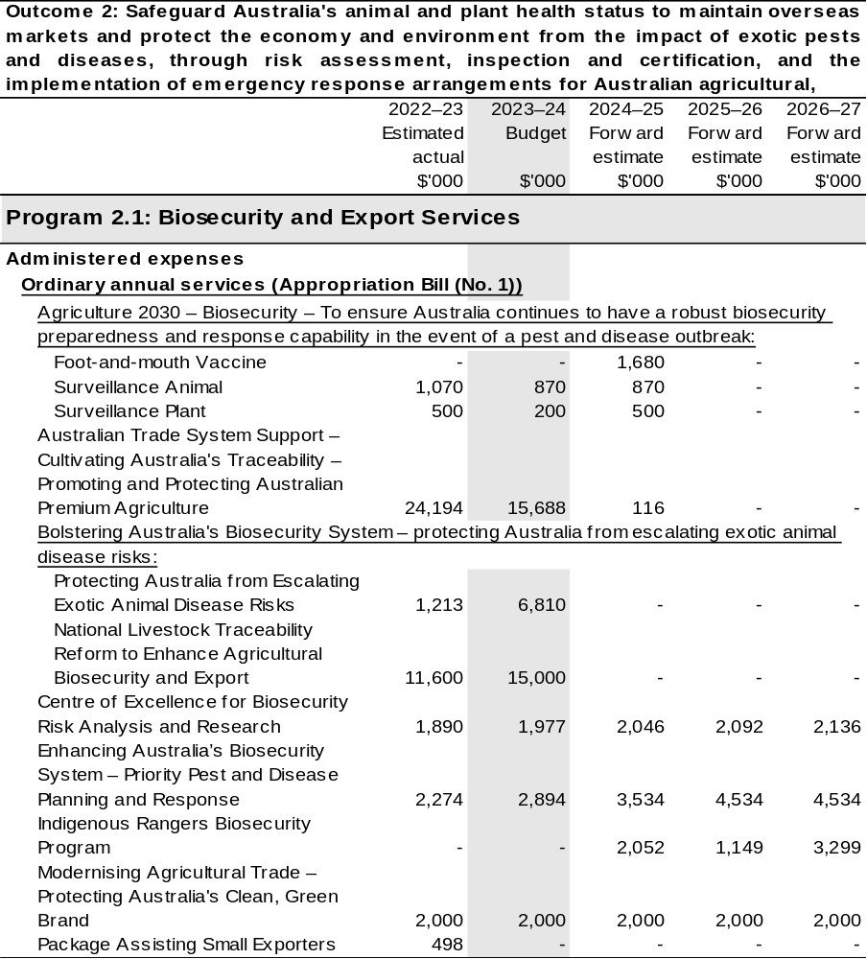
Continued on following pages

Table 2.4: Budgeted expenses for Outcome 2 (continued)
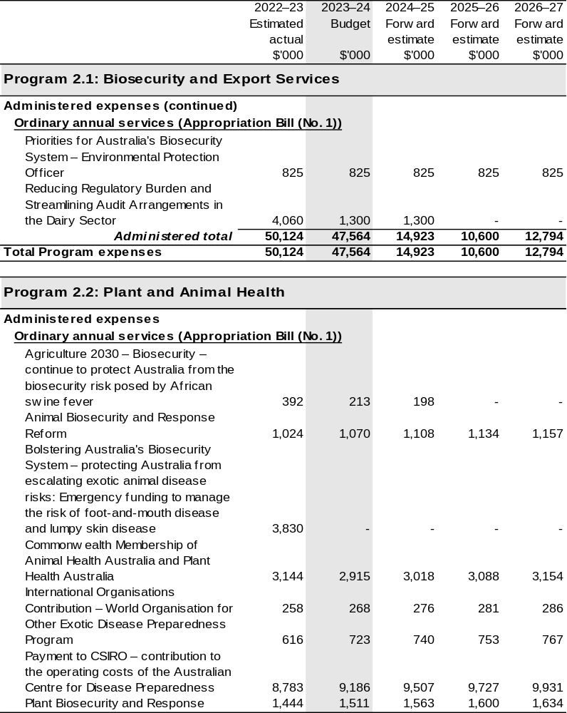
Continued on following pages
Table 2.4: Budgeted expenses for Outcome 2 (continued)
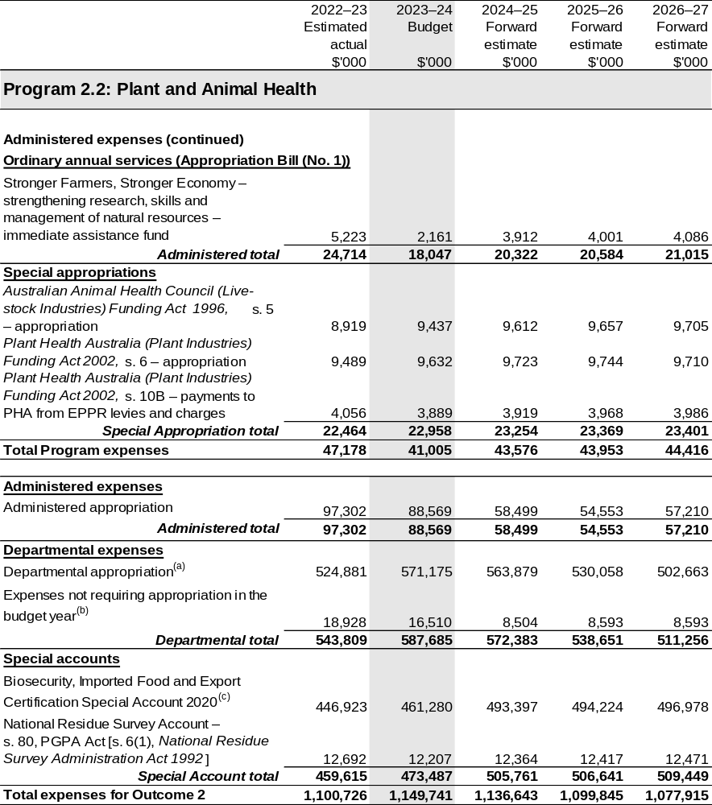
Continued on following pages
Table 2.4: Budgeted expenses for Outcome 2 (continued)
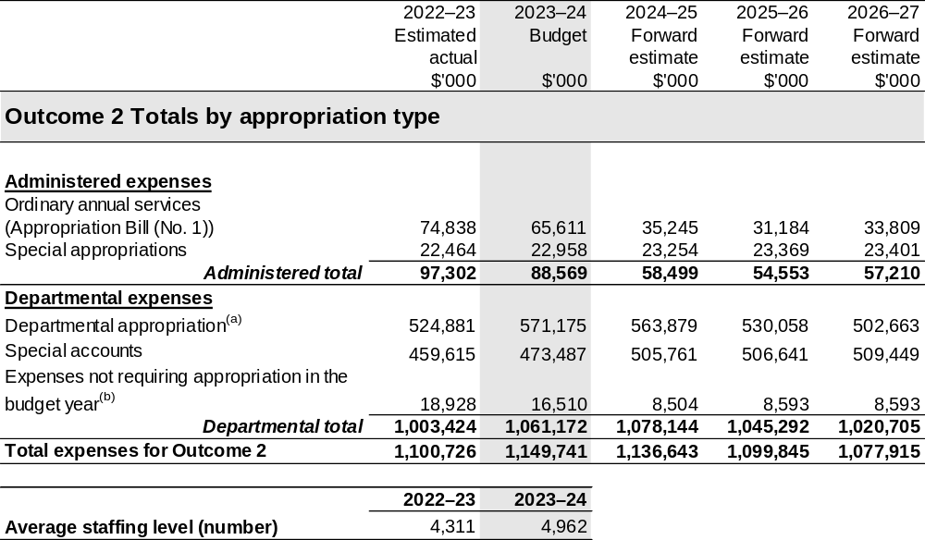
(a) Departmental appropriation allocations are notional and reflect the current structure of the department. Expenses are funded from both ‘ordinary annual services’ Appropriation Bill (No. 1) 2023–24 and ‘revenue from independent sources’ (receipts retained under section 74 of the PGPA Act).
(b) ‘Expenses not requiring appropriation in the budget year’ are made up of depreciation and amortisation
expenses, resources received free of charge, balance sheet adjustments and an approved operating loss.
(c) The Biosecurity, Imported Food and Export Certification Special Account was formerly known as the Australian Quarantine and Inspection Service Special Account.

Note: Departmental appropriation splits and totals are indicative estimates and may change in the course of the budget year as Government priorities change.

Table has been prepared inclusive of 2022–23 Additional Estimates figures.

Continued on following page

Table 2.4: Budgeted expenses for Outcome 2 (continued)
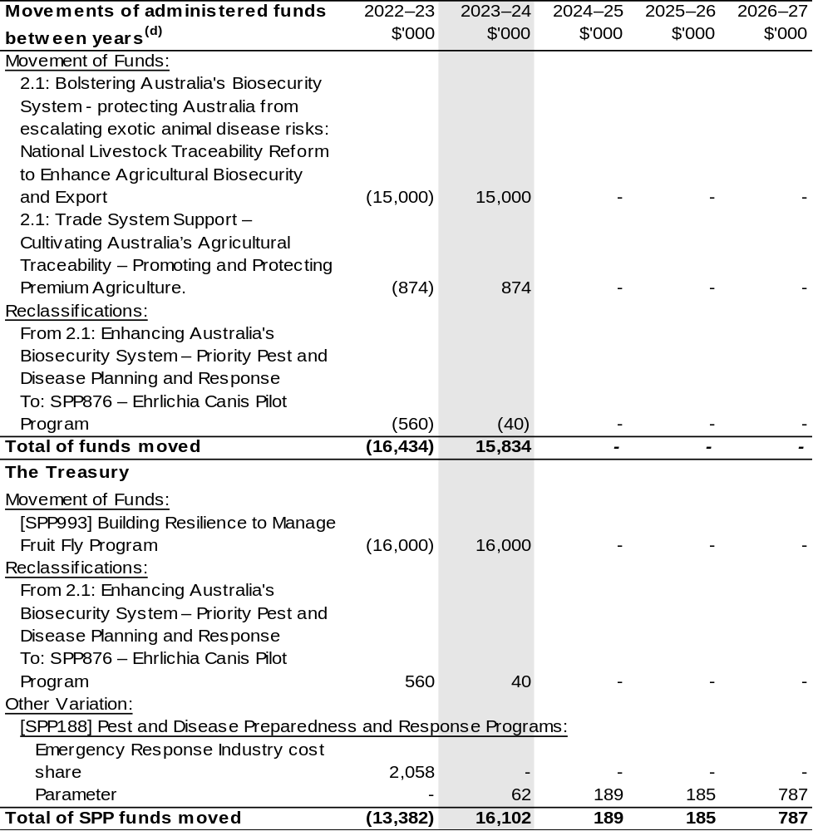
(d) Figures displayed as a negative (-) represent a decrease in funds and a positive (+) represent an increase in funds.

Table 2.5: Performance measure for Outcome 2
Performance measures for budget year 2022–23 and forward estimates have been published in the DAFF Corporate Plan 2022–23.
Outcome 2: Safeguard Australia’s animal and plant health status to maintain overseas markets and protect the economy and environment from the impact of exotic pests and diseases, through risk assessment, inspection and certification, and the implementation of emergency response arrangements for Australian agricultural, food and fibre industries.
Program 2.1: Biosecurity and Export Services
Key Activities | Effectively prepare for the management of biosecurity risk through pragmatic policy, fit-for-purpose regulation, and mature preparedness.  Minimise the impact of biosecurity incursions through appropriate post-biosecurity and post-border measures.
Year | Performance measures | Expected Performance Results
Current year 2022–23 | Reduced levels of non-compliance with regulations administered by the department: | Reduction in:  - high value cargo non-compliance rate  - non-compliance rate for approved arrangements  - post-intervention non-compliance rate for international travellers.
Current year 2022–23 | Biosecurity service standards are met. | Service standards are met or exceeded.
Current year 2022–23 | Number and extent of biosecurity preparedness exercises completed. | One preparedness exercise.
Year | Performance measures | Planned Performance Results
Budget Year 2023–24 | As per 2022–23. | Reduction equal to or lower than the previous year in:  - high value cargo non-compliance rate  - non-compliance rate for approved arrangements  - post-intervention non-compliance rate for international travellers.

Continued on following page
Table 2.5: Performance measure for Outcome 2 (continued)
Year | Performance measures | Planned Performance Results
Budget Year 2023–24 (continued) | As per 2022–23. | As per 2022–23.
Budget Year 2023–24 (continued) | As per 2022–23. | As per 2022–23.
Forward Estimates 2024–27 | As per 2023–24. | As per 2023–24.
Material changes to Program 2.1 resulting from 2023–24 Budget Measures: Nil

Program 2.2: Plant and Animal Health
Key Activities | Effectively detect biosecurity risk through intelligence-led targeting, technology-supported inspections, and efficient detection methods.
Year | Performance measures | Expected Performance Results
Current year 2022–23 | Reduction in risk of African swine fever because of biosecurity measures implemented by the department. | Assessment of reduced risk from risk-based interventions in mail and traveller pathways, including interception rates of pork products.
Current year 2022–23 | Number of consignments of imported goods arriving with khapra beetle reduced as a result of biosecurity measures implemented by the department. | Assessment of reduced risk through a reduction in the number of consignments of imported goods where khapra beetle is detected.
Year | Performance measures | Expected Performance Results
Budget Year 2023–24 | As per 2022–23. | To be developed.
Budget Year 2023–24 | As per 2022–23. | As per 2022–23.
Forward Estimates 2024–27 | As per 2023–24. | As per 2023–24.
Forward Estimates 2024–27 | As per 2023–24. | As per 2023–24.
Material changes to Program 2.2 resulting from 2023–24 Budget Measures: Nil

Section 3: Budgeted financial statements
Section 3 presents budgeted financial statements which provide a comprehensive snapshot of entity finances for the 2023–24 budget year, including the impact of budget measures and resourcing on financial statements.

3.1 Budgeted financial statements

3.1.1: Differences between entity resourcing and financial statements
The financial statements incorporate all budget estimates changes since the October 2022–23 PBS. An analysis of the primary causes of movements in the budgeted departmental financial statements and administered schedules is provided in the relevant sections. The October 2022–23 PBS is used as comparative figures in the analysis.

3.1.2: Budgeted comprehensive departmental income statement
The changes in departmental expense, income and revenue estimates are primarily attributable to the:
- New measures as outlined in Table 1.2
- Estimate variations.
Since the October 2022–23 PBS, estimated revenue from Government in 2023–24 has increased by $193.8 million. The increase is mainly due to 2023–24 Budget measures listed in Table 1.2.
The own source revenue estimate in 2023–24 has reduced by $6.3 million since the October 2022–23 PBS, mainly due to lower than anticipated external revenue receipts.
The expense estimate in 2023–24 has increased by $201.4 million and is mainly due to 2023–24 Budget measures listed in Table 1.2.
The department is budgeting for a pre-existing approved $8.1 million net operating loss in 2023–24. This net operating loss has not changed from the October 2022–23 PBS.

3.1.3: Budgeted departmental balance sheet
The value of departmental net assets as at 30 June 2024 is anticipated to be $11.3 million lower than the estimate published in the October 2022–23 PBS.
The reduced estimate is mainly due to the higher estimated unfunded depreciation loss attributable to the Australian Government position for the Department.
This reduction is partially offset by 2023–24 Budget measures listed in Table 1.2.

3.1.4: Schedule of budgeted income and expenses administered on behalf of the Government
Administered expenses are estimated to be $1,422.8 million in 2023–24, a decrease of $1.3 million since the October 2022–23 PBS. The decrease largely relates to an estimate variation of $35.4 million non cash accounting under the Regional Investment Corporation concessional loans, $8.8 million under the Farm Household Allowance program and $0.9 million relating to 2023–24 Budget measures listed in Table 1.2.
The decrease is offset by a total of $24.9 million relating to movements of funds, $18.5 million for RFCS program transferring from the NEMA detailed in Table 2.1 and Table 2.2 under program 1.12 Rural Programs and $0.5 million of estimates variation for Administered programs that are subject to indexation.
The department estimated to receive non-appropriation revenue on behalf of Government of $833.9 million in 2023–24, a decrease of $6.9 million since the October 2022–23 PBS. The decrease is largely due to lower levy revenue estimates and 2023–24 Budget measures listed in Table 1.2.

3.1.5: Schedule of budgeted assets and liabilities administered on behalf of the Government
The value of administered net assets as at 30 June 2024 is anticipated to be $61.3 million lower than the estimate published in the October 2022–23 PBS.
The decrease in net assets is mainly due to lower than anticipated receivables in loan activities.

3.2 Budgeted financial statements tables

Table 3.1 Comprehensive income statement (showing net cost of services)
for the period ended 30 June
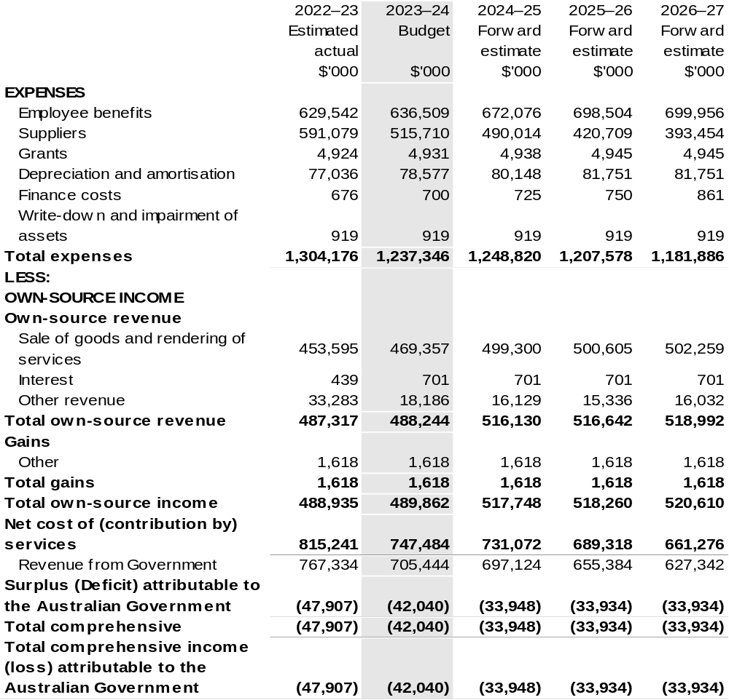
Continued on following page

Table 3.1 Comprehensive income statement (showing net cost of services) for the period ended 30 June (continued)
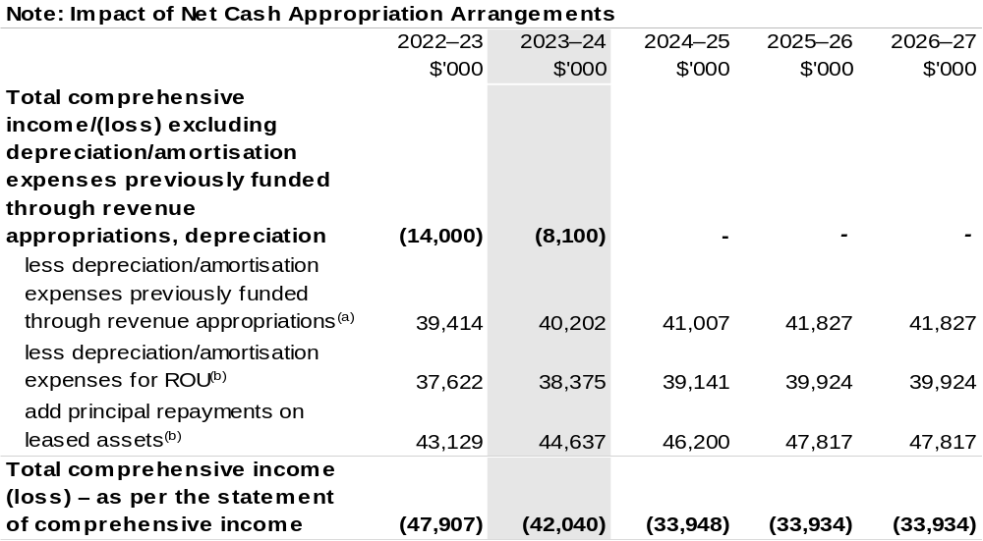
(a) From 2010–11, the Government introduced net cash appropriation arrangements where Appropriation Bill (No. 1) revenue appropriations for the depreciation/amortisation expenses of non-corporate Commonwealth entities (and select corporate Commonwealth entities) were replaced with a separate capital budget (the Departmental Capital Budget, or DCB) provided through Appropriation Bill (No. 1) equity appropriations. For information regarding DCBs, please refer to Table 3.5 Departmental Capital Budget Statement.
(b) Applies to leases under AASB 16 Leases. Right of Use (ROU).

Table has been prepared inclusive of 2022–23 Additional Estimates figures.

Prepared on Australian Accounting Standards basis.

Table 3.2: Budgeted departmental balance sheet (as at 30 June)
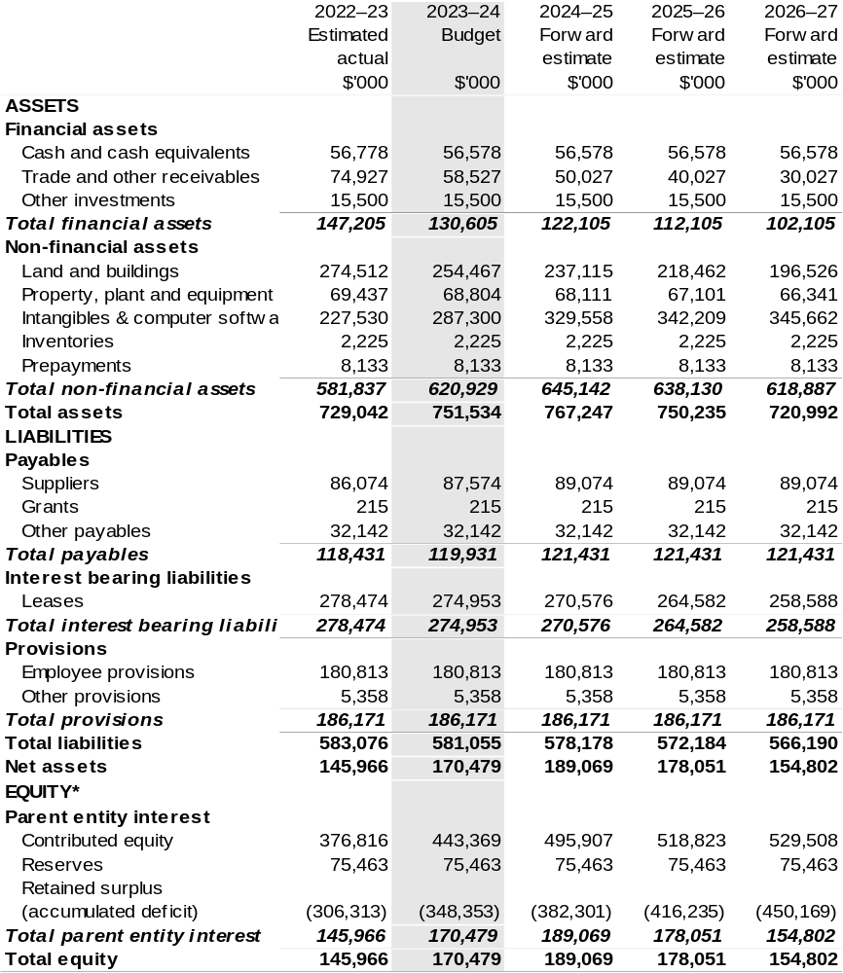
*‘Equity’ is the residual interest in assets after deduction of liabilities.

Table has been prepared inclusive of 2022–23 Additional Estimates figures.

Prepared on Australian Accounting Standards basis.

Table 3.3: Departmental statement of changes in equity – summary of movement (Budget year 2023–24)
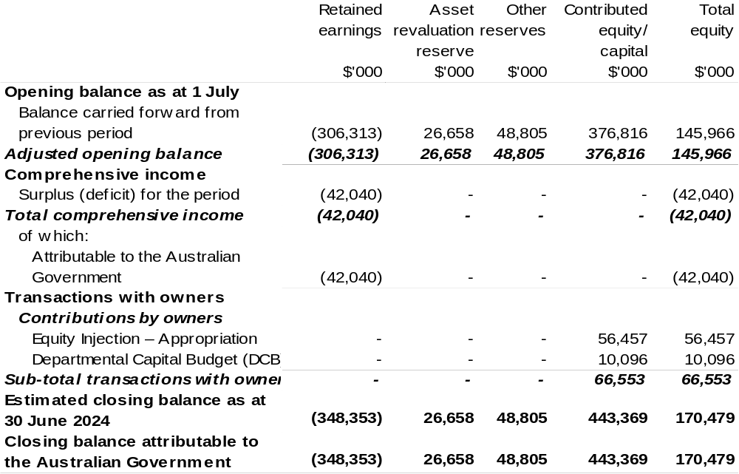
Table has been prepared inclusive of 2022–23 Additional Estimates figures.

Prepared on Australian Accounting Standards basis.

Table 3.4: Budgeted departmental statement of cash flows (for the period ended 30 June)
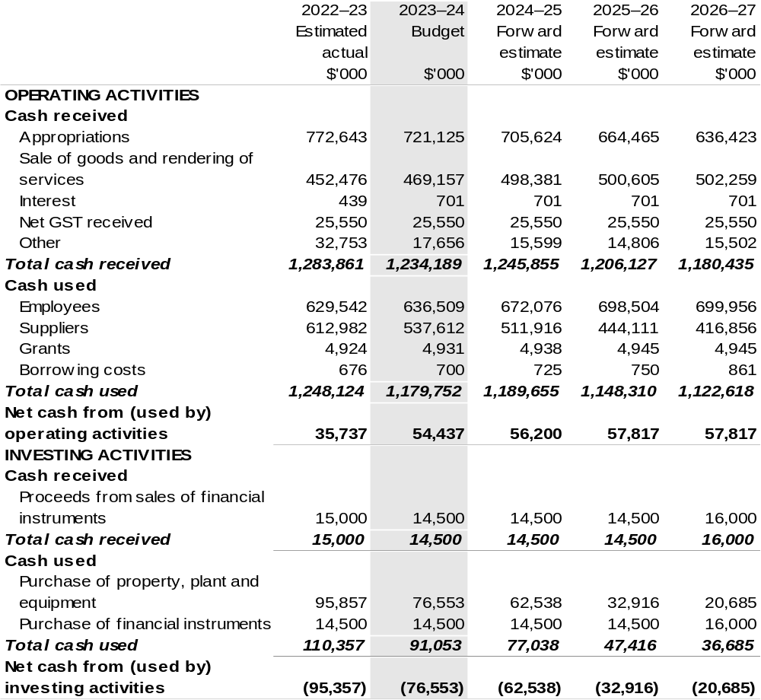
Continued on following page

Table 3.4: Budgeted departmental statement of cash flows (for the period ended 30 June) (continued)
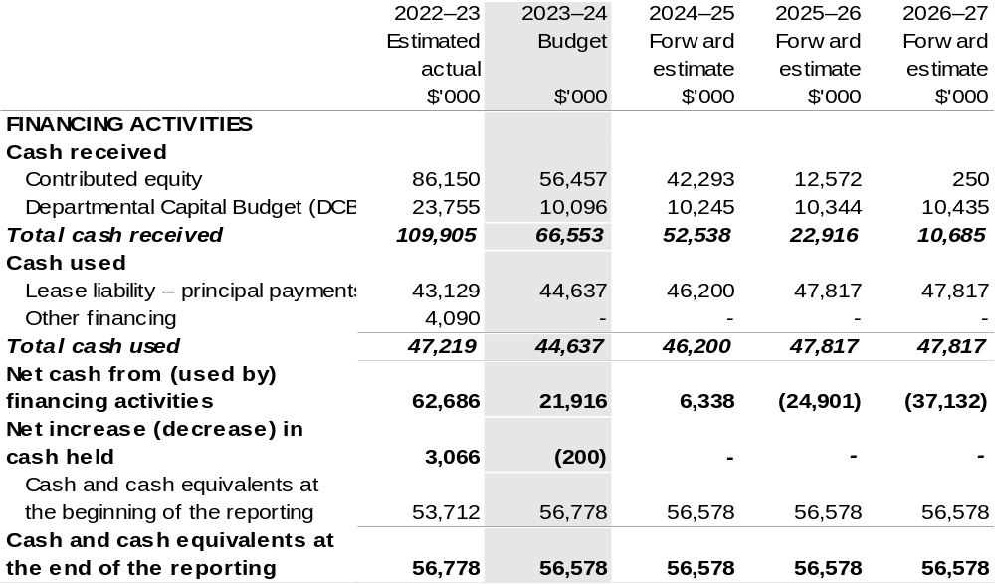
Prepared on Australian Accounting Standards basis.

Table 3.5: Departmental capital budget statement (for the period ended 30 June)
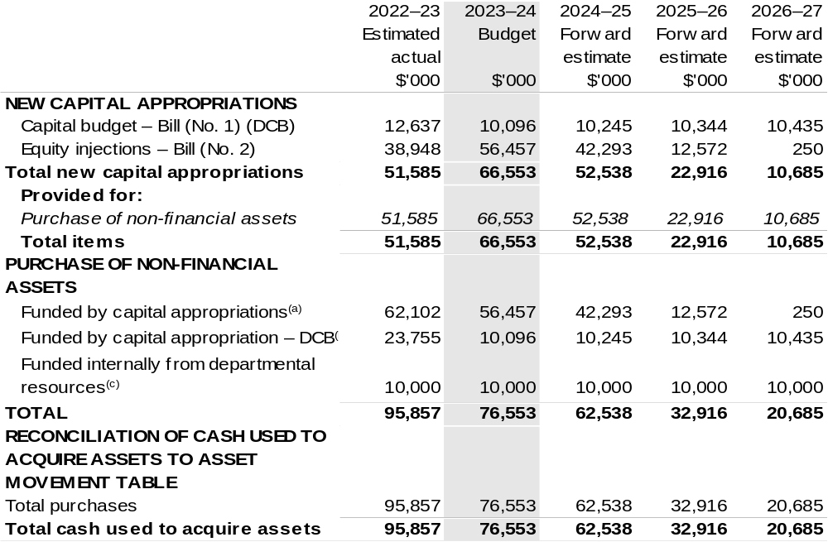
- Includes both current Bill (No. 2) and prior Act (No. 2/4/6) appropriations and special capital appropriations.
(b) Does not include annual finance lease costs. Includes purchases from current and previous years’ Departmental Capital Budgets (DCBs).
(c) Includes the following sources of funding:
- internally developed assets;
- section 74 external revenue; and
- proceeds from the sale of assets.

Prepared on Australian Accounting Standards basis.

Table 3.6: Statement of departmental asset movements (Budget year 2023–24)
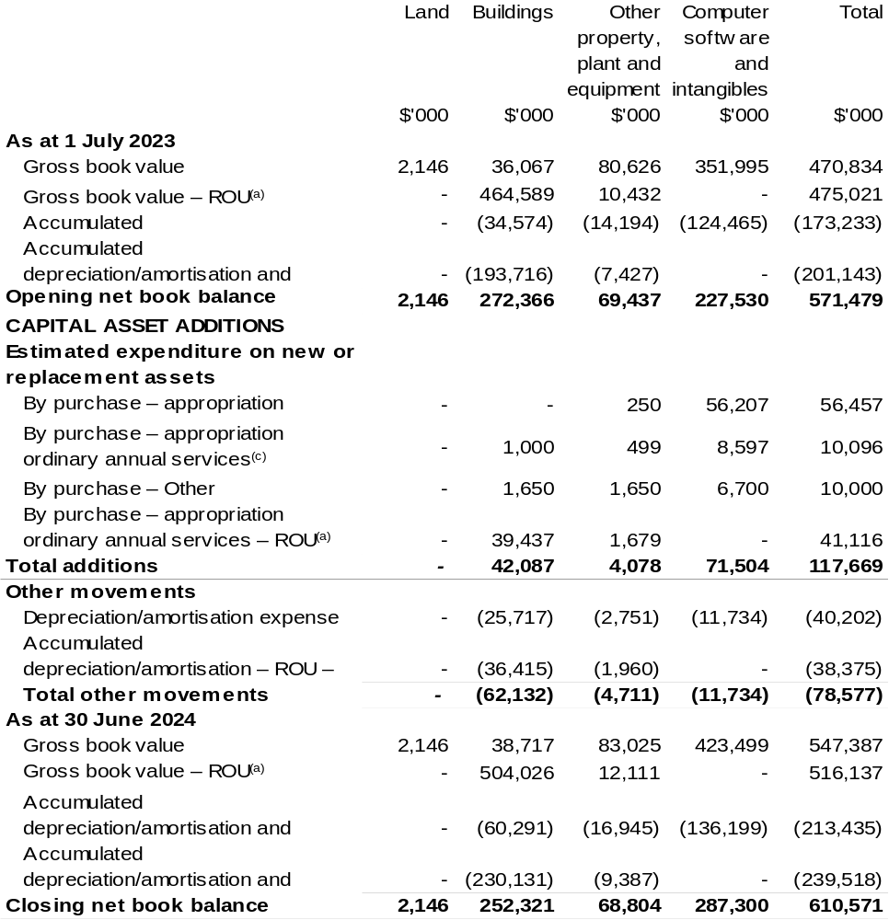

(a) Applies to leases under AASB 16 Leases. Right of Use (ROU).
(b) ‘Appropriation equity’ refers to equity injections, appropriations provided through Appropriation
Bill (No. 2) 2023–24.
(c) ‘Appropriation ordinary annual services’ refers to funding provided through Appropriation Bill (No. 1)
2023–24 for depreciation / amortisation expenses, DCBs or other operational expenses.

Prepared on Australian Accounting Standards basis.

Table 3.7: Schedule of budgeted income and expenses administered on behalf of Government (for the period ended 30 June)
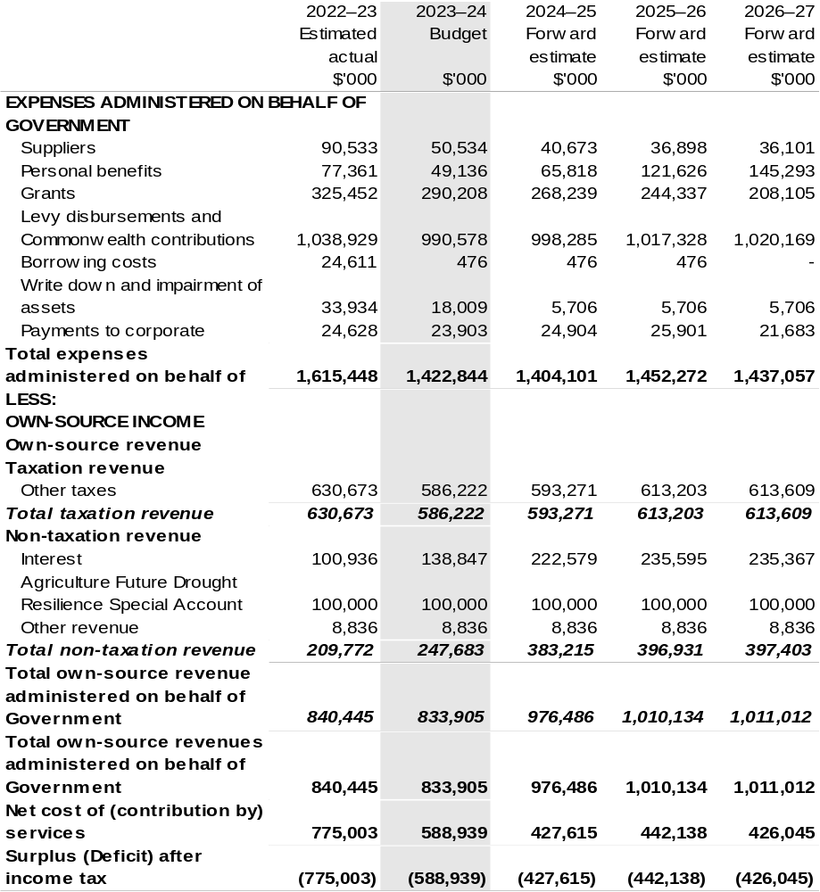
Continued on following page
Table 3.7: Schedule of budgeted income and expenses administered on behalf of Government (for the period ended 30 June) (continued)
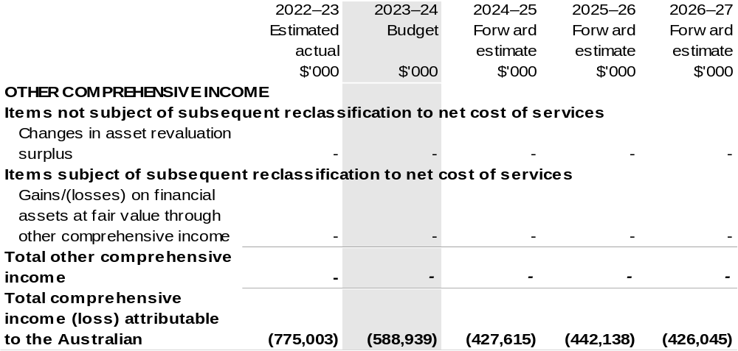
Prepared on Australian Accounting Standards basis.

Table 3.8: Schedule of budgeted assets and liabilities administered on behalf of Government (as at 30 June)
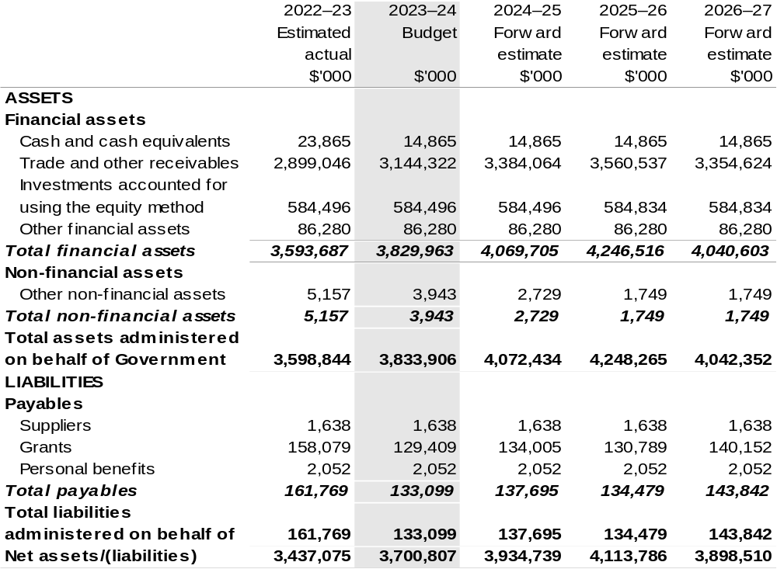

Prepared on Australian Accounting Standards basis.

Table 3.9: Schedule of budgeted administered cash flows (for the period ended 30 June)
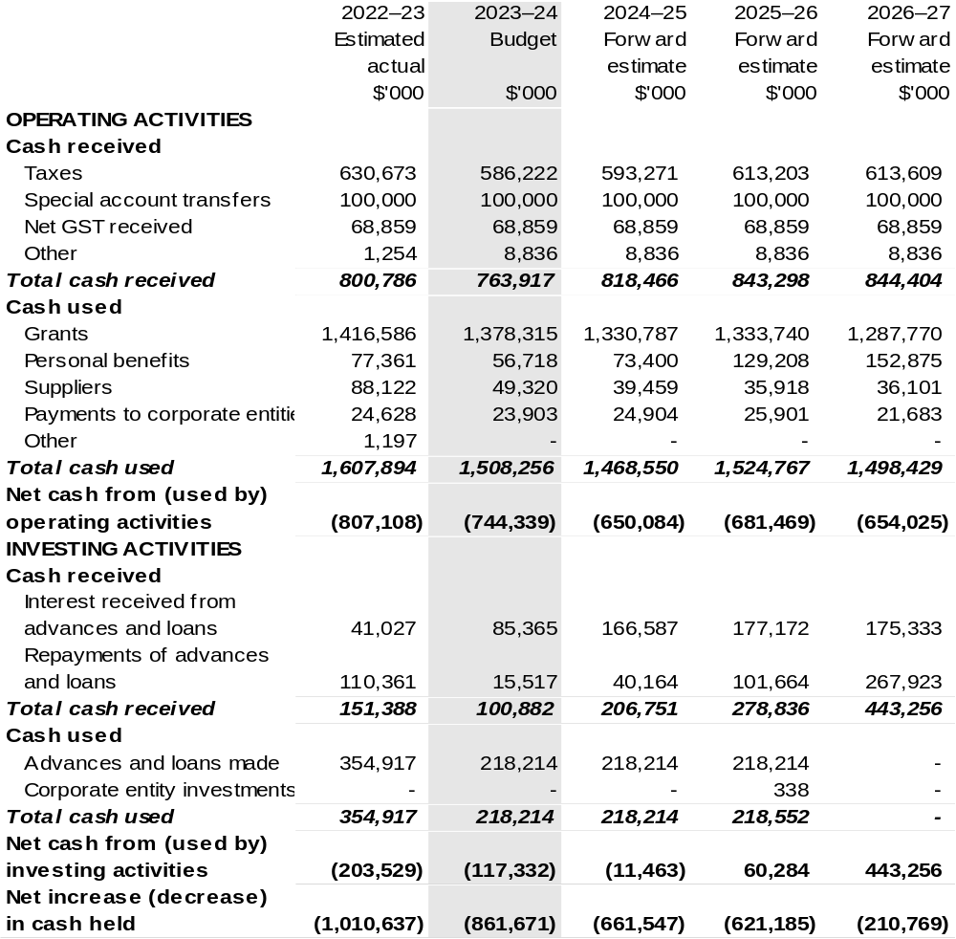
Continued on following page

Table 3.9: Schedule of budgeted administered cash flows (for the period ended 30 June) (continued)
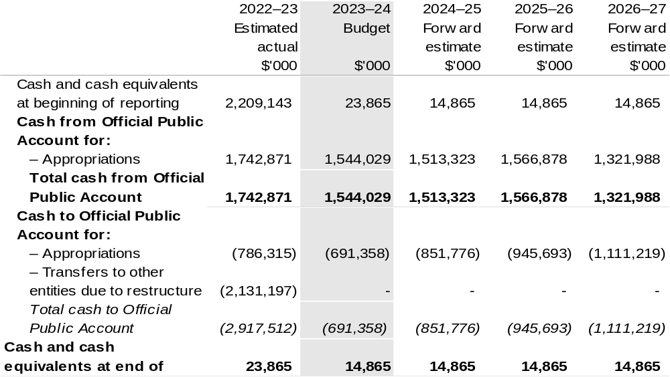

Prepared on Australian Accounting Standards basis.

Table 3.10: Administered capital budget statement (for the period ended 30 June)
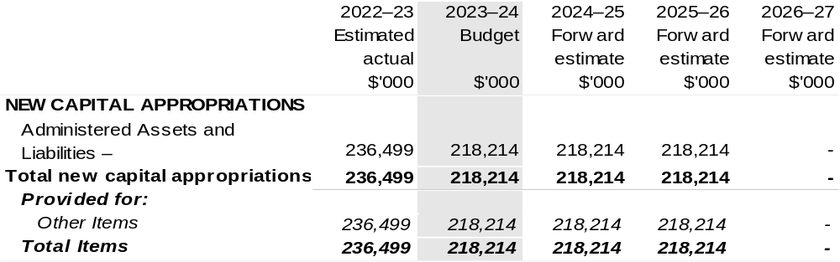
Prepared on Australian Accounting Standards basis.

AgriFutures Australia
Section 1: Entity overview and resources 75
1.1 Strategic direction statement 75
1.2 Entity resource statement 78
1.3 Budget measures 80
Section 2: Outcomes and planned performance 81
2.1 Budgeted expenses and performance for Outcome 1 82
Section 3: Budgeted financial statements 88
3.1 Budgeted financial statements 88
3.2 Budgeted financial statements tables 89

AgriFutures Australia

Section 1: Entity overview and resources

1.1 Strategic direction statement
AgriFutures Australia (AgriFutures) is the trading name for the Rural Industries Research and Development Corporation (RIRDC). AgriFutures is one of 15 Research Development Corporations (RDCs) that service the Research, Development and Extension (RD&E) needs of Australian rural industries. We represent the research needs for 13 thriving rural industries (chicken meat, rice, honeybee and pollination, ginger, tea tree oil, pasture seeds, export fodder, thoroughbred horses, kangaroo, buffalo, deer, goat fibre and ratite).

With a head office in Wagga Wagga, NSW, AgriFutures has a unique role among the RDCs as we are also responsible for investing into building the leadership skills of those who work in the industry, researching issues that affect the whole of agriculture, identifying and supporting emerging rural industries and engaging in the global agrifood system.

AgriFutures’ vision is to grow the long-term prosperity of Australian rural industries and communities through:

- Investing in RD&E programs to meet the current challenges and future needs for our 13 rural industries

- Investing in RD&E which aim to drive the growth and development of emerging, high potential agricultural rural industries such as sesame, industrial hemp and seaweed

- Developing and delivering programs that respond to the specific workforce and leadership needs of those working in the Australian agricultural sector

- Delivering programs that futureproof Australian rural industries by identifying and responding to national challenges and opportunities which impact the Australian agricultural sector

- Engaging with the global agrifood innovation system to ensure Australia is a leader in accessing, adopting, developing and exporting agrifood technologies and innovation.

We work alongside our levied industries and other stakeholders. These partnerships allow us to bring together different capabilities, knowledge, skills and experience to facilitate the wider adoption of research outputs and outcomes.

We embrace a commercial approach to research and innovation that results in practice change on-farm, across rural industries and within regional communities.

As outlined in AgriFutures Australia Research and Innovation Strategic Plan
2022–2027 published on 1 July 2022, AgriFutures has designed the AgriFutures’ 16:5:5 Roadmap - a simple, decisive set of priorities, centred around two important audiences – our levied industries and Australian rural industries.
Sixteen priorities within five focus areas over five years (2022–2027).
AgriFutures’ 16:5:5 Roadmap
Focus Area: Our Industries
In partnership with each of our industries, create value by:
- Maximising the return on investment for R&D levies.
- Listening to, engaging, collaborating, and consulting with our industries.
- Delivering research and innovation that addresses the specific needs of each of our industries.
- Supporting our industries to prepare for and thrive into the future.
- Identifying, linking, and testing new technologies, practices, and innovations with the potential for our industries to uptake and adopt.
- Assisting our industries to enhance their industry stewardship to build community and consumer confidence.
Focus Area: Emerging Industries
Grow the value and diversity of Australia’s rural economy by:
- Driving the growth of emerging, high-potential rural industries.
- Identifying new revenue streams.
Focus Area: Workforce and Leadership
Assist in the development of the agricultural workforce by:
- Understanding and responding to the future workforce needs of Australia’s rural industries.
- Attracting and retaining a workforce that will ensure Australia’s rural industries are future ready.
- Supporting people in Australia’s rural industries to build their motivation and skills to lead change.
- Responding to the specific workforce and leadership needs of our levied and emerging industries.
Focus Area: National Challenges and Opportunities
Future proof Australian rural industries by:
- Identifying, understanding, and responding to national challenges and opportunities impacting Australian rural industries.
- Facilitating collaboration across sectors and organisations including other RDCs and Agricultural Innovation Australia (AIA).
- Fostering responsible industry stewardship and building community trust.
Focus Area: Global Innovation Networks
Engage with the global agrifood innovation system by:
- Ensuring Australia is a leader in accessing and adopting, as well as developing and exporting agrifood technologies and innovation.

1.2 Entity resource statement
Table 1.1 shows the total funding from all sources available to the entity for its operations and to deliver programs and services on behalf of the Government.
The table summarises how resources will be applied by outcome (Government strategic policy objectives) and by administered (on behalf of the Government or the public) and departmental (for the entity’s operations) classification.
For more detailed information on special accounts and special appropriations, please refer to Budget Paper No. 4: Agency Resourcing.
Information in this table is presented on a resourcing (that is, appropriations/cash available) basis, whilst the ‘Budgeted expenses by Outcome’ tables in Section 2 and the financial statements in Section 3 are presented on an accrual basis.

Table 1.1: AgriFutures Australia – Resource Statement – Budget Estimates for 2023–24 as at Budget May 2023
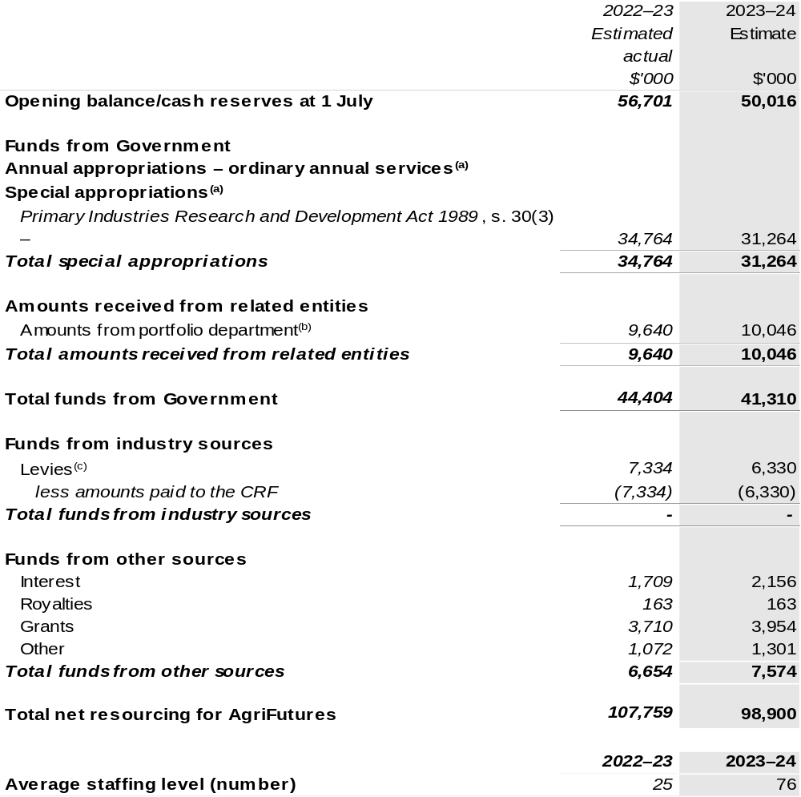

(a) AgriFutures' special appropriation is not directly appropriated as it is a corporate Commonwealth entity (CCE) under the Public Governance, Performance and Accountability Act 2013 (PGPA Act). Appropriations are made to the Department of Agriculture, Fisheries and Forestry (DAFF) and are then paid to AgriFutures and are considered departmental for all purposes.
(b) Funding provided by the portfolio department that is not specified within the Annual Appropriation Bills as a payment to that CCE (for example, a grant awarded to a CCE from one of its portfolio department's administered programs).
(c) The levies are imposed by the Primary Industries (Excise) Levies Act 1999. The levies are collected by DAFF under the Primary Industries Levies and Charges Collection Act 1991 and transferred to the Consolidated Revenue Fund (CRF). These amounts are then drawn down by the department as a special appropriation and paid to AgriFutures under the Primary Industries Research and Development Act 1989 (PIRD Act) s. 30(3) – Rural Industries R&D Corporation.

Please note: All figures shown above are GST exclusive – these may not match figures in the cash flow statement.

Prepared on a resourcing (i.e., appropriations available) basis.

1.3 Budget measures
Budget measures in Part 1 relating to AgriFutures Australia are detailed in Budget Paper No. 2 and are summarised below.

Table 1.2: AgriFutures Australia – 2023–24 Budget Measures

Part 1: Measures announced since the 2022–23 October Budget

AgriFutures does not have any 2023–24 Budget measures.

Section 2: Outcomes and planned performance
Government outcomes are the intended results, impacts or consequences of actions by the Government on the Australian community. Commonwealth programs are the primary vehicle by which government entities achieve the intended results of their outcome statements. Entities are required to identify the programs which contribute to Government outcomes over the Budget and forward years.
Each outcome is described below together with its related programs. The following provides detailed information on expenses for each outcome and program, further broken down by funding source.
Note:
Performance reporting requirements in the Portfolio Budget Statements are part of the Commonwealth performance framework established by the Public Governance, Performance and Accountability Act 2013. It is anticipated that the performance criteria described in Portfolio Budget Statements will be read with broader information provided in an entity’s corporate plans and annual performance statements – included in Annual Reports – to provide a complete picture of an entity’s planned and actual performance.
The most recent corporate plan and annual performance statement for AgriFutures can be found at:
http://www.agrifutures.com.au/about/corporate-documents/.

2.1 Budgeted expenses and performance for Outcome 1
Outcome 1: Growth in the long-term prosperity of Australian rural industries by investing, through partnerships with industry, in research, development, extension, and commercialisation that fosters sustainable and profitable existing and emerging rural industries, and cross sector opportunities and challenges.

2.1.1: Linked programs
Department of Agriculture, Fisheries and Forestry
Program 1.10: Agricultural Resources
Contribution to Outcome 1 made by linked program:
AgriFutures works together with DAFF to ensure sustainable, productive and profitable rural industries.

2.1.2: Budgeted expenses for Outcome 1
This table shows how much the entity intends to spend (on an accrual basis) on achieving the outcome, broken down by program, as well as by administered and departmental funding sources.

Table 2.1: Budgeted expenses for Outcome 1
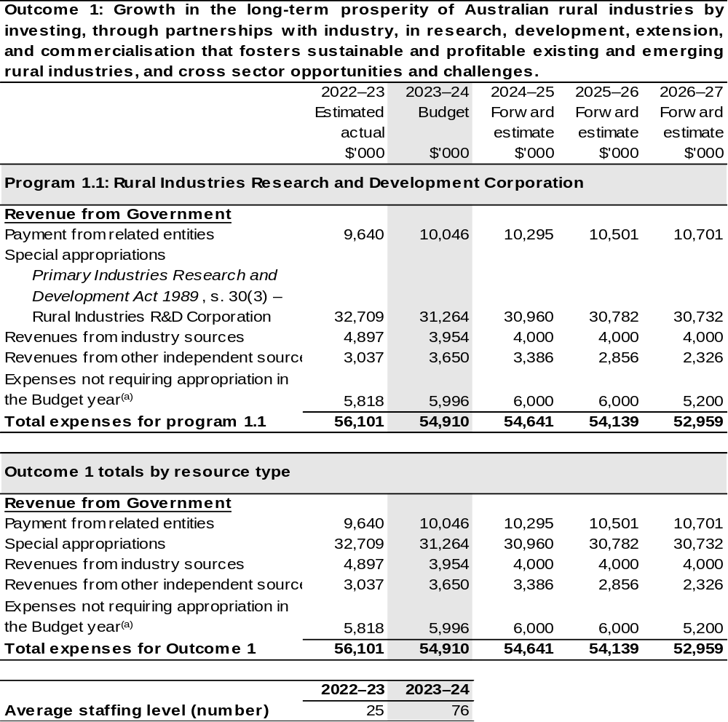

- ‘Expenses not requiring appropriation in the budget year’ are made up of make good expenses, audit fees, and can include depreciation / amortisation expenses not requiring an appropriation.

Note: Departmental appropriation splits and totals are indicative estimates and may change in the course of the budget year as government priorities change.

Prepared on Australian Accounting Standards basis.

Table 2.2: Performance measure for Outcome 1
Table 2.2 details the performance measures for each program associated with Outcome 1. It also provides the related key activities as expressed in the current corporate plan where further detail is provided about the delivery of the activities related to the program, the context in which these activities are delivered and how the performance of these activities will be measured. Where relevant, the 2023–24 Budget measures that have created new programs or materially changed existing programs are provided.
As an entity established under the Primary Industries Research and Development Act 1989 (PIRD Act), AgriFutures does not produce a corporate plan under the PGPA Act and is therefore exempt from the requirement to map purposes to outcomes.
Outcome 1: Growth in the long-term prosperity of Australian rural industries by investing, through partnerships with industry, in research, development, extension, and commercialisation that fosters sustainable and profitable existing and emerging rural industries, and cross sector opportunities and challenges.
Program 1.1: Rural Industries Research and Development Corporation
Objective | Through research and development create thriving rural industries and vibrant regional communities.
Key Activities | Focus Area: Our Industries  In partnership with each of our industries, create value by:  - Maximising the return on investment for R&D levies.  - Listening to, engaging, collaborating, and consulting with our industries.  - Delivering research and innovation that addresses the specific needs of each of our industries.  - Supporting our industries to prepare for and thrive into the future.  - Identifying, linking, and testing new technologies, practices, and innovations with the potential for our industries to uptake and adopt.  - Assisting our industries to enhance their industry stewardship to build community and consumer confidence.
Key Activities | Focus Area: Emerging Industries  Grow the value and diversity of Australia’s rural economy by:  - Driving the growth of emerging, high-potential rural industries.  - Identifying new revenue streams.

Continued on following pages
Table 2.2: Performance measure for Outcome 1 (continued)
Key Activities (continued) | Focus Area: Workforce and Leadership  Assist in the development of the agricultural workforce by:  - Understanding and responding to the future workforce needs of Australia’s rural industries.  - Attracting and retaining a workforce that will ensure Australia’s rural industries are future ready.  - Supporting people in Australia’s rural industries to build their motivation and skills to lead change.  - Responding to the specific workforce and leadership needs of our levied and emerging industries.
Key Activities (continued) | Focus Area: National Challenges and Opportunities  Future proof Australian rural industries by:  - Identifying, understanding, and responding to national challenges and opportunities impacting on Australian rural industries.  - Facilitating collaboration across sectors and organisations including other RDCs and AIA.  - Fostering responsible industry stewardship and building community trust.
Key Activities (continued) | Focus Area: Global Agrifood Innovation  Engage with the global agrifood innovation system by:  - Ensuring Australia is a leader in accessing and adopting, as well as developing and exporting agrifood technologies and innovation.
Year | Performance measures | Expected Performance Results
Current year  2022–23 | As per AgriFutures Research and Innovation Strategic Plan  2022–2027 published 1 July 2022. | As per AgriFutures Research and Innovation Strategic Plan  2022–2027 published 1 July 2022.
Current year  2022–23 | Deliver economic assessments of the investment in each of our  13 industry R&D programs. | A Benefit: cost ratio of 4:1.  (One assessment per industry during the five years of AgriFutures Research and Innovation Strategic Plan  2022–2027).
Current year  2022–23 | Percentage of industry representative bodies and panel members that believe AgriFutures’ engagement with our industries has been effective. | 70 per cent.

Continued on following pages
Table 2.2: Performance measure for Outcome 1 (continued)
Year | Performance measures | Expected Performance Results
Current year  2022–23 (continued) | Degree to which the objectives of the industry-based R&D plans are being achieved. | 80 per cent.
Current year  2022–23 (continued) | Percentage of industry representative bodies and panel members that feel AgriFutures’ engagement with industry has supported them to prepare for the future. | 70 per cent.
Current year  2022–23 (continued) | The number of new technologies or innovation tested relevant to our levied industries | Five per annum.
Current year  2022–23 (continued) | Percentage of our industry representative bodies and panel members that feel AgriFutures’ has assisted their industry to build community and consumer confidence. | 70 per cent.
Current year  2022–23 (continued) | Deliver investments across emerging industries that enables them to address the highest priorities identified in their RD&E Plans. | Five investments across five emerging industries.
Current year  2022–23 (continued) | Identify new potential revenue streams post farm-gate or ecosystem* market opportunities that have the potential to return additional revenue streams. | Five.
Current year  2022–23 (continued) | Deliver and extend to stakeholders the key findings of a study that addresses national workforce needs. | One study per annum.
Current year  2022–23 (continued) | Percentage of participants in AgriFutures leadership and capacity building programs that feel equipped and confident to contribute to the future of Australia’s rural industries. | 80 per cent.

Table 2.2: Performance measure for Outcome 1 (continued)
Year | Performance measures | Expected Performance Results
Current year  2022–23 (continued) | Percentage of participants in AgriFutures leadership and capacity building programs that feel their motivation and skills to lead change have increased due to their participation. | 80 per cent.
Current year  2022–23 (continued) | Percentage of participants in levied and emerging industries capacity building programs that feel they are better equipped to address workforce needs within their industry. | 80 per cent.
Current year  2022–23 (continued) | Deliver and extend to stakeholders the key findings of studies addressing national challenges and opportunities impacting Australian rural industries. | Four studies per annum.
Current year  2022–23 (continued) | Deliver the Emerging National Rural Issues Forum (ENRI). | One per annum resulting in five or more national collaborative projects/programs.
Current year  2022–23 (continued) | Deliver and extend to stakeholders the key findings of studies addressing responsible industry stewardship and building community trust. | One per annum.
Current year  2022–23 (continued) | Deliver events, networks and/or platforms that support the positioning of Australia as a global leader in agrifood tech. | Three events.
Year | Performance measures | Planned Performance Results
Budget Year  2023–24 | As per 2022–23. | As per 2022–23.
Forward Estimates 2024–27 | As per 2023–24. | As per 2023–24.

Section 3: Budgeted financial statements
Section 3 presents budgeted financial statements which provide a comprehensive snapshot of entity finances for the 2023–24 budget year, including the impact of budget measures and resourcing on financial statements.

3.1 Budgeted financial statements

3.1.1: Differences between entity resourcing and financial statements
The financial statements are prepared on an accrual basis where revenues and expenses are recognised as and when the resources are received and used. The entity resourcing table recognises the cash resources available to be used during the period and includes amounts recognised as revenue in previous periods.

3.1.2: Explanatory notes and analysis of budgeted financial statements
AgriFutures is budgeting for a deficit of $6.0 million in 2023–24.
AgriFutures’ balance sheet remains strong with estimated total assets of $52.8 million in 2023–24. Of the total assets, approximately $44.0 million is represented by cash and investments.
Total liabilities of $8.4 million are mostly represented by payables to R&D providers and suppliers of $3.1 million and employee entitlements of $0.8 million over the same period.

3.2 Budgeted financial statements tables

Table 3.1: Comprehensive income statement (showing net cost of services) (for the period ended 30 June)
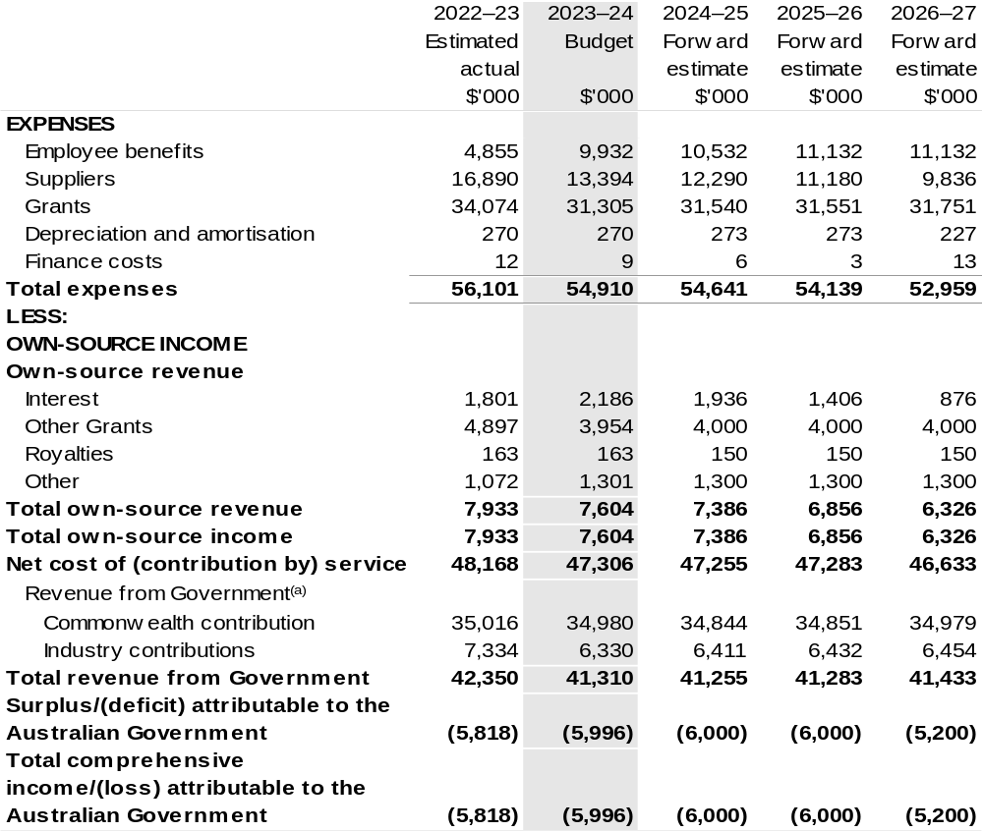

Continued on following page
Table 3.1: Comprehensive income statement (showing net cost of services) (for the period ended 30 June) (continued)
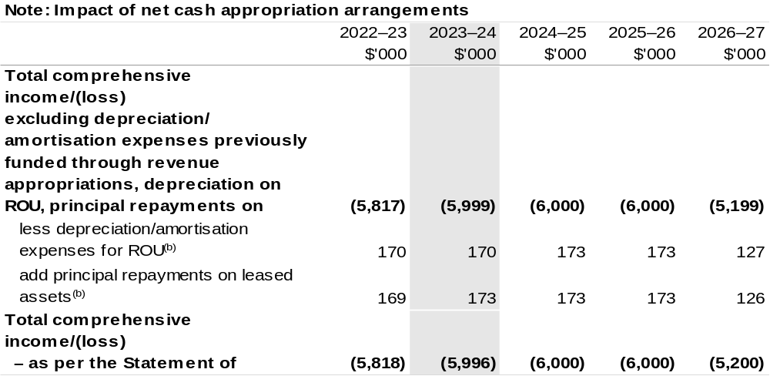
(a) Revenue from Government includes a Commonwealth contribution under the PIRD Act and levies collected from industry by DAFF for R&D activities.
(b) Applies to leases under Australian Account Standards Board (AASB) 16 Leases. Right of Use (ROU).

Prepared on Australian Accounting Standards basis.

Table 3.2: Budgeted departmental balance sheet (as at 30 June)
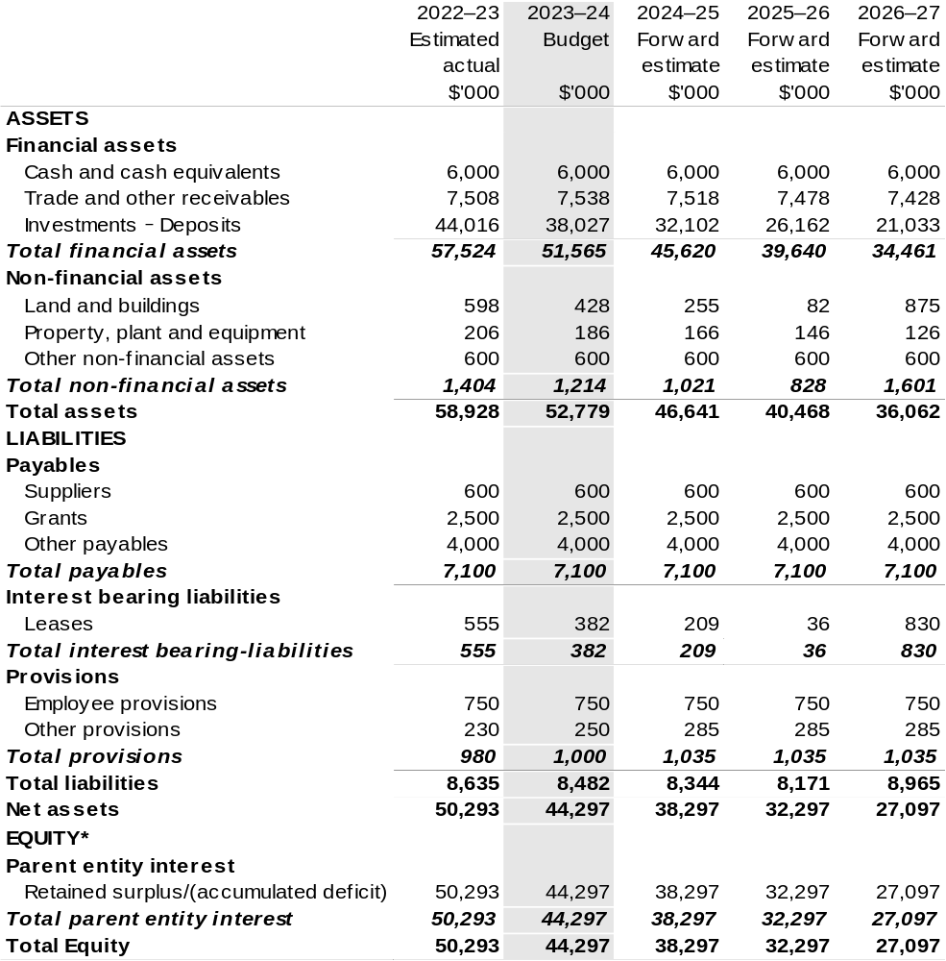

*'Equity' is the residual interest in assets after deduction of liabilities.

Prepared on Australian Accounting Standards basis.

Table 3.3: Departmental statement of changes in equity – summary of movement (Budget year 2023–24)
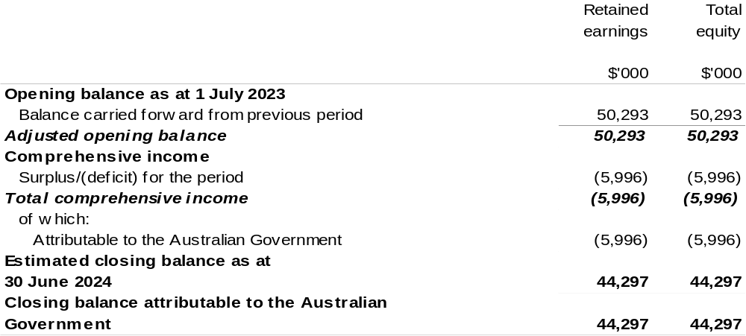

Prepared on Australian Accounting Standards basis.

Table 3.4: Budgeted departmental statement of cash flows (for the period
ended 30 June)
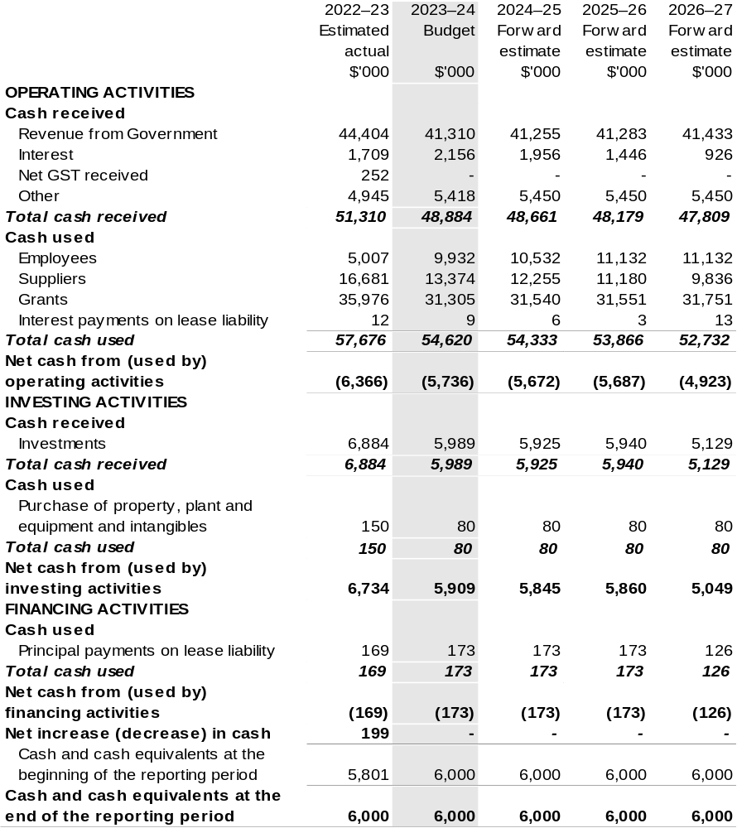

Prepared on Australian Accounting Standards basis.

Table 3.5: Departmental capital budget statement (for period ended 30 June)
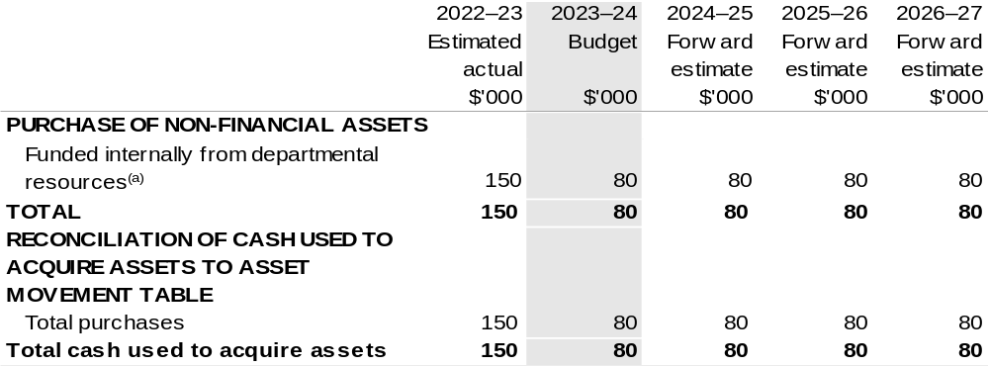
(a) Includes the following s74 external revenue:
– internally developed assets; and
– proceeds from the sale of assets.

Consistent with information contained in the Statement of Asset Movements and the Budgeted Statement of Cash Flows.

Prepared on Australian Accounting Standards basis.

Table 3.6: Statement of departmental asset movements (Budget year 2023–24)
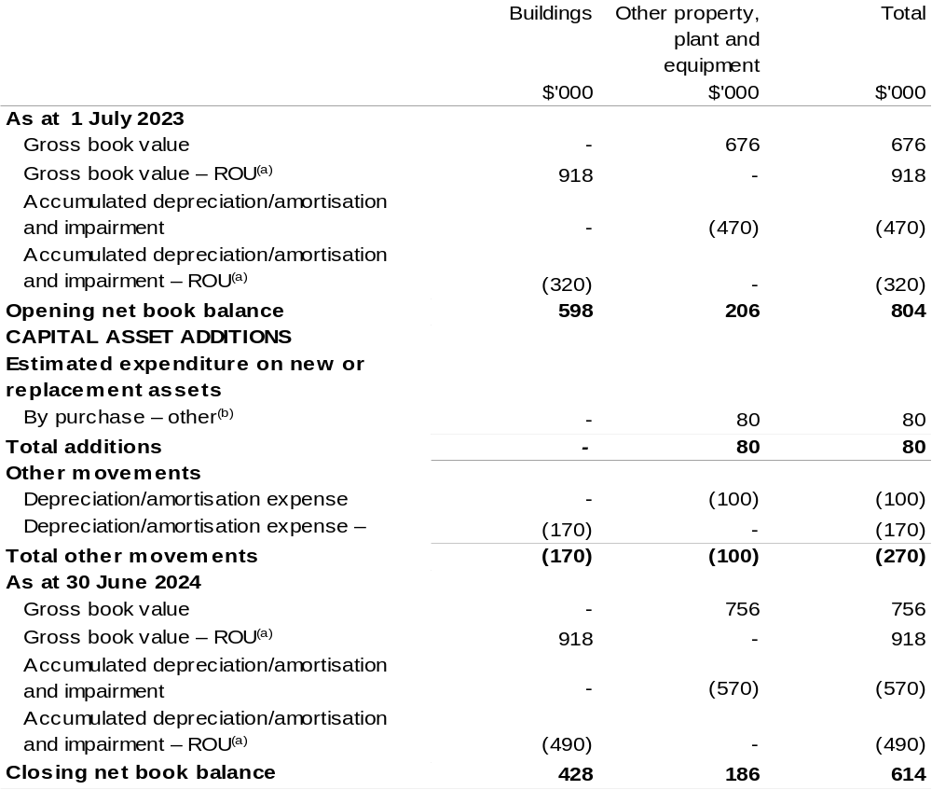

(a) Applies to leases under AASB 16 Leases. Right of Use (ROU).
(b) ‘By purchase – other’ refers to funding provided through other internal funding sources.

Prepared on Australian Accounting Standards basis.

Australian Fisheries Management Authority
Section 1: Entity overview and resources 99
1.1 Strategic direction statement 99
1.2 Entity resource statement 101
1.3 Budget measures 103
Section 2: Outcomes and planned performance 104
2.1 Budgeted expenses and performance for Outcome 1 105
Section 3: Budgeted financial statements 112
3.1 Budgeted financial statements 112
3.2 Budgeted financial statements tables 113

Australian Fisheries Management Authority

Section 1: Entity overview and resources

1.1 Strategic direction statement
The purpose of the Australian Fisheries Management Authority (AFMA) is the ecologically sustainable development of Commonwealth fisheries for the benefit of the Australian community.
To achieve its purpose, AFMA pursues the objectives of:
- Implementing efficient and cost-effective fisheries management.
- Ensuring the exploitation of fisheries and related activities is consistent with the principles of ecologically sustainable development.
- Where Australia has obligations under international agreements, ensuring the exploitation of fish stocks and related activities in the Australian fishing zone and the high seas are carried on consistently with those obligations.
- To the extent that Australia has obligations under international law or agreements, ensuring that fishing activities by Australian flagged vessels on the high seas are conducted consistently with those obligations.
- Maximising net economic returns to the Australian community from the management of Australian fisheries.
- Ensuring accountability to the fishing industry and the Australian community in the management of fisheries resources.
- Achieving government targets in relation to the recovery of AFMA’s costs.
AFMA is also required to have regard to the objectives of:
- Ensuring that the interests of commercial, recreational, and Indigenous fishers are taken into account.
- Ensuring, through proper conservation and management measures, that the living resources of the Australian fishing zone are not endangered by over-exploitation.
- Achieving optimum utilisation of the living resources of the Australian fishing zone.
AFMA must ensure that, as far as practicable, that measures adopted in pursuit of legislated objectives are not inconsistent with the preservation, conservation and protection of whales.
Success in pursuing these objectives is increasingly impacted by greater competition in the marine space as well as environmental change. The Department of Agriculture, Fisheries and Forestry has commenced reviews of the Commonwealth Harvest Strategy Policy and the Commonwealth Bycatch Policy, which are key guiding documents for the way that AFMA manages fisheries. AFMA has work underway to recalibrate its management regime in some fisheries, in addition to planning for technology, business environment and workforce upgrades to ensure AFMA is prepared to continue to meet future challenges.
In 2023–24, AFMA will focus on technological refreshment and sustainment, gaining efficiencies in AFMA business processes, and investing in different science to meet the demands of climate change. AFMA will also be working to increase the profile of Commonwealth fisheries in Australian and international contexts.
AFMA’s Corporate Plan outlines the key priorities that will support AFMA to achieve its purpose in the dynamic marine and economic environment in which it operates.

1.2 Entity resource statement
Table 1.1 shows the total funding from all sources available to the entity for its operations and to deliver programs and services on behalf of the Government.
The table summarises how resources will be applied by outcome (Government strategic policy objectives) and by administered (on behalf of the Government or the public) and departmental (for the entity’s operations) classification.
For more detailed information on special accounts and special appropriations, please refer to Budget Paper No. 4: Agency Resourcing.
Information in this table is presented on a resourcing (that is, appropriations/cash available) basis, whilst the ‘Budgeted expenses by Outcome’ table in Section 2 and the financial statements in Section 3 are presented on an accrual basis.

Table 1.1: Australian Fisheries Management Authority – Resource Statement – Budget Estimates for 2023–24 as at May Budget 2023
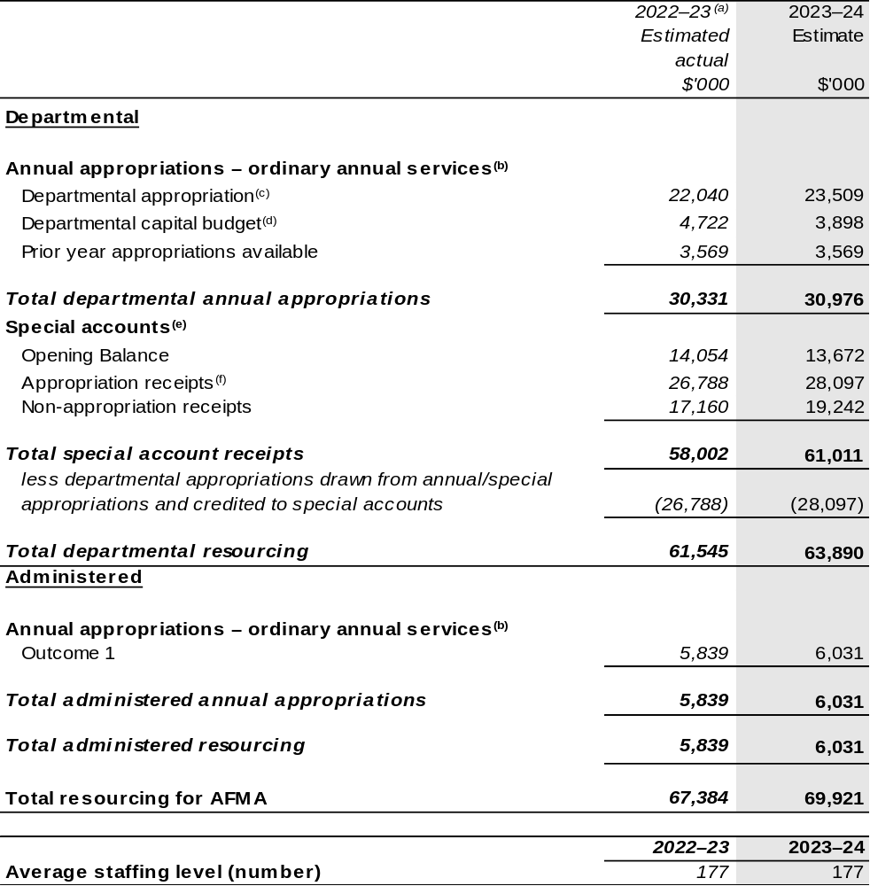
(a) Annual appropriation amounts presented for 2022–23 do not include the Appropriation Bills (No. 3), as they had not been enacted at the time of publication. For the AFMA, $0.026 million will be received through the 2022–23 Annual Appropriation Bill (No. 3). The annual appropriations received from this bill will be recognised in a future portfolio budget statement but only after the Bills have received Royal Assent.
(b) Appropriation Bill (No. 1) 2023–24.
(c) Excludes departmental capital budget (DCB).
(d) Departmental capital budgets are not separately identified in Appropriation Bill (No.1) and form part of ordinary annual services items. Please refer to Table 3.5 for further details. For accounting purposes, this amount has been designated as a 'contribution by owner'.
(e) For further information on special appropriations and special accounts, please refer to Budget Paper No. 4: Agency Resourcing 2023–24. Please also see Table 2.1 for further information on outcome and program expenses broken down by various funding sources, e.g., annual appropriations, special appropriations and special accounts.
(f) Amounts credited to the special account from the Authority’s annual appropriations.
Please note: All figures shown above are GST exclusive – these may not match figures in the cash flow statement. Prepared on a resourcing (i.e., appropriations available) basis.

1.3 Budget measures
Budget measures in Part 1 relating to the Australian Fisheries Management Authority are detailed in Budget Paper No. 2 and are summarised below.

Table 1.2: Australian Fisheries Management Authority – 2023–24 May Budget Measures

Part 1: Measures announced since the 2022–23 October Budget

Australian Fisheries Management Authority does not have any 2023–24 Budget measures.

Section 2: Outcomes and planned performance
Government outcomes are the intended results, impacts or consequences of actions by the Government on the Australian community. Commonwealth programs are the primary vehicle by which government entities achieve the intended results of their outcome statements. Entities are required to identify the programs which contribute to Government outcomes over the Budget and forward years.
Each outcome is described below together with its related programs. The following provides detailed information on expenses for each outcome and program, further broken down by funding source.
Note:
Performance reporting requirements in the Portfolio Budget Statements are part of the Commonwealth performance framework established by the PGPA Act. It is anticipated that the performance criteria described in Portfolio Budget Statements will be read with broader information provided in an entity’s corporate plans and annual performance statements – included in Annual Reports – to provide a complete picture of an entity’s planned and actual performance.
AFMA’s most recent corporate plan can be found at:
https://www.afma.gov.au/corporate-and-reports/2022-25-afma-corporate-plan.
AFMA’s most recent annual performance statement can be found at:
https://www.afma.gov.au/corporate-and-reports/2021-22-annual-report.

2.1 Budgeted expenses and performance for Outcome 1
Outcome 1: Ecologically sustainable and economically efficient Commonwealth fisheries, through understanding and monitoring Australia’s marine living resources and regulating and monitoring commercial fishing, including domestic licensing and deterrence of illegal foreign fishing.

2.1.1: Linked programs
Department of Agriculture, Fisheries and Forestry
Program 1.4: Fishing Industry
Program 2.1: Biosecurity and Export Services
Contribution to Outcome 1 made by linked program:
AFMA and DAFF engage on fisheries management to ensure a sustainable, productive, and profitable fishing industry.
Department of Climate Change, Energy, the Environment and Water
Program 2.4: Conservation of Australia’s Heritage and Environment
Contribution to Outcome 1 made by linked program:
AFMA and DCCEEW engage on fisheries management to ensure a sustainable, productive, and profitable fishing industry.
Department of Home Affairs
Program 3.4: Border Enforcement
Contribution to Outcome 1 made by linked program:
AFMA provides the fisheries focus within the Australian Government Civil Maritime Surveillance and Response Program and is responsible for the administration of legislation on illegal fishing in the Australian Fishing Zone. AFMA deters and prevents illegal foreign fishing by carrying out education programs, cooperative enforcement operations, prosecution of offenders, confiscation of boats, and capacity building projects.

2.1.2: Budgeted expenses for Outcome 1
This table shows how much the entity intends to spend (on an accrual basis) on achieving the outcome, broken down by program, as well as by administered and departmental funding sources.

Table 2.1: Budgeted expenses for Outcome 1
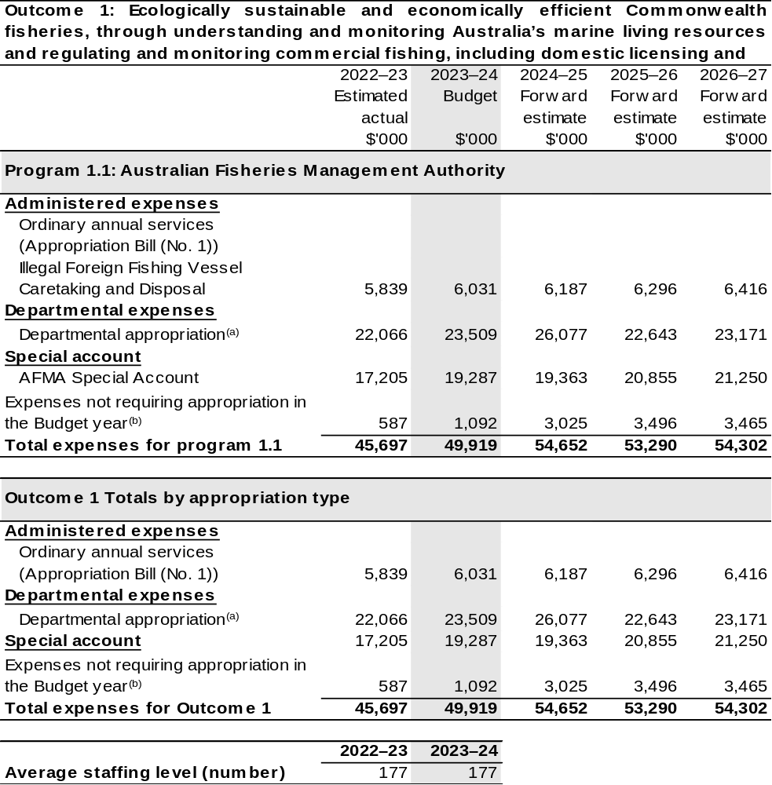

(a) Expenses are funded from both ‘ordinary annual services’ Appropriation Bill (No. 1) 2023–24 and ‘revenue from independent sources’ (receipts retained under section 74 of the PGPA Act).
(b) ‘Expenses not requiring appropriation in the budget year’ are made up of make good expenses, audit fees, and can include depreciation / amortisation expenses not requiring an appropriation.

Note: Departmental appropriation splits and totals are indicative estimates and may change in the course of the budget year as Government priorities change.
Table has been prepared inclusive of 2022–23 Additional Estimates figures.
Prepared on Australian Accounting Standards basis.

Table 2.2: Performance measure for Outcome 1
Table 2.2 details the performance measures for each program associated with Outcome 1. It also provides the related key activities as expressed in the current corporate plan where further detail is provided about the delivery of the activities related to the program, the context in which these activities are delivered and how the performance of these activities will be measured. Where relevant, the 2023–24 Budget measures that have created new programs or materially changed existing programs are provided.
Outcome 1: Ecologically sustainable and economically efficient Commonwealth fisheries, through understanding and monitoring Australia’s marine living resources and regulating and monitoring commercial fishing, including domestic licensing and deterrence of illegal foreign fishing.
Program 1.1: Australian Fisheries Management Authority
Objective 1 | Management of Commonwealth fisheries consistent with principles of ecological sustainable development.
Key Activities | - Developing management arrangements that:  - Support the implementation of Commonwealth fisheries policies including the Harvest Strategy and Bycatch Policies  - Implement AFMA’s Ecological Risk Management Framework  - Recover overfished stocks and prevent overfishing  - Ensure commercial, recreational and Indigenous fishing information is used to the extent possible in decision making.  - Investing in and applying monitoring, scientific and economic research to decision making on fish stocks, sub-stocks, species (target and non-target species) and the impact of fishing on the marine environment.
Objective 2 | Maximise net economic returns to the Australian community from the management of Commonwealth fisheries.
Key Activities | - Reviewing management arrangements to take into account commercial, recreational and Indigenous fishing interests when maximising net economic returns from the commercial sector.  - Increasing catch levels within sustainable total allowable catches (TACs) by conducting and considering implementation of research focussed on under caught TACs.  - Managing exploratory fisheries (potentially underutilised fisheries).  - Understanding impacts of resource allocation between commercial, recreational, and Indigenous fishers.

Continued on following pages
Table 2.2: Performance measure for Outcome 1 (continued)
Objective 3 | Compliance with Commonwealth fisheries laws and policies and relevant international fishing obligations and standards.
Key Activities | - Operating an effective compliance and enforcement regime encompassing:  - Measures to maximise voluntary compliance  - Risk-based, intelligence driven, and targeted domestic operations  - Building and maintaining strategic links and relationships with relevant law enforcement agencies.  - Operating effective foreign fisheries compliance enforcement and capacity building by:  - Implementing strategies to deter and eliminate IUU foreign fishing in Australian waters and on the high seas where Australia has an interest  - Delivering capacity building programs internationally and providing technical input to support key regional and international fishing bodies.
Objective 4 | Deliver effective, cost efficient and accountable management of Commonwealth fisheries resources.
Key Activities | - Pursuing initiatives to improve regulation and administration generally in the Australian Government sector including:  - Exploring opportunities to streamline fisheries assessment and management processes  - Implementing new fisheries policies for harvest strategies and bycatch to improve fishery management performance.  - Reviewing business processes and systems, information flows and financial management arrangements through:  - Assessing and mitigating high financial and operating risks  - Implementing a digital first service delivery policy that provides electronic service delivery for all relevant programs (E-logs, Electronic Catch Disposal Records, licensing, data requests, etc.).^{(a)}  - Increasing AFMA accountability and stakeholder engagement through:  - Expanded membership of management advisory committees (MACs) and resource assessment groups (RAGs)  - Capability development for recreational and Indigenous stakeholders.

Continued on following pages

Table 2.2: Performance measure for Outcome 1 (continued)
Year | Performance measures | Expected Performance Results
Current year  2022–23 | - The number of stocks for which management measures are based on species-appropriate scientific assessment. | Performance results of no change or an increase are on track.
Current year  2022–23 | - The percentage of species assessed as “residual High Risk” under Ecological Risk Assessment. | Performance results of no change or an increase are on track.
Current year  2022–23 | - The number of AFMA-only stocks assessed as “subject to overfishing” in the Australian Bureau of Agricultural and Resource Economics and Sciences (ABARES) Fishery Status Report. | Zero target is not on track.
Current year  2022–23 | - AFMA advocates measures to address stocks shared with states and territories that are assessed as “overfished” or “subject to overfishing” in the ABARES Fishery Status Report in relevant negotiations. | Qualitative assessment is on track.
Current year  2022–23 | - Status of Wildlife Trade Operations (WTOs) under the Environmental Protection and Biodiversity Conservation Act 1999. | All WTOs are maintained on track.
Current year  2022–23 | - The number of stocks with target reference points based on Maximum Economic Yield, an agreed proxy thereof or a multi-stock harvest strategy. | Performance results of no change or an increase are on track.
Current year  2022–23 | - Net Economic Return, as assessed in the ABARES Status of Fish Stocks Report. | Positive trend over a 3-year window is on track.
Current year  2022–23 | - Treatment of identified domestic compliance risks as outlined in the National Compliance and Enforcement Program (NCEP). | >90 per cent of NCEP performance targets met are not on track.
Current year  2022–23 | - Incidence level of illegal foreign fishing vessels operating in the Australian Fishing Zone. | Lower than the previous 10-year average is not on track to be met.

Continued on following pages
Table 2.2: Performance measure for Outcome 1 (continued)
Year | Performance measures | Expected Performance Results
Current year  2022–23 (continued) | - Compliance rate with international obligations as assessed in Regional Fisheries Management Organisation (implemented by AFMA). | >90 per cent is on track.
Current year  2022–23 (continued) | - Cost recovery budget. | At or below 2005–06 once adjusted for CPI is on track.
Current year  2022–23 (continued) | - Corporate overheads compared to total budget. | <20 per cent is not on track.
Current year  2022–23 (continued) | - Engagement with legislated peak body. | Commonwealth Fisheries Association is satisfied that meaningful opportunity is given to contribute to planning, delivery and reporting is on track.
Current year  2022–23 (continued) | - Number of services offered digitally. | Increase in the number of empirical data collection services offered electronically.
Year | Performance measures | Planned Performance Results
Budget Year  2023–24 | - Percentage of TAC determinations which are based on RAG/MAC scientific assessments. | ≥95 per cent.
Budget Year  2023–24 | - The number of new ERA assessments completed for regulated fisheries. | ≥5.
Budget Year  2023–24 | - Independent evaluation of the biological and economic status of fish stocks managed solely by AFMA. | No additional stocks evaluated as ‘overfished’.
Budget Year  2023–24 | - Compliance with conditions imposed on fisheries assessments. | 100 per cent of fisheries assessments maintained.
Budget Year  2023–24 | - The number of stocks with target reference points based on Maximum Economic Yield, an agreed proxy thereof, or a multi-stock harvest strategy. | No change or an increase.
Budget Year  2023–24 | - Net Economic Return, as assessed in the ABARES Fishery Status Reports. | Positive trend over rolling 3-year average.

Continued on following page

Table 2.2: Performance measure for Outcome 1 (continued)
Year | Performance measures | Planned Performance Results
Budget Year  2023–24 (continued) | - Treatment of identified domestic compliance risks as outlined in the National Compliance and Enforcement Program (NCEP). | 95 per cent of AFMA’s National Compliance and Enforcement Program performance targets met or within threshold.
Budget Year  2023–24 (continued) | - Incidence level of illegal foreign fishing vessels operating in the Australian Fishing Zone. | Lower than the previous 3-year average.
Budget Year  2023–24 (continued) | - Compliance rate with international obligations as assessed by International Fisheries Management Organisations (implemented by AFMA). | >90 per cent.
Budget Year  2023–24 (continued) | - Cost recovery budget. | At or below 2005–06 once adjusted for CPI.
Budget Year  2023–24 (continued) | - Engagement with legislated  peak body. | Commonwealth Fisheries Association is satisfied that meaningful opportunity is given to contribute to planning, delivery and reporting.
Budget Year  2023–24 (continued) | - Number of services offered  digitally. | Increase in the number of empirical data collection services offered electronically.
Year | Performance measures | Planned Performance Results
Forward Estimates  2024–27 | As per 2023–24. | As per 2023–24.

Section 3: Budgeted financial statements
Section 3 presents budgeted financial statements which provide a comprehensive snapshot of entity finances for the 2023–24 budget year, including the impact of budget measures and resourcing on financial statements.

3.1 Budgeted financial statements

3.1.1: Differences between entity resourcing and financial statements
The financial statements are prepared on an accrual basis where revenues and expenses are recognised as and when the resources are received and used. The entity resourcing table recognises cash resources available to be used during the period and includes amounts recognised as revenue in previous periods.

3.1.2: Explanatory notes and analysis of budgeted financial statements
AFMA expects to maintain a balanced budget position over the forward years before depreciation and amortisation.
AFMA collects levies via regulations under the Fishing Levy Act 1991, in accordance with the Fisheries Management Act 1991, Fisheries Administration Act 1991, Australian Government cost recovery policy and AFMA’s Cost Recovery Implementation Statement.
Administered income reflects the fines imposed by AFMA for domestic and international illegal fishing activities and the receipt of administered revenue for expenditure incurred.
Administered expenditure reflects payments to the providers of illegal foreign fishing vessel caretaking and disposal services.

3.2 Budgeted financial statements tables

Table 3.1: Comprehensive income statement (showing net cost of services) (for the period ended 30 June)
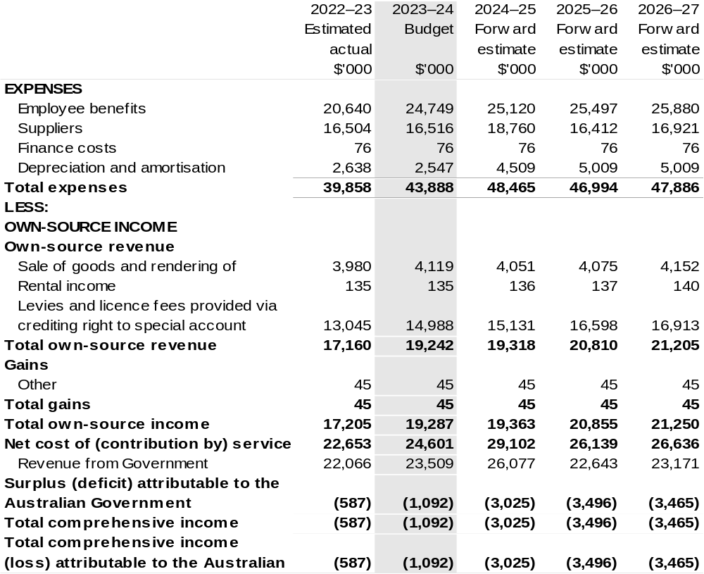

Continued on following page

Table 3.1: Comprehensive income statement (showing net cost of services) (for the period ended 30 June) (continued)
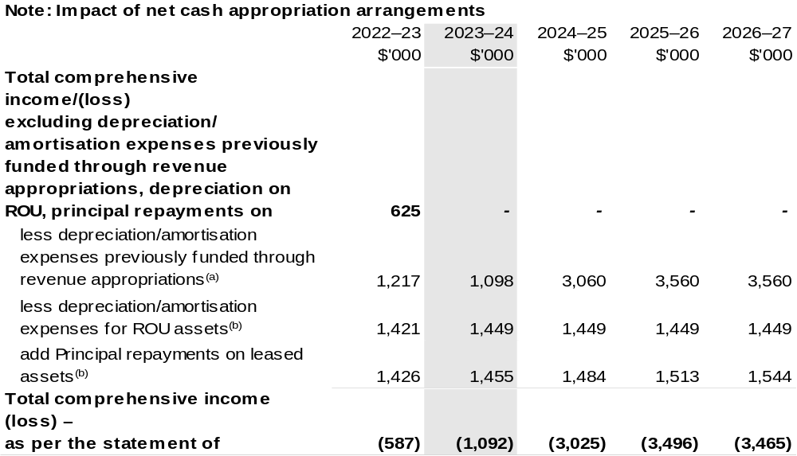

(a) From 2010–11, the Government introduced net cash appropriation arrangements where Appropriation
Bill (No. 1) revenue appropriations for the depreciation/amortisation expenses of non-corporate Commonwealth entities (and select corporate Commonwealth entities) were replaced with a separate capital budget (the Departmental Capital Budget, or DCB) provided through Appropriation Bill (No. 1) equity appropriations. For information regarding DCBs, please refer to Table 3.5 Departmental Capital Budget Statement.
- Applies to leases under Australian Account Standards Board (AASB) 16 Leases. Right of Use (ROU).

Table has been prepared inclusive of 2022–23 Additional Estimates figures.

Prepared on Australian Accounting Standards basis.

Table 3.2: Budgeted departmental balance sheet (as at 30 June)
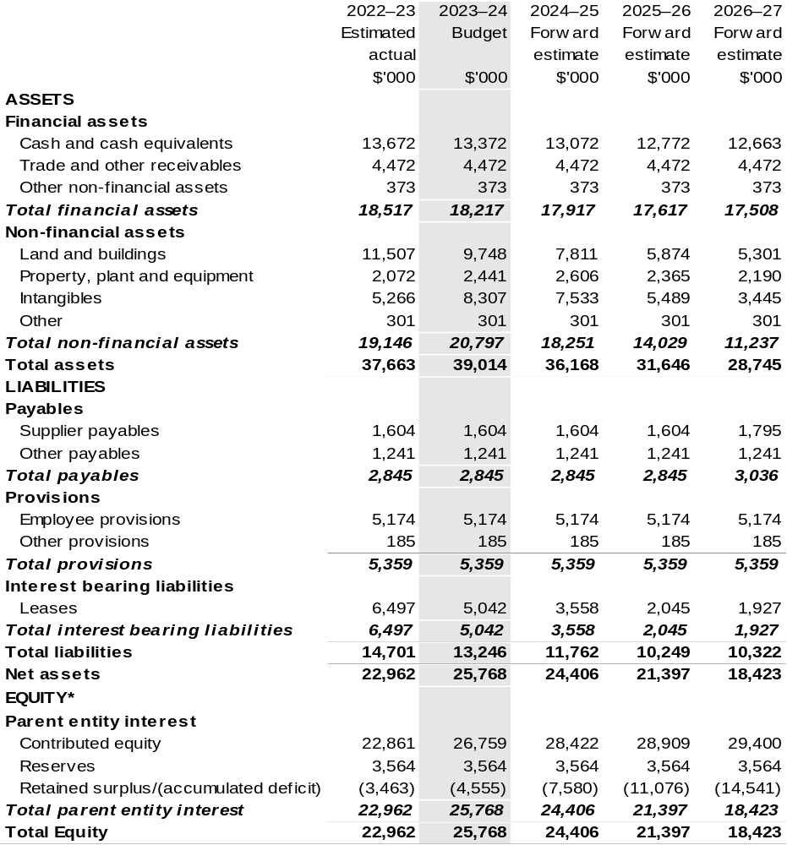

*’Equity’ is the residual interest in assets after deduction of liabilities.

Table has been prepared inclusive of 2022–23 Additional Estimates figures.

Prepared on Australian Accounting Standards basis.

Table 3.3: Departmental statement of changes in equity — summary of movement (Budget year 2023–24)
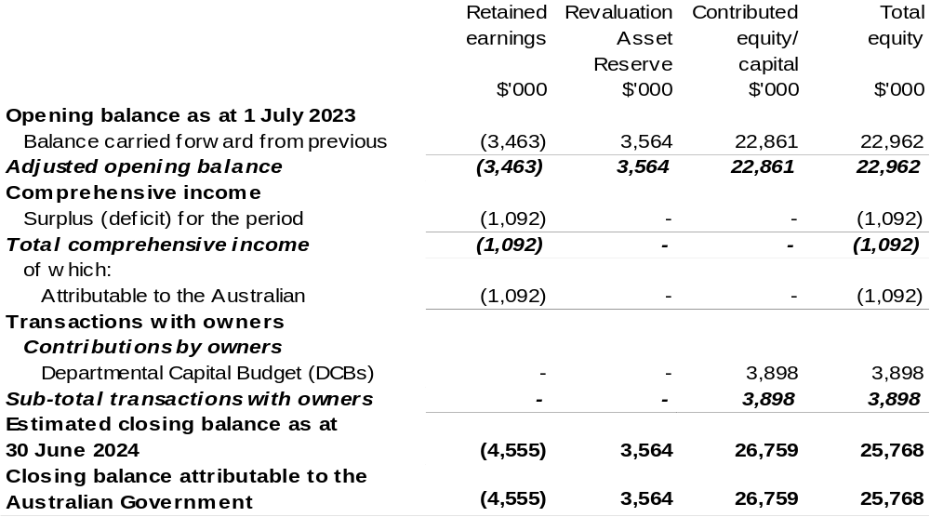

Table has been prepared inclusive of 2022–23 Additional Estimates figures.

Prepared on Australian Accounting Standards basis.

Table 3.4: Budgeted departmental statement of cash flows (for the period
ended 30 June)
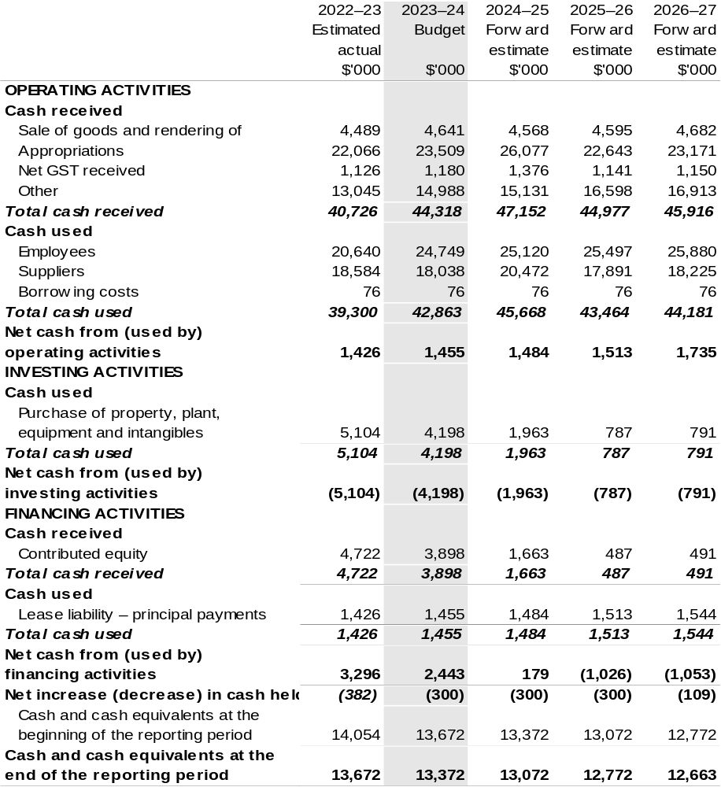

Prepared on Australian Accounting Standards basis.

Table 3.5: Departmental capital budget statement (for the period ended 30 June)
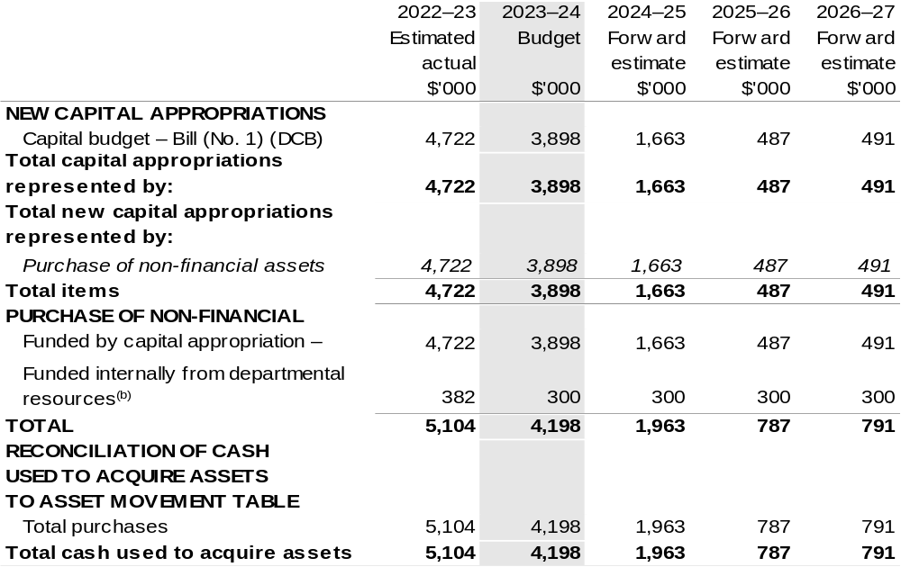

(a) Does not include annual finance lease costs. Include purchases from current and previous years Departmental Capital Budgets (DCBs).
(b) Includes the following s74 external revenue:
– current Bill (No. 1) and prior year Act/Bill (No. 1/3/5) appropriations (excluding amounts from the DCBs);
– sponsorship, subsidy, gifts or similar contribution;
– internally developed assets;
– proceeds from the sale of assets; and
– the AFMA Special Account under s 94B of the Fisheries Administration Act 1991.

Consistent with information contained in the Statement of Asset Movements and the Budgeted Statement of Cash Flows.

Prepared on Australian Accounting Standards basis.`

Table 3.6: Statement of departmental asset movements (Budget year 2023–24)
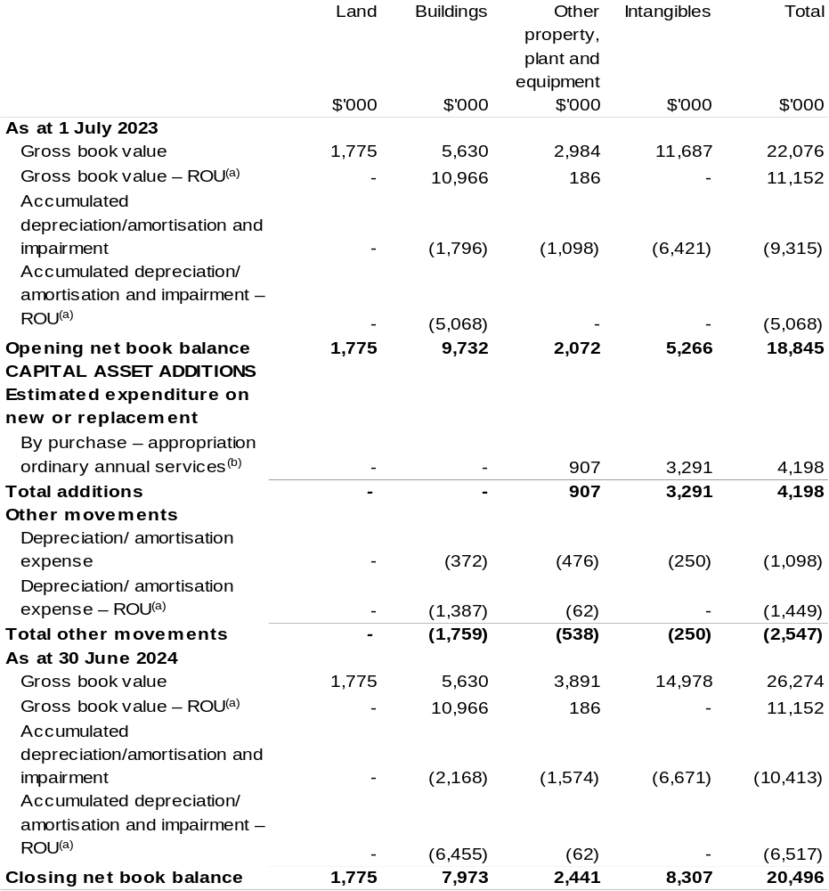

(a) Applies to leases under AASB 16 Leases. Right of Use (ROU).
(b) 'Appropriation ordinary annual services' refers to funding provided through Appropriation Bill (No.1)
2023–24 for Departmental Capital Budget or other operational expenses.

Prepared on Australian Accounting Standards basis.

Table 3.7: Schedule of budgeted income and expenses administered on behalf of Government (for the period ended 30 June)
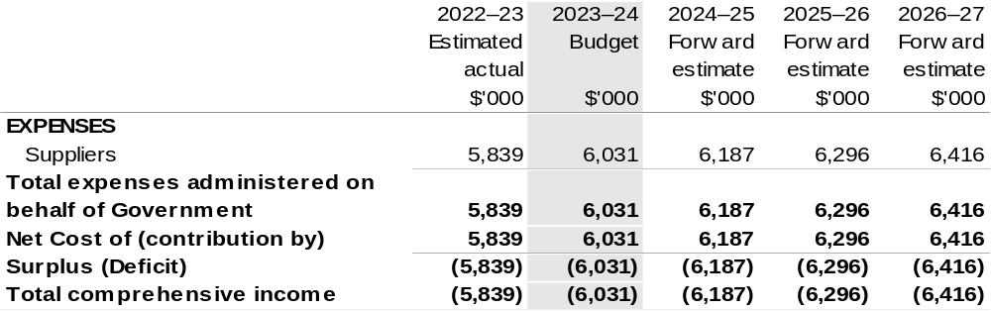

Prepared on Australian Accounting Standards basis.

Table 3.8: Schedule of budgeted assets and liabilities administered on behalf of Government (as at 30 June)
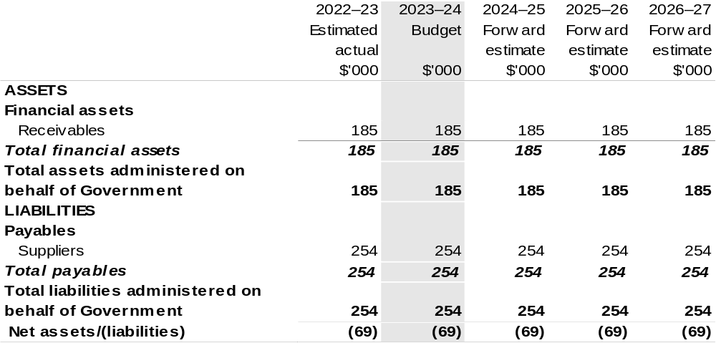

Prepared on Australian Accounting Standards basis.

Table 3.9: Schedule of budgeted administered cash flows (for the period ended

30 June)
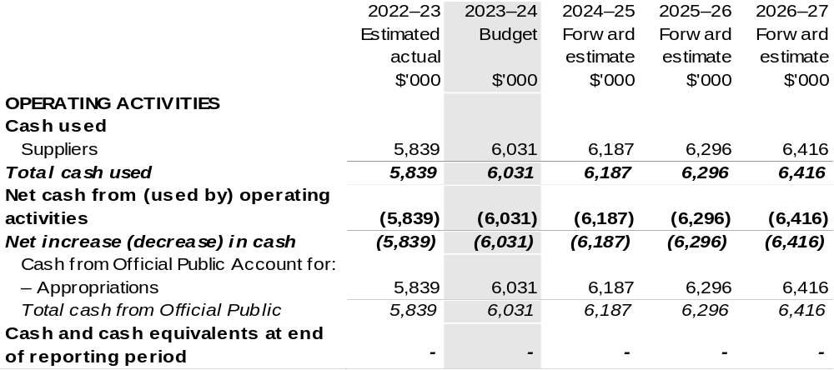

Prepared on Australian Accounting Standards basis.

Table 3.10: Statement of administered asset movements (Budget year 2023–24)

The schedule of administered asset movements on behalf of Government is nil.

Australian Pesticides and Veterinary Medicines Authority
Section 1: Entity overview and resources 125
1.1 Strategic direction statement 125
1.2 Entity resource statement 127
1.3 Budget measures 129
Section 2: Outcomes and planned performance 130
2.1 Budgeted expenses and performance for Outcome 1 131
Section 3: Budgeted financial statements 136
3.1 Budgeted financial statements 136
3.2 Budgeted financial statements tables 137

Australian Pesticides and Veterinary Medicines Authority

Section 1: Entity overview and resources

1.1 Strategic direction statement
The Australian Pesticides and Veterinary Medicines Authority (APVMA) is established under the Agricultural and Veterinary Chemicals (Administration) Act 1992 (Administration Act). The APVMA’s principal responsibilities are described in the Administration Act and the Agricultural and Veterinary Chemicals Code Act 1994. We support the delivery and management of the National Registration Scheme (NRS) through the responsible regulation and control of agricultural and veterinary (agvet) chemicals up to and including the point of retail sale.
Partnerships are crucial to achieving our objectives, meeting our responsibilities as part of the NRS and supporting growth in the Australian agricultural sector and trade.
We are actively engaging with stakeholders in domestic and international forums on matters of agvet regulation, strengthening our relationships with regulatory partners through Memorandums of Understanding and global joint reviews, and harmonising requirements, guidance, and approaches to better align with international counterparts, as appropriate in the Australian context.
The APVMA is deeply committed to building a safe, diverse, inclusive, and high-performing culture united by the Australian Public Service Values and our purpose and values. Through the delivery of our People Strategy 2022–25 we will build a positive culture of respect, inclusiveness, and accountability and strengthen the agility of our organisation to respond to emerging risks and opportunities. We will continue to deliver contemporary training and development solutions to support our people to attain the skills and capabilities required to achieve our purpose, objectives, priorities, and values.
Technology continues to advance at an increasingly rapid pace. Innovations in precision agriculture and smart farming continue to provide farmers with more effective and efficient ways of managing their farms and new approach methodologies are reducing our reliance on vertebrate animal testing and improving the reliability of data.
Safer, more effective veterinary vaccines are being produced using messenger ribonucleic acid (mRNA) technology. The APVMA will need to respond quickly, technically and within our legislative mandate, to this evolving landscape.

Our ability to make scientifically robust and timely regulatory decisions is dependent on our highly capable staff as well as the regulatory platform, tools and systems that enable us to provide them. These systems must be designed to support and enhance the user, enabling them to engage more effectively with information and services today, and into the future.
The ongoing and effective management of our information and communications technology (ICT) infrastructure and services through a fit-for-purpose managed services arrangement is the backbone of our forward operations. Working in partnership with our stakeholders, the APVMA is implementing significant reform to ensure the reliability and sustainability of our ICT services.

1.2 Entity resource statement
Table 1.1 shows the total funding from all sources available to the entity for its operations and to deliver programs and services on behalf of the Government.
The table summarises how resources will be applied by outcome (Government strategic policy objectives) and by administered (on behalf of the Government or the public) and departmental (for the entity’s operations) classification.
For more detailed information on special accounts and special appropriations, please refer to Budget Paper No. 4: Agency Resourcing.
Information in this table is presented on a resourcing (that is, appropriations/cash available) basis, whilst the ‘Budgeted expenses by Outcome’ tables in Section 2 and the financial statements in Section 3 are presented on an accrual basis.

Table 1.1: Australian Pesticides and Veterinary Medicines Authority – Resource Statement – Budget Estimates for 2023–24 as at May Budget 2023
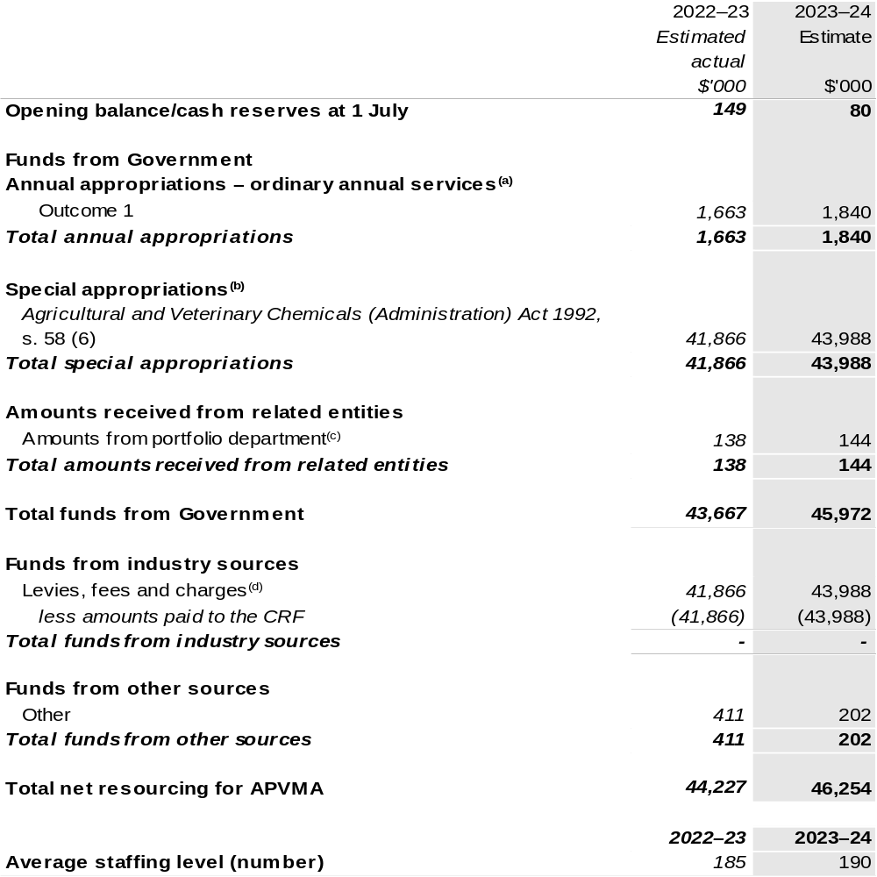

(a) Appropriation Bill (No. 1) 2023–24. Appropriation is provided through the Department of Agriculture, Fisheries and Forestry (DAFF) and is specified within the Annual Appropriation Bills as a payment to APVMA and is considered departmental for all purposes.
(b) APVMA’s special appropriation is not directly appropriated as it is a corporate Commonwealth entity (CCE) under the Public Governance, Performance and Accountability Act 2013 (PGPA Act). Appropriations are made to DAFF and are then paid to APVMA and are considered departmental for all purposes.
(c) Funding provided by the portfolio department that is not specified within the Annual Appropriation Bills as a payment to that CCE (for example, a grant awarded to a CCE from one of its portfolio department's administered programs).
(d) These charges are imposed by the Agricultural and Veterinary Chemicals Code Act 1994 and the Agricultural and Veterinary Chemical Products (Collection of Levy) Act 1994. They are collected by APVMA and transferred to the Consolidated Revenue Fund (CRF). These amounts are then drawn down by the department as a special appropriation under the Administration Act.

Please note: All figures shown above are GST exclusive – these may not match figures in the cash flow
statement.
Prepared on a resourcing (i.e., appropriations available) basis.

1.3 Budget measures
Budget measures in Part 1 relating to the Australian Pesticides and Veterinary Medicines Authority are detailed in Budget Paper No. 2 and are summarised below.

Table 1.2: Australian Pesticides and Veterinary Medicines Authority – 2023–24 Budget Measures

Part 1: Measures announced since the 2022–23 October Budget

Australian Pesticides and Veterinary Medicines Authority does not have any 2023–24 Budget measures.

Section 2: Outcomes and planned performance
Government outcomes are the intended results, impacts or consequences of actions by the Government on the Australian community. Commonwealth programs are the primary vehicle by which government entities achieve the intended results of their outcome statements. Entities are required to identify the programs which contribute to Government outcomes over the Budget and forward years.
Each outcome is described below together with its related programs. The following provides detailed information on expenses for each outcome and program, further broken down by funding source.
Note:
Performance reporting requirements in the Portfolio Budget Statements are part of the Commonwealth performance framework established by the Public Governance, Performance and Accountability Act 2013. It is anticipated that the performance criteria described in Portfolio Budget Statements will be read with broader information provided in an entity’s corporate plans and annual performance statements – included in Annual Reports – to provide a complete picture of an entity’s planned and actual performance.
APVMA’s most recent corporate plan can be found at: https://www.transparency.gov.au/sites/default/files/reports/2022-23_australian_pesticides_and_veterinary_medicines_authority_corporate_plan.pdfhttp://www.agriculture.gov.au/about/reporting/corporate-plan.
APVMA’s most recent annual performance statement can be found at:
https://www.transparency.gov.au/annual-reports/australian-pesticides-and-veterinary-medicines-authority/reporting-year/2021-22 in chapter 3.

2.1 Budgeted expenses and performance for Outcome 1
Outcome 1: Protection of the health and safety of people, animals, the environment, and agricultural and livestock industries through regulation of pesticides and veterinary medicines.

2.1.1: Linked programs
Department of Agriculture, Fisheries and Forestry
Program 1.10: Agricultural Resources
Contribution to Outcome 1 made by linked programs:
APVMA and DAFF work together to ensure the protection of the health and safety of humans, animals, and the environment.

2.1.2: Budgeted expenses for Outcome 1
This table shows how much the entity intends to spend (on an accrual basis) on achieving the outcome, broken down by program, as well as by administered and departmental funding sources.

Table 2.1: Budgeted expenses for Outcome 1
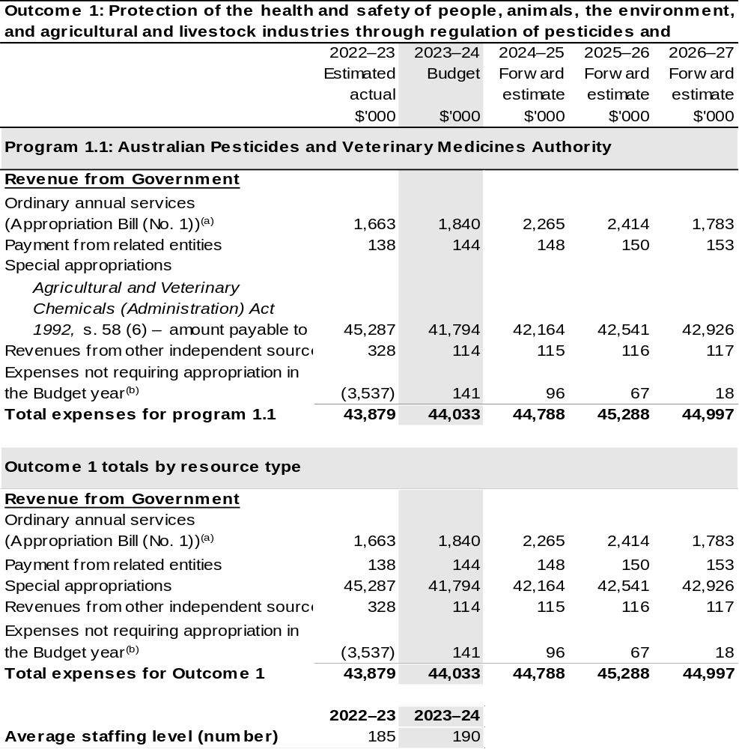

(a) Appropriation Bill (No. 1) 2023–24. APVMA is CCE under the PGPA Act and does not receive direct appropriations. Appropriation is provided through DAFF and is specified with the Annual Appropriation Bills as payment to APVMA and is considered departmental for all purposes.
(b) ‘Expenses not requiring appropriation in the budget year’ are made up of make good expenses, audit fees, and can include depreciation / amortisation expenses not requiring an appropriation.

Note: Departmental appropriation splits and totals are indicative estimates and may change in the course of the budget year as government priorities change.

Prepared on Australian Accounting Standards basis.

Table 2.2: Performance measure for Outcome 1
Table 2.2 details the performance measures for each program associated with Outcome 1. It also provides the related key activities as expressed in the current corporate plan where further detail is provided about the delivery of the activities related to the program, the context in which these activities are delivered and how the performance of these activities will be measured. Where relevant, the 2023–24 Budget measures that have created new programs or materially changed existing programs are provided.
Outcome 1: Protection of the health and safety of people, animals, the environment, and agricultural and livestock industries through regulation of pesticides and veterinary medicines.
Program 1.1: Australian Pesticides and Veterinary Medicines Authority
Objective | APVMA regulates agricultural and veterinary chemicals to manage the risks of pests and diseases for the Australian community and to protect Australia’s trade and the health and safety of people, animals, and the environment.
Key Activities | Achievement of the APVMA objective is achieved through our six strategic objectives, each supported by a range of key activities.  - Trusted Regulator  - Risk-based assessment and registration of pesticides and veterinary chemicals  - Identification and review of the safety of existing chemicals of regulatory concern  - Quality audits of application decisions and decision-making process  - Implementation of the APVMA Stakeholder Engagement Framework  - Engagement with domestic partners on agvet biosecurity matters.  - Respected partner, nationally and internationally  - Active engagement in domestic and international forums on matters of agvet regulation  - Strengthen our relationship with domestic and international regulatory partners through memorandum of understanding, trilateral reviews, and joint activities.  - Harmonise requirements, guidance, and approach to better align with international counterparts, as appropriate in the Australian context.

Table 2.2: Performance measure for Outcome 1 (continued)
Key Activities (continued) | - Contemporary regulatory system  - Implementation of measures outlined in the Improvements Act  - Ongoing implementation of key improvement projects such as Tailored Guidance, Permit to Label, and Agvet Labelling Code  - Actively participate in method and technique development for agvet chemical risk assessment  - Engage with, and contribute to, the development of contemporary policies for agvet chemical regulation.  - Superior ‘over the horizon’ capability  - Engagement with domestic and international partners on emerging technology and advances on agvet chemical formulations and delivery systems (e.g. ribonucleic acid (RNA) interference)  - Active engagement in discussions on emerging issues, e.g. exotic pest incursions, climate and population pressures, mRNA, mono-clonal vaccines etc.  - Improve Information Technology infrastructure and systems to support a modern regulatory environment.  - Operational excellence  - Maintain pragmatic science-based risk assessment along with risk-mitigation approaches  - Ongoing implementation of the Quality Management Framework  - Maintain a robust peer-review and application approval process.  - Attracting, developing and retaining the best people  - Implementation of the APVMA People Strategy 2022–2025  - Implementation of the APVMA Culture Pulse Check Roadmap 2023–2025.
Year | Performance measures | Expected Performance Results
Current year  2022–23 | Percentage of applications finalised within statutory timeframes. | 97 per cent.
Year | Performance measures | Planned Performance Results
Budget Year  2023–24 | Proportion of applications finalised within legislative timeframes. | 90 per cent.
Budget Year  2023–24 | Proportion of applications that pass quality audits under the Quality Management Framework. | 95 per cent.

Table 2.2: Performance measure for Outcome 1 (continued)
Year | Performance measures | Planned Performance Results
Budget Year  2023–24 (continued) | Proportion of stakeholders that report they are satisfied with the quality of engagements with the APVMA. | 70 per cent.
Budget Year  2023–24 (continued) | Proportion of committed reform projects implemented within the required timeframes. | 80 per cent.
Forward Estimates  2024–27 | Performance measures | Planned Performance Results
Forward Estimates  2024–27 | Performance measures | 2024–25 | 2025–26 | 2026–27
Forward Estimates  2024–27 | Proportion of applications finalised within legislative timeframes. | 90 per cent.
Forward Estimates  2024–27 | Proportion of applications that pass quality audits under the Quality Management Framework. | 95 per cent.
Forward Estimates  2024–27 | Proportion of stakeholders that report they are satisfied with the quality of engagements with the APVMA. | 70 per cent. | 75 per cent. | 75 per cent.
Forward Estimates  2024–27 | Proportion of committed reform projects implemented within the required timeframes. | 80 per cent.

Section 3: Budgeted financial statements
Section 3 presents budgeted financial statements which provide a comprehensive snapshot of entity finances for the 2023–24 budget year, including the impact of budget measures and resourcing on financial statements.

3.1 Budgeted financial statements

3.1.1: Differences between entity resourcing and financial statements
The resourcing statement is prepared on a cash basis. The financial statements are prepared on an accrual basis. Differences between the resourcing and financial statements represent timing differences between revenue recognition and cash received.

3.1.2: Explanatory notes and analysis of budgeted financial statements
Revenue forecasts for the 2022–23 financial year have been revised following sales declarations lodged by industry during the year. This has seen an increase to APVMA’s revenue over the original estimate, which is now shown in the following financial tables.

3.2 Budgeted financial statements tables

Table 3.1: Comprehensive income statement (showing net cost of services)
(for the period ended 30 June)
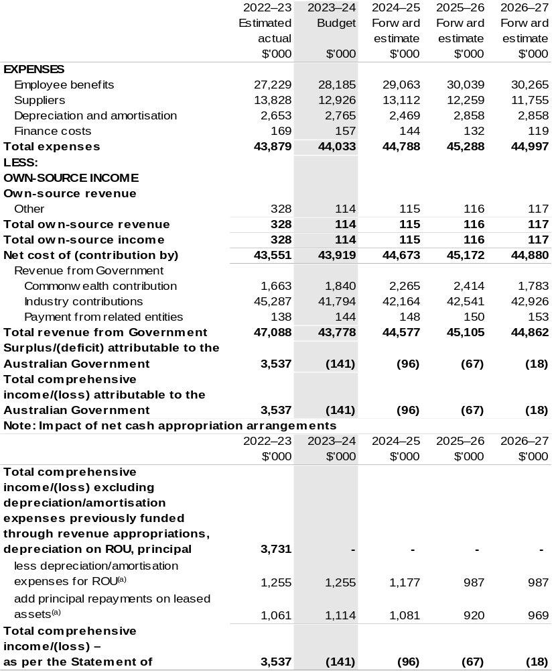

(a) Applies to leases under Australian Account Standards Board (AASB) 16 Leases. Right of Use (ROU).

Prepared on Australian Accounting Standards basis.

Table 3.2: Budgeted departmental balance sheet (as at 30 June)
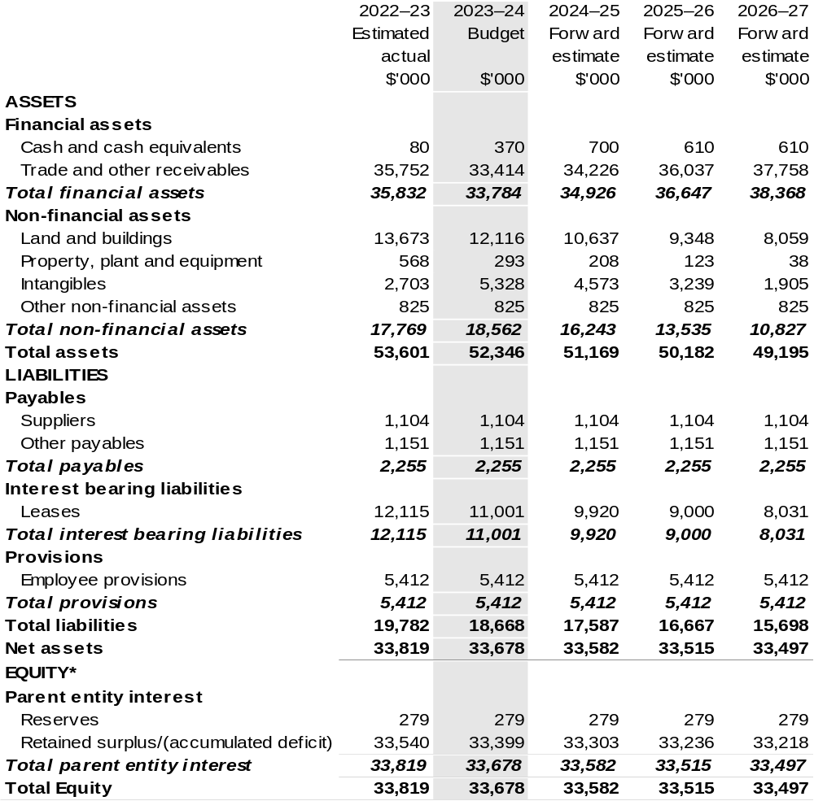

*’Equity’ is the residual interest in assets after deduction of liabilities.

Prepared on Australian Accounting Standards basis.

Table 3.3: Departmental statement of changes in equity — summary of movement (Budget year 2023–24)
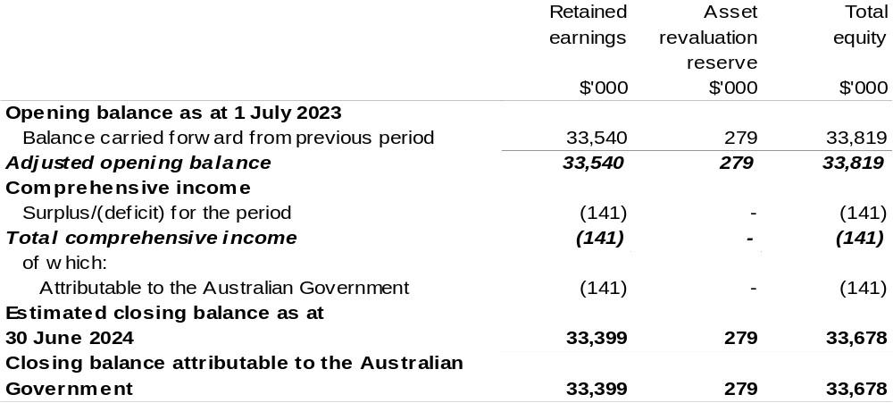

Prepared on Australian Accounting Standards basis.

Table 3.4: Budgeted departmental statement of cash flows (for the period
ended 30 June)
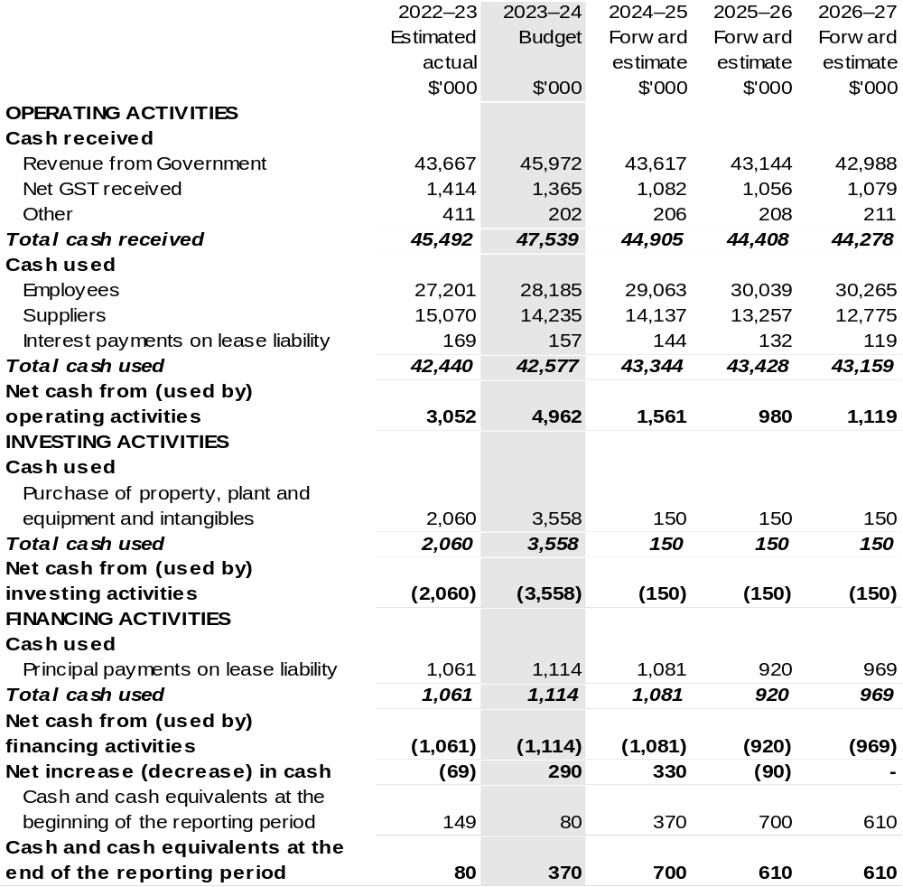

Prepared on Australian Accounting Standards basis.

Table 3.5: Departmental capital budget statement (for the period ended 30 June)
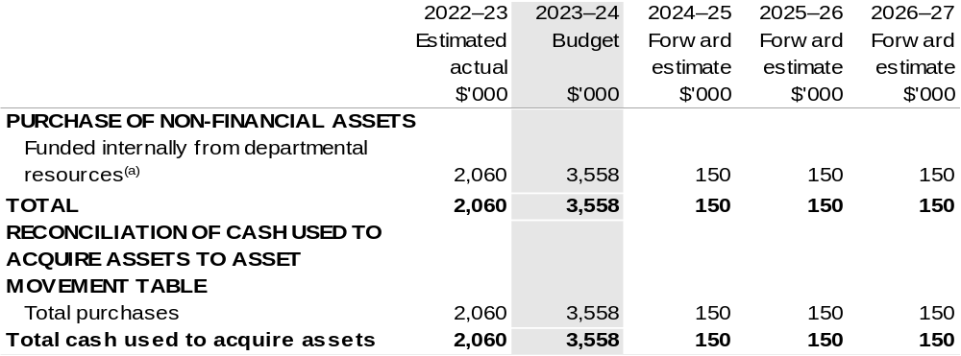

(a) Includes the following s74 external revenue:
– internally developed assets;
– proceeds from the sale of assets.

Consistent with information contained in the Statement of Asset Movements and the Budgeted Statement of Cash Flows.

Prepared on Australian Accounting Standards basis.

Table 3.6: Statement of departmental asset movements (Budget year 2023–24)
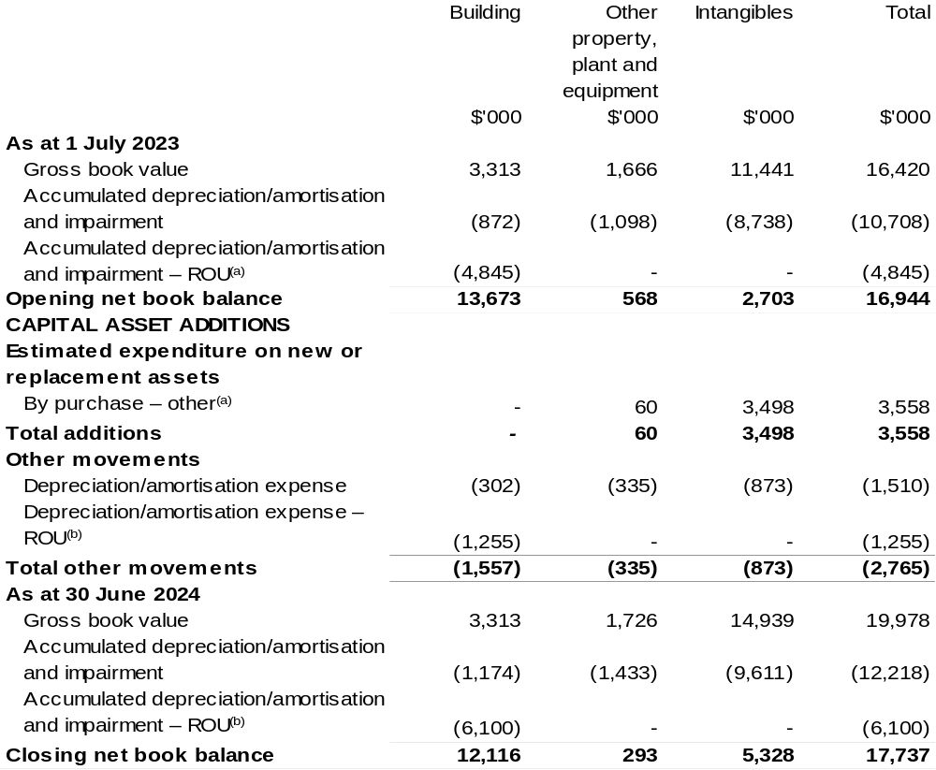

(a) Applies to leases under AASB 16 Leases. Right of Use (ROU).
(b) 'By purchase – other' refers to funding provided through other internal funding sources.

Prepared on Australian Accounting Standards basis.
Cotton Research and Development Corporation
Section 1: Entity overview and resources 145
1.1 Strategic direction statement 145
1.2 Entity resource statement 147
1.3 Budget measures 149
Section 2: Outcomes and planned performance 150
2.1 Budgeted expenses and performance for Outcome 1 151
Section 3: Budgeted financial statements 158
3.1 Budgeted financial statements 158
3.2 Budgeted financial statements tables 160

Cotton Research and Development Corporation

Section 1: Entity overview and resources

1.1 Strategic direction statement
The Cotton Research and Development Corporation (CRDC) delivers outcomes in cotton research, development and extension (RD&E) on behalf of Australia’s cotton growers and the Australian Government. Established in October 1990 and operating under the Primary Industries Research and Development Act 1989 (PIRD Act), CRDC exists to grow the sustainable future of cotton through innovation with impact.
CRDC delivers world-class RD&E outcomes through thought leadership, innovation, adoption, collaboration, and partnerships. Cotton growers are at the heart of CRDC’s activity: they determine CRDC’s RD&E priorities and co-fund the resulting research through a grower levy, matched by Commonwealth contributions. CRDC is based in Narrabri, NSW: the heart of one of Australia's major cotton growing regions and home to the Australian Cotton Research Institute.
Cotton is a major contributor to the nation's economic, environmental, and social fabric. According to the Australian Bureau of Agricultural and Resource Economics and Sciences (ABARES), the value of exported cotton is expected to be close to
$7 billion from 2022–23, making cotton the third-ranking agricultural export commodity.
Australia's cotton is among the best and most sustainable in the world, thanks in part to the RD&E that underpins it. Compared to 1992, Australian cotton growers use 97 per cent less pesticides, 52 per cent less water, and 34 per cent less land to grow a bale of cotton.
Cotton employs more than 12,000 people across 150 rural and regional communities, many of which rely heavily on cotton for their economic prosperity and viability.
Each year, Australia grows enough of this high-quality natural fibre to clothe 500 million people.
Innovative and adaptive growers, supported by RD&E and world-leading researchers, have driven Australian cotton's success. CRDC’s role is to continue driving this success through RD&E.
CRDC’s investments are governed by a five-year strategic plan, with 2022–23 being the fifth year under CRDC’s 2018–23 Strategic Plan.
CRDC’s new Strategic RD&E Plan 2023–28: Clever Cotton commences in the 2023–24 year. Clever Cotton sets out CRDC’s vision for a sophisticated, prosperous and sustainable Australian cotton industry that is strongly connected to its value chain.
The strategic RD&E investments that CRDC will make in 2023–24 under Clever Cotton will help the industry increase its productivity and profitability; sustainably address the impacts of climate change and improve decision making using data and digital technologies. CRDC’s goal is to add an additional $1 billion in economic value to the Australian cotton industry over the next five to ten years.
Clever Cotton contains three pillars of investment – Paddock, People, Planet – aligned with the Australian Cotton Industry’s Sustainability Framework. Each of these pillars contains three themes, creating nine key investment areas:
- Paddock: Our future fields
- Data-driven decisions
- Adaptive systems
- Connected market.
- People: Central to our success
- Design and innovation
- Leadership and capacity
- Adoption and impact.
- Planet: Our shared future
- Natural capital
- Carbon
- Circular economy.
To help achieve this, Australian cotton growers and the Australian Government will
co-invest $150 million into cotton RD&E during 2023–2028, across these key focus areas.

1.2 Entity resource statement
Table 1.1 shows the total funding from all sources available to the entity for its operations and to deliver programs and services on behalf of the Government.
The table summarises how resources will be applied by outcome (Government strategic policy objectives) and by administered (on behalf of the Government or the public) and departmental (for the entity’s operations) classification.
For more detailed information on special accounts and special appropriations, please refer to Budget Paper No. 4: Agency Resourcing.
Information in this table is presented on a resourcing (that is, appropriations/cash available) basis, whilst the ‘Budgeted expenses by Outcome’ tables in Section 2 and the financial statements in Section 3 are presented on an accrual basis.

Table 1.1: Cotton Research and Development Corporation – Resource Statement – Budget Estimates for 2023–24 as at Budget May 2023
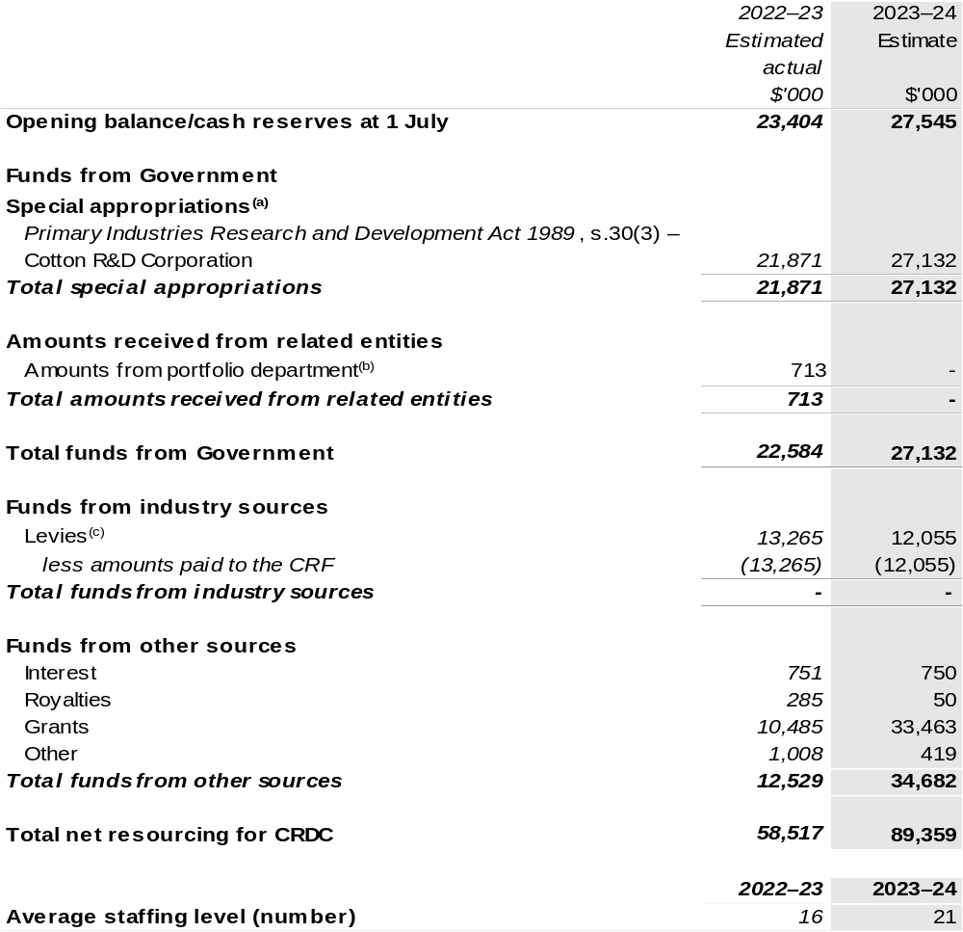
(a) CRDC's special appropriation is not directly appropriated as it is a corporate Commonwealth entity (CCE) under the Public Governance, Performance and Accountability Act 2013 (PGPA Act). Appropriations are made to the Department of Agriculture, Fisheries and Forestry (DAFF) and are then paid to CRDC and are considered departmental for all purposes.
(b) Funding provided by the portfolio department that is not specified within the Annual Appropriation Bills as a payment to that CCE (for example, a grant awarded to a CCE from one of its portfolio department's administered programs).
(c) The levies are imposed by the Primary Industries (Excise) Levies Act 1999. The levies are collected by DAFF under the Primary Industries Levies and Charges Collection Act 1991 and transferred to the Consolidated Revenue Fund (CRF). These amounts are then drawn down by the department as a special appropriation and paid to CRDC under the PIRD Act, s. 30(3) – Cotton Research and Development (R&D) Corporation.

Please note: All figures shown above are GST exclusive – these may not match figures in the cash flow statement.

Prepared on a resourcing (i.e., appropriations available) basis.

1.3 Budget measures
Budget measures in Part 1 relating to the Cotton Research and Development Corporation are detailed in Budget Paper No. 2 and are summarised below.

Table 1.2: Cotton Research and Development Corporation – May 2023–24 Budget Measures

Part 1: Measures announced since the 2022–23 October Budget

CRDC does not have any 2023–24 Budget measures.

Section 2: Outcomes and planned performance
Government outcomes are the intended results, impacts or consequences of actions by the Government on the Australian community. Commonwealth programs are the primary vehicle by which government entities achieve the intended results of their outcome statements. Entities are required to identify the programs which contribute to Government outcomes over the Budget and forward years.
Each outcome is described below together with its related programs. The following provides detailed information on expenses for each outcome and program, further broken down by funding source.
Note:
Performance reporting requirements in the Portfolio Budget Statements are part of the Commonwealth performance framework established by the Public Governance, Performance and Accountability Act 2013. It is anticipated that the performance criteria described in Portfolio Budget Statements will be read with broader information provided in an entity’s corporate plans and annual performance statements – included in Annual Reports – to provide a complete picture of an entity’s planned and actual performance.
The most recent corporate plan for the Cotton Research and Development Corporation can be found at: www.crdc.com.au/publications/crdc-strategic-plan.
The most recent annual performance statement for the Cotton Research and Development Corporation can be found at:
www.crdc.com.au/publications/crdc-annual-report.

2.1 Budgeted expenses and performance for Outcome 1
Outcome 1: Adoption of innovation that leads to increased productivity, competitiveness and environmental sustainability through investment in research and development that benefits the Australian cotton industry and the wider community.

2.1.1: Linked programs
Department of Agriculture, Fisheries and Forestry
Program 1.10: Agricultural Resources
Contribution to Outcome 1 made by linked program:
CRDC works together with DAFF to ensure a sustainable, productive, and profitable cotton industry.

2.1.2: Budgeted expenses for Outcome 1
This table shows how much the entity intends to spend (on an accrual basis) on achieving the outcome, broken down by program, as well as by administered and departmental funding sources.

Table 2.1: Budgeted expenses for Outcome 1
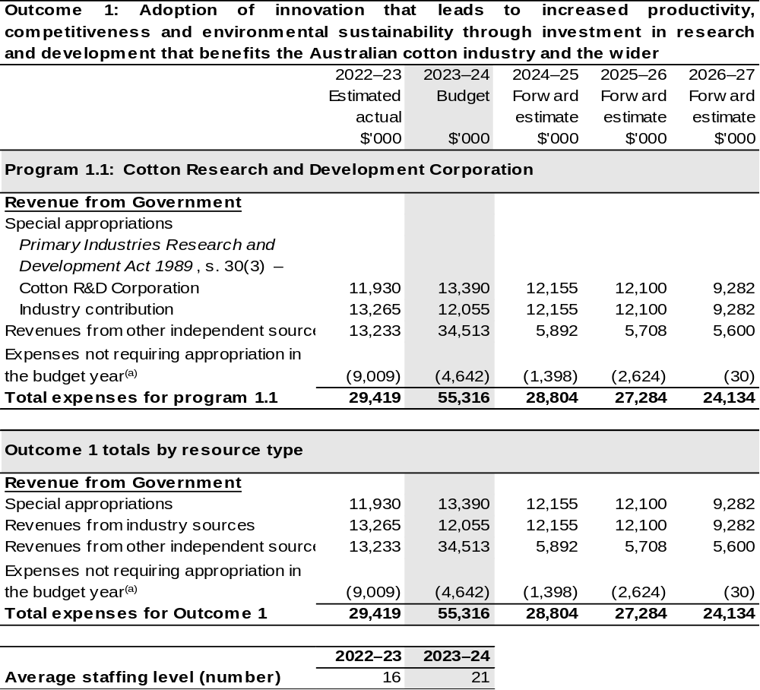
(a) Expenses not requiring appropriation in the budget year are made up of make good expenses, audit fees, and can include depreciation / amortisation expenses not requiring an appropriation.

Note: Departmental appropriation splits and totals are indicative estimates and may change in the course of the budget year as government priorities change.

Prepared on Australian Accounting Standards basis.

Table 2.2: Performance measure for Outcome 1
Table 2.2 details the performance measures for each program associated with Outcome 1. It also provides the related key activities as expressed in the current corporate plan where further detail is provided about the delivery of the activities related to the program, the context in which these activities are delivered and how the performance of these activities will be measured. Where relevant, the 2023–24 Budget measures that have created new programs or materially changed existing programs are provided.
As an entity established under the PIRD Act, CRDC does not produce a Corporate Plan under the PGPA Act and is therefore exempt from the requirement to map purposes to outcomes.
Outcome 1: Adoption of innovation that leads to increased productivity, competitiveness and environmental sustainability through investment in research and development that benefits the Australian cotton industry and the wider community.
Program 1.1: Cotton Research and Development Corporation
Objective 1 | Increase productivity and profitability on cotton farms  Deliver RD&E for cotton producers to increase productivity, successfully protect crops from biotic threats and environmental stresses, adopt transformative technologies and innovate for improved profitability.
Key Activities 1 | Strategically prioritise investment in basic, applied and blue-sky research collaboratively with research and cross-sectoral partners to develop new knowledge, practices and adapt transformative technologies for on-farm application that also protect industry from biotic threats and environmental stresses.
Year | Performance measures | Expected Performance Results
Current year  2022–23 | Improved yield and quality. | Annual increase of 0.35 bales per hectare for irrigated cotton and 0.14 bales per hectare for dryland cotton.  On target for irrigated cotton.  The rolling five-year target for dryland cotton is less than the target due to the influence of drought. However, the 2022–23 yield is expected to be on target.

Continued on following pages
Table 2.2: Performance measure for Outcome 1 (continued)
Objective 2 | Improve cotton farming sustainability and value chain competitiveness  Deliver RD&E and innovation to create higher value uses for cotton and assist the industry achieve its ambition to be the highest yielding, finest, cleanest, and most responsibly produced cotton in the world.
Key Activities 2 | Strategically prioritise investment in basic, applied and blue-sky research collaboratively with research, industry and cross-sectoral partners to develop new knowledge, practices, processes, higher value products and innovative approaches to improve the sustainability of cotton farming and strengthen value chain competitiveness.
Year | Performance measures | Expected Performance Results
Current year  2022–23 | CRDC collaborates in global leadership for sustainability initiatives. | Participates in six global initiatives.  On target.

Objective 3 | Build adaptive capacity of the cotton industry  Deliver RD&E to develop science and innovation capacity as well as new knowledge to strengthen adaptive capacity.
Key Activities 3 | Strategically prioritise investment in RD&E collaboratively with research, industry and cross-sectoral partners to develop new knowledge, future thinking, science and innovation capability.
Year | Performance measures | Expected Performance Results
Current year  2022–23 | Science and innovation capacity is strengthened and strategically fit for a digital future. | Eleven PhD and four Post-doctoral researchers were supported in 2022–23.  On target.

Objective 4 | Strengthening partnerships and adoption  Deliver RD&E and innovation through collaborative partnerships to ensure adoption of best practice, new knowledge, products, and services.
Key Activities 4 | Strategically prioritise investment in the effective adoption of research by strengthening partnerships and collaboration, development of best practice and supporting innovation and commercialisation.
Year | Performance measures | Expected Performance Results
Current year  2022–23 | Partnerships are strengthened to engage multi-disciplinary and multi-institutional resources. | 42 per cent of annual RD&E investments are through cross sectoral partnerships.  On target.

Continued on following pages
Table 2.2: Performance measure for Outcome 1 (continued)
Objective 5 | Driving RD&E impact  Deliver assessments of the impact of CRDC’s RD&E investments that inform future investment direction and continuous improvement.
Key Activities 5 | Strategically prioritise investment in research, data capture, analysis and reviews with stakeholders and partners to demonstrate that RD&E investments deliver impact.
Year | Performance measures | Expected Performance Results
Current year  2022–23 | CRDC monitors and evaluates RD&E impact. | One RD&E impact report per annum.  On target.
The 2023–2028 Strategic Research and Development Plan commences on 1 July 2023. The three objectives for the new plan and the 2023–24 and forward years outcomes are:
Objective 1 | PADDOCK – Our future fields:  Focuses on the on-farm cotton system. Unites data and insights to support thriving cotton farms producing a premium product being demanded by the market.
Key Activities 1 | Data-driven decisions  Improve productivity, profitability and sustainability by accurately monitoring and measuring every field on every cotton farm.
Key Activities 1 | Adaptive systems  Grow the profitability and resilience of Australian cotton farming systems through innovative solutions, technologies and practices.
Key Activities 1 | Connected market intelligence  Enhance the sustainability, market access and diversity, and value of Australian cotton.
Year | Performance measures | Planned Performance Results
Budget Year  2023–24 | The economic value added to the industry over the next five to ten years. By 2028 target for added value is $1 billion. | The rolling five-year gross value of production is increased by $0.2 billion.
Forward Estimates  2024–27 | As per 2023–24. | As per 2023–24.

Continued on following pages

Table 2.2: Performance measure for Outcome 1 (continued)
Year | Performance measures | Planned Performance Results
Objective 2 | PEOPLE – Central to our success:  Ensure that in developing our world-class research capability, we are providing practical RD&E solutions and increasing the reach and impact of adoption.
Key Activities 2 | Design and innovation  Embed collaboration in RD&E prioritisation, design, development and adoption.
Key Activities 2 | Leadership and capacity  Develop people and skills to support industry RD&E.
Key Activities 2 | Adoption and impact  Adopt knowledge and technology through dedicated development and delivery pathways.
Year | Performance measures | Planned Performance Results
Budget Year  2023–24 | The level of satisfaction in CRDC by growers and research partners. | Surveys demonstrate growers and research partners are satisfied with CRDC’s performance.
Forward Estimates  2024–27 | As per 2023–24. | As per 2023–24.

Continued on following page

Table 2.2: Performance measure for Outcome 1 (continued)
Objective 3 | PLANET – Our shared future:  Ensure the cotton industry contributes positively to the environment, meeting community, government and market expectations.
Key Activities 3 | Natural capital  Implement resilient natural capital practices that support productivity, help maintain biodiverse ecosystems, strengthen capacity for adaptation to climate change and progressively improve regional water, land and soil quality.
Key Activities 3 | Carbon  Establish a sustainable low-carbon production system for a changing future.
Key Activities 3 | Circular economy  Develop the circular economy for Australian cotton.
Year | Performance measures | Planned Performance Results
Budget Year  2023–24 | The level of trust the cotton industry has from the community, the market and government about how it manages and reports on its environmental and social impacts. | Surveys demonstrate trust from community, the market and government about cotton’s management and reporting of environmental and social impacts.
Forward Estimates  2024–27 | As per 2023–24. | As per 2023–24.

Section 3: Budgeted financial statements
Section 3 presents budgeted financial statements which provide a comprehensive snapshot of entity finances for the 2023–24 budget year, including the impact of budget measures and resourcing on financial statements.

3.1 Budgeted financial statements

3.1.1: Differences between entity resourcing and financial statements
The resourcing statement is prepared on a cash basis. The financial statements are prepared on an accrual basis. Differences between the resourcing and financial statements represent timing differences between revenue recognition and cash received.

3.1.2: Explanatory notes and analysis of budgeted financial statements
Budgeted Comprehensive Income Statement
Variability in CRDC’s revenue and expenditure is a result of significant fluctuations in the production of Australian cotton each year. Cotton production has been as low as 0.6 million bales in 2008 and 2020, as high as 5.4 million bales in 2012 and is estimated to be 5.5 million bales in 2023–24.
Revenue from industry levies and matching contributions from the Australian Government are determined by the level of cotton production and historically represent more than 75 per cent of total revenue. Since 2008–09 CRDC’s revenue has fluctuated between $7.7 million and $31.4 million per annum.
The impact of a highly variable revenue stream on CRDC’s investment in RD&E is minimised by managing cash reserves. During periods of high revenue CRDC builds up reserves by operating in surplus. During periods of low revenue CRDC draws on reserves by operating under approved deficits. This financial strategy allows CRDC to maintain a more consistent level of RD&E expenditure each year.
Matching contributions from the Australian Government are determined by either the value of industry levies collected or 0.5 per cent of the cotton industry’s three-year average gross value of production. Which limit will apply depends on the price of cotton, timing of the harvest and ginning and the variability of the crop size.
Royalties, interest on investments, external grant revenue and research project refunds make up the balance of the CRDC’s income.

To achieve the strategic priorities of the R&D plan for the period 2018–23, CRDC planned to invest a total of $125.0 million for the five-year R&D plan. The 2019 to 2020 drought reduced cotton production in most of the major cotton growing regions and impacted CRDC’s revenues and ability to invest $125.0 million over the five-year R&D plan. The current forward estimate is for a total investment of $108.8 million.
CRDCs investments during drought have focused on supporting core research activities to support industry needs and building research and innovation skills that will provide the foundation for the future of the cotton industry.
In 2023–24 CRDC has budgeted for a surplus of $4.6 million based on revenues of $59.9 million and RD&E expenditure of $55.3 million.

Budgeted Balance Sheet
Reserves increased between 2010–11 and 2013–14 during years of high cotton production and decreased from 2014–15 to 2021–22 due to below average levels of cotton production. Recent rainfall resulting in inflows to irrigation storages and above average world cotton prices have resulted in production of approximately 5.1 million bales in 2022–23. In 2023–24 CRDC estimates production will be approximately 5.5 million bales and estimated 5.5 million bales in 2024–25, returning to above-average production.
CRDC plans to rebuild reserves while maintaining research expenditure at a consistent level in future years.

3.2 Budgeted financial statements tables

Table 3.1: Comprehensive income statement (showing net cost of services)
(for the period ended 30 June)
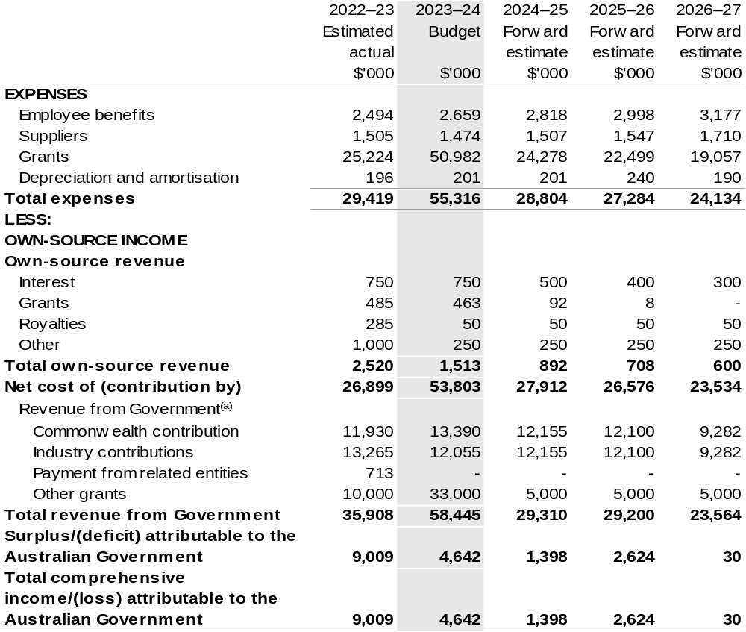
(a) Revenue from Government includes a Commonwealth contribution under the PIRD Act and levies collected from industry by DAFF for R&D activities.

Prepared on Australian Accounting Standards basis.

Table 3.2: Budgeted departmental balance sheet (as at 30 June)
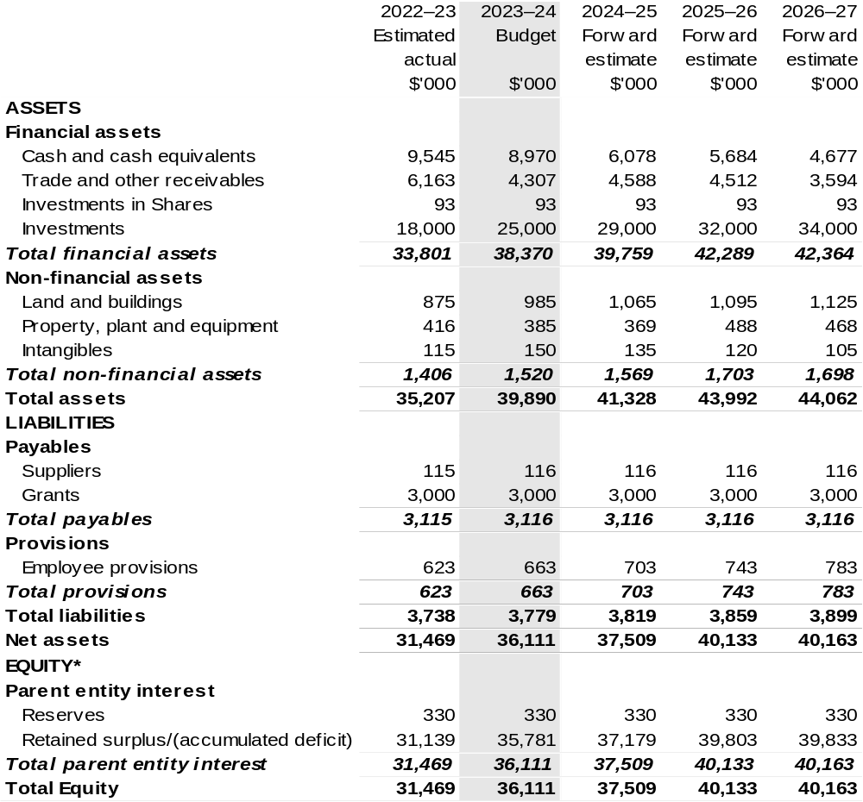
*’Equity’ is the residual interest in assets after deduction of liabilities.

Prepared on Australian Accounting Standards basis.

Table 3.3: Departmental statement of changes in equity – summary of movement (Budget year 2023–24)
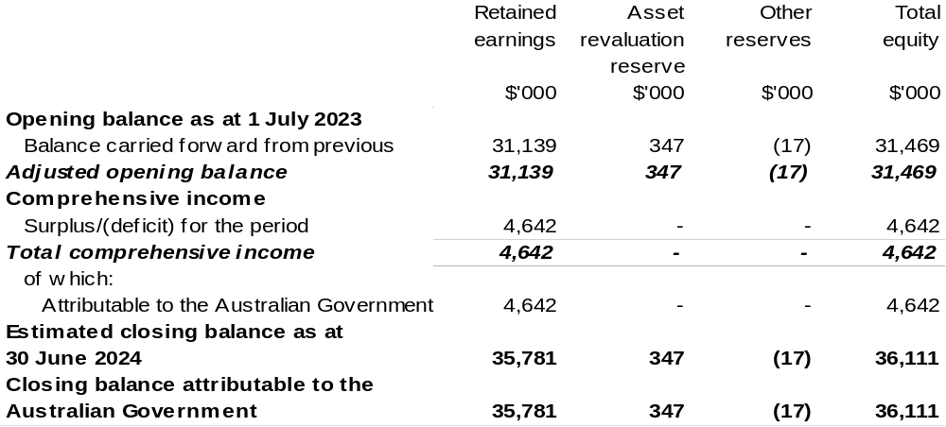
Prepared on Australian Accounting Standards basis.

Table 3.4: Budgeted departmental statement of cash flows (for the period
ended 30 June)
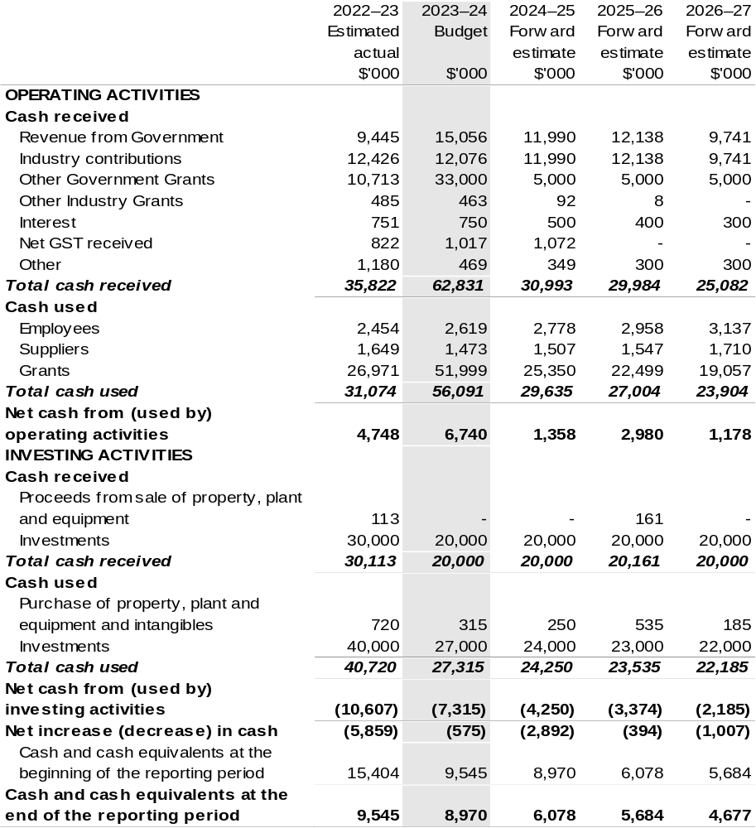
Prepared on Australian Accounting Standards basis.

Table 3.5: Departmental capital budget statement (for period ended 30 June)
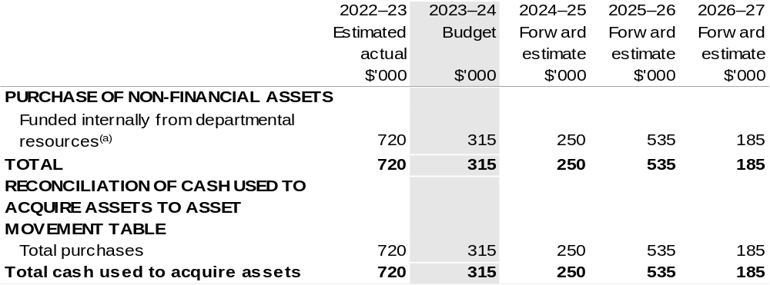
(a) Includes the following s74 external revenue:
– internally developed assets;
– proceeds from the sale of assets.

Consistent with information contained in the Statement of Asset Movements and the Budgeted Statement of Cash Flows.

Prepared on Australian Accounting Standards basis.

Table 3.6: Statement of departmental asset movements (Budget year 2023–24)
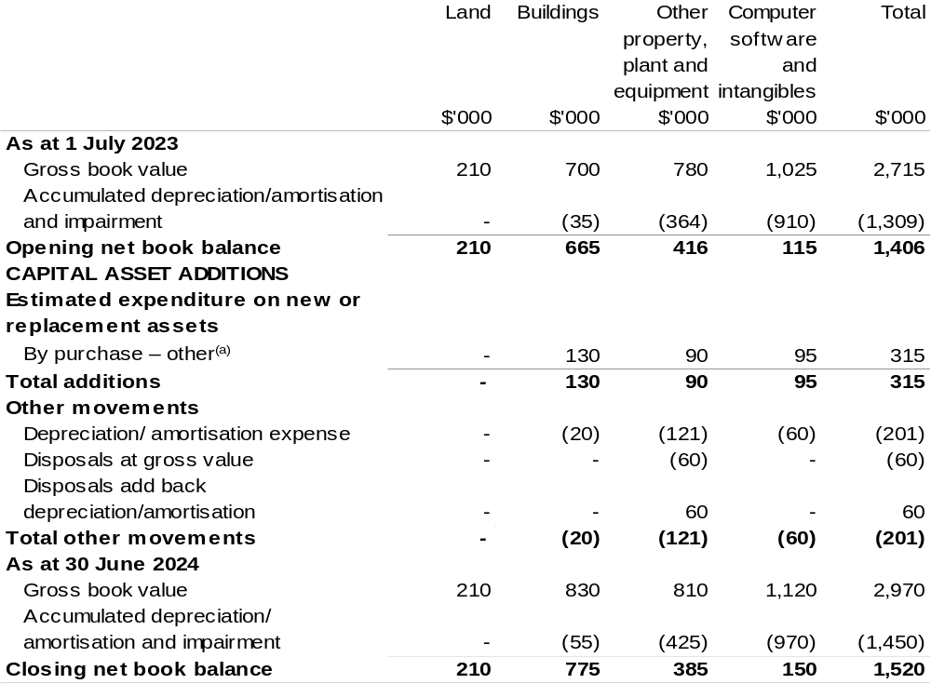
(a) ‘By purchase – other' refers to funding provided through other internal funding sources.

Prepared on Australian Accounting Standards basis.

Fisheries Research and Development Corporation
Section 1: Entity overview and resources 167
1.1 Strategic direction statement 167
1.2 Entity resource statement 169
1.3 Budget measures 171
Section 2: Outcomes and planned performance 172
2.1 Budgeted expenses and performance for Outcome 1 173
Section 3: Budgeted financial statements 178
3.1 Budgeted financial statements 178
3.2 Budgeted financial statements tables 179

Fisheries
Research and Development Corporation

Section 1: Entity overview and resources

1.1 Strategic direction statement
The Fisheries Research and Development Corporation (FRDC) exists to facilitate thought leadership, knowledge creation, collaboration and innovation to shape the future of fishing and aquaculture for the benefit of the Australian people.
We plan, invest in and manage research and development for fishing and aquaculture, and the wider community, and encourage adoption of the resulting knowledge and innovation for impact. We operate under the provisions of the Public Governance, Performance and Accountability Act 2013 (PGPA Act), which applies high standards of accountability while providing for the independence required by the Corporation’s role as a statutory authority.
We have three representative organisations declared under the Primary Industries Research and Development Act 1989 (PIRD Act): Australian Recreational and Sport Fishing Industry Confederation Inc. (trading as Recfish Australia), Commonwealth Fisheries Association Inc. and Seafood Industry Australia. We involve the Indigenous Reference Group and the Australian Recreational Fishing Foundation in all representative organisation activities.
More broadly, we work with a diverse and geographically dispersed collective of stakeholders that share a connection and interest in fishing and aquaculture. This includes Indigenous, commercial wild catch, aquaculture, recreational, and post-harvest sectors, fisheries managers, researchers, non-government organisations and the Australian community.
We invest to help realise a shared vision of creating “fish forever: collaborative, vibrant fishing and aquaculture, creating diverse benefits from aquatic resources and celebrated by the community”. Our investments support the pursuit of five strategic outcomes:
- Growth for enduring prosperity
- Best practices and production systems
- A culture that is inclusive and forward thinking
- Fair and secure access to aquatic resources
- Community trust, respect and value.
Pursuit of these outcomes is accelerated through investment in five enabling strategies:
- Digitisation and advanced analytics
- Strengthening adoption for transformative change
- Promoting innovation and entrepreneurship
- Building capability and capacity
- Providing foundational information and support services.
Our investment policy seeks to balance short-, medium-, and long-term investments, high- and low-risk, and strategic and adaptive Research and Development (R&D) demands. The needs of stakeholders ultimately determine FRDC’s R&D investments, to ensure specific, planned end-user-driven solutions are delivered in response to national, regional and sector-based needs. Partnerships and previous research, development and extension (RD&E) are considered in our planning, investment and extension processes to optimise the use of existing knowledge, maximise leverage and reduce duplication. We also contribute to the broader national strategic approach to fishing and aquaculture RD&E to build cohesion and establish common goals between sectors.
Our activities span environments from the northern tropics to temperate seas, from icy Antarctic waters to freshwater rivers and lakes, and from estuaries to land-based aquaculture around Australia.
We adopt the Commonwealth Government’s input, output, outcome, impact reporting framework, and apply a coordinated approach for monitoring, evaluation and reporting to enable the Corporation to better meet the needs of its stakeholders. Our Statutory Funding Agreement and Guidelines provide useful guidance on these aspects.

1.2 Entity resource statement
Table 1.1 shows the total funding from all sources available to the entity for its operations and to deliver programs and services on behalf of the Government.
The table summarises how resources will be applied by outcome (Government strategic policy objectives) and by administered (on behalf of the Government or the public) and departmental (for the entity’s operations) classification.
For more detailed information on special accounts and special appropriations, please refer to Budget Paper No. 4: Agency Resourcing.
Information in this table is presented on a resourcing (that is, appropriations/cash available) basis, whilst the ‘Budgeted expenses by Outcome’ table in Section 2 and the financial statements in Section 3 are presented on an accrual basis.

Table 1.1: Fisheries Research and Development Corporation –
Resource Statement – Budget Estimates for 2023–24 as at Budget May 2023
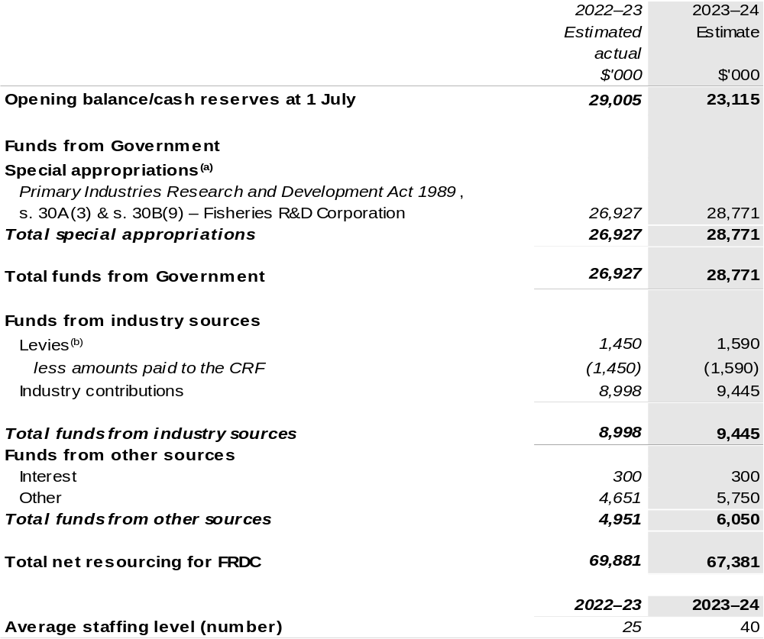
(a) FRDC's special appropriation is not directly appropriated as it is a corporate Commonwealth entity (CCE) under the PGPA Act. Appropriations are made to the Department of Agriculture, Fisheries and Forestry (DAFF) and are then paid to FRDC and are considered departmental for all purposes.
(b) The levies are imposed by the Primary Industries (Excise) Levies Act 1999. The levies are collected by DAFF under the PIRD Act and the Fishing Levy Regulations and are transferred to the Consolidated Revenue Fund (CRF). These amounts are then drawn down by the department as a special appropriation and paid to FRDC under the
PIRD Act, s. 30A (3) and s. 30B (9) – Fisheries R&D Corporation.

Please note: All figures shown above are GST exclusive – these may not match figures in the cash flow statement.

Prepared on a resourcing (i.e., appropriations available) basis.

1.3 Budget measures
Budget measures in Part 1 relating to the Fisheries Research and Development Corporation are detailed in Budget Paper No. 2 and are summarised below.

Table 1.2: Fisheries Research and Development Corporation – May 2023–24 Budget Measures

Part 1: Measures announced since the 2022–23 October Budget

FRDC does not have any May 2023–24 Budget measures.

Section 2: Outcomes and planned performance
Government outcomes are the intended results, impacts or consequences of actions by the Government on the Australian community. Commonwealth programs are the primary vehicle by which government entities achieve the intended results of their outcome statements. Entities are required to identify the programs which contribute to Government outcomes over the Budget and forward years.
Each outcome is described below together with its related programs. The following provides detailed information on expenses for each outcome and program, further broken down by funding source.
Note:
Performance reporting requirements in the Portfolio Budget Statements are part of the Commonwealth performance framework established by the Public Governance, Performance and Accountability Act 2013. It is anticipated that the performance criteria described in Portfolio Budget Statements will be read with broader information provided in an entity’s corporate plans and annual performance statements – included in Annual Reports - to provide a complete picture of an entity’s planned and actual performance.
While the FRDC reports against an annual framework, as an organisation that invests in science, the benefit of those investments endures over a longer time period.
The most recent corporate plans (annual operating plan and research development and extension plan for the Fisheries Research and Development Corporation can be found at:
https://www.frdc.com.au/annual-operational-plans and
https://www.frdc.com.au/strategic-planning-and-priorities.

The most recent annual performance statement for the Fisheries Research and Development Corporation can be found at:
https://www.frdc.com.au/annual-reports.

2.1 Budgeted expenses and performance for Outcome 1
Outcome 1: Increased economic, social and environmental benefits for Australian fishing and aquaculture, and the wider community, by investing in knowledge, innovation, and marketing.

2.1.1: Linked programs
Department of Agriculture, Fisheries and Forestry
Program 1.4: Fishing Industry
Contribution to Outcome 1 made by linked program:
FRDC works together with DAFF to ensure fishing and aquaculture in Australia is sustainable, productive, and profitable.

2.1.2: Budgeted expenses for Outcome 1
This table shows how much the entity intends to spend (on an accrual basis) on achieving the outcome, broken down by program, as well as by administered and departmental funding sources.

Table 2.1: Budgeted expenses for Outcome 1
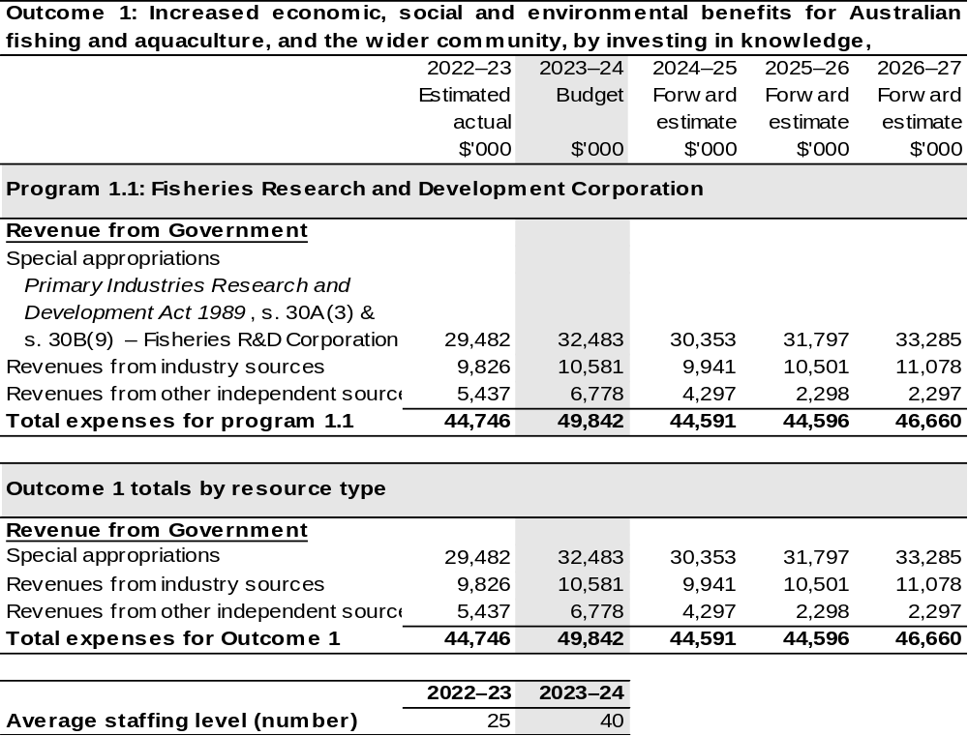
Note: Departmental appropriation splits and totals are indicative estimates and may change in the course
of the budget year as government priorities change.

Prepared on Australian Accounting Standards basis.

Table 2.2: Performance measure for Outcome 1
Table 2.2 details the performance measures for each program associated with Outcome 1. It also provides the related key activities as expressed in the current corporate plan where further detail is provided about the delivery of the activities related to the program, the context in which these activities are delivered and how the performance of these activities will be measured. Where relevant, the 2023–24 Budget measures that have created new programs or materially changed existing programs are provided.
As an entity established under the PIRD Act, FRDC does not produce a corporate plan under the PGPA Act and is therefore exempt from the requirement to map purposes to outcomes.
Outcome 1: Increased economic, social and environmental benefits for Australian fishing and aquaculture, and the wider community, by investing in knowledge, innovation, and marketing.
Program 1.1: Fisheries Research and Development Corporation
Objective | Establish collaborative, vibrant fishing and aquaculture, creating diverse benefits from aquatic resources, and celebrated by the community.
Key Activities | Throughout the 2023–24 financial year, FRDC's investment will support initiatives that help realise a shared vision of what fishing and aquaculture will become in Australia by 2030. This will be achieved by continued investment in pursuit of the five R&D Plan outcomes and five enabling strategies that are designed to assist, accelerate and simplify outcome delivery.  FRDC’s 2023–24 investment approach will seek to appropriately balance our focus on tackling shared national challenges, whilst also helping our partners to respond to today’s more pressing needs. We will invest in research and innovation to support implementation of Aquaplan to enhance biosecurity, develop minimum-viable product for national data exchange and data catalogue, advance technically feasible and scalable alternative fuel and energy solutions for wild harvest fisheries and aquaculture, enhance national reporting of environmental, social, and governance (ESG) metrics throughout fishing and aquaculture, and  co-invest in knowledge and innovation to enable improved ocean management outcomes for fishing and aquaculture.  To incentivise collaboration on these national challenges and promote exploration of diversification opportunities that help build resilience  (such as investigation of alternative aquaculture species or catching technologies), we will offer matching investment opportunities to our industry partners in these areas.  We will also keep working with our fishing and aquaculture partners to overcome current obstacles. Over the coming year we will be implementing a new investment approach in collaboration with our Research Advisory Committees that will prioritise relieving pressing immediate problems for our fisheries and aquaculture stakeholders.

Continued on following pages
Table 2.2: Performance measure for Outcome 1 (continued)
Key Activities | Throughout the course of this Annual Operational Plan (AOP), FRDC will also work to drive R&D adoption by shifting the Corporation's focus from research to development, boosting spending on the latter.  New investment opportunities will provide resources for players across fishing and aquaculture who are interested in conducting trials and/or demonstrating emerging solutions, with matching FRDC investment available for associated capital expenditures.  The FRDC will continue to make our systems, procedures, and services more understandable and responsive to stakeholder needs, and form new, often unexpected alliances to address common issues. The FRDC will continue to evolve how we communicate impactful stories about what works and what doesn't.
Year | Performance measures | Expected Performance Results
Current year  2022–23 | Growth for enduring prosperity.  Enduring and balanced ecological, social, and economic growth for the community benefit. | Achieved.  Projects align with strategic priorities set out in FRDC’s  2023–24 AOP and partner plans.  Projects sampled for cost-benefit analysis show positive average return on investment.
Current year  2022–23 | A culture that is inclusive and forward thinking.  A fishing and aquaculture community that is cooperative, diverse and well equipped to enable growth and adaptability in a complex and uncertain world. | Achieved.  Projects align with strategic priorities set out in FRDC’s  2023–24 AOP and partner plans.
Current year  2022–23 | Fair and secure access to aquatic resources.  Integrated management of Australia’s aquatic resources, providing certainty and confidence.
Current year  2022–23 | Community trust, respect and value.  People feel good about using the products, services and experiences provided by fishing and aquaculture.

Continued on following page

Table 2.2: Performance measure for Outcome 1 (continued)
Year | Performance measures | Planned Performance Results
Budget Year 2023–24 | As per 2022–23. | As per 2022–23.
Forward Estimates  2024–27 | As per 2023–24. | As per 2023–24.

Section 3: Budgeted financial statements
Section 3 presents budgeted financial statements which provide a comprehensive snapshot of entity finances for the 2023–24 budget year, including the impact of budget measures and resourcing on financial statements.

3.1 Budgeted financial statements

3.1.1: Differences between entity resourcing and financial statements
The financial statements are prepared on an accrual basis where revenues and expenses are recognised as and when the resources are received and used. The entity resourcing table recognises the cash resources available to be used during the period and includes amounts recognised as revenue in previous periods.

3.1.2: Explanatory notes and analysis of budgeted financial statements
The FRDC’s RD&E expenditure is dependent on the gross value of production (GVP) of the Australian seafood industry. The indication for the GVP for the Australian seafood industry is positive, with growth expected in 2023–24. This is based primarily on aquaculture, which is anticipated to grow – prawns, barramundi, Atlantic salmon and yellowtail kingfish will be key drivers. Income contributions from the commercial sector are expected to maintain current levels.

3.2 Budgeted financial statements tables

Table 3.1: Comprehensive income statement (showing net cost of services)
(for the period ended 30 June)
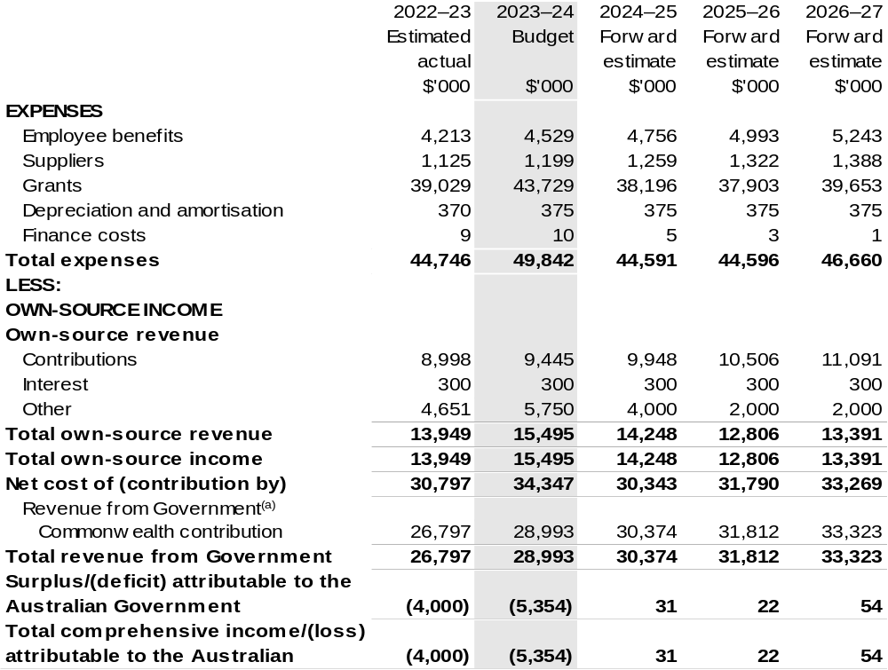
Continued on following page

Table 3.1: Comprehensive income statement (showing net cost of services)
(for the period ended 30 June) (continued)
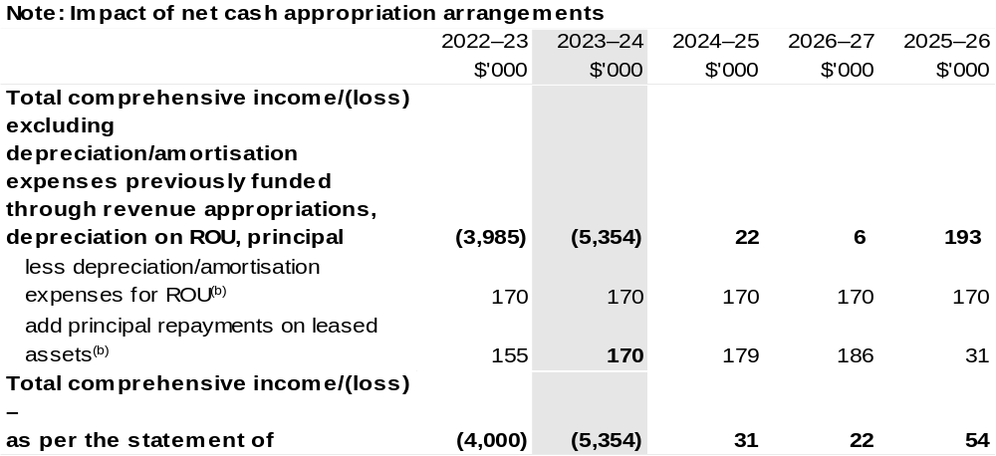
(a) Revenue from Government includes a Commonwealth contribution under the PIRD Act and levies collected from industry by DAFF for R&D activities.
(b) Applies to leases under Australian Account Standards Board (AASB) 16 Leases. Right of Use (ROU).

Prepared on Australian Accounting Standards basis

Table 3.2: Budgeted departmental balance sheet (as at 30 June)
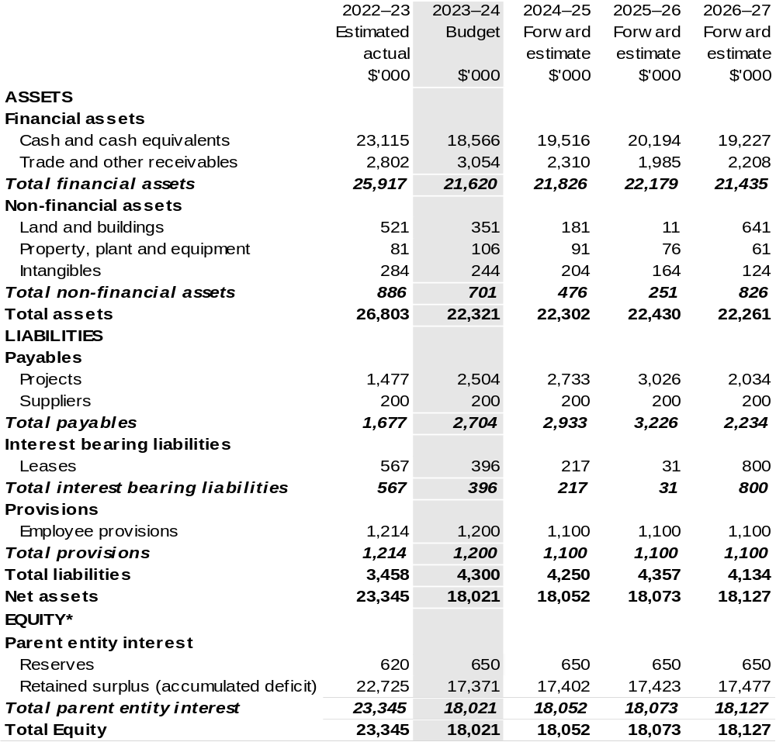
*'Equity' is the residual interest in assets after deduction of liabilities.

Prepared on Australian Accounting Standards basis.

Table 3.3: Departmental statement of changes in equity – summary of movement (Budget year 2023–24)
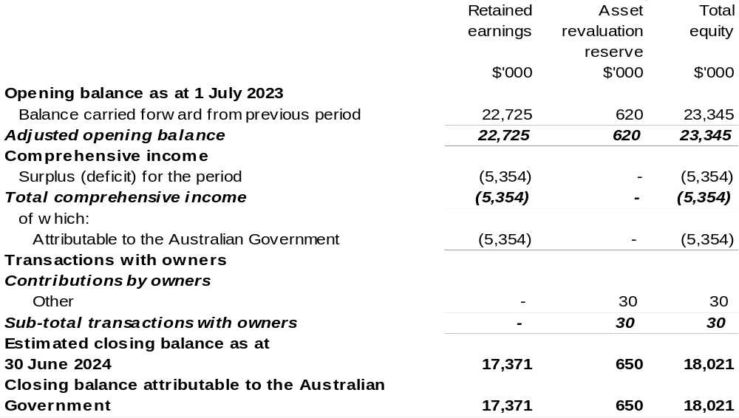

Prepared on Australian Accounting Standards basis.

Table 3.4: Budgeted departmental statement of cash flows (for the period
ended 30 June)
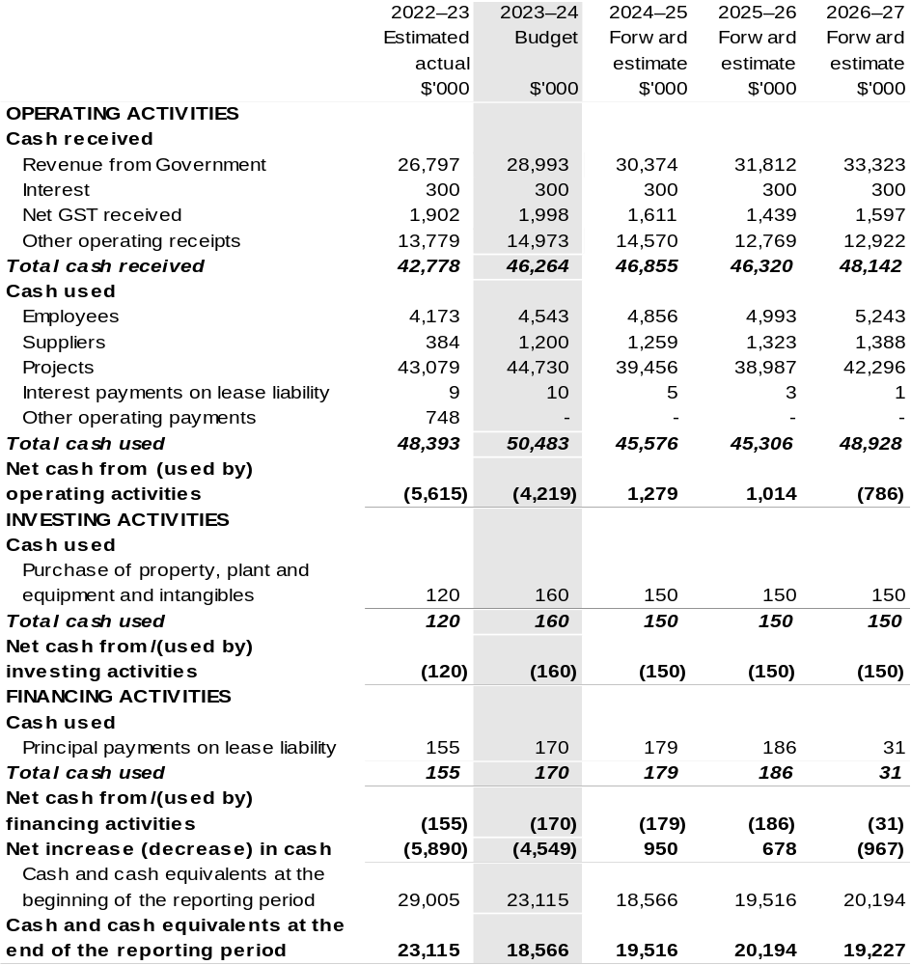

Prepared on Australian Accounting Standards basis.

Table 3.5: Departmental capital budget statement (for the period ended 30 June)
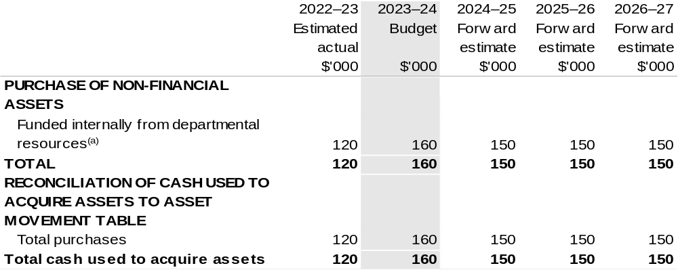

(a) Includes the following s74 external revenue:
– internally developed assets.

Consistent with information contained in the Statement of Asset Movements and the Budgeted Statement of Cash Flows.

Prepared on Australian Accounting Standards basis.

Table 3.6: Statement of departmental asset movements (Budget year 2023–24)
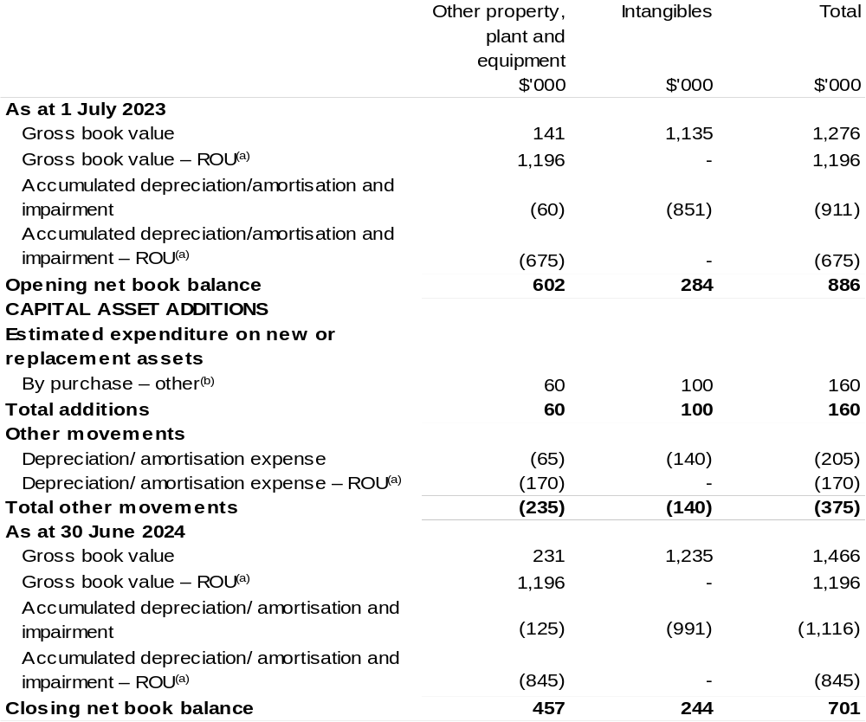
(a) Applies to leases under AASB 16 Leases. Right of Use (ROU).
(b) 'By purchase – other’ refers to funding provided through other internal funding sources.

Prepared on Australian Accounting Standards basis.

Grains Research and Development Corporation
Section 1: Entity overview and resources 189
1.1 Strategic direction statement 189
1.2 Entity resource statement 191
1.3 Budget measures 193
Section 2: Outcomes and planned performance 194
2.1 Budgeted expenses and performance for Outcome 1 195
Section 3: Budgeted financial statements 201
3.1 Budgeted financial statements 201
3.2 Budgeted financial statements tables 202

Grains
Research and Development Corporation

Section 1: Entity overview and resources

1.1 Strategic direction statement
The Grains Research and Development Corporation’s (GRDC) purpose is to invest in research, development and extension (RD&E) to create enduring profitability for Australian grain growers. The purpose is supported by a vision that world-class innovation creates solutions that Australian grain growers need for a better tomorrow.
GRDC is primarily funded through the partnership between Australian grain growers and the Australian Government. To maximise impact from every dollar invested, GRDC partners with the brightest and most creative minds to drive the delivery of world-class innovation.
Grower levies are collected at the first point of sale based on a percentage of the net farm-gate value of 25 crops, including:
- Wheat
- Coarse grains – barley, oats, sorghum, maize, triticale, millets/panicums, cereal rye and canary seed
- Pulses – lupins, field peas, chickpeas, faba beans, vetch, peanuts, mungbeans, navy beans, pigeon peas, soybeans, cowpeas and lentils
- Oilseeds – canola, sunflower, safflower and linseed.
The Australian Government matches grower levy contributions up to a limit of 0.5 per cent of the three-year rolling average of the gross value of production.
GRDC invests these funds in a diverse mix of RD&E activities. This involves identifying and prioritising research for investment, monitoring, evaluating, and reporting on research impacts, and facilitating the dissemination, adoption and commercialisation of research results.
Significant production, productivity and profitability gains continue to be delivered through ongoing investment in grains RD&E in Australia – much of this being co-ordinated by GRDC on behalf of grain growers.
GRDC also contributes to the development of strategic national approaches to grains industry RD&E, to reduce fragmentation and duplication and to help address industry-wide issues such as biosecurity, grains market access and sustainable resource management.
While its focus is on delivering benefits to Australian grain growers, GRDC also generates outcomes from investing in RD&E that benefit other participants in the Australian grains industry value chain and the wider Australian community, as well as the grains research community in Australia. GRDC investments support the capacity of the Australian research community through collaborative approaches that minimise duplication of effort and provide access to shared knowledge, infrastructure, and facilities.
Effective partnerships with other Australian organisations enable GRDC to leverage resources and research capability, share market knowledge, technologies and intellectual property, and reduce the risk associated with transformational investments. GRDC also builds strong relationships with organisations overseas, both to broaden the resources available to the Australian grains industry and to access international RD&E efforts that offer potential benefits, such as food security, for Australia.
GRDC’s investment priorities are articulated in a five-year RD&E Plan. In 2022–23,
a new RD&E Plan was finalised that addresses RD&E priorities for the period
2023–2028. The 2023–28 Plan aims to drive impact to Australian grain growers well beyond its five-year timeframe. It builds on the RD&E investments GRDC has made for the industry in the past and has been informed by extensive consultation with growers and industry.
The 2023–28 RD&E Plan will see continued investment focused on increasing yield and yield stability and optimising costs, improving technical efficiency and helping manage risk to reach potential.

1.2 Entity resource statement
Table 1.1 shows the total funding from all sources available to the entity for its operations and to deliver programs and services on behalf of the Government.
The table summarises how resources will be applied by outcome (Government strategic policy objectives) and by administered (on behalf of the Government or the public) and departmental (for the entity’s operations) classification.
For more detailed information on special accounts and special appropriations, please refer to Budget Paper No. 4: Agency Resourcing.
Information in this table is presented on a resourcing (that is, appropriations/cash available) basis, whilst the ‘Budgeted expenses by Outcome 1’ tables in Section 2 and the financial statements in Section 3 are presented on an accrual basis.

Table 1.1: Grains Research and Development Corporation –
Resource Statement – Budget Estimates for 2023–24 as at Budget May 2023
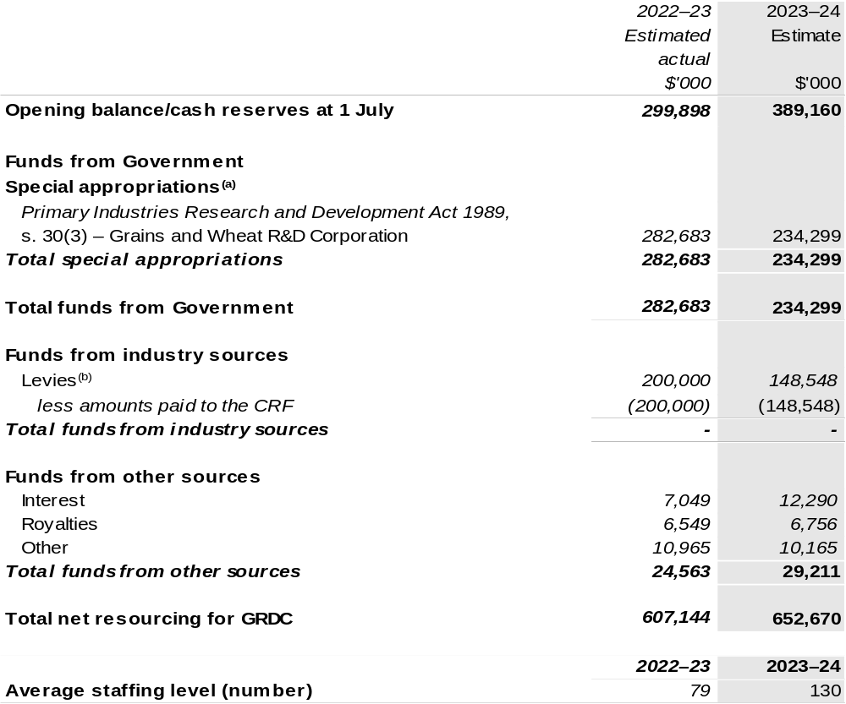
(a) GRDC's special appropriation is not directly appropriated as it is a corporate Commonwealth entity under the Public Governance, Performance and Accountability Act 2013 (PGPA Act). Appropriations are made to the Department of Agriculture, Fisheries and Forestry (DAFF) and are then paid to GRDC and are considered departmental for all purposes.
(b) The levies are imposed by the Primary Industries (Excise) Levies Act 1999. The levies are collected by DAFF under the Primary Industries Levies and Charges Collection Act 1991 and transferred to the Consolidated Revenue Fund (CRF). These amounts are then drawn down by the department as a special appropriation and paid to GRDC under the Primary Industries Research and Development
Act 1989 (PIRD Act), s. 30(3) – Grains and Wheat R&D Corporation.

Prepared on a resourcing (i.e., appropriations available) basis.

Please note: All figures shown above are GST exclusive – these may not match figures in the cash flow statement.

1.3 Budget measures
Budget measures in Part 1 relating to the Grains Research and Development Corporation are detailed in Budget Paper No. 2 and are summarised below.

Table 1.2: Grains Research and Development Corporation – May 2023–24 Budget Measures

Part 1: Measures announced since the 2022–23 October Budget

GRDC does not have any 2023–24 Budget measures.

Section 2: Outcomes and planned performance
Government outcomes are the intended results, impacts or consequences of actions by the Government on the Australian community. Commonwealth programs are the primary vehicle by which government entities achieve the intended results of their outcome statements. Entities are required to identify the programs which contribute to Government outcomes over the Budget and forward years.
Each outcome is described below together with its related programs. The following provides detailed information on expenses for each outcome and program, further broken down by funding source.
Note:
Performance reporting requirements in the Portfolio Budget Statements are part of the Commonwealth performance framework established by the Public Governance, Performance and Accountability Act 2013. It is anticipated that the performance criteria described in Portfolio Budget Statements will be read with broader information provided in an entity’s corporate plans and annual performance statements – included in Annual Reports – to provide a complete picture of an entity’s planned and actual performance.
The most recent corporate plan for the Grains Research and Development Corporation can be found at:
https://rdeplan.grdc.com.au/.
The most recent annual performance statement for the Grains Research and Development Corporation can be found at:
https://grdc.com.au/about/who-we-are/corporate-governance/annual-reports.

2.1 Budgeted expenses and performance for Outcome 1
Outcome 1: New information and products that enhance the productivity, competitiveness and environmental sustainability of Australian grain growers and benefit the industry and wider community, through planning, managing and implementing investments in grains research and development.

2.1.1: Linked programs
Department of Agriculture, Fisheries and Forestry
Program 1.7: Grains Industry
Contribution to Outcome 1 made by linked program:
GRDC works together with DAFF to ensure a sustainable, productive, and profitable grains industry.

2.1.2: Budgeted expenses for Outcome 1
This table shows how much the entity intends to spend (on an accrual basis) on achieving the outcome, broken down by program, as well as by administered and departmental funding sources.

Table 2.1: Budgeted expenses for Outcome 1
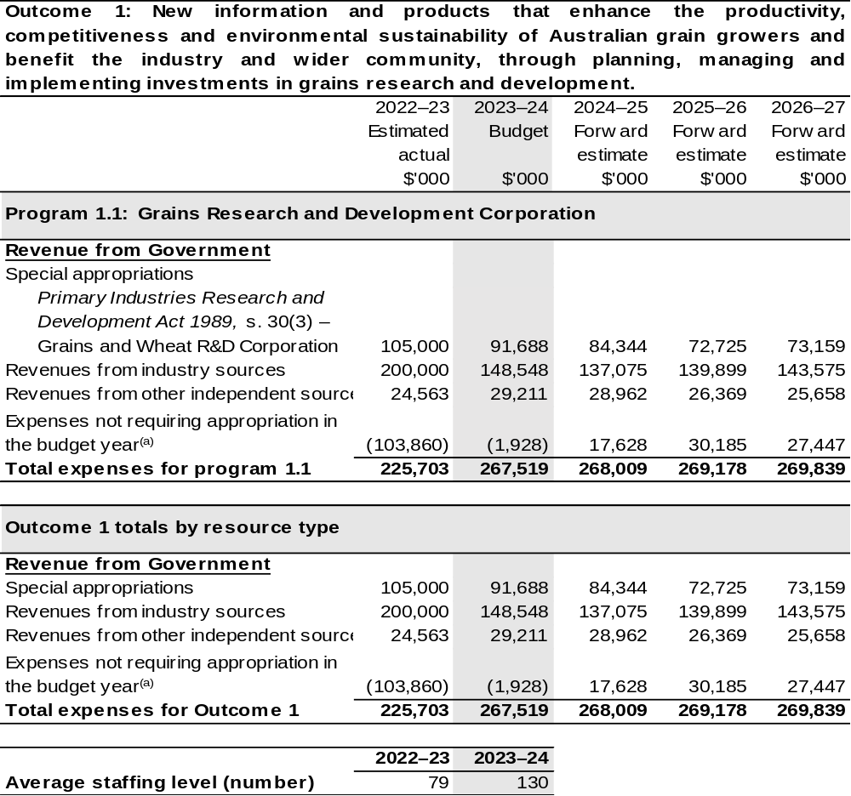
(a) ‘Expenses not requiring appropriation in the Budget year’ are made up of make good expenses, audit fees, and can include depreciation / amortisation expenses not requiring an appropriation.

Note: Departmental appropriation splits and totals are indicative estimates and may change in the course of the budget year as government priorities change.

Prepared on Australian Accounting Standards basis.

Table 2.2: Performance measure for Outcome 1
Table 2.2 details the performance measures for each program associated with Outcome 1. It also provides the related key activities as expressed in the current corporate plan where further detail is provided about the delivery of the activities related to the program, the context in which these activities are delivered and how the performance of these activities will be measured. Where relevant, the 2023–24 Budget measures that have created new programs or materially changed existing programs are provided.
As an entity established under the PIRD Act, GRDC does not produce a corporate plan under the PGPA Act and is therefore exempt from the requirement to map purposes to outcomes.
Outcome 1: New information and products that enhance the productivity, competitiveness and environmental sustainability of Australian grain growers and benefit the industry and wider community, through planning, managing and implementing investments in grains research and development.
Program 1.1: Grains Research and Development Corporation
Objective | Drive the discovery, development and delivery of world-class innovation to enhance the productivity, profitability and sustainability of Australian grain growers and benefit the industry and the wider community.
Key Activities^{(a)} | Continue to prioritise RD&E investments that support the enduring profitability of Australian grain growers. The target group is primarily Australian grain growers but the grains industry value chain also includes Governments, industry groups, rural and regional communities, research organisations and the wider community.
Year | Performance measures | Expected Performance Results
Current year  2022–23 | Average farm business rates of return. | A minimum of 6 per cent by 2023.  In 2021–22 the Rate of Return was 5.7 per cent.
Current year  2022–23 | Improvements in yield and yield stability. | Minimum yield increases equivalent to one per cent per annum for cereals, two per cent per annum for pulses and 1.5 per cent for oilseeds.  2021–22 results:  1.72 per cent increase on the  5–year average for wheat.  2.4 per cent increase on the  5–year average for pulses.  7.29 per cent increase on the  5–year average for oilseeds.
Continued on following pages
Table 2.2: Performance measure for Outcome 1 (continued)
Year | Performance measures | Expected Performance Results
Current year  2022–23 (continued) | Yield stability. | By 2023 a minimum 20 per cent closure of the gap between potential yield and actual yield.  As at 2021–22, 70 per cent of wheat, barley and canola crops showed no discernible yield gap (Paddock Survey 2019).  GRDC is continuing to develop reliable measures of yield gap, including through the continuation of the National Paddock Survey and exploring Water Use Efficiency as alternative measure.
Current year  2022–23 (continued) | Maintaining and improving price. | In 2020, 84 per cent of the 20 commonly grown wheat varieties used rust resistance genes or markers that were developed through GRDC investment.  85 per cent of tonnes of pulses produced over the past 5 years are varieties bred with the support of GRDC investment.*  *Based on data from receivals.
Current year  2022–23 (continued) | Optimising input costs. | Maintain increases in chemistry costs below the five-year trend (2018–2023) equivalent to $85.50 per hectare or a ratio of input to crop revenue of 0.166.  Ratio 0.142.  The result in 2021–22 is a ratio of 0.129 or $100.50 per hectare.  Maintain increases in fertiliser costs below the five-year trend (2018–2023) equivalent to $84.30 per hectare or a ratio of input to crop revenue of 0.164.  Ratio 0.140.  The result in 2021–22 is a ratio of 0.136 or $95.33 per hectare.

Continued on following pages
Table 2.2: Performance measure for Outcome 1 (continued)
Year | Performance measures | Expected Performance Results
Current year  2022–23 (continued) |  | Note:  - Not all input costs are captured in this target – all inputs costs as a share of cash receipts are captured in the calculation of Rates of Return.  - Reporting on a figure can be informative but is not the best indicator of impact due to variations across region, soil type, rainfall, and business characteristics of each farm.
Year | Performance measures | Planned Performance Results
Budget Year  2023–24 | Grower profitability | Rate of return of grain farms maintains or exceeds long-term trend.  Long term trend calculated from the rolling seven-year average.
Budget Year  2023–24 | Farm productivity | Total factor productivity (climate adjusted) maintains or exceeds long-term trend.  Long term trend calculated from the rolling seven-year average.
Budget Year  2023–24 | Crop yield | - Cereals yield gain and water-use efficiency (WUE) per annum are equal to or greater than the long-term trend.  - Pulses yield gain and WUE per annum are equal to or greater than the long-term trend.  - Oilseeds yield gain and WUE per annum are equal to or greater than the long-term trend.  Mean national crop yield (t/ha) and WUE (kg/ha/mm) in comparison to long term trends calculated from the rolling seven-year average

Table 2.2: Performance measure for Outcome 1 (continued)
Year | Performance measures | Planned Performance Results
Budget Year  2023–24 (continued) | Return on inputs | - Fertiliser costs as percentage of revenue equal to or less than the long-term trend.  - Crop protection costs as a percentage of revenue equal to or less than the long-term trend revenue).  - Total plant, machinery and labour costs (TPML) does not exceed the long-term trend.  Long term trend calculated from the rolling seven-year average.
Budget Year  2023–24 (continued) | Industry and market health | - Gross value of grains production ($B), adjusted for hectares planted, exceeds long-term growth trend.  - Market diversity is maintained or improved for major grains crops.  Based on the Herfindal-Hirschman Index (HHI) for wheat, barley, sorghum, canola and chickpea being at or below the 10-year average for each commodity.
Forward Estimates  2024–27 | As per 2023–24. | As per 2023–24.

- Additional performance information that supports the achievement of the above performance criteria are available in the GRDC’s 2018–2023 Strategic RD&E plan.

Section 3: Budgeted financial statements
Section 3 presents budgeted financial statements which provide a comprehensive snapshot of entity finances for the 2022–23 budget year, including the impact of budget measures and resourcing on financial statements.

3.1 Budgeted financial statements

3.1.1: Differences between entity resourcing and financial statements
The financial statements are prepared on an accrual basis where revenues and expenses are recognised as and when the resources are received and used. The entities resourcing table recognises cash resources available to be used during the period and includes amounts recognised as revenue in previous periods.

3.1.2: Explanatory notes and analysis of budgeted financial statements
GRDC’s revenue is primarily from industry contributions in the form of levies paid on the farm gate value of grain sold and Australian Government contributions which are capped at 0.5 per cent of the three-year rolling average of gross value of production (GVP). GRDC’s revenue streams are therefore subject to the volatility of local and international grain commodity markets, farm gate costs, environmental conditions, and the marketing decisions of growers. This means the assumptions in developing financial forecasts have a high degree of uncertainty and change frequently.
In 2023–24, GRDC is budgeting for an operating surplus of $2 million. Industry contributions are expected to decrease from 2022–23 by around $52 million but remain above the long-term average.
Australian Government contributions are expected to decrease by circa $13 million after the higher-than-average gross volume of production across recent years.
Own source income is expected to increase by $5 million on current year estimates, of which interest is expected to be the main contributor. In delivering higher values of R&D expenditure (investment), supplier, employee costs and general support expenses are modestly increasing. However relative to total expenditure support costs are decreasing, especially in the nearer term.
The budgeted net asset position for 2023–24 is $528 million which is $1.4 million more than the 2022–23 estimated actual. This increase is largely due to the flow on impacts from record levels of industry contributions and Australian Government
co-contributions received in the past two years.

3.2 Budgeted financial statements tables

Table 3.1: Comprehensive income statement (showing net cost of services)
(for the period ended 30 June)
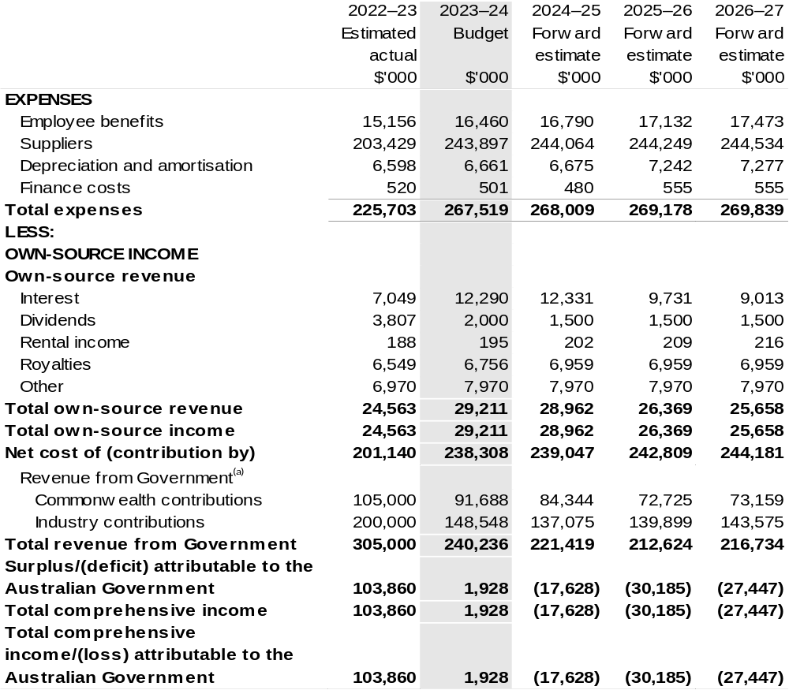
Continued on following page

Table 3.1: Comprehensive income statement (showing net cost of services) (for the period ended 30 June) (continued)
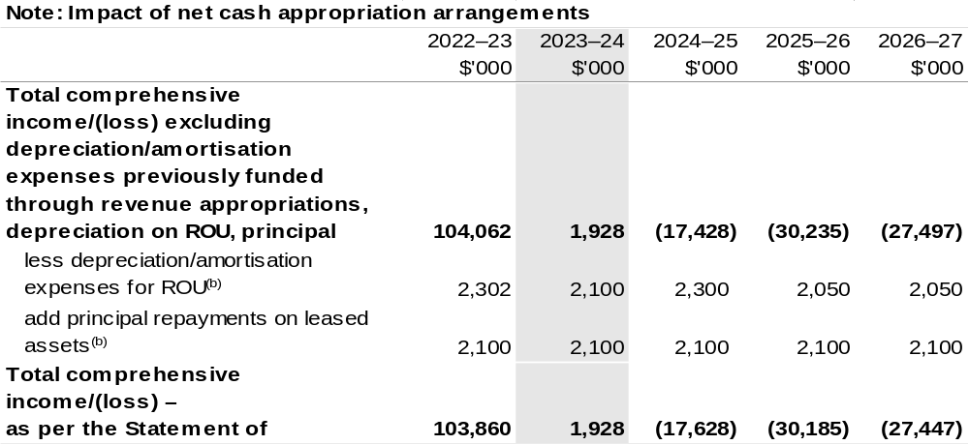
(a) Revenue from Government includes a Commonwealth contribution under the PIRD Act and levies collected from industry by DAFF for R&D activities.
(b) Applies to leases under Australian Account Standards Board (AASB) 16 Leases. Right of Use (ROU).

Prepared on Australian Accounting Standards basis.

Table 3.2: Budgeted departmental balance sheet (as at 30 June)
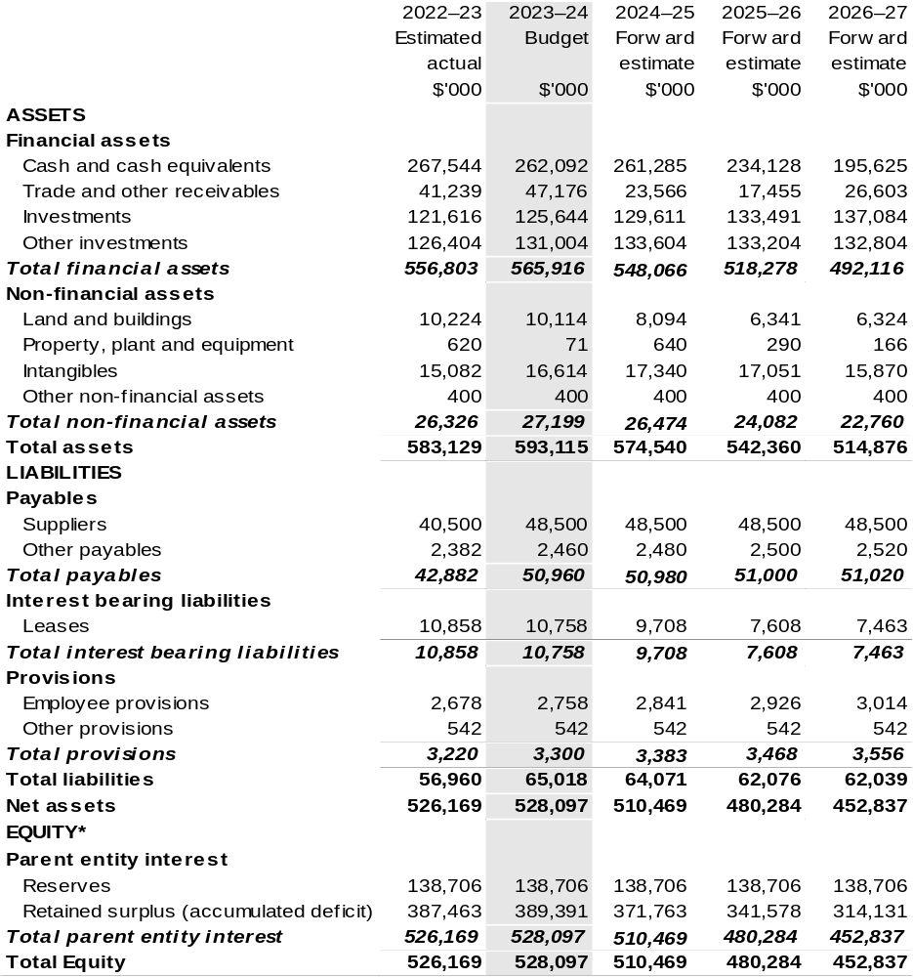
*'Equity' is the residual interest in assets after deduction of liabilities.

Prepared on an Australian Accounting Standards basis.

Table 3.3: Departmental statement of changes in equity – summary of movement (Budget year 2023–24)
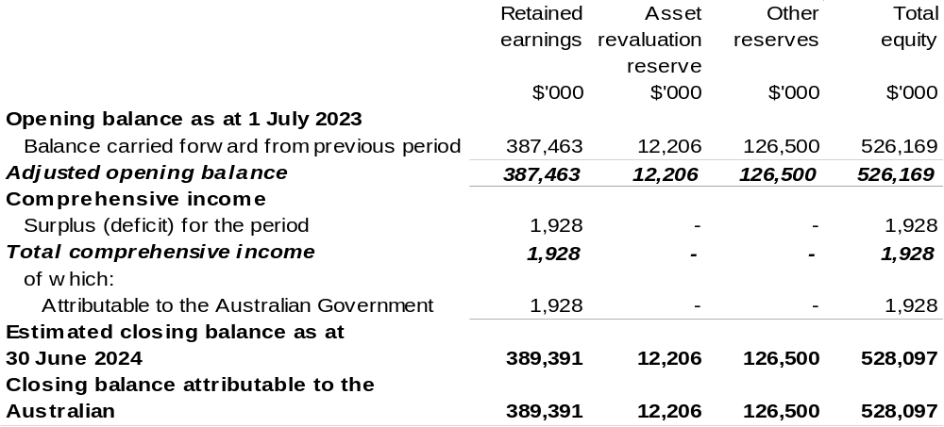

Prepared on Australian Accounting Standards basis.

Table 3.4: Budgeted departmental statement of cash flows (for the period
ended 30 June)
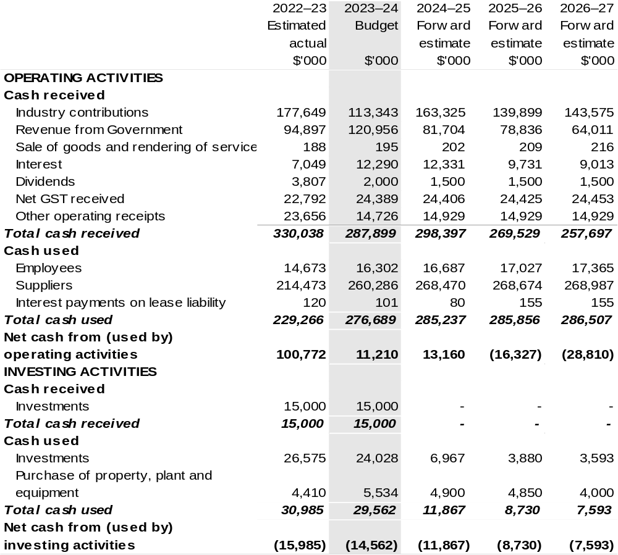

Continued on following page

Table 3.4: Budgeted departmental statement of cash flows (for the period
ended 30 June) (continued)
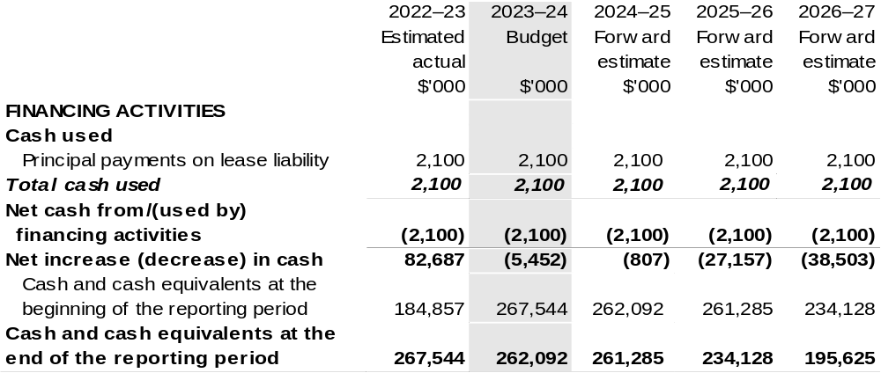

Prepared on Australian Accounting Standards basis.

Table 3.5: Departmental capital budget statement (for the period ended 30 June)
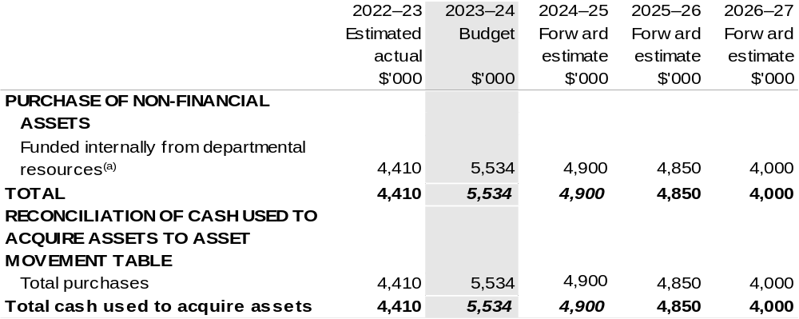
(a) Includes the following s74 external revenue:
– internally developed assets.

Consistent with information contained in the Statement of Asset Movements and the Budgeted Statement of Cash Flows.

Prepared on Australian Accounting Standards basis.

Table 3.6: Statement of departmental asset movements (Budget year 2023–24)
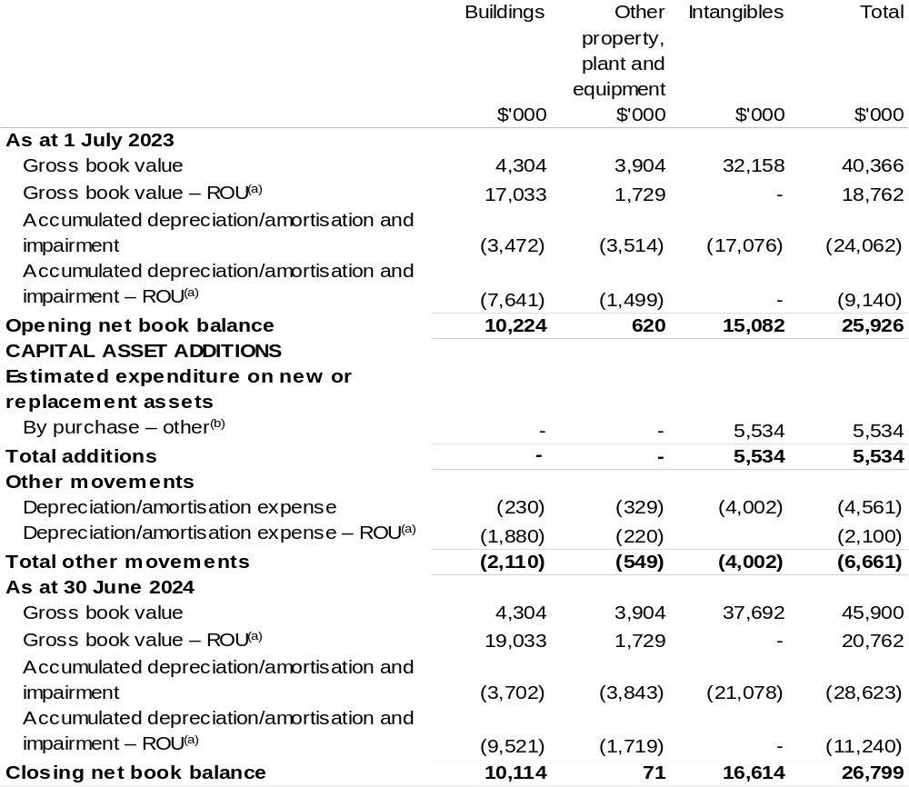
(a) Applies to leases under AASB 16 Leases. Right of Use (ROU).
(b) ‘By purchase – other’ refers to funding provided through other internal funding sources.

Prepared on Australian Accounting Standards basis.

Regional Investment Corporation
Section 1: Entity overview and resources 213
1.1 Strategic direction statement 213
1.2 Entity resource statement 214
1.3 Budget measures 215
Section 2: Outcomes and planned performance 216
2.1 Budgeted expenses and performance for Outcome 1 217
Section 3: Budgeted financial statements 222
3.1 Budgeted financial statements 222
3.2 Budgeted financial statements tables 223

Regional Investment Corporation

Section 1: Entity overview and resources

1.1 Strategic direction statement
The Regional Investment Corporation (RIC) is a corporate Commonwealth entity established by the Regional Investment Corporation Act 2018. An independent Board oversees RIC and is responsible for providing loans to eligible farm businesses, farm-related small businesses, and forestry businesses.
RIC Board also provides independent advice to the Minister for Agriculture, Fisheries and Forestry on the making of individual grants or arrangements for projects and activities that build drought resilience to be funded by the Future Drought Fund.
RIC streamlines the administration of concessional loans by delivering loans that are assessed in a nationally consistent, prudent, and timely manner. Loans are targeted at farm businesses and farm-related small businesses impacted by drought and those that are in financial need that mainly supply, or intend to mainly supply, products into supply chains that are interstate or overseas. Loans are also targeted at forestry businesses to encourage new plantation developments and the replanting of bushfire damaged plantation areas.
The concessional loan programs support the long-term strength, resilience and profitability of eligible farm businesses, farm-related small businesses and forestry businesses with $218.2 million in loan funding available for RIC in 2023–24.
This funding recognises the importance of RIC loans for farmers, foresters, and small businesses in need of practical assistance and the demand for RIC loan products.
RIC achieves this through its outcome.
Outcome 1: Encourage growth, investment and resilience in Australian farm businesses and rural and regional communities by delivering the Commonwealth’s farm business concessional loans.

1.2 Entity resource statement
Table 1.1 shows the total funding from all sources available to the entity for its operations and to deliver programs and services on behalf of the Government.
The table summarises how resources will be applied by outcome (Government strategic policy objectives) and by administered (on behalf of the Government or the public) and departmental (for the entity’s operations) classification.
For more detailed information on special accounts and special appropriations, please refer to Budget Paper No. 4: Agency Resourcing.
Information in this table is presented on a resourcing (that is, appropriations/cash available) basis, whilst the ‘Budgeted expenses by Outcome 1’ tables in Section 2 and the financial statements in Section 3 are presented on an accrual basis.

Table 1.1: Regional Investment Corporation – Resource Statement – Budget Estimates for 2023–24 as at Budget May 2023
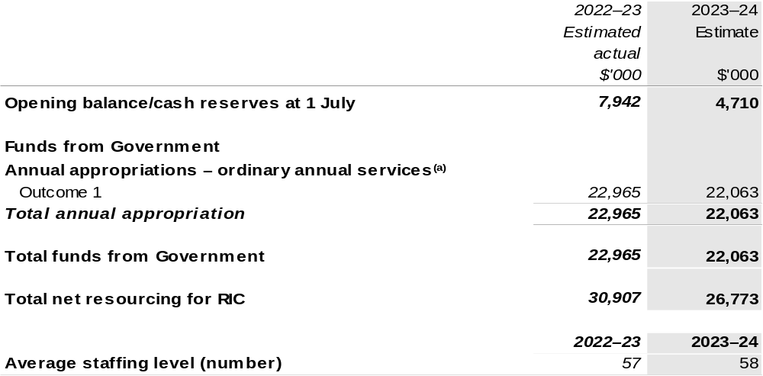
(a) Appropriation Bill (No. 1) 2023–24. Appropriation is provided through the Department of Agriculture, Fisheries and Forestry (DAFF) and is specified with the Annual Appropriation Bills as payment to RIC and is considered departmental for all purposes.

Please note: All figures shown above are GST exclusive – these may not match figures in the cash flow statement.

Prepared on a resourcing (i.e., appropriations available) basis.

1.3 Budget measures
Budget measures in Part 1 relating to the Regional Investment Corporation are detailed in Budget Paper No. 2 and are summarised below.

Table 1.2: Regional Investment Corporation – May 2023–24 Budget Measures

Part 1: Measures announced since the 2022–23 October Budget
Regional Investment Corporation does not have any 2023–24 Budget measures.

Section 2: Outcomes and planned performance
Government outcomes are the intended results, impacts or consequences of actions by the Government on the Australian community. Commonwealth programs are the primary vehicle by which government entities achieve the intended results of their outcome statements. Entities are required to identify the programs which contribute to Government outcomes over the Budget and forward years.
Each outcome is described below together with its related programs. The following provides detailed information on expenses for each outcome and program, further broken down by funding source.
Note:
Performance reporting requirements in the Portfolio Budget Statements are part of the Commonwealth performance framework established by the Public Governance, Performance and Accountability Act 2013. It is anticipated that the performance criteria described in Portfolio Budget Statements will be read with broader information provided in an entity’s corporate plans and annual performance statements – included in Annual Reports – to provide a complete picture of an entity’s planned and actual performance.
The most recent corporate plan for the Regional Investment Corporation can be found at: www.ric.gov.au/about/corporate-plan.
The most recent annual report for the Regional Investment Corporation can be found at: http://www.ric.gov.au/about/reporting/annual-report.

2.1 Budgeted expenses and performance for Outcome 1
Outcome 1: Encourage growth, investment and resilience in Australian farm businesses and rural and regional communities by delivering the Commonwealth’s farm business concessional loans.

2.1.1: Linked programs
Department of Agriculture, Fisheries and Forestry
- Program 1.3: Forestry Industry
- Program 1.11: Drought Programs
Contribution to Outcome 1 made by linked program:
RIC works together with DAFF to ensure more sustainable, productive, internationally competitive, and profitable Australian agricultural and forestry industries.

2.1.2: Budgeted expenses for Outcome 1
This table shows how much the entity intends to spend (on an accrual basis) on achieving the outcome, broken down by program, as well as by administered and departmental funding sources.

Table 2.1: Budgeted expenses for Outcome 1
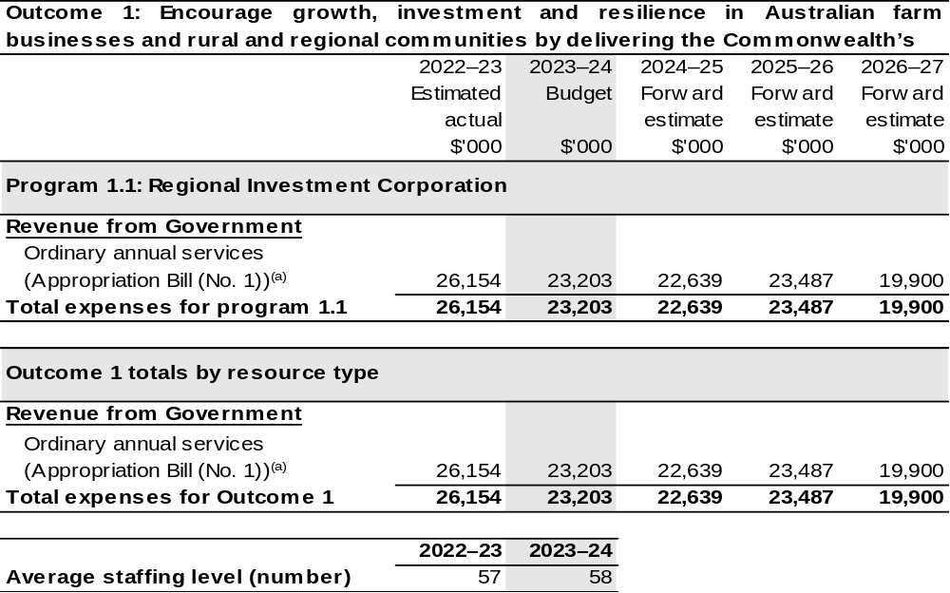
(a) Appropriation Bill (No. 1) 2023–24. RIC is a corporate Commonwealth entity under the Public Governance, Performance and Accountability Act 2013 (PGPA Act) and does not receive direct appropriations. Appropriation is provided through DAFF and is specified with the Annual Appropriation Bills as payment to RIC and is considered departmental for all purposes.

Note: Departmental appropriation splits and totals are indicative estimates and may change in the course of the budget year as government priorities change.

Prepared on Australian Accounting Standards basis.

Table 2.2: Performance measure for Outcome 1
Table 2.2 details the performance measures for each program associated with Outcome 1. It also provides the related key activities as expressed in the current corporate plan where further detail is provided about the delivery of the activities related to the program, the context in which these activities are delivered and how the performance of these activities will be measured. Where relevant, the 2023–24 Budget measures that have created new programs or materially changed existing programs are provided.
Outcome 1 – Encourage growth, investment and resilience in Australian farm businesses and rural and regional communities by delivering the Commonwealth’s farm business concessional loans.
Program 1.1: Regional Investment Corporation
Objectives | Provide practical support and investment to help rural and regional communities achieve economic growth, agricultural productivity, and resilience through the delivery of farm business loans, farm-related small business loans and plantation development loans.  RIC’s farm business loans and farm related small business loans provide low-cost finance to businesses that are in financial need of assistance, to recover from short-term hardship, but are assessed as financially viable over the long-term and able to repay the loan.  RIC also provides plantation development concessional loans to support new plantation developments and the replanting of bushfire-damaged plantations.
Key Activities | We will manage the credit risk in the loan portfolio, with a focus to ensure all new loans are assessed in line with the credit risk appetite statement.  We will implement final stages of the transformation program, involving the deployment of new technology that insources loan management and origination, and realigns our workforce and capability to a new operating model.  We will deliver our loans in accordance with funding appropriations available and application decision timelines.  We will increase customer satisfaction to enhance our customer service and experience.  We will deliver new products or product amendments as directed by the Australian Government.  We will develop a framework for Environment, Social and Governance (ESG) and associated reporting.

Continued on following pages

Table 2.2: Performance measure for Outcome 1 (continued)
Year | Performance measures | Expected Performance Results
Current year  2022–23 | Ongoing portfolio management framework is finalised and operational. | Fully achieved.
Current year  2022–23 | 90 per cent of loan decisions are consistent with the risk appetite. | Fully achieved.
Current year  2022–23 | Loan management system implemented and functional  (December 2023). | On track for completion by target date.
Current year  2022–23 | Workforce plan implemented and embedded (December 2023). | On track for completion by target date.
Current year  2022–23 | Support provided within appropriation limits. | Fully achieved.
Current year  2022–23 | Operate within approved operating budget. | Fully achieved.
Current year  2022–23 | 85 per cent of eligible loans are decisioned in 30 RIC-handling days for the loan facility of $266 million. | Fully achieved.
Current year  2022–23 | Increase in satisfaction rates compared with prior years. | Fully achieved.
Current year  2022–23 | New products delivered on time and within appropriation limit. | Fully achieved.
Year | Performance measures | Planned Performance Results
Budget Year  2023–24 | Risk is managed within acceptable tolerances. | 95 per cent of new loan decisions are consistent with the risk appetite.
Budget Year  2023–24 | Implement loan management system. | Loan management system implemented and functional by December 2023.
Table 2.2: Performance measure for Outcome 1 (continued)
Year | Performance measures | Planned Performance Results
Budget Year  2023–24 (continued) | Workforce capability aligned to RIC operating model. | Workforce plan implemented and embedded by December 2023.
Budget Year  2023–24 (continued) | Number and value of loans approved. | Support provided within funding appropriation limits.
Budget Year  2023–24 (continued) | Deliver services efficiently within approved funding. | Operate within approved operating budget.
Budget Year  2023–24 (continued) | Loan processing timeframe. | 85 per cent of eligible loans decisioned in 30 RIC-handling days.
Budget Year  2023–24 (continued) | Improved customer satisfaction. | Customer satisfaction rates above 80 per cent.
Budget Year  2023–24 (continued) | Responsive and efficient delivery of new products and enhancements. | New products delivered on time and within funding appropriation limits.
Budget Year  2023–24 (continued) | Adoption of government policy and expectation on Environment, Social and Governance. | Progress towards carbon net zero.  Develop a Reconciliation Action Plan.
Forward Estimates  2024–27 | As per 2023–24. | As per 2023–24.

Section 3: Budgeted financial statements
Section 3 presents budgeted financial statements which provide a comprehensive snapshot of entity finances for the 2023–24 budget year, including the impact of budget measures and resourcing on financial statements.

3.1 Budgeted financial statements

3.1.1: Explanatory notes and analysis of budgeted financial statements
In 2023–24, RIC will continue to support the provision of loans to eligible farm businesses, farm-related small businesses, and loans for eligible forestry businesses.
RIC is budgeting for an approved $1.1 million operating loss in 2023–24 with expenses (including employee and supplier expenses) budgeted at $24.0 million representing expenditure funded from appropriations received in prior years. RIC has sufficient cash reserves to fund the operating loss without impacting on the financial viability of RIC in the future.
The expense budget reflects the work programs for RIC in receiving and evaluating loan applications and managing approved loans to eligible farm businesses,
farm-related small businesses and eligible forestry businesses and providing independent advice to the Government.

3.2 Budgeted financial statements tables

Table 3.1: Comprehensive income statement (showing net cost of services)
(for the period ended 30 June)
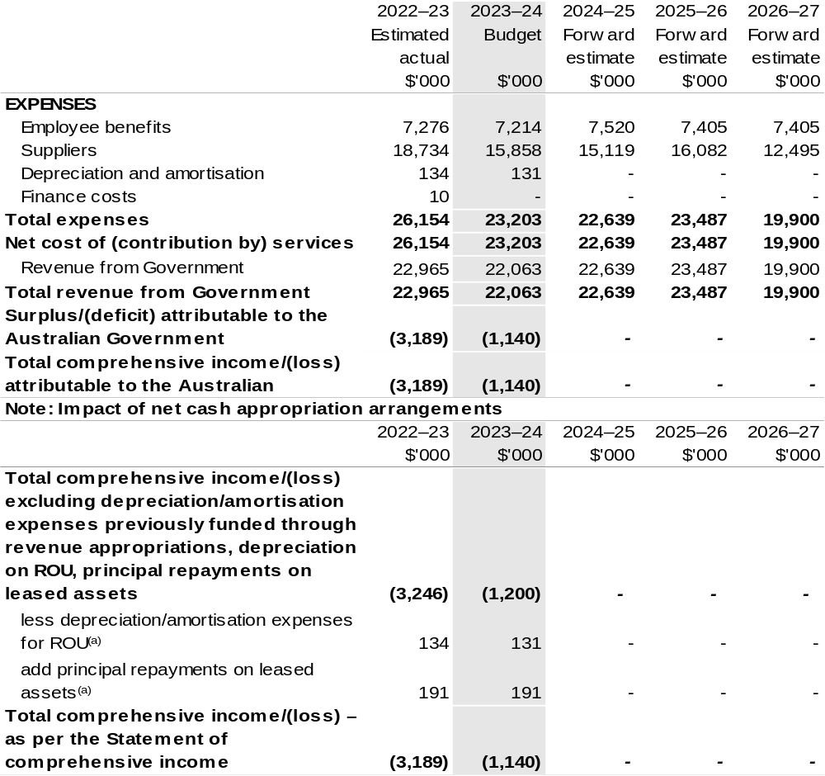
(a) Applies to leases under Australian Account Standards Board (AASB) 16 Leases. Right of Use (ROU).

Prepared on Australian Accounting Standards basis.

Table 3.2: Budgeted departmental balance sheet (as at 30 June)
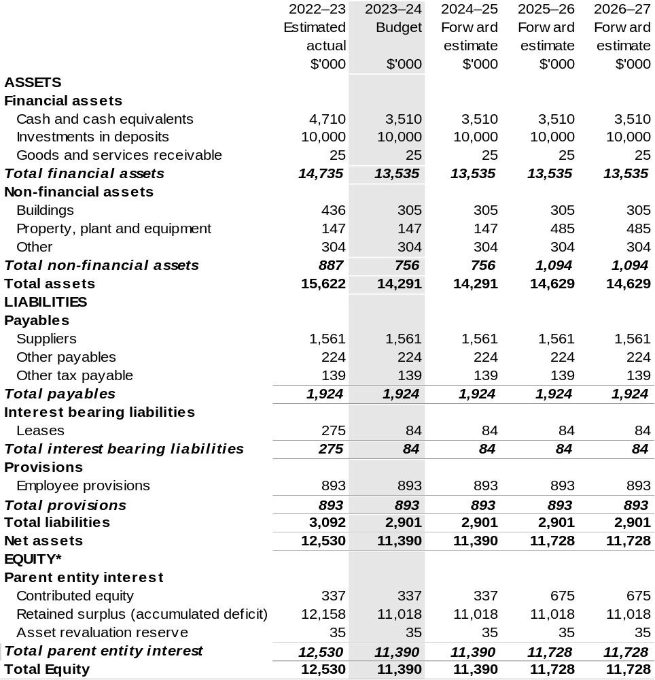
*’Equity’ is the residual interest in assets after deduction of liabilities.

Prepared on Australian Accounting Standards basis.

Table 3.3: Departmental statement of changes in equity—summary of movement (Budget year 2023–24)
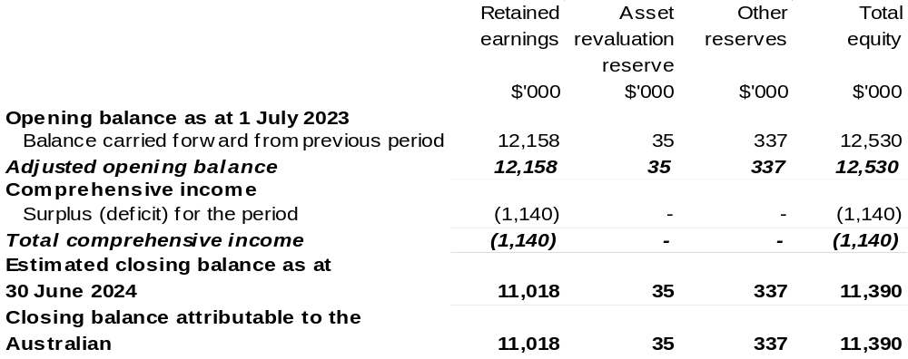

Prepared on Australian Accounting Standards basis.

Table 3.4: Budgeted departmental statement of cash flows (for the period
ended 30 June)
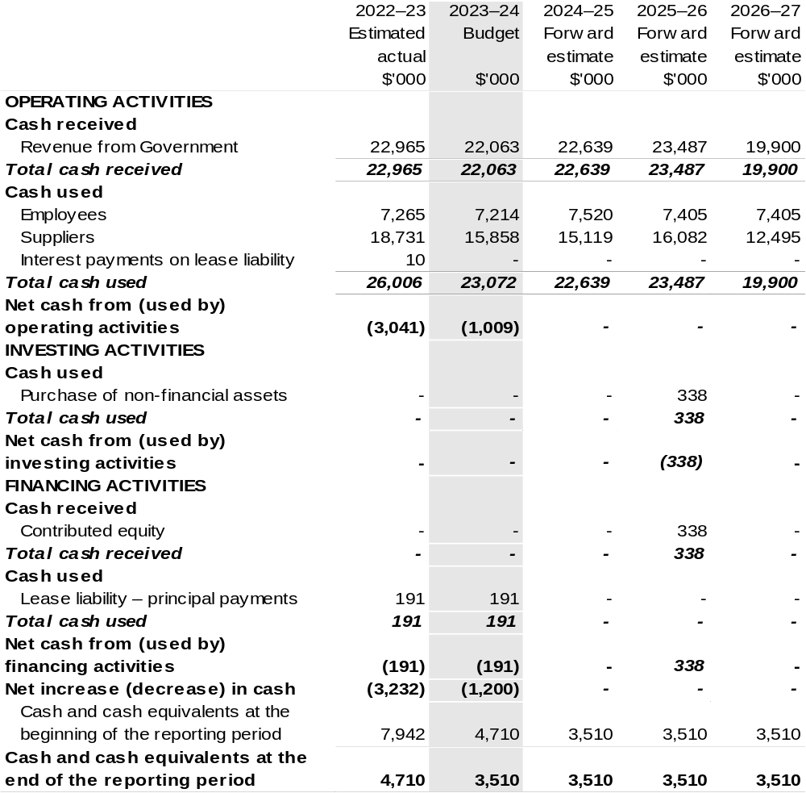
Prepared on Australian Accounting Standards basis.

Table 3.5: Departmental capital budget statement (for the period ended 30 June)
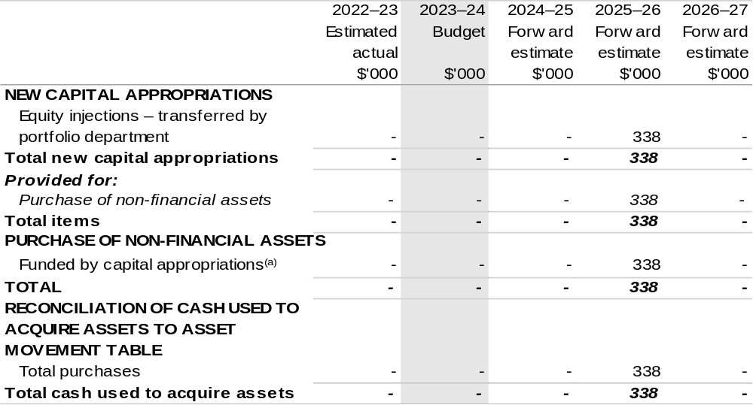
(a) Includes current Appropriation Bill (No. 2) and prior year Act (No. 2/4/6) appropriation.

Consistent with information contained in the Statement of Asset Movements and the Budgeted Statement of Cash Flows.

Prepared on Australian Accounting Standards basis.

Table 3.6: Statement of departmental asset movements (Budget year 2023–24)
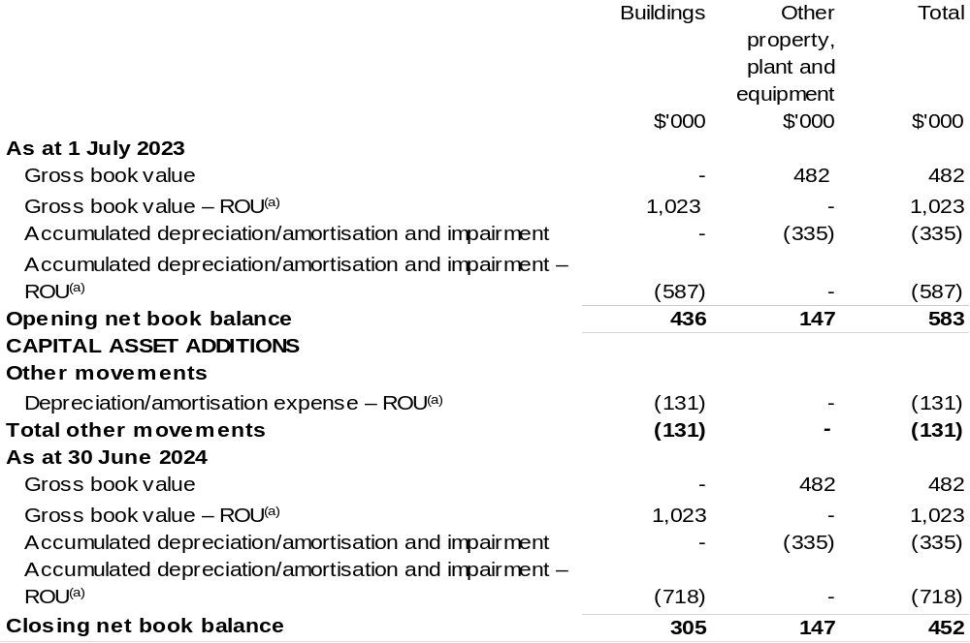
(a) Applies to leases under AASB 16 Leases. Right of Use (ROU).
(b) ‘By purchase – appropriation equity’ refers to equity injections appropriations provided through Appropriation Bill (No. 2) 2023–24 and other internal funding sources.

Prepared on Australian Accounting Standards basis.

Table 3.7: Schedule of budgeted income and expenses administered on behalf of Government (for the period ended 30 June)

The schedule of budgeted income and expenses administered on behalf of Government does not apply to RIC.

Table 3.8: Schedule of budgeted assets and liabilities administered on behalf of Government (as at 30 June)

The schedule of budgeted assets and liabilities administered on behalf of Government does not apply to RIC.

Table 3.9: Schedule of budgeted administered cash flows (for the period
ended 30 June)

The schedule of budgeted administered cash flows on behalf of Government does not apply to RIC.

Wine Australia
Section 1: Entity overview and resources 233
1.1 Strategic direction statement 233
1.2 Entity resource statement 238
1.3 Budget measures 240
Section 2: Outcomes and planned performance 241
2.1 Budgeted expenses and performance for Outcome 1 242
Section 3: Budgeted financial statements 249
3.1 Budgeted financial statements 249
3.2 Budgeted financial statements tables 250

Wine Australia

Section 1: Entity overview and resources

1.1 Strategic direction statement
Wine Australia seeks to foster and encourage profitable, resilient, and sustainable Australian winegrape and wine businesses by investing in research and development (R&D), building markets, disseminating market information and knowledge, encouraging adoption, and ensuring compliance through our regulatory functions.
We are governed by the Wine Australia Act 2013 (Wine Australia Act).

Wine Australia’s role under the Wine Australia Act is to:
- support grape or wine research and development activities
- support the growth of the wine industry, and other industries that make wine (within the meaning of section 33-1 of the A New Tax System (Wine Equalisation Tax) Act 1999)
- to support the growth of international wine tourism, and services, products and experiences that complement international wine tourism
- control the export of grape products from Australia
- promote the consumption and sale of grape products, both in Australia and overseas, and
- to enable Australia to fulfil its obligations under prescribed wine-trading agreements and other international agreements. Authorised Version C2021C00178 registered 16 April 2020.
Wine Australia is funded by grape growers, winemakers and exporters through levies and user-pays charges, and by the Australian Government, which provides matching funding for research, development, and adoption (RD&A) investments.

Australian wine is a unique, high-quality product crafted in 65 wine regions around the country. The Australian wine sector has approximately 6,000 grape growers, 146,244 hectares of vines, 2,156 wineries and produced 1.3 billion litres of wine in 2021–22.
In the year ended December 2022, Australian wine exports increased by 1 per cent in volume to 623 million litres and declined by 4 per cent in value to $1.94 billion.
The rise in volume relative to value was driven by growth in the shipments of unpackaged wine, particularly to the United States of America (US) and Canada, as global shipping challenges improve. Diversification and intensification efforts of Australian wine exporters were also evident in the report, with exporters shipping wine to 120 destinations during the period, up from 112 the previous year and the highest since the start of the COVID-19 pandemic. Growth in the value of exports to Southeast Asia continued through the period with a 16 per cent rise in value to $305 million. Notwithstanding, it was another tough year for Australian wine exporters, with rising inflation, business costs and interest rates impacting margins, and it is anticipated this will continue in 2023.
Wine Australia’s goal is profitable, resilient, and sustainable winegrape and wine businesses, and how Wine Australia achieves its responsibilities under the Wine Australia Act is outlined in the five-year Strategic Plan 2020–25. In 2023–24, the fourth year of the strategic plan, Wine Australia will continue to invest in five strategies.
- Strategy 1: Promote Australian wine
- Strategy 2: Protect Australian wine
- Strategy 3: Build grape and wine excellence
- Strategy 4: Build sustainable environments
- Strategy 5: Build business sustainability, excellence, and leadership.
Since Wine Australia’s Strategic Plan 2020–25 was approved in June 2020, the environment within which it operates has been significantly impacted by COVID-19 restrictions, and the imposition of tariffs on Australian wine exported to China.
The operational impacts that will flow from the current market and financial challenges have been contemplated in developing this statement and will be reflected in future annual operational plans.
Wine Australia’s marketing efforts will continue to be directed toward increasing the demand and premium paid for all Australian wine.
It is anticipated that Marketing funding will be significantly reduced given the lowest national crush this century. The drop in production directly impacts the wine grape levy (WGL) that funds our operations, further exacerbating the budget pressures resulting from a reduction in wine export charges (WEC) post the China tariffs, with over $1.2 billion in total export revenue disappearing over the past two years.
In this operational environment, Wine Australia is seeking to intensify marketing efforts to gain a greater market share in established markets of the United States of America (USA) and Canada, defend share in the United Kingdom (UK) and diversify into emerging markets including Japan, Korea and South East Asia.
Market attractiveness has been determined through quantitative and qualitative market insights, reflecting the opportunity for commercial and premium wine.
Specific approaches for each market will be informed and refined by category and consumer insights, direct in-market learnings, sector feedback and alignment with other cross-sector activations and Austrade.
The 2023–24 imperatives of our Marketing strategy are:
- Prioritise and quantify market attractiveness by segment
- Build sector capability through education and insights
- Maximise resource base
- Evolve current “Australian Wine” brand to better reflect the needs of the sector and incorporate ESG credentials as an area of competitive advantage.
Wine Australia will continue to work in concert with Austrade to leverage our collective resource and expertise to assist wine businesses to develop their own capabilities to support diversification efforts.
Wine Australia’s regulatory services activities seek to protect the reputation and integrity of Australian wine in all markets, including the domestic market. It will ensure that the regulatory regime remains fit for purpose, explores new opportunities for traceability technologies, builds relationships with counterpart regulators in export markets and enhances the Wine Australia Licensing and Approvals System (WALAS) and the Label Directory. Wine Australia will also support the Geographical Indications Committee that defines the winegrape producing regions of Australia.
In Strategy 3, Wine Australia’s R&D investments will continue to enhance grape and wine excellence by transitioning our longstanding investment in grapevine breeding to make full use of new gene editing technologies. The advances that have been made through conventional breeding will remain accessible to the sector, with a strengthened pathway to market. Other new investments to enhance grape and wine excellence will also commence or continue in 2023–24 following co-design with the sector in 2022–23, in no and low alcohol (NOLO) wine production, supply chain optimisation and profitability, and in digital and data opportunities.
To maintain the supply of genetically diverse and high-health planting material, Wine Australia will continue to work towards the establishment of a national germplasm collection.
To enhance production efficiency without sacrificing sustainability, new investments in sustainable grape and wine production practices will be guided by a sector wide ESG Business Plan and co-designed with the grape and wine sector and other partners to deliver greater impact. It will continue to develop, test, and commercialise new technologies and demonstrate them through agricultural technology demonstration sites to encourage adoption.

In Strategy 4, Wine Australia’s R&D investments will provide knowledge and tools to help growers and producers to be more environmentally sustainable. Wine Australia will deliver a roadmap for the grape and wine sector to achieve net zero carbon emissions, and co-design and initiate waste reduction activities with the sector. Wine Australia will also commence a project to provide recovery and recycling options for treated timber vineyard posts. We will continue work to create a single point of entry data ecosystem for online spray diaries so that growers can share their records to purchasing wineries and the Sustainable Winegrowing Australia program.
Wine Australia will continue to provide the sector the information it needs to manage the challenges of long-term climate change, including that of increased bushfire risk. We will initiate the investments required to support the grape and wine sector’s adoption of climate change mitigation strategies.
We will continue to invest in research relating to soil health, cover crops and biodiversity, in more sustainable management of endemic pests and diseases and in initiatives to better prepare the sector for exotic pests and diseases, guided by the sector wide ESG Business Plan.
In Strategy 5, Wine Australia’s R&D investments focuses on empowering people across the sector, enabling diversity into leadership and decision-making and accelerating the adoption of research outcomes and best practice.
Wine Australia will continue to focus on facilitating practice change and the adoption of existing knowledge to improve winegrape growing, winemaking, exporting and running a wine business through the use of innovative approaches to behaviour and practice change in our programs, including those delivered by extension providers we support and through the Wine Australia Regional Program and other initiatives such as Agtech demonstration sites.
Evidence-based and data-driven decision-making in the sector will be enhanced through the Interactive Insights online platform, preparation of regular market reports and analysis, presentations at wine sector forums and individual analyst sessions. Wine Australia will continue to deliver the Australian Government-funded Improving Market Transparency project to promote transparency of winegrape pricing for growers in the major inland regions.
Wine Australia will continue to help develop the leaders of tomorrow – and build the skills of the leaders of today – through both national and regional leadership programs. Wine Australia’s support of the whole-of-sector Wine Industry Mentor Program will continue and the outcomes from a pilot project in NSW building a structured network supporting youth (aged under 35) across the sector will be considered for scalability nationally.
Wine Australia will continue to work with the school, vocational and higher education sectors as well as Australian Government-funded initiatives addressing workforce and labour issues across agriculture to promote pathways to the grape and wine sector as a career of choice. A suite of new case studies and an online virtual reality resource that showcases contemporary grape and wine careers across the sector value chain will be launched and promoted for use within schools, education providers and the sector.
Through these activities, the aim is to attract and retain young skilled and semi-skilled people in all areas of the wine industry, to encourage the future generation to be engaged and committed to their careers and encourage and support innovation and profitability in wine businesses.
Wine Australia will also invest in the sector’s research capability by supporting postgraduate students and encouraging stronger engagement and collaboration with the sector so that their research is relevant and addresses clear sector needs.
Wine Australia will measure and report on stakeholder satisfaction with the services we provide, and on our effectiveness in achieving our measures of success.
Wine Australia also works closely with other rural research and development corporations (RDCs) in cross-sectoral collaborative research, including through Agricultural Innovation Investments Limited, to deliver RD&A benefits to the broader community.

1.2 Entity resource statement
Table 1.1 shows the total funding from all sources available to the entity for its operations and to deliver programs and services on behalf of the Government.
The table summarises how resources will be applied by outcome (Government strategic policy objectives) and by administered (on behalf of the Government or the public) and departmental (for the entity’s operations) classification.
For more detailed information on special accounts and special appropriations, please refer to Budget Paper No. 4: Agency Resourcing.
Information in this table is presented on a resourcing (that is, appropriations/cash available) basis, whilst the ‘Budgeted expenses by Outcome’ table in Section 2 and the financial statements in Section 3 are presented on an accrual basis.

Table 1.1: Wine Australia – Resource Statement – Budget Estimates for 2023–24 as at Budget May 2023
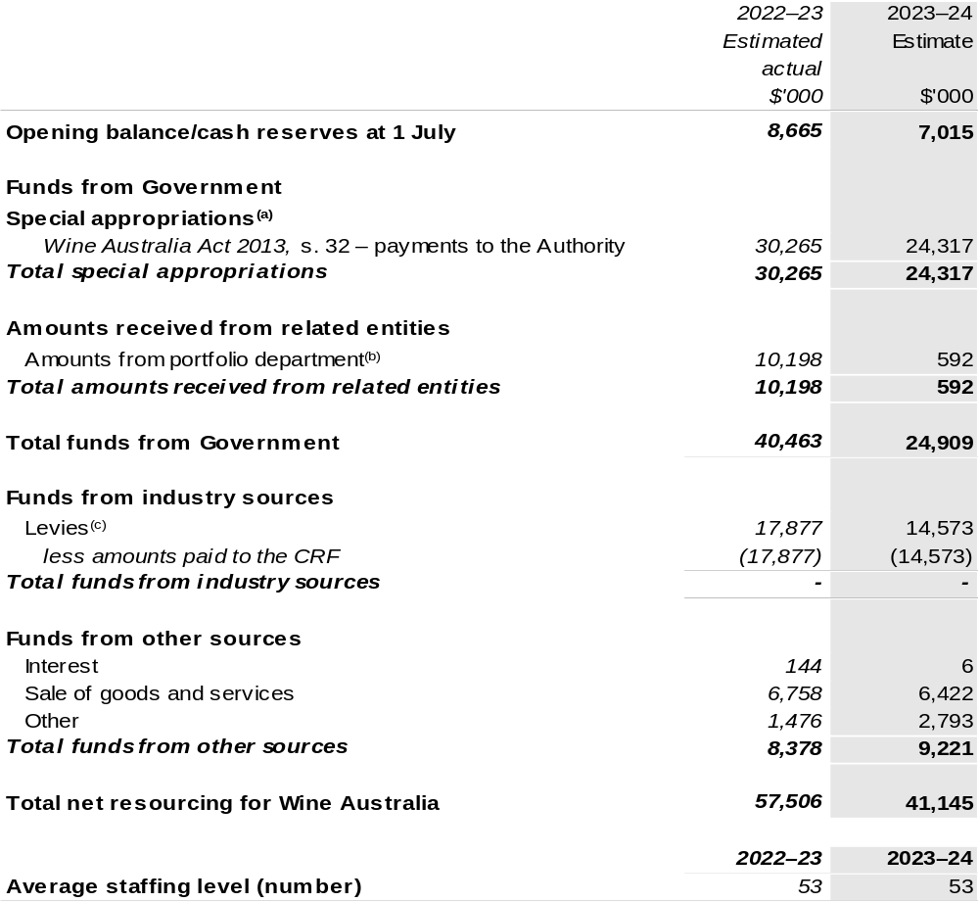
(a) Wine Australia's special appropriation is not directly appropriated as it is a corporate Commonwealth Entity (CCE) under the Public Governance, Performance and Accountability Act 2013 (PGPA Act). Appropriations are made to the Department of Agriculture, Fisheries and Forestry (DAFF) and are then paid to Wine Australia and are considered departmental for all purposes.
(b) Funding provided by the portfolio department that is not specified within the Annual Appropriation Bills as a payment to that CCE (for example, a grant awarded to a CCE from one of its portfolio department's administered programs).
(c) The levies are imposed by the Primary Industries (Excise) Levies Act 1999. Levies are collected by DAFF under the Primary Industries (Excise) Levies Act 1999 and Primary Industries (Customs) Charges Act 1999 and comprise of the Grape Research Levy and the Wine Grapes Levy and are transferred to the Consolidated Revenue Fund (CRF). These amounts are then drawn down by the department as a special appropriation and paid to Wine Australia under the Wine Australia Act 2013, s. 32.

Please note: All figures shown above are GST exclusive – these may not match figures in the cash flow statement.

Prepared on a resourcing (i.e., appropriations available) basis.

1.3 Budget measures
Budget measures in Part 1 relating to the Wine Australia are detailed in Budget Paper No. 2 and are summarised below.

Table 1.2: Wine Australia – May 2023–24 Budget Measures

Part 1: Measures announced since the 2022–23 October Budget

Wine Australia does not have any 2023–24 Budget measures.

Section 2: Outcomes and planned performance
Government outcomes are the intended results, impacts or consequences of actions by the Government on the Australian community. Commonwealth programs are the primary vehicle by which government entities achieve the intended results of their outcome statements. Entities are required to identify the programs which contribute to Government outcomes over the Budget and forward years.
Each outcome is described below together with its related programs. The following provides detailed information on expenses for each outcome and program, further broken down by funding source.
Note:
Performance reporting requirements in the Portfolio Budget Statements are part of the Commonwealth performance framework established by the Public Governance, Performance and Accountability Act 2013. It is anticipated that the performance criteria described in Portfolio Budget Statements will be read with broader information provided in an entity’s corporate plans and annual performance statements — included in Annual Reports — to provide a complete picture of an entity’s planned and actual performance.
The most recent corporate plan as well as the most recent annual performance statement for Wine Australia can be found at https://www.wineaustralia.com/about-us/performance-and-reporting.

2.1 Budgeted expenses and performance for Outcome 1
Outcome 1: Foster and enable a competitive Australian wine industry by investing in research and development, building markets, disseminating knowledge and ensuring compliance.

2.1.1: Linked programs
Department of Agriculture, Fisheries and Forestry
Program 1.10: Agricultural Resources
Program 1.13: International Market Access
Contribution to Outcome 1 made by linked program:
Wine Australia and DAFF work together to ensure a sustainable, productive, and profitable grape and wine sector.
Wine Australia will also administer the Wine Tourism and Cellar Door Grant program that commenced in 2019–20.

2.1.2: Budgeted expenses for Outcome 1
This table shows how much the entity intends to spend (on an accrual basis) on achieving the outcome, broken down by program, as well as by administered and departmental funding sources.

Table 2.1: Budgeted expenses for Outcome 1
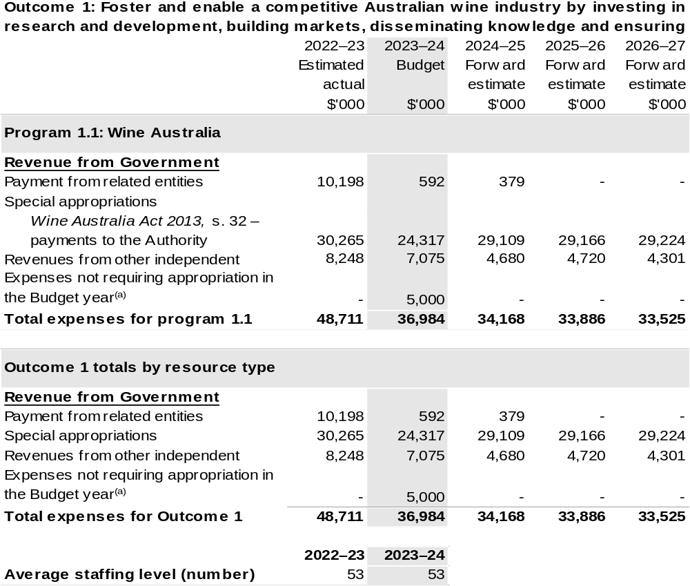
(a) ‘Expenses not requiring appropriation in the Budget year’ are made up of make good expenses, audit fees, and can include depreciation / amortisation expenses not requiring an appropriation.

Note: Departmental appropriation splits and totals are indicative estimates and may change in the course of the budget year as government priorities change.

Prepared on Australian Accounting Standards basis.

Table 2.2: Performance measure for Outcome 1
Table 2.2 below details the performance measure for each program associated with Outcome 1. It also summarises how each program is delivered and where relevant, the 2023–24 Budget measures have created new programs or materially changed existing programs are provided.
As an entity established under the Wine Australia Act, Wine Australia does not produce a corporate plan under the PGPA Act and is therefore exempt from the requirement to map purposes to outcomes.
Outcome 1: Foster and enable a competitive Australian wine industry by investing in research and development, building markets, disseminating knowledge and ensuring compliance.
Program 1.1: Wine Australia
Objective | Invest in R&D, building markets, disseminating knowledge, and ensuring compliance to foster and enable a competitive Australian wine sector.
Key Activities | Wine Australia will:  - Invest in R&D in the five strategic areas outlined in its Strategic Plan 2020–2025 for the benefit of wine-grape growers, winemakers, wine businesses and the wider community.  - Invest in RD&A to build grape and wine excellence, build sustainable environments, and build business sustainability, excellence, and leadership.  - Invest in marketing to promote Australian wine and grow international markets.  - Invest in regulatory services to protect the reputation of Australian wine.  - Support grape and wine businesses with market insights that allow them to make effective and informed decisions.

Continued on following pages
Table 2.2: Performance measure for Outcome 1 (continued)
Year | Performance measures | Expected Performance Results
Current year  2022–23 | Wine Australia
Current year  2022–23 | Improve our stakeholder net promoter score from 2019 baseline. | Target Above +12.  In 2022–23, after a refresh of our Customer Engagement Strategy, we again distributed a Stakeholder Engagement Survey.  Wine Australia’s Net Promoter Score was returned to +12.
Current year  2022–23 | RD&A
Current year  2022–23 | Research contracts are actively managed through regular and ongoing monitoring of the research. | Target 100 per cent.
Current year  2022–23 | Market Insights customers are satisfied or very satisfied with the services they receive. | Target >90 per cent.  During the year, 40 individual analyst sessions were booked by our levy-payers. The “Ask Analyst’ sessions were heavily promoted throughout the year to encourage usage.
Current year  2022–23 | Levy payers who participate in  Wine Australia-supported extension and adoption programs consider them a ‘good’ or ‘very good’ use of levy funds. | Target 80 per cent.  Australian Grape and Wine (AGW) Research Advisory Committee continue to assist in identifying and prioritising extension and adoption priorities.  Monitoring and evaluation metrics across Wine Australia supported extension activities with the Australian Wine Research Institute and the Australian Society of Viticulture and Oenology indicate that events overall are delivering value – on average at least 80 per cent of attendees at workshops, seminars and

Continued on following pages
Table 2.2: Performance measure for Outcome 1 (continued)
Year | Performance measures | Expected Performance Results
Current year  2022–23 (continued) | RD&A (continued)
Current year  2022–23 (continued) |  | webinars rated these events ‘very good’ or ‘excellent’ and at least 70 per cent of attendees intend to make changes to current practices, reassess current practices, seek extra information or discuss with peers about making changes to their current practices.
Current year  2022–23 (continued) | Marketing
Current year  2022–23 (continued) | Tier A influencers actively engage with Wine Australia. | Target 85 per cent.  Tier A engagement is on track for the 2022–23 year with 49 per cent engaged by 31 January 2023.  Australian Wine Discovered Net Promoter Score is 64, a ‘very good’ to ‘excellent’ score.  The tone in 93 per cent of media articles about Australian wine was positive or neutral, holding this very strong result from 2021–22.
Current year  2022–23 (continued) | Marketing (continued)
Current year  2022–23 (continued) | The perception of Australian wine increases in Canada, the UK and the USA. | Target is to further increase perception above 2019 baseline.  The annual Wine Intelligence survey results will not be available until the end of quarter 4 in  2022–23.
Current year  2022–23 (continued) | Wineries and distributors who participate in Wine Australia events report that they are ‘satisfied’ or ‘very satisfied. | Target >90 per cent.  Average satisfaction rating across marketing campaigns was 88 per cent.

Continued on following pages
Table 2.2: Performance measure for Outcome 1 (continued)
Year | Performance measures | Expected Performance Results
Current year  2022–23 (continued) | Regulatory services
Current year  2022–23 (continued) | Achieve the six key performance indicators in the Regulatory Performance Framework. | Achieved, noting that the Regulatory Performance Framework has been replaced by the Prime Minister and Cabinet’s Regulatory Performance Guide, with Wine Australia awaiting a Statement of Expectation from the Minister.
Current year  2022–23 (continued) | Through our Label Integrity Program, we inspect producers’ records, focusing on those relating to wine regions and varieties in particular demand. | We will conduct up to 200 on-site winery inspections to verify compliance with the record keeping obligations of the Label Integrity Program (LIP).  We will have demonstrated continuous improvement by continuously reviewing and improving our Licensing and Compliance Guide and our Export Market Guides.  We will have continued to focus resources on high-risk producers and exporters, with higher risk producers and exporters being inspected for LIP compliance more regularly than others, and high-risk exporters being required to routinely verify label claims for exported products.  We will continue to contemplate demand for wines of certain variety and origin is contemplated in assessing the risk of misuse of varietal and GI claims.  An anonymous portal is maintained through which alleged incidents of non-compliance can be anonymously reported. All allegations of LIP non-compliance are investigated using coercive and compulsory statutory powers.

Continued on following page

Table 2.2: Performance measure for Outcome 1 (continued)
Year | Performance measures | Planned Performance Results
Budget Year  2023–24 | As per 2022–23. | As per 2022–23.
Forward Estimates  2024–27 | As per 2023–24. | As per 2023–24.

Section 3: Budgeted financial statements
Section 3 presents budgeted financial statements which provide a comprehensive snapshot of entity finances for the 2023–24 budget year, including the impact of budget measures and resourcing on financial statements.

3.1 Budgeted financial statements

3.1.1: Differences between entity resourcing and financial statements
There are no differences between the resource information presented in the Budget Papers and Portfolio Budget Statements.

3.1.2: Explanatory notes and analysis of budgeted financial statements
The Budget incorporates the contracted and committed research, development and extension activities, the anticipated marketing programs and statutory duties.

Wine Australia receives levies on the tonnage of fruit grown (Grape Research Levy), grape products used in the manufacture of wine (WGL), and on the value of wine exported (WEC). Revenue from these levies is expected to be approximately $14.6 million for the 2023–24 year, based on an expected 2023 vintage of 1.4 million tonnes.

Research, development, and extension expenditure attracts Commonwealth matching funding, which is calculated in accordance with the provisions of the Primary Industries Research and Development Act 1989 (PIRD Act).

Other major sources of revenue are export licences and associated fees and promotional user-pays events.

3.2 Budgeted financial statements tables

Table 3.1: Comprehensive income statement (showing net cost of services)
(for the period ended 30 June)
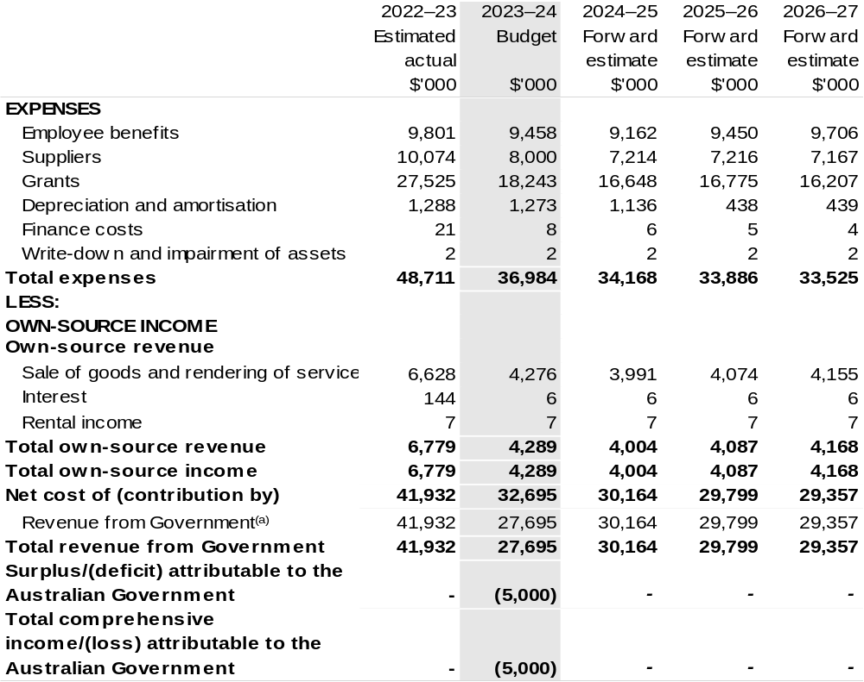
Continued on following page

Table 3.1: Comprehensive income statement (showing net cost of services)
(for the period ended 30 June) (continued)
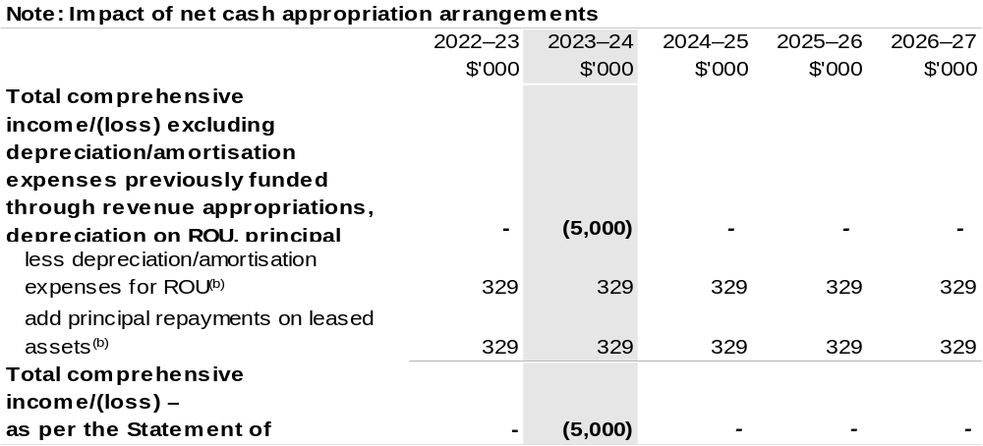
(a) Revenue from Government includes a Commonwealth contribution under the PIRD Act and levies collected from industry by DAFF for R&D and marketing activities.
(b) Applies to leases under Australian Account Standards Board (AASB) 16 Leases. Right of Use (ROU).

Prepared on Australian Accounting Standards basis.

Table 3.2: Budgeted departmental balance sheet (as at 30 June)
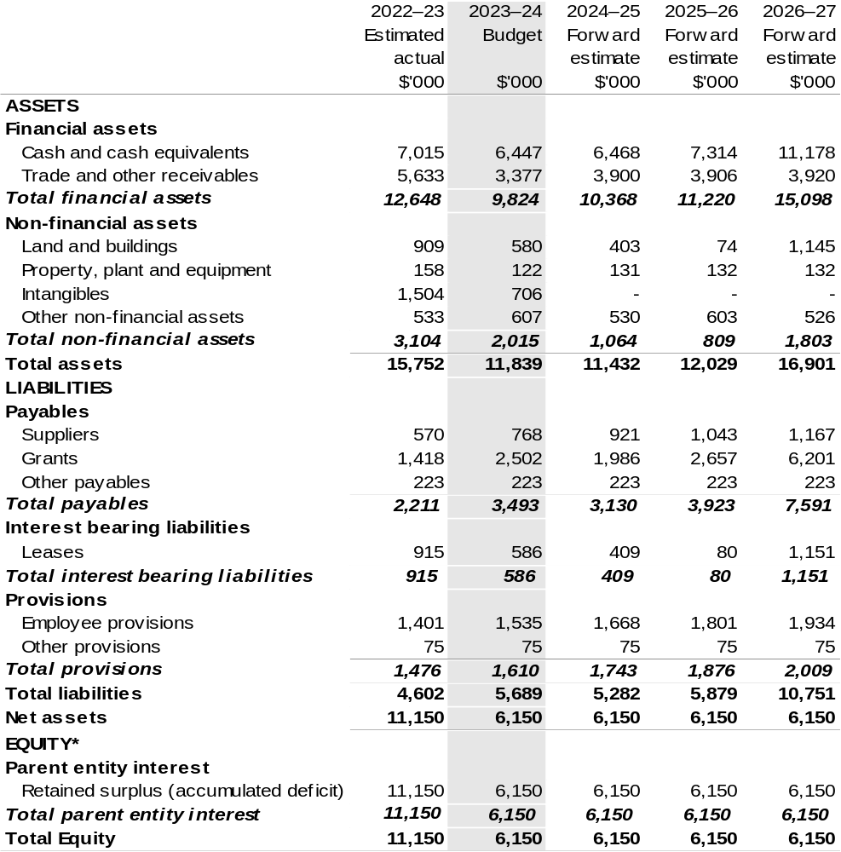
*’Equity’ is the residual interest in assets after deduction of liabilities.

Prepared on Australian Accounting Standards basis.

Table 3.3: Departmental statement of changes in equity – summary of movement (Budget year 2023–24)
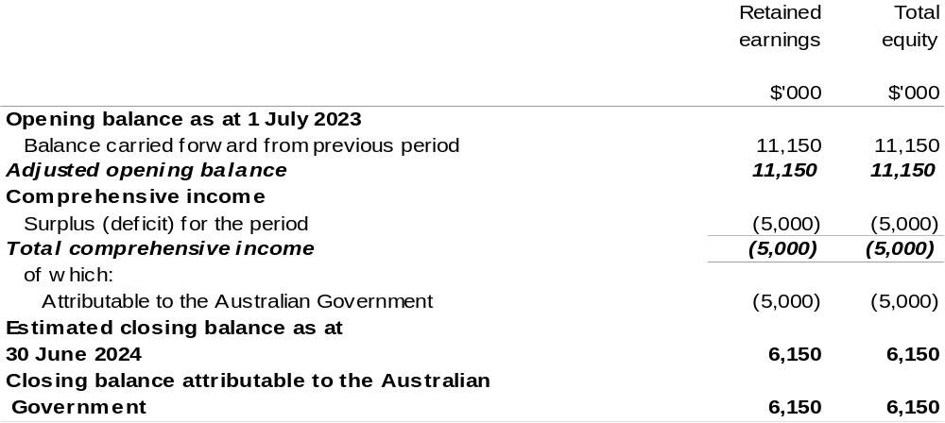
Prepared on Australian Accounting Standards basis.

Table 3.4: Budgeted departmental statement of cash flows (for the period
ended 30 June)
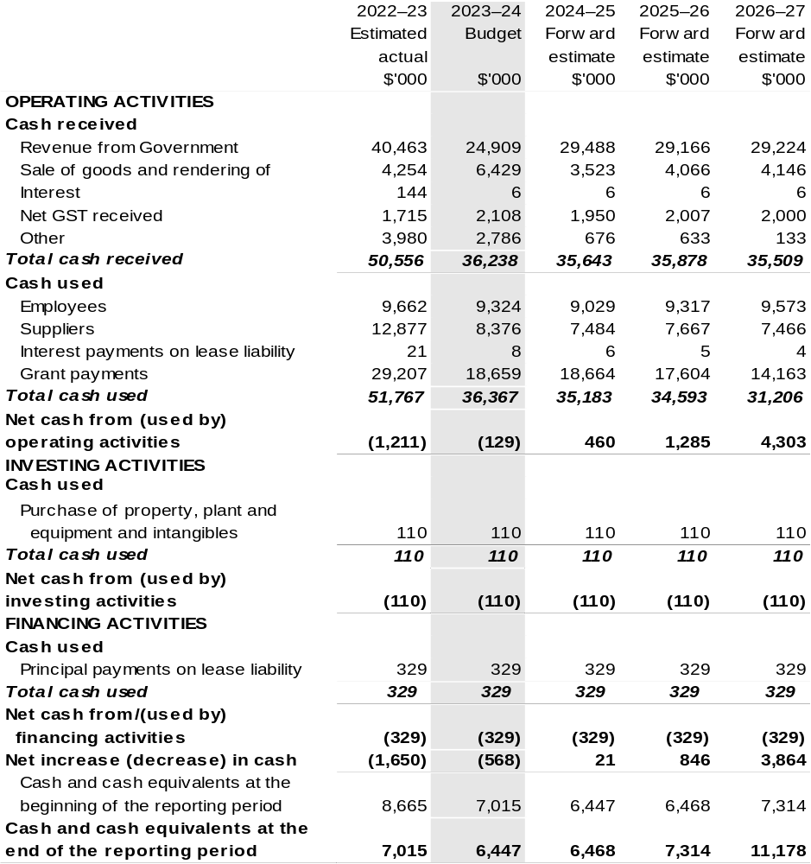

Prepared on Australian Accounting Standards basis.

Table 3.5: Departmental capital budget statement (for the period ended 30 June)
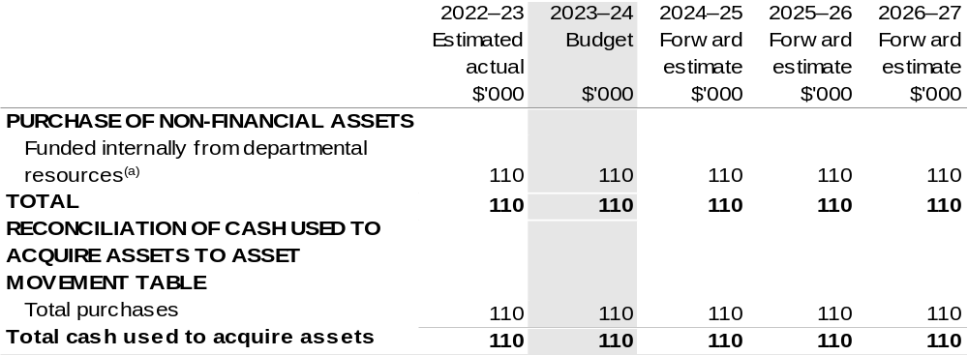
(a) Includes the following s74 external revenue:
– internally developed assets.

Consistent with information contained in the Statement of Asset Movements and the Budgeted Statement of Cash Flows.

Prepared on Australian Accounting Standards basis.

Table 3.6: Statement of departmental asset movements (Budget year 2023–24)
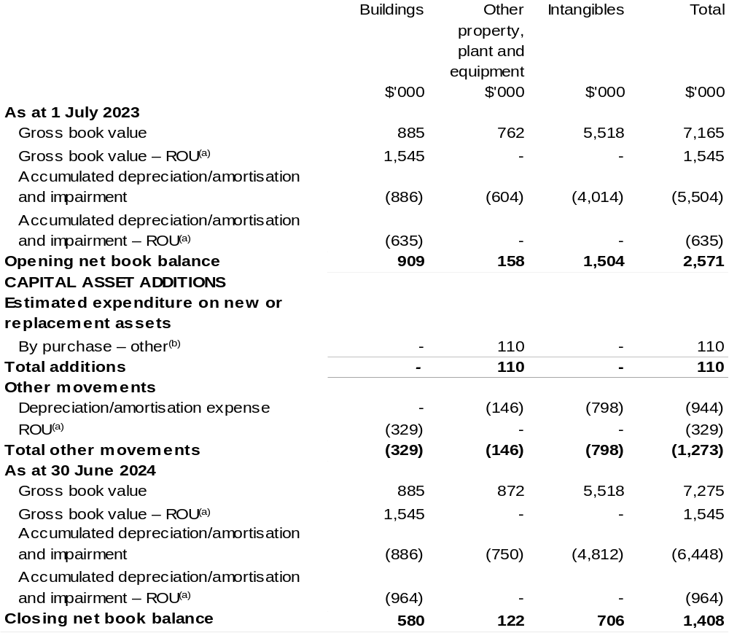

(a) Applies to leases under AASB 16 Leases. Right of Use (ROU).
(b) ‘By purchase – other’ refers to funding provided through other internal funding sources.

Prepared on Australian Accounting Standards basis.

