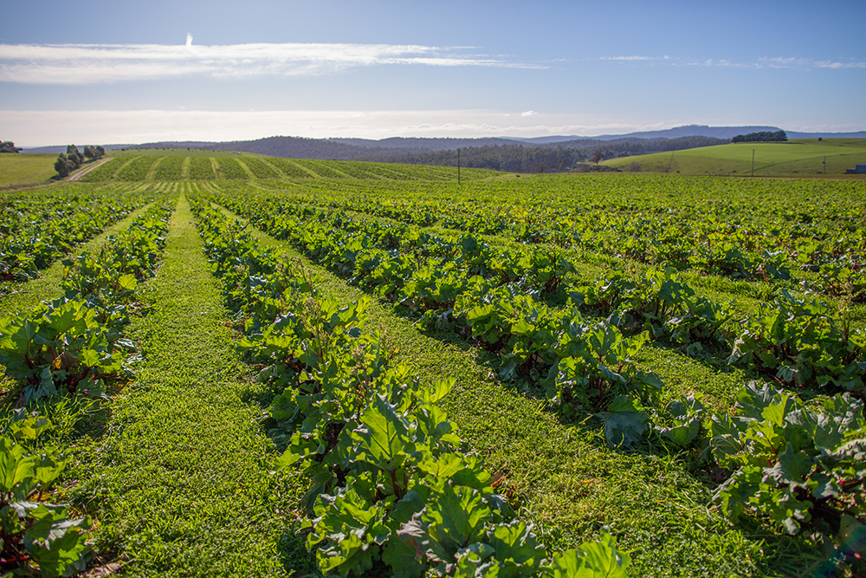
Securing the future of agricultural trade
$104 million

Australia’s agricultural industries are trade focused, and Australia’s agricultural export systems are world-leading – and have been for many years, but we must continue to work hard to maintain our world-leading status.
In recent years, the rate of change in Australia’s export trade landscape has accelerated. Our market access requirements are changing and the global agricultural trade environment is becoming more complex.
Trading partner notifications of new measures and rules (for example, sanitary and phytosanitary, and technical barriers to trade) have grown in number, detail and sophistication.
Countries, especially within our region, are also increasingly alert to plant and animal disease status and freedom, evidenced by very recent events relating to lumpy skin disease (LSD) and foot-and-mouth disease.
What’s being funded
The Australian Government is committing $104.3 million to support our agricultural commodity groups navigate these changes, through stronger export and agricultural trade services. It builds on the government’s continued support in assisting the agriculture sector in their goal to become a $100 billion industry by 2030.
Enabling agriculture exports into the future
The Australian Government is investing a total of $95.5 million over 3 years to ensure Australia’s regulatory export and trade system remains able to meet the needs of both our exporters and the expectations of our trading partners, while supporting industry to achieve its goals now and into the future.
This measure consists of $91.8 million over 2 years, to sustain the delivery of key export trade and regulatory functions. This funding will ensure we are able to service the growing demands of Australian exporters, and continue to fulfil existing export regulatory and legislative obligations and trading partner requirements—all necessary to maintain and grow agricultural market access.
It will enable continued responsiveness to a changing trade landscape, reducing the risk of market access problems which have the potential for significant financial impacts on exporters of perishable or seasonal goods.
A further $3.7 million over 3 years has been provided to enable the development of an ongoing sustainable funding model. This will ensure the department remains appropriately resourced to carry out its agricultural trade and exports functions into the future.
Live cattle trade disruption
A further $8.8 million will be invested over 2 years to support the ongoing trade of live cattle with Indonesia and Malaysia.
On 8 September 2023, the temporary suspension and restrictions imposed by Indonesian officials on live cattle and buffalo exports from a combined 7 registered establishments across northern Australia were lifted after the department negotiated an agreement with the Indonesian Quarantine Authority.
Prompt action by the department also saw the temporary suspension lifted by Malaysia. Subsequent effort by the department and industry demonstrating that Australia remains free of LSD supported a resumption of trade with additional requirements on cattle exports to Indonesia, and the department will continue to engage with stakeholders and provide assurances of our animal health status to trading partners.
There remains work to do in order to mitigate, as much as possible, suspensions of trade in live cattle from Australia to its export markets, including the development of an appropriate return to Australia protocol.
Why this is important
Australian agriculture, fisheries and forestry is a substantial part of the Australian economy, with exports contributing around $1.6 billion every week (total $83 billion in 2022–23).
Many communities, especially in regional Australia, are reliant on agricultural trade and exports. Australia exports more than 70% of its agricultural production, while 4 out of 5 jobs in agriculture are in rural and regional Australia. More than 50% of jobs in agriculture, fisheries and forestry are linked to an international trade activity (ABARES, 2019).
This investment maintains and builds on existing and potential market access, our international reputation, and our ability to negotiate and influence (bilaterally and multilaterally) for favourable conditions for our agricultural industries.
It protects employment in remote, regional and peri-urban areas, by ensuring export-registered establishments can continue to operate and/or maintain capacity because the regulatory and market access work required here in Australia by the department is adequately funded.
How much this will cost
 | 2023-24  $m | 2024-25  $m | 2025-26  $m | 2026-27  $m | TOTAL  $m
Facilitating agricultural exports
Enabling agriculture exports into the future | 47.848 | 47.050 | 0.628 | - | 95.526
Live cattle trade disruption | 5.486 | 3.332 | - | - | 8.818
Subtotal | 53.334 | 50.382 | 0.628 | - | 104.344
More information
For more information about facilitating agricultural exports visit agriculture.gov.au
For more information about the 2023–24 MYEFO visit budget.gov.au

