Portfolio Additional
Estimates Statements 2019–20

Agriculture, Water and Environment Portfolio

Explanations of Additional Estimates 2019–20

© Commonwealth of Australia 2020
ISSN: 2652-4589 (print) 2652-4597 (online)
This publication is available for your use under a Creative Commons BY Attribution 3.0 Australia licence, with the exception of the Commonwealth Coat of Arms, the Department of Agriculture, Water and the Environment logo, photographs, images, signatures and where otherwise stated. The full licence terms are available from http://creativecommons.org /licenses/by/3.0/au/legalcode.


Use of Department of Agriculture, Water and the Environment material under a Creative Commons BY Attribution 3.0 Australia licence requires you to attribute the work (but not in any way that suggests that the Department of Agriculture endorses you or your use of the work).
Department of Agriculture, Water and the Environment material used ‘as supplied’.
Provided you have not modified or transformed Department of Agriculture, Water and the Environment material in any way including, for example, by changing the department’s text; calculating percentage changes; graphing or charting data; or deriving new statistics from published Department of Agriculture, Water and the Environment statistics, then the department prefers the following attribution:
Source: Australian Government Department of Agriculture, Water and the Environment
Derivative material
If you have modified or transformed Department of Agriculture, Water and the Environment material, or derived new material from those of the Department of Agriculture, Water and the Environment in any way, then the department prefers the following attribution:
Based on Australian Government Department of Agriculture, Water and the Environment data
Use of the Coat of Arms
The terms under which the Coat of Arms can be used are set out on the It’s an Honour website (see www.itsanhonour.gov.au)
Other Uses
Inquiries regarding this licence and any other use of this document are welcome at:
External Budget Section
Finance and Business Support Division
Department of Agriculture, Water and the Environment
18 Marcus Clarke Street
CANBERRA CITY ACT 2601 Email: externalbudgetsbranch@agriculture.gov.au


The Hon David Littleproud MP The Hon Sussan Ley MP
Minister for Agriculture, Drought, Minister for the Environment
and Emergency Management

President of the Senate
Australian Senate
Parliament House
CANBERRA ACT 2600

Speaker
House of Representatives
Parliament House
CANBERRA ACT 2600

Dear Mr President
Dear Mr Speaker
We hereby submit Portfolio Additional Estimates Statements in support of the 2019–20 Additional Estimates for the Agriculture, Water and Environment portfolio.
These statements have been developed, and are submitted to the Parliament, as a statement on the outcomes for the portfolio.
I present these statements to provide accountability to the Parliament and, through
it, the public.
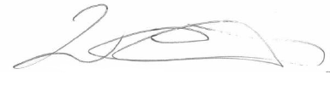
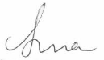
Yours sincerely

David Littleproud Sussan Ley

Abbreviations and conventions
The following notation may be used:
NEC/nec not elsewhere classified
- nil
.. not zero, but rounded to zero
na not applicable (unless otherwise specified)
nfp not for publication
$m $ million
$b $ billion
Figures in tables and in the text may be rounded. Figures in text are generally rounded to one decimal place, whereas figures in tables are generally rounded to the nearest thousand. Discrepancies in tables between totals and sums of components are due to rounding.
Enquiries
Should you have any enquiries regarding this publication please contact
Scott Brown, Chief Finance Officer, Department of Agriculture, Water and the Environment, on 02 6272 5523.
Links to Portfolio Budget Statements (including Portfolio Additional Estimates Statements and Portfolio Supplementary Additional Estimates Statements) can be located on the Australian Government Budget website at www.budget.gov.au.

User guide
to the
Portfolio Additional
Estimate Statements

User Guide
The purpose of the 2019–20 Portfolio Additional Estimates Statements (PAES), like that of the Portfolio Budget Statements (PBS), is to inform Senators and Members of Parliament of the proposed allocation of resources to Government outcomes by entities within a portfolio. The focus of PAES differs from the PBS in one important aspect. While PAES includes an Entity Resource Statement to inform the Parliament of revised estimates of total resources available to an entity, its focus is to explain changes in resourcing by outcome(s) since the Budget. As such, PAES provides information on new measures and their impact on the financial and/or non-financial planned performance of programs supporting those outcomes.
PAES facilitates understanding of proposed appropriations in Appropriation Bills
(No. 3) and (No. 4) 2019–20. For this reason PAES is declared by the Appropriation Bills to be a ‘relevant document’ to the interpretation of the Bills according to section 15AB of the Acts Interpretation Act 1901.
Whereas the 2019–20 Mid-Year Economic and Fiscal Outlook (MYEFO) is a mid-year budget report that provides updated information to allow the assessment of the Government’s fiscal performance against its fiscal strategy, PAES update the most recent budget appropriations for entities within a portfolio.
Structure of the Portfolio Additional Estimates Statements
PAES is presented in three parts with subsections.
User Guide
Provides a brief introduction explaining the purpose of PAES.
Portfolio Overview
Provides an overview of the portfolio, including a chart that outlines the outcomes for entities in the portfolio.
Entity Additional Estimates Statements
A statement (under the name of the entity) for each entity affected by Additional Estimates.
Section 1: Entity overview and resources | This section details the changes in total resources available to an entity, the impact of any measures since Budget, and impact of Appropriation Bills (No. 3) and (No. 4) 2019–20.
Section 2: Revisions to entity outcomes and planned performance | This section details any changes to Government outcomes and/or any changes to the planned performance of entity programs.
Section 3: Special account flows and budgeted financial statements | This section contains updated explanatory tables on special account flows and staffing levels and revisions to the budgeted financial statements.
Portfolio glossary
Defines key terms relevant to the portfolio.
Contents
Portfolio overview 3
Entity additional estimates statements 11
Department of Agriculture, WATER AND THE ENVIRONMENT 13
BUREAU OF Meteorology 109
Great Barrier Reef Marine Park Authority 131
Regional Investment Corporation 155
Portfolio glossary 173

Portfolio Overview

Portfolio Overview
Since the 2019–20 Portfolio Budget Statements (PBS) the following changes have occurred:
- The Hon. David Littleproud MP was appointed Minister for Agriculture, Drought and Emergency Management;
- The Hon. Sussan Ley MP was appointed Minister for the Environment;
- The Hon. Keith Pitt MP was appointed Minister for Resources, Water and Northern Australia;
- The Hon. Trevor Evans MP was appointed Assistant Minister for Waste Reduction and Environmental Management;
- Senator the Hon. Jonathon Duniam was appointed Assistant Minister for Forestry and Fisheries;
- The Agriculture and Water Resources portfolio was renamed the Agriculture portfolio; and
- The Department of Agriculture and Water Resources was renamed the Department of Agriculture.
As a result of the Administrative Arrangements Orders (AAO), which took effect on 1 February 2020, the following changes occurred:
- The Agriculture, Water and Environment portfolio was created;
- The Department of the Environment and Energy was renamed the Department of Agriculture, Water and the Environment;
- Agriculture and Water functions were transferred to the Department of Agriculture, Water and the Environment;
- Climate change adaptation strategy and co-ordination, and co-ordination of climate change science activities were transferred to the Department of Agriculture, Water and the Environment;
- Energy functions were transferred to the renamed Department of Industry, Science, Energy and Resources;
- National fuel quality standards and the Fuel Quality Standards Act 2000 were transferred to the Department of Industry, Science, Energy and Resources;
- AgriFutures Australia, Australian Fisheries Management Authority, Australian Pesticides and Veterinary Medicines Authority, Cotton Research and Development Corporation, Fisheries Research and Development Corporation, Grains Research and Development Corporation, Murray-Darling Basin Authority, Regional Investment Corporation and Wine Australia were transferred to the Agriculture, Water and Environment portfolio;
- Bureau of Meteorology, Director of National Parks, Great Barrier Reef Marine Park Authority and Sydney Harbour Federation Trust were transferred to the Agriculture, Water and Environment portfolio; and
- Australian Renewable Energy Agency, Clean Energy Finance Corporation, Clean Energy Regulator, Climate Change Authority and Snowy Hydro Limited were transferred to the Industry, Science, Energy and Resources portfolio.
From 1 February 2020 the Agriculture, Water and Environment portfolio consists of the Department of Agriculture, Water and the Environment (the department) and
13 portfolio bodies. A revised portfolio structure reflecting these changes is presented at Figure 1.
The responsibilities of the department and the portfolio entities have not changed since the 2019–20 PBS for the former Agriculture and Water Resources and Environment and Energy portfolios.
The department, the Bureau of Meteorology and the Great Barrier Reef Marine Park Authority are receiving additional appropriations through Appropriation Bills (No. 3) and (No. 4) 2019–20. The Regional Investment Corporation will receive additional resourcing that will pass through the department.

Figure 1: Agriculture, Water and Environment Portfolio Structure
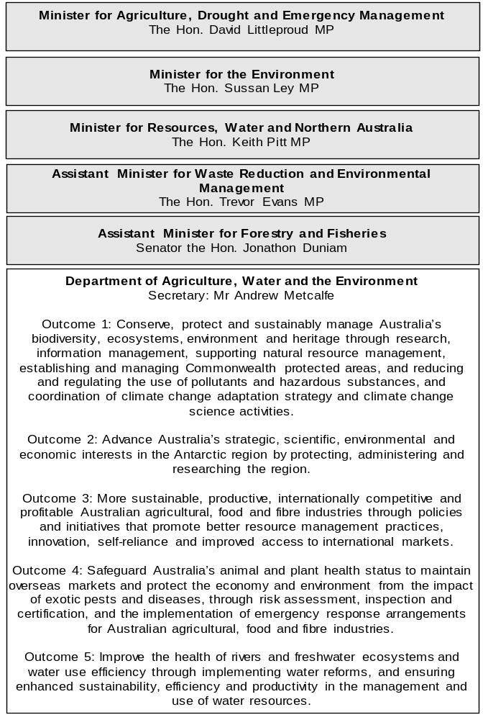

Figure 1: Agriculture, Water and Environment Portfolio Structure (continued)
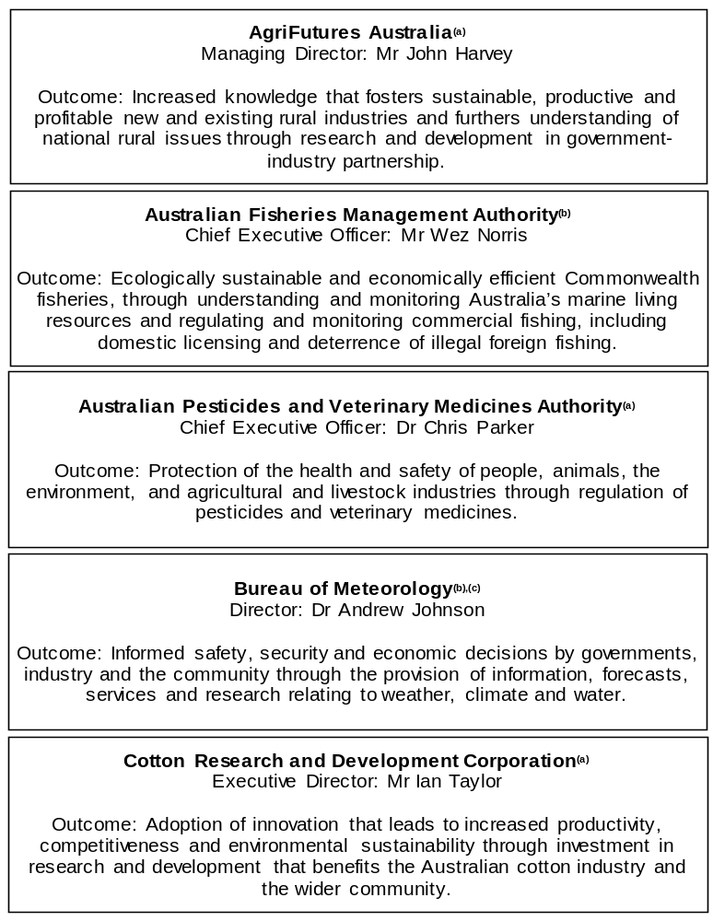

Figure 1: Agriculture, Water and Environment Portfolio Structure (continued)
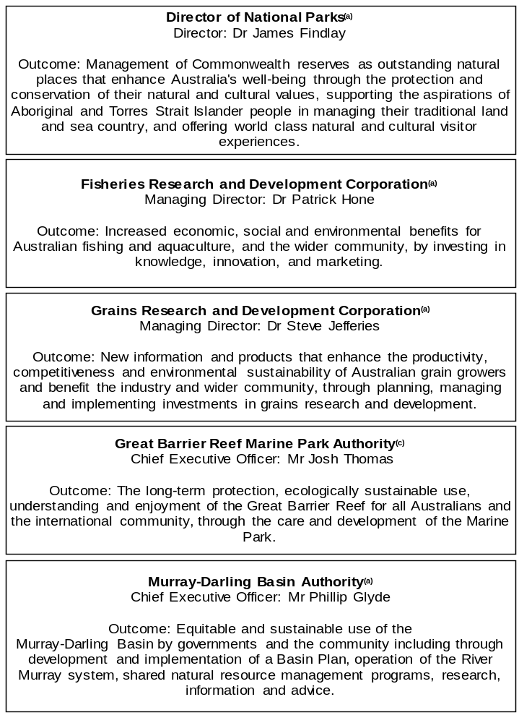

Figure 1: Agriculture, Water and Environment Portfolio Structure (continued)
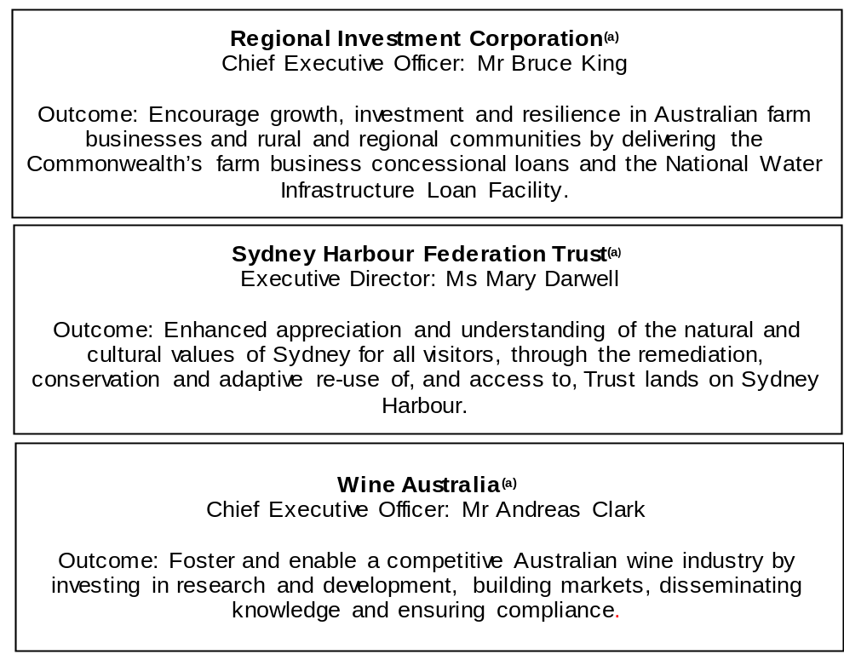

(a) ‘Corporate Commonwealth Entity’ (CCE) as defined under the Public Governance, Performance and Accountability Act 2013.
(b) ‘Non-corporate Commonwealth Entity’ (NCCE) as defined under the Public Governance, Performance and Accountability Act 2013.
(c) ‘Executive Agency’ as defined under the Public Service Act 1999.

Other industry-owned and not-for-profit companies related to the portfolio
Australian industry-owned companies are independent corporate entities, established under specific legislation with expertise-based boards. The company members appoint the directors of the board. Companies are accountable to the Minister for Agriculture through legislation and statutory funding agreements and are entitled to receive industry levies and matching Australian Government funding for eligible research and development (R&D). These entities report outside of the general government sector.
The following industry-owned companies provide R&D and marketing services:
- Australian Eggs Limited;
- Australian Livestock Export Corporation Limited;
- Australian Meat Processor Corporation Limited;
- Australian Pork Limited;
- Australian Wool Innovation Limited;
- Dairy Australia Limited;
- Forest and Wood Products Australia Limited;
- Horticulture Innovation Australia Limited;
- Meat and Livestock Australia Limited; and
- Sugar Research Australia Limited.
The Australian Government provides funding to the following not-for-profit, portfolio-related companies:
- Animal Health Australia;
- Landcare Australia Limited; and
- Plant Health Australia Limited.

Entity additional estimates statements

Department of Agriculture, Water and the Environment
Section 1: Entity overview and resources 15
1.1 Strategic direction statement 15
1.2 Entity resource statement 18
1.3 Entity measures 24
1.4 Additional estimates, resourcing and variations to outcomes 35
1.5 Breakdown of additional estimates by Appropriation Bill 48
Section 2: Revisions to outcomes and planned
performance 51
2.1 Changes to outcome and program structures 51
2.2 Budgeted expenses and performance for Outcome 1 55
2.3 Budgeted expenses and performance for Outcome 2 61
2.4 Budgeted expenses and performance for Outcome 3 63
2.5 Budgeted expenses and performance for Outcome 4 74
2.6 Budgeted expenses and performance for Outcome 5 80
2.7 Budgeted expenses and performance for Outcome 6 84
2.8 Budgeted expenses and performance for Outcome 7 87
Section 3: Special account flows and budgeted financial
statements 90
3.1 Special account flows 90
3.2 Budgeted financial statements 93

Department of Agriculture, Water and the Environment

Section 1: Entity overview and resources

1.1 Strategic direction statement
The strategic direction of the Department of Agriculture, Water and the Environment is largely unchanged since the 2019–20 PBS for the former Department of Agriculture and Water Resources and Department of the Environment and Energy.
The creation of the new department has resulted in three outcomes from the former Department of Agriculture and Water Resources combining with two outcomes from the former Department of the Environment and Energy, as referred to in figure 1.
The following text outlines decisions of the Government since the 2019–20 Budget.
Outcome 1: Conserve, protect and sustainably manage Australia’s biodiversity, ecosystems, environment and heritage through research, information management, supporting natural resource management, establishing and managing Commonwealth protected areas, and reducing and regulating the use of pollutants and hazardous substances, and coordination of climate change adaptation strategy and climate change science activities.
The Government is taking action on recycling and waste to ensure a sustainable future for Australia by providing $15.1 million over two years to deliver a ban on the export of waste plastic, paper, glass and tyres, while building Australia’s capacity to generate high value commodities and associated demand. The Government is also creating a $20 million Product Stewardship Fund to support small and medium sized projects to develop product stewardship schemes and improve recycling rates of new and existing schemes.
$40.7 million will be provided to support short-term congestion busting measures in environment and heritage assessment and approval processes, and digital transformation of environmental assessments. This will reduce the administrative burden on businesses and deliver positive outcomes to the economy and the environment.

Outcome 2: Advance Australia’s strategic, scientific, environmental and economic interests in the Antarctic region by protecting, administering and researching the region.
The Government is making unprecedented investments in Antarctica that are vital to Australia’s longer-term strategic interests in the region and to reinforce Australia’s position as a leading Antarctic nation. This includes $58.8 million to support the final investment decision on the construction of Antarctica’s first paved runway near Davis research station, by funding environmental assessments and more detailed technical studies. $6.8 million will also be spent to support the establishment of Australia’s deep field traverse capability and delivering the globally significant Million Year Ice Core.
Outcome 3: More sustainable, productive, internationally competitive and profitable Australian agricultural, food and fibre industries through policies and initiatives that promote better resource management practices, innovation, self-reliance and improved access to international markets.
The Government is providing an additional $1.3 billion over four years to support farmers and communities in drought. These measures provide immediate action for those in drought, support for wider drought-affected communities and support for long-term resilience and preparedness. Another $36.2 million has been allocated to permanently increase the Farm Household Allowance asset test threshold to $5 million, increasing the availability of the payment to farmers with larger farm asset holdings and limited income.
The Government is also investing a further $67.4 million to strengthen and showcase the agriculture and fisheries sectors. Funding includes $20 million over two years to establish the Regional Agricultural Show Development Grants program to support regional show societies to upgrade and maintain existing infrastructure or build new infrastructure. The Government will provide $10 million over three years to better educate Australian students about agriculture and $3.5 million over four years for a new National Farm Safety Education Fund. Another $20 million will support local councils to improve, maintain or build new boating, marine rescue, fishing and camping facilities and $8 million will be spent to support non-government organisations to restore marine and estuarine habitats and ensure the health of fisheries and fish stocks.
The Government is also providing $25.9 million over three years to trial a horticultural netting program to improve resilience on farms across New South Wales, Queensland, South Australia, Victoria and Western Australia.

Outcome 4: Safeguard Australia’s animal and plant health status to maintain overseas markets and protect the economy and environment from the impact of exotic pests and diseases, through risk assessment, inspection and certification, and the implementation of emergency response arrangements for Australian agricultural, food and fibre industries.
The Government has committed $66.6 million over two years to address the biosecurity risk posed by African swine fever. The funding will increase screening at Australia’s international airports and mail centres to increase detection capability, and strengthen global and industry preparedness.
The Government is also investing $29.2 million over four years to streamline export processes by completing the delivery of a digital export certification management system, which will provide a modern and secure approach to assuring that produce meets importing country requirements.
Outcome 5: Improve the health of rivers and freshwater ecosystems and water use efficiency through implementing water reforms, and ensuring enhanced sustainability, efficiency and productivity in the management and use of water resources.
Under the Water for Fodder program, the Government is providing funding to the South Australian Government to secure up to 100 gigalitres of water for farmers in the Murray-Darling Basin to grow fodder, silage and pasture at a discounted rate.
The Government is investing $7.6 million over four years to establish the Office of the Inspector-General of Murray-Darling Basin Water Resources. The Inspector-General will improve transparency, accountability and community confidence in the delivery of the Murray-Darling Basin Plan.

1.2 Entity resource statement
These tables detail the resourcing for the Department of Agriculture, Water and the Environment at 2019–20 Additional Estimates. Table 1.1 outlines the total resourcing available from all sources for the 2019–20 Budget year, including variations through Appropriation Bills (No. 3) and (No. 4) 2019–20, Special Appropriations and Special Accounts.

Table 1.1: Department of Agriculture, Water and the Environment (DAWE) – Resource Statement as at 2019–20 Additional Estimates – February 2020
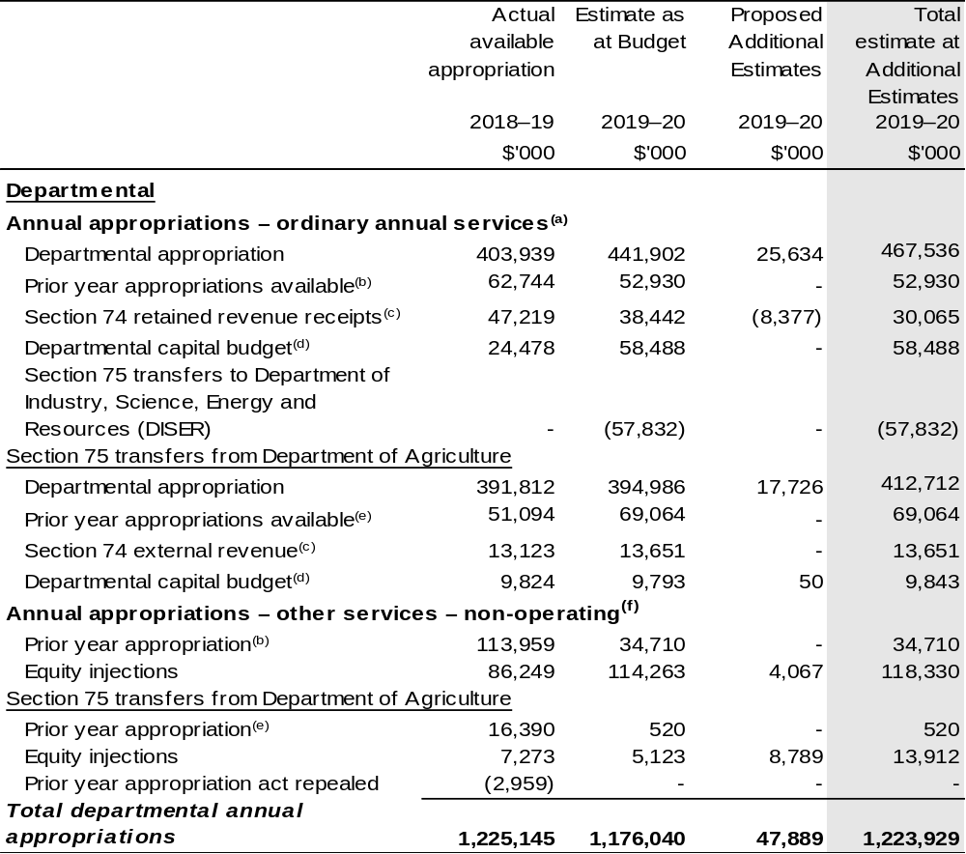

Continued on following pages

Table 1.1: Department of Agriculture, Water and the Environment – Resource Statement as at 2019–20 Additional Estimates – February 2020 (continued)
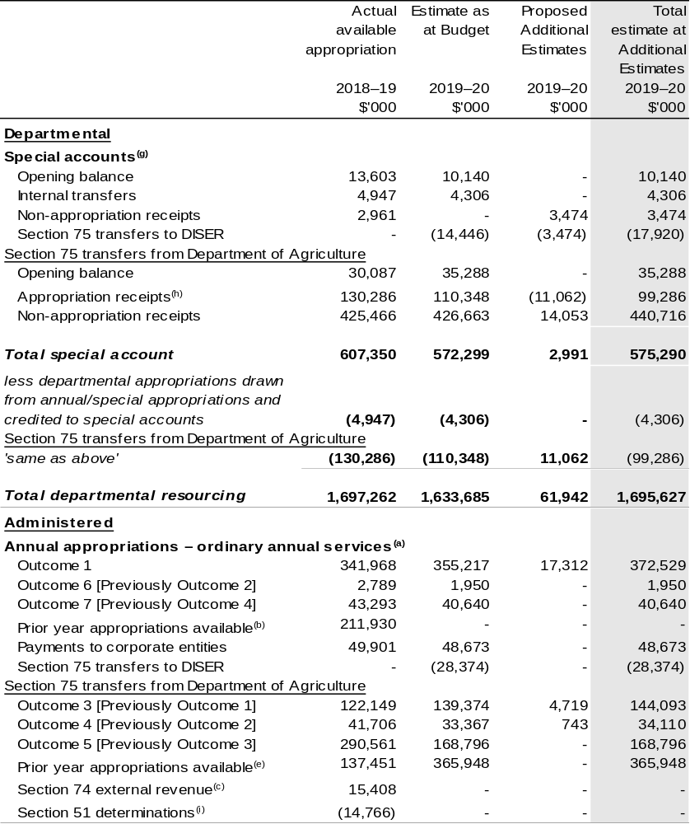

Continued on following pages

Table 1.1: Department of Agriculture, Water and the Environment – Resource Statement as at 2019–20 Additional Estimates – February 2020 (continued)
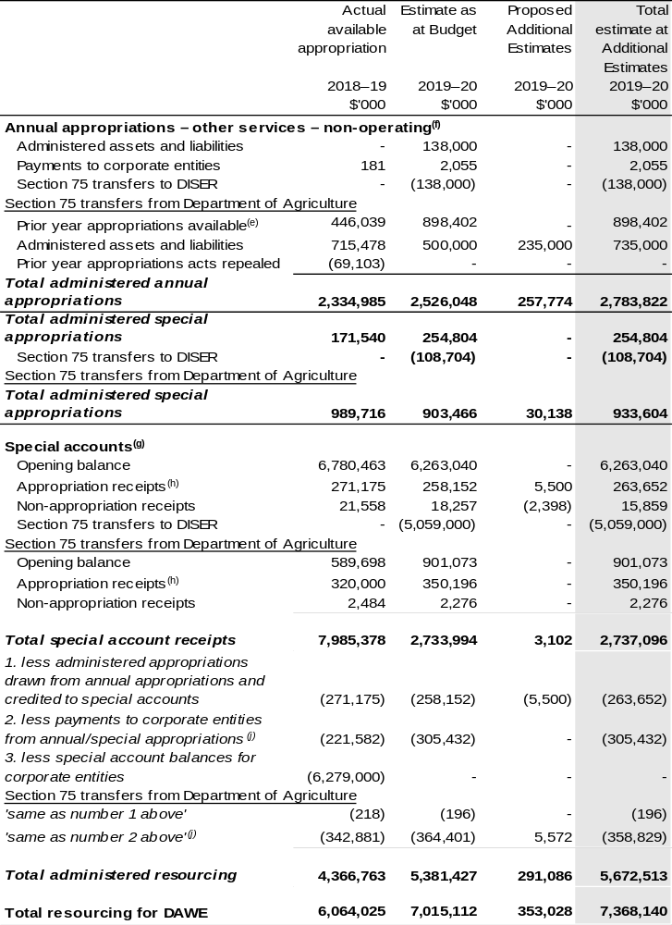

Continued on following pages
Table 1.1: Department of Agriculture, Water and the Environment – Resource Statement as at 2019–20 Additional Estimates – February 2020 (continued)
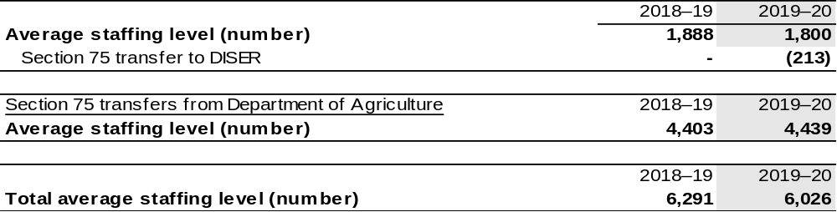

- Appropriation Act (No. 1) 2019–20 and Appropriation Bill (No. 3) 2019–20.
- Excludes $28.355 million subject to administrative quarantine by the Department of Finance or withheld under section 51 of the Public Governance, Performance and Accountability Act 2013 (PGPA Act).
- Estimated external revenue under section 74 of the PGPA Act.
- Departmental capital budgets are not separately identified in the Appropriation Bills and form part of ordinary annual services items. Please refer to Table 3.6 for further details. For accounting purposes, this amount has been designated as a 'contribution by owner'.
- Excludes $14.766 million subject to administrative quarantine by the Department of Finance or withheld under section 51 of the PGPA Act.
- Appropriation Act (No. 2) 2019–20 and Appropriation Bill (No. 4) 2019–20.
- Excludes 'Special Public Money' held in accounts like Other Trust Monies accounts (OTM), Services for Other Government and Non-agency Bodies accounts (SOG) or Services for Other Entities and Trust Moneys accounts (SOETM). For further information on special accounts see Table 3.1.
- Amounts credited to the special account(s) from the department’s annual appropriations or crediting provisions in special account acts.
- A direction under section 51 of the PGPA Act, withholds access to appropriated funds resulting in a ‘loss of control’ for the entity over relevant amounts, for example Government decisions, movements of funds, reallocations or reclassifications.
- 'Corporate entities' are corporate Commonwealth entities and Commonwealth companies as defined under the PGPA Act.

The Department of Agriculture, Water and Environment has received $2.875 billion under a section 75 determination.

Prepared on a resourcing (i.e. appropriations available) basis.

Please note: All figures shown above are GST exclusive – these may not match figures in the cash flow statement.

Continued on following pages

Table 1.1: Department of Agriculture, Water and the Environment – Resource Statement as at 2019–20 Additional Estimates – February 2020 (continued)
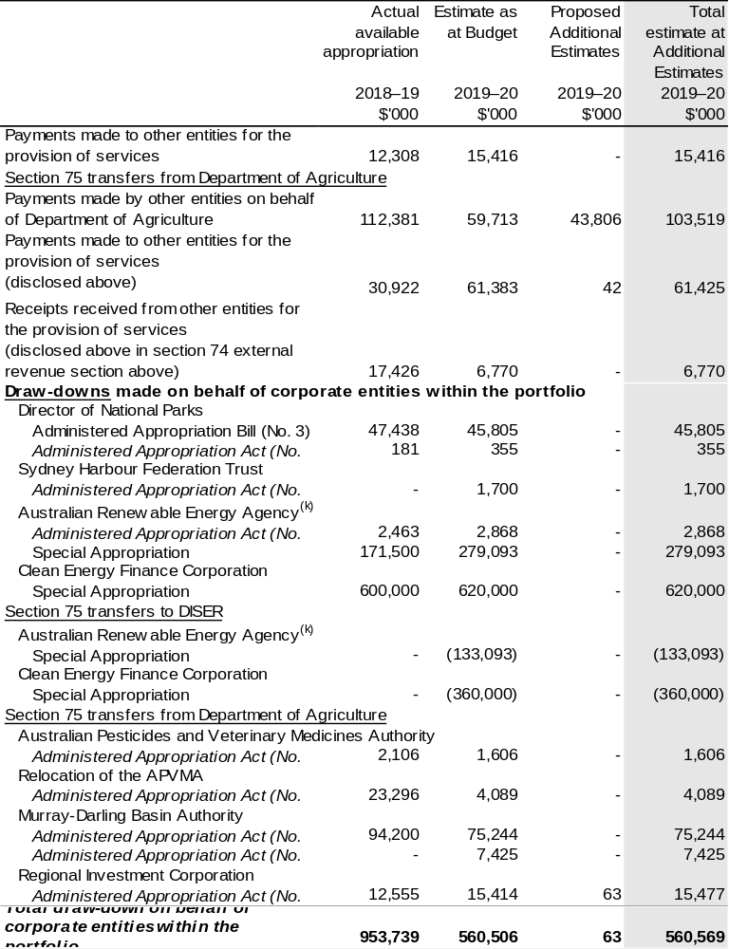

- Includes a re-profiling of Special Appropriation funding paid to the Australian Renewable Energy Agency due to fluctuations in the timing of grant payments by the agency.

Continued on following pages

Table 1.1: Department of Agriculture, Water and the Environment – Resource Statement as at 2019–20 Additional Estimates – February 2020 (continued)
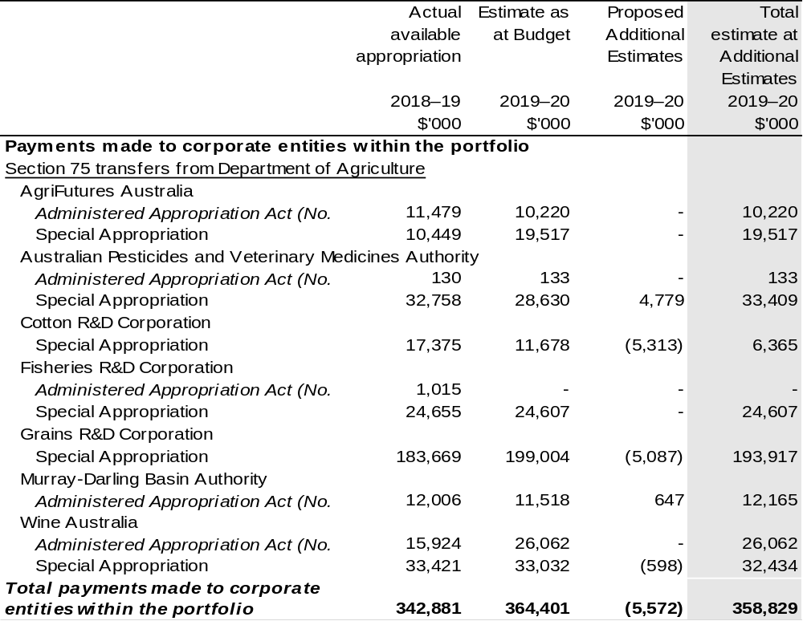

1.3 Entity measures
Table 1.2 and 1.3 summarises new Government measures taken since the 2019–20 Budget. The tables are split into revenue, expense and capital measures, with the affected program identified. The tables are separated by the former departments so that the reader can easily identify measures relating to agriculture or environment.

Table 1.2: Department of Agriculture, Water and the Environment – measures since 2019–20 Budget – Environment
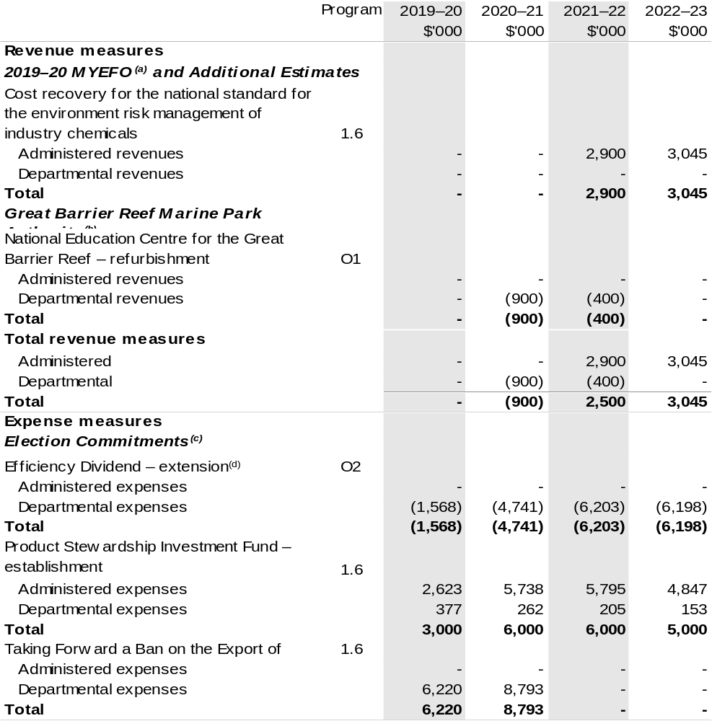

Continued on following pages

Table 1.2: Department of Agriculture, Water and the Environment – measures since 2019–20 Budget – Environment (continued)
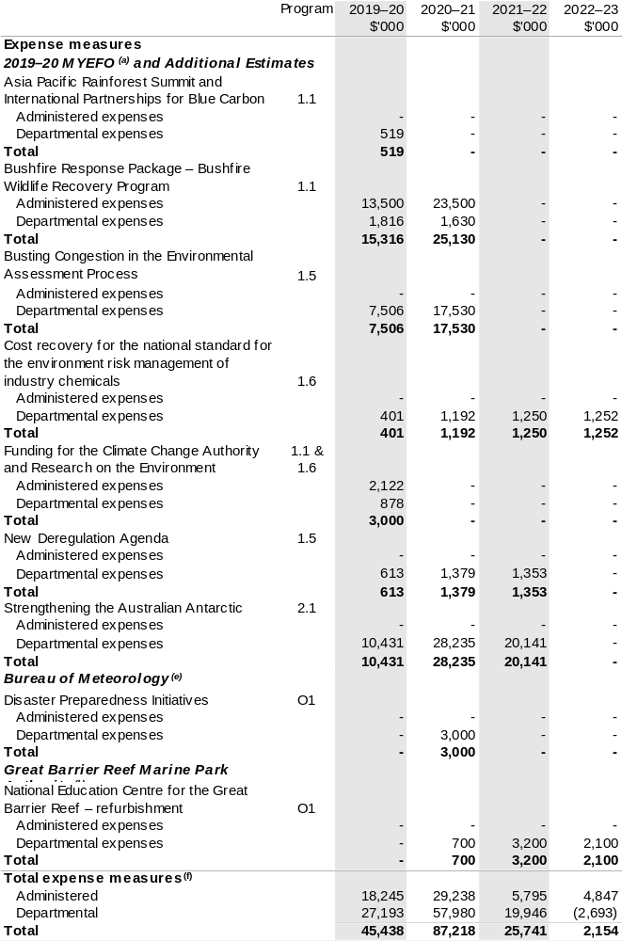
Table 1.2: Department of Agriculture, Water and the Environment – measures since 2019–20 Budget – Environment (continued)
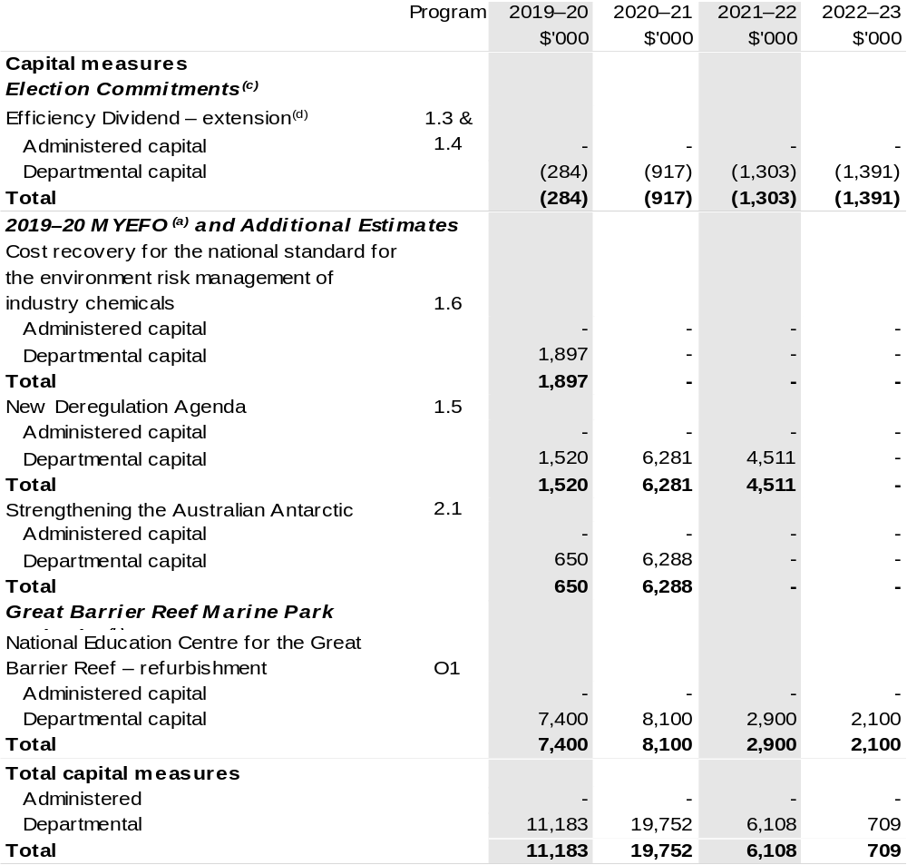

- These measures were published in 2019–20 MYEFO under the Environment and Energy portfolio.
- Funding for this measure passes through the department to the Great Barrier Reef Marine Park Authority.
- These measures were announced during the 2019 election, with details published at www.electioncostings.gov.au under the Environment and Energy portfolio.
- The lead entity for this measure is the Department of Finance. The measure was announced during the 2019 election, with details published at www.electioncostings.gov.au under the Finance portfolio.
- Funding for this measure passes through the department to the Bureau of Meteorology.
- The totals do not reconcile to additional appropriations provided through Appropriation Bills (No. 3) and (No. 4) as appropriation for 2019 election commitments has already been provided through Appropriation Acts (No. 1) and (No. 2) 2019–20.

Prepared on a Government Financial Statistics (fiscal) basis

Continued on following pages

Table 1.3: Department of Agriculture, Water and the Environment – measures since 2019–20 Budget – Agriculture and Water
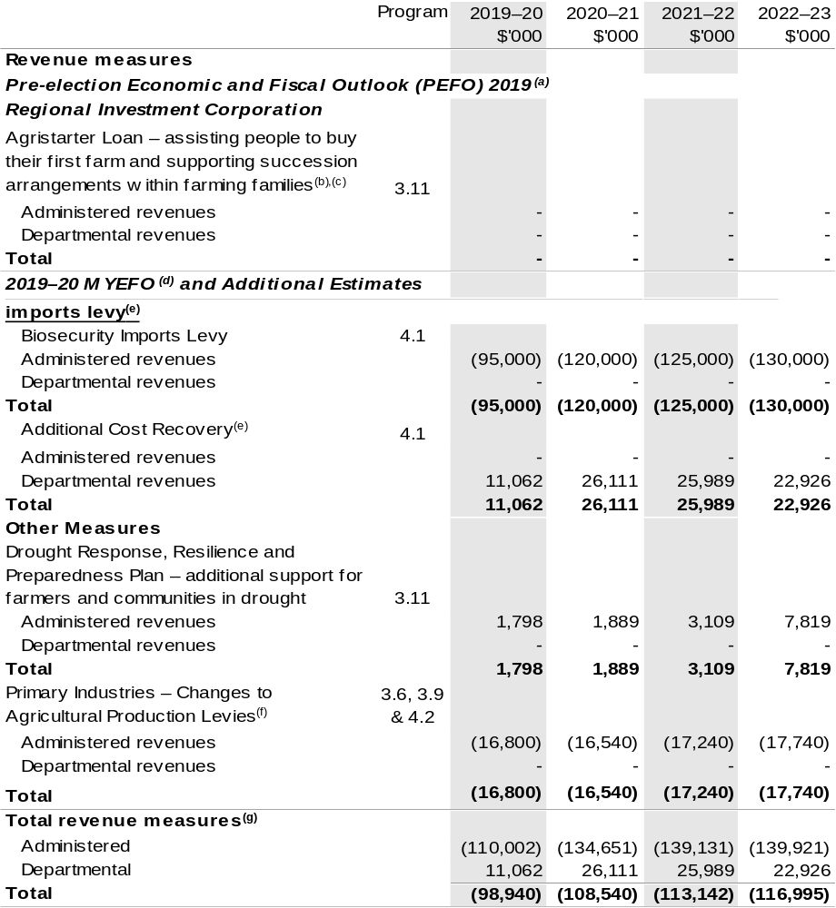

Continued on following pages

Table 1.3: Department of Agriculture, Water and the Environment – measures since 2019–20 Budget – Agriculture and Water (continued)
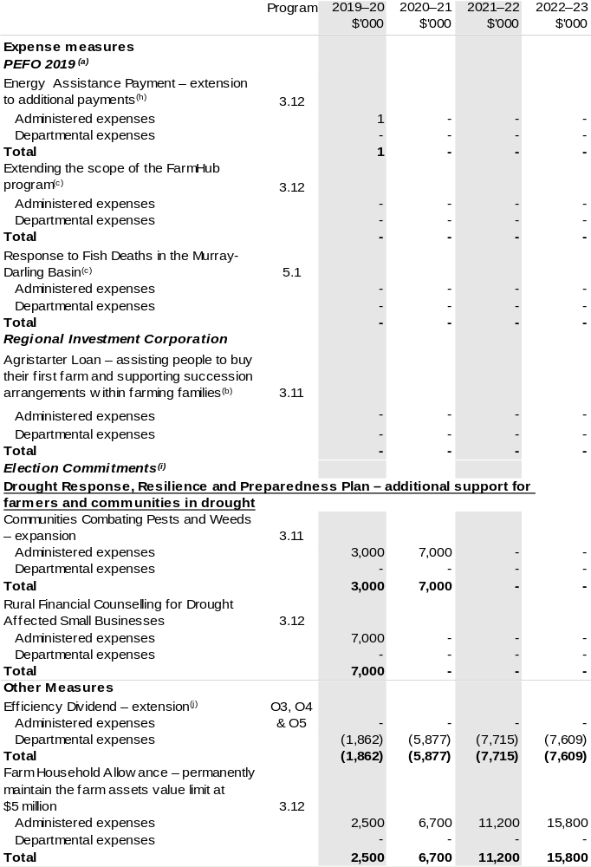

Continued on following pages
Table 1.3: Department of Agriculture, Water and the Environment – measures since 2019–20 Budget – Agriculture and Water (continued)
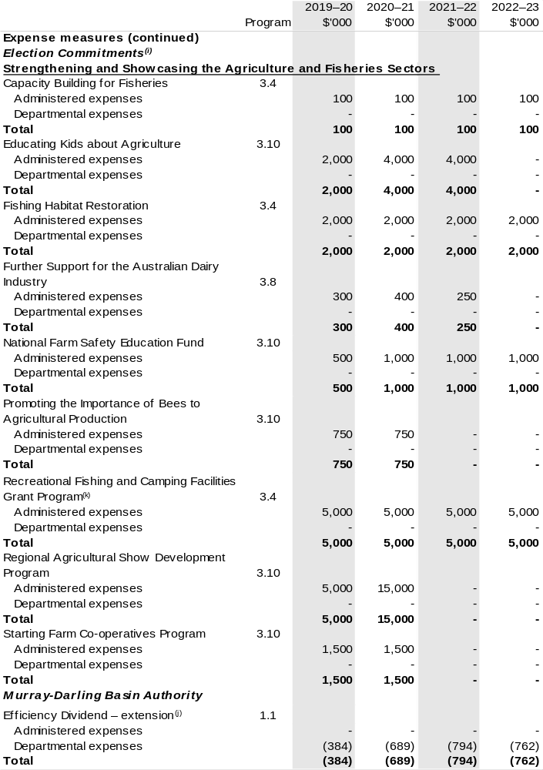

Continued on following pages
Table 1.3: Department of Agriculture, Water and the Environment – measures since 2019–20 Budget – Agriculture and Water (continued)
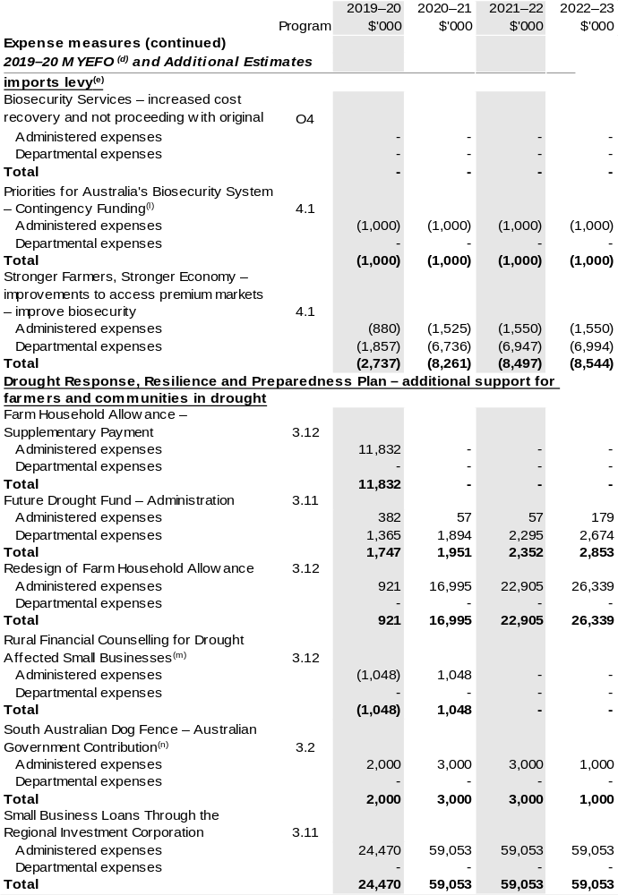

Continued on following pages
Table 1.3: Department of Agriculture, Water and the Environment – measures since 2019–20 Budget – Agriculture and Water (continued)
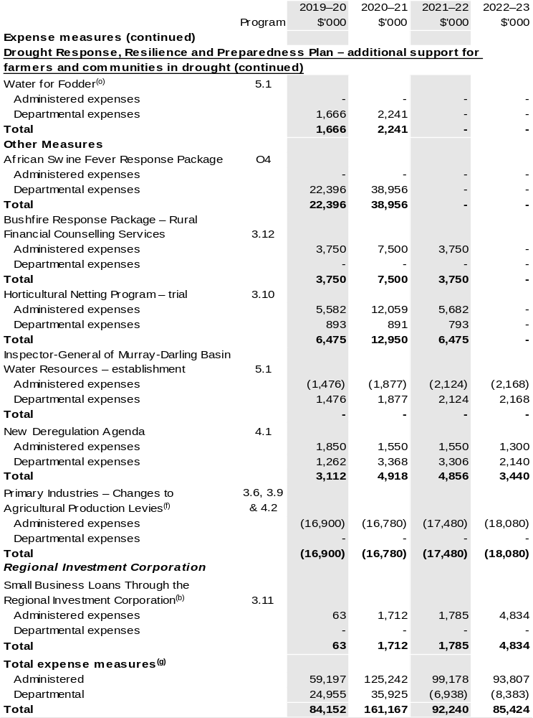

Continued on following pages

Table 1.3: Department of Agriculture, Water and the Environment – measures since 2019–20 Budget – Agriculture and Water (continued)
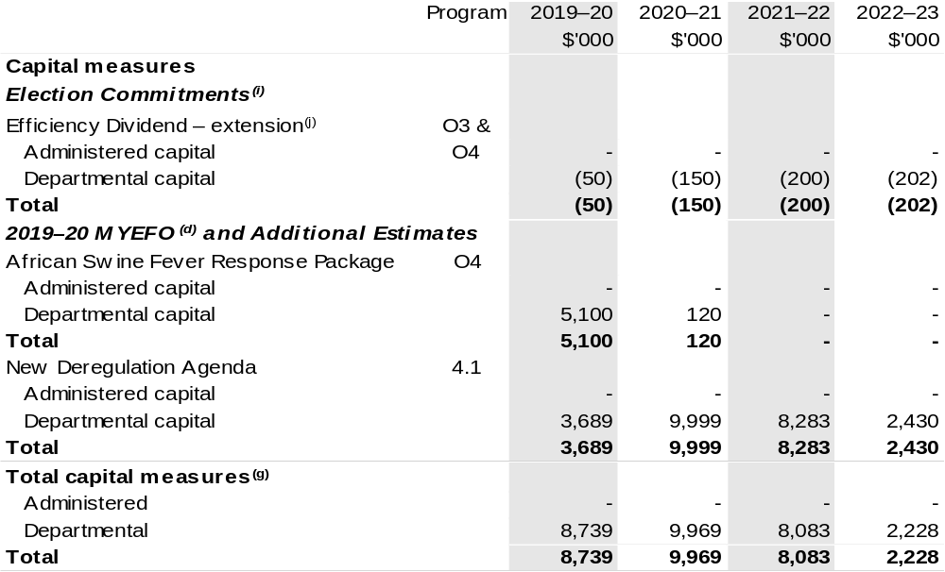

- These measures were published in the 2019 Pre-election Economic and Fiscal Outlook under the Agriculture and Water Resources portfolio.
- Funding for this measure passes through the department to the Regional Investment Corporation.
- This measure is being funded from within existing resources.
- These measures were published in the 2019–20 MYEFO under the Agriculture portfolio.
- The measure Biosecurity Services – increased cost recovery and not proceeding with original imports levy comprises a reduction in departmental appropriation and a matching increase in departmental revenue.

Continued on following pages

Table 1.3: Department of Agriculture, Water and the Environment – measures since 2019–20 Budget – Agriculture and Water (continued)
- The measure Primary Industries – Changes to agricultural production levies appears under revenue and expense measure headings. These changes are made at the request of the relevant industry.
The measure comprises:
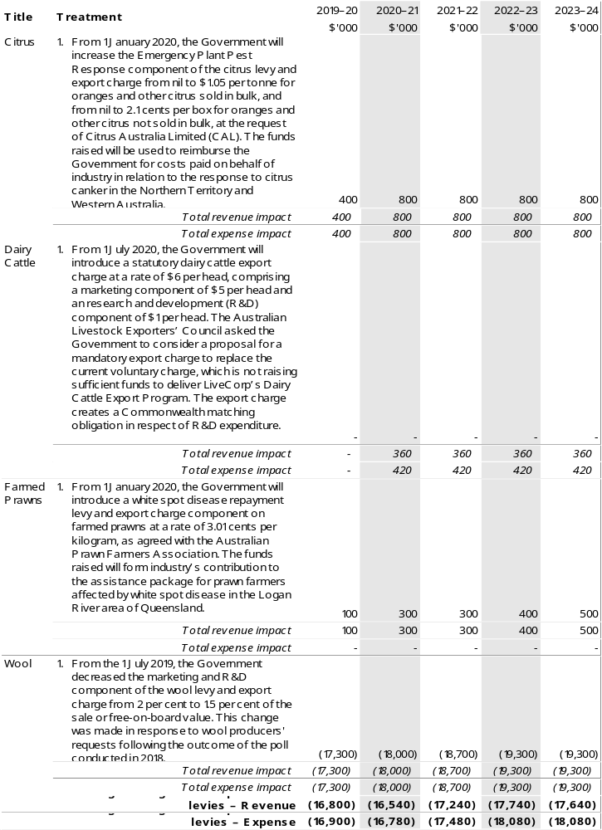
Continued on following page
Table 1.3: Department of Agriculture, Water and the Environment – measures since 2019–20 Budget – Agriculture and Water (continued)

- The totals do not reconcile to additional appropriations provided through Appropriation Bills (No. 3) and (No. 4) as appropriation for 2019 election commitments has already been provided through Appropriation Acts (No. 1) and (No. 2) 2019–20.
- The lead entity for this measure is the Department of Social Services. The measure description appears in 2019 PEFO under the Social Services portfolio.
- These measures were announced during the 2019 election, with details published at www.electioncostings.gov.au under the Agriculture and Water Resources portfolio.
- The lead entity for this measure is the Department of Finance. The measure was announced during the 2019 election, with details published at www.electioncostings.gov.au under the Finance portfolio.
- This measure has been reclassified to be funded under the Federal Financial Relations Framework, which is administered by the Department of the Treasury.
- This measure also includes a reduction to the National Partnership on Pest and Disease Preparedness and Response Programs (SPP188), which is administered by the Department of the Treasury.
- This measure was to re-profile funding for the 2019 election commitment of the same name.
- This measure has been reclassified to be funded under the Federal Financial Relations Framework, which is administered by the Department of the Treasury.
- This measure was published as nfp at 2019–20 MYEFO due to commercial-in-confidence sensitivities, however it has since been announced.

Prepared on a Government Financial Statistics (fiscal) basis

1.4 Additional estimates, resourcing and variations to outcomes
The following tables detail changes in resourcing for the Department of Agriculture, Water and the Environment at Additional Estimates, by outcome. The tables show variations since the 2019–20 Budget due to new measures (as per Table 1.2 and 1.3) and variations due to other factors, such as movements of funds, reclassifications, reallocations and adjustments due to the efficiency dividend and changes in economic parameters.
The following tables are separated by the former departments so that the reader can easily identify whether measures and other variations relate to agriculture or environment. There is a separate table for each set of announcements since the 2019–20 Budget, comprising the 2019 Pre-election Economic and Fiscal Outlook (PEFO),
2019 Election Commitments, the 2019–20 Mid-Year Economic and Fiscal Outlook (MYEFO) and 2019–20 Additional Estimates.

Additional Estimates and other variations to outcomes since 2019–20 Budget – Environment

Table 1.4: Election Commitments
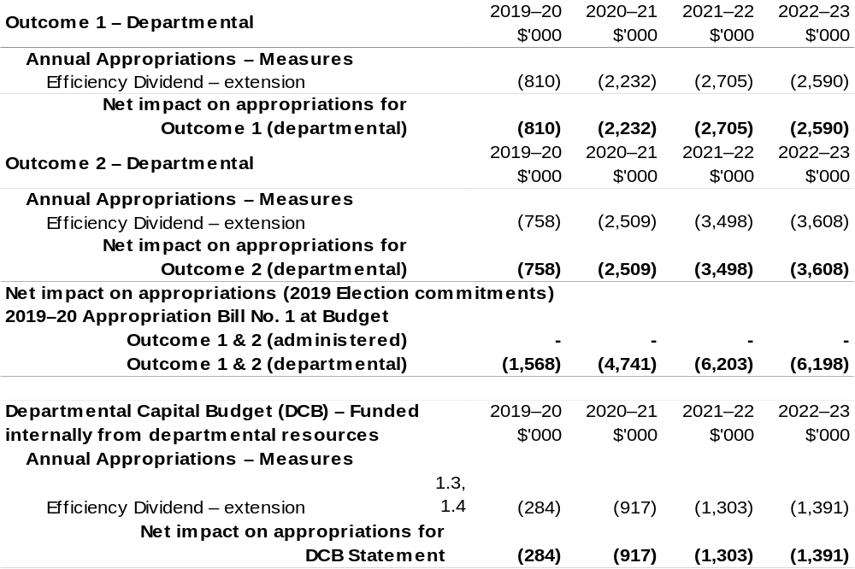
Continued on following pages

Table 1.5: 2019–20 MYEFO and Additional Estimates
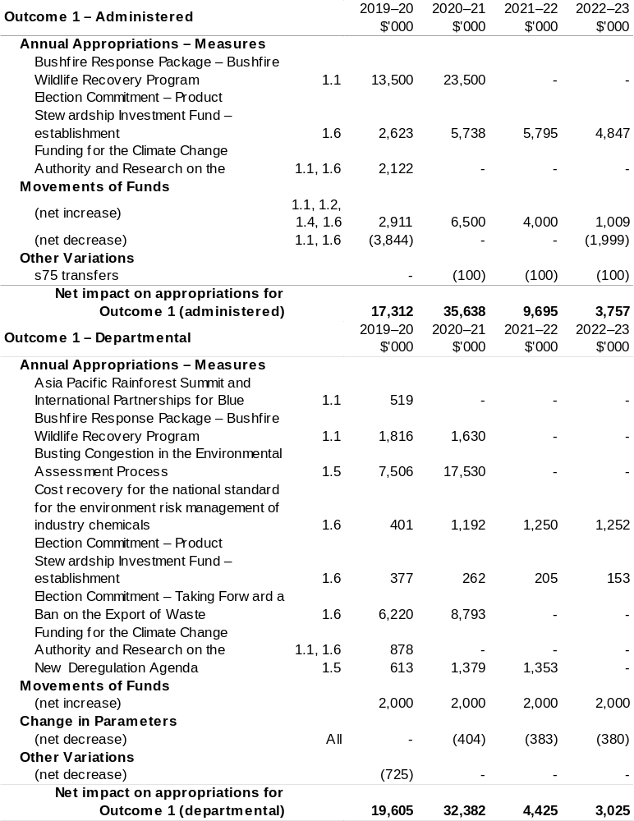
Continued on following pages

Table 1.5: 2019–20 MYEFO and Additional Estimates (continued)
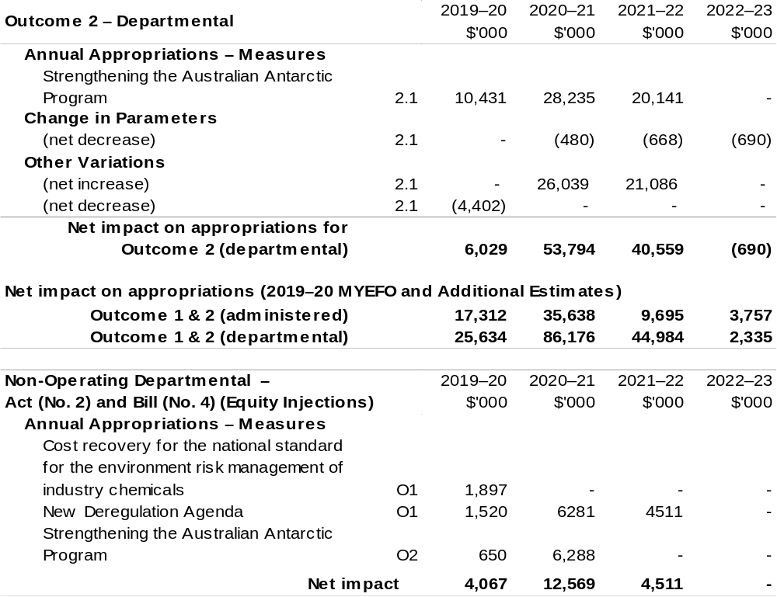
Continued on following pages

Additional Estimates and other variations to outcomes since 2019–20 Budget – Agriculture and Water

Table 1.6: PEFO 2019
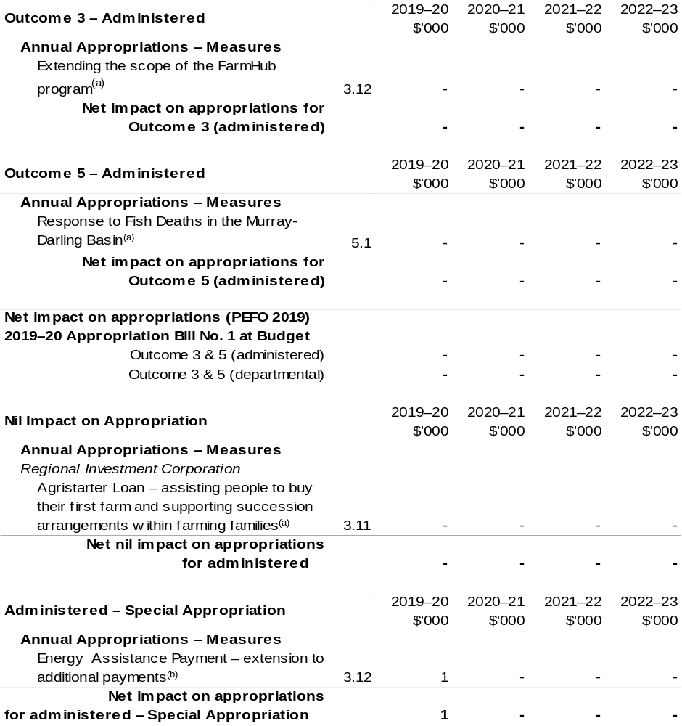
(a) This measure is being funded from within existing resources.
(b) The lead entity for this measure is the Department of Social Services. The measure description appears in 2019 PEFO under the Social Services portfolio.

Continued on following pages

Table 1.7: Election Commitments
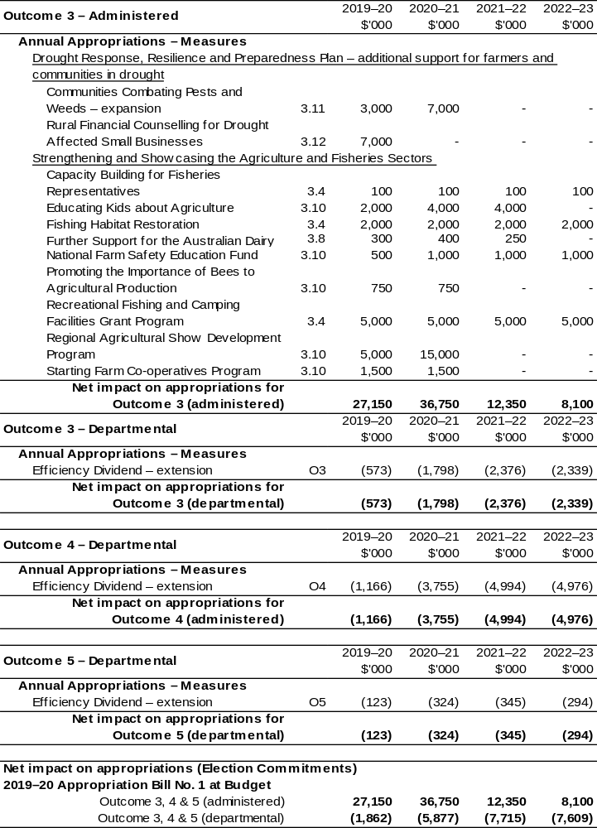
Continued on following pages

Table 1.7: Election Commitments (continued)
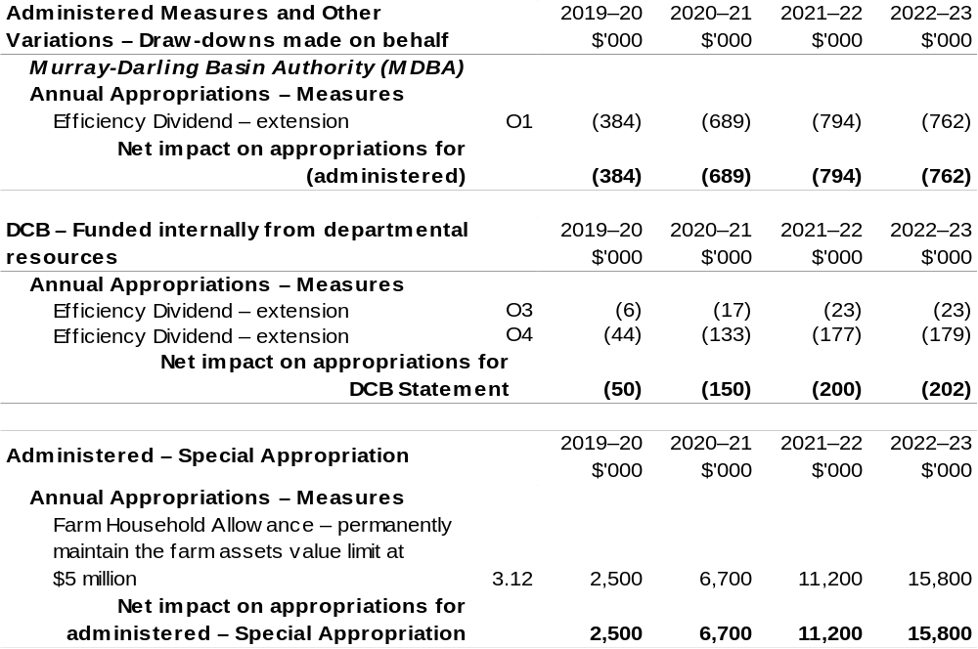
Continued on following pages

Table 1.8: 2019–20 MYEFO and Additional Estimates
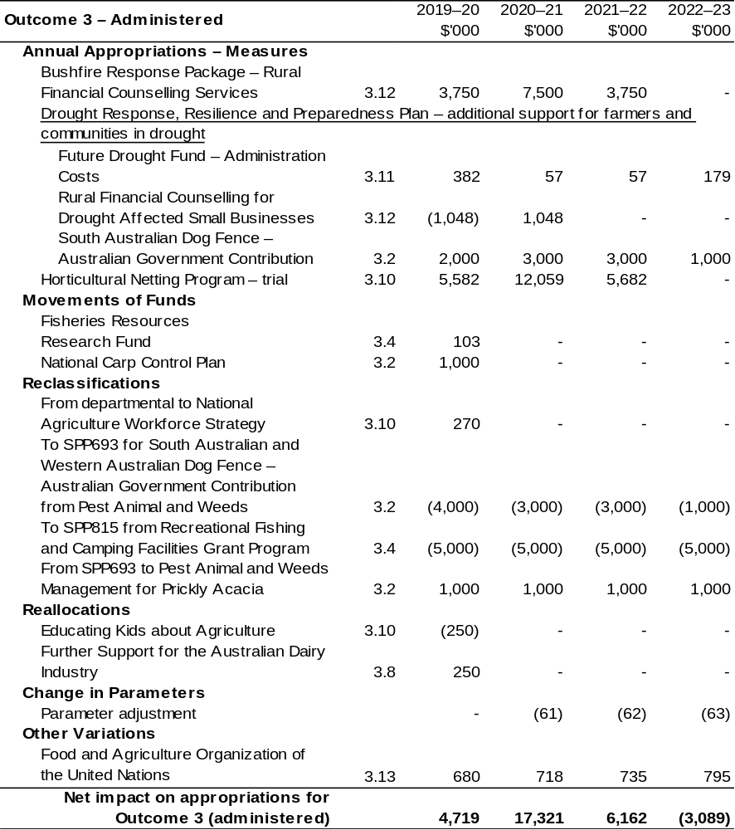
Continued on following pages

Table 1.8: 2019–20 MYEFO and Additional Estimates (continued)
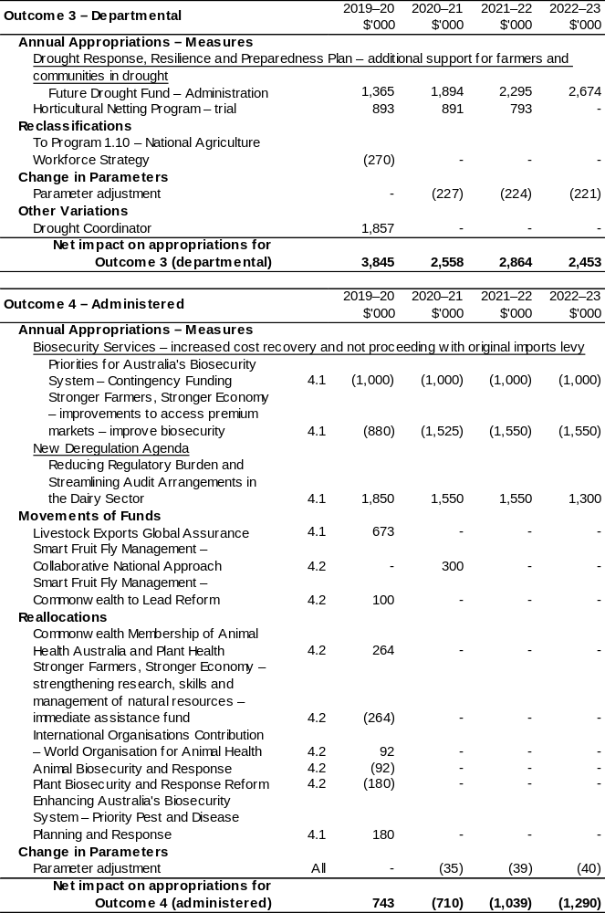
Table 1.8: 2019–20 MYEFO and Additional Estimates (continued)
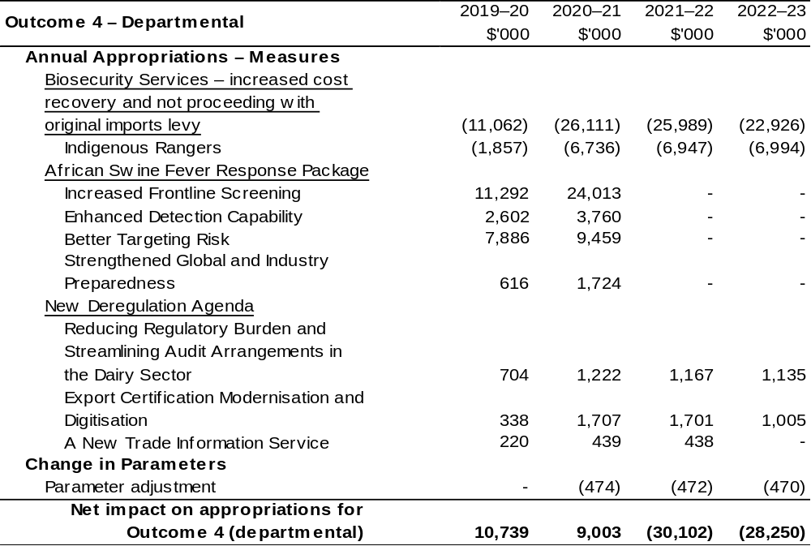
Continued on following pages
Table 1.8: 2019–20 MYEFO and Additional Estimates (continued)
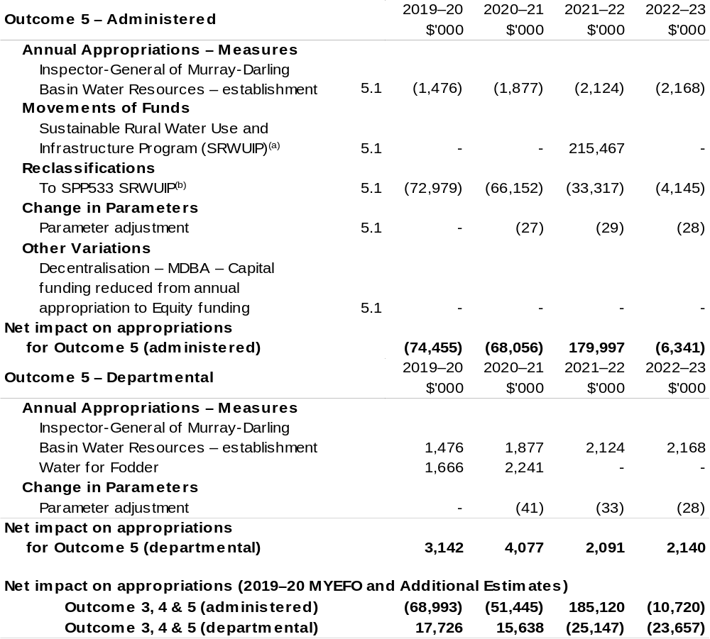
Continued on following pages

Table 1.8: 2019–20 MYEFO and Additional Estimates (continued)
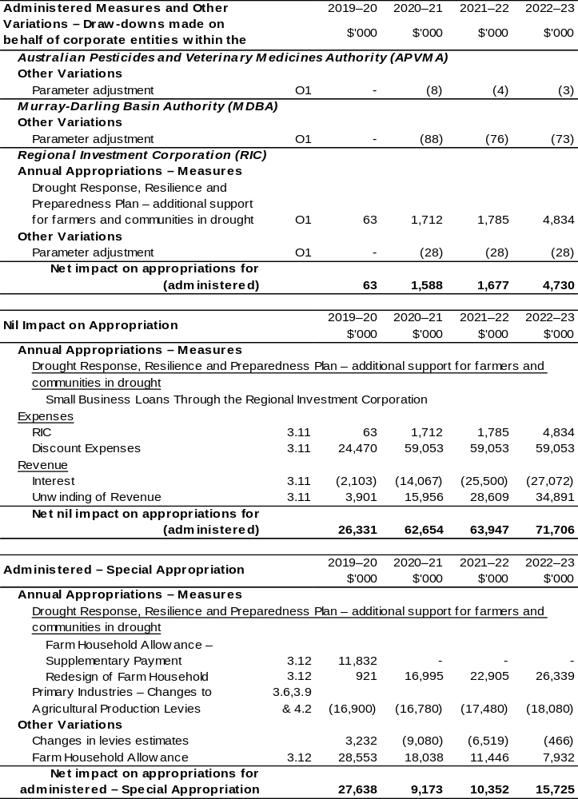
Continued on following pages

Table 1.8: 2019–20 MYEFO and Additional Estimates (continued)
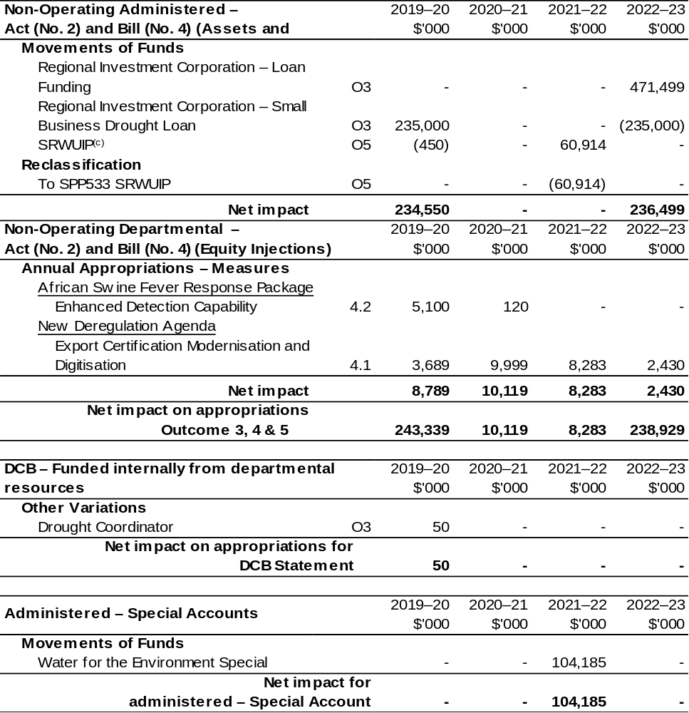
Continued on following page

Table 1.8: 2019–20 MYEFO and Additional Estimates (continued)

Note: Additional variations processed through the Department of the Treasury that impact the Department of Agriculture, Water and the Environment:

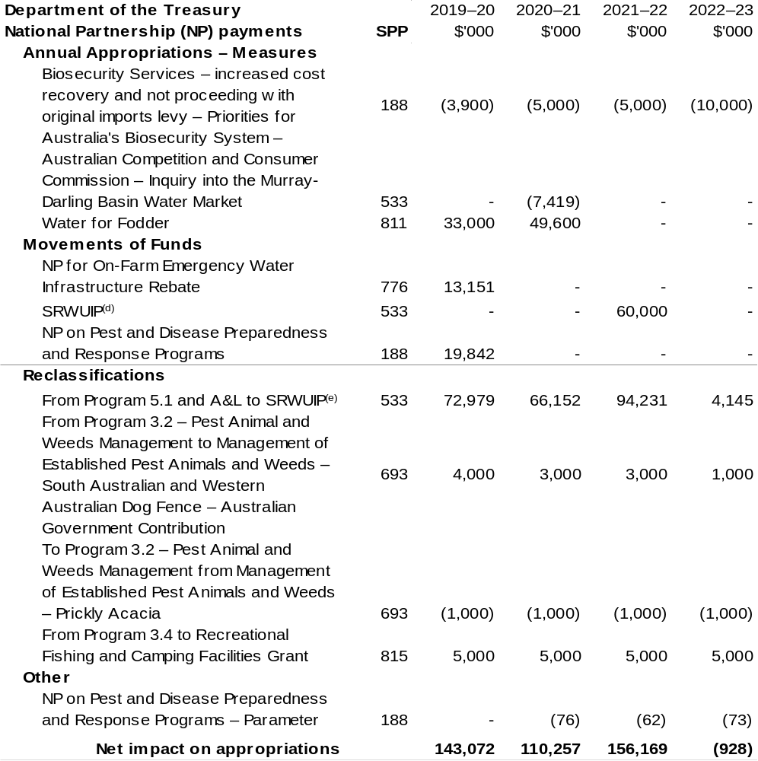
(a) $31.615 million for this program has been moved beyond the forward estimates to 2023–24.
(b) $27.839 million for this program has been reclassified to SPP533 in 2023–24.
(c) $27.166 million for this program has been moved beyond the forward estimates to 2023–24 and has been reclassified from Administered – Act (No. 2) Non-Operating (Equity Injections) to SPP533 in
2023–24.
(d) $13.506 million for this program has been moved beyond the forward estimates to 2023–24.
(e) $55.005 million has been reclassified beyond the forward estimates to 2023–24.

1.5 Breakdown of additional estimates by appropriation bill
The following table shows Additional Estimates sought for the Department of Agriculture, Water and the Environment through Appropriation Bills (No. 3) and
(No. 4) 2019–20.

Table 1.9: Appropriation Bill (No. 3) 2019–20 – Administered
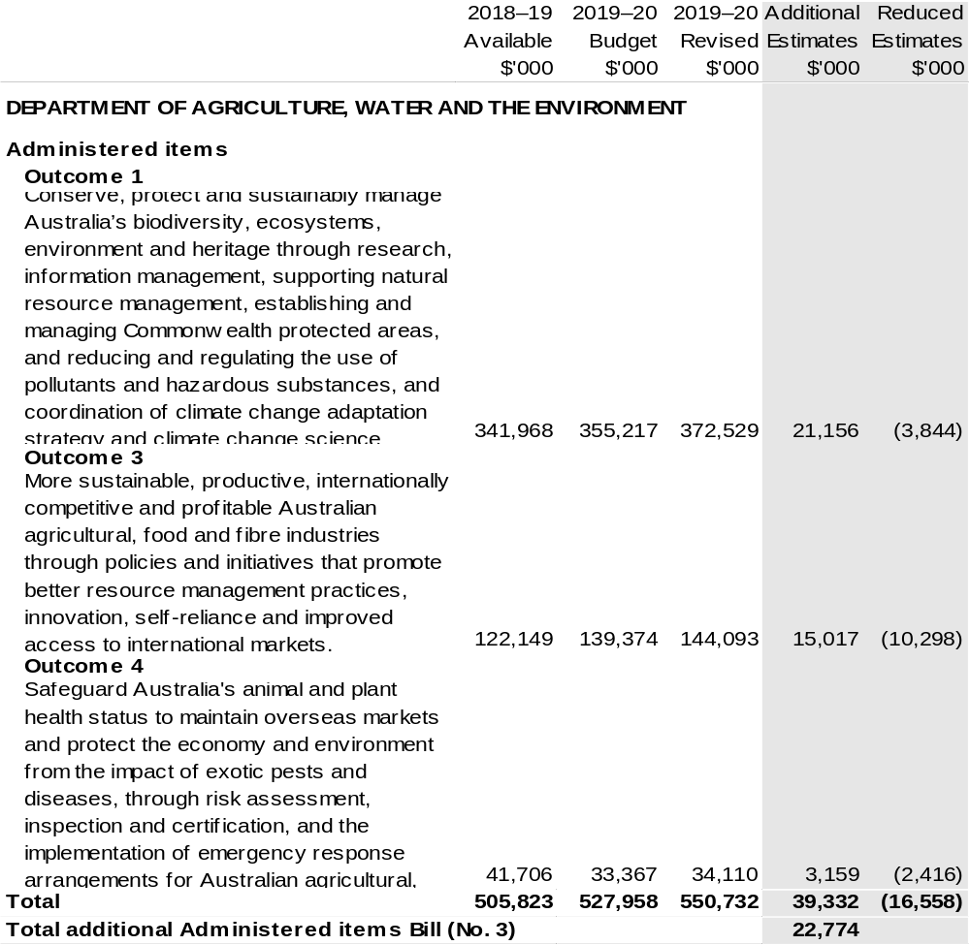
Continued on following pages

Table 1.10: Appropriation Bill (No. 3) 2019–20 – Departmental
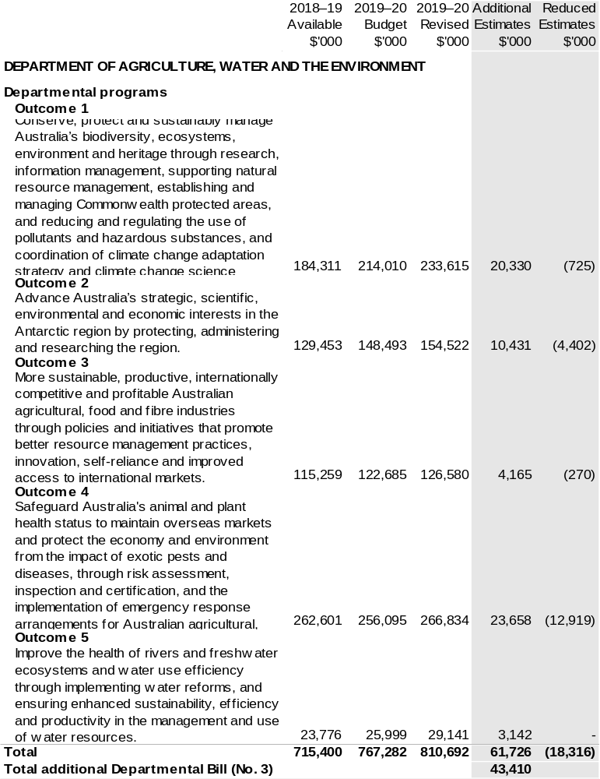
Continued on following page

Table 1.11: Appropriation Bill (No. 4) 2019–20
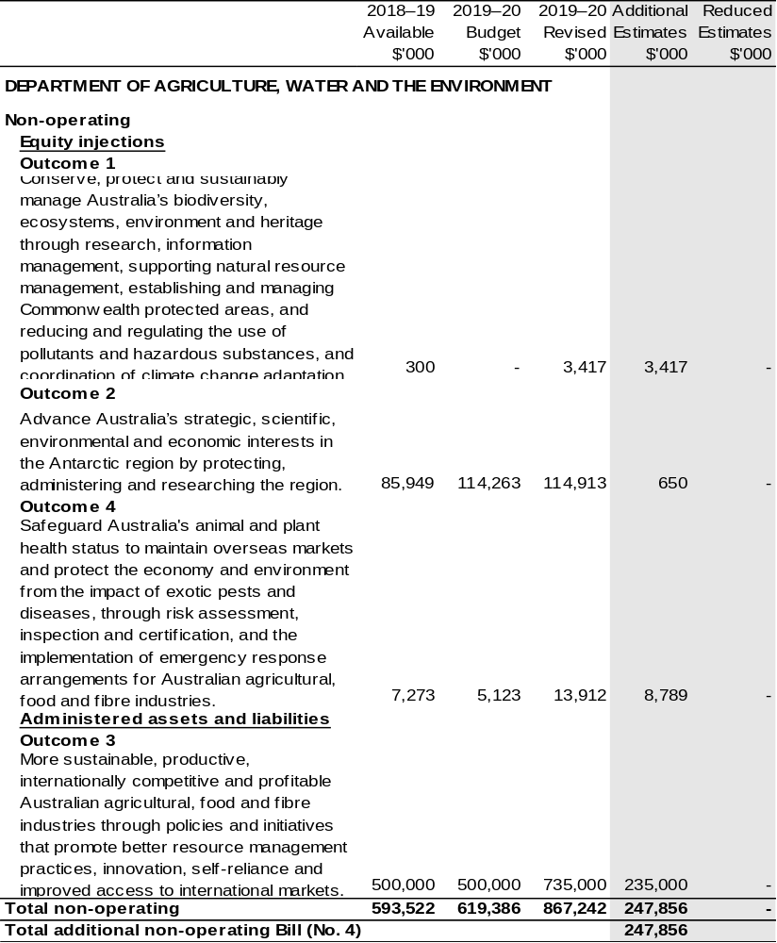

Section 2: Revisions to outcomes and planned performance

2.1 Changes to outcome and program structures
The creation of the new department has resulted in two outcomes from the former Department of the Environment and Energy combining with three outcomes from the former Department of Agriculture.
As shown in Table 2, the order of the department’s five outcomes statements has changed and Outcome 1 has additional authority. Outcomes 6 and 7 are now the responsibility of the Department of Industry, Science, Energy and Resources.

Table 2.1: Changes to the outcome and program structures since the last portfolio statement
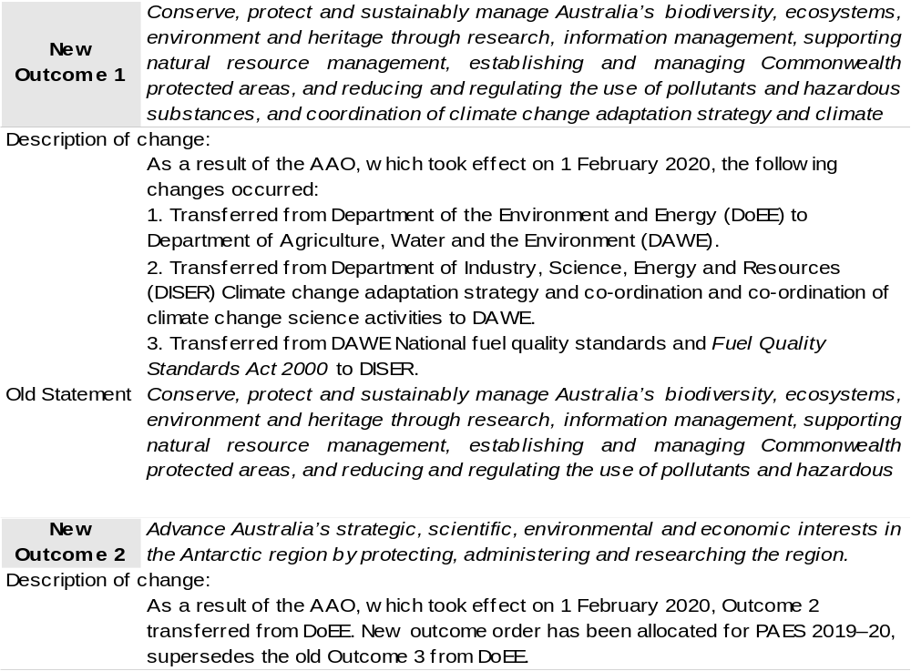
Continued on following pages
Table 2.1: Changes to the outcome and program structures since the last portfolio statement (continued)
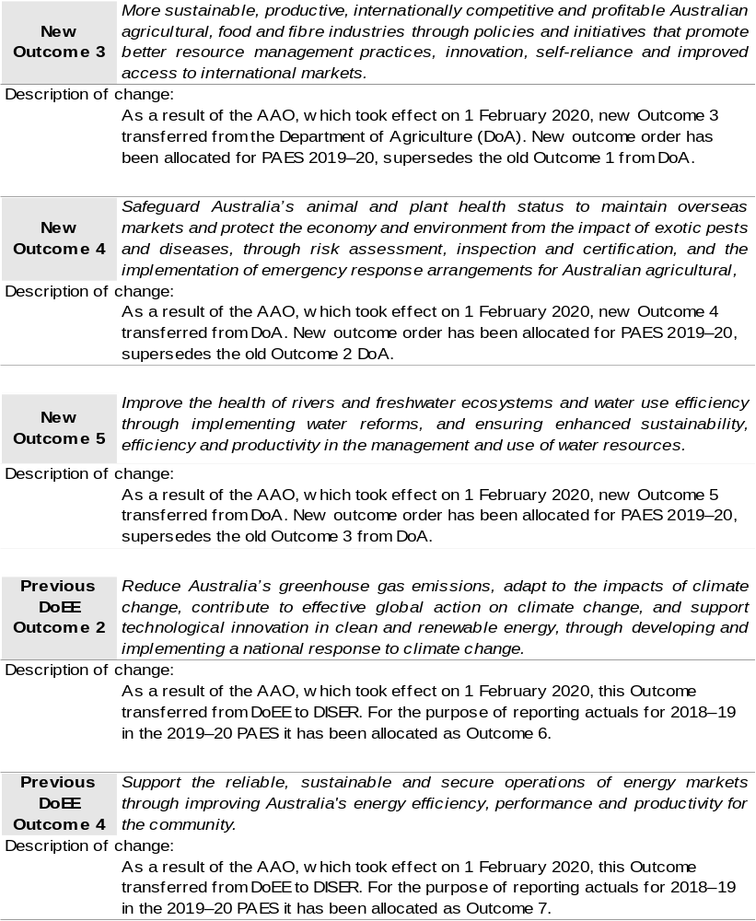

Continued on following pages

Table 2.1: Changes to the outcome and program structures since the last portfolio statement (continued)
Program Changes
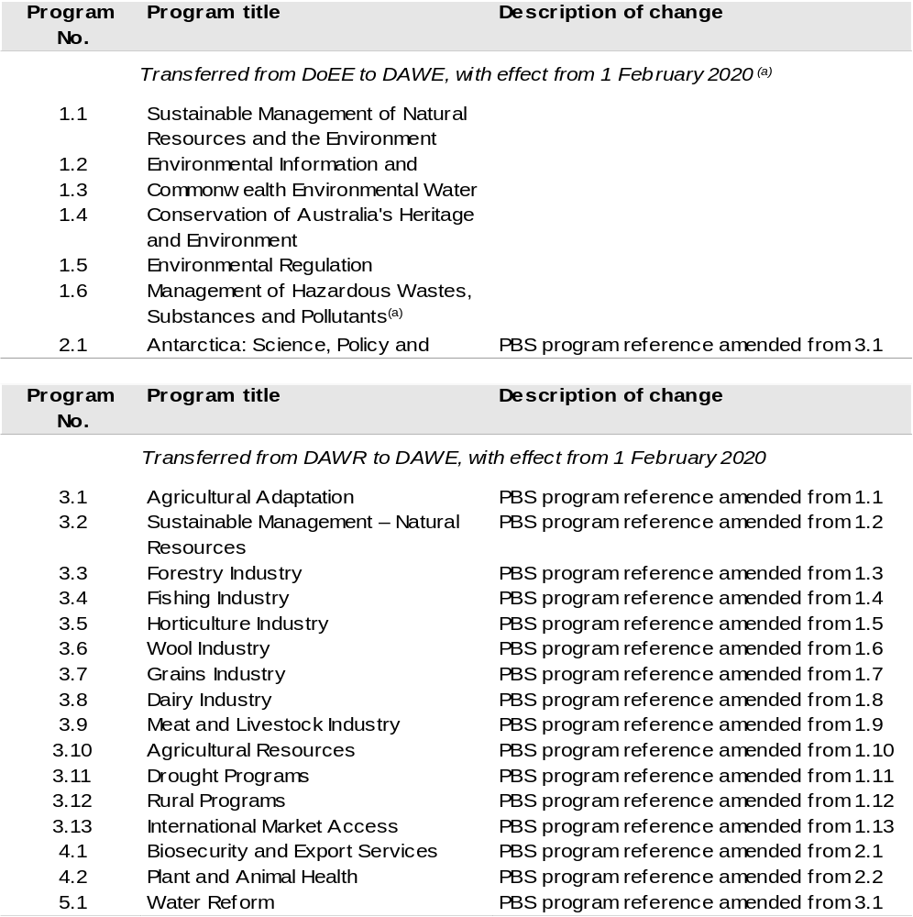
(a) As a result of the AAO, which took effect on 1 February 2020, the sub-program Biofuels – Monitoring, Compliance and Enforcement of Fuel Quality, which reports under Program 1.6 Management of Hazardous Wastes, Substances and Pollutants, has transferred to DISER.

Continued on following page

Table 2.1: Changes to the outcome and program structures since the last portfolio statement (continued)
Program Changes
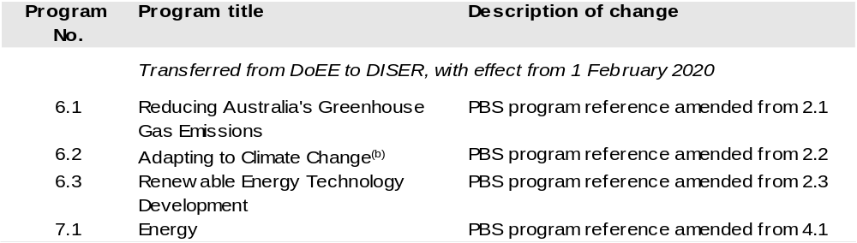
(b) As a result of the AAO, which took effect on 1 February 2020, Program 6.2 Adapting to Climate Change, has been partially transferred to Outcome 1 DAWE.

Note: Outcome order has been rearranged for reporting purposes only. Refer to DISER 2019–20 PAES for new outcome reference and forward estimates.

2.2 Budgeted expenses and performance for outcome 1

Linked programs
There have been no changes to linked programs for Outcome 1 since the 2019–20 Portfolio Budget Statements.

Performance criteria
There have been no changes to performance criteria for Outcome 1 since the 2019–20 Portfolio Budget Statements.

Budgeted expenses
Table 2.2.1 (below) shows how much the entity intends to spend (on an accrual basis) on achieving the outcome, broken down by program, as well as by Administered and Departmental funding sources.

Table 2.2.1: Budgeted Expenses for Outcome 1
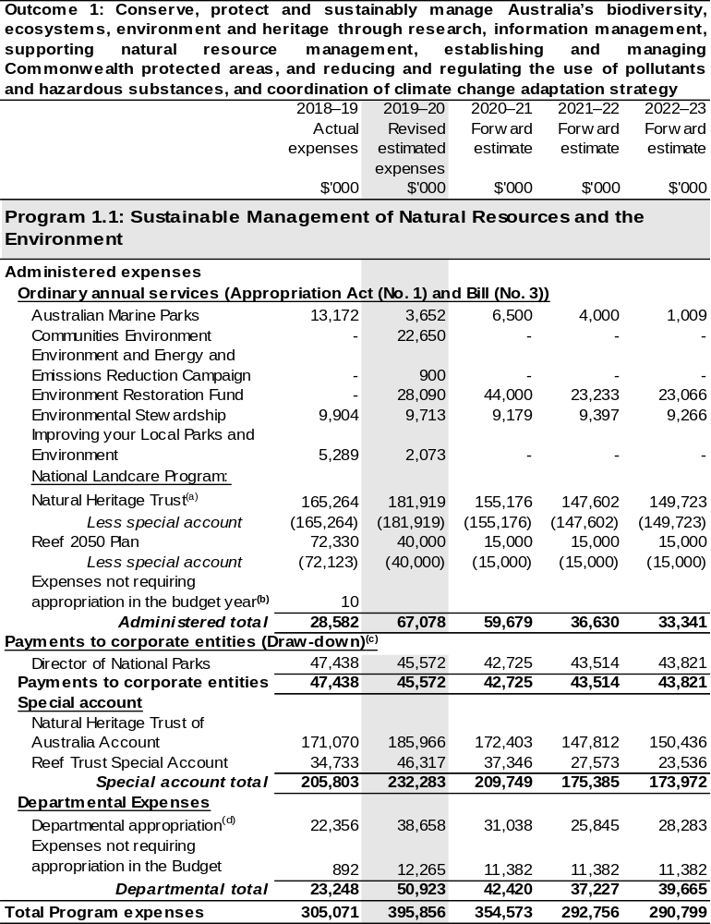
Continued on following pages
Table 2.2.1 Budgeted Expenses for Outcome 1 (continued)
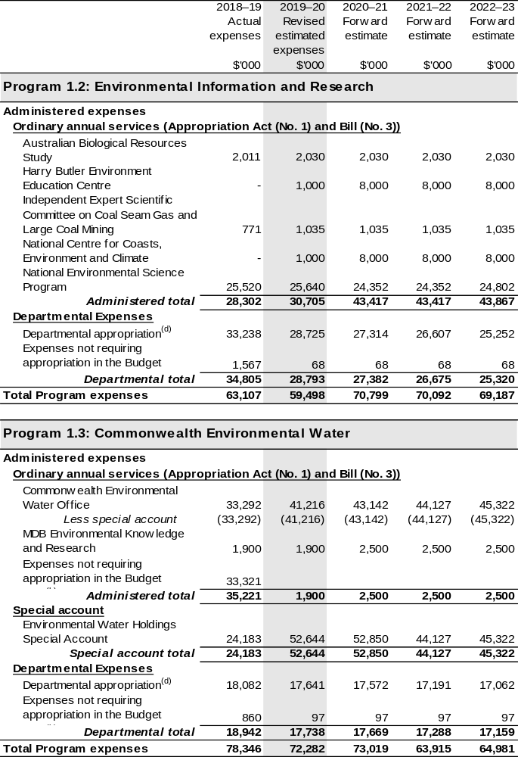

Continued on following pages
Table 2.2.1 Budgeted Expenses for Outcome 1 (continued)
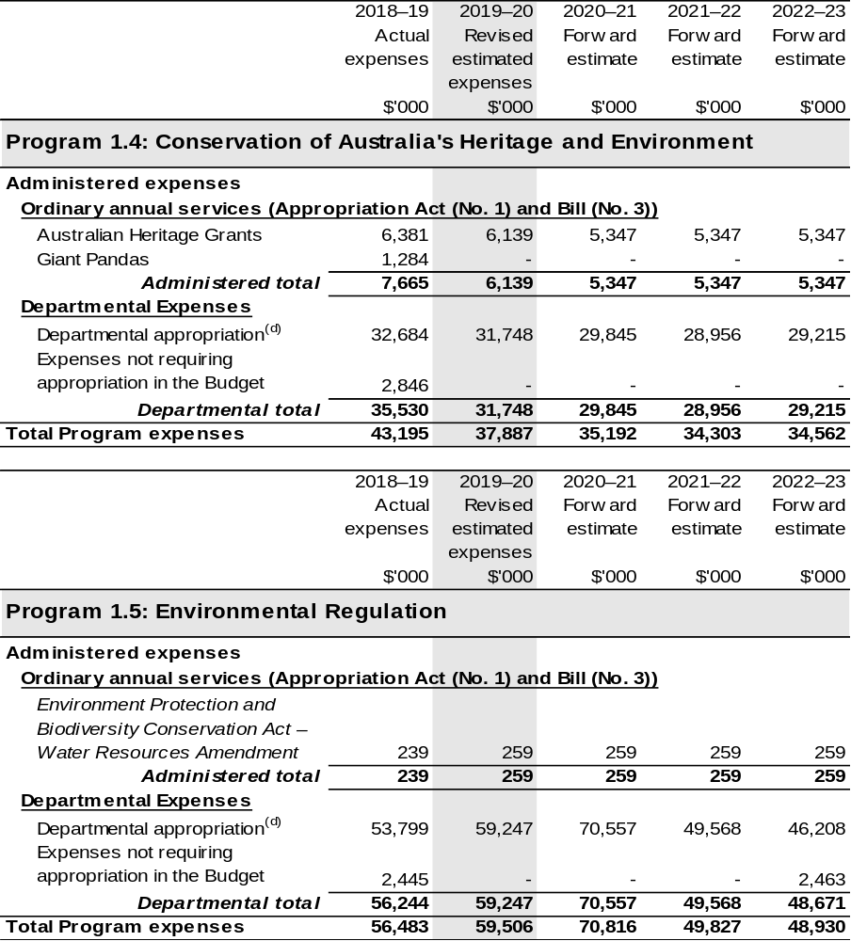

Continued on following pages

Table 2.2.1 Budgeted Expenses for Outcome 1 (continued)
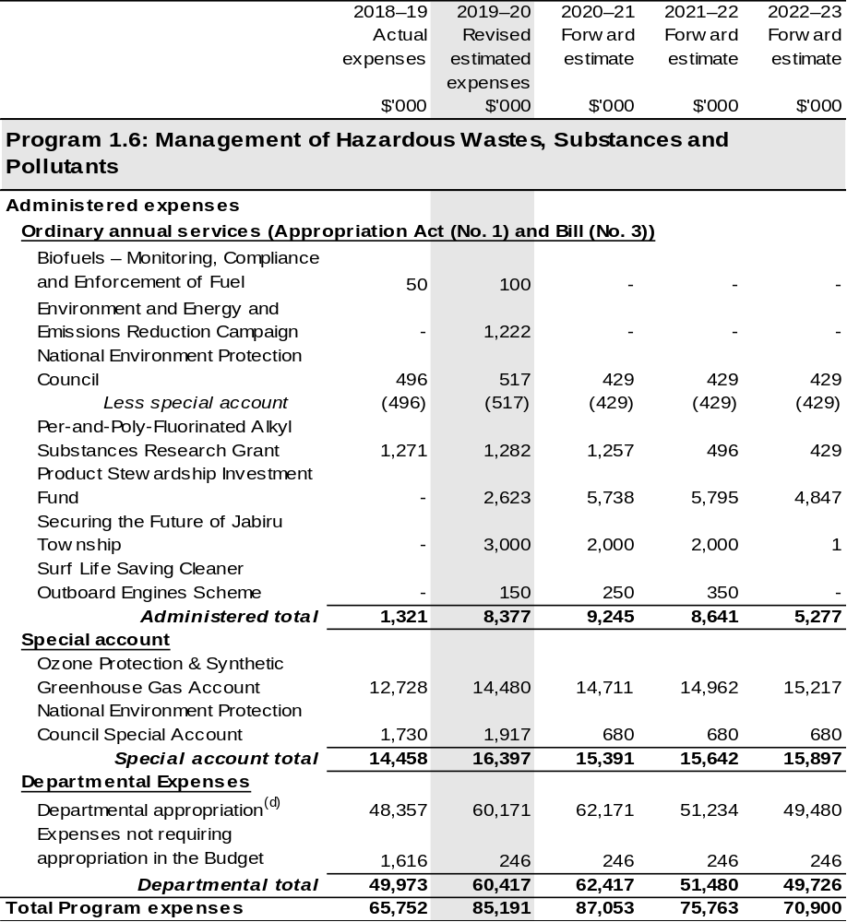
Continued on following page

Table 2.2.1 Budgeted Expenses for Outcome 1 (continued)
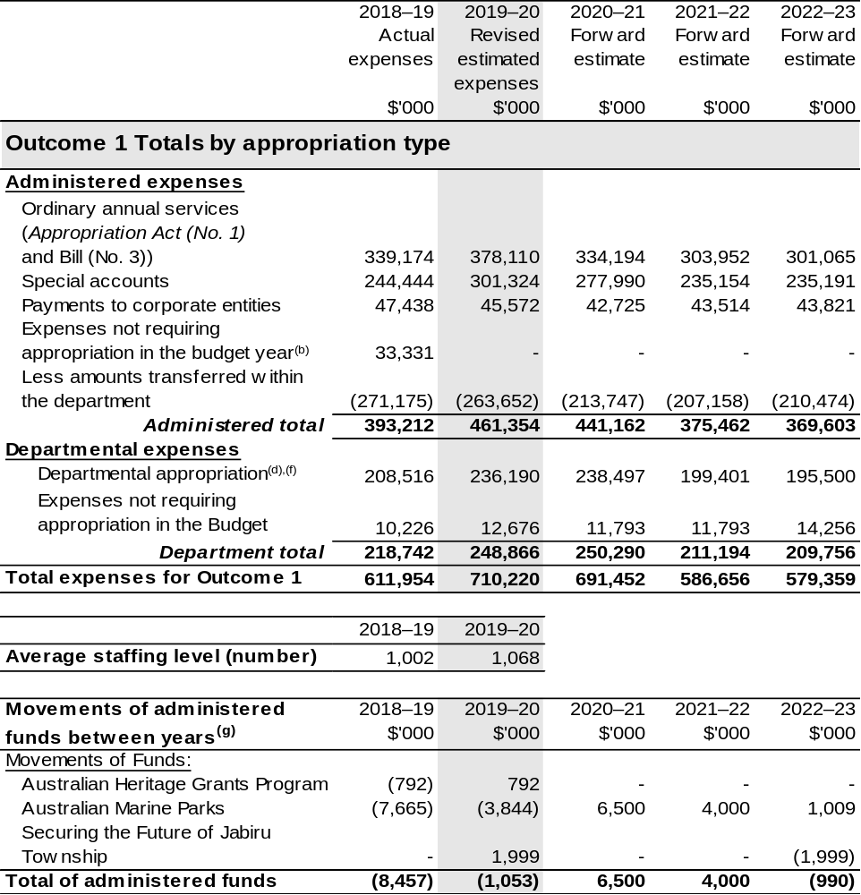
(a) Funding for components of the National Landcare Program will be directly appropriated to the Department of the Treasury and the Department of the Prime Minister and Cabinet.
(b) ‘Expenses not requiring appropriation in the Budget year’ are made up of depreciation and amortisation expenses, audit fees and an approved operating loss.
(c) The Director of National Parks is a CCE under the PGPA Act and does not receive direct appropriations. Instead, this funding passes through the department and drawn-down on their behalf.
(d) Expenses funded from both ‘Ordinary annual services (Appropriation Act (No. 1) and Bill (No. 3))’ and ‘External Revenue’ under section 74 of the Public Governance, Performance and Accountability
Act 2013 (PGPA Act).
(e) As a result of the AAO that took effect on the 1 February 2020, the sub-program; Biofuels – Monitoring, Compliance and Enforcement of Fuel Quality has transferred to DISER.
(f) Outcome 1 also has a departmental capital budget of $22.016 million in 2019–20.
(g) Figures displayed as a negative (-) represent a decrease in funds and a positive (+) represent an increase in funds.

Note: Departmental appropriation splits and totals are indicative estimates and may change in the course of the budget year as Government priorities change.

2.3 Budgeted expenses and performance for outcome 2

Linked programs
There have been no changes to linked programs for Outcome 2 since the 2019–20 Portfolio Budget Statements.

Performance criteria
There have been no changes to performance criteria for Outcome 2 since the 2019–20 Portfolio Budget Statements.

Budgeted expenses
Table 2.2.2 (below) shows how much the entity intends to spend (on an accrual basis) on achieving the outcome, broken down by program, as well as by Administered and Departmental funding sources.

Table 2.2.2: Budgeted Expenses for Outcome 2
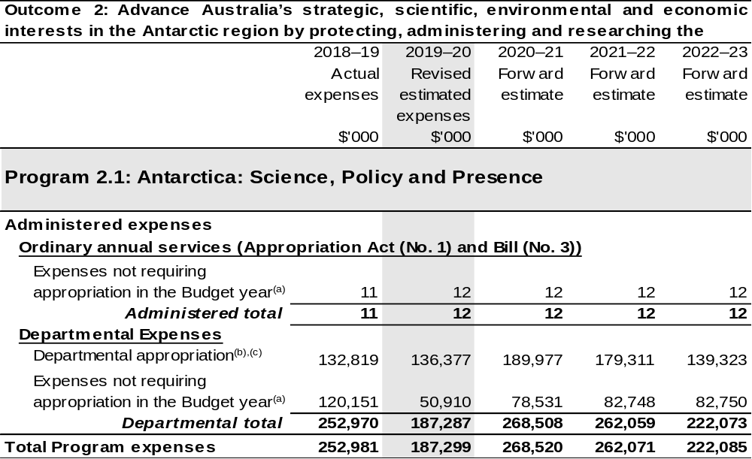
Continued on following page

Table 2.2.2 Budgeted Expenses for Outcome 2 (continued)
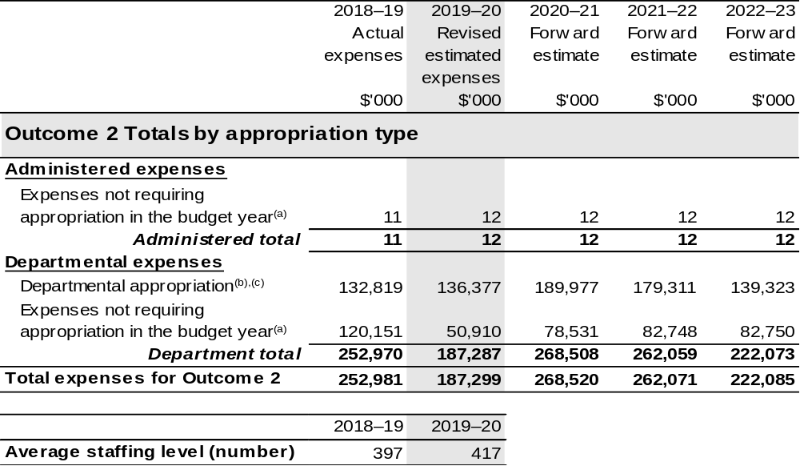
(a) ‘Expenses not requiring appropriation in the Budget year’ are made up of depreciation and amortisation expenses, audit fees and an approved operating loss.
(b) Expenses funded from both ‘Ordinary annual services (Appropriation Act (No. 1) and Bill (No. 3))’ and ‘External Revenue’ under section 74 of the PGPA Act.
(c) Outcome 2 also has a departmental capital budget of $31.082 million in 2019–20.

Note: Departmental appropriation splits and totals are indicative estimates and may change in the course of the budget year as Government priorities change.

2.4 Budgeted expenses and performance for outcome 3

Linked programs
There have been no changes to linked programs for Outcome 3 since the 2019–20 Portfolio Budget Statements.

Performance criteria
There have been no changes to performance criteria for Outcome 3 since the 2019–20 Portfolio Budget Statements.

Budgeted expenses
Table 2.2.3 (below) shows how much the entity intends to spend (on an accrual basis) on achieving the outcome, broken down by program, as well as by Administered and Departmental funding sources.

Table 2.2.3: Budgeted Expenses for Outcome 3
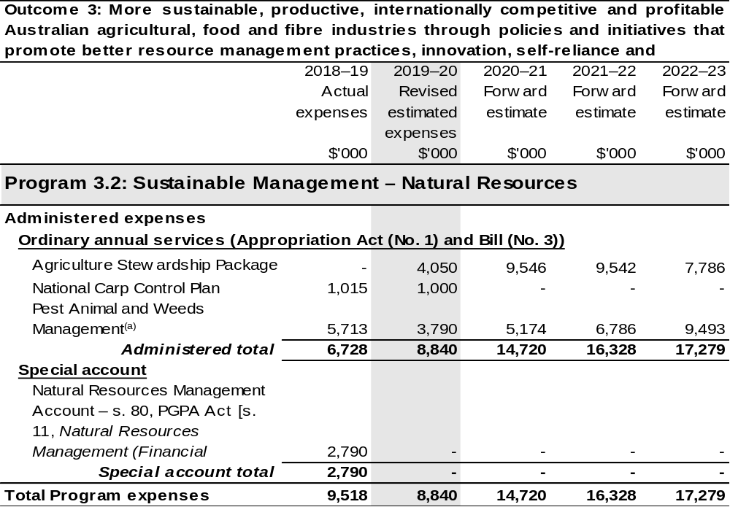
Continued on following pages
Table 2.2.3 Budgeted Expenses for Outcome 3 (continued)
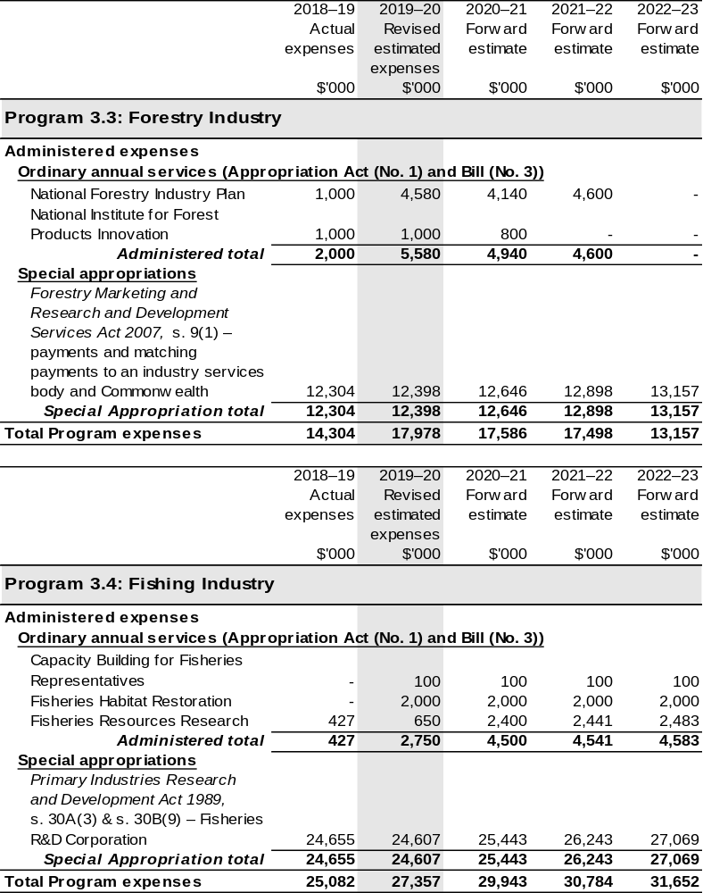
Continued on following pages

Table 2.2.3 Budgeted Expenses for Outcome 3 (continued)
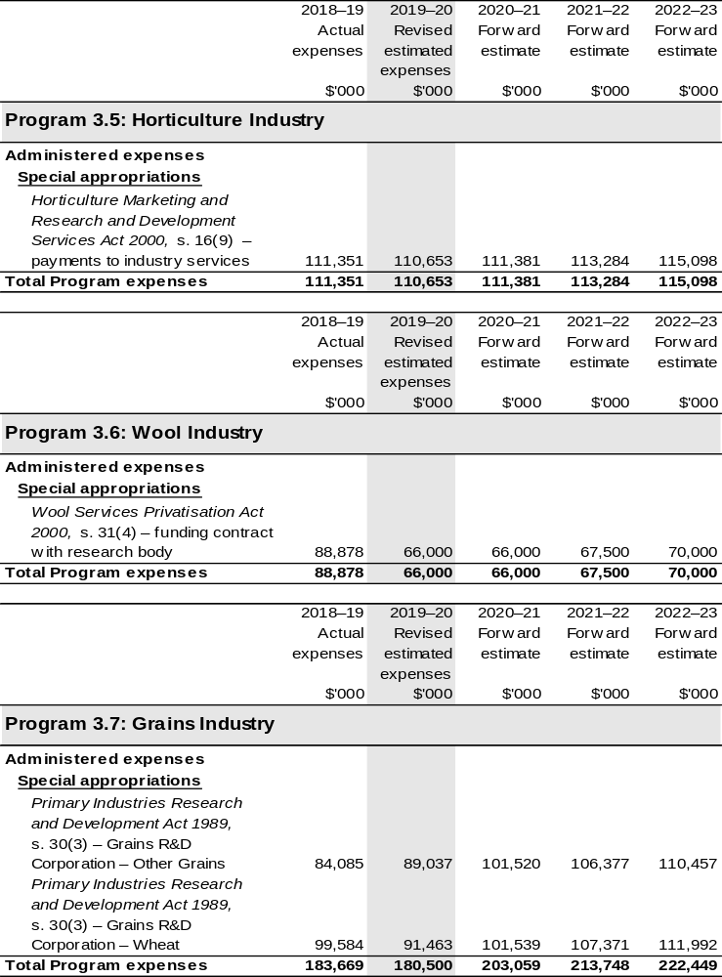
Continued on following pages
Table 2.2.3 Budgeted Expenses for Outcome 3 (continued)
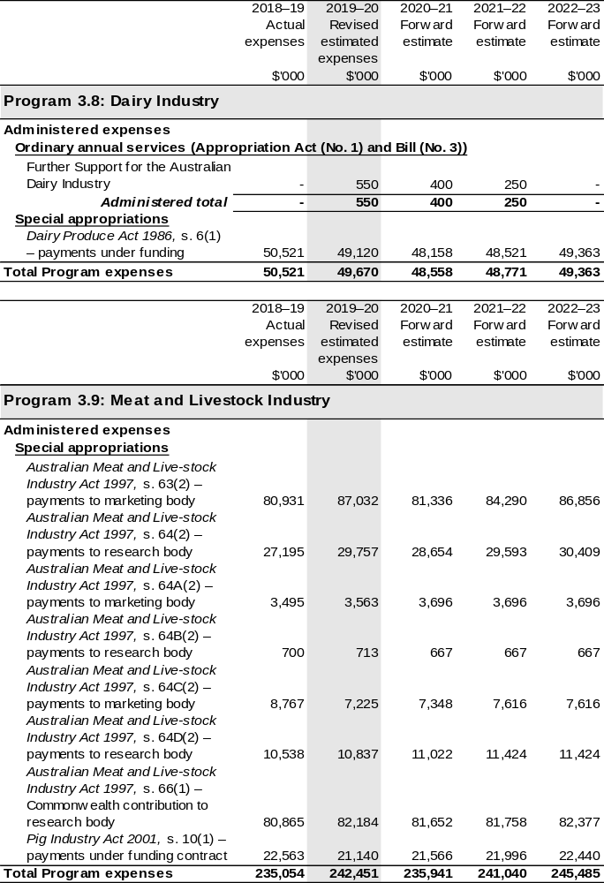
Continued on following pages
Table 2.2.3 Budgeted Expenses for Outcome 3 (continued)
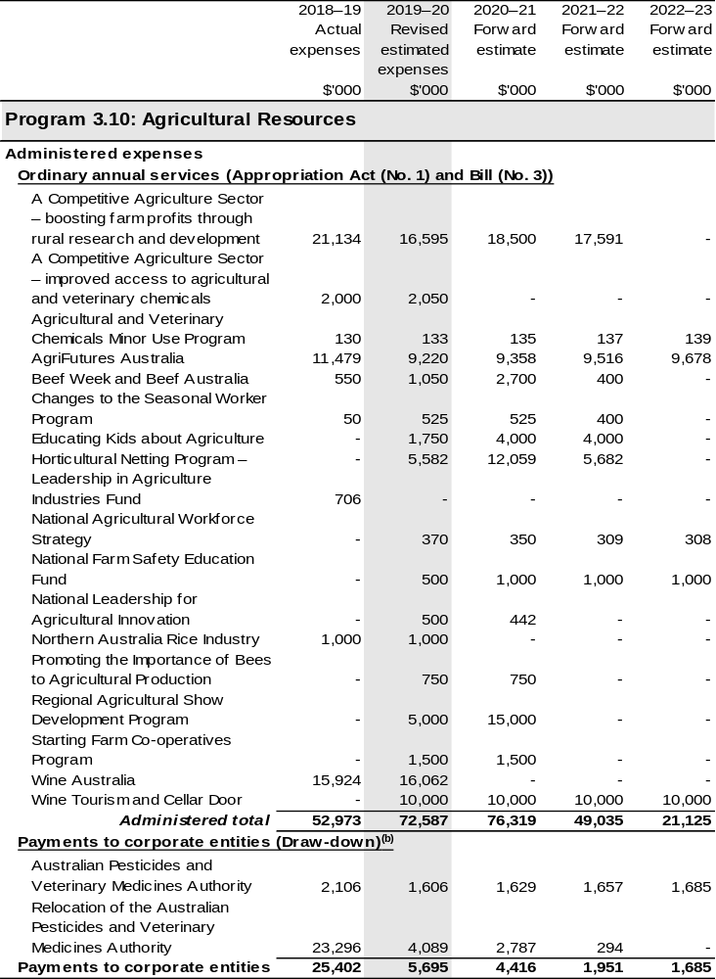
Continued on following pages
Table 2.2.3 Budgeted Expenses for Outcome 3 (continued)
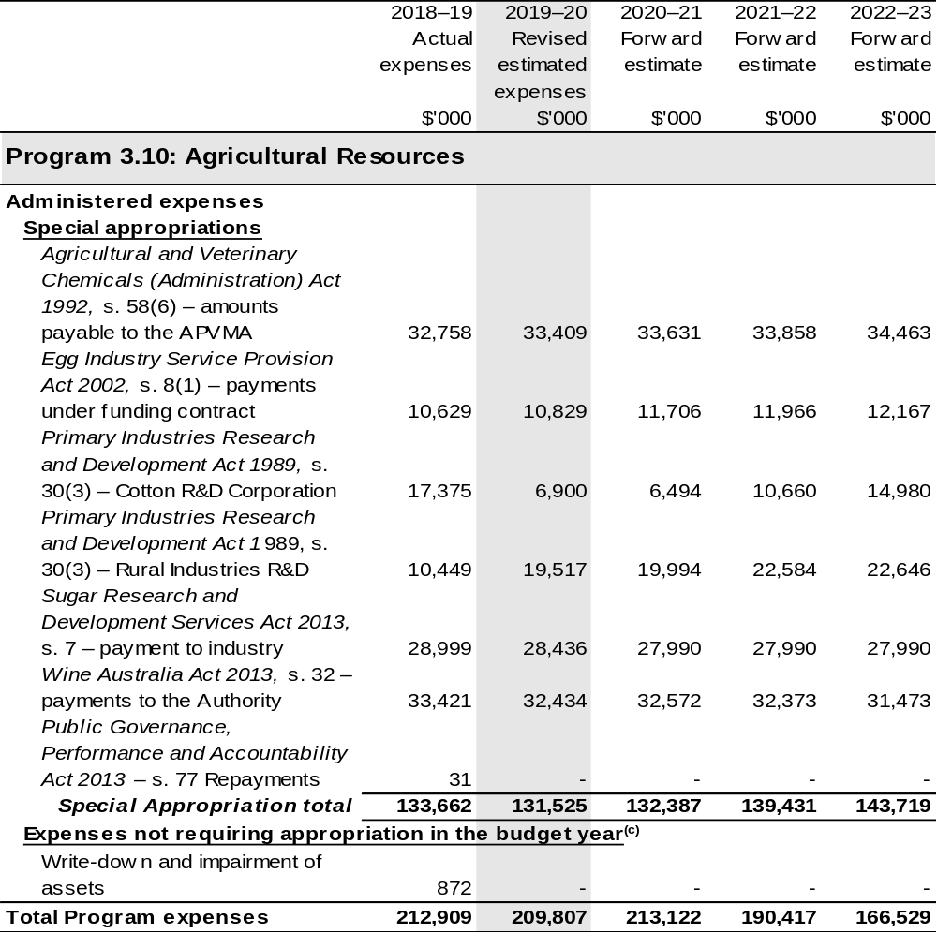
Continued on following pages

Table 2.2.3 Budgeted Expenses for Outcome 3 (continued)
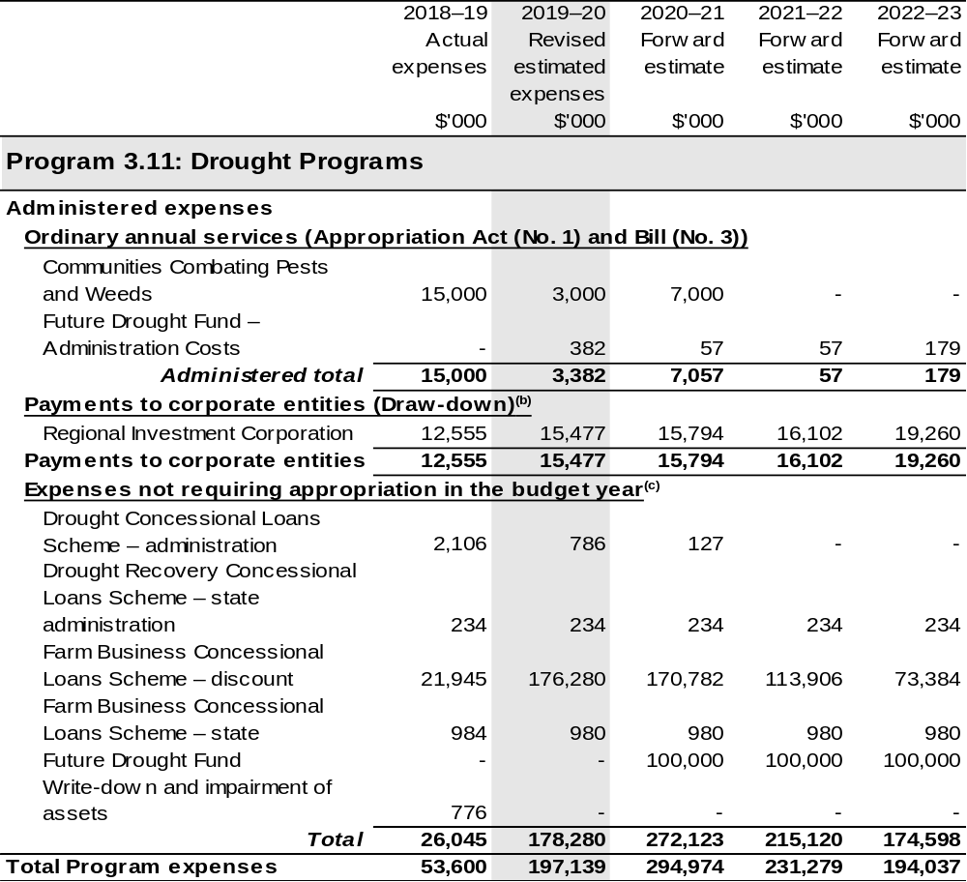
Continued on following pages

Table 2.2.3 Budgeted Expenses for Outcome 3 (continued)
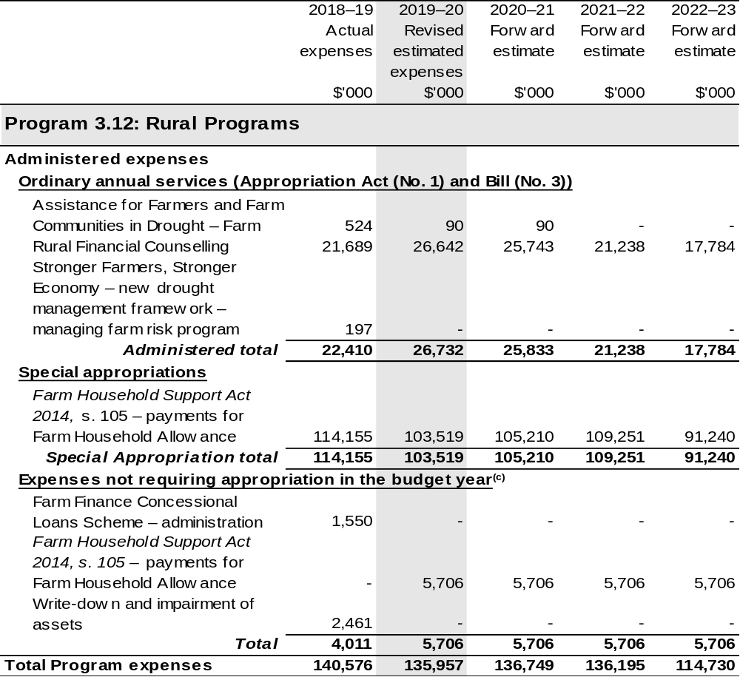
Continued on following pages

Table 2.2.3 Budgeted Expenses for Outcome 3 (continued)
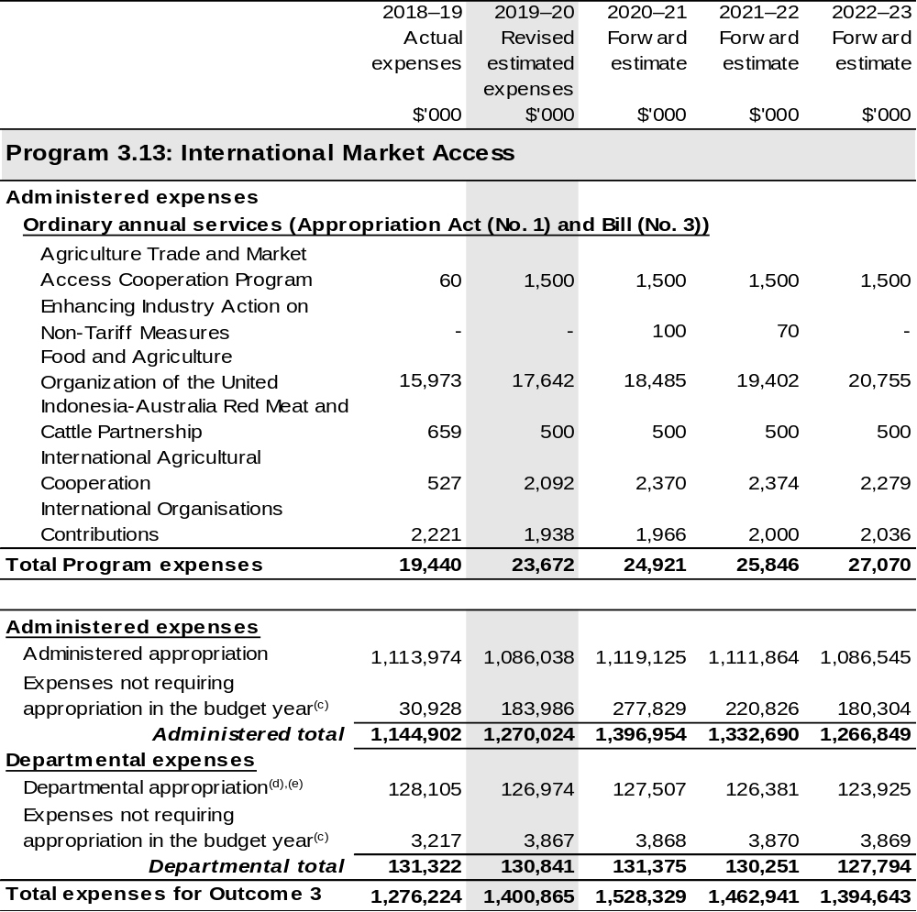
Continued on following pages

Table 2.2.3 Budgeted Expenses for Outcome 3 (continued)
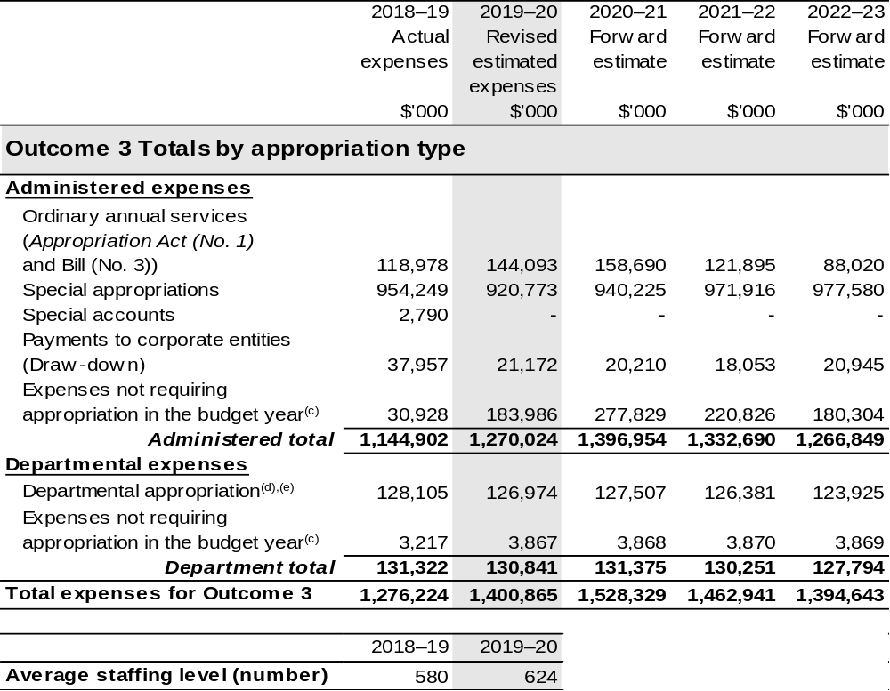
(a) Under program 3.2 Sustainable Management – Natural Resources, the sub-program Pest Animal and Weeds Management has funding for the new measure South Australian Dog Fence – Australian Government Contribution, this funding has been reclassified to be funded through the National Partnership payment program; Management of Established Pest Animals and Weeds, which is administered by the Department of the Treasury.
(b) The Australian Pesticides and Veterinary Medicines Authority and Regional Investment Corporation are corporate Commonwealth entities (CCE) under the PGPA Act and do not receive direct appropriations. Instead, this funding passes through the department to these entities.
(c) ‘Expenses not requiring appropriation in the Budget year’ are made up of depreciation and amortisation
expenses, resources received free of charge, concessional loan discount and balance sheet adjustments.
(d) Expenses funded from both ‘Ordinary annual services (Appropriation Act (No. 1) and Bill (No. 3))’ and ‘External Revenue’ under section 74 of the PGPA Act.
(e) Departmental appropriation allocations are notional and reflect the current structure of the department.

Note: Departmental appropriation splits and totals are indicative estimates and may change in the course of the budget year as Government priorities change.

Continued on following page

Table 2.2.3 Budgeted Expenses for Outcome 3 (continued)
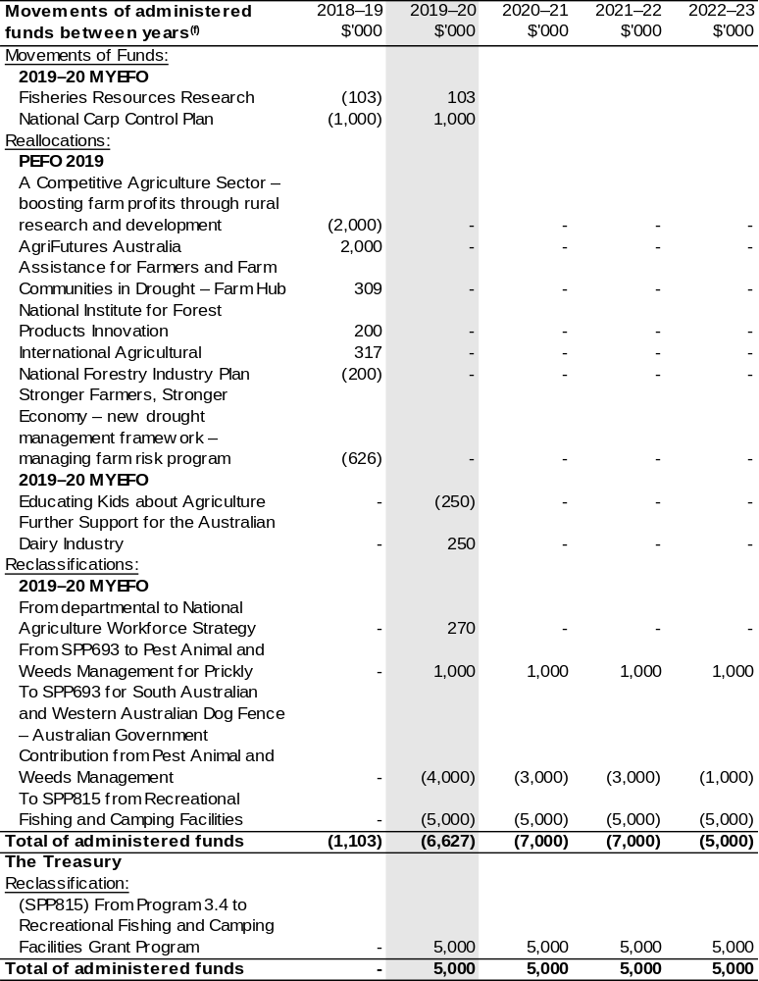
(f) Figures displayed as a negative (-) represent a decrease in funds and a positive (+) represent an increase in funds.

2.5 Budgeted expenses and performance for outcome 4

Linked programs
There have been no changes to linked programs for Outcome 4 since the 2019–20 Portfolio Budget Statements.

Performance criteria
There have been no changes to performance criteria for Outcome 4 since the 2019–20 Portfolio Budget Statements.

Budgeted expenses
Table 2.2.4 (below) shows how much the entity intends to spend (on an accrual basis) on achieving the outcome, broken down by program, as well as by Administered and Departmental funding sources.

Table 2.2.4 Budgeted Expenses for Outcome 4
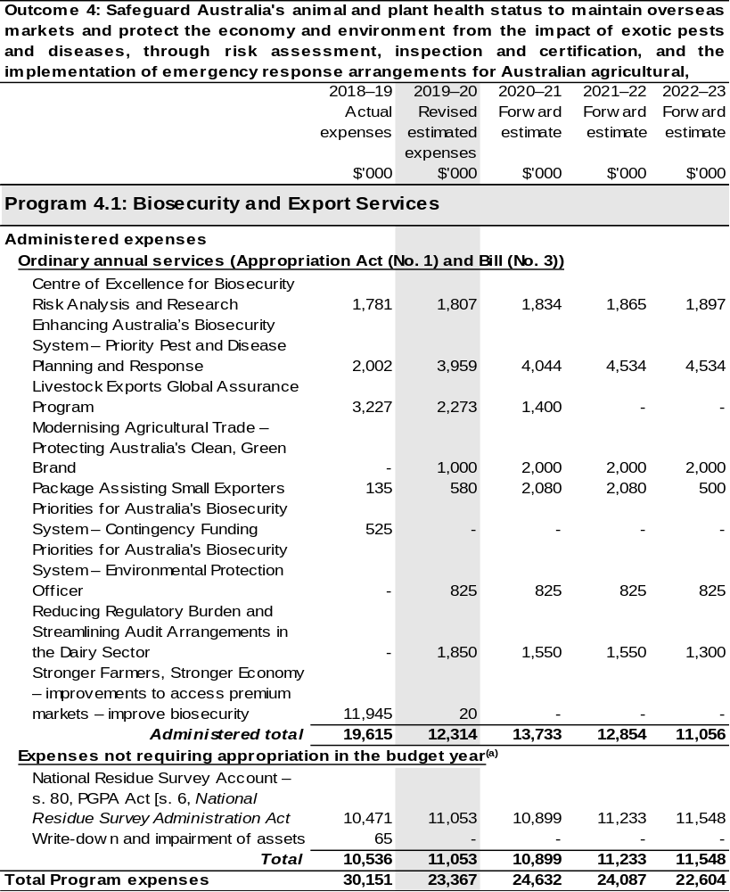
Continued on following pages
Table 2.2.4 Budgeted Expenses for Outcome 4 (continued)
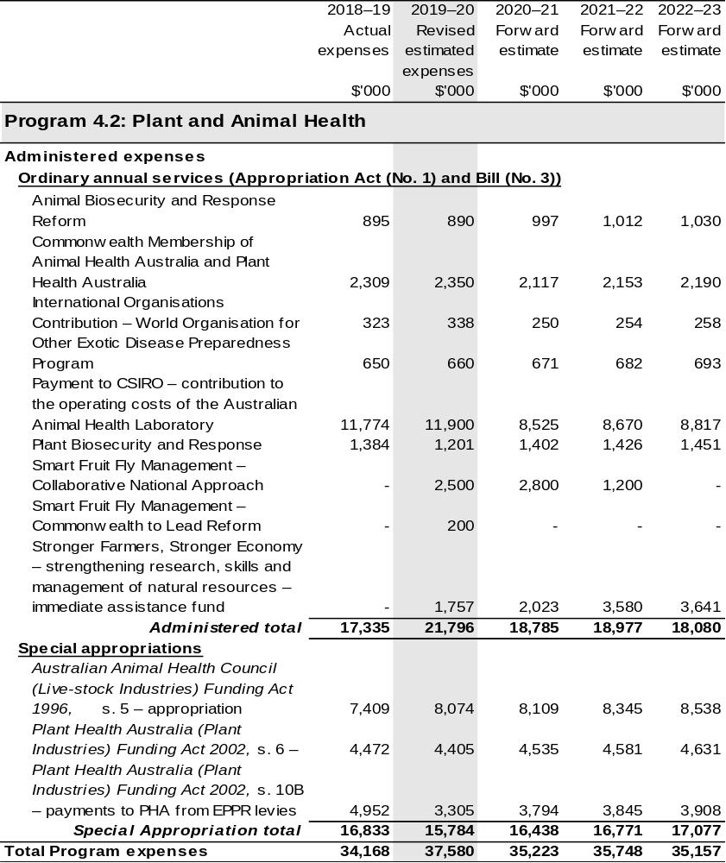
Continued on following pages
Table 2.2.4 Budgeted Expenses for Outcome 4 (continued)
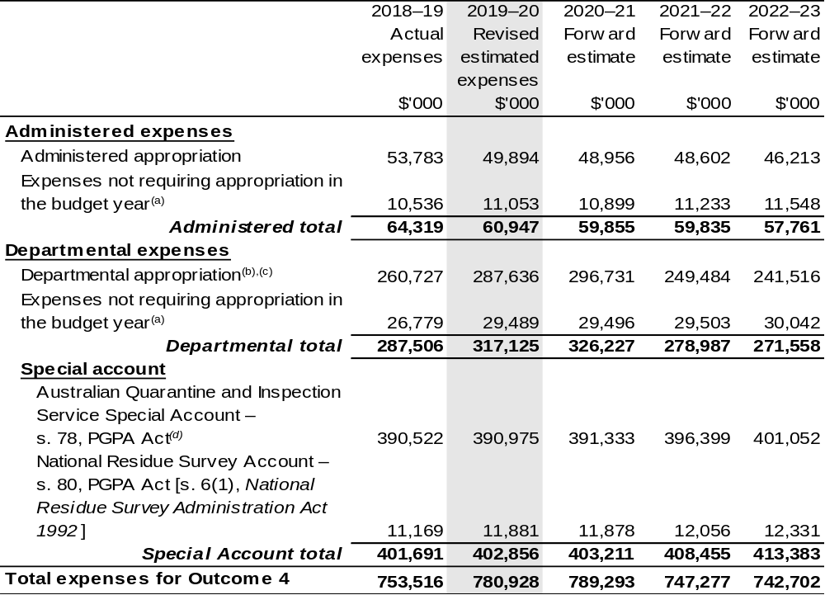
Continued on following pages
Table 2.2.4 Budgeted Expenses for Outcome 4 (continued)
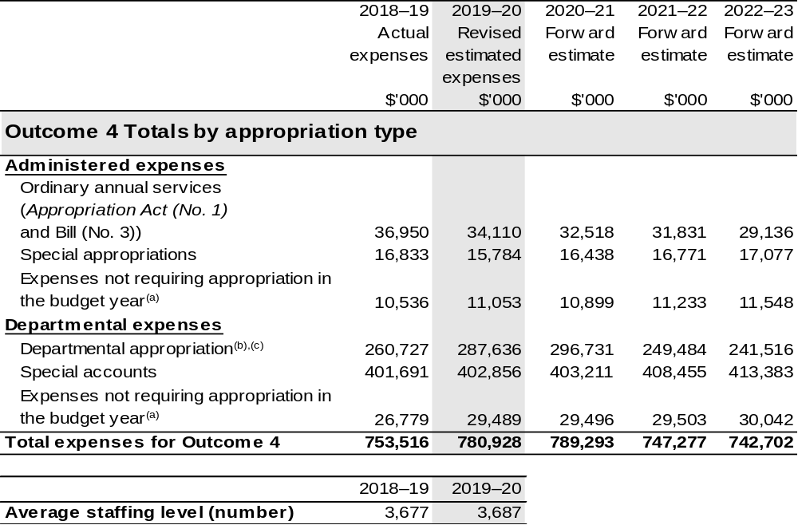
(a) ‘Expenses not requiring appropriation in the Budget year’ are made up of depreciation and amortisation
expenses, resources received free of charge, concessional loan discount and balance sheet
adjustments.
(b) Expenses funded from both ‘Ordinary annual services (Appropriation Act (No. 1) and Bill (No. 3))’ and ‘External Revenue’ under section 74 of the PGPA Act.
(c) Departmental appropriation allocations are notional and reflect the current structure of the department.
(d) The Australian Quarantine Inspection Service ceased to be a business operation in the department from 29 February 2012 but the title of the special account has not yet been changed.

Note: Departmental appropriation splits and totals are indicative estimates and may change in the course of the budget year as Government priorities change.

Continued on following page

Table 2.2.4 Budgeted Expenses for Outcome 4 (continued)
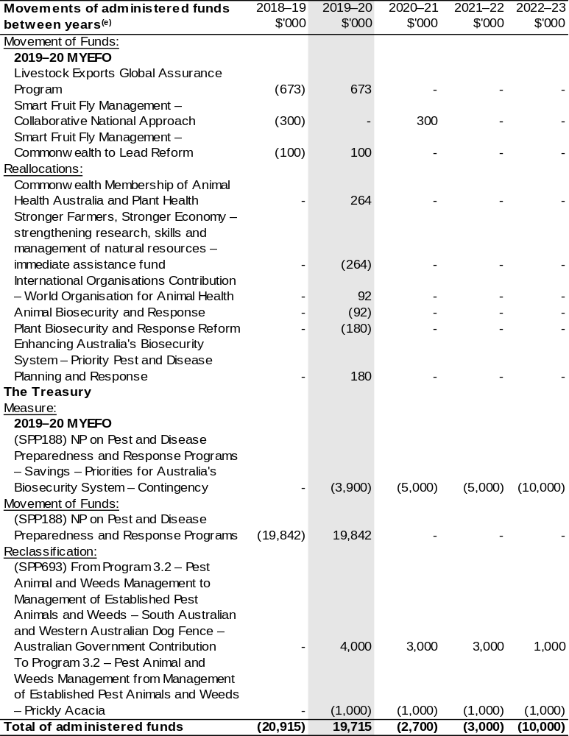
(e) Figures displayed as a negative (-) represent a decrease in funds and a positive (+) represent an increase in funds.

2.6 Budgeted expenses and performance for outcome 5

Linked programs
There have been no changes to linked programs for Outcome 5 since the 2019–20 Portfolio Budget Statements.

Performance criteria
There have been no changes to performance criteria for Outcome 5 since the 2019–20 Portfolio Budget Statements.

Budgeted expenses
Table 2.2.5 (below) shows how much the entity intends to spend (on an accrual basis) on achieving the outcome, broken down by program, as well as by Administered and Departmental funding sources.

Table 2.2.5 Budgeted Expenses for Outcome 5
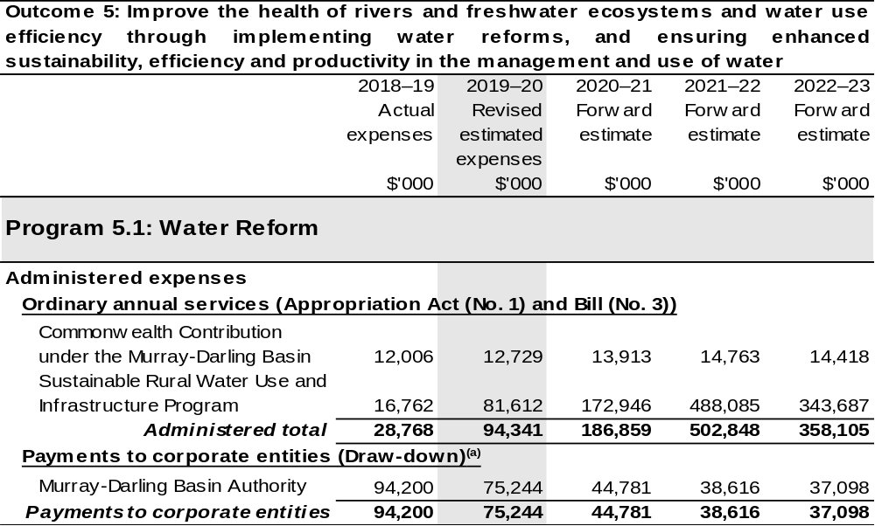
Continued on following pages
Table 2.2.5 Budgeted Expenses for Outcome 5 (continued)
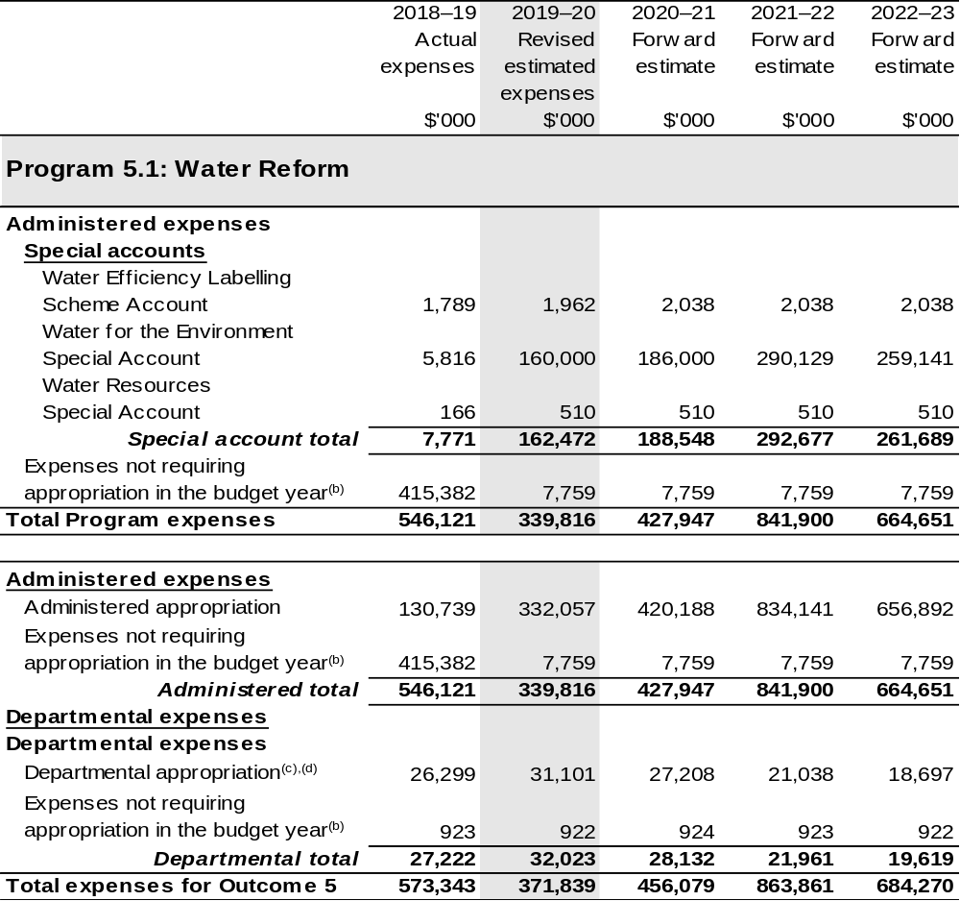
Continued on following pages
Table 2.2.5 Budgeted Expenses for Outcome 5 (continued)
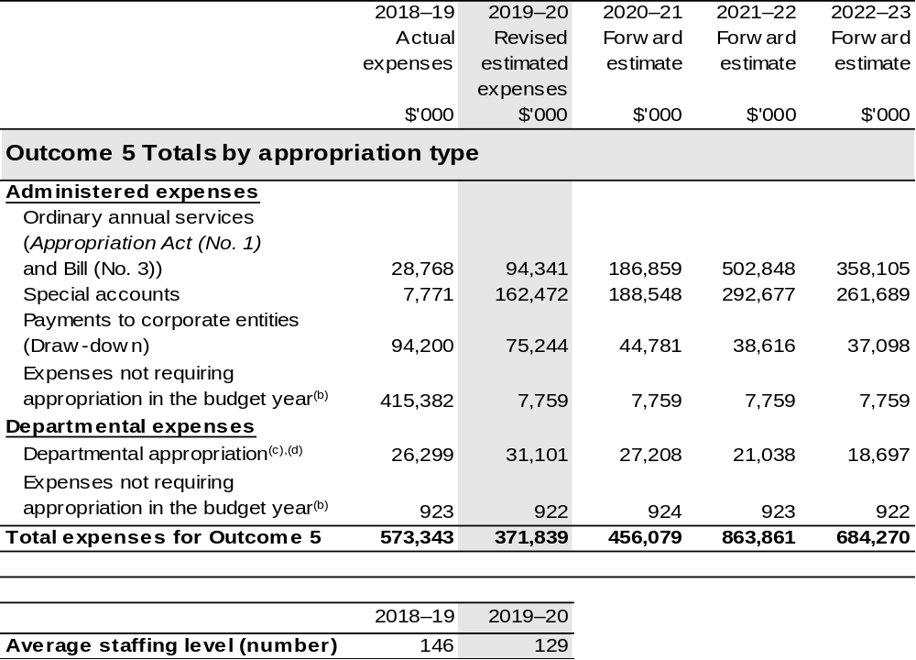
(a) The MDBA is a corporate Commonwealth entity (CCE) under the PGPA Act and does not receive direct appropriations. Instead, this funding passes through the department to the MDBA.
(b) ‘Expenses not requiring appropriation in the budget year’ is made up of depreciation expenses,
amortisation expenses, resources received free of charge and balance sheet adjustments.
(c) Departmental Appropriation combines ‘Ordinary annual services (Appropriation Act (No. 1) and
Bill (No. 3))’ and ‘External Revenue’ under section 74 of the PGPA Act.
(d) Departmental appropriation allocations are notional and reflect the current structure of the department.

Note: Departmental appropriation splits and totals are indicative estimates and may change in the course of the budget year as Government priorities change.

Continued on following page

Table 2.2.5 Budgeted Expenses for Outcome 5 (continued)
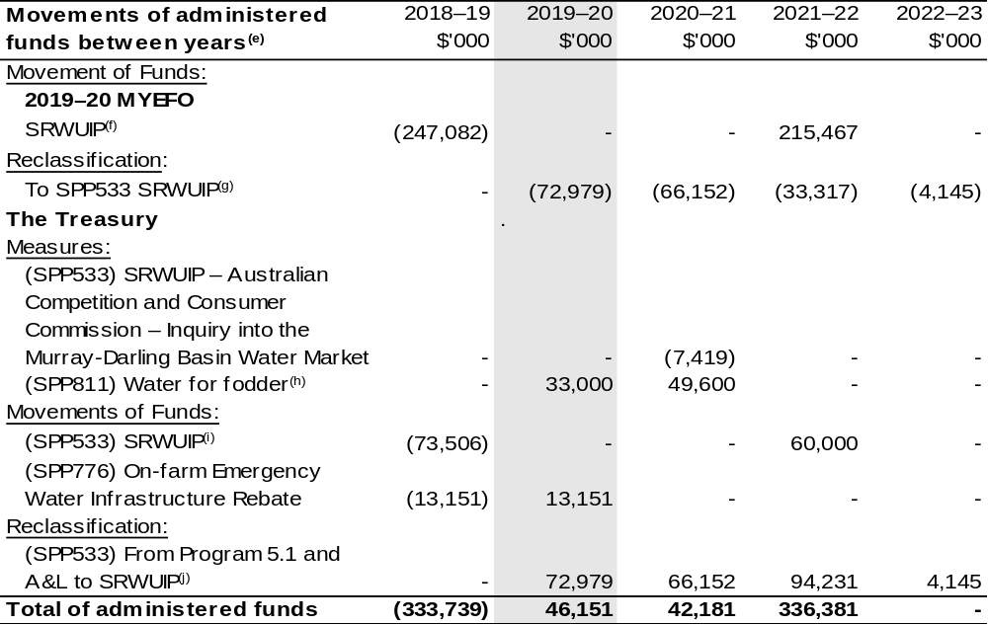
(e) Figures displayed as a negative (-) represent a decrease in funds and a positive (+) represent an increase in funds.
(f) $31.615 million for this program has been moved beyond the forward estimates to 2023–24.
(g) $27.839 million for this program has been moved beyond the forward estimates to 2023–24.
(h) This measure was published as nfp at 2019–20 MYEFO due to commercial-in-confidence sensitivities, however it has since been announced.
(i) $13.506 million for this program has been moved beyond the forward estimates to 2023–24.
(j) $55.005 million for this program has been moved beyond the forward estimates to 2023–24.

2.7 Budgeted expenses and performance for outcome 6

Linked programs
There have been no changes to linked programs for Outcome 6 since the 2019–20 Portfolio Budget Statements.

Performance criteria
There have been no changes to performance criteria for Outcome 6 since the 2019–20 Portfolio Budget Statements.

Budgeted expenses
Table 2.2.6 (below) shows how much the entity intends to spend (on an accrual basis) on achieving the outcome, broken down by program, as well as by Administered and Departmental funding sources. Outcomes 6 is now the responsibility of the Department of Industry, Science, Energy and Resources.

Table 2.2.6 Budgeted Expenses for Outcome 6
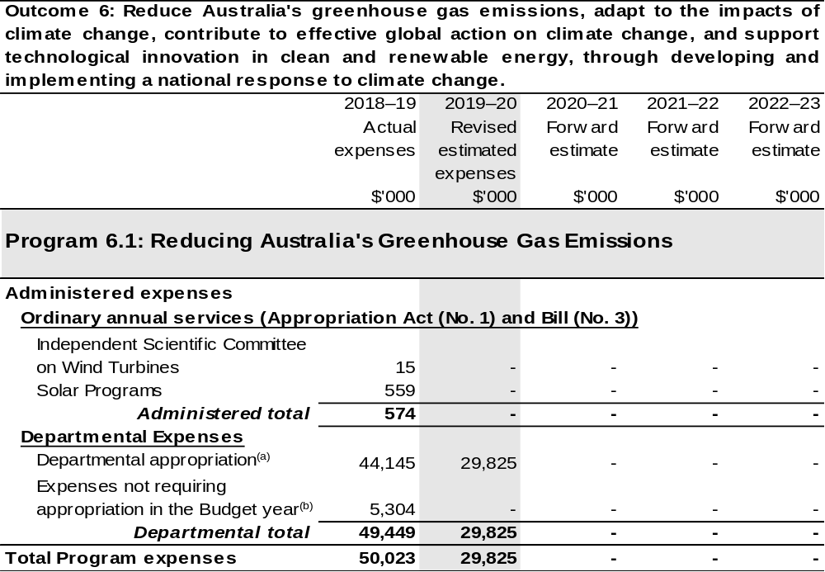
Continued on following pages

Table 2.2.6 Budgeted Expenses for Outcome 6 (continued)
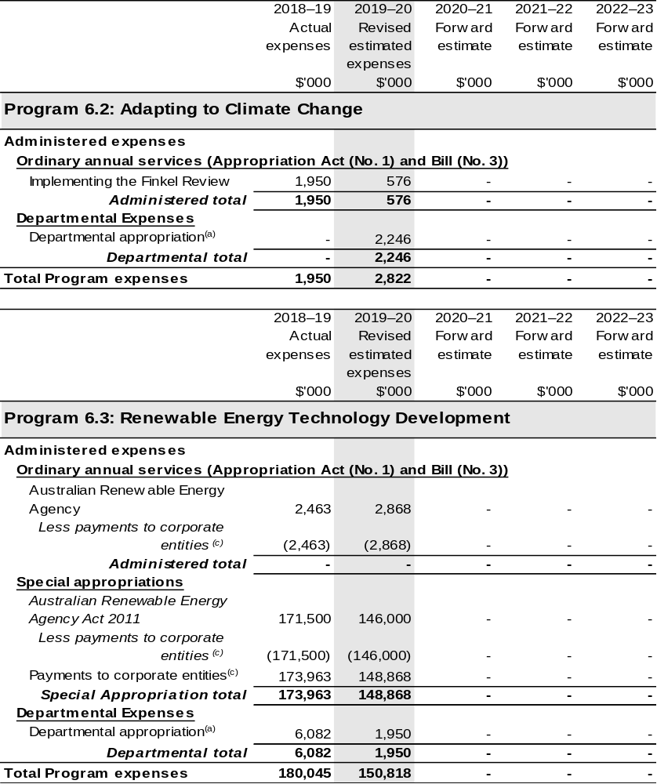
Continued on following pages

Table 2.2.6 Budgeted Expenses for Outcome 6 (continued)
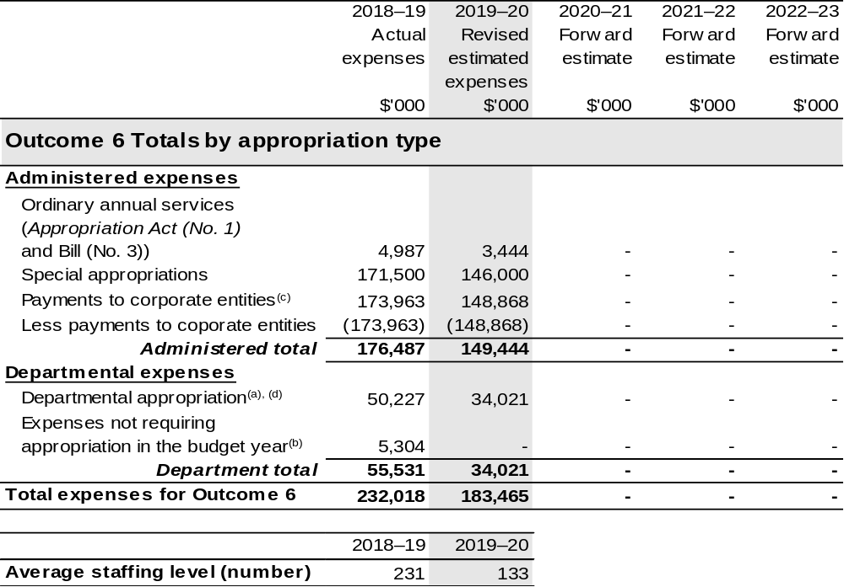
(a) Expenses funded from both ‘Ordinary annual services (Appropriation Act (No. 1) and Bill (No. 3))’ and ‘External Revenue’ under section 74 of the Public Governance, Performance and Accountability
Act 2013 (PGPA Act).
(b) ‘Expenses not requiring appropriation in the Budget year’ are made up of depreciation and amortisation expenses, audit fees and an approved operating loss.
(c) Further information on payments to the Australian Renewable Energy Agency corporate entity can be found in the ‘Third Party Payments’ section of Table 1.1: Department of Agriculture, Water and the Environment Resource Statement.
(d) Outcome 6 also has a departmental capital budget of $1.264 million in 2019–20.

Note: Departmental appropriation splits and totals are indicative estimates and may change in the course of the budget year as Government priorities change.

2.8 Budgeted expenses and performance for outcome 7

Linked programs
There have been no changes to linked programs for Outcome 7 since the 2019–20 Portfolio Budget Statements.

Performance criteria
There have been no changes to performance criteria for Outcome 7 since the 2019–20 Portfolio Budget Statements.

Budgeted expenses
Table 2.2.7 (below) shows how much the entity intends to spend (on an accrual basis) on achieving the outcome, broken down by program, as well as by Administered and Departmental funding sources. Outcomes 7 is now the responsibility of the Department of Industry, Science, Energy and Resources.

Table 2.2.7 Budgeted Expenses for Outcome 7
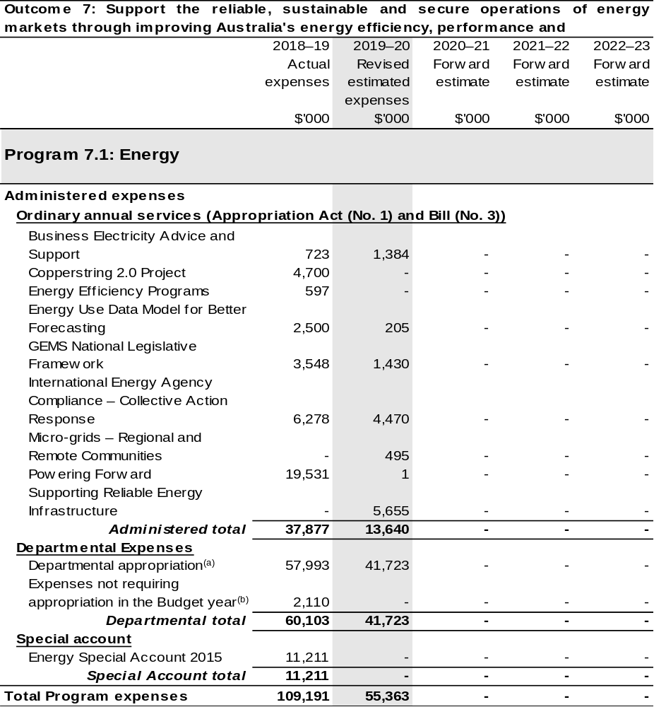
Continued on following page
Table 2.2.7 Budgeted Expenses for Outcome 7 (continued)
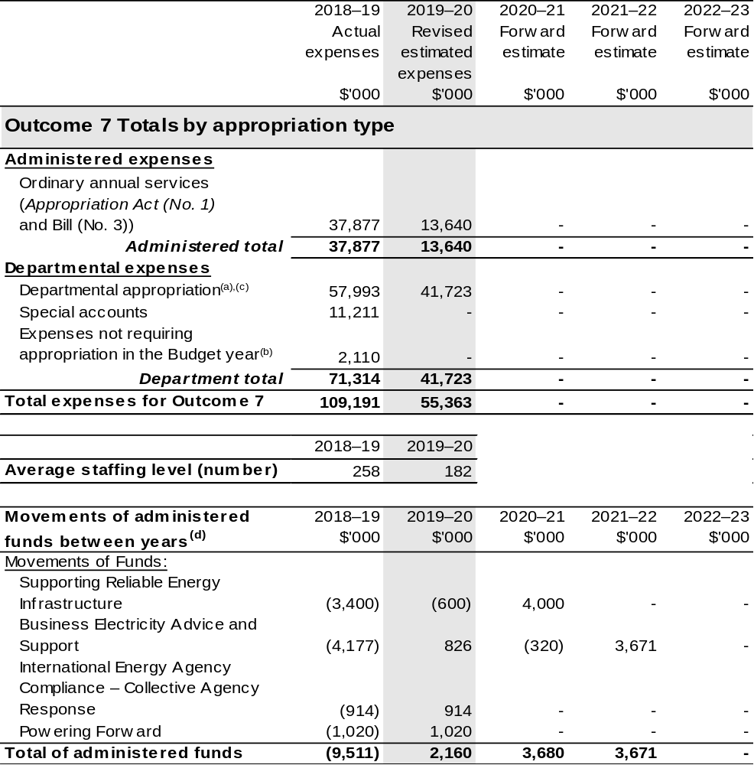
(a) Expenses funded from both ‘Ordinary annual services (Appropriation Act (No. 1) and Bill (No. 3))’ and ‘External Revenue’ under section 74 of the PGPA Act.
(b) ‘Expenses not requiring appropriation in the Budget year’ are made up of depreciation and amortisation expenses and audit fees.
(c) Outcome 7 also has a departmental capital budget of $1.011 million in 2019–20.
(d) Figures displayed as a negative (-) represent a decrease in funds and a positive (+) represent an increase in funds.

Note: Departmental appropriation splits and totals are indicative estimates and may change in the course of the budget year as Government priorities change.

Section 3: Special account flows and budgeted
financial Statements

3.1 Special account flows
Estimates of special account flows

Special Accounts provide a means to set aside and record amounts used for specified purposes. Table 3.1 and Table 3.2 shows the expected additions (receipts) and reductions (payments) for each account used by the Department of Agriculture, Water and the Environment. The tables are separated by the former departments so that the reader can easily identify between agriculture and environment.

Table 3.1: Estimates of special account flows and balances: Environment
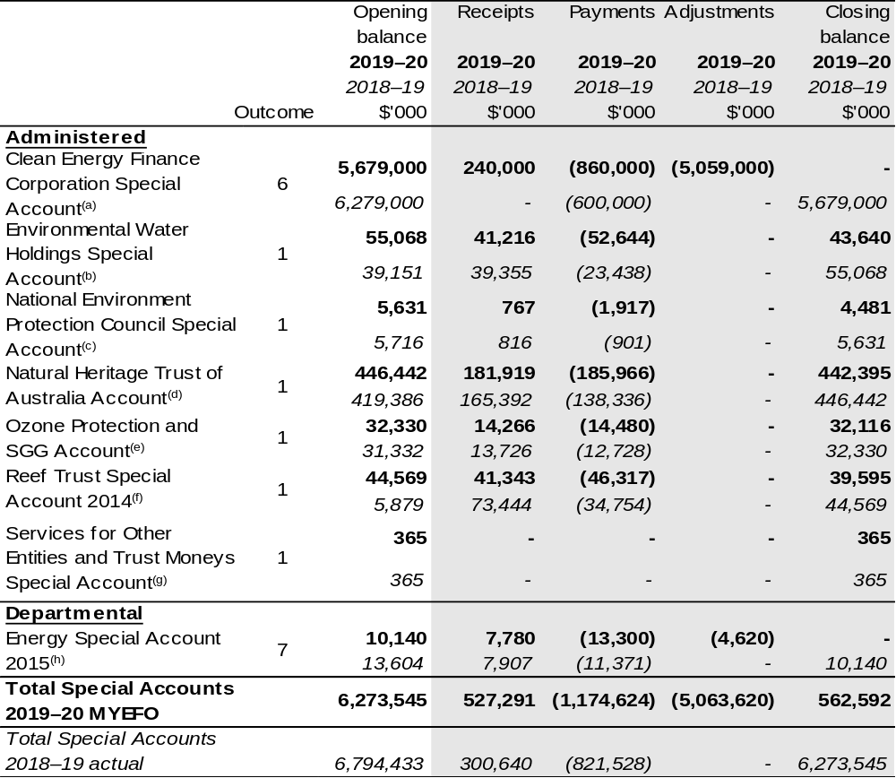
Continued on following page

Table 3.1: Estimates of special account flows and balances: Environment (continued)

(a) Clean Energy Finance Corporation Special Account – section 80 of the PGPA Act [Clean Energy Finance Corporation Act 2012]. This special account is transferring to the renamed Department of Industry, Science, Energy and Resources (DISER). It was previously reported as Outcome 2 under the Department of the Environment and Energy (DoEE), for reporting purposes it is Outcome 6.
(b) Environmental Water Holdings Special Account – section 80 of the PGPA Act [Water Act 2007].
(c) National Environment Protection Council Special Account – section 80 of the PGPA Act [National Environment Protection Council Act 1994].
(d) Natural Heritage Trust of Australia Account – section 80 of the Public Governance, Performance and Accountability Act 2013 (PGPA Act) [Natural Heritage Trust of Australia Act 1997].
(e) Ozone Protection and SGG Account – section 80 of the PGPA Act [Ozone Protection and Synthetic Greenhouse Gas Management Act 1989].
(f) Reef Trust Special Account 2014 – section 78 of the PGPA Act [PGPA Act (Reef Trust Special Account 2014) Determination 01].
(g) Services for Other Entities and Trust Moneys Special Account – section 78 of the PGPA Act Determination 2010/02.
(h) Energy Special Account 2015 – section 78 of the PGPA Act Determination 2015/07. This special account is transferring to the renamed DISER. It was previously reported as Outcome 4 under DoEE for reporting purposes it is Outcome 7.

Table 3.2: Estimates of special account flows and balances:
Agriculture and Water
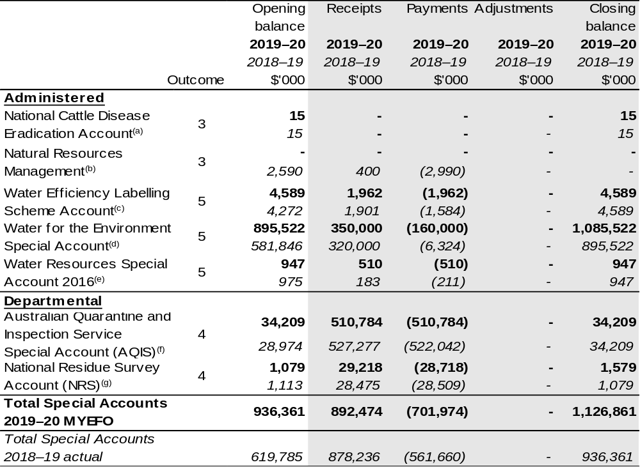
(a) The department has responsibility for the National Cattle Disease Eradication Special Account.
For the year ended 30 June 2019, the total balance carried to the next period was $0.015 million.
There were no transactions debited or credited to the account during the current or prior reporting period.

Continued on following page

Table 3.2: Estimates of special account flows and balances:
Agriculture and Water (continued)

(b) Appropriation: section 80 of the PGPA Act. Establishing Instrument: section 11 of the Natural Resources Management (Financial Assistance) Act 1992. Purpose: Granting financial assistance in connection with projects relating to natural resources management.
(c) Appropriation: section 80 of the PGPA Act. Establishing Instrument: section 64 of the Water Efficiency Labelling and Standards Act 2005. Purpose: Conserving water by reducing demand through the provision of water efficiency information about water-using products and promoting the adoption of efficient water-saving techniques.
(d) Appropriation: section 80 of the PGPA Act. Establishing Instrument: section 86AB of the Water Act 2007. Purpose: Improving the water efficiency of irrigation infrastructure and improving delivery and storage of environmental water supply within the Murray-Darling Basin.
(e) Appropriation: section 78 of the PGPA Act. Establishing Instrument: Water Resources Special Account 2016 – Establishment Determination 2016/01 under the PGPA Act. Purpose: Supporting inter-governmental activities relating to water. Note: This special account was established on 31 August 2016.
(f) Appropriation: section 78 of the PGPA Act. Establishing Instrument: Financial Management and Accountability Determination 2010/11 – Australian Quarantine and Inspection Service Special Account Establishment 2010. Purpose: For expenditure relating to the provision of quarantine and inspection services and payment of moneys to the Consolidated Revenue Fund as agreed by the relevant Minister and Minister for Finance. The AQIS special account determination is to sunset on 1 October 2020.
(g) Appropriation: section 80 of the PGPA Act. Establishing Instrument: section 6(1) of the National Residue Survey Administration Act 1992. Purpose: For conducting national residue surveys and to provide for collection of the NRS levy imposed by various acts.

Note:
The department has responsibility for the Building Australia Fund Water Portfolio Special Account.
For the year ended 30 June 2019, the account had a nil balance and there were no transactions debited or credited to it during the current or prior reporting period. Appropriation: section 80 of the PGPA Act. Establishing Instrument: section 82 of the Nation-building Funds Act 2008. Purpose: Creating and developing water infrastructure.

3.2 Budgeted financial statements

3.2.1 Analysis of budgeted financial statements
Changes to departmental and administered budgeted financial statements since the 2019–20 PBS include adjustments to recognise the AAO that took effect on 1 February 2020. The changes in responsibility are detailed in the Portfolio Overview. Other changes include the actual financial results for 2018–19, new measures, movement of funds between years and estimate variations.

3.2.2 Budgeted comprehensive departmental income statements
The changes in departmental expense, income and revenue estimates are primarily attributable to the:
- New measures announced since budget, as outlined in Tables 1.2 and 1.3;
- Transfer of responsibility of functions between entities as a result of AAO changes, as outlined in Table 2.1.; and
- Estimate variations as outlined in Table 1.4, 1.5,1.6, 1.7 and 1.8.
Estimate variations include an additional $40.9 million to support Antarctica operations over three years to address unavoidable cost pressures associated with delivery of strategic Antarctic investments. The funding will maintain vital Antarctic resupply and scientific activity, whilst introducing improved scientific, logistic and infrastructure capabilities into service.
The change in accounting policy for leases, due to AASB 16 primarily accounts for the increase in depreciation and finance costs. These adjustments are technical in nature and additional disclosures are included in the impact of net cash appropriation arrangements.
Balance Sheet
The budgeted departmental balance sheet has been updated for the impact of 2018–19 actuals which changed the opening balances for 2019–20. The change in accounting arrangements for leases requires a provision to be recognised and primarily accounts for the increase in other provisions. Also the reflection of transfer of responsibility of functions between entities from the AAO.
Statements of Changes in Equity
The changes in equity estimates from the 2019–20 PBS reflect the updated 30 June 2019 actual operating result and transfer of responsibility of functions between entities from the AAO.

3.2.3 Schedule of budgeted income and expenses administered on behalf of the Government
Schedule of budgeted income and expenses
The revised schedule reflects the impact to administered expenses from measures outlined in Tables 1.2 and 1.3 and changes in entity responsibilities arising from the AAO. The AAO also impacts the accounting treatment of water entitlements and the recognition of a non-cash adjustments for assets transferred and received. The revised schedule also reflects the impact to administered revenue from levies estimates and accounting change for the Agriculture Future Drought Resilience Special Account.

3.2.4 Schedule of budgeted assets and liabilities administered on behalf of the Government
Schedule of budgeted assets and liabilities
The change to the budgeted administered balance sheet reflect the update of the
2018–19 actuals which change the opening balances for 2019–20 and the change in responsibilities arising from the AAO.

3.2.5 Budgeted financial statements tables

Table 3.3: Comprehensive income statement (showing net cost of services) for the period ended 30 June
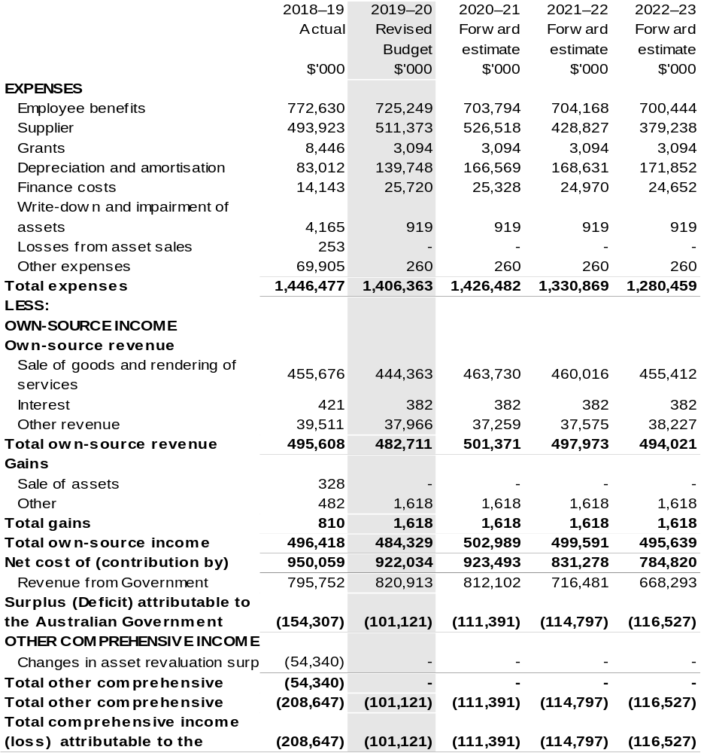

Continued on following page

Table 3.3: Comprehensive income statement (showing net cost of services) for the period ended 30 June (continued)
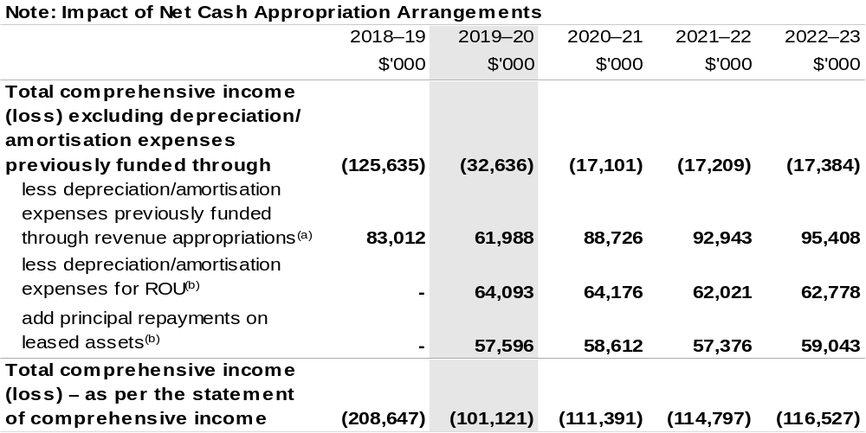

(a) From 2010–11, the Government introduced net cash appropriation arrangements where Appropriation Act (No. 1) or Bill (No. 3) revenue appropriations for the depreciation/amortisation expenses of
non-Corporate Commonwealth Entities were replaced with a separate capital budget (the Departmental Capital Budget, or DCB) provided through Appropriation Act (No. 1) or Bill (No. 3) equity appropriations. For information regarding DCBs, please refer to Table 3.6 Departmental Capital Budget Statement.
(b) Applies leases under AASB 16 Leases. Right of Use (ROU).

Prepared on Australian Accounting Standards basis.

Table 3.4: Budgeted departmental balance sheet (as at 30 June)
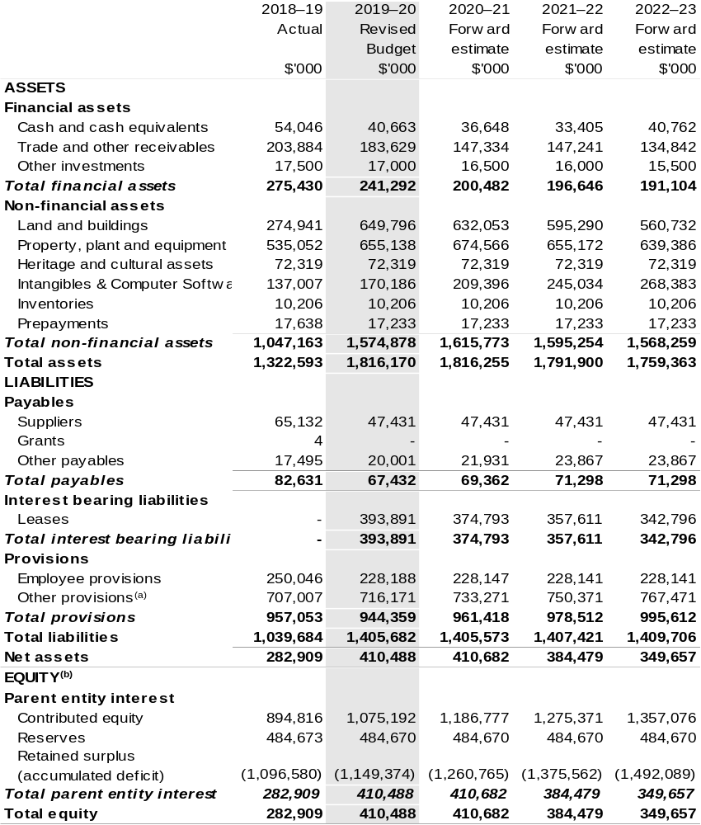
(a) The department has a ‘make good’ obligation for: the removal and site restoration of buildings and infrastructure located in Antarctica and on sub-Antarctic Macquarie Island; and remediation of past waste disposal sites and areas of ground contamination in Antarctica for which Australia is responsible. These make good provisions are calculated using a net present value methodology. This requires that each year the provision increases by the value of unwinding a discount on the future value of the provisions. This increase results in liabilities that are not covered by assets for the department. Funding will not be provided to the department until such time as payments are required to be made, which is beyond the forward estimates.
(b) ‘Equity’ is the residual interest in assets after deduction of liabilities.

Prepared on Australian Accounting Standards basis.

Table 3.5: Departmental statement of changes in equity — summary of movement (Budget year 2019–20)
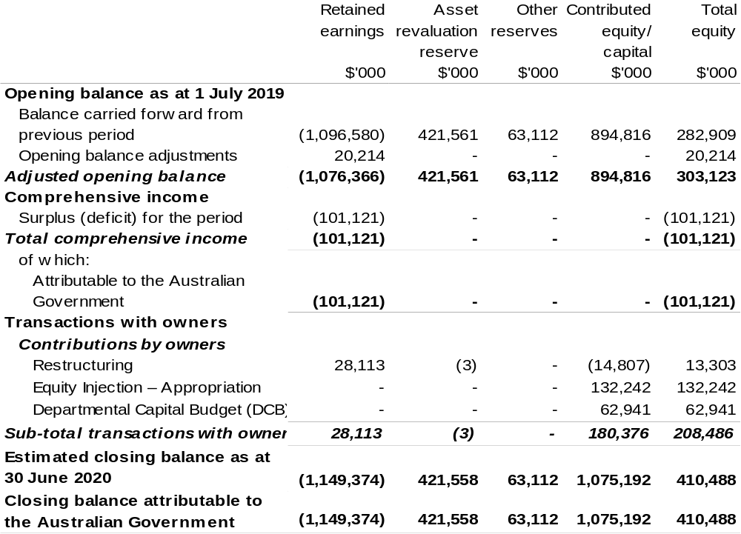

Prepared on Australian Accounting Standards basis.

Table 3.6: Budgeted departmental statement of cash flows (for the period ended 30 June)
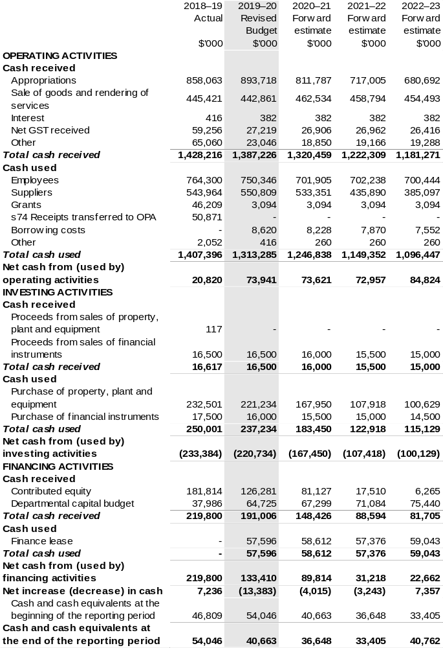

Prepared on Australian Accounting Standards basis.

Table 3.7: Departmental capital budget statement (for the period ended 30 June)
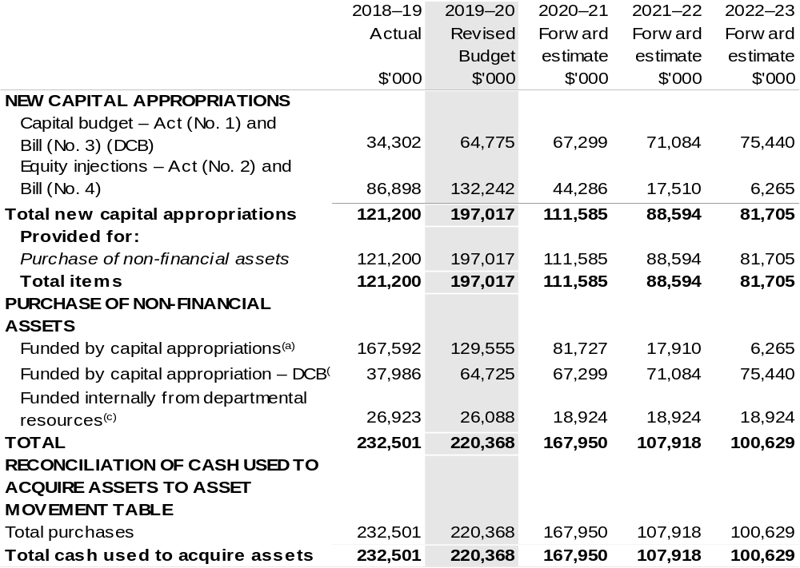

(a) Includes both current Bill (No. 4) and prior Act (No. 2/4/6) appropriations.
(b) Does not include annual finance lease costs. Includes purchases from current and previous years’ Departmental Capital Budgets.
(c) Includes the following sources of funding:
– current Bill (No. 3) and prior year Act (No. 1/3/5) appropriations (excluding amounts from the DCB);
– internally developed assets;
– section. 74 External Revenue; and
– proceeds from the sale of assets.

Consistent with information contained in the Statement of Asset Movements and the Budgeted Statement of Cash Flows.

Table 3.8: Statement of asset movements (2019–20 Budget year)
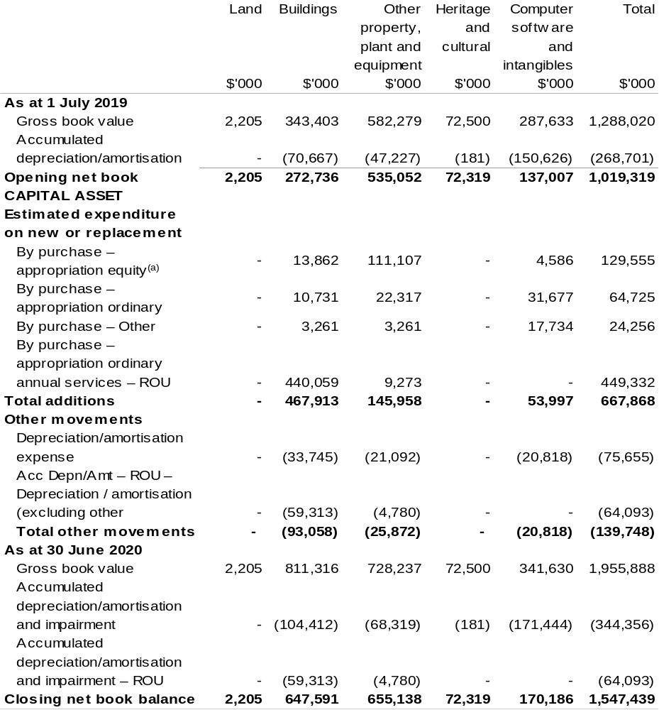

(a) ‘Appropriation equity’ refers to equity injections, appropriations provided through Appropriation
Act (No. 2) and Bill (No. 4) 2019–20.
(b) ‘Appropriation ordinary annual services’ refers to funding provided through Appropriation Act (No. 1) and Bill (No. 3) 2019–20 for depreciation / amortisation expenses, DCBs or other operational expenses.

Prepared on Australian Accounting Standards basis.

Table 3.9: Schedule of budgeted income and expenses administered on behalf of Government (for the period ended 30 June)
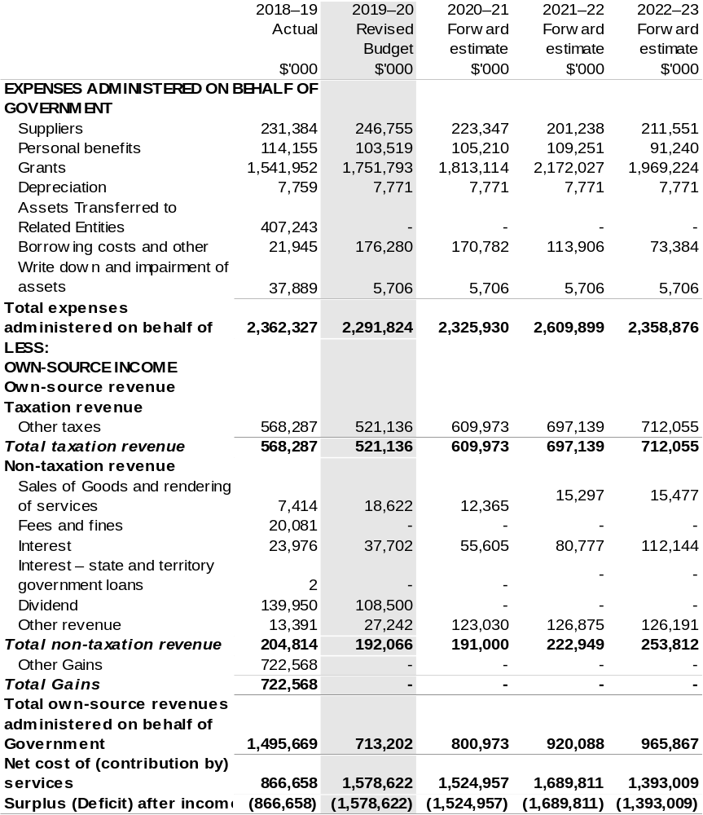

Prepared on Australian Accounting Standards basis.

Table 3.9: Schedule of budgeted income and expenses administered on behalf of Government (for the period ended 30 June) continued
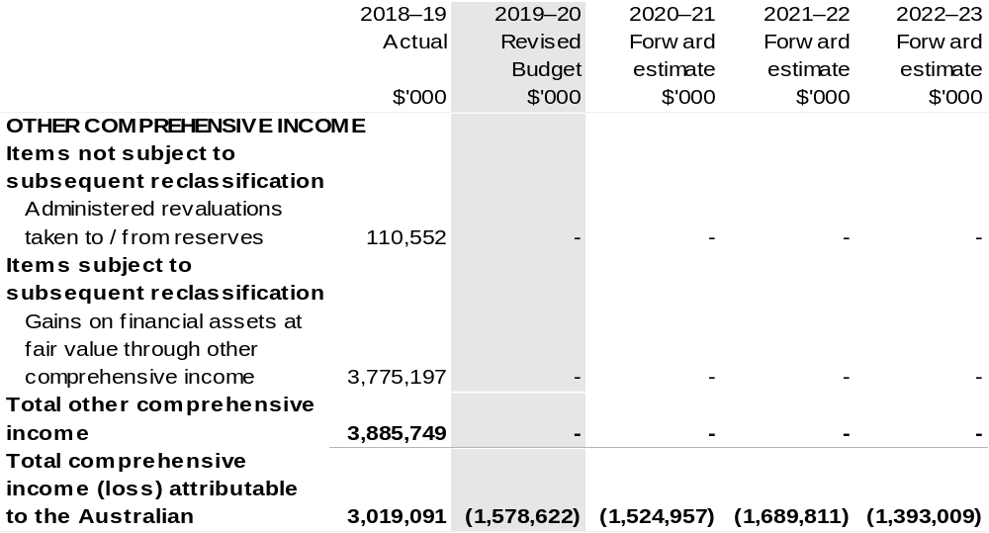

Prepared on Australian Accounting Standards basis.

Table 3.10: Schedule of budgeted assets and liabilities administered on behalf of Government (as at 30 June)
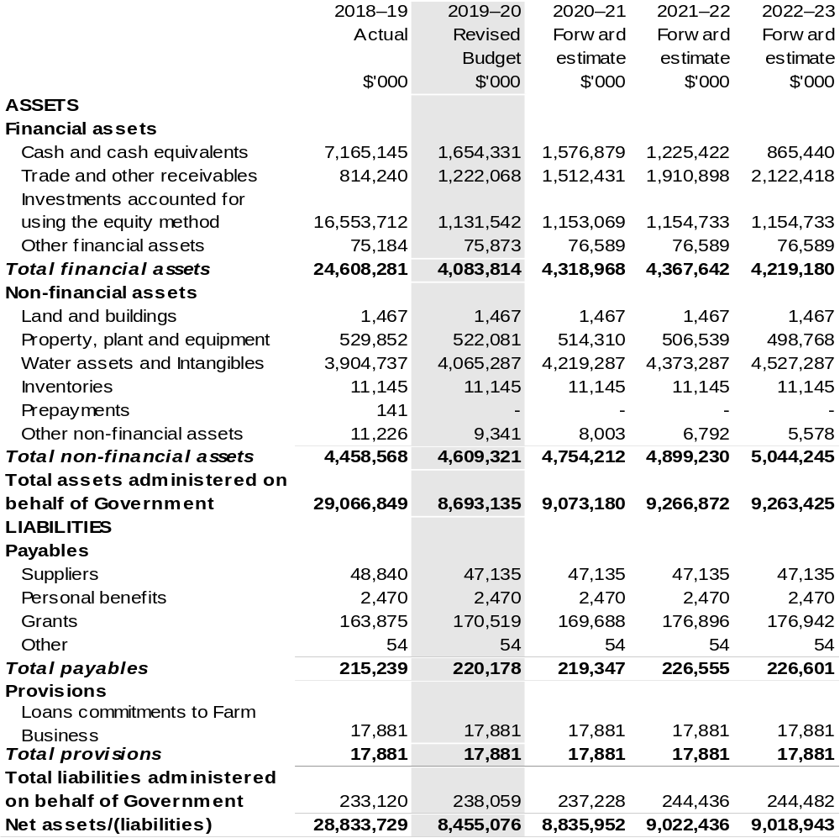
Prepared on Australian Accounting Standards basis.

Table 3.11: Schedule of budgeted administered cash flows (for the period ended 30 June)
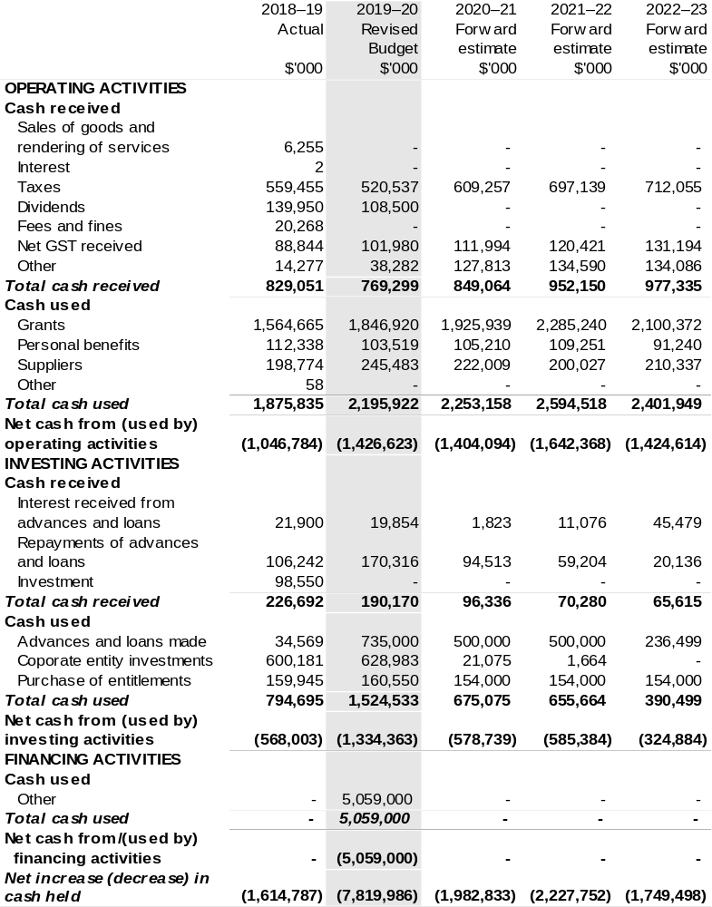
Continued on following page

Table 3.11: Schedule of budgeted administered cash flows (for the period ended 30 June) (continued)
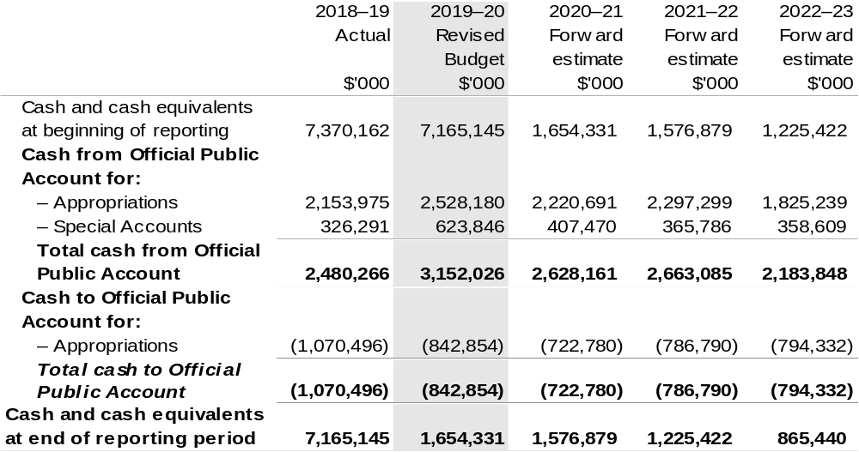

Prepared on Australian Accounting Standards basis.

Table 3.12: Schedule of administered capital budget (for the period ended 30 June)
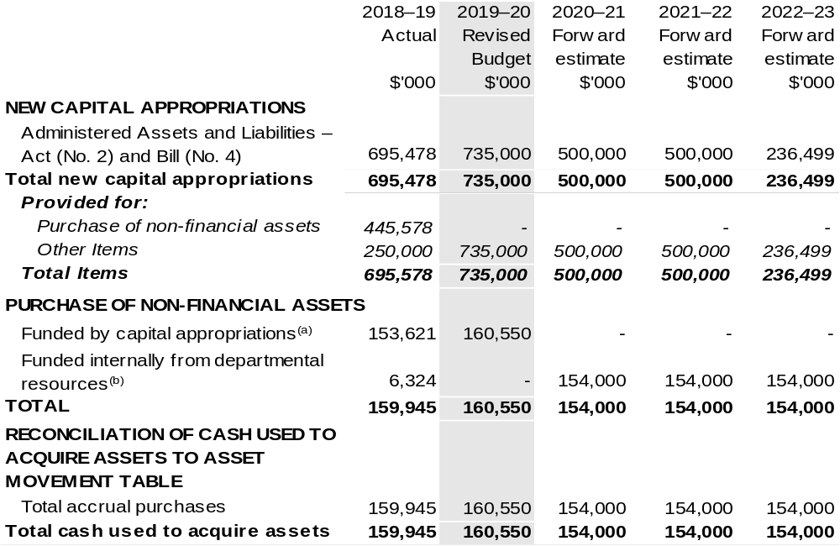

(a) Includes both current Bill (No. 4) and prior Act (No. 2/4/6) appropriations and special capital appropriations.
(b) Includes funding credited to the Water for the Environment Special Account.

Prepared on Australian Accounting Standards basis.

Table 3.13: Statement of administered asset movements (2019–20 Budget year)
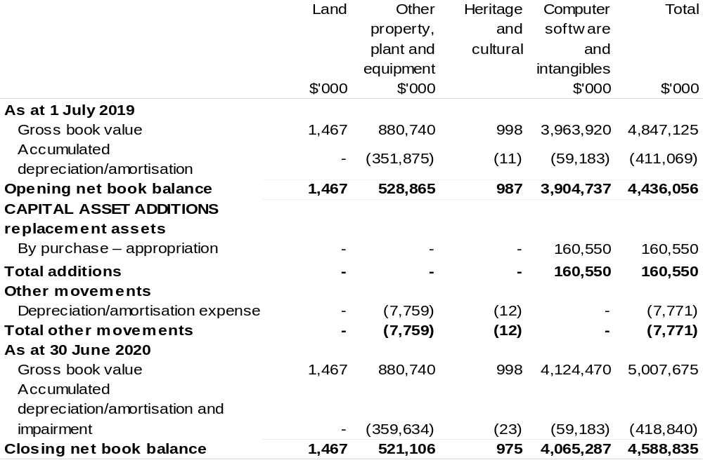

(a) ‘Appropriation equity’ refers to Administered Assets and Liabilities provided through Appropriation Act (No. 2) and Bill (No. 4) 2019–20.

Prepared on Australian Accounting Standards basis.

Bureau Of Meteorology
Section 1: Entity overview and resources 111
1.1 Strategic direction statement 111
1.2 Entity resource statement 112
1.3 Enity measures 114
1.4 Additional esimates, resourcing and variations to outcome 115
1.5 Breakdown of additional estimates by Appropriation Bill 117
Section 2: REVISIONS TO Outcome and planned performance 118
2.1 Changes to outcome and program structures 118
2.2 Budgeted expenses and performance for Outcome 1 118
Section 3: SpECIAL ACCOUNT FLOWS AND Budgeted financial
statements 120
3.1 Special account flows 120
3.2 Budgeted financial statements 120

Bureau Of Meteorology

Section 1: Entity overview and resources

1.1 Strategic direction statement
The following text outlines updates to Strategic Direction Statement in the 2019–20 Environment and Energy Portfolio Budget Statements to reflect decisions of the Government since the 2019–20 Budget.
The Government will fund $3 million for the Bureau of Meteorology (BoM) to establish a service to assure the quality of observations data emanating from privately owned weather stations. It will support industry to offer and consumers to take up sustainable parametric weather insurance products, reducing the financial volatility of farm businesses caused by weather, climate and water variability. This will rapidly improve the capacity of private weather networks to support a sustainable parametric insurance market.

1.2 Entity resource statement
These tables detail the resourcing for the Bureau of Meteorology at 2019–20 Additional Estimates. Table 1.1 outlines the total resources available from all sources for the
2019–20 Budget year, including variations through Appropriation Bills (No. 3) and
(No. 4) 2019–20 and Special Appropriations.

Table 1.1: Bureau of Meteorology – Resource Statement – Additional Estimates for 2019–20 as at Additional Estimates February 2020
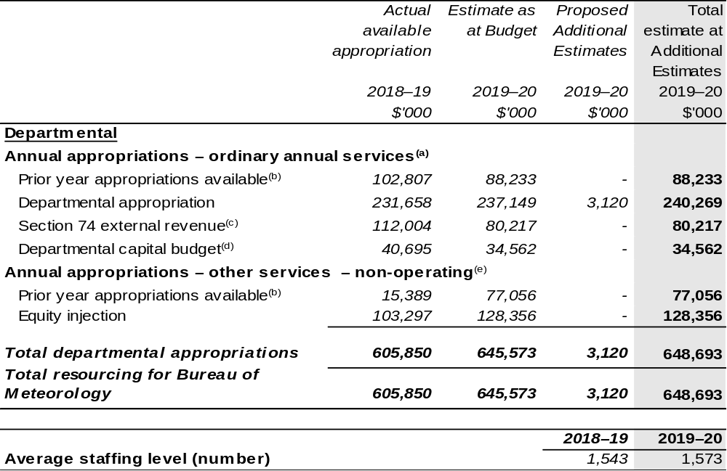

- Appropriation Act (No. 1) 2019–20 and Appropriation Bill (No. 3) 2019–20.
- Excludes $43 million subject to administrative quarantine by Finance or withheld under section 51 of the PGPA Act.
- Estimated external revenue receipts under section 74 of the PGPA Act.
- Departmental capital budgets are not separately identified in Appropriation Bill (No.1) and form part of ordinary annual services items. Please refer to Table 3.7 for further details. For accounting purposes, this amount has been designated as a 'contribution by owner'.
- Appropriation Act (No. 2) 2019–20 and Appropriation Bill (No. 4) 2019–20.

Prepared on a resourcing (i.e. appropriations available) basis.

Note: all figures shown above are GST exclusive – these may not match figures in the cash flow statement.

Table 1.1: Bureau of Meteorology – Resource Statement – Additional Estimates for 2019–20 as at Additional Estimates February 2020 (continued)
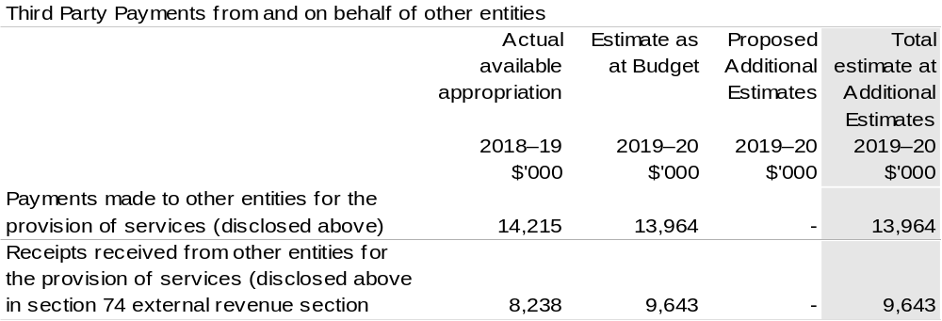

1.3 Entity measures
Table 1.2 summarises new Government measures taken since the 2019–20 Budget.
The table is split into revenue, expense and capital measures, with the affected program identified.

Table 1.2: Bureau of Meteorology – measures since 2019–20 Budget
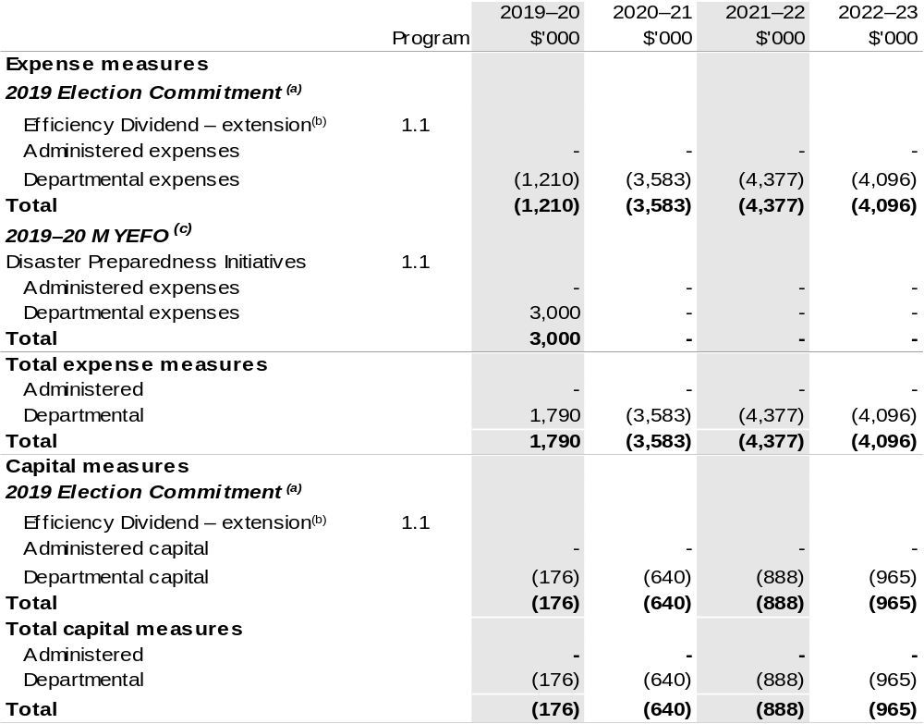

(a) This measure relates to an Election Commitment identified under Appendix A included in the Explanatory Memorandum to 2019–20 Appropriation Bills (No. 1) and (No. 2).
(b) The lead entity for the measure Efficiency Dividend – extension is Department of Finance. The publicly released costing can be found through the ‘2019 Election Costings’ website, under the Finance portfolio.
(c) These measures were published on the 16 December 2019 and appear in 2019–20 Mid-Year Economic and Fiscal Outlook (MYEFO) under the Environment and Energy portfolio. Measures relates to an Election Commitment identifies under Appendix A included in the Explanatory Memorandum to 2019–20 Appropriation Bills (No. 1) and (No. 2).

Prepared on a Government Finance Statistics (Fiscal) basis.

1.4 Additional estimates, resourcing and variations to outcomes
The following tables detail changes in resourcing for the Bureau of Meteorology at Additional Estimates, by outcome. The tables show variations since the 2019–20 Budget due to new measures (as per Table 1.2) and variations due to other factors, such as movements of funds, reclassifications, reallocations and adjustments due to the efficiency dividend and changes in economic parameters.

Additional Estimates and other variations to outcome since 2019–20 Budget

Table 1.3: Election Commitment
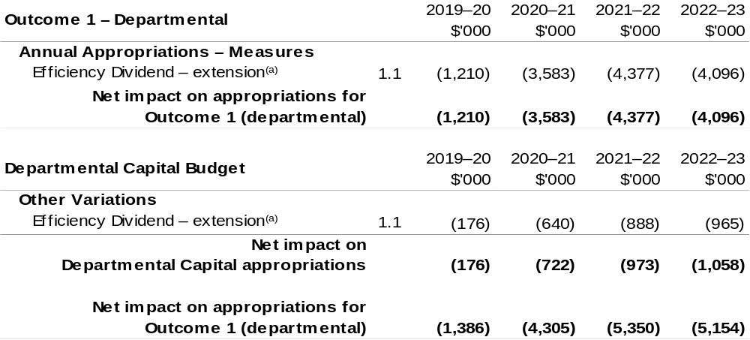
(a) This measure relates to an Election Commitment identified under Appendix A included in the Explanatory Memorandum to 2019–20 Appropriation Bills (No. 1) and (No. 2).

Continued on following page

Table 1.4: 2019–20 MYEFO and Additional Estimates
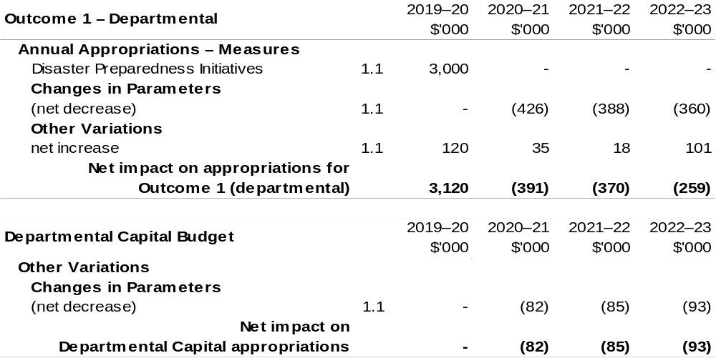

Prepared on a Government Finance Statistics (Fiscal) basis.

1.5 Breakdown of additional estimates by appropriation bill
The following table shows Additional Estimates sought for the Bureau of Meteorology through Appropriation Bill (No. 3) 2019–20.

Table 1.5: Appropriation Bill (No. 3) 2019–20 – Departmental
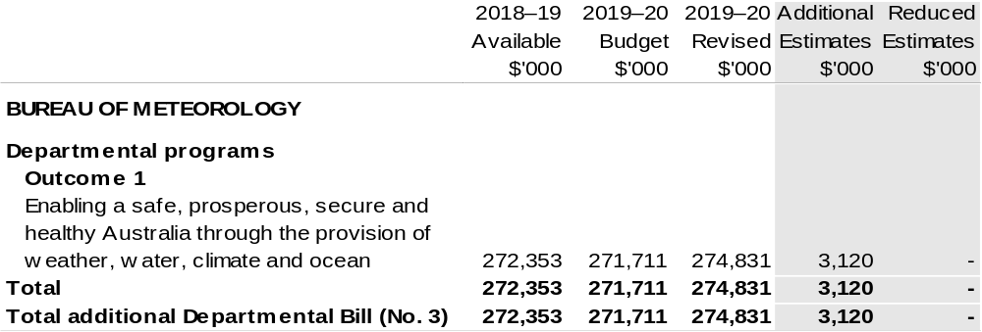

Section 2: Revisions to outcomes and planned performance

2.1 Changes to outcome and program structures
There have been no changes to the department’s outcomes and program structure since the 2019–20 Portfolio Budget Statements.

2.2 Budgeted expenses and performance for outcome 1

Linked programs
There have been no changes to linked programs for Outcome 1 since the 2019–20 Portfolio Budget Statements.

Performance criteria
There has been no change to performance criteria for Outcome 1 since the 2019–20 Portfolio Budget Statements.

Budgeted expenses
Table 2.1 (below) shows how much the entity intends to spend (on an accrual basis) on achieving the outcome, broken down by program and Departmental funding sources.

Table 2.1: Budgeted expenses for Outcome 1
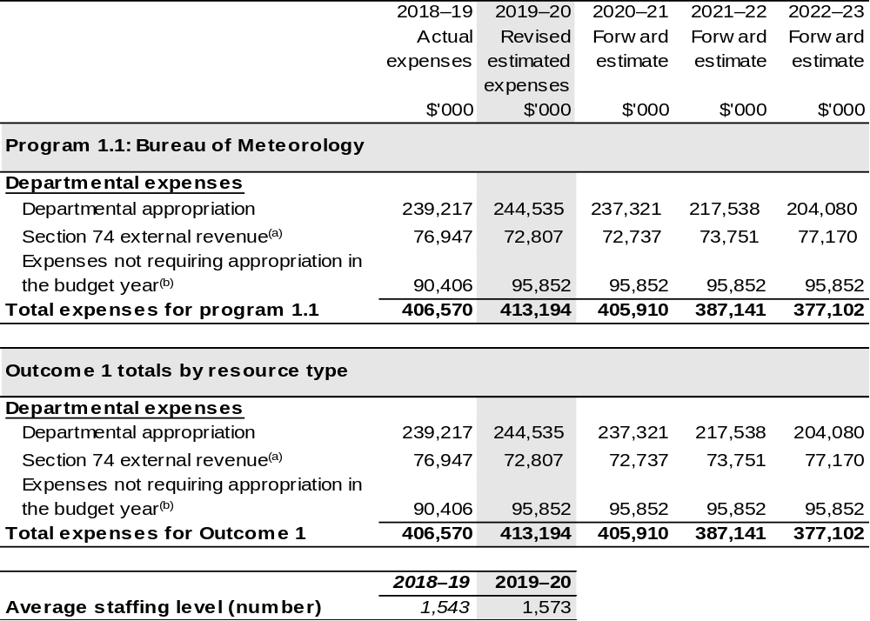

(a) Estimated expenses incurred in relation to receipts retained under section 74 of the PGPA Act 2013.
(b) Expenses not requiring appropriation in the Budget year are made up of depreciation expenses, amortisation expenses, make good expense and audit fees.

Section 3: Special account flows and budgeted financial Statements

3.1 Special account flows
Special Accounts provide a means to set aside and record amounts used for specified purposes. Table 3.1 shows the expected additions (receipts) and reductions (payments) for each account used by the Bureau of Meteorology.

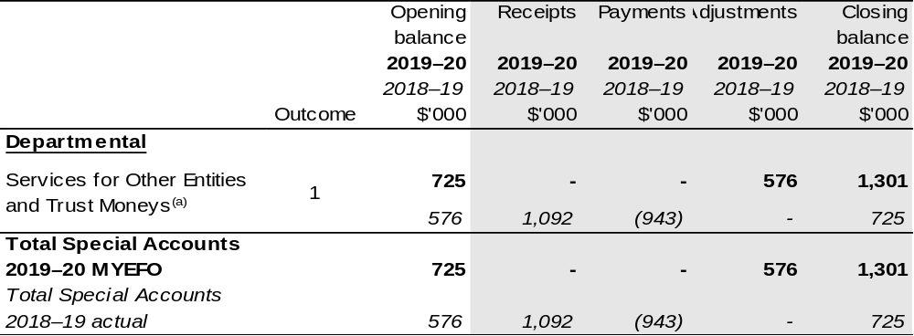
Table 3.1: Estimates of special account flows and balances

(a) Appropriation: section 78 of the PGPA Act. Establishing Financial Management and Accounting Determination 2008/06. Purpose: To enable BoM to hold and expend amounts on behalf of persons or entities other than the Commonwealth.

3.2 Budgeted financial statements

3.2.1 Analysis of budgeted financial statements
There has been no major change to the analysis of budgeted financial statements since the 2019–20 Portfolio Budget Statements.

3.2.2 Explanatory notes and analysis of budgeted financial statements
An analysis of the Bureau of Meteorology’s (the Bureau) budgeted financial statements, as reflected in the Bureau’s budgeted departmental financial statements and administered schedules for the 2019–20 Additional Estimates, is provided below:
Total revised revenue to the Bureau in 2019–20 is estimated to be $317.7 million,
a decrease of $6.7 million from the 2018–19 actual result. The movement in funding is the result of:
• funding associated with the 2019–20 Budget measure – Bureau of Meteorology additional radars and rain gauges;

• funding associated with the 2019–20 Budget measure – Barkly Regional deal;
• Additional Estimates Budget measure – Disaster Preparedness Initiative;
• a reduction in revenue associated with cost recoverable projects and services; and
• increased funding for economic parameter adjustments offset by increased Efficiency Dividends.
Total expenses are estimated to be $413.2 million, an increase of $6.6 million from the 2018–19 actual result.
Whilst the Bureau is no longer funded for Depreciation through Appropriation
Bill (No. 1) the expenditure is still recognised on the Income Statement.

3.2.3 Budgeted financial statements tables

Table 3.2: Comprehensive income statement (showing net cost of services)
(for the period ended 30 June)
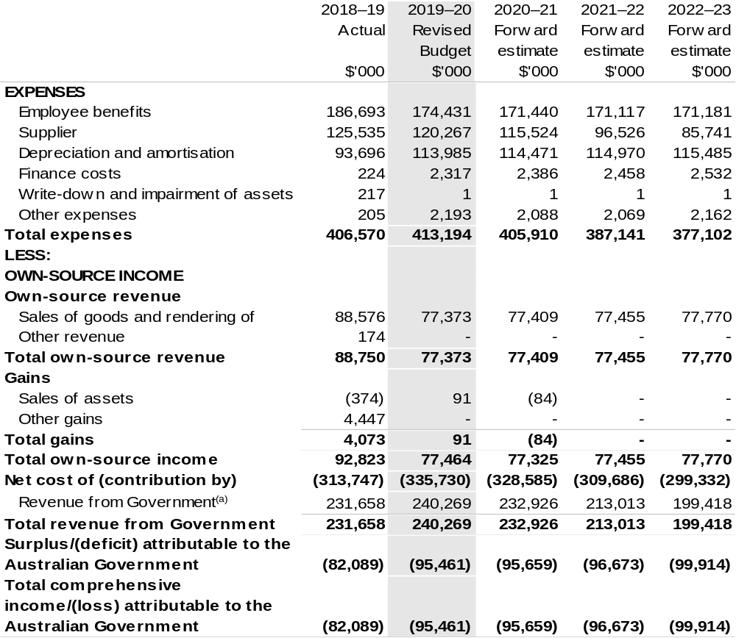
Continued on following page
Table 3.2: Comprehensive income statement (showing net cost of services) (for the period ended 30 June) (continued)
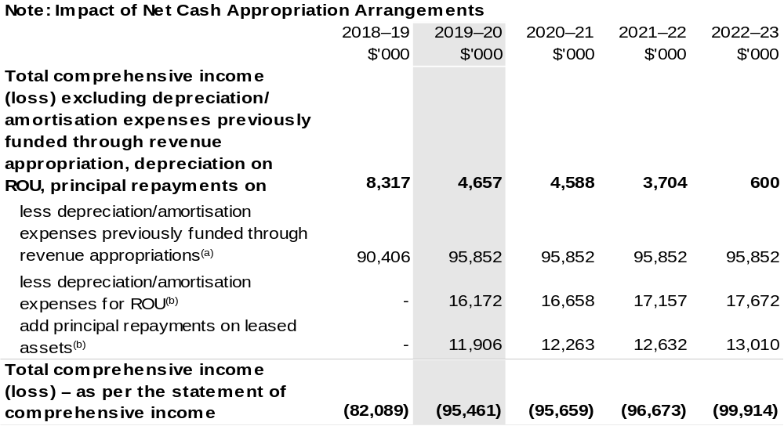
(a) From 2010–11, the Government introduced net cash appropriation arrangements where Appropriation
Act (No. 1) or Appropriation Bill (No. 3) revenue appropriations for the depreciation/amortisation expenses of non-corporate Commonwealth entities were replaced with a separate capital budget (the Departmental Capital Budget, or DCB) provided through Appropriation Act (No. 1) or Bill (No. 3) equity appropriations. For information regarding DCB, please refer to Table 3.7 Departmental Capital Budget Statement.
(b) Applies leases under AASB 16 Leases. Right of Use (ROU).

Prepared on Australian Accounting Standards basis.

Table 3.3: Budgeted departmental balance sheet (as at 30 June)
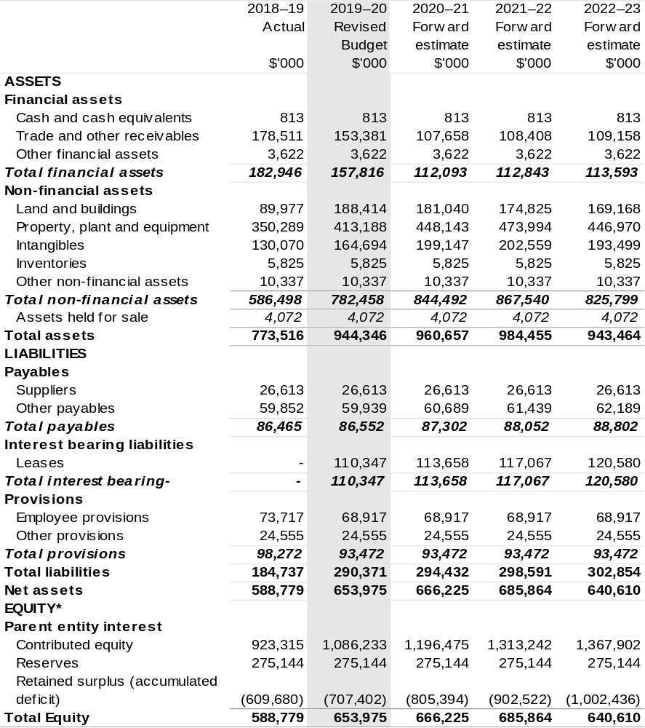

*'Equity is the residual interest in assets after deduction of liabilities.

Prepared on Australian Accounting Standards basis.

Table 3.4: Departmental statement of changes in equity—summary of movement (Budget year 2019–20)
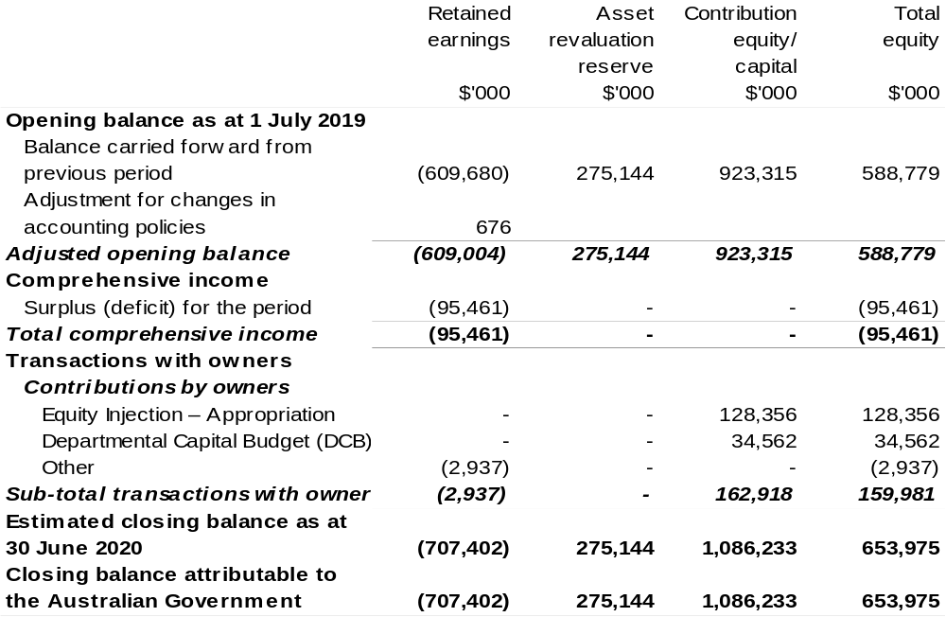

Prepared on Australian Accounting Standards basis.

Table 3.5: Budgeted departmental statement of cash flows (for the period
ended 30 June)
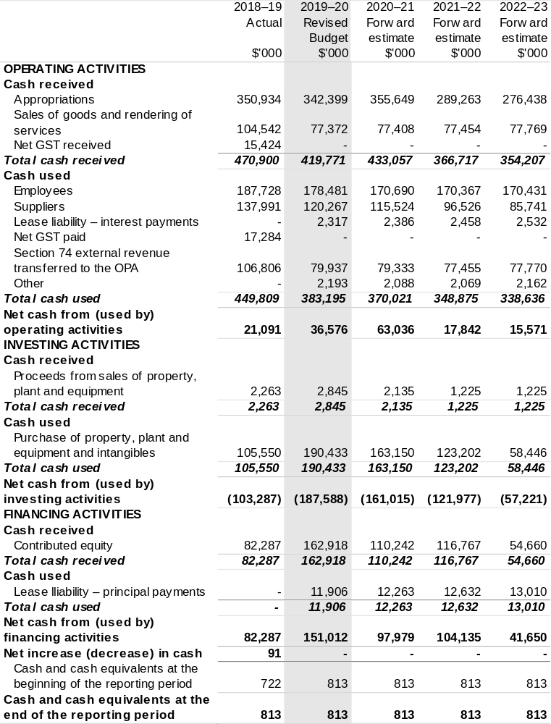
Prepared on Australian Accounting Standards basis.

Table 3.6: Departmental capital budget statement (for the period ended 30 June)
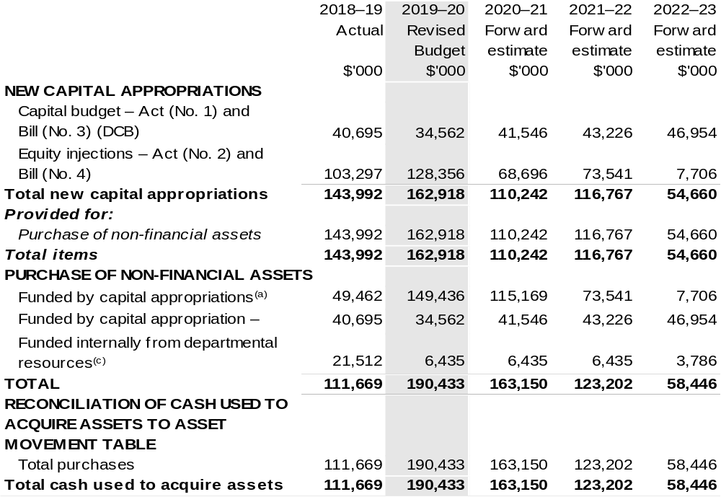

(a) Includes both current Bill (No. 4) and prior Act/Bill (No. 2/4/6) appropriation.
(b) Does not include annual finance lease costs. Include purchases from current and previous years'
Departmental Capital Budgets (DCBs).
(c) Includes the following sources of funding:
– current Bill (No. 3) and prior year Act/Bill (No. 1/3/5) appropriations (excluding amounts from the DCBs);
– donations and gifts of non-financial assets;
– internally developed assets;
– section 74 external revenue; and
– proceeds from the sale of assets.

Consistent with information contained in the Statement of Asset Movements and the Budgeted Statement of Cash Flows.

Prepared on Australian Accounting Standards basis.

Table 3.7: Statement of asset movements (Budget year 2019–20)
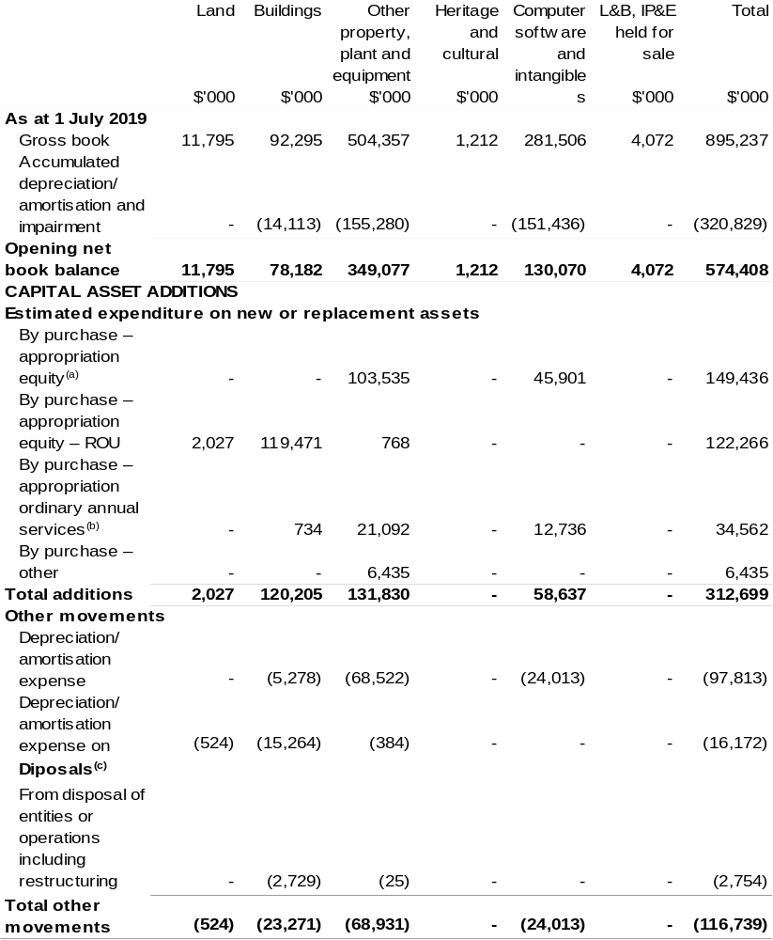

Continued on following page
Table 3.7: Statement of asset movements (Budget year 2019–20) (continued)
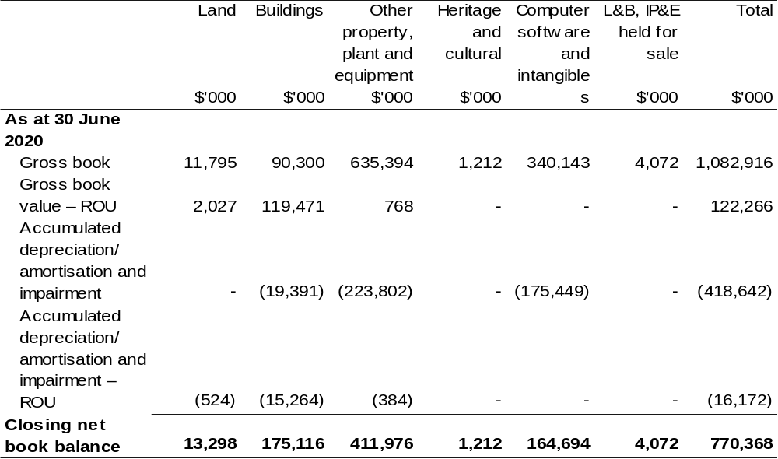

- "Appropriation equity" refers to equity injections or Administered Assets and Liabilities appropriations provided through Appropriation Act (No. 2) 2019–2020 and Appropriation Bill (No. 4) 2019–2020, including Collection Development Acquisition Budget.
- "Appropriation ordinary annual services" refers to funding provided through Appropriation Act (No. 1) 2019–2020 and Appropriation Bill (No. 3) 2019–2020 for depreciation/amortisation expenses, Departmental Capital Budget or other operational expenses.
- Net proceeds may be returned to the OPA.

Prepared on Australian Accounting Standards basis.

Table 3.8: Schedule of budgeted income and expenses administered on behalf of Government (for the period ended 30 June)
The schedule of budgeted income and expenses administered on behalf of Government does not apply to the BoM.

Table 3.9: Schedule of budgeted assets and liabilities administered on behalf of Government (as at 30 June)
The schedule of budgeted assets and liabilities administered on behalf of Government does not apply to the BoM.

Table 3.10: Schedule of budgeted administered cash flows (for the period
ended 30 June)
The schedule of budgeted administered cash flows on behalf of Government does not apply to the BoM.

Great Barrier Reef Marine Park Authority
Section 1: Entity overview and resources 133
1.1 Strategic direction statement 133
1.2 Entity resource statement 134
1.3 Enity measures 135
1.4 Additional esimates, resourcing and variations to outcome 137
1.5 Breakdown of additional estimates by Appropriation Bill 139
Section 2: REVISIONS TO Outcome and planned performance 140
2.1 Changes to outcome and program structures 140
2.2 Budgeted expenses and performance for Outcome 1 140
Section 3: SpECIAL ACCOUNT FLOWS AND Budgeted financial
statements 142
3.1 Sepcial account flows 142
3.2 Budgeted financial statements 142

Great Barrier Reef Marine Park Authority

Section 1: Entity overview and resources

1.1 Strategic direction statement
The following text outlines updates to Strategic Direction Statement in the 2019–20 Environment and Energy Portfolio Budget Statements to reflect decisions of the Government since the 2019–20 Budget.
The Government will fund $26.9 million for critical works required to upgrade the Great Barrier Reef Marine Park Authority Reef HQ aquarium.

1.2 Entity resource statement
These tables detail the resourcing for the Great Barrier Reef Marine Park Authority (GBRMPA) at 2019–20 Additional Estimates. Table 1.1 outlines the total resources available from all sources for the 2019–20 Budget year, including variations through Appropriation Bills (No. 3) and (No. 4) 2019–20 and Special Appropriations.

Table 1.1: Great Barrier Reef Marine Park Authority – Resource Statement – Additional Estimates for 2019–20 as at Additional Estimates February 2020 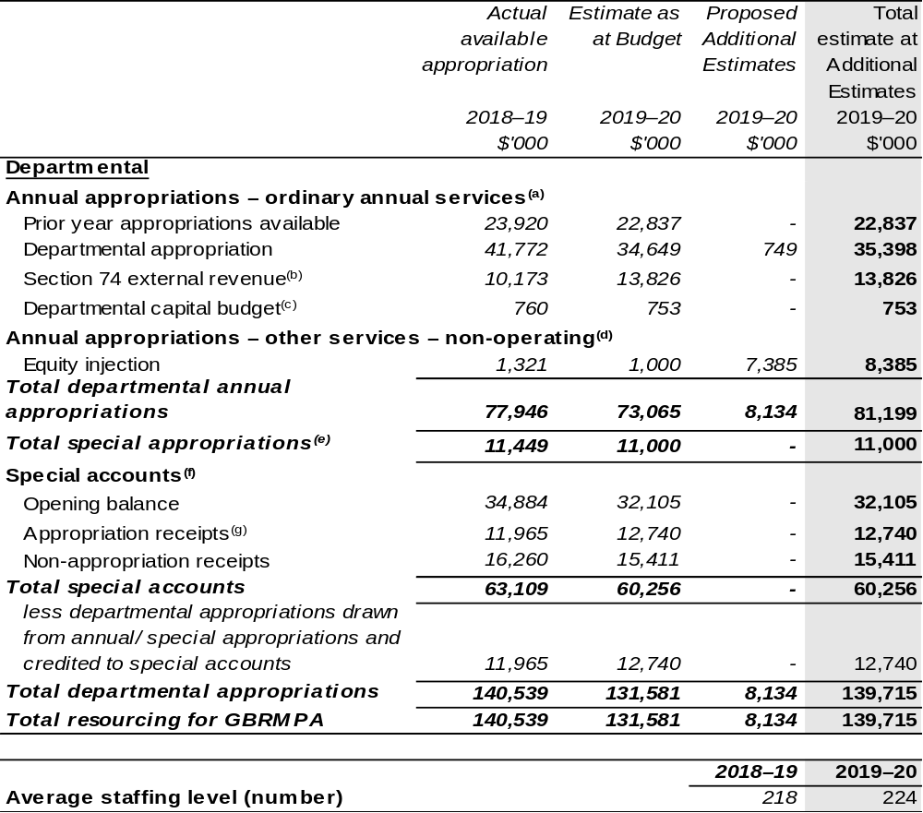
- Appropriation Act (No. 1) 2019–2020 and Appropriation Bill (No. 3) 2019–2020.
- Estimated external revenue receipts under section 74 of the PGPA Act.
- Departmental capital budgets are not separately identified in Appropriation Act (No. 1) and form part of ordinary annual services items. Please refer to Table 3.7 for further details. For accounting purposes, this amount has been designated as a 'contribution by owner'.
- Amounts credited to the Authority as special appropriation under Section 65a of the Great Barrier Reef Marine Park Act 1975.
- For further information on special accounts see Table 3.1.
- Amounts credited to the special accounts from the Authority's annual and special appropriations.
- Amounts credited to the special accounts from the Queensland Government and other revenue.

Prepared on a resourcing (i.e. appropriations available) basis.
Please note: all figures shown above are GST exclusive – these may not match figures in the cash flow statement.

1.3 Entity measures
Table 1.2 summarises new Government measures taken since the 2019–20 Budget.
The table is split into revenue, expense and capital measures, with the affected program identified.

Table 1.2: Great Barrier Reef Marine Park Authority – measures since 2019–20 Budget
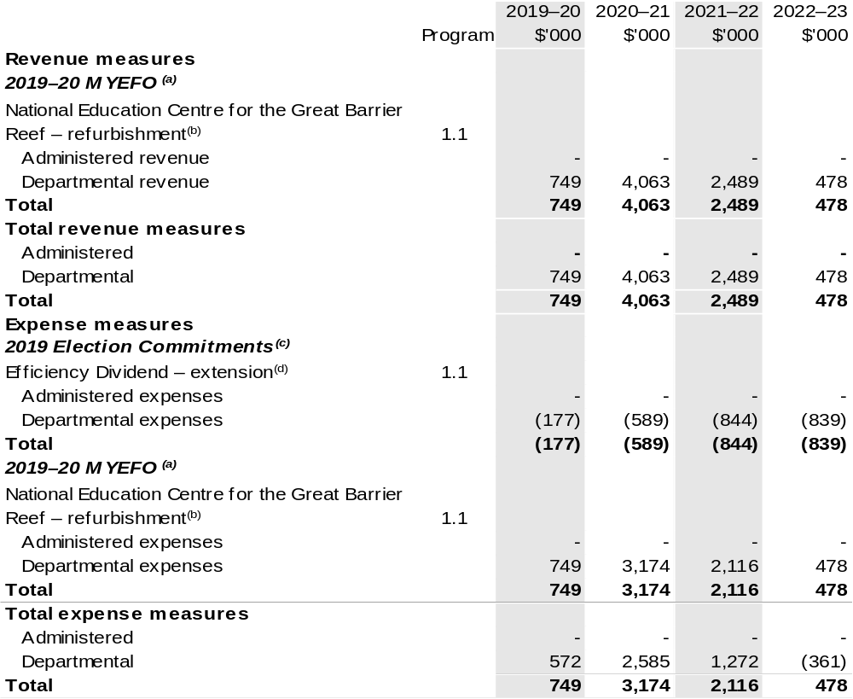

Continued on following page

Table 1.2: Great Barrier Reef Marine Park Authority – measures since 2019–20 Budget (continued) 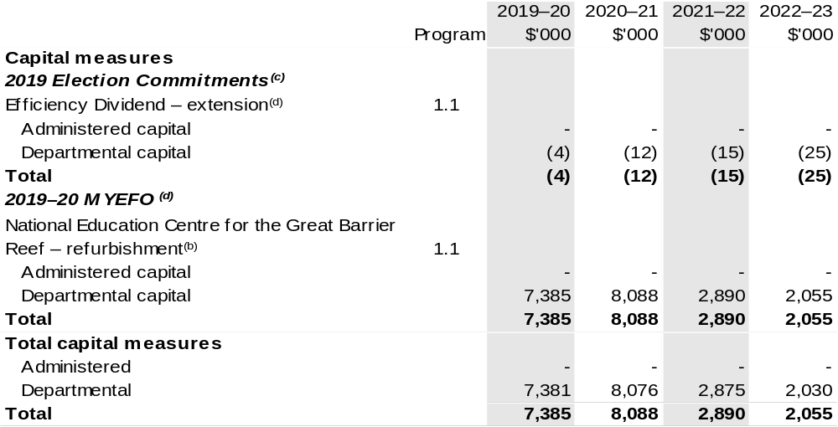
- These measures were published on the 16 December 2019 and appear in 2019–20 Mid-Year Economic and Fiscal Outlook (MYEFO) under the Environment and Energy portfolio.
- This measure provides funding for the Government's Great Barrier Reef National Education Centre for critical works.
- Measures relates to an Election Commitment identifies under Appendix A included in the Explanatory Memorandum to 2019–20 Appropriation Bills (No. 1) and (No. 2).
- The lead entity for the measure Efficiency Dividend – extension is Department of Finance. The publicly released costing can be found through the ‘2019 Election Costings’ website, under the Finance portfolio.

Prepared on a Government Finance Statistics (Fiscal) basis.

1.4 Additional estimates, resourcing and variations to outcomes
The following tables detail changes in resourcing for the Great Barrier Reef Marine Park Authority at Additional Estimates, by outcome. The tables show variations since the 2019–20 Budget due to new measures (as per Table 1.2) and variations due to other factors, such as movements of funds, reclassifications, reallocations and adjustments due to the efficiency dividend and changes in economic parameters.

Additional Estimates and other variations to outcome since 2019–20 Budget

Table 1.3: Election Commitment
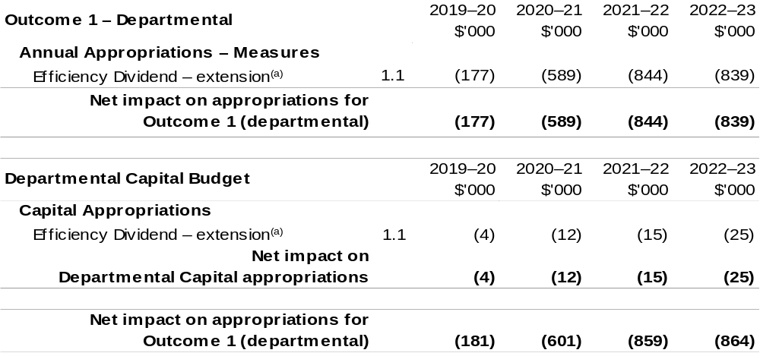
- Measure relates to an Election Commitment identified under Appendix A included in the Explanatory Memorandum to 2019–20 Appropriation Bills (No. 1) and (No. 2).

Continued on following page.

Table 1.4: 2019–20 MYEFO and Additional Estimates
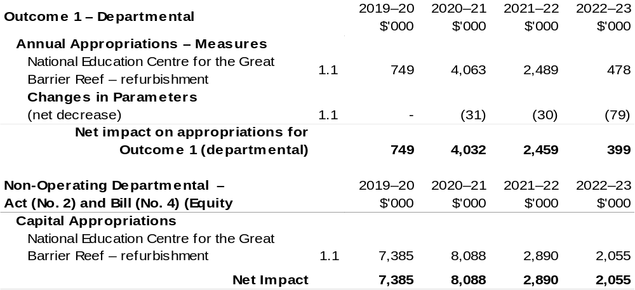
Prepared on a Government Finance Statistics (Fiscal) basis.

1.5 Breakdown of additional estimates by appropriation bill
The following table shows Additional Estimates sought for the Great Barrier Reef Marine Park Authority through Appropriation Bills (No. 3) and (No. 4) 2019–20.

Table 1.5: Appropriation Bill (No. 3) 2019–20 – Departmental 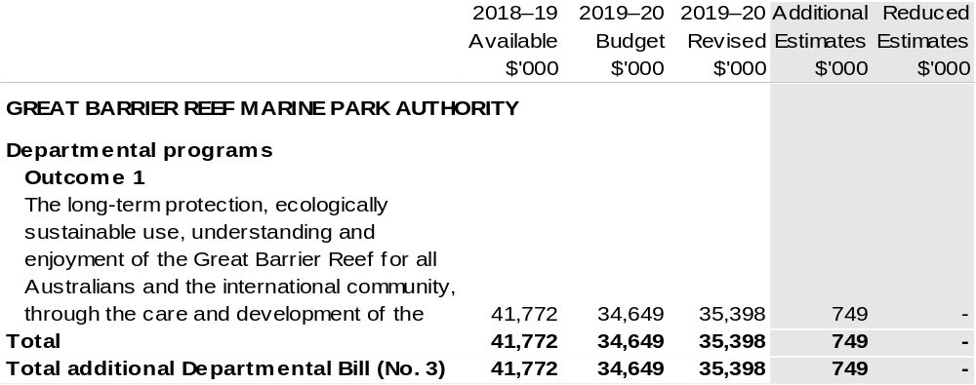

Table 1.6: Appropriation Bill (No. 4) 2019–20 – Departmental
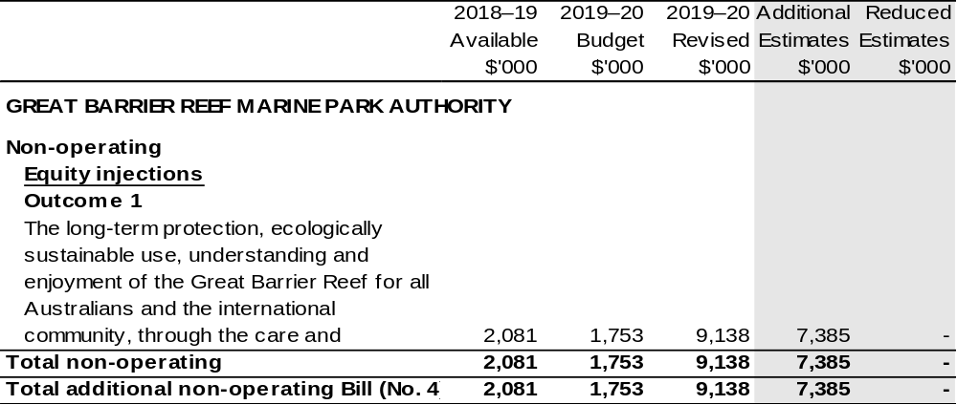

Section 2: Revisions to outcomes and planned performance

2.1 Changes to outcome and program structures
There have been no changes to the department’s outcomes and program structure since the 2019–20 Portfolio Budget Statements.

2.2 Budgeted expenses and performance for outcome 1

Linked programs
There have been no changes to linked programs for Outcome 1 since the 2019–20 Portfolio Budget Statements.

Performance criteria
There has been no change to performance criteria for Outcome 1 since the 2019–20 Portfolio Budget Statements.

Budgeted expenses
Table 2.1 (below) shows how much the entity intends to spend (on an accrual basis) on achieving the outcome, broken down by program and Departmental funding sources.

Table 2.1: Budgeted expenses for Outcome 1
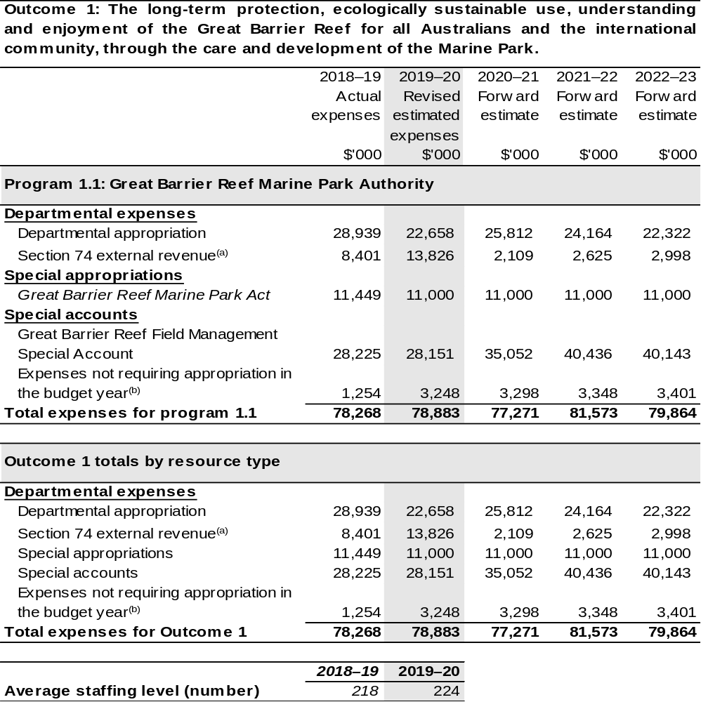
- Estimated expenses incurred in relation to receipts retained under section 74 of the PGPA Act 2013.
- Expenses not requiring appropriation in the Budget year are made up of depreciation expenses,
amortisation expenses, lease expenses, make good expense and audit fees.
Section 3: Special account flows and budgeted financial Statements

3.1 Special account flows
Special Accounts provide a means to set aside and record amounts used for specified purposes. Table 3.1 shows the expected additions (receipts) and reductions (payments) for each account used by the Great Barrier Reef Marine Park Authority.

Table 3.1: Estimates of special account flows and balances
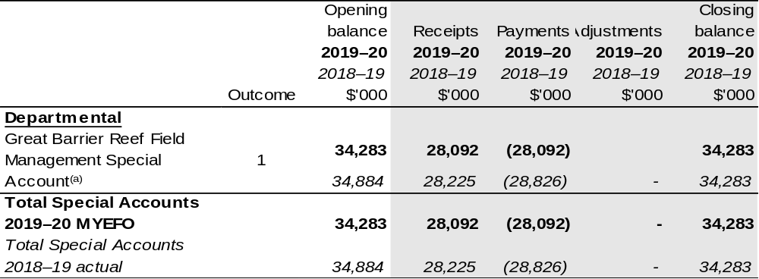

- Appropriation: section 80 of the PGPA Act. Establishing Instrument: section 49 of the Great Barrier Reef Marine Park Act 1975. Purpose: section 51(2) of the Great Barrier Reef Marine Park Act 1975.

3.2 Budgeted financial statements

3.2.1 Analysis of budgeted financial statements
There has been no major change to the analysis of budgeted financial statements since the 2019–20 Portfolio Budget Statements.

3.2.2 Explanatory notes and analysis of budgeted financial statements
Changes to the Great Barrier Reef Marine Park Authority’s budgeted financial statements since the 2019–20 Environment and Energy Portfolio Budget Statements include funding for critical works required to upgrade the Great Barrier Reef National education centre, Reef HQ Aquarium.

3.2.3 Budgeted financial statements tables

Table 3.2: Comprehensive income statement (showing net cost of services) for the period ended 30 June
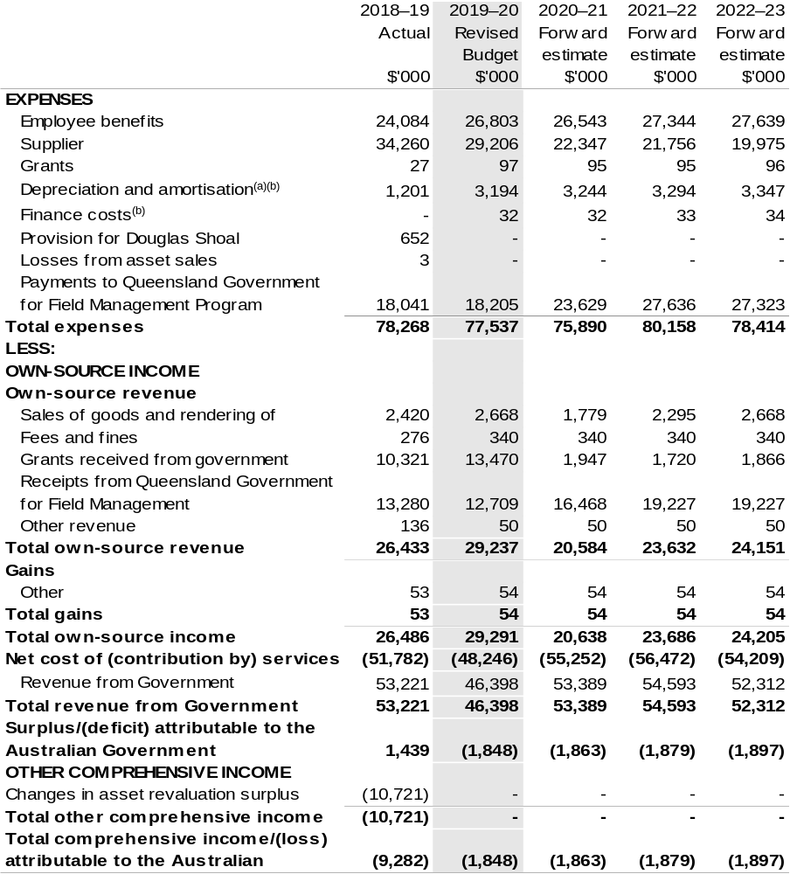
Continued on following page.
Table 3.2: Comprehensive income statement (showing net cost of services) for the period ended 30 June (continued)
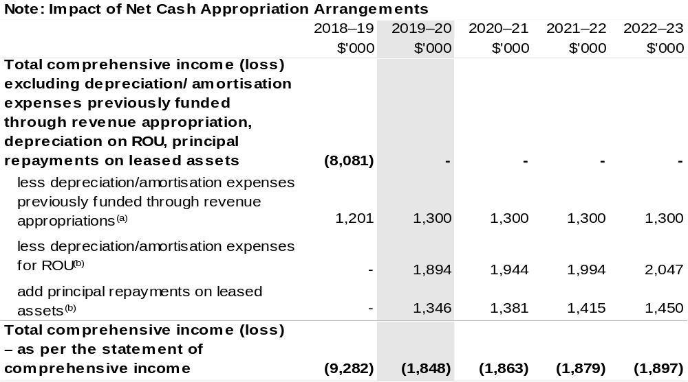
- From 2010–11, the Government introduced net cash appropriation arrangements where Appropriation Act (No. 1) or Bill (No. 3) revenue appropriations for the depreciation/amortisation expenses of
non-Corporate Commonwealth Entities were replaced with a separate capital budget (the Departmental Capital Budget, or DCB) provided through Appropriation Act (No. 1) or Bill (No. 3) equity appropriations. For information regarding DCBs, please refer to Table 3.6 Departmental Capital Budget Statement.
- Applies leases under AASB 16 Leases. Right of Use (ROU).

Prepared on Australian Accounting Standards basis

Table 3.3: Budgeted departmental balance sheet (as at 30 June)
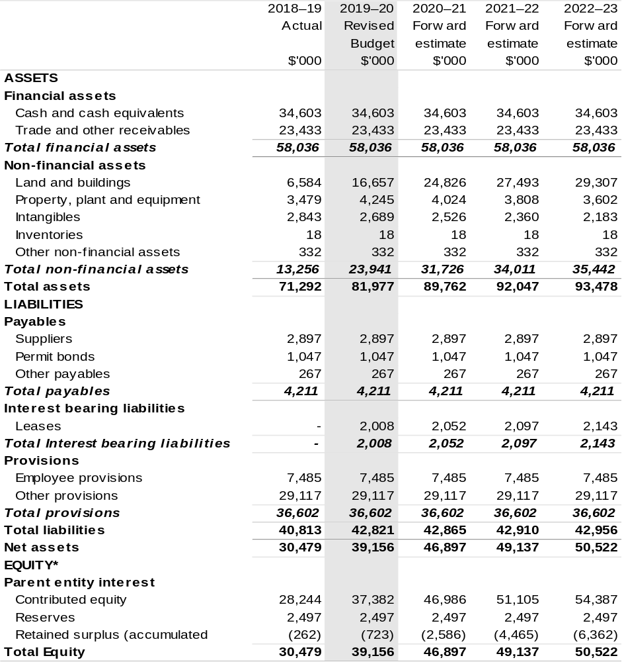

*'Equity' is the residual interest in assets after deduction of liabilities.

Prepared on Australian Accounting Standards basis.

Table 3.4: Departmental statement of changes in equity—summary of movement (Budget year 2019–20)
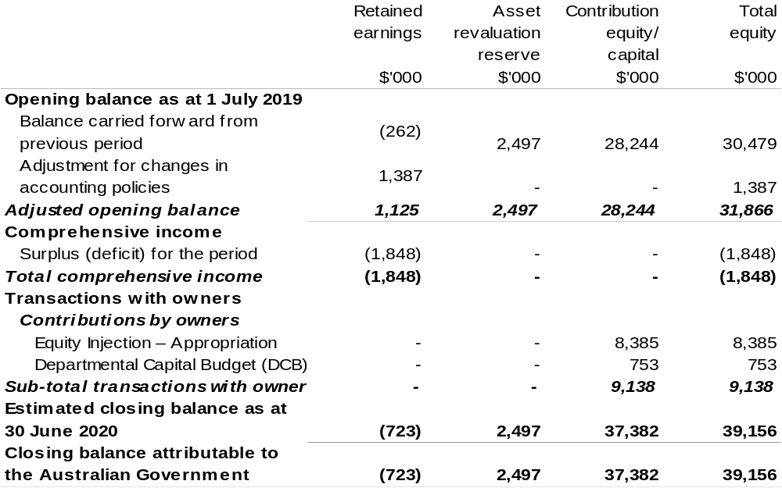

Prepared on Australian Accounting Standards basis.

Table 3.5: Budgeted departmental statement of cash flows (for the period
ended 30 June)

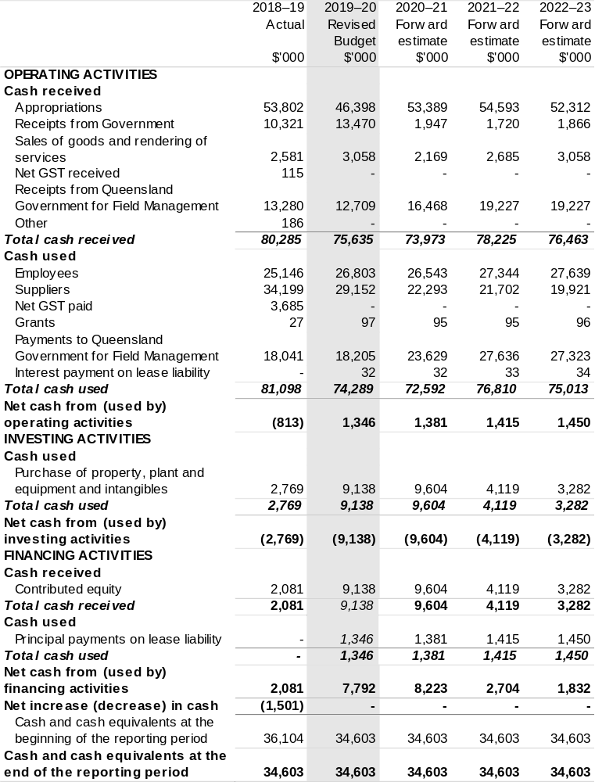
Prepared on Australian Accounting Standards basis.

Table 3.6: Departmental capital budget statement (for the period ended 30 June)

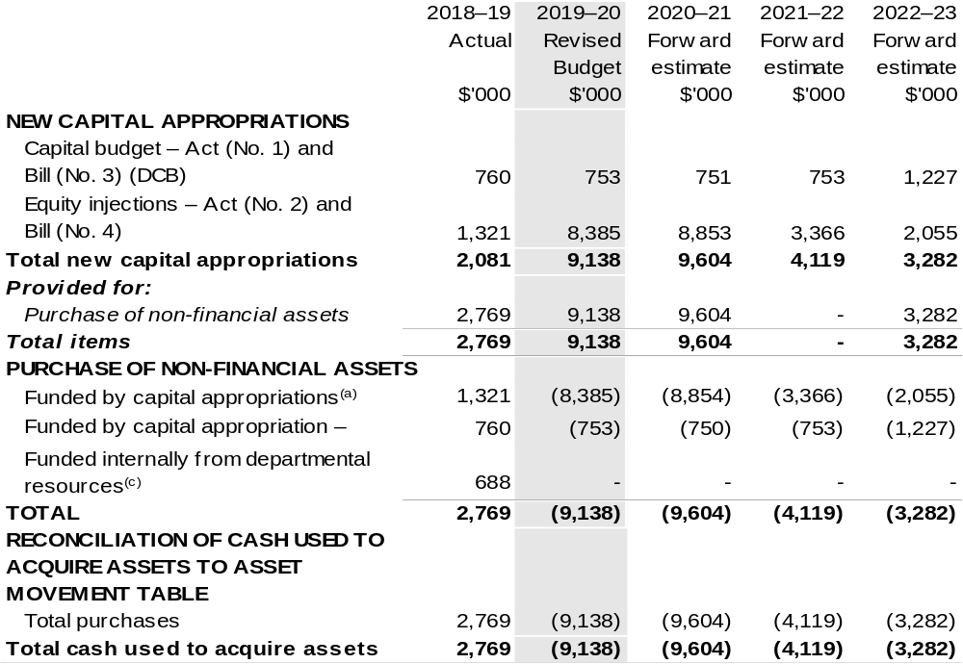

- Includes current Appropriation Bill (No. 4) and prior year Appropriation Act No. 2/4/6.
- Does not include annual finance lease costs. Includes purchases from current and previous years’
Departmental capital budgets (DCBs).
- Includes the following sources of funding:
– current Bill (No. 3) and prior year Act/Bill (No. 1/3/5) appropriations (excluding amounts from the DCBs);
– donations and gifts of non-financial assets;
– internally developed assets;
– section 74 external revenue; and
– proceeds from the sale of assets.

Consistent with information contained in the Statement of Asset Movements and the Budgeted Statement of Cash Flows.

Prepared on Australian Accounting Standards basis.

Table 3.7: Statement of asset movements (Budget year 2019–20)
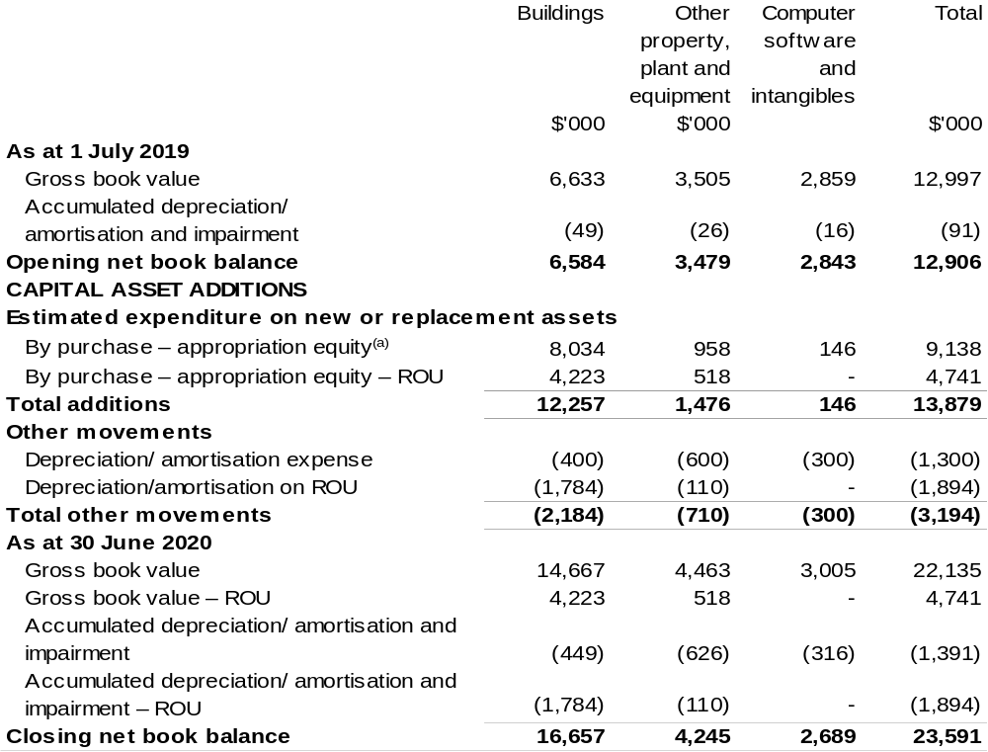

- "Appropriation equity" refers to equity injections or Administered Assets and Liabilities appropriations provided through Appropriation Act (No. 2) 2019–2020 and Appropriation Bill (No. 4) 2019–2020, including Collection Development Acquisition Budget.

Prepared on Australian Accounting Standards basis.

Table 3.8: Schedule of budgeted income and expenses administered on behalf of Government (for the period ended 30 June)
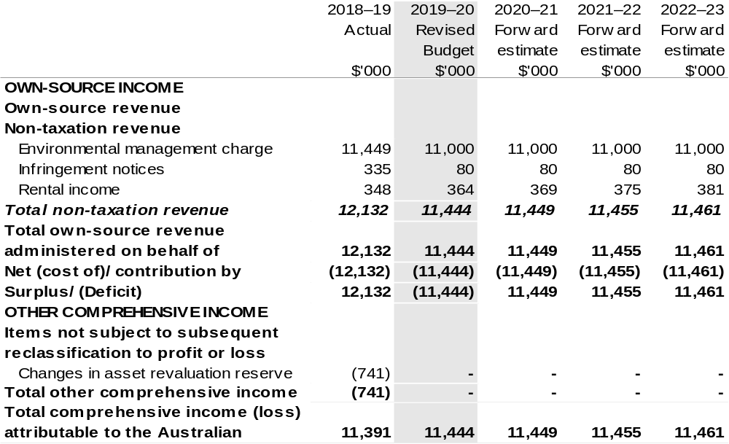

Prepared on Australian Accounting Standards basis.

Table 3.9: Schedule of budgeted assets and liabilities administered on behalf of Government (as at 30 June)
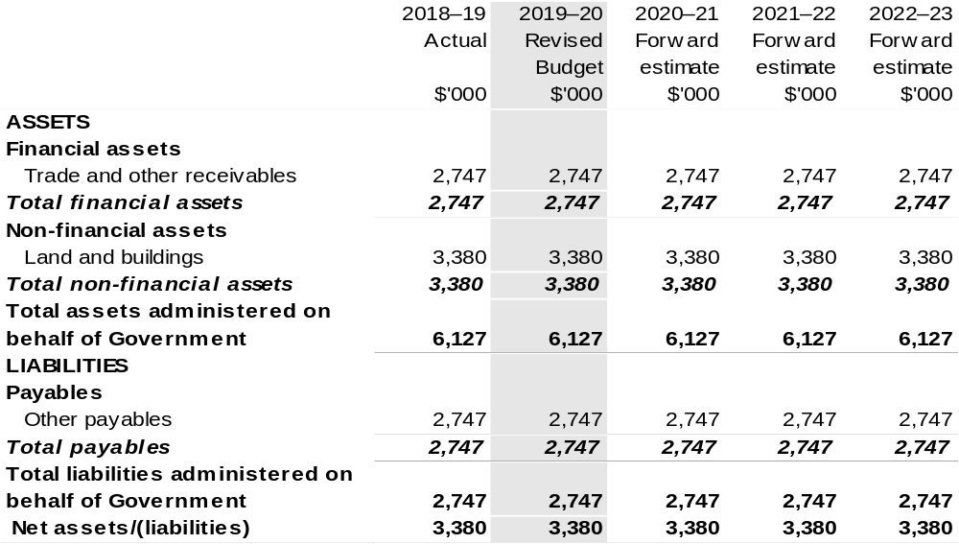

Prepared on Australian Accounting Standards basis.

Table 3.10: Schedule of budgeted administered cash flows (for the period
ended 30 June)

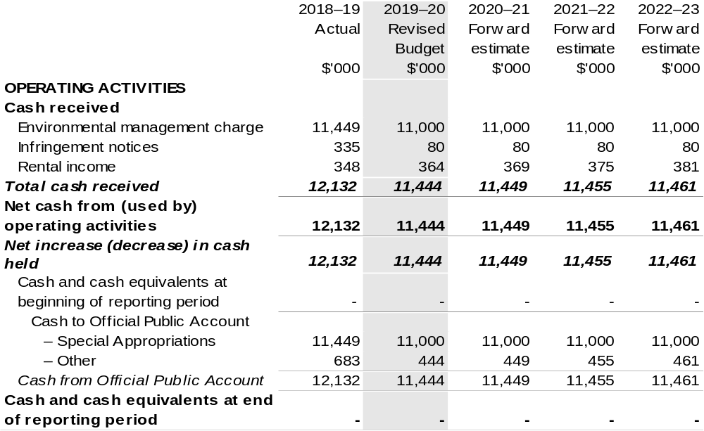
Prepared on Australian Accounting Standards basis.

Table 3.11: Statement of asset movements (Budget year 2019–20)

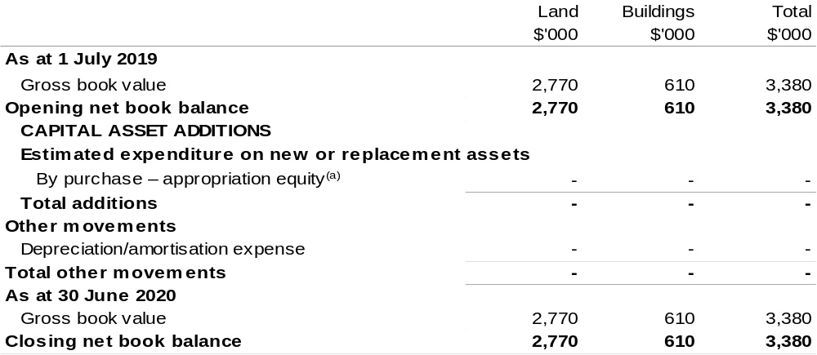

- 'Appropriation equity' refers to equity injections or Administered Assets and Liabilities appropriations provided through Appropriation Act (No. 2) 2019–20 and Appropriation Bill (No. 4) 2019–2020.

Prepared on Australian Accounting Standards basis.

Regional Investment Corporation
Section 1: Entity overview and resources 157
1.1 Strategic direction statement 157
1.2 Entity resource statement 158
1.3 Enity measures 159
1.4 Additional esimates, resourcing and variations to outcome 160
1.5 Breakdown of additional estimates by Appropriation Bill 161
Section 2: REVISIONS TO Outcome and planned performance 162
2.1 Changes to outcome and program structures 162
2.2 Budgeted expenses and performance for Outcome 1 162
Section 3: SpECIAL ACCOUNT FLOWS AND Budgeted financial
statements 164
3.1 Sepcial account flows 164
3.2 Budgeted financial statements 164

Regional Investment Corporation

Section 1: Entity overview and resources

1.1 Strategic direction statement
The strategic direction statement for the Regional Investment Corporation (RIC) has not changed since the 2019–20 Portfolio Budget Statements (PBS) for the former Agriculture and Water Resources portfolio.

1.2 Entity resource statement
Table 1.1 details resourcing for the Regional Investment Corporation as at 2019–20 Additional Estimates. The table outlines the total resources available from all sources for the 2019–20 Budget year, including variations through Appropriation Bills (No. 3) and (No. 4) 2019–20 and Special Appropriations.

Table 1.1: Regional Investment Corporation – Resource Statement – Additional Estimates for 2019–20 as at Additional Estimates February 2020

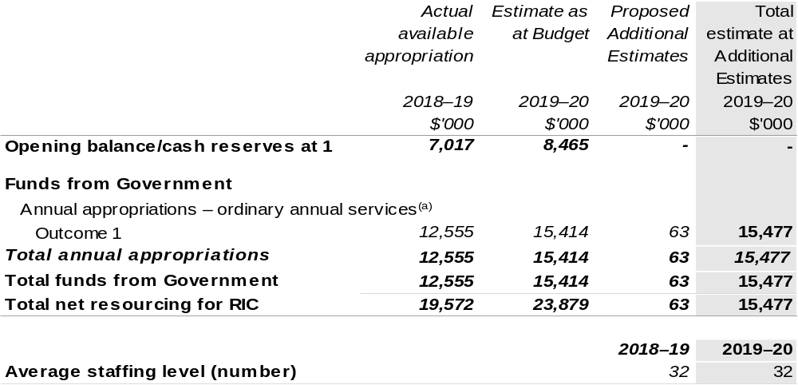

(a) Appropriation Act (No. 1) 2019–20. Appropriation is provided through the Department of Agriculture, Water and the Environment and is specified within the Annual Appropriation Bills as a payment to the RIC.

Prepared on a resourcing (i.e. appropriations available) basis.

Note: all figures shown above are GST exclusive – these may not match figures in the cash flow statement.

1.3 Entity measures
Table 1.2 summarises new Government measures taken since the 2019–20 Budget.
The table is split into revenue, expense and capital measures, with the affected program identified.

Table 1.2: Regional Investment Corporation – measures since 2019–20 Budget
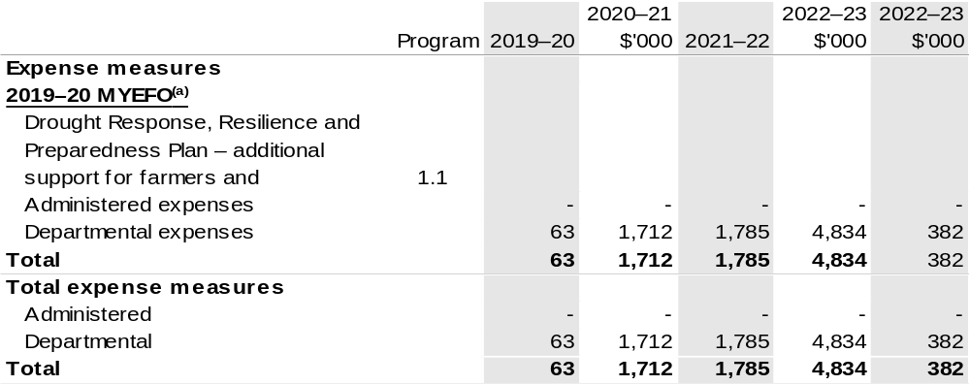

- This measure was published in the 2019–20 MYEFO under the Agriculture portfolio.

Prepared on a Government Finance Statistics (Fiscal) basis.

1.4 Additional estimates, resourcing and variations to outcomes
The following tables detail changes in resourcing for the Regional Investment Corporation at 2019–20 Additional Estimates, by outcome. The tables show variations since the 2019–20 Budget due to new measures (as per Table 1.2) and variations due to other factors, such as movements of funds, reclassifications, reallocations and adjustments due to the efficiency dividend and changes in economic parameters.

Additional Estimates and other variations since 2019–20 Budget

Table 1.3: MYEFO and Additional Estimates 2019–20
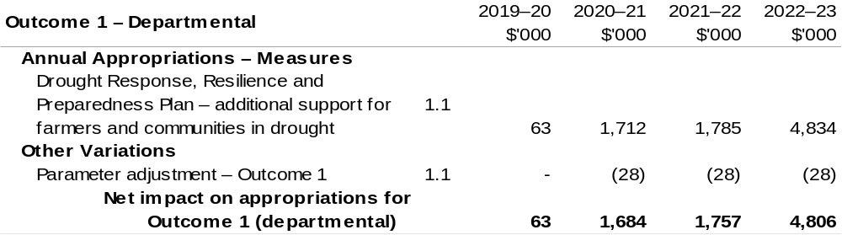

Prepared on a Government Finance Statistics (Fiscal) basis.

1.5 Breakdown of additional estimates by appropriation bill
The following table shows Additional Estimates sought for the Regional Investment Corporation through Appropriation Bill (No. 3) 2019–20.

Table 1.4: Appropriation Bill (No. 3) 2019–20 – Departmental 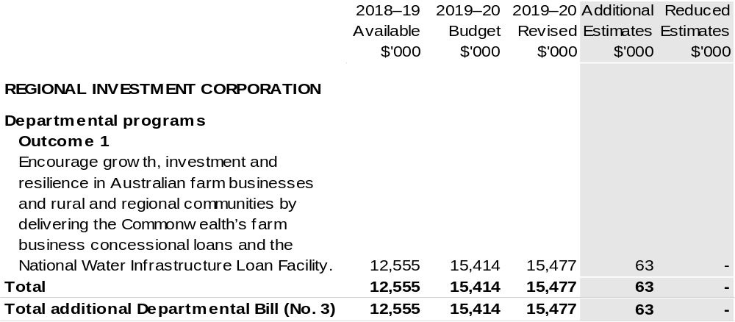

Section 2: Revisions to outcomes and planned performance

2.1 Changes to outcome and program structures
There have been no changes to the department’s outcomes and program structure since the 2019–20 Portfolio Budget Statements.

2.2 Budgeted expenses and performance for outcome 1

Linked programs
There have been no changes to linked programs for Outcome 1 since the 2019–20 Portfolio Budget Statements.

Performance criteria
There have been no changes to the performance criteria since the 2019–20 Portfolio Budget Statements.

Budgeted expenses
Table 2.1 (below) shows how much the entity intends to spend (on an accrual basis) on achieving the outcome, broken down by program and by departmental funding sources.

Table 2.1: Budgeted expenses for Outcome 1

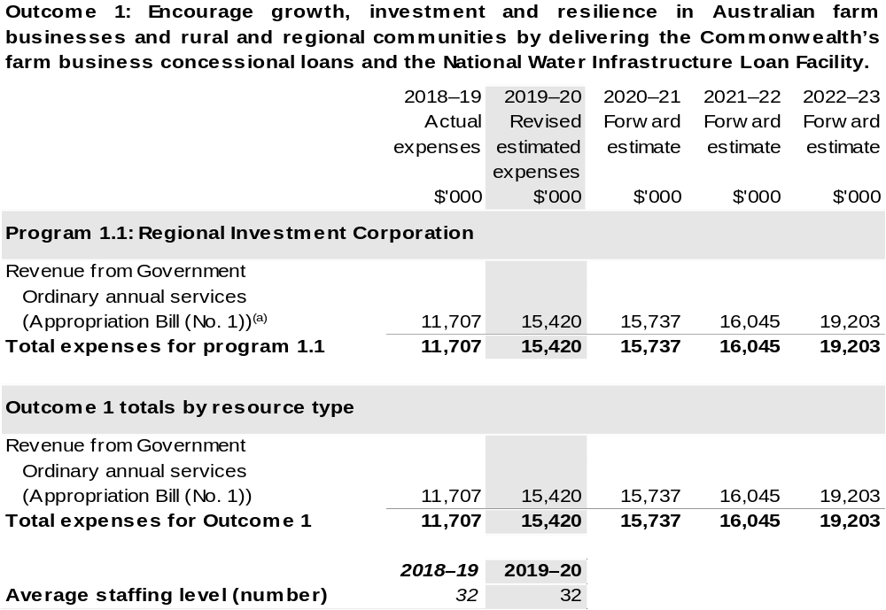

(a) The Regional Investment Corporation is a corporate Commonwealth entity (CCE) under the PGPA Act and does not receive direct appropriations. Instead, this funding passes through the Department of Agriculture, Water and the Environment.

Section 3: Special account flows and budgeted financial Statements

3.1 Special account flows
The Regional Investment Corporation does not have any Special Accounts.

3.2 Budgeted financial statements

3.2.1 Analysis of budgeted financial statements
There has been no major change to the analysis of budgeted financial statements since the 2019–20 Portfolio Budget Statements for the Agriculture and Water Resources portfolio.

3.2.2 Explanatory notes and analysis of budgeted financial statements
The Regional Investment Corporation is budgeting for a balanced budget position in 2019–20. The Corporation’s expected employee and supplier expense budget is $15.4 million in 2019–20 and $15.7 million in 2020–21.
In 2019–20, the Corporation will continue to develop its corporate ability to support the provision of loans to eligible farm businesses and advice to government on nationally significant water infrastructure projects. It will be the first full financial year the Corporation will be staffed by its own ongoing workforce.
The expense budget reflects the work programs for the Corporation in receiving and evaluating loan applications and managing approved loans to eligible farm businesses, as well as evaluating projects for consideration under the National Water Infrastructure Loan Facility, providing independent advice to the Government and delivering approved loans to the states and territories.

3.2.3 Budgeted financial statements tables

Table 3.1: Comprehensive income statement (showing net cost of services)
(for the period ended 30 June)
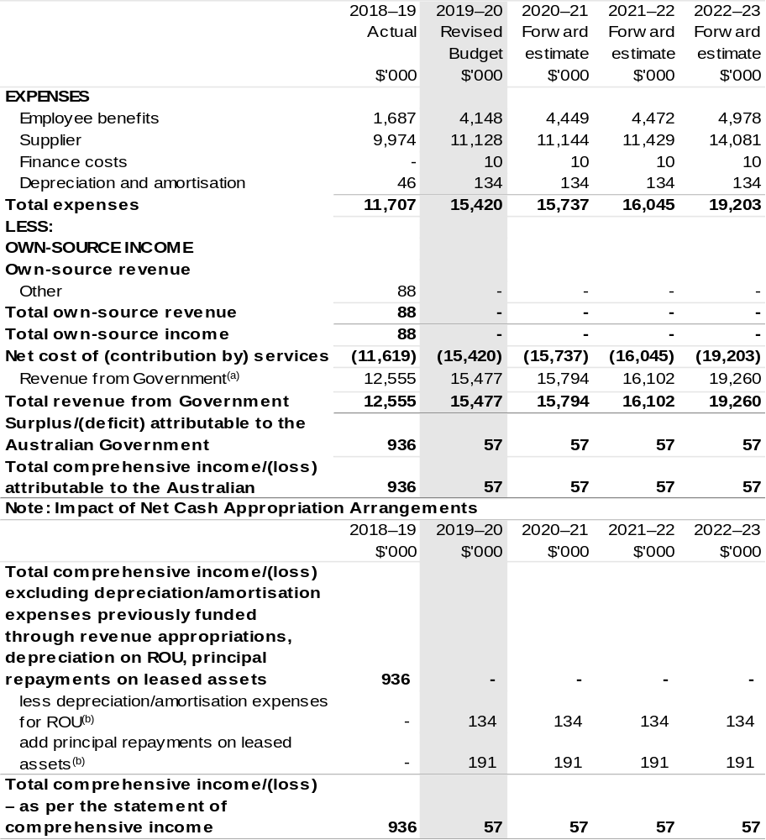

- The RIC is a corporate Commonwealth entity (CCE) under the PGPA Act and does not receive direct appropriations. Instead, this funding passes through the department to the RIC.
- Applies leases under AASB 16 Leases. Right of Use (ROU).

Prepared on Australian Accounting Standards basis.

Table 3.2: Budgeted departmental balance sheet (as at 30 June)
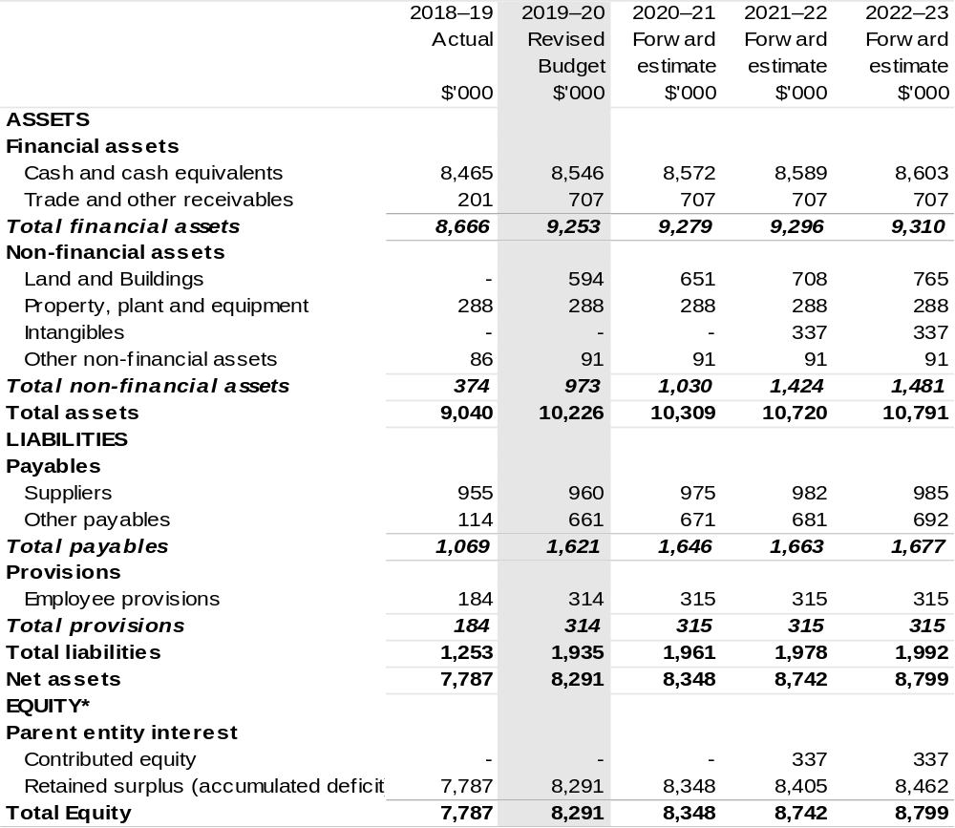

*Equity is the residual interest in assets after deduction of liabilities.

Prepared on Australian Accounting Standards basis.

Table 3.3: Departmental statement of changes in equity—summary of movement (Budget year 2019–20)
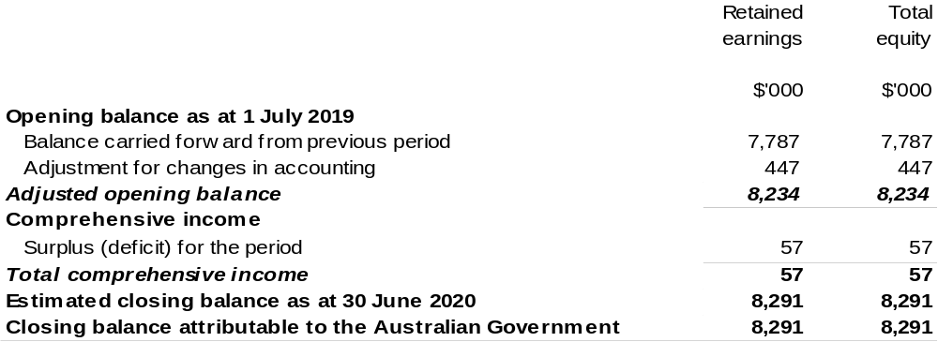
Prepared on Australian Accounting Standards basis.

Table 3.4: Budgeted departmental statement of cash flows (for the period
ended 30 June)
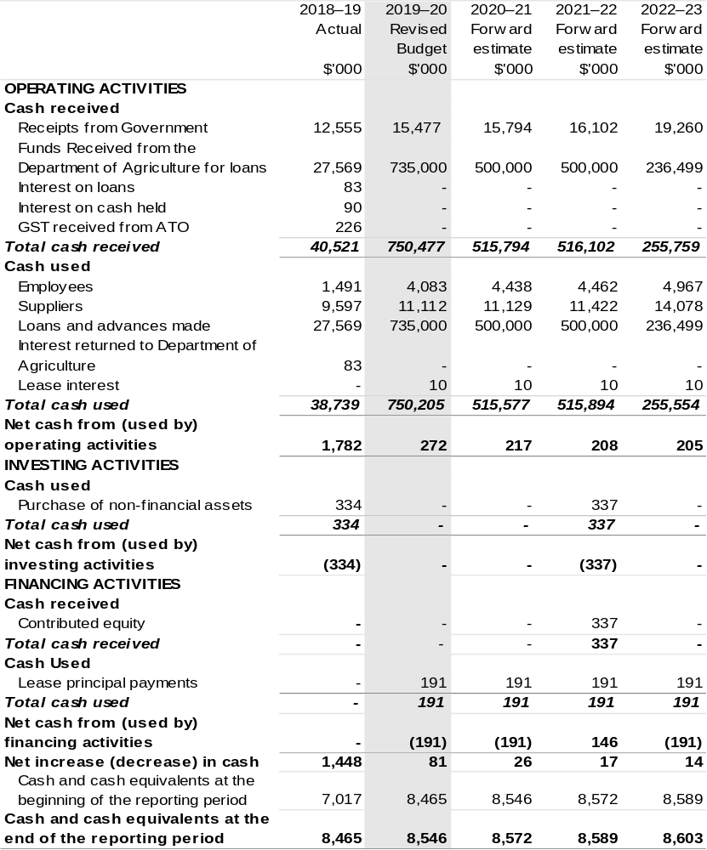

Prepared on Australian Accounting Standards basis.

Table 3.5: Departmental capital budget statement (for the period ended 30 June)
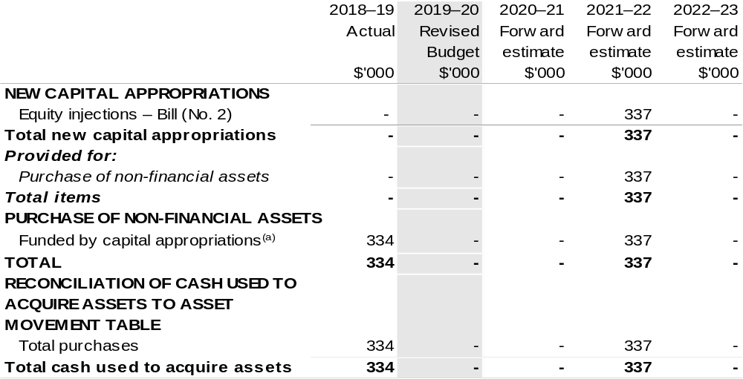

- Includes both current Bill (No. 4) and prior Act/Bill (No. 2/4/6) appropriation.

Consistent with information contained in the Statement of Asset Movements and the Budgeted Statement of Cash Flows.

Prepared on Australian Accounting Standards basis.

Table 3.6: Statement of asset movements (Budget year 2019–20)
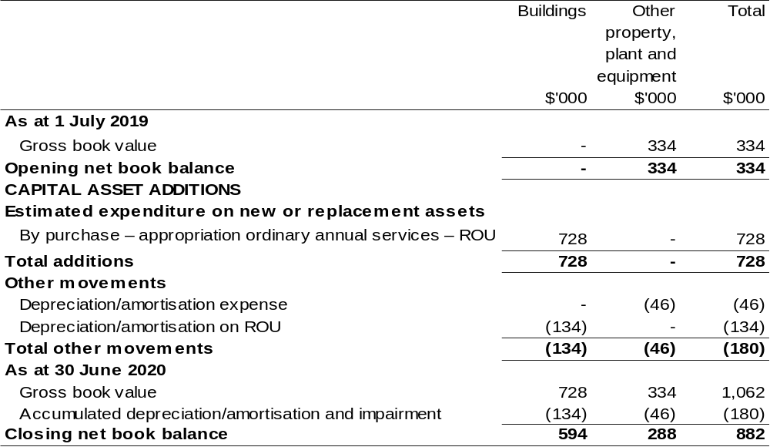

Prepared on Australian Accounting Standards basis.

Table 3.7: Schedule of budgeted income and expenses administered on behalf of Government (for the period ended 30 June)

The schedule of budgeted income and expenses administered on behalf of Government does not apply to the RIC.

Table 3.8: Schedule of budgeted assets and liabilities administered on behalf of Government (as at 30 June)

The schedule of budgeted assets and liabilities administered on behalf of Government does not apply to the RIC.

Table 3.9: Schedule of budgeted administered cash flows (for the period
ended 30 June)

The schedule of budgeted administered cash flows on behalf of Government does not apply to the RIC.

Portfolio glossary

Term | Meaning
Accumulated depreciation | The aggregate depreciation recorded for a particular depreciating asset.
Actual Available  Appropriation | The Actual Available Appropriation indicates the total appropriations available to the entity for 2017–18 as at the 2018–19 Portfolio Additional Estimates Statements. It includes all appropriations made available to the entity in the year (+/‐ section 75 transfers, formal reductions, Advance to the Minister for Finance, movements of funds and other quarantines). It is the same as the comparator figure included in the Appropriation Bills, and as such provides a comparison with the appropriation proposed for the budget year.
Additional Estimates | Appropriation Bills that seek appropriation authority from Parliament for the additional expenditure of money from the Consolidated Revenue Fund, in order to meet requirements that have arisen since the last Budget. Further annual appropriation Bills can be introduced during the year if required. These Bills are called the Additional Estimates (AEs) Appropriation Bills (after the Mid-Year Economic and Fiscal Outlook) or Supplementary Additional Estimates Appropriation Bills (at the same time as Bills for the next Budget).
Administered Items | Expenses, revenues, assets or liabilities managed by entities on behalf of the Australian Government. Entities do not control administered items. Administered items include grants, subsidies and benefits. In many cases, administered items fund the delivery of third party outputs.
Annual Appropriation | A law of the Parliament that provides authority to draw money from the Consolidated Revenue Fund. An appropriation authorises expenditure for a specified purpose. The Commonwealth cannot spend money without an appropriation authorising that expenditure (and, in some cases, legislation other than an appropriation may be required to authorise the relevant expenditure). Two Appropriation Bills are introduced to the Parliament in May and comprise the Budget for the financial year beginning 1 July. Further Bills are introduced later in the financial year, usually in February, as part of Additional Estimates.
Term | Meaning
Appropriation | A law of the Parliament that provides authority for entities to spend money from the Consolidated Revenue Fund for a particular purpose. Entities may not spend money without an appropriation authorising that expenditure and, where necessary, other legislation authorising the specified purpose.
Budget Paper 1 (BP1) | Budget Strategy and Outlook. Provides information on the economic and fiscal outlook for the Australian Government, including information on the Government’s fiscal strategy.
Budget Paper 2 (BP2) | Budget Measures. Provides a description of each Budget measure (revenue, expense and capital) by portfolio.
Budget Paper 3 (BP3) | Federal Financial Relations. Provides information and analysis on federal funding provided to the States and Territories and local government.
Budget Paper 4 (BP4) | Agency Resourcing. Contains information on resourcing for Australian Government entities (including special appropriations, special accounts and a summary of agency resourcing).
Capital Expenditure | Expenditure by an entity on capital projects, for example purchasing a building.
CRF | The Consolidated Revenue Fund is established by section 81 of the Constitution and consists of all revenues and moneys raised or received by the executive government of the Commonwealth. The Consolidated Revenue Fund is self-executing in nature, which means that all money forms part of the CRF automatically upon receipt by the Commonwealth.
DCB | Departmental (or Administered) Capital Budget are provided to non-corporate entities (as an equity injection) that receive government funding to meet the costs associated with the replacement of minor assets (assets valued at $10 million or less) or maintenance costs that are eligible to be capitalised. The funding for depreciation, amortisation and make-good expenses was replaced with a Departmental Capital Budget in the 2010–11 Budget.
Term | Meaning
Departmental Items | Resources (assets, liabilities, revenues and expenses) that the entity’s accountable authority controls directly. This includes outsourced activities funded and controlled by the entity. Examples of departmental items include entity running costs, accrued employee entitlements and net appropriations. A departmental item is a component of a departmental program.
Depreciation | Apportionment of an asset’s capital value as an expense over its estimated useful life to take account of normal usage, obsolescence, or the passage of time.
Equity or net assets | Residual interest in the assets of an entity after deduction of its liabilities.
Estimated Actual Expenses | Details of the current year‘s estimated final figures as included in the Budget. As the Budget is generally released in May each year, but the financial year does not end until 30 June, the current year numbers that are used for comparison with Budget amounts can only be estimates.
Expense | Total value of all of the resources consumed in producing goods and services or the loss of future economic benefits in the form of reductions in assets or increases in liabilities.
Expenses not requiring appropriation in the Budget year | Expenses not involving a cash flow impact are not included within the calculation of an appropriation. An example of such an event is goods or services received free of charge that are then expensed: e.g. Australian National Audit Office (ANAO) audit services — the ANAO does not charge for audit services however the expense must be recognised. Similarly, bad debts are recognised as an expense but are not recognised for the purpose of calculating appropriation amounts to be sought from the Parliament.
Fair value | Valuation methodology: the amount for which an asset could be exchanged, or a liability settled, between knowledgeable and willing parties in an arm’s length transaction. Fair value can be affected by conditions of the sale, market conditions and the intentions of the asset holder.
Term | Meaning
Forward Estimates  Period | The three years following the Budget year. For example, if 2019–20 is the Budget year, 2020–21 is forward year 1,  2021–22 is forward year 2 and 2022–23 is forward year 3. This period does not include the current financial year or the Budget year.
Levies | Money collected and administered by the department on behalf of industry for use in research and development, marketing and promotion, plant and animal health programs and residue testing activities that benefit industry.
Measure | A new policy or savings decision of the government with financial impacts on the underlying cash balance; fiscal balance; operating balance; headline cash balance; net debt or net worth. Such proposals are normally made in the context of the annual Budget, and are typically published in Budget Paper No. 2, the Mid-Year Economic and Fiscal Outlook and the Pre-election Economic and Fiscal Outlook.
MYEFO | The Mid-Year Economic and Fiscal Outlook provides an update of Budget estimates by examining expenses and revenues in the year to date, as well as provisions for new decisions that have been taken since the Budget. The report provides updated information to allow the assessment of the government‘s fiscal performance against the fiscal strategy set out in its current fiscal strategy statement.
NCCE | Non-Corporate Commonwealth Entity under the Public Governance, Performance, and Accountability Act 2013.
OPA | The Commonwealth’s central bank account. The Official Public Account is one of a group of linked bank accounts, referred to as the Official Public Account Group of Accounts. OPAs are maintained with the Reserve Bank of Australia, as required by subsection 53(3) of the Public Governance, Performance, and Accountability Act 2013
Operating Result | Equals revenue less expense.
Outcomes | The Government’s objectives in each portfolio area. Outcomes are desired results, impacts or consequences for the Australian community as influenced by the actions of the Australian Government. Actual outcomes are assessments of the end-results or impacts actually achieved.
Term | Meaning
PAES | Portfolio Additional Estimates Statements. These are Budget Statements prepared by portfolios to explain appropriations at Additional Estimates.
PBS | Portfolio Budget Statements. These are Budget Statements prepared by portfolios to explain appropriations at the time of the Budget.
PGPA Act | Public Governance, Performance and Accountability Act 2013.
Programs | The name given to the variety of activities a government agency may undertake to achieve stated outcomes.
Revenue | Total value of resources earned or received to cover the production of goods and services.
Special Account | A type of special appropriation, limited by amount, criteria or time, which may be established under sections 78 and 80 of the Public Governance, Performance, and Accountability Act 2013.
Special Appropriations | Authority within an Act (other than an annual Appropriation Act) to spend money from the Consolidated Revenue Fund for particular purposes.
Specific Purpose Payments | Commonwealth payments to states and territories made under the Federal Financial Relations Act 2009.
Supplementary Additional Estimates | Where amounts appropriated in the Budget and at Additional Estimates are insufficient, the Parliament may appropriate more funds to portfolios at Supplementary Additional Estimates. These is done through Appropriation Bills (No. 5) and (No. 6). These Bills are usually introduced into the Parliament with the Budget in May.
Portfolio abbreviations
AAO | Administrative Arrangements Order
AASB 16 | Australian Accounting Standards Board 16
AEs | Additional Estimates
AFMA | Australian Fisheries Management Authority
APVMA | Australian Pesticides and Veterinary Medicines Authority
AQIS | Australian Quarantine and Inspection Service
BOM | Department of Bureau of Meteorology
CAL | Citrus Australia Limited
CCE | Corporate Commonwealth Entity
CRDC | Cotton Research and Development Corporation
CRF | Consolidated Revenue Fund
CSIRO | Commonwealth Scientific and Industrial Research Organisation
DCB | Departmental Capital Budget
DoA | Department of Agriculture
DAWR | Department of Agriculture, Water and Resources
DAWE | Department of Agriculture, Water and the Environment
DISER | Department of Industry, Science, Energy and Resources
DoNP | Director of National Parks
DoEE | Department of the Environment and Energy
EPPR | Emergency Plant Pest Response
FAO | Food and Agriculture Organization of the United Nations
FRDC | Fisheries Research and Development Corporation
GBRMPA | Great Barrier Reef Marine Park Authority
GRDC | Grains Research and Development Corporation
GST | Goods and Services Tax
MDBA | Murray-Darling Basin Authority
MP | Member of Parliament
MYEFO | Mid-Year Economic and Fiscal Outlook
NCCE | Non-Corporate Commonwealth Entity
NP | National Partnership
NRS | National Residue Survey
OC1 | Outcome 1
OC2 | Outcome 2
OC3 | Outcome 3
ODA | Official Development Assistance
OPA | Official Public Account
PAES | Portfolio Additional Estimates Statements
PBS | Portfolio Budget Statements
PEFO | Pre-election Economic and Fiscal Outlook
PGPA Act | Public Governance, Performance, and Accountability Act 2013
PHA | Plant Health Australia
R&D | Research and Development
RSV | Research and Supply Vessel
RIC | Regional Investment Corporation
RIRDC | Rural Industries Research and Development Corporation  (known as AgriFutures Australia)
ROU | Right of Use
SRWUIP | Sustainable Rural Water Use and Infrastructure Program
SHFT | Sydney Harbour Federation Trust
WELS | Water Efficiency Labelling and Standards

