Portfolio Additional
Estimates Statements 2020–21

Agriculture, Water and Environment Portfolio

Explanations of Additional Estimates 2020–21

© Commonwealth of Australia 2021
ISSN: 2652-4589 (print) 2652-4597 (online)
This publication is available for your use under a Creative Commons BY Attribution 3.0 Australia licence, with the exception of the Commonwealth Coat of Arms, the Department of Agriculture, Water and the Environment logo, photographs, images, signatures and where otherwise stated. The full licence terms are available from http://creativecommons.org /licenses/by/3.0/au/legalcode.


Use of Department of Agriculture, Water and the Environment material under a Creative Commons BY Attribution 3.0 Australia licence requires you to attribute the work (but not in any way that suggests that the Department of Agriculture endorses you or your use of the work).
Department of Agriculture, Water and the Environment material used ‘as supplied’.
Provided you have not modified or transformed Department of Agriculture, Water and the Environment material in any way including, for example, by changing the department’s text; calculating percentage changes; graphing or charting data; or deriving new statistics from published Department of Agriculture, Water and the Environment statistics, then the department prefers the following attribution:
Source: Australian Government Department of Agriculture, Water and the Environment
Derivative material
If you have modified or transformed Department of Agriculture, Water and the Environment material, or derived new material from those of the Department of Agriculture, Water and the Environment in any way, then the department prefers the following attribution:
Based on Australian Government Department of Agriculture, Water and the Environment data
Use of the Coat of Arms
The terms under which the Coat of Arms can be used are set out on the It’s an Honour website (see www.itsanhonour.gov.au)
Other Uses
Inquiries regarding this licence and any other use of this document are welcome at:
External Budget Section; Finance Division
Department of Agriculture, Water and the Environment
John Gorton Building,
King Edward Terrace,
Parkes ACT 2600
Email: externalbudgets@awe.gov.au

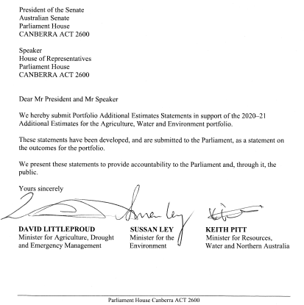

Abbreviations and conventions
The following notation may be used:
NEC/nec not elsewhere classified
- nil
.. not zero, but rounded to zero
na not applicable (unless otherwise specified)
nfp not for publication
$m $ million
$b $ billion
Figures in tables and in the text may be rounded. Figures in text are generally rounded to one decimal place, whereas figures in tables are generally rounded to the nearest thousand. Discrepancies in tables between totals and sums of components are due to rounding.
Enquiries
Should you have any enquiries regarding this publication please contact
Paul Pak Poy, Acting Chief Finance Officer, Department of Agriculture, Water and the Environment, on (02) 6272 5523.
Links to Portfolio Budget Statements (including Portfolio Additional Estimates Statements and Portfolio Supplementary Additional Estimates Statements) can be located on the Australian Government Budget website at www.budget.gov.au.

User guide
to the
Portfolio Additional
Estimate Statements

User Guide
The purpose of the 2020–21 Portfolio Additional Estimates Statements (PAES), like that of the Portfolio Budget Statements (PBS), is to inform Senators and Members of Parliament of the proposed allocation of resources to Government outcomes by entities within a portfolio. The focus of PAES differs from the PBS in one important aspect. While PAES includes an Entity Resource Statement to inform the Parliament of revised estimates of total resources available to an entity, its focus is to explain changes in resourcing by outcome(s) since the Budget. As such, PAES provides information on new measures and their impact on the financial and/or non-financial planned performance of programs supporting those outcomes.
PAES facilitates understanding of proposed appropriations in Appropriation Bills
(No. 3) and (No. 4) 2020–21. For this reason, PAES is declared by the Appropriation Bills to be a ‘relevant document’ to the interpretation of the Bills according to section 15AB of the Acts Interpretation Act 1901.
Whereas the 2020–21 Mid-Year Economic and Fiscal Outlook (MYEFO) is a mid-year budget report that provides updated information to allow the assessment of the Government’s fiscal performance against its fiscal strategy, PAES update the most recent budget appropriations for entities within a portfolio.
Structure of the Portfolio Additional Estimates Statements
PAES is presented in three parts with subsections.
User Guide
Provides a brief introduction explaining the purpose of PAES.
Portfolio Overview
Provides an overview of the portfolio, including a chart that outlines the outcomes for entities in the portfolio.
Entity Additional Estimates Statements
A statement (under the name of the entity) for each entity affected by Additional Estimates.
Section 1: Entity overview and resources | This section details the changes in total resources available to an entity, the impact of any measures since Budget, and impact of Appropriation Bills (No. 3) and (No. 4) 2020–21.
Section 2: Revisions to entity outcomes and planned performance | This section details any changes to Government outcomes and/or any changes to the planned performance of entity programs.
Section 3: Special account flows and budgeted financial statements | This section contains updated explanatory tables on special account flows and staffing levels and revisions to the budgeted financial statements.
Contents
Portfolio overview 3
Entity additional estimates statements 9
Department of Agriculture, WATER AND THE ENVIRONMENT 13
bureau of meteorology 81

Portfolio Overview

Portfolio Overview
The Agriculture, Water and Environment portfolio consists of the Department of Agriculture, Water and the Environment (the department) and 13 portfolio entities (Figure 1 refers).
The role and responsibilities of the department and the portfolio entities have not changed since the 2020–21 Portfolio Budget Statements (PBS). An outline of the department’s Portfolio Overview can be found in the 2020–21 PBS.
The department is receiving additional appropriations through Appropriation Bills (No. 3) and (No. 4) 2020–21. The Bureau of Meteorology will also be receiving additional appropriation through Appropriation Bills (No. 3) and (No. 4) 2020–21.

Figure 1: Agriculture, Water and Environment Portfolio Structure
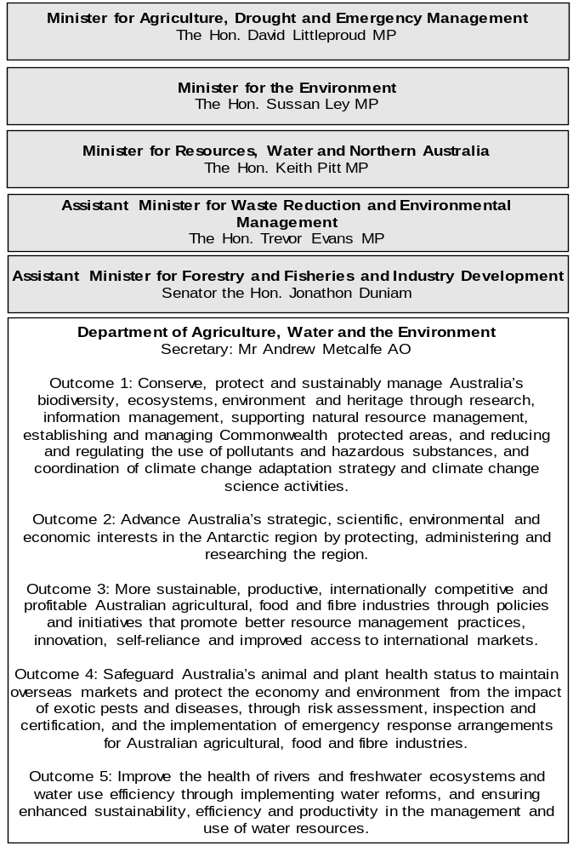

Figure 1: Agriculture, Water and Environment Portfolio Structure (continued)
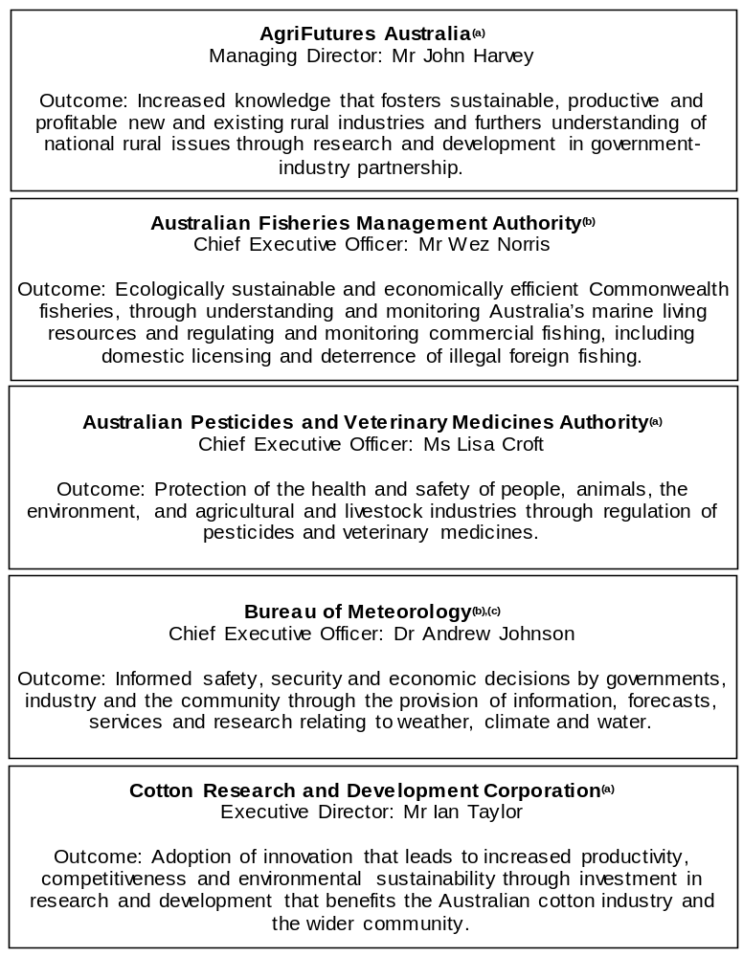

Figure 1: Agriculture, Water and Environment Portfolio Structure (continued)
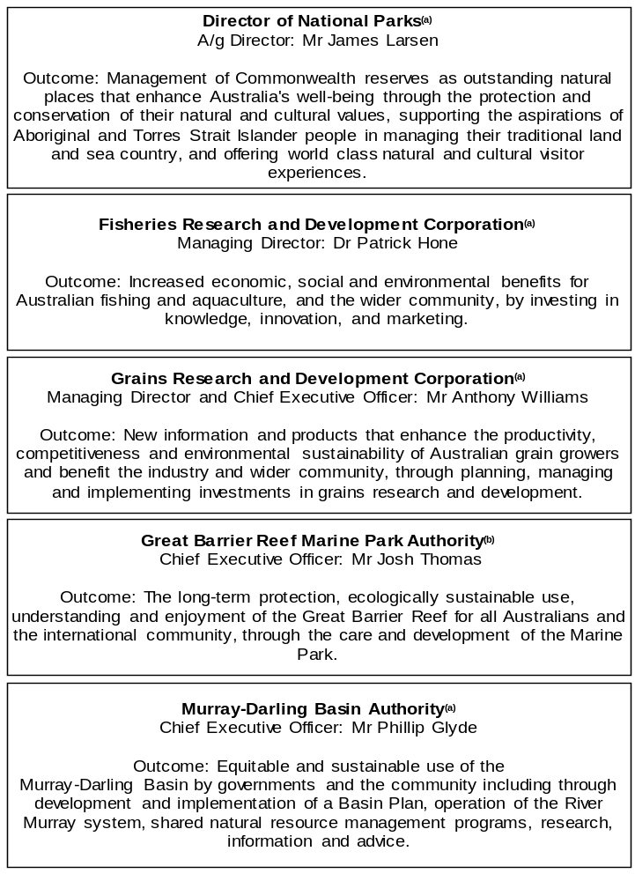

Figure 1: Agriculture, Water and Environment Portfolio Structure (continued)
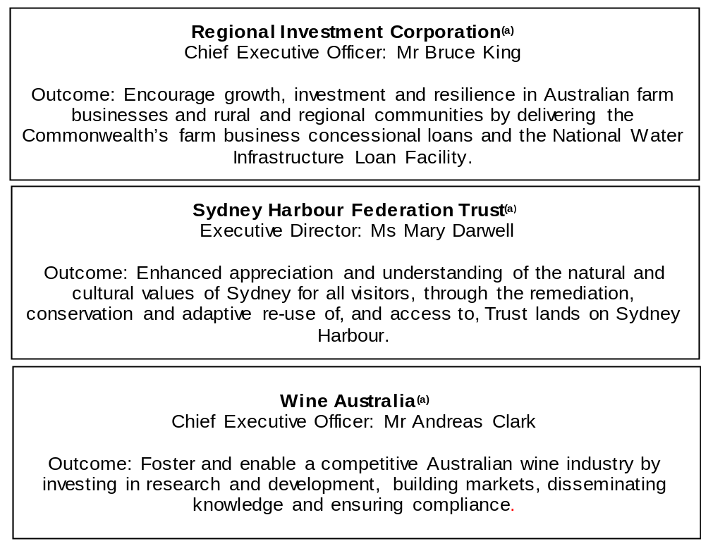

(a) ‘Corporate Commonwealth Entity’ (CCE) as defined under the Public Governance, Performance and Accountability Act 2013.
(b) ‘Non-corporate Commonwealth Entity’ (NCCE) as defined under the Public Governance, Performance and Accountability Act 2013.
(c) ‘Executive Agency’ through an Order made by the Governor-General, under subsection 65(1) of the Public Service Act 1999.

Other industry-owned and not-for-profit companies related to the portfolio
Australian industry-owned companies are independent corporate entities, established under specific legislation with expertise-based boards. The company members appoint the directors of the board. Companies are accountable to the Minister for Agriculture, Drought and Emergency Management through legislation and statutory funding agreements and are entitled to receive industry levies and matching Australian Government funding for eligible research and development (R&D). These entities report outside of the general government sector.
The following industry-owned companies provide R&D and marketing services:
- Australian Egg Corporation Limited;
- Australian Livestock Export Corporation Limited;
- Australian Meat Processor Corporation Limited;
- Australian Pork Limited;
- Australian Wool Innovation Limited;
- Dairy Australia Limited;
- Forest and Wood Products Australia Limited;
- Horticulture Innovation Australia Limited;
- Meat and Livestock Australia Limited; and
- Sugar Research Australia Limited.
The Australian Government provides funding to the following not-for-profit, portfolio-related companies:
- Animal Health Australia;
- Landcare Australia Limited;
- National Environment Protection Council; and
- Plant Health Australia Limited.

Entity additional estimates statements

Department of Agriculture, Water and the Environment
Section 1: Entity overview and resources 13
1.1 Strategic direction statement 13
1.2 Entity resource statement 14
1.3 Entity measures 19
1.4 Additional estimates, resourcing and variations to outcomes 22
1.5 Breakdown of additional estimates by Appropriation Bill 27
Section 2: Revisions to outcomes and planned
performance 30
2.1 Changes to outcome and program structures 30
2.2 Budgeted expenses and performance for Outcome 1 31
2.3 Budgeted expenses and performance for Outcome 2 38
2.4 Budgeted expenses and performance for Outcome 3 40
2.5 Budgeted expenses and performance for Outcome 4 51
2.6 Budgeted expenses and performance for Outcome 5 57
2.7 Budgeted expenses and performance for Outcome 6 60
2.8 Budgeted expenses and performance for Outcome 7 62
Section 3: Special account flows and budgeted financial
statements 64
3.1 Special account flows 64
3.2 Budgeted financial statements 67

Department of Agriculture, Water and the Environment

Section 1: Entity overview and resources

1.1 Strategic direction statement
There have been no changes to the department’s strategic direction statement since the 2020–21 Portfolio Budget Statement.

1.2 Entity resource statement
These tables detail the resourcing for the Department of Agriculture, Water and the Environment at 2020–21 Additional Estimates. Table 1.1 outlines the total resourcing available from all sources for the 2020–21 Budget year, including variations through Appropriation Bills (No. 3) and (No. 4) 2020–21, Special Appropriations and Special Accounts.

Table 1.1: Department of Agriculture, Water and the Environment – Resource Statement as at 2020–21 Additional Estimates – February 2021
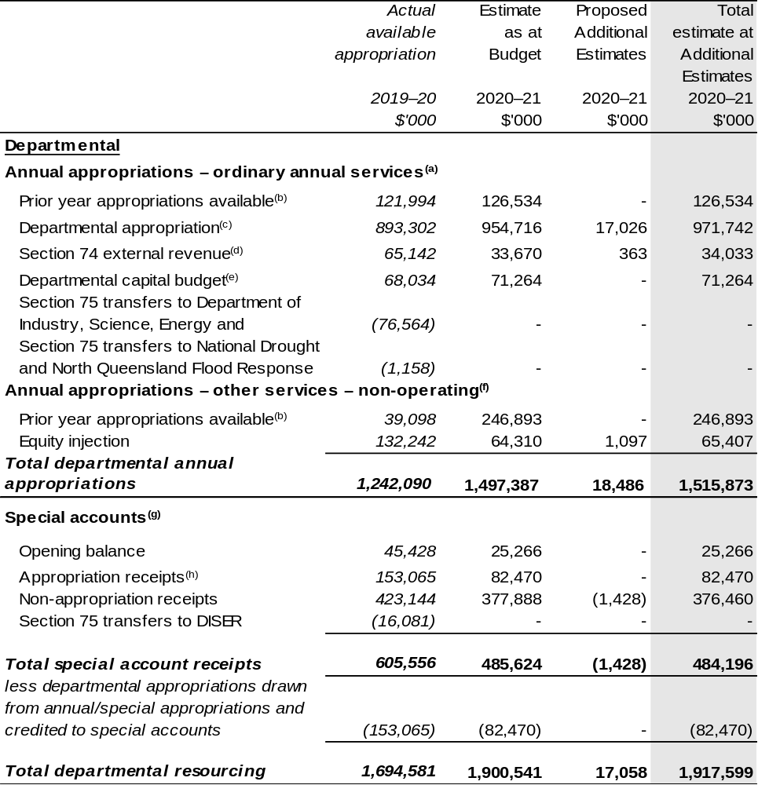
Continued on following pages

Table 1.1: Department of Agriculture, Water and the Environment – Resource Statement as at 2020–21 Additional Estimates – February 2021 (continued)
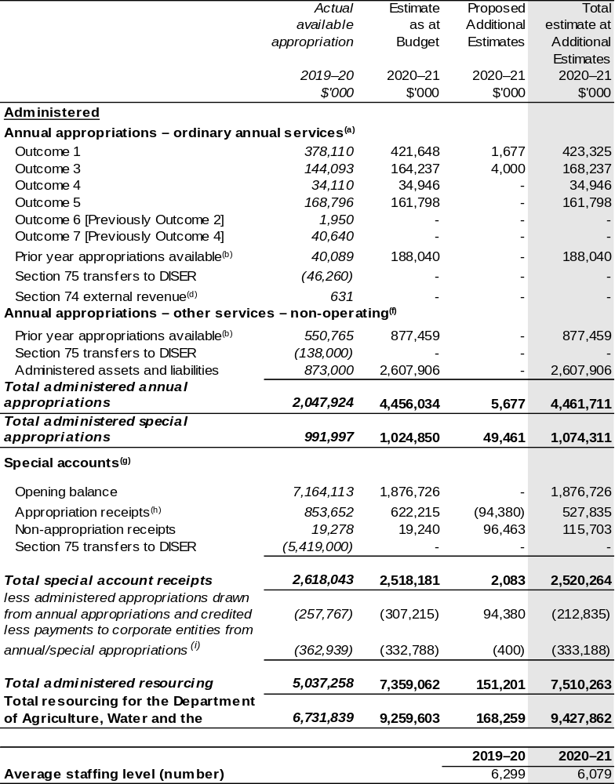
Continued on following pages

Table 1.1: Department of Agriculture, Water and the Environment – Resource Statement as at 2020–21 Additional Estimates – February 2021 (continued)

- Supply Act (No.1) 2020–21, Appropriation Act (No. 1) 2020–21 and Appropriation Bill (No. 3) 2020–21.
- Excludes $876.283 million subject to administrative quarantine by the Department of Finance or withheld under section 51 of the Public Governance, Performance and Accountability Act 2013 (PGPA Act).
- Exclude departmental capital budget (DCB).
- Estimated external revenue under section 74 of the PGPA Act.
- Departmental capital budgets are not separately identified in the Appropriation Bills and form part of ordinary annual services items. Please refer to Table 3.6 for further details. For accounting purposes, this amount has been designated as a 'contribution by owner'.
- Supply Act (No. 2) 2020–21, Appropriation Act (No. 2) 2020–21 and Appropriation Bill (No. 4) 2020–21.
- Excludes 'Special Public Money' held in accounts like Other Trust Monies accounts (OTM), Services for Other Government and Non-agency Bodies accounts (SOG) or Services for Other Entities and Trust Moneys accounts (SOETM). For further information on special accounts see Table 3.1.
- Amounts credited to the special account(s) from the department’s annual appropriations or crediting provisions in special account acts.
- 'Corporate entities' are corporate Commonwealth entities and Commonwealth companies as defined under the PGPA Act.

The Department of Agriculture, Water and the Environment has received $2.875 billion under a section 75 determination.

Prepared on a resourcing (i.e. appropriations available) basis.

Please note: All figures shown above are GST exclusive – these may not match figures in the cash flow statement.

Continued on following pages

Table 1.1: Department of Agriculture, Water and the Environment – Resource Statement as at 2020–21 Additional Estimates – February 2021 (continued)
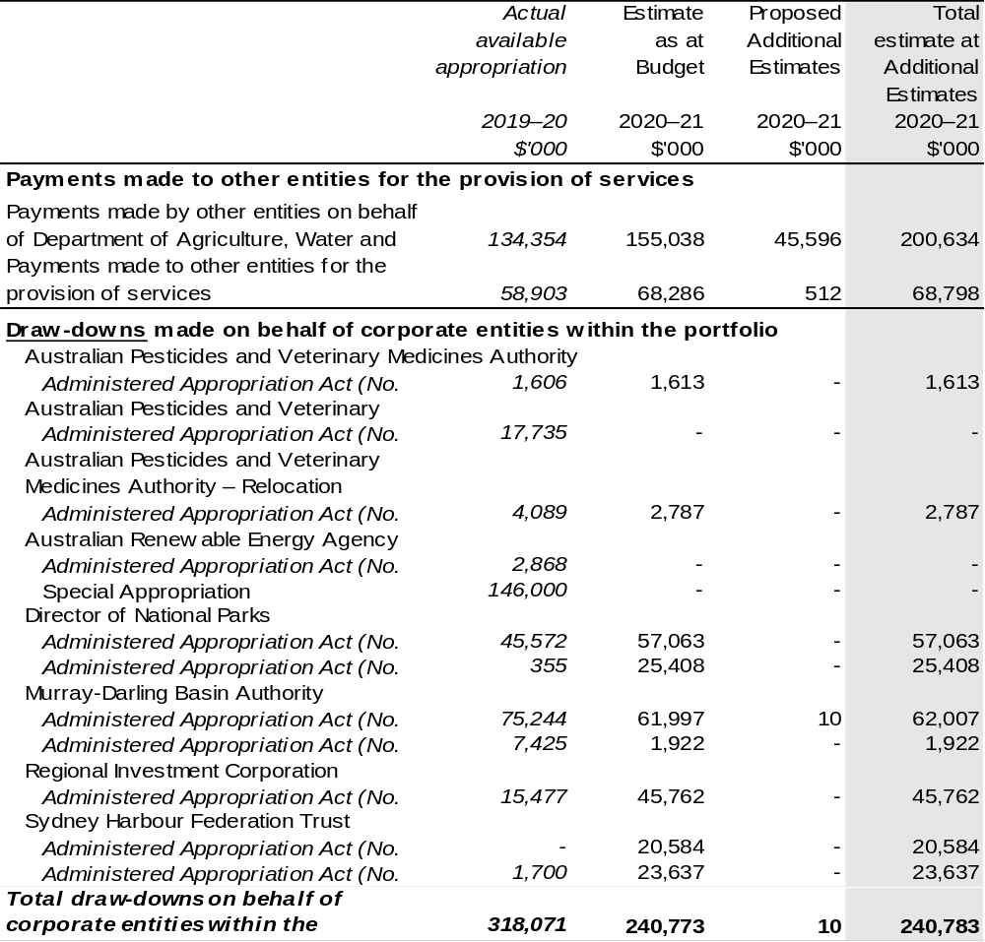
- The proposed additional estimates increase in 2020–21 to the Murray Darling Basin Authority, is a related entity movement with no appropriation impact.

Continued on following page

Table 1.1: Department of Agriculture, Water and the Environment – Resource Statement as at 2020–21 Additional Estimates – February 2021 (continued)
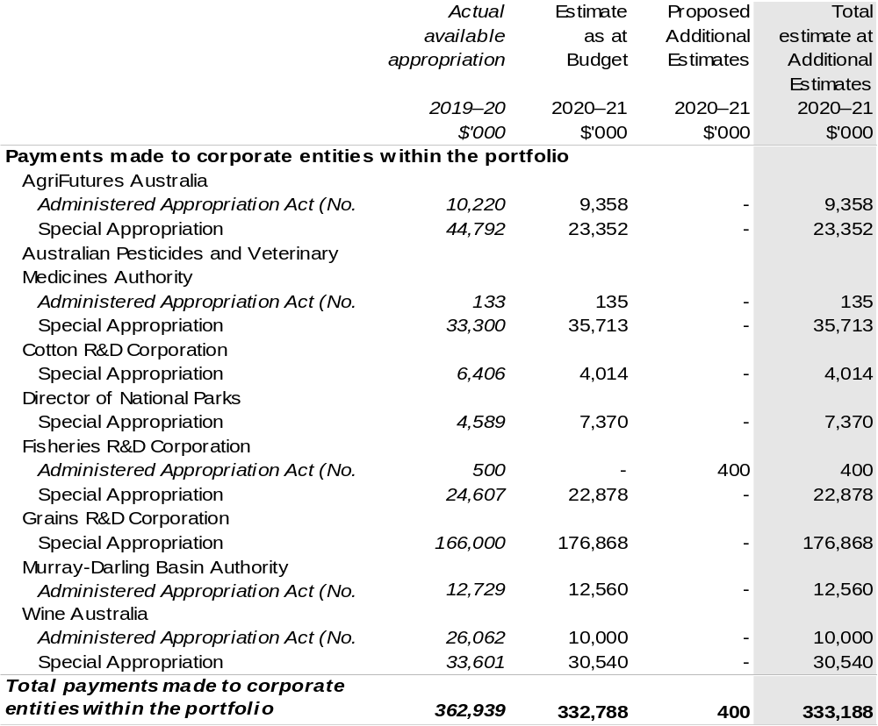
- The proposed additional estimates increase in 2020–21 to Fisheries R&D Corporation is a related entity movement with no appropriation impact.

1.3 Entity measures
Table 1.2 summarises new Government measures taken since the 2020–21 Budget.
The table is split into receipt, payment and capital measures, with the affected programs identified.

Table 1.2: Department of Agriculture, Water and the Environment – measures since 2020–21 Budget
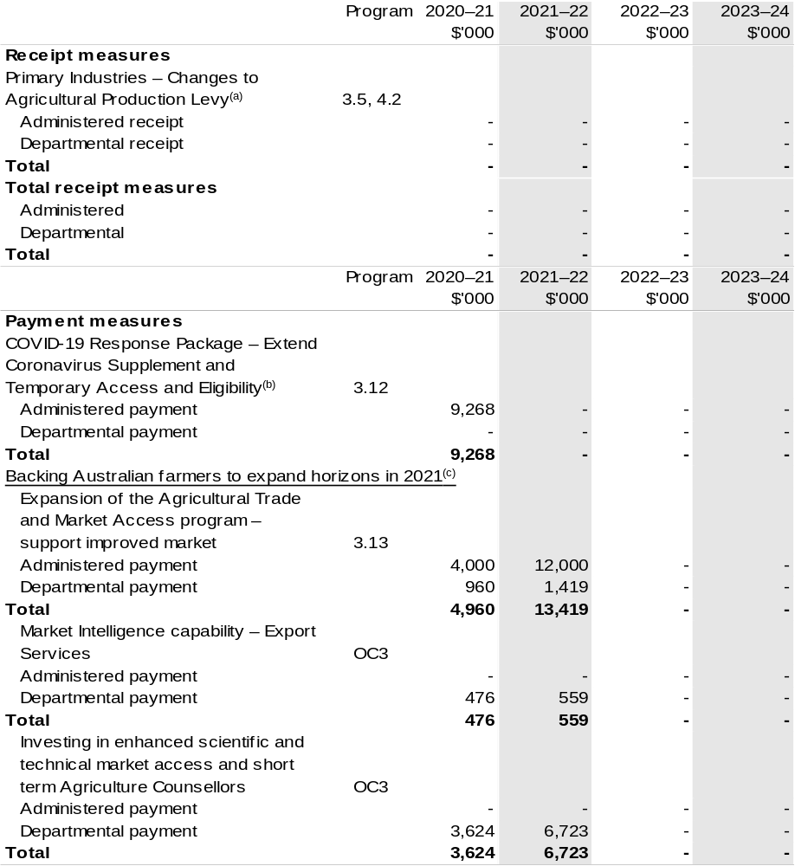
Continued on following pages

Table 1.2: Department of Agriculture, Water and the Environment – measures since 2020–21 Budget (continued)
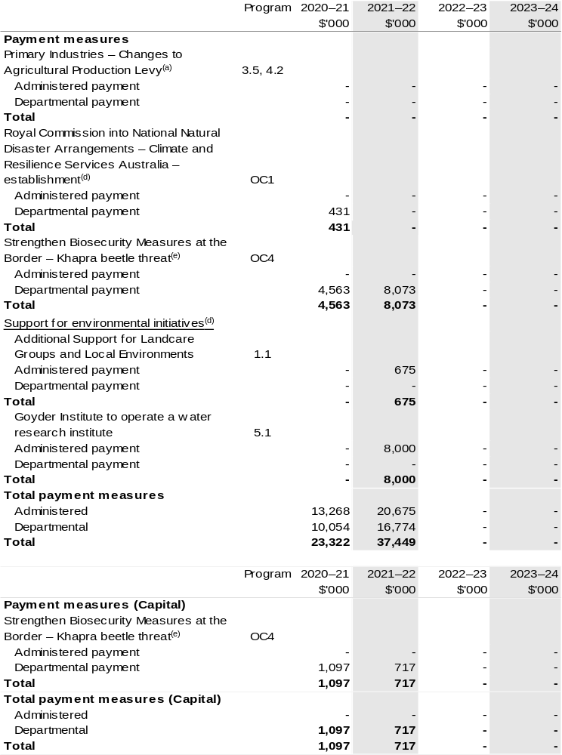
Continued on following page
Table 1.2: Department of Agriculture, Water and the Environment – measures since 2020–21 Budget (continued)
- The measure Primary Industries – Changes to agricultural production levy appears under receipt and payment measure headings. These changes are made at the request of the relevant industry.
The measure comprises:
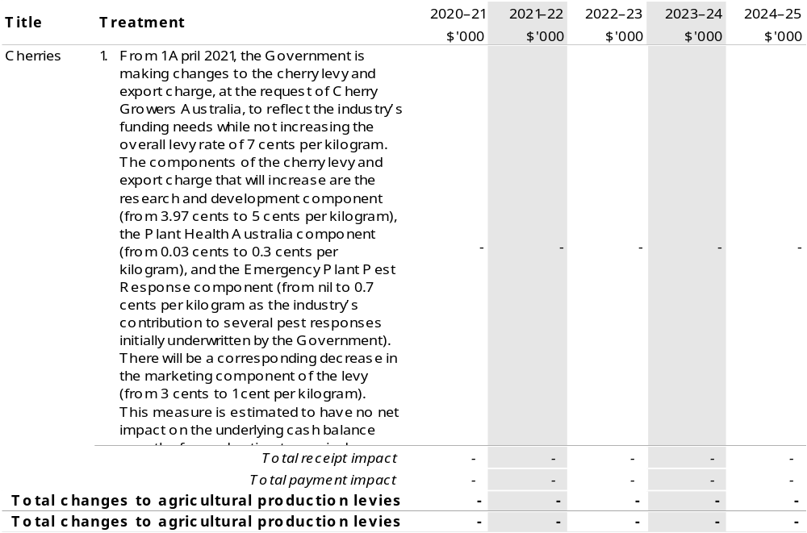
- The lead entity for this measure is the Department of Social Services. The measure description appears in the December 2020–21 Mid-Year Economic and Fiscal Outlook (MYEFO) under the Social Services portfolio.
- This measure was announced through a joint media release on the 23 December 2020 by The Hon David Littleproud MP: Minster for Agriculture, Drought and Emergency Management, Deputy Leader of the Nationals, The Hon Dan Tehan: Minister for Trade, Tourism and Investment and Senator The Hon Johnathon Duniam: Assistant Minister for Forestry and Fisheries, Assistant Minister for Industry Development and Senator for Tasmania. Total package is $72.685 million over three years: Department of Agriculture, Water and the Environment will receive $29.761 million over two years and Austrade $42.924 million over three years.
- This measure was published in the December 2020–21 MYEFO under the Agriculture, Water and Environment portfolio.
- This measure was announced on the 29 December 2020 by The Hon David Littleproud MP.

Prepared on a Government Financial Statistics (fiscal) basis

1.4 Additional estimates, resourcing and variations to outcomes
The following tables detail changes in resourcing for the Department of Agriculture, Water and the Environment at Additional Estimates, by outcome. The tables show variations since the 2020–21 Budget due to new measures (as per Table 1.2) and variations due to other factors, such as movements of funds, reclassifications, reallocations and adjustments due to the efficiency dividend and changes in economic parameters.

Table 1.3: Additional Estimates and other variations to outcomes since 2020–21 Budget
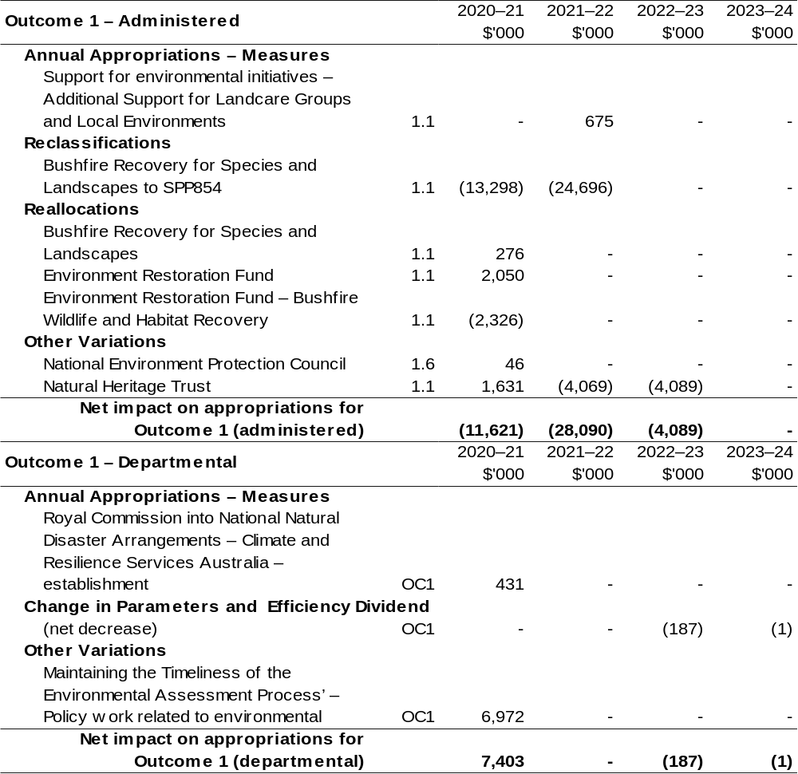

Continued on following pages
Table 1.3: Additional Estimates and other variations to outcomes since 2020–21 Budget (continued)
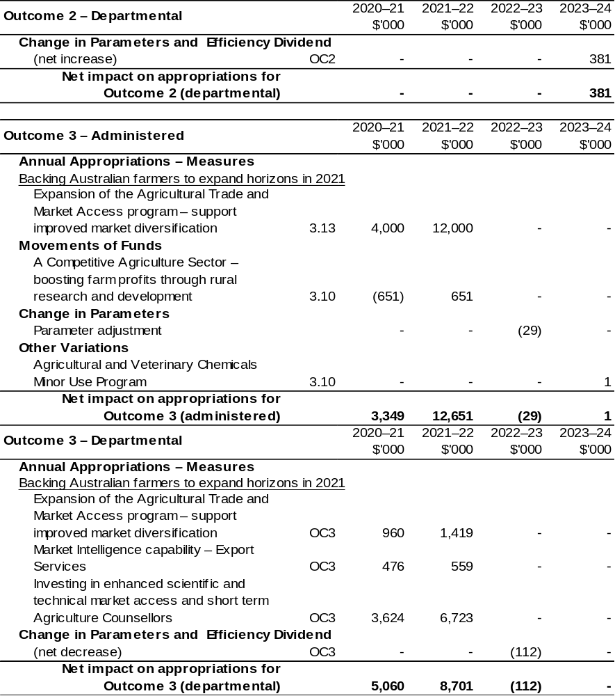
Continued on following pages
Table 1.3: Additional Estimates and other variations to outcomes since 2020–21 Budget (continued)
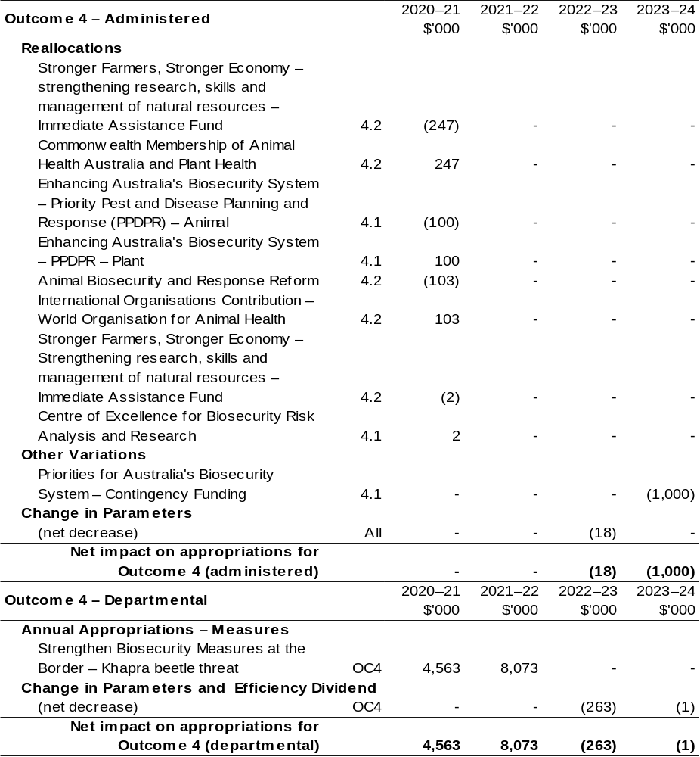
Continued on following pages

Table 1.3: Additional Estimates and other variations to outcomes since 2020–21 Budget (continued)
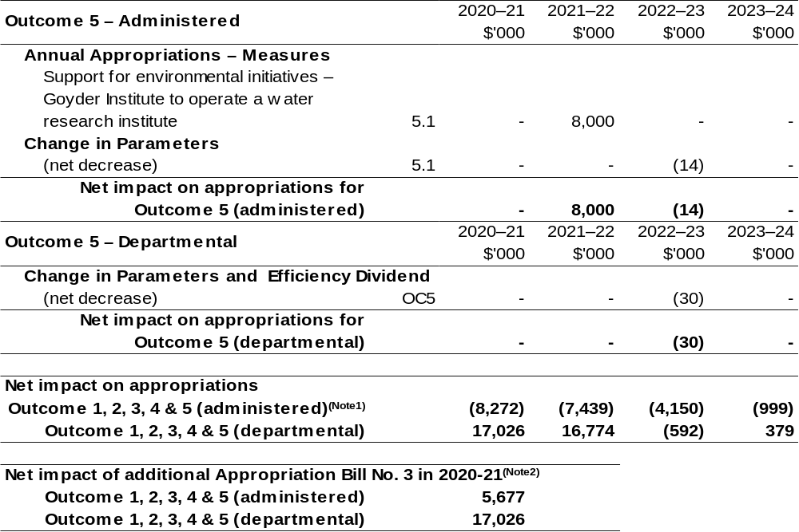
Note 1: Net impact on appropriations, includes negative amounts in 2020–21, however these amounts will be quarantine and do not impact the additional appropriation that will be received through additional Appropriation Bills (No.3).
Note 2: Net impact of additional appropriation through Bill (No. 3) in 2020–21, has removed the quarantined amounts in 2020–21. These totals match the amounts Department of Agriculture, Water and the Environment will receive through Appropriation Bill (No. 3) in administered and departmental funding, refer to Table 1.4: Appropriation Bill (No. 3) 2020–21 and Administered and Table 1.4: Appropriation Bill (No. 3) 2020–21 – Departmental.

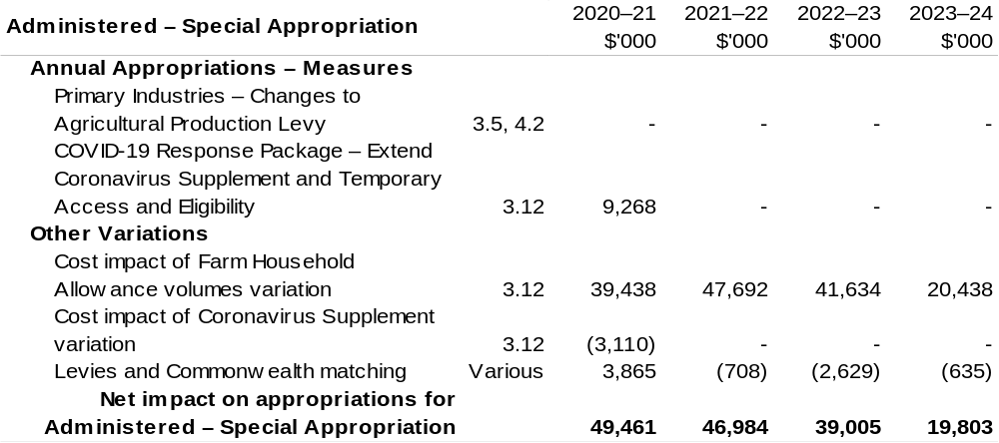
Continued on following page

Table 1.3: Additional Estimates and other variations to outcomes since 2020–21 Budget (continued)

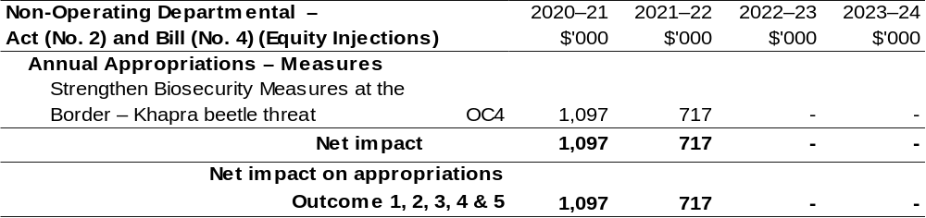
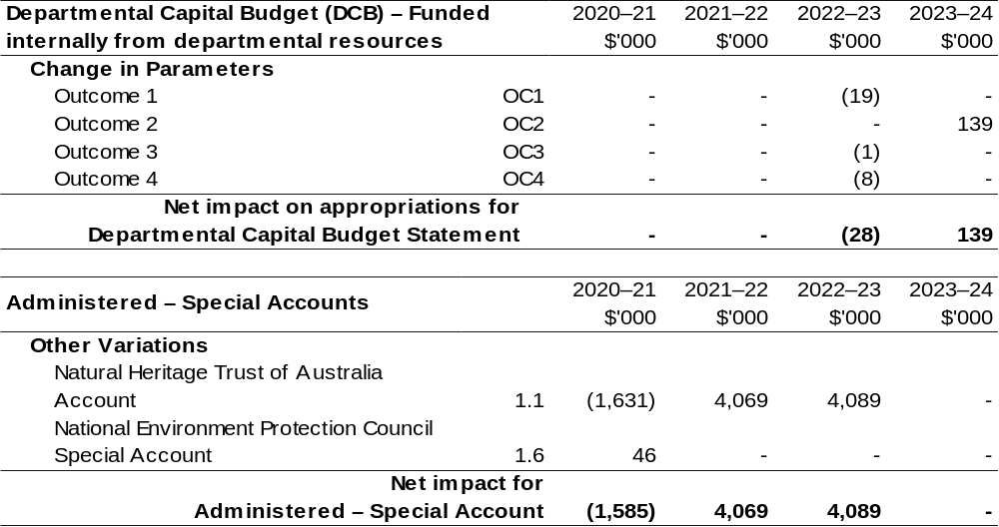

Additional variations processed through the Department of the Treasury that impact the Department of
Agriculture, Water and the Environment:

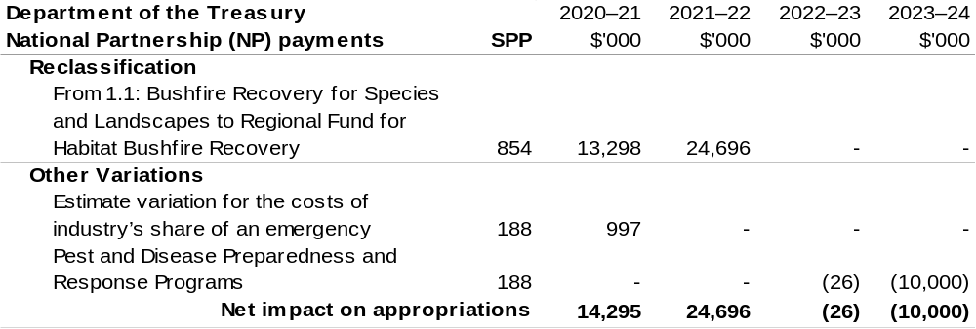

1.5 Breakdown of additional estimates by appropriation bill
The following table shows Additional Estimates sought for the Department of Agriculture, Water and the Environment through Appropriation Bills (No. 3) and
(No. 4) 2020–21.

Table 1.4: Appropriation Bill (No. 3) 2020–21 – Administered
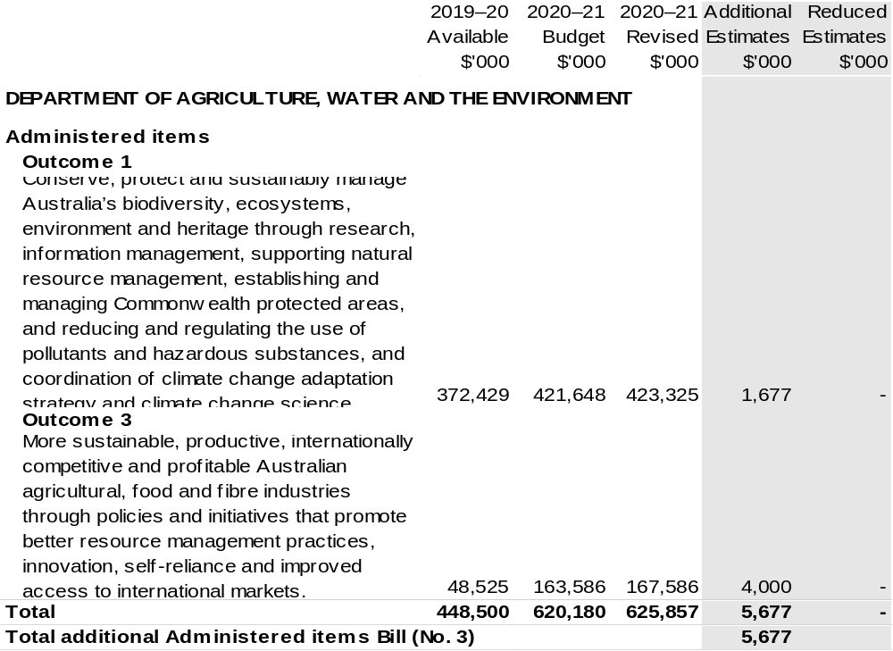
Continued on following pages

Table 1.4: Appropriation Bill (No. 3) 2020–21 – Departmental
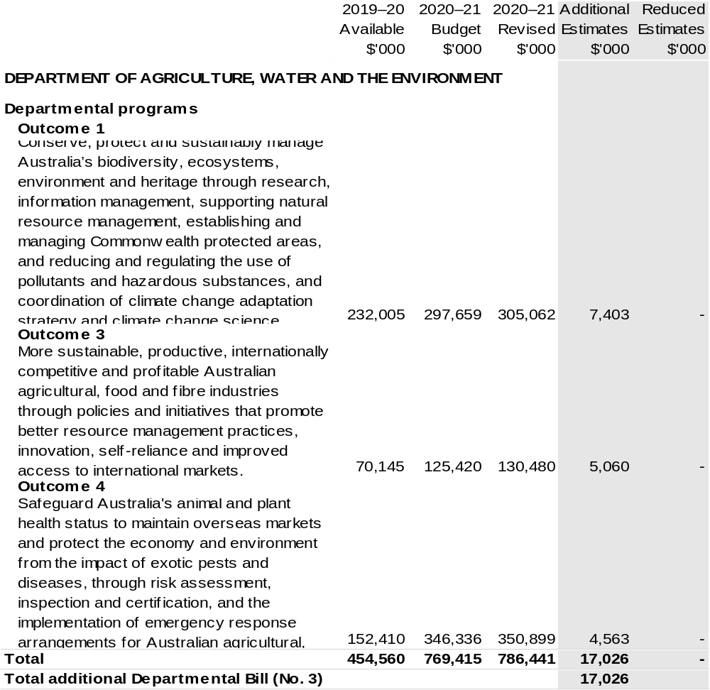
Continued on following page

Table 1.5: Appropriation Bill (No. 4) 2020–21
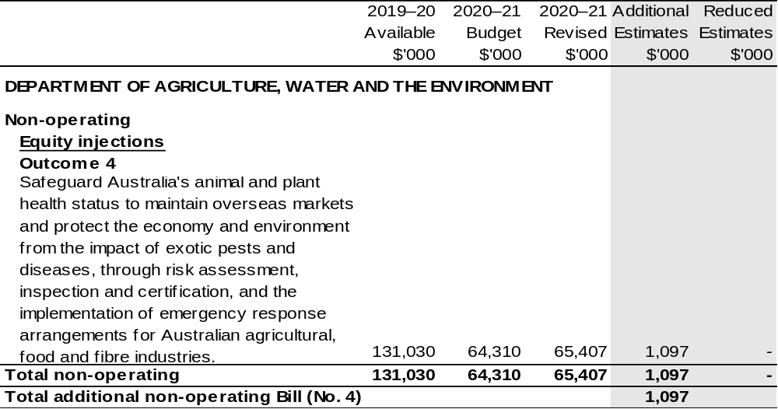

Section 2: Revisions to outcomes and planned performance

2.1 Changes to outcome and program structures
There have been no changes to the department’s outcomes and program structure since the 2020–21 Portfolio Budget Statements.

2.2 Budgeted expenses and performance for outcome 1

2.2.1: Linked programs
There have been no changes to linked programs for Outcome 1 since the 2020–21 Portfolio Budget Statements.

2.2.2: Performance criteria
There have been no changes to performance criteria for Outcome 1 since the 2020–21 Portfolio Budget Statements.

2.2.3: Budgeted expenses
Table 2.2.4 (below) shows how much the entity intends to spend (on an accrual basis) on achieving the outcome, broken down by program, as well as by Administered and Departmental funding sources.

Table 2.2.4: Budgeted Expenses for Outcome 1
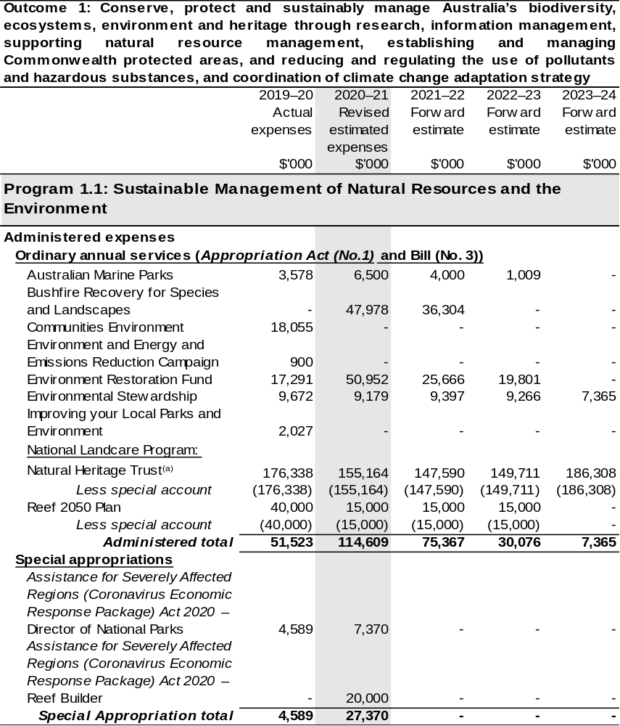
Continued on following pages
Table 2.2.4 Budgeted Expenses for Outcome 1 (continued)
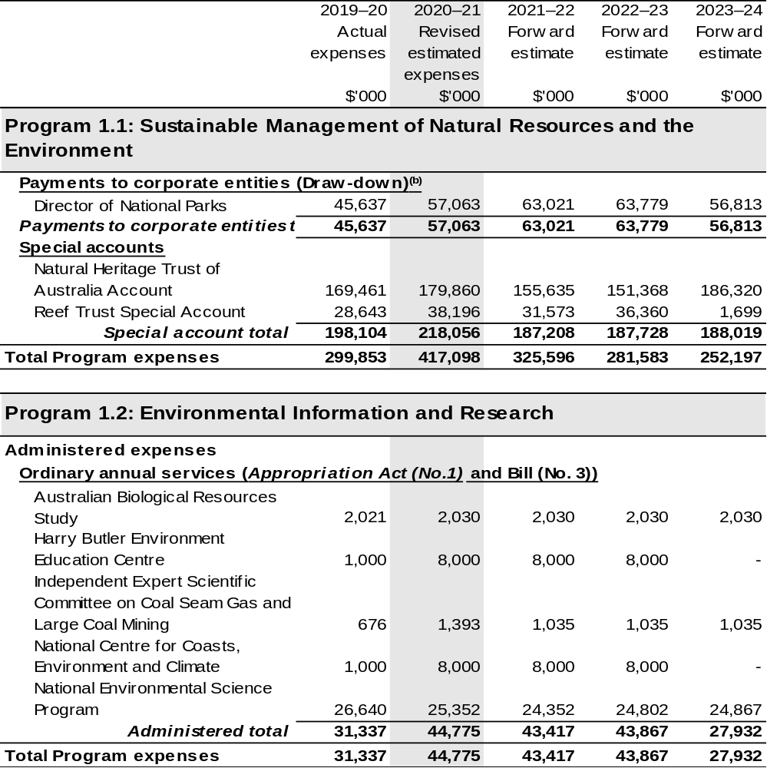

Continued on following pages
Table 2.2.4 Budgeted Expenses for Outcome 1 (continued)
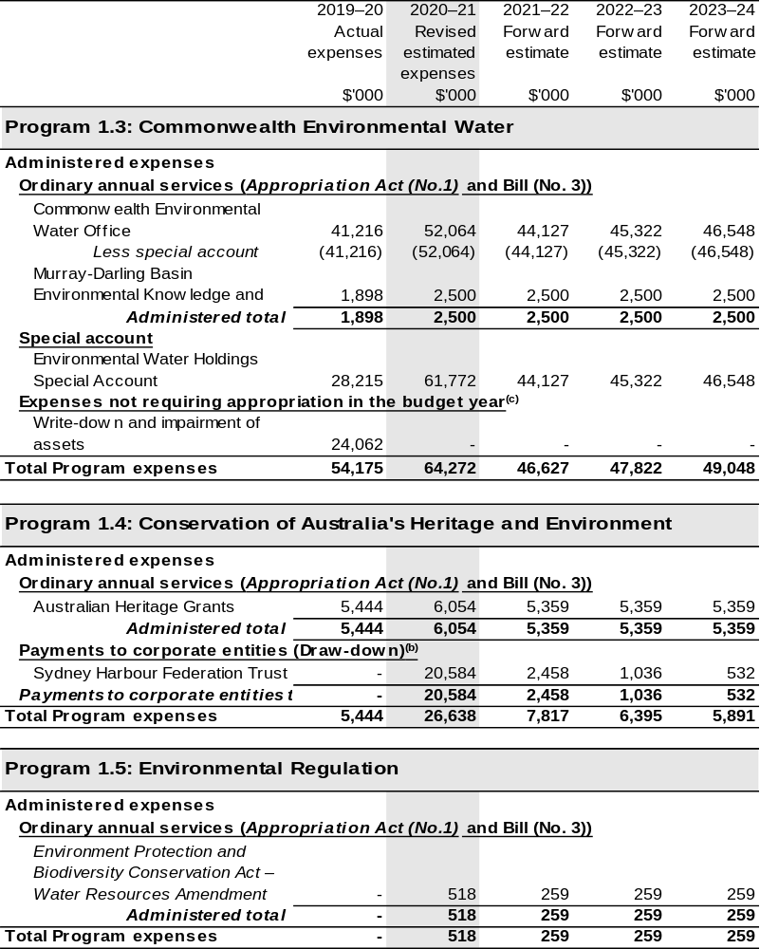

Continued on following pages

Table 2.2.4 Budgeted Expenses for Outcome 1 (continued)
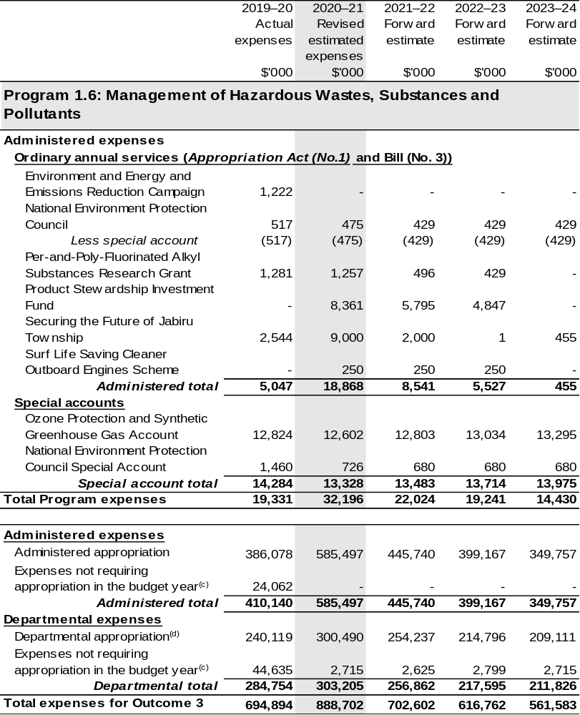
Continued on following pages

Table 2.2.4 Budgeted Expenses for Outcome 1 (continued)
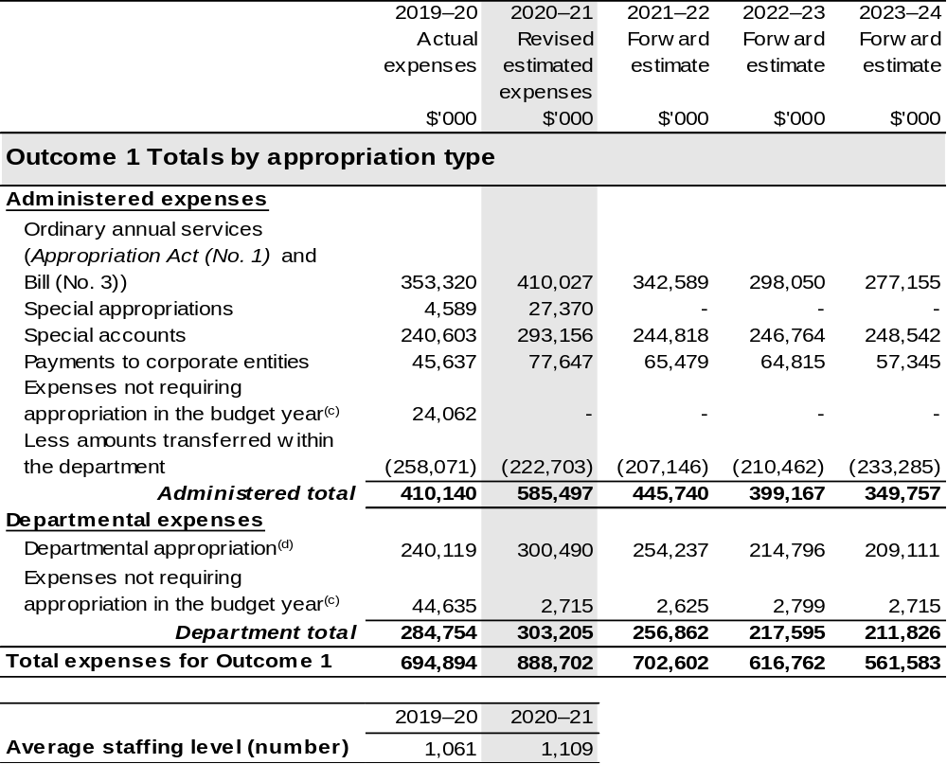
(a) Funding for components of the National Landcare Program are directly appropriated to the Department of the Treasury and the Department of the Prime Minister and Cabinet.
(b) The Director of National Parks and Sydney Harbour Federation Trust are CCEs under the PGPA Act and do not receive direct appropriations. Instead, their funding passes through the department and is drawn-down on their behalf.
(c) ‘Expenses not requiring appropriation in the Budget year’ are made up of depreciation and amortisation expenses, audit fees and an approved operating loss.
(d) Departmental appropriation allocations are notional and reflect the current structure of the department. Expenses funded from both ‘Ordinary annual services (Supply Act (No. 1), Appropriation Act (No. 1) and Appropriation Bill (No. 3))’ and ‘External Revenue’ under section 74 of the PGPA Act.

Note: Departmental appropriation splits and totals are indicative estimates and may change in the course of the budget year as Government priorities change.

Continued on following page

Table 2.2.4 Budgeted Expenses for Outcome 1 (continued)
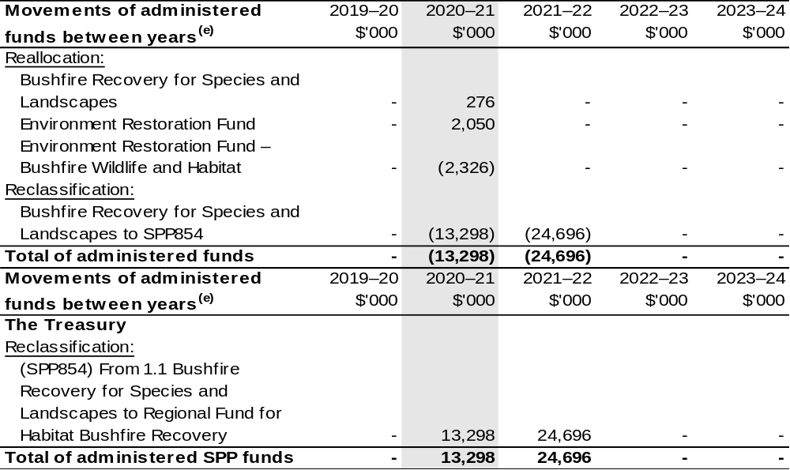
(e) Figures displayed as a negative (-) represent a decrease in funds and a positive (+) represent an increase in funds.

2.3 Budgeted expenses and performance for outcome 2

2.3.1: Linked programs
There have been no changes to linked programs for Outcome 2 since the 2020–21 Portfolio Budget Statements.

2.3.2: Performance criteria
There have been no changes to performance criteria for Outcome 2 since the 2020–21 Portfolio Budget Statements.

2.3.3: Budgeted expenses
Table 2.3.4 (below) shows how much the entity intends to spend (on an accrual basis) on achieving the outcome, broken down by program, as well as by Administered and Departmental funding sources.

Table 2.3.4: Budgeted Expenses for Outcome 2
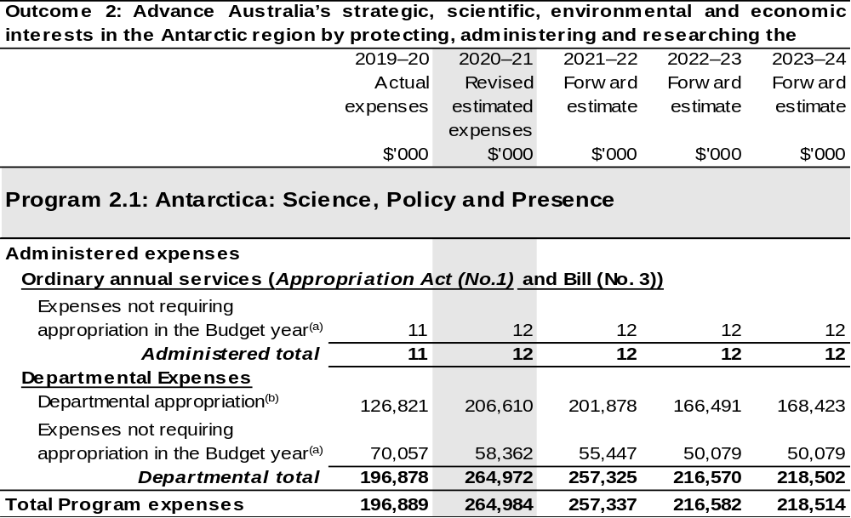
Continued on following page

Table 2.3.4 Budgeted Expenses for Outcome 2 (continued)
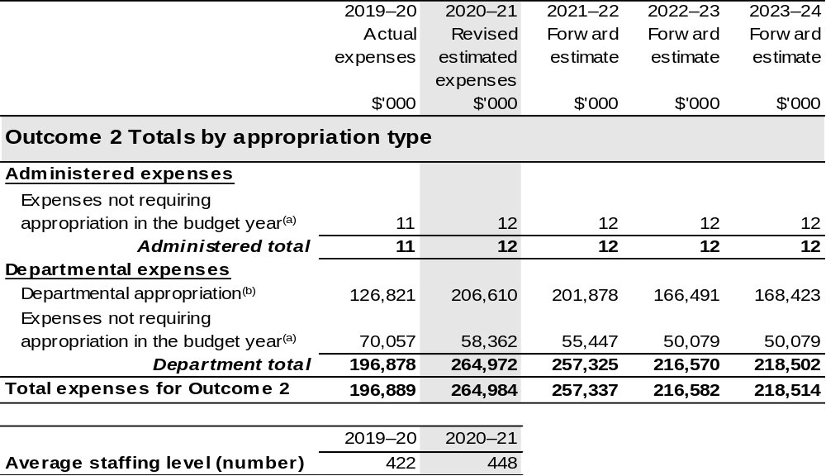
(a) ‘Expenses not requiring appropriation in the Budget year’ are made up of depreciation and amortisation expenses, audit fees and an approved operating loss.
(b) Departmental appropriation allocations are notional and reflect the current structure of the department. Expenses funded from both ‘Ordinary annual services (Supply Act (No. 1), Appropriation Act (No. 1) and Appropriation Bill (No. 3))’ and ‘External Revenue’ under section 74 of the PGPA Act.

Note: Departmental appropriation splits and totals are indicative estimates and may change in the course of the budget year as Government priorities change.

2.4 Budgeted expenses and performance for outcome 3

2.4.1: Linked programs
There have been no changes to linked programs for Outcome 3 since the 2020–21 Portfolio Budget Statements.

2.4.2: Performance criteria
There have been no changes to performance criteria for Outcome 3 since the 2020–21 Portfolio Budget Statements.

2.4.3: Budgeted expenses
Table 2.4.4 (below) shows how much the entity intends to spend (on an accrual basis) on achieving the outcome, broken down by program, as well as by Administered and Departmental funding sources.

Table 2.4.4: Budgeted Expenses for Outcome 3
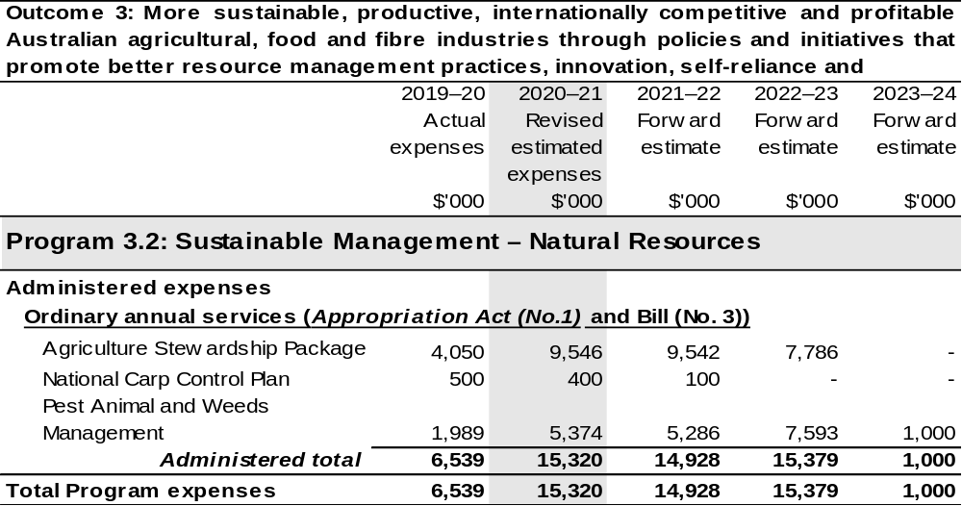
Continued on following pages
Table 2.4.4: Budgeted Expenses for Outcome 3 (continued)
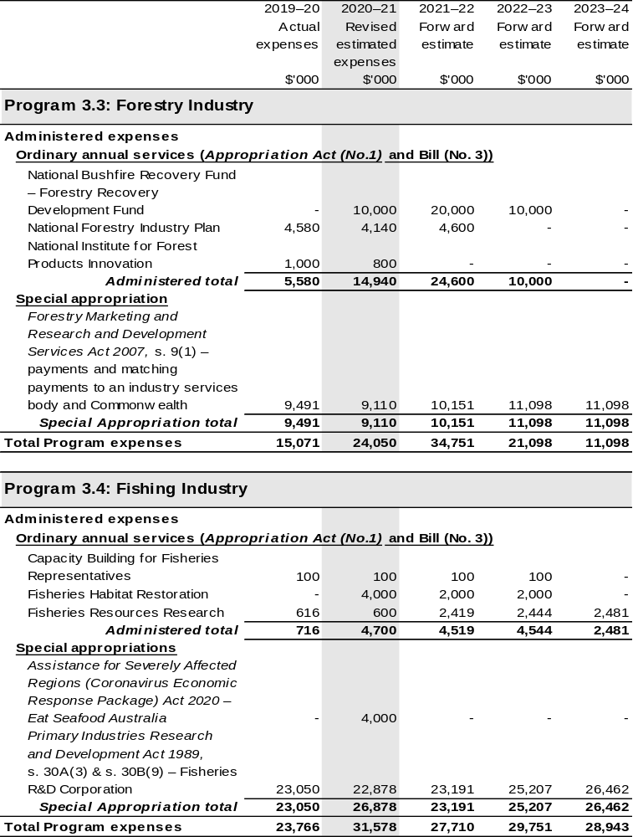
Continued on following pages

Table 2.4.4: Budgeted Expenses for Outcome 3 (continued)
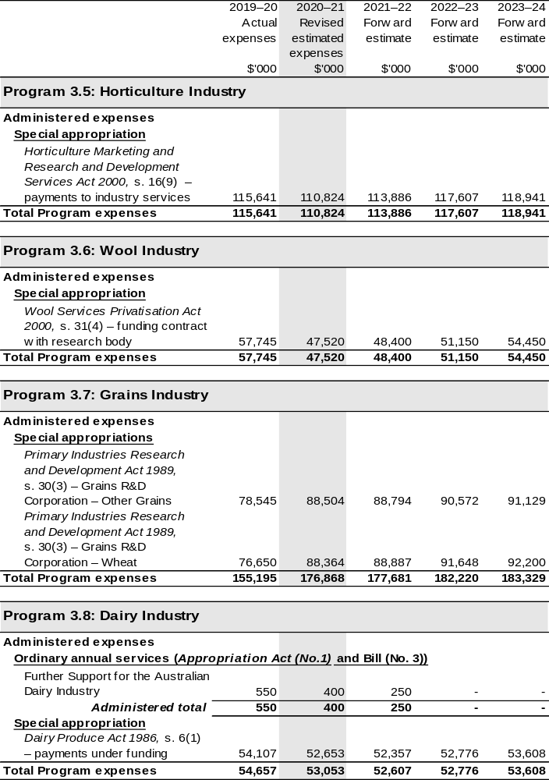
Continued on following pages
Table 2.4.4: Budgeted Expenses for Outcome 3 (continued)
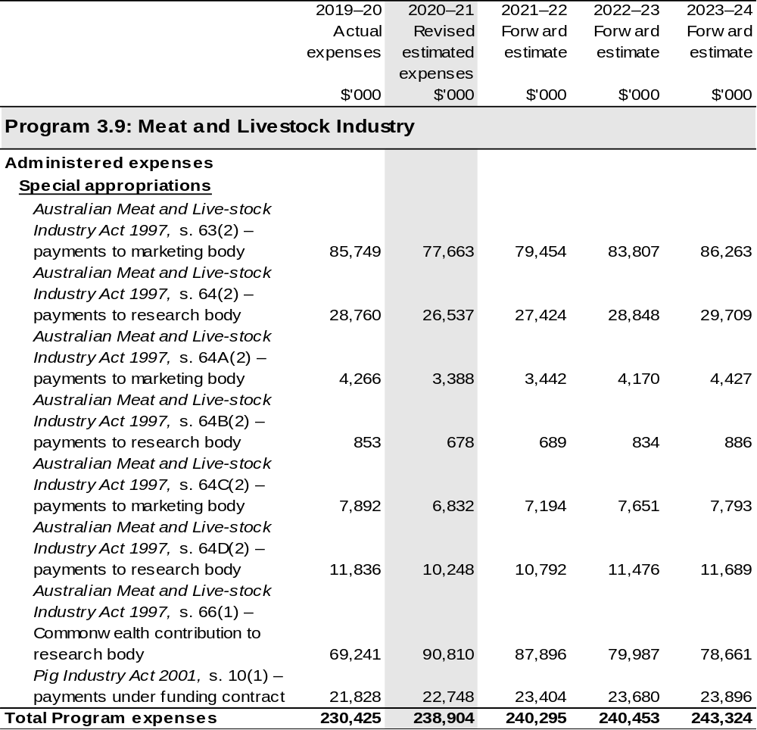
Continued on following pages
Table 2.4.4: Budgeted Expenses for Outcome 3 (continued)
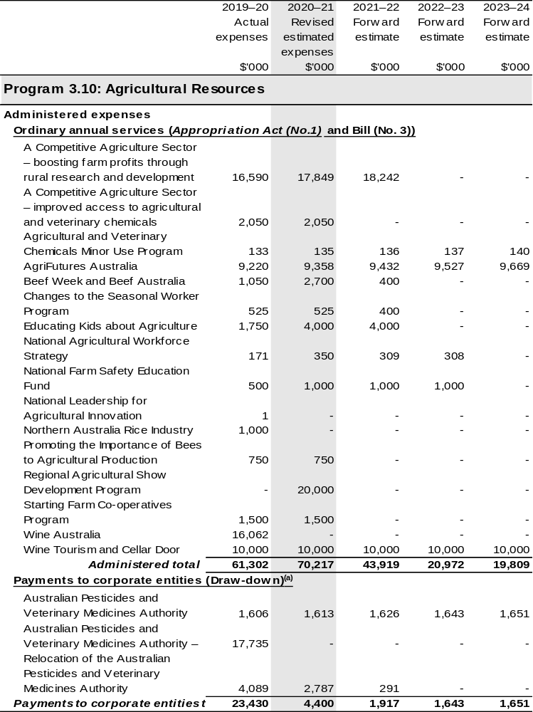
Continued on following pages
Table 2.4.4: Budgeted Expenses for Outcome 3 (continued)
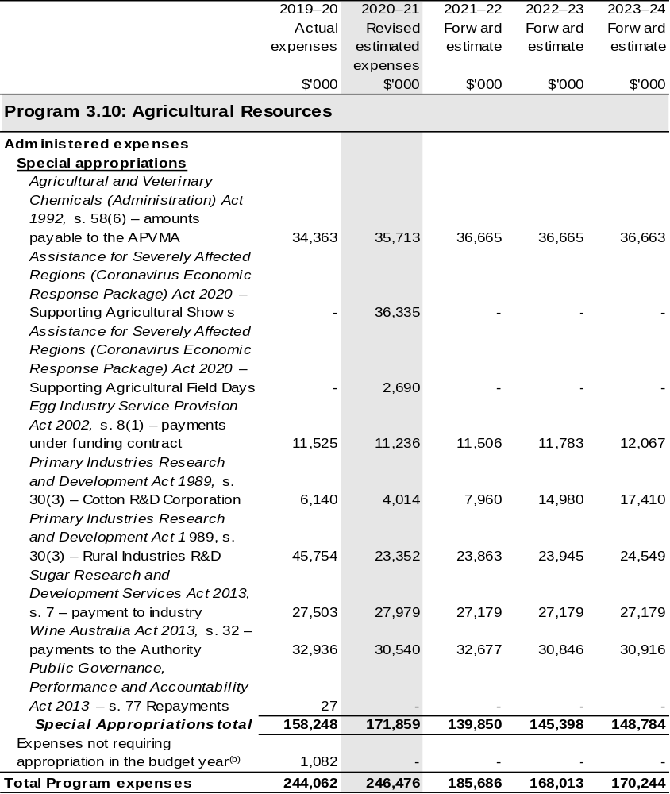
Continued on following pages

Table 2.4.4: Budgeted Expenses for Outcome 3 (continued)
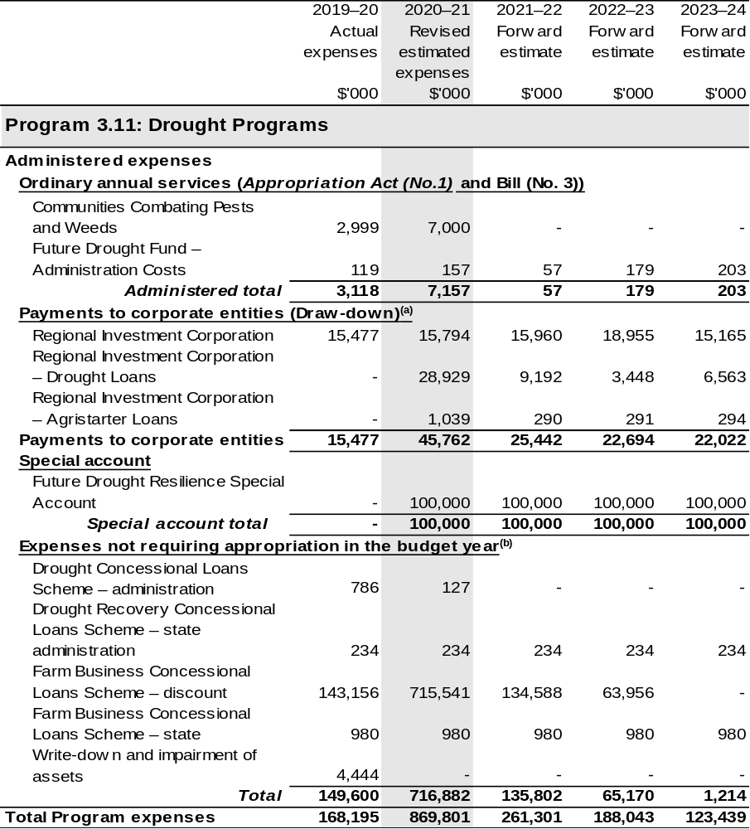
Continued on following pages

Table 2.4.4: Budgeted Expenses for Outcome 3 (continued)
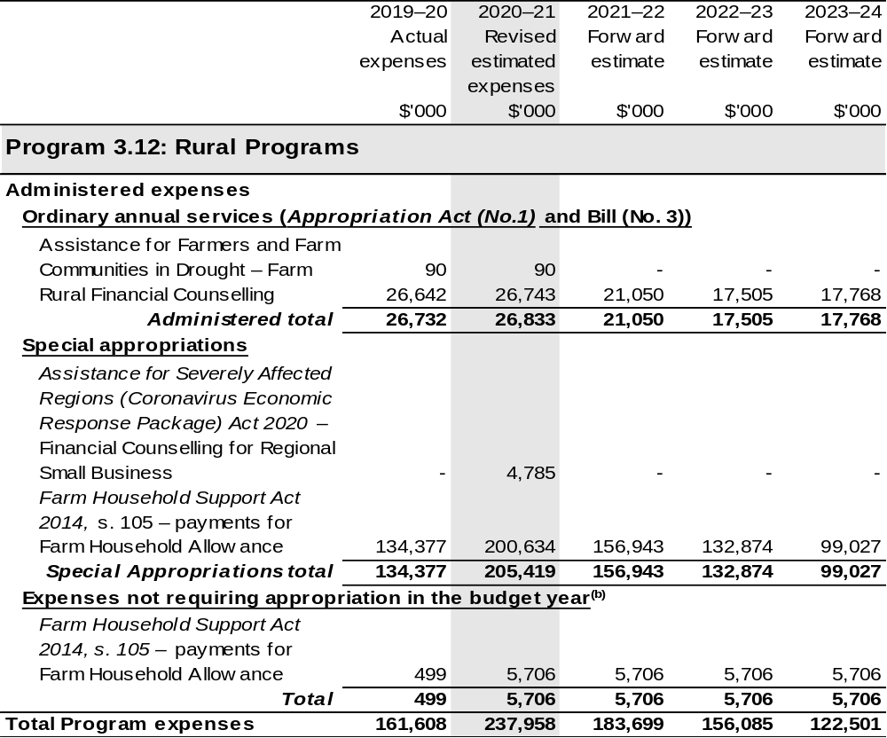
Continued on following pages

Table 2.4.4: Budgeted Expenses for Outcome 3 (continued)
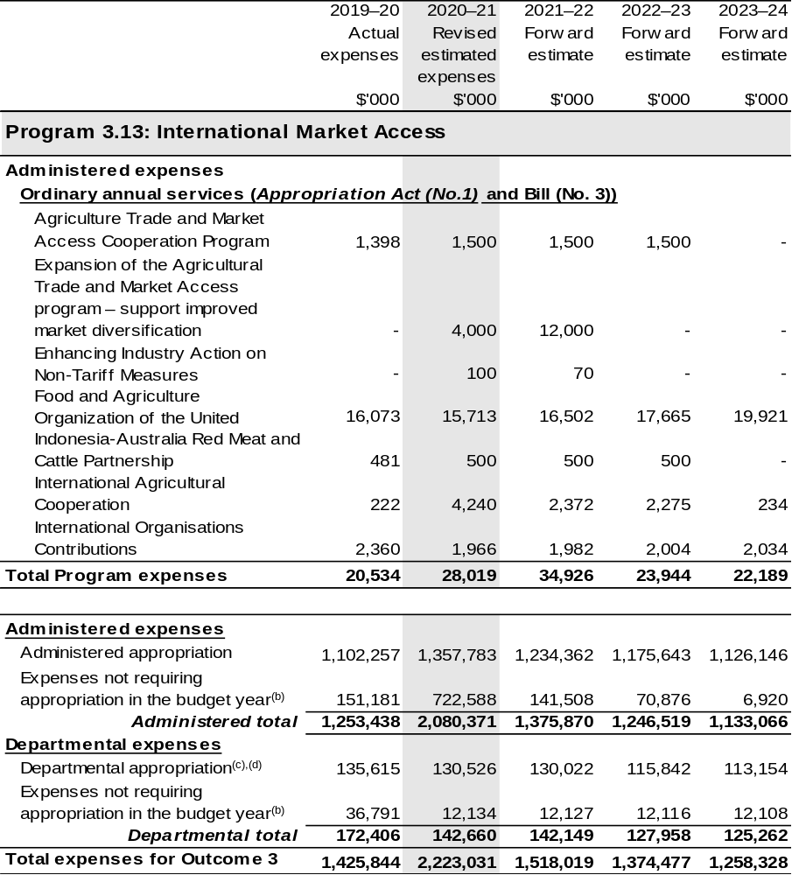
Continued on following pages

Table 2.4.4: Budgeted Expenses for Outcome 3 (continued)
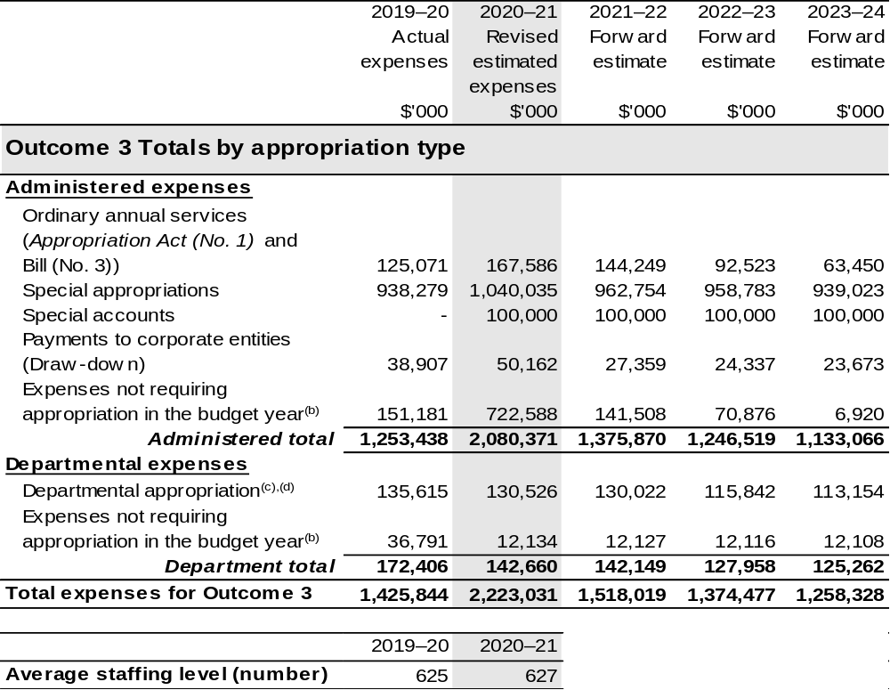
(a) APVMA and RIC are corporate Commonwealth entities (CCE) under the PGPA Act and do not receive direct appropriations. Instead, this funding passes through the department to these entities.
(b) ‘Expenses not requiring appropriation in the Budget year’ are made up of depreciation and amortisation expenses, resources received free of charge, concessional loan discount and balance sheet adjustments.
(c) Departmental appropriation allocations are notional and reflect the current structure of the department. Expenses funded from both ‘Ordinary annual services (Supply Act (No. 1), Appropriation Act (No. 1) and Appropriation Bill (No. 3))’ and ‘External Revenue’ under section 74 of the PGPA Act.
(d) Departmental appropriation allocations are notional and reflect the current structure of the department.

Note: Departmental appropriation splits and totals are indicative estimates and may change in the course of the budget year as Government priorities change.

Continued on following page

Table 2.4.4: Budgeted Expenses for Outcome 3 (continued)
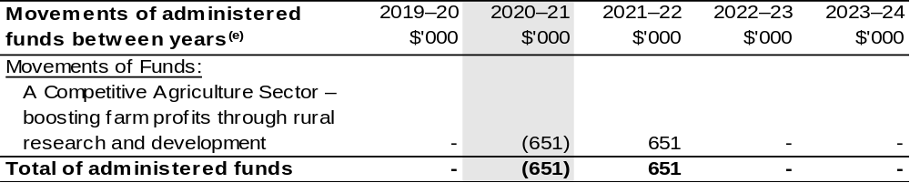
(e) Figures displayed as a negative (-) represent a decrease in funds and a positive (+) represent an increase in funds.

2.5 Budgeted expenses and performance for outcome 4

2.5.1: Linked programs
There have been no changes to linked programs for Outcome 4 since the 2020–21 Portfolio Budget Statements.

2.5.2: Performance criteria
There have been no changes to performance criteria for Outcome 4 since the 2020–21 Portfolio Budget Statements.

2.5.3 Budgeted expenses
Table 2.5.4 (below) shows how much the entity intends to spend (on an accrual basis) on achieving the outcome, broken down by program, as well as by Administered and Departmental funding sources.

Table 2.5.4 Budgeted Expenses for Outcome 4
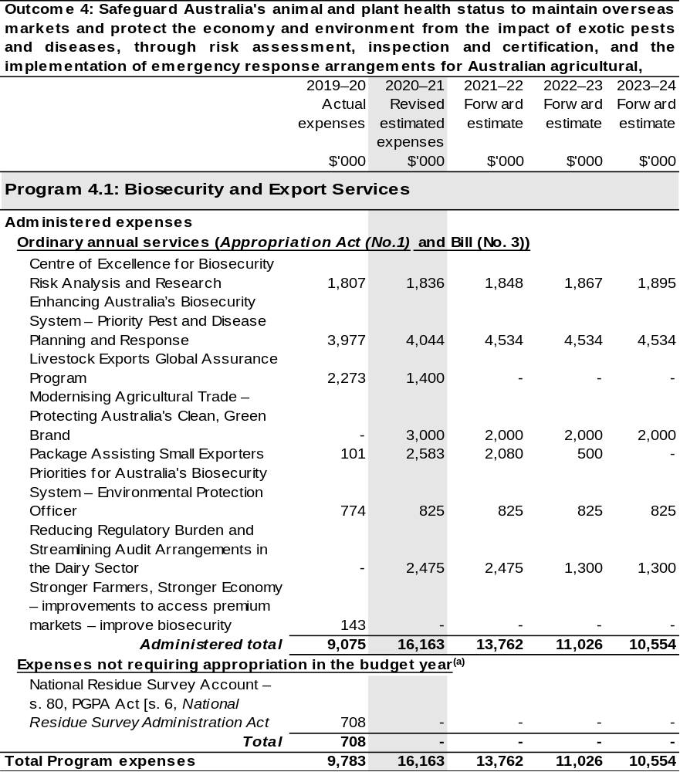
Continued on following pages
Table 2.5.4 Budgeted Expenses for Outcome 4 (continued)
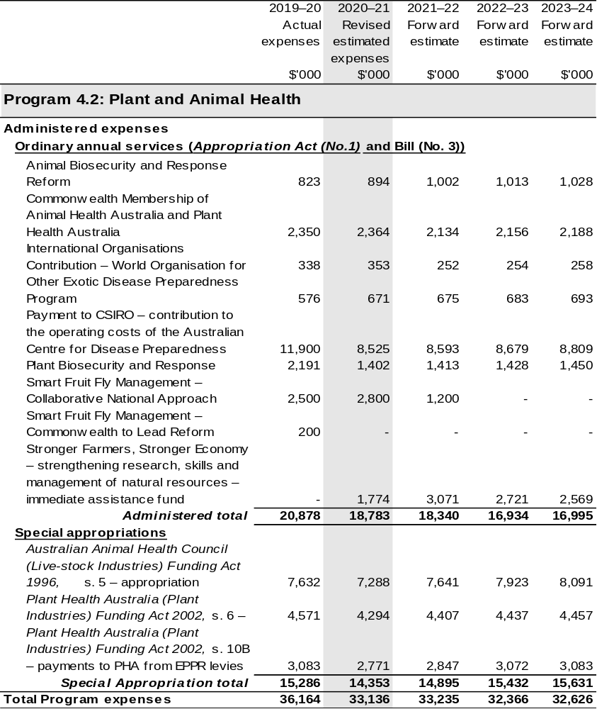
Continued on following pages
Table 2.5.4 Budgeted Expenses for Outcome 4 (continued)
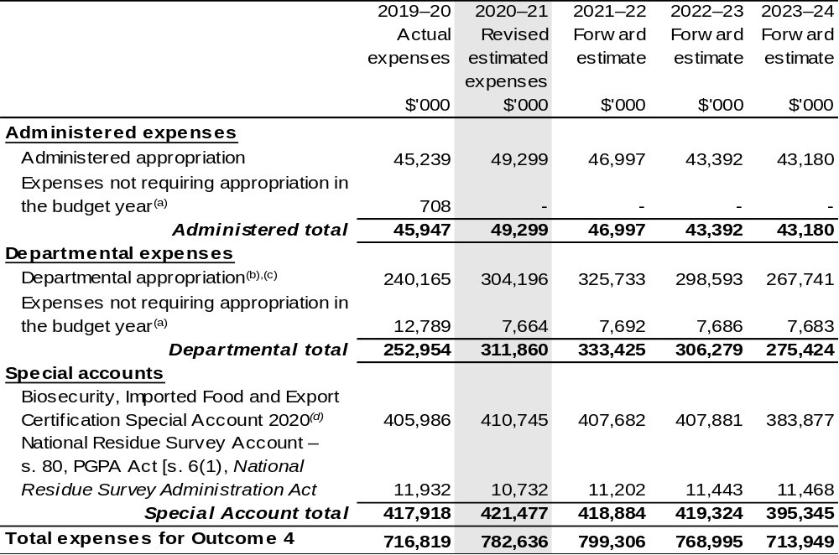
Continued on following pages
Table 2.5.4 Budgeted Expenses for Outcome 4 (continued)
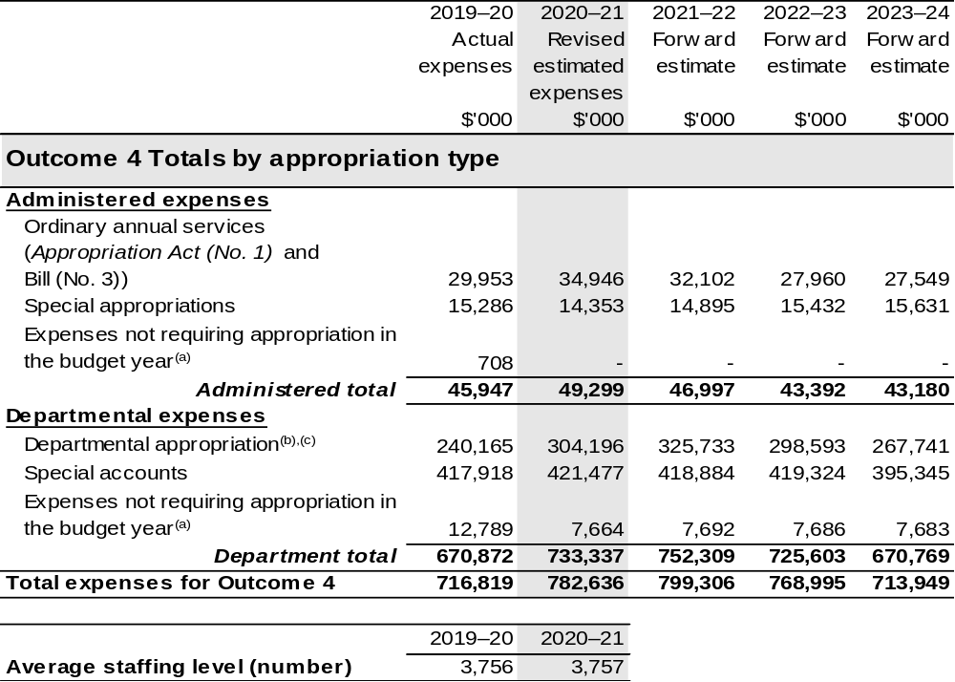
(a) ‘Expenses not requiring appropriation in the Budget year’ are made up of depreciation and amortisation
expenses, resources received free of charge, concessional loan discount and balance sheet adjustments.
(b) Departmental appropriation allocations are notional and reflect the current structure of the department. Expenses funded from both ‘Ordinary annual services (Supply Act (No. 1), Appropriation Act (No. 1) and Appropriation Bill (No. 3))’ and ‘External Revenue’ under section 74 of the PGPA Act.
(c) Departmental appropriation allocations are notional and reflect the current structure of the department.
(d) The Biosecurity, Imported Food and Export Certification Special Account was formerly known as the Australian Quarantine and Inspection Service Special Account.

Note: Departmental appropriation splits and totals are indicative estimates and may change in the course of the budget year as Government priorities change.

Continued on following page

Table 2.5.4 Budgeted Expenses for Outcome 4 (continued)
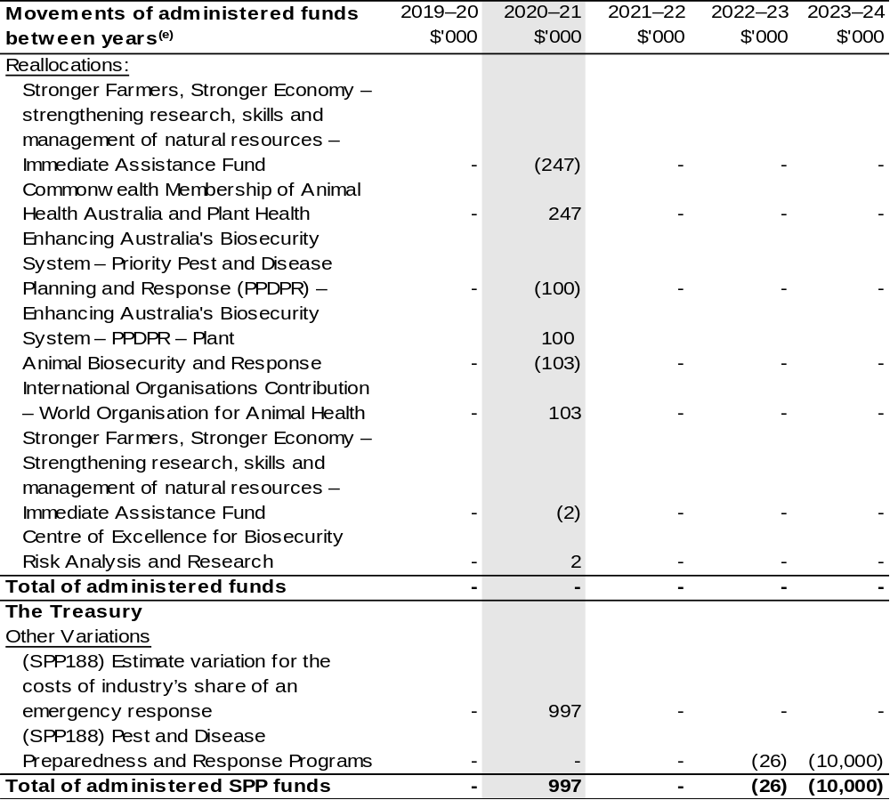
(e) Figures displayed as a negative (-) represent a decrease in funds and a positive (+) represent an increase in funds.

2.6 Budgeted expenses and performance for outcome 5

2.6.1: Linked programs
There have been no changes to linked programs for Outcome 5 since the 2020–21 Portfolio Budget Statements.

2.6.2: Performance criteria
There have been no changes to performance criteria for Outcome 5 since the 2020–21 Portfolio Budget Statements.

2.6.3: Budgeted expenses
Table 2.6.4 (below) shows how much the entity intends to spend (on an accrual basis) on achieving the outcome, broken down by program, as well as by Administered and Departmental funding sources.

Table 2.6.4: Budgeted Expenses for Outcome 5
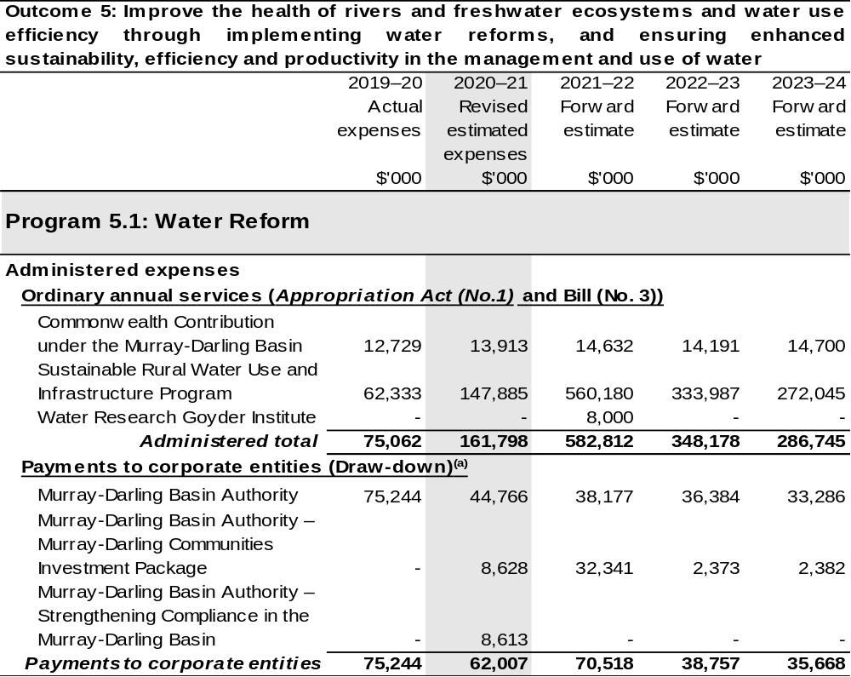
Continued on following pages
Table 2.6.4: Budgeted Expenses for Outcome 5 (continued)
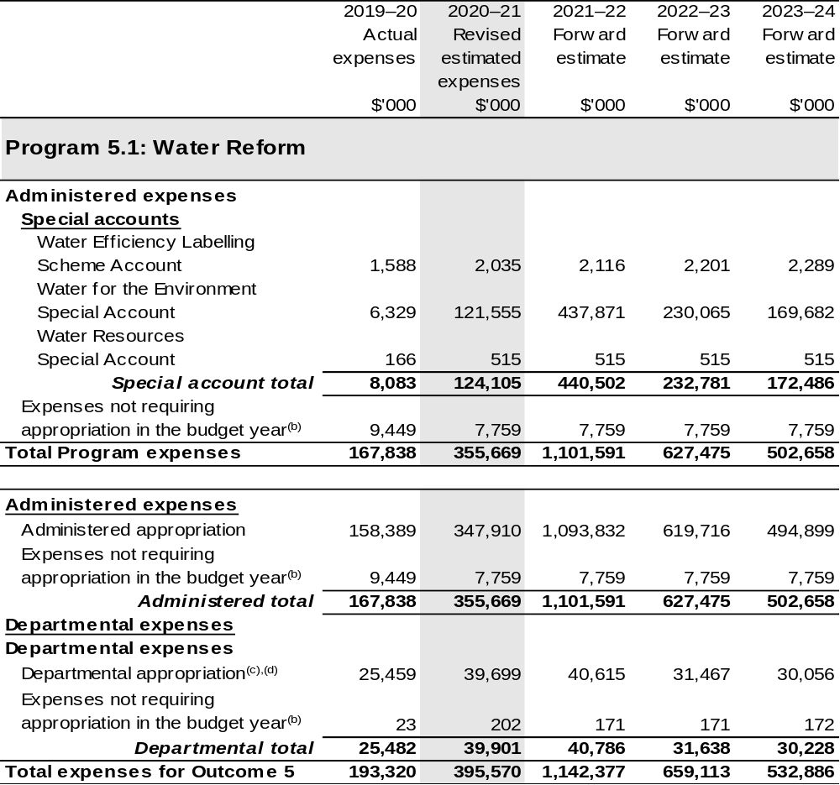
Continued on following page
Table 2.6.4: Budgeted Expenses for Outcome 5 (continued)
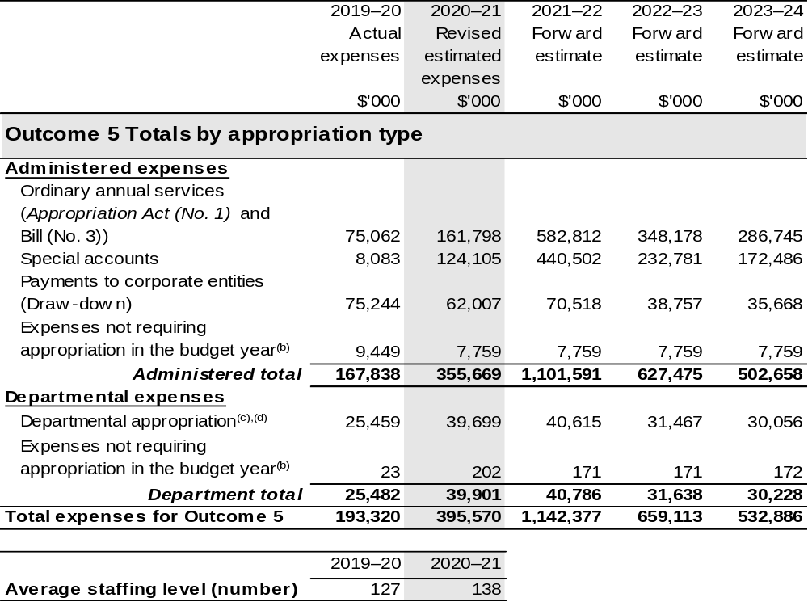
(a) The MDBA is a CCE under the PGPA Act and does not receive direct appropriations. Instead, this funding passes through the department to the MDBA.
(b) ‘Expenses not requiring appropriation in the Budget year’ are made up of depreciation and amortisation
expenses, resources received free of charge, concessional loan discount and balance sheet adjustments.
(c) Departmental appropriation allocations are notional and reflect the current structure of the department.
(d) Departmental appropriation allocations are notional and reflect the current structure of the department. Expenses funded from both ‘Ordinary annual services (Supply Act (No. 1), Appropriation Act (No. 1) and Appropriation Bill (No. 3))’ and ‘External Revenue’ under section 74 of the PGPA Act.

Note: Departmental appropriation splits and totals are indicative estimates and may change in the course of the budget year as Government priorities change.

2.7 Budgeted expenses and performance for outcome 6

2.7.1: Linked programs
There have been no changes to linked programs for Outcome 6 since the 2020–21 Portfolio Budget Statements.

2.7.2: Performance criteria
There have been no changes to performance criteria for Outcome 6 since the 2020–21 Portfolio Budget Statements.

2.7.3: Budgeted expenses
Table 2.7.4 (below) shows how much the entity intends to spend (on an accrual basis) on achieving the outcome, broken down by program, as well as by Administered and Departmental funding sources. Outcomes 6 is now the responsibility of the Department of Industry, Science, Energy and Resources.

Table 2.7.4: Budgeted Expenses for Outcome 6
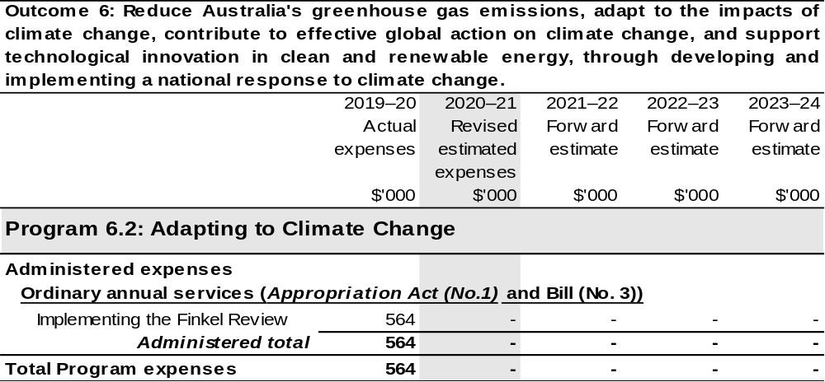
Continued on following page

Table 2.7.4: Budgeted Expenses for Outcome 6 (continued)
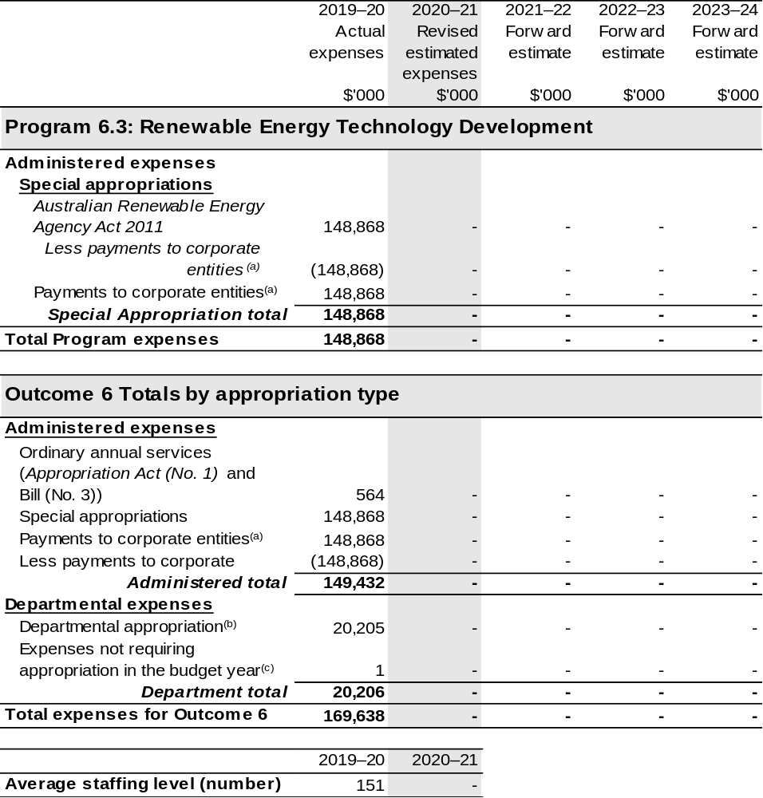
(a) Further information on payments to the Australian Renewable Energy Agency corporate entity can be found in the ‘Third Party Payments’ section of Table 1.1: Department of Agriculture, Water and the Environment Resource Statement.
(b) Expenses funded from both ‘Ordinary annual services (Appropriation Act (No. 1))’ and ‘External Revenue’ under section 74 of the PGPA Act.
(c) ‘Expenses not requiring appropriation in the Budget year’ are made up of depreciation and amortisation expenses, audit fees and an approved operating loss.

2.8 Budgeted expenses and performance for outcome 7

2.8.1: Linked programs
There have been no changes to linked programs for Outcome 7 since the 2020–21 Portfolio Budget Statements.

2.8.2: Performance criteria
There have been no changes to performance criteria for Outcome 7 since the 2020–21 Portfolio Budget Statements.

2.8.3: Budgeted expenses
Table 2.8.4 (below) shows how much the entity intends to spend (on an accrual basis) on achieving the outcome, broken down by program, as well as by Administered and Departmental funding sources. Outcomes 7 is now the responsibility of the Department of Industry, Science, Energy and Resources.

Table 2.8.4: Budgeted Expenses for Outcome 7
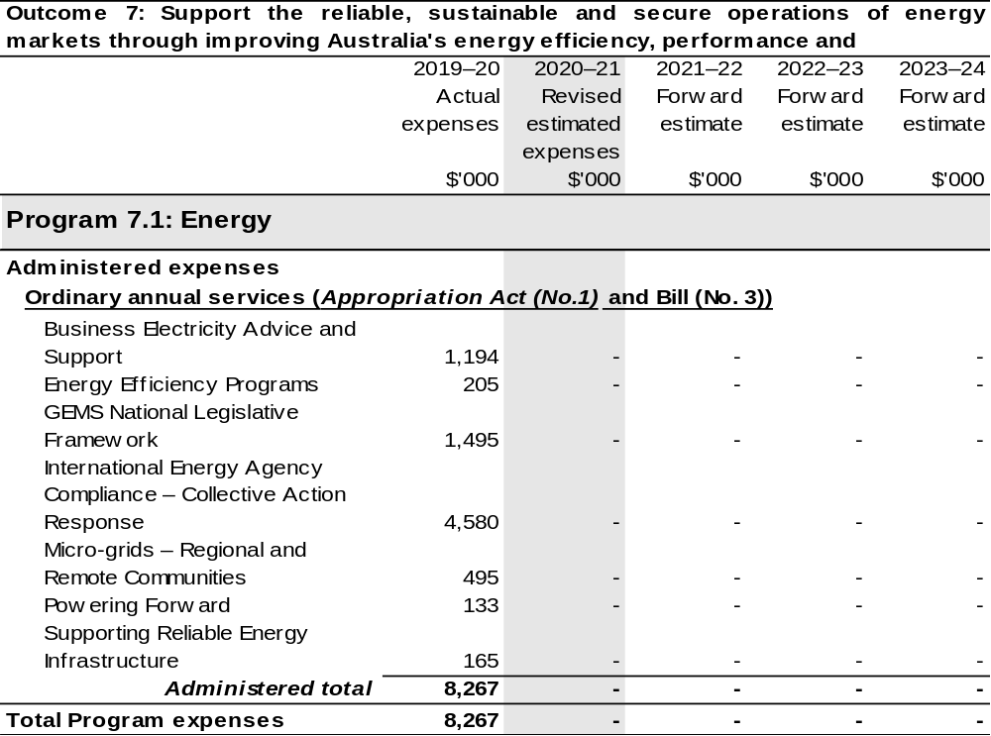
Continued on following page
Table 2.8.4: Budgeted Expenses for Outcome 7 (continued)
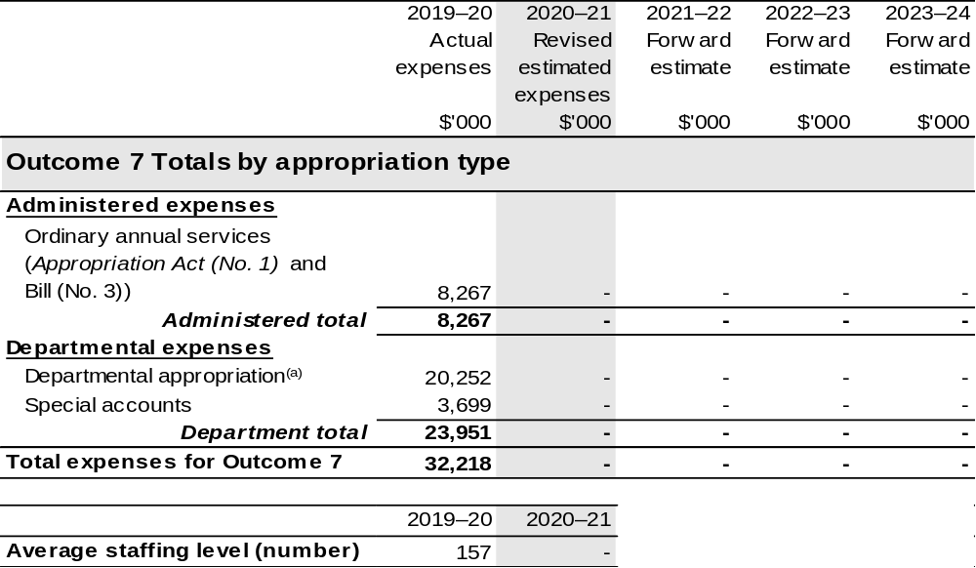
(a) Expenses funded from both ‘Ordinary annual services (Appropriation Act (No. 1)’ and ‘External Revenue’ under section 74 of the PGPA Act.

Section 3: Special account flows and budgeted
financial Statements

3.1 Special account flows
Estimates of special account flows

Special Accounts provide a means to set aside and record amounts used for specified purposes. Table 3.1 shows the expected additions (receipts) and reductions (payments) for each account used by the Department of Agriculture, Water and the Environment.

Table 3.1: Estimates of special account flows and balances 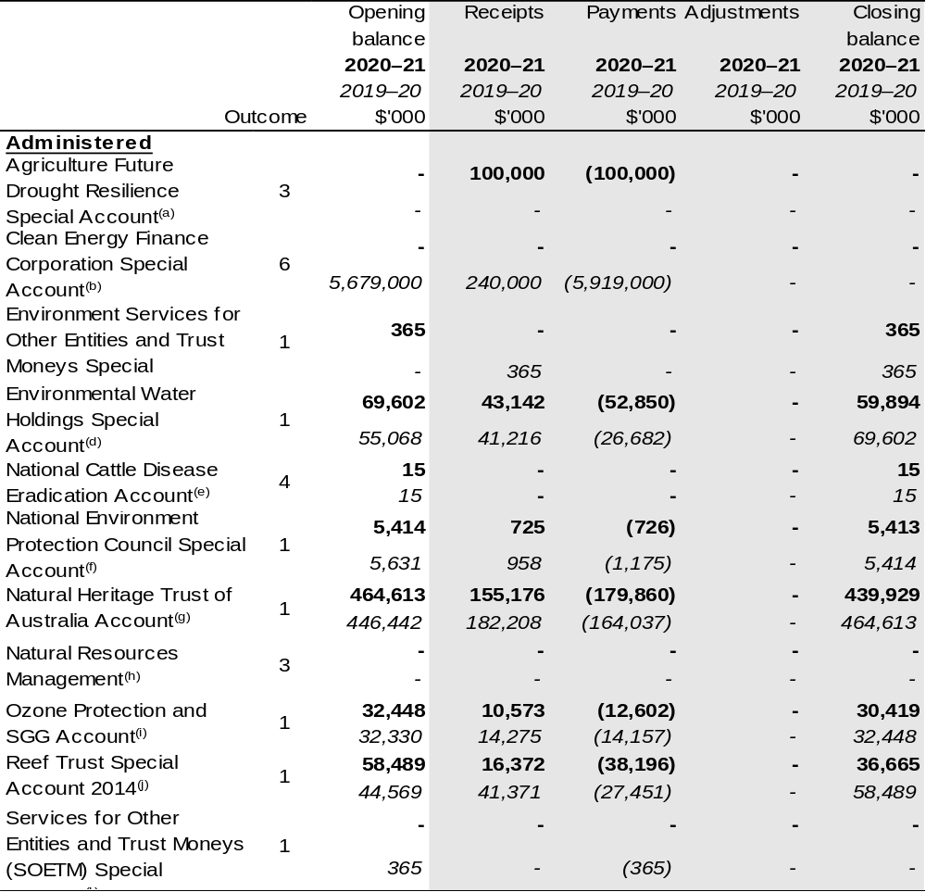
Continued on following pages
Table 3.1: Estimates of special account flows and balances (continued)
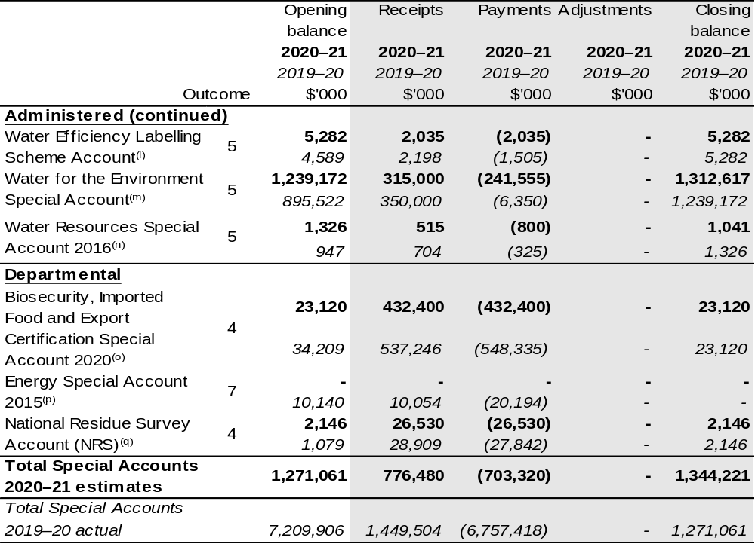
(a) Agriculture Future Drought Resilience Special Account – Establishing Instrument: Future Drought Fund Act 2019, Section 33. Purpose: of making payments associated with projects, research, advice, service and technology that will work towards achieving drought resilience. For the year ended 30 June 2020, the account had a nil balance and there were no transactions debited or credited to it during the current reporting period.
(b) Clean Energy Finance Corporation Special Account – Establishing Instrument: Clean Energy Finance Corporation Act 2012, section 45. Purpose: of making payments to CEFC and ARENA as authorised by the nominated Minister. This account is non-interest bearing. As a result of the Administrative Order effective 1 February 2020, this special account was transferred to Department of Industry, Science, Energy and Resources (DISER). It was previously reported as Outcome 2 under the Department of the Environment and Energy (DoEE), for reporting purposes it is Outcome 6.
(c) Environment Services for Other Entities and Trust Moneys (SOETM) Special Account – Establishing Instrument: Public Governance, Performance and Accountability Act 2013, Section 78 (PGPA Act) Determination, (Environment SOETM Special Account 2020). Purpose: for the disbursement of amounts held in trust or otherwise for the benefit of a person other than the Commonwealth and for services relating to other governments and bodies including Commonwealth Entities. This account is no-interest bearing. The new account commenced on 9 April 2020. An amount equal to the closing balance of the old special account was credited into this new special account. The closing balance represents the amounts held in trust.
(d) Environmental Water Holdings Special Account – Establishing Instrument: Water Act 2007, section 111. Purpose: of performing the functions of the Commonwealth Environment Water Holder. The expenses of administering the Account to not include the cost of salaries of the Commonwealth Environmental Water Holder or the staff referred to in section 116. This account is non-interest bearing.
(e) National Cattle Disease Eradication Account – Establishing Instrument: National Cattle Disease Eradication Act 1991, section 4. Purpose: of the eradication of any disease of cattle that endemic in Australia. For the year ended 30 June 2020, the account balance carried to the next period was $15 161 (2019: $15 161). There were no transactions debited or credited to the account during the current or prior reporting period.
(f) National Environment Protection Council Special Account – Establishing Instrument: National Environment Protection Council Act 1994; section 53. Purpose: Of performing the functions of the NEPC Council and NEPC committee. This account is interest bearing.

Continued on following page
Table 3.1: Estimates of special account flows and balances (continued)

(g) Natural Heritage Trust of Australia Account – Establishing Instrument: Natural Heritage Trust of Australia Act 1997] (NHT Act) section 4. Purpose: of administering environmental protection, supporting sustainable and natural resources management projects as specified by the NHT Act. This account earns interest at the rate of interest earned by the Commonwealth as at the end of financial year on deposits held with the Reserve Bank of Australia. In accordance with section 42 of the NHT Act, the department has ensured that the balance of the account has not fallen below the base amount.
(h) Natural Resources Management – Establishing Instrument: Natural Resources Management (Financial Assistance) Act 1992 section 11. Purpose: Granting financial assistance in connection with projects relating to natural resources management.
(i) Ozone Protection and SGG Account – Establishing Instrument: Ozone Protection and Synthetic Greenhouse Gas Management Act 1989, section 65B. Purpose: of administering ozone protection and synthetic greenhouse gas regulations and research and the National Halon Bank. This account is non-interest bearing.
(j) Reef Trust Special Account 2014 – Establishing Instrument: PGPA Act, Reef Trust Special Account 2014) Determination 01]. Purpose: of improving water quality and the coastal habitat, addressing threats to the environment and protecting, repairing or mitigating damage to the Great Barrier Reef Wold Heritage Area. This account is non-interest bearing.
(k) SOETM Special Account – Establishing Instrument: PGPA Act, Financial Management and Accountability Determination 2010/02 – Services for Other Entities and Trust Moneys – Department of the Environment, Water, Heritage and the Arts Special Account Establishment. Purpose: for the disbursement of amounts held in trust of otherwise for the benefit of a person other than the Commonwealth and for services relating to other governments and bodies that are not FMA Act agencies. This account is not-interest bearing. The account was repealed on 9 April 2020. An amount equal of the closing balance was credited to the new special account – Environment SOETM Special Account 2020 on 9 April.
(l) Water Efficiency Labelling and Scheme Account – Establishing Instrument: Water Efficiency Labelling and Standards Act 2005 section 64. Purpose: Conserving water by reducing demand through the provision of water efficiency information about water-using products and promoting the adoption of efficient water-saving techniques.
(m) Water for the Environment Special Account – Establishing Instrument: Water Act 2007 section 86AB. Purpose: Improving the water efficiency of irrigation infrastructure and improving delivery and storage of environmental water supply within the Murray-Darling Basin. The Water for the Environment Special Account increases related to statutory credits in Water Act 2007 section 86AG.
(n) Water Resources Special Account 2016 – Establishing Instrument: PGPA Act (Water Resources Special Account 2016– Establishment) Determination 2016/01. Purpose: of supporting inter-governmental activities relating to water.
(o) Biosecurity, Imported Food and Export Certification Special Account 2020 – Establishing Instrument: section 5 paragraph 78(1)(a) of the Act, the Biosecurity, Imported Food and Export Certification Special Account 2020. Purpose: Is to manage cost-recovered fees, levies and charges associated with biosecurity, import and export inspection and certification services provided by the Department of Agriculture, Water and the Environment (the Department) under legislative framework which includes the Imported Food Control Act 1992, Export Control Act 1982, Export Control Act 2020 and the Biosecurity Act 2015. The AQIS special account determination was sunset on 1 October 2020.
(p) Energy Special Account 2015 – Establishing Instrument: Energy Special Account 2015-Establishment Determination 2015/07. Purpose: For conducting activities that contribute to policy development in the energy and resources sectors. As a result of the Administrative Arrangement Order on 1 February 2020, this special account was transferred to Department of Industry, Science, Energy and Resources. It was previously reported as Outcome 4 under DoEE for reporting purposes it is Outcome 7.
(q) National Residue Survey Account – Establishing Instrument: section 6(1) of the National Residue Survey Administration Act 1992. Purpose: For conducting national residue surveys and to provide for collection of the NRS levy imposed by various acts.

Note:
The department has responsibility for the Building Australia Fund Water Portfolio Special Account.
For the year ended 30 June 2020, the account had a nil balance and there were no transactions debited or credited to it during the current or prior reporting period. Appropriation: section 80 of the PGPA Act. Establishing Instrument: section 82 of the Nation-building Funds Act 2008 (NBF). Purpose: Creating and developing water infrastructure. The establishing NBF Act was repealed on 12 December 2019.

3.2 Budgeted financial statements

3.2.1 Analysis of budgeted financial statements
The financial statements incorporate all budget estimate changes since the
2020–21 Portfolio Budget Statements (PBS). An analysis of the primary causes of the movements in the budgeted departmental financial statements and administered schedules is provided in the relevant sections. The 2020–21 PBS is used as the comparative figures in the analysis.

3.2.2 Budgeted comprehensive departmental income statements
Since PBS, estimated revenue from government in 2020–21 has increased by $17.0 million. The increase is mainly due to measures listed in Table 1.2.
The own source revenue estimate in 2020–21 has increased by $0.3 million since PBS, mainly due to higher than anticipated revenue from the department’s cost recovered activities.
The department is budgeting for a $17.1 million operating loss in 2020–21 before unfunded depreciation.
The departmental balance sheet has incorporated the final 2019–20 position as published in the 2019–20 Annual Report.

3.2.3 Schedule of budgeted income and expenses administered on behalf of the Government
It is estimated that the department will receive non-appropriation revenue on behalf of government of $479.4 million in 2020–21, a decrease of $1.7 million since PBS.
The reduction is due to lower than previously estimated levy revenue.
Administered expenses are estimated to be $3,070.8 million in 2020–21, an increase of $41.4 million since PBS. The increase largely relates to 2020–21 Budget measures detailed in Table 1.2, movements of funds, reclassifications of funds and other variations detailed in Table 1.3.

3.2.4 Schedule of budgeted assets and liabilities administered on behalf of the Government
The value of administered net assets as at 30 June 2021 is anticipated to be $59.7 million lower than the estimate published in PBS. The decrease is mainly due to lower than previously estimated trade and other receivables.
The schedule of budgeted assets and liabilities administered on behalf of the Government has incorporated the final 2019–20 position as published in the 2019–20 Annual Report.

3.3 Budgeted financial statements tables

Table 3.2: Comprehensive income statement (showing net cost of services) for the period ended 30 June
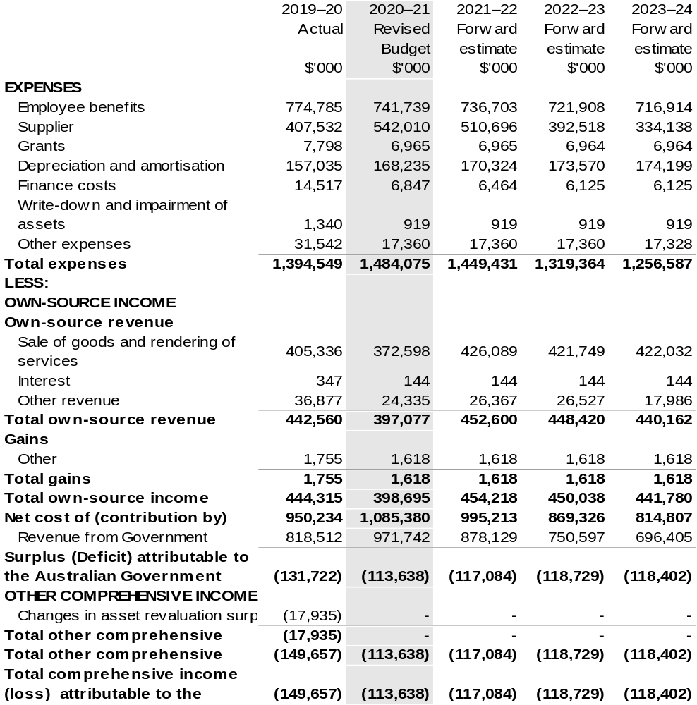

Continued on following page

Table 3.2: Comprehensive income statement (showing net cost of services) for the period ended 30 June (continued)
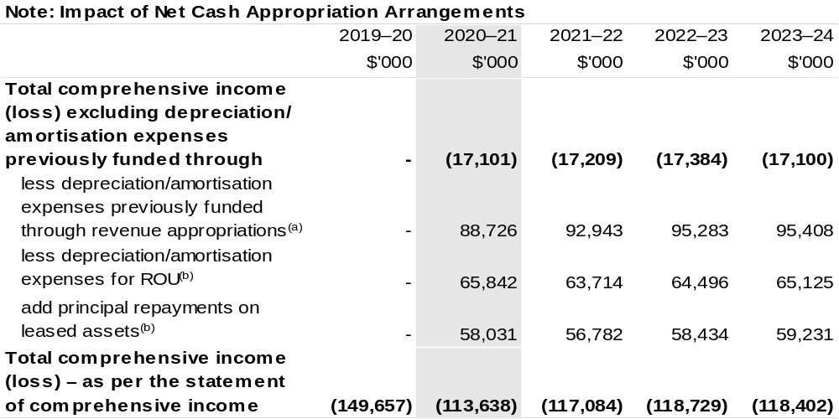

(a) From 2010–11, the Government introduced net cash appropriation arrangements where Appropriation Act (No. 1) or Bill (No. 3) revenue appropriations for the depreciation/amortisation expenses of
non-Corporate Commonwealth Entities were replaced with a separate capital budget (the Departmental Capital Budget, or DCB) provided through Appropriation Act (No. 1) or Bill (No. 3) equity appropriations. For information regarding DCBs, please refer to Table 3.6 Departmental Capital Budget Statement.
(b) Applies to leases under AASB 16 Leases. Right of Use (ROU).

Prepared on Australian Accounting Standards basis.

Table 3.3: Budgeted departmental balance sheet (as at 30 June)
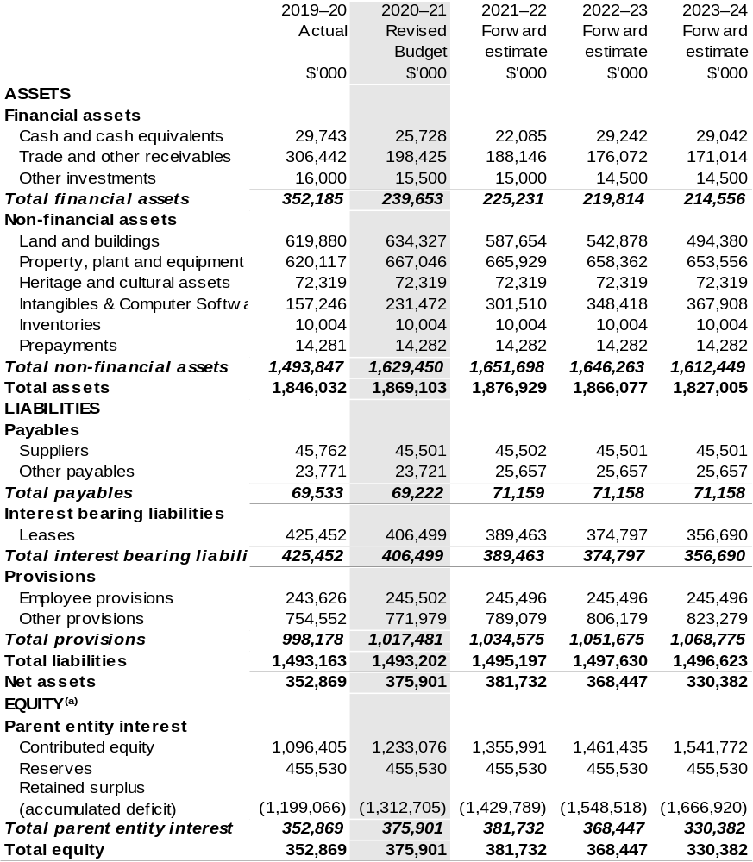
(a) ‘Equity’ is the residual interest in assets after deduction of liabilities.

Prepared on Australian Accounting Standards basis.

Table 3.4: Departmental statement of changes in equity — summary of movement (Budget year 2020–21)
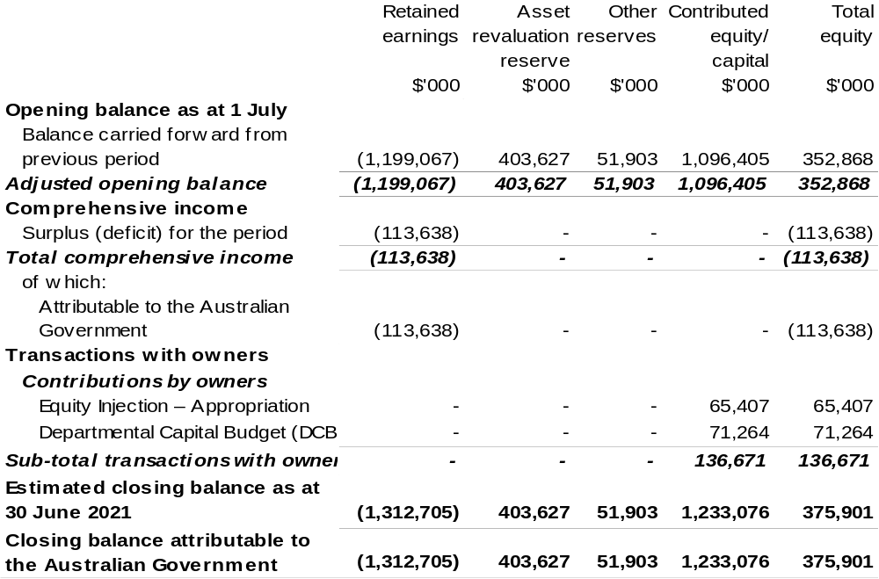

Prepared on Australian Accounting Standards basis.

Table 3.5: Budgeted departmental statement of cash flows (for the period ended 30 June)
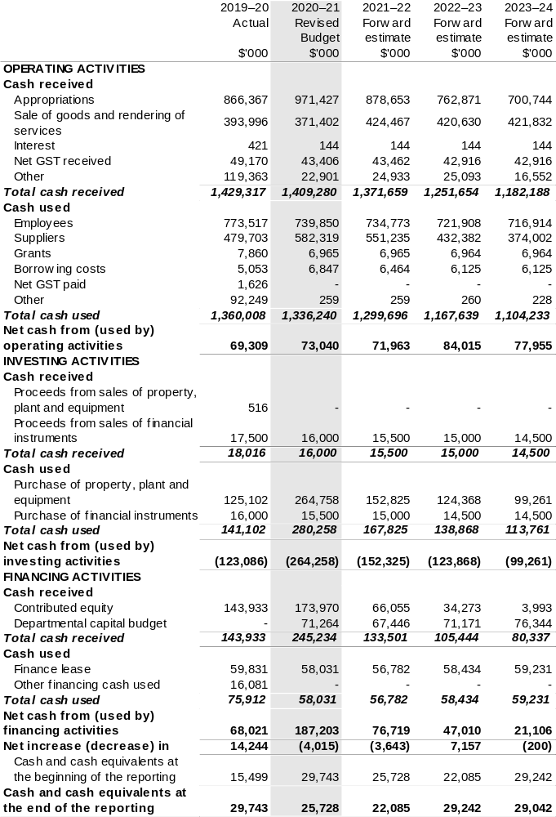

Table 3.6: Departmental capital budget statement (for the period ended 30 June)
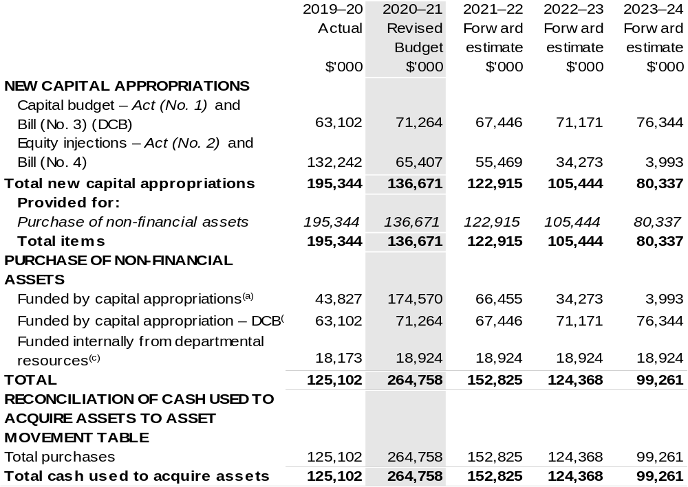

(a) Includes both current Bill (No. 4) and prior Act (No. 2/4/6) appropriations.
(b) Does not include annual finance lease costs. Includes purchases from current and previous years’ Departmental Capital Budgets.
(c) Includes the following sources of funding:
– current Bill (No. 3) and prior year Act (No. 1/3/5) appropriations (excluding amounts from the DCB);
– internally developed assets;
– section 74 External Revenue; and
– proceeds from the sale of assets.

Consistent with information contained in the Statement of Asset Movements and the Budgeted Statement of Cash Flows.

Table 3.7: Statement of asset movements (2020–21 Budget year)
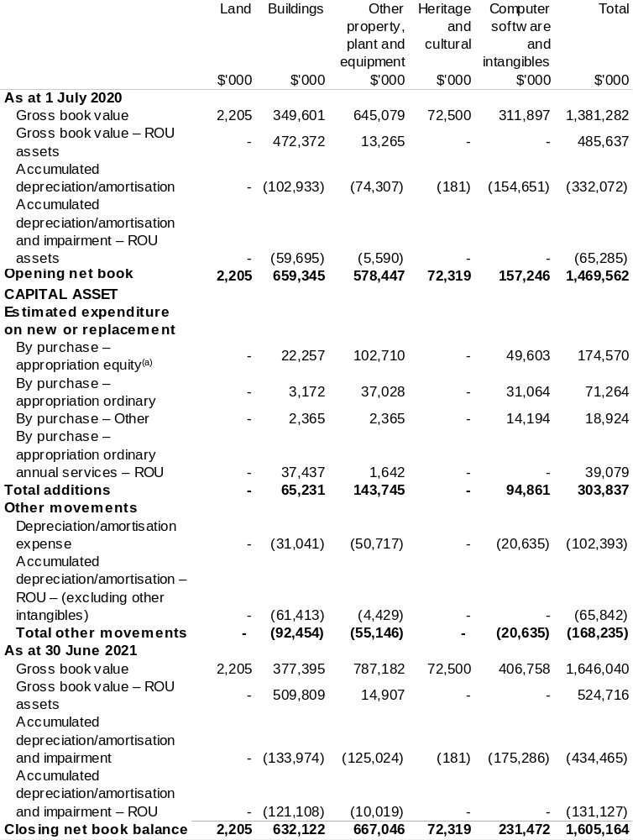

(a) ‘Appropriation equity’ refers to equity injections, appropriations provided through Appropriation
Act (No. 2) and Bill (No. 4) 2020–21.
(b) ‘Appropriation ordinary annual services’ refers to funding provided through Appropriation Act (No. 1) and Bill (No. 3) 2020–21 for depreciation / amortisation expenses, DCBs or other operational expenses.

Prepared on Australian Accounting Standards basis.

Table 3.8: Schedule of budgeted income and expenses administered on behalf of Government (for the period ended 30 June)
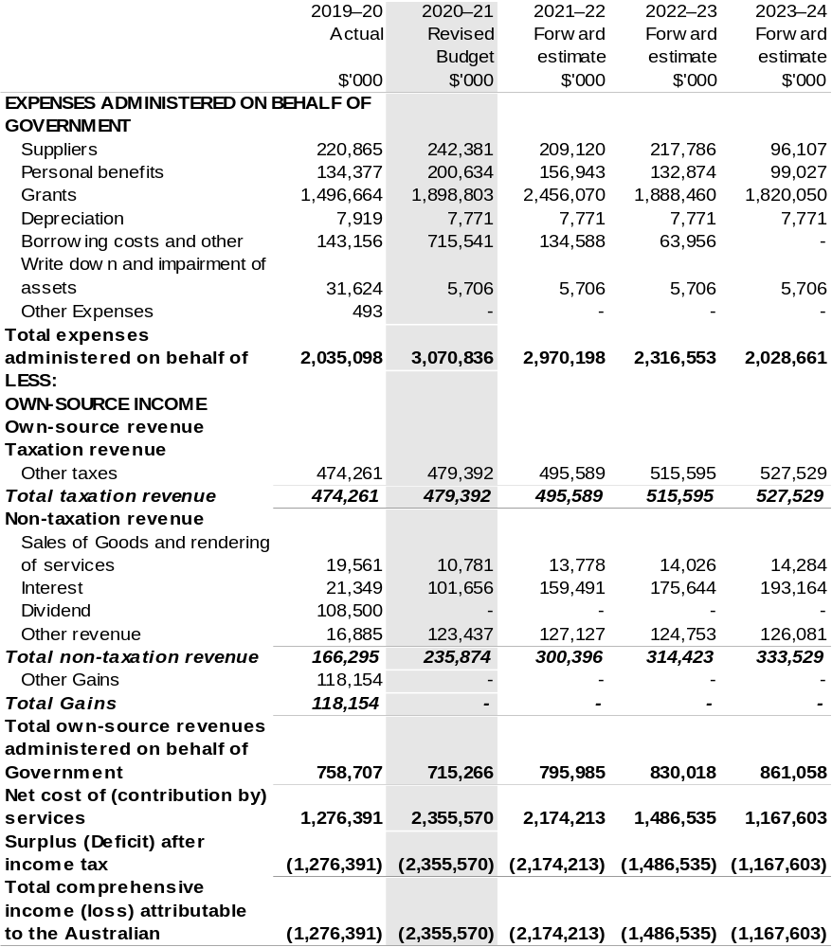
Prepared on Australian Accounting Standards basis.

Table 3.9: Schedule of budgeted assets and liabilities administered on behalf of Government (as at 30 June)
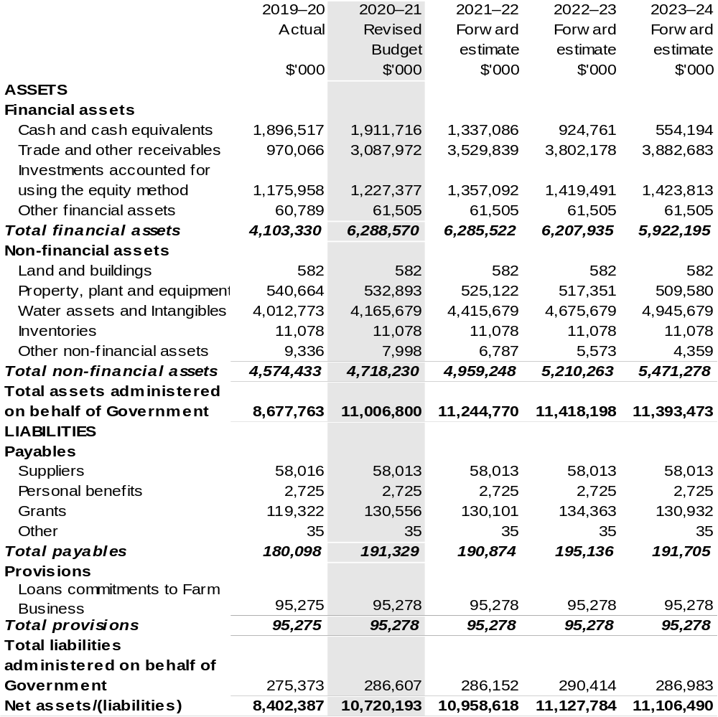
Prepared on Australian Accounting Standards basis.

Table 3.10: Schedule of budgeted administered cash flows (for the period ended 30 June)
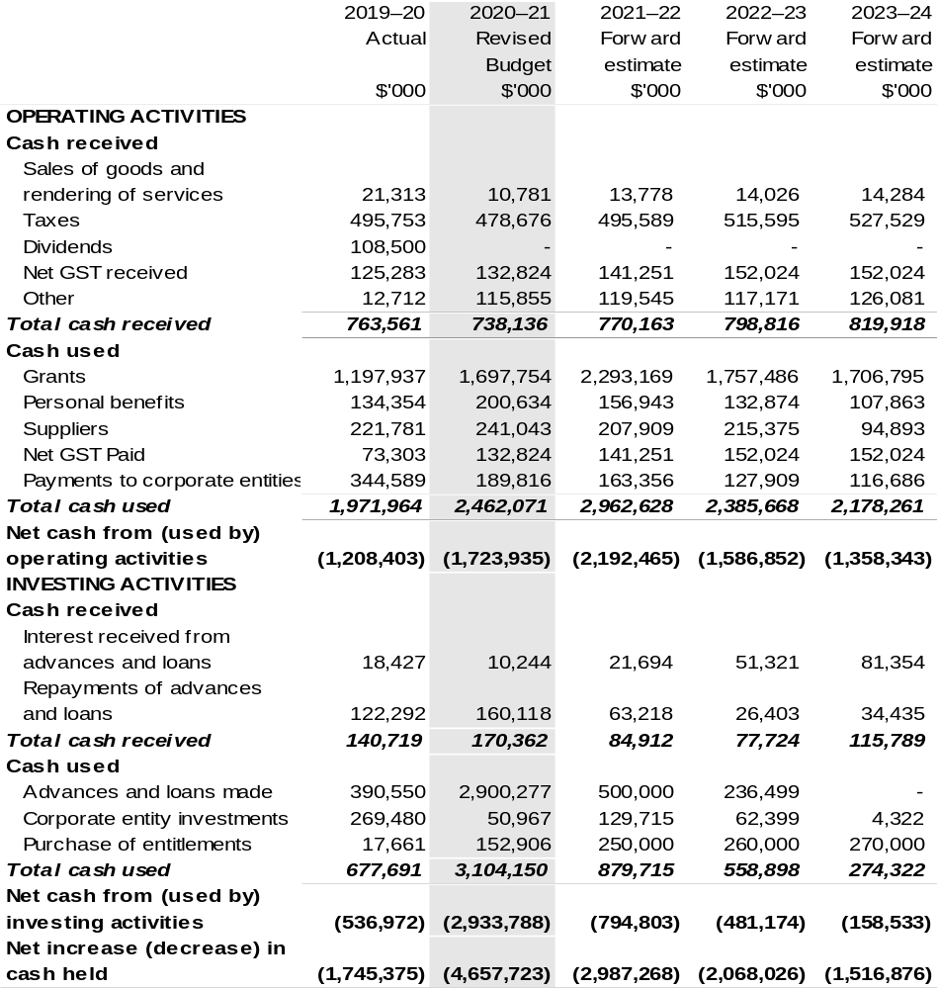
Continued on following page

Table 3.10: Schedule of budgeted administered cash flows (for the period ended 30 June) (continued)
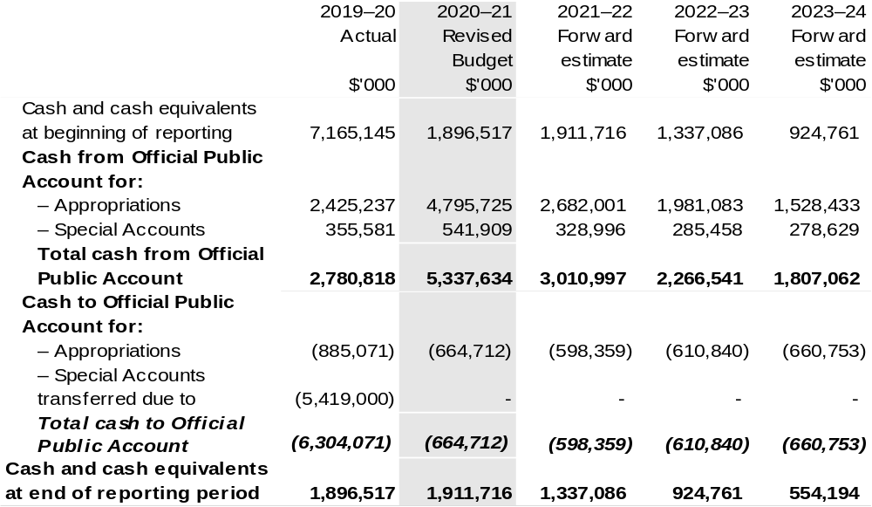

Prepared on Australian Accounting Standards basis.

Table 3.11: Schedule of administered capital budget (for the period ended 30 June)
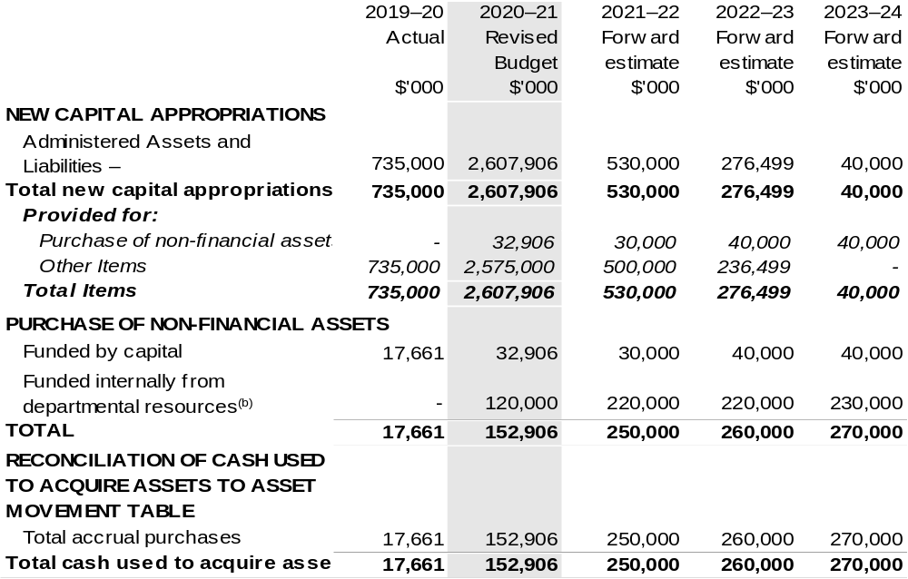
(a) Includes both current Bill (No. 4) and prior Act (No. 2/4/6) appropriations and special capital appropriations.
(b) Includes funding credited to the Water for the Environment Special Account.

Prepared on Australian Accounting Standards basis.

Table 3.12: Statement of administered asset movements (2020–21 Budget year)
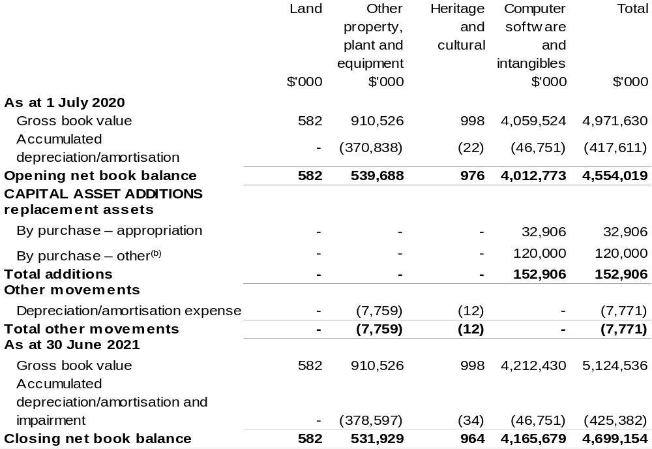

(a) Includes both current Bill (No. 4) and prior Act (No. 2/4/6) appropriations and special capital appropriations.
(b) Includes funding credited to the Water for the Environment Special Account.

Prepared on Australian Accounting Standards basis.

Bureau Of Meteorology
Section 1: Entity overview and resources 83
1.1 Strategic direction statement 83
1.2 Entity resource statement 84
1.3 Entity measures 86
1.4 Additional estimates, resourcing and variations to outcomes 87
1.5 Breakdown of additional estimates by Appropriation Bill 88
Section 2: Outcome and planned performance 89
2.1 Changes to outcome and program structures 89
2.2 Budgeted expenses and performance for Outcome 1 89
Section 3: Budgeted financial statements 91
3.1 Special account flows 91
3.2 Budgeted financial statements 92

Bureau Of Meteorology

Section 1: Entity overview and resources

1.1 Strategic direction statement
The following text outlines updates to the Strategic Direction Statement in the 2020–21 Agriculture, Water and Environment Portfolio Budget Statements to reflect decisions of the Government since the 2020–21 Budget.
The Government will fund $5.277 million for the Bureau of Meteorology (the Bureau) to establish Climate and Resilience Services Australia, to better connect and leverage the Commonwealth’s extensive data, information and capabilities to manage climate and disaster risk, including those of the Bureau, the CSIRO, Geoscience Australia and the Australian Bureau of Statistics.

1.2 Entity resource statement
These tables detail the resourcing for the Bureau at 2020–21 Additional Estimates. Table 1.1 outlines the total resourcing available from all sources for the 2020–21 Budget year, including variations through Appropriation Bills (No. 3) and (No. 4) 2020–21, Special Appropriations and Special Account.

Table 1.1: Bureau of Meteorology – Resource Statement as at 2020–21 Additional Estimates – February 2021
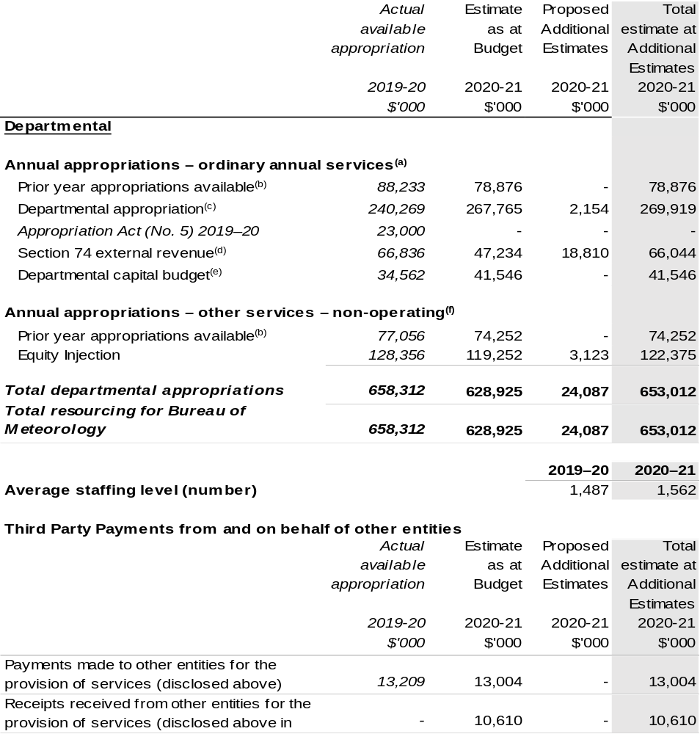
- Supply Act (No. 1) 2020–21, Appropriation Act (No. 1) 2020–21 and Appropriation Bill (No. 3) 2020–21.
- Excludes $43 million subject to administrative quarantine by the Department of Finance or withheld under section 51 of the PGPA Act.
- Excludes departmental capital budget (DCB).
- Estimated external revenue receipts under section 74 of the PGPA Act.
- Departmental capital budgets are not separately identified in Supply Act (No. 1) 2020–21 and Appropriation Act (No. 1) 2020–21 and form part of ordinary annual services items. Please refer to Table 3.7 for further details. For accounting purposes, this amount has been designated as a 'contribution by owner'.
- Supply Act (No. 2) 2020–21, Appropriation Act (No. 2) 2020–21 and Appropriation Bill (No. 4) 2020–21.

Prepared on a resourcing (i.e. appropriations available) basis.

Note: all figures shown above are GST exclusive – these may not match figures in the cash flow statement.

1.3 Entity measures
Table 1.2 summarises new Government measures taken since the 2020–21 Budget. The tables are split into receipts, payments and capital measures, with the affected program identified.

Table 1.2: Bureau of Meteorology – measures since 2020–21 Budget
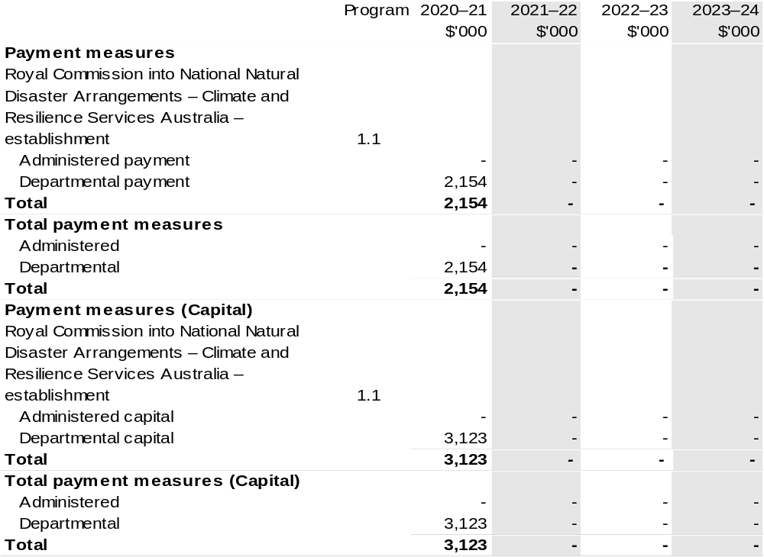
Prepared on a Government Financial Statistics (fiscal) basis.

1.4 Additional estimates, resourcing and variations to outcomes
The following tables detail changes in resourcing for the Bureau at Additional Estimates, by outcome. The table show variations since the 2020–21 Budget due to new measures (as per Table 1.2) and variations due to other factors, such as movements of funds, reclassifications, reallocations and adjustments due to the efficiency dividend and changes in economic parameters.

Table 1.3: Additional Estimates and other variations to outcome since 2020–21 Budget
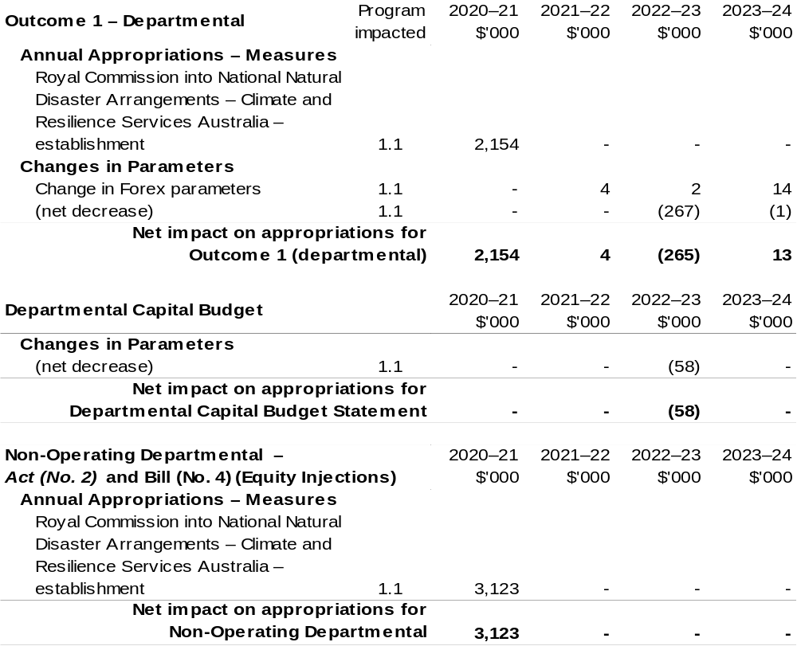
Prepared on a resourcing (i.e. appropriations available) basis.

1.5 Breakdown of additional estimates by appropriation bill
The following table shows Additional Estimates sought for the Bureau through Appropriation Bills (No. 3) and (No. 4) 2020–21.

Table 1.4: Appropriation Bill (No. 3) 2020–21 – Departmental
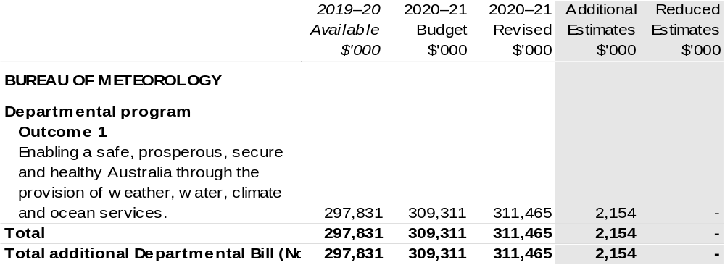

Table 1.5: Appropriation Bill (No. 4) 2020–21
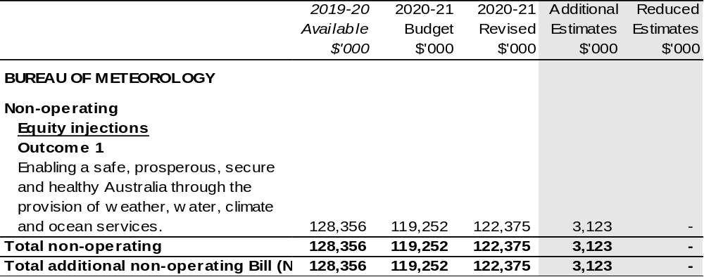

Section 2: Outcomes and planned performance

2.1 Changes to outcome and program structures
There have been no changes to the department’s outcomes and program structure since the 2020–21 Portfolio Budget Statements.

2.2 Budgeted expenses and performance for outcome 1

2.2.1: Linked programs
There have been no changes to linked programs for Outcome 1 since the 2020–21 Portfolio Budget Statements.

2.2.2: Performance criteria
There have been no changes to performance criteria for Outcome 1 since the 2020–21 Portfolio Budget Statements.

2.2.3: Budgeted expenses
Table 2.2.4 (below) shows how much the entity intends to spend (on an accrual basis) on achieving the outcome, broken down by program, as well as by Administered and Departmental funding sources.

2.2.3: Budgeted expenses (continued)

Table 2.2.4: Budgeted expenses for Outcome 1
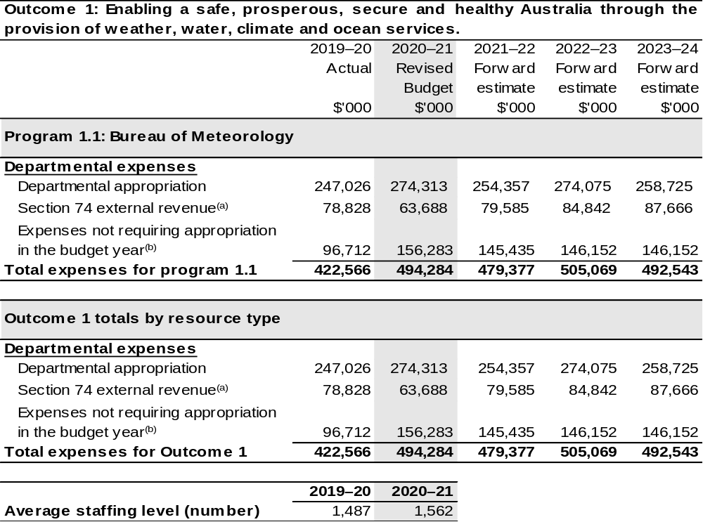
- Estimated expenses incurred in relation to receipts retained under section 74 of the PGPA Act.
- Expenses not requiring appropriation in the Budget year are made up of depreciation expenses,
amortisation expenses, make good expenses and audit fees.

Note: Departmental appropriation splits and totals are indicative estimates and may change in the course of the budget year as government priorities change.

Prepared on Australian Accounting Standards basis.

Section 3: Special account flows and budgeted
financial Statements

3.1 Special account flows
Estimates of special account flows

Special Accounts provide a means to set aside and record amounts used for specified purposes. Table 3.1 shows the expected additions (receipts) and reductions (payments) for each account used by the Bureau.

Table 3.1: Estimates of special account flows and balances
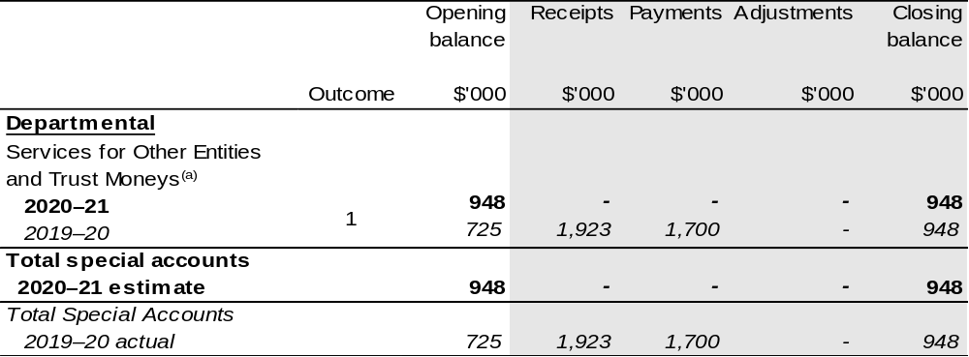
(a) Appropriation: section 78 of the PGPA Act. Establishing Financial Management and Accounting Determination 2008/06. Purpose: To enable the Bureau to hold and expend amounts on behalf of persons or entities other than the Commonwealth.

3.2 Budgeted financial statements

3.2.1 Analysis of budgeted financial statements
There are no major changes to the analysis of budgeted financial statements since the 2020–21 Portfolio Budget Statements.

3.2.2: Explanatory notes and analysis of budgeted financial statements
Budgeted Comprehensive Departmental Income Statement
An analysis of the Bureau budgeted financial statements, as reflected in the Bureau’s budgeted departmental financial statements and administered schedules for the
2020–21 Additional Estimates Budget, is provided below.

Total revised revenue to the Bureau in 2020–21 is estimated to be $333.7 million, a decrease of $3.9 million from the 2019–20 actual result. The movement in funding is the result of:
- funding associated with the 2020–21 Budget measure – Improved security and
resilience (T3);
- funding associated with the 2020–21 Budget measure – Aviation Meteorology
Services Program;
- funding associated with the 2020–21 Budget measure – Long-Term Financial
Sustainability;
- Additional Estimates Budget measure – Climate and Resilience Services Australia;
- reduced funding associated with the 2020–21 Budget measure – Savings through
Additional Revenue;
- a reduction in revenue associated with cost recoverable projects and services; and
- net funding for economic parameter adjustments offset by Efficiency Dividends.
Total expenses are estimated to be $494.3 million, an increase of $71.7 million from
2019–20 actual expenditure.

Whilst the Bureau is not funded for depreciation through the Appropriation Bills, the expenditure is still recognised on the Income Statement.

3.3 Budgeted financial statements tables

Table 3.2: Comprehensive income statement (showing net cost of services) (for the period ended 30 June)
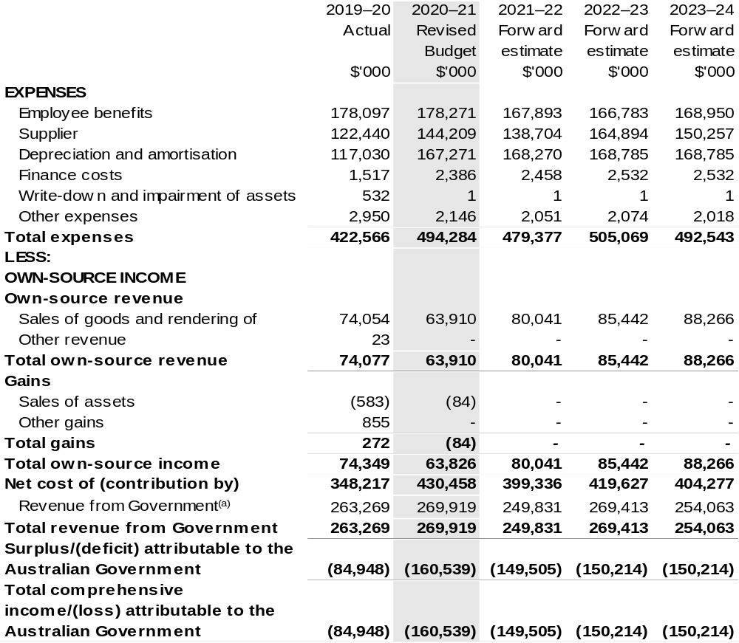

Continued on following page
Table 3.2: Comprehensive income statement (showing net cost of services) (for the period ended 30 June) (continued)
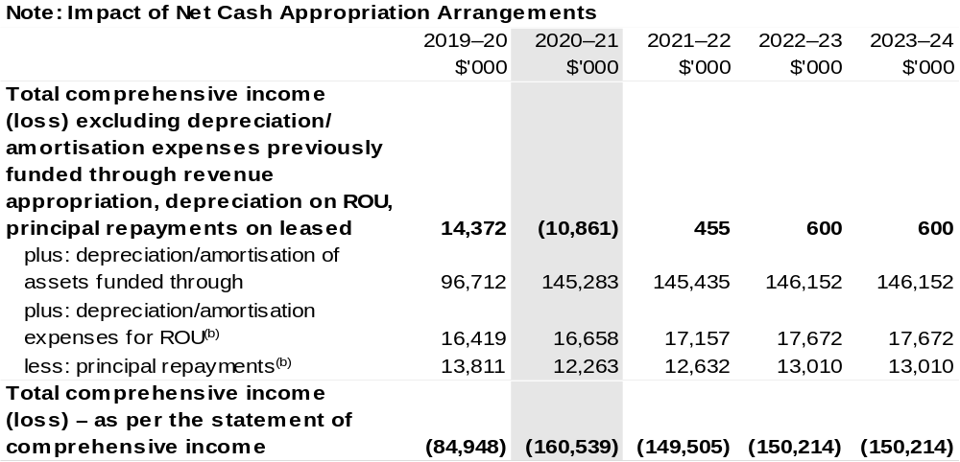
(a) From 2010–11, the Government introduced net cash appropriation arrangements where Appropriation Act (No. 1) or Bill (No. 3) revenue appropriations for the depreciation/amortisation expenses of
non-Corporate Commonwealth Entities were replaced with a separate capital budget (the Departmental Capital Budget, or DCB) provided through Appropriation Act (No. 1) or Bill (No. 3) equity appropriations. For information regarding DCBs, please refer to Table 3.6 Departmental Capital Budget Statement.
(b) Applies to leases under AASB 16 Leases. Right of Use (ROU).

Prepared on Australian Accounting Standards basis.

Table 3.3: Budgeted departmental balance sheet (as at 30 June)
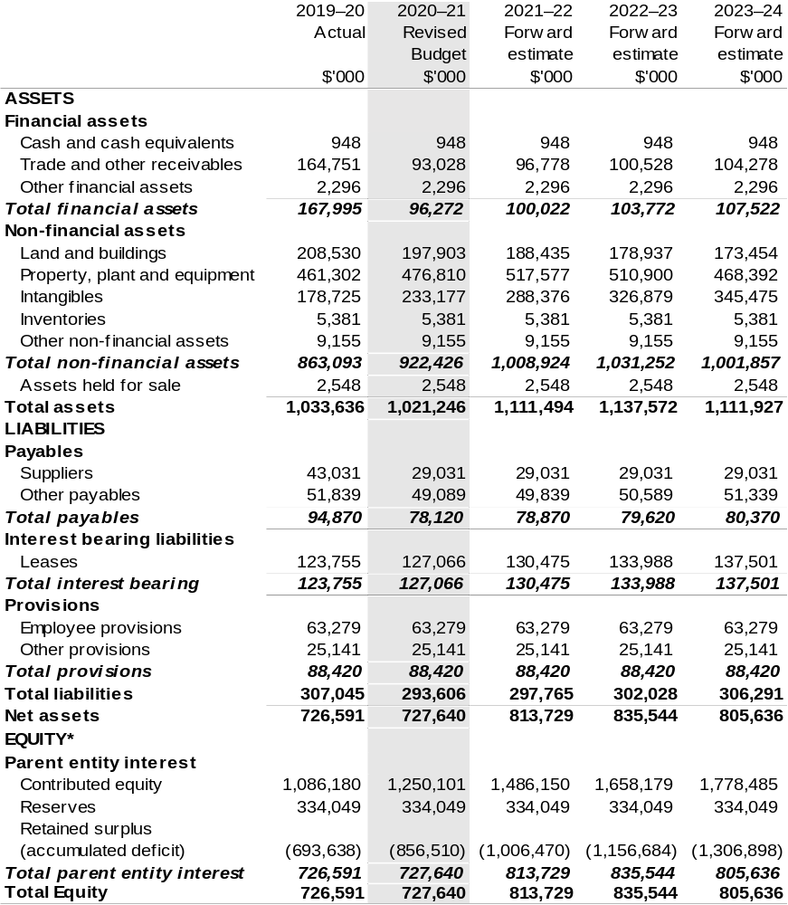
*Equity is the residual interest in assets after deduction of liabilities.

Prepared on Australian Accounting Standards basis.

Table 3.4: Departmental statement of changes in equity—summary of movement (Budget year 2020–21)
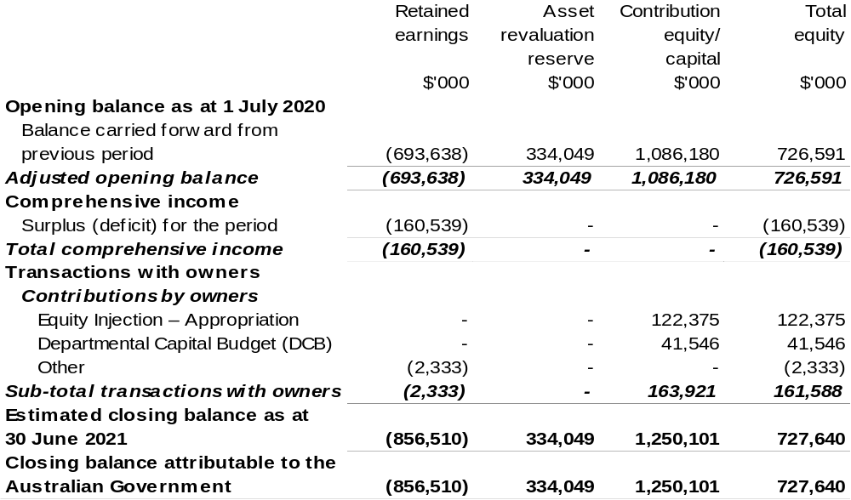
Prepared on Australian Accounting Standards basis.

Table 3.5: Budgeted departmental statement of cash flows (for the period
ended 30 June)
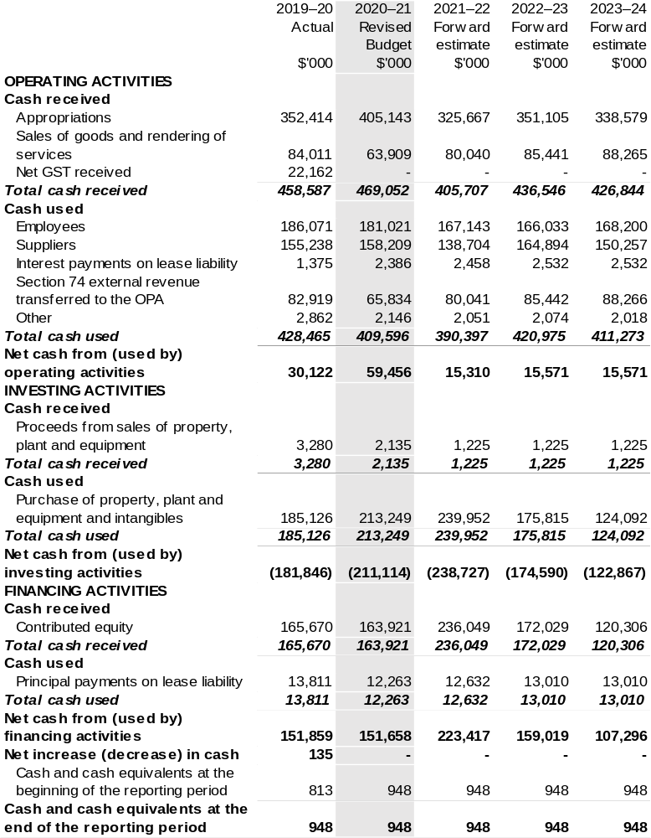
Prepared on Australian Accounting Standards basis.

Table 3.6: Departmental capital budget statement (for the period ended 30 June)
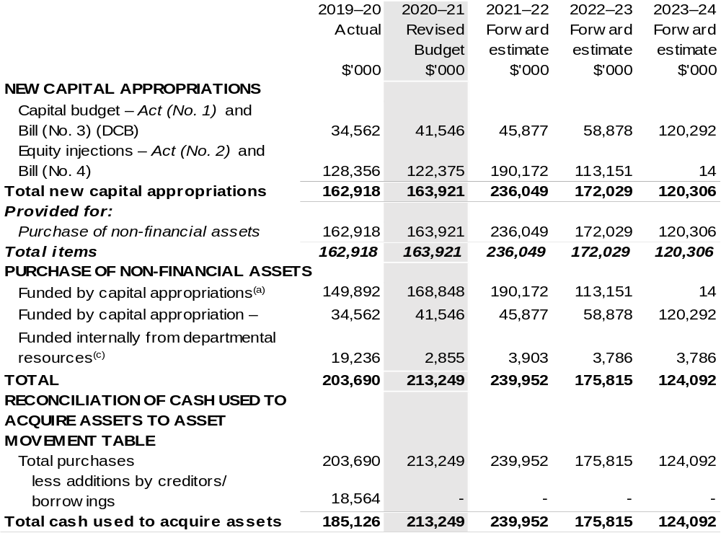
(a) Includes both current Bill (No. 2) and prior Act/Bill (No. 2/4/6) appropriation.
(b) Does not include annual finance lease costs. Include purchases from current and previous years'
Departmental Capital Budgets (DCBs).
(c) Includes the following sources of funding:
– current Bill (No. 1) and prior year Act/Bill (No. 1/3/5) appropriations (excluding amounts from the DCBs);
– donations and gifts of non-financial assets;
– internally developed assets;
– section 74 external revenue; and
– proceeds from the sale of assets.

Consistent with information contained in the Statement of Asset Movements and the Budgeted Statement of Cash Flows.

Prepared on Australian Accounting Standards basis.

Table 3.7: Statement of asset movements (Budget year 2020–21)
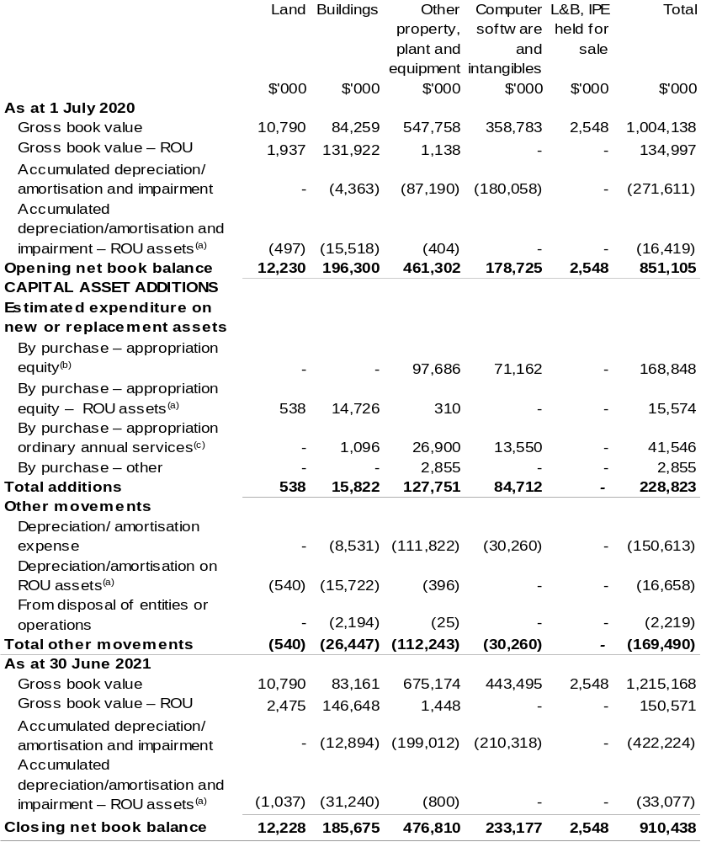
(a) Applies to leases under AASB 16 Leases, Right of Use (RoU).
(b) ‘Appropriation equity’ refers to equity injections or Administered Assets and Liabilities appropriations provided through Supply Act (No. 2) 2020–21 and Appropriation Act (No. 2) 2020–2021, including Collection Development Acquisition Budget.
(c) ‘Appropriation ordinary annual services’ refers to funding provided through Supply Act (No. 1) 2020–21 and Appropriation Act (No. 1) 2020–2021 for depreciation/amortisation expenses, Departmental Capital Budget or other operational expenses.

Prepared on Australian Accounting Standards basis.

Table 3.8: Schedule of budgeted income and expenses administered on behalf of Government (for the period ended 30 June)
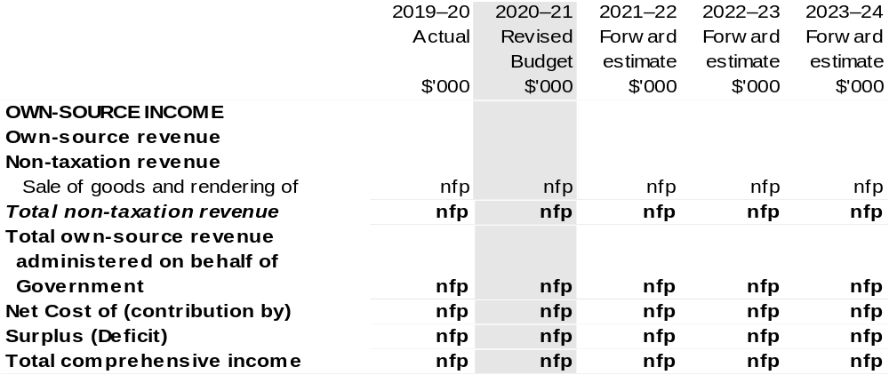

Table 3.9: Schedule of budgeted assets and liabilities administered on behalf of Government (as at 30 June)
The schedule of budgeted assets and liabilities administered on behalf of Government does not apply to the Bureau.

Table 3.10: Schedule of budgeted administered cash flows (for the period
ended 30 June)
The schedule of budgeted administered cash flows on behalf of Government does not apply to the Bureau.

