Portfolio Additional
Estimates Statements 2021–22

Agriculture, Water and the Environment Portfolio

Explanations of Additional Estimates 2021–22

© Commonwealth of Australia 2022
ISSN: 2652-4589 (print) 2652-4597 (online)
This publication is available for your use under a Creative Commons BY Attribution 3.0 Australia licence, with the exception of the Commonwealth Coat of Arms, the Department of Agriculture, Water and the Environment logo, photographs, images, signatures and where otherwise stated. The full licence terms are available from http://creativecommons.org /licenses/by/3.0/au/legalcode.


Use of Department of Agriculture, Water and the Environment material under a Creative Commons BY Attribution 3.0 Australia licence requires you to attribute the work (but not in any way that suggests that the Department of Agriculture, Water the Environment endorses you or your use of the work).
Department of Agriculture, Water and the Environment material used ‘as supplied’.
Provided you have not modified or transformed Department of Agriculture, Water and the Environment material in any way including, for example, by changing the department’s text; calculating percentage changes; graphing or charting data; or deriving new statistics from published Department of Agriculture, Water and the Environment statistics, then the department prefers the following attribution:
Source: Australian Government Department of Agriculture, Water and the Environment
Derivative material
If you have modified or transformed Department of Agriculture, Water and the Environment material, or derived new material from those of the Department of Agriculture, Water and the Environment in any way, then the department prefers the following attribution:
Based on Australian Government Department of Agriculture, Water and the Environment data
Use of the Coat of Arms
The terms under which the Coat of Arms can be used are set out on the It’s an Honour website (see www.pmc.gov.au/government/commonwealth-coat-arms)
Other Uses
Inquiries regarding this licence and any other use of this document are welcome at:
External Budgets Section; Finance Division
Department of Agriculture, Water and the Environment
John Gorton Building,
King Edward Terrace,
Parkes ACT 2600
Email: externalbudgets@awe.gov.au

President of the Senate
Australian Senate
Parliament House
CANBERRA ACT 2600

Speaker
House of Representatives
Parliament House
CANBERRA ACT 2600

Dear Mr President
Dear Mr Speaker
We hereby submit Portfolio Additional Estimates Statements in support of the 2021–22 Additional Estimates for the Agriculture, Water and the Environment portfolio.
These statements have been developed, and are submitted to the Parliament, as a statement on the funding requirements being sought for the Portfolio.

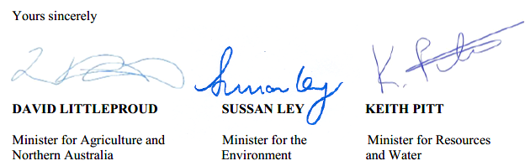
We present these statements by virtue of our ministerial responsibility for accountability to the Parliament and, through it, the public.
Yours sincerely

DAVID LITTLEPROUD SUSSAN LEY KEITH PITT
Minister for Agriculture and Minister for the Minister for Resources and
Northern Australia Environment Water

Abbreviations and conventions
The following notation may be used:
NEC/nec not elsewhere classified
- nil
.. not zero, but rounded to zero
na not applicable (unless otherwise specified)
nfp not for publication
$m $ million
$b $ billion
Figures in tables and in the text may be rounded. Figures in text are generally rounded to one decimal place, whereas figures in tables are generally rounded to the nearest thousand. Discrepancies in tables between totals and sums of components are due to rounding.
Enquiries
Should you have any enquiries regarding this publication please contact
Mr Paul Pak Poy, Chief Finance Officer, Department of Agriculture, Water and the Environment, on (02) 6272 5523.
Links to Portfolio Budget Statements (including Portfolio Additional Estimates Statements and Portfolio Supplementary Additional Estimates Statements) can be located on the Australian Government Budget website at www.budget.gov.au.

User guide
to the
Portfolio Additional
Estimate Statements

User Guide
The purpose of the 2021–22 Portfolio Additional Estimates Statements (PAES), like that of the Portfolio Budget Statements (PBS), is to inform Senators and Members of Parliament of the proposed allocation of resources to Government outcomes by entities within a portfolio. The focus of PAES differs from the PBS in one important aspect. While PAES includes an Entity Resource Statement to inform the Parliament of revised estimates of total resources available to an entity, its focus is to explain changes in resourcing by outcome(s) since the Budget. As such, PAES provides information on new measures and their impact on the financial and/or non-financial planned performance of programs supporting those outcomes.
PAES facilitates understanding of proposed appropriations in Appropriation Bills
(No. 3) and (No. 4) 2021–22. For this reason, PAES is declared by the Additional Estimates Appropriation Bills to be a ‘relevant document’ to the interpretation of the Bills according to section 15AB of the Acts Interpretation Act 1901.
Whereas the 2021–22 Mid-Year Economic and Fiscal Outlook (MYEFO) is a mid-year budget report that provides updated information to allow the assessment of the Government’s fiscal performance against its fiscal strategy, PAES update the most recent budget appropriations for entities within a portfolio.
Structure of the Portfolio Additional Estimates Statements
PAES is presented in three parts with subsections.
User Guide
Provides a brief introduction explaining the purpose of PAES.
Portfolio Overview
Provides an overview of the portfolio, including a chart that outlines the outcomes for entities in the portfolio.
Entity Additional Estimates Statements
A statement (under the name of the entity) for each entity affected by Additional Estimates.
Section 1: Entity overview and resources | This section details the changes in total resources available to an entity, the impact of any measures since Budget, and impact of Appropriation Bills (No. 3) and (No. 4).
Section 2: Revisions to entity outcomes and planned performance | This section details any changes to Government outcomes and/or any changes to the planned performance of entity programs.
Section 3: Special account flows and budgeted financial statements | This section contains updated explanatory tables on special account flows and staffing levels and revisions to the budgeted financial statements.
Contents
Portfolio overview 3
Entity additional estimates statements 8
Department of Agriculture, Water and the Environment 11
Bureau of Meteorology 103
Director of National Parks 125
Great Barrier Reef Marine Park Authority 143

Portfolio overview

Agriculture, Water and the Environment Portfolio overview
The Agriculture, Water and the Environment portfolio consists of the Department of Agriculture, Water and the Environment (the department) and 13 portfolio entities (Figure 1 refers).
The role and responsibilities of the department and the portfolio entities have not changed since the 2021–22 Portfolio Budget Statements (PBS). An outline of the department’s Portfolio Overview can be found in the 2021–22 PBS.
The department is receiving additional appropriations through Appropriation Bills (No. 3) and (No. 4) 2021–22. The Bureau of Meteorology, Director of National Parks and Great Barrier Reef Marine Park Authority will also be receiving additional appropriation through Appropriations Bills (No. 3) and (No. 4) 2021–22.
As a result of the Government announcement, the following change occurred (refer to Section 2).
- Murray-Darling Basin Aboriginal Water Entitlements Program within the Sustainable Rural Water Use and Infrastructure Program under program 5.1 Water Reform was transferred to the National Indigenous Australians Agency within the Prime Minister and Cabinet portfolio and extended to June 2024.

Figure 1: Agriculture, Water and the Environment Portfolio Structure
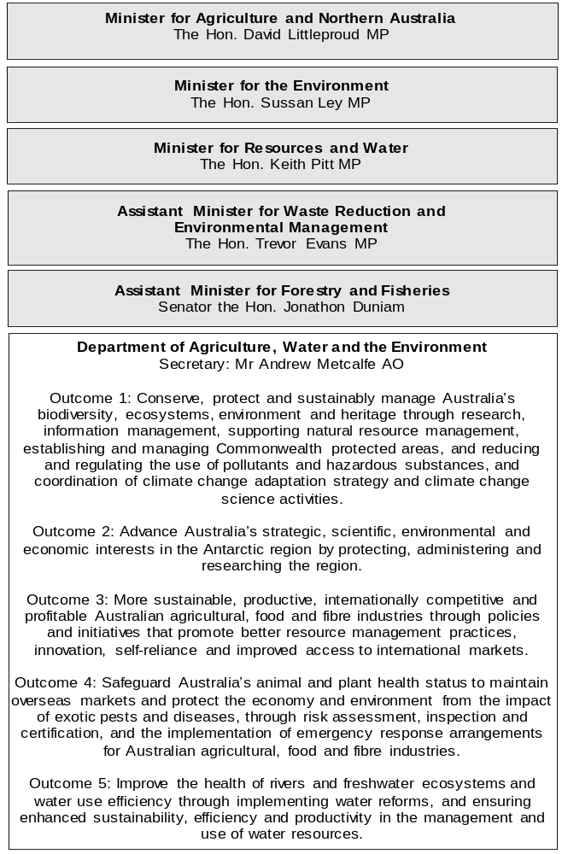

Figure 1: Agriculture, Water and the Environment Portfolio Structure (continued)
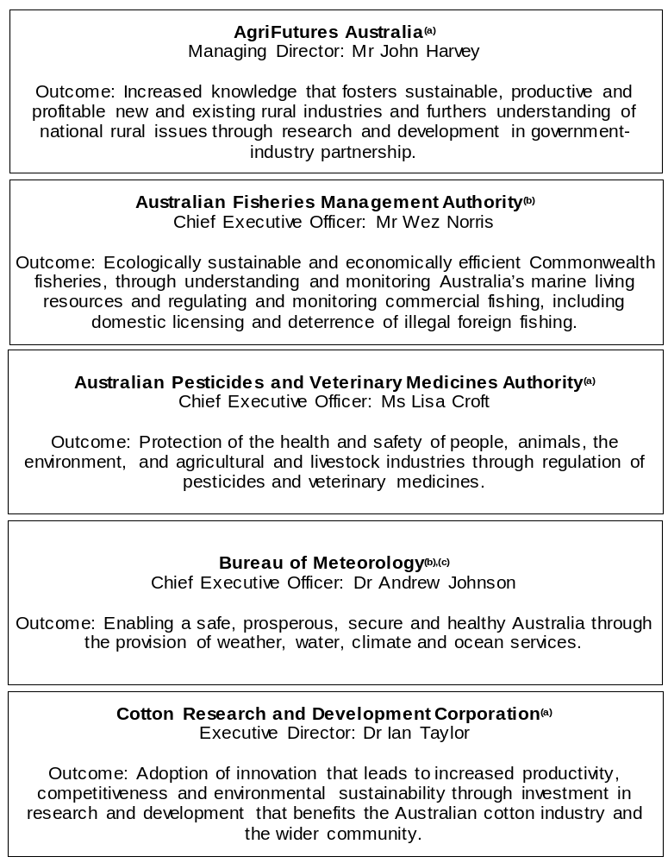

Figure 1: Agriculture, Water and the Environment Portfolio Structure (continued)
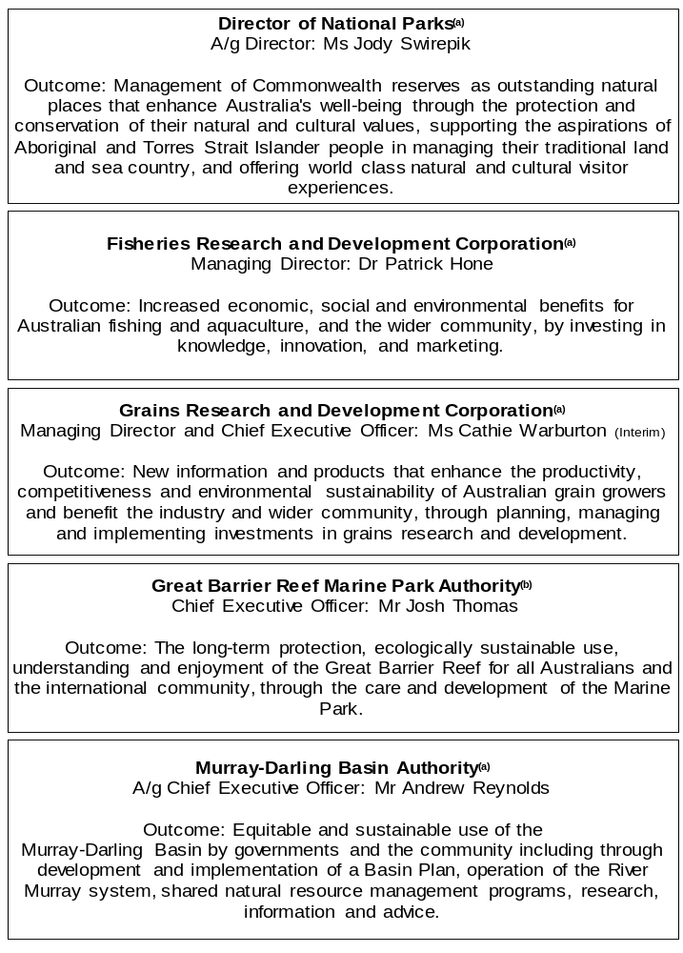

Figure 1: Agriculture, Water and the Environment Portfolio Structure (continued)
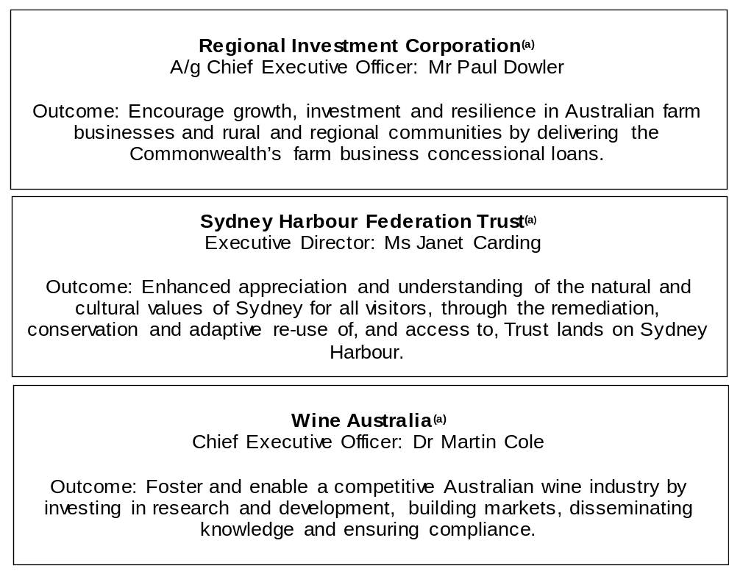
(a) ‘Corporate Commonwealth Entity’ (CCE) as defined under the Public Governance, Performance and Accountability Act 2013.
(b) ‘Non-corporate Commonwealth Entity’ (NCCE) as defined under the Public Governance, Performance and Accountability Act 2013.
(c) ‘Executive Agency’ through an Order made by the Governor-General, under subsection 65(1) of the Public Service Act 1999.

Other industry-owned and not-for-profit companies related to the portfolio
Australian industry-owned companies are independent corporate entities, established under specific legislation with expertise-based boards. The company members appoint the directors of the board. Companies are accountable to the Minister for Agriculture and Northern Australia through legislation and statutory funding agreements and are entitled to receive industry levies and matching Australian Government funding for eligible research and development (R&D). These entities report outside the general government sector.
The following industry-owned companies provide R&D and marketing services:
- Australian Egg Corporation Limited
- Australian Livestock Export Corporation Limited
- Australian Meat Processor Corporation Limited
- Australian Pork Limited
- Australian Wool Innovation Limited
- Dairy Australia Limited
- Forest and Wood Products Australia Limited
- Horticulture Innovation Australia Limited
- Meat and Livestock Australia Limited
- Sugar Research Australia Limited.
Separately, the Australian Government provides funding to the following not-for-profit, portfolio-related companies:
- Animal Health Australia
- Landcare Australia Limited
- National Environment Protection Council
- Plant Health Australia Limited.

Entity additional estimates statements

Department of Agriculture, Water and the Environment
Section 1: Entity overview and resources 13
1.1 Strategic direction statement 13
1.2 Entity resource statement 14
1.3 Entity measures 19
1.4 Additional estimates, resourcing, and variations to outcomes 29
1.5 Breakdown of additional estimates by Appropriation Bill 44
Section 2: Revisions to outcome and planned performance 47
2.1 Changes to outcome and program structures 47
2.2 Budgeted expenses and performance for Outcome 1 48
2.3 Budgeted expenses and performance for Outcome 2 56
2.4 Budgeted expenses and performance for Outcome 3 58
2.5 Budgeted expenses and performance for Outcome 4 72
2.6 Budgeted expenses and performance for Outcome 5 79
Section 3: Special account flows and budgeted financial statements 83
3.1 Special account flows 83
3.2 Budgeted financial statements 87
3.3 Budgeted financial statements tables 88

Department of Agriculture, Water and the Environment

Section 1: Entity overview and resources

1.1 Strategic direction statement
There have been no changes to the department’s strategic direction statement since the 2021–22 Portfolio Budget Statements.

1.2 Entity resource statement
These tables detail the resourcing for the Department of Agriculture, Water and the Environment at 2021–22 Additional Estimates. Table 1.1 outlines the total resourcing available from all sources for the 2021–22 Budget year, including variations through Appropriation Bills (No. 3) and (No. 4) 2021–22, Special Appropriations and Special Accounts.

Table 1.1: Department of Agriculture, Water and the Environment – Resource Statement – Additional Estimates for 2021–22 as at February 2022
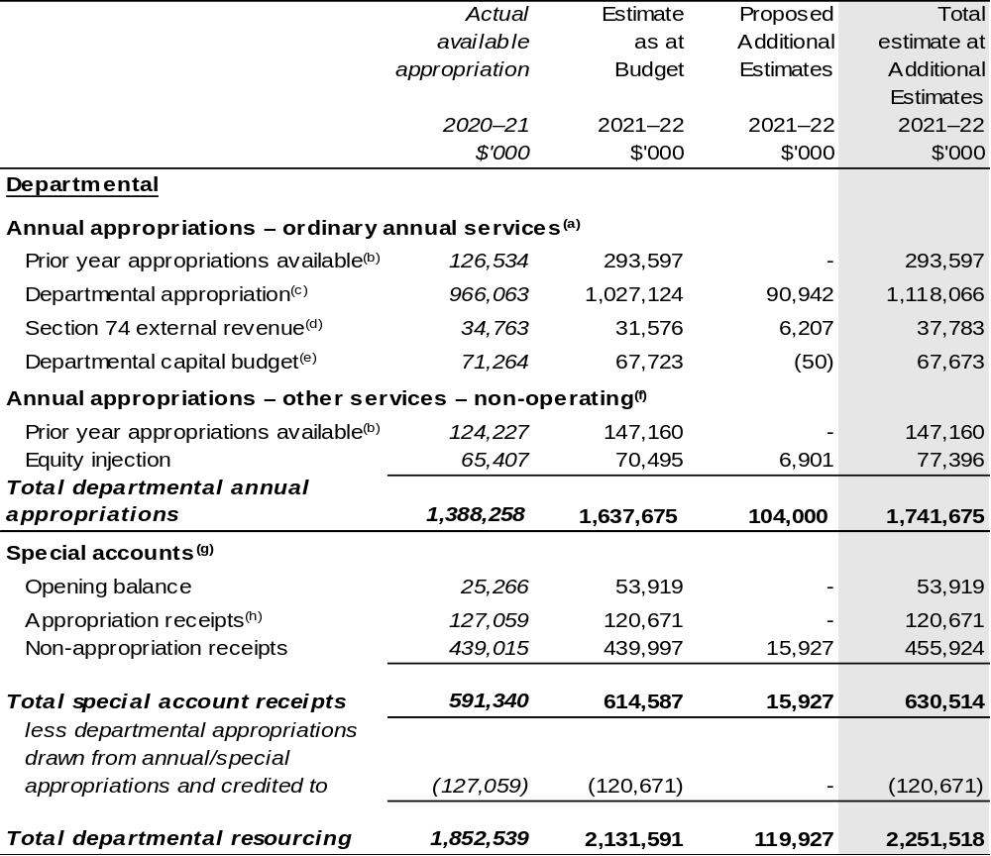
Continued on following pages

Table 1.1: Department of Agriculture, Water and the Environment – Resource Statement – Additional Estimates for 2021–22 as at February 2022 (continued)
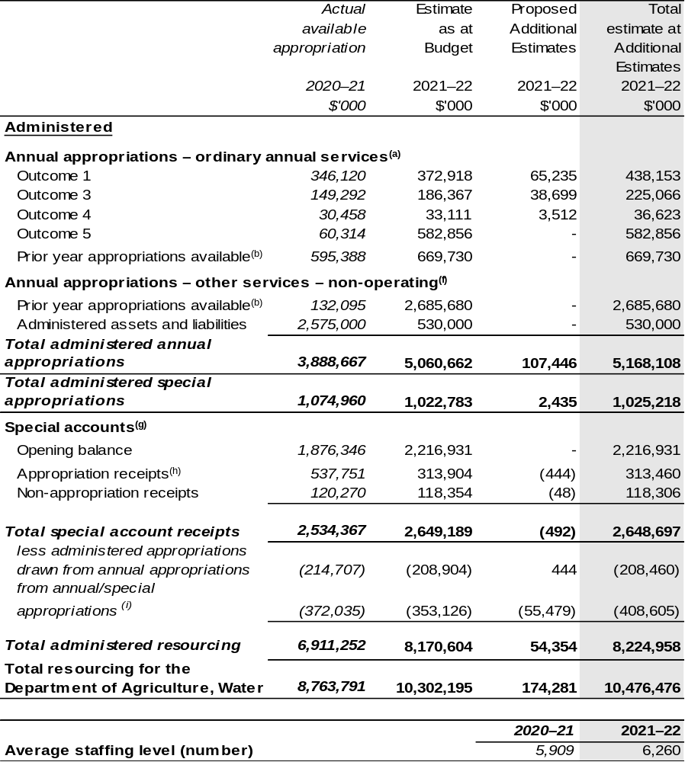
Continued on following pages

Table 1.1: Department of Agriculture, Water and the Environment – Resource Statement – Additional Estimates for 2021–22 as at February 2022 (continued)

- Appropriation Act (No. 1) 2021–22 and Appropriation Bill (No. 3) 2021–22.
- Excludes $778.060 million subject to administrative quarantine by the Department of Finance or withheld under section 51 of the Public Governance, Performance and Accountability Act 2013 (PGPA Act).
- Excludes departmental capital budget (DCB).
- Estimated external revenue under section 74 of the PGPA Act.
- Departmental capital budgets are not separately identified in the Appropriation Bills and form part of ordinary annual services items. Please refer to Table 3.6 for further details. For accounting purposes, this amount has been designated as a 'contribution by owner'.
- Appropriation Act (No. 2) 2021–22 and Appropriation Bill (No. 4) 2021–22.
- Excludes trust moneys held in Services for Other Entities and Trust Moneys (SOETM) and other special accounts. For further information on special accounts (excluding amounts held on trust), please see Table 3.1.
- Amounts credited to the special account(s) from the department’s annual appropriations or crediting provisions in special account acts.
- 'Corporate entities' are corporate Commonwealth entities and Commonwealth companies as defined under the PGPA Act.

The National Indigenous Australians Agency has received $40.000 million from administered appropriation under a section 75 determination in 2021–22 from the department. Refer to Table 2.1: Budgeted Expenses for Outcome 5.

Please note: All figures shown above are GST exclusive – these may not match figures in the cash flow statement.

Prepared on a resourcing (i.e. appropriations available) basis.

Continued on following pages

Table 1.1: Department of Agriculture, Water and the Environment – Resource Statement – Additional Estimates for 2021–22 as at February 2022 (continued)
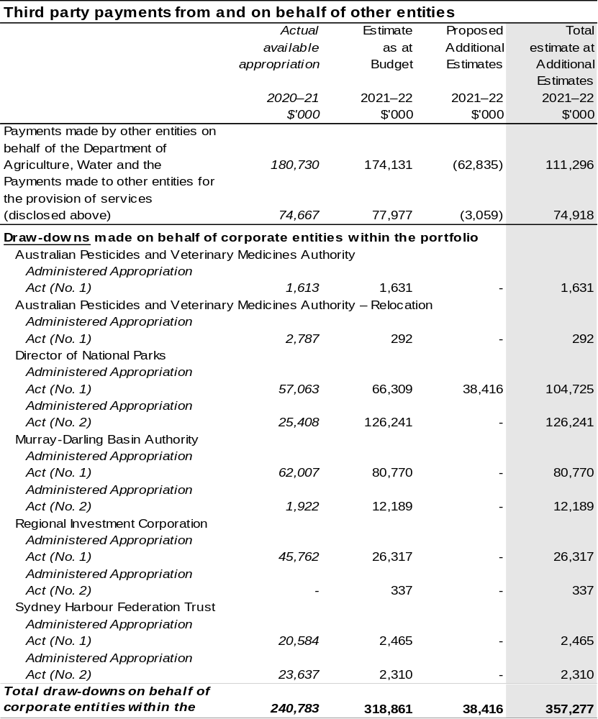

Continued on following page

Table 1.1: Department of Agriculture, Water and the Environment – Resource Statement – Additional Estimates for 2021–22 as at February 2022 (continued)
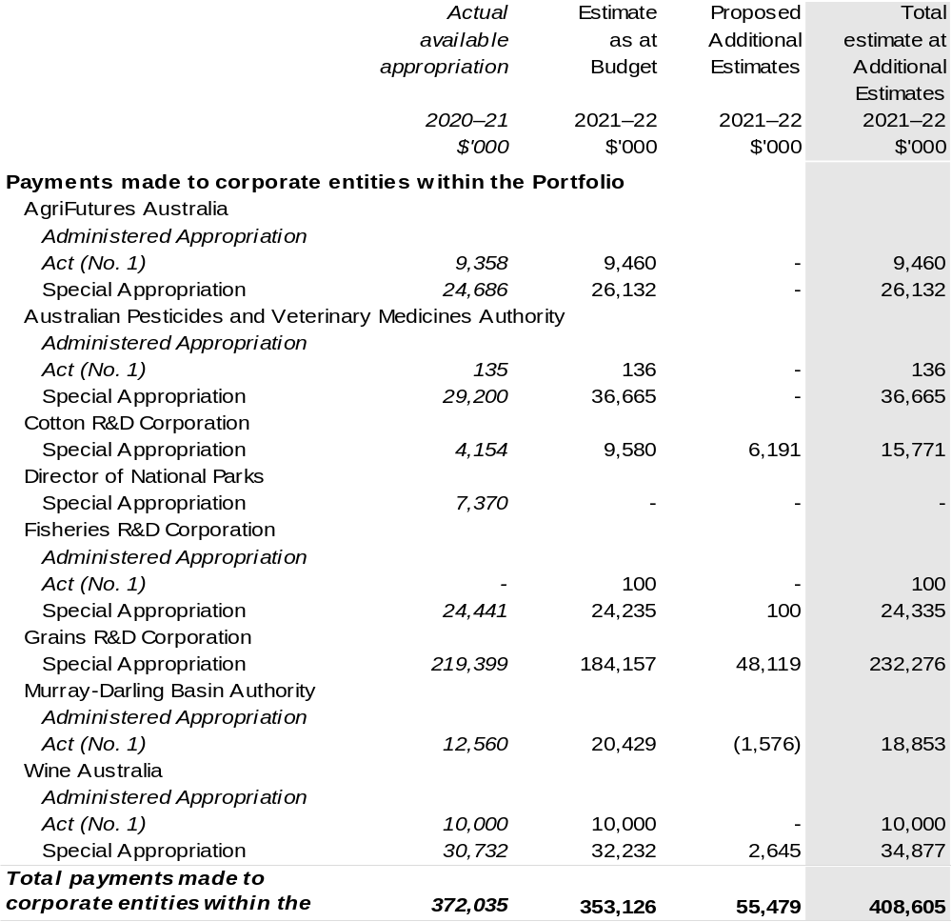

1.3 Entity measures
Table 1.2 summarises new Government measures taken since the 2021–22 Budget.
The table is split into receipt, payment and capital measures, with the affected programs identified.

Table 1.2: Department of Agriculture, Water and the Environment – measures since 2021–22 Budget
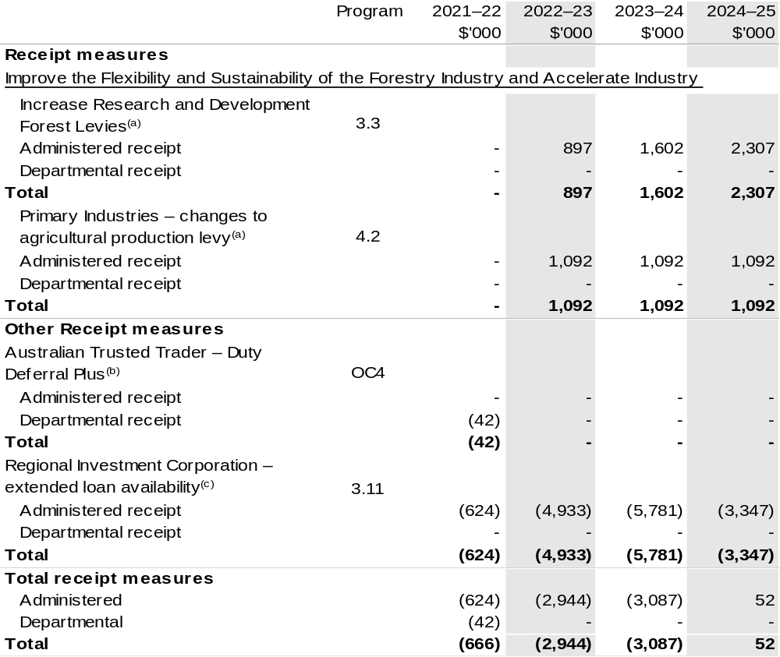

Continued on following pages

Table 1.2: Department of Agriculture, Water and the Environment – measures since 2021–22 Budget (continued)
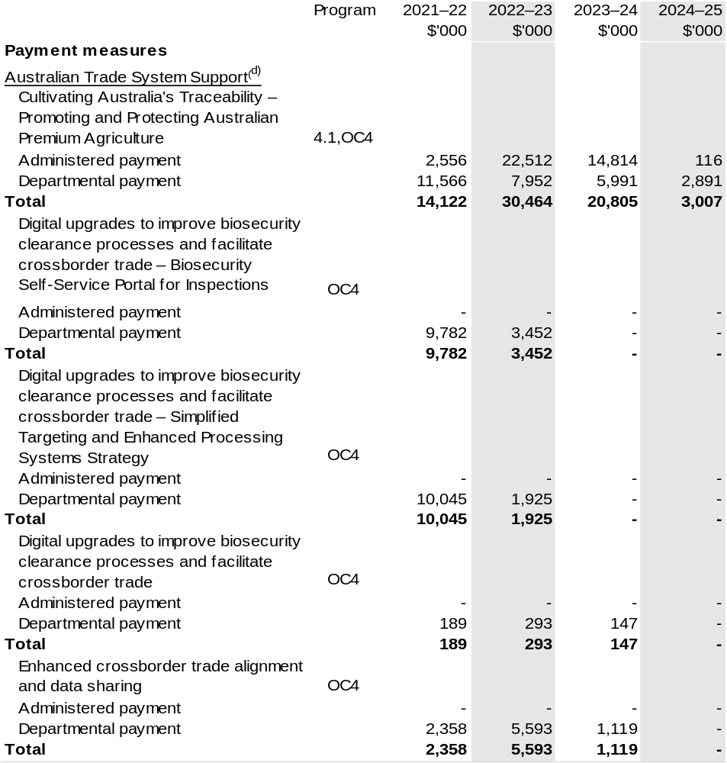

Continued on following pages

Table 1.2: Department of Agriculture, Water and the Environment – measures since 2021–22 Budget (continued)
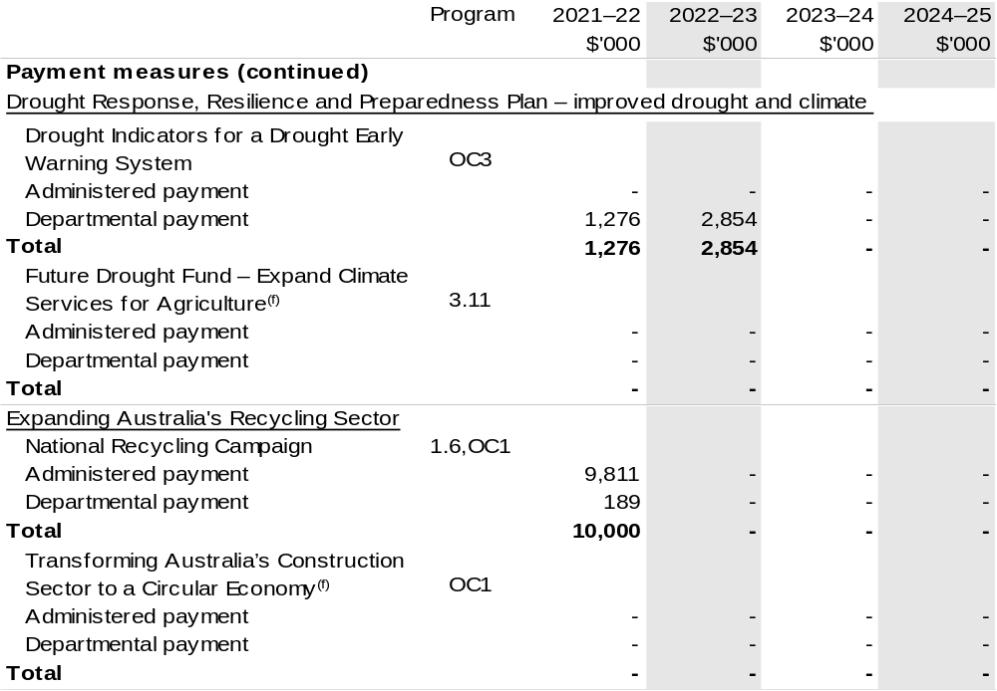

Continued on following pages
Table 1.2: Department of Agriculture, Water and the Environment – measures since 2021–22 Budget (continued)
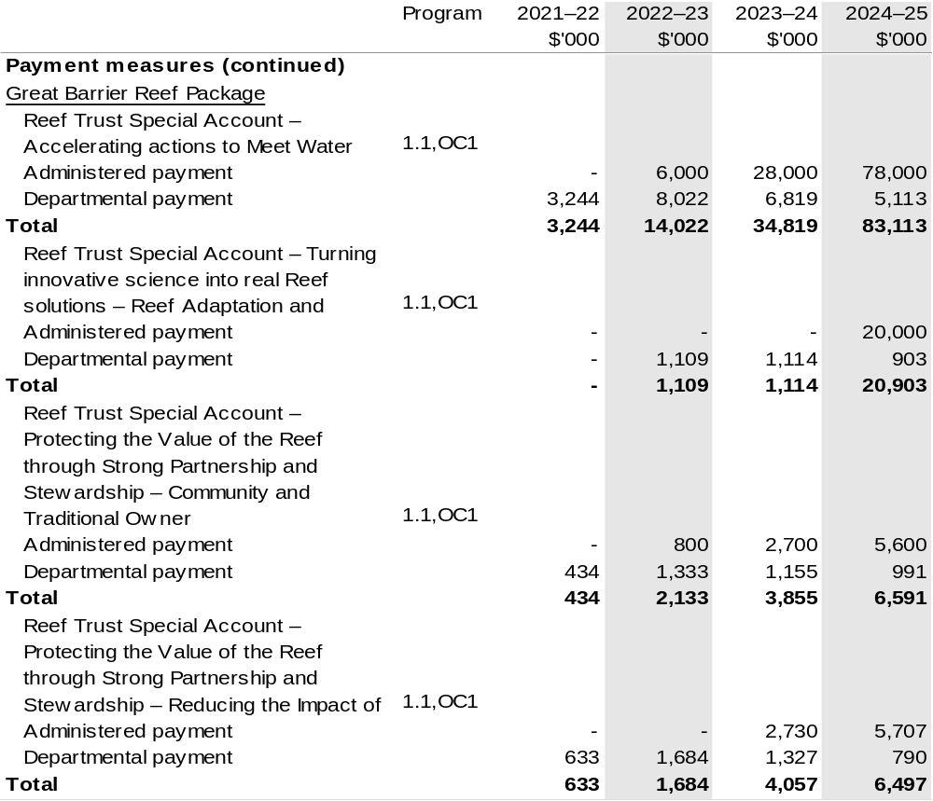

Continued on following pages

Table 1.2: Department of Agriculture, Water and the Environment – measures since 2021–22 Budget (continued)
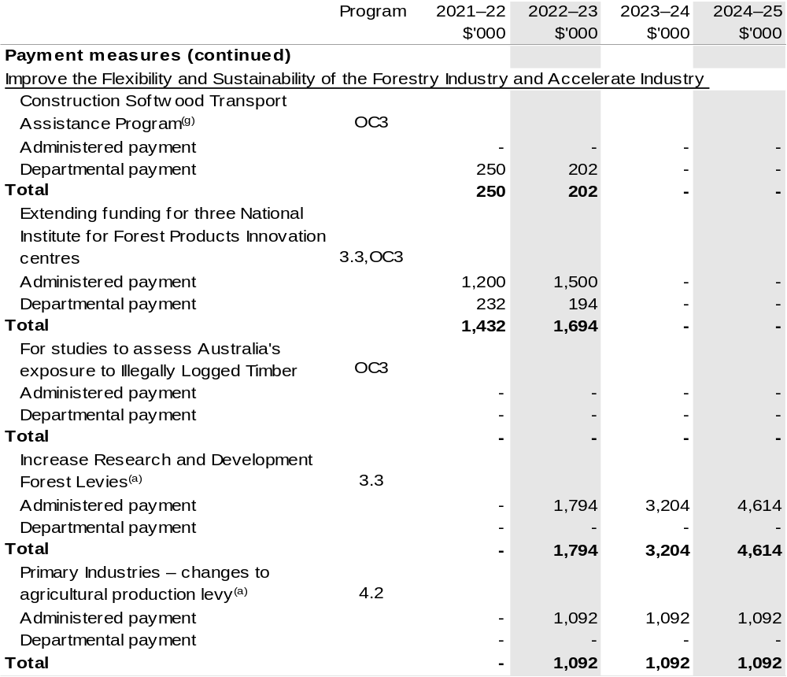

Continued on following pages

Table 1.2: Department of Agriculture, Water and the Environment – measures since 2021–22 Budget (continued)
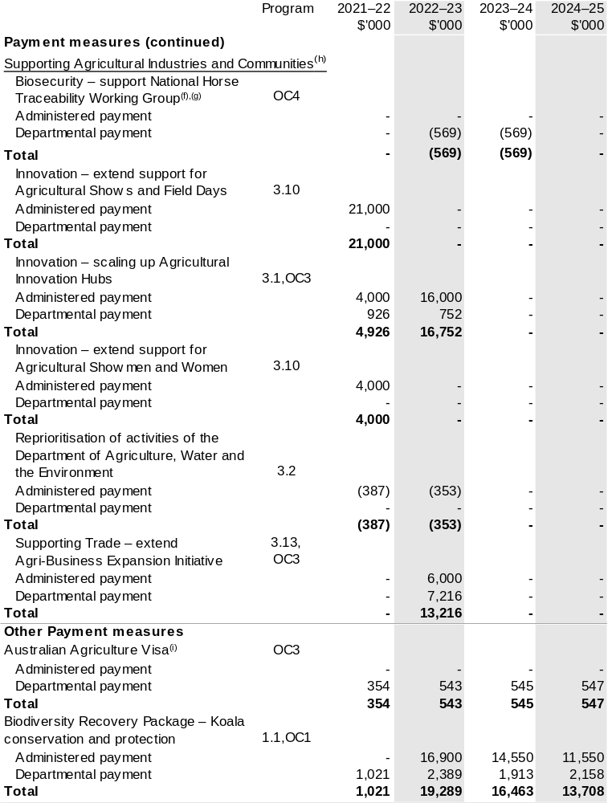

Continued on following pages
Table 1.2: Department of Agriculture, Water and the Environment – measures since 2021–22 Budget (continued)
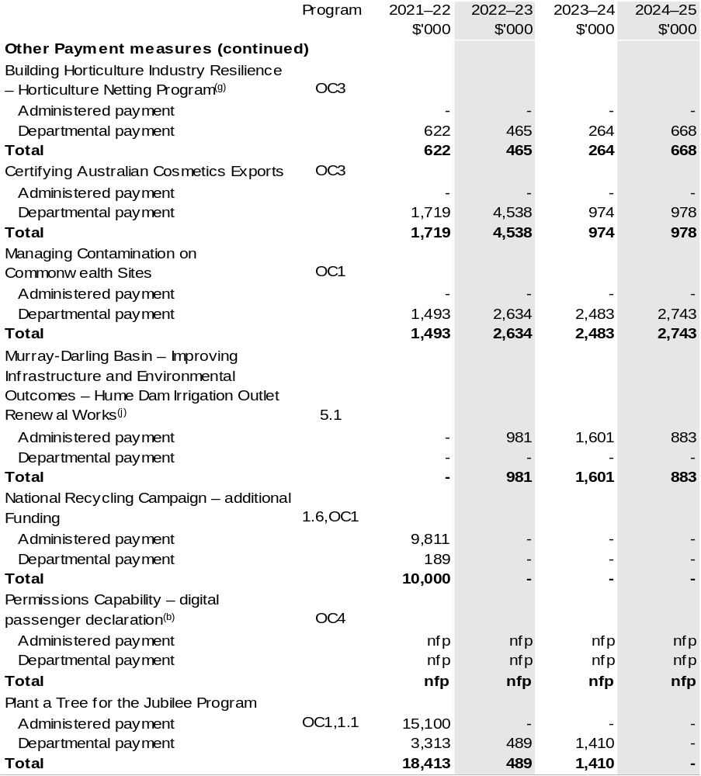

Continued on following pages

Table 1.2: Department of Agriculture, Water and the Environment – measures since 2021–22 Budget (continued)
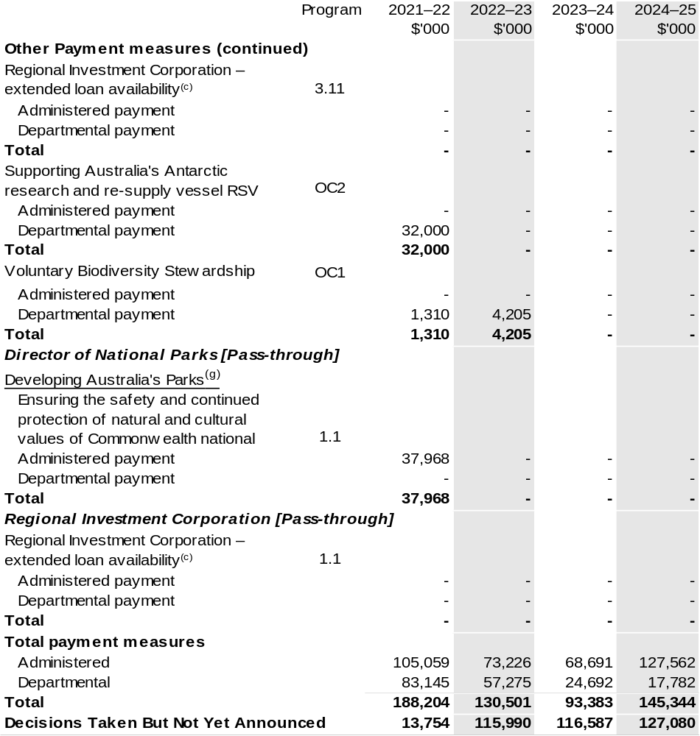

Continued on following pages

Table 1.2: Department of Agriculture, Water and the Environment – measures since 2021–22 Budget (continued)
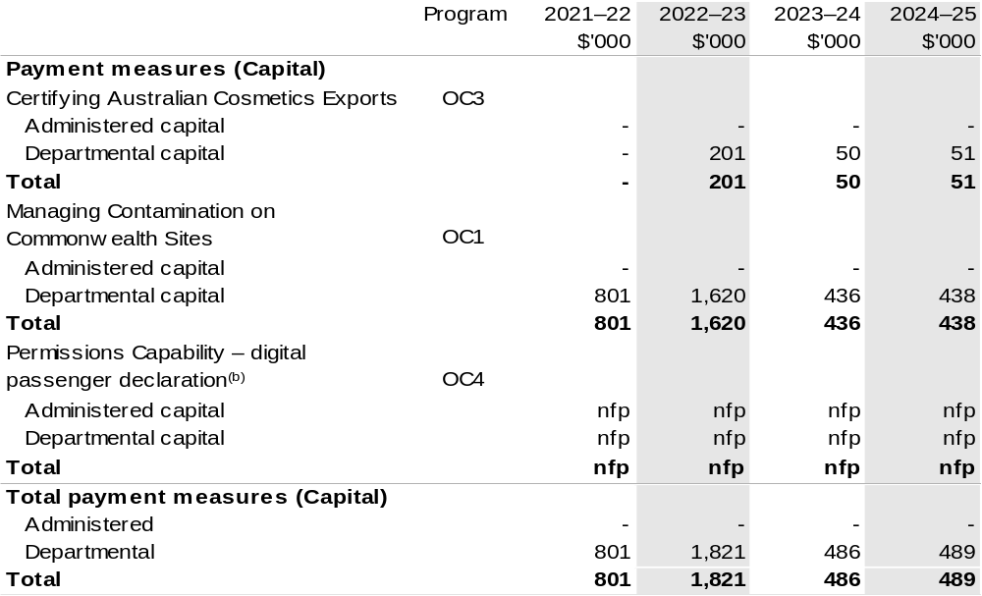

Continued on following page

Table 1.2: Department of Agriculture, Water and the Environment – measures since 2021–22 Budget (continued)
- The measure Improve the Flexibility and Sustainability of the Forestry Industry and Accelerated Industry Innovation appears under receipt and payment measure headings. These changes are made at the request of the relevant industry. The measure comprises:
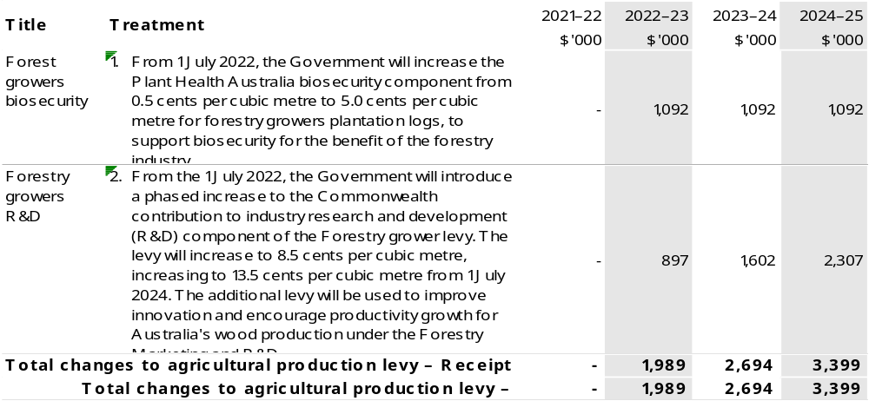
- The lead entity for this measure is the Department of Home Affairs. The measure description appears in the December 2021–22 Mid-Year Economic and Fiscal Outlook (MYEFO) under the Home Affairs portfolio.
- The measure description appears in the December 2021–22 MYEFO under the Agriculture, Water and the Environment portfolio. The administrative costs of this measure will be met from within the existing resources of the Department of Agriculture, Water and the Environment and the Regional Investment Corporation.
- The lead entity for this measure is the Department of Home Affairs. The measure description appears in the December 2021–22 MYEFO under the Cross Portfolio. This measure builds on the 2021–22 Budget measure titled Simplified Trade System.
- This measure builds on the 2021–22 Budget measure titled Drought Response, Resilience and Preparedness Plan – continued support.
- The cost of this component will be met from within the existing resources of the Agriculture, Water and the Environment portfolio.
- The measure provides funding to the National Partnership programs within the Department of the Treasury. Details appear in December 2021–22 MYEFO under Appendix C: Annex A – Payments to States and the measure description under the Agriculture, Water and the Environment portfolio.
- This measure builds on the 2021–22 Budget measures titled Agriculture 2030 and Supporting Agricultural Showmen and Women.
- The lead entity for this measure is the Department of Foreign Affairs and Trade. The measure description appears in the December 2021–22 MYEFO under the Foreign Affairs and Trade portfolio.
- This measure totals $19.0 million over seven years with the department receiving $6.7 million over six years and National Indigenous Australians Agency $12.2 million over four years. The description appears in the December 2021–22 MYEFO under the Agriculture, Water and the Environment portfolio. This measure builds on the 2021–22 Budget measure Murray-Darling Basin – managing water resources.

Prepared on a Government Financial Statistics (fiscal) basis.

Figures displayed as a negative (-) represent a decrease in funds and a positive (+) represent an increase in funds.

1.4 Additional estimates, resourcing and variations to outcomes
The following tables detail changes in resourcing for the Department of Agriculture, Water and the Environment at Additional Estimates, by outcome. The tables show variations since the 2021–22 Budget due to new measures (as per Table 1.2) and variations due to other factors, such as movements of funds, reclassifications, reallocations and adjustments due to the efficiency dividend and changes in economic parameters.

Table 1.3: Additional Estimates and other variations to outcomes since 2021–22 Budget
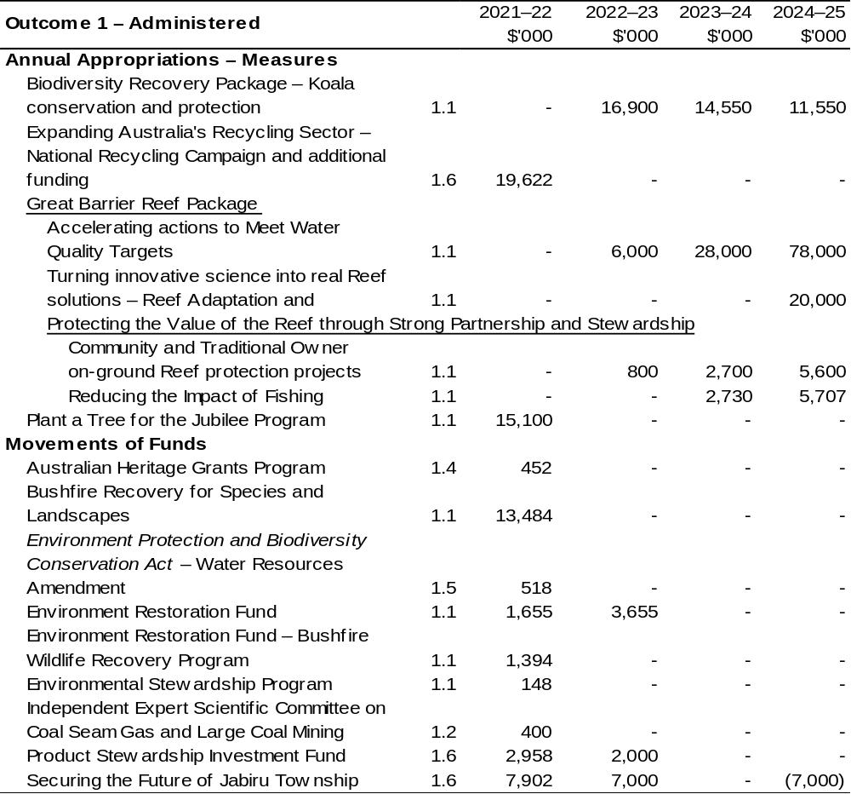
Continued on following pages
Table 1.3: Additional Estimates and other variations to outcomes since 2021–22 Budget (continued)
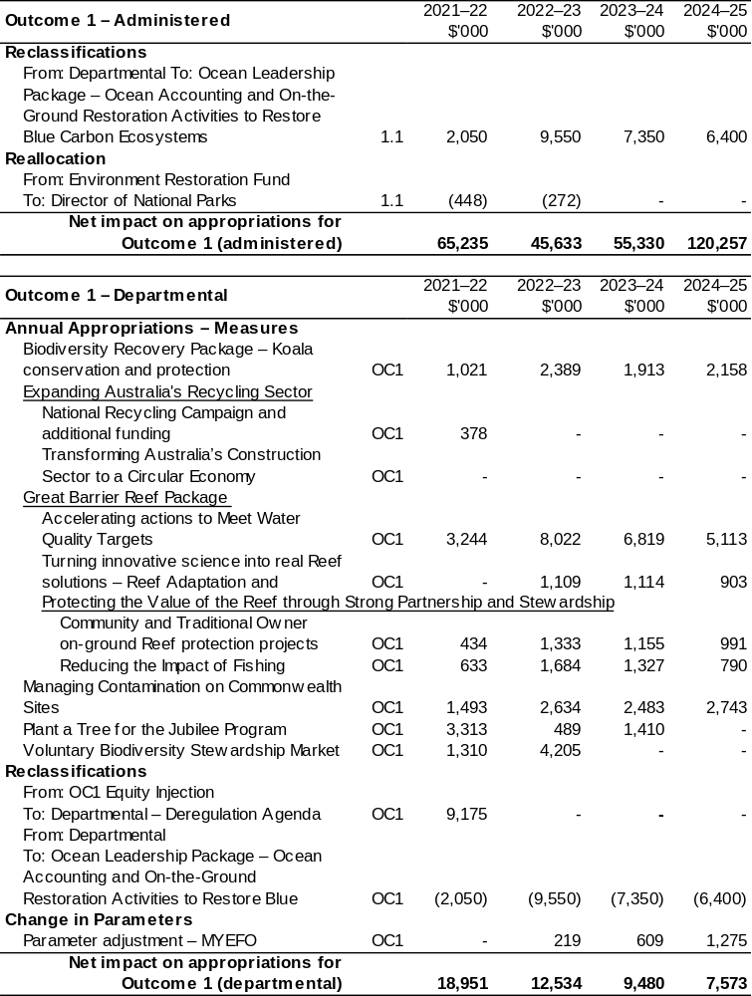
Continued on following pages
Table 1.3: Additional Estimates and other variations to outcomes since 2021–22 Budget (continued)
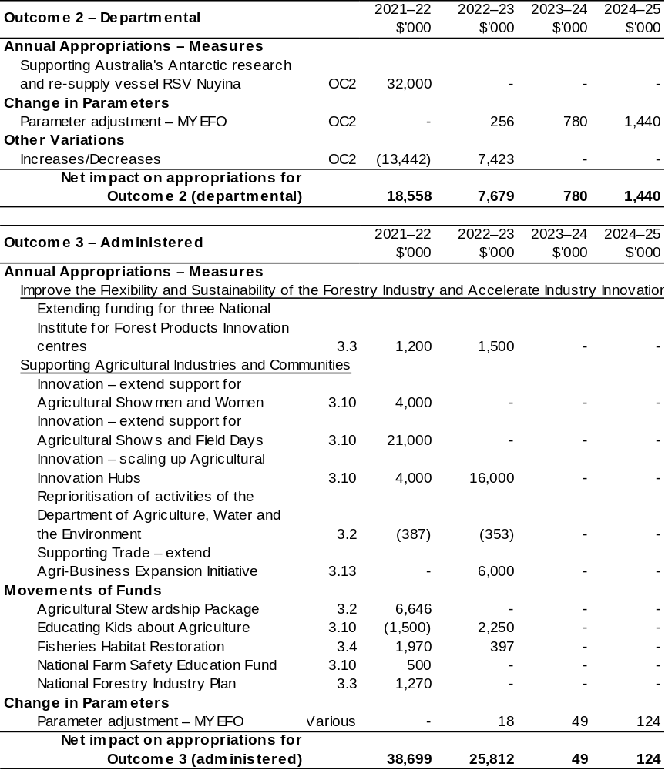
Continued on following pages

Table 1.3: Additional Estimates and other variations to outcomes since 2021–22 Budget (continued)
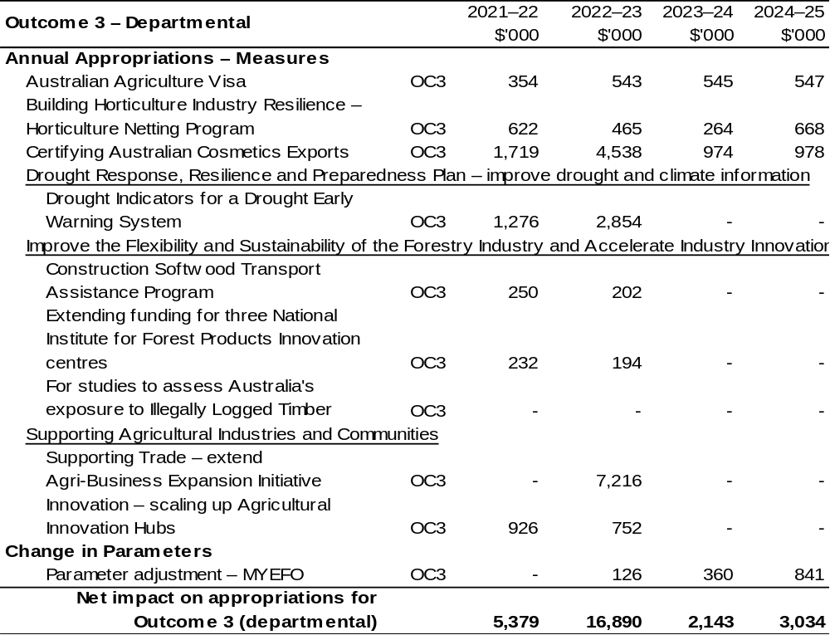
Continued on following pages

Table 1.3: Additional Estimates and other variations to outcomes since 2021–22 Budget (continued)
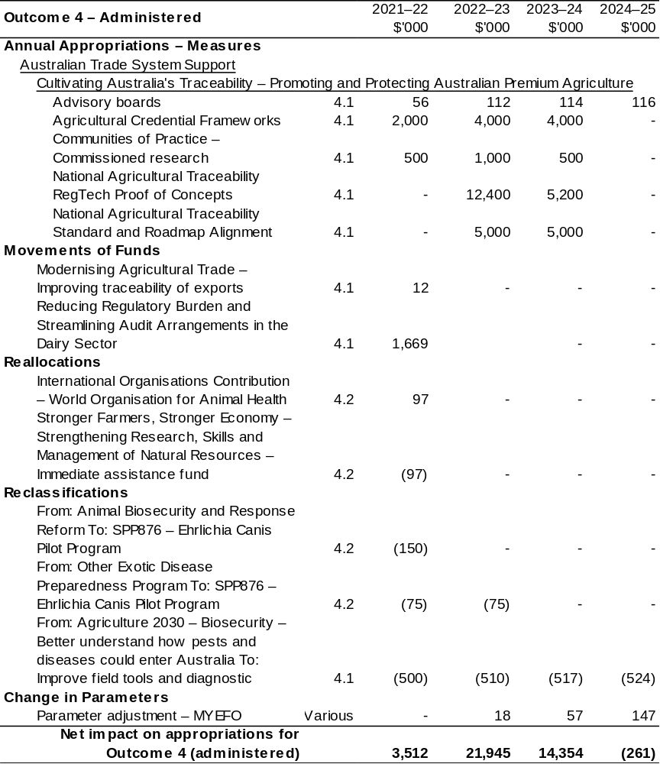
Continued on following pages
Table 1.3: Additional Estimates and other variations to outcomes since 2021–22 Budget (continued)
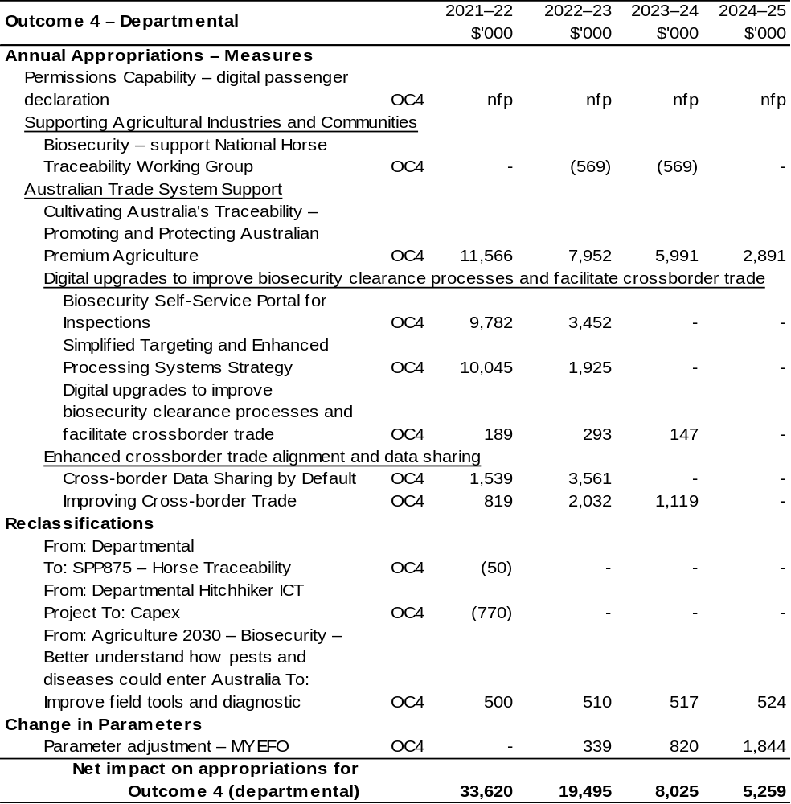
Continued on following pages

Table 1.3: Additional Estimates and other variations to outcomes since 2021–22 Budget (continued)

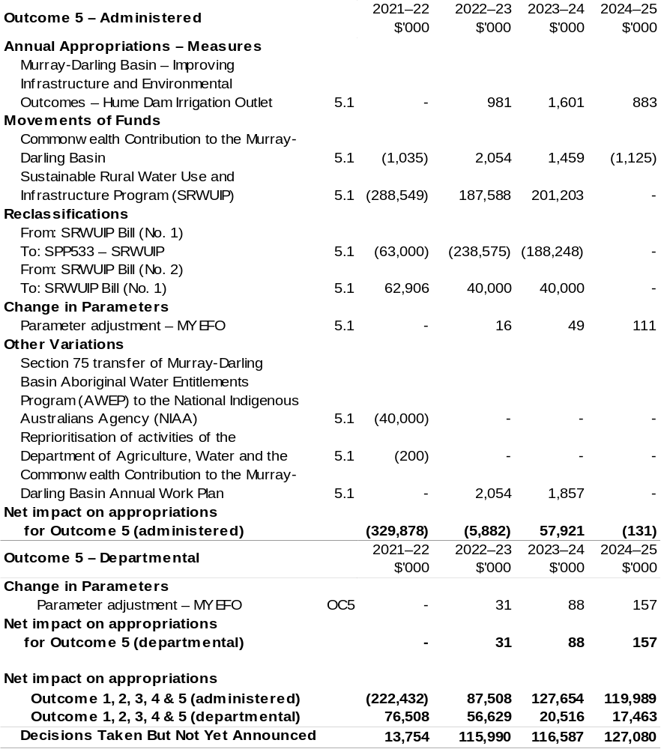
Continued on following pages
Table 1.3: Additional Estimates and other variations to outcomes since 2021–22 Budget (continued)
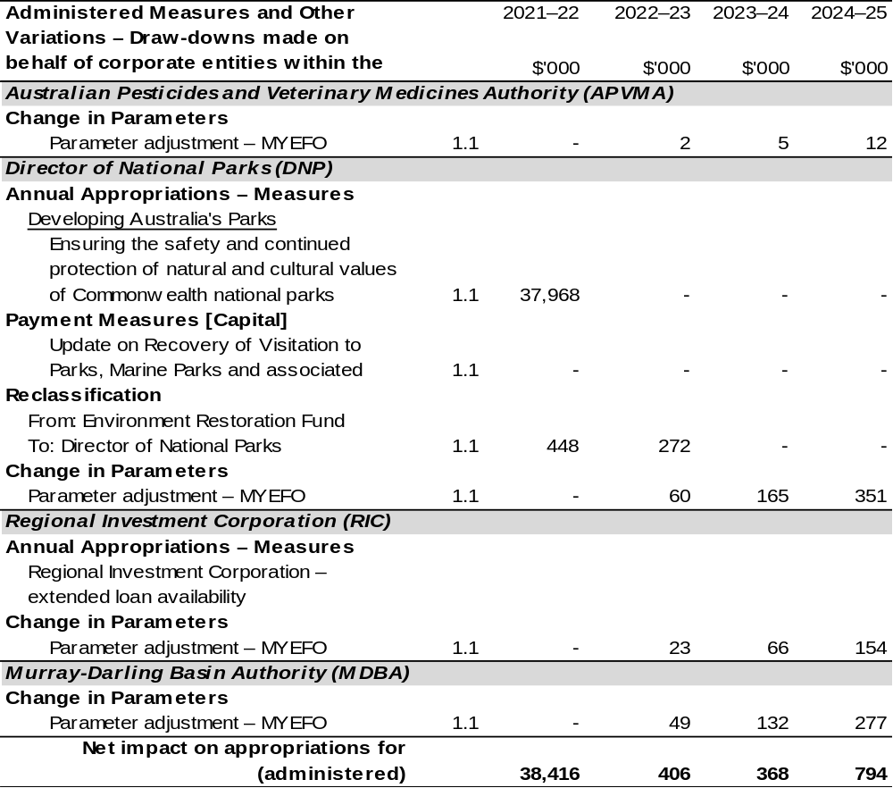
Continued on following pages

Table 1.3: Additional Estimates and other variations to outcomes since 2021–22 Budget (continued)
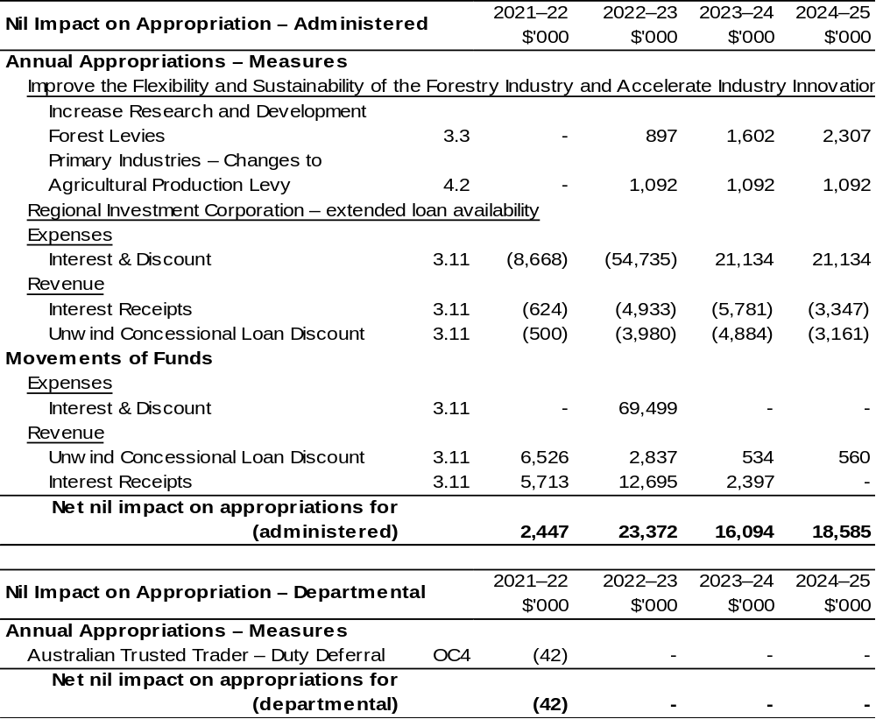
Continued on following pages

Table 1.3: Additional Estimates and other variations to outcomes since 2021–22 Budget (continued)
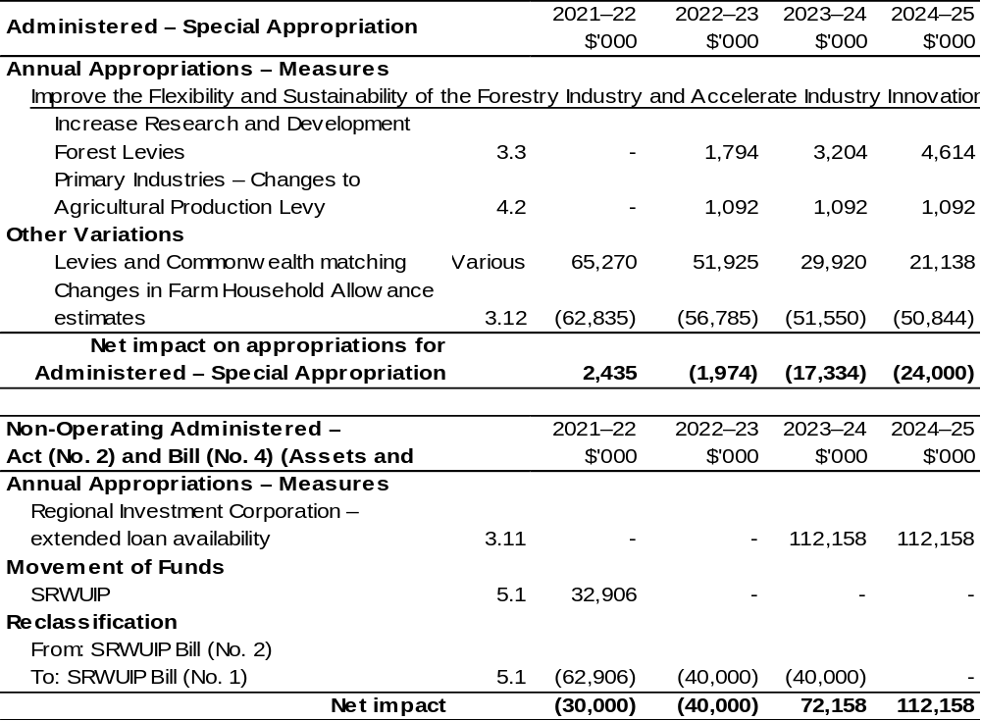
Continued on following pages

Table 1.3: Additional Estimates and other variations to outcomes since 2021–22 Budget (continued)
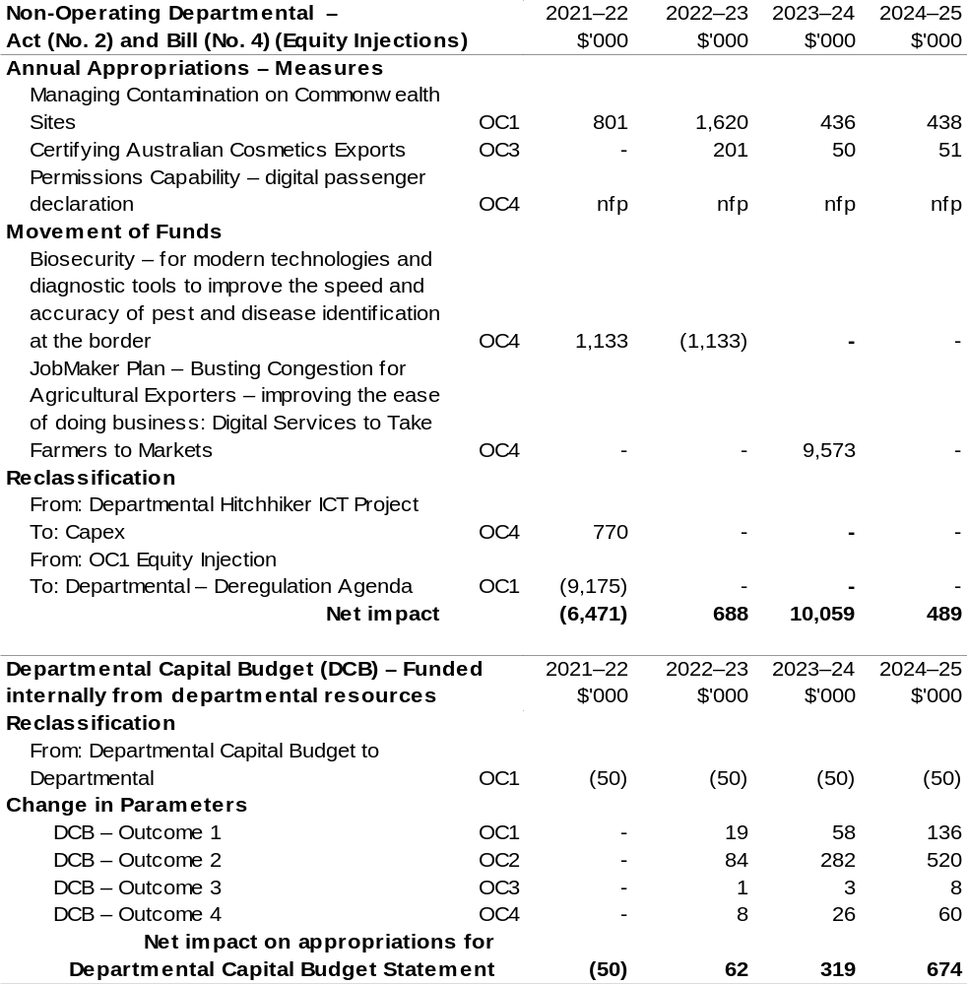
Continued on following pages
Table 1.3: Additional Estimates and other variations to outcomes since 2021–22 Budget (continued)
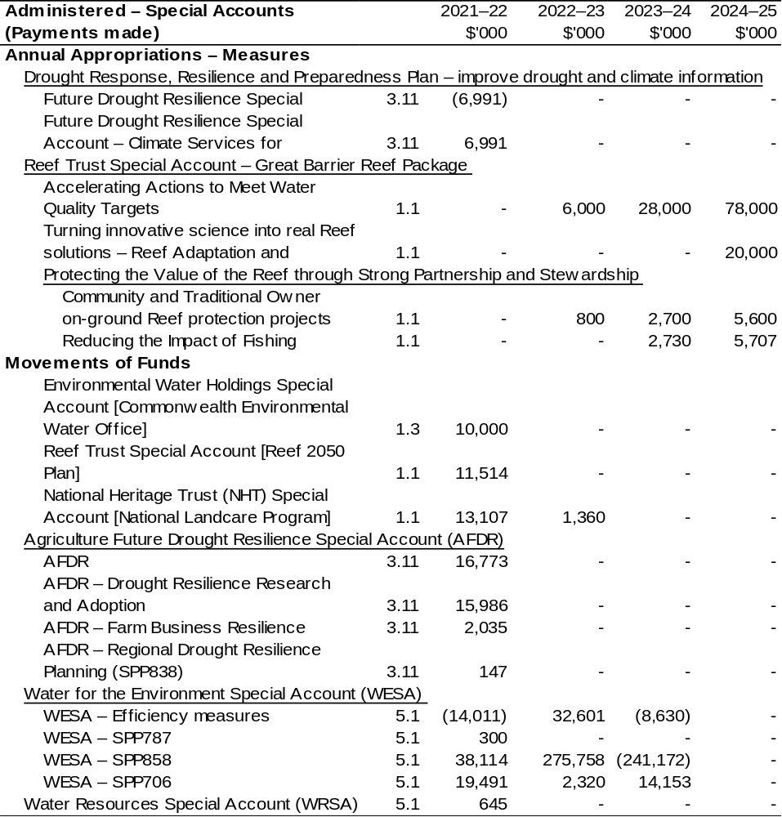
Continued on following pages

Table 1.3: Additional Estimates and other variations to outcomes since 2021–22 Budget (continued)
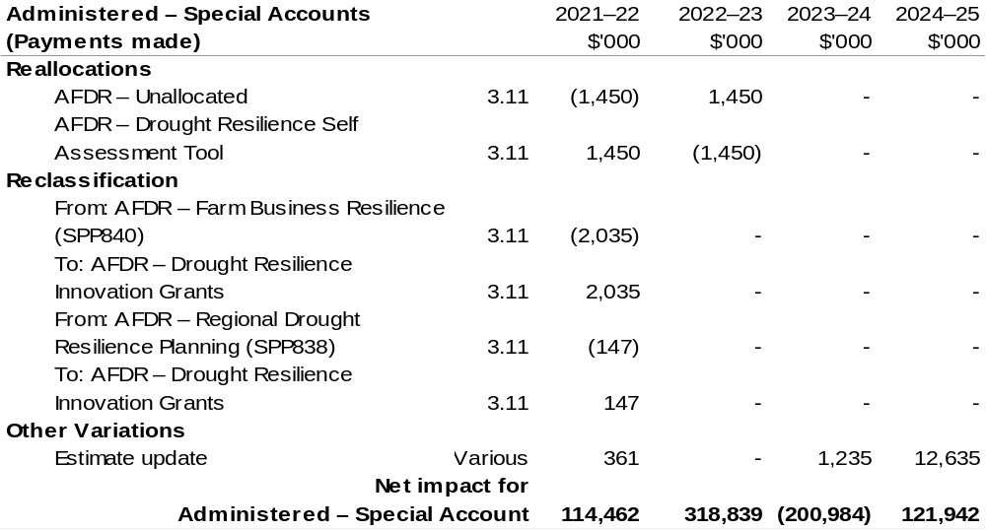
Continued on following pages

Table 1.3: Additional Estimates and other variations to outcomes since 2021–22 Budget (continued)

Additional variations processed through the Department of the Treasury that impact the Department of
Agriculture, Water and the Environment:
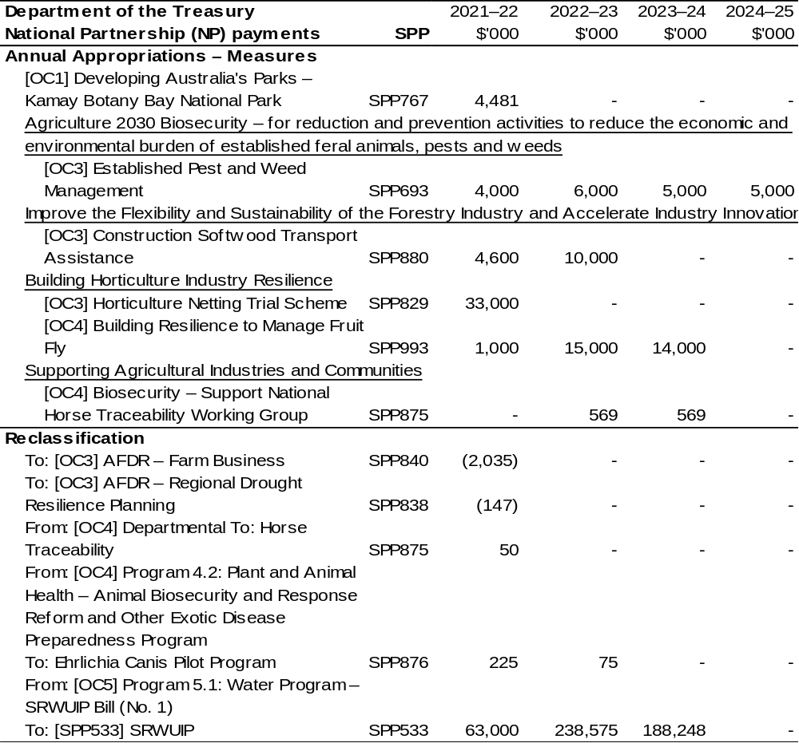
Continued on following page
Table 1.3: Additional Estimates and other variations to outcomes since 2021–22 Budget (continued)
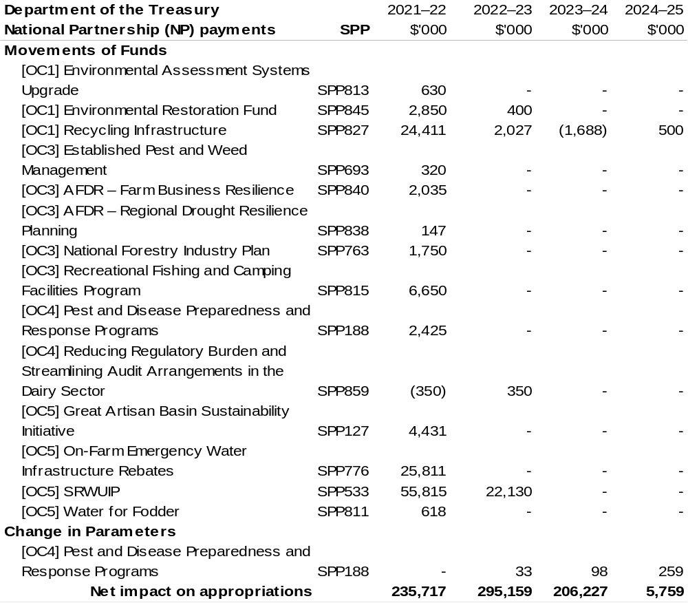

1.5 Breakdown of additional estimates by Appropriation Bill
The following table shows Additional Estimates sought for the Department of Agriculture, Water and the Environment through Appropriation Bills (No. 3) and
(No. 4) 2021–22.

Table 1.4: Appropriation Bill (No. 3) 2021–22 – Administered
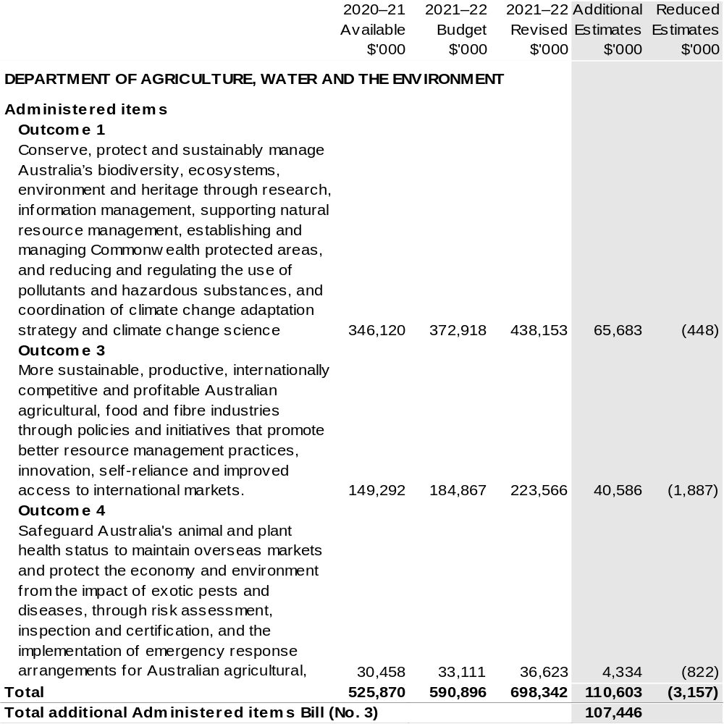
Continued on following pages

Table 1.4: Appropriation Bill (No. 3) 2021–22 – Departmental
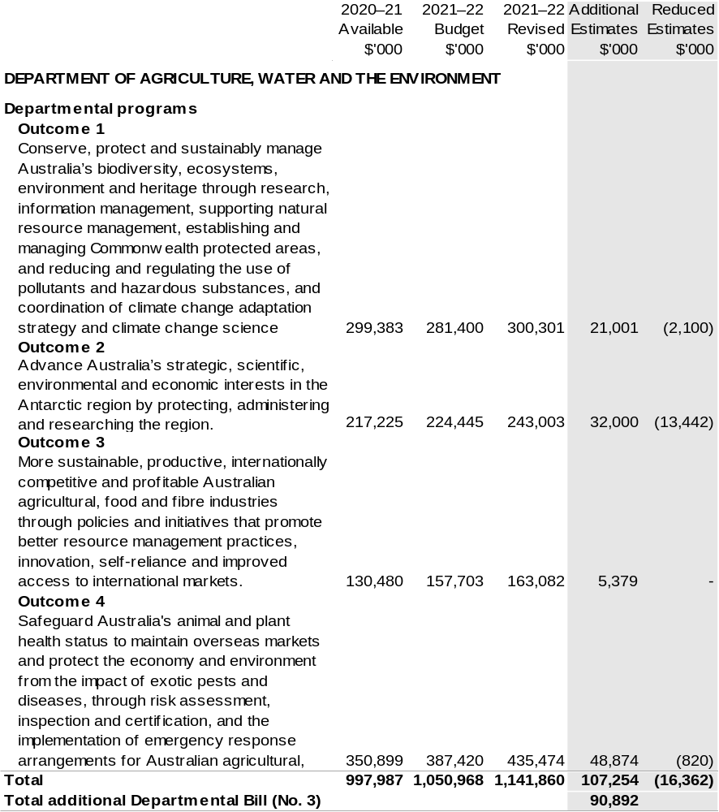
Continued on following page

Table 1.5: Appropriation Bill (No. 4) 2021–22
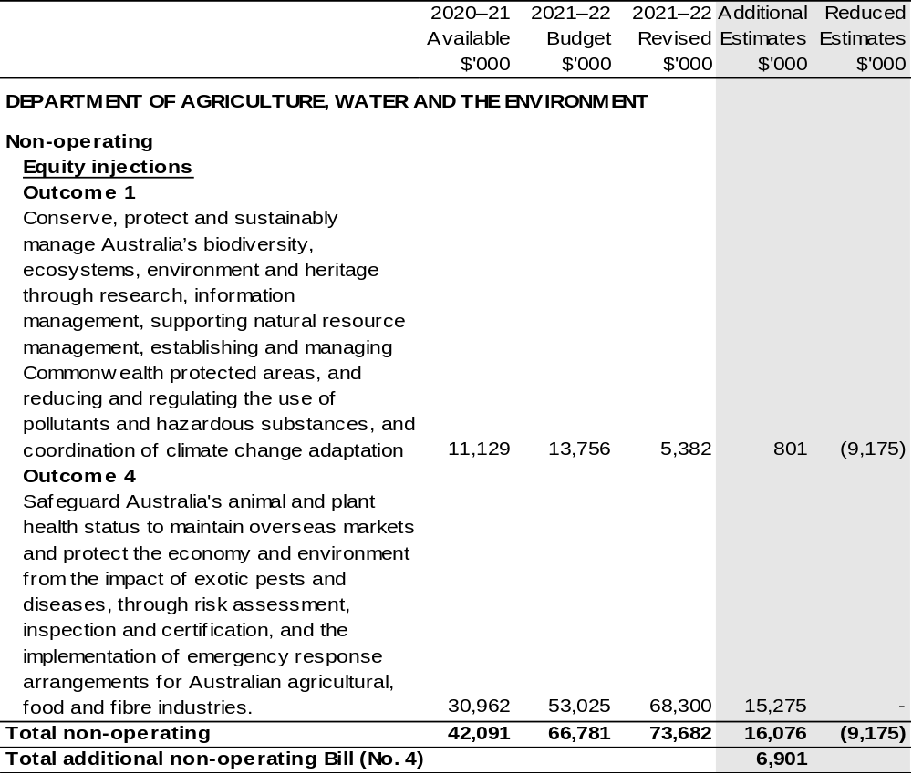

Section 2: Revisions to outcomes and planned performance

2.1 Changes to outcome and program structures
There have been no changes to the department’s outcomes since the 2021–22 Portfolio Budget Statements.
As a result of a Government announcement the Murray-Darling Basin Aboriginal Water Entitlements Program (AWEP) was transferred to the National Indigenous Australians Agency (NIAA). Administered appropriation of $40.000 million from 2021–22 was transferred, and the program was extended to 30 June 2024.

Table 2.1: Changes to the outcome and program structures since the last portfolio statement
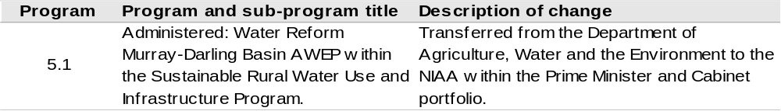

2.2 Budgeted expenses and performance for outcome 1

2.2.1: Linked programs
There have been no changes to linked programs for Outcome 1 since the 2021–22 Portfolio Budget Statements.

2.2.2: Performance criteria
There have been no changes to performance criteria for Outcome 1 since the 2021–22 Portfolio Budget Statements.

2.2.3: Budgeted expenses
Table 2.2 (below) shows how much the entity intends to spend (on an accrual basis) on achieving the outcome, broken down by program, as well as by Administered and Departmental funding sources.

Table 2.2: Budgeted Expenses for Outcome 1
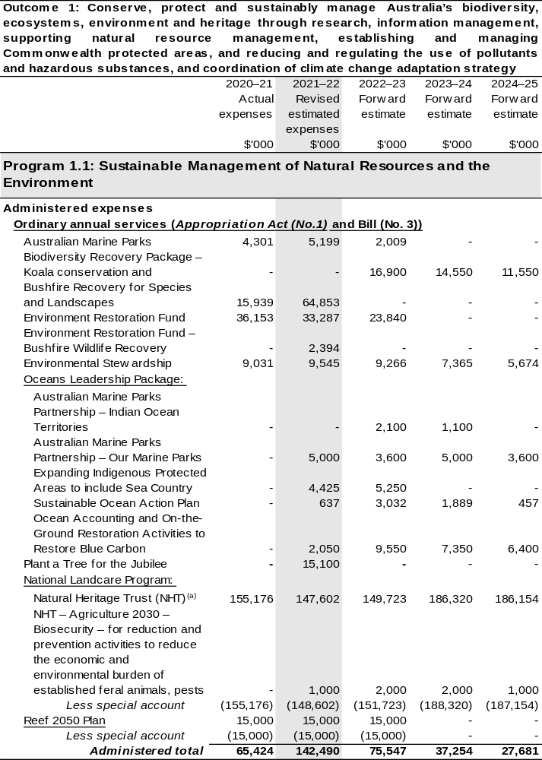
Continued on following pages
Table 2.2: Budgeted Expenses for Outcome 1 (continued)
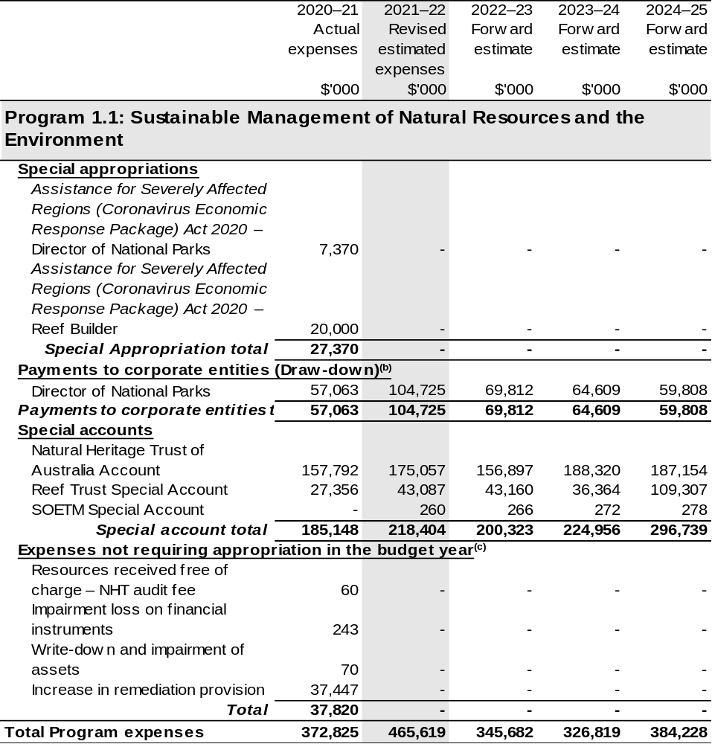

Continued on following pages
Table 2.2: Budgeted Expenses for Outcome 1 (continued)
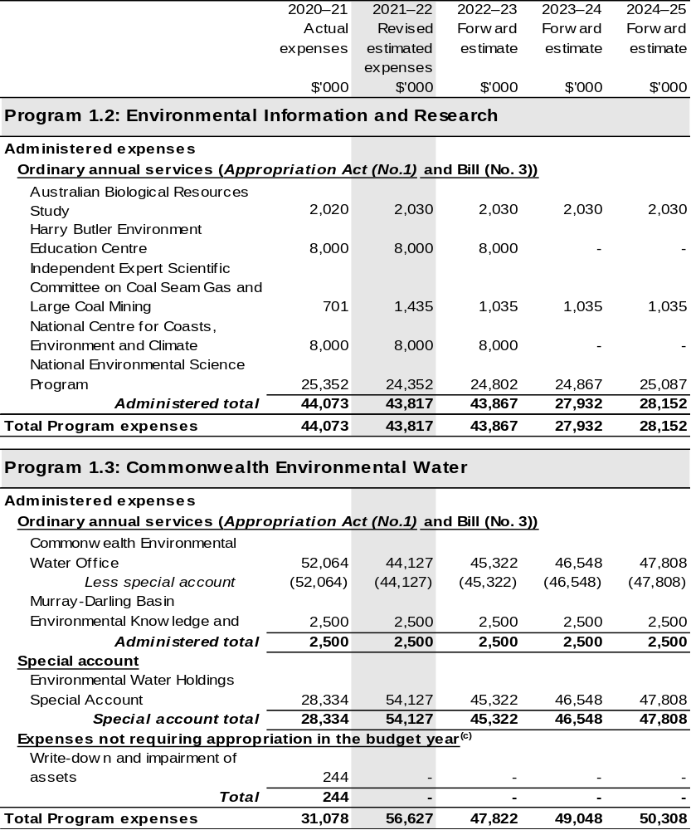

Continued on following pages
Table 2.2: Budgeted Expenses for Outcome 1 (continued)
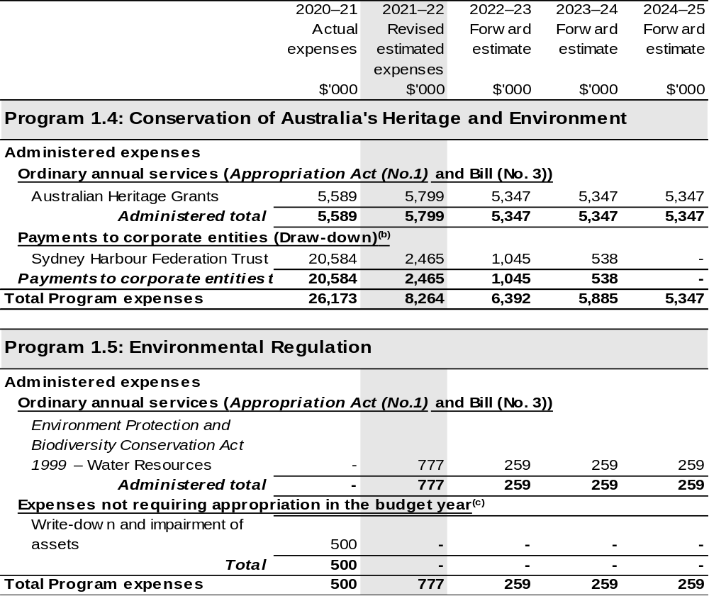
Continued on following pages

Table 2.2: Budgeted Expenses for Outcome 1 (continued)
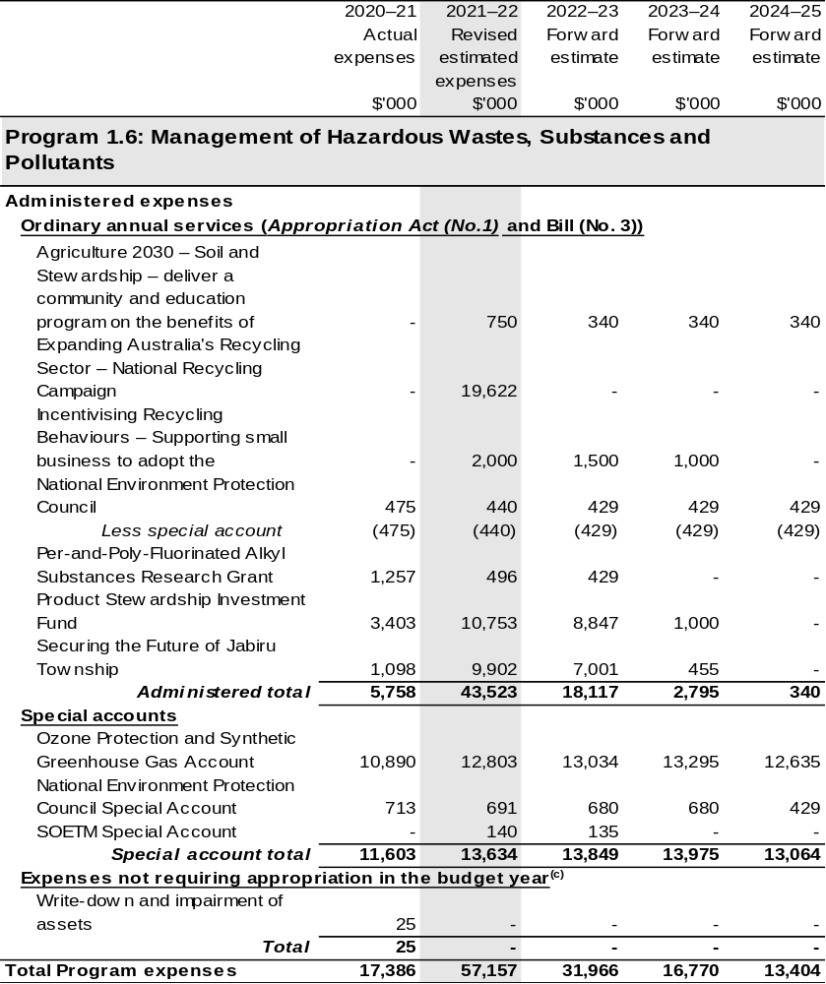
Continued on following pages

Table 2.2: Budgeted Expenses for Outcome 1 (continued)
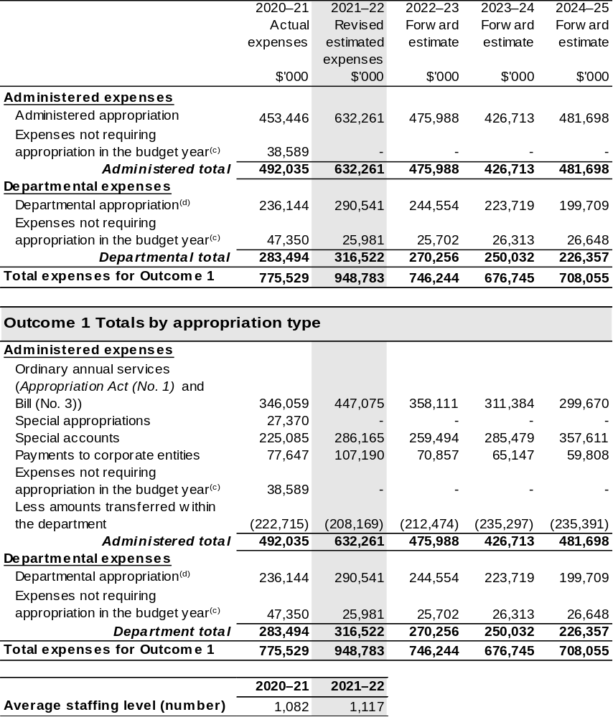
(a) Funding for components of the National Landcare Program are directly appropriated to the Department of the Treasury and the Department of the Prime Minister and Cabinet.
(b) The Director of National Parks and Sydney Harbour Federation Trust are CCEs under the PGPA Act and do not receive direct appropriations. Instead, their funding passes through the department and is drawn-down on their behalf.
(c) ‘Expenses not requiring appropriation in the Budget year’ are made up of depreciation and amortisation expenses, audit fees and an approved operating loss.
(d) Departmental appropriation allocations are notional and reflect the current structure of the department. Expenses funded from both ‘Ordinary annual services Appropriation Act (No. 1) and Appropriation
Bill (No. 3) and ‘External Revenue’ under section 74 of the PGPA Act.
Note: Departmental appropriation splits and totals are indicative estimates and may change in the course of the budget year as Government priorities change.
Continued on following page
Table 2.2: Budgeted Expenses for Outcome 1 (continued)

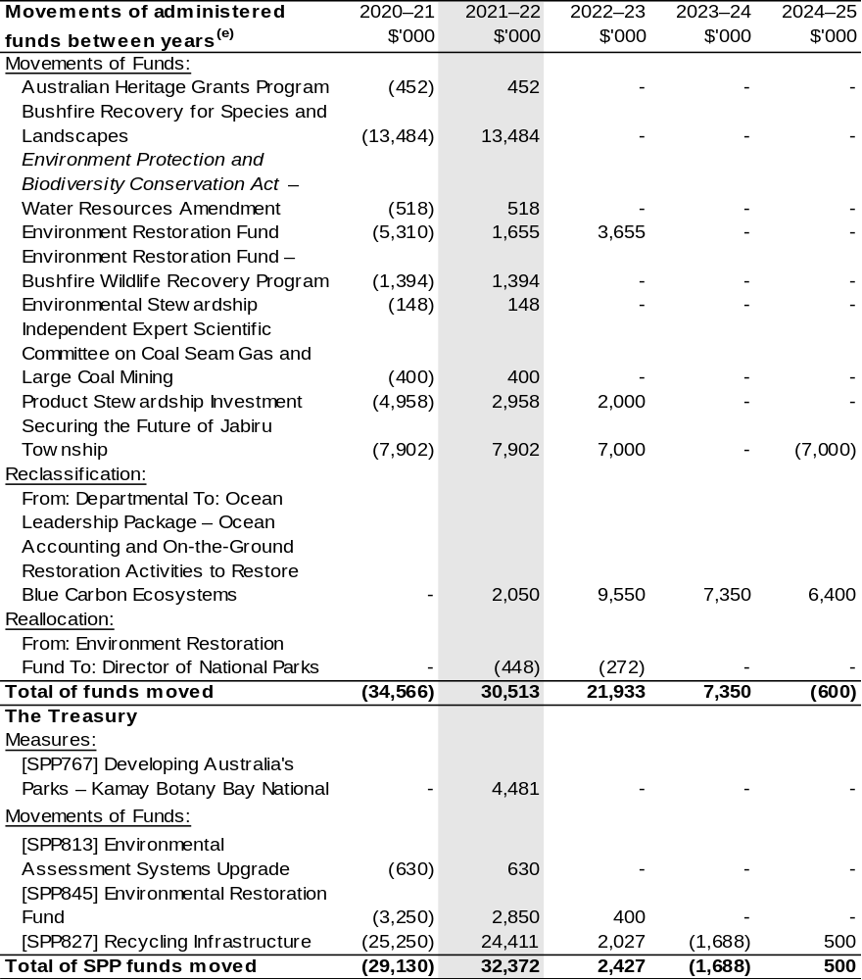
(e) Figures displayed as a negative (-) represent a decrease in funds and a positive (+) represent an
increase in funds.

2.3 Budgeted Expenses and performance for outcome 2

2.3.1: Linked programs
There have been no changes to linked programs for Outcome 2 since the 2021–22 Portfolio Budget Statements.

2.3.2: Performance criteria
There have been no changes to performance criteria for Outcome 2 since the 2021–22 Portfolio Budget Statements.

2.3.3: Budgeted expenses
Table 2.3 (below) shows how much the entity intends to spend (on an accrual basis) on achieving the outcome, broken down by program, as well as by Administered and Departmental funding sources.

Table 2.3: Budgeted Expenses for Outcome 2
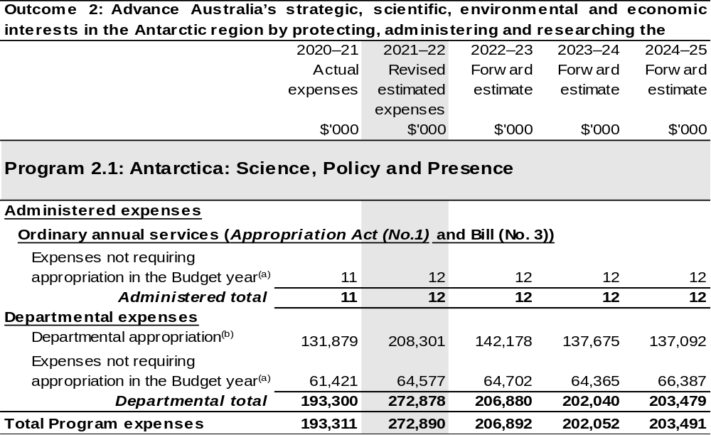
Continued on following page

Table 2.3: Budgeted Expenses for Outcome 2 (continued)
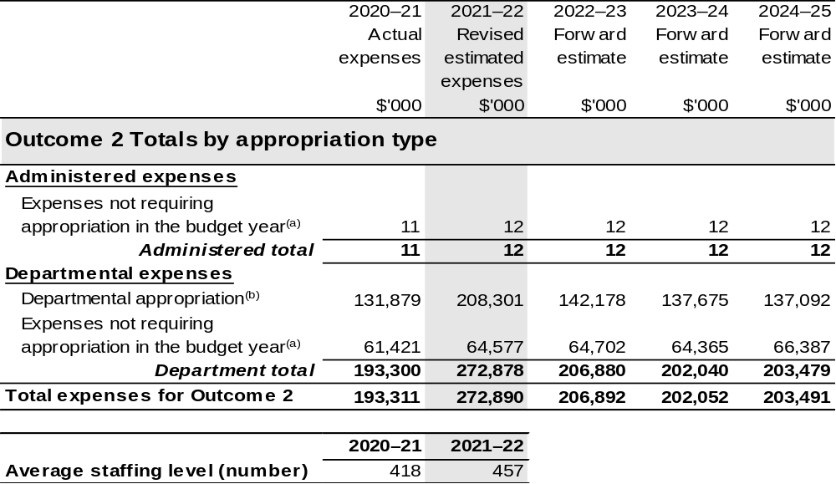
(a) ‘Expenses not requiring appropriation in the Budget year’ are made up of depreciation and amortisation expenses, audit fees and an approved operating loss.
(b) Departmental appropriation allocations are notional and reflect the current structure of the department. Expenses funded from both ‘Ordinary annual services Appropriation Act (No. 1) and Appropriation
Bill (No. 3) and ‘External Revenue’ under section 74 of the PGPA Act.

Note: Departmental appropriation splits and totals are indicative estimates and may change in the course of the budget year as Government priorities change.

2.4 Budgeted expenses and performance for outcome 3

2.4.1: Linked programs
There have been no changes to linked programs for Outcome 3 since the 2021–22 Portfolio Budget Statements.

2.4.2: Performance criteria
There have been no changes to performance criteria for Outcome 3 since the 2021–22 Portfolio Budget Statements.

2.4.3: Budgeted expenses
Table 2.4 (below) shows how much the entity intends to spend (on an accrual basis) on achieving the outcome, broken down by program, as well as by Administered and Departmental funding sources.

Table 2.4: Budgeted Expenses for Outcome 3
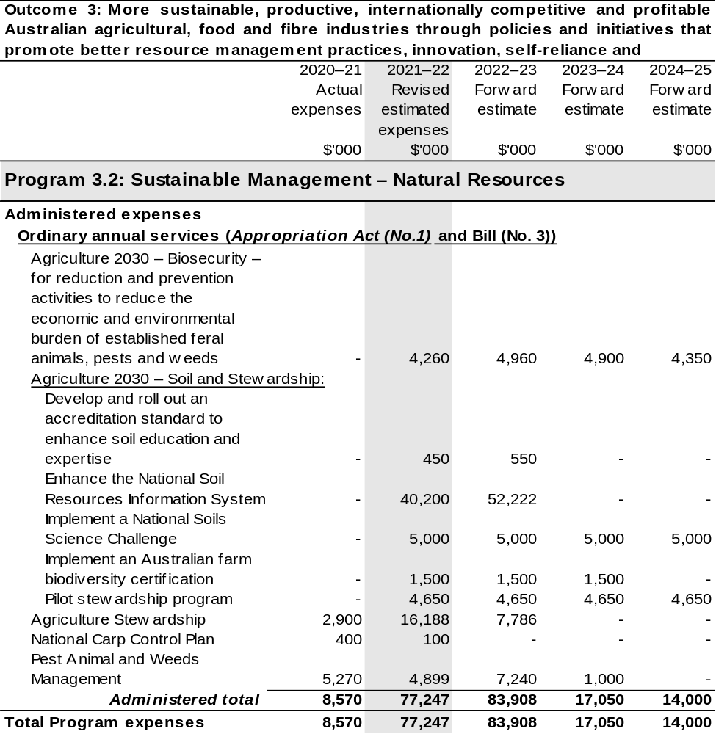
Continued on following pages
Table 2.4: Budgeted Expenses for Outcome 3 (continued)
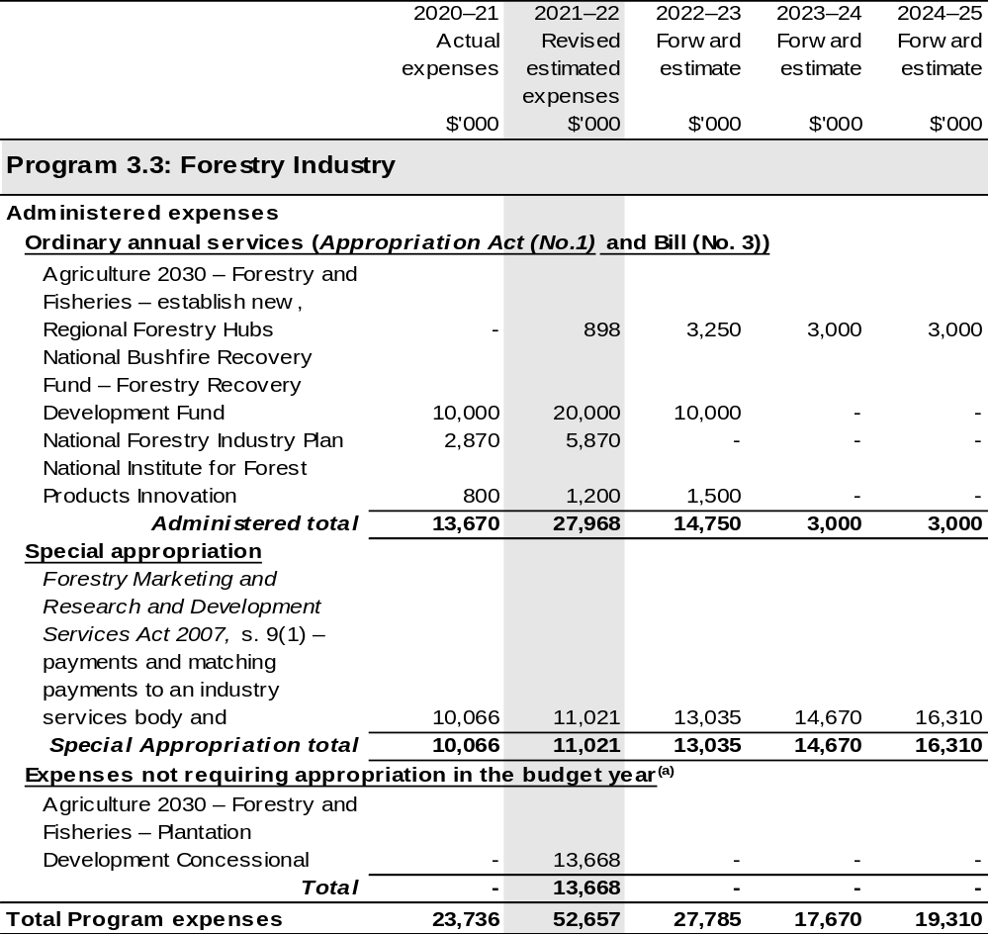
Continued on following pages
Table 2.4: Budgeted Expenses for Outcome 3 (continued)
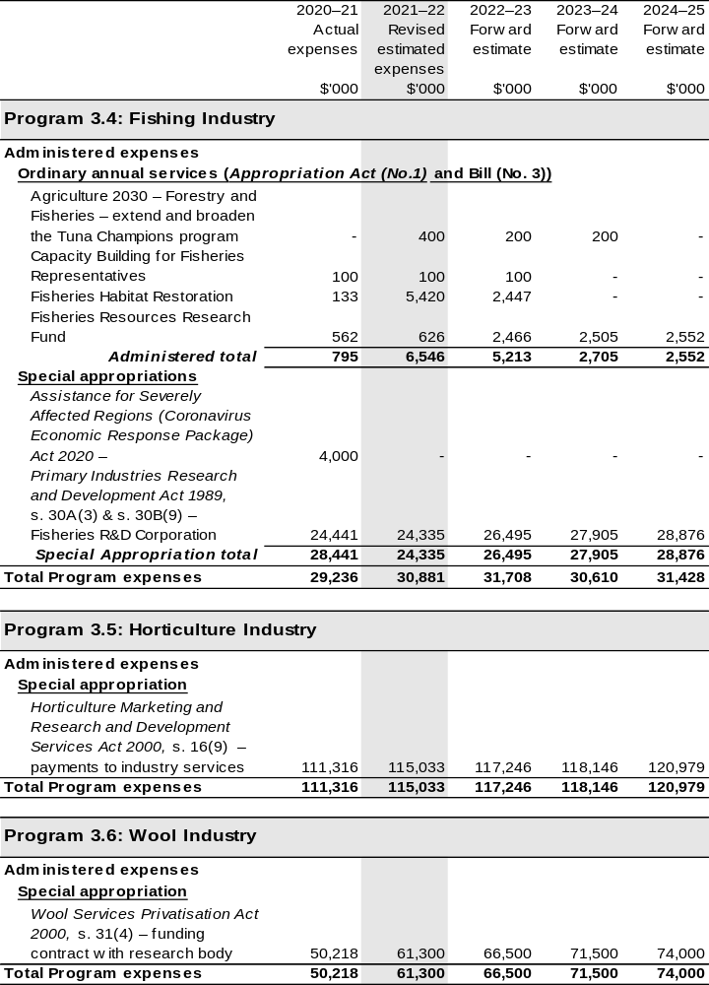
Continued on following pages
Table 2.4: Budgeted Expenses for Outcome 3 (continued)
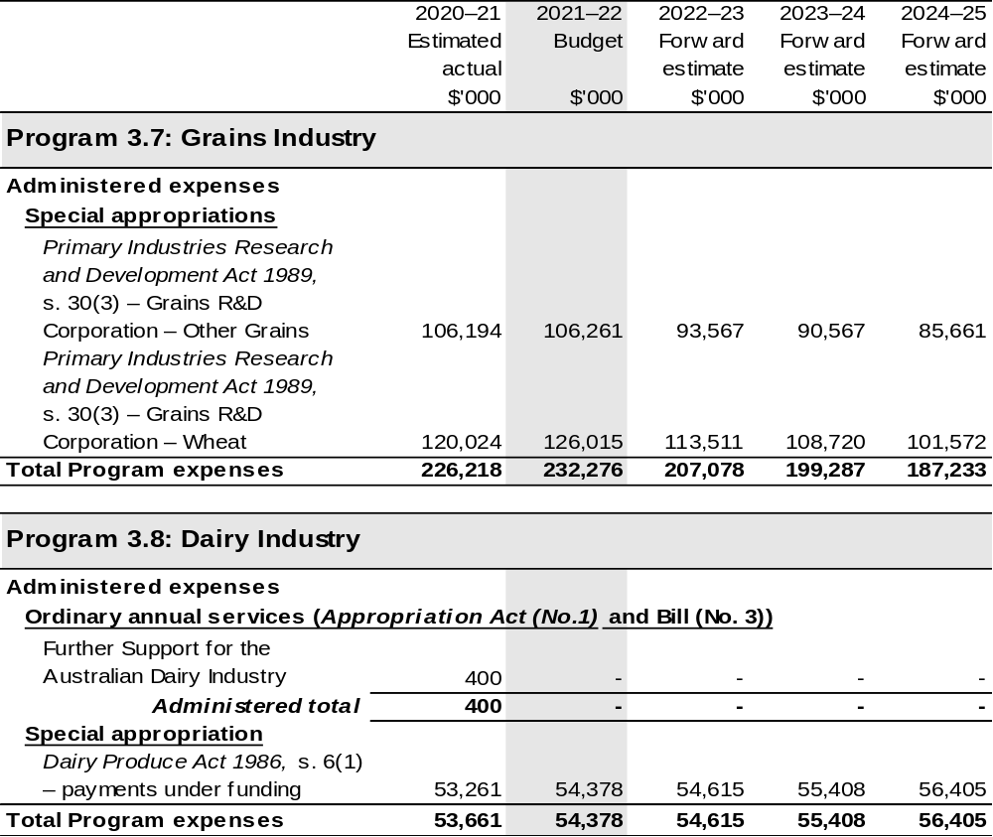
Continued on following pages
Table 2.4: Budgeted Expenses for Outcome 3 (continued)
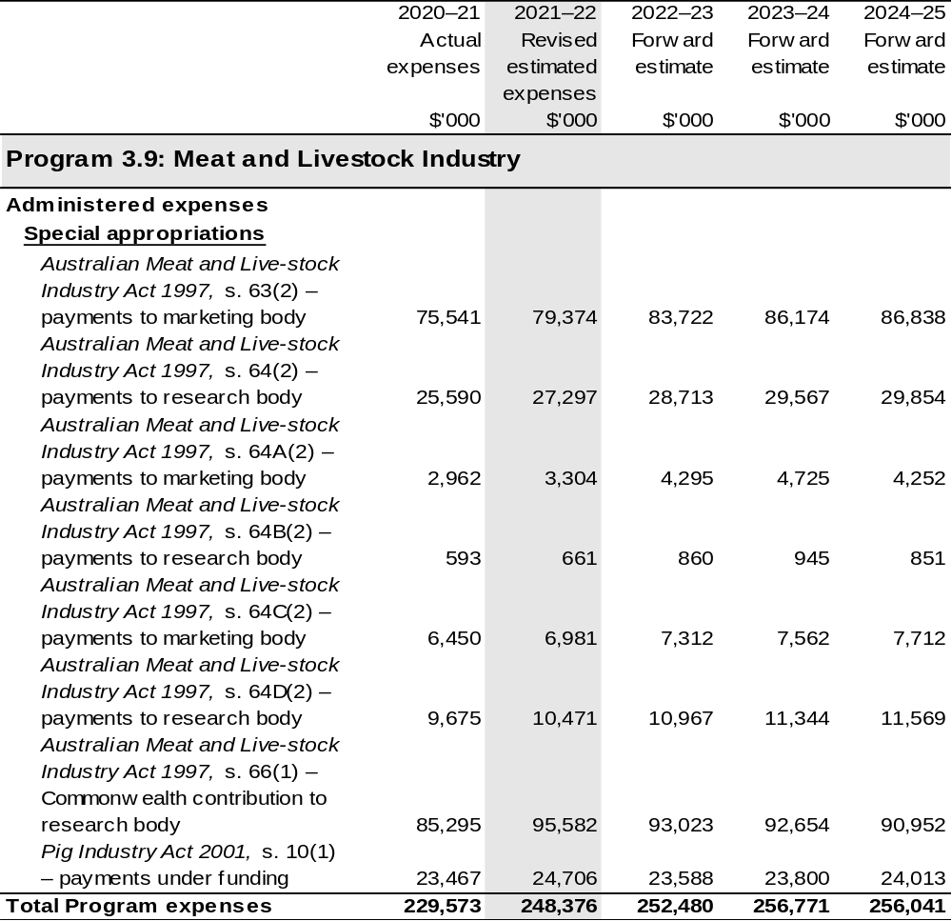
Continued on following pages

Table 2.4: Budgeted Expenses for Outcome 3 (continued)
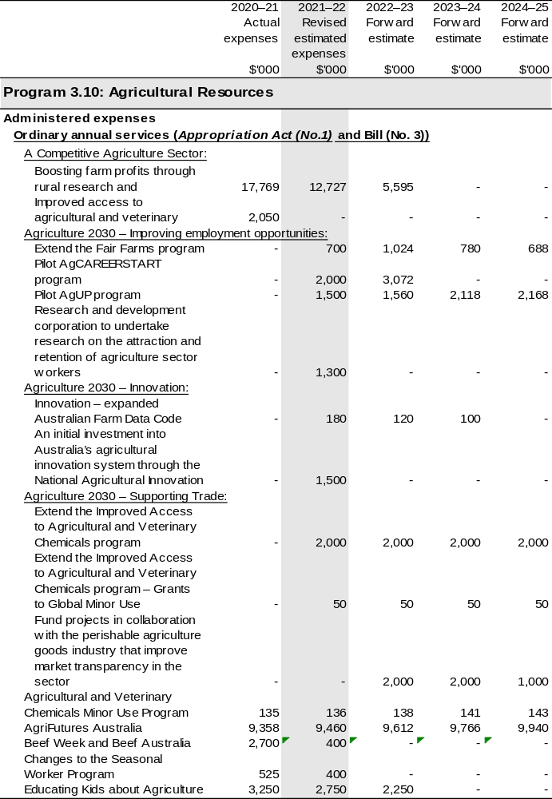
Continued on following pages
Table 2.4: Budgeted Expenses for Outcome 3 (continued)
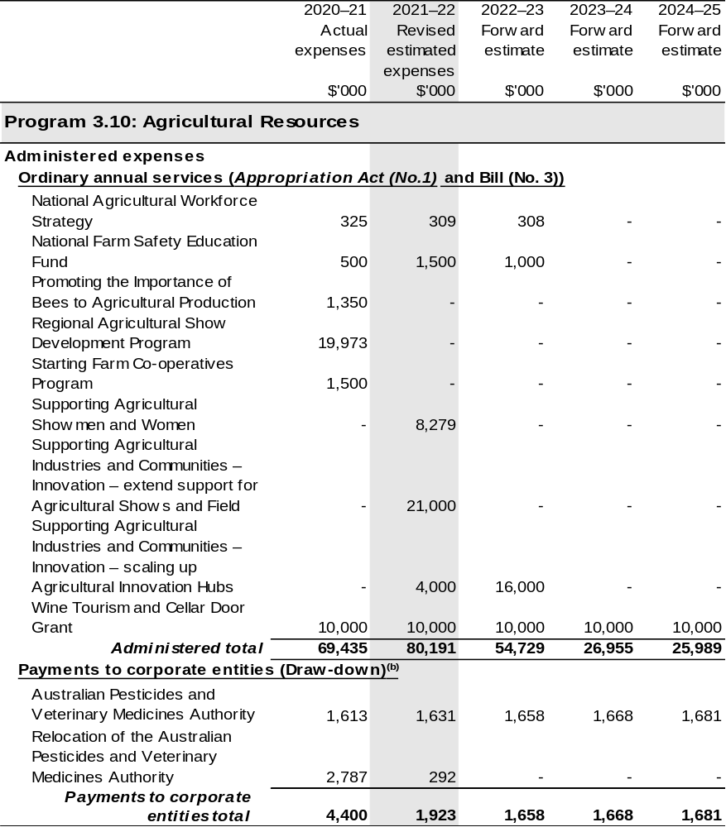
Continued on following pages
Table 2.4: Budgeted Expenses for Outcome 3 (continued)
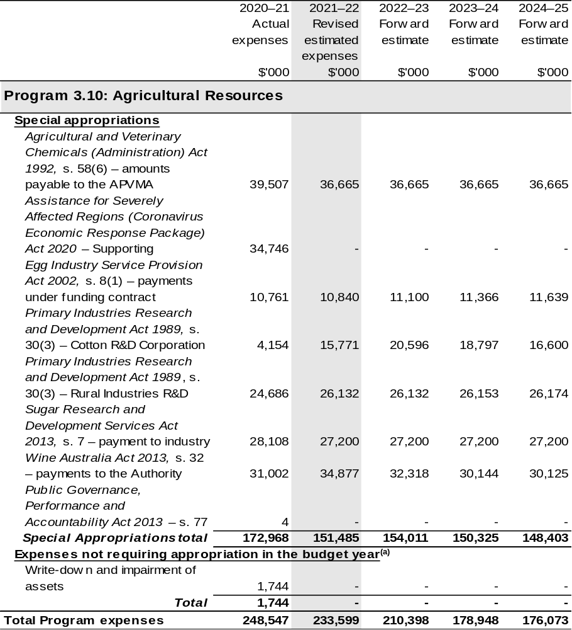
Continued on following pages
Table 2.4: Budgeted Expenses for Outcome 3 (continued)
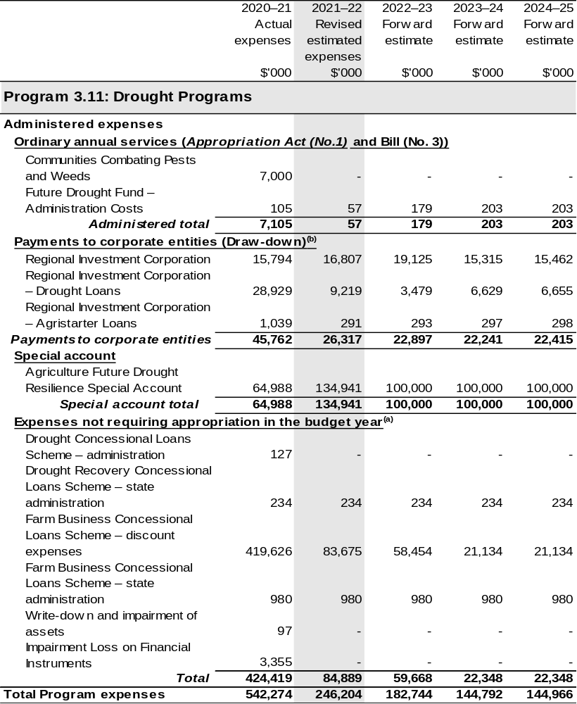
Continued on following pages

Table 2.4: Budgeted Expenses for Outcome 3 (continued)
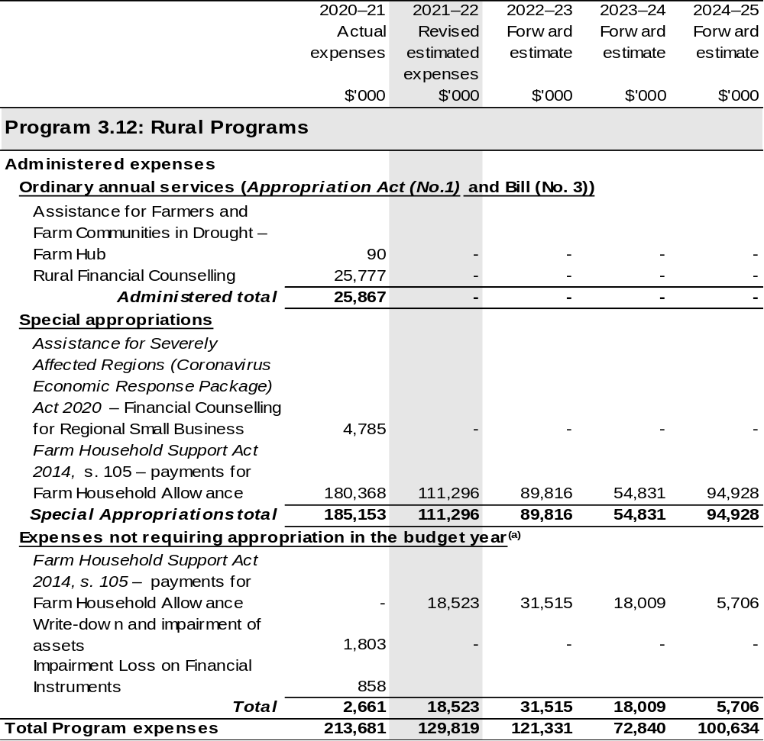
Continued on following pages

Table 2.4: Budgeted Expenses for Outcome 3 (continued)
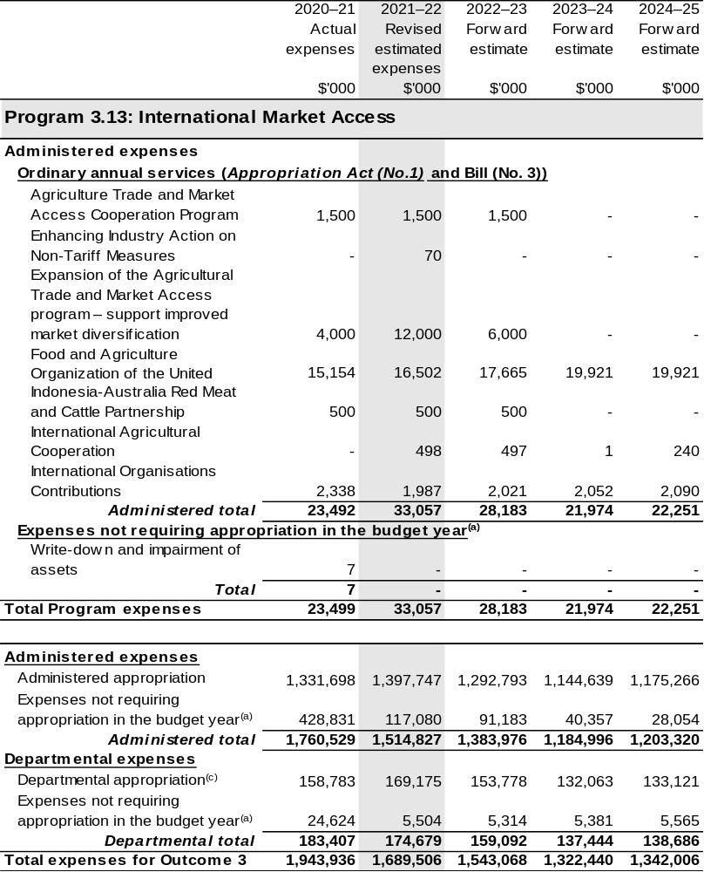
Continued on following pages

Table 2.4: Budgeted Expenses for Outcome 3 (continued)
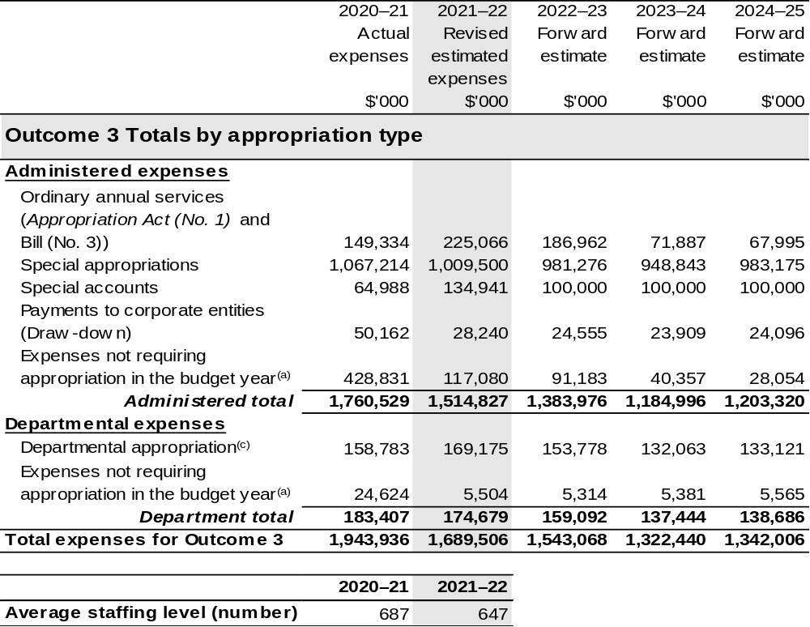
(a) ‘Expenses not requiring appropriation in the Budget year’ are made up of depreciation and amortisation expenses, resources received free of charge, concessional loan discount and balance sheet adjustments.
(b) APVMA and RIC are CCEs under the PGPA Act and do not receive direct appropriations. Instead, their funding passes through the department and is drawn-down on their behalf.
(c) Departmental appropriation allocations are notional and reflect the current structure of the department. Expenses funded from both ‘Ordinary annual services Appropriation Act (No. 1) and Appropriation
Bill (No. 3) and ‘External Revenue’ under section 74 of the PGPA Act.

Note: Departmental appropriation splits and totals are indicative estimates and may change in the course of the budget year as Government priorities change.

Continued on following page

Table 2.4: Budgeted Expenses for Outcome 3 (continued)
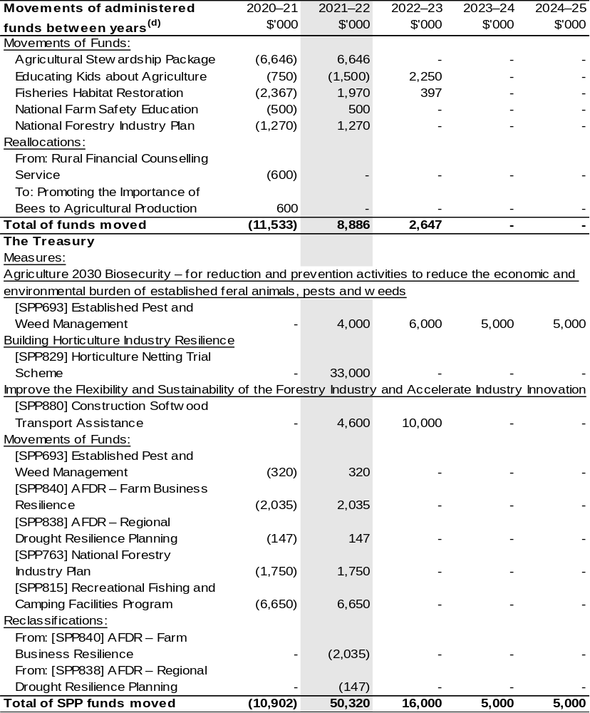
(d) Figures displayed as a negative (-) represent a decrease in funds and a positive (+) represent an
increase in funds.

2.5 Budgeted expenses and performance for outcome 4

2.5.1: Linked programs
There have been no changes to linked programs for Outcome 4 since the 2021–22 Portfolio Budget Statements.

2.5.2: Performance criteria
There have been no changes to performance criteria for Outcome 4 since the 2021–22 Portfolio Budget Statements.

2.5.3 Budgeted expenses
Table 2.5 (below) shows how much the entity intends to spend (on an accrual basis) on achieving the outcome, broken down by program, as well as by Administered and Departmental funding sources.

Table 2.5: Budgeted Expenses for Outcome 4
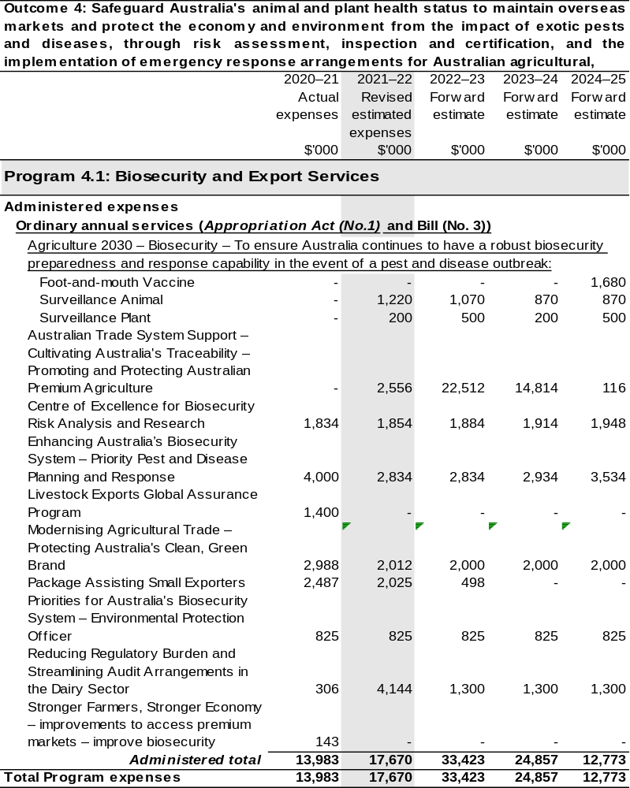
Continued on following pages
Table 2.5: Budgeted Expenses for Outcome 4 (continued)
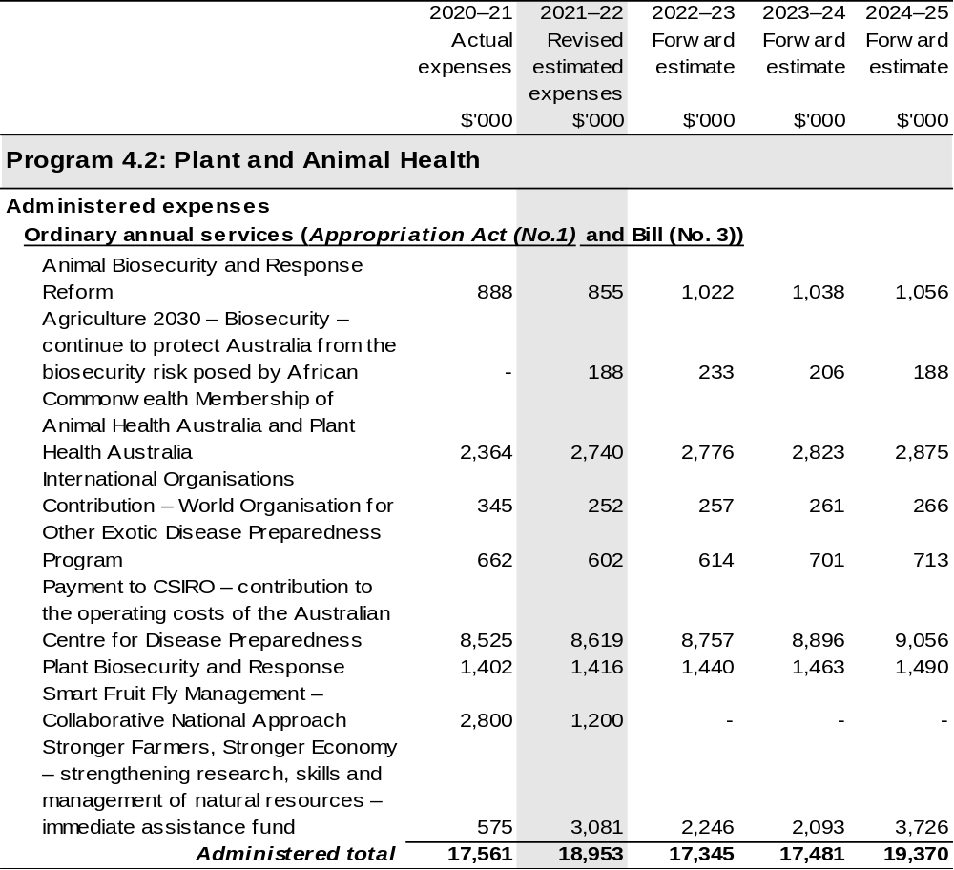
Continued on following pages
Table 2.5: Budgeted Expenses for Outcome 4 (continued)
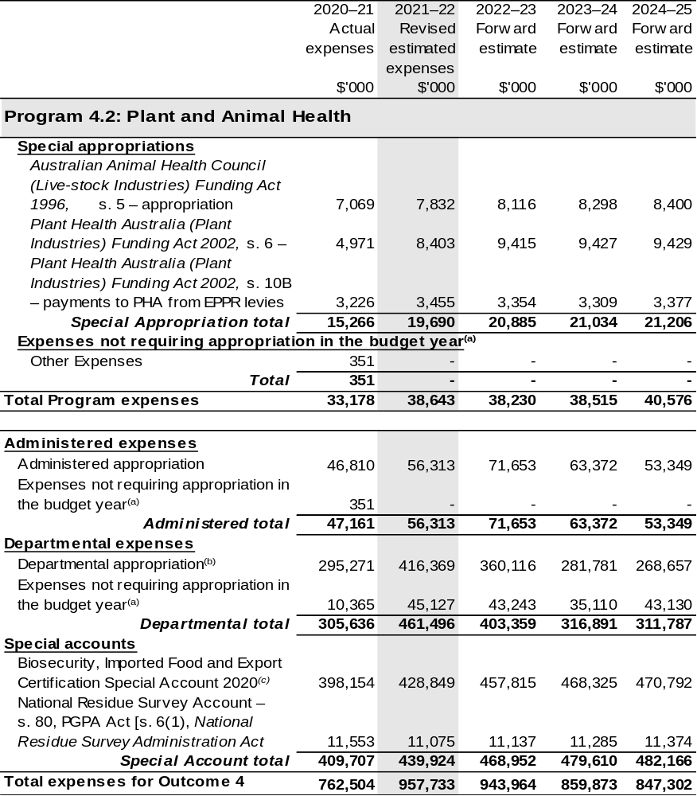
Continued on following pages
Table 2.5: Budgeted Expenses for Outcome 4 (continued)
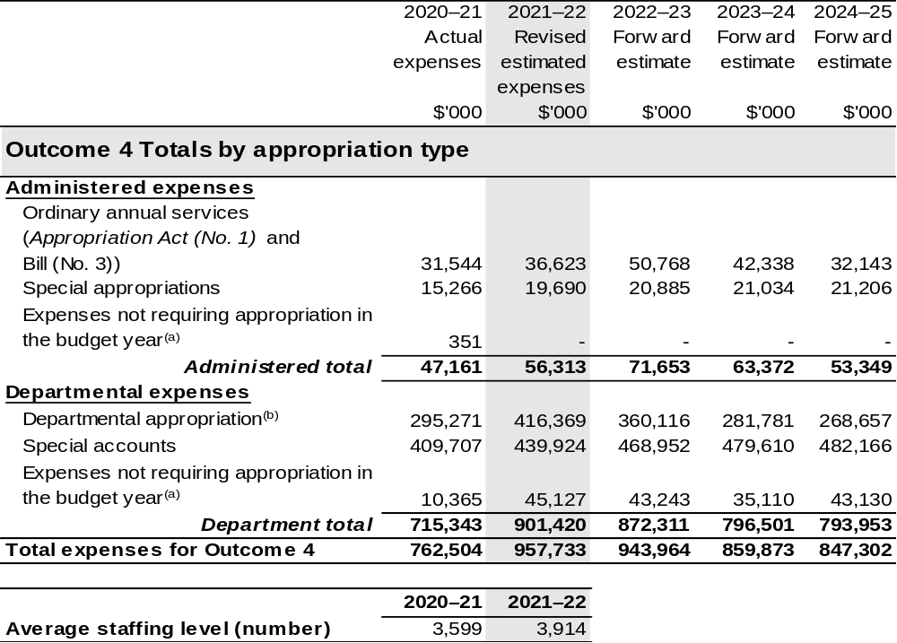
(a) ‘Expenses not requiring appropriation in the Budget year’ are made up of depreciation and amortisation
expenses, resources received free of charge and balance sheet adjustments.
(b) Departmental appropriation allocations are notional and reflect the current structure of the department. Expenses funded from both ‘Ordinary annual services Appropriation Act (No. 1) and Appropriation
Bill (No. 3) and ‘External Revenue’ under section 74 of the PGPA Act.
(c) The Biosecurity, Imported Food and Export Certification Special Account was formerly known as the Australian Quarantine and Inspection Service Special Account.

Note: Departmental appropriation splits and totals are indicative estimates and may change in the course of the budget year as Government priorities change.

Continued on following pages

Table 2.5: Budgeted Expenses for Outcome 4 (continued)
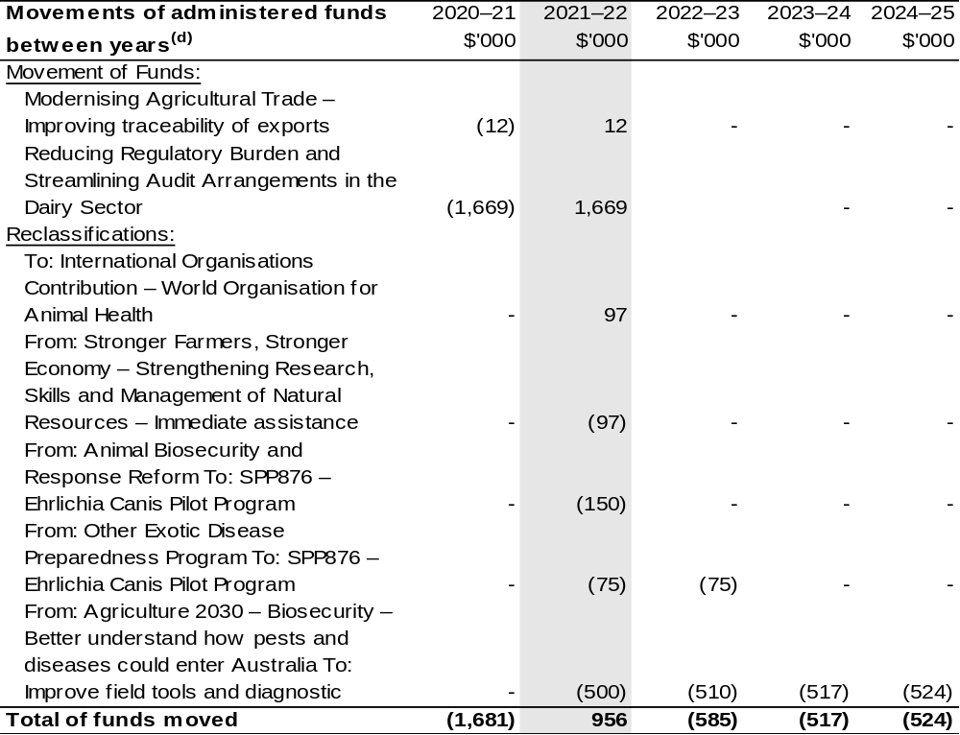
Continued on following page

Table 2.5: Budgeted Expenses for Outcome 4 (continued)
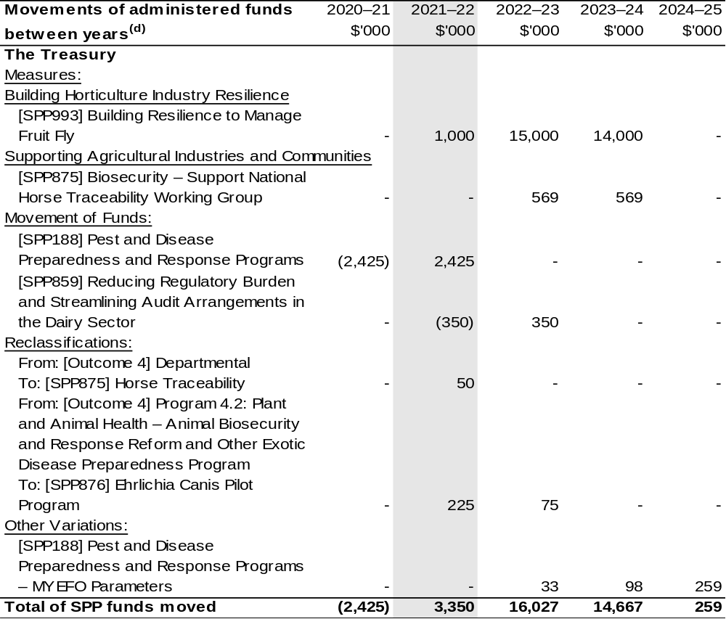
(d) Figures displayed as a negative (-) represent a decrease in funds and a positive (+) represent an increase in funds.

2.6 Budgeted expenses and performance for outcome 5

2.6.1: Linked programs
There have been no changes to linked programs for Outcome 5 since the 2021–22 Portfolio Budget Statements.

2.6.2: Performance criteria
There have been no changes to performance criteria for Outcome 5 since the 2021–22 Portfolio Budget Statements.

2.6.3: Budgeted expenses
Table 2.6 (below) shows how much the entity intends to spend (on an accrual basis) on achieving the outcome, broken down by program, as well as by Administered and Departmental funding sources.

Table 2.6: Budgeted Expenses for Outcome 5
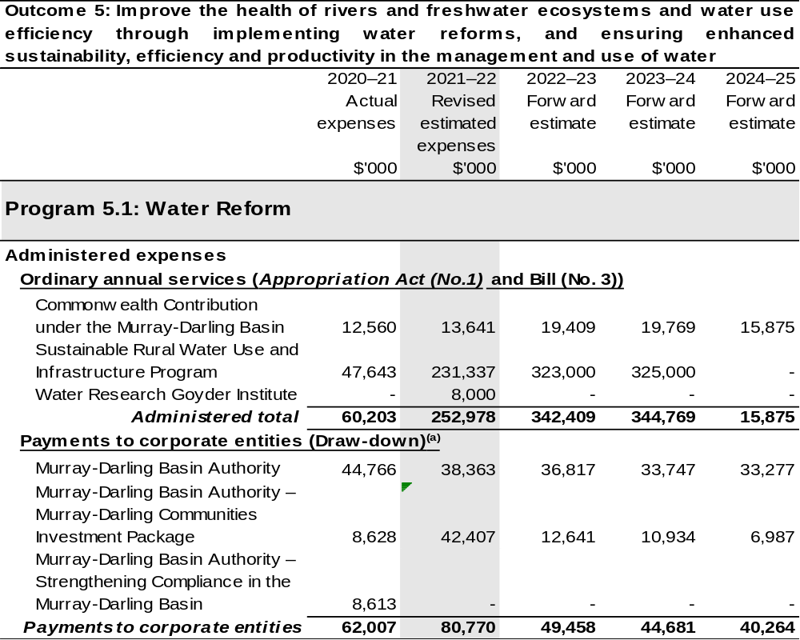
Continued on following pages
Table 2.6: Budgeted Expenses for Outcome 5 (continued)
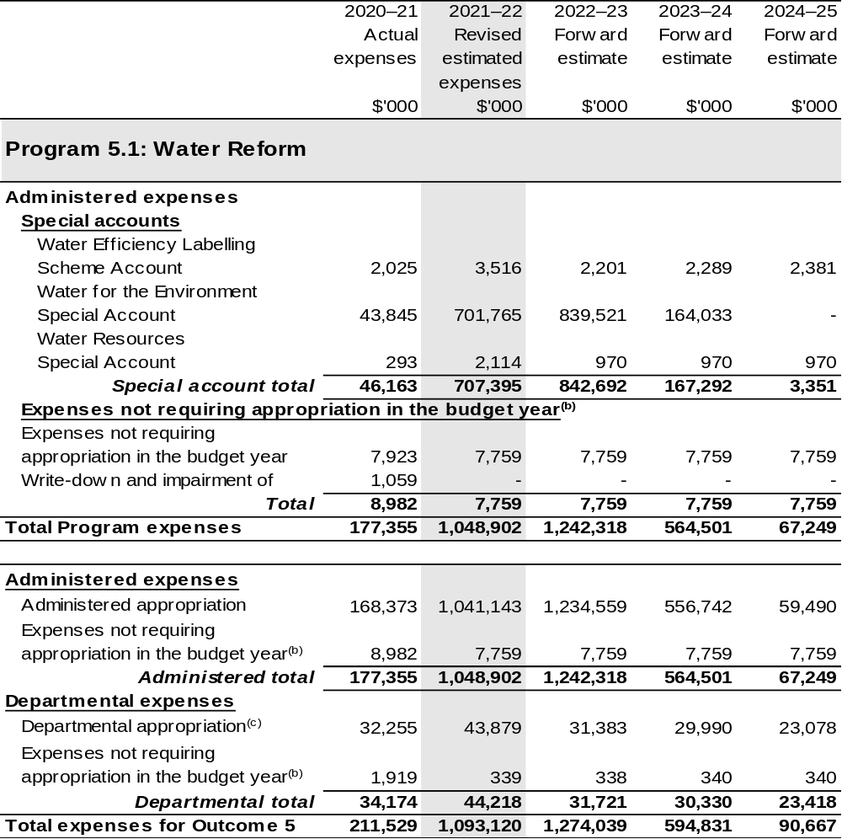
Continued on following pages
Table 2.6: Budgeted Expenses for Outcome 5 (continued)
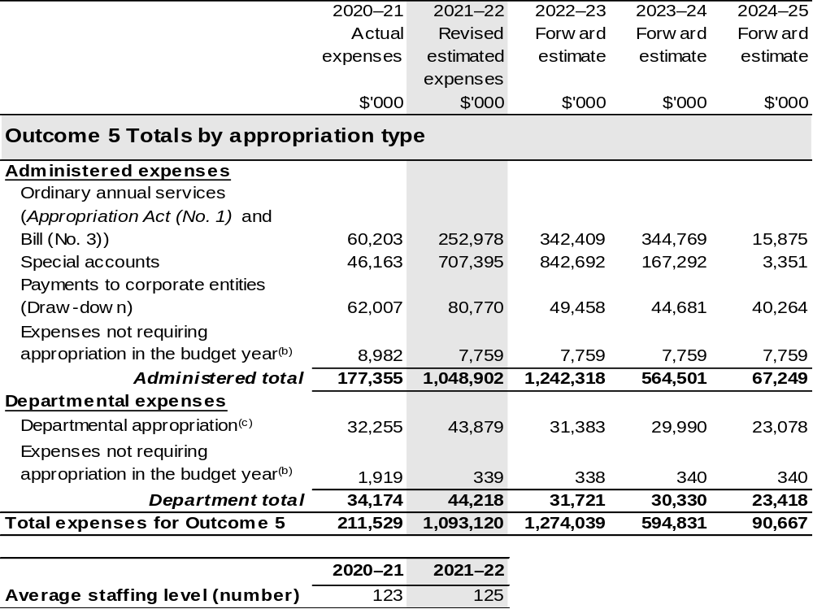
(a) The MDBA is a CCE under the PGPA Act and do not receive direct appropriations. Instead, their funding passes through the department and is drawn-down on their behalf.
(b) ‘Expenses not requiring appropriation in the Budget year’ are made up of depreciation and amortisation
expenses, resources received free of charge and balance sheet adjustments.
(c) Departmental appropriation allocations are notional and reflect the current structure of the department. Expenses funded from both ‘Ordinary annual services Appropriation Act (No. 1) and Appropriation
Bill (No. 3) and ‘External Revenue’ under section 74 of the PGPA Act.

Note: Departmental appropriation splits and totals are indicative estimates and may change in the course of the budget year as Government priorities change.

Continued on following page

Table 2.6: Budgeted Expenses for Outcome 5 (continued)
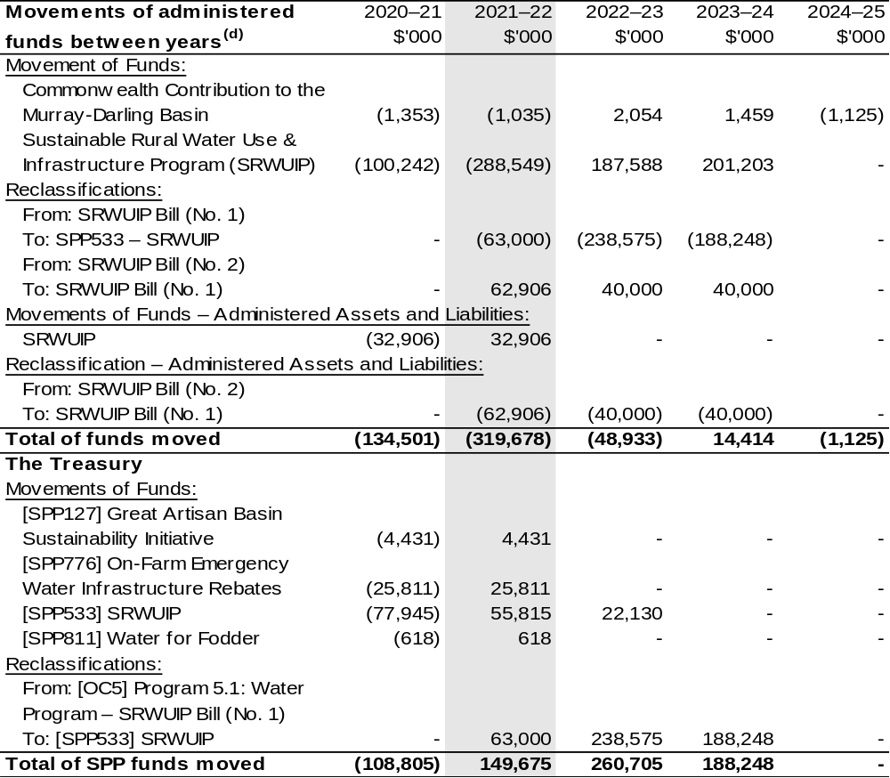
(d) Figures displayed as a negative (-) represent a decrease in funds and a positive (+) represent an
increase in funds.

Section 3: Special account flows and budgeted financial Statements

3.1 Special account flows
Estimates of special account flows

Special accounts provide a means to set aside and record amounts used for specified purposes. Table 3.1 shows the expected additions (receipts) and reductions (payments) for each account used by the Department of Agriculture, Water and the Environment.

Table 3.1: Estimates of special account flows and balances
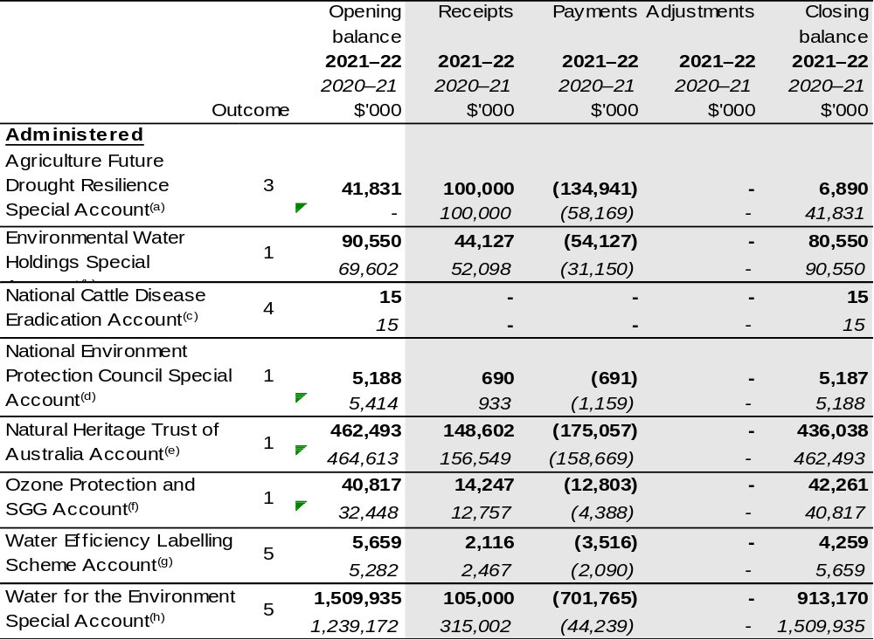

Continued on following pages
Table 3.1: Estimates of special account flows and balances (continued)
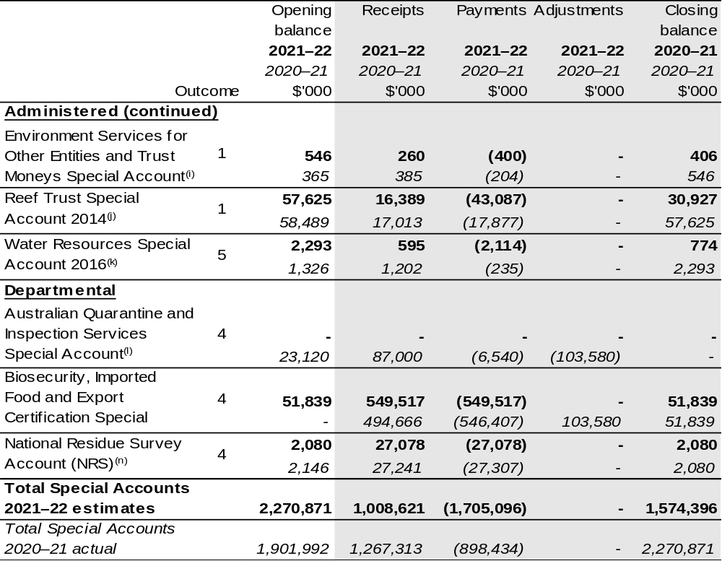

The following Administered special accounts are appropriated under Public Governance, Performance and Accountability Act 2013 section 80.

(a) Agriculture Future Drought Resilience Special Account – Establishing Instrument: Future Drought Fund Act 2019, section 33. Purpose: of making payments associated with projects, research, advice, service and technology that will work towards achieving drought resilience.
(b) Environmental Water Holdings Special Account – Establishing Instrument: Water Act 2007, section 111. Purpose: of performing the functions of the Commonwealth Environment Water Holder. The expenses of administering the Account to not include the cost of salaries of the Commonwealth Environmental Water Holder or the staff referred to in section 116.
(c) National Cattle Disease Eradication Account – Establishing Instrument: National Cattle Disease Eradication Act 1991, section 4. Purpose: of the eradication of any disease of cattle that endemic in Australia. For the year ended 30 June 2021, the total balance carried to the next period was $15 161 (2020: $15 161). There were no transactions debited or credited to the account during the current or prior reporting period.
(d) National Environment Protection Council (NEPC) Special Account – Establishing Instrument: National Environment Protection Council Act 1994; section 53. Purpose: of performing the functions of the NEPC Council and the CEPC committee.
(e) Natural Heritage Trust of Australia Account – Establishing Instrument: Natural Heritage Trust of Australia Act 1997 (NHT Act) section 4. Purpose: of administering environmental protection, supporting sustainable and natural resources management projects as specified by the NHT Act. In accordance with section 42 of the NHT Act, the department has ensured that the balance of the account has not fallen below the base amount.
(f) Ozone Protection and SGG Account – Establishing Instrument: Ozone Protection and Synthetic Greenhouse Gas Management Act 1989, section 65B. Purpose: of administering ozone protection and synthetic greenhouse gas regulations and research and the National Halon Bank.

Continued on following pages

(g) Water Efficiency Labelling and Scheme (WELS) Account – Establishing Instrument: Water Efficiency Labelling and Standards Act 2005 section 64. Purpose: Conserving water by reducing demand through the provision of water efficiency information about water-using products and promoting the adoption of efficient water-saving techniques.
(h) Water for the Environment Special Account – Establishing Instrument: Water Act 2007 section 86AB. Purpose: Improving the water efficiency of irrigation infrastructure and improving delivery and storage of environmental water supply within the Murray-Darling Basin.

Note:
Building Australia Fund (BAF) Water Portfolio Special Account – Establishing Instrument: National-building Funds Act 2008: Section 82. Purpose: making payments in relation to the creation or development of water infrastructure. For the year ended 30 June 2021, the account had a nil balance and there were no transactions debited or credited to it during the current or prior period. The special account was repealed on 12 December 2019.
Natural Resources Management – Establishing Instrument: Natural Resources Management (Financial Assistance) Act 1992 section 11. Purpose: Granting financial assistance in connection with projects relating to natural resources management. For the year ended 30 June 2021, the account had a nil balance and there were no transactions debited or credited to it during the current or prior reporting period.

The following Administered special accounts are appropriated under Public Governance, Performance and Accountability Act 2013 section 78.

(i) Environment Services for Other Entities and Trust Moneys (SOETM) Special Account 2020 – Establishing Instrument: Public Governance, PGPA Act Determination (Environment SOETM Special Account 2020). Purpose: for the disbursement of amounts held in trust or otherwise for the benefit of a person other than the Commonwealth and for services relating to other governments and bodies including Commonwealth Entities. The new account commenced on 9 April 2020. An amount equal to the closing balance of the old special account was credited into this new special account. The closing balance represents the amounts held in trust.
(j) Reef Trust Special Account 2014 – Establishing Instrument: PGPA Act, Reef Trust Special Account 2014) Determination 01]. Purpose: of improving water quality and the coastal habitat, addressing threats to the environment and protecting, repairing or mitigating damage to the Great Barrier Reef World Heritage Area.
(k) Water Resources Special Account 2016 – Establishing Instrument: PGPA Act (Water Resources Special Account 2016– Establishment) Determination 2016/01. Purpose: of supporting inter-governmental activities relating to water.

Note:
SOETM – Department of the Environment, Water, Heritage and the Arts Special Account – Establishing Instrument: Financial Management and Accountability Determination 2010/02 – Services for Other Entities and Trust Moneys – Department of the Environment, Water, Heritage and the Arts Special Account established 2010. Purpose: for the disbursement of amounts held in trust of otherwise for the benefit of a person other than the Commonwealth and for services relating to other governments and bodies that are not FMA Act agencies. The account was repealed on 9 April 2020. An amount equal of the closing balance was credited to the new special account – Environment SOETM Special Account 2020 on 9 April 2020.

The following Departmental special accounts are appropriated under Public Governance, Performance and Accountability Act 2013 section 78.

(l) Australian Quarantine and Inspection Services Special Account – Establishing Instrument: Financial Management and Accountability Determination 2010/11 – Australian Quarantine and Inspection Service Special Account Established 2010. This special account was repealed on 3 September 2020. An amount equal to the closing balance of this special account was credited into the Biosecurity, Imported Food and Export Certification Special Account 2020 on 3 September 2020. Purpose: For providing quarantine, inspection and certification services for: passengers, cargo, mail, animals, plants and animal or plant products arriving in Australia and agricultural products exported from Australia.

Continued on following page

(m) Biosecurity, Imported Food and Export Certification Special Account 2020 – Establishing Instrument: PGPA Act Determination (Biosecurity, Imported Food and Export Certification Special Account 2020). This special account commenced on 3 September 2020. An amount equal to the closing balance of the Australian Quarantine and Inspection Service Special Account was credited into the new special account on 3 September 2020. Purpose: For providing biosecurity, inspection and certification services for: passengers, cargo, mail, animals, plants and animal or plant products arriving in Australian and agricultural products exported from Australia.

The following Departmental special accounts are appropriated under Public Governance, Performance and Accountability Act 2013 section 80.

(n) National Residue Survey Account – Establishing Instrument: National Residue Survey Administration Act 1992; section 6(1). Purpose: For conducting national residue surveys and to provide for the collection of National Residue Survey levy imposed by various acts. The department held $0.016 million in term deposits as a result of investments made under s58 of the PGPA Act. This includes amounts realised and automatically reinvested in term deposits.

3.2 Budgeted financial statements

3.2.1 Analysis of budgeted financial statements
The financial statements incorporate all budget estimate changes since the
2021–22 Portfolio Budget Statements (PBS). An analysis of the primary causes of the movements in the budgeted departmental financial statements and administered schedules is provided in the relevant sections. The 2021–22 PBS is used as the comparative figures in the analysis.

3.2.2 Budgeted comprehensive departmental income statements
Since PBS, estimated revenue from government in 2021–22 has increased by $90.9 million. The increase is mainly due to measures listed in Table 1.2.
The own source revenue estimate in 2021–22 has increased by $23.7 million since PBS, mainly due to higher than anticipated revenue from the department’s cost recovered activities.
The department is budgeting for a $17.2 million operating loss in 2021–22 before unfunded depreciation.
The departmental balance sheet has incorporated the final 2020–21 position as published in the 2020–21 Annual Report.

3.2.3 Schedule of budgeted income and expenses administered on behalf of the Government
It is estimated the department will receive non-appropriation revenue on behalf of government of $554.0 million in 2021–22, an increase of $48.6 million since PBS.
The increase is mainly due to higher than previously estimated grains and wool levy revenues.
Administered expenses are estimated to be $3,252.3 million in 2021–22, a decrease of $101.9 million since PBS. The decrease largely relates to reclassifications of funds and other variations detailed in Table 1.3.

3.2.4 Schedule of budgeted assets and liabilities administered on behalf of the Government
The value of administered net assets as at 30 June 2022 is anticipated to be $4.7 million lower than the estimate published in PBS. The decrease is due in part to recognising a liability for remediation at Jabiru in the 2020-21 financial year.
The schedule of budgeted assets and liabilities administered on behalf of the Government has incorporated the final 2020–21 position as published in the 2020–21 Annual Report.

3.3 Budgeted financial statements tables

Table 3.2: Comprehensive income statement (showing net cost of services) for the period ended 30 June
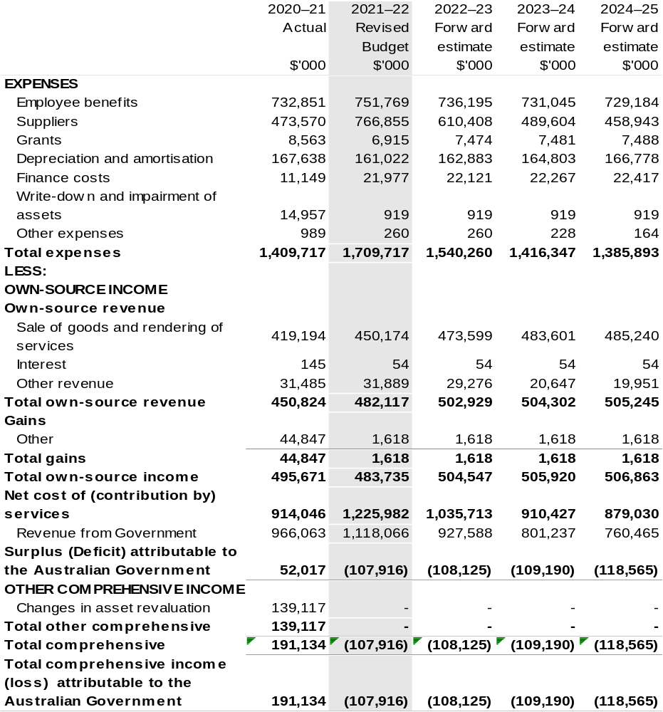

Continued on following page

Table 3.2: Comprehensive income statement (showing net cost of services) for the period ended 30 June (continued)
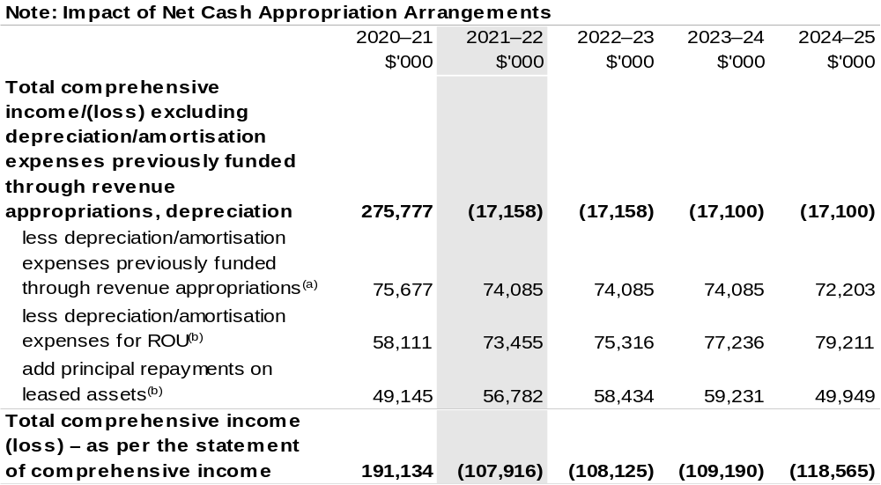

(a) From 2010–11, the Government introduced net cash appropriation arrangements where Appropriation Act (No. 1) or Bill (No. 3) revenue appropriations for the depreciation/amortisation expenses of
non-Corporate Commonwealth Entities were replaced with a separate capital budget (the Departmental Capital Budget, or DCB) provided through Appropriation Act (No. 1) or Bill (No. 3) equity appropriations. For information regarding DCBs, please refer to Table 3.6 Departmental Capital Budget Statement.
(b) Applies to leases under AASB 16 Leases. Right of Use (ROU).

Prepared on Australian Accounting Standards basis.

Table 3.3: Budgeted departmental balance sheet (as at 30 June)
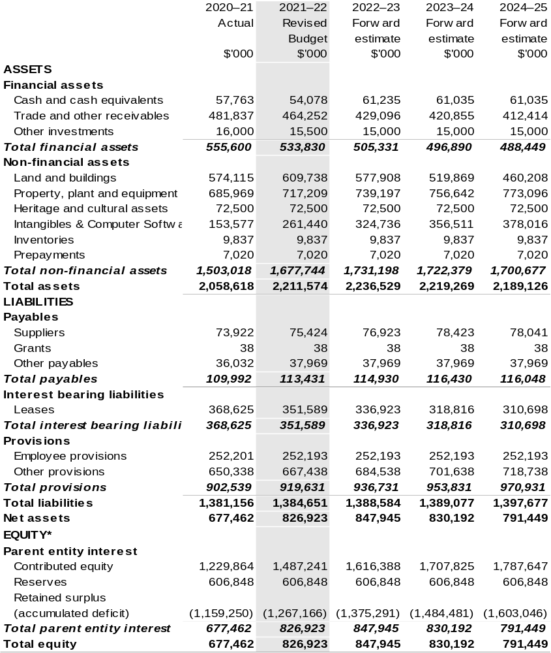
*‘Equity’ is the residual interest in assets after deduction of liabilities.

Prepared on Australian Accounting Standards basis.

Table 3.4: Departmental statement of changes in equity — summary of movement (Budget year 2021–22)
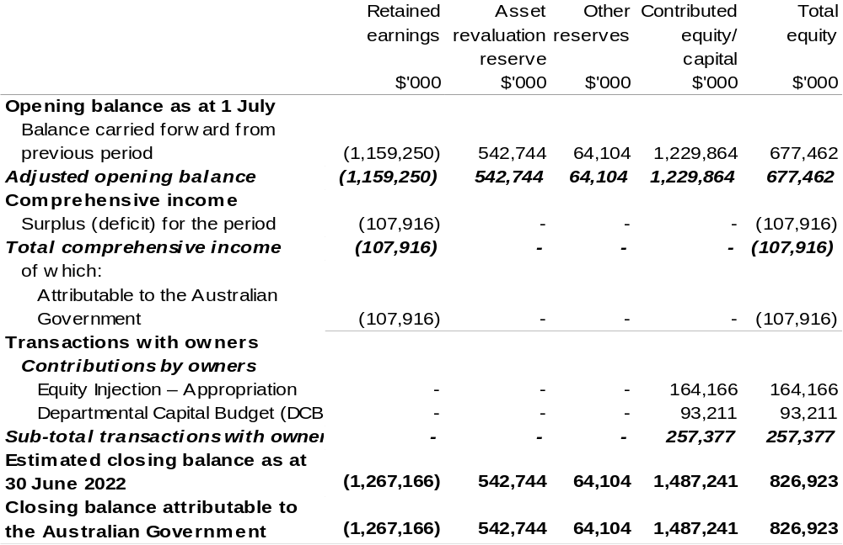

Prepared on Australian Accounting Standards basis.

Table 3.5: Budgeted departmental statement of cash flows (for the period ended 30 June)
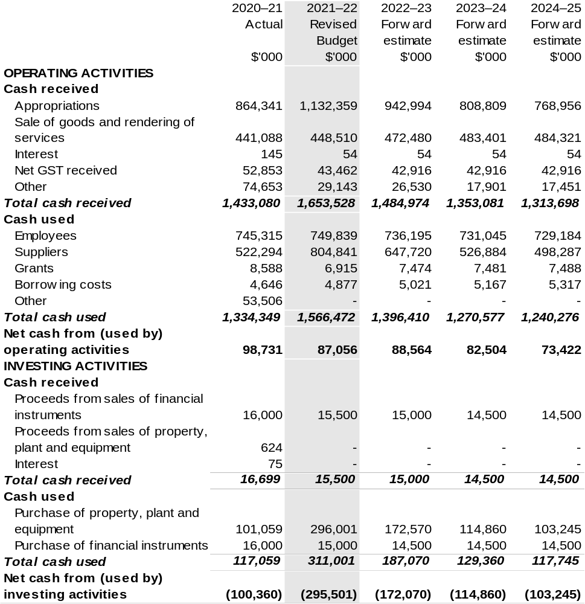
Continued on following page

Table 3.5: Budgeted departmental statement of cash flows (for the period ended 30 June) (continued)
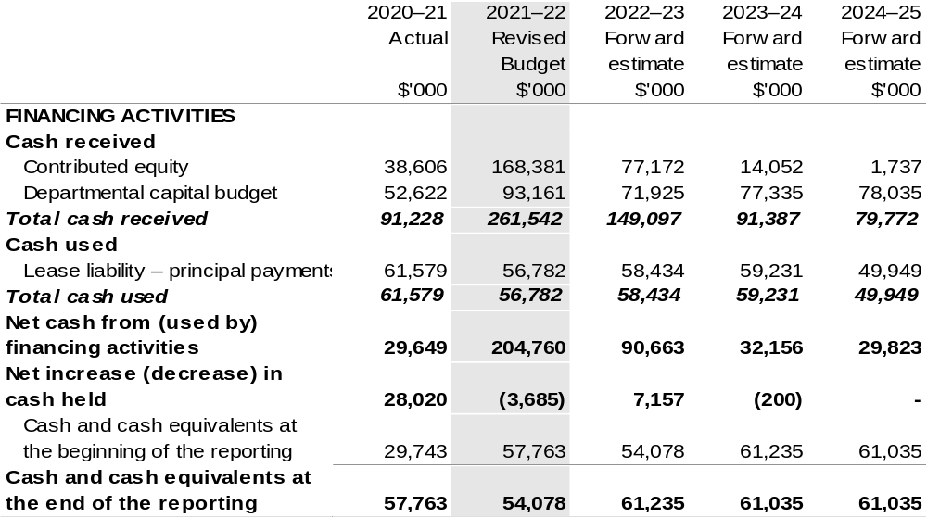
Prepared on Australian Accounting Standards basis.

Table 3.6: Departmental capital budget statement (for the period ended 30 June)
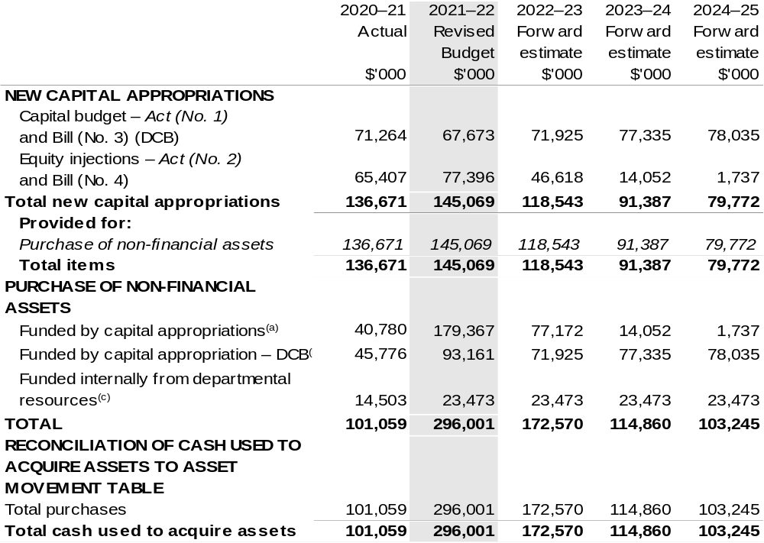

(a) Includes both current Act (No. 2) 2021–22, Bill (No. 4) 2021–22 and prior year Act (No. 2/4/6) appropriations.
(b) Does not include annual finance lease costs. Includes purchases from current and previous years’ Departmental Capital Budgets.
(c) Includes the following sources of funding:
– current Act (No. 1) 2021–22, Bill (No. 3) 2021–22 and prior year Act (No. 1/3/5) appropriations (excluding amounts from the DCB).
- internally developed assets;
- section 74 external revenue; and
- proceeds from the sale of assets.

Consistent with information contained in the Statement of Asset Movements and the Budgeted Statement of Cash Flows.

Prepared on Australian Accounting Standards basis.

Table 3.7: Statement of asset movements (2021–22 Budget year)
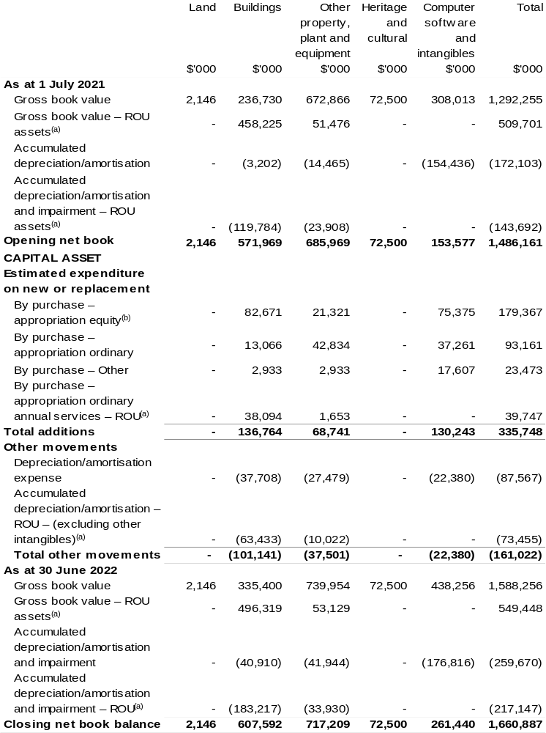
(a) Applies to leases under AASB 16 Leases. Right of Use (ROU).
(b) ‘Appropriation equity’ refers to equity injections, appropriations provided through Act (No. 2) and
Bill (No. 4) 2021–22 appropriation.
(c) ‘Appropriation ordinary annual services’ refers to funding provided through` Act (No. 1) and Bill (No. 3) 2021–22 appropriation for depreciation / amortisation expenses, DCBs or other operational expenses.
Prepared on Australian Accounting Standards basis.

Table 3.8: Schedule of budgeted income and expenses administered on behalf of Government (for the period ended 30 June)
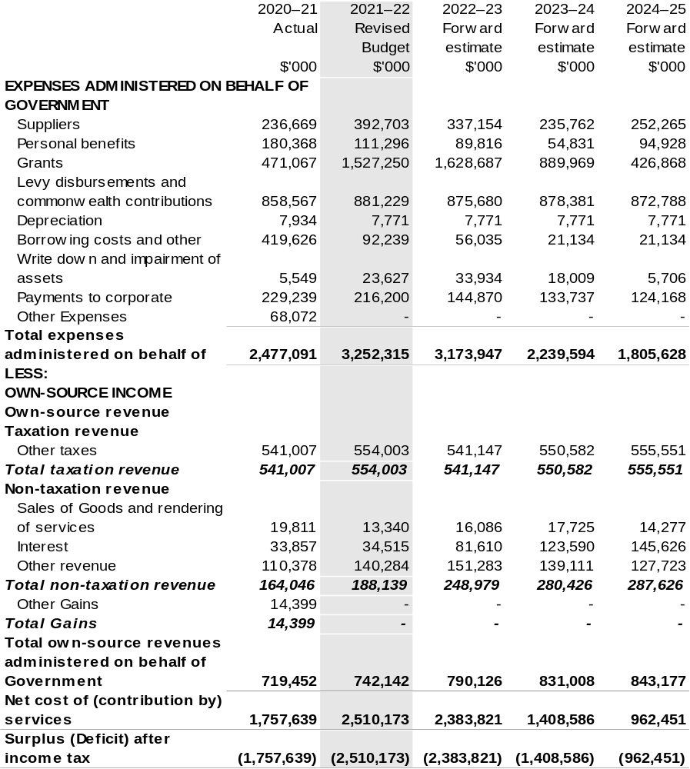
Continued on following page

Table 3.8: Schedule of budgeted income and expenses administered on behalf of Government (for the period ended 30 June) (continued) 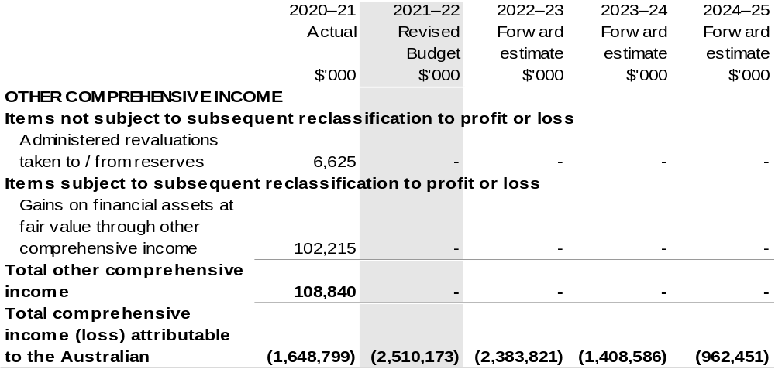
Prepared on Australian Accounting Standards basis.

Table 3.9: Schedule of budgeted assets and liabilities administered on behalf of Government (as at 30 June)
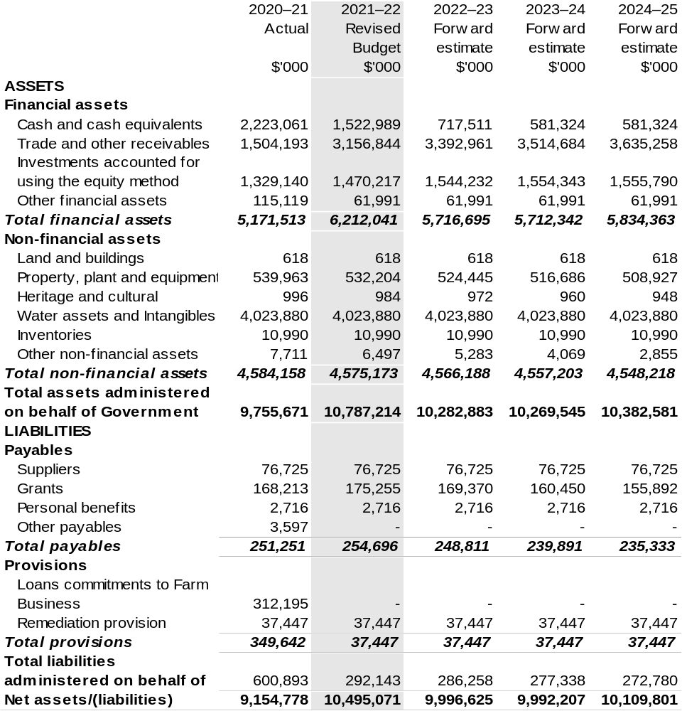
Prepared on Australian Accounting Standards basis.

Table 3.10: Schedule of budgeted administered cash flows (for the period ended 30 June)
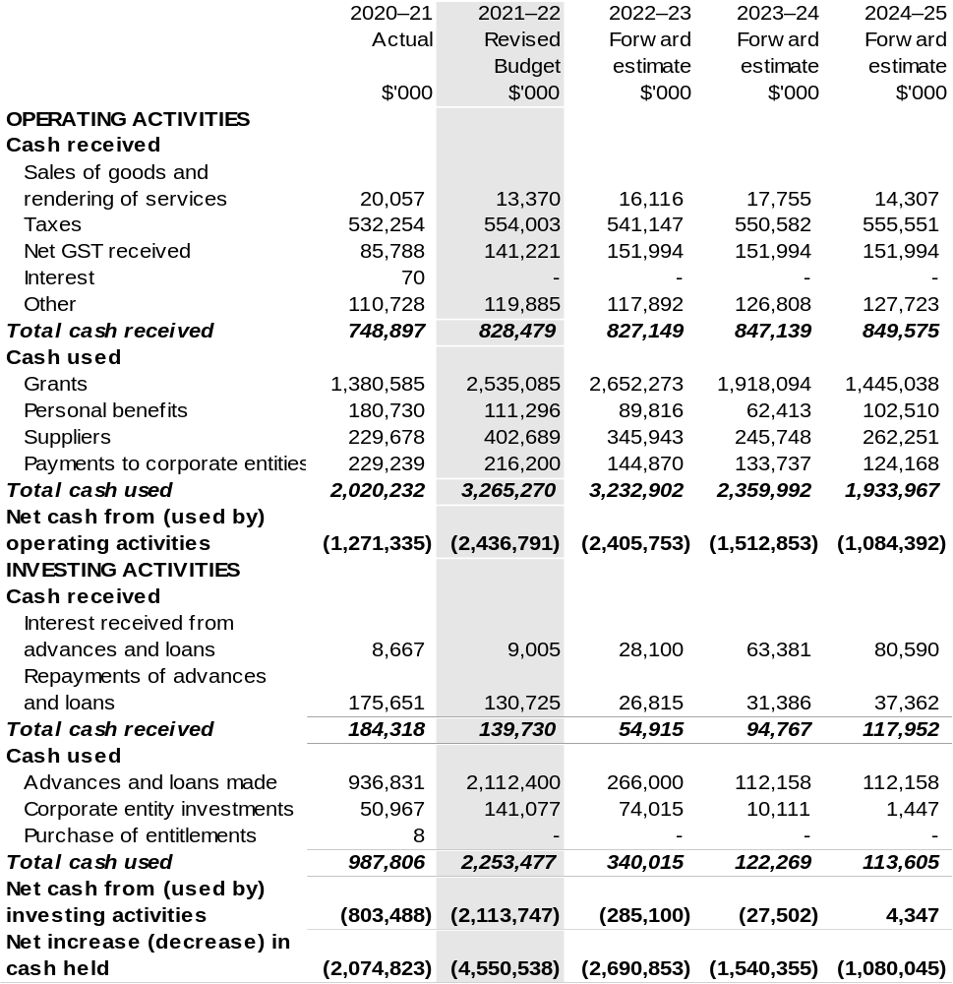
Continued on following page

Table 3.10: Schedule of budgeted administered cash flows (for the period ended 30 June) (continued)
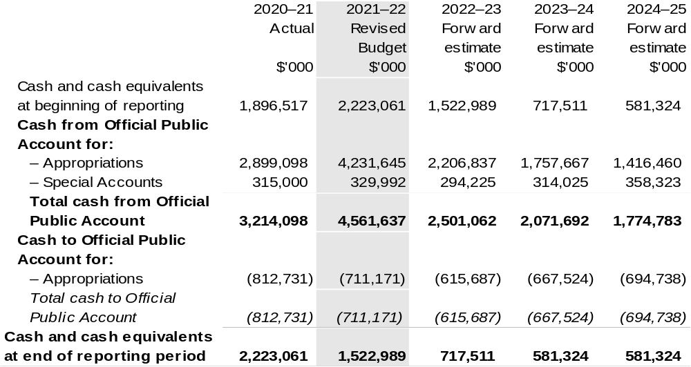

Prepared on Australian Accounting Standards basis.

Table 3.11: Schedule of administered capital budget (for the period ended 30 June)
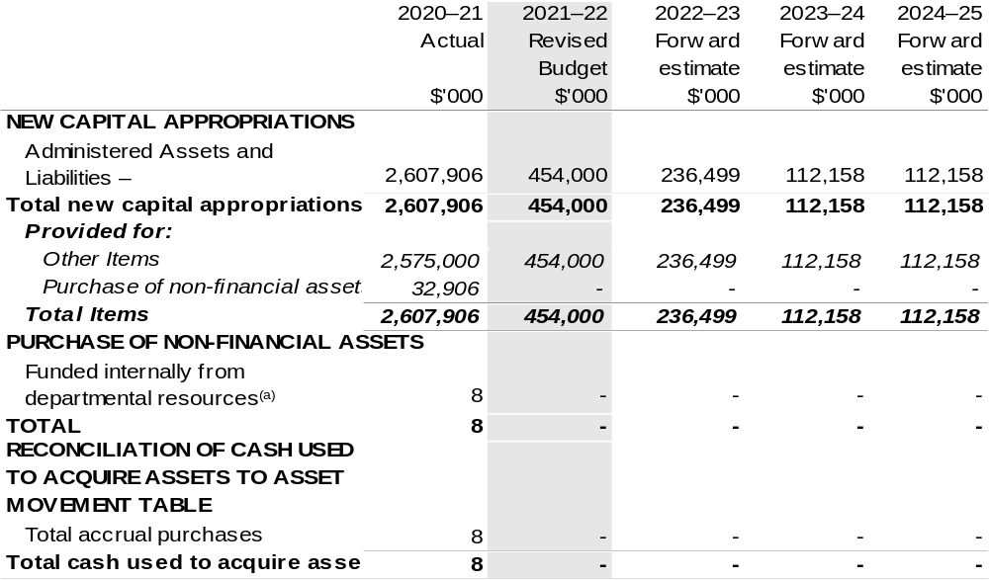
(a) Includes both current Act (No. 2) 2021–22, Bill (No. 4) 2021–22, prior Act (No. 2/4/6) appropriations and capital appropriations.

Prepared on Australian Accounting Standards basis.

Table 3.12: Statement of administered asset movements (2021–22 Budget year)
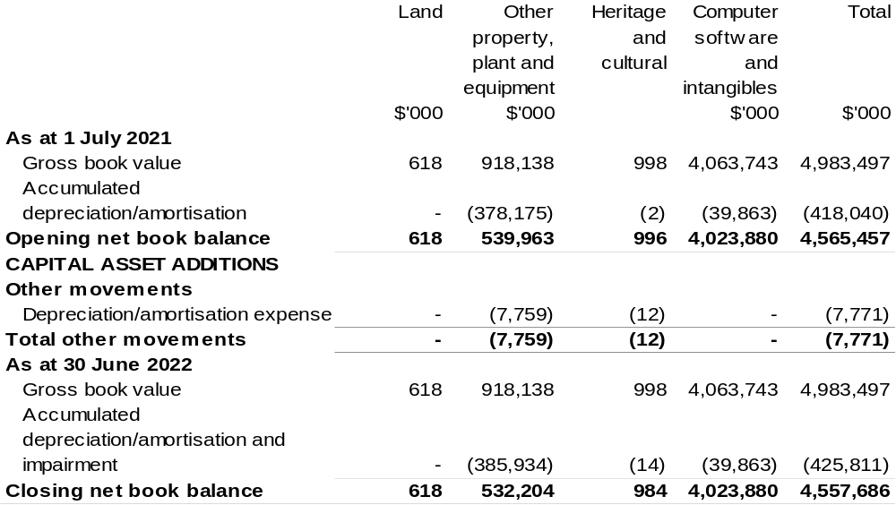
Prepared on Australian Accounting Standards basis.
Bureau Of Meteorology
Section 1: Entity overview and resources 105
1.1 Strategic direction statement 105
1.2 Entity resource statement 106
1.3 Entity measures 108
1.4 Additional estimates, resourcing, and variations to outcomes 109
1.5 Breakdown of additional estimates by Appropriation Bill 110
Section 2: Revisions to outcome and planned performance 111
2.1 Changes to outcome and program structures 111
2.2 Budgeted expenses and performance for Outcome 1 111
Section 3: Special account flow and budgeted financial statements 113
3.1 Special account flows 113
3.2 Budgeted financial statements 114
3.3 Budgeted financial statements tables 115

Bureau Of Meteorology

Section 1: Entity overview and resources

1.1 Strategic direction statement
There have been no changes to the entity’s strategic direction statement since the
2021–22 Portfolio Budget Statements.

1.2 Entity resource statement
These tables detail the resourcing for the Bureau of Meteorology (the Bureau) at
2021–22 Additional Estimates. Table 1.1 outlines the total resourcing available from all sources for the 2021–22 Budget year, including variations through Appropriation Bills (No. 3) and (No. 4) 2021–22, Special Appropriations and Special Accounts.

Table 1.1: Bureau of Meteorology – Resource Statement – Additional Estimates for 2021–22 as at February 2022 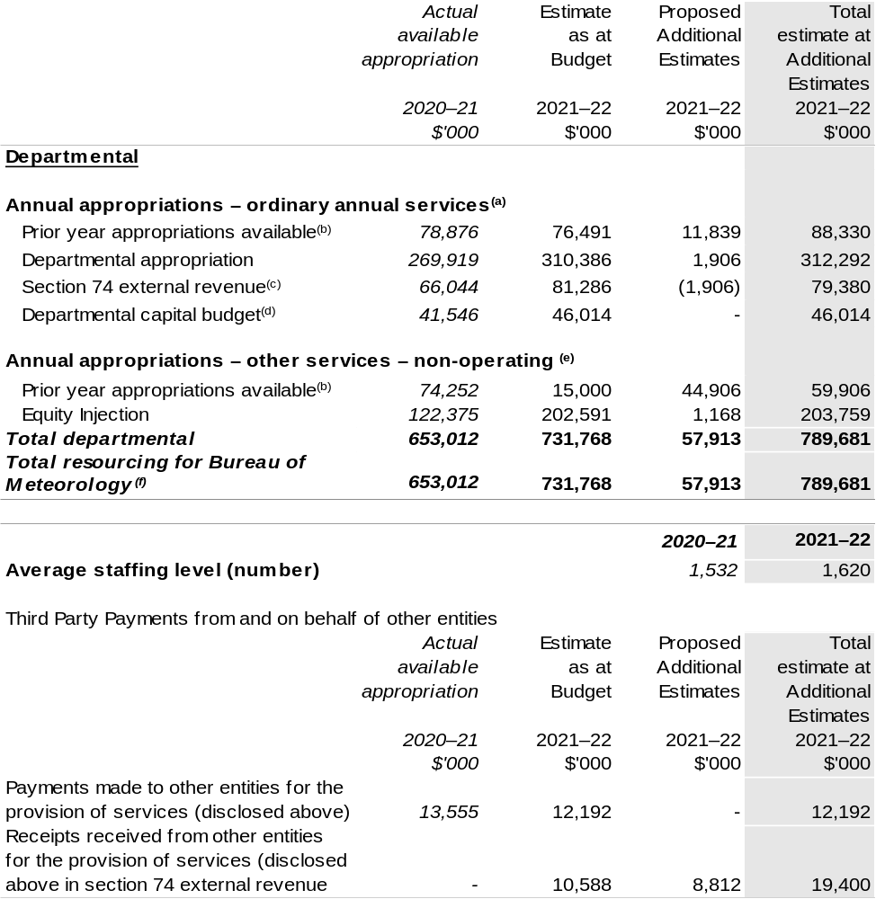
- Appropriation Act (No. 1) 2021–22 and Appropriation Bill (No. 3) 2021–22.
- Excludes $32.037 million subject to administrative quarantine by Finance or withheld under section 51 of the Public Governance, Performance and Accountability Act 2013 (PGPA Act).
- Estimated external revenue receipts under section 74 of the PGPA Act.

Continued on following page
Table 1.1: Bureau of Meteorology – Resource Statement – Additional Estimates for 2021–22 as at February 2022 (continued)

- Departmental capital budgets are not separately identified in Appropriation Act (No. 1) and form part of ordinary annual services items. Please refer to Table 3.6 for further details. For accounting purposes, this amount has been designated as a 'contribution by owner'.
- Appropriation Act (No. 2) 2021–22 and Appropriation Bill (No. 4) 2021–22.
- Excludes trust moneys held in Services for Other Entities and Trust Moneys (SOETM) and other special accounts. For further information on special accounts (excluding amounts held on trust), please see
Table 3.1.

Please note: all figures shown above are GST exclusive – these may not match figures in the cash flow statement.

Prepared on a resourcing (i.e. appropriations available) basis.

1.3 Entity measures
Table 1.2 summarises new Government measures taken since the 2021–22 the Budget.
The table is split into receipt, payment, and capital measures, with the affected programs identified.

Table 1.2: Bureau of Meteorology – measures since 2021–22 Budget t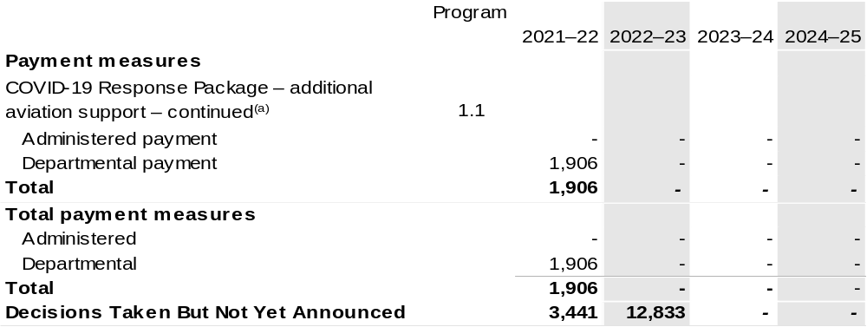

- The lead entity for this measure is the Department of Infrastructure, Transport, Regional Development and Communications. The measure description appears in the December 2021–22 Mid-Year Economic and Fiscal Outlook (MYEFO) under Cross Portfolio.

Prepared on a Government Finance Statistics (Underlying Cash) basis.

1.4 Additional estimates, resourcing and variations to outcomes
The following tables detail changes in resourcing for the Bureau at Additional Estimates, by outcome. The table show variations since the 2021–22 Budget due to new measures (as per Table 1.2) and variations due to other factors, such as movements of funds, reclassifications, reallocations, and adjustments due to the efficiency dividend and changes in economic parameters.

Table 1.3: Additional Estimates and other variations to outcome since 2021–22 Budget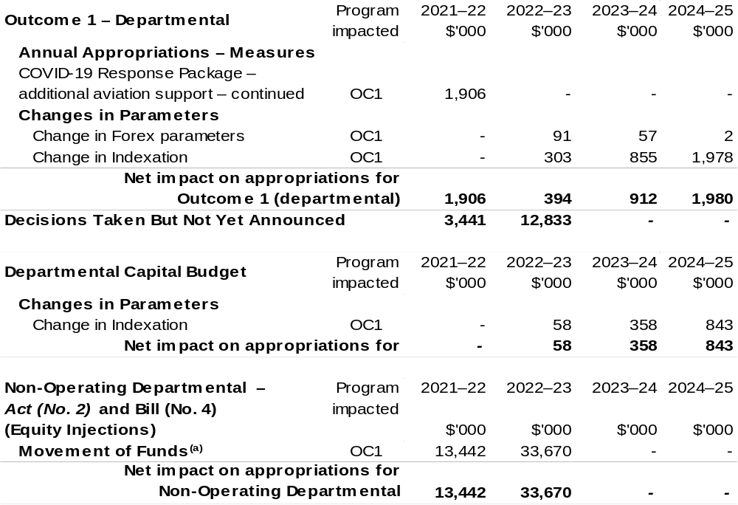

- Total additional Appropriation Bill (No. 4) (equity Injections) for 2021–22 is $1.168 million (refer to
Table 1.5). The difference between the two tables is the inclusion of decisions that provide the authority to draw down from existing appropriation.

Prepared on a resourcing (i.e. appropriations available) basis.

1.5 Breakdown of additional estimates by appropriation bill
The following table shows Additional Estimates sought for the Bureau through Appropriation Bills (No. 3) and (No. 4) 2021–22.

Table 1.4: Appropriation Bill (No. 3) 2021–22 – Departmental
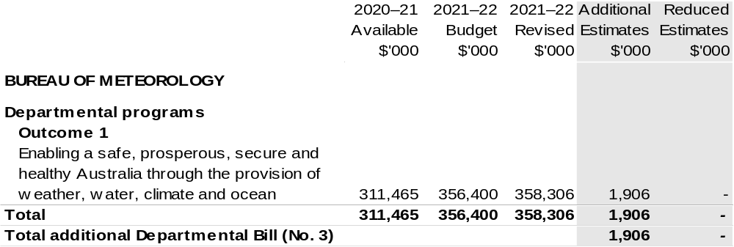

Table 1.5: Appropriation Bill (No. 4) 2021–22
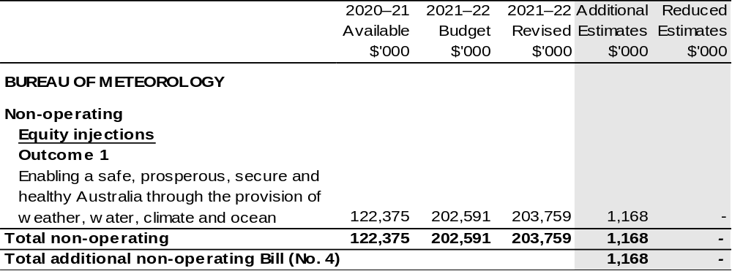

Section 2: Revisions to Outcomes and planned performance

2.1 Changes to outcome and program structures
There have been no changes to the entity’s outcomes and program structure since the 2021–22 Portfolio Budget Statements.

2.2 Budgeted expenses and performance for outcome 1

2.2.1: Linked programs
There have been no changes to linked programs for Outcome 1 since the 2021–22 Portfolio Budget Statements.

2.2.2: Performance criteria
There have been no changes to performance criteria for Outcome 1 since the 2021–22 Portfolio Budget Statements.

2.2.3: Budgeted expenses
Table 2.1 (below) shows how much the entity intends to spend (on an accrual basis) on achieving the outcome, broken down by program, as well as by Administered and Departmental funding sources.
2.2.3: Budgeted expenses (continued)

Table 2.1: Budgeted expenses for Outcome 1
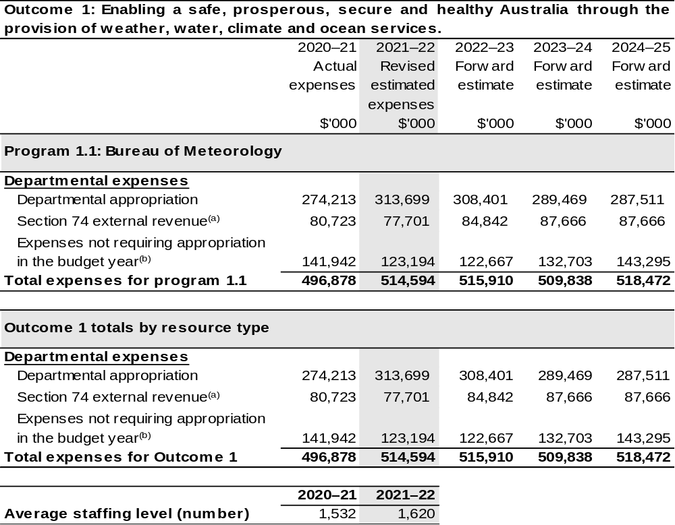
- Estimated expenses incurred in relation to receipts retained under section 74 of the PGPA Act.
- Expenses not requiring appropriation in the Budget year are made up of depreciation expenses, amortisation expenses, make good expenses and audit fees.

Note: Departmental appropriation splits and totals are indicative estimates and may change in the course of the budget year as Government priorities change.

Prepared on Australian Accounting Standards basis.

Section 3: Special account flows and budgeted financial statements

3.1 Special account flows
Estimates of special account flows

Special Accounts provide a means to set aside and record amounts used for specified purposes. Table 3.1 shows the expected additions (receipts) and reductions (payments) for each account used by the Bureau.

Table 3.1: Estimates of special account flows and balances
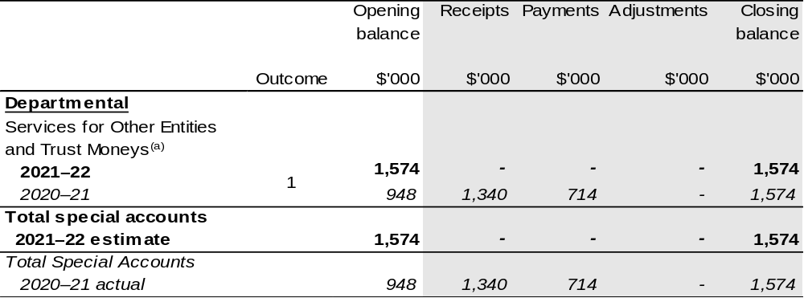
(a) Appropriation: section 78 of the PGPA Act. Establishing Financial Management and Accounting
Determination 2008/06. Purpose: To enable the Bureau to hold and expend amounts on behalf of persons
or entities other than the Commonwealth.

3.2 Budgeted financial statements

3.2.1 Analysis of budgeted financial statements
There are no major changes to the analysis of budgeted financial statements since the 2021–22 Portfolio Budget Statements.

3.2.2: Explanatory notes and analysis of budgeted financial statements
An analysis of the Bureau’s budgeted financial statements, as reflected in the Bureau’s budgeted departmental financial statements and administered schedules for the 2021–22 Additional Estimates, is provided below:
Total revised revenue to the Bureau in 2021–22 is estimated to be $390.4 million, an increase of $46.2 million from the 2020–21 actual result. The movement in funding is the result of:
- funding associated with the 2021–22 Budget measure – Building Australia's Resilience;
- funding associated with the 2021–22 Budget measure – Aviation Meteorology Services Program;
- funding associated with the 2021–22 at Budget Additional Estimates – Additional Aviation Support;
- an increase in revenue associated with cost recoverable projects and services; and
- net funding for economic parameter adjustments offset by efficiency dividends.
Total expenses are estimated to be $514.6 million, an increase of $17.7 million from the 2020–21 actual result.
Whilst the Bureau is no longer funded for depreciation through Appropriation
Bill (No. 1) the expenditure is still recognised on the Income Statement.
3.3 Budgeted financial statements tables

Table 3.2: Comprehensive income statement (showing net cost of services)
(for the period ended 30 June)
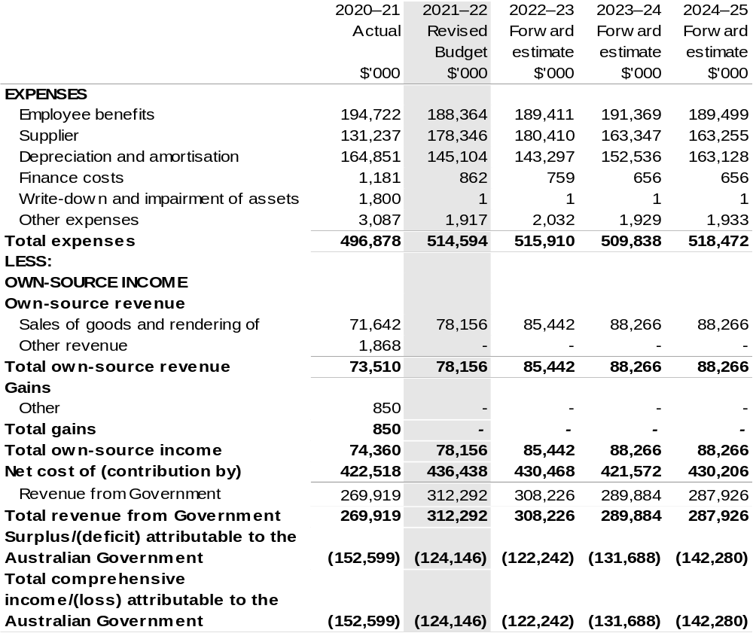
Continued on following page
Table 3.2: Comprehensive income statement (showing net cost of services) (for the period ended 30 June) (continued)
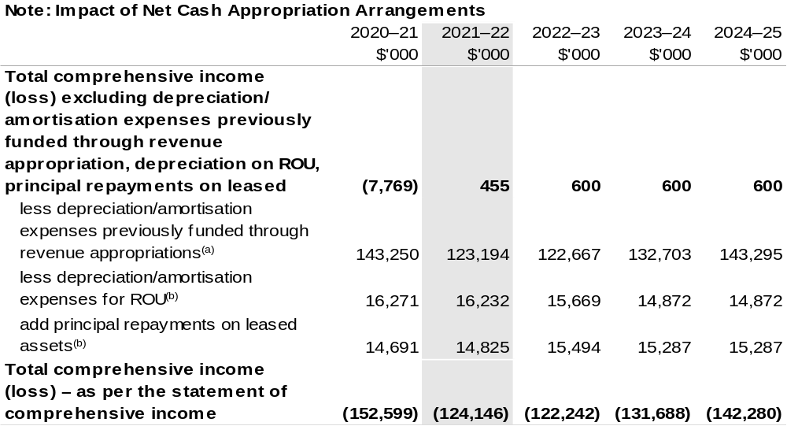
(a) From 2010–11, the Government introduced net cash appropriation arrangements where Appropriation Act (No. 1) or Bill (No. 3) revenue appropriations for the depreciation/amortisation expenses of non-Corporate Commonwealth Entities were replaced with a separate capital budget (the Departmental Capital Budget, or DCB) provided through Appropriation Act (No. 1) or Bill (No. 3) equity appropriations. For information regarding DCBs, please refer to Table 3.6 Departmental Capital Budget Statement.
(b) Applies to leases under AASB 16 Leases. Right of Use (ROU).

Prepared on Australian Accounting Standards basis.

Table 3.3: Budgeted departmental balance sheet (as at 30 June)
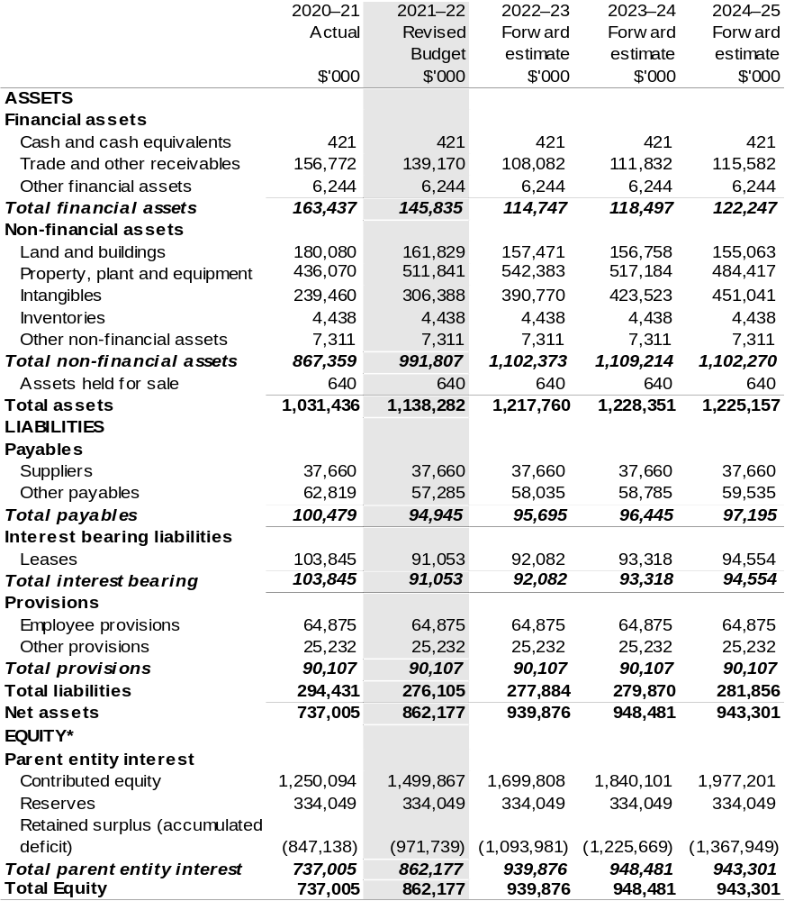
*’Equity’ is the residual interest in assets after deduction of liabilities.

Prepared on Australian Accounting Standards basis.

Table 3.4: Departmental statement of changes in equity—summary of movement (Budget year 2021–22)
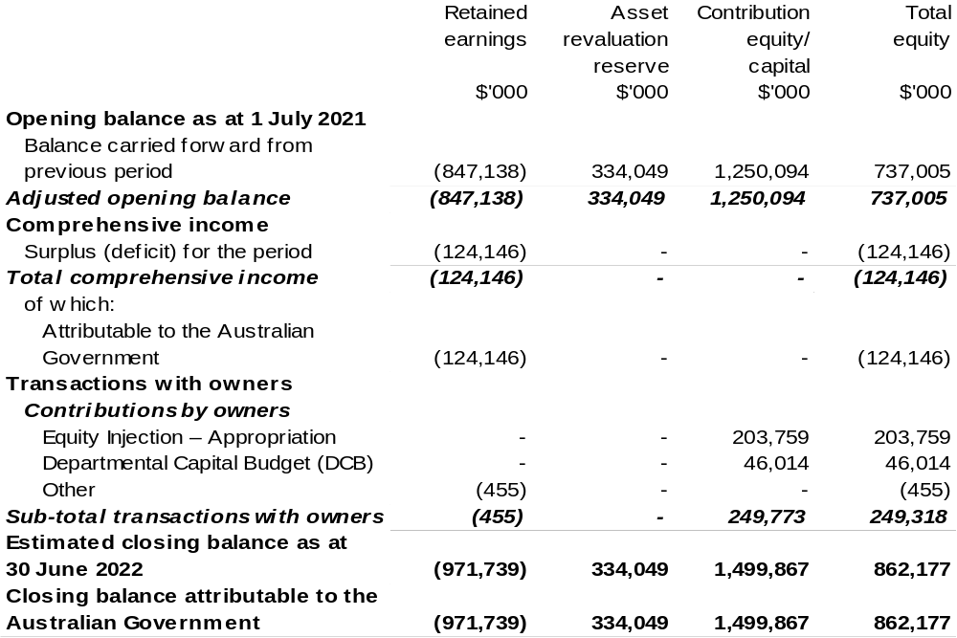
Prepared on Australian Accounting Standards basis.

Table 3.5: Budgeted departmental statement of cash flows (for the period
ended 30 June)
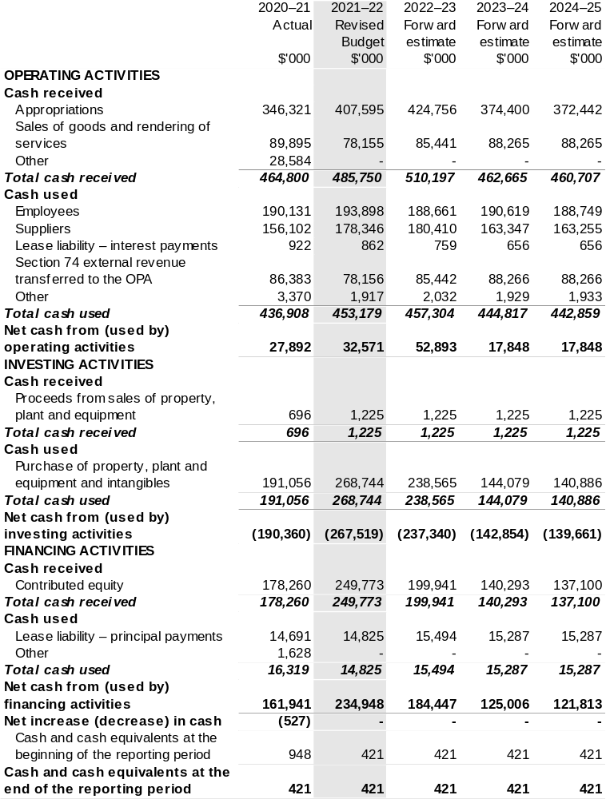
Prepared on Australian Accounting Standards basis.

Table 3.6: Departmental capital budget statement (for the period ended 30 June)
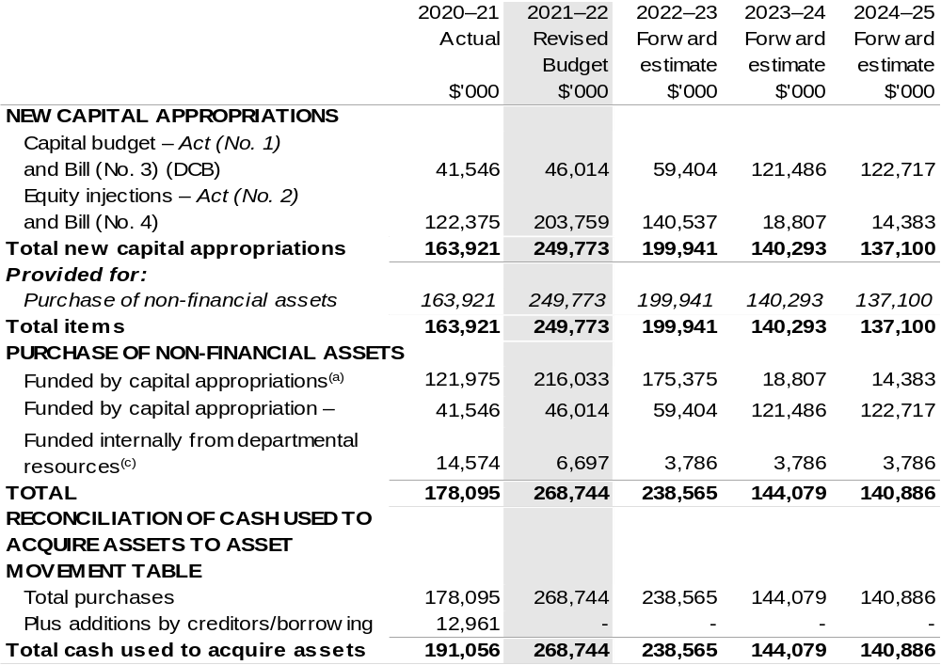
(a) Includes both current Act (No. 2), Bill (No. 4) and prior Act/Bill (No. 2/4/6) appropriation.
(b) Does not include annual finance lease costs. Include purchases from current and previous years'
Departmental Capital Budgets (DCBs).
(c) Includes the following sources of funding:
- current Act (No. 1) 2021–22, Bill (No. 3) 2021–22 and prior year Act (No. 1/3/5) appropriations (excluding amounts from the DCB).
- donations and gifts of non-financial assets;
- internally developed assets;
- section 74 external revenue; and
- proceeds from the sale of assets.

Consistent with information contained in the Statement of Asset Movements and the Budgeted Statement of Cash Flows.

Prepared on Australian Accounting Standards basis.

Table 3.7: Statement of asset movements (Budget year 2021–22)
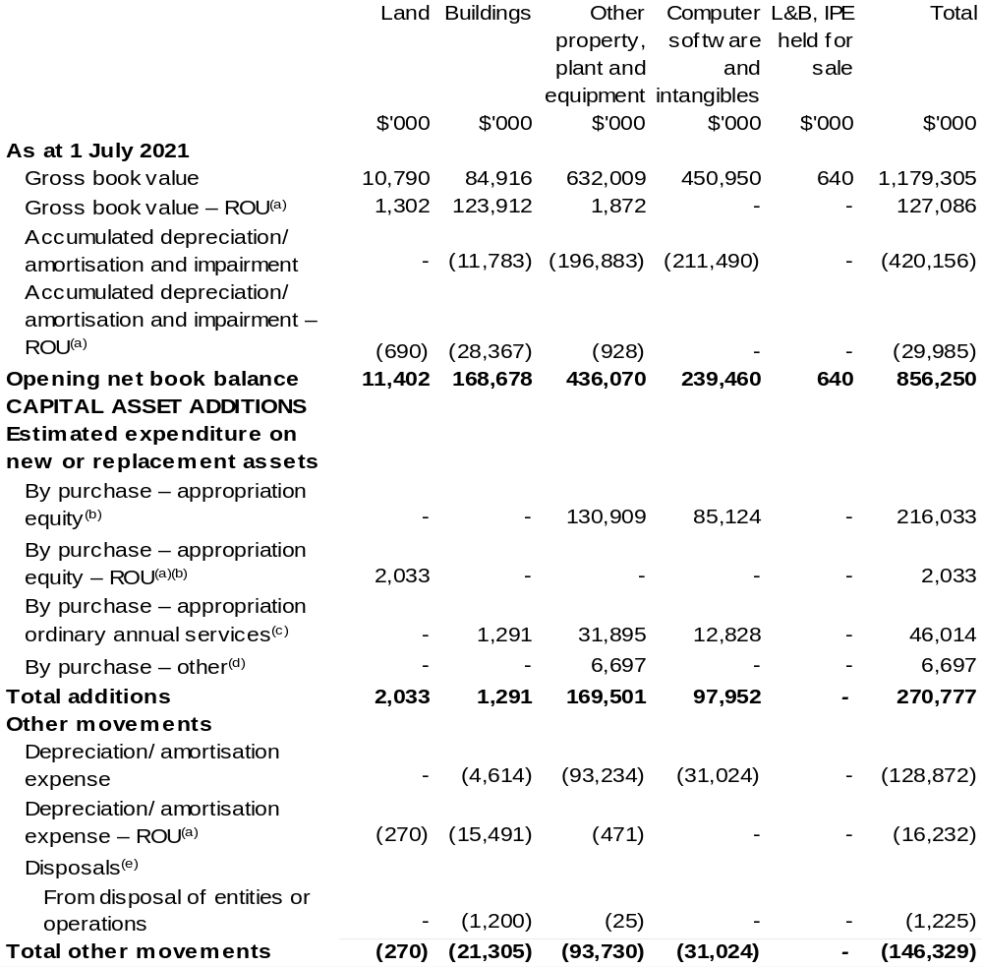
Continued on following page
Table 3.7: Statement of asset movements (Budget year 2021–22) (continued)
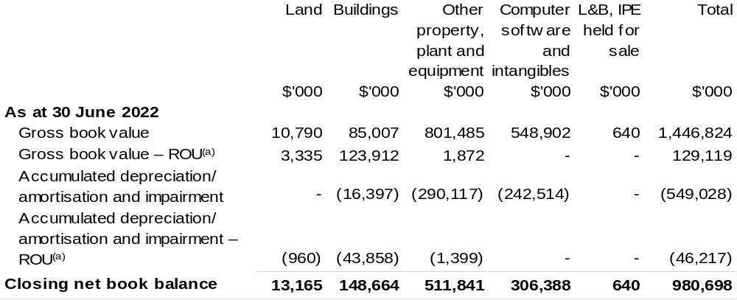
- Applies to leases under AASB 16 Leases. Right of Use (ROU).
- ‘Appropriation equity’ refers to equity injections or Administered Assets and Liabilities appropriations provided through Act (No. 2) and Bill (No. 4) 2021–22 appropriation, including Collection Development Acquisition Budget.
- ‘Appropriation ordinary annual services’ refers to funding provided through Act (No. 1) and Bill (No. 3) 2021–22 appropriation for depreciation/amortisation expenses, Departmental Capital Budget or other operational expenses.
- ‘By purchase – other’ refers to funding provided through other internal funding sources.
- Net proceeds may be returned to the OPA.

Prepared on Australian Accounting Standards basis.

Table 3.8: Schedule of budgeted income and expenses administered on behalf of Government (for the period ended 30 June)
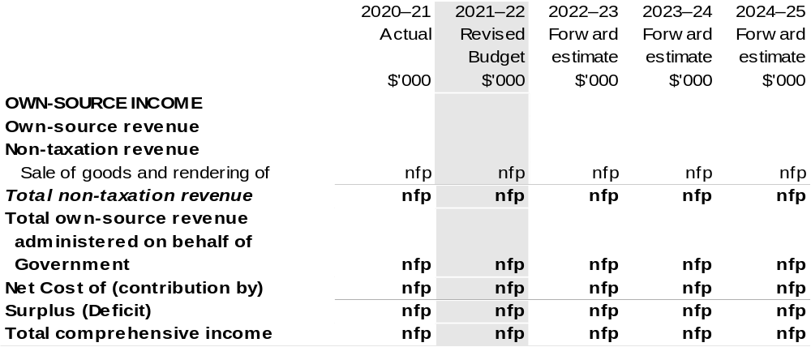
Prepared on Australian Accounting Standards basis.

Table 3.9: Schedule of budgeted assets and liabilities administered on behalf of Government (as at 30 June)

The schedule of budgeted assets and liabilities administered on behalf of Government does not apply to the Bureau.

Table 3.10: Schedule of budgeted administered cash flows (for the period
ended 30 June)

The schedule of budgeted administered cash flows on behalf of Government does not apply to the Bureau.

Director of National Parks
Section 1: Entity overview and resources 127
1.1 Strategic direction statement 127
1.2 Entity resource statement 128
1.3 Entity measures 130
1.4 Additional estimates, resourcing, and variations to outcomes 131
1.5 Breakdown of additional estimates by Appropriation Bill 132
Section 2: Revisions to outcome and planned performance 133
2.1 Changes to outcome and program structures 133
2.2 Budgeted expenses and performance for Outcome 1 133
Section 3: Special account flows and budgeted financial statements 135
3.1 Special account flows 135
3.2 Budgeted financial statements 135
3.3 Budgeted financial statements tables 136

Director of National Parks

Section 1: Entity overview and resources

1.1 Strategic direction statement
There have been no changes to the entity’s strategic direction statement since the
2021–22 Portfolio Budget Statements.

1.2 Entity resource statement
These tables detail the resourcing for the Director of National Parks at 2021–22 Additional Estimates. Table 1.1 outlines the total resourcing available from all sources for the 2021–22 Budget year, including variations through Appropriation Bills (No. 3) and (No. 4) 2021–22, Special Appropriations and Special Accounts.

Table 1.1: Director of National Parks – Resource Statement – Additional Estimates for 2021–22 as at February 2022 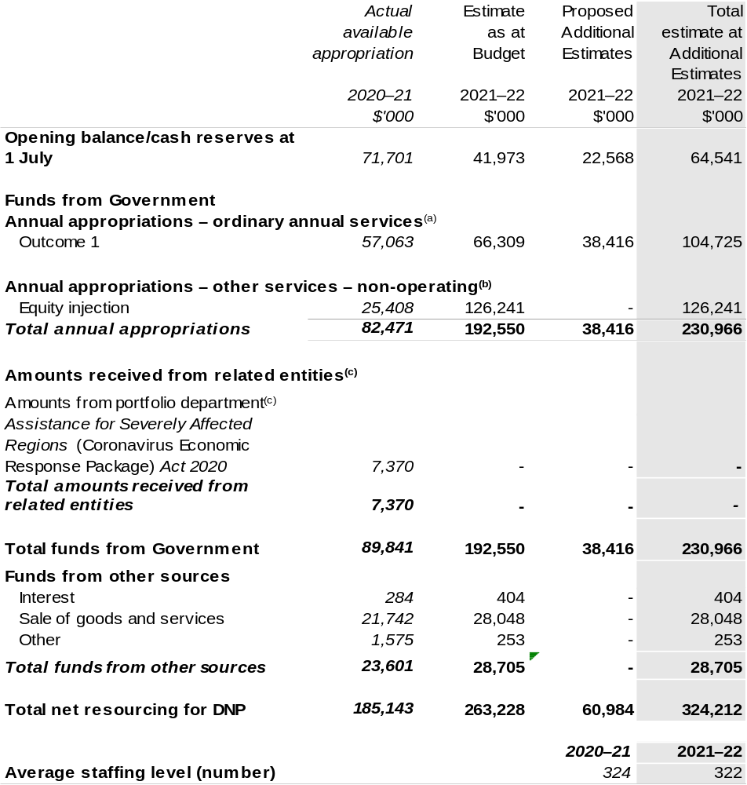
- Appropriation Act (No. 1) 2021–22 and Appropriation Bill (No. 3) 2021–22. Director of National Parks (DNP) is not directly appropriated as it is a Corporate Commonwealth Entity (CCE) under the PGPA Act. Appropriations are made to Department of Agriculture, Water and the Environment (DAWE) and then paid to DNP and are considered departmental for all purposes.
- Appropriation Act (No. 2) 2021–22 and Appropriation Bill and (No. 4) 2021–22 is provided through DAWE and is specified within the Annual Appropriation Bills as a payment to the DNP.
Continue on following page
Table 1.1: Director of National Parks – Resource Statement – Additional Estimates for 2021–22 as at February 2022 (continued)

- Funding provided by the portfolio department that is not specified within the Annual Appropriation Bills as a payment to that corporate entity (for example, a grant awarded to a corporate entity from one of the portfolio department's administered programs).

Please note: all figures shown above are GST exclusive – these may not match figures in the cash flow statement.

Prepared on a resourcing (i.e. appropriations available) basis.

1.3 Entity measures
Table 1.2 summarises new Government measures taken since the 2021–22 Budget.
The table is split into receipt, payment, and capital measures, with the affected programs identified.

Table 1.2: Director of National Parks – measures since 2021–22 Budget
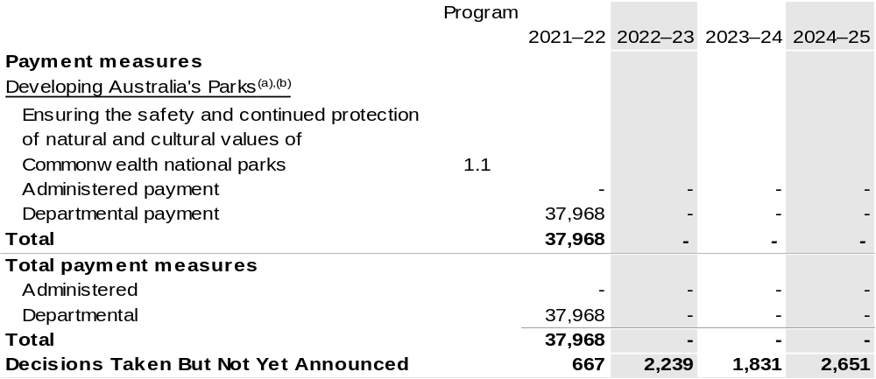

- Funding for this measure passes through the Department of Agriculture, Water and the Environment to the DNP.
- The measure description appears in the December 2021–22 Mid-Year Economic and Fiscal Outlook (MYEFO) under the Agriculture, Water and the Environment portfolio.

Prepared on a Government Finance Statistics (Underlying Cash) basis.

1.4 Additional estimates, resourcing and variations to outcomes
The following tables detail changes in resourcing for the Director of National Parks at Additional Estimates, by outcome. The table show variations since the 2021–22 Budget due to new measures (as per Table 1.2) and variations due to other factors, such as movements of funds, reclassifications, reallocations, and adjustments due to the efficiency dividend and changes in economic parameters.

Table 1.3: Additional Estimates and other variations to outcome since 2021–22 Budget
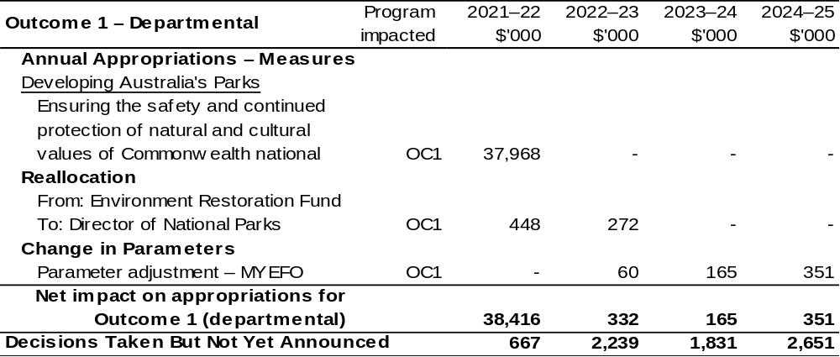
Prepared on a resourcing (i.e., appropriations available) basis.

1.5 Breakdown of additional estimates by appropriation bill
The following table shows Additional Estimates sought for the Director of National Parks through Appropriation Bills (No. 3) and (No. 4) 2021–22.

Table 1.4: Appropriation Bill (No. 3) 2021–22
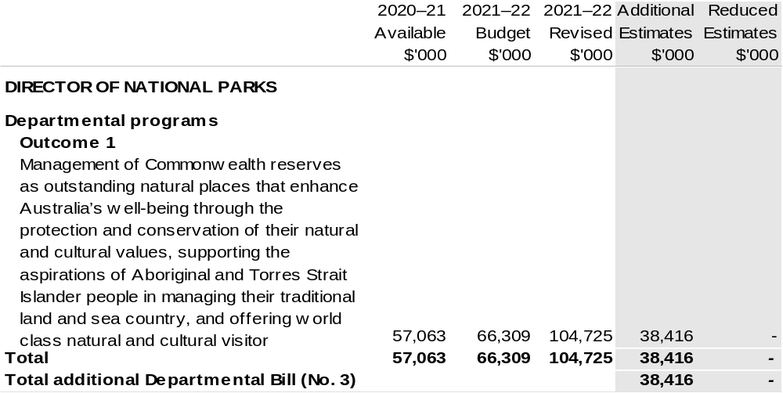

Table 1.5: Appropriation Bill (No. 4) 2021–22
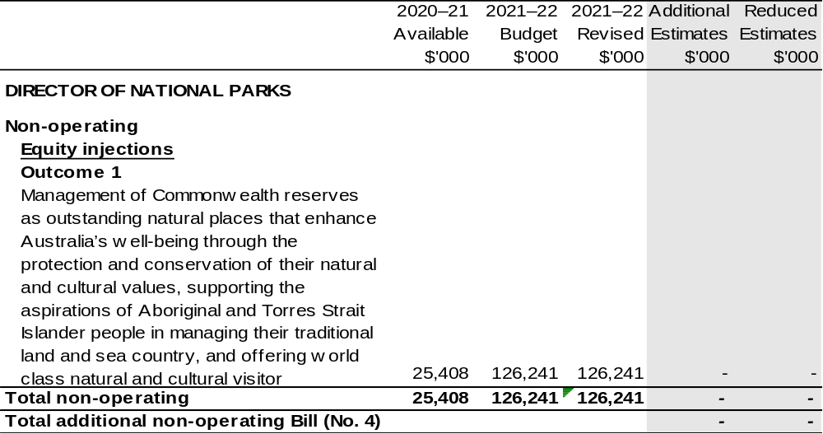

Section 2: Revisions to Outcomes and planned performance

2.1 Changes to outcome and program structures
There have been no changes to the entity’s outcomes and program structure since the 2021–22 Portfolio Budget Statements.

2.2 Budgeted expenses and performance for outcome 1

2.2.1: Linked programs
There have been no changes to linked programs for Outcome 1 since the 2021–22 Portfolio Budget Statements.

2.2.2: Performance criteria
There have been no changes to performance criteria for Outcome 1 since the 2021–22 Portfolio Budget Statements.

2.2.3: Budgeted expenses
Table 2.1 (below) shows how much the entity intends to spend (on an accrual basis) on achieving the outcome, broken down by program and Departmental funding sources.

2.2.3: Budgeted expenses (continued)

Table 2.1: Budget expenses for Outcome 1
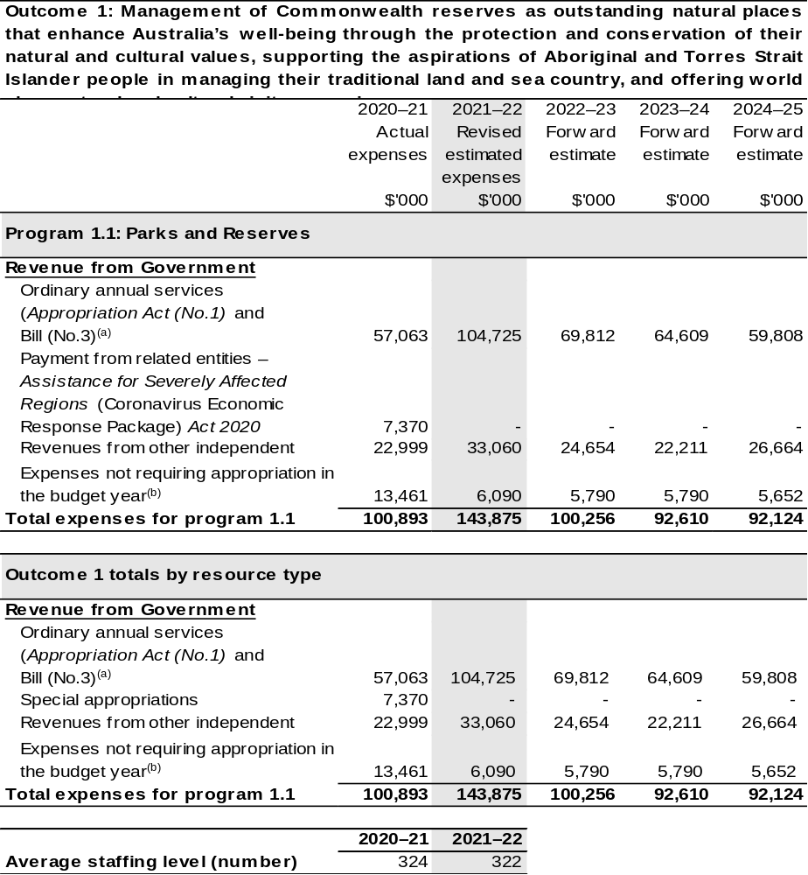
(a) Appropriation Act (No. 1) 2021–22 and Appropriation Bill (No. 3) 2021–22. The DNP is a CCE under the PGPA Act and does not receive direct appropriations. Appropriation is provided through Department of Agriculture, Water and the Environment and is specified with the Annual Appropriation Bills as payment to the DNP and is considered departmental for all purposes.
(b) Expenses not requiring appropriation in the Budget year are made up of depreciation expenses, amortisation expenses, make good expense and audit fees and expenses funded in the prior year.

Note: Departmental appropriation splits and totals are indicative estimates and may change in the course of the budget year as Government priorities change.

Prepared on Australian Accounting Standards basis.

Section 3: Special account flows and budgeted financial statements

3.1 Special account flows
Estimates of special account flows

The Director of National Parks does not have any special accounts.

3.2 Budgeted financial statements

3.2.1: Analysis of budgeted financial statements
There are no major changes to the analysis of budgeted financial statements since the 2021–22 Portfolio Budget Statements.

3.2.2: Explanatory notes and analysis of budgeted financial statements
The Agency Resource Statement (Table 1.1) is prepared on a cash basis and provides a consolidated view of all the cash resources available to DNP in 2021–22.
For departmental items this includes equity injections and appropriation receivable that is yet to be drawn down to cover payables and provisions on the Departmental Balance Sheet (Table 3.2). The Comprehensive Income Statement (Table 3.1) shows only the operating appropriation provided each year and own source revenue generated by the agency. The approved operating loss for DNP is attributed to the depreciation of the entity’s asset base.
3.3 Budgeted financial statements tables
Table 3.1: Comprehensive income statement (showing net cost of services) for the period ended 30 June
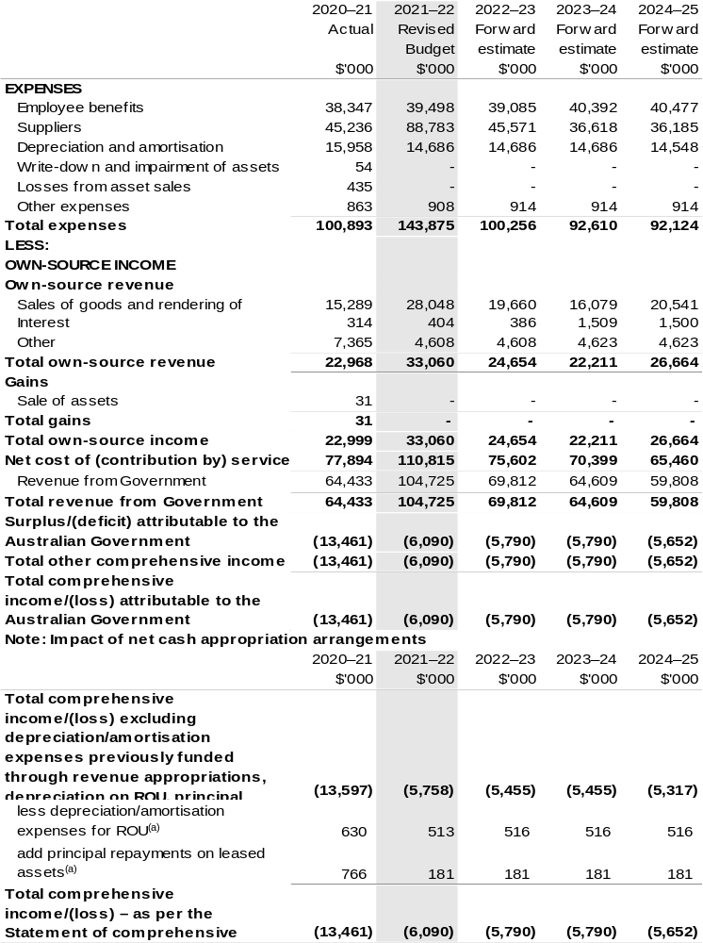(a) Applies to leases under AASB 16 Leases. Right of Use (ROU).
Prepared on Australian Accounting Standards basis.

Table 3.2: Budgeted departmental balance sheet (as at 30 June)
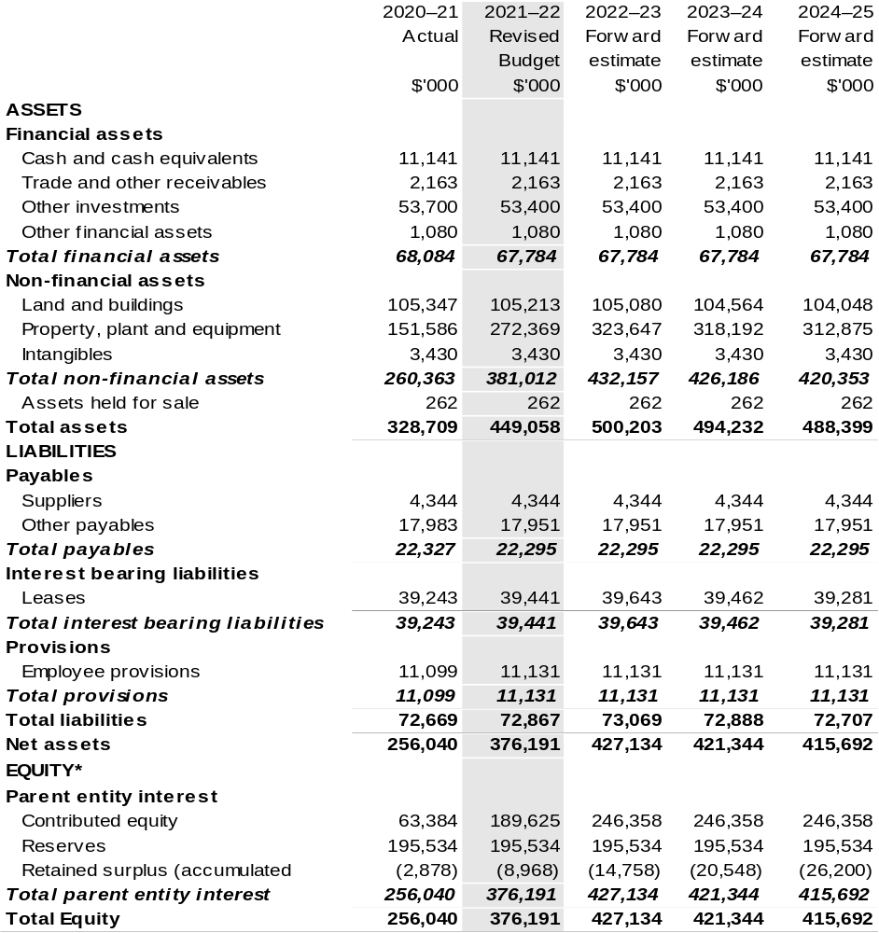
*’Equity’ is the residual interest in assets after deduction of liabilities.

Prepared on Australian Accounting Standards basis.

Table 3.3: Departmental statement of changes in equity – summary of movement (Budget year 2021–22)
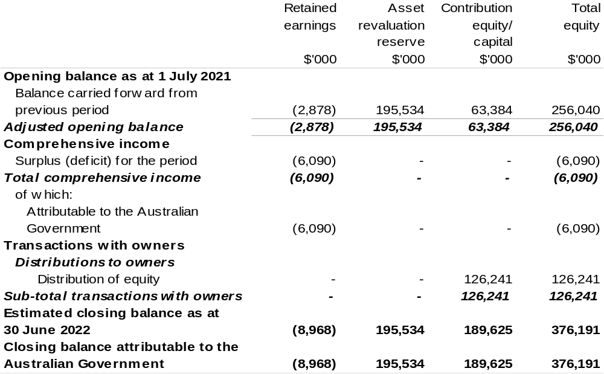
Prepared on Australian Accounting Standards basis.

Table 3.4: Budgeted departmental statement of cash flows (for the period
ended 30 June)
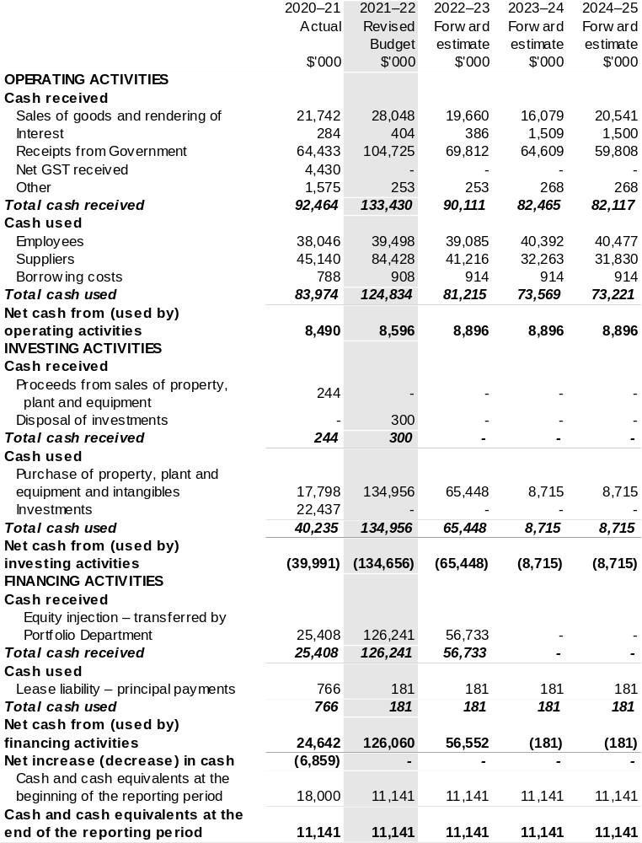
Prepared on Australian Accounting Standards basis.

Table 3.5: Departmental capital budget statement (for the period ended 30 June)
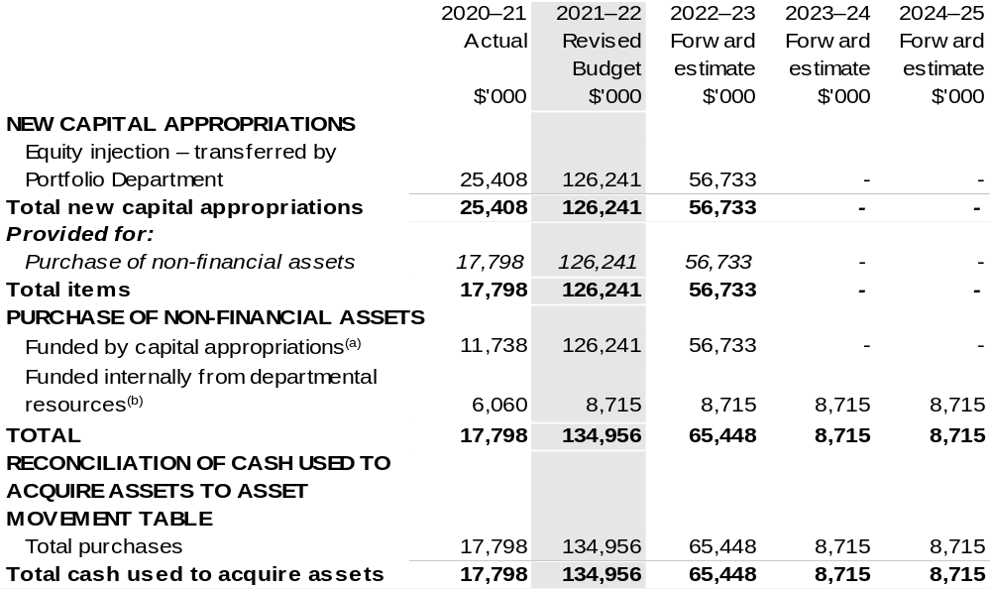
- Includes both current Act (No. 2) and prior year Act No. 2/4/6 appropriation.
- Includes the following sources of funding:
– current Act (No. 1) and prior year Act/Bill (No. 1/3/5) appropriations (excluding amounts from the DCBs);
– donations and gifts of non-financial assets;
– internally developed assets;
– proceeds from the sale of assets;
– section 74 external revenue;

Consistent with information contained in the Statement of Asset Movements and the Budgeted Statement of Cash Flows.

Prepared on Australian Accounting Standards basis.

Table 3.6: Statement of asset movements (Budget year 2021–22)
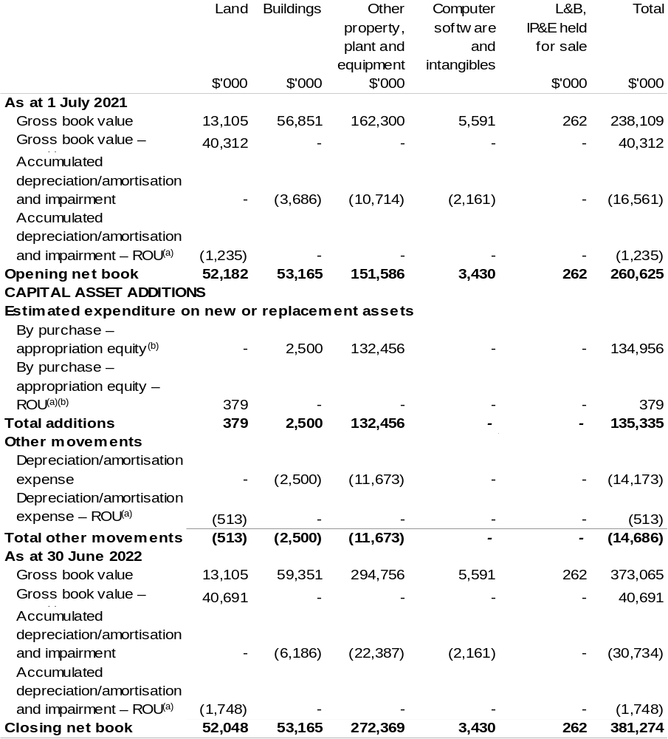
(a) Applies to leases under AASB 16 Leases. Right of Use (ROU).
(b) ‘Appropriation equity’ refers to equity injections appropriations provided through Appropriation Act (No. 2) 2021–22, including Collection Development Acquisition Budget, and other internal funding sources.

Prepared on Australian Accounting Standards basis.

Great Barrier Reef Marine Park Authority
Section 1: Entity overview and resources 145
1.1 Strategic direction statement 145
1.2 Entity resource statement 146
1.3 Entity measures 148
1.4 Additional estimates, resourcing, and variations to outcomes 150
1.5 Breakdown of additional estimates by Appropriation Bill 151
Section 2: Revisions to outcome and planned performance 152
2.1 Changes to outcome and program structures 152
2.2 Budgeted expenses and performance for Outcome 1 152
Section 3: Special account flows and budgeted financial statements 154
3.1 Special account flows 154
3.2 Budgeted financial statements 155
3.3 Budgeted financial statements tables 156

Great Barrier Reef Marine Park Authority

Section 1: Entity overview and resources

1.1 Strategic direction statement
The following text outlines updates to Strategic Direction Statement in the 2021–22 Agriculture, Water and the Environment Portfolio Budget Statements to reflect decisions of the Government since the 2021–22 Budget.
The Government will provide $252.8 million over nine years from 2021–22 to support world-leading management of the Great Barrier Reef. The investment will support Reef resilience and protect the Reef’s Outstanding Universal Value in the face of a changing climate. It will deliver on targets in the Reef 2050 Plan, enhance Australia’s leadership on reef protection and science, and strengthen our management response to key threats to the Reef.
The Government will provide $40 million over three years from 2021–22 to help transform Reef HQ into a national centre of excellence for tropical reef education as part of the Townsville City Deal.

Our Purpose:
Provide for the long-term protection, ecologically sustainable use, understanding and enjoyment of the Great Barrier Reef for all Australians and the international community through the care and development of the Marine Park.
1.2 Entity resource statement
These tables detail the resourcing for the Great Barrier Reef Marine Park Authority at 2021–22 Additional Estimates. Table 1.1 outlines the total resourcing available from all sources for the 2021–22 Budget year, including variations through Appropriation Bills (No. 3) and (No. 4) 2021–22, Special Appropriations and Special Accounts.

Table 1.1: Great Barrier Reef Marine Park Authority – Resource Statement – Additional Estimates for 2021–22 as at February 2022 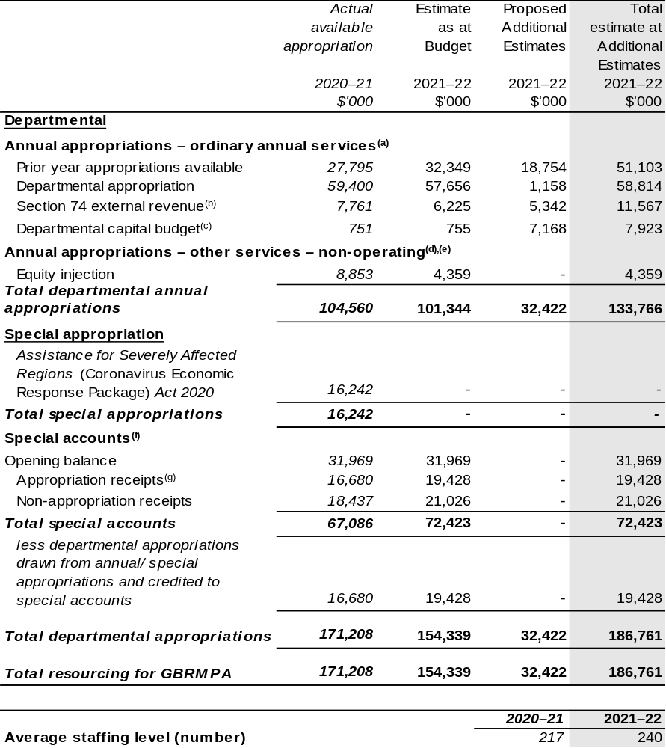
Continued on following page
Table 1.1: Great Barrier Reef Marine Park Authority – Resource Statement – Additional Estimates for 2021–22 as at February 2022 (continued)
- Appropriation Act (No. 1) 2021–22 and Appropriation Bill (No. 3) 2021–22.
- Estimated external revenue receipts under section 74 of the Public Governance, Performance and
Accountability Act 2013 (PGPA Act).
- Departmental capital budgets are not separately identified in Appropriation Act (No. 1) 2021–22 and form part of ordinary annual services items. Please refer to Table 3.7 for further details. For accounting purposes, this amount has been designated as a ‘contribution by owner’.
- Amounts credited to the Authority as special appropriation under Section 65(a) of the Great Barrier Reef Marine Park Act 1975.
- Appropriation Act (No. 2) 2021–22 and Appropriation Bill (No. 4) 2021–22.
- Excludes trust moneys held in Services for Other Entities and Trust Moneys (SOETM) and other special accounts. For further information on special accounts (excluding amounts held on trust), refer to Table 3.1.
- Amounts credited to the special account(s) from the Authority’s annual and special appropriations.

- Please note: all figures shown above are GST exclusive – these may not match figures in the cash flow statement.

- Prepared on a resourcing (i.e. appropriations available) basis.

1.3 Entity measures
Table 1.2 summarises new Government measures taken since the 2021–22 Budget.
The table is split into receipt, payment, and capital measures, with the affected programs identified.

Table 1.2: Great Barrier Reef Marine Park Authority – measures since 2021–22 Budget
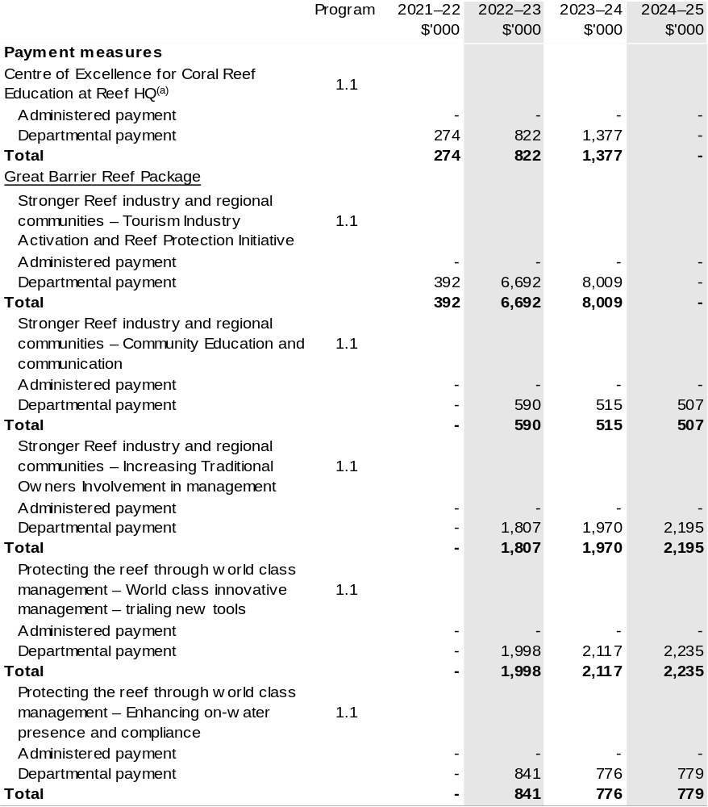
Continued on following page

Table 1.2: Great Barrier Reef Marine Park Authority – measures since 2021–22 Budget (continued)
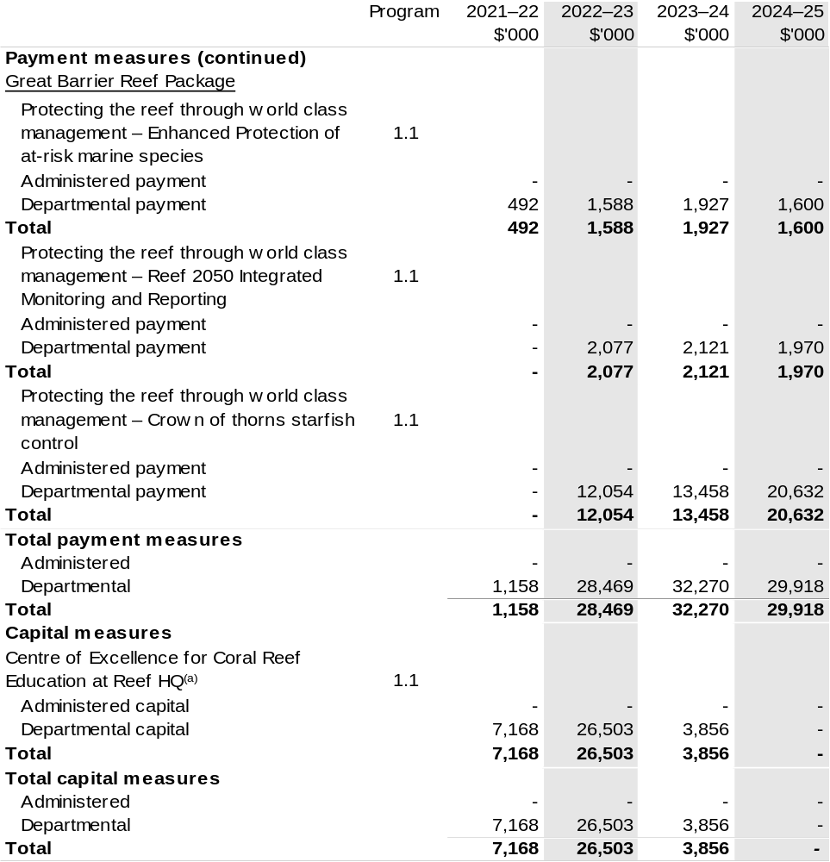
- The lead entity for this measure is the Department of Agriculture, Water and the Environment. The measure description appears in the December 2021–22 Mid-Year Economic and Fiscal Outlook (MYEFO) under the Agriculture, Water and the Environment portfolio.

Prepared on a Government Finance Statistics (Underlying Cash) basis.

1.4 Additional estimates, resourcing and variations to outcomes
The following tables detail changes in resourcing for the Great Barrier Reef Marine Park Authority at Additional Estimates, by outcome. The table show variations since the 2021–22 Budget due to new measures (as per Table 1.2) and variations due to other factors, such as movements of funds, reclassifications, reallocations, and adjustments due to the efficiency dividend and changes in economic parameters.
Table 1.3: Additional Estimates and other variations to outcome since 2021–22 Budget
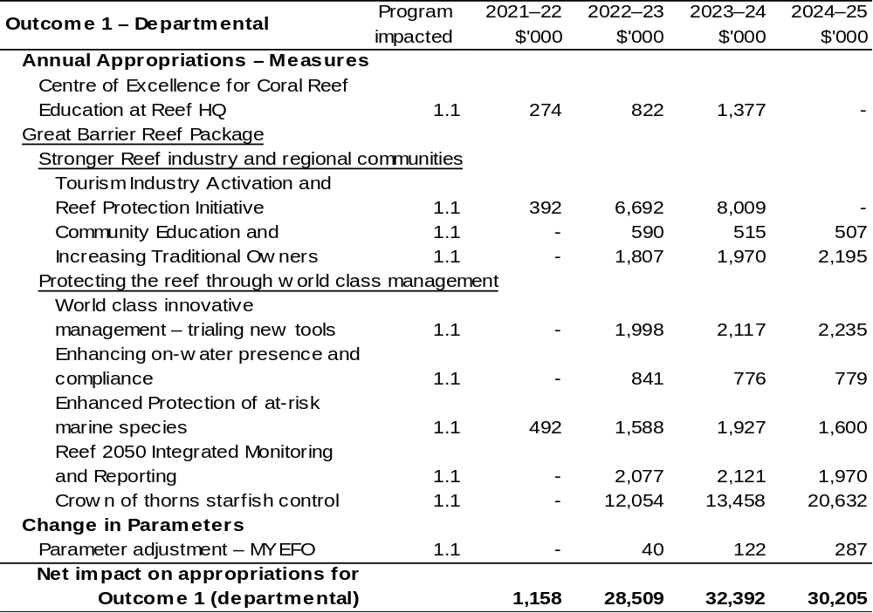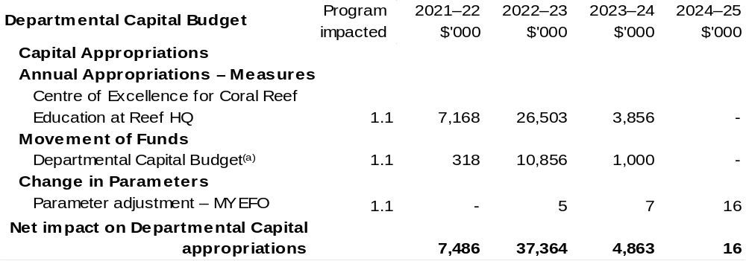
(a) Total additional Appropriation Bill (No. 3) (departmental) for 2021–22 is $8.326 million (refer to Table 1.4). The difference between the two tables is the inclusion of decision that provided the authority to draw down from existing appropriation.

Prepared on a resourcing (i.e. appropriations available) basis.

1.5 Breakdown of additional estimates by appropriation bill
The following table shows Additional Estimates sought for the Great Barrier Reef Marine Park Authority through Appropriation Bills (No. 3) and (No. 4) 2021–22.
Table 1.4: Appropriation Bill (No. 3) 2021–22 – Departmental
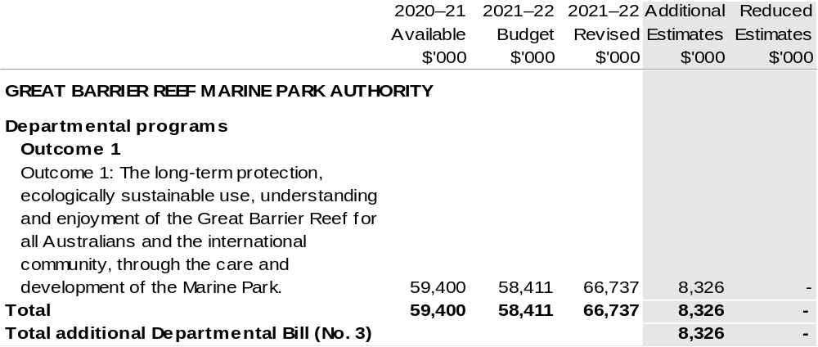
Table 1.5: Appropriation Bill (No. 4) 2021–22
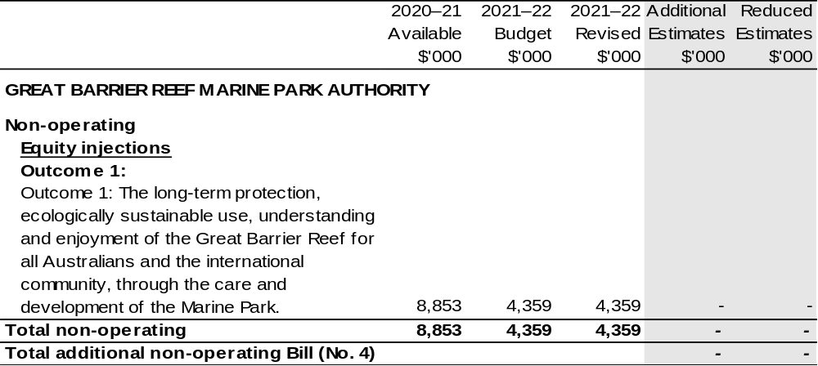

Section 2: Revisions to Outcomes and planned performance

2.1 Changes to outcome and program structures
There have been no changes to the entity’s outcomes and program structure since the 2021–22 Portfolio Budget Statements.

2.2 Budgeted expenses and performance for outcome 1

2.2.1: Linked programs
There have been no changes to linked programs for Outcome 1 since the 2021–22 Portfolio Budget Statements.

2.2.2: Performance criteria
There have been no changes to performance criteria for Outcome 1 since the 2021–22 Portfolio Budget Statements.

2.2.3: Budgeted expenses
Table 2.1 (below) shows how much the entity intends to spend (on an accrual basis) on achieving the outcome, broken down by program, as well as by Administered and Departmental funding sources.

2.2.3: Budgeted expenses (continued)

Table 2.1: Budgeted expenses for Outcome 1
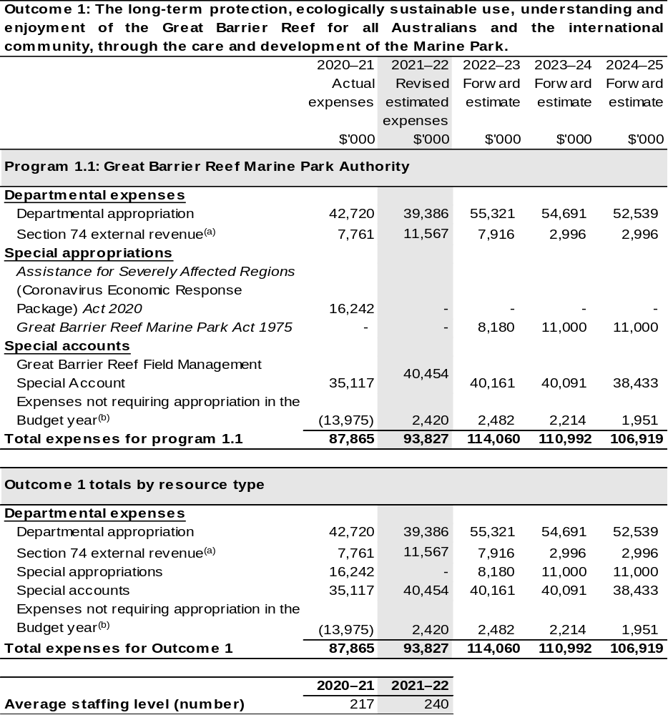
- Estimated expenses incurred in relation to receipts retained under section 74 of the PGPA Act.
- Expenses not requiring appropriation in the Budget year are made up of depreciation expenses, amortisation expenses, lease expenses, make good expense and audit fees.

Note: Departmental appropriation splits and totals are indicative estimates and may change in the course of the budget year as Government priorities change.

Prepared on Australian Accounting Standards basis.

Section 3: Special account flows and budgeted financial Statements

3.1 Special account flows
Estimates of special account flows

Special accounts provide a means to set aside, and record amounts used for specified purposes. Table 3.1 shows the expected additions (receipts) and reductions (payments) for each account used by the Great Barrier Reef Marine Park Authority.

Table 3.1: Estimates of special account flows and balances
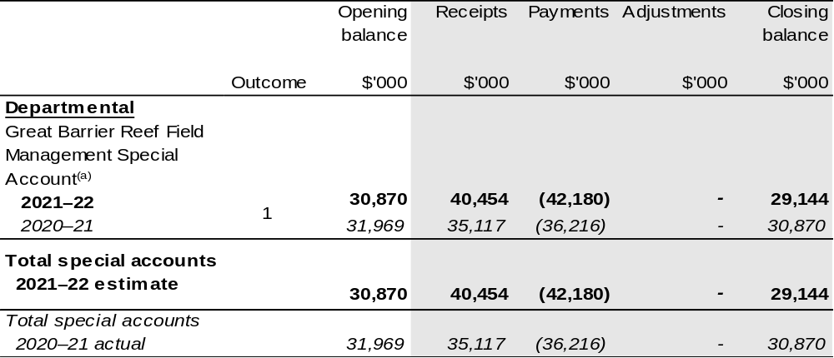

- Appropriation: section 80 of the PGPA Act. Establishing Instrument: section 49 of the Great Barrier Reef Marine Park Act 1975. Purpose: section 51(2) of the Great Barrier Reef Marina Park Act 1975.

3.2 Budgeted financial statements

3.2.1 Analysis of budgeted financial statements
There are no major changes to the analysis of budgeted financial statements since the 2021–22 Portfolio Budget Statements.

3.2.2: Explanatory notes and analysis of budgeted financial statements
Changes to the Great Barrier Reef Marine Park Authority's budgeted financial statements since the 2021–22 Agriculture, Water and the Environment Portfolio Budget Statements include further funding for the Great Barrier Reef National education centre, Reef HQ Aquarium, and funding to support world-leading management of the Great Barrier Reef. The former will ensure Reef HQ Aquarium becomes a centre of excellence for tropical reef education. The latter will support Reef resilience and protect the Reef’s Outstanding Universal Value in the face of a changing climate.

3.3 Budgeted financial statements tables

Table 3.2: Comprehensive income statement (showing net cost of services) for the period ended 30 June
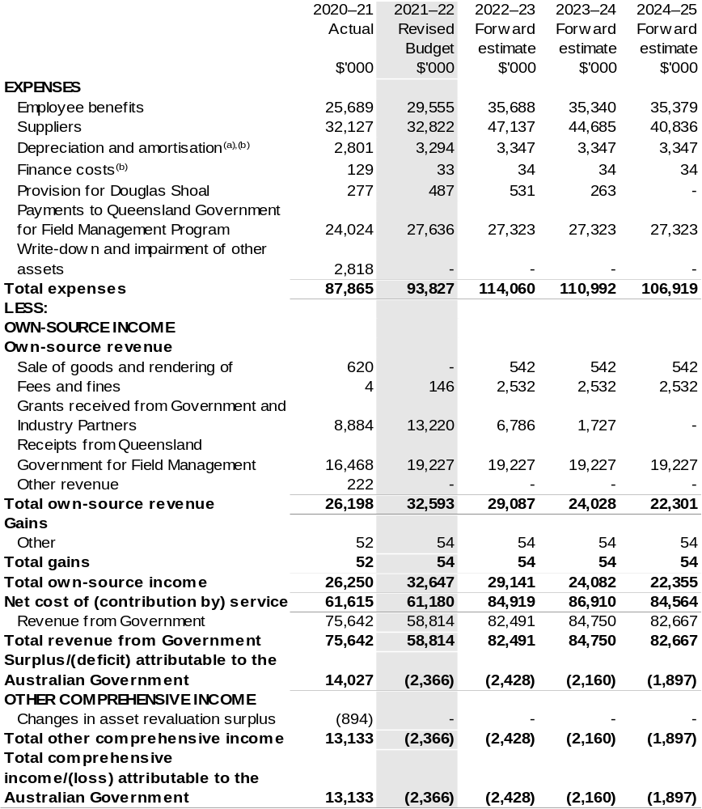
Continued on following page
Table 3.2: Comprehensive income statement (showing net cost of services) for the period ended 30 June (continued)
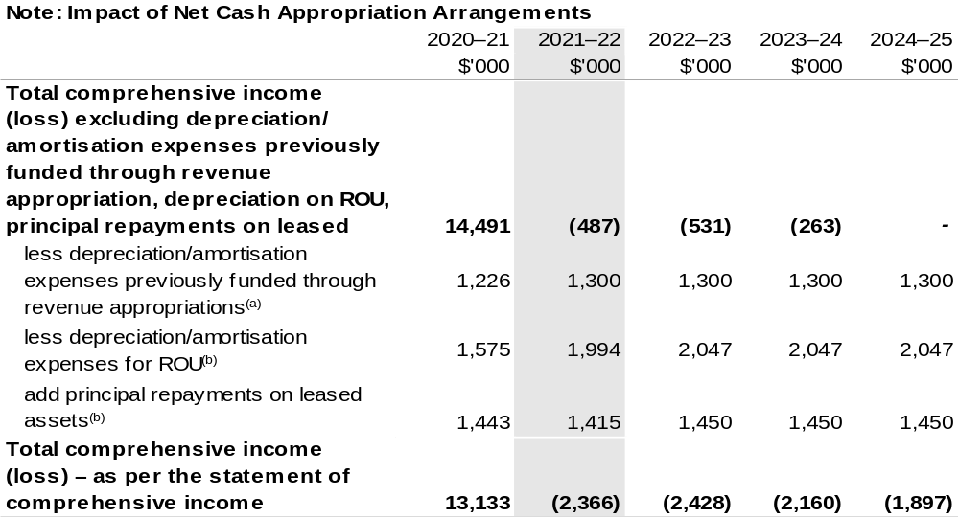
- From 2010–11, the Government introduced net cash appropriation arrangements where Appropriation Bill (No. 1) or Bill (No. 2) revenue appropriations for the depreciation/amortisation expenses of non-Corporate Commonwealth Entities were replaced with a separate capital budget (the Departmental Capital Budget, or DCB) provided through Appropriation Bill (No. 1) or Bill (No. 2) equity appropriations. For information regarding DCBs, please refer to Table 3.5 Departmental Capital Budget Statement.
- Applies to leases under AASB 16 Leases. Right of Use (ROU).

Prepared on Australian Accounting Standards basis.

Table 3.3: Budgeted departmental balance sheet (as at 30 June)
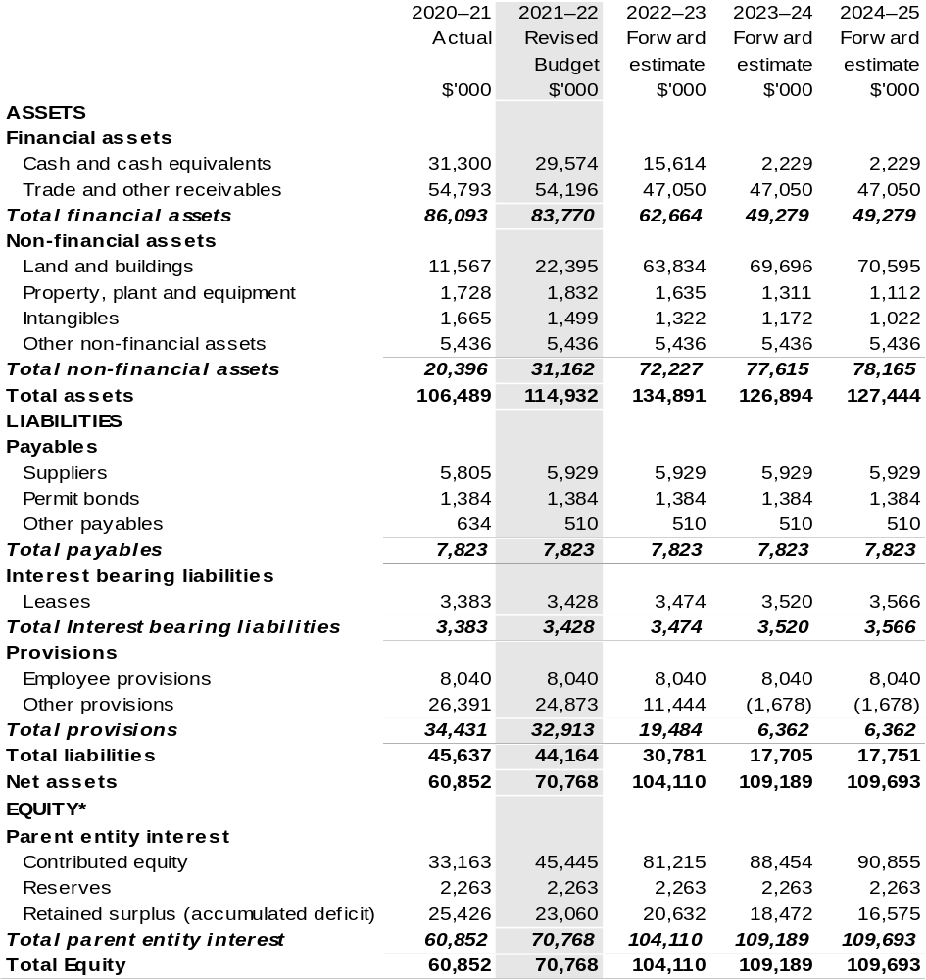
*’Equity’ is the residual interest in assets after deduction of liabilities.

Prepared on Australian Accounting Standards basis.

Table 3.4: Departmental statement of changes in equity – summary of movement (Budget year 2021–22)
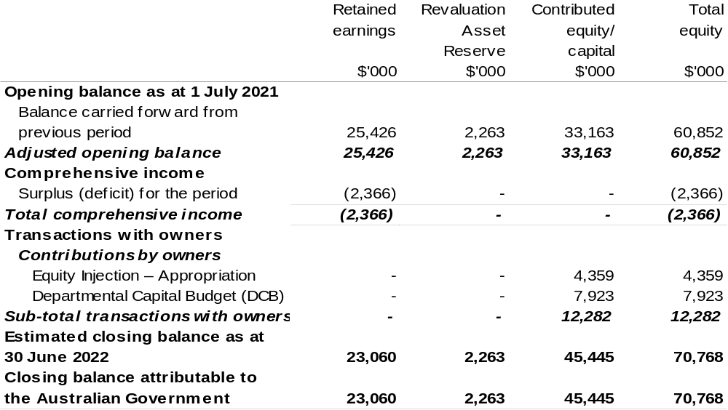
Prepared on Australian Accounting Standards basis.

Table 3.5: Budgeted departmental statement of cash flows (for the period
ended 30 June)
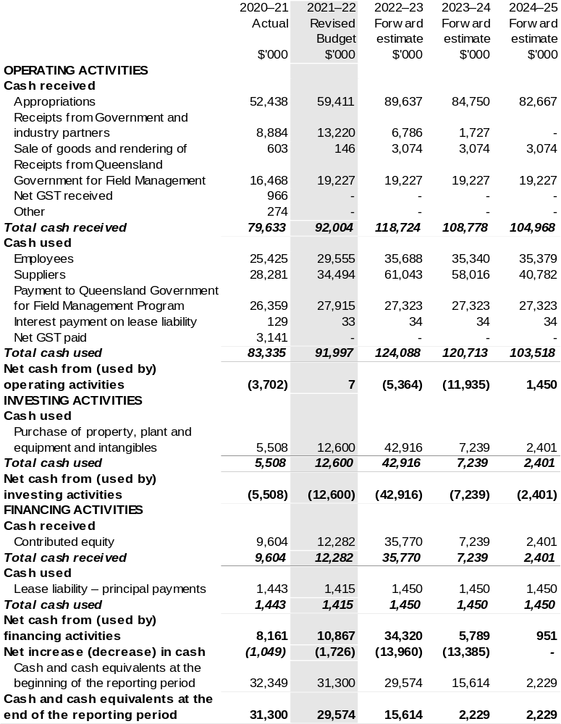
Prepared on Australian Accounting Standards basis.

Table 3.6: Departmental capital budget statement (for the period ended 30 June)
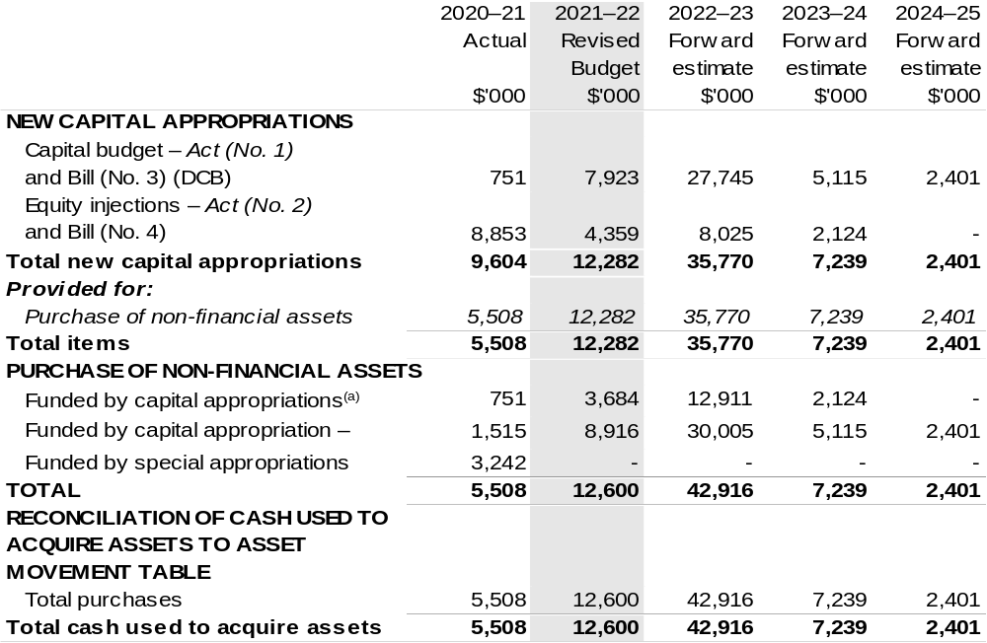
- Includes current Act (No. 2), Bill (No. 4) 2021–22 and prior year Act (No. 2/4/6) appropriation.
- Does not include annual finance lease costs. Includes purchases from current and previous years’ Departmental capital budgets (DCBs).

Consistent with information contained in the Statement of Asset Movements and the Budgeted Statement of Cash Flows.

Prepared on Australian Accounting Standards basis.

Table 3.7: Statement of asset movements (Budget year 2021–22)
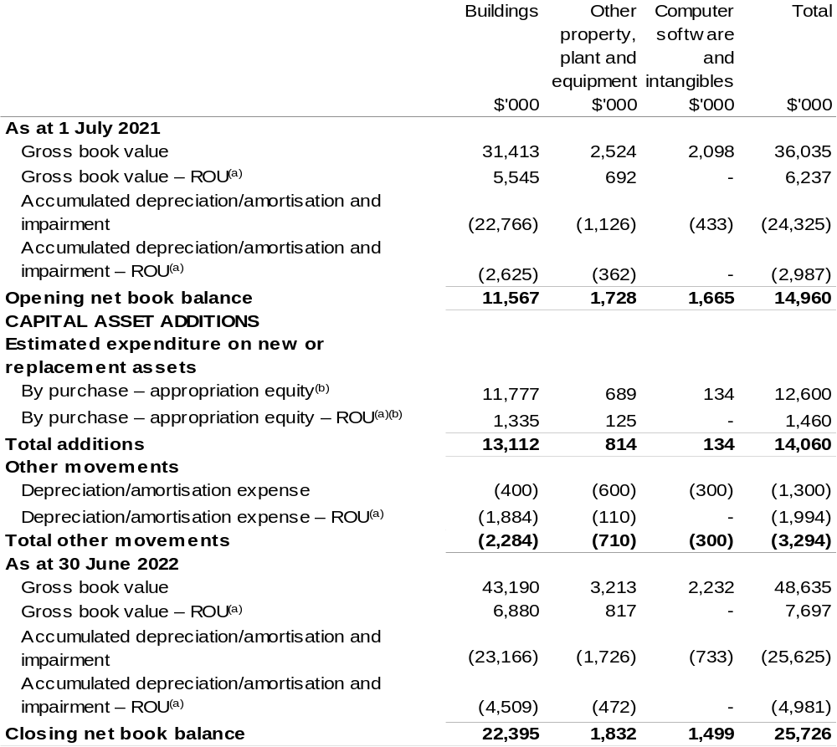

(a) Applies to leases under AASB 16 Leases. Right of Use (ROU).
(b) ‘Appropriation equity’ refers to equity injections appropriations provided through Act (No. 2) and Bill (No. 4) 2021–22 appropriation, including Collection Development Acquisition Budgets; and funding provided through Act (No. 1) and Bill (No. 3) 2021–22 appropriation for depreciation/amortisation expenses, DCBs or other operational expenses.

Prepared on Australian Accounting Standards basis.

Table 3.8: Schedule of budgeted income and expenses administered on behalf of Government (for the period ended 30 June)
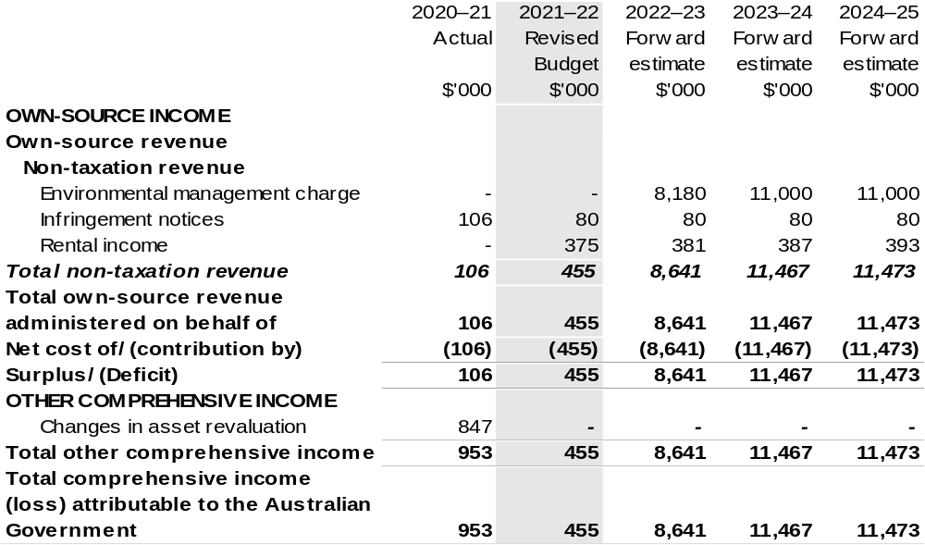
Prepared on Australian Accounting Standards basis.

Table 3.9: Schedule of budgeted assets and liabilities administered on behalf of Government (as at 30 June)
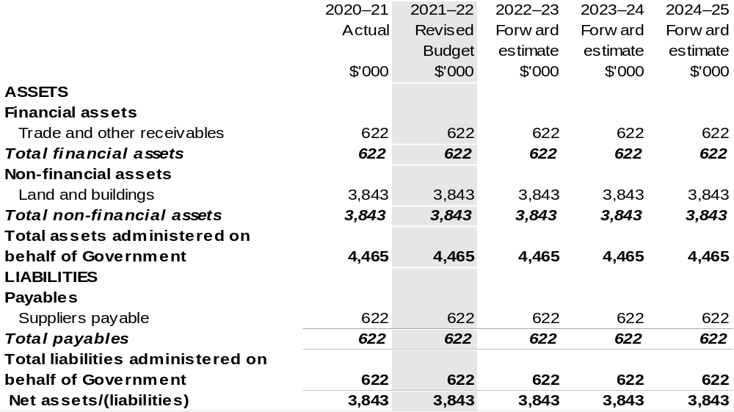
Prepared on Australian Accounting Standards basis.

Table 3.10: Schedule of budgeted administered cash flows (for the period
ended 30 June)
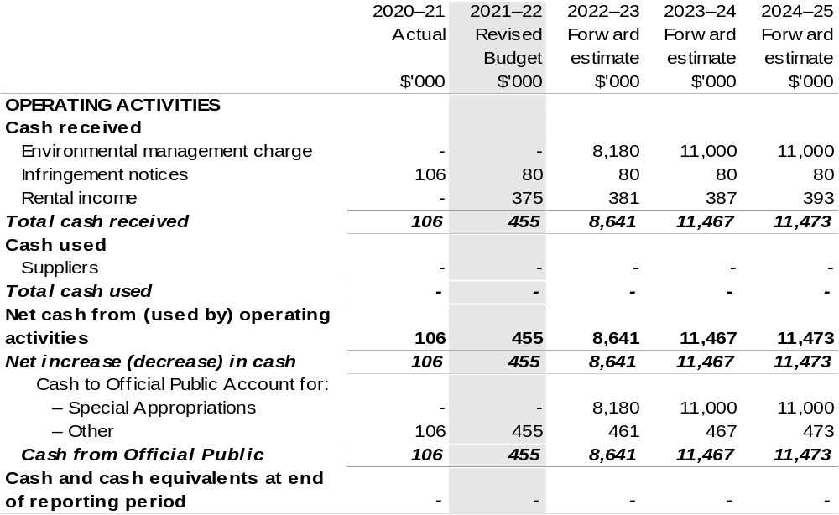
Prepared on Australian Accounting Standards basis.

Table 3.11: Statement of asset movements (Budget year 2021–22)
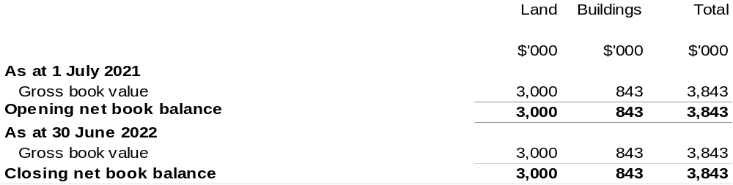
Prepared on Australian Accounting Standards basis.

