Portfolio Budget Statements 2022–23
Budget Related Paper No. 1.1

Agriculture, Water and the Environment Portfolio

Budget Initiatives and Explanations of
Appropriations Specified by Outcomes
and Programs by Entity
© Commonwealth of Australia 2022
ISSN: 2652-8665 (print) 2652-8657 (online)
This publication is available for your use under a Creative Commons BY Attribution 3.0 Australia licence, with the exception of the Commonwealth Coat of Arms, the Department of Agriculture, Water and the Environment logo, photographs, images, signatures and where otherwise stated. The full licence terms are available from http://creativecommons.org /licenses/by/3.0/au/legalcode.


Use of Department of Agriculture, Water and the Environment material under a Creative Commons BY Attribution 3.0 Australia licence requires you to attribute the work (but not in any way that suggests that the Department of Agriculture, Water and the Environment endorses you or your use of the work).
Department of Agriculture, Water and the Environment material used ‘as supplied’
Provided you have not modified or transformed Department of Agriculture, Water and the Environment material in any way including, for example, by changing the department’s text; calculating percentage changes; graphing or charting data; or deriving new statistics from published Department of Agriculture, Water and the Environment statistics, then the department prefers the following attribution:
Source: Australian Government Department of Agriculture, Water and the Environment
Derivative material
If you have modified or transformed Department of Agriculture, Water and the Environment material, or derived new material from those of the Department of Agriculture, Water and the Environment in any way, then the department prefers the following attribution:
Based on Australian Government Department of Agriculture, Water and the Environment data
Use of the Coat of Arms
The terms under which the Coat of Arms can be used are set out on the It’s an Honour website (see www.pmc.gov.au/government/commonwealth-coat-arms).
Other Uses
Enquiries regarding this licence and any other use of this document are welcome at:
External Budgets Section; Finance Division
Department of Agriculture, Water and the Environment
John Gorton Building,
King Edward Terrace,
Parkes ACT 2600
Email: externalbudgets@awe.gov.au

President of the Senate
Australian Senate

Parliament House
CANBERRA ACT 2600

Speaker
House of Representatives
Parliament House
CANBERRA ACT 2600

Dear Mr President
Dear Mr Speaker
We hereby submit Portfolio Budget Statements in support of the 2022–23 Budget for the Agriculture, Water and the Environment portfolio.
These statements have been developed, and are submitted to the Parliament, as a statement on the outcomes for the portfolio.
We present these statements to provide accountability to the Parliament and, through it, the public.
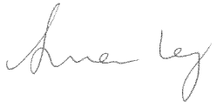


Yours sincerely

DAVID LITTLEPROUD SUSSAN LEY KEITH PITT

Minister for Agriculture and Minister for the Minister for Resources
Northern Australia Environment and Water

Abbreviations and conventions
The following notation may be used:
NEC/nec not elsewhere classified
- nil
.. not zero, but rounded to zero
na not applicable (unless otherwise specified)
nfp not for publication
$m $ million
$b $ billion
Figures in tables and in the text may be rounded. Figures in text are generally rounded to one decimal place, whereas figures in tables are generally rounded to the nearest thousand. Discrepancies in tables between totals and sums of components are due to rounding.
Enquiries
Should you have any enquiries regarding this publication please contact
Paul Pak Poy, Chief Finance Officer, Department of Agriculture, Water and the Environment, on (02) 6272 5523.
Links to Portfolio Budget Statements (including Portfolio Additional Estimates Statements and Portfolio Supplementary Additional Statements) can be located on the Australian Government Budget website at: www.budget.gov.au.

User Guide
To The
Portfolio Budget Statements

User guide
The purpose of the 2022–23 Portfolio Budget Statements (PBS) is to inform Senators and Members of Parliament of the proposed allocation of resources to government outcomes by entities within the portfolio. Entities receive resources from the annual appropriations acts, special appropriations (including standing appropriations and special accounts), and revenue from other sources.
The PBS facilitates understanding of proposed annual appropriations in Appropriation Bills (No. 1 and No. 2) 2022–23. For this reason, the PBS is declared by the Appropriation Acts to be a ‘relevant document’ to the interpretation of the Bills according to section 15AB of the Acts Interpretation Act 1901.
The PBS provides information, explanation and justification to enable Parliament to understand the purpose of each outcome proposed in the Bills.
As required under section 12 of the Charter of Budget Honesty Act 1998, only entities within the general government sector are included as part of the Commonwealth general government sector fiscal estimates and produce PBS where they receive funding (either directly or via portfolio departments) through the annual appropriation acts.
The Commonwealth Performance Framework
The following diagram outlines the key components of the Commonwealth performance framework. The diagram identifies the content of each of the publications and the relationship between them. Links to the publications for each entity within the portfolio can be found in the introduction to Section 2: Outcomes and planned performance.
Commonwealth Performance Framework
Key components of relevant publications

Portfolio Budget Statements (March)
Portfolio based
Corporate Plan
(August)
Entity based
Supports Annual Appropriations. Informs Senators and Members of Parliament of the proposed allocation of other resources to government outcomes and programs.
Provides links to relevant programs
undertaken by other Commonwealth
entities.
Provides high level performance
information for current, ongoing programs, particularly a forecast of performance for the current year.
Provides detailed prospective
performance information for proposed new budget measures that require a new program or significantly change an existing program.

Primary planning document of a
Commonwealth entity.
Sets out the purposes of the entity, the activities it will undertake to achieve its purposes and the results it expects to achieve over a minimum four-year period.
Describes the environment in which the entity operates, the capability it requires to undertake activities and a discussion
of risk.
Explains how the entity’s performance will be measured and assessed.
Annual Performance Statement (October following year)
Entity based

Included in the Commonwealth entity’s Annual Report. Focuses on recent
performance.
Reports on the actual performance results for the year against the forecasts made in the corporate plan and Portfolio Budget Statements and provides other performance information relevant to the entity.
Provides an analysis of the factors that contributed to the entity’s
performance results.

Contents

User guide v
Agriculture, Water and the Environment Portfolio Overview 3
Entities’ resources and planned performance 11
Department of Agriculture, Water and the Environment 15
AgriFutures Australia 109
Australian Fisheries Management Authority 133
Australian Pesticides and Veterinary Medicines Authority 159
Bureau of Meteorology 177
Cotton Research and Development Corporation 201
Director of National Parks 221
Fisheries Research and Development Corporation 245
Grains Research and Development Corporation 265
Great Barrier Reef Marine Park Authority 287
Murray-Darling Basin Authority 313
Regional Investment Corporation 335
Sydney Harbour Federation Trust 353
Wine Australia 373

Portfolio overview

Agriculture, Water and the Environment Portfolio overview
Ministers and portfolio responsibilities
The Agriculture, Water and the Environment portfolio is overseen by:
- The Minister for Agriculture and Northern Australia, the Hon. David Littleproud MP
- The Minister for the Environment, the Hon. Sussan Ley MP
- The Minister for Resources and Water, the Hon. Keith Pitt MP.
The three ministers are supported by:
- The Assistant Minister for Forestry and Fisheries, Senator the Hon. Jonathon Duniam
- The Assistant Minister for Waste Reduction and Environmental Management, the Hon. Trevor Evans MP.
The portfolio consists of:
- Australian Government Department of Agriculture, Water and the Environment
- AgriFutures Australia
- Australian Fisheries Management Authority
- Australian Pesticides and Veterinary Medicines Authority
- Bureau of Meteorology
- Cotton Research and Development Corporation
- Director of National Parks
- Fisheries Research and Development Corporation
- Grains Research and Development Corporation
- Great Barrier Reef Marine Park Authority
- Murray-Darling Basin Authority
- Regional Investment Corporation
- Sydney Harbour Federation Trust
- Wine Australia.
Each entity within the portfolio has at least one outcome and program. Details are provided in each entity’s section of this document.
For information on resourcing across the portfolio, please refer to Part 1: Agency Financial Resourcing in Budget Paper No. 4: Agency Resourcing.

Figure 1: Agriculture, Water and the Environment portfolio structure and outcomes
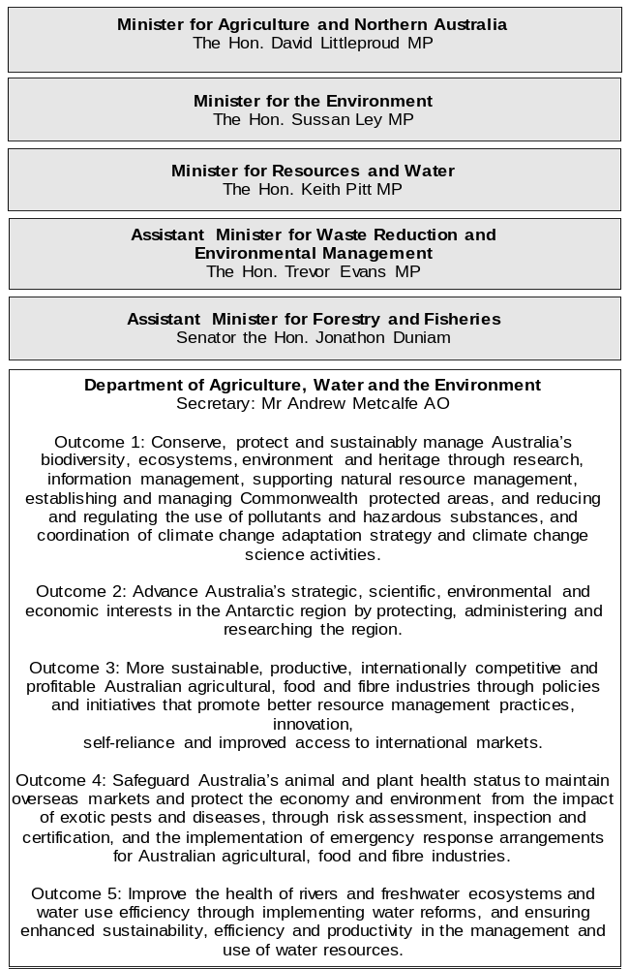
Figure 1: Agriculture, Water and the Environment portfolio structure and outcomes (continued)
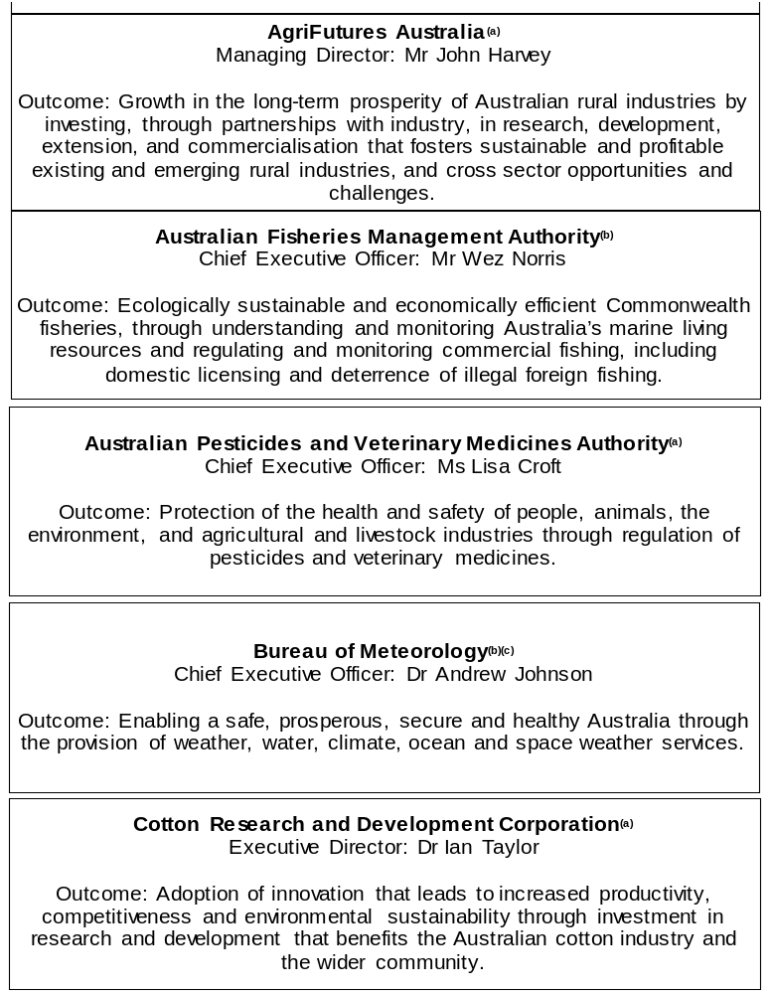

Figure 1: Agriculture, Water and the Environment portfolio structure and outcomes (continued)
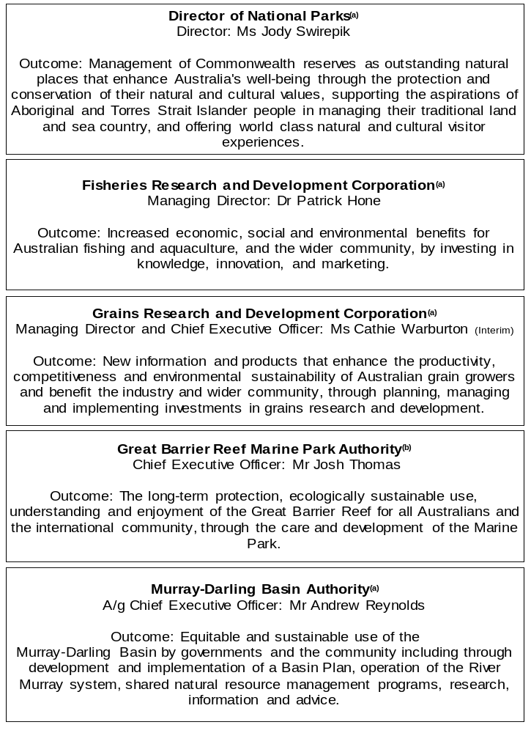
Figure 1: Agriculture, Water and the Environment portfolio structure and outcomes (continued)
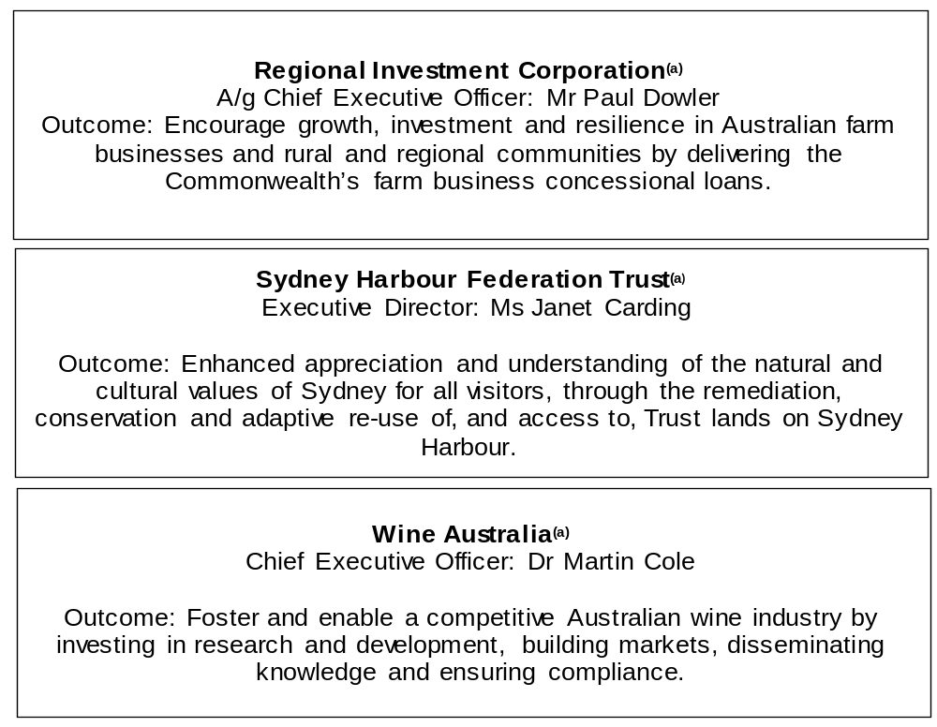
(a) ‘Corporate Commonwealth Entity’ (CCE) as defined under the Public Governance, Performance and Accountability Act 2013.
(b) ‘Non-corporate Commonwealth Entity’ (NCCE) as defined under the Public Governance, Performance and Accountability Act 2013.
(c) ‘Executive Agency’ through an Order made by the Governor-General, under subsection 65(1) of the Public Service Act 1999.

Other industry-owned and not-for-profit companies related to the portfolio
Australian industry-owned companies are independent corporate entities, established under specific legislation with expertise-based boards. The company members appoint the directors of the board. Companies are accountable to the Minister for Agriculture and Northern Australia through legislation and statutory funding agreements and are entitled to receive industry levies and matching Australian Government funding for eligible research and development (R&D). These entities report outside the general government sector.
The following industry-owned companies provide R&D and marketing services:
- Australian Egg Corporation Limited
- Australian Livestock Export Corporation Limited
- Australian Meat Processor Corporation Limited
- Australian Pork Limited
- Australian Wool Innovation Limited
- Dairy Australia Limited
- Forest and Wood Products Australia Limited
- Horticulture Innovation Australia Limited
- Meat and Livestock Australia Limited
- Sugar Research Australia Limited.
Separately, the Australian Government provides funding to the following
not-for-profit, portfolio-related companies:
- Animal Health Australia
- Landcare Australia Limited
- National Environment Protection Council
- Plant Health Australia Limited.

Entities’ resources and
planned performance
Department of Agriculture, Water and the Environment 15
AgriFutures Australia 109
Australian Fisheries Management Authority 133
Australian Pesticides and Veterinary Medicines Authority 159
Bureau of Meteorology 177
Cotton Research and Development Corporation 201
Director of National Parks 221
Fisheries Research and Development Corporation 245
Grains Research and Development Corporation 265
Great Barrier Reef Marine Park Authority 287
Murray-Darling Basin Authority 313
Regional Investment Corporation 335
Sydney Harbour Federation Trust 353
Wine Australia 373

Department of Agriculture, Water and the Environment

Entity resources and planned performance

Department of Agriculture, Water and the Environment
Section 1: Entity overview and resources 17
1.1 Strategic direction statement 17
1.2 Entity resource statement 22
1.3 Budget measures 28
Section 2: Outcomes and planned performance 36
2.1 Planned performance 37
2.2 Budgeted expenses for Outcome 1 46
2.3 Budgeted expenses for Outcome 2 59
2.4 Budgeted expenses for Outcome 3 63
2.5 Budgeted expenses for Outcome 4 79
2.6 Budgeted expenses for Outcome 5 87
Section 3: Budgeted financial statements 92
3.1 Budgeted financial statements 92
3.2 Budgeted financial statements tables 94

Department of Agriculture, Water and the Environment

Section 1: Entity overview and resources

1.1 Strategic direction statement
The Department of Agriculture, Water and the Environment is the Australian Government’s first integrated natural living resources and heritage agency. We work to enhance Australia’s agriculture, water resources and unique environment and heritage through regulation and partnership for the benefit of all Australians and the natural world. The department’s diverse roles and functions include policy advice, world-class science and research, program administration, provision of client services, regulation, natural resource conservation, biosecurity capabilities and market access negotiation. Our work is central to the nation’s identity and touches the lives of all Australians, particularly those living in regional and remote areas. We support economic prosperity while caring for our country and protecting the quality of life that Australians enjoy.
Our partnerships are crucial to providing stewardship of our land, water and iconic places so they can be enjoyed by future generations. They ensure we can achieve the best possible outcomes in agriculture, biosecurity, water and environmental and heritage policy and practice. We work directly with industry, governments,
non-government organisations (NGOs), primary producers, research organisations, Traditional Owners and local communities to protect the environment and develop productive and enduring agricultural industries. A priority for our department is building on our engagement and partnerships with Aboriginal and Torres Strait Islander peoples across our shared interests.
As the Australian Government continues to focus on economic recovery in 2022–23, the department maintains its critical role in boosting the contribution of agriculture to Australia’s economic growth and creating jobs through activities to protect our environment, water and natural resources.
Australia’s farmers, fishers and foresters have faced devastating floods, bushfires, drought, the COVID-19 pandemic and global trade disruptions. Despite these challenges, our primary industries have continued to grow and are now forecast to be worth a record $87.0 billion in 2021–22, which includes $5.5 billion from fisheries and forestry. As we continue to face increasingly complex challenges and evolving threats, the Australian Government is supporting this growth and creating the settings for industry to reach its goal of $100 billion in farm gate output by 2030. Achieving this goal will require a sustained, collaborative effort across industry, government and communities to make sure the foundations are strong and industry can capitalise on emerging opportunities.

The Agriculture 2030 objectives remain a key part of the Australian Government’s strategy to revitalise our regions, create jobs and build a more resilient Australia. Significant initiatives to finalise a voluntary biodiversity stewardship market with new income streams for farmers, improve drought management through the Future Drought Fund, support the viability of Australia’s forest products industry, maximise farm gate output through traceability and on-farm biosecurity and support agricultural shows and large agricultural events, are all important parts of this strategy and are funded in this Budget. These measures build on past successes to help drive industry growth and navigate future challenges.
Australia’s world-class biosecurity system is critical to the integrity and sustainability of our agricultural sector and unique environment. Biosecurity is at the heart of how Australia prevents, responds to and recovers from pests and diseases that threaten human health, regional communities, agriculture, our environment and our economy. Changes in global trade continue to create new and complex biosecurity risk pathways, increasing pressure on Australia’s biosecurity system. Preventing lumpy skin disease, recently detected in Indonesia, from entering Australia and impacting our $15 billion cattle industry, is a key priority, as is supporting states and territories with the emergency response to the current Japanese encephalitis outbreak.
We are also strengthening our biosecurity capabilities in northern Australia, which is a high-risk pathway into Australia’s agricultural industries and communities. Continuing to improve diagnostics and implement emerging surveillance technologies is crucial, as is working closely with industry partners and the near regions.
The Australian Government is working to deliver improved environmental outcomes, support economic recovery and create jobs across Australia – including in regional communities – through more efficient environmental assessment processes.
The department continues to deliver environmental reform initiatives to strengthen our national environmental protection system. These include maintaining on-time environmental approvals, streamlining the assessment and approvals process, and delivering an accelerated regional planning scheme. These initiatives will streamline development decisions and provide business certainty while delivering better environmental outcomes and encouraging investment in high-quality environment protection.
Protecting Australia’s water, soil, native plants and animals and supporting their productive and sustainable use is a longstanding commitment of the Australian Government. The department works cooperatively with state and territory governments, Aboriginal and Torres Strait Islander peoples, organisations and private landholders to deliver initiatives that build on this commitment to care for our country. This includes delivering the Australian Government’s initiatives to safeguard ongoing protection and recovery for threatened and migratory species and their habitat, protect Australia’s coastal rivers and waterways, and deliver greening projects in our cities to ensure our environment is protected for future generations.

Aboriginal and Torres Strait Islander heritage is central to Australia's national story and how we manage our valuable natural and cultural resources. The department is working to reform and modernise Indigenous cultural heritage protections in partnership with the First Nations Heritage Protection Alliance, ensuring that Aboriginal and Torres Strait Islander peoples are at the centre of Indigenous heritage reform. The Australian Government is also investing additional funds to maintain timely assessments and determinations for Indigenous cultural heritage protection applications. The department, together with the Director of National Parks, continues to partner with Traditional Owners to manage Australia’s Commonwealth national parks, gardens and marine parks. We are working together to design and implement employment initiatives for on-country jobs in our national parks, which will deliver improved employment outcomes as well as stronger environmental outcomes in our national parks.
We are supporting the Australian Government’s $1 billion transformation of the waste and recycling sector, including the 2022–23 initiative to boost the successful Recycling Modernisation Fund (RMF) to deliver state of the art advanced recycling solutions for hard to recycle plastics. The department is partnering with states, territories and industry to improve plastics recycling technology in Australia, targeting hard to recycle plastics, such as bread bags and chip packets and plastic e-waste, to allow these items to be fully recycled and remanufactured in Australia from domestically recycled material. The Plastics Technology Stream of the RMF will increase plastic recycling rates, help drive progress on the National Packaging Targets and help tackle plastic pollution. These initiatives, as well as other actions that will promote Australia’s growing remanufacturing industries and deliver the world-first waste export ban, are futureproofing Australia’s capabilities in developing, collecting, and recycling resources, which will reduce the impacts of waste on our environment, create jobs, and grow the economy.
The department works to improve the sustainable management of Australia’s water resources for agriculture, the environment and communities. We lead water reform across the country, provide national leadership and work with relevant state and territory governments to implement the Australian Government’s plan to deliver a healthy, sustainable and more certain future for Murray-Darling Basin communities and rivers. In 2022–23, the department continues to support community actions to improve river health and water security while building community confidence in the governance of water management systems and improving the economic, social and climate resilience of Basin communities.

Australia’s Antarctic science program is one of our most iconic and enduring national endeavours. The Australian Government’s investment over the next ten years will cement Australia’s leadership in the conservation of Antarctica, strengthening our strategic and scientific capabilities in the region while boosting jobs and providing more opportunities for businesses across Australia that support this work.
These investments will also enhance Tasmania’s global reputation as the premier gateway into east Antarctica. The Australian Government is supporting our
world-class scientists and expeditioners to build on their research in Antarctica and the Southern Ocean, explore new areas of east Antarctica’s inland that no country has reached before, and is reinforcing Australia’s commitment to the Antarctic Treaty system.
Outcomes
The department is responsible for five outcomes, which align with our strategic objectives and support the achievement of our purpose:
Outcome 1: Conserve, protect and sustainably manage Australia’s biodiversity, ecosystems, environment and heritage through research, information management, supporting natural resource management, establishing and managing Commonwealth protected areas, and reducing and regulating the use of pollutants and hazardous substances, and coordination of climate change adaptation strategy and climate change science activities.
Outcome 2: Advance Australia’s strategic, scientific, environmental and economic interests in the Antarctic region by protecting, administering and researching the region.
Outcome 3: More sustainable, productive, internationally competitive and profitable Australian agricultural, food and fibre industries through policies and initiatives that promote better resource management practices, innovation, self-reliance and improved access to international markets.
Outcome 4: Safeguard Australia’s animal and plant health status to maintain overseas markets and protect the economy and environment from the impact of exotic pests and diseases, through risk assessment, inspection and certification, and the implementation of emergency response arrangements for Australian agricultural, food and fibre industries.
Outcome 5: Improve the health of rivers and freshwater ecosystems and water use efficiency through implementing water reforms, and ensuring enhanced sustainability, efficiency and productivity in the management and use of water resources.

1.2 Entity resource statement
Table 1.1 shows the total funding from all sources available to the entity for its operations and to deliver programs and services on behalf of the Government.
The table summarises how resources will be applied by outcome (Government strategic policy objectives) and by administered (on behalf of the Government or the public) and departmental (for the entity’s operations) classification.
For more detailed information on special accounts and special appropriations, please refer to Budget Paper No. 4: Agency Resourcing.
Information in this table is presented on a resourcing (i.e. appropriations/cash available) basis, whilst the ‘Budgeted expenses by Outcome’ tables in Section 2 and the financial statements in Section 3 are presented on an accrual basis.

Table 1.1: Department of Agriculture, Water and the Environment – Resource Statement – Budget Estimates for 2022–23 as at Budget March 2022
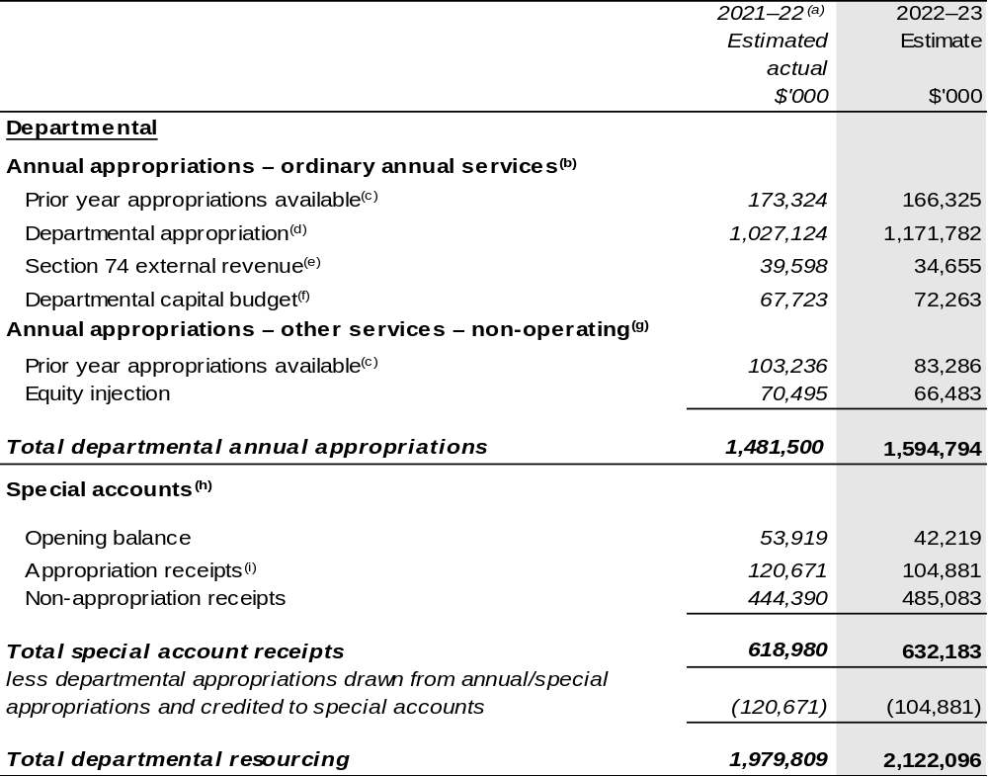

Continued on following pages
Table 1.1: Department of Agriculture, Water and the Environment – Resource Statement – Budget Estimates for 2022–23 as at Budget March 2022 (continued)
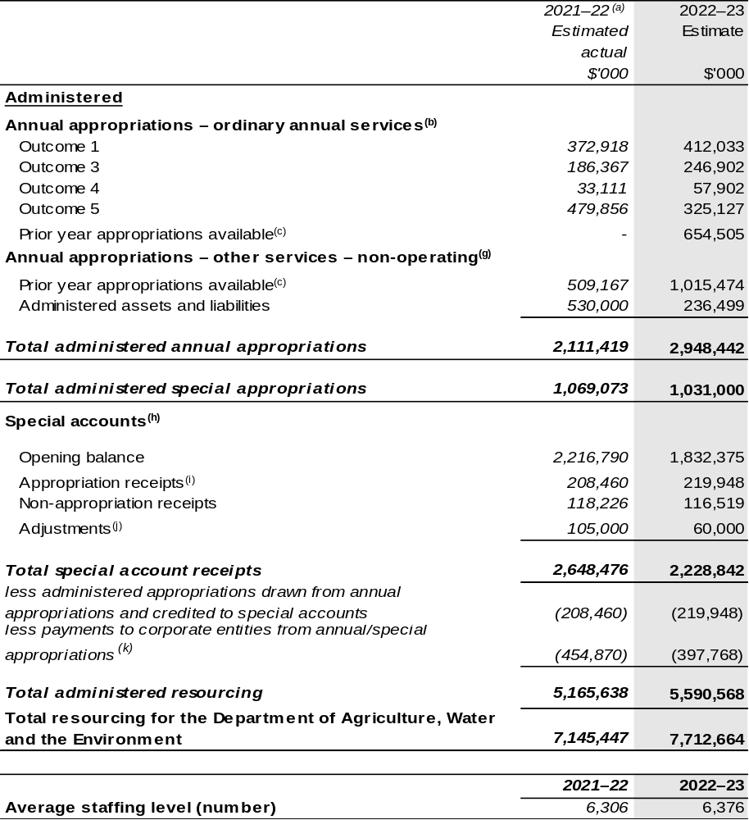

Continued on following pages

Table 1.1: Department of Agriculture, Water and the Environment – Resource Statement – Budget Estimates for 2022–23 as at Budget March 2022 (continued)

- Annual Appropriation amounts presented for 2021–22 do not include the Appropriation Bills (No. 3) and (No. 4), as they had not been enacted at the time of publication. For the department, $198.338 million will be received through the 2021–22 Annual Appropriation Bill (No. 3) and $6.901 million will be received through 2021–22 Annual Appropriation Bill (No. 4). The annual appropriations received from these bills will be recognised in a future portfolio budget statement but only after the Bills have received Royal Assent.
- Appropriation Bill (No. 1) 2022–23.
- Excludes $447.639 million subject to administrative quarantine by the Department of Finance or withheld under section 51 of the Public Governance, Performance and Accountability Act 2013 (PGPA Act). The movement from the 2021–22 Portfolio Additional Estimates Statements is attributed to the repeal, quarantine or draw down of annual appropriations.
- Excludes departmental capital budget (DCB).
- Estimated external revenue under section 74 of the PGPA Act.
- Departmental capital budgets are not separately identified in Appropriation Bill (No. 1) and form part of ordinary annual services items. Please refer to Table 3.5 for further details. For accounting purposes, this amount has been designated as a ‘contribution by owner’.
- Appropriation Bill (No. 2) 2022–23.
- Excludes trust moneys held in Services for Other Entities and Trust Moneys (SOETM) accounts and other special accounts. For further information on special accounts, please refer to Budget Paper No. 4: Agency Resourcing. Please also see Table 2.1 for further information on outcome and program expenses broken down by various funding sources, e.g. annual appropriations, special appropriations and special accounts.
- Amounts credited to the special account(s) from the department’s annual appropriations.
- Amounts are statutory credits provided to the special account(s). For further information on special accounts, please refer to Budget Paper No. 4: Agency Resourcing.
- ‘Corporate entities’ are CCE and Commonwealth companies as defined under the PGPA Act.

Note: All figures shown above are GST exclusive – these may not match figures in the cash flow statement.

Prepared on a resourcing (i.e. appropriations available) basis.

Continued on following pages

Table 1.1: Department of Agriculture, Water and the Environment – Resource Statement – Budget Estimates for 2022–23 as at Budget March 2022 (continued)
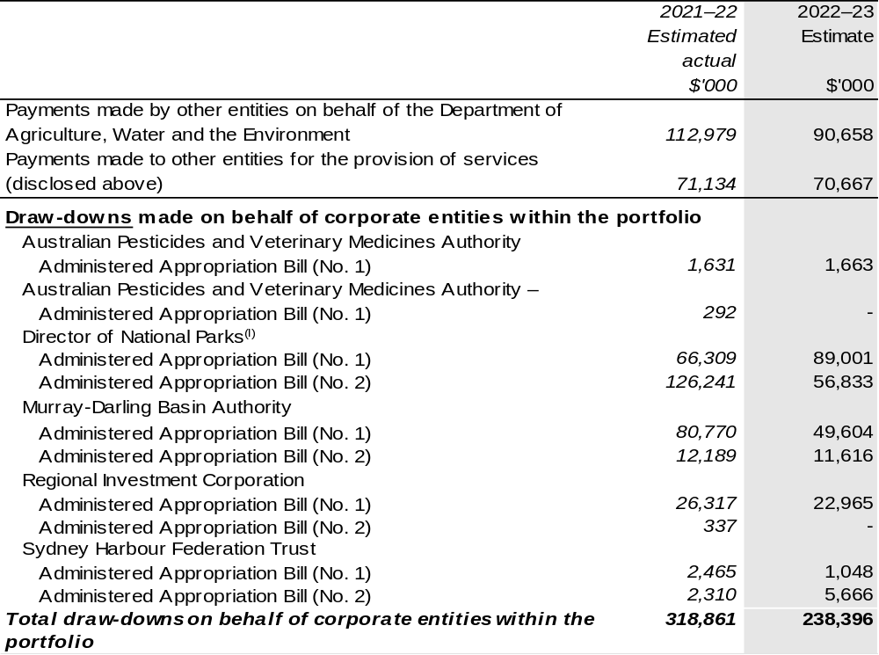
- Annual Appropriation amounts presented for 2021–22 do not include the Appropriation Bills (No. 3) and (No. 4), as they had not been enacted at the time of publication. Please refer to Director of National Parks Entity Resource Statement (Table 1.1) for further information.

Continued on following page

Table 1.1: Department of Agriculture, Water and the Environment – Resource Statement – Budget Estimates for 2022–23 as at Budget March 2022 (continued)
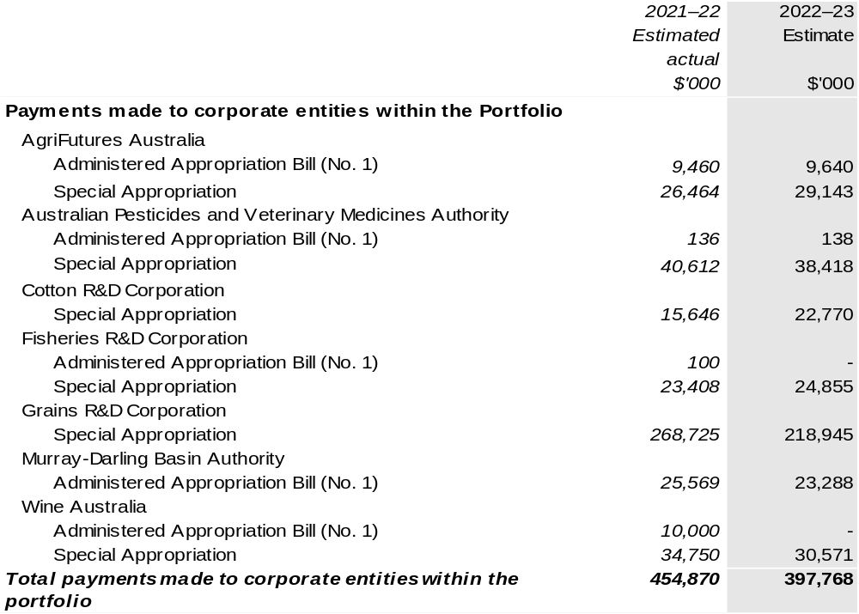

1.3 Budget measures
Budget measures relating to the department are detailed in Budget Paper No.2 and are summarised below.

Table 1.2: Department of Agriculture, Water and the Environment – 2022–23 Budget measures – Measures announced since the 2021–22 Mid-Year Economic and Fiscal Outlook (MYEFO)
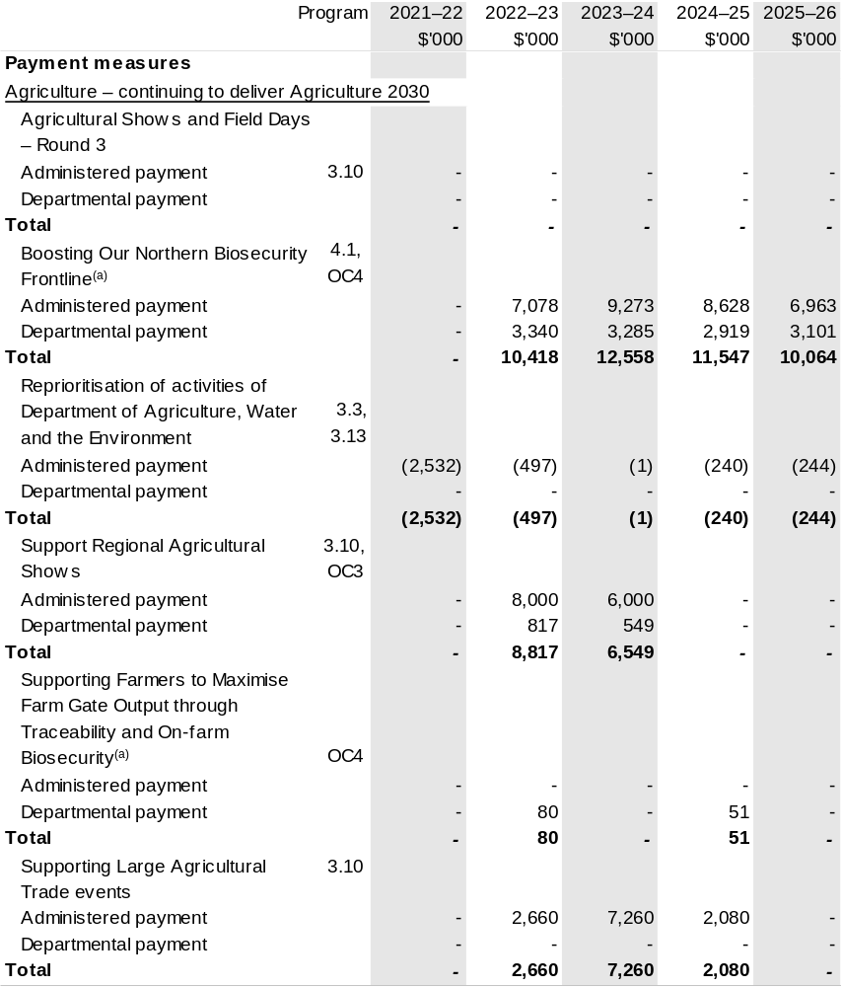

Continued on following pages

Table 1.2: Department of Agriculture, Water and the Environment – 2022–23 Budget measures – Measures announced since the 2021–22 MYEFO
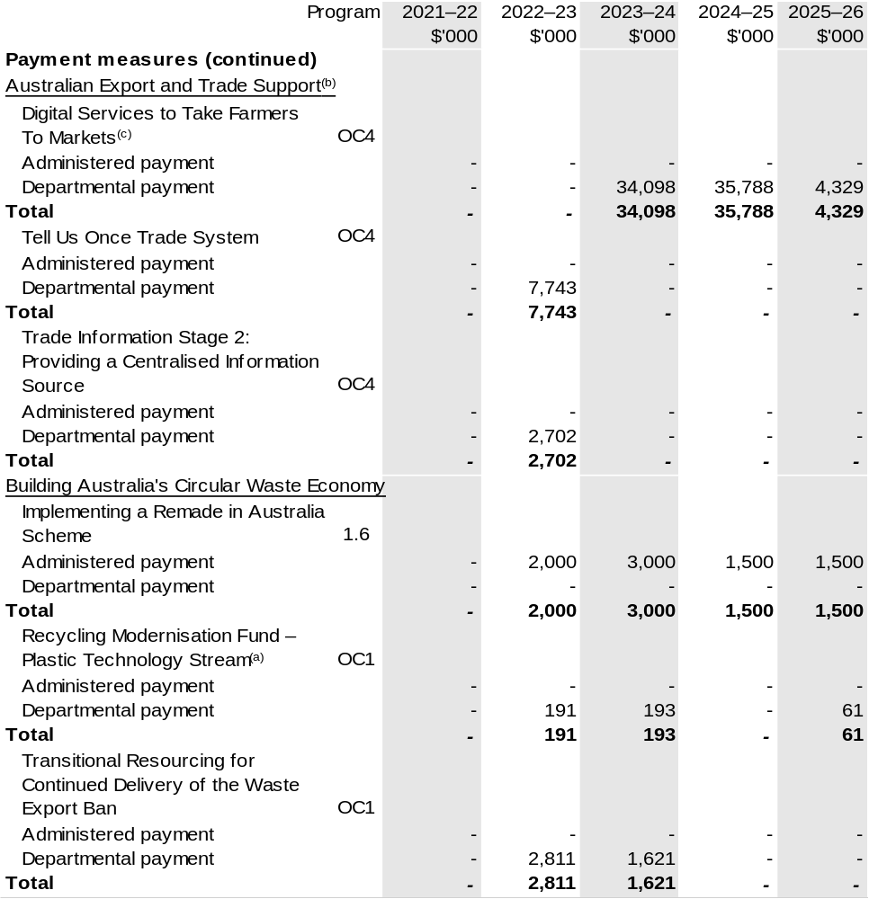

Continued on following pages
Table 1.2: Department of Agriculture, Water and the Environment – 2022–23 Budget measures – Measures announced since the 2021–22 MYEFO
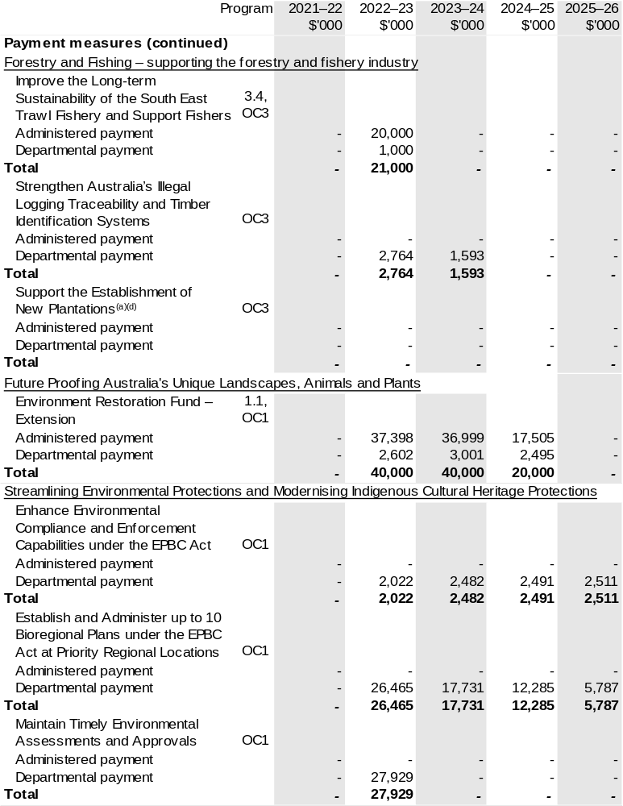

Continued on following pages
Table 1.2: Department of Agriculture, Water and the Environment – 2022–23 Budget measures – Measures announced since the 2021–22 MYEFO
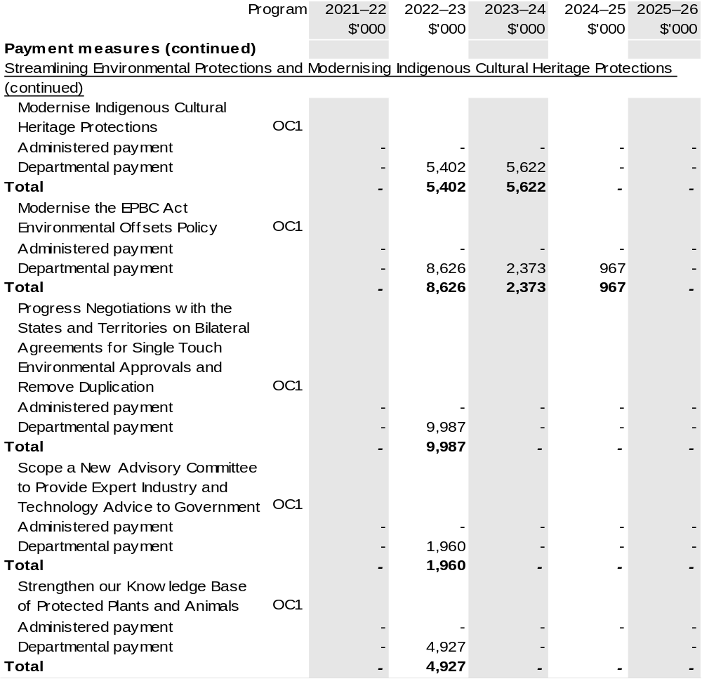

Continued on following pages
Table 1.2: Department of Agriculture, Water and the Environment – 2022–23 Budget measures – Measures announced since the 2021–22 MYEFO
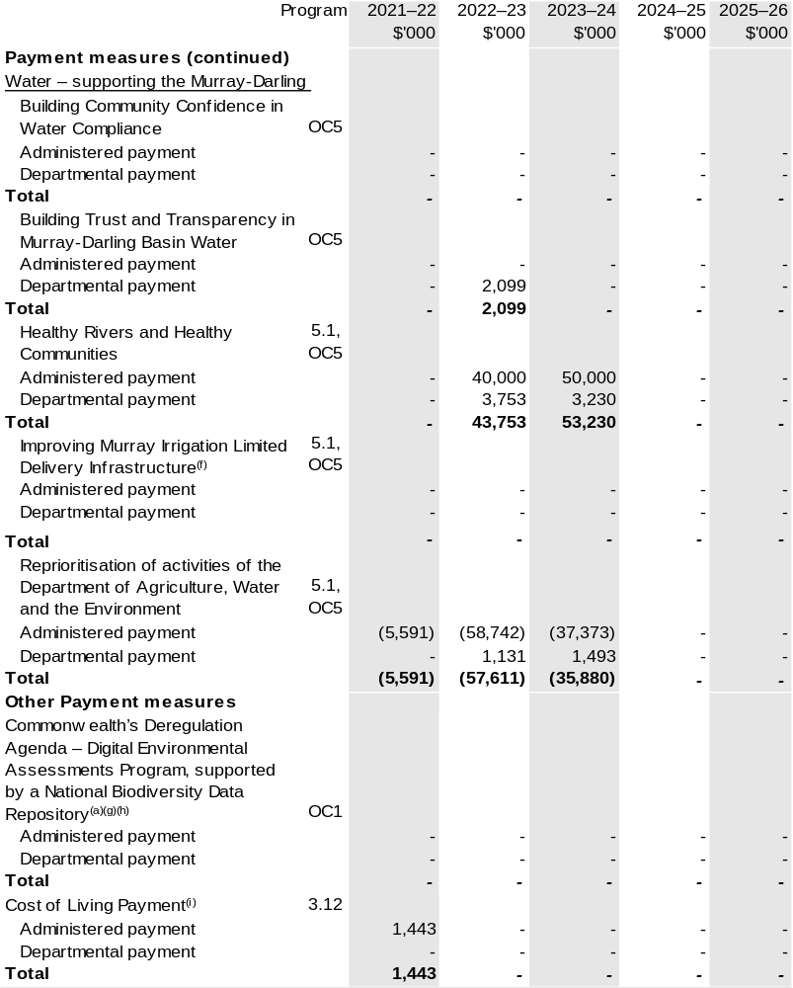

Continued on following pages
Table 1.2: Department of Agriculture, Water and the Environment – 2022–23 Budget measures – Measures announced since the 2021–22 MYEFO
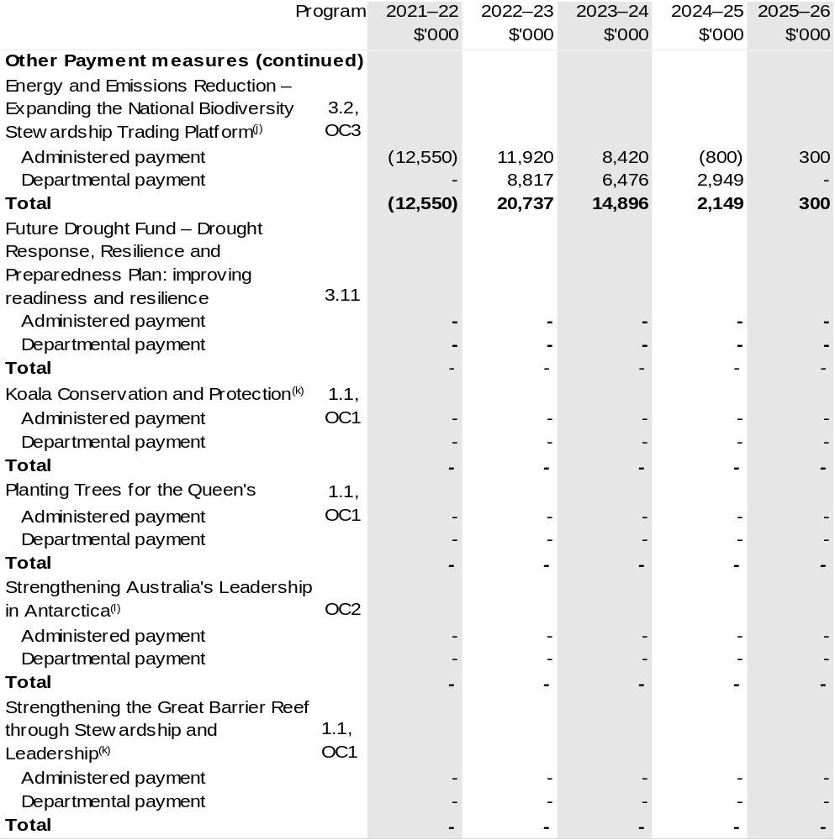

Continued on following pages
Table 1.2: Department of Agriculture, Water and the Environment – 2022–23 Budget measures – Measures announced since the 2021–22 MYEFO
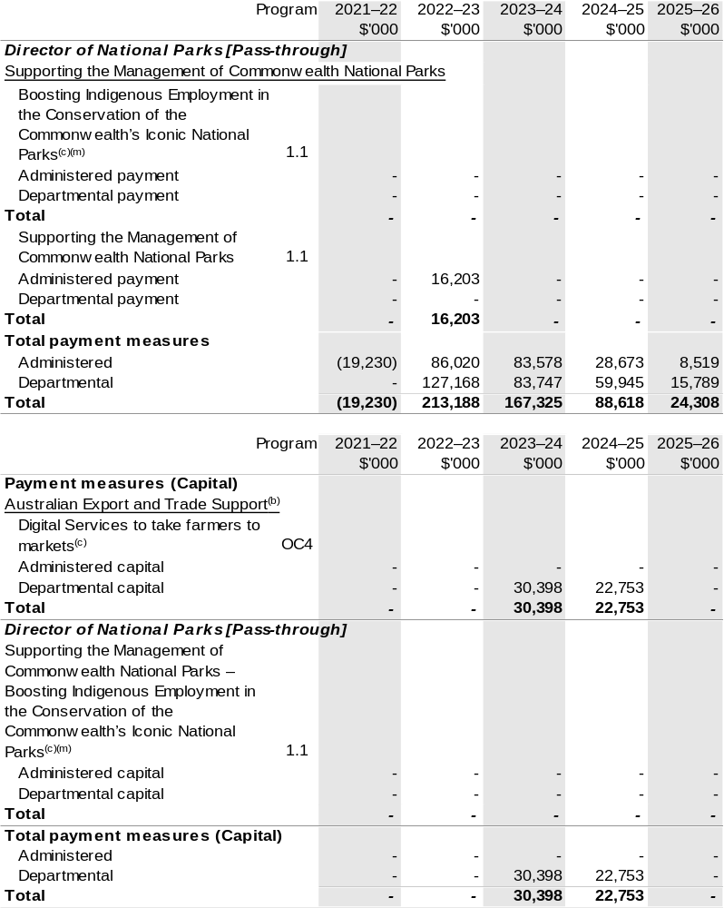
(a) This measure provides funding to the National Partnership programs within the Department of the Treasury. Details appear in Budget Paper No. 3: Federal Financial Relations.
(b) These items are part of the measure Australian Export and Trade Support. The measure description appears in Budget Paper No. 2: Budget Measures 2022–23 under the Foreign Affairs and Trade portfolio.
(c) This measure can also be found in the capital and payment section of the 2022–23 Department of Agriculture, Water and the Environment PBS.
Continued on following page
Table 1.2: Department of Agriculture, Water and the Environment – 2022–23 Budget measures – Measures announced since the 2021–22 MYEFO

(d) The measure Forestry and Fishing – supporting the forestry and fishery industry – Support the Establishment of New Plantations was a Decision Taken But Not Yet Announced (DTBNYA) in the 2021–22 Agriculture, Water and the Environment Portfolio Additional Estimates Statements (PAES), with the following departmental impacts: 2021–22 $0.294 million; 2022–23 $0.209 million; 2023–24 $0.209 million; 2024–25 $0.210 million and 2025–26 $0.287 million. The measure description appears in Budget Paper No. 2: Budget Measures 2022–23 under the Agriculture, Water and the Environment portfolio. This measure also provides funding to the National Partnership programs within the Department of the Treasury, with the following impact: 2022–23 $10.000 million; 2023–24 $25.000 million; 2024–25 $30.000 million and 2025–26 $20.000 million. Details appear in Budget Paper No. 3: Federal Financial Relations.
(e) The cost of this measure will be met from within the existing resources of the Department of Agriculture, Water and the Environment. The measure description appears in Budget Paper No. 2: Budget Measures 2022–23 under the Agriculture, Water and the Environment portfolio.
(f) The measure Water – supporting the Murray-Darling Basin – Improving Murray Irrigation Limited Delivery Infrastructure was a DTBNYA in the 2021–22 PAES, with the following departmental impacts: 2021–22 $0.446 million; 2022–23 $0.936 million and 2023–24 $0.852 million, with the following administered impacts: 2021–22 $1.000 million; 2022–23 $3.750 million; 2023–24 $28.100 million; with the total of these lines reprioritised from administered funding in the same years. The measure description appears in Budget Paper No. 2: Budget Measures 2022–23 under the Agriculture, Water and the Environment portfolio.
(g) The measure Commonwealth’s Deregulation Agenda – Digital Environmental Assessments Program, supported by a National Biodiversity Data Repository appears in Budget Paper No. 2: Budget Measures 2022–23 under Cross Portfolio.
(h) The measure Commonwealth’s Deregulation Agenda – Digital Environmental Assessments Program, supported by a National Biodiversity Data Repository was a DTBNYA in the 2021–22 PAES, with the following departmental impacts: 2021–22 $0.287 million; 2022–23 $14.433 million; 2023–24 $12.454 million; 2024–25 $10.056 million and 2025–26 $4.723 million, this is an ongoing program.
This measure also provides funding to the National Partnership programs within the Department of the Treasury, with the following impact: 2022–23 $4.000 million; 2023–24 $4.700 million and 2024–25 $1.800 million. Details appear in Budget Paper No. 3: Federal Financial Relations.
(i) The lead entity for the measure Cost of Living Payment is the Department of Social Services.
The measure description appears in Budget Paper No. 2: Budget Measures 2022–23 under the Social Services portfolio.
(j) The lead entity for the measure Energy and Emissions Reduction – Expanding the National Biodiversity Stewardship Trading Platform is the Department of Industry, Science, Energy and Resources. The measure description appears in Budget Paper No. 2: Budget Measures 2022–23 under the Industry, Science, Energy and Resources portfolio.
(k) These measures were published in the 2021–22 PAES, please refer to Table 1.2: Department of Agriculture, Water and the Environment (DAWE) – measures announced since the 2021–22 Budget. The measure description appears in Budget Paper No. 2: Budget Measures 2022–23 under the Agriculture, Water and the Environment portfolio.
(l) The measure Strengthening Australia's Leadership in Antarctica was a DTBNYA in the 2021–22 PAES, with the following departmental impacts: 2021–22 $12.119 million; 2022–23 $83.209 million; 2023–24 $66.576 million; 2024–25 $78.654 million; 2025–26 $88.485 million. The measure description appears in Budget Paper No. 2: Budget Measures 2022–23 under the Agriculture, Water and the Environment portfolio.
(m) The measure Supporting the Management of Commonwealth National Parks – Boosting Indigenous Employment in the Conservation of the Commonwealth’s Iconic National Parks was a DTBNYA in the 2021–22 PAES, with the following administered impacts, as this is a passthrough for the DAWE to Director of National Parks: 2021–22 $0.667 million; 2022–23 $2.139 million; 2023–24 $1.831 million; 2024–25 $2.651 million; 2025–26 $3.223 million and with the following impact on capital appropriation: 2022–23 $0.100 million; this is an ongoing program. The measure description appears in Budget Paper No. 2: Budget Measures 2022–23 under the Agriculture, Water and the Environment portfolio.

Prepared on a Government Finance Statistics (Underlying Cash) basis.

Figures displayed as a negative (-) represent a decrease in funds and a positive (+) represent an increase in funds.

Section 2: Outcomes and planned performance
Government Outcomes are the intended results, impacts or consequences of actions by the Government on the Australian community. Commonwealth programs are the primary vehicle by which government entities achieve the intended results of their Outcome Statements. Entities are required to identify the programs which contribute to Government outcomes over the Budget and forward years.
Each outcome is described below together with its related programs. The following provides detailed information on expenses for each Outcome and program, further broken down by funding source.
Note:
Performance reporting requirements in the Portfolio Budget Statements are part of the Commonwealth performance framework established by the Public Governance, Performance and Accountability Act 2013. It is anticipated that the performance criteria described in Portfolio Budget Statements will be read with broader information provided in an entity’s corporate plans and annual performance statements — included in Annual Reports — to provide a complete picture of an entity’s planned and actual performance.
Our most recent corporate plan can be found at awe.gov.au/about/reporting/corporate-plan.
The most recent annual performance statements can be found at: awe.gov.au/about/reporting/annual-report.

2.1 Planned performance
The performance information in the Portfolio Budget Statements is aligned to the PBS outcomes and the department’s purpose, objectives and priorities in the Corporate Plan. Table 2.1 shows the alignment between the department’s objectives, priorities and PBS programs.

Table 2.1: Outcomes and objectives 2021–22
Corporate plan objective | Priorities | PBS programs
Environment and Heritage:  Improve stewardship and sustainable management of Australia’s environment and unique heritage. | Improve the status of threatened species and ecosystems.  Deliver substantial actions to build climate adaptation and resilience in the economy, community and environment.  Protect, conserve and enhance the value of Commonwealth marine and terrestrial parks and gardens for the use and wellbeing of all Australians. | Program 1.1:  Sustainable Management of Natural Resources and the Environment  Program 1.2:  Environmental Information and Research
 | Conserve and maintain Australia’s unique heritage. | Program 1.4:  Conservation of Australia’s Heritage and Environment
 | Administer and reform the Environment Protection and Biodiversity Conservation  Act 1999 to drive economic recovery post-COVID-19 and strong environment and heritage outcomes.  Improve regulatory efficiency, effectiveness and maturity, including through deregulation. | Program 1.5:  Environmental Regulation
 | Provide national leadership to effectively manage Australia’s waste. | Program 1.6:  Management of Hazardous Wastes, Substances and Pollutants

Table 2.1: Outcomes and objectives 2021–22 (continued)
Corporate plan objective | Priorities | PBS programs
Antarctic:  Advance Australia’s strategic, scientific and environmental interests in the Antarctic and the Southern Ocean. | Maintain Australian leadership  in Antarctica and the Southern Ocean. | Program 2.1: Antarctica: Science, Policy and Presence
Agriculture:  Assist industry to accelerate growth towards a $100 billion agricultural sector by 2030. | Support economic recovery post-COVID-19 across industry.  Deliver policies and programs to support profitable and resilient agribusinesses.  Deliver substantial actions to build climate adaptation and resilience in the economy, community and environment.  Foster collaboration in research and development to drive uptake of innovative practices in the agricultural sector.  Improve regulatory efficiency, effectiveness and maturity, including through deregulation. | Program 3.2:  Sustainable Management – Natural Resources  Program 3.3:  Forestry Industry  Program 3.4:  Fishing Industry  Program 3.5:  Horticulture Industry  Program 3.6:  Wool Industry  Program 3.7:  Grains Industry  Program 3.8:  Dairy Industry  Program 3.9:  Meat and Livestock Industry  Program 3.10:  Agricultural Resources  Program 3.11:  Drought Programs  Program 3.12:  Rural Programs
 | Improved market access and, with our partners, maximise opportunities for agricultural exports. | Program 3.13:  International Market Access

Table 2.1: Outcomes and objectives 2021–22 (continued)
Corporate plan objective | Priorities | PBS programs
Biosecurity:  Work with our partners to lower biosecurity risks to Australian agriculture, the environment and our way of life. | Maintain and strengthen our biosecurity system by working with our partners and through innovation and business transformation.  Transform the export regulatory system.  Improve regulatory efficiency, effectiveness and maturity, including through deregulation. | Program 4.1:  Biosecurity and Export Services  Program 4.2:  Plant and Animal Health
Water resources:  Improve the sustainable management of Australia’s water resources for agriculture, the environment and communities. | Improve the status of threatened species and ecosystems.  Conserve and maintain Australia’s unique heritage.  Partner with Murray–Darling Basin states to implement the Basin Plan and manage Basin water resources in the national interest. | Program 1.3:  Commonwealth Environmental Water  Program 5.1:  Water Reform

Table 2.2: Performance measures for 2021–22 and beyond
Table 2.2 reports the expected results for the performance measures published in the Portfolio Budget Statements 2021–22. The table also shows the high-level performance measures for each objective and outcome in 2022–23 and forward years.
Outcome 1: Conserve, protect and sustainably manage Australia’s biodiversity, ecosystems, environment and heritage through research, information management, supporting natural resource management, establishing and managing Commonwealth protected areas, and reducing and regulating the use of pollutants and hazardous substances, and coordination of climate change adaptation strategy and climate change science activities.
Objective | Environment and Heritage: Improve stewardship and sustainable management of Australia’s environment and unique heritage.
Year | Performance measures | Expected Performance Results
Current year  2021–22 | A reduction in nutrient, sediment and pesticide loads consistent with meeting targets in the Reef 2050 Water Quality Improvement Plan. | On track.
Current year  2021–22 | Habitat condition and connectivity within major vegetation groups improves relative to baseline. | Unable to forecast^{(a)}
Current year  2021–22 | 100% of World Heritage listed properties are managed under management plans that are consistent with the management principles in the Environment Protection and Biodiversity Conservation (EPBC) Regulations. | Not on track.
Current year  2021–22 | Australian targets for Montreal Protocol. | On track.
Current year  2021–22 | Mixed waste plastics that are not of a single resin/polymer type banned from export from 1 July 2021. | Achieved.
Current year  2021–22 | Whole waste tyres banned from export from 1 December 2021. | Achieved.

(a) Data for the performance measure is generated annually using remote sensing. The result will be reported in the 2021–22 annual performance statements.

Continued on following pages
Table 2.2: Performance measures for 2021–22 and beyond (continued)
Outcome 1 (continued)
Year | Performance measures | Planned Performance Results
Budget Year 2022–23 | Percentage improvement in 5 to  10-year rolling average of:  - habitat condition assessment scores across major vegetation groups, after any relevant offsets  - National Connectivity Index scores across major vegetation groups, after any relevant offsets  - remaining area of major vegetation groups as a percentage of pre-1750 levels, after any relevant offsets. | Maintained or improved (≥0 per cent).
Budget Year 2022–23 | Percentage of Environmental Protection and Biodiversity Act 1999 referral, assessment, and approval decisions that meet statutory time frames. | 100 per cent.
Budget Year 2022–23 | Percentage of World Heritage listed properties with management plans that are consistent with the principles in the Environment Protection and Biodiversity Conservation Regulations. | 100 per cent.
Budget Year 2022–23 | Progress implementation of the National Strategy for Environmental-Economic Accounting. | Continual improvement of the National Land Account.
Budget Year 2022–23 | Delivery of the National Soil Strategy. | Completion of the National Soil Monitoring and Incentives Pilot Program by 2023.
Forward Estimates 2023–26 | As per 2022–23. | As per 2022–23.

Continued on following pages

Table 2.2: Performance measures for 2021–22 and beyond (continued)
Outcome 2: Advance Australia’s strategic, scientific, environmental and economic interests in the Antarctic region by protecting, administering and researching the region.
Objective | Antarctic: Advance Australia’s strategic, scientific and environmental interests in the Antarctic and the Southern Ocean.
Year | Performance measures | Expected Performance Results
Current year  2021–22 | Measure progress against the  20 Year Action Plan. | On track.
Year | Performance measures | Planned Performance Results
Budget Year 2022–23 | Increased compliance with legislation protecting Australian Antarctic Territory and Territory of Heard Island and McDonald Islands. (Output). | 100 per cent of Australian Antarctic Program Activities conducted in Antarctica are undertaken with prior environmental authorisation.
Forward Estimates 2023–26 | As per 2022–23. | As per 2022–23.

Outcome 3: More sustainable, productive, internationally competitive and profitable Australian agricultural, food and fibre industries through policies and initiatives that promote better resource management practices, innovation, self-reliance and improved access to international markets.
Objective | Agriculture: Assist industry to accelerate growth towards a $100 billion agricultural sector by 2030.
Year | Performance measures | Planned Performance Results
Current year  2021–22 | Growth in agricultural commodity exports in markets for which the department has negotiated improved market access exceeds average export growth. | On track.
Current year  2021–22 | Average annual productivity growth for the past 10 years is equal to, or exceeds, average annual market sector productivity growth over the same period. | On track.

Continued on following pages
Table 2.2: Performance measures for 2021–22 and beyond (continued)
Outcome 3 (continued)
Year | Performance measures | Planned Performance Results
Current year  2021–22 (continued) | Levy collection processes cost no more than 1.2 per cent of levies disbursed.  Inspections of levy agent records cover at least 20 per cent of levy revenue over a three-year rolling average. | On track.  On track.
Year | Performance measures | Planned Performance Results
Budget Year 2022–23 | Greater growth in average agriculture, forestry and fishing sector productivity for the past  10 years compared to average annual growth in Australian market sector productivity over the same period. | ≥0 per cent difference over past  10 years.
Budget Year 2022–23 | Equal or reduced cost of levy collection processes compared with levies disbursed. | Cost ≤1.2 per cent of levies disbursed.
Budget Year 2022–23 | Value of potential trade achieved through new and improved market access arrangements. | Improvement in market value achieved (above zero).
Budget Year 2022–23 | Decrease in the number of  point-of-entry failures from agricultural exports. | <0 per cent difference in number of point-of-entry failures from baseline.
Budget Year 2022–23 | Lead and report on the implementation of Australian, state and territory government obligations under the National Drought Agreement. | Annual report completed within  6 months of the end of each financial year.
Forward Estimates 2023–26 | As per 2022–23. | As per 2022–23.

Continued on following pages
Table 2.2: Performance measures for 2021–22 and beyond (continued)
Outcome 4: Safeguard Australia’s animal and plant health status to maintain overseas markets and protect the economy and environment from the impact of exotic pests and diseases, through risk assessment, inspection and certification, and the implementation of emergency response arrangements for Australian agricultural, food and fibre industries.
Objective | Biosecurity: Work with our partners to lower biosecurity risks to Australian agriculture, the environment and our way of life.
Year | Performance measures | Expected Performance Results
Current year 2021–22 | Performance measures are developed to assess the effectiveness of the national biosecurity system. | On track.
Current year 2021–22 | Rates of compliance with regulations administered by the department are maintained or improved. | On track.
Year | Performance measures | Planned Performance Results
Budget Year 2022–23 | Reduction in risk from targeted priority pests and diseases due to biosecurity measures implemented by the department. | African swine fever: Risk-based interventions in mail and traveller pathways including interception rates of pork products.  Brown marmorated stink bug: Reduced proportion of live insects intercepted due to departmental measures.  Hitchhiker pests including khapra beetle: A comprehensive risk-based intervention method including a reduced number of live insects intercepted at the border in high-risk commodities.
Budget Year 2022–23 | Reduced levels of non-compliance with regulations administered by the department. | Reduced high-value cargo  non-compliance rate.  Reduced Approved Arrangements non-compliance rate.  Reduced post-intervention  non-compliance rate for international travellers.
Forward Estimates 2023–26 | As per 2022–23. | As per 2022–23.

Continued on following page
Table 2.2: Performance measures for 2021–22 and beyond (continued)
Outcome 5: Improve the health of rivers and freshwater ecosystems and water use efficiency through implementing water reforms, and ensuring enhanced sustainability, efficiency and productivity in the management and use of water resources.
Objective | Water Resources: Improve the sustainable management of Australia’s water resources for agriculture, the environment and communities.
Year | Performance measures | Expected Performance Results
Current year 2021–22 | Number of Water Resource Plans (WRPs) accredited under Commonwealth law:  33 of 33 WRPs accredited. | Not on track.
Current year 2021–22 | Water-dependent ecosystems are protected and restored. | On track.
Year | Performance measure | Planned Performance Results
Budget Year 2022–23 | The application of environmental water delivers ecological benefit in accordance with the Murray–Darling Basin Plan. | The Commonwealth Environmental Water Office is assessed as delivering positive benefits.
Budget Year 2022–23 | Increase in the volume of water recovered for environmental purposes in the Murray–Darling Basin to meet Basin Plan targets. | Bridging the Gap water recovery: +26 GL recovered.  Progress towards the recovery of 450 GL of additional water.
Budget Year 2022–23 | Delivery of the Murray–Darling Basin Communities Investment Package. | All 11 commitments ongoing or completed.
Forward Estimates 2023–26 | As per 2022–23. | As per 2022–23.
Forward Estimates 2023–26 | As per 2022–23. | 2023–24:  Bridging the Gap water recovery complete.  450 GL of additional water recovered by 30 June 2024.
Forward Estimates 2023–26 | As per 2022–23. | 2023–24:  All 11 commitments completed.

2.2 Budgeted expenses for Outcome 1
Outcome 1: Conserve, protect and sustainably manage Australia’s biodiversity, ecosystems, environment and heritage through research, information management, supporting natural resource management, establishing and managing Commonwealth protected areas, and reducing and regulating the use of pollutants and hazardous substances, and coordination of climate change adaptation strategy and climate change science activities.

2.2.1: Linked programs
Australian Fisheries Management Authority
Program 1.1: Australian Fisheries Management Authority
Contribution to Outcome 1 made by linked programs
The DAWE and the Australian Fisheries Management Authority (AFMA) engage on sustainable management of Commonwealth fisheries.
Australian Institute of Marine Science
Program 1.1: Marine Research
Contribution to Outcome 1 made by linked programs
DAWE and the Australian Institute of Marine Science work together on implementation of the Reef 2050 Plan to protect and conserve the Great Barrier Reef.
Australian Maritime Safety Authority
Program 1.1: Australian Maritime Safety Authority
Contribution to Outcome 1 made by linked programs
The Australian Maritime Safety Authority works to minimise the risk of shipping incidents and pollution in Australian waters and contributes to the sustainable management of natural resources, including the Great Barrier Reef.
Australian Taxation Office
Program 1.9: Product Stewardship for Oil program
Contribution to Outcome 1 made by linked programs
The Australian Taxation Office administers the Product Stewardship for Oil program on behalf of DAWE by providing incentives to increase used oil recycling and encourage environmentally sustainable management and re-refining of used oil and its re-use.

Continued on following pages

2.2.1: Linked programs (continued)
Australian Transaction Reports and Analysis Centre
Program 1.1: Australian Transaction Reports and Analysis Centre
Contribution to Outcome 1 made by linked programs
Australian Transaction Reports and Analysis Centre (AUSTRAC) works with DAWE to identify and disrupt illegal wildlife trade.
Bureau of Meteorology
Program 1.1: Bureau of Meteorology
Contribution to Outcome 1 made by linked programs
The Bureau of Meteorology (BOM) is a partner in the Climate Systems Hub in the National Environmental Science Program. BOM also provides weather, climate and water modelling and information to DAWE.
Clean Energy Finance Corporation
Program 1.1: Clean Energy Finance Corporation
Contribution to Outcome 1 made by linked programs
DAWE has responsibility for policies that reduce waste and increase domestic recycling capacity. The Clean Energy Finance Corporation (CEFC) contributes to these policies by making available funding to the Clean Energy Innovation Fund and Reef Funding Program. Through the Australian Recycling Investment Fund, CEFC provides flows of finance into clean energy technologies that support the recycling of waste, in particular wastes that are – or by 1 July 2024 will be – banned for export.
Commonwealth Scientific and Industrial Research Organisation
Program 1: Scientific and Industrial Research and Infrastructure
Contribution to Outcome 1 made by linked programs
The Commonwealth Scientific and Industrial Research Organisation (CSIRO) contributes to Outcome 1 through the delivery of research to support the implementation of the Reef 2050 Plan to protect and conserve the Great Barrier Reef.
CSIRO leads the Climate Systems Hub and is a partner in other Hubs in the National Environmental Science Program.
CSIRO collaborates in the delivery of the Geological and Bioregional Assessments program, contributing expertise in ecology, ecotoxicology, hydrology, hydrogeology, informatics and risk analysis.

Continued on following pages
2.2.1: Linked programs (continued)
Department of Defence
Program 2.5: Navy Capabilities
Program 2.7: Air Force Capabilities
Program 2.10: Security and Estate
Contribution to Outcome 1 made by linked programs
Defence actively participates in forums and initiatives led by the DAWE to ensure alignment with national approaches for the effective and efficient management of environmental factors.
Department of Foreign Affairs and Trade
Program 1.1: Foreign Affairs and Trade Operations
Program 1.2: Official Development Assistance
Contribution to Outcome 1 made by linked programs
The Department of Foreign Affairs and Trade (DFAT) supports DAWE on matters relating to the protection and conservation of coral reefs globally. This draws on Australian expertise in coral reef science and management, particularly from the Great Barrier Reef.
DAWE receives funding from DFAT for several international engagement activities. DAWE, with engagement from DFAT, is the lead agency for Australia’s engagement in the High-Level Panel for a Sustainable Ocean Economy. DAWE works with Australia’s Ambassador to United Nations Educational, Scientific and Cultural Organization (UNESCO) and Australia’s Ambassador for the Environment in support of Australia’s membership of the World Heritage Committee. DFAT supports promotion internationally of Australia’s work on nature-based solutions, including through Indigenous fire/land management knowledge sharing.
Department of Health
Program 1.8: Health Protection, Emergency Response and Regulation
Contribution to Outcome 1 made by linked programs
DAWE and the Department of Health work together to manage policy and regulatory issues that have combined human and environmental health implications.
Department of Home Affairs
Program 3.4: Border Enforcement
Program 3.2: Border Management
Contribution to Outcome 1 made by linked programs
DAWE and the Department of Home Affairs work together to prevent the illegal wildlife trade, control transboundary movements of hazardous wastes and their disposal and share information on imports of products subject to air quality standards.

Continued on following pages
2.2.1: Linked programs (continued)
Department of Industry, Science, Energy and Resources
Program 1.1: Investing in Science, Technology and Commercialisation
Program 1.3: Supporting a Strong Resources Sector
Contribution to Outcome 1 made by linked programs
DAWE works collaboratively with the Department of Industry, Science, Energy and Resources (DISER) on science and research priorities for a resilient Great Barrier Reef. DAWE provides advice to DISER to ensure the ongoing protection of the Alligator Rivers Region from impacts of mining uranium at Ranger mine.
DISER also works collaboratively with DAWE to support manufacturers in the food and beverage and recycling sectors through the Modern Manufacturing Strategy.
Through the National Measurement Institute, DAWE accesses analytical laboratory services and expertise to support the National Residue Survey and Imported Food Inspection Scheme, and environmental services.
Department of Infrastructure, Transport, Regional Development and Communications
Program 3.3: Cities
Contribution to Outcome 1 made by linked programs
DAWE supports the Government’s cities agenda led by the Department of Infrastructure, Transport, Regional Development and Communications, including through the delivery of commitments under the Launceston, Western Sydney, Perth, Hobart and South East Queensland City Deals; strategic assessments under the Environment Protection and Biodiversity Conservation Act 1999 (EPBC Act); streamlining of environmental approvals processes to reduce assessment timeframes; establishment of recycling infrastructure to support the development of a recyclables market; and national approaches to managing waste and hazardous substances and air quality in cities.

Continued on following pages
2.2.1: Linked programs (continued)
Department of the Treasury
Program 1.9: National Partnerships Payments to the States
Contribution to Outcome 1 made by linked programs
The Department of the Treasury contributes to Outcome 1 by making payments through the Federation Funding Agreement framework on behalf of DAWE, for the following funding agreements:
- Environmental Assessment Systems Upgrade (SPP813)
- Environment Restoration Fund (SPP845)
- Kamay 250th Anniversary Project (SPP767)
- Raine Island Recovery Project (SPP866)
- Regional Fund for Wildlife and Habitat Bushfire Recovery (SPP854)
- Transforming Digital Environmental Assessments (SPP893)
- World Heritage Sites (SPP752)
- Yellow Crazy Ant Control (SPP790)
Recycling Modernisation Fund
- Plastics Technology Stream (SPP903)
- Recycling Infrastructure and Soils Package (SPP827)
Director of National Parks
Program 1.1: Parks and Reserves
Contribution to Outcome 1 made by linked programs
DAWE and the Director of National Parks (DNP) work together to set policy directions for science, heritage and species management in Commonwealth managed marine and terrestrial reserves. DAWE works with DNP to transition Jabiru township from a mining to a tourism-based economy.
Geoscience Australia
Program 1.1: Geoscientific and Spatial Information Services
Contribution to Outcome 1 made by linked programs
Geoscience Australia provides geoscience expertise in the delivery of the Geological and Bioregional Assessments Program and the National Environmental Science Program Marine Biodiversity Hub. Geoscience Australia’s Digital Earth Australia Program works with DAWE to deliver new, continental-scale environmental monitoring capabilities using satellite imagery.

Continued on following page

2.2.1: Linked programs (continued)
Great Barrier Reef Marine Park Authority
Program 1.1: Great Barrier Reef Marine Park Authority
Contribution to Outcome 1 made by linked programs
DAWE and the Great Barrier Reef Marine Park Authority work together on heritage management, environment health, species conservation and fisheries management as well as joint implementation of the Reef 2050 Plan to protect and conserve the Great Barrier Reef.
Murray-Darling Basin Authority
Program 1.1: Equitable and Sustainable Use of the Murray-Darling Basin
Contribution to Outcome 1 made by linked programs
DAWE and the Murray-Darling Basin Authority (MDBA) work together on implementation of the Basin Plan, operation of the River Murray System, shared natural resource management programs, research, information, advice and Basin Plan reporting obligations, all of which contribute to the management of Commonwealth environmental water.
National Indigenous Australians Agency
Program 1.1: Indigenous Advancement – Jobs, Land and the Economy
Contribution to Outcome 1 made by linked programs
DAWE and the National Indigenous Australians Agency (NIAA) work together to provide opportunities for Indigenous communities and land managers to engage with the National Landcare Program. DAWE and the NIAA work cooperatively on Indigenous Protected Areas.
National Offshore Petroleum Safety and Environmental Management Authority
Program 1.1: Regulatory oversight of Safety Cases, Well Operations Management Plans and Environment Plans Coupled with Effective Monitoring, Investigation and Enforcement
Contribution to Outcome 1 made by linked programs
The National Offshore Petroleum Safety and Environmental Management Authority contributes to Outcome 1 through administration of its EPBC Act-endorsed environmental management authorisations process under the Offshore Petroleum and Greenhouse Gas Storage Act 2006 and complementary compliance monitoring, investigations and enforcement activities as appropriate across its environmental management, safety and integrity regulatory functions.
Sydney Harbour Federation Trust
Program 1.1: Sydney Harbour Federation Trust
Contribution to Outcome 1 made by linked programs
DAWE and the Sydney Harbour Federation Trust (SHFT) collaborate through engagement on policy direction and site management to conserve and enhance the natural and cultural heritage of SHFT land and maximise public access and enjoyment of its sites.

2.2.2: Budgeted expenses for Outcome 1
This table shows how much the entity intends to spend (on an accrual basis) on achieving the outcome, broken down by program, as well as by administered and departmental funding sources.

Table 2.3: Budgeted expenses for Outcome 1
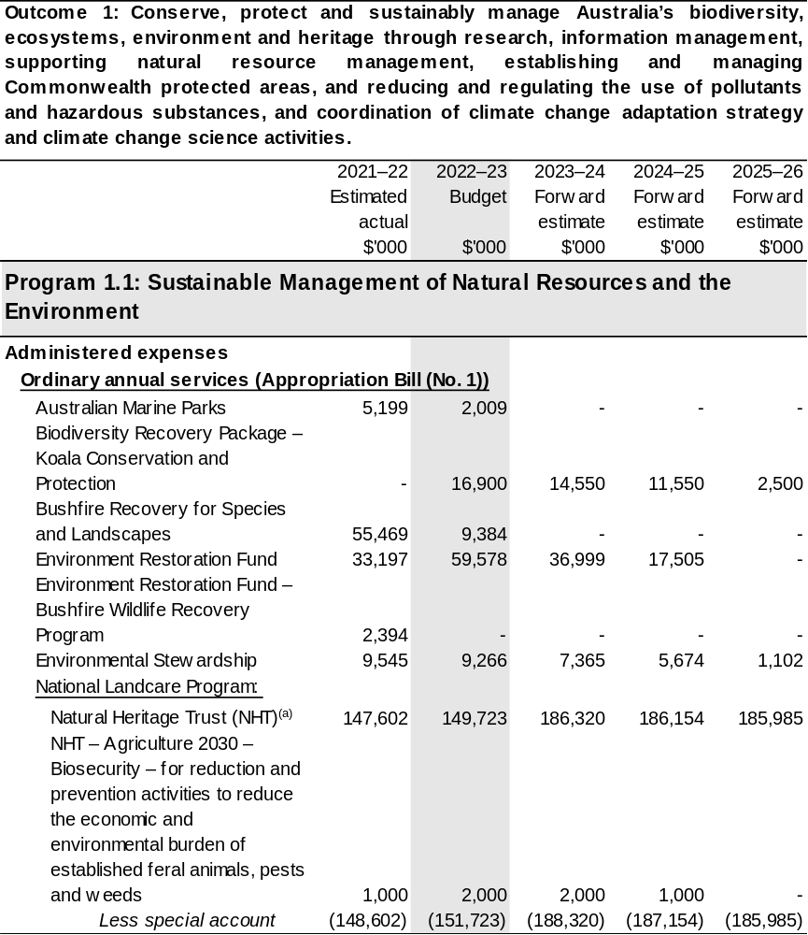
Continued on following pages
Table 2.3: Budgeted expenses for Outcome 1 (continued)
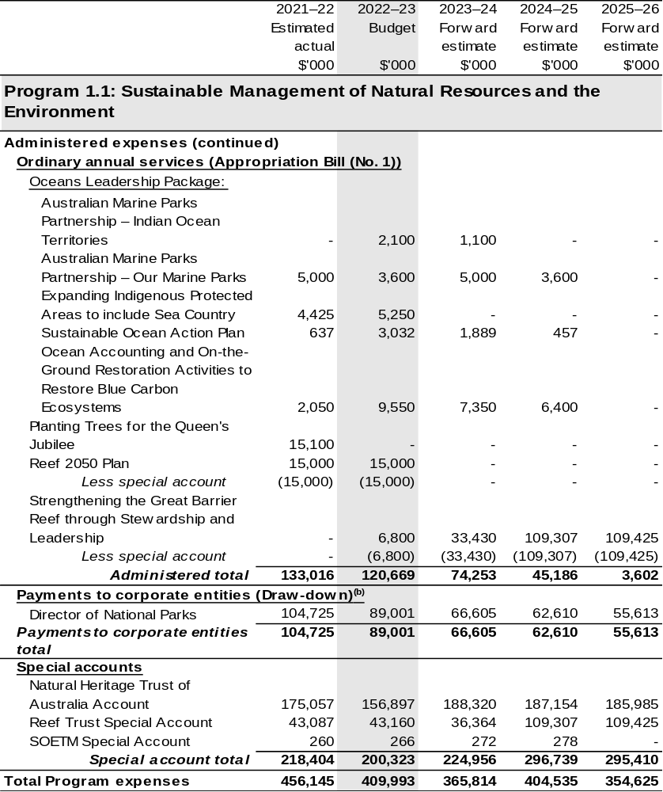
Continued on following pages
Table 2.3: Budgeted expenses for Outcome 1 (continued)
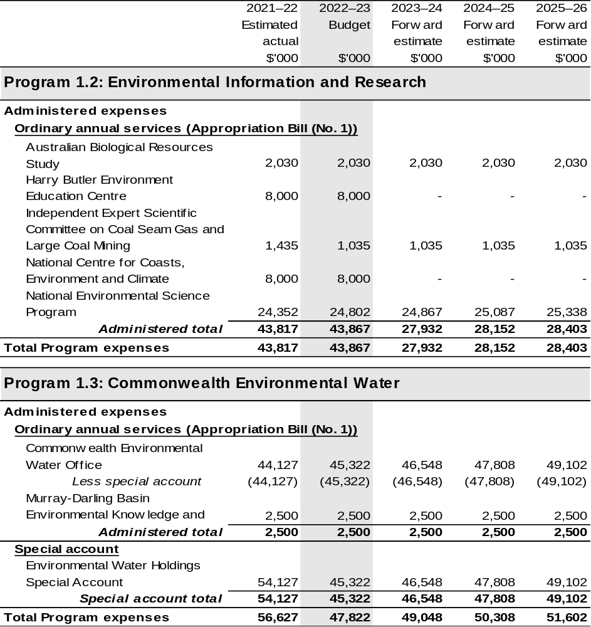
Continued on following pages
Table 2.3: Budgeted expenses for Outcome 1 (continued)
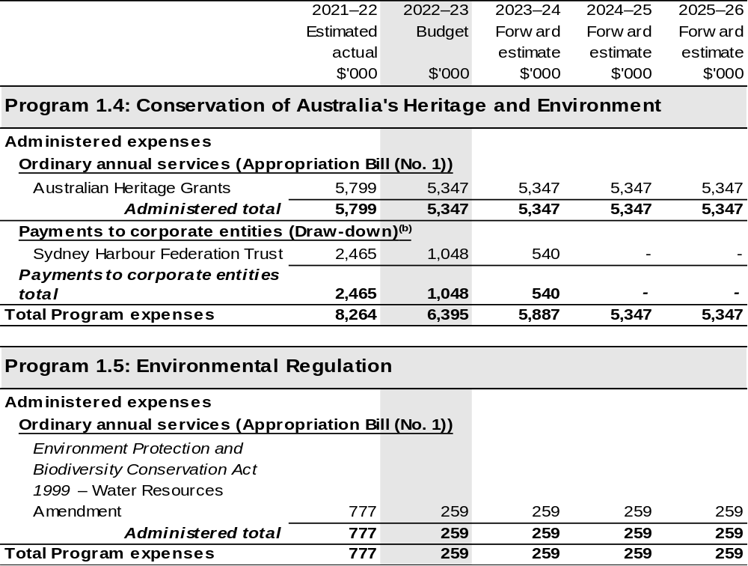
Continued on following pages

Table 2.3: Budgeted expenses for Outcome 1 (continued)
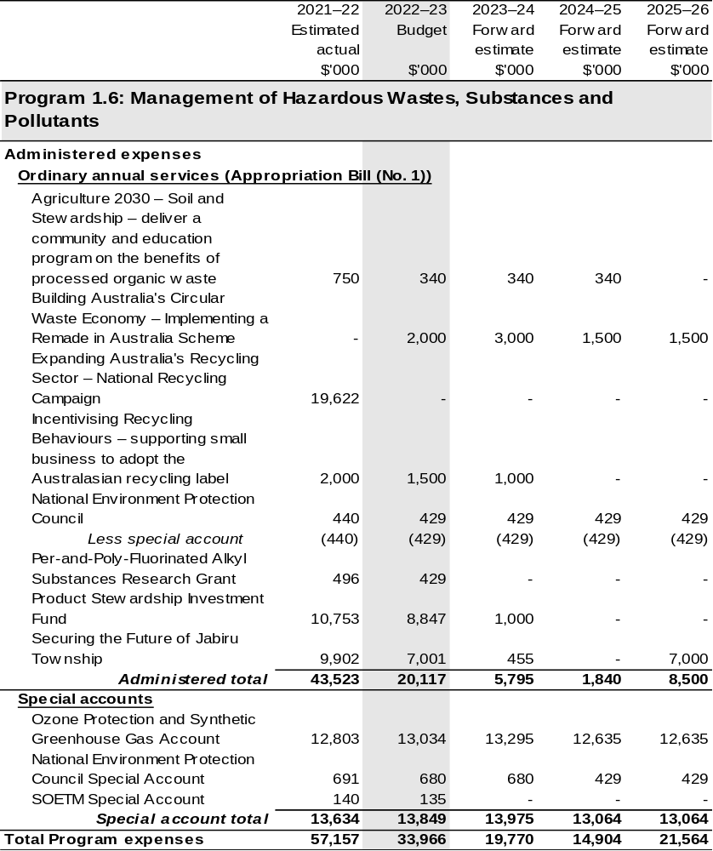
Continued on following pages

Table 2.3: Budgeted expenses for Outcome 1 (continued)
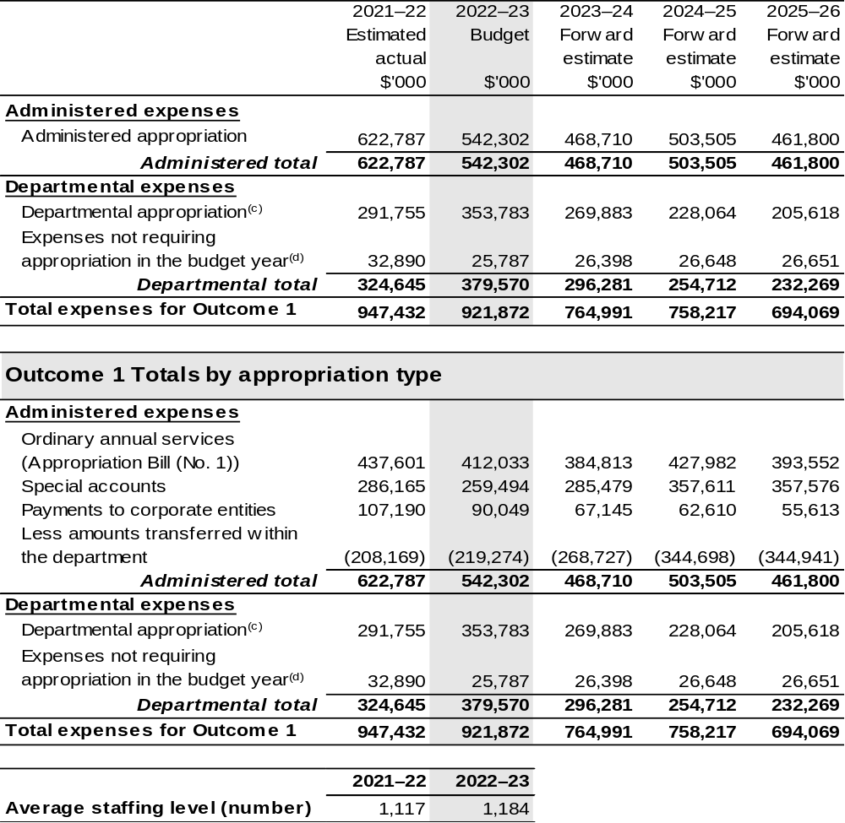
(a) Funding for components of the National Landcare Program are directly appropriated to the Department of the Treasury and the Department of the Prime Minister and Cabinet.
(b) The Director of National Parks and Sydney Harbour Federation Trust are CCEs under the PGPA Act and do not receive direct appropriations. Instead, their funding passes through the department and is drawn down on their behalf.
(c) Departmental appropriation allocations are notional and reflect the current structure of the department. Expenses are funded from both ‘Ordinary annual services (Appropriation Bill (No. 1))’ and ‘External Revenue’ under section 74 of the PGPA Act.
(d) ‘Expenses not requiring appropriation in the budget year’ are made up of depreciation and amortisation expenses, audit fees and an approved operating loss.

Note: Departmental appropriation splits and totals are indicative estimates and may change in the course of the budget year as Government priorities change.

Continued on following page
Table 2.3: Budgeted expenses for Outcome 1 (continued)
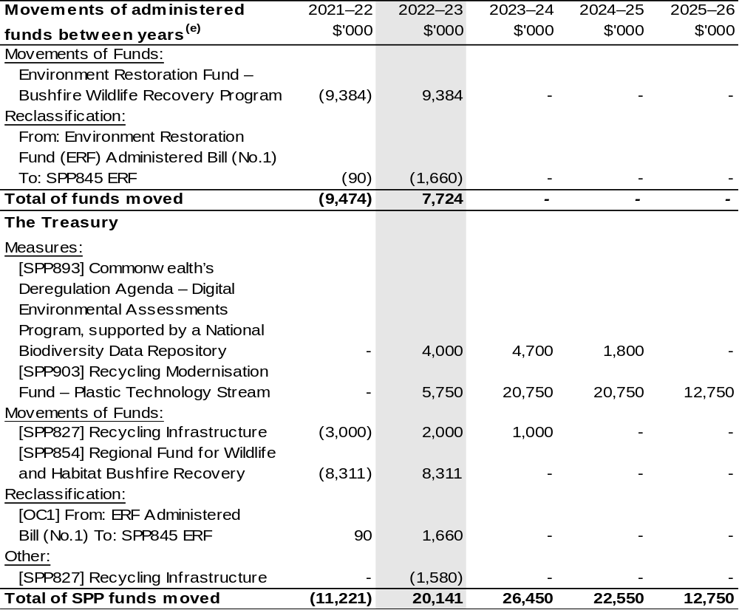
(e) Figures displayed as a negative (-) represent a decrease in funds and a positive (+) represent an increase in funds.

2.3 Budgeted expenses for Outcome 2
Outcome 2: Advance Australia’s strategic, scientific, environmental and economic interests in the Antarctic region by protecting, administering and researching the region.

2.3.1: Linked programs
Australian Research Council
Program 1.2: Linkage - Cross Sector Research Partnerships
Contribution to Outcome 2 made by linked programs
The Australian Research Council (ARC) is responsible for the management of the Special Research Initiative in Excellence in Antarctic Science. DAWE is responsible for the Australian Antarctic program. As these two programs support the Australian Antarctic Science Strategic Plan 2011–12 to 2020–21, ARC and DAWE work together to ensure effective delivery of these initiatives.
Bureau of Meteorology
Program 1.1: Bureau of Meteorology
Contribution to Outcome 2 made by linked programs
BOM provides meteorological and related services in support of the Australian Antarctic program under a Memorandum of Understanding. There are also joint science projects underway between the BOM and the Australian Antarctic Division.
Commonwealth Scientific and Industrial Research Organisation
Program 1: Scientific and Industrial Research and Infrastructure
Contribution to Outcome 2 made by linked programs
CSIRO undertakes scientific research and monitoring in the Southern Ocean and at Australia’s Antarctic Stations, as part of the Australian Antarctic program.
Department of Defence
Program 2.5: Navy Capabilities
Program 2.7: Air Force Capabilities
Contribution to Outcome 2 made by linked programs
The Department of Defence provides a range of logistics support services and advice to the Australian Antarctic program, including air and sealift capability to supplement existing arrangements in the delivery of cargo and contributing to aeromedical emergency responses in the region.

Continued on following page
2.3.1: Linked programs (continued)

Department of Foreign Affairs and Trade
Program 1.1: Foreign Affairs and Trade Operations
Contribution to Outcome 2 made by linked programs
DFAT leads, in cooperation with DAWE, a whole of government approach to Antarctic policy development and international relations, including through the Antarctic Treaty System.
Department of Industry, Science, Energy and Resources
Program 1.1: Investing in Science, Technology and Commercialisation
Contribution to Outcome 2 made by linked programs
As part of the Australian Antarctic Program, DAWE works with DISER, which administers the Antarctic Science Collaboration Initiative.
Geoscience Australia
Program 1.1: Geoscience Australia
Contribution to Outcome 2 made by linked programs
Geoscience Australia undertakes research, mapping and monitoring in the Australian Antarctic Territory, as part of the Australian Antarctic program.

2.3.2: Budgeted expenses for Outcome 2
This table shows how much the entity intends to spend (on an accrual basis) on achieving the outcome, broken down by program, as well as by administered and departmental funding sources.

Table 2.4: Budgeted expenses for Outcome 2
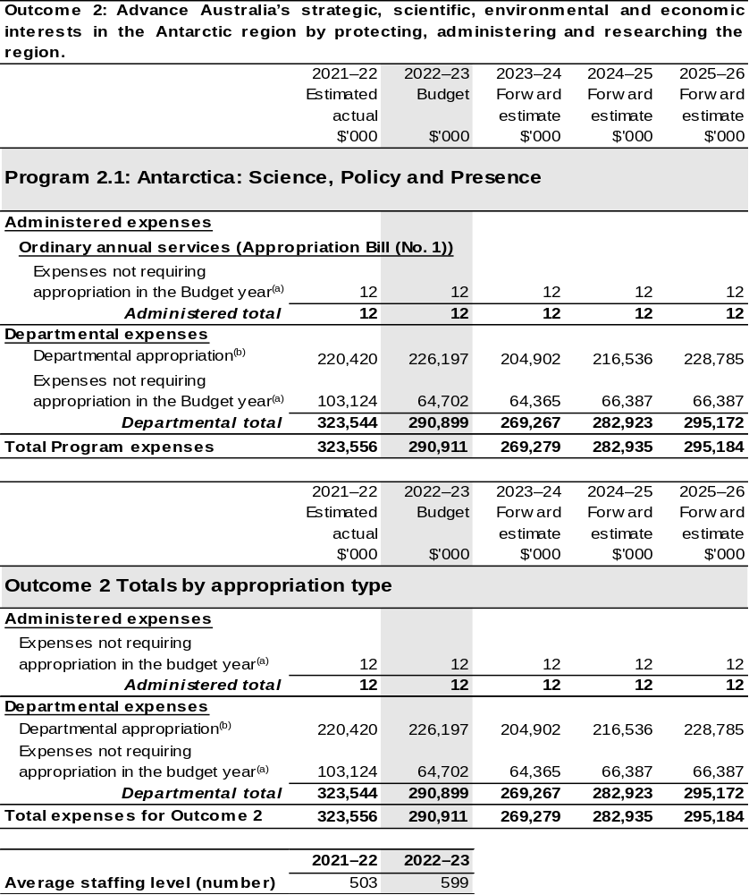
Continued on following page

Table 2.4: Budgeted expenses for Outcome 2 (continued)

(a) ‘Expenses not requiring appropriation in the budget year’ are made up of depreciation and amortisation expenses, audit fees and an approved operating loss.
(b) Departmental appropriation allocations are notional and reflect the current structure of the department. Expenses are funded from both ‘Ordinary annual services (Appropriation Bill (No. 1))’ and ‘External Revenue’ under section 74 of the PGPA Act.

Note: Departmental appropriation splits and totals are indicative estimates and may change in the course of the budget year as Government priorities change.

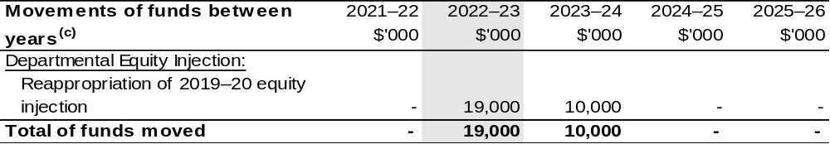
(c) Figures displayed as a negative (-) represent a decrease in funds and a positive (+) represent an increase in funds.

2.4 Budgeted expenses for Outcome 3
Outcome 3: More sustainable, productive, internationally competitive and profitable Australian agricultural, food and fibre industries through policies and initiatives that promote better resource management practices, innovation, self-reliance and improved access to international markets.

2.4.1: Linked programs
Portfolio Agencies:
AgriFutures Australia
Australian Fisheries Management Authority
Australian Pesticides and Veterinary Medicines Authority
Cotton Research and Development Corporation
Fisheries Research and Development Corporation
Grains Research and Development Corporation
Regional Investment Corporation
Wine Australia
Program 1.1: Australian Fisheries Management Authority
Program 1.1: Australian Pesticides and Veterinary Medicines Authority
Program 1.1: Cotton Research and Development Corporation
Program 1.1: Fisheries Research and Development Corporation
Program 1.1: Grains Research and Development Corporation
Program 1.1: Rural Industries Research and Development Corporation
Program 1.1: Regional Investment Corporation
Program 1.1: Wine Australia
Contribution to Outcome 3 made by linked program:
DAWE works together with AgriFutures Australia, Australian Fisheries Management Authority, Australian Pesticides and Veterinary Medicines Authority, Cotton, Fisheries and Grains Research and Development Corporations, Regional Investment Corporation and Wine Australia to ensure sustainable, productive and profitable agricultural industries.

Continued on following pages
2.4.1: Linked programs (continued)
Australian Trade and Investment Commission
Program 1.1: Promotion of Australia’s export and other international economic interests
Program 1.2: Programs to promote Australia’s export and other international economic
interests
Contribution to Outcome 3 made by linked program
DAWE and the Australian Trade and Investment Commission (Austrade) work together to achieve the best outcomes for Australian agricultural, fisheries and forestry exports, including through improved market access and addressing non-tariff measures. The agencies also work cooperatively to deliver whole-of-government programs such as the Agri-Business Expansion Initiative and the Non-Tariff Barrier Action Plan.
Bureau of Meteorology
Program 1.1: Bureau of Meteorology
Contribution to Outcome 3 made by linked program
BOM provides weather, climate and water modelling and information to DAWE.
Department of Industry, Science, Energy and Resources
Program 1.1: Investing in Science, Technology and Commercialisation
Contribution to Outcome 3 made by linked program:
DAWE and DISER are working collaboratively on the National Carp Control Plan, which is being delivered by the Fisheries Research and Development Corporation.

Continued on following page
2.4.1: Linked programs (continued)
Department of the Treasury
Program 1.9: National Partnership Payments to the States
Contribution to Outcome 3 made by linked program
The Department of the Treasury contributes to Outcome 3 by making payments through the Federation Funding Agreement framework on behalf of DAWE, for the following funding agreements:
- Construction Softwood Transport Assistance (SPP880)
- Fishing and Camping Facilities Program (SPP815)
- Horticultural Netting (SPP829)
- Management of Established Pest and Weeds (SPP693)
- National Forestry Industry Plan (SPP763)
- Support Plantation Establishment (SPP895)
Future Drought Fund
- Farm Business Resilience (SPP840)
- Regional Drought Resilience Planning (SPP838)
National Indigenous Australians Agency
Program 1.1: Indigenous Advancement – Jobs, Land and the Economy
Contribution to Outcome 3 made by linked program:
DAWE and NIAA work together to provide opportunities for Indigenous communities and land managers to engage with the National Landcare Program.
Services Australia
Program 1.1: Strategy and Corporate Enabling
Program 1.2: Customer Service Delivery
Program 1.3: Technology and Transformation
Contribution to Outcome 3 made by linked program
Services Australia manages payments under the Farm Household Support Act 2014 on behalf of DAWE.

2.4.2: Budgeted expenses for Outcome 3
This table shows how much the entity intends to spend (on an accrual basis) on achieving the outcome, broken down by program, as well as by administered and departmental funding sources.

Table 2.5: Budgeted expenses for Outcome 3
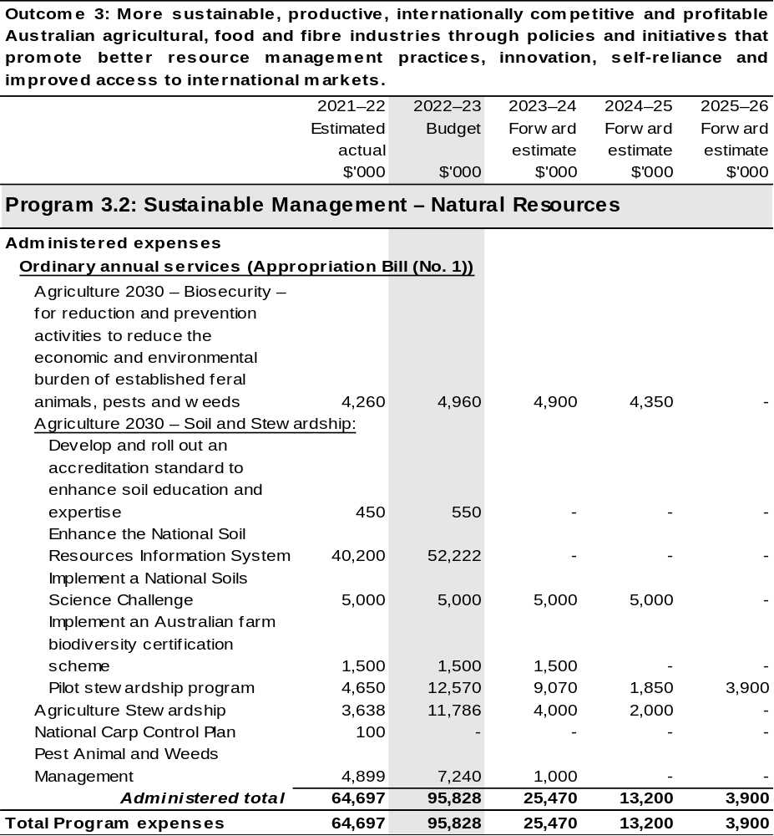

Continued on following pages
Table 2.5: Budgeted expenses for Outcome 3 (continued)
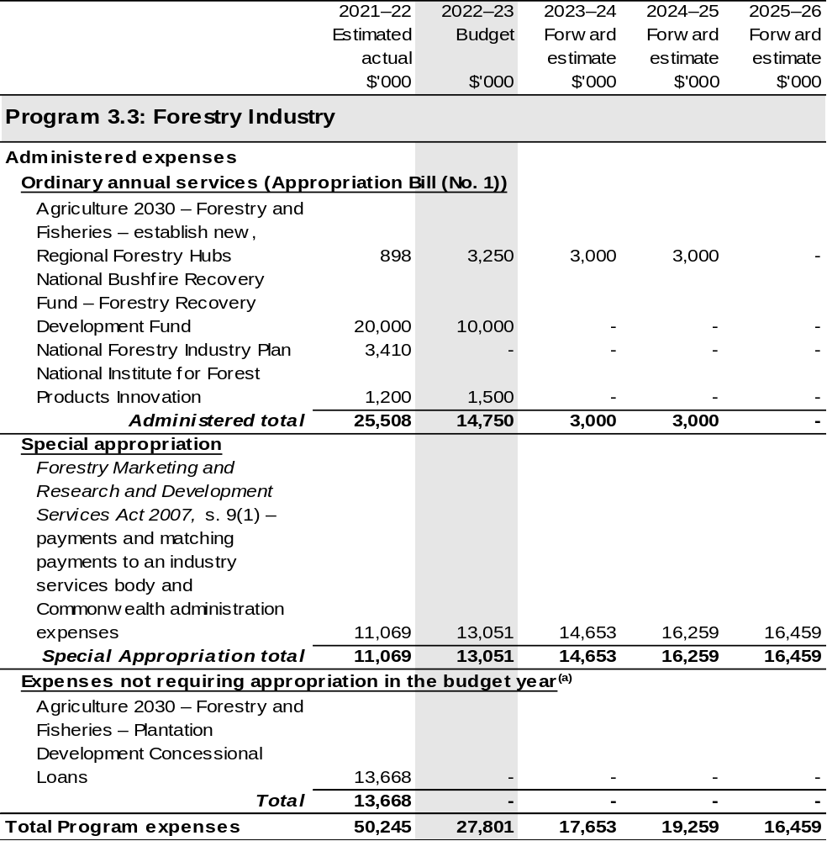

Continued on following pages
Table 2.5: Budgeted expenses for Outcome 3 (continued)
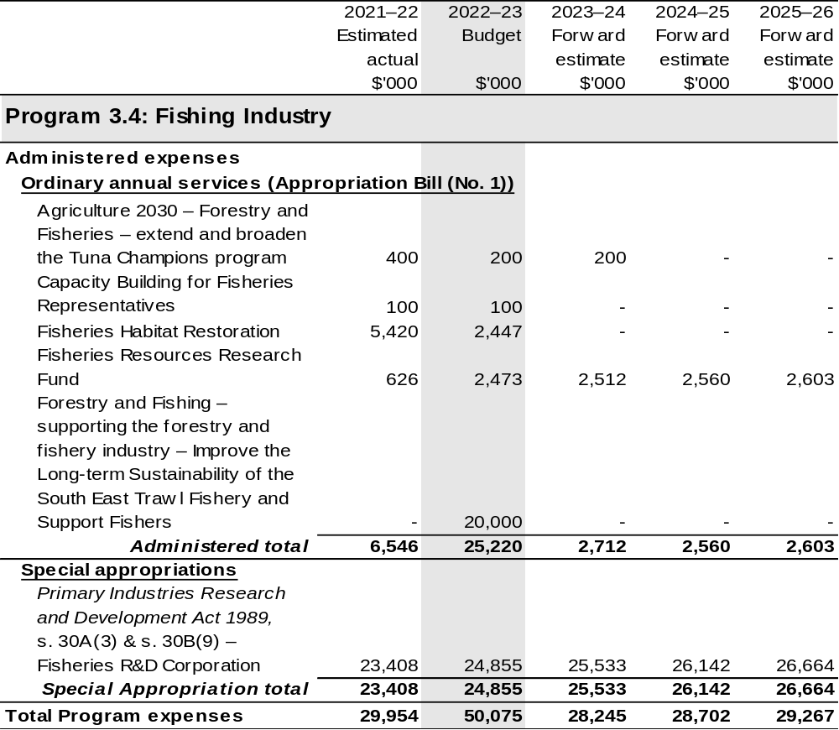

Continued on following pages
Table 2.5: Budgeted expenses for Outcome 3 (continued)
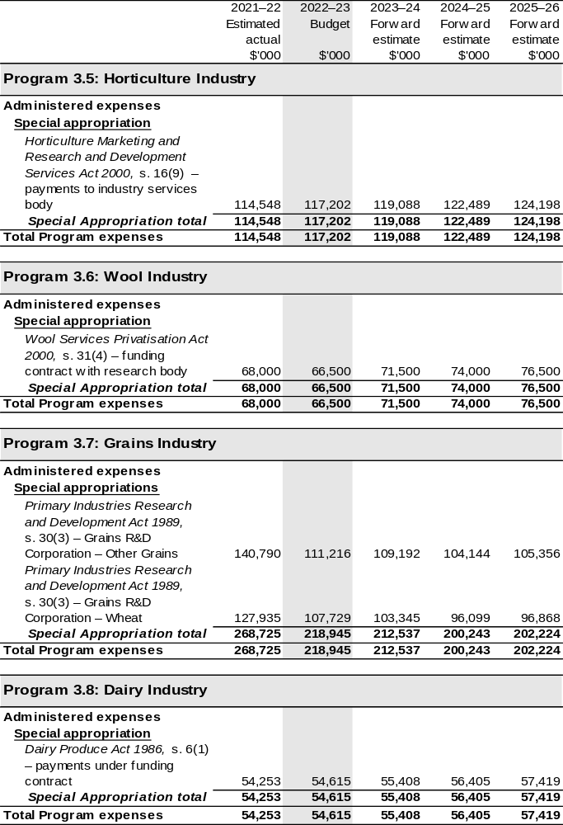

Continued on following pages
Table 2.5 Budgeted expenses for Outcome 3 (continued)
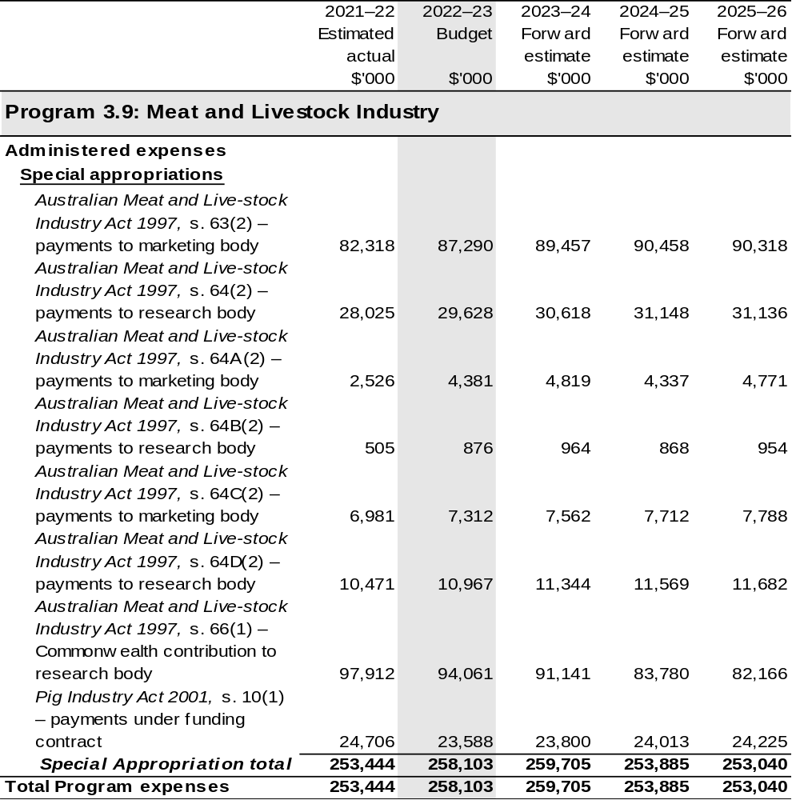

Continued on following pages
Table 2.5: Budgeted expenses for Outcome 3 (continued)
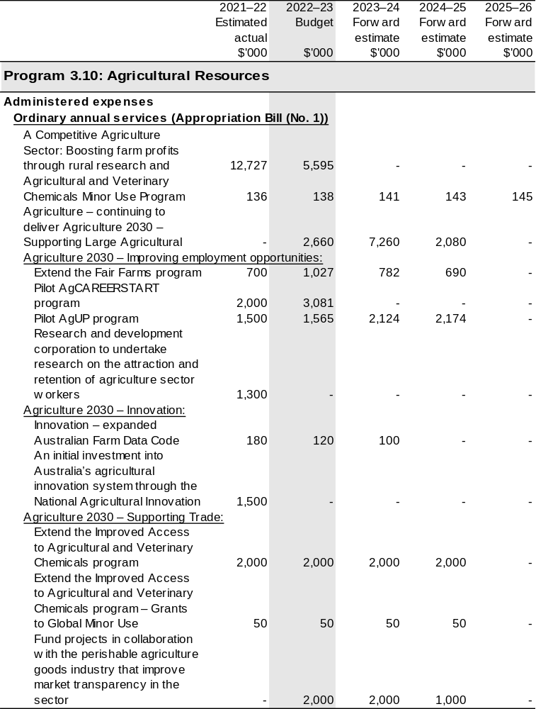

Continued on following pages
Table 2.5: Budgeted expenses for Outcome 3 (continued)
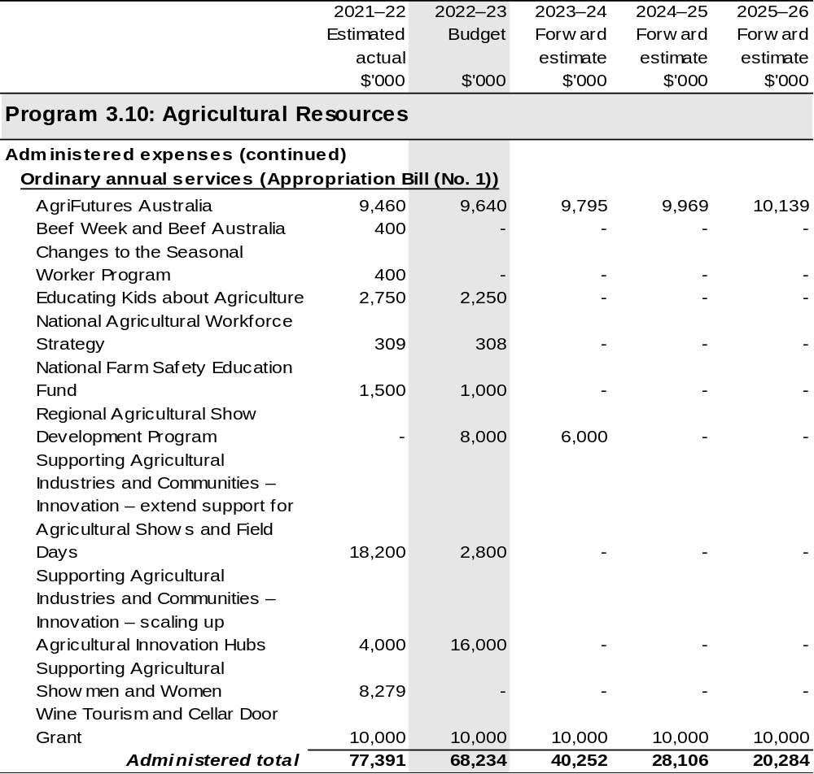

Continued on following pages
Table 2.5: Budgeted expenses for Outcome 3 (continued)
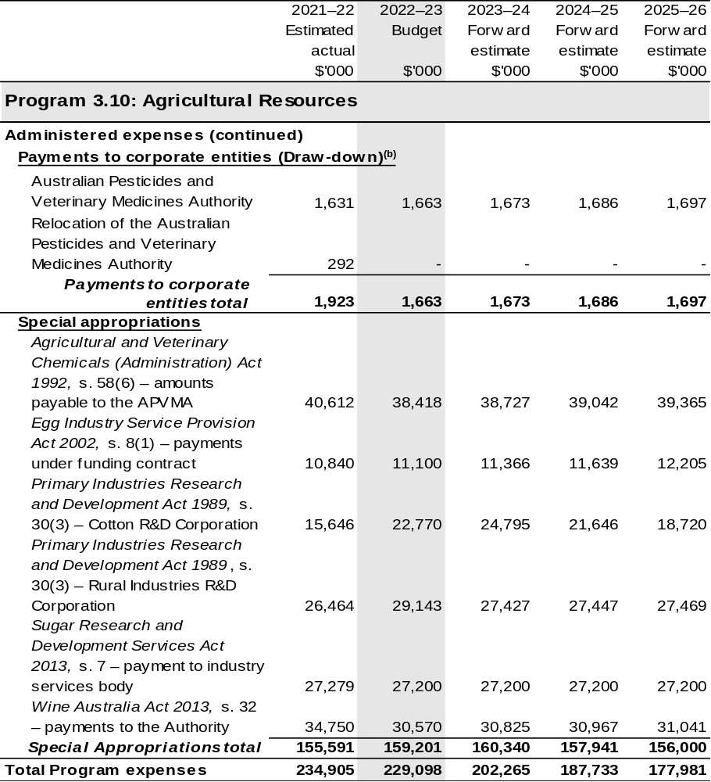

Continued on following pages
Table 2.5: Budgeted expenses for Outcome 3 (continued)
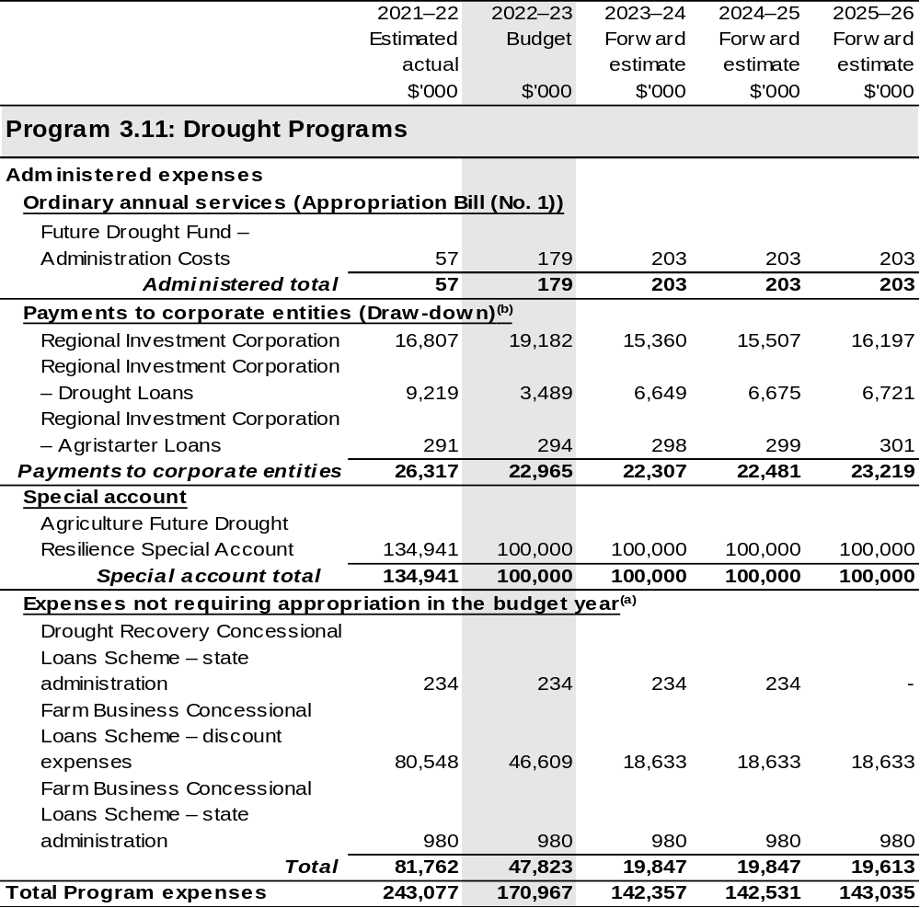

Continued on following pages
Table 2.5: Budgeted expenses for Outcome 3 (continued)
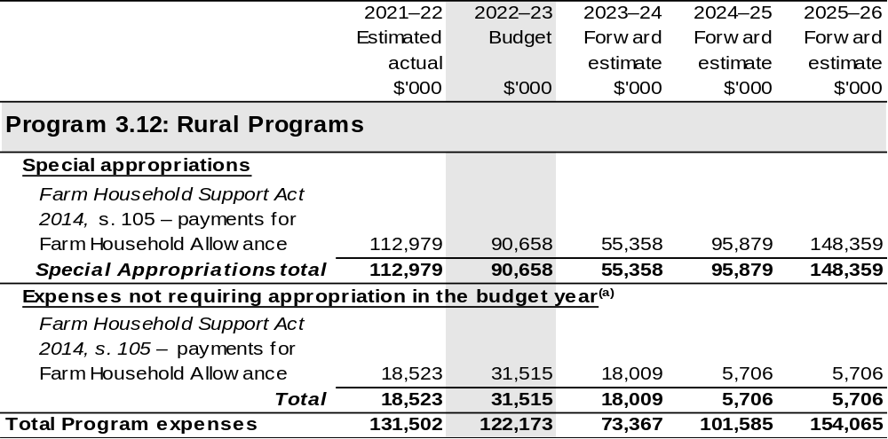

Continued on following pages
Table 2.5: Budgeted expenses for Outcome 3 (continued)
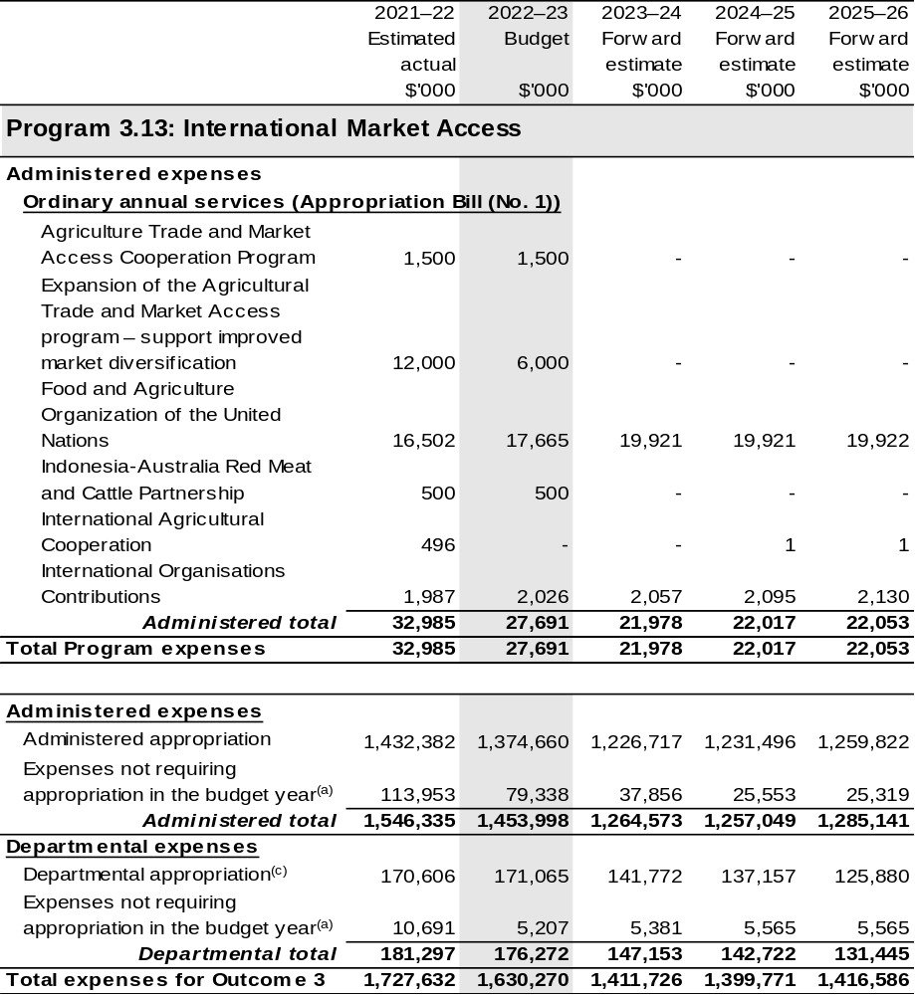

Continued on following pages

Table 2.5: Budgeted expenses for Outcome 3 (continued)
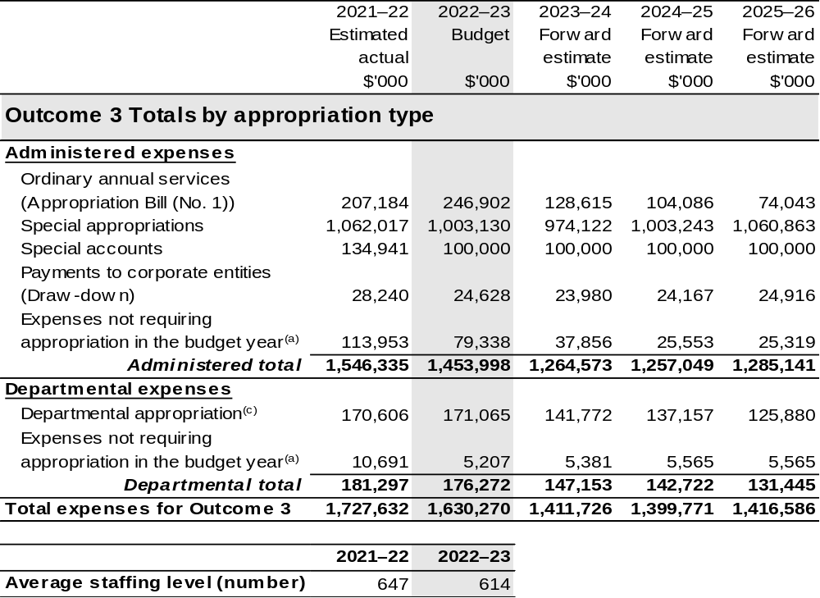

(a) ‘Expenses not requiring appropriation in the budget year’ are made up of depreciation and amortisation expenses, resources received free of charge, concessional loan discount and balance sheet adjustments.
(b) APVMA and RIC are CCEs under the PGPA Act and do not receive direct appropriations. Instead, this funding passes through the department to these entities.
(c) Departmental appropriation allocations are notional and reflect the current structure of the department. Expenses are funded from both ‘Ordinary annual services (Appropriation Bill (No. 1))’ and ‘External Revenue’ under section 74 of the PGPA Act.

Note: Departmental appropriation splits and totals are indicative estimates and may change in the course of the budget year as Government priorities change.

Continued on following page
Table 2.5: Budgeted expenses for Outcome 3 (continued)
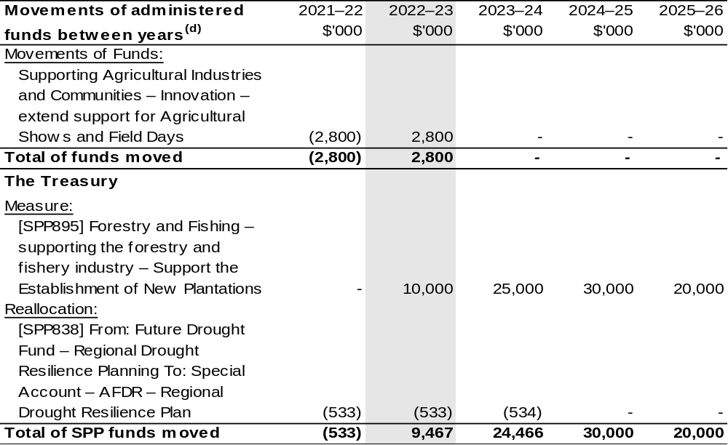

(d) Figures displayed as a negative (-) represent a decrease in funds and a positive (+) represent an increase in funds.

2.5 Budgeted expenses for Outcome 4
Outcome 4: Safeguard Australia’s animal and plant health status to maintain overseas markets and protect the economy and environment from the impact of exotic pests and diseases, through risk assessment, inspection and certification, and the implementation of emergency response arrangements for Australian agricultural, food and fibre industries.

2.5.1: Linked programs
Australian Trade and Investment Commission
Program 1.1: Promotion of Australia’s export and other international economic interests
Contribution to Outcome 4 made by linked program:
DAWE and Austrade work together to achieve the best outcomes for Australian agricultural, fisheries and forestry exports.
Commonwealth Scientific and Industrial Research Organisation
Program 1: Scientific and Industrial Research and Infrastructure
Contribution to Outcome 4 made by linked program:
DAWE contributes to the operating costs of the CSIRO’s Australian Centre for Disease Preparedness (formerly the Australian Animal Health Laboratory) for animal disease diagnosis, prevention and research.
Department of Health
Program 1.8: Health Protection, Emergency Response and Regulation
Contribution to Outcome 4 made by linked program:
DAWE provides border services for the management of human biosecurity risks on behalf of the Department of Health under the Biosecurity Act 2015 and a memorandum of understanding.

Continued on following pages
2.5.1: Linked programs (continued)
Department of Home Affairs
Program 3.4: Border Enforcement
Program 3.2: Border Management
Contribution to Outcome 4 made by linked programs:
DAWE and the Department of Home Affairs work collaboratively to undertake screening and surveillance for all people and goods entering Australia.
Department of Industry, Science, Energy and Resources
Program 1.1: Investing in Science, Technology and Commercialisation
Program 1.3: Supporting a Strong Resources Sector
Contribution to Outcome 4 made by linked programs:
DAWE works collaboratively with the Department of Industry, Science, Energy and Resources (DISER) through the National Measurement Institute. DAWE access analytical laboratory services and expertise to support the National Residue Survey and Imported Food Inspection Scheme, and environmental services.
Department of the Treasury
Program 1.9: National Partnership Payments to the States
Contribution to Outcome 4 made by linked program:
The Department of the Treasury contributes to Outcome 4 by making payments through the Federation Funding Agreement framework on behalf of DAWE, for the following funding agreements:
- Building Resilience to Manage Fruit Fly (SPP993)
- Ehrlichia Canis Pilot Program (SPP876)
- Horse Traceability (SPP875)
- Boosting Our Northern Biosecurity Frontline (SPP900)
- National Plant Health Surveillance Program (SPP857)
- Pest and Disease Preparedness and Response Programs (SPP188)
- Reducing Regulatory Burden and Streamlining Audit Arrangements in the Dairy Sector (SPP859)
- Supporting Farmers to Maximise Farm Gate Output through Traceability and On-farm Biosecurity (SPP913)
- Supporting Plantation Establishment (SPP895)

Continued on following page
2.5.1: Linked programs (continued)
Food Standards Australia New Zealand
Program 1.1: Food Regulatory Activity and Services to the Minister and Parliament
Contribution to Outcome 4 made by linked program:
Food Standards Australia New Zealand provides advice on whether foods pose a medium to high risk to public health to help DAWE to manage the food safety risks associated with imported food for human consumption.
National Indigenous Australians Agency
Program 2.1: Indigenous Advancement – Jobs, Land and Economy
Contribution to Outcome 4 made by linked programs:
DAWE and NIAA partner with Aboriginal and Torres Strait Islander Ranger groups to deliver biosecurity work that protects Australian agriculture and the northern Australian environment.

2.5.2: Budgeted expenses for Outcome 4
This table shows how much the entity intends to spend (on an accrual basis) on achieving the outcome, broken down by program, as well as by administered and departmental funding sources.

Table 2.6: Budgeted expenses for Outcome 4
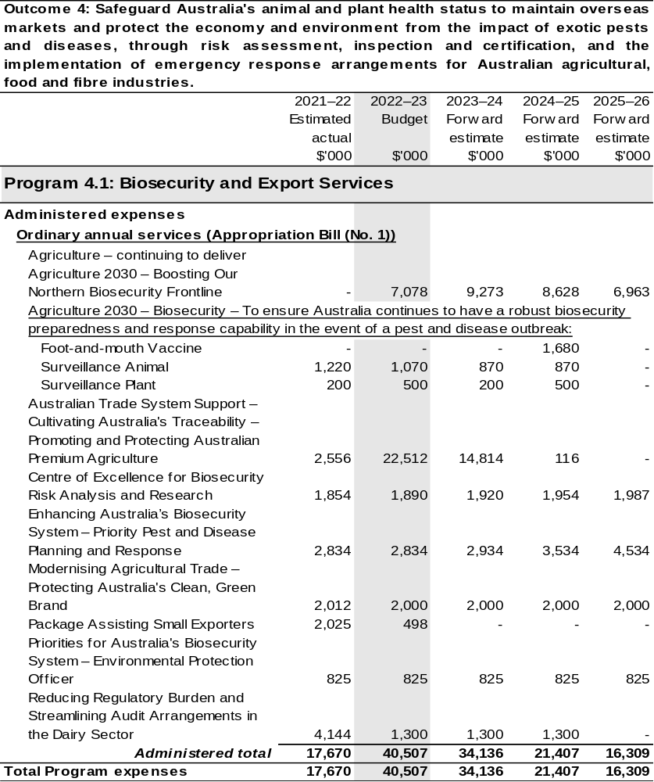

Continued on following pages
Table 2.6: Budgeted expenses for Outcome 4 (continued)
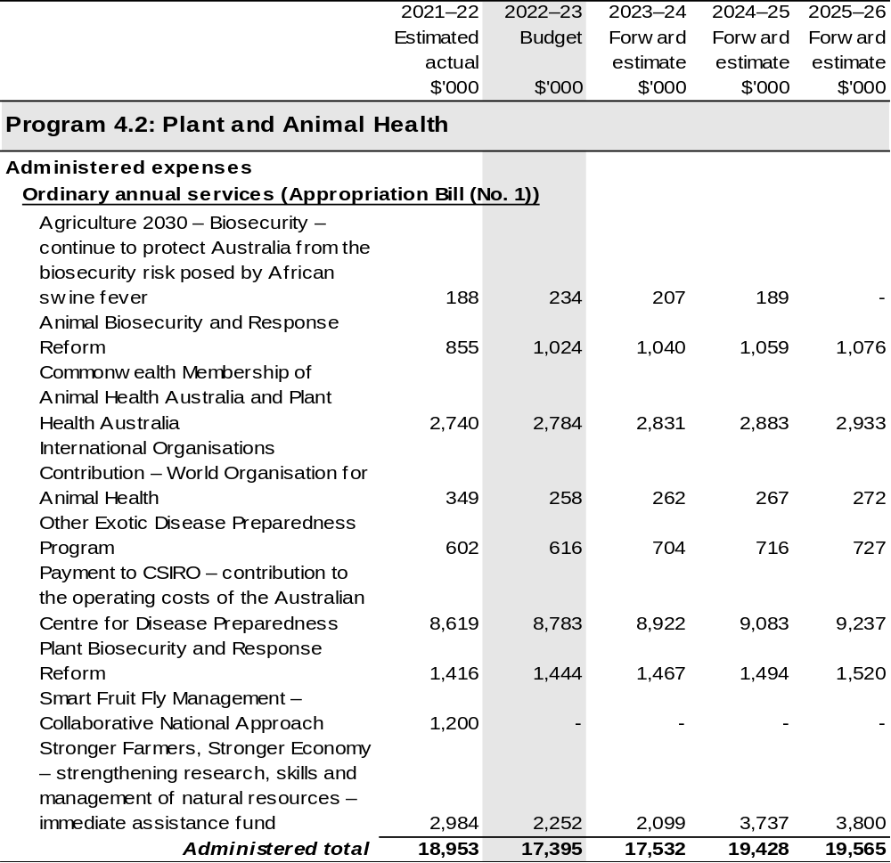

Continued on following pages
Table 2.6: Budgeted expenses for Outcome 4 (continued)
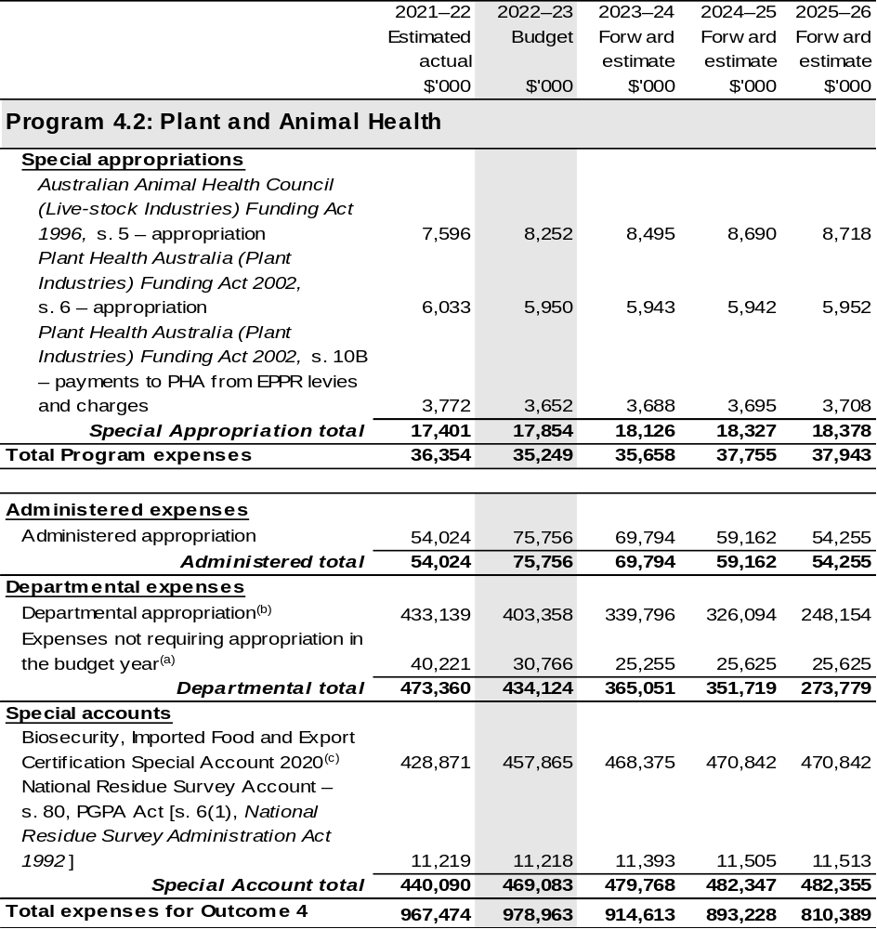
Continued on following pages
Table 2.6: Budgeted expenses for Outcome 4 (continued)
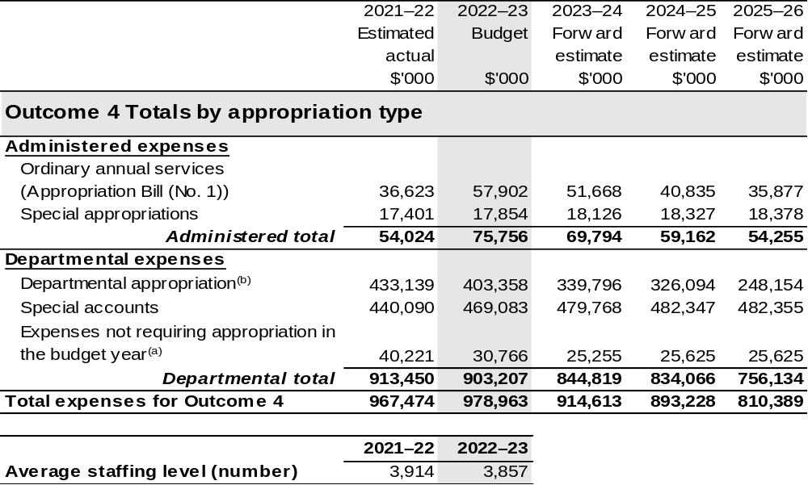
(a) ‘Expenses not requiring appropriation in the budget year’ are made up of depreciation and amortisation
expenses, resources received free of charge and balance sheet adjustments.
(b) Departmental appropriation allocations are notional and reflect the current structure of the department. Expenses are funded from both ‘Ordinary annual services (Appropriation Bill (No. 1))’ and ‘External Revenue’ under section 74 of the PGPA Act.
(c) The Biosecurity, Imported Food and Export Certification Special Account was formerly known as the Australian Quarantine and Inspection Service Special Account.

Note: Departmental appropriation splits and totals are indicative estimates and may change in the course of the budget year as Government priorities change.

Continued on following page

Table 2.6: Budgeted expenses for Outcome 4 (continued)
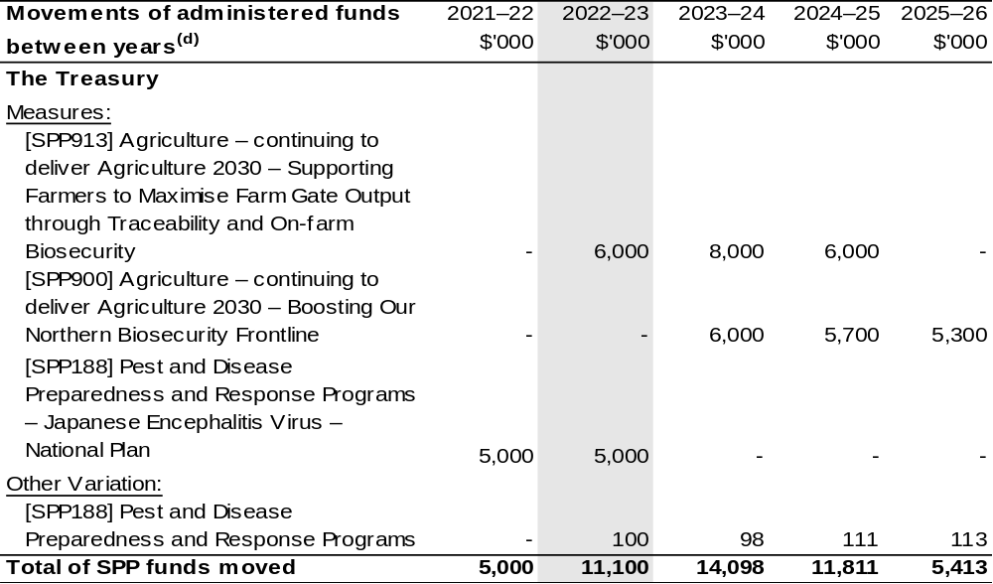
(d) Figures displayed as a negative (-) represent a decrease in funds and a positive (+) represent an increase in funds.

2.6 Budgeted expenses for Outcome 5
Outcome 5: Improve the health of rivers and freshwater ecosystems and water use efficiency through implementing water reforms, and ensuring enhanced sustainability, efficiency and productivity in the management and use of water resources.

2.6.1 Linked programs
Murray-Darling Basin Authority
Program 1.1: Equitable and Sustainable Use of the Murray-Darling Basin
Contribution to Outcome 5 made by linked program:
DAWE and MDBA work collaboratively to implement the Murray-Darling Basin Plan and the Intergovernmental Agreement on Murray-Darling Basin Reform.
Bureau of Meteorology
Program 1.1: Bureau of Meteorology
Contribution to Outcome 5 made by linked program:
BOM’s water information services inform Commonwealth water planning and decision making in relation to water resource availability.
Department of the Treasury
Program 1.9: National Partnership Payments to the States
Contribution to Outcome 5 made by linked program:
The Department of the Treasury contributes to Outcome 5 by making payments through the Federation Funding Agreement framework on behalf of DAWE, for the following funding agreements:
- Great Artesian Basin Sustainability Initiative (SPP127)
- Implementing Water Reform in the Murray-Darling Basin (SPP632)
- On-Farm Emergency Water Infrastructure Rebate (SPP776)
- Sustainable Rural Water Use and Infrastructure Program (SPP533)
- Water for Fodder Program (SPP811)
Water for the Environment Special Account (WESA)
- Implementation of Constraints Measures (SPP706
- Off-Farm Efficiency Program (SPP858)
- Water Efficiency Program (SPP787)

2.6.2: Budgeted expenses for Outcome 5
This table shows how much the entity intends to spend (on an accrual basis) on achieving the outcome, broken down by program, as well as by administered and departmental funding sources.

Table 2.7: Budgeted expenses for Outcome 5
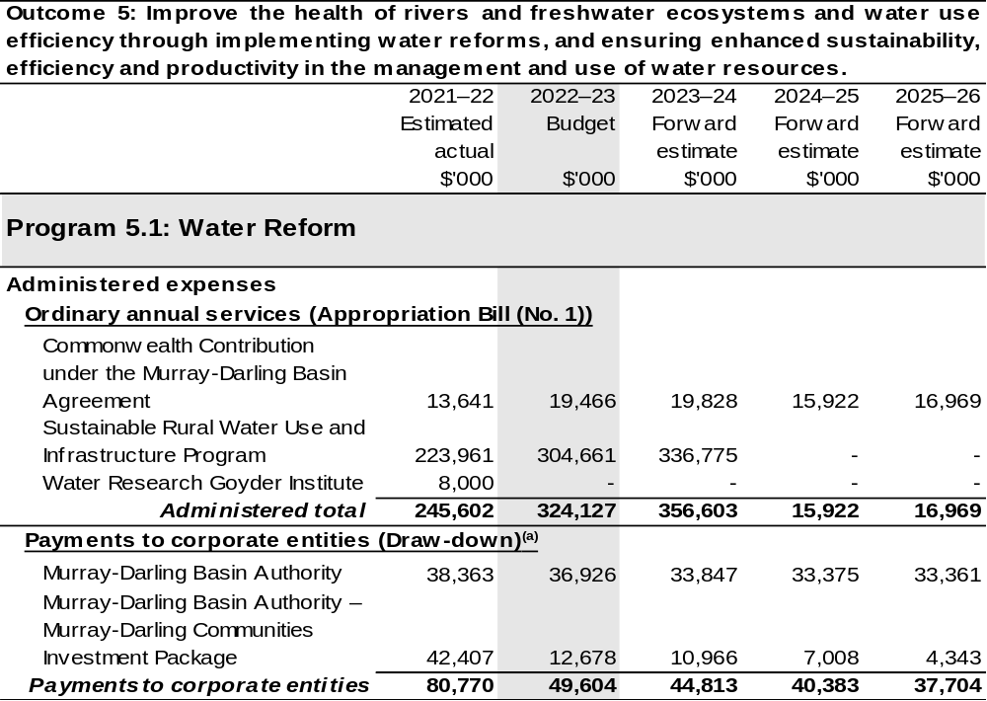
Continued on following pages

Table 2.7: Budgeted expenses for Outcome 5 (continued)
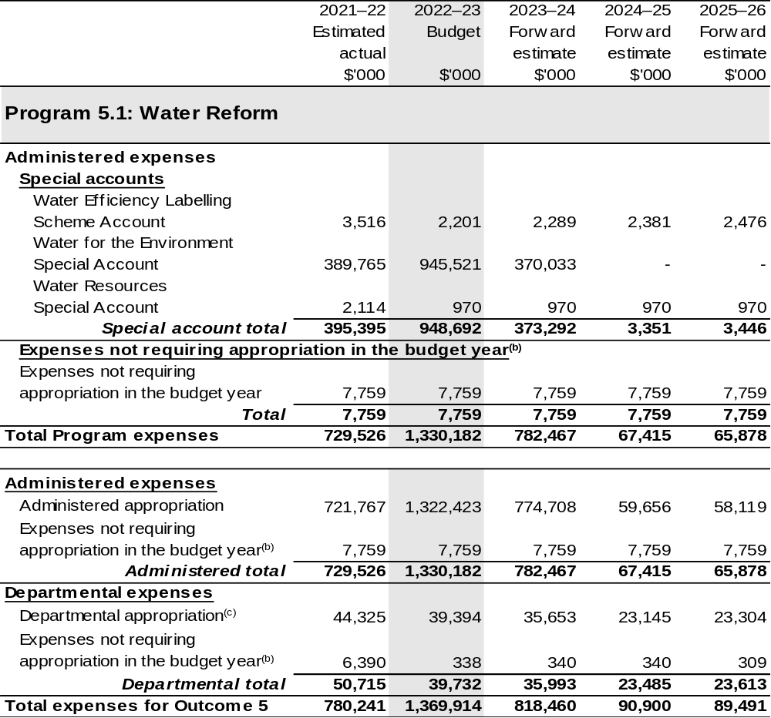
Continued on following pages

Table 2.7: Budgeted expenses for Outcome 5 (continued)
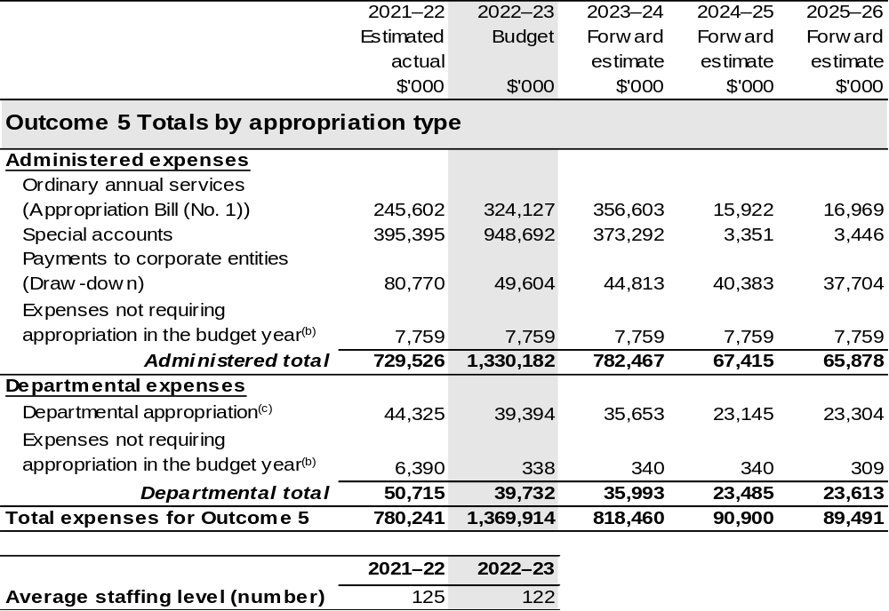
(a) The MDBA is a CCE under the PGPA Act and does not receive direct appropriations. Instead, this funding passes through the department to the MDBA.
(b) ‘Expenses not requiring appropriation in the budget year’ are made up of depreciation and amortisation
expenses, resources received free of charge and balance sheet adjustments.
(c) Departmental appropriation allocations are notional and reflect the current structure of the department. Expenses are funded from both ‘Ordinary annual services (Appropriation Bill (No. 1))’ and ‘External Revenue’ under section 74 of the PGPA Act.
Note: Departmental appropriation splits and totals are indicative estimates and may change in the course of the budget year as Government priorities change.

Continued on following page
Table 2.7: Budgeted expenses for Outcome 5 (continued)
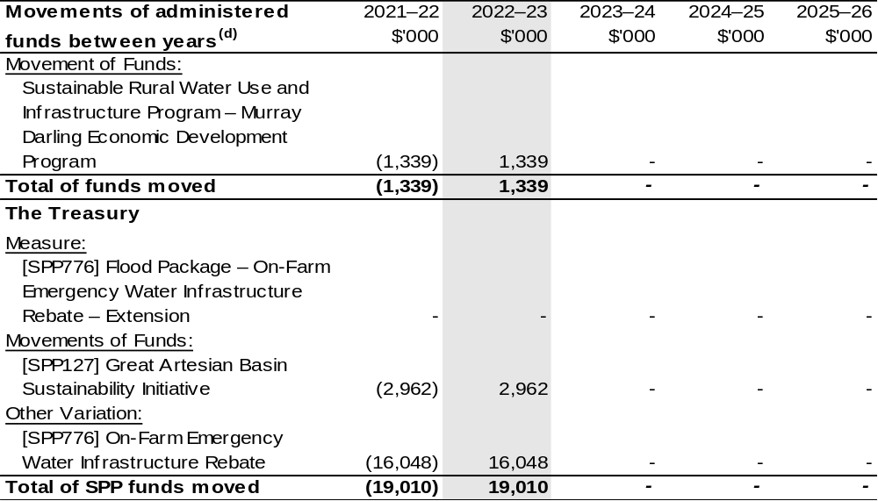
(d) Figures displayed as a negative (-) represent a decrease in funds and a positive (+) represent an increase in funds.

Section 3: Budgeted financial statements
Section 3 presents budgeted financial statements which provide a comprehensive snapshot of entity finances for 2022–23, including the impact of 2022–23 Budget measures and resourcing on financial statements.

3.1 Budgeted financial statements

3.1.1: Differences between entity resourcing and financial statements
The financial statements incorporate all budget estimate changes since the 2021–22 PAES. An analysis of the primary causes of movements in the budgeted departmental financial statements and administered schedules is provided in the relevant sections. PAES figures are used as comparators in the analysis.

3.1.2: Budgeted comprehensive departmental income statement
Since PAES, estimated revenue from government in 2022–23 has increased by $230.7 million. The increase is mainly due to 2022–23 Budget measures listed in
Table 1.2.
The own source revenue estimate in 2022–23 has increased by $4.8 million since PAES, mainly due to higher than anticipated external revenue receipts.
The department is budgeting for a $31.2 million operating loss in 2022–23 before unfunded depreciation is accounted for. The budgeted operating loss has increased from PAES due to delays in program delivery. The increased loss is funded through unspent funds and does not impact the department’s sustainability.

3.1.3: Budgeted departmental balance sheet
The value of departmental net assets as at 30 June 2023 is anticipated to be $74.7 million lower than the estimate published in PAES. The reduced estimate is mainly a result of the department using unspent funds to ensure program delivery. These impacts are also affected when there is a difference between the financial year when appropriation is received and the financial year when expenses are incurred.

3.1.4: Schedule of budgeted income and expenses administered on behalf of the Government
It is estimated the department will receive non-appropriation revenue on behalf of government of $816.5 million in 2022–23, an increase of $26.4 million since PAES.
The increase is largely due to higher levy revenue estimates and interest revenue estimates relating to loans activities.
Administered expenses are estimated to be $3,402.3 million in 2022–23, an increase of $228.3 million since PAES. The increase largely relates to 2022–23 Budget measures detailed in Table 1.2, movements of funds and reclassifications of funds detailed in the Budgeted Expenses tables for each Outcome.

3.1.5: Schedule of budgeted assets and liabilities administered on behalf of the Government
The value of administered net assets as at 30 June 2023 is anticipated to be $240.6 million higher than the estimate published in PAES. The increase in net assets is mainly due to a movement of special account expenditure that has improved the cash position at 30 June 2023 by $206.0 million. This cash will be used to fund expenditure in 2023–24. Further details are in the Budgeted Expenses table for Outcome 5.

3.2 Budgeted financial statements tables

Table 3.1 Comprehensive income statement (showing net cost of services)
for the period ended 30 June
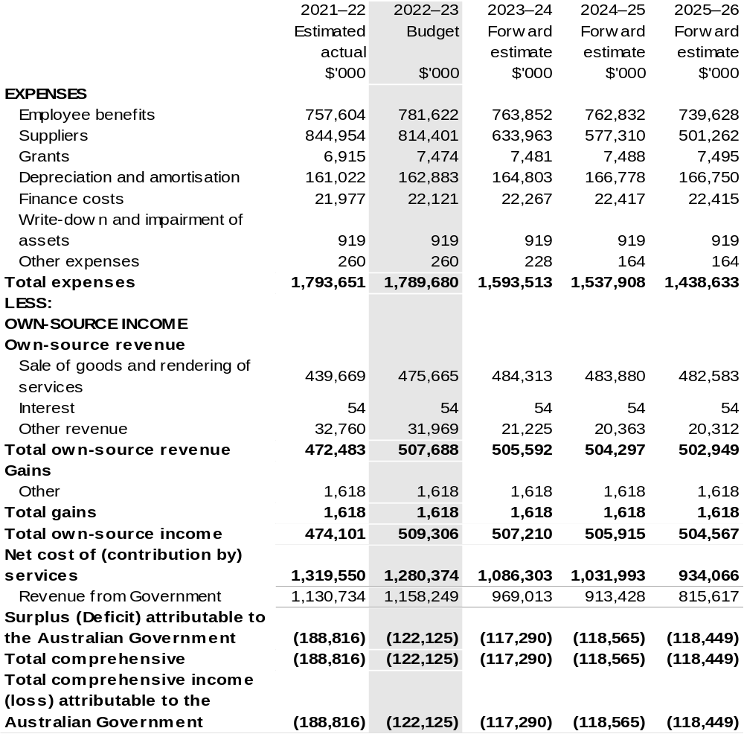

Continued on following page

Table 3.1 Comprehensive income statement (showing net cost of services) for the period ended 30 June (continued)
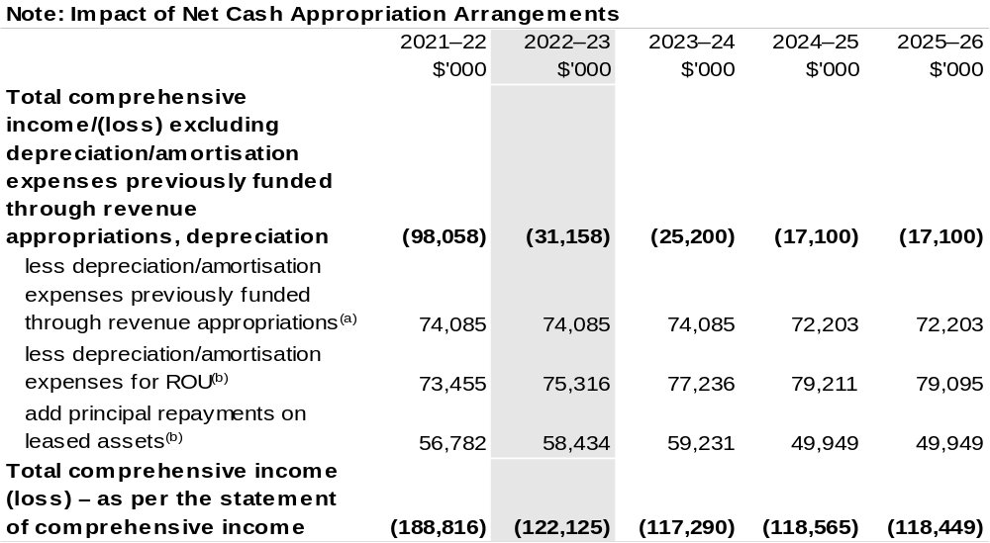

(a) From 2010–11, the Government introduced net cash appropriation arrangements where Appropriation Bill (No. 1) revenue appropriations for the depreciation/amortisation expenses of non-corporate Commonwealth entities (and select corporate Commonwealth entities) were replaced with a separate capital budget (the Departmental Capital Budget, or DCB) provided through Appropriation Bill (No. 1) equity appropriations. For information regarding DCBs, please refer to Table 3.5 Departmental Capital Budget Statement.
(b) Applies to leases under AASB 16 Leases. Right of Use (ROU).

Prepared on Australian Accounting Standards basis.

Table 3.2: Budgeted departmental balance sheet (as at 30 June)
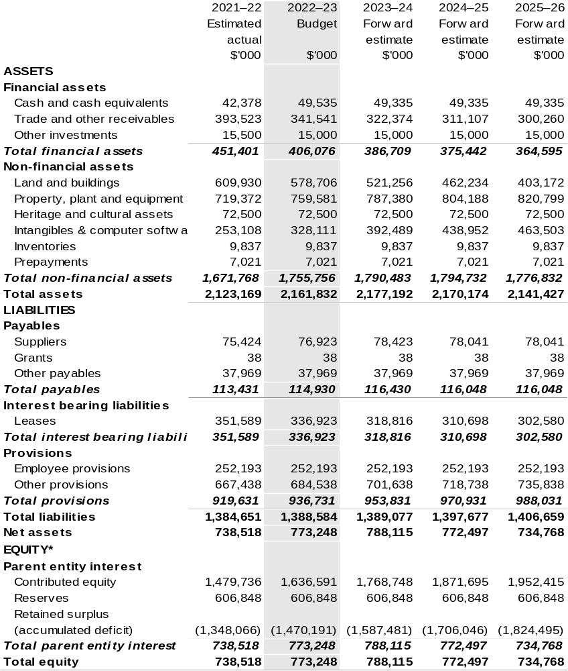

*‘Equity’ is the residual interest in assets after deduction of liabilities.

Prepared on Australian Accounting Standards basis.

Table 3.3: Departmental statement of changes in equity – summary of movement (Budget year 2022–23)
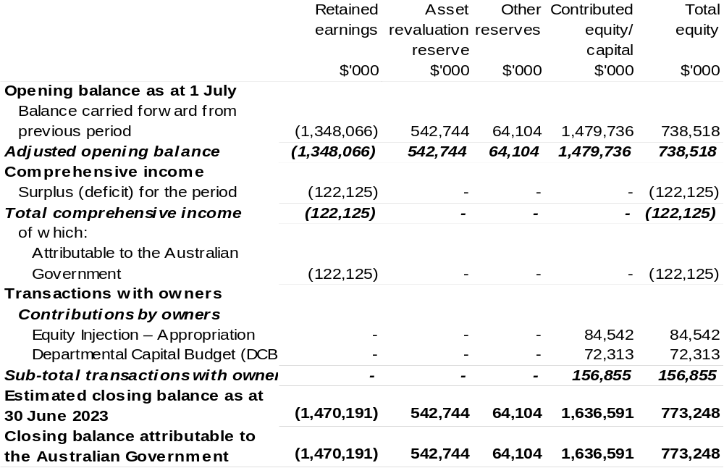

Prepared on Australian Accounting Standards basis.

Table 3.4: Budgeted departmental statement of cash flows (for the period ended 30 June)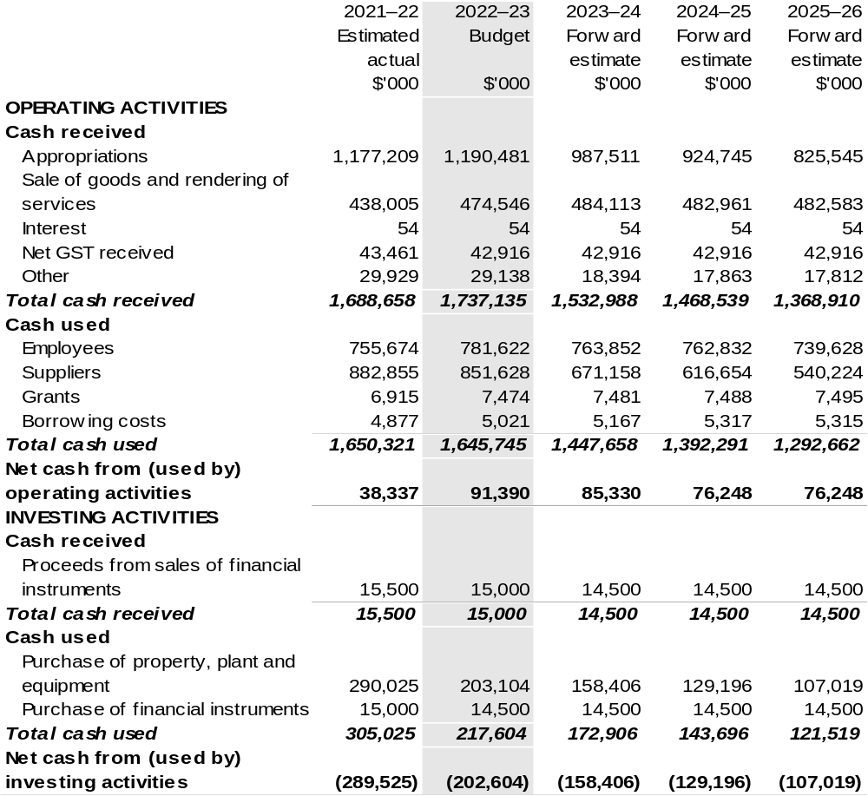

Continued on following page

Table 3.4: Budgeted departmental statement of cash flows (for the period ended 30 June) (continued)
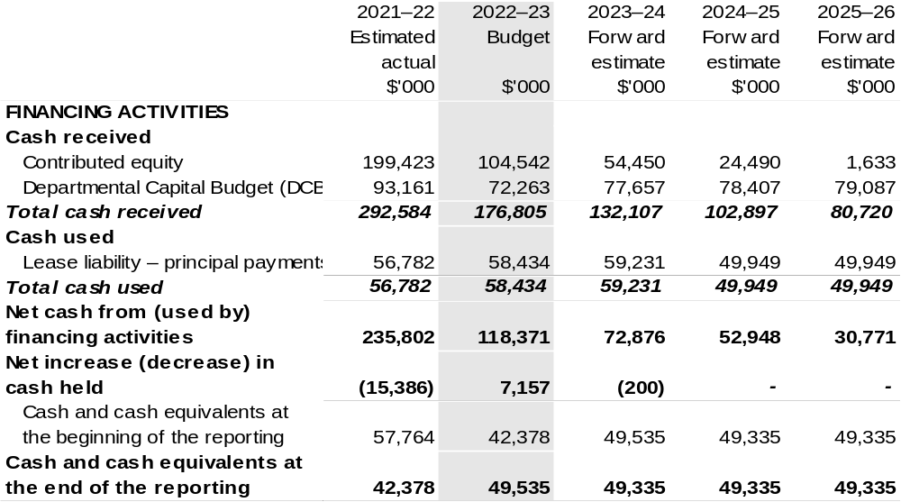

Prepared on Australian Accounting Standards basis.

Table 3.5: Departmental capital budget statement (for the period ended 30 June)
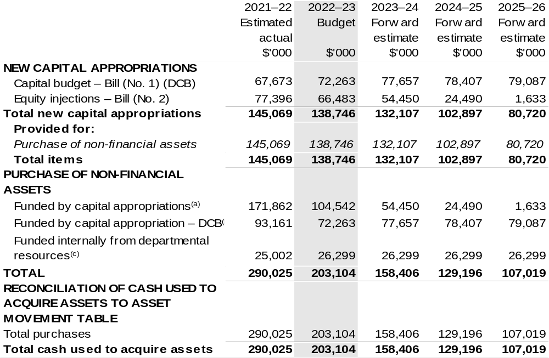

- Includes both current Bill (No. 2) and prior Act (No. 2/4/6) appropriations and special capital appropriations.
- Does not include annual finance lease costs. Includes purchases from current and previous years’ Departmental Capital Budgets (DCBs).
- Includes the following sources of funding:
  - current Bill (No. 1) and prior year Act (No. 1/3/5) appropriations (excluding amounts from the DCB);
  - internally developed assets;
  - section 74 external revenue; and
  - proceeds from the sale of assets.

Prepared on Australian Accounting Standards basis.

Table 3.6: Statement of asset movements (Budget year 2022–23)
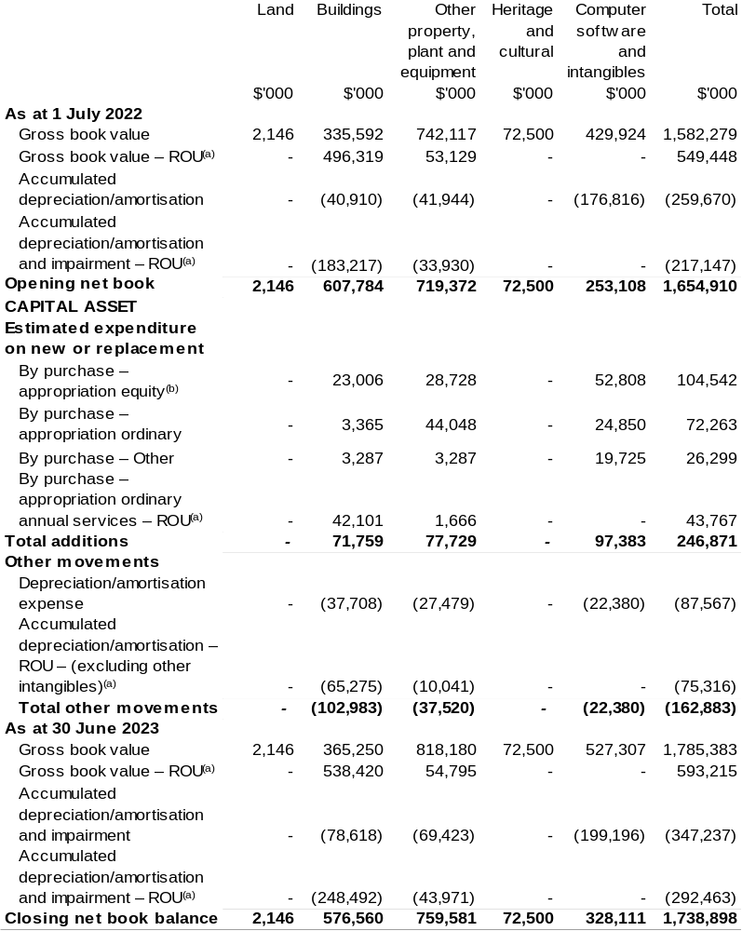

(a) Applies to leases under AASB 16 Leases. Right of Use (ROU).
(b) ‘Appropriation equity’ refers to equity injections, appropriations provided through Appropriation
Bill (No. 2) 2021–22.
(c) ‘Appropriation ordinary annual services’ refers to funding provided through Appropriation Bill (No. 1) 2021–22 for depreciation / amortisation expenses, DCBs or other operational expenses.

Prepared on Australian Accounting Standards basis.

Table 3.7: Schedule of budgeted income and expenses administered on behalf of Government (for the period ended 30 June)
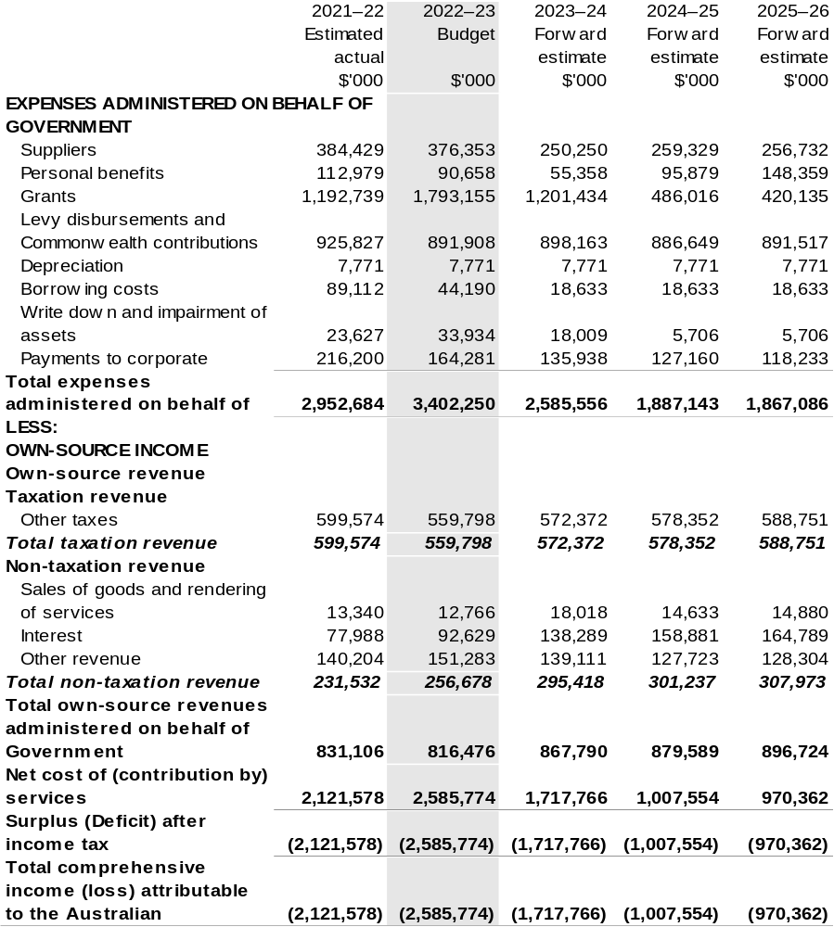

Prepared on Australian Accounting Standards basis.

Table 3.8: Schedule of budgeted assets and liabilities administered on behalf of Government (as at 30 June)
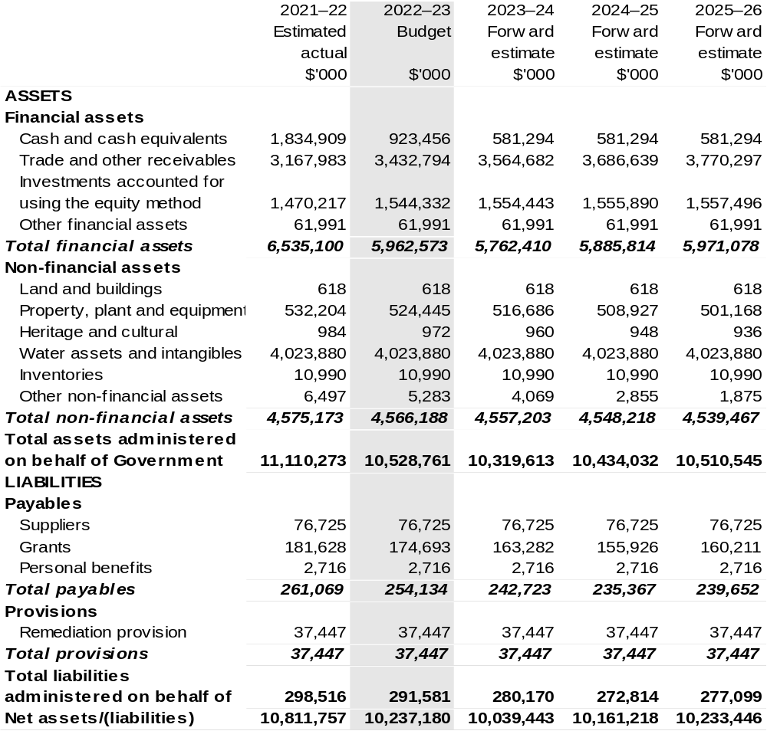

Prepared on Australian Accounting Standards basis.

Table 3.9: Schedule of budgeted administered cash flows (for the period ended 30 June)
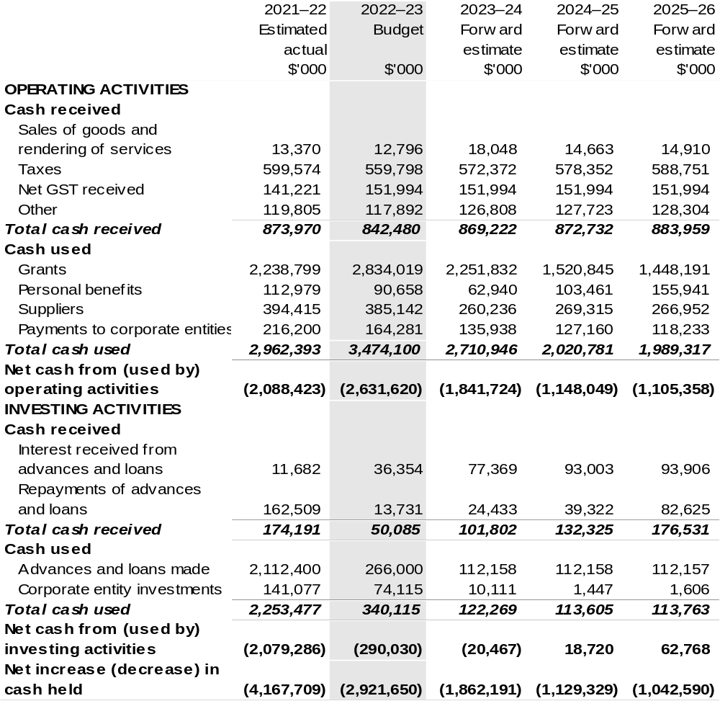

Continued on following page

Table 3.9: Schedule of budgeted administered cash flows (for the period ended 30 June) (continued)
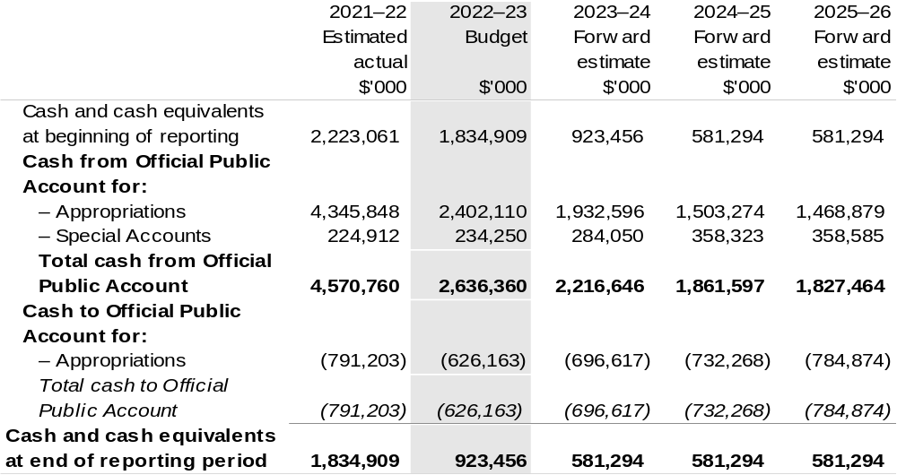

Prepared on Australian Accounting Standards basis.

Table 3.10: Administered capital budget statement (for period ended 30 June)
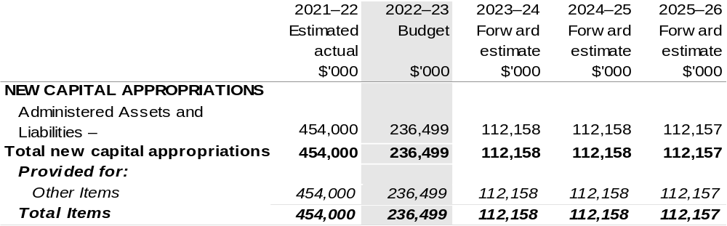

Prepared on Australian Accounting Standards basis.

Table 3.11: Statement of administered asset movements (Budget year 2022–23)
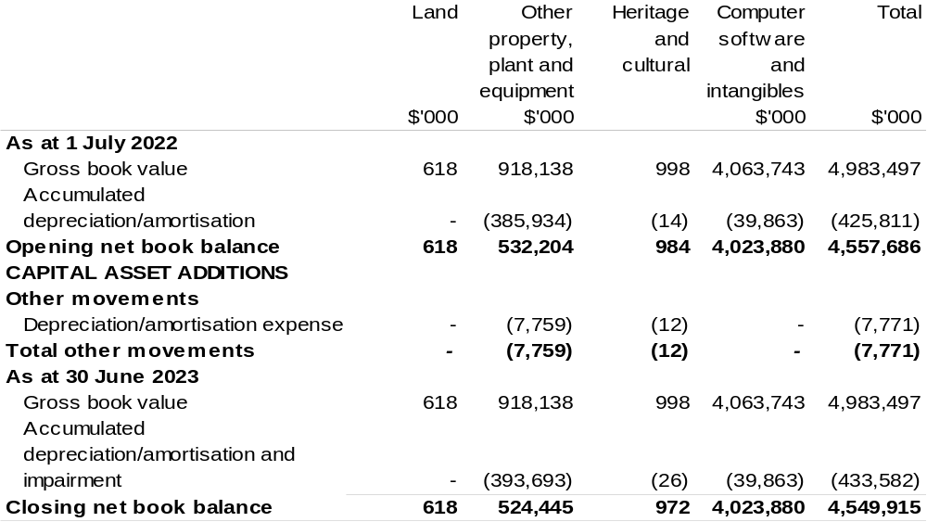

Prepared on Australian Accounting Standards basis.

AgriFutures Australia
Section 1: Entity overview and resources 111
1.1 Strategic direction statement 111
1.2 Entity resource statement 114
1.3 Budget measures 116
Section 2: Outcomes and planned performance 117
2.1 Changes to the outcome and program structures 118
2.2 Budgeted expenses and performance for Outcome 1 119
Section 3: Budgeted financial statements 124
3.1 Budgeted financial statements 124
3.2 Budgeted financial statements tables 125

AgriFutures Australia

Section 1: Entity overview and resources

1.1 Strategic direction statement
AgriFutures Australia (AgriFutures) is the trading name for the Rural Industries Research and Development Corporation (RIRDC). AgriFutures plays a unique role in Australian agriculture by investing in research and development (R&D) to maintain and create profitable and sustainable rural industries. AgriFutures knows that the key to developing real and lasting solutions for rural industries is to take a shared approach to shared challenges. That is why AgriFutures works in collaboration with a range of stakeholders to develop and implement its initiatives.
AgriFutures’ vision is to grow the long-term prosperity of Australian rural industries. AgriFutures’ mission is to collaborate with its partners to create lasting value for its stakeholders, through investing in research, innovation and learning initiatives that enhance the prosperity, profitability and sustainability of the agricultural, fisheries and forestry sectors. AgriFutures’ approach is guided by an ambition to be an organisation that places people, rural industries and regional communities at the centre of all its activities.
AgriFutures supports rural industries that do not have their own research and development corporation (RDC) and invests in R&D to accelerate the establishment of new and emerging rural industries.
AgriFutures’ cross-sectoral mandate supports it to focus on national opportunities and challenges that affect multiple rural industries, not just the industries it traditionally serves. AgriFutures’ future orientation enables it to not only tackle the challenges and opportunities that rural industries face today, but to identify and unearth the challenges and opportunities of tomorrow. AgriFutures does this by listening and collaborating with the emerging leaders in agriculture, industries bodies, other RDCs and government.
As outlined in AgriFutures Australia Research and Innovation Strategic Plan
2022–2027 due to be published on 1 July 2022, AgriFutures has designed the “AgriFutures’ 16:5:5 Roadmap” – a simple, decisive set of priorities, centred around two important audiences – our levied industries and Australian rural industries.
The plan sets out sixteen priorities within five focus areas over five years (2022–2027).
AgriFutures’ 16:5:5 Roadmap:
Focus Area: Our Industries:
In partnership with each of our industries, create value by:
- Maximising the return on investment for R&D levies.
- Listening to, engaging, collaborating, and consulting with our industries.
- Delivering research and innovation that addresses the specific needs of each of our industries.
- Supporting our industries to prepare for and thrive into the future.
- Road testing new technologies, practices, and innovations with the potential for our industries to uptake and adopt.
- Assisting our industries to enhance their industry stewardship to build community and consumer confidence.
Focus Area: Emerging Industries:
Grow the value and diversity of Australia’s rural economy by:
- Driving the growth of emerging, high-potential rural industries.
- Driving the growth of new enterprises that generate additional revenue streams for primary producers.
Focus Area: Workforce and Leadership:
Assist in the development of the agricultural workforce by:
- Understanding and responding to the future workforce needs of Australia’s rural industries.
- Attracting and retaining a workforce that will ensure Australia’s rural industries are future ready.
- Supporting people in Australia’s rural industries to build their motivation and skills to lead change.
- Responding to the specific workforce and leadership needs of our levied and emerging industries.
Focus Area: National Challenges and Opportunities
Future proof Australian rural industries by:
- Identifying, understanding, and responding to national challenges and opportunities impacting on Australian rural industries.
- Facilitating collaboration across sectors.
- Fostering responsible industry stewardship and building community trust.
Focus Area: Global Agrifood Innovation
Engage with the global agrifood innovation system by:
- Ensuring Australia is a leader in accessing and adopting, as well as, developing and exporting agrifood technologies and innovation.

1.2 Entity resource statement
Table 1.1 shows the total funding from all sources available to the entity for its operations and to deliver programs and services on behalf of the Government.
The table summarises how resources will be applied by outcome (Government strategic policy objectives) and by administered (on behalf of the Government or the public) and departmental (for the entity’s operations) classification.
For more detailed information on special accounts and special appropriations, please refer to Budget Paper No. 4: Agency Resourcing.
Information in this table is presented on a resourcing (i.e. appropriations/cash available) basis, whilst the ‘Budgeted expenses by Outcome’ tables in Section 2 and the financial statements in Section 3 are presented on an accrual basis.

Table 1.1: AgriFutures Australia – Resource Statement – Budget Estimates for 2022–23 as at Budget March 2022
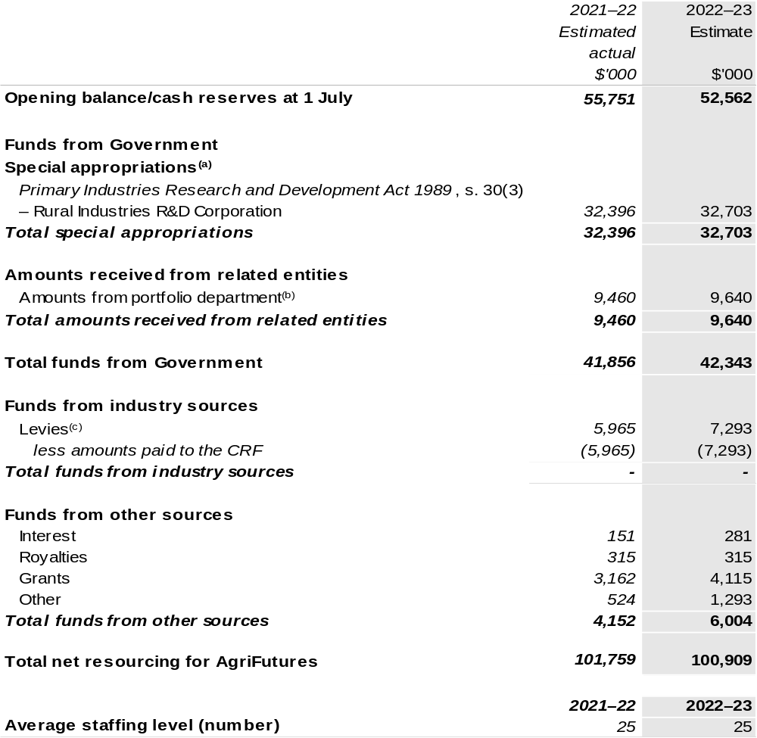

(a) AgriFutures' special appropriation is not directly appropriated as it is a corporate Commonwealth entity (CCE) under the Public Governance, Performance and Accountability Act 2013 (PGPA Act). Appropriations are made to Department of Agriculture, Water and the Environment (DAWE) and are then paid to AgriFutures and are considered departmental for all purposes.
(b) Funding provided by the portfolio department that is not specified within the Annual Appropriation Bills as a payment to that CCE (for example, a grant awarded to a CCE from one of its portfolio department's administered programs).
(c) The levies are imposed by the Primary Industries (Excise) Levies Act 1999. The levies are collected by DAWE under the Primary Industries Levies and Charges Collection Act 1991 and transferred to the Consolidated Revenue Fund (CRF). These amounts are then drawn down by the department as a special appropriation and paid to AgriFutures under the Primary Industries Research and Development Act 1989 (PIRD Act) s. 30(3) – Rural Industries R&D Corporation.

Please note: All figures shown above are GST exclusive – these may not match figures in the cash flow statement.

Prepared on a resourcing (i.e. appropriations available) basis.

1.3 Budget measures
Budget measures in Part 1 relating to AgriFutures Australia are detailed in Budget Paper No. 2: Budget Measures 2022–23 and are summarised below.

Table 1.2: AgriFutures Australia – 2022–23 Budget measures – Measures announced since the 2021–22 Mid-Year Economic and Fiscal Outlook (MYEFO)
AgriFutures does not have any 2022–23 Budget measures.

Section 2: Outcomes and planned performance
Government outcomes are the intended results, impacts or consequences of actions by the Government on the Australian community. Commonwealth programs are the primary vehicle by which government entities achieve the intended results of their outcome statements. Entities are required to identify the programs which contribute to Government outcomes over the Budget and forward years.
Each outcome is described below together with its related programs. The following provides detailed information on expenses for each outcome and program, further broken down by funding source.
Note:
Performance reporting requirements in the Portfolio Budget Statements are part of the Commonwealth performance framework established by the Public Governance, Performance and Accountability Act 2013. It is anticipated that the performance criteria described in Portfolio Budget Statements will be read with broader information provided in an entity’s corporate plans and annual performance statements – included in Annual Reports – to provide a complete picture of an entity’s planned and actual performance.
The most recent corporate plan and annual performance statement for AgriFutures can be found at:
http://www.agrifutures.com.au/about/corporate-documents/.

2.1 Changes to the outcome and program structures

Table 2.1: Outcome changes
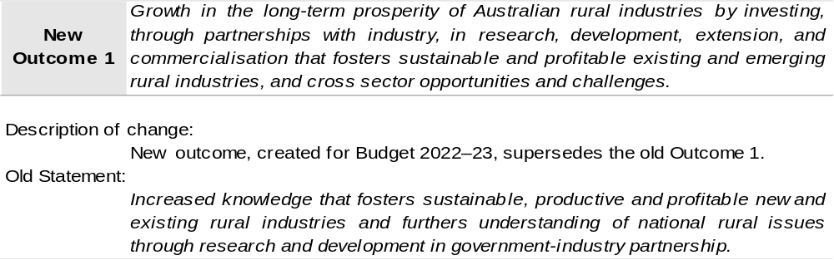

2.2 Budgeted expenses and performance for Outcome 1
Outcome 1: Growth in the long-term prosperity of Australian rural industries by investing, through partnerships with industry, in research, development, extension, and commercialisation that fosters sustainable and profitable existing and emerging rural industries, and cross sector opportunities and challenges.

2.2.1: Linked programs
Department of Agriculture, Water and the Environment
Program 3.10: Agricultural Resources
Contribution to Outcome 1 made by linked program:
AgriFutures works together with the DAWE to ensure sustainable, productive and profitable rural industries.

2.2.2: Budgeted expenses for Outcome 1
This table shows how much the entity intends to spend (on an accrual basis) on achieving the outcome, broken down by program, as well as by administered and departmental funding sources.

Table 2.2: Budgeted expenses for Outcome 1
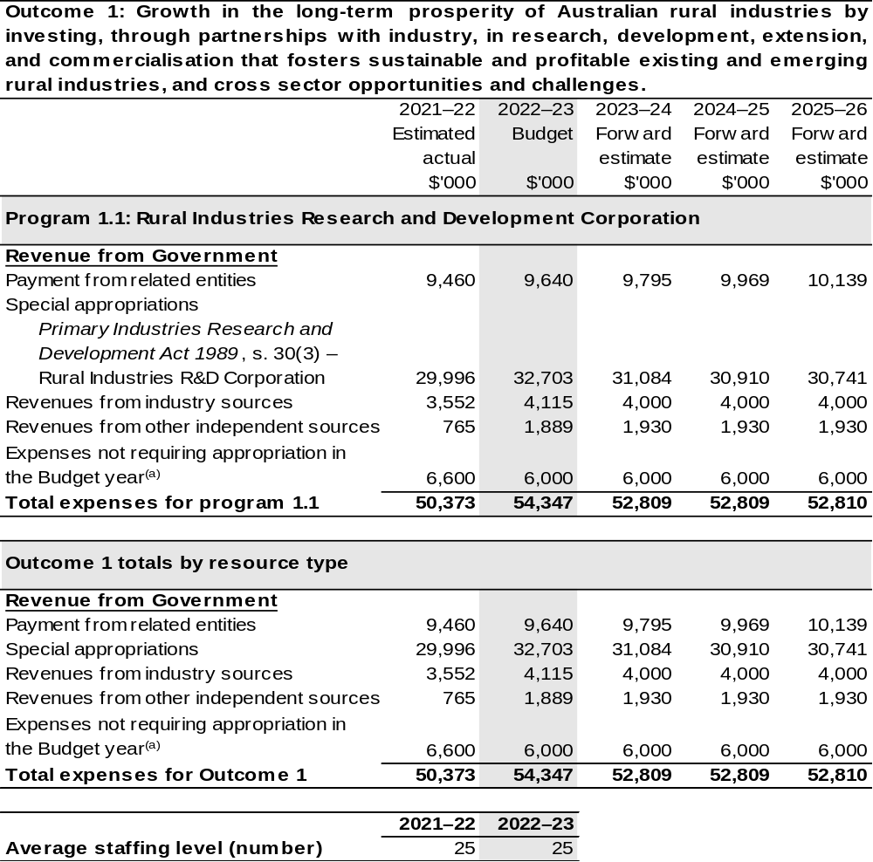

- Expenses not requiring appropriation in the budget year are made up of make good expenses, audit fees, and can include depreciation / amortisation expenses not requiring an appropriation.

Note: Departmental appropriation splits and totals are indicative estimates and may change in the course of the budget year as government priorities change.

Prepared on Australian Accounting Standards basis.

2.2.3: Performance criteria for Outcome 1
Table 2.1.3 details the performance measures for each program associated with Outcome 1. It also provides the related key activities as expressed in the current corporate plan where further detail is provided about the delivery of the activities related to the program, the context in which these activities are delivered and how the performance of these activities will be measured. Where relevant, details of 2022–23 Budget measures that have created new programs or materially changed existing programs are provided.
As an entity established under the Primary Industries Research and Development Act 1989 (PIRD Act), AgriFutures does not produce a corporate plan under the PGPA Act and is therefore exempt from the requirement to map purposes to outcomes.
Outcome 1: Growth in the long-term prosperity of Australian rural industries by investing, through partnerships with industry, in research, development, extension, and commercialisation that fosters sustainable and profitable existing and emerging rural industries, and cross sector opportunities and challenges.
Program 1.1: Rural Industries Research and Development Corporation
Objective | Through research and development create thriving rural industries and vibrant regional communities.
Key Activities | Focus Area: Our Industries:  In partnership with each of our industries, create value by:  - Maximising the return on investment for your R&D levy.  - Listening to, engaging, collaborating, and consulting with our industries.  - Delivering research and innovation that addresses the specific needs of each of our industries.  - Supporting our industries to prepare for and thrive into the future.  - Road testing new technologies, practices, and innovations with the potential for our industries to uptake and adopt.  - Assisting our industries to enhance their industry stewardship to build community and consumer confidence.
Key Activities | Focus Area: Emerging Industries:  Grow the value and diversity of Australia’s rural economy by:  - Driving the growth of emerging, high-potential rural industries.  - Driving the growth of new enterprises that generate additional revenue streams for primary producers.

Continued on following pages
2.1.3: Performance criteria for Outcome 1 (continued)
Key Activities (continued) | Focus Area: Workforce and Leadership:  Assist in the development of the agricultural workforce by:  - Understanding and responding to the future workforce needs of Australia’s rural industries.  - Attracting and retaining a workforce that will ensure Australia’s rural industries are future ready.  - Supporting people in Australia’s rural industries to build their motivation and skills to lead change.  - Responding to the specific workforce and leadership needs of our levied and emerging industries.
Key Activities (continued) | Focus Area: National Challenges and Opportunities  Future proof Australian rural industries by:  - Identifying, understanding, and responding to national challenges and opportunities impacting on Australian rural industries.  - Facilitating collaboration across sectors.  - Fostering responsible industry stewardship and building community trust.
Key Activities (continued) | Focus Area: Global Agrifood Innovation  Engage with the global agrifood innovation system by:  - Ensuring Australia is a leader in accessing and adopting, as well as, developing and exporting agrifood technologies and innovation.
Year | Performance measures | Expected Performance Results
Current year  2021–22 | 1,800 graduates per annum of an agriculture or agriculture science course at Australian universities. | 1,800 per annum.  Information from the Australian Council of Deans of Agriculture annual survey show an increasing number of enrolments.
Current year  2021–22 | Percentage of participants who feel their confidence as a leader has increased significantly or very significantly as a result of participation in an AgriFutures sponsored activity. | 80 per cent of surveyed participants.
Current year  2021–22 | Impact of AgriFutures sponsored studies on debates of national significance to rural industries. | Ten.

Continued on following pages
2.1.3: Performance criteria for Outcome 1 (continued)
Year | Performance measures | Expected Performance Results
Current year  2021–22 (continued) | New technologies adapted for use in Australian rural industries. | Three.
Current year  2021–22 (continued) | Evidence of collaboration between RDCs in cross sector investment initiatives. | Two.
Current year  2021–22 (continued) | Percentage of growers comfortable or very comfortable paying the R&D levy. | 80 per cent of surveyed participants.
Current year  2021–22 (continued) | Degree to which the objectives of the industry-based R&D plans are being achieved. | 85 per cent.
Current year  2021–22 (continued) | Stakeholders rate the value of AgriFutures’ information products and services as high or very high. | 75 per cent of surveyed participants.
Current year  2021–22 (continued) | Number of new rural industries reaching or exceeding $10 million per annum threshold. | One.
Year | Performance measures | Planned Performance Results
Budget Year  2022–23 | As per AgriFutures Research and Innovation Strategic Plan  2022–2027 to be published 1 July 2022. | As per AgriFutures Research and Innovation Strategic Plan  2022–2027 to be published 1 July 2022.
Forward Estimates 2023–26 | As per 2022–23. | As per 2022–23.

Section 3: Budgeted financial statements
Section 3 presents budgeted financial statements which provide a comprehensive snapshot of entity finances for 2022–23, including the impact of 2022–23 Budget measures and resourcing on financial statements.

3.1 Budgeted financial statements

3.1.1: Differences between entity resourcing and financial statements
The financial statements are prepared on an accrual basis where revenues and expenses are recognised as and when the resources are received and used. The entity resourcing table recognises the cash resources available to be used during the period and includes amounts recognised as revenue in previous periods.

3.1.2: Explanatory notes and analysis of budgeted financial statements
AgriFutures is budgeting for a deficit of $6.0 million in 2022–23.
AgriFutures’ balance sheet remains strong with estimated total assets of $52.5 million in 2022–23. Of the total assets, approximately $46.5 million is represented by cash and investments.
Total liabilities of $7.7 million are mostly represented by payables to R&D providers and suppliers of $3.1 million and employee entitlements of $0.8 million over the same period.

3.2 Budgeted financial statements tables

Table 3.1: Comprehensive income statement (showing net cost of services) (for the period ended 30 June)
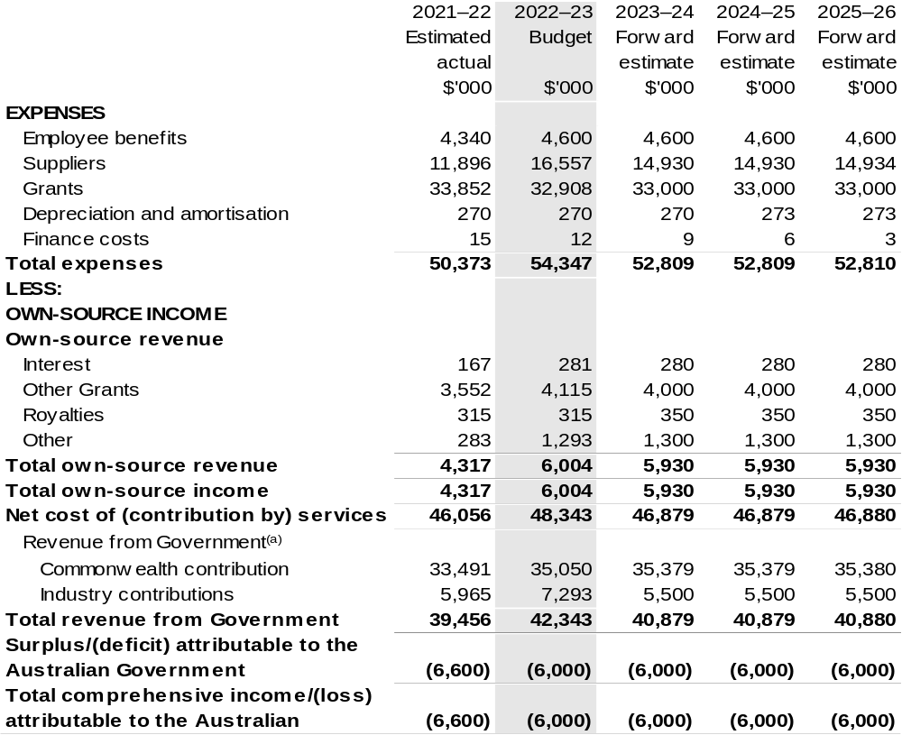

Continued on following page
Table 3.1: Comprehensive income statement (showing net cost of services) (for the period ended 30 June) (continued)
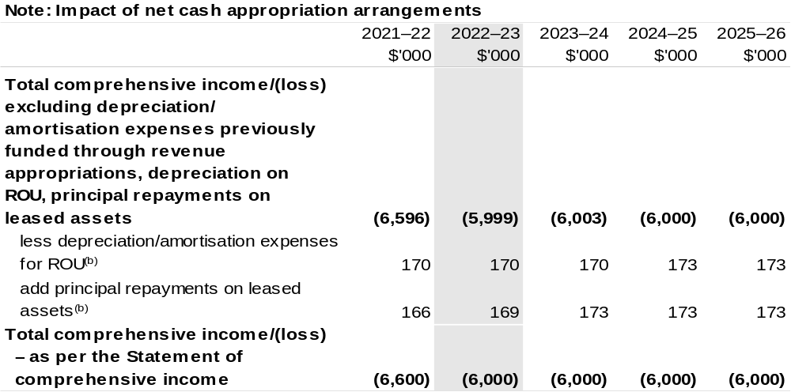

(a) Revenue from Government includes a Commonwealth contribution under the PIRD Act and levies collected from industry by DAWE for R&D activities.
(b) Applies to leases under AASB 16 Leases. Right of Use (ROU).

Prepared on Australian Accounting Standards basis.

Table 3.2: Budgeted departmental balance sheet (as at 30 June)
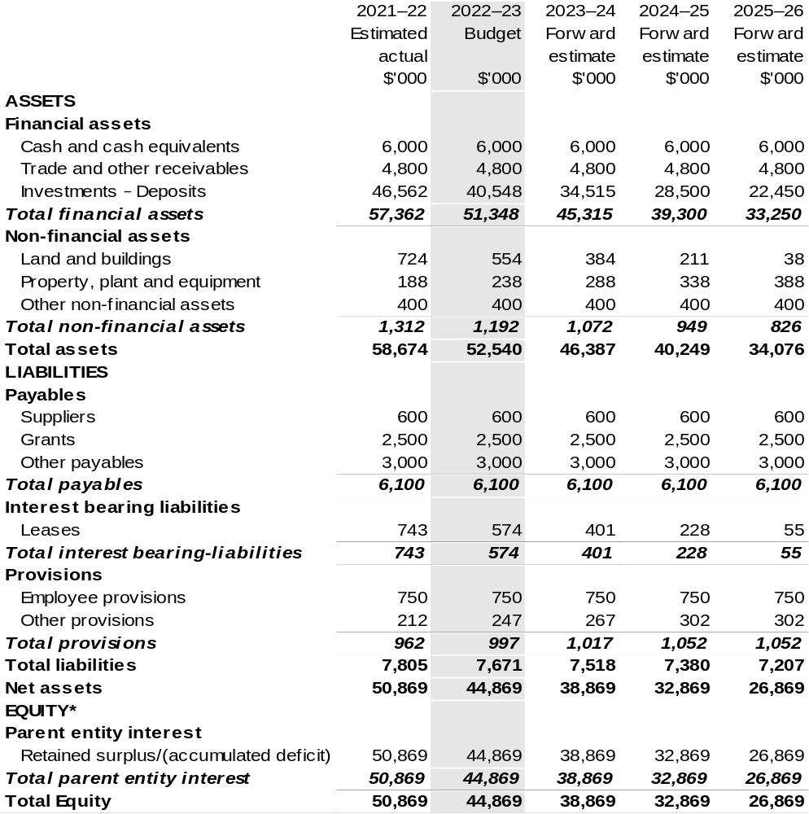

*'Equity' is the residual interest in assets after deduction of liabilities.

Prepared on Australian Accounting Standards basis.

Table 3.3: Departmental statement of changes in equity – summary of movement (Budget year 2022–23)
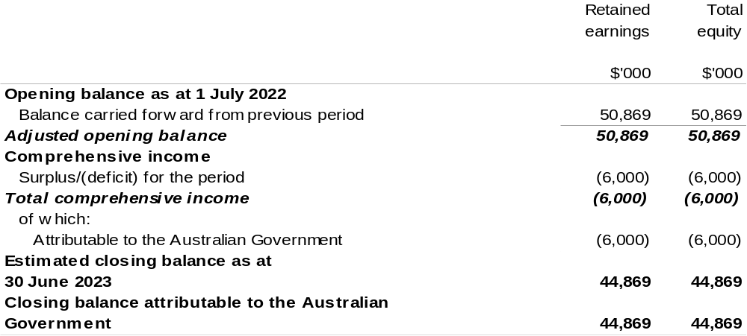

Prepared on Australian Accounting Standards basis.

Table 3.4: Budgeted departmental statement of cash flows (for the period
ended 30 June)
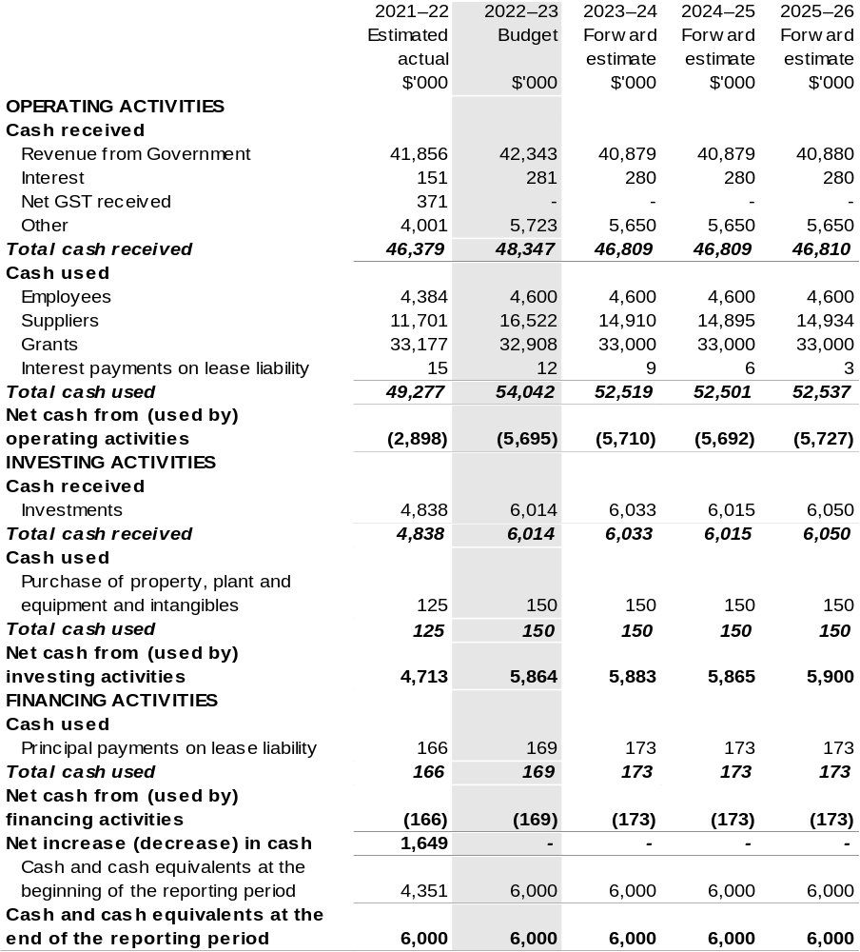

Prepared on Australian Accounting Standards basis.

Table 3.5: Departmental capital budget statement (for period end 30 June)
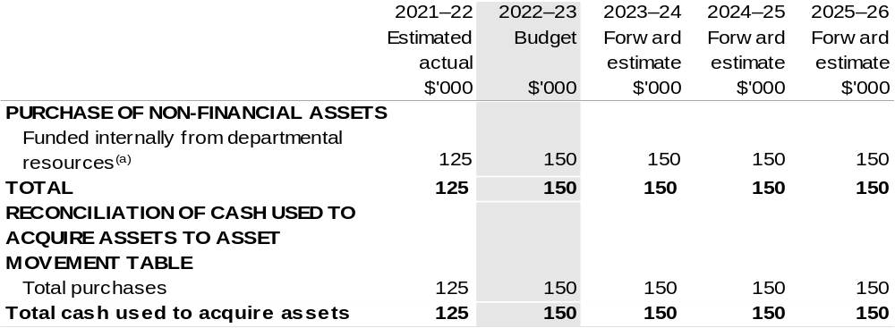

(a) Includes the following s74 external revenue:
– internally developed assets; and
– proceeds from the sale of assets.

Consistent with information contained in the Statement of Asset Movements and the Budgeted Statement of Cash Flows.

Prepared on Australian Accounting Standards basis.

Table 3.6: Statement of asset movements (Budget year 2022–23)
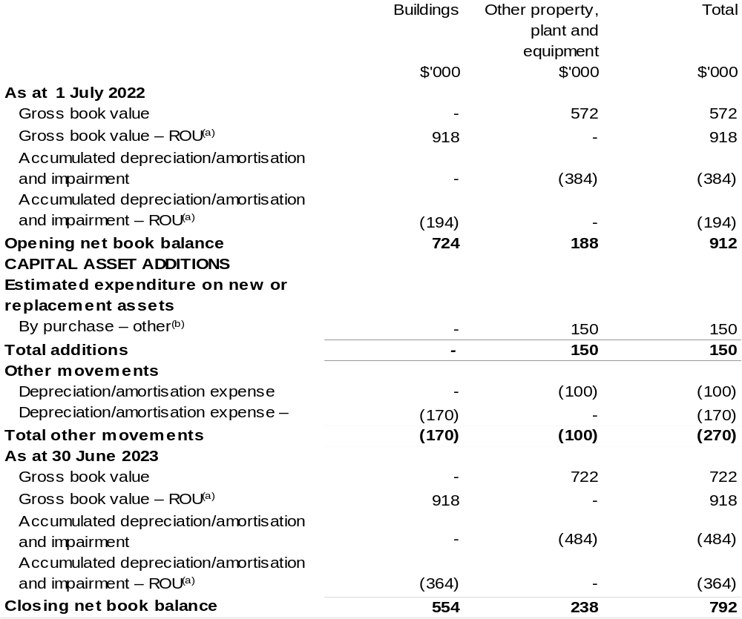

(a) Applies to leases under AASB 16 Leases. Right of Use (ROU).
(b) ‘By purchase – other’ refers to funding provided through other internal funding sources.

Prepared on Australian Accounting Standards basis.

Australian Fisheries Management Authority
Section 1: Entity overview and resources 135
1.1 Strategic direction statement 135
1.2 Entity resource statement 137
1.3 Budget measures 139
Section 2: Outcomes and planned performance 140
2.1 Budgeted expenses and performance for Outcome 1 141
Section 3: Budgeted financial statements 148
3.1 Budgeted financial statements 148
3.2 Budgeted financial statements tables 149

Australian Fisheries Management Authority

Section 1: Entity overview and resources

1.1 Strategic direction statement
The Australian Fisheries Management Authority (AFMA) was established under the Fisheries Administration Act 1991 (FAA) to manage Commonwealth fisheries on behalf of the Australian community in accordance with the Fisheries Management Act 1991 (FMA).
The AFMA Commission is responsible for exercising AFMA’s domestic fisheries management functions and powers under the FAA and FMA. The Chief Executive Officer (CEO) of AFMA is responsible for assisting the Commission, including giving effect to its decisions and is also a Commissioner. The CEO is also responsible for exercising AFMA’s foreign compliance functions, is the accountable authority under the Public Governance, Performance and Accountability Act 2013 (PGPA Act) and the agency head for the purposes of the Public Service Act 1999.
AFMA pursues four overarching goals, drawn from our legislated functions and objectives:
- Management of Commonwealth fisheries consistent with principles of ecologically sustainable development;
- Maximise net economic returns to the Australian community from the management of Commonwealth fisheries;
- Compliance with Commonwealth fisheries laws and policies and relevant international fishing obligations and standards; and
- Deliver effective, cost efficient and accountable management of Commonwealth fisheries resources.
We have regard to the impact of fishing on non-target species and on the long-term sustainability of the marine environment as well as taking into account the interests of commercial and recreational fishers. We are committed to better understanding Indigenous fishing interests as they relate to Commonwealth fisheries so that these too can be considered properly.
Climate change challenges our understanding of, and ability to influence fish stocks and marine ecosystems. We continue to improve our understanding of and response to the impacts of climate change through a number of projects, which are progressing from research to implementation.
We commission and place high importance on scientific and economic research and ecological risk assessments to inform decision making. AFMA uses these tools and our own monitoring activities to identify Australian marine living resources potentially affected by Commonwealth managed commercial fishing and implement measures to pursue sustainable fishing.
Our risk-based domestic compliance programs, participation in the Australian Government’s civil maritime surveillance and response arrangements and engaging internationally are all integral activities to improve the management of fish stocks within and beyond the Australian Fishing Zone. Our activities include education, monitoring and enforcement to protect Commonwealth fisheries from illegal fishing and engaging internationally to provide specialist advice and delivering capacity building programs to deter illegal, unreported and unregulated (IUU) fishing beyond Australia’s borders.
AFMA also provides fisheries management, licensing and domestic compliance services for the Protected Zone Joint Authority (PZJA) under the Torres Strait Fisheries Act 1984. Decisions under this legislation are made by the PZJA, which comprises the Commonwealth Fisheries Minister as Chair, with the Torres Strait Regional Authority and the Queensland Government as other members. Management and policy reform is of growing importance to the PZJA to ensure that the objectives of sustainable fisheries, economic development, and employment opportunities for traditional inhabitants and protection of the traditional way of life and traditional fishing can be achieved.
AFMA works in partnership with stakeholders, including commercial fishing operators, prescribed peak industry bodies, sectoral industry associations, Indigenous communities, recreational and charter fishing representatives, researchers, environment/conservation organisations, state and territory agencies and others with an interest in Commonwealth fisheries management. We engage with stakeholder groups through management advisory committees, resource assessment groups, scientific panels, working groups, liaison meetings, port visits, and electronic newsletters to concession holders in Commonwealth fisheries. We consult with the public using contemporary digital, web and social media communication channels.
AFMA applies the Australian Government’s cost recovery policy through its Cost Recovery Implementation Statement (CRIS). The commercial fishing industry operating in Commonwealth fisheries pay for activities directly attributed to it, while the Commonwealth pays for activities that benefit the broader community, including compliance and enforcement. Delivering on government and community expectations in a cost-efficient manner is a growing challenge in some Commonwealth fisheries.
We have a strong record of applying technological and other solutions to reduce and help minimise costs and improve efficiency in the delivery of our regulatory services to the Commonwealth managed commercial fishing industry.
Our purpose
The ecologically sustainable development of Commonwealth fisheries for the benefit of the Australian community.

1.2 Entity resource statement
Table 1.1 shows the total funding from all sources available to the entity for its operations and to deliver programs and services on behalf of the Government.
The table summarises how resources will be applied by outcome (Government strategic policy objectives) and by administered (on behalf of the Government or the public) and departmental (for the entity’s operations) classification.
For more detailed information on special accounts and special appropriations, please refer to Budget Paper No. 4: Agency Resourcing.
Information in this table is presented on a resourcing (that is, appropriations/cash available) basis, whilst the ‘Budgeted expenses by Outcome’ table in Section 2 and the financial statements in Section 3 are presented on an accrual basis.

Table 1.1: Australian Fisheries Management Authority – Resource Statement – Budget Estimates for 2022–23 as at Budget March 2022
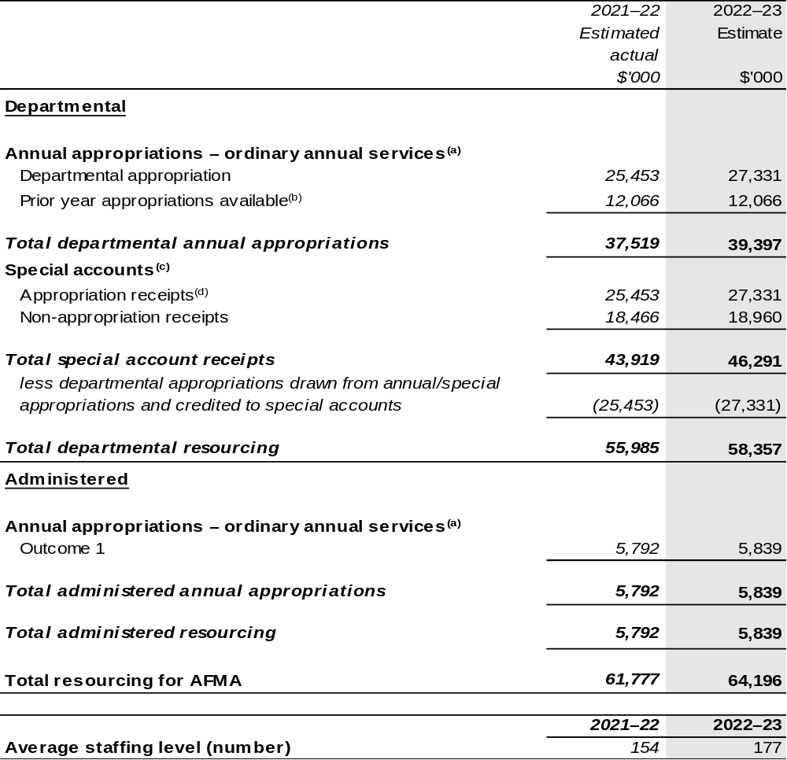

(a) Appropriation Bill (No. 1) 2022–23.
(b) These amounts reflect opening special account balances only.
(c) For further information on special appropriations and special accounts, please refer to Budget Paper No. 4: Agency Resourcing 2022–23. Please also see Table 2.1 for further information on outcome and program expenses broken down by various funding sources, e.g. annual appropriations, special appropriations and special accounts.
(d) Amounts credited to the special account(s) from the Authority’s annual and special appropriations.

Please note: All figures shown above are GST exclusive – these may not match figures in the cash flow statement.

Prepared on a resourcing (i.e. appropriations available) basis.

1.3 Budget measures
Budget measures in Part 1 relating to the Australian Fisheries Management Authority are detailed in Budget Paper No. 2: Budget Measures 2022–23 and are summarised below.

Table 1.2: Australian Fisheries Management Authority – 2022–23 Budget measures – Measures announced since the 2021–22 Mid-Year Economic and Fiscal Outlook (MYEFO)
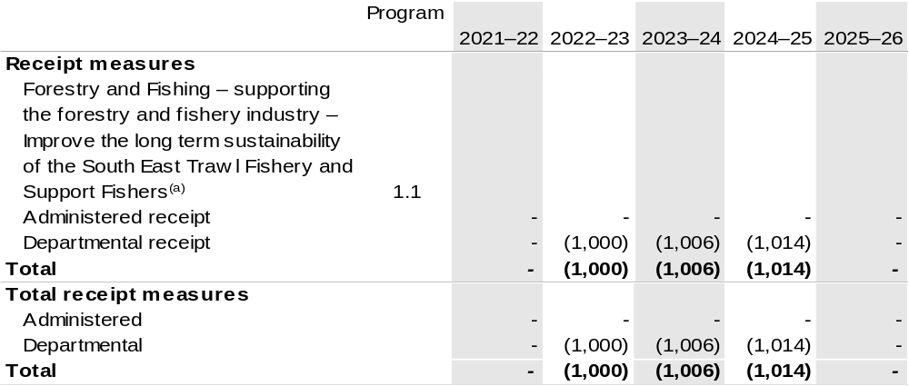

(a) The lead entity for this measure is the Department of Agriculture, Water and the Environment (DAWE). The measure description appears in Budget Paper No. 2: Budget Measures 2022–23 under the Agriculture, Water and the Environment portfolio.

Prepared on a Government Finance Statistics (Underlying Cash) basis. Figures displayed as a negative (-) represent a decrease in funds and a positive (+) represent an increase in funds.

Section 2: Outcomes and planned performance
Government outcomes are the intended results, impacts or consequences of actions by the Government on the Australian community. Commonwealth programs are the primary vehicle by which government entities achieve the intended results of their outcome statements. Entities are required to identify the programs which contribute to Government outcomes over the Budget and forward years.
Each outcome is described below together with its related programs. The following provides detailed information on expenses for each outcome and program, further broken down by funding source.
Note:
Performance reporting requirements in the Portfolio Budget Statements are part of the Commonwealth performance framework established by the PGPA Act. It is anticipated that the performance criteria described in Portfolio Budget Statements will be read with broader information provided in an entity’s corporate plans and annual performance statements – included in Annual Reports – to provide a complete picture of an entity’s planned and actual performance.
AFMA’s most recent corporate plan can be found at:
https://www.afma.gov.au/sites/default/files/corporate_plan_2021-24_final_03082021.pdf
AFMA’s most recent annual performance statement can be found at:
https://www.afma.gov.au/sites/default/files/afma_annual_report_2020-21_fa-tagged.pdf

2.1 Budgeted expenses and performance for Outcome 1
Outcome 1: Ecologically sustainable and economically efficient Commonwealth fisheries, through understanding and monitoring Australia’s marine living resources and regulating and monitoring commercial fishing, including domestic licensing and deterrence of illegal foreign fishing.

2.1.1: Linked programs
Department of Agriculture, Water and the Environment
Program 1.4: Conservation of Australia’s Heritage and Environment
Program 3.4: Fishing Industry
Program 4.1: Biosecurity and Export Services
Contribution to Outcome 1 made by linked program:
The AFMA and DAWE engage on fisheries management to ensure a sustainable, productive and profitable fishing industry.
Department of Home Affairs
Program 3.2: Border Enforcement
Contribution to Outcome 1 made by linked program:
AFMA provides the fisheries focus within the Australian Government Civil Maritime Surveillance and Response Program and is responsible for the administration of legislation on illegal fishing in the Australian Fishing Zone. AFMA deters and prevents illegal foreign fishing by carrying out education programs, cooperative enforcement operations, prosecution of offenders, confiscation of boats and capacity building projects.

2.1.2: Budgeted expenses for Outcome 1
This table shows how much the entity intends to spend (on an accrual basis) on achieving the outcome, broken down by program, as well as by administered and departmental funding sources.

Table 2.1: Budgeted expenses for Outcome 1
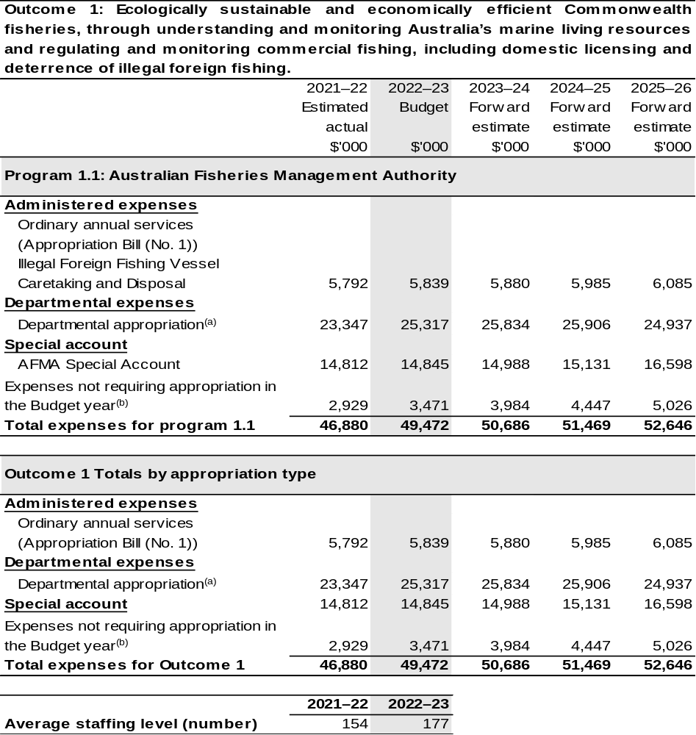
(a) Expenses funded from both ‘ordinary annual services’ Appropriation Bills (No. 1) and (No. 3) and ‘revenue from independent sources’ (receipts retained under section 74 of the PGPA Act).
(b) Expenses not requiring appropriation in the budget year are made up of make good expenses, audit fees, and can include depreciation / amortisation expenses not requiring an appropriation.

Note: Departmental appropriation splits and totals are indicative estimates and may change in the course of the budget year as Government priorities change.

Prepared on Australian Accounting Standards basis.

2.1.3: Performance criteria for Outcome 1
Table 2.1.3 details the performance measures for each program associated with Outcome 1. It also provides the related key activities as expressed in the current corporate plan where further detail is provided about the delivery of the activities related to the program, the context in which these activities are delivered and how the performance of these activities will be measured. Where relevant, details of 2022–23 Budget measures that have created new programs or materially changed existing programs are provided.
Outcome 1: Ecologically sustainable and economically efficient Commonwealth fisheries, through understanding and monitoring Australia’s marine living resources and regulating and monitoring commercial fishing, including domestic licensing and deterrence of illegal foreign fishing.
Program 1.1: Australian Fisheries Management Authority
Objective 1 | Management of Commonwealth fisheries consistent with principles of ecological sustainable development.
Key Activities^{(a)} | - Developing management arrangements that:  - Support the implementation of Commonwealth fisheries policies including the Harvest Strategy and Bycatch Policies;  - Implement AFMA’s Ecological Risk Management Framework;  - Recover overfished stocks and prevent overfishing; and  - Ensure commercial, recreational and Indigenous fishing information is used to the extent possible in decision making.  - Investing in and applying monitoring, scientific and economic research to decision making on fish stocks, sub-stocks, species (target and non-target species) and the impact of fishing on the marine environment.
Objective 2 | Maximise net economic returns to the Australian community from the management of Commonwealth fisheries.
Key Activities^{(a)} | - Reviewing management arrangements to take into account commercial, recreational and Indigenous fishing interests when maximising net economic returns from the commercial sector.  - Increasing catch levels within sustainable total allowable catches (TACs) by conducting and considering implementation of research focussed on under caught TACs.  - Managing exploratory fisheries (potentially underutilised fisheries).  - Understanding impacts of resource allocation between commercial, recreational, and Indigenous fishers.

Continued on following pages
2.1.3: Performance criteria for Outcome 1 (continued)
Objective 3 | Compliance with Commonwealth fisheries laws and policies and relevant international fishing obligations and standards.
Key Activities^{(a)} | - Operating an effective compliance and enforcement regime encompassing:  - Measures to maximise voluntary compliance;  - Risk-based, intelligence driven, and targeted domestic operations; and  - Building and maintaining strategic links and relationships with relevant law enforcement agencies.  - Operating effective foreign fisheries compliance enforcement and capacity building by:  - Implementing strategies to deter and eliminate illegal, unreported, and unregulated (IUU) foreign fishing in Australian waters and on the high seas where Australia has an interest; and  - Delivering capacity building programs internationally and providing technical input to support key regional and international fishing bodies.
Objective 4 | Deliver effective, cost efficient and accountable management of Commonwealth fisheries resources.
Key Activities^{(a)} | - Pursuing initiatives to improve regulation and administration generally in the Australian Government sector including:  - Exploring opportunities to streamline fisheries assessment and management processes; and  - Implementing new fisheries policies for harvest strategies and bycatch to improve fishery management performance.  - Reviewing business processes and systems, information flows and financial management arrangements through:  - Assessing and mitigating high financial and operating risks; and  - Implementing a digital first service delivery policy that provides electronic service delivery for all relevant programs (E-logs, Electronic Catch Disposal Records, licencing, data requests, etc.).^{(a)}  - Increasing AFMA accountability and stakeholder engagement through:  - Expanded membership of management advisory committees (MACs) and resource assessment groups (RAGs); and  - Capability development for recreational and Indigenous stakeholders.

Continued on following pages
2.1.3: Performance criteria for Outcome 1 (continued)
Year | Performance measures | Expected Performance Results
Current year  2021–22 | - The number of stocks for which management measures are based on species-appropriate scientific assessment. | Performance results of no change or an increase are on track.
Current year  2021–22 | - The percentage of species assessed as “residual High Risk” under Ecological Risk Assessment. | Performance results of no change or an increase are on track.
Current year  2021–22 | - The number of AFMA-only stocks assessed as “subject to overfishing” in the Australian Bureau of Agricultural and Resource Economics and Sciences (ABARES), Fishery Status Report. | Zero target is not on track.
Current year  2021–22 | - AFMA advocates measures to address stocks shared with states and territories that are assessed as “overfished” or “subject to overfishing” in the ABARES Fishery Status Report in relevant negotiations. | Qualitative assessment is on track.
Current year  2021–22 | - Status of Wildlife Trade Operations under the Environmental Protection and Biodiversity Conservation Act 1999. | All WTOs are maintained on track.
Current year  2021–22 | - The number of stocks with target reference points based on Maximum Economic Yield, an agreed proxy thereof or a multi-stock harvest strategy. | Performance results of no change or an increase are on track.
Current year  2021–22 | - Net Economic Return, as assessed in the ABARES Status of Fish Stocks Report. | Positive trend over 3 year window is on track.
Current year  2021–22 | - Treatment of identified domestic compliance risks as outlined in the National Compliance and Enforcement Program (NCEP). | >90 per cent of NCEP performance targets met is on track.
Current year  2021–22 | - Incidence level of illegal foreign fishing vessels operating in the Australian Fishing Zone. | Lower than the previous 10 year average is not on track to be met.

Continued on following pages
2.1.3: Performance criteria for Outcome 1 (continued)
Year | Performance measures | Expected Performance Results
Current year  2021–22 (continued) | - Compliance rate with international obligations as assessed in Regional Fisheries Management Organisation (implemented by AFMA). | >90 per cent is on track.
Current year  2021–22 (continued) | - Cost recover budget. | At or below 2005–06 once adjusted for CPI is on track.
Current year  2021–22 (continued) | - Corporate overheads compared to total budget. | <20 per cent is not on track.
Current year  2021–22 (continued) | - Engagement with legislated peak body. | Commonwealth Fisheries Association is satisfied that meaningful opportunity is given to contribute to planning, delivery and reporting is on track.
Year | Performance measures | Planned Performance Results
Budget Year  2022–23 | - As per 2021–22. | No change or an increase.
Budget Year  2022–23 | - As per 2021–22. | No change or a decrease.
Budget Year  2022–23 | - As per 2021–22. | Zero.
Budget Year  2022–23 | - As per 2021–22. | Qualitative assessment.
Budget Year  2022–23 | - As per 2021–22. | All WTOs are maintained.
Budget Year  2022–23 | - As per 2021–22. | No change or an increase.
Budget Year  2022–23 | - As per 2021–22. | Positive trend over rolling 3-year average.
Budget Year  2022–23 | - As per 2021–22. | >90 percent of NCEP performance targets met.
Budget Year  2022–23 | - As per 2021–22. | Lower than the previous 3-year average.
Budget Year  2022–23 | - As per 2021–22. | >90 per cent.
Budget Year  2022–23 | - As per 2021–22. | At or below 2005–06 once adjusted for CPI.
Budget Year  2022–23 | - As per 2021–22. | <25 per cent.

Continued on following page
2.1.3: Performance criteria for Outcome 1 (continued)
Year | Performance measures | Planned Performance Results
Budget Year  2022–23 (continued) | - As per 2021–22. | Commonwealth Fisheries Association is satisfied that meaningful opportunity is given to contribute to planning, delivery, and reporting.
Budget Year  2022–23 (continued) | - Number of services offered digitally.^{(b)} | Increased trend in the number of empirical data collection services offered electronically.
Forward Estimates  2023–26 | - As per 2022–23. | As per 2022–23.

- Refers to updated key activities that will be reflected in the 2022–23 Corporate Plan.
- New performance measures that reflect new or materially changed programs are shown in italics.

Section 3: Budgeted financial statements
Section 3 presents budgeted financial statements which provide a comprehensive snapshot of entity finances for 2022–23, including the impact of 2022–23 Budget measures and resourcing on financial statements.

3.1 Budgeted financial statements

3.1.1: Differences between entity resourcing and financial statements
The financial statements are prepared on an accrual basis where revenues and expenses are recognised as and when the resources are received and used. The entity resourcing table recognises cash resources available to be used during the period and includes amounts recognised as revenue in previous periods.

3.1.2: Explanatory notes and analysis of budgeted financial statements
AFMA expects to maintain a balanced budget position over the forward years, before depreciation and amortisation.
AFMA collects levies via regulations under the Fishing Levy Act 1991, in accordance with the Fisheries Management Act 1991, Fisheries Administration Act 1991, Australian Government cost recovery policy and AFMA’s Cost Recovery Implementation Statement.
Administered income reflects the fines imposed by AFMA for domestic and international illegal fishing activities and the receipt of administered revenue for expenditure incurred.
Administered expenditure reflects payments to the providers of illegal foreign fishing vessel caretaking and disposal services.

3.2 Budgeted financial statements tables

Table 3.1: Comprehensive income statement (showing net cost of services) (for the period ended 30 June)
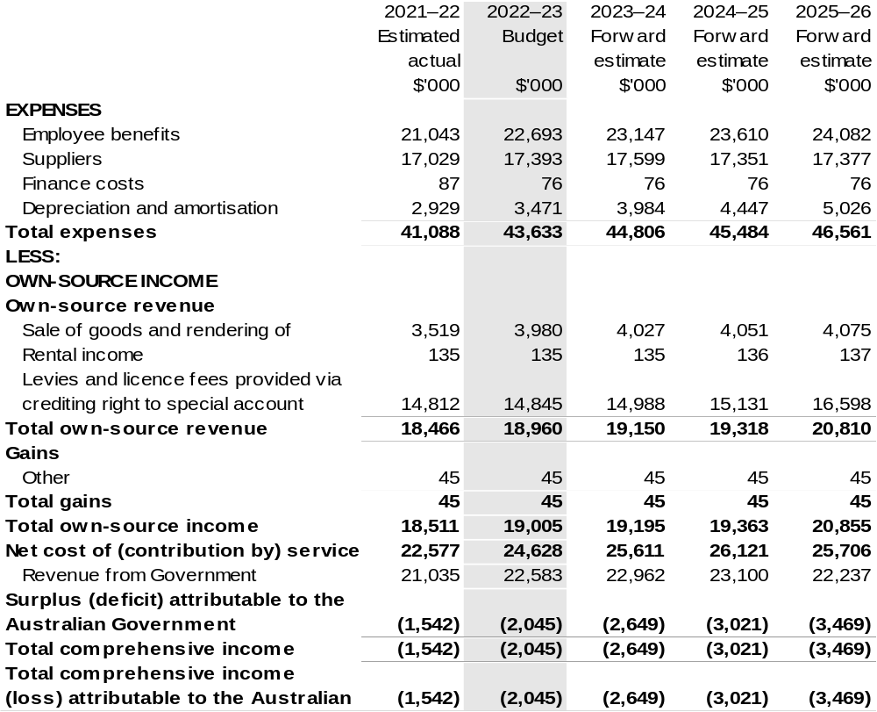

Continued on following page

Table 3.1: Comprehensive income statement (showing net cost of services) (for the period ended 30 June) (continued)
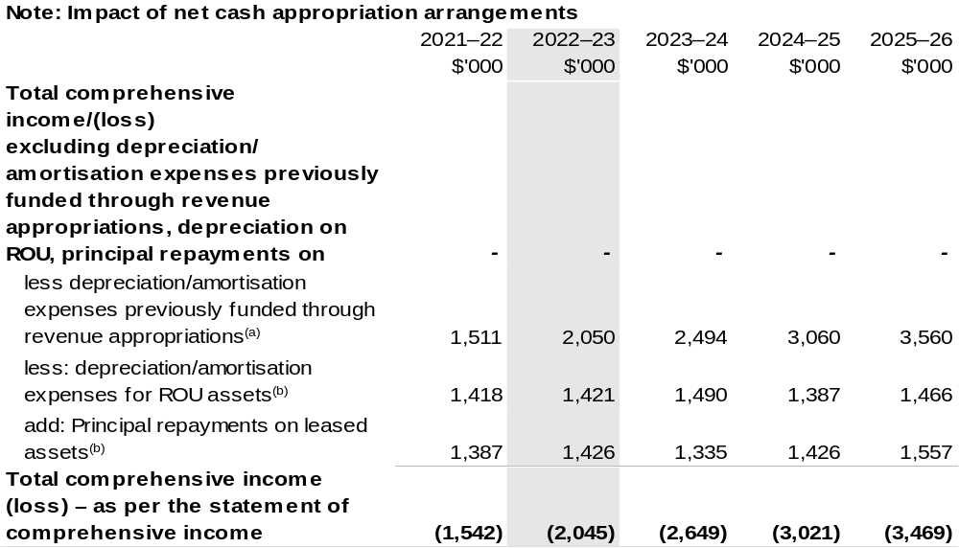

(a) From 2010–11, the Government introduced net cash appropriation arrangements where Appropriation
Bill (No. 1) revenue appropriations for the depreciation/amortisation expenses of non-corporate Commonwealth entities (and select corporate Commonwealth entities) were replaced with a separate capital budget (the Departmental Capital Budget, or DCB) provided through Appropriation Bill (No. 1) equity appropriations. For information regarding DCBs, please refer to Table 3.5 Departmental Capital Budget Statement.
- Applies to leases under AASB 16 Leases. Right of Use (ROU).

Prepared on Australian Accounting Standards basis.

Table 3.2: Budgeted departmental balance sheet (as at 30 June)
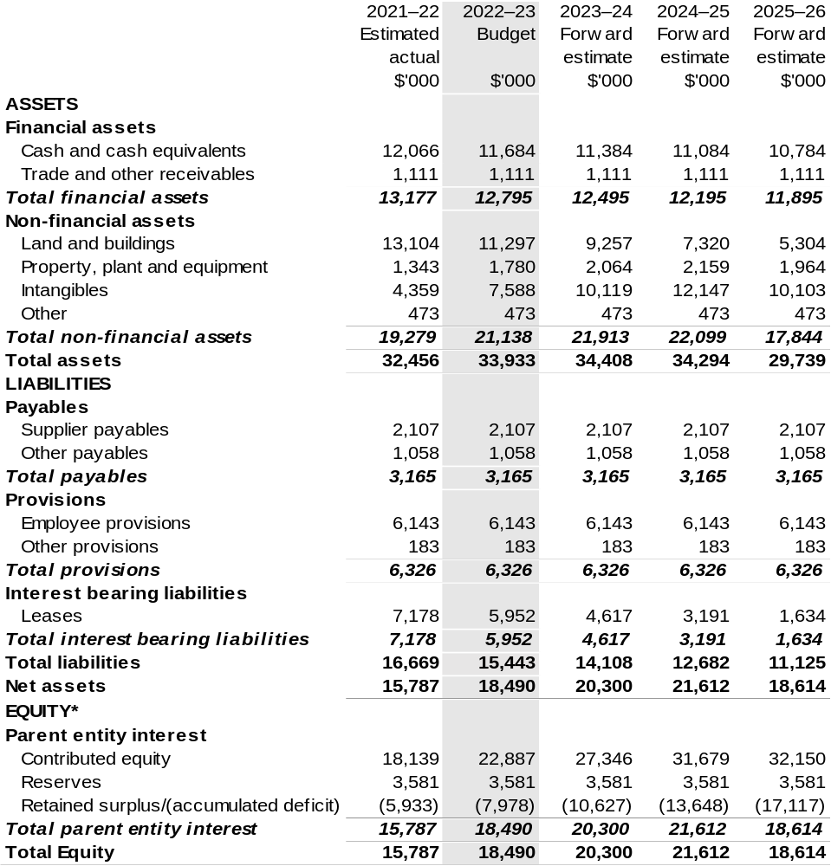

*’Equity’ is the residual interest in assets after deduction of liabilities.

Prepared on Australian Accounting Standards basis.

Table 3.3: Departmental statement of changes in equity — summary of movement (Budget year 2022–23)
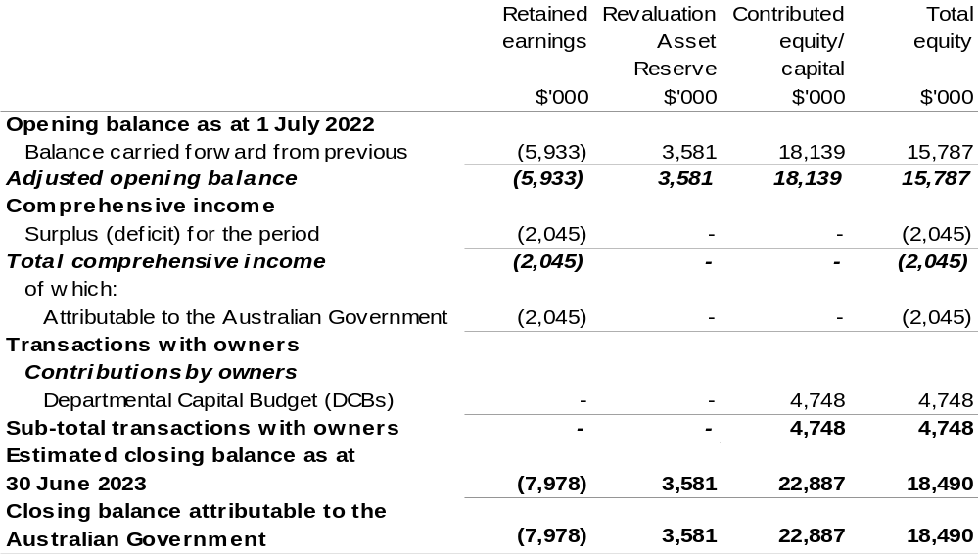

Prepared on Australian Accounting Standards basis.

Table 3.4: Budgeted departmental statement of cash flows (for the period
ended 30 June)
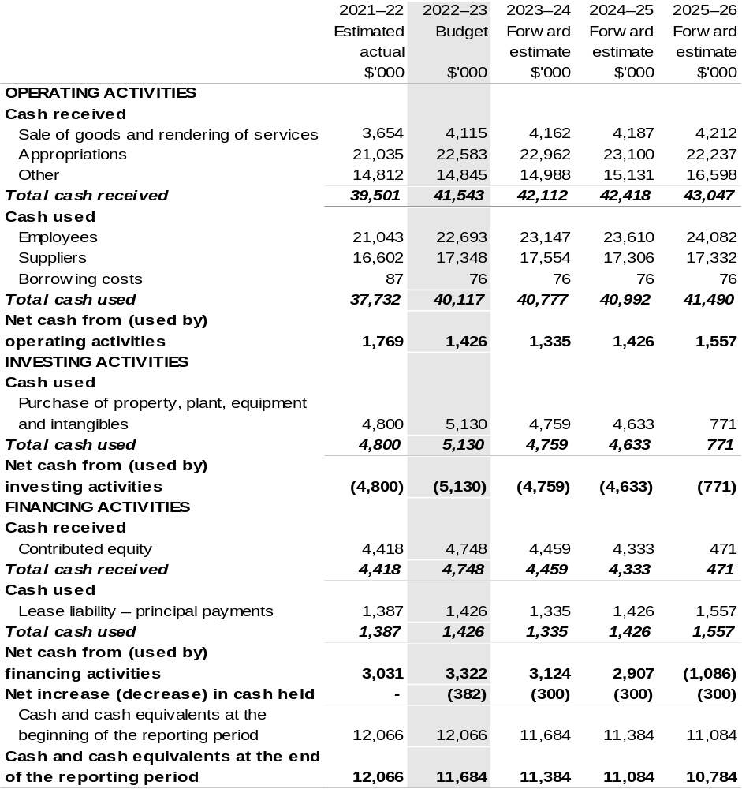

Prepared on Australian Accounting Standards basis.

Table 3.5: Departmental capital budget statement (for the period ended 30 June)
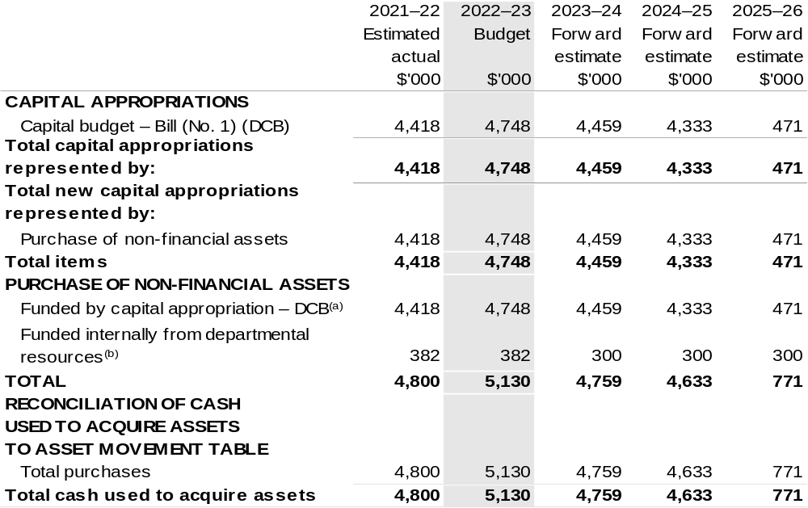

(a) Does not include annual finance lease costs. Include purchases from current and previous years' Departmental Capital Budgets (DCBs).
(b) Includes the following s74 external revenue:
– current Bill (No. 1) and prior year Act/Bill (No. 1/3/5) appropriations (excluding amounts from the DCBs);
– sponsorship, subsidy, gifts or similar contribution;
– internally developed assets;
– proceeds from the sale of assets; and
– the AFMA Special Account under s 94B of the Fisheries Administration Act 1991.

Consistent with information contained in the Statement of Asset Movements and the Budgeted Statement of Cash Flows.

Prepared on Australian Accounting Standards basis.

Table 3.6: Statement of asset movements (Budget year 2022–23)
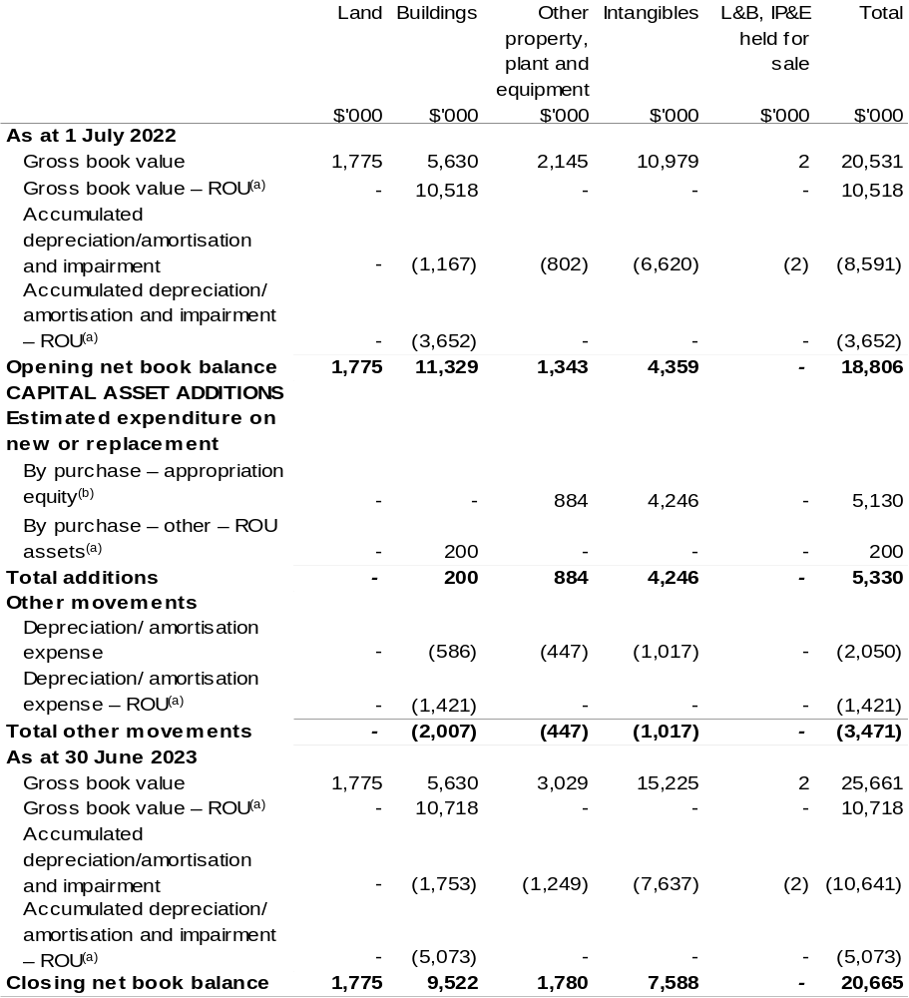

(a) Applies to leases under AASB 16 Leases. Right of Use (ROU).
(b) ‘By purchase – Appropriation equity’ refers to equity injections appropriations provided through Appropriation Bill (No. 2) 2022–23, including Collection Development Acquisition Budgets.

Prepared on Australian Accounting Standards basis.

Table 3.7: Schedule of budgeted income and expenses administered on behalf of Government (for the period ended 30 June)
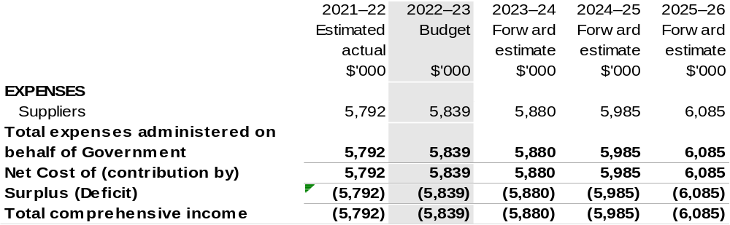

Prepared on Australian Accounting Standards basis.

Table 3.8: Schedule of budgeted assets and liabilities administered on behalf of Government (as at 30 June)
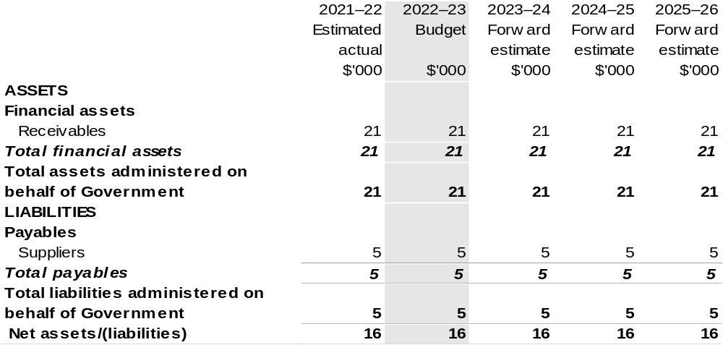

Prepared on Australian Accounting Standards basis.

Table 3.9: Schedule of budgeted administered cash flows (for the period
ended 30 June)
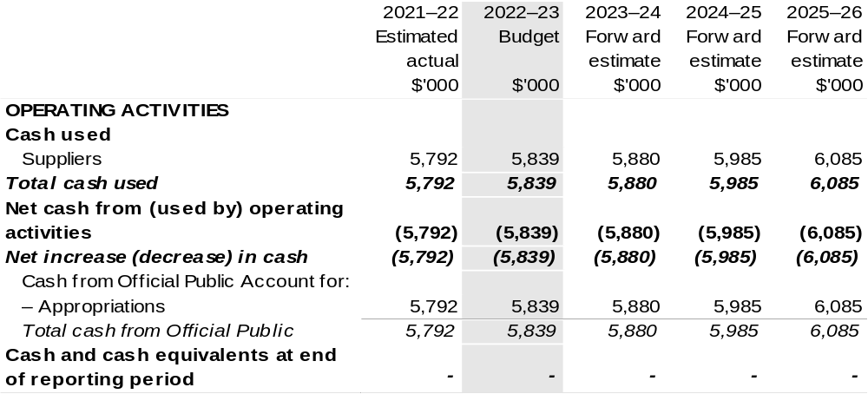

Prepared on Australian Accounting Standards basis.

Table 3.10: Statement of administered asset movements (Budget year 2022–23)

The schedule of administered asset movements on behalf of Government is nil.

Australian Pesticides and Veterinary Medicines Authority
Section 1: Entity overview and resources 161
1.1 Strategic direction statement 161
1.2 Entity resource statement 162
1.3 Budget measures 164
Section 2: Outcomes and planned performance 165
2.1 Budgeted expenses and performance for Outcome 1 166
Section 3: Budgeted financial statements 169
3.1 Budgeted financial statements 169
3.2 Budgeted financial statements tables 170

Australian Pesticides and Veterinary Medicines Authority

Section 1: Entity overview and resources

1.1 Strategic direction statement
The Australian Pesticides and Veterinary Medicines Authority (APVMA) is established under the Agricultural and Veterinary Chemicals (Administration) Act 1992 (Administration Act). The APVMA’s principal responsibilities are described in the Administration Act and the Agricultural and Veterinary Chemicals Code Act 1994.
The APVMA regulates the supply of safe and effective agricultural and veterinary (agvet) chemicals in Australia. Robust risk assessment methods are used to scientifically evaluate new and existing pesticides and veterinary medicines. Through efficient and effective regulation, the APVMA ensures the registration of agvet chemical products, delivers appropriate protections for human health and safety, animals and the environment, and supports international trade.
The APVMA’s regulatory responsibility extends from registration and manufacturing through to the point of sale. By agreement, the states and territories are then responsible for regulating and monitoring how agvet chemicals are used.
We will build on the adaptive and flexible response adopted during the COVID-19 pandemic, continuing to deliver regulatory services through collaborative and innovative work practices.
We will work to minimise cost recovery charges, consistent with the Australian Government Cost Recovery Guidelines, through the efficient implementation of cost recovered activities.

1.2 Entity resource statement
Table 1.1 shows the total funding from all sources available to the entity for its operations and to deliver programs and services on behalf of the Government.
The table summarises how resources will be applied by outcome (Government strategic policy objectives) and by administered (on behalf of the Government or the public) and departmental (for the entity’s operations) classification.
For more detailed information on special accounts and special appropriations, please refer to Budget Paper No. 4: Agency Resourcing.
Information in this table is presented on a resourcing (i.e. appropriations/cash available) basis, whilst the ‘Budgeted expenses by Outcome’ tables in Section 2 and the financial statements in Section 3 are presented on an accrual basis.

Table 1.1: Australian Pesticides and Veterinary Medicines Authority – Resource Statement – Budget Estimates for 2022–23 as at Budget March 2022
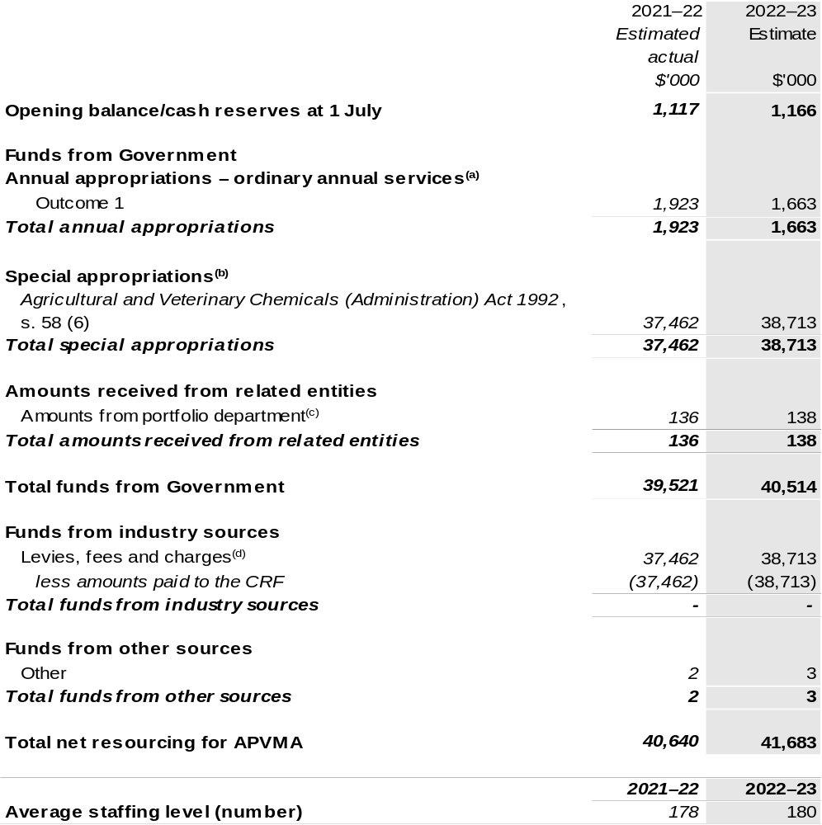

(a) Appropriation Bill (No. 1) 2022–23. Appropriation is provided through the Department of Agriculture, Water and the Environment (DAWE) and is specified within the Annual Appropriation Bills as a payment to the APVMA and is considered departmental for all purposes.
(b) APVMA’s special appropriation is not directly appropriated as it is a corporate Commonwealth entity (CCE) under the Public Governance, Performance and Accountability Act 2013 (PGPA Act). Appropriations are made to DAWE and are then paid to APVMA and are considered departmental for all purposes.
(c) Funding provided by the portfolio department that is not specified within the Annual Appropriation Bills as a payment to that CCE (for example, a grant awarded to a CCE from one of its portfolio department's administered programs).
(d) These charges are imposed by the Agricultural and Veterinary Chemicals Code Act 1994 and the Agricultural and Veterinary Chemical Products (Collection of Levy) Act 1994. They are collected by APVMA and transferred to the CRF. These amounts are then drawn down by the department as a special appropriation under the Administration Act.

Please note: All figures shown above are GST exclusive - these may not match figures in the cash flow
statement.
Prepared on a resourcing (i.e. appropriations available) basis.

1.3 Budget measures
Budget measures in Part 1 relating to the Australian Pesticides and Veterinary Medicines Authority are detailed in Budget Paper No. 2: Budget Measures 2022–23 and are summarised below.

Table 1.2: Australian Pesticides and Veterinary Medicines Authority – 2022–23 Budget measures – Measures announced after the Mid-Year Economic and Fiscal Outlook (MYEFO)
APVMA does not have any 2022–23 Budget measures.

Section 2: Outcomes and planned performance
Government outcomes are the intended results, impacts or consequences of actions by the Government on the Australian community. Commonwealth programs are the primary vehicle by which government entities achieve the intended results of their outcome statements. Entities are required to identify the programs which contribute to Government outcomes over the Budget and forward years.
Each outcome is described below together with its related programs. The following provides detailed information on expenses for each outcome and program, further broken down by funding source.
Note:
Performance reporting requirements in the Portfolio Budget Statements are part of the Commonwealth performance framework established by the Public Governance, Performance and Accountability Act 2013. It is anticipated that the performance criteria described in Portfolio Budget Statements will be read with broader information provided in an entity’s corporate plans and annual performance statements – included in Annual Reports – to provide a complete picture of an entity’s planned and actual performance.
APVMA’s most recent corporate plan can be found at: https://apvma.gov.au/node/87421
APVMA’s most recent annual performance statement can be found at:
https://apvma.gov.au/node/92371 in chapter 3.

2.1 Budgeted expenses and performance for Outcome 1
Outcome 1: Protection of the health and safety of people, animals, the environment, and agricultural and livestock industries through regulation of pesticides and veterinary medicines.

2.1.1: Linked programs
Department of Agriculture, Water and the Environment
Program 3.10: Agricultural Resources
Contribution to Outcome 1 made by linked programs:
The APVMA and DAWE work together to ensure the protection of the health and safety of humans, animals and the environment.

2.1.2: Budgeted expenses for Outcome 1
This table shows how much the entity intends to spend (on an accrual basis) on achieving the outcome, broken down by program, as well as by administered and departmental funding sources.

Table 2.1: Budgeted expenses for Outcome 1
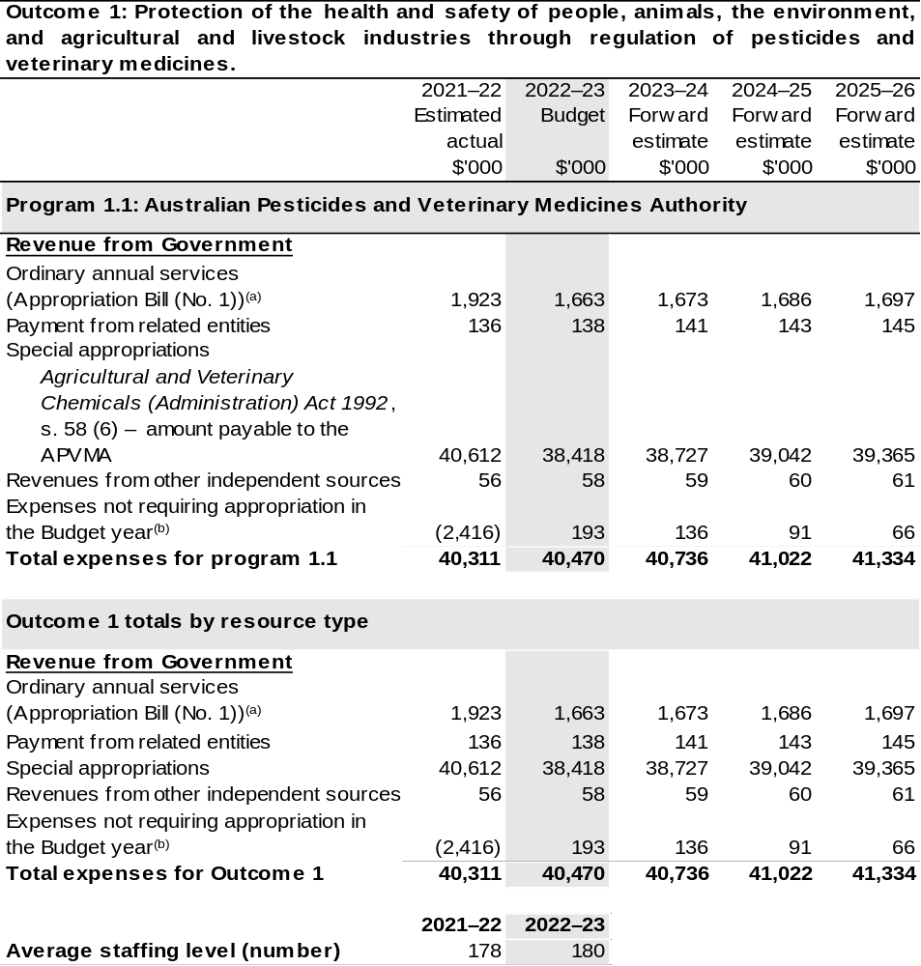
(a) Appropriation Bill (No. 1) 2022–23. The APVMA is CCE under the PGPA Act and does not receive direct appropriations. Appropriation is provided through DAWE and is specified with the Annual Appropriation Bills as payment to the APVMA and is considered departmental for all purposes.
(b) Expenses not requiring appropriation in the budget year are made up of make good expenses, audit fees, and can include depreciation / amortisation expenses not requiring an appropriation.

Note: Departmental appropriation splits and totals are indicative estimates and may change in the course of the budget year as government priorities change.
Prepared on Australian Accounting Standards basis.

2.1.3: Performance criteria for Outcome 1
Table 2.1.3 details the performance measures for each program associated with Outcome 1. It also provides the related key activities as expressed in the current corporate plan where further detail is provided about the delivery of the activities related to the program, the context in which these activities are delivered and how the performance of these activities will be measured. Where relevant, details of 2022–23 Budget measures that have created new programs or materially changed existing programs are provided.
Outcome 1: Protection of the health and safety of people, animals, the environment, and agricultural and livestock industries through regulation of pesticides and veterinary medicines.
Program 1.1: Australian Pesticides and Veterinary Medicines Authority
Objective | The APVMA regulates agricultural and veterinary chemicals to manage the risks of pests and diseases for the Australian community and to protect Australia’s trade and the health and safety of people, animals and the environment.
Key Activities | Regulation of agricultural and veterinary chemicals is delivered through four mechanisms:  - Risk-based assessment and registration of pesticides and veterinary chemicals;  - Identification and resolution of non-compliance up to and including the point of retail sale;  - Licence and audit veterinary manufacturers; and  - Identification and review of the safety of existing chemicals of regulatory concern.
Year | Performance measures | Expected Performance Results
Current year  2021–22 | Percentage of applications finalised within statutory timeframes. | 100 per cent.
Year | Performance measures | Planned Performance Results
Budget Year  2022–23 | As per 2021–22. | As per 2021–22.
Forward Estimates  2023–26 | As per 2022–23. | As per 2022–23.

Section 3: Budgeted financial statements
Section 3 presents budgeted financial statements which provide a comprehensive snapshot of entity finances for 2022–23, including the impact of 2022–23 Budget measures and resourcing on financial statements.

3.1 Budgeted financial statements

3.1.1: Differences between entity resourcing and financial statements
The resourcing statement is prepared on a cash basis. The financial statements are prepared on an accrual basis. Differences between the resourcing and financial statements represent timing differences between revenue recognition and cash received.

3.1.2: Explanatory notes and analysis of budgeted financial statements
A new Cost Recovery Implementation Statement was approved by the Minister for Agriculture, Drought and Emergency Management in April 2020, and came into effect on 1 July 2020.
The APVMA has experienced an increase in sales declarations for levy revenue greater than historical averages would indicate. Future sales of agvet products are difficult to predict and the forward estimates have been based on a 3-year average.
The Government made available an additional $17.7 million to the APVMA through Appropriation Act (No. 5) 2019–20 in response to the COVID-19 pandemic, to ensure funding was available in the event of a fall in cost recovered revenue from industry.
This appropriation has not been drawn down and the receivable is planned to be reversed against equity in 2021–22.

3.2 Budgeted financial statements tables

Table 3.1: Comprehensive income statement (showing net cost of services)
(for the period ended 30 June)
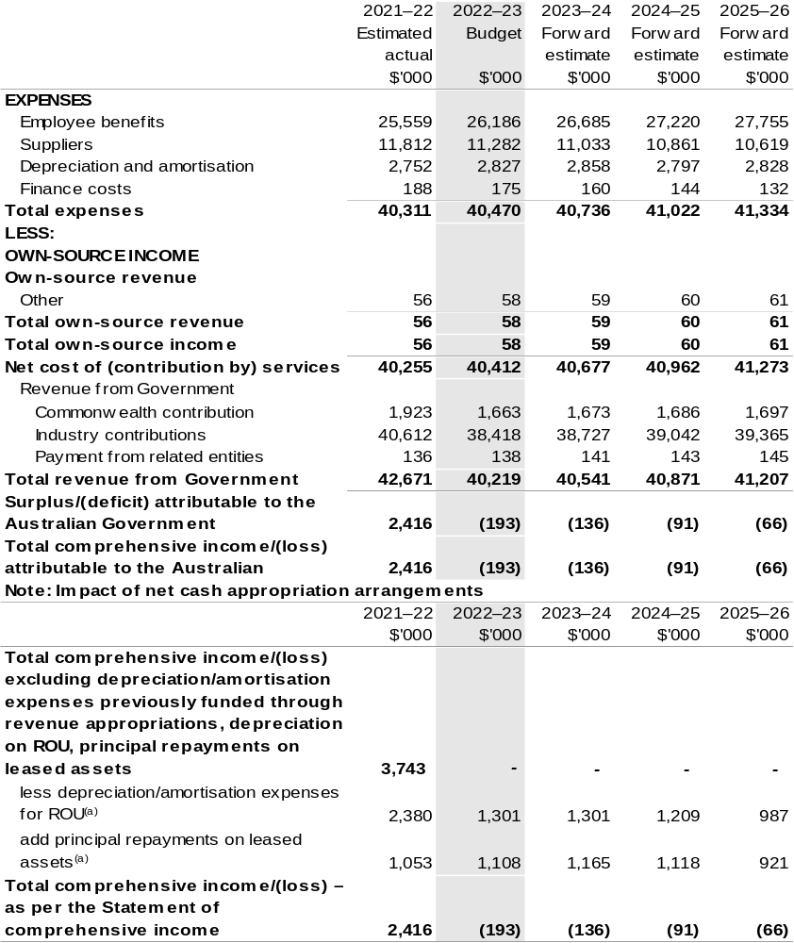

(a) Applies to leases under AASB 16 Leases. Right of Use (ROU).

Prepared on Australian Accounting Standards basis.

Table 3.2: Budgeted departmental balance sheet (as at 30 June)
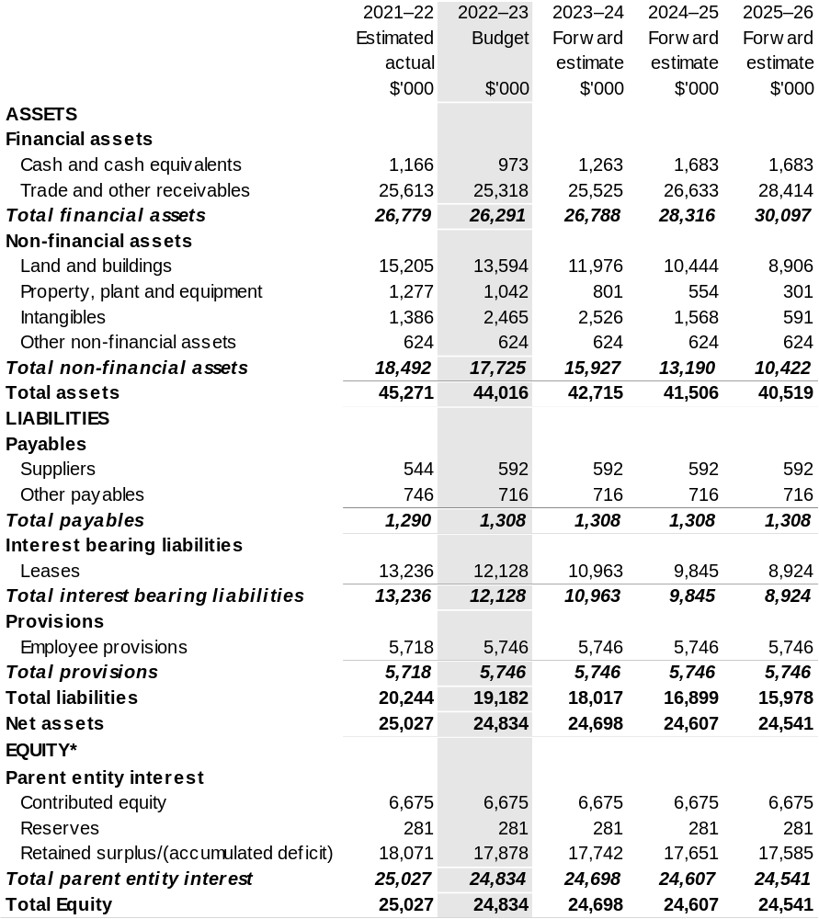

*’Equity’ is the residual interest in assets after deduction of liabilities.

Prepared on Australian Accounting Standards basis.

Table 3.3: Departmental statement of changes in equity — summary of movement (Budget year 2022–23)
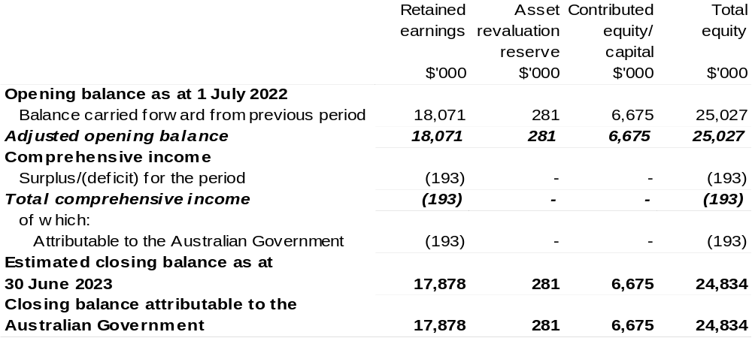

Prepared on Australian Accounting Standards basis.

Table 3.4: Budgeted departmental statement of cash flows (for the period
ended 30 June)
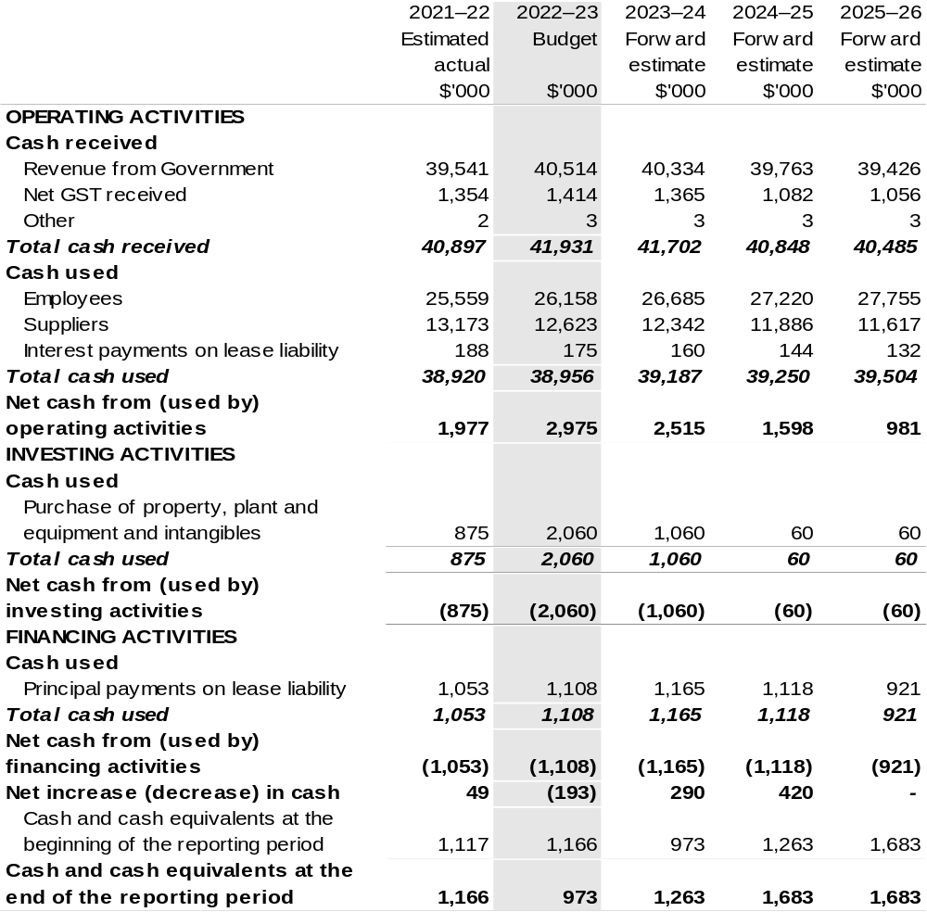

Prepared on Australian Accounting Standards basis.

Table 3.5: Departmental capital budget statement (for the period ended 30 June)
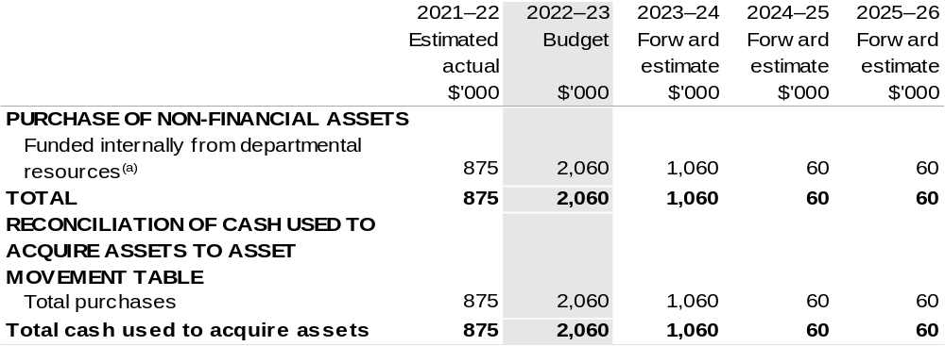

(a) Includes the following s74 external revenue:
– internally developed assets;
– proceeds from the sale of assets.

Consistent with information contained in the Statement of Asset Movements and the Budgeted Statement of Cash Flows.

Prepared on Australian Accounting Standards basis.

Table 3.6: Statement of asset movements (Budget year 2022–23)
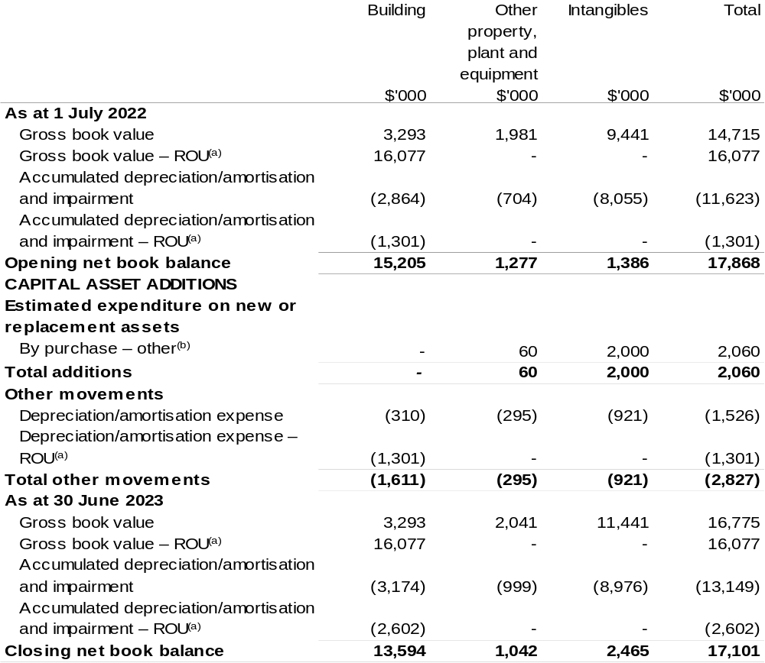

(a) Applies to leases under AASB 16 Leases. Right of Use (ROU).
(b) 'By purchase – other' refers to funding provided through other internal funding sources.

Prepared on Australian Accounting Standards basis.

Bureau Of Meteorology
Section 1: Entity overview and resources 179
1.1 Strategic direction statement 179
1.2 Entity resource statement 180
1.3 Budget measures 182
Section 2: Outcome and planned performance 183
2.1 Changes to the outcome and program structures 184
2.2 Budgeted expenses and performance for Outcome 1 185
Section 3: Budgeted financial statements 191
3.1 Budgeted financial statements 191
3.2 Budgeted financial statements tables 192

Bureau Of Meteorology

Section 1: Entity overview and resources

1.1 Strategic direction statement
The Bureau of Meteorology (the Bureau) is Australia’s national weather, climate and water agency, providing essential and trusted products and services that contribute to the safety, prosperity and wellbeing of the Australian community all day, every day.
The Bureau’s work directly informs decisions by governments and the community and supports industry in key sectors such as emergency management, aviation, transport, water management, agriculture and environmental management.
The Bureau will commence delivery of its next five-year Strategy from 2022–23, continuing to focus on the following four whole-of-enterprise pillars of success:
- Impact and Value.
- Operational Excellence.
- Insight and Innovation.
- The Bureau Way.
In 2022–23 the Bureau will undertake critical maintenance on the national Flood Warning Observations Network, to ensure flood forecasts and warnings are timely, accurate and reliable in Australia’s highest risk areas.
The Bureau will continue to improve the security and resilience of its Information Communications Technology systems and business processes under the 2020–21 measure Bureau of Meteorology — Improved Security and Resilience for ICT Systems – Tranche Three.
In addition, the Bureau will continue to invest in, maintain and replace critical assets under the 2020–21 Budget measure Bureau of Meteorology – Long-term Financial Sustainability. These measures ensure the Bureau can continue to provide reliable, ongoing access to weather, climate, water and oceans information, with improved response times. They will also enable Bureau forecasters and climate scientists to access cutting edge tools and technologies needed to deal with the increasing number of multiple and concurrent severe weather events, now and into the future.
In collaboration with key partner agencies, the Bureau will continue to lead coordination of the Australian Climate Service which provides critical climate and natural disaster risk information to Emergency Management Australia and the National Recovery and Resilience Agency to ensure the safety, security and prosperity of all Australians.
1.2 Entity resource statement
Table 1.1 shows the total funding from all sources available to the entity for its operations and to deliver programs and services on behalf of the Government.
The table summarises how resources will be applied by outcome (Government strategic policy objectives) and by administered (on behalf of the Government or the public) and departmental (for the entity’s operations) classification.
For more detailed information on special accounts and special appropriations, please refer to Budget Paper No. 4 – Agency Resourcing.
Information in this table is presented on a resourcing (that is, appropriations/cash available) basis, whilst the ‘Budgeted expenses by Outcome’ table in Section 2 and the financial statements in Section 3 are presented on an accrual basis.

Table 1.1: Bureau of Meteorology – Resource Statement – Budget Estimates for 2022–23 as at Budget March 2022
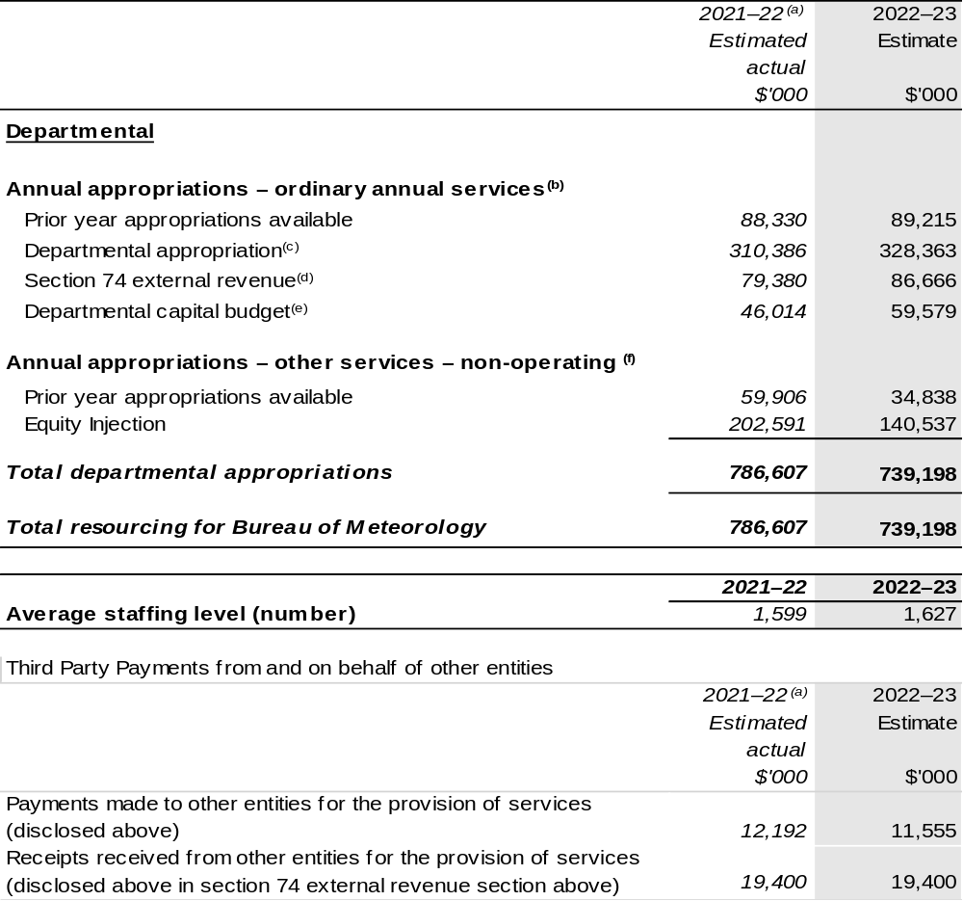

- Annual Appropriation amounts presented for 2021–22 do not include the Appropriation Bills (No. 3) and (No. 4), as they had not been enacted at the time of publication. The Bureau will receive $1.906 million through the 2021–22 Annual Appropriation Bill (No. 3) and $1.168 million through the 2021–22 Annual Appropriation Bill (No. 4). The annual appropriations received from these bills will be recognised in a future portfolio budget statement but only after the Bills have received Royal Assent.
- Appropriation Bill (No. 1) 2022–23.
- Excludes departmental capital budget (DCB).
- Estimated external revenue receipts under section 74 of the Public Governance, Performance and Accountability Act 2013 (PGPA Act).
- Departmental capital budgets are not separately identified in Appropriation Bill (No. 1) and form part of ordinary annual services items. Please refer to Table 3.7 for further details. For accounting purposes, this amount has been designated as a 'contribution by owner'.
- Appropriation Bill (No. 2) 2022–23.

Note: all figures shown above are GST exclusive – these may not match figures in the cash flow statement.

Prepared on a resourcing (i.e. appropriations available) basis.

1.3 Budget measures
Budget measures in Part 1 relating to the Bureau are detailed in Budget Paper No. 2: Budget Measures 2022–23 and are summarised below.

Table 1.2: Bureau of Meteorology – 2022–23 Budget measures – Measures announced since the 2021–22 Mid-Year Economic and Fiscal Outlook (MYEFO)
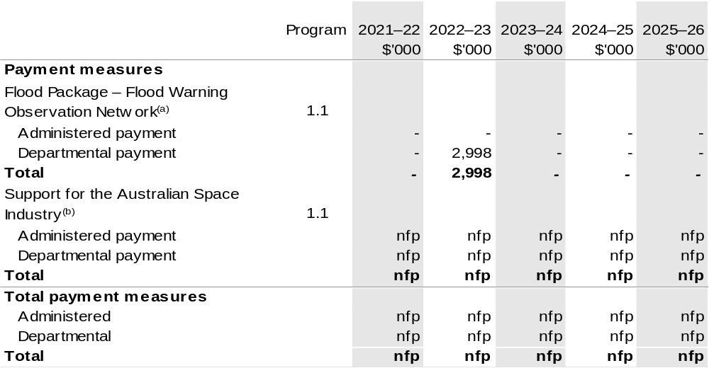

- The measure description appears in Budget Paper No. 2: Budget Measures 2022–23 under Cross Portfolio.
- Elements of this measure were Decisions Taken But Not Yet Announced (DTBNYA) in the 2021–22 Portfolio Additional Estimates Statements (PAES), with the departmental impact nfp. The lead entity for this measure is the Department of Industry, Science, Energy and Resources (DISER). The measure description appears in Budget Paper No. 2: Budget Measures 2022–23 under the Industry, Science, Energy and Resources portfolio.

Not for publication (nfp).

Prepared on a Government Finance Statistics (Underlying Cash) basis. Figures displayed as a negative (-) represent a decrease in funds and a positive (+) represent an increase in funds.

Section 2: Outcomes and planned performance
Government outcomes are the intended results, impacts or consequences of actions by the Government on the Australian community. Commonwealth programs are the primary vehicle by which government entities achieve the intended results of their outcome statements. Entities are required to identify the programs which contribute to Government outcomes over the Budget and forward years.
Each outcome is described below together with its related programs. The following provides detailed information on expenses for each outcome and program, further broken down by funding source.
Note:
Performance reporting requirements in the Portfolio Budget Statements are part of the Commonwealth performance framework established by the Public Governance, Performance and Accountability Act 2013. It is anticipated that the performance criteria described in Portfolio Budget Statements will be read with broader information provided in an entity’s corporate plans and annual performance statements – included in Annual Reports – to provide a complete picture of an entity’s planned and actual performance.
The most recent corporate plan for the Bureau of Meteorology can be found at: http://www.bom.gov.au/inside/Corporate_Plan_2021-22_Accessible_Verison.pdf.
The most recent annual performance statement can be found at: https://www.transparency.gov.au/annual-reports/bureau-meteorology/reporting-year/2020-21.

2.1 Changes to the outcome and program structures

Table 2.1: Outcome changes
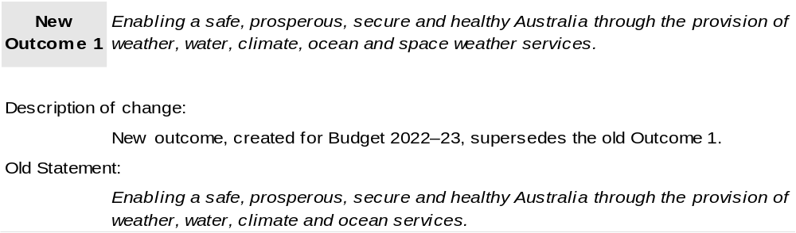

2.2 Budgeted expenses and performance for Outcome 1
Outcome 1: Enabling a safe, prosperous, secure and healthy Australia through the provision of weather, water, climate, ocean and space weather services.

2.1.1: Linked programs
Australian Bureau of Statistics
Program 1.1: Australian Bureau of Statistics
Contribution to Outcome 1 made by linked programs
The Bureau partners with the Australian Bureau of Statistics to deliver world-leading climate and natural disaster science, information and expertise through the Australian Climate Service.
Australian Maritime Safety Authority
Program 1.1 Seafarer and ship safety, environment protection and search and rescue.
Contribution to Outcome 1 made by linked programs
The Bureau provides marine weather information covering wind, weather, sea and swell conditions for safe maritime operations.
Civil Aviation Safety Authority
Program 1.1: Sub-program 2: Collaborative engagement with the aviation industry and wider community to promote and support aviation safety.
Contribution to Outcome 1 made by linked programs
The Bureau provides aviation users with meteorological information necessary for safe and efficient civil aviation operations.
Climate Change Authority
Program 1.1: Reviewing climate change policies
Contribution to Outcome 1 made by linked programs
The Bureau has a strategic relationship agreement for the provision of climate research and advice to support the Climate Change Authority.
Commonwealth Scientific and Industrial Research Organisation
Program 1: Scientific and Industrial Research and Infrastructure
Contribution to Outcome 1 made by linked programs
The Bureau works with CSIRO to undertake research as part of the Climate Systems Hub through the National Environmental Science Program.
The Bureau partners with the CSIRO to deliver world-leading climate and natural disaster science, information and expertise through the Australian Climate Service.

Continued on following pages
Linked programs (continued)
Department of Agriculture, Water and the Environment
Program 1.2: Environmental Information and Research
Program 1.3: Commonwealth Environmental Water
Program 2.1: Antarctica: Science, Policy and Presence
Program 3.2: Sustainable Management – Natural Resources
Program 3.11: Drought Programs
Program 5.1: Water Reform
Contribution to Outcome 1 made by linked programs
The Bureau is a partner in the Climate Systems Hub in the National Environmental Science Program.
The Bureau’s water information services inform Commonwealth water planning and decision making in relation to water resource availability.
The Bureau provides weather, climate and water modelling and information to the Department of Agriculture, Water and the Environment.
The Bureau provides meteorological and related services in support of the Australian Antarctic Program under a Memorandum of Understanding. There are also joint science projects underway between the Bureau and the Australian Antarctic Division.
Department of Defence
Program 2.10: Security and Estate
Program 2.14: Defence Intelligence
Contribution to Outcome 1 made by linked programs
The Bureau has a strategic partnering agreement for the provision of meteorological and oceanographic services to support the Department of Defence.
Department of Foreign Affairs and Trade
Program 1.2: Official Development Assistance
Contribution to Outcome 1 made by linked programs
The Bureau delivers several activities funded by official development assistance programs including:
• the Climate and Ocean Support Program in the Pacific, which is delivering enhanced climate, ocean and tidal services for Pacific Island communities and governments; and
• support for restoring Papua New Guinea's (PNG) meteorological observation network and enhancing technical and governance capacity within the PNG National Weather Service.

Continued on following page

Linked programs (continued)
Department of Home Affairs
Program 1.10: Australian Government Disaster Financial Support Payments
Contribution to Outcome 1 made by linked programs
The Bureau collaborates with the Department of Home Affairs by providing alerts relating to severe weather events, including floods and tsunami, to protect the community, weather for maritime security operations and space weather alerts for critical infrastructure management and climatic advice for strategic risk management.
Department of Industry, Science, Energy and Resources
Program 1.2: Growing innovative and competitive businesses, industries and regions
Program 2.1: Reducing Australia’s Greenhouse Gas Emissions
Program 3.1: Supporting reliable, secure and affordable energy
Contribution to Outcome 1 made by linked programs
The Bureau provides weather and climate information to the DISER to inform priority climate science investment areas and research needs and the reliable and secure operation of energy markets.
The Bureau works with the department (through the Australian Space Agency) to provide expertise in space weather and earth observations to achieve outcomes across the National Priority Areas as outlined in Advancing Space: Australian Civil Space Strategy 2019–28.
Department of Infrastructure, Transport, Regional Development and Communications
Program 2.3: Air Transport
Contribution to Outcome 1 made by linked programs
The Bureau works with the Department of Infrastructure, Transport, Regional Development and Communications to maintain air connectivity for Australians, enabling critical freight movement for essential workers and domestic tourism across the country.
Geoscience Australia
Program 1.1: Geoscientific and Spatial Information Services
Contribution to Outcome 1 made by linked programs
The Bureau partners with Geoscience Australia to provide the Joint Australian Tsunami Warning Centre and to deliver world-leading climate and natural disaster science, information and expertise through the Australian Climate Service.
Murray-Darling Basin Authority
Program 1.1: Murray-Darling Basin Authority
Contribution to Outcome 1 made by linked programs
The Bureau provides weather, climate and water modelling, insight and analysis to the
Murray-Darling Basin Authority.

2.1.2: Budgeted expenses for Outcome 1
This table shows how much the entity intends to spend (on an accrual basis) on achieving the outcome, broken down by program, as well as by administered and departmental funding sources.

Table 2.1: Budgeted expenses for Outcome 1
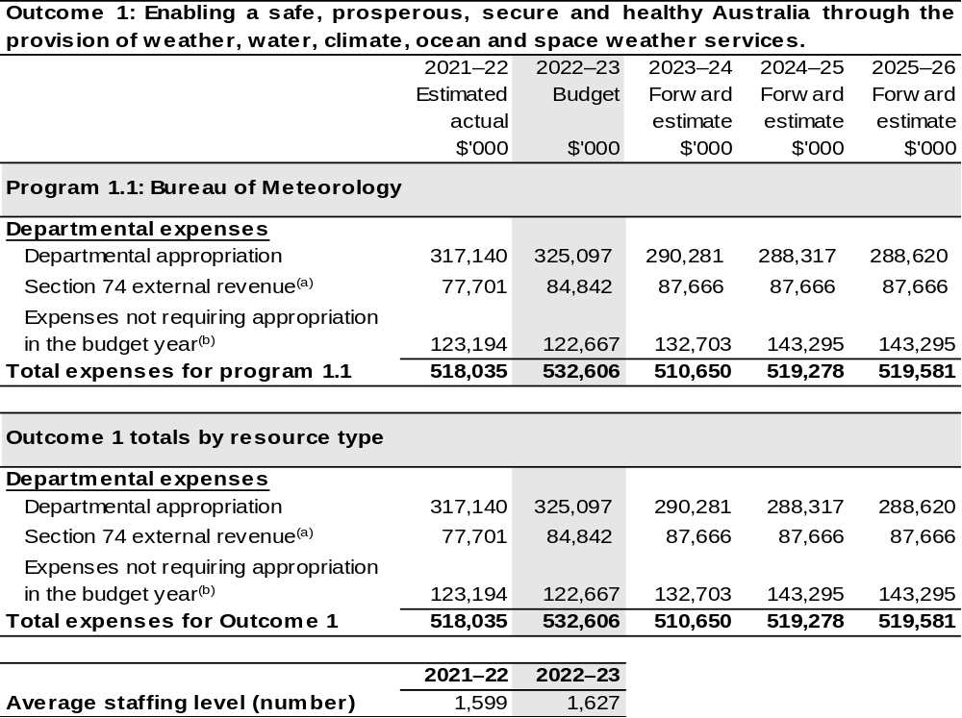

- Estimated expenses incurred in relation to receipts retained under section 74 of the PGPA Act.
- Expenses not requiring appropriation in the budget year are made up of make good expenses, audit
fees, and can include depreciation / amortisation expenses not requiring an appropriation.

Note: Departmental appropriation splits and totals are indicative estimates and may change in the course of the budget year as government priorities change.

Prepared on Australian Accounting Standards basis.

2.1.3: Performance criteria for Outcome 1
Table 2.1.3 details the performance measures for each program associated with Outcome 1. It also provides the related key activities as expressed in the current corporate plan where further detail is provided about the delivery of the activities related to the program, the context in which these activities are delivered and how the performance of these activities will be measured. Where relevant, details of 2022–23 Budget measures that have created new programs or materially changed existing programs are provided.
Outcome 1: Enabling a safe, prosperous, secure and healthy Australia through the provision of weather, water, climate, ocean and space weather services.
Program 1.1: Bureau of Meteorology
Objective | The Bureau’s purpose is: To provides trusted, reliable, and responsive services for Australia – all day, every day. To achieve its purpose – across the domains of weather, water, climate, oceans and space weather –  the Bureau:  - monitors and reports on current conditions;  - provides forecasts, warnings and long-term outlooks;  - analyses and explains trends;  - fosters greater public understanding and use of the information it provides; and  - continues to extend its understanding of, and ability to forecast, Australian conditions.
Key Activities | To support the delivery of Program 1.1, and to achieve the Bureau's purpose and Outcome, the Bureau is structured into six Groups, each with defined accountabilities and responsibilities:  - Community Services;  - Business Solutions;  - Data and Digital;  - Science and Innovation;  - Enterprise Services; and  - the Australian Climate Service.  For 2022–23, and the outlook period (2023–24 to 2025–26), these are regarded as the organisation's key activities.

Continued on following page

2.1.3: Performance criteria for Outcome 1 (continued)
Year | Performance measures | Expected Performance Results
Current year  2021–22 | - Financial and social value is delivered to Government, industry, and the Australian community.  - Delivery of products and services that meet customer requirements, are delivered to budget, meet quality and security specifications and benchmark well in relation to international standards and peer organisations.  - The speed, maturity and quality of innovation and novel solutions meets customer needs or enhances internal capability.  - Feedback from staff, customers and partners demonstrates alignment of our actual behaviours with our stated intent to create a safe, diverse, and empowered enterprise that puts customers first, and provides an outstanding experience every time that they engage with us. | The Bureau is on track to meet the 2021–22 performance measures.  Evidence of achievement will be described in the Bureau's Annual Performance Statement 2021–22 in line with the targets described in the Corporate Plan 2021–22.
Year | Performance measures | Planned Performance Results
Budget Year  2022–23 | - Economic value added to Australian industry including within the agriculture, aviation, water, energy, and resource sectors.  - Community, industry, and government customers are satisfied with the services provided by the Bureau. | More than $250 million in economic value added to Australian industry.  Various.
Forward Estimates  2023–26 | As per 2022–23. | As per 2022–23.

Section 3: Budgeted financial statements
Section 3 presents budgeted financial statements which provide a comprehensive snapshot of entity finances for 2022–23, including the impact of 2022–23 Budget measures and resourcing on financial statements.

3.1 Budgeted financial statements

3.1.1: Explanatory notes and analysis of budgeted financial statements
Budgeted Comprehensive Departmental Income Statement
An analysis of the Bureau’s budgeted financial statements, as reflected in the Bureau’s budgeted departmental financial statements, and administered schedules for the
2022–23 Budget, is provided below:
Total revised revenue to the Bureau in 2022–23 is estimated to be $410.4 million, an increase of $16.5 million from the 2021–22 estimated Budget amount. The movement in funding is the result of factors including government decisions, movements in indexation rates and adjustments related to other Budget items. The overall appropriated revenue includes specific funding related to:
- 2016–17 MYEFO measure – Essential Commonwealth Water Functions;
- 2017–18, 2018–19 and 2020–21 Budgets measures – Improved security and resilience;
- 2019–20 Budget measure – Bureau of Meteorology – Additional Radars and Gauges;
- 2019–20 Budget measure – Barkley Regional Deal;
- 2020–21 Budget measure – Long-Term Financial Sustainability;
- 2020–21 Budget measure – Savings through Additional Revenue; and
- 2021–22 Budget measure – Building Australia's Resilience.
Total expenses are estimated to be $532.6 million, an increase of $14.6 million from
2021–22 estimated budget expenditure. The increase chiefly reflects increased expenditure associated with new Budget measure activities. Whilst the Bureau is no longer funded for Depreciation through Appropriation Bill (No. 1) the expenditure is still recognised on the Income Statement.

3.2 Budgeted financial statements tables

Table 3.1: Comprehensive income statement (showing net cost of services)
(for the period ended 30 June)
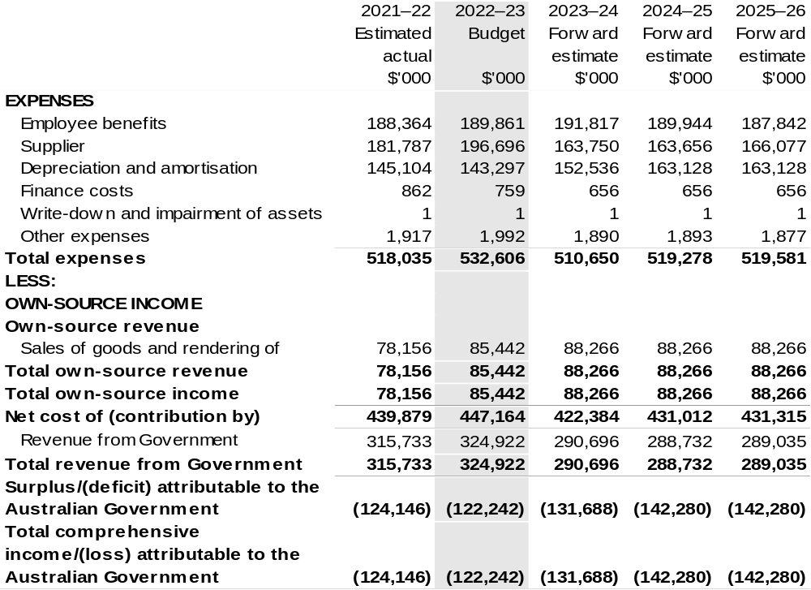

Continued on following page

Table 3.1: Comprehensive income statement (showing net cost of services) (for the period ended 30 June) (continued)
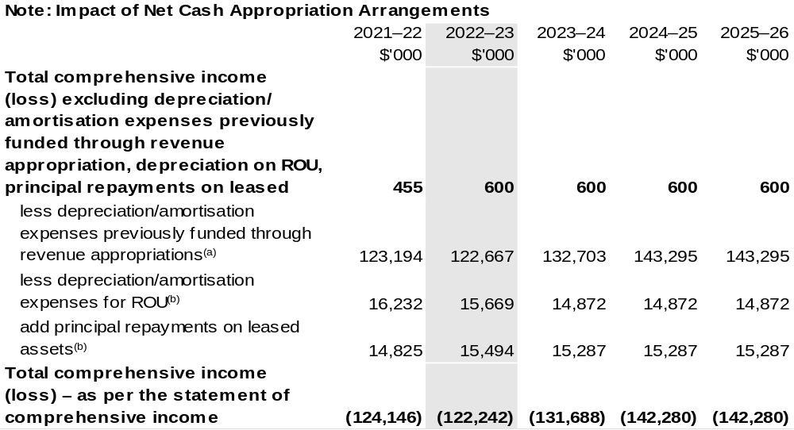

(a) From 2010–11, the Government introduced net cash appropriation arrangements where Appropriation
Bill (No. 1) revenue appropriations for the depreciation/amortisation expenses of non-corporate Commonwealth entities (and select corporate Commonwealth entities) were replaced with a separate capital budget (the Departmental Capital Budget, or DCB) provided through Appropriation Bill (No. 1) equity appropriations. For information regarding DCBs, please refer to Table 3.5 Departmental Capital Budget Statement.
(b) Applies to leases under AASB 16 Leases. Right of Use (ROU).

Prepared on Australian Accounting Standards basis.

Table 3.2: Budgeted departmental balance sheet (as at 30 June)
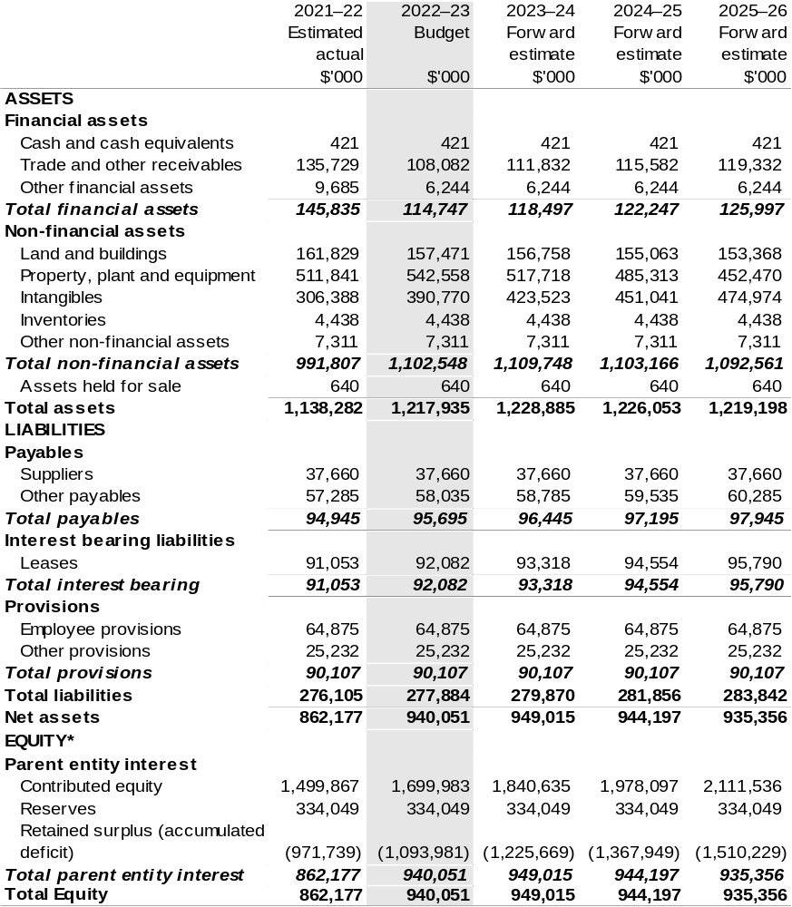

*'Equity' is the residual interest in assets after deduction of liabilities.

Prepared on Australian Accounting Standards basis.

Table 3.3: Departmental statement of changes in equity—summary of movement (Budget year 2022–23)
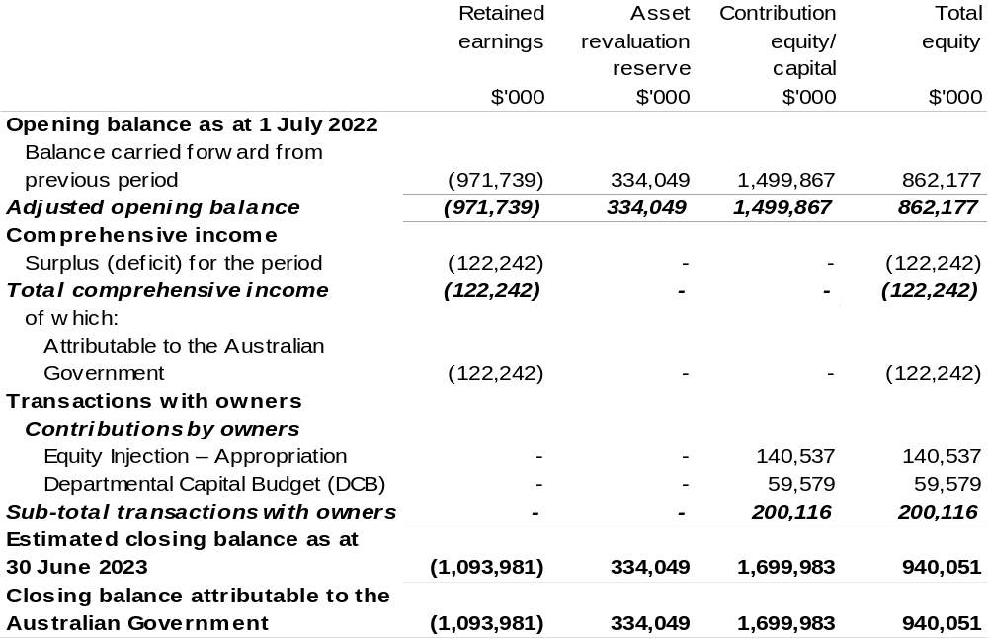

Prepared on Australian Accounting Standards basis.

Table 3.4: Budgeted departmental statement of cash flows (for the period
ended 30 June)
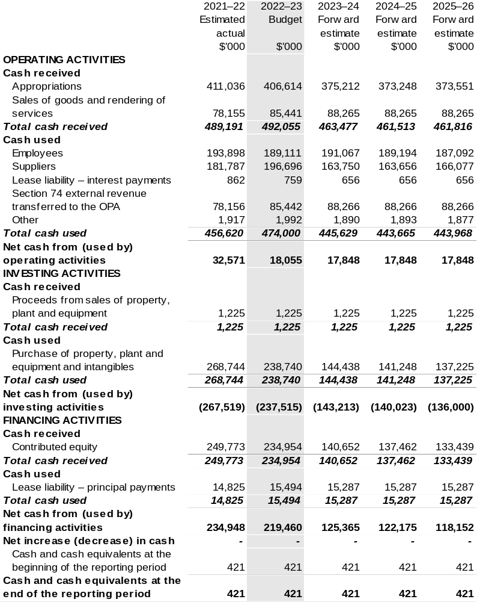

Prepared on Australian Accounting Standards basis.

Table 3.5: Departmental capital budget statement (for the period ended 30 June)
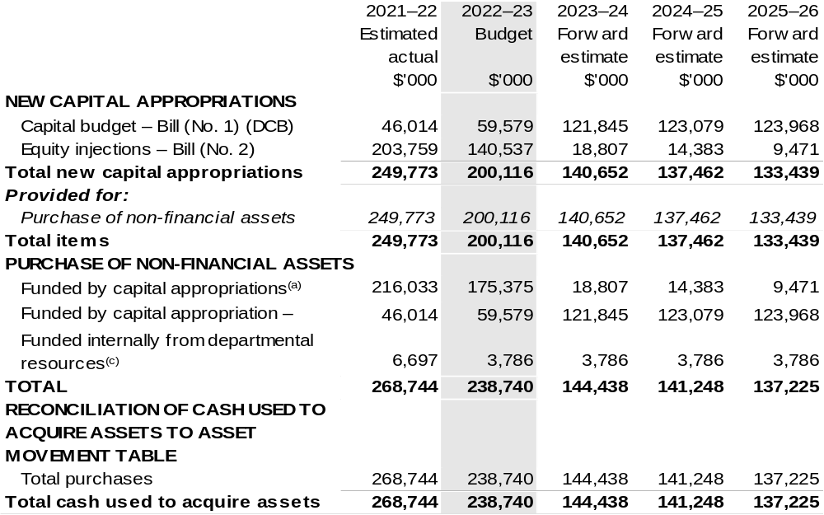

(a) Includes current Appropriation Bill (No. 2) and prior year Appropriation Act No. 2/4/6.
(b) Does not include annual finance lease costs. Include purchases from current and previous years' Departmental Capital Budgets (DCBs).
(c) Includes the following s74 external revenue:
– current Bill (No. 1) and prior year Act/Bill (No. 1/3/5) appropriations (excluding amounts from the
DCBs);
– sponsorship, subsidy, gifts or similar contribution;
– internally developed assets; and
– proceeds from the sale of assets.

Consistent with information contained in the Statement of Asset Movements and the Budgeted Statement of Cash Flows.

Prepared on Australian Accounting Standards basis.

Table 3.6: Statement of asset movements (Budget year 2022–23)
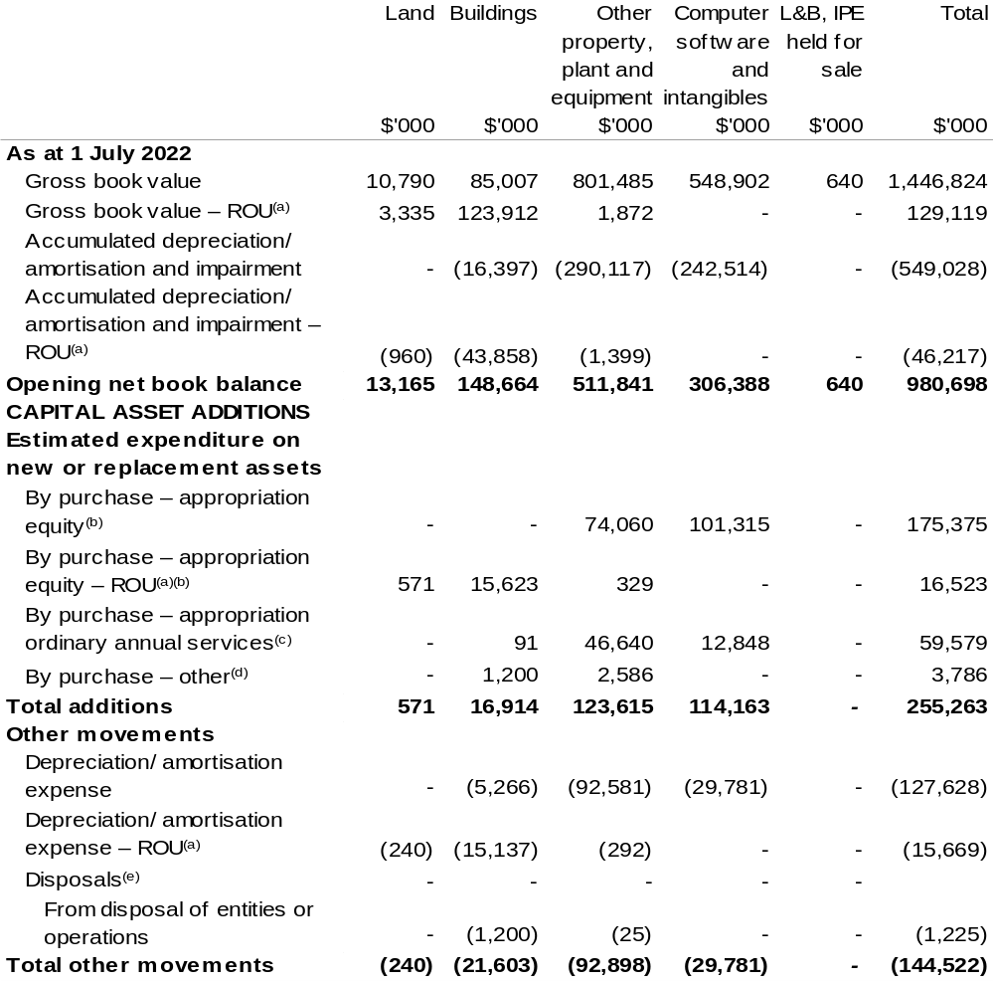

Continued on following page

Table 3.6: Statement of asset movements (Budget year 2022–23) (continued)
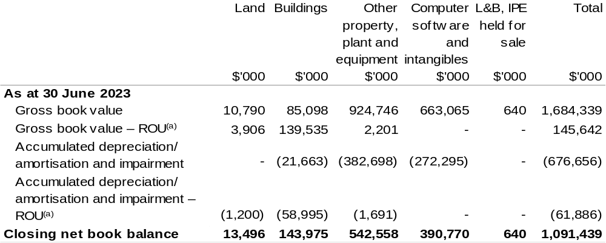

- Applies to leases under AASB 16 Leases. Right of Use (ROU).
- ‘By purchase – Appropriation equity’ refers to equity injections appropriations provided through Appropriation Bill (No. 2) 2022–23, including Collection Development Acquisition Budgets.
- 'By purchase – Appropriation ordinary annual services' refers to funding provided through Appropriation Bill (No. 1) 2022–23 for depreciation/amortisation expenses, Departmental Capital Budget or other operational expenses.
- 'By purchase – other' refers to funding provided through other internal funding sources.
- Net proceeds may be returned to the Official Public Account.

Prepared on Australian Accounting Standards basis.

Table 3.7: Schedule of budgeted income and expenses administered on behalf of Government (for the period ended 30 June)
The schedule of Schedule of budgeted income and expenses administered on behalf of Government (for the period ended 30 June) does not apply to the Bureau.

Table 3.8: Schedule of budgeted assets and liabilities administered on behalf of Government (as at 30 June)

The schedule of budgeted assets and liabilities administered on behalf of Government does not apply to the Bureau.

Table 3.9: Schedule of budgeted administered cash flows (for the period
ended 30 June)

The schedule of budgeted administered cash flows on behalf of Government does not apply to the Bureau.

Cotton Research and Development Corporation
Section 1: Entity overview and resources 203
1.1 Strategic direction statement 203
1.2 Entity resource statement 205
1.3 Budget measures 207
Section 2: Outcomes and planned performance 208
2.1 Budgeted expenses and performance for Outcome 1 209
Section 3: Budgeted financial statements 214
3.1 Budgeted financial statements 214
3.2 Budgeted financial statements tables 216

Cotton Research and Development Corporation

Section 1: Entity overview and resources

1.1 Strategic direction statement
The Cotton Research and Development Corporation (CRDC) delivers outcomes in cotton research, development and extension (RD&E) on behalf of Australia’s cotton growers and the Australian Government.
Established in October 1990 and operating under the Primary Industries Research and Development Act 1989 (PIRD Act), CRDC exists to power the success of Australian cotton through investment in, and delivery of, cotton RD&E. CRDC is based in Narrabri, New South Wales: the heart of one of Australia's major cotton-growing regions and home to the Australian Cotton Research Institute.
Cotton is a major contributor to the economic, environmental and social fabric of rural Australia. Predominately grown in New South Wales and Queensland, with expansion into northern Australia, cotton is a major employer and contributor to the local, state and national economy. The industry generates significant wealth and provides an economic foundation to these regions and their communities, employing some 10,000 people. Cotton is Australia’s fifth most valuable agricultural export commodity, generating an average of $1.9 billion in export revenue annually.
CRDC’s role is to invest in RD&E on behalf of cotton growers and the Government, with the outcomes boosting the productivity and profitability of industry. RD&E, and its resulting innovations, are a key driving force behind the cotton industry’s continued success. CRDC’s ultimate aim is to deliver increased economic, social and environmental benefits for the Australian cotton industry, and the wider community, by investing in knowledge, innovation and its adoption.
CRDC’s investments are governed by a five-year strategic plan, with 2022–23 being the fifth year under CRDC’s 2018–23 Strategic Plan. The strategic plan provides an ambitious roadmap for CRDC’s investments.
CRDC’s aim through the plan is to contribute to creating $2 billion in additional gross value of cotton production for the benefit of Australian cotton growers and the wider community.
The plan has five key areas of focus:
- Increasing productivity and profitability on Australian cotton farms;
- Improving cotton farming sustainability and value chain competitiveness;
- Building the adaptive capacity of the Australian cotton industry;
- Strengthening partnerships and adoption; and
- Driving RD&E impact.
To help achieve this, Australia cotton growers and the Australia Government will
co-invest $18.6 million into cotton RD&E during 2022–23, across these key focus areas.

1.2 Entity resource statement
Table 1.1 shows the total funding from all sources available to the entity for its operations and to deliver programs and services on behalf of the Government.
The table summarises how resources will be applied by outcome (Government strategic policy objectives) and by administered (on behalf of the Government or the public) and departmental (for the entity’s operations) classification.
For more detailed information on special accounts and special appropriations, please refer to Budget Paper No. 4: Agency Resourcing.
Information in this table is presented on a resourcing (that is, appropriations/cash available) basis, whilst the ‘Budgeted expenses by Outcome’ table in Section 2 and the financial statements in Section 3 are presented on an accrual basis.

Table 1.1: Cotton Research and Development Corporation – Resource Statement – Budget Estimates for 2022–23 as at Budget March 2022
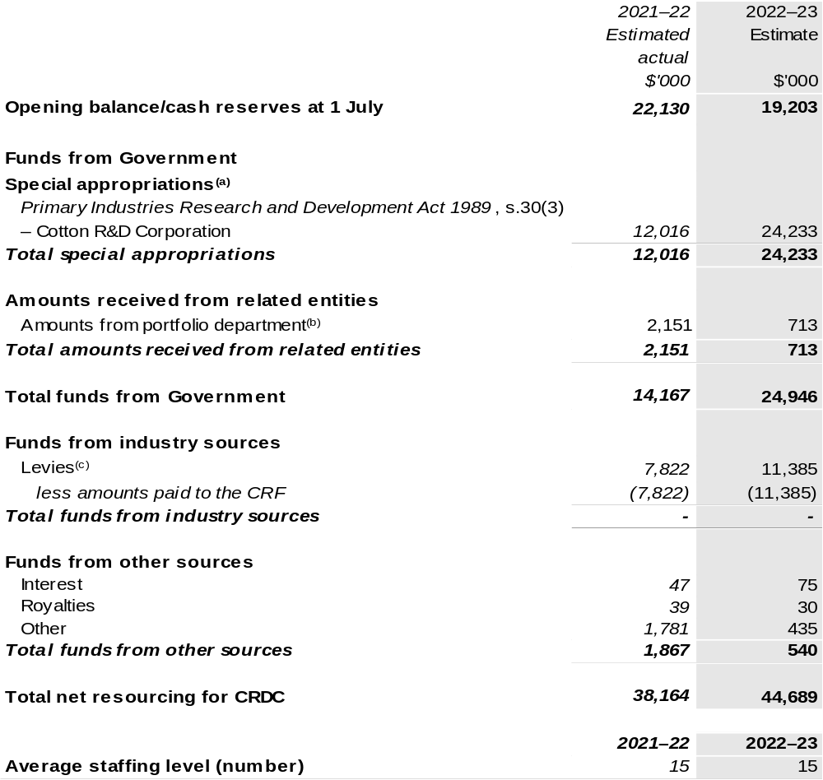

(a) CRDC's special appropriation is not directly appropriated as it is a corporate Commonwealth entity (CCE) under the Public Governance, Performance and Accountability Act 2013 (PGPA Act). Appropriations are made to Department of Agriculture, Water and the Environment (DAWE) and are then paid to CRDC and are considered departmental for all purposes.
(b) Funding provided by the portfolio department that is not specified within the Annual Appropriation Bills as a payment to that CCE (for example, a grant awarded to a CCE from one of its portfolio department's administered programs).
(c) The levies are imposed by the Primary Industries (Excise) Levies Act 1999. The levies are collected by DAWE under the Primary Industries Levies and Charges Collection Act 1991 and transferred to the Consolidated Revenue Fund (CRF). These amounts are then drawn down by the department as a special appropriation and paid to CRDC under the Primary Industries Research and Development Act 1989 (PIRD Act), s. 30(3) – Cotton R&D Corporation.

Please note: All figures shown above are GST exclusive – these may not match figures in the cash flow statement.

Prepared on a resourcing (i.e. appropriations available) basis.

1.3 Budget measures
Budget measures in Part 1 relating to the Cotton Research and Development Corporation are detailed in Budget Paper No. 2: Budget Measures 2022–23 and are summarised below.

Table 1.2: Cotton Research and Development Corporation – 2022–23 Budget measures – Measures announced since the 2021–22 Mid-Year Economic and Fiscal Outlook (MYEFO)
CRDC does not have any 2022–23 Budget measures.

Section 2: Outcomes and planned performance
Government outcomes are the intended results, impacts or consequences of actions by the Government on the Australian community. Commonwealth programs are the primary vehicle by which government entities achieve the intended results of their outcome statements. Entities are required to identify the programs which contribute to Government outcomes over the Budget and forward years.
Each outcome is described below together with its related programs. The following provides detailed information on expenses for each outcome and program, further broken down by funding source.
Note:
Performance reporting requirements in the Portfolio Budget Statements are part of the Commonwealth performance framework established by the Public Governance, Performance and Accountability Act 2013. It is anticipated that the performance criteria described in Portfolio Budget Statements will be read with broader information provided in an entity’s corporate plans and annual performance statements – included in Annual Reports – to provide a complete picture of an entity’s planned and actual performance.
The most recent corporate plan for the Cotton Research and Development Corporation can be found at: www.crdc.com.au/publications/crdc-strategic-plan.
The most recent annual performance statement for the Cotton Research and Development Corporation can be found at:
www.crdc.com.au/publications/crdc-annual-report.

2.1 Budgeted expenses and performance for Outcome 1
Outcome 1: Adoption of innovation that leads to increased productivity, competitiveness and environmental sustainability through investment in research and development that benefits the Australian cotton industry and the wider community.

2.1.1: Linked programs
Department of Agriculture, Water and the Environment
Program 3.10: Agricultural Resources
Contribution to Outcome 1 made by linked program:
The CRDC works together with the DAWE to ensure a sustainable, productive and profitable cotton industry.

2.1.2: Budgeted expenses for Outcome 1
This table shows how much the entity intends to spend (on an accrual basis) on achieving the outcome, broken down by program, as well as by administered and departmental funding sources.

Table 2.1: Budgeted expenses for Outcome 1
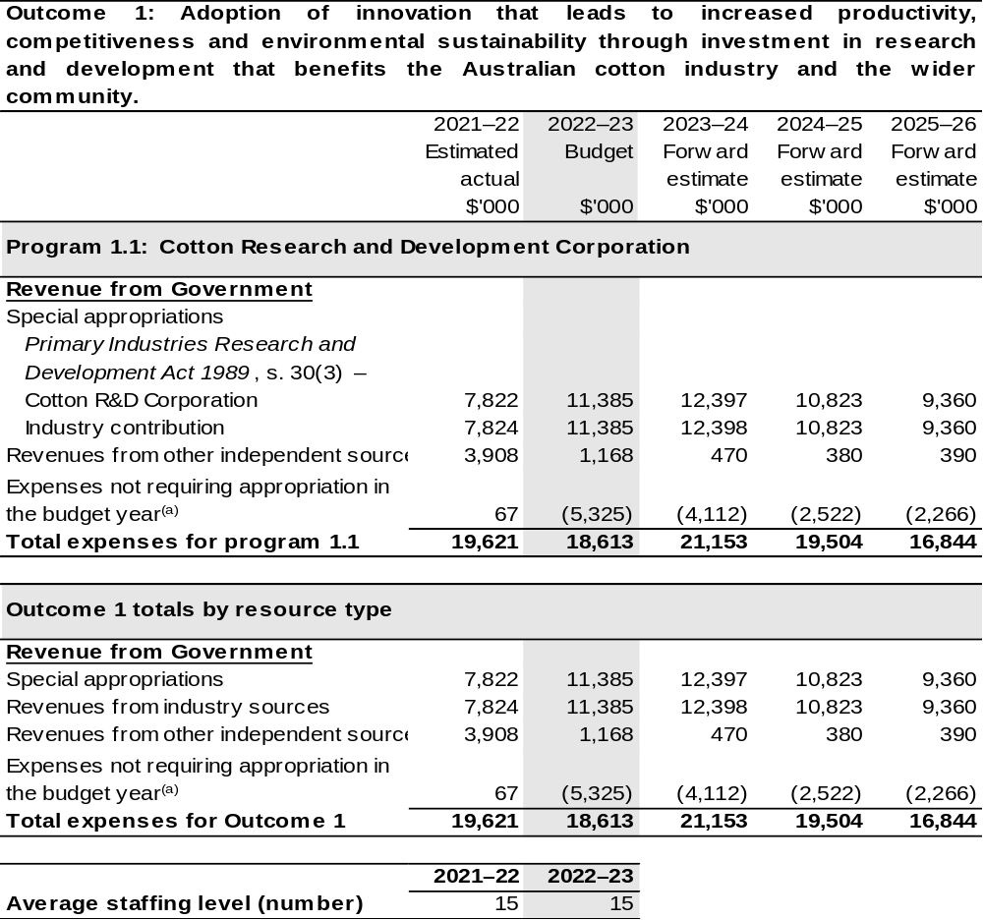
(a) Expenses not requiring appropriation in the budget year are made up of make good expenses, audit fees, and can include depreciation / amortisation expenses not requiring an appropriation.

Note: Departmental appropriation splits and totals are indicative estimates and may change in the course of the budget year as government priorities change.

Prepared on Australian Accounting Standards basis.

2.1.3: Performance criteria for Outcome 1
Table 2.1.3 details the performance measures for each program associated with Outcome 1. It also provides the related key activities as expressed in the current corporate plan where further detail is provided about the delivery of the activities related to the program, the context in which these activities are delivered and how the performance of these activities will be measured. Where relevant, details of 2022–23 Budget measures that have created new programs or materially changed existing programs are provided.
As an entity established under the PIRD Act, CRDC does not produce a Corporate Plan under the PGPA Act and is therefore exempt from the requirement to map purposes to outcomes.
Outcome 1: Adoption of innovation that leads to increased productivity, competitiveness and environmental sustainability through investment in research and development that benefits the Australian cotton industry and the wider community.
Program 1.1: Cotton Research and Development Corporation
Objective 1 | Increase productivity and profitability on cotton farms  Deliver RD&E for cotton producers to increase productivity, successfully protect crops from biotic threats and environmental stresses, adopt transformative technologies and innovate for improved profitability.
Key Activities 1 | Strategically prioritise investment in basic, applied and blue-sky research collaboratively with research and cross-sectoral partners to develop new knowledge, practices and adapt transformative technologies for on-farm application that also protect industry from biotic threats and environmental stresses.
Year | Performance measures | Expected Performance Results
Current year  2021–22 | Improved yield and quality. | Annual increase of 0.35 bales per hectare for irrigated cotton and 0.14 bales per hectare for dryland cotton.  On target for irrigated cotton.  Not on target for dryland due to drought conditions in 2020–21.
Year | Performance measures | Planned Performance Results
Budget Year 2022–23 | As per 2021–22. | As per 2021–22.
Forward Estimates  2023–26 | As per 2022–23. | As per 2022–23.

Continued on following pages
2.1.3: Performance criteria for Outcome 1 (continued)
Objective 2 | Improve cotton farming sustainability and value chain competitiveness  Deliver RD&E and innovation to create higher value uses for cotton and assist the industry achieve its ambition to be the highest yielding, finest, cleanest and most responsibly produced cotton in the world.
Key Activities 2 | Strategically prioritise investment in basic, applied and blue-sky research collaboratively with research, industry and cross-sectoral partners to develop new knowledge, practices, processes, higher value products and innovative approaches to improve the sustainability of cotton farming and strengthen value chain competitiveness.
Year | Performance measures | Expected Performance Results
Current year  2021–22 | CRDC collaborates in global leadership for sustainability initiatives. | Participates in six global initiatives.  On target.
Year | Performance measures | Planned Performance Results
Budget Year 2022–23 | As per 2021–22. | As per 2021–22.
Forward Estimates  2023–26 | As per 2022–23. | As per 2022–23.
Objective 3 | Build adaptive capacity of the cotton industry  Deliver RD&E to develop science and innovation capacity as well as new knowledge to strengthen adaptive capacity.
Key Activities 3 | Strategically prioritise investment in RD&E collaboratively with research, industry and cross-sectoral partners to develop new knowledge, futures thinking, science and innovation capability.
Year | Performance measures | Expected Performance Results
Current year  2021–22 | Science and innovation capacity is strengthened and strategically fit for a digital future. | 10+ new/early career researchers supported through strategic career pathways.  On target.
Year | Performance measures | Planned Performance Results
Budget Year 2022–23 | As per 2021–22. | As per 2021–22.
Forward Estimates  2023–26 | As per 2022–23. | As per 2022–23.

Continued on following page
2.1.3: Performance criteria for Outcome 1 (continued)
Objective 4 | Strengthening partnerships and adoption  Deliver RD&E and innovation through collaborative partnerships to ensure adoption of best practice, new knowledge, products and services.
Key Activities 4 | Strategically prioritise investment in the effective adoption of research by strengthening partnerships and collaboration, development of best practice and supporting innovation and commercialisation.
Year | Performance measures | Expected Performance Results
Current year  2021–22 | Partnerships are strengthened to engage multi-disciplinary and multi-institutional resources. | 40 per cent of annual RD&E investments are through cross sectoral partnerships.  On target.
Year | Performance measures | Planned Performance Results
Budget Year 2022–23 | As per 2021–22. | As per 2021–22.
Forward Estimates  2023–26 | As per 2022–23. | As per 2022–23.
Objective 5 | Driving RD&E impact  Deliver assessments of the impact of CRDC’s RD&E investments that inform future investment direction and continuous improvement.
Key Activities 5 | Strategically prioritise investment in research, data capture, analysis and reviews with stakeholders and partners to demonstrate that RD&E investments deliver impact.
Year | Performance measures | Expected Performance Results
Current year  2021–22 | CRDC monitors and evaluates RD&E impact. | One RD&E impact report per annum.  On target.
Year | Performance measures | Planned Performance Results
Budget Year 2022–23 | As per 2021–22. | As per 2021–22.
Forward Estimates  2023–26 | As per 2022–23. | As per 2022–23.

Section 3: Budgeted financial statements
Section 3 presents budgeted financial statements which provide a comprehensive snapshot of entity finances for 2022–23, including the impact of 2022–23 Budget measures and resourcing on financial statements.

3.1 Budgeted financial statements

3.1.1: Differences between entity resourcing and financial statements
The resourcing statement is prepared on a cash basis. The financial statements are prepared on an accrual basis. Differences between the resourcing and financial statements represent timing differences between revenue recognition and cash received.

3.1.2: Explanatory notes and analysis of budgeted financial statements
Budgeted Comprehensive Income Statement
Variability in CRDC’s revenue and expenditure is a result of significant fluctuations in the production of Australian cotton each year. Cotton production has been as low as 0.6 million bales in 2008 and 2020, as high as 5.4 million bales in 2012 and is estimated to be 5.0 million bales in 2022–23.
Revenue from industry levies and matching contributions from the Australian Government are determined by the level of cotton production and represent more than 95 per cent of total revenue. Since 2008–09 CRDC’s revenue has fluctuated between $7.7 million and $31.4 million per annum.
The impact of a highly variable revenue stream on CRDC’s investment in RD&E is minimised by managing cash reserves. During periods of high revenue CRDC builds up reserves by operating in surplus. During periods of low revenue CRDC draws on reserves by operating under approved deficits. This financial strategy allows CRDC to maintain a more consistent level of RD&E expenditure each year.
Matching contributions from the Australian Government are determined by either the value of industry levies collected or 0.5 per cent of the cotton industry’s three-year average gross value of production. Which limit will apply depends on the price of cotton, timing of the harvest and ginning and the variability of the crop size. Royalties, interest on investments, external grant revenue and research project refunds make up the balance of the CRDC’s income.

To achieve the strategic priorities of the research and development (R&D) plan for the period 2018–23, CRDC planned to invest a total of $125.0 million for the five-year R&D plan. The 2019 to 2020 drought reduced cotton production in most of the major cotton growing regions and impacted CRDC’s revenues and ability to invest $125 million over the five-year R&D plan. The current forward estimate is for a total investment of $99.3 million.
CRDCs investments during drought have focussed on supporting core research activities to support industry needs and building research and innovation skills that will provide the foundation for the future of the cotton industry.
In 2022–23 CRDC has budgeted for a surplus of $5.3 million based on revenues of $23.9 million and RD&E expenditure of $18.6 million.
Budgeted Balance Sheet
Reserves increased between 2010–11 and 2013–14 during years of high cotton production and decreased from 2014–15 to 2021–22 due to below average levels of cotton production. In 2022–23 CRDC estimates production will be approximately 5.0 million bales, returning to above-average production. Recent rainfall resulting in inflows to irrigation storages and above average world cotton prices has resulted in production increasing from 2.7 million bales in 2020–21 to an estimated 5.0 million bales in 2021–22, an 85 per cent increase.
CRDC plans to rebuild reserves while maintaining research expenditure at a consistent level in future years.

3.2 Budgeted financial statements tables

Table 3.1: Comprehensive income statement (showing net cost of services)
(for the period ended 30 June)
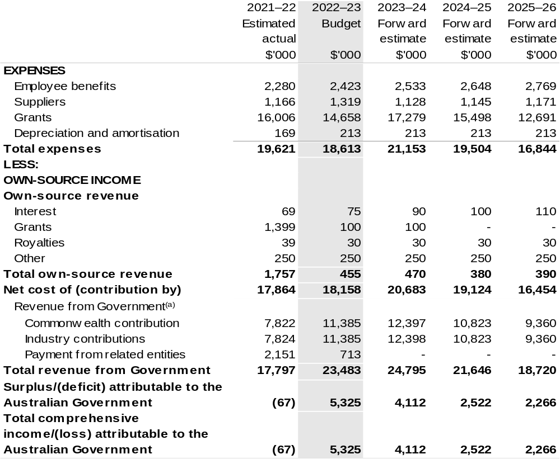

(a) Revenue from Government includes a Commonwealth contribution under the PIRD Act and levies collected from industry by DAWE for R&D activities.

Prepared on Australian Accounting Standards basis.

Table 3.2: Budgeted departmental balance sheet (as at 30 June)
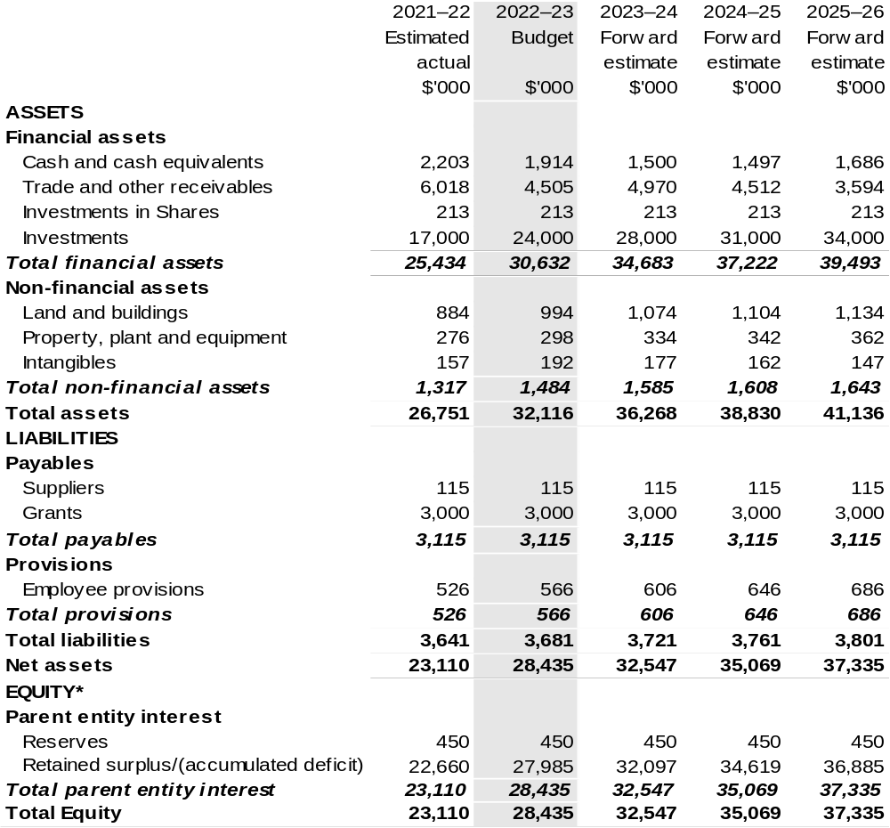

*’Equity’ is the residual interest in assets after deduction of liabilities.

Prepared on Australian Accounting Standards basis.

Table 3.3: Departmental statement of changes in equity — summary of movement (Budget year 2022–23)
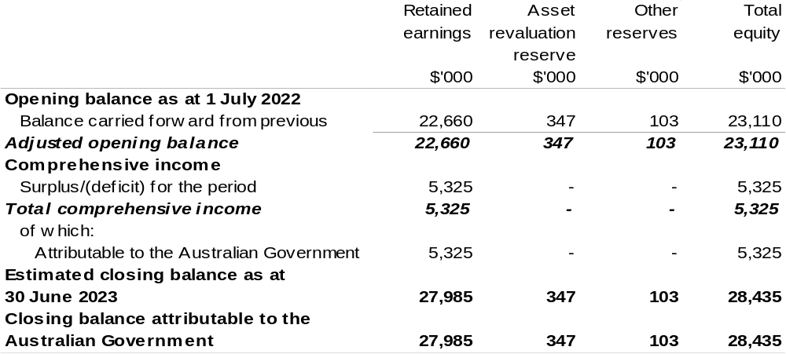

Prepared on Australian Accounting Standards basis.

Table 3.4: Budgeted departmental statement of cash flows (for the period
ended 30 June)
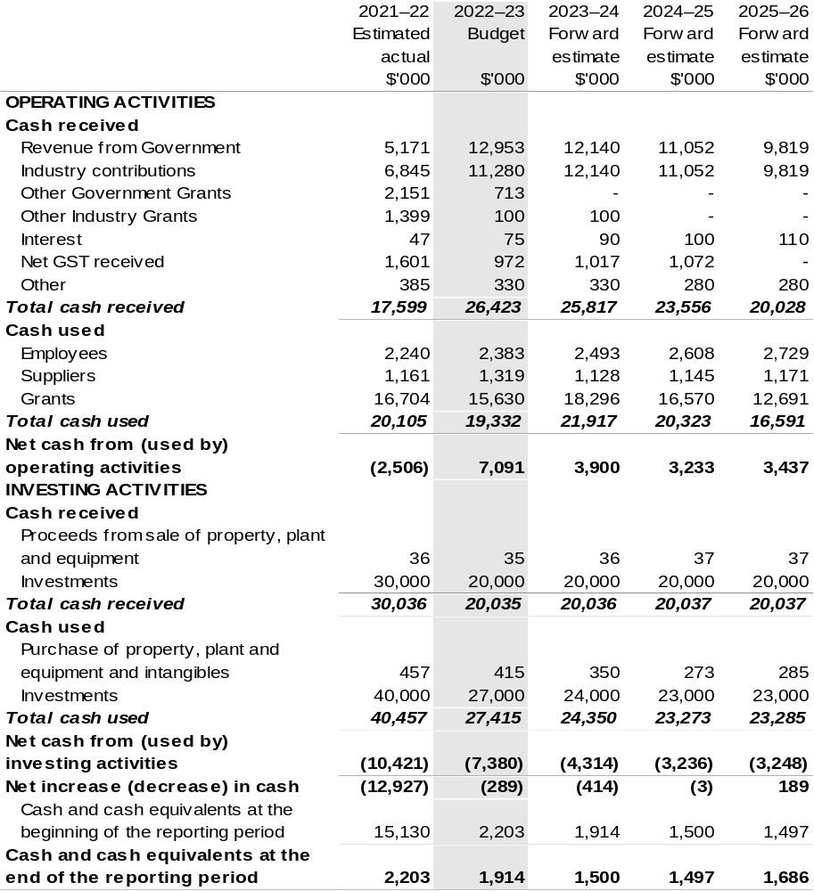

Prepared on Australian Accounting Standards basis.

Table 3.5: Departmental capital budget statement (for period end 30 June)
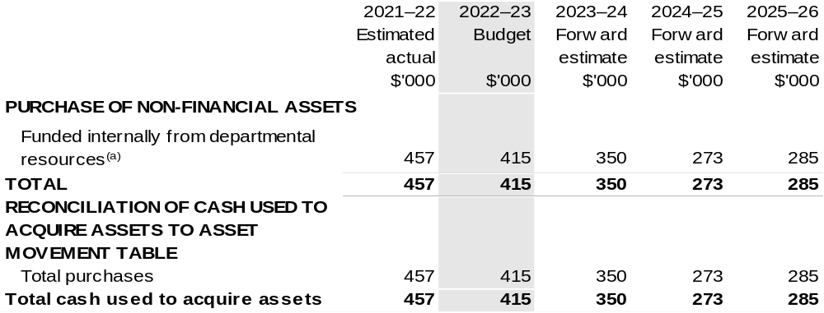

(a) Includes the following s74 external revenue:
– internally developed assets; and
– proceeds from the sale of assets.

Consistent with information contained in the Statement of Asset Movements and the Budgeted Statement of Cash Flows.

Prepared on Australian Accounting Standards basis.

Table 3.6: Statement of asset movements (Budget year 2022–23)
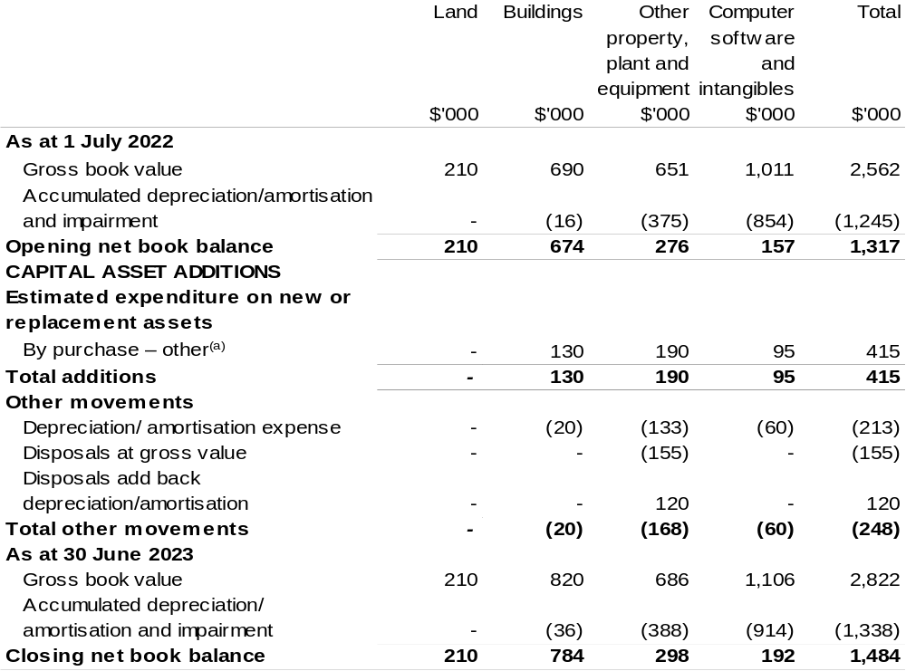

(a) ‘By purchase – other' refers to funding provided through other internal funding sources.

Prepared on Australian Accounting Standards basis.

Director of National Parks
Section 1: Entity overview and resources 223
1.1 Strategic direction statement 223
1.2 Entity resource statement 225
1.3 Budget measures 227
Section 2: Outcome and planned performance 228
2.1 Budgeted expenses and performance for Outcome 1 229
Section 3: Budgeted financial statements 237
3.1 Budgeted financial statements 237
3.2 Budgeted financial statements tables 238

Director of National Parks

Section 1: Entity overview and resources

1.1 Strategic direction statement
The Director of National Parks (DNP) is a corporate Commonwealth entity (CCE), operating under the Environment Protection and Biodiversity Conservation Act 1999 (EPBC Act) to administer and manage Commonwealth reserves, including:
- Booderee, Kakadu and Uluru-Kata Tjuta National Parks, which are each jointly managed with their Aboriginal Traditional Owners. Kakadu and Uluru-Kata Tjuta National Parks are World Heritage listed.
- National parks in the Australian territories of Norfolk, Christmas and Cocos (Keeling) Islands.
- The Australian National Botanic Gardens, which is a major national institution for the study of Australian plants.
- The 60 marine parks managed by DNP in the South East, South West, North West, North and Temperate East marine regions, the Coral Sea and the Indian Ocean territories (Christmas and Cocos Keeling marine parks) proclaimed in March 2022. The Director of National Parks has delegated responsibilities under the EPBC Act in respect of the Heard Island and McDonald Islands Reserve to the Australian Antarctic Division.
The DNP’s purpose is to protect, conserve and enhance the values of Commonwealth parks and gardens for the use and wellbeing of all Australians.
The DNP is assisted by staff employed by Parks Australia, a division of the Department of Agriculture, Water and the Environment (DAWE).
To deliver these priorities within the Government’s fiscal strategy, the DNP will continue to look to diversify and increase external revenue and partnerships, seek further improvements in the efficient use of resources and continue to invest in the skills and capabilities of staff.

Diagram 1: Location of Commonwealth Parks and Gardens

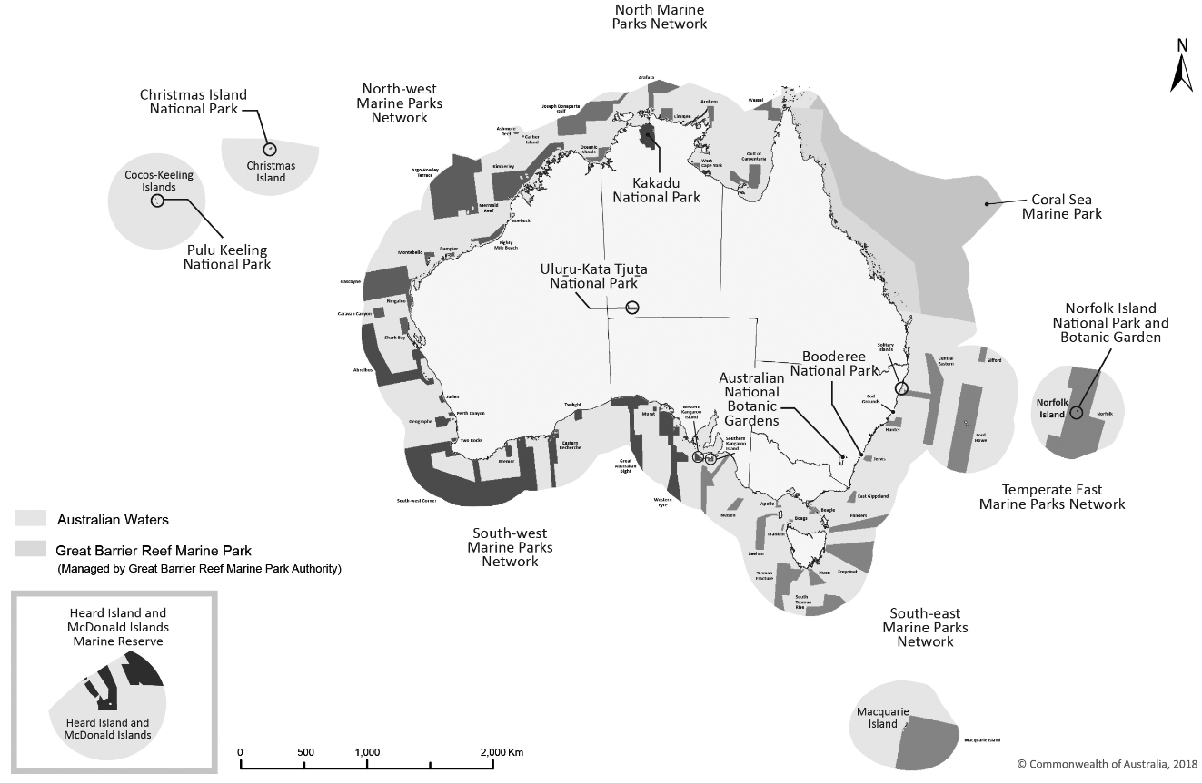

1.2 Entity resource statement
Table 1.1 shows the total funding from all sources available to the entity for its operations and to deliver programs and services on behalf of the Government.
The table summarises how resources will be applied by outcome (Government strategic policy objectives) and by administered (on behalf of the Government or the public) and departmental (for the entity’s operations) classification.
For more detailed information on special accounts and special appropriations, please refer to Budget Paper No. 4: Agency Resourcing.
Information in this table is presented on a resourcing (that is, appropriations/cash available) basis, whilst the ‘Budgeted expenses by Outcome’ table in Section 2 and the financial statements in Section 3 are presented on an accrual basis.

Table 1.1: Director of National Parks – Resource Statement – Budget Estimates for 2022–23 as at Budget March 2022
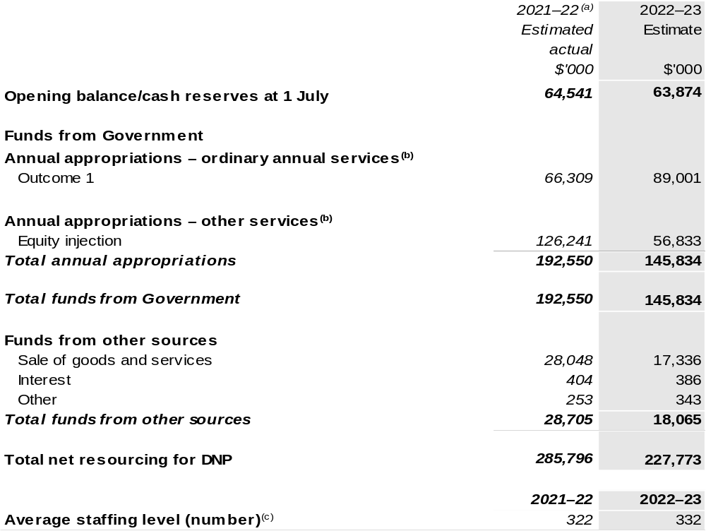

- Annual Appropriation amounts presented for 2021–22 do not include the Appropriation Bills (No. 3) and (No. 4), as they had not been enacted at the time of publication. The entity will receive $38.416 million through the 2021–22 Annual Appropriation Bill (No. 3). The annual appropriations received from these bills will be recognised in a future portfolio budget statement but only after the Bills have received Royal Assent.
- Appropriation Bill (No. 1) and Bill (No. 2) 2022–23. Appropriation is provided through the DAWE and is specified with the Annual Appropriation Bills as payment to the DNP and is considered departmental for all purposes.
- For the purposes of financial reporting, the Director of National Parks ASL presented here is the number of ASL paid for by the DNP appropriations. However, for the purposes of the Environment Protection and Biodiversity Conservation Act 1999 DAWE is the employer of all staff in Parks Australia, with the exception of the Director of National Parks.

Please note: all figures shown above are GST exclusive – these may not match figures in the cash flow statement.

Prepared on a resourcing (i.e. appropriations available) basis.

1.3 Budget measures
Budget measures in Part 1 relating to the Director of National Parks are detailed in Budget Paper No. 2: Budget Measures 2022–23 and are summarised below.

Table 1.2: Director of National Parks – 2022–23 Budget measures – Measures announced since the 2021–22 Mid-Year Economic and Fiscal Outlook (MYEFO)
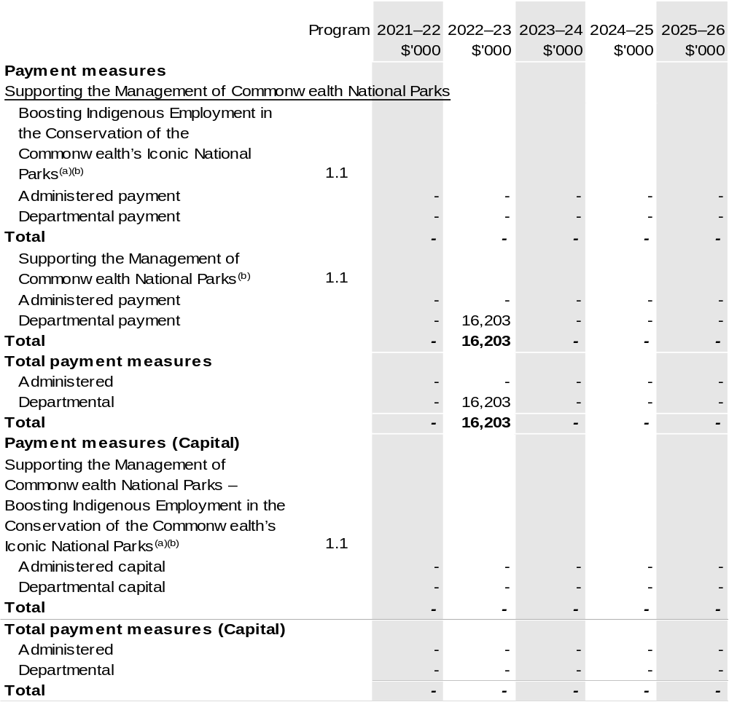
(a) The measure was a Decision Taken But Not Yet Announced (DTBNYA) in the 2021–22 Portfolio Additional Estimates Statements (PAES), with the following departmental: 2021–22 $0.667 million; 2022–23 $2.139 million; 2023–24 $1.831 million; 2024–25 $2.651 million; 2025–26 $3.223 million and with the following impact on capital appropriation: 2022–23 $0.100 million, this is an ongoing program.
The measure description appears in Budget Paper No. 2: Budget Measures 2022–23 under the Agriculture, Water and the Environment portfolio.
(b) Funding for this measure passes through DAWE to the DNP.

Prepared on a Government Finance Statistics (Underlying Cash) basis.
Figures displayed as a negative (-) represent a decrease in funds and a positive (+) represent an increase in funds.

Section 2: Outcomes and planned performance
Government outcomes are the intended results, impacts or consequences of actions by the Government on the Australian community. Commonwealth programs are the primary vehicle by which government entities achieve the intended results of their outcome statements. Entities are required to identify the programs which contribute to Government outcomes over the Budget and forward years.
Each outcome is described below together with its related programs. The following provides detailed information on expenses for each outcome and program, further broken down by funding source.
Note:
Performance reporting requirements in the Portfolio Budget Statements are part of the Commonwealth performance framework established by the Public Governance, Performance and Accountability Act 2013. It is anticipated that the performance criteria described in Portfolio Budget Statements will be read with broader information provided in an entity’s corporate plans and annual performance statements – included in Annual Reports – to provide a complete picture of an entity’s planned and actual performance.
The most recent corporate plan for Director of National Parks can be found at: Director of National Parks Corporate Plan 2020–21 (awe.gov.au).
The most recent annual performance statement can be found at: Director of National Parks Annual Report 2020-21 (awe.gov.au).

2.1 Budgeted expenses and performance for outcome 1
Outcome 1: Management of Commonwealth reserves as outstanding natural places that enhance Australia’s well-being through the protection and conservation of their natural and cultural values, supporting the aspirations of Aboriginal and Torres Strait Islander people in managing their traditional land and sea country, and offering world class natural and cultural visitor experiences.

2.1.1: Linked programs
Department of the Agriculture, Water and the Environment
Program 1.1: Sustainable Management of Natural Resources and the Environment
Program 1.2: Environmental Information and Research
Program 1.4: Conservation of Australia’s Heritage and Environment
Contribution to Outcome 1 made by linked programs
The DNP and DAWE work together in setting policy directions for science, heritage and species management in Commonwealth managed parks and gardens. The DNP works with DAWE to transition Jabiru township from a mining to a tourism-based economy.
Great Barrier Reef Marine Park Authority
Program 1.1: Improving the Outlook for the Great Barrier Reef
Contribution to Outcome 1 made by linked programs
The Coral Sea Marine Park managed by the DNP adjoins the Great Barrier Reef Marine Park and provides complementary protection for ecosystems and biodiversity in the region.
Department of Infrastructure, Transport, Regional Development and Communications
Program 1.1: Infrastructure Investment
Contribution to Outcome 1 made by linked programs
The DNP is working with the Department of Infrastructure, Transport, Regional Development and Communications to secure the future of Jabiru by supporting the township’s transition from a reliance on mining to a tourism-based economy that leverages its proximity to the Kakadu National Park. Funding of $70 million for roads within Kakadu National Park under the Infrastructure Investment Program will complement an investment of more than $100 million by the Australian Government to improve tourism infrastructure across the park and to bolster the local economy and support Indigenous businesses and employment.

Continued on following page

2.1.1: Linked programs (continued)
National Indigenous Australians Agency
Program 1.1: National Indigenous Australians Agency
Contribution to Outcome 1 made by linked programs
The DNP is working with the National Indigenous Australians Agency to grow tourism within Kakadu National Park, with funding of $35 million.

2.1.2: Budgeted expenses for Outcome 1
This table shows how much the entity intends to spend (on an accrual basis) on achieving the outcome, broken down by program, as well as by administered and departmental funding sources.

Table 2.1: Budgeted expenses for Outcome 1
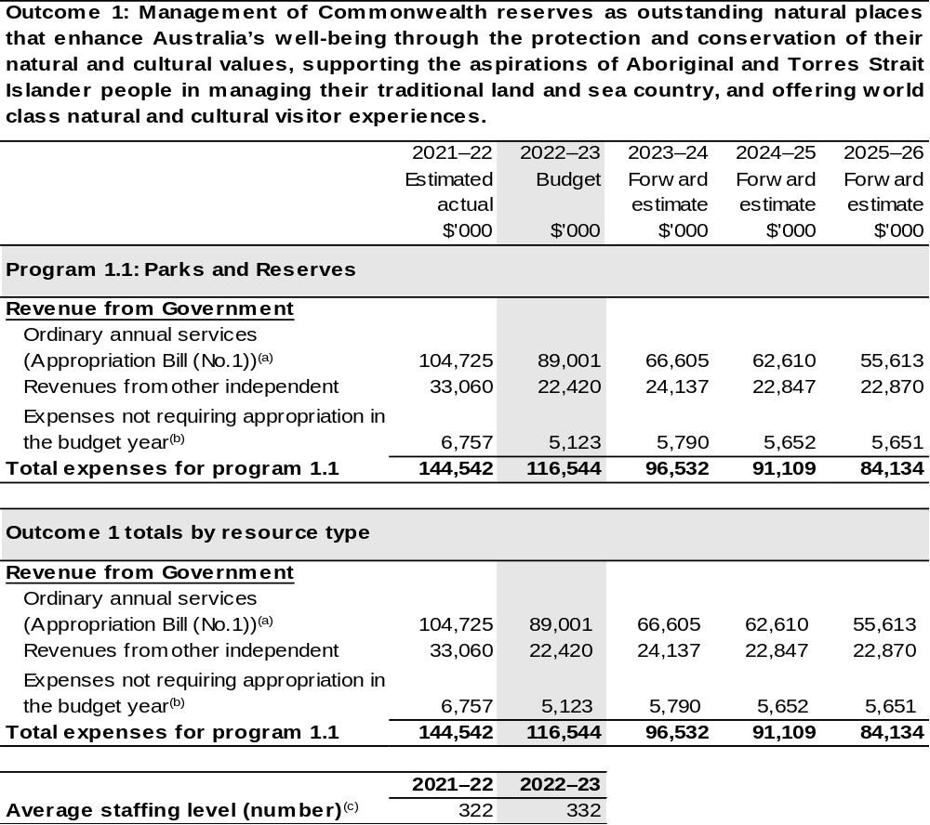
(a) Appropriation Bill (No. 1) 2022–23. The DNP is a CCE under the Public Governance, Performance and Accountability Act 2013 (PGPA Act) and does not receive direct appropriations. Appropriation is provided through DAWE and is specified with the Annual Appropriation Bills as payment to the DNP and is considered departmental for all purposes.
(b) Expenses not requiring appropriation in the budget year are made up of make good expenses, audit fees, and can include depreciation / amortisation expenses not requiring an appropriation.
(c) For the purposes of financial reporting, the Director of National Parks ASL presented here is the number of ASL paid for by the DNP appropriations. However, for the purposes of the Environment Protection and Biodiversity Conservation Act 1999 DAWE is the employer of all staff in Parks Australia, with the exception of the Director of National Parks.

Note: Departmental appropriation splits and totals are indicative estimates and may change in the course of the budget year as government priorities change.

Prepared on Australian Accounting Standards basis.

2.1.3: Performance criteria for Outcome 1
Table 2.1.3 details the performance measures for each program associated with Outcome 1. It also provides the related key activities as expressed in the current corporate plan where further detail is provided about the delivery of the activities related to the program, the context in which these activities are delivered and how the performance of these activities will be measured. Where relevant, details of 2022–23 Budget measures that have created new programs or materially changed existing programs are provided.
Outcome 1: Management of Commonwealth reserves as outstanding natural places that enhance Australia’s well-being through the protection and conservation of their natural and cultural values, supporting the aspirations of Aboriginal and Torres Strait Islander people in managing their traditional land and sea country, and offering world class natural and cultural visitor experiences.
Program 1.1: Parks and Reserves
Objective | Purpose: Protect, conserve and enhance the values of Commonwealth parks and gardens for the use and well-being of all Australians.  Delivery: With Traditional Owners and stakeholders, develop and implement management plans for Commonwealth reserves.
Key Activities^{(a)} | Performance Criterion 1: Sustainable use and enjoyment of Commonwealth parks and gardens by the Australian and international community.  Criterion 1 aligns with the ‘use and well-being’ component of our purpose, encompassing the sustainable use of parks and gardens by visitors, Traditional Owners, staff, researchers, and others. In line with this criterion the DNP also reports on the management and enhancement of socio-economic values in Commonwealth parks to benefit local communities. Key activities for this criterion are significant programs or areas of work that assist the Australian and international communities to sustainably use and enjoy Commonwealth parks and gardens.  - Maintain and continue to enhance the Parks Australia digital marketing platforms including website, visitor apps, and digital asset management system.  - Develop a Parks Australia compliance framework and coordinate  the development and implementation of plans, policies, and standard operating procedures that support terrestrial park compliance activities.  - Continue to provide informed and educational experiences in the discovery, visitor, and cultural centres at Booderee, Kakadu,  Uluru-Kata Tjuta, and Norfolk Island National Parks and the Australian National Botanic Gardens.  - Develop and implement a Visitor Research Strategy to improve and expand visitor data and insights.

Continued on following pages
2.1.3: Performance criteria for Outcome 1 (continued)
Key Activities^{(a)} | Performance Criterion 2: Opportunities and threats to natural and cultural values are effectively managed for all Australians.  Criterion 2 aligns with the protection, conservation, and enhancement component of our purpose. This will be done in a way to actively manage the condition of natural and cultural values of Commonwealth parks and gardens in line with national and international best practice guidelines. Key activities for this criterion are significant programs or areas of work that assist the DNP to effectively manage opportunities and threats to natural and cultural values in Commonwealth parks and gardens.  - Commission and influence research to establish environmental, social, and economic baselines and build knowledge about Australian Marine Parks and park management.  - Implement a system for monitoring and evaluating management effectiveness across Parks Australia.  - Review and update of the Environmental Impact Assessment processes in accordance with a Parks Australia policy statement.  - Develop and implement priorities for Cultural Heritage Management and undertake activities under the direction of Traditional Owners and the Boards of Management.  - Implement the Cat Eradication Strategy on Christmas Island.
Key Activities^{(a)} | Performance Criterion 3: Partnerships with Traditional Owners and/or other stakeholders enhance the management of Commonwealth parks and gardens for all Australians.  Criterion 3 acknowledges the key role of partnerships with Traditional Owners and other stakeholders in the DNP’s purpose to protect, conserve and enhance the management of Commonwealth parks and gardens. Key activities for this criterion are significant programs or areas of work that enhance the management of Commonwealth parks and gardens through partnerships with Traditional Owners and/or other stakeholders.  - Build partnerships with Traditional Owners and Indigenous communities to manage country in jointly managed parks/sea country, and to facilitate participation in park management activities  - Establish and Implement the CANBR Partnership Agreement  2020–25.  - Enhance the decision making and governance capabilities of Boards of Management and Traditional Owner input into decision making.  - In partnership with the Boards of Management, identify and seek solutions that support improved management level opportunities for Indigenous personnel.  - Promote the National Parks Conservation Trust to explore innovative funding opportunities for Commonwealth parks and gardens.  - Develop and implement avenues to support Indigenous employment.
Continued on following pages
2.1.3: Performance criteria for Outcome 1 (continued)
Key Activities^{(a)} | Cross cutting key activities.  These key activities are significant programs or areas of work that contribute to the achievement of any combination of the DNP’s three performance criteria.  - Deliver the $233 million Government investment into Parks Australia for infrastructure upgrades across our national parks and at the Australian National Botanic Gardens.  - Deliver the $216 million commitment to grow tourism within Kakadu National Park and support the post mining future of Jabiru township.  - Implement a system for monitoring and evaluating management effectiveness across Parks Australia including developing and implementing the monitoring, evaluation, reporting and improvement (MERI) system and science plans for the Australian Marine Parks, and develop a framework for all Commonwealth parks and gardens.  - Undertake a technical audit of the following management plans, and prepare their replacements: Australian National Botanic Garden Management Plan 2012–22, South East marine reserves Management Plan 2013–23, Christmas Island National Park Management Plan 2014–24.  - Develop, curate and manage scientific collections to international best practice (including the Australian National Herbarium, the Australian Plant Image Index collection, the Australian National Botanic Gardens living collection, and the National Seed Bank collection).  - Implement new Australian Marine Parks in the Indian Ocean Territories.  - Implement Australian Marine Parks management plans and management program actions to protect and conserve natural, cultural and heritage values of the parks; and allow for ecologically sustainable use and enjoyment of the natural resources in the parks  - Implement the Fisheries Assistance and User Engagement Package through completion of the Our Marine Parks Grants Programs  Round 1 and Round 2 and delivery of the Vessel Monitoring System Assistance program.  - Implement the Australian Marine Parks Partnerships package through completion of the Our Marine Parks Grants Program Round 3 and Round 4.  - Deliver further opportunities for Australians to engage and connect with Australian Marine Parks through stimulating philanthropic and private investment in marine park research, management and monitoring.

Continued on following pages
2.1.3: Performance criteria for Outcome 1 (continued)
Year | Performance measures | Expected Performance Results
Current year  2021–22 | Sustainable use and enjoyment of Commonwealth parks and gardens by the Australian and international community. | Number of visitors is within 10 per cent of target total visitor numbers.  Some concerns.
Current year  2021–22 |  | Maintain or improve visitor satisfaction.  On track.
Current year  2021–22 |  | Maintain or increase number of virtual visitors.  On track.
Current year  2021–22 |  | 95 per cent authorisations processed within target timeframe.  Some concerns.
Current year  2021–22 |  | 100 per cent of non-compliance reports have an initial assessment within target timeframe.  On track.
Current year  2021–22 |  | Maintain or increase the economic contribution made to local economies.  On track.
Current year  2021–22 |  | Maintain or increase the financial benefit to Traditional Owners through lease arrangements and other avenues in jointly managed parks.  Some concerns.
Current year  2021–22 |  | Maintain or increase number of peer reviewed publications resulting from research in Commonwealth parks.  Some concerns.

Continued on following page
2.1.3: Performance criteria for Outcome 1 (continued)
Year | Performance measures | Expected Performance Results
Current year  2021–22 (continued) | Opportunities and threats to natural and cultural values are effectively managed for all Australians. | Maintain or improve the condition of priority natural values in Commonwealth parks and gardens.  On track.
Current year  2021–22 (continued) |  | Maintain or improve the condition of priority cultural values in Commonwealth parks.  Some concerns.
Current year  2021–22 (continued) |  | Review and define priority natural and cultural values for all Commonwealth parks and gardens by 2023.  Some concerns.
Current year  2021–22 (continued) | Partnerships with Traditional Owners and/or other stakeholders enhance the management of Commonwealth parks and gardens for all Australians. | Maintain or improve key stakeholder and partner satisfaction.  On track.
Current year  2021–22 (continued) |  | Resources delivered through partnerships meet or exceed target level.  On track.
Current year  2021–22 (continued) |  | Maintain or increase the number of people who identify as members of the local or Indigenous community who are employed directly or indirectly.  On track.
Year | Performance measures | Planned Performance Results
Budget Year  2022–23 | As per 2021–22. | As per 2021–22.
Forward Estimates  2023–26 | As per 2022–23. | As per 2022–23.
- New or modified performance measures that reflect new or materially changed programs are shown in italics.

Section 3: Budgeted financial statements
Section 3 presents budgeted financial statements which provide a comprehensive snapshot of entity finances for 2022–23, including the impact of 2022–23 Budget measures and resourcing on financial statements.

3.1 Budgeted financial statements

3.1.1: Differences between entity resourcing and financial statements
The financial statements are prepared on an accrual basis where revenues and expenses are recognised as and when the resources are received and used. The entity resourcing table recognises the cash resources available to be used during the period and includes amounts recognised as revenue in previous periods.

3.1.2: Explanatory notes and analysis of budgeted financial statements
The Agency Resource Statement (Table 1.1) is prepared on a cash basis and provides a consolidated view of all the cash resources available to DNP in 2021–22. For departmental items this includes equity injections and appropriation receivable that is yet to be drawn down to cover payables and provisions on the Departmental Balance Sheet (Table 3.2). The Comprehensive Income Statement (Table 3.1) shows only the operating appropriation provided each year and own source revenue generated by the agency.
The approved operating loss for DNP is attributed to the depreciation of the entity’s asset base.

3.2 Budgeted financial statements tables

Table 3.1: Comprehensive income statement (showing net cost of services) for the period ended 30 June
- 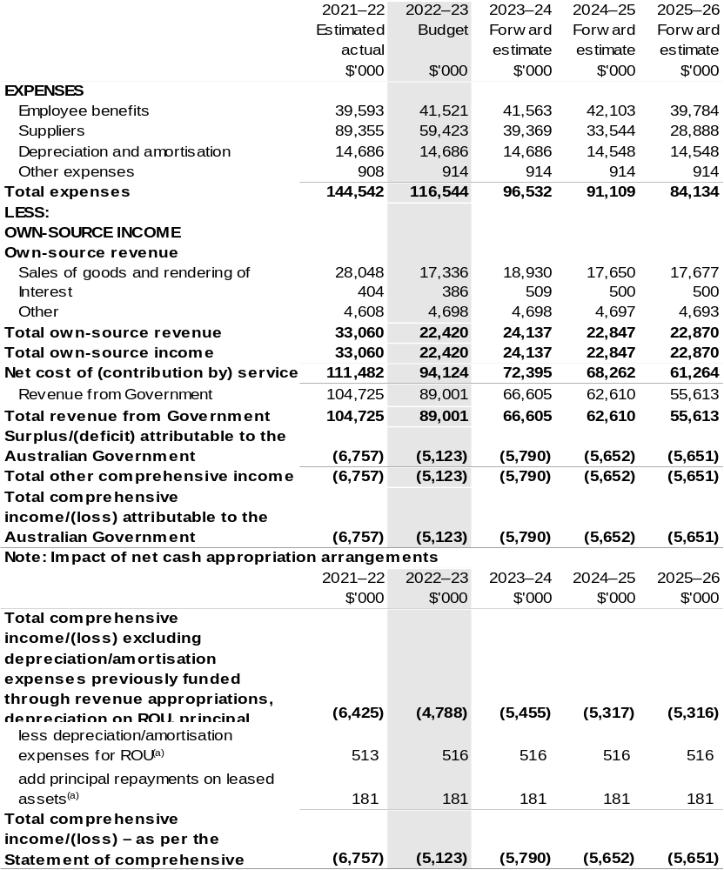

        - Applies to leases under AASB 16 Leases. Right of Use (ROU).

Prepared on Australian Accounting Standards basis.

Table 3.2: Budgeted departmental balance sheet (as at 30 June)
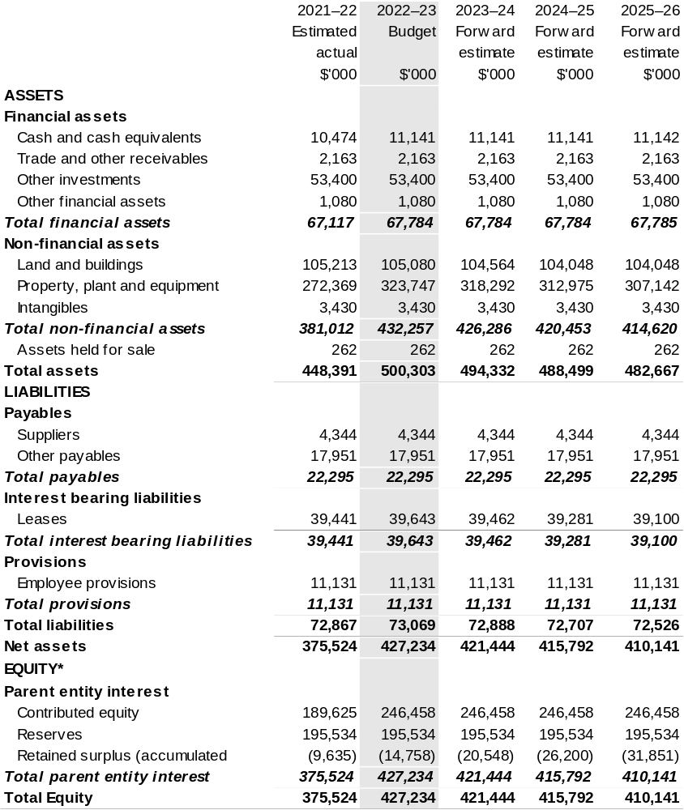

*’Equity’ is the residual interest in assets after deduction of liabilities.

Prepared on Australian Accounting Standards basis.

Table 3.3: Departmental statement of changes in equity – summary of movement (Budget year 2022–23)
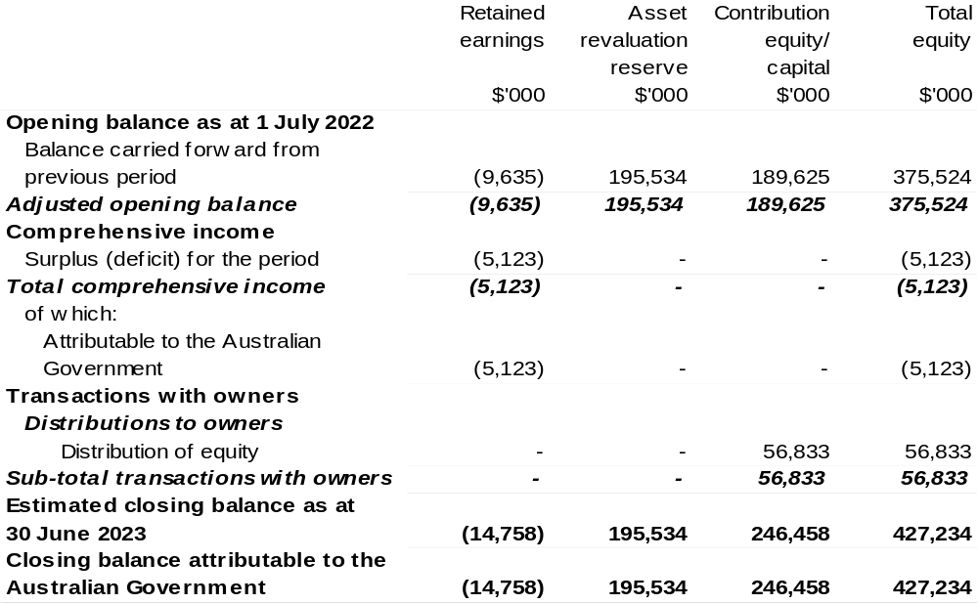

Prepared on Australian Accounting Standards basis.

Table 3.4: Budgeted departmental statement of cash flows (for the period
ended 30 June)
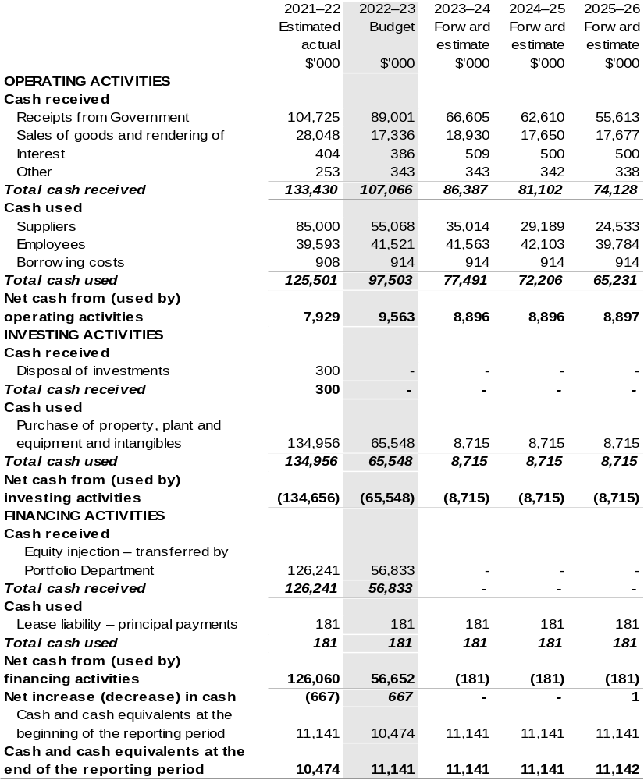

Prepared on Australian Accounting Standards basis.

Table 3.5: Departmental capital budget statement (for the period ended 30 June)
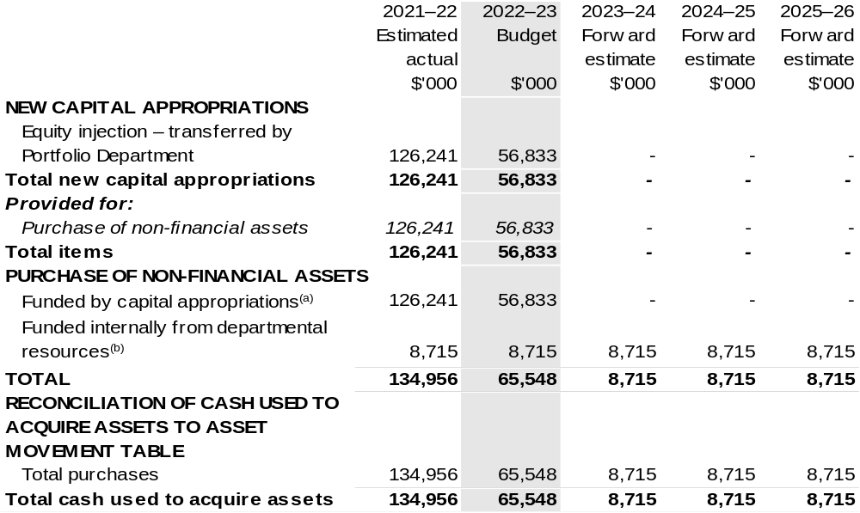

- Includes current Appropriation Bill (No. 2) and prior year Appropriation Act No. (2/4/6).
- Includes the following s74 external revenue:
– internally developed assets.
– section 74 external revenue.

Consistent with information contained in the Statement of Asset Movements and the Budgeted Statement of Cash Flows.

Prepared on Australian Accounting Standards basis.

Table 3.6: Statement of asset movements (Budget year 2022–23)
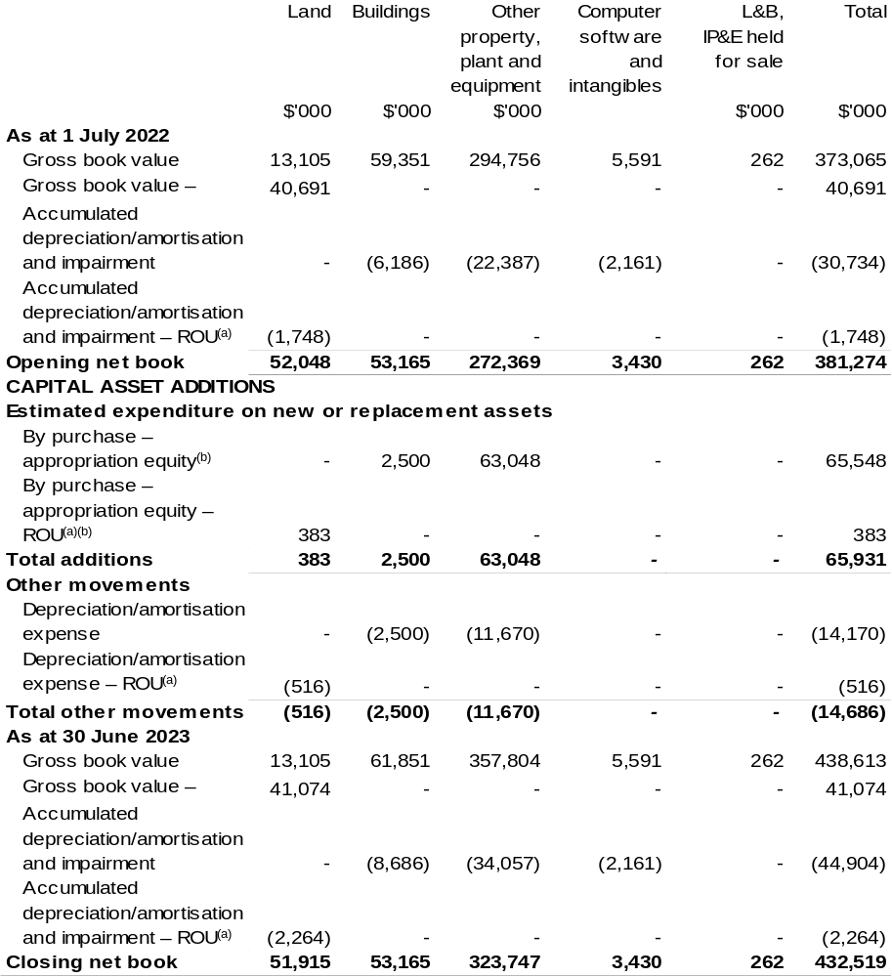

(a) Applies to leases under AASB 16 Leases. Right of Use (ROU).
(b) ‘By purchase – appropriation equity’ refers to equity injections appropriations provided through Appropriation Bill (No. 2) 2022–23 and other internal funding sources.

Prepared on Australian Accounting Standards basis.

Fisheries Research and Development Corporation
Section 1: Entity overview and resources 247
1.1 Strategic direction statement 247
1.2 Entity resource statement 248
1.3 Budget measures 250
Section 2: Outcome and planned performance 251
2.1 Budgeted expenses and performance for Outcome 1 252
Section 3: Budgeted financial statements 256
3.1 Budgeted financial statements 256
3.2 Budgeted financial statements tables 257

Fisheries
Research and Development Corporation

Section 1: Entity overview and resources

1.1 Strategic direction statement
The Fisheries Research and Development Corporation (FRDC) plans, invests in and manages research and development (R&D) activities for fishing, aquaculture and the wider community, and encourages the adoption of the resulting knowledge and innovation to achieve impact.
We work with diverse stakeholders from sectors including aquaculture, commercial wild harvest, Indigenous, recreational fishing, post-harvest, fisheries management, research, consumers and the wider community. Our activities span environments from the northern tropics to temperate seas, from icy Antarctic waters to freshwater rivers and lakes, and from estuaries to land-based aquaculture around Australia.
Our investment policy balances the needs of our stakeholders to achieve specific, planned end-user-driven solutions to national, regional and sector-based priorities. Partnerships and previous research, development and extension (RD&E) are considered in our planning and investment processes to optimise the use of existing knowledge, maximise leverage and reduce duplication. We also contribute to the broader national strategic approach to fishing and aquaculture RD&E to build cohesion and establish common goals between sectors.
We lead investment in fisheries RD&E, partnering with organisations that have the capabilities to undertake the varied and specialised activities necessary to achieve the five outcomes in our R&D Plan 2020–25. Our R&D Plan outcomes are: growth for enduring prosperity; best practices and production systems; a culture that is inclusive and forward thinking; fair and secure access to aquatic resources; and, community trust, respect and value. We will achieve these by driving digitisation and advanced analytics; strengthening adoption for transformative change; promoting innovation and entrepreneurship; building capability and capacity; and providing foundational information and support services.
We encourage adaptive and creative approaches to problem solving and focus on continuous improvement.

1.2 Entity resource statement
Table 1.1 shows the total funding from all sources available to the entity for its operations and to deliver programs and services on behalf of the Government.
The table summarises how resources will be applied by outcome (Government strategic policy objectives) and by administered (on behalf of the Government or the public) and departmental (for the entity’s operations) classification.
For more detailed information on special accounts and special appropriations, please refer to Budget Paper No. 4: Agency Resourcing.
Information in this table is presented on a resourcing (that is, appropriations/cash available) basis, whilst the ‘Budgeted expenses by Outcome’ table in Section 2 and the financial statements in Section 3 are presented on an accrual basis.

Table 1.1: Fisheries Research and Development Corporation –
Resource Statement – Budget Estimates for 2022–23 as at Budget March 2022
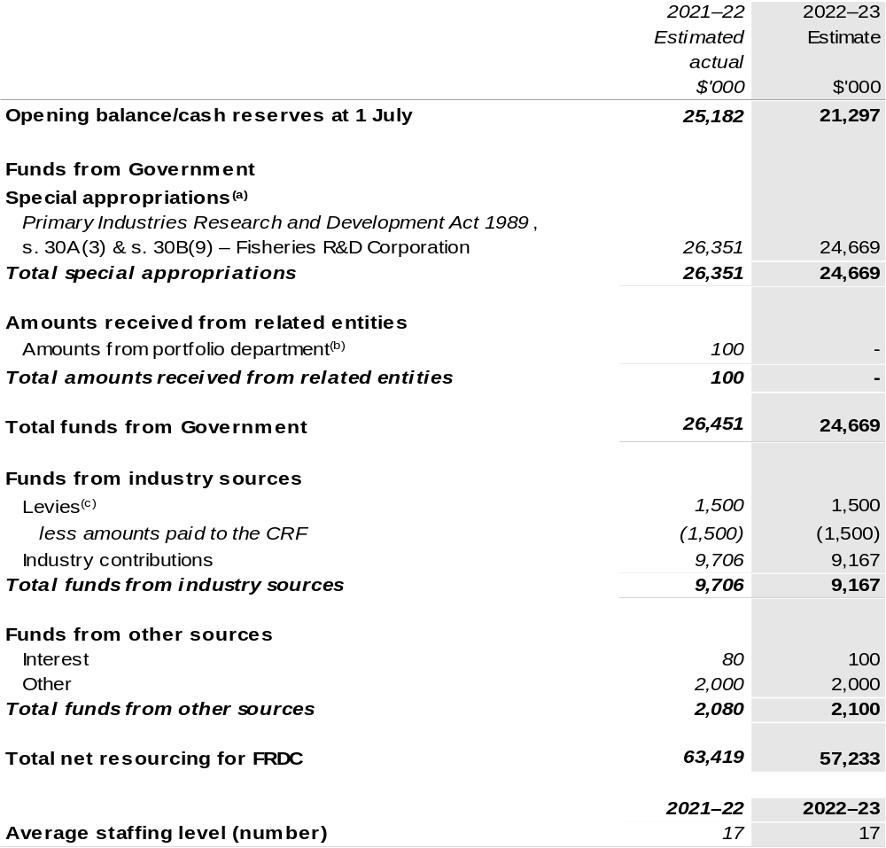

(a) FRDC's special appropriation is not directly appropriated as it is a corporate Commonwealth entity (CCE)
under the Public Governance, Performance and Accountability Act 2013 (PGPA Act). Appropriations are made to Department of Agriculture, Water and the Environment (DAWE) and are then paid to FRDC and are considered departmental for all purposes.
(b) Funding provided by the portfolio department that is not specified within the Annual Appropriation Bills as a payment to that CCE (for example, a grant awarded to a CCE from one of its portfolio department's administered programs). FRDC receives this to develop the National Carp Control Plan.
(c) The levies are imposed by the Primary Industries (Excise) Levies Act 1999. The levies are collected by DAWE under the Primary Industries Research and Development Act 1989 (PIRD Act) and the Fishing Levy Regulations and are transferred to the Consolidated Revenue Fund (CRF). These amounts are then drawn down by the department as a special appropriation and paid to FRDC under the
PIRD Act, s. 30A(3) and s. 30B(9) – Fisheries R&D Corporation.

Please note: All figures shown above are GST exclusive – these may not match figures in the cash flow statement.

Prepared on a resourcing (i.e. appropriations available) basis.

1.3 Budget measures
Budget measures in Part 1 relating to the Fisheries Research and Development Corporation are detailed in Budget Paper No. 2: Budget Measures 2022–23 and are summarised below.

Table 1.2: Fisheries Research and Development Corporation – 2022–23 Budget measures – Measures announced since the 2021–22 Mid-Year Economic and Fiscal Outlook (MYEFO)
FRDC does not have any 2022–23 Budget measures.

Section 2: Outcomes and planned performance
Government outcomes are the intended results, impacts or consequences of actions by the Government on the Australian community. Commonwealth programs are the primary vehicle by which government entities achieve the intended results of their outcome statements. Entities are required to identify the programs which contribute to Government outcomes over the Budget and forward years.
Each outcome is described below together with its related programs. The following provides detailed information on expenses for each outcome and program, further broken down by funding source.
Note:
Performance reporting requirements in the Portfolio Budget Statements are part of the Commonwealth performance framework established by the Public Governance, Performance and Accountability Act 2013. It is anticipated that the performance criteria described in Portfolio Budget Statements will be read with broader information provided in an entity’s corporate plans and annual performance statements – included in Annual Reports - to provide a complete picture of an entity’s planned and actual performance.
While the FRDC reports against an annual framework, as an organisation that invests in science, the benefit of those investments endures over a longer time period.
The most recent corporate plans (annual operating plan and research development and extension plan for the Fisheries Research and Development Corporation can be found at:
https://www.frdc.com.au/annual-operational-plans and
https://www.frdc.com.au/strategic-planning-and-priorities

The most recent annual performance statement for the Fisheries Research and Development Corporation can be found at:
https://www.frdc.com.au/annual-reports.

2.1 Budgeted expenses and performance for Outcome 1
Outcome 1: Increased economic, social and environmental benefits for Australian fishing and aquaculture, and the wider community, by investing in knowledge, innovation, and marketing.

2.1.1: Linked programs
Department of Agriculture, Water and the Environment
Program 3.4: Fishing Industry
Contribution to Outcome 1 made by linked program:
The FRDC works together with the DAWE to ensure fishing and aquaculture in Australia is sustainable, productive and profitable.

2.1.2: Budgeted expenses for Outcome 1
This table shows how much the entity intends to spend (on an accrual basis) on achieving the outcome, broken down by program, as well as by administered and departmental funding sources.

Table 2.1: Budgeted expenses for Outcome 1
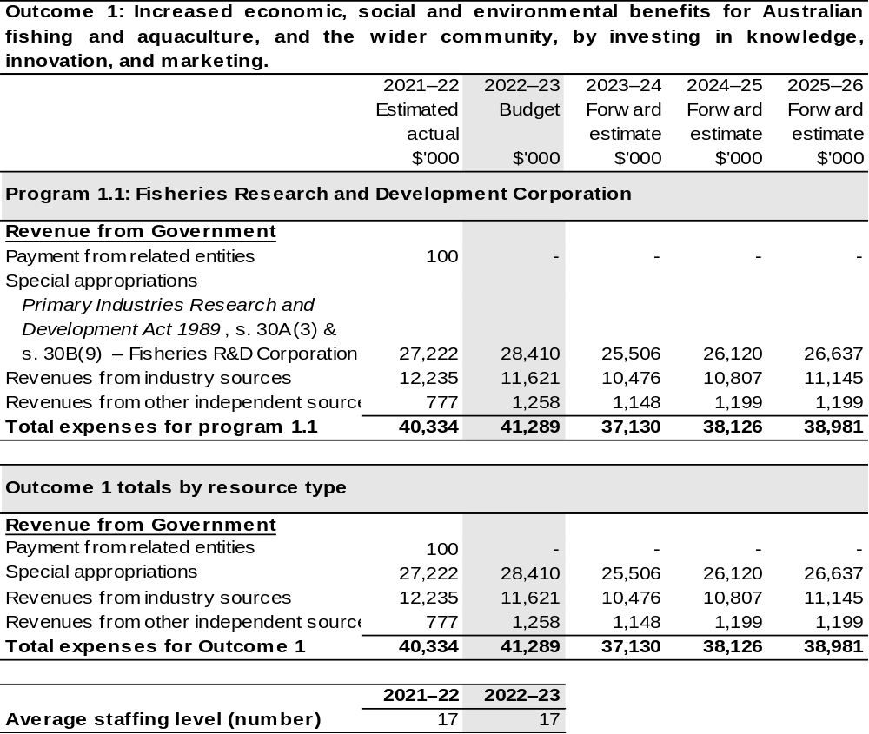
Note: Departmental appropriation splits and totals are indicative estimates and may change in the course
of the budget year as government priorities change.

Prepared on Australian Accounting Standards basis.

2.1.3: Performance criteria for Outcome 1
Table 2.1.3 details the performance measures for each program associated with Outcome 1. It also provides the related key activities as expressed in the current corporate plan where further detail is provided about the delivery of the activities related to the program, the context in which these activities are delivered and how the performance of these activities will be measured. Where relevant, details of 2022–23 Budget measures that have created new programs or materially changed existing programs are provided.
As an entity established under the PIRD Act, FRDC does not produce a corporate plan under the PGPA Act and is therefore exempt from the requirement to map purposes to outcomes.
Outcome 1: Increased economic, social and environmental benefits for Australian fishing and aquaculture, and the wider community, by investing in knowledge, innovation, and marketing.
Program 1.1: Fisheries Research and Development Corporation
Objective | Establish collaborative, vibrant fishing and aquaculture, creating diverse benefits from aquatic resources, and celebrated by the community.
Key Activities | - Drive digitisation and advanced analytics;  - Strengthen the adoption of transformative change;  - Promote innovation and entrepreneurship;  - Build capability and capacity; and  - Provide foundational information and support services.
Year | Performance measures | Expected Performance Results
Current year  2021–22 | Growth for enduring prosperity.  Enduring and balanced ecological, social and economic growth for the community benefit. | On track for 100 per cent of priority activities identified in Annual Operational Plans to be invested in by 2025.  Projects sampled for cost-benefit analysis show positive average return on investment.
Current year  2021–22 | Best practices and production systems.  Diverse benefits from aquatic resources to be consistent with shared principles.

Continued on following page
2.1.3: Performance criteria for Outcome 1 (continued)
Year | Performance measures | Expected Performance Results
Current year  2021–22 (continued) | A culture that is inclusive and forward thinking.  A fishing and aquaculture community that is cooperative, diverse and well equipped to enable growth and adaptability in a complex and uncertain world. | As per the above.
Current year  2021–22 (continued) | Fair and secure access to aquatic resources.  Integrated management of Australia’s aquatic resources, providing certainty and confidence. | As per the above.
Current year  2021–22 (continued) | Community trust, respect and value.  People feel good about using the products, services and experiences provided by fishing and aquaculture. | As per the above.
Year | Performance measures | Planned Performance Results
Budget Year  2022–23 | As per 2021–22. | As per 2021–22.
Forward Estimates  2023–26 | As per 2022–23. | As per 2022–23.

Section 3: Budgeted financial statements
Section 3 presents budgeted financial statements which provide a comprehensive snapshot of entity finances for 2022–23, including the impact of 2022–23 Budget measures and resourcing on financial statements.

3.1 Budgeted financial statements

3.1.1: Differences between entity resourcing and financial statements
The financial statements are prepared on an accrual basis where revenues and expenses are recognised as and when the resources are received and used. The entity resourcing table recognises the cash resources available to be used during the period and includes amounts recognised as revenue in previous periods.

3.1.2 Explanatory notes and analysis of budgeted financial statements
The FRDC’s RD&E expenditure is dependent on the gross value of production (GVP) of the Australian seafood industry. The indication for the GVP for the Australian seafood industry is positive, with growth expected in 2022–23. This is based primarily on aquaculture, which is anticipated to grow – prawns, barramundi, Atlantic salmon and yellowtail kingfish will be key drivers. Income contributions from the commercial sector are expected to maintain current levels.

3.2 Budgeted financial statements tables

Table 3.1: Comprehensive income statement (showing net cost of services)
(for the period ended 30 June)
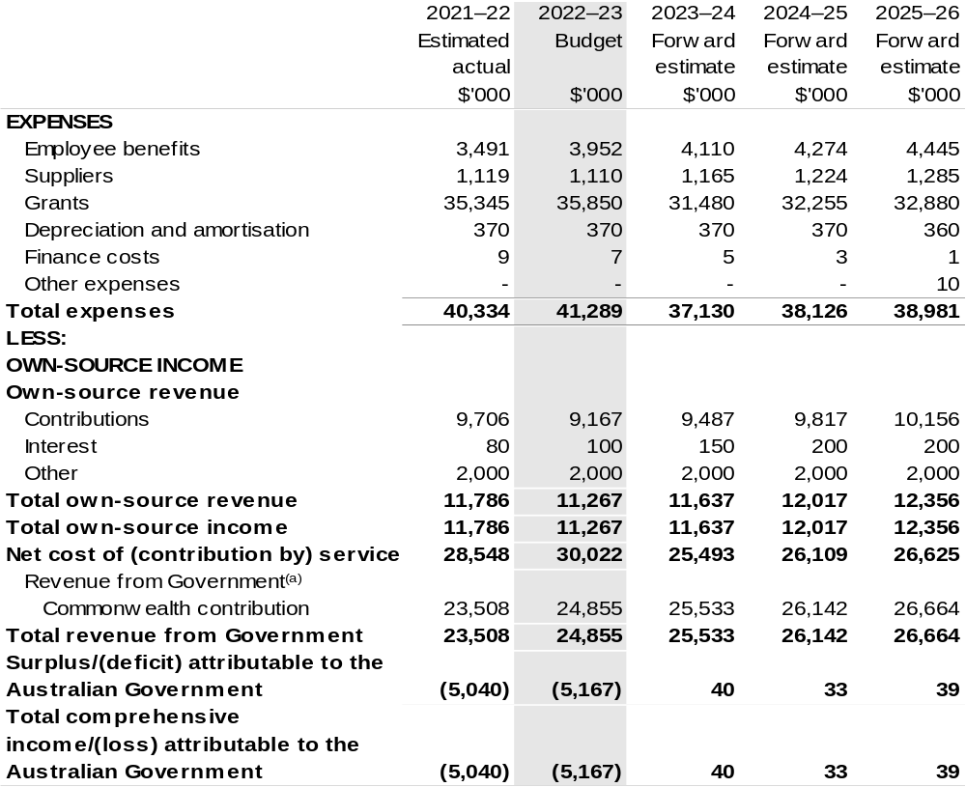

Continued on following page

Table 3.1: Comprehensive income statement (showing net cost of services)
(for the period ended 30 June) (continued)
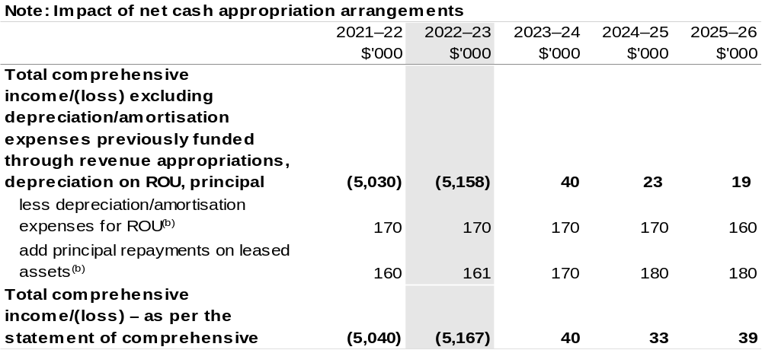

(a) Revenue from Government includes a Commonwealth contribution under the PIRD Act and levies collected from industry by DAWE for R&D activities.
(b) Applies to leases under AASB 16 Leases. Right of Use (ROU).

Prepared on Australian Accounting Standards basis

Table 3.2: Budgeted departmental balance sheet (as at 30 June)
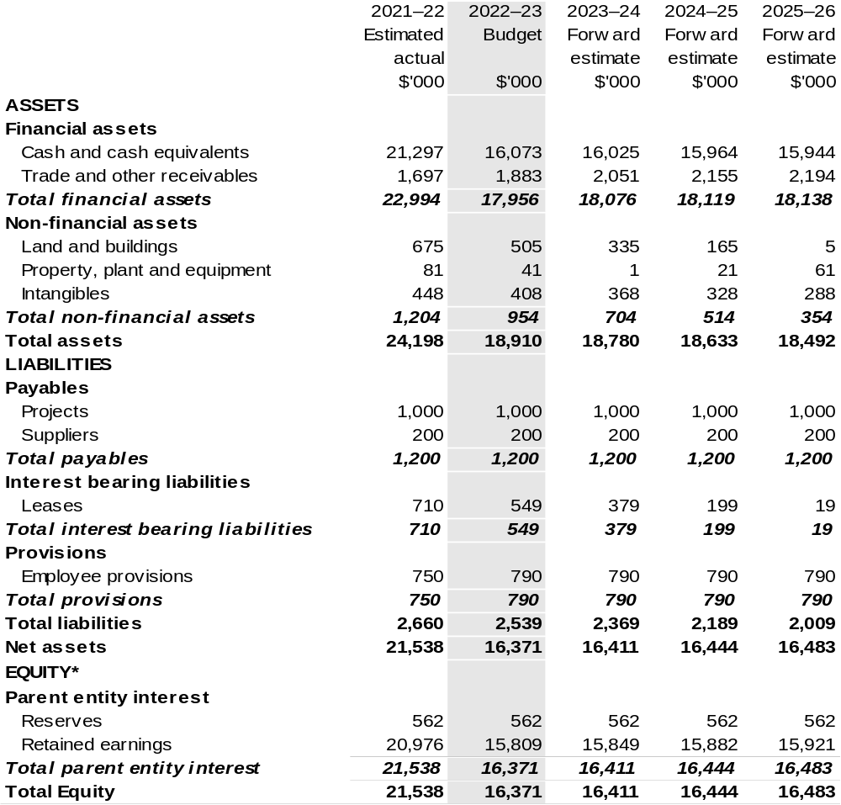

*'Equity' is the residual interest in assets after deduction of liabilities.

Prepared on Australian Accounting Standards basis.

Table 3.3: Departmental statement of changes in equity – summary of movement (Budget year 2022–23)
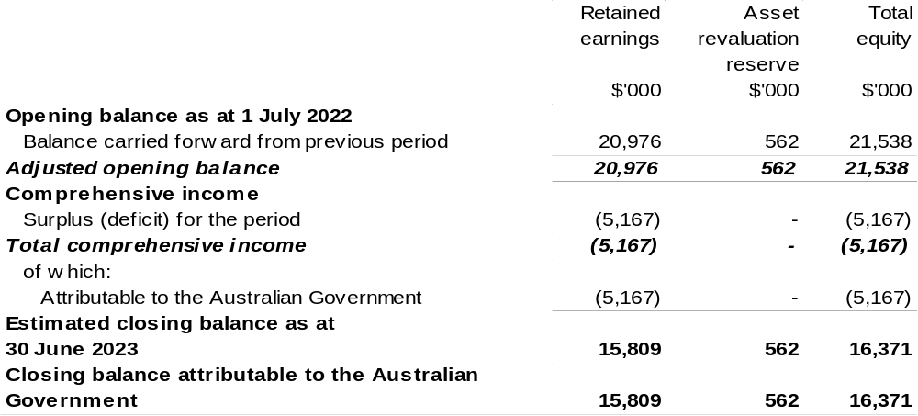

Prepared on Australian Accounting Standards basis.

Table 3.4: Budgeted departmental statement of cash flows (for the period
ended 30 June)
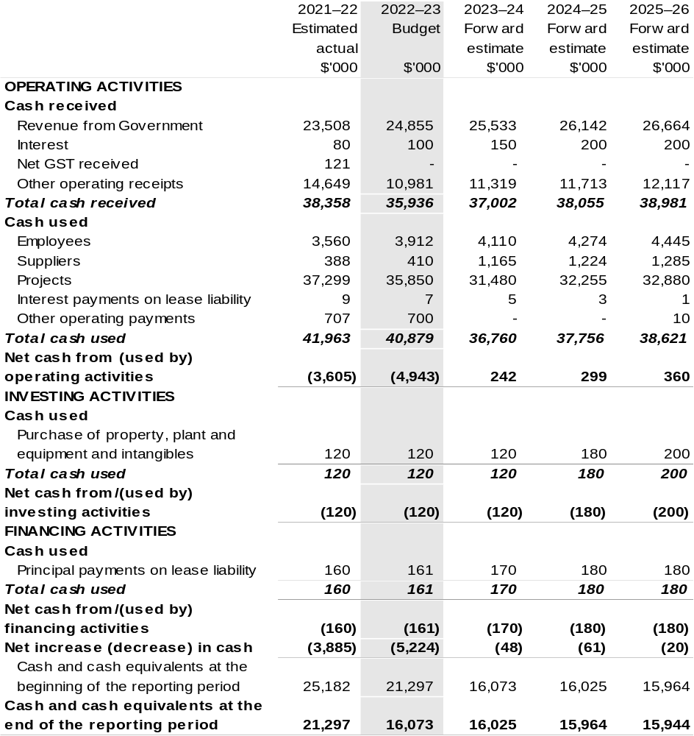

Prepared on Australian Accounting Standards basis.

Table 3.5: Departmental capital budget statement (for the period end 30 June)
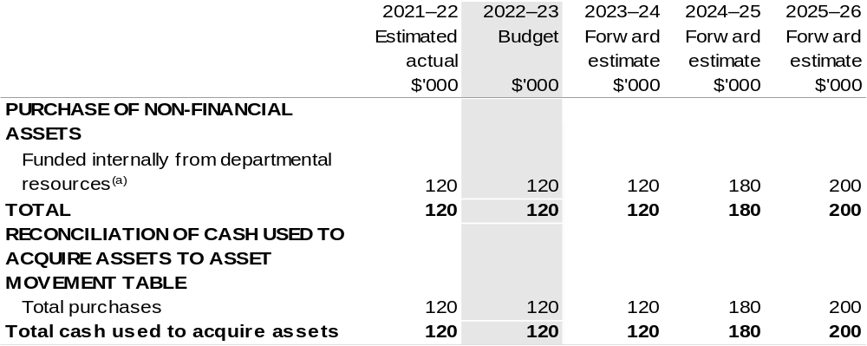

(a) Includes the following s74 external revenue:
– internally developed assets.

Consistent with information contained in the Statement of Asset Movements and the Budgeted Statement of Cash Flows.

Prepared on Australian Accounting Standards basis.

Table 3.6: Statement of asset movements (Budget year 2022–23)
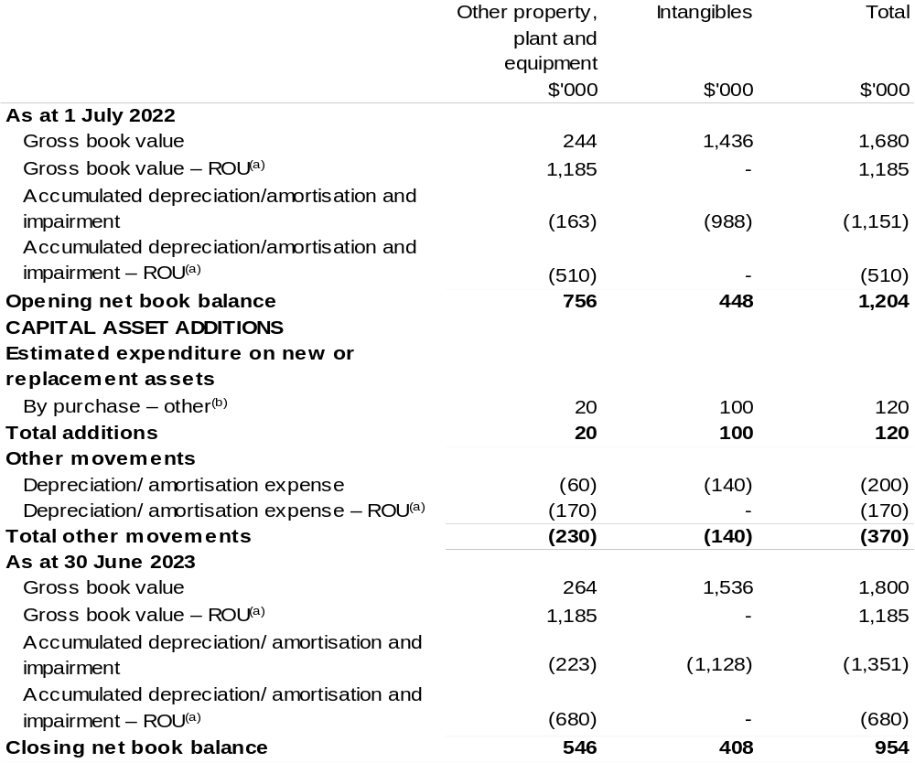

(a) Applies to leases under AASB 16 Leases. Right of Use (ROU).
(b) ‘By purchase – other’ refers to funding provided through other internal funding sources.

Prepared on Australian Accounting Standards basis.

Grains Research and Development Corporation
Section 1: Entity overview and resources 267
1.1 Strategic direction statement 267
1.2 Entity resource statement 269
1.3 Budget measures 271
Section 2: Outcomes and planned performance 272
2.1 Budgeted expenses and performance for Outcome 1 273
Section 3: Budgeted financial statements 278
3.1 Budgeted financial statements 278
3.2 Budgeted financial statements tables 279

Grains
Research and Development Corporation

Section 1: Entity overview and resources

1.1 Strategic direction statement
The Grains Research and Development Corporation’s (GRDC) purpose is to invest in research, development and extension (RD&E) to create enduring profitability for Australian grain growers.
In supporting its purpose, GRDC invests in RD&E activities across a portfolio spanning temperate and tropical cereals (including coarse grains), pulses and oilseeds. This involves identifying and prioritising research for investment; monitoring, evaluating and reporting on research impacts; and facilitating the dissemination, adoption and commercialisation of research results.
GRDC also contributes to the development of strategic national approaches to grains industry RD&E, to reduce fragmentation and duplication and to help address industry-wide issues such as biosecurity, grains market access and sustainable resource management.
While its focus is on delivering benefits to Australian grain growers, GRDC also generates outcomes from investing in RD&E that benefit other participants in the Australian grains industry value chain and the wider Australian community, as well as the grains research community in Australia and overseas. GRDC investments support the capacity of the Australian research community through collaborative approaches that minimise duplication of effort and provide access to shared knowledge, infrastructure and facilities.
Effective partnerships with other Australian organisations enable GRDC to leverage resources and research capability; share market knowledge, technologies and intellectual property; and reduce the risk associated with transformational investments. GRDC also builds strong relationships with organisations overseas, both to broaden the resources available to the Australian grains industry and to access international RD&E efforts that offer potential benefits, such as food security, for Australia.
Because adoption by growers is critical to achieving benefits from research and development (R&D), GRDC undertakes activities to raise awareness of grains industry R&D and extend the results of GRDC-supported investments to grain growers and their advisers, other participants in rural industry and the wider community. Recognising different needs and preferences for receiving information, GRDC uses a range of products and channels, from phone apps to field days.

GRDC works closely with Australian grain growers and the Australian Government to ensure that their RD&E priorities are effectively addressed through GRDC investments. GRDC also maintains strong connections with its other stakeholders, particularly in the R&D and agribusiness sectors.
GRDC’s investment priorities are articulated in the RD&E Plan 2018–2023. The plan is firmly focussed on delivering research and extension investments that increase the profitability of Australian grain growers. The plan considers the key drivers of profitability in terms of yield, price, costs (on-farm and post farm gate) as well as risk.
The RD&E Plan 2018–2023 has been informed by extensive consultation across a broad spectrum of grains industry participants, government, and research providers. The consultation identified 29 key investment targets, with relative priorities that will underpin the delivery of the GRDC’s purpose.
Detailed performance information across all the drivers of profitability through Key Investment Targets will be available in each of the GRDC Annual Operational Plans across the five-year period.

1.2 Entity resource statement
Table 1.1 shows the total funding from all sources available to the entity for its operations and to deliver programs and services on behalf of the Government.
The table summarises how resources will be applied by outcome (Government strategic policy objectives) and by administered (on behalf of the Government or the public) and departmental (for the entity’s operations) classification.
For more detailed information on special accounts and special appropriations, please refer to Budget Paper No. 4: Agency Resourcing.
Information in this table is presented on a resourcing (i.e. appropriations/cash available) basis, whilst the ‘Budgeted expenses by Outcome 1’ tables in Section 2 and the financial statements in Section 3 are presented on an accrual basis.

Table 1.1: Grains Research and Development Corporation –
Resource Statement – Budget Estimates for 2022–23 as at Budget March 2022
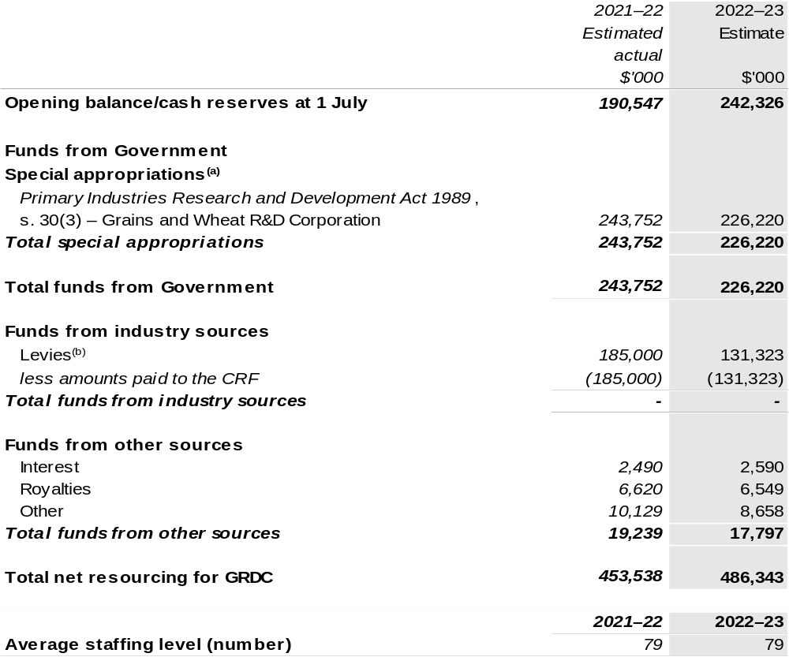

(a) GRDC's special appropriation is not directly appropriated as it is a corporate Commonwealth entity under the Public Governance, Performance and Accountability Act 2013 (PGPA Act). Appropriations are made to Department of Agriculture, Water and the Environment (DAWE) and are then paid to GRDC and are considered departmental for all purposes.
(b) The levies are imposed by the Primary Industries (Excise) Levies Act 1999. The levies are collected by DAWE under the Primary Industries Levies and Charges Collection Act 1991 and transferred to the Consolidated Revenue Fund (CRF). These amounts are then drawn down by the department as a special appropriation and paid to GRDC under the Primary Industries Research and Development
Act 1989 (PIRD Act), s. 30(3) – Grains and Wheat R&D Corporation.

Prepared on a resourcing (i.e. appropriations available) basis.

Please note: All figures shown above are GST exclusive – these may not match figures in the cash flow statement.

1.3 Budget measures
Budget measures in Part 1 relating to the Grains Research and Development Corporation are detailed in Budget Paper No. 2: Budget Measures 2022–23 and are summarised below.

Table 1.2: Grains Research and Development Corporation – 2022–23 Budget measures – Measures announced since the 2021–22 Mid-Year Economic and Fiscal Outlook (MYEFO)
GRDC does not have any 2022–23 Budget measures.

Section 2: Outcomes and planned performance
Government outcomes are the intended results, impacts or consequences of actions by the Government on the Australian community. Commonwealth programs are the primary vehicle by which government entities achieve the intended results of their outcome statements. Entities are required to identify the programs which contribute to Government outcomes over the Budget and forward years.
Each outcome is described below together with its related programs. The following provides detailed information on expenses for each outcome and program, further broken down by funding source.
Note:
Performance reporting requirements in the Portfolio Budget Statements are part of the Commonwealth performance framework established by the Public Governance, Performance and Accountability Act 2013. It is anticipated that the performance criteria described in Portfolio Budget Statements will be read with broader information provided in an entity’s corporate plans and annual performance statements – included in Annual Reports – to provide a complete picture of an entity’s planned and actual performance.
The most recent corporate plan for the Grains Research and Development Corporation can be found at:
https://grdc.com.au/about/who-we-are/corporate-governance/corporate-planning.
The most recent annual performance statement for the Grains Research and Development Corporation can be found at:
https://grdc.com.au/about/who-we-are/corporate-governance/performance-monitoring-and-reporting.

2.1 Budgeted expenses and performance for Outcome 1
Outcome 1: New information and products that enhance the productivity, competitiveness and environmental sustainability of Australian grain growers and benefit the industry and wider community, through planning, managing and implementing investments in grains research and development.

2.1.1: Linked programs
Department of Agriculture, Water and the Environment
Program 3.7: Grains Industry
Contribution to Outcome 1 made by linked program:
The GRDC works together with DAWE to ensure sustainable, productive, and profitable grains industry.

2.1.2: Budgeted expenses for Outcome 1
This table shows how much the entity intends to spend (on an accrual basis) on achieving the outcome, broken down by program, as well as by administered and departmental funding sources.

Table 2.1: Budgeted expenses for Outcome 1
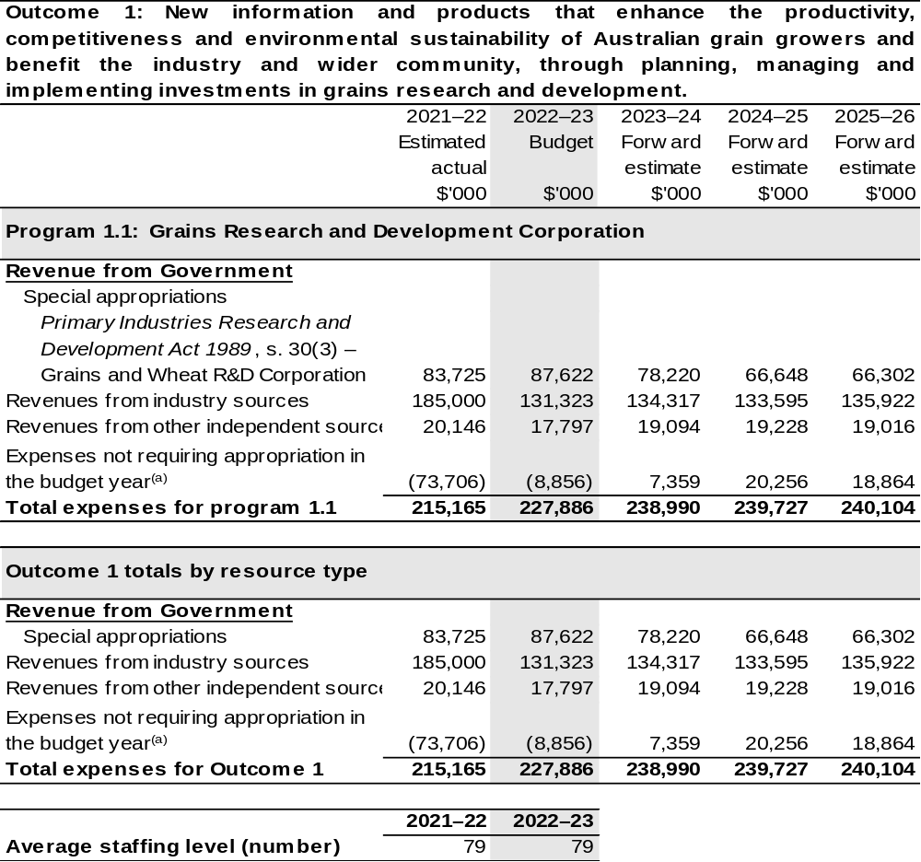

(a) Expenses not requiring appropriation in the Budget year are made up of make good expenses, audit fees, and can include depreciation / amortisation expenses not requiring an appropriation.

Note: Departmental appropriation splits and totals are indicative estimates and may change in the course of the budget year as government priorities change.

Prepared on Australian Accounting Standards basis.

2.1.3: Performance criteria for Outcome 1
Table 2.1.3 details the performance measures for each program associated with Outcome 1. It also provides the related key activities as expressed in the current corporate plan where further detail is provided about the delivery of the activities related to the program, the context in which these activities are delivered and how the performance of these activities will be measured. Where relevant, details of 2022–23 Budget measures that have created new programs or materially changed existing programs are provided.
As an entity established under the PIRD Act, GRDC does not produce a corporate plan under the PGPA Act and is therefore exempt from the requirement to map purposes to outcomes.
Outcome 1: New information and products that enhance the productivity, competitiveness and environmental sustainability of Australian grain growers and benefit the industry and wider community, through planning, managing and implementing investments in grains research and development.
Program 1.1: Grains Research and Development Corporation
Objective | Drive the discovery, development and delivery of world-class innovation to enhance the productivity, profitability and sustainability of Australian grain growers and benefit the industry and the wider community.
Key Activities^{(a)} | Continue to prioritise RD&E investments that support the enduring profitability of Australian grain growers. The target group is primarily Australian grain growers but the grains industry value chain also includes Governments, industry groups, rural and regional communities, research organisations and the wider community.
Year | Performance measures | Expected Performance Results
Current year  2021–22 | Average farm business rates of return. | A minimum of 6 per cent by 2023.  3.8 per cent.
Current year  2021–22 | Improvements in yield and yield stability. | Minimum yield increases equivalent to one per cent per annum for cereals, two per cent per annum for pulses and 1.5 per cent for oilseeds.  7.04 per cent increase on the  five-year average for wheat.  4.34 per cent increase on the  five-year average for pulses.  5.80 per cent increase on the  five-year average for oilseeds.

Continued on following pages

2.1.3: Performance criteria for Outcome 1
Year | Performance measures | Expected Performance Results
Current year  2021–22 (continued) | Yield stability. | By 2023 a minimum 20 per cent closure of the gap between potential yield and actual yield.  70 per cent of wheat, barley and canola crops showed no discernible yield gap (Paddock Survey 2019).
Current year  2021–22 (continued) | Maintaining and improving price. | Identification of potential new products that attract premium prices.  Identification of opportunities for product differentiation.  Defence of current market access programs.  New varieties of wheat screened for Late Maturity Alpha-amylase markers earlier in breeding process.  Reports on market opportunities by Australian Export Grains Innovation Centre (AEGIC).  Surveys and diagnostics of incidence and severity of diseases in cereals and pulses completed.
Current year  2021–22 (continued) | Optimising input costs. | Maintain increases in chemistry costs below the five-year trend (2018–2023) equivalent to $85.50 per hectare or a ratio of input to crop revenue of 0.166.  Ratio 0.142.  Maintain increases in fertilizer costs below the five-year trend (2018–2023) equivalent to $84.30 per hectare or a ratio of input to crop revenue of 0.164.  Ratio 0.140.

Continued on following page
2.1.3: Performance criteria for Outcome 1
Year | Performance measures | Expected Performance Results
Current year  2021–22 (continued) |  | Note:  - Not all input costs are captured in this target – all inputs costs as a share of cash receipts are captured in the calculation of Rates of Return.  - Reporting on a mean can be informative but is not the best indicator of impact due to variations across region, soil type, rainfall, and business characteristics of each farm. GRDC is working toward developing a more detailed regionalised dataset which will allow for impact measurement.
Year | Performance measures | Planned Performance Results
Budget Year  2022–23 | As per 2021–22. | As per 2021–22.
Forward Estimates  2023–26 | As per 2023–28 RD&E Plan. | As per 2023–28 RD&E Plan.

- Additional performance information that supports the achievement of the above performance criteria are available in the GRDC’s 2018–2023 Strategic RD&E plan.

Section 3: Budgeted financial statements
Section 3 presents budgeted financial statements which provide a comprehensive snapshot of entity finances for 2022–23, including the impact of 2022–23 Budget measures and resourcing on financial statements.

3.1 Budgeted financial statements

3.1.1: Differences between entity resourcing and financial statements
The financial statements are prepared on an accrual basis where revenues and expenses are recognised as and when the resources are received and used. The entities resourcing table recognises cash resources available to be used during the period and includes amounts recognised as revenue in previous periods.

3.1.2: Explanatory notes and analysis of budgeted financial statements
GRDC’s revenue is primarily from industry contributions in the form of levies paid on the farm gate value of grain sold and Australian Government contributions which are capped at 0.5 per cent of the three-year rolling average of gross value of production (GVP). GRDC’s revenue streams are therefore subject to the volatility of local and international grain commodity markets, farm gate costs, environmental conditions, and the marketing decisions of growers. This means the assumptions in developing financial forecasts have a high degree of uncertainty and change frequently.
In 2022–23, GRDC is budgeting for an operating surplus of $8.9 million which will marginally increase accumulated reserves. Industry contributions are expected to decrease by $53.7 million, down on current year estimates and returning to around long-term trend. Australian Government contributions are expected to increase by $3.9 million after the higher-than-average gross volume of production across recent years. Own source income is expected to largely hold steady with slight decreases to grant income and dividend revenue being offset by increases in interest and royalties. In support of current higher values of R&D expenditure, supplier expenses, including those relating to contracted operational support services, are expected to remain consistent with prior periods.
The budgeted net asset position for 2022–23 is $359.5 million which is $8.9 million more than the 2021–22 estimated actual. This increase is largely due to the flow on impacts from record levels of industry contributions and Australian Government co-contributions received in the past two years.

3.2 Budgeted financial statements tables

Table 3.1: Comprehensive income statement (showing net cost of services)
(for the period ended 30 June)
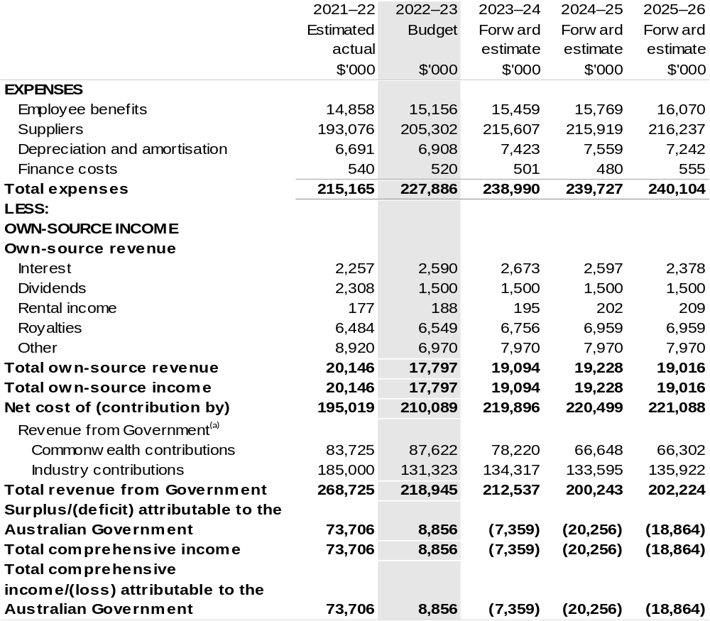
Continued on following page

Table 3.1: Comprehensive income statement (showing net cost of services) (for the period ended 30 June) (continued)
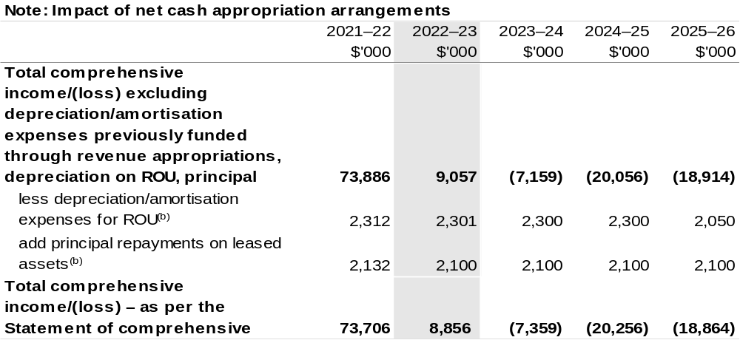
(a) Revenue from Government includes a Commonwealth contribution under the PIRD Act and levies collected from industry by DAWE for R&D activities.
(b) Applies to leases under AASB 16 Leases. Right of Use (ROU).

Prepared on Australian Accounting Standards basis.

Table 3.2: Budgeted departmental balance sheet (as at 30 June)
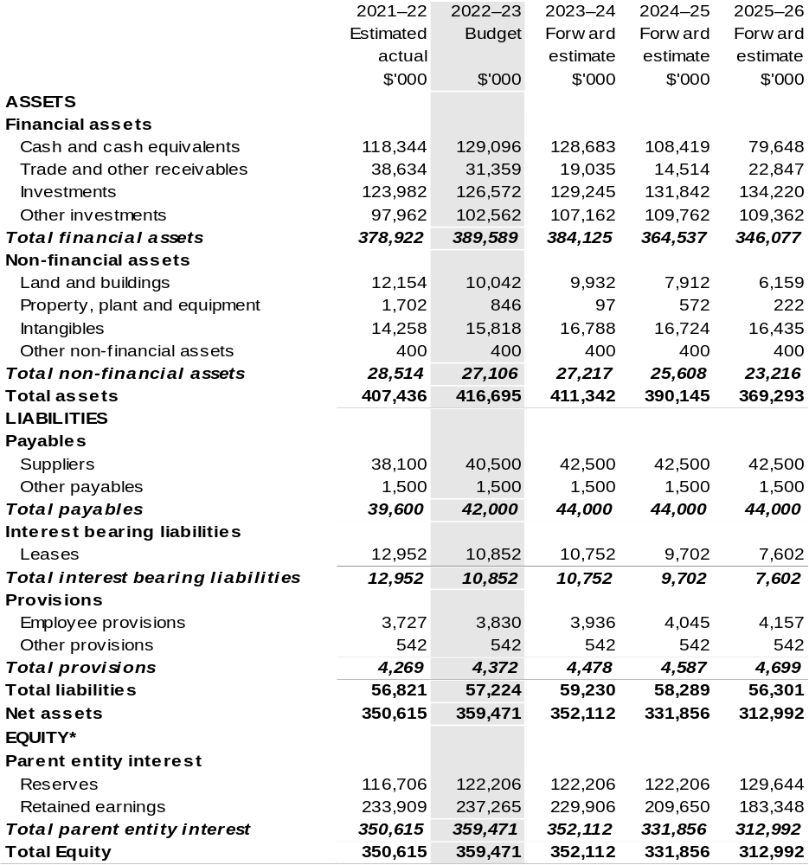

*'Equity' is the residual interest in assets after deduction of liabilities.

Prepared on an Australian Accounting Standards basis.

Table 3.3: Departmental statement of changes in equity – summary of movement (Budget year 2022–23)
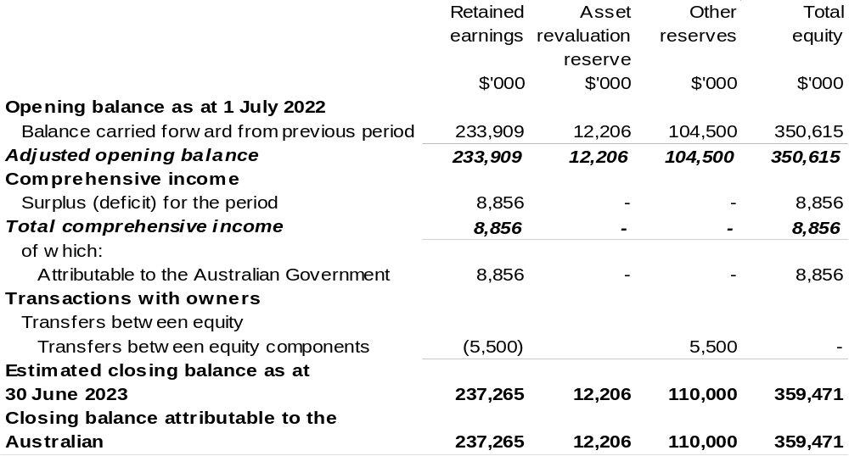

Prepared on Australian Accounting Standards basis.

Table 3.4: Budgeted departmental statement of cash flows (for the period
ended 30 June)
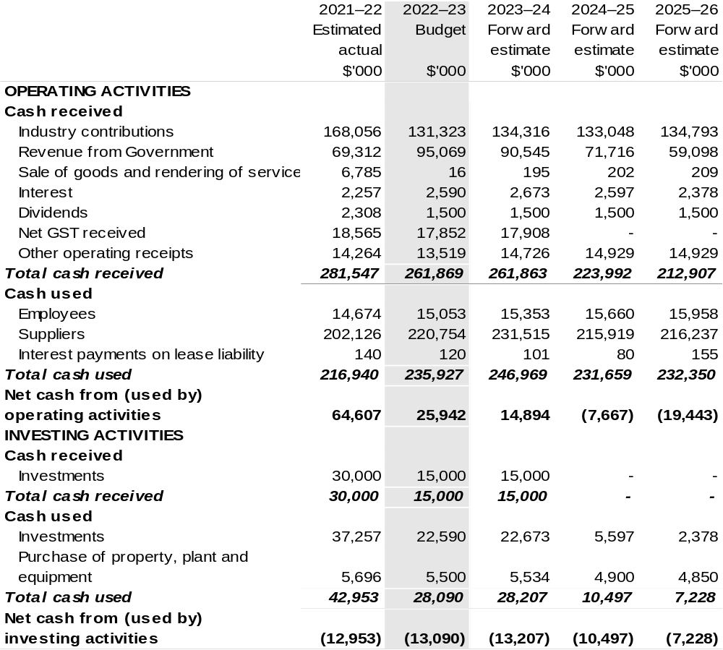

Continued on following page

Table 3.4: Budgeted departmental statement of cash flows (for the period
ended 30 June) (continued)
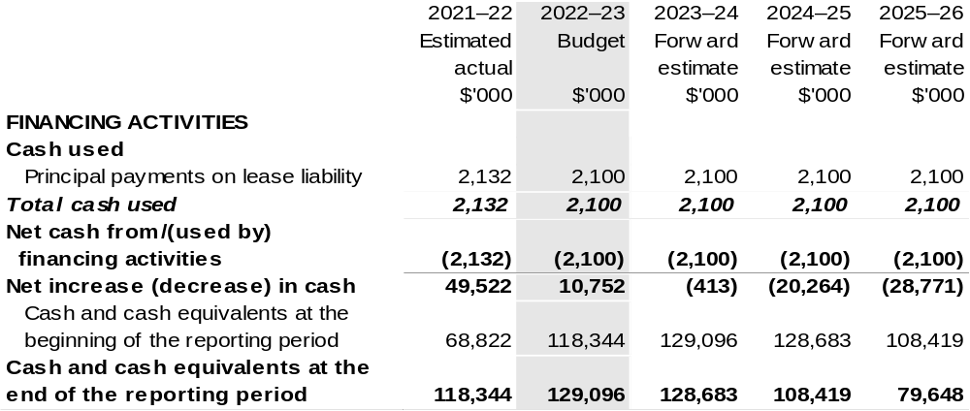

Prepared on Australian Accounting Standards basis.

Table 3.5: Departmental capital budget statement
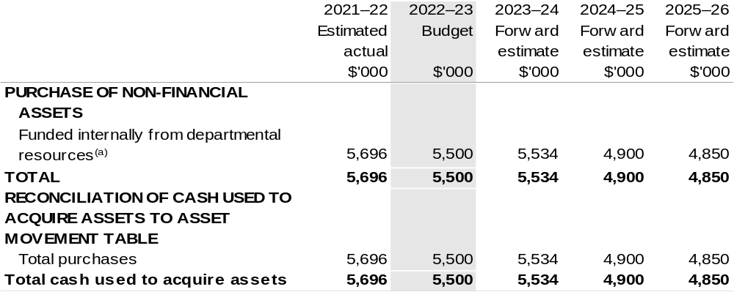

(a) Includes the following s74 external revenue:
– internally developed assets.

Consistent with information contained in the Statement of Asset Movements and the Budgeted Statement of Cash Flows.

Prepared on Australian Accounting Standards basis.

Table 3.6: Statement of asset movements (Budget year 2022–23)
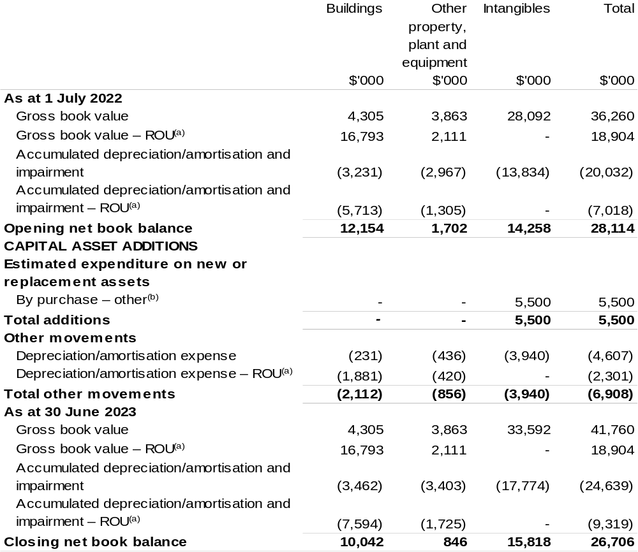

(a) Applies to leases under AASB 16 Leases. Right of Use (ROU).
(b) ‘By purchase – other’ refers to funding provided through other internal funding sources.

Prepared on Australian Accounting Standards basis.

Great Barrier Reef Marine Park Authority
Section 1: Entity overview and resources 289
1.1 Strategic direction statement 289
1.2 Entity resource statement 292
1.3 Budget measures 294
Section 2: Outcome and planned performance 295
2.1 Budgeted expenses and performance for Outcome 1 296
Section 3: Budgeted financial statements 302
3.1 Budgeted financial statements 302
3.2 Budgeted financial statements tables 303

Great Barrier Reef Marine Park Authority

Section 1: Entity overview and resources

1.1 Strategic direction statement
The Great Barrier Reef (the Reef) is one of the most significant natural places on Earth. Recognised globally for its extraordinary beauty and diversity, it is listed as a World Heritage site of Outstanding Universal Value. This exceptional and complex ecosystem is made up of a network of almost 3000 coral reefs and non-reef habitats stretching 2300 kilometres along the coast of Queensland. The vast size of the Reef is becoming a less effective buffer against broad scale and cumulative threats, with climate change the greatest threat.
While the world takes action to reduce greenhouse gas emissions, protecting the Reef requires an innovative and multi-disciplinary approach. The Great Barrier Reef Marine Park Authority (Reef Authority) will continue to take actions in the Marine Park and throughout the Reef region that strengthen Reef resilience, reduce cumulative impacts, and protect and enhance reef habitats. This work will be critical to help the Reef cope better with the changing climate.
The Reef Authority’s management approach is adaptive and focused on building the resilience of the Reef ecosystem, promoting Reef recovery, and protecting and restoring critical Reef habitats. Guided by the Great Barrier Reef Blueprint for Resilience 2017, the Reef Authority supports a range of initiatives in the Marine Park, such as enhancing compliance, protecting key species, crown-of-thorns starfish control and investigating options for Reef restoration and adaptation.
In early 2022, the Australian Government invested additional funding to protect the World Heritage listed Reef. This significant investment will enable the Reef Authority to amplify its efforts to protect this natural wonder and ensure it remains world-leading in Reef management approaches. This new funding package will boost key program areas, including controlling the crown-of-thorns starfish, Marine Park planning, on-water conservation and compliance activities, monitoring and reporting, and working with Traditional Owners, key stakeholders and the community on Reef protection measures.
The Reef Authority’s work is guided by the Great Barrier Reef Marine Park Act 1975 and relevant legislation that provides for the long-term protection and conservation of the Reef’s environment, biodiversity and heritage values while allowing for ecologically sustainable use. The Reef Authority works with Traditional Owners, other Australian and Queensland government agencies, industry, community organisations, and individuals to help protect and manage the Reef.
The Reef Authority is committed to strengthening its relationships with Traditional Owners of the Reef and will continue to implement its Aboriginal and Torres Strait Islander Heritage Strategy for the Marine Park. The strategy focuses on approaches and actions that support Traditional Owners to protect and care for Indigenous heritage within the Marine Park.
Traditional Use of Marine Resources Agreements (TUMRAs) describe how the Reef Traditional Owner groups work in partnership with the Australian and Queensland governments to manage traditional use activities on their Sea Country. Following the accreditation of a new TUMRA in late 2021, 43 per cent of the Marine Park coastline is now managed under these agreements — contributing to the outcomes of the Aboriginal and Torres Strait Islander Heritage Strategy.
The Reef 2050 Long-Term Sustainability Plan (Reef 2050 Plan) sets an overarching framework for protection of the Reef’s Outstanding Universal Value. The Reef Authority will continue to work in partnership with the Australian and Queensland governments to implement the priorities and actions in the updated Reef 2050 Plan, released in early 2022.
The Reef Authority will continue to deliver against the Reef 2050 Integrated Monitoring and Reporting Program (RIMReP), a partnership involving Australian and Queensland government agencies, research organisations, and Traditional Owners. The primary purpose of RIMReP is to drive resilience-based management and track progress against the objectives and goals of the Reef 2050 Plan. The Reef Authority will continue to develop the interactive online Reef Knowledge System — a ‘first stop shop’ for uptodate information about the Reef to guide effective management decisions in a rapidly changing world.
The Reef Joint Field Management Program is delivered jointly by the Australian and Queensland governments. It will continue to protect the Great Barrier Reef World Heritage Area’s primary values from identified and emerging threats, while delivering in-field operations to build the resilience of the Reef, including islands and species; and supporting ecotourism opportunities across the 348,000 square kilometre World Heritage Area.
The Crown-of-thorns Starfish Control Program will continue to suppress outbreaks of the coral eating starfish and protect coral on reefs with high ecological and tourism value throughout the Marine Park. Strategic management of crown-of-thorns starfish outbreaks is one of the few direct, targetable and scalable management actions that can protect coral and support the resilience of the Reef ecosystem and the industries and communities that rely on it.
Commercial and non-commercial uses collectively form an important part of the social and economic fabric that support adjacent communities in the Reef Catchment, and Australian and international communities more broadly. The Reef Authority invests in improving understanding of the Marine Park’s values and its key threats, fostering responsible behaviours of Marine Park users, and providing visitor infrastructure critical to achieving ecological sustainable use. This engagement with industry and the broader community contributes directly to the reduction of human impacts that threaten the Marine Park.
It is vital that Reef-dependent communities and industries, as well as the broader community nationally and internationally, are invested in its long-term protection.
The Reef Authority’s commitment to education and partnering with Reef-dependent industries and communities is targeted at encouraging Reef stewardship action, creating lifelong ambassadors for the Reef, and enabling inter-generational change.
The COVID-19 pandemic and travel restrictions have impacted some Reef-dependent industries, particularly Reef-based tourism. Through proactive management, strategic relationships and well-established stewardship programs, the Reef Authority will continue to work with the tourism industry to ensure tourism sites remain protected during the current downturn in visitation, and ready to welcome guests as travel restrictions continue to ease.
Significant upgrades to the Reef HQ Great Barrier Reef Aquarium (Reef HQ) in Townsville will support delivery of the Reef Authority’s strong focus on education in line with its functions in the Great Barrier Reef Marine Park Act 1975. A suite of upgrades will be undertaken to transform the world’s largest living coral reef aquarium into a global centre of excellence for tropical coral reef education. The Reef HQ Master Plan
2021–2041 provides long-term direction for continuous improvements to remain a highly effective mechanism to influence community perceptions (local, regional, national and international) for decades to come.
Our Purpose:
Provide for the long-term protection, ecologically sustainable use, understanding and enjoyment of the Great Barrier Reef for all Australians and the international community through the care and development of the Marine Park.

1.2 Entity resource statement
Table 1.1 shows the total funding from all sources available to the entity for its operations and to deliver programs and services on behalf of the Government.
The table summarises how resources will be applied by outcome (Government strategic policy objectives) and by administered (on behalf of the Government or the public) and departmental (for the entity’s operations) classification.
For more detailed information on special accounts and special appropriations, please refer to Budget Paper No. 4: Agency Resourcing.
Information in this table is presented on a resourcing (i.e. appropriations/cash available) basis, whilst the ‘Budgeted expenses by Outcome 1’ tables in Section 2 and the financial statements in Section 3 are presented on an accrual basis.

Table 1.1: Great Barrier Reef Marine Park Authority – Resource Statement – Budget Estimates for 2022–23 as at Budget March 2022
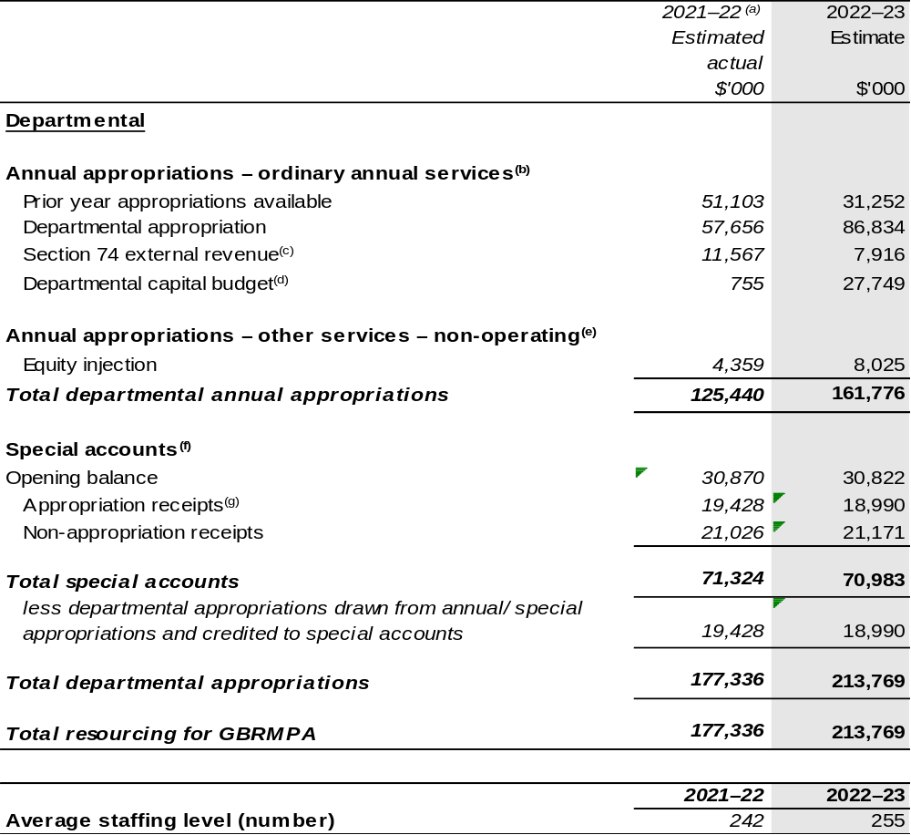
- Appropriation amounts presented for 2021–22 do not include the Appropriation Bills (No. 3) and (No. 4), as they had not been enacted at the time of publication. The entity will receive $1.158 million through the 2021–22 Annual Appropriation Bill (No. 3) and $7.168 million through the 2021–22 Annual Appropriation Bill (No. 4). The annual appropriations received from these bills will be recognised in a future portfolio budget statement but only after the Bills have received Royal Assent.
- Appropriation Bill (No. 1) 2022–2023.
- Estimated external revenue receipts under section 74 of the Public Governance, Performance and Accountability Act 2013 (PGPA Act).
- Departmental capital budgets are not separately identified in Appropriation Bill (No. 1) and form part of ordinary annual services items. Please refer to Table 3.7 for further details. For accounting purposes, this amount has been designated as a ‘contribution by owner’.
- Appropriation Bill (No. 2) 2022–23.
- Excludes trust moneys held in Services for Other Entities and Trust Moneys (SOETM) and other special accounts. For further information on special accounts, please refer to Budget Paper No. 4: Agency Resourcing 2022–23. Please also see Table 2.1 for further information on outcome and program expenses broken down by various sources, e.g. annual appropriations, special appropriation and special accounts.
- Amounts credited to the special account from the Reef Authority’s annual and special appropriations.

Please note: all figures shown above are GST exclusive – these may not match figures in the cash flow statement.
Prepared on a resourcing (i.e. appropriations available) basis.

1.3 Budget measures
Budget measures in Part 1 relating to the Great Barrier Reef Marine Park Authority are detailed in Budget Paper No. 2: Budget Measures 2022–23 and are summarised below.

Table 1.2: Great Barrier Reef Marine Park Authority – 2022–23 Budget measures – Measures announced since the 2021–22 Mid-Year Economic and Fiscal Outlook (MYEFO)
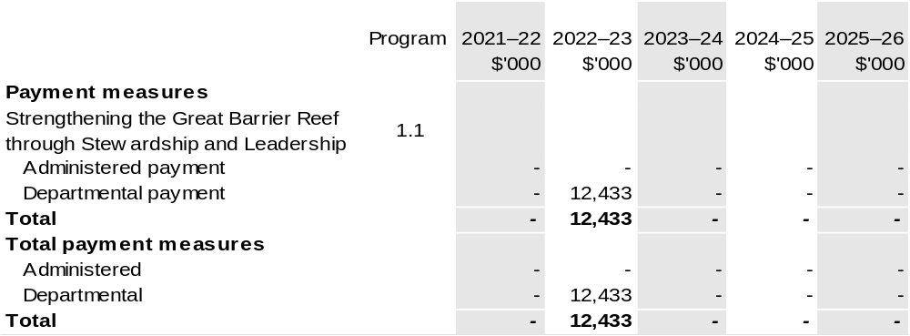

Prepared on a Government Finance Statistics (Underlying Cash) basis. Figures displayed as a negative (-) represent a decrease in funds and a positive (+) represent an increase in funds.

Section 2: Outcomes and planned performance
Government outcomes are the intended results, impacts or consequences of actions by the Government on the Australian community. Commonwealth programs are the primary vehicle by which government entities achieve the intended results of their outcome statements. Entities are required to identify the programs which contribute to Government outcomes over the Budget and forward years.
Each outcome is described below together with its related programs. The following provides detailed information on expenses for each outcome and program, further broken down by funding source.
Note:
Performance reporting requirements in the Portfolio Budget Statements are part of the Commonwealth performance framework established by the Public Governance, Performance and Accountability Act 2013. It is anticipated that the performance criteria described in Portfolio Budget Statements will be read with broader information provided in an entity’s corporate plans and annual performance statements – included in Annual Reports – to provide a complete picture of an entity’s planned and actual performance.
The most recent corporate plan for the Great Barrier Reef Marine Park Authority can be found at: http://www.gbrmpa.gov.au/about-us/corporate-plan.
The most recent annual performance statement can be found at: http://www.gbrmpa.gov.au/about-us/annual-report.

2.1 Budgeted expenses and performance for outcome 1
Outcome 1: The long-term protection, ecologically sustainable use, understanding and enjoyment of the Great Barrier Reef for all Australians and the international community, through the care and development of the Marine Park.

2.1.1: Linked programs
Australian Institute of Marine Science
Program 1: Marine Research
Contribution to Outcome 1 made by linked programs
The Reef Authority and the Australian Institute of Marine Science work together on implementation of the Reef 2050 Plan to protect and conserve the Great Barrier Reef.
Australian Maritime Safety Authority
Program 1.1: Australian Maritime Safety Authority
Contribution to Outcome 1 made by linked programs
The Reef Authority is the regulator responsible for the management of the Great Barrier Reef Marine Park. The Australian Maritime Safety Authority (AMSA) supports the ongoing management of the Great Barrier Reef through providing services to enable safer shipping within the Reef, such as: aids to navigation, Great Barrier Reef Vessel Traffic Services, emergency response arrangements to minimise maritime pollution incidents (including delivery of a dedicated emergency towage vessel) and regulation of shipping for safety and environmental performance.
The Reef Authority supports AMSA emergency response functions through provision of resources and subject matter expertise.
Clean Energy Finance Corporation
Program 1.1: Clean Energy Finance Corporation
Contribution to Outcome 1 made by linked programs
The Clean Energy Finance Corporation is making available up to $1 billion of investment finance over 10 years for the Reef Funding Program (the Program). The Program invests in clean energy projects delivered in the Great Barrier Reef catchment region. In targeting the financing of clean energy projects and businesses in the region, the Program supports delivery of the Australian and Queensland governments’ Reef 2050 Plan.

Continued on following page

2.1.1: Linked programs (continued)
Department of Agriculture, Water and the Environment
Program 1.1: Sustainable Management of Natural Resources and the Environment
Program 1.4: Conservation of Australia’s Heritage and Environment
Program 1.5: Environmental Regulation
Contribution to Outcome 1 made by linked programs
The Department of Agriculture, Water and the Environment and the Reef Authority work together on heritage management, environment health, species conservation and fisheries management as well as joint implementation of the Reef 2050 Plan to protect and conserve the Great Barrier Reef.
Director of National Parks
Program 1.1: Parks and Reserves: healthy and resilient parks, gardens and marine reserves, protecting nature and culture and valued by the community now and into the future.
Contribution to Outcome 1 made by linked programs
The Coral Sea Commonwealth Marine Reserve managed by the Director of National Parks adjoins the Great Barrier Reef Marine Park and provides complementary protection for ecosystems and biodiversity in the region.

2.1.2: Budgeted expenses for Outcome 1
This table shows how much the entity intends to spend (on an accrual basis) on achieving the outcome, broken down by program, as well as by administered and departmental funding sources.

Table 2.1: Budgeted expenses for Outcome 1
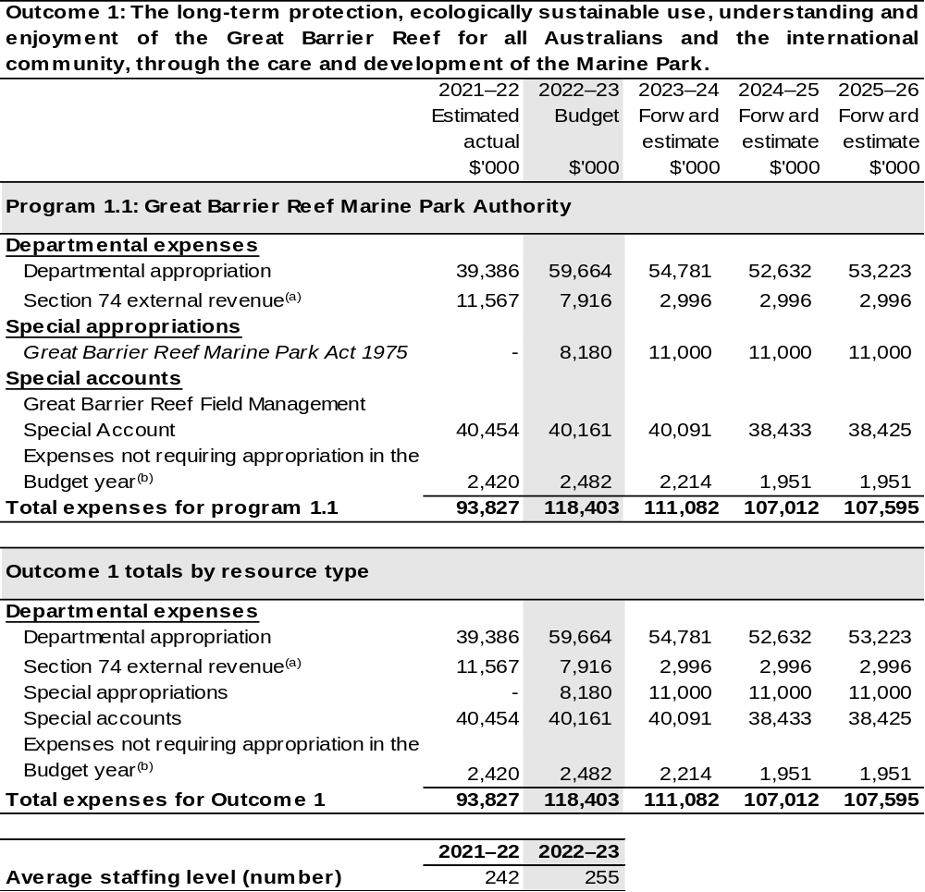

- Estimated expenses incurred in relation to receipts retained under section 74 of the PGPA Act.
- Expenses not requiring appropriation in the Budget year are made up of make good expenses, audit fees, and can include depreciation / amortisation expenses not requiring an appropriation.

Note: Departmental appropriation splits and totals are indicative estimates and may change in the course of the budget year as government priorities change.

Prepared on Australian Accounting Standards basis.

2.1.3: Performance criteria for Outcome 1
Table 2.1.3 details the performance measures for each program associated with Outcome 1. It also provides the related key activities as expressed in the current corporate plan where further detail is provided about the delivery of the activities related to the program, the context in which these activities are delivered and how the performance of these activities will be measured. Where relevant, details of 2022–23 Budget measures that have created new programs or materially changed existing programs are provided.
Outcome 1: The long-term protection, ecologically sustainable use, understanding and enjoyment of the Great Barrier Reef for all Australians and the international community through the care and development of the Marine Park.
Program 1.1: Great Barrier Reef Marine Park Authority
Objective | Protects and manages the environment, biodiversity, and heritage values of the Great Barrier Reef Region, and ensures the ecologically sustainable use and benefits of the Great Barrier Reef Marine Park for current and future generations.
Key Activities | Program 1.1 will be delivered by:  - Enhancing Reef resilience by providing expert knowledge to advise key decision makers on managing, reducing or avoiding significant threats to the Reef.  - Enhancing Reef resilience through innovation, management and regulation of the Marine Park and our in-field presence.  - Enhancing Reef resilience through partnerships, collaboration and education.  - Supporting a high-performing organisation.
Year | Performance measures | Expected Performance Results
Current year  2021–22 | The Reef is Protected:  - Percentage of allocated short-term actions that are ‘on track’ or ‘completed’ in the Aboriginal and Torres Strait Islander Heritage Strategy for the Great Barrier Reef Marine Park. | 75 per cent.
Current year  2021–22 | The Reef is Protected:  - Proportion of Policy and Planning Roadmap agreed actions for 2021–22 that are either ‘on track’ or ‘completed’. | 85 per cent.

Continued on following pages
2.1.3: Performance criteria for Outcome 1 (continued)
Year | Performance measures | Expected Performance Results
Current year  2021–22 (continued) | Sustainable use of the Reef:  - Proportion of Reef Joint Field Management Program Annual Business Plan targets achieved or with significant progress in  2021–22. | 85 per cent.
Current year  2021–22 (continued) | The Reef is Understood:  - Priority knowledge gaps are identified and understood. | The Reef Authority promotes the Science Information Needs Framework to key stakeholders (70 per cent/10 key stakeholders).  The number of priority knowledge gaps being addressed increases each financial year (with a target of a 10 per cent increase annually).
Current year  2021–22 (continued) | The Reef is Understood:  - Publication of a five-year Reef 2050 Integrated Monitoring and Reporting Program Business Strategy that defines activities to support resilience-based management and enable progress reporting against the Reef 2050 Plan. | The five-year Business Strategy – endorsed by partners – published on the Reef Authority’s website.
Current year  2021–22 (continued) | The Reef is Understood:  - Proportion of participants that ‘strongly agree’ or ‘agree’ that participating in initiatives delivered as part of the Reef Education and Engagement Implementation Plan 2020–2025:  - Inspires the audience to care about the Great Barrier Reef (Care).  - Increases the audience’s knowledge and understanding about the Great Barrier Reef (Learn).  - Encourages/motivates the audience to take environmental/sustainable actions (Act). | Care and Learn – 80 per cent.  Act – 75 per cent.  Share and Steward – 60 per cent.

Continued on following page

2.1.3: Performance criteria for Outcome 1 (continued)
Year | Performance measures | Expected Performance Results
Current year  2021–22 (continued) | - Encourages/motivates the audience to share their learning and experiences with others (Share).  - Encourages/motivates the audience to take actions that enhance Reef resilience (Steward).
Year | Performance measures | Planned Performance Results
Budget Year  2022–23 | - As per 2021–22. | As per 2021–22.
Budget Year  2022–23 | The Reef is Protected:  - Proportion of Policy and Planning Roadmap agreed actions for 2022–23 that are either ‘on track’ or ‘completed’. | 85 per cent.
Budget Year  2022–23 | Sustainable use of the Reef:  - Proportion of Reef Joint Field Management Program annual business plan targets achieved  or with significant progress  2022–23. | 85 per cent.
Budget Year  2022–23 | - As per 2021–22. | As per 2021–22.
Budget Year  2022–23 | The Reef is Understood:  - Implementation of the five-year Reef 2050 Integrated Monitoring and Reporting Program Business Strategy that defines activities to support resilience-based management and enable progress reporting against the Reef 2050 Plan. | Progress on the Reef 2050 Reporting Framework and its implementation, in accordance with the Reef 2050 Integrated Monitoring and Reporting Program’s 2022–23 Annual Business Plan.
Budget Year  2022–23 | - As per 2021–22. | As per 2021–22.
Forward Estimates 2023–26 | As per 2022–23. | As per 2022–23.

Section 3: Budgeted financial statements
Section 3 presents budgeted financial statements which provide a comprehensive snapshot of entity finances for 2022–23, including the impact of 2022–23 Budget measures and resourcing on financial statements.

3.1 Budgeted financial statements

3.1.1: Differences between entity resourcing and financial statements
The financial statements are prepared on an accrual basis where revenues and expenses are recognised as and when the resources are received and used. The entity resourcing table recognises cash resources available to be used during the period and includes amounts recognised as revenue in previous periods.

3.1.2: Explanatory notes and analysis of budgeted financial statements
Changes in appropriation from 2021–22 to 2022–23 are the result of the additional funding received in the 2021–22 Portfolio Additional Estimates Statements for the Centre of Excellence for Coral Reef Education at Reef HQ, and the Great Barrier Reef Package.

3.2 Budgeted financial statements tables

Table 3.1: Comprehensive income statement (showing net cost of services) for the period ended 30 June
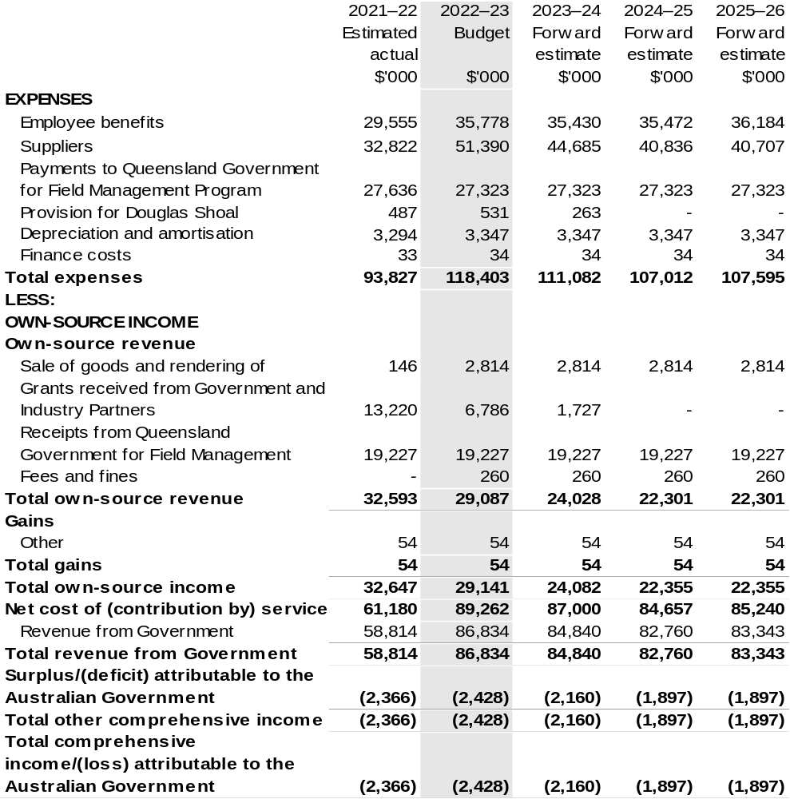

Continued on following page

Table 3.1: Comprehensive income statement (showing net cost of services) for the period ended 30 June (continued)
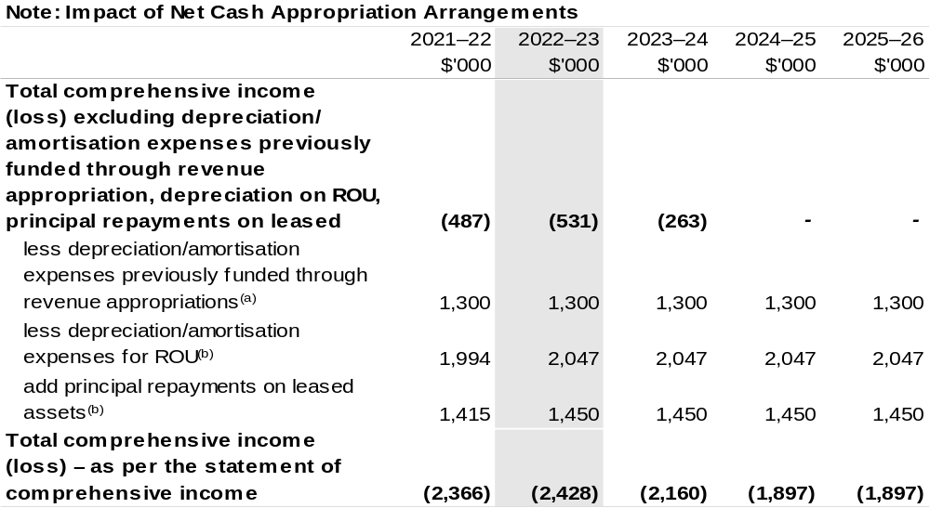

- From 2010–11, the Government introduced net cash appropriation arrangements where Appropriation
Bill (No. 1) revenue appropriations for the depreciation/amortisation expenses of non-corporate Commonwealth entities (and select corporate Commonwealth entities) were replaced with a separate capital budget (the Departmental Capital Budget, or DCB) provided through Appropriation Bill (No. 1) equity appropriations. For information regarding DCBs, please refer to Table 3.5 Departmental Capital Budget Statement.
- Applies to leases under AASB 16 Leases. Right of Use (ROU).

Prepared on Australian Accounting Standards basis.

Table 3.2: Budgeted departmental balance sheet (as at 30 June)
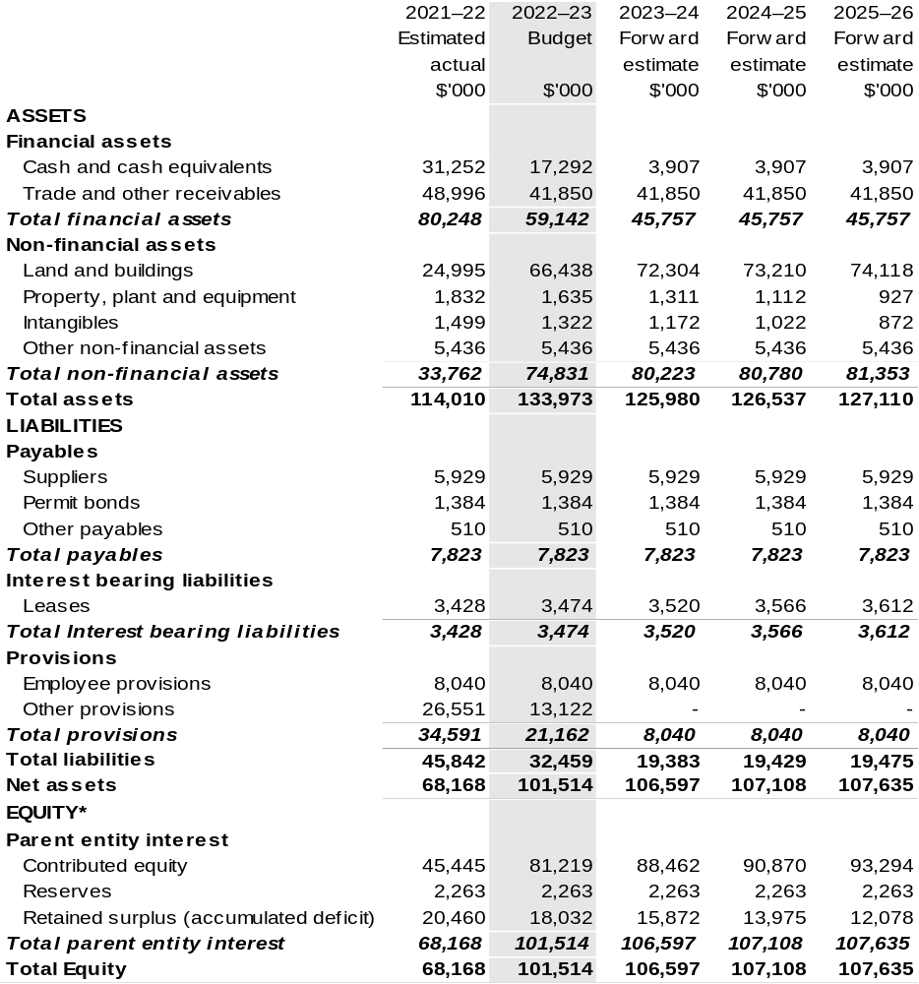

*’Equity’ is the residual interest in assets after deduction of liabilities.

Prepared on Australian Accounting Standards basis.

Table 3.3: Departmental statement of changes in equity – summary of movement (Budget year 2022–23)
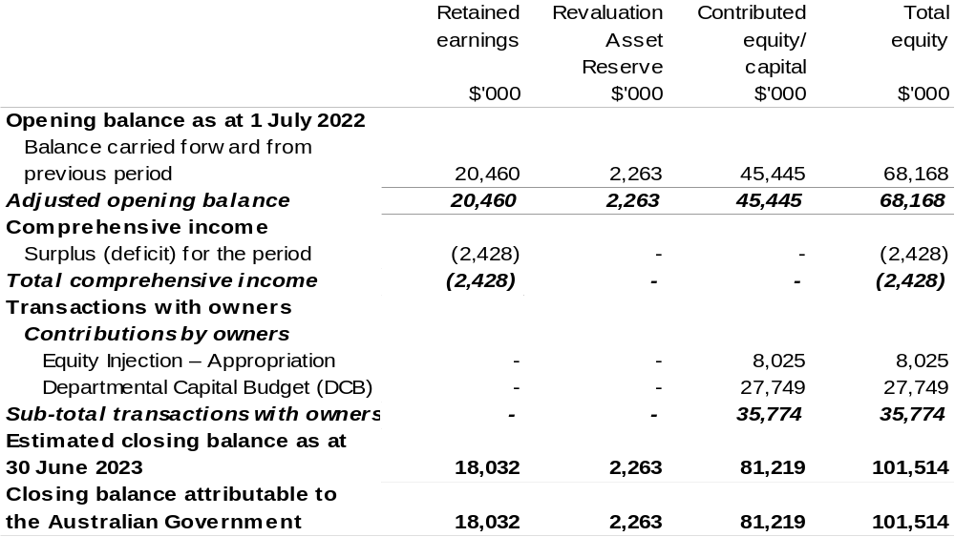

Prepared on Australian Accounting Standards basis.

Table 3.4: Budgeted departmental statement of cash flows (for the period
ended 30 June)
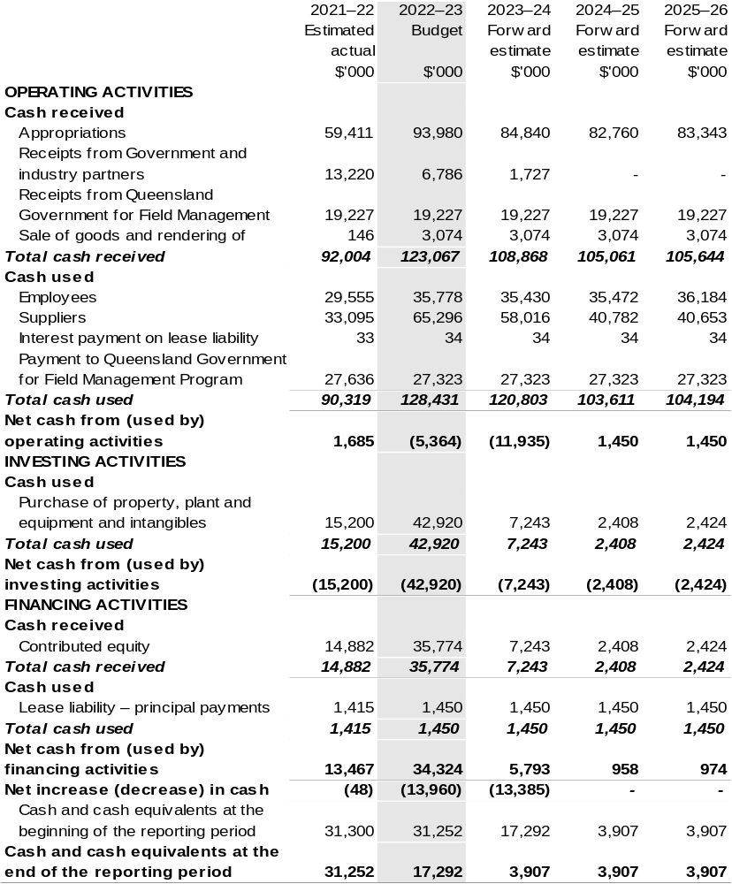

Prepared on Australian Accounting Standards basis.

Table 3.5: Departmental capital budget statement (for the period ended 30 June)
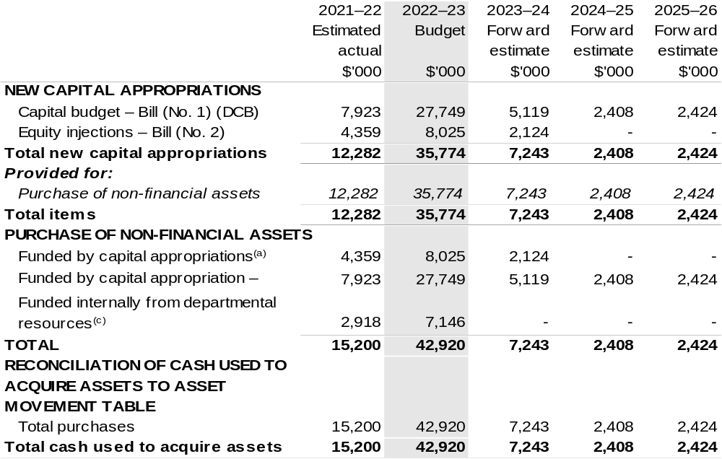

- Includes current Appropriation Bill (No. 2) and prior year Appropriation Act No. 2/4/6.
- Does not include annual finance lease costs. Include purchases from current and previous years’ Departmental capital budgets (DCBs).
- Includes the following s74 external revenue:
– current Bill (No. 1) and prior year Act/Bill (No. 1/3/5) appropriations (excluding amounts from the
DCBs);
– sponsorship, subsidy, gifts or similar contribution;
– internally developed assets; and
– proceeds from the sale of assets.

Consistent with information contained in the Statement of Asset Movements and the Budgeted Statement of Cash Flows.

Prepared on Australian Accounting Standards basis.

Table 3.6: Statement of asset movements (Budget year 2022–23)
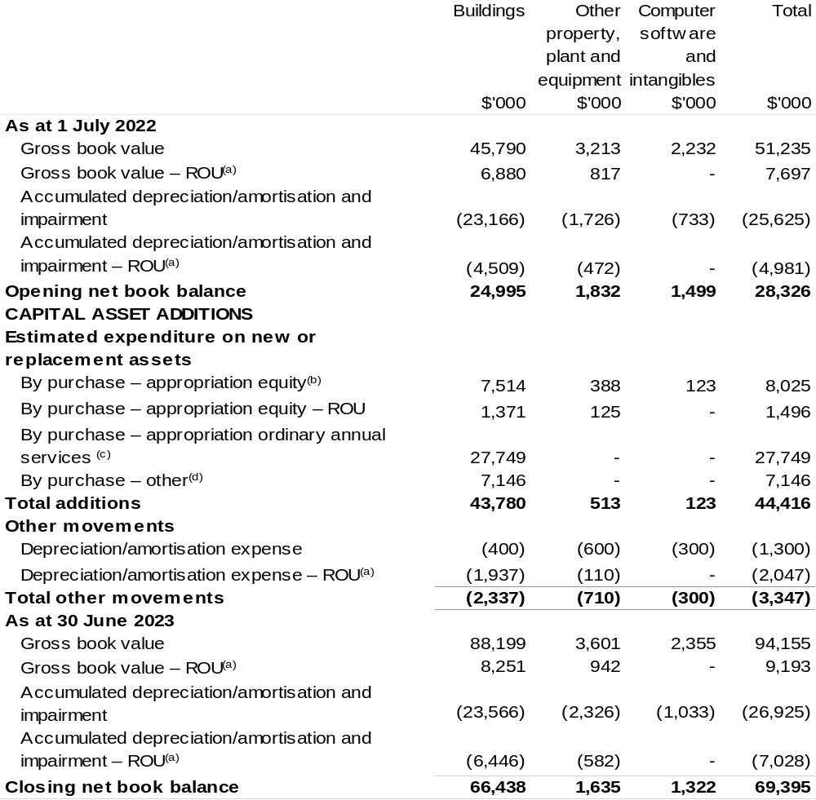

(a) Applies to leases under AASB 16 Leases. Right of Use (ROU).
(b) ‘By purchase – Appropriation equity’ refers to equity injections appropriations provided through Appropriation Bill (No. 2) 2022–23, including Collection Development Acquisition Budgets.
(c) ‘By purchase – Appropriation ordinary annual services' refers to funding provided through Appropriation Bill (No. 1) 2022–23 for depreciation/amortisation expenses, Departmental Capital Budget or other operational expenses.
(b) ‘By purchase – other' refers to funding provided through other internal funding sources.

Prepared on Australian Accounting Standards basis.

Table 3.7: Schedule of budgeted income and expenses administered on behalf of Government (for the period ended 30 June)
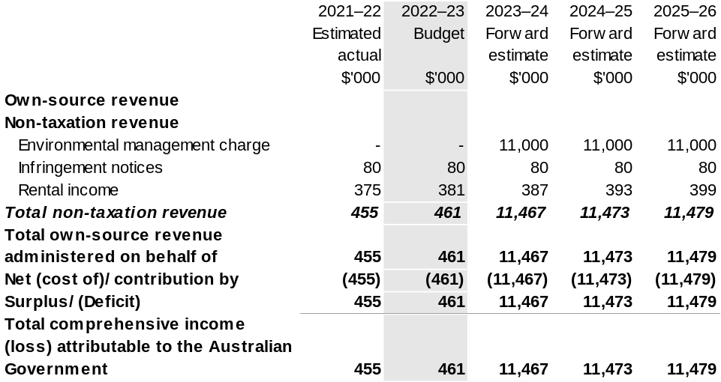

Prepared on Australian Accounting Standards basis.

Table 3.8: Schedule of budgeted assets and liabilities administered on behalf of Government (as at 30 June)
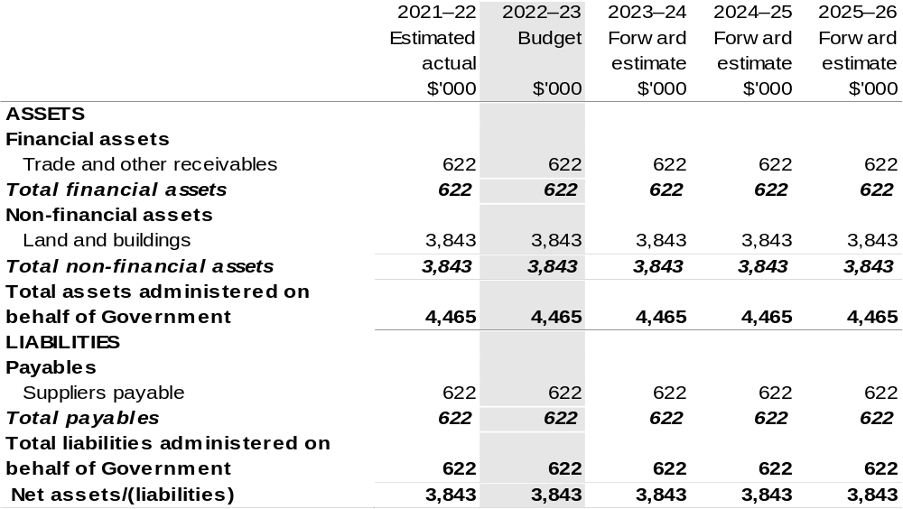

Prepared on Australian Accounting Standards basis.

Table 3.9: Schedule of budgeted administered cash flows (for the period
ended 30 June)
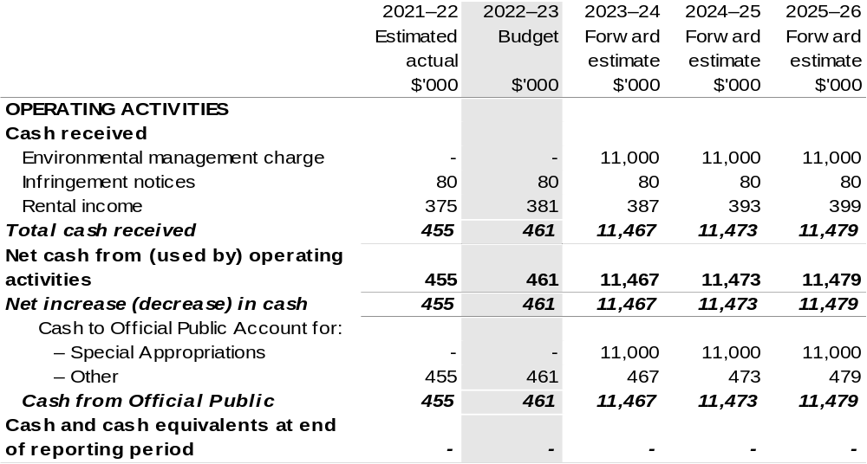

Prepared on Australian Accounting Standards basis.

Table 3.10: Statement of asset movements (Budget year 2022–23)
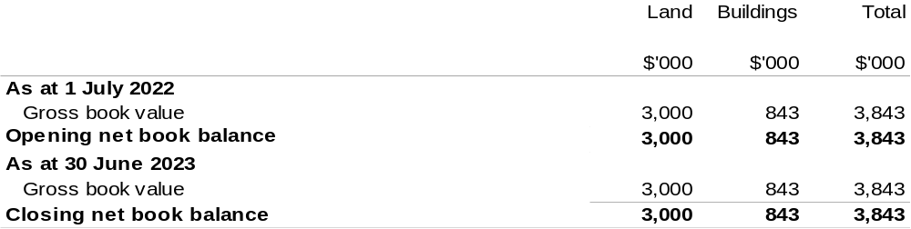

Prepared on Australian Accounting Standards basis.

Murray-Darling Basin Authority
Section 1: Entity overview and resources 315
1.1 Strategic direction statement 315
1.2 Entity resource statement 317
1.3 Budget measures 319
Section 2: Outcomes and planned performance 320
2.1 Budgeted expenses and performance for Outcome 1 321
Section 3: Budgeted financial statements 325
3.1 Budgeted financial statements 325
3.2 Budgeted financial statements tables 326

Murray-Darling Basin Authority

Section 1: Entity overview and resources

1.1 Strategic direction statement
The Murray-Darling Basin Authority (MDBA) is an independent government agency which, in partnership with Murray-Darling Basin (Basin) governments, manages the Basin’s water resources in the national interest. The MDBA’s top priority is the wellbeing and resilience of the Basin’s river system, its people and places. The MDBA achieves this through its outcome:
Outcome 1: Equitable and sustainable use of the Murray-Darling Basin by governments and the community including through development and implementation of a Basin Plan, operation of the River Murray system, shared natural resource management programmes, research, information and advice.
Our purpose
To advance the sustainability, productivity, wellbeing and resilience of the Basin and its communities.
Our objectives
During 2022–23, the MDBA has two key activities:

- Drive the successful implementation of the Basin Plan; and
- Efficiently and effectively operate the River Murray System for Basin governments.
Areas of focus include:

- Assessing water resource plans for consistency with the Basin Plan for accreditation including enabling amendments to accredited water resource plans;
- Completing the sustainable diversion limits accounts and actions arising;
- Developing annual watering priorities;
- Developing the roadmap for the 2026 Basin Plan and undertaking effectiveness and impact assessments of the Basin Plan;
- Conducting quality research to inform Basin water resource management;
- Implementing asset management strategies and oversee asset management activities;
- Managing and delivering Basin government water shares in accordance with the Murray-Darling Basin Agreement (Agreement);
- Maintaining and improving the health of the River Murray system (and the Basin where relevant) in accordance with the Agreement and associated agreements; and
- Commencing the four-year program to integrate Murray-Darling Basin River modelling.
Murray-Darling Basin Agreement functions
In addition to its functions under the Water Act 2007 (the Act), the MDBA has functions under the Agreement, which forms Schedule 1 to the Act. These functions include giving effect to decisions of the Murray-Darling Basin Ministerial Council and the Basin Officials’ Committee in relation to the Basin governments’ joint programs. The MDBA delivers its functions under the Agreement in conjunction with and on behalf of the contracting governments – the Australian Government and the governments of Victoria, South Australia, New South Wales, Queensland and the Australian Capital Territory.

1.2 Entity resource statement
Table 1.1 shows the total funding from all sources available to the entity for its operations and to deliver programs and services on behalf of the Government.
The table summarises how resources will be applied by outcome (Government strategic policy objectives) and by administered (on behalf of the Government or the public) and departmental (for the entity’s operations) classification.
For more detailed information on special accounts and special appropriations, please refer to Budget Paper No. 4: Agency Resourcing.
Information in this table is presented on a resourcing (i.e. appropriations/cash available) basis, whilst the ‘Budgeted expenses by Outcome’ tables in Section 2 and the financial statements in Section 3 are presented on an accrual basis.

Table 1.1: Murray-Darling Basin Authority – Resource Statement – Budget Estimates for 2022–23 as at Budget March 2022
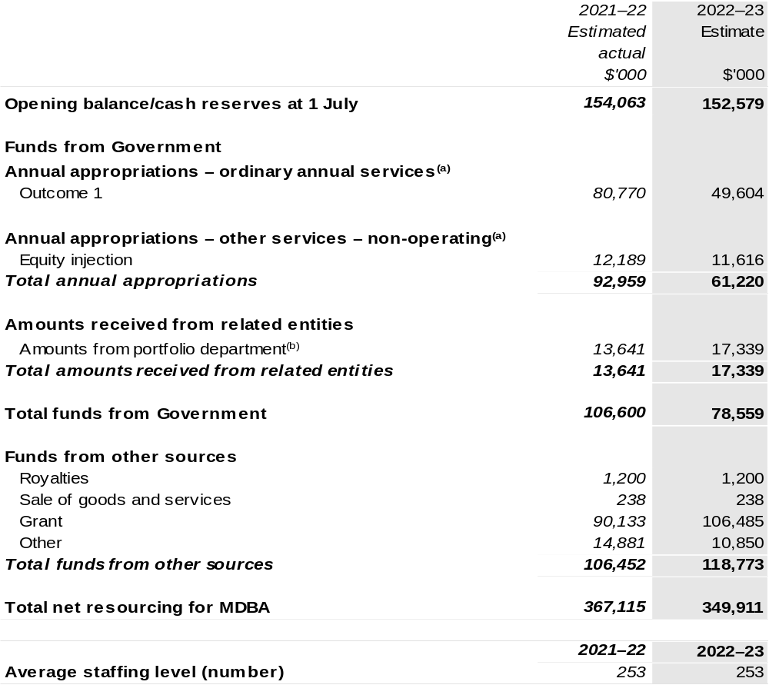

Continued on following page
Table 1.1: Murray-Darling Basin Authority – Resource Statement – Budget Estimates for 2022–23 as at Budget March 2022 (continued)
(a) Appropriation Bill (No. 1) and Bill (No. 2) 2022–23. Appropriation is provided through the Department of Agriculture, Water and the Environment (DAWE) and is specified with the Annual Appropriation Bills as payment to the MDBA and is considered departmental for all purposes.
(b) Funding provided by the portfolio department that is not specified within the Annual Appropriation Bills as a payment to that corporate Commonwealth entity (CCE) (for example, a grant awarded to a CCE from one of its portfolio department's administered programs).

Please note: All figures shown above are GST exclusive – these may not match figures in the cash flow statement.

Prepared on a resourcing (i.e. appropriations available) basis.

1.3 Budget measures
Budget measures in Part 1 relating to the Murray-Darling Basin Authority are detailed in Budget Paper No. 2: Budget Measures 2022–23 and are summarised below.

Table 1.2: Murray-Darling Basin Authority – 2022–23 Budget measures – Measures announced since the 2021–22 Mid-Year Economic and Fiscal Outlook (MYEFO)
Murray-Darling Basin Authority does not have any 2022–23 Budget measures.

Section 2: Outcomes and planned performance
Government outcomes are the intended results, impacts or consequences of actions by the Government on the Australian community. Commonwealth programs are the primary vehicle by which government entities achieve the intended results of their outcome statements. Entities are required to identify the programs which contribute to Government outcomes over the Budget and forward years.
Each outcome is described below together with its related programs. The following provides detailed information on expenses for each outcome and program, further broken down by funding source.
Note:
Performance reporting requirements in the Portfolio Budget Statements are part of the Commonwealth performance framework established by the Public Governance, Performance and Accountability Act 2013. It is anticipated that the performance criteria described in Portfolio Budget Statements will be read with broader information provided in an entity’s corporate plans and annual performance statements – included in Annual Reports – to provide a complete picture of an entity’s planned and actual performance.

MDBA’s most recent corporate plan can be found at: https://www.mdba.gov.au/publications/policies-guidelines/corporate-plan.

MDBA’s most recent annual performance statement can be found at:
Murray–Darling Basin Authority annual reports | Murray-Darling Basin Authority (mdba.gov.au).

2.1 Budgeted expenses and performance for Outcome 1
Outcome 1: Equitable and sustainable use of the Murray-Darling Basin by governments and the community including through development and implementation of a Basin Plan, operation of the River Murray system, shared natural resource management programs, research, information and advice.

2.1.1: Linked programs
Department of Agriculture, Water and the Environment
Program 1.3: Commonwealth Environmental Water
Program 5.1: Water Reform
Contribution to Outcome 1 made by linked programs:
The MDBA works collaboratively with the Department of Agriculture, Water and the Environment (DAWE) to implement the Murray-Darling Basin Plan and the Intergovernmental Agreement on Murray-Darling Basin Reform.
MDBA and DAWE also work together on the operation of the River Murray System, shared natural resource management programs, research, information, advice and Basin Plan reporting obligations, all of which contribute to the management of Commonwealth environmental water.
Bureau of Meteorology
Program 1.1: Bureau of Meteorology
Contribution to Outcome 1 made by linked program:
The Bureau of Meteorology provides weather, climate and water modelling, insight, data and analysis to the MDBA.

2.1.2: Budgeted expenses for Outcome 1
This table shows how much the entity intends to spend (on an accrual basis) on achieving the outcome, broken down by program, as well as by administered and departmental funding sources.

Table 2.1: Budgeted expenses for Outcome 1
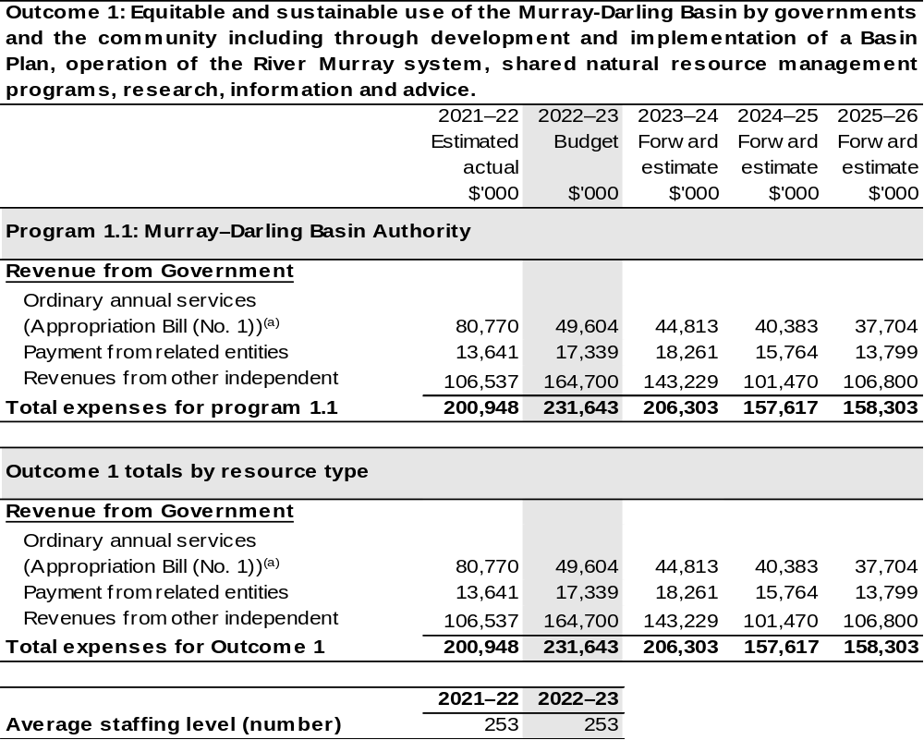

(a) Appropriation Bill (No. 1) 2022–23. The MDBA is a CCE under the Public Governance, Performance and Accountability Act 2013 (PGPA Act) and does not receive direct appropriations. Appropriation is provided through DAWE and is specified with the Annual Appropriation Bills as payment to the MDBA and is considered departmental for all purposes.
(b) Revenues from other independent sources include contributions from jurisdictions for Agreement functions, other miscellaneous revenue and funds drawn from the Murray-Darling Basin special account. The Murray-Darling Basin special account is not a Special Account for the purpose of the PGPA Act.

Note: Departmental appropriation splits and totals are indicative estimates and may change in the course of the budget year as government priorities change.

Prepared on Australian Accounting Standards basis.

2.1.3: Performance criteria for Outcome 1
Table 2.1.3 details the performance measures for each program associated with Outcome 1. It also provides the related key activities as expressed in the current corporate plan where further detail is provided about the delivery of the activities related to the program, the context in which these activities are delivered and how the performance of these activities will be measured. Where relevant, details of 2022–23 Budget measures that have created new programs or materially changed existing programs are provided.
Outcome 1 – Equitable and sustainable use of the Murray-Darling Basin by governments and the community including through development and implementation of a Basin Plan, operation of the River Murray system, shared natural resource management programs, research, information and advice.
Program 1.1: Equitable and sustainable use of the Murray-Darling Basin
Objective | To improve the sustainability of the Murray-Darling Basin through integrated reform and management of water and other natural resources for the long-term benefit of the Australian community.
Key Activities | Successful implementation of the Basin Plan and operation of the River Murray System.
Year | Performance measures | Expected Performance Results
Current year  2021–22 | Drive the successful implementation of the Basin Plan. | The MDBA is on track to meet its performance measures for 2021–22.  The measures and evidence of progress against this measure will be described in the Authority’s Annual Performance Statement 2021–22 in line with the evidence targets described in the 2021–22 Corporate Plan.
Current year  2021–22 | Efficiently and effectively operate the River Murray System for partner governments. | The MDBA is on track to meet its performance measures for 2021–22.  The measures and evidence of progress against this measure will be described in the Authority’s Annual Performance Statement 2021–22 in line with the evidence targets described in the 2021–22 Corporate Plan.

Continued on following page
2.1.3: Performance criteria for Outcome 1 (continued)
Year | Performance measures | Planned Performance Results
Budget Year  2022–23 | As per 2021–22. | The measures and evidence of progress against this measure will be described in the Authority’s Annual Performance Statement 2022–23 in line with the evidence targets described in the 2022–23 Corporate Plan.
Forward Estimates  2023–26 | As per 2022–23. | As per 2022–23.

Section 3: Budgeted financial statements
Section 3 presents budgeted financial statements which provide a comprehensive snapshot of entity finances for 2022–23, including the impact of 2022–23 Budget measures and resourcing on financial statements.

3.1 Budgeted financial statements

3.1.1: Differences between entity resourcing and financial statements
There are no differences between the resource information presented in the Budget Papers and Portfolio Budget Statements.

3.1.2: Explanatory notes and analysis of budgeted financial statements
Revenue is credited to the Murray-Darling Basin special account from the following:
• Funding received through DAWE for Basin Plan functions and the South Australian Riverland Floodplain Integrated Infrastructure Project (SARFIIP) (refer below);
• Australian Government contribution to the Agreement; and
• State and territory government contributions and miscellaneous revenue from other sources (for example, property revenues, hydro generation and sale of assets) for the Agreement functions.
Australian Government and state and territory government contributions to the Agreement functions, which are reflected as grants income in the financial statements and grants cash in the balance sheet, for 2022–23, and forward years represent amounts as per the 2021–22 work plan approved by Ministerial Council.
Where appropriate, expenses, both employees and suppliers, have been adjusted to reflect the appropriations and changes in revenues resulting from any revised contributions to the joint programs.
The MDBA has budgeted for an operating deficit in 2022–23 which is impacted by the need to complete a number of joint programs (i.e. programs funded through
non-appropriation receipts), including for river and environmental management programs and the residual components of the Environmental Works and Measures Program, SARFIIP, Hydrometric Networks and Remote Sensing Program, Water and Environment Research Program for which funds have been retained in the
Murray-Darling Basin special account.

3.2 Budgeted financial statements tables

Table 3.1: Comprehensive income statement (showing net cost of services) (for the period ended 30 June)
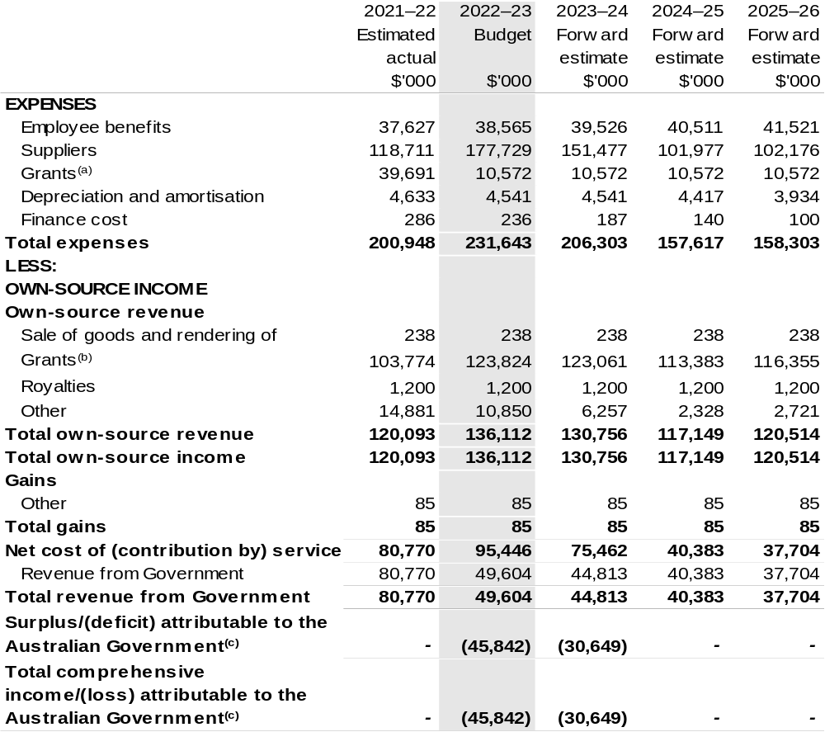

Continued on following page

Table 3.1: Comprehensive income statement (showing net cost of services) (for the period ended 30 June) (continued)
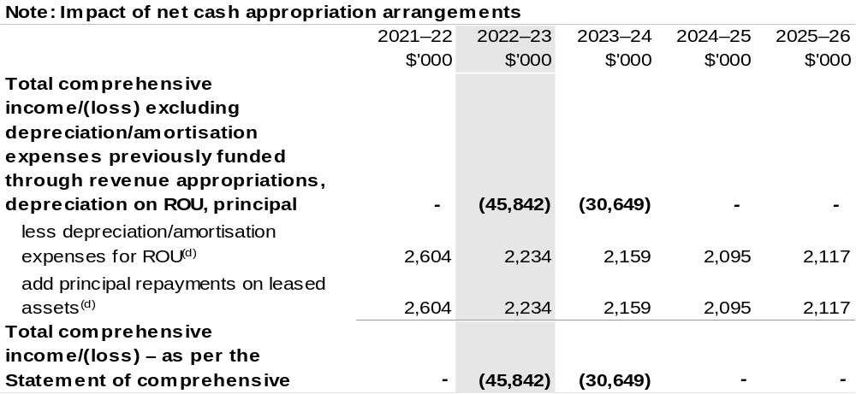

(a) The amount includes payment to South Australia under the SARFIIP. This program was due to be completed in 2019–20. However, the SARFIIP was extended by two years in the 2020–21 Budget, with additional funding of $37.600 million ($7.630 million in 2020–21 and $29.970 million in 2021–22).
Other payments relate to grants paid to other jurisdictions, non-profit organisations and the private sector.
(b) 2022–23 and the forward years represent amounts as per 2021–22 Joint Program work plan approved by the Ministerial Council.
(c) The MDBA’s operating loss is an outcome of a technical accounting treatment related to the revenue recognition. The accounting treatment results in an operating surplus in the year revenue is received but not spent, and an operating loss in the subsequent years when funds are spent.
(d) Applies to leases under AASB 16 Leases. Right of Use (ROU).

Prepared on Australian Accounting Standards basis.

Table 3.2: Budgeted departmental balance sheet (as at 30 June)
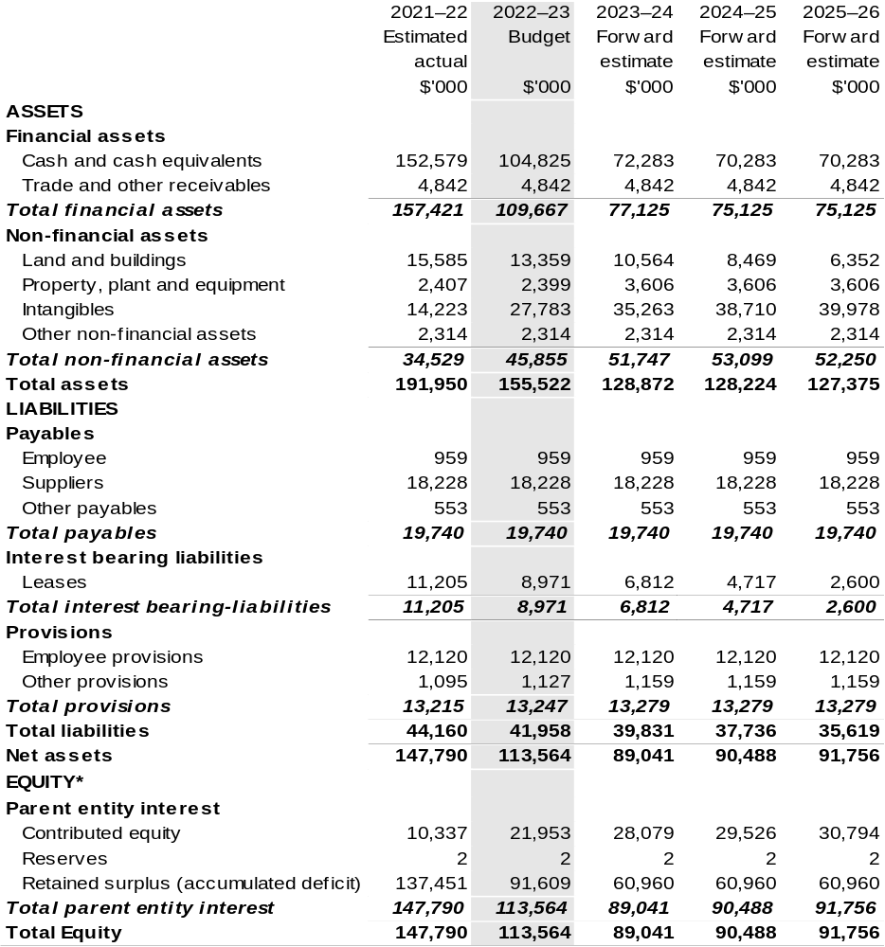

*Equity is the residual interest in assets after deduction of liabilities.

Prepared on Australian Accounting Standards basis.

Table 3.3: Departmental statement of changes in equity – summary of movement (Budget year 2022–23)
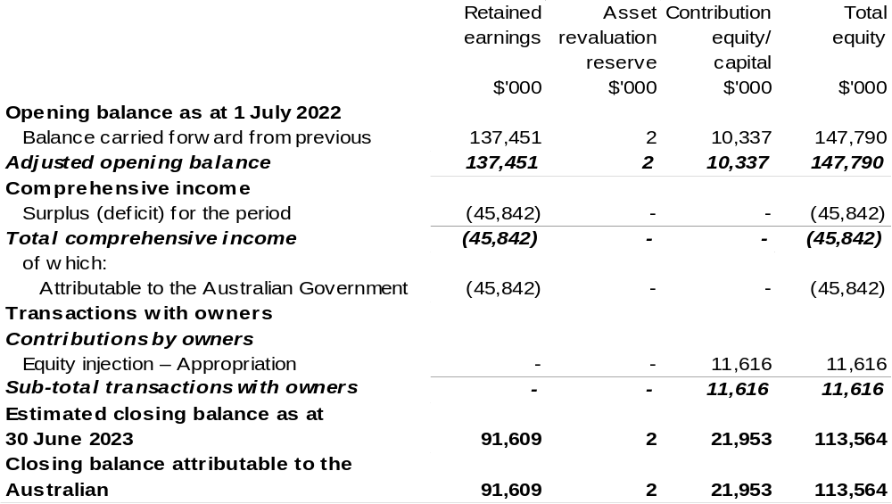

Prepared on Australian Accounting Standards basis.

Table 3.4: Budgeted departmental statement of cash flows (for the period
ended 30 June)
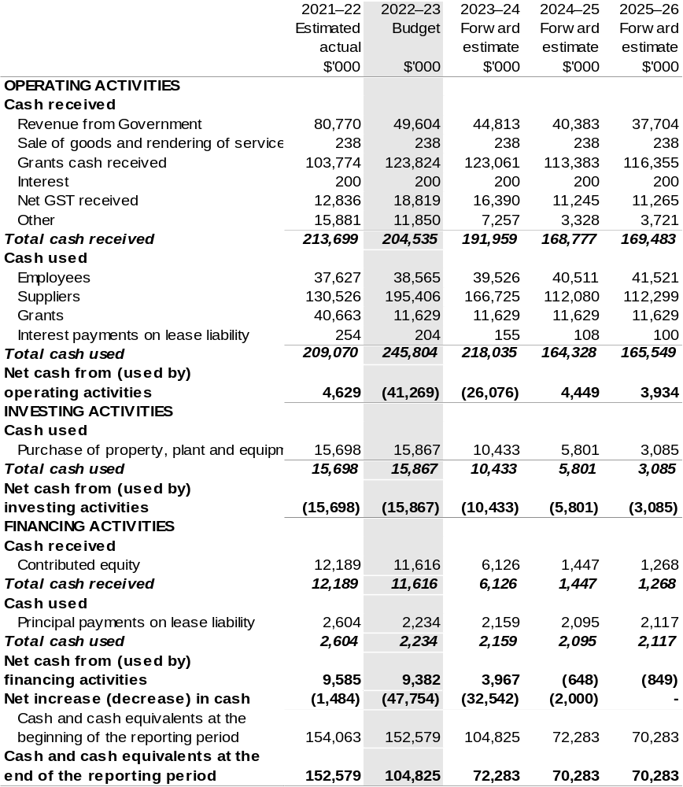

Prepared on Australian Accounting Standards basis.

Table 3.5: Departmental capital budget statement (for the period ended 30 June)
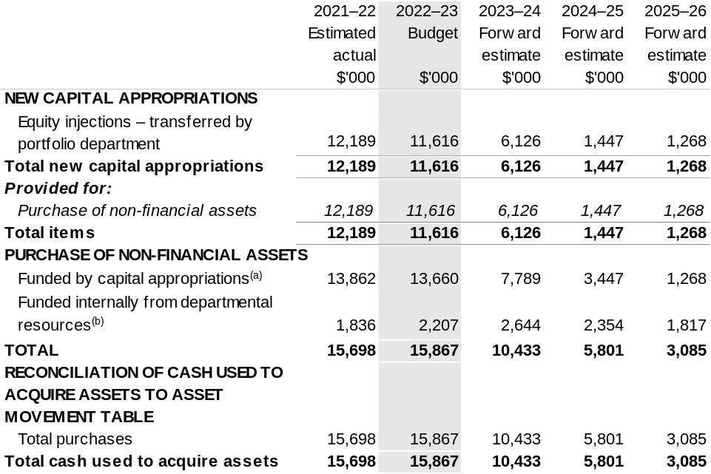

(a) Includes current Appropriation Bill (No. 2) and prior year Appropriation Act No. (2/4/6).
(b) Includes the following s74 external revenue:
– internally developed assets.

Consistent with information contained in the Statement of Asset Movements and the Budgeted Statement of Cash Flows.

Prepared on Australian Accounting Standards basis.

Table 3.6: Statement of asset movements (Budget year 2022–23)
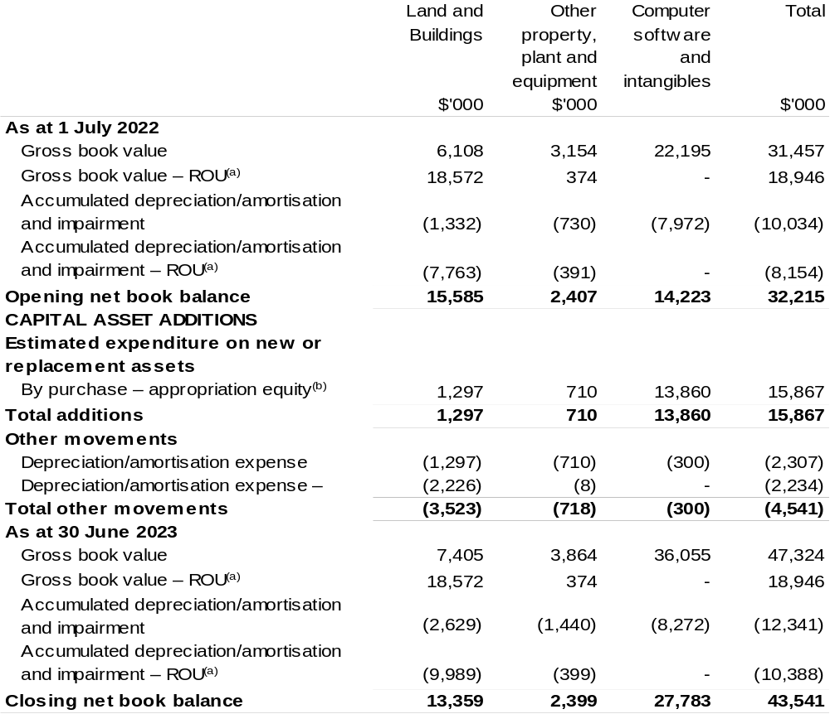

(a) Applies to leases under AASB 16 Leases. Right of Use (ROU).
(b) ‘Appropriation equity’ refers to equity injections appropriations provided through Appropriation Bill (No. 2) 2022–23, including Collection Development Acquisition Budgets; and other internal funding sources.

Prepared on Australian Accounting Standards basis.

Table 3.7: Schedule of budgeted income and expenses administered on behalf of Government (for the period ended 30 June)
The schedule of budgeted income and expenses administered on behalf of Government does not apply to the MDBA.

Table 3.8: Schedule of budgeted assets and liabilities administered on behalf of Government (as at 30 June)
The schedule of budgeted assets and liabilities administered on behalf of Government does not apply to the MDBA.

Table 3.9: Schedule of budgeted administered cash flows (for the period
ended 30 June)
The schedule of budgeted administered cash flows on behalf of Government does not apply to the MDBA.

Regional Investment Corporation
Section 1: Entity overview and resources 337
1.1 Strategic direction statement 337
1.2 Entity resource statement 338
1.3 Budget measures 339
Section 2: Outcomes and planned performance 340
2.1 Budgeted expenses and performance for Outcome 1 341
Section 3: Budgeted financial statements 345
3.1 Budgeted financial statements 345
3.2 Budgeted financial statements tables 346

Regional Investment Corporation

Section 1: Entity overview and resources

1.1 Strategic direction statement
The Regional Investment Corporation (RIC) is a corporate Commonwealth entity established by the Regional Investment Corporation Act 2018. An independent Board oversees the RIC and is responsible for providing loans to eligible farm businesses, farm-related small businesses and forestry businesses.
The RIC Board also provides independent advice to the Minister for Agriculture and Northern Australia on the making of individual grants or arrangements for projects and activities that build drought resilience to be funded by the Future Drought Fund.
The RIC streamlines the administration of concessional loans by delivering loans that are assessed in a nationally consistent, prudent and timely manner. Loans are targeted at farm businesses and farm-related small businesses impacted by drought and those that are in financial need that mainly supply, or intend to mainly supply, products into supply chains that are interstate or overseas. Loans are also targeted at forestry businesses to encourage new plantation developments and the replanting of bushfire damaged plantation areas.
The concessional loan programs support the long-term strength, resilience and profitability of eligible farm businesses, farm-related small businesses and forestry businesses with $266 million in loan funding available for the RIC in 2022–23.
This funding recognises the importance of RIC loans for farmers, foresters and small businesses in need of practical assistance and the high demand for RIC loan products.
The RIC achieves this through its outcome:
Outcome 1: Encourage growth, investment and resilience in Australian farm businesses and rural and regional communities by delivering the Commonwealth’s farm business concessional loans.

1.2 Entity resource statement
Table 1.1 shows the total funding from all sources available to the entity for its operations and to deliver programs and services on behalf of the Government.
The table summarises how resources will be applied by outcome (Government strategic policy objectives) and by administered (on behalf of the Government or the public) and departmental (for the entity’s operations) classification.
For more detailed information on special accounts and special appropriations, please refer to Budget Paper No. 4: Agency Resourcing.
Information in this table is presented on a resourcing (i.e. appropriations/cash available) basis, whilst the ‘Budgeted expenses by Outcome 1’ tables in Section 2 and the financial statements in Section 3 are presented on an accrual basis.

Table 1.1: Regional Investment Corporation – Resource Statement – Budget Estimates for 2022–23 as at Budget March 2022
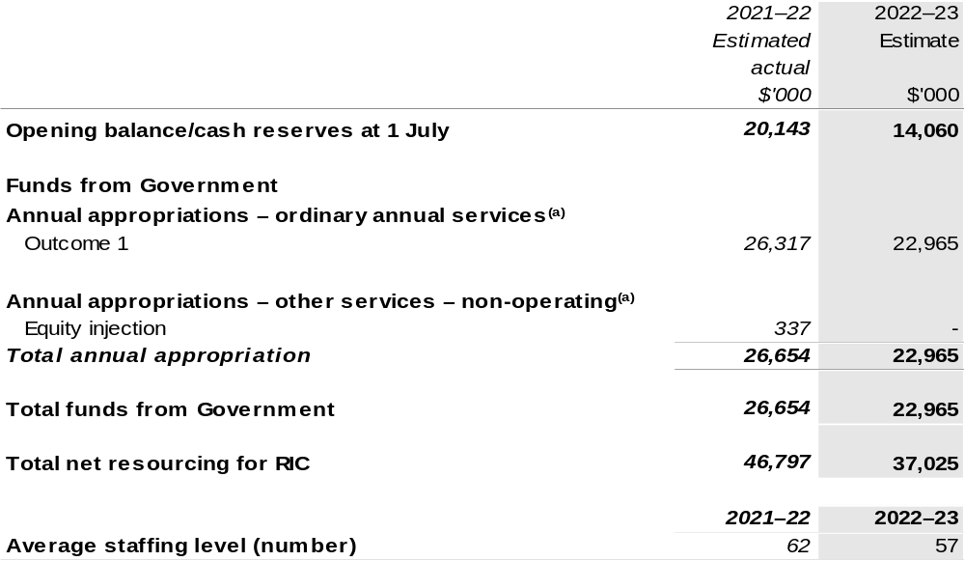

(a) Appropriation Bill (No. 1) and Bill (No. 2) 2022–23. Appropriation is provided through the Department of Agriculture, Water and the Environment (DAWE) and is specified with the Annual Appropriation Bills as payment to the RIC and is considered departmental for all purposes.

Please note: All figures shown above are GST exclusive – these may not match figures in the cash flow statement.

Prepared on a resourcing (i.e. appropriations available) basis.

1.3 Budget measures
Budget measures in Part 1 relating to the Regional Investment Corporation are detailed in Budget Paper No. 2: Budget Measures 2022–23 and are summarised below.

Table 1.2: Regional Investment Corporation – 2022–23 Budget measures – Measures announced since the 2021–22 Mid-Year Economic and Fiscal Outlook (MYEFO)
Regional Investment Corporation does not have any 2022–23 Budget measures.

Section 2: Outcomes and planned performance
Government outcomes are the intended results, impacts or consequences of actions by the Government on the Australian community. Commonwealth programs are the primary vehicle by which government entities achieve the intended results of their outcome statements. Entities are required to identify the programs which contribute to Government outcomes over the Budget and forward years.
Each outcome is described below together with its related programs. The following provides detailed information on expenses for each outcome and program, further broken down by funding source.
Note:
Performance reporting requirements in the Portfolio Budget Statements are part of the Commonwealth performance framework established by the Public Governance, Performance and Accountability Act 2013. It is anticipated that the performance criteria described in Portfolio Budget Statements will be read with broader information provided in an entity’s corporate plans and annual performance statements – included in Annual Reports – to provide a complete picture of an entity’s planned and actual performance.
The most recent corporate plan for the Regional Investment Corporation can be found at: www.ric.gov.au/about/corporate-plan.
The most recent annual report for the Regional Investment Corporation can be found at: http://www.ric.gov.au/about/reporting/annual-report.

2.1 Budgeted expenses and performance for Outcome 1
Outcome 1: Encourage growth, investment and resilience in Australian farm businesses and rural and regional communities by delivering the Commonwealth’s farm business concessional loans.

2.1.1: Linked programs
Department of Agriculture, Water and the Environment
- Program 3.3: Forestry Industry
- Program 3.11: Drought Programs
Contribution to Outcome 1 made by linked program:
The RIC works together with DAWE to ensure more sustainable, productive, internationally competitive and profitable Australian agricultural and forestry industries.

2.1.2: Budgeted expenses for Outcome 1
This table shows how much the entity intends to spend (on an accrual basis) on achieving the outcome, broken down by program, as well as by administered and departmental funding sources.

Table 2.2: Budgeted expenses for Outcome 1
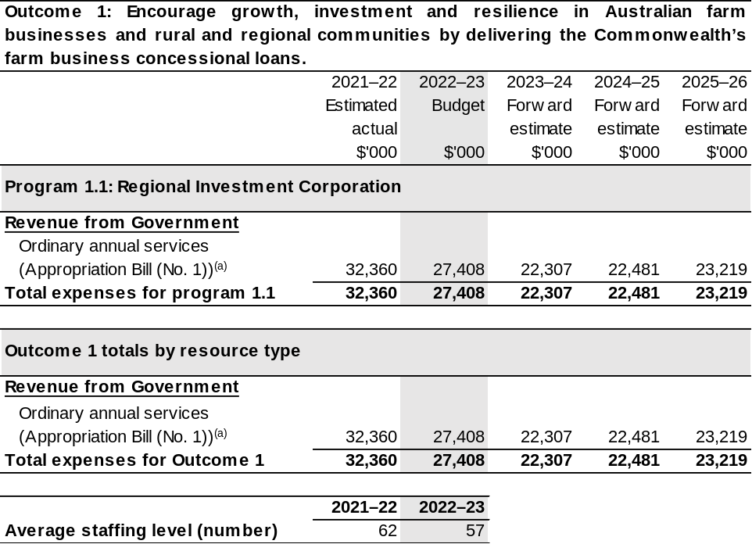
(a) Appropriation Bill (No. 1) 2022–23. The RIC is a corporate Commonwealth entity under the Public Governance, Performance and Accountability Act 2013 (PGPA Act) and does not receive direct appropriations. Appropriation is provided through DAWE and is specified with the Annual Appropriation Bills as payment to the RIC and is considered departmental for all purposes.

Note: Departmental appropriation splits and totals are indicative estimates and may change in the course of the budget year as government priorities change.

Prepared on Australian Accounting Standards basis.

2.1.3: Performance criteria for Outcome 1
Table 2.1.3 details the performance measures for each program associated with Outcome 1. It also provides the related key activities as expressed in the current corporate plan where further detail is provided about the delivery of the activities related to the program, the context in which these activities are delivered and how the performance of these activities will be measured. Where relevant, details of 2022–23 Budget measures that have created new programs or materially changed existing programs are provided.
Outcome 1 – Encourage growth, investment and resilience in Australian farm businesses and rural and regional communities by delivering the Commonwealth’s farm business concessional loans.
Program 1.1: Regional Investment Corporation
Objectives | Provide practical support and investment to help rural and regional communities achieve economic growth, agricultural productivity, and resilience through the delivery of farm business loans, farm-related small business loans and plantation development loans.  The RIC’s farm business loans and farm related small business loans provide low-cost finance to businesses that are in financial need of assistance, to recover from short-term hardship, but are assessed as financially viable over the long-term and able to repay the loan.  The RIC’s also provides plantation development concessional loans to support new plantation developments and the replanting of bushfire-damaged plantations.
Key Activities | The RIC will:  - Deliver our loans in accordance with appropriation and timelines.  - Manage the risk and assurance in the loan portfolio.  - Implement a transformation program.  - Increase customer and stakeholder satisfaction and better manage expectations.  - Utilise data and insights inform future policy relating to concessional loan funding.
Year | Performance measures | Expected Performance Results
Current year  2021–22 | - Support is provided within funding appropriation limits. | Achieved.
Current year  2021–22 | - Plantation Development Loan is implemented. | Achieved.
Current year  2021–22 | - 90 per cent of loan decisions are consistent with the loan appetite. | Achieved.

Continued on following pages
2.1.3: Performance criteria for Outcome 1
Year | Performance measures | Expected Performance Results
Current year  2021–22 (continued) | - Financial risk management program is implemented. | Achieved.
Current year  2021–22 (continued) | - 80 per cent farm business loans are processed within 65 RIC handling days. | Achieved.
Current year  2021–22 (continued) | - Loan application management system is implemented. | Achieved.
Current year  2021–22 (continued) | - Data capture and reporting arrangements are improved. | Achieved.
Current year  2021–22 (continued) | - Information Governance and Records Management system is implemented. | Achieved.
Current year  2021–22 (continued) | - Enterprise Resource Planning system is implemented. | Achieved.
Current year  2021–22 (continued) | - Operating results are within approved budgets. | Achieved.
Current year  2021–22 (continued) | - Increase in satisfaction rates and Net Promoter Score (NPS). | Survey underway, results not yet available.
Year | Performance measures | Planned Performance Results
Budget Year  2022–23 | - Risk is managed within acceptable tolerances. | Ongoing portfolio management framework is finalised and operational.  Ensure 90 per cent of loan decisions are consistent with the risk appetite.
Budget Year  2022–23 | - Implement future operating model. | Future operating model implemented and functional.
Budget Year  2022–23 | - Workforce capability aligned to RIC operating model. | Workforce plan implemented and embedded.
Budget Year  2022–23 | - Number and value of farm business loans provided. | Support provided within funding appropriation limits.
Budget Year  2022–23 | - Improved stakeholder satisfaction. | Increase in satisfaction rates.
Budget Year  2022–23 | - Deliver services within approved funding (efficiency). | Operate within approved operating budget.
Continued on following pages
2.1.3: Performance criteria for Outcome 1 (continued)
Year | Performance measures | Planned Performance Results
Budget Year  2022–23 (continued) | - Improved customer satisfaction and awareness. | Increase in satisfaction rates.
Budget Year  2022–23 (continued) | - Loan processing timeframe. | 80 per cent farm business loans processed in 65 RIC-handling days.
Budget Year  2022–23 (continued) | - Responsive and efficient delivery of new programs. | New programs delivered on time and within funding appropriation limits.
Forward Estimates  2023–26 | As per 2022–23. | As per 2022–23.

Section 3: Budgeted financial statements
Section 3 presents budgeted financial statements which provide a comprehensive snapshot of entity finances for 2022–23, including the impact of 2022–23 Budget measures and resourcing on financial statements.

3.1 Budgeted financial statements

3.1.1: Explanatory notes and analysis of budgeted financial statements
In 2022–23, the RIC will continue to support the provision of loans to eligible farm businesses, farm-related small businesses and loans for eligible forestry businesses.
The RIC is budgeting for an approved $4.5 million operating loss in 2022–23 with expenses (including employee and supplier expenses) budgeted at $27.4 million representing expenditure funded from appropriations received in prior years. The RIC has sufficient cash reserves to fund the operating loss without impacting on the financial viability of the RIC in the future.
The expense budget reflects the work programs for the RIC in receiving and evaluating loan applications and managing approved loans to eligible farm businesses,
farm-related small businesses and eligible forestry businesses and providing independent advice to the Government.

3.2 Budgeted financial statements tables

Table 3.1: Comprehensive income statement (showing net cost of services) (for the period ended 30 June)
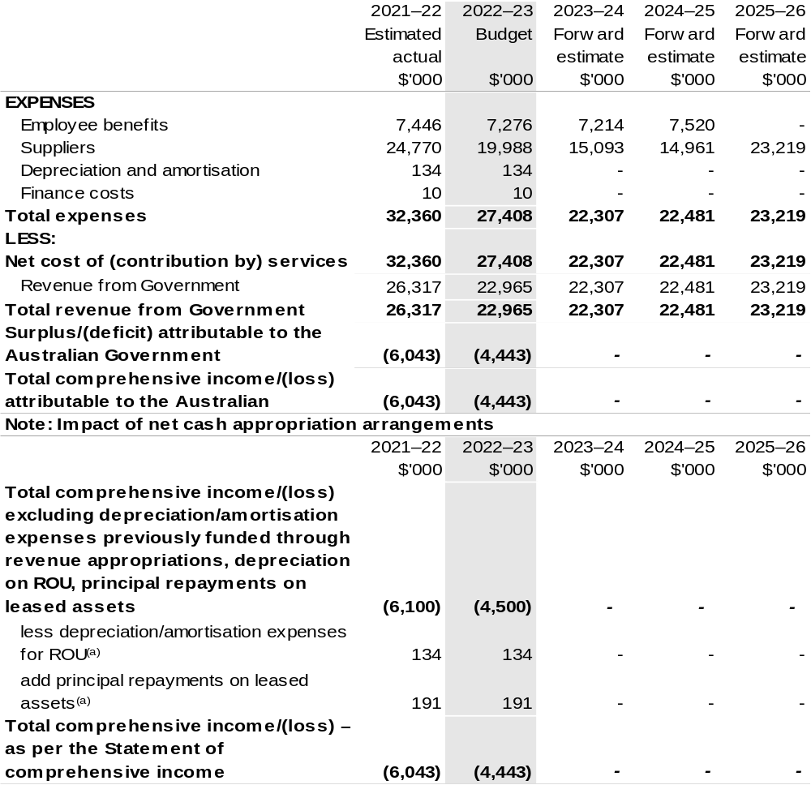
(a) Applies to leases under AASB 16 Leases. Right of Use (ROU).

Prepared on Australian Accounting Standards basis.

Table 3.2: Budgeted departmental balance sheet (as at 30 June)
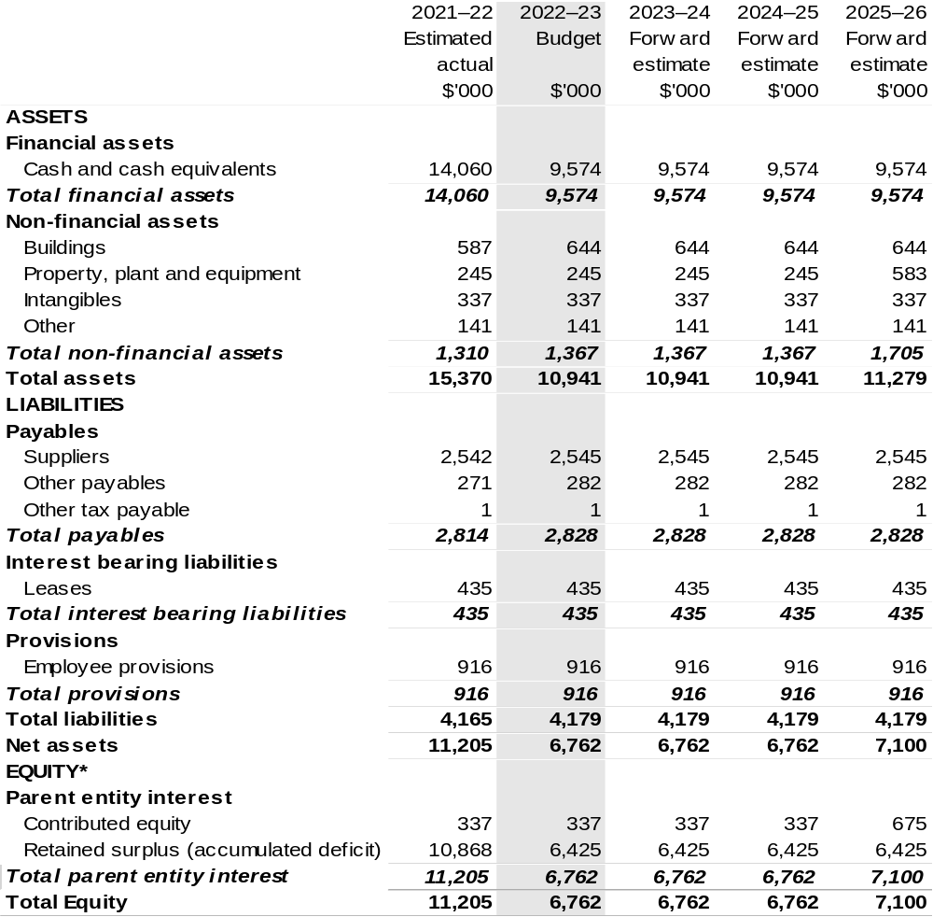

*Equity is the residual interest in assets after deduction of liabilities.

Prepared on Australian Accounting Standards basis.

Table 3.3: Departmental statement of changes in equity—summary of movement (Budget year 2022–23)
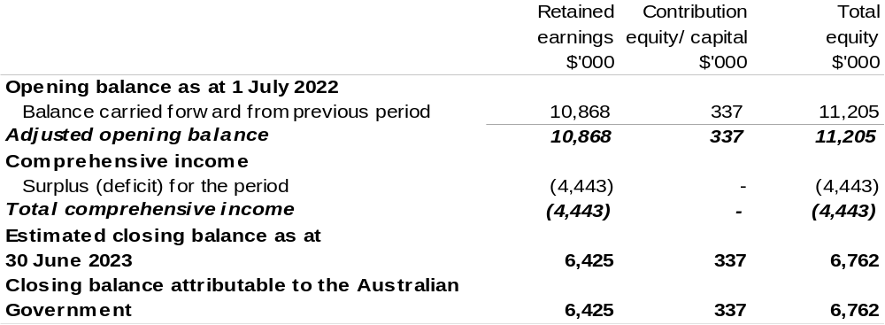
Prepared on Australian Accounting Standards basis.

Table 3.4: Budgeted departmental statement of cash flows (for the period
ended 30 June)
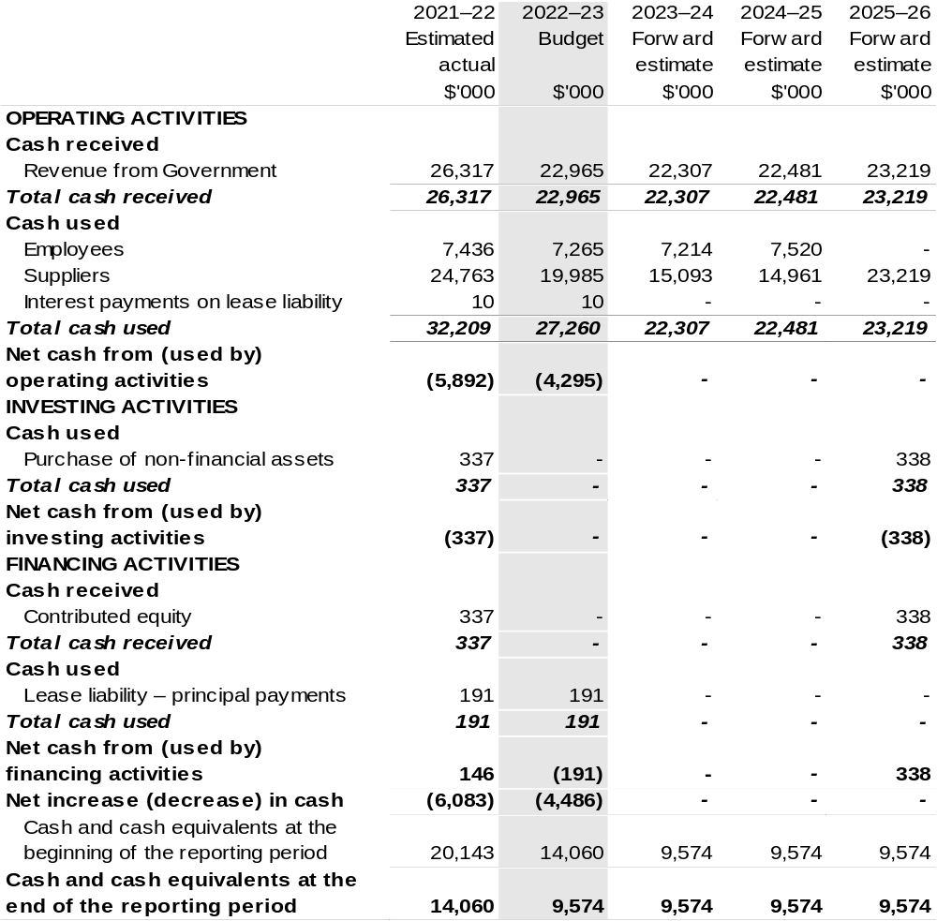
Prepared on Australian Accounting Standards basis.

Table 3.5: Departmental capital budget statement (for the period ended 30 June)
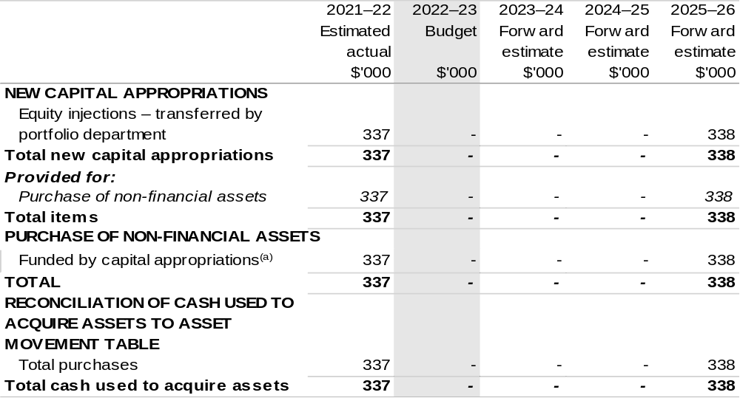
(a) Includes current Appropriation Bill (No. 2) and prior year Appropriation Act No. (2/4/6).

Consistent with information contained in the Statement of Asset Movements and the Budgeted Statement of Cash Flows.

Prepared on Australian Accounting Standards basis.

Table 3.6: Statement of asset movements (Budget year 2022–23)
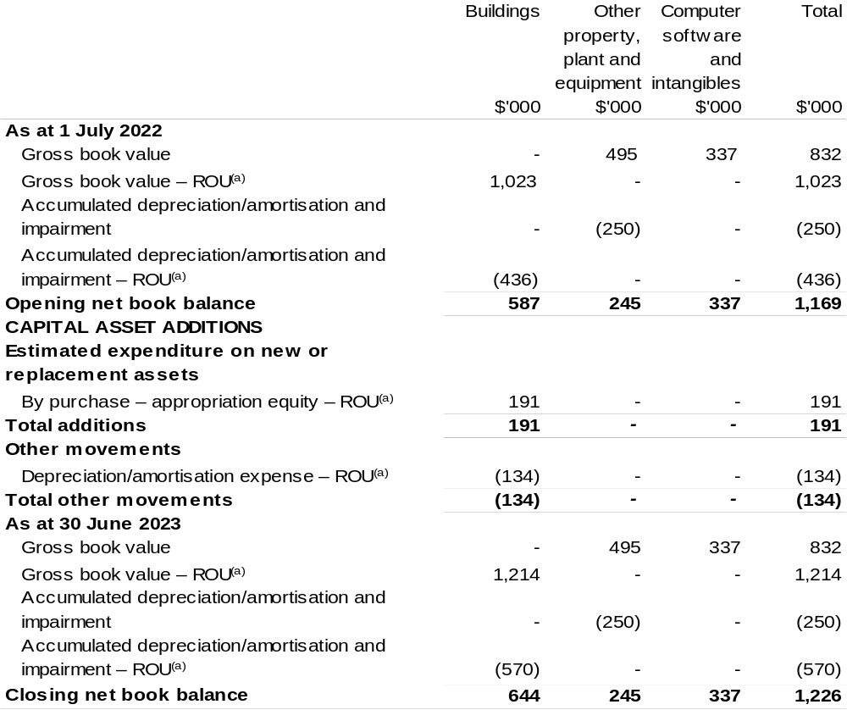
(a) Applies to leases under AASB 16 Leases. Right of Use (ROU).
(b) ‘By purchase – appropriation equity’ refers to equity injections appropriations provided through Appropriation Bill (No. 2) 2022–23 and other internal funding sources.

Prepared on Australian Accounting Standards basis.

Table 3.7: Schedule of budgeted income and expenses administered on behalf of Government (for the period ended 30 June)

The schedule of budgeted income and expenses administered on behalf of Government does not apply to the RIC.

Table 3.8: Schedule of budgeted assets and liabilities administered on behalf of Government (as at 30 June)

The schedule of budgeted assets and liabilities administered on behalf of Government does not apply to the RIC.

Table 3.9: Schedule of budgeted administered cash flows (for the period
ended 30 June)

The schedule of budgeted administered cash flows on behalf of Government does not apply to the RIC.

Sydney Harbour Federation Trust
Section 1: Entity overview and resources 355
1.1 Strategic direction statement 355
1.2 Entity resource statement 357
1.3 Budget measures 359
Section 2: Outcome and planned performance 360
2.1 Budgeted expenses and performance for Outcome 1 361
Section 3: Budgeted financial statements 366
3.1 Budgeted financial statements 366
3.2 Budgeted financial statements tables 367

Sydney Harbour Federation Trust

Section 1: Entity overview and resources

1.1 Strategic direction statement
The Sydney Harbour Federation Trust (the Trust) manages some of the most renowned and prominent foreshore lands on Sydney Harbour. These sites are the former Defence lands at Middle Head, Georges Heights and Chowder Bay in Mosman, the North Head former School of Artillery, Macquarie Lightstation near South Head, Woolwich Dock and Parklands, Cockatoo Island, the former Marine Biological Station at Watsons Bay and the former HMAS Platypus (Sub Base Platypus) at Neutral Bay. The Sydney Harbour Federation Trust Act 2001 also provides the potential for other Commonwealth lands in Sydney Harbour, such as Snapper Island, to be vested in the Trust.
The Trust is responsible for the management of sites of nationally significant cultural, natural, industrial and heritage value. The Trust actively researches and makes accessible knowledge of sites’ multi-layered history and stories, including their importance to First Nations communities. Through remediation and use, both the sites and their buildings are enlivened through the creation of communities which encourage a sense of place and belonging.
To achieve this – and other beneficial outcomes for the public – the Trust develops relationships and collaborations with community organisations, partners, funders, and supporters. Fostering such long-term relationships requires the Trust to be responsive, transparent and consistent in its discussions with stakeholders. These relationships and collaborations are important, as the Trust raises all the revenue required to sustain its activities in operating the network of sites.
In mid-2020 the Minister for the Environment, the Hon. Sussan Ley MP, released the Final Report of the Independent Review of the Sydney Harbour Federation Trust
(the Independent Review). Since its release, the Trust has made substantial progress in implementing the Independent Review’s 21 recommendations.
In looking at the past year, of particular note, the Trust worked closely with the Department of Agriculture, Water and the Environment (DAWE) to support the development of amendments to the Trust’s legislation, which received Royal Assent in June 2021. Significant within the amendments is the repeal of provisions which previously mandated an end-date for the Trust, with the Trust now an ongoing entity.
This shift in status fundamentally alters the strategic direction of the Trust, necessitating a shift in operational focus from that of a temporary entity originally envisaged as primarily a planning and rehabilitation agency, to one entrusted with the ongoing responsibility of perpetual custodianship of its sites. Along with this shift, the Trust will be required to adapt its processes and improve the way in which it conducts its work. Over the coming year, the way in which the Trust engages and interacts with the community will be reset, recognising, and celebrating the important role stakeholders play in the ultimate success of the Trust.
Throughout the COVID-19 pandemic the Trust’s sites, buildings and parklands have played an important role in providing much needed green space and areas of respite. The coming year will see this vital role further enhanced, with major programs of work progressing to improve access to and the amenity of sites. Building on the invaluable consultation outcomes received from the Draft Concepts produced for Cockatoo Island and North Head Sanctuary, 2022–23 will see the Trust progress the development of Master Plans for both sites. This work will seek to produce future visions for both sites that unleash their significant unrealised potential. The community’s passion for these beloved sites and their stories will once again be vital input to this work, as progress is made towards their renewal for the benefit of current and future generations.
Further progress on other projects announced in prior budgets will continue to be a focus throughout 2022–23. Preservation works to buildings at 10 Terminal (Middle Head) will commence, as well as the development of a broader Draft Concept Design for Middle Head.
Having received approval in 2021, construction works on the Torpedo Factory Renewal Project at Sub Base Platypus will commence in 2022. This next stage of renewal will deliver a new foreshore park, heritage interpretation, public access improvements and a welcoming entry to the site.
The Repairs and Maintenance program will also see significant progress over the coming year, with a comprehensive Asset & Infrastructure Condition Audit across all Trust properties being undertaken, along with an update of the Strategic Asset Management Plan (SAMP), and the development of a 10-year capital replacement plan. Work will also continue on the backlog of maintenance projects across sites, allowing for the repair of heritage infrastructure and to address public safety improvements.

1.2 Entity resource statement
Table 1.1 shows the total funding from all sources available to the entity for its operations and to deliver programs and services on behalf of the Government.
The table summarises how resources will be applied by outcome (Government strategic policy objectives) and by administered (on behalf of the Government or the public) and departmental (for the entity’s operations) classification.
For more detailed information on special accounts and special appropriations, please refer to Budget Paper No. 4 – Agency Resourcing.
Information in this table is presented on a resourcing (that is, appropriations/cash available) basis, whilst the ‘Budgeted expenses by Outcome’ table in Section 2 and the financial statements in Section 3 are presented on an accrual basis.

Table 1.1: Sydney Harbour Federation Trust – Resource Statement – Budget Estimates for 2022–23 as at Budget March 2022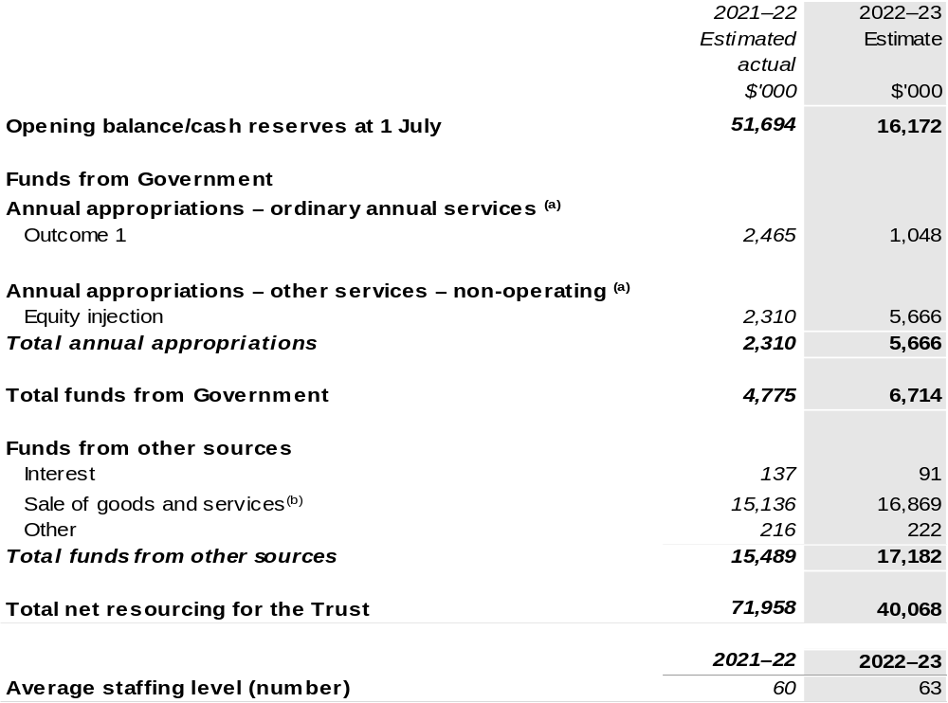

(a) Appropriation Bill (No. 1) and Bill (No. 2) 2022–23. Appropriation is provided through the Department of
Agriculture, Water and the Environment (DAWE) and is specified with the Annual Appropriation Bills as payment to the Trust and is considered departmental for all purposes.
(b) Funds from Sales of Goods and Services excludes cash received and held on trust as security for the performance of tenants’ obligation under various lease agreements.

Prepared on a resourcing (i.e. appropriations available) basis.

Please note: all figures shown above are GST exclusive – these may not match figures in the cash flow statement.

1.3 Budget measures
Budget measures in Part 1 relating to the Trust are detailed in Budget Paper No. 2: Budget Measures 2022–23 and are summarised below.

Table 1.2: Sydney Harbour Federation Trust – 2022–23 Budget measures – Measures announced since the 2021–22 Mid-Year Economic and Fiscal Outlook (MYEFO)

The Trust does not have any 2022–23 Budget measures.

Section 2: Outcomes and planned performance
Government outcomes are the intended results, impacts or consequences of actions by the Government on the Australian community. Commonwealth programs are the primary vehicle by which government entities achieve the intended results of their outcome statements. Entities are required to identify the programs which contribute to Government outcomes over the Budget and forward years.
Each outcome is described below together with its related programs. The following provides detailed information on expenses for each outcome and program, further broken down by funding source.
Note:
Performance reporting requirements in the Portfolio Budget Statements are part of the Commonwealth performance framework established by the Public Governance, Performance and Accountability Act 2013. It is anticipated that the performance criteria described in Portfolio Budget Statements will be read with broader information provided in an entity’s corporate plans and annual performance statements – included in Annual Reports – to provide a complete picture of an entity’s planned and actual performance.
The most recent corporate plan and annual performance statement (contained within the annual report) for the Trust can be found at: https://www.harbourtrust.gov.au/en/corporate/publications/.

2.1 Budgeted expenses and performance for outcome 1
Outcome 1: Enhanced appreciation and understanding of the natural and cultural values of Sydney for all visitors, through the remediation, conservation and adaptive re-use of, and access to, Trust lands on Sydney Harbour.

2.1.1: Linked programs
Department of Agriculture, Water and the Environment
Program 1.4: Conservation of Australia’s Heritage and Environment
Contribution to Outcome 1 made by linked program:
DAWE and the Trust collaborate through engagement on policy direction and site management to conserve and enhance the natural and cultural heritage of Trust land and maximise public access and enjoyment of its sites.

2.1.2: Budgeted expenses for Outcome 1
This table shows how much the entity intends to spend (on an accrual basis) on achieving the outcome, broken down by program, as well as by administered and departmental funding sources.

Table 2.1: Budgeted expenses for Outcome 1
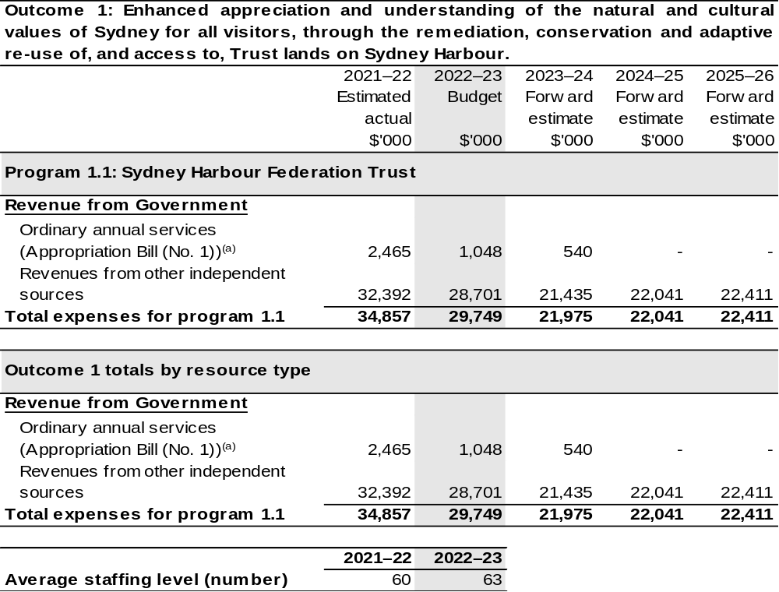

(a) Appropriation Bill (No. 1) 2022–23. The Trust is a corporate Commonwealth entity under the Public Governance, Performance and Accountability Act 2013 (PGPA Act) and does not receive direct appropriations. Appropriation is provided through DAWE and is specified with the Annual Appropriation Bills as payment to the Trust and is considered departmental for all purposes.

Note: Departmental appropriation splits and totals are indicative estimates and may change in the course of the budget year as government priorities change.

Prepared on a Government Finance Statistics (fiscal) basis.

2.1.3: Performance criteria for Outcome 1
Table 2.1.3 details the performance measures for each program associated with Outcome 1. It also provides the related key activities as expressed in the current corporate plan where further detail is provided about the delivery of the activities related to the program, the context in which these activities are delivered and how the performance of these activities will be measured. Where relevant, details of 2022–23 Budget measures that have created new programs or materially changed existing programs are provided.
Outcome 1: Enhanced appreciation and understanding of the natural and cultural values of Sydney for all visitors, through the remediation, conservation and adaptive re-use of, and access to, Trust lands on Sydney Harbour.
Program 1.1: Sydney Harbour Federation Trust
Objective | To manage emblematic lands around Sydney Harbour, preserve their natural and cultural heritage and foster and promote them as place of leisure, enjoyment and interest for all Australians.
Key Activities | - Steward Our Parklands: to care for, conserve, and enhance our parklands and built assets, applying the principles of ecological sustainable development.  - Welcome Everyone: our parklands are for all Australians, and we welcome both domestic and international visitors. We want to ensure our sites tell their rich stories, are easy to access, and are places of exploration and discovery.  - Build Partnerships: underpin our work through collaboration and engagement with partners to help us deliver our vision. We are responsible for important public places, and we want to encourage dialogue and debate about their future and the choices we make to ensure sustainability.
Year | Performance measures | Expected Performance Results
Current year  2021–22 | 1. Steward Our Parklands
Current year  2021–22 | - Percentage of our land open to the public. | Target: 90 per cent – On Track.
Current year  2021–22 | - Percentage of our built assets (with the potential to be in active use), in active use. | Target: 77 per cent – On Track.
Current year  2021–22 | - Visitor satisfaction with the public domain. | Target: >90 per cent –  Behind Target.
Current year  2021–22 | 2. Welcome Everyone
Current year  2021–22 | - Number of visits. | Target: 1.8 million visits –  On Track.
Current year  2021–22 | - Visitor satisfaction. | Target: >90 per cent – Behind Target.

2.1.3: Performance criteria for Outcome 1 (continued)
Year | Performance measures | Expected Performance Results
Current year  2021–22 (continued) | 3. Build Partnerships
Current year  2021–22 (continued) | - Number of volunteer hours. | Target: 20,000 hours –  Behind Target.
Current year  2021–22 (continued) | - Number of significant, multi-year community, cultural, environmental and heritage partners. | Target: 10 – On Track.
Year | Performance measures | Planned Performance Results
Budget Year  2022–23 | 1. Steward Our Parklands
Budget Year  2022–23 | - Percentage of our land open to the public. | Target: 90 per cent.
Budget Year  2022–23 | - Percentage of our built assets (with the potential to be in active use), in active use. | Target: 77 per cent.
Budget Year  2022–23 | - Visitor satisfaction with the public domain. | Target: >90 per cent.
Budget Year  2022–23 | 2. Welcome Everyone
Budget Year  2022–23 | - Number of visits. | Target: 1.8 million visits.
Budget Year  2022–23 | - Visitor satisfaction. | Target: >90 per cent.
Budget Year  2022–23 | 3. Build Partnerships
Budget Year  2022–23 | - Number of volunteer hours. | Target: 16,500 hours.
Budget Year  2022–23 | - Number of significant, multi-year community, cultural, environmental and heritage partners. | Target: 10.

Continue on following page

2.1.3: Performance criteria for Outcome 1 (continued)
Year | Performance measures | Planned Performance Results
Forward Estimates  2023–26 | 1. Steward Our Parklands
Forward Estimates  2023–26 | As per 2022–23. | As per 2022–23, except: Percentage of our built assets (with the potential to be in active use), in active use:  - 2023–24 onwards: 79 per cent.
Forward Estimates  2023–26 | 2. Welcome Everyone
Forward Estimates  2023–26 | As per 2022–23. | As per 2022–23.
Forward Estimates  2023–26 | 3. Build Partnerships
Forward Estimates  2023–26 | As per 2022–23. | As per 2022–23, except:  Number of volunteer hours:  - 2023–24: 20,000 hours.  - 2024–25: 22,500 hours.  - 2025–26: 25,000 hours.

Section 3: Budgeted financial statements
Section 3 presents budgeted financial statements which provide a comprehensive snapshot of entity finances for 2022–23, including the impact of 2022–23 Budget measures and resourcing on financial statements.

3.1 Budgeted financial statements

3.1.1: Differences between entity resourcing and financial statements
There are no differences between the resource information presented in the Budget Papers and Portfolio Budget Statements.

3.1.2: Explanatory notes and analysis of budgeted financial statements
Budgeted Comprehensive Income Statement
The Trust has budgeted for an operating deficit of $11.5 million in 2022–23. $6.4 million of this deficit relates to the timing impact of operational funding received through appropriations in prior financial years being expended in 2022–23. Whilst the major impacts of COVID-19 appear to have passed, there remain consequential effects on rental returns, vacancy rates, major events, and accommodation – these residual
COVID-19 impacts have been budgeted in 2022–23.
The Trust is continuing to work through a detailed reform program to deliver on the Independent Review recommendations and restructure the business. That work is due to be fully implemented in 2022–23 with a focus on returning the Trust to a break-even or operating surplus position. Increased revenue is forecast as more property assets come online in the outer years, major events return, and domestic and international tourism returns to pre-pandemic levels.
With Australian Government support and investment, the Trust is pursuing capital projects that will enhance public amenity and its lease stock of heritage buildings and has progressed master planning for the revitalisation of Cockatoo Island and North Head. Once completed, these measures will bring on new revenue streams and move the Trust towards self-sufficiency.
Overall expenditure forecast for the 2022–23 financial year is $29.7 million, including $7.4 million for the acquittal of the departmental grant funding to fund backlog repairs and maintenance. Excluding the grant acquittal, underlying budgeted expenditure is $22.3 million in 2022–23 with an anticipated reduction in costs in 2023–24 as the program for delivery of the Independent Review recommendations concludes and major projects are delivered in 2022–23. Small cost increases over the subsequent years reflect cost indexation.

3.2 Budgeted financial statements tables

Table 3.1: Comprehensive income statement (showing net cost of services) for the period ended 30 June
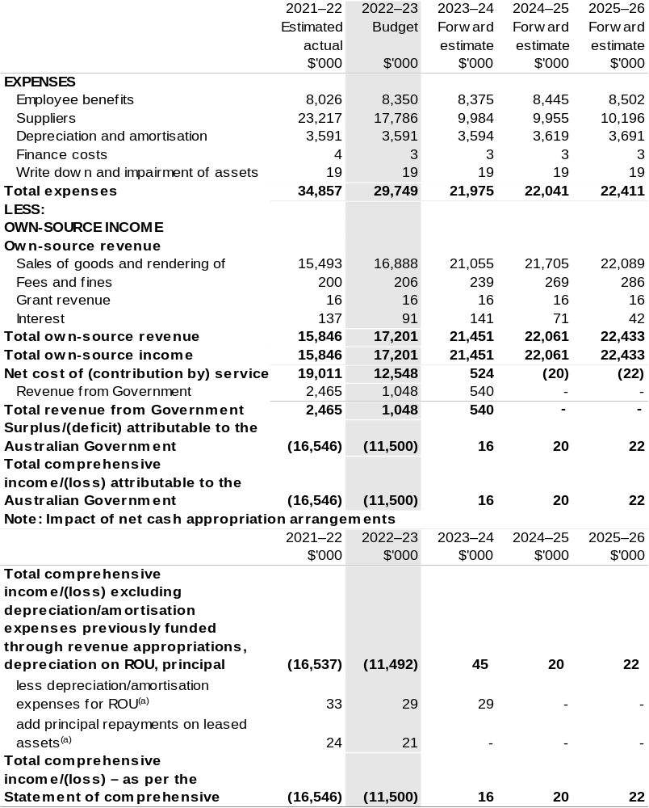

(a) Applies to leases under AASB 16 Leases. Right of Use (ROU).

Prepared on Australian Accounting Standards basis.

Table 3.2: Budgeted departmental balance sheet (as at 30 June)
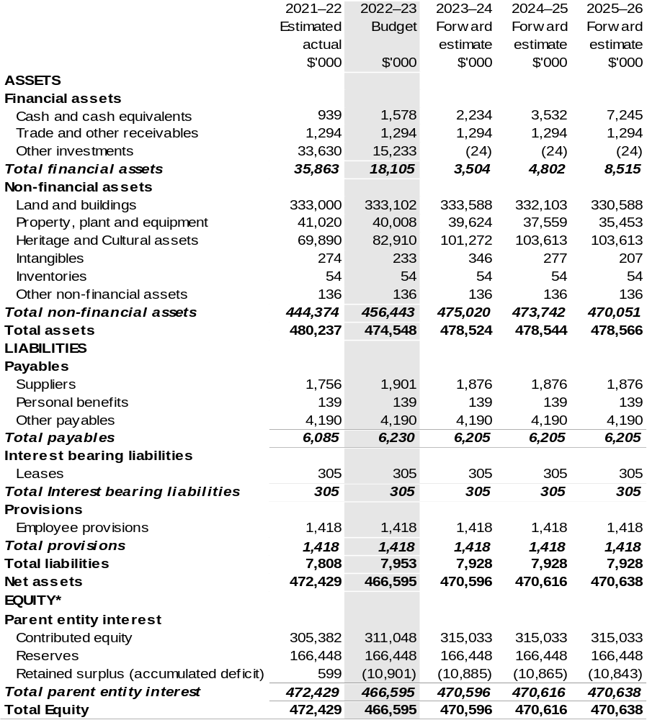

*Equity' is the residual interest in assets after deduction of liabilities.

Prepared on Australian Accounting Standards basis.

Table 3.3: Departmental statement of changes in equity – summary of movement (Budget year 2022–23)
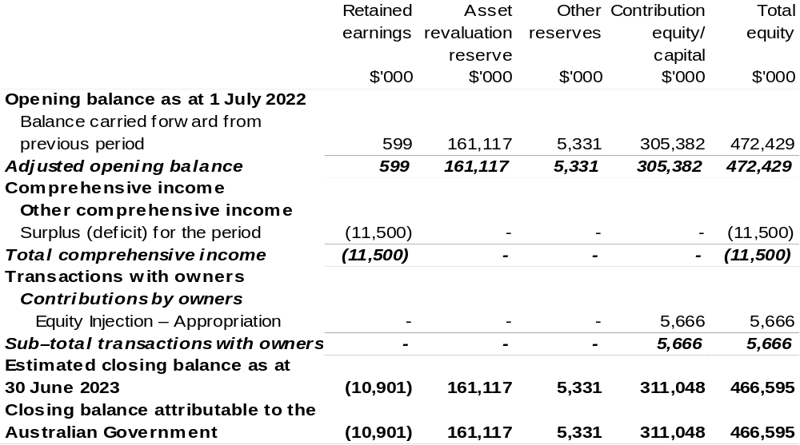

Prepared on Australian Accounting Standards basis.

Table 3.4: Budgeted departmental statement of cash flows (for the period
ended 30 June)
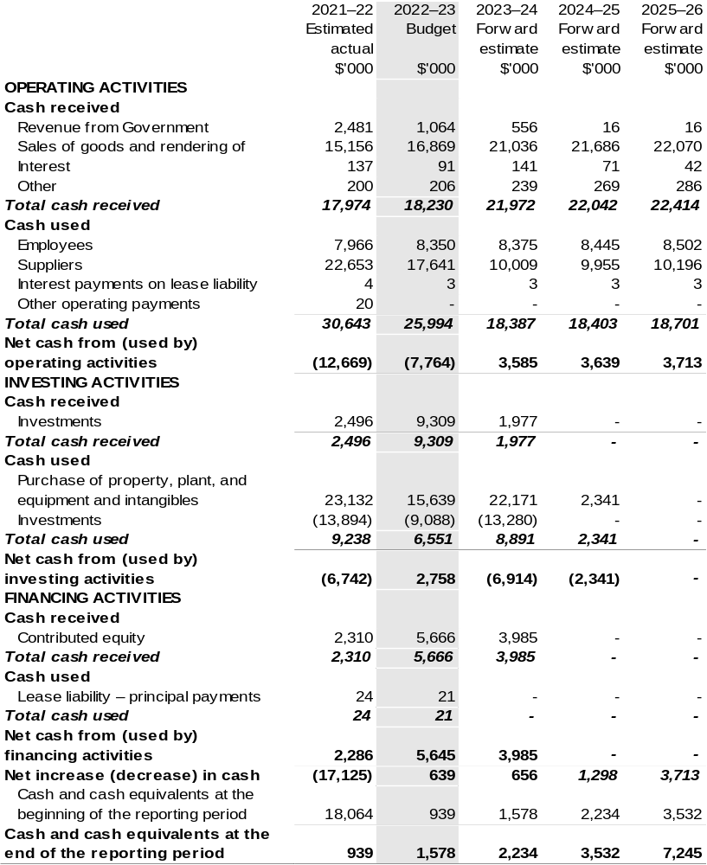

Prepared on Australian Accounting Standards basis.

Table 3.5: Departmental capital budget statement (for the period ended 30 June)
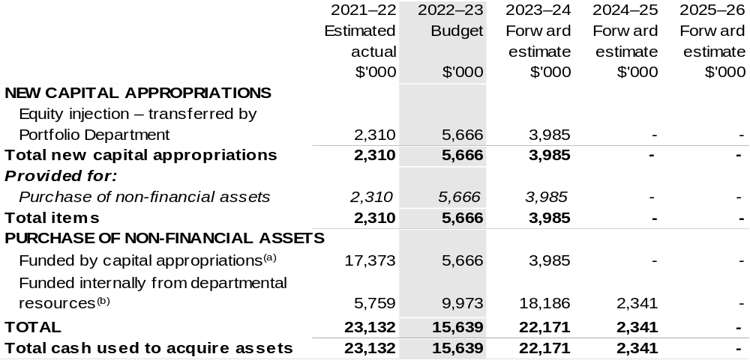

- Includes current Appropriation Bill (No. 2) and prior year Appropriation Act No. (2/4/6).
- Includes the following s74 external revenue:
– internally developed assets.

Consistent with information contained in the Statement of Asset Movements and the Budgeted Statement of Cash Flows.

Prepared on Australian Accounting Standards basis.

Table 3.6: Statement of asset movements (Budget year 2022–23)
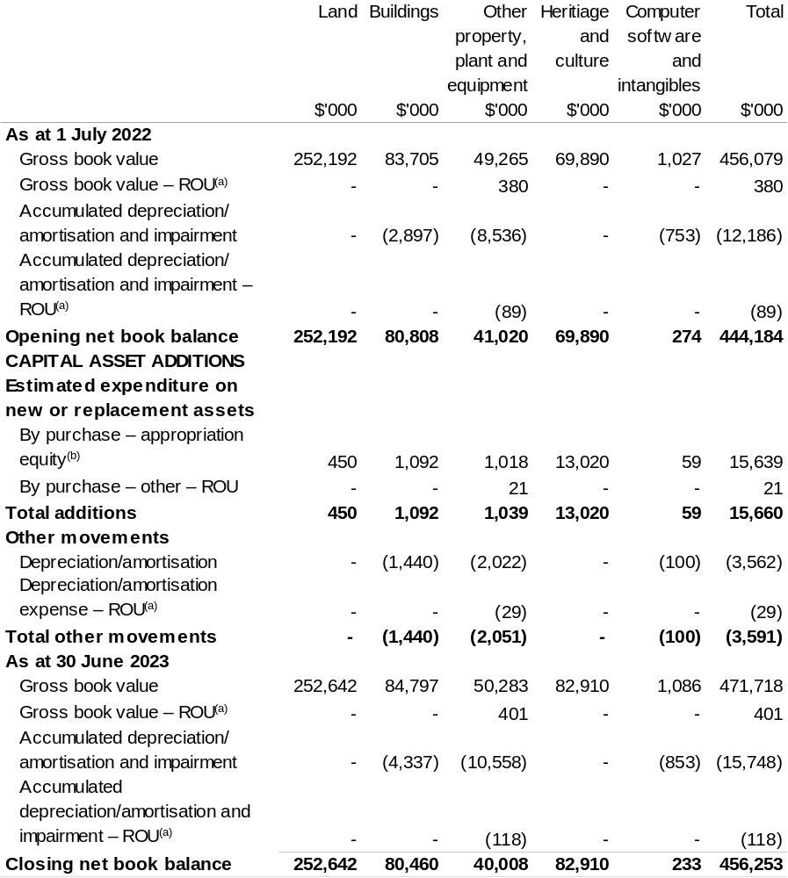

(a) Applies to leases under AASB 16 Leases. Right of Use (ROU).
(b) ‘By purchase – appropriation equity’ refers to equity injections appropriations provided through Appropriation Bill (No. 2) 2022–23 and other internal funding sources.

Prepared on Australian Accounting Standards basis.

Wine Australia
Section 1: Entity overview and resources 375
1.1 Strategic direction statement 375
1.2 Entity resource statement 378
1.3 Budget measures 380
Section 2: Outcomes and planned performance 381
2.1 Budgeted expenses and performance for Outcome 1 382
Section 3: Budgeted financial statements 386
3.1 Budgeted financial statements 386
3.2 Budgeted financial statements tables 387

Wine Australia

Section 1: Entity overview and resources

1.1 Strategic direction statement
Wine Australia seeks to foster and encourage profitable, resilient, and sustainable Australian winegrape and wine businesses by investing in research and development (R&D), building markets, disseminating market information and knowledge, encouraging adoption, and ensuring compliance through our regulatory functions.
We are governed by the Wine Australia Act 2013 (Wine Australia Act).

Wine Australia’s role under the Wine Australia Act is to:
- coordinate or fund grape and wine R&D and facilitate the dissemination, adoption, and commercialisation of the results;
- control the export of wine from Australia; and
- promote the sale and consumption of wine, both in Australia and overseas.
Wine Australia is funded by grape growers, winemakers and exporters through levies and user-pays charges; and by the Australian Government, which provides matching funding for research, development, and adoption (RD&A) investments.

Australian wine is a unique, high-quality product crafted in 65 wine regions around the country. The Australian wine sector has approximately 6,000 grape growers, 146,244 hectares of vines, 2,156 wineries and produced 1.48 billion litres of wine in 2020–21.
In the year ended December 2021, Australian wine exports decreased by 30 per cent in value to $2.03 billion and 17 per cent in volume to 619 million litres (69 million 9-litre case equivalents). This resulted in a 15 per cent decline in average value to $3.27 per litre. The biggest driver of the decline was the reduction in exports to mainland China, following the imposition of tariffs on Australian packaged wine in November 2020. The 619 million litres shipped in total for the 2021 calendar year represents the lowest volume shipped in a 12-month period since the year ended September 2004. Aside from the decrease in shipments to mainland China, the significant decline in volume can also be attributed to low inventory at the start of the year after three small vintages and delays in getting the large 2021 vintage onto ships due to the ongoing global freight disruptions. There were 1,269 active exporters in 2021 and 19,247 products exported to 112 destinations.

Wine Australia’s goal is profitable, resilient, and sustainable winegrape and wine businesses, and how Wine Australia achieves its responsibilities under the Wine Australia Act is outlined in the five-year Strategic Plan 2020–25. In 2022–23, the third year of the strategic plan, Wine Australia will continue to invest in five strategies:
- Strategy 1: Promote Australian wine;
- Strategy 2: Protect Australian wine;
- Strategy 3: Build grape and wine excellence;
- Strategy 4: Build sustainable environments;
- Strategy 5: Build business sustainability, excellence, and leadership.
Since Wine Australia’s Strategic Plan 2020–25 was approved in June 2020, the environment within which it operates has been significantly impacted by COVID-19 restrictions, and the imposition of tariffs on Australian wine exported to China.
The operational impacts that will flow from the current market and financial challenges have been contemplated in developing this statement and will be reflected in future annual operational plans.
In the current operational environment, Wine Australia are seeking to intensify marketing efforts to gain greater market share in established markets of the United States of America (USA), Canada and the United Kingdom (UK) and diversify into emerging markets. Wine Australia’s key marketing objectives are to:
- build the Australian wine category to drive positive sentiment and awareness among trade and consumers;
- drive increased market entry into the USA, Canada, UK, Europe, and Asia Pacific;
- build availability and reach of product across distributors, on premise and retail;
- align investment and category building activities with exporters and federal, state, and regional bodies to target growth; and
- promote sustainability in key markets with activations for trade and consumers.
Wine Australia has partnered with Austrade through the Australian Government’s Agri-Business Expansion Initiative (ABEI) to unlock market diversification opportunities in the Asia Pacific Accreditation Cooperation (APAC) markets, such as Vietnam, Thailand, South Korea, Indonesia, Japan, and Taiwan. The partnership is also helping wine businesses develop capabilities to support diversification efforts.
Wine Australia’s regulatory services activities seek to protect the reputation and integrity of Australian wine in all markets, including the domestic market. It will ensure that the regulatory regime remains fit for purpose, explore new opportunities for traceability technologies, build relationships with counterpart regulators in export markets and enhance the Wine Australia Licensing and Approvals System (WALAS) and the Label Directory. Wine Australia will also support the Geographical Indications Committee that defines the wine grape producing regions of Australia.
In Strategy 3, Wine Australia’s R&D investments will continue to enhance grape and wine excellence by identifying enhanced grapevine varieties and clones and breeding new varieties and rootstocks that suit our environment and consumer tastes. To maintain the supply of genetically diverse and high-health planting material, Wine Australia will continue to work towards the establishment of a national germplasm collection. To increase grape and wine production efficiency and sustainability, it will continue to develop, test, and commercialise new technologies and demonstrate them through agricultural technology demonstration sites to encourage adoption.
In Strategy 4, Wine Australia’s R&D investments will provide knowledge and tools to help growers and producers to be more environmentally sustainable, including information to manage the challenges of short-term climate cycles and long-term climate change. Wine Australia will determine baseline levels of carbon emissions and waste production in a grape and wine production setting so that the sector can develop benchmarks as a first step towards its goal of zero net carbon emissions and zero waste production by 2050.
Wine Australia will continue investing in research to allow more efficient and effective use of water in the vineyard, and focus on the value of soil remediation processes, lower chemical use in the vineyard, more sustainably managing endemic pests and diseases and being better prepared for exotic pests and diseases. It will actively support the sector’s Sustainable Winegrowing Australia program to help the sector demonstrate its sustainability credentials.
In Strategy 5, Wine Australia’s R&D adoption investments seek to accelerate the adoption of research outcomes and best practice. Wine Australia will implement our Extension and Adoption Strategy to build capacity and drive behaviour and practice change, including through our Regional Program. It will continue developing the leaders of tomorrow – and building the skills of the leaders of today – through regional governance and leadership programs and by supporting postgraduate students and early-career researchers.
Wine Australia also works closely with other rural research and development corporations (RDCs) in cross-sectoral collaborative research, including through Agricultural Innovation Investments Limited, to deliver RD&A benefits to the broader community.

1.2 Entity resource statement
Table 1.1 shows the total funding from all sources available to the entity for its operations and to deliver programs and services on behalf of the Government.
The table summarises how resources will be applied by outcome (Government strategic policy objectives) and by administered (on behalf of the Government or the public) and departmental (for the entity’s operations) classification.
For more detailed information on special accounts and special appropriations, please refer to Budget Paper No. 4: Agency Resourcing.
Information in this table is presented on a resourcing (that is, appropriations/cash available) basis, whilst the ‘Budgeted expenses by Outcome’ table in Section 2 and the financial statements in Section 3 are presented on an accrual basis.

Table 1.1: Wine Australia – Resource Statement – Budget Estimates for 2022–23 as at Budget March 2022
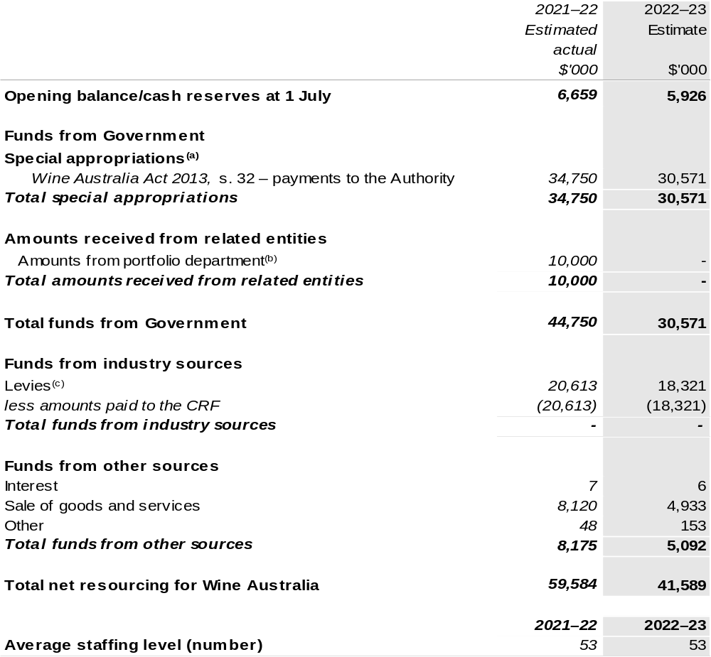

(a) Wine Australia's special appropriation is not directly appropriated as it is a corporate Commonwealth Entity (CCE) under the Public Governance, Performance and Accountability Act 2013 (PGPA Act). Appropriations are made to Department of Agriculture, Water and the Environment (DAWE) and are then paid to Wine Australia (WA) and are considered departmental for all purposes.
(b) Funding provided by the portfolio department that is not specified within the Annual Appropriation Bills as a payment to that CCE (for example, a grant awarded to a CCE from one of its portfolio department's administered programs).
(c) The levies are imposed by the Primary Industries (Excise) Levies Act 1999. Levies are collected by DAWE under the Primary Industries (Excise) Levies Act 1999 and Primary Industries (Customs) Charges Act 1999 and comprise of the Grape Research Levy and the Wine Grapes Levy and are transferred to the Consolidated Revenue Fund (CRF). These amounts are then drawn down by the department as a special appropriation and paid to WA under the Wine Australia Act 2013, s. 32.

Prepared on a resourcing (i.e. appropriations available) basis.

Please note: All figures shown above are GST exclusive - these may not match figures in the cash flow statement.

1.3 Budget measures
Budget measures in Part 1 relating to the Wine Australia are detailed in Budget Paper No. 2: Budget Measures 2022–23 and are summarised below.

Table 1.2: Wine Australia – 2022–23 Budget measures – Measures announced since the 2021–22 Mid-Year Economic and Fiscal Outlook (MYEFO)
Wine Australia does not have any 2022–23 Budget measures.

Section 2: Outcomes and planned performance
Government outcomes are the intended results, impacts or consequences of actions by the Government on the Australian community. Commonwealth programs are the primary vehicle by which government entities achieve the intended results of their outcome statements. Entities are required to identify the programs which contribute to Government outcomes over the Budget and forward years.
Each outcome is described below together with its related programs. The following provides detailed information on expenses for each outcome and program, further broken down by funding source.
Note:
Performance reporting requirements in the Portfolio Budget Statements are part of the Commonwealth performance framework established by the Public Governance, Performance and Accountability Act 2013. It is anticipated that the performance criteria described in Portfolio Budget Statements will be read with broader information provided in an entity’s corporate plans and annual performance statements — included in Annual Reports — to provide a complete picture of an entity’s planned and actual performance.
The most recent corporate plan for Wine Australia can be found at: https://www.wineaustralia.com/WA_StrategicPlan_2020-25.
The most recent annual performance statement for Wine Australia can be found at:
https://www.wineaustralia.com/WA_AnnualReport_2020-21.

2.1 Budgeted expenses and performance for Outcome 1
Outcome 1: Foster and enable a competitive Australian wine industry by investing in research and development, building markets, disseminating knowledge and ensuring compliance.

2.1.1: Linked programs
Department of Agriculture, Water and the Environment
Program 3.10: Agricultural Resources
Program 3.13: International Market Access
Contribution to Outcome 1 made by linked program:
WA and DAWE work together to ensure a sustainable, productive and profitable grape and wine sector.
Department of the Treasury
Program 1.3: Support for markets and business
Contribution to Outcome 1 made by linked program:
Wine Australia will also administer the Wine Tourism and Cellar Door Grant program that commenced in 2019–20.

2.1.2: Budgeted expenses for Outcome 1
This table shows how much the entity intends to spend (on an accrual basis) on achieving the outcome, broken down by program, as well as by administered and departmental funding sources.

Table 2.1: Budgeted expenses for Outcome 1
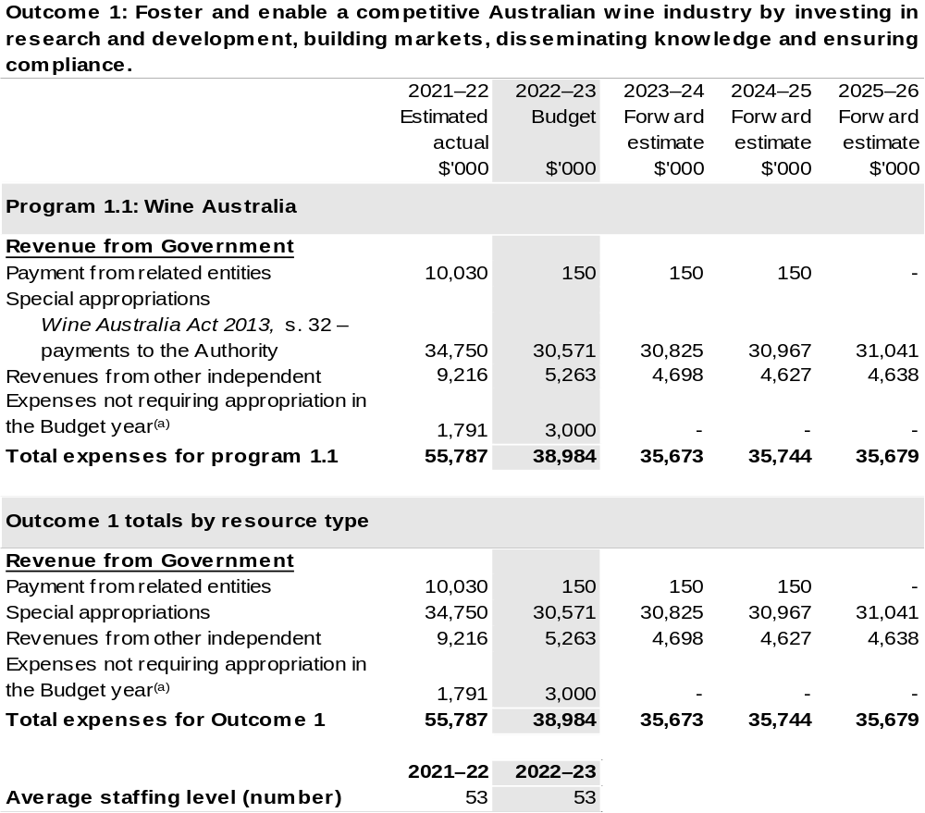
(a) Expenses not requiring appropriation in the Budget year are made up of make good expenses, audit fees, and can include depreciation / amortisation expenses not requiring an appropriation.

Note: Departmental appropriation splits and totals are indicative estimates and may change in the course of the budget year as government priorities change.

Prepared on Australian Accounting Standards basis.

2.1.3: Performance criteria for Outcome 1
Table 2.1.3 below details the performance criteria for each program associated with Outcome 1. It also summarises how each program is delivered and where 2022–23 Budget measures have created new programs or materially changed existing programs.
As an entity established under the Wine Australia Act, Wine Australia does not produce a corporate plan under the PGPA Act and is therefore exempt from the requirement to map purposes to outcomes.
Outcome 1: Foster and enable a competitive Australian wine industry by investing in research and development, building markets, disseminating knowledge and ensuring compliance.
Program 1.1: Wine Australia
Objective | Invest in R&D, building markets, disseminating knowledge and ensuring compliance to foster and enable a competitive Australian wine sector.
Key Activities | Wine Australia will:  - Invest in R&D in the five strategic areas outlined in its Strategic Plan 2020–2025 for the benefit of wine grape growers, winemakers, wine businesses and the wider community.  - Invest in RD&A to build grape and wine excellence, build sustainable environments, and build business sustainability, excellence and leadership.  - Invest in marketing to promote Australian wine and grow international markets.  - Invest in regulatory services to protect the reputation of Australian wine.  - Support grape and wine businesses with market insights that allow them to make effective and informed decisions.
Year | Performance measures | Expected Performance Results
Current year  2021–22 | Wine Australia
Current year  2021–22 | Improve our stakeholder net promoter score from 2019 baseline. | Above +12.
Current year  2021–22 | RD&A
Current year  2021–22 | Research contracts are actively managed through regular and ongoing monitoring of the research. | 100 per cent.

Continued on following page.
2.1.3: Performance criteria for Outcome 1 (continued)
Year | Performance measures | Expected Performance Results
Current year  2021–22 (continued) | Market Insights customers are satisfied or very satisfied with the services they receive. | >90 per cent.
Current year  2021–22 (continued) | Levy payers who participate in Wine Australia-supported extension and adoption programs consider them a ‘good’ or ‘very good’ use of levy funds. | 80 per cent.
Current year  2021–22 (continued) | Marketing
Current year  2021–22 (continued) | Tier A influencers actively engage with Wine Australia. | 81 per cent.
Current year  2021–22 (continued) | The perception of Australian wine increases in Canada, the UK and the USA. | Increase above 2019 baseline.
Current year  2021–22 (continued) | Wineries and distributors who participate in Wine Australia events report that they are ‘satisfied’ or ‘very satisfied. | >90 per cent.
Current year  2021–22 (continued) | Regulatory services
Current year  2021–22 (continued) | Achieve the six key performance indicators in the Regulatory Performance Framework. | Achieved.
Current year  2021–22 (continued) | Through our Label Integrity Program, we inspect producers’ records, focusing on those relating to wine regions and varieties in particular demand. | 300 inspections of records kept under the Label Integrity Program.
Year | Performance measures | Planned Performance Results
Budget Year  2022–23 | As per 2021–22. | As per 2021–22.
Forward Estimates  2023–26 | As per 2022–23. | As per 2022–23.

Section 3: Budgeted financial statements
Section 3 presents budgeted financial statements which provide a comprehensive snapshot of entity finances for 2022–23, including the impact of 2022–23 Budget measures and resourcing on financial statements.

3.1 Budgeted financial statements

3.1.1: Differences between entity resourcing and financial statements
There are no differences between the resource information presented in the Budget Papers and Portfolio Budget Statements.

3.1.2 Explanatory notes and analysis of budgeted financial statements
The Budget incorporates the contracted and committed research, development and extension activities, the anticipated marketing programs and statutory duties.

Wine Australia receives levies on the tonnage of fruit grown (Grape Research Levy); grape products used in the manufacture of wine (Wine Grapes Levy); and on the value of wine exported (Wine Export Charge). Revenue from these levies is expected to be approximately $18.3 million for the 2022–23 year, based on an expected 2022 vintage of 1.75 million tonnes.

Research, development, and extension expenditure attracts Commonwealth matching funding, which is calculated in accordance with the provisions of the Primary Industries Research and Development Act 1989 (PIRD Act).

Other major sources of revenue are export licence and associated fees and promotional user-pays events.

3.2 Budgeted financial statements tables

Table 3.1: Comprehensive income statement (showing net cost of services)
(for the period ended 30 June)
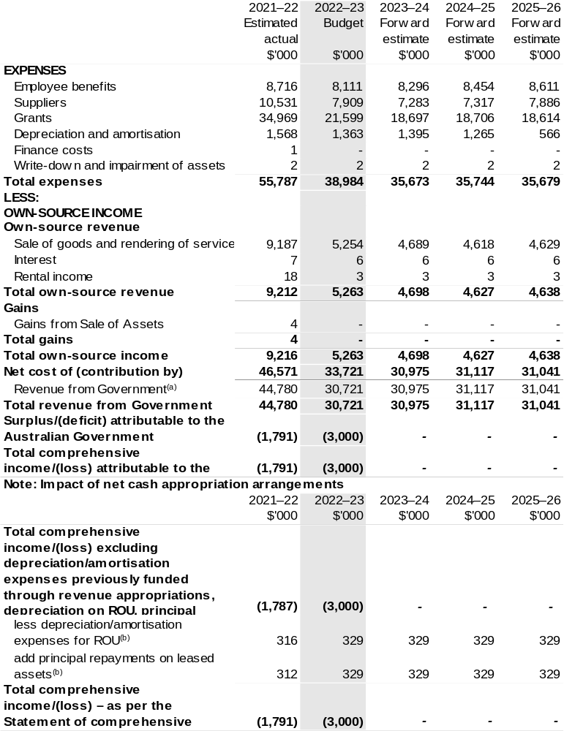
(a) Revenue from Government includes a Commonwealth contribution under the PIRD Act and levies collected from industry by the DAWE for R&D and marketing activities.
(b) Applies to leases under AASB 16 Leases. Right of Use (ROU).
Prepared on Australian Accounting Standards basis.

Table 3.2: Budgeted departmental balance sheet (as at 30 June)
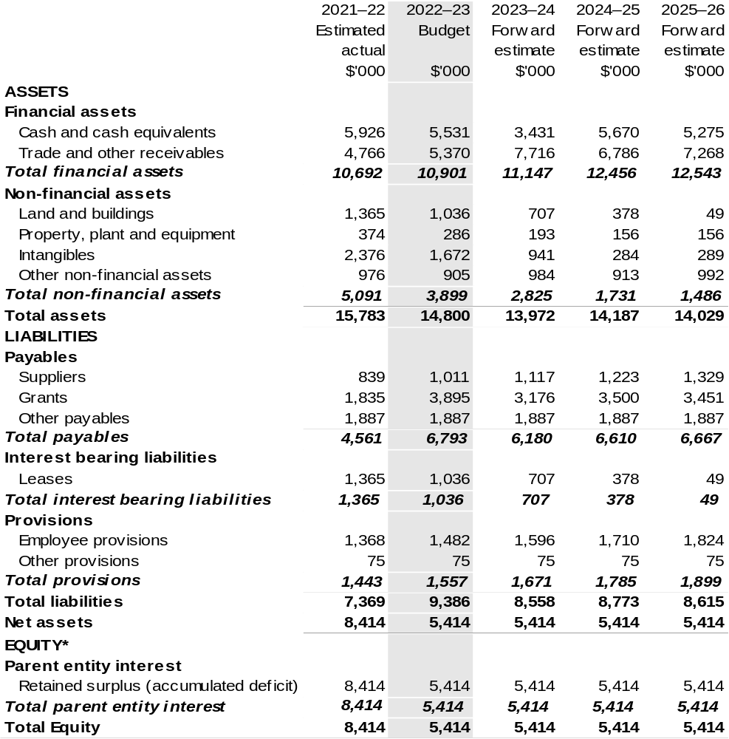

*’Equity’ is the residual interest in assets after deduction of liabilities.

Prepared on Australian Accounting Standards basis.

Table 3.3: Departmental statement of changes in equity – summary of movement (Budget year 2022–23)
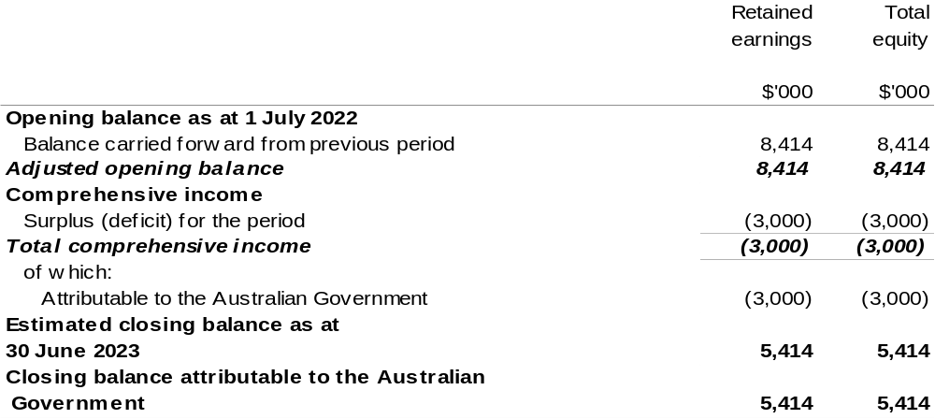

Prepared on Australian Accounting Standards basis.

Table 3.4: Budgeted departmental statement of cash flows (for the period
ended 30 June)
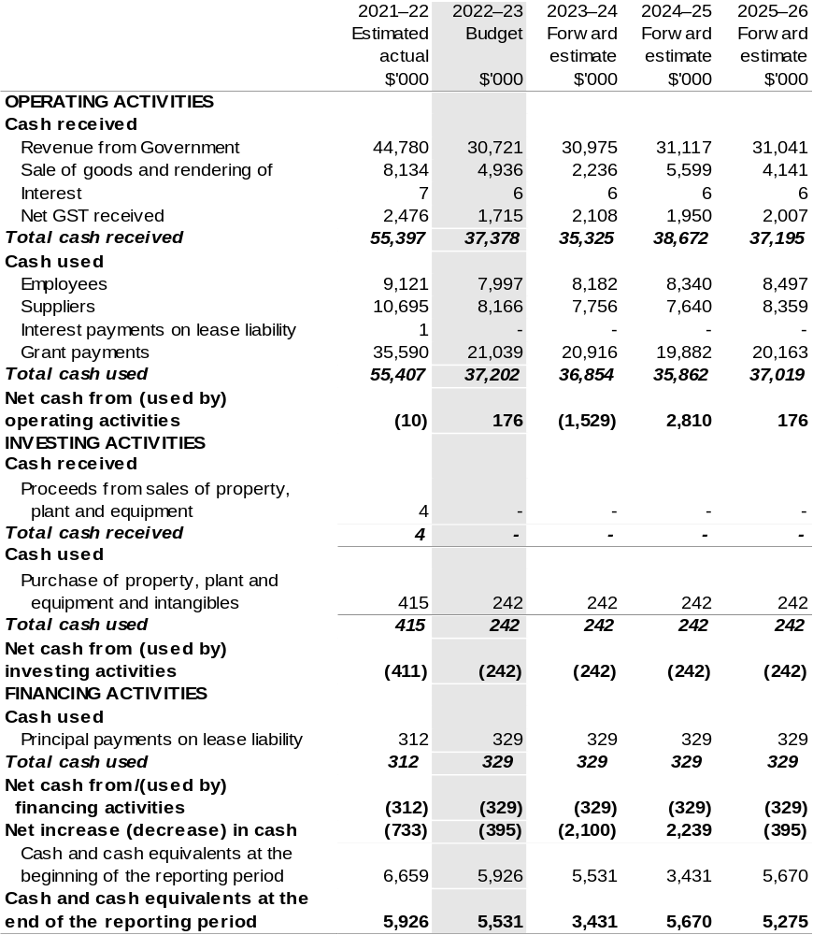

Prepared on Australian Accounting Standards basis.

Table 3.5: Departmental capital budget statement (for the period ended 30 June)
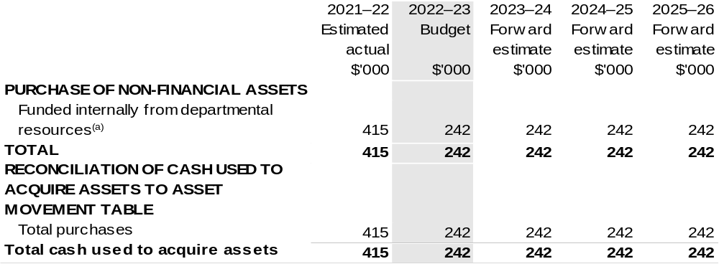

(a) Includes the following s74 external revenue:
– internally developed assets.

Consistent with information contained in the Statement of Asset Movements and the Budgeted Statement of Cash Flows.

Prepared on Australian Accounting Standards basis.

Table 3.6: Statement of asset movements (Budget year 2022–23)
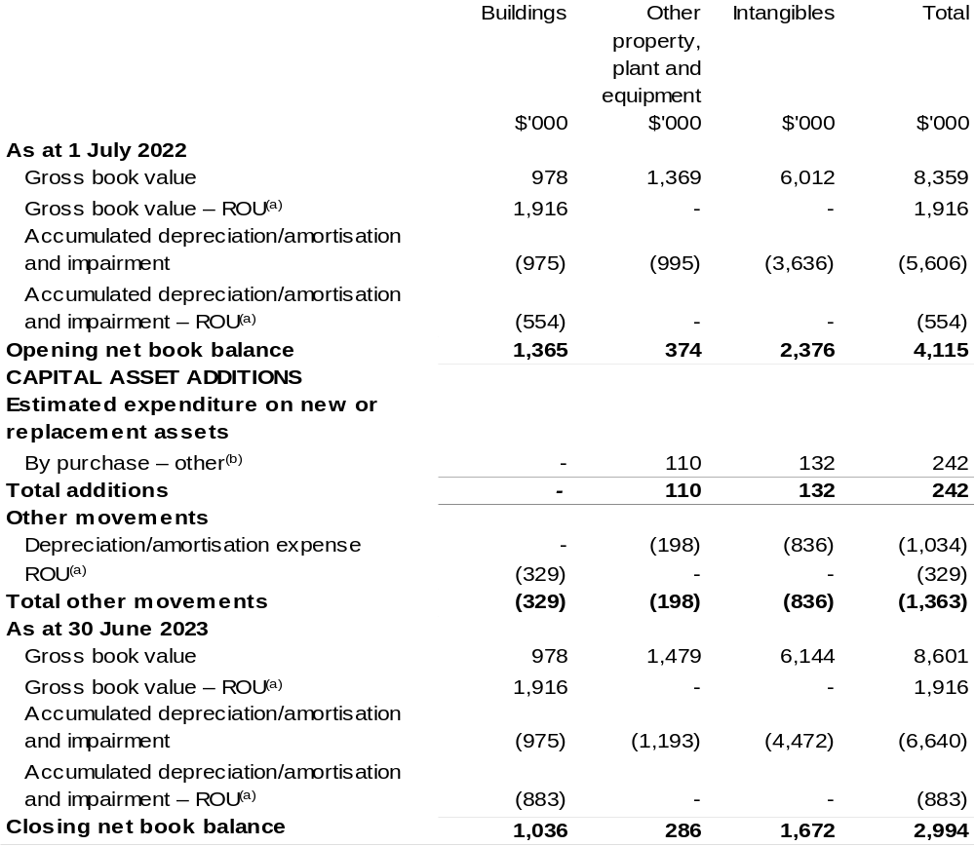

(a) Applies to leases under AASB 16 Leases. Right of Use (ROU).
(b) ‘By purchase – other’ refers to funding provided through other internal funding sources.

Prepared on Australian Accounting Standards basis.

