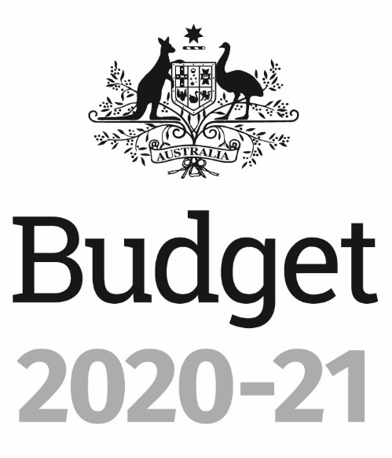

Portfolio Budget Statements 2020–21
Budget Related Paper No. 1.1

Agriculture, Water and Environment Portfolio

Budget Initiatives and Explanations of
Appropriations Specified by Outcomes
and Programs by Entity
© Commonwealth of Australia 2020
ISSN: 2652-4589 (print) 2652-4597 (online)
This publication is available for your use under a Creative Commons BY Attribution 3.0 Australia licence, with the exception of the Commonwealth Coat of Arms, the Department of Agriculture, Water and the Environment logo, photographs, images, signatures and where otherwise stated. The full licence terms are available from http://creativecommons.org /licenses/by/3.0/au/legalcode.


Use of Department of Agriculture, Water and the Environment material under a Creative Commons BY Attribution 3.0 Australia licence requires you to attribute the work (but not in any way that suggests that the Department of Agriculture, Water and the Environment endorses you or your use of the work).
Department of Agriculture, Water and the Environment material used ‘as supplied’
Provided you have not modified or transformed Department of Agriculture, Water and the Environment material in any way including, for example, by changing the department’s text; calculating percentage changes; graphing or charting data; or deriving new statistics from published Department of Agriculture, Water and the Environment statistics, then the department prefers the following attribution:
Source: Australian Government Department of Agriculture, Water and the Environment
Derivative material
If you have modified or transformed Department of Agriculture, Water and the Environment material, or derived new material from those of the Department of Agriculture, Water and the Environment in any way, then the department prefers the following attribution:
Based on Australian Government Department of Agriculture, Water and the Environment data
Use of the Coat of Arms
The terms under which the Coat of Arms can be used are set out on the It’s an Honour website (see www.pmc.gov.au/government/commonwealth-coat-arms).
Other Uses
Enquiries regarding this licence and any other use of this document are welcome at:
External Budget Section
Finance Division
Department of Agriculture, Water and the Environment
18 Marcus Clarke Street
CANBERRA CITY ACT 2601
Email: externalbudgets@awe.gov.au

President of the Senate
Australian Senate
Parliament House
CANBERRA ACT 2600

Speaker
House of Representatives
Parliament House
CANBERRA ACT 2600

Dear Mr President and Mr Speaker

We hereby submit Portfolio Budget Statements in support of the 2020–21 Budget for the Agriculture, Water and Environment portfolio.

These statements have been developed, and are submitted to the Parliament, as a statement on the outcomes for the portfolio.

We present these statements to provide accountability to the Parliament and, through it, the public.


Yours sincerely

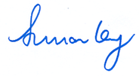

DAVID LITTLEPROUD SUSSAN LEY KEITH PITT
Minister for Agriculture, Drought Minister for the Minister for Resources, and Emergency Management Environment Water and Northern Australia
Abbreviations and conventions
The following notation may be used:
NEC/nec not elsewhere classified
- nil
.. not zero, but rounded to zero
na not applicable (unless otherwise specified)
nfp not for publication
$m $ million
$b $ billion
Figures in tables and in the text may be rounded. Figures in text are generally rounded to one decimal place, whereas figures in tables are generally rounded to the nearest thousand. Discrepancies in tables between totals and sums of components are due to rounding.
Enquiries
Should you have any enquiries regarding this publication please contact
Scott Brown, Chief Finance Officer, Department of Agriculture, Water and the Environment, on 02 6272 5523.
Links to Portfolio Budget Statements (including Portfolio Additional Estimates Statements and Portfolio Supplementary Additional Statements) can be located on the Australian Government Budget website at: www.budget.gov.au.

User Guide
To The
Portfolio Budget Statements

User Guide
The purpose of the 2020–21 Portfolio Budget Statements (PBS) is to inform Senators and Members of Parliament of the proposed allocation of resources to government outcomes by entities within the portfolio. Entities receive resources from the annual appropriations acts, special appropriations (including standing appropriations and special accounts), and revenue from other sources.
The PBS facilitates understanding of proposed annual appropriations in Appropriation Bills (No. 1 and No. 2) 2020–21. For this reason the PBS is declared by the Appropriation Acts to be a ‘relevant document’ to the interpretation of the Bills according to section 15AB of the Acts Interpretation Act 1901.
The PBS provides information, explanation and justification to enable Parliament to understand the purpose of each outcome proposed in the Bills.
As required under section 12 of the Charter of Budget Honesty Act 1998, only entities within the general government sector are included as part of the Commonwealth general government sector fiscal estimates and produce PBS where they receive funding (either directly or via portfolio departments) through the annual appropriation acts.
The Commonwealth Performance Framework
The following diagram outlines the key components of the Commonwealth performance framework. The diagram identifies the content of each of the publications and the relationship between them. Links to the publications for each entity within the portfolio can be found in the introduction to Section 2: Outcomes and planned performance.
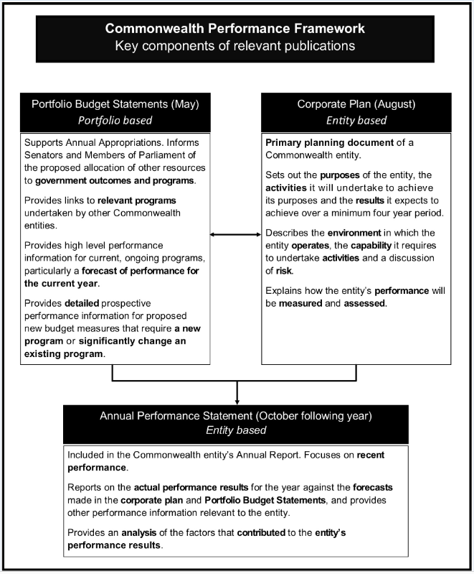

Contents

User guide v
Agriculture, Water and Environment Portfolio Overview 3
EntitIES’ resources and planned performance 11
Department of Agriculture, water and the environment 15
AgriFutures Australia 115
Australian Fisheries Management Authority 137
Australian Pesticides and Veterinary Medicines Authority 173
bureau of meteorology 193
Cotton Research and Development Corporation 217
director of national parks 237
Fisheries Research and Development Corporation 257
Grains Research and Development Corporation 277
great barrier reef marine park authority 301
Murray-Darling Basin Authority 329
Regional Investment Corporation 351
sydney harbour federation trust 371
Wine Australia 395

Portfolio Overview

Agriculture, Water and Environment
Portfolio Overview
Ministers and portfolio responsibilities
The Agriculture, Water and Environment portfolio is overseen by:
- The Minister for Agriculture, Drought and Emergency Management, the Hon. David Littleproud MP;
- The Minister for the Environment, the Hon. Sussan Ley MP; and
- The Minister for Resources, Water and Northern Australia, the Hon. Keith Pitt MP.
The three ministers are supported by:
- The Assistant Minister for Forestry and Fisheries, Senator the Hon. Jonathon Duniam; and
- The Assistant Minister for Waste Reduction and Environmental Management, the Hon. Trevor Evans MP.
From 1 February 2020 the portfolio consists of:
- Australian Government Department of Agriculture, Water and the Environment;
- AgriFutures Australia;
- Australian Fisheries Management Authority;
- Australian Pesticides and Veterinary Medicines Authority;
- Bureau of Meteorology;
- Cotton Research and Development Corporation;
- Director of National Parks;
- Fisheries Research and Development Corporation;
- Grains Research and Development Corporation;
- Great Barrier Reef Marine Park Authority;
- Murray-Darling Basin Authority;
- Regional Investment Corporation;
- Sydney Harbour Federation Trust; and
- Wine Australia.
Each entity within the portfolio has at least one outcome and program. Details are provided in each entity’s section of this document.
For information on resourcing across the portfolio, please refer to Part 1: Agency Financial Resourcing in Budget Paper No. 4: Agency Resourcing.

Figure 1: Agriculture, Water and Environment portfolio structure and outcomes
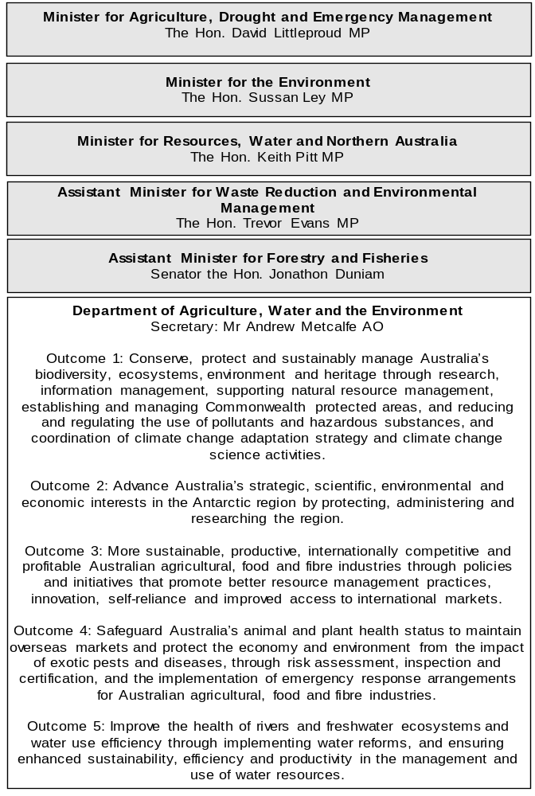
Figure 1: Agriculture, Water and Environment portfolio structure and outcomes (continued)
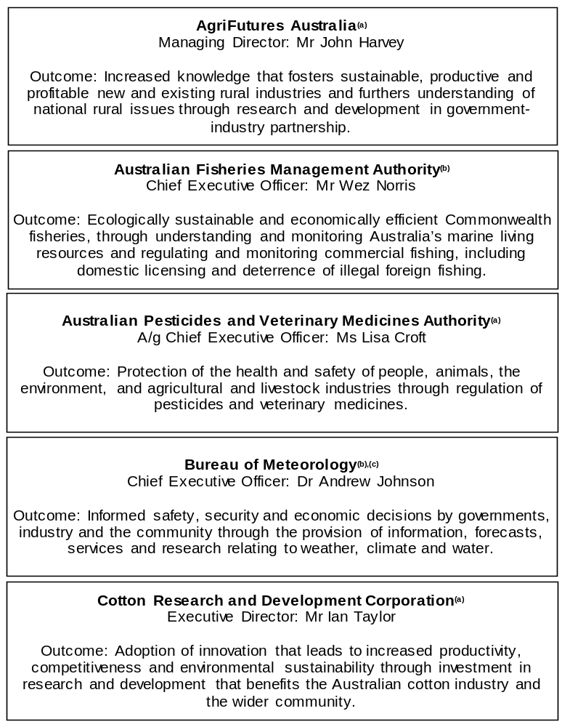

Figure 1: Agriculture, Water and Environment portfolio structure and outcomes (continued)
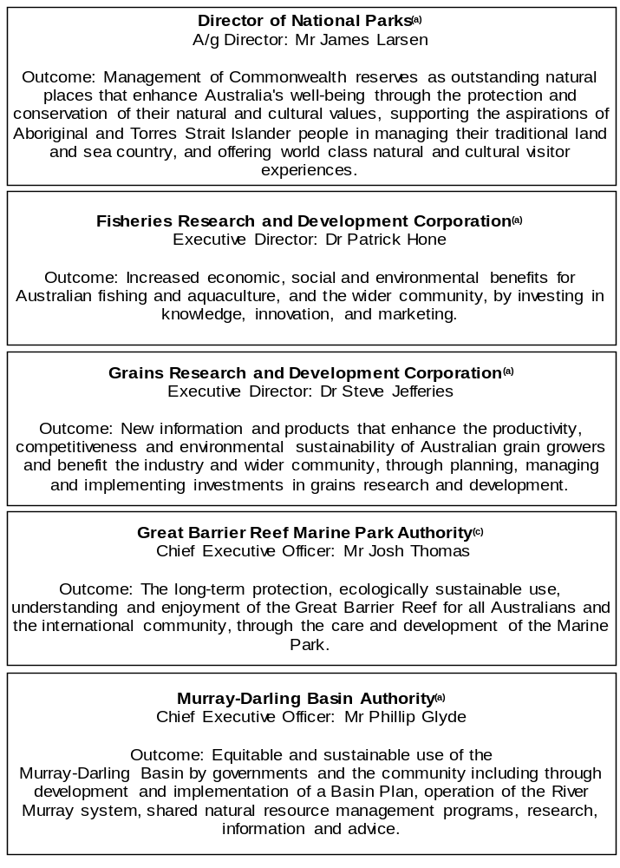
Figure 1: Agriculture, Water and Environment portfolio structure and outcomes (continued)
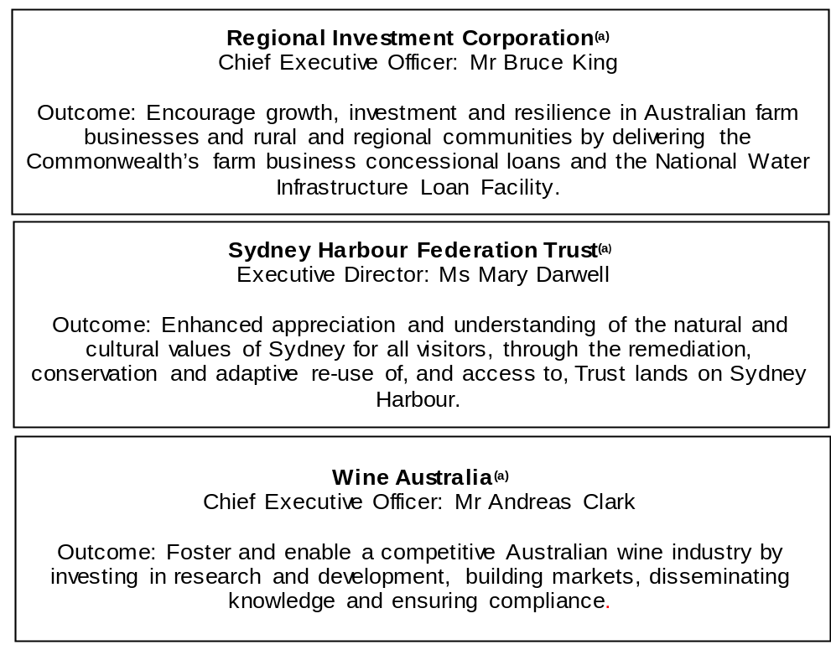
(a) ‘Corporate Commonwealth Entity’ (CCE) as defined under the Public Governance, Performance and Accountability Act 2013.
(b) ‘Non-corporate Commonwealth Entity’ (NCCE) as defined under the Public Governance, Performance and Accountability Act 2013.
(c) ‘Executive Agency’ as defined under the Public Service Act 1999.

Other industry-owned and not-for-profit companies related to the portfolio
Australian industry-owned companies are independent corporate entities, established under specific legislation with expertise-based boards. The company members appoint the directors of the board. Companies are accountable to the Minister for Agriculture, Drought and Emergency Management through legislation and statutory funding agreements and are entitled to receive industry levies and matching Australian Government funding for eligible research and development (R&D). These entities report outside of the general government sector.
The following industry-owned companies provide R&D and marketing services:
- Australian Egg Corporation Limited;
- Australian Livestock Export Corporation Limited;
- Australian Meat Processor Corporation Limited;
- Australian Pork Limited;
- Australian Wool Innovation Limited;
- Dairy Australia Limited;
- Forest and Wood Products Australia Limited;
- Horticulture Innovation Australia Limited;
- Meat and Livestock Australia Limited; and
- Sugar Research Australia Limited.
The Australian Government provides funding to the following not-for-profit, portfolio-related companies:
- Animal Health Australia;
- Landcare Australia Limited;
- National Environment Protection Council; and
- Plant Health Australia Limited.

Entities’ resources and
planned performance
Department of Agriculture, water and the environment 15
Agrifutures australia 115
Australian Fisheries Management Authority 137
Australian Pesticides and Veterinary Medicines Authority 173
BUREAU OF METEOROLOGY 193
Cotton Research and Development Corporation 217
dIRECTOR OF NATIONAL PARKS 237
Fisheries Research and Development Corporation 257
Grains Research and Development Corporation 277
GREAT BARRIER REEF MARINE PARK AUTHORITY 301
Murray-Darling Basin Authority 329
Regional investment Corporation 351
SYDNEY HARBOUR FEDERATION TRUST 371
Wine Australia 395

Department of Agriculture, Water and the Environment

Entity resources and planned performance

Department of Agriculture, Water and the Environment
Section 1: Entity overview and resources 17
1.1 Strategic direction statement 17
1.2 Entity resource statement 20
1.3 Budget measures 26
Section 2: Outcomes and planned performance 36
2.1 Planned performance 37
2.2 Change in presentation 39
2.3 Performance results for 2019–20 44
2.4 Budgeted expenses for Outcome 1 51
2.5 Budgeted expenses for Outcome 2 64
2.6 Budgeted expenses for Outcome 3 67
2.7 Budgeted expenses for Outcome 4 82
2.8 Budgeted expenses for Outcome 5 88
2.9 Budgeted expenses for Outcome 6 93
2.10 Budgeted expenses for Outcome 7 95
Section 3: Budgeted financial statements 98
3.1 Budgeted financial statements 98
3.2 Budgeted financial statements tables 100

Department of Agriculture, Water and the Environment

Section 1: Entity overview and resources

1.1 Strategic direction statement
The Department of Agriculture, Water and the Environment supports the delivery of the Australian Government’s policy agenda across the important and interrelated areas of agriculture, the environment and heritage, and water resources. Our functions are critical to our country’s prosperity and to maintaining the quality of life that Australians currently enjoy.
The department partners and regulates to enhance Australia’s agriculture, unique environment and heritage, and water resources. Our role and functions are diverse. We protect Australia’s natural resources and help develop strong agricultural industries. We work with others to ensure our land, water and heritage are well-managed, protected and productive—for today and into the future.
The past year has seen a range of challenges to Australia’s agricultural, food and fibre industries, its natural resources and environment and to the broader community—from catastrophic events such as the Black Summer bushfires, drought conditions in many parts of the country, to the impact of the COVID-19 pandemic and ongoing threats to Australia’s unique biodiversity and ecosystems.
While remaining at the forefront of the immediate response to these challenges, the department is focusing on the reality of operating in a COVID-19 and post-COVID-19 world. We will continue to support our agricultural, environment and heritage-related industries to recover and take advantage of new opportunities. We have changed the way that we work, using flexible working arrangements to keep our people safe while making sure we are delivering on our purpose, objectives and priorities. We are focused on building our capabilities to ensure we have the right balance of skills, expertise and knowledge to deliver on our responsibilities.
Maintaining and improving conditions for our primary producers is key to their success. The department continues to play a crucial role in supporting the agricultural sector to maintain domestic food security and to supply Australian-produced food to our trading partners. We are supporting exporters to find new markets, maintain existing markets where possible and minimise disruptions to their export activities through investing in strong relationships with our trading partners. In the face of an ongoing pandemic, helping industry reach the target of $100 billion in agricultural output by 2030 will require a strong partnership between industry and government.
It will also require some hard choices to be made that lift farm productivity, ensure a consistent and skilled agricultural workforce, increase the value of our produce and keep Australian exports competitive.
Australia’s biosecurity system underpins our agricultural exports, expected to be worth $43.5 billion in 2020–21, cementing our global reputation for quality produce. It also protects our unique environment, native flora and fauna, our tourism industries and lifestyle. Global trade pathways are becoming more complex, with COVID-19 adding to this complexity. We partner with many other organisations to anticipate, prevent, prepare, detect, respond to and recover from threats to agriculture sectors, human health and the environment. We implement a risk-based approach supported by research, science and intelligence to target what matters most.
Our environment has begun the long journey towards recovery from the Black Summer bushfires. The early positive signs are encouraging, but the recovery of native wildlife and their habitats will require significant effort and long-term planning.
We have supported the commitment of funds for the recovery of our biodiversity and ecosystems. We are also working across government to provide support to affected farmers, fishers and foresters, along with rural, regional and urban communities.
We are committed to the sustained effort that will be needed to support bushfire-affected areas.
In 2020–21 we are at a pivotal point in our national environmental protection efforts. Planning is underway to deliver a reform program that revitalises the legislative and policy framework for environment protection. This will ensure ongoing ecologically sustainable development that is both streamlined for businesses and effectively protects the environment.
We are supporting the Government’s ambitious recycling and waste recovery agenda under the National Waste Policy Action Plan. The first milestone—a ban on the export of unprocessed glass—will commence on 1 January 2021. We will continue to take a national and strategic approach to identifying solutions for our waste and recycling industry.
Our heritage is an important part of our national identity. We will work actively to ensure the protection of our national and world heritage places that tell the stories of our history, our unique Indigenous heritage and the exceptional environment of our continent and its surrounding waters.
Water is critical to the future of Australian agriculture and the wellbeing of our communities and the environment. We continue to work to improve the health of rivers and freshwater systems, to ensure the sustainable, efficient and productive management and use of water resources, and to achieve social, economic and environmental benefits to water users and the community. We provide national leadership to ensure water resources are managed sustainably, with strong focus on our partnerships in the Murray–Darling Basin.
Outcomes
The department is responsible for five outcomes, which align with our strategic objectives and support the achievement of our purpose:
Outcome 1: Conserve, protect and sustainably manage Australia’s biodiversity, ecosystems, environment and heritage through research, information management, supporting natural resource management, establishing and managing Commonwealth protected areas, and reducing and regulating the use of pollutants and hazardous substances, and coordination of climate change adaptation strategy and climate change science activities.
Outcome 2: Advance Australia’s strategic, scientific, environmental and economic interests in the Antarctic region by protecting, administering and researching the region.
Outcome 3: More sustainable, productive, internationally competitive and profitable Australian agricultural, food and fibre industries through policies and initiatives that promote better resource management practices, innovation, self-reliance and improved access to international markets.
Outcome 4: Safeguard Australia’s animal and plant health status to maintain overseas markets and protect the economy and environment from the impact of exotic pests and diseases, through risk assessment, inspection and certification, and the implementation of emergency response arrangements for Australian agricultural, food and fibre industries.
Outcome 5: Improve the health of rivers and freshwater ecosystems and water use efficiency through implementing water reforms, and ensuring enhanced sustainability, efficiency and productivity in the management and use of water resources.

1.2 Entity resource statement
Table 1.1 shows the total funding from all sources available to the entity for its operations and to deliver programs and services on behalf of the Government.
The table summarises how resources will be applied by outcome (Government strategic policy objectives) and by administered (on behalf of the Government or the public) and departmental (for the entity’s operations) classification.
For more detailed information on special accounts and special appropriations, please refer to Budget Paper No. 4: Agency Resourcing.
Information in this table is presented on a resourcing (i.e. appropriations/cash available) basis, whilst the ‘Budgeted expenses by Outcome’ tables in Section 2 and the financial statements in Section 3 are presented on an accrual basis.

Table 1.1: Department of Agriculture, Water and the Environment – Resource Statement – Budget Estimates for 2020–21 as at Budget October 2020
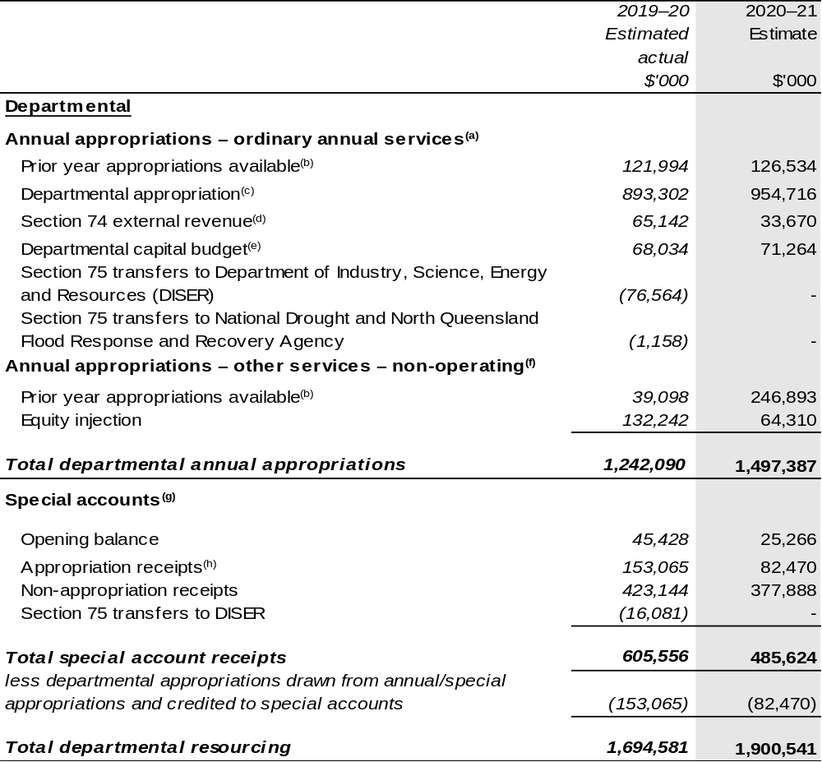
Continued on following pages
Table 1.1: Department of Agriculture, Water and the Environment – Resource Statement – Budget Estimates for 2020–21 as at Budget October 2020 (continued)
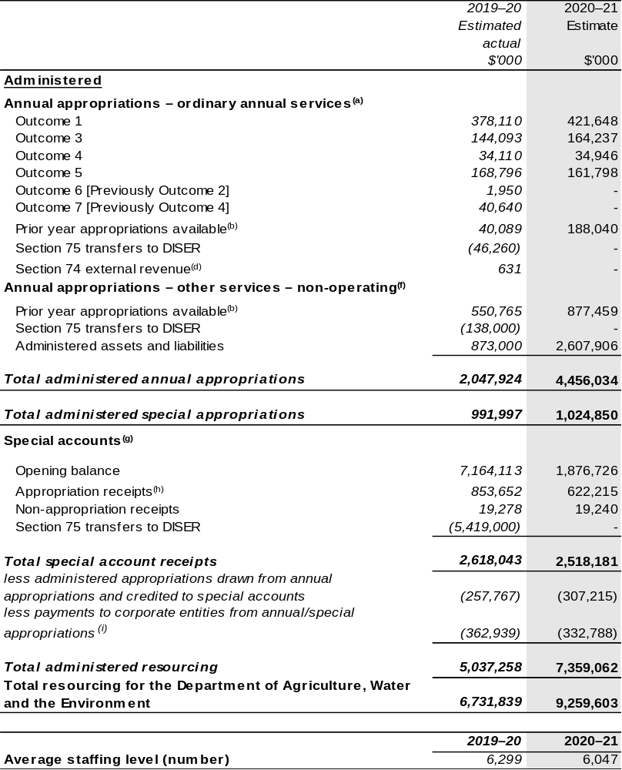
Continued on following pages

Table 1.1: Department of Agriculture, Water and the Environment – Resource Statement – Budget Estimates for 2020–21 as at Budget October 2020 (continued)

- Supply Act (No. 1) and Appropriation Bill (No. 1) 2020–21.
- Excludes $876.283 million subject to administrative quarantine by the Department of Finance or withheld under section 51 of the Public Governance, Performance and Accountability Act 2013 (PGPA Act). This also includes opening special account balances (but excluding ‘Special Public Money’ held in accounts like Other Trust Monies accounts (OTM), Services for Other Government and non-agency bodies accounts (SOG) or Services for Other Entities and Trust Moneys (SOETM) accounts.
- Excludes departmental capital budget (DCB).
- Estimated external revenue under section 74 of the PGPA Act.
- Departmental capital budgets are not separately identified in Appropriation Bill (No. 1) 2020–21 and form part of ordinary annual services items. Please refer to Table 3.5 for further details. For accounting purposes, this amount has been designated as a ‘contribution by owner’.
- Supply Act (No. 2) and Appropriation Bill (No. 2) 2020–21.
- Excludes trust moneys held in SOETM accounts and other special accounts. For further information on special accounts, please refer to Budget Paper No. 4: Agency Resourcing. Please also see Table 2.1 for further information on outcome and program expenses broken down by various funding sources,
e.g. annual appropriations, special appropriations and special accounts.
- Amounts credited to the special account(s) from the department’s annual appropriations.
- ‘Corporate entities’ are corporate Commonwealth entities and Commonwealth companies as defined under the PGPA Act.

Prepared on a resourcing (i.e. appropriations available) basis.

Note: As a result of the Administrative Arrangements Order effective 1 February 2020, actual available appropriation for 2019–20 shown above includes available appropriation for Outcome 6 and 7 up to 31 January 2020.

All figures shown above are GST exclusive – these may not match figures in the cash flow statement.

Continued on following pages

Table 1.1: Department of Agriculture, Water and the Environment – Resource Statement – Budget Estimates for 2020–21 as at Budget October 2020 (continued)
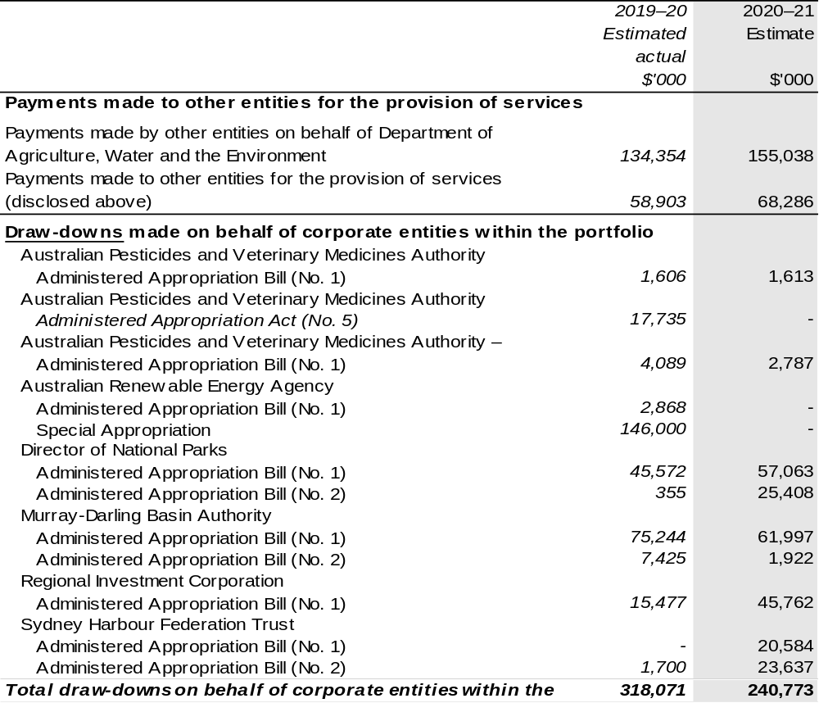
Continued on following page

Table 1.1: Department of Agriculture, Water and the Environment – Resource Statement – Budget Estimates for 2020–21 as at Budget October 2020 (continued)
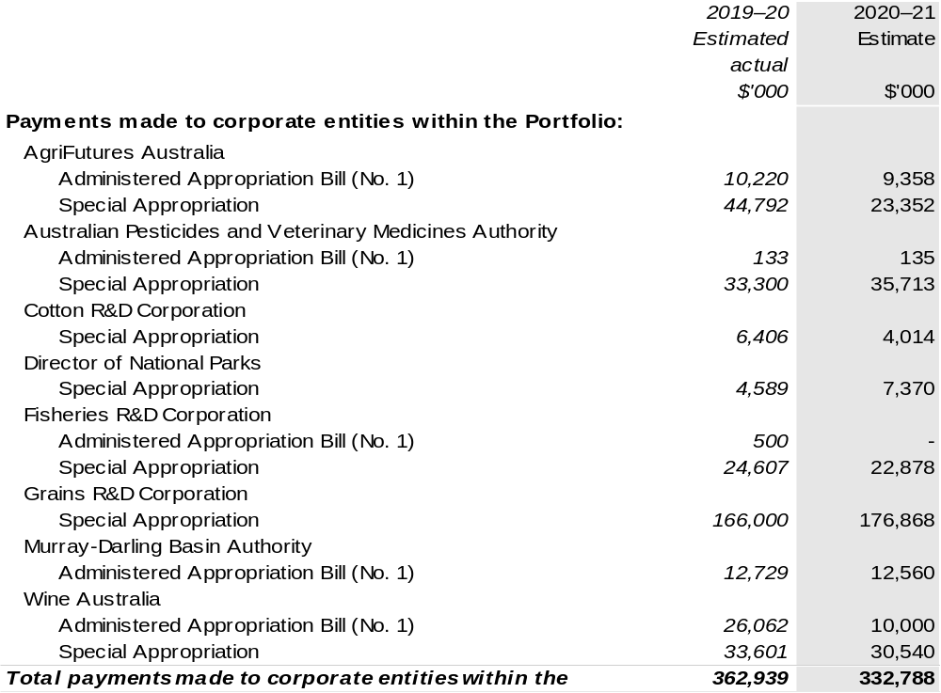

1.3 Budget measures

Budget measures in Part 1 relating to the department are detailed in Budget Paper No.2: Budget Measures 2020–21 and are summarised below.

Table 1.2: Department of Agriculture, Water and the Environment – 2020–21 Budget measures – Measures announced after the Economic and Fiscal Update July 2020
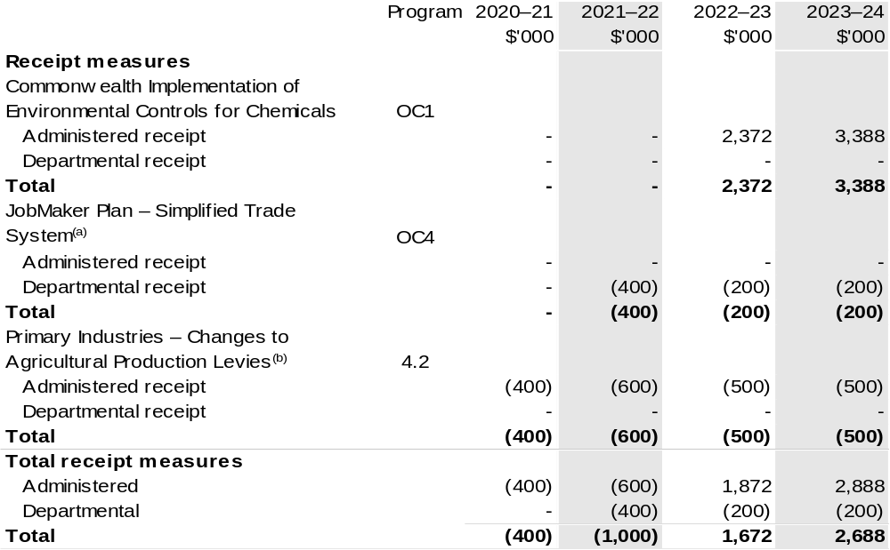
Continued on following pages
Table 1.2: Department of Agriculture, Water and the Environment 2020–21 Budget measures – Measures announced after the Economic and Fiscal Update July 2020 (continued)
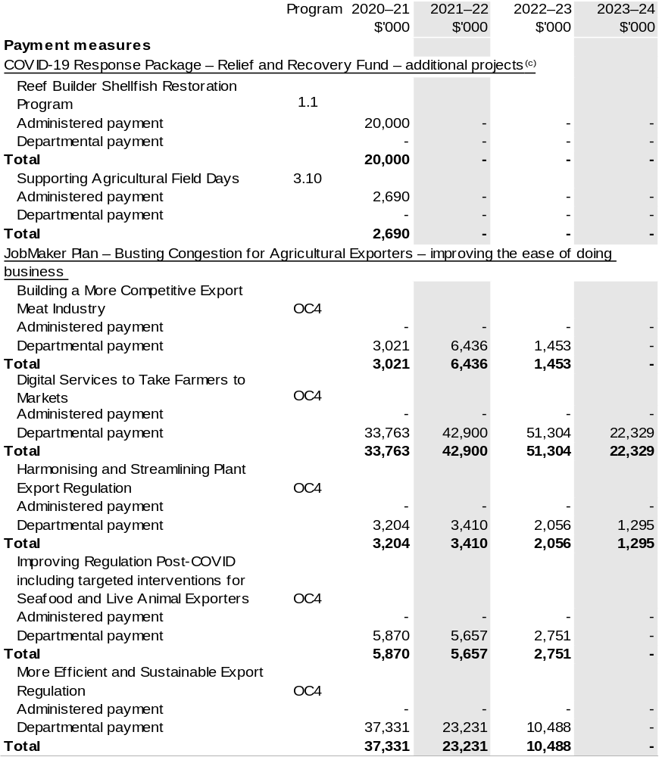
Continued on following pages
Table 1.2: Department of Agriculture, Water and the Environment 2020–21 Budget measures – Measures announced after the Economic and Fiscal Update July 2020 (continued)
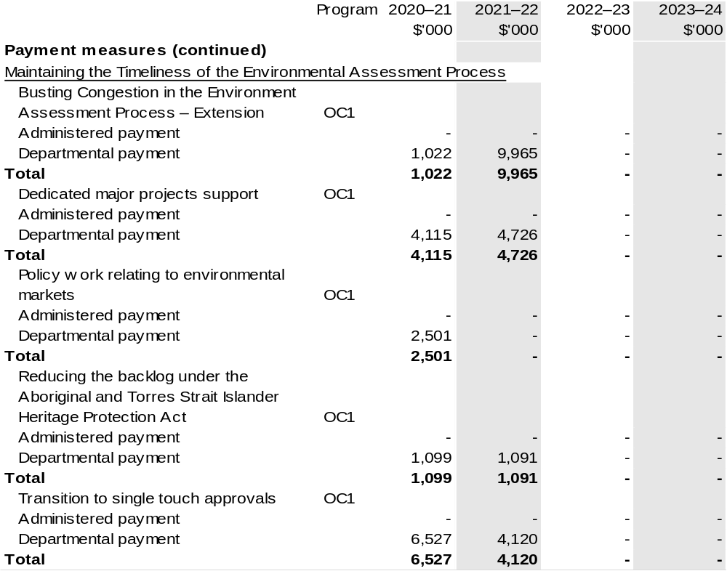
Continued on following pages
Table 1.2: Department of Agriculture, Water and the Environment 2020–21 Budget measures – Measures announced after the Economic and Fiscal Update July 2020 (continued)
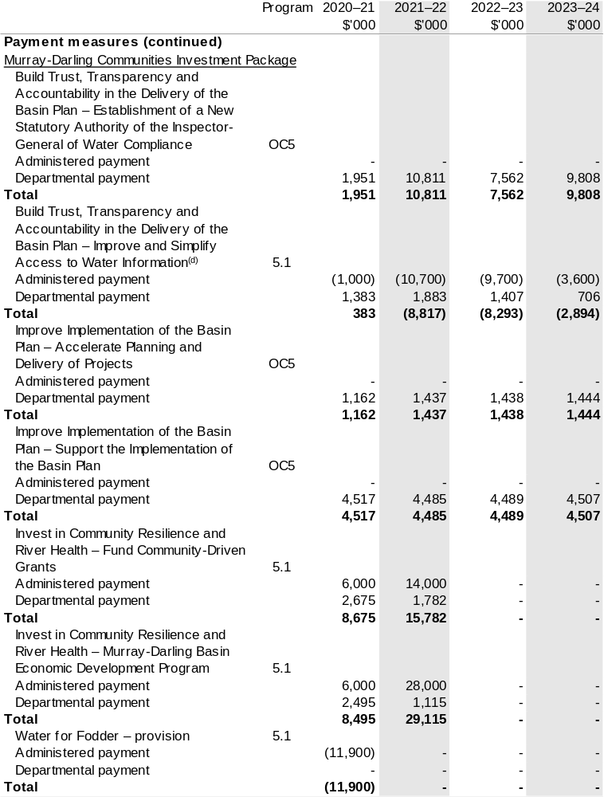
Continued on following pages

Table 1.2: Department of Agriculture, Water and the Environment 2020–21 Budget measures – Measures announced after the Economic and Fiscal Update July 2020 (continued)
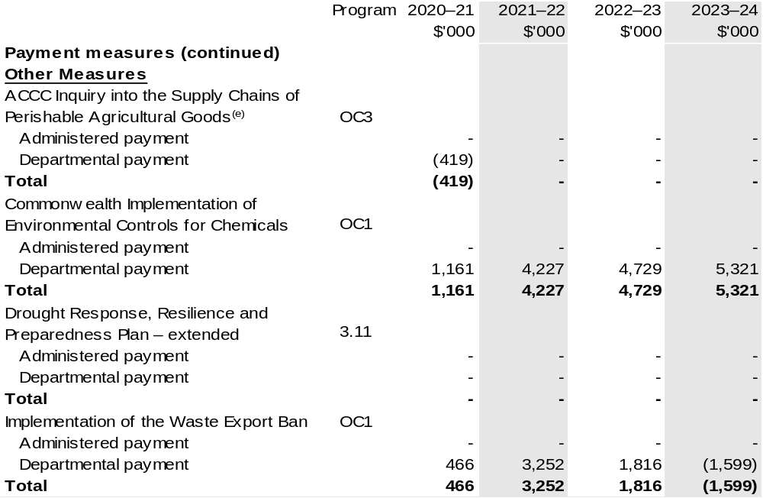

Continued on following pages

Table 1.2: Department of Agriculture, Water and the Environment 2020–21 Budget measures – Measures announced after the Economic and Fiscal Update July 2020 (continued)
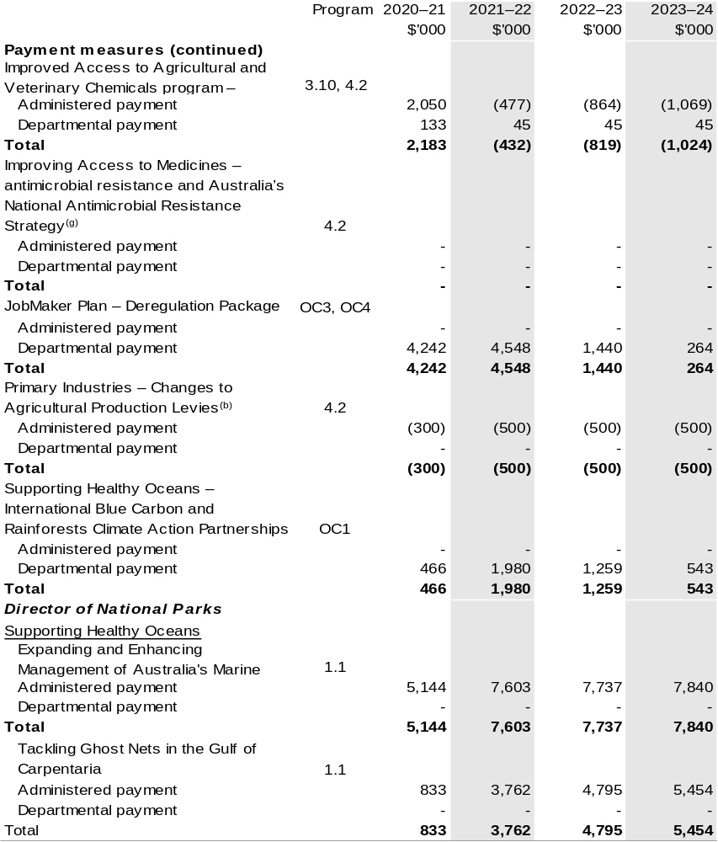

Continued on following pages

Table 1.2: Department of Agriculture, Water and the Environment 2020–21 Budget measures – Measures announced after the Economic and Fiscal Update July 2020 (continued)
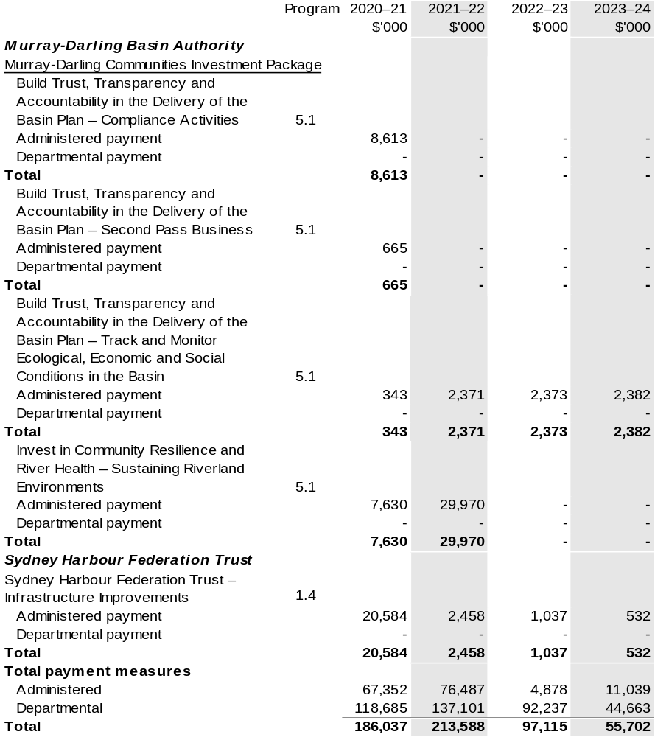
Continued on following pages
Table 1.2: Department of Agriculture, Water and the Environment 2020–21 Budget measures – Measures announced after the Economic and Fiscal Update July 2020 (continued)
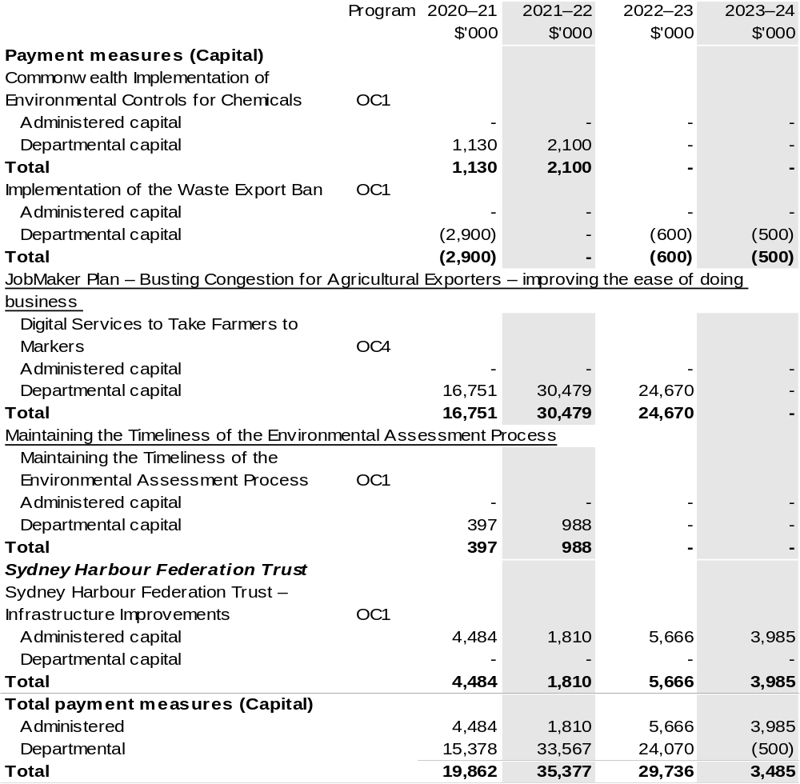
Table 1.2: Department of Agriculture, Water and the Environment 2020–21 Budget measures – Measures announced after the Economic and Fiscal Update July 2020 (continued)

(a) The lead entity for this measure is the Department of Home Affairs. The measure description appears in Budget Paper No. 2: Budget Measures 2020–21 under the Home Affairs portfolio.
(b) The measure ‘Primary Industries – Changes to Agricultural Production Levies’ appears under receipt and payment measure headings. The change is being made in consultation with the industries.
Further details are below:
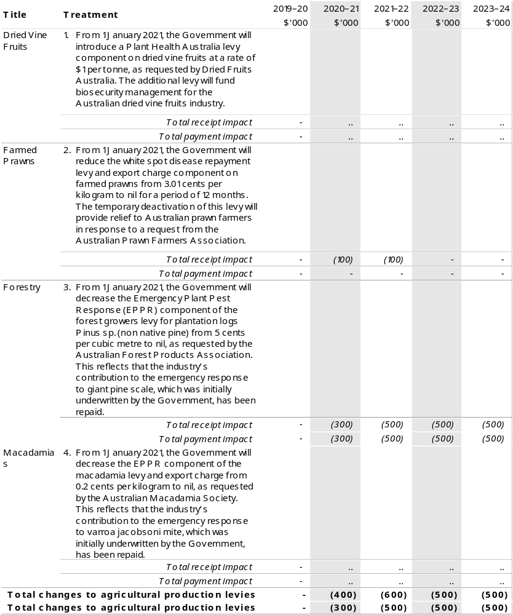
Continued on following page
Table 1.2: Department of Agriculture, Water and the Environment 2020–21 Budget measures – Measures announced after the Economic and Fiscal Update July 2020 (continued)

(c) These items are funded through the Assistance for Severely Affected Regions (Special Appropriation) (Coronavirus Economic Response Package) Act 2020, also known as the COVID-19 Relief and Recovery Fund. The lead entity is the Department of Infrastructure, Transport, Regional Development and Communications. The measure description appears in Budget Paper No. 2: Budget Measures 2020–21 under the Infrastructure, Transport, Regional Development and Communications portfolio.
(d) This measure involves a reclassification of funds from administered to SPP533 (Sustainable Rural Water Use and Infrastructure Program).
(e) The lead entity for this measure is the Department of the Treasury. The measure description appears in Budget Paper No. 2: Budget Measures 2020–21 under the Treasury portfolio.
(f) This measure provides additional funding to the National Partnership for On-Farm Emergency Water Infrastructure Rebate. Details appear in Budget Paper No. 3: Federal Financial Relations.
(g) The lead entity for this measure is the Department of Health. The measure description appears in Budget Paper No. 2: Budget Measures 2020–21 under the Health portfolio.

Figures displayed as a negative (-) represent a decrease in funds and a positive (+) represent an increase in funds.
Prepared on a Government Finance Statistics (Underlying Cash) basis

Section 2: Outcomes and planned performance
Government Outcomes are the intended results, impacts or consequences of actions by the Government on the Australian community. Commonwealth programs are the primary vehicle by which government entities achieve the intended results of their Outcome Statements. Entities are required to identify the programs which contribute to government outcomes over the Budget and forward years.
Each outcome is described below together with its related programs. The following provides detailed information on expenses for each Outcome and program, further broken down by funding source.
Note:
Performance reporting requirements in the Portfolio Budget Statements are part of the Commonwealth performance framework established by the Public Governance, Performance and Accountability Act 2013. It is anticipated that the performance criteria described in Portfolio Budget Statements will be read with broader information provided in an entity’s corporate plans and annual performance statements — included in Annual Reports — to provide a complete picture of an entity’s planned and actual performance.
The most recent corporate plan for the Department of Agriculture, Water and the Environment can be found at: https://www.awe.gov.au/about/reporting/corporate-plan.
The most recent annual performance statements can be found at: https://www.awe.gov.au/about/reporting/annual-report.

2.1 Planned performance
The performance information in the Portfolio Budget Statements is aligned to the objectives that underpin the delivery of the department’s Outcomes and its purpose. The objectives form the basis of the department’s Corporate Plan 2020–21. Table 2.1.1 shows the alignment between the department’s Outcomes and its objectives in the corporate plan.

Table 2.1.1: Outcomes and objectives 2020–21
Outcome | Objective  (Corporate Plan 2020–21)
Outcome 1:  Conserve, protect and sustainably manage Australia’s biodiversity, ecosystems, environment and heritage through research, information management, supporting natural resource management, establishing and managing Commonwealth protected areas, and reducing and regulating the use of pollutants and hazardous substances, and coordination of climate change adaptation strategy and climate change science activities. | Environment and Heritage  Support stewardship and sustainable management to enhance Australia’s environment and our unique heritage
Outcome 2:  Advance Australia’s strategic, scientific, environmental and economic interests in the Antarctic region by protecting, administering and researching the region. | Antarctic  Advance Australia’s strategic, scientific and environmental interests in the Antarctic and the Southern Ocean
Outcome 3:  More sustainable, productive, internationally competitive and profitable Australian agricultural, food and fibre industries through policies and initiatives that promote better resource management practices, innovation, self-reliance and improved access to international markets. | Agriculture  Assist industry to grow to a  $100 billion agricultural sector by 2030

Table 2.1.1: Outcomes and objectives 2020–21 (continued)
Outcome | Objective  (Corporate Plan 2020–21)
Outcome 4:  Safeguard Australia’s animal and plant health status to maintain overseas markets and protect the economy and environment from the impact of exotic pests and diseases, through risk assessment, inspection and certification, and the implementation of emergency response arrangements for Australian agricultural, food and fibre industries. | Biosecurity  Manage biosecurity risks to Australian agriculture, the environment and our way of life
Outcome 5:  Improve the health of rivers and freshwater ecosystems and water use efficiency through implementing water reforms, and ensuring enhanced sustainability, efficiency and productivity in the management and use of water resources. | Water Resources  Support the sustainable management and productive use of Australia’s water resources

2.2 Change in presentation
For 2020–21 and forward years, the department’s performance framework consists of five objectives and 23 programs. Figure 2 shows which programs contribute to the department’s five objectives.

Figure 2: Departmental programs by objectives
Programs | Objectives
Programs | Agriculture | Water Resources | Environment and Heritage | Biosecurity | Antarctic
1.1  Sustainable management of natural resources and the environment |  | ✓ | ✓
1.2  Science, information and research | ✓ | ✓ | ✓ | ✓ | ✓
1.3 Commonwealth Environmental Water |  | ✓
1.4 Conservation of Australia’s heritage and the environment |  |  | ✓
1.5 Environmental regulation |  |  | ✓
1.6 Management of hazardous wastes, substances and pollutants | ✓ | ✓ | ✓
2.1  Antarctic science, policy and presence |  |  |  |  | ✓
3.1  Agricultural Adaptation | ✓ | ✓ | ✓
3.2  Sustainable Management – Natural Resources | ✓ | ✓ | ✓

Figure 2: Departmental program by objectives (continued)
Programs | Objectives
Programs | Agriculture | Water Resources | Environment and Heritage | Biosecurity | Antarctic
3.3  Forestry Industry | ✓ |  | ✓
3.4  Fishing Industry | ✓ |  | ✓ |  | ✓
3.5  Horticulture Industry | ✓ |  | ✓
3.6  Wool Industry | ✓
3.7  Grains Industry | ✓
3.8  Dairy Industry | ✓
3.9  Meat and Livestock Industry | ✓
3.10  Agricultural Resources | ✓ | ✓ | ✓
3.11  Drought Programs | ✓ | ✓
3.12  Rural Programs | ✓
3.13 International Market Access | ✓
4.1  Biosecurity and Export Services | ✓ | ✓ | ✓ | ✓
4.2  Plant and Animal Health | ✓ | ✓ | ✓ | ✓
5.1  Water Reform | ✓ | ✓ | ✓

Table 2.2.1: Performance criteria for 2020–21 and beyond
Table 2.2.1 shows the high-level performance measures for each objective in 2020–21 and forward years.
Objective 1 – Environment and Heritage
Year | Performance criteria | Targets
2020–21 | Ecosystem diversity, extent and function are maintained or improved. | A reduction in nutrient, sediment and pesticide loads consistent with meeting targets in the Reef 2050 Water Quality Improvement Plan.  Habitat condition and connectivity within major vegetation groups improves relative to baseline.
2020–21 | Species diversity, range and abundance are maintained or improved. | Threatened Bird Index improves relative to 2019–20 baseline.
2020–21 | Heritage is recognised and protected. | 100 per cent of World Heritage listed properties are managed under management plans that are consistent with the management principles in the Environment Protection and Biodiversity Conservation (EPBC) Regulations.
2020–21 | Provide national leadership to effectively manage Australia’s waste. | Australian targets for Montreal Protocol.  Unprocessed waste glass in a whole or broken state banned from waste export from 1 January 2021.
2021–22 and beyond | As per 2020–21. | As per 2020–21.
2021–22 and beyond | Provide national leadership to effectively manage Australia’s waste. | Mixed waste plastics that are not of a single resin/polymer type banned from export from 1 July 2021.  Whole waste tyres banned from export from 1 December 2021.

Continued on following pages
Table 2.1.2: Performance criteria for 2020–21 (continued)
Objective 2 – Antarctic
Year | Performance criteria | Targets
2020–21 | Strengthen Australia’s leadership in Antarctica and the Southern Ocean, by conducting world-leading science, promoting environmental best practice, and developing economic, educational and collaborative opportunities. | Measure progress against 20 Year Action Plan.
2021–22 and beyond | As per 2020–21. | As per 2020–21.
Objective 3 – Agriculture
Year | Performance criteria | Targets
2020–21 | Increase, improve and maintain markets. | Growth in agricultural commodity exports in markets for which the department has negotiated improved market access exceeds average export growth.
2020–21 | Encourage and reduce risks to agricultural productivity. | Average annual productivity growth for the past 10 years is equal to, or exceeds, average annual market sector productivity growth over the same period.
2020–21 | The efficient collection and distribution of levies to fund rural research and development. | Levy collection processes cost no more than 1.2 per cent of levies disbursed.  Inspections of levy agent records cover at least 20 per cent of levy revenue over a three-year rolling average.
2021–22 and beyond | As per 2020–21. | As per 2020–21.

Continued on following page
Table 2.1.2: Performance criteria for 2020–21 (continued)
Objective 4 – Biosecurity
Year | Performance criteria | Targets
2020–21 | The national biosecurity system meets the agreed national goals and objectives of the Intergovernmental Agreement on Biosecurity. | Performance measures are developed to assess the effectiveness of the national biosecurity system.
2020–21 | Regulation, partnerships and service delivery manage biosecurity risk. | Rates of compliance with regulations administered by the department are maintained or improved.
2021–22 and beyond | As per 2020–21. | As per 2020–21.
Objective 5 – Water Resources
Year | Performance criteria | Targets
2020–21 | Support sustainable use and maintenance of high-quality water resources. | Number of Water Resource Plans (WRPs) accredited under Commonwealth law:  33 of 33 WRPs accredited.
2020–21 | Water quality and flows, and ecosystem health are maintained or improved. | Water-dependent ecosystems are protected and restored.
2021–22 and beyond | As per 2020–21. | As per 2020–21.

2.3 Performance results for 2019–20
This section reports the forecast performance results for the department’s five outcomes in 2019–20.
These results are presented against the performance criteria outlined in the
2019–20 Agriculture and Water Resources Portfolio Budget Statements and 2019–20 Environment and Energy Portfolio Budget Statements.

Table 2.3.1: Performance results for Outcome 1, 2019–20
The table below details the forecast performance results for Outcome 1 in 2019–20.
Program results are reported against the performance information previously presented for Outcome 1 in the 2019–20 Environment and Energy Portfolio Budget Statements.
Outcome 1: Conserve, protect and sustainably manage Australia’s biodiversity, ecosystems, environment and heritage through research, information management, supporting natural resource management, establishing and managing Commonwealth protected areas, and reducing and regulating the use of pollutants and hazardous substances, and coordination of climate change adaptation strategy and climate change science activities.
Program 1.1: Sustainable Management of Natural Resources and the Environment
Objective | The objective of this program is to improve the extent, condition and connectivity of Australia’s unique biodiversity and natural resources, including the Great Barrier Reef, through protection of habitats and mitigation of threats to threatened species and ecological communities.
Performance information
Performance criteria | Targets | 2019–20 Actual Achievement
Australia’s biodiversity including priority threatened species, ecological communities, cetaceans and migratory species, and significant heritage places are conserved and protected via targeted investments and collaborative partnerships. | Program objectives are delivered under the National Landcare Program and other key programs, including the Improving Your Local Parks and Environment Program and the Australian Heritage Grants Program. | Achieved.

Continued on following pages
Table 2.3.1: Performance criteria for Outcome 1 (continued)
Performance information
Performance criteria | Targets | 2019–20 Actual Achievement
(continued) | Contracts are in place to deliver Australian Government investment under the National Landcare Program and other key programs, including the Improving Your Local Parks and Environment Program and the Australian Heritage Grants Program. | Achieved.
Through investment and in collaboration with others, the department contributes to building the Great Barrier Reef’s resilience and capacity to respond to threats. | Reef programs deliver on the Reef 2050 Plan and Reef Trust objectives. | Achieved.

Program 1.2: Science, Information and Research
Objective | Improve understanding of Australia’s environment and inform environmental decision-making through collaborative research and enhanced discovery of, access to and use of environmental information; and improve the knowledge of, and inform decision-making on, the environmental impacts of unconventional gas and coal mining development.
Performance information
Performance criteria | Targets | 2019–20 Actual Achievement
Data and information generated by the department are used by stakeholders and/or support evidence-based decision-making. | Targets detailed in the Department of Environment and Energy 2019–20 Corporate Plan will be reported in the Department of Agriculture, Water and the Environment Annual Report 2019–20. | Achieved.

Continued on following pages

Table 2.3.1: Performance criteria for Outcome 1 (continued)
Program 1.3: Commonwealth Environmental Water
Objective | Protect and restore water-dependent ecosystems in the Murray-Darling Basin through the management and use of Commonwealth environmental water and manage Australia’s obligations under the Ramsar Convention; and improve the knowledge of, and inform decision-making on, the impacts to and management of water-dependent ecosystems consistent with international and national obligations.
Performance information
Performance criteria | Targets | 2019–20 Actual Achievement
Protect and restore water-dependent ecosystems and their functions in the  Murray-Darling Basin. | Water dependent ecosystems are protected and restored. | Achieved.
 | Adequate flushing of salt from the River Murray system into the Southern Ocean. | Achieved.
Australia’s priority wetlands are identified, conserved and protected. | Ramsar Information Sheets for Wetlands of International Importance listed under the Ramsar Convention are prepared and updated and include appropriate descriptions of the ecological character of the sites and threats to the sites. | Partially achieved.

Program 1.4: Conservation of Australia’s Heritage and the Environment
Objective | Identify, protect and conserve our world and nationally significant natural, Indigenous and historic heritage places, threatened species, ecological communities, cetaceans and migratory species: and contribute to protecting internationally traded flora and fauna consistent with national and international obligations.
Performance information
Performance criteria | Targets | 2019–20 Actual Achievement
Australia’s biodiversity, including priority threatened species, ecological communities, cetaceans and migratory species, and significant heritage places are identified, conserved and protected through regulation. | All Australian properties included on the list of World Heritage are well managed. | Partially achieved.

Continued on following pages

Table 2.3.1: Performance criteria for Outcome 1 (continued)
Program 1.5: Environmental Regulation
Objective | Support sustainable development outcomes by delivering efficient and effective regulation of matters of national environmental significance.
Performance information
Performance criteria | Targets | 2019–20 Actual Achievement
Australia’s biodiversity, including priority threatened species, ecological communities, cetaceans and migratory species, and significant heritage places are identified, conserved and protected through regulation. | Activities required by legislation are conducted within statutory timeframe. | Achieved.
The Alligator Rivers Region environment remains protected from uranium mining effects consistent with statutory requirements. | There has been no detrimental effect to the people and the environment of the Alligator Rivers Region, including Kakadu National Park, as a result of mining activities. | Achieved.

Program 1.6: Management of Hazardous Wastes, Substances and Pollutants
Objective | Protect the environment through national approaches to effectively and efficiently manage hazardous wastes, substances and pollutants.
Performance information
Performance criteria | Targets | 2019–20 Actual Achievement
The department’s regulatory activities and policies relating to management of hazardous waters, substance and pollutants support environmental health outcomes. | Import of controlled chemicals does not exceed the limits set out in the Ozone Protection and Synthetic Greenhouse Gas Management Act 1989 and Regulations. | Achieved.
 | All Australians have access to timely, quality data on emissions and transfers of polluting or harmful substances. | Achieved.
 | Activities required by legislation are conducted within statutory timeframes. | Achieved.

Continued on following page

Table 2.3.1: Performance criteria for Outcome 1 (continued)
Performance information
Performance criteria | Targets | 2019–20 Actual Achievement
(continued) | Compliance activities are undertaken to deliver environmental health outcomes. | Achieved.

Table 2.3.2: Performance results for Outcome 2, 2019–20
The table below details the forecast performance results for Outcome 2 in 2019–20.
Program results are reported against the performance information previously presented for Outcome 2 in the 2019–20 Environment and Energy Portfolio Budget Statements.
Outcome 2: Advance Australia’s strategic, scientific, environmental and economic interests in the Antarctic region by protecting, administering and researching the region
Program 2.1: Antarctic Science, Policy and Presence
Objective | The objective of this program is to strengthen Australia’s leadership in Antarctica and the Southern Ocean, including by maintaining a strong and effective presence, by conducting world-leading science, promoting environmental best practice, and developing economic, educational and collaborative opportunities.
Performance information
Performance criteria | Targets | 2019–20 Actual Achievement
Antarctica and the Southern Ocean are protected, valued and understood. | Australian Antarctic Strategy and 20 Year Action Plan is delivered in accordance with stated timeframes and priorities. | Partially achieved.

Table 2.3.3: Performance results for Outcome 3, 4 and 5, 2019–20
The table below details the forecast performance results for Outcomes 3, 4 and 5 in 2019–20.
Program results are reported against the performance information previously presented for Outcomes 1, 2 and 3 in the 2019–20 Agriculture and Water Resources Portfolio Budget Statements.
Outcome 3 – More sustainable, productive, internationally competitive and profitable Australian agricultural, food and fibre industries through policies and initiatives that promote better resource management practices, innovation, self-reliance and improved access to international markets.
Outcome 4 – Safeguard Australia’s animal and plant health status to maintain overseas markets and protect the economy and environment from the impact of exotic pests and diseases, through risk assessment, inspection and certification, and the implementation of emergency response arrangements for Australian agricultural, food and fibre industries.
Outcome 5 – Improve the health of rivers and freshwater ecosystems and water use efficiency through implementing water reforms, and ensuring enhanced sustainability, efficiency and productivity in the management and use of water resources.
Increase, Improve and Maintain Markets
Performance information
Performance criteria | Targets | 2019–20 Actual Achievement
The trend in value of agricultural exports increases in real terms over time. | The value of agricultural, forestry and fishery exports exceeds the average value of the previous 10 years. | Achieved.
Encourage Agricultural Productivity
Performance information
Performance criteria | Targets | 2019–20 Actual Achievement
Portfolio industries record an increase in productivity. | Average annual productivity growth for the past 10 years is equal to or exceeds average annual market sector productivity growth over the same period. | Not achieved.

Continued on following page
Table 2.3.3: Performance results for Outcome 3–5, 2019–20 (continued)
Support Sustainable, High-Quality Natural Resources
Performance information
Performance criteria | Targets | 2019–20 Actual Achievement
The quality of the resource base is maintained or improved. | The status and productivity of agricultural land, water resources and Commonwealth fisheries is at least maintained in trend terms. | Partially achieved.

2.4 Budgeted expenses for Outcome 1
Outcome 1: Conserve, protect and sustainably manage Australia’s biodiversity, ecosystems, environment and heritage through research, information management, supporting natural resource management, establishing and managing Commonwealth protected areas, and reducing and regulating the use of pollutants and hazardous substances, and coordination of climate change adaptation strategy and climate change science activities.

2.4.1: Linked programs
Australian Fisheries Management Authority
Program 1.1: Australian Fisheries Management Authority
Contribution to Outcome 1 made by linked programs
The Department of the Agriculture, Water and the Environment (DAWE) and the Australian Fisheries Management Authority engage on sustainable management of Commonwealth fisheries.
Australian Institute of Marine Science
Program 1.1: Marine Research
Contribution to Outcome 1 made by linked programs
DAWE and the Australian Institute of Marine Science work together on implementation of the Reef 2050 Plan to protect and conserve the Great Barrier Reef.
Australian Maritime Safety Authority
Program 1.1: Australian Maritime Safety Authority
Contribution to Outcome 1 made by linked programs
The Australian Maritime Safety Authority works to minimise the risk of shipping incidents and pollution in Australian waters and contributes to the sustainable management of natural resources, including the Great Barrier Reef.
Australian Taxation Office
Program 1.9: Product Stewardship for Oil program
Contribution to Outcome 1 made by linked programs
The Australian Taxation Office administers the Product Stewardship for Oil program on behalf of DAWE by providing incentives to increase used oil recycling and encourage environmentally sustainable management and re-refining of used oil and its re-use.

Continued on following pages

2.4.1: Linked programs (continued)
Bureau of Meteorology
Program 1.1: Bureau of Meteorology
Contribution to Outcome 1 made by linked programs
The Bureau of Meteorology (BOM) is a partner in the Earth Systems and Climate Change Hub in the National Environmental Science Program. BOM also provides weather, climate and water modelling and information to DAWE.
Clean Energy Finance Corporation
Program 1.1: Clean Energy Finance Corporation
Contribution to Outcome 1 made by linked programs
DAWE has responsibility for policies that reduce waste and increase domestic recycling capacity. The Clean Energy Finance Corporation (CEFC) contributes to these policies by making available funding to the Clean Energy Innovation Fund and Reef Funding Program. Through the Australian Recycling Investment Fund, CEFC provides flows of finance into clean energy technologies that support the recycling of waste, in particular wastes that are – or by 1 July 2024 will be – banned for export.
Commonwealth Scientific and Industrial Research Organisation
Program 1.1: Research - Science, Services and Innovation Fund
Contribution to Outcome 1 made by linked programs
The Commonwealth Scientific and Industrial Research Organisation (CSIRO) contributes to Outcome 1 through the delivery of research to support the implementation of the Reef 2050 Plan to protect and conserve the Great Barrier Reef.
CSIRO leads the Earth Systems and Climate Change Hub and is a partner in other Hubs in the National Environmental Science Program.
CSIRO collaborates in the delivery of the Geological and Bioregional Assessments program, contributing expertise in ecology, ecotoxicology, hydrology, hydrogeology, informatics and risk analysis.

Continued on following pages
2.4.1: Linked programs (continued)
Department of Foreign Affairs and Trade
Program 1.1: Foreign Affairs and Trade Operations
Program 1.2: Official Development Assistance
Contribution to Outcome 1 made by linked programs
The Department of Foreign Affairs and Trade (DFAT) supports DAWE on matters relating to the protection and conservation of coral reefs globally. This draws on Australian expertise in coral reef science and management, particularly from the Great Barrier Reef.
DAWE receives funding from DFAT for a number of international engagement activities. DAWE, with engagement from DFAT, is the lead agency for Australia’s engagement in the High-Level Panel for a Sustainable Ocean Economy. DAWE works with Australia’s Ambassador to United Nations Educational, Scientific and Cultural Organization (UNESCO) and Australia’s Ambassador for the Environment in support of Australia’s membership of the World Heritage Committee.
Department of Health
Program 5.1: Protect the Health and Safety of the Community through Regulation
Contribution to Outcome 1 made by linked programs
DAWE and the Department of Health work together to manage policy and regulatory issues that have combined human and environmental health implications.
Department of Home Affairs
Program 1.1: Border Enforcement
Program 1.2: Border Management
Contribution to Outcome 1 made by linked programs
DAWE and the Department of Home Affairs work together to prevent the illegal wildlife trade, control transboundary movements of hazardous wastes and their disposal and share information on imports of products subject to air quality standards.
Department of Industry, Science, Energy and Resources
Program 1.1: Investing in Science, Technology and Commercialisation
Program 1.3: Supporting a Strong Resources Sector
Contribution to Outcome 1 made by linked programs
DAWE works collaboratively with the Department of Industry, Science and Resources (DISER) on science and research priorities for a resilient Great Barrier Reef. DAWE provides advice to DISER to ensure the ongoing protection of the Alligator Rivers Region from impacts of mining uranium at Ranger mine.

Continued on following pages
2.4.1: Linked programs (continued)
Department of Infrastructure, Transport, Regional Development and Communications
Program 3.3: Cities
Contribution to Outcome 1 made by linked programs
DAWE supports the Government’s cities agenda led by the Department of Infrastructure, Transport, Regional Development and Communications, including through the delivery of commitments under the Launceston, Western Sydney and Hobart City Deals; strategic assessments under the Environment Protection and Biodiversity Conservation Act 1999 (EPBC Act); and national approaches to managing waste and hazardous substances and air quality in cities.
Department of the Treasury
Program 1.9: National Partnerships Payments to the States
Contribution to Outcome 1 made by linked programs
The Department of the Treasury contributes to Outcome 1 by making payments for the following national partnership agreements on behalf of DAWE:
- National Partnership on Bushfire Wildlife and Habitat Recovery (SPP822);
- National Partnership on the Environmental Assessment Systems Upgrade (SPP813);
- National Partnership on the Environment Restoration Fund (SPP845);
- National Partnership on Recycling Infrastructure (SPP827);
- National Partnership on World Heritage Sites (SPP752);
- National Partnership on COVID-19 World and National Heritage (SPP844); and
- National Partnership on Yellow Crazy Ant Control (SPP790).
Director of National Parks
Program 1.1: Parks and Reserves
Contribution to Outcome 1 made by linked programs
DAWE and the Director of National Parks (DNP) work together to set policy directions for science, heritage and species management in Commonwealth managed marine and terrestrial reserves. DAWE works with DNP to transition Jabiru township from a mining to a tourism-based economy.

2.4.1: Linked programs (continued)
Geoscience Australia
Program 1.1: Geoscientific and Spatial Information Services
Contribution to Outcome 1 made by linked programs
Geoscience Australia provides geoscience expertise in the delivery of the Geological and Bioregional Assessments Program and the National Environmental Science Program Marine Biodiversity Hub. Geoscience Australia’s Digital Earth Australia Program works with DAWE to deliver new, continental-scale environmental monitoring capabilities using satellite imagery.
Great Barrier Reef Marine Park Authority
Program 1.1: Great Barrier Reef Marine Park Authority
Contribution to Outcome 1 made by linked programs
DAWE and the Great Barrier Reef Marine Park Authority work together on heritage management, environment health, species conservation and fisheries management as well as joint implementation of the Reef 2050 Plan to protect and conserve the Great Barrier Reef.
Murray-Darling Basin Authority
Program 1.1: Equitable and Sustainable Use of the Murray-Darling Basin
Contribution to Outcome 1 made by linked programs
DAWE and the Murray-Darling Basin Authority (MDBA) work together on implementation of the Basin Plan, operation of the River Murray System, shared natural resource management programs, research, information, advice and Basin Plan reporting obligations, all of which contribute to the management of Commonwealth environmental water.
National Indigenous Australian Agency
Program 1.1: Indigenous Advancement – Jobs, Land and the Economy
Contribution to Outcome 1 made by linked programs
DAWE and the National Indigenous Australians Agency (NIAA) work together to provide opportunities for Indigenous communities and land managers to engage with the National Landcare Program. DAWE and the NIAA work cooperatively on Indigenous Protected Areas.

2.4.1: Linked programs (continued)
National Offshore Petroleum Safety and Environmental Management Authority
Program 1.1: Regulatory oversight of Safety Cases, Well Operations Management Plans and Environment Plans Coupled with Effective Monitoring, Investigation and Enforcement
Contribution to Outcome 1 made by linked programs
The National Offshore Petroleum Safety and Environmental Management Authority contributes to Outcome 1 through administration of its EPBC Act-endorsed environmental management authorisations process under the Offshore Petroleum and Greenhouse Gas Storage Act 2006 and complementary compliance monitoring, investigations and enforcement activities as appropriate across its environmental management, safety and integrity regulatory functions.
Sydney Harbour Federation Trust
Program 1.1: Sydney Harbour Federation Trust
Contribution to Outcome 1 made by linked programs
DAWE and the Sydney Harbour Federation Trust (SHFT) collaborate through engagement on policy direction and site management to conserve and enhance the natural and cultural heritage of SHFT land and maximise public access and enjoyment of its sites.

2.4.2: Budgeted expenses for Outcome 1
This table shows how much the entity intends to spend (on an accrual basis) on achieving the outcome, broken down by program, as well as by administered and departmental funding sources.

Table 2.4.3: Budgeted expenses for Outcome 1
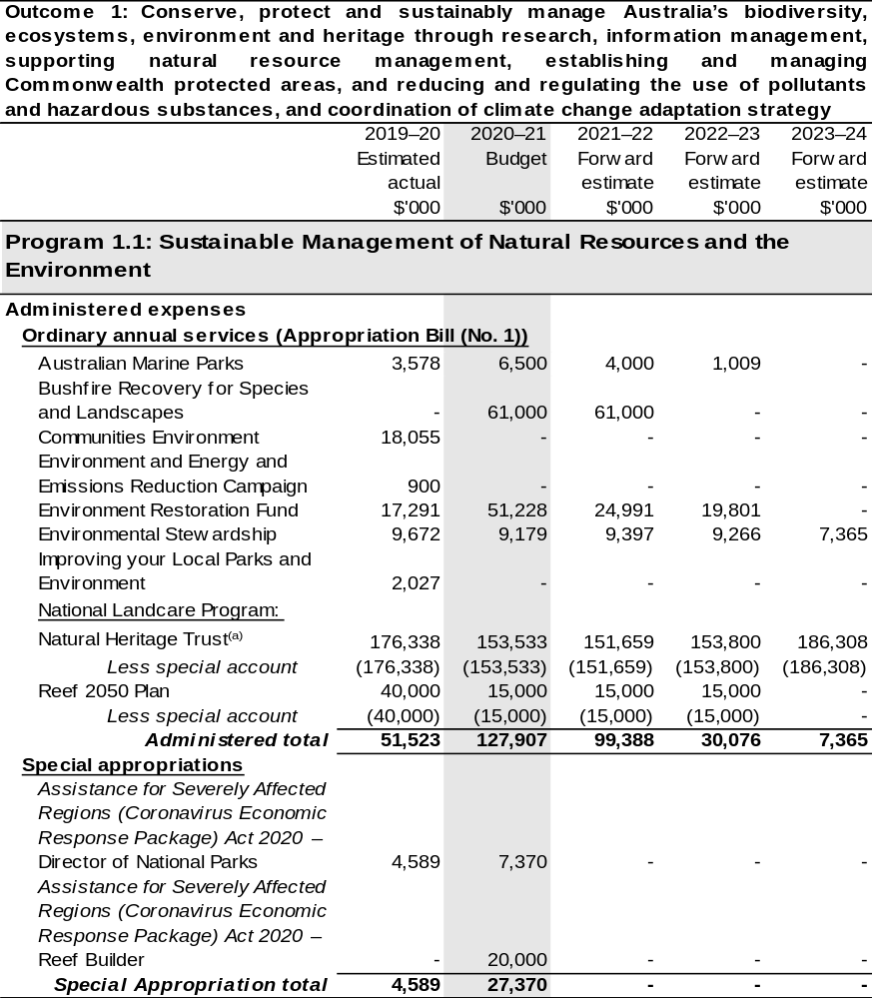
Continued on following pages
Table 2.4.3: Budgeted expenses for Outcome 1 (continued)
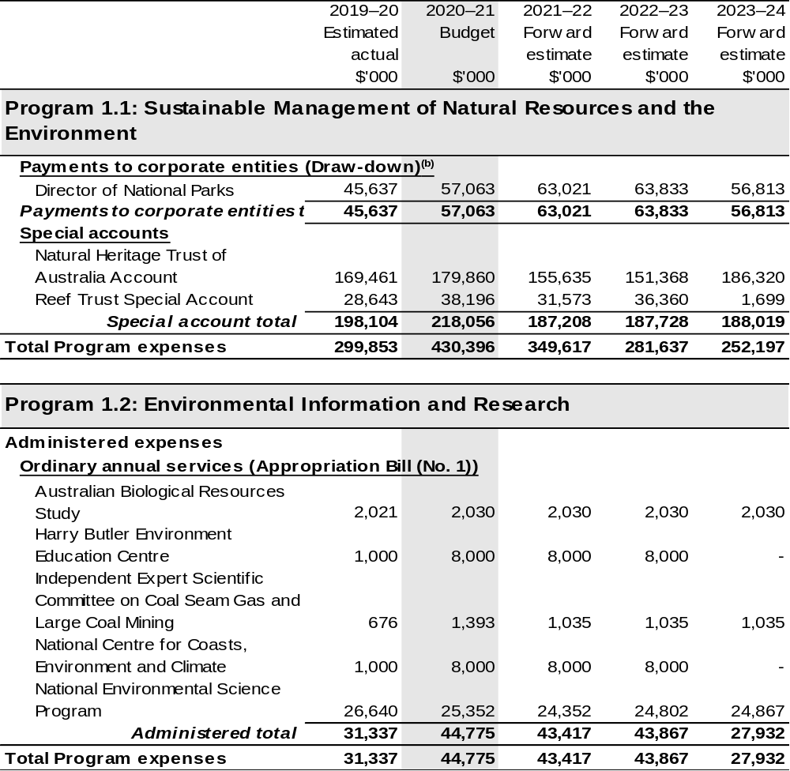
Continued on following pages
Table 2.4.3: Budgeted expenses for Outcome 1 (continued)
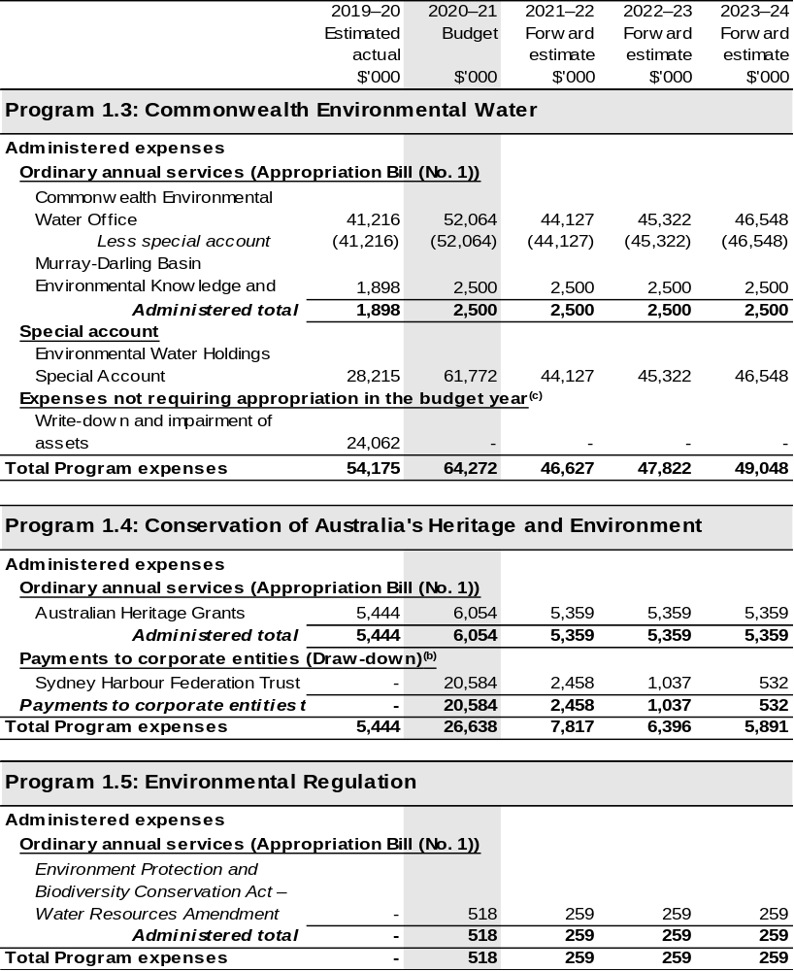
Continued on following pages

Table 2.4.3: Budgeted expenses for Outcome 1 (continued)
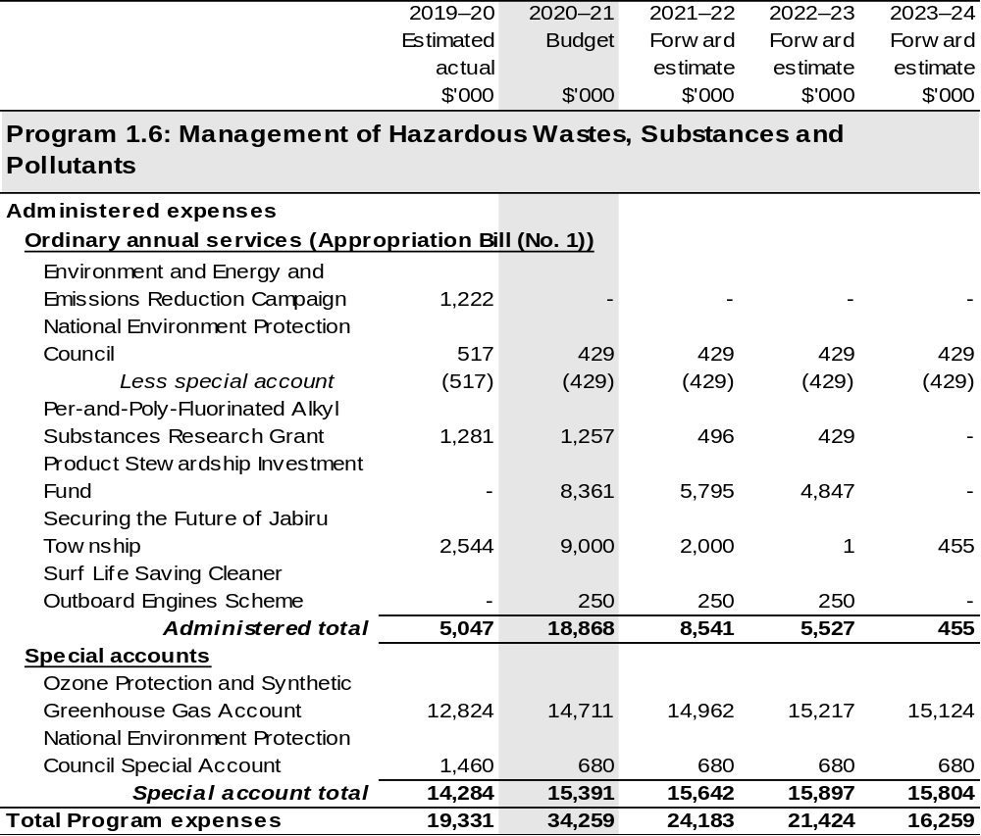
Continued on following pages

Table 2.4.3: Budgeted expenses for Outcome 1 (continued)
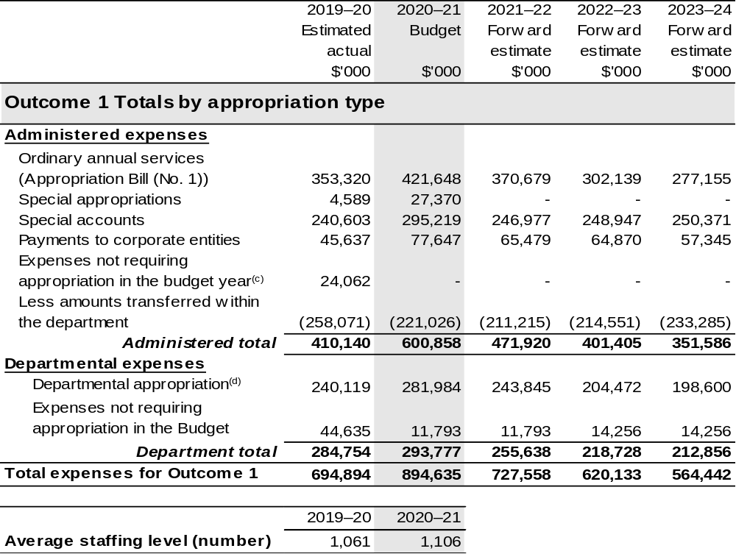
(a) Funding for components of the National Landcare Program are directly appropriated to the Department of the Treasury and the Department of the Prime Minister and Cabinet.
(b) The Director of National Parks and Sydney Harbour Federation Trust are CCEs under the PGPA Act and do not receive direct appropriations. Instead, their funding passes through the department and is drawn-down on their behalf.
(c) ‘Expenses not requiring appropriation in the Budget year’ are made up of depreciation and amortisation expenses, audit fees and an approved operating loss.
(d) Departmental appropriation allocations are notional and reflect the current structure of the department. Expenses funded from both ‘Ordinary annual services is (Supply Act (No. 1) and Appropriation Bill (No. 1))’ and ‘External Revenue’ under section 74 of the PGPA Act.

Note: Departmental appropriation splits and totals are indicative estimates and may change in the course of the budget year as Government priorities change.

Continued on following page

Table 2.4.3: Budgeted expenses for Outcome 1 (continued)
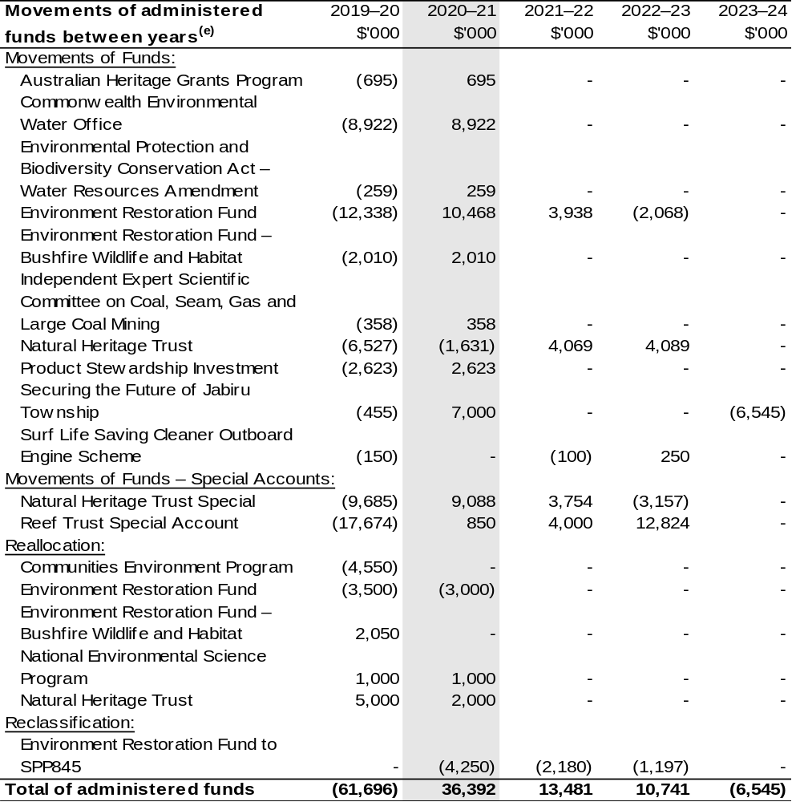
Continued on following page

Table 2.4.3: Budgeted expenses for Outcome 1 (continued)
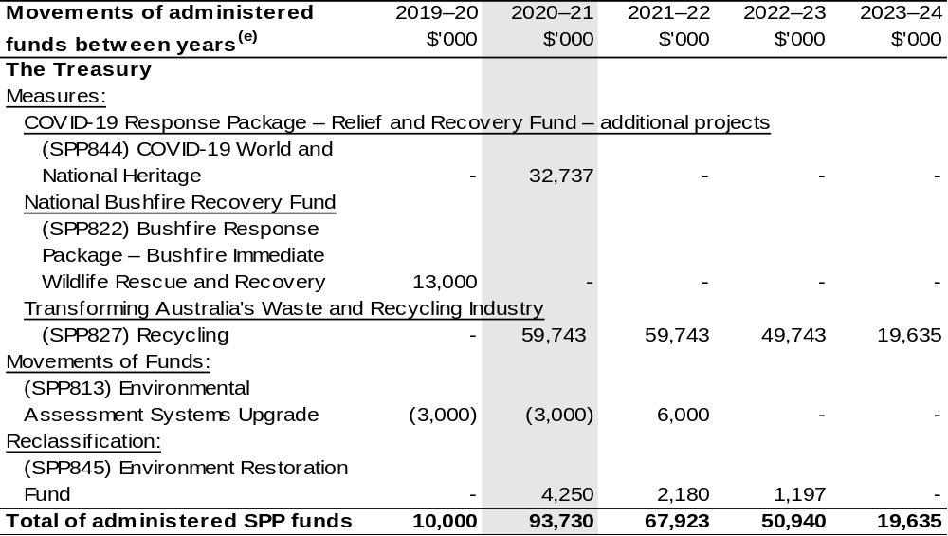
(e) Figures displayed as a negative (-) represent a decrease in funds and a positive (+) represent an increase in funds.

2.5 Budgeted expenses for Outcome 2
Outcome 2: Advance Australia’s strategic, scientific, environmental and economic interests in the Antarctic region by protecting, administering and researching the region.

2.5.1: Linked programs
Australian Research Council
Program 1.2: Cross Sector Research Partnerships
Contribution to Outcome 2 made by linked programs
The Australian Research Council (ARC) is responsible for the management of the Special Research Initiative in the current Gateway Partnership and establishing the new Special Research Initiative in Excellence in Antarctic Science. DAWE is responsible for the Australian Antarctic program. As these two programs support the Australian Antarctic Science Strategic Plan 2011–12 to 2020–21, ARC and DAWE work together to ensure effective delivery of these initiatives.
Bureau of Meteorology
Program 1.1: Bureau of Meteorology
Contribution to Outcome 2 made by linked programs
BOM provides meteorological and related services in support of the Australian Antarctic program under a Memorandum of Understanding. There are also joint science projects underway between the BOM and the Australian Antarctic Division.
Commonwealth Scientific and Industrial Research Organisation
Program 1.1: Research – Science, Services and Innovation Fund
Contribution to Outcome 2 made by linked programs
CSIRO undertakes scientific research and monitoring in the Southern Ocean and at Australia’s Antarctic Stations, as part of the Australian Antarctic program.
Department of Defence
Program 2.5: Navy Capabilities
Program 2.7: Air Force Capabilities
Contribution to Outcome 2 made by linked programs
The Department of Defence provides a range of logistics support services and advice to the Australian Antarctic program, including C130J and C-17 airlift capability to supplement existing flights in the delivery of cargo and contributing to aeromedical emergency responses in the region.

Continued on following page
2.5.1: Linked programs (continued)

Department of Foreign Affairs and Trade
Program 1.1: Foreign Affairs and Trade Operations
Contribution to Outcome 2 made by linked programs
DFAT leads, in cooperation with DAWE, a whole of government approach to Antarctic policy development and international relations, including through the Antarctic Treaty System.
Department of Industry, Science, Energy and Resources
Program 1.1: Investing in Science, Technology and Commercialisation
Contribution to Outcome 2 made by linked programs
As part of the Australian Antarctic Program, DAWE works with DISER, which administers the Antarctic Science Collaboration Initiative.
Geoscience Australia
Program 1.1: Geoscience Australia
Contribution to Outcome 2 made by linked programs
Geoscience Australia undertakes research, mapping and monitoring in the Australian Antarctic Territory, as part of the Australian Antarctic program.

2.5.2: Budgeted expenses for Outcome 2
This table shows how much the entity intends to spend (on an accrual basis) on achieving the outcome, broken down by program, as well as by administered and departmental funding sources.

Table 2.5.3: Budgeted expenses for Outcome 2
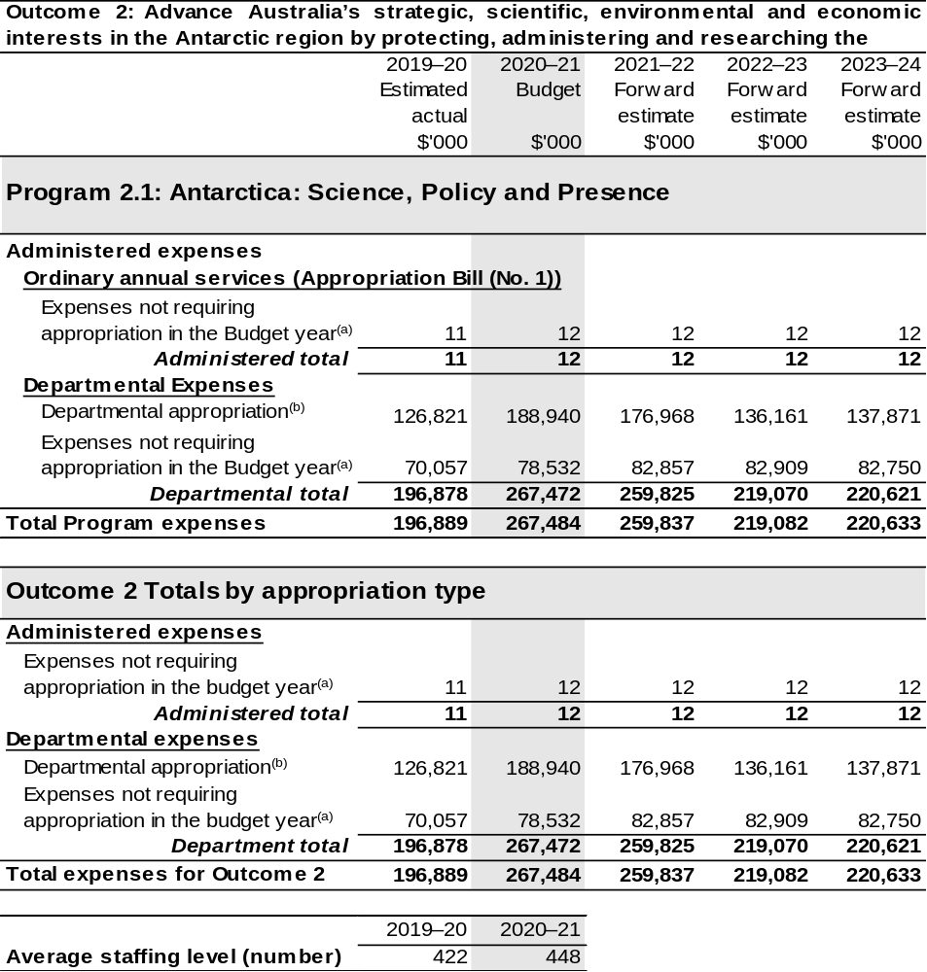
(a) ‘Expenses not requiring appropriation in the Budget year’ are made up of depreciation and amortisation expenses, audit fees and an approved operating loss.
(b) Departmental appropriation allocations are notional and reflect the current structure of the department. Expenses funded from both ‘Ordinary annual services (Supply Act (No. 1) and Appropriation Bill (No. 1))’ and ‘External Revenue’ under section 74 of the PGPA Act.

Note: Departmental appropriation splits and totals are indicative estimates and may change in the course of the budget year as Government priorities change.

2.6 Budgeted expenses for Outcome 3
Outcome 3: More sustainable, productive, internationally competitive and profitable Australian agricultural, food and fibre industries through policies and initiatives that promote better resource management practices, innovation, self-reliance and improved access to international markets.

2.6.1: Linked programs
Portfolio Agencies:
AgriFutures Australia
Australian Fisheries Management Authority
Australian Pesticides and Veterinary Medicines Authority
Cotton Research and Development Corporation
Fisheries Research and Development Corporation
Grains Research and Development Corporation
Regional Investment Corporation
Wine Australia
Program 1.1: Australian Fisheries Management Authority
Program 1.1: Australian Pesticides and Veterinary Medicines Authority
Program 1.1: Cotton Research and Development Corporation
Program 1.1: Fisheries Research and Development Corporation
Program 1.1: Grains Research and Development Corporation
Program 1.1: Rural Industries Research and Development Corporation
Program 1.1: Regional Investment Corporation
Program 1.1: Wine Australia
Contribution to Outcome 3 made by linked program:
DAWE works together with AgriFutures Australia, Australian Fisheries Management Authority, Australian Pesticides and Veterinary Medicines Authority, Cotton, Fisheries and Grains Research and Development Corporations, Regional Investment Corporation and Wine Australia to ensure sustainable, productive and profitable agricultural industries.

Continued on following pages
2.6.1: Linked programs (continued)
Australian Trade and Investment Commission
Program 1.1: Promotion of Australia’s export and other international economic interests
Program 1.2: Programs to promote Australia’s export and other international economic
interests
Contribution to Outcome 3 made by linked program
DAWE and the Australian Trade and Investment Commission (Austrade) work together to achieve the best outcomes for Australian agricultural, fisheries and forestry exports.
Bureau of Meteorology
Program 1.1: Bureau of Meteorology
Contribution to Outcome 3 made by linked program
BOM provides weather, climate and water modelling and information to DAWE.
Department of Industry, Science, Energy and Resources
Program 1.1: Investing in Science, Technology and Commercialisation
Contribution to Outcome 3 made by linked program:
DAWE and DISER are working collaboratively on the National Carp Control Plan, which is being delivered by the Fisheries Research and Development Corporation.

Continued on following page
2.6.1: Linked programs (continued)
Department of the Treasury
Program 1.9: National Partnership Payments to the States
Contribution to Outcome 3 made by linked program
The Department of the Treasury contributes to Outcome 3 by making payments for the following national partnership agreements on behalf of DAWE:
- National Partnership for the Future Drought Fund – Farm Business Resilience (SPP840);
- National Partnership for the Future Drought Fund – Regional Drought Resilience Planning (SPP838);
- National Partnership on Forestry Industries Bushfire Salvage Transport Assistance (SPP831);
- National Partnership on the Horticulture Netting Trial Scheme (SPP829);
- National Partnership on the Management of Established Pest and Weeds (SPP693);
- National Partnership on the National Forestry Industry Plan (SPP763);
- National Partnership on the Fishing and Camping Facilities Program (SPP815); and
- National Partnership on Securing Forestry Resources for Economic Security (SPP839).
National Indigenous Australians Agency
Program 1.1: Indigenous Advancement – Jobs, Land and the Economy
Contribution to Outcome 3 made by linked program:
DAWE and NIAA work together to provide opportunities for Indigenous communities and land managers to engage with the National Landcare Program.
Services Australia
Program 1.1: Services to the Community – Social Security and Welfare
Contribution to Outcome 3 made by linked program
Services Australia manages payments under the Farm Household Support Act 2014 on behalf of DAWE.

2.6.2: Budgeted expenses for Outcome 3
This table shows how much the entity intends to spend (on an accrual basis) on achieving the outcome, broken down by program, as well as by administered and departmental funding sources.

Table 2.6.3: Budgeted expenses for Outcome 3
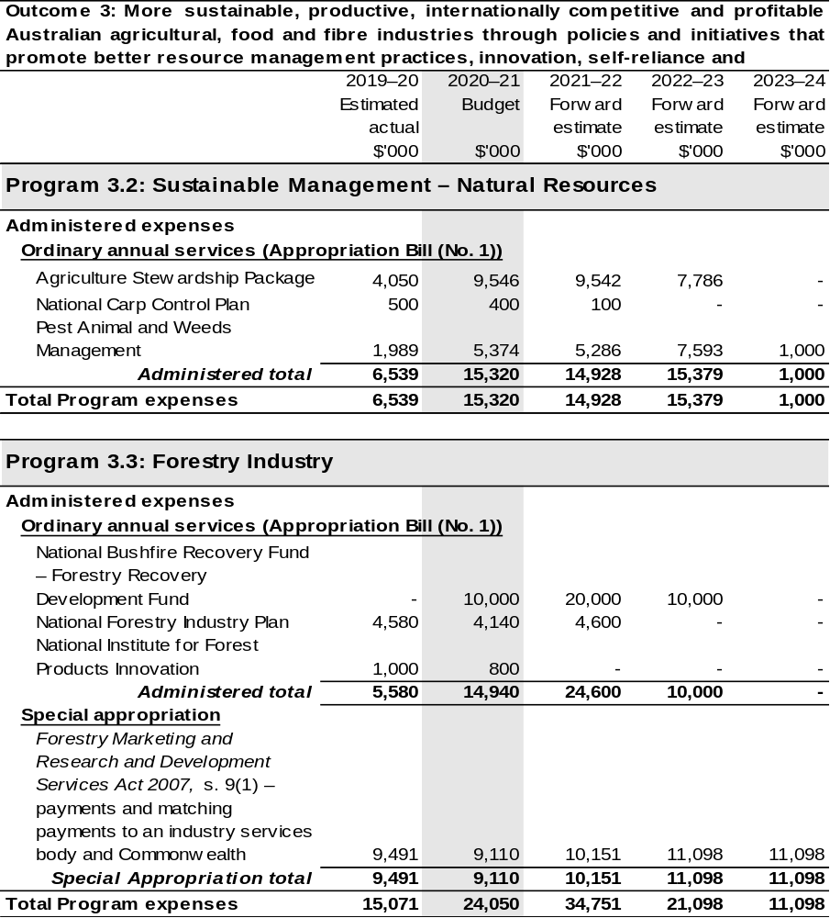
Continued on following pages
Table 2.6.3: Budgeted expenses for Outcome 3 (continued)
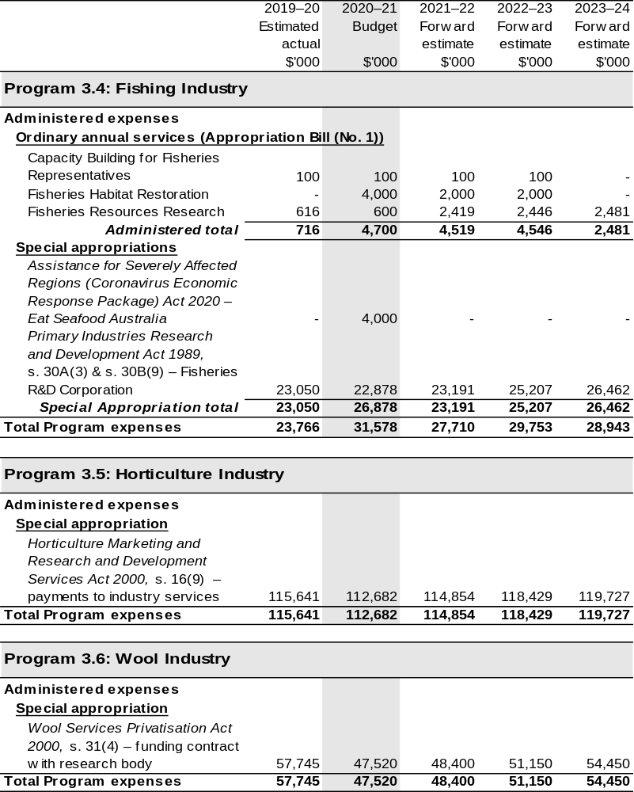

Continued on following pages
Table 2.6.3: Budgeted expenses for Outcome 3 (continued)
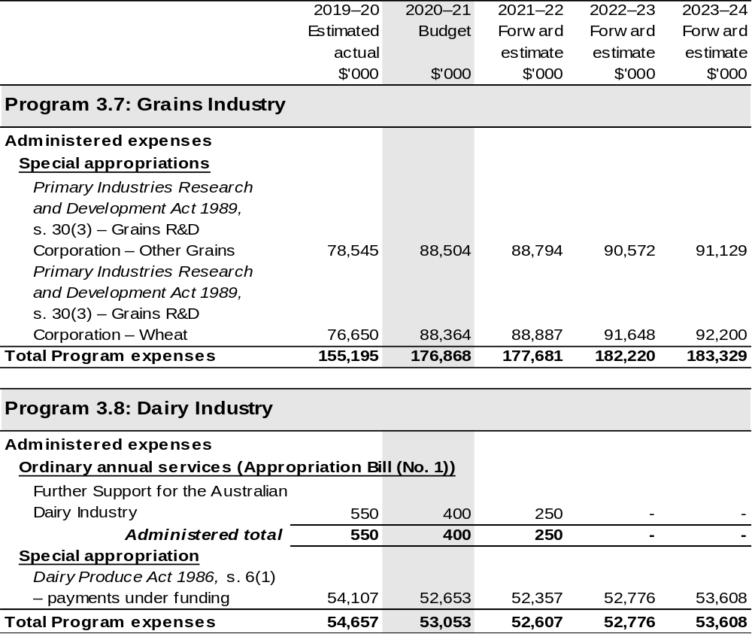

Continued on following pages
Table 2.6.3: Budgeted expenses for Outcome 3 (continued)
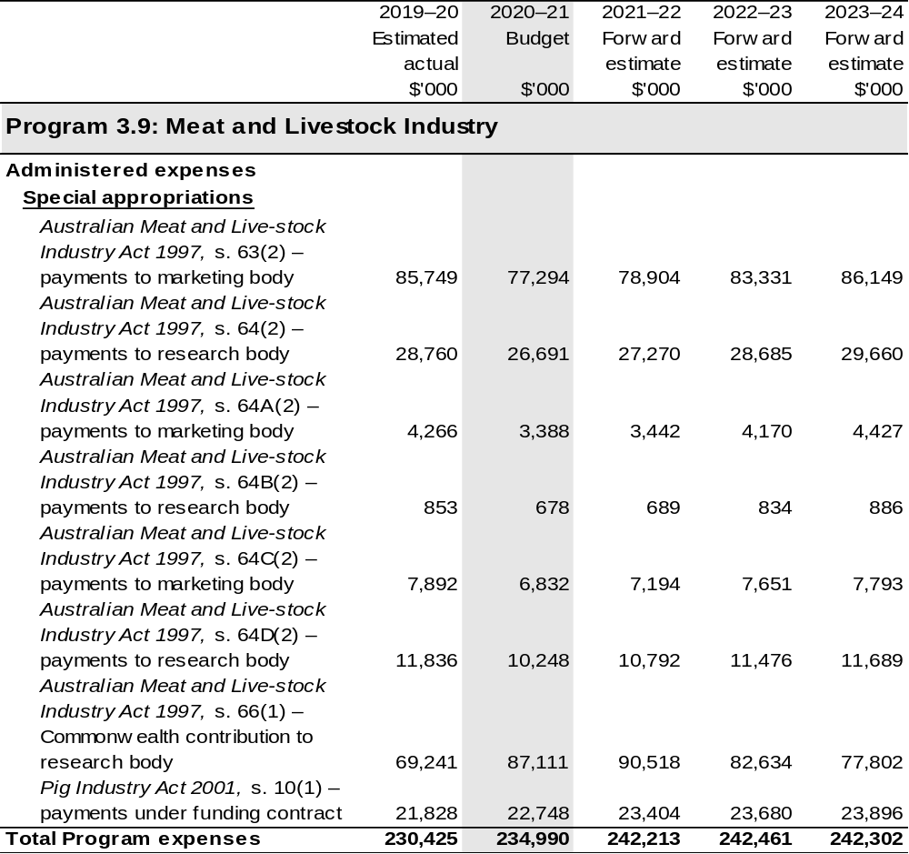

Continued on following pages
Table 2.6.3: Budgeted expenses for Outcome 3 (continued)
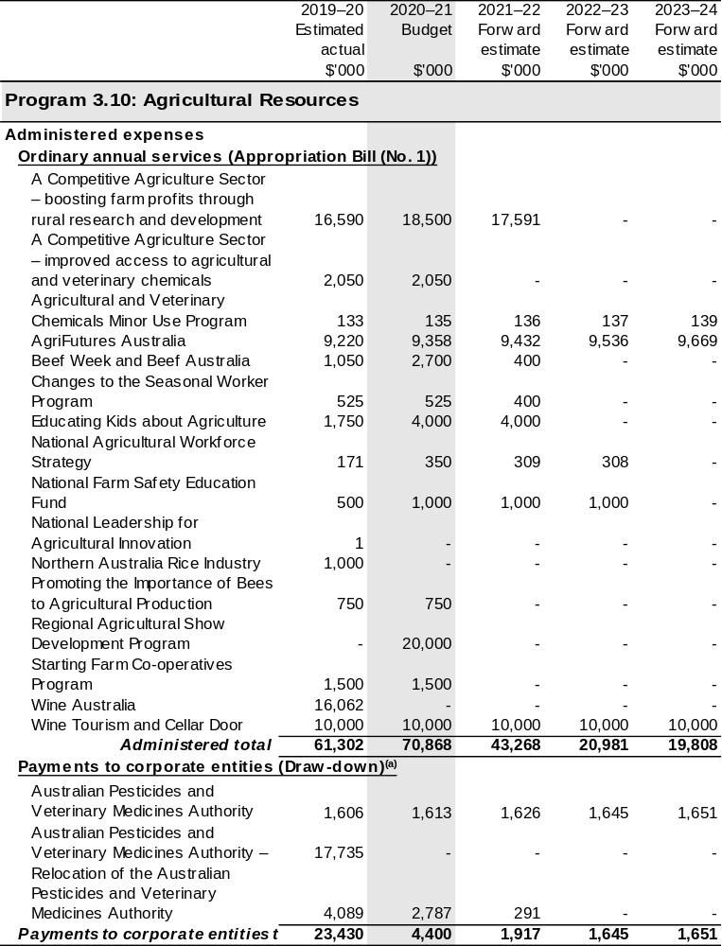

Continued on following pages
Table 2.6.3: Budgeted expenses for Outcome 3 (continued)
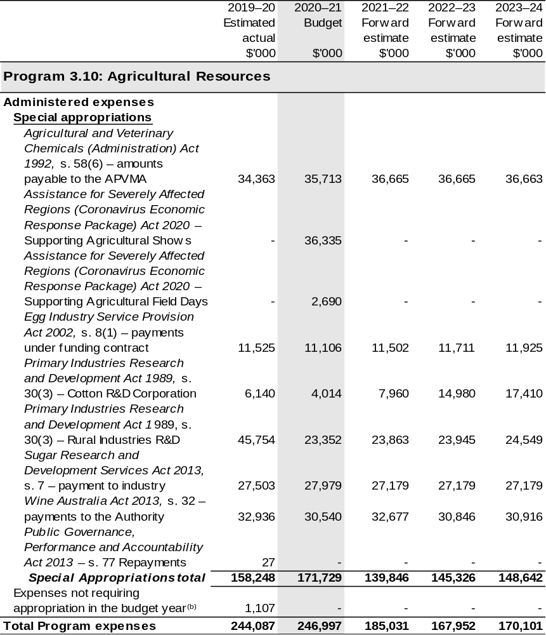
Continued on following pages
Table 2.6.3: Budgeted expenses for Outcome 3 (continued)
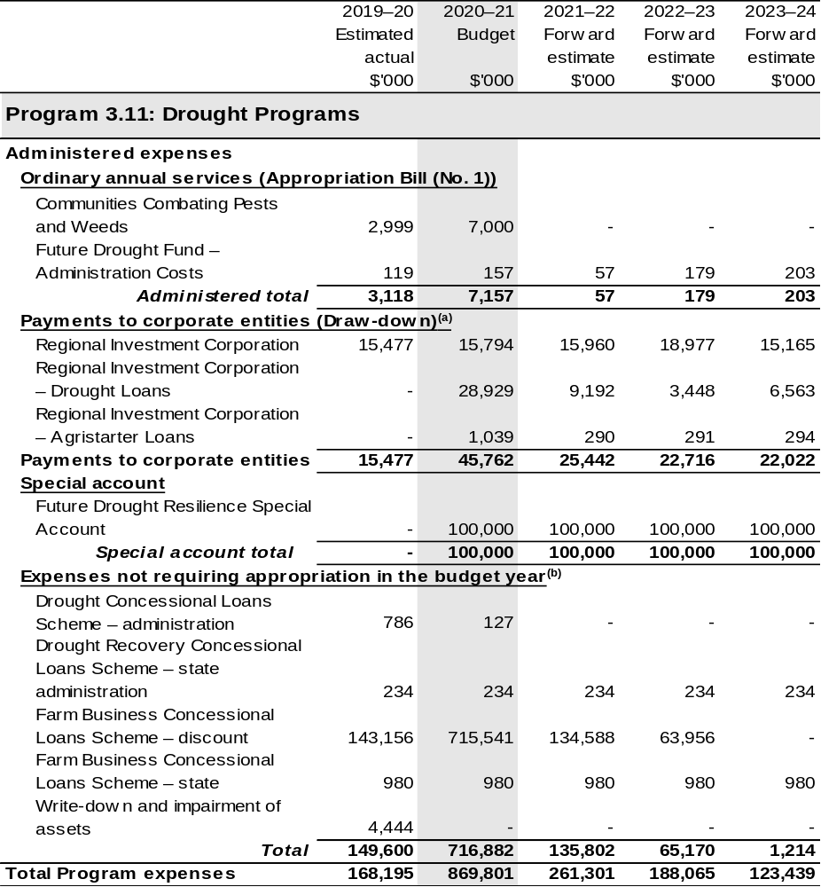
Continued on following pages
Table 2.6.3: Budgeted expenses for Outcome 3 (continued)
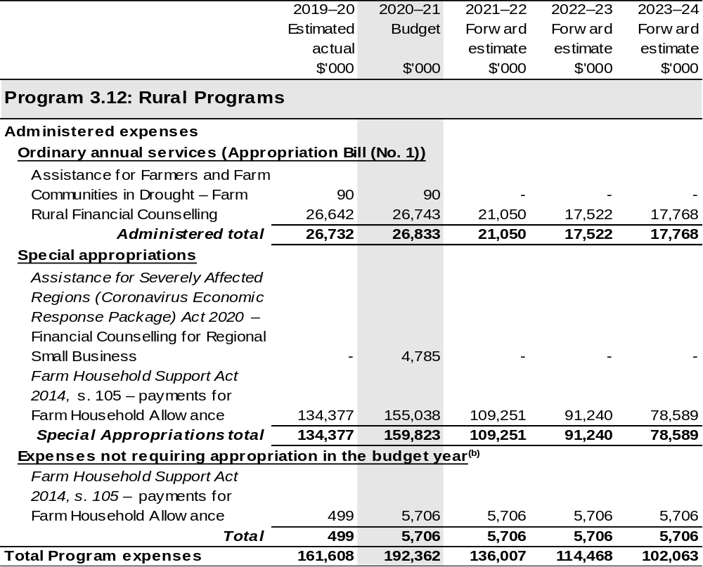
Continued on following pages
Table 2.6.3: Budgeted expenses for Outcome 3 (continued)
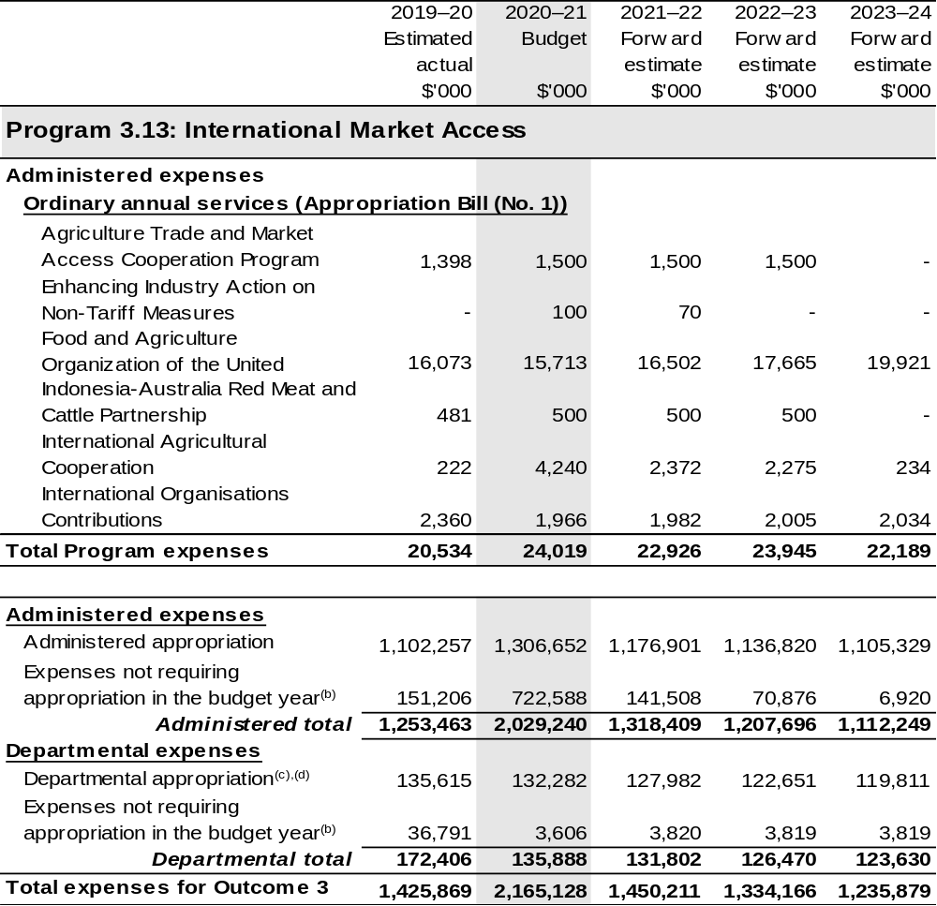
Continued on following pages
Table 2.6.3: Budgeted expenses for Outcome 3 (continued)
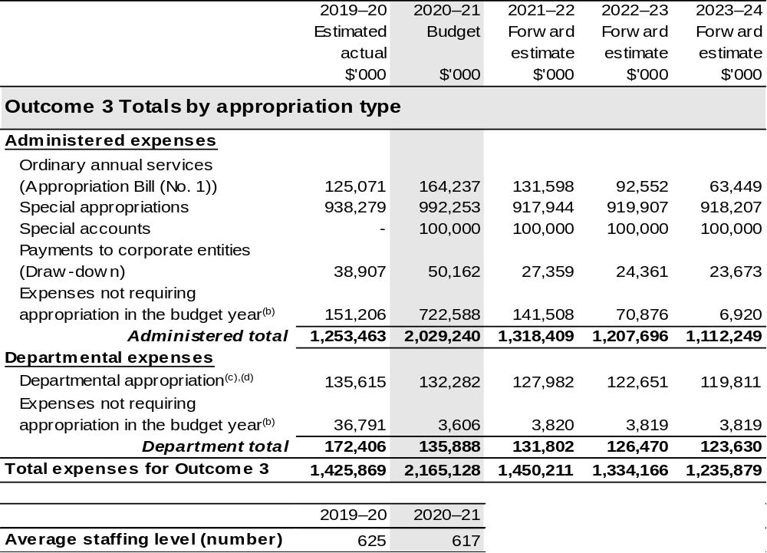
(a) APVMA and RIC are corporate Commonwealth entities (CCE) under the PGPA Act and do not receive direct appropriations. Instead, this funding passes through the department to these entities.
(b) ‘Expenses not requiring appropriation in the Budget year’ are made up of depreciation and amortisation expenses, resources received free of charge, concessional loan discount and balance sheet adjustments.
(c) Expenses funded from both ‘Ordinary annual services (Supply Act (No. 1) and (Appropriation Bill (No. 1))’ and ‘External Revenue’ under section 74 of the PGPA Act.
(d) Departmental appropriation allocations are notional and reflect the current structure of the department.

Note: Departmental appropriation splits and totals are indicative estimates and may change in the course of the budget year as Government priorities change.

Continued on following pages
Table 2.6.3: Budgeted expenses for Outcome 3 (continued)
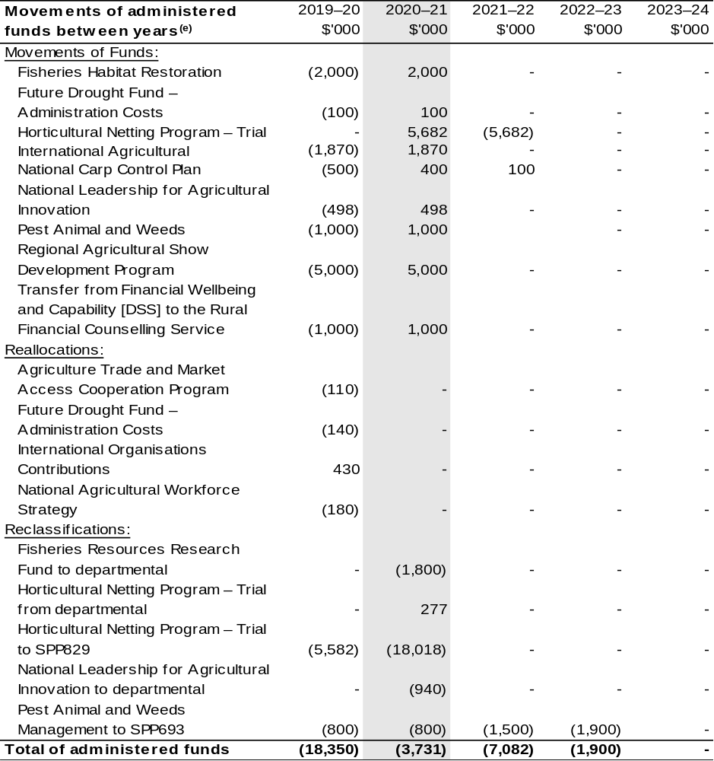
Continued on following page
Table 2.6.3: Budgeted expenses for Outcome 3 (continued)
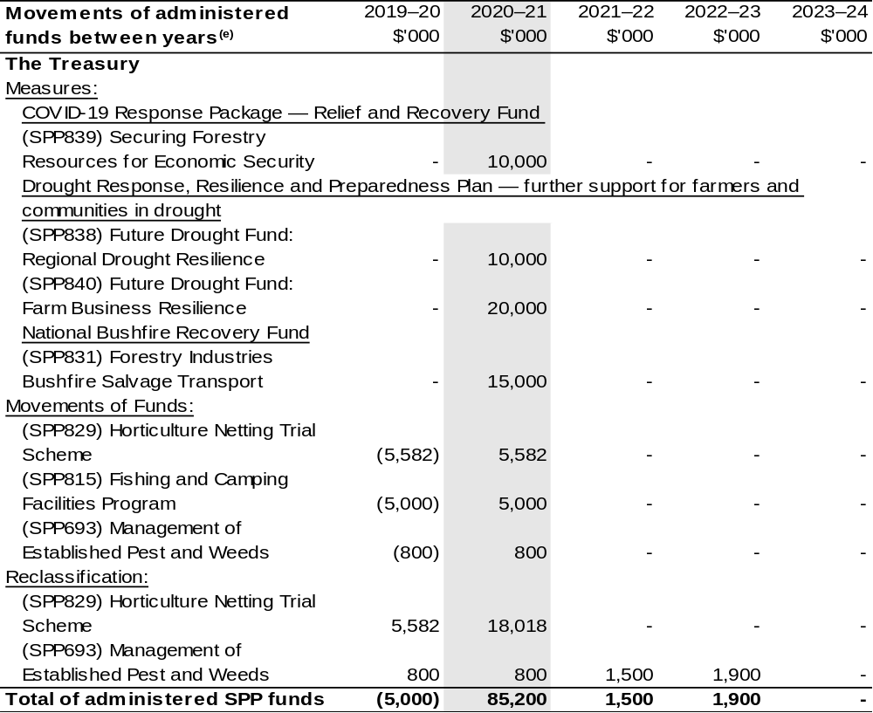
(e) Figures displayed as a negative (-) represent a decrease in funds and a positive (+) represent an increase in funds.

2.7 Budgeted expenses for Outcome 4
Outcome 4: Safeguard Australia’s animal and plant health status to maintain overseas markets and protect the economy and environment from the impact of exotic pests and diseases, through risk assessment, inspection and certification, and the implementation of emergency response arrangements for Australian agricultural, food and fibre industries.

2.7.1: Linked programs
Australian Trade and Investment Commission
Program 1.1: Promotion of Australia’s export and other international economic interests
Program 1.2: Programs to promote Australia’s export and other international economic
interests
Contribution to Outcome 4 made by linked program:
DAWE and Austrade work together to achieve the best outcomes for Australian agricultural, fisheries and forestry exports.
Commonwealth Scientific and Industrial Research Organisation (CSIRO)
Program 1.2: National Research Infrastructure – National Facilities and Collections
Contribution to Outcome 4 made by linked program:
DAWE contributes to the operating costs of the CSIRO’s Australian Centre for Disease Preparedness (formerly the Australian Animal Health Laboratory) for animal disease diagnosis, prevention and research.
Department of Health
Program 5.2: Health Protection and Emergency Response
Contribution to Outcome 4 made by linked program:
DAWE provides border services for the management of human biosecurity risks on behalf of the Department of Health under the Biosecurity Act 2015 and a memorandum of understanding.

Continued on following page
2.7.1: Linked programs (continued)
Department of Home Affairs
Program 1.1: Border Enforcement
Program 1.2: Border Management
Contribution to Outcome 4 made by linked programs:
DAWE and the Department of Home Affairs work collaboratively to undertake screening and surveillance for all people and goods entering Australia.
Department of the Treasury
Program 1.9: National Partnership Payments to the States
Contribution to Outcome 4 made by linked program:
The Department of the Treasury contributes to Outcome 4 by making payments for the following national partnership agreements on behalf of DAWE:
- National Partnership on Pest and Disease Preparedness and Response Programs (SPP188).
Food Standards Australia New Zealand
Program 1.1: Food Regulatory Activity and Services to the Minister and Parliament
Contribution to Outcome 4 made by linked program:
Food Standards Australia New Zealand provides advice on whether foods pose a medium to high risk to public health to help DAWE to manage the food safety risks associated with imported food for human consumption.
National Indigenous Australians Agency
Program 2.1: Indigenous Advancement – Jobs, Land and Economy
Contribution to Outcome 4 made by linked programs:
DAWE and NIAA partner with Aboriginal and Torres Strait Islander Ranger groups to deliver biosecurity work that protects Australian agriculture and the northern Australian environment.

2.7.2: Budgeted expenses for Outcome 4
This table shows how much the entity intends to spend (on an accrual basis) on achieving the outcome, broken down by program, as well as by administered and departmental funding sources.

Table 2.7.3: Budgeted expenses for Outcome 4
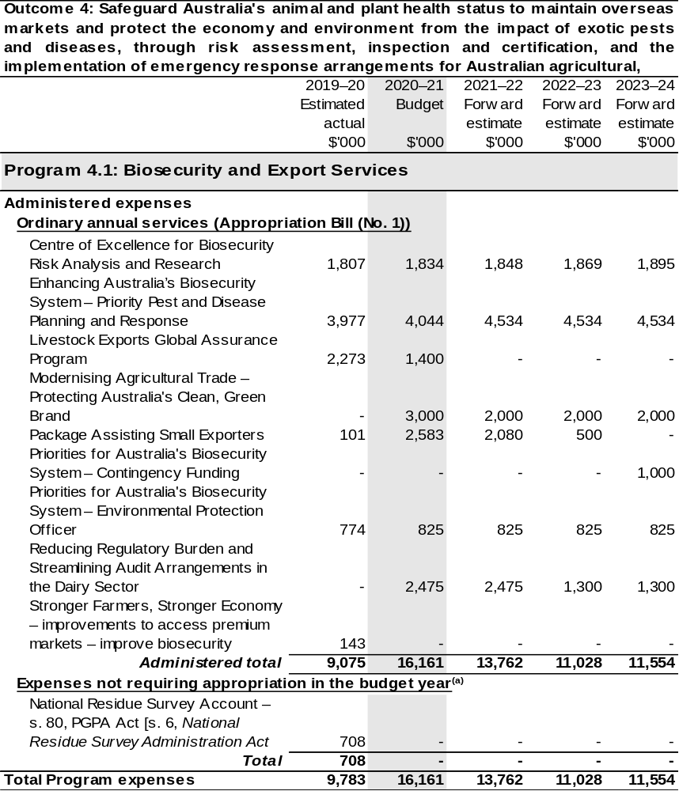

Continued on following pages
Table 2.7.3: Budgeted expenses for Outcome 4 (continued)
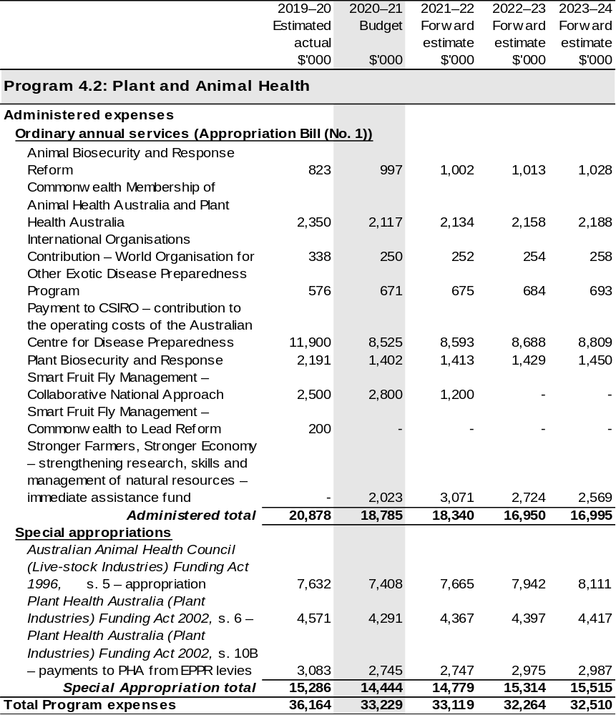

Continued on following pages
Table 2.7.3: Budgeted expenses for Outcome 4 (continued)
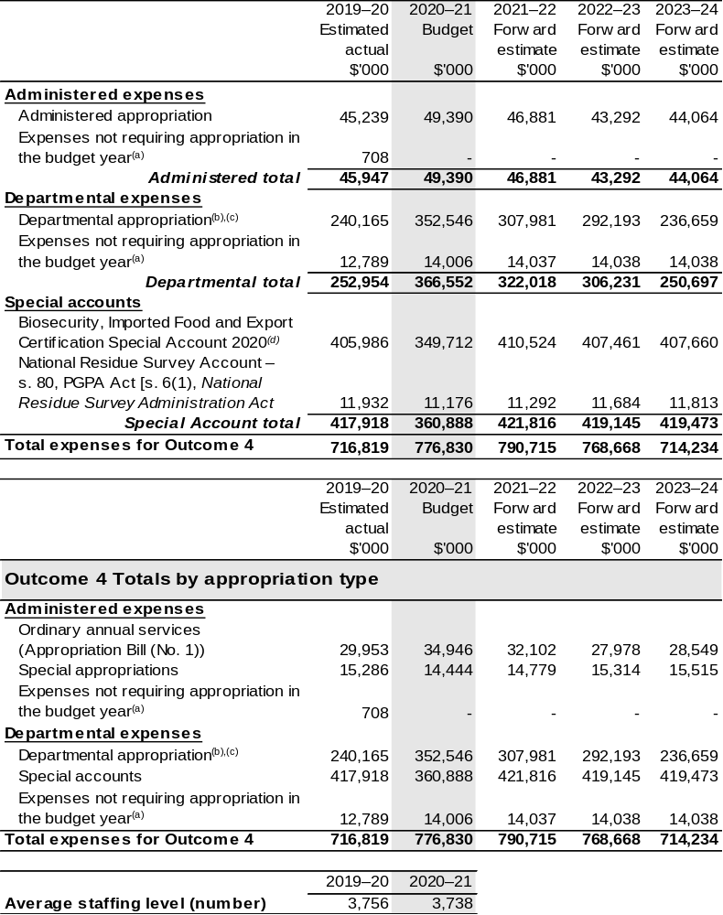
Continued on following page
Table 2.7.3: Budgeted expenses for Outcome 4 (continued)
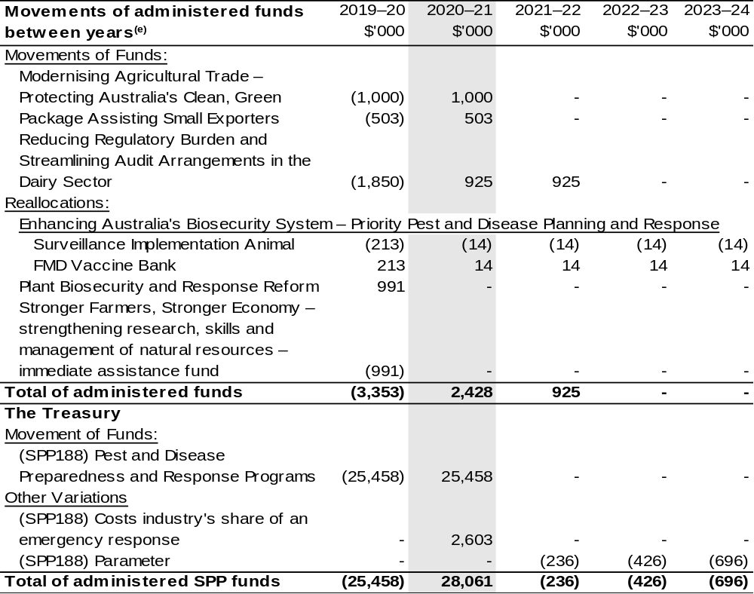
(a) ‘Expenses not requiring appropriation in the Budget year’ are made up of depreciation and amortisation
expenses, resources received free of charge, concessional loan discount and balance sheet adjustments.
(b) Expenses funded from both ‘Ordinary annual services (Supply Act (No. 1) and (Appropriation Bill (No. 1))’ and ‘External Revenue’ under section 74 of the PGPA Act.
(c) Departmental appropriation allocations are notional and reflect the current structure of the department.
(d) The Biosecurity, Imported Food and Export Certification Special Account was formerly known as the Australian Quarantine and Inspection Service Special Account.
(e) Figures displayed as a negative (-) represent a decrease in funds and a positive (+) represent an increase in funds.

Note: Departmental appropriation splits and totals are indicative estimates and may change in the course of the budget year as Government priorities change.

2.8 Budgeted expenses for Outcome 5
Outcome 5: Improve the health of rivers and freshwater ecosystems and water use efficiency through implementing water reforms, and ensuring enhanced sustainability, efficiency and productivity in the management and use of water resources.

2.8.1 Linked programs
Murray-Darling Basin Authority
Program 1.1: Equitable and Sustainable Use of the Murray-Darling Basin
Contribution to Outcome 5 made by linked program:
DAWE and MDBA work collaboratively to implement the Murray-Darling Basin Plan and the Intergovernmental Agreement on Murray-Darling Basin Reform.
Bureau of Meteorology
Program 1.1: Bureau of Meteorology
Contribution to Outcome 5 made by linked program:
BOM’s water information services inform Commonwealth water planning and decision making in relation to water resource availability
Department of the Treasury
Program 1.9: National Partnership Payments to the States
Contribution to Outcome 5 made by linked program:
The Department of the Treasury contributes to Outcome 5 by making payments for the following national partnership agreements on behalf of DAWE:
- National Partnership on the Development of Business Cases for Constraints Measures and Implementation (SPP706);
- National Partnership on Implementing Water Reform in the Murray-Darling Basin (SPP632);
- National Partnership on the Great Artesian Basin Sustainability Initiative (SPP127);
- National Partnership on the On-Farm Emergency Water Infrastructure Rebate (SPP776);
- National Partnership on the Water Efficiency Program (SPP787);
- National Partnership on the Water for Fodder Program (SPP811); and
- Sustainable Rural Water Use and Infrastructure Program (SPP533).

2.8.2: Budgeted expenses for Outcome 5
This table shows how much the entity intends to spend (on an accrual basis) on achieving the outcome, broken down by program, as well as by Administered and Departmental funding sources.

Table 2.8.3: Budgeted expenses for Outcome 5
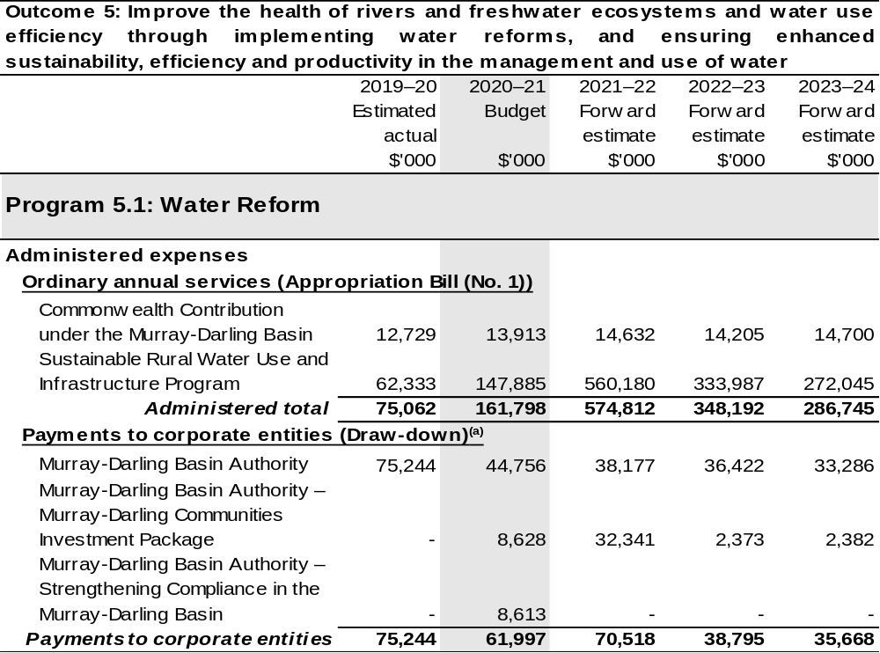

Continued on following pages

Table 2.8.3: Budgeted expenses for Outcome 5 (continued)
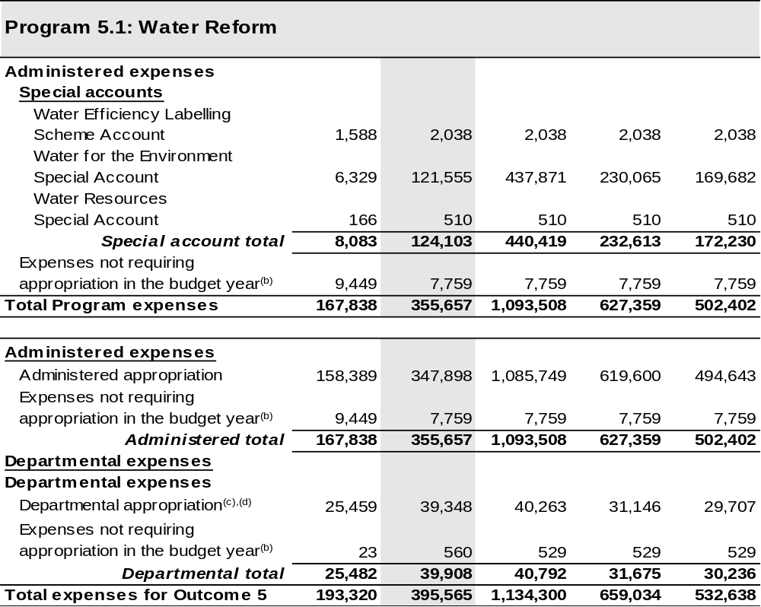

Continued on following pages

Table 2.8.3: Budgeted expenses for Outcome 5 (continued)
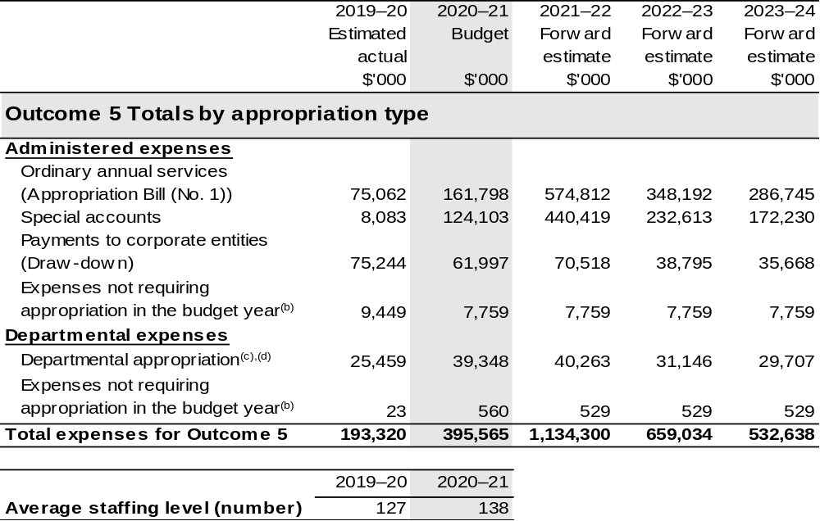

(a) The MDBA is a CCE under the PGPA Act and does not receive direct appropriations. Instead, this funding passes through the department to the MDBA.
(b) ‘Expenses not requiring appropriation in the Budget year’ are made up of depreciation and amortisation
expenses, resources received free of charge, concessional loan discount and balance sheet adjustments.
(c) Departmental appropriation allocations are notional and reflect the current structure of the department.
(d) Expenses funded from both ‘Ordinary annual services (Supply Act (No. 1) and (Appropriation Bill (No. 1))’ and ‘External Revenue’ under section 74 of the PGPA Act.
Note: Departmental appropriation splits and totals are indicative estimates and may change in the course of the budget year as Government priorities change.
Continued on following page
Table 2.8.3: Budgeted expenses for Outcome 5 (continued)
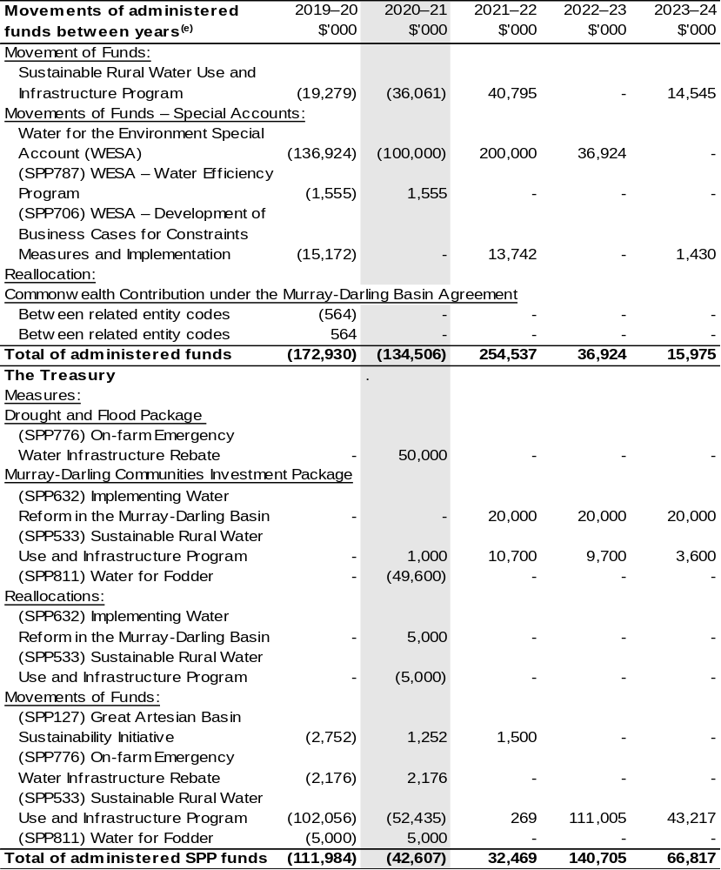
(e) Figures displayed as a negative (-) represent a decrease in funds and a positive (+) represent an increase in funds.

2.9 Budgeted expenses for Outcome 6
Outcome 6: Reduce Australia’s greenhouse gas emissions, adapt to the impacts of climate change, contribute to effective global action on climate change, and support technological innovation in clean and renewable energy, through developing and implementing a national response to climate change.

2.9.1: Linked programs
Refer to 2020–21 Industry, Science, Energy and Resources Portfolio Budget Statements, Outcome 2.

2.9.2: Budgeted expenses for Outcome 6
This table shows how much the entity intends to spend (on an accrual basis) on achieving the outcome, broken down by program, as well as by Administered and Departmental funding sources.
Forward year estimates are published in the 2020–21 Industry, Science, Energy and Resources Portfolio Budget Statements, refer to Outcome 2.

Table 2.9.3: Budgeted expenses for Outcome 6
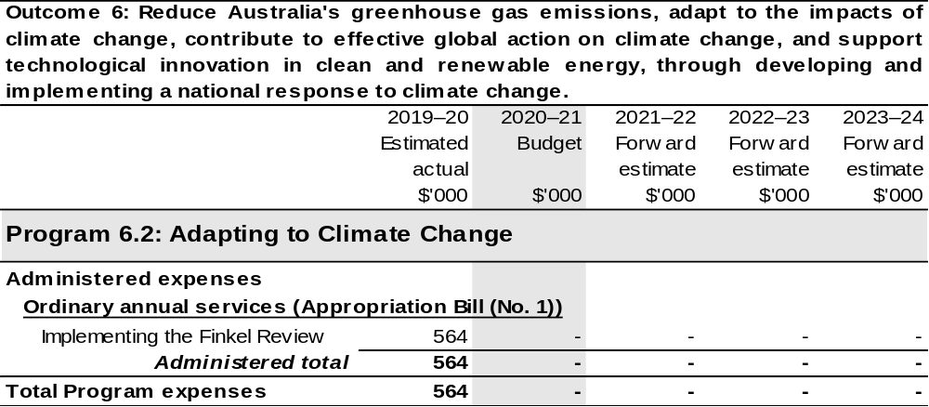
Continued on following page
Table 2.9.3: Budgeted expenses for Outcome 6 (continued)
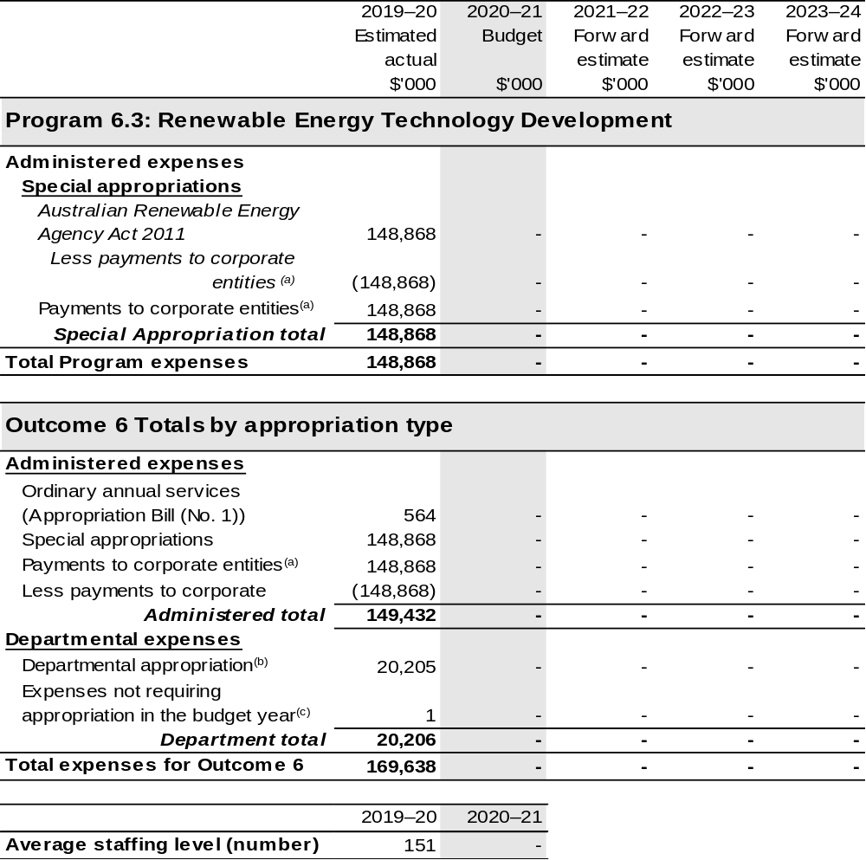
(a) Further information on payments to the Australian Renewable Energy Agency corporate entity can be found in the ‘Third Party Payments’ section of Table 1.1: Department of Agriculture, Water and the Environment Resource Statement.
(b) Expenses funded from both ‘Ordinary annual services (Appropriation Bill (No. 1))’ and ‘External Revenue’ under section 74 of the PGPA Act.
(c) ‘Expenses not requiring appropriation in the Budget year’ are made up of depreciation and amortisation expenses, audit fees and an approved operating loss.

Note: Departmental appropriation splits and totals are indicative estimates and may change in the course of the budget year as Government priorities change.

2.9.4: Performance criteria for Outcome 6
Refer to 2020–21 Industry, Science, Energy and Resources Portfolio Budget Statements, Outcome 2 for performance criteria for each program associated with Outcome 6.

2.10 Budgeted expenses for Outcome 7
Outcome 7: Support the reliable, sustainable and secure operations of energy markets through improving Australia’s energy efficiency, performance and productivity for the community.

2.10.1: Linked programs
Refer to 2020–21 Industry, Science, Energy and Resources Portfolio Budget Statements, Outcome 3.

2.10.2: Budgeted expenses for Outcome 7
This table shows how much the entity intends to spend (on an accrual basis) on achieving the outcome, broken down by program, as well as by Administered and Departmental funding sources.
Forward year estimates are published in the 2020–21 Industry, Science, Energy and Resources Portfolio Budget Statements, refer to Outcome 3.

Table 2.10.3: Budgeted expenses for Outcome 7
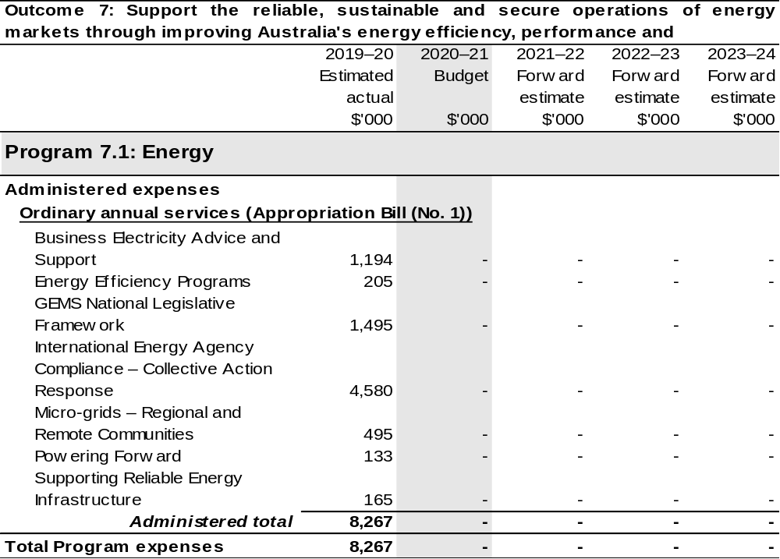
Continued on following page
Table 2.10.3: Budgeted expenses for Outcome 7 (continued)
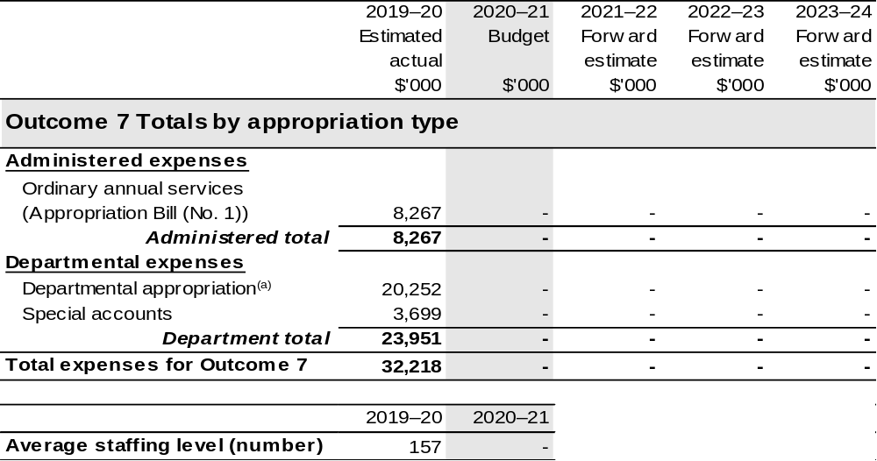
(a) Expenses funded from both ‘Ordinary annual services (Appropriation Bill (No. 1)’ and ‘External Revenue’ under section 74 of the PGPA Act.

Note: Departmental appropriation splits and totals are indicative estimates and may change in the course of the budget year as Government priorities change.

2.10.4: Performance criteria for Outcome 7
Refer to 2020–21 Industry, Science, Energy and Resources Portfolio Budget Statements, Outcome 3 for performance criteria for each program associated with Outcome 7.

Section 3: Budgeted financial statements
Section 3 presents budgeted financial statements which provide a comprehensive snapshot of entity finances for 2020–21, including the impact of 2020–21 Budget measures and resourcing on financial statements.

3.1 Budgeted financial statements

3.1.1: Differences between entity resourcing and financial statements
The financial statements incorporate all budget estimate changes since the 2019–20 Portfolio Additional Estimates Statements (PAES). An analysis of the primary causes of movements in the budgeted departmental financial statements and administered schedules is provided in the relevant sections. PAES is used as comparative figures in the analysis.

3.1.2: Budgeted comprehensive departmental income statement
Since PAES, estimated revenue from government in 2020–21 has increased by $142.6 million. The increase is mainly due to 2020–21 Budget measures listed in
Table 1.2.
The increase is partly offset by a reduction of $10.0 million in 2020–21 due to the finalisation of machinery of government funding transfers to the Department of Industry, Science, Energy and Resources and the National Drought and North Queensland Flood Response and Recovery Agency. There is also a minor reduction due to the transfer of $0.5 million in 2020–21 to the Australian Public Service Commission.
The own source revenue estimate in 2020–21 has reduced by $104.6 million since PAES, mainly due to lower than anticipated revenue from the department’s cost recovered activities as a result of the COVID-19 pandemic and accounting changes relating to the Special Account.
The department is budgeting for a $17.1 million operating loss in 2020–21 before unfunded depreciation.

3.1.3: Budgeted departmental balance sheet
The value of departmental net assets as at 30 June 2021 is anticipated to be $38.1 million higher than the estimate published in PAES. The higher estimate is due to the impact of 2019–20 actuals that resulted in lower than expected opening balances for 2020–21. Also contributing to the revised net assets position are movements of funds and 2020–21 Budget measures detailed in Table 1.2.

3.1.4: Schedule of budgeted income and expenses administered on behalf of the Government
It is estimated that the department will receive non-appropriation revenue on behalf of government of $481.1 million in 2020–21, a decrease of $128.8 million since PAES.
The reduction is due to lower than previously estimated levy revenue, the COVID-19 pandemic and 2020–21 Budget measures detailed in Table 1.2.
Administered expenses are estimated to be $3,035.1 million in 2020–21, an increase of $709.2 million since PAES. The increase largely relates to 2020–21 Budget measures detailed in Table 1.2, movements of funds and reclassifications of funds detailed in the Budgeted Expenses tables for each Outcome.

3.1.5: Schedule of budgeted assets and liabilities administered on behalf of the Government
The value of administered net assets as at 30 June 2021 is anticipated to be $1,943.9 million higher than the estimate published in PAES. The increase is mainly due to the additional loan funding for the Regional Investment Corporation of $2,000.0 million in 2020–21 for Drought loans and $75.0 million for AgriStarter loans.

3.2 Budgeted financial statements tables

Table 3.1 Comprehensive income statement (showing net cost of services)
for the period ended 30 June
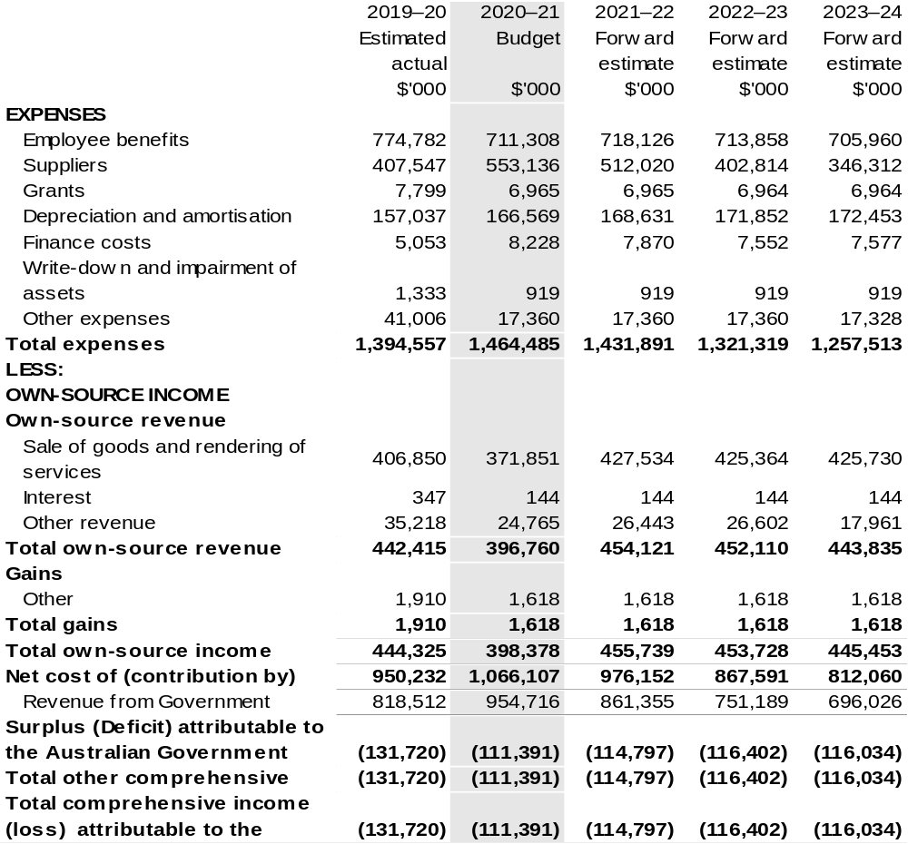

Continued on following page

Table 3.1 Comprehensive income statement (showing net cost of services) for the period ended 30 June (continued)
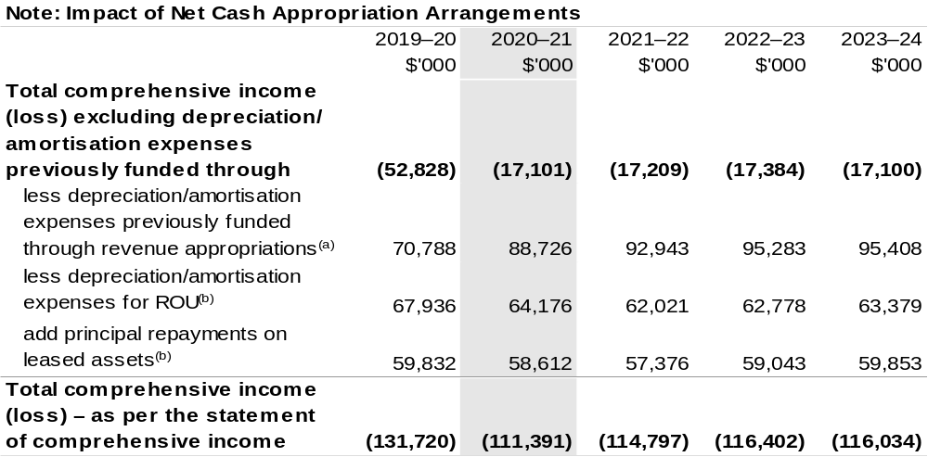
(a) From 2010–11, the Government introduced net cash appropriation arrangements where Bill (No. 1) revenue appropriations for the depreciation/amortisation expenses of non-corporate Commonwealth entities (and select corporate Commonwealth entities) were replaced with a separate capital budget
(the Departmental Capital Budget, or DCB) provided through Bill (No. 1) equity appropriations.
For information regarding DCBs, please refer to Table 3.5 Departmental Capital Budget Statement.
(b) Applies to leases under AASB 16 Leases. Right-of-Use (ROU).

Prepared on Australian Accounting Standards basis.

Table 3.2: Budgeted departmental balance sheet (as at 30 June)
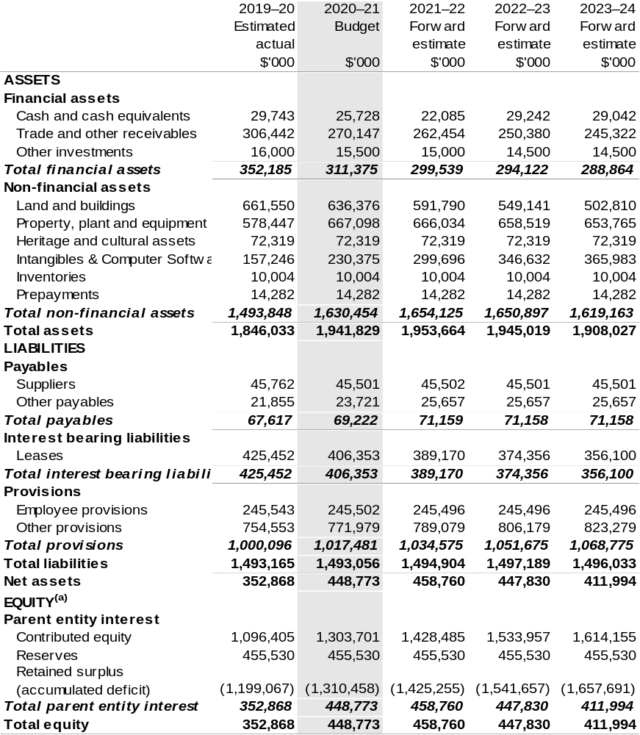
(a) Equity’ is the residual interest in assets after deduction of liabilities.

Prepared on Australian Accounting Standards basis.

Table 3.3: Departmental statement of changes in equity – summary of movement (Budget year 2020–21)
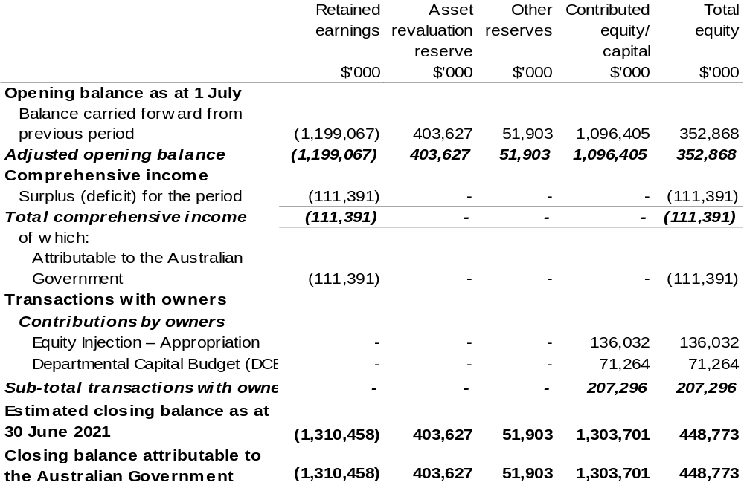
Prepared on Australian Accounting Standards basis.

Table 3.4: Budgeted departmental statement of cash flows (for the period ended 30 June)
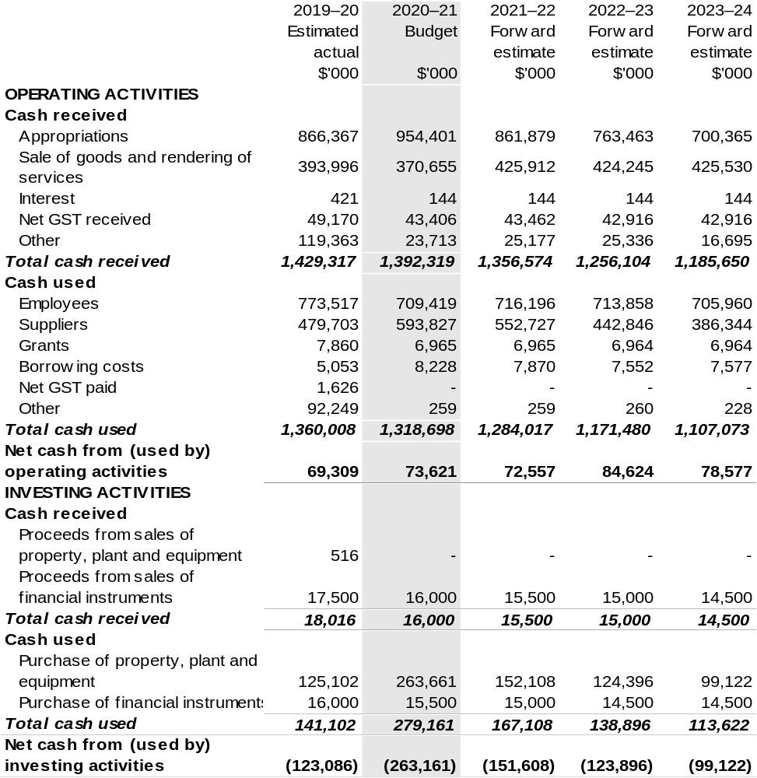
Prepared on Australian Accounting Standards basis.

Table 3.4: Budgeted departmental statement of cash flows (for the period ended 30 June) (continued)
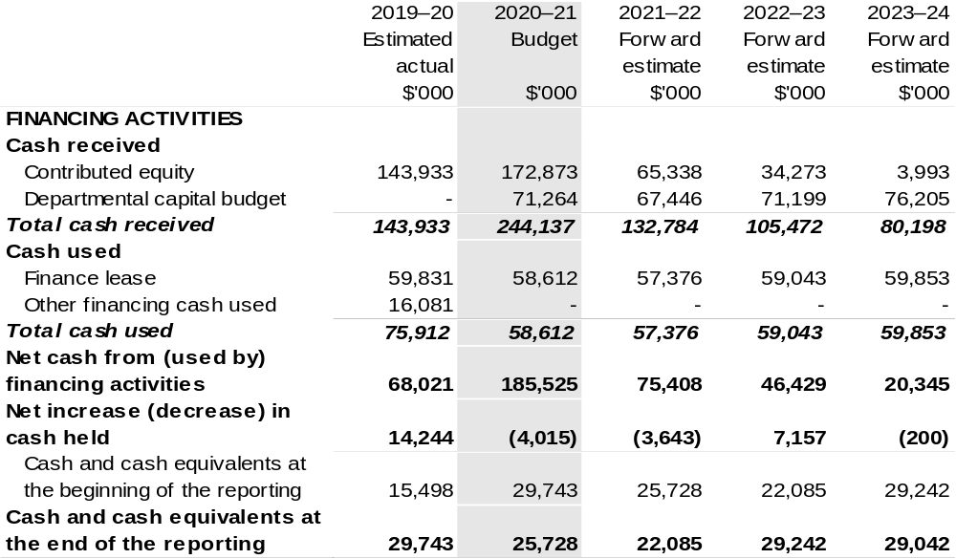
Prepared on Australian Accounting Standards basis.

Table 3.5: Departmental capital budget statement (for the period ended 30 June)
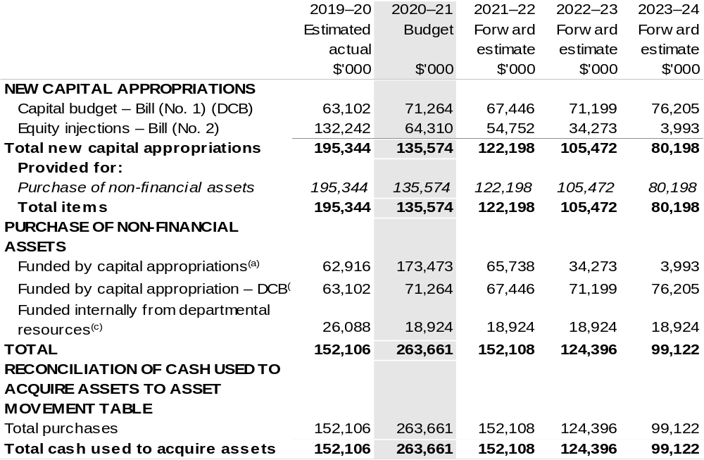

- Includes both current Bill (No. 2) and prior Act (No. 2/4/6) appropriations and special capital appropriations.
(b) Does not include annual finance lease costs. Includes purchases from current and previous years’ Departmental Capital Budgets (DCBs).
(c) Includes the following sources of funding:
- current Bill (No. 1) and prior year Act (No. 1/3/5) appropriations (excluding amounts from the DCB);
- internally developed assets;
- section 74 External revenue; and
- proceeds from the sale of assets.

Prepared on Australian Accounting Standards basis.

Table 3.6: Statement of asset movements (Budget year 2020–21)
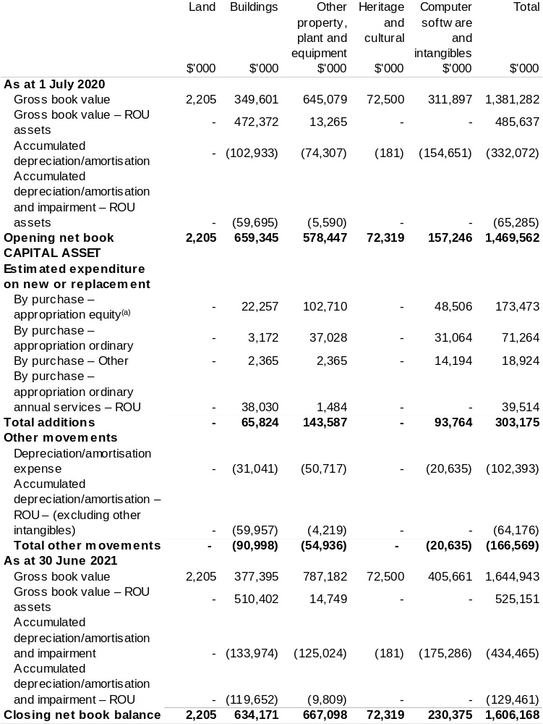

(a) "Appropriation equity" refers to equity injections, appropriations provided through Supply Act (No. 2) and Appropriation Bill (No. 2) 2020–21.
(b) "Appropriation ordinary annual services" refers to funding provided through Supply Act (No. 1) and Appropriation Bill (No. 1) 2020–21 for depreciation / amortisation expenses, DCBs or other operational expenses.
Prepared on Australian Accounting Standards basis.
Table 3.7: Schedule of budgeted income and expenses administered on behalf of Government (for the period ended 30 June)
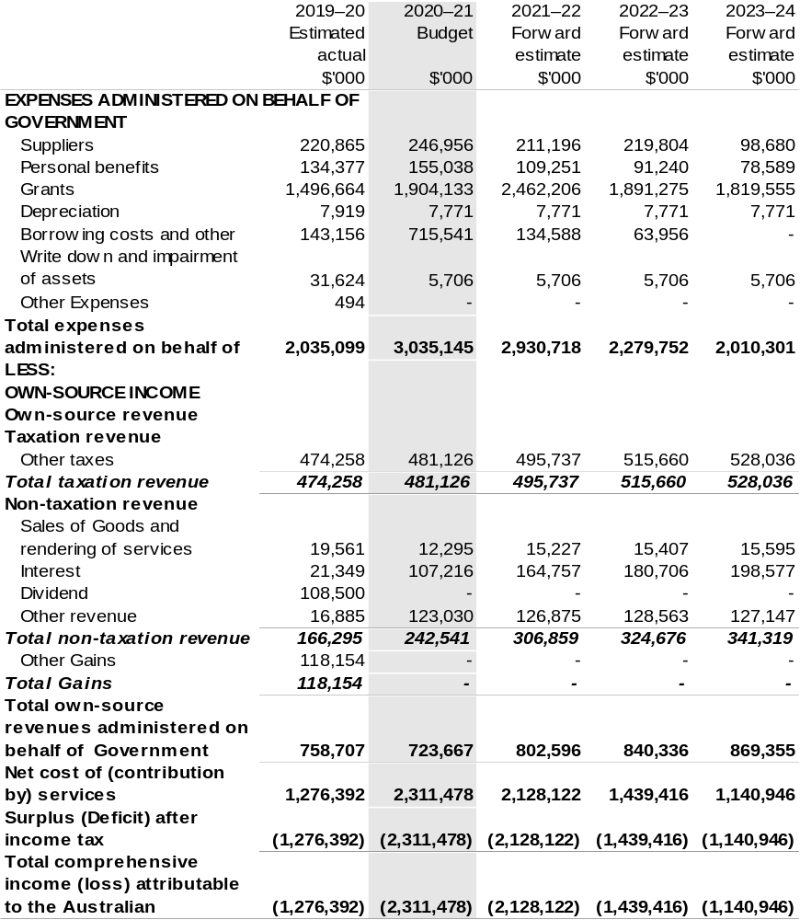
Prepared on Australian Accounting Standards basis.

Table 3.8: Schedule of budgeted assets and liabilities administered on behalf of Government (as at 30 June)
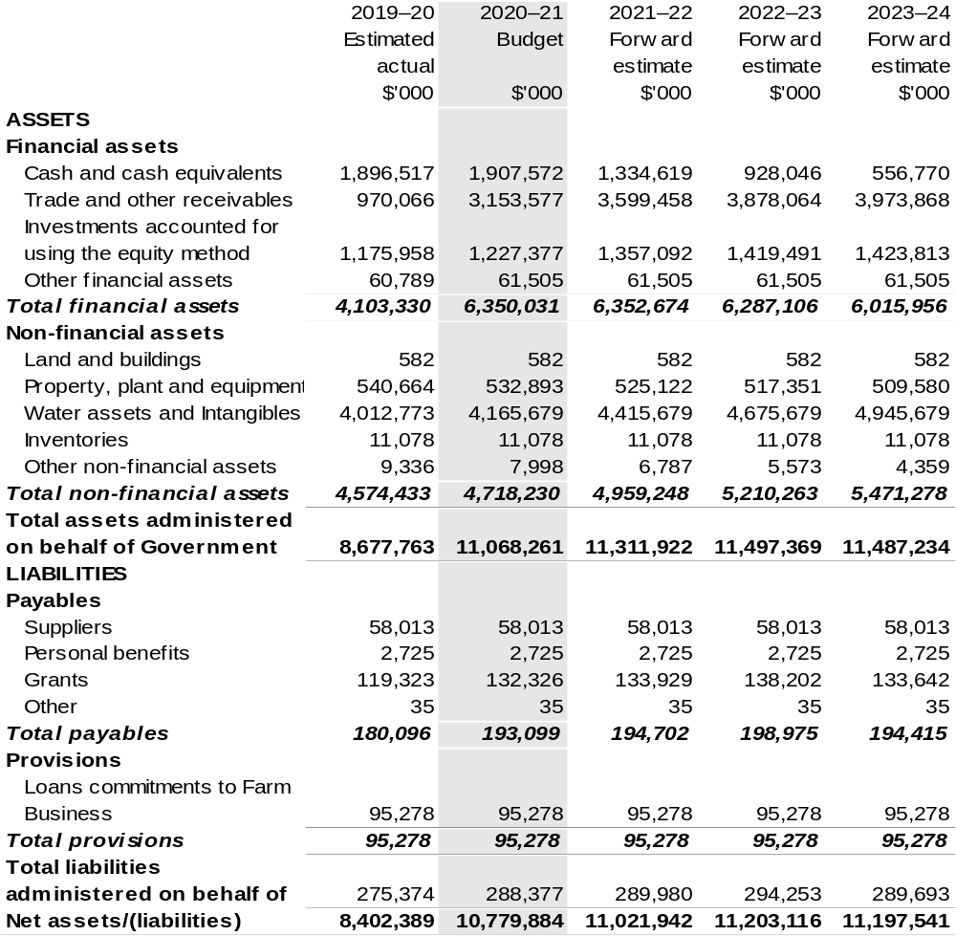

Prepared on Australian Accounting Standards basis.

Table 3.9: Schedule of budgeted administered cash flows (for the period ended 30 June)
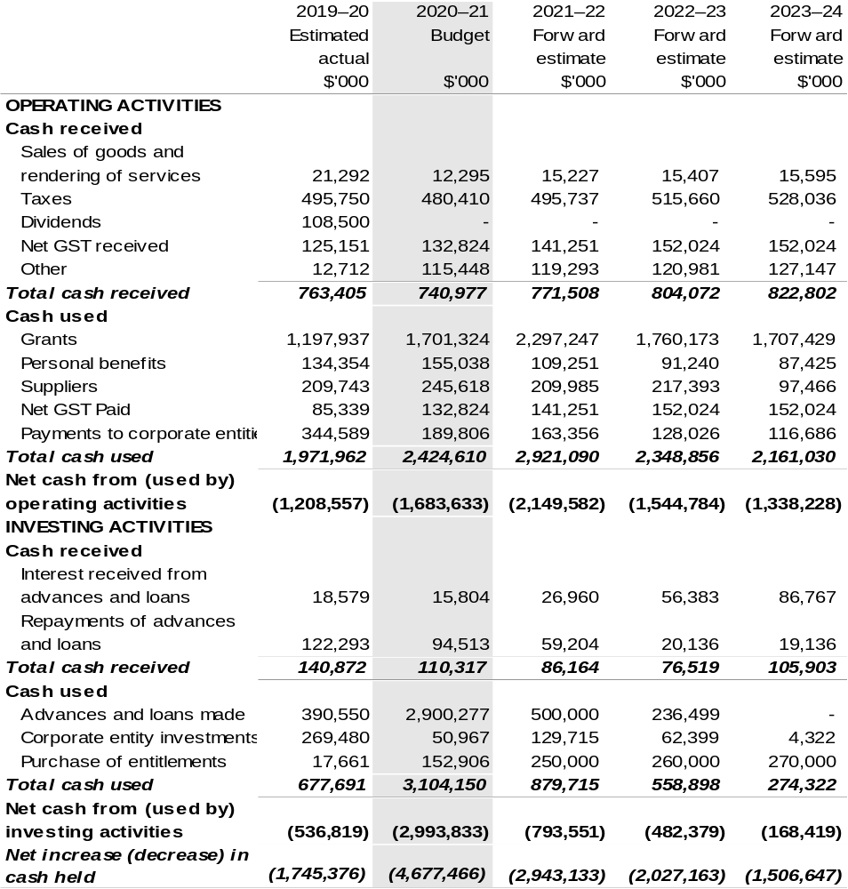
Prepared on Australian Accounting Standards basis.
Table 3.9: Schedule of budgeted administered cash flows (for the period ended 30 June) (continued)
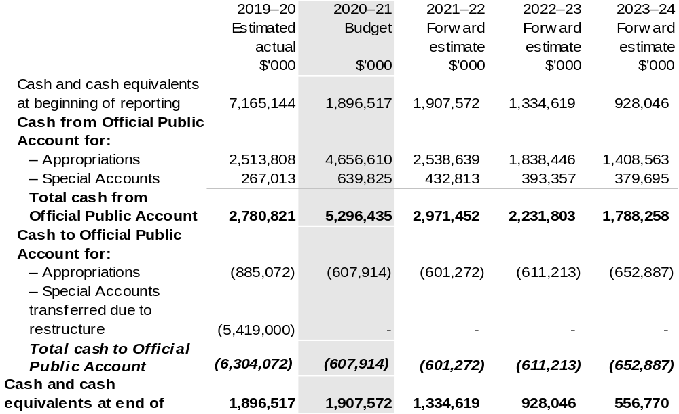
Prepared on Australian Accounting Standards basis.

Table 3.10: Administered capital budget statement (for period ended 30 June)
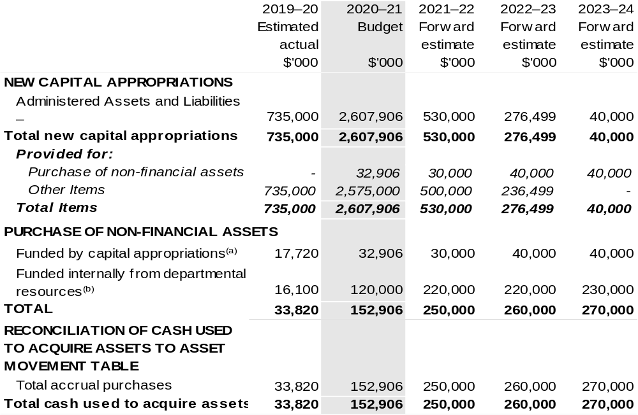

(a) Includes both current Supply Act (No. 2) and Appropriation Bill (No. 2) and prior Act 2/4/6 appropriations.
(b) Includes funding credited to the Water for Environment Special Account.

Prepared on Australian Accounting Standards basis.

Table 3.11: Statement of administered asset movements (Budget year 2020–21)
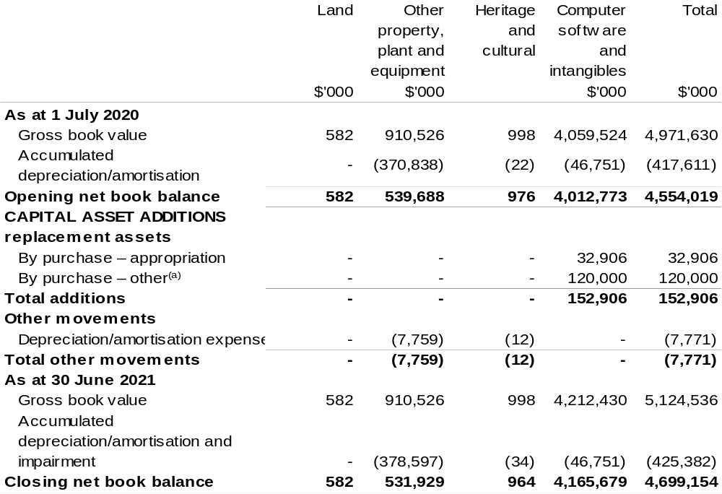

(a) ‘Other’ refers to funding credited to the Water for the Environment Special Account.

Prepared on Australian Accounting Standards basis.

AgriFutures Australia
Section 1: Entity overview and resources 117
1.1 Strategic direction statement 117
1.2 Entity resource statement 119
1.3 Budget measures 121
Section 2: Outcomes and planned performance 122
2.1 Budgeted expenses and performance for Outcome 1 123
Section 3: Budgeted financial statements 129
3.1 Budgeted financial statements 129
3.2 Budgeted financial statements tables 130

AgriFutures Australia

Section 1: Entity overview and resources

1.1 Strategic direction statement
AgriFutures Australia (AgriFutures) is the trading name for Rural Industries Research and Development Corporation (RIRDC). AgriFutures plays a unique role in Australian agriculture by investing in research and development (R&D) to maintain and create profitable and sustainable rural industries. AgriFutures knows that the key to developing real and lasting solutions for rural industries is to take a shared approach to shared challenges. That is why AgriFutures works in collaboration with a range of stakeholders to develop and implement its initiatives.
AgriFutures’ vision is to grow the long-term prosperity of Australian rural industries. AgriFutures’ mission is to collaborate with its partners to create lasting value for its stakeholders, investing in research, innovation and learning initiatives that enhance the prosperity, profitability and sustainability of the agricultural, fisheries and forestry sectors. AgriFutures’ approach is guided by an ambition to be an organisation that places people, rural industries and regional communities at the centre of all its activities.
AgriFutures supports rural industries that do not have their own research and development corporation (RDC) and invests in R&D to accelerate the establishment of new and emerging rural industries.
AgriFutures’ cross-sectoral mandate supports it to focus on national opportunities and challenges that affect multiple rural industries, not just the industries it traditionally serves. AgriFutures’ future orientation enables it to not only tackle the challenges and opportunities that rural industries face today, but to identify and unearth the challenges and opportunities of tomorrow. AgriFutures will do this by listening and collaborating with the emerging leaders in agriculture, industries bodies, other RDCs and government.
As outlined in AgriFutures Strategic R&D Plan 2017–2022, AgriFutures has four goals across four arenas:
Arena 1: People and leadership
Goal: To support the people driving the future prosperity of Australian rural industries and regional communities by providing them with learning opportunities and experiences.
Priorities:
- Attracting capable people into careers in agriculture; and
- Building the capability of future rural leaders.
Arena 2: National challenges and opportunities
Goal: To identify and nurture research and innovation opportunities that are productive across rural sectors.
Priorities:
- Informing debate on issues of importance to rural industries;
- Adapting new technologies for use across rural industries; and
- Working collaboratively on issues common across rural sectors.
Arena 3: Growing profitability
Goal: To enhance the profitability and sustainability of our levied rural industries.
Priorities:
- Engaging industry participants in determining R&D priorities;
- Investing in innovation that assists levied industries to be more profitable; and
- Delivering outcomes to maximise industry uptake and adoption.
Arena 4: Emerging industries
Goal: To support new and emerging rural industries.
Priorities:
- Supporting the early stage establishment of high potential rural industries.

1.2 Entity resource statement
Table 1.1 shows the total funding from all sources available to the entity for its operations and to deliver programs and services on behalf of the Government.
The table summarises how resources will be applied by outcome (Government strategic policy objectives) and by administered (on behalf of the Government or the public) and departmental (for the entity’s operations) classification.
For more detailed information on special accounts and special appropriations, please refer to Budget Paper No. 4: Agency Resourcing.
Information in this table is presented on a resourcing (i.e. appropriations/cash available) basis, whilst the ‘Budgeted expenses by Outcome’ tables in Section 2 and the financial statements in Section 3 are presented on an accrual basis.

Table 1.1: AgriFutures Australia – Resource Statement – Budget Estimates for 2020–21 as at October 2020
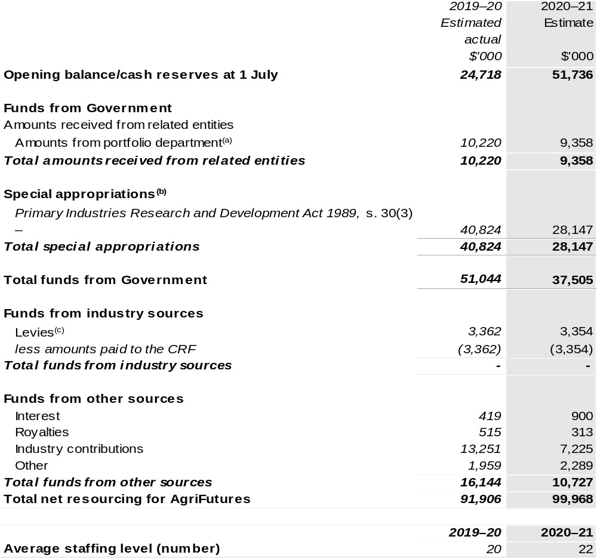

(a) Appropriation Bill (No. 1) 2020–21.
(b) AgriFutures Australia (AgriFutures) is not directly appropriated as it is a corporate Commonwealth entity under the PGPA Act. Appropriations are made to the Department of Agriculture, Water and the Environment (DAWE) and then paid to AgriFutures and are considered departmental for all purposes. Special appropriations in the Portfolio Budget Statements (PBS) 2019–20 Estimated Actuals is $40.824 million. This amount includes a one-off back payment of $21.405 million which was treated as revenue at the time the PBS data was submitted. Subsequently, this amount has been treated as the correction of a prior period error in the 2019–20 Financial Statements. Refer to the Prior Period Error note in the Overview section of the 2019–20 AgriFutures Australia financial statements for further information.
(c) The levies are imposed by the Primary Industries (Excise) Levies Act 1999. The levies are collected by DAWE under the Primary Industries Levies and Charges Collection Act 1991 and are transferred to the CRF. An equivalent amount is paid by DAWE to AgriFutures as a special appropriation under the Primary Industries Research and Development Act 1989 (PIRD Act).

CRF – Consolidated Revenue Fund.

Prepared on a resourcing (i.e. appropriations available) basis.

Please note: All figures shown above are GST exclusive – these may not match figures in the cash flow statement.

1.3 Budget measures
Budget measures in Part 1 relating to AgriFutures Australia are detailed in Budget Paper No. 2: Budget Measures 2020–21 and are summarised below.

Table 1.2: AgriFutures Australia – 2020–21 Budget measures – Measures announced after the Economic and Fiscal Update July 2020
AgriFutures does not have any 2020–21 Budget measures.

Section 2: Outcomes and planned performance
Government outcomes are the intended results, impacts or consequences of actions by the Government on the Australian community. Commonwealth programs are the primary vehicle by which government entities achieve the intended results of their outcome statements. Entities are required to identify the programs which contribute to government outcomes over the Budget and forward years.
Each outcome is described below together with its related programs. The following provides detailed information on expenses for each outcome and program, further broken down by funding source.
Note:
Performance reporting requirements in the Portfolio Budget Statements are part of the Commonwealth performance framework established by the Public Governance, Performance and Accountability Act 2013. It is anticipated that the performance criteria described in Portfolio Budget Statements will be read with broader information provided in an entity’s corporate plans and annual performance statements – included in Annual Reports – to provide a complete picture of an entity’s planned and actual performance.
The most recent corporate plan and annual performance statement for AgriFutures Australia can be found at:
http://www.agrifutures.com.au/about/corporate-documents/

2.1 Budgeted expenses and performance for Outcome 1
Outcome 1: Increased knowledge that fosters sustainable, productive and profitable new and existing rural industries and furthers understanding of national rural issues through research and development in
government-industry partnership.

2.1.1: Linked programs
Department of Agriculture, Water and the Environment
Program 3.10: Agricultural Resources
Contribution to Outcome 1 made by linked program:
AgriFutures works together with the Department of Agriculture, Water and the Environment to ensure sustainable, productive and profitable rural industries.

2.2.1: Budgeted expenses for Outcome 1
This table shows how much the entity intends to spend (on an accrual basis) on achieving the outcome, broken down by program, as well as by Administered and Departmental funding sources.

Table 2.1: Budgeted expenses for Outcome 1
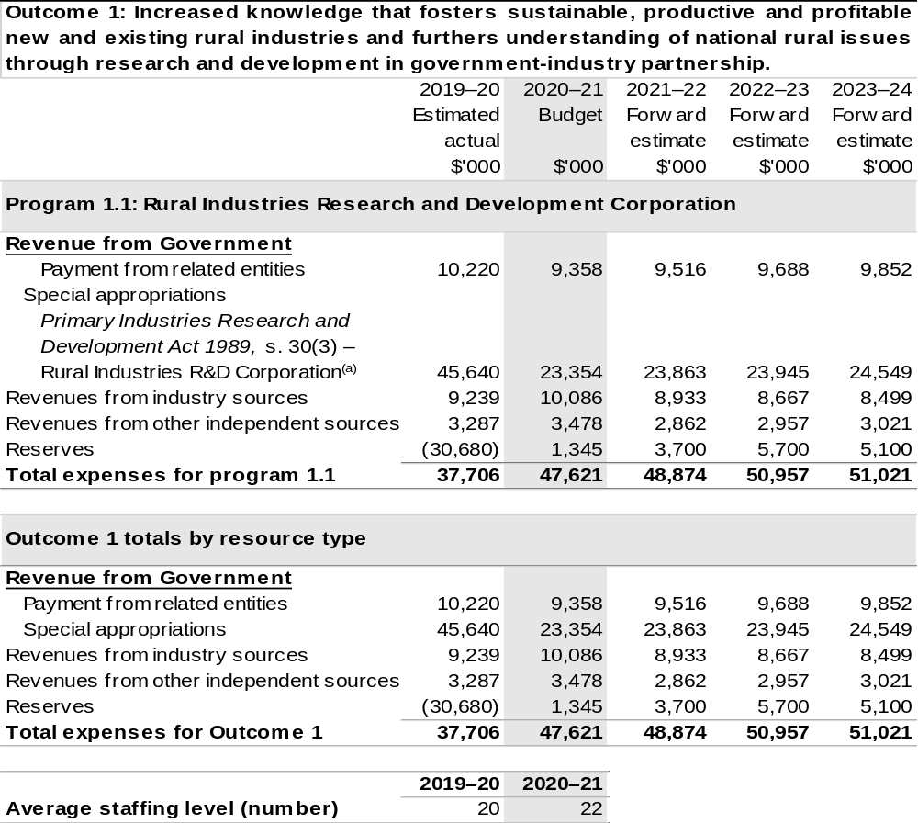

(a) Special appropriations in the PBS 2019–20 Estimated Actuals is $45.640 million. This amount includes a one-off back payment of $21.405 million which was treated as revenue at the time the PBS data was submitted. Subsequently, this amount has been treated as the correction of a prior period error in the 2019–20 Financial Statements. Refer to the Prior Period Error note in the Overview section of the
2019–20 AgriFutures Australia financial statements for further information.

Note: Departmental appropriation splits and totals are indicative estimates and may change in the course of the budget year as Government priorities change.

Prepared on a Government Finance Statistics (fiscal) basis.

2.3.1: Performance criteria for Outcome 1
Table 2.3.1 below details the performance criteria for each program associated with Outcome 1. It also summarises how each program is delivered and where 2020–21 Budget measures have created new programs or materially changed existing programs.
As an entity established under the PIRD Act, AgriFutures does not produce a Corporate Plan under the PGPA Act and is therefore exempt from the requirement to map purposes to outcomes.
Outcome 1: Increased knowledge that fosters sustainable, productive and profitable new and existing rural industries and furthers understanding of national rural issues through research and development in
government-industry partnership.
Program 1.1: Rural Industries Research and Development Corporation
Objective | Through research and development create thriving rural industries and vibrant regional communities.
Delivery | AgriFutures supports the people driving the future prosperity of Australian rural industries by:  Attracting capable people into careers in agriculture through:  - Introducing agricultural careers pathways in schools; and  - Collaboration with other RDCs, government, the private sector and not-for-profit organisations to highlight to young people the opportunities a career in agriculture has to offer.  - Building the capacity of future rural leaders through development programs like Rural Women’s Award, Horizon Scholarship and the Ignite Network.
Delivery | AgriFutures identifies and nurtures research and innovation opportunities that are productive across rural sectors by:  Prioritising and driving cross-sectoral R&D that considers the needs of a diverse portfolio of plant and animal industries.  Brokering partnerships, facilitating priority setting and providing advice to strengthen the national agricultural research and innovation effort.  Complementing industry R&D by investing in research of cross-sectoral value, in areas such as climate change, natural resource management, and safety and welfare.  - Informing debate on issues of importance to rural industries.  - Adapting new technologies for use across rural industries.

Continued on following pages
Contributions to Outcome 1 (continued)
Program 1.1: Rural Industries Research and Development Corporation
Delivery (continued) | AgriFutures enhances the profitability and sustainability of our levied rural industries by:  - Engaging industry participants in determining R&D priorities though industry R&D planning and participation in industry panels to allocate levied funds to projects.  - Investing in innovation that assists levied industries to be more profitable and that demonstrates value to industry participants.  - Delivering outcomes to maximise industry uptake and adoption.  - Communicating research outcomes to farmers at events like field days and workshops and through channels including e-newsletters, emails, social media and hardcopy publications.
Delivery (continued) | AgriFutures supports viable and sustainable new and emerging rural industries by:  - Identifying and targeting high-potential emerging rural industries by supporting rigorous feasibility assessments and identifying critical impediments that can be addressed through R&D.  - Building partnerships with key stakeholders, including the private sector, to support the development of high-potential emerging rural industries.

Continued on following pages
Contributions to Outcome 1 (continued)
Performance information
Year | Performance criteria | 2019–20 Actual Achievement/Targets
2019–20 | - Contribute to the increase of annual intakes of students into agriculture and agricultural science courses at universities. | Data for 2019–20 reporting period is not available.
2019–20 | - Percentage of participants who feel their confidence as a leader has increased significantly or very significantly as a result of participation in an AgriFutures Australia sponsored activity. | This information is not available as the Stakeholder Survey is still underway.
2019–20 | - Impact of AgriFutures Australia sponsored studies on debates of national significance to rural industries. | Eight.
2019–20 | - New technologies adapted for use in Australian rural industries. | Four.
2019–20 | - Evidence of collaboration between RDCs in cross sector investment initiatives. | 15.
2019–20 | - Percentage of growers comfortable or very comfortable paying the R&D levy. | This information is not available as the Stakeholder Survey is still underway.
2019–20 | - Degree to which the objectives of the industry-based R&D plans are being achieved. | This information is not available as the Stakeholder Survey is still underway.
2019–20 | - Stakeholders rate the value of AgriFutures Australia’s information products and services as high or very high. | This information is not available as the Stakeholder Survey is still underway.
2019–20 | - Number of new rural industries reaching or exceeding $10 million per annum threshold. | Two.

Continued on following page
Contributions to Outcome 1 (continued)
Performance information
Year | Performance criteria | 2019–20 Actual Achievement/Targets
2020–21 | - As per 2019–20. | 1,800 per annum.  Information from the Australian Council of Deans of Agriculture annual survey show an increasing number of enrolments.
 | - As per 2019–20 | 80 per cent of surveyed participants.
 | - As per 2019–20. | Five.
 | - As per 2019–20. | One.
 | - As per 2019–20. | 10.
 | - As per 2019–20. | 80 per cent of surveyed participants.
 | - As per 2019–20. | 85 per cent.
 | - As per 2019–20. | 75 per cent of surveyed participants.
 | - As per 2019–20. | One.
 | - Percentage of participants who feel their confidence as a leader has increased significantly or very significantly as a result of participation in an AgriFutures Australia sponsored activity. | 80 per cent of surveyed participants.
 | - Delivery of grow^{AG.}platform and ongoing engagement of evoke^{AG.} community. | grow^{AG.} platform launched
2021–22 and beyond | As per 2020–21. | As per 2020–21.

Note: The superscript AG. stands for “Agriculture”.

Section 3: Budgeted financial statements
Section 3 presents budgeted financial statements which provide a comprehensive snapshot of entity finances for 2020–21, including the impact of 2020–21 Budget measures and resourcing on financial statements.

3.1 Budgeted financial statements

3.1.1: Differences between entity resourcing and financial statements
The financial statements are prepared on an accrual basis where revenues and expenses are recognised as and when the resources are received and used. The entity resourcing table recognises the cash resources available to be used during the period and includes amounts recognised as revenue in previous periods.

3.2.1: Explanatory notes and analysis of budgeted financial statements
AgriFutures is budgeting for a deficit of $1.3 million in 2020–21.
AgriFutures’ balance sheet remains strong with estimated total assets of $55.7 million in 2020–21 and in forward years. Of the total assets, approximately $51.2 million is represented by cash and investments.
Total liabilities of $3.2 million are mostly represented by payables to R&D providers and suppliers of $2.0 million and employee entitlements of $0.6 million over the same period.

3.2 Budgeted financial statements tables

Table 3.1: Comprehensive income statement (showing net cost of services) (for the period ended 30 June)
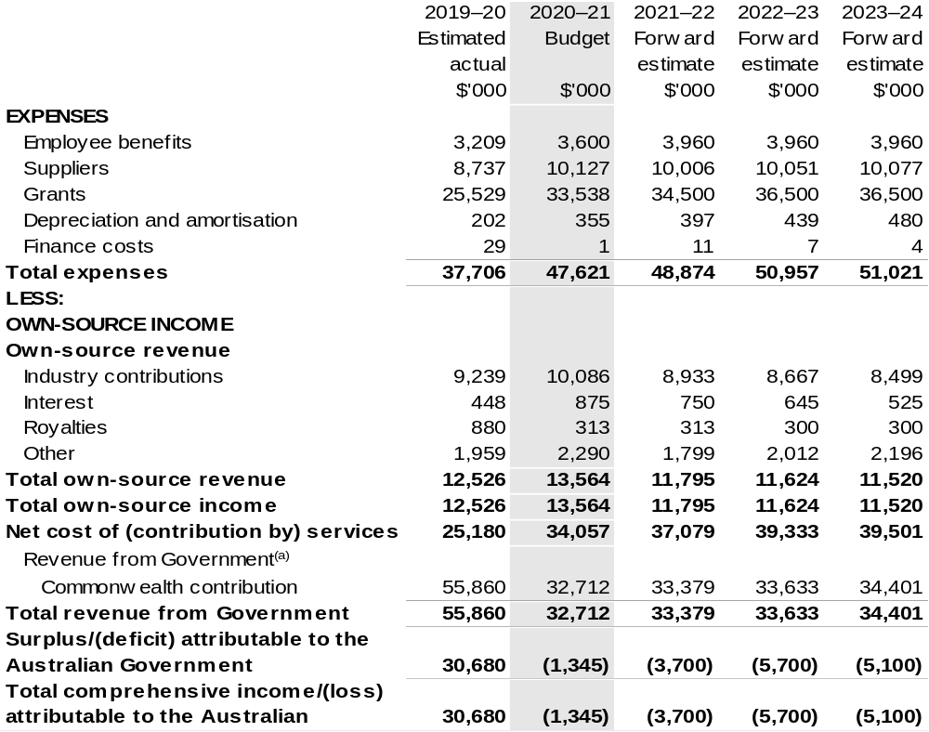

Continued on following page
Table 3.1: Comprehensive income statement (showing net cost of services) (for the period ended 30 June)
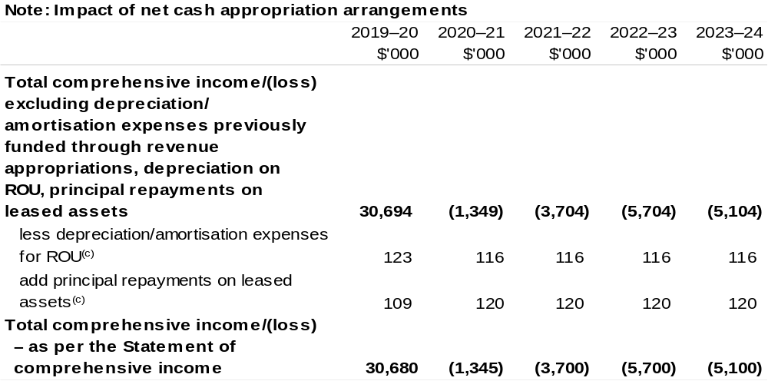
(a) Revenue from Government includes a Commonwealth contribution under the PIRD Act and levies collected from industry by DAWE for R&D activities.
(b) Total comprehensive income/(loss) attributable to the Australian Government in the PBS 2019–20 Estimated Actuals is $30.680 million. This amount includes a one-off back payment of $21.405 million which was treated as revenue at the time the PBS data was submitted. Subsequently, this amount has been treated as the correction of a prior period error in the 2019–20 Financial Statements, resulting in total comprehensive income of $9.275 million. Refer to the Prior Period Error note in the Overview section of the 2019–20 AgriFutures Australia financial statements for further information
(c) Applies to leases under AASB 16 Leases. Right of Use (ROU).

Table 3.2: Budgeted departmental balance sheet (as at 30 June)
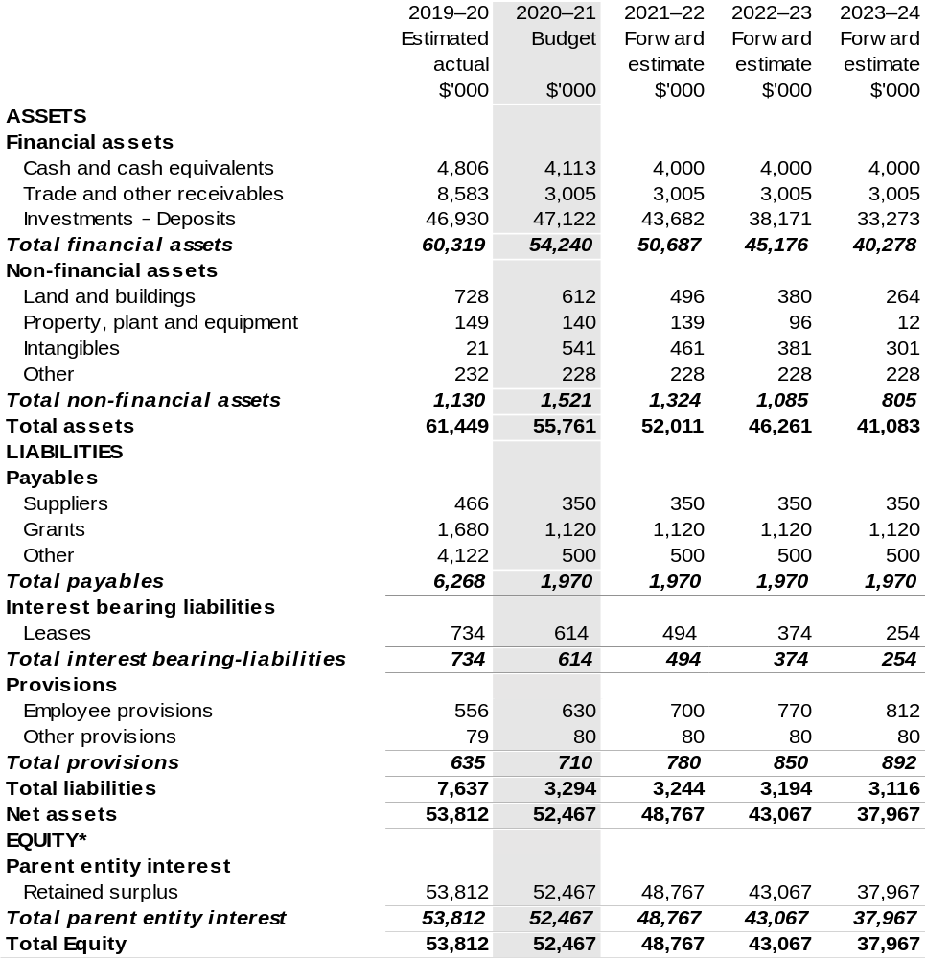

*Equity is the residual interest in assets after deduction of liabilities.

Prepared on Australian Accounting Standards basis.

Table 3.3: Departmental statement of changes in equity – summary of movement (Budget year 2020–21)
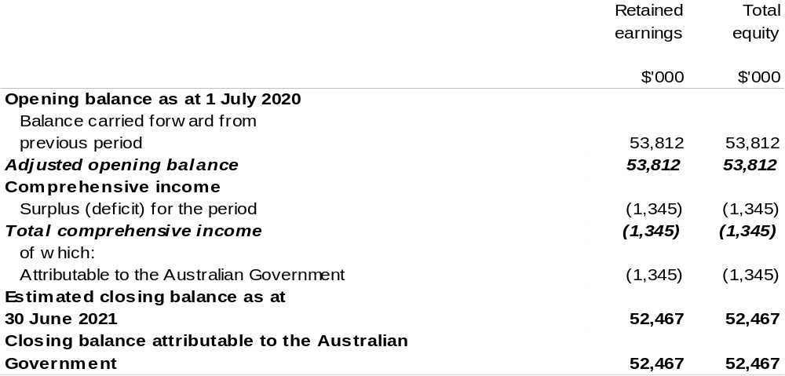

Prepared on Australian Accounting Standards basis.

Table 3.4: Budgeted departmental statement of cash flows (for the period
ended 30 June)
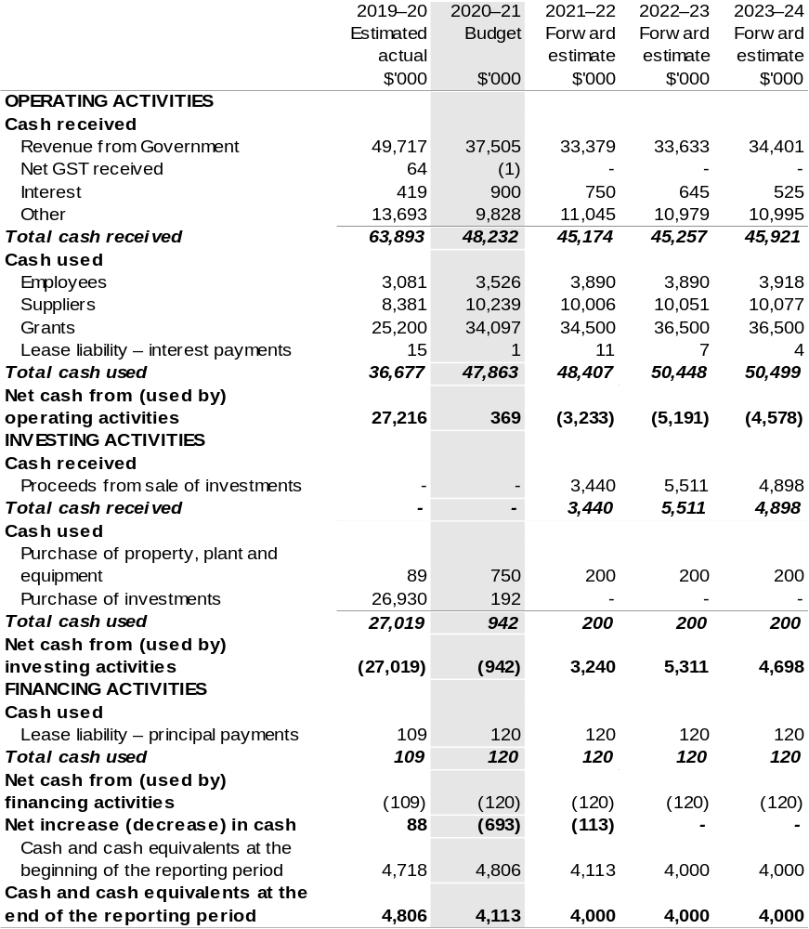

Prepared on Australian Accounting Standards basis.

Table 3.5: Departmental capital budget statement (for period end 30 June)
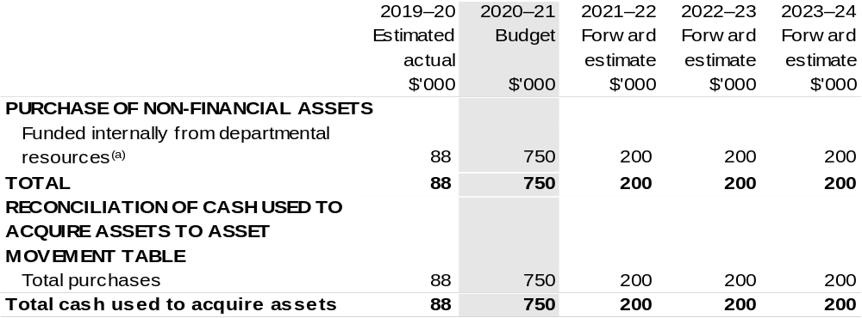

(a) Includes the following sources of funding:
– annual and prior year appropriation; and
– internally developed assets.

Consistent with information contained in the Statement of Asset Movements and the Budgeted Departmental Statement of Cash Flows.

Table 3.6: Statement of asset movements (Budget year 2020–21)
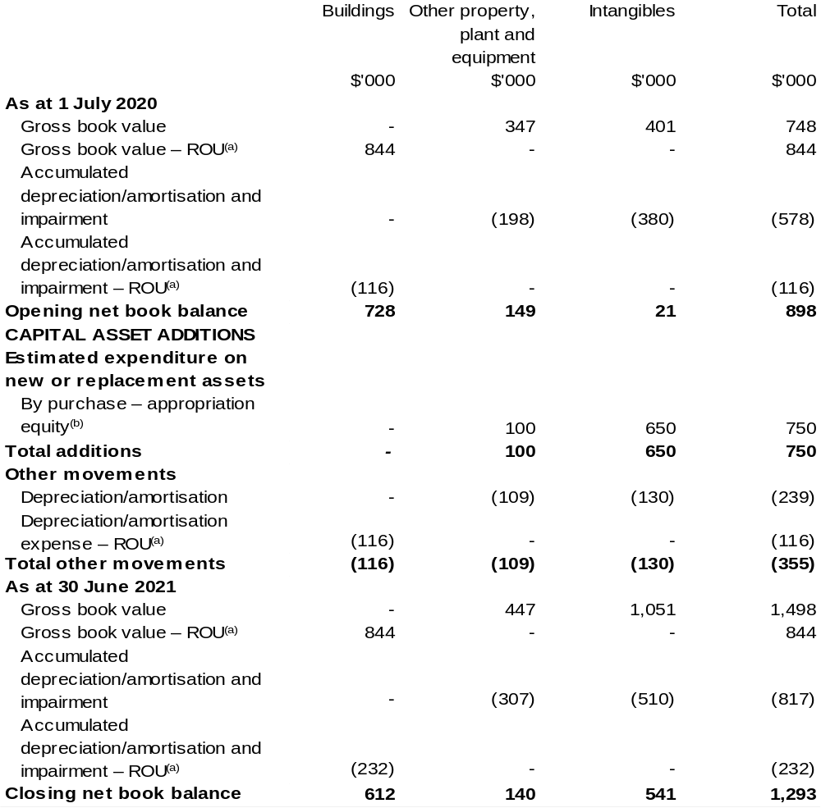

(a) Applies to leases under AASB 16 Leases. Right of Use (ROU).
(b) ‘Appropriation ordinary annual services' refers to funding provided through and Appropriation Bill (No. 1) 2020–21 for depreciation/amortisation expenses, DCBs or other operational expenses.

Prepared on Australian Accounting Standards basis.

Australian Fisheries Management Authority
Section 1: Entity overview and resources 139
1.1 Strategic direction statement 139
1.2 Entity resource statement 142
1.3 Budget measures 144
Section 2: Outcomes and planned performance 145
2.1 Budgeted expenses and performance for Outcome 1 146
Section 3: Budgeted financial statements 162
3.1 Budgeted financial statements 162
3.2 Budgeted financial statements tables 163

Australian Fisheries Management Authority

Section 1: Entity overview and resources

1.1 Strategic direction statement
The Australian Fisheries Management Authority (AFMA) was established under the Fisheries Administration Act 1991 (FAA) to manage Commonwealth fisheries on behalf of the Australian community in accordance with the Fisheries Management Act 1991 (FMA).
The AFMA Commission is responsible for exercising AFMA’s domestic fisheries management functions and powers under the FAA and FMA. The Chief Executive Officer (CEO) of AFMA is responsible for assisting the Commission, including giving effect to its decisions and is also a Commissioner. The CEO is also responsible for exercising AFMA’s foreign compliance functions, is the accountable authority under the Public Governance, Performance and Accountability Act 2013 (PGPA Act) and the agency head for the purposes of the Public Service Act 1999.
AFMA’s legislated functions and objectives require the pursuit of efficient and cost effective fisheries management consistent with the principles of ecologically sustainable development (ESD), including the precautionary principle, and maximising the net economic returns to the Australian community from the management of Commonwealth fisheries. As part of its consideration of ESD, AFMA is seeking to increase its understanding of, and ways to account for, social impacts of its management decisions. Following initial public consultation, AFMA released a position statement in mid-2019 to provide transparency about how AFMA currently considers the social aspects of the ESD principles in the management of Commonwealth fisheries. The statement will evolve over time reflecting changing stakeholder expectations, emerging market requirements and changes in AFMA’s operating environment.
AFMA has regard to the impact of fishing on non-target species and on the long-term sustainability of the marine environment as well as taking into account the interests of commercial, recreational and Indigenous fishers in the management of Commonwealth fisheries. AFMA is implementing new Fisheries Management Strategies following the release of the Commonwealth Fisheries Harvest Strategy and the Commonwealth Bycatch Policy in November 2018 with a focus on improving fishery management performance. AFMA continues to improve the understanding of and the response to the impacts of climate change through a number of projects including: Adaptation of Commonwealth Fisheries Management to Climate Change, with CSIRO as the co-investigator.
AFMA delivers a range of regulatory services to the Commonwealth fishing industry through fisheries management arrangements, compliance programs, licensing services and develops operational policies and regulations. AFMA uses information gained from scientific research and its own monitoring activities to identify Australian marine living resources potentially affected by Commonwealth fisheries and implements measures to pursue sustainable fishing.
AFMA’s role includes developing and implementing risk-based domestic compliance programs, participating in the Australian Government’s civil maritime surveillance and response arrangements and engaging internationally to improve the management of fish stocks beyond the Australian Fishing Zone. Activities include education, enforcement and vessel disposal activities to protect Commonwealth fisheries from illegal fishing, participation in international fora to provide specialist advice and delivering capacity building programs to deter illegal, unreported and unregulated fishing beyond Australia’s borders.
AFMA also provides fisheries management and domestic compliance services for the Protected Zone Joint Authority (PZJA) under the Torres Strait Fisheries Act 1984 (TSFA). Decisions under this legislation are made by the PZJA, which comprises the Commonwealth as Chair, and the Torres Strait Regional Authority and the Queensland Government as other members. The key objectives of the TSFA are to acknowledge and protect the traditional way of life and livelihood of traditional inhabitants, including their rights in relation to traditional fishing and to protect and preserve the marine environment and fauna and flora in, and in the vicinity of, the Protected Zone.
When developing and implementing fisheries management arrangements, AFMA works in partnership with the public and key stakeholders, including commercial fishing operators, the prescribed peak industry body, sectoral industry associations, Indigenous communities, recreational and charter fishing representatives, researchers, environment/conservation organisations, state and territory agencies and others with an interest in Commonwealth fisheries management. AFMA engages with stakeholder groups through management advisory committees, resource assessment groups, scientific panels, working groups, liaison meetings, port visits, and electronic newsletters to concession holders in Commonwealth fisheries. AFMA consults with the public on the development of, and amendments to, fishery management plans, using contemporary digital, web and social media communication channels.
In managing Commonwealth fisheries, AFMA applies the Australian Government’s cost recovery policy through its Cost Recovery Implementation Statement (CRIS). The Commonwealth commercial fishing industry pays for activities directly attributed to, and recoverable from, the fishing industry while the Government pays for compliance and enforcement activities that benefit the broader community. AFMA conducts periodic reviews of its cost-recovered activities and where applicable, applies technological and other solutions to reduce and to help minimise costs and improve efficiency in the delivery of its regulatory services to the Commonwealth fishing industry.
To fulfil its functions, AFMA commissions and places a high importance on scientific and economic research and risk assessments to inform its decision making.
AFMA’s goals and strategies are aimed at continuing to deliver ecologically sustainable and economically efficient Commonwealth fisheries over the current and forecast period.
Our purpose
The ecologically sustainable development of Commonwealth fisheries for the benefit of the Australian community.

1.2 Entity resource statement
Table 1.1 shows the total funding from all sources available to the entity for its operations and to deliver programs and services on behalf of the Government.
The table summarises how resources will be applied by outcome (government strategic policy objectives) and by administered (on behalf of the Government or the public) and departmental (for the entity’s operations) classification.
For more detailed information on special accounts and special appropriations, please refer to Budget Paper No. 4 – Agency Resourcing 2020–21.
Information in this table is presented on a resourcing (that is, appropriations/cash available) basis, whilst the ‘Budgeted expenses by Outcome’ table in Section 2 and the financial statements in Section 3 are presented on an accrual basis.

Table 1.1: Australian Fisheries Management Authority – Resource Statement – Budget Estimates for 2020–21 as at October 2020
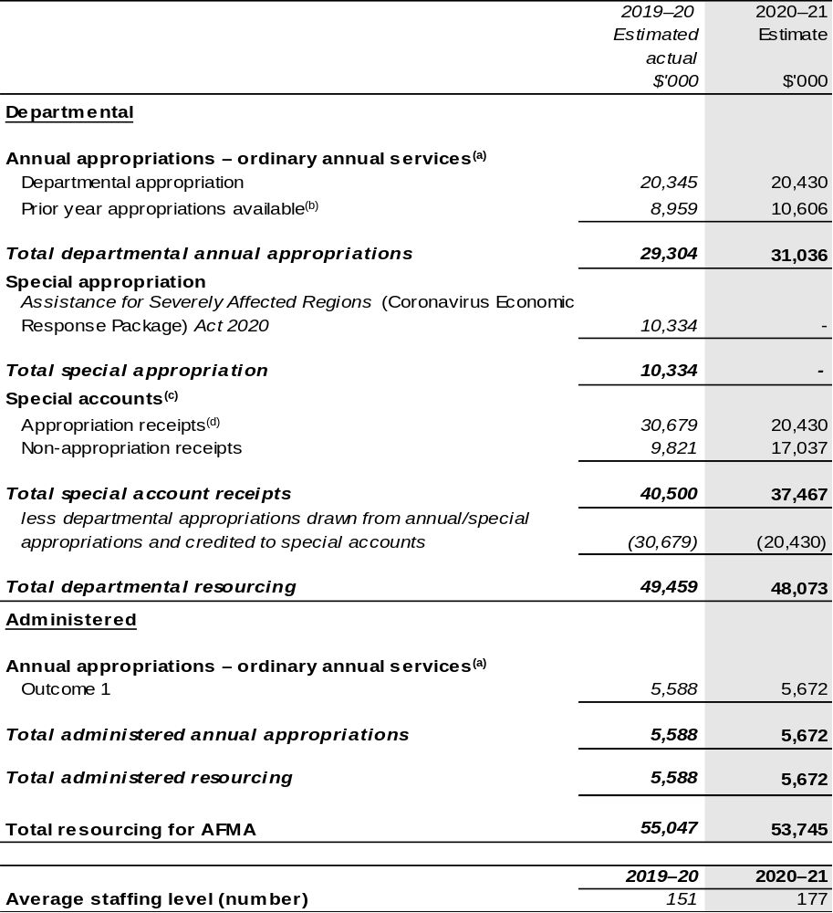
(a) Supply Act (No. 1) and Appropriation Bill (No. 1) 2020–21.
(b) These amounts reflects opening special account balances only.
(c) For further information on special appropriations and special accounts, please refer to Budget Paper No. 4: Agency Resourcing 2020–21. Please also see Table 2.1 for further information on outcome and program expenses broken down by various funding sources, e.g. annual appropriations, special appropriations and special accounts.
(d) Amounts credited to the special account(s) from entity AFMA’s annual appropriations.

Prepared on a resourcing (i.e. appropriations available) basis.

Please note: All figures shown above are GST exclusive – these may not match figures in the cash flow statement.

1.3 Budget measures
Budget measures in Part 1 relating to the Australian Fisheries Management Authority are detailed in Budget Paper No. 2: Budget Measures 2020–21 and are summarised below.

Table 1.2: Australian Fisheries Management Authority – 2020–21 Budget measures – Measures announced after the Economic and Fiscal Update
July 2020
AFMA does not have any 2020–21 Budget measures.

Section 2: Outcomes and planned performance
Government outcomes are the intended results, impacts or consequences of actions by the Government on the Australian community. Commonwealth programs are the primary vehicle by which government entities achieve the intended results of their outcome statements. Entities are required to identify the programs which contribute to government outcomes over the Budget and forward years.
Each outcome is described below together with its related programs. The following provides detailed information on expenses for each outcome and program, further broken down by funding source.
Note:
Performance reporting requirements in the Portfolio Budget Statements are part of the Commonwealth performance framework established by the PGPA Act. It is anticipated that the performance criteria described in Portfolio Budget Statements will be read with broader information provided in an entity’s corporate plans and annual performance statements – included in Annual Reports – to provide a complete picture of an entity’s planned and actual performance.
AFMA’s most recent corporate plan can be found at:
https://www.afma.gov.au/sites/default/files/corporate_plan_2020-23_final.pdf
AFMA’s most recent annual performance statement can be found at:
https://www.afma.gov.au/sites/default/files/annual_operational_plan_2020-21_final.pdf

2.1 Budgeted expenses and performance for Outcome 1
Outcome 1: Ecologically sustainable and economically efficient Commonwealth fisheries, through understanding and monitoring Australia’s marine living resources and regulating and monitoring commercial fishing, including domestic licensing and deterrence of illegal foreign fishing.

2.1.1: Linked programs
Department of Agriculture, Water and the Environment
Program 1.4: Conservation of Australia’s Heritage and the Environment
Program 3.4: Fishing Industry
Program 4.1: Biosecurity and Export Services
Contribution to Outcome 1 made by linked program:
The Australian Fisheries Management Authority (AFMA) and the Department of Agriculture, Water and the Environment engage on fisheries management to ensure a sustainable, productive and profitable fishing industry.
Department of Home Affairs
Program 1.1: Border Enforcement
Contribution to Outcome 1 made by linked program:
AFMA provides the fisheries focus within the Australian Government Civil Maritime Surveillance and Response Program and is responsible for the administration of legislation on illegal fishing in the Australian Fishing Zone. AFMA deters and prevents illegal foreign fishing by carrying out education programs, cooperative enforcement operations, prosecution of offenders, confiscation of boats and capacity building projects.

2.2.1: Budgeted expenses for Outcome 1
This table shows how much the entity intends to spend (on an accrual basis) on achieving the outcome, broken down by program, as well as by administered and departmental funding sources.

Table 2.1: Budgeted expenses for Outcome 1
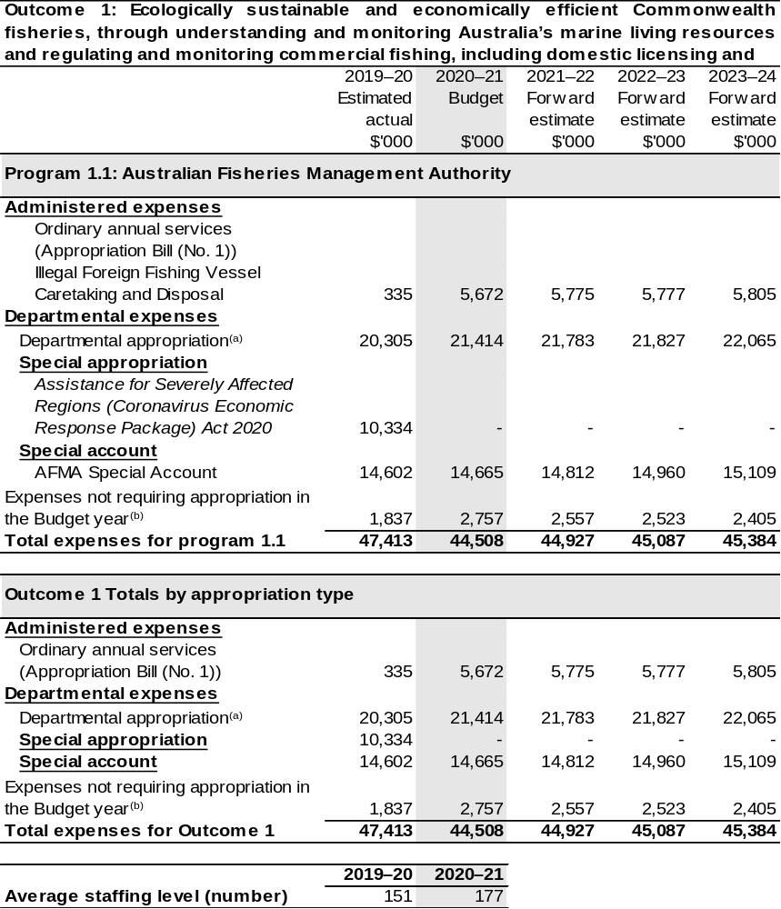
Continued on following page
Table 2.1: Budgeted expenses for Outcome 1 (continued)

(a) Expenses funded from both ‘ordinary annual services’ (Supply Act (No. 1) and Appropriation Bill (No. 1) 2020–21) and ‘revenue from independent sources’ (section 74 of the PGPA Act).
(b) Expenses not requiring appropriation in the Budget year are made up of depreciation expenses, amortisation expenses, and audit fees.

Note: Departmental appropriation splits and totals are indicative estimates and may change in the course of the budget year as Government priorities change.

Prepared on Australian Accounting Standards basis.

2.3.1: Performance criteria for Outcome 1
Table 2.3.1 below details the performance criteria for each program associated with Outcome 1. It also summarises how each program is delivered and where 2020–21 Budget measures have created new programs or materially changed existing programs.
Outcome 1: Ecologically sustainable and economically efficient Commonwealth fisheries, through understanding and monitoring Australia’s marine living resources and regulating and monitoring commercial fishing, including domestic licensing and deterrence of illegal foreign fishing.
Program 1.1: Australian Fisheries Management Authority
Objective | The ecologically sustainable development of Commonwealth fisheries for the benefit of the Australian community.
Delivery | AFMA manages Commonwealth fisheries resources consistent with principles of ecological sustainable development by:  - Developing management arrangements that:  - Support the implementation of Commonwealth fisheries policies including the Harvest Strategy and Bycatch Policies;  - Implement AFMA’s revised Ecological Risk Management Framework;  - Recover overfished stocks and prevent overfishing; and  - Ensure commercial, recreational and Indigenous fishing information is used in decision making.  - Investing in and applying scientific and economic research to decision making on fish stocks, sub-stocks, species (target and non-target species) and the impact of fishing on the marine environment.  AFMA maximises the net economic returns to the Australian community from the management of Commonwealth fisheries by:  - Reviewing management arrangements to take into account commercial, recreational and Indigenous fishing interests when maximising net economic returns from the commercial sector.  - Increasing catch levels within sustainable total allowable catches (TACs) by conducting and considering implementation of research focussed on under caught TACs.  - Managing exploratory fisheries (potentially underutilised fisheries).  - Understanding impacts of resource allocation between commercial, recreational and Indigenous fishers.

Continued on following pages

Contributions to Outcome 1 (continued)
Program 1.1 – Australian Fisheries Management Authority (continued)
Delivery (continued) | AFMA ensures compliance with Commonwealth fisheries laws and policies and relevant international fishing obligations and standards by:  - Operating an effective compliance and enforcement regime encompassing:  - Measures to maximise voluntary compliance;  - Risk-based, intelligence driven, and targeted domestic operations; and  - Building and maintaining strategic links and relationships with relevant law enforcement agencies.  - Operating effective foreign fisheries compliance enforcement and capacity building by:  - Implementing strategies to deter and eliminate illegal, unreported and unregulated (IUU) foreign fishing in Australian waters and on the high seas where Australia has an interest; and  - Delivering capacity building programs internationally and supporting key regional and international fishing bodies.  AFMA delivers effective, cost efficient and accountable management of Commonwealth fisheries resources by:  - Pursuing ministerial directives and government initiatives to improve regulation and administration generally in the Australian Government sector including:  - Exploring opportunities to streamline fisheries assessment and management processes; and  - Implementing new fisheries policies for harvest strategies and bycatch to improve fishery management performance.  - Reviewing business processes and systems, information flows and financial management arrangements through:  - Assessing and mitigating high financial and operating risks; and  - Developing an e-business plan that considers cost effective and efficient use of electronic systems for logbooks, monitoring and licensing.  - Increasing AFMA accountability and stakeholder engagement through:  - Expanded membership of management advisory committees (MACs) and resource assessment groups (RAGs); and  - Capability development for recreational and Indigenous stakeholders.
Continued on following pages

Contributions to Outcome 1 (continued)
Performance information
Year | Performance criteria^{(a)} | 2019–20 Actual Achievement/Targets
2019–20 | - Complete an Ecological Risk Assessment (ERA) and Fisheries Management Strategy (FMS) for each fishery every five years. (Number of fisheries). | Actual: six  Target: five
2019–20 | - The number of high risk rated species from ERAs declines. | Actual: 87  Target: 80
2019–20 | - Fisheries reporting on general bycatch quantity each year. (Number of fisheries). | Actual: 12  Target: eight
2019–20 | - Fisheries reporting decreasing volume of general bycatch each year.  (Number of fisheries). | Actual: eight  Target: six
2019–20 | - Interaction rates with Threatened Endangered and Protected species (TEPs) decreasing each year.  (Number of fisheries). | Actual: six  Target: five
2019–20 | - For economically significant stocks:^{(b)}
2019–20 | a. maximise the number of key commercial stocks with harvest strategy targets based on Maximum Economic Yield (MEY) or the best available proxy.^{(c),(d)} | Actual: 14  Target: At least 14.
2019–20 | b. improve the number of stocks in (a) assessed as being on target.^{(e)} | Actual: four  Target: four
2019–20 | c. for those stocks in (a) that are assessed as not on target, improve the number that are heading towards their target reference point. | Actual: four  Target: seven

Continued on following pages
Contributions to Outcome 1 (continued)
Performance information
Year | Performance criteria^{(a)} | 2019–20 Actual Achievement/Targets
2019–20 (continued) | - Major fisheries have harvest strategies that meet the Harvest Strategy Policy 2018 (HSP2018) within three years.  (Number of fisheries). | Actual: zero  Target: six
2019–20 (continued) | - Other fisheries have harvest strategies that meet the HSP2018 within four years. (Number of fisheries). | Actual: two  Target: 22
2019–20 (continued) | - Percentage of treatment targets for all priority domestic compliance risks met. | Actual: 78.1 per cent  Target: 90 per cent
2019–20 (continued) | - Percentage of apprehended foreign IUU vessels and suspected illegal entry vessels (SIEVs) delivered to AFMA disposed of. | Actual: 100 per cent  Target: 100 per cent
2019–20 (continued) | - Percentage of briefs of evidence relating to foreign offenders submitted to the Commonwealth Director of Public Prosecutions within 7 to 10 days from their arrival in Australia. | Actual: 100 per cent  Target: 90 per cent
2019–20 (continued) | - Industry cost recovery charges do not exceed the levels derived by increasing the 2005–06 recoveries by the Consumer Price Index (CPI) each year. | Actual: $14.3 million  Target: <$19.0 million
2020–21 | - All major fisheries have Management Plans in place and managed in accordance with them (percentage of major fisheries). | 100 per cent.
2020–21 | - Current ERA for all fisheries/sub fisheries and responses in place for high risk species (percentage of fisheries/sub fisheries). | 100 per cent.
Contributions to Outcome 1 (continued)
Performance information
Year | Performance criteria^{(a)} | 2019–20 Actual Achievement/Targets
2020–21 (continued) | - Fishery Specific Harvest Strategies in place for all fisheries/ sub fisheries (percentage of fisheries/sub fisheries). | 90 per cent.
2020–21 (continued) | - Individual species Total Allowable Catch and effort limits set in accordance with harvest control rules based on scientific advice (percentage of species). | 100 per cent.
2020–21 (continued) | - Bycatch mitigation and management arrangements in place for protected species and general bycatch (percentage of fisheries/sub fisheries). | 70 per cent.
2020–21 (continued) | - Appropriate assessment – primarily Wildlife Trade Operation renewals – under the Environment Protection and Biodiversity Conservation Act 1999 (percentage of fisheries/sub fisheries due per annum). | 100 per cent.
2020–21 (continued) | - Number of solely Commonwealth managed stocks subject to overfishing by ABARES Fisheries Status Reports (percentage of fisheries/sub fisheries). | <10 per cent.
2020–21 (continued) | - For economically significant stocks:^{(b)}
2020–21 (continued) | - As per 2019–20.^{(c),(d)} | At least 15.
2020–21 (continued) | - As per 2019–20.^{(e)} | Four
2020–21 (continued) | - As per 2019–20. | Seven
2020–21 (continued) | - Major fisheries have harvest strategies that meet the HSP2018 within three years. (Number of fisheries). | Eight

Contributions to Outcome 1 (continued)
Performance information
Year | Performance criteria^{(a)} | 2019–20 Actual Achievement/Targets
2020–21 (continued) | - Other fisheries have harvest strategies that meet the HSP2018 within four years (number of fisheries). | Four
2020–21 (continued) | - National Compliance and Enforcement Policy reviewed every two years. | ✓
2020–21 (continued) | - Risk assessment reviewed every two years. | ✓
2020–21 (continued) | - National Compliance and Enforcement Program developed and implemented annually. | ✓
2020–21 (continued) | - Non-compliance incident levels in targeted risk areas maintained at current levels or reduced. | ✓
2020–21 (continued) | - Treatment targets for all priority compliance risks met. | 90 per cent.
2020–21 (continued) | - AFMA’s International Compliance and Engagement Program endorsed by the CEO, reviewed every two years and available on the AFMA website. | N/A
2020–21 (continued) | - Media releases for major activities and significant outcomes. | 100 per cent.
2020–21 (continued) | - Number of illegal foreign fishing vessels detected in Australian waters remains low. | ✓  Incident rates maintained at historical low levels.
2020–21 (continued) | - Disposal of apprehended foreign IUU vessels received by AFMA. | 100 per cent.
2020–21 (continued) | - Foreign fishers charged are successfully prosecuted. | 100 per cent.
Contributions to Outcome 1 (continued)
Performance information
Year | Performance criteria^{(a)} | 2019–20 Actual Achievement/Targets
2020–21 (continued) | - High risk foreign fishing vessels visiting Australian ports inspected. | 100 per cent.
2020–21 (continued) | - High Seas Boarding and Inspection reports by Australian officers submitted, as required, to flag States and International Fisheries Management Organisations (IFMO). | 100 per cent.
2020–21 (continued) | - AFMA priorities for meetings and bilateral engagement are incorporated in government briefings and negotiating frameworks. | 100 per cent.
2020–21 (continued) | - Nominations of non-compliant vessels for IUU listing in accordance with IFMO are successful. | 100 per cent.
2020–21 (continued) | - In-country programs to provide technical, policy and operational advice to build capacity are delivered. | Two
2020–21 (continued) | - Participation in Forum Fisheries Agency-led cooperative training activities and multilateral maritime surveillance activities, as appropriate. | Four
2020–21 (continued) | - Australian officers target IUU threats and engage flag States to implement remedial actions. | 100 per cent of identified suspected non-compliant actions acted on.
2020–21 (continued) | - The percentage of overhead costs in total cost recovery expenditure remains below 20 per cent. | ✓
2020–21 (continued) | - The variance between total actual and budgeted cost recovered expenditure should not exceed 5.0 per cent. | ✓

Contributions to Outcome 1 (continued)
Performance information
Year | Performance criteria^{(a)} | 2019–20 Actual Achievement/Targets
2020–21 (continued) | - The percentage of total cost recovery expenditure to the Gross Value of Production (GVP) of Commonwealth fisheries should be no greater than 5.0 per cent. | ✓
2020–21 (continued) | - The cost recovered budget will remain at or below the budget in 2005–06 once adjusted for Consumer Price Index (CPI) increases. | ✓
2020–21 (continued) | - An internal review of the AFMA CRIS will be undertaken each year prior to being provided to being provided to the Commonwealth fishing industry’s peak body, the CFA, for their review. | ✓
2020–21 (continued) | - Financial reports will be provided to the CFA detailing actual versus budget cost recovery expenditure by AFMA CRIS activity group and by fishery. A report will be provided for financial year to 31 December (by no later than 31 March) and for the full year (by no later than  30 September). | ✓
2020–21 (continued) | - Information sessions for the Commonwealth fishing industry on the CRIS document and on activity cost formulation will be offered in March and October each year. | ✓

Continued on following pages
Contributions to Outcome 1 (continued)
Performance information
Year | Performance criteria^{(a)} | 2019–20 Actual Achievement/Targets
2020–21 (continued) | - The change request register detailing industry feedback on the draft budget and CRIS will be published along with the final CRIS on the AFMA website each year before the commencement of the new financial year. | ✓
2020–21 (continued) | - Implementation of Stakeholder Engagement Framework and Communication plan. | ✓
2020–21 (continued) | - The percentage of stakeholders responding to AFMA surveys (including biennial perception and ‘pop-up’ style surveys) increases by 10 per cent per annum. | ✓
2020–21 (continued) | - The level of overall satisfaction of stakeholders increases over time. | ✓
2020–21 (continued) | - The level of satisfaction responses of stakeholders to ‘pop up’ surveys increases over time. | ✓
2020–21 (continued) | - The level of engagement and feedback from engagement with stakeholders increases over time. | ✓
2020–21 (continued) | - The Agency Data Strategy and Roadmap is delivered and endorsed. | ✓
2020–21 (continued) | - The Agency Data Capture project is implemented successfully, and extended across the agency to all logbook, catch disposal and observer data. | ✓

Continued on following pages
Contributions to Outcome 1 (continued)
Performance information
Year | Performance criteria^{(a)} | 2019–20 Actual Achievement/Targets
2020–21 (continued) | - AFMA continues to align to the Digital 2020 policy and ensures internal processes and technology are enhanced to meet this requirement. | ✓
2020–21 (continued) | - Data Governance and Culture is embedded into AFMA practices | ✓
2020–21 (continued) | - Significant increases to data analytical capability provided for AFMA staff. | ✓
2020–21 (continued) | - The technical delivery of an integrated fisheries data architecture is implemented | ✓
2021–22 and beyond | - As per 2020–21. | As per 2020–21.
2021–22 and beyond | - As per 2020–21. | As per 2020–21.
2021–22 and beyond | - Fishery Specific Harvest Strategies in place for all fisheries/sub fisheries (percentage of fisheries/sub fisheries). | (2021–22) 95 per cent.  (2022–23) 100 per cent.  (2023–24) 100 per cent.
2021–22 and beyond | - As per 2020–21. | As per 2020–21.
2021–22 and beyond | - Bycatch mitigation and management arrangements in place for protected species and general bycatch (percentage of fisheries/sub fisheries). | (2021–22) 70 per cent.  (2022–23) 80 per cent.  (2023–24) 100 per cent.
2021–22 and beyond | - As per 2020–21. | As per 2020–21.
2021–22 and beyond | - As per 2020–21. | As per 2020–21.
2021–22 and beyond | - For economically significant stocks:^{(b)}
2021–22 and beyond | - As per 2020–21.^{(c),(d)} | As per 2020–21.
2021–22 and beyond | - As per 2020–21.^{(e)} | As per 2020–21.

Continued on following pages
Contributions to Outcome 1 (continued)
Performance information
Year | Performance criteria^{(a)} | 2019–20 Actual Achievement/Targets
2021–22 and beyond | - As per 2020–21. | As per 2020–21.
2021–22 and beyond | - As per 2020–21. | (all forward years)  10
2021–22 and beyond | - As per 2020–21. | (all forward years)  Five
2021–22 and beyond | - As per 2020–21. | (2021–22) N/A  (2022–23) ✓  (2023–24) N/A
2021–22 and beyond | - As per 2020–21. | (2021–22) N/A  (2022–23) ✓  (2023–24) N/A
2021–22 and beyond | - As per 2020–21. | As per 2020–21.
2021–22 and beyond | - As per 2020–21. | As per 2020–21.
2021–22 and beyond | - As per 2020–21. | As per 2020–21.
2021–22 and beyond | - As per 2020–21. | (2021–22) ✓  (2022–23) N/A  (2023–24) ✓
2021–22 and beyond | - As per 2020–21. | As per 2020–21.
2021–22 and beyond | - As per 2020–21. | As per 2020–21.
2021–22 and beyond | - As per 2020–21. | As per 2020–21.
2021–22 and beyond | - As per 2020–21. | As per 2020–21.
2021–22 and beyond | - As per 2020–21. | As per 2020–21.

Continued on following pages
Contributions to Outcome 1 (continued)
Performance information
Year | Performance criteria^{(a)} | 2019–20 Actual Achievement/Targets
2021–22 and beyond | - As per 2020–21. | As per 2020–21.
2021–22 and beyond | - As per 2020–21. | As per 2020–21.
2021–22 and beyond | - As per 2020–21. | As per 2020–21.
2021–22 and beyond | - As per 2020–21. | Dependent on funding  (all forward years)
2021–22 and beyond | - As per 2020–21. | Dependent on funding  (all forward years
2021–22 and beyond | - As per 2020–21. | As per 2020–21.
2021–22 and beyond | - As per 2020–21. | As per 2020–21.
2021–22 and beyond | - As per 2020–21. | As per 2020–21.
2021–22 and beyond | - As per 2020–21. | As per 2020–21.
2021–22 and beyond | - As per 2020–21. | As per 2020–21.
2021–22 and beyond | - As per 2020–21. | As per 2020–21.
2021–22 and beyond | - As per 2020–21. | As per 2020–21.
2021–22 and beyond | - As per 2020–21. | As per 2020–21.
2021–22 and beyond | - As per 2020–21. | As per 2020–21.
2021–22 and beyond | - As per 2020–21. | As per 2020–21.
2021–22 and beyond | - As per 2020–21. | As per 2020–21.
2021–22 and beyond | - As per 2020–21. | As per 2020–21.
2021–22 and beyond | - As per 2020–21. | As per 2020–21.

Continued on following page
Contributions to Outcome 1 (continued)
Performance information
Year | Performance criteria^{(a)} | 2019–20 Actual Achievement/Targets
2021–22 and beyond | - As per 2020–21. | As per 2020–21.
2021–22 and beyond | - The Agency Data Strategy and Roadmap is delivered and endorsed. | N/A
2021–22 and beyond | - The Agency Data Capture project is implemented successfully, and extended across the agency to all logbook, catch disposal and observer data. | (2021–22) ✓  (2022–23) ✓  (2023–24) N/A.
2021–22 and beyond | - As per 2020–21. | As per 2020–21.
2021–22 and beyond | - As per 2020–21. | As per 2020–21.
2021–22 and beyond | - As per 2020–21. | As per 2020–21.
2021–22 and beyond | - As per 2020–21. | As per 2020–21.
Purposes | AFMA is responsible for:  - Managing Commonwealth fisheries resources consistent with principles of ecological sustainable development;  - Maximising net economic returns to the Australian community from the management of Commonwealth fisheries;  - Promoting compliance with Commonwealth fisheries laws and policies and relevant international fishing obligations and standards;  - Delivering effective, cost efficient and accountable management of Commonwealth fisheries resources; and  - Considering the economic benefits for recreational and Indigenous stakeholders as well as commercial fishers.

- New or modified performance criteria that reflect new or materially changed programs are shown in italics.
- Please note that not all Commonwealth fish stocks can be managed by MEY; for example, those managed under international regional bodies.
- Where higher and lower value species are caught together, different targets for the lower value species may maximise net economic returns overall.
- Assessment methodologies are being reviewed. This may mean projections may vary.
- Key commercial stocks of a fishery as defined by the Commonwealth Fisheries Harvest Strategy Policy and Guidelines.

Section 3: Budgeted financial statements
Section 3 presents budgeted financial statements which provide a comprehensive snapshot of entity finances for 2020–21, including the impact of 2020–21 Budget measures and resourcing on financial statements.

3.1 Budgeted financial statements

3.1.1: Differences between entity resourcing and financial statements
The financial statements are prepared on an accrual basis where revenues and expenses are recognised as and when the resources are received and used. The entity resourcing table recognises cash resources available to be used during the period and includes amounts recognised as revenue in previous periods.

3.2.1: Explanatory notes and analysis of budgeted financial statements
AFMA expects to maintain a balanced budget position over the forward years, before depreciation and amortisation.
AFMA collects levies via regulations under the Fishing Levy Act 1991, in accordance with the Fisheries Management Act 1991, Fisheries Administration Act 1991, Australian Government cost recovery policy and AFMA’s Cost Recovery Implementation Statement.
Administered income reflects the fines imposed by AFMA for domestic and international illegal fishing activities and the receipt of administered revenue for expenditure incurred.
Administered expenditure reflects payments to the providers of illegal foreign fishing vessel caretaking and disposal services.

3.2 Budgeted financial statements tables

Table 3.1: Comprehensive income statement (showing net cost of services) (for the period ended 30 June)
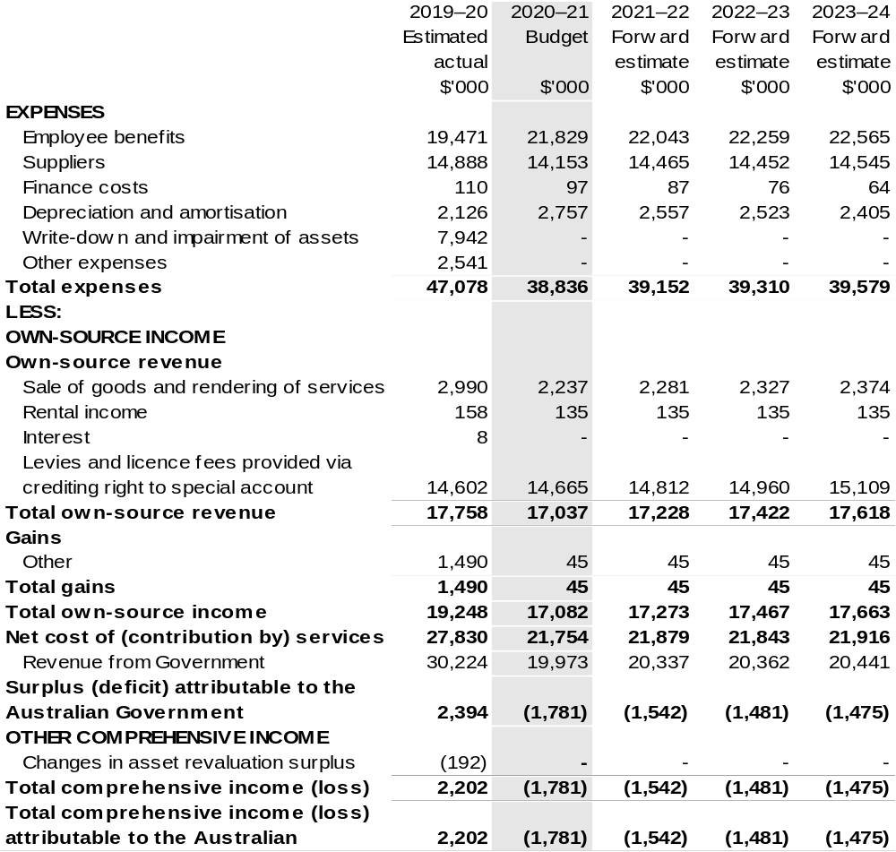
Continued on following page

Table 3.1 Comprehensive income statement (showing net cost of services) (for the period ended 30 June) (continued)
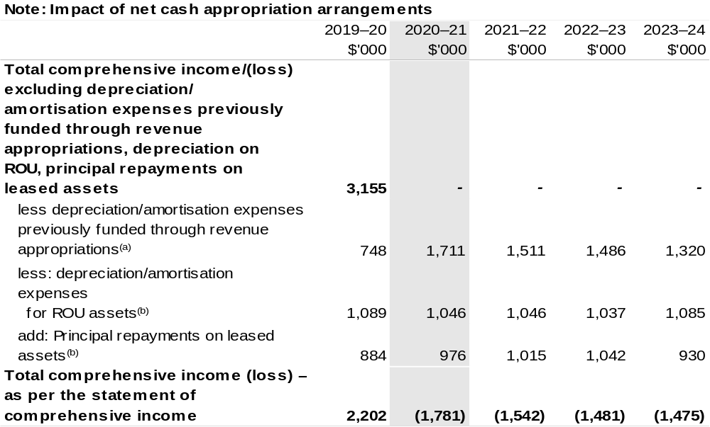
(a) From 2010–11, the Government introduced net cash appropriation arrangements where Bill (No. 1) revenue appropriations for the depreciation/amortisation expenses of non-corporate Commonwealth entities (and select corporate Commonwealth entities) were replaced with a separate capital budget
(the Departmental Capital Budget, or DCB) provided through Bill (No. 1) equity appropriations.
For information regarding DCBs, please refer to Table 3.5 Departmental Capital Budget Statement.
- Applies to leases under AASB 16 Leases. Right of Use (ROU).

Prepared on Australian Accounting Standards basis.

Table 3.2: Budgeted departmental balance sheet (as at 30 June)
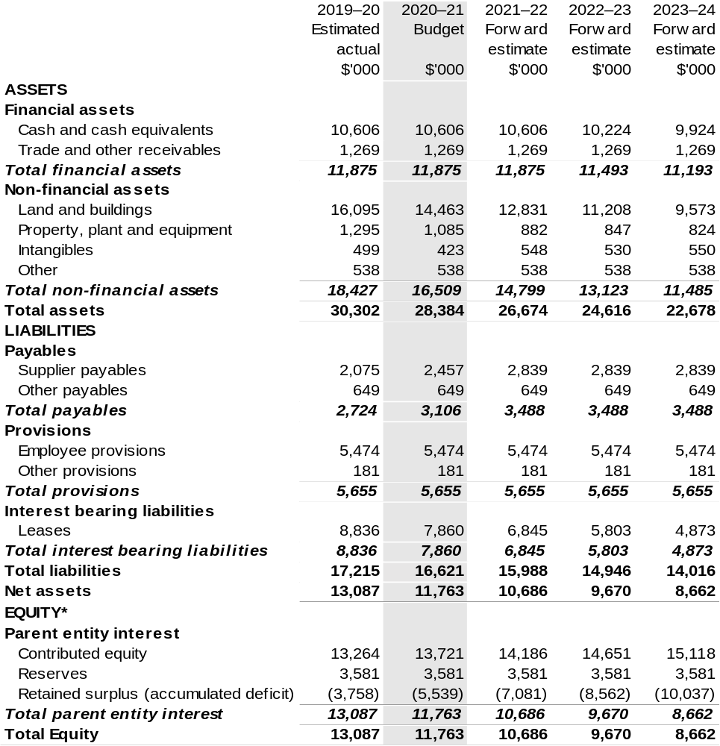
*Equity is the residual interest in assets after deduction of liabilities.

Prepared on Australian Accounting Standards basis.

Table 3.3: Departmental statement of changes in equity — summary of movement (Budget year 2020–21)
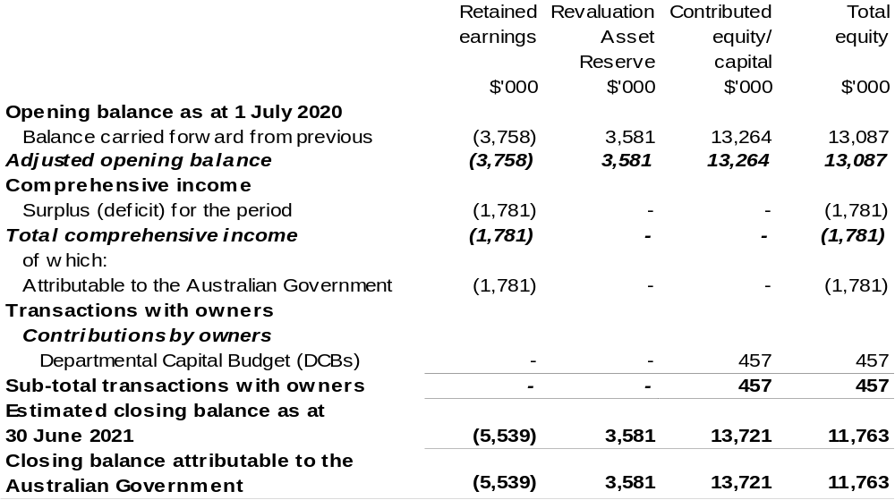
Prepared on Australian Accounting Standards basis.

Table 3.4: Budgeted departmental statement of cash flows (for the period
ended 30 June)
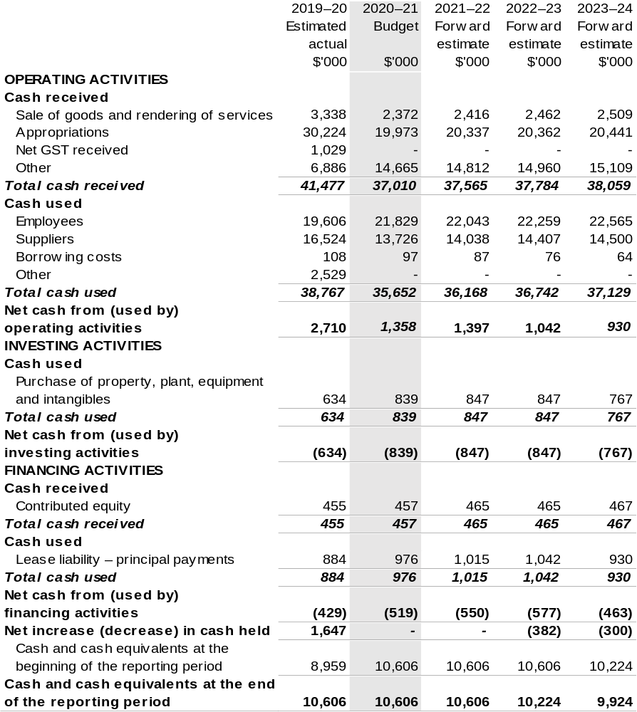
Prepared on Australian Accounting Standards basis.

Table 3.5: Departmental capital budget statement (for the period ended 30 June)
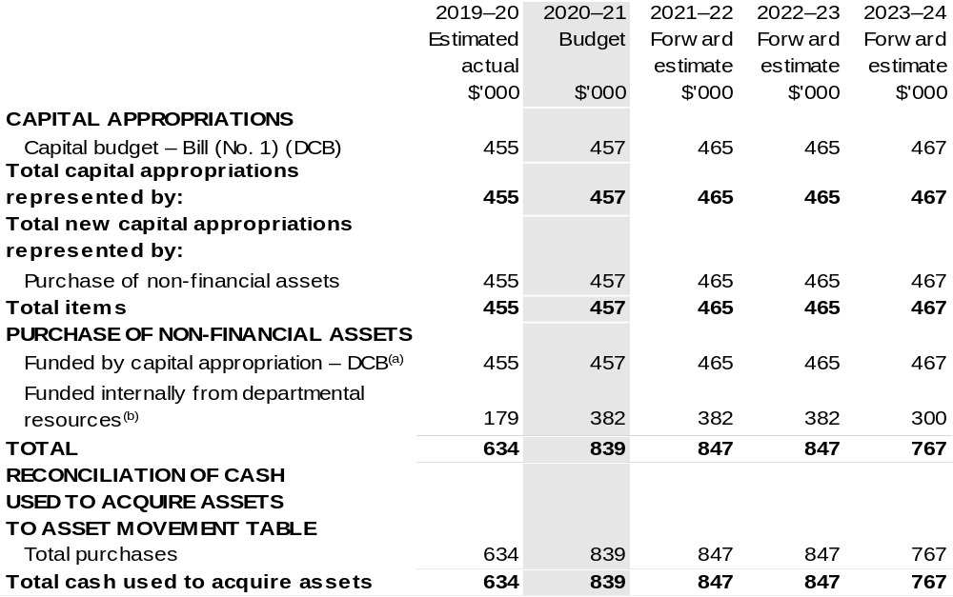
(a) Does not include annual finance lease costs. Include purchases from current and previous years' Departmental Capital Budgets (DCBs).
(b) Includes the following sources of funding:
– annual and prior year appropriations;
– internally developed assets;
– section 74 External Revenue receipts;
– proceeds from the sale of assets; and
– the AFMA Special Account under section 94B of the Fisheries Administration Act 1991.

Prepared on Australian Accounting Standards basis.

Consistent with information contained in the Statement of Asset Movements and the Budgeted Statement of Cash Flows.

Table 3.6: Statement of asset movements (Budget year 2020–21)
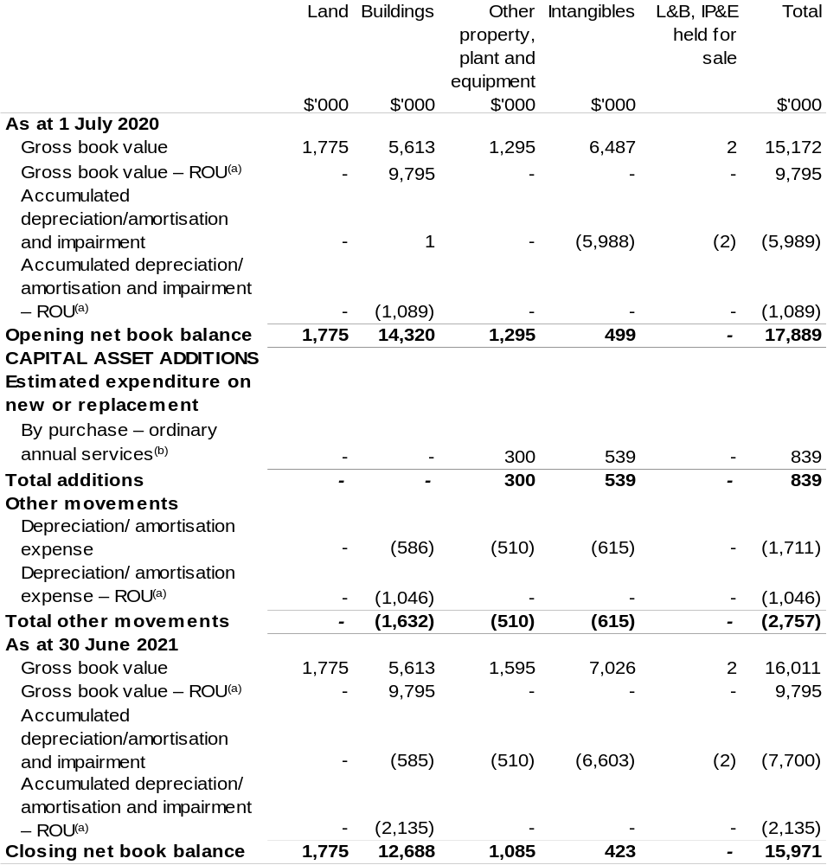

(a) Applies to leases under AASB 16 Leases, Right of Use (RoU).
(b) ‘Appropriation ordinary annual services' refers to funding provided through Supply Act (No. 1) and Appropriation Bill (No. 1) 2020–21 for depreciation/amortisation expenses, DCBs or other operational expenses.

Prepared on Australian Accounting Standards basis.

Table 3.7: Schedule of budgeted income and expenses administered on behalf of Government (for the period ended 30 June)
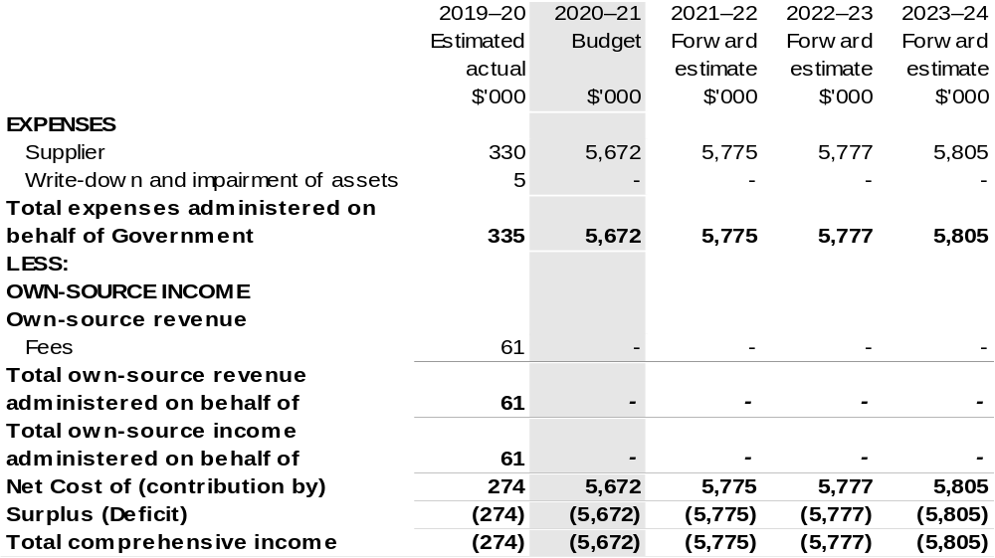

Table 3.8: Schedule of budgeted assets and liabilities administered on behalf of Government (as at 30 June)
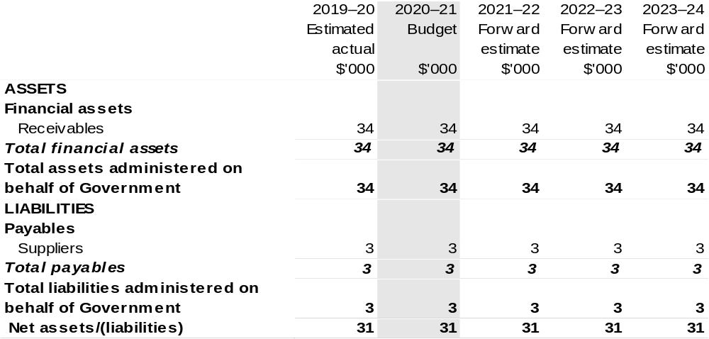
Prepared on Australian Accounting Standards basis.

Table 3.9: Schedule of budgeted administered cash flows (for the period
ended 30 June)
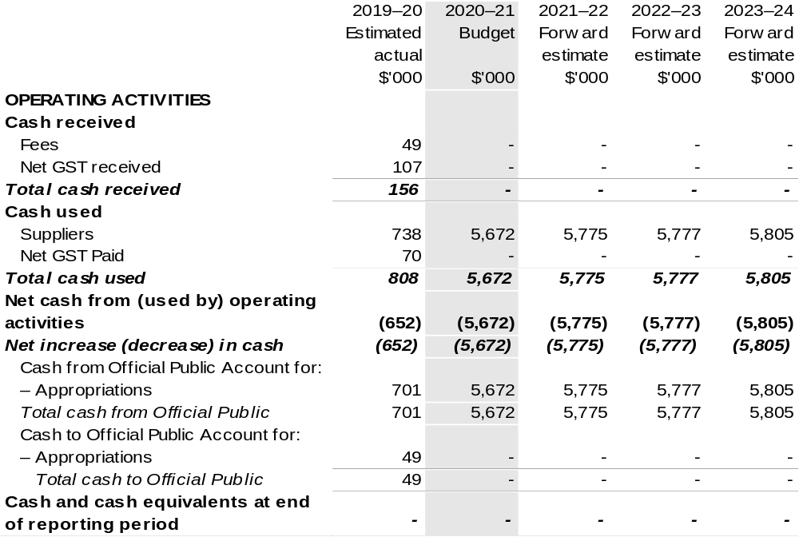
Prepared on Australian Accounting Standards basis.

Table 3.10: Statement of administered asset movements (Budget year 2020–21)

The schedule of administered asset movements on behalf of Government is nil.

Australian Pesticides and Veterinary Medicines Authority
Section 1: Entity overview and resources 175
1.1 Strategic direction statement 175
1.2 Entity resource statement 177
1.3 Budget measures 180
Section 2: Outcomes and planned performance 181
2.1 Budgeted expenses and performance for Outcome 1 182
Section 3: Budgeted financial statements 185
3.1 Budgeted financial statements 185
3.2 Budgeted financial statements tables 186

Australian Pesticides and Veterinary Medicines Authority

Section 1: Entity overview and resources

1.1 Strategic direction statement
The Australian Pesticides and Veterinary Medicines Authority (APVMA) is established under the Agricultural and Veterinary Chemicals (Administration) Act 1992 (Administration Act). APVMA’s principal responsibilities are described in the Administration Act and the Agricultural and Veterinary Chemicals Code Act 1994.
APVMA regulates the supply of safe and effective agricultural and veterinary (agvet) chemicals in Australia. Robust risk assessment methods are used to scientifically evaluate new and existing pesticides and veterinary medicines. Through regulatory action and decisions APVMA ensures the registration of agvet chemical products delivers appropriate protections for human health and safety, animals and the environment, and supports international trade.
APVMA’s regulatory responsibility extends from registration and manufacturing through to the point of sale. By agreement, the states and territories are then responsible for regulating and monitoring how agvet chemicals are used.
APVMA has three key corporate strategies:
- Continue to be a world-class leader in agvet chemical regulation.
- Deliver high-quality decision making that is timely, science based and proportionate to risk.
- Improve regulatory delivery and feedback systems.
Operational and technological improvements at APVMA aim to improve regulatory efficiency for clients and stakeholders while delivering a service that is open, transparent, and provides opportunity for stakeholder feedback.
In the 2018–19 Budget, APVMA received digital transformation funding of $10.1 million over three years to upgrade and enhance its information technology capability. The Enabling Technologies Program will continue to be delivered throughout 2020–21 and will stabilise and transform the agency’s ICT environment, enhancing the agency’s capacity and business operations.

A key component of the Enabling Technologies Program is the Applications Transformation Project, which will provide APVMA staff and stakeholders with integrated, end-to-end core business systems. These enhancements will enable the ICT environment to grow with business and legislative changes and produce a system that meets the needs of APVMA and its stakeholders.
Further details of the objectives and performance evaluation mechanisms attached to this strategy are detailed in Section 2 of this document.

1.2 Entity resource statement
Table 1.1 shows the total funding from all sources available to the entity for its operations and to deliver programs and services on behalf of the Government.
The table summarises how resources will be applied by outcome (Government strategic policy objectives) and by administered (on behalf of the Government or the public) and departmental (for the entity’s operations) classification.
For more detailed information on special accounts and special appropriations, please refer to Budget Paper No. 4: Agency Resourcing.
Information in this table is presented on a resourcing (i.e. appropriations/cash available) basis, whilst the ‘Budgeted expenses by Outcome’ tables in Section 2 and the financial statements in Section 3 are presented on an accrual basis.

Table 1.1: Australian Pesticides and Veterinary Medicines Authority – Resource Statement – Budget Estimates for 2020–21 as at Budget October 2020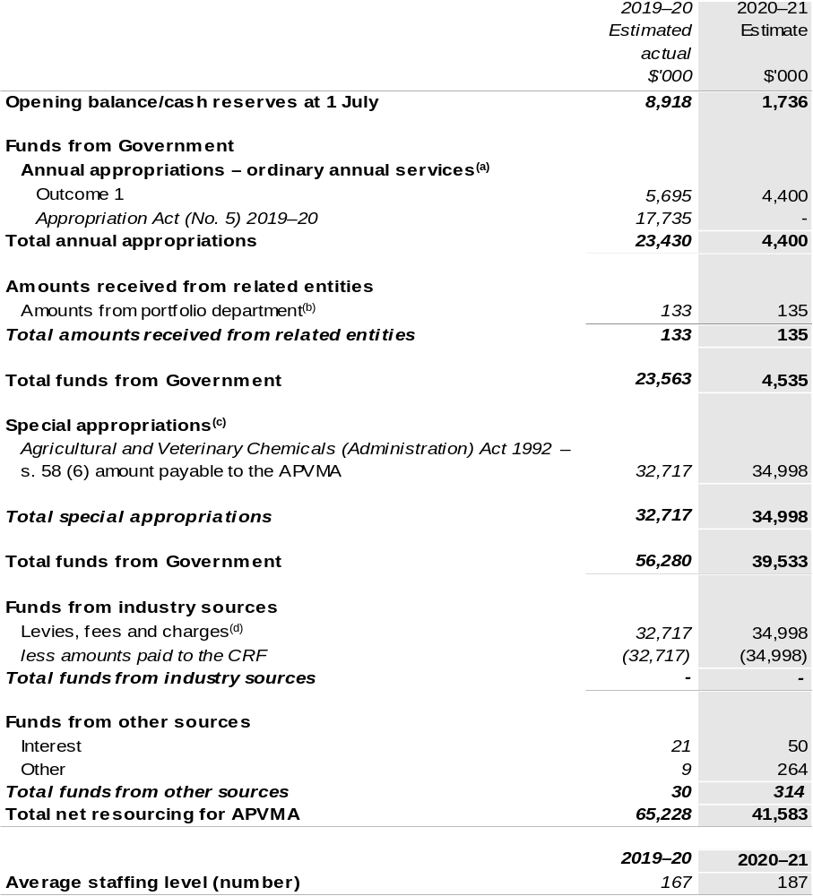
(a) Supply Act (No. 1) and Appropriation Bill (No. 1) 2020–21. Appropriation is provided through the Department of Agriculture, Water and the Environment (DAWE) and is specified within the Annual Appropriation Bills as a payment to the Australian Pesticides and Veterinary Medicines Authority (APVMA) and is considered departmental for all purposes.
(b) Funding provided by the portfolio department that is not specified within the Annual Appropriation Bills as a payment to that corporate entity (for example, a grant awarded to a corporate entity from one of its portfolio department's administered programs).
(c) APVMA’s special appropriation is not directly appropriated as it is a corporate Commonwealth entity under the PGPA Act. Appropriations are made to DAWE and are then paid to APVMA and are considered departmental for all purposes.

Continued on following page
Table 1.1: Australian Pesticides and Veterinary Medicines Authority – Resource Statement – Budget Estimates for 2020–21 as at Budget October 2020 (continued)

(d) These charges are imposed by the Agricultural and Veterinary Chemicals Code Act 1994 and the Agricultural and Veterinary Chemical Products (Collection of Levy) Act 1994. They are collected by APVMA and transferred to the CRF. These amounts are then drawn down by the department as a Special Appropriation under the Administration Act.

CRF – Consolidated Revenue Fund.

Please note: All figures shown above are GST exclusive - these may not match figures in the cash flow
statement.

Prepared on a resourcing (i.e. appropriations available) basis.

1.3 Budget measures
Budget measures in Part 1 relating to the Australian Pesticides and Veterinary Medicines Authority are detailed in Budget Paper No. 2: Budget Measures 2020–21 and are summarised below.

Table 1.2: Australian Pesticides and Veterinary Medicines Authority – 2020–21 Budget measures – Measures announced after the Economic and Fiscal Update July 2020
APVMA does not have any 2020–21 Budget measures.

Section 2: Outcomes and planned performance
Government outcomes are the intended results, impacts or consequences of actions by the Government on the Australian community. Commonwealth programs are the primary vehicle by which government entities achieve the intended results of their outcome statements. Entities are required to identify the programs which contribute to government outcomes over the Budget and forward years.
Each outcome is described below together with its related programs. The following provides detailed information on expenses for each outcome and program, further broken down by funding source.
Note:
Performance reporting requirements in the Portfolio Budget Statements are part of the Commonwealth performance framework established by the Public Governance, Performance and Accountability Act 2013. It is anticipated that the performance criteria described in Portfolio Budget Statements will be read with broader information provided in an entity’s corporate plans and annual performance statements – included in Annual Reports – to provide a complete picture of an entity’s planned and actual performance.
APVMA’s most recent corporate plan can be found at: https://apvma.gov.au/node/69251.
APVMA’s most recent annual performance statement can be found at:
https://apvma.gov.au/node/55871 in chapter 3.

2.1 Budgeted expenses and performance for Outcome 1
Outcome 1: Protection of the health and safety of people, animals, the environment, and agricultural and livestock industries through regulation of pesticides and veterinary medicines.

2.1.1: Linked programs
Department of Agriculture, Water and the Environment
Program 3.10: Agricultural Resources
Contribution to Outcome 1 made by linked programs:
The Australian Pesticides and Veterinary Medicines Authority and the Department of Agriculture, Water and the Environment work together to ensure the protection of the health and safety of humans, animals and the environment.

2.2.1: Budgeted expenses for Outcome 1
This table shows how much the entity intends to spend (on an accrual basis) on achieving the outcome, broken down by program, as well as by Administered and Departmental funding sources.

Table 2.1: Budgeted expenses for Outcome 1
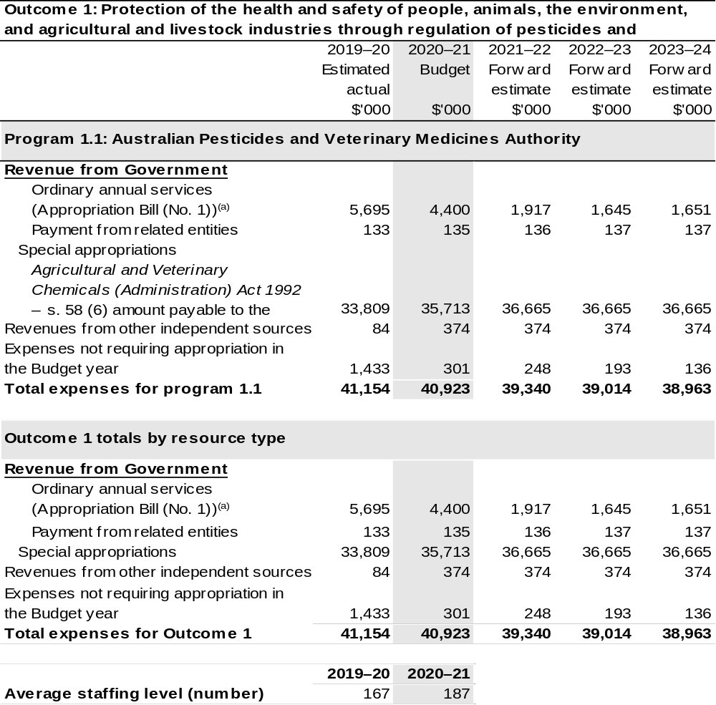
(a) Supply Act (No. 1) and Appropriation Bill (No. 1) 2020–21. The APVMA is a corporate Commonwealth entity (CCE) under the PGPA Act and does not receive direct appropriations. Instead, this funding passes through DAWE to APVMA.
(b) Expenses not requiring appropriation in the Budget year are made up of make good expenses, audit fees, and can include depreciation / amortisation expenses not requiring an appropriation.

Note: Departmental appropriation splits and totals are indicative estimates and may change in the course of the budget year as Government priorities change.

Prepared on Australian Accounting Standards basis.

2.3.1: Performance criteria for Outcome 1
Table 2.3.1 below details the performance criteria for each program associated with Outcome 1. It also summarises how each program is delivered and where 2020–21 Budget measures have created new programs or materially changed existing programs.
Outcome 1: Protection of the health and safety of people, animals, the environment, and agricultural and livestock industries through regulation of pesticides and veterinary medicines.
Program 1.1: Australian Pesticides and Veterinary Medicines Authority
Objective | The APVMA regulates agricultural and veterinary chemicals up to and including at the point of sale to protect the health and safety of people, animals and crops, the environment and trade and support Australian primary industries.
Delivery | Regulation of agricultural and veterinary chemicals is delivered through four mechanisms:  - Risk-based assessment and registration of pesticides and veterinary chemicals;  - Identification and resolution of non-compliance up to and including the point of retail sale;  - Licence and audit veterinary manufacturers; and  - Identification and review of the safety of existing chemicals of regulatory concern.
Performance information
Year | Performance criteria | 2019–20 Actual Achievement/Targets
2019–20 | Registered chemicals are available for:  - Product registrations;  - Actives; and  - Permits. | 89 per cent of applications were completed within timeframes.
2020–21 | As per 2019–20. | 100 per cent of applications were completed within timeframes.
2021–22 and beyond | As per 2019–20. | As per 2020–21.
Purpose | Regulate the production of agricultural and veterinary chemicals to ensure they are safe for Australian people, animals and the environment.

Section 3: Budgeted financial statements
Section 3 presents budgeted financial statements which provide a comprehensive snapshot of entity finances for 2020–21, including the impact of 2020–21 Budget measures and resourcing on financial statements.

3.1 Budgeted financial statements

3.1.1: Differences between entity resourcing and financial statements
The resourcing statement is prepared on a cash basis. The financial statements are prepared on an accrual basis. Differences between the resourcing and financial statements represent timing differences between revenue recognition and cash received.

3.2.1: Explanatory notes and analysis of budgeted financial statements
A new Cost Recovery Implementation Statement (CRIS) was approved by the Minister for Agriculture, Drought and Emergency Management in April 2020, and came in to effect on 1 July 2020.
The Government made available an additional $17.7 million to the APVMA through Appropriation Act (No. 5) 2019–20 in response to the COVID-19 pandemic, to ensure funding was available in the event of a fall in cost recovered revenue from industry. This appropriation was recorded as revenue in 2019–20 but has not yet been drawn down.
The APVMA has not covered its cost of operations over recent financial years, resulting in the erosion of its equity reserves. This situation has been ameliorated with the implementation of the new CRIS.
The implementation of a new accounting standard has required that APVMA’s office leases now be recognised on the balance sheet as a right of use asset, and a corresponding liability representing the future lease payments. These balances can be seen to reduce over the forward estimates as the leases progress.

3.2 Budgeted financial statements

Table 3.1: Comprehensive income statement (showing net cost of services)
(for the period ended 30 June)
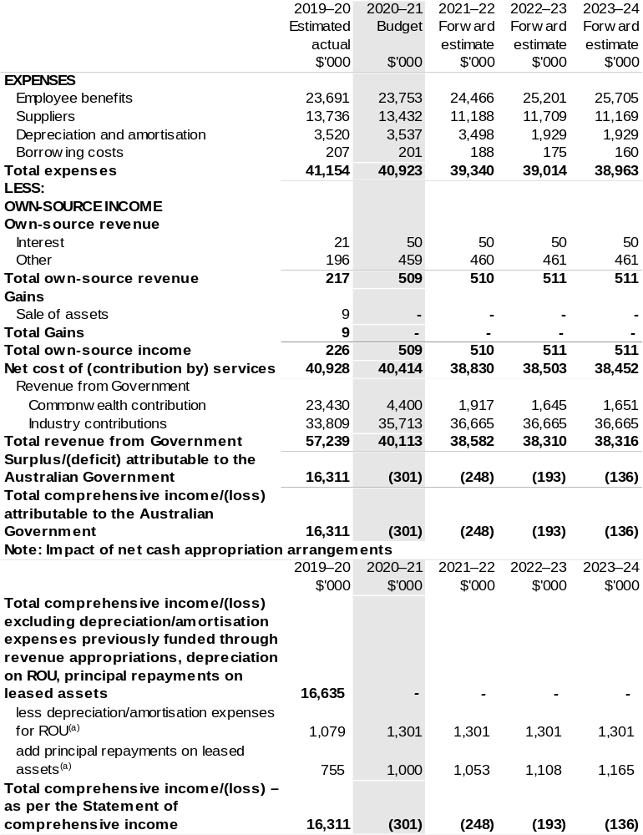
(a) Applies to leases under AASB 16 Leases. Right of Use (ROU).

Prepared on Australian Accounting Standards basis.

Table 3.2: Budgeted departmental balance sheet (as at 30 June)
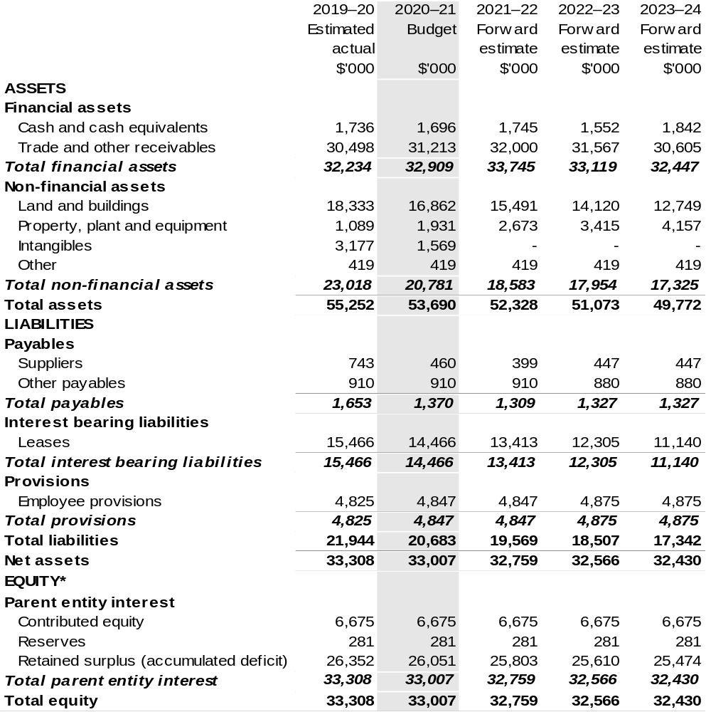
*Equity is the residual interest in assets after deduction of liabilities.

Prepared on Australian Accounting Standards basis.

Table 3.3: Departmental statement of changes in equity — summary of movement (Budget year 2020–21)
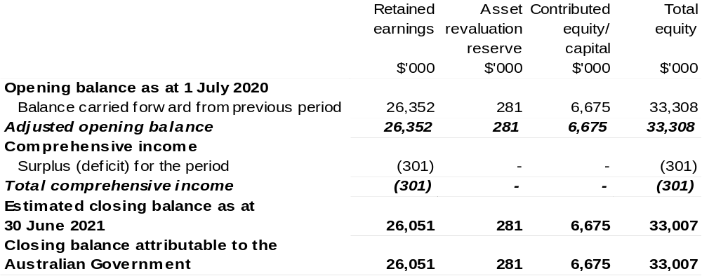
Prepared on Australian Accounting Standards basis.

Table 3.4: Budgeted departmental statement of cash flows (for the period
ended 30 June)
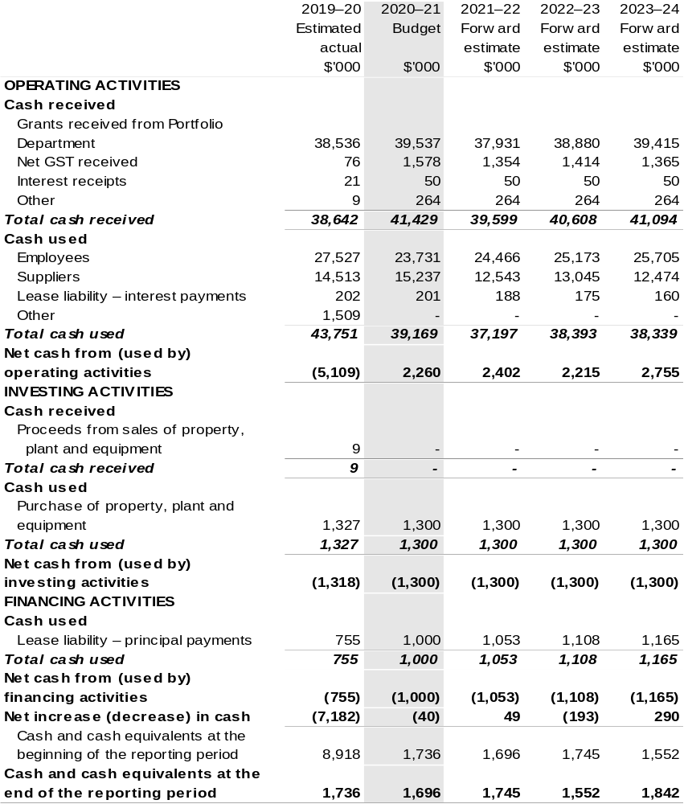
Prepared on Australian Accounting Standards basis.

Table 3.5: Departmental capital budget statement (for the period ended 30 June)
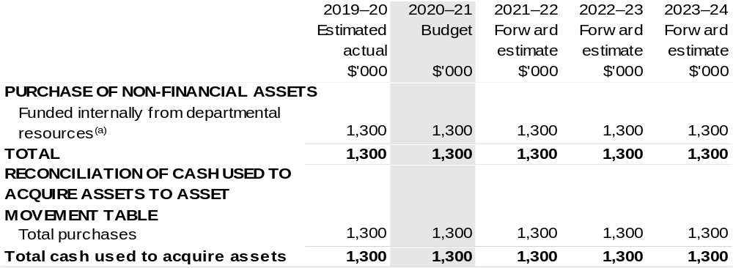
(a) Includes the following sources of funding:
– annual and prior year appropriations;
– internally developed assets;
– section 74 External Revenue; and
– proceeds from the sale of assets.

Consistent with information contained in the Statement of Asset Movements and the Budgeted Statement of Cash Flows.

Prepared on Australian Accounting Standards basis.

Table 3.6: Statement of asset movements (Budget year 2020–21)
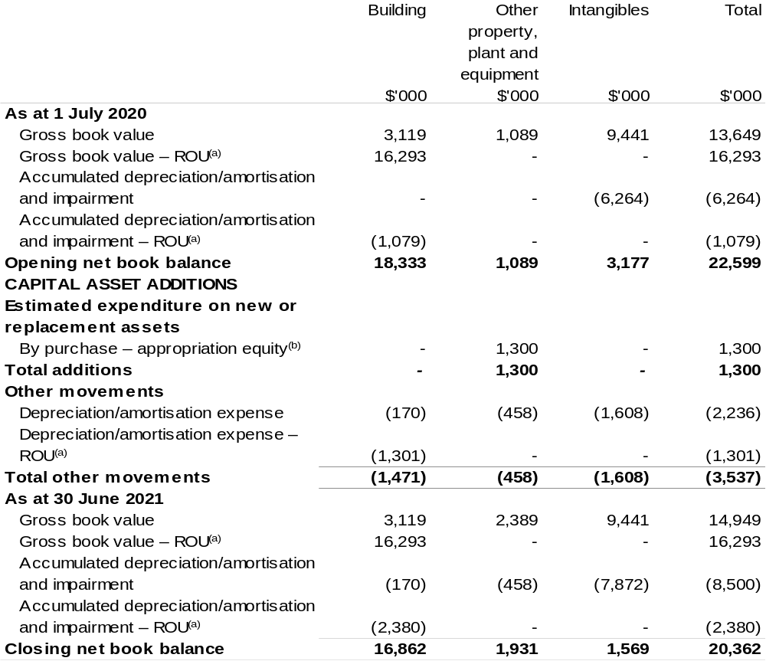
(a) Applies to leases under AASB 16 Leases. Right of Use (ROU).
(b) “Appropriation ordinary annual services" refers to funding provided through Supply Act (No. 1) and Appropriation Bill (No. 1) 2020–21 for depreciation / amortisation expenses, DCBs or other operational expenses.

Prepared on Australian Accounting Standards basis.

Bureau Of Meteorology
Section 1: Entity overview and resources 195
1.1 Strategic direction statement 195
1.2 Entity resource statement 197
1.3 Budget measures 199
Section 2: Outcome and planned performance 200
2.1 Budgeted expenses and performance for Outcome 1 201
Section 3: Budgeted financial statements 207
3.1 Budgeted financial statements 207
3.2 Budgeted financial statements tables 208

Bureau Of Meteorology

Section 1: Entity overview and resources

1.1 Strategic direction statement
The Bureau of Meteorology (the Bureau) is Australia’s national weather, climate and water agency, providing essential and trusted products and services that contribute to the safety, prosperity and wellbeing of the Australian community all day, every day.
The Bureau’s work directly informs decisions by governments, the community and supports industry in key sectors such as emergency management, aviation, transport, water management, agriculture and environmental management.
The Bureau is committed to delivering its Strategy 2017–2022. The Strategy is focused on four pillars of success:
- Impact and Value – products and services that benefit the Australian community and drive competitive advantage for businesses and industries.

- Operational Excellence – outstanding people, science, systems, infrastructure and partnerships working together for maximum simplicity, productivity and agility.

- Insight and Innovation – deep understanding and creative thinking that generates novel solutions for our customers and our organisation.

- The Bureau Way – one enterprise, that is safe and diverse, where our people grow and are empowered to excel, and where our customers come first, trust us and consider that we are a pleasure to work with.
The Bureau will continue to improve the security and resilience of its Information Communications Technology systems and business processes under the measure Bureau of Meteorology — Improved Security and Resilience for ICT Systems – Tranche Two. This builds upon the measure Bureau of Meteorology – Improved Security and Resilience from 2017–18 and will assist the Bureau to continue to provide reliable, ongoing access to weather, climate, water and oceans information.
In addition, the Bureau will continue to contribute to the Assistance for Farmers and Farm Communities in Drought package announced in the 2018–19 Mid-Year Economic and Fiscal Outlook, which provided $2.7 million over two years to create of localised weather intelligence guides to enable farmers to improve their ability to make quantitative business risk management decisions.
The Bureau will invest in, maintain and replace critical assets under the 2020–21 Budget measure Bureau of Meteorology – Long-term Financial Sustainability. This measure will benefit the community with improved response times and more consistent and resilient services delivered by the Bureau across urban, regional and remote areas. This investment will also enable Bureau forecasters and climate scientists to access cutting-edge tools and technologies needed to deal with the increasing number of multiple and concurrent severe weather events, now and into the future.
The Bureau will also continue to provide essential aviation meteorological services to support the recovery of the aviation industry, through the Bureau of Meteorology – Improved Security and Resilience – Aviation Meteorological Services measure in the 2020–21 Budget.

1.2 Entity resource statement
Table 1.1 shows the total funding from all sources available to the entity for its operations and to deliver programs and services on behalf of the Government.
The table summarises how resources will be applied by outcome (government strategic policy objectives) and by administered (on behalf of the Government or the public) and departmental (for the entity’s operations) classification.
For more detailed information on special accounts and special appropriations, please refer to Budget Paper No. 4 – Agency Resourcing.
Information in this table is presented on a resourcing (that is, appropriations/cash available) basis, whilst the ‘Budgeted expenses by Outcome’ table in Section 2 and the financial statements in Section 3 are presented on an accrual basis.

Table 1.1: Bureau of Meteorology – Resource Statement – Budget Estimates for 2020–21 as at October 2020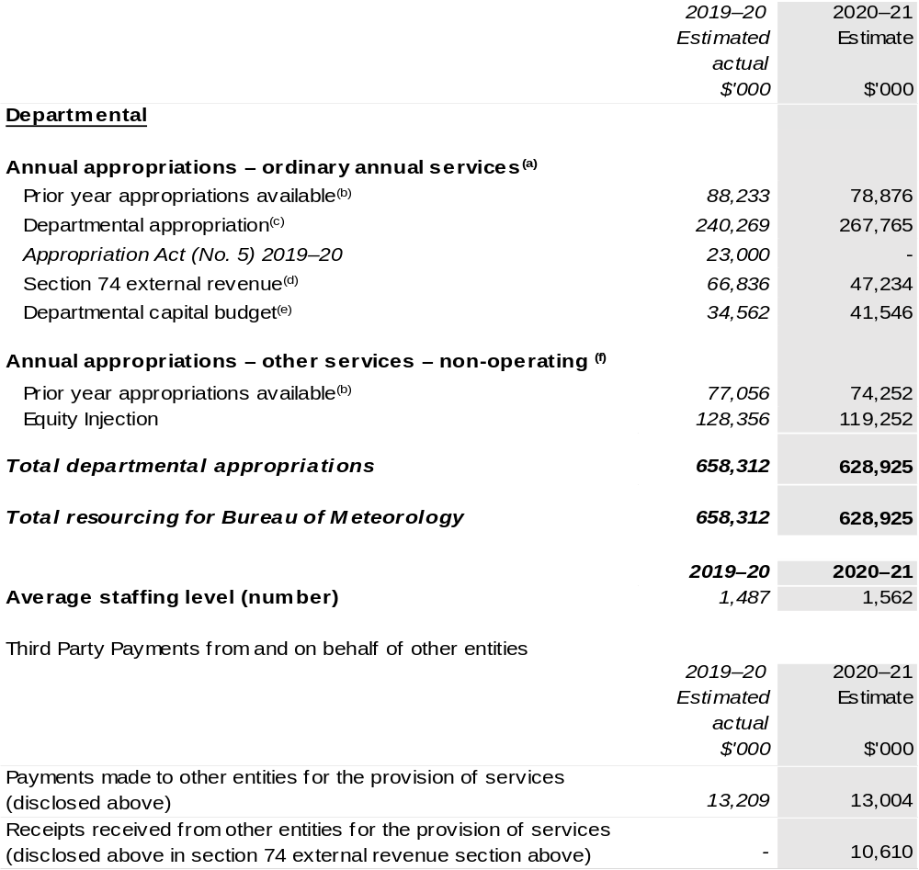
- Supply Act (No. 1) and Appropriation Bill (No. 1) 2020–21.
- Excludes $43 million subject to administrative quarantine by the Department of Finance or withheld under section 51 of the PGPA Act.
- Excludes departmental capital budget (DCB).
- Estimated external revenue receipts under section 74 of the PGPA Act.
- Departmental capital budgets are not separately identified in Supply Act (No. 1) and Appropriation Bill (No. 1) and form part of ordinary annual services items. Please refer to Table 3.7 for further details. For accounting purposes, this amount has been designated as a 'contribution by owner'.
- Supply Act (No. 2) and Appropriation Bill (No. 2) 2020–21.

Prepared on a resourcing (i.e. appropriations available) basis.

Note: all figures shown above are GST exclusive – these may not match figures in the cash flow statement.

1.3 Budget measures
Budget measures in Part 1 relating to the Bureau of Meteorology are detailed in Budget Paper No. 2: Budget Measures 2020–21 and are summarised below.

Table 1.2: Bureau of Meteorology – 2020–21 Budget measures – Measures announced after the Economic and Fiscal Update July 2020
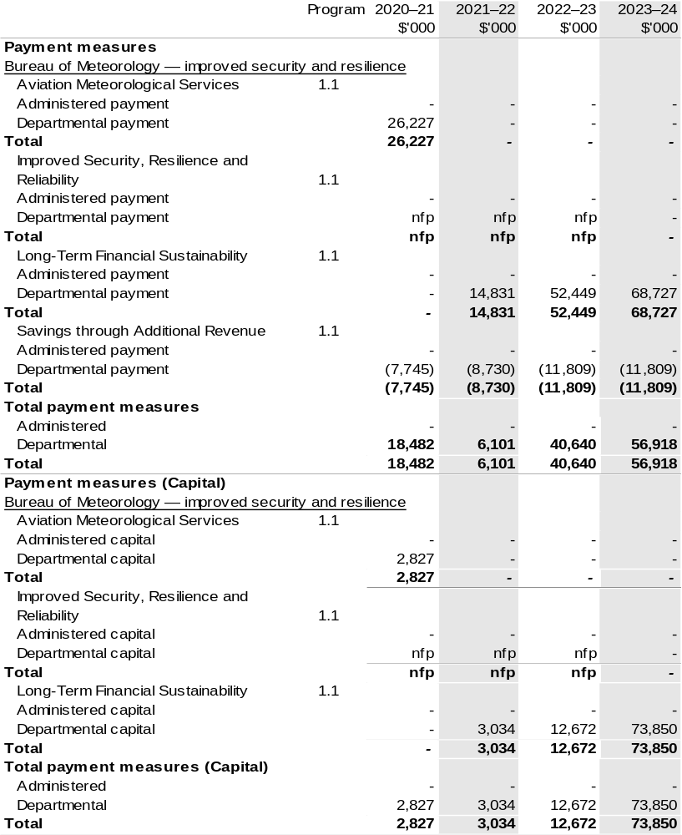Prepared on a Government Finance Statistics (Underlying Cash) basis

Section 2: Outcomes and planned performance
Government outcomes are the intended results, impacts or consequences of actions by the Government on the Australian community. Commonwealth programs are the primary vehicle by which government entities achieve the intended results of their outcome statements. Entities are required to identify the programs which contribute to government outcomes over the Budget and forward years.
Each outcome is described below together with its related programs. The following provides detailed information on expenses for each outcome and program, further broken down by funding source.
Note:
Performance reporting requirements in the Portfolio Budget Statements are part of the Commonwealth performance framework established by the Public Governance, Performance and Accountability Act 2013. It is anticipated that the performance criteria described in Portfolio Budget Statements will be read with broader information provided in an entity’s corporate plans and annual performance statements – included in Annual Reports – to provide a complete picture of an entity’s planned and actual performance.
The most recent corporate plan for the Bureau of Meteorology can be found at: http://www.bom.gov.au/inside/2020-21_BOM_Corporate_Plan.pdf.
The most recent annual performance statement can be found at: http://www.bom.gov.au/inside/eiab/reports/ar18-19/annualReport/02.1_Annual_Performance_Statement.pdf

2.1 Budgeted expenses and performance for Outcome 1
Outcome 1: Enabling a safe, prosperous, secure and healthy Australia through the provision of weather, water, climate and ocean services.

2.1.1: Linked programs
Australian Maritime Safety Authority
Program 1.1 Seafarer and ship safety, environment protection and search and rescue.
Contribution to Outcome 1 made by linked programs
The Bureau provides marine weather information covering wind, weather, sea and swell conditions for safe maritime operations.
Civil Aviation Safety Authority
Program 1.1: Sub-program 2: Collaborative engagement with the aviation industry and wider community to promote and support aviation safety.
Contribution to Outcome 1 made by linked programs
The Bureau provides aviation users with meteorological information necessary for safe and efficient civil aviation operations.
Commonwealth Scientific and Industrial Research Organisation
Program 1: Research – Science, Services and Innovation Fund
Contribution to Outcome 1 made by linked programs
The Bureau works with CSIRO to undertake research as part of the Earth Systems and Climate Change Hub through the National Environmental Science Program.

Linked programs (continued)
Department of Agriculture, Water and the Environment
Program 1.2: Environmental Information and Research
Program 1.3: Commonwealth Environmental Water
Program 2.2: Adapting to Climate Change
Program 2.1: Antarctica: Science, Policy and Presence
Program 3.2: Sustainable Management – Natural Resources
Program 3.11: Drought Programs
Program 5.1: Water Reform
Contribution to Outcome 1 made by linked programs
The Bureau is a partner in the Earth Systems and Climate Change Hub in the National Environmental Science Program.
In addition, the Bureau’s water information services inform Commonwealth water planning and decision making in relation to water resource availability.
The Bureau provides weather, climate and water modelling and information to the Department of Agriculture, Water and the Environment.
The Bureau provides meteorological and related services in support of the Australian Antarctic Program under a Memorandum of Understanding. There are also joint science projects underway between the Bureau and the Australian Antarctic Division.
Department of Defence
Various programs
Contribution to Outcome 1 made by linked programs
The Bureau has a strategic partnering agreement for the provision of meteorological and oceanographic services to support the Department of Defence.
Department of Foreign Affairs and Trade
Program 1.2: Official Development Assistance
Contribution to Outcome 1 made by linked programs
The Bureau delivers a number of activities funded by official development assistance programs including:
• the Climate and Ocean Support Program in the Pacific, which is delivering enhanced climate, ocean and tidal services for Pacific Island communities and governments; and
• the PNG Capacity Development Program which is restoring PNG’s meteorological observation network and enhancing technical and governance capacity within the PNG National Weather Service.

Linked programs (continued)
Department of Home Affairs
Program 1.10: Australian Government Disaster Financial Support Payments
Contribution to Outcome 1 made by linked programs
The Bureau collaborates with the Department of Home Affairs by providing alerts relating to severe weather events, including floods and tsunami, to protect the community, weather for maritime security operations and space weather alerts for critical infrastructure management and climatic advice for strategic risk management.
Department of Industry, Science, Energy and Resources
Program 2.1: Reducing Australia’s Greenhouse Gas Emissions
Program 3.1: Energy
Contribution to Outcome 1 made by linked programs
The Bureau provides weather and climate information to the Department of Industry, Science, Energy and Resources to inform priority climate science investment areas and research needs and the reliable and secure operation of energy markets.
Geoscience Australia
Program 1.1: Geoscientific and Spatial Information Services
Contribution to Outcome 1 made by linked programs
The Bureau partners with Geoscience Australia to provide the Joint Australian Tsunami Warning Centre.
Murray-Darling Basin Authority
Program 1.1: Equitable and sustainable use of the Murray-Darling Basin
Contribution to Outcome 1 made by linked programs
The Bureau provides weather, climate and water modelling, insight and analysis to the Murray-Darling Basin Authority.

2.2.1: Budgeted expenses for Outcome 1
This table shows how much the entity intends to spend (on an accrual basis) on achieving the outcome, broken down by program, as well as by Administered and Departmental funding sources.

Table 2.1: Budgeted expenses for Outcome 1
- 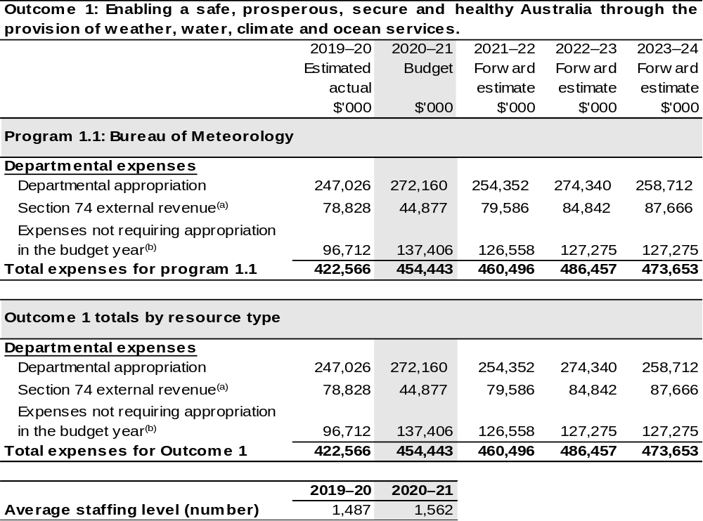
- Estimated expenses incurred in relation to receipts retained under section 74 of the PGPA Act.
- Expenses not requiring appropriation in the Budget year are made up of depreciation expenses, amortisation expenses, make good expenses and audit fees.

Note: Departmental appropriation splits and totals are indicative estimates and may change in the course of the budget year as government priorities change.

Prepared on Australian Accounting Standards basis.

2.3.1: Performance criteria for Outcome 1
Table 2.3.1 below details the performance criteria for each program associated with Outcome 1. It also summarises how each program is delivered and where 2020–21 Budget measures have created new programs or materially changed existing programs.
Outcome 1: Enabling a safe, prosperous, secure and healthy Australia through the provision of weather, water, climate and ocean services.
Program 1.1: Bureau of Meteorology
Objective | Provides trusted, reliable and responsive weather, water, climate and ocean services for Australia—all day, every day.
Delivery | Program 1.1 will be delivered by:  - Weather, water, climate and ocean products and services that benefit the Australian community and drive competitive advantage for businesses and industries.  - Outstanding people, science, systems, infrastructure and partnerships working together for maximum simplicity, productivity and agility.  - Deep understanding and creative thinking that generates novel solutions for our customers and our organisation.  - One enterprise, that is safe and diverse, where our people grow and are empowered to excel, and where our customers come first, trust us and consider that we are a pleasure to work with.
Performance information
Year | Performance criteria | 2019–20 Actual Achievement/Targets
2019–20 | - Financial and social value is delivered to Government, industry and the Australian community.  - Delivery of products and services that meet customer requirements, are delivered to budget, meet quality and security specifications and benchmark well in relation to international standards and peer organisations.  - The speed, maturity and quality of innovation and novel solutions meets customer needs or enhances internal capability.  - Feedback from staff, customers and partners demonstrates alignment of our actual behaviours with our stated intent to create a safe, diverse and empowered enterprise that puts customers first, and provides an outstanding experience every time that they engage with us. | a. and b.  Performance met expectations against targets. Evidence of achievement is provided in the Bureau’s Annual Performance Statement 2019–20.  c. and d.  Performance partially met expectations against targets. Evidence of achievement is provided in the Bureau’s Annual Performance Statement 2019–20.

Contributions to Outcome 1 (continued)
Performance information
Year | Performance criteria | 2019–20 Actual Achievement/Targets
2020–21 | - Financial and social value is delivered to Government, industry and the Australian community.  - Delivery of products and services that meet customer requirements, are delivered to budget, meet quality and security specifications and benchmark well in relation to international standards and peer organisations.  - The speed, maturity and quality of innovation and novel solutions meets customer needs or enhances internal capability.  - Feedback from staff, customers and partners demonstrates alignment of our actual behaviours with our stated intent to create a safe, diverse and empowered enterprise that puts customers first, and provides an outstanding experience every time that they engage with us. | The Bureau’s enterprise level performance criteria have broad relevance across the agency as a whole. Both quantitative and qualitative targets that collectively demonstrate the achievement of the Bureau’s enterprise level performance criteria are set out in the Bureau’s Corporate Plan 2020–21 and will be reported in the Bureau’s Annual Performance Statement 2020–21.
2021–22 and beyond | As per 2020–21. | As per 2020–21.
Purposes | To provide trusted, reliable and responsive weather, water, climate and ocean services for Australia – all day, every day.

Section 3: Budgeted financial statements
Section 3 presents budgeted financial statements which provide a comprehensive snapshot of entity finances for 2020–21, including the impact of 2020–21 Budget measures and resourcing on financial statements.

3.1 Budgeted financial statements

3.1.1: Explanatory notes and analysis of budgeted financial statements
Budgeted Comprehensive Departmental Income Statement
An analysis of the Bureau budgeted financial statements, as reflected in the Bureau’s budgeted departmental financial statements and administered schedules for the
2020–21 Budget, is provided below.
Total revised revenue to the Bureau in 2020–21 is estimated to be $312.8 million, a decrease of $24.8 million from the 2019–20 actual revenue amount. The lower funding is the result of a number of factors including new Budget Measures, movements in the efficiency dividend, indexation rates and minor adjustments related to other items such as foreign exchange movements.
The overall appropriated revenue includes specific funding related to:
- funding associated with the 2014–15 Budget measure Supercomputer;
- funding associated with the 2016–17 Mid-Year Economic and Fiscal Outlook measure – Commonwealth Water Functions;
- funding associated with the Budget measure – Improved security and resilience in the 2017–18, 2018–19 and 2020–21 Budgets;
- funding associated with the 2019–20 Budget measure – Bureau of Meteorology – additional radars and gauges;
- funding associated with the 2019–20 Budget measure – Barkly Regional Deal;
- funding associated with the 2020–21 Budget measure – Long-Term Financial Sustainability;
- funding associated with 2019–20 and 2020–21 measures – Aviation Meteorology Services Program; and
- reduced funding associated with the 2020–21 Budget measure – Savings through Additional Revenue.
Total expenses are estimated to be $454.4 million, an increase of $31.9 million from
2019–20 actual expenditure. The increase mainly reflects increased Depreciation and Amortisation expenditure impacted by an Asset Revaluation in 2019–20. Whilst the Bureau is not funded for depreciation through the Appropriation Bills, the expenditure is still recognised on the Income Statement.

3.2 Budgeted financial statements tables

Table 3.1: Comprehensive income statement (showing net cost of services)
(for the period ended 30 June) 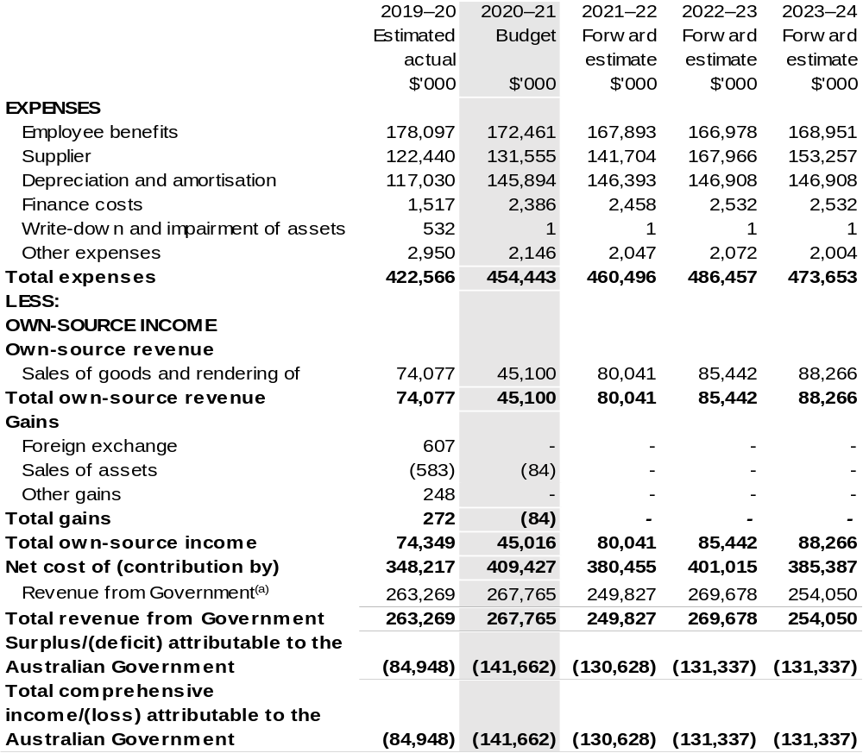
Continued on following page

Table 3.1: Comprehensive income statement (showing net cost of services) (for the period ended 30 June) (continued)
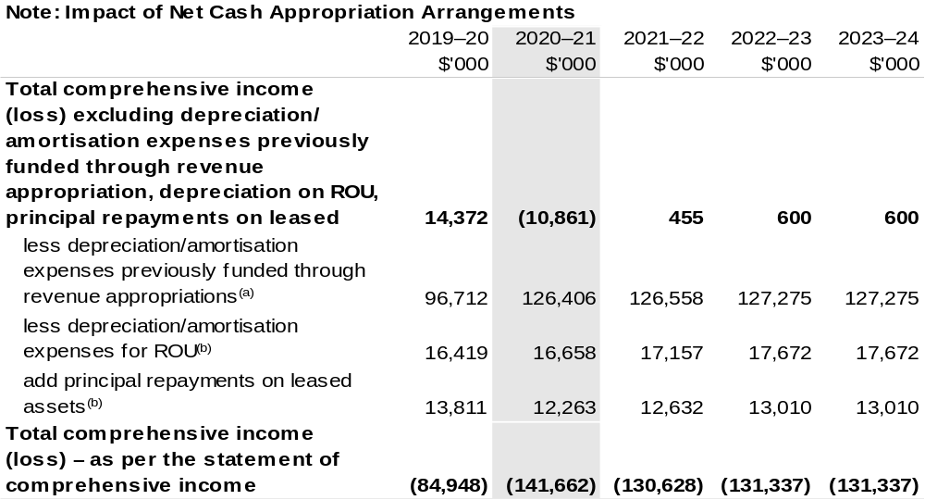
(a) From 2010–11, the Government introduced net cash appropriation arrangements where Appropriation
Bill (No. 1) or Appropriation Bill (No. 3) revenue appropriations for the depreciation/amortisation expenses of non-corporate Commonwealth entities were replaced with a separate capital budget (the Departmental Capital Budget, or DCB) provided through Appropriation Bill (No. 1) or Bill (No. 3) equity appropriations. For information regarding DCB, please refer to Table 3.6 Departmental Capital Budget Statement.
(b) Applies to leases under AASB 16 Leases. Right of Use (ROU).

Prepared on Australian Accounting Standards basis.

Table 3.2: Budgeted departmental balance sheet (as at 30 June)
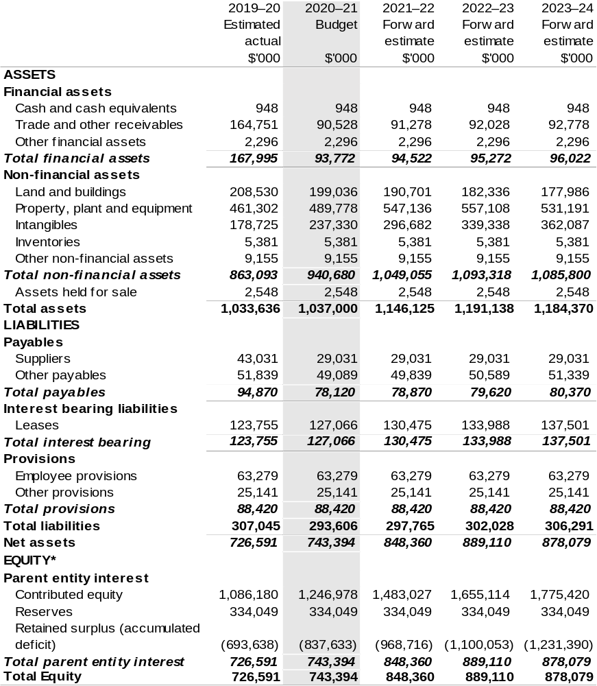
*Equity is the residual interest in assets after deduction of liabilities.

Prepared on Australian Accounting Standards basis.

Table 3.3: Departmental statement of changes in equity—summary of movement (Budget year 2020–21)
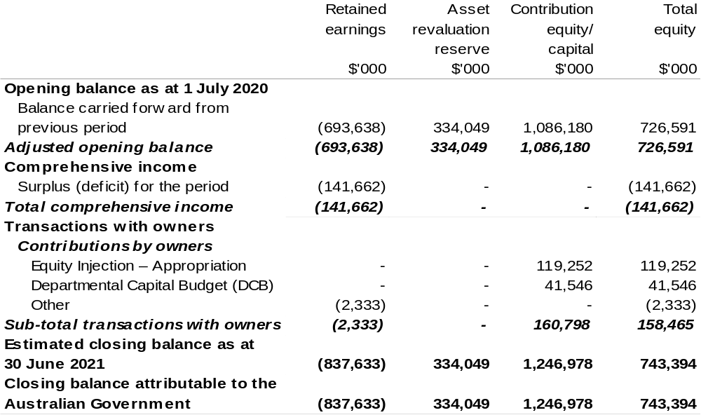
Prepared on Australian Accounting Standards basis.

Table 3.4: Budgeted departmental statement of cash flows (for the period
ended 30 June)
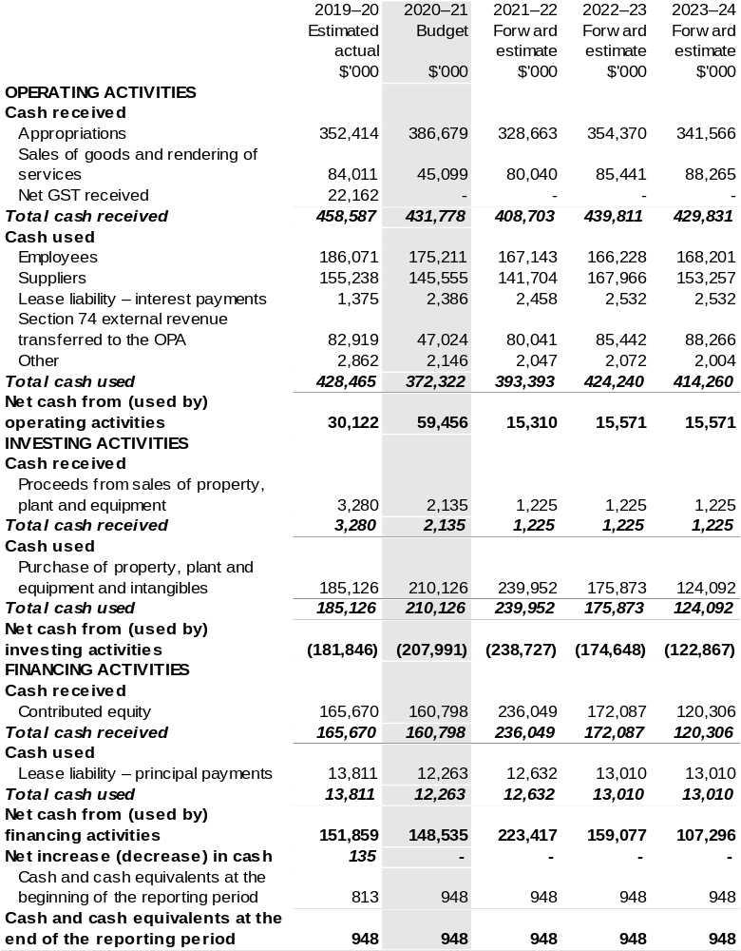
Prepared on Australian Accounting Standards basis.

Table 3.5: Departmental capital budget statement (for the period ended 30 June)
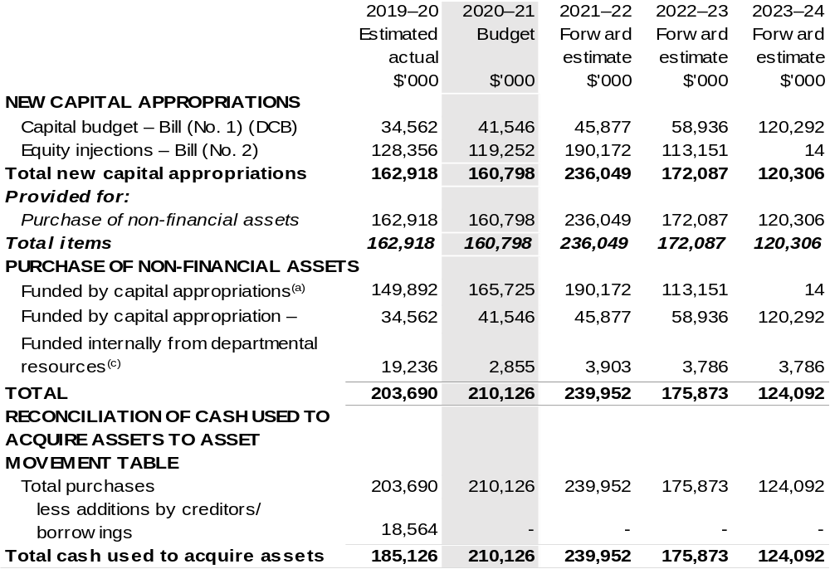
(a) Includes both current Bill (No. 2) and prior Act/Bill (No. 2/4/6) appropriation.
(b) Does not include annual finance lease costs. Include purchases from current and previous years'
Departmental Capital Budgets (DCBs).
(c) Includes the following sources of funding:
– current Bill (No. 1) and prior year Act/Bill (No. 1/3/5) appropriations (excluding amounts from the DCBs);
– donations and gifts of non-financial assets;
– internally developed assets;
– section 74 external revenue; and
– proceeds from the sale of assets.

Consistent with information contained in the Statement of Asset Movements and the Budgeted Statement of Cash Flows.

Prepared on Australian Accounting Standards basis.

Table 3.6: Statement of asset movements (Budget year 2020–21)
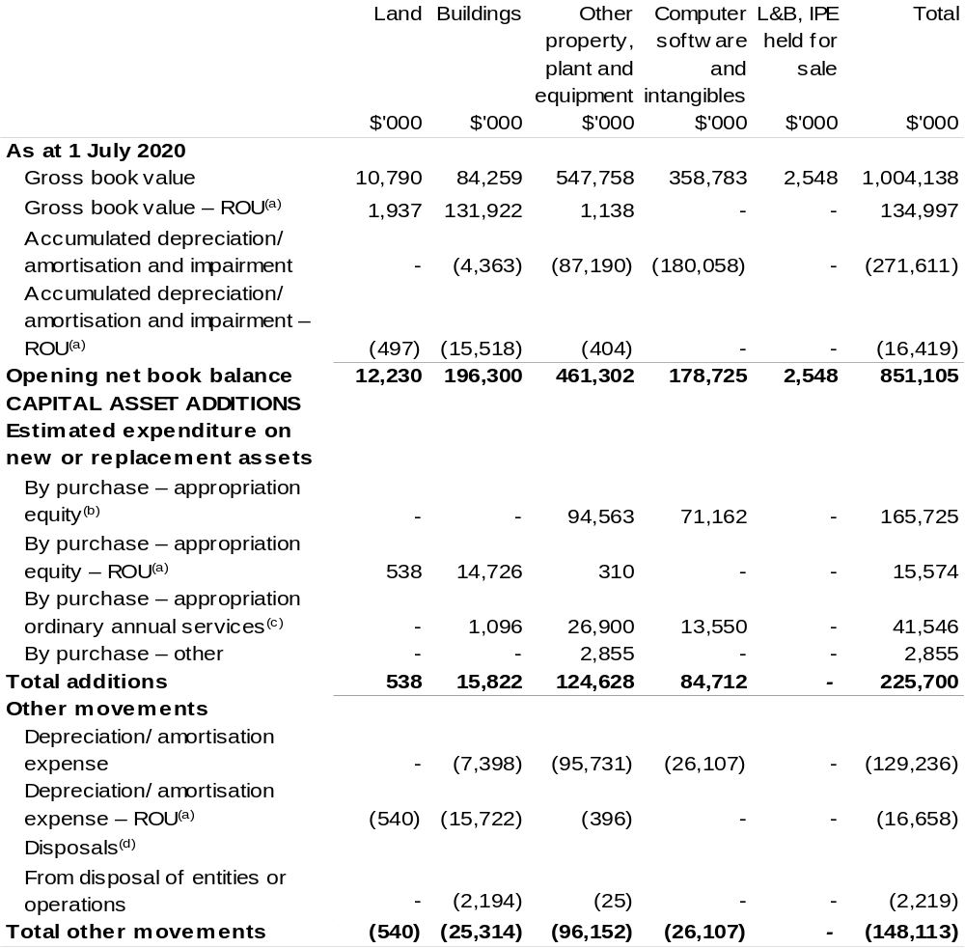

Continued on following page

Table 3.6: Statement of asset movements (Budget year 2020–21)
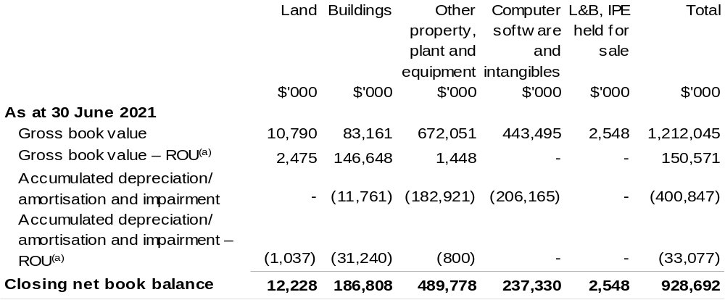

- Applies to leases under AASB 16 Leases, Right of Use (RoU).
- ‘Appropriation equity’ refers to equity injections or Administered Assets and Liabilities appropriations provided through Supply Act (No. 1) and Appropriation Bill (No. 2) 2020–2021, including Collection Development Acquisition Budget.
- ‘Appropriation ordinary annual services’ refers to funding provided through Supply Act (No. 1) and Appropriation Bill (No. 1) 2020–2021 for depreciation/amortisation expenses, Departmental Capital Budget or other operational expenses.
- Net proceeds may be returned to the OPA.

Prepared on Australian Accounting Standards basis.

Table 3.7: Schedule of budgeted income and expenses administered on behalf of Government (for the period ended 30 June)
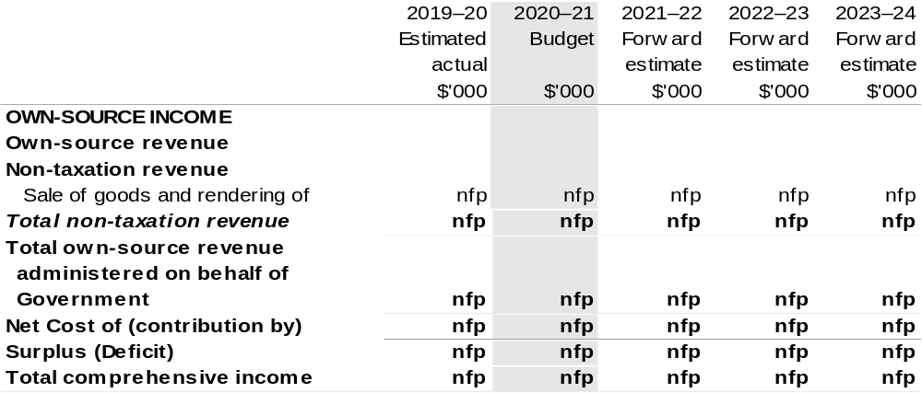
Prepared on Australian Accounting Standards basis.

Table 3.8: Schedule of budgeted assets and liabilities administered on behalf of Government (as at 30 June)

The schedule of budgeted assets and liabilities administered on behalf of Government does not apply to the Bureau.

Table 3.9: Schedule of budgeted administered cash flows (for the period
ended 30 June)

The schedule of budgeted administered cash flows on behalf of Government does not apply to the Bureau.

Cotton
Research and Development Corporation
Section 1: Entity overview and resources 219
1.1 Strategic direction statement 219
1.2 Entity resource statement 221
1.3 Budget measures 223
Section 2: Outcomes and planned performance 224
2.1 Budgeted expenses and performance for Outcome 1 225
Section 3: Budgeted financial statements 230
3.1 Budgeted financial statements 230
3.2 Budgeted financial statements tables 232

Cotton
Research and Development Corporation

Section 1: Entity overview and resources

1.1 Strategic direction statement
The Cotton Research and Development Corporation (CRDC) delivers outcomes in cotton research, development and extension (RD&E) on behalf of Australia’s cotton growers and the Australian Government.
Established in October 1990 and operating under the Primary Industries Research and Development Act 1989 (PIRD Act), CRDC exists to power the success of Australian cotton through investment in, and delivery of, cotton RD&E. CRDC is based in Narrabri, New South Wales: the heart of one of Australia's major cotton-growing regions and home to the Australian Cotton Research Institute.
Cotton is a major contributor to the economic, environmental and social fabric of rural Australia. Predominately grown in New South Wales and Queensland, with expansion into Victoria and commercial trials in northern Australia, cotton is a major employer and contributor to the local, state and national economy. The industry generates significant wealth and provides an economic foundation to these regions and their communities, employing some 10,000 people. Cotton is Australia’s fifth most valuable agricultural export commodity, generating an average of $1.9 billion in export revenue annually.
CRDC’s role is to invest in RD&E on behalf of cotton growers and the government, with the outcomes boosting the productivity and profitability of industry. RD&E, and its resulting innovations, are a key driving force behind the cotton industry’s continued success. CRDC’s ultimate aim is to deliver increased economic, social and environmental benefits for the Australian cotton industry, and the wider community, by investing in knowledge, innovation and its adoption.
CRDC’s investments are governed by a five-year strategic plan, with 2020–21 being the third year under CRDC’s 2018–23 Strategic Plan. The new plan builds on the success of the preceding five-year plan and provides an ambitious roadmap for CRDC’s investment.
CRDC’s aim through the plan is to contribute to creating $2 billion in additional gross value of cotton production for the benefit of Australian cotton growers and the wider community.
The plan has five key areas of focus:
- Increasing productivity and profitability on Australian cotton farms;
- Improving cotton farming sustainability and value chain competitiveness;
- Building the adaptive capacity of the Australian cotton industry;
- Strengthening partnerships and adoption; and
- Driving RD&E impact.
To help achieve this, Australian cotton growers and the Australian Government will co-invest $19.0 million into cotton RD&E during 2020–21, across these key focus areas.

1.2 Entity resource statement
Table 1.1 shows the total funding from all sources available to the entity for its operations and to deliver programs and services on behalf of the Government.
The table summarises how resources will be applied by outcome (government strategic policy objectives) and by administered (on behalf of the Government or the public) and departmental (for the entity’s operations) classification.
For more detailed information on special accounts and special appropriations, please refer to Budget Paper No. 4 – Agency Resourcing.
Information in this table is presented on a resourcing (that is, appropriations/cash available) basis, whilst the ‘Budgeted expenses by Outcome’ table in Section 2 and the financial statements in Section 3 are presented on an accrual basis.

Table 1.1: Cotton Research and Development Corporation – Resource Statement – Budget Estimates for 2020–21 as at October 2020
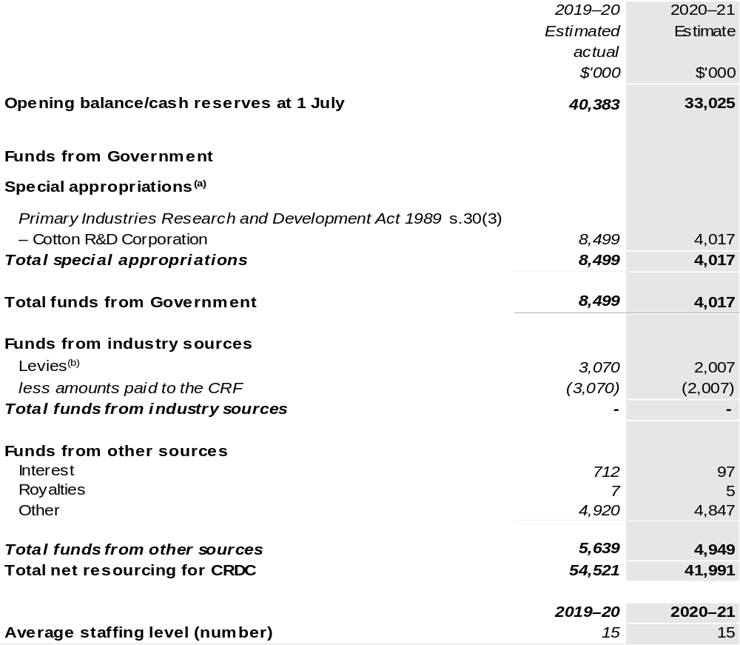
(a) The CRDC is a corporate Commonwealth entity (CCE) under the PGPA Act and does not receive direct appropriations. Instead, this funding passes through DAWE to CRDC and are considered departmental for all purposes.
(b) Levies imposed and collected under the following legislation: Primary Industries Research and Development Act 1989 (PIRD Act), Primary Industries (Excise) Levies Act 1999, Primary Industries Levies and Charges Collection Act 1991 and associated legislation.

CRF – Consolidated Revenue Fund

Prepared on a resourcing (i.e. appropriations available) basis.

Please note: All figures shown above are GST exclusive – these may not match figures in the cash flow statement.

1.3 Budget measures
Budget measures in Part 1 relating to the Cotton Research and Development Corporation are detailed in Budget Paper No. 2: Budget Measures 2020–21 and are summarised below.

Table 1.2: Cotton Research and Development Corporation – 2020–21 Budget measures – Measures announced after the Economic and Fiscal Update July 2020
CRDC does not have any 2020–21 Budget measures.

Section 2: Outcomes and planned performance
Government outcomes are the intended results, impacts or consequences of actions by the Government on the Australian community. Commonwealth programs are the primary vehicle by which government entities achieve the intended results of their outcome statements. Entities are required to identify the programs which contribute to government outcomes over the Budget and forward years.
Each outcome is described below together with its related programs. The following provides detailed information on expenses for each outcome and program, further broken down by funding source.
Note:
Performance reporting requirements in the Portfolio Budget Statements are part of the Commonwealth performance framework established by the Public Governance, Performance and Accountability Act 2013. It is anticipated that the performance criteria described in Portfolio Budget Statements will be read with broader information provided in an entity’s corporate plans and annual performance statements – included in Annual Reports – to provide a complete picture of an entity’s planned and actual performance.
The most recent corporate plan for the Cotton Research and Development Corporation can be found at: www.crdc.com.au/publications/crdc-strategic-plan.
The most recent annual performance statement for the Cotton Research and Development Corporation can be found at:
www.crdc.com.au/publications/crdc-annual-report.

2.1 Budgeted expenses and performance for Outcome 1
Outcome 1: Adoption of innovation that leads to increased productivity, competitiveness and environmental sustainability through investment in research and development that benefits the Australian cotton industry and the wider community.

2.1.1: Linked programs
Department of Agriculture, Water and the Environment
Program 3.10: Agricultural Resources
Contribution to Outcome 1 made by linked program:
The Cotton Research and Development Corporation works together with the Department of Agriculture, Water and the Environment to ensure a sustainable, productive and profitable cotton industry.

2.2.1: Budgeted expenses for Outcome 1
This table shows how much the entity intends to spend (on an accrual basis) on achieving the outcome, broken down by program, as well as by Administered and Departmental funding sources.

Table 2.1: Budgeted expenses for Outcome 1
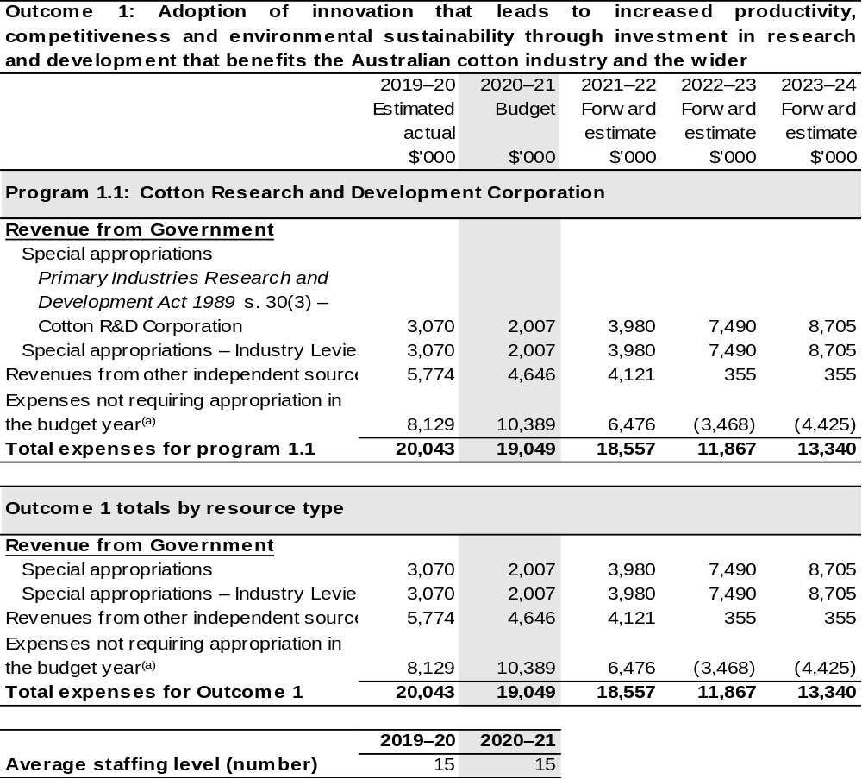
(a) Expenses not requiring appropriation in the Budget year are made up of depreciation expenses, amortisation expenses, make good expenses and audit fees.

Note: Departmental appropriation splits and totals are indicative estimates and may change in the course of the budget year as government priorities change.

Prepared on Australian Accounting Standards basis.

2.3.1: Performance criteria for Outcome 1
Table 2.3.1 below details the performance criteria for each program associated with Outcome 1. It also summarises how each program is delivered and where 2020–21 Budget measures have created new programs or materially changed existing programs.
As an entity established under the PIRD Act, CRDC does not produce a Corporate Plan under the PGPA Act and is therefore exempt from the requirement to map purposes to outcomes.
Outcome 1: Adoption of innovation that leads to increased productivity, competitiveness and environmental sustainability through investment in research and development that benefits the Australian cotton industry and the wider community.
Program 1.1: Cotton Research and Development Corporation
Objectives | Increase productivity and profitability on cotton farms  Deliver RD&E for cotton producers to increase productivity, successfully protect crops from biotic threats and environmental stresses, adopt transformative technologies and innovate for improved profitability.
Objectives | Improve cotton farming sustainability and value chain competitiveness  Deliver RD&E and innovation to create higher value uses for cotton and assist the industry achieve its ambition to be the highest yielding, finest, cleanest and most responsibly produced cotton in the world.
Objectives | Build adaptive capacity of the cotton industry  Deliver RD&E to develop science and innovation capacity as well as new knowledge to strengthen adaptive capacity.
Objectives | Strengthening partnerships and adoption  Deliver RD&E and innovation through collaborative partnerships to ensure adoption of best practice, new knowledge, products and services.
Objectives | Driving RD&E impact  Deliver assessments of the impact of CRDC’s RD&E investments that inform future investment direction and continuous improvement.

Continued on following pages
Contributions to Outcome 1 (continued)
Program 1.1: Cotton Research and Development Corporation (continued)
Delivery | Increase productivity and profitability on cotton farms  Strategically prioritise investment in basic, applied and blue-sky research collaboratively with research and cross-sectoral partners to develop new knowledge, practices and adapt transformative technologies for on-farm application that also protect industry from biotic threats and environmental stresses.
Delivery | Improve cotton farming sustainability and value chain competitiveness  Strategically prioritise investment in basic, applied and blue-sky research collaboratively with research, industry and cross-sectoral partners to develop new knowledge, practices, processes, higher value products and innovative approaches to improve the sustainability of cotton farming and strengthen value chain competitiveness.
Delivery | Build adaptive capacity of the cotton industry  Strategically prioritise investment in RD&E collaboratively with research, industry and cross-sectoral partners to develop new knowledge, futures thinking, science and innovation capability.
Delivery | Strengthening partnerships and adoption  Strategically prioritise investment in the effective adoption of research by strengthening partnerships and collaboration, development of best practice and supporting innovation and commercialisation.
Delivery | Driving RD&E impact  Strategically prioritise investment in research, data capture, analysis and reviews with stakeholders and partners to demonstrate that RD&E investments deliver impact.

Continued on following pages
Contributions to Outcome 1 (continued)
Performance information
Year | Performance criteria | 2019–20 Actual Achievement/Targets
2019–20 | Increase productivity and profitability on cotton farms  Improved yield and quality. | Annual increase of 0.35 bales per hectare for irrigated cotton and 0.14 bales per hectare for dryland cotton.  On target for irrigated cotton. Not on target for dryland due to drought conditions.
2019–20 | Improve cotton farming sustainability and value chain competitiveness  CRDC collaborates in global leadership for sustainability initiatives. | Participates in six global initiatives.  On target.
2019–20 | Build adaptive capacity of the cotton industry  Science and innovation capacity is strengthened and strategically fit for a digital future. | 10+ new/early career researchers supported through strategic career pathways.  On target.
2019–20 | Strengthening partnerships and adoption  Partnerships are strengthened to engage multi-disciplinary and multi-institutional resources. | 40 per cent of annual RD&E investments are through cross sectoral partnerships.  On target.
2019–20 | Driving RD&E impact  CRDC monitors and evaluates RD&E impact. | One RD&E impact report per annum.  On target.
2020–21 | As per 2019–20. | As per 2019–20.
2021–22 and beyond | As per 2019–20. | As per 2019–20.

Section 3: Budgeted financial statements
Section 3 presents budgeted financial statements which provide a comprehensive snapshot of entity finances for 2020–21, including the impact of 2020–21 Budget measures and resourcing on financial statements.

3.1 Budgeted financial statements

3.1.1: Differences between entity resourcing and financial statements
The resourcing statement is prepared on a cash basis. The financial statements are prepared on an accrual basis. Differences between the resourcing and financial statements represent timing differences between revenue recognition and cash received.

3.2.1: Explanatory notes and analysis of budgeted financial statements
Budgeted Comprehensive Income Statement
Variability in CRDC’s revenue and expenditure is a result of significant fluctuations in the production of Australian cotton each year. Cotton production has been as low as 560,000 bales in 2008, as high as 5.4 million bales in 2012 and is estimated to be 1.0 million bales in 2020–21.
Revenue from industry levies, matching contributions from the Australian Government and royalties are determined by the level of cotton production and represent more than 83 per cent of total revenue. Since 2008–09 CRDC’s revenue has fluctuated between $7.7 million and $31.4 million per annum.
The impact of a highly variable revenue stream on CRDC’s investment in RD&E is minimised by managing cash reserves. During periods of high revenue CRDC builds up reserves by operating in surplus. During periods of low revenue CRDC draws on reserves by operating under approved deficits. This financial strategy allows CRDC to maintain a more consistent level of RD&E expenditure each year.
Matching contributions from the Australian Government are determined by either the value of industry levies collected or 0.5 per cent of the cotton industry’s three-year average gross value of production. Which limit will apply depends on the price of cotton, timing of the harvest and ginning and the variability of the crop size. Royalties, interest on investments, external grant revenue and research project refunds make up the balance of the CRDC’s income.
To achieve the strategic priorities of the R&D plan for the period 2018–23, CRDC planned to invest a total of $125.0 million for the five-year R&D plan. The current drought has reduced cotton production in most of the major cotton growing regions and will impact CRDC’s revenue and ability to invest $125 million over the five year R&D plan. The current forward estimate is for a total investment of $93.7 million.
CRDCs investments during drought have focussed on supporting core research activities to support industry needs and building research and innovation skills that will provide the foundation for the future of the cotton industry.
In 2020–21 CRDC has budgeted for a deficit of $10.4 million based on revenues of $8.6 million and RD&E expenditure of $19.0 million.
Budgeted Balance Sheet
Reserves increased between 2010–11 and 2013–14 during years of high cotton production and decreased from 2014–15 to 2019–20 due to below average levels of cotton production. In 2020–21 CRDC estimates production will be 1.0 million bales, continuing the trend of below-average production.
CRDC plans to use its reserves to maintain research expenditure at a consistent level in future years when crop levels are below historical averages. The balance of expenditure and reserves will be closely monitored to ensure that reserves remain at an appropriate level.

3.2 Budgeted financial statements tables

Table 3.1: Comprehensive income statement (showing net cost of services)
(for the period ended 30 June)
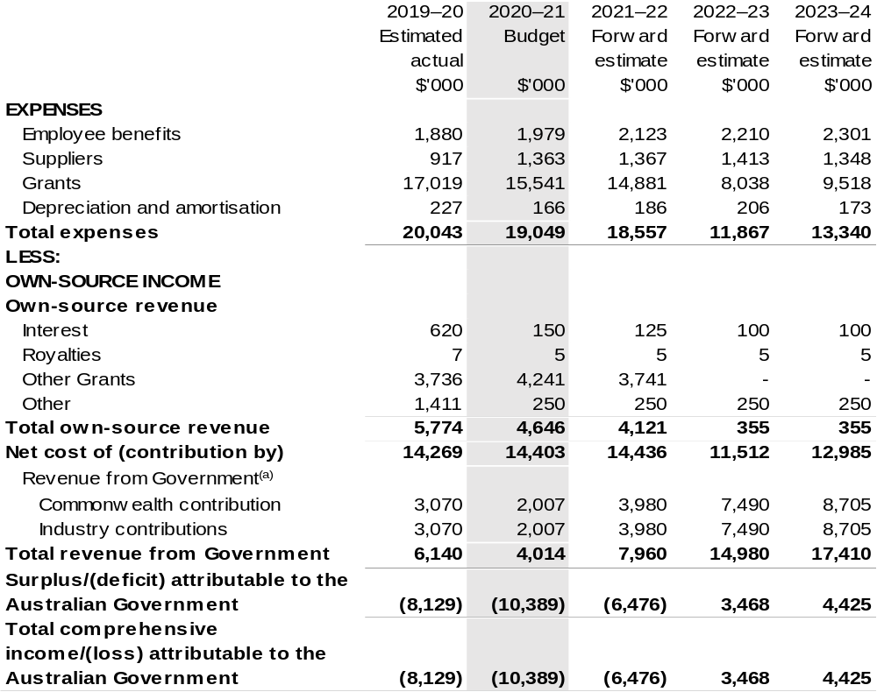
(a) Revenue from Government includes a Commonwealth contribution under the PIRD Act and levies collected from industry by the Department of Agriculture, Water and the Environment for R&D activities.

Prepared on Australian Accounting Standards basis.

Table 3.2: Budgeted departmental balance sheet (as at 30 June)
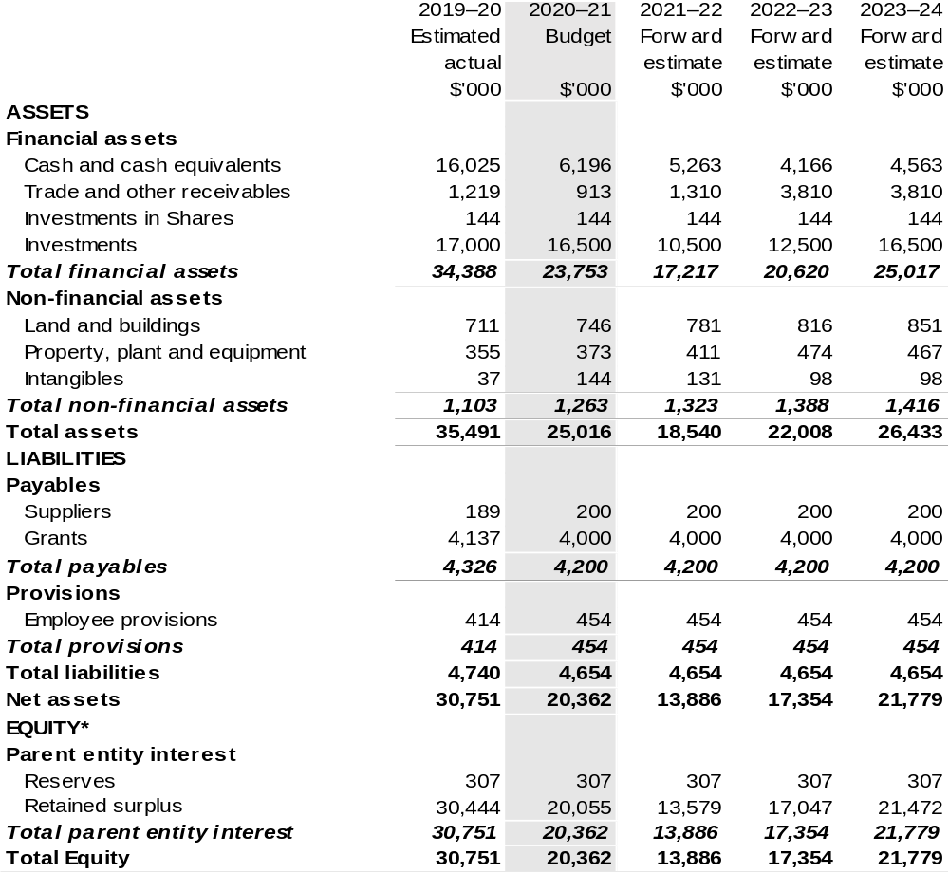
*Equity is the residual interest in assets after deduction of liabilities.

Prepared on Australian Accounting Standards basis.

Table 3.3: Departmental statement of changes in equity — summary of movement (budget year 2020–21)
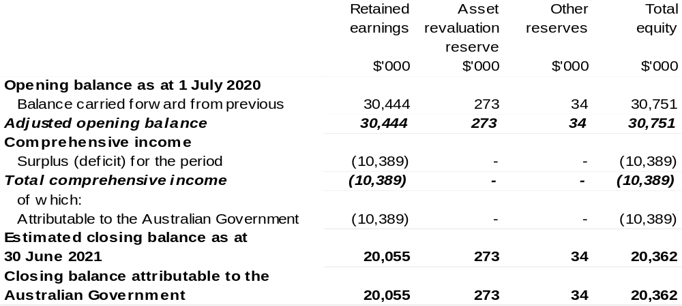
Prepared on Australian Accounting Standards basis.

Table 3.4: Budgeted departmental statement of cash flows (for the period
ended 30 June)
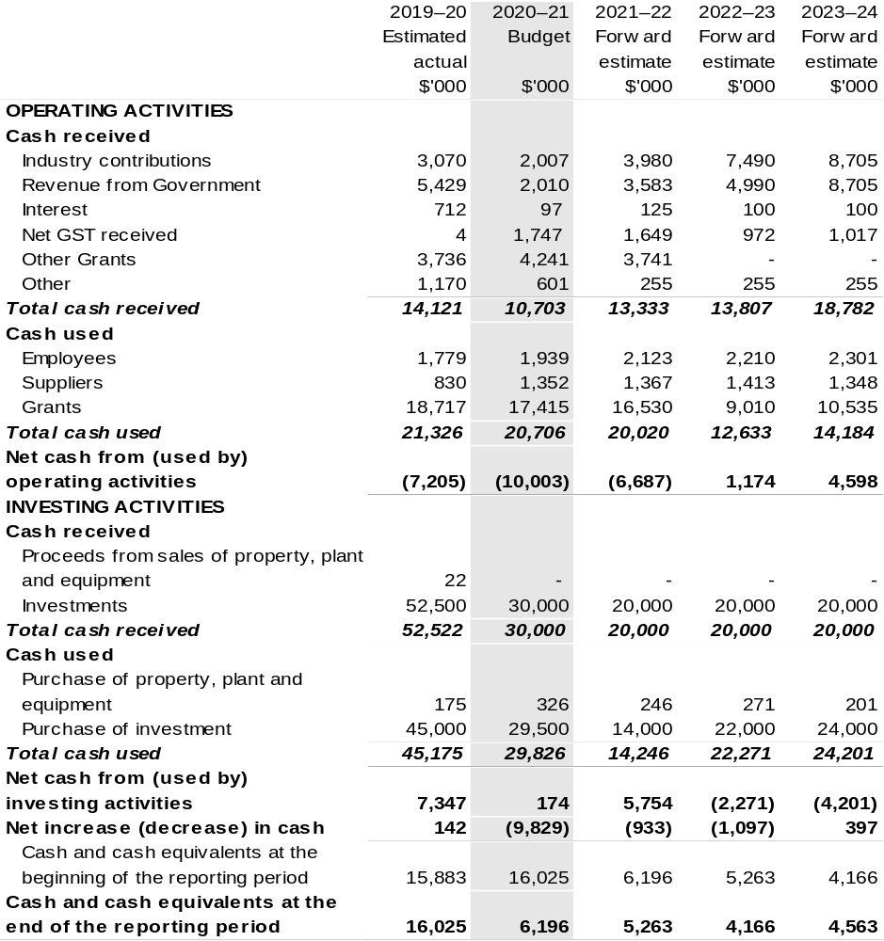
Prepared on Australian Accounting Standards basis.

Table 3.5: Departmental capital budget statement (for period end 30 June)
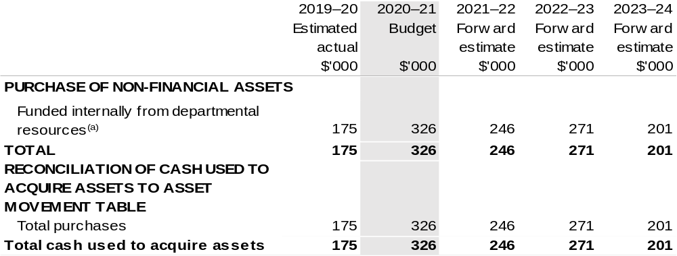
(a) Includes the following sources of funding:
– internally developed assets.

Consistent with information contained in the Statement of Asset Movements and the Budgeted Statement of Cash Flows.

Table 3.6: Statement of asset movements (Budget year 2020–21)
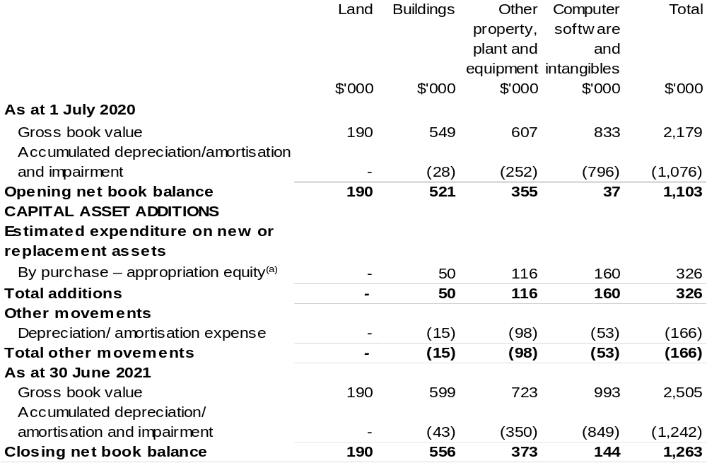
(a) ‘Appropriation ordinary annual services’ refers to funding provided through Appropriation Bill (No. 1) 2020–21 for depreciation / amortisation expenses, DCBs or other operational expenses.

Prepared on Australian Accounting Standards basis.

Director of National Parks
Section 1: Entity overview and resources 239
1.1 Strategic direction statement 239
1.2 Entity resource statement 241
1.3 Budget measures 243
Section 2: Outcome and planned performance 244
2.1 Budgeted expenses and performance for Outcome 1 245
Section 3: Budgeted financial statements 250
3.1 Budgeted financial statements 250
3.2 Budgeted financial statements tables 251

Director of National Parks

Section 1: Entity overview and resources

1.1 Strategic direction statement
The Director of National Parks (DNP) is a Corporate Commonwealth Entity, operating under the Environment Protection and Biodiversity Conservation Act 1999 (EPBC Act) to administer and manage Commonwealth reserves (national parks, botanic gardens, marine and terrestrial reserves). These reserves include:
- Booderee, Kakadu and Uluru-Kata Tjuta National Parks, which are each jointly managed with their Aboriginal Traditional Owners. Kakadu and Uluru-Kata Tjuta National Parks are World Heritage listed.
- National parks in the Australian territories of Norfolk, Christmas and Cocos (Keeling) Islands.
- The Australian National Botanic Gardens, which is a major national institution for the study of Australian plants.
- The 58 marine parks managed by DNP in the South East, South West, North West, North and Temperate East marine regions and the Coral Sea. The Director of National Parks has delegated responsibilities under the EPBC Act in respect of the Heard Island and McDonald Islands Reserve to the Australian Antarctic Division.
The DNPs’ purpose is to protect, conserve and enhance the values of Commonwealth parks and gardens for the use and wellbeing of all Australians.
To deliver these priorities within the Government’s fiscal strategy, the DNP will continue to look to diversify and increase external revenue and partnerships, seek further improvements in the efficient use of our resources and continue to invest in the skills and capabilities of our staff.
Diagram 1: Location of Commonwealth Parks and Gardens

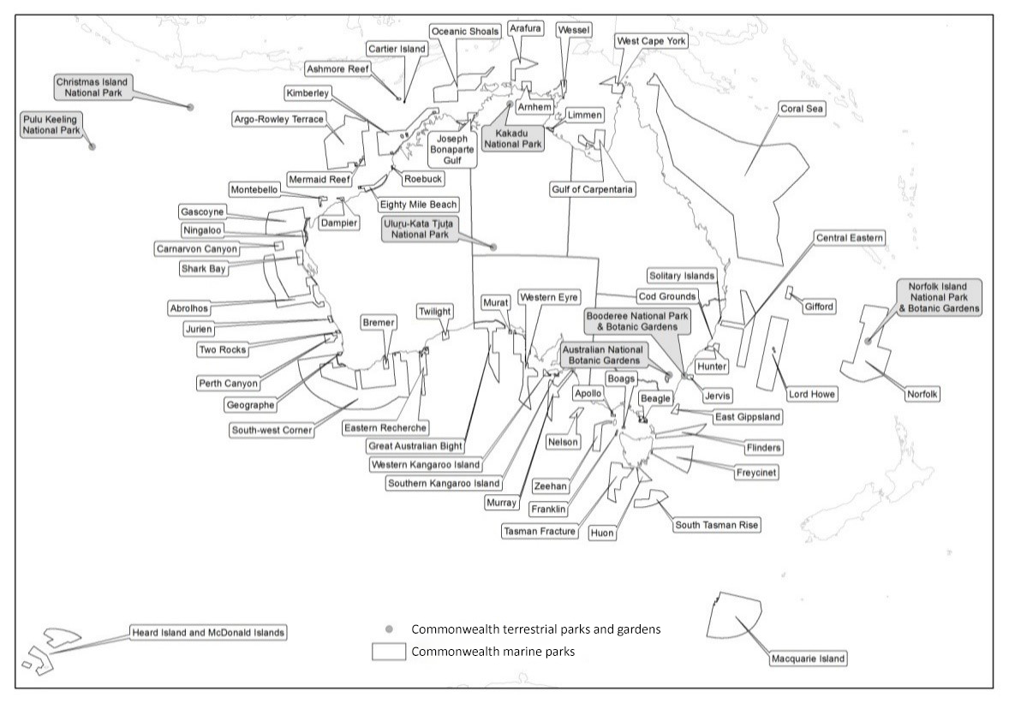

1.2 Entity resource statement
Table 1.1 shows the total funding from all sources available to the entity for its operations and to deliver programs and services on behalf of the Government.
The table summarises how resources will be applied by outcome (government strategic policy objectives) and by administered (on behalf of the Government or the public) and departmental (for the entity’s operations) classification.
For more detailed information on special accounts and special appropriations, please refer to Budget Paper No. 4 – Agency Resourcing.
Information in this table is presented on a resourcing (that is, appropriations/cash available) basis, whilst the ‘Budgeted expenses by Outcome’ table in Section 2 and the financial statements in Section 3 are presented on an accrual basis.
Table 1.1: Director of National Parks – Resource Statement –Budget Estimates for 2020–21 as at October 2020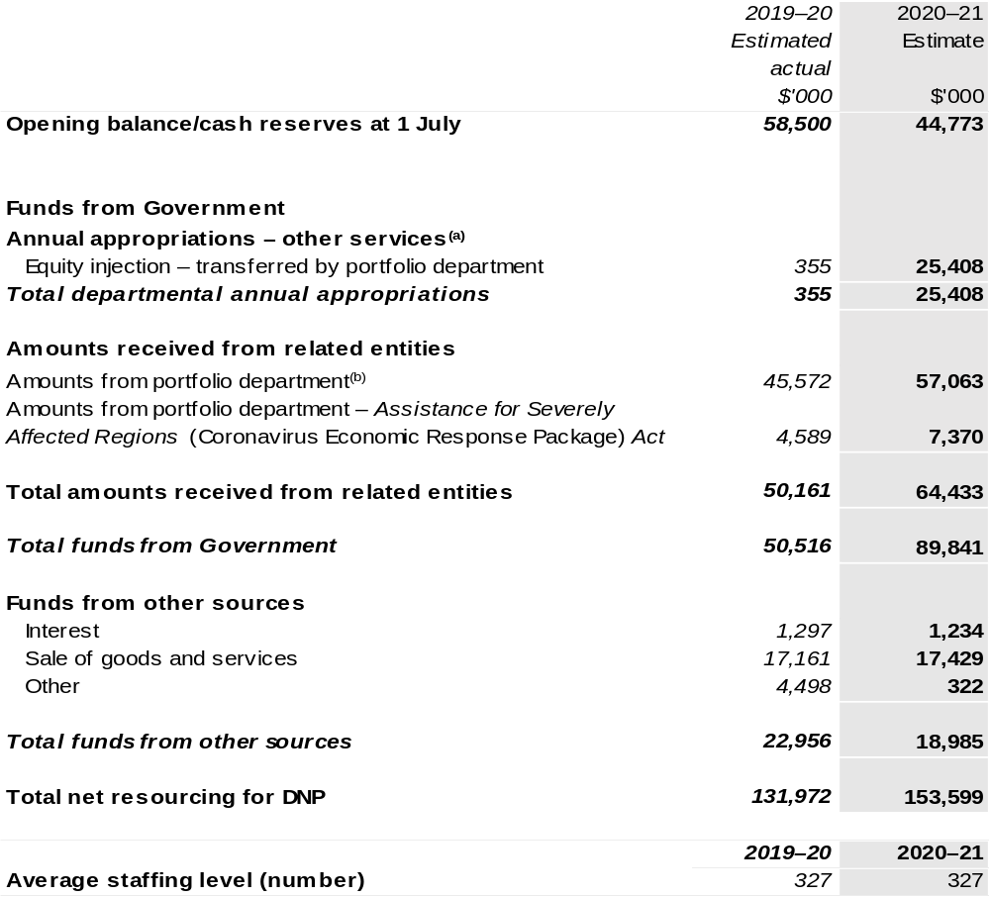
- Supply Act (No. 1) and Appropriation Bill (No. 1) 2020–21. DNP is not directly appropriated as it is a corporate Commonwealth entity under the PGPA Act. Appropriations are made to DAWE and are then paid to DNP and are considered departmental for all purposes.
- Funding provided by the portfolio department that is not specified within the Annual Appropriation Bills as a payment to that corporate entity (for example, a grant awarded to a corporate entity from one of the portfolio department's administered programs).

Prepared on a resourcing (i.e. appropriations available) basis.

Please note: all figures shown above are GST exclusive – these may not match figures in the cash flow statement.

1.3 Budget measures
Budget measures in Part 1 relating to the Director of National Parks are detailed in Budget Paper No. 2: Budget Measures 2020–21 and are summarised below.

Table 1.2: Director of National Parks – 2020–21 Budget measures – Measures announced after the Economic and Fiscal Update July 2020
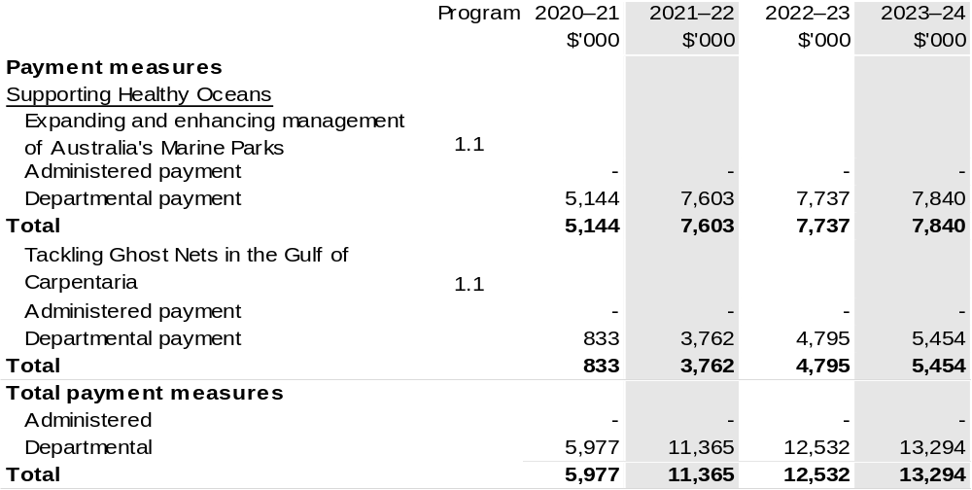
Prepared on a Government Finance Statistics (Underlying Cash) basis

Section 2: Outcomes and planned performance
Government outcomes are the intended results, impacts or consequences of actions by the Government on the Australian community. Commonwealth programs are the primary vehicle by which government entities achieve the intended results of their outcome statements. Entities are required to identify the programs which contribute to government outcomes over the Budget and forward years.
Each outcome is described below together with its related programs. The following provides detailed information on expenses for each outcome and program, further broken down by funding source.
Note:
Performance reporting requirements in the Portfolio Budget Statements are part of the Commonwealth performance framework established by the Public Governance, Performance and Accountability Act 2013. It is anticipated that the performance criteria described in Portfolio Budget Statements will be read with broader information provided in an entity’s corporate plans and annual performance statements – included in Annual Reports – to provide a complete picture of an entity’s planned and actual performance.
The most recent corporate plan for Director of National Parks can be found at: http://www.environment.gov.au/resource/corporate-plan-2020-21-director-national-parks.
The most recent annual performance statement can be found at: https://www.environment.gov.au/resource/annual-report-2018-19-director-national-parks.

2.1 Budgeted expenses and performance for outcome 1
Outcome 1: Management of Commonwealth reserves as outstanding natural places that enhance Australia’s well-being through the protection and conservation of their natural and cultural values, supporting the aspirations of Aboriginal and Torres Strait Islander people in managing their traditional land and sea country, and offering world class natural and cultural visitor experiences.

2.1.1: Linked programs
Department of the Agriculture, Water and the Environment
Program 1.1: Sustainable Management of Natural Resources and the Environment
Program 1.2: Environmental Information and Research
Program 1.4: Conservation of Australia’s Heritage and Environment
Contribution to Outcome 1 made by linked programs
The DNP and Department of Agriculture, Water and the Environment (DAWE) work together in setting policy directions for science, heritage and species management in Commonwealth managed parks and gardens. The DNP works with DAWE to transition Jabiru township from a mining to a tourism-based economy.
Great Barrier Reef Marine Park Authority
Program 1.1: Improving the Outlook for the Great Barrier Reef
Contribution to Outcome 1 made by linked programs
The Coral Sea Marine Park managed by the DNP adjoins the Great Barrier Reef Marine Park and provides complementary protection for ecosystems and biodiversity in the region.
Department of Infrastructure, Transport, Regional Development and Communications
Program 1.1: Infrastructure Investment
Contribution to Outcome 1 made by linked programs
The DNP is working with the Department of Infrastructure, Transport, Regional Development and Communications to secure the future of Jabiru by supporting the township’s transition from a reliance on mining to a tourism-based economy that leverages its proximity to the Kakadu National Park. Funding of $70 million for roads within Kakadu National Park under the Infrastructure Investment Program will complement an investment of more than $100 million by the Australian Government to improve tourism infrastructure across the park and to bolster the local economy and support Indigenous businesses and employment.

2.2.1: Budgeted expenses for Outcome 1
This table shows how much the entity intends to spend (on an accrual basis) on achieving the outcome, broken down by program, as well as by Administered and Departmental funding sources.

Table 2.1: Budgeted expenses for Outcome 1
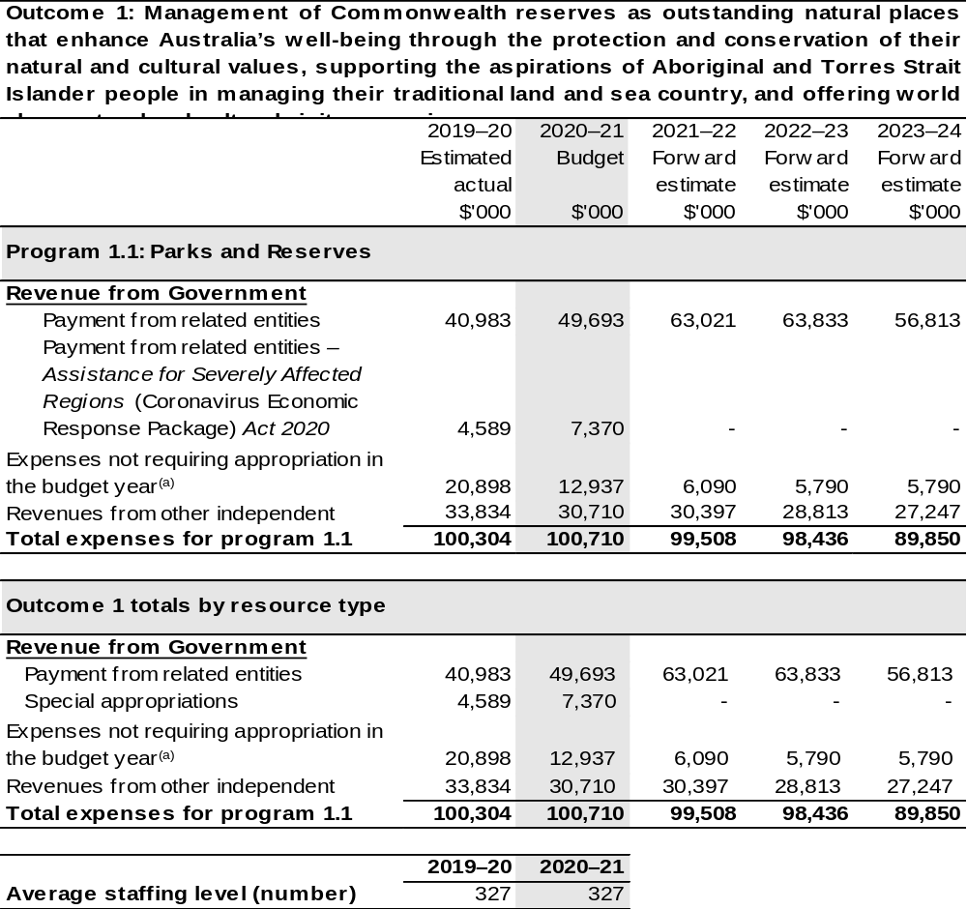
(a) Expenses not requiring appropriation in the Budget year are made up of depreciation expenses, amortisation expenses, make good expense and audit fees and expenses funded in the prior year.

Note: Departmental appropriation splits and totals are indicative estimates and may change in the course
of the budget year as government priorities change.

Prepared on Australian Accounting Standards basis.

2.3.1: Performance criteria for Outcome 1
Table 2.3.1 below details the performance criteria for each program associated with Outcome 1. It also summarises how each program is delivered and where 2020–21 Budget measures have created new programs or materially changed existing programs.
Outcome 1: Management of Commonwealth reserves as outstanding natural places that enhance Australia’s well-being through the protection and conservation of their natural and cultural values, supporting the aspirations of Aboriginal and Torres Strait Islander people in managing their traditional land and sea country, and offering world class natural and cultural visitor experiences.
Program 1.1: Parks and Reserves
Objective | Healthy and resilient parks, gardens and marine reserves, protecting nature and culture and valued by the community now and into the future.
Delivery | With traditional owners and stakeholders, develop and implement management plans for Commonwealth reserves.
Performance information
Year | Performance criteria | 2019–20 Actual Achievement/Targets
2019–20 | Populations of threatened and significant species are increasing. | Increase in populations of prioritised threatened and significant species.  Not achieved
 | Populations of priority invasive species are reduced. | Decrease in size of populations of prioritised invasive species.  Achieved
 | Increase in numbers of Indigenous staff and/or contractors directly or indirectly providing park services. | Increase in numbers of Indigenous staff.  Not achieved  Increase in value of services provided by Indigenous providers.  Achieved
 | Maintain or improve the level of visitor satisfaction and number of visitors. | Maintain or improve levels of visitor satisfaction.  Achieved  5 per cent increase in visitor numbers.  Not achieved

Continued on following pages
Contributions to Outcome 1 (continued)
Performance information
Year | Performance criteria | 2019–20 Actual Achievement/Targets
2019–20 (continued) | Enhance level of active management of Australian Marine Parks and engagement of users and stakeholders. | - Number of management plans for Australian Marine Parks in effect.  - Number of advisory committee meetings.  Achieved
 | Increase the knowledge base for long term adaptive management of the Australian Marine Parks. | Increase in the number of marine reserves long-term monitoring sites.  Achieved
Purposes | - Resilient places and ecosystems: to protect and conserve the natural and cultural values of Commonwealth reserves.  - Multiple benefits to traditional owners and local communities: to support the aspirations of traditional owners and local communities in managing land and sea country.  - Amazing destinations: to offer world class natural and cultural experiences, enhancing Australia’s visitor economy.
2020–21 | Sustainable use and enjoyment of Commonwealth parks and gardens by the Australian and international community. | Number of visitors is within 10 per cent of target total visitor numbers.
2020–21 |  | Maintain or improve visitor satisfaction.
2020–21 |  | Maintain or increase number of virtual visitors.
2020–21 |  | 95 per cent authorisations processed within target timeframe.
2020–21 |  | 100 per cent of non-compliance reports have an initial assessment within target timeframe
2020–21 |  | Maintain or increase the economic contribution made to local economies.
2020–21 |  | Maintain or increase the financial benefit to Traditional Owners through lease arrangements and other avenues in jointly managed parks.

Continued on following page

Contributions to Outcome 1 (continued)
Performance information
Year | Performance criteria | 2019–20 Actual Achievement/Targets
2020–21 (continued) |  | Maintain or increase number of peer reviewed publications resulting from research in Commonwealth parks.
2020–21 (continued) | Opportunities and threats to natural and cultural values are effectively managed for all Australians. | Maintain or improve the condition of priority natural values in Commonwealth parks and gardens.
2020–21 (continued) |  | Maintain or improve the condition of priority cultural values in Commonwealth parks.
2020–21 (continued) |  | Review and define priority natural and cultural values for all Commonwealth parks and gardens by 2023.
2020–21 (continued) | Partnerships with Traditional Owners and/or other stakeholders enhance the management of Commonwealth parks and gardens for all Australians. | Maintain or improve key stakeholder and partner satisfaction.
2020–21 (continued) |  | Resources delivered through partnerships meet or exceed target level.
2020–21 (continued) |  | Maintain or increase the number of people who identify as members of the local or Indigenous community who are employed directly or indirectly.
2021–22 and beyond | As per 2020–21. | As per 2020–21.
Purposes | Revised Purpose for 2020–21 and beyond:  Protect, conserve and enhance the values of Commonwealth parks and gardens for the use and well-being of all Australians.

Section 3: Budgeted financial statements
Section 3 presents budgeted financial statements which provide a comprehensive snapshot of entity finances for 2020–21, including the impact of 2020–21 Budget measures and resourcing on financial statements.

3.1 Budgeted financial statements
Section 3 presents budgeted financial statements which provide a comprehensive snapshot of entity finances for 2020–21, including the impact of 2020–21 Budget measures and resourcing on financial statements.

3.1.1: Differences between entity resourcing and financial statements
The estimated operating deficit for DNP has increased as a result of unexpected repairs, environmental factors and additional depreciation. Additional measures have provided support against the loss of revenue due to COVID-19 through the National Park commercial tour operator licence and permit fee waiver ($772,000 over two years from 2019–20) and the temporary waiver of entry fees to Commonwealth-operated National Parks ($11.2 million over two years from 2020–21) measures.

3.2.1: Explanatory notes and analysis of budgeted financial statements
The Agency Resource Statement (Table 1.1) is prepared on a cash basis and provides a consolidated view of all the cash resources available to DNP in 2020–21. For departmental items this includes equity injections and appropriation receivable that is yet to be drawn down to cover payables and provisions on the Departmental Balance Sheet (Table 3.2). The Comprehensive Income Statement (Table 3.1) shows only the operating appropriation provided each year and own source revenue generated by the agency.
The approved operating loss for DNP is attributed to the depreciation of the entity’s asset base.

3.2 Budgeted financial statements tables

Table 3.1: Comprehensive income statement (showing net cost of services) for the period ended 30 June 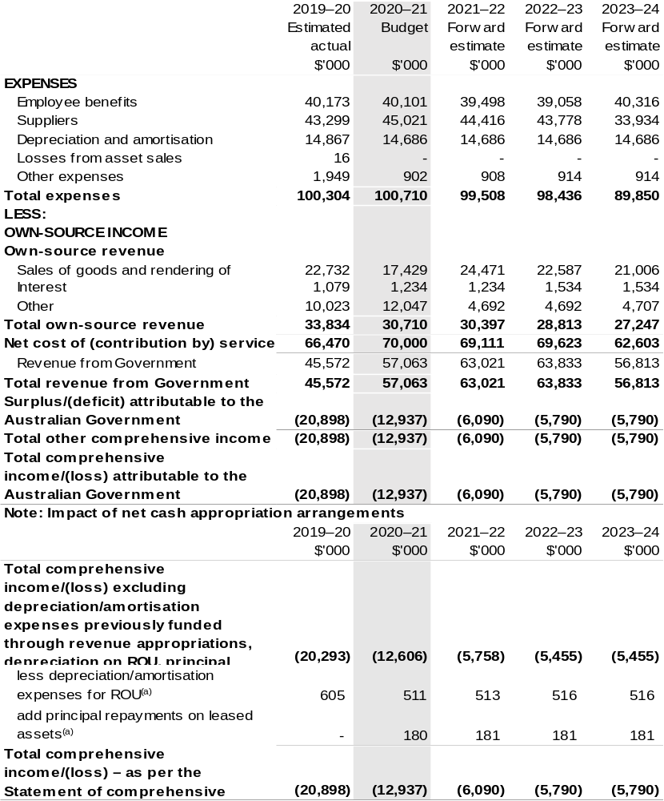
- Applies to leases under AASB 16 Leases. Right of Use (ROU).

Prepared on Australian Accounting Standards basis.

Table 3.2: Budgeted departmental balance sheet (as at 30 June)
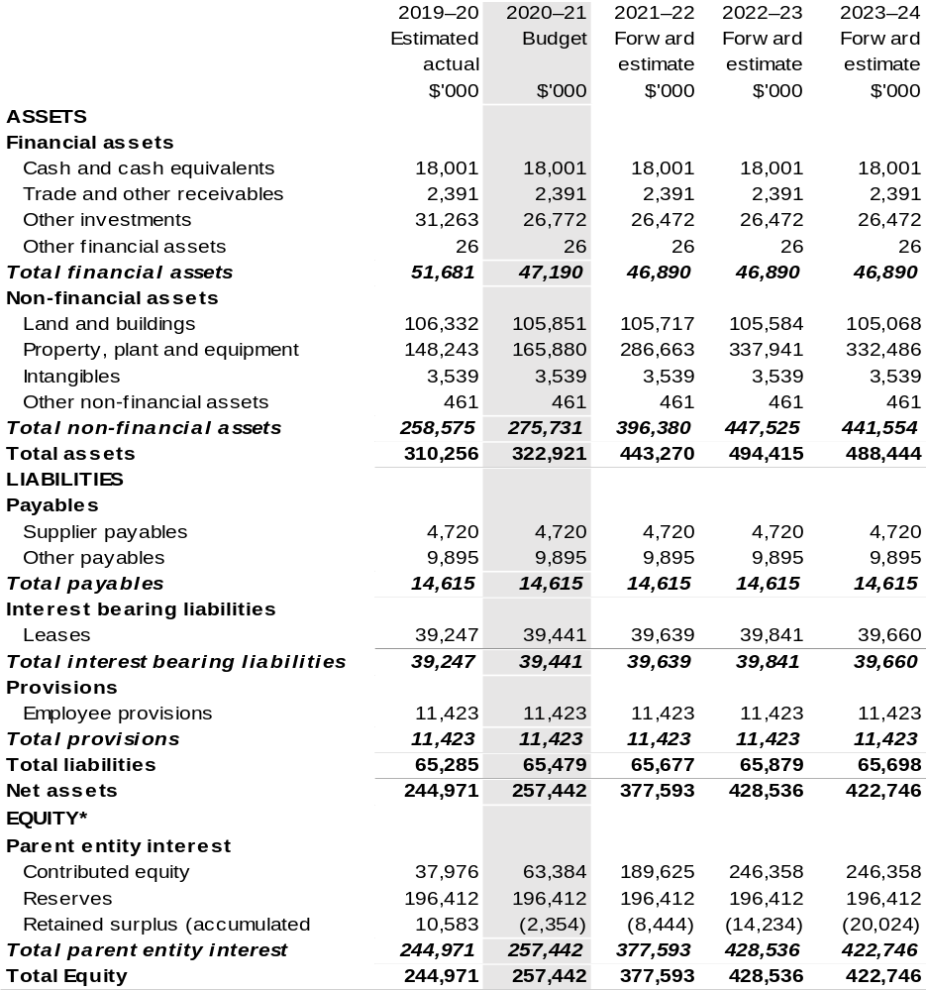
*Equity is the residual interest in assets after deduction of liabilities.

Prepared on Australian Accounting Standards basis.

Table 3.3: Departmental statement of changes in equity – summary of movement (Budget year 2020–21)
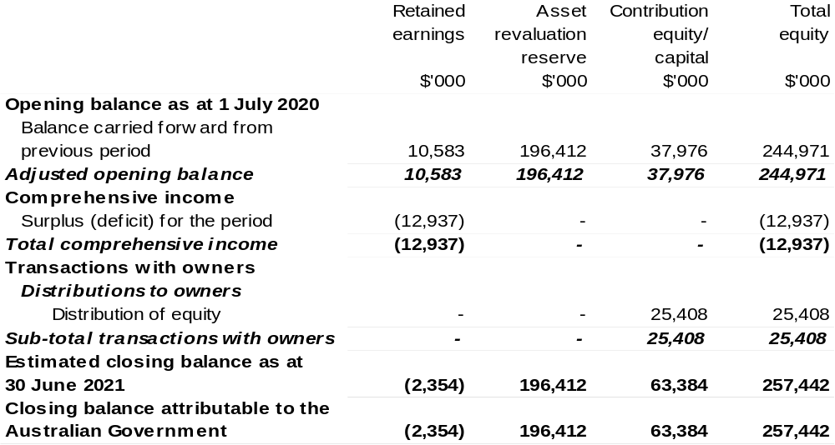
Prepared on Australian Accounting Standards basis.

Table 3.4: Budgeted departmental statement of cash flows (for the period
ended 30 June)
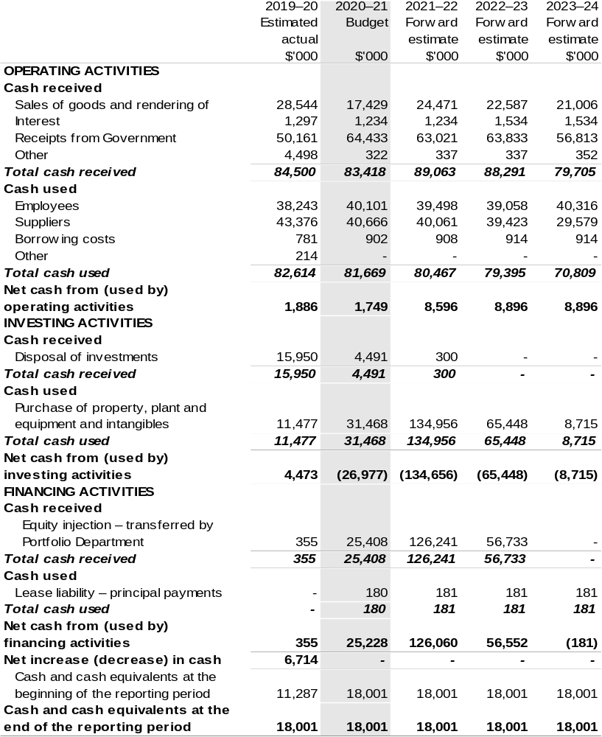
Prepared on Australian Accounting Standards basis.

Table 3.5: Departmental capital budget statement (for the period ended 30 June)
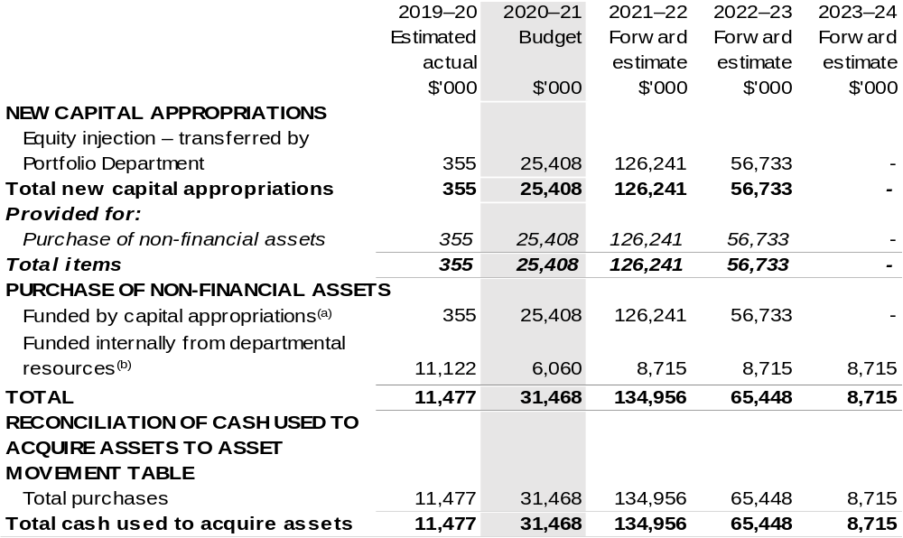
- Includes current Appropriation Bill (No. 2) and prior year Appropriation Act No. 2/4/6.
- Includes the following sources of funding:
– current Bill (No. 1) and prior year Act/Bill (No. 1/3/5) appropriations (excluding amounts from the DCBs);
– donations and gifts of non-financial assets;
– internally developed assets;
– proceeds from the sale of assets.

Consistent with information contained in the Statement of Asset Movements and the Budgeted Statement of Cash Flows.

Prepared on Australian Accounting Standards basis.

Table 3.6: Statement of asset movements (Budget year 2020–21)
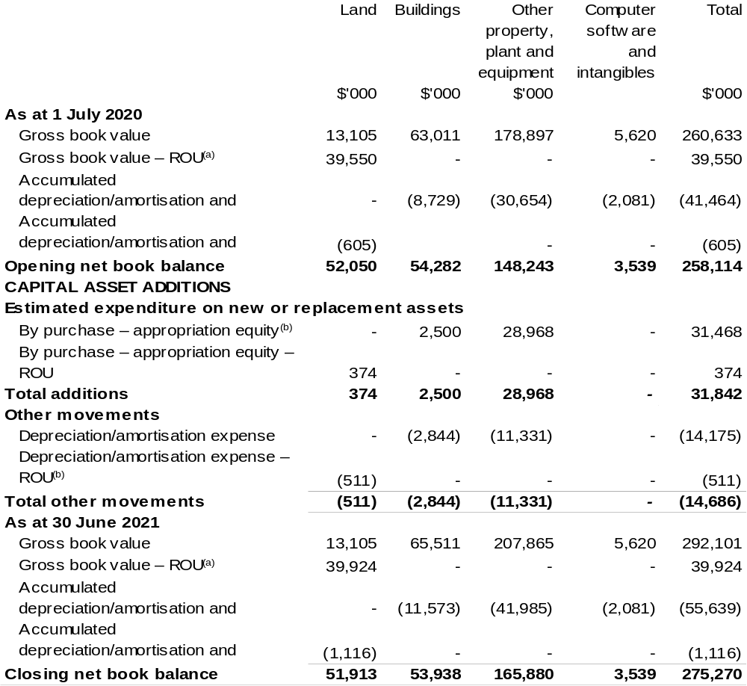
(a) Applies to leases under AASB 16 Leases. Right of Use (ROU).
(b) ‘Appropriation ordinary annual services’ refers to funding provided through Supply Act (No. 1) and Appropriation Bill (No. 1) 2020–21 for depreciation/amortisation expenses, DCBs or other operational expenses.

Prepared on Australian Accounting Standards basis.

Fisheries
Research and Development Corporation
Section 1: Entity overview and resources 259
1.1 Strategic direction statement 259
1.2 Entity resource statement 261
1.3 Budget measures 262
Section 2: Outcomes and planned performance 263
2.1 Budgeted expenses and performance for Outcome 1 264
Section 3: Budgeted financial statements 269
3.1 Budgeted financial statements 269
3.2 Budgeted financial statements tables 270

Fisheries
Research and Development Corporation

Section 1: Entity overview and resources

1.1 Strategic direction statement
The Fisheries Research and Development Corporation (FRDC) invests in research, development and extension (RD&E) that supports aquaculture, as well as commercial, Indigenous and recreational fishers. These stakeholders operate across environments that range from the northern tropics through to temperate seas and icy Antarctic waters, from freshwater rivers and lakes, to estuaries land-based aquaculture facilities.
FRDC’s investment policy balances the needs of stakeholders, including the community, with achieving specific, planned end user solutions to national, regional and sector-based priorities. Partnerships and previous RD&E are considered in its planning and investment processes, to ensure best use of previous research, maximise leverage and reduce duplication. FRDC also contributes to the broader national strategic approach to fishing and aquaculture RD&E to build cohesion and establish common goals between sectors.
The FRDC leads investment in fisheries RD&E, partnering with organisations that have the necessary capabilities to undertake the varied and specialised activities. The focus for impact from FRDC activities, encompasses a number of end users, including those who participate in fishing and aquaculture and Australian seafood consumers. To this end, FRDC invests and facilitates extension of the research and development (R&D) that will lead to adoption and commercialisation.
In terms of its internal operations, FRDC is a quality-certified organisation (AS/NZS ISO 9001:2015) working to ensure continuous improvement. The RD&E investment activities are underpinned by a quality management system including mechanisms for reviewing performance and implementing changes.
The new FRDC 2020–25 R&D Plan is pursuing outcomes in five key strategic areas, with a strong focus on capacity building, culture, relationships, shared principles and values. The proposed approach towards implementation allows for adaptive and creative approaches to problem solving in anticipation of the increasing uncertainty and volatility faced by Australia’s fishing and aquaculture sectors. Further, the commercial sector will contribute to the National Farmers’ Federation 2030 target of Agriculture being worth $100 billion, which is supported by the Australian Government. This achievement will require more production value from less use of resources. To achieve this will require the commercial sector to embrace the principles of the circular economy, innovation and to drive productivity.

1.2 Entity resource statement
Table 1.1 shows the total funding from all sources available to the entity for its operations and to deliver programs and services on behalf of the Government.
The table summarises how resources will be applied by outcome (government strategic policy objectives) and by administered (on behalf of the Government or the public) and departmental (for the entity’s operations) classification.
For more detailed information on special accounts and special appropriations, please refer to Budget Paper No. 4 – Agency Resourcing.
Information in this table is presented on a resourcing (that is, appropriations/cash available) basis, whilst the ‘Budgeted expenses by Outcome’ table in Section 2 and the financial statements in Section 3 are presented on an accrual basis.

Table 1.1: Fisheries Research and Development Corporation –
Resource Statement – Budget Estimates for 2020–21 as at Budget October 2020
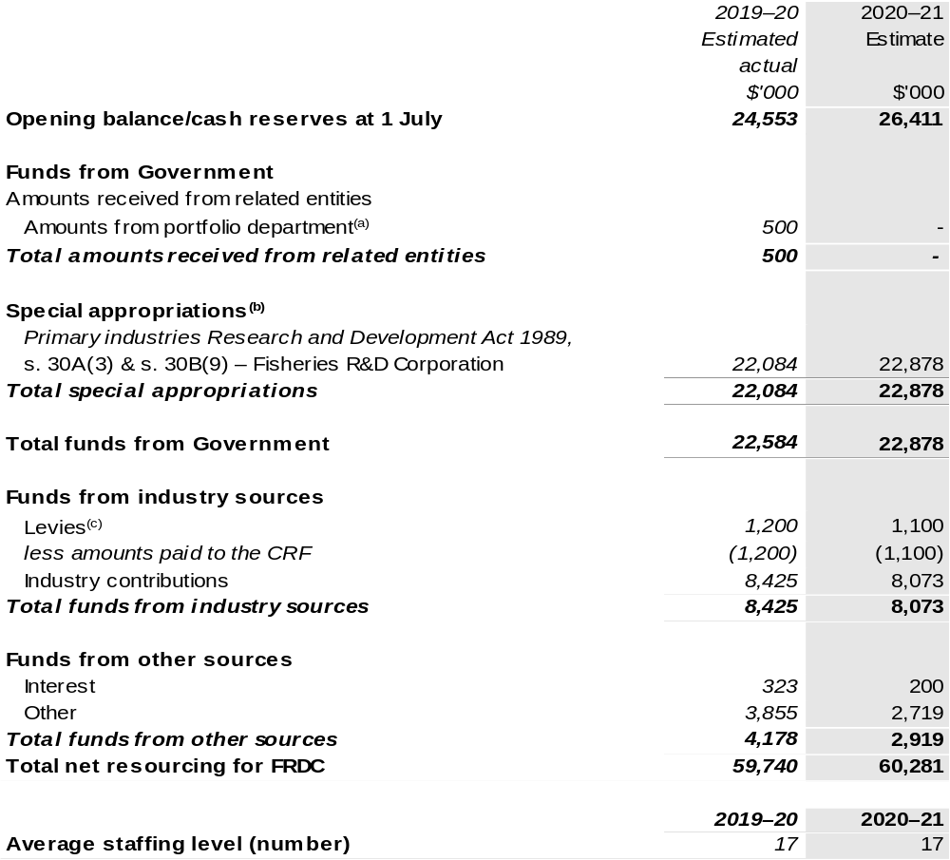
(a) FRDC has a grant agreement with the Department of Agriculture, Water and the Environment (DAWE) to develop the National Carp Control Plan.
(b) FRDC's special appropriation is not directly appropriated as it is a corporate Commonwealth entity under the PGPA Act. Appropriations are made to DAWE and then paid to FRDC and are considered departmental for all purposes.
(c) Levies are collected under the Primary Industries Research and Development Act 1989 (PIRD Act) and the Fishing Levy Regulations and are remitted to DAWE and transferred to the CRF. An equivalent amount of FRDC management levy is paid to FRDC by DAWE under a special appropriation under the PIRD Act.

CRF – Consolidated Revenue Fund

Prepared on a resourcing (i.e. appropriations available) basis.

Please note: All figures shown above are GST exclusive – these may not match figures in the cash flow statement.

1.3 Budget measures
Budget measures in Part 1 relating to the Fisheries Research and Development Corporation are detailed in Budget Paper No. 2: Budget Measures 2020–21 and are summarised below.

Table 1.2: Fisheries Research and Development Corporation – 2020–21 Budget measures – Measures announced after the Economic and Fiscal Update July 2020
FRDC does not have any 2020–21 Budget measures.

Section 2: Outcomes and planned performance
Government outcomes are the intended results, impacts or consequences of actions by the Government on the Australian community. Commonwealth programs are the primary vehicle by which government entities achieve the intended results of their outcome statements. Entities are required to identify the programs which contribute to government outcomes over the Budget and forward years.
Each outcome is described below together with its related programs. The following provides detailed information on expenses for each outcome and program, further broken down by funding source.
Note:
Performance reporting requirements in the Portfolio Budget Statements are part of the Commonwealth performance framework established by the Public Governance, Performance and Accountability Act 2013. It is anticipated that the performance criteria described in Portfolio Budget Statements will be read with broader information provided in an entity’s corporate plans and annual performance statements – included in Annual Reports - to provide a complete picture of an entity’s planned and actual performance.
While the FRDC reports against an annual framework, as an organisation that invests in science, the benefit of those investments endures over a longer time period.
The most recent corporate plans (annual operating plan and research development and extension plan for the Fisheries Research and Development Corporation can be found at:
http://frdc.com.au/en/about/corporate-documents/annual-operational-plan and
http://frdc.com.au/en/research/rde-planning-and-priorities.
The most recent annual performance statement for the Fisheries Research and Development Corporation can be found at:
http://frdc.com.au/en/about/corporate-documents/annual-reports.

2.1 Budgeted expenses and performance for Outcome 1
Outcome 1: Increased economic, social and environmental benefits for Australian fishing and aquaculture, and the wider community, by investing in knowledge, innovation, and marketing.

2.1.1: Linked programs
Department of Agriculture, Water and the Environment
Program 3.4: Fishing Industry
Contribution to Outcome 1 made by linked program:
The Fisheries Research Development Corporation works together with the Department of Agriculture, Water and the Environment to ensure fishing and aquaculture in Australia is sustainable, productive and profitable.

2.2.1: Budgeted expenses for Outcome 1
This table shows how much the entity intends to spend (on an accrual basis) on achieving the outcome, broken down by program, as well as by Administered and Departmental funding sources.

Table 2.1: Budgeted expenses for Outcome 1
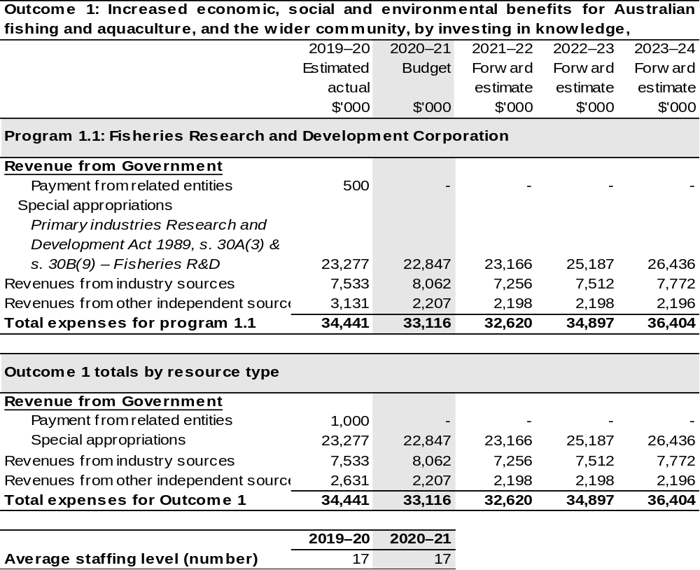
Note: Departmental appropriation splits and totals are indicative estimates and may change in the course
of the budget year as government priorities change.

Prepared on Australian Accounting Standards basis.

2.3.1: Performance criteria for Outcome 1
Table 2.3.1 below details the performance criteria for each program associated with Outcome 1. It also summarises how each program is delivered and where 2020–21 Budget measures have created new programs or materially changed existing programs.
As an entity established under the PIRD Act, FRDC does not produce a Corporate Plan under the PGPA Act and is therefore exempt from the requirement to map purposes to outcomes.
Outcome 1: Increased economic, social and environmental benefits for Australian fishing and aquaculture, and the wider community, by investing in knowledge, innovation, and marketing.
Program 1.1: Fisheries Research and Development Corporation
Objectives | Australian fishing and aquaculture products are sustainable and acknowledged to be so.  By 2020, the community has effective access to, and understanding of, RD&E that supports fishing and aquaculture sustainability and improves perceptions of Australian seafood.
Delivery | Australian fishing and aquaculture products are sustainable and acknowledged to be so.  Continue to prioritise investment in RD&E that contributes to the sustainability of fishing and aquaculture, including consideration of target species, bycatch species, threatened, endangered and protected species, and the broader marine environment.
Desired R&D Outcomes | Growth for enduring prosperity.  Enduring and balanced ecological, social and economic growth for the community benefit.
Desired R&D Outcomes | Best practices and production systems.  Diverse benefits from aquatic resources to be consistent with shared principles.
Desired R&D Outcomes | A culture that is inclusive and forward thinking.  A fishing and aquaculture community that is cooperative, diverse and well equipped to enable growth and adaptability in a complex and uncertain world.
Desired R&D Outcomes | Fair and secure access to aquatic resources.  Integrated management of Australia’s aquatic resources, providing certainty and confidence.
Desired R&D Outcomes | Community trust, respect and value.  People feel good about using the products, services and experiences provided by fishing and aquaculture.
Continued on following pages
Contributions to Outcome 1 (continued)
Performance information
Year | Performance criteria | 2019–20 Actual Achievement/Targets
2019–20 | Projects focus on the FRDC Board’s assessment of priority research and development issues. | 95 per cent are a priority.
2019–20 | Projects are assessed as meeting high standards/peer review requirements for improvements in performance and likely adoption. | 95 per cent are a high priority.
2019–20 | Maintain ISO9001:2008 accreditation. | FRDC maintains certification.
2019–20 | Submit planning and reporting documents in accordance with legislative and Australian Government requirements and timeframes. | 100 per cent met Government requirements.
2019–20 | Implement best practice governance arrangements to promote transparency, good business performance and unqualified audits. | Achieve unqualified audit result.
2019–20 | Demonstrate the benefits of RD&E investments by positive benefit cost analysis results. | Benefit analysis undertaken on one investment area.
2019–20 | The number of species in the national Status of Key Australian Fish Stocks Reports increases to include 200 species. | 160 species included in Status of Australian Fish Stocks Reports.
2019–20 | The number of species classified as ‘undefined’ is reduced from the previous [2016] Status of Key Australian Fish Stocks Reports. | Undefined species is less than 20 per cent.
2019–20 | Perception of the commercial fishing industry increased from 28 per cent to 40 per cent by 2020. | Perception of industry increases to 34 per cent.
2019–20 | Understand the quantity of potential production from Australia’s fishing and aquaculture resources. | One report completed on quantity of production from Australia’s fishing and aquaculture resources.

Continued on following page
Contributions to Outcome 1 (continued)
Performance information
Year | Performance criteria | 2019–20 Actual Achievement/Targets
2019–20  (continued) | Advance two or more new or emerging aquaculture opportunities for which RD&E has identified clear opportunities and technologies for good production and profitability growth, as measured by increases in harvest tonnages. | 1,500 tonnes of additional production.
2019–20  (continued) | Partners have a RD&E plan.  Partners invest in a balanced portfolio across the FRDC purpose themes – environment, industry, communities, people and extension. | 90 per cent of partners have an RD&E Plan.  Investment portfolios include investment across FRDC purposes.
2020–21^{Note} | Projects focus on the FRDC Board’s assessment of priority research and development issues. | 95 per cent are a priority.
2020–21^{Note} | Projects are assessed as meeting high standards/peer review requirements for improvements in performance and likely adoption. | 95 per cent are a high priority.
2020–21^{Note} | Submit planning and reporting documents in accordance with legislative and Australian Government requirements and timeframes. | 100 per cent met Government requirements.
2020–21^{Note} | Implement best practice governance arrangements to promote transparency, good business performance and unqualified audits. | Achieve unqualified audit result.
2020–21^{Note} | Demonstrate the benefits of RD&E investments by positive benefit cost analysis results. | Benefit analysis undertaken on one investment area.
2021–22 and beyond | As per 2020–21. | As per 2020–2021.

Note: Performance criteria and targets were changed in 2020–21 for subsequent years following the approval of the FRDC Research, Development and Extension Plan 2020–25.

Section 3: Budgeted financial statements
Section 3 presents budgeted financial statements which provide a comprehensive snapshot of entity finances for 2020–21, including the impact of 2020–21 Budget measures and resourcing on financial statements.

3.1 Budgeted financial statements

3.1.1: Explanatory notes and analysis of budgeted financial statements
The FRDC’s RD&E expenditure is dependent on the gross value of production (GVP) of the Australian fishing industry. The indication for the GVP for the Australian fishing industry is positive, with growth expected in 2020–21 year. This is based primarily on aquaculture which is anticipated to grow – prawns, Barramundi, Atlantic Salmon and Yellowtail Kingfish will be key drivers. Income contributions from the commercial sector are expected to maintain current levels.

3.2 Budgeted financial statements tables

Table 3.1: Comprehensive income statement (showing net cost of services)
(for the period ended 30 June)
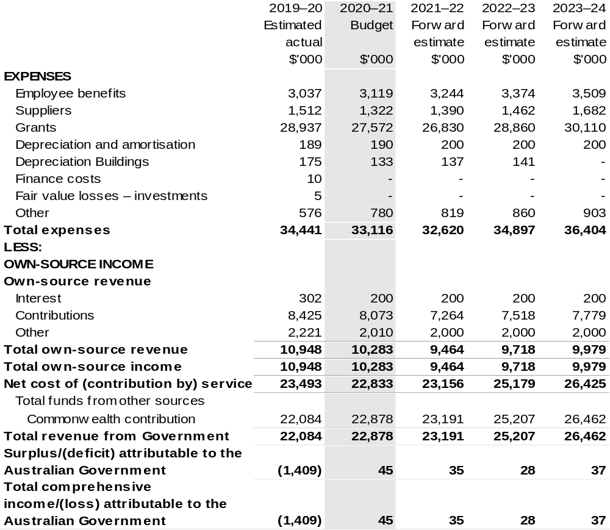
Continued on following page

Table 3.1: Comprehensive income statement (showing net cost of services)
(for the period ended 30 June)

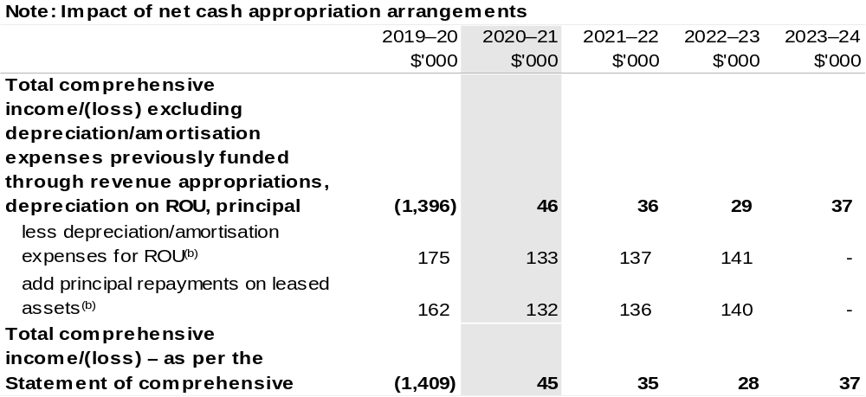
(a) Revenue from Government includes a Commonwealth contribution under the PIRD Act and levies collected from industry by the Department of Agriculture, Water and the Environment for R&D activities.
(b) Applies to leases under AASB 16 Leases. Right of USE (ROU).

Prepared on Australian Accounting Standards basis.

Table 3.2: Budgeted departmental balance sheet (as at 30 June)
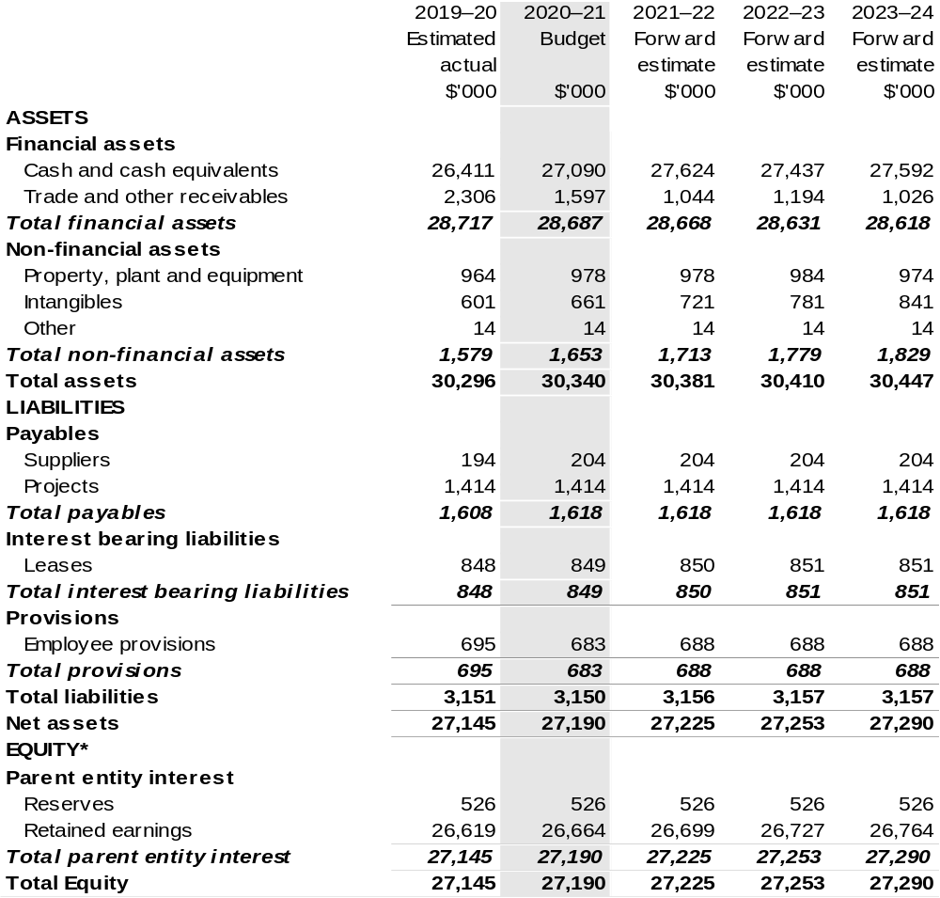
* Equity is the residual interest in assets after deduction of liabilities.

Prepared on Australian Accounting Standards basis.

Table 3.3: Departmental statement of changes in equity – summary of movement (Budget year 2020–21)
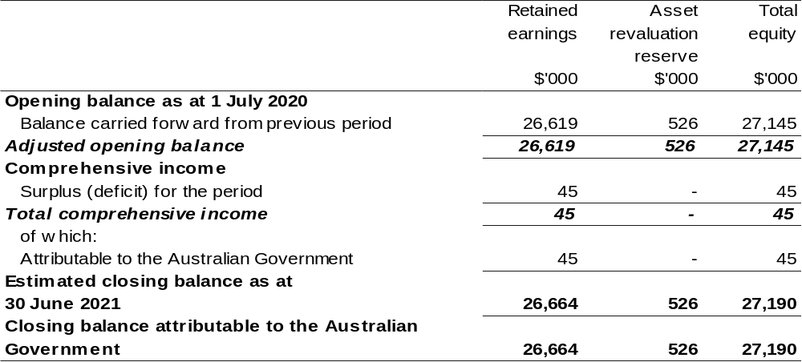

Prepared on Australian Accounting Standards basis.

Table 3.4: Budgeted departmental statement of cash flows (for the period
ended 30 June)
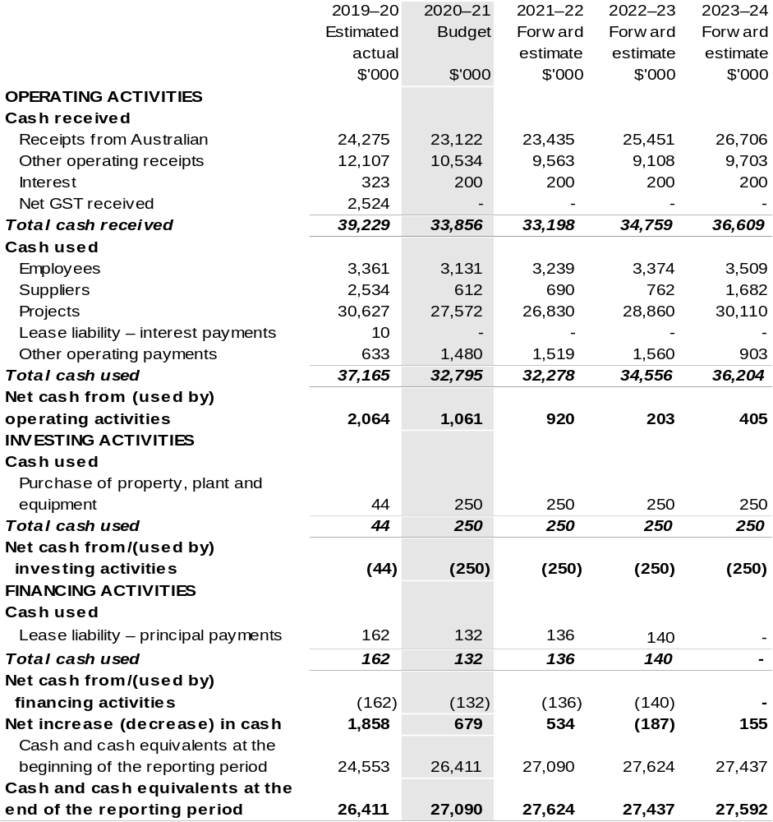

Prepared on Australian Accounting Standards basis.

Table 3.5: Departmental capital budget statement (for the period end 30 June)
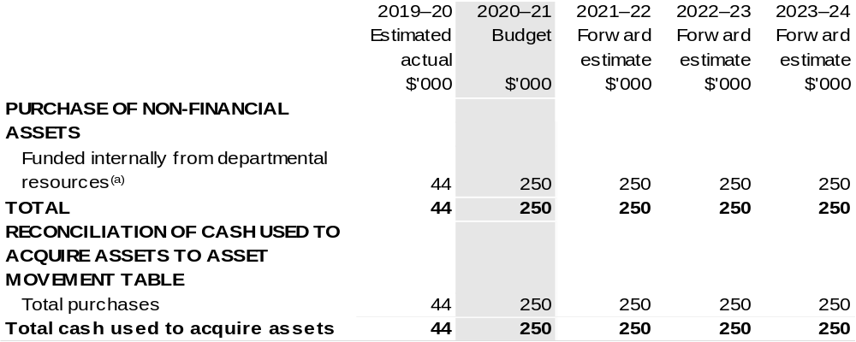

(a) Includes the following source of funding:
– internally developed assets.

Consistent with information contained in the Statement of Asset Movements and the Budgeted Statement of Cash Flows.

Table 3.6: Statement of asset movements (Budget year 2020–21)
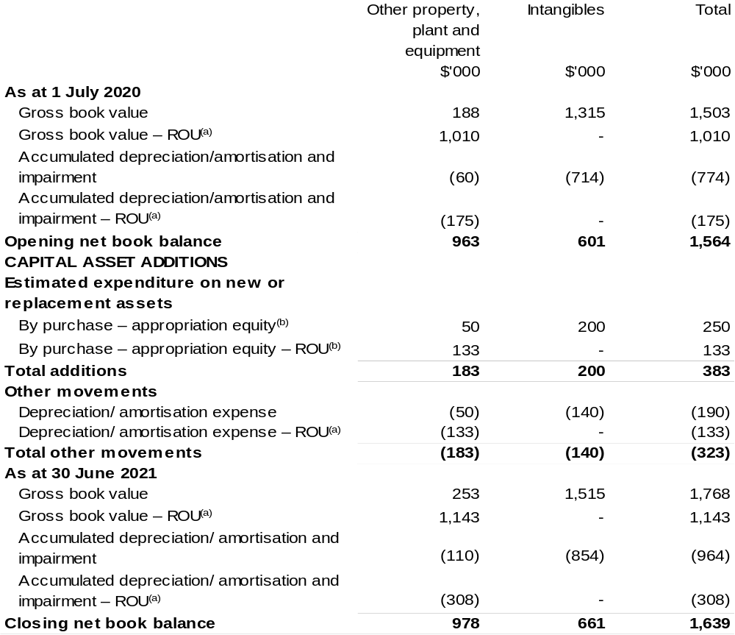

(a) Applies to leases under AASB 16 Leases. Right of Use (ROU).
(b) ‘Appropriation ordinary annual services’ refers to funding provided through Appropriation Bill (No. 1) 2020–21 for depreciation / amortisation expenses, DCBs or other operational expenses.

Prepared on Australian Accounting Standards basis.

Grains
Research and Development Corporation
Section 1: Entity overview and resources 279
1.1 Strategic direction statement 279
1.2 Entity resource statement 281
1.3 Budget measures 283
Section 2: Outcomes and planned performance 284
2.1 Budgeted expenses and performance for Outcome 1 285
Section 3: Budgeted financial statements 291
3.1 Budgeted financial statements 291
3.2 Budgeted financial statements tables 292

Grains
Research and Development Corporation

Section 1: Entity overview and resources

1.1 Strategic direction statement
The Grains Research and Development Corporation’s (GRDC) purpose is to invest in research, development and extension (RD&E) to create enduring profitability for Australian grain growers.
In supporting its purpose, GRDC invests in RD&E activities across a portfolio spanning temperate and tropical cereals (including coarse grains), pulses and oilseeds. This involves identifying and prioritising research for investment; monitoring, evaluating and reporting on research impacts; and facilitating the dissemination, adoption and commercialisation of research results.
GRDC also contributes to the development of strategic national approaches to grains industry RD&E, to reduce fragmentation and duplication and to help address industry-wide issues such as biosecurity, grains market access and sustainable resource management.
While its focus is on delivering benefits to Australian grain growers, who pay levies, GRDC also generates outcomes from investing in RD&E that benefit other participants in the Australian grains industry value chain and the wider Australian community, as well as the grains research community in Australia and overseas. GRDC investments support the capacity of the Australian research community through collaborative approaches that minimise duplication of effort and provide access to shared knowledge, infrastructure and facilities.
Effective partnerships with other Australian organisations enable GRDC to leverage resources and research capability; share market knowledge, technologies and intellectual property; and reduce the risk associated with transformational investments. GRDC also builds strong relationships with organisations overseas, both to broaden the resources available to the Australian grains industry and to access international RD&E efforts that offer potential benefits, such as food security, for Australia.
Because adoption by growers is critical to achieving benefits from research and development (R&D), GRDC undertakes activities to raise awareness of grains industry R&D and extend the results of GRDC-supported investments to grain growers and their advisers, other participants in rural industry and the wider community. Recognising different needs and preferences for receiving information, GRDC uses a range of products and channels, from phone apps to field days.
GRDC works closely with Australian grain growers and the Australian Government to ensure that their RD&E priorities are effectively addressed through GRDC investments. GRDC also maintains strong connections with its other stakeholders, particularly in the R&D and agribusiness sectors.
GRDC’s investment priorities are articulated in the RD&E Plan 2018–2023. The plan is firmly focussed on delivering research and extension investments that increase the profitability of Australian grain growers. The plan considers the key drivers of profitability in terms of yield, price, costs (on-farm and post farm gate) as well as risk.
It is important to note that the impact of different drivers on profit will vary across grain-growing businesses and environments. This will inform the potential shape and scope of the GRDC’s RD&E investment portfolio at the national level, and on the activities and approaches required to support adoption of RD&E outputs at the regional and local levels.
The RD&E Plan 2018–2023 has been informed by extensive consultation across a broad spectrum of grains industry participants, government, and research providers. The consultation identified 36 key investment targets, with relative priorities that will underpin the delivery of the GRDC’s purpose.
Detailed performance information across all the drivers of profitability through Key Investment Targets will be available in each of the GRDC Annual Operational Plans across the five-year period.

1.2 Entity resource statement
Table 1.1 shows the total funding from all sources available to the entity for its operations and to deliver programs and services on behalf of the Government.
The table summarises how resources will be applied by outcome (Government strategic policy objectives) and by administered (on behalf of the Government or the public) and departmental (for the entity’s operations) classification.
For more detailed information on special accounts and special appropriations, please refer to Budget Paper No. 4: Agency Resourcing.
Information in this table is presented on a resourcing (i.e. appropriations/cash available) basis, whilst the ‘Budgeted expenses by Outcome 1’ tables in Section 2 and the financial statements in Section 3 are presented on an accrual basis.

Table 1.1: Grains Research and Development Corporation –
Resource Statement – Budget Estimates for 2020–21 as at Budget October 2020
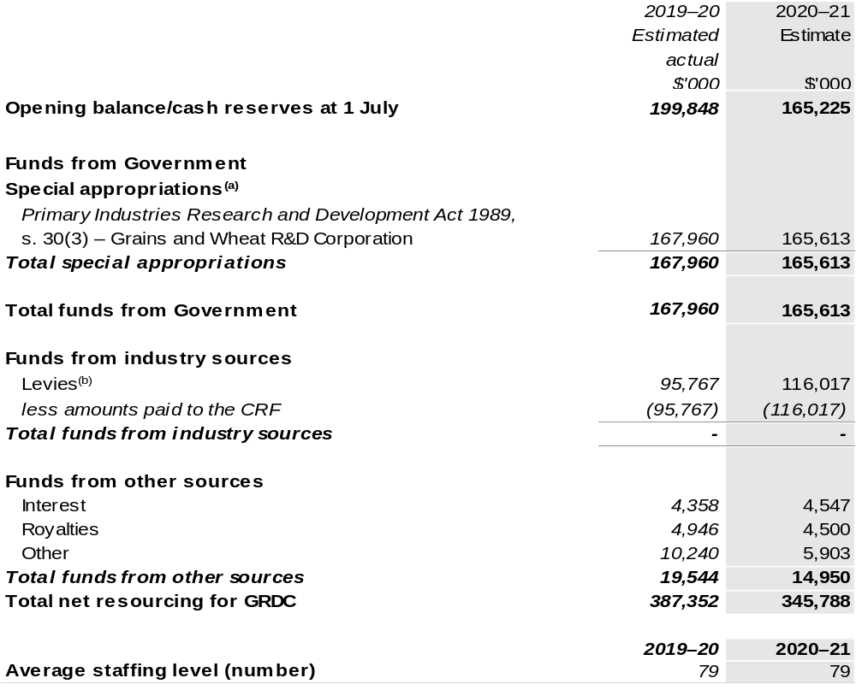
Continued on following page
Table 1.1: Grains Research and Development Corporation –
Resource Statement – Budget Estimates for 2020–21 as at Budget October 2020 (continued)

(a) GRDC is not directly appropriated as it is a corporate Commonwealth entity under the PGPA Act. Appropriations are made to the Department of Agriculture, Water and the Environment (DAWE) and then paid to GRDC and are considered departmental for all purposes
(b) The levies collected under the Primary Industries Levies and Charges Collection Act 1991 are remitted to DAWE and transferred to the CRF. An equivalent amount is paid to GRDC by DAWE under a special appropriation under the Primary Industries Research and Development Act 1989 (PIRD Act).

CRF – Consolidated Revenue Fund

Prepared on a resourcing (i.e. appropriations available) basis.

Please note: All figures shown above are GST exclusive – these may not match figures in the cash flow statement.

1.3 Budget measures
Budget measures in Part 1 relating to the Grains Research and Development Corporation are detailed in Budget Paper No. 2: Budget Measures 2020–21 and are summarised below.

Table 1.2: Grains Research and Development Corporation – 2020–21 Budget measures – Measures announced after the Economic and Fiscal Update July 2020
GRDC does not have any 2020–21 Budget measures.

Section 2: Outcomes and planned performance
Government outcomes are the intended results, impacts or consequences of actions by the Government on the Australian community. Commonwealth programs are the primary vehicle by which government entities achieve the intended results of their outcome statements. Entities are required to identify the programs which contribute to government outcomes over the Budget and forward years.
Each outcome is described below together with its related programs. The following provides detailed information on expenses for each outcome and program, further broken down by funding source.
Note:
Performance reporting requirements in the Portfolio Budget Statements are part of the Commonwealth performance framework established by the Public Governance, Performance and Accountability Act 2013. It is anticipated that the performance criteria described in Portfolio Budget Statements will be read with broader information provided in an entity’s corporate plans and annual performance statements – included in Annual Reports – to provide a complete picture of an entity’s planned and actual performance.
The most recent corporate plan for the Grains Research and Development Corporation can be found at:
https://grdc.com.au/About-Us/Corporate-Governance/Strategic-RD-Plan.
The most recent annual performance statement for the Grains Research and Development Corporation can be found at:
https://grdc.com.au/About-Us/Corporate-Governance/Annual-Report.

2.1 Budgeted expenses and performance for Outcome 1
Outcome 1: New information and products that enhance the productivity, competitiveness and environmental sustainability of Australian grain growers and benefit the industry and wider community, through planning, managing and implementing investments in grains research and development.

2.1.1: Linked programs
Department of Agriculture, Water and the Environment
Program 3.7: Grains Industry
Contribution to Outcome 1 made by linked program:
The Grains Research Development Corporation works together with the Department of Agriculture, Water and the Environment to ensure sustainable, productive and profitable grains industry.

2.2.1: Budgeted expenses for Outcome 1
This table shows how much the entity intends to spend (on an accrual basis) on achieving the outcome, broken down by program, as well as by Administered and Departmental funding sources.

Table 2.1: Budgeted expenses for Outcome 1
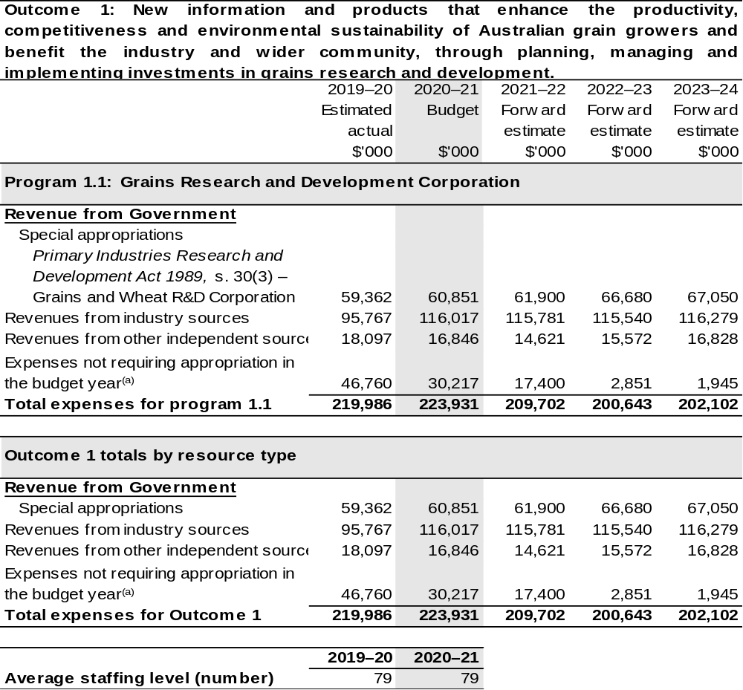
(a) Expenses not requiring appropriation in the Budget year are made up of depreciation expenses, amortisation expenses, make good expenses and audit fees.

Note: Departmental appropriation splits and totals are indicative estimates and may change in the course of the budget year as government priorities change.

Prepared on Australian Accounting Standards basis.

2.3.1: Performance criteria for Outcome 1
Table 2.3.1 below details the performance criteria for each program associated with Outcome 1. It also summarises how each program is delivered and where 2020–21 Budget measures have created new programs or materially changed existing programs.
As an entity established under the PIRD Act, GRDC does not produce a Corporate Plan under the PGPA Act and is therefore exempt from the requirement to map purposes to outcomes.
Outcome 1: New information and products that enhance the productivity, competitiveness and environmental sustainability of Australian grain growers and benefit the industry and wider community, through planning, managing and implementing investments in grains research and development.
Program 1.1: Grains Research and Development Corporation
Objective | Drive the discovery, development and delivery of world-class innovation to enhance the productivity, profitability and sustainability of Australian grain growers and benefit the industry and the wider community.
Delivery | Continue to prioritise RD&E investments that supports the enduring profitability of Australian grain growers. The target group is primarily Australian grain growers but the grains industry value chain also includes Governments, industry groups, rural and regional communities, research organisations and the wider community.
Performance information^{(a)}
Year | Performance criteria | 2019–20 Actual Achievement/Targets
2019–20 | Average farm business rates of return. | In 2019–20 Rates of Return (RoR) were 3.98 per cent.  The result is lower than the five-year average RoR from 2014–2018, which is 4.24 per cent, but above the 10-year average RoR  (2009–2018) of 3.69 per cent.  Data source: ABARES Australian grains: financial performance of grain farms 2016–17 to 2018–19.

Continued on following pages
Contributions to Outcome 1 (continued)
Performance information^{(a)}
Year | Performance criteria | 2019–20 Actual Achievement/Targets
2019–20 (continued) | Improvements in yield and yield stability. | In 2019–20 the yield increase results* were:  - Cereals – 1.02 per cent increase in yield;  - Oilseeds – 0.99 per cent increase in yield; and  - Pulses – 0.87 per cent increase in yield.  Data source: ABARES yield values 2019–20.  *Results are derived from the year on year percentage changes in the five-year average yields.
2019–20 (continued) | Yield stability. | Over a five-year average (2015–16 to 2019–20) newer wheat varieties provided a 1.78 per cent yield gain per year relative to a set of varieties which were between three and 10 years old.  Data source: 2019 National Variety Trials.  Over a four-year period (2015–2018), 70 per cent of surveyed wheat, barley and canola crops had no discernible yield gap.  Data source: Final Technical Report, GRDC National.

Continued on following pages
Contributions to Outcome 1 (continued)
Performance information^{(a)}
Year | Performance criteria | 2019–20 Actual Achievement/Targets
2019–20 (continued) | Maintaining and improving price. | Australian Export Grains Innovation Centre (AEGIC) have been collaborating with a Chinese university to undertake sensory analysis on new oat products. Oats are high in beta glucan which can provide consumers with cardiovascular health benefits. To date the investment has delivered several new oat products including oat rice and an oat milk drink.  Other relevant investments that were current in 2019–20 include:  - An AEGIC study has found that red bran not only has a large impact on the colour of whole grain bread, it also imparts a bitter flavour.  The white bran of Australian wheat does not have these issues, giving it a significant advantage in Asian countries.  - Understanding the opportunities for Australian sorghum in domestic and export food markets.  - Improving Australian malt barley flavour to address Chinese brewing requirements.  - The malt market in Vietnam has seen substantial growth over the past five years. AEGIC has conducted choice analysis with various brewers and identified their preference for malt traits.  - Study on increasing barley protein levels for the Asian brewing market.  - Diagnostic development and surveillance for biosecurity threats to Australian grains, horticulture, cotton and forestry industries.
Contributions to Outcome 1 (continued)
Performance information^{(a)}
Year | Performance criteria | 2019–20 Actual Achievement/Targets
2019–20 (continued) | Optimising input costs. | $82.68 per hectare (2018–19) or a ratio of 0.130.  Data source: ABARES Australian Agricultural and Grazing Industry Surveys.  $82.35 per hectare (2018–19) or a ratio 0.131.  Data source: ABARES Australian Agricultural and Grazing Industry Surveys.
2020–21 | As per 2019–20. | As per 2019–20.
2021–22 and beyond | As per 2019–20. | As per 2019–20.

(a) Additional performance information that support the achievement of the above performance criteria are available in the GRDC’s 2018–2023 Strategic RD&E plan.

Section 3: Budgeted financial statements
Section 3 presents budgeted financial statements which provide a comprehensive snapshot of entity finances for 2020–21, including the impact of 2020–21 Budget measures and resourcing on financial statements.

3.1 Budgeted financial statements

3.1.1: Differences between entity resourcing and financial statements
The financial statements are prepared on an accrual basis where revenues and expenses are recognised as and when the resources are received and used. The entities resourcing table recognises cash resources available to be used during the period and includes amounts recognised as revenue in previous periods.

3.2.1: Explanatory notes and analysis of budgeted financial statements
GRDC’s revenue is primarily from industry contributions in the form of levies paid on the farm gate value of grain sold and Australian Government contributions which are capped at 0.5 per cent of the three-year rolling average of gross value of production (GVP). GRDC’s revenue streams are therefore subject to the volatility of local and international grain commodity markets, farm gate costs, environmental conditions and the marketing decisions of growers. This means the assumptions in developing financial forecasts have a high degree of uncertainty and change frequently.
In 2020–21, GRDC is budgeting for an operating deficit of $30.2 million which will be funded from its own accumulated reserves. Industry contributions are expected to increase by $20.3 million on the current year estimates and in line with long term trends. Australian Government contributions are expected to increase by $1.5 million. Own source income is expected to hold steady with the slight increase in interest offset by a reduction in royalties and dividends. In support of current higher values of RD&E investment, supplier expenses, including those relating to contracted operational support services are expected to increase by $2.3 million in 2020–21.
The budgeted net asset position for 2020–21 is $187.3m million which is $30.2 million less than the 2019–20 estimated actual. This decrease is due to the reduction in investments required to manage losses that were greater than budgeted in 2019–20.

3.2 Budgeted financial statements tables

Table 3.1: Comprehensive income statement (showing net cost of services)
(for the period ended 30 June)
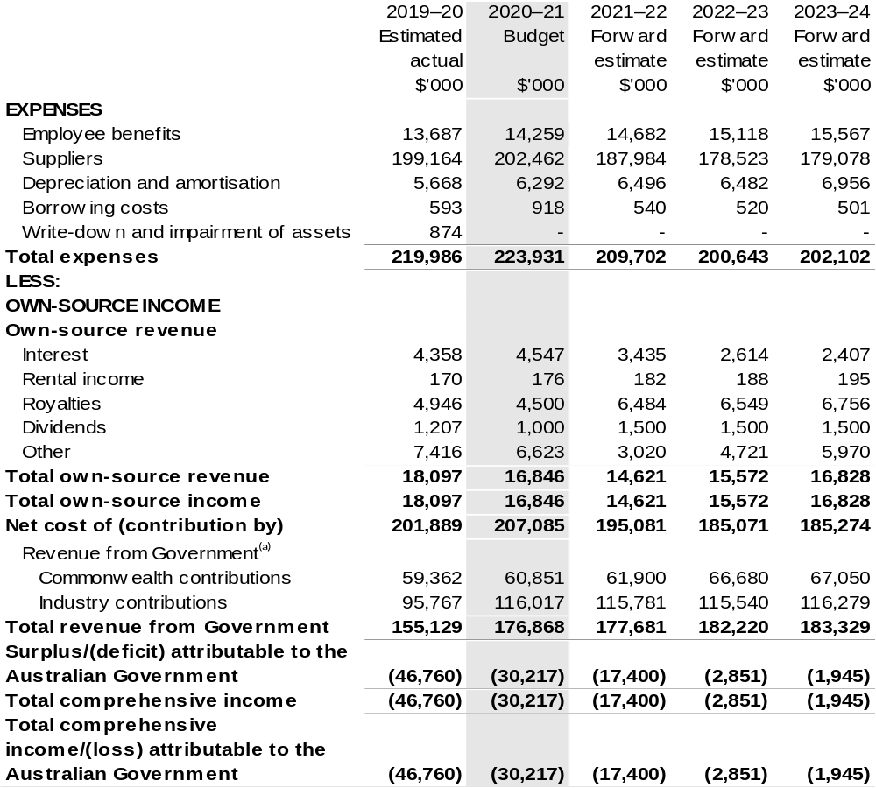
Continued on following page

Table 3.1: Comprehensive income statement (showing net cost of services) (for the period ended 30 June) (continued)
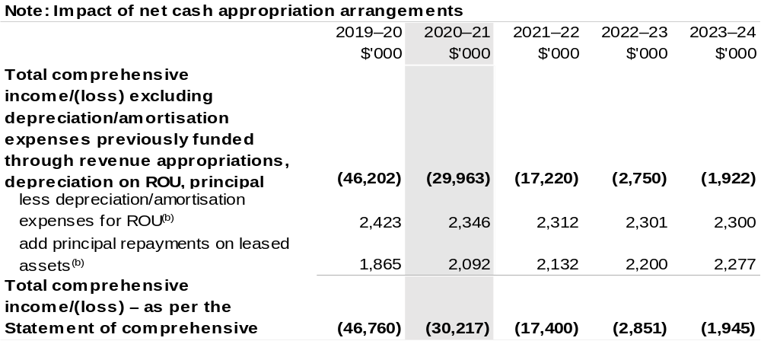
(a) Revenue from Government includes a Commonwealth contribution under the PIRD Act and levies collected from industry by the Department of Agriculture, Water and the Environment for R&D activities.
(b) Applies to leases under AASB 16 Leases. Right of Use (ROU).

Prepared on Australian Accounting Standards basis.

Table 3.2: Budgeted departmental balance sheet (as at 30 June)
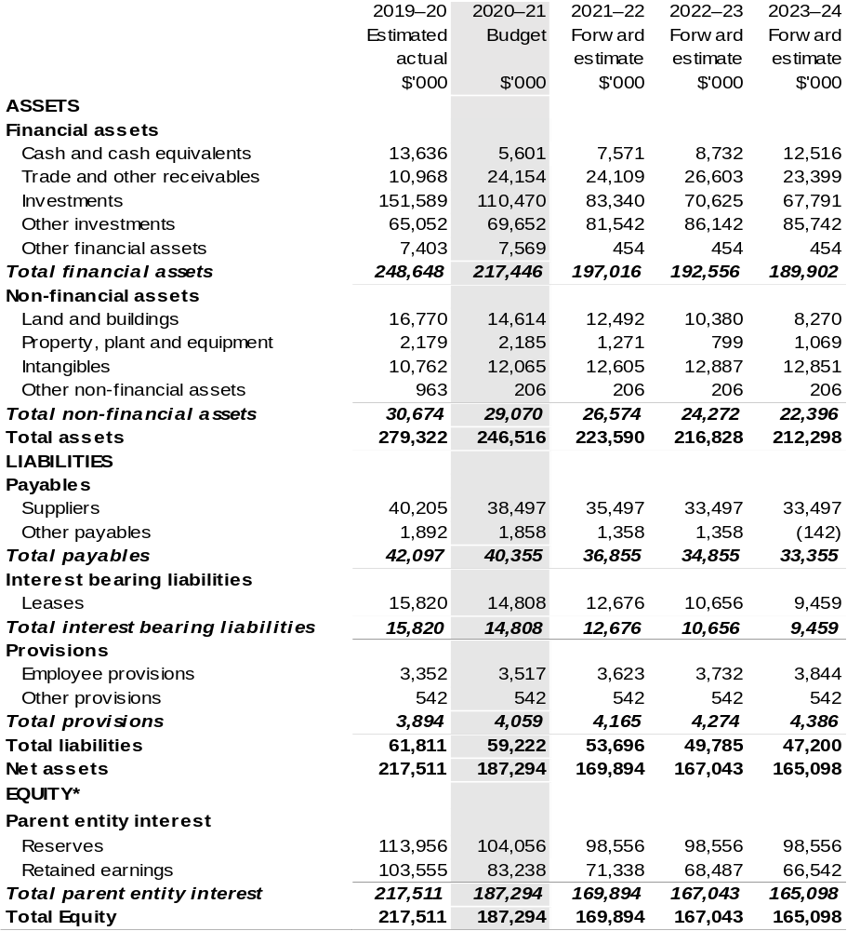
* Equity is the residual interest in assets after deduction of liabilities.

Prepared on Australian Accounting Standards basis.

Table 3.3: Departmental statement of changes in equity – summary of movement (Budget year 2020–21)
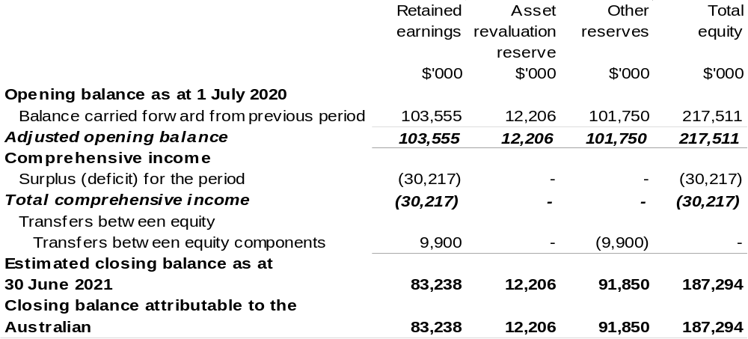

Prepared on Australian Accounting Standards basis.

Table 3.4: Budgeted departmental statement of cash flows (for the period
ended 30 June)
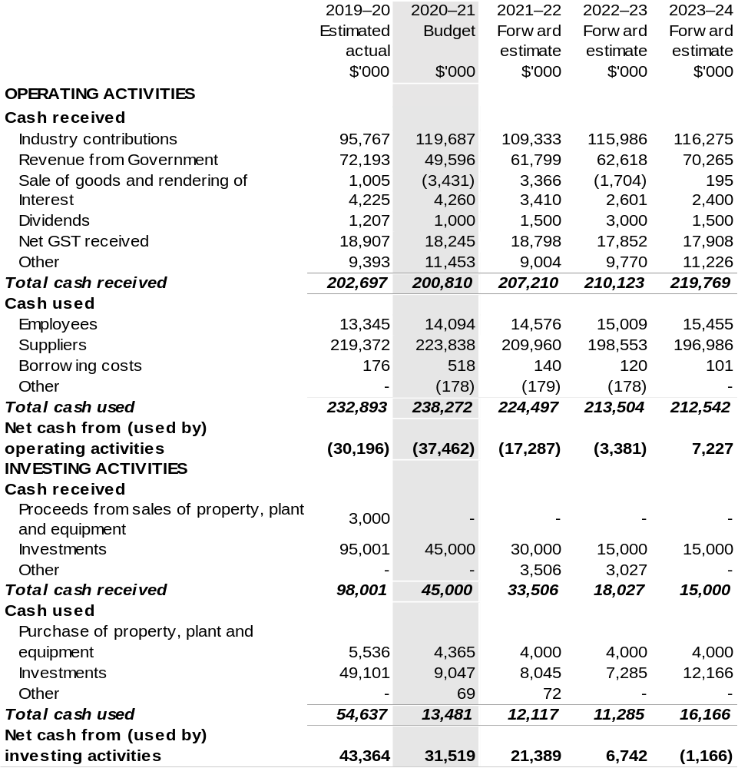

Continued on following page

Table 3.4: Budgeted departmental statement of cash flows (for the period
ended 30 June) (continued)
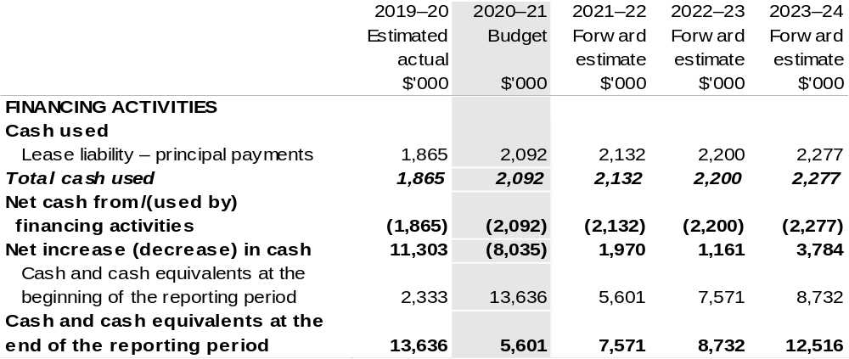

Prepared on Australian Accounting Standards basis.

Table 3.5: Departmental capital budget statement
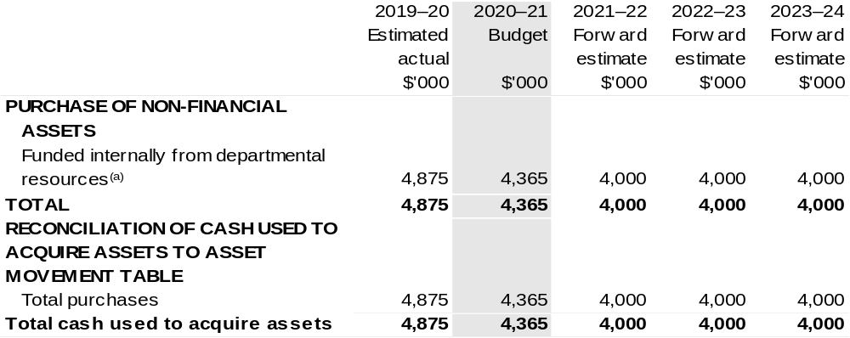
(a) Includes the following source of funding:
– internally developed assets.

Consistent with information contained in the Statement of Asset Movements and the Budgeted Statement of Cash Flows.

Table 3.6: Statement of asset movements (Budget year 2020–21)
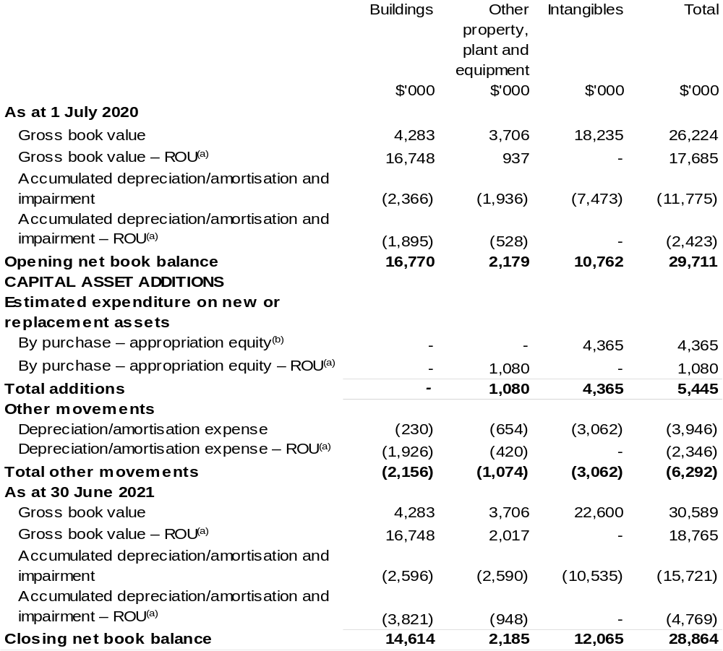

(a) Applies to leases under AASB 16 Leases. Right of Use (ROU).
(b) ‘Appropriation ordinary annual services’ refers to funding provided through Appropriation Bill (No.1) 2020–21 for depreciation / amortisation expenses, DCBs or other operational expenses.

Prepared on Australian Accounting Standards basis.

Great Barrier Reef Marine Park Authority
Section 1: Entity overview and resources 303
1.1 Strategic direction statement 303
1.2 Entity resource statement 305
1.3 Budget measures 307
Section 2: Outcome and planned performance 308
2.1 Budgeted expenses and performance for Outcome 1 309
Section 3: Budgeted financial statements 316
3.1 Budgeted financial statements 316
3.2 Budgeted financial statements tables 317

Great Barrier Reef Marine Park Authority

Section 1: Entity overview and resources

1.1 Strategic direction statement
The Great Barrier Reef Marine Park Authority (the Authority) is a world leader in marine park management, and for more than 40 years has acted to protect and conserve the Great Barrier Reef Marine Park (Marine Park) and World Heritage Area. The Great Barrier Reef (the Reef) is a vast and spectacular ecosystem and one of the most complex natural wonders on Earth. It is an iconic symbol of the nation and helps shape Australia’s global reputation. The health of the Reef is critical to the Australian and Queensland economies, supporting 64,000 full-time jobs and contributing $6.4 billion a year to the economy.
The COVID-19 pandemic has created significant, long-term challenges for Reef-dependent businesses, particularly tourism operators. The Authority is supporting those communities throughout the recovery process, and prioritising our work accordingly in consultation with the Authority’s Board. The Authority has adapted rapidly and effectively to respond to COVID-19 impacts on our internal operations, as well as how we engage with Reef stakeholders.
The Authority continues to take a strategic approach to ensuring the long-term protection, ecologically sustainable use, understanding and enjoyment of the Great Barrier Reef for all Australians and the international community through the care and development of the Marine Park. The Authority was established under the Great Barrier Reef Marine Park Act 1975 to fulfil this purpose.
The Authority protects the Reef from its key threats, the most concerning of which come from outside the Marine Park boundary. As identified in the Authority’s 2019 Outlook Report, the most concerning threats to the Reef are the impacts of climate change, and land-based runoff from Reef catchments and coastal development. To address these challenges, the Authority will continue to oversee a range of Reef management programs and provide advice to decision makers on managing, reducing or avoiding significant threats to the Reef.
While action to address climate change remains critical, the Authority also recognises the need to intensify efforts and adopt new approaches to build the Reef’s resilience to current and future disturbances, as well as support its ongoing recovery from previous disturbances. The Authority’s Zoning Plan and established management practices are the foundation upon which new approaches can be tailored to promote recovery and resilience of the ecosystem. The Policy and Planning Strategic Roadmap has been developed to focus the Authority’s efforts to deliver a proactive, contemporary and risk-based approach to Marine Park policy, planning and regulation that will protect key values and enable ecologically sustainable use for a changed and changing Reef.
The Authority will continue to implement our innovative and adaptive Blueprint for Resilience, which emphasises the need for collaborative, targeted actions that include:
- Building a resilience network.
- Delivering on-ground actions to enhance resilience.
- Empowering others to be part of the solution.
The Authority’s management of the Marine Park is enhanced by its partnership with the Queensland Government through the award-winning Reef Joint Field Management Program. This Program is an essential part of managing the Marine Park through conservation actions, monitoring Reef health, responding to incidents, and enforcing the Zoning Plan. The Australian Government provided an additional $42.7 million over six years from 2018–19 and an ongoing commitment of $10.2 million (indexed) beyond that point to the Reef Joint Field Management Program, which will increase the presence and delivery of field activities essential for the Reef’s resilience. This new funding has been matched by the Queensland Government. Later this year, the new patrol vessel, the Reef Resilience, will join our fleet of Field Management vessels, to expand our management capabilities. The Authority also partners with Parks Australia as the Coral Sea Commonwealth Marine Reserve adjoins the Marine Park and provides complementary environmental protection for the region.
The Authority works with Traditional Owners of the Reef to implement the Aboriginal and Torres Strait Islander Heritage Strategy to keep their Indigenous heritage strong, safe and healthy, and move towards a future where the enduring culture and connection of Reef Traditional Owners with their Sea Country is widely recognised. More broadly, the Authority continues to empower communities and industry to protect and conserve the Reef through actives that support recovery and resilience.
In 2015, the Australian and Queensland Governments released the Reef 2050 Long-Term Sustainability Plan (the Reef 2050 Plan). The Authority will continue to play a key role implementing the Reef 2050 Plan which sets an overarching framework for protection of the Reef’s Outstanding Universal Value. The Reef 2050 Plan is the subject of a significant review in 2020, which will outline the strategic direction of the Australian and Queensland Government’s management of the Reef.
The Authority engages with the international community in support of the protection of coral reefs world-wide. Australia, through the Authority, was one of eight countries that founded the International Coral Reef Initiative (ICRI) in 1994 – and has been an active member over the past 25 years. Australia is currently co-chairing the ICRI Secretariat with Monaco and Indonesia. ICRI also provides a united voice to raise awareness, and encourage action, to combat pressures on coral reefs that are occurring at a global scale.
The Authority remains optimistic that, by advancing multi-pronged solutions, including enhanced on-ground management, we can improve the resilience of this magnificent ecosystem.

1.2 Entity resource statement
Table 1.1 shows the total funding from all sources available to the entity for its operations and to deliver programs and services on behalf of the Government.
The table summarises how resources will be applied by outcome (Government strategic policy objectives) and by administered (on behalf of the Government or the public) and departmental (for the entity’s operations) classification.
For more detailed information on special accounts and special appropriations, please refer to Budget Paper No. 4: Agency Resourcing.
Information in this table is presented on a resourcing (i.e. appropriations/cash available) basis, whilst the ‘Budgeted expenses by Outcome 1’ tables in Section 2 and the financial statements in Section 3 are presented on an accrual basis.

Table 1.1: Great Barrier Reef Marine Park Authority – Resource Statement –Budget Estimates for 2020–21 as at October 2020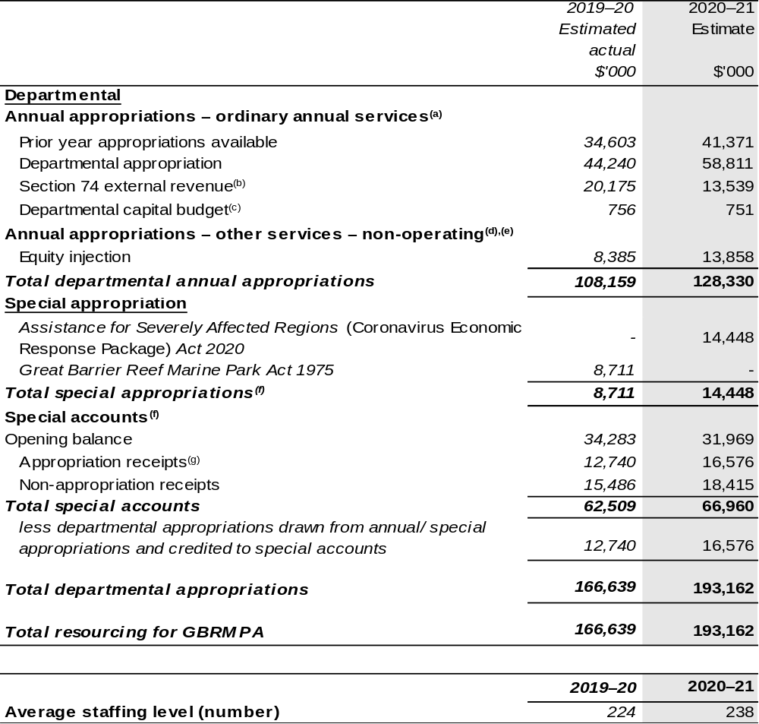
- Supply Act (No. 1) Appropriation Bill (No. 1) 2020–2021.
- Estimated external revenue receipts under section 74 of the PGPA Act.
- Departmental capital budgets are not separately identified in Supply Act (No. 1) and Appropriation Bill (No. 1) and form part of ordinary annual services items. Please refer to Table 3.7 for further details. For accounting purposes, this amount has been designated as a ‘contribution by owner’.
- Amounts credited to the Authority as special appropriation under Section 65(a) of the Great Barrier Reef Marine Park Act 1975.
- Supply Act (No. 2) and Appropriation Bill (No. 2) 2020–21.
- Excludes trust moneys held in Services for Other Entities and Trust Moneys (SOETM) and other special accounts. For further information on special accounts, please refer to Budget Paper No. 4: Agency Resourcing. Please also see Table 2.1 for further information on outcome and program expenses broken down by various funding sources, e.g. annual appropriations, special appropriations and special accounts.
- Amounts credited to the special account(s) from the Authority’s annual and special appropriations.

Prepared on a resourcing (i.e. appropriations available) basis.

Please note: all figures shown above are GST exclusive – these may not match figures in the cash flow statement.

1.3 Budget measures
Budget measures in Part 1 relating to the Great Barrier Reef Marine Park Authority are detailed in Budget Paper No. 2: Budget Measures 2020–21 and are summarised below.

Table 1.2: Great Barrier Reef Marine Park Authority – 2020–21 Budget measures – Measures announced after the Economic and Fiscal Update July 2020
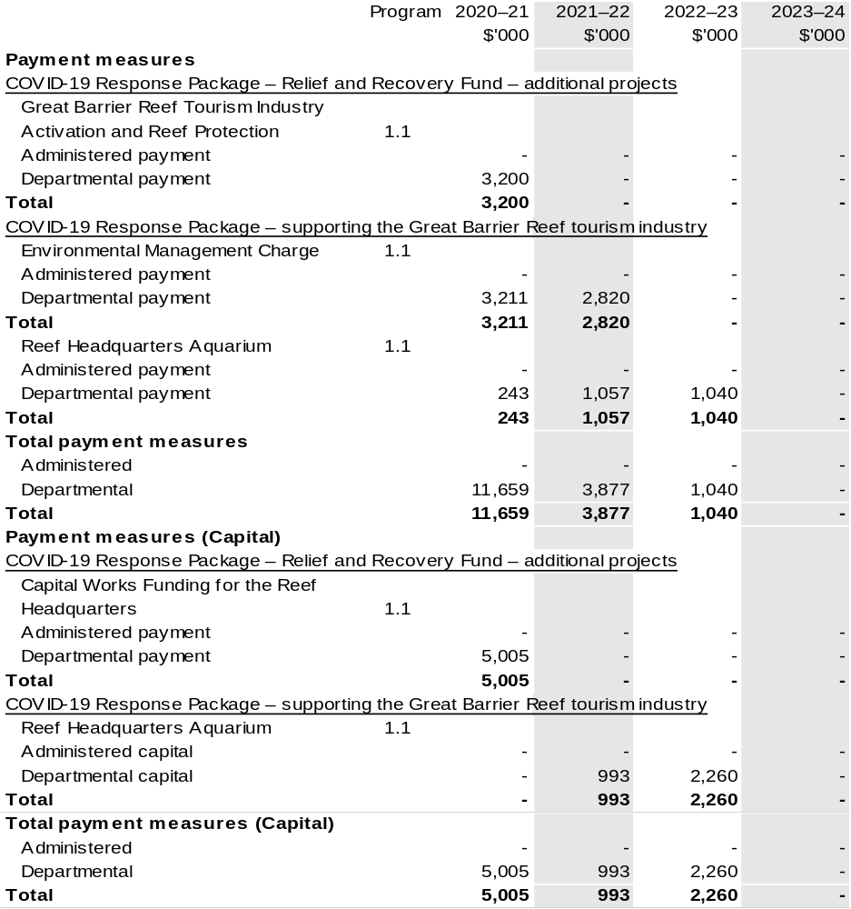

Prepared on a Government Finance Statistics (Underlying Cash) basis

Section 2: Outcomes and planned performance
Government outcomes are the intended results, impacts or consequences of actions by the Government on the Australian community. Commonwealth programs are the primary vehicle by which government entities achieve the intended results of their outcome statements. Entities are required to identify the programs which contribute to government outcomes over the Budget and forward years.
Each outcome is described below together with its related programs. The following provides detailed information on expenses for each outcome and program, further broken down by funding source.
Note:
Performance reporting requirements in the Portfolio Budget Statements are part of the Commonwealth performance framework established by the Public Governance, Performance and Accountability Act 2013. It is anticipated that the performance criteria described in Portfolio Budget Statements will be read with broader information provided in an entity’s corporate plans and annual performance statements – included in Annual Reports – to provide a complete picture of an entity’s planned and actual performance.
The most recent corporate plan for the Great Barrier Reef Marine Park Authority can be found at: http://www.gbrmpa.gov.au/about-us/corporate-plan.
The most recent annual performance statement can be found at: http://www.gbrmpa.gov.au/about-us/annual-report.

2.1 Budgeted expenses and performance for outcome 1
Outcome 1: The long-term protection, ecologically sustainable use, understanding and enjoyment of the Great Barrier Reef for all Australians and the international community, through the care and development of the Marine Park.

2.1.1: Linked programs
Australian Institute of Marine Science
Program 1: Marine Research
Contribution to Outcome 1 made by linked programs
The Great Barrier Reef Marine Park Authority (GBRMPA) and the Australian Institute of Marine Science work together on implementation of the Reef 2050 Plan to protect and conserve the Great Barrier Reef.
Clean Energy Finance Corporation
Program 1.1: Clean Energy Finance Corporation
Contribution to Outcome 1 made by linked programs
The Clean Energy Finance Corporation is making available up to $1 billion of investment finance over 10 years for the Reef Funding Program. This program will deliver financial investment in clean energy projects delivered in the Great Barrier Reef catchment region. In targeting the financing of clean energy projects and businesses in the region, the Reef Funding Program supports delivery of the Australian and Queensland Governments’ Reef 2050 Plan.
Department of Agriculture, Water and the Environment
Program 1.1: Sustainable Management of Natural Resources and the Environment
Program 1.4: Conservation of Australia’s Heritage and Environment
Program 1.5: Environmental Regulation
Contribution to Outcome 1 made by linked programs
The Department of Agriculture, Water and the Environment (DAWE) and GBRMPA work together on heritage management, environment health, species conservation and fisheries management as well as joint implementation of the Reef 2050 Plan to protect and conserve the Great Barrier Reef. Climate Change is the most significant threat to the Great Barrier Reef. DAWE is responsible for policy to support an effective global response to climate change and for adapting to climate change.

2.1.1: Linked programs (continued)
Director of National Parks
Program 1.1: Parks and Reserves: healthy and resilient parks, gardens and marine reserves, protecting nature and culture and valued by the community now and into the future
Contribution to Outcome 1 made by linked programs
The Coral Sea Commonwealth Marine Reserve managed by the Director of National Parks adjoins the Great Barrier Reef Marine Park and provides complementary protection for ecosystems and biodiversity in the region.

2.2.1: Budgeted expenses for Outcome 1
This table shows how much the entity intends to spend (on an accrual basis) on achieving the outcome, broken down by program, as well as by Administered and Departmental funding sources.

Table 2.1: Budgeted expenses for Outcome 1
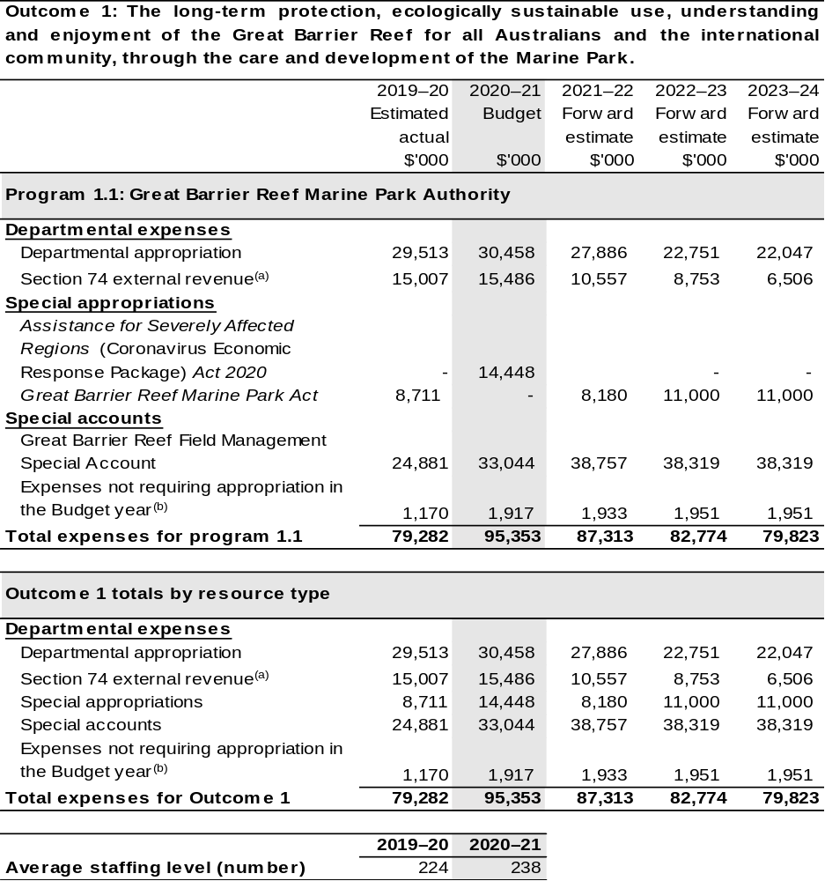

- Estimated expenses incurred in relation to receipts retained under section 74 of the PGPA Act.
- Expenses not requiring appropriation in the Budget year are made up of depreciation expenses, amortisation expenses, lease expenses, make good expense and audit fees.

Note: Departmental appropriation splits and totals are indicative estimates and may change in the course of the budget year as government priorities change.

Prepared on Australian Accounting Standards basis.

2.3.1: Performance criteria for Outcome 1
Table 2.3.1 below details the performance criteria for each program associated with Outcome 1. It also summarises how each program is delivered and where 2020–21 Budget measures have created new programs or materially changed existing programs.
Outcome 1: The long-term protection, ecologically sustainable use, understanding and enjoyment of the Great Barrier Reef for all Australians and the international community through the care and development of the Marine Park.
Program 1.1: Great Barrier Reef Marine Park Authority
Objective | Protects and manages the environment, biodiversity, and heritage values of the Great Barrier Reef Region, and ensures the ecologically sustainable use and benefits of the Great Barrier Reef Marine Park for current and future generations.
Delivery | Program 1.1 will be delivered by:  - Enhancing Reef resilience by providing expert knowledge to advise key decision makers on managing, reducing or avoiding significant threats to the Reef.  - Enhancing Reef resilience through innovation, management and regulation of the Marine Park and our in-field presence.  - Enhancing Reef resilience through partnerships, collaboration and education.  - Supporting a high-performing organisation.
Performance information
Year | Performance criteria | 2019–20 Actual Achievement/Targets
2019–20 | The Authority is the authoritative voice on the Reef; its positions on values and threats to the Reef shape its priorities and investment and that of its key stakeholders.  On track | Key stakeholders policies, positions and priorities are influenced by the Authority’s strategic advice and position statements for key issues, values and threats.  In progress.  The Reef Knowledge System framework delivers improved access to data to support Reporting, Incident Response and Reef 2050 planning and adaptive management of the Great Barrier Reef.  In progress.

Contributions to Outcome 1 (continued)
Performance information
Year | Performance criteria | 2019–20 Actual Achievement/Targets
2019–20 (continued) |  | Reef Outlook report is delivered by June 2019 and recognised as the authoritative source on the state of the Reef and utilised by key partners, stakeholders, and international bodies and internal and Reef 2050 programs and activities.  Achieved.
2019–20 (continued) | Planning, permissions and compliance activities enable use of the Marine Park that is ecologically sustainable.  On track | A risk based approach for regulation of Marine Park activities is developed.  Achieved.  Permissions facilitate sustainable use in the Marine Park.  Achieved.  Reduced non-compliance of Marine Park users.  Not achieved.
2019–20 (continued) | The Authority, its partners, and the public improve stewardship of the Reef through their commitment to, and adoption of, sustainable behaviours and best practices relevant to the Reef.  On track | Reef HQ exhibitions, public and community education activities improve awareness, attitudes and aspirations.  Achieved.  Stewardship partnerships, networks and programs deliver outcomes informed by and consistent with the Authority’s positions.  Achieved.

Contributions to Outcome 1 (continued)
Performance information
Year | Performance criteria | 2019–20 Actual Achievement/Targets
2019–20 (continued) | Incident responses and interventions by the Authority and partners improve Reef health, and enhance future knowledge and capability.  On track | Incident response is effective and efficient, and mitigates damage to the Reef.  Achieved.  Stakeholders and partners are aware of and understand future intervention priorities and locations.  In progress.  Management activities and priority conservation actions are delivered on budget, provide the intended impact and inform future activities.  In progress.  Capability is developed to implement effective new approaches to conservation.  In progress.
2020–21 | The Reef is Protected:  Percentage allocated short-term actions that are ‘on track’ or ‘completed’ in the Aboriginal and Torres Strait Islander Heritage Strategy for the Great Barrier Reef Marine Park. | 75 per cent.  On track.
2020–21 | The Reef is Protected:  Proportion of Policy and Planning Roadmap agreed actions for 2020–21 that are either ‘on track’ or ‘completed’. | 85 per cent.  On track.
2020–21 | Sustainable use of the Reef:  Proportion of effective KPIs identified in the Authority’s Regulator Performance Framework Self-Assessment 2020–21. | 100 per cent of key performance indicators are ‘effective’ or ‘mostly effective’.  On track.
2020–21 | Sustainable use of the Reef:  Proportion of Joint Field Management Program Annual Business Plan targets achieved or with significant progress 2020–21. | 85 per cent.  On track.

Contributions to Outcome 1 (continued)
Performance information
Year | Performance criteria | 2019–20 Actual Achievement/Targets
2020–21 (continued) | The Reef is Understood:  Identify priority knowledge gaps for Reef management. | Develop revised Science for Information Needs Strategy by end 2020–21.  On track.
2020–21 (continued) | The Reef is Understood:  Reef Integrated Monitoring and Reporting Business Strategy defines the activities of the Reef 2050 Reef Integrated Monitoring and Reporting program (RIMReP) and includes a measurable Annual Business Plan for 2021–22. | Develop Business Strategy 2020–2025, which is endorsed by partners, and develop an Annual Business Plan for 2021–22 by the end of 2020–21.  On track.
2021–22 and beyond | As per 2020–21. | As per 2020–21.
Purpose | Our Purpose is to ensure the long-term protection, ecologically sustainable use, understanding and enjoyment of the Great Barrier Reef for all Australians and the international community through the care and development of the Marine Park.

Section 3: Budgeted financial statements
Section 3 presents budgeted financial statements which provide a comprehensive snapshot of entity finances for 2020–21, including the impact of 2020–21 Budget measures and resourcing on financial statements.

3.1 Budgeted financial statements

3.1.1: Differences between entity resourcing and financial statements
The financial statements are prepared on an accrual basis where revenues and expenses are recognised as and when the resources are received and used. The entity resourcing table recognises cash resources available to be used during the period and includes amounts recognised as revenue in previous periods.

3.2.1: Explanatory notes and analysis of budgeted financial statements
Changes in appropriation from 2019–20 to 2020–21 are the result of the additional funding received in 2020–21 for the Joint Field Management Program, National Education Centre for the Great Barrier Reef – refurbishment, funding through the COVID-19 Economic Response Package and 2020–21 Budget measures in Table 1.2

3.2 Budgeted financial statements tables

Table 3.1: Comprehensive income statement (showing net cost of services) for the period ended 30 June 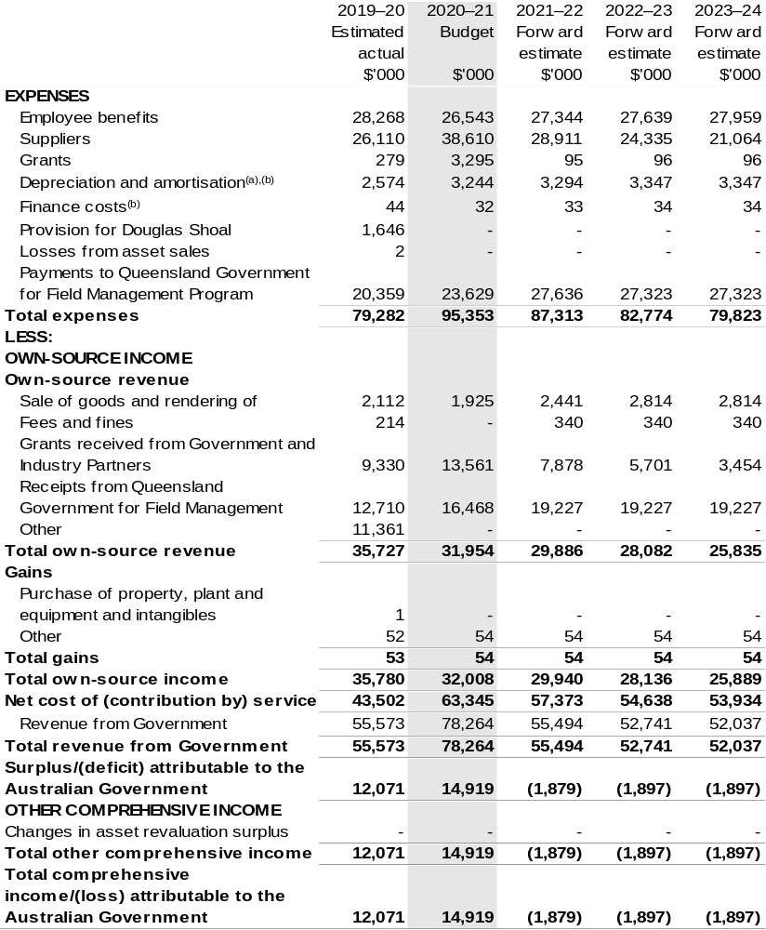
Continued on following page

Table 3.1: Comprehensive income statement (showing net cost of services) for the period ended 30 June (continued)
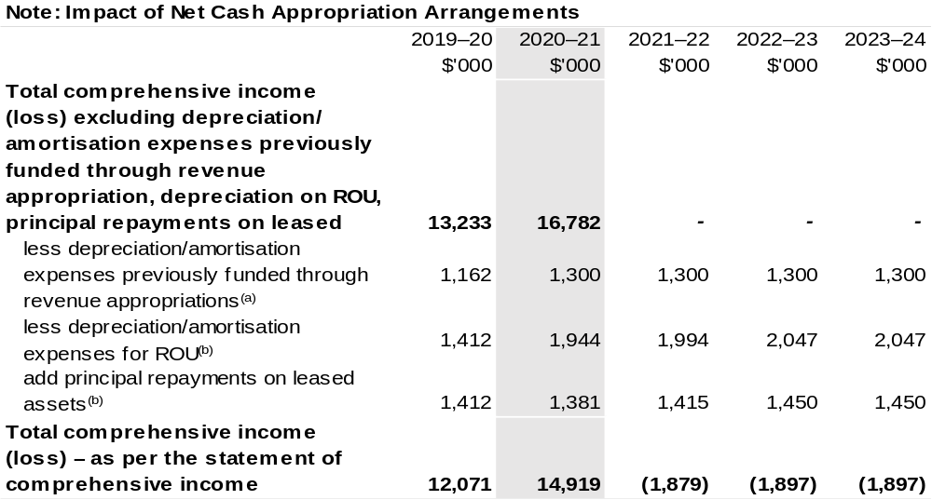
- From 2010–11, the Government introduced net cash appropriation arrangements where Appropriation Bill (No. 1) or Bill (No. 2) revenue appropriations for the depreciation/amortisation expenses of non-Corporate Commonwealth Entities were replaced with a separate capital budget (the Departmental Capital Budget, or DCB) provided through Appropriation Bill (No. 1) or Bill (No. 2) equity appropriations. For information regarding DCBs, please refer to Table 3.5 Departmental Capital Budget Statement.
- Applies to leases under AASB 16 Leases. Right of Use (ROU).

Prepared on Australian Accounting Standards basis

Table 3.2: Budgeted departmental balance sheet (as at 30 June)
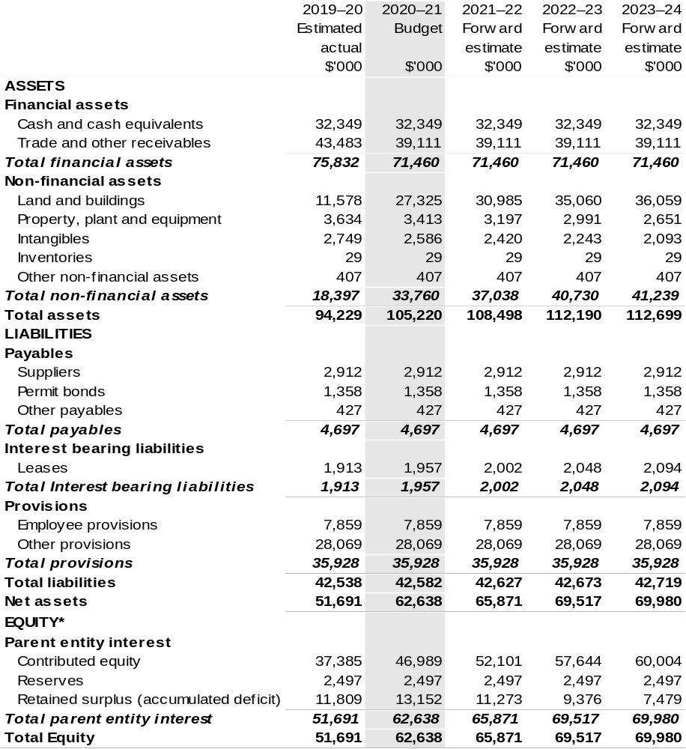
*Equity is the residual interest in assets after deduction of liabilities.

Prepared on Australian Accounting Standards basis.

Table 3.3: Departmental statement of changes in equity – summary of movement (Budget year 2020–21)
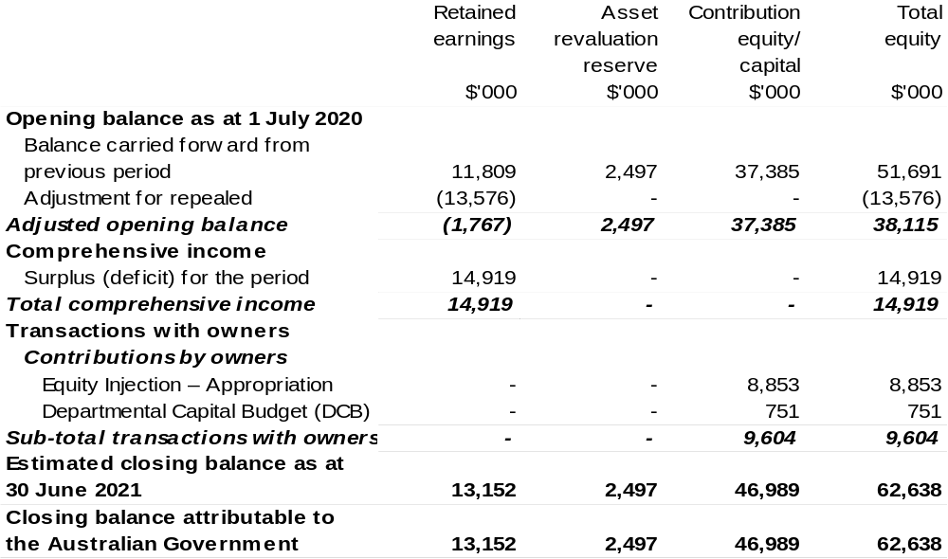

Prepared on Australian Accounting Standards basis.

Table 3.4: Budgeted departmental statement of cash flows (for the period
ended 30 June)
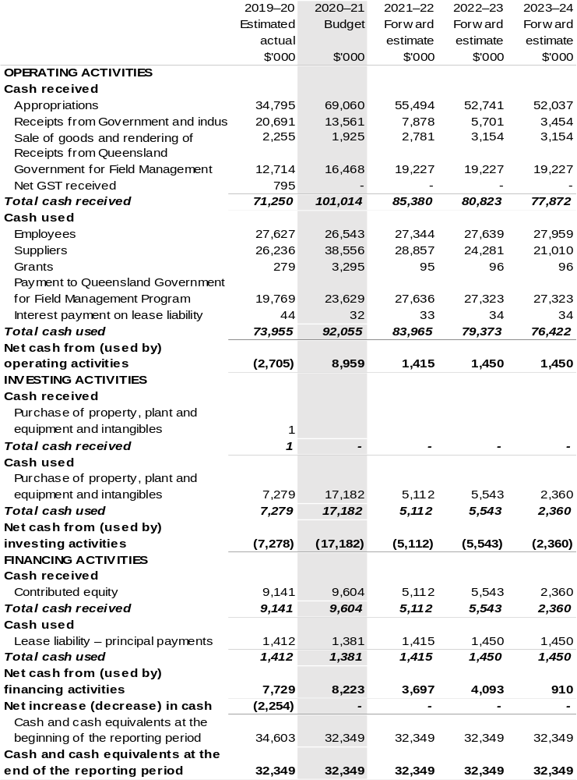

Prepared on Australian Accounting Standards basis.

Table 3.5: Departmental capital budget statement (for the period ended 30 June)
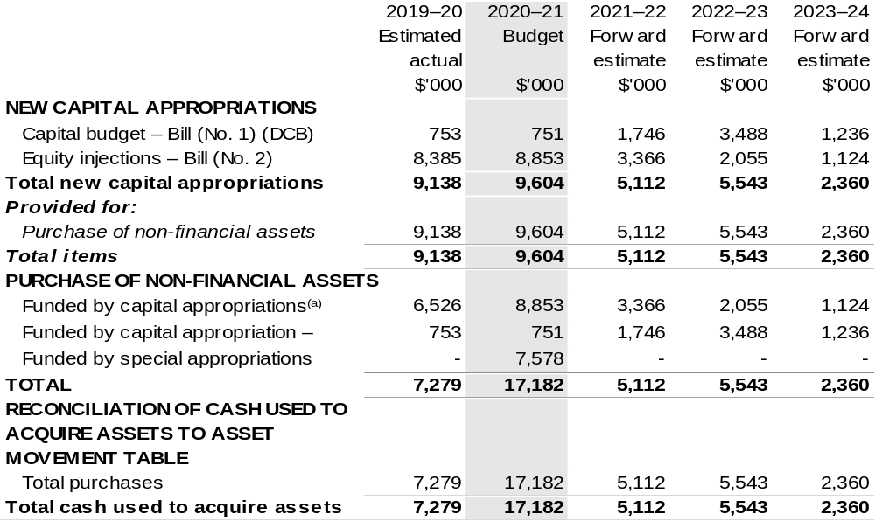
- Includes current Appropriation Bill (No. 2) and prior year Appropriation Bill No. 2/4/6.
- Does not include annual finance lease costs. Includes purchases from current and previous years’ Departmental capital budgets (DCBs).
- Includes the following sources of funding:
– current Bill (No. 1) and prior year Act/Bill (No. 1/3/5) appropriations (excluding amounts from the DCBs);
– donations and gifts of non-financial assets;
– internally developed assets;
– section 74 external revenue; and
– proceeds from the sale of assets.

Consistent with information contained in the Statement of Asset Movements and the Budgeted Statement of Cash Flows.

Prepared on Australian Accounting Standards basis.

Table 3.6: Statement of asset movements (Budget year 2020–21)
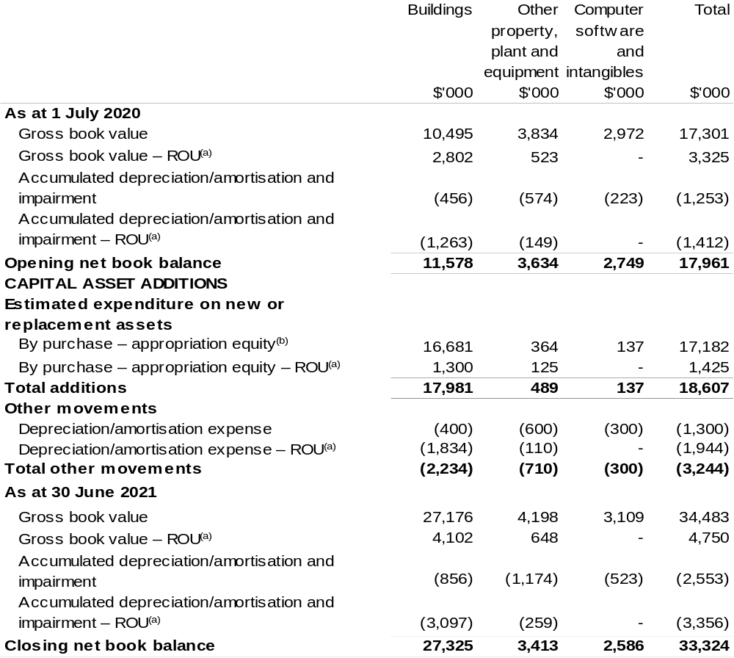
(a) Applies to leases under AASB 16 Leases. Right of Use (ROU).
(b) "Appropriation ordinary annual services" refers to funding provided through Supply Act (No. 1) and Appropriation Bill (No. 1) 2020–21 for depreciation / amortisation expenses, DCBs or other operational expenses.

Prepared on Australian Accounting Standards basis.

Table 3.7: Schedule of budgeted income and expenses administered on behalf of Government (for the period ended 30 June)
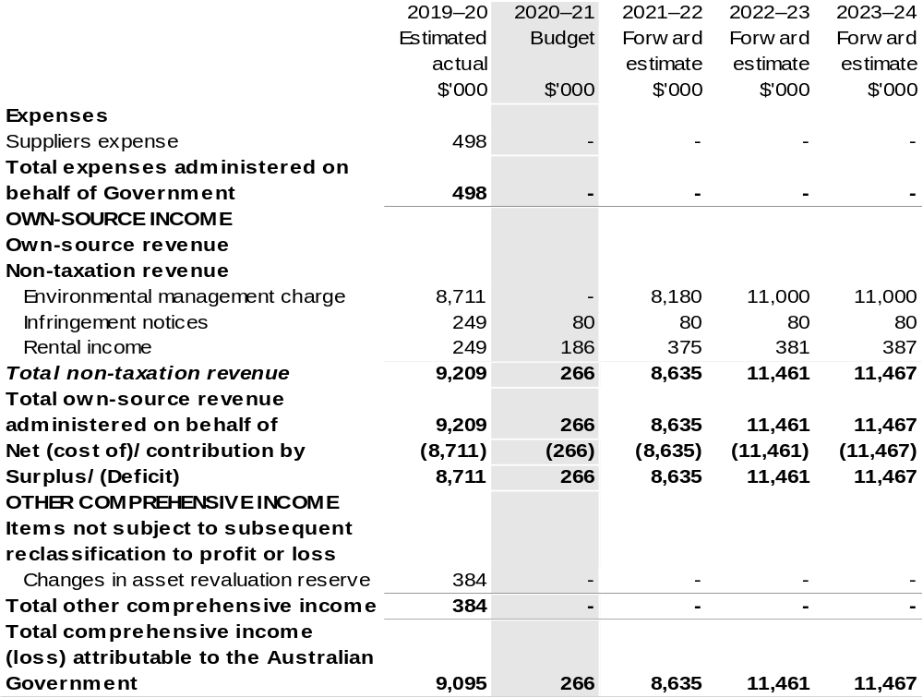
Prepared on Australian Accounting Standards basis.

Table 3.8: Schedule of budgeted assets and liabilities administered on behalf of Government (as at 30 June)
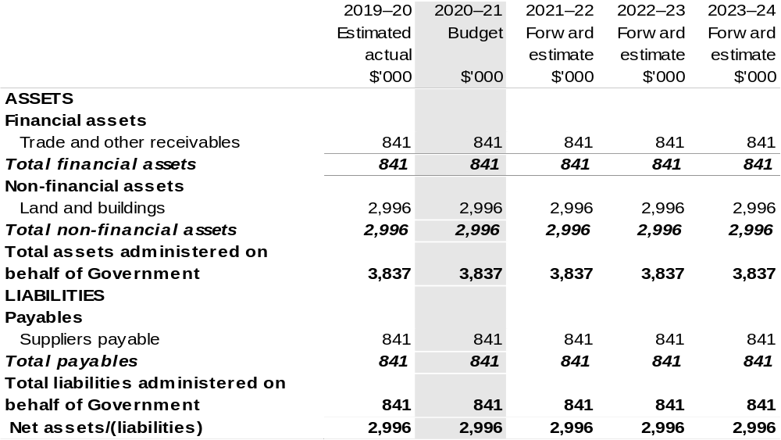
Prepared on Australian Accounting Standards basis.

Table 3.9: Schedule of budgeted administered cash flows (for the period
ended 30 June)
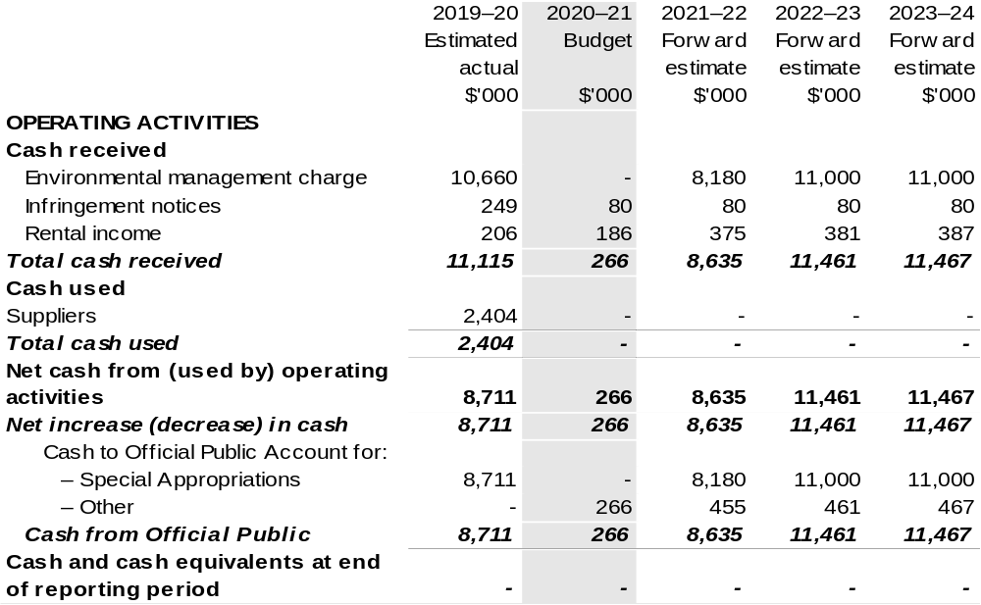
Prepared on Australian Accounting Standards basis.

Table 3.10: Statement of asset movements (Budget year 2020–21)
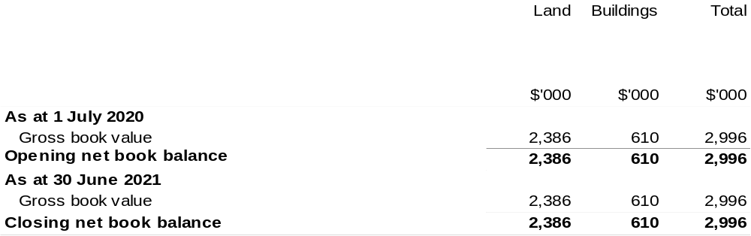

Prepared on Australian Accounting Standards basis.

Murray-Darling Basin Authority
Section 1: Entity overview and resources 331
1.1 Strategic direction statement 331
1.2 Entity resource statement 333
1.3 Budget measures 335
Section 2: Outcomes and planned performance 336
2.1 Budgeted expenses and performance for Outcome 1 337
Section 3: Budgeted financial statements 341
3.1 Budgeted financial statements 341
3.2 Budgeted financial statements tables 343

Murray-Darling Basin Authority

Section 1: Entity overview and resources

1.1 Strategic direction statement
The Murray-Darling Basin Authority (MDBA) establishes and monitors the sustainable and integrated management of the water resources of the Murray-Darling Basin. We do this in a way that best meets the social, economic and environmental needs of the Basin and its communities. We work in collaboration with other Australian Government agencies, Basin State governments, local governments, regional bodies, industry groups, landholders, environmental organisations, scientists, research organisations and
Murray-Darling Basin communities, including Indigenous communities, and the broader Australian community.
The MDBA achieves this through its outcome:
Outcome 1: Equitable and sustainable use of the Murray-Darling Basin by governments and the community including through development and implementation of a Basin Plan, operation of the River Murray system, shared natural resource management programs, research, information and advice.
In addition to its functions under the Water Act 2007, the MDBA has functions under the Murray-Darling Basin Agreement (Agreement), which forms Schedule 1 to the Act. These include giving effect to decisions of the Murray-Darling Basin Ministerial Council and the Basin Officials’ Committee in relation to the Basin governments’ joint programs. The MDBA delivers its functions under the Agreement in conjunction with and on behalf of the contracting governments – the Australian Government and the governments of Victoria, South Australia, New South Wales, Queensland and the Australian Capital Territory.
Our purpose
To achieve a healthy working Basin through the integrated management of water resources for the long-term benefit of the Australian community.
Our objectives
During 2020–21, the MDBA will continue to focus its efforts on implementing the Basin Plan.
Key priorities are to:
- Drive the successful implementation of the Basin Plan;
- Strengthen the culture of compliance in the Murray-Darling Basin;
- Efficiently and effectively operate the River Murray System for partner governments;
- Improve transparency and confidence in the Basin Plan; and
- Apply the best available science and knowledge to the management of the
Murray-Darling Basin.
Throughout 2020–21, the MDBA will also continue to work with and on behalf of the Basin governments to deliver the following priorities:
- The Basin Plan and water reform are understood with a strong baseline of commitment from all key stakeholders, including State and Territory governments, to a healthy working basin;
- Compliance with water management arrangements is in place and effective;
- Water management arrangements in the Southern Basin are modernised to effectively integrate delivery of water to all users;
- The evidence base to monitor Basin Plan conditions is robust and clearly reported, and used to inform Basin Plan adaptation;
- MDBA is trusted, provides effective service through a regionally distributed workforce, and is appropriately funded; and
- Risks to water resources are understood and effectively managed.
The MDBA is committed to establishing and maintaining a regional footprint, in line with the Australian Government’s decentralisation approach. The purpose of the MDBA’s enhanced regional presence is to develop a greater understanding of stakeholder concerns, improve relationships with Basin stakeholders, and enhance our regional water management connections. In 2020–21, the MDBA will continue to increase its regional presence, with the goal to have 103 staff in regional locations by mid-2021. From 2020–21 the Government has also provided funding for an additional part time Regional Engagement Officer in Goolwa, South Australia.
The 2020–21 Budget measure to establish the Inspector-General of Water Compliance will impact the role of MDBA from 2021–22.

1.2 Entity resource statement
Table 1.1 shows the total funding from all sources available to the entity for its operations and to deliver programs and services on behalf of the Government.
The table summarises how resources will be applied by outcome (Government strategic policy objectives) and by administered (on behalf of the Government or the public) and departmental (for the entity’s operations) classification.
For more detailed information on special accounts and special appropriations, please refer to Budget Paper No. 4: Agency Resourcing.
Information in this table is presented on a resourcing (i.e. appropriations/cash available) basis, whilst the ‘Budgeted expenses by Outcome’ tables in Section 2 and the financial statements in Section 3 are presented on an accrual basis.

Table 1.1: Murray-Darling Basin Authority – Resource Statement – Budget Estimates for 2020–21 as at Budget October 2020
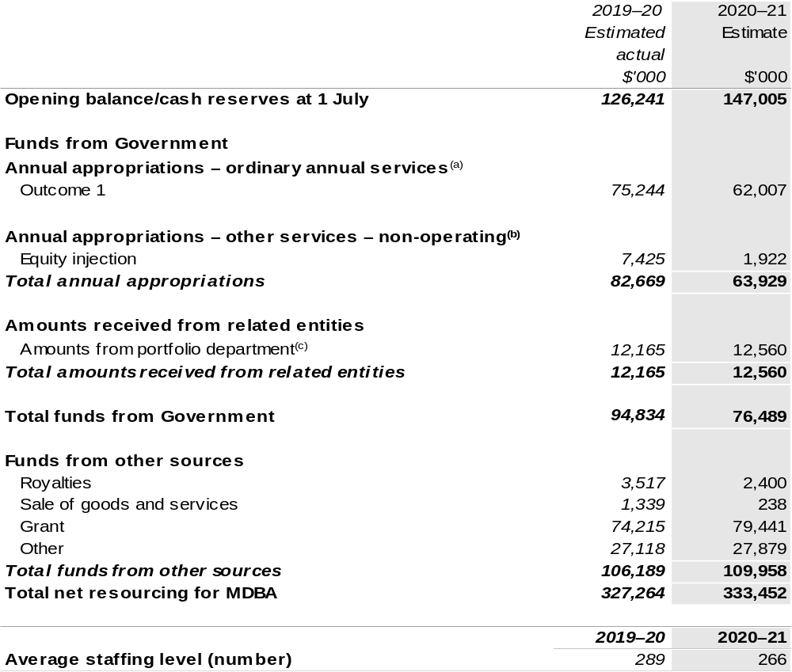
Continued on following page

Table 1.1: Murray-Darling Basin Authority – Resource Statement – Budget Estimates for 2020–21 as at Budget October 2020 (continued)
(a) Supply Act (No. 1) and Appropriation Bill (No. 1) 2020–21. Appropriation is provided through the Department of Agriculture, Water and the Environment (DAWE) and is specified with the Annual Appropriation Bills as payment to the MDBA.
(b) Supply Act (No. 1) and Appropriation Bill (No. 1) and Bill (No. 2) 2020–21. Appropriation is provided through DAWE and is specified within the Annual Appropriation Bills as a payment to the MDBA.
(c) Funding provided by the portfolio department that is not specified within the Annual Appropriation Bills as a payment to that corporate entity (for example, a grant awarded to a corporate entity from one of its portfolio department's administered programs).

Please note: All figures shown above are GST exclusive – these may not match figures in the cash flow statement.

Prepared on a resourcing (i.e. appropriations available) basis.

1.3 Budget measures
Budget measures in Part 1 relating to the Murray-Darling Basin Authority are detailed in Budget Paper No. 2: Budget Measures 2020–21 and are summarised below.

Table 1.2: Murray-Darling Basin Authority – 2020–21 Budget measures – Measures announced after the Economic and Fiscal Update July 2020
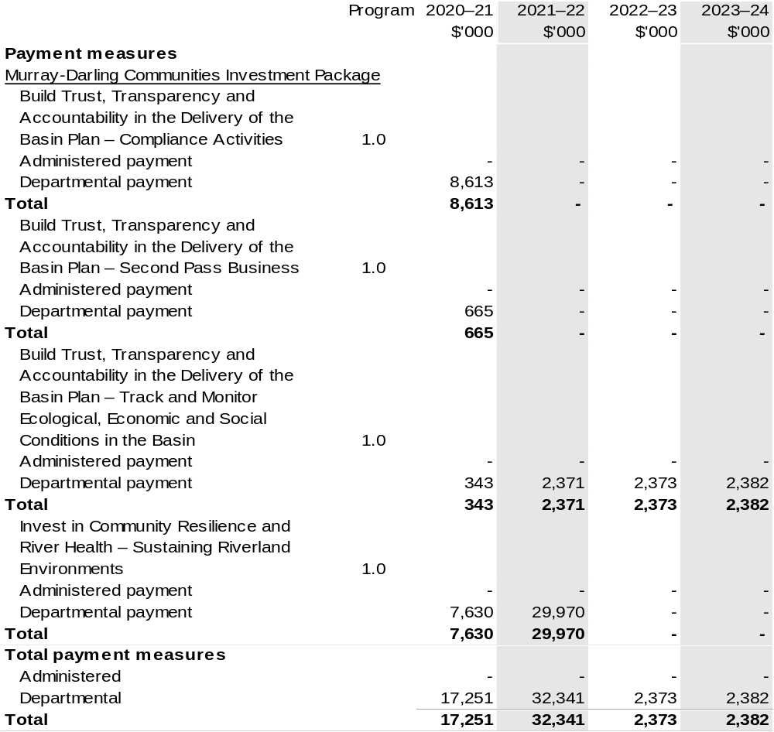
Prepared on a Government Finance Statistics (Underlying Cash) basis

Section 2: Outcomes and planned performance
Government outcomes are the intended results, impacts or consequences of actions by the Government on the Australian community. Commonwealth programs are the primary vehicle by which government entities achieve the intended results of their outcome statements. Entities are required to identify the programs which contribute to government outcomes over the Budget and forward years.
Each outcome is described below together with its related programs. The following provides detailed information on expenses for each outcome and program, further broken down by funding source.
Note:
Performance reporting requirements in the Portfolio Budget Statements are part of the Commonwealth performance framework established by the Public Governance, Performance and Accountability Act 2013. It is anticipated that the performance criteria described in Portfolio Budget Statements will be read with broader information provided in an entity’s corporate plans and annual performance statements – included in Annual Reports – to provide a complete picture of an entity’s planned and actual performance.

MDBA’s most recent corporate plan can be found at: https://www.mdba.gov.au/publications/policies–guidelines/corporate–plan.

MDBA’s most recent annual performance statement can be found at:
https://www.mdba.gov.au/publications/mdba–reports/mdba–annual–report.

2.1 Budgeted expenses and performance for Outcome 1
Outcome 1: Equitable and sustainable use of the Murray-Darling Basin by governments and the community including through development and implementation of a Basin Plan, operation of the River Murray system, shared natural resource management programs, research, information and advice.

2.1.1: Linked programs
Department of Agriculture, Water and the Environment
Program 1.3: Commonwealth Environmental Water
Program 5.1: Water Reform
Contribution to Outcome 1 made by linked programs:
The Murray-Darling Basin Authority (MDBA) works collaboratively with the Department of Agriculture, Water and the Environment (DAWE) to implement the Murray-Darling Basin Plan and the Intergovernmental Agreement on Murray-Darling Basin Reform.
MDBA and DAWE also work together on the operation of the River Murray System, shared natural resource management programs, research, information, advice and Basin Plan reporting obligations, all of which contribute to the management of Commonwealth environmental water.
Bureau of Meteorology
Program 1.1: Bureau of Meteorology
Contribution to Outcome 1 made by linked program:
The Bureau of Meteorology provides weather, climate and water modelling, insight and analysis to the MDBA.

2.2.1: Budgeted expenses for Outcome 1
This table shows how much the entity intends to spend (on an accrual basis) on achieving the outcome, broken down by program, as well as by Administered and Departmental funding sources.

Table 2.1: Budgeted expenses for Outcome 1
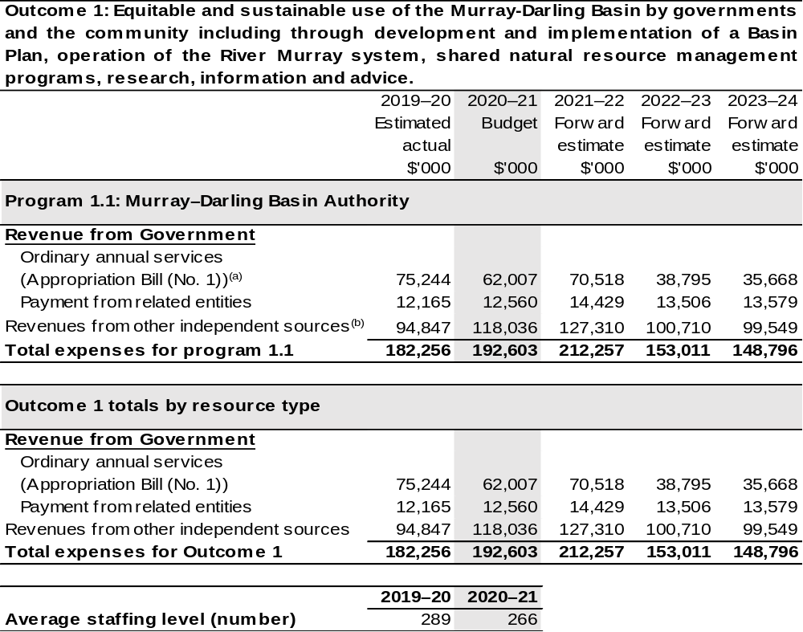
(a) Supply Act (No. 1) and Appropriation Bill (No. 1) 2020–21. The MDBA is a corporate Commonwealth entity (CCE) under the PGPA Act and does not receive direct appropriations. Appropriation is provided through DAWE and is specified with the Annual Appropriation Bills as payment to the MDBA and is considered departmental for all purposes.
(b) Revenues from other independent sources include contributions from jurisdictions for Agreement functions, other miscellaneous revenue and funds drawn from the Murray-Darling Basin special account. The Murray-Darling Basin special account is not a Special Account for the purpose of the PGPA Act.

Note: Departmental appropriation splits and totals are indicative estimates and may change in the course of the budget year as government priorities change.

Prepared on Australian Accounting Standards basis.

2.3.1: Performance criteria for Outcome 1
Table 2.3.1 below details the performance criteria for each program associated with Outcome 1. It also summarises how each program is delivered and where 2020–21 Budget measures have created new programs or materially changed existing programs.
Outcome 1 – Equitable and sustainable use of the Murray-Darling Basin by governments and the community including through development and implementation of a Basin Plan, operation of the River Murray system, shared natural resource management programs, research, information and advice.
Program 1.1: Equitable and sustainable use of the Murray-Darling Basin
Objective | To improve the health and sustainability of the Murray Darling Basin through integrated reform and management of water and other natural resources for the long-term benefit of the Australian community.
Delivery | Collaborating with Basin governments, communities and the Commonwealth to achieve sustainable management of the  Murray-Darling Basin river system, while ensuring continual application of the Water Act 2007, Murray-Darling Basin Agreement and the Murray-Darling Basin Plan.
Performance information
Year | Performance criteria | 2019–20 Actual Achievement/Targets^{(a)}
2019–20 | Lead the implementation of the Basin Plan in collaboration with Basin state and territory governments and other Australian government agencies. | The measures and evidence of progress against this measure will be described in the Authority’s Annual Performance Statement 2019–20 in line with the evidence targets described in the 2019–20 Corporate Plan.
2019–20 | Operate the River Murray system efficiently for partner governments. | The measures and evidence of progress against this measure will be described in the Authority’s Annual Performance Statement 2019–20 in line with the evidence targets described in the 2019–20 Corporate Plan.
2020–21 | Lead the implementation of the Basin Plan in collaboration with Basin state and territory governments and other Australian government agencies. | The measures and evidence of progress against this measure will be described in the Authority’s Annual Performance Statement 2020–21 in line with the evidence targets described in the 2020–21 Corporate Plan.
Contributions to Outcome 1 (continued)
Performance information
Year | Performance criteria | 2019–20 Actual Achievement/Targets^{(a)}
2020–21 (continued) | Efficiently and effectively operate the River Murray system for partner governments. | The measures and evidence of progress against this measure will be described in the Authority’s Annual Performance Statement 2020–21 in line with the evidence targets described in the 2020–21 Corporate Plan
2021–22 and beyond | As per 2020–21. | As per 2020–21.
Purpose^{(b)} | To achieve a healthy working Basin through the integrated management of water resources for the long-term benefit of the Australian Community.

- Targets are not comprehensive enough to stand alone without other performance information. The MDBA’s annual performance statements provide a total assessment of performance against all of the measures set out in the Corporate Plan.
- Refers to updated purpose reflected in the 2020–21 Corporate Plan.

Section 3: Budgeted financial statements
Section 3 presents budgeted financial statements which provide a comprehensive snapshot of entity finances for 2020–21, including the impact of 2020–21 Budget measures and resourcing on financial statements.

3.1 Budgeted financial statements

3.1.1: Differences between entity resourcing and financial statements
There are no differences between the resource information presented in the Budget Papers and Portfolio Budget Statements.

3.2.1: Explanatory notes and analysis of budgeted financial statements
Revenue is credited to the Murray-Darling Basin special account from the following:
- Funding received through the Department of Agriculture, Water and the Environment for Basin Plan functions and the South Australian Riverland Floodplain Integrated Infrastructure Project (refer below);
- Australian Government contribution to Murray-Darling Basin Agreement; and
- State and territory government contributions and miscellaneous revenue from other sources (for example, property revenues, hydro generation and sale of assets) for the Agreement functions.
Australian Government and state and territory government contributions to the Agreement functions, which are reflected as grants income in the financial statements and grants cash in the balance sheet, for 2020–21, represent amounts approved by Ministerial Council.
Where appropriate, expenses, both employees and suppliers, have been adjusted to reflect the appropriations and changes in revenues resulting from any revised contributions to the joint programs.
The MDBA has budgeted for an operating deficit in 2020–21 and forward years which is impacted by the need to complete a number of joint programs (i.e. programs funded through non-appropriation receipts), including for river and environmental management programs and the residual components of the Environmental Works and Measures Program, for which funds have been retained in the Murray-Darling Basin special account.

Revenue from government includes funding for the South Australia Riverland Floodplain Integrated Infrastructure Program (SARFIIP). SARFIIP had an initial cost of $155 million and was due to be completed in 2019–20. However, the 2020–21 Budget includes an additional $37.6 million over two years for SARFIIP, bringing the Government’s total investment in the program to $192.6 million. This funding will be used for the following three additional projects:
- Restoring natural river patterns in Lock 6 reach;
- River infrastructure and operational investments in the Lock 3 reach; and
- Reinstating natural habitat conditions in the Bookmark Creek area.

3.2 Budgeted financial statements tables

Table 3.1: Comprehensive income statement (showing net cost of services) (for the period ended 30 June)
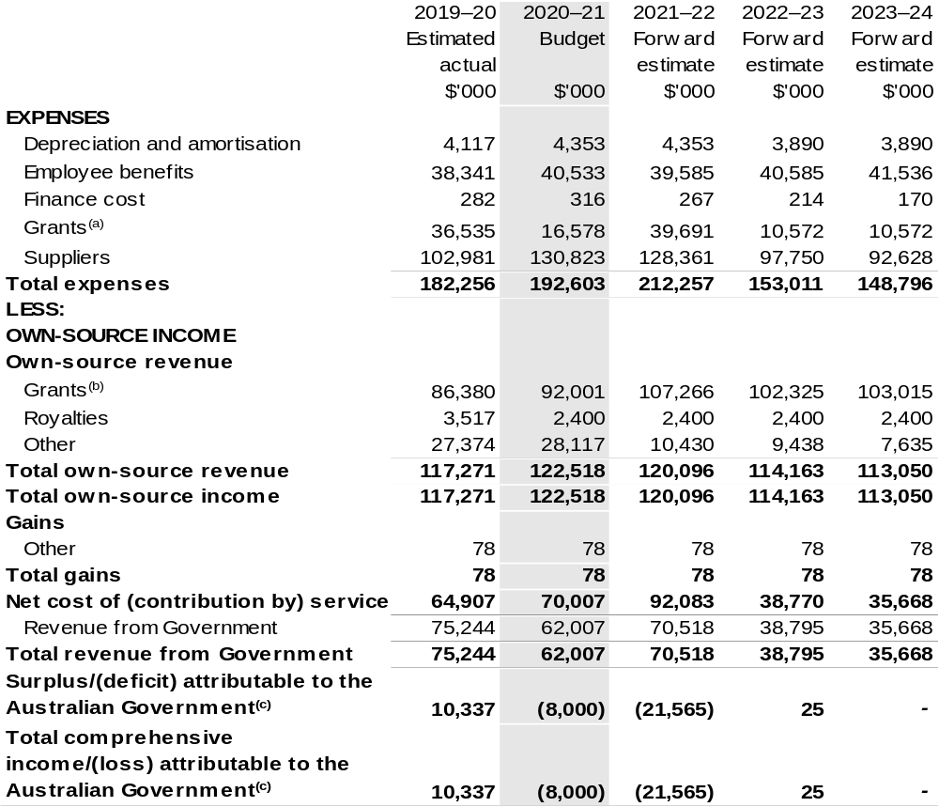
Continued on following pages

Table 3.1: Comprehensive income statement (showing net cost of services) (for the period ended 30 June) (continued)
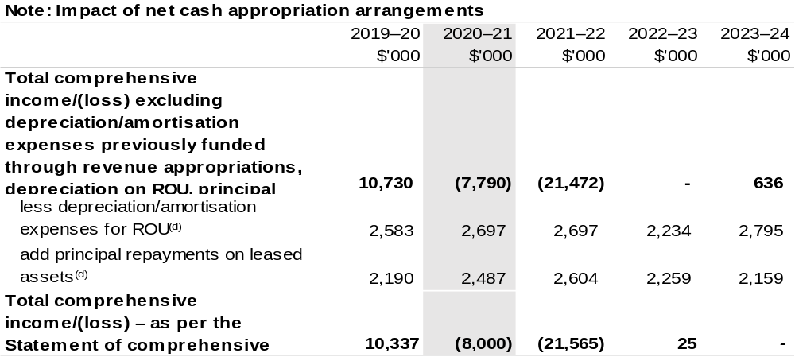
(a) The amount includes payment to South Australia under the South Australia Riverland Floodplain Integrated Infrastructure Program (SARFIIP). This program was due to completed in 2019–20. However, the program has been extended by two years in the 2020–21 Budget, with an additional funding of $37.600 million ($7.630 million in 2020–21 and $29.970 million in 2021–22). Other payments relate to grants paid to other jurisdictions, non-profit organisations and the private sector.
(b) For 2020–21 and the forward years this amount is an estimate pending Ministerial Council's decision.
(c) The MDBA’s operating loss is primarily the result of recommended accounting treatment for the special appropriation of $441.500 million recognised as revenue during transition from Murray-Darling Basin Commission to MDBA in 2008–09.
(d) Applies to leases under AASB 16 Leases. Right of Use (ROU).

Prepared on Australian Accounting Standards basis.

Table 3.2: Budgeted departmental balance sheet (as at 30 June)
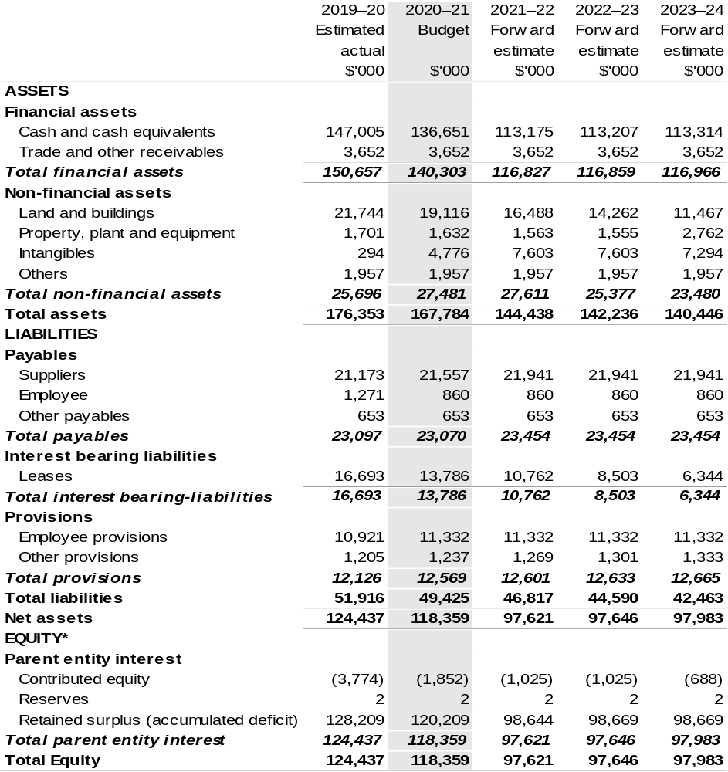
*Equity is the residual interest in assets after deduction of liabilities.

Prepared on Australian Accounting Standards basis.

Table 3.3: Departmental statement of changes in equity — summary of movement (Budget year 2020–21)
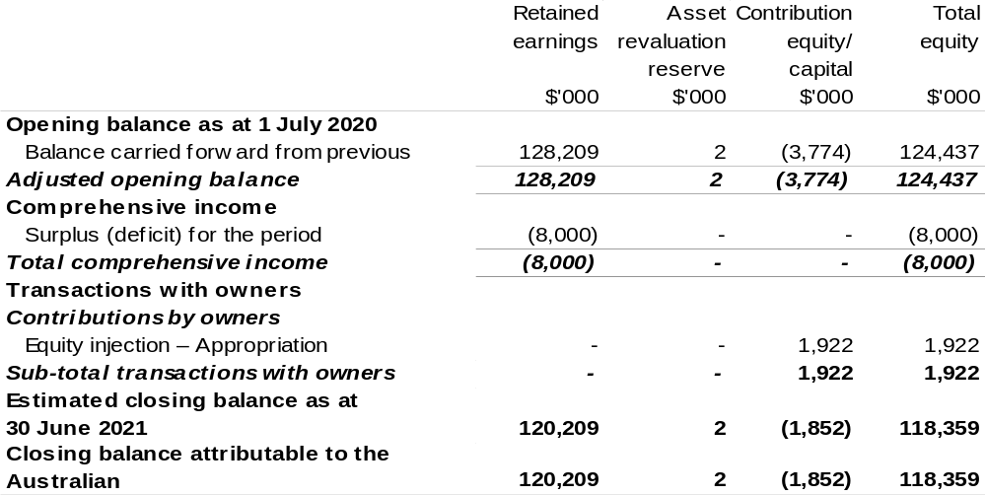
Prepared on Australian Accounting Standards basis.

Table 3.4: Budgeted departmental statement of cash flows (for the period
ended 30 June)
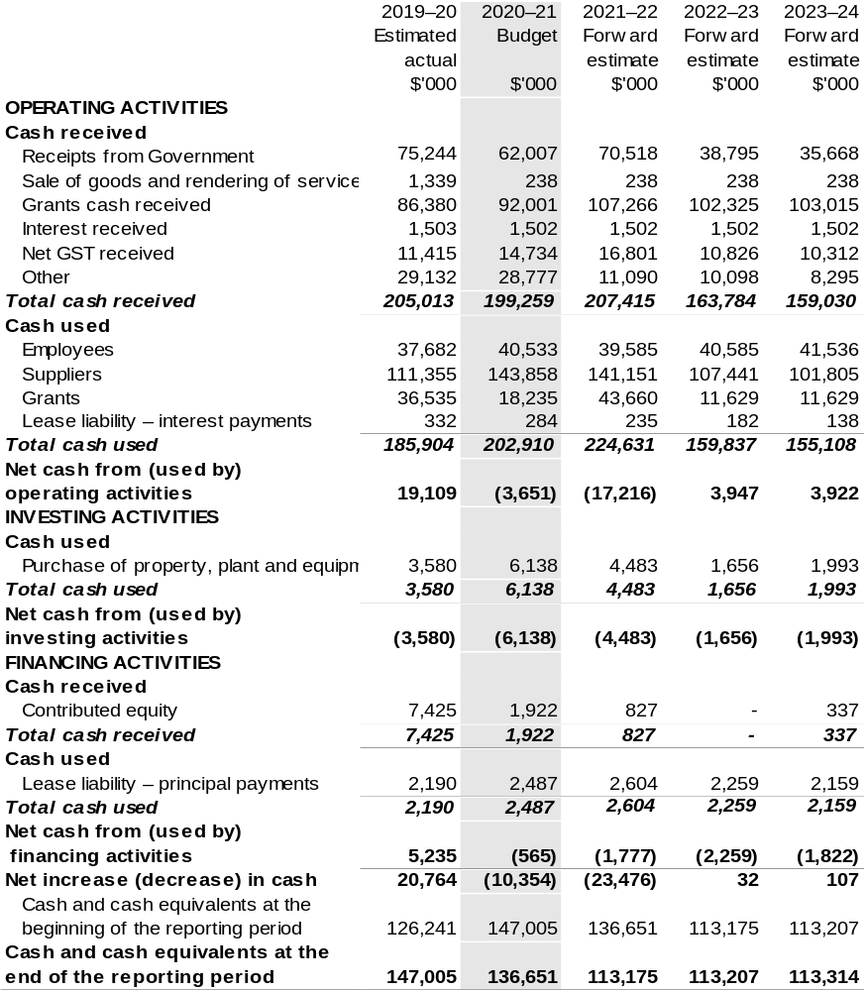
Prepared on Australian Accounting Standards basis.

Table 3.5: Departmental capital budget statement (for the period ended 30 June)
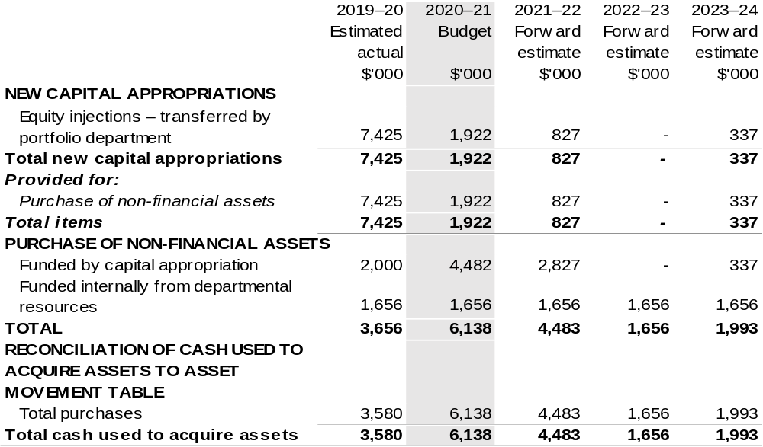
Consistent with information contained in the Statement of Asset Movements and the Budgeted Statement of Cash Flows.

Prepared on Australian Accounting Standards basis.

Table 3.6: Statement of asset movements (Budget year 2020–21)
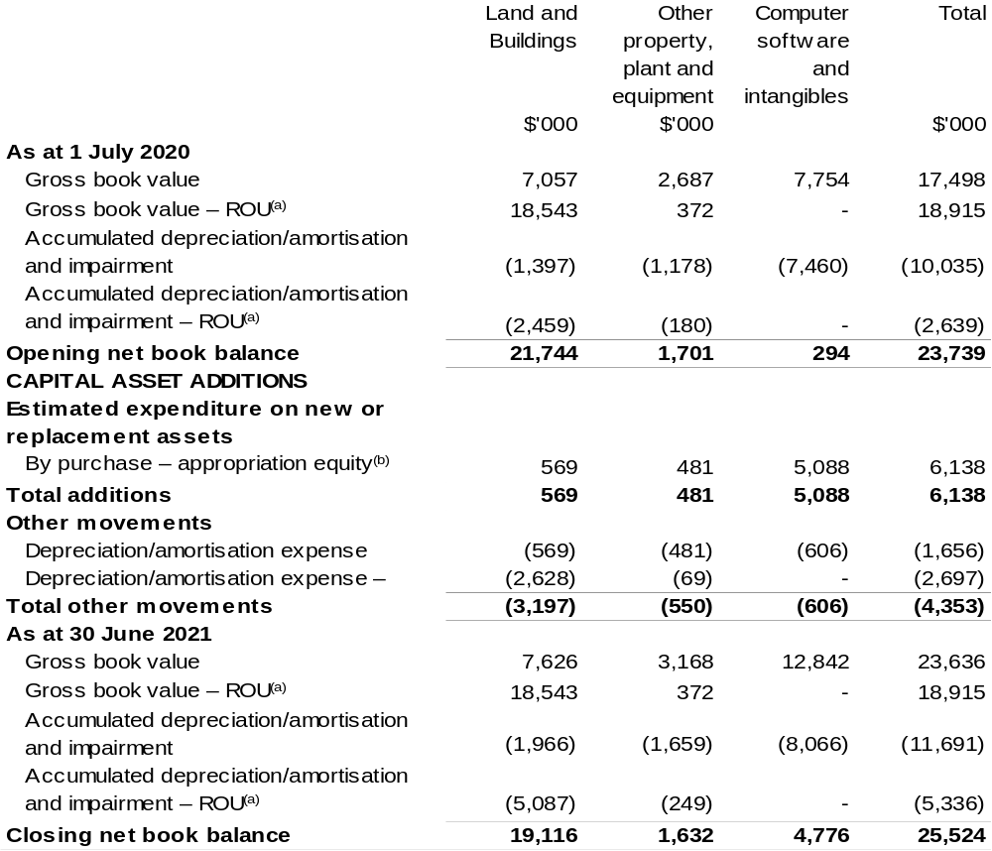
(a) Applies to leases under AASB 16 Leases. Right of Use (ROU).
(b) ‘Appropriation ordinary annual services’ refers to funding provided through Supply Act (No. 1) and Appropriation Bill (No.1) 2020–21 for depreciation / amortisation expenses, DCBs or other operational expenses.

Prepared on Australian Accounting Standards basis.

Table 3.7: Schedule of budgeted income and expenses administered on behalf of Government (for the period ended 30 June)
The schedule of budgeted income and expenses administered on behalf of Government does not apply to the MDBA.

Table 3.8: Schedule of budgeted assets and liabilities administered on behalf of Government (as at 30 June)
The schedule of budgeted assets and liabilities administered on behalf of Government does not apply to the MDBA.

Table 3.9: Schedule of budgeted administered cash flows (for the period
ended 30 June)
The schedule of budgeted administered cash flows on behalf of Government does not apply to the MDBA.

Regional Investment Corporation
Section 1: Entity overview and resources 353
1.1 Strategic direction statement 353
1.2 Entity resource statement 354
1.3 Budget measures 355
Section 2: Outcomes and planned performance 356
2.1 Budgeted expenses and performance for Outcome 1 357
Section 3: Budgeted financial statements 362
3.1 Budgeted financial statements 362
3.2 Budgeted financial statements tables 363

Regional Investment Corporation

Section 1: Entity overview and resources

1.1 Strategic direction statement
The Regional Investment Corporation (RIC) is a corporate Commonwealth entity established by the Regional Investment Corporation Act 2018. An independent Board oversees the RIC and is responsible for providing loans to eligible farm businesses and farm-related small businesses.
The RIC Board also provides independent advice to the Minister for Agriculture, Drought and Emergency Management on the making of individual grants or arrangements for projects and activities that build drought resilience to be funded by the Future Drought Fund.
The RIC streamlines the administration of concessional loans by delivering loans that are assessed in a nationally consistent, prudent and timely manner. Loans are targeted at farm businesses and farm-related small businesses impacted by drought and those that are in financial need that mainly supply, or intend to mainly supply, products into supply chains that are interstate or overseas. RIC also provided loans to those affected by the North Queensland flooding event of 2019 (applications closed on 30 June 2020).
The concessional loan programs support the long-term strength, resilience and profitability of eligible farm businesses and farm-related small businesses.
In 2020–21, there is $2.575 billion in loan funding available for the RIC, which is a significant increase from prior years. This additional funding recognises the importance of RIC loans for farmers and small businesses in need of practical assistance and the high demand for RIC loan products. The RIC has also been provided with additional operational funding of $50.0 million over four years from 2020–21 to deliver the additional loans and to process the significant volume of loan applications already on hand.
The RIC achieves this through its outcome:
Outcome 1: Encourage growth, investment and resilience in Australian farm businesses and rural and regional communities by delivering the Commonwealth’s farm business concessional loans and the National Water Infrastructure Loan Facility.

1.2 Entity resource statement
Table 1.1 shows the total funding from all sources available to the entity for its operations and to deliver programs and services on behalf of the Government.
The table summarises how resources will be applied by outcome (Government strategic policy objectives) and by administered (on behalf of the Government or the public) and departmental (for the entity’s operations) classification.
For more detailed information on special accounts and special appropriations, please refer to Budget Paper No. 4: Agency Resourcing.
Information in this table is presented on a resourcing (i.e. appropriations/cash available) basis, whilst the ‘Budgeted expenses by Outcome 1’ tables in Section 2 and the financial statements in Section 3 are presented on an accrual basis.

Table 1.1: Regional Investment Corporation – Resource Statement – Budget Estimates for 2020–21 as at Budget October 2020
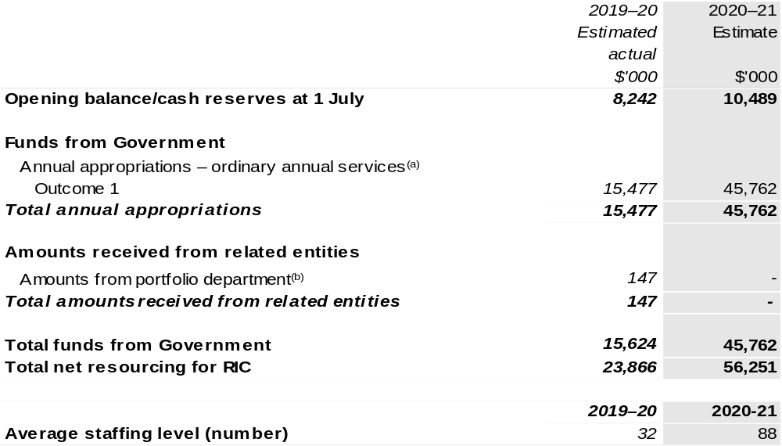
(a) Supply Act (No. 1) and Appropriation Bill (No. 1) 2020–21. Appropriation is provided through the Department of Agriculture, Water and the Environment and is specified within the Annual Appropriation Bills as a payment to the RIC.
(b) Funding provided by the portfolio department that is not specified within the Annual Appropriation Bills as a payment to that corporate entity (for example, a grant awarded to a corporate entity from one of its portfolio department's administered programs).

Please note: All figures shown above are GST exclusive – these may not match figures in the cash flow statement.

Prepared on a resourcing (i.e. appropriations available) basis.

1.3 Budget measures
Budget measures in Part 1 relating to the Regional Investment Corporation are detailed in Budget Paper No. 2: Budget Measures 2020–21 and are summarised below.

Table 1.2: Regional Investment Corporation – 2020–21 Budget measures – Measures announced after the Economic and Fiscal Update July 2020
RIC does not have any 2020–21 Budget measures.

Section 2: Outcomes and planned performance
Government outcomes are the intended results, impacts or consequences of actions by the Government on the Australian community. Commonwealth programs are the primary vehicle by which government entities achieve the intended results of their outcome statements. Entities are required to identify the programs which contribute to government outcomes over the Budget and forward years.
Each outcome is described below together with its related programs. The following provides detailed information on expenses for each outcome and program, further broken down by funding source.
Note:
Performance reporting requirements in the Portfolio Budget Statements are part of the Commonwealth performance framework established by the Public Governance, Performance and Accountability Act 2013. It is anticipated that the performance criteria described in Portfolio Budget Statements will be read with broader information provided in an entity’s corporate plans and annual performance statements – included in Annual Reports – to provide a complete picture of an entity’s planned and actual performance.
The most recent corporate plan for the Regional Investment Corporation can be found at: www.ric.gov.au/about/corporate-plan.
The most recent annual report for the Regional Investment Corporation can be found at: http://www.ric.gov.au/about/reporting/annual-report.

2.1 Budgeted expenses and performance for Outcome 1
Outcome 1: Encourage growth, investment and resilience in Australian farm businesses and rural and regional communities by delivering the Commonwealth’s farm business concessional loans and the National Water Infrastructure Loan Facility.

2.1.1: Linked programs
Department of Agriculture, Water and the Environment
- Program 3.11: Drought Programs
Contribution to Outcome 1 made by linked program:
The Regional Investment Corporation (RIC) works together with the Department of Agriculture, Water and the Environment to ensure more sustainable, productive, internationally competitive and profitable Australian agricultural industries.

2.2.1: Budgeted expenses for Outcome 1
This table shows how much the entity intends to spend (on an accrual basis) on achieving the outcome, broken down by program, as well as by Administered and Departmental funding sources.

Table 2.1: Budgeted expenses for Outcome 1
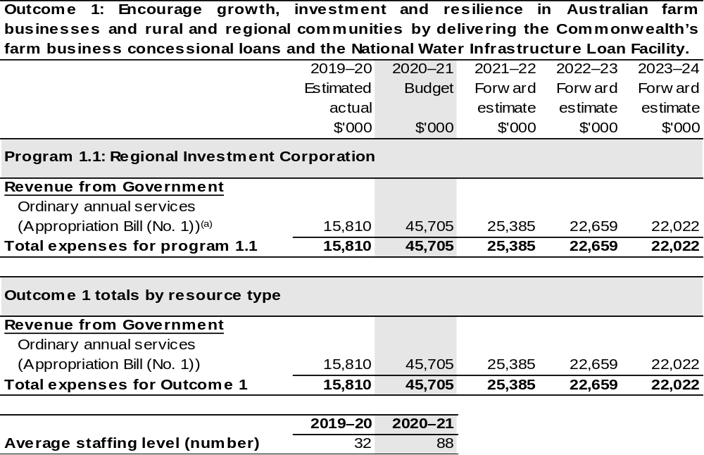
(a) Supply Act (No. 1) and Appropriation Bill (No. 1) 2020–21. The RIC is a corporate Commonwealth entity (CCE) under the PGPA Act and does not receive direct appropriations. Instead, this funding passes through the Department of Agriculture, Water and the Environment to the RIC.

Note: Departmental appropriation splits and totals are indicative estimates and may change in the course of the budget year as government priorities change.

Prepared on Australian Accounting Standards basis.

2.3.1: Performance criteria for Outcome 1
Table 2.3.1 below details the performance criteria for each program associated with Outcome 1. It also summarises how each program is delivered and where 2020–21 Budget measures have created new programs or materially changed existing programs.
Outcome 1 – Encourage growth, investment and resilience in Australian farm businesses and rural and regional communities by delivering the Commonwealth’s farm business concessional loans and the National Water Infrastructure Loan Facility.
Program 1.1: Regional Investment Corporation
Objectives | Provide practical support and investment to help rural and regional communities achieve economic growth, agricultural productivity and resilience through the delivery of farm business loans and flood recovery loans.  The Corporation’s farm business loans and flood recovery loans provide low-cost finance to farm businesses that are in financial need of assistance, to recover from short-term hardship, but are assessed as financially viable over the long-term and able to repay the loan.  The Corporation administers water infrastructure loans to the states and territories to support long-term regional economic growth and development by investing in economically viable water infrastructure that will provide secure and affordable water.
Delivery | Concessional loans are delivered directly to eligible farm businesses in a streamlined and nationally consistent way.
Performance information
Year | Performance criteria | 2019–20 Actual Achievement/Targets
2019–20 | $500 million is made available to eligible farm businesses in need to improve their circumstances. | Achieved.
2019–20 | All eligible farm business have access to farm business loans and flood recovery loans. | Achieved.
2019–20 | The water loan facility is available to states and territories. | Achieved.

Continued on following pages
Contributions to Outcome 1 (continued)
Performance information
Year | Performance criteria |  | 2019–20 Actual Achievement/Targets
2019–20 (continued) | Loan monies (farm business loans, flood recovery loans and water loans) are disbursed and received accurately and in line with contractual and legislative requirements. | Achieved.
2020–21 | - Loan transactions completed in accordance with funding appropriation. |  | Support provided within funding appropriation limits.  Implementation of the AgriStarter loan program.  90 per cent of loan approvals fall within risk profile determined by the Board.  Fraud awareness training undertaken at staff induction with regular refresher programs.
2020–21 | - Improve loan processes. |  | 80 per cent of loans with an end-to-end delivery timeframe of 65 days.  Implement refined process and documentation for farm business loans.  Average cost per loan decision decreases over time.
2020–21 | - Customer and stakeholder satisfaction. |  | 10 per cent increase in satisfaction rates.

Continued on following page
Contributions to Outcome 1 (continued)
Performance information
Year | Performance criteria | 2019–20 Actual Achievement/Targets
2021–22 and beyond | - Loan transactions completed in accordance with funding appropriation. | Support provided within funding appropriation limits.  Implementation of the AgriStarter loan program.  90 per cent of loan approvals fall within risk profile determined by the Board.  Fraud awareness training undertaken at staff induction with regular refresher programs.
2021–22 and beyond | - As per 2020–21. | As per 2020–21.
2021–22 and beyond | - As per 2020–21. | As per 2020–21.
Purpose | To provide loans that support the long-term strength, resilience and profitability of Australian farm businesses to support the growth of regional economies and communities.

Section 3: Budgeted financial statements
Section 3 presents budgeted financial statements which provide a comprehensive snapshot of entity finances for 2020–21, including the impact of 2020–21 Budget measures and resourcing on financial statements.

3.1 Budgeted financial statements

3.1.1: Explanatory notes and analysis of budgeted financial statements
The RIC is budgeting for a balanced budget position in 2020–21. The RIC’s expected employee and supplier expense budget is $15.4 million in 2019–20 and $45.7 million in 2020–21.
In 2020–21, the RIC will continue to develop its corporate ability to support the provision of loans to eligible farm businesses and farm-related small businesses. It will be the first full financial year the RIC will be staffed by its own ongoing workforce.
The expense budget reflects the work programs for the RIC in receiving and evaluating loan applications and managing approved loans to eligible farm businesses and farm-related small businesses and providing independent advice to the Government.

3.2 Budgeted financial statements tables

Table 3.1: Comprehensive income statement (showing net cost of services) (for the period ended 30 June)
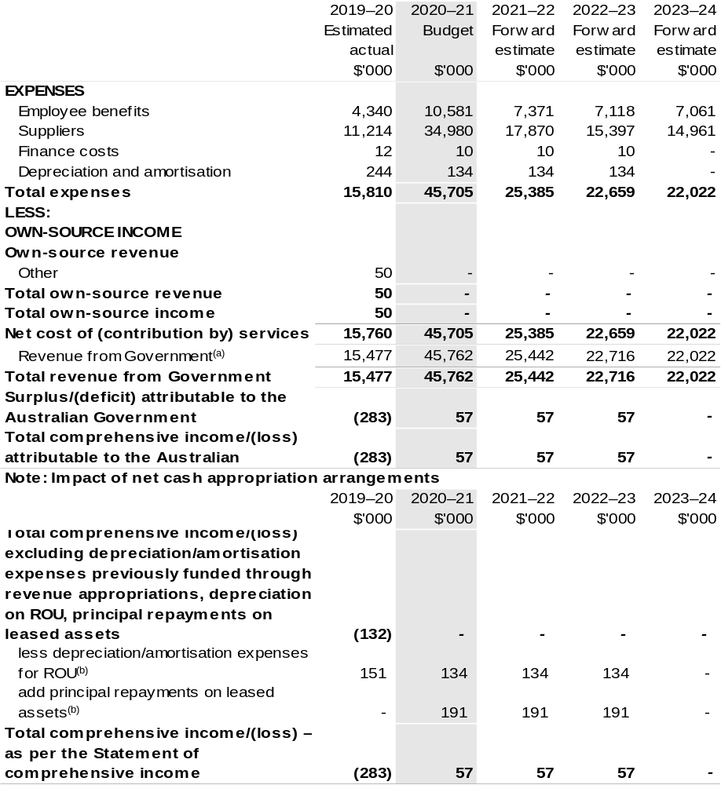
(a) The RIC is a corporate Commonwealth entity (CCE) under the PGPA Act and does not receive direct appropriations. Instead, this funding passes through the department to the RIC.
(b) Applies to leases under AASB 16 Leases. Right of Use (ROU).

Prepared on Australian Accounting Standards basis.

Table 3.2: Budgeted departmental balance sheet (as at 30 June)
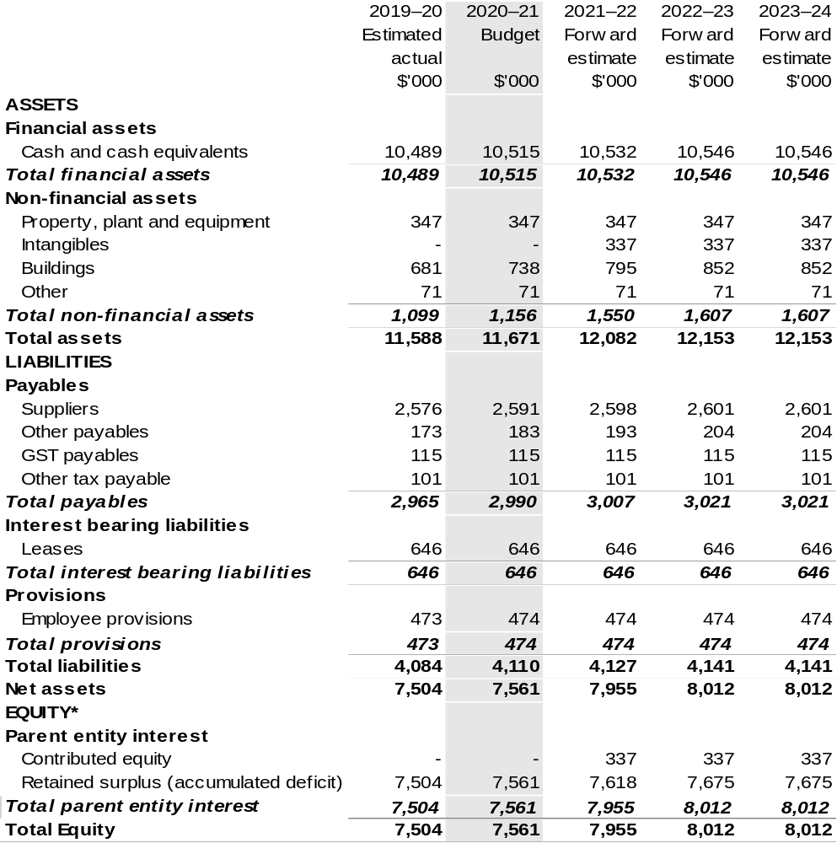
*Equity is the residual interest in assets after deduction of liabilities.

Prepared on Australian Accounting Standards basis.

Table 3.3: Departmental statement of changes in equity—summary of movement (Budget year 2020–21)
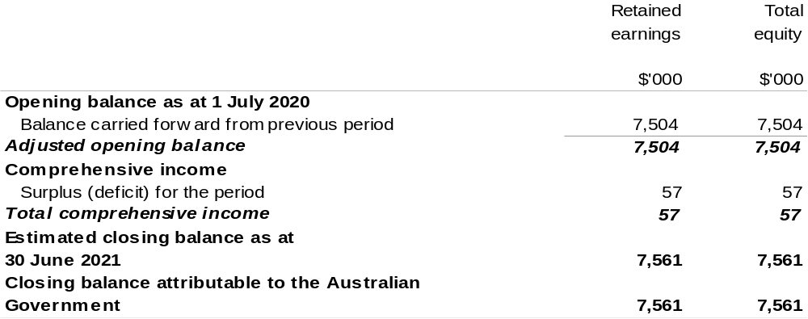
Prepared on Australian Accounting Standards basis.

Table 3.4: Budgeted departmental statement of cash flows (for the period
ended 30 June)
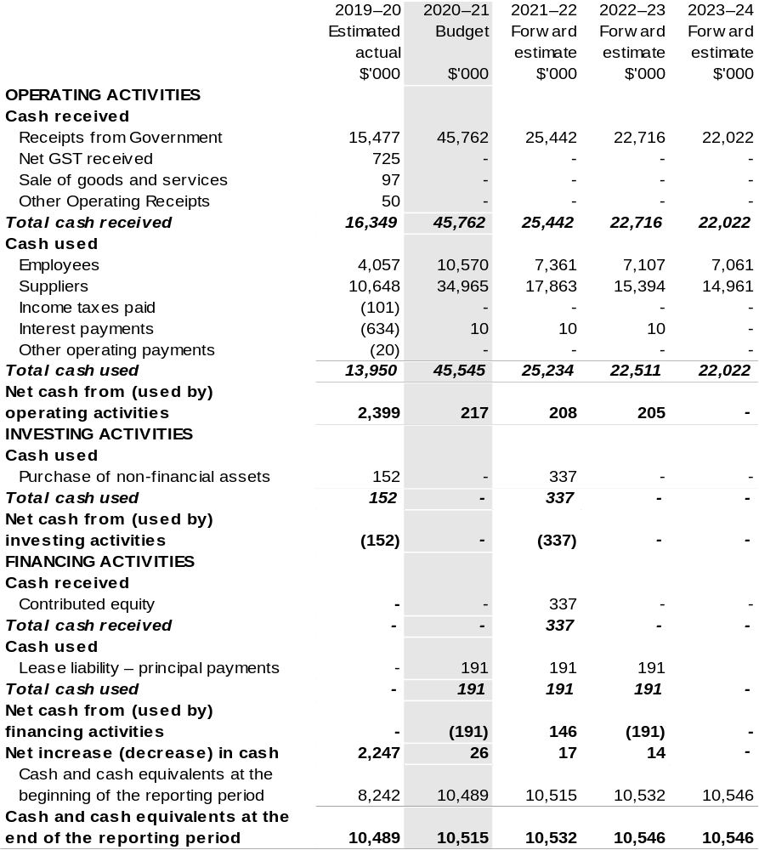
Prepared on Australian Accounting Standards basis.

Table 3.5: Departmental capital budget statement (for the period ended 30 June)
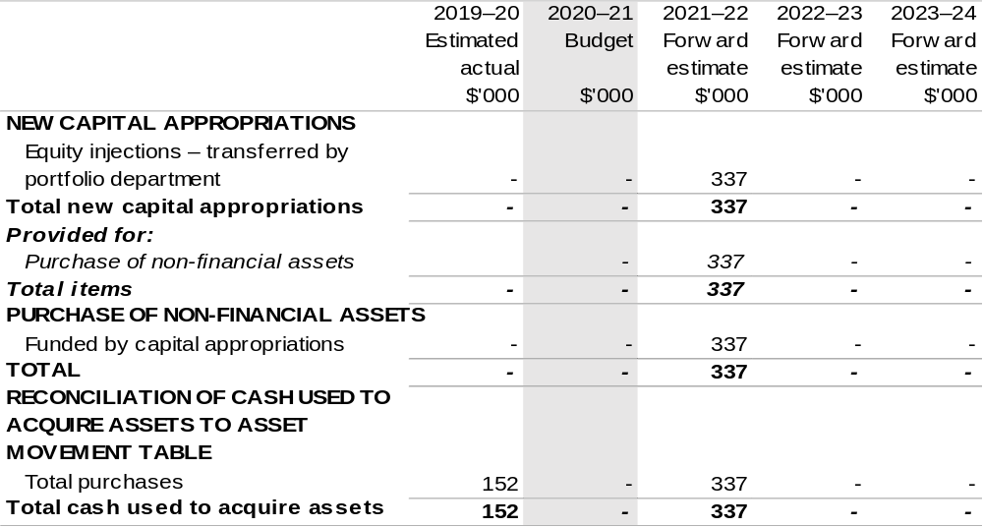
Consistent with information contained in the Statement of Asset Movements and the Budgeted Statement of Cash Flows.

Prepared on Australian Accounting Standards basis.

Table 3.6: Statement of asset movements (Budget year 2020–21)
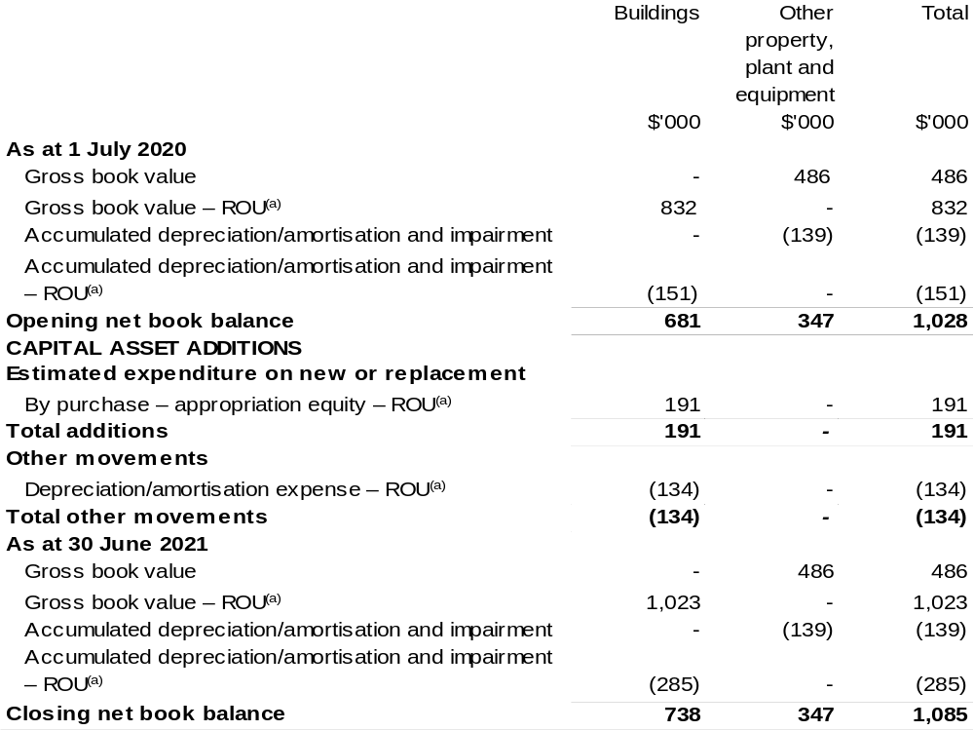
(a) Applies to leases under AASB 16 Leases. Right of Use (ROU).

Prepared on Australian Accounting Standards basis.

Table 3.7: Schedule of budgeted income and expenses administered on behalf of Government (for the period ended 30 June)

The schedule of budgeted income and expenses administered on behalf of Government does not apply to the RIC.

Table 3.8: Schedule of budgeted assets and liabilities administered on behalf of Government (as at 30 June)

The schedule of budgeted assets and liabilities administered on behalf of Government does not apply to the RIC.

Table 3.9: Schedule of budgeted administered cash flows (for the period
ended 30 June)

The schedule of budgeted administered cash flows on behalf of Government does not apply to the RIC.

Sydney Harbour Federation Trust
Section 1: Entity overview and resources 373
1.1 Strategic direction statement 373
1.2 Entity resource statement 376
1.3 Budget measures 378
Section 2: Outcome and planned performance 379
2.1 Budgeted expenses and performance for Outcome 1 380
Section 3: Budgeted financial statements 386
3.1 Budgeted financial statements 386
3.2 Budgeted financial statements tables 388

Sydney Harbour Federation Trust

Section 1: Entity overview and resources

1.1 Strategic direction statement
The Sydney Harbour Federation Trust (the Trust) manages some of Sydney’s most renowned and prominent foreshore lands on Sydney Harbour. These sites are the former Defence lands at Middle Head, Georges Heights and Chowder Bay in Mosman, the North Head former School of Artillery, Macquarie Lightstation near South Head, Woolwich Dock and Parklands, Cockatoo Island, the former Marine Biological Station at Watsons Bay and the former HMAS Platypus (Sub Base Platypus) at Neutral Bay.
The Sydney Harbour Federation Trust Act 2001 also provides the potential for other Commonwealth lands in Sydney Harbour to be vested in the Trust.
The Trust is adapting and reusing heritage buildings to bring life and activity to these harbour foreshores and, at the same time, generate revenue towards operating and maintaining the sites. Its overarching objective is to transform its sites into precincts and parklands that will enhance the cultural and historical values of the city, whilst conserving the environmental integrity and unique heritage of the sites.
The impact of COVID-19 has been significant for the Trust. Generating the majority of revenue from leasing and accommodation activities, both the restrictions put in place and the prevailing economic climate have meant that a substantial decline in revenue has been experienced. Through this period, the Trust has sought to aid tenants through the provision of rental assistance, where eligible. The Government agreed to release $14 million in funding to help the Trust provide short-term relief for commercial and residential tenants and to address other revenue shortfalls in the context of COVID-19.
Whilst the Trust has rehabilitated buildings for preservation as well as revenue generation, the majority of the Trust’s investment to date has been in enabling public access to the sites, conserving historic buildings, remediation activities and enhancing the public domain. These social investments are necessary to support visitation to the sites and provide a social return, however they generate minimal financial return on investment. While decontamination, conservation, refurbishment and rehabilitation of sites has been substantial, there remains significant works and unrealised potential at a number of sites, most notably Cockatoo Island and North Head Sanctuary.
The Trust was the subject of an Independent Review in 2019–20, examining its legislative, financial and governance arrangements. With the Trust now approaching 20 years of age, the Review provided an opportunity to take stock and ensure that arrangements are fit for the future.
Released on the 18 June 2020 by the Minister for the Environment, the Hon. Sussan Ley MP, the Independent Review Report contains 21 recommendations on the future of the Trust and our operations. Chief amongst these recommendations is for the Trust to become an ongoing entity, with current provisions contained in the Sydney Harbour Federation Trust Act 2001 mandating the repeal of the Trust to be removed.
Another significant event to occur in 2019–20 was the completion of Stage 1B works at Sub Base Platypus. The project has allowed for further public access to former Defence land, while also welcoming new tenancies to the historic buildings on site. In addition, planning has progressed for projects announced in last year’s budget at Headland Park (10 Terminal) and Sub Base Platypus (Stage 2).
A focus for the Trust in 2020–21 is to further advance works at Sub Base Platypus and Headland Park with the continuation of investment from the Government allowing for landscaping works, and the refurbishment of key buildings to allow for their adaptive reuse. Once completed, both projects will add to and enhance the vibrancy of both Sub Base Platypus and Headland Park.
Much of the Trust’s focus for the coming year will be to work with the Department of Agriculture, Water and the Environment to implement the recommendations of the Independent Review. Work has already begun with the Trust’s Statement of Intent outlining – in broad terms – the response to the recommendations. The Trust looks forward to progressing these actions, which will help alleviate current pressures and safeguard the future of the Trust.
Responding to Recommendations 21 a) and b) of the Independent Review, the Government has provided funding of $50 million for maintenance and upkeep of the Harbour Trust’s sites, including addressing a backlog of repairs and maintenance, and to enable the development of the masterplan for Cockatoo Island, an asset audit for Cockatoo Island and a rehabilitation plan for North Head Sanctuary, providing a basis for site-specific capital plans. $9 million of the $50 million was provided in 2019–20 through the release of the Markham Close funds while the remaining $40.6 million has been provided through appropriations over four years, starting in 2020–21.
Specifically, this funding will help the Harbour Trust:
• refine the future directions for Cockatoo Island and North Head Sanctuary, enabling the protection, conservation, and interpretation of environmental and heritage values, public access and providing a pathway to the creation of vibrant places whilst placing the Harbour Trust in a more sustainable financial position over the medium-term.
• undertake restoration works to the cranes on Cockatoo Island; restoration and conservation of the Commonwealth Heritage Listed Greenway Stone Wall at Macquarie Lighthouse; and stabilisation and restoration of the World War II era Gun Emplacements, Observation Post and Tunnels at North Head.
• protect our unique sites for the enjoyment of current and future generations via essential repair and maintenance works to mitigate safety risks across Harbour Trust sites, and to prevent the further deterioration of assets and protect their unique values.

1.2 Entity resource statement
Table 1.1 shows the total funding from all sources available to the entity for its operations and to deliver programs and services on behalf of the Government.
The table summarises how resources will be applied by outcome (government strategic policy objectives) and by administered (on behalf of the Government or the public) and departmental (for the entity’s operations) classification.
For more detailed information on special accounts and special appropriations, please refer to Budget Paper No. 4 – Agency Resourcing.
Information in this table is presented on a resourcing (that is, appropriations/cash available) basis, whilst the ‘Budgeted expenses by Outcome’ table in Section 2 and the financial statements in Section 3 are presented on an accrual basis.

Table 1.1: Sydney Harbour Federation Trust – Resource Statement – Budget Estimates for 2020–21 as at October 2020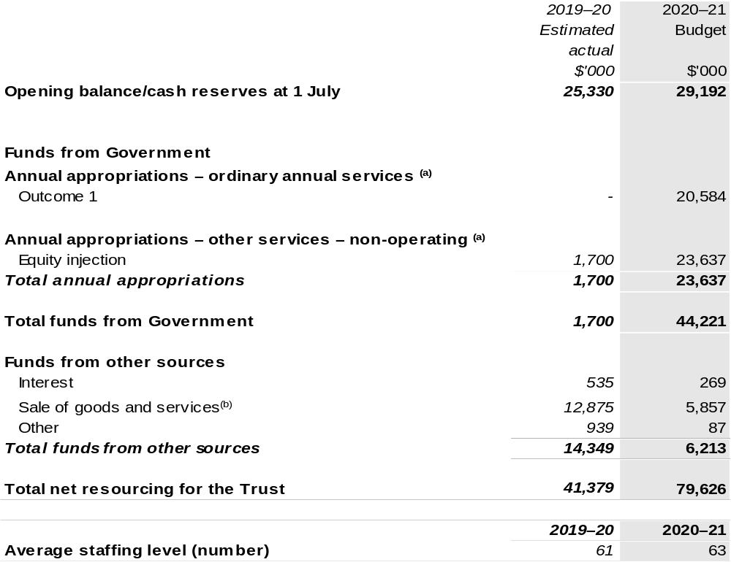
- Supply Act (No. 2) and Appropriation Bill (No. 1) 2020–2021. The Trust is not directly appropriated as it is a corporate Commonwealth entity under the PGPA Act. Appropriations are made to DAWE and are then paid to the Trust and are considered departmental for all purposes.
- Funds from Sales of Goods and Services excludes cash received and held on trust as security for the performance of tenants’ obligation under various lease agreements.

Prepared on a resourcing (i.e. appropriations available) basis.

Please note: all figures shown above are GST exclusive – these may not match figures in the cash flow statement.

1.3 Budget measures
Budget measures in Part 1 relating to the Sydney Harbour Federation Trust (the Trust) are detailed in Budget Paper No. 2: Budget Measures 2020–21 and are summarised below.

Table 1.2: Sydney Harbour Federation Trust – 2020–21 Budget measures – Measures announced after the Economic and Fiscal Update July 2020

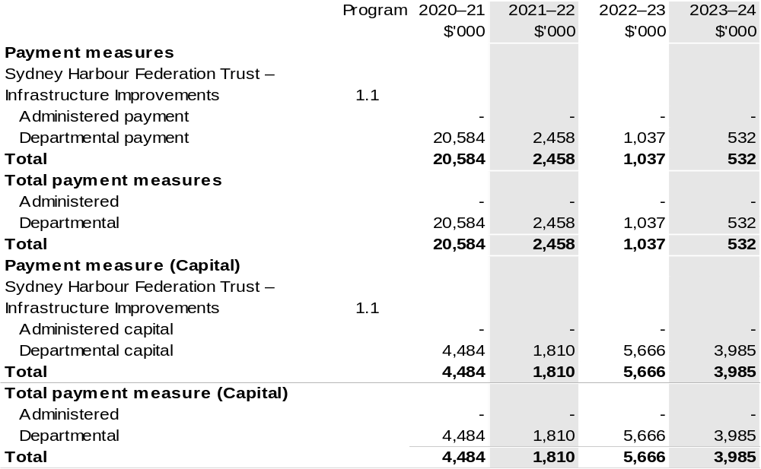
Prepared on a Government Finance Statistics (Underlying Cash) basis

Section 2: Outcomes and planned performance
Government outcomes are the intended results, impacts or consequences of actions by the Government on the Australian community. Commonwealth programs are the primary vehicle by which government entities achieve the intended results of their outcome statements. Entities are required to identify the programs which contribute to government outcomes over the Budget and forward years.
Each outcome is described below together with its related programs. The following provides detailed information on expenses for each outcome and program, further broken down by funding source.
Note:
Performance reporting requirements in the Portfolio Budget Statements are part of the Commonwealth performance framework established by the Public Governance, Performance and Accountability Act 2013. It is anticipated that the performance criteria described in Portfolio Budget Statements will be read with broader information provided in an entity’s corporate plans and annual performance statements – included in Annual Reports – to provide a complete picture of an entity’s planned and actual performance.
The most recent corporate plan and annual performance statement (contained within the annual report) for the Sydney Harbour Federation Trust can be found at: https://www.harbourtrust.gov.au/en/corporate/publications/.

2.1 Budgeted expenses and performance for outcome 1
Outcome 1: Enhanced appreciation and understanding of the natural and cultural values of Sydney for all visitors, through the remediation, conservation and adaptive re-use of, and access to, Trust lands on Sydney Harbour.

2.1.1: Linked programs
Department of Agriculture, Water and the Environment
Program 1.4: Conservation of Australia’s Heritage and Environment
Contribution to Outcome 1 made by linked program:
The Department of Agriculture, Water and the Environment and the Sydney Harbour Federation Trust collaborate through engagement on policy direction and site management to conserve and enhance the natural and cultural heritage of Sydney Harbour Federation Trust land and maximise public access and enjoyment of its sites.

2.2.1: Budgeted expenses for Outcome 1
This table shows how much the entity intends to spend (on an accrual basis) on achieving the outcome, broken down by program, as well as by Administered and Departmental funding sources.

Table 2.1: Budgeted expenses for Outcome 1
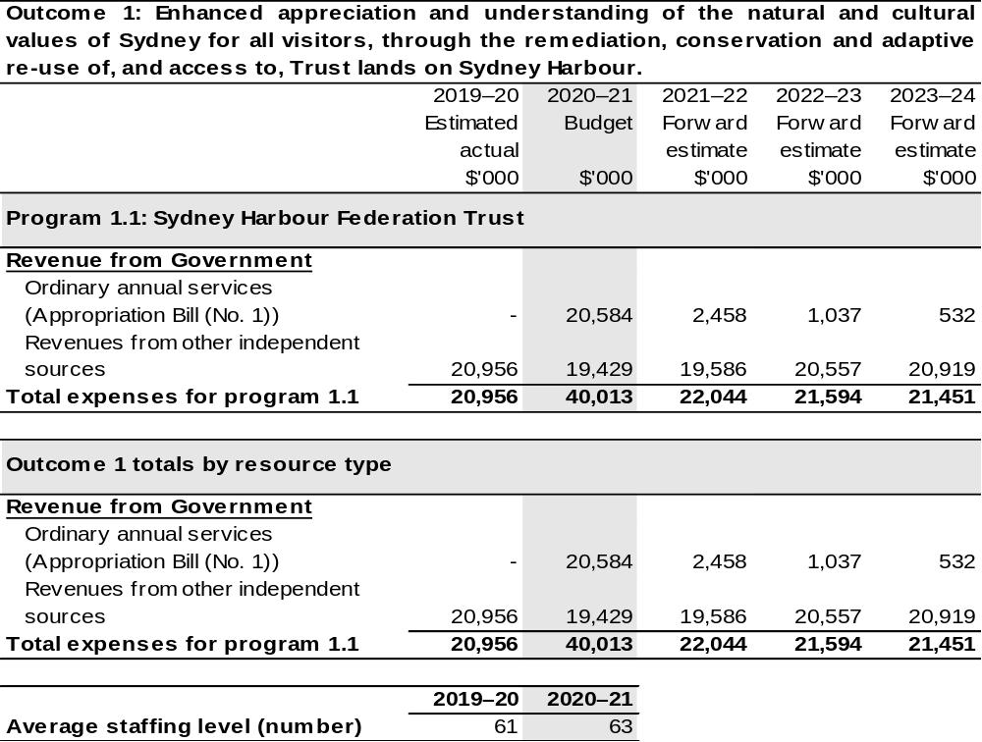
(a) Appropriation Bill (No. 1) 2020–21. The SHFT is a corporate Commonwealth entity (CCE) under the
PGPA Act and does not receive direct appropriations. Appropriation is provided through DAWE and is specified with the Annual Appropriation Bills as payment to the SHFT and is considered departmental for all purposes.

Note: Departmental appropriation splits and totals are indicative estimates and may change in the course of the budget year as government priorities change.

Prepared on a Government Finance Statistics (fiscal) basis.

2.3.1: Performance criteria for Outcome 1
Table 2.3.1 below details the performance criteria for each program associated with Outcome 1. It also summarises how each program is delivered and where 2020–21 Budget measures have created new programs or materially changed existing programs.
Outcome 1: Enhanced appreciation and understanding of the natural and cultural values of Sydney for all visitors, through the remediation, conservation and adaptive re-use of, and access to, Trust lands on Sydney Harbour.
Program 1.1: Sydney Harbour Federation Trust
Objective | To manage emblematic lands around Sydney Harbour, preserve their natural and cultural heritage and foster and promote them as place of leisure, enjoyment and interest for all Australians.
Delivery | Undertake works and develop programs and facilities to ensure the Trust sites are progressively rehabilitated, conserved and made available for public use and enjoyment.
Performance information
Year | Performance criteria | 2019–20 Actual Achievement/Targets
2019–20 | Steward Our Parklands – to care for, conserve, and enhance our parklands and built assets, applying the principles of ecological sustainable development. | 90 per cent of our land open to public.  Achieved  77 per cent of our built assets in active use.  Achieved.  Visitor satisfaction with public domain greater than 90 per cent.  Not achieved – the unprecedented events (NSW bushfires and COVID-19) significantly disrupted programming, events and accessibility to sites, impacting visitation and visitor satisfaction levels.

Continued on following pages

Contributions to Outcome 1 (continued)
Performance information
Year | Performance criteria | 2019–20 Actual Achievement/Targets
2019–20 (continued) | Welcome Everyone – our parklands are for all Australians and we welcome both domestic and international visitors. We want to ensure our sites tell their rich stories, are easy to access, and are places of exploration and discovery. | 1.9 million visits to Trust sites.  Not achieved – as noted above, unprecedented events impacted Harbour Trust performance in visitation.  Visitor satisfaction greater than 90 per cent.  Not achieved – as noted above, unprecedented events impacted Harbour Trust performance in visitor satisfaction.
2019–20 (continued) | Build Partnerships – underpin our work through collaboration and engagement with partners to help us deliver our vision. We are responsible for important public places, and we want to encourage dialogue and debate about their future and the choices we make to ensure sustainability. | Number of volunteer hours of 30,500.  Not achieved – due to COVID-19 all public volunteer roles were suspended on 17 March 2020 until September 2020.  Eight significant, multi-year cultural, environmental and heritage partners.  Achieved  $20,000 in philanthropic and sponsorship contributions.  Not achieved – progress deferred pending the implementation of several recommendations contained in the Independent Review.

Continued on following pages
Contributions to Outcome 1 (continued)
Performance information
Year | Performance criteria | 2019–20 Actual Achievement/Targets
2020–21 | Steward Our Parklands – to care for, conserve, and enhance our parklands and built assets, applying the principles of ecological sustainable development. | 90 per cent of our land open to public.  77 per cent of our built assets in active use.  Visitor satisfaction with public domain greater than 90 per cent.
2020–21 | Welcome Everyone – our parklands are for all Australians and we welcome both domestic and international visitors. We want to ensure our sites tell their rich stories, are easy to access, and are places of exploration and discovery. | 1.85 million visits to Trust sites.  Visitor satisfaction greater than 85 per cent.
2020–21 | Build Partnerships – underpin our work through collaboration and engagement with partners to help us deliver our vision. We are responsible for important public places, and we want to encourage dialogue and debate about their future and the choices we make to ensure sustainability. | Number of volunteer hours of 16,665.  10 significant, multi-year cultural, environmental and heritage partners.  $0 in philanthropic and sponsorship contributions (target to be reassessed in 2021–22)
2021–22 and beyond | As per 2020–21. | As per 2020–21 except where indicated below.
2021–22 and beyond | As per 2020–21. | 79 per cent of our built assets in active use in  2021–22 onwards.
2021–22 and beyond | As per 2020–21. | Visitor satisfaction greater than 90 per cent in 2021–22 onwards.
2021–22 and beyond | As per 2020–21. | 20,000 volunteer hours in 2021–22 and 25,000 in 2022–23 onwards.  11 significant, multi-year cultural, environmental and heritage partners in  2021–22, 12 in 2022–23 and 13 in 2023–24.

Continued on following page
Contributions to Outcome 1 (continued)
Performance information
Year | Performance criteria | 2019–20 Actual Achievement/Targets
Purposes | The Trust’s purpose, as set out in the Sydney Harbour Federation Trust Act 2001, is:  - To ensure that management of Harbour Trust land contributes to enhancing the amenity of the Sydney Harbour region;  - To protect, conserve and interpret the environmental and heritage values of Harbour Trust land;  - To maximise public access to Harbour Trust land;  - To establish and manage suitable Harbour Trust land as a park on behalf of the Commonwealth as the national government;  - To cooperate with other Commonwealth bodies that have a connection with any Harbour land in managing that land; and  - To cooperate with New South Wales, affected councils and the community in furthering the above objects.  We achieve our purpose by vision planning, remediating and enabling the adaptive reuse of Commonwealth lands to create a network of urban parklands for the enjoyment of all Australians.

Section 3: Budgeted financial statements
Section 3 presents budgeted financial statements which provide a comprehensive snapshot of entity finances for 2020–21, including the impact of 2020–21 Budget measures and resourcing on financial statements.

3.1 Budgeted financial statements

3.1.1: Differences between entity resourcing and financial statements
There are no differences between the resource information presented in the Budget Papers and Portfolio Budget Statements.

3.2.1: Explanatory notes and analysis of budgeted financial statements
Budgeted Comprehensive Income Statement
The Sydney Harbour Federation Trust has budgeted for an operating deficit of $12.0 million in 2020–21 with the ongoing uncertainty regarding COVID-19 and periodic changes to public health restrictions delaying a return to normal operations and severely impacting the Harbour Trust’s revenue streams. The budget assumes a recovery in income beginning in the second half of 2020–21. Small operating surpluses are maintained in the forward years with improvement in own source revenue.
The Harbour Trust typically receives no operating funding from the Government, with its final operating appropriation received in 2009–10. However, following a recommendation of the Independent Review into the Harbour Trust, a departmental grant of $20.6 million has been budgeted in 2020–21 to fund backlog repairs and maintenance works. The acquittal of the grant will have no net impact on the Harbour Trust’s operating result. Further grants are forecast over the forward estimates.
Harbour Trust generated income comes primarily from the leasing of its rehabilitated heritage buildings. Harbour Trust generated revenue ($7.4 million) is budgeted to decrease by 53 per cent in 2020–21 with property leasing income slowly recovering from COVID-19 impacts. The Harbour Trust anticipates difficult leasing conditions will continue into 2021 with pressure on rents and challenges in maintaining occupancy levels. Visitation based revenue across the Trust’s various sites is not budgeted to recover in any meaningful way until the second half of 2020–21. Event and accommodation revenue in particular will be materially impacted in the first half of the year as COVID-19 restrictions in NSW continue. Property leasing growth is estimated in the out years as the full impact of new lease stock is realised.

Overall expenditure forecast for the 2020–21 financial year is $40.0 million, including $20.6 million for the acquittal of the departmental grant to fund backlog repairs and maintenance. Excluding the grant acquittal, budget expenditure is $19.4 million, a seven per cent decline on 2019–20 reflecting ongoing cost savings measures. Resources will be focused on key strategic and planning works to enable the Trust to develop appropriate business plans for its forward operations under an environment of limited funds and following the completion of the review into the Trust. The Trust will continue to focus on the preservation and conservation of our aging assets and the capture of asset condition information to assist in forward resource allocation decision making.
The Trust will continue to improve tenant and visitor experiences at our sites, both supported by the introduction of property and marketing customer relationship management solutions.

3.2 Budgeted financial statements tables

Table 3.1: Comprehensive income statement (showing net cost of services) for the period ended 30 June
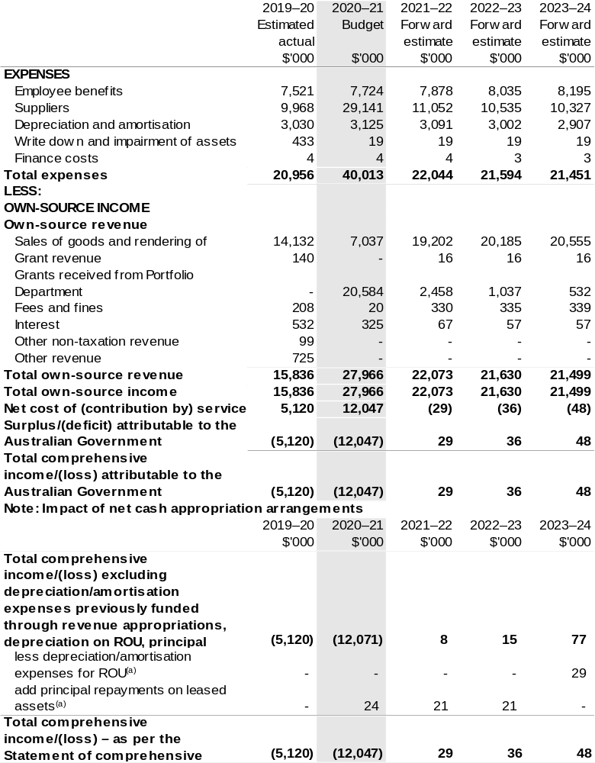
(a) Applies to leases under AASB 16 Leases. Right of Use (ROU).

Prepared on Australian Accounting Standards basis.

Table 3.2: Budgeted departmental balance sheet (as at 30 June)
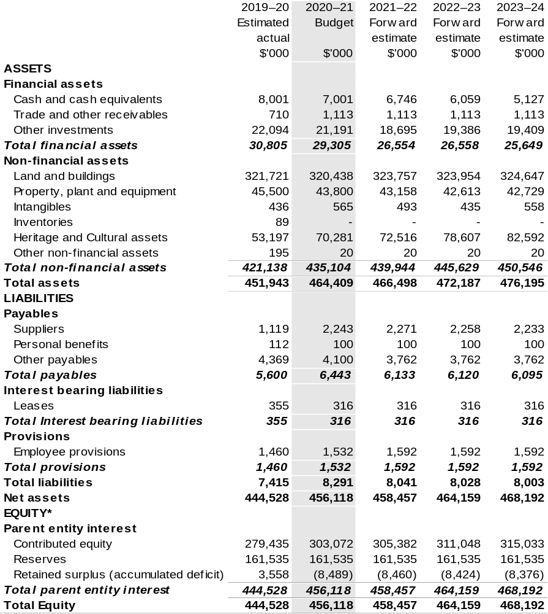
*Equity is the residual interest in assets after deduction of liabilities.

Prepared on Australian Accounting Standards basis.

Table 3.3: Departmental statement of changes in equity – summary of movement (Budget year 2020–21)
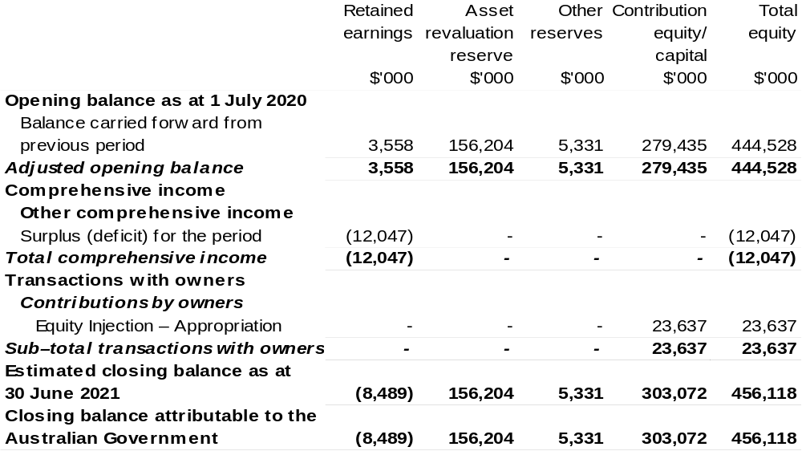
Prepared on Australian Accounting Standards basis.

Table 3.4: Budgeted departmental statement of cash flows (for the period
ended 30 June)
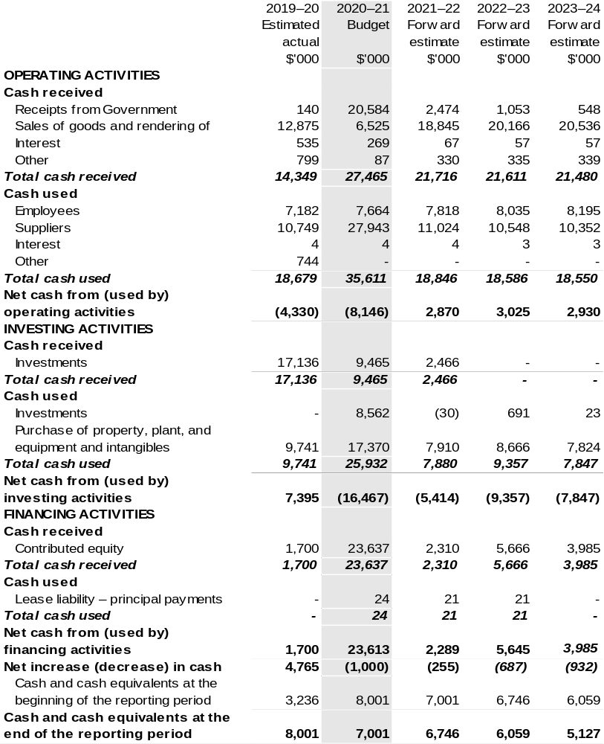
Prepared on Australian Accounting Standards basis.

Table 3.5: Departmental capital budget statement (for the period ended 30 June)
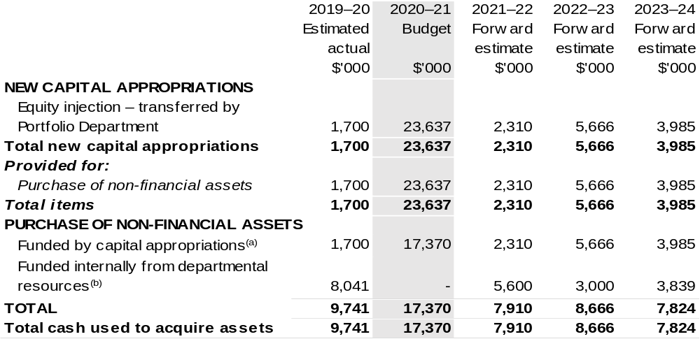
- Includes current Appropriation Bill (No. 1) and prior year Appropriation Bill No. 2/4/6.
- Includes the following sources of funding:
– current Bill (No. 1) and prior year Act/Bill (No. 1/3/5) appropriations (excluding amounts from the DCBs);
– donations and gifts of non-financial assets;
– section 74 External Revenue;
– internally developed assets; and
– proceeds from the sale of assets.

Consistent with information contained in the Statement of Asset Movements and the Budgeted Statement of Cash Flows.

Prepared on Australian Accounting Standards basis.

Table 3.6: Statement of asset movements (Budget year 2020–21)
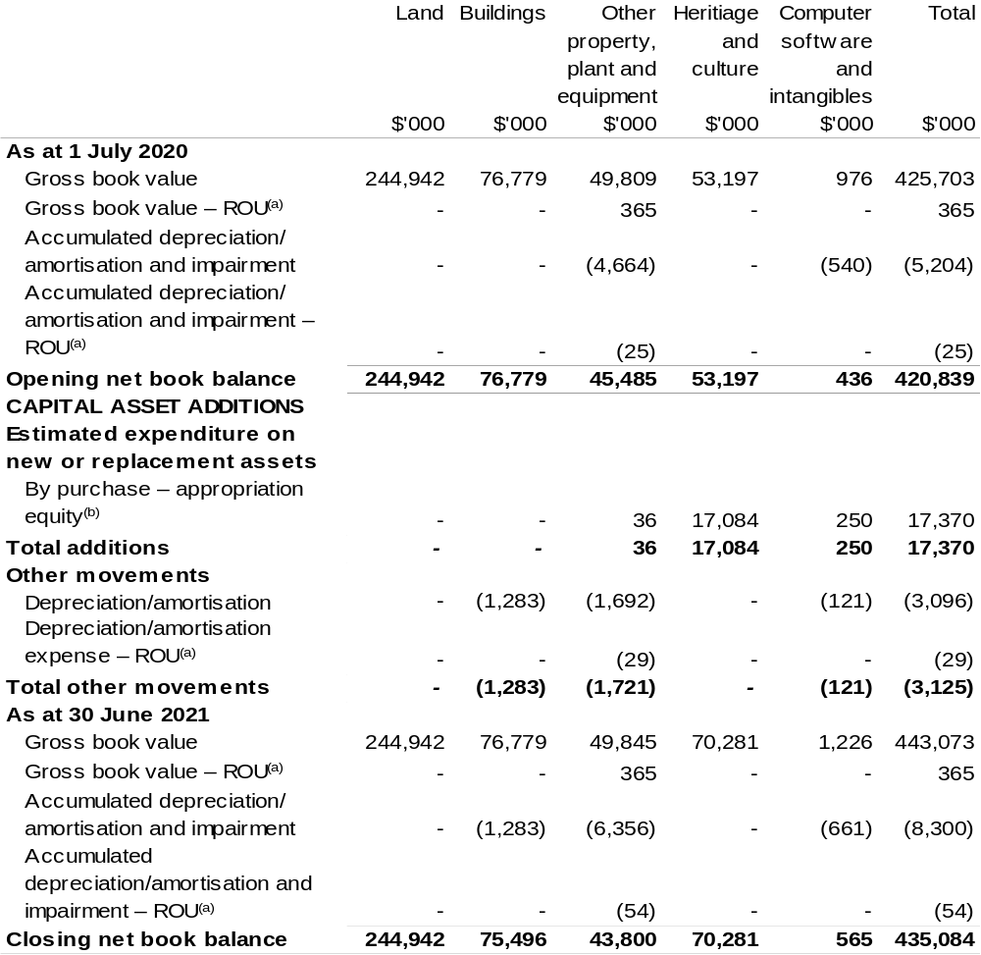
(a) Applies to leases under AASB 16 Leases. Right of Use (ROU).
(b) ‘Appropriation ordinary annual services’ refers to funding provided through Supply Act (No. 2) and Appropriation Bill (No.1) 2020–21 for depreciation / amortisation expenses, DCBs or other operational expenses.

Prepared on Australian Accounting Standards basis.

Wine Australia
Section 1: Entity overview and resources 397
1.1 Strategic direction statement 397
1.2 Entity resource statement 400
1.3 Budget measures 402
Section 2: Outcomes and planned performance 403
2.1 Budgeted expenses and performance for Outcome 1 404
Section 3: Budgeted financial statements 410
3.1 Budgeted financial statements 410
3.2 Budgeted financial statements tables 411

Wine Australia

Section 1: Entity overview and resources

1.1 Strategic direction statement
Wine Australia seeks to foster and encourage profitable, resilient and sustainable Australian winegrape and wine businesses by investing in research and development (R&D), building markets, disseminating market information and knowledge, encouraging adoption and ensuring compliance through our regulatory functions.
We are governed by the Wine Australia Act 2013 (Wine Australia Act).
Our role under the Wine Australia Act is to:
Coordinate or fund grape and wine R&D and facilitate the dissemination, adoption and commercialisation of the results;
Control the export of wine from Australia; and
Promote the sale and consumption of wine, both in Australia and overseas.
We are funded by grape growers, winemakers and exporters through levies and user-pays charges; and by the Australian Government, which provides matching funding for research, development and adoption (RD&A) investments.
Australian wine is a unique, high-quality product crafted in 65 wine regions around the country. The Australian wine sector has approximately 6,251 grape growers, 146,244 hectares of vines, 2,468 wineries and produces 1.2 billion litres of wine. In 2019, independent economic research quantified the Australian grape and wine sector’s contribution to the national economy. The wine sector—defined as grape growing, winemaking and wine-related tourism—supported 163,790 full-time and part-time jobs, most of which are in regional Australia, and contributed $45.5 billion to the value of gross output to the Australian economy.
International demand for fine Australian wine declined slightly in 2019–20, with the growth in the first two quarters disrupted by the COVID-19 pandemic, which led to a one per cent fall in the value of exports to $2.8 billion free on board (FOB). Three consecutive lower vintages in 2018, 2019 and 2020 contributed to the ongoing decline in volume of nine per cent to 730 million litres (81 million nine-litre case equivalents), driven mainly by lower price segments. There is now less wine available for export. The average value of exported wine grew to $3.89 per litre FOB. There were 2,813 active exporters in 2019–20 and 28,057 products exported to 116 destinations.
Our goal is profitable, resilient and sustainable winegrape and wine businesses and how we achieve our responsibilities under the Act is outlined in our five-year Strategic Plan 2020–25. In 2020–21, the first year of our strategic plan, we will invest in five strategies:
Strategy 1: Promote Australian wine
Strategy 2: Protect Australian wine
Strategy 3: Build grape and wine excellence
Strategy 4: Build sustainable environments
Strategy 5: Build business sustainability, excellence and leadership.
Our marketing strategy is focused on our four largest markets: Canada, China, the United Kingdom and the United States of America. Our marketing activities aim to continually improve the perception of the quality of Australian wine; to create a platform for the commercial success of our brand owners; and to facilitate in-market support and engagement for brand owners.
Our regulatory services activities seek to protect the reputation and integrity of Australian wine in all our markets, including the domestic market. We will ensure that the regulatory regime remains fit for purpose, we will explore new opportunities for traceability technologies, we will build relationships with counterpart regulators in import markets and we will continue to streamline our export approval process through our new Wine Australia Licensing and Approvals System (WALAS). We will also support the Geographical Indications Committee that defines the wine grape producing regions of Australia.
In Strategy 3, our R&D investments seek to enhance grape and wine excellence by identifying enhanced grapevine varieties and clones and breeding new varieties and rootstocks that suit our environment and consumer tastes. To maintain the supply of genetically diverse and high-health planting material, we will work towards the establishment of a national germplasm collection. To increase viticultural efficiency and sustainability, we will develop, test and commercialise new vineyard technologies and establish agricultural technology demonstration farms, and we will encourage adoption of new methods and strategies to increase winery efficiency and sustainability.
In Strategy 4, our R&D investments will provide knowledge and tools to help growers and producers to be more environmentally sustainable, including information to manage the challenges of short-term climate cycles and long-term climate change. We will determine how best to measure carbon emissions and waste production in a grape and wine production setting so that the sector can develop benchmarks as a first step towards its goal of zero net carbon emissions and zero waste production by 2050.
We will continue investing in research to allow more efficient and effective use of water in the vineyard, and focus on the value of soil remediation processes, lower chemical use in the vineyard, more sustainably managing endemic pests and diseases and being better prepared for exotic pests and diseases. We will actively support the sector’s Sustainable Winegrowing Australia program to help the sector demonstrate its sustainability credentials.
In Strategy 5, our R&D adoption investments seek to accelerate the adoption of research outcomes and best practice. We will implement our Extension and Adoption Strategy to build capacity and drive behaviour and practice change, including through our Regional Program. We will continue developing the leaders of tomorrow – and building the skills of the leaders of today – through regional governance and leadership programs and by supporting postgraduate students and early-career researchers.
In 2020–21, we will deliver the final elements of the Export and Regional Wine Support Package under the Ten-Year Enterprise Tax Plan – wine equalisation tax rebate integrity and wine tourism funding measure. The $50 million program has focused on wine promotion both internationally and domestically. Initiatives will benefit regional wine producers and assist export-focused businesses to continue to grow. We also administer the Wine Tourism and Cellar Door Grant program that commenced in 2019–20.
We also work closely with other research and development corporations (RDCs) in cross-sectoral collaborative research, including through Agricultural Innovation Investments Limited, to deliver RD&A benefits to the broader community.
Since 2015–16, we have been collecting the Wine Export Charge on behalf of the Australian Government. This streamlined the payment process for companies that pay the charge. In 2020–21, we will continue to investigate ways to reduce the time spent on compliance for our levy payers. We will engage with all of our levy payers through our new levy payer register.

1.2 Entity resource statement
Table 1.1 shows the total funding from all sources available to the entity for its operations and to deliver programs and services on behalf of the Government.
The table summarises how resources will be applied by outcome (government strategic policy objectives) and by administered (on behalf of the Government or the public) and departmental (for the entity’s operations) classification.
For more detailed information on special accounts and special appropriations, please refer to Budget Paper No. 4 – Agency Resourcing.
Information in this table is presented on a resourcing (that is, appropriations/cash available) basis, whilst the ‘Budgeted expenses by Outcome’ table in Section 2 and the financial statements in Section 3 are presented on an accrual basis.

Table 1.1: Wine Australia – Resource Statement – Budget Estimates for 2020–21 as at October 2020

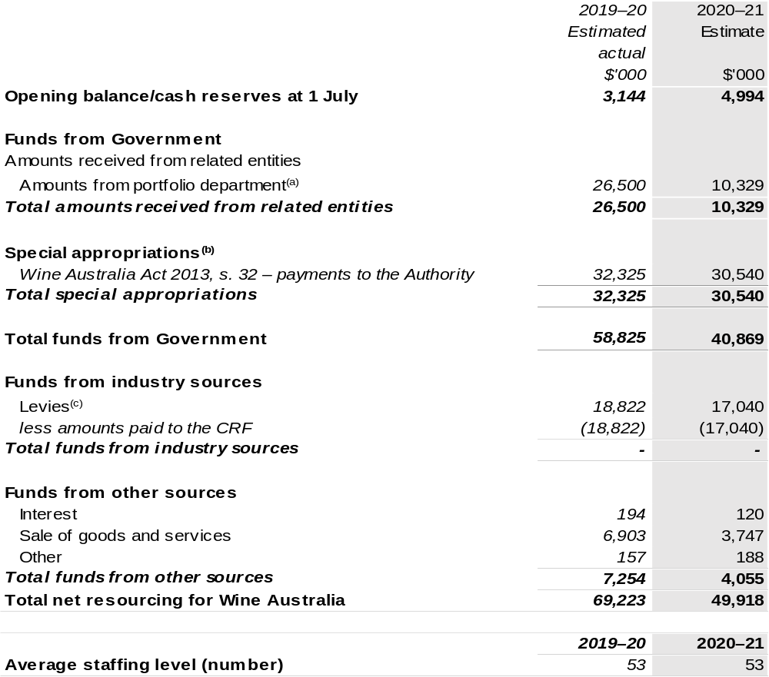
(a) Funding provided by the portfolio department that is not specified within the Annual Appropriation Bills as a payment to that corporate entity (for example, a grant awarded to a corporate entity from one of its portfolio department's administered programs).
(b) Wine Australia is not directly appropriated as it is a Corporate Commonwealth Entity (CCE) under the
PGPA Act. Appropriations are made to the Department of Agriculture, Water and the Environment and then paid to Wine Australia and are considered departmental for all purposes.
(c) Levies comprise the Grape Research Levy and the Wine Grapes Levy, imposed by the Primary Industries (Excise) Levies Act 1999 and Primary Industries (Customs) Charges Act 1999.

CRF – Consolidated Revenue Fund

Prepared on a resourcing (i.e. appropriations available) basis.

Please note: All figures shown above are GST exclusive – these may not match figures in the cash flow statement.

1.3 Budget measures
Budget measures in Part 1 relating to the Wine Australia are detailed in Budget Paper No. 2: Budget Measures 2020–21 and are summarised below.

Table 1.2: Wine Australia – 2020–21 Budget measures – Measures announced after the Economic and Fiscal Update July 2020
Wine Australia does not have any 2020–21 Budget measures.

Section 2: Outcomes and planned performance
Government outcomes are the intended results, impacts or consequences of actions by the Government on the Australian community. Commonwealth programs are the primary vehicle by which government entities achieve the intended results of their outcome statements. Entities are required to identify the programs which contribute to government outcomes over the Budget and forward years.
Each outcome is described below together with its related programs. The following provides detailed information on expenses for each outcome and program, further broken down by funding source.
Note:
Performance reporting requirements in the Portfolio Budget Statements are part of the Commonwealth performance framework established by the Public Governance, Performance and Accountability Act 2013. It is anticipated that the performance criteria described in Portfolio Budget Statements will be read with broader information provided in an entity’s corporate plans and annual performance statements — included in Annual Reports — to provide a complete picture of an entity’s planned and actual performance.
The most recent corporate plan for Wine Australia can be found at: https://www.wineaustralia.com/getmedia/83f33cf4-a1c6-42d7-85b4-08cb9415e44c/WA_StrategicPlan_2020-25_W_1.pdf.
The most recent annual performance statement for Wine Australia can be found at:
https://www.wineaustralia.com/getmedia/ffdc0314-7c89-4dd1-9a2e-4bc987f54b7f/WA_AnnualReport_2018-19_F2_1.pdf.

2.1 Budgeted expenses and performance for Outcome 1
Outcome 1: Foster and enable a competitive Australian wine industry by investing in research and development, building markets, disseminating knowledge and ensuring compliance.

2.1.1: Linked programs
Department of Agriculture, Water and the Environment
Program 3.10: Agricultural Resources
Contribution to Outcome 1 made by linked program:
Wine Australia and the Department of Agriculture, Water and the Environment work together to ensure a sustainable, productive and profitable grape and wine sector.
Department of the Treasury
Program 1.3: Support for markets and business
Contribution to Outcome 1 made by linked program:
Wine Australia delivers the Export and Regional Wine Support Package under the Department of the Treasury’s Ten-Year Enterprise Tax Plan – wine equalisation tax rebate integrity and wine tourism funding measure. This promotes wine and assists export-focused businesses to continue to grow. It also benefits regional wine producers and their communities through increasing wine tourism. Wine Australia also administers the Wine Tourism and Cellar Door Grant program, which commenced in 2019–20.

2.2.1: Budgeted expenses for Outcome 1
This table shows how much the entity intends to spend (on an accrual basis) on achieving the outcome, broken down by program, as well as by Administered and Departmental funding sources.

Table 2.1: Budgeted expenses for Outcome 1
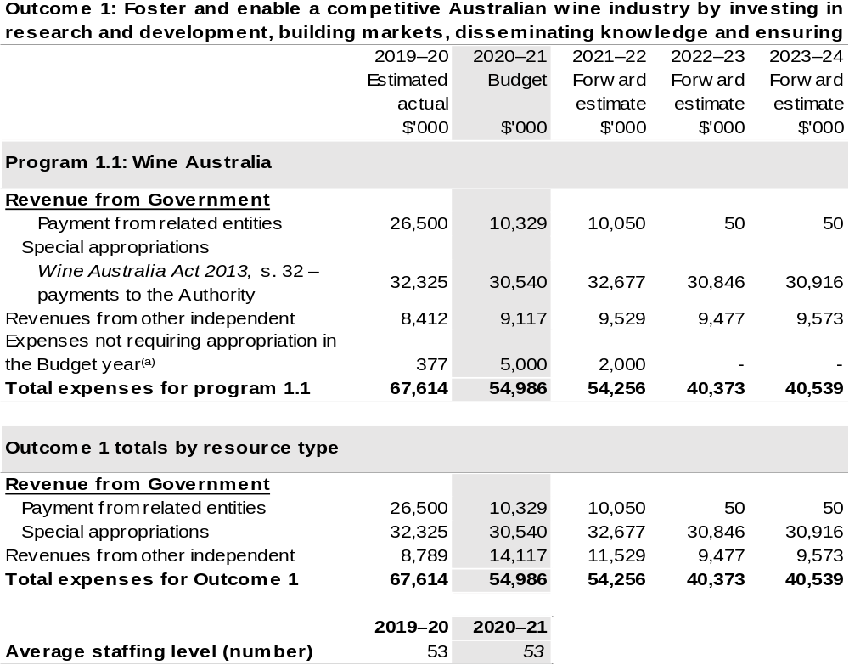
(a) Expenses not requiring appropriation in the Budget year are made up of depreciation expenses, amortisation expenses, make good expense and audit fees and expenses funded in the prior year.

Note: Departmental appropriation splits and totals are indicative estimates and may change in the course of the budget year as government priorities change.

Prepared on Australian Accounting Standards basis.

2.3.1: Performance criteria for Outcome 1
Table 2.3.1 below details the performance criteria for each program associated with Outcome 1. It also summarises how each program is delivered and where 2020–21 Budget measures have created new programs or materially changed existing programs.
As an entity established under the Wine Australia Act, Wine Australia does not produce a Corporate Plan under the PGPA Act and is therefore exempt from the requirement to map purposes to outcomes.
Outcome 1: Foster and enable a competitive Australian wine industry by investing in research and development, building markets, disseminating knowledge and ensuring compliance.
Program 1.1: Wine Australia
Objective | Invest in R&D, building markets, disseminating knowledge and ensuring compliance to foster and enable a competitive Australian wine sector.
Delivery | We will invest in R&D in the five strategic areas outlined in our Strategic Plan 2020–2025 for the benefit of wine grape growers, winemakers, wine businesses and the wider community.  We will invest in RD&A to build grape and wine excellence, build sustainable environments and build business sustainability, excellence and leadership.  We will invest in marketing to promote Australian wine and grow international markets.  We will invest in regulatory services to protect the reputation of Australian wine.  We will support grape and wine businesses with market insights that allow them to make effective decisions.

Continued on following pages
Contributions to Outcome 1 (continued)
Performance information
Year | Performance criteria | 2019–20 Actual Achievement/Targets
2019–20 | RD&E
2019–20 | R&D projects are funded in line with the Annual Operational Plan (AOP). | 100 per cent.
2019–20 | Contracts are actively managed through regular and ongoing monitoring of the research. | 100 per cent.
2019–20 | RD&E newsletter has more subscribers. | 2,500
2019–20 | The number of Regional Program partners is maintained. | 11
2019–20 | Marketing
2019–20 | Export and Regional Wine Support Package activities are completed in line with the funding agreement. | 100 per cent.
2019–20 | Wineries and distributors who participate in Wine Australia events report that they are satisfied. | At least 90 per cent.
2019–20 | Market insights
2019–20 | Improvement in customer satisfaction rating for market insights services. | 75 per cent.
2019–20 | Regulatory services
2019–20 | Risk-based audits reinforce a culture of compliance and help protect the reputation of Australian wine. | 300 audits.
2019–20 | Market export guides provide accurate information about import requirements for largest export markets. | 33 guides.

Continued on following pages
Contributions to Outcome 1 (continued)
Performance information
Year | Performance criteria | 2019–20 Actual Achievement/Targets
2020–21 | Wine Australia
2020–21 | We improve our stakeholder net promoter score from 2019 baseline. | Above +12.
2020–21 | RD&A
2020–21 | Research contracts are actively managed through regular and ongoing monitoring of the research. | 100 per cent.
2020–21 | Market Insights customers are satisfied or very satisfied with the services they receive. | > 90 per cent.
2020–21 | Levy payers who participate in Wine Australia-supported extension and adoption programs consider them a good or very good use of levy funds. | 80 per cent.
2020–21 | Marketing
2020–21 | Tier A influencers actively engage with Wine Australia. | 81 per cent.
2020–21 | The perception of Australian wine increases in Canada, China, the UK and the USA. | Increase above 2019 baseline.
2020–21 | Wineries and distributors who participate in Wine Australia events report that they are satisfied or very satisfied. | > 90 per cent.
2020–21 | Regulatory services
2020–21 | Achieve the six key performance indicators in our Regulator Performance Framework. | Achieved.
2020–21 | Through our Label Integrity Program, we inspect producers’ records, focusing on those relating to wine regions and varieties in particular demand. | Up to 300 records.

Continued on following page
Contributions to Outcome 1 (continued)
Performance information
Year | Performance criteria | 2019–20 Actual Achievement/Targets
2021–22 and beyond | Wine Australia
2021–22 and beyond | As per 2020–21. | As per 2020–21.
2021–22 and beyond | RD&A
2021–22 and beyond | As per 2020–21. | As per 2020–21.
2021–22 and beyond | As per 2020–21. | As per 2020–21.
2021–22 and beyond | As per 2020–21. | As per 2020–21.
2021–22 and beyond | Marketing
2021–22 and beyond | Tier A influencers actively engage with Wine Australia. | 82 per cent in 2021–22  83 per cent in 2022–23  84 per cent in 2023–24  85 per cent in 2024–25.
2021–22 and beyond | As per 2020–21. | As per 2020–21.
2021–22 and beyond | As per 2020–21. | As per 2020–21.
2021–22 and beyond | Regulatory services
2021–22 and beyond | As per 2020–21. | As per 2020–21.
2021–22 and beyond | As per 2020–21. | As per 2020–21.

Section 3: Budgeted financial statements
Section 3 presents budgeted financial statements which provide a comprehensive snapshot of entity finances for 2020–21, including the impact of 2020–21 Budget measures and resourcing on financial statements.

3.1 Budgeted financial statements

3.1.1: Differences between entity resourcing and financial statements
There are no differences between the resource information presented in the Budget Papers and Portfolio Budget Statements.

3.2.1 Explanatory notes and analysis of budgeted financial statements
The Budget incorporates the contracted and committed research, development and extension activities, the anticipated marketing programs and statutory duties.
Wine Australia receives levies on the tonnage of fruit grown (Grape Research Levy); grape products used in the manufacture of wine (Wine Grapes Levy); and on the value of wine exported (Wine Export Charge). Revenue from these levies is expected to be approximately $17.0 million for the 2020–21 year, based on an expected 2020 vintage of 1.52 million tonnes.
Research, development and extension expenditure attracts Commonwealth matching funding, which is calculated in accordance with the provisions of the Primary Industries Research and Development Act 1989 (PIRD Act).
Other major sources of revenue are export licence and associated fees and promotional user-pays events.

3.2 Budgeted financial statements tables

Table 3.1: Comprehensive income statement (showing net cost of services)
(for the period ended 30 June)
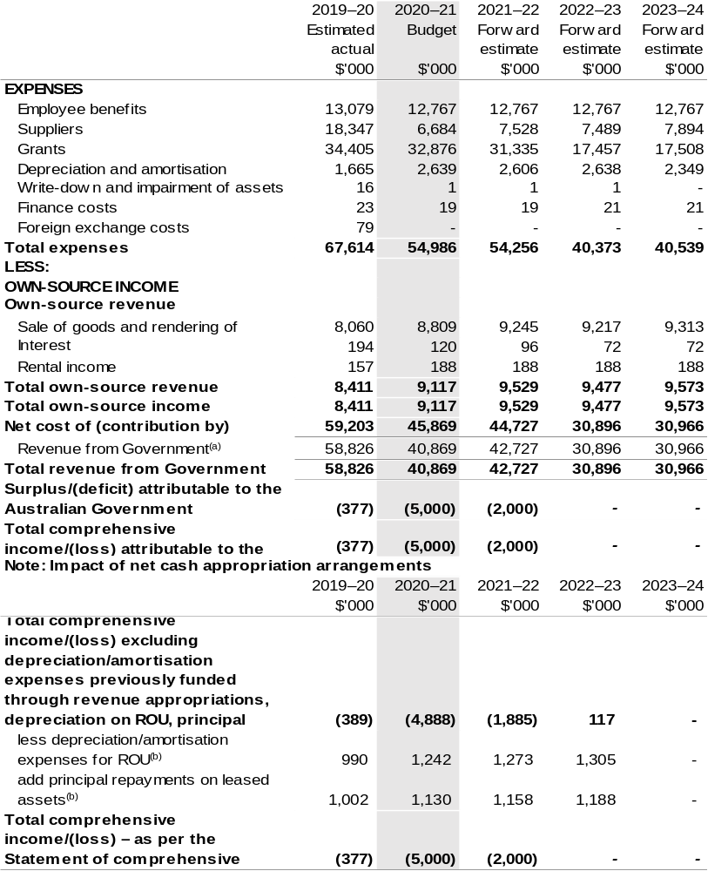
(a) Revenue from Government includes a Commonwealth contribution under the PIRD Act and levies collected from industry by the Department of Agriculture, Water and the Environment for research and development and marketing activities.
(b) Applies to leases under AASB 16 Leases. Right of Use (ROU).

Prepared on Australian Accounting Standards basis.

Table 3.2: Budgeted departmental balance sheet (as at 30 June)
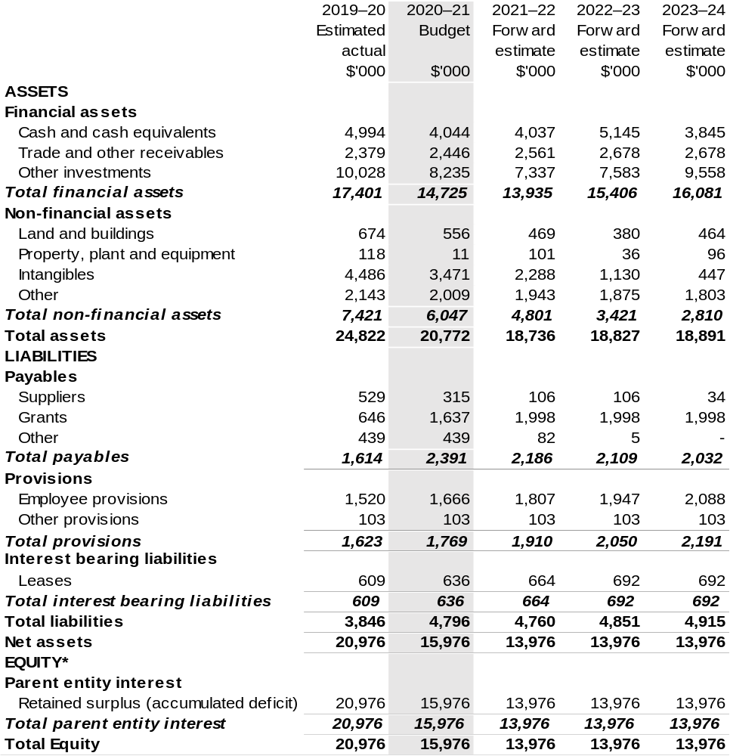
* Equity is the residual interest in assets after deduction of liabilities.

Prepared on Australian Accounting Standards basis.

Table 3.3: Departmental statement of changes in equity – summary of movement (Budget year 2020–21)
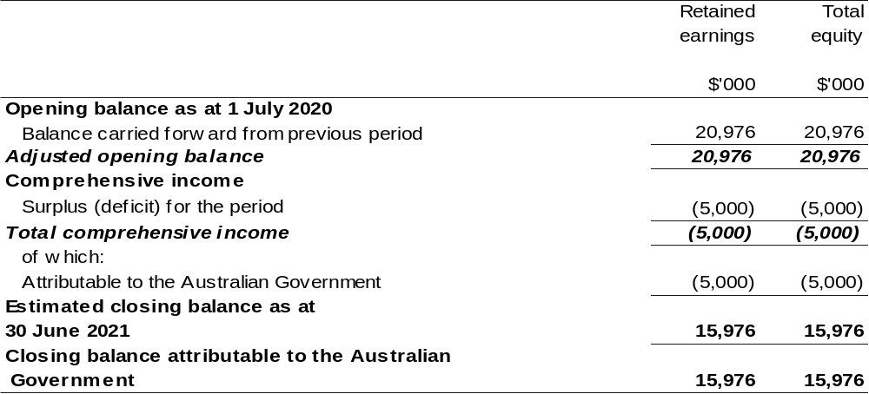
Prepared on Australian Accounting Standards basis.

Table 3.4: Budgeted departmental statement of cash flows (for the period
ended 30 June)
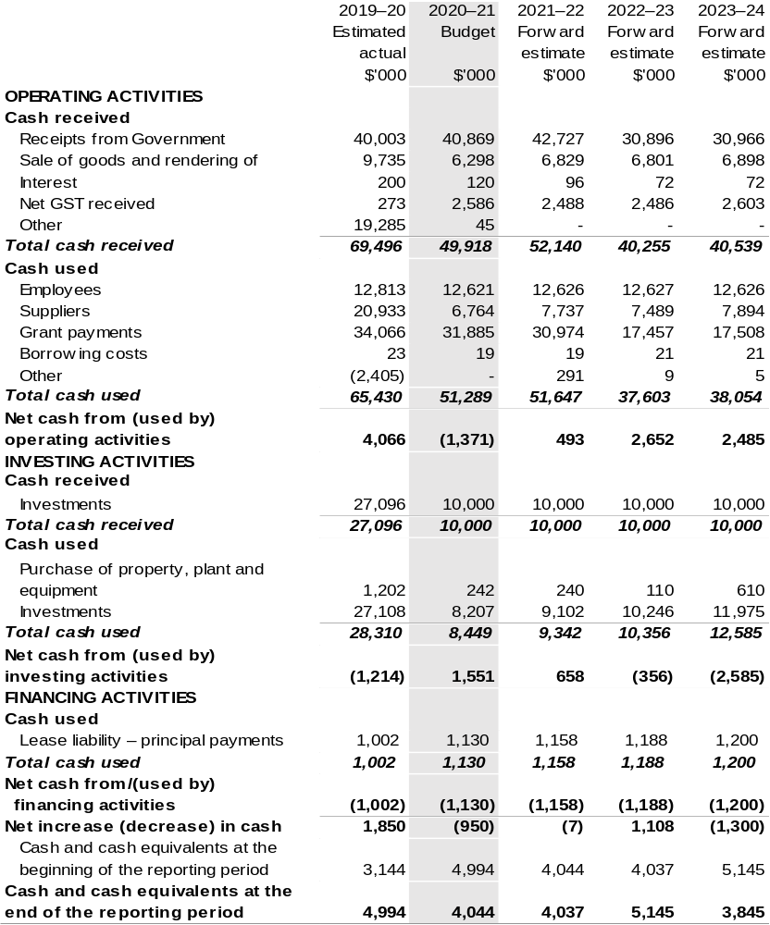

Prepared on Australian Accounting Standards basis.

Table 3.5: Departmental capital budget statement (for the period ended 30 June)
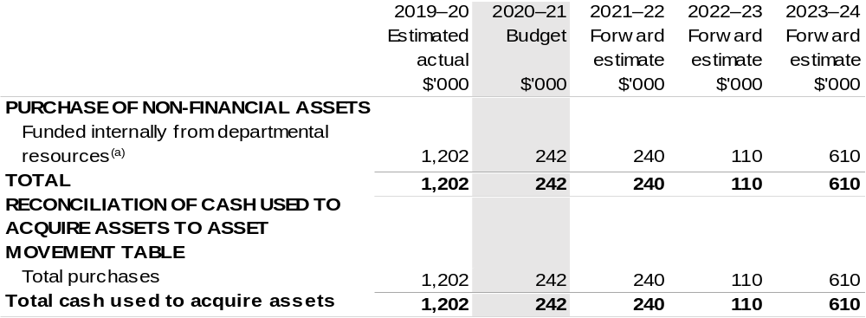

(a) Includes the following source of funding:
– internally developed assets.

Consistent with information contained in the Statement of Asset Movements and the Budgeted Statement of Cash Flows.

Prepared on Australian Accounting Standards basis.

Table 3.6: Statement of asset movements (Budget year 2020–21)
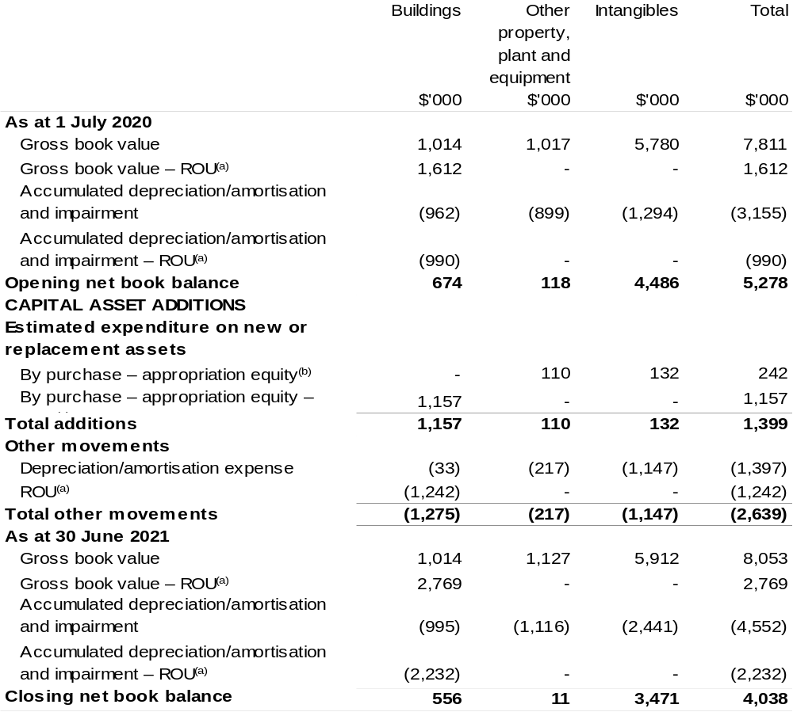

(a) Applies to leases under AASB 16 Leases. Right of Use (ROU).
(b) ‘Appropriation ordinary annual services’ refers to funding provided through and Appropriation Bill (No. 1) 2020–21 for depreciation / amortisation expenses, DCBs or other operational expenses.

Prepared on Australian Accounting Standards basis.

