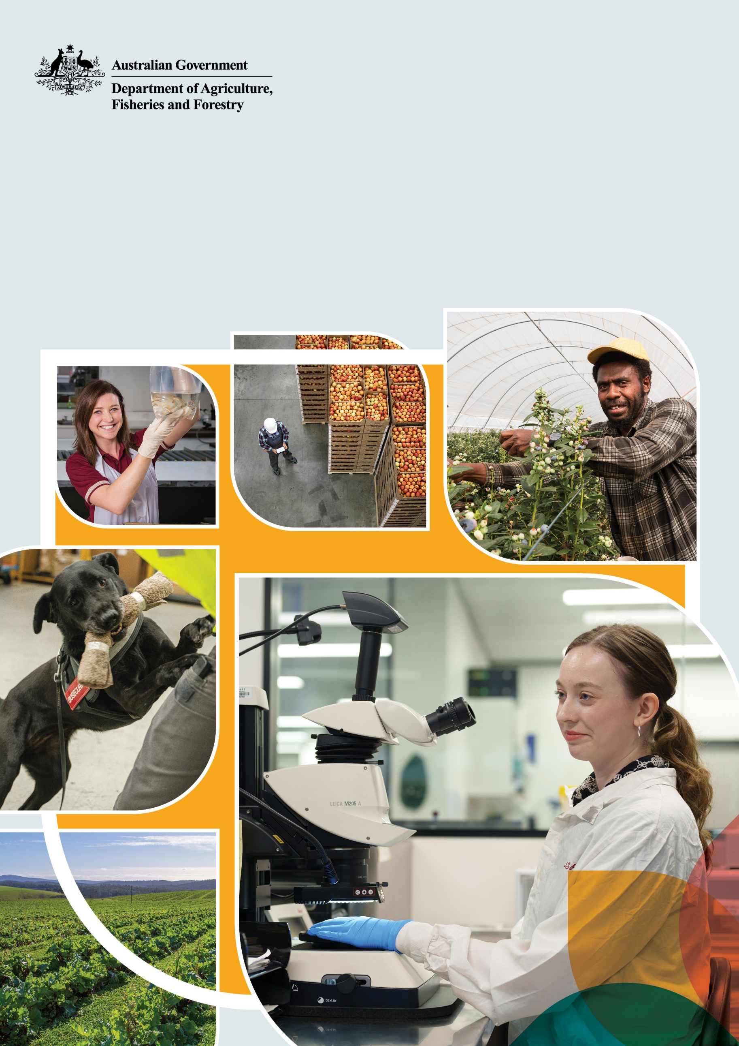
Corporate Plan 2024–25
© Commonwealth of Australia 2024
Ownership of intellectual property rights
Unless otherwise noted, copyright (and any other intellectual property rights) in this publication is owned by the Commonwealth of Australia (referred to as the Commonwealth).
Creative Commons licence
All material in this publication is licensed under a Creative Commons Attribution 4.0 International Licence except content supplied by third parties, logos and the Commonwealth Coat of Arms.

Cataloguing data
This publication (and any material sourced from it) should be attributed as: DAFF 2024, Corporate Plan 2024–25, Department of Agriculture, Fisheries and Forestry, Canberra. CC BY 4.0.
This publication is available at agriculture.gov.au/about/reporting/corporate-plan.
Department of Agriculture, Fisheries and Forestry
GPO Box 858 Canberra ACT 2601
Telephone 1800 900 090
Web agriculture.gov.au
Disclaimer
The Australian Government acting through the Department of Agriculture, Fisheries and Forestry has exercised due care and skill in preparing and compiling the information and data in this publication. Notwithstanding, the Department of Agriculture, Fisheries and Forestry, its employees and advisers disclaim all liability, including liability for negligence and for any loss, damage, injury, expense or cost incurred by any person as a result of accessing, using or relying on any of the information or data in this publication to the maximum extent permitted by law.
Acknowledgement of Country
We acknowledge the Traditional Custodians of Australia and their continuing connection to land and sea, waters, environment and community. We pay our respects to the Traditional Custodians of the lands we live and work on, their culture, and their Elders past and present.
Image credits
Cover photographs all © Department of Agriculture, Fisheries and Forestry, except top left © Sheldon Davies and top right © Kerry Trapnell.

Secretary’s foreword
The Department of Agriculture, Fisheries and Forestry (DAFF) leads the Australian Government’s efforts to support, protect and grow the country’s food and fibre production industries.
Our work touches the lives of all Australians, particularly those living in regional and rural areas.
We play a pivotal role in developing and promoting Australia’s sustainable agricultural production practices, increasing trade and international market access, maximising economic opportunities for Australia’s First Nations peoples and helping our producers become more productive, profitable and resilient.
As a department, we deliver world-class work in areas such as agricultural economics, plant and animal sciences, and use digital technology to deliver better regulatory outcomes.
We help keep Australians safe through effective biosecurity. Each day, we protect our industries, communities and natural environment from potentially devastating pests and diseases. We support every clean, safe meal that Australians sit down to enjoy.
These are important responsibilities, and we’re passionate about them.
We are delivery focused and connected. Operating under the banner of One DAFF, our people develop impactful policy and program solutions that promote productivity growth across the agricultural sector, secure improved access to international markets and safeguard our animal and plant health status and Australia’s environment.
This Corporate Plan 2024–25 is our primary planning document and forms part of our annual strategic planning process, in line with the requirements of the Commonwealth Performance Framework. It details our strategic direction, operating environment, management of enterprise risks, key activities and performance goals. It explains how we intend to deliver against our purpose over the next 4 years (2024–25 to 2027–28) – working together to safeguard and grow sustainable agriculture, fisheries and forestry for all Australians.
The gross value of agricultural production is forecast to reach $89.5 billion in 2024–25, the third highest result on record behind 2022–23 and 2021–22. It’s a significant contribution to the national economy and the backbone of rural and regional communities, economies and employment.
We place great value on collaboration to achieve our purpose and strategic objectives. We work in partnership with industry, Australian Government agencies, state, territory and local governments, private and philanthropic sectors, research and academic entities, and communities, particularly in rural and regional Australia.
These partnerships are central to our efforts to ensure the agricultural, fisheries and forestry industries are competitive and sustainable. We build on the knowledge, experience and innovation of Australia’s First Nations Peoples, farmers and other stakeholders.
New challenges and opportunities continue to emerge, from global and regional food security to sustainability, emerging biosecurity threats, improving productivity and supply-chain resilience, education and skills, and empowering First Nations people.
We are increasing our use of data analytics and investments in strategic intelligence for horizon-scanning and trend monitoring, enabling better informed biosecurity risk management decisions.
As an organisation we are investing in our foundational capabilities, including governance, workforce planning and financial management. Through our 4-year departmental Transformation Action Plan, we are enacting immediate and longer-term actions to uplift our leadership and culture, collaboration, delivery, people and resourcing, and risk capabilities. The Transformation Action Plan will help clarify and align our financial and non-financial performance architecture and ensure excellence in our regulatory service delivery. These actions will hone our ability to deliver the most appropriate and beneficial programs and services to Australia’s agricultural sector and rural and regional communities.
I am proud to lead a diverse workforce, dedicated to making a difference and committed to working in partnership with our stakeholders to achieve our vision of a more sustainable and prosperous Australia.

Statement of preparation
As the accountable authority of the Department of Agriculture, Fisheries and Forestry, I present the Corporate Plan 2024–25. This plan covers the reporting periods from 2024–25 to 2027–28, as required under paragraph 35(1)(b) of the Public Governance, Performance and Accountability Act 2013.

Adam Fennessy PSM
Secretary
Department of Agriculture, Fisheries and Forestry

Contents
Secretary’s foreword iii
Statement of preparation iv
Commonwealth Performance Framework 1
Alignment with our Portfolio Budget Statements 2024–25 2
Corporate plan overview 4
About us 5
Our role 5
Our vision 5
Our purpose 5
Our strategic objectives 5
Our key activities 5
Our people: One DAFF 7
Our structure 8
Our operating context 9
Operating environment 9
Strengthening departmental capability 13
Risk oversight and management 17
Collaborating with others 19
Subsidiaries 22
Our performance framework 23
Performance measures and targets 23
Appendix A: Alignment of key activities and performance measures 63
Appendix B: PGPA Rule requirements 74
Tables
Table 1 Our key activities 6
Table 2 Enterprise risks 18
Table 3 Objective 1 Sector growth – performance measure overview 24
Table 4 Objective 2 Sector resilience and sustainability – performance measure overview 37
Table 5 Objective 3 National biosecurity – performance measure overview 45
Table 6 Emergency management capability maturity levels 52
Table A1 Sector growth strategic objective – changes to performance information 63
Table A2 Sector resilience and sustainability strategic objective – changes to performance information 65
Table A3 National biosecurity strategic objective – changes to performance information 67
Table A4 Alignment between Portfolio Budget Statements 2024–25 and Corporate Plan 2024–25 70
Table B1 Alignment with PGPA Rule requirements 74
Figures
Figure 1 Commonwealth Performance Framework 1
Figure 2 Connections between PBS, corporate plan and annual performance statements 2
Figure 3 Connecting our purpose, outcomes and objectives 3
Figure 4 How the elements of our corporate plan integrate 4
Figure 5 Our departmental structure 8
Figure 6 Transformation Action Plan – 5 domains 13
Figure 7 Our stakeholders and partners 20

Commonwealth Performance Framework
The Commonwealth Performance Framework is established by the Public Governance, Performance and Accountability Act 2013 (PGPA Act), and requires all Commonwealth approved entities to demonstrate how public resources have been applied to achieve their purpose. It sets out how entities must report on how they plan, measure and assess their performance. Figure 1 shows the 3 related publications required under the framework.
Figure 1 Commonwealth Performance Framework
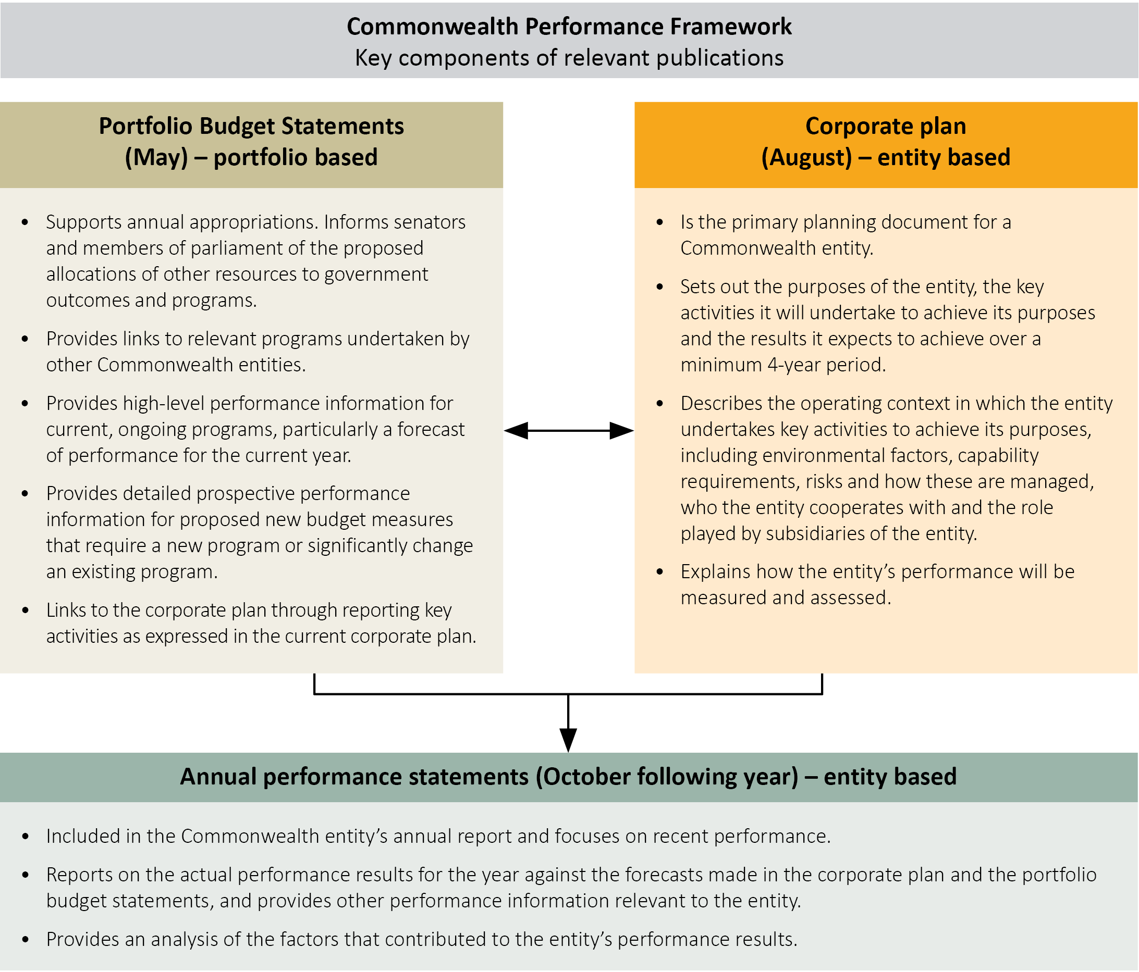
Planned performance targets are set in the Portfolio Budget Statements (PBS) and corporate plan at the start of each financial year. Actual results achieved against the performance measures published in the corporate plan and the PBS are reported in the annual performance statements, in the annual report, at the end of that financial year. This information must be presented in accordance with the requirements of the PGPA Act and the Public Governance Performance and Accountability Rule (PGPA Rule).
Figure 2 shows the connections between the PBS, corporate plan and annual performance statements in the annual report.
Figure 2 Connections between PBS, corporate plan and annual performance statements
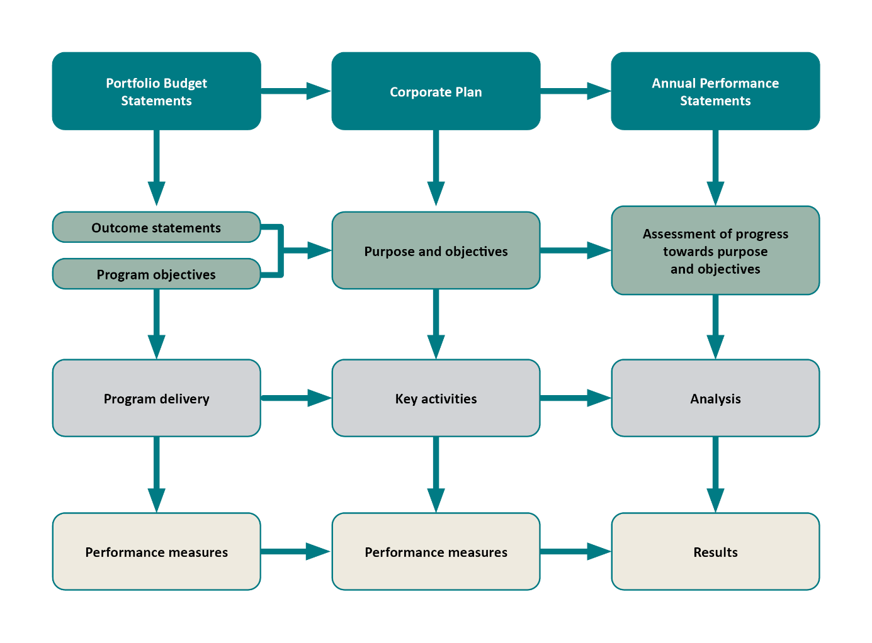

Alignment with our Portfolio Budget Statements 2024–25
In accordance with the Finance Secretary’s Direction, the key activities and performance measures in our Portfolio Budget Statements 2024–25 (PBS 2024–25) reflect those in our Corporate Plan 2023–24, which was the current corporate plan when the PBS was published. The key activities and performance measures in this corporate plan supersede those in the PBS 2024–25.
We currently have 2 PBS outcome statements. Figure 3 shows how these align to our purpose, strategic objectives, key activities and performance measures. Table A4 shows the broad alignment with the PBS outcomes and programs and the updated key activities and performance measures for 2024–25.
We will continue to review our PBS outcomes and programs to align them more clearly with our key activities with a view for this work to be completed for the PBS 2025–26.
Figure 3 Connecting our purpose, outcomes and objectives
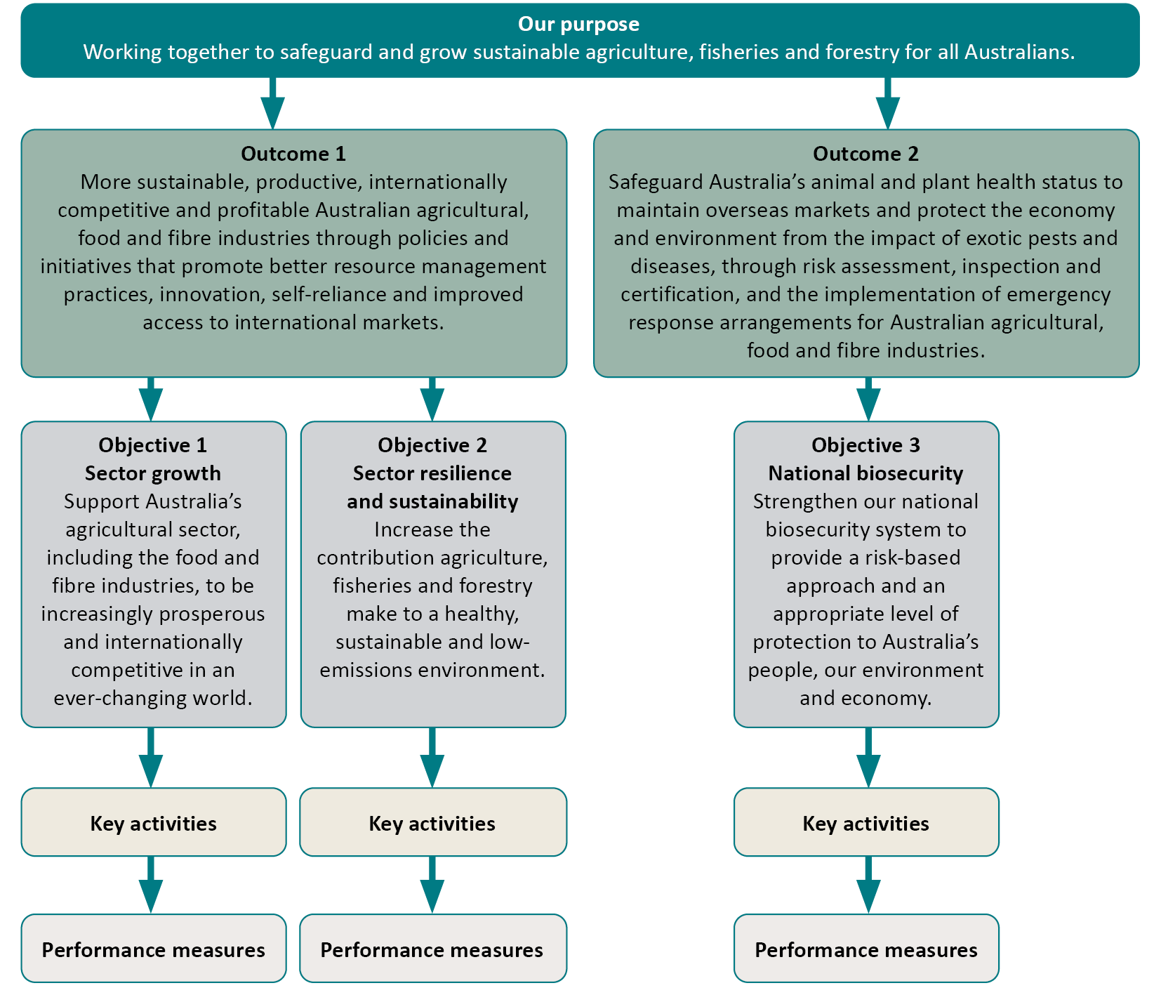
For a comprehensive view of our outcomes and planned performance cycle, this corporate plan should be read in conjunction with our Portfolio Budget Statements 2024–25 and with the full annual performance statements in our Annual report 2024–25, to be published in October 2025, which will detail the outcomes of our planned performance set out here, including results and achievements.

Corporate plan overview
Section 16E of the PGPA Rule outlines the requirements for accountable authorities to prepare corporate plans. These are detailed in Appendix B. Figure 4 shows the connections between these elements in our corporate plan.
Figure 4 How the elements of our corporate plan integrate
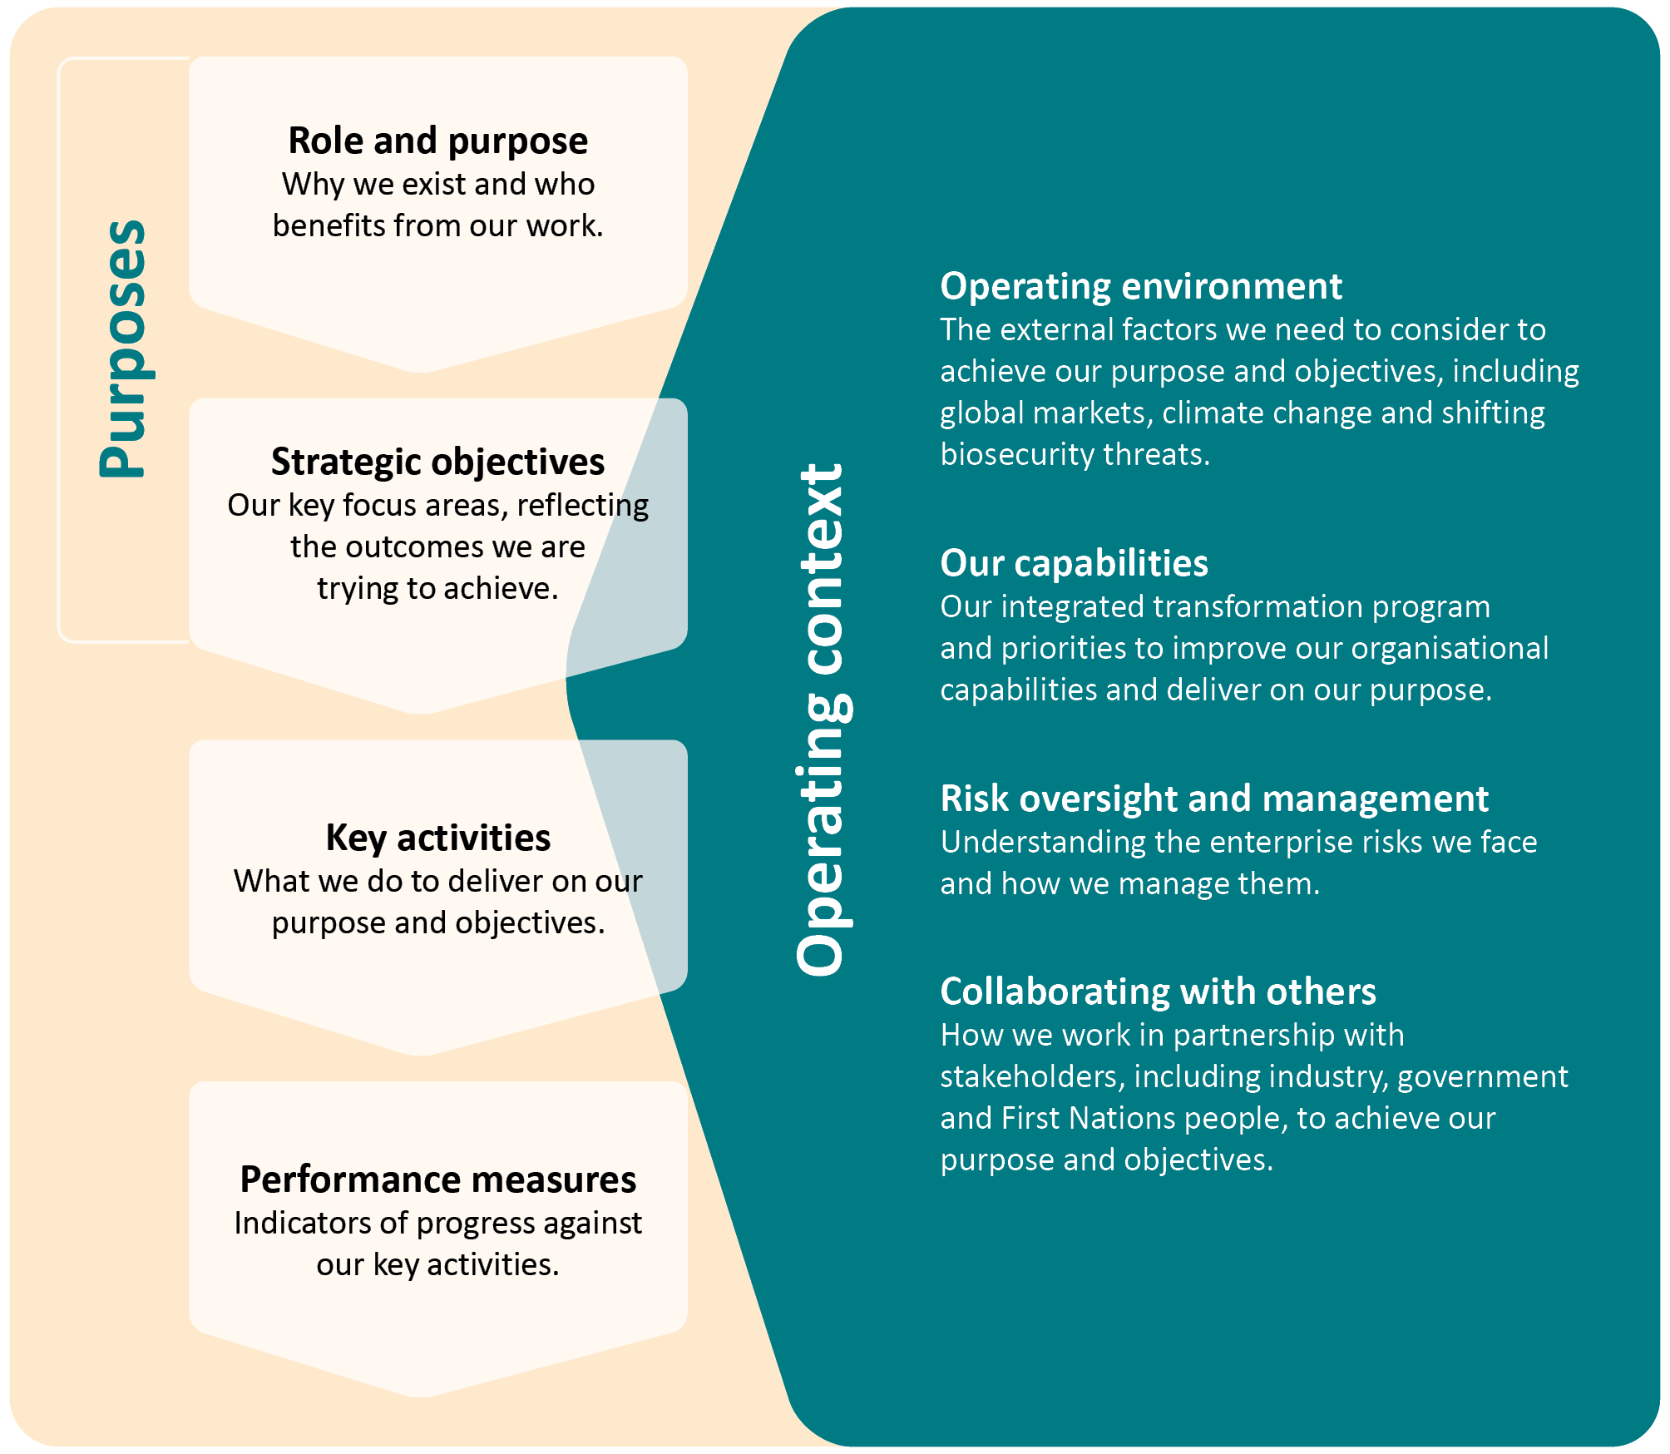

About us

Our role
The Department of Agriculture, Fisheries and Forestry (DAFF) is the lead government agency for the agricultural sector (the agricultural, fisheries and forestry industries) in Australia.
Our work is central to the health and prosperity of the nation. Our policies and services protect and span the entire supply chain, helping to grow Australia’s economy and enable the Australian agricultural sector to produce high quality, more sustainable products for consumption within Australia and overseas.
We are a national regulator with portfolio responsibilities that include biosecurity and trade. We work in partnership with all levels of government and with local communities. We have scientific and technical expertise, connections with a range of domestic and international stakeholders and important partnerships across the private sector, from small agricultural businesses to multinational enterprises.

Our vision
A more sustainable and prosperous Australia through biosecurity, production and trade.

Our purpose
Working together to safeguard and grow sustainable agriculture, fisheries and forestry for all Australians.

Our strategic objectives
To achieve our purpose, we focus on 3 strategic objectives:
- Sector growth – Support Australia’s agricultural sector, including the food and fibre industries, to be increasingly prosperous and internationally competitive in an ever-changing world.
- Sector resilience and sustainability – Increase the contribution agriculture, fisheries and forestry make to a healthy, sustainable and low-emissions environment.
- National biosecurity – Strengthen our national biosecurity system to provide a risk-based approach and an appropriate level of protection to Australia’s people, our environment and economy.
Together, our role, purpose and strategic objectives form our ‘purposes’ as defined in the requirements of the PGPA Act, PGPA Rule and the Department of Finance’s resource management guides.

Our key activities
Our purpose, PBS outcome statements and objectives are achieved through key activities that best represent our significant regulatory, program and policy responsibilities.
Since the publication of our last corporate plan, we have updated our key activities and several performance measures to better reflect the work we do under each outcome and strategic objective. Table 1 lists these key activities by strategic objective. Table A1, Table A2 and Table A3 in Appendix A explain the adjustments from our last corporate plan. The key activities and associated performance measures for 2024–25 in this corporate plan will be assessed during our annual performance planning cycle to ensure they remain relevant and appropriate.
Table 1 Our key activities
Strategic objective | Key activities
Objective 1 Sector growth: Support Australia’s agricultural sector, including the food and fibre industries, to be increasingly prosperous and internationally competitive in an ever-changing world. | 1.1 Develop and deliver policies and manage programs to ensure primary producers are well positioned to maintain and increase their productivity.  1.2 Work with levy stakeholders to effectively administer the agricultural levies system.  1.3 Deliver programs and work with portfolio agencies to support farmers’ financial growth.  1.4 Enable and protect international market access to provide growth opportunities for agricultural producers and exporters and support global food security.  1.5 Represent Australia’s interests and contribute to global standards for open and free trade by participating in multilateral standard-setting bodies.  1.6 Provide effective, efficient, and modernised regulation as the administrator of the Export Control Act 2020.  1.7 Support a productive and sustainable Australian forestry industry.
Objective 2 Sector resilience and sustainability: Increase the contribution agriculture, fisheries and forestry make to a healthy, sustainable and low-emissions environment. | 2.1 Create pathways that support the agricultural sector to build an understanding of emissions reduction opportunities and adopt emissions reduction activities that strengthen productivity and competitiveness.  2.2 Deliver annual funding to support the agricultural sector to adopt sustainable agriculture practices in accordance with the Natural Heritage Trust.  2.3 Administer annual funding from the Future Drought Fund to build drought resilience in Australia’s agricultural sector in accordance with the Drought Resilience Funding Plan (2024–2028).  2.4 Ensure Australian Government fisheries are sustainably managed through the development and review of legislative and policy settings and other initiatives.
Objective 3 National biosecurity: Strengthen our national biosecurity system to provide a risk-based approach and an appropriate level of protection to Australia’s people, our environment and economy. | Pre-border:  3.1 Use international standards and science-based risk assessments to develop and inform policy, legislative frameworks and tools to support the management of exotic pest and disease risk.  3.2 Assess and finalise applications for biosecurity risk goods that require an import permit, ensuring fit-for-purpose regulation and biosecurity risk management.  3.3 Establish new and maintain existing pre-border biosecurity arrangements with overseas governments and entities to manage biosecurity risks associated with imported goods, to reduce the number and frequency of exotic pests entering Australia.  3.4 Undertake targeted public engagement and communication to enhance awareness of biosecurity requirements.  3.5 Maintain and mature emergency management arrangements.
At the border:
3.6 Establish and maintain biosecurity measures (both onshore and offshore) to prevent the entry or establishment of pests and diseases into Australia.
3.7 Screen and inspect goods which present a high level of biosecurity risk at the border.
3.8 Verify and assure our controls through monitoring, auditing and applying actions against non-compliance.
3.9 Manage biosecurity risks to an acceptable level while delivering quality services to our stakeholders.
Post-border:
3.10 Manage non-compliance with biosecurity and other relevant portfolio legislation.

Our people: One DAFF
We can only perform our departmental role and activities with the support of our people. We’re better than the sum of our parts. As One DAFF, we work together to deliver policy, regulation and operations domestically and internationally, maintaining and growing overseas markets.

Our Core 4 values
Our values are embedded in departmental culture, defining the quality of our workforce, and consistently reflected and delivered through our activities.
Our Core 4 values are:
- Working together – We look after each other, work as a team and actively engage and collaborate with internal and external stakeholders.
- Courage – We innovate, engage with risk, identify and learn from our mistakes.
- Diversity – We are inclusive and listen to and draw on expertise.
- Excellence – We accept personal responsibility for our work and use data and research to make well-informed decisions.
With a diverse and dispersed workforce, we focus on collaboration and the One DAFF approach to our work. We will work as One DAFF to grow Australia together.

Our structure
We focus our programs of work through divisions organised into 4 groups, as shown in Figure 5. As One DAFF, our 5,700 people work together and with our stakeholders to achieve our purpose and objectives.
Figure 5 Our departmental structure
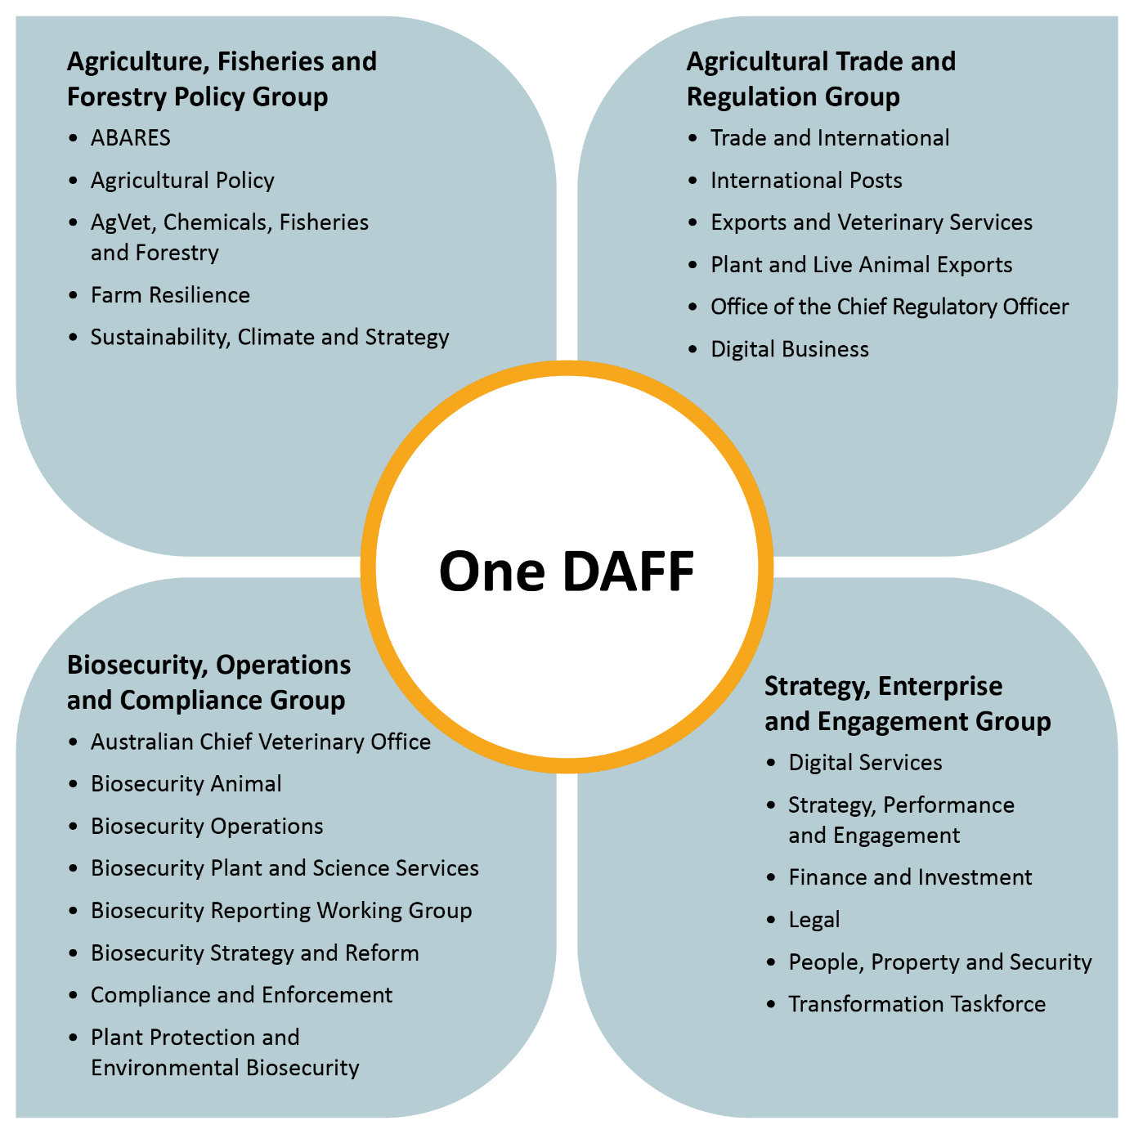

Our operating context

Operating environment
Our operating environment is challenging and dynamic. The agricultural sector is exposed to fluctuations in trade and climatic conditions which are beyond our control. For example, the risk of different biosecurity threats or significant pest and disease outbreaks is constantly shifting (such as the recent foot-and-mouth disease outbreaks in Indonesia, or outbreaks of highly pathogenic avian influenza). Trade routes and global supply chains heavily impacted by the COVID-19 pandemic continue to be affected by geopolitical shifts. Our stakeholders are on the frontline of climate change and the transition to a net-zero economy.

Another strong year forecast for agriculture
Our research arm, the Australian Bureau of Agricultural and Resource Economics and Sciences (ABARES), in the June 2024 Agricultural Commodities Report forecasted the gross value of agricultural production to reach $89.5 billion in 2024–25, consisting of $83.6 billion for agriculture, $3.6 billion for fisheries and $2.3 billion for forestry. This is the third highest result on record behind 2022–23 and 2021–22.
More favourable climatic conditions compared to 2023–24 are expected to lead to higher crop production, while prices for many agricultural products continue to be supported by strong global demand.
Higher expected global consumption of food, particularly in key Asian markets, puts Australian exporters in a strong position to capitalise given proximity to the region. Economic growth and consumption are expected to remain resilient in southeast Asia, Japan, and China in 2024–25, supporting demand for Australian exports.
Australian agriculture reached a record gross value of production in 2022–23 on the back of past reforms, investments in productivity and industry responses to domestic and global pressures. These factors put the sector in a strong position to take advantage of historically favourable climatic conditions and high global commodity prices in that year, with 2024–25 expected to be another strong result.
The majority of operating costs for agricultural businesses are expected to ease in 2024–25 but remain relatively elevated in historical terms. Lower costs along with more favourable production conditions are expected to lead to improved profitability at the farm level across most industries.

Facilitating better trade outcomes
The global trade market remains dynamic and Australian farmers and exporters continue to face diverse climatic impacts and geopolitical factors that will impact trade. However, with ABARES forecasting the value of agriculture, fisheries, and forestry exports to reach $73.1 billion in 2024–25, we continue to work to get Australian farmers’ goods to market and deliver value for our exporters.
With more than two-thirds of Australia’s agricultural products exported, Australia continues to enjoy an international reputation as a trusted partner in feeding and clothing the world’s growing population. The burgeoning global middle-class presents opportunities for expanded trade and we continue to invest in facilitating global consumers’ access to Australia’s high-quality food and fibre products.
Our department plays a vital role in maintaining and growing our global share of trade through market access and the effectiveness of our biosecurity. We deliver export controls, invest in traceability and undertake the facilitation and regulation required to export goods and meet importing country requirements. Our work to negotiate market access and regulate exports is supported by our trusted overseas agricultural counsellor network. Our counsellors are based around the world in key agricultural trade markets, promoting Australia’s agricultural interests and helping our agricultural sector grow.
Profitability for our farmers, fishers, and foresters in an international trading environment relies on a robust multilateral trade system committed to free and open markets. Regulatory decision-making in the development of agriculture and food health and safety standards must be science and risk based. We play an active role in multilateral trade and standard-setting forums, growing Australia’s reputation as an exporter of climate-smart, sustainable food and fibre that will continue to be crucial to maintain our competitive edge in global markets.

Addressing biosecurity threats
Australia is fortunate to be free from many of the damaging plant pests and animal diseases that occur in other countries. This favourable status helps Australian producers access overseas markets, protects our unique environment, and supports a healthy way of life for all Australians.
Increasingly complex supply chains and the movement of goods bring elevated biosecurity risks. Engagement with international standard-setting organisations is also essential to improve biosecurity regulatory outcomes for the import of goods.
We know our biosecurity operating environment will face new and increasing challenges. These include biosecurity threats at our doorstep, fuelled by greater numbers of travellers, diversifying trade and cargo, geopolitics and changes in climate. Increased biosecurity threats, especially to Australia’s north, create a need for stronger prevention and surveillance in Australia and across the Southeast Asia and Pacific regions, and constant improvements and investment in our joint preparedness and response ability. Continual engagement with trading partners, particularly in Asia and the Pacific, is important to enable biosecurity risk management capacity and capability improvements.
Australia’s biosecurity system consists of 3 focus areas for preventing or responding to the incursion of pests and diseases: pre-border, at our border and post-border activities. Across these 3 focus areas, we undertake a range of policy, operational and compliance functions. These are supported by a series of third-party agreements and partnerships with industry, state and territory governments, authorisations and programs, together with research, intelligence, innovation and data analytics. We also implement a range of education, engagement and public communication campaigns.
This work includes:
- Pre-border (overseas) activities – working with overseas governments and agencies, importers and other stakeholders to mitigate risk and reduce the number and frequency of pests and diseases that reach Australia. This includes developing international standards, assessing offshore risks and setting appropriate import conditions, educating stakeholders and building industry capability.
- At our border activities – screening and inspecting air and sea vessels, cargo, mail and travellers to assess and manage biosecurity risk; surveillance to ensure the earliest and most effective response to exotic pests, disease and weeds; undertaking laboratory diagnostics, verification, assurance and post-entry quarantine to prevent pests and diseases entering Australia.
- Post-border activities – addressing non-compliance with biosecurity legislation; working with the states, territories and industry partners to detect and respond to incursions and contain and eradicate pests and diseases within Australia.
The Commonwealth Biosecurity 2030 strategy guides our priorities and the development of business activities to manage biosecurity risks.
Our work is underpinned by a strong science capability. We maintain the largest cohort of biosecurity diagnosticians in Australia, encompassing entomology, plant pathology, botany, molecular biology, and aquatic biology. We are also the largest public sector employer of veterinarians in Australia. This expertise supports appropriate import and export regulatory activities and supports key preparedness, surveillance and diagnostic capabilities which enables us to assess and manage biosecurity risks.
We are investing in the 5 enablers identified in Commonwealth Biosecurity 2030 to improve biosecurity outcomes, with a focus on our people and supportive investments in data, technology and innovation. For example, remote inspections, arising from COVID-19 impacts, are now a valuable addition to our regulatory toolkit. Our development and deployment of innovative diagnostic tools is enhancing regulatory and surveillance outcomes.
We are bolstering our biosecurity preparedness and response with states and territories, and industry through the National Biosecurity Strategy. The Northern Australia Quarantine Strategy augments the work of states, territories and industry to detect and report incursions of exotic pests and diseases in northern Australia. Additionally, we are increasing our use of data analytics and investments in strategic intelligence for horizon-scanning and trend monitoring, enabling better informed biosecurity risk management decisions. We continue to engage with and rely on approved arrangements with industry to help manage biosecurity risks effectively and efficiently, while performing regulatory and operational assurance activities to adapt and improve the biosecurity system.

Supporting sustainable agriculture
Governments and enterprises globally are grappling with how to reduce emissions and manage climate risks while maintaining critical agricultural production. Additionally, supply chains, international markets and the finance sector are increasingly requiring farmers to demonstrate their climate and sustainability credentials. We are working to ensure Australia’s long-term agricultural productivity and food, feed and fibre security by supporting producers to reduce emissions and embrace climate-smart practices.
We are working with the agricultural sector to chart a way forward for emissions reduction through the development of the Agriculture and Land Sectoral Plan. This will assist agricultural producers and land managers to increase their understanding of emissions reduction opportunities and to implement emissions reduction activities. It will also help achieve the Australian Government’s whole-of-economy emission reduction targets. The Australian Government has committed $63.8 million to assist the agricultural sector to further contribute to the net-zero economy, building on the knowledge and innovation of Australian farmers and landholders.
However, even with progress on emissions reduction, some climate impacts are locked in. For example, with a hotter, drier future predicted, we can expect to see an increase in heatwaves, droughts and other extreme weather events. We are investing in adaptation efforts necessary to address further loss and damages. For example, the Future Drought Fund (FDF) allocates $100 million a year in government funding available for programs and initiatives that improve drought resilience. We have set out the next 4-year funding plan for the FDF and will respond to the 2023 Productivity Commission inquiry of the fund in mid-to-late 2024.
We are further supporting the adoption of climate-smart and sustainable agricultural practices through the $302.1 million Climate-Smart Agriculture Program, funded through the Natural Heritage Trust (NHT). With 9 integrated investment streams, the Climate-Smart Agriculture Program is driving agricultural sustainability, productivity and competitiveness by supporting farmers to adopt climate-smart practices that manage emissions, build resilience to climate change, improve soil health and protect natural capital.
Partnerships are critical to achieving climate-smart agriculture outcomes. We are partnering with states and territories through a Federation Funding Agreement to deliver $20 million of on‑ground activities on National Soil Action Plan priorities, and we will continue delivering the National Statement on Climate Change and Agriculture.
Our continued efforts in delivering climate-smart initiatives, policies, programs and partnerships will support producers to contribute to Australia’s climate goals, boost farm productivity and profitability, and secure vital trade outcomes.

Responsive regulation
As a major regulator, we work to ensure that our regulatory approach keeps pace with changes in technology, industry practices, international regulation, and community expectations. We regularly review and, where necessary, adjust policies, protocols and operating procedures to ensure we can respond to the changing social, technological and international regulatory environment, as well as the commercial context, in which we operate.

Strengthening departmental capability
We are committed to improving our organisational capabilities to meet the expectations of government and align with the broader Australian Public Service (APS) Reform agenda.

Our Integrated Transformation Program
As part of the APS Reform agenda, the Australian Public Service Commission (APSC) delivered a capability review of the department. The review assessed our ability to meet future objectives and identified organisational capability gaps and opportunities to address them. In response to this and other reviews, a Transformation Action Plan (TAP) was released in November 2023 and sets out 10 priority actions across 5 domains (consistent with the APSC Capability Framework) as shown in Figure 6.
Figure 6 Transformation Action Plan – 5 domains
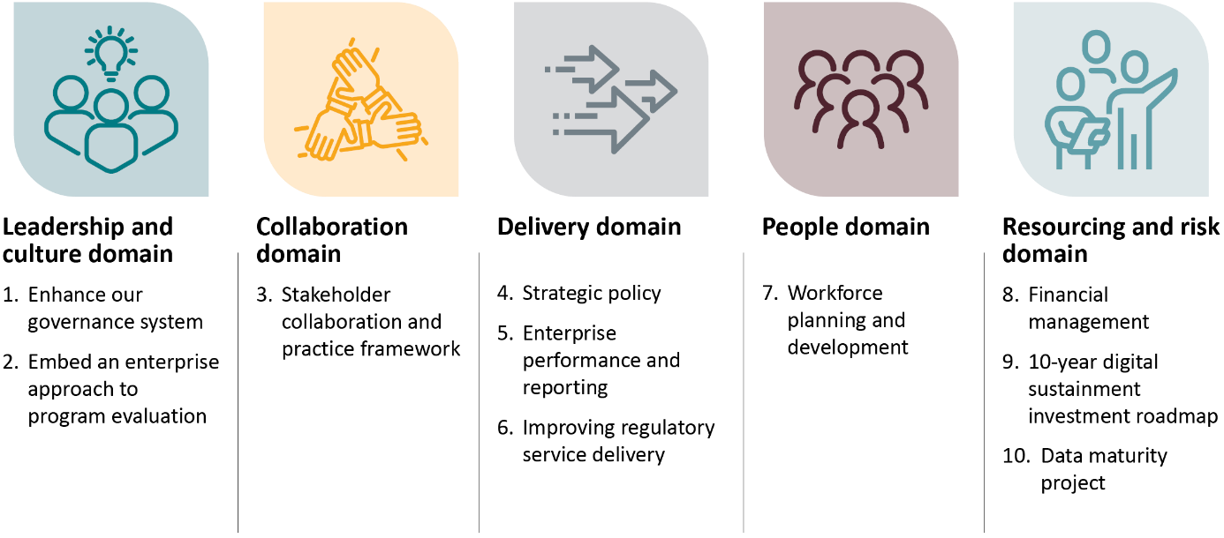
A transformation steering committee has been established to guide transformation projects developed under the priority actions of the TAP to date.
As we implement the TAP, new transformation priorities have been identified that require coordinated, focused and timely action to accelerate delivery. These priorities are being brought together in a broader integrated transformation program to drive 4 pillars of work:
- Embedding our new Statement of Strategic Intent.
- Developing a departmental operating model and structure.
- Developing a One DAFF departmental culture.
- Continuing capability uplift through the implementation of the TAP.

Strengthening our people’s capability
Under the TAP workforce planning and development priority action, in 2024–25 we will deliver a workforce strategy and action plan to ensure that our staff have the right mix of skills and capabilities, working in the right locations where they can perform effectively, safely and to the highest standards.
Our new workforce strategy will include an ongoing focus on First Nations and disability affirmative recruitment measures to boost representation. We will continue to focus on building cultural capability through the development and implementation of a cultural competency development plan, which is a flagship initiative under our First Nations roadmap.
We are committed to flexible work practices to improve diversity in our working arrangements and leadership and to position ourselves as an employer of choice to attract and retain an engaged workforce.
Building a safe, diverse, inclusive and high-performing culture with a shared purpose and values will enable us to build a future-ready workforce and foster outstanding leadership and consistent behaviours. Our Inclusion Strategy 2021–24 aligns our diversity action plans to Commonwealth strategy and legislation. These plans include policy development, programs, training, and the acknowledgement and celebration of national days of significance.
To ensure all genders have equal opportunities in the workplace, we participate in the Workplace Gender Equality Agency (WGEA) reporting process and the Australian Workplace Equality Index (AWEI), the definitive national benchmark for LGBTIQA+ workplace inclusion.
We are maturing our safety management system. Through our Work Health and Safety Strategic Plan 2025–2027 we will focus on safety leadership, safe work design and simple and effective safety systems, to ensure our people are safe wherever they work.
We will deliver a learning and development strategy, innovative leadership tools and communities of practice to guide our approach to uplift capability and support broader APS capability development priorities. We will continue to deliver contemporary learning solutions. Our Essentials mandatory training suite and departmental induction ensure our people understand their responsibilities and obligations as APS employees. All our training encompasses the principles of safety and integrity that underpin our Core 4 values.
We continue to mature and enhance our workforce planning capabilities. This helps us prepare for future challenges and opportunities to support our strategic direction and the APS Reform agenda. We have implemented a revised job family framework and developed employee surveys to gain insights that will better support the attraction and retention of staff. Data continues to be collected on workforce trends to identify critical roles and capabilities and inform workforce decisions. We are developing tactical workforce plans to ensure we have the workforce we need to achieve our strategic goals.

APS Strategic Commissioning Framework annual targets
The APS Strategic Commissioning Framework is part of the Australian Government’s commitment to reduce inappropriate outsourcing of core work and strengthen the capability of the APS. It requires government entities to apply an outcomes-focussed, principles based and whole-of-service framework and set annual targets in the corporate plan. Progress against these targets is reported in the annual report for that financial year.
In 2024–25, we will reduce outsourcing of core work in line with the APS Strategic Commissioning Framework. Our targets for 2024–25 focus on reduced outsourcing of work in administration, accounting and finance, data and research, ICT and digital services, portfolio program and project management, and trades and labour work, with an indicative reduction in outsourcing expenditure of $7,492,684 for the financial year.
This consists of:
- 50 contractor conversions to APS staff, resulting in $6,625,117 in contractor outsourcing expenditure
- 2 consultancy conversions resulting in $867,567 in consultancy outsourcing expenditure.
Success in achieving this target is dependent on labour market supply, successful bulk recruitment rounds and incentives, and initiatives being available where APS remuneration is below market rate to assist with conversion, attraction, and retention.

Maintaining a robust integrity culture
Integrity-based behaviour and decision-making are fundamental to the way we operate, particularly in our regulatory roles. We understand that what we do is connected to strengthening integrity across the public sector and ensuring the public’s confidence in our ability to effectively deliver outcomes for the Australian Government. We are stewards of the APS values, employment principles and APS Code of Conduct and demonstrate ethical behaviour in connection with our APS employment.
Our integrity framework policy suite, security and integrity training, and outreach and education activities support our people by giving them practical tools to fulfill their obligations as public office holders.
Through our integrity framework and dedicated in-house integrity functions, we proactively prevent, detect and respond to integrity matters. We educate our people about fraud and corruption and the behavioural standards set out in the APS Code of Conduct. We give our people tools to fulfill their security obligations. We remain committed to addressing allegations of wrongdoing, including investigating allegations of fraud, corruption and suspected misconduct. We embrace and promote a pro-integrity culture that is ethical, fair and appropriate by maintaining high standards of professionalism, accountability and responsible behaviour.

Investing in regulatory maturity
We continue to improve our regulatory practice in accordance with the principles of regulator best practice and improving regulator performance, capability and culture as required under the Department of Finance’s Resource Management Guide – Regulator Performance (RMG 128). Effective and efficient regulation enhances Australia’s economy, supports business and benefits the wider community.
As a regulator, we are responsible for laws relating to:
- the assessment and management of biosecurity risks and risks relating to ballast water
- the regulation of the export of goods
- the prohibition of the importation of illegally logged timber and the processing of illegally logged domestic raw logs
- ensuring food imported into Australia complies with Australian food standards and public health and safety requirements
- agricultural levies and charges and their collection for the disbursement of certain funds for research and development, marketing, biosecurity activities, residue testing and biosecurity emergency responses.
As required under RMG 128, our regulatory context is informed by the Ministerial Statement of Expectations and our responding Regulator Statement of Intent, which will be published on our website.
Our Regulatory Practice Statement (RPS) provides the overarching framework and principles guiding our regulatory teams. It informs the delivery of our strategy to streamline our strong regulatory culture and associated decision-making processes and ensure continuous improvement in regulatory practice. It signals our ongoing commitment to good regulation in accordance with the 3 principles of regulator best practice as per RMG 128:
- Principle 1 Continuous improvement and building trust – regulators adopt a whole-of-system perspective, continuously improving their performance, capability and culture to build trust and confidence in Australia’s regulatory settings.
- Principle 2 Risk based and data driven – regulators manage risks proportionately and maintain essential safeguards while minimising regulatory burden and leveraging data and digital technology to support those they regulate to comply and grow.
- Principle 3 Collaboration and engagement – regulators are transparent and responsive communicators, implementing regulations in a modern and collaborative way.
Our Regulatory Practice Committee and regulatory leaders continue to oversee and drive our regulatory maturity initiatives. We will address issues identified by independent reviewers and issues in the evolving markets and industries we regulate. As our regulatory capability matures, we will ensure that the regulations we are responsible for remain relevant and effective and that future improvements are developed transparently and in consultation with staff and stakeholders.
We have established a chief regulatory officer role to lead a team dedicated to improving our regulatory operating model, provide strategic advice and support to regulators and to policy areas on best practice policy and regulation. The development and maintenance of our RPS, regulatory operating model and subordinate strategic policies will increase understanding across the department and our stakeholders on our enterprise regulatory posture, improve our regulatory maturity, strengthen our approach to regulatory stewardship and ensure we invest in a culture of continuous improvement.
The improving regulatory service delivery priority action under our TAP aims to develop and implement a future-focused regulatory strategy that increases the efficiency and effectiveness of our regulatory service delivery and uplifts the capability of regulatory staff. This includes establishing and implementing platforms that empower our people and stakeholders to drive regulatory policy and operation improvements, and the development of best practice guides on common regulatory functions and techniques.

Risk oversight and management
Every day, we face a diverse range of risks in the pursuit of our vision, purpose and strategic objectives.
Our Enterprise Risk Management Framework and Policy outlines the principles, expectations, accountabilities and responsibilities for our staff in applying effective risk management practices.
This framework also defines our risk appetite and provides risk tolerance statements which articulate the amount and type of risk we are willing to accept or retain to achieve our strategic objectives. Our risk matrix – which we use to assess, report and escalate risk – ensures that we maintain an appropriate and consistent level of risk management oversight, accountability and control.
Our governance committees play a key role in ensuring we have effective leadership, direction, control and accountability:
- the Executive Board determines our risk appetite and tolerances and oversees the enterprise risks that may affect our ability to achieve our vision, purpose and strategic objectives
- other governance committees oversee the management of specialist risks relevant to their areas of responsibility
- the Audit and Risk Committee advises the Secretary and senior executives on the effectiveness of our system of risk oversight, management and internal control.
The chief risk officer provides oversight of risk management, culture and capabilities across the department and regularly informs the Executive Board and Audit and Risk Committee about current and emerging risks and issues.
At every level, our people are responsible for identifying, assessing, reporting and managing risk on a daily basis. We are committed to a positive risk culture that promotes an open and proactive approach to risk management. Our risk culture guides innovation, and helps us manage threats, harness opportunities and empower our people to make informed, risk-based decisions.
At an enterprise level, we manage 9 risks that may impact our ability to achieve our vision, purpose, and strategic objectives. Table 2 outlines these risks and the key mitigation strategies we use to manage them. Our first 3 enterprise risks align with achieving our strategic objectives. The remaining 6 enterprise risks relate to our organisational resources and capabilities. Managing these risks is critical to our ability to perform our core functions and responsibilities effectively, and they are mitigated by organisation-wide initiatives.
Table 2 Enterprise risks
Enterprise risks | Key mitigations for these risks
- Sector growth and market access: Inadequate support of sector growth and market access limits the ability of the agricultural, food and fibre industries to remain competitive and sustainable. | Support sector productivity and growth through science, policy and partnerships.  Maintain, regain and expand international markets by certifying and regulating exports and negotiating new and improved market access.  Provide facilitation and regulation services to support the export of goods from Australia.  Ensure certification and regulation protocols meet regulatory and legal requirements.
- Sector resilience and sustainability: Insufficient support of the agricultural, fisheries and forestry industries to enhance or adopt innovative practices which are resilient, sustainable and contribute to mitigating the impacts of climate change. | Support opportunities for industry to build resilience, mitigate the impacts of climate change and market disruptions and meet low emission targets.  Support industry to build innovative, competitive and sustainable practices through funding partnerships and engagement activities.
- National biosecurity: Insufficient ability to adapt and protect Australia from biosecurity threats and respond effectively to biosecurity incursions. | Effectively prepare for the management of biosecurity risk through pragmatic policy, fit-for-purpose regulation and mature preparedness.  Effectively detect biosecurity risk through intelligence-led targeting, technology-supported inspections and efficient detection methods.  Minimise the impact of biosecurity incursions through appropriate post-border measures.  Work together with industry, states and territories, international trading partners, research institutions and other key stakeholders to support a connected, resilient and national biosecurity system.
- Engagement and partnerships: Inadequate engagement and ineffective partnerships with stakeholders, including First Nations people. | Enhance engagement with Commonwealth, portfolio, state, territories and local government agencies, private and philanthropic sectors, research and academia, and community groups.  Use policy and initiatives to improve both engagement with, and access to, international markets.  Invest in the uplift of the department’s strategic policy capabilities to deliver high-quality, timely and trusted strategic policy advice to key stakeholders in a whole of government context.  Partner with agricultural, food and fibre industries including First Nations people, government, private and research entities to ensure industries remain innovative and sustainable.  Empower First Nations peoples’ economic self-determination across agricultural, fisheries and forestry industries through delivery of priority reforms and outcomes in support of the National Agreement on Closing the Gap.
- Financial resources: Inadequate management of financial resources to achieve our strategic objectives. | Ensure the department’s revenue collection through industry levies is optimal.  Manage departmental expenses to achieve appropriate value for money. This includes ensuring the department’s financial systems, capabilities and processes are fit-for-purpose and support staff in delivering effective financial management outcomes.  Undertake reform priorities to strengthen the department’s current and future financial needs.
- Regulatory obligations and outcomes: Inadequate achievement of regulatory responsibilities and failure to deliver effective regulatory outcomes. | Strengthen our regulatory capabilities, improve engagement with stakeholders and support reform efforts.  Invest in regulatory maturity initiatives to advance the department’s regulatory systems to deliver effective outcomes.  Ensure the department’s regulatory framework is fit-for-purpose to execute appropriate regulatory action.
- Digital service-delivery capability: Ineffective departmental and industry digital service-delivery capabilities to achieve our strategic objectives. | Invest in fit-for-purpose digital architecture and systems which meet the digital capability needs of the department and industry.  Progress initiatives under the department’s Transformation Action Plan to further mature the department’s information and data practices, management, culture and capabilities.  Invest in a 10-year plan for digital investment and sustainment for the department which addresses compounding ICT technical debt, and establishes an ongoing, robust and secure ICT landscape.  Reform system functionality and utility for our stakeholders.
- Workforce capability, health and safety: Ineffective management of our diverse and dispersed workforce and failure to protect the health and safety our people. | Invest in workforce practices and policies which support staff to effectively deliver the department’s objectives, including provision of flexible work, training and development opportunities.  Strengthen our systems and safe work practices to protect the physical and psychological health of our people.
- Security and critical infrastructure: Inadequate management of cyber, data, critical infrastructure, physical and personnel security and integrity. | Invest in digital expertise and systems to manage cyber threats and incidents and protect our data.  Maintain and develop policies, frameworks, systems and training which uphold and enforce appropriate physical and personnel security and integrity standards. This includes investing in the department’s ability to meet the new Commonwealth Fraud Rule requirements for Commonwealth entities to take measures to prevent, detect and deal with corruption.  Maintain and invest in fit-for-purpose infrastructure, systems and digital technology that is assured by proficient business continuity arrangements.

Management of climate-related risks
To help meet our requirements under the whole-of-government Climate Risk and Opportunity Management Program, we have established and embedded climate change as a specialist risk under our Enterprise Risk Management Framework and Policy. Specialist risks have context and requirements which require a tailored management approach to comply with relevant and specific legislation and government policy. This means that climate-related risks, being a specialist risk category, are relevant to all other types of risks within the department which range from enterprise, divisional and operational level risks. Through this approach, our staff are responsible for considering specialist risks in the context of their risk exposure and management approaches, and to ensure they are managed in accordance with their respective departmental policies and procedures.
Our teams across climate policy, enterprise risk, governance, property, and finance work together to implement, assess, manage and disclose our climate-related risks and opportunities in accordance with government policy.

Collaborating with others
We cannot work alone to meet the challenges of the future and deliver a sustainable and more prosperous Australia. To succeed we must work with the agricultural sector, engaging internationally and drawing on First Nations values and experience. We must work in partnership with Australian Government agencies, state, territory and local governments, private and philanthropic sectors, research and academic entities, and communities. Figure 7 shows some of the many stakeholders that we work in partnership with.
These partnerships are central to our efforts to ensure industries are competitive and sustainable. We work with regional natural resource management groups, non-government organisations and across the private sector to address issues of sustainable resource management and use. We conduct research to build an evidence-driven information base and encourage information sharing. We work bilaterally with trading partners to negotiate requirements that enable the efficient international trade of food and fibre products.
Figure 7 Our stakeholders and partners
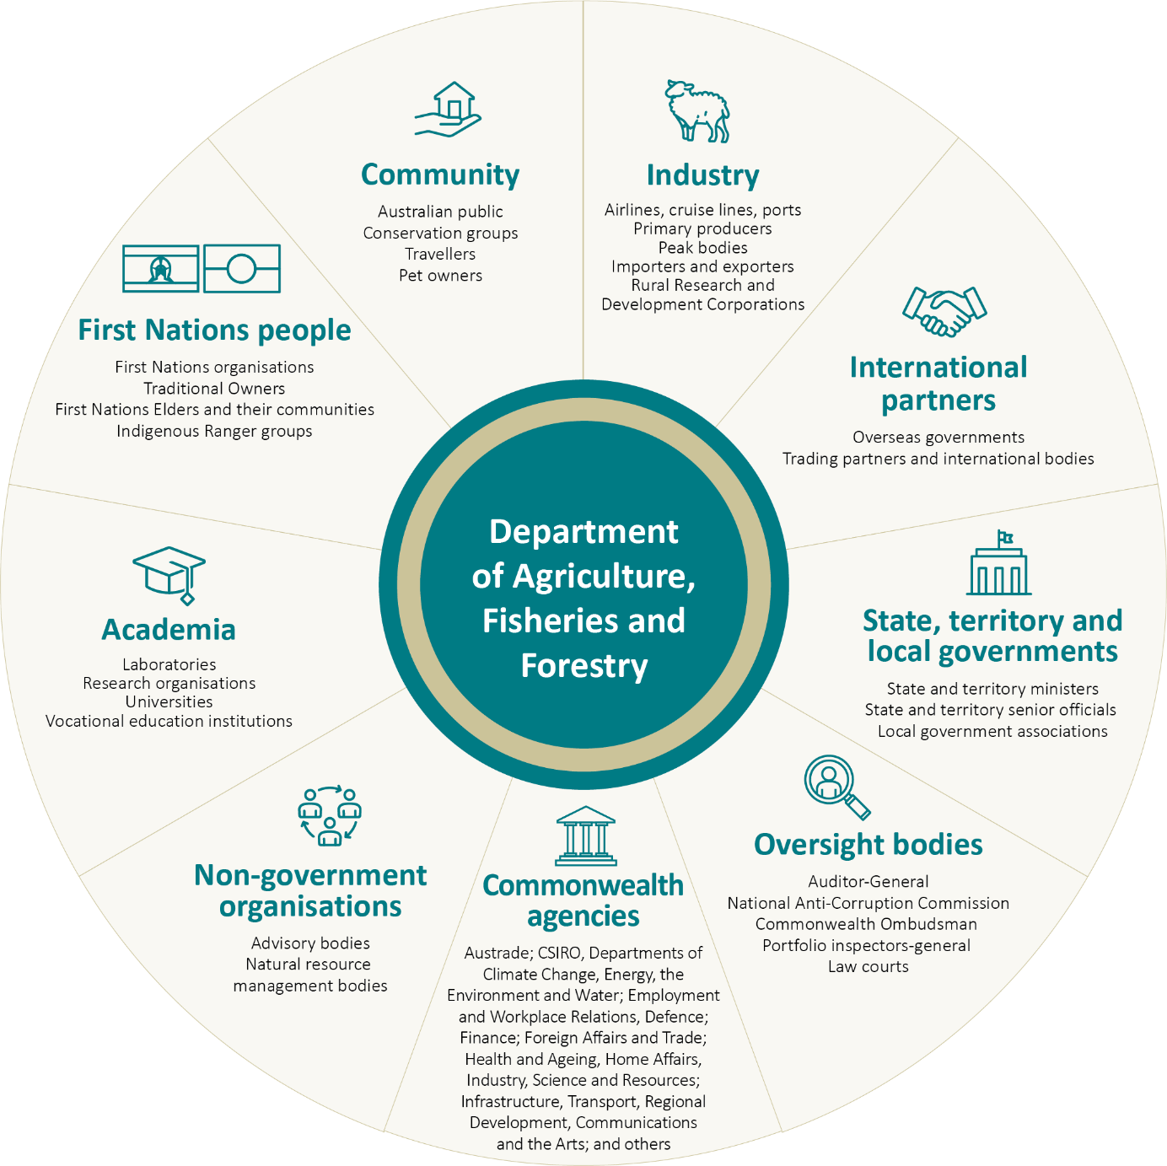

Our first partners – Australia’s First Nations peoples
We commit to empowering First Nations economic self-determination across Australia’s agricultural, fisheries and forestry industries. We do this by working in partnership with First Nations stakeholders and elevating First Nations voices through ongoing engagement.
We acknowledge that First Nations Australians hold an unceded connection with the land, waters and seas of this country and hold aspirations for more sustainable, productive and profitable land and sea-based economies. We commit to supporting First Nations agribusiness ownership and employment. We encourage the use of Indigenous knowledges to activate the economic value of land and sea resource rights to enhance the productivity, resilience, innovation and sustainability of the Australian food and fibre supply chain. We commit to strengthening the role of Indigenous Ranger groups in Australia’s biosecurity protection and expanding pathways for First Nations food and fibre exporters to international markets.
We commit to embedding the priority reforms and supporting the achievement of outcomes under the National Agreement on Closing the Gap. Working in partnership with First Nations Australians is a central priority.

Our reconciliation journey
We continue to progress initiatives under our Reconciliation Action Plan 2021–24 (RAP), a 3-year plan that aligns with the Commonwealth Aboriginal and Torres Strait Islander Workforce Strategy 2020–24 and the National Agreement on Closing the Gap Priority Reforms. These initiatives focus on cultural integrity, career pathways, career development and advancement for First Nations people. The RAP helps deliver our vision for reconciliation through a practical plan of actions and identifies how we support, maintain and build relationships with First Nations people. We will develop our First Nations plan moving forward to provide a clear direction of commitments to First Nations peoples. The strategy will align our work with Closing the Gap priority reforms and targets and whole of government priorities.

Examples of how we collaborate

Strengthening agricultural traceability
Australia’s inaugural National Agricultural Traceability Strategy 2023 to 2033 is now accompanied by its first 5-year implementation plan – both were co-designed with, and for, our Australian Agricultural Traceability Alliance stakeholders, from producers and retailers to government regulators. The plan provides tangible, targeted actions to drive coordinated implementation and provide further enhancements and competitiveness in our agricultural traceability systems. The approach aims to accelerate the export of safe, high-quality and sustainably produced Australian agricultural commodities and products, and strengthen biosecurity and food safety responses. The Australian Government continues to support enhancement of Australia’s traceability systems and arrangements. This includes using grant programs to support Australia’s evidence-based credentials, better use of data, technology adaption, value-added benefits to First Nations people, exhibiting Australia’s traceability practice and innovation, and improving sustainability reporting.

What Australian farming systems could look like by 2050
We partnered with CSIRO to develop the Ag2050 Scenarios Report (Ag2050), engaging 100-plus representatives across 54 organisations to co-design 4 evidence-based future scenarios. The report uses these future scenarios to explore a range of trends, risks and opportunities. It identifies key shifts and actions needed to support Australian farming systems to be profitable, productive and sustainable in 2050.
Insights from the Ag2050 scenarios will support the development of long-term, future-ready policy and programs to better meet the challenges for a productive, resilient and sustainable future for Australian agriculture.

Preparing for drought alongside farmers
The Future Drought Fund (FDF) was established in 2019 in accordance with the agreed role of the Commonwealth under the National Drought Agreement. The National Drought Agreement is an intergovernmental agreement between the Commonwealth and all state and territory governments. It provides a framework to deliver nationally consistent drought policy and programs across the drought cycle and share learnings and experience to improve outcomes for farmers and regional communities.
The FDF makes $100 million available each year to build drought resilience with a variety of stakeholders to create change at the farm, community, and regional level. Two of the 10 FDF programs are designed, delivered, and funded in partnership between the Commonwealth and state and territory governments, with a next phase for these programs totalling $147 million to 2029–30, as announced in the 2024–25 Budget. Through the Regional Drought Resilience Planning program, we are supporting around 70 regions to develop and kickstart implementation of locally tailored plans for future droughts. Plans are built via collaboration amongst community, industry and local government. Through the Farm Business Resilience program, we support farmers to build their capability and plan for future droughts via diverse offerings of group workshops, coaching, and other events that build on government and private sector initiatives. These important partnerships within and outside government enable collaboration on shared priorities, leveraging of resourcing and efforts, and opportunities to share learnings for continuous improvement.

Dairy Export Assurance Program
We have been partnering with Dairy Australia to progress projects under the Dairy Export Assurance Program. These projects aim to reduce regulatory burden and streamline audit arrangements in the dairy sector, by working with industry and creating targeted resources to support these changes. We have created a new dairy exporter welcome pack to start dairy exporters on their journey, as well as a dairy export registration manual to provide detailed information on becoming export registered. In addition, the program has partnered with Charles Sturt University to develop new training modules and toolkits to build exporter skills and knowledge, while focusing on whole of system thinking that improves participants' self-regulation of Australia’s export dairy sector.
The program has collaborated with state regulatory authorities to codesign a new audit framework including the reclassification of medium and high-risk dairy products and alignment of risk categories at the national level.

Subsidiaries
The department does not have any subsidiaries.

Our performance framework
Strengthening our approach to enterprise performance and reporting is one of the 10 priority actions under the department’s Transformation Action Plan, in response to the APSC Capability Review and recommendations from the Australian National Audit Office’s annual performance statements audits.
In the past 12 months we have developed a new enterprise performance framework. This provides a consistent approach to planning, monitoring and reporting non-financial performance information across our department. It reflects the legislative requirements of the Commonwealth Performance Framework and will be implemented in 2024–25.

Performance measures and targets
This section details the performance measures and targets for each of our key activities under our 3 strategic objectives and 2 PBS outcomes.
Table 3, Table 4 and Table 5 under each strategic objective list all the key activities and performance measures associated with that objective. Each table is followed by details for every performance measure including annual targets, tolerances, methodology and data sources.
We have introduced 5 new performance measures since the last corporate plan:
- SG-05 Significant representation of Australian interests on multilateral standard-setting bodies
- SG-06 Effective delivery of regulatory responsibilities for relevant export applications under the Export Control Act 2020
- RS-04 The proportion of Australian Government managed fish stocks that are sustainable
- BI-02 The import permit service standard is met
- BI-04 Targeted public communication and engagement activities.

Regulator performance reporting
We approach regulatory performance reporting in accordance with the Resource Management Guide – Regulator Performance (RMG 128).
In addition to measuring against regulatory outcomes, we address the 3 principles of regulator best practice listed in our Investing in regulatory maturity section. Our regulatory performance measures (as identified by the measure type in Table 3, Table 4 and Table 5) encompass the 3 principles and collectively demonstrate our regulatory activity. Reporting against each of the principles will appear in our Annual report 2024–25.

PBS Outcome 1
More sustainable, productive, internationally competitive and profitable Australian agricultural, food and fibre industries through policies and initiatives that promote better resource management practices, innovation, self-reliance and improved access to international markets.

Strategic objective 1 Sector growth
Support Australia’s agricultural sector, including the food and fibre industries, to be increasingly prosperous and internationally competitive in an ever-changing world.
Table 3 Objective 1 Sector growth – performance measure overview
Key activity | Performance measure | Measure type
1.1 Develop and deliver policies and manage programs to ensure primary producers are well positioned to maintain and increase their productivity. | SG-01 Greater growth in average agricultural productivity (adjusted for climate and weather effects) for the past 10 years, compared with average annual market sector productivity growth over the same period. | Quantitative effectiveness measure.
1.2 Work with levy stakeholders to effectively administer the agricultural levies system. | SG-02 Equal or reduced cost of levies administration compared with levies disbursed. | Quantitative efficiency and regulatory measure.
1.3 Deliver programs and work with portfolio agencies to support farmers’ financial growth. | SG-03 Proportion of farm businesses making capital investments. | Quantitative effectiveness measure.
1.4 Enable and protect international market access to provide growth opportunities for agricultural producers and exporters and support global food security. | SG-04 Grow access to a diverse range of international markets for Australian exporters of agricultural, fisheries and forestry products. | Qualitative output measure.
1.5 Represent Australia’s interests and contribute to global standards for open and free trade by participating in multilateral standard-setting bodies. | SG-05 Significant representation of Australian interests on multilateral standard-setting bodies. | Quantitative proxy measure.
1.6 Provide effective, efficient, and modernised regulation as the administrator of the Export Control Act 2020. | SG-06 Effective delivery of regulatory responsibilities for relevant export applications under the Export Control Act 2020. | Quantitative effectiveness and regulatory measure.
 | SG-07 Increase in the number of electronic certificates issued for export. | Quantitative efficiency and regulatory measure.
1.7 Support a productive and sustainable Australian forestry industry. | SG-08 Encourage forestry industry investment in innovation. | Quantitative output measure.

Performance measure SG-01
Greater growth in average agricultural productivity (adjusted for climate and weather effects) for the past 10 years, compared with average annual market sector productivity growth over the same period.

Targets
2024–25 | 2025–26 | 2026–27 | 2027–28
Greater than 0% difference over past 10 years. | As for 2024–25. | As for 2024–25. | As for 2024–25.

Tolerances
Achieved | Partially achieved | Not achieved
Average annual growth in agricultural productivity (climate-adjusted) exceeds average annual market sector productivity growth over the same period. | Not applicable. | Average annual growth in agricultural productivity (climate adjusted) is lower than average annual market sector productivity growth over the same period.

Rationale
Productivity is a key measure of performance because it considers the efficiency of production. In the long term, agricultural productivity measures technological advancement and its impact on industry progress.
We develop policies and manage programs to ensure primary producers are well positioned to maintain and increase their productivity. We support innovation in agriculture and agribusiness management through co-investment with industry in the research and development corporations to benefit industry and regional communities.
Productivity is affected by global prices and supply chains, consumer demand and trading partner decisions. State and territory governments are responsible for many of the regulatory settings that affect industry performance. However, the Australian Government, through us, is responsible for export and import regulations and technical trade negotiations.

Methodology and data sources
This performance measure tracks progress over a 10-year period to provide an assessment of long-term productivity trends.
We obtain productivity data for this measure from ABARES and the Australian Bureau of Statistics (ABS). We source climate-adjusted productivity estimates for the broadacre industry from ABARES, and the market sector productivity comparison measure from the ABS.
Climate-adjusted productivity estimates remove the influence of climate and weather effects on agricultural productivity estimates.
Productivity is best measured over long periods because short-term fluctuations in measured productivity may be due to short-term influences on the production process – for example, fluctuations in prices paid or prices received.
Due to the time lag between measurement, publication of the productivity data, and the performance reporting deadline, we use a forecast for the most recent year of data. The forecast assumes that productivity growth in the most recent financial year equals the long-run productivity growth rate since 1988–89.
We base market sector productivity estimates on the ABS estimates of industry multifactor productivity data source. Again, due to the time lag between measurement, publication of the productivity data and the performance reporting deadline, we use a forecast for the most recent year of data. The forecast assumes that productivity growth in the most recent financial year equals the long run productivity growth rate.
The agricultural productivity result is for the Australian broadacre industries. Farm businesses engaged in other agricultural production, such as sugarcane farming, dairy farming and horticultural (fruit and vegetable) production, are not included in the performance measure because climate-adjusted productivity measures are not available for these industries.
Broadacre industries account for around two-thirds of Australia’s agricultural production by total value and the majority of agricultural land use. The performance of the broadacre sector is the main driver of total agricultural industry productivity.

Performance measure SG-02
Equal or reduced cost of levies administration compared with levies disbursed.

Targets
2024–25 | 2025–26 | 2026–27 | 2027–28
Levies administration cost is less than or equal to 1.2% of levies disbursed. | To be reviewed. | Subject to outcome of 2025–26 review. | Subject to outcome of 2025–26 review.

Tolerances
Achieved | Partially achieved | Not achieved
Levies administration cost is less than or equal to 1.2% of levies disbursed. | Not applicable. | Levies administration cost is more than 1.2% of levies disbursed.

Rationale
We are responsible for administering the agricultural levies system, which is a partnership between government and industry. This allows primary industries to collectively invest in research and development (R&D), marketing, biosecurity activities, residue testing and biosecurity emergency responses.
This measure supports sector growth as the efficient collection and disbursement of levies will enable more of the levies to be directed to biosecurity preparedness, emergency plant pest and animal disease responses, marketing, R&D and residue testing.
Our role is underpinned by the levies legislative framework. We receive levies and levy return forms from collection agents, disburse the levies to specified levy recipient bodies and conduct compliance inspections to ensure the integrity of the levy collection. We recover the cost of conducting these activities and strive to achieve efficiencies and maintain the cost of our administration and compliance activities at the optimum level.
More than 110 levies and charges are collected on more than 70 commodities across the agricultural, fisheries and forestry industries. Each year, we disburse around $800 million to 18 levy recipient bodies. This comprises around $500 million in levies and charges and $300 million in Commonwealth matching payments for eligible R&D activities. The funds raised from the levies help industries drive growth, maintain competitiveness, manage risks and ensure their ongoing contribution to the Australian economy.
The levies team undertakes business improvement programs and projects that increase the capability and efficiency of the levy system’s administration and regulation. We regularly liaise with key industry representative bodies to share information on trends, developments and compliance issues. Through this engagement, we identify areas of interest and potential risk, create strategic compliance projects that target specific risk factors, and increase stakeholder understanding of the levies compliance program. The program increases staff awareness of industry-specific issues, risks and how levies are used to benefit levy payers. This work aligns with the 3 principles of regulatory best practice.

Methodology and data sources
Levies cost recovery is based on the principles of activity-based costing and a risk-based approach to compliance activities. The framework supports transparent, equitable and consistent allocation of charges across industries.
Our departmental information systems provide data on disbursements, levy rate, levies compliance, administration activities and costs. We combine this data to attribute collection costs to respective agricultural commodities.
During 2016–17 a benchmark performance target of 1.2% was established. The average levies administration cost between 2010–11 to 2015–16 was $5.26 million (1.18% of levies collected).
If the 1.2% target benchmark is exceeded, this indicates that levies administration is no longer effective or some of the levies’ settings may need to be changed as they are no longer appropriate. This target is appropriate for 2024–25 but will be subject to review in 2025–26 after the implementation of modernisation reforms to agricultural levies legislation.
Results can be compared from year to year because the target was measured in percentage terms rather than nominal dollar terms, which can fluctuate. The efficiency of the system to collect those monies, and all other necessary levy information, from the affected levy collection agents can also fluctuate.

Performance measure SG-03
Proportion of farm businesses making capital investments.

Targets
2024–25 | 2025–26 | 2026–27 | 2027–28
Increase in percentage of farm businesses making new capital investments compared to previous year (based on a 5-year moving average). | As for 2024–25. | As for 2024–25. | As for 2024–25.

Tolerances
Achieved | Partially achieved | Not achieved
If the proportion of farms making new capital investments increases (based on annual reporting of a 5-year moving average). | Not applicable. | If the proportion of farms making new capital investments decreases or is the same (based on annual reporting of a 5-year moving average).

Rationale
This effectiveness measure was developed to measure the impact of our work on farm businesses making capital investments, with many of our programs focusing on building farmers’ financial stability and their capacity to make investments. As this performance measure focuses on the long-term growth of farm businesses, this contributes to our sector growth objective.
Sector growth partly relies on farm businesses investing and taking advantage of new opportunities. While capital investment is affected by income and profitability, government interventions that support growth in farmers’ confidence is likely to contribute as well.
Farmers are more likely to make capital investments when they are confident or have positive expectations about the future. Confidence is influenced by having suitable skills, tools and financial resources available to support their ability to manage drought and other climate-related risks. Our Farm Resilience division manages policies and programs that build farmers’ skills by offering business tools and financial resources to improve confidence in decision-making and in turn, influence their ability to make capital investments.
These programs include the Farm Management Deposits Scheme, a financial risk management program that creates a financial buffer for farm businesses in the agriculture sector; the Regional Investment Corporation which administers the Australian Government’s concessional loans for farmers and farm-related small businesses; the Farm Household Allowance program and the Rural Financial Counselling Service, which both provide assistance for those in, or at risk of, financial hardship to manage their financial situation and build their financial stability.
These policies and programs managed by the Farm Resilience division support profitability and, in turn, increase farmers’ capacity to sustainably invest in their businesses. The outcomes of our activities are expected to contribute to investment levels. While there may be some other external factors that will influence farm businesses’ investment levels, such as interest rates and input prices, these factors are beyond our influence.

Methodology and data sources
We source data from ABARES Australian Agricultural and Grazing Industries Survey and the Australian Dairy Industry Survey. The use of a 5-year moving average accounts for annual fluctuations resulting from seasonal conditions. An annual result is reported. We assess new capital investments over time to measure continuing confidence.
ABARES has been conducting surveys of farms since the 1940s to provide a range of financial and physical information on farm activities to provide an empirical basis for understanding Australian agriculture at a farm level. The data on which this measure is based has been collected annually since 1977–78.

Performance measure SG-04

Grow access to a diverse range of international markets for Australian exporters of agricultural, fisheries and forestry products.

Targets
2024–25 | 2025–26 | 2026–27 | 2027–28
Each year, at least one new and one improved trade protocol is implemented by the department and made available to agriculture, fisheries and forestry exporters. | As for 2024–25. | As for 2024–25. | As for 2024–25.

Tolerances
Achieved | Partially achieved | Not achieved
If at least one new, and one improved, market access protocol is made available each year. | If one new or one improved protocol is made available, but not both. | If the department fails to deliver at least one new, and one improved, market access protocol each year.

Rationale
This measure reflects our work to grow overseas trade opportunities for Australian agricultural producers through negotiating new, improved, maintained or restored market access for specific commodities and markets.
Opening and improving access to international markets is one of our core functions. Australia exports 70% of its agricultural production, accounting for around 14% of the value of Australia’s total exports and supporting global food security. We provide opportunities for producers and exporters by enabling access to new markets and improving and maintaining access to existing markets.
- New market access – we open technical market access for a specific commodity for the first time, or where access has not been available for 5 or more years. This includes negotiating new biosecurity protocols, or certification and assurance requirements, with international trading partners.
- Improved market access – we negotiate revised protocols for market access that reduce the time, cost, or requirements for exporters to access a given market.
- Maintained market access – where trade for an agricultural commodity was threatened or ceased, but the disruption was avoided or resolved within 6 months due to the department’s remedial actions, including providing assurances or negotiating improved outcomes with international trading partners.
- Restored access – where trade ceased for between 6 months and 5 years due to concerns related to technical market access (including biosecurity and food safety concerns), but the department was able to negotiate to restore access.
The long-term outcome of this work is that Australia grows its status as a trusted trading partner and influences international policy in favour of our agricultural sector. However, measuring the impact of market access on an annual basis is challenging.
There are multiple factors outside our control that impact whether negotiated trade outcomes are realised in a given year. These range from external factors such as crop yields, climate and global supply and demand through to political choices made by trading partners that have a downstream impact on agriculture.
The number of commodities and international markets to gain access to is dynamic. Novel products are developed and international trading partners morph and change. For example, the United Kingdom became an individual market to negotiate access with when it left the European Union. There is no known ‘end-point’ that would inform a more specific or time-constrained target, therefore demonstrating steady progress each year is our best annual measure.
Trade is a two-way interaction. Our commitment to open trade with evidence-based requirements must be reflected by facilitating trading partners to access our market. Enabling access to the Australian market complements our activities to advocate for exporters’ access to international markets. The imports side of this two-way interaction is represented by performance measure BI-01 (Proportion of biosecurity risk assessments completed in the development of import policy and regulation of biosecurity risks on imported goods, within regulatory and target time frames).

Methodology and data sources
We record the status of new, improved, maintained and restored market access achievements in our market access achievements database, drawing on data from each of our export functions. Twice a year, in January and July, a quality assurance review of the data is undertaken, to ensure consistent use of achievement definitions.
Annual reporting aggregates achievements by their type (new, improved, maintained, restored) and highlights specific achievements that were high-impact and why.
This measure has a quantitative aspect as we count the number and type of market access achievements. The context and potential impact of individual market access achievements best describe their value and illustrate our performance in achieving a better outcome for exporters.
Outcomes may be under-reported, due to a reliance on manual tracking and reporting on the progress of trade negotiations. A full list of market access achievements may not be published if we determine there is a commercial-in-confidence or similar risk in sharing specific examples.

Performance measure SG-05
Significant representation of Australian interests on multilateral standard-setting bodies.

Targets
2024–25 | 2025–26 | 2026–27 | 2027–28
At least one meeting, with in-person attendance, to each of the multilateral trade standard-setting bodies (WTO, OECD, WOAH, IPPC, and Codex). | As for 2024–25. | As for 2024–25. | As for 2024–25.

Tolerances
Achieved | Partially achieved | Not achieved
There is evidence the department has represented at each of the multilateral trade standard-setting bodies (WTO, OECD, WOAH, IPPC, and Codex). | There is evidence the department participated in some, but not all relevant bodies. | The department does not participate in any international standard-setting or multilateral trade fora.

Rationale
This new measure provides a proxy for our soft-diplomacy contributions to multilateral standard-setting bodies that support international trade in agricultural, fisheries and forestry products.
Stable trade is underpinned by shared standards and shared mechanisms for resolving disputes. In agricultural trade specifically, alignment in food safety testing and biosecurity protocols allow food and agriculture products to transit smoothly between international markets.
It is important for us, on behalf of Australia, to proactively engage with international trading partners to ensure trading protocols and standards are evidence-based and achieve their objectives without unduly burdening Australian exporters.
Different standard-setting bodies manage different aspects of agricultural trade. This measure holds us accountable to actively participate in the following forums and reinforces our commitment to open and free trade, and evidence-based trading protocols for food and agriculture.
The World Trade Organization (WTO) reduces trade volatility. Membership allows Australia to benefit from shared trade rules that promote an open global trading system. It also provides Australia with a process to settle disputes if other trade partners breach these rules.
The Organisation for Economic Co-operation and Development (OECD) has been shown to result in member countries being less ‘excessively concentrated’ in their imports and exports. Member countries are able to take advantage of opportunities to diversify their international markets.
The World Organisation for Animal Health (WOAH) allows transparent assessment of risks to animal health. Membership allows Australia to take measures to prevent disease spread and protect our biosecurity status and market access. It also allows Australia to contribute to shaping WOAH standards, ensuring standards are science-based and achieve their purpose without imposing an unjustified burden on Australian producers and exporters.
The Food and Agriculture Organization of the United Nations (FAO) allows Australia to participate in multiple initiatives to harmonise trade and international standards. These include:
- The International Plant Protection Convention (IPPC), to which Australia is a contracting party. The IPPC provides Australia with the ability to contribute to the international standards setting process for plant health, as well as providing a mechanism for dispute resolution and information exchange.
- The Codex Alimentarius Commission (or Codex) which allows Australia to build consensus with other member-countries on international food standards. This ensures a safe global food supply and fair-trade practices for food. Harmonisation in global policies around food and trade faces many challenges – including geopolitical tensions, trade disputes, and non-tariff barriers – reinforcing the importance of the Codex for stable trade.
Specific meetings or calls for input for each body are expected to vary year-by-year. Success is indicated by at least one meeting with in-person attendance, to each of the multilateral trade standard-setting bodies each year (WTO, OECD, WOAH, IPPC and Codex).
We publish information on our role engaging with these bodies on our website. Over the long term, this engagement is expected to grow Australia’s status as a trusted trading partner with valued contributions to setting international standards and promote our systems and sustainability credentials.
We also participate in a range of commodity-specific or region-specific forums that are not included as part of this measure. Currently only overarching forums that are open to all markets and set standards for all (or a large group of) commodities are included.

Methodology and data sources
We record the status of multilateral engagement activities in our multilateral engagement register each quarter. We define significant engagement as in-person attendance and require evidence of this to qualify for inclusion against the target.
Twice a year, in January and July, a quality assurance review of the data is undertaken, to determine the purpose of the forum, the meeting date, who attended from the department and the expected outcomes.
Annual reporting aggregates engagements with each body and highlights specific outcomes achieved that were high impact for Australia’s agricultural industry and why.

Performance measure SG-06
Effective delivery of regulatory responsibilities for relevant export applications under the Export Control Act 2020.

Targets
2024–25 | 2025–26 | 2026–27 | 2027–28
Establish a baseline. | Increase from 2024–25 baseline, to be determined. | Increase from 2024–25 baseline, to be determined. | Increase from 2024–25 baseline, to be determined.

Tolerances
Achieved | Partially achieved | Not achieved
95% or more of all relevant export applications are completed within the requisite consideration period specified by the Export Control Act. | Over 85% of all relevant export applications are completed within the requisite consideration period specified by the Export Control Act. | Under 85% of all relevant export applications are completed within the requisite consideration period specified by the Export Control Act.
Note: These are indicative tolerances. Exact tolerances will depend on the baseline established.

Rationale
This measure is designed to capture the effectiveness of our administrative obligations as a regulator of exports under the Export Control Act 2020.
In order to help Australian exporters get their goods to market, we must provide confidence to our trading partners as to the integrity, safety, and traceability of prescribed export agricultural commodities from Australia. Businesses and people seeking to export such goods from Australia are required to obtain a requisite minimum amount of regulatory approval and permission from the Australian Government. Exporters must first apply for, and progress through, requisite regulatory processes under the Export Control Act to become approved and licensed to conduct export operations.
We also demonstrate to our trading partners the compliance of our regulated industry with traceability, sanitary and phytosanitary standards through further regulatory actions such as inspections, quarantine procedures, seals and certification for goods.
This measure tracks 4 key indicators of regulatory success for relevant export applications for prescribed goods under the Export Control Act. These applications are:
- the export registration of an establishment
- the accreditation of a farm property to meet the requirements of the European Union Cattle Accreditation Scheme (EUCAS)
- the variation of an approved arrangement an occupier of a registered establishment holds with the department
- the obtaining of a license to export meat and meat products from Australia.
Exporters will be delayed in getting to market unless they receive streamlined and effective regulatory services from our authorised officers who conduct these requisite regulatory assessments and approvals.
Measuring the proportion of relevant export applications that were, and were not, processed within the requisite consideration period specified by the Export Control Act enables us to determine whether we are achieving our goal of delivering streamlined regulation that enables industry to get its goods to market efficiently.
We define relevant applications as those that are valid and complete and able to be assessed by the department. This measure does not include incomplete applications, or applications that were unable to be processed due to the actions of the applicant.

Methodology and data sources
We are the identified competent authority for the purposes of regulatory decision-making for exporter applications under the Export Control Act. This identifies that successful regulatory decision-making by departmental officers for specific types of export applications occurs when a relevant officer completes their assessment of specified types of applications within the specified consideration period defined within the Act.
To determine the baseline target, the methodology takes the combined percentage of on-target completion for each of the indicator sets for all relevant prescribed export goods and divides the final percentage by the number of indicators to provide an overall averaged figure of success.
This year (2024–25) will set a baseline to determine the current level of success for relevant export applications relating to accreditation, registration, approved arrangements and meat export commodity licenses, that were completed by our authorised officers within the requisite consideration period specified by the Export Control Act.

Performance measure SG-07
Increase in the number of electronic certificates issued for export.

Targets
2024–25 | 2025–26 | 2026–27 | 2027–28
Plus 2% of what the final 2023–24 eCert number is. | Plus 2% of what the final 2024–25 eCert number is. | Plus 2% of what the final 2025–26 eCert number is. | Measure to be reviewed.

Tolerances
Achieved | Partially achieved | Not achieved
2% or more increase. | 1% – 1.99% increase. | Less than 1% increase.

Rationale
We oversee the regulations governing exports and provide export inspection and certification services to gain, improve or maintain market access for a wide range of goods.
Our export regulatory framework is designed to facilitate trade, providing a transparent and predictable environment for businesses involved in international trade. The regulatory framework aligns with the Export Control Act, and subordinate commodity rules, harmonising with international standards where possible. It provides guidelines and procedures for exporters to follow when preparing and submitting export documentation.
This measure tracks the transition of our export agricultural trade from being heavily reliant on paper government certificates, that are at risk of fraud, getting lost or being damaged, to one of a modern certifier that is willing to trade in a modern and secure way.
Since the COVID-19 pandemic, we have been at the forefront of electronic certification (eCert) development, encouraging our trading partners to use eCert paperless certification to modernise their border clearance processes, reduce the impact of trade disruptions and strengthen confidence around food security.
Moving to eCert enables Australian goods to be cleared faster, making them available for sale sooner and avoiding costly border clearance delays and processes. Rather than a paper certificate being printed and sent to accompany the goods for export, electronic certification takes place at a government-to-government level, which also makes it more secure. This efficiency improvement helps make Australian goods more appealing to importers, supporting an increase in exports to key destinations and contributing to our sector growth objective.
This measure demonstrates the improved efficiencies we are making to in relation to our regulatory responsibility within Australia and on behalf of importing countries that request us to regulate a certification on their behalf. It demonstrates not only our reform work, but also our commitment to improve how we regulate better under the Export Control Act. For example, the use of eCert means that we manage the return of export certificates instead of exporters. As there is no longer a paper certificate issued to exporters, they no longer need to return it.
eCert also allows us to be more efficient and responsive to changes in agreed certification. For example, a paper-based certification for the European Union (EU) that needs to be developed across all EU markets and be bilingual for all countries requires us to produce 46 versions of the same template. For eCert we can reduce that down to 8, saving significant time.
This measure demonstrates our desire for continuous improvement in how we conduct cross border trade in a way that can help improve our regulatory role, while also building greater levels of trust with our government trading partners. Taking a collaborative approach to help government trading partners progress to eCert assists in our regulatory modernisation.

Methodology and data sources
We extract reports on the number of electronic certificates from 2 of our export documentation management systems: Export Documentation System (EXDOC) and New Export Documentation System (NEXDOC). The data is cross referenced against the list of paperless exchanges.
Only the number of eCerts issued to paperless markets are in scope for this measure. It does not include how certification is applied for, or the overall percentage of paperless certificates issued as a part of all certifications.

Performance measure SG-08
Encourage forestry industry investment in innovation.

Targets
2024–25 | 2025–26 | 2026–27 | 2027–28
Deliver 30% of total grant program funding. | Deliver 20% of total grant program funding. | Not applicable – program terminates in 2025–26. | Not applicable – program terminates in 2025–26.

Tolerances
Achieved | Partially achieved | Not achieved
70–100% of grants have met their milestone requirements to enable grant payments to be made in the year. | 50–69% of grants have met their milestone requirements to enable grant payments to be made in the year. | 0–49% of grants have met their milestone requirements to enable grant payments to be made in the year.

Rationale
The Australian Government’s policy A Future Grown in Australia: A Better Plan for Forestry and Forest Products establishes grant programs to strengthen and support a sustainable forestry industry now and into the future. This measure covers our administration of the Accelerate Adoption of Wood Processing Innovation Program established under this policy.
Forestry and forest products are important for the Australian economy, providing jobs for regional Australians and timber products for the construction industry.
Australian forestry operations are regulated by state and territory governments or local government planning laws. Consequently, we support the forestry industry through the development of national policies and strategies and the delivery of support programs.
The Accelerate Adoption of Wood Processing Innovation Program provides support for wood processing businesses to adopt new or innovative technologies designed to support their medium to long term sustainability. Investment through this program is anticipated to enable wood processing facilities to provide domestic sources of in-demand products, make better use of existing timber supplies and allow the industry to be more resilient to future supply chain disruptions. This will be achieved through wood processing facilities using innovative technologies in their production to supply more of Australia’s wood demands into the future.
The program offers grant funding of up to 40% of the total project cost, with the remaining 60% to be met by the grantee’s co-funding. The measure was established in 2023–24 and includes targets out to its termination in 2025–26. The original 2023–24 measure was based on 37 grants and a program expenditure of $108.8 million from 2022–23 to 2025–26. Due to the withdrawal of 4 grantees from the program in 2023–24 it was necessary to revise the overall committed grant funding figures. The program now has 33 approved grants with an overall committed program expenditure of $100.7 million from 2022–23 to 2025–26.
Overall, the measure only captures 80% of total payments being made against grant funding. The remaining 20% is not reflected in the measure as it was administered in 2022–23 prior to the establishment of the measure. Distribution of the 80% has been split over a 3-year period, with 30% of the total payments being targeted in 2023–24, 30% in 2024–25 and 20% in 2025–26.
While there are other programs within the forestry space, this program is the most advanced in terms of implementation which is why it has been selected for inclusion as a performance measure over other programs. At the conclusion of this program, we will determine another suitable performance measure to track the impact of our forestry work.

Methodology and data sources
The primary information reported is expenditure against grant agreements based on successful completion and acceptance of milestone reporting.
Grantees are required to submit an activity workplan and budget in June and December each year. Payments to grantees are triggered by the review and acceptance of this milestone reporting and processed through the Community Grants Hub.
Payment information is recorded by us and verified monthly against a Department of Social Services financial system report, corresponding grant agreements and approval minutes.
Analysis to support the measure target may also be drawn from information recorded in relation to how much of their grant payments grantees have spent, combined with expenditure from their own project co-contribution. However, this does not influence whether or not the target for the measure has been met.
The total grant funding paid is then compared against the annual target to determine if the measure is on target or not.
The targets and tolerances for each year are linked to the requirement that payments to grantees can only be made upon provision and acceptance of milestone reporting. If milestone reports are not provided, then this will impact our ability to meet the target as payments cannot be made under the grants outside of this requirement.

Strategic objective 2 Sector resilience and sustainability
Increase the contribution agriculture, fisheries and forestry make to a healthy, sustainable and low-emissions environment.
Table 4 shows the key activities and associated performance measures for this objective.
Table 4 Objective 2 Sector resilience and sustainability – performance measure overview
Key activity | Performance measure | Measure type
2.1 Create pathways that support the agricultural sector to build an understanding of emissions reduction opportunities and adopt emissions reduction activities that strengthen productivity and competitiveness. | RS-01 Increased pathways to support the understanding and adoption of emissions reduction opportunities, technologies and practices. | Quantitative composite output measure.
2.2 Deliver annual funding to support the agricultural sector to adopt sustainable agriculture practices in accordance with the Natural Heritage Trust. | RS-02 Sustainable farming practices are funded through the Climate-Smart Agriculture Program. | Quantitative output measure.
2.3 Administer annual funding from the Future Drought Fund to build drought resilience in Australia’s agricultural sector in accordance with the Drought Resilience Funding Plan (2024–2028). | RS-03 Increased investment in activities to build economic, social and environmental resilience to drought. | Quantitative output measure.
2.4 Ensure Australian Government fisheries are sustainably managed through the development and review of legislative and policy settings and other initiatives. | RS-04 The proportion of Australian Government managed fish stocks that are sustainable. | Quantitative effectiveness measure.

Performance measure RS-01
Increased pathways to support the understanding and adoption of emissions reduction opportunities, technologies and practices.

Targets
2024–25 | 2025–26 | 2026–27 | 2027–28
- Targeted consultation to inform the Agriculture and Land Sectoral Plan.  - Deliver the Agriculture and Land Sectoral Plan to government.  - Deliver 100% of 2024–25 funding profile according to agreed milestones for Budget measures related to emissions reduction activities.  - 2 engagement activities planned with another country. | - Deliver 100% of 2025–26 funding profile according to agreed milestones for Budget measures related to emissions reduction activities.  - 2 engagement activities planned with another country. | - Deliver 100% of 2026–27 funding profile according to agreed milestones for Budget measures related to emissions reduction activities.  - 2 engagement activities planned with another country | - Deliver 100% of 2027–28 funding profile according to agreed milestones for Budget measures related to emissions reduction activities.  - 2 engagement activities planned with another country.

Tolerances
Achieved | Partially achieved | Not achieved
- Stakeholders consulted to inform the Agriculture and Land Sectoral Plan.  - Agriculture and Land Sectoral Plan is endorsed by the government in 2024–25.  - 100% of relevant financial year funding profile for Budget measures delivered.  - Planned engagement with other countries is delivered. | - Stakeholder consultation to inform the Agriculture and Land Sectoral Plan planned but not delivered.  - 80–99% of relevant financial year funding profile for Budget measures delivered.  - Engagement with other countries is planned but not delivered. | - Stakeholders not consulted to inform the Agriculture and Land Sectoral Plan.  - Agriculture and Land Sectoral Plan not endorsed in 2024–25.  - 0–79% of relevant financial year funding profile for Budget measures delivered.  - No engagement with other countries is planned or delivered.

Rationale
Representing 18.4% of Australia’s total emissions in the year to December 2023, agriculture will have an important role to play in helping Australia mitigate the impacts of climate change and meet its net zero goals. The Australian Government is committed to supporting the agricultural sector to sustainably reduce emissions and manage the impacts of climate change, including the challenge of increasing food production to meet global demand, while reducing the impact of agricultural production on the environment.
Accelerated access to innovative technologies and farming practices will position farmers to strengthen their productivity and competitiveness while contributing to Australia’s net zero goals. Actively managing emissions will also be critical to maintaining and growing export markets and achieving sector growth.
This performance measure demonstrates our contribution to help the agricultural sector build an understanding of emissions reduction opportunities and adopt technologies and practices over time. For this financial year, and the following 3 years, the initiatives outlined in this section will be implemented to demonstrate how we are providing pathways that support the sector to transition to a low-emissions future.
The Agriculture and Land Sectoral Plan is one of 6 sectoral plans being developed that will support the government’s net zero goals. The department received $4.9 million to support development of the plan. In 2023–24 we ran public consultation processes to inform the plan with stakeholders and received over 230 written submissions. Engagement with industry is continuing in 2024–25 after which time the plan will be provided to the government for endorsement.
In direct response to what was heard through our consultations, the Australian Government committed $63.8 million over 10 years for measures to support initial emissions reduction efforts in the agricultural sector. Delivered jointly by us and the Department of Climate Change, Energy, the Environment and Water (DCCEEW), and commencing in 2024–25, these measures will help build the capacity of Australian farmers and trusted advisors, improve greenhouse gas accounting at national and farm levels and drive innovation for emissions reduction and carbon sequestration in the sector. It will also contribute to the new Zero Net Emissions Agriculture Cooperative Research Centre to support long-term research into emission reductions from Australian agriculture.
The global shared commitment to collaborate and innovate on climate issues will continue to be paramount. We are actively pursuing ways to establish productive and enduring international partnerships that will leverage international knowledge, expertise and technology to support Australian producers with ways to reduce emissions, respond to climate change impacts and provide co-benefits to partner countries. Workshops for officials will be held in 2024–25 with our international counterparts to share policy approaches to agricultural climate issues and identify opportunities for collaboration.
ABARES is also undertaking work on better climate modelling and data. This includes a 3-year work program that commenced in 2023–24 on regional land use modelling capability to better understand likely regional and land-use impacts of emissions policies.
Emissions reduction achieved by the sector is expected to occur over time as awareness and adoption of tools and techniques increases. Many of the initiatives that are facilitating pathways to adoption are only commencing in 2024–25 and there will be other variables that impact the pace and extent of adoption and the consequential reduction in emissions. We will continue to work towards developing an outcome-oriented measure as the development and implementation of pathways mature.

Methodology and data sources
The multiple targets and associated tolerances for this measure recognise that performance will be measured using more than one metric.
A branch within our Sustainability, Climate and Strategy Division (SCSD) is leading the development of the Agriculture and Land Sectoral Plan, including through consultation and working closely with the sector. That team manages record keeping on this body of work and reports on progress as required specifically to address this measure. Endorsement of the plan is a matter for government, including announcements.
Responsibility for implementing individual Budget measures is allocated to teams within SCSD Program managers use the expertise of the internal grants policy teams, and the Community Grants Hub to ensure grants processes are being delivered consistent with the Commonwealth Grant Rules and Guidelines 2017, and departmental policies and procedures.

Performance measure RS-02
Sustainable farming practices are funded through the Climate-Smart Agriculture Program.

Targets
2024–25 | 2025–26 | 2026–27 | 2027–28
Deliver 100% of 2024–25 funding profile according to agreed milestones for Climate-Smart Agriculture Program. | Deliver 100% of 2025–26 funding profile according to agreed milestones for Climate-Smart Agriculture Program. | Deliver 100% of 2026–27 funding profile according to agreed milestones for Climate-Smart Agriculture Program. | Deliver 100% of 2027–28 funding profile according to agreed milestones for Climate-Smart Agriculture Program.

Tolerances
Achieved | Partially achieved | Not achieved
100% of relevant financial year funding profile for Climate-Smart Agriculture Program funding delivered. | 80–99% of relevant financial year funding profile for Climate-Smart Agriculture Program funding delivered. | 0–79% of relevant financial year funding profile for Climate-Smart Agriculture Program funding delivered.

Rationale
Sustainable farming practices provide environmental benefits and support a productive and resilient sector, thriving communities and climate-smart production.
This measure monitors the rollout of the $302.1 million Climate-Smart Agriculture Program under the Natural Heritage Trust (NHT) – a program that supports farmers to build climate resilience, increase market access and agricultural growth and achieve sustainability outcomes.
NHT investments are governed by the Natural Heritage Trust of Australia Act 1997. Each phase of the NHT is funded over a 5-year cycle. The current phase commenced in 2023–24 and will operate to 2027–28.
Funding is being delivered in a staged process over the 5 years via a series of grant and procurement investment streams, including:
- $73 million for impactful on-ground projects that will trial, demonstrate and implement climate-smart, sustainable agriculture practices
- $85.6 million for on-ground sustainable agriculture and natural resource management priority projects in the 56 regional management units across Australia
- $40.7 million to support a national network of Sustainable Agriculture Facilitators, which will ensure farmers have access to trusted advice on climate-smart agriculture practices and carbon and biodiversity markets to inform critical investment decisions for their future sustainability
- $36 million to focus on supporting soil health. This includes funding to design and deliver a new National Soil Monitoring Program. Data collection will be standardised and made publicly available on the Australian National Soil Information System, which will also be improved as part of this funding. The data will support stakeholders to make evidence-based decisions to improve soil health at a range of scales
- $35 million to maintain the operational capacity of natural resource management delivery partners and national land care organisations.
The investment in projects through the Climate-Smart Agriculture Program will contribute to building capacity, knowledge and accelerating the uptake of sustainable agricultural practices, and will contribute to the uptake of farms using sustainable management practices. Funded projects will support trials, undertake on-farm demonstrations and implement practices that address local and regional natural resource management priorities to deliver long term sustainable agriculture outcomes.
Climate-Smart Agriculture Program investments are expected to be delivered by the Australian Government and third parties (including regional natural resource management organisations, industry, research organisations and academia, non-government organisations (NGOs) and community groups) through a variety of arrangements (including grants and procurements). The capacity of our delivery partners, and on-ground challenges, can influence the preferred timelines of programs, and therefore the timing of funding commitments.
This measure may adapt over time, to ensure continued relevance to emerging issues, emissions reductions innovations and technologies. How we are performing against the measure, particularly the specified targets, will help inform future policy development and will inform the future funding opportunities under the Natural Heritage Trust.

Methodology and data sources
This performance measure details the funding delivered under the Climate-Smart Agriculture Program that supports the uptake of sustainable farming practices. We maintain records of funding committed and expended based on the Natural Heritage Trust estimates of debits, as approved by the Natural Heritage Ministerial Board.
Responsibility for implementing individual Budget measures and Climate-Smart Agriculture Program investment streams is allocated to teams within SCSD. Tracking of expenditure and commitments are verified through invoices, contractual arrangements and data held in the department’s financial management system, as well as the financial management system within DCCEEW.

Performance measure RS-03
Increased investment in activities to build economic, social and environmental resilience to drought.

Targets
2024–25 | 2025–26 | 2026–27 | 2027–28
$58 million | $110 million | $126 million | $119 million

Tolerances
Achieved | Partially achieved | Not achieved
70–100% | 50–69% | 0–49%

Rationale
This measure covers drought policy and Future Drought Fund (FDF) programs to support long-term drought resilience.
Drought is an enduring feature of the Australian landscape that has significant economic, social, and environmental impacts. Australia’s changing climate is likely to mean more frequent, longer lasting, and intense droughts.
We provide whole-of-government coordination and advice on drought policy and promote the importance of preparedness to build long-term resilience for farmers and communities affected by drought. The FDF is a $5 billion initiative, established in accordance with the agreed role of the Commonwealth under the National Drought Agreement and is aligned with the forthcoming Australian Government Drought Plan.
FDF investments are governed by the Future Drought Fund Act 2019 and the Drought Resilience Funding Plan (Funding Plan) that is renewed every 4 years. For this reporting period, the Future Drought Fund (Drought Resilience Funding Plan 2024–2028) Determination 2024 is the relevant governing document, and the strategic objectives of the plan are to build economic, social and environmental resilience to drought.
Each year, approximately $100 million is made available to build long-term drought resilience. This provides funding for investments that support Australian farmers and regional communities to prepare for, and become more resilient to, the impacts of future droughts. Investments are aligned with the 4-year Funding Plan, with the target of spending $400 million over 4 years. The FDF may commit less funding in some years, as programs are established and to ensure prudent financial management of the program funds. In other years, more funding (over $100 million) will be invested, in line with the total funding available for the funding period.
FDF investments are delivered by the Australian Government in partnership with third parties (including industry, universities and NGOs) and state and territory governments through a variety of arrangements, including grants, procurement and Federation Funding Agreements. The capacity of our delivery partners, and on-ground challenges, can affect program timelines and therefore the timing of funding commitments.
This measure currently captures a high-level, whole-of-fund output. However, work is underway to better capture the achievements of drought policy and FDF investments and this will likely inform a revision of this measure in the future. As the FDF matures and more data becomes available, we will consider reclassifying this as an effectiveness measure.

Methodology and data sources
We manage the flow of funds into and out of the FDF Special Account. The FDF’s financial commitments are verified through invoices, contractual arrangements and data held in the department’s financial management system. We keep up-to-date, accurate summary information that records the monthly actual and forecast expenditure of the FDF administered funds, by program, for each financial year. The funding commitments and all payments are then managed, released and monitored through our financial management system.
The targets anticipate less funding ($58 million) will be administered in 2024–25, while significant program design, and co-design activities occur under the 2024–2028 Funding Plan.
In 2025–26 to 2027–28, it is anticipated that more funds ($110 million, $126 million, and $119 million respectively) will be administered. This is in line with the expectation that $413 million in funding is available for delivery over the period, which in this case includes an underspend from the prior period. The Future Drought Fund Investment Strategy 2024–2028 will provide additional information regarding activities, funding and sequencing and is expected to be released in 2024.
The measure tolerances recognise that the FDF works with many stakeholders and delivery partners to maximise the on-ground impact of its activities. Delays in establishing effective co-designed programs as well as the capacity of delivery partners and on-ground conditions can affect our ability to deliver FDF programs in line with our targets each financial year.

Performance measure RS-04
The proportion of Australian Government managed fish stocks that are sustainable.

Targets
2024–25 | 2025–26 | 2026–27 | 2027–28
The proportion of fish stocks assessed as ‘not subject to overfishing’ is maintained or increases year-on-year. | As per prior year. | As per prior year. | As per prior year.

Tolerances
Achieved | Partially achieved | Not achieved
The proportion of Australian Government managed fish stocks assessed as ‘not subject to overfishing’ is maintained or increases compared with the previous year. | Not applicable. | If the proportion of Australian Government managed fish stocks assessed as ‘not subject to overfishing’ decreases compared with the previous year.

Rationale
This performance measure reports on the trend in stock status for fisheries managed by the Australian Government and provides an indicator of whether fisheries are being managed in a sustainable manner.
We play an important policy role in promoting the biological, economic and social sustainability of Australian fisheries, particularly those managed by the Australian Government (Commonwealth fisheries).
We specifically develop policy that outlines the requirements for harvesting and sharing of fish stocks in a way that maintains long-term sustainably of the stock, and the economic stability of the fishing industry. Key policy documents include the Commonwealth fisheries resource sharing framework, the Commonwealth Fisheries Harvest Strategy Policy and the Commonwealth Fisheries Bycatch Policy. We review these policies at least every 5 years and provide options for improvement to government.
The Australian Fisheries Management Authority (AFMA) undertakes the day-to-day management of Commonwealth fisheries, including implementation of licensing arrangements and harvest control measures. This must occur in accordance with relevant fisheries legislation and the policy settings established by us.
The policy framework is designed to achieve sustainably managed fish stocks by setting clear requirements and standards that AFMA must consider when establishing and implementing management arrangements for each Commonwealth fishery.
Every year, ABARES prepares Fishery status reports for all fisheries that are managed, or jointly managed, by the Australian Government. These reports provide an independent assessment of the biological status of fish stocks and the economic status of each fishery. The Fishery status reports play a critical role in ensuring transparency and accountability for the management of these fisheries, consistent with the requirements of legislation and policy. They provide the Australian public with confidence that Australia’s marine resources are being managed appropriately. The Fishery status reports can also be a key source of information for the fishing industry – for example, to support independent certification processes that can increase industry market access and economic viability.
The Fishery status reports classify each fish stock managed by the Australian Government as either ‘not subject to overfishing’, ‘subject to overfishing’ or ‘uncertain’. This can be used to determine the proportion of fish stocks that are assessed as sustainable and then be compared to previous years.
If the proportion of fish stocks that are sustainable were to decline, this would trigger us to review AFMA’s management measures. If these are found to be consistent with the policy settings, this may indicate changes to the policy framework are required.
In exceptional circumstances, other measures are available to us to ensure stocks managed by the Australian Government are not subject to overfishing. This includes implementing measures to reduce fishing intensity where fish stocks are declining, such as the recent structural adjustment process in the South East Trawl Sector Fishery.

Methodology and data sources
The number of fish stocks assessed as ‘not subject to overfishing’ in ABARES annual Fishery status reports will be divided by the total number of fish stocks assessed to determine the proportion of fish stocks that are considered to be sustainable in the reporting year (that is, the proportion of fish stocks that are not considered ‘uncertain’ or ‘subject to overfishing’).
The proportion of fish stocks that are ‘not subject to overfishing’ in the reporting year will be compared to the proportion of fish stocks 'not subject to overfishing’ in the previous year to identify whether there a change (trending upwards or downwards).
It is important to note that the Fishery status reports is an assessment of status using information that is available to ABARES at the time of preparation and published in October each year. The annual report assesses the previous year’s performance. In some instances, biological status is assessed using information that has only recently become available and was not available to AFMA to inform its management decision-making for the period being assessed.

PBS Outcome 2
Safeguard Australia’s animal and plant health status to maintain overseas markets and protect the economy and environment from the impact of exotic pests and diseases, through risk assessment, inspection and certification, and the implementation of emergency response arrangements for Australian agricultural, food and fibre industries.

Strategic objective 3 National biosecurity
Strengthen our national biosecurity system to provide a risk-based approach and an appropriate level of protection to Australia’s people, our environment and economy.
Table 5 shows the key activities and associated performance measures for this objective.
Table 5 Objective 3 National biosecurity – performance measure overview
Key activity | Performance measure | Measure type
3.1 Use international standards and science-based risk assessments to develop and inform policy, legislative frameworks and tools to support the management of exotic pest and disease risk. | BI-01 Proportion of biosecurity risk assessments completed in the development of import policy and regulation of biosecurity risks on imported goods, within regulatory and target time frames. | Qualitative output and regulatory measure.
3.2 Assess and finalise applications for biosecurity risk goods that require an import permit, ensuring fit-for-purpose regulation and biosecurity risk management. | BI-02 The import permit service standard is met. | Quantitative output and regulatory measure.
3.3 Establish new and maintain existing pre-border biosecurity arrangements with overseas governments and entities to manage biosecurity risks associated with imported goods, to reduce the number and frequency of exotic pests entering Australia. | BI-03 Increased pre-border biosecurity assurance arrangements to manage biosecurity risks in countries exporting to Australia. | Quantitative effectiveness and regulatory measure.
3.4 Undertake targeted public engagement and communication to enhance awareness of biosecurity requirements. | BI-04 Targeted public communication and engagement activities. | Quantitative output measure.
3.5 Maintain and mature emergency management arrangements. | BI-05 Strengthened emergency management capabilities. | Qualitative effectiveness measure.
3.6 Establish and maintain biosecurity measures (both onshore and offshore) to prevent the entry or establishment of pests and diseases into Australia. | BI-06 Reduction in risk of significant disease threats because of biosecurity measures implemented by the department. | Quantitative effectiveness and regulatory measure.
 | BI-07 Number of consignments of imported goods with khapra beetle detections is reduced as a result of biosecurity measures implemented by the department. | Quantitative effectiveness and regulatory measure.
3.7 Screen and inspect goods which present a high level of biosecurity risk at the border. | BI-08 Reduced levels of non-compliance with regulations administered by the department that apply to high value cargo. | Quantitative effectiveness and regulatory measure.
 | BI-09 Reduced levels of non-compliance with regulations administered by the department that apply to international travellers and their goods. | Quantitative effectiveness and regulatory measure.
3.8 Verify and assure our controls through monitoring, auditing and applying actions against non-compliance. | BI-10 Reduced levels of non-compliance with regulations administered by the department that apply to approved arrangements. | Quantitative effectiveness and regulatory measure.
3.9 Manage biosecurity risks to an acceptable level while delivering quality services to our stakeholders. | BI-11 Biosecurity service standards conducted at the border are met. | Quantitative effectiveness and regulatory measure.
3.10 Manage non-compliance with biosecurity and other relevant portfolio legislation. | BI-12 Investigate and respond to incidents of high-risk non-compliance through compliance and enforcement measures. | Quantitative output and regulatory measure.

Performance measure BI-01
Proportion of biosecurity risk assessments completed in the development of import policy and regulation of biosecurity risks on imported goods, within regulatory and target time frames.

Targets
2024–25 | 2025–26 | 2026–27 | 2027–28
Risk assessments are completed within regulatory and target time frames. | As for 2024–25. | As for 2024–25. | As for 2024–25.

Tolerances
Achieved | Partially achieved | Not achieved
Import permits: 100% of risk assessments finalised within regulated time frame. | Import permits: Between 95–99% of risk assessments finalised within regulated time frame. | Import permits: Less than 95% of risk assessments finalised within regulated time frame.
Risk analyses: 75% or more of risk analyses finalised within the target 24 months of announcement; 30 months regulated for BIRA. | Risk analyses: 50–75% of risk analyses finalised within the target 24 months of announcement; 30 months regulated for BIRA. | Risk analyses: Less than 50% of risk analyses finalised within the target 24 months of announcement; 30 months regulated for BIRA.

Rationale
We develop risk-based and fit-for-purpose regulation and policies for the importation of goods into Australia to protect human, animal and plant health, and the environment from biosecurity pests and diseases.
Our biosecurity risk assessments inform the import policy and regulatory requirements for imported goods that facilitate safe trade and reduce the likelihood of exotic pests and diseases entering and establishing in Australia. This benefits our import industries, domestic agriculture and production industries and consumers, and strengthens our biosecurity system.
The importation of some goods into Australia is, by law, only allowed upon the granting of an import permit from the department. An import permit assessment is triggered by applicants lodging an electronic import permit application through our Biosecurity Import Conditions (BICON) system and paying the associated import permit fees. Every permit application is considered on a case-by-case basis and is subject to a risk assessment to allow specific consideration of the biosecurity risks posed by the proposed import pathway. If the risk cannot be managed effectively, we will not permit trade. If it can, we will mandate import conditions that importers must meet to import the good.
This is a regulatory measure as the requirement for an import permit is imposed as regulations on importers through conditions in the Biosecurity (Conditionally Non-prohibited Goods) Determination 2021. Our delivery of import risk analysis and import permit assessments is consistent with the best practice regulatory principles.
We include 2 types of biosecurity risk assessment in this performance measure that have legislated and target assessment time frames. Risk analyses are formal risk assessments undertaken to inform published import policies. They detail the biosecurity risks and control measures required to import the goods into Australia or to release an exotic pest into Australia’s environment. Import permit assessments are undertaken to allow specific consideration of the biosecurity risks posed by the proposed import commodity. Import permit applications are subjected to a case-by-case risk assessment to determine the import conditions necessary to achieve Australia’s appropriate level of protection. In some cases, we conduct the analysis as a Biosecurity Import Risk Analysis (BIRA). The BIRA process involves more steps and is used when risk management measures have not been established or there is a significant variation in risk from similar goods previously assessed.

Methodology and data sources
This performance measure has been developed as an output and regulatory measure. We use the proportion of assessments completed within regulated and targeted time frames as a measure of quality of the products produced. Measure data is obtained from our import systems using established queries and data parameters to extract data. We curate the data to exclude out-of-scope permit assessment activities, such as bulk permit variations or withdrawn permit applications.
Measuring the effectiveness or impact of risk assessments that underpin import policy and regulations can be challenging. Trade can take time to commence, and biosecurity risks are complex, rapidly evolving, and can take many years to emerge and be detected. The number of risk assessments undertaken is partially driven by external factors, such as demand for alternative import measures and goods, emergence of biosecurity risk on import pathways and actions by importing industries and other governments. This means that a higher or lower output value alone is not necessarily indicative of our performance. For this reason, we have focused on providing a quality output measure.
Since the last corporate plan, targets and tolerances have been added to this measure.
Risk assessments must be comprehensive but also pragmatic and fit for purpose, and they require time to complete. Due to the small number of risk analysis milestones completed within each financial year a larger tolerance range is considered acceptable in comparison to the smaller tolerance range appropriate to the large number of import permit assessments completed in the same time frame.
Due to the addition of quality output targets, 3 risk assessments that were part of this measure have been removed because they did not have a legislative or target time frame to measure quality:
- Post-entry quarantine (PEQ) releases – this activity occurs at border prior to release from biosecurity control and is not suitable for a measure of pre-border activity. All PEQ releases are subject to assessment of completion of required testing and containment time frames with no target or legislative time frames.
- BICON case amendments – this activity occurs within internal departmental workflows with no target or legislative time frame.
- Internal technical risk assessment requests – this activity occurs within internal departmental workflows with no target or legislative time frames.

Performance measure BI-02
The import permit service standard is met.

Targets
2024–25 | 2025–26 | 2026–27 | 2027–28
Partially achieved for standard goods (Category 1).  Partially achieved for non-standard goods (Categories 2 to 5). | Achieved for standard goods (Category 1).  Partially achieved for non-standard goods (Categories 2 to 5). | Achieved for standard and non-standard goods. | Achieved for standard and non-standard goods.

Tolerances
Achieved | Partially achieved | Not achieved
Standard goods: when 90% or more of Category 1 permit applications are processed and finalised within 20 business days. | Standard goods: when 50–89% of Category 1 permit applications are processed and finalised within 20 business days. | Standard goods: when less than 50% of Category 1 permit applications are processed and finalised within 20 business days.
Non-standard goods: when 90% or more of Category 2 to 5 applications are processed and finalised within 40 business days. | Non-standard goods: when 50–89% of Category 2 to 5 applications are processed and finalised within 40 business days. | Non-standard goods: when less than 50% of Category 2 to 5 applications are processed and finalised within 40 business days.

Rationale
The decision-making associated with granting import permits is critical to safeguarding Australia’s animal and plant health status because it allows for assessment and, if applicable, issuance of an import permit that sets out the conditions applicable to managing the biosecurity risks associated with goods within Australia’s appropriate level of protection.
This measure assesses our performance against the import permit service standard for the issuance of permits through our BICON system to manage biosecurity risk.
Under the Biosecurity Act 2015 and Biosecurity Regulation 2016, we have a maximum of 6 months (123 business days) to assess and finalise a permit application and decide whether to grant or refuse a permit. We also have a client service charter and client service standard that sets out what clients can expect when interacting with us.
Recognising that the regulatory service we provide is integral to our clients’ needs and biosecurity management, we established a service standard of 90% of permit applications processed and a decision made within 20 business days. However, permit applications may take longer if the application is complex, the information provided is incomplete or it is a novel product.
The complexity of an assessment can be defined by the category of application submitted and the associated fee-for-service charged for the amount of time the assessment takes. For example, the Category 1 application (standard goods) initial assessment fee is $77, versus a Category 5 application (non-standard goods) initial assessment fee of $616.
Historically, we have reported on all permit assessments as one grouping, and not differentiated between standard and non-standard assessments. For 2024–25, we will differentiate standard (Category 1) applications from non-standard (Category 2 to 5) applications and establish ambitious targets of 20 business days for standard assessments and 40 business days for non-standard assessments.
Our efforts to meet this service standard align with regulator best practices principles. The measure demonstrates the degree to which we minimise the biosecurity regulatory burden by providing services in a timely manner. This reduces the costs to industry of delays and supports industry to meet their regulatory obligations through responsive communications – building industry confidence in our regulatory service delivery.

Methodology and data sources
This regulatory measure is an output measure as it relates to activities that can be measured through volumes and time or effort. Import permit data is stored in our BICON database. Permit applications are categorised as standard or non-standard by the fee charging category in BICON. They are then categorised against the service standard based on the elapsed time of 9,600 minutes for 20 business days and 19,200 minutes for 40 business days (based on a standard 8-hour working day).

Performance measure BI-03
Increased pre-border biosecurity assurance arrangements to manage biosecurity risks in countries exporting to Australia.

Targets
2024–25 | 2025–26 | 2026–27 | 2027–28
Government-to-government and/or government-to-industry arrangements are in at least 22.5% of countries in the world. | An increase of 1% over the 2024–25 result. | An increase of 1% over the 2025–26 result. | An increase of 1% over the 2026–27 result.

Tolerances
Achieved | Partially achieved | Not achieved
Government-to-government and/or government-to-industry arrangements increased to be in at least 22.5% of countries in the world. | Government-to-government and/or government-to-industry arrangements are in between 21.5% – 22.5% of countries in the world. | Government-to-government and/or government-to-industry arrangements are in less than 21.5% of countries in the world.

Rationale
We engage with government and industry stakeholders both domestically and overseas to establish and administer pre-border arrangements that reduce biosecurity risks that may be present in imported goods before they reach Australia. Pre-border biosecurity treatment assurance schemes are conducted in conjunction with industry treatment providers and the governments of overseas countries who establish, apply and verify biosecurity treatments of goods being exported to Australia. These biosecurity treatments, such as fumigation, heat treatment, cleaning and inspection include both government-to-government arrangements (such as the Australian Fumigation Accreditation Scheme (AFAS) and government-to-industry arrangements (such as AusTreat).
These arrangements increase offshore understanding of Australia’s import requirements and support faster clearance of commodities at our borders. We build and maintain relationships with trading partners, strengthening regional and global biosecurity frameworks and practices. Collaboration and engagement help us manage biosecurity risks offshore and enhance Australia’s status as a trade partner of choice.
This measure demonstrates our commitment to providing safeguards against biosecurity risks through pre-border biosecurity arrangements. It assesses whether we have installed government-to-government arrangements and/or government-to-industry arrangements in countries that previously did not have pre-border arrangements in place, whilst also maintaining existing arrangements. Increasing the number of countries that have arrangements in place will lead to greater assurance that biosecurity risks are being addressed pre-border.
It is a requirement of the Biosecurity Act 2015 that when we approve or recognise pre-border biosecurity treatment providers, the Director of Biosecurity must be satisfied the treatment provider is able to apply the treatment to goods to manage biosecurity risk associated with the goods to an acceptable level. Government-to-government and government-to-industry arrangements are the mechanisms for providing the Director of Biosecurity that assurance.

Methodology and data sources
A verified list of countries with pre-border arrangements currently in place is divided by the total number of countries in the world as per the United Nations declaration at the time of compiling the data.
All government-to-government arrangements are published on our website under the Australian Fumigation Accreditation Scheme. All government-to-industry arrangements are published on our list of treatment providers. A government-to-government arrangement is deemed to be in place when a formal partnership between the department and the government of the exporting country has been established. A government-to-industry arrangement is deemed to be in place when an agreement between us and the respective treatment providers within the exporting country has been formalised.
The target of increasing government-to-government and/or government-to-industry arrangements to be in at least 22.5% of countries in the world (an increase of 1% from 2023–24) is a measure of what could be achieved should all required resources be available.
The achieved tolerance of government-to-government and/or government-to-industry arrangements to be in at least 22.5% of countries in the world has been set as this would directly reflect both an increase in countries with arrangements in place and maintenance of existing arrangements. An increase of 1% would represent 2 new countries having arrangements in place, which would be a significant achievement given the effort that would be required and the additional pre-border assurance this would provide.

Performance measure BI-04
Targeted public communication and engagement activities.

Targets
2024–25 | 2025–26 | 2026–27 | 2027–28
Conduct at least 2 targeted biosecurity awareness campaigns per financial year. | As per previous year. | As per previous year. | As per previous year.

Tolerances
Achieved | Partially achieved | Not achieved
At least 2 targeted campaigns (paid or unpaid) are conducted per year. | One targeted campaign (paid or unpaid) is conducted per year. | No targeted campaigns are conducted.

Rationale
All Australians and people travelling to Australia, or sending material via post or cargo, have a role to play in managing biosecurity risk. Communication and engagement activities are an important element in helping Australians understand what biosecurity risk is, their role in helping to prevent pests and diseases entering the country, and what to do if they suspect a biosecurity risk.
This measure tracks the number of public education campaigns we undertake to increase public compliance with biosecurity regulations. Our communication and engagement activities align to the National Biosecurity Strategy and to the strategic action of ‘Generate greater shared responsibility through improved awareness and understanding’ in our Commonwealth Biosecurity 2030 roadmap.
Well-informed audiences are a key contributor to a shared biosecurity culture where everyone understands its importance and plays their part to support a strong national biosecurity system.

Methodology and data sources
We will count a communication activity as a ‘campaign’ if it is a time-limited, targeted program of messages with a specific aim to inform and educate a target audience, and ideally also change behaviour or intention of behaviour. A campaign can either be unpaid, using our own channels and resources only, or a paid campaign that aligns with the Australian Government Guidelines on Information and Advertising Campaigns by non-corporate Commonwealth entities.
For unpaid campaigns engagement metrics will be sourced from departmental social media management software. For paid advertising campaigns, engagement metrics including analysis of performance against industry benchmarks, are provided by Universal McCann – the Australian Government provider for media placement.

Performance measure BI-05
Strengthened emergency management capabilities.

Targets
2024–25 | 2025–26 | 2026–27 | 2027–28
An overall increase in emergency management capability from the 2023–24 baseline. | An overall increase in emergency management capability from the previous period. | An overall increase in emergency management capability from the previous period. | An overall increase in emergency management capability from the previous period.

Tolerances
Achieved | Partially achieved | Not achieved
Maturity level has increased from the previous period. | Maturity level has remained steady. | Maturity level has decreased from the previous period.

Rationale
We have a range of responsibilities in emergency management, including for the outbreak of severe to catastrophic exotic pests or diseases (biosecurity incursions). Under the Australian Government Crisis Management Framework, we are designated as the lead agency for domestic plant and animal biosecurity crises.
This measure captures the work we undertake to prepare for emergencies. Our policies and emergency management arrangements aim to improve departmental and Australian Government capabilities to prepare for, respond to, and recover from, biosecurity emergencies and other hazards affecting agriculture, fisheries and forestry stakeholders.
To do this we deliver activities to enhance emergency management capabilities, including through the delivery of training programs, facilitation of exercises and application of lessons management and continual improvement processes. These activities are codified in a 3-year Strategic Emergency Management Capability Development Program. This measure assesses the impacts these activities have upon our emergency management capability by undertaking an annual capability assessment to measure change against a benchmark set in 2023–24.
We work closely with a range of other Australian, state and territory government agencies and industry organisations on emergency preparedness. Our work benefits all agricultural sector stakeholders and the wider community by ensuring we maintain the capabilities required to protect Australian agriculture, the environment and economy from biosecurity threats, other hazards and their consequences.

Methodology and data sources
Our emergency management capability assessment matrix is used to assess individual emergency management capabilities and their maturity. The matrix adopts best practice from the capability maturity assessment tool published by the Bushfire and Natural Hazards Cooperative Research Centre. It harnesses the repeatable approach to assessing emergency management capability across 5 core elements (people, resources, governance, systems and processes) described in the Department of Home Affairs Australian Disaster Preparedness Framework.
Capability is the collective ability and power to deliver and sustain an effect within a specific context and time frame. Capacity is the key determinant to how long an effect can be sustained for at a particular level of ability. The level of capability is determined by the combination of ability and capacity across people, resources, governance, systems and processes. Capability maturity levels range from 1 (informal) to 4 (self-sustaining), as shown in Table 6.
Table 6 Emergency management capability maturity levels
Maturity level | Mostly demonstrates
1 Informal | - Critical weakness in current capability.  - Critical weakness in ability to deliver the capability in the short or medium-term.  - No or minimal awareness of capability gaps.  - No or minimal action underway to address the capability gaps.  - No or minimal evidence of learning or a focus on continuous improvement.
2 Developing | - Weakness or gaps in current capability.  - Concerns in ability to deliver future capability.  - Some current and future capability gaps not clearly identified and forecasting of future capability challenges needs to be improved.  - Identified weaknesses not systematically addressed.  - Greater focus on learning and continuous improvement is needed.
3 Established | - Good current capability.  - Majority of future capability gaps identified.  - Activities to improve in areas of current and future capability gaps and well placed to continue improving.  - Majority of business areas have some focus on learning.
4 Self-sustaining | - Excellent current capability.  - Strategic and systematic approach to forecasting future capability challenges and responding accordingly.  - Plans and undertakes development to meet future and changing needs and conditions.  - Actively participates in learning and focuses on continuous improvement.
Using an overall assessment of capability means that in any given year, individual capabilities may increase or decrease either within the department or within a core capability element.
Our capacity to undertake emergency management capability development and assessment may be limited by the need to respond to actual emergencies. If this occurs, the resources and personnel allocated to such activities may be reallocated to engage in the actual response.

Performance measure BI-06
Reduction in risk of significant disease threats because of biosecurity measures implemented by the department.

Targets
2024–25 | 2025–26 | 2026–27 | 2027–28
Greater than 50%. | To be determined. | To be determined. | To be determined.

Tolerances
Achieved | Partially achieved | Not achieved
Mail: 50% or greater improvement in detection of non-letter class containing animal products compared to pre-African swine fever (ASF) measures. | Mail: 1–49% improvement in detection of non-letter class containing animal products compared to pre-ASF measures. | Mail: No improvement in detection of non-letter class containing animal products compared to pre-ASF measures.
Traveller: 50% or greater improvement in detection of travellers with animal products compared to pre-ASF measures. | Traveller: 1–49% improvement in detection of travellers with animal products compared to pre-ASF measures. | Traveller: No improvement in the detection of travellers with animal products compared to pre-ASF measures.

Rationale
To maintain Australia’s favourable animal health status, we have in place specific conditions for animals and animal-based products that enter the country either via an approved pathway into Australia (e.g. the cargo pathway for commercial imports) or via mail and traveller pathways. For mail and traveller pathways, we have developed specific protocols and use several tools for improved interception of illegally imported meat and animal products that may carry diseases such as African swine fever (ASF), foot-and-mouth disease (FMD), and highly pathogenic avian influenza (HPAI).
This is a measure of effectiveness and regulation, assessing the interception rates of animal products, through mail and traveller pathways.
Commodity-specific import conditions ensure that harmful diseases are appropriately managed. For example, conditions imposed on the commercial import of pork and pork products are based on the country of origin and specific heat treatment, the provision of an animal health certificate and post-entry processing at approved premises.
In November 2018 we increased our risk-mitigation activities to reduce the likelihood of ASF entering Australia following outbreaks in neighbouring countries. The risk-mitigation activities that were implemented included education and awareness campaigns (e.g. signage at airports), enforcement activities (e.g. infringement notices) and increased screening of incoming mail and travellers from ASF-affected countries (e.g. 3D X-ray, detector dogs).
From this year, we are collecting data and reporting on interception rates of an expanded range of animal products, including egg products and poultry, dairy products, feathers/hides/skins and animal specimens, all of which may be detected through the mail and traveller pathway using the risk-mitigation activities mentioned. This means that the data collection process and its analysis remain the same as when we only tracked ASF.
We expect interception rates to increase before they reduce over the longer term as education and awareness campaigns take effect. These campaigns have an increased focus on potential contaminated products.

Methodology and data sources
The primary data source is the department’s Traveller and Mail System (TAMS). Airport and mail biosecurity officers enter data into this system daily.
We will compare data that predates implementation of ASF measures in November 2018 with post-implementation performance to assess the effectiveness of the measures. Analysis of the mail and traveller datasets will show whether we have achieved improvements in the interception of risk materials.
Reports are peer reviewed. Where the results vary from expected findings, we validate the reporting methodology and potential reasons for variation.
Beyond this financial year, the measure will be subject to review to determine continuing suitability, methodology and potential holistic change. As a result, the targets for 2025–26 onwards have not been completed to account for the review.

Performance measure BI-07
Number of consignments of imported goods with khapra beetle detections is reduced as a result of biosecurity measures implemented by the department.

Targets
2024–25 | 2025–26 | 2026–27 | 2027–28
Reduction in the number of consignments of imported goods where khapra beetle is detected compared to the 2020–21 baseline. | Not applicable. | Not applicable. | Not applicable.

Tolerances
Achieved | Partially achieved | Not achieved
The number of khapra beetle interceptions falls across all import pathways or remains at zero. | The number of khapra beetle interceptions falls for at least one import pathway but not for all import pathways. | The number of khapra beetle interceptions does not fall for any import pathway.

Rationale
Khapra beetle is a serious and highly invasive pest that is not present in Australia. It is our second-highest National Priority Plant Pest and the highest ranked pest for the grain industry. The introduction and spread of khapra beetle in Australia would have severe economic consequences, particularly for agricultural and food production.
This performance measure assesses the effectiveness of our urgent actions in reducing the number of consignments of imported goods arriving infested with khapra beetle. After observing an increase in khapra beetle interceptions during 2020–2021, we introduced urgent actions, in phases, from September 2020. These actions included:
- Banning imports of high-risk plant products within unaccompanied personal effects and low value freight.
- Banning imports of high-risk plant products within accompanied baggage, via international travellers or mail articles.
- Offshore treatment of sea containers packed with high-risk plant products in khapra beetle target risk countries.
- Offshore treatment of sea containers packed in a khapra beetle target risk country that will be unpacked in a rural khapra risk postcode of Australia.
- Offshore treatment of high-risk plant products exported from a khapra beetle target risk country.
- Revised phytosanitary certification requirements for listed other goods such as seeds, nuts, green coffee beans and seeds for sowing.
To increase compliance and therefore reduce detections across all these import pathways, we are educating international and domestic stakeholders on the risks of this pest. Regular monitoring of khapra beetle detections allows us to take action to address non-compliance on an import pathway, for a specific country, importer or treatment provider.

Methodology and data sources
We established the baseline measure in 2020–21, on consignments of imported goods where khapra beetle was intercepted (including empty sea containers and post-biosecurity detections). This preceded the introduction of the urgent actions. The baseline supports the measurement of khapra beetle interceptions and assessment of the urgent actions.
We source data for this measure from biosecurity pest and disease notifications, our incidents database and management systems. We curate the data to remove duplication and exclude out-of-scope detections, such as detections of dead khapra beetle in treated goods.
Since the Corporate Plan 2023–24, the tolerance description for ‘achieved’ has been updated to clarify that the number of khapra beetle interceptions falls across all import pathways or remains at zero.
This measure will be reviewed during the year and is expected to be replaced with a new measure considering our approach to reducing the risk of multiple significant pests. This is why there are no targets beyond this year.

Performance measure BI-08
Reduced levels of non-compliance with regulations administered by the department that apply to high-value cargo.

Targets
2024–25 | 2025–26 | 2026–27 | 2027–28
Reduction in high-value cargo non-compliance rate. | Equal to or lower than the previous year. | As per 2025–26. | As per 2026–27.

Tolerances
Achieved | Partially achieved | Not achieved
The result is lower than the previous period’s non-compliance rate. | The result is the same as the previous period’s non-compliance rate. | The result is higher than the previous period’s non-compliance rate.

Rationale
High-value cargo is cargo imported on a full import declaration. It includes goods being imported into Australia with a high monetary value such as cars, industrial equipment or pharmaceutical products.
We work with the Department of Home Affairs to review high-value cargo imports for biosecurity risks. For example, we might focus on goods being imported from a country known to harbour priority pests or diseases.
We ensure that appropriate and fit-for-purpose biosecurity safeguards exist by supporting policies, procedures, arrangements and regulatory processes. These safeguards are closely monitored and reviewed for any non-compliance, which is proportionately and appropriately responded to.
Compliance with regulation is subject to factors partly within our control, including individuals or businesses either being unaware of or not understanding their obligations, or taking actions that are not compliant with those obligations. We can influence these actions through advice, assurance and deterrence.
A reduction in non-compliance directly supports the achievement of our biosecurity objective by applying and enforcing fit-for-purpose regulations to maintain Australia’s favourable pest and disease status.

Methodology and data sources
We determine the non-compliance rate using data:
- from the Department of Home Affairs’ Integrated Cargo System (ICS), which provides the volume of high-value cargo full import declarations and total volume
- from the department’s Agriculture Import Management System (AIMS), which categorises biosecurity direction results into compliance and non-compliance with import requirements
- from our detection of pests or diseases.
Data used in the calculation of post-intervention compliance comes from the department’s systems and the Department of Home Affairs’ ICS.

Performance measure BI-09
Reduced levels of non-compliance with regulations administered by the department that apply to international travellers and their goods.

Targets
2024–25 | 2025–26 | 2026–27 | 2027–28
Reduction in post-intervention non-compliance rate for international travellers. | Equal to or lower than the previous year. | As per 2025–26. | As per 2026–27.

Tolerances
Achieved | Partially achieved | Not achieved
Reduction in post-intervention non-compliance rate for international travellers, compared with the previous year. | No change in post-intervention non-compliance rate for international travellers compared with the previous year. | Increase in post-intervention non-compliance rate for international travellers compared with the previous year.

Rationale
This measure demonstrates the effectiveness of biosecurity controls, including screening and interventions applied at the border.
Goods carried by travellers arriving in Australia are subject to biosecurity control and are assessed to mitigate any biosecurity risks. Anyone who travels to Australia is legally required to truthfully declare, on an incoming passenger card, any goods they are carrying that may present a biosecurity risk and present the declaration on arrival to a biosecurity officer. Biosecurity officers will assess and manage any risks associated with the traveller.
We also identify travellers who may be carrying undeclared high risk biosecurity goods through the use of detailed data analytics, undertaking real time risk assessments and screening with X-rays and detector dogs. A proportion of travellers are also randomly selected to undergo biosecurity screening to detect and manage any potentially undeclared risk goods.
We strive to educate and inform travellers of biosecurity requirements through multiple avenues including websites, onboard messaging, airport signage and communication campaigns. Our ability to achieve the target measure may be impacted by traveller behaviours (employing elaborate and deliberate non-compliance strategies to avoid detection at the border) or by evolving and emerging global biosecurity risks which may result in changes to import conditions for goods and a diversion of resources. Our focus on a specific emerging risk may result in a shift in controls which reduces non-compliance with respect to that particular risk, but this may impact the overall rate measured against all biosecurity risks approaching the border.
This measure, which captures the proportion of international travellers leaving an airport with undetected biosecurity risk material, provides an overall snapshot of how effective border controls are in preventing biosecurity risk from crossing the border. We aim high (over 95%) to achieve Australia’s appropriate level of protection. The target rates are considered achievable based on long-standing measurement results, but continually reducing non-compliance rates is becoming more challenging in the face of increased emerging global risks and significant growth and diversity in traveller arrivals. Improvements at the border may not be reflected in reduced non-compliance rates due to these other factors, hence the target is ‘equivalent to, or lower than’ the previous year.

Methodology and data sources
The measure is calculated for air travellers only – these make up 98% of all international traveller arrivals. A traveller detected with non-compliant goods (goods that do not meet Australia’s strict biosecurity import requirements) at the airport exit point, after passing through border checks, is considered to be a ‘non-compliant’ unit for the purposes of this calculation.
We use an endpoint survey to measure post-intervention compliance – that is, the proportion of travellers cleared at the border who have no biosecurity risk goods, or their goods meet import conditions.
Surveys are undertaken on a daily basis at all international airports with a permanent biosecurity officer presence. Outcomes of survey inspections, including where no biosecurity risk goods are found, are recorded on either the department’s Mail and Passenger System or on the replacement TAMS if the location has transitioned to TAMS. Over 50,000 survey inspections are undertaken each year.
To undertake the survey, we select a proportion of travellers who have already passed through border control screening and/or partial or full inspection. Our officers re-screen for the individual’s compliance. This provides data to determine the approach rate of biosecurity risk material, which enables measurement of the overall effectiveness of intervention measures. The level of effectiveness drives understanding of the need for change or reform.

Performance measure BI-10
Reduced levels of non-compliance with regulations administered by the department that apply to approved arrangements.

Targets
2024–25 | 2025–26 | 2026–27 | 2027–28
Reduction in non-compliance rate for approved arrangements. | Equal to or lower than the previous year. | As per 2025–26. | As per 2026–27.

Tolerances
Achieved | Partially achieved | Not achieved
The result is lower than the previous period’s non-compliance rate. | The result is the same as the previous period’s non-compliance rate. | The result is higher than the previous period’s non-compliance rate.

Rationale
The system of approved arrangements is a key element of Australia’s range of biosecurity safeguards, one of many measures applied at the Australian border to manage biosecurity risks posed by goods imported into Australia.
Approved arrangements, previously known as quarantine approved premises and compliance agreements, allow operators to share the role of managing biosecurity risk with us. These operators include individuals and organisations whose operations are associated with imported cargo and other material of biosecurity concern. Entities are approved by us to perform biosecurity activities in accordance with an approved arrangement, using their own sites, facilities, equipment and people, without constant supervision by us.
We administer biosecurity approved arrangements through our approved arrangement program. These arrangements enable us to deliver against legislative and regulatory responsibilities under the Biosecurity Act 2015. We develop policy, conditions, systems and processes that support risk and control settings. This enables biosecurity industry participants to perform biosecurity activities in response to increasing trade volumes and the changing global spread of pests and diseases and to pursue streamlined border clearance.
Our approved arrangement policy requires that biosecurity industry participants who hold approved arrangements are audited at least once per year to assess their compliance with arrangement conditions.
Maintaining a low level of non-compliance means that those facilities with approved arrangements continue to meet their obligations to minimise biosecurity risk.

Methodology and data sources
During the year, we audit approved arrangements for compliance with the conditions. Non-compliance can be affected by several factors, including entity behaviour, departmental resourcing, risk and policy settings, trends in import types and volumes, changes in supply chains, and environmental factors such as seasonal pests.
We record the results in our Quarantine Premises Register system. This system automates the pass or fail decision based on the number and severity of non-conformities. This is in accordance with the audit policy for approved arrangements.
To calculate the results, we extract a report from the Quarantine Premises Register system. We filter for scheduled and probation audit types and arrangements with an approved class. We summarise the data into categories and then repeat the reports to ensure that filters have been correctly applied.

Performance measure BI-11
Biosecurity service standards conducted at the border are met.

Targets
2024–25 | 2025–26 | 2026–27 | 2027–28
Service standards are partially achieved. | As for 2024–25. | As for 2024–25. | As for 2024–25.

Tolerances
Achieved | Partially achieved | Not achieved
When 8 or more out of 11 service standard measures are met. | When 5 or more out of 11 service standard measures are met. | When less than 5 out of 11 service standard measures are met.

Rationale
This measure assesses our performance against service standards associated with delivering our biosecurity regulatory responsibilities at the border. It demonstrates the degree to which we minimise the biosecurity regulatory burden by providing services in a timely manner. This reduces the costs to industry of delays and supports industry to meet their regulatory obligations through responsive communications – building industry confidence in our regulatory service delivery.
Our client service standards provide targets for the timely delivery of regulatory services to the importing community. They are not legislative. The standards identify our clients’ obligations and describe how individuals and businesses can expect us to process requests for information or services that we provide. Performance results may be affected by stakeholders’ ability to meet their obligations, and the resources and technology available to the department. For these reasons, we set a realistic target of ‘partially achieved’ across all service standards, while striving to meet the full requirements under each individual service standard.
The service standards are:
- calls to our national contact number
- online general enquiries form
- goods inspection at an approved premises
- non-commercial vessel inspection
- treatments
- import documents lodged via Cargo Online Lodgement System (COLS), urgent and non-urgent
- import documents lodged by email
- goods inspection at an export-registered establishment
- goods inspection for airfreight exports
- goods inspection for sea freight exports.

Methodology and data sources
This measure covers 10 service standards associated with delivery of our biosecurity regulatory responsibilities specifically for calls, general enquiries, import document lodgement, goods inspections, and treatments. There are separate measures where there are differentiators for the services including:
- document lodgement – separate measures between lodgement channels related to COLS and email and separate measures within COLS lodgement for urgent and non-urgent lodgements.
- goods inspection – separate measures determined by the type and/or location to which the inspection is occurring: export registered establishment, air and sea freight for exports, at an approved arrangement for imports.
- vessel inspections – separate measures for non-commercial vessels entering Australia.
Therefore, we have 10 service standards and 11 measures across those service standards that we are accountable for.
There were 2 other client service standards previously part of this measure that have been removed. The client service standard ‘Bulk vessels for export inspection’ was removed as bulk vessels for export inspection are conducted by industry authorised officers, not departmental staff. The client service standard relating to ‘Import permits’ has been moved to become a new pre-border service standard measure (BI-02).
We aggregate performance against individual service standards. Reporting will be at both the aggregate and individual service standard level. We extract data from multiple departmental information systems. Reports are peer reviewed. Where the results vary from expected findings, we validate the reporting methodology and potential reasons for variation.
Significant changes to activities related to service standards are assessed to determine if the service standard should change. This includes the implementation of digital technologies and applications; process improvements; transition to industry self-service or regulatory service delivery. There are no known significant changes to biosecurity activities for the services standards for the next 4 years.

Performance measure BI-12
Investigate and respond to incidents of high-risk non-compliance through compliance and enforcement measures.

Targets
2024–25 | 2025–26 | 2026–27 | 2027–28
100% of instances of high-risk non-compliance identified against the Biosecurity Act 2015, Export Control Act 2020 and other relevant portfolio legislation are subject to enforcement action. | Same as the previous year. | Same as the previous year. | Same as the previous year.

Tolerances
Achieved | Partially achieved | Not achieved
100% of instances of high-risk non-compliance identified against the Biosecurity Act 2015, Export Control Act 2020 and other relevant portfolio legislation are subject to enforcement action. | 90–99% of instances of high-risk non-compliance identified against the Biosecurity Act 2015, Export Control Act 2020 and other relevant portfolio legislation are subject to enforcement action. | Less than 90% of instances of high-risk non-compliance identified against the Biosecurity Act 2015, Export Control Act 2020 and other relevant portfolio legislation are subject to enforcement action.

Rationale
To enforce compliance with regulations we have a Compliance and Enforcement division which assesses and responds to internal and external referrals of potential high-risk non-compliance with biosecurity and other portfolio legislation through an Operations Coordination Committee (OCC). This includes but is not limited to breaches of the Biosecurity Act 2015, Imported Food Control Act 1992, Export Control Act 2020 and Illegal Logging Prohibition Act 2012.
Enforcement actions are appropriately identified and actioned through established processes, including regulatory options (such as auditing, education, increased intervention, suspension or revocation of licences or permits) and formal investigations. These can result in a variety of outcomes including but not limited to civil sanctions, infringements, enforceable undertakings or criminal prosecutions.
Ultimately the intention of undertaking these enforcement actions is to change the behaviour of offenders and improve levels of compliance with regulatory requirements. This helps protect our reputation as a regulator and strengthen our national biosecurity system.
The target of undertaking enforcement action for 100% of high-risk non-compliance incidents reported to Compliance and Enforcement Division during the financial year is what we see as the benchmark for achieving success in this area. This ensures appropriate regulatory oversight that drives proportionate, scalable and defensible regulatory response options when actions that may compromise Australia’s favourable pest and disease status are reported.

Methodology and data sources
During the year, the Compliance and Enforcement division receives, triages and assesses non-compliance referrals from across the department, including suspected incidents of high-risk non-compliance.
Non-compliance can be affected by several factors, including entity behaviour, departmental resourcing, risk and policy settings, trends in import and export types and volumes, changes in supply chains and environmental factors such as seasonal pests.
We consider a range of factors when making an assessment, including the actual risk, the seriousness of the contravention, the intent and the frequency with which the non-compliance has been occurring. Some matters do not progress to assessment for valid reasons, including a lack of sufficient evidence. Similarly, a reported incident of a non-compliance may not necessarily constitute a breach of legislation and may be used for intelligence purposes only.
We record the non-compliance referrals in our Compliance Case Management System (CCMS). Reports of high-risk non-compliance are assessed through our case categorisation and prioritisation model. If determined to be high-risk non-compliance, matters are referred to the OCC for assessment and appropriate allocation of resources. This is in accordance with the terms of reference for the OCC.

Appendix A: Alignment of key activities and performance measures
Table A1 Sector growth strategic objective – changes to performance information
Key activities and performance measures in the Corporate Plan 2023–24 | Revisions to key activities and performance measures in the Corporate Plan 2024–25 | Changes made | Reason for changes
Key activity 1.1 Support industry productivity and growth through science, policy and partnerships. | Not applicable. | Removed. | Replaced with new key activities aligned to the relevant performance measures.
Not applicable. | Key activity 1.1 Develop and deliver policies and manage programs to ensure primary producers are well positioned to maintain and increase their productivity. | New. | New key activity relating to performance measure SG-01.
IG-01 Greater growth in average agricultural productivity (adjusted for climate and weather effects) for the past 10 years, compared to average annual market sector productivity growth over the same period. | SG-01 Greater growth in average agricultural productivity (adjusted for climate and weather effects) for the past 10 years, compared with average annual market sector productivity growth over the same period. | Amended. | Minor grammatical change to performance measure wording for greater clarity. Performance measure numbering updated.
Not applicable. | Key activity 1.2 Work with levy stakeholders to effectively administer the agricultural levies system. | New. | New key activity relating to performance measure SG-02.
IG-02 Equal or reduced cost of levies administration compared with levies disbursed. | SG-02 Equal or reduced cost of levies administration compared with levies disbursed. | Amended. | The tolerance for ‘achieved’ has been updated to reflect the measure and target more accurately. Performance measure numbering updated.
Not applicable. | Key activity 1.3 Deliver programs and work with portfolio agencies to support farmers’ financial growth. | New. | New key activity relating to performance measure SG-03.
IG-03 Proportion of farm businesses making capital investments. | SG-03 Proportion of farm businesses making capital investments. | Numbering. | Performance measure numbering updated.
IG-04 Encourage forestry industry investment in innovation. | SG-08 Encourage forestry industry investment in innovation. | Amended. | Total program expenditure figures reported against have been revised to reflect a reduction in overall committed grant funding payable. Tolerances have been updated. Performance measure numbering updated.
Key activity 1.2 Maintain and expand international markets by certifying and regulating exports and negotiating new and improved market access. | Not applicable. | Removed. | Replaced with new key activities aligned to the relevant performance measures.
Not applicable. | Key activity 1.4 Enable and protect international market access to provide growth opportunities for agricultural producers and exporters and support global food security. | New. | New key activity relating to performance measure SG-04.
IG-05 Number of international markets opened or improved by the department. | SG-04 Grow access to a diverse range of international markets for Australian exporters of agricultural, fisheries and forestry products. | Amended. | Measure wording has been refined to more accurately reflect the work of the department. The amended measure includes all outcomes to grow access to as many markets as possible. Target and tolerances established. Performance measure numbering updated.
IG-06 Potential value of trade facilitated through the prevention and/or resolution of trade disruptions. | Not applicable. | Removed. | This measure has been consolidated into SG-04. Outcomes will continue to be reported as part of our work to grow market access under SG-04.
Not applicable. | Key activity 1.5 Represent Australia’s interests and contribute to global standards for open and free trade by participating in multilateral standard-setting bodies. | New. | New key activity relating to performance measure SG-05.
Not applicable. | SG-05 Significant representation of Australian interests on multilateral standard-setting bodies. | New. | This measure has been introduced for completeness. Our multilateral engagement is an important function to support stable and evidence-based trade.
Key activity 1.3 Streamline export regulations and compliance arrangements. | Not applicable. | Removed. | Replaced with new key activities aligned to the relevant performance measures.
Not applicable. | Key activity 1.6 Provide effective, efficient, and modernised regulation as the administrator of the Export Control Act 2020. | New. | New key activity relating to performance measures SG-06 and SG-07.
Not applicable. | SG-06 Effective delivery of regulatory responsibilities for relevant export applications under the Export Control Act 2020. | New. | This measure has been introduced to capture the effectiveness of our administrative obligations as a regulator of exports under the Export Control Act 2020.
IG-07 Increase in the number of electronic certificates issued for export (moving to paperless trade). | SG-07 Increase in the number of electronic certificates issued for export. | Amended. | Measure wording and target amended for greater clarity. Tolerances updated to more clearly relate to the target. Performance measure numbering updated.
Not applicable. | Key activity 1.7 Support a productive and sustainable Australian forestry industry. | New. | New key activity relating to performance measure SG-08.
Table A2 Sector resilience and sustainability strategic objective – changes to performance information
Key activities and performance measures in the Corporate Plan 2023–24 | Revisions to key activities and performance measures in the Corporate Plan 2024–25 | Changes made | Reason for changes
Key activity 3.1 Increase opportunities for industry to reduce emissions and contribute to Australia’s net-zero goals. | Not applicable. | Removed. | Replaced with new key activity 2.1.
Not applicable. | Key activity 2.1 Create pathways that support the agricultural sector to build an understanding of emissions reduction opportunities and adopt emissions reduction activities that strengthen productivity and competitiveness. | New. | New key activity relating to performance measure RS-01.
RS-01 Funding is committed to projects, programs and activities that aim to reduce emissions and help the agricultural industry transition to a net-zero economy. | RS-01 Increased pathways to support the understanding and adoption of emissions reduction opportunities, technologies and practices. | Amended. | Measure wording updated to better demonstrate how we are providing pathways that support the agricultural sector to transition to a low emissions future. Targets and tolerances added.
Key activity 3.2 Support the increased adoption of sustainable management practices through funding partnerships and engagement activities. | Not applicable. | Removed. | Replaced with new key activity 2.2.
Not applicable. | Key activity 2.2 Deliver annual funding to support the agricultural sector to adopt sustainable agriculture practices in accordance with the Natural Heritage Trust. | New. | New key activity relating to performance measure RS-02.
RS-02 The percentage of farms using sustainable management practices. | RS-02 Sustainable farming practices are funded through the Climate-Smart Agriculture Program. | Amended. | Measure wording, targets and tolerances updated to relate more directly to the Climate-Smart Agriculture Program.
Key activity 3.3 Strengthen the resilience of industry and its ability to adapt to the impacts of climate change. | Not applicable. | Removed. | Replaced with new key activity 2.3.
Not applicable. | Key activity 2.3 Administer annual funding from the Future Drought Fund to build drought resilience in Australia’s agricultural sector in accordance with the Drought Resilience Funding Plan (2024–2028). | New. | New key activity relating to performance measure RS-03.
RS-03 Each year, the Australian Government commits $100 million to impactful programs and initiatives to drive drought-resilience outcomes. | RS-03 Increased investment in activities to build economic, social and environmental resilience to drought. | Amended. | Measure wording and targets updated to relate more explicitly to the annual funding commitments under the Future Drought Fund.
Not applicable. | Key activity 2.4 Ensure Australian Government fisheries are sustainably managed through the development and review of legislative and policy settings and other initiatives. | New. | New key activity relating to performance measure RS-04.
Not applicable. | RS-04 The proportion of Australian Government managed fish stocks that are sustainable. | New. | A similar measure was included in our Corporate Plan 2022–23 but removed from the 2023–24 corporate plan. This updated measure refers to the proportion of fish stocks that are sustainable, which can be more accurately compared to previous years and provides a more accurate indication of change. It is also more closely tied to the policy framework we manage.
Table A3 National biosecurity strategic objective – changes to performance information
Key activities and performance measures in the Corporate Plan 2023–24 | Revisions to key activities and performance measures in the Corporate Plan 2024–25 | Changes made | Reason for changes
Key activity 2.1 Effectively prepare for the management of biosecurity risk through pragmatic policy, fit-for-purpose regulation and mature preparedness. | Not applicable. | Removed. | Replaced with new key activities aligned to the relevant performance measures.
Not applicable. | Key activity 3.7 Screen and inspect goods which present a high level of biosecurity risk at the border. | New. | New at border key activity relating to performance measures BI-08 and BI-09.
BI-01-01 Reduced levels of non-compliance with regulations that apply to high-value cargo. | BI-08 Reduced levels of non-compliance with regulations administered by the department that apply to high value cargo. | Amended. | Measure wording updated to align with the new key activity. Tolerances updated for greater clarity. Performance measure numbering updated.
Not applicable. | Key activity 3.8 Verify and assure our controls through monitoring, auditing and applying actions against non-compliance. | New. | New at border key activity relating to performance measure BI-10.
BI-01-02 Reduced levels of non-compliance with regulations that apply to approved arrangements. | BI-10 Reduced levels of non-compliance with regulations administered by the department that apply to approved arrangements. | Amended. | Measure wording updated to align with the new key activity. Performance measure numbering updated.
BI-01-03 Reduced levels of non-compliance with regulations that apply to international travellers. | BI-09 Reduced levels of non-compliance with regulations administered by the department that apply to international travellers and their goods. | Amended. | Measure wording updated to align with the new key activity. Tolerances updated for greater clarity. Performance measure numbering updated.
Not applicable. | Key activity 3.9 Manage biosecurity risks to an acceptable level while delivering quality services to our stakeholders. | New. | New at border key activity relating to performance measure BI-11.
BI-02 Biosecurity service standards are met. | BI-11 Biosecurity service standards conducted at the border are met. | Amended. | Performance measure BI-02 split into 2 measures and aligned to new key activities specific to:  - At the border: BI-11 Biosecurity service standards conducted at the border are met. The tolerances for this measure have been updated.  - Pre-border: BI-02 The import permit service standard is met. This is a new measure.
Not applicable. | Key activity 3.1 Use international standards and science-based risk assessments to develop and inform policy, legislative frameworks and tools to support the management of exotic pest and disease risk. | New. | New pre-border key activity relating to performance measure BI-01.
BI-03 Number of risk assessments completed in the development, maintenance and revision of import regulations and assessment of plant goods. | BI-01 Proportion of biosecurity risk assessments completed in the development of import policy and regulation of biosecurity risks on imported goods, within regulatory and target time frames. | Amended. | Methodology updated. Targets and tolerances have been added to the measure. Measure aligned to new key activity.
Not applicable. | Key activity 3.2 Assess and finalise applications for biosecurity risk goods that require an import permit, ensuring fit-for-purpose regulation and biosecurity risk management. | New. | New pre-border key activity relating to performance measure BI-02.
Not applicable. | BI-02 The import permit service standard is met. | New. | New performance measure relating to the import permit service standard. Adapted from the 2023–24 BI-02 measure.
Not applicable. | Key activity 3.4 Undertake targeted public engagement and communication to enhance awareness of biosecurity requirements. | New. | New pre-border key activity relating to performance measure BI-04.
Not applicable. | BI-04 Targeted public communication and engagement activities. | New. | This measure has been introduced for completeness. This measure tracks the number of public education campaigns we undertake to increase public compliance with biosecurity regulations.
Not applicable. | Key activity 3.6 Establish and maintain biosecurity measures (both onshore and offshore) to prevent the entry or establishment of pests and diseases into Australia. | New. | New at border key activity relating to performance measures BI-06 and BI-07.
BI-04 Number of consignments of imported goods with khapra beetle detections is reduced as a result of biosecurity measures implemented by the department. | BI-07 Number of consignments of imported goods with khapra beetle detections is reduced as a result of biosecurity measures implemented by the department. | Amended. | Performance measure aligned to new key activity. Tolerances updated for greater clarity. Measure numbering updated.
Not applicable. | Key activity 3.5 Maintain and mature emergency management arrangements. | New. | New pre-border key activity relating to performance measure BI-05.
BI-05 Number and extent of biosecurity preparedness exercises completed. | BI-05 Strengthened emergency management capabilities. | Amended. | This measure has been updated to measure the effectiveness of preparedness activities and how they impact overall emergency management capability. Targets and tolerances have been updated accordingly.
Key activity 2.2 Effectively detect biosecurity risk through intelligence-led targeting, technology-supported inspections and efficient detection methods. | Not applicable. | Removed. | Replaced with new key activities aligned to the relevant performance measures.
Not applicable. | Key activity 3.3 Establish new and maintain existing pre-border biosecurity arrangements with overseas governments and entities to manage biosecurity risks associated with imported goods to reduce the number and frequency of exotic pests entering Australia. | New. | New pre-border key activity relating to performance measure BI-03.
BI-06 Expand offshore biosecurity arrangements. | BI-03 Increased pre-border biosecurity assurance arrangements to manage biosecurity risks in countries exporting to Australia. | Amended. | The measure wording has been refined to be more meaningful and reflective of the goal of the measure. The targets and tolerances have been updated. Performance measure numbering updated.
BI-07 Reduction in risk of African swine fever because of biosecurity measures implemented by the department. | BI-06 Reduction in risk of significant disease threats because of biosecurity measures implemented by the department. | Amended. | Measure wording updated to reflect increased scope to cover all significant animal disease biosecurity threats. Targets and tolerances updated accordingly. Performance measure numbering updated.
Key activity 2.3 Minimise the impact of biosecurity incursions through appropriate post-biosecurity and post-border measures. | Not applicable. | Removed. | Replaced with new key activities aligned to the relevant performance measures.
Not applicable. | Key activity 3.10 Manage non-compliance with biosecurity and other relevant portfolio legislation. | New. | New post-border key activity relating to performance measure BI-12.
BI-08 Undertake compliance and enforcement actions. | BI-12 Investigate and respond to incidents of high-risk non-compliance through compliance and enforcement measures. | Amended. | Measure wording, targets and tolerances updated to be more meaningful.
Table A4 Alignment between Portfolio Budget Statements 2024–25 and Corporate Plan 2024–25
PBS outcome statements | PBS programs | Key activities in PBS 2024–25 | Key activities in the Corporate Plan 2024–25 | Performance measures in the Corporate Plan 2024–25
Outcome 1: More sustainable, productive, internationally competitive and profitable Australian agricultural, food and fibre industries through policies and initiatives that promote better resource management practices, innovation, self-reliance and improved access to international markets. | Performance measure SG-01 aligned to multiple programs under Outcome 1. | Support sector productivity, resilience and growth through science, policy and partnership. | 1.1 Develop and deliver policies and manage programs to ensure primary producers are well positioned to maintain and increase their productivity. | SG-01 Greater growth in average agricultural productivity (adjusted for climate and weather effects) for the past 10 years, compared with average annual market sector productivity growth over the same period.
 | Performance measure SG-02 aligned to multiple programs under Outcome 1. | Support sector productivity, resilience and growth through science, policy and partnership. | 1.2 Work with levy stakeholders to effectively administer the agricultural levies system. | SG-02 Equal or reduced cost of levies administration compared with levies disbursed.
 | Program 1.11 Drought Programs. | Strengthen the resilience of industry and its ability to adapt to the impacts of climate change. | 2.3 Administer annual funding from the Future Drought Fund to build drought resilience in Australia’s agricultural sector in accordance with the Drought Resilience Funding Plan (2024–2028). | RS-03 Increased investment in activities to build economic, social and environmental resilience to drought.
 | Program 1.12 Rural Programs. | Support sector productivity, resilience and growth through science, policy and partnership. | 1.3 Deliver programs and work with portfolio agencies to support farmers’ financial growth. | SG-03 Proportion of farm businesses making capital investments.
 | Program 1.13 International Market Access. | Maintain and expand exports and access to international markets. | 1.4 Enable and protect international market access to provide growth opportunities for agricultural producers and exporters and support global food security. | SG-04 Grow access to a diverse range of international markets for Australian exporters of agricultural, fisheries and forestry products.
 | Program 1.13 International Market Access. | Not applicable. New key activity and performance measure in the Corporate Plan 2024–25. | 1.5 Represent Australia’s interests and contribute to global standards for open and free trade by participating in multilateral standard-setting bodies. | SG-05 Significant representation of Australian interests on multilateral standard-setting bodies.
 | Program 1.13 International Market Access. | Not applicable. New key activity and performance measure in the Corporate Plan 2024–25. | 1.6 Provide effective, efficient, and modernised regulation as the administrator of the Export Control Act 2020. | SG-06 Effective delivery of regulatory responsibilities for relevant export applications under the Export Control Act 2020.
 | Program 1.13 International Market Access. | Streamline export regulations and compliance arrangements. | 1.6 Provide effective, efficient, and modernised regulation as the administrator of the Export Control Act 2020. | SG-07 Increase in the number of electronic certificates issued for export.
 | Program 1.2 Sustainable Management – Natural Resources. | Increase opportunities for industry to reduce emissions and contribute to Australia’s net-zero goals. | 2.1 Create pathways that support the agricultural sector to build an understanding of emissions reduction opportunities and adopt emissions reduction activities that strengthen productivity and competitiveness. | RS-01 Increased pathways to support the understanding and adoption of emissions reduction opportunities, technologies and practices.
 | Program 1.2 Sustainable Management – Natural Resources. | Support the increased adoption of sustainable management practices through funding partnerships and engagement activities. | 2.2 Deliver annual funding to support the agricultural sector to adopt sustainable agriculture practices in accordance with the Natural Heritage Trust. | RS-02 Sustainable farming practices are funded through the Climate-Smart Agriculture Program.
 | Program 1.2 Sustainable Management – Natural Resources. | Not applicable. New key activity and performance measure in the Corporate Plan 2024–25. | 2.4 Ensure Australian Government fisheries are sustainably managed through the development and review of legislative and policy settings and other initiatives. | RS-04 The proportion of Australian Government managed fish stocks that are sustainable.
 | Program 1.3 Forestry Industry. | Support sector productivity, resilience and growth through science, policy and partnership. | 1.7 Support a sustainable Australian forestry industry. | SG-08 Encourage forestry industry investment in innovation.
Outcome 2: Safeguard Australia’s animal and plant health status to maintain overseas markets and protect the economy and environment from the impact of exotic pests and diseases, through risk assessment, inspection and certification, and the implementation of emergency response arrangements for Australian agricultural, food and fibre industries. | Program 2.1 Biosecurity and Export Services. | Effectively prepare for the management of biosecurity risk through pragmatic policy, fit-for-purpose regulation and mature preparedness. | 3.1 Use international standards and science-based risk assessments to develop and inform policy, legislative frameworks and tools to support the management of exotic pest and disease risk. | BI-01 Proportion of biosecurity risk assessments completed in the development of import policy and regulation of biosecurity risks on imported goods, within regulatory and target time frames.
 | Program 2.1 Biosecurity and Export Services. | Not applicable. New key activity and performance measure in the Corporate Plan 2024–25. | 3.2 Assess and finalise applications for biosecurity risk goods that require an import permit, ensuring fit-for-purpose regulation and biosecurity risk management. | BI-02 The import permit service standard is met.
 | Program 2.1 Biosecurity and Export Services. | Effectively prepare for the management of biosecurity risk through pragmatic policy, fit-for-purpose regulation and mature preparedness. | 3.7 Screen and inspect goods which present a high level of biosecurity risk at the border. | BI-08 Reduced levels of non-compliance with regulations administered by the department that apply to high value cargo.
 | Program 2.1 Biosecurity and Export Services. | Effectively prepare for the management of biosecurity risk through pragmatic policy, fit-for-purpose regulation and mature preparedness. | 3.7 Screen and inspect goods which present a high level of biosecurity risk at the border. | BI-09 Reduced levels of non-compliance with regulations administered by the department that apply to international travellers and their goods.
 | Program 2.1 Biosecurity and Export Services. | Effectively prepare for the management of biosecurity risk through pragmatic policy, fit-for-purpose regulation and mature preparedness. | 3.8 Verify and assure our controls through monitoring, auditing and applying actions against non-compliance. | BI-10 Reduced levels of non-compliance with regulations administered by the department that apply to approved arrangements.
 | Program 2.1 Biosecurity and Export Services. | Effectively prepare for the management of biosecurity risk through pragmatic policy, fit-for-purpose regulation and mature preparedness. | 3.6 Establish and maintain biosecurity measures (both onshore and offshore) to prevent the entry or establishment of pests and diseases into Australia. | BI-07 Number of consignments of imported goods with khapra beetle detections is reduced as a result of biosecurity measures implemented by the department.
 | Program 2.1 Biosecurity and Export Services. | Effectively prepare for the management of biosecurity risk through pragmatic policy, fit-for-purpose regulation and mature preparedness. | 3.5 Maintain and mature emergency management arrangements. | BI-05 Strengthened emergency management capabilities.
 | Program 2.1 Biosecurity and Export Services. | Not applicable. New key activity and performance measure in the Corporate Plan 2024–25. | 3.4 Undertake targeted public engagement and communication to enhance awareness of biosecurity requirements. | BI-04 Targeted public communication and engagement activities.
 | Program 2.1 Biosecurity and Export Services | Effectively prepare for the management of biosecurity risk through pragmatic policy, fit-for-purpose regulation and mature preparedness. | 3.9 Manage biosecurity risks to an acceptable level while delivering quality services to our stakeholders. | BI-11 Biosecurity service standards conducted at the border are met.
 | Program 2.1 Biosecurity and Export Services | Minimise the impact of biosecurity incursions through appropriate post-biosecurity and post-border measures. | 3.10 Manage non-compliance with biosecurity and other relevant portfolio legislation. | BI-12 Investigate and respond to incidents of high-risk non-compliance through compliance and enforcement measures.
 | Program 2.2 Plant and Animal Health | Effectively detect biosecurity risk through intelligence-led targeting, technology-supported inspections and efficient detection methods. | 3.3 Establish new and maintain existing pre-border biosecurity arrangements with overseas governments and entities to manage biosecurity risks associated with imported goods to reduce the number and frequency of exotic pests entering Australia. | BI-03 Increased pre-border biosecurity assurance arrangements to manage biosecurity risks in countries exporting to Australia.
 | Program 2.2 Plant and Animal Health. | Effectively detect biosecurity risk through intelligence-led targeting, technology-supported inspections and efficient detection methods. | 3.6 Establish and maintain biosecurity measures (both onshore and offshore) to prevent the entry or establishment of pests and diseases into Australia. | BI-06 Reduction in risk of significant disease threats because of biosecurity measures implemented by the department.

Appendix B: PGPA Rule requirements
There are 5 key requirements that must be included in the corporate plan of every Commonwealth entity. These are outlined in section 16E(2) of the PGPA Rule and explained in the Department of Finance’s Resource Management Guide – Corporate plans for Commonwealth entities (RMG 132). Table B1 shows how this corporate plan meets the relevant requirements.
Table B1 Alignment with PGPA Rule requirements
PGPA Rule requirement | Relevant section in Corporate Plan 2024–25 | Page
Introduction:  - statement of preparation that the plan has been prepared for paragraph 35(1)(b) of the PGPA Act  - specifies the reporting period for which the plan is prepared  - specifies the reporting periods covered by the plan. | Statement of preparation | iv
Purposes | Our purpose  Our role  Our strategic objectives | 5  5  5
Key activities | Our key activities | 5
Operating context:  - The environment in which the entity will operate over the period covered by the plan. | Operating environment | 9
- The capability required by the entity to undertake its key activities to achieve its purposes. | Strengthening departmental capability | 13
- Targets under the APS Strategic Commissioning Framework. | APS Strategic Commissioning Framework | 14
- Summary of the risk oversight and management systems of the entity, the key risks the entity will manage and how those risks will be managed. | Risk oversight and management | 17
- Any organisations or bodies with which the entity cooperates that make a significant contribution to achieving the entity’s purposes. | Collaborating with others | 19
- If an entity has subsidiaries, the entity’s corporate plan must cover both the entity and its subsidiaries. | Subsidiaries | 22
Performance | Our performance framework | 23

