Enterprise Evaluation Strategy 2026 to 2028

© Commonwealth of Australia 2026
Ownership of intellectual property rights
Unless otherwise noted, copyright (and any other intellectual property rights) in this publication is owned by the Commonwealth of Australia (referred to as the Commonwealth).
Creative Commons licence
All material in this publication is licensed under a Creative Commons Attribution 4.0 International Licence except content supplied by third parties, logos and the Commonwealth Coat of Arms.

Cataloguing data
This publication (and any material sourced from it) should be attributed as: DAFF 2026, Enterprise Evaluation Strategy 2026 to 2028, Department of Agriculture, Fisheries and Forestry, Canberra. CC BY 4.0.
This publication is available at agriculture.gov.au/about/reporting.
Department of Agriculture, Fisheries and Forestry
GPO Box 858 Canberra ACT 2601
Telephone 1800 900 090
Web agriculture.gov.au
Disclaimer
The Australian Government acting through the Department of Agriculture, Fisheries and Forestry has exercised due care and skill in preparing and compiling the information and data in this publication. Notwithstanding, the Department of Agriculture, Fisheries and Forestry, its employees and advisers disclaim all liability, including liability for negligence and for any loss, damage, injury, expense or cost incurred by any person as a result of accessing, using or relying on any of the information or data in this publication to the maximum extent permitted by law.
Acknowledgement of Country
We acknowledge the continuous connection of First Nations Traditional Owners and Custodians to the lands, seas and waters of Australia. We recognise their care for and cultivation of Country. We pay respect to Elders past and present, and recognise their knowledge and contribution to the productivity, innovation and sustainability of Australia’s agriculture, fisheries and forestry industries.

Foreword
I am pleased to introduce the Department of Agriculture, Fisheries and Forestry Enterprise Evaluation Strategy 2026 to 2028.
This policy document and practical guide aim to build awareness about evaluation, including why it is important and what tools are available. It also ensures our approach to evaluation aligns with Commonwealth evaluation principles.
Evaluation uses data and evidence to improve the delivery of our programs and outcomes for our stakeholders, ensuring our work contributes to sustainable and prosperous agricultural, fisheries and forestry industries across Australia.
An enterprise approach to program evaluation is one of our Transformation Action Plan priorities. It will enable us to improve policy and programs and be accountable to our stakeholders. This strategy forms part of our enterprise evaluation framework, which includes:
- an annual evaluation plan
- a central function to set standards and expectations
- clear rules that uplift departmental capability in relation to commissioning external providers.
The Australian Public Service (APS) value of stewardship involves ensuring that the APS serves the government, the parliament and the Australian community. We demonstrate our commitment to stewardship by effectively monitoring and evaluating our operations, advice and decisions to ensure consistent improvement.
I encourage you to engage with the department’s evaluation community, the Australian Centre for Evaluation and the APS evaluation profession to ensure our work continues to be supported and enhanced through strong evaluation practices.

Victoria Anderson
Secretary
Department of Agriculture, Fisheries and Forestry

Contents
Foreword iii
Contents iv
Introduction 1
Purpose 1
1 Importance of evaluation 3
2 Evaluation in DAFF 5
3 Undertaking evaluation 7
3.1 Evaluation methods 7
3.2 Types of evidence 7
3.3 Timing of evaluation 9
3.4 Assessing evaluation requirements 9
3.5 Developing an evaluation plan 10
4 Ethically and culturally appropriate evaluation 12
5 Commonwealth requirements and guiding principles 13
5.1 Key Commonwealth documents 14
5.2 Commonwealth Evaluation Policy 14
5.3 Budget Process Operational Rules and new policy proposals 15
6 Progress against this strategy 16
7 Support 17
7.1 APS-wide professional networks 17
7.2 Resourcing evaluations 17
8 Resources 18
Professional development 18
Commonwealth guidance material 18
Planning and undertaking an evaluation 18
Ethically and culturally appropriate 18
Data 18
Additional resources 19
Appendix A: Program logic 20
Glossary 22
References 23
Tables
Table 1 Evidence generation during program cycle 8
Table 2 Evaluation considerations 9
Table 3 Progress indicators, 2026 to 2028 onwards 16
Table A1 Evaluation strategy program 20
Figures
Figure 1 Evaluation steps 10
Figure 2 Commonwealth evaluation networks 17

Introduction
This strategy provides guidance for staff involved in evaluations. Applying the concepts and using the tools outlined in this strategy will build a solid foundation to embed a mature evaluation culture, driving performance improvement and accountability and leading to better outcomes for our stakeholders.
The strategy is one of 6 components of an overarching evaluation framework consisting of:
- Enterprise Evaluation Strategy 2026 to 2028
- Annual evaluation plan that aligns with Strengthening Evaluation in the Australian Government – Action Plan 2026–2030
- Evaluation repository – including lessons learned and data gathered
- Guidance – including a service offering, collaboration and partnership opportunities
- Tools – including templates and checklists
- Training and professional development opportunities.
The strategy is the first step in delivering the framework and provides a basis for consolidating existing and building new evaluation practices within the department over the next 3 years.
The document provides guidance to help staff involved in evaluations work inclusively with First Nations people and organisations. We are putting our First Nations Commitment into action and delivering outcomes that support the National Agreement on Closing the Gap. This strategy addresses recommendations by the Productivity Commission on the national agreement and aims to:
- include First Nations people in evaluation design to improve data collection and make it more meaningful to relevant stakeholders
- ensure decision-making is more accountable by giving First Nations people real opportunities and the power to take part in decisions that affect them.
Implementing an enterprise evaluation strategy meets our Transformation Action Plan (TAP) capability uplift commitment to ‘design and deliver an enterprise-wide approach to evaluation that drives performance improvement and accountability and is inclusive of First Nations people and organisations’.

Purpose
This strategy focuses on 3 outcomes:
- Evaluations are consistent, high-quality and aligned with contemporary Commonwealth principles and practice.
- Staff capability to undertake evaluations is improved.
- Evaluation is embedded in policy development, including planning and use of evaluation outcomes.
To achieve these outcomes, the strategy sets 3 measurable objectives that will ensure a consistent approach to evaluation:
- Improve evaluation leadership and governance – Establish clear roles and responsibilities.
- Build and strengthen evaluation capability and practices – Provide opportunities for staff to develop improved evaluation skills and knowledge. Ensure commissioning of external providers is managed in accordance with Commonwealth requirements and uplifts the evaluation capability of our staff.
- Embed evaluation into program planning and policy cycle – Require robust evaluation planning in all proposals considered in the Budget and Cabinet process (including new policy proposals). Integrate evaluation into associated programs and activities.

Importance of evaluation
The Australian Centre for Evaluation defines evaluation as:
the systematic and objective assessment of the design, implementation or results of a government program or activity for the purposes of continuous improvement, accountability and decision-making. It provides a structured and disciplined analysis of the value of policies, programs and activities at all stages of the policy cycle (ACE 2025c).
Evaluation provides us with the data and evidence to improve the delivery of our programs and ensure our work contributes to sustainable and prosperous agricultural, fisheries and forestry industries across Australia.
Our vision is to design and deliver an enterprise-wide approach to evaluation that drives performance improvement and accountability and embeds a robust and mature evaluative culture by 2028.
Evaluation is a key tool for measuring and assessing the impacts and performance of our programs and policies. It provides evidence that we are meeting our objectives and managing risks appropriately. It demonstrates the benefits of our programs and policies and identifies the need for corrective actions by providing a robust evidence base to:
- determine whether a program is achieving intended outcomes
- track the delivery of government priorities
- assess the extent to which expected outcomes are being achieved
- identify when initiatives require modification
- improve performance reporting
- demonstrate our accountability, commitment to service and stewardship
- improve evidence-based decision-making
- ensure risks are identified and managed within tolerances
- using evidence and data, provide assurance that controls are effective in managing risks.
We care about evaluation because it helps build trust with our external stakeholders, including industry, the Australian community, oversight bodies and other Australian Government agencies.
We use evaluation evidence to:
- inform new policy and programs
- be accountable and transparent
- share insights into how we improve and enhance programs
- demonstrate how we use Commonwealth resources.
Building trust with our external stakeholders:
- enhances our reputation as a reliable, evidence-based decision-maker
- provides reassurance that our decisions are sound
- enables better partnership and co-design opportunities.
It demonstrates our commitment to the APS values and the delivery of meaningful programs and services to the Australian public.

Evaluation in DAFF
Evaluation helps us ensure our programs and policies will achieve the purpose and strategic objectives set out in our Statement of Strategic Intent.
This strategy builds on existing departmental evaluation programs and learnings in line with the renewed focus within the APS to ensure evaluation is at the heart of policy design and evidence-based decision-making (ACE 2025).
Evaluation builds on performance measurement under our Enterprise Performance Framework and determines the management of risks and controls under our Enterprise Risk Management Framework and Policy, and Internal Control Framework. Performance measurement is often described as ‘monitoring and evaluation’. The Enterprise Performance Framework uses these terms interchangeably. However, this strategy distinguishes between monitoring and evaluation.
Monitoring:
- is an important part of the evaluation cycle and helps us keep track of our progress
- involves the collection of evidence and data (including data lineage) during the operation of the policy or program
- includes the use of this data to track progress against intended targets and activities.
Evaluation involves:
- analysing evidence and data in the context of the program’s intended outcomes
- using learnings to improve evidence-based decision-making and underpin continuous improvement
- identifying and linking evaluation outcomes to performance measures under the Enterprise Performance Framework.
As part of our broader commitment to performance and accountability, the department’s Regulatory Assurance Strategy complements our enterprise evaluation efforts by focusing on the effectiveness of our regulatory systems. It ensures that:
- regulatory systems are functioning as intended to achieve desired outcomes
- requirements and conditions align with legislation and deliver on regulatory objectives
- controls are appropriately assessed and monitored to support compliance and performance
- performance evaluation is conducted in a way that enables continuous improvement.
Our Regulatory Assurance Strategy provides a structured approach to evaluating regulatory activities, reinforcing our commitment to stewardship, integrity and evidence-based decision-making. It aligns with the principles of the Commonwealth Evaluation Policy and supports the department’s goal of embedding evaluation across all functions.
Under the Commonwealth Performance Framework, established by the Public Governance, Performance and Accountability Act 2013 and its associated Rule, all Commonwealth entities are required to assess their performance in relation to achieving their stated purposes (Department of Finance 2024).
Using and understanding these resources will foster our culture of evaluation and One DAFF approach, ensuring our enterprise approach to evaluation continues to evolve.

Undertaking evaluation
To effectively evaluate departmental programs and other initiatives, staff should:
- familiarise themselves with the evaluation methods supported by the Australian Government
- understand the types of evidence generation
- use the questions in Table 2 to assess the evaluation requirements.
This section provides useful information, tips and links to resources to assist staff in their evaluation activity.

Evaluation methods
The 4 main evaluation methods are:
- Process – how a program is implemented and operates, focusing on activities, delivery, and alignment with original plan.
- Impact (outcome) – focuses on the difference the program or policy makes – its long-term effects on and outcomes for its intended beneficiaries.
- Formative – conducted during the initial stages or development of a program to test feasibility, appropriateness and design.
- Summative – conducted at the end of a program or project to assess overall effectiveness and impact.
Government evaluations primarily use the impact method to determine the effectiveness of programs in bringing about change and the consequences of intended outcomes for stakeholders. The Australian Centre for Evaluation (ACE) is encouraging the use of high-quality impact evaluations across the APS.
Initiatives should have clear objectives, outcomes, established data sources and performance measures. However, some programs or policies may only require limited evaluation (e.g. robust performance monitoring).

Types of evidence
Evaluation primarily uses evidence to make informed decisions about the appropriateness, effectiveness and efficiency of our programs, policies and activities through:
- Research – the creation of new knowledge and/or the use of existing knowledge in a new and creative way to generate new ideas.
- Risk management – systematic process of identifying, evaluating, mitigating, monitoring and reviewing risks to enhance program resilience.
- Performance measurement and monitoring – continuous process of collecting and analysing data to compare how well a project, program, or policy is being implemented against expected results, and monitoring routine measurements to detect changes.
- Audit – primary independent examination of financial and non-financial performance information.
- Quality improvement – systematic formal approach to analyse performance and efforts for improvement.
Each of these methods have their own purposes or processes, but they also intersect. Each method provides data that can be used to inform decision-making and drive better outcomes for our stakeholders.
Table 1 illustrates the points of evidence generation and assurance in a program cycle, and the Commonwealth requirements and enterprise frameworks used to help generate evidence for evaluation.
Table 1 Evidence generation during program cycle
Program stage | Related business processes
New proposal or project | - New policy proposal processes (including mandatory consultations)  - Budget Process Operational Rules  - Enterprise Risk Management Framework and Policy  - Research and recommendations
Establish and implement | - Project and program management tools
Deliver outcomes | - Enterprise Performance Framework  - Project Management Framework  - Enterprise Risk Management Framework and Policy  - Internal Control Framework  - Commonwealth Performance Framework
Measure and monitor outcomes | - Enterprise Performance Framework  - Benefits Management Framework  - Enterprise Risk Management Framework and Policy  - Internal Control Framework  - Internal data program  - Quality improvement processes
Assure outcomes and delivery | - Internal audit program  - Internal Control Framework  - External audit (e.g. ANAO)
Evaluate | - Enterprise Evaluation Framework  - Internal Control Framework  - Commonwealth Evaluation Policy  - Indigenous Evaluation Policy
Across this cycle, business areas should ensure compliance with applicable Commonwealth requirements, use the Stakeholder Collaboration Framework and First Nations Partnership Framework, and consider the priorities under our First Nations Commitment.

Timing of evaluation
Business areas should prioritise their evaluation effort based on the scale, complexity and risk impact and tolerance of their investments, or where there are identified gaps in the evidence to support ongoing or future program or policy development.
Once a decision has been made to evaluate, the purpose and any existing triggers for the evaluation will determine the timing and evaluation approach. For example, to evaluate feasibility, appropriateness and design of a program or project, a formative evaluation will be conducted during the development stage of a program.
The timing of an evaluation may be based on other corporate requirements. For example, the outcomes of an evaluation may contribute to performance reporting in our annual report, corporate plan and portfolio budget statements.
An evaluation may also be scheduled to ensure it is completed in time to provide an evidence base for an upcoming Budget cycle, or a decision point on a program of work.

Assessing evaluation requirements
Consider the questions in Table 2 to determine the need for and required extent of evaluation.
Table 2 Evaluation considerations
Question | Considerations
Is there a requirement or commitment? | Is a commitment to evaluate included in:  - a new policy proposal  - an Australian Government Budget process  - a public statement  - sunsetting legislative instruments or policy impact analysis.  Where there is a commitment, determine whether formal evaluation is required or performance monitoring is sufficient.
Would a formal evaluation be beneficial? | Consider factors such as:  - monitoring, review and stakeholder priorities and feedback  - program sensitivity (e.g. high profile or sensitive)  - timing and outcomes of previous evaluations  - risks of conducting versus not conducting  - balancing cost of the evaluation against the risk  - overlap with current data and performance monitoring
Is it feasible, cost-effective and appropriate to evaluate? | Consider data availability, including:  - whether the outcomes are clearly measurable  - whether there are current data sources or data assets available  - whether use of randomised controlled trials is necessary or feasible  - ethical considerations around data collection and use.
Evaluations should also consider counterfactuals (evidence about what would have happened if the program had not been implemented). Other factors to consider include the:
- value added through a policy intervention (additionality)
- loss that occurs when an intervention does not change anything (deadweight) (Brett-Harding 2023)
- risk of conducting or not conducting an evaluation, government or departmental priority, and resources and funding.
Once you understand your evaluation requirements, follow the steps in Figure 1. Develop an evaluation plan to collate and record this information. The Australian Centre for Evaluation provides an in depth description of each of these steps, including things to consider.
Steps 1 to 4 must be considered before evaluation activity begins. Step 5 continues throughout the evaluation cycle. Steps 6 to 8 must be considered early to ensure stakeholder expectations are met.
Figure 1 Evaluation steps
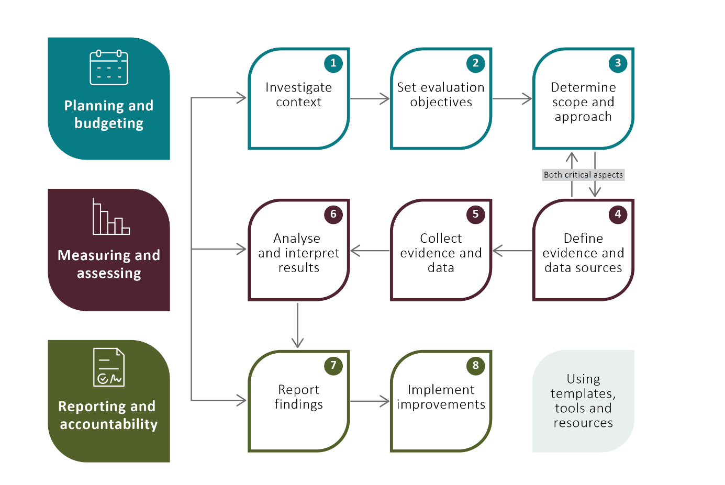

Developing an evaluation plan
An evaluation plan should establish clear objectives and include:
- a program logic model
- the purpose and scope of the evaluation
- key evaluation questions, and data sources that will be used to answer the questions
- data collection methods, including document review, informant interviews and access to datasets
- information about how the evaluation findings are intended to be used.
The plan is useful for communication during stakeholder consultation.
Developing a meaningful evaluation plan requires a clear understanding of the objective, inputs, outputs and outcomes of the initiative being evaluated. A program logic is a useful tool that can help link program activities and outputs to short-, medium- and long-term outcomes. Suitable performance measures for monitoring and evaluation can then be identified.
A program logic:
- helps structure a program
- states why the program exists
- includes a review of existing information to inform how the program will operate and its outcomes
- identifies barriers, enablers and related programs and policies
- identifies data sources and assets that could be used to inform the evaluation
- ensures stakeholder input is documented and circulated for feedback.
A program logic is the first step in developing an effective evaluation plan. The program logic will identify the relationship between program activities and intended outcomes. It will also guide development of the evaluation questions required to determine whether your program achieved its desired outcomes. These questions will be used to assess each aspect of the program, from inputs through to long-term outcomes.
For an example of a program logic in use, see the TAP evaluation program logic at Appendix A.
To access templates, including an evaluation plan and program logic, see ACE templates, tools and resources.

Ethically and culturally appropriate evaluation
Evaluation needs to be ethically and culturally appropriate. Business areas are responsible for understanding specific ethical, cultural and diversity aspects and how their work affects stakeholders.
To ensure ethical and cultural considerations are contemporary and relevant, consult:
- internal resources – including Culture, Wellbeing and Inclusion on The Source, and the Inclusion Networks: Gender Equity, First Nations, LGBTIQA+ Pride, Culturally and Linguistically Diverse, Mental Health Awareness, Care and Ability, and Neurodiversity
- relevant Commonwealth resources
- specialist diversity sector guidance (e.g. Guidelines for Ethical Conduct of Evaluations).
The Evaluation team can help identify resources and activities, including:
- current work on ethics
- other frameworks and plans that embed cultural safety
- development of an evaluation toolkit for engaging people with disability.
We must prioritise creating genuine partnerships, striving for cultural safety and proficiency, leading with integrity and ensuring shared decision-making.
We use and apply the Indigenous Evaluation Strategy in conjunction with the Commonwealth Evaluation Principles when planning and conducting evaluation activities that affect First Nations people.
The department is implementing its First Nations Commitment and delivering outcomes in support of the National Agreement on Closing the Gap. We are working across all levels of government to cultivate accountable partnerships with First Nations people, businesses and communities.
Underpinning this work is the development of a First Nations Monitoring, Evaluation and Learning (MEL) Framework and First Nations Data Strategy. These will help us:
- appropriately manage First Nations data
- effectively evaluate policies and programs affecting First Nations outcomes
- enhance accountability for government decision-making more broadly.
This work will complement this evaluation strategy and associated framework tools that are in development.
Additional internal resources are available to assist staff to undertake ethically and culturally appropriate evaluations.

Commonwealth requirements and guiding principles
The Australian Centre for Evaluation (ACE) was established under the APS Reform Agenda to support the APS to create policies and programs that improve the lives of Australians. ACE promotes the use of robust evaluation evidence to inform decision-making and drive better outcomes.
The APS is placing renewed emphasis on building and strengthening evaluation capability and practice. We are collaborating with ACE to promote evaluation uptake in line with Commonwealth requirements.
ACE is working with agencies to develop Commonwealth evaluation guidance, including an APS Place-based Evaluation Strategy. In 2025 ACE delivered the:
- Commonwealth Evaluation Maturity Model
- Strengthening Evaluation in the Australian Government – Action Plan 2026–2030
- Using artificial intelligence tools to support evaluation in the Australian Government.
These resources will continue to guide our efforts as we design and implement evaluation frameworks, tools and guidance.
The State of Evaluation in the Australian Government 2025 report highlights that:
Establishing a well-resourced central enabling evaluation function – the ACE was established in Treasury from July 2023 – and increasing the resourcing and remit for in-house evaluation units across government are central pillars for achieving enduring cultural change.
The report will be published annually and demonstrate the change in evaluation maturity across the Australian Government.
The ACE website lists whole-of-government legislative frameworks and policies that require planning and implementation of evaluation activities. Our enterprise evaluation framework will help embed strong evaluation practices throughout the policy cycle. We are taking steps to ensure our evaluation practices are fit-for-purpose and effectively used across business areas. The enterprise evaluation function also provides guidance on applying Commonwealth frameworks to our work, including:
- tools to enable consistent monitoring and evaluation practices
- expertise to help identify program objectives and outcomes, delivery times and baseline data
- guidance for robust program logic from the outset to ensure programs can be evaluated
- capability uplift opportunities.

Key Commonwealth documents
Documents that should be considered when planning an evaluation include:
- Commonwealth Evaluation Policy
  - Principles based
  - Includes evaluation principles that apply at all stages of the policy, project or program lifecycle – including design, implementation and review
  - Balances risk, resourcing and necessity
  - Focuses on continuous improvement
- Indigenous Evaluation Strategy (2020)
  - Centring First Nations people, perspectives, priorities and knowledges in practice
  - Data planning, collection and use are undertaken with First Nations people so that the right data are collected, data are of high quality, and governance arrangements are in place for ownership and use of data
  - Priorities under our First Nations Commitment
  - Closing the Gap – across the priority reforms, particularly Priority Reform 3: Transforming government organisations
- Budget Process Operational Rules (BPOR)
  - Refer to BPOR Rule 32 - evaluation of proposals
- Public Governance, Performance and Accountability Act 2013 (PGPA Act)
  - All entities subject to the PGPA Act must adhere to the Commonwealth Evaluation Policy.
  - We have developed guidelines to measure, assess and report on frameworks established under the PGPA Act (referencing best practice evaluation).
- Commonwealth Performance Framework
  - Consider evaluation objectives in the context of Commonwealth performance reporting requirements. Commonwealth entities are required to assess their performance in relation to achieving their stated purposes.
- Commonwealth Grant Rules and Principles (2024)
  - Evaluation strategy to be developed during initial stages of grant lifecycle.

Commonwealth Evaluation Policy
The Commonwealth Evaluation Policy applies to all Commonwealth entities subject to the PGPA Act and outlines 5 principles we must align with when undertaking evaluations. Evaluations must be:
- Fit for purpose
  - Not all programs or projects need to be evaluated in the same way – factors such as the scale of effort, proportionality, strategic importance and risk profile must be considered.
  - Agencies should evaluate to inform and continually improve programs or to inform policy decisions.
  - The methods of evaluation should be different for each purpose.
  - No one-size-fits-all approach exists for each program or policy.
  - We need to consider the diversity of our policies, projects and programs and learn from experience.
- Useful
  - Evaluations to inform program delivery should drive continuous improvement and accountability against objectives.
  - We need to understand government policy intent when evaluation is used as an input to design a program.
- Robust, ethical and culturally appropriate
  - Well-designed evaluations should identify potential bias, provide performance insights and consider impacts on stakeholders.
  - The principle should be considered across all aspects of evaluation, including collection, assessment and use of information.
- Credible
  - Evaluation should be resourced by technically and culturally capable people, conducted to appropriate standards with data used in an impartial and systematic way.
- Transparent, where appropriate
  - Evaluations should be released publicly, with appropriate exceptions to ensure accountability.
  - This principle promotes a transparent approach to our work and commitment to improvement and integrity in our deliverables.
If evaluation activities affect First Nations people, use the Indigenous Evaluation Strategy in conjunction with the Commonwealth Evaluation Policy and this strategy. The overarching principle of the Indigenous Evaluation Strategy is ‘Centring First Nations people, perspectives, priorities and knowledge’. The other principles of credible, useful, ethical and transparent should be viewed through that lens.

Budget Process Operational Rules and new policy proposals
The Budget Process Operational Rules (BPOR) state that agencies must develop evidence-based policy proposals that articulate measurable outcomes and impact objectives. Agencies should provide detailed new policy proposals and ensure an evaluation plan is established in the initial stages of policy implementation, and state whether a formal evaluation will be conducted. The Budget Strategy team supports business areas to develop new policy proposals. The evaluation function is included as a mandatory consultation during this process. Learn more about evaluation planning for new policy proposals.

Progress against this strategy
Using evaluation to make informed decisions about the effectiveness of our programs, policies and activities is everyone’s responsibility. This strategy supports our progress over the next 3 years towards the government’s agenda to uplift evaluation capability and practice across the APS.
We will track our progress using the progress indicators in Table 3. Our evaluation maturity will be assessed using the Commonwealth Evaluation Maturity Model.
Table 3 Progress indicators, 2026 to 2028 onwards
Objective | 2026 | 2027 | 2028 onwards
Improve evaluation leadership and governance | - Senior leaders actively promote evaluation across the department.  - A brains trust, led by a senior executive, is established. | - Annual evaluation plan is implemented and reported against within an authorising environment.  - Evaluation best practice is supported and promoted by leadership across the department. | - Evaluation outcomes included as a standing item in appropriate governance forums (e.g. Finance Performance committee, Executive Board).  - Evaluation findings inform and improve government decision-making towards priorities such as Closing the Gap.
Strengthen evaluation capability and practice | - Staff have an increased understanding of evaluation and its benefits.  - Staff have access to evaluation resources, support and training to develop and build their evaluation and data skills.  - The department is working to uplift data maturity and capabilities to improve internal evaluation capability. | - Strengthen staff capability to design, deliver, and procure evaluations with reduced reliance on external expertise.  - Program areas apply evaluation findings for better decision-making and improvement.  - Strengthen cultural responsiveness and Indigenous data governance through ongoing First Nations engagement. | - Evaluation thinking and activities applied to a diverse range of our initiatives.  - Strong evaluation culture that drives improvement, learning and policy design.
Embed evaluation into our practices and the policy cycle | - The department has an enterprise view of evaluation activity and a process for planning and prioritising future evaluations.  - Annual evaluation plan is developed, championed and implemented. | - Embed evaluation in program and policy development, ensuring readiness and use of ethical, robust methods for credible findings. | - The department receives an evaluation capability rating of ‘embedded’ in the next APSC capability review

Support
The Enterprise Program Management Office (EPMO) has a dedicated function to deliver the TAP evaluation priorities and support this strategy.

APS-wide professional networks
The EPMO are working collaboratively with a range of Commonwealth evaluation networks and encourage staff to familiarise themselves with these resources and levels of support (Figure 2).
Figure 2 Commonwealth evaluation networks
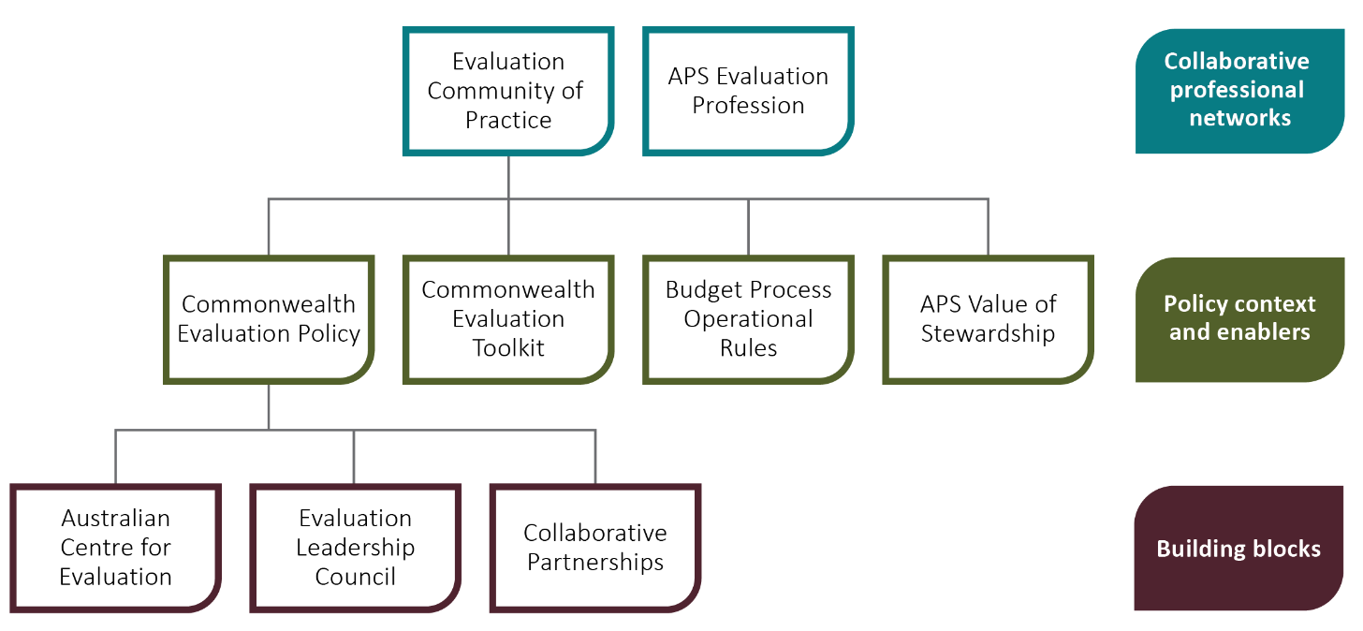

Resourcing evaluations
Resourcing evaluations is one of the challenges we have faced in the past – both in terms of funding and human resourcing. Internal guidance is available to help staff make decisions about human resourcing for evaluations.

Resources

Professional development
- Australian Centre for Evaluation
- Australian Public Service (APS) Academy
- Australian Evaluation Society
- Office of Impact Analysis

Commonwealth guidance material
- Australian Centre for Evaluation
- Australian Government Guide to Policy Impact Analysis
- Budget Process Operational Rules
- Commonwealth Evaluation Policy
- Commonwealth Evaluation Toolkit
- Commonwealth Grant Rules and Principles
- Commonwealth Performance Framework
- Successful implementation of policy initiatives: better practice guide

Planning and undertaking an evaluation
- How to develop a program logic for planning and evaluation
- Planning an evaluation

Ethically and culturally appropriate
- Code of Ethics for Aboriginal and Torres Strait Islander Research
- Ethics in evaluation
- First Nations Cultural Safety Framework
- Guidelines for the Ethical Conduct of Evaluations
- Indigenous Evaluation Strategy
- Link-Up Services recognised for culturally safe monitoring and evaluation strategy
- National Agreement on Closing the Gap

Data
- Closing the Gap Priority Reform 3
- State of Evaluation in the Australian Government 2025

Additional resources
- Better Evaluation
- New framework and toolkit for evaluating place-based delivery approaches
- The Magenta Book (HM Treasury)

Appendix A: Program logic
Table A1 Evaluation strategy program
Category | Description
Problem statement | The department does not have an enterprise-level approach to evaluation resulting in a lack of evaluations and inconsistencies in approaches. This leads to ineffective sharing of data to inform continuous improvement of our policy and programs.
Inputs | 1 x EL 1, 1 x APS 5
Activities | - Research and analysis  - Evaluation team training  - Informal and facilitated engagement  - Development of framework and tools, including repository of learnings and data  - Procurement process for external consultants  - Development and/or adaption of available training material for staff
Outputs | - Strategy  - Guidance tools  - Annual action plan  - Evaluation repository  - Training catalogue  - Professional networks
Assumptions | - There are skilled evaluators in the department.  - There is aptitude for evaluative thinking within the public service.  - ACE and APS resources are appropriate and fit, or adaptive, for departmental purposes.  - Flexibility in approach is required, not a one size fits all.  - Increased knowledge and understanding of evaluation principles and practice will be welcomed and valued.
Program objective | - Design and deliver an enterprise-wide approach to evaluation that drives performance improvement and accountability and embeds a robust and mature evaluative culture.  - Develop a framework to help business areas improve evaluation planning, build capability, define key performance indicators and develop frameworks for evaluation and success measurement of policy, projects and programs.
Short-term outcomes | - Uptake in training  - Increased staff engagement  - Increased knowledge of Commonwealth requirements  - Improved awareness of resources
Medium-term outcomes | - Increased evaluative thinking  - Evaluation framework is used to guide evaluations and enables flexibility in approaches  - Sharing of data and lessons learned
Long-term outcomes | - Evaluation is used in a consistent way to better understand and demonstrate the performance of programs and services  - Evaluative skills and thinking are valued as critical  - Credible policy leader  - Improved delivery of program outcomes, aligned to our strategic objectives and purpose
External factors | - Cultural and environmental – engagement with and use of framework  - Direction and guidance from broader APS reform agenda  - Reduced investment  - Change in government or ministerial priorities  - Global trade and economic factors impacting government priorities  - Whole-of-government work on National Agreement on Closing the Gap

Glossary
Term | Definition
ACE | Australian Centre for Evaluation
audit | Primary independent examination of financial and non-financial performance information.
BPORs | Budget Process Operational Rules
data lineage | The process of understanding, recording, and visualising data as it flows from data sources to consumption.
performance measurement and monitoring | Continuous process of collecting and analysing data to compare how well a project, program or policy is being implemented against expected results and monitoring routine measurements to detect changes.
program logic | Models that illustrate causal pathways for programs, including theory of change, program theory and logic models.
quality improvement | Systematic formal approach to analysing performance and improvement efforts.

References
ACE 2025a, Evaluation planning for new policy proposals, Australian Centre for Evaluation, Canberra, accessed 17 April 2025.
——2025b, Public governance, performance and accountability framework, Australian Centre for Evaluation, Canberra, accessed 9 May 2025.
——2025c, What is evaluation, Australian Centre for Evaluation, Canberra, accessed 3 March 2025.
——2025d, When to evaluate, Australian Centre for Evaluation, Canberra, accessed 28 April 2025.
APSC 2023, Capability review: Department of Agriculture, Fisheries and Forestry, Australian Public Service Commission, Canberra, accessed 3 March 2025.
Brett-Harding 2023, Understanding additionality and deadweight, What Works Centre for Local Economic Growth, accessed 4 November 2025.

