Transformation Action Plan
© Commonwealth of Australia 2023
Ownership of intellectual property rights
Unless otherwise noted, copyright (and any other intellectual property rights) in this publication is owned by the Commonwealth of Australia (referred to as the Commonwealth).
Creative Commons licence
All material in this publication is licensed under a Creative Commons Attribution 4.0 International Licence except content supplied by third parties, logos and the Commonwealth Coat of Arms.

Cataloguing data
This publication (and any material sourced from it) should be attributed as: DAFF 2023, Transformation Action Plan, Department of Agriculture, Fisheries and Forestry, Canberra. CC BY 4.0.
This publication is available at agriculture.gov.au/about/reporting/capability-review.
Department of Agriculture, Fisheries and Forestry
GPO Box 858 Canberra ACT 2601
Telephone 1800 900 090
Web agriculture.gov.au
Disclaimer
The Australian Government acting through the Department of Agriculture, Fisheries and Forestry has exercised due care and skill in preparing and compiling the information and data in this publication. Notwithstanding, the Department of Agriculture, Fisheries and Forestry, its employees and advisers disclaim all liability, including liability for negligence and for any loss, damage, injury, expense or cost incurred by any person as a result of accessing, using or relying on any of the information or data in this publication to the maximum extent permitted by law.
Acknowledgement of Country
We acknowledge the Traditional Custodians of Australia and their continuing connection to land and sea, waters, environment and community. We pay our respects to the Traditional Custodians of the lands we live and work on, their culture, and their Elders past and present.

Foreword
The work of our department is central to the health and prosperity of the nation.
Each day, we protect our industries, communities and natural environment from potentially devastating pests and diseases. We support every clean, safe meal that Australians sit down to enjoy, and our work facilitates much of our trade as a nation. We deliver world-class activities in areas such as agricultural economics, plant and animal sciences, and digital technology, to deliver better regulatory outcomes. Our people design policies and deliver programs and regulatory services to manage biosecurity risks, support agricultural productivity and improve international market access.
In 2022–23 total agriculture, fisheries and forestry production topped $98 billion. Around 90% of the food we eat is grown here, and around three-quarters of our food and fibre production – a record $82 billion last financial year – is exported annually. It’s a significant contribution to the national economy and the backbone of rural and regional communities, economies and employment.
The Capability Review acknowledged the important role played by the department as stewards of that contribution. It’s an important responsibility. It also identified the potential to do better by improving our foundational capabilities, including governance, workforce planning and financial management. Additionally, new challenges continue to emerge, from regional food security to sustainability, improving productivity and supply-chain resilience, education and skills, and empowering First Nations people. It’s essential that we continue to lift its capability. Ongoing success will demand stewardship, leadership and coordination across the department and our stakeholders.
I am dedicated to strengthening these areas of the department’s work so we can better meet the priorities of the Australian Government and the expectations of our stakeholders. We are good at what we do. We can be great. Our aspiration is to be a proactive leader in delivering a more sustainable and prosperous Australia through agricultural production, trade and biosecurity.
This Transformation Action Plan identifies the immediate and longer-term actions we will take to uplift our leadership and culture, collaboration, delivery, people and resourcing, and risk capabilities. We will report progress on delivering this roadmap through our annual report.
It is my pleasure to present the department’s Transformation Action Plan as we work to uplift our capability over the next 4 years.

Adam Fennessy PSM
Secretary
Department of Agriculture, Fisheries and Forestry
Contents
Foreword iii
What success looks like 1
Accountability and evaluation 2
Overview 3
1 Leadership and culture 4
Vision 4
Priority actions 4
2 Collaboration 5
Vision 5
Priority action 5
3 Delivery 6
Vision 6
Priority actions 6
4 People 7
Vision 7
Priority action 7
5 Resourcing and risk 8
Vision 8
Priority actions 8

Figures
Figure 1 Interlinkages of actions across domains 3

What success looks like
As we look forward to 2027, we will seek to ensure that:
- We are a trusted and credible adviser on the strategic issues shaping the future of the domestic and international agricultural sector, biosecurity and trade systems.
- Our value proposition is clear and we have a strong track record of shaping whole-of-government priorities.
- Our digital capabilities keep pace with technology and service innovation, with products that are highly reliable and fully integrated.
- We operate regulatory systems that are transparent, efficient, risk-based and promote high-performance and service excellence.
- We have strong, diverse and inclusive relationships with our domestic and international stakeholders that inform decision-making about policy, programs and excellence in regulatory service delivery.
- We use evidence, science, data and feedback from stakeholders and users in an integrated way to co-design practical solutions.
- We use evaluation in a consistent way to better understand and demonstrate the performance of programs and services.
- Our use of public resources is subject to consistent evaluation and high standards of risk management and accountability.
- We have a governance system that supports our leaders to collectively set priorities, align resource allocations and promote a shared sense of purpose and direction.
- We have a joined-up approach to financial management that enables the most efficient use of our resources, including through the transparent application of cost recovery.
- We measure and report on performance at an enterprise level in a coordinated and consistent manner to support continuous improvement, effective decision-making and resource management.
- We use high-quality workforce data and effective workforce planning to develop, attract and retain the talent we need, ensuring commitment to our core values and integrity frameworks.
- We have embedded First Nations shared benefits throughout our capability improvement activities.

Accountability and evaluation
All staff will be involved in supporting the successful delivery of the Transformation Action Plan. We will evaluate success and drive accountability through:
- an annual refresh on future direction and priorities in our corporate plan
- an annual assessment of progress in our annual report
- monitoring progress on the Action Plan and priority actions through our Executive Board and committees
- embedding relevant activities in business planning and performance agreements.
The implementation of the Transformation Action Plan will be supported by a monitoring and evaluation framework that will ensure transparent, ongoing and proactive monitoring on reform activities, assessment of progress against performance criteria, and reporting on progress.

Overview
Figure 1 shows the actions that we will undertake to uplift capability in 5 domains:
- Leadership and culture.
- Collaboration.
- Delivery.
- People.
- Resourcing and risk.
Figure 1 Interlinkages of actions across domains
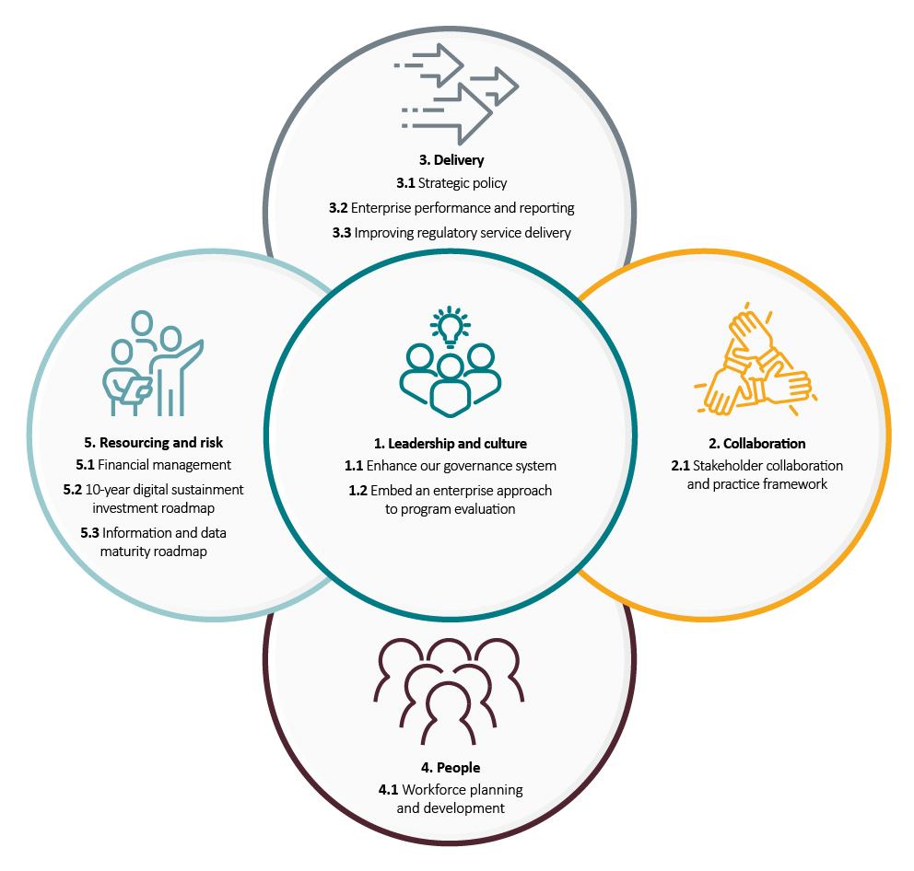

Leadership and culture

Vision
Leadership occurs at all levels to drive a culture of continuous improvement. A shared sense of purpose and direction is promoted, alongside strong alignment and shared accountability for priorities and resource allocation. All staff leaders focus on service excellence driven by assessment of performance against our objectives and priorities. Staff model our core values and engage openly with capability enhancements that reinforce a strong culture of integrity and safety.

Priority actions

Enhance our governance system
Establish an enhanced governance system that supports collective responsibility for setting, monitoring and clearly communicating enterprise-wide priorities. The system will support effective resource allocation and decision-making (including a financial performance management framework) and incorporate the principles of our First Nations Platform.

Embed an enterprise approach to program evaluation
Design and deliver an enterprise-wide approach to evaluation that drives performance improvement and accountability, and is inclusive of First Nations people and organisations.

Collaboration

Vision
We engage and collaborate in a meaningful way with Commonwealth and state governments, industry partners and stakeholders to shape whole-of-government priorities. We consider the needs and aspirations of primary producers, importers and exporters, First Nations partners and other key stakeholders early when developing and delivering policy, programs and services.

Priority action

Stakeholder collaboration and practice framework
Develop a framework that clarifies stakeholder management and engagement responsibilities. It will improve transparency in the performance of our cost-recovered activities and consistency in the way that we use stakeholder insights to drive innovation and service excellence.

Delivery

Vision
We deliver on our enterprise-wide objectives and proactively shape whole-of-government policy priorities such as the economy’s transition to net-zero emissions, improving productivity, food security, agricultural employment and First Nations Closing the Gap reforms.

Priority actions

Strategic policy
Build a strong and proactive strategic policy capability and culture with a focus on influencing and engaging on priority policy areas that meet the economic, environmental, social and governance needs of Australian communities.

Enterprise performance and reporting
Improve our enterprise and performance reporting framework, including consolidating performance, financial, workforce and other assurance information and data to underpin effective decision-making and resource management.

Improving regulatory service delivery
Develop and implement a future-focused regulatory strategy that increases the efficiency and effectiveness of our regulatory service delivery and uplifts the capability of regulatory staff.

People

Vision
We have a comprehensive workforce strategy that identifies the skills and capabilities required to achieve our ambitions, maintain existing capabilities, address workforce risks and skills gaps, and ensure we are an employer of choice. The strategy helps deliver human resource systems that improve recruitment and retention of staff, underpinned by reliable and up-to-date workforce data and analytics. The workforce strategy also supports a culturally safe and competent workplace that helps us exceed 5% First Nations staff representation.

Priority action

Workforce planning and development
Develop a strategic workforce framework to build a fit-for-future workforce and support the attraction, development and retention of staff with critical skills. The framework will include actions that focus on exceeding the government’s commitment to 5% First Nations representation.

Resourcing and risk

Vision
We set agreed priorities at an enterprise level, allocate resources accordingly and make decisions about stopping or scaling back activities based on assessment of enterprise-level risks and evidence of what works.

Priority actions

Financial management
Redesign our finance operating model to uplift financial literacy and accountability, review our operating model and deliver an enterprise-wide approach that lifts financial maturity and performance across the organisation.

10-year digital sustainment investment roadmap
Deliver a roadmap that will address key risks (including the ICT technical debt), modernise systems and establish an ongoing sustainment, robust and secure digital landscape.

Information and data maturity roadmap
Strengthen our data analytics capability to underpin effective performance monitoring, risk management, operational and strategic policy settings, regulation, and service delivery operations.

