Delivering Ag2030
The Australian Government is setting the foundations for Australia’s world-class farmers, fishers and foresters to rebound from COVID-19 and build toward the agricultural sectors’ vision for a $100 billion industry by 2030.
October 2020
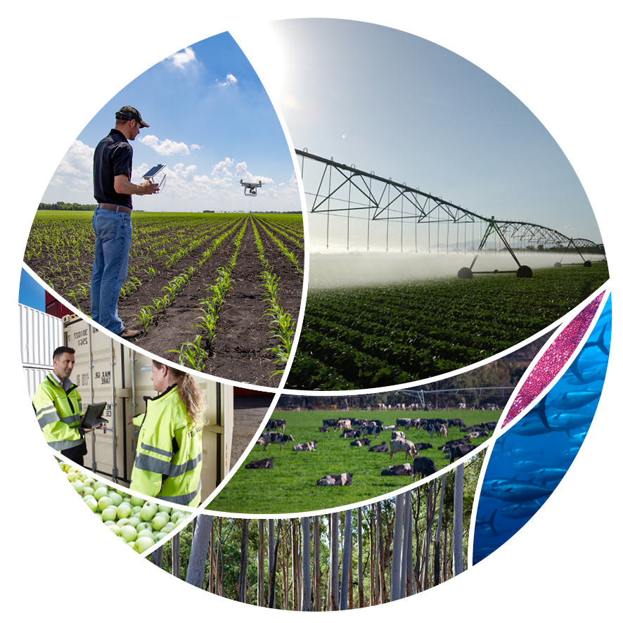
© Commonwealth of Australia 2020
Ownership of intellectual property rights
Unless otherwise noted, copyright (and any other intellectual property rights) in this publication is owned by the Commonwealth of Australia (referred to as the Commonwealth).
Creative Commons licence
All material in this publication is licensed under a Creative Commons Attribution 4.0 International Licence except content supplied by third parties, logos and the Commonwealth Coat of Arms.
Inquiries about the licence and any use of this document should be emailed to copyright@awe.gov.au.

Cataloguing data
This publication (and any material sourced from it) should be attributed as: 2020, Delivering Ag2030, Department of Agriculture, Water and the Environment, Canberra, October. CC BY 4.0.
ISBN 978-1-76003-348-4
This publication is available at https://www.agriculture.gov.au/ag-farm-food/ag2030.
Department of Agriculture, Water and the Environment
GPO Box 858 Canberra ACT 2601
Telephone 1800 900 090
Web awe.gov.au
Disclaimer
The Australian Government acting through the Department of Agriculture, Water and the Environment has exercised due care and skill in preparing and compiling the information and data in this publication. Notwithstanding, the Department of Agriculture, Water and the Environment, its employees and advisers disclaim all liability, including liability for negligence and for any loss, damage, injury, expense or cost incurred by any person as a result of accessing, using or relying on any of the information or data in this publication to the maximum extent permitted by law.

Foreword
Australia’s agricultural industry has historically made a unique contribution to our nation’s character and economy. The Australian people have long recognised that when our farmers, fishers and foresters are strong, the whole country benefits.
The Australian Government’s policy approach to supporting our agricultural industry has evolved in line with broader trends in economic philosophy and management: from the relative protectionism of the 1950s and 1960s; to the liberalising efforts of the 1980s and 1990s; and in recent years, a consistent policy of setting the foundations and frameworks to support our primary producers to do what they do best—produce, feed Australia and export.
This modern approach has seen our agricultural sector become amongst the most advanced, competitive, and efficient in the world.
The Australian Government remains committed to delivering on our responsibility to provide strong foundations and frameworks to support industry achieve its visions and for producers to be appropriately rewarded for their efforts. Ag2030 is another step forward in that direction.
In 2018 the agriculture industry, led by the National Farmers’ Federation (NFF), announced an ambitious plan to build the Australian agriculture sector to $100 billion by 2030. The government is backing this industry-led plan and is delivering Ag2030 to support industry to reach its $100 billion vision.
Since the release of the NFF’s Roadmap in 2018, the sector has been hit by drought, bushfires, COVID-19 and now a recession, yet despite this Australian agriculture is still thriving. The agriculture, fisheries and forestry sectors are bright lights for Australia’s economy and whilst it still faces challenges, agriculture continues to grow.
Modelling by the Australian Bureau of Agricultural and Resource Economics and Sciences’ (ABARES) suggests a business-as-usual approach would see the sector grow from $61 billion in 2020-21 to $70 billion by 2030. In order to achieve the $100 billion Ag2030 vision, the sector needs to almost double the current rate of value growth. Together with industry and other governments, the government is committed to breaking down barriers, solving challenges and creating opportunities to help industry achieve this growth.
Ag2030 is already delivering foundational, current measures to underpin competitiveness, growth, adaptability and resilience.
But the work does not end here.
The government will continue to respond to the needs and requirements of the sector to achieve productivity and value growth over the next 10 years.
Ag2030 is not set and forget; there are substantial efforts in implementation across the
7 themes, and there will be further announcements in the future.
Achieving growth of this magnitude is no small feat. But Australian farmers and our agricultural industry are ambitious and all levels of government, industry and individual producers stand shoulder to shoulder in this aspirational vision.
The government will continue to work with all stakeholders towards the Australian agriculture sectors’ $100 billion vision. Ag2030 sets the framework for supporting the sector and will allow Australian producers to get on with running their businesses and reaping the rewards of a $100 billion sector.




Hon David Littleproud MP
Minister for Agriculture, Drought and Emergency Management

Contents
Foreword 3
The vision 6
Theme 1: Trade and exports 7
Theme 2: Biosecurity 9
Theme 3: Stewardship 10
Theme 4: Supply chains 11
Theme 5: Water and infrastructure 12
Theme 6: Innovation and research 13
Theme 7: Human capital 15
Future steps 17

The vision
The Australian agricultural industry—farming, fishing and forestry sectors—aims to be a $100 billion industry by 2030 (Ag2030).
The agricultural industry has grown consistently, with the farming sector currently valued at $61 billion, and the fisheries and forestry sectors valued at $5.5 billion combined. The magnitude of the challenge to meet the $100 billion vision is significant; industry needs to almost double its current annual growth rate, from 3% to 5.4%.
Achieving the Ag2030 vision requires all levels of government and industry to work together. It will require a significant increase in productivity while maintaining Australia’s reputation for high quality and sustainable produce.
Our Vision: Through Ag2030, the Australian Government is setting the foundations for the agricultural sector to grow agriculture to $100 billion by 2030, ensuring Australian agricultural producers receive maximum returns for their hard work and are supported by vibrant rural and regional communities.
Ag2030 sets 7 themes for action.
- Trade and exports - strengthening agricultural ties with major and emerging export markets. This will deliver new trade and market access for producers, while also reducing red tape.
- Biosecurity – safeguarding Australia from exotic pests and diseases means lower costs for our producers and is critical to our market access.
- Stewardship – ensuring Australian farmers are rewarded for their stewardship of land and water.
- Supply chains – ensuring that we have fair, strong and resilient supply chains where everyone is treated fairly and pays their share.
- Water and infrastructure – supporting Australian farmers, rural and regional communities with infrastructure when and where it is needed.
- Innovation and research – modernising Australia’s agricultural innovation system to drive improvements in collaboration, commercialisation and uptake to grow their productivity and competitiveness.
- Human capital – enabling people and their communities right across the agriculture supply chain with the support, infrastructure and skills to do their jobs.
The government has announced foundational initiatives across the 7 themes in a whole-of-government approach to support progress in this agenda. These will be built on in the future by further targeted initiatives to support productivity growth and in line with the needs and requirements of the sector.

Theme 1: Trade and exports
Increased and improved market access and streamlined exporting processes to provide producers with greater opportunities.
Around 70% of Australia’s agricultural production is exported. One of the greatest opportunities for industry growth is through increased access to international markets.
The Australian Government is committed to making sure Australian producers have access to both existing and new markets through Free Trade Agreement negotiations, technical bilateral market access negotiations, addressing non-tariff measures and building long-term strategic partnerships with key trading partners.
The government is focusing on gaining, improving and maintaining market access with major and emerging export markets to deliver new and improved trade and market access for producers, while also reducing red tape to make it easier for producers to export the goods.
The government is:
- providing $328.4 million over 4 years for the Busting Congestion for Agricultural Exporters package, to slash unnecessary red tape to get products to export markets faster and support jobs in rural and regional Australia
- providing a further $317.1 million extension of the International Freight Assistance Mechanism (IFAM), taking the Government’s total IFAM commitment to $669 million as a temporary measure to keep vital imports and exports flowing during the COVID-19 recovery
- reviewing and amending the Export Control Act 2020 to modernise and improve it with revised legislation due to commence in April 2021
- progressing the government’s Free Trade Agreement (FTA) agenda - ensuring we get the most out of existing and recently concluded FTAs, including with Indonesia, Peru and Hong Kong, and negotiating new FTAs with the European Union and United Kingdom
- providing $6.8 million over 4 years to extend the Agricultural Trade and Market Access Cooperation (ATMAC) program to help open, improve and maintain access to markets for Australian agricultural products
- providing an additional $6.1 million over 4 years to extend the Package Assisting Small Exporters (PASE) program
- providing $11.4 million over 4 years to accelerate horticulture market access into overseas markets
- delivering $15 million per year to help grow Australian agricultural exports and expand market access
- maintaining the overseas agricultural trade counsellors network, including in the United Kingdom, Mexico, Japan, India and Chile
- providing $7 million over 4 years to support better traceability outcomes, through the Modernising Agricultural Trade initiative
- providing $14.8 million over 6 years for Dairy Export Assurance Reforms to help the export dairy industry by raising export awareness, reducing red tape and streamlining audit arrangements by 2024-25.

Theme 2: Biosecurity
Safeguarding Australia from exotic pests and diseases to deliver lower costs for producers and support market access.
Safeguarding Australia from exotic pests and diseases is vital. Biosecurity controls, from place of origin through to Australia’s borders, must continue to minimise the risk of exotic pests and diseases entering Australia. This means lower costs for producers, and helps ensure Australian exporters maintain access to export markets. More effective management of established pest animals and weeds through innovative solutions will reduce costs and allow farmers to focus on their business.
The Australian Government is committed to ensuring that Australia’s biosecurity system continues to safeguard Australia’s reputation.
The government is focused on ensuring Australia’s biosecurity framework remains contemporary and efficient in facilitating both safe imports and exports in a changing global environment, while reducing the regulatory burden on industry.
The government is:
- making available $873 million for biosecurity and export programs in 2020-21, an increase of around 45% since 2012-13
- making new investments to deliver a strong national biosecurity system including:
  - $55 million over 5 years from 2019-20 for priority pest and disease planning and response and $33 million over 4 years for Biosecurity Indigenous Rangers
  - over $5 million per annum for a biosecurity innovation program to invest in technology to enable us to work smarter
  - ongoing funding, totalling $61.9 million in 2021-22, to support the eradication of nationally significant pests and diseases
  - $37.2 million over 5 years from 2019-20 to established pest animal and weed management programs, $16.9 million over 4 years to strengthen fruit fly management and $67 million over 2 years to protect Australia from African swine fever
  - continued investment in intelligence to better respond to emerging biosecurity threats, with $36 million over 4 years to strengthen our analytics capabilities
- ensuring a continued national focus on emergency preparedness and exercises to embed the learnings from recent natural disasters and COVID-19 pandemic to ensure fast and effective responses to pest and disease incidents
- a forward commitment to a simplified trade system that delivers effective biosecurity risk management in the most efficient manner possible.

Theme 3: Stewardship
Providing Australian producers with the appropriate tools to adapt to a changing climate and build a sustainable agricultural base for the future.
Australian farmers, fishers and foresters are some of our greatest environmental stewards.
Agricultural production occurs on over 50% of Australia’s landmass. Australian farmers, fishers and foresters have a role in maintaining healthy ecosystems which are of critical importance to future production, the environment, regional communities and the broader economy.
The Australian Government is committed to supporting Australian farmers, fishers and foresters in their role as agri-stewards to ensure a long-term sustainable agricultural base for the future, including improving water management.
The government is focusing on establishing mechanisms to grow industry resilience and diversification while also improving environmental outcomes and rewarding producers for their stewardship of the land and water.
The government is:
- investing $34 million over 4 years to strengthen sustainable development through the Agriculture Stewardship Package with on-ground trials to commence in 2021
- investing $5 billion in a Future Drought Fund, which will provide $100 million each year to build drought preparedness and resilience including investing in Natural Resource Management activities
- delivering a National Soil Strategy by June 2021, with soils work supported through the National Soils Advocate
- providing $1.9 billion to invest in future technologies that lower emissions, including backing new technologies that will increase productivity and cut emissions in agriculture, reducing the time to develop new methodologies under the Emissions Reduction Fund, and reducing the cost of measuring soil carbon to $3/ha/year
- providing $36.6 million to maintain the timeliness of assessments under the Environment Protection and Biodiversity Conservation Act 1999
- providing $4.2 million over 2 years for 4 new Indigenous River Ranger Groups across the Murray-Darling Basin
- providing $1.1 billion over 7 years from 2016-17 to the National Landcare Program to deliver long-term benefits to our farmers, our communities, the economy and the environment.

Theme 4: Supply chains
Supporting Australian producers to grow their profitability and competitiveness, and ensuring the sustainability of their industry.
The agricultural industry need to improve its responsiveness to changes in their markets, and uptake of new and innovative approaches along the value chain. A key driver of growth will be capitalising on Australia’s reputation for quality and safe products.
The Australian Government is committed to ensuring public policy settings are business enabling and fit for purpose, while also addressing egregious behaviour and market power imbalances along the supply chain.
The government is focused on ensuring everyone in the supply chain is treated fairly and pays their share.
The government is:
- providing $1.3 billion to develop and implement a new Modern Manufacturing Strategy – including for food and beverages
- providing $50 million for Industry Growth Centres including Food Innovation Australia Limited, to assist in implementation of the government’s new Modern Manufacturing Strategy
- investing $107.2 million towards the Supply Chain Resilience Initiative which will support projects that address identified supply chain vulnerabilities
- supporting an Australian Competition and Consumer Commission inquiry into perishable agricultural supply chains delivered by November 2020
- improving competition and fairness across the supply chain through codes of conduct for Dairy, Wheat Port, Sugar and Horticulture
- showcasing Australian products through Country of Origin Labelling
- investing $4 million into an ‘Eat Seafood Australia’ campaign to help invigorate domestic seafood consumption and supply chains.

Theme 5: Water and infrastructure
Investment in regional infrastructure and transport, digital connectivity and water security projects to support local jobs and improve the efficiency of the agricultural industry.
Agricultural regions underpin Australia’s economy. One in 3 Australians live in regional Australia. It is vital for the regions to have access to infrastructure, water and services.
The Australian Government is committed to supporting rural and regional Australia now and into the future through improved regional planning, strengthened networks, leadership and community capabilities, and infrastructure projects. Given the agriculture industry has a strong rural and regional presence, a strong and growing industry directly supports vibrant rural and regional communities.
The government is focused on supporting Australian farmers, rural and regional communities with infrastructure when and where it is needed.
The government is:
- providing $270 million over 4 years for the Murray-Darling Communities Investment Package including delivery of 11 initiatives to put communities at the centre of the Murray-Darling Basin Plan
- providing $50 million in 2020-21 to extend the On-farm Emergency Water Infrastructure Rebate Scheme for a further year
- identifying and building new water infrastructure through the $3.5 billion National Water Infrastructure Development Fund
- improving communications for the agriculture sector through $22.1 million for the Australian 5G Innovation Initiative, and $30.3 million for the Regional Connectivity Program to support telecommunications projects developed by local communities
- delivering new Regional Policy Package including $100 million over 2 years for Regional Recovery Partnerships to coordinate investments with other levels of government to support recovery and growth in 10 priority investment regions
- providing $9.3 billion to complete the Inland Rail by 2025
- improving the supply chain through the National Freight and Supply Chain Strategy.

Theme 6: Innovation and research
Greater access to technologies to support Australian producers increase productivity and competitiveness.
Innovation drives productivity growth, sustainability and resilience across Australia’s agriculture, forestry and fisheries sectors. Australia needs a world-class agricultural innovation system that can quickly respond and adapt to the emerging risks and opportunities of the 21st century.
Australian agriculture increasingly faces big, complex challenges and opportunities, driven by changing global markets, increasing international competition, technological disruption, climate and water-related risk and global economic shocks.
The Australian Government is committed to modernising Australia’s agricultural innovation system to better allow Australian producers to access and adopt new technologies and innovations. Through the National Agricultural Innovation Agenda, the Australian Government is providing national leadership and driving improvements across the agricultural innovation system by targeting 5 Pillars of Reform: strengthening ecosystem leadership, improving the balance of funding and investment, embedding world-class innovation practices, strengthening our regions and creating the next generation innovation platform. This will allow our regions to achieve greater uptake of innovation.
The government is focused on ensuring the agricultural industry has an appropriately skilled workforce, regulatory framework, and research and development mechanisms in place to drive innovation and adoption of new technologies.
The government is:
- developing a National Agricultural Innovation Policy Statement and mission-oriented agricultural innovation priorities by mid-2021
- providing $86 million over 4 years to deliver 8 Adoption and Innovation Hubs, through the Future Drought Fund by March 2021
- developing a Digital Foundations for Agriculture Strategy that will set the foundations for widespread uptake of digital technologies across our agriculture, forestry and fisheries sectors by July 2021
- supporting industry’s $500 million annual investment into research, development and marketing by providing approximately $300 million annually in government matching contributions, to support eligible research and development activities
- supporting Agricultural Innovation Australian Ltd (AIA) to drive new cross-industry approach to agriculture innovation by providing $1.3 million in seed funding for the AIA investment strategies
- providing $7.2 million over 4 years towards streamlining and modernising the agricultural levies legislation by April 2023
- developing the first National Fisheries Plan by the end of 2021
- delivery of 9 Regional Forestry Hubs through to the end of 2022.

Theme 7: Human capital
Investing in preparedness, resilience and the agricultural workforce to strengthen and ensure the sustainability of agricultural businesses.
Over 322,000 people are employed across the agricultural sectors. Access to workers, including those with the skills required, underpins the future success of the industry.
The Australian Government is committed to helping the agricultural industry attract a workforce able to accommodate for rapid technological advancements, changing product markets and trade opportunities, new work methods, demographic, and other social and economic changes.
The government will also continue to put in place the resources and tools required to support producers and communities to prepare for, manage and sustain their livelihoods during extreme events and, when these events occur, provide targeted recovery measures such as those aimed at assisting drought and bushfire-affected producers.
The government is focused on ensuring people and their communities across the agriculture supply chain have the support, infrastructure and skills to do their jobs.
The government is:
- providing $250 million to support access to up to 400 short courses for priority fields, including agriculture, to upskill our workforce
- providing $17.4 million in relocation assistance, and $16.3 million to incentivise young Australians to take up farm work
- providing $19.6 million to support communities to recover from drought to extend the drought function of the National Drought and North Queensland Flood Response and Recovery Agency including Regional Recovery Officers
- providing $36.3 million to support rural and regional shows, and $2.7 million for agricultural field days impacted by COVID-19
- developing a National Agricultural Workforce Strategy for future workforce development and availability
- investing $5 billion in a Future Drought Fund, which will provide $100 million each year to build drought preparedness and resilience including in leadership and networks
- providing over $4 billion to the Regional Investment Corporation for loans to farm and small agri-businesses
- providing $18 billion in 2020 towards the Job-ready Graduates Package of reforms to higher education, which will grow to $20 billion by 2024
- delivering changes to the Farm Household Allowance to make it easier for farmers to access support
- supporting primary producers and businesses through the Rural Financial Counselling Service
- providing $40 million to support the forestry sector through the Forestry Recovery Development Fund Program
- funding mental health support for regional commercial fishers
- adjusting visa arrangements to support farm businesses reliant on temporary foreign workers
- providing over $151 million to support primary producers to recover from the 2019-20 Black Summer bushfires.

Future steps
Delivering Ag2030 outlines current foundational actions being undertaken by the Australian Government to support industry growth towards the 2030 vision. The agenda will be updated periodically to reflect future initiatives announced by the government to support industry reach its vision.
The 2020-21 Federal Government Budget demonstrates the Australian Government’s commitment to support farmers, fishers and foresters—driving job creation and economic growth, while also supporting recovery from the impacts of COVID-19.
Key initial measures driving the delivery of Ag2030 over the next decade include:
- an Agricultural Workforce Strategy in 2020
- Agriculture Stewardship Package, with an on-ground pilot commencing in 2021, over 4 years
- Adoption and Innovation Hubs, through the Future Drought Fund established in early-2021, over 4 years
- a National Agricultural Innovation Policy Statement with priorities by mid-2021
- a Digital Foundations for Agriculture Strategy by mid-2021
- Busting Congestion for Agricultural Exporters package
- ongoing, world-class biosecurity and export programs
- a Modern Manufacturing Strategy – including a food and beverages roadmap
- a stretch goal to reduce the cost of measuring soil carbon to less than $3/ha/year, over the next 10 years
- timely environmental assessments under the Environment Protection and Biodiversity Conservation Act 1999, over 2 years
- investing in upskilling people through short courses for priority fields, including agriculture, over 5 years
- relocation assistance and incentives to take up farm work, over 2 years
- Regional Recovery Partnerships over 2 years
- Murray-Darling Communities Investment Package over 4 years.
To stay up to date with the Australian Government’s Ag2030 agenda, visit www.agriculture.gov.au/ag-farm-food/ag2030

