Module 5 Assignment

Part A
- Select all columns from the employee table in the humanresources schema
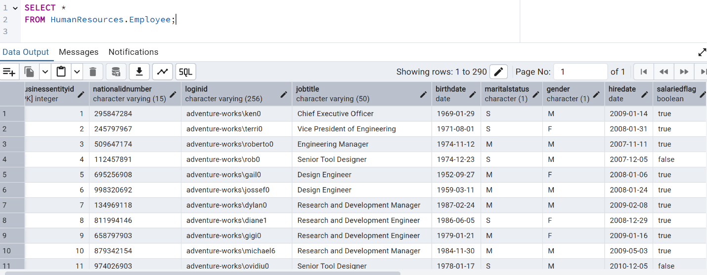

- Select the business entity id, person type, first name, and last name from the person table in the person schema
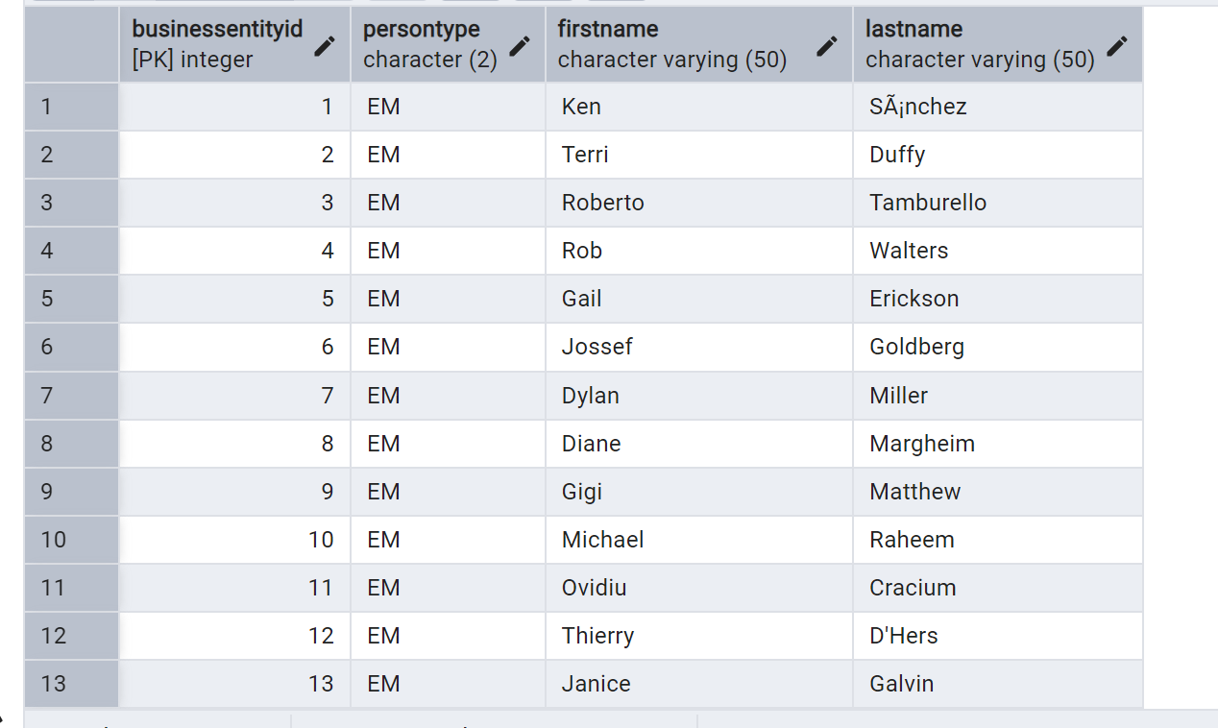

- Write a query to return all the distinct management job titles that include the following in their name: Manager, Supervisor, Chief, Vice President
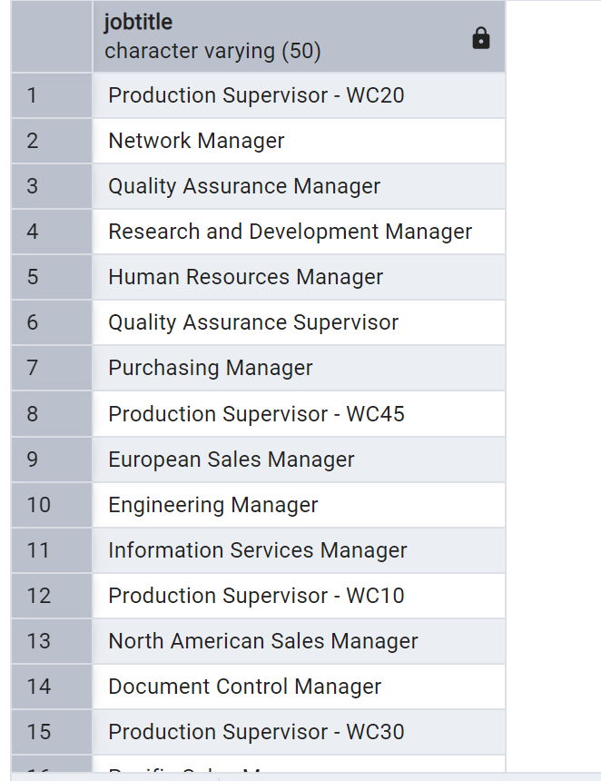

- Write a query to return all of the products from the product table in the production schema with a sellstartdate between ‘1/1/2013’ and ‘6/30/2013’. Order the resulting products by name.
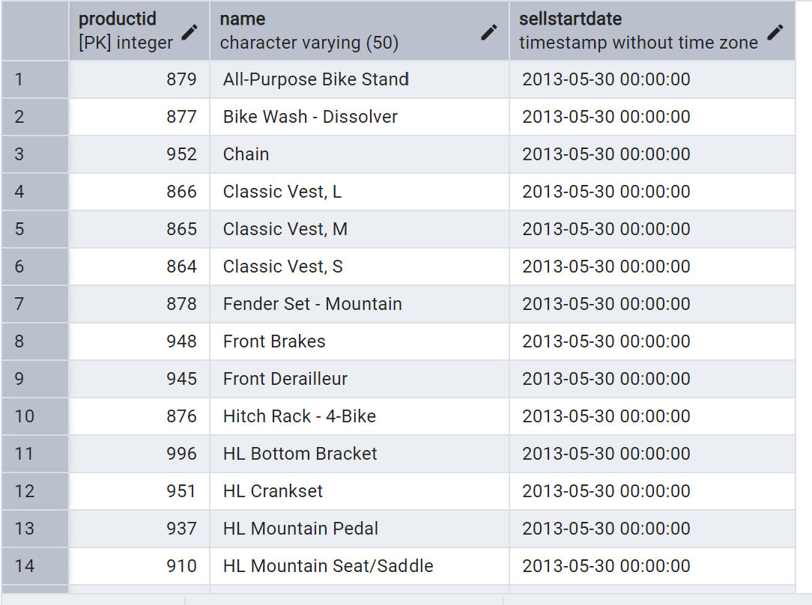

Part B
- Write a query that provides the names and job titles of all AdventureWorks employees.
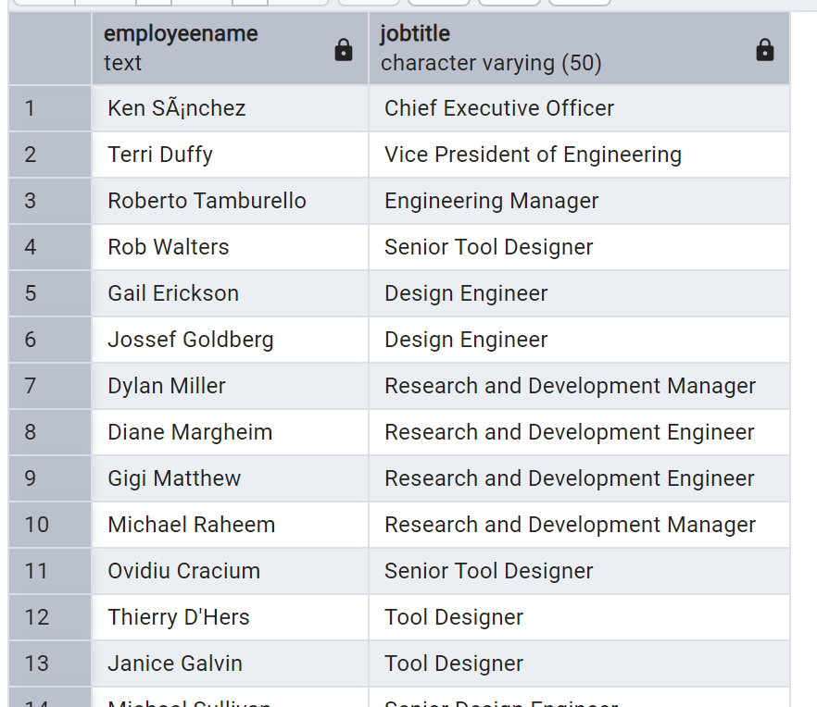

- Modify your query from part B1 (above) to include email addresses
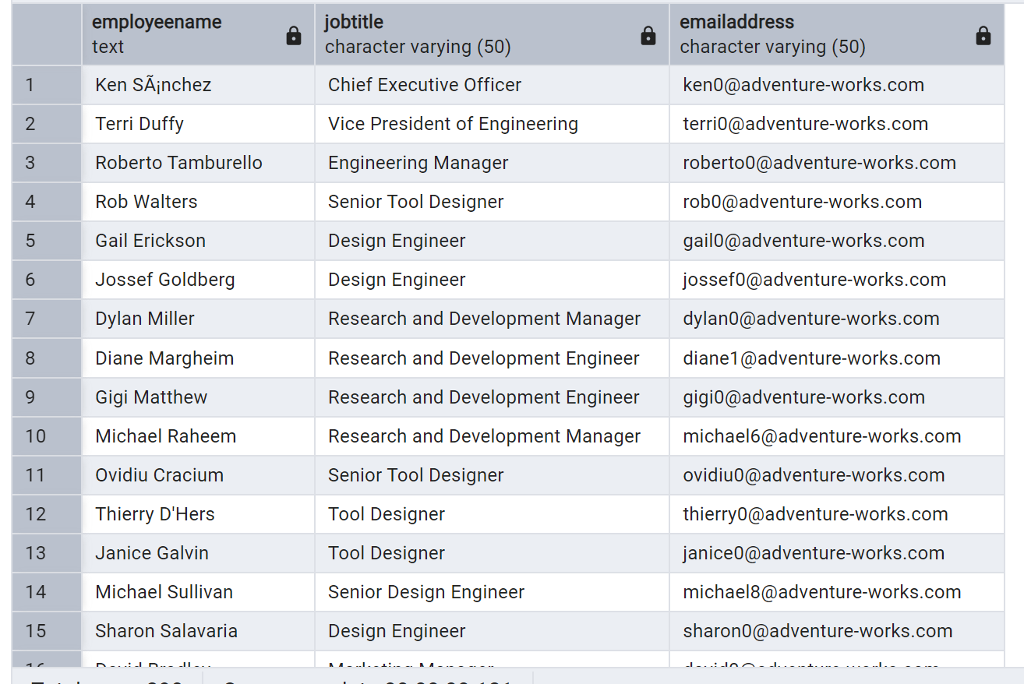

Part C
- Write a query that provides the number of products made by AdventureWorks broken out by color. Exclude products that do not have a value in the Color field and sort the list in descending order of number of products.
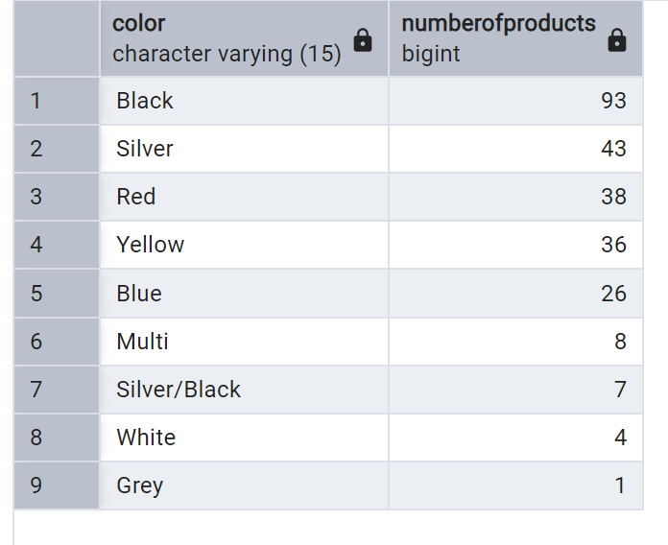
- Modify your query from part 1c1 to further break out the results by whether the product is a finished good or not.
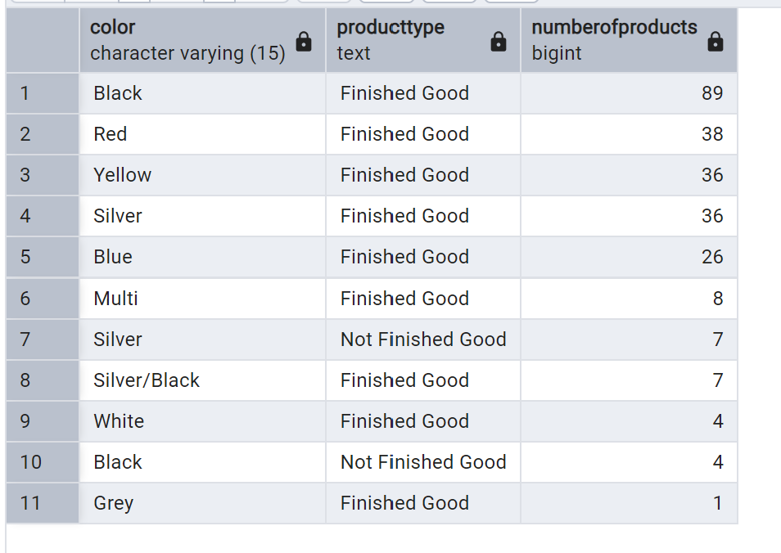

- Modify your query from part 1c2 to only show those groupings with more than 25 products.
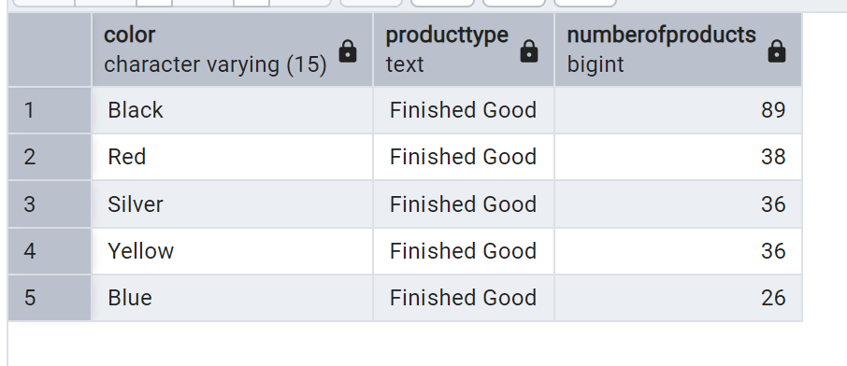

- Write a new query to find the total freight amount for each product category in the AdventureWorks database. The freight amount per order is located in sales.salesorderheader and the product category names are located in production.productcategory. Round the total freight costs to two decimal places and order from highest to lowest total amount.
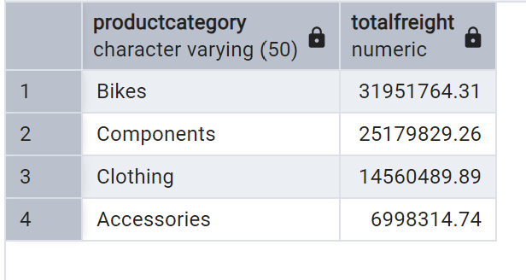

Part D
- Write a query that returns the years of service of employees as of the current date, and calculates if that employee is either “Fully Vested” if they have been with the company for greater than or equal to 15 years, “Partially Vested” if they have been with the company for greater than or equal to 10 years, and otherwise “Unvested”
