Module 3 Homework

Part A
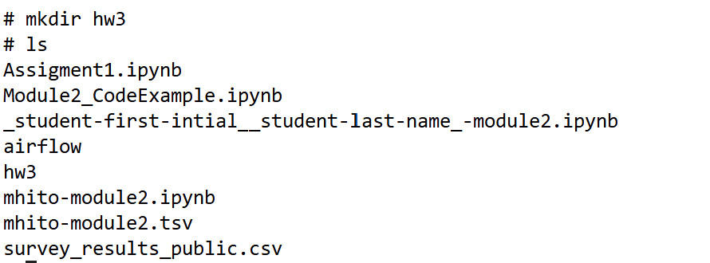
- Make a folder in your home directory called hw3. What is the command you executed to make the folder? Paste a screenshot of the command and output.

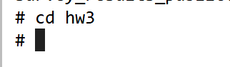
A2. Change directory to the folder hw3. What is the command you executed to change the directory to the newly created hw3 folder? Paste a screenshot of the command and output.

A3. There are 3 files that are available in as part of the assignment in Canvas. Using the browser download the 3 files named emp_data.tsv, I.file and address.txt and place it in hw3 folder. Since you are already in the hw3 folder, execute the command to get a long listing of the files in the hw3 folder. What is the command you executed to do a long listing of the files in hw3 folder? Paste a screenshot of the command and output.

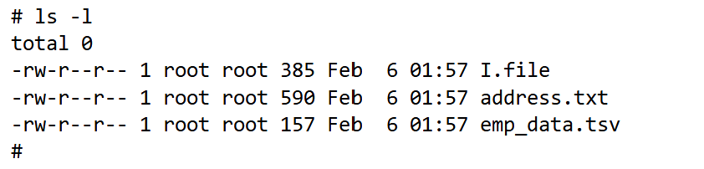
A4. View the contents of files emp_data.tsv, I.file and address.txt one by one (hint – this is 3 commands).
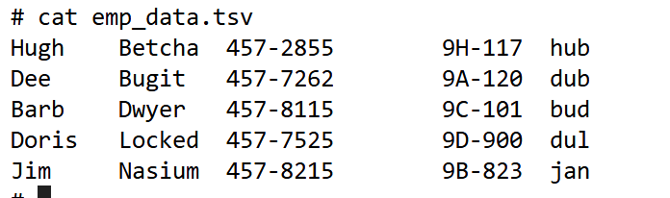
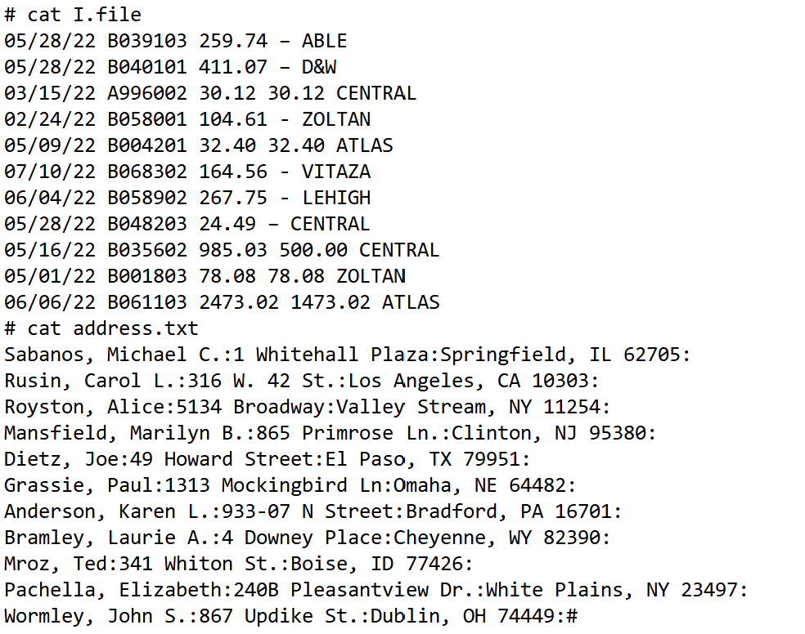

A5. Find out user id you are logged in by executing the appropriate Unix command to determine that. What is the command you used?
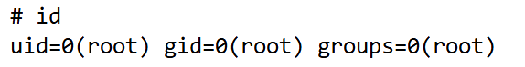
A6. Here is another way to find your user id in a Unix terminal - “who am i”. Can you guess? If not, do a quick google search on looking for the term “who am I unix”. Also, note the difference between what you typed in the previous command and this new command. What command is that?
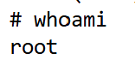
A7. Print the current date. When you use the command, you will note that it prints the date, the time zone etc. What is the command you used?
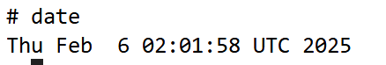
A8. The date command is a very powerful command. It has lots of options, arguments, customizations etc. What command will you use to read the manual for the date command?
Command is man date
A9. Now that you have seen/read the manual, customize the date command in such a way that it prints the output as YYYYMMDD_HHMM. So, if today is July 4th, 2025, 10:37AM, it should print 20250704_1037. Try to figure this out by reading the manual. Otherwise, you can always do Google search – but do the Google search as the last resort.
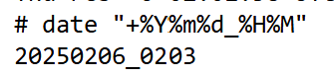

Part B
- Using sed, print each line of emp_data.tsv twice.
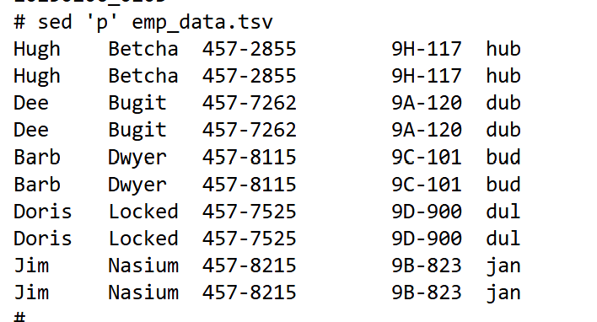
B2. Using emp_data.tsv as input, put the area code, (908) in front of each phone. Perform this using the sed command.
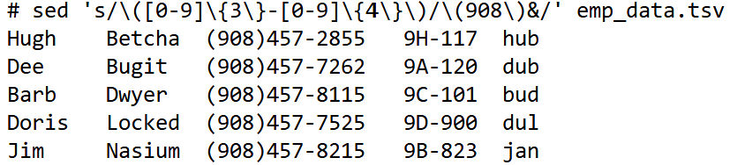
B3. Again use emp_data.tsv as input. Doris Locked would like to be known by her married name, Ajar. Write the appropriate sed command to change this as well as her login id (the last field) to dua. Redirect the output to a file called new_data.
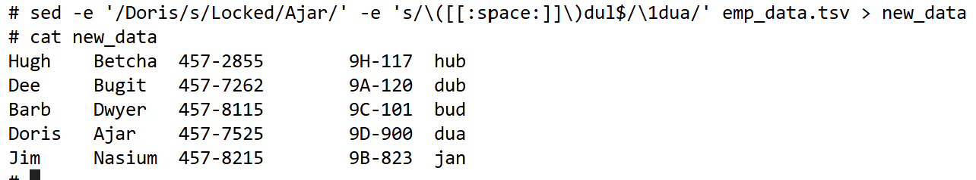
B4. Using new_data, obtain a list of login ids in the file.
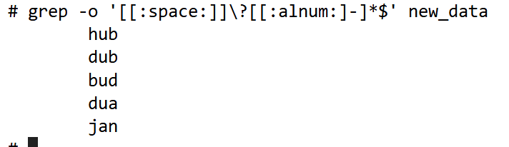
B5. Building sections 9A and 9B have been combined into one new section, 9J. Also, Hugh Betcha has left the group, delete him. Create the file newer_data with this new info using new_data as input. 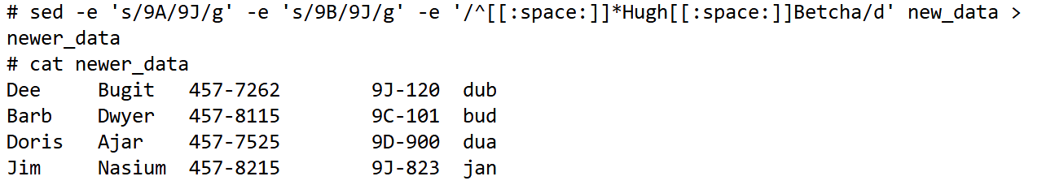
B6. Print only the first and last lines of new_data.
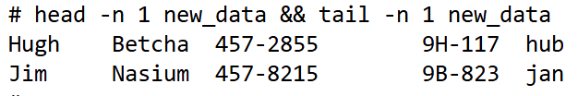
B7. Using address.txt as input, print out the line number for records with New York addresses.
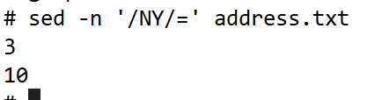
B8. Again using address.txt, print only the first New York record and quit.
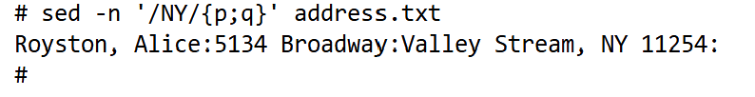

Part C
- Sort the file emp_data.tsv based on the login id.
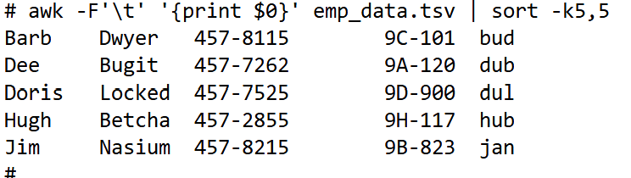
C2. Sort the emp_data.tsv in reverse order based on the employees' last name and save the output in a file called rev_names
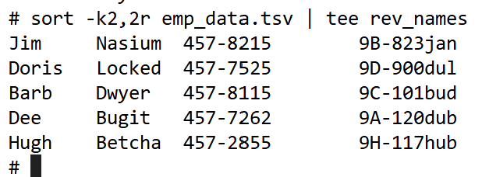
C3. Using I.file as input, create a list of invoices for which no payment has been made. This list should be in sequence by invoice date. If there are multiple invoices for a given date, place these in sequence by invoice amount.
C4. Using I.file as input, create a list of all start dates in the file. Each date must be listed only once.
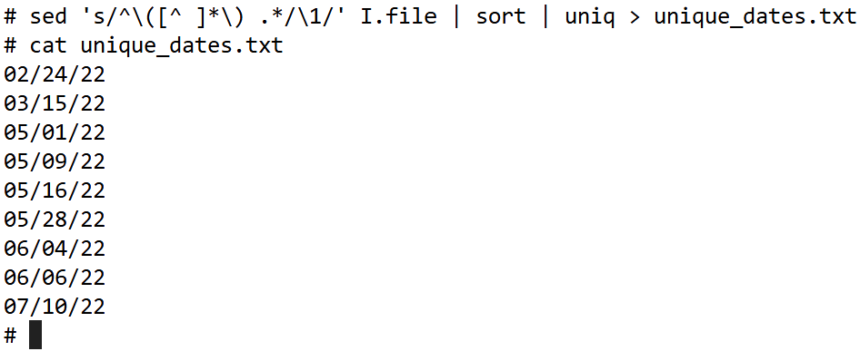
C5. Sort address.file by city.
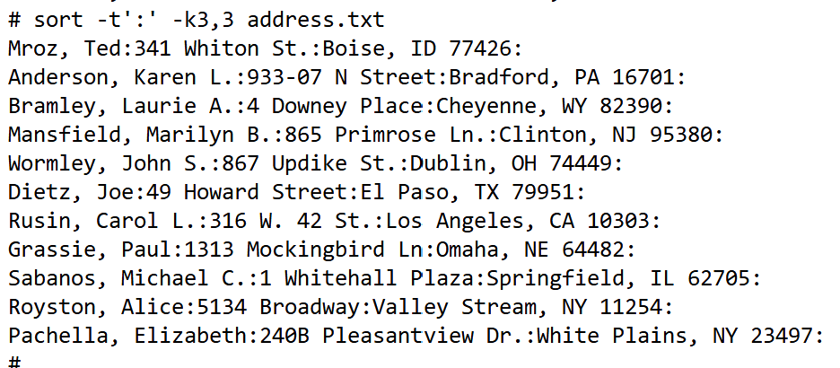

Part D
- Compare emp_date.tsv against new_data (which you created in one of the previous exercises). Use cmp first, then try it with diff. Write a short response as to what you noticed.
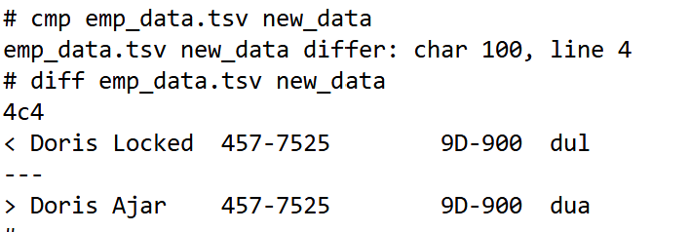

cmp will give a byte-by-byte indication of where the first difference occurs but won't provide details. While diff will give you a more detailed line-by-line breakdown of what exactly is different between the two files, including line deletions and replacements.
D2. Do a side-by-side comparison of emp_data.tsv and newer_data. 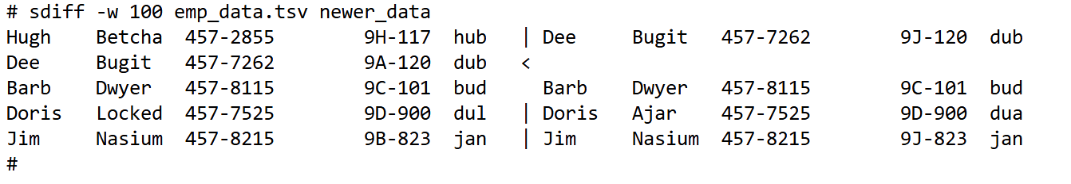

Part E
- Using a member of the GREP family of commands, search I.file for all CENTRAL company invoices.
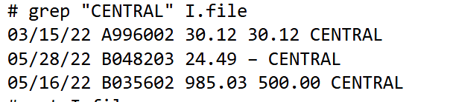
E2. Using a member of the GREP family of commands, search I.file to print invoices for both CENTRAL and ZOLTAN companies.
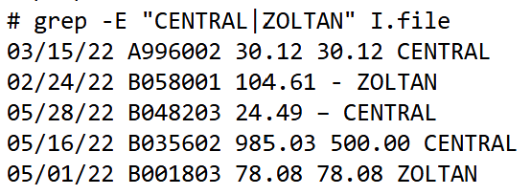
E3. Search emp_data.tsv to print records for users with login ids hub and jan.
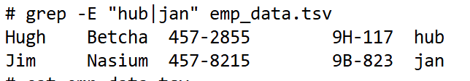
E4. Write a command to print a list consisting of names from address.txt. The list should be in ascending order of last name.
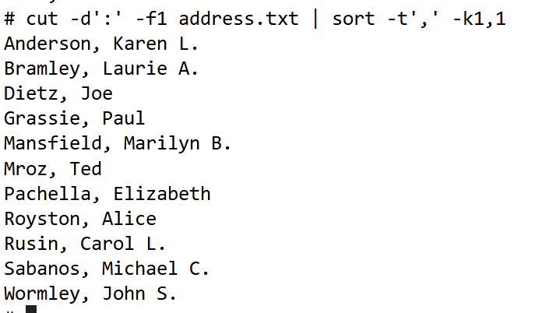
E5. Modify the previous command you just wrote so that the names are in this format: first-name, middle-initial (if any), last-name. The output delimiter should be a space. 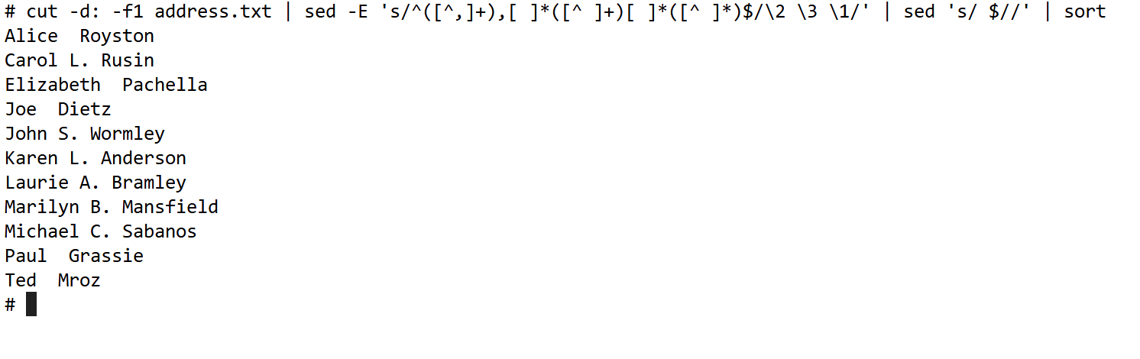
E6. Write a series of commands that at the end of it will create a report file from I.file, called invoices.txt with the following format:
Company Invoice Date
Use the <TAB> as the delimiter. Be sure to include a line of headings like the above.
