**Predicting car prices with Neural Networks:**

In this project, we’ll be building a neural network model to predict the price of a car given a range of features such as the car’s manufacturer, levy, category, color and more. We used a dataset of car prices from Kaggle which we used to preprocess, train and evaluate the model.

**1.Preparing the data:**

Before building the model, we first started by preparing and cleaning our data. We imported the car prices dataset from kaggle using pandas then we split our dataset into: Features(X) and target(Y);

The features represents the columns we’ll use to analyze and make our prediction and the target is the column we want to predict(Price).

As we look closer into the features, we saw there were multiple categorical features which we needed to convert to numerical values before we could use them in our model so we used encoding to convert each categorical features into numerical or binary features by using python dictionaries and pd.getdummies() function that will create new columns corresponding to the values in the categorical features columns .

We also added some plots to show the relationship between the evolution of the car price and the features

Finally we standardized the numerical features using sickit-learn’s Standard Scaler which scales the features to have 0 mean.

**2.Model Architecture**

After setting up the data, we built our neural network model using keras TensorFlow. We defined a function to build the model, which had 2 layers with 32 and 64 nodes respectively and an output layer with one node for predicting the car price. We used the Adam optimizer and mse loss function, and we used the fit method to train our model.

The model was trained on the training set with a validation split of 20% of data and 100 epochs.

**3.Results:**

After training the model we had to evaluate it’s performance on the testing set using the r2_score function from sickit-learn and we found that the model performed really well with an R-squared score of 0.99 and to be more sure, we created a new csv file containing the predicted values and the actual prices values of the cars and we saw that the values were really close

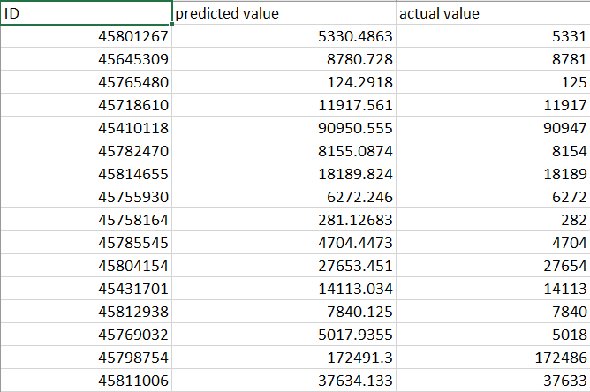

**Made by:**

**Pamela Bou Khalil 220199 Maria Hourani 222310 Wissam Nasreddine 222074**