Our beautiful project - To-do list

- writing to the mentor
- work plan with deadline

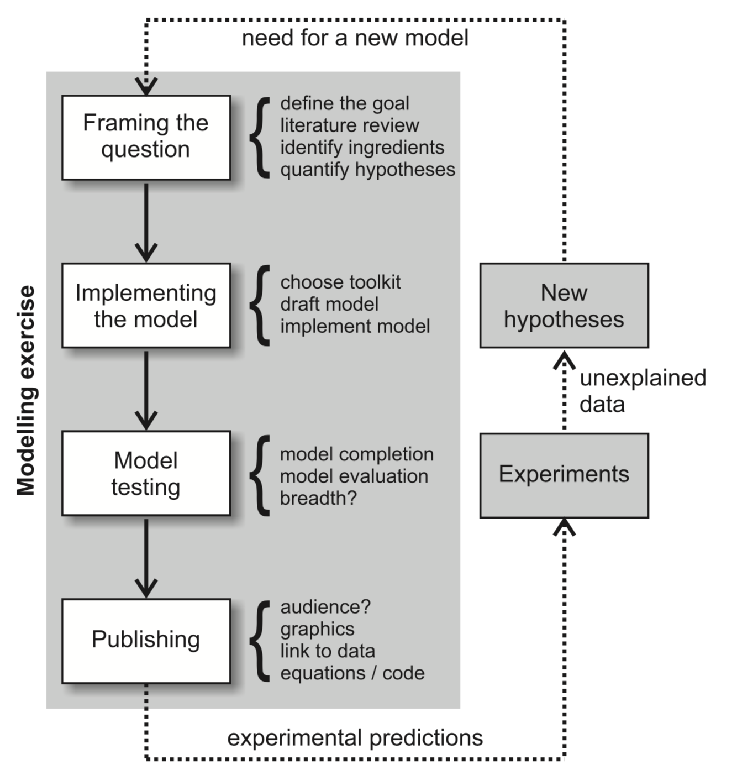

FRAMING THE QUESTION

What factors control functional correlations between brain areas?

- Areas of interest → depends on the data
- Quick state of the art on anatomical connectivity
- literature on activity of areas during behavior (once we have selected areas)

- what kind of data do we need?
  - Spikes
  - Behavior and performance
  - Connectivity data → optional

- How to do we need to represent the data
- How do we extract them → partially solved

IMPLEMENTING
- Toolkit
  - SELECTION OF THE DATASET. Constrain of the data → from similar animals, cells from different areas should be recorded simultaneously

  - Area activity during behavior

    - Isolate the time series

    - Define the phases of the behavior → compute spikes rates → dimensionality reduction and clustering
Identify the phases for each trials

    - Regression on the population activity or individual neuron activity and the energy of face / liking / wheel motion / movement of the eyes → OUTCOME A: SELECT interesting cells in distinct areas with similar response profile

Xin Wei → look at the behavioral data; define the sampling rate of the acquisition of the behavior
→ define phases, and find a way to select the spikes in those windows.

    - K-means on trials of different length (Maria).
    - T-SNE + hierarchical clustering

  - Selected data (outcome A) → are those neurons from distinct areas functionally coupled ? (interpretation: potentially but not necessarily connected)
    - Granger causality (limits because of non-continuous)
    - Cross-correlation of activities (cross-correlograms) Do we see cells from area A firing right after or before cells from area B.

Jean: implement a ISI histogram and cross correlogram
Jean: try implement a simple model for selected neurons based on Poisson process and refractory periods?

    - Coupled GLM:
      - GLM 1 → single neuron firing modelling the neuron A
      - GLM 2 → single neuron firing modelling the neuron B
      - GLM 3 → GLM1 ← → GLM2

Maria → play with the GLM toolbox and understand it. Then you can report what it does? what kind of data we should feed the script? Can we use it for our question?

MODEL TESTING

PUBLISHING

Reference – Help

https://tupleblog.github.io/generalized-linear-model-neural-data/

