NAME:MARIA KHALILI

ID:FA17-MSCS-0059

ASSIGNMENT NO:4

COURSE:DESIGN PATTERN

OBSERVER PATTERN:

EXAMPLE:

Observer pattern uses three actor classes. Subject, Observer and Client. Subject is an object having methods to attach and detach observers to a client object. We have created an abstract class *Observer* and a concrete class *Subject* that is extending class *Observer*.

*ObserverPatternDemo*, our demo class, will use *Subject* and concrete class object to show observer pattern in action.

CLASS DIAGRAM:

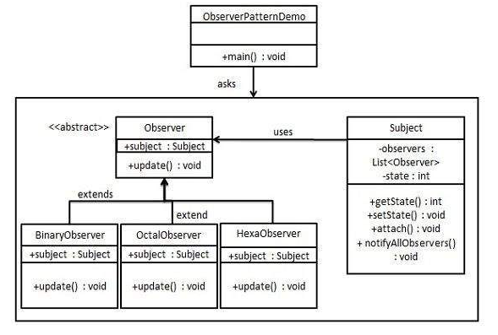

Abstract diagram:

