Rodilla: <https://www.mayoclinic.org/es-es/diseases-conditions/swollen-knee/symptoms-causes/syc-20378129>

<https://medlineplus.gov/spanish/ency/article/003187.htm>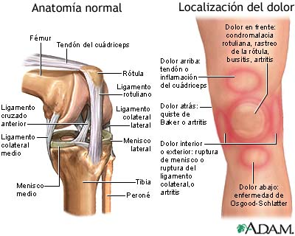

<https://es.familydoctor.org/sintoma/problemas-de-rodilla/?adfree=true> (preguntas)

<https://www.redaccionmedica.com/recursos-salud/diccionario-enfermedades/dolor-rodilla>

<https://www.drmanriqueavila.com/dolor-de-rodilla>

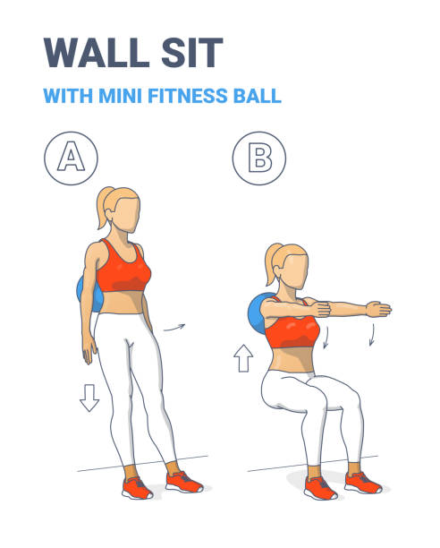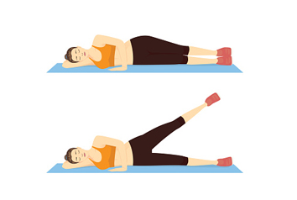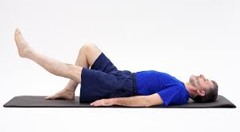

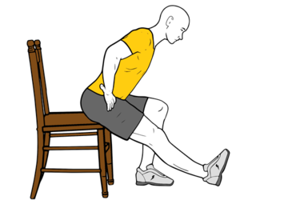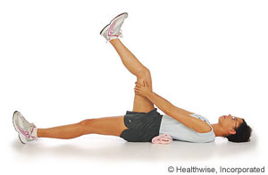

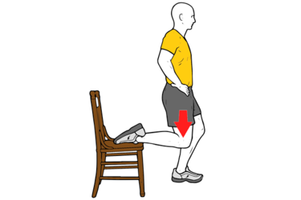

Cadera: <https://www.cun.es/enfermedades-tratamientos/enfermedades/artrosis-cadera>

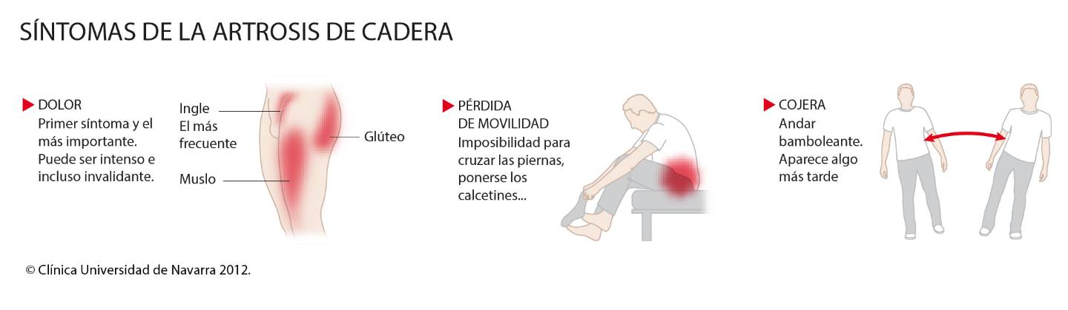

<https://medlineplus.gov/spanish/ency/article/003179.htm>

<https://www.intramed.net/contenidover.asp?contenidoid=92425>

<https://www.medicalnewstoday.com/articles/es/dolor-de-cadera-al-caminar#causas>

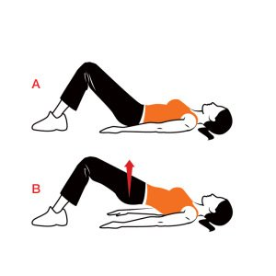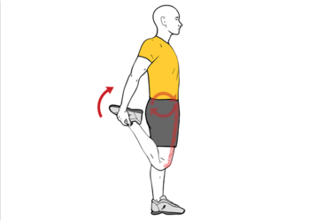

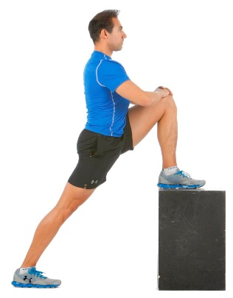

Espalda: <https://www.mayoclinic.org/es-es/diseases-conditions/back-pain/symptoms-causes/syc-20369906>

<https://medicinadeldolor.es/enfermedades-causan-dolor-espalda-cronico/>

<https://www.spine-health.com/espanol/enfermedad-degenerativa-de-disco/sintomas-comunes-de-enfermedad-degenerativa-de-disco>

<https://www.biziondo.com/patolog%C3%ADas-de-columna-vertebral>

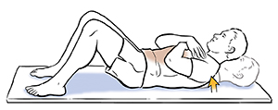

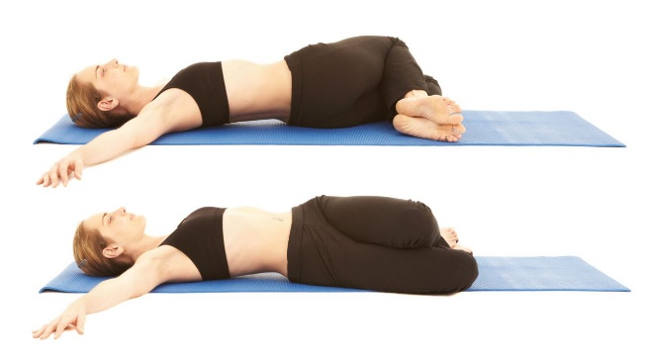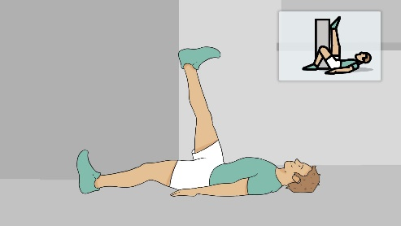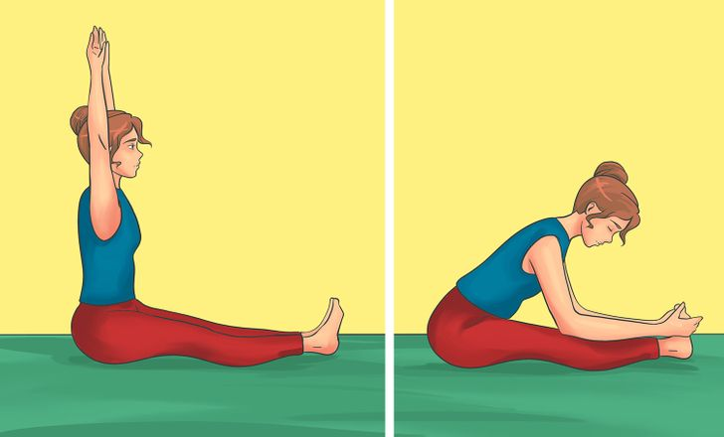

Codo: <https://medlineplus.gov/spanish/elbowinjuriesanddisorders.html>

<https://www.topdoctors.es/diccionario-medico/dolor-de-codo>

<https://www.siicsalud.com/pdf/actron_codo_11018.pdf>

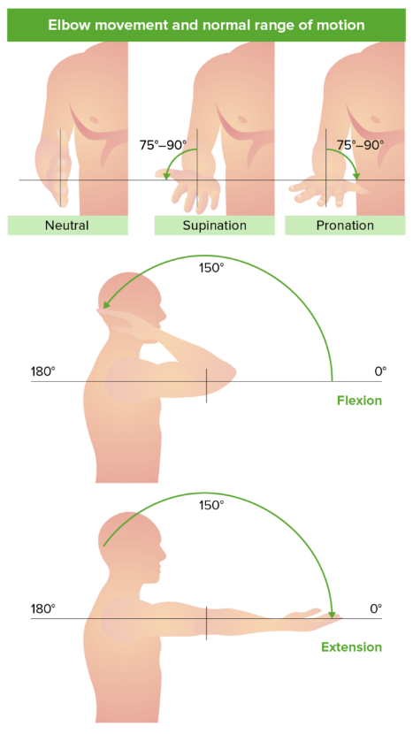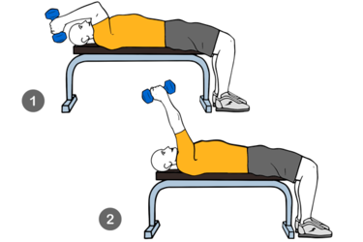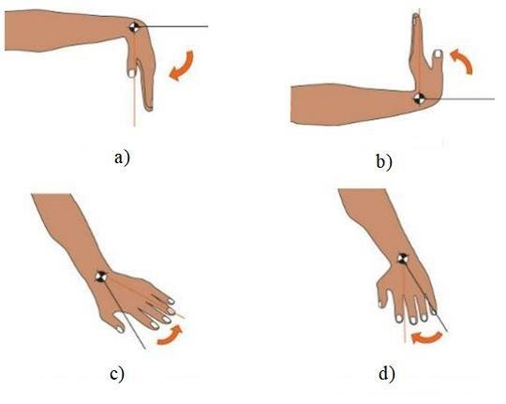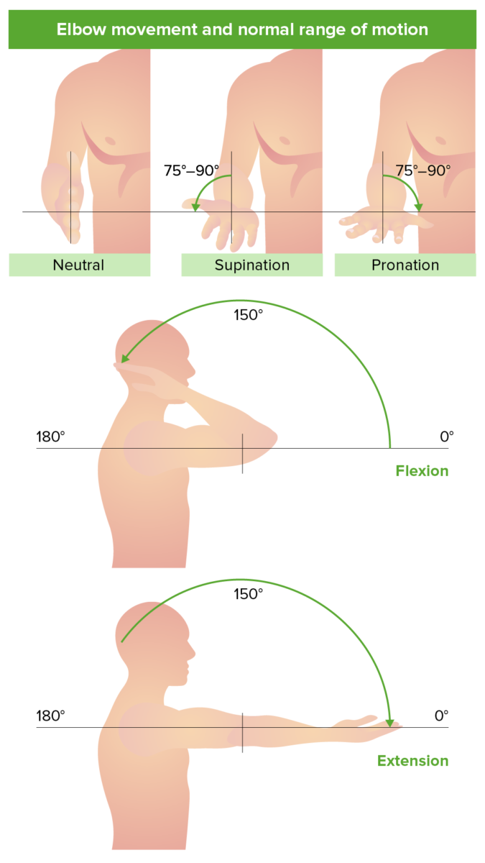

Hombros: <https://medlineplus.gov/spanish/shoulderinjuriesanddisorders.html>

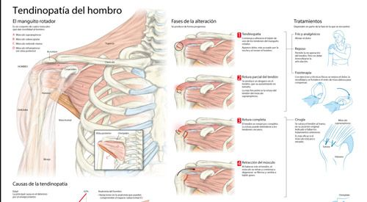

<https://www.cun.es/enfermedades-tratamientos/enfermedades/dolor-hombro>

<https://orthoinfo.aaos.org/es/diseases--conditions/dolor-de-hombro-y-problemas-comunes-del-hombro-shoulder-pain/>

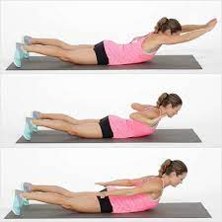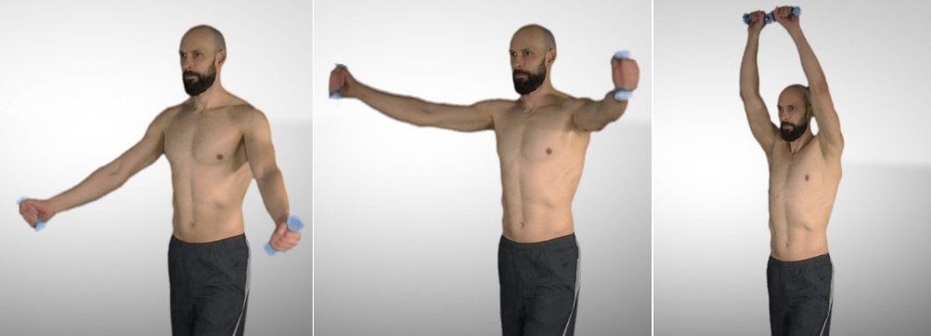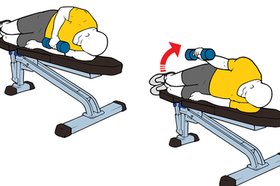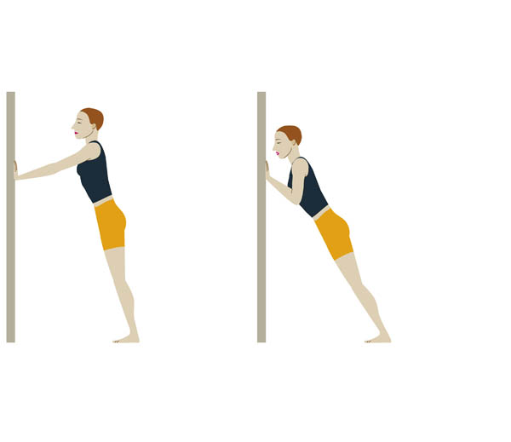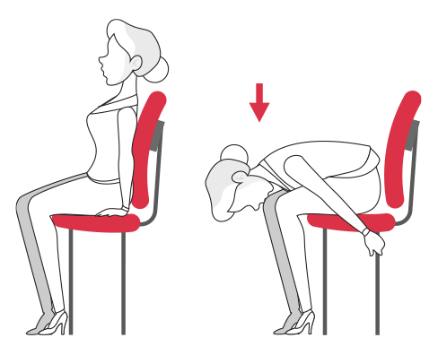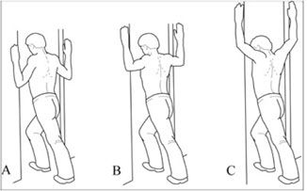

Cuello: <https://www.spine-health.com/espanol/dolor-de-cuello/dolor-de-cuello-cronico>

<https://www.mayoclinic.org/es-es/diseases-conditions/neck-pain/symptoms-causes/syc-20375581>

<https://www.cigna.com/es-us/individuals-families/health-wellness/hw/temas-de-salud/problemas-y-lesiones-en-el-cuello-necpn>

<https://www.wnyurology.com/content.aspx?chunkiid=465704>

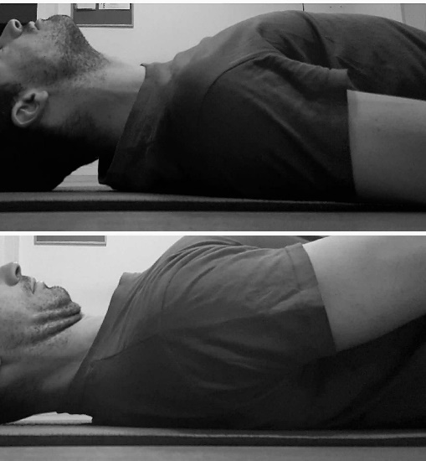

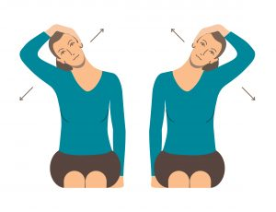

Muñeca: <https://medlineplus.gov/spanish/wristinjuriesanddisorders.html>

<https://medlineplus.gov/spanish/ency/article/003175.htm>

<https://www.mayoclinic.org/es-es/diseases-conditions/wrist-pain/diagnosis-treatment/drc-20366215>

<https://www.mayoclinic.org/es-es/diseases-conditions/wrist-pain/symptoms-causes/syc-20366213>

ejercicios de muñeca 🡪 <https://espanol.kaiserpermanente.org/es/health-wellness/health-encyclopedia/he.tendinitis-en-la-mu%C3%B1eca-ejercicios.bo1652>

<https://uihc.org/search-results/instant?uihc_prod%5Bquery%5D=Ejercicios%20para%20dolor%20de%20>