Reproducible Research: Course Project 1

Maria Lauve

June 22, 2017

This assignments involves using data from activity monitoring devices to answer questions about the activity levels of individuals tracked over 5-minute intervals over a two-month period in October and November 2012.

# Reading in the Data

activity <- read.table(file="activity.csv", sep=",", na.strings="NA", header=TRUE)

# Total Number of Steps per Day

stepsbyday <- aggregate(steps ~ date, data=activity, sum)  
meansteps <- mean(stepsbyday$steps)  
mediansteps <- median(stepsbyday$steps)  
  
with(stepsbyday, hist(steps, breaks=20, xlim=c(0,25000),  
 col="lightblue"))  
abline(v=meansteps, col="pink", lwd=6)  
abline(v=mediansteps, col="red", lwd=1)

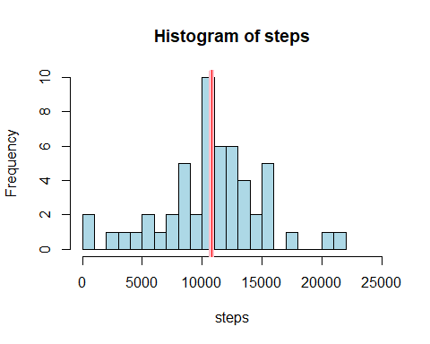

The mean number of steps taken per day is meansteps. The median number of steps taken per day is median steps.

# Average Steps per Interval

library(dplyr)

##   
## Attaching package: 'dplyr'

## The following objects are masked from 'package:stats':  
##   
## filter, lag

## The following objects are masked from 'package:base':  
##   
## intersect, setdiff, setequal, union

stepsbyint <- aggregate(steps ~ interval, data=activity, mean)  
stepsort <- arrange(stepsbyint,desc(steps))  
maxsteps <- stepsort[1,2]  
maxint <- stepsort[1,1]  
  
with(stepsbyint, plot(x=interval,y=steps,type="l",ylim=c(0,250)))  
points(x=maxint, y=maxsteps, col="red", pch=19)  
text(x=maxint+10, y=maxsteps+10, paste("max: (interval=",round(maxint,0),  
 ", steps=",round(maxsteps,0),")",sep=""))

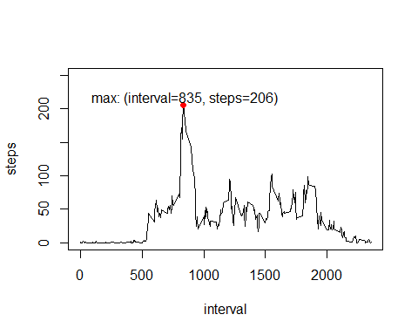

# Imputing Missing Data

NAcnt1 <- sum(is.na(activity$steps))  
NAcnt2 <- sum(is.na(activity$date))  
NAcnt3 <- sum(is.na(activity$interval))

The total number of missing "steps" values in the activity dataset is NAcnt1. Note: there are no missing values in the "date" or "interval" columns.

We can impute missing values by replacing them with the average number of steps for the respective interval as computed above.

active_mrg <- merge(activity,stepsbyint,by="interval",all.x=TRUE)  
  
missing <- active_mrg[is.na(active_mrg$steps.x),]  
missing$steps <- missing$steps.y  
  
nonmissing <- active_mrg[!is.na(active_mrg$steps.x),]  
nonmissing$steps <- nonmissing$steps.x  
  
active_impute <- rbind(missing,nonmissing)

# Total Number of Steps per Day Using Data with Imputed Values

stepsbyday_new <- aggregate(steps ~ date, data=active_impute, sum)  
meansteps_new <- mean(stepsbyday_new$steps)  
mediansteps_new <- median(stepsbyday_new$steps)  
  
with(stepsbyday_new, hist(steps, breaks=20, xlim=c(0,25000),  
 col="lightblue"))  
abline(v=meansteps_new, col="pink", lwd=6)  
abline(v=mediansteps_new, col="red", lwd=1)

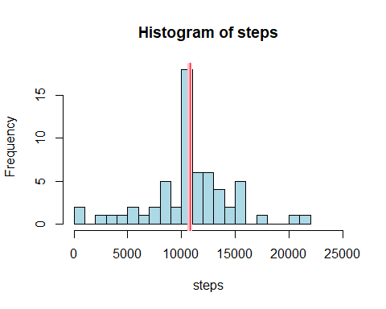

The mean number of steps taken per day is meansteps_new. The median number of steps taken per day is median steps_new.

Imputing the missing values left the mean unchanged and caused the median to increase slightly to equal the mean.

# Differences in Activity Patterns: Weekdays v. Weekend

active_impute$weekday <- weekdays(as.Date(active_impute$date))  
active_impute$weekend <- "weekday"  
active_impute$weekend[active_impute$weekday=="Saturday" |  
 active_impute$weekday=="Sunday"] <- "weekend"  
  
stepsbyint_new <- aggregate(steps ~ interval * weekend, data=active_impute, mean)  
  
library(lattice)  
xyplot(steps ~ interval | weekend, data=stepsbyint_new, layout=c(1,2), type="l")

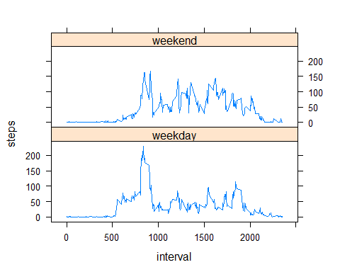

# *** THE END ***