Streamlit assignment — Public spaces in Lebanon
Mariam Ismail · Visualization & Communication · AUB, Fall 2026

Links
App (Streamlit Community Cloud): [paste your app link here after deploying]
GitHub repository: [paste your repository link here]

Snapshot of the page
The national view. The governorate control is set to All Lebanon, so the district control is disabled and the first chart is at governorate level.
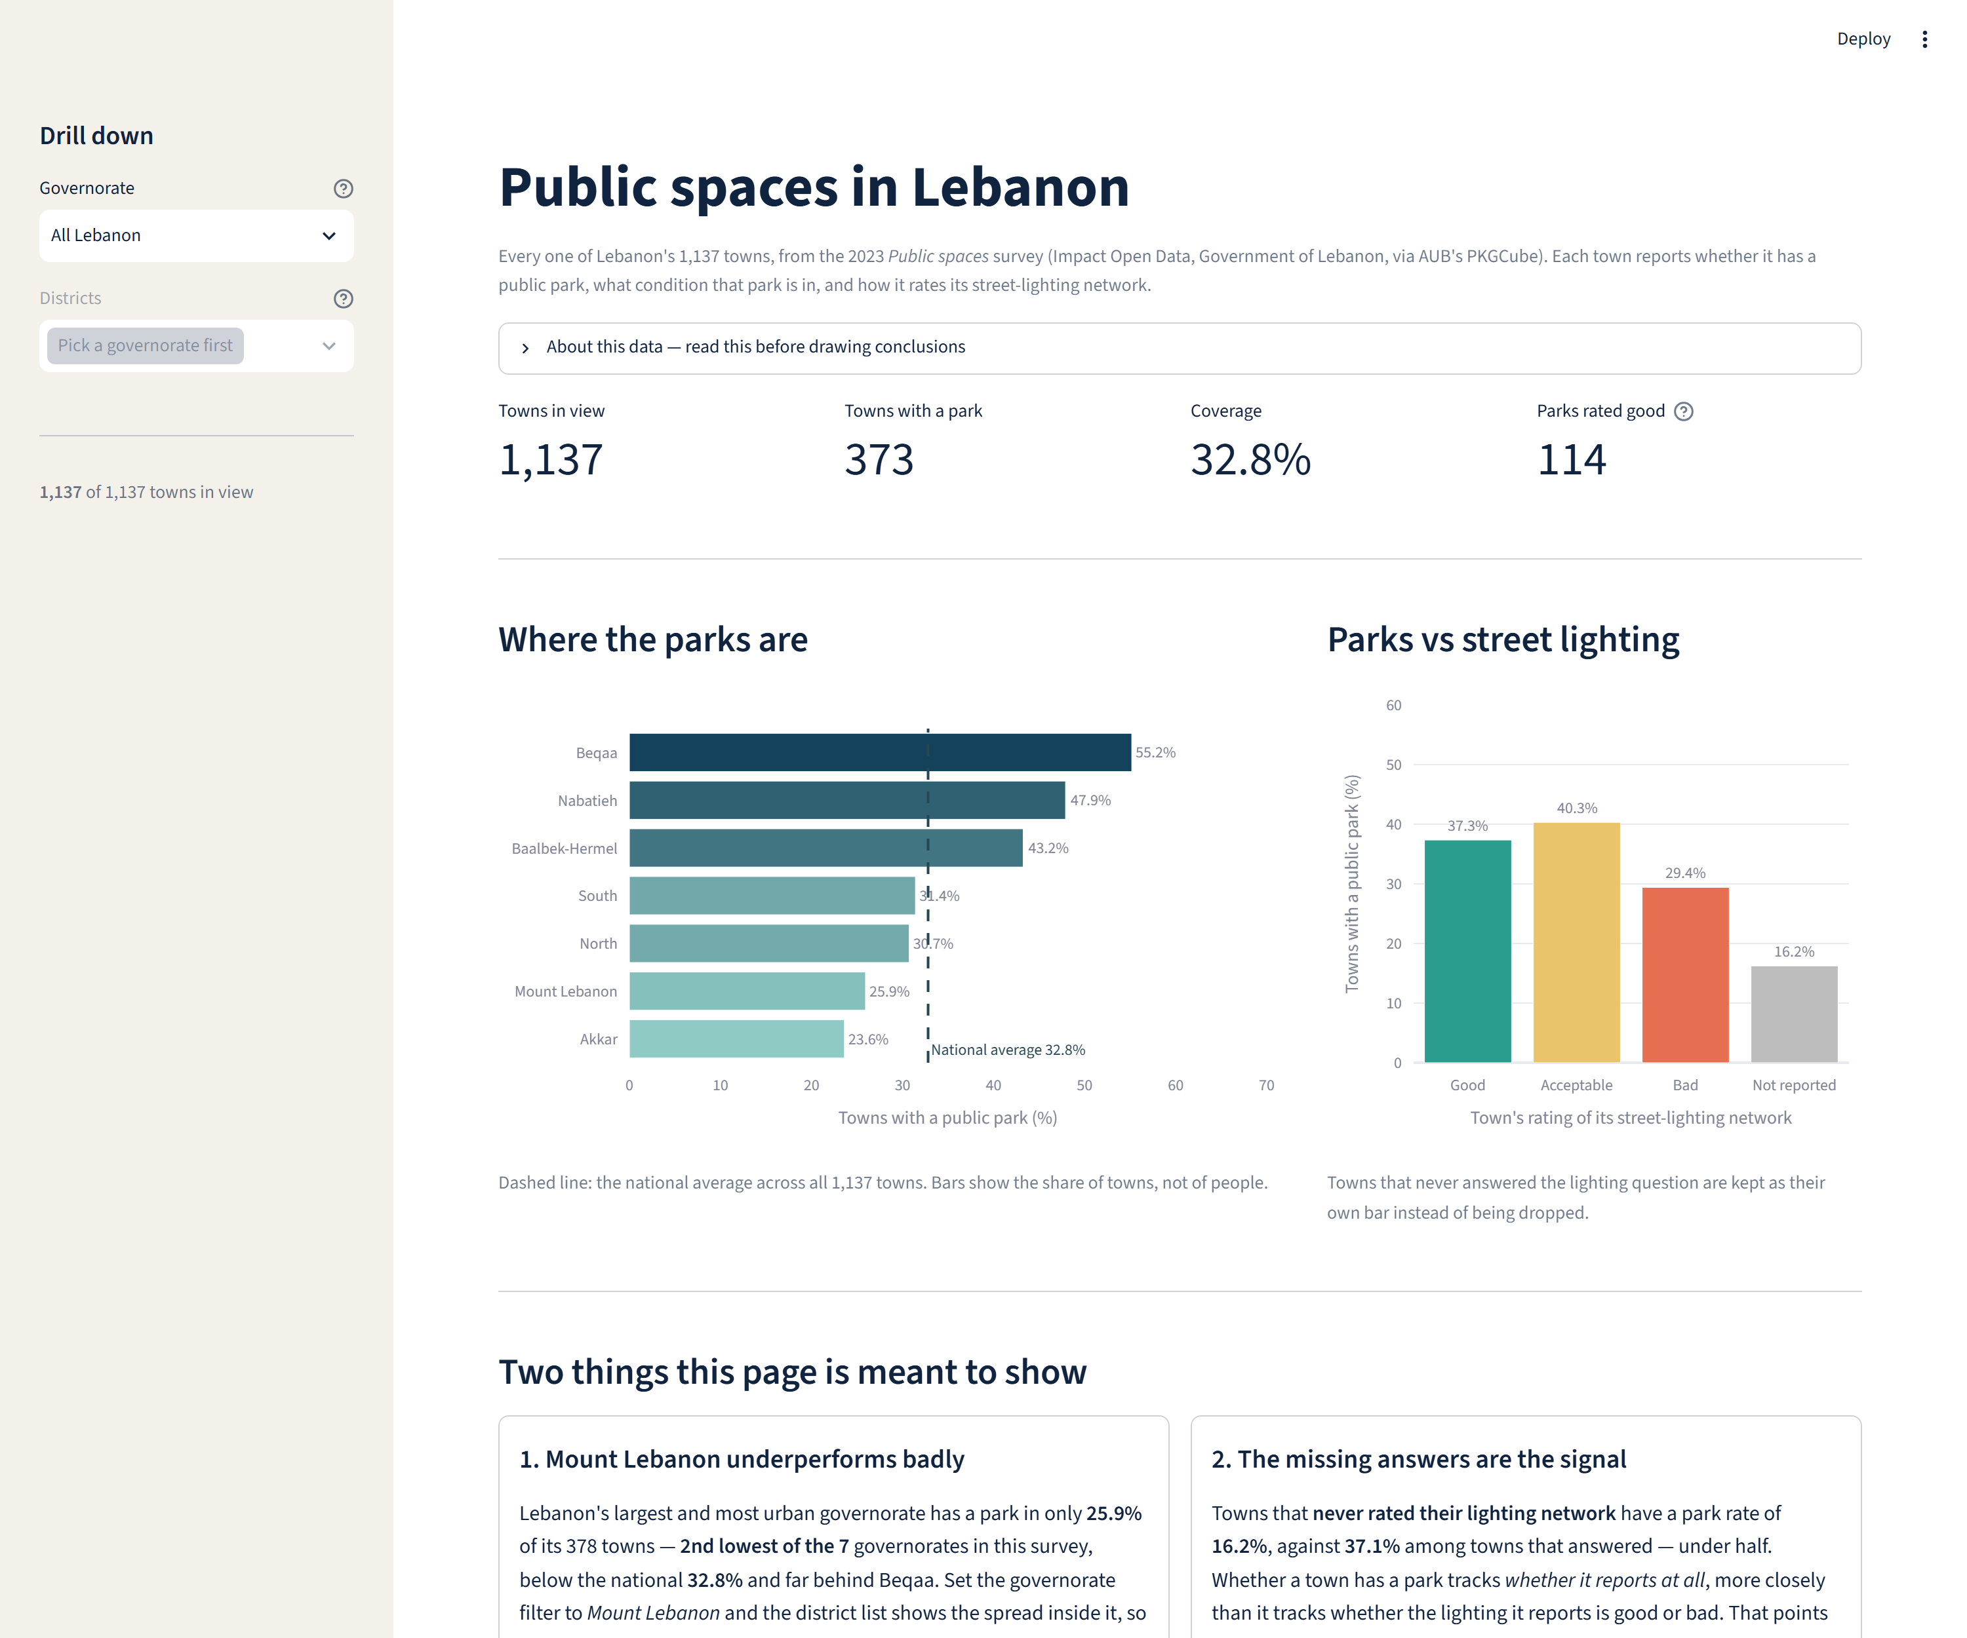
The drill-down. Selecting Mount Lebanon fills the district control with that governorate's districts only, and the first chart switches to district level. Both charts and all four metrics follow the selection.
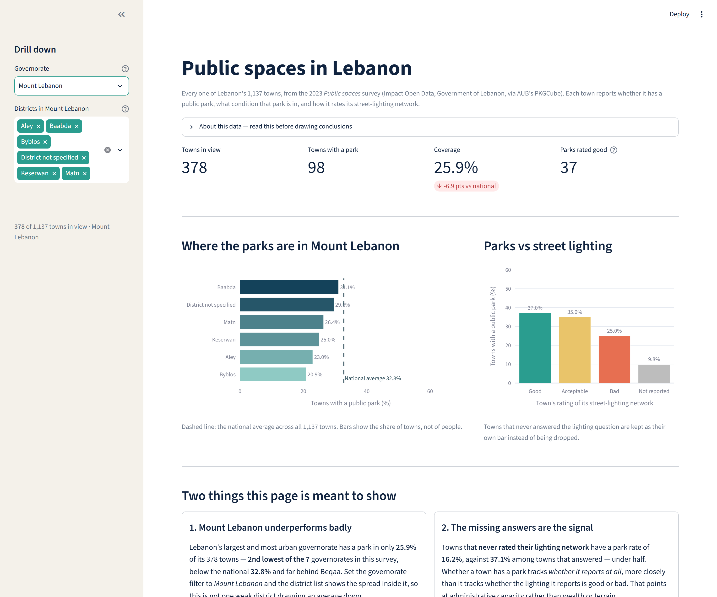

Design justifications

Control 1 — Governorate (single-select dropdown)
User question: “Is the national picture true where I live?” The single national figure (32.8% of towns have a public park) hides a range from Akkar at 23.6% to Beqaa at 55.2%, so a reader needs to move from the country to one region.
Why this widget: there are seven governorates in the survey, and only one can be the scope at a time. Pills or a segmented control would put all seven on screen permanently, competing with the charts for attention and wrapping awkwardly on a laptop. A multiselect would let a reader merge, for example, Akkar and Beqaa into a single bar — a combination with no administrative meaning. The dropdown enforces exactly one scope, which is what a drill-down needs.
Course concepts — reducing clutter and providing context: the control collapses seven options into one line of the sidebar. Because filtering can mislead, the chosen scope is restated in three places: the sidebar caption (“378 of 1,137 towns in view”), the metrics row (with the gap to the national average), and the dashed national-average line, which stays at its national value no matter how far the reader drills in.

Control 2 — Districts (multiselect, options driven by control 1)
User question: “Inside this region, is coverage even, or is one district pulling the average?” This is the natural follow-up, and it only makes sense after a governorate is chosen.
How the two are linked: the options in this control are generated from the governorate selected above, never from the full list of districts. Choosing North offers only Batroun, Bsharri, Miniyeh–Danniyeh, Tripoli and Zgharta. The first chart also changes level with the selection: governorate bars for All Lebanon, district bars once a governorate is picked. While the scope is All Lebanon the control is disabled with the hint “Pick a governorate first”, and for Akkar — which has no district recorded anywhere in the published data — it is disabled with an explanation instead of showing an empty list.
Why this widget: comparing two or three districts against each other is the point, so the control must allow several selections at once, which rules out a selectbox. Individual checkboxes would mean one widget per district and would not reset when the governorate changes.
Course concepts — focusing attention and honest comparison: deselecting districts removes bars but never rescales the reference line, so a narrowed view is still read against the same national yardstick rather than a flattering local one.

What broke and how I fixed it

1. District selections survived a change of governorate
What happened: with one multiselect reused across governorates, Streamlit kept the previous widget state. Selecting Tripoli and Zgharta under North and then switching to South left the app holding districts that do not exist in South, so the charts came back empty.
The fix: give the multiselect a key that includes the governorate, key=f’districts::{governorate}’. Streamlit then treats it as a different widget per governorate, so the list resets to that governorate's own districts. This is also why the control is disabled, rather than merely empty, for All Lebanon and for Akkar.

2. The national-average label collided with the bars
What happened: the dashed national-average line is annotated with its value. Positioned at the top of the line, the label was clipped by the edge of the plot in the national view, and in the Mount Lebanon view it landed on top of the longest bar's value label.
The fix: move the annotation to the bottom of the line, where both views have empty space, and add top margin to the chart. I checked both states before accepting the fix.

3. Windows console encoding broke the Streamlit CLI
What happened: running ‘streamlit skills’ failed with a UnicodeEncodeError, because the default Windows console encoding (cp1252) cannot print the warning symbol the command emits.
The fix: run it with PYTHONIOENCODING=utf-8. A second Windows-specific issue appeared right after: the project-scoped install uses symlinks, which require Developer Mode, so the installer fell back to a global install — which works the same way for this project.

AI-use statement
[Review and edit this section so it matches exactly what you did.]
Tool used: Claude (Claude Code), as a coding assistant throughout this assignment.
What it was used for: installing Streamlit and its official agent skills; writing streamlit_app.py and data_prep.py, including the two linked controls and both Plotly charts; drafting the page text, the on-page design justifications and this document; running headless tests of the app and capturing the snapshots; and setting up the Git repository.
What I checked and changed: I supplied the dataset, the cleaning logic and the two insights from my earlier Plotly assignment, and I verified every figure in the app against that notebook (1,137 towns, 32.8% national coverage, Mount Lebanon 25.9%, non-reporting towns 16.2%). I corrected the assistant where it was wrong: it first described eight governorates when the survey contains seven, because Beirut has no towns in this dataset. I also had it replace a cluttered district list with a control that stays disabled until a governorate is chosen. I reviewed all text on the page and rewrote parts of it in my own words before submitting.

Notes on the data
- Coverage always means the share of towns, never the share of people: the survey has no population figures and no geometry.
- The published refArea field mixes governorates and districts. Towns with no district recorded are labelled “District not specified” instead of being assigned one by guesswork.
- Missing ratings are shown as their own category (“Not reported”), never dropped — that category carries the second insight.
- The source CSV is double-encoded (ZahlÃ© → Zahlé) and several column names carry trailing spaces; both are handled in data_prep.py.

