**Design**

**Registration feature**

Class Diagram

Name:Design_FEAT001_ClassDiagram_001

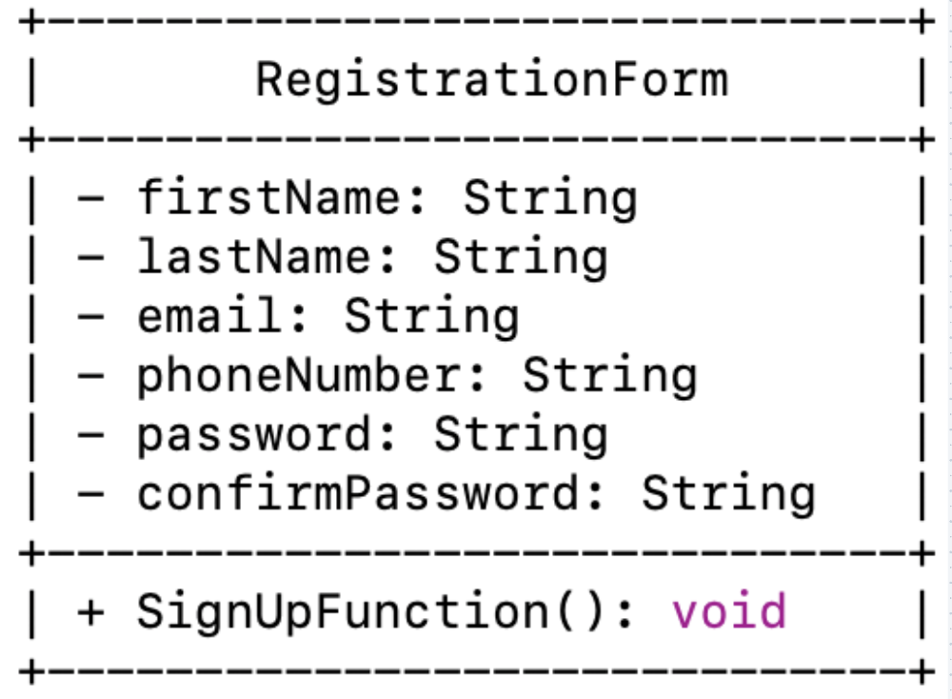

Low-Level Design

Name: Design_FEAT001_Lowlevel_001

Description:

**Login Feature**

Class Diagram

High-level Design

Desgin_Feature002_SequenceDiagram_001

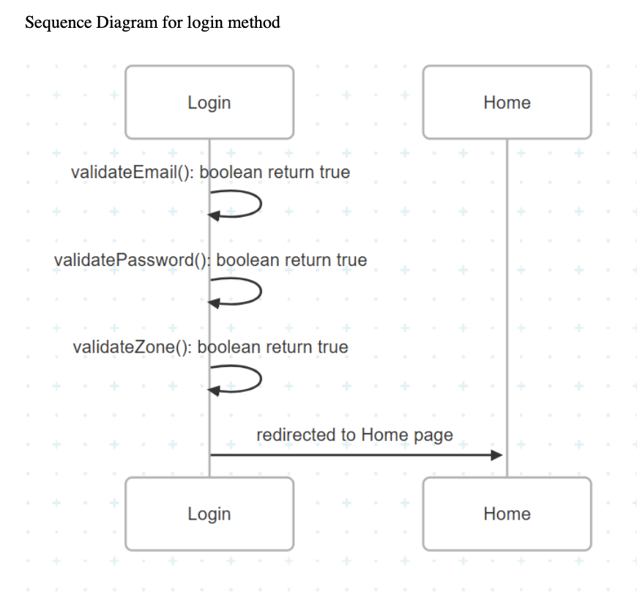

Low-Level Design

Design_FEAT002_FLOWCHART_001

Description:

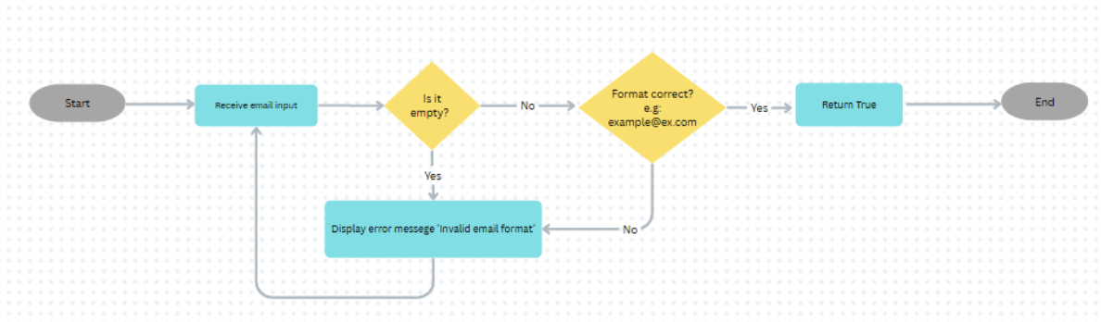

Design_FEAT002_FLOWCHART_002

Description:

Design_FEAT002_FLOWCHART_003

Description:

**Loyality Points**

Class Diagram

DESIGN_FEAT006_CLASSDIAGRAM_001

High-Level Design

Low-level Design

Design_FEAT006_FLOWCHART_001

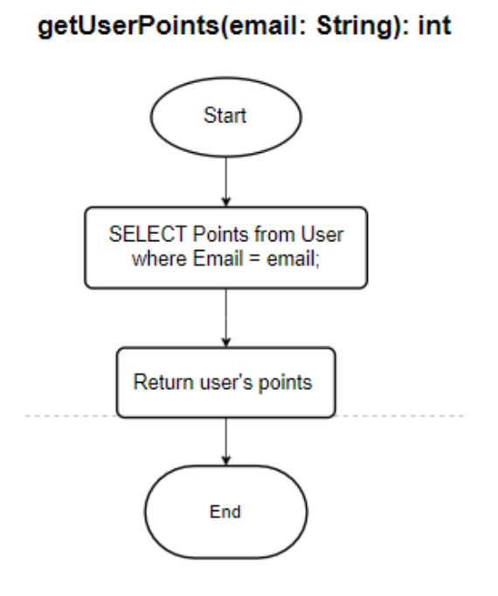

Design_FEAT006_FLOWCHART_002

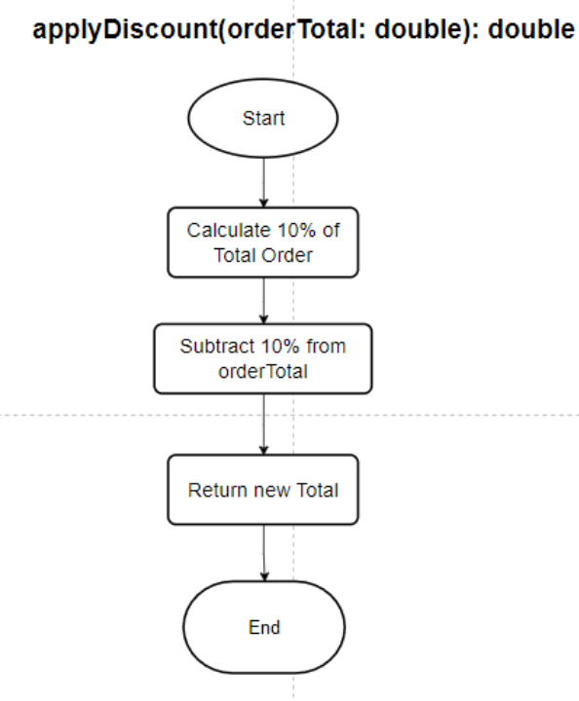

Design_FEAT006_FLOWCHART_004

Design_FEAT006_FLOWCHART_005

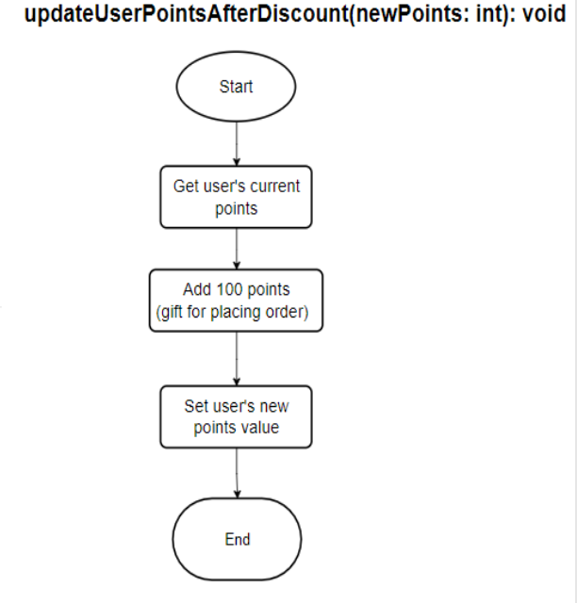

Design_FEAT006_FLOWCHART_006

**CHECKOUT**

ClassDiagram

DESIGN_FEAT007_CLASSDIAGRAM_001

Sequence Diagram

DESIGN_FEAT007_SequenceDiagram_001

LowLevel Design

DESIGN_FEAT007_FLOWCHART_001

DESIGN_FEAT007_FLOWCHART_002

DESIGN_FEAT007_FLOWCHART_003

DESIGN_FEAT007_FLOWCHART_004

DESIGN_FEAT007_FLOWCHART_005

