What is color?

Color is basically our perception to everything. To elaborate, objects reflect light in a different manner, or to be specific, in a different combination of wavelengths. Thus, as the reflected light penetrates our cornea, it paves its way to the brain via the optic nerve located in the back of the eye. Eventually, the brain interprets the transmitted signal into what we call “Color”. Color is a fundamental characteristic of nearly everything surrounding us, and is also an attribute that people would judge whether they like a product or not. Therefore, colors are extremely essential in the modern human era.

The Color Theory

Colors are not only about human perception, but it is also a basic component in defining the culture and psychology of human beings. Since understanding the importance of manipulation of colors, the need for specific guidelines and rules was inevitable for all those concerned with choice of color, or more truthfully speaking, a combination of colors. This is when Sir Isaac Newton invented **“The Color Wheel”** in 1666, which systematically categorizes colors into three groups:

1. Primary (Red, Yellow, Blue)
2. Secondary (Mixes of Primary Colors: Green, Orange, Purple)
3. Tertiary (Mixes of Primary and Secondary Colors)

This indeed was the beginning of creation of characteristics of colors by which people could be more objective and specific when communicating about colors in various fields. These characteristics are:

1. Hue: The appearance of color itself (e.g., “blue”)
2. Chroma: Purity of Color
3. Lighting: Saturation of Color

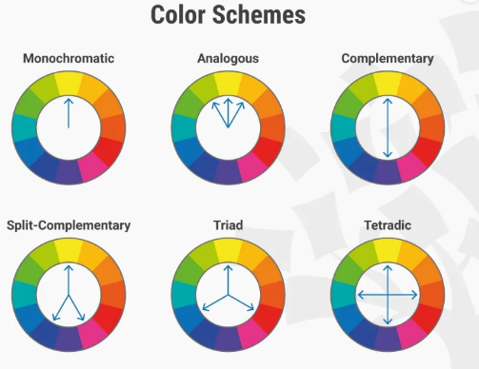Color Theory is then considered a solid foundation on which we can decide whether a certain color “goes along” with another or not. This actually is what **Color Schemes** are all about.

Color Schemes are developed by designers to facilitate the choice of color combination of visual elements of any kind of visual design. This aims for optimization of users’ experience in terms of usability as well as the attractive and appealing appearance, regardless of the application.

1. Monochromatic: Specific hue with different shades and tints of it
2. Analogous: Colors beside each other
3. Complementary: Opposite pairs (Maximizes Contrast)
4. Split-Complementary: Softens Contrast
5. Triadic: Three Equally-distant colors
6. Tetradic: Pick a dominant color from two sets of Complementary colors

Usage of Color Theory for Color-matching of clothes targeted towards the Colorblind

As stated before, color is perception, and for some people, that perception would differ than the majority of people due to physiological issues, and that condition is known as “Colorblindness”.

Our application aims to help the colorblind make a good match of clothing using the color theory. The application simply works by asking the user to capture photos of a pair of clothes, then it proceeds by extracting the colors of the pieces of clothing through image processing methods, yielding the hue eventually for each piece of clothing. Lastly, it compares the hue of the pair of clothes using the color schemes and decides on whether the pair of pieces of clothing are a match or not based on computed ranges of Hue.

Regarding intermediate steps, we make sure of an error-free output by checking for a certain minimum threshold of brightness of the picture that the user adds, that if the brightness is below that threshold, the user is asked to re-capture the picture. This step is fundamental to make sure colors are interpreted correctly. Afterwards, the application automatically identifies and crops the Region of Interest, and then proceeds by extracting the RGB components of the image and transforming them into Hue.