University Student Registration Database Project

Introduction
This document provides a comprehensive overview of the University Student Registration Database Project. The project involves designing, creating, and using a SQL database that meets specific requirements. The database is designed to manage student registrations in a university setting.-

System Overview
The system includes the following entities: . Each entity has specific attributes and relationships with other entities. The system is designed to handle student registrations, course assignments, and grade management.
ENTITIES | USER
student | student
course | admin
enrollment | instructor
department
instructor

Normalization Explanation
Normalization is the process of organizing the fields and tables of a relational database to minimize redundancy and dependency. The tables in this project are designed to be in 3NF (Third Normal Form), ensuring that each table contains only related data and each non-key attribute is fully functionally dependent on the primary key.

ER Diagram and mapping
Was created using the website (https://app.diagrams.net/) and was draw manually on the site without using any code{
.department_id THROUGH department RELATED TO student.
.course and student CONNECTS THEM enrohhment.
.department_id THROUGH department RELATED TO course.
.instructor_id THROUGH instructor RELATED TO course.
.department RELATED TO instructor.
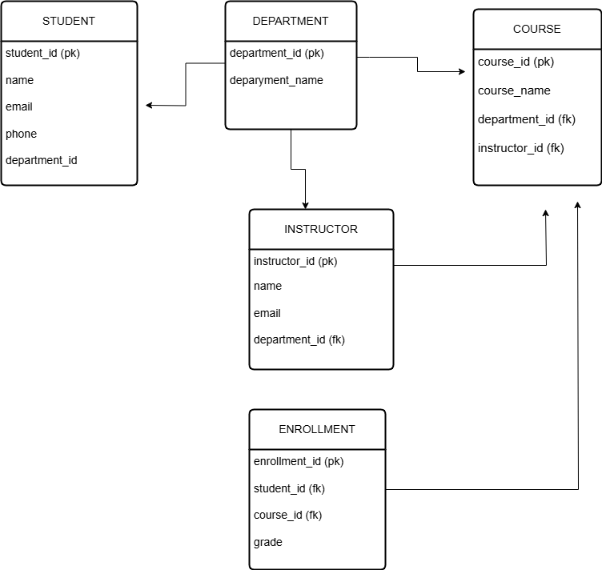

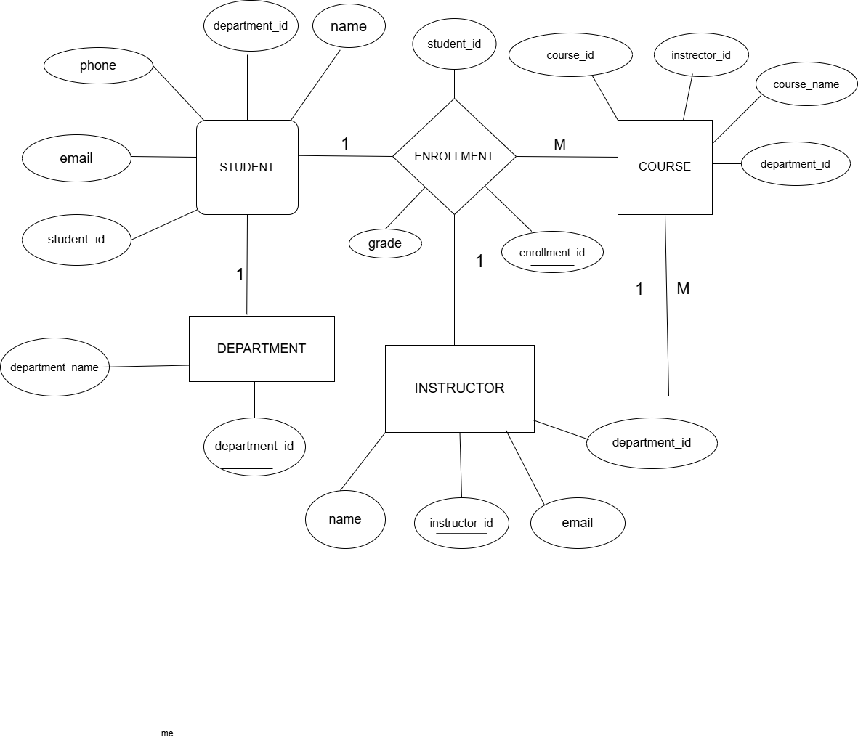

Table Structures
The following tables are created in the database: Department, Student, Instructor, Course, and Enrollment. Each table has specific columns and data types.
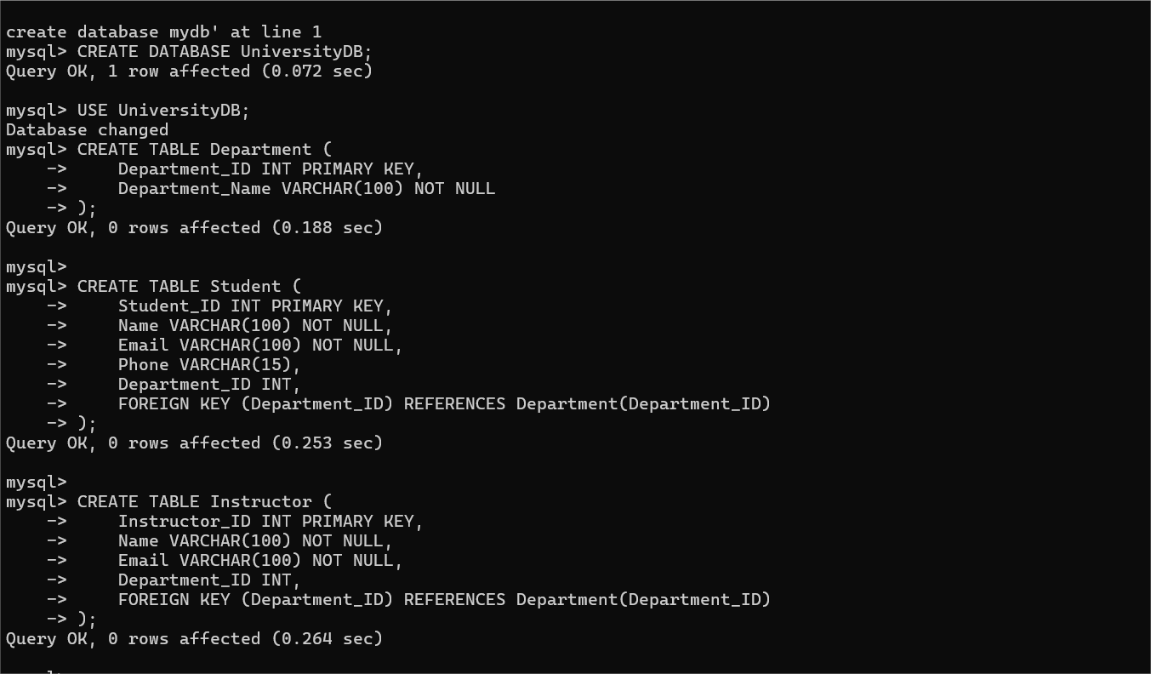
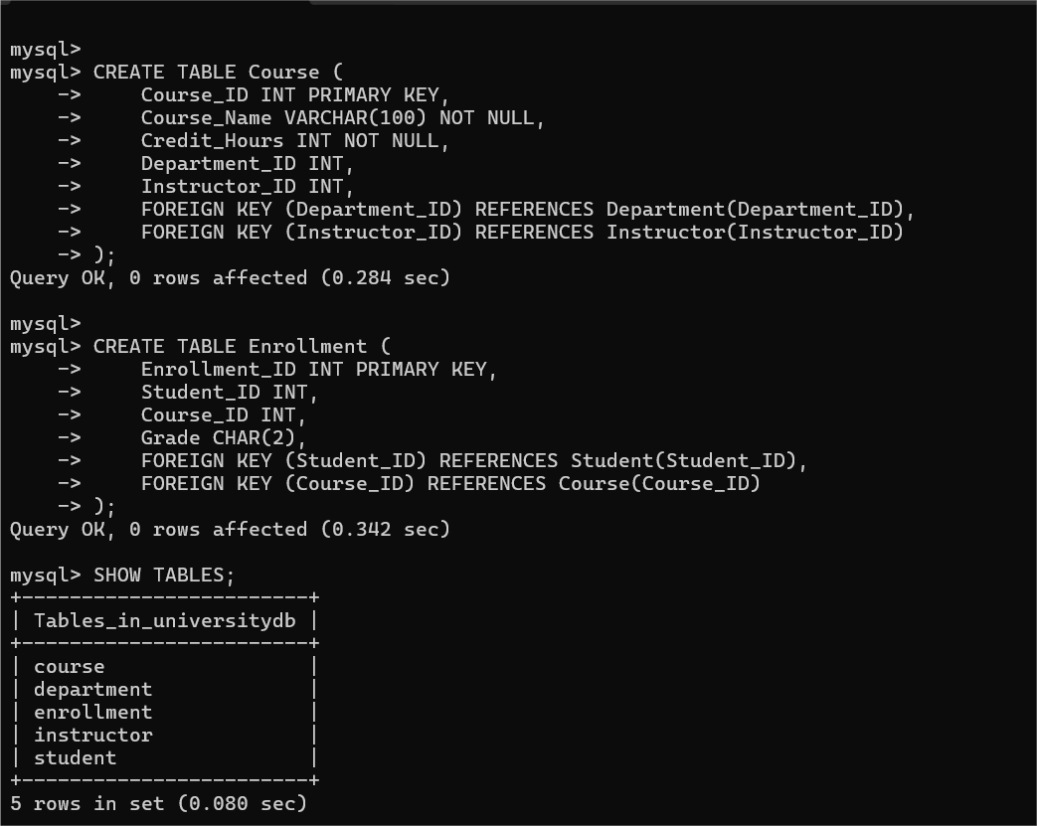
Table data
Each table contains 10 data.They are 5 tables:student , course, enrollment ,department , instructor

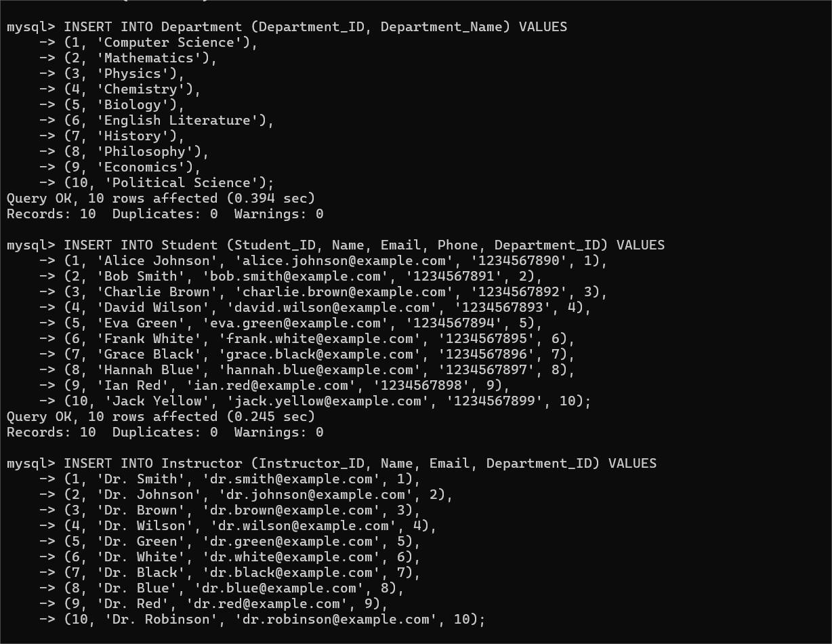

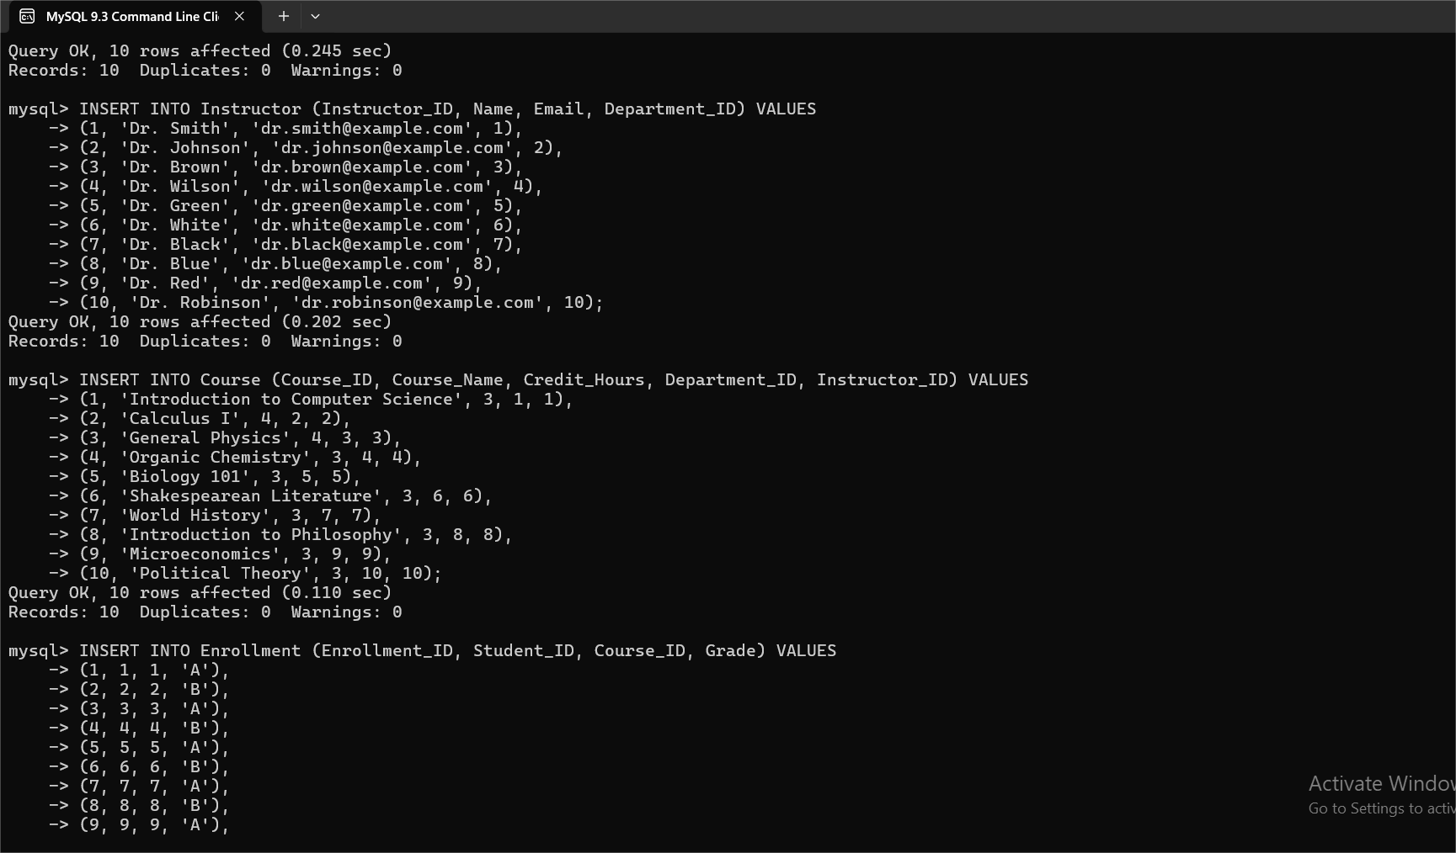

INQUIRY CODE

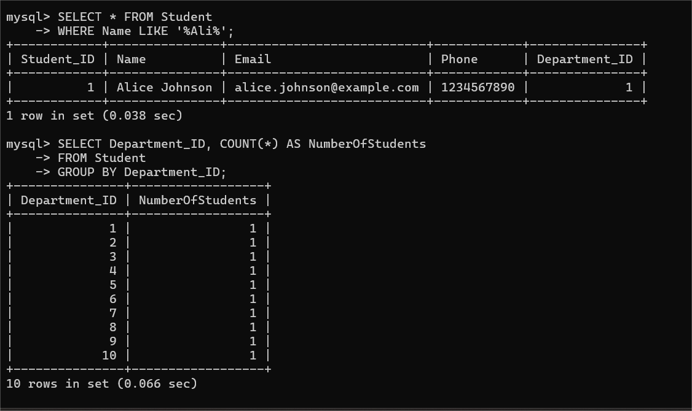

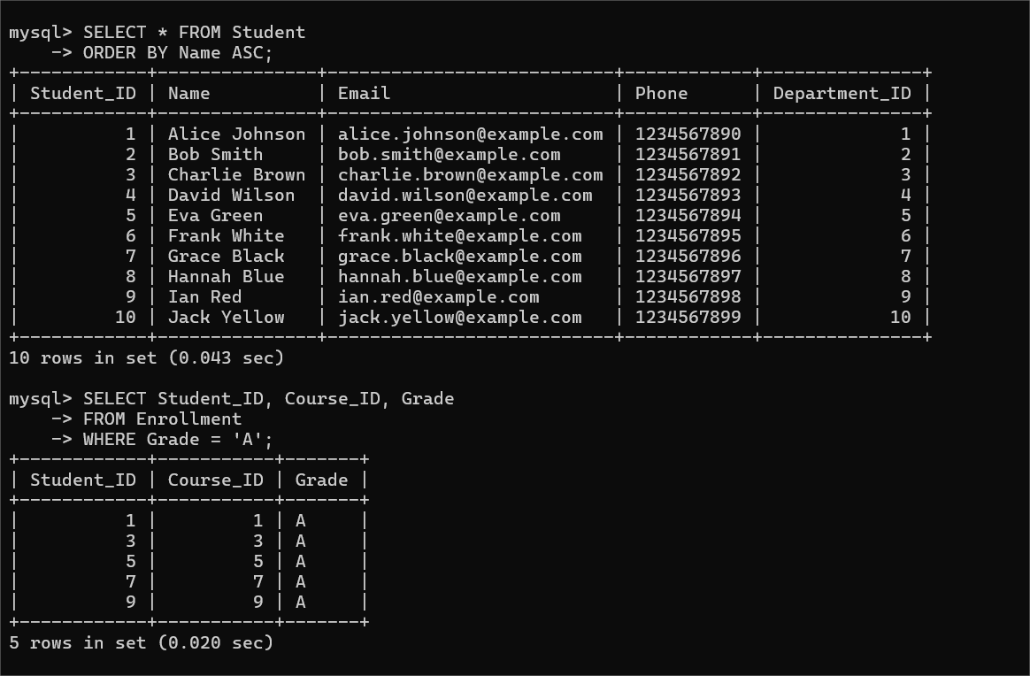

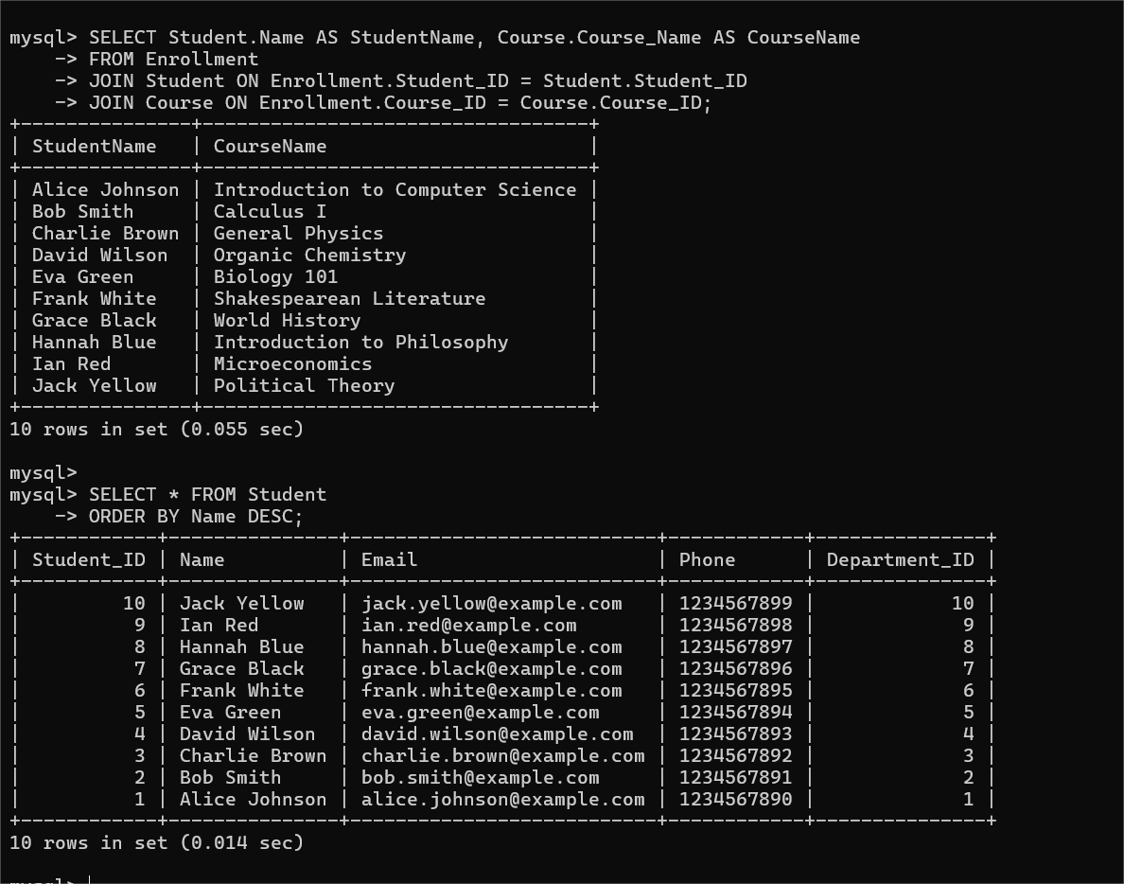
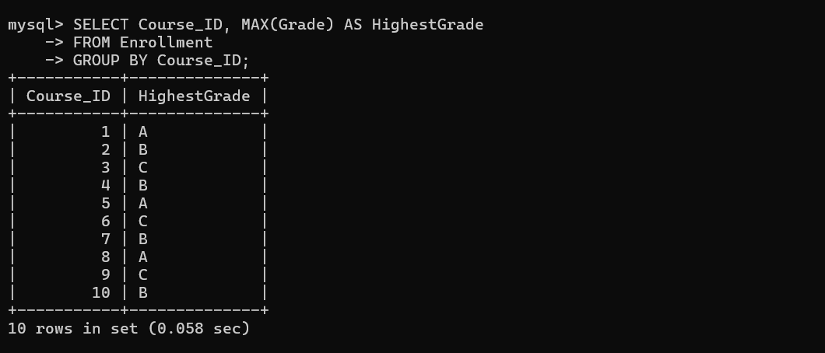
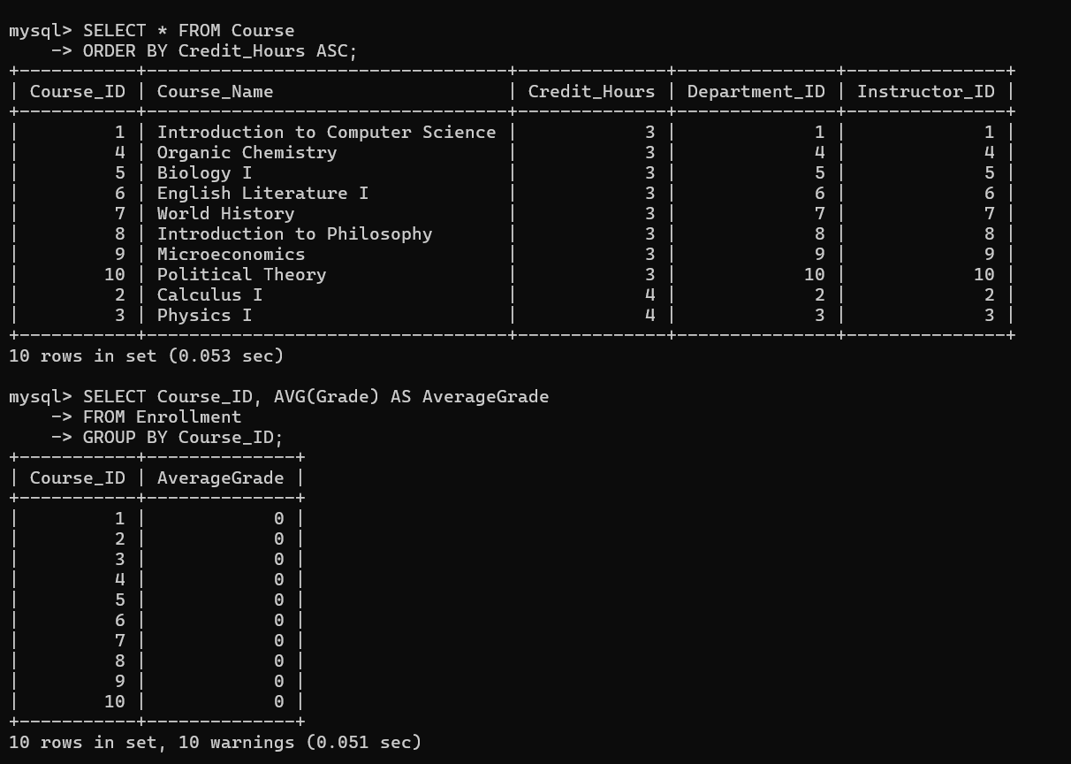

Conclusion
This project demonstrates the design and implementation of a university student registration database. The database is normalized to 3NF and includes various entities and relationships. Sample queries are provided to illustrate the operations that can be performed on the database.

