I was assigned to do a 22- bits Project.
All the following components are designed accordingly.

Instruction format
My Instruction formats are of R (Register), I (Immediate), and J (Jump) type.
R-Type instructions are used for arithmetic and logical operations. The fields are defined as follows:
Op (5 bit) | Rs (4 bit) | Rt (4 bit) | Rd (4 bit) | Shift (3 bit) | Function  (2 bit)

Op: 5-bit opcode specifying the operation.
Rs: 4-bit source register specifier.
Rt: 4-bit target register specifier.
Rd: 4-bit destination register specifier.
Shamt: 3-bit shift amount (used for shift operations).

Function: 2-bit function to identify different R-type operations.

I-Type instructions are used for operations that involve immediate values and for data transfer instructions. The fields are:
Op (5 bit) | Rs (4 bit) | Rt (4 bit) | Immediate (9 bit)

Op: 5-bit opcode specifying the operation (e.g., addi, lw, sw, etc.).
Rs: 4-bit base register specifier.
Rt: 4-bit target register specifier.
Immediate: 9-bit immediate operand.

J-Type instructions are used for jump operations. The fields are:
Op (5 bit) | Target (17 bit)

Op: 5-bit opcode specifying the jump operation (e.g., j, jal, etc.).
Target: 17-bit address to jump to.

ALU
An arithmetic-logic unit is the part of a central processing unit that carries out arithmetic and logic operations on the operands in computer instruction words. My Project’s ALU have ADD, SUB, XOR, SRL, ORi, SLTi. My Input and Output bits are 22.

ALUOP | Operation
000 | ADD
001 | SUB
010 | XOR
011 | ORi
100 | SHIFTRIGHT_A
110 | SLTi

I also implemented a Zero Logic, which basically takes the NOR of all the bits of the output. If all bits are zero, output is one, which means output is zero.

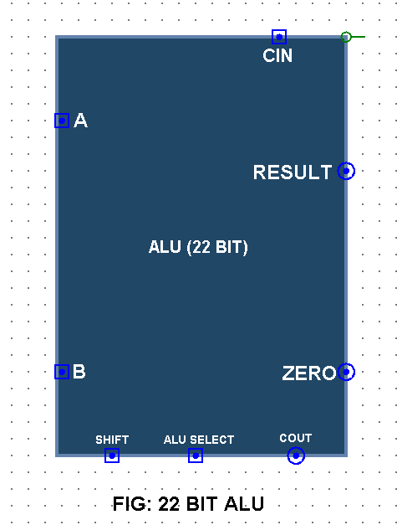
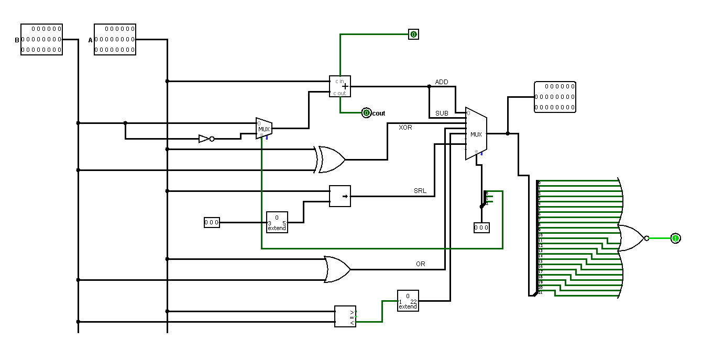

Register File
A register file is a small set of high-speed storage cells inside the CPU. There are special-purpose registers such as the IR and PC, and also generalpurpose registers for storing operands of instructions such as add, sub etc. Since there are very few registers compared to memory cells, registers also require far fewer bits to specify which register to use.
I used 22-bit Register File for my project. As my RS RT and RD are 4 bits. 2⁴ = 16 register files would suffice.
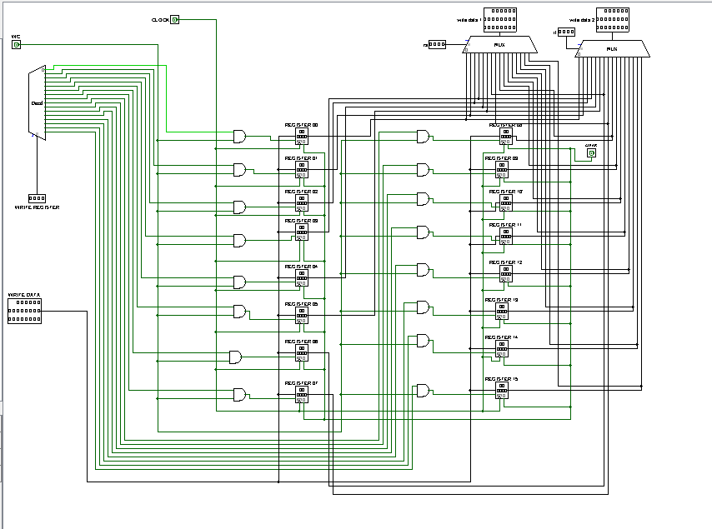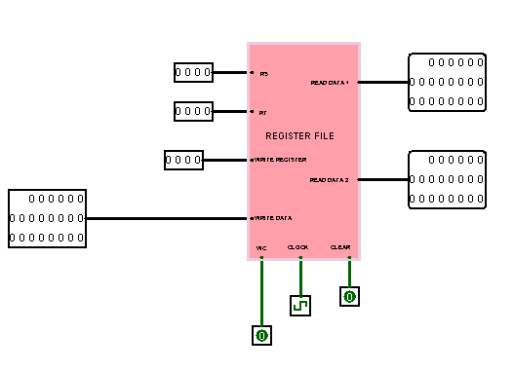
FIG: REGISTER FILES

Datapath
The Datapath is a crucial component of a CPU, playing a key role in executing the fetch-decode-execute cycle. The process for designing a Datapath typically involves the following steps:
- Identify the different types and formats of instructions specified.
- Create components of the Datapath and establish connections between them to accommodate each type or format of instruction.
- Combine the Datapath segments from Step 2 to form a comprehensive Datapath that can handle multiple instructions.
Some basic components of a simple Datapath include memory, which holds the current instruction; the program counter (PC), which keeps track of the address of the ongoing instruction; and the Arithmetic Logic Unit (ALU), which carries out the instruction. Connecting these fundamental components together establishes a rudimentary Datapath.
My Datapath can handle I type, R type and J type instructions. I designed it in such a way that it can carry out instructions such as add, sub, jump, load, store branch etc. I utilized the Register File and ALU that I described earlier to design my Datapath and overall circuit.
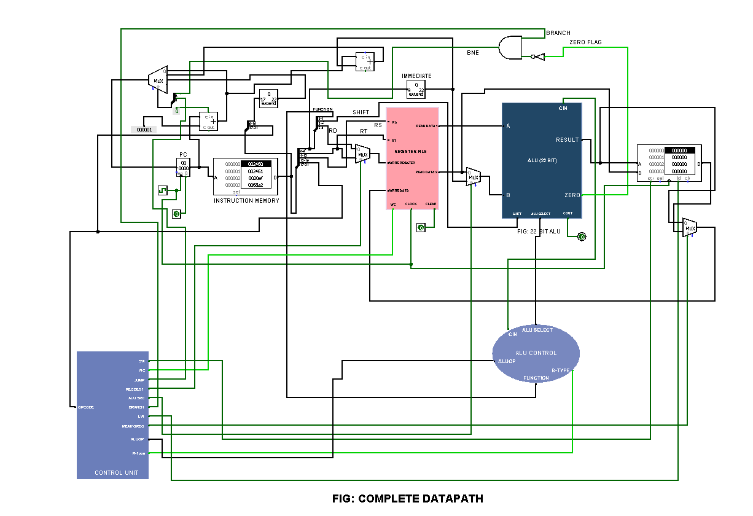

Control unit
Operation | Op Code | ALU  Operation | ALU  Select | WC | Reg Dest | ALU SRC | SW | LW | Mem  To Reg | Jump | Branch | ALUOP
ADD | 00000 | Add | 000 | 1 | 0 | 0 | 0 | 0 | 0 | 0 | 0 | 00
SUB | 00000 | Sub | 001 | 1 | 0 | 0 | 0 | 0 | 0 | 0 | 0 | 00
XOR | 00000 | XOR | 010 | 1 | 0 | 0 | 0 | 0 | 0 | 0 | 0 | 00
SRL | 00000 | ShiftRight | 110 | 1 | 0 | 0 | 0 | 0 | 0 | 0 | 0 | 00
BNE | 00001 | Zero flag | 001 | 0 | 0 | 0 | 0 | 0 | X | 0 | 1 | X
SLTi | 00010 | Shift Left (Immediate) | 100 | 1 | 1 | 1 | 0 | 0 | 0 | 0 | 0 | 11
JMP | 00011 | Add | 000 | 0 | 0 | 0 | 0 | 0 | X | 1 | 0 | X
SW | 00100 | Add | 000 | 0 | X | 1 | 1 | 0 | X | 0 | 0 | 00
ORi | 00101 | OR | 011 | 1 | 1 | 1 | 0 | 0 | 0 | 0 | 0 | 10
NOP | X | X | X | X | 1 | X | X | X | X | 0 | X | X
LW | 00110 | Add | 000 | 1 | 1 | 1 | 0 | 1 | 1 | 0 | 0 | 00

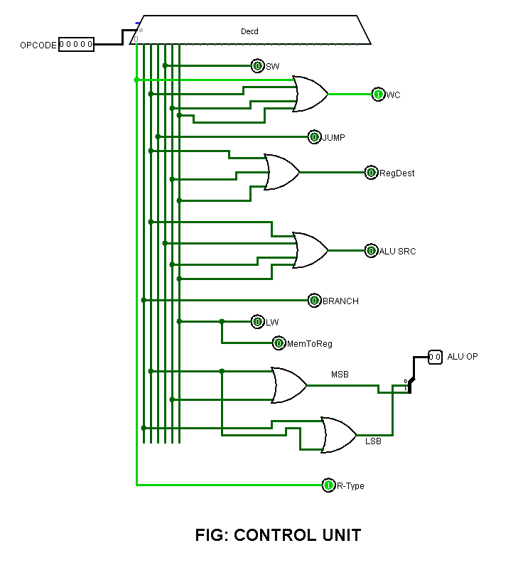
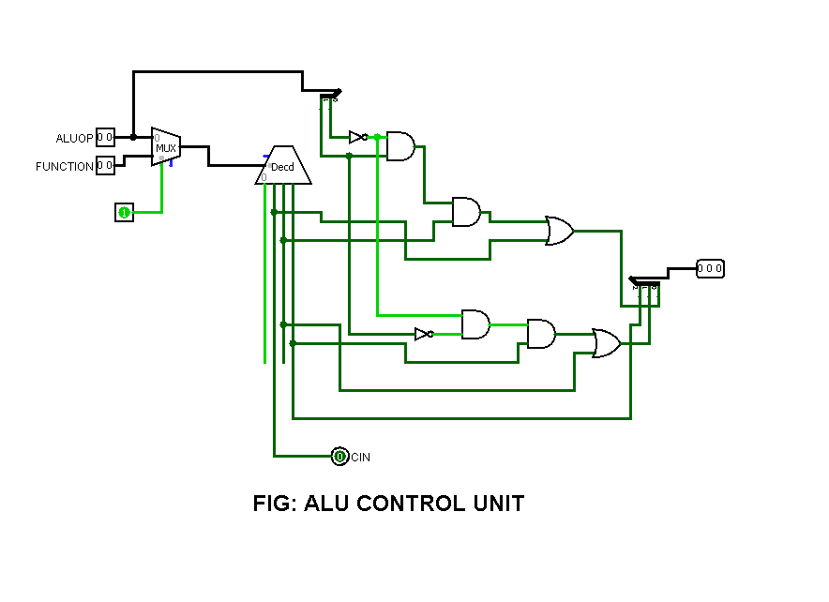

Conclusion
In conclusion, this project provided an invaluable opportunity to dive deeply into the world of computer architecture and digital design. By designing a 22-bit processor, I gained comprehensive understanding of the core operations and functionalities within a processor’s instruction set. Moreover, the task of creating compiled assembly codes enabled me to test the processor's capabilities thoroughly and assured me of the effectiveness of my design. This was a good project to implement all that I’ve learned in this course.

