Table of Contents:
Problem Description……………………………………………………………………………………………………………….2
Background………………………………………………………………………………………………………………………….2
Community Impact……………………………………………………………………………………………………………….2
Proposed Solution…………………………………………………………………………………………………………………2
Computational Thinking Process…………………………………………………………………………………………….3
Algorithm Design………………………………………………………………………………………………………………….3
SDG Alignment…………………………………………………………………………………………………………………….3
Open Source Justification………………………………….………………………………………………………………….3
Digital Public Goods Justification……………………………………………………………………………………………3
Algorithm……………………………………………………………………………………………………………………………..4
Pseudocode………………………………………………………………………………………………………………………….5
Flowcharts……………………………………………………………………………………………………………………………6
Functional Modules……………………………………………………………………………………………………………….8
Expected Outputs……………………………………………………………………………………………………………..….9
GitHub Evidence………………………………………………………………………………………………………………….10
References………………………………………………………………………………………………………………………….11

Problem Description
The community problem chosen for this assignment is the slow and error-prone way in which schools check whether a student has attended enough days to be allowed to sit examinations. In many schools, attendance is recorded in paper registers and each student's attendance percentage is worked out by hand by a class teacher or an administrator. When a school has many students and the examination period is close, this manual process takes a lot of time and mistakes can easily happen.
The people affected by this problem are:
- Students: who may be wrongly allowed or wrongly stopped from sitting an examination because of a calculation error.
- Teachers and administrators: who spend long hours calculating percentages and checking registers.
- Parents and guardians: who depend on fair and accurate decisions about their children's examinations.
The problem exists because attendance records are mostly kept on paper, calculations are repeated by hand for every student, and many schools do not have a simple, standard tool to support the decision. The proposed solution addresses this by using one clear set of steps that takes a student's name, total school days and days present, calculates the attendance percentage, and tells the user immediately whether the student is eligible for the examinations.

Background
Regular attendance is one of the strongest indicators of whether a student is following the school programme. For this reason, schools commonly set a minimum attendance percentage that a student must reach before sitting examinations. In this design, the minimum attendance requirement is 75 percent, and a school can change this value to match its own policy. Schools in Sierra Leone, especially community schools, often work with limited equipment, unstable electricity and limited internet access. A solution for this setting must therefore be simple, light, and able to run on basic devices without needing an internet connection.

Community Impact
- Problem being solved: inconsistent and time-consuming manual checking of examination eligibility based on attendance.
- Expected impact on the local community: faster decisions, fewer calculation errors, fairer treatment of students, and more time for teachers to focus on teaching.
- Beneficiaries: students, teachers, school administrators, parents and guardians.
- Long-term sustainability: because the logic is simple and can be shared openly, schools can reuse and maintain it with local skills and without paying licence fees.

Proposed Solution
The proposed solution is an Exams Eligibility Checker. When the program starts, it displays a welcome message. While the user answers "yes", the program asks for the name of the student, the total number of school days and the total number of days the student was present. It then calculates the attendance percentage by dividing the days present by the total school days and multiplying by 100. If the percentage is 75 or more, the program displays that the student is eligible for the exams. Otherwise, it displays that the student is not eligible. Finally, the program asks whether the user wants to check another student, and it repeats the process until the user answers anything other than "yes".

Computational Thinking Process
- Decomposition: the problem is broken into smaller parts: starting the program, getting the inputs, calculating the percentage, deciding on eligibility, displaying the result, and asking whether to repeat.
- Pattern recognition: every student is checked using the same pattern of steps, which means one set of steps can be repeated for any number of students.
- Abstraction: only the details needed for the decision are kept (student name, total school days and days present). Other details such as class, age or subject are ignored.
- Algorithm design: the smaller parts are arranged in the correct order as a step-by-step algorithm, pseudocode and a flowchart.

Algorithm Design
The algorithm uses the three basic control structures of programming logic. Sequence is used to input the data and calculate the percentage in order. Selection is used in one decision structure that compares the percentage with the pass mark of 75. Repetition is used in a loop that continues while the variable choice equals "yes". The design uses the following data:
- Variables and data types: studentName (String), choice (String), totalSchoolDays (Integer), totalDaysPresent (Integer) and percentage (Real).
- Constant value: the minimum attendance of 75 percent used in the decision, and the value 100 used to convert the result to a percentage.
- Boolean logic: the loop condition choice == "yes" and the decision condition percentage >= 75 each give a result of True or False.

SDG Alignment
- SDG 4 – Quality Education (main goal): the system supports schools in managing attendance and examination eligibility fairly, which encourages regular attendance and supports inclusive and equitable quality education.
- SDG 16 – Peace, Justice and Strong Institutions (supporting goal): using one clear and transparent rule for every student supports fair, accountable and effective school administration.

Open Source Justification
- Why it should be open source: the logic of this system is not secret and is useful to every school. Sharing it openly allows any school, teacher or student to read it, check that the rule is fair, and adapt it.
- Benefits for Sierra Leone: no licence cost, local ownership, skills development for students and developers, and freedom to change the pass mark or messages to suit each school.
- Potential community contributions: other developers can translate the messages into local languages, add input validation, add class lists, build mobile or offline versions, and report or fix errors.

Digital Public Goods Justification
The Exams Eligibility Checker could become a Digital Public Good (DPG) by being released under an open licence, with clear documentation, so that anyone can use, copy and improve it, and by avoiding any collection of private data beyond what is needed. It promotes accessibility because it is simple and can run on basic devices, openness because the design and documentation are free to read and reuse, and public benefit because schools can use it at no cost to make fair decisions about their students.

Algorithm
- Start the program (Main).
- Declare the variables: studentName (String), percentage (Real), choice (String), totalSchoolDays (Integer) and totalDaysPresent (Integer).
- Set choice to "yes".
- Display "Welcome to our exams eligibility checker".
- Check whether choice is equal to "yes". If True, go to step 6. If False, go to step 19.
- Display "Please enter the name of the student".
- Read studentName.
- Display "Please enter total school days".
- Read totalSchoolDays.
- Display "Please enter total days present".
- Read totalDaysPresent.
- Calculate percentage = totalDaysPresent / totalSchoolDays * 100.
- Check whether percentage is greater than or equal to 75. If True, go to step 14. If False, go to step 15.
- Display "Based on the attendance record, " & studentName & " is eligible for the exams", then go to step 16.
- Display "Based on the attendance record, " & studentName & " is not eligible for this exams", then go to step 16.
- Display "Do you want to check another student? Enter yes or no".
- Read choice.
- Go back to step 5.
- End the program.

Pseudocode
The pseudocode below matches the flowchart block by block.
START Main
DECLARE studentName AS String
DECLARE percentage AS Real
DECLARE choice AS String
DECLARE totalSchoolDays AS Integer
DECLARE totalDaysPresent AS Integer
SET choice = "yes"
OUTPUT "Welcome to our exams eligibility checker"
WHILE choice == "yes" DO
OUTPUT "Please enter the name of the student"
INPUT studentName
OUTPUT "Please enter total school days"
INPUT totalSchoolDays
OUTPUT "Please enter total days present"
INPUT totalDaysPresent
SET percentage = totalDaysPresent / totalSchoolDays * 100
IF percentage >= 75 THEN
OUTPUT "Based on the attendance record, " & studentName & " is eligible for the exams"
ELSE
OUTPUT "Based on the attendance record, " & studentName & " is not eligible for this exams"
END IF
OUTPUT "Do you want to check another student? Enter yes or no"
INPUT choice
END WHILE
END Main

Flowcharts
Figure 1 shows the flowchart of the Exams Eligibility Checker, drawn with Flowgorithm App. It uses the Main start and End terminators, process blocks for declarations and calculation, input and output blocks, a decision block for the loop (choice == "yes"), and a decision block for eligibility (percentage >= 75).
Figure 1: Flowchart of the Exams Eligibility Checker

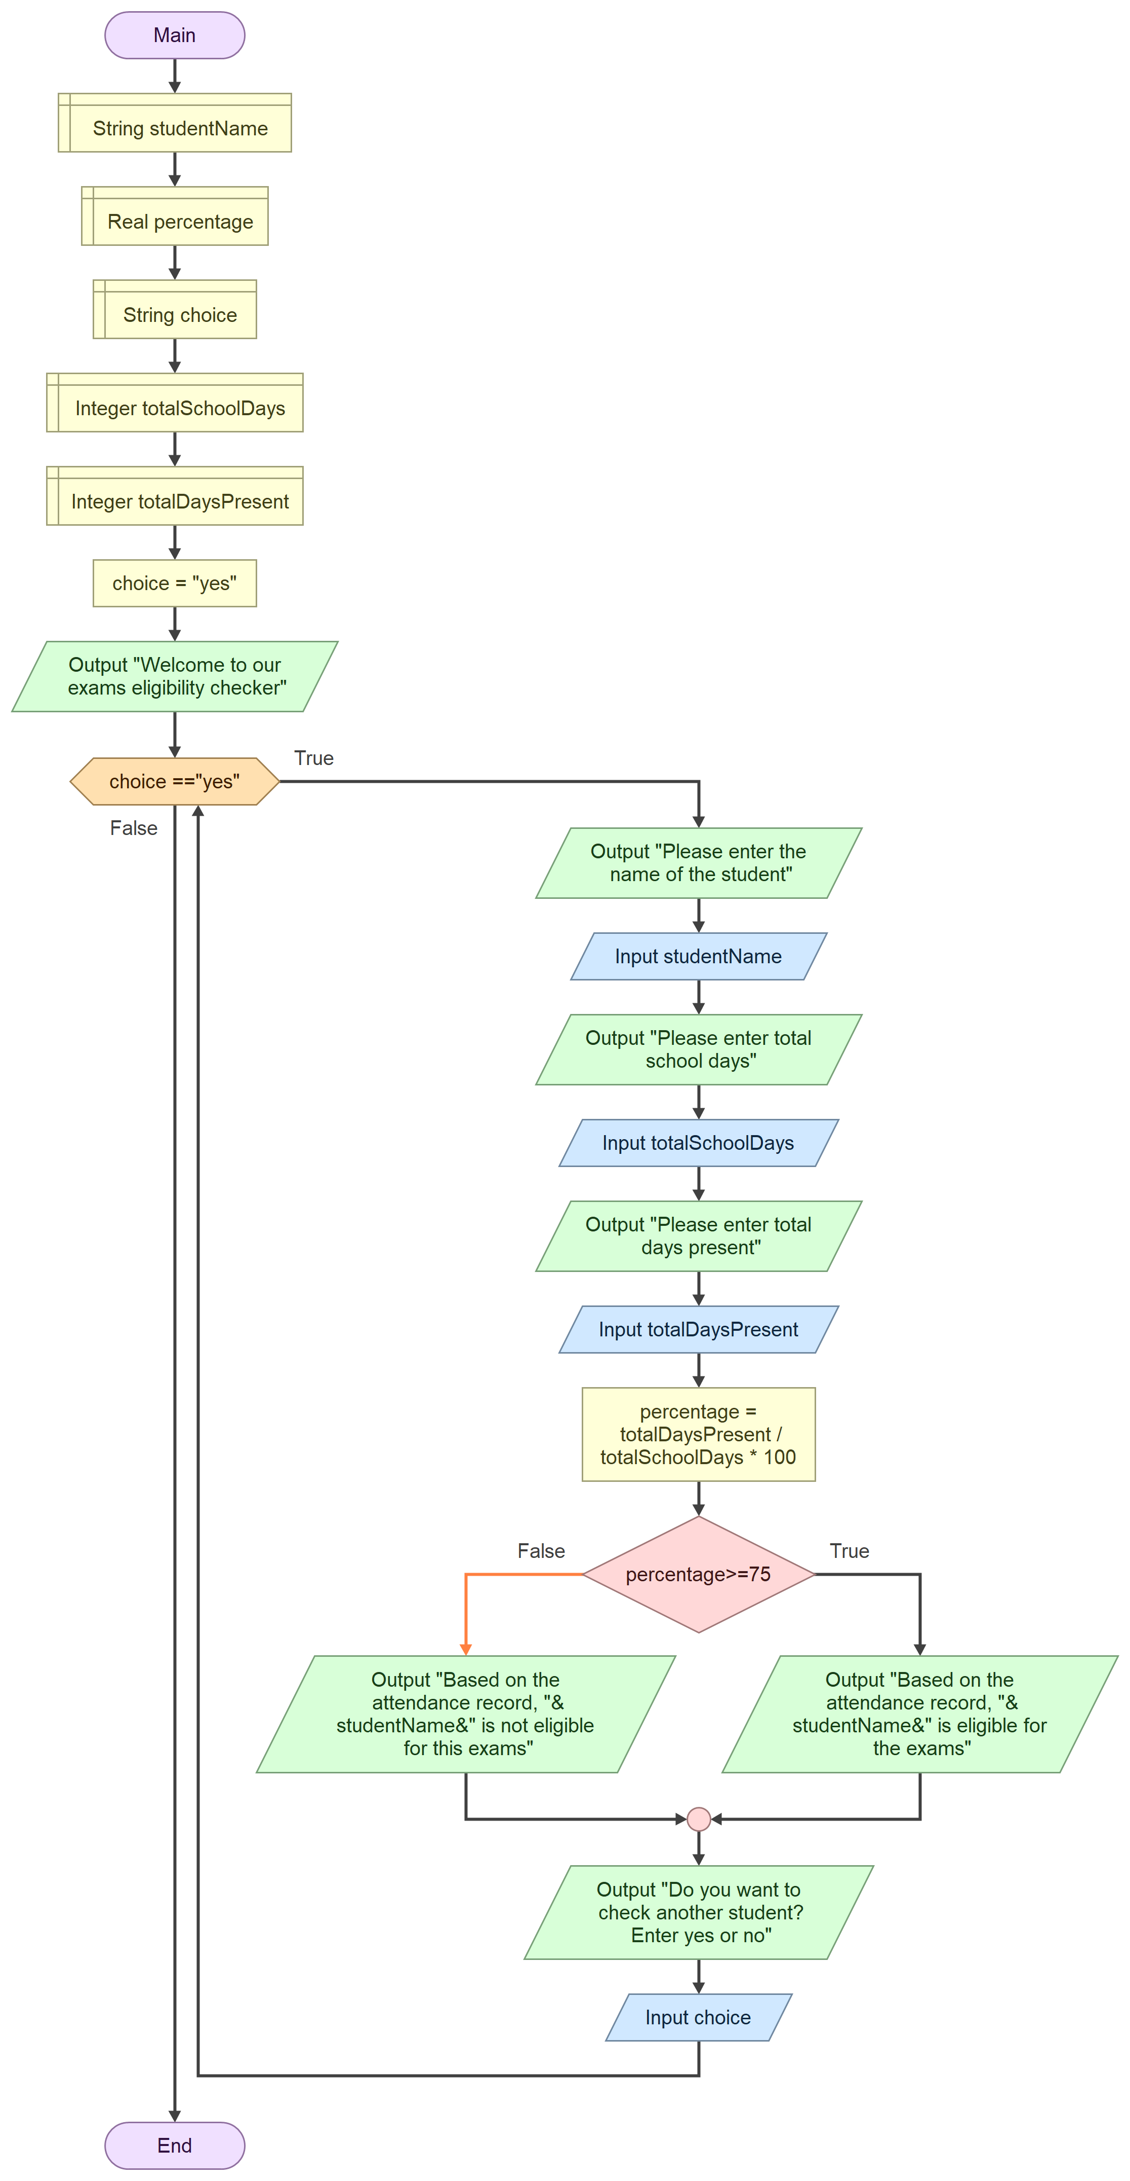

Functional Modules
The solution is divided into the following functional modules. In the flowchart they all sit inside Main, and each one can later become its own function without changing the logic.
- Initialisation Module: declares the variables, sets choice to "yes" and displays the welcome message.
- Loop Control Module: checks whether choice == "yes" to decide whether to check another student or end the program.
- Input Module: displays the prompts and reads studentName, totalSchoolDays and totalDaysPresent.
- Processing Module (function view: calculatePercentage): takes totalDaysPresent and totalSchoolDays and returns percentage = totalDaysPresent / totalSchoolDays * 100.
- Decision and Output Module (function view: checkEligibility): takes percentage, tests percentage >= 75 and displays the eligible or not eligible message with the student's name.
- Repeat Prompt Module: asks "Do you want to check another student? Enter yes or no" and reads choice.

Expected Outputs
The table below shows three sample scenarios and the output the system should give for each one.
Case | Student name | School days | Days present | Percentage | Output
1 | Aminata Kamara | 100 | 90 | 90 | Based on the attendance record, Aminata Kamara is eligible for the exams
2 | Mohamed Sesay | 120 | 90 | 75 | Based on the attendance record, Mohamed Sesay is eligible for the exams
3 | Fatmata Bangura | 80 | 50 | 62.5 | Based on the attendance record, Fatmata Bangura is not eligible for this exams

Case 2 shows the boundary condition: a percentage of exactly 75 is eligible because the decision uses greater than or equal to (>=). The design assumes valid input, where totalSchoolDays is greater than 0 and totalDaysPresent is not more than totalSchoolDays. Input validation can be added as a future improvement.
A sample run of the program:
Welcome to our exams eligibility checker
Please enter the name of the student
Aminata Kamara
Please enter total school days
100
Please enter total days present
90
Based on the attendance record, Aminata Kamara is eligible for the exams
Do you want to check another student? Enter yes or no
yes
Please enter the name of the student
Fatmata Bangura
Please enter total school days
80
Please enter total days present
50
Based on the attendancwe record, Fatmata Bangura is not eligible for this exams
Do you want to check another student? Enter yes or no
no
(The program ends.)

GitHub Evidence
Repository name: PROG101_Assignment1_MariamaBarrie_905006320
Repository URL:mariamabarrie505-cmd/PROG101_Assignment1_MariamBarrie_905006320
Git commit history:
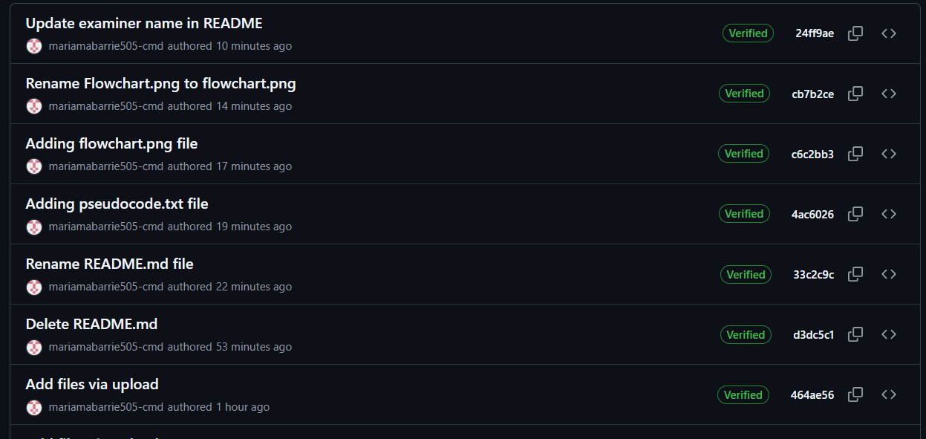
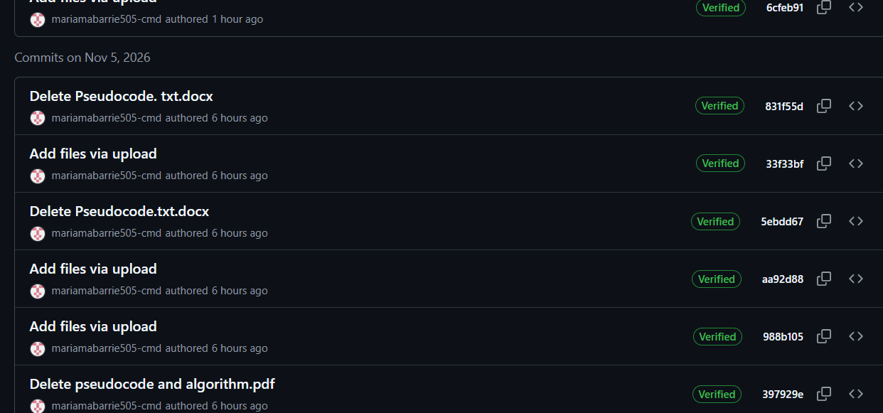
README.md screenshort:


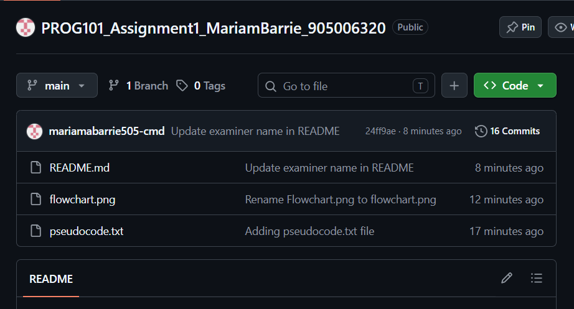
Repository screenshot:

References
Digital Public Goods Alliance (n.d.) Digital Public Goods Alliance. Available at: https://digitalpublicgoods.net
Open Source Initiative (n.d.) The Open Source Definition. Available at: https://opensource.org/osd
United Nations (2015) Transforming our world: the 2030 Agenda for Sustainable Development. A/RES/70/1. Available at: https://sdgs.un.org/2030agenda
United Nations (n.d.) Goal 4: Quality Education. Available at: https://sdgs.un.org/goals/goal4
Wing, J.M. (2006) 'Computational thinking', Communications of the ACM, 49(3), pp. 33–35.

