TABLE OF CONTENTS:
1. RATIONALE 2
Problem Description 2
Background 2
Community Impact 2
Proposed Solution 2
Computational Thinking Process 3
Algorithm Design 3
SDG Alignment 3
Open Source Justification 4
Digital Public Goods Justification 4
2. ALGORITHM 5
Main program 5
Module DisplayMenu 5
Module RegisterVisitor 5
Function IsValidVisitor(name, id) 5
Module ViewDailyRecords 5
3. PSEUDOCODE 7
Constants, variables and data types 7
Main program 7
Module DisplayMenu 7
Module RegisterVisitor 8
Function IsValidVisitor 8
Module ViewDailyRecords 8
4. FLOWCHART 9
5. FUNCTIONAL MODULES 10
6. EXPECTED OUTPUTS 11
7. REFERENCES 12
APPENDIX A: GITHUB EVIDENCE 13
APPENDIX B: FLOWGORITHM SCREENSHOTS 14

Problem Description

Background
Libraries support quality education by giving students access to books, study space and digital resources. Managing a library well depends on knowing how it is used, but where visits are recorded only on paper this information is slow to produce and often unreliable, which weakens planning and reporting.
For this assignment the author acts as a Junior System Analyst, and the task is to design the logical solution rather than write source code. The solution is expressed through an algorithm, pseudocode, a flowchart and a modular design. In the design, visitorRecords stands for the list of visit records; a real implementation would store them in a file or database so that they remain after the program closes.

Community Impact
- The problem being solved: unreliable manual registration of visitors and time-consuming manual counting of daily visits.
- Expected impact: faster sign-in, complete and consistent records and an instant daily count, which managers can use to justify opening hours, seating and resources.
- Beneficiaries: students (primary), library staff, library and university management, and any institution that later adopts the design.
- Long-term sustainability: the logic needs no paid software and only basic hardware. It is modular and documented, so others can maintain or extend it, and open source release lets other institutions reuse it at no cost.

Proposed Solution
The proposed system is a menu-driven program with three options: 1. Register Visitor, 2. View Daily Records and 3. Exit, repeated until the operator chooses Exit. Registering captures the student name, student ID and visit date, checks that the name and ID are not blank, and saves the record. Viewing asks for a date, checks every saved record, displays and counts the matches, and reports the total (or "No Records Available"). Any other entry gives "Invalid Option". The program is organised into small modules (Section 5) so each task can be designed, tested and changed independently.

Computational Thinking Process
- Decomposition: the problem was broken into parts: show the menu, register a visitor, validate the details, search by date, count the matches and report. Each part became a module.
- Pattern recognition: registering and viewing follow a common pattern of input, check, store or search, then report. The repeating menu is the same pattern used by ATMs and ticket machines.
- Abstraction: only the name, student ID and date were kept. Screen layout, storage technology and printing were left out, and the records are represented as visitorRecords.
- Algorithm design: the steps were written as an algorithm, refined into pseudocode and drawn as a flowchart, using IF decisions and WHILE / FOR repetition.
- Evaluation: the logic was tested with sample scenarios (Section 6) and built and run as a chart in Flowgorithm.

Algorithm Design
The algorithm follows the Input, Processing, Output model. The full algorithm is in Section 2, the pseudocode in Section 3 and the flowchart in Section 4.
- Input: menu choice, student name, student ID, visit date and selected date.
- Processing: validating the name and ID, saving the record and counting the matching records.
- Output: the menu, success and error messages, the matching records, "Total Visits", "System Closed" and "Invalid Option".
- Decision structures: IF / ELSE IF / ELSE for the menu choice; IF for validation, date matching and DailyCount = 0.
- Repetition structures: a WHILE loop for the menu (until choice = 3) and a FOR loop over the saved records.
- Modular design and functions: Main, DisplayMenu, RegisterVisitor and ViewDailyRecords, plus the function IsValidVisitor, which returns a Boolean.

SDG Alignment
The project supports at least one Sustainable Development Goal; its primary goal is SDG 4.
- SDG 4: Quality Education (primary), Target 4.a (build and upgrade education facilities): better management of the library as a learning facility. Accurate visit data helps plan space, opening hours and resources for students.
- SDG 16: Peace, Justice and Strong Institutions, Target 16.6 (effective, accountable and transparent institutions): reliable, auditable visitor records let the library report its use honestly to management and funders.
- SDG 9: Industry, Innovation and Infrastructure: a low-cost digital tool that moves a manual process to a simple information system that runs on basic hardware.

Open Source Justification
The Open Source Initiative defines open source software as software whose licence lets anyone use, study, change and share it. The visitor system should be open source because it serves a public-interest purpose in education; institutions with small budgets can adopt it without licence fees; an open design lets others inspect how personal data such as names and student IDs is handled; and it avoids dependence on a single vendor.
Benefits for Sierra Leone. No licence costs; local students and staff can learn from the design and adapt it to local needs such as ID formats and offline use; knowledge can be shared between institutions; and the country builds its own technical skills.
Potential community contributions. Translations and local-language interfaces, test cases and bug reports, documentation, extra modules (for example monthly reports or spreadsheet export), security and accessibility reviews, and adaptations for school or community libraries.

Digital Public Goods Justification
Following the United Nations Roadmap for Digital Cooperation, the Digital Public Goods Alliance describes digital public goods (DPGs) as open source software, open data, open AI models, open standards and open content that respect privacy and applicable laws, do no harm and help attain the SDGs. Its DPG Standard asks for SDG relevance, an approved open licence, clear ownership, sufficient documentation, export of data in non-proprietary formats, privacy protection and steps to prevent harm.
How this system could become a Digital Public Good. It would be released under an OSI-approved open licence with clear documentation (README, algorithm, pseudocode and flowchart); it supports SDG 4; visitor data could be exported in an open format such as CSV; and it would follow privacy by design by collecting only a name, student ID and date and limiting who can view the records.
Accessibility, openness and public benefit. The system is accessible because it is simple, menu-driven and runs on low-cost, offline computers; open because its logic is published and reusable; and beneficial to the public because it improves a shared educational service. A local example is DHIS2, an open-source health information platform that the Digital Public Goods Alliance registry lists as deployed in Sierra Leone, showing that the open, shared-software model already works in the country.

ALGORITHM
The algorithm below describes the whole system step by step. It is divided into the main program and its modules, using the same names as the pseudocode.

Main program
- Start the program.
- Define the constants REGISTER_OPTION = 1, VIEW_OPTION = 2 and EXIT_OPTION = 3.
- Declare the variables: choice, DailyCount, TotalRecords and i as Integer; StudentName, StudentID, VisitDate and SelectedDate as String; and visitorRecords as an empty list of visit records.
- Set TotalRecords to 0 and choice to 0.
- While choice is not equal to 3, repeat steps 6 to 11.
- Call DisplayMenu to show the three options.
- Input the operator’s choice.
- If choice = 1, call RegisterVisitor.
- Otherwise, if choice = 2, call ViewDailyRecords.
- Otherwise, if choice = 3, display "System Closed".
- Otherwise, display "Invalid Option". Return to step 5.
- When choice = 3 the loop ends. End the program.

Module DisplayMenu
- Display "1. Register Visitor".
- Display "2. View Daily Records".
- Display "3. Exit".
- Return to the main program.

Module RegisterVisitor
- Input StudentName.
- Input StudentID.
- Input VisitDate.
- Call the function IsValidVisitor with StudentName and StudentID.
- If the function returns True, save StudentName, StudentID and VisitDate in visitorRecords, add 1 to TotalRecords and display "Visitor Registered Successfully".
- Otherwise, display "Name and Student ID are required" and do not save the record.
- Return to the main program.

Function IsValidVisitor(name, id)
- If name is not blank AND id is not blank, return True.
- Otherwise, return False.

Module ViewDailyRecords
- Input SelectedDate.
- Set DailyCount to 0 and set i to 1.
- While i is less than or equal to TotalRecords, repeat steps 4 to 6.
- If the visit date of record i equals SelectedDate, display the record (name, ID and date) and add 1 to DailyCount.
- Add 1 to i.
- Return to step 3.
- If DailyCount = 0, display "No Records Available".
- Display "Total Visits: " followed by DailyCount.
- Return to the main program.

PSEUDOCODE

Constants, variables and data types
- Constants (Integer): REGISTER_OPTION = 1, VIEW_OPTION = 2 and EXIT_OPTION = 3. These are the menu codes; the main loop ends when EXIT_OPTION is entered.
- Integer variables: choice (the menu option entered), DailyCount (visits found for the selected date), TotalRecords (records saved) and i (counter used to check each record).
- String variables: StudentName, StudentID, VisitDate and SelectedDate. StudentID is text because IDs are not used in calculations and may contain letters.
- List: visitorRecords stores each visit as (StudentName, StudentID, VisitDate).
- Boolean: the function IsValidVisitor returns True when both name and ID are not blank, otherwise False.

In the flowchart the menu codes appear as the numbers 1, 2 and 3, which are the values of the three constants.

Main program
BEGIN Main
CONSTANT REGISTER_OPTION = 1
CONSTANT VIEW_OPTION = 2
CONSTANT EXIT_OPTION = 3
DECLARE choice, DailyCount, TotalRecords, i AS Integer
DECLARE StudentName, StudentID, VisitDate, SelectedDate AS String
DECLARE visitorRecords AS List of records (StudentName, StudentID, VisitDate)
SET TotalRecords = 0
SET choice = 0
WHILE choice <> EXIT_OPTION DO
CALL DisplayMenu()
INPUT choice
IF choice = REGISTER_OPTION THEN
CALL RegisterVisitor()
ELSE IF choice = VIEW_OPTION THEN
CALL ViewDailyRecords()
ELSE IF choice = EXIT_OPTION THEN
OUTPUT "System Closed"
ELSE
OUTPUT "Invalid Option"
END IF
END WHILE
END Main

Module DisplayMenu
PROCEDURE DisplayMenu()
OUTPUT "1. Register Visitor"
OUTPUT "2. View Daily Records"
OUTPUT "3. Exit"
END PROCEDURE

Module RegisterVisitor
PROCEDURE RegisterVisitor()
INPUT StudentName
INPUT StudentID
INPUT VisitDate
IF IsValidVisitor(StudentName, StudentID) = True THEN
SAVE StudentName, StudentID, VisitDate in visitorRecords
SET TotalRecords = TotalRecords + 1
OUTPUT "Visitor Registered Successfully"
ELSE
OUTPUT "Name and Student ID are required"
END IF
END PROCEDURE

Function IsValidVisitor
FUNCTION IsValidVisitor(name, id) RETURNS Boolean
IF name <> "" AND id <> "" THEN
RETURN True
ELSE
RETURN False
END IF
END FUNCTION

Module ViewDailyRecords
PROCEDURE ViewDailyRecords()
INPUT SelectedDate
SET DailyCount = 0
FOR i = 1 TO TotalRecords DO
IF visitorRecords[i].VisitDate = SelectedDate THEN
OUTPUT visitorRecords[i] // name, ID and date
SET DailyCount = DailyCount + 1
END IF
END FOR
IF DailyCount = 0 THEN
OUTPUT "No Records Available"
END IF
OUTPUT "Total Visits: " & DailyCount
END PROCEDURE

FLOWCHART
The flowchart below shows the complete logic of the system in a single chart, built in Flowgorithm. It follows the algorithm and pseudocode: the main menu loop, the register-visitor branch with the blank-field check, and the view-records branch with the FOR loop that counts the visits for the selected date. Standard symbols are used: rounded shapes for start and end, parallelograms for input and output, rectangles for processing, and diamonds for decisions. The Flowgorithm project file is included in the GitHub repository.
In the flowchart the steps of the modules RegisterVisitor and ViewDailyRecords are shown inline in the main chart; the pseudocode groups the same steps into modules.
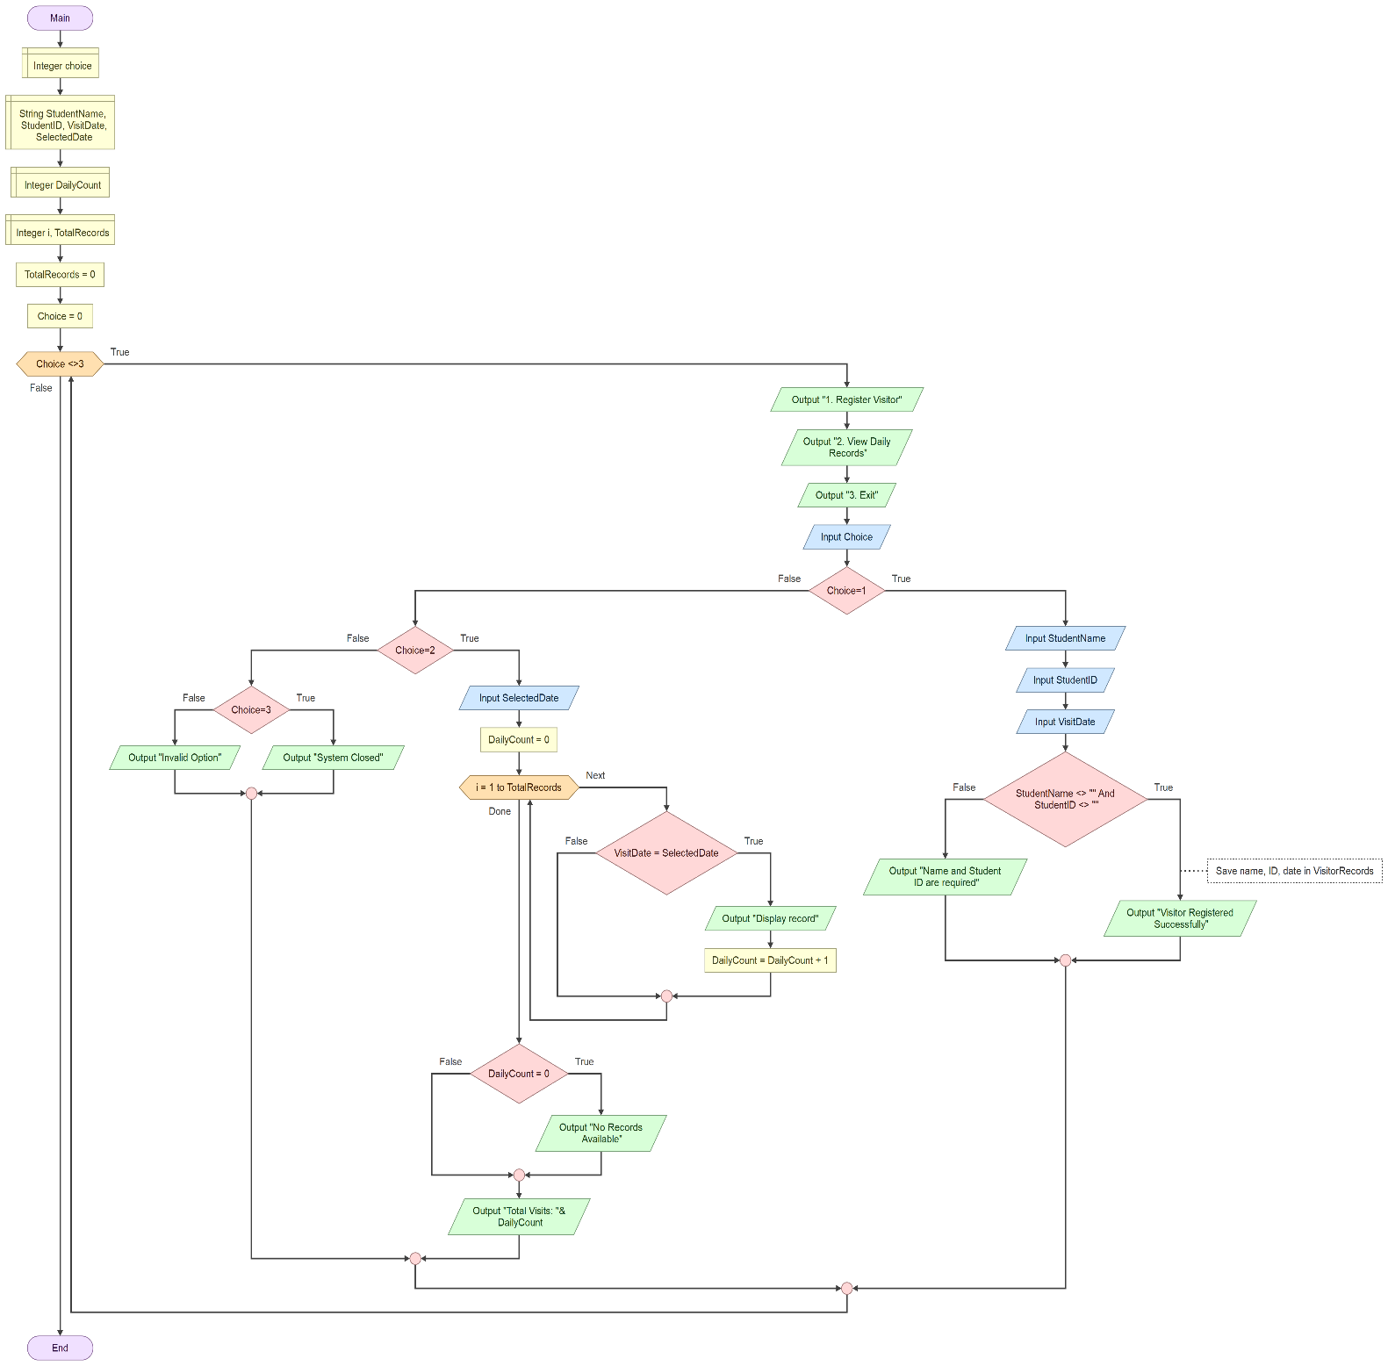

FUNCTIONAL MODULES
Problem decomposition. The system was divided into modules so that each one has a single job:
- Main controls the program and routes each menu choice.
- DisplayMenu shows the options.
- RegisterVisitor collects the details and saves a valid record.
- IsValidVisitor (function) decides whether the details are acceptable.
- ViewDailyRecords searches, displays and counts the visits for one date.
Module details.
- Main (program): input: choice. Processing: a WHILE loop and an IF / ELSE IF chain route the choice to a module. Output: "System Closed" or "Invalid Option".
- DisplayMenu (procedure): no input. Processing: prints the three options. Output: the menu.
- RegisterVisitor (procedure): input: StudentName, StudentID and VisitDate. Processing: validates, saves the record and adds 1 to TotalRecords. Output: a success or error message.
- IsValidVisitor (function): input: name and id. Processing: the Boolean test name <> "" AND id <> "". Output: True or False.
- ViewDailyRecords (procedure): input: SelectedDate. Processing: a FOR loop over the records, an IF on the date, and a count in DailyCount. Output: the matching records, "No Records Available" and "Total Visits".

Boolean logic. The solution uses comparison and logical operators: choice <> 3 controls the main loop, the AND operator in IsValidVisitor requires both fields to be filled, and DailyCount = 0 decides whether to display "No Records Available".

EXPECTED OUTPUTS
The scenarios below show the output the system should produce. The sample names and IDs are invented for demonstration. The menu from DisplayMenu is shown before every choice; to save space it is only written out in the first scenario.
- Scenario 1, valid registration: input choice = 1, name = Aminata Sesay, ID = S1001, date = 2026-10-12. Output: Visitor Registered Successfully, then the menu again.
- Scenario 2, more registrations: (Ibrahim Conteh, S1002, 2026-10-12) and (Fatmata Bangura, S1003, 2026-10-13). Output: Visitor Registered Successfully for each. TotalRecords = 3.
- Scenario 3, blank student ID: input choice = 1, name = Alusine Kamara, ID left blank. Output: Name and Student ID are required. The record is not saved.
- Scenario 4, date with records: input choice = 2, date = 2026-10-12. Output: the two matching records (Aminata Sesay, S1001 and Ibrahim Conteh, S1002) and Total Visits: 2.
- Scenario 5, date with no records: input choice = 2, date = 2026-10-20. Output: No Records Available and Total Visits: 0.
- Scenario 6, invalid choice: input choice = 7. Output: Invalid Option, then the menu again.
- Scenario 7, exit: input choice = 3. Output: System Closed. The program ends.

Sample session (scenarios 1, 4 and 7):
1. Register Visitor
2. View Daily Records
3. Exit
Choice: 1
Student name: Aminata Sesay
Student ID: S1001
Visit date: 2026-10-12
Visitor Registered Successfully
(menu is displayed again) Choice: 2
Date to view: 2026-10-12
Aminata Sesay | S1001 | 2026-10-12
Ibrahim Conteh | S1002 | 2026-10-12
Total Visits: 2
(menu is displayed again) Choice: 3
System Closed

REFERENCES
Cook, D. (n.d.) Flowgorithm: Flowchart programming language. Available at: http://www.flowgorithm.org (Accessed: October 2026).
Digital Public Goods Alliance (n.d.) DHIS2, Digital Public Goods Registry. Available at: https://digitalpublicgoods.net/registry/dhis2.html (Accessed: October 2026).
Digital Public Goods Alliance (n.d.) Setting a Standard for Digital Public Goods. Available at: https://www.digitalpublicgoods.net/blog/setting-a-standard-for-digital-public-goods (Accessed: October 2026).
Fullah, E. (2026) PROG101 Principles of Programming Logic and Design: Assignment 1, Designing Logical Solutions for Sierra Leone Community Challenges. Limkokwing University of Creative Technology, Sierra Leone.
Git (n.d.) Git documentation. Available at: https://git-scm.com/doc (Accessed: October 2026).
GitHub (n.d.) GitHub Docs. Available at: https://docs.github.com (Accessed: October 2026).
Open Source Initiative (n.d.) The Open Source Definition. Available at: https://opensource.org/osd (Accessed: October 2026).
United Nations (n.d.) Goal 4: Ensure inclusive and equitable quality education and promote lifelong learning opportunities for all. Available at: https://sdgs.un.org/goals/goal4 (Accessed: October 2026).
United Nations (n.d.) Goal 9: Build resilient infrastructure, promote inclusive and sustainable industrialization and foster innovation. Available at: https://sdgs.un.org/goals/goal9 (Accessed: October 2026).
United Nations (n.d.) Goal 16: Promote peaceful and inclusive societies for sustainable development. Available at: https://sdgs.un.org/goals/goal16 (Accessed: October 2026).
Wing, J.M. (2006) ‘Computational thinking’, Communications of the ACM, 49(3), pp. 33–35.

APPENDIX A: GITHUB EVIDENCE
The project files (report, flowchart, pseudocode, algorithm, Flowgorithm project and README.md) are stored in a GitHub repository named according to the course convention PROG101_Assignment1_StudentName_StudentID. The repository was developed with regular commits.
- GitHub repository name: PROG101_Assignment1_MariamaBarrie_905006320
- Repository URL: [https://github.com/your-username/repository-name]
- Git commit history: [Insert screenshot of the commit history here]
- README.md: [Insert screenshot or summary of README.md here]
- Repository screenshot: [Insert screenshot of the repository file list here]

APPENDIX B: FLOWGORITHM SCREENSHOTS
The following screenshots show the Flowgorithm program running, which confirms that the flowchart design works as intended.
- [Insert screenshot: Flowgorithm run with menu choice 1 (successful registration)]
- [Insert screenshot: Flowgorithm run with menu choice 3 (System Closed)]

