Database Project :
ERD For the System :
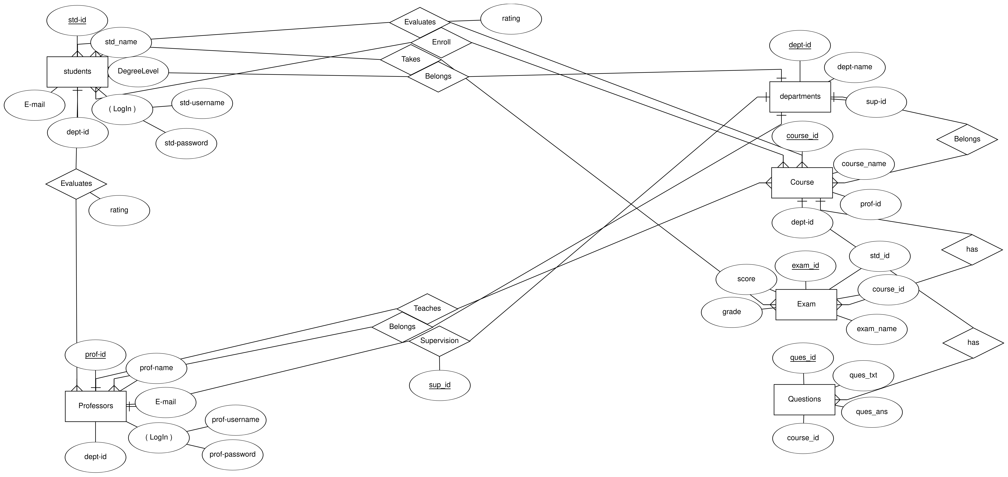
Mapping With Normalization :
Professors
prof_id (PK) | name | E-mail | dept_id(FK) | Username | Password

Students
std_id (PK) | name | E-mail | dept_id(FK) | Username | Password | Degree_lvl

Departments
dept_id (PK) | dept_name | sup_id (FK)

Exam
exam_id (PK) | std_id(FK) | course_id(FK) | exam_name | score | grade

Questions
ques_id (PK) | ques_txt | ques-ans | course_id(FK)

Courses
course_id (PK) | course_name | pof_id(FK) | std_id (FK)

Prof_Evaluation
prof_id(FK) | std_id(FK) | rating

Course Evaluation
course_id(FK) | std_id(FK) | rating

