Project 1: Interface to a Smart Object
Project Overview
SmartCase is a smart carry-on suitcase designed specially to ease travelling. With SmartCase, you don’t have to worry about weighing it on a machine, missing important items while packing, carrying heavy bags around, or even finding where you left it last. With an on-screen display and a mobile app, everything is a click away.
I chose SmartCase because I travel very frequently and often struggle with issues that SmartCase solves effortlessly.

Design Process
Physical Properties and Affordances
SmartCase is a portable hard-shell suitcase with four wheels, a telescoping handle, and side handles. Its normal features already suggest how it is used: the handle is used to pull it, the wheels allow it to roll, and the zipper allows the suitcase to open and close.
It has a built-in weighing system that detects the weight of the suitcase when the suitcase is lifted.
The suitcase also adds smart features across different parts of the object. A front display shows information such as weight, lock status, battery level, and packing alerts. A side panel includes physical controls and a USB-C charging port.
SmartCase can also connect to the user’s phone through Bluetooth. In a Follow Mode, the suitcase can move along with the user, so they do not have to continuously pull it.
It also has a Find My feature that helps users locate their suitcases.

Interview Findings + User Needs and Design Requirements
User Need | Design Requirement
Easily check luggage weight | SmartCase should include a built-in weighing system
Know what is packed | The display should show packed and missing items
Prevent overweight baggage | The display should show an overweight warning
Locate lost luggage | SmartCase should include a Find My / tracking feature
Improve security | SmartCase should include lock/unlock controls
Access information quickly | Important information should appear on the front display
Control features conveniently | SmartCase should include both physical controls and Bluetooth phone connectivity
Charge devices while traveling | SmartCase should include a USB-C port
Reduce effort when moving luggage | SmartCase can include Follow Mode and smooth 360° wheels

Smart / Sensing Feature Assumptions
- A weight sensor measures the suitcase weight when it is lifted.
- A lock sensor detects whether the suitcase is locked or unlocked.
- A lid/zipper sensor detects whether the suitcase is open or closed.
- A tracking feature allows the suitcase location to be viewed through a connected phone.
- A Bluetooth connection allows the suitcase to connect to the user’s phone.
- A Follow Mode allows the suitcase to move alongside the user without being pulled.
- The suitcase can track packed and missing items and show reminders on the display.
- A battery sensor shows the remaining battery level for the smart features.
- A USB-C port allows users to charge compatible devices.

Sketching Stage
3 Design Challenges:
1. How can SmartCase show suitcase weight and overweight warnings clearly and quickly?
2. How can SmartCase help users know what is packed, missing, or still needs to be added?
3. How should users control SmartCase features such as locking, Find My, Follow Mode, and phone connectivity?

Vanilla Sketch
Feedback from users was generally positive. They liked having the most important information visible on the suitcase itself, especially the weight and packing checklist. They also liked the Bluetooth connection showing and the controls on the side panel. Based on the feedback, I plan to keep the interface simple and make warnings and important status information easy to notice.
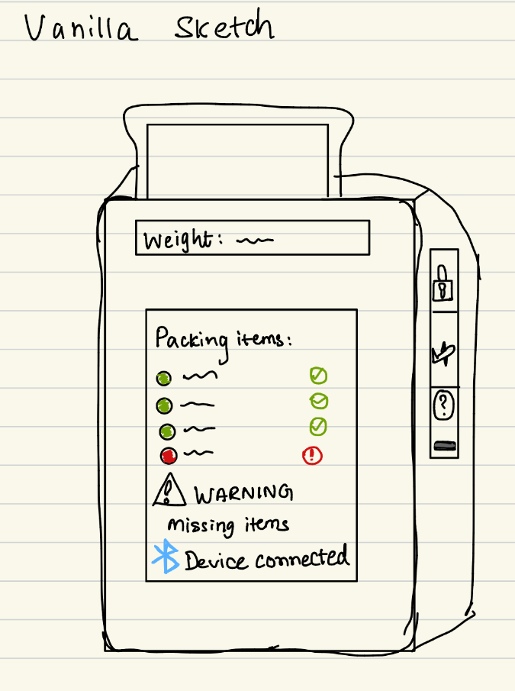

Hybrid Sketch
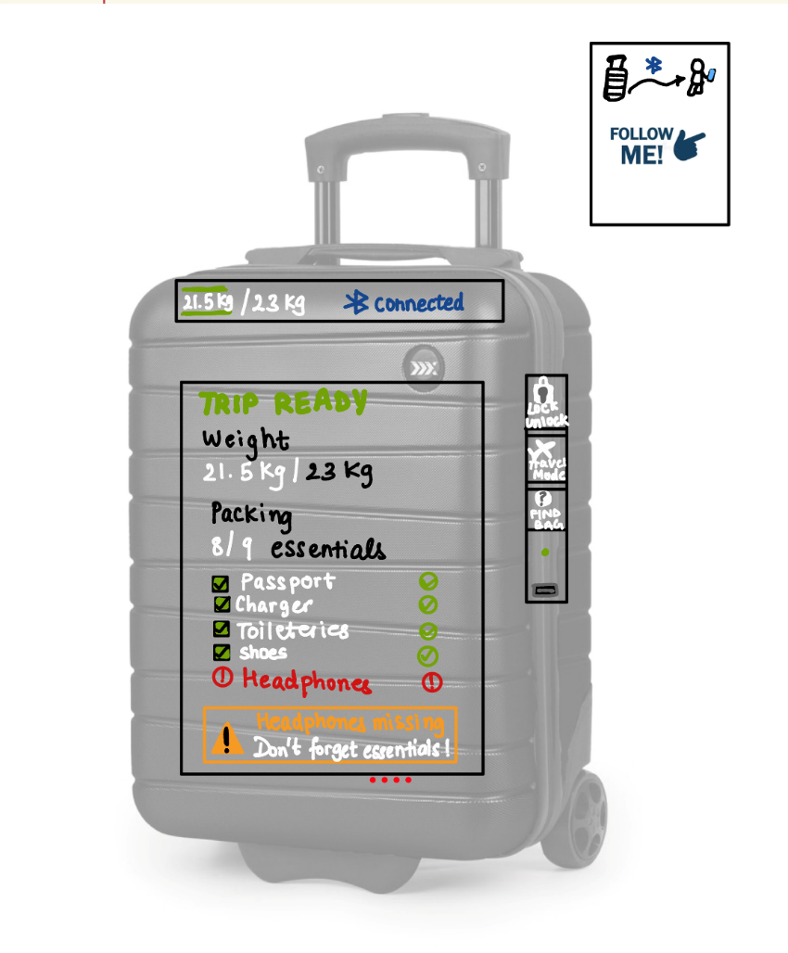

Interface Features
- Weight Monitoring- In-built weighing system that measures the weight of the bag when lifted.
- Packing Checklist- Option to create a packing checklist, that will track and indicate packed/ unpacked items on the display screen.
- Lock/ Unlock- Easy lock/ unlock functionality on the side panel that can be operated with the phone app making it more secure.
- Travel Mode- The travel mode feature ensures the bag is ready- overweight warnings, unpacked item warnings, securing the lock, and enabling flight mode.
- Find My- Feature to track the bag on your phone and keep its location in check
- Bluetooth Phone Connection- Bluetooth connection to control all smart features from a smartphone device.
- Follow Mode- SmartCase follows when the Follow Mode is activated avoiding dragging it everywhere.
- USB-C Charging- Charging port available for convenience
- Battery Monitoring- SmartCase has an internal rechargeable battery that powers the display, sensors, Bluetooth, tracking, lock system, and Follow Mode. The suitcase itself is charged through the USB-C port on the side panel by plugging it into a wall charger or power adapter.
- Open/ Closed Sensing- The bag is able to detect when it is locked/ unlocked making it safe for travel.

Testing UI
It includes controls for changing the bag’s weight, adding or removing packed items, locking/unlocking the suitcase, connecting a phone, testing battery and USB-C charging, loading different travel scenarios, and running the Follow Mode simulation. The Device UI updates immediately based on these actions, allowing the smart features to be demonstrated and tested.

Screenshots
Normal / Trip Ready
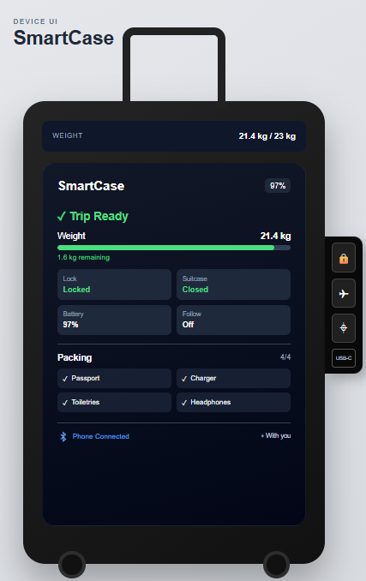

Overweight
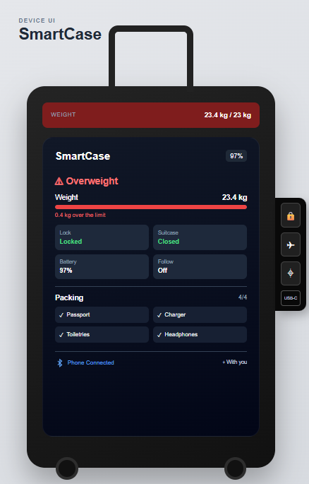

Missing Items
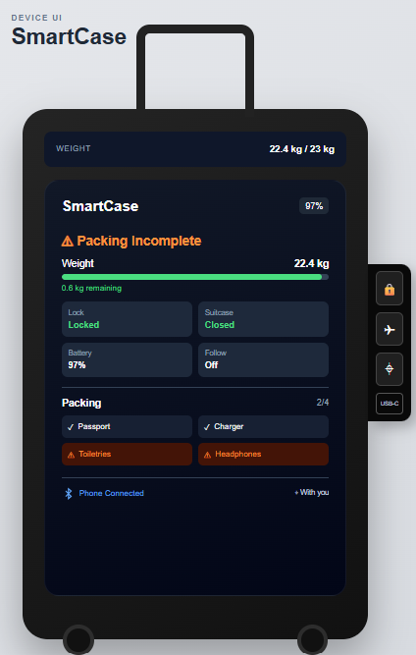
Phone Connected
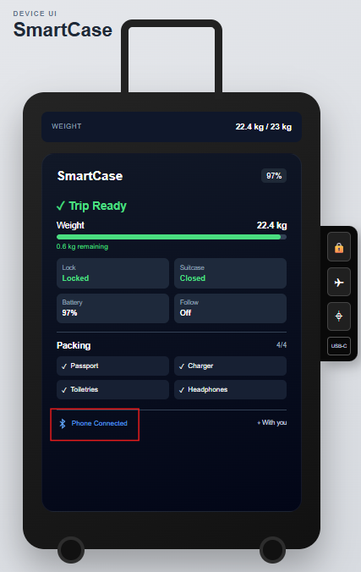

Follow Mode
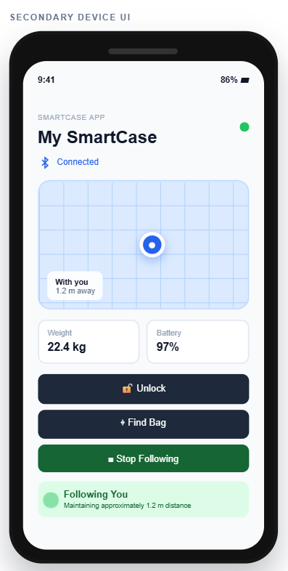

Find My
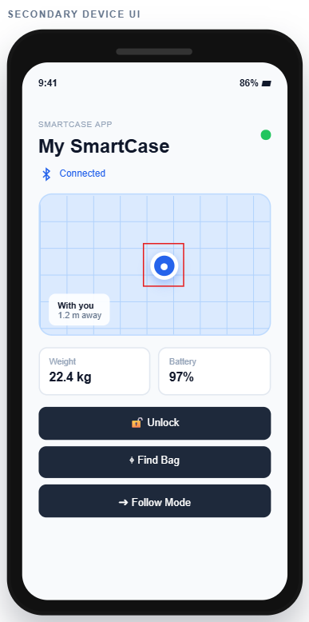

Travel Mode
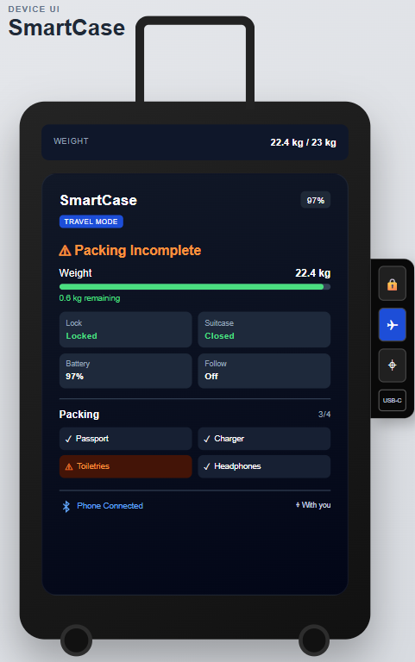
Separated Bag scenario
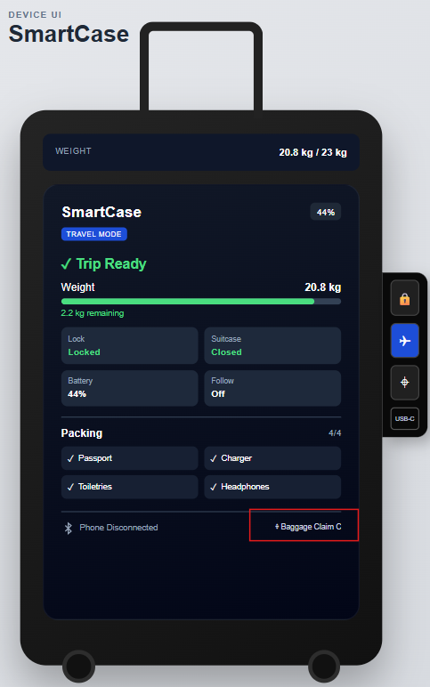

Future Work
- More realistic item sensing
- Real Bluetooth hardware
- Motorized Follow Mode
- GPS integration
- Biometric lock
- More detailed phone app

Links
GitHub- https://github.com/mariamalik2105/smart-suitcase
Vercel- https://smart-suitcase.vercel.app/
Google Doc Interview- https://forms.gle/da86zqM5NB7hH2js6

