**My portfolio - Mariam Antar**

I created my portfolio using html/css/jquery and javascript. I used bootstrap for the navigation bar on every single page. I decided to make single pages because I find it sorts out the content better and provides a clean look to the website compared to if it was only one page.

**Frameworks used**

* <https://codepen.io/stephanrusu/pen/QwKLJX>
* <https://getbootstrap.com/docs/4.0/components/navbar/>
* Bubble effect from code pen
* <https://fontawesome.com/>
* <https://fonts.google.com/>

**Design decisions**

**For the design I kept going back and forth between something minimal and something really interactive and animated. In the end i settled for a minimalistic / sleek design with a lot of vintage imagery. I wasn’t completely happy with it in the end because there was so much that I wanted to alter from the content to the contact page. I had created multiple wireframes for what I wanted and settled for the design shown below.**

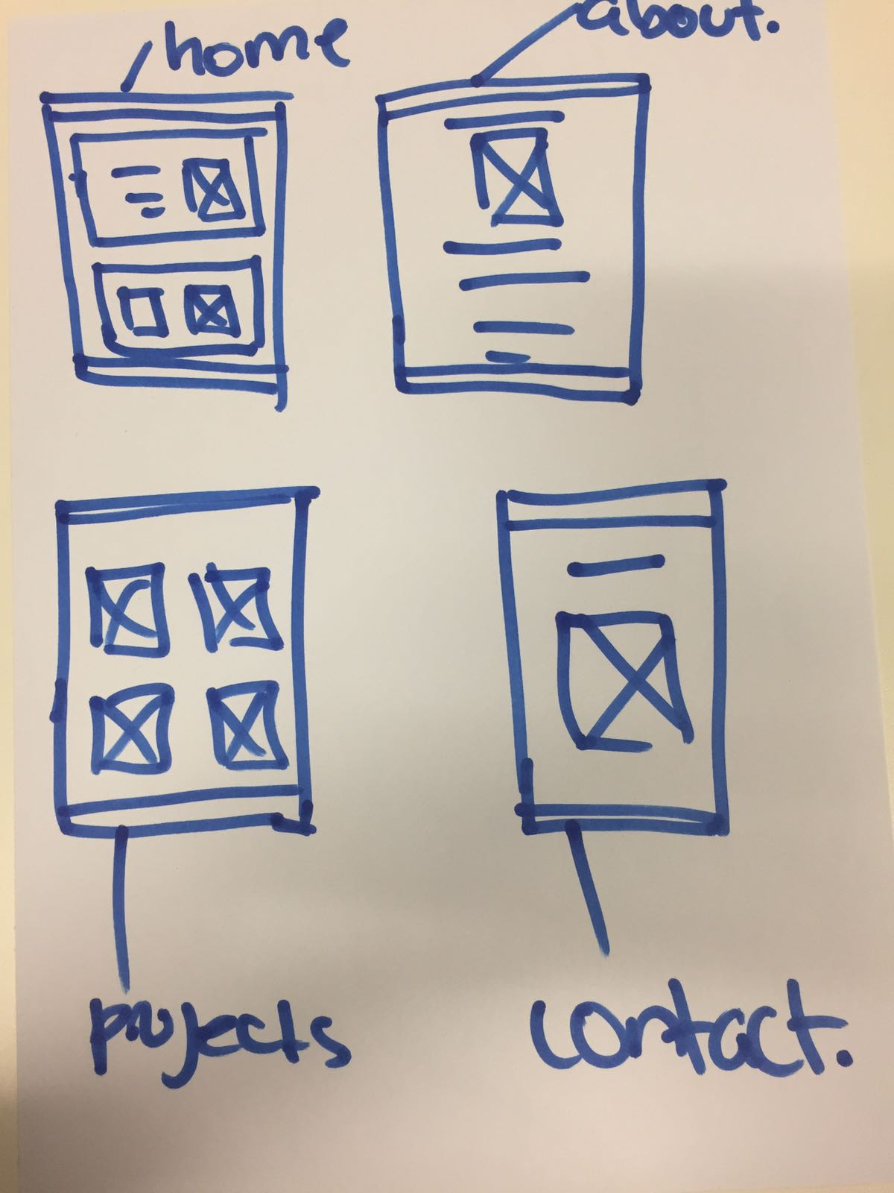

**I created four separate pages including a home page, about page, projects page and contact page with a contact form.**

**I used the book called the art of skiing for design inspiration**

**Difficulties**

**I experienced a lot of difficulties trying to get the nav bar the same on every page , centering content, getting the bubbles on the about page to go through the background because the image was stopping the bubbles from being visible. I ran out of time and couldn't make it responsive.**

**Changes I would make**

* **Prioritise tasks better**
* **Manage time better**
* **Fix header and add hover color**
* **Update about page**
* **Make the website responsive**

