Name : Mariam Muhammed Ibrahim Abdel-Fattah Year: Third

Faculty: Computers and Artificial Intelligence (CS)

Introduction to the Pandora Web Application

Welcome to our Pandora Web Application, an online platform dedicated to showcasing and managing an exquisite collection of jewelry products

#### Key Features:

1. **Product Catalog**:
   1. A comprehensive and visually appealing product catalog that displays various jewelry items, including rings, charms, bracelets, earrings, and necklaces.
   2. High-quality images and detailed descriptions for each product to help users make informed decisions
2. **Search and Filter**:
   1. An efficient search functionality allowing users to quickly find specific jewelry items by entering keywords.
   2. Advanced filtering options by category (Rings, Charms, Bracelets, Earrings, Necklaces) and material (Gold, Silver, Platinum), enabling users to narrow down their search results to find the perfect piece.
3. **Category Catalog**:
   1. A detailed category catalog that organizes jewelry items into distinct categories, making it easier for users to explore items based on their preferences.
   2. Each category includes a curated list of products that fit within that category, providing a focused browsing experience.
4. **Material Catalog**:
   1. A specialized material catalog that allows users to explore jewelry items based on their material preferences, such as Gold, Silver, or Platinum.
   2. Each material section provides a collection of items made from the chosen material, helping users find jewelry that matches their taste and requirements.
5. **Product Management**:
   1. Easy-to-use interface for managing jewelry products, including adding new items, editing existing ones, and deleting products that are no longer available.
   2. Detailed forms to capture all necessary information about each product, ensuring accurate and up-to-date catalog entries.
6. **Product Actions**:
   1. Quick access buttons for viewing detailed information, editing product details, and deleting products directly from the product listing page.
   2. Expandable sections within product cards to display additional details, providing users with a comprehensive view of each item without cluttering the interface.

Home Page:

the home page of our Jewelry Web Application features an elegant and interactive slider, his slider is a focal point of the home page, designed to capture the attention of visitors and provide them with a glimpse of the stunning collections

* **Call-to-Action Button - "Discover it now"**:

Each slide features a prominent call-to-action (CTA) button labeled "Discover it now." This button directs users to the product index view, allowing them to explore the full range of products available on our site. This strategic placement of the CTA encourages users to engage with our products and explore the detailed offerings.

### Navigation Bar Overview

The navigation bar in our Jewelry Web Application is designed to provide users with easy access to the main sections of the site. It serves as a guide, helping users navigate through the application seamlessly. Below is an overview of the key features and structure of our navigation bar.

#### Key Features:

**Brand Logo**:

* 1. The navigation bar prominently features the brand logo on the left side. Clicking the logo redirects users to the homepage, providing a quick way to return to the main page from anywhere in the application.

**Primary Navigation Links**:

* 1. **Home**: Takes users to the homepage, where they can find a general overview and featured products.
  2. **Privacy**: Directs users to the privacy policy page, ensuring transparency about how user data is handled.
  3. **Product**: Allows users to view the complete list of all products available on the site.
  4. **Category**: Allows users to view the complete list of all categories available on the site.
  5. **Material**: Allows users to view the complete list of all Materials available on the site.

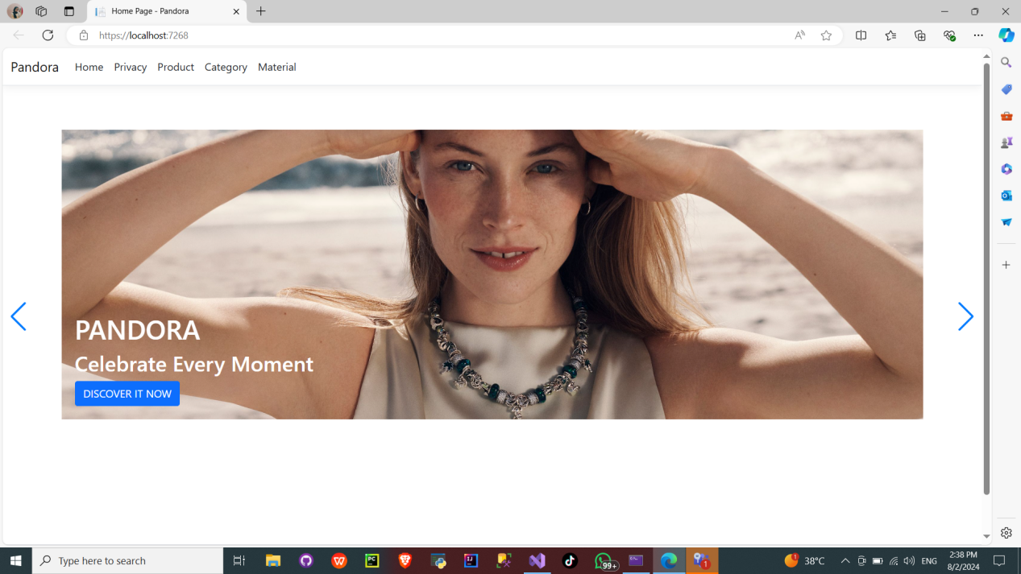

### Products Page

* **Functionality**:
  + **Create New Button**: Allows the user to add a new product.
  + **Search Bar**: Users can search for products by typing keywords and clicking the search icon.
  + **Filter Section**:
    - **Category Filter**: Users can filter products by categories such as Rings, Charms, Bracelets, Earrings, and Necklaces.
    - **Material Filter**: Users can filter products by materials such as Gold, Silver, and Platinum.
  + **Products Display**:
    - Shows a grid of products with each product displaying an image, name, price, discount, and availability status.
  + **Product Actions**:
    - **Details Button (Blue)**: View more detailed information about the product.
    - **Edit Button (Yellow)**: Edit the product's details.
    - **Delete Button (Red)**: Delete the product.
  + **Product Details Expansion**:
    - Each product card has a "+ Product Details" button. When clicked, it likely expands to show additional details about the product.
  + **Search and Filter**:
    - Similar to the first screenshot, with search functionality and category/material filters on the left side.

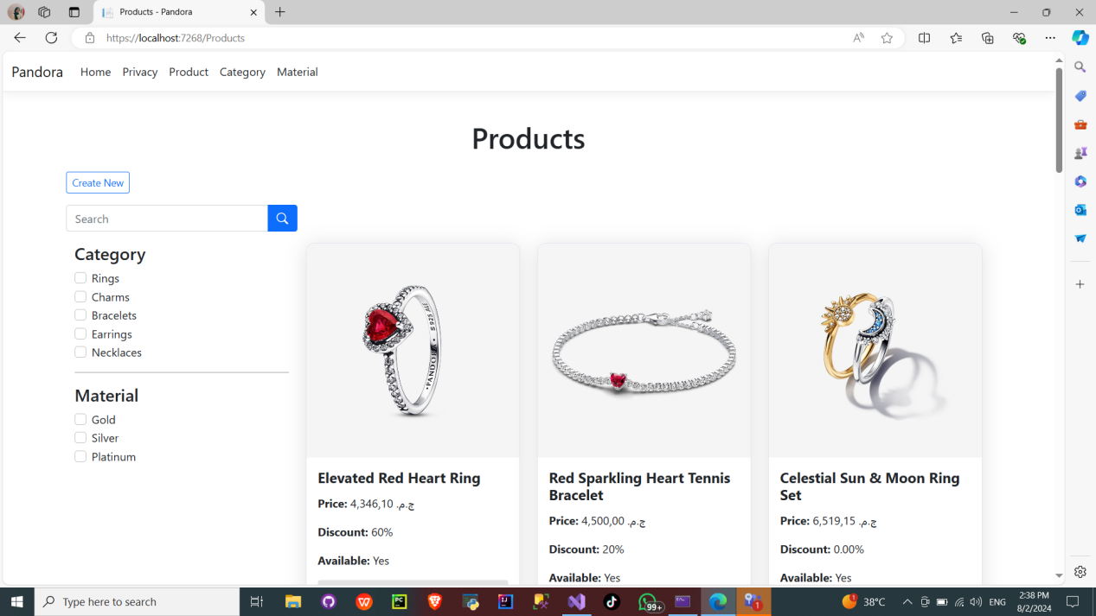

Filter Feature

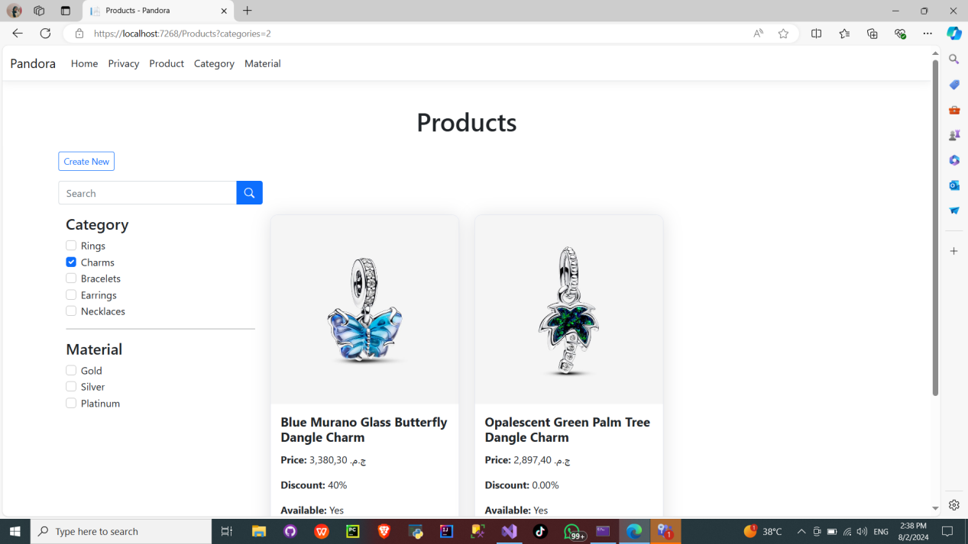

Search Feature

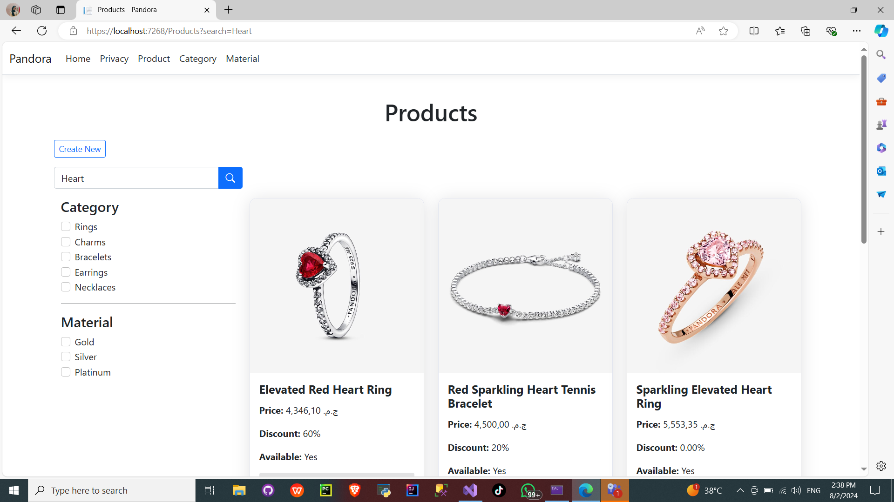

Buttons

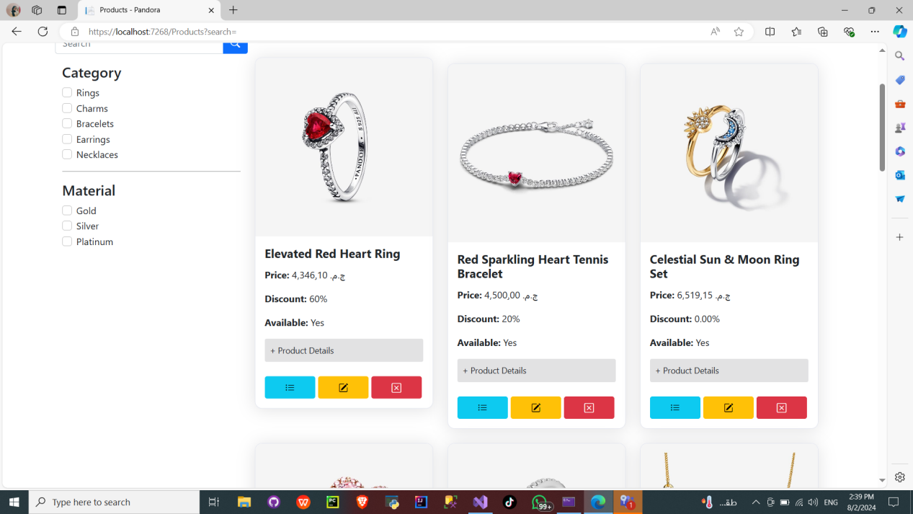

Product Details

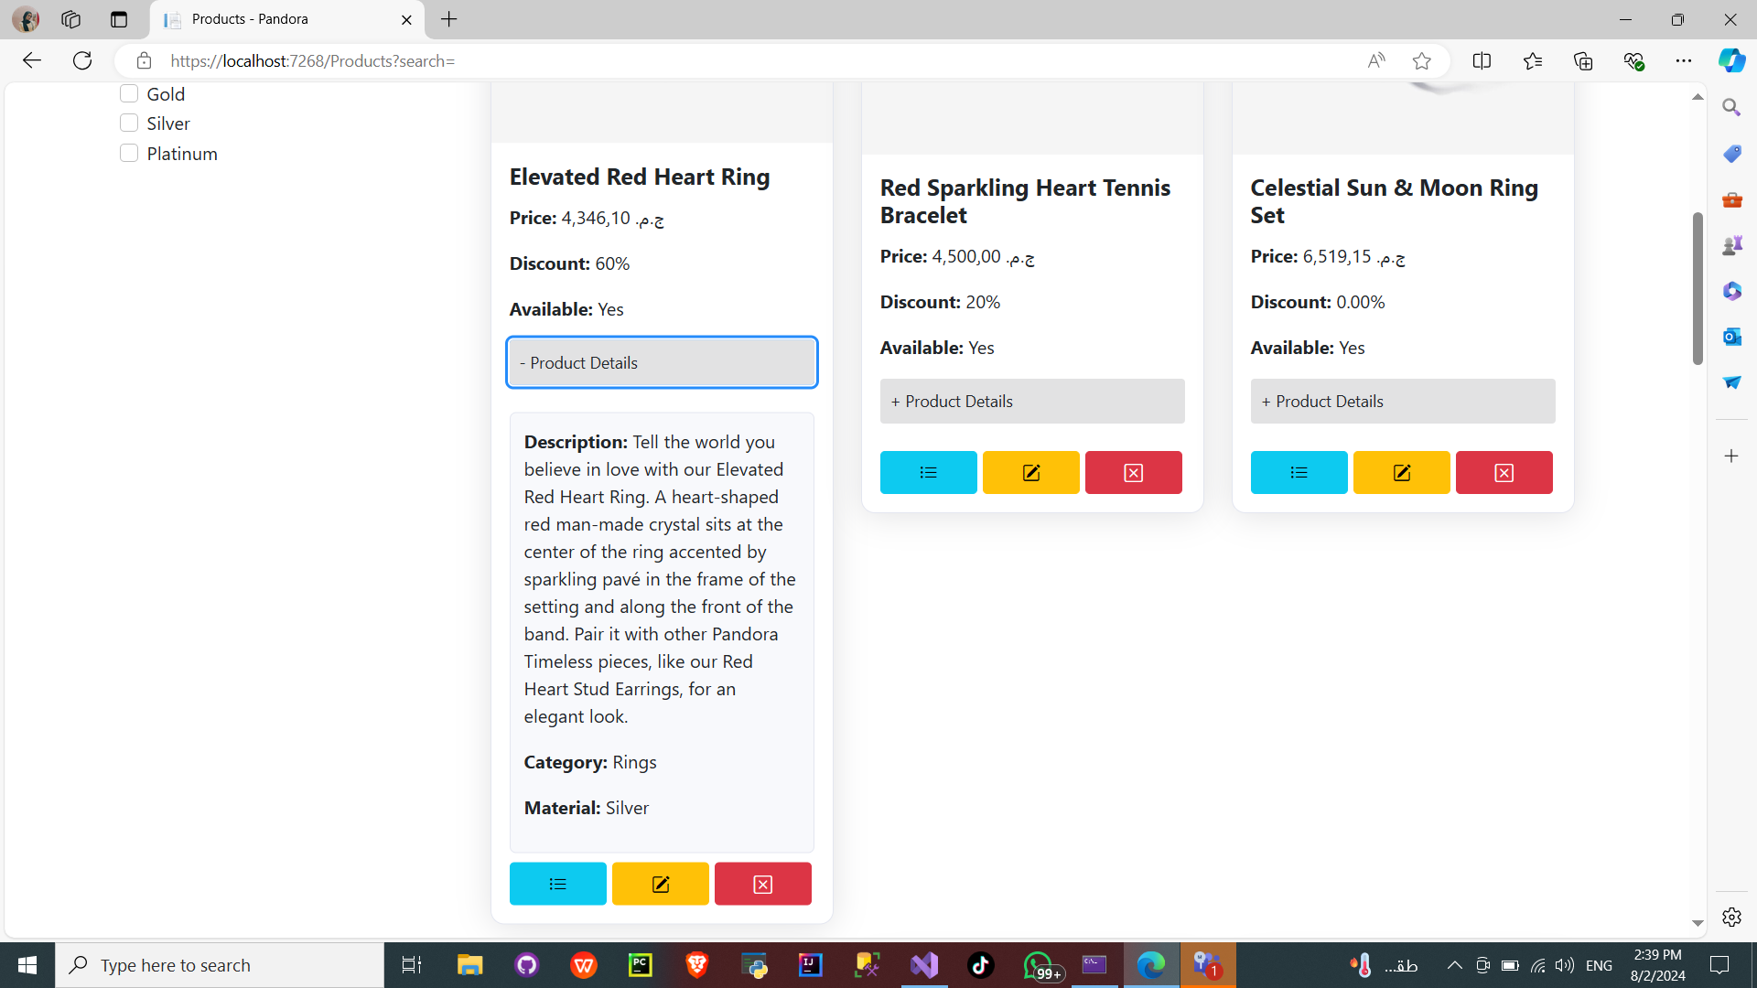

Details Page

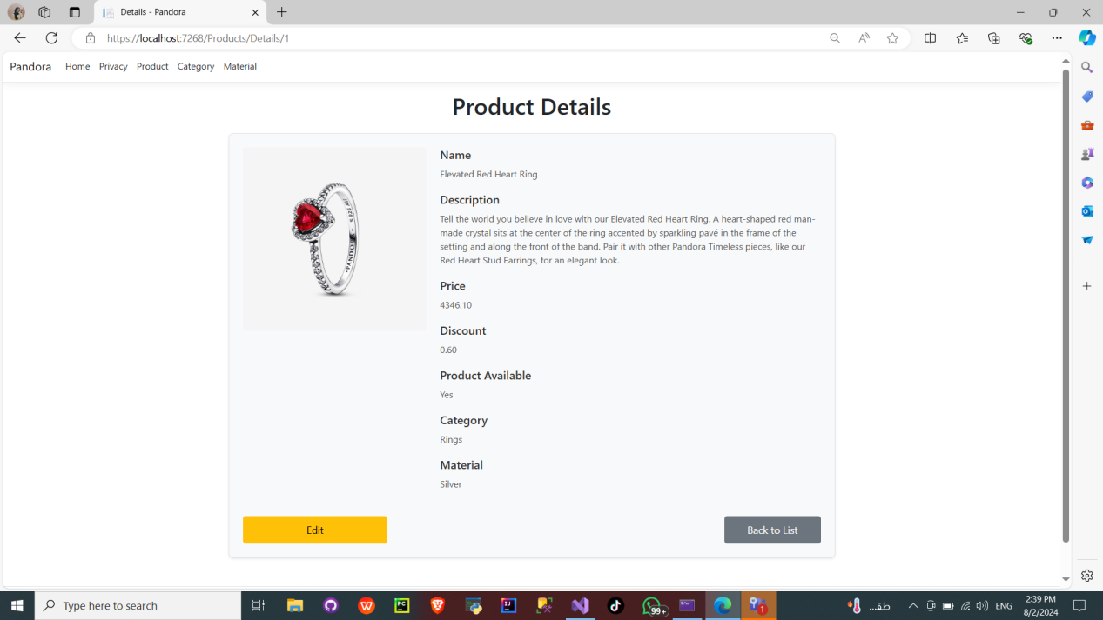

Edit Page

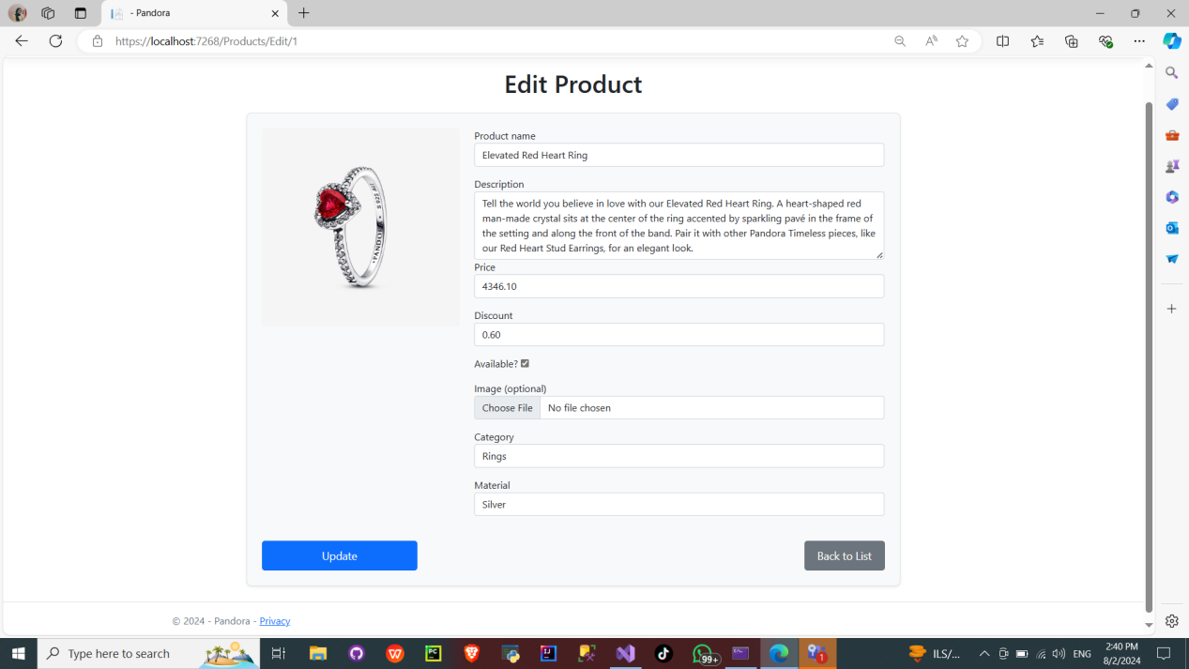

Delete Page

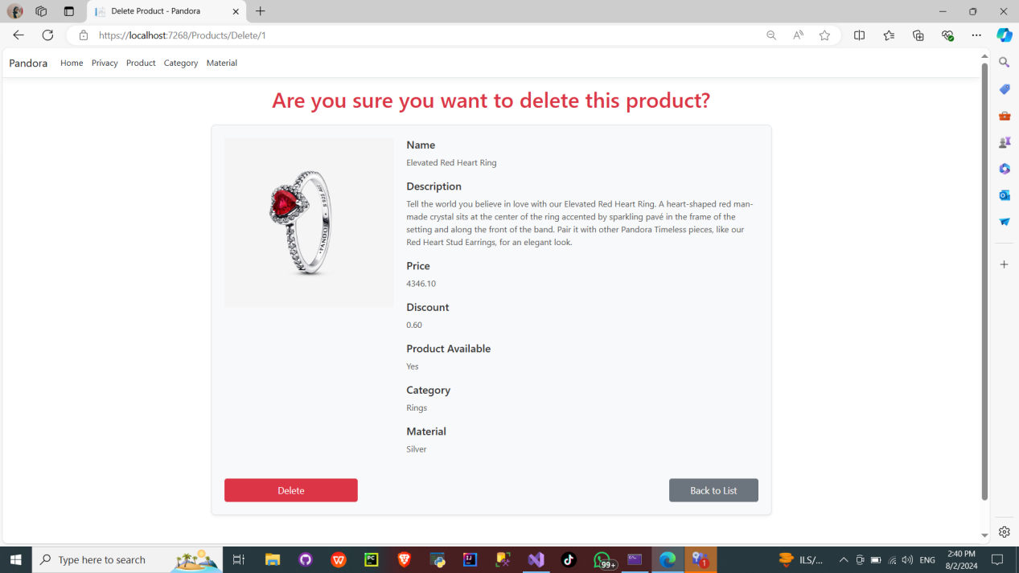

Create New Page

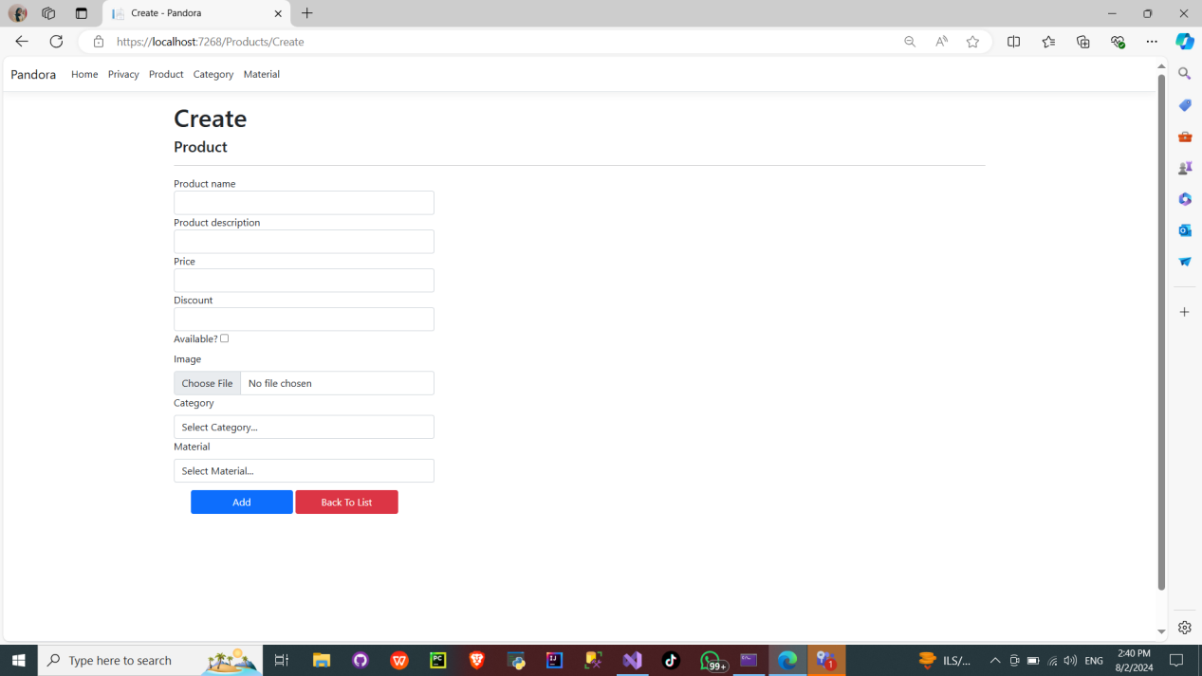

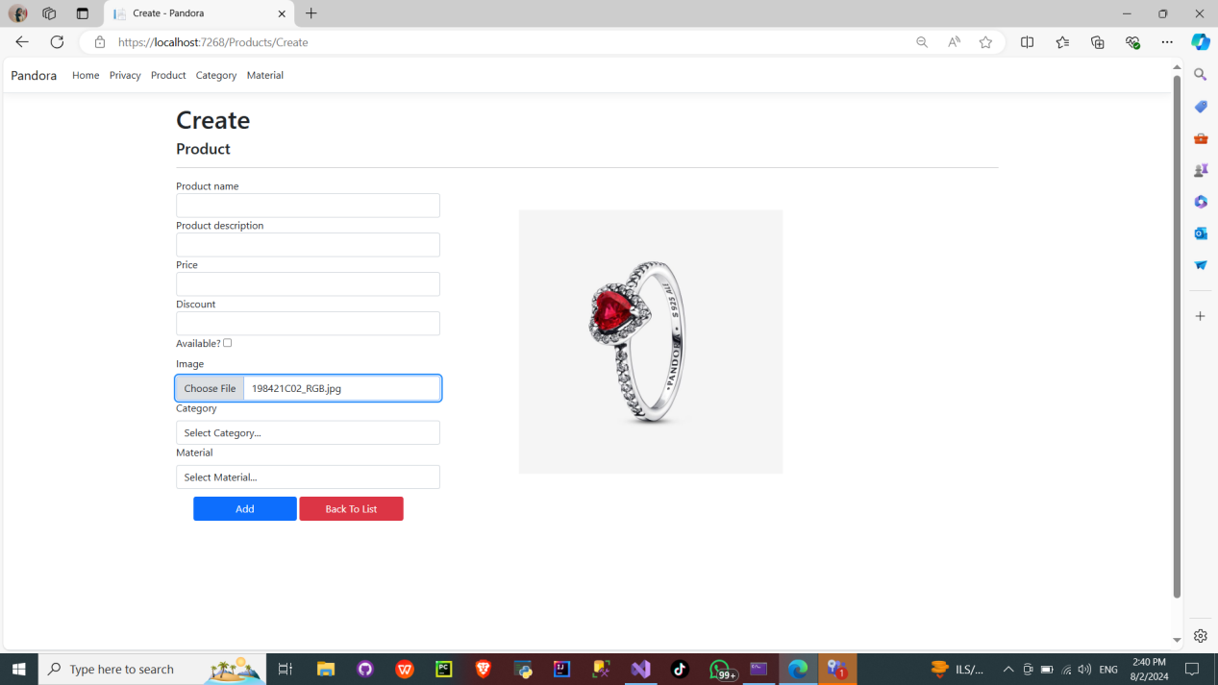

### Category Page

The Category page serves as the index view for the Category table within our Jewelry Web Application. This page is designed to facilitate the management of categories, allowing users to add, edit, delete, and view details of different jewelry categories. Here’s a detailed overview of the Category page and its features:

#### Key Features:

**Organized Layout**:

* 1. The Category page is neatly organized, presenting users with a structured view of all available categories. This layout helps users quickly navigate through different categories without feeling overwhelmed.

**Category List**:

* 1. The main section of the page displays a comprehensive list of jewelry categories. Each category is showcased with its name and relevant actions.

**Add New Category**:

* 1. At the top of the page, there is a prominent button labeled "Create New" which allows users to add a new category to the database. Clicking this button directs users to a form where they can enter the necessary details for the new category.

**Actions for Each Category**:

* 1. For each category listed, the following actions are available:
     1. **View Details**: Allows users to see detailed information about the category, including its description and associated products.
     2. **Edit**: Enables users to modify the category details. Clicking the edit button takes users to a form where they can update the category information.
     3. **Delete**: Allows users to remove the category from the database. A confirmation prompt ensures that users do not accidentally delete a category.

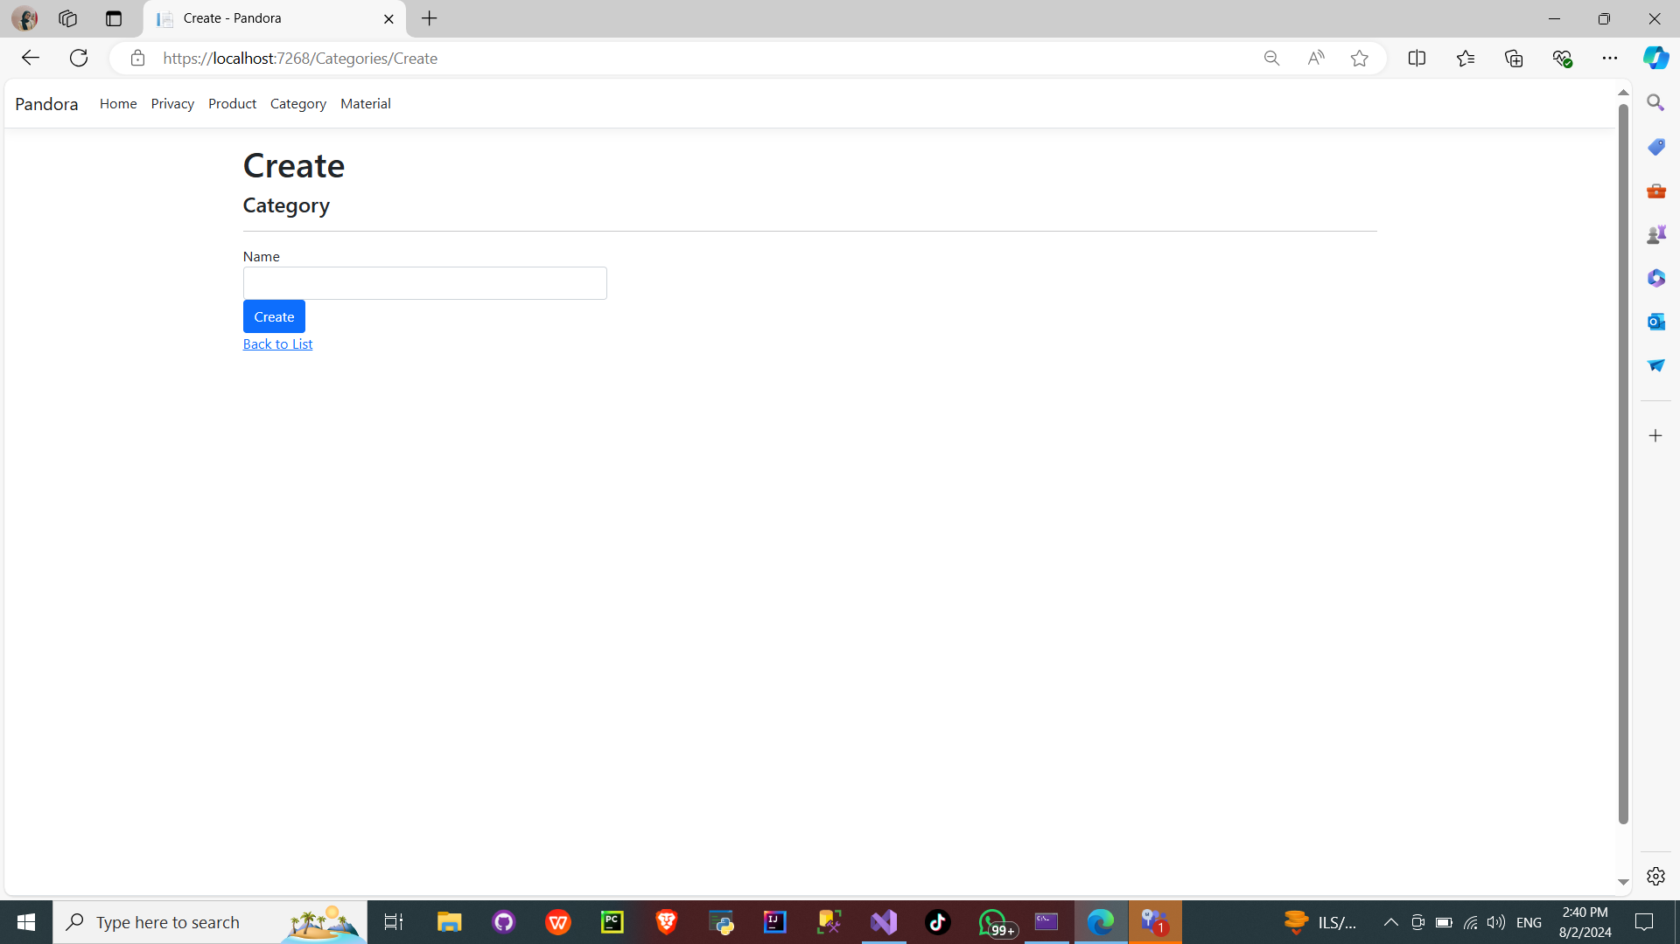

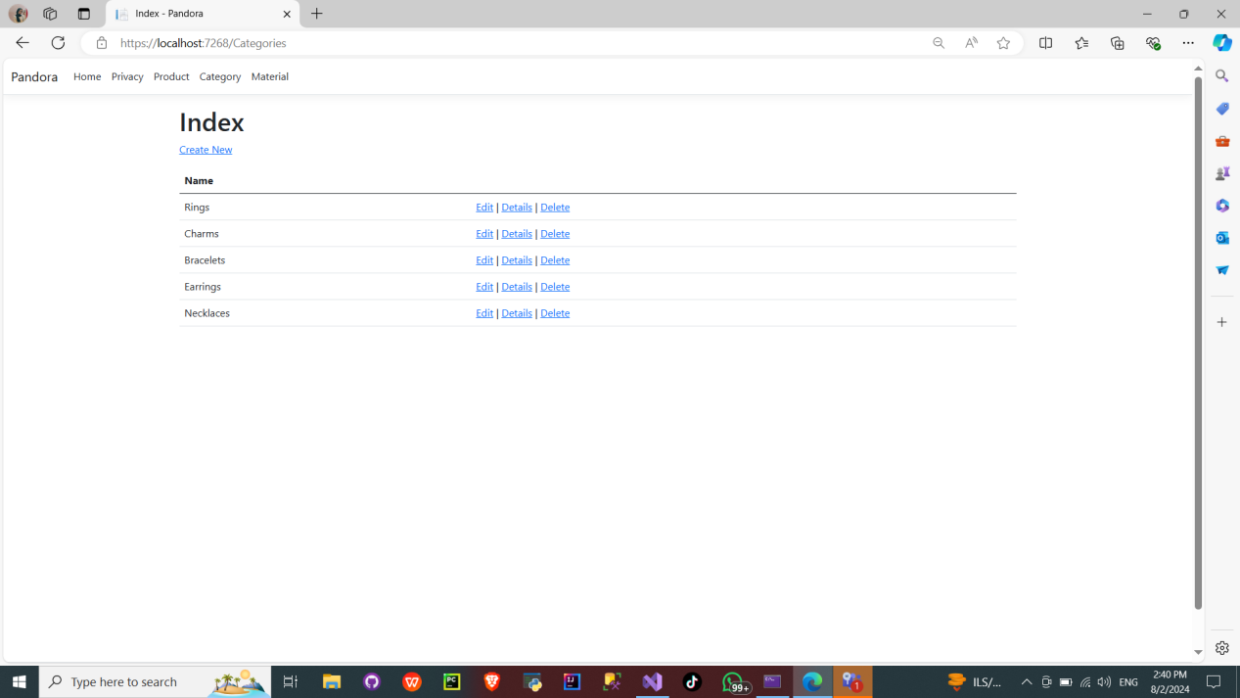

### Material Page

The Material page functions as the index view for the Material table in our Jewelry Web Application. It provides a comprehensive interface for managing materials used in jewelry items, allowing users to add, edit, delete, and view details of different materials. Below is a detailed description of the Material page and its features:

#### Key Features:

**Organized Layout**:

* 1. The Material page is designed with a clean and structured layout, making it easy for users to navigate through the list of materials. This organized view helps users quickly find and manage materials.

**Material List**:

* 1. The central part of the page displays a list of all materials available in the system. Each material is presented with its name and relevant actions.

**Add New Material**:

* 1. At the top of the page, a "Create New" button is prominently displayed. This button allows users to add a new material to the database. Clicking it directs users to a form where they can enter the necessary details for the new material.

**Actions for Each Material**:

* 1. For each material listed, the following actions are available:
     1. **View Details**: Provides users with detailed information about the material, including its properties and associated products.
     2. **Edit**: Enables users to update the material's information. Clicking the edit button takes users to a form where they can modify the material details.
     3. **Delete**: Allows users to remove the material from the database. A confirmation prompt ensures that users do not accidentally delete a material.

