ML OPS
Assignment 2
Mariam Fatima
22F-3168

Task 1: Project Setup + Version Control (Git + DVC)

Create Project Structure
Screenshot of folder structure
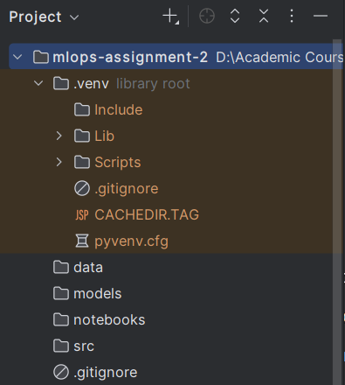
Activity:
• Initialize git
• Add .gitignore
• Create a Python environment
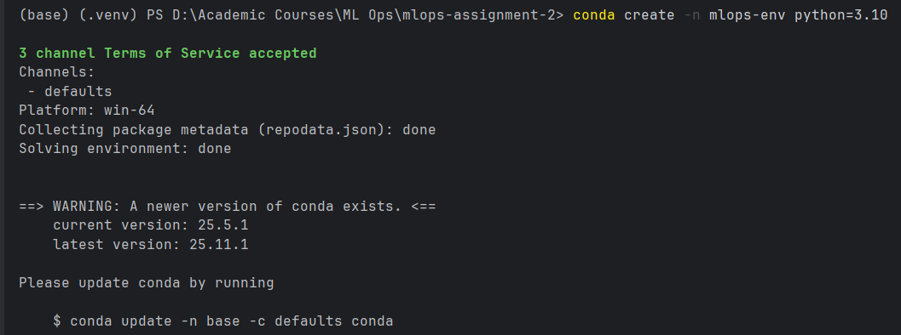
Screenshot of git init output 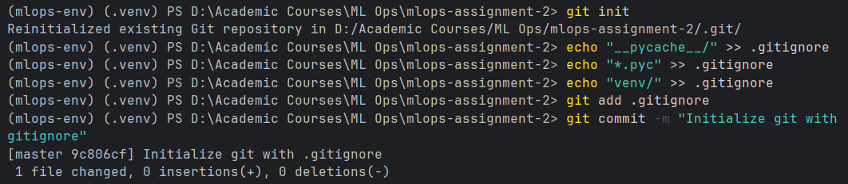

Initialize DVC
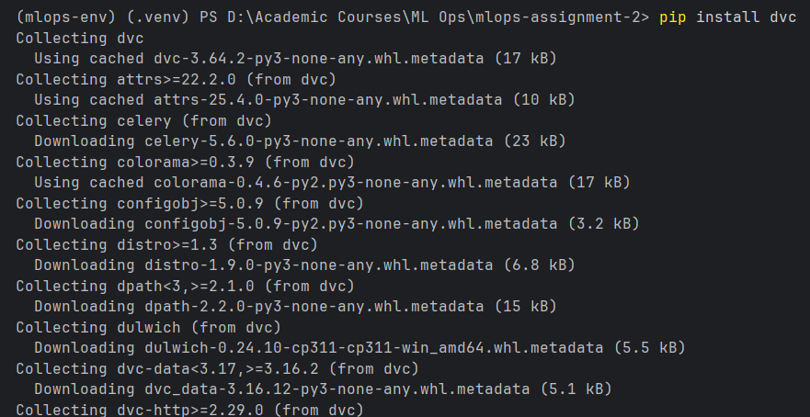
Run:
dvc init
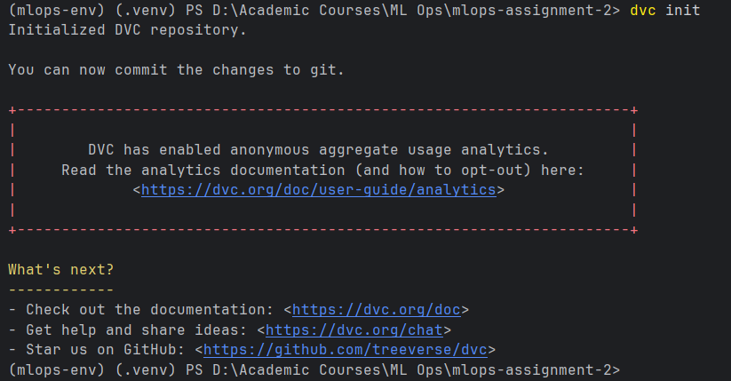
dvc remote add -d myremote ./dvcstore
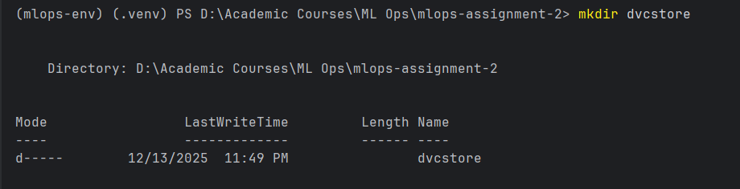
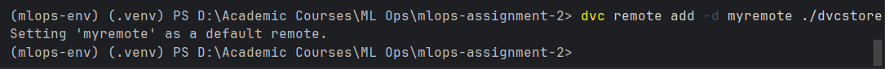
Activity:
• Add dataset to data/
• Track it using DVC:
dvc add data/dataset.csv
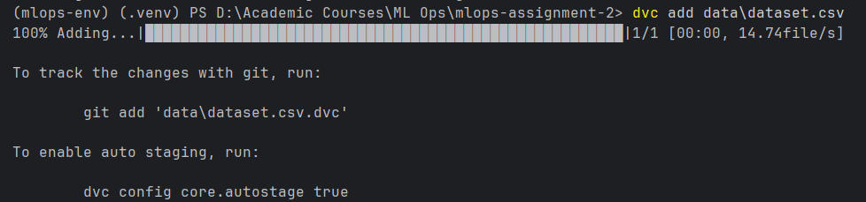
git add data/.gitignore data/dataset.csv.dvc
git commit -m "Add dataset with DVC"
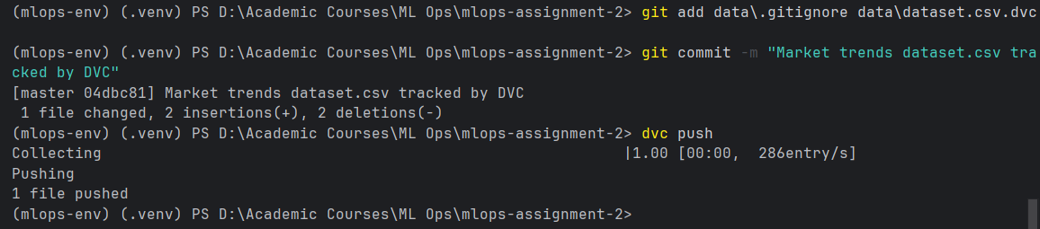
Deliverables:
• Screenshot of DVC commands
• Screenshot of .dvc file
• DVC status/output logs

Create a Basic Training Pipeline
Create src/train.py that:
• Loads dataset
• Trains a small model
• Saves model to models/model.pkl
Create DVC pipeline:
dvc run -n train_model \
-d src/train.py -d data/dataset.csv \
-o models/model.pkl \
python src/train.py
Deliverables:
• Screenshot of successful DVC pipeline run
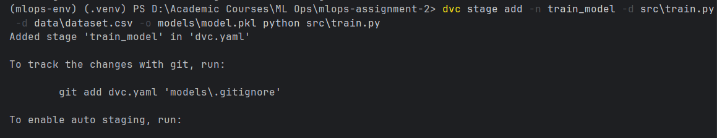
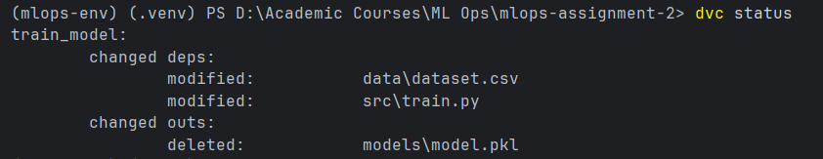
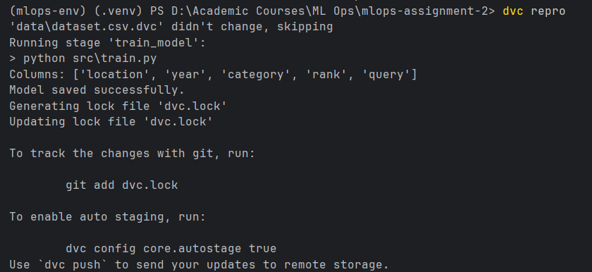

• dvc.yaml file screenshot
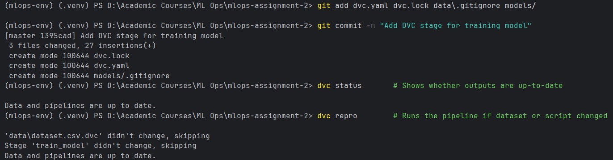
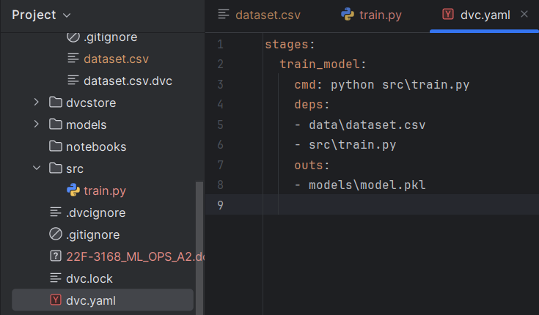

Task 2 — CI/CD Pipeline (GitHub Actions)

2.1. Create Workflow File
In .github/workflows/ci.yml:
Include steps:
• Setup Python
• Install requirements
• Run unit tests
• Run linting (flake8 or pylint)
• Verify training script runs
Deliverables:
• Screenshot of workflow file
• Screenshot of GitHub Actions successful run
• Include failing workflow screenshot if any

2.2. Add Tests
In tests/test_train.py, write tests for:
• Data loading
• Model training
• Shape validation
Deliverables:
• Screenshot of test results

Task 3: Docker (Full Assignment)

3.1. Create Dockerfile
Container should:
• Install dependencies
• Copy project files
• Run training script or API
Example:
FROM python:3.10
WORKDIR /app
COPY . .
RUN pip install -r requirements.txt
CMD ["python", "src/train.py"]
Activity:
Build and run the container:
docker build -t mlops-app .
docker run mlops-app
Deliverables:
• Dockerfile screenshot
• Build logs
• Running container screenshot

3.2. Push Docker Image to Docker Hub
Commands:
docker tag mlops-app yourusername/mlops-app:v1
docker push yourusername/mlops-app:v1
Deliverables:
• Screenshot of Docker Hub repository page
• Screenshot of push logs

Task 4:Airflow Pipeline

4.1. Install Airflow Locally (Docker Compose)
Use Airflow official docker-compose file.
Activity:
• Create DAG train_pipeline.py that:
o Loads data
o Trains model
o Saves trained model
o Logs results

Deliverables:
• Screenshot of Airflow UI
• Screenshot of DAG graph
• Screenshot of successful job run

Task 5: RESTful API (FastAPI/Flask)

5.1. Build ML Inference API
Create api/main.py:
Endpoints:
• /predict → returns model prediction
• /health → returns status
Run:
uvicorn api.main:app --reload
Deliverables:
• Screenshot of API running
• Screenshot of testing using Postman/cURL
• Sample prediction outputs

5.2. Containerize the API
Modify Dockerfile:
CMD ["uvicorn", "api.main:app", "--host", "0.0.0.0", "--port", "8000"]
Run:
docker build -t mlops-api .
docker run -p 8000:8000 mlops-api
Deliverables:
• API running in Docker screenshot

Task 6: AWS EC2 + S3 Deployment (Free Tier)

6.1. Create AWS S3 Bucket
Activity:
• Create bucket
• Upload dataset
• Configure permissions
• Generate bucket URL
Deliverables:
• Screenshot of S3 bucket
• Screenshot of uploaded data

6.2. Launch EC2 Instance (Free Tier)
• Choose Ubuntu 22.04
• Open port 8000 for API
• Install dependencies
Run:
sudo apt update
sudo apt install docker.io python3-pip
Deliverables:
• Screenshot of EC2 instance dashboard

• Screenshot of instance SSH terminal

6.3. Deploy API Using Docker on EC2
Commands:
docker pull yourusername/mlops-api:v1
docker run -d -p 8000:8000 yourusername/mlops-api:v1
Deliverables:
• Screenshot of logs
• Screenshot of running container
• Public endpoint test screenshot (browser/Postman)

Task 7: Final Deliverables and Reflection
Students must submit:
1. GitHub repository link
2. Docker Hub link
3. Airflow DAG screenshot
4. EC2 Public API URL
5. DVC pipeline screenshot
6. CI/CD workflow screenshot
7. Report with:
o Problems faced
o Fixes applied
o Learning summary

