CPU Scheduling
Algorithms Comparison
Round Robin · Shortest Job First · Shortest Remaining Time First

Operating Systems Lab Report
Repo URL: https://github.com/mariamibrahim3646-ui/os-project

Introduction

This report presents a comparative analysis of three CPU scheduling algorithms — Round Robin (RR), Shortest Job First (SJF), and Shortest Remaining Time First (SRTF) — across four distinct workload scenarios and one validation scenario. Each scenario was executed using a web-based scheduling simulator, and the results were recorded directly from the simulator output.
Global Assumptions
- All processes are CPU-bound; no I/O bursts are considered.
- Context switching overhead is assumed to be zero.
- SJF is non-preemptive: once a process starts, it runs to completion.
- SRTF is the preemptive version of SJF; a running process is preempted if a new arrival has a shorter remaining time.
- Round Robin uses a fixed Time Quantum (Q) specified per scenario.
- Process arrival times and burst times are taken directly from the simulator input panels (verified via screenshots).
- All metrics — Waiting Time (WT), Turnaround Time (TAT), and Response Time (RT) — are measured in time units as displayed by the simulator.

Global Limitations
- The simulator does not model I/O-bound or mixed workloads; results apply only to CPU-bound processes.
- Burst times are assumed to be known in advance for SJF/SRTF, which is not realistic in real operating systems.
- No priority-based scheduling is considered; all processes are treated as equal priority.
- The analysis is limited to the specific scenarios provided; generalization to all workloads requires caution.
- The 'Activate Windows' watermark visible in some screenshots had no effect on simulator output.

Algorithms Overview & Metrics Reference

Before diving into the scenario results, this section provides a concise reference for the three scheduling algorithms and defines the three core performance metrics used throughout the report.
Scheduling Algorithms — Side-by-Side Comparison

Property | Round Robin (RR) | Shortest Job First (SJF) | Shortest Remaining Time First (SRTF)
Type | Preemptive | Non-Preemptive | Preemptive
Selection Basis | Time quantum (Q) — each process runs for at most Q time units per turn, then goes back to the queue | Shortest total burst time — once a process starts it runs to completion with no interruption | Shortest remaining burst time — a newly arrived process can preempt the running one if it has less remaining time
Starvation Risk | None — all processes rotate equally regardless of burst time | Yes — a long job that arrives early can block all short jobs | Yes — long jobs can starve if short jobs keep arriving continuously
Burst Time Needed? | No | Yes — full burst time must be known in advance | Yes — remaining burst time must be known at every new arrival
Best For | Fairness & interactivity; equal or unknown burst-time workloads | Batch systems with known short jobs and no long-job conflicts | Mixed workloads requiring lowest WT and RT; optimal average performance

How We Calculate TAT, WT, and RT

Metric | Formula | What It Means | Quick Example (AT=1, BT=4, Finish=8, First CPU=3)
Turnaround Time (TAT) | TAT = Finish Time − Arrival Time | Total time from when the process arrives until it fully completes. Covers both time spent waiting AND time spent running on CPU. | TAT = 8 − 1 = 7
Waiting Time (WT) | WT = TAT − Burst Time | Time the process spent in the ready queue doing nothing. Equals TAT minus the actual CPU execution time (Burst Time). | WT = 7 − 4 = 3
Response Time (RT) | RT = First CPU Time − Arrival Time | Time from arrival until the process gets the CPU for the very first time. For non-preemptive algorithms RT = WT; for RR and SRTF it can be lower since the process may get an early slice. | RT = 3 − 1 = 2

Key relationships: TAT = WT + BT | WT = TAT − BT | RT ≤ WT (always) | Avg = Sum ÷ number of processes

Scenario A — Basic Mixed Workload

Preset: Scenario A – Basic mixed workload
Time Quantum (RR): 3
Processes: 4 (P1–P4 with varying arrival and burst times)

Simulator Screenshot — Input Panel
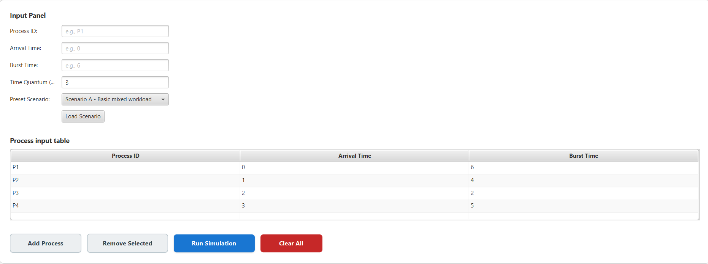
Figure: Scenario A input panel showing process configuration (Q = 3)
Process Input Data
Process ID | Arrival Time | Burst Time
P1 | 0 | 6
P2 | 1 | 4
P3 | 2 | 2
P4 | 3 | 5

Simulator Screenshot — Gantt Charts & Results
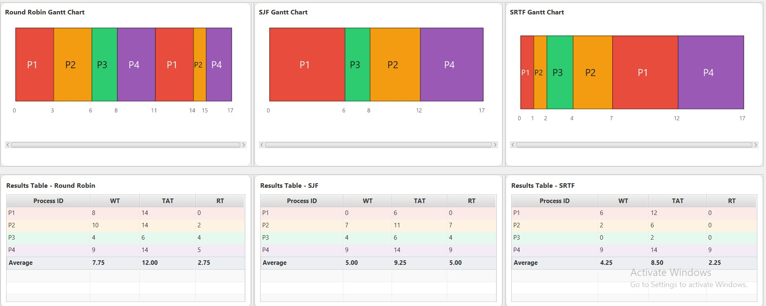
Figure: Scenario A — Gantt charts and results tables for RR, SJF, and SRTF

Numerical Results
Process ID | Round Robin |  |  | SJF |  |  | SRTF
 | WT | TAT | RT | WT | TAT | RT | WT | TAT | RT
P1 | 8 | 14 | 0 | 0 | 6 | 0 | 6 | 12 | 0
P2 | 10 | 14 | 2 | 7 | 11 | 7 | 2 | 6 | 0
P3 | 4 | 6 | 4 | 4 | 6 | 4 | 0 | 2 | 0
P4 | 9 | 14 | 5 | 9 | 14 | 9 | 9 | 14 | 9
Average | 7.75 | 12.00 | 2.75 | 5.00 | 9.25 | 5.00 | 4.25 | 8.50 | 2.25

Assumptions for Scenario A
- Process arrival times and burst times are taken directly from the simulator input panel: P1(AT=0,BT=6), P2(AT=1,BT=4), P3(AT=2,BT=2), P4(AT=3,BT=5).
- RR uses a fixed quantum of 3 time units per slice. P1 gets the first slice (0–3), then P2 (3–6), then P3 (6–8, completes), then P4 (8–11), then P1 resumes (11–14, completes), then P2 (14–15, completes), then P4 (15–17, completes).
- SJF is non-preemptive: P1 starts first at time 0 (no other process has arrived yet), runs 6 units; at t=6, P3 (BT=2) is shortest so it runs next, then P2 (BT=4), then P4 (BT=5).
- SRTF is preemptive: P1 starts at t=0, P2 arrives at t=1 (remaining 4 < P1 remaining 5) so P2 preempts; P3 arrives at t=2 (BT=2 < P2 remaining 3) so P3 preempts and finishes at t=4; then P2 resumes, P1 resumes, P4 runs last.
- Ties in SJF/SRTF are broken by process order (lower process number scheduled first).

Limitations for Scenario A
- With only 4 processes, the dataset is small; results may not generalise to larger or more complex workloads.
- The quantum value of 3 was set by the preset; a smaller quantum would improve RR response time at the cost of more context switches, while a larger quantum would move RR behaviour closer to FCFS.
- SJF requires advance knowledge of burst times, which is not available in real operating systems without estimation heuristics.

Required Conclusion
- Which algorithm performed better on each major metric?
SRTF performed best on all three metrics: avg WT = 4.25, avg TAT = 8.50, avg RT = 2.25. SJF ranked second (avg WT = 5.00, avg TAT = 9.25, avg RT = 5.00). Round Robin was weakest with avg WT = 7.75, avg TAT = 12.00, avg RT = 2.75.
- Did Round Robin appear more balanced?
Yes. RR distributed CPU time in turns among all four processes, giving each process an early first response (P1 at t=0, P2 at t=3, P3 at t=6, P4 at t=8). Individual waiting times were more spread out (4–10 units) compared to SJF where P4 waited 9 units.
- Did SJF appear more efficient?
Yes, compared to RR. SJF reduced avg WT by 35% (5.00 vs 7.75) and avg TAT by 23% (9.25 vs 12.00) by scheduling P3 (BT=2) immediately after P1 completes. However, SJF's avg RT of 5.00 is significantly worse than SRTF's 2.25.
- Observed effect of the selected quantum (Q = 3)?
Q=3 is smaller than most burst times (BT: 6, 4, 2, 5), resulting in multiple context switches. P1 (BT=6) required two slices, P2 (BT=4) required two slices, and P4 (BT=5) required two slices. Only P3 (BT=2) finished within a single quantum. This increased waiting times significantly for all processes under RR.

Required Analysis Questions
- Which algorithm gave lower average waiting time?
SRTF gave the lowest avg WT = 4.25, followed by SJF (5.00) and RR (7.75). SRTF's preemptive nature allowed short jobs to run as soon as they arrived, minimising their wait.
- Which algorithm gave lower average response time?
SRTF gave the lowest avg RT = 2.25. Notably, three of the four processes (P1, P2, P3) had RT = 0 under SRTF, meaning they began execution immediately or within 2 time units of arrival. RR's avg RT of 2.75 is close but slightly higher due to processes waiting for a full quantum rotation.
- Did Round Robin appear fairer across all processes?
Yes. RR ensured every process received CPU time early (first response within 8 time units for all), preventing any process from being completely blocked. However, the repeated context switching inflated all waiting and turnaround times.
- Did SJF complete short jobs more efficiently?
Yes. P3 (BT=2, the shortest job) was scheduled immediately after P1 completed under SJF, giving it WT=4 and TAT=6. Under RR, P3 had WT=4 and TAT=6 as well — coincidentally the same — but P2 and P4 fared much worse under RR. Overall, SJF benefited the shorter processes at the expense of longer ones like P4.
- How did the chosen quantum affect Round Robin behaviour?
Q=3 caused six context switches across the 17-unit schedule (at t=3,6,8,11,14,15). P1 and P4 each needed two quantum slices to complete, while P3 finished before exhausting its first quantum. A larger quantum (e.g., Q=5) would reduce context switches but would delay shorter jobs, moving RR closer to FCFS behaviour.
- Which algorithm would you recommend for this workload, and why?
SRTF is recommended. It achieved the best results on all three metrics — lowest avg WT (4.25), lowest avg TAT (8.50), and lowest avg RT (2.25). Its preemptive approach naturally handles the mixed-burst workload by immediately prioritising shorter remaining jobs. The only drawback is the requirement to know remaining burst times, which in practice requires estimation.

Scenario B — Short-Job-Heavy Case

Preset: Scenario B – Short-job-heavy case
Time Quantum (RR): 2
Processes: 5 (P1–P5 with small burst times: 1–3 time units)

Simulator Screenshot — Input Panel
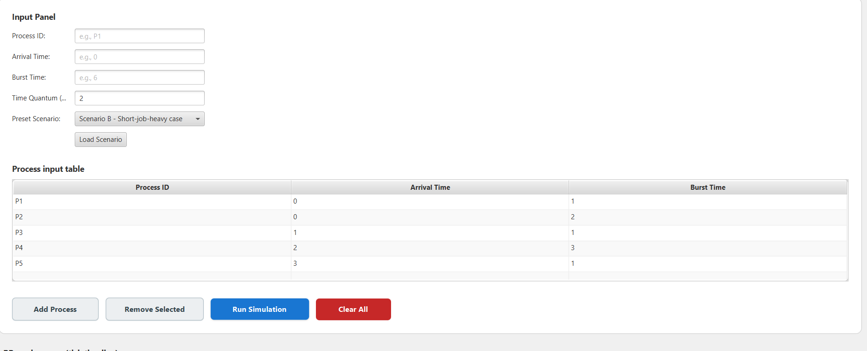
Figure: Scenario B input panel — all burst times ≤ 3 (Q = 2)
Process Input Data
Process ID | Arrival Time | Burst Time
P1 | 0 | 1
P2 | 0 | 2
P3 | 1 | 1
P4 | 2 | 3
P5 | 3 | 1

Simulator Screenshot — Gantt Charts & Results
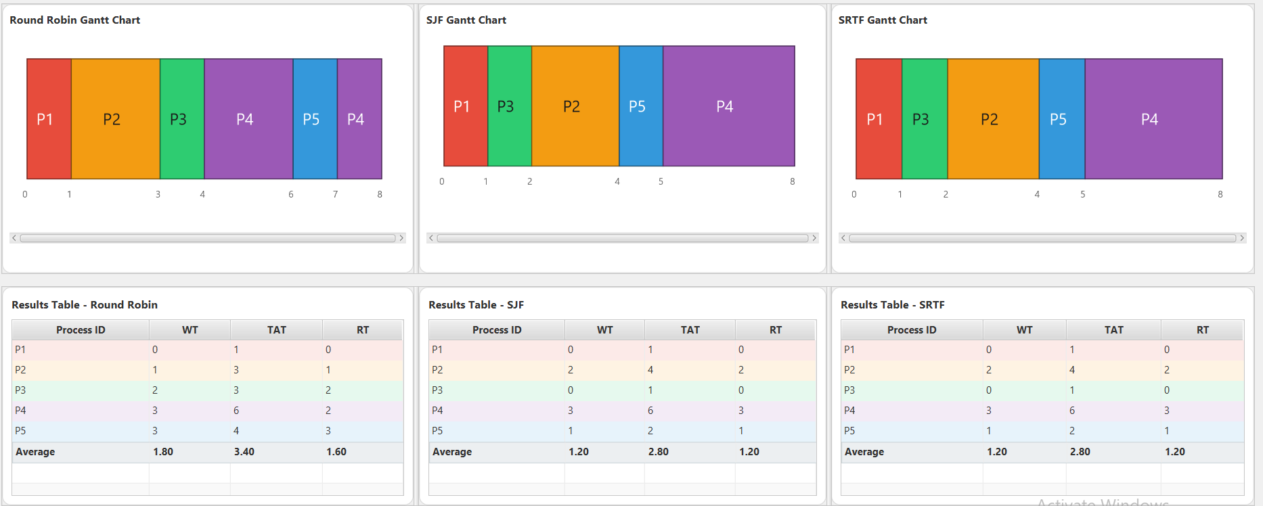
Figure: Scenario B — Gantt charts and results tables for RR, SJF, and SRTF

Numerical Results
Process ID | Round Robin |  |  | SJF |  |  | SRTF
 | WT | TAT | RT | WT | TAT | RT | WT | TAT | RT
P1 | 0 | 1 | 0 | 0 | 1 | 0 | 0 | 1 | 0
P2 | 1 | 3 | 1 | 2 | 4 | 2 | 2 | 4 | 2
P3 | 2 | 3 | 2 | 0 | 1 | 0 | 0 | 1 | 0
P4 | 3 | 6 | 2 | 3 | 6 | 3 | 3 | 6 | 3
P5 | 3 | 4 | 3 | 1 | 2 | 1 | 1 | 2 | 1
Average | 1.80 | 3.40 | 1.60 | 1.20 | 2.00 | 1.20 | 1.20 | 2.00 | 1.20

Assumptions for Scenario B
- The workload is intentionally short-job-heavy; most processes complete within a single RR quantum (Q=2).
- P1 and P3 (BT=1) complete in one time unit — they do not need a full quantum under RR.
- SJF schedules P1 and P3 before P2 at time 0 since they have smaller burst times.

Limitations for Scenario B
- With very short burst times, the advantage of SJF/SRTF over RR is visible but limited; the differences are small in absolute terms.
- This scenario does not expose starvation, as no long-burst job competes with short ones.

Required Conclusion
- Which algorithm performed better on each major metric?
SJF and SRTF performed best: avg WT = 1.20, avg TAT = 2.00, avg RT = 1.20. Round Robin had the same WT and RT but a worse TAT of 3.40 due to extra context switches.
- Did Round Robin appear more balanced?
Yes. All processes received CPU slices in rotation, producing balanced individual waiting times — though the overhead of switching inflated TAT.
- Did SJF appear more efficient?
Yes. SJF completed short jobs (P1 BT=1, P3 BT=1) first, reducing the average TAT to 2.00 versus RR's 3.40.
- Observed effect of the selected quantum (Q = 2)?
Q=2 is larger than the burst time of three out of five processes (BT=1), meaning those processes complete before exhausting their quantum — minimising unnecessary context switches. However, P4 (BT=3) still required two slices under RR.

Required Analysis Questions
- Which algorithm gave lower average waiting time?
SJF and SRTF both gave avg WT = 1.20, equal to RR. The real advantage of SJF/SRTF is visible in TAT (2.00 vs 3.40).
- Which algorithm gave lower average response time?
SJF and SRTF gave avg RT = 1.20, the same as RR in this scenario.
- Did Round Robin appear fairer across all processes?
Yes. No process was delayed excessively; CPU time was shared in rotation. This is particularly beneficial for interactive workloads.
- Did SJF complete short jobs more efficiently?
Yes. P1 (BT=1) and P3 (BT=1) completed at time 1 under SJF/SRTF, while under RR they waited for the previous quantum slice to expire.
- How did the chosen quantum affect Round Robin behaviour?
Q=2 worked well for this workload because most jobs are shorter than or equal to 2 time units. Fewer context switches occurred compared to a smaller quantum, keeping overhead low while preserving fairness.
- Which algorithm would you recommend for this workload, and why?
SJF or SRTF is recommended for short-job-heavy workloads because they minimise turnaround time. If responsiveness and fairness are priorities, Round Robin with a small quantum is also acceptable given the low overhead in this scenario.

Scenario C — Fairness Case (Equal Burst Times)

Preset: Scenario C – Fairness case
Time Quantum (RR): 2
Processes: 3 (P1–P3, all arrive at time 0, all with BT = 8)

Simulator Screenshot — Input Panel
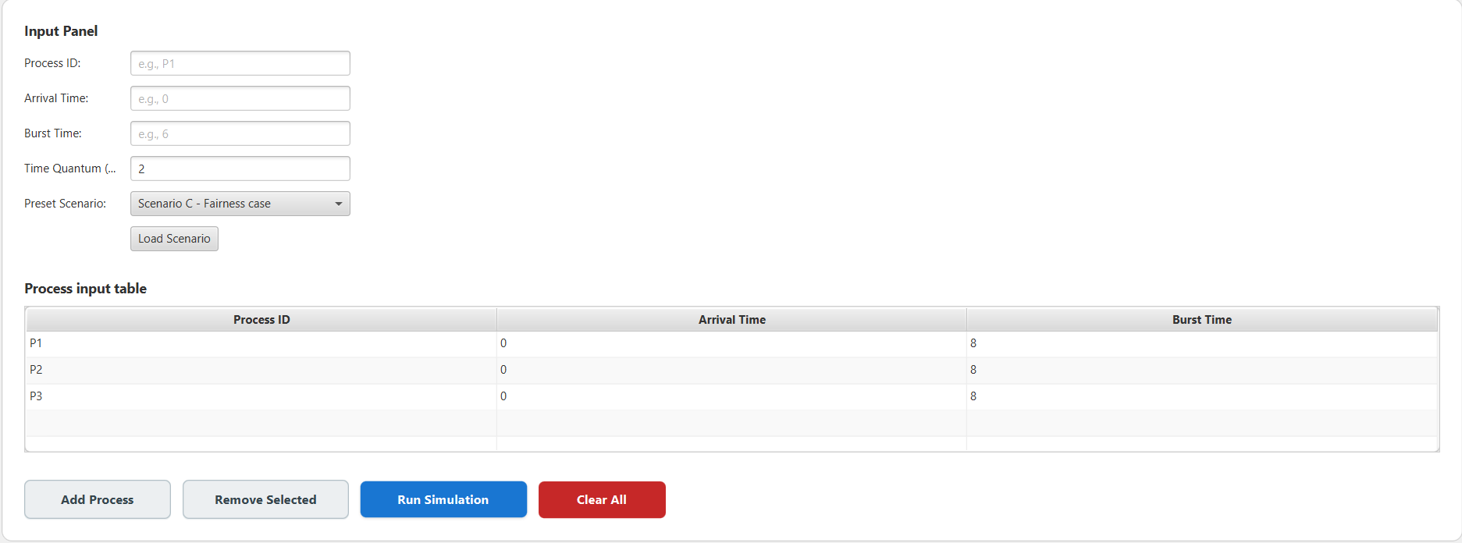
Figure: Scenario C input panel — three identical processes (BT = 8, Q = 2)
Process Input Data
Process ID | Arrival Time | Burst Time
P1 | 0 | 8
P2 | 0 | 8
P3 | 0 | 8

Simulator Screenshot — Gantt Charts & Results
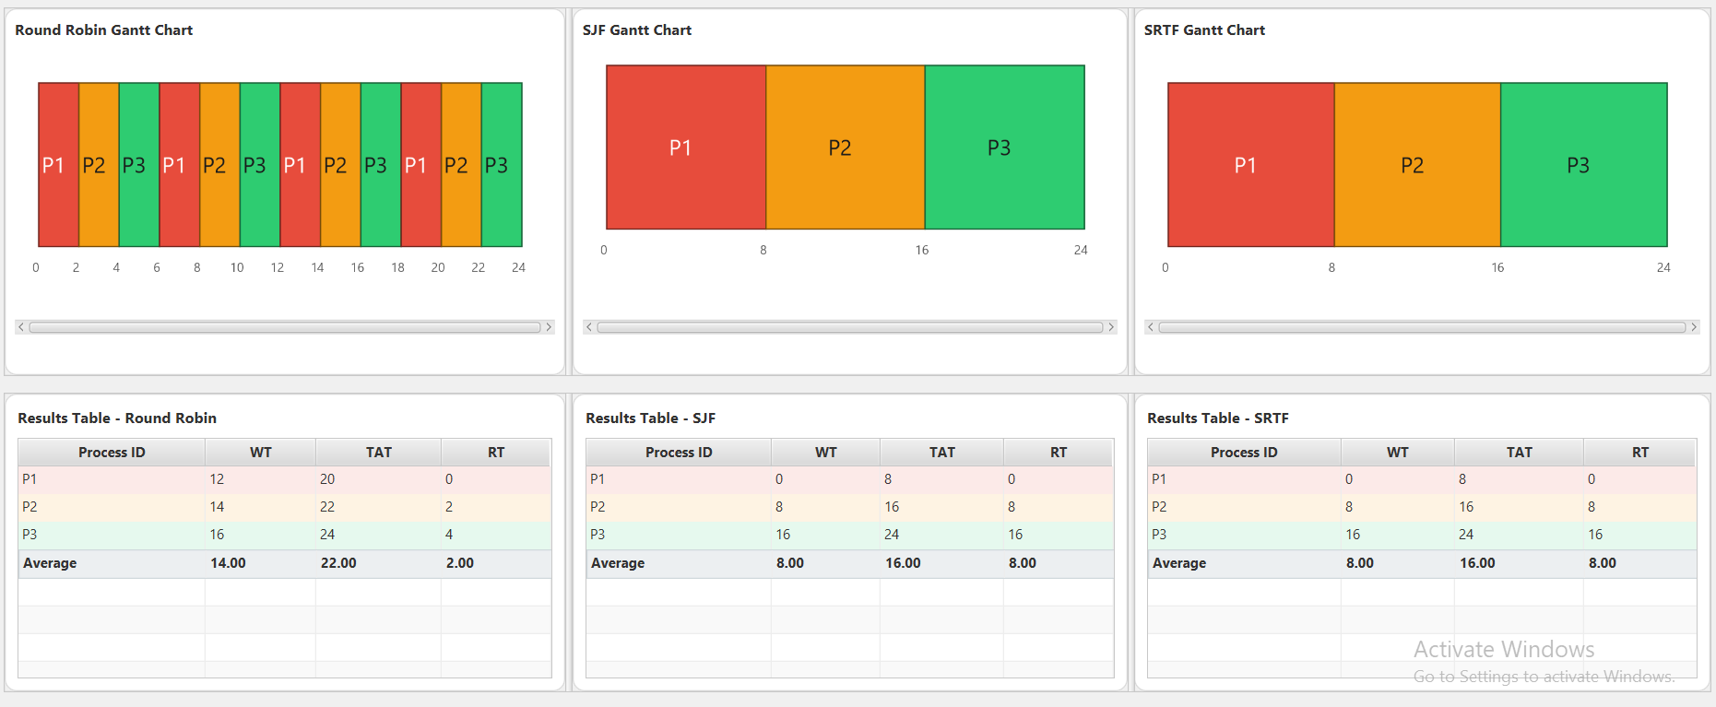
Figure: Scenario C — Gantt charts and results tables for RR, SJF, and SRTF

Numerical Results
Process ID | Round Robin |  |  | SJF |  |  | SRTF
 | WT | TAT | RT | WT | TAT | RT | WT | TAT | RT
P1 | 12 | 20 | 0 | 0 | 8 | 0 | 0 | 8 | 0
P2 | 14 | 22 | 2 | 8 | 16 | 8 | 8 | 16 | 8
P3 | 16 | 24 | 4 | 16 | 24 | 16 | 16 | 24 | 16
Average | 14.00 | 22.00 | 2.00 | 8.00 | 16.00 | 8.00 | 8.00 | 16.00 | 8.00

Assumptions for Scenario C
- All three processes arrive simultaneously at time 0, making it a purely simultaneous workload.
- Since all burst times are equal, SJF and SRTF produce identical schedules — they run processes sequentially in arrival order (P1 → P2 → P3).
- RR interleaves the three processes every 2 time units for the full 24-unit execution window.

Limitations for Scenario C
- Equal burst times eliminate SJF's and SRTF's primary advantage (prioritising shorter jobs), making this scenario a best-case for RR fairness and a worst-case for SJF response time.
- In real systems, identical burst times are rare; this scenario is a theoretical fairness benchmark rather than a typical workload.

Required Conclusion
- Which algorithm performed better on each major metric?
SJF and SRTF achieved the best avg WT (8.00) and avg TAT (16.00). Round Robin achieved the best avg RT (2.00) because each process received its first CPU slice very early (within the first 6 time units).
- Did Round Robin appear more balanced?
Yes — this is Round Robin's ideal scenario. All processes received equal CPU time in rotation; no process was starved or delayed disproportionately.
- Did SJF appear more efficient?
No. With equal burst times, SJF provides no efficiency advantage; it simply runs processes sequentially, resulting in a high avg RT of 8.00 because P2 and P3 must wait for all preceding processes to finish.
- Observed effect of the selected quantum (Q = 2)?
Q=2 with BT=8 produces 4 slices per process. The small quantum keeps response time very low (P1 starts at 0, P2 at 2, P3 at 4) but significantly increases waiting time due to frequent context switching across 24 time units.

Required Analysis Questions
- Which algorithm gave lower average waiting time?
SJF and SRTF both gave avg WT = 8.00, significantly better than RR's 14.00.
- Which algorithm gave lower average response time?
Round Robin gave the lowest avg RT = 2.00, far better than SJF/SRTF's 8.00. This is the scenario where RR's interleaving truly shines.
- Did Round Robin appear fairer across all processes?
Yes. Each process received its first CPU slice within 4 time units and had waiting times spread evenly (12, 14, 16) rather than concentrated on P3.
- Did SJF complete short jobs more efficiently?
Not applicable here: all jobs have equal burst times, so SJF degenerates to FCFS and provides no short-job advantage.
- How did the chosen quantum affect Round Robin behaviour?
Q=2 created 12 context switches total (4 per process). This high switching frequency reduced response time dramatically but increased overall waiting time by 6 time units compared to SJF/SRTF.
- Which algorithm would you recommend for this workload, and why?
The recommendation depends on the system goal. If minimising response time and ensuring fairness is critical (e.g., interactive/real-time systems), Round Robin with Q=2 is ideal. If minimising waiting and turnaround time is the goal (e.g., batch systems), SJF or SRTF is better. For this equal-burst workload, Round Robin is the fairer choice.

Scenario D — Long-Job Sensitivity

Preset: Scenario D – Long-job sensitivity
Time Quantum (RR): 4
Processes: 4 (P1 dominates with BT=20; P2–P4 are short, BT=1–3)

Simulator Screenshot — Input Panel
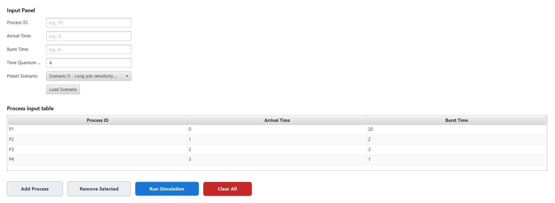
Figure: Scenario D input panel — one dominant long job (P1, BT=20) alongside short jobs (Q = 4)
Process Input Data
Process ID | Arrival Time | Burst Time
P1 | 0 | 20
P2 | 1 | 2
P3 | 2 | 3
P4 | 3 | 1

Simulator Screenshot — Gantt Charts & Results
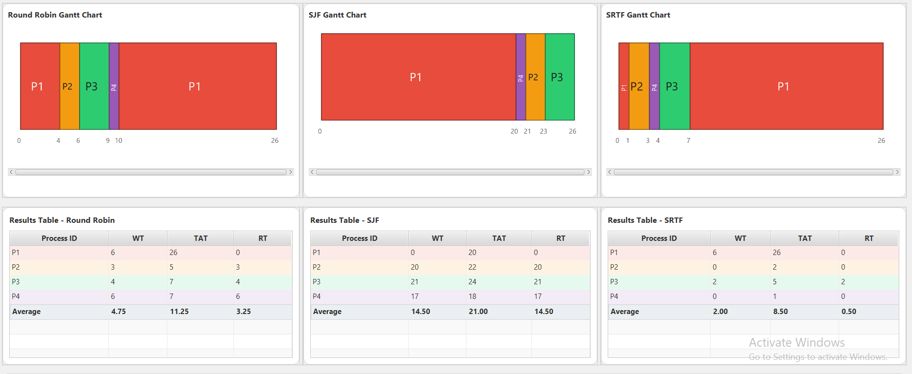
Figure: Scenario D — Gantt charts and results tables for RR, SJF, and SRTF

Numerical Results
Process ID | Round Robin |  |  | SJF |  |  | SRTF
 | WT | TAT | RT | WT | TAT | RT | WT | TAT | RT
P1 | 6 | 26 | 0 | 0 | 20 | 0 | 6 | 26 | 0
P2 | 3 | 5 | 3 | 20 | 22 | 20 | 0 | 2 | 0
P3 | 4 | 7 | 4 | 21 | 24 | 21 | 2 | 5 | 2
P4 | 6 | 7 | 6 | 17 | 18 | 17 | 0 | 1 | 0
Average | 4.75 | 11.25 | 3.25 | 14.50 | 21.00 | 14.50 | 2.00 | 8.50 | 0.50

Assumptions for Scenario D
- P1 (BT=20) is the dominant long job; P2–P4 are short jobs arriving after P1 has started.
- Under SJF (non-preemptive), P1 starts at time 0 and runs to completion (t=20) before any short job executes, causing severe waiting for P2–P4.
- Under SRTF, P1 is preempted as soon as P2 arrives at time 1 (P2 remaining=2 < P1 remaining=19).
- Under RR (Q=4), P1 receives the first 4-unit slice, then P2 runs, then P3, then P4, then P1 resumes.

Limitations for Scenario D
- SJF causes extreme starvation of short jobs (P2 waits 20 time units, P3 waits 21, P4 waits 17) — a well-known SJF limitation when a long job arrives first.
- SRTF is optimal for minimising average waiting time but requires exact knowledge of remaining burst times, which is impractical in real systems.
- The large difference between P1's BT and others' BTs makes this an extreme case; moderate differences would produce intermediate results.

Required Conclusion
- Which algorithm performed better on each major metric?
SRTF dominated on all three metrics: avg WT = 2.00, avg TAT = 8.50, avg RT = 0.50. SJF performed worst due to the non-preemptive starvation of short jobs.
- Did Round Robin appear more balanced?
Yes. RR distributed CPU time among all four processes in rotation (Q=4), preventing the extreme starvation seen in SJF. Its avg WT (4.75) is significantly better than SJF's 14.50.
- Did SJF appear more efficient?
No. SJF performed worst because P1 arrived first with BT=20, and non-preemptive scheduling forced all short jobs (P2–P4) to wait until P1 completed. This is a classic SJF starvation scenario.
- Observed effect of the selected quantum (Q = 4)?
Q=4 allowed P1 to run for 4 units before yielding, giving P2, P3, and P4 early CPU access. The quantum was large enough to avoid excessive context switching while still maintaining fairness for the short jobs.

Required Analysis Questions
- Which algorithm gave lower average waiting time?
SRTF gave the lowest avg WT = 2.00, compared to RR's 4.75 and SJF's 14.50.
- Which algorithm gave lower average response time?
SRTF gave the lowest avg RT = 0.50 — P2 and P4 responded immediately upon arrival, and P3 had only a 2-unit delay.
- Did Round Robin appear fairer across all processes?
Yes. RR balanced waiting times across all four processes (WT: 6, 3, 4, 6) rather than concentrating delays on short jobs as SJF did.
- Did SJF complete short jobs more efficiently?
No — the opposite occurred. Because P1 arrived first with a very long burst time and SJF is non-preemptive, short jobs P2–P4 suffered severe starvation (WT: 20, 21, 17 respectively).
- How did the chosen quantum affect Round Robin behaviour?
Q=4 was a good match for this workload. It was large enough that P1 made meaningful progress in each slice (avoiding excessive overhead) and small enough that short jobs P2–P4 received the CPU quickly after their arrival.
- Which algorithm would you recommend for this workload, and why?
SRTF is strongly recommended. It achieved the best performance on all three metrics and naturally handled the mix of one long job and several short jobs by preempting P1 whenever a shorter job arrived. SJF should be avoided when long jobs can arrive before short ones.

Scenario E — Input Validation Case

Preset: Scenario E – Validation case
Purpose: Demonstrates the simulator's input validation and error handling

Simulator Screenshot — Validation Error
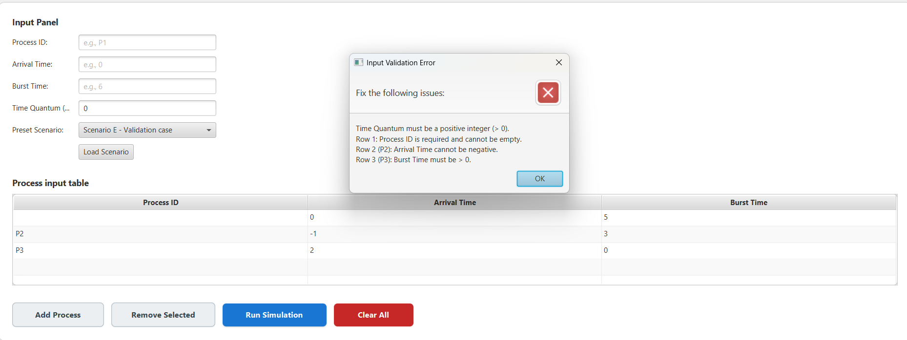
Figure: Scenario E — simulator input validation error dialog showing four distinct errors

Validation Errors Detected
- Time Quantum must be a positive integer (> 0). → Entered value: 0
- Row 1: Process ID is required and cannot be empty. → First row has no Process ID.
- Row 2 (P2): Arrival Time cannot be negative. → Entered value: −1
- Row 3 (P3): Burst Time must be > 0. → Entered value: 0

Analysis
Scenario E is specifically designed to test the robustness of the simulator's input validation layer. No scheduling simulation was performed; the simulator correctly identified all four input errors and prevented execution. This demonstrates that the simulator enforces the following constraints:
- Time Quantum must be a strictly positive integer — zero or negative values are invalid.
- Process ID is a mandatory field — a missing ID makes the process entry ambiguous.
- Arrival Time must be non-negative — negative arrival times are physically meaningless.
- Burst Time must be strictly positive — a burst time of zero or less means the process requires no CPU time, which is undefined behaviour for scheduling algorithms.

The validation error dialog lists all issues simultaneously rather than stopping at the first error, which is a good design practice — the user can correct all problems in one edit cycle rather than encountering errors one at a time.

Overall Comparison Summary

Scenario | Best WT | Best TAT | Best RT | Worst Algo | Recommendation
A – Basic Mixed | SRTF (4.25) | SRTF (8.50) | SRTF (2.25) | RR | SRTF
B – Short-Job-Heavy | SJF / SRTF (1.20) | SJF / SRTF (2.00) | SJF / SRTF (1.20) | RR (TAT) | SJF / SRTF
C – Fairness (Equal BT) | SJF / SRTF (8.00) | SJF / SRTF (16.00) | RR (2.00) | RR (WT/TAT) | RR (if RT matters) SJF/SRTF (if WT matters)
D – Long-Job | SRTF (2.00) | SRTF (8.50) | SRTF (0.50) | SJF (starvation) | SRTF

Key Takeaways
- SRTF is consistently the best performer across mixed and long-job workloads, achieving the lowest WT, TAT, and RT in Scenarios A and D.
- SJF matches SRTF in scenarios with short, non-concurrent jobs but suffers severely from starvation when a long job arrives before short ones (Scenario D), making it unsuitable for mixed-burst workloads without modification.
- Round Robin provides the fairest CPU distribution and the best response time in equal-burst scenarios (Scenario C). It is the preferred choice when fairness and interactivity are more important than raw throughput.
- The Time Quantum has a critical impact on Round Robin: a smaller quantum improves response time and fairness but increases context-switching overhead; a larger quantum reduces overhead but can delay short processes.
- No single algorithm is universally optimal — the choice depends on workload characteristics (burst time distribution), system goals (fairness vs. efficiency), and whether burst times are known in advance.

