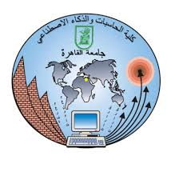

***Bank System Project***

**Prepared by:**

|  |  |
| --- | --- |
| **Name** | **ID** |
| Farah Tawfik Salem | 20200378 |
| Salma Hani Gamal | 20200231 |
| Mariam Hani Gamal | 20200532 |
| Yomna Sayed Mohamed | 20200640 |
| Ziyad Ashraf Ali | 20200193 |
| Shahd Ihab Ateya | 20200260 |

Conceptual Model:

Physical Model:

ERD:

