Project Proposal: Lake Geneva Water Temperature Forecast
Student : Maria Micioni, MLOps HS26 (I.BA_MLOPS)
Repository (public): https://github.com/mariamicioni/lake-geneva-temp

1 Problem statement
In short: predict tomorrow’s mean water temperature of Lake Geneva at Geneva (BAFU station 2606), one day ahead, targeting at least 20% lower MAE than persistence (preliminary persistence MAE 0.42 °C; provisional target 0.33 °C).
I want to predict the daily mean water temperature of Lake Geneva for the next day, measured where the lake flows out into the Rhône in Geneva (BAFU station 2606, Genève Halle de l’Île), about 1 km from the Bains des Pâquis. The forecast runs every evening at 18:00 and predicts the mean of the following calendar day, so the horizon is one day (6 to 30 hours ahead), in time to plan the next day. The scope is one station with daily values, evaluated from October 2026 to January 2027.
The forecast is meant for people who swim or paddle in the lake, which many do all year round. The official BAFU measurements only show the current temperature, not tomorrow’s.
Success criterion: model MAE at least 20% lower than persistence on the out-of-time test set; with preliminary persistence MAE 0.42 °C, the provisional target is about 0.33 °C. For a swimmer, an error of a third of a degree is negligible. On the data I have so far (15 pairs of consecutive complete days between 29.08. and 26.09.2026), persistence has an MAE of 0.42 °C, with a worst day of 1.34 °C.

2 Originality & motivation
I am attached to the Lake Geneva region for family reasons, and there people swim and do sports like stand-up paddling on the lake all year round. The water temperature is one of the first things you check before going in, so knowing it for the next day is useful. The problem is also interesting for ML: on calm days the temperature hardly changes and persistence is hard to beat, but after strong wind or a change in the weather the surface water gets mixed, and the temperature at the outflow can change by more than 1 °C in a day.
I went through the 15 FS26 projects on mlops-lab.ch [7] and the KTH ID2223 project lists of 2024 (31 projects) and 2025 (35 projects) [8]. None of them predicts water temperature. The closest one is “Predict UK river flooding events” (ID2223, 2024), which classifies floods in the UK. Eawag’s Alplakes platform [6] already publishes a physics-based simulation of Lake Geneva. My project is different because it is a data-driven model for one measured point that is evaluated against a baseline and retrained automatically; a comparison with Alplakes is an optional extra.

3 Data source & features
The water data comes from the Federal Office for the Environment (FOEN/BAFU) [1]. Station 2606 measures water temperature and discharge every 10 minutes. I access it through the REST API of existenz.ch [2], which republishes the BAFU data and allows free non-commercial use. If that API is down, the fallback is the official BAFU feed on LINDAS [3], which has the same latest values but no history. The weather comes from the Open-Meteo forecast API [4] for Geneva (46.20 N / 6.14 E). For backfill I use Open-Meteo’s Single Runs API [5], selecting the latest archived run available before 18:00 so training uses only information available at inference time.
The weak point is the history: existenz.ch only keeps about 32 days. On 29.09.2026 I saved everything that was still available (3,856 readings from 28.08. on; only 20 days are complete because of gaps). So in practice the water history starts when my poller starts. It grows by 144 readings, or one training row, per day, which gives around 90 rows by MS3. The Open-Meteo Single Runs archive covers the current water-history period. Because the data set stays small, I start with a regularised linear model (Ridge).
The label is the mean of the measured temperatures at station 2606 on the next day. It is only used if at least 120 of the 144 readings exist; otherwise the day is skipped. It is a measurement from the future, so it cannot be calculated from the features. There is no rare class because this is a regression, but I will report the error separately for days where the temperature changes by more than 0.8 °C, because those are the days where persistence fails.
Features per day:
- water_mean_d0: mean water temperature today (until 18:00)
- water_last: last reading before 18:00
- water_mean_3d, water_trend_3d: mean of the last 3 days, and the change compared to 3 days ago
- flow_mean_d0: mean discharge today
- air_temp_fc_d1, sunshine_fc_d1, wind_max_fc_d1: Open-Meteo forecast for tomorrow (mean air temperature, sunshine duration, maximum wind speed)
Leakage: I split by time (train on older days, test on the latest weeks) and never shuffle randomly. The pipeline only uses readings from before 18:00 and weather forecasts that were published before that time. Backfill uses the latest archived model run available before 18:00, preventing future-weather leakage. All daily values are computed in the Europe/Zurich time zone, and training and inference use the same feature code.

4 System design
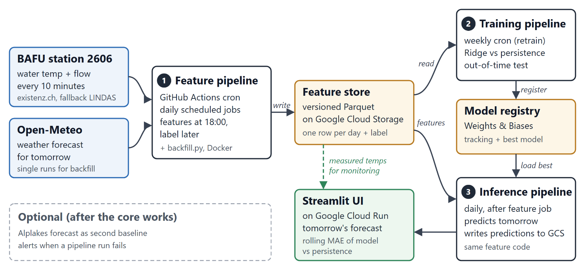
Figure 1: FTI architecture of the project. The numbered boxes are the three pipelines; the dashed box contains optional parts.
Component | Tool | Why
Feature store | Versioned Parquet files on Google Cloud Storage | One row per day is very little data, so a separate feature store service is not needed. Paid with the GCP student credits.
Orchestration | GitHub Actions (cron) | Free and part of the repo. Runs the daily feature and inference jobs and the weekly retraining.
Experiment tracking and registry | Weights & Biases | Hosted, so I don’t need to run my own tracking server. It has tracking and a model registry.
Model | scikit-learn (Ridge), LightGBM if there is time | Small tabular data set; a simple model is fast to train and easy to explain.
Serving and UI | Streamlit on Google Cloud Run | Same cloud as the feature store, paid with the GCP student credits, scales to zero when unused. Shows tomorrow’s forecast and model performance versus persistence over time.
Packaging | Docker, uv (uv.lock) | The same environment locally and in GitHub Actions, with pinned dependencies.

References and AI use

[1] FOEN/BAFU, station 2606 - hydrodaten.admin.ch/.../2606 | [5] Open-Meteo Single Runs - open-meteo.com/.../single-runs-api
[2] Existenz BAFU Hydrology API - api.existenz.ch | [6] Eawag Alplakes - alplakes.eawag.ch
[3] LINDAS SPARQL endpoint - ld.admin.ch/query | [7] HSLU MLOps project showcase - mlops-lab.ch
[4] Open-Meteo Forecast API - open-meteo.com/en/docs | [8] KTH ID2223 project archive - id2223kth.github.io

AI use disclosure: OpenAI GPT and Anthropic Claude models were used for brainstorming, language editing, and technical review. The author reviewed and is responsible for the final content and technical decisions.

