  Credit Hours System  CMPN306  Advanced Programming Techniques |  |   Cairo University  Faculty of Engineering

Search Engine
“Finder”
Algorithms

Team: 1
Group: Monday
Under Supervision of: Eng. Ali Elseddeek
Eng. Fatema Othman

Crawler:

Robots Exclusion:

Indexer
Input: list of crawled websites from crawler
- Read stopping words from text file into a list
- Loop over each website with status =2 ( crawled but not indexed) only
- Preprocessing:
- Open page document using jsoup
- Extract <titles>, <h1..h6>, <p>
- For each title, heading and plain text:
  - Remove any characters other than alphabets
  - If the word isnt a stopping word:
  - Stem using PorterStemmer
  - Add to processedXXX list (title / heading / plain text)
- Loop over each processed list
- Count word’s frequency (TF)
- Count word’s type frequency (title / heading / plain text)
- Add URL (DF = size of URLs list)
- Output of preprocessing step:
  - 3 words list merged into 1 list (all_words)
  - 3 corresponding dictionaries merged into 1 dictionary (all_dicts)
Output: Add (all_words,all_dicts) to database

- Snippet of indexer collection:
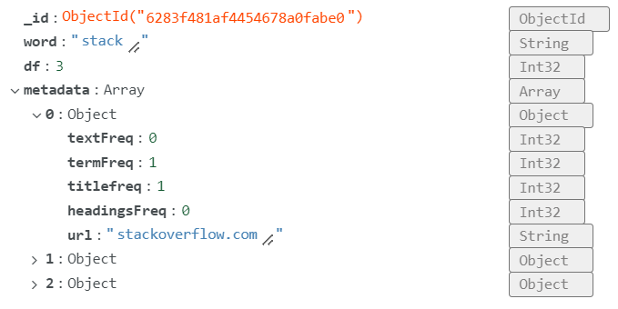

Ranker:

Stopping words:
Reference: https://countwordsfree.com/stopwords

