  Credit Hours System  GENN002 English | CMPN-445 |   Cairo University  Faculty of Engineering

Project Report
“Elevator”

Basant Loay | 1170507
Mohamed Waleed
Mariam Mohamed Osama | 1170470

Submitted to: Dr. Bassem Ibrahim
Submission Date: 10.6.2021
Under Supervision of: Eng Hassan
Eng Mostafa
Report Contents
Project idea | 3
Functionality , features | 4
Components | 5,6
How to run | 7,8
Petri network | 9

Project Idea
(Inspired from : https://www.youtube.com/watch?v=V2Uwux0C2E0)
Functionality
- 8 floor scalable elevator
- The elevator box is driven by a stepper motor
- Each floor’s door is modelled by a servo motor
- A 7 segment BCD at each floor showing which floor is the elevator at
- An internal keypad to choose a floor to go to
- External push buttons at each floor to order a trip down/up stairs

Features and assumptions

- Floor number is global between keypad and push buttons.
- The elevator can do as much stops for calls in the SAME direction.
- If a button is pressed and the elevator is in the request’s floor, the floor’s door opens and closes normally.
- If a door is open and someone tries calling it again, this will be ignored
- Assume no 2 elevator calls can be made in the SAME moment.
- Assume if the elevator is gowing up and a down-trip is called, the elevator will finish its trip upwards and then visit the down orders

- Simulation tool used : SimulIDE

Components
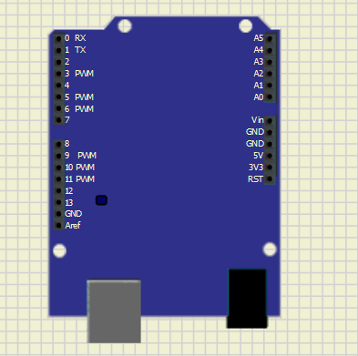 | x1 arduino uno: main microcontroller
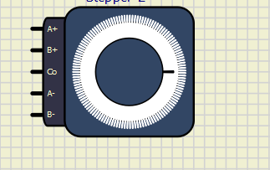 | x1 stepper motor:  - Driving the elevator box.  - Can rotate in both directions
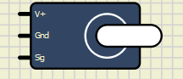 | x8 servo motors:  - Modelling doors, a door at each floor.  - Opens with 180degree angle and waits 2 seconds before closing
 | x8 7 segment BCDs:  All 7 segments show the number of floor the elevator is currently at
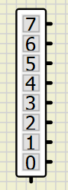 | x1 internal keypad:  To pick a floor to go to from inside the elevator
 | x14 push buttons:  - 1 at ground floor (goes up only)  - 1 at last floor (goes down only)  - 2 at each floor between 1st and 7th (can go up and down)

How to run
Step 1:
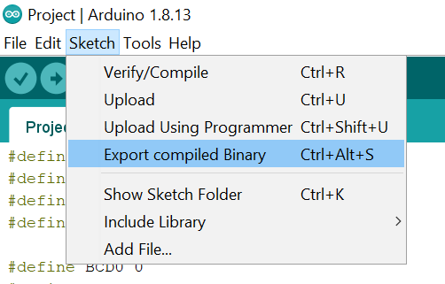
Step 2:
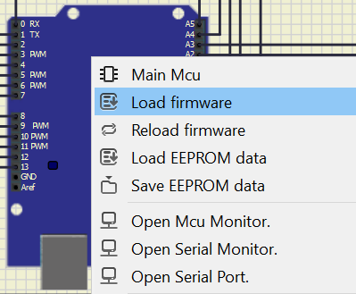
Step 3:
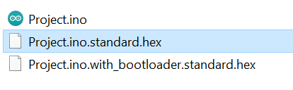

Step 4:
Turn on
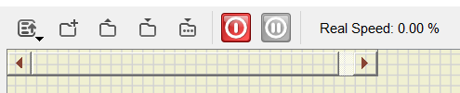

Petri Network
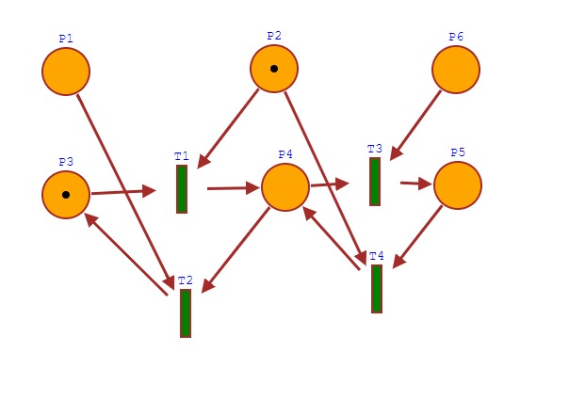

Reachability tree:
