

Labor Force Structure in Quetta Division
Research study: Analysing the Structure of the Labor Force
Division = Quetta
NAME: Syeda Mariam Naqvi
Independent Research | LFS 2020–21

Introduction
In this analysis, I examine the Labor Force Survey (LFS) 2020-21 data for the Quetta Division of Balochistan to gain insights into the socio-economic landscape of the region. I have imported and analyzed the data collected from the Pakistan Bureau of Statistics (PBS) to assess key aspects such as labor force participation, educational attainment, marital status, and gender dynamics in the division. The aim of this report is to explore the distribution of these variables across various age groups, regions, and genders, using statistical methods like t-tests and chi-square tests to uncover significant relationships.

Section 1: Data Import and Preparation
1.1 – I downloaded the microdata of the Labor Force Survey (LFS) 2020-21 from the Pakistan Bureau of Statistics (PBS) website.
1.2 – I imported the dataset into Stata for analysis.
1.3 – I extracted the first two digits from the PCode variable, which represents the division code, in order to identify the specific division.
1.4 – I selected the Quetta Division (Division Code: 41) for analysis from the dataset.
1.5 – I created 10 distinct age groups, ranging from 0-9 years to 90+ years, and labeled them accordingly for further analysis.
1.6 – I generated a new variable named edu_level and defined the following education levels:
- No formal education
- Below primary
- Primary
- Middle
- Matric
- Intermediate
- Graduation
1.7 – I created three variables: ‘employed’, ‘unemployed’, and ‘not in labor force’, according to the instructions provided. These were used to classify individuals based on their labor force status.
1.8 – I created a ‘labor force participation’ variable. Individuals were considered to be part of the labor force if they were either employed or unemployed.
1.9 – I created a variable named ‘student_status’, where a value of 1 was assigned to individuals who were students.

Preparation and Cleaning

2.1 Data Import and Overview
- Source: The LFS 2020-21 data was downloaded from the Pakistan Bureau of Statistics (PBS).
- Focus Area: The analysis focuses on the Quetta Division, specifically the districts of Killa Abdullah, Pishin, and Quetta City. The division code 41 was used to filter the dataset.
- Data Cleaning: The dataset was processed to include variables such as age groups, education levels, labor force status, and student status. These were labeled and structured for analysis.

Key Variables Created
- Age Groups: The population was classified into 10 age groups, ranging from 0-9 years to 90+ years, allowing for detailed age-based analysis.
- Education Levels: Seven education categories were created, ranging from no formal education to graduation. This helps track the progression of educational attainment across age groups.
- Labor Force Status: Variables for employed, unemployed, and not in the labor force were defined. Additionally, a labor force participation variable was created, combining both employed and unemployed individuals.
- Student Status: A new variable was defined to identify individuals who are currently in school, offering insights into educational engagement.
Section 2: Analysis & Comparison
2.1 Principal Economic Activities:
2.1.1 - Distribution of employed individuals across the ten age groups, using weights.
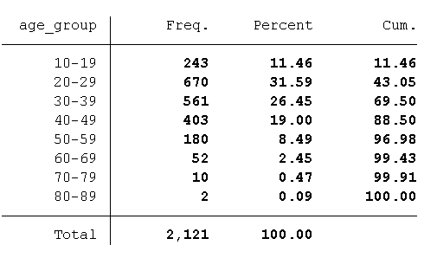

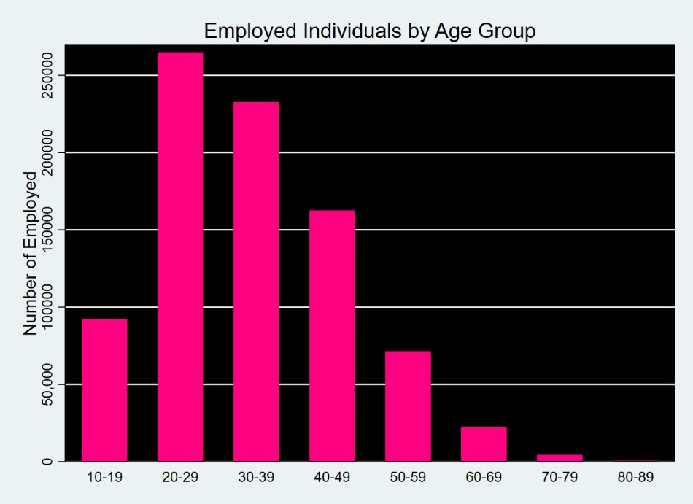
employed population across different age groups reveals significant trends. The 20-29 age group makes up the largest share of employed individuals, representing 31.59% of the total employed population. This aligns with expectations, as young adults are typically entering the workforce for the first time after completing their education. The 30-39 age group, which makes up 26.45% of the employed population, reflects a more stable period in individuals' careers, with many in this group likely holding full-time, permanent jobs.
However, as the age groups increase beyond 40, the proportion of individuals employed drops significantly. The 50+ age groups, particularly the 60+ age group, exhibit the lowest employment rates, which can be attributed to factors such as retirement, health-related issues, or a decreased likelihood of continued employment among older individuals.
2.1.2 - Distribution of unemployed individuals across the ten age groups, using weights.
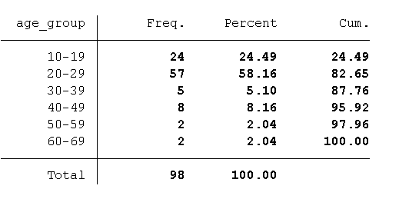

The unemployed population is heavily concentrated in the 20-29 age group, which represents 58.16% of all unemployed individuals. This suggests that youth unemployment is a significant challenge in the region, as young adults are transitioning from education to employment but are struggling to find suitable work opportunities. The 30-39 age group has a smaller proportion of unemployed individuals, which could indicate that this age group is more likely to have stable employment. In contrast, the 50+ age groups show much lower unemployment rates, likely because many individuals in these groups are either retired or no longer seeking employment.
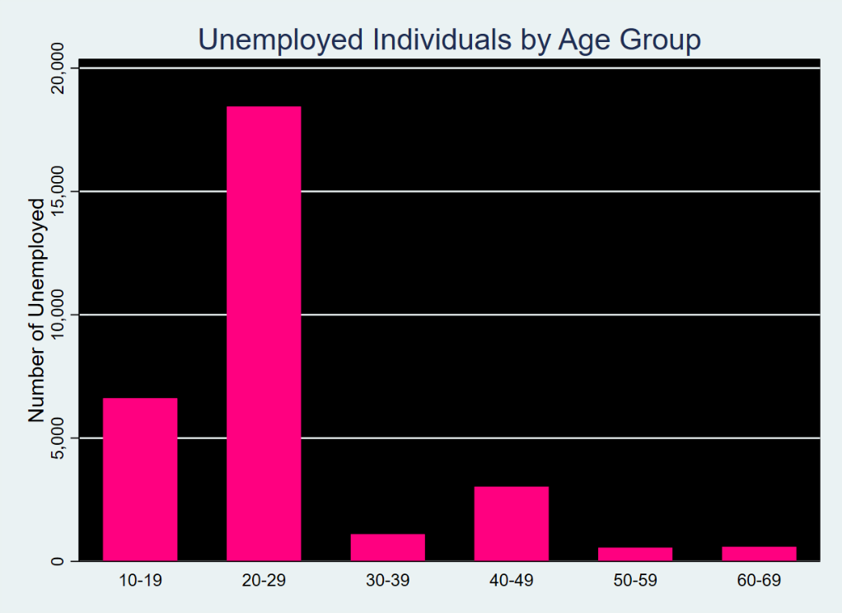

2.1.3 – Distribution of individuals in the labor force (employed + unemployed) across the ten age groups.
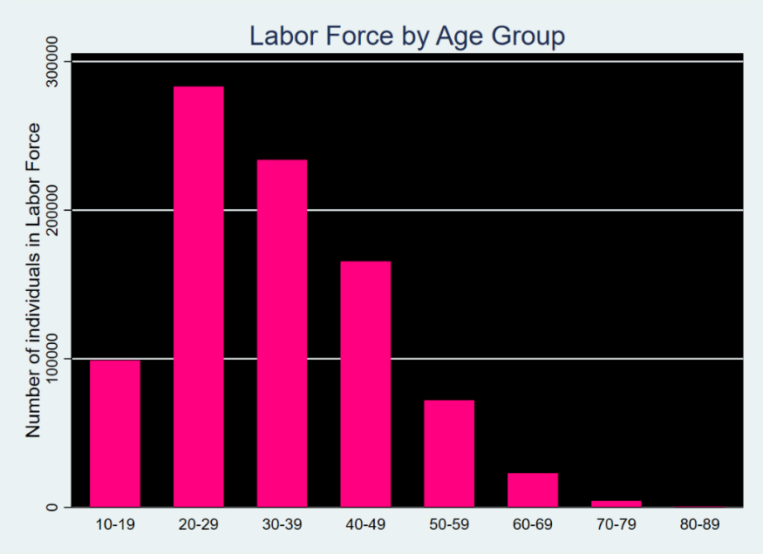
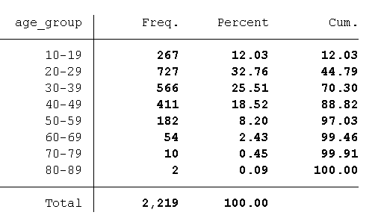
Labor force participation across age groups reveals that the 20-29 age group is the most active in the labor market, accounting for 32.76% of the total labor force. This high participation rate is indicative of young adults who are either employed or actively seeking employment. As individuals grow older, labor force participation rates decline, with very few individuals over the age of 60 participating in the labor force. This reflects the typical pattern of retirement or disengagement from the workforce due to age-related factors.

2.1.4 – Distribution of individuals outside the labor force across the ten age groups, by weights.

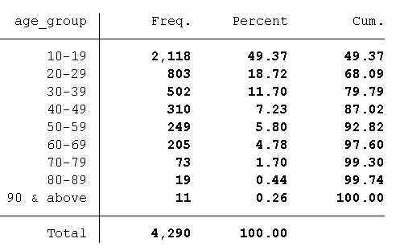

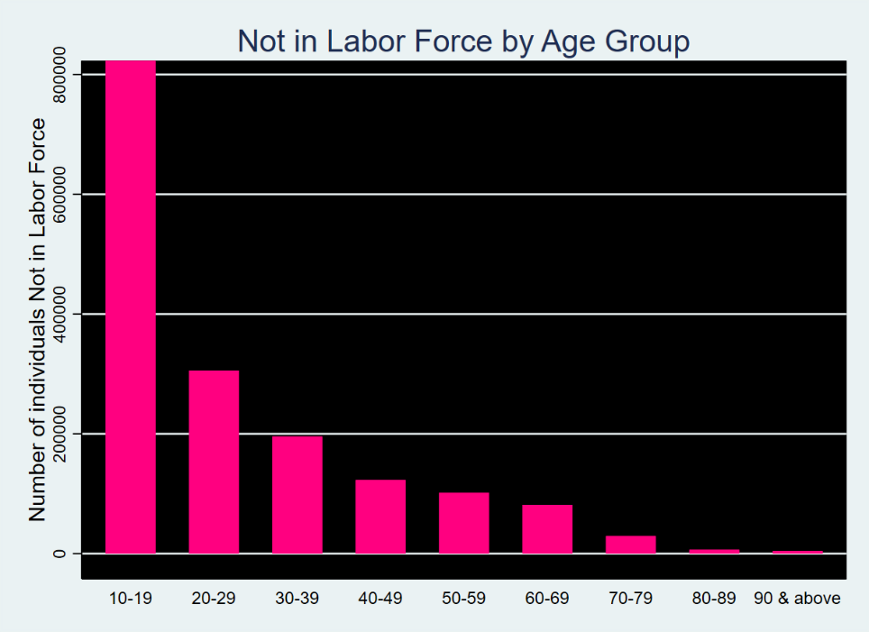
A significant portion of the population outside the labor force is in the 0-19 age group, which accounts for 49.37% of individuals not participating in the labor force. This is expected, as most individuals in this age group are still in school or too young to work. Additionally, the 60+ age group also shows a high percentage of individuals outside the labor force, likely due to retirement or health issues. The 0-19 age group represents a crucial demographic for future education and employment programs, as they will eventually transition into the workforce.

2.2 – Educational Attainment:
2.2.1 – Distribution of the seven defined education levels achieved by the population within each of the ten age groups.

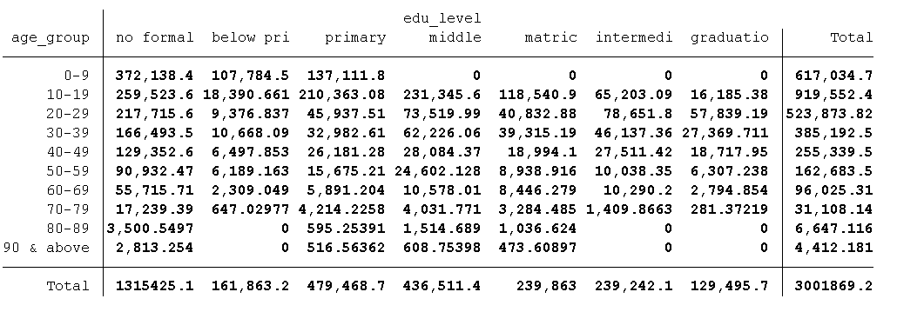
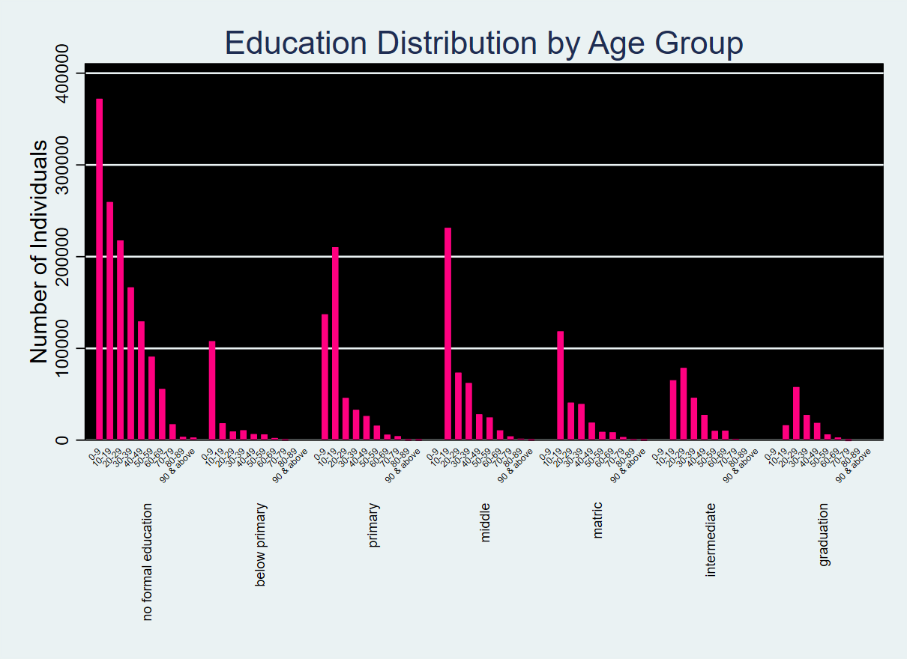
educational attainment across age groups shows a clear improvement in education levels over time. In the 0-9 age group, many individuals are either in primary school or have no formal education. In the 10-19 age group, a significant number of individuals have completed primary and middle school, with some progressing to matric education. The 20-39 age group shows the highest levels of educational attainment, with many individuals achieving matriculation, intermediate, or graduation.
The 60+ age group exhibits much lower educational attainment, with a large proportion of individuals having no formal education. This reflects historical trends where older generations in rural areas had limited access to education, particularly for females. The educational disparities between rural and urban areas are evident, with urban areas generally showing higher levels of educational attainment.

2.3 – Marital Status:
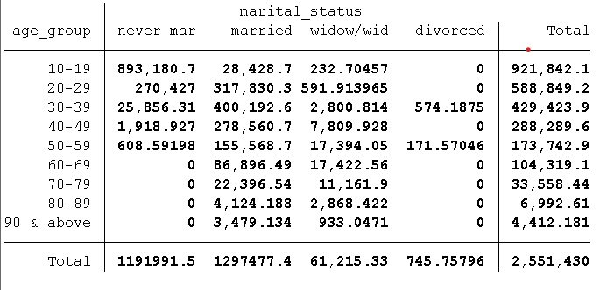
2.3.1 – Distribution of marital status categories

The marital status distribution reveals a clear pattern that correlates with age. In the 10-19 age group, nearly all individuals are never married, which is expected for this age range. In the 20-29 age group, over half of the individuals are married, and as individuals age, the proportion of married individuals increases. The 30-49 age group has the highest percentage of married individuals, while the 50+ age group shows a significant increase in widowhood, particularly in the 60+ age group.
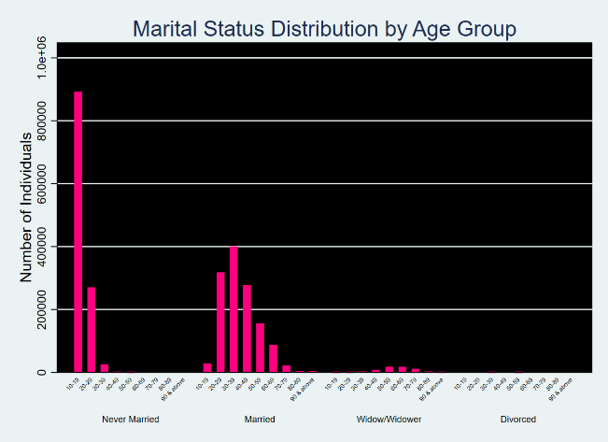
The low divorce rate observed across all age groups suggests that marital stability is relatively high in Quetta Division, possibly due to cultural factors or economic factors where divorce may not be as common. The chi-square test results indicate that employment status and educational attainment influence marital decisions, with employed individuals marrying at higher rates and those with higher education tending to marry later.
2.4 – Disaggregation Dimensions
2.4.1 – Urban, rural, and total population (within each age group).
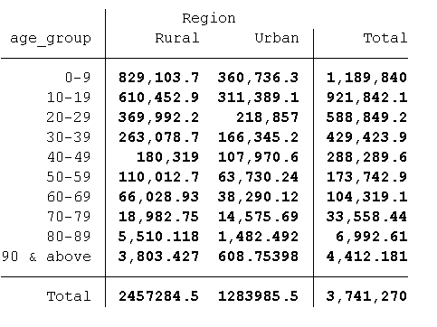

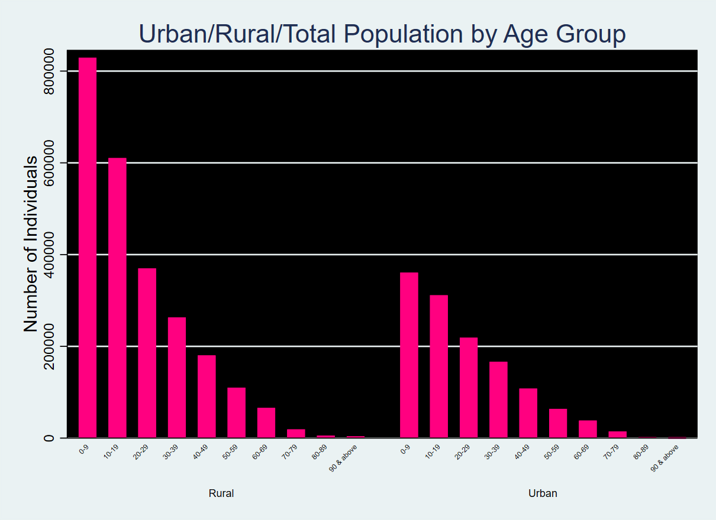

The distribution of individuals in urban vs rural areas reveals that a larger proportion of individuals reside in rural areas, especially among the younger population (0-19 age group). However, urban areas show an increase in population in the 20-29 age group, likely due to migration for education and employment opportunities.
The labor force participation is higher in urban areas, reflecting better access to jobs and education, while rural areas continue to have lower employment opportunities.

    - – Male, female, and total population (within each age group).
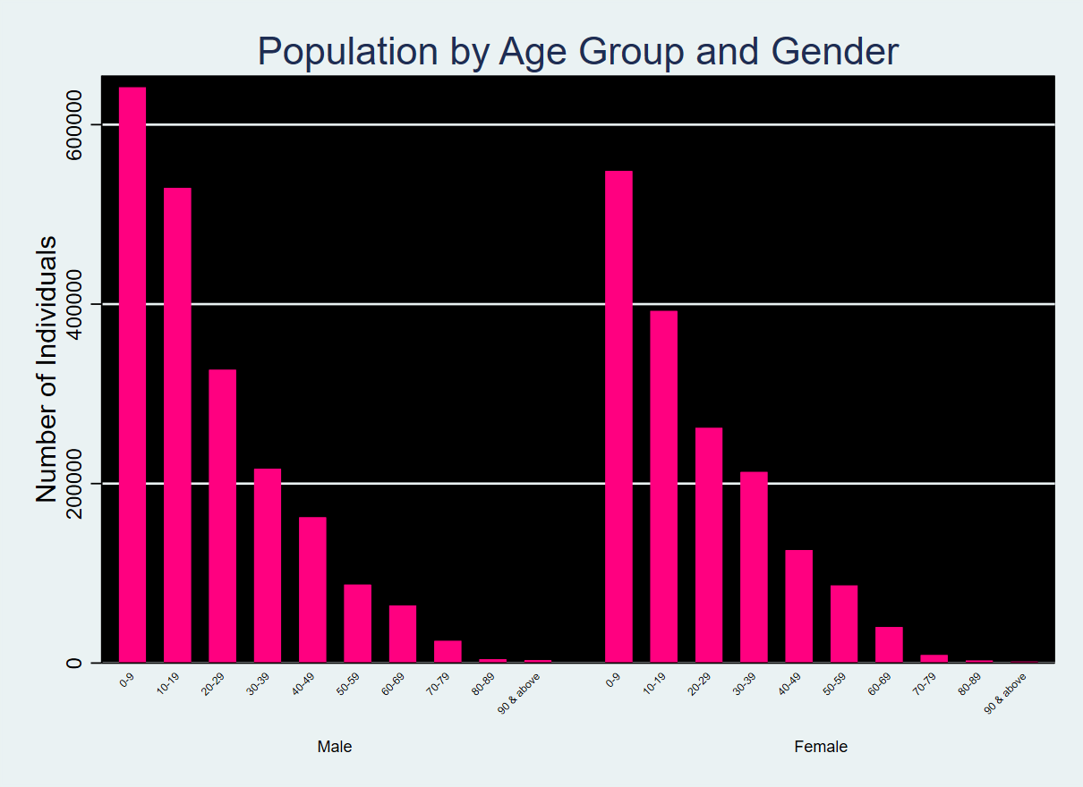
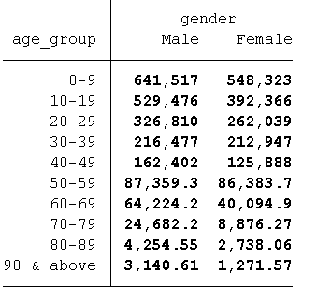

The gender distribution shows that males generally outnumber females in both urban and rural populations, though the gap narrows in the older age groups. Females tend to have lower labor force participation and educational attainment compared to males, especially in rural areas. The chi-square test reveals that gender and region significantly affect employment and education outcomes, with males in rural areas typically having higher educational attainment than females.

2.4.3 – Rural population (male vs. female) within each age group.
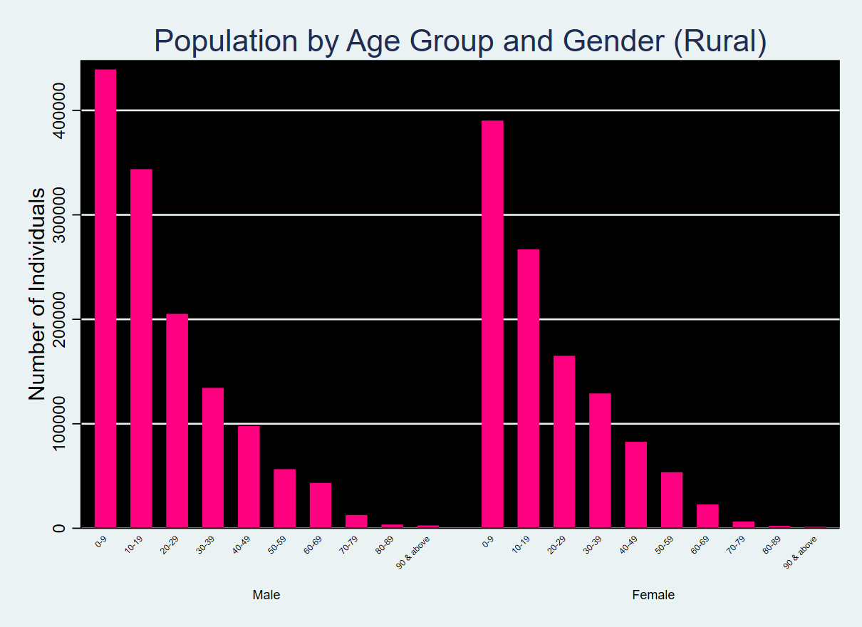
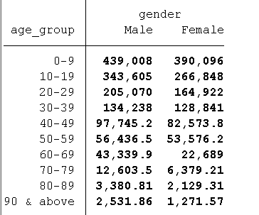

In rural areas, the male population slightly exceeds the female population, with the difference becoming more pronounced as age increases. This trend can be attributed to several factors, including:
Migration: Young males may be more likely to migrate to urban areas for employment or education, but the male population still remains larger in rural areas.
Cultural Norms: In rural settings, males often hold the primary role in the workforce, leading to a higher male representation in economic activities.
Younger Age Groups: In the 0-9 and 10-19 age groups, males slightly outnumber females, consistent with the general trend observed in birth ratios.
Older Age Groups: The difference between the male and female population in rural areas grows as the age increases, with males outnumbering females more significantly in the 50+ age groups. This might reflect the greater mortality rate among males at older ages.

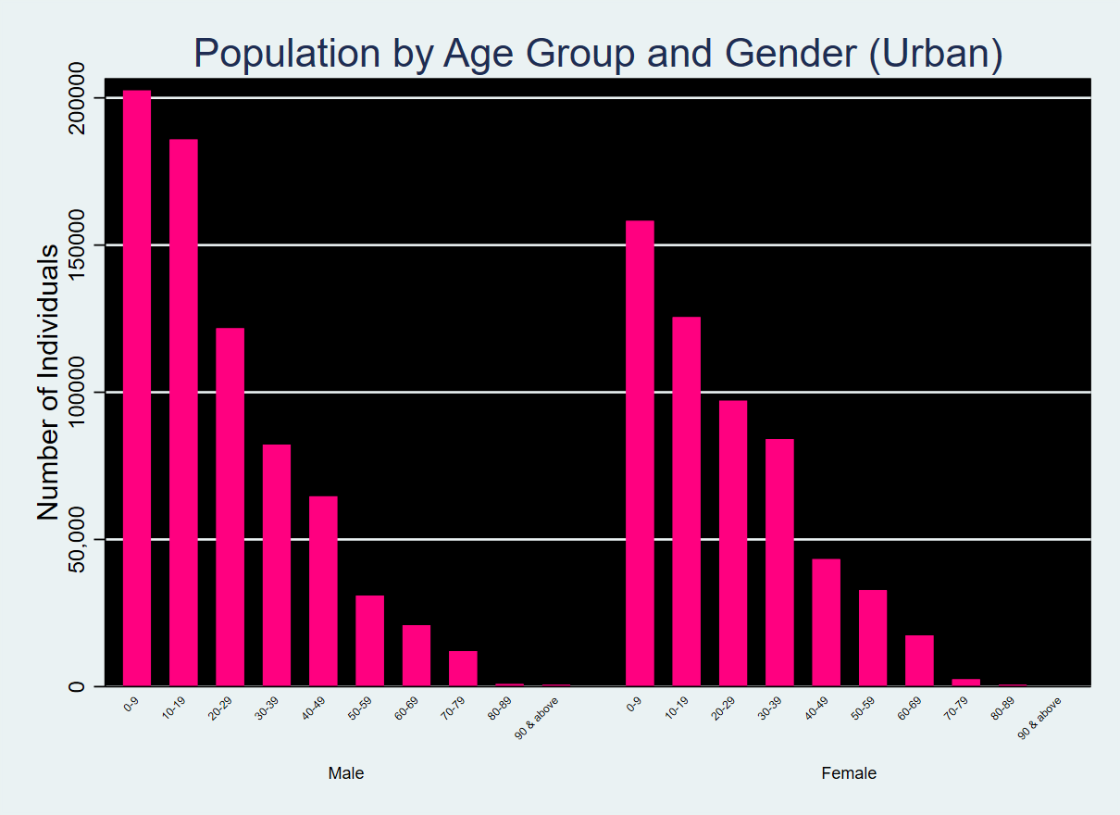
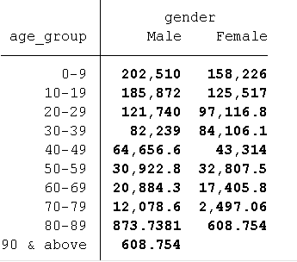
2.4.4 – Urban population (male vs. female) within each age group.

In urban areas, males outnumber females in most age groups, except for the 30-39 and 50-59 age groups, where females slightly lead. This trend may be attributed to several factors:
Younger Age Groups: Males tend to be more represented in urban areas, particularly due to migration for employment and education. However, females in urban areas, especially in the 30-39 and 50-59 age groups, might have slightly higher representation due to increased educational and employment opportunities for women.
Older Age Groups: The trend reverses in some older age groups, with females outnumbering males, particularly in the 50-59 age group. This can be explained by longer life expectancy among women in urban settings.
Section 3: Hypothesis Testing
3.1 Chi-Square Test of Independence
3.1.1 Marital Status:

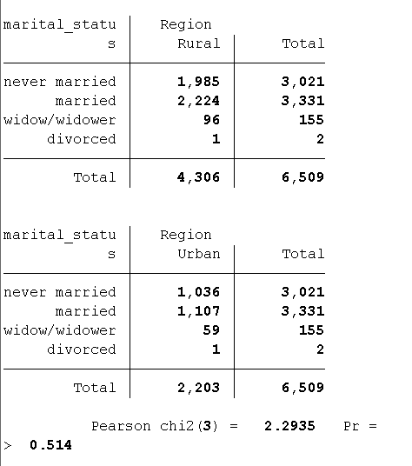
3.1.1.1 Hypothesis: The distribution of marital status is the same across regions.

Null Hypothesis (H₀): The distribution of marital status is independent of region.
Alternative Hypothesis (H₁): The distribution of marital status is dependent on region.
P-value: 0.514 (greater than 0.05). Fail to reject the null hypothesis, indicating no significant relationship.

3.1.1.2 Hypothesis: The distribution of marital status is the same across employment status.
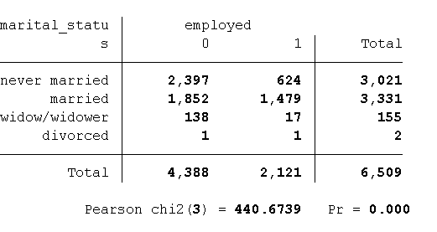
Null Hypothesis (H₀): The distribution of marital status is independent of employment status.
Alternative Hypothesis (H₁): The distribution of marital status is dependent on employment status.
P-value: 0.000 (less than 0.05). Reject the null hypothesis, indicating a significant relationship between marital status and employment status.

3.1.1.3 Hypothesis: The distribution of marital status is the same across educational attainment.
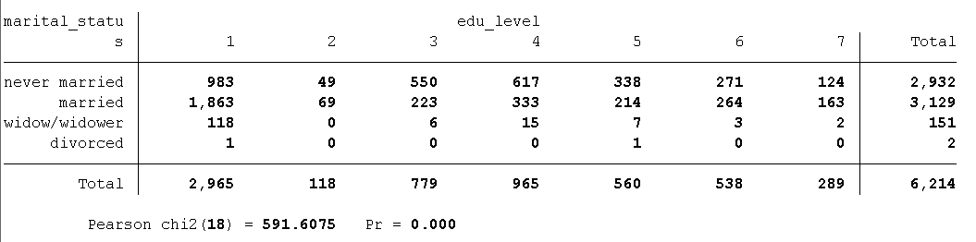
Null Hypothesis (H₀): The distribution of marital status is independent of educational attainment.
Alternative Hypothesis (H₁): The distribution of marital status is dependent on educational attainment.
P-value: 0.000 (less than 0.05). Reject the null hypothesis, indicating a significant relationship between marital status and education.

3.1.2 Education Level:
3.1.2.1 Hypothesis: The distribution of educational attainment is the same across gender.
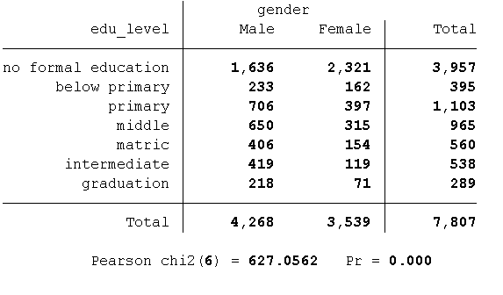

Null Hypothesis (H₀): The distribution of educational attainment is independent of gender. This means that males and females in Quetta Division have similar levels of educational attainment.
Alternative Hypothesis (H₁): The distribution of educational attainment depends on gender. In other words, there is a significant difference in educational attainment between males and females in the division.

P-value: 0.000 (less than 0.05)
Since the p-value is less than 0.05, we reject the null hypothesis. This indicates that there is a significant difference in the educational attainment levels between males and females. Specifically, males tend to achieve higher education levels in certain categories compared to females in Quetta Division.

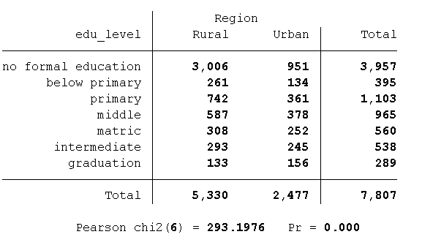
3.1.2.2 Hypothesis: The distribution of educational attainment is the same across region.

Null Hypothesis (H₀): The distribution of educational attainment is independent of the region (rural vs urban). This assumes that education levels are the same in both rural and urban areas of Quetta Division.
Alternative Hypothesis (H₁): The distribution of educational attainment depends on the region. This means that individuals living in rural areas have different educational attainment levels compared to those living in urban areas.
P-value: 0.000 (less than 0.05)
Since the p-value is less than 0.05, we reject the null hypothesis. This suggests that educational attainment varies between rural and urban areas in Quetta Division. Urban residents tend to have higher educational attainment levels, likely due to better access to educational institutions, resources, and opportunities.

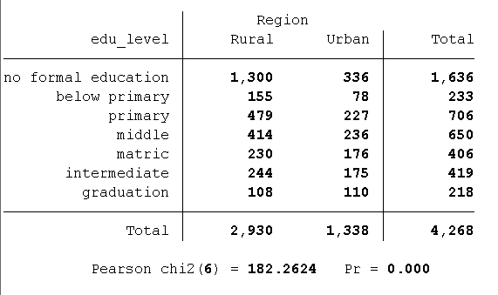
3.1.2.3 Hypothesis: The distribution of educational attainment of males is the same across region.

Null Hypothesis (H₀): The distribution of educational attainment among males is independent of the region (rural vs urban).
Alternative Hypothesis (H₁): The distribution of educational attainment among males depends on the region. This means that male individuals in rural and urban areas have different levels of educational attainment.
P-value: 0.000 (less than 0.05)
The p-value being less than 0.05 means we reject the null hypothesis. This shows that male educational attainment varies between rural and urban areas. Males in urban areas tend to have higher education levels, reflecting better access to education in these regions.

3.1.2.4 Hypothesis: The distribution of educational attainment of females is the same across region.
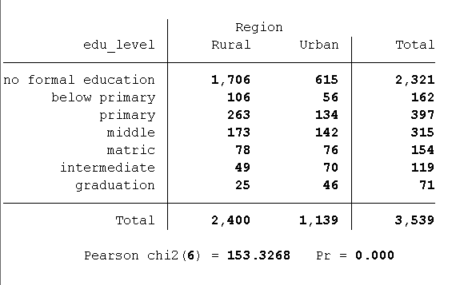

Null Hypothesis (H₀): The distribution of educational attainment among females is independent of the region (rural vs urban).
Alternative Hypothesis (H₁): The distribution of educational attainment among females depends on the region.
P-value: 0.000 (less than 0.05)
Since the p-value is less than 0.05, we reject the null hypothesis. This indicates that female educational attainment is also significantly influenced by region. Females in urban areas are more likely to achieve higher education levels, which may be due to better access to schools, universities, and educational resources.

3.1.3 Employment Status:

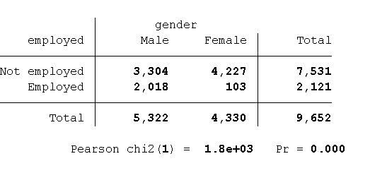
3.1.3.1 Hypothesis: The distribution of employment status is the same across gender.

Null Hypothesis (H₀): The distribution of employment status is independent of gender. This means that males and females are equally likely to be employed or unemployed in Quetta Division.
Alternative Hypothesis (H₁): The distribution of employment status depends on gender. This implies that employment patterns differ between males and females.
P-value: 0.000 (less than 0.05)
Since the p-value is less than 0.05, we reject the null hypothesis. This suggests that employment status significantly differs between males and females in Quetta Division. Males are more likely to be employed compared to females, which may be due to socio-cultural factors, access to opportunities, or gender-based discrimination.

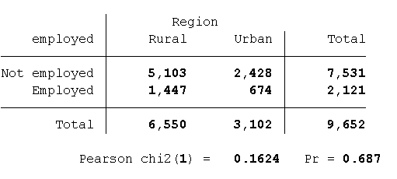
3.1.3.2 Hypothesis: The distribution of employment status is the same across region.

Null Hypothesis (H₀): The distribution of employment status is independent of region (rural vs urban).
Alternative Hypothesis (H₁): The distribution of employment status depends on region (rural vs urban).
P-value: 0.687 (greater than 0.05)
Since the p-value is greater than 0.05, we fail to reject the null hypothesis. This means there is no significant difference in employment status between individuals living in rural and urban areas. Employment status seems to be fairly consistent across regions, possibly due to similar economic activities available in both rural and urban areas.

3.1.3.3 Hypothesis: The distribution of employment status of males is the same across region.
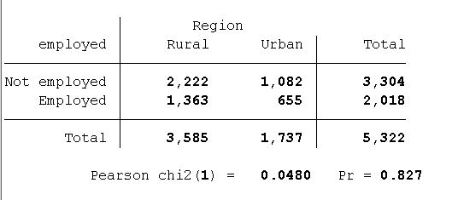

Null Hypothesis (H₀): The distribution of employment status among males is independent of region (rural vs urban).
Alternative Hypothesis (H₁): The distribution of employment status among males depends on region (rural vs urban).
P-value: 0.827 (greater than 0.05)
Since the p-value is greater than 0.05, we fail to reject the null hypothesis. This means that there is no significant difference in the employment status of males between rural and urban areas. The distribution of employment status among males appears to be consistent across both regions.

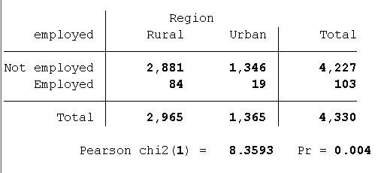
3.1.3.4 Hypothesis: The distribution of employment status of females is the same across region.

Null Hypothesis (H₀): The distribution of employment status among females is independent of region (rural vs urban).
Alternative Hypothesis (H₁): The distribution of employment status among females depends on region (rural vs urban).
P-value: 0.004 (less than 0.05)
The p-value is less than 0.05, so we reject the null hypothesis. This suggests that females' employment status differs between rural and urban regions. Women in rural areas likely face more barriers to employment, such as cultural constraints, lack of education, and fewer job opportunities.

3.2 Independent Samples t-Test
3.2.1 Comparison of Mean Age of Individuals:

3.2.1.1 Hypothesis: The mean age of rural individuals is equal to that of urban individuals.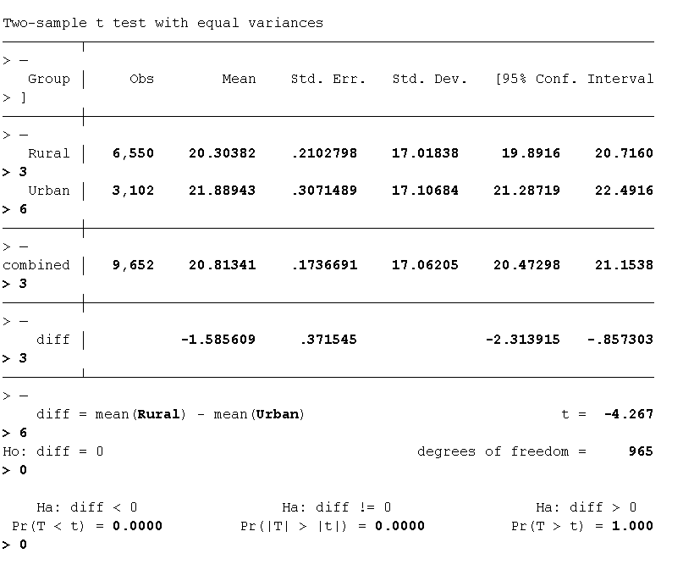

P-value: 0.0000 (less than 0.05). Reject the null hypothesis, indicating a significant difference in mean age between rural and urban individuals.

3.2.1.2 Hypothesis: The mean age of male individuals is equal to that of female individuals.

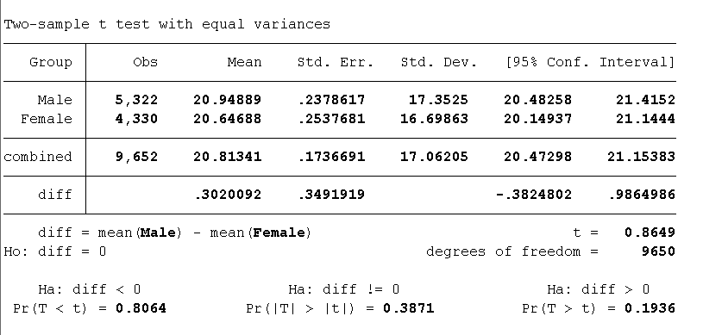

P-value: 0.3871 (greater than 0.05)
Since the p-value is greater than 0.05, we fail to reject the null hypothesis. This suggests that there is no significant difference in the mean age between males and females in the total population.

3.2.1.3 Hypothesis: The mean age of male individuals is equal to that of female individuals in the rural region.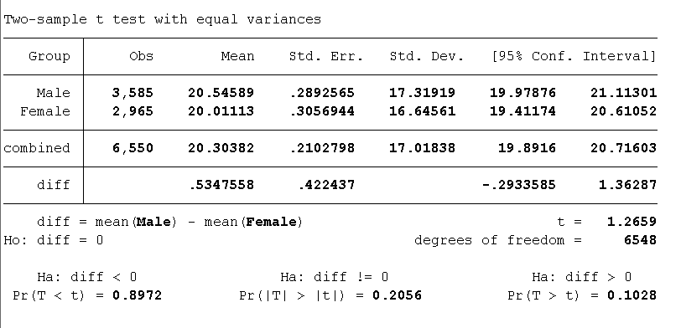

P-value: 0.2056 (greater than 0.05)
Since the p-value is greater than 0.05, we fail to reject the null hypothesis. This suggests that there is no significant difference in the mean age between males and females in rural areas.

Summary:
The analysis of the Labor Force Survey (LFS) 2020-21 for Quetta Division provides critical insights into the socio-economic dynamics of the region, highlighting significant trends in employment, education, marital status, and gender-based disparities. Below are the key findings:

1. Youth Employment and Unemployment:

A major observation from the analysis is the high concentration of both employment and unemployment in the 20-29 age group. While many individuals in this group are employed, a substantial portion is also actively seeking employment, indicating that the transition from education to the workforce remains challenging for youth. The unemployment rate among young individuals is disproportionately high, which emphasizes the need for targeted employment policies, vocational training, and skills development programs for young people.

2. Educational Attainment:

The analysis reveals that educational attainment has significantly improved among younger generations in Quetta Division. The 20-39 age group has the highest levels of education, with a substantial portion completing matriculation, intermediate, and even graduation. However, the older age groups (60+) show limited educational attainment, which reflects the historical challenges faced by previous generations in accessing education. Despite improvements, disparities remain between rural and urban areas, with urban areas having a higher proportion of individuals with matriculation and higher education.

This highlights the importance of education policy to bridge the gap between rural and urban areas, ensuring equal opportunities for all demographics. Additionally, there is a gender-based educational divide, with males having higher educational attainment in some age groups, indicating the need to promote gender equality in education.

3. Marital Status and Its Socio-economic Implications:

Marital status trends show that most individuals in the 10-19 age group are never married, with marriage rates rising in the 20-29 age group. As individuals age, marriage becomes more common, while the widowhood rate increases significantly in the 60+ age group. Divorce rates, however, remain low across all age groups in Quetta Division, suggesting that marital stability is relatively high.

The analysis also indicates that marital status is influenced by employment status and educational attainment. Unemployed individuals and those with lower education levels tend to marry earlier, whereas those with higher educational attainment or employed status tend to delay marriage. This finding underscores the socioeconomic factors that influence family dynamics and decision-making in Quetta Division.

4. Gender and Regional Disparities:

Significant disparities are observed between urban and rural populations, as well as between male and female populations. The gender distribution is nearly balanced in the younger age groups but shows slight variations across different age groups, particularly in rural areas. In urban regions, males tend to outnumber females, though this trend reverses slightly in certain age groups.

Regional differences are also evident in the labor force participation rates. Urban areas have better access to employment opportunities and educational institutions, leading to higher labor force participation, especially among educated women. In contrast, rural areas face significant barriers, including limited access to quality education and fewer job opportunities, which result in a lower employment rate and labor force participation.

Recommendations:
- Youth Employment Programs: Tailored initiatives to address youth unemployment and bridge the gap between education and job opportunities.
- Education Access: Focus on improving educational outcomes in rural areas, with an emphasis on gender equality.
- Gender-sensitive Policies: Implement policies aimed at reducing gender disparities in education and employment, particularly in rural areas.

