Computer Science Distilled

**Pseudocode** is human-friendly code that cannot be understood by a machine.

Finding the maximum value between three variables.

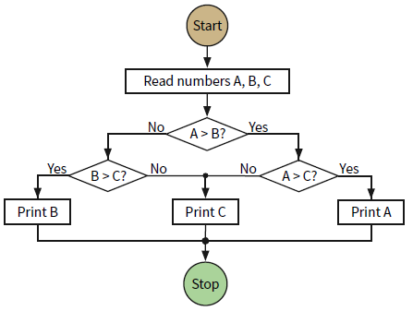 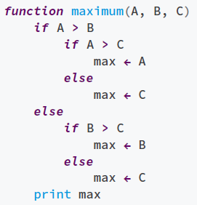

Problem #1:  
*LIVESTOCK FENCE Your farm has two types of livestock. You have 100 units of barbed wire to make a rectangular fence for the animals, with a straight division for separating them. How do you frame the fence in order to maximize the pasture’s area?*

**Solution**:  
 Starting with what’s to be determined, w and l are the pasture’s dimensions; w × l, the area. Maximizing it means using all the barbed wire, so we relate w and l with 100:

