AIRLINE LOYALTY PROGRAM
End-to-End Data Engineering & Business Intelligence Project

Northern Lights Air (NLA) Customer Loyalty Analytics

Source  CSV Files | → | SSIS  ETL Pipeline | → | SQL Server  Data Warehouse | → | Power BI  Dashboards

Prepared by:
Mariam Safwat Heshmat
National Telecommunication Institute (NTI)
Digital Egypt Youth Program
Data Engineering & Analytics Track (June_ 2026)

Table of Contents

1 | Project Overview | 3
2 | Data Overview & Column Reference | 3
2.1 | Customer Loyalty History — 16 Columns, 16,737 Rows | 3
2.2 | Customer Flight Activity — 8 Columns, 392,936 Rows | 4
2.3 | Calendar — 4 Columns, 2,557 Rows | 4
3 | Data Modeling — Galaxy Schema | 5
4 | SSIS ETL Pipeline | 5
4.1 | Layer A: ODS Package — Raw Data Ingestion | 6
4.2 | Layer B: STG Package — Staging & Transformation | 6
4.3 | Layer C: DWH Package — Warehouse Load | 7
5 | Data Warehouse Structure & SQL Validation | 8
6 | Power BI Dashboards | 8
7 | Key Business Findings & Conclusion | 9

1. Project Overview
This document presents a full-stack Business Intelligence solution for Northern Lights Air (NLA), a fictitious Canadian airline. The pipeline covers raw CSV ingestion via SSIS, a Galaxy Schema Data Warehouse in SQL Server, and interactive Power BI dashboards.

Key Business Questions
1. What impact did the 2018 campaign have on loyalty program memberships (gross / net)?
2. Was the campaign adoption more successful for certain demographics of loyalty members?
3. What impact did the campaign have on booked flights during the summer?

2. Data Overview & Column Reference
The project is based on 3 CSV source files — 412,230 total rows and 28 columns combined. Below is a full breakdown of each dataset.

Dataset | Columns | Rows | Coverage
Customer Loyalty History | 16 | 16,737 | Member profiles, enrollment, cancellations, CLV, demographics
Customer Flight Activity | 8 | 392,936 | Monthly flight records for all members: 2017–2018
Calendar | 4 | 2,557 | Date dimension: 2012-01-01 to 2018-12-31

2.1 Customer Loyalty History — 16 Columns, 16,737 Rows
Each row = one unique loyalty program member. Covers demographics, enrollment/cancellation dates, loyalty tier, salary, and customer lifetime value.

# | Column Name | Type | Description / Notes
1 | Loyalty Number | INT | Unique member ID — Business Key (BK) for DimCustomer
2 | Country | String | Always 'Canada' — single-country dataset
3 | Province | String | 11 unique values: Ontario, British Columbia, Alberta, Quebec, Manitoba, Saskatchewan, Nova Scotia, New Brunswick, Newfoundland, Prince Edward Island, Yukon
4 | City | String | City of residence
5 | Postal Code | String | Canadian postal code — 6-character alphanumeric
6 | Gender | String | 2 values: Female, Male
7 | Education | String | 5 values: Bachelor, College, Master, Doctor, High School or Below
8 | Salary | FLOAT/NULL | Annual salary — NULLs exist; used to derive SalaryBand in STG (Low / Mid / High / Unknown)
9 | Marital Status | String | Married, Single, Divorced
10 | Loyalty Card | String | 3 tiers: Star (entry), Nova (mid), Aurora (premium)
11 | CLV | FLOAT | Customer Lifetime Value — used to derive CLVBand: Low <2,500 | Mid 2,500–5,000 | High >5,000
12 | Enrollment Type | String | 2 values: Standard (15,766) | 2018 Promotion (971)
13 | Enrollment Year | INT | Year customer joined the loyalty program
14 | Enrollment Month | INT | Month of enrollment (1–12)
15 | Cancellation Year | INT/NULL | NULL = still active (14,670 members); populated for 2,067 cancelled members
16 | Cancellation Month | INT/NULL | Month of cancellation — NULL if no cancellation

2.2 Customer Flight Activity — 8 Columns, 392,936 Rows
Each row = one member's flight activity for one month. Data spans 2017–2018 (all 12 months × all 16,737 members). Key totals: 508,808 flights | 762.86M km | 796.5M points accumulated | 12.3M redeemed | $2.21M revenue lost.

# | Column Name | Type | Description / Notes
1 | Loyalty Number | INT | FK to Customer Loyalty History — links each record to a member
2 | Year | INT | 2017 or 2018 — two-year activity window
3 | Month | INT | 1–12 — combined with Year to build DateKey (YYYYMM) in STG
4 | Total Flights | FLOAT | Number of flights taken by that member in that month
5 | Distance | FLOAT | Total distance flown in km for that month
6 | Points Accumulated | FLOAT | Loyalty points earned from flights in that month
7 | Points Redeemed | FLOAT | Points redeemed in that month (0 for most rows)
8 | Dollar Cost Points Redeemed | FLOAT | Dollar value of redeemed points — total $2,214,454 across all records

Derived Column Added in STG: NetPoints = Points Accumulated − Points Redeemed → Total Net Points: 784,248,420

2.3 Calendar — 4 Columns, 2,557 Rows
Daily date table covering 2012-01-01 to 2018-12-31. Used to build DimDate with derived flags for summer and promotion period analysis.

# | Column Name | Type | Description / Notes
1 | Date | DATE | Full date YYYY-MM-DD — daily grain; range 2012-01-01 to 2018-12-31
2 | Start of Year | DATE | First day of year — used for Year grouping
3 | Start of Quarter | DATE | First day of quarter — Q1/Q2/Q3/Q4 grouping
4 | Start of Month | DATE | First day of month — used to derive DateKey (YYYYMM INT) in STG

Derived in STG: DateKey = Year×100+Month (e.g., 201806) | IsSummer = 1 when Month IN (6,7,8) | IsPromoPeriod = 1 when Year=2018 AND Month IN (2,3,4)

3. Data Modeling — Galaxy Schema
The warehouse implements a Galaxy Schema (Fact Constellation): two fact tables sharing conformed dimensions, supporting two analytical grains without data duplication.

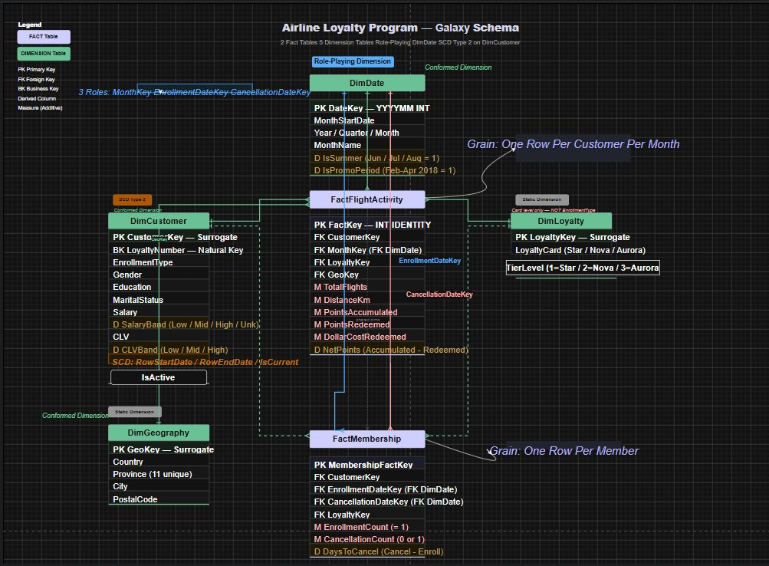
Figure 1: Galaxy Schema — 2 Fact Tables, 4 Dimension Tables

Table | Type | Grain / Rows | Key Measures / Attributes
FactFlightActivity | Fact | 392,936 rows — 1 per member/month | TotalFlights, DistanceKm, PointsAccumulated, PointsRedeemed, DollarCostRedeemed, NetPoints
FactMembership | Fact | 16,737 rows — 1 per member | EnrollmentCount (=1), CancellationCount (0 or 1), DaysToCancel
DimDate | Dim (Role-Playing) | 2,557 rows | DateKey (YYYYMM), Year, Quarter, Month, IsSummer, IsPromoPeriod; used 3× in FactMembership
DimCustomer | Dim (SCD Type 2) | 16,737+ rows | CustomerKey (surrogate), LoyaltyNumber (BK), SalaryBand, CLVBand, RowStartDate, RowEndDate, IsCurrent
DimLoyalty | Static Dim | 3 rows | LoyaltyKey, LoyaltyCard (Star/Nova/Aurora), TierLevel (1/2/3)
DimGeography | Conformed Dim | Unique cities | GeoKey, Country, Province (11), City, PostalCode

4. SSIS ETL Pipeline
Three SSIS packages implement a layered ETL architecture. Data flows from raw CSV through three progressively refined SQL Server databases.

CSV Files → [ODS.dtsx] → AirlineLoyaltyODS → [STG.dtsx] → AirlineLoyaltySTG → [DWH.dtsx] → AirlineLoyaltyDWH

4.1 Layer A: ODS Package — Raw Data Ingestion
Objective: Extract the 3 CSV files and load into AirlineLoyaltyODS with minimal transformation — preserving raw data for auditability.

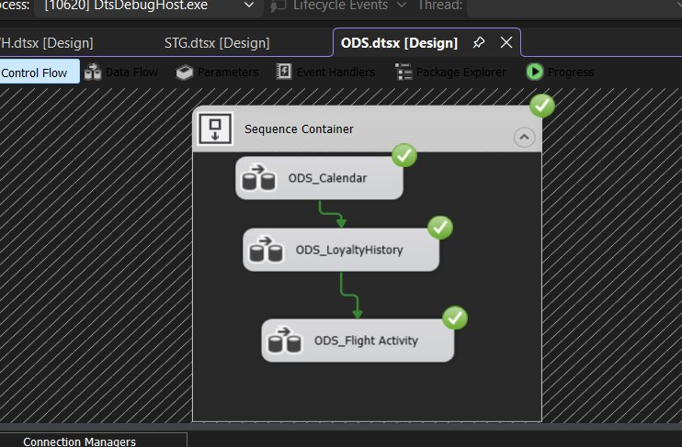
Figure 2: ODS Package — Sequence Container: ODS_Calendar → ODS_LoyaltyHistory → ODS_FlightActivity

Step | Component | Action
1 | Execute SQL Task | TRUNCATE all ODS tables — full refresh, no incremental load
2 | Flat File Source | Reads 3 CSV files via Flat File Connection Manager
3 | Data Conversion | Converts Unicode strings (DT_WSTR) to correct types: Year/Month → INT, Salary/CLV/Points → FLOAT
4 | Derived Column | Adds IsActive = (CancellationYear IS NULL ? 1 : 0); passes NULL cancellation fields through correctly
5 | OLE DB Destination | Writes to ODS_Calendar (2,557), ODS_LoyaltyHistory (16,737), ODS_FlightActivity (392,936)

- NULL Salary values allowed through — handled in STG (mapped to 'Unknown' SalaryBand)
- CancellationYear / CancellationMonth NULLs preserved — used in STG to identify active vs cancelled members
- No business logic at ODS — raw layer is a faithful copy of source CSV data

4.2 Layer B: STG Package — Staging & Transformation
Objective: Apply all business rules, derive analytical columns, and structure data into dimension/fact staging tables mirroring the DWH schema.

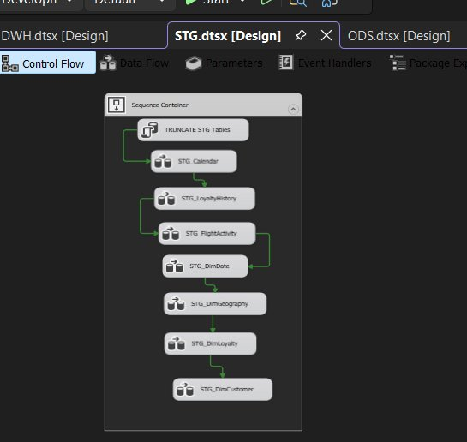
Figure 3: STG Package — 8 Data Flow Tasks in Sequence Container

Step | Staging Table | Key Transformations & Business Rules
1 | TRUNCATE STG | Clears all 8 staging tables before reload
2 | STG_Calendar | DateKey = Year×100+Month; IsSummer = Month IN (6,7,8); IsPromoPeriod = Year=2018 AND Month IN (2,3,4)
3 | STG_LoyaltyHistory | SalaryBand: NULL/0→'Unknown', <60K→'Low', <100K→'Mid', ≥100K→'High'; CLVBand: <2500→'Low', <5000→'Mid', ≥5000→'High'
4 | STG_FlightActivity | NetPoints = PointsAccumulated − PointsRedeemed; DateKey = Year×100+Month
5 | STG_DimDate | Full date dim from STG_Calendar with all derived flags
6 | STG_DimGeography | Deduplicates 16,737 rows → unique Province/City combinations (11 provinces)
7 | STG_DimLoyalty | Maps card name to TierLevel: Star→1, Nova→2, Aurora→3
8 | STG_DimCustomer | SCD Type 2: RowStartDate = EnrollmentDate; RowEndDate = CancellationDate (active → 9999-12-31); IsCurrent flag

- Conditional Split separates active (14,670) from cancelled (2,067) members for SCD Type 2 date assignment
- Sort on DimGeography deduplicates geography records before loading
- All surrogate key assignment deferred to DWH Package — STG retains business keys only

4.3 Layer C: DWH Package — Warehouse Load
Objective: Populate AirlineLoyaltyDWH with surrogate-keyed, lookup-resolved data. Two Sequence Containers enforce load order: Dimensions first, then Facts.

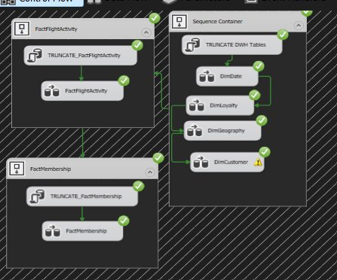
Figure 4: DWH Package — Container 1: Dimensions | Container 2: Fact Tables

Container | Step | Task | Detail
1 — Dims | 1 | TRUNCATE DWH | Clears all 6 DWH tables
1 — Dims | 2 | DimDate | Direct load — 2,557 rows with DateKey, Year, Quarter, Month, IsSummer, IsPromoPeriod
1 — Dims | 3 | DimLoyalty | Direct load — 3 rows (Star / Nova / Aurora)
1 — Dims | 4 | DimGeography | Direct load — deduplicated geography; GeoKey = IDENTITY
1 — Dims | 5 | DimCustomer | SCD Type 2 load — CustomerKey = IDENTITY surrogate
2 — Facts | 6 | FactFlightActivity | Lookup: CustomerKey (IsCurrent=1), DateKey (YYYYMM), LoyaltyKey, GeoKey → 392,936 rows
2 — Facts | 7 | FactMembership | Lookup: CustomerKey, EnrollmentDateKey, CancellationDateKey (NULL-safe for active members) → 16,737 rows

- Lookup uses Full Cache mode — dimension tables fully cached before fact processing for performance
- NULL-safe CancellationDateKey: active members (14,670) receive NULL FK correctly — no default row error
- Customer Key lookup always filters IsCurrent = 1 to resolve the correct SCD Type 2 record

5. Data Warehouse Structure & SQL Validation
AirlineLoyaltyDWH contains 6 fully loaded tables. The SQL query below confirms correct surrogate key resolution and measure loading in FactFlightActivity.

Table | Type | Rows | PK | FK Columns
DimDate | Dimension | 2,557 | DateKey (INT) | —
DimCustomer | Dim SCD2 | 16,737+ | CustomerKey (IDENTITY) | —
DimLoyalty | Dimension | 3 | LoyaltyKey (IDENTITY) | —
DimGeography | Dimension | Unique cities | GeoKey (IDENTITY) | —
FactFlightActivity | Fact | 392,936 | FactKey (IDENTITY) | CustomerKey, DateKey, LoyaltyKey, GeoKey
FactMembership | Fact | 16,737 | MembershipFactKey (IDENTITY) | CustomerKey, EnrollDateKey, CancelDateKey, LoyaltyKey

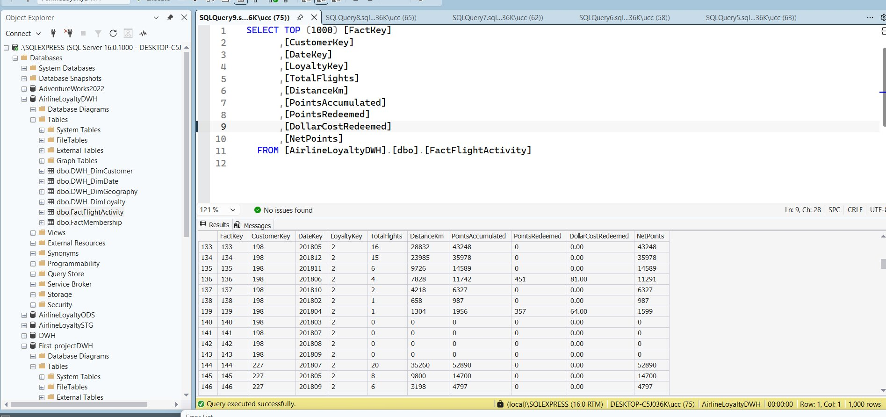
Figure 5: SQL Server — SELECT TOP 1000 from FactFlightActivity confirming all surrogate keys and measures loaded correctly

- All surrogate keys resolved — no NULL FKs in FactFlightActivity output
- NetPoints confirmed correct in result set (PointsAccumulated − PointsRedeemed)
- Database: AirlineLoyaltyDWH on SQL Server Express 16.0 (local\SQLEXPRESS)

6. Power BI Dashboards
Three interactive dashboards connect to the Power BI model. All pages support dynamic filtering by Enrollment Type, Loyalty Card, Province, Gender, and more.

7.1 Campaign Overview
Answers: What impact did the 2018 promotion have on membership gross and net numbers?

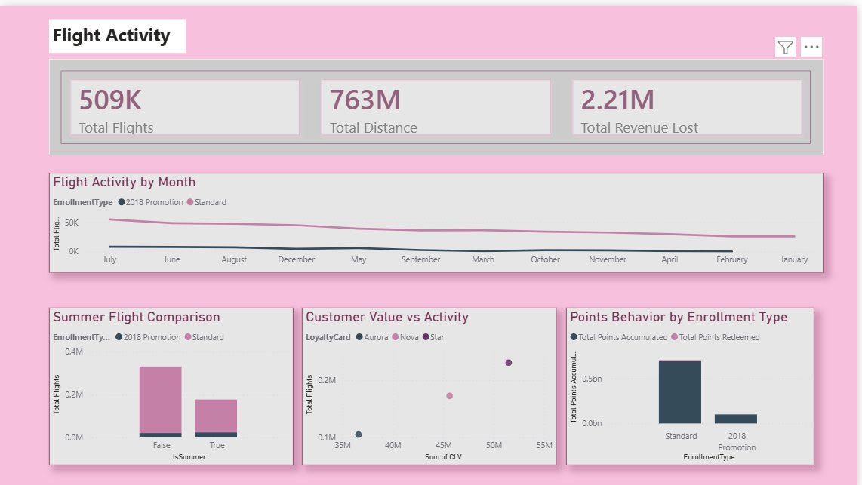
Figure 7: Campaign Overview — KPIs, Membership Growth, Standard vs Promo, Member Status
- KPIs: 17K Total Members | 971 Promo Members | 15K Active | 0.12 Churn Rate | 13K Net Members
- Membership Growth Over Time: Standard enrollment grows steadily; 2018 Promo shows a brief spike in Feb–Apr 2018
- Member Status donut: Active 87.65% (15K) vs Cancelled 12.35% (2K) strong long-term retention

7.2 Demographics Analysis
Answers: Was campaign adoption more successful for specific customer demographics?

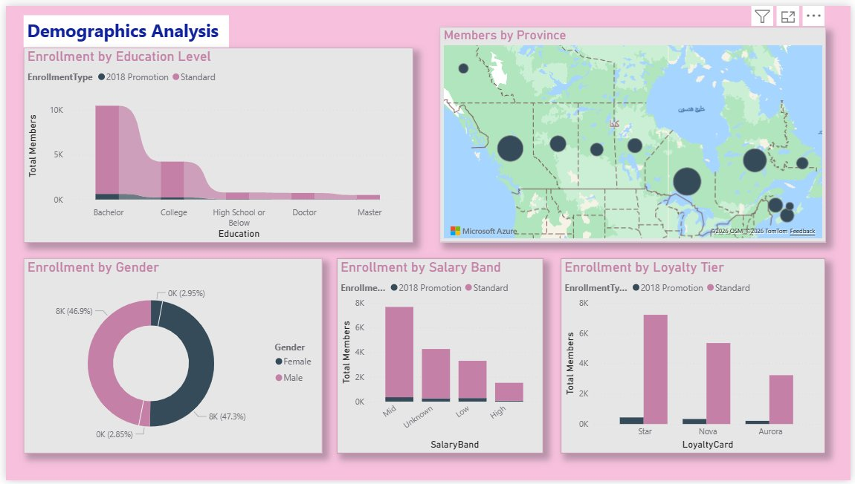
Figure 8: Demographics — Education, Province Map, Gender, Salary Band, Loyalty Tier
- Bachelor-educated members are the largest segment in both Standard and Promo enrollment types
- Ontario and British Columbia show highest provincial concentration on the bubble map
- Gender split near-equal: Female 46.9% vs Male 47.3% — no demographic skew from campaign
- Mid-salary earners dominate enrollment; High-salary segment is smaller but carries higher CLV
- Star card (entry tier) dominates — promotion attracted new-to-loyalty customers, not premium upgrades

7.3 Flight Activity
Answers: What impact did the campaign have on summer flight bookings?

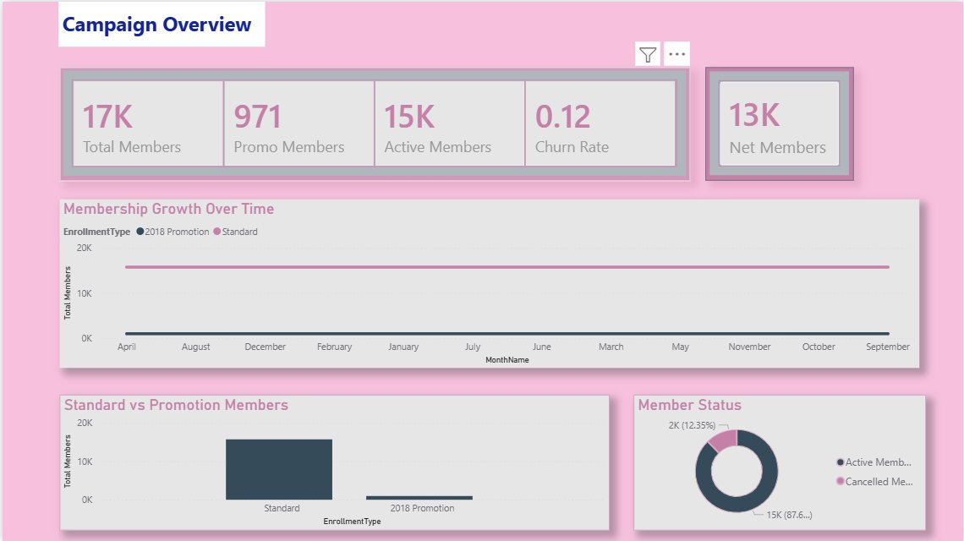
Figure 9: Flight Activity — Monthly Trend, Summer Comparison, CLV vs Flights, Points Behavior
- KPIs: 509K Total Flights | 763M km Distance | $2.21M Total Revenue Lost from point redemptions
- Standard enrollment members drive virtually all monthly flight volumes — Promo members show minimal activity
- Summer Comparison (IsSummer): Standard members show clear summer peak; Promo members have negligible uplift
- Aurora (premium) members show highest CLV with moderate flight counts — high-value selective fliers
- Points Behavior: Standard members accumulated ~0.5Bn points vs negligible accumulation by Promo members

7. Key Business Findings & Conclusion

Campaign Impact on Membership
- The 2018 promotion added 971 new members — 5.7% of total 16,737 member base.
- Churn rate is low at 0.12; 14,670 members (87.65%) remain active — strong long-term retention.
- Net Members (13K) after accounting for 2,067 historical cancellations across all years.

Demographic Adoption
- Bachelor-educated, mid-salary Canadians are the core loyalty segment — both Standard and Promo.
- Gender split is equal; campaign reached both male and female customers uniformly.
- Star card dominates promo enrollment — campaign attracted entry-level loyalty customers.

Summer Flight Impact
- Standard members drive 508,808 total flights and 796.5M points accumulated over 2017–2018.
- 2018 Promo members contributed minimal summer flight uplift — campaign ROI on bookings is limited.
- $2.21M revenue cost from point redemptions is the key financial metric for program ROI evaluation.

Conclusion
This project delivers a complete, production-ready BI solution for NLA. The three-layer SSIS pipeline (ODS → STG → DWH) ensures data quality and auditability. The Galaxy Schema with SCD Type 2 and Role-Playing Dimensions supports rich multi-grain analysis. Three Power BI dashboards translate data into clear business answers.
The analysis shows that the 2018 promotion successfully recruited 971 new members, but high-value long-term behaviors — flight activity, points accumulation, and summer bookings — remain driven by the Standard enrollment base. This finding is critical for designing future campaigns and loyalty tier incentives.

Mariam Safwat Heshmat | NTI Scholarship — Business Intelligence | June 2026

