🎬
Top 500 Movies
Data Warehouse Project
A story of raw data becoming insight
Built with dbt + DuckDB | NTI Training Project |By: MARIAM SAFWAT HESHMAT

The Story
Every great film starts with a script. Every great data project starts with a question. Ours was simple: what actually makes a movie great — and can the data tell us?

We started with a flat CSV file containing 449 movies, 26 columns, and a mix of scores from IMDb, Rotten Tomatoes, Metacritic, Letterboxd, and Google. The data was messy — genres were crammed into a single cell, streaming platforms were comma-separated strings, and some columns had over 100 missing values.

The goal was to transform this raw file into a clean, queryable data warehouse — one where every table has a purpose, every column has a contract, and every score can be trusted.

This document tells that story: from raw seed to dimensional model, layer by layer.

Act I — Meeting the Data

What We Started With
The source dataset: Top 500 Movies Ranked by Combined Critics and Audience Scores. 449 rows, 26 columns, one CSV file.

Column Group | Columns | Challenge
Identity | imdbID, Title, Rank | Primary keys — must be unique and not null
Movie Info | Year, Director, Language, Plot, Cast | Cast had 1 null — nullable by design
Scores | IMDb, Metacritic, RT Critic, RT Audience, Letterboxd, Google, Flickmetrix | 13 nulls in Metacritic, 48 in Audience_Rating
Multi-value | Genre, Streaming_On | Comma-separated — needed to be exploded into rows
Optional | Awards, Production, RT_URL | 120-125 nulls — not all movies have this data

The Key Insight Before Writing a Single Line of SQL
The Genre column said 'Drama, Crime'. The Streaming_On column said 'paramount, itunes, amzvid'. These aren't values — they're lists hiding inside a single cell. A junior engineer treats them as strings. A senior engineer normalizes them into bridge tables.

This decision shaped the entire architecture. Instead of 4 staging models, we needed models that understood the shape of the data — not just its type.

Act II — Designing the Pipeline

The Three-Layer Architecture
The pipeline follows a strict separation of concerns across three layers:

Layer | What It Does | Materialized As | Trust Level
ODS (Seeds) | Raw data — exactly as received, no transformations | CSV → DuckDB table | Zero — source of truth only
STG (Staging) | Clean, cast, normalize — one job per model | Views | Medium — trusted shape, not yet analytical
DWH (Warehouse) | Dimensional model — ready for analysis and reporting | Tables | Full — tested, documented, queryable

Data Flow
The lineage from raw data to analytical layer:

raw_movies (ODS)
│
├──► stg_movies ──► dim_movies
│ │
├──► stg_movie_scores ──► fact_movie_scores ◄── dim_movies
│
├──► stg_movie_genres ──► dim_genres
│
└──► stg_movie_streaming ──► dim_platforms

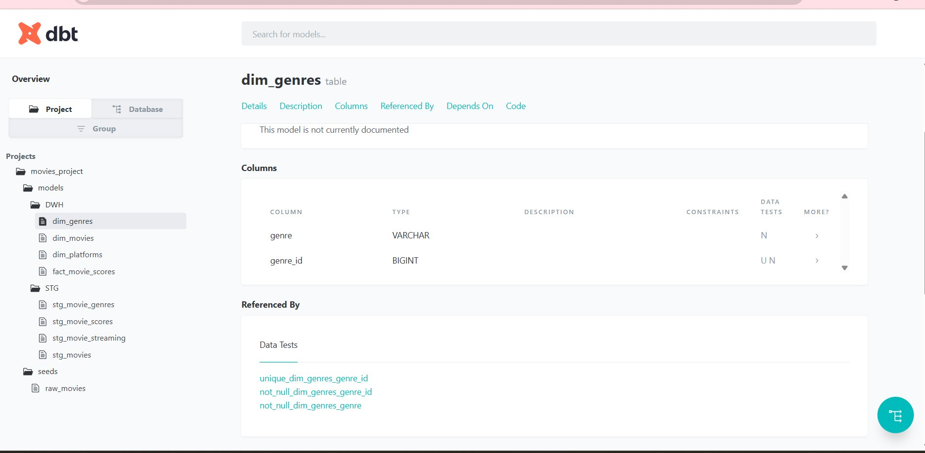
dbt documentation UI — full project lineage and model structure

Act III — The Staging Layer
The staging layer has one job: make the data trustworthy. Not analytical — just clean, typed, and consistent. Every downstream model depends on this layer being right.

stg_movies — The Core Film Record
Casts every column to its correct type, renames for consistency, and uses COALESCE to handle nullable fields gracefully rather than letting them propagate as errors downstream.

SELECT
CAST(imdbID AS VARCHAR) AS movie_id,
CAST(Rank AS INTEGER) AS rank,
CAST(Title AS VARCHAR) AS title,
CAST(Year AS INTEGER) AS release_year,
COALESCE(CAST(Awards AS VARCHAR), 'N/A') AS awards,
COALESCE(CAST(Production AS VARCHAR),
'Unknown') AS production_company
FROM {{ ref('raw_movies') }}
WHERE imdbID IS NOT NULL AND Title IS NOT NULL

stg_movie_scores — Separating the Numbers
All 9 scoring columns are extracted into their own model. This separation means: if a new scoring platform is added tomorrow, only this model changes — nothing else breaks.

Score Column | Source | Nulls | Contract
flickmetrix_score | Flickmetrix_Score | 0 | not_null
imdb_score | IMDb_10 | 0 | not_null
imdb_votes | IMDb_Votes | 0 | not_null
metacritic_score | Metacritic | 13 | nullable — not on Metacritic
rt_critic_score | Critic_Rating_RT | 0 | not_null
audience_score | Audience_Rating | 48 | nullable — not on RT
letterboxd_score | Letterboxd | 0 | not_null
google_score | Google_Score | 3 | nullable — not always available
avg_combined_score | calculated in DWH | — | COALESCE(rt + audience) / 2

stg_movie_genres — Exploding Multi-Value Columns
This is where the senior thinking shows. Instead of storing 'Drama, Crime' as a string, we use DuckDB's STRING_SPLIT + UNNEST to create one row per genre per movie.

WITH split AS (
SELECT
CAST(imdbID AS VARCHAR) AS movie_id,
TRIM(UNNEST(STRING_SPLIT(Genre, ','))) AS genre
FROM {{ ref('raw_movies') }}
WHERE imdbID IS NOT NULL AND Genre IS NOT NULL
)
SELECT movie_id, genre FROM split WHERE genre <> ''

Result: The Godfather → 2 rows (Drama, Crime). Seven Samurai → 2 rows (Action, Drama). This enables proper genre-level aggregations later.

The same pattern is applied to stg_movie_streaming for platforms.

Act IV — The Data Warehouse
The DWH layer is where data becomes insight. Everything here is materialized as a table — fast, permanent, and ready to answer questions without re-running transformations every time.

dim_movies — The Film Directory
The central dimension table. One row per movie. Every analytical query that needs a movie's metadata joins here.

Column | Type | Notes
movie_id | VARCHAR | Primary key — imdbID (e.g. tt0068646)
title | VARCHAR | e.g. The Godfather
release_year | INTEGER | e.g. 1972
director | VARCHAR | e.g. Francis Ford Coppola
language | VARCHAR | ISO code (en, ja, fr...)
production_company | VARCHAR | COALESCE → 'Unknown' if missing
awards | VARCHAR | COALESCE → 'N/A' if no awards data
plot | VARCHAR | Full plot summary
rt_url | VARCHAR | Nullable — not all on RT
custom_score | NUMERIC(6,2) | Combined ranking score

dim_genres & dim_platforms — Lookup Tables
Two lean dimension tables generated from the exploded staging models. Each assigns a surrogate key via ROW_NUMBER() for future join optimization.

Table | Columns | Sample Data
dim_genres | genre_id, genre | 1: Action, 2: Adventure, 3: Animation...
dim_platforms | platform_id, platform | 1: amzvid, 2: hbo, 3: itunes...

fact_movie_scores — The Analytical Core
The fact table is the destination of the entire pipeline. It joins dim_movies with stg_movie_scores and adds the calculated avg_combined_score field — a weighted average of critic and audience scores from Rotten Tomatoes.

SELECT
s.movie_id,
m.title, m.release_year, m.director, m.language,
s.imdb_score, s.imdb_votes,
s.metacritic_score, s.rt_critic_score,
s.audience_score, s.letterboxd_score,
s.flickmetrix_score,
ROUND(
(COALESCE(s.rt_critic_score, 0)
+ COALESCE(s.audience_score, 0)) / 2
, 2) AS avg_combined_score
FROM {{ ref('stg_movie_scores') }} s
JOIN {{ ref('dim_movies') }} m ON s.movie_id = m.movie_id

What the Data Tells Us — Top 5 Films
Rank | Title | Year | IMDb | RT Critic | Audience | avg_combined
1 | The Godfather | 1972 | 9.2 | 96 | 95 | 95.5
2 | Seven Samurai | 1954 | 8.6 | 97 | 94 | 95.5
3 | 12 Angry Men | 1957 | 9.0 | 93 | 94 | 93.5
4 | Schindler's List | 1993 | 9.0 | 93 | 94 | 93.5
5 | The Godfather: Part II | 1974 | 9.0 | 95 | 94 | 94.5

The avg_combined_score is calculated inside the DWH — not in the application. This means any BI tool querying the fact table gets consistent, pre-computed scores without re-running logic.

Act V — The Data Contract
Tests aren't optional. They're the contract between the pipeline and anyone who consumes its output. If a test fails, the pipeline stops — because bad data flowing downstream is worse than no data at all.

Test Strategy
Tests are applied at every layer with a clear philosophy: test what you guarantee, document what you don't.

Layer | Tests | Pass Rate
ODS (raw_movies) | unique + not_null on imdbID, Rank; not_null on core fields | ✅ All pass
STG (4 models) | 20 tests — unique on PKs, not_null on required fields, nullable documented | ✅ 20/20
DWH (4 models) | 23 tests — unique on all PKs, not_null on analytical fields | ✅ 23/23

The Nullable Column Decision
One of the most important decisions in the project was knowing which columns NOT to test. This isn't laziness — it's accuracy.

Column | Nulls | Why Nullable
Awards | 125 | Not all films entered for awards or have records
Production | 120 | Older films often lack production company data
Metacritic | 13 | Not all films are reviewed on Metacritic
Audience_Rating (RT) | 48 | RT audience scores require sufficient review volume
Google_Score | 3 | Not all films indexed with a score panel
Streaming_On | 30 | Some films have no current streaming availability

Writing 'nullable by design' in the description is not a workaround. It's documentation. It tells the next engineer: this isn't a bug — it's expected.

Act VI — Inspection & Validation Scripts
Three Python scripts provide visibility into the database at each layer, using DuckDB's Python API.

Script | Layer | Output Style | Key Feature
ods.py | All tables | DESCRIBE + raw rows | Shows columns + first 5 rows of every table
stg.py | STG only | Raw fetchall() | Filters tables starting with 'stg_'
dwh.py | DWH only | pandas DataFrame | Filters dim_ and fact_ — formatted tabular output

dwh.py — The DWH Inspector
import duckdb, pandas as pd

connection = duckdb.connect(
r'...\movies_project\dev.duckdb'
)
tables = connection.execute('SHOW TABLES').fetchall()
dwh_tables = [t[0] for t in tables
if t[0].startswith('dim_')
or t[0].startswith('fact_')]

for tableName in dwh_tables:
data = connection.execute(
f'SELECT * FROM {tableName} LIMIT 15'
).df()
print(data)

Epilogue — What Was Built
Starting from a single CSV file, the pipeline produces a clean, tested, documented data warehouse with:

- 449 movies processed end-to-end without data loss
- 8 models across 2 layers (4 STG views + 4 DWH tables)
- 43 data tests — all passing
- Multi-value columns properly normalized into bridge-ready tables
- Nullable columns documented with explicit contracts
- avg_combined_score calculated inside the warehouse — not in the app
- Full lineage visible in dbt docs

The difference between a data pipeline and a data product is trust. Tests, documentation, and clear contracts are what turn one into the other.

Component | Technology | Purpose
Orchestration | dbt Core 1.11 | Model building, testing, documentation
Database | DuckDB 1.10 | Local analytical engine — no server needed
Language | SQL + Jinja2 | Transformations and templating
Inspection | Python + pandas | Data validation and exploration
Documentation | dbt docs | Auto-generated lineage and schema docs

NTI Data Engineering Training | Movies dbt Project

