Cairo University  
Faculty of Computers and Artificial Intelligent

**CS251 - Software Engineering I**

Parking System

Software Design Specifications (SDS)

Kevin Marco marcory

Michael Maher Nagi

Mariam Tarek Galal

Hagar Abd-Elhamed Mohamed Ali

May & 2022

Contents

Team 3

Document Purpose and Audience 3

System Models 3

I. Class diagrams 3

Important Algorithm 4

II. Sequence diagrams 5

Class - Sequence Usage Table 6

Ownership Report 6

Policy Regarding Plagiarism: 7

# Team

|  |  |  |  |
| --- | --- | --- | --- |
| **ID** | **Name** | **Email** | **Mobile** |
| 20200401 | Kevin Marco marcory | kevinmarco9000@gmail.com | 01202914566 |
| 20200576 | Michael Maher Nagi | [Michael.maher.nagi@gmail.com](mailto:Michael.maher.nagi@gmail.com) | 01285382191 |
| 20200522 | Mariam Tarek Galal | mmaarriiaammttaarreekk@gmail.com | 01006056040 |
| 20210558 | Hagar Abd-Elhamed Mohamed Ali | Habdelhameed585@gmail.com | 0115206902 |

# Document Purpose and Audience

* **This document is a software requirements specification for a parking garage system and the main purpose is to facilitate the finding of Slots and payment process.**
* **The target audience to read this document is the garage owner and the developers.**

# System Models

## Class diagrams

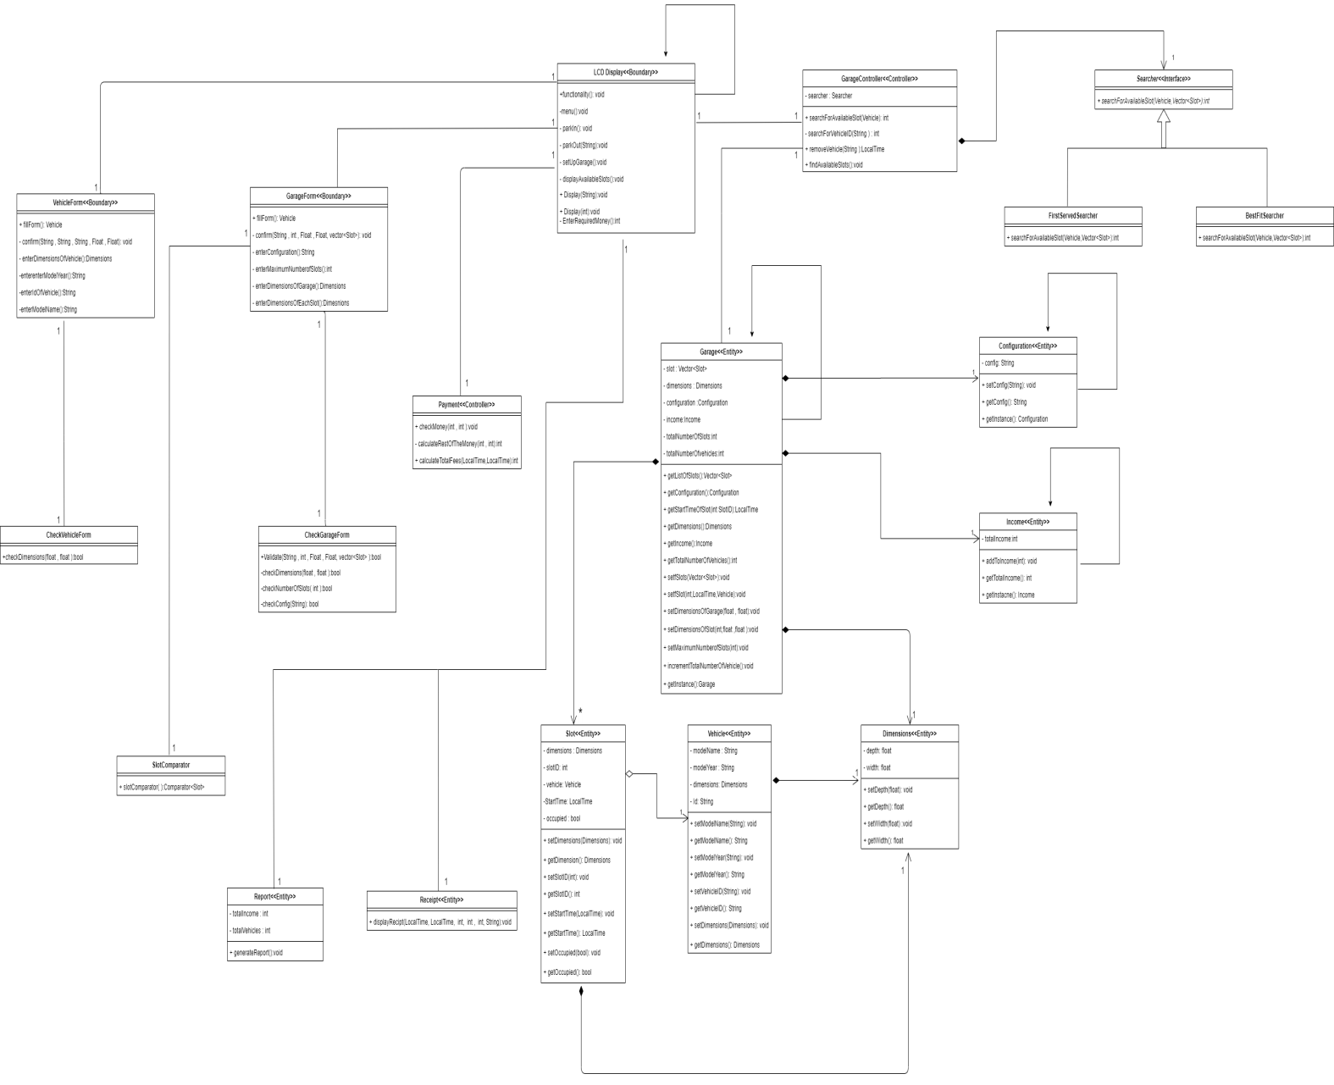

| **Class ID** | **Class Name** | **Description & Responsibility** |
| --- | --- | --- |
| **1** | **Payment** | **Responsible for payment process and checks the entered money is enough for total fees or not.** |
| **2** | **LCD Display** | **The LCD Display Consider The GUI Of The System It’s Make Driver Interact With The System and use It’s Functionality.** |
| **3** | **Garage** | **Responsible For Storing The All Data Of The System Include Dimensions Of The Garage, Number Of Slots, Dimensions Of Each Slot And Vehicle Data.** |
| **4** | **Vehicle** | **Responsible For Vehicles Information as Model name, Model Year ….** |
| **5** | **Dimensions** | **Responsible For Dimensions**  **(Width, Depth)** |
| **6** | **Slot** | **Responsible For Storing Dimensions of Slot, Slot ID, Vehicle and Start Time Of Parking Vehicle.** |
| **7** | **Garage Controller** | **Responsible For Controlling The System**  **It’s Search For Available Slots To Park The Vehicle, Park-Out The Vehicle and Checks For Invalid Input.** |
| **8** | **Vehicle Form** | **Responsible For Filling Form About Vehicles Information Like Model name, Model Year ….** |
| **9** | **Garage Form** | **Responsible For Filling Form About Garage Information like Dimensions Of The Garage, Number Of Slots, Dimensions Of Each Slot And Vehicle Data.** |
| **10** | **Check Vehicle Form** | **Responsible For Checking What The Driver Enter In Vehicle Form** |
| **11** | **Check Garage Form** | **Responsible For Checking What The Driver Enter In Garage Form** |
| **12** | **Income** | **Responsible For Calculating Total Income For Garage** |
| **13** | **Configuration** | **Responsible For Set And Get Configuration** |
| **14** | **Searcher** | **Responsible For Search For Available Slot In The Garage** |
| **15** | **First Served Searcher** |
| **16** | **Best Fit Searcher** |
| **17** | **Receipt** | **Responsible For Display Receipt** |
| **18** | **Report** | **Responsible For Generating Report** |
| **19** | **Slot Comparator** | **Responsible For Sorting Slots When Using Best Fit Approach** |

## 

## II. Sequence diagrams

## Park-out Sequence Diagram:

**ID: UC04**

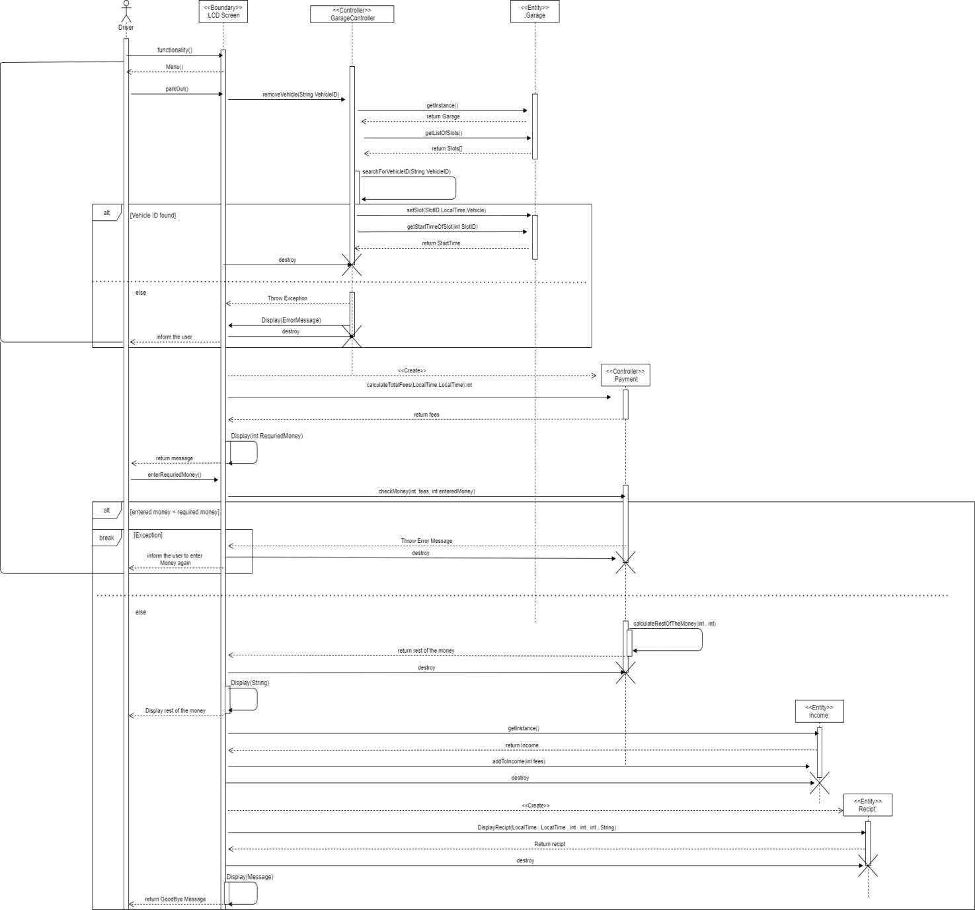

**Setup Garage Sequence Diagram:**

**ID: UC05**

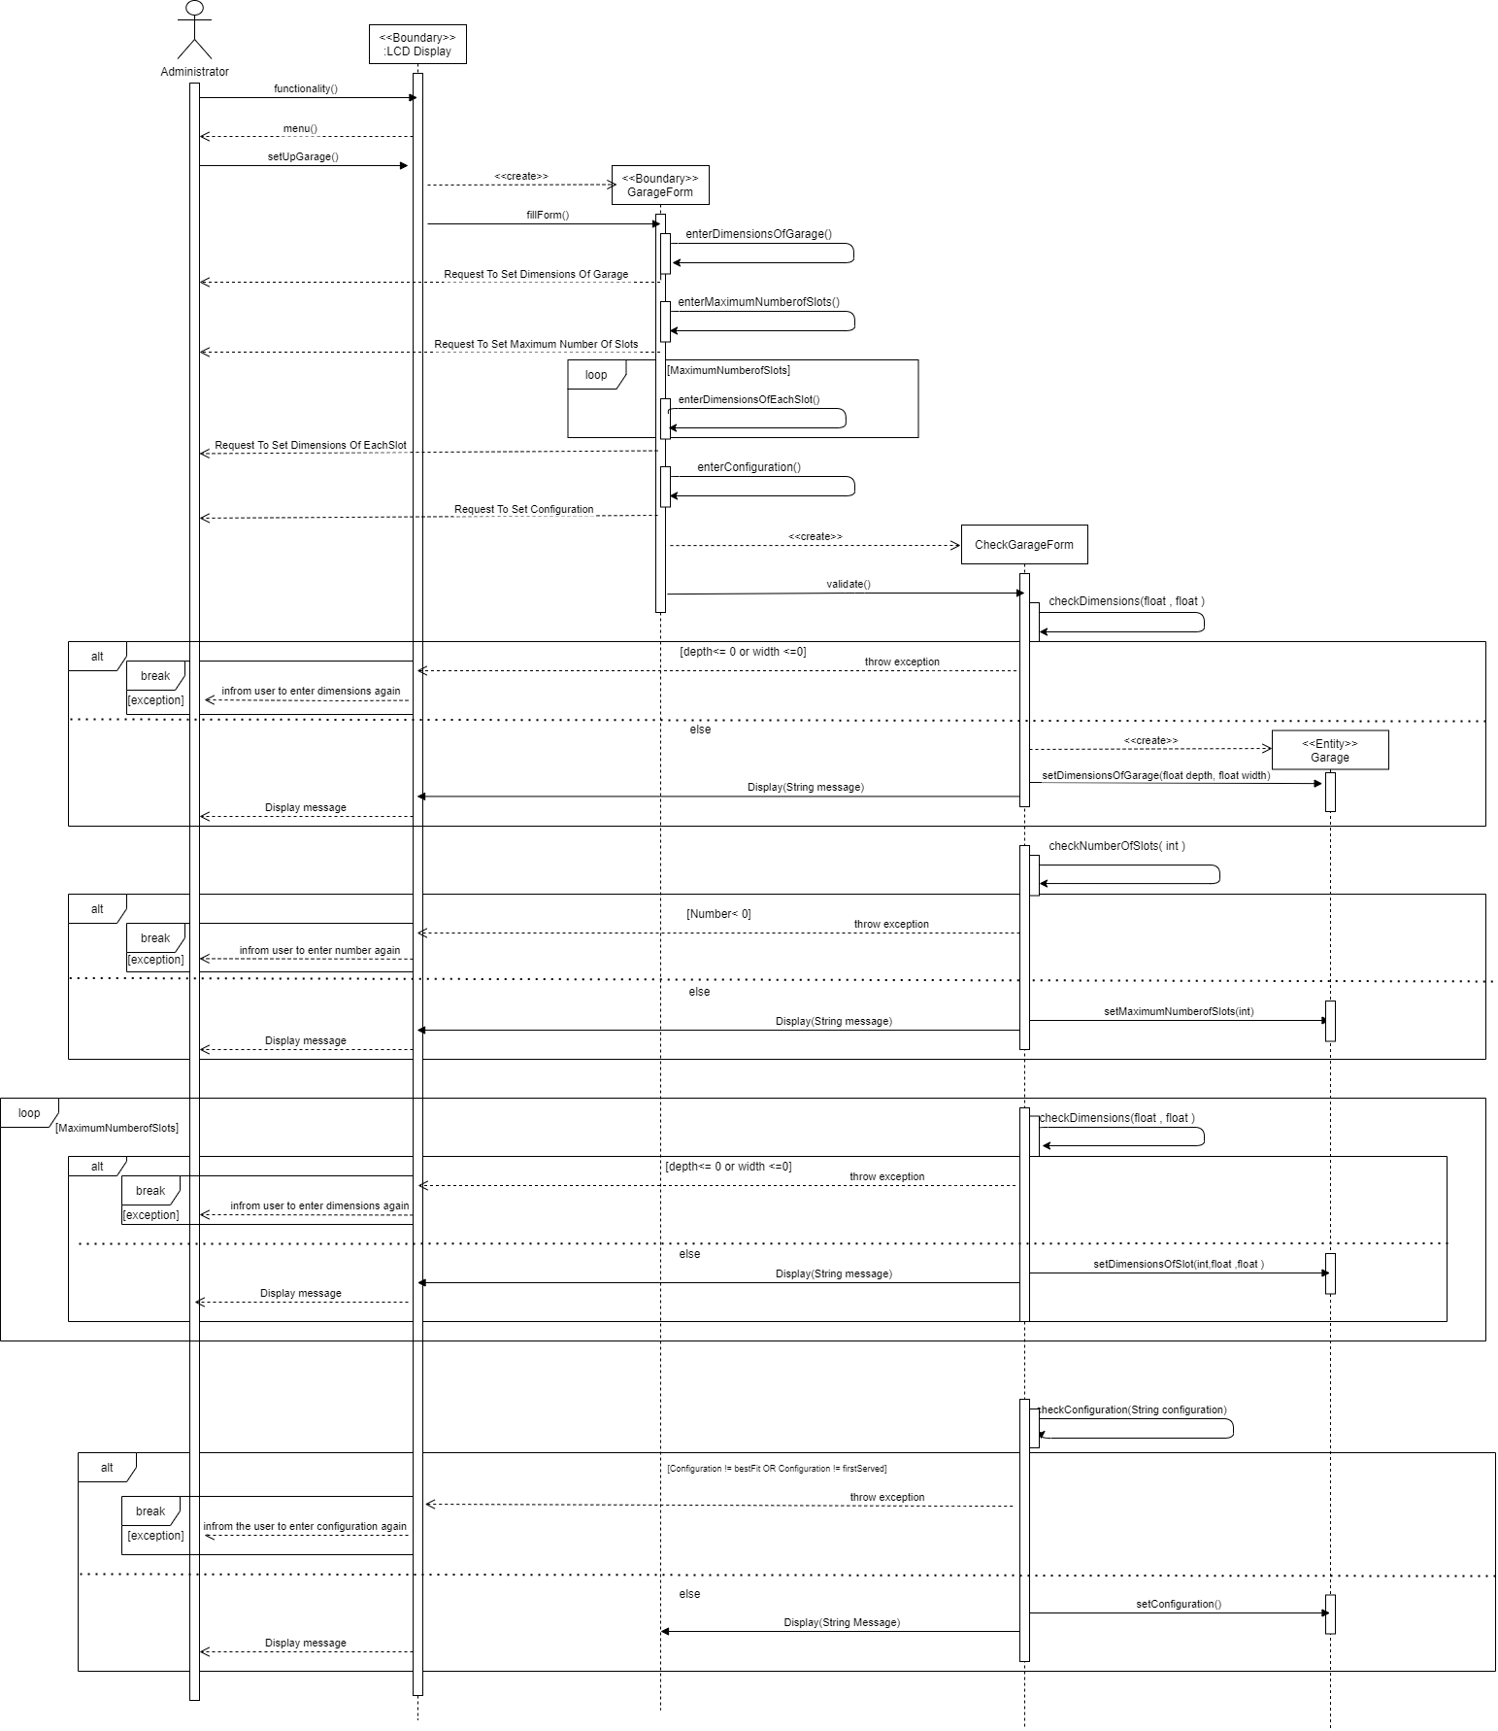

**Payment Sequence Diagram:**

**ID: UC03**

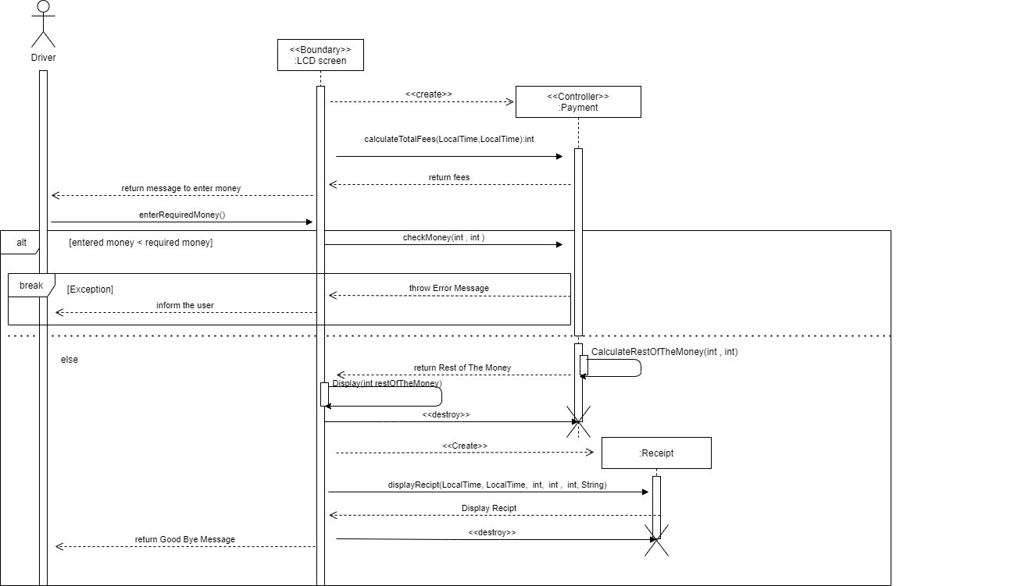

**Park-in Sequence Diagram:**

**ID: UC01**

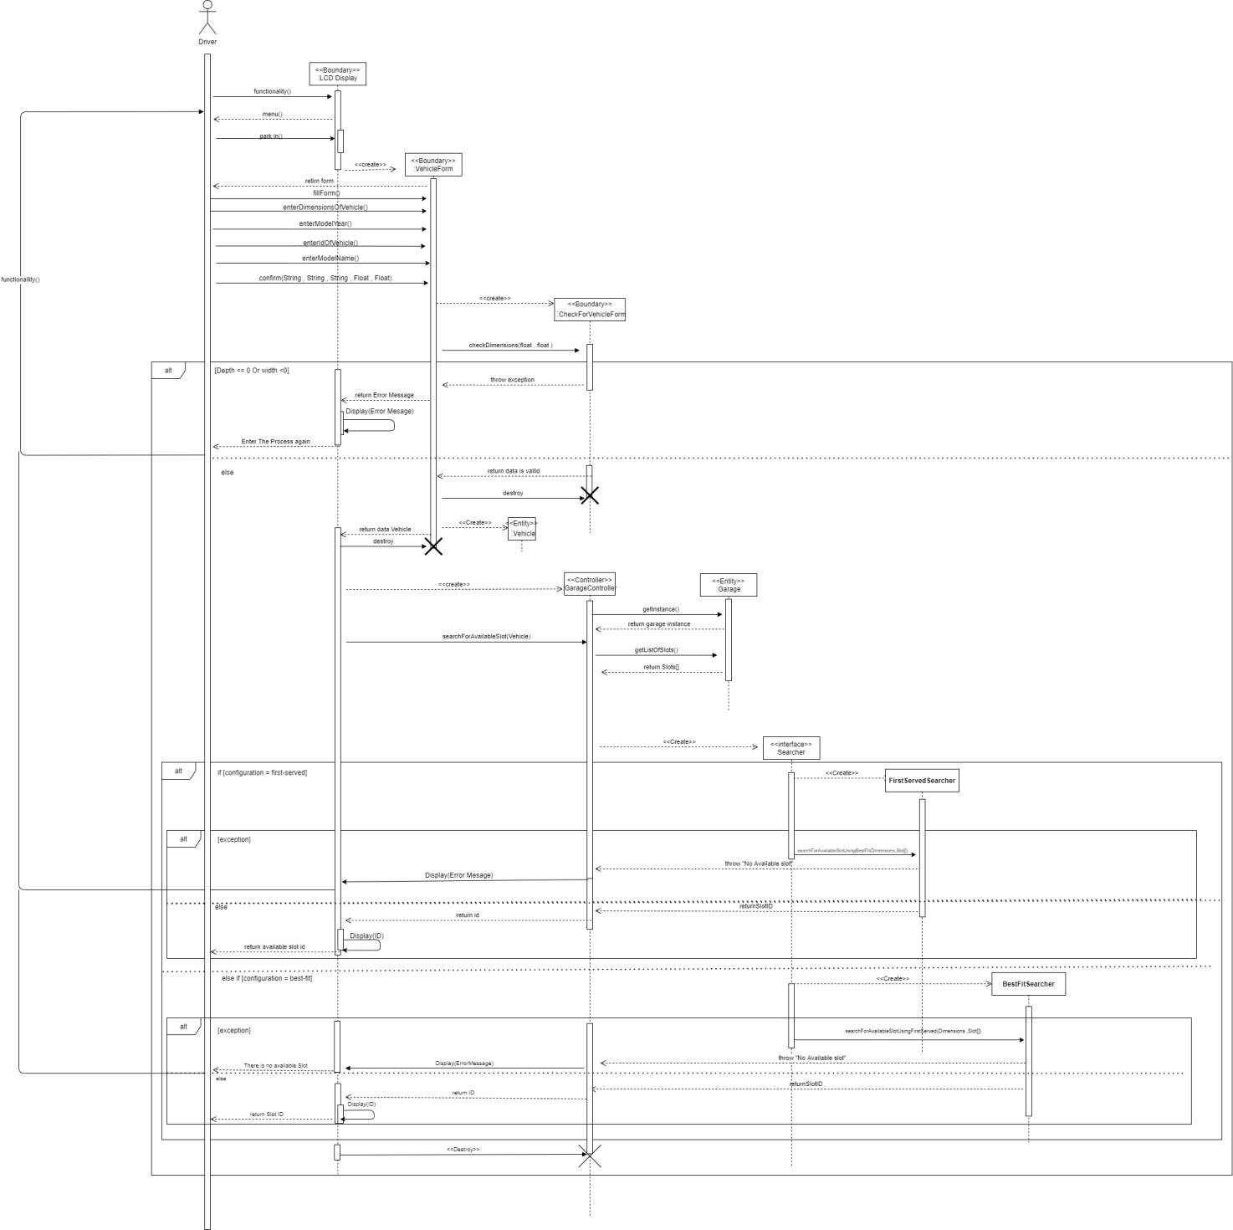

**Search for Available Slots Sequence Diagram:**

**ID: UC02**

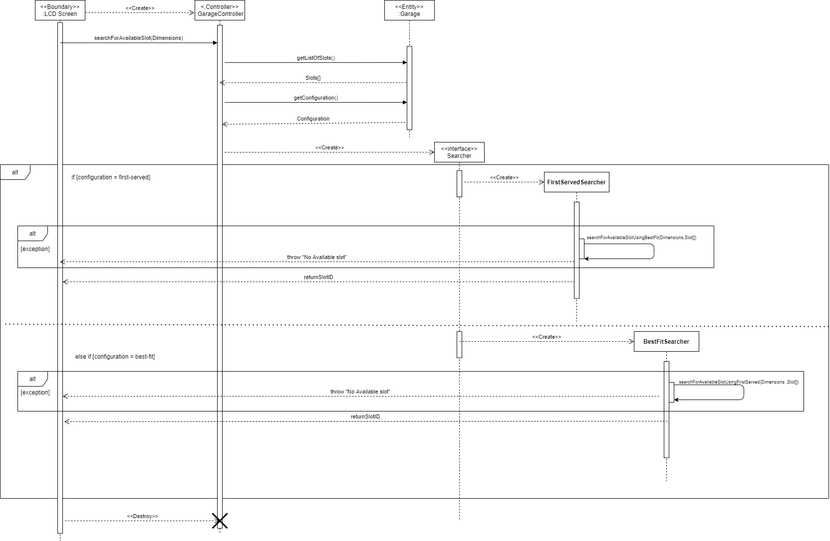

### Class - Sequence Usage Table

| **Class Name** | **Sequence Diagrams** | **Overall used methods** |
| --- | --- | --- |
| **Payment** | **UC03 , UC04** | * **checkMoney** * **calculateRestOfTheMoney** |
| **LCD Display** | **UC01 , UC02 , UC03 , UC04,UC05** | * **functionality** * **menu** * **parkIn** * **ParkOut** * **enterRequiredMoney** * **setUpGarage** * **Display** * **Display** |
| **Garage** | **UC01 , UC02 , UC04,UC05** | * **getListOfSlots** * **getConfiguration getStartTimeOfSlot** * **setfSlot** * **setDimensionsOfGarage** * **setDimensionsOfSlot** * **setMaximumNumberofSlots** * **setConfiguration** * **incrementTotalNumberOfVehicle** * **addToIncome** * **getInstance** |
| **Vehicle** | **UC01,UC04** | * **setModelName** * **setModelYear** * **setId** * **getDimensions** * **getId** * **getModelName** * **getModelYear** |
| **Dimensions** | **UC01** | * **setDepth** * **setWidth** * **getDepth** * **getWidth** |
| **Slot** | **UC01 , UC02 , UC04,UC05** | * **getDimension** * **getSlotID** * **getStartTime** * **setDimensions** * **setSlotID** * **setOccupied** * **setStartTime** |
| **GarageController** | **UC01 , UC02 , UC04,UC05** | * **searchForAvailableSlot** * **searchForVehicleID** * **removeVehicle** * **findAvailableSlots** |
| **Searcher** | **UC02, UC01** | * **searchForAvailableSlots** |
| **Configuration** | **UC01 , UC02 , UC04,UC05** | * **setConfig** * **getConfig** * **getInstance** |
| **Income** | **UC04** | * **addToIncome** * **getTotalIncome** * **getInstacne** |
| **Garage Form** | **UC05** | * **fillForm** * **confirm** * **enterConfiguration** * **enterMaximumNumberofSlots** * **enterDimensionsOfGarage** * **enterDimensionsOfEachSlot** |
| **Check Garage Form** | **UC05** | * **Validate** * **checkDimensions** * **checkNumberOfSlots** * **checkConfig** |
| **Vehicle Form** | **UC01** | * **fillForm** * **confirm** * **enterDimensionsOfVehicle** * **enterenterModelYear** * **enterIdOfVehicle** * **enterModelName** |
| **Check Vehicle Form** | **UC01** | * **checkDimensions** |
| **Receipt** | **UC03** | * **displayRecipt** |
| **Report** | **UC04** | * **generateReport** |
| **Sort Comparator** | **UC05** | * **slotComparator( )** |

## 

# 

# Ownership Report

|  |  |
| --- | --- |
| **Item** | **Owners** |
| * Software Requirements Specifications * Class Diagram * Search for Available Slots * Park In * Setup Garage * Coding | **Kevin Marco marcory** |
| * Software Requirements Specifications * Class Diagram * Search for Available Slots * Park In * Setup Garage * Coding | **Michael Maher Nagi** |
| * Software Requirements Specifications * Class Diagram * Search for Available Slots * Park Out * Payment * Coding | **Mariam Tarek Galal** |
| * Software Requirements Specifications * Class Diagram * Search for Available Slots * Park Out * Payment * Coding | **Hagar Abd-Elhamed Mohamed Ali** |